July 2023

Chemical profile

# Perfluorooctanoic acid (PFOA) and related substances

## Summary

* PFOA and related substances (PFOA chemicals) includes:
  + perfluorooctanoic acid (PFOA)
  + PFOA salts
  + substances with the potential to degrade to PFOA in the environment
* PFOA chemicals are recognised globally as persistent organic pollutants (POPs) and are listed on the Stockholm Convention. This group of POPs are a priority for scheduling under the Industrial Chemicals Environmental Management Standard (IChEMS).
* PFOA chemicals have historically been used in a wide variety of consumer and industrial applications. Uses of PFOA chemicals in Australia included dyeing processes, fire-fighting foam and paint. PFOA chemicals may also be present in finished goods such as textiles, medical devices, carpets and non-stick metal cookware.
* These chemicals are of concern due to their persistence, bioaccumulation, toxicity and potential for long range transport.
* They are a subset of a broad group of synthetic chemicals known as per- and polyfluoroalkyl substances (PFAS).
* An indicative list of PFOA chemical identities is included as part of the consultation package.

## Introduction and use of PFOA chemicals in Australia

The [Stockholm Convention PFOA risk profile](http://chm.pops.int/Portals/0/download.aspx?d=UNEP-POPS-POPRC.12-11-Add.2.English.pdf) indicates that PFOA chemicals have historically been widely used in products as listed in Table 1, noting this is not an exhaustive list.

In Australia, the reported uses of [PFOA in an Australia risk assessment](https://www.industrialchemicals.gov.au/sites/default/files/Perfluorooctanoic%20Acid%20%28PFOA%29%20and%20its%20Direct%20Precursors_Human%20health%20tier%20II%20assessment.pdf) included:

* as a primer for non-stick metal cookware
* as a dispersant in paints
* in antifoam formulations used in dyeing processes
* in fire-fighting foams
* in textile and carpet protection.

PFOA chemicals are also potential impurities in some of the shorter-chain PFAS alternatives that have been used to replace them. Therefore, shorter-chain PFAS products can be a source of residual PFOA chemicals.

Table 1 Products and finished goods that may contain PFOA

| Product | Finished goods |
| --- | --- |
| Adhesives | Carpets |
| Antifoam products for dyeing processes | Food packaging |
| Cleaning agents | Leather |
| Fire-fighting foams | Membranes for apparel |
| Floor waxes and stone/wood sealants | Medical devices |
| Impregnating sprays/ waterproofing agents | Outdoor clothing |
| Inks | Paints and lacquers |
| Leather finishing products | Paper and cardboard |
| Impregnating sprays/ waterproofing agents | Paper packaging of microwave popcorn bags |
| Lubricants | Personal protective equipment - clothing |
| Manufacture of fluoropolymers | Photo imaging including film |
| Paint | Plastics |
| Photographic film additives | Semi-conductors |
| Primer for non-stick metal cookware | Treated home textile and upholstery |
| Side-chain fluorinated polymers | Treated non-woven medical garments |
| Ski waxes |  |
| Stain- and water-resistant coatings |  |
| Wetting agents or cleaners |  |
| Textile and carpet protection products |  |
| Thread sealant tapes and pastes |  |

Sources of Information: APCO [PFAS in Fibre-Based Packaging – Version 1](https://www.pfas.gov.au/news/australian-packaging-covenant-organisation-apco-study-pfas-fibre-based-packaging); NICNAS [Perfluorooctanoic acid (PFOA) and its Direct Precursors: Human Health Tier II Assessment (PDF 192 KB)](https://www.industrialchemicals.gov.au/sites/default/files/Perfluorooctanoic%20Acid%20%28PFOA%29%20and%20its%20Direct%20Precursors_Human%20health%20tier%20II%20assessment.pdf) and [Indirect Precursors of Perfluorooctanoic Acid (PFOA): Human health tier II assessment (PDF 281 KB)](https://www.industrialchemicals.gov.au/sites/default/files/Indirect%20Precursors%20of%20Perfluorooctanoic%20Acid%20%28PFOA%29_Human%20health%20tier%20II%20assessment.pdf); UNEP [Risk profile on Pentadecafluorooctanoic Acid (CAS No: 335-67-1, PFOA, perfluorooctanoic acid), its salts and PFOA-related compounds (Addendum) (PDF 483)](http://chm.pops.int/Portals/0/download.aspx?d=UNEP-POPS-POPRC.12-11-Add.2.English.PDF)

PFOA chemicals may also be introduced into Australia in finished goods, particularly as an additive or surface treatment. A wide range of goods containing PFOA chemicals are identified in the Stockholm Convention PFOA risk profile; from food packaging and containers to automotive parts and construction materials (Table 1).

Finished goods can be a significant source of PFOA chemicals. For example, in the Stockholm Convention PFOA risk profile, it was estimated that textiles imported into the European Union in 2014 contained 1000 to 10,000 tonnes of PFOA chemicals.

## Controls under the Stockholm Convention

PFOA chemicals are listed in Annex A of the Stockholm Convention for persistent organic pollutants for elimination of global production and use. Restrictions on import, manufacture, use and disposal of these chemicals apply in countries which have ratified the PFOA amendment to the Stockholm convention. Australia has not yet ratified this amendment.

The Stockholm Convention has [specific exemptions](http://chm.pops.int/Implementation/Exemptions/SpecificExemptions/tabid/1133/Default.aspx) that allow production or use of PFOA chemicals on a time limited basis. Exempted uses currently include, but are not limited to, fire-fighting foam for liquid fuel vapour suppression and liquid fuel fires (Class B fires) in installed systems, in some medical devices and filtration media, and as oil and water repellents for certain textiles to meet safety requirements.

The waste management requirements of Article 6 apply for PFOA chemicals, which includes measures to manage stockpiles and waste disposal in an environmentally sound manner to eliminate or minimise releases.

## Chemical identity

PFOA chemicals include:

* + 1. Perfluorooctanoic acid, or PFOA, (CAS No: 335-67-1), including any of its branched isomers
    2. PFOA salts
    3. substances with the potential to degrade to PFOA in the environment, including any substances (including salts and polymers) having a linear or branched perfluoroheptyl group with the moiety (C7F15)C as one of the structural elements.

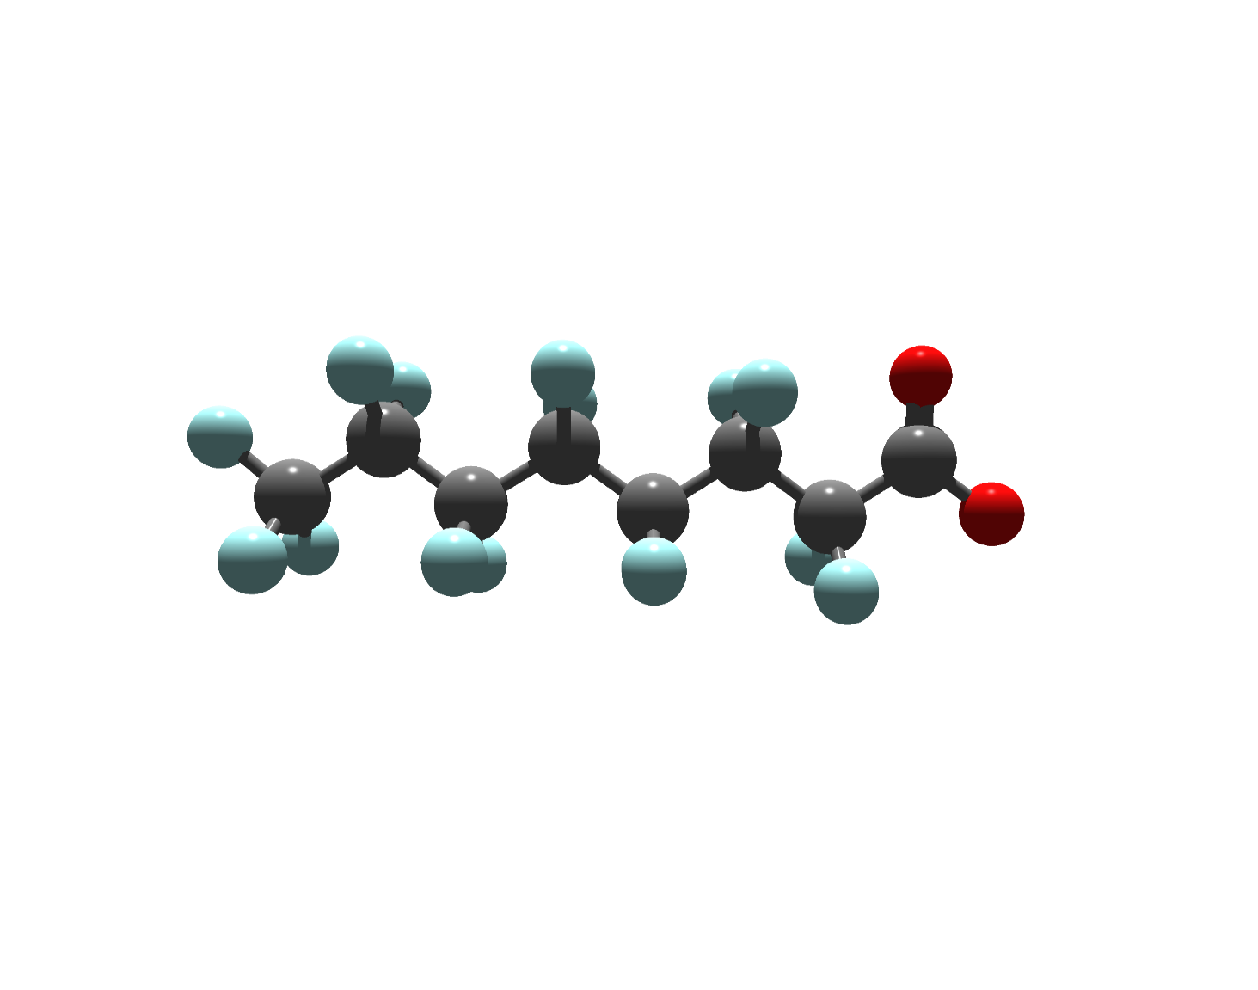

Figure 1 The perfluorooctanoate anion, to which all PFOA chemicals eventually transform in the environment (Key: carbon: grey, fluorine: teal, oxygen: red).

PFOA is highly stable due to the strength of the carbon-fluorine bonds. PFOA chemicals are a subset of a broad group of synthetic chemicals known as PFAS that have been in use since the 1950s to make a wide variety of products that resist heat, other chemicals and abrasion.

## An indicative list of compounds covered by the proposed scheduling decision for PFOA is available as part of the consultation package. Hazards and risks to the environment

PFOA chemicals pose a risk to the environment because they are persistent, can be transported long distances, have widespread occurrence in environmental compartments including in remote regions, accumulate through food chains, and can cause adverse effects to the environment and humans.

The Stockholm Convention PFOA risk profile concludes that PFOA can bioaccumulate and biomagnify in aquatic air-breathing mammals and terrestrial species including humans. PFOA is toxic to animals including humans, with a wide range of effects including reproductive or developmental, immunotoxicity and endocrine disruption.

Monitoring studies summarised in the Stockholm Convention PFOA risk profile demonstrate that PFOA is a widely dispersed environmental contaminant including in water, air and sediment biota at remote locations. Human exposure away from occupational settings takes place by consumption of drinking water and food, including breastfeeding, through uptake of contaminated indoor air and dust and from consumer products containing PFOA.

## Additional information: regulation of PFOA chemicals in Australia

Regulatory and policy frameworks for PFOA chemicals include the National PFAS Position Statement, Australian Industrial Chemicals Introduction Scheme (AICIS), workplace safety and hazardous waste regulatory systems, and state and territory environmental legislation.

Key regulations and policies, noting this is not a comprehensive list, include:

* A series of [advisory alerts](https://webarchive.nla.gov.au/awa/20091030155531/http:/www.nicnas.gov.au/Publications/NICNAS_Alerts.asp) issued between 2002 and 2008 under the National Industrial Chemical Notification and Assessment Scheme (NICNAS, since replaced by AICIS) include recommendations that industry phase out PFOA chemicals, avoid selecting PFOA as an alternative to PFOS and recommend inclusion of information on safe use and handling on product labels and safety data sheets.
* Many PFOA chemicals are listed on the Australian Inventory of Industrial Chemicals ([AIIC](https://www.industrialchemicals.gov.au/search-inventory)), which means they can be introduced into Australia subject to any AICIS conditions on the listing.
* The [National PFAS Position Statement](https://www.pfas.gov.au/news/national-pfas-position-statement-publication-and-consultation-1) sets out nationally agreed objectives for phasing-out the use of PFAS of concern in Australia. After the release of this policy the Australian Packaging Covenant Organisation (APCO) launched its [industry-led action plan](http://www.packagingnews.com.au/latest/apco-launches-pfas-action-plan) to remove intentionally added PFAS in fibre-based food contact packaging by the end of 2023, and will monitor progress of the phase-out through data reporting in early 2023 and mid-2024.
* The [PFAS National Environmental Management Plan (PFAS NEMP)](https://www.dcceew.gov.au/environment/protection/publications/pfas-nemp-2) provides nationally agreed guidance on the management of PFAS contamination in the environment, including prevention of the spread of contamination.
* PFOA chemicals are included in Annex I of the [Basel Convention on the Control of Transboundary Movements of Hazardous Wastes and Their Disposal](http://www.basel.int/TheConvention/Overview/TextoftheConvention/tabid/1275/Default.aspx). In Australia this means that wastes containing PFOA chemicals cannot be imported or exported without a permit under the Hazardous Waste (Regulation of Exports and Imports) Act 1989.
* PFOA chemicals are classified as hazardous chemicals under the model Work Health and Safety Regulations. They must have labels and safety data sheets classified in accordance with the Globally Harmonized System of Classification and Labelling of Chemicals (GHS). The [Hazardous Chemical Information System (HCIS)](http://hcis.safeworkaustralia.gov.au/) gives guidance on PFOA classification.
* Ammonium perfluorooctanoate (APFO) is the only PFOA chemical that has a [workplace exposure standard (PDF 1.0 MB)](https://www.safeworkaustralia.gov.au/system/files/documents/1912/workplace-exposure-standards-airborne-contaminants.pdf) under the [model Work Health and Safety Regulations](https://www.safeworkaustralia.gov.au/doc/model-whs-regulations). Workers cannot be exposed to APFO above the workplace exposure standard for this chemical. PFOA and its inorganic salts have been [proposed for addition](https://www.safeworkaustralia.gov.au/doc/wes-review-selection-hazardous-chemicals-be-considered-addition-or-removal-workplace-exposure-standards-list) to the workplace exposure standards list. The model WHS Regulations require that exposure to these chemicals be minimised to as low as reasonably practical and that exposure risks are managed.
* Some States have regulations on use of PFAS fire-fighting foams, including [New South Wales’s 2021 PFAS firefighting foam regulation](https://www.epa.nsw.gov.au/your-environment/contaminated-land/regulation-of-pfas-firefighting-foams), [South Australia’s 2018 regulation on use of fluorinated fire-fighting foams (PDF 328)](https://www.epa.sa.gov.au/files/14472_14453_info_fire_protection_fluorinated_foam.pdf), and [Queensland’s 2016 Environmental Management of Firefighting Foam–Operational Policy](https://www.qld.gov.au/environment/pollution/management/disasters/pfas/firefighting-foam).

## Additional Information: replacements for PFOA chemicals

The Stockholm Convention PFOA risk profile and [Stockholm Convention PFOA risk management evaluation](http://chm.pops.int/Portals/0/download.aspx?d=UNEP-POPS-POPRC.13-7-Add-2.English.pdf) indicate that cost competitive alternatives to PFOA chemicals that do not exhibit POPs characteristics have been implemented in many countries. Chemicals that are equivalent in performance and meet relevant certifications are available for almost all uses.

Alternatives for some allowed uses under the Stockholm Convention are emerging. For example, polytetrafluoroethylene (PTFE) used in implantable medical devices can be made without PFOA and alternatives are reportedly now commercially available. For membranes used in medical textiles and in filtration in water and effluent treatment, some short-chain fluorinated and non-fluorine containing alternatives and non-chemical alternatives meet regulatory requirements and are in current use.

Through the [National PFAS Position Statement](https://www.pfas.gov.au/news/national-pfas-position-statement-publication-and-consultation-1) Australian governments encouraged industry that sell or use long- or short-chain PFAS to develop a strategy for how and when they will transition away from these chemicals.

## Key references

ECHA2015, [Background Document to the Opinion on the Annex XV Dossier Proposing Restrictions on Perfluorooctanoic acid (PFOA), PFOA Salts and PFOA-related Substance (PDF 4.5 MB)](https://echa.europa.eu/documents/10162/61e81035-e0c5-44f5-94c5-2f53554255a8), accessed 11 April 2022.

enHealth 2019, [Factsheet: Revised enHealth Guidance Statements on Per-and Poly-fluoroalkyl Substances (PFAS)](https://www.health.gov.au/resources/publications/enhealth-guidance-revised-guidance-statements-on-per-and-polyfluoroalkyl-substances-pfas?language=en), Environmental Health Standing Committee of the Australian Health Protection Principal Committee.

HEPA 2020, [PFAS National Environmental Management Plan 2.0](https://www.dcceew.gov.au/environment/protection/publications/pfas-nemp-2), Heads of EPAs Australia and New Zealand.

Jia, X, Guan, H, Guo, Z, Qian, C, Shi, Y & Cai, Y 2021, 'Occurrence of Legacy and Emerging Poly- and Perfluoroalkyl Substances in Fluorocarbon Paint and Their Implications for Emissions in China', Environmental Science & Technology Letters, vol. 8, no. 11, pp. 968-74, doi: 10.1021/acs.estlett.1c00709.

NICNAS 2015, [Perfluorooctanoic acid (PFOA) and its direct precursors: Environment tier II assessment (PDF 176 KB)](https://www.industrialchemicals.gov.au/sites/default/files/Perfluorooctanoic%20acid%20%28PFOA%29%20and%20its%20direct%20precursors_%20Environment%20tier%20II%20assessment.pdf), National Industrial Chemicals Notification and Assessment Scheme, Sydney, Australia.

NICNAS 2015, [Perfluorooctanoic acid (PFOA) and its Direct Precursors: Human Health Tier II Assessment (PDF 192 KB)](https://www.industrialchemicals.gov.au/sites/default/files/Perfluorooctanoic%20Acid%20%28PFOA%29%20and%20its%20Direct%20Precursors_Human%20health%20tier%20II%20assessment.pdf), National Industrial Chemicals Notification and Assessment Scheme, Sydney, Australia.

NICNAS 2016, [Indirect Precursors of Perfluorooctanoic Acid (PFOA): Human health tier II assessment (PDF 281 KB)](https://www.industrialchemicals.gov.au/sites/default/files/Indirect%20Precursors%20of%20Perfluorooctanoic%20Acid%20%28PFOA%29_Human%20health%20tier%20II%20assessment.pdf), National Industrial Chemicals Notification and Assessment Scheme, Sydney, Australia, accessed 6 April 2022.

NICNAS 2019, [Indirect precursors to perfluorooctanoic acid (PFOA): Environment tier II assessment (PDF 201 KB)](https://www.industrialchemicals.gov.au/sites/default/files/Indirect%20precursors%20to%20perfluorooctanoic%20acid%20%28PFOA%29_%20Environment%20tier%20II%20assessment.pdf),National Industrial Chemicals Notification and Assessment Scheme, Sydney, Australia.

Prevedouros, K, Cousins, IT, Buck, RC & Korzeniowski, SH 2006, 'Sources, Fate and Transport of Perfluorocarboxylates', Environmental Science & Technology, vol. 40, no. 1, pp. 32-44, doi: 10.1021/es0512475.

UNEP 2006, [OECD Environment, Health and Safety Publications Series on Risk Management No. 22: Results of the 2006 Survey on Production and Use Of PFOS, PFAS, PFOA, PFCA, Their Related Substances And Products/Mixtures Containing These Substances (PDF 243 KB)](https://one.oecd.org/document/ENV/JM/MONO%282006%2936/En/pdf) . Joint Meeting of the Chemicals Committee and the Working Party on Chemicals, Pesticides and Biotechnology.

UNEP 2016, [Risk profile on Pentadecafluorooctanoic Acid (CAS No: 335-67-1, PFOA, perfluorooctanoic acid), its salts and PFOA-related compounds (Addendum)](http://chm.pops.int/Implementation/IndustrialPOPs/PFAS/Overview/tabid/5221/Default.aspx), Report of the Persistent Organic Pollutants Review Committee on the work of its twelfth meeting, 13 October 2016.

UNEP 2017, [Risk management Evaluation on Pentadecafluorooctanoic Acid (CAS No: 335-67-1, PFOA, Perfluorooctanoic Acid), its Salts and PFOA-related Compounds (Addendum)](http://chm.pops.int/Implementation/IndustrialPOPs/PFAS/Overview/tabid/5221/Default.aspx), Report of the Persistent Organic Pollutants Review Committee on the Work of its Thirteenth Meeting, accessed 22 April 2022.

UNEP 2018, [Addendum to the Risk Management Evaluation on Perfluorooctanoic Acid (PFOA), its Salts and PFOA-Related Compounds](http://chm.pops.int/Implementation/IndustrialPOPs/PFAS/Overview/tabid/5221/Default.aspx), Report of the Persistent Organic Pollutants Review Committee on the Work of its Fourteenth Meeting, accessed 22 April 2022.

UNEP 2019, [Factsheet: POPs Chemicals Perfluorooctanoic Acid (PFOA), its Salts and PFOA-related Compounds](http://www.pops.int/TheConvention/ThePOPs/TheNewPOPs/tabid/2511/Default.aspx). United Nations Environment Programme, accessed 22 April 2022.

## More information

Email [ichems.enquiry@dcceew.gov.au](mailto:ichems.enquiry@dcceew.gov.au)

Web [www.dcceew.gov.au/environment/protection/chemicals-management/national-standard](http://www.dcceew.gov.au/environment/protection/chemicals-management/national-standard)

**Acknowledgement of Country**

We recognise the First Peoples of this nation and their ongoing connection to culture and country. We acknowledge First Nations Peoples as the Traditional Owners, Custodians and Lore Keepers of the world's oldest living culture and pay respects to their Elders past, present and emerging.

© Commonwealth of Australia 2023

Unless otherwise noted, copyright (and any other intellectual property rights) in this publication is owned by the Commonwealth of Australia (referred to as the Commonwealth).

All material in this publication is licensed under a [Creative Commons Attribution 4.0 International Licence](https://creativecommons.org/licenses/by/4.0/legalcode) except content supplied by third parties, logos and the Commonwealth Coat of Arms.

The Australian Government acting through the Department of Climate Change, Energy, the Environment and Water has exercised due care and skill in preparing and compiling the information and data in this publication. Notwithstanding, the Department of Agriculture, Water and the Environment, its employees and advisers disclaim all liability, including liability for negligence and for any loss, damage, injury, expense or cost incurred by any person as a result of accessing, using or relying on any of the information or data in this publication to the maximum extent permitted by law.