**Wired for change:**

Regulation for small electrical products and solar photovoltaic system waste

© Commonwealth of Australia 2023

**Ownership of intellectual property rights**

Unless otherwise noted, copyright (and any other intellectual property rights) in this publication is owned by the Commonwealth of Australia (referred to as the Commonwealth).

**Creative Commons licence**

All material in this publication is licensed under a [Creative Commons Attribution 4.0 International Licence](https://creativecommons.org/licenses/by/4.0/legalcode) except content supplied by third parties, logos and the Commonwealth Coat of Arms.

Inquiries about the licence and any use of this document should be emailed to [copyright@dcceew.gov.au](mailto:copyright@dcceew.gov.au).



**Cataloguing data**

This publication (and any material sourced from it) should be attributed as: DCCEEW 2023, Wired for Change: *Regulation for small electrical products and solar photovoltaic systems waste* Department of Climate Change, Energy, the Environment and Water, Canberra, June 2023. CC BY 4.0.

This publication is available at [dcceew.gov.au/publications](https://www.dcceew.gov.au/publications).

Department of Climate Change, Energy, the Environment and Water

GPO Box 3090 Canberra ACT 2601

Telephone 1800 900 090

Web [dcceew.gov.au](https://www.dcceew.gov.au)

**Disclaimer**

The Australian Government acting through the Department of Climate Change, Energy, the Environment and Water has exercised due care and skill in preparing and compiling the information and data in this publication. Notwithstanding, the Department of Climate Change, Energy, the Environment and Water, its employees and advisers disclaim all liability, including liability for negligence and for any loss, damage, injury, expense or cost incurred by any person as a result of accessing, using or relying on any of the information or data in this publication to the maximum extent permitted by law.

**Acknowledgements**

The authors thank all stakeholders for their input during the preparation of this report.

**Acknowledgement of Country**

Our department recognises the First Peoples of this nation and their ongoing connection to culture and country. We acknowledge First Nations Peoples as the Traditional Owners, Custodians and Lore Keepers of the world's oldest living culture and pay respects to their Elders past, present and emerging.

We acknowledge the Traditional Owners of Country throughout Australia and their continuing connection to land, sea and community. We pay our respects to them and their cultures and to their elders both past and present. We are committed to working respectfully with Aboriginal and Torres Strait Islander peoples and give particular acknowledgement to their use, knowledge and custodianship of Australia’s native plants and animals over countless generations. We support Aboriginal and Torres Strait Islander peoples and their aspirations to maintain, protect and manage their culture, language, land and sea Country and heritage.

## A portrait photo of the Minister for the Environment and Water, Tanya Plibersek.Foreword

E-waste is the fastest-growing waste stream in the world. Yet it contains precious metals such as gold, copper and nickel as well as silicon, lithium and other materials we need to power our renewable energy transition. We need to recover and recycle more of these valuable resources.

E-waste also contains hazardous materials that can damage the environment, start dangerous fires and put human health at risk. It must be managed safely.

It is estimated that by 2030, the average Australian will generate almost 22 kg of e-waste per year. In 2019 alone, Australia sent over $430 million worth of materials within e-waste, to landfill. These wasted resources included 84% of the solar panel systems and household electronics that Australians discarded.

That is why the Australian Government intends to regulate waste from solar photovoltaic systems and small electrical and electronic products.

This Discussion Paper seeks your views on a proposal for a regulated product stewardship scheme. I encourage you to have your say in the online survey, or make a written submission, and help us design effective regulation to stop the valuable materials in our e-products being wasted.

I regularly hear that Australians want to live more sustainable lives and do the right thing by the environment. To do this, we must act to reduce our e-waste. As we undergo our renewable energy transition, it is essential we manage associated products in a truly sustainable way across their whole lifecycle.

We can shape a future that works for everyone in our circular economy. This means businesses will be able to create valuable products from materials that would otherwise go to waste. It means we can create employment in stable, environmentally friendly, green jobs.

When we develop the right rules, when we invest in the necessary infrastructure and when we get the logistics right, regulation can be a win for business, a win for workers, and a win for our planet.

Thank you for contributing to this process to protect our beautiful environment.

The Hon Tanya Plibersek MP

Minister for the Environment and Water

Contents

Foreword iv

Executive Summary 7

Introduction 7

Product stewardship 7

Domestic and international context 7

Proposed regulatory approach 8

Small electrical and electronic equipment (SEEE) 9

Small-scale PV systems 10

Large-scale PV systems 10

Conclusion 11

1. Introduction 12

1.1 Purpose 12

1.2 About this consultation 13

1.3 The problem with e-waste 14

1.4 What products would be covered by potential regulation 16

1.5 Role of the Australian Government in managing e-waste 17

1.6 Roles of state and territory governments 17

2. Product Stewardship 19

2.1 What is product stewardship? 19

2.2 Product stewardship in Australia 19

3 Australian context 20

3.1 National waste policy action plan 20

3.2 State and territory legislation and policy 20

3.3 Regulation of hazardous waste exports and other waste exports and imports 20

3.4 Waste exports under the RAWR Act 21

3.5 Current product stewardship schemes covering e‑products 21

4 International context 23

4.1 Approaches taken to e-stewardship internationally 23

4.2 International approaches to large-scale solar 25

5 Proposed Regulatory Approach 27

5.1 Purpose of proposed scheme 27

5.2 Scheme design 28

5.3 Liable parties 30

5.4 Funding the scheme 30

5.5 Structure of proposed scheme 32

6 Small electrical and electronic equipment 35

6.1 Product scope 35

6.2 Targets and Obligations 36

7 Small-scale PV systems 41

7.2 Legacy waste 41

7.3 Targets and obligations 42

7.4 Recovery target and obligations 42

7.5 Access obligations 43

7.6 Education and awareness 44

8 Large-scale PV systems 45

8.1 Defining large-scale systems 45

8.2 Large-scale obligations 45

8.3 Large-scale legacy waste 46

Glossary 47

References 50

Appendix A: Contributing stakeholders 53

Appendix B: Product codes 55

## Executive Summary

### Introduction

This paper details a proposed regulatory approach to product stewardship for two categories of electrical/electronic-products (e-products), solar photovoltaic (PV) systems and small electrical and electronic equipment (SEEE). The Department of Climate Change, Energy, the Environment and Water (the department) is seeking feedback on this proposal.

On 21 October 2022 the Hon Tanya Plibersek MP, the Minister for the Environment and Water, announced the Australian Government’s intent to develop a regulated product stewardship scheme for e-products.

Following this announcement, the department consulted with key stakeholders to develop a potential product stewardship scheme that could be enforced through regulation. This scheme would reduce negative effects on the environment and human health, through regulations designed to:

* maximise the amount of waste from e-products (e-waste) that is directly collected and recycled by the scheme via free disposal services provided to households and small businesses
* improve recycling outcomes for e-waste collected outside of the scheme’s disposal services (for example, e-waste collected from large businesses and government agencies by commercial service providers).

It is anticipated that scheme costs would be passed on to consumers through slightly higher product prices. To minimise these costs, the proposed scheme is designed to promote competition in the delivery of scheme activities, while achieving the desired recycling and waste avoidance outcomes.

### Product stewardship

Product stewardship is a framework for reducing product’s impacts on the environment and human health. It involves manufacturers, importers, distributers, retailers, and end-users sharing this responsibility. It aims to influence all stages of a product’s lifecycle, from raw material extraction through to end-of-life management. The primary focus of the proposed scheme is managing end‑of‑life impacts.

The *Recycling and Waste Reduction Act 2020* (RAWR Act) allows the Australian Government to make legislative rules requiring certain product stewardship action to be taken, and to accredit voluntary schemes. These provisions are expected to be used to implement the regulated product stewardship scheme proposed in this paper.

### Domestic and international context

In 2018, Australia’s Environment Ministers endorsed the National Waste Policy and the resulting National Waste Policy Action Plan 2019, as well as updates contained in the National Waste Policy Action Plan Annexure 2022. They have committed to waste targets and actions to move Australia towards a circular economy. This includes:

* the Australian Government identifying a preferred product stewardship scheme for photovoltaic systems by 2023 and implementing it by 2025
* all governments developing a common approach to restrict the disposal of priority products and materials (including e-waste) in landfill by 2024
* transition to a circular economy by 2030.

In March 2020, Australia’s Environment Ministers agreed that the Australian Government would regulate exports of waste glass, plastic, tyres, paper and cardboard from 2021. This requires plastic and glass from e-waste to be sorted and processed prior to export.

Recycling e-waste generates a variety of valuable, low value, and hard-to recycle materials. Historically, a large portion of materials recovered from e-waste that was generated in Australia, including e-waste plastics, were recovered through overseas processing.

Exports of hazardous e-waste trigger requirements of the Basel Convention, an international convention that controls the transboundary movements of hazardous and certain other wastes, which requires:

* Australia to ensure hazardous and certain other waste that are sent overseas are managed in an environmentally sound manner
* the consent of the receiving and transit countries for this waste to enter their territory*.*

By 2024 it is expected that around half of Australians will live in jurisdictions with some form of e-waste landfill ban. In addition, parties to the Basel Convention have agreed to control the international movement of all e-waste (whether hazardous or not) from 2025. This means that exporting, transit and receiving countries will need to agree to the import and export of all e-waste before movement. This changing policy context means action is required to encourage and support additional environmentally sound domestic management options for e-waste.

It is anticipated that any national e-stewardship regulation would support state and territory e-waste environmental and waste management policies. Should the Australian Government decide to implement the scheme proposed in this paper, the department will work with state and territory government agencies to identify opportunities for harmonisation and improvement of related state and territory regulation that will support efficient implementation of the proposed scheme.

More than 30 countries have implemented regulated product stewardship for e-products (also known as e-stewardship regulation). This includes European countries which have adopted Directive 2012/19/EU on waste electrical and electronic equipment (WEEE Directive), as well as South Korea, some Canadian provinces and some states of the United States of America. There is no standard regulatory approach to implementing e-stewardship regulation, but recent reviews of these schemes have highlighted the benefits of centralising certain scheme functions such as fee collection, scheme membership, and collection and recycling co-ordination.

### Proposed regulatory approach

Many Australians do not have access to suitable e-waste disposal options for environmentally sustainable e-waste management. This is because management options for e‑waste have not kept pace with the growth in our consumption of e-products or restrictions on disposal pathways for e‑waste (such as landfill bans). The purpose of the proposed product stewardship scheme is to:

* ensure that Australia manages decommissioned solar PV systems in an environmentally sustainable manner
* provide Australian households and businesses with sustainable pathways to manage end‑of‑life small electrical and electronic equipment
* reduce solar PV system and SEEE waste
* create an effective national product stewardship framework which can be used to address additional product types, if required in the future.

The proposed regulation aims to:

* reduce waste to landfill
* increase the recovery of reusable materials
* provide convenient access to e-stewardship services across Australia
* support Australia’s transition to a more circular economy
* foster shared responsibility across the lifecycle of covered products.

The proposed scheme structure includes a single scheme administrator and multiple network operators. The scheme administrator would be appointed by the government and be responsible for scheme outcomes. Network operators would also be appointed by the government and be responsible for managing collection, transportation and recycling services within a certain geographic area. The scheme administrator would be responsible for ensuring the price of a network operator’s services represents good value for money.

The scheme would be funded by liable parties – organisations that import or produce a quantity of products covered by the scheme above a set threshold limit. Liable parties would be required to join the scheme and pay fees to the scheme administrator. These fees would support the scheme administrator to acquit their obligations and deliver their responsibilities under the scheme, including:

* ensuring sufficient e-waste disposal services are provided to households and small businesses, via the network operators
* ensuring sufficient recycling is undertaken via network operators
* entering into contracts with network operators and ensuring payment is made
* other scheme objectives (such as encouraging repair and re-use) are achieved.

### Small electrical and electronic equipment (SEEE)

The proposed scope for SEEE covers most of the small electronic and electrical equipment found in homes and small businesses, weighing up to 20 kg. It also includes all products currently covered by the National Television and Computer Recycling Scheme (NTCRS). The scheme would include any embedded batteries in these products but is not proposed to cover loose batteries (such as AAA batteries).

The proposed scheme’s scope is designed to:

* cover products with low recovery rates and/or limited disposal pathways
* be easy for consumers and businesses to understand and access
* provide support for Australia’s transition to a circular economy.

The proposed scheme has 5 categories of targets and obligations for the scheme administrator to deliver relating to SEEE.

1. An obligation on how much e-waste must be recycled each year.
2. An obligation on the proportion of material from recycled products that must be recovered for remanufacture.
3. An obligation for a minimum level of accessible drop-off services available to households and small businesses.
4. An obligation to encourage maximising the re-use of products.
5. Educating and awareness-raising obligations about re-use and repair, how to keep products out of the waste stream as long as practicable, and how to choose more sustainable products.

### Small-scale PV systems

Consistent with the [Renewable Energy Target scheme](https://www.dcceew.gov.au/energy/renewable/target-scheme#:~:text=The%20Renewable%20Energy%20Target%20(RET,emissions%20from%20the%20electricity%20sector.), the department proposes defining small-scale solar PV systems as those with up to 100 kW of capacity.

The proposed scope for small-scale PV systems covers all solar panels, inverters, attached cabling and racking. It could potentially also cover household energy storage batteries. Installation and decommissioning of these systems requires a qualified electrician and should not be attempted by unqualified persons. As such, PV system waste drop-off services would only be made available to industry participants and not to members of the public.

There is one exception to restricting drop-off service access to industry participants. This is for disposing of ‘plug-and-play’ PV products. Plug-and-play PV products include camping, automotive, marine, and other systems where installation and decommissioning does not require a qualified electrician. Drop-off services for these products would be accessible to members of the public.

The department proposes that the scheme captures waste from small-scale systems installed prior to the commencement of the scheme (legacy waste).

The proposed scheme has 3 categories of targets and obligations for the scheme administrator to deliver relating to small-scale PV systems.

1. An obligation on the proportion of material from recycled products that must be recovered for remanufacture.
2. A free PV waste disposal network appropriate for the collection of Australia’s installed solar PV capacity.
3. Educating and awareness-raising among consumers about sustainability of PV products.

### Large-scale PV systems

The department proposes defining large-scale solar PV systems as those with a capacity of over 100 kW. The proposed scheme would allow additional options for liable parties to manage waste from large-scale PV systems.

The proposed scheme would not take financial responsibility for recycling or managing legacy waste from large-scale PV systems. It is also proposed that liability for products used in large-scale systems could be transferred from importers and producers of PV products to large-scale system owners.

It is proposed that transitional arrangements for large-scale legacy waste would be addressed through a mandatory rule under the RAWR Act. This would require owners of large-scale PV systems that were commissioned prior to the commencement of the scheme, and decommissioned after the commencement of the scheme, to provide information on the management of waste from these systems to the scheme administrator. The intended rule would require this information to be sufficient for the scheme administrator to ensure it does not cover any end-of-life management costs of large-scale systems commissioned prior to the commencement of the scheme.

### Conclusion

The development of a regulated product stewardship scheme for managing waste from SEEE and solar PV products is a crucial part of Australia’s renewable energy transition and an important step towards a circular economy. The proposed scheme would reduce the negative environmental and human health effects of e-waste, by ensuring importers and producers take responsibility for the management of their products.

This paper invites interested parties to comment on the proposed regulation.

This paper is not consultation on proposed legislation and is not government policy. This publication does not indicate a commitment by the Australian Government to a particular course of action.

## Introduction

Australia is facing a growing e-waste problem. Each year Australians generate around 20 kg per person, one of the highest per capita e-waste levels in the world. This is on track to grow to almost 22 kg per person by 2030. It is imperative that Australians reduce the environmental and health costs from e-waste, including by increasing recycling and material recovery rates. This will help to reduce the pressure on valuable non-renewable resources.

Product stewardship provides pathways to support collection and processing of e-waste and increase recovery and recycling rates. It can also support higher levels and standards of re-use, repair and the development of markets for recycled components and materials.

This discussion paper details a proposed national, legislated product stewardship scheme for e-products (e-stewardship). The proposed regulation discussed in this paper focuses on the largest category of e-waste: small electrical and electronic equipment (SEEE), and the fastest growing   
e-waste stream: solar photovoltaic (PV) systems.

The department commissioned Iceni and Lifecycles to develop a detailed stock and flow model of the consumption of e-products in the economy and to project future amounts of e-waste to 2030. The model uses the methodology published by the United Nations University and used in the calculation of the annual Global E-waste Monitor (Bontinck & Bricout 2022). Unless otherwise referenced, all figures quoted in this Discussion Paper are based on the second iteration of the model (version 1.1).

### 1.1 Purpose

On 21 October 2022, the Hon Tanya Plibersek MP, the Minister for the Environment and Water, announced the Australian Government’s intent to develop options for a regulated product stewardship scheme for solar PV systems and household electronics. Following this announcement, the Department of Climate Change, Energy, the Environment and Water (the department) consulted with industry and other key stakeholders on potential regulation. A list of organisations consulted during this engagement is at Appendix A.

This paper presents key elements of the potential regulation. It provides the Australian public an opportunity to engage in the discussion and shape any new regulation. It consists of 2 parts:

1. Sections 1–4 describe the problem of e-waste and outlines the broader domestic and international policy context.
2. Sections 5–8 provide a high-level summary of the department’s proposed option for regulatory product stewardship for solar PV systems and SEEE.

This paper is not consultation on proposed legislation and is not government policy. This publication does not indicate a commitment by the Australian Government to a particular course of action.

### 1.2 About this consultation

**We want to hear from you**

The department invites interested parties to provide information and comment on this discussion paper. We want to hear from brand owners, businesses, consumers, organisations, communities and local governments.

**How to provide feedback**

To have your say, read this discussion paper and register your details at the [Have Your Say consultation page](https://aus01.safelinks.protection.outlook.com/?url=https%3A%2F%2Fconsult.dcceew.gov.au%2Fregulation-small-electrical-products-solar-pv&data=05%7C01%7CRoger.Morrison%40dcceew.gov.au%7C537b3c9776c04b8c118208db6bc1f266%7C2be67eb7400c4b3fa5a11258c0da0696%7C0%7C0%7C638222252961153310%7CUnknown%7CTWFpbGZsb3d8eyJWIjoiMC4wLjAwMDAiLCJQIjoiV2luMzIiLCJBTiI6Ik1haWwiLCJXVCI6Mn0%3D%7C3000%7C%7C%7C&sdata=PzVISxVf7vqIj3PJ1K8r%2Bht6wfgdo6nAWsYz5xndLtY%3D&reserved=0).

You have 2 options to provide written feedback by Sunday 23 July 2023:

1. Answer the questions in the Have Your Say survey at the link above.
2. Download the response document if you have multiple contributors for your submission. Then upload your response at the link above.

You may also like to attend a webinar discussion on 11 July 2023. This webinar will provide a summary of the scheme and provide an opportunity to ask questions. Register for this webinar event at the Have Your Say page linked above by 10 July 2023.

**Confidentiality**

All submissions will be treated as public documents and published on the department’s website unless otherwise requested.

Parties wishing to submit confidential information are requested to:

* clearly identify the information that is the subject of the confidentiality claim – the identified information must be genuinely of a confidential nature and not otherwise publicly available
* provide a non-confidential version of the submission in a form suitable for publication – this public version should identify where confidential information has been redacted.

**Next steps**

Once this consultation process has finished, the department will prepare a Policy Impact Assessment (PIA) to assess policy options available to address the problem of e-waste. The PIA will provide information to government about the costs and benefits of different options. Impact Analysis is required for all policy proposals to government where changes are expected to have major impacts on our community.

If the Australian Government provides authority to regulate waste from small electrical products and solar PV systems, the department will conduct further consultations to inform the design of regulations.

### 1.3 The problem with e-waste

Globally, e-waste volumes are rising rapidly. The [Global E-waste Monitor 2020](https://ewastemonitor.info/wp-content/uploads/2020/11/GEM_2020_def_july1_low.pdf) estimated that the world’s e-waste would increase from 54 million tonnes in 2019 – heavier than the Great Wall of China – to 75 million tonnes in 2030.

The average Australian produced 20 kg of e-waste in 2019 compared with the global average of 7 kg (Forti et al. 2020). This is projected to rise by nearly 30% by 2030, from 511,000 tonnes to 657,000 tonnes annually. Despite our high rate of e-waste production, we only recover a third of the total value of the materials in the e-waste we generate. In 2019 alone, Australia sent $430 million worth of materials to landfill along with their e-waste. In addition to containing valuable substances, e-waste also contains hazardous materials such as lead, cadmium, mercury and persistent organic pollutants (POPs).

#### Negative externalities of e-waste

A negative externality exists when the production or consumption of a product results in a cost to a third party, and that third party is not compensated. Air, water and soil pollution or contamination from poor e-waste management practices are examples of negative externalities associated with e-products. E-products can generate a wide array of environmental costs on governments, communities and the environment. These include:

* loss of animal habitat, air pollution and water pollution from mining raw materials to manufacture e-products
* pollution from battery fires in waste trucks, landfills and waste management facilities
* hazardous components of e-waste (for example, those containing lead, cadmium, mercury POPs and brominated flame retardants) contaminating soil and water, leading to negative human health and environmental impacts and loss of agricultural productivity.

#### Consumption of non-renewable resources

The production of e-products requires non-renewable resources as inputs. In 2022 the Royal Society of Chemistry (RSC) ran a campaign to draw attention to current unsustainable practices of mining the precious materials used in e-products. Professor Tom Welton, president of the RSC, said: ‘Our tech consumption habits remain highly unsustainable and have left us at risk of exhausting the raw elements we need’ (Gill 2022).

Electrical and electronic products contain a large variety of valuable, critical and rare-earth materials like gold, silver, cobalt and neodymium (DISER 2022). When e-waste is disposed of in landfill these materials are lost. A well-managed product stewardship scheme can ensure these materials are recovered and available to be used in new products.

#### Waste from small electrical and electronic equipment

SEEE includes a diverse range of products, such as toasters, kettles, microwaves, cameras, vacuum cleaners and headphones. Currently it is the largest e-waste stream and projected to make up 39% of all e-waste generated between 2019 and 2030. The volumes are likely to stay high due to consumer demand for these products, and the relative (lower) cost of replacing SEEE products compared with repairing them.

SEEE has some of the lowest recycling and recovery rates of any type of e-waste. In 2019 only 16% of small equipment was collected for recycling with only 8% of the materials recovered. Many SEEE products are not commercially viable to recycle without incentives. As such, without regulatory intervention SEEE recycling and recovery rates are expected to remain low.

#### Waste from solar PV systems

Solar PV system waste is the fastest growing e-waste stream in Australia. Graph 1 below shows that waste from solar PV systems is forecast to rise from 3,000 tonnes in 2019 to 54,000 tonnes in 2030. Solar PV systems comprise solar panels, inverters, large format batteries and associated components (such as racking and cables). Australia has the world’s highest per-capita rate of solar panel installation (ed. Masson 2023). Solar PV systems currently have low recycling and recovery rates. In 2016, 16% of PV systems were collected for recycling, with 6% of resources recovered.

There is currently no national scheme or program for the collection, recycling or re-use of decommissioned PV systems in Australia (even where systems are fully operational at time of decommissioning).

Graph 1: Forecast waste from solar photovoltaic systems

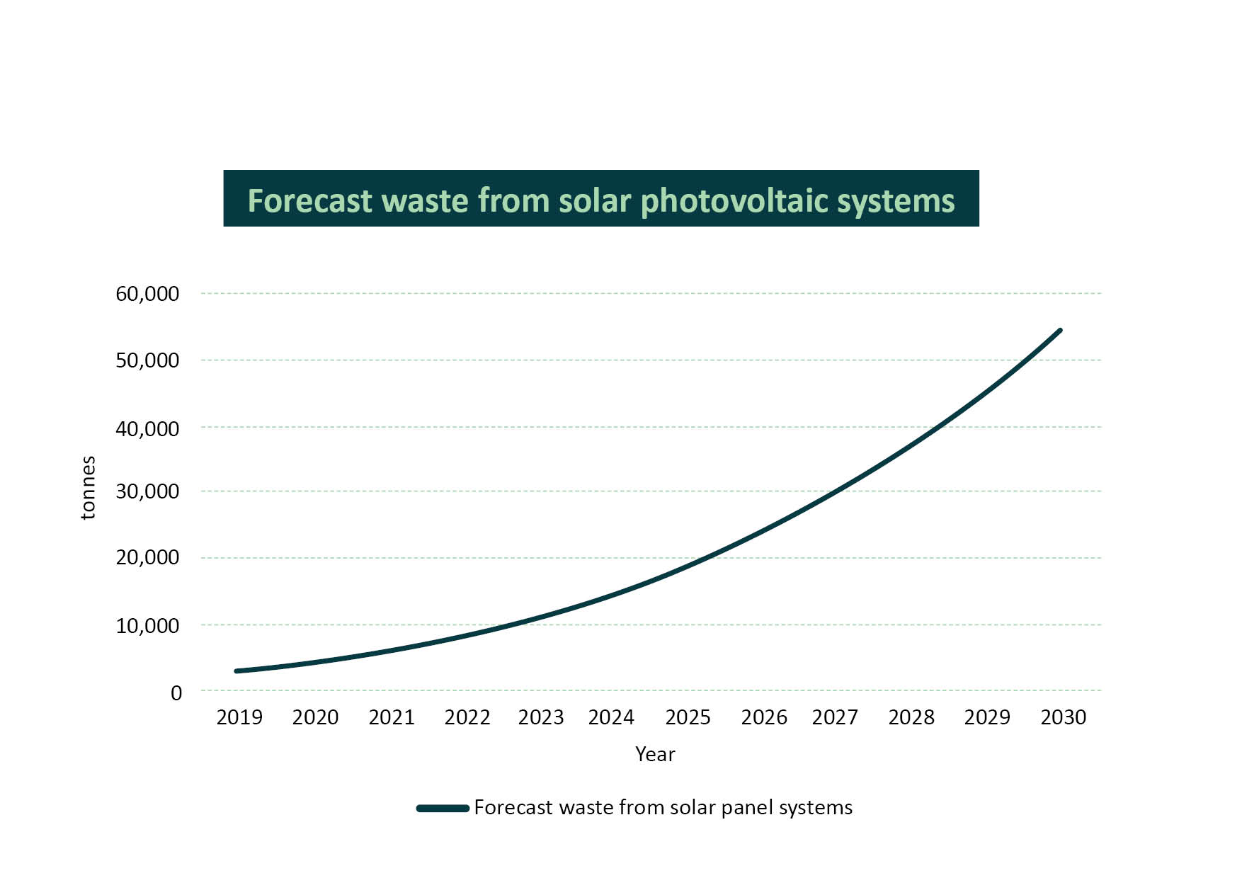

### 1.4 What products would be covered by potential regulation

The proposed product stewardship regulation detailed in this paper is intended to cover solar PV systems and SEEE. Specifically, it is intended that:

* SEEE would include screens and monitors, information technology and telecommunications equipment, and other small electrical and electronic equipment which can be easily lifted and carried and does not weigh more than 20 kg
* solar PV systems would include solar panels, racks, inverters and system wiring, and household energy storage batteries would also be considered for inclusion.

Appendix B lists in-scope SEEE products based on current product codes, known as Harmonised System codes. Products that are currently covered by the [NTCRS](https://www.dcceew.gov.au/environment/protection/waste/product-stewardship/products-schemes/television-computer-recycling-scheme#:~:text=The%20National%20Television%20and%20Computer,printers%2C%20computer%20parts%20and%20peripherals.) would also be included in SEEE (the 20 kg limit would not apply for large televisions or other products currently covered by the NTCRS). See Section 6 of this paper for more information.

While SEEE is intended to be a broad product class there is a need to exclude certain products that are covered under other regulation or pose a significant health and safety risk. For example, the department proposes to exclude end‑of‑life electronic medical devices that are considered biohazardous waste and smoke alarms containing radioactive material. Other products may be excluded if they pose a high risk to collection sites, transporters or recyclers.

Lighting, temperature exchange equipment, large appliances, and other large equipment is proposed to be out of scope. However, the proposed regulation would complement existing Australian Government legislation about the treatment of [mercury](https://www.dcceew.gov.au/environment/protection/chemicals-management/mercury/sector-specific-guidance) and [ozone depleting substances](https://www.dcceew.gov.au/environment/protection/ozone/ozone-science/ozone-depleting-substances#:~:text=Ozone%20depleting%20substances%20are%20chemicals,halon) in certain products (such as lighting and temperature exchange equipment).

### 1.5 Role of the Australian Government in managing e-waste

The Australian Government, and state and territory governments, all have an important role in managing e-waste. State and territory governments have primary responsibility for regulating domestic waste management. The Australian Government’s role is to provide national leadership and coordination, and to ensure that Australia meets its international obligations regarding waste.

Given the respective roles of the Australian Government and state and territory governments, the regulation proposed in this paper does not cover direct regulation of waste management. For example, banning disposing of e-waste in landfill is a decision for state and territory governments and is not explored in this paper.

One of the steps taken by the Australian Government to manage waste and promote a circular economy is implementing the *Recycling and Waste Reduction Act 2020* [(RAWR Act)](https://www.legislation.gov.au/Details/C2021C00501). The RAWR Act establishes a framework for managing waste products across all stages of the product lifecycle. This includes the authority to establish national, legislated product stewardship schemes such as the scheme proposed in this paper.

The Australian Government has also implemented the [Industrial Chemicals Environmental Management Standard (IChEMS)](https://www.dcceew.gov.au/environment/protection/chemicals-management/national-standard). IChEMS establishes nationally consistent regulatory standards for managing harmful industrial chemicals, including their import, use and disposal.

### 1.6 Roles of state and territory governments

State and territory governments are responsible for legislative frameworks to protect the environment, conserve natural resources, and regulate and manage waste. This includes imposing licence conditions for waste and recycling, providing incentives for recycling, and undertaking environmental protection measures.

Each of Australia’s states and territories has its own approach to managing e-waste, but most have introduced measures to promote the safe disposal and recycling of e-waste. [South Australia](https://www.epa.sa.gov.au/page/view_by_id/4279), [Victoria](https://www.environment.vic.gov.au/sustainability/e-waste-in-victoria), and the [Australian Capital Territory](https://www.cityservices.act.gov.au/recyclopaedia/items/e/e-waste-computers,-printers,-modems,-tvs-etc) have imposed restrictions on disposing e-waste in landfill. [Western Australia](https://www.wa.gov.au/service/building-utilities-and-essential-services/waste-management/e-waste-landfill-ban) have announced their intention to implement similar restrictions and [Queensland](https://www.qld.gov.au/environment/management/waste/recovery/reduction/draft-e-products-action-plan) is consulting on restricting disposal options for some e-waste.

The department acknowledges that several aspects of state and territory legislation are important to how any national e-stewardship scheme will operate. These include:

* restrictions on the transport of e-waste across state or territory boarders
* regulatory obligations on the storage, transportation, processing and recycling of e-waste
* permitting and licensing requirements for e-waste recycling facilities
* requirements and timeframes for development approvals of new e-waste recycling facilities.

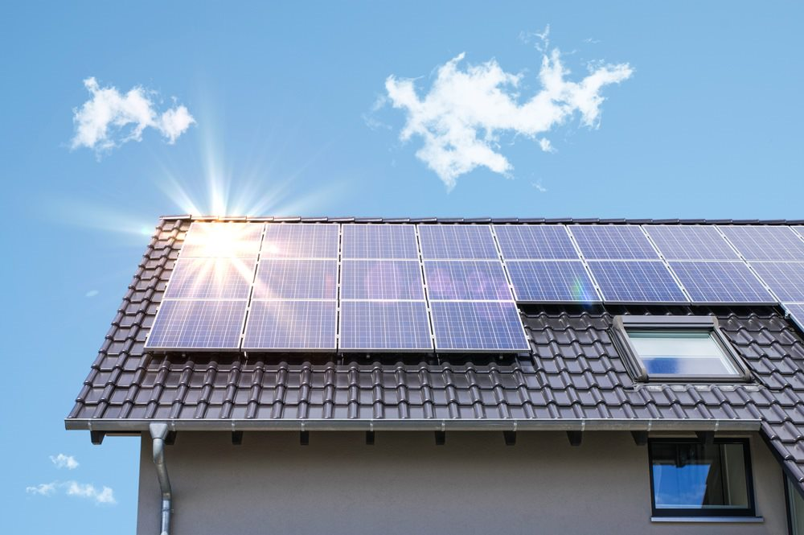As any national scheme will interact with a variety of state and territory regulation, the department will continue to work with state and territory government agencies to identify and implement opportunities for harmonisation and improvement of these regulations to support a national scheme.

## 2. Product Stewardship

### What is product stewardship?

Product stewardship is an approach to reduce the environmental and human health impacts of the products we use every day. It does this by creating a system where manufacturers, importers, distributers, retailers, and end-users take responsibility for managing the impacts of their products. It aims to influence all stages of the product’s lifecycle, from raw material extraction through to end‑of-life management.

Voluntary product stewardship schemes occur where parties involved in a product’s lifecycle voluntarily take financial and/or operational responsibility for the stewardship of that product. Regulated product stewardship schemes involve the government setting specific legal requirements for different parties across a product’s lifecycle. This can include the obligation to make financial contributions to fund the scheme.

### Product stewardship in Australia

There are both voluntary and regulated product stewardship schemes operating in Australia. The RAWR Act is the framework legislation for national, legislated, product stewardship action. The RAWR Act allows the Minister for the Environment and Water to:

* make legislative rules about product stewardship, including making rules to establish regulated product stewardship schemes (such as the NTCRS)
* publish a product stewardship [priority list](https://www.dcceew.gov.au/environment/protection/waste/product-stewardship/ministers-priority-list/2022-23) that names products and materials that need urgent product stewardship action
* [accredit voluntary stewardship schemes](https://www.dcceew.gov.au/environment/protection/waste/product-stewardship/product-schemes/voluntary-product-stewardship).

Voluntary product stewardship schemes are industry-led (either single business or industry-wide) and operate independently of government. Voluntary schemes can seek accreditation by the Australian Government under the RAWR Act, to recognise their environmental and health benefits. Currently there are [7 voluntary schemes accredited by the Australian Government](https://www.dcceew.gov.au/environment/protection/waste/product-stewardship/products-schemes). These schemes cover mobile phones, tyres, large plastic bags, batteries, aluminium cladding, paint containers, and plastics and packaging.

Regulated product stewardship schemes can be set up under the RAWR Act. The Act distinguishes between co-regulatory and mandatory product stewardship. There is currently one co-regulatory product stewardship scheme, the [NTCRS](https://www.dcceew.gov.au/environment/protection/waste/product-stewardship/products-schemes/television-computer-recycling-scheme). The [*Recycling and Waste Reduction (Mandatory Product Stewardship--Mercury-added Products) Rules 2021*](https://www.legislation.gov.au/Details/F2021L01393) is the only mandatory measure under the RAWR Act.

## Australian context

There are currently Commonwealth and state and territory policies which are relevant when considering new product stewardship regulation for e-products. Further, there is an array of voluntary action taken by industry. While not exhaustive, this section provides a summary of key Commonwealth, and state and territory policies relevant to e-stewardship as well as relevant industry action.

### National waste policy action plan

Australia’s Environment Ministers and the Australian Local Government Association endorsed the National Waste Policy in 2018 and resulting [[National Waste Policy Action Plan 2019](https://www.dcceew.gov.au/environment/protection/waste/publications/national-waste-policy-action-plan)](https://www.dcceew.gov.au/environment/protection/waste/publications/national-waste-policy-action-plan). These commit governments to waste targets and support and promote actions moving Australia towards a circular economy, reducing waste and accelerating the efficient recovery and reuse of resources. On 21 October 2022, Environment Ministers agreed to an [Annexure](https://www.dcceew.gov.au/environment/protection/waste/publications/national-waste-policy-action-plan) updating the Plan’s action items, including:

* the Australian Government to identify a preferred product stewardship scheme for photovoltaic systems by 2023 and implementing this scheme by 2025
* all governments committing to develop a common approach to restrict the disposal of priority products and materials in landfill, including e-waste, by 2024.

### State and territory legislation and policy

State and territory governments have primary responsibility for the protection of their environments and populations from harmful wastes, including e-waste. Additionally, through the National Waste Policy Action Plan they have committed to joint action to manage e-waste.

To this end, all jurisdictions regulate the handling of hazardous wastes and materials. They, in conjunction with their local government bodies, encourage the recycling and recovery of the resources in e-waste. Measures include the bans on disposal of e-waste in landfill and investments to improve provision of local government and privately managed waste collection and recycling facilities.

### Regulation of hazardous waste exports and other waste exports and imports

The [Basel Convention](https://www.dcceew.gov.au/environment/protection/hazardous-waste/conventions) was established to control international movements of hazardous waste and other wastes so that they are disposed of, or recycled, in a way that protects human health and the environment. The Basel Convention is implemented in Australia through the [*Hazardous Waste (Regulation of Exports and Imports) Act 1989*](https://www.dcceew.gov.au/environment/protection/hazardous-waste/about#:~:text=The%20main%20purpose%20of%20the,Australia%2C%20are%20protected%20from%20the)*.* This Act controls a wide range of hazardous wastes and other wastes, including some e-waste. For e-waste to be categorised as non-hazardous waste it must be demonstrated to not contain toxic or hazardous material such as mercury, lead or POPs. The movement of hazardous e-waste from one country to another requires consent from all countries involved before it can proceed.

An amendment to the Basel Convention to control transboundary movement to also include non-hazardous e-waste was adopted by a Conference of the Parties held in June 2022. This change will take effect on 1 January 2025.

Most types of e-waste (including components) would normally be considered hazardous and are already subject to controls if exported, as e-waste contain brominated flame retardants, POPs, cadmium, mercury, lead, polychlorinated biphenyls or other chemicals that are covered by the Basel Convention.

One study reports 10% of plastic sourced from e-waste contains harmful chemicals such as brominated flame retardants (Chaine et al. 2022). Plastics can contain POPs at levels that require the POP content to be destroyed, often through high temperature incineration, to avoid the POPs being recycled into new products.

Glass from cathode-ray tubes contains lead, and some solar panel glass contain antimony, and are therefore considered hazardous and controlled under the Basel Convention. These requirements are likely to impact Australia’s PV recycling industry as they try to find markets for their recovered glass.

### Waste exports under the RAWR Act

In March 2020, the Commonwealth, state and territory governments, and the Australian Local Government Association, as members of the then Council of Australian Governments (COAG) agreed to the export of waste glass, plastic, tyres and paper being regulated by the Australian Government.

Australia’s [waste export requirements](https://www.dcceew.gov.au/environment/protection/waste/exports) have implications for management of non-hazardous e-waste plastics, which have historically been sold to overseas processing facilities. The RAWR Act waste export rules require non-hazardous plastic to be sorted into a single polymer or resin type and then processed into flakes or pellets before export.

Non-hazardous waste glass also has strict requirements for processing and limiting contamination prior to export under the RAWR Act.

### Current product stewardship schemes covering e‑products

In 2011 the Australian Government implemented a co-regulatory product stewardship scheme for televisions and computers, the NTCRS. The NTCRS has recycled more than 500,000 tonnes of e‑waste since its commencement. This scheme covers desktop computers, laptops, monitors, televisions and peripheral devices such as keyboards. It requires importers and producers of televisions and computer products to join a co-regulatory arrangement approved by the government. This includes the payment of membership fees which are used to fund free e‑waste drop-off services to households and small businesses, as well as cover recycling costs for products covered by the scheme.

In addition to the NTCRS some businesses and organisations have voluntarily sought to contribute to the reduction of e-waste through re-use and recycling programs.

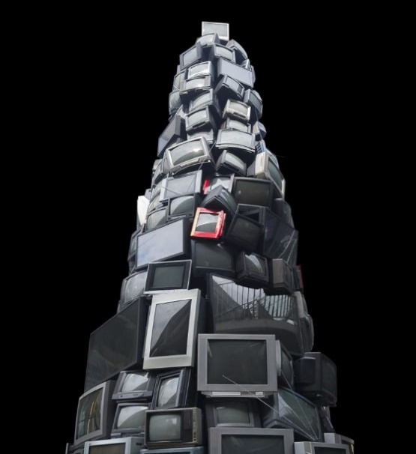[MobileMuster](https://www.mobilemuster.com.au/) was created in 1998 by the Australian Mobile Telecommunications Association to collect and recycle mobile phones. MobileMuster has maintained government accreditation since 2014. The program has been responsible for collecting and recycling nearly 1,500 tonnes of mobile phones and accessories. In July 2022 MobileMuster expanded collection and recycling to also include network connectivity products (for example modems and routers), and smart home and wearables devices.

Launched in February 2022, [B-Cycle](https://bcycle.com.au/) is an industry-led initiative established by the Battery Stewardship Council to provide free battery recycling to consumers across Australia. All batteries are hazardous to some degree, and it is important that Australia can safely and responsibly dispose of batteries. B-Cycle also aims to increase awareness of battery recycling and safety to minimise the environmental, health and safety impacts of end-of-life batteries. In the first six months of operation B-Cycle collected around 900 tonnes of batteries for recycling. B-Cycle is an Australian Government Accredited Product Stewardship Scheme.

## International context

### Approaches taken to e-stewardship internationally

More than 30 countries have implemented e-stewardship regulation. This includes European countries which have adopted Directive 2012/19/EU on waste electrical and electronic equipment ([WEEE Directive](https://eur-lex.europa.eu/legal-content/EN/TXT/?uri=celex%3A32012L0019)) which aims to reduce the amount of e-waste that ends up in landfill.

European countries have taken a variety of different approaches to domestic implementation of the WEEE Directive. Regulated e-stewardship has also been enacted in South Korea, some Canadian provinces, and some states of the United States of America. There is no standard regulatory approach to implementing regulated e-stewardship. Countries have adopted regulation based on their current circumstances and existing activities or actions on e-stewardship.

Generally, e-stewardship has been implemented through centralised administrative structures, but arrangements vary significantly between countries. Box 1 provides high-level summaries of 4 international approaches to regulated e-stewardship.

The WEEE Directive guides e-waste management practices within the EU. However, not all circular economy requirements for e-products are within this directive. For example, one of the most wide-reaching measures to ‘design out’ e-waste is the EU’s recent requirement for a common charger for mobile phones, tablets and laptops. This change was enacted through the Radio Equipment Directive ([Directive 2022/2380](https://eur-lex.europa.eu/legal-content/EN/TXT/PDF/?uri=CELEX:32022L2380#:~:text=This%20Directive%20is%20aimed%20at,thereby%20promoting%20a%20circular%20economy.)). Traceability requirements through digital product passports are a key feature of the proposal for a new EU [Ecodesign for Sustainable Products Regulation](https://commission.europa.eu/energy-climate-change-environment/standards-tools-and-labels/products-labelling-rules-and-requirements/sustainable-products/ecodesign-sustainable-products_en), as an enabler to the transition to a circular economy.

The European Parliament has also reached an agreement to make all [batteries](https://www.iea.org/policies/16763-eu-sustainable-batteries-regulation) placed on the market more sustainable, circular and safe, with a phased introduction starting in 2024. Again, this measure will be introduced through a mechanism separate to the WEEE Directive.

#### Re-use of e-products

E-stewardship schemes may seek to prevent waste by running education campaigns about keeping products in service for as long as possible and running re-use programs. However, there is growing concern about cross-border flows of second-hand information technology and solar panels (Deutsche Umwelthife 2021 and European Court of Auditors 2021). If not properly managed, the export of second‑hand e-products for re- use is exploited by some entities to avoid restrictions on the export of hazardous materials required by the Basel Convention. This illegal activity can have detrimental impacts on receiving countries that must then manage the waste arising.

Product redundancy and refurbishment costs are also barriers to re-use. In Sweden, research has found that only 3% of small e-waste is suitable for re-use, and it is often not cost-effective to refurbish small electronics (El-Kretsen n.d.).

In France, a collaborative effort between retailers, manufacturers, product-responsibility organisations and social enterprises aims to reduce e-waste. A website helps consumers and businesses locate nearby social enterprise collection points for second-hand e-products, and pop-up events are organised for product collection. Partnerships between manufacturers and social enterprises provide access to parts and manuals. E-products refurbished under this initiative are sold through a network of 50 stores with warranties (Brabant 2015).

Spain has established re-use targets for large appliances and televisions (2% and 3% respectively), backed by consumer protection laws governing second-hand markets. Companies selling used products must maintain records of their origin, brand, serial number, and buyer (Comunidad de Madrid n.d.).

**Box 1: Regulated e- stewardship country examples**

**Germany**

In Germany there is a non-government organisation known as a clearinghouse that performs centralised functions. These include reporting on scheme outcomes to the government and consumer education. Producers must register with the clearinghouse before selling electrical products. This involves obtaining a registration number and providing data about products and waste management.

Municipal waste services and electrical retailers collect e-waste. The clearinghouse assigns batches of waste to individual producers. Individual producers are then responsible for organising and financing collection, transport, recycling, and reporting outcomes for that batch (Forrest & Hilton 2019).

**France**

The French government registers producers and assigns a registration number to products. Once products have been registered, producers must join one of 4 authorised product responsibility organisations or run their own individual scheme (which must be approved by the government). Waste collection is done by municipal services, social enterprises and retailers. The product responsibility organisations finance a clearinghouse to balance collection and financing costs and run awareness campaigns, audits and infrastructure improvements (Forrest & Hilton 2019).

**United Kingdom**

In the United Kingdom the government accredits organisations to participate in their regulated e‑stewardship approach. These participants include ‘compliance schemes’ and recyclers. All manufacturers and importers must join an accredited compliance scheme to collect, transport, recycle and report on e-waste outcomes. England has 21 compliance schemes, Scotland has 4 and Northern Ireland has 1. Local governments collect waste, and retailers offer free take-back for some products (HSE n.d.).

**California, United States of America**

California levies a state tax on the sale of certain e-products, such as televisions and information technology products, to cover the cost of managing e-waste. Retailers charge a visible tax at the point of sale, which goes into a fund managed by the state. A non-profit scheme administrator then uses the fund to reimburse recyclers for the net cost of recycling. Recyclers receive payments after reporting on their activities and outcomes, including payments to e-waste collectors. The fund also covers the cost of compliance and government audits, as well as the running costs of the scheme administrator (CA.GOV n.d.).

#### Reviews of international approaches

The European Commission is reviewing the WEEE Directive during 2023 (European Commission n.d.). Reviews of member states' implementation have highlighted several areas for improvement (Ahlers et al. 2021; Arduin et al. 2021; Baldé et al. 2020; CEWASTE 2021; European Court of Auditors 2021; Forrest & Hilton 2019; Hogg et al. 2021; Tesar et al. 2021; UK House of Commons Audit Committee 2020; WEEE Forum 2020).

* Collection targets – reviews have critiqued approaches to setting and achieving collection targets for e-waste. For example, 28 of 31 Member States failed to reach the 2019 collection targets. Failures to achieve collection targets are attributed to both methods used to set targets as well as actions taken to achieve them. Challenges in accurately estimating the volume of decommissioned solar panels and consumers’ reluctance to dispose of small equipment have contributed to failures to achieve targets. There is a conflict between achieving high collection targets and promoting re-use and repair. Many suggest that instead of targets, there should be an obligation to recycle all available e-waste.
* Recovery targets – reviews suggest that recovery targets based solely on the weight of material recovered are inadequate. Valuable materials from products containing small amounts of high-value material, such as solar panels and computers, are often lost. To address this issue, specific reporting and management requirements for recovering precious and critical raw materials and removing harmful chemicals, are recommended to ensure recycling achieves the most important environmental outcomes.
* Balance between coordination and competition – reviews reveal that countries with a single coordination body achieve better results, because they have a single point to collect data, educate consumers, oversee collecting and recycling, ensure standards are met and ensure as much waste as possible is collected by compliance organisations. When this is balanced with competition between compliance organisations to provide high quality collection, transport, logistics and recycling, the combination drives innovation and lower costs.
* Improved standards and better compliance – reviews have called for greater shared responsibility across the supply chain to improve management of e-waste. To address this, all organisations should be held to the same high standards for collection, transport, recycling, monitoring and compliance. Weak enforcement has led to low collection rates, including disposal of e-waste in landfills, illegal waste exports to developing countries and limited transparency about the flows and fates of business-to-business waste.
* Financing – reviews of best practices suggest that product stewardship schemes should publish fees and apply them consistently to all producers and importers. Visible fees at the point of sale can also increase consumer awareness about recycling.

### International approaches to large-scale solar

In Europe, under Article 13 of the WEEE Directive, there are specific treatments for e-waste from ‘users other than private households’, also known as business-to-business (B2B). Producers can reach agreements with businesses about other ways to manage B2B waste. Under Article 13, the last owner of a B2B solar panel may share end-of-life management costs with the panel’s producer, or they may reach an agreement that the last owner is responsible for all end-of-life management costs.

Approaches to management of end-of-life panels from solar farms differs between EU member states. In Italy solar panel serial numbers are tracked from when panels enter the market to end-of-life (WEEE Forum 2021a). In Germany producers of B2B products, such as solar panels and inverters, must submit detailed ‘take-back concepts’. These concepts identify third-party businesses responsible for collecting, recycling and reporting on recycling outcomes. Failing to lodge these concepts carries penalties, and concepts must be kept up to date (Take-e-away n.d.).

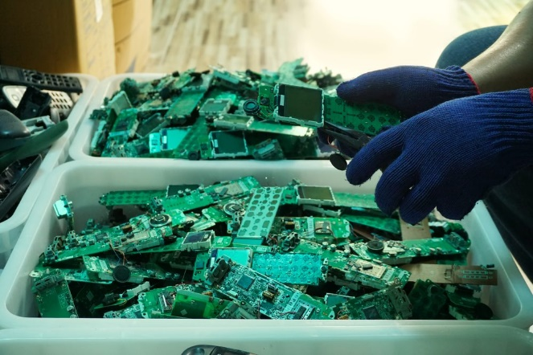The decommissioning of solar farms in the US is regulated by local and state guidelines and legal agreements. Owners of utility-scale solar farms may need to provide decommissioning plans and financial assurances before gaining planning approval. Liability insurance and decommissioning bonds are used. These bonds can be large and are often held in trust by a third party such as a state body (Cox 2022).

## Proposed Regulatory Approach

### Purpose of proposed scheme

The proposed scheme would be a national, legislated product stewardship scheme covering solar PV systems and SEEE. The scheme’s primary focus would be to increase the recycling of end-of-life solar PV systems and SEEE, but it would also seek to reduce waste, encourage repair and re-use, and support consumers to make better decisions about which products they purchase (for example, through consumer education on repair and re-use, and sustainable product design). It would also create a regulatory framework to which other products can be added if the need for further regulation arises.

Management options for e-waste have not kept pace with either the growth of this waste stream, or with restrictions on disposal practices. As such, accessible options for environmentally sustainable management of e-waste do not meet community needs. The purpose of the scheme proposed in this paper is to:

* provide Australian households and businesses with a sustainable pathway to manage end-of-life SEEE
* ensure that Australia manages decommissioned solar PV systems in an environmentally sustainable manner.

All Australian jurisdictions have a strong focus on developing Australia’s circular economy. This supports actions ranging from harmonising waste levies and data classifications to all jurisdictions taking strong product stewardship action. This scheme is not proposed to further Australia’s circular economy for e‑products in isolation of these actions. Rather, it is intended that the proposed scheme would complement initiatives by Australian governments in other areas such as:

* [sustainable procurement](https://www.dcceew.gov.au/environment/protection/waste/sustainable-procurement)
* the work of the [Circular Economy Ministerial Advisory Group](https://www.dcceew.gov.au/environment/protection/circular-economy/ministerial-advisory-group#:~:text=The%20Advisory%20Group%20advises%20the,to%20a%20more%20circular%20economy)
* the development of a verified labelling scheme for Australian made products that contain recycled in Australia content—[ReMade](https://www.dcceew.gov.au/environment/protection/waste/consumers/remade-in-australia) in Australia label
* the [government support for industry-led product stewardship](https://www.dcceew.gov.au/environment/protection/waste/product-stewardship/national-product-stewardship-investment-fund)
* harmonisation and improvement of related state and territory regulation.

It is proposed the regulation would have the following objectives, which would guide specific regulatory obligations the scheme creates.

* Reduce waste to landfill, especially hazardous materials found in electronic waste.
* Increase the recovery of reusable materials in a safe, scientific and environmentally sound manner.
* Provide convenient access to e-stewardship services across Australia.
* Support Australia’s transition to a more circular economy, see Diagram 1.
* Foster shared responsibility across the life cycle of covered products.

Diagram 1: Product stewardship circular economy model

A diagram of the product stewardship circular economy. Stages of the circular economy are arranged in a circle with text reading:
Manufacture: simplify assembly, eliminate waste, eliminate/minimise emissions, efficient use of materials.
Logistics: Resource efficient, reusable, recyclable, compostable packaging, best practice reverse logistics.
Retail: Infrastructure for end-of-life items, enhanced warranties, use of digital platforms.
Use-Phase: Education to promote environmentally sound product use, minimal reliance on ongoing consumables, repair and reuse.
 Post-Consumer: Information about recycling and safe disposal, free services to consumers at the point of disposal.
Materials: Renewable, recycled, low carbon emissions, no hazardous substances.
Design: Durable, energy and water efficiency, eliminate litter, repairability and reuse.

It is anticipated that any national e-stewardship regulation would support state and territory e-waste landfill bans. However, the proposed regulation is not intended to be the sole mechanism to support these bans. As such, if government decides to implement the scheme proposed in this paper, the department will work with state and territory government agencies to identify related areas of state and territory regulation that could support efficient implementation of the proposed scheme.

### Scheme design

The objective of the proposed scheme is to reduce the environmental and human health impacts associated with Australia’s consumption of e-products (with end-of-life management costs borne by product users). The proposed regulation would aim to:

* maximise the amount of e-waste that is directly collected and recycled by the scheme through free disposal services provided to households and small businesses
* improve recycling outcomes for e-waste collected outside of the scheme’s disposal services (for example, e-waste collected from large businesses and government agencies by commercial service providers).

It is important that the scheme is structured in a way that does not push costs outside of the scheme. For example, a lack of convenient disposal services could lead to households or small businesses disposing of e-waste at council landfills. In jurisdictions with an e-waste landfill ban, these councils would need to engage commercial service providers to collect and recycle this e-waste. This would shift costs from the e-stewardship scheme on to councils and ratepayers.

The department has designed the proposed scheme with 2 different types of administrative bodies, a single *scheme administrator* and multiple (competing) *network operators*.

* **Scheme administrator:** a single body accountable for achieving scheme outcomes to the standards required in potential regulation. This would include achieving targets for the amount of e-waste recycled, the amount of materials recovered from this waste, and a minimum amount of scheme access (via free e-waste drop off sites); as well as education and awareness, re-use, and other scheme outcomes. The scheme administrator would also have a general obligation to ensure value for money in achieving scheme outcomes. The department proposes a single scheme administrator be responsible for SEEE and PV.
* **Network operators:** to provide collection sites, and logistic and e-waste recycling services. These network operators would provide bids to the scheme administrator to provide these services for a certain geographic area and the scheme administrator would enter into agreements covering all of Australia with network operators. Network operator fees (charged to the scheme administrator) would be dependent, in part, on the weight of e‑waste collected, transported and recycled. The department anticipates there would be separate network operators for SEEE and PV because of the different collection and logistics challenges of these product classes. Some network operators could be approved providers for both SEEE and PV.

It is anticipated that a single scheme administrator combined with multiple network operators would deliver the best value for money for scheme outcomes. A single scheme administrator with a general value-for-money obligation would not be competing to attract members based on lowest overall cost. As such the administrator would be responsible for achieving set scheme outcomes in a value‑for‑money manner, but would not be incentivised to reduce the quality of outcomes (such as scheme accessibility or material recovery rate) by charging lower fees in order to attract members.

While solar PV waste and SEEE will be covered by the scheme, they would be treated as different product classes and have different liable parties (although some liable parties may be liable for both). The scheme administrator would be required to achieve different outcomes for PV systems and SEEE, refer to section 5.3 for more information on liable parties. This is due to the different consumer engagement in the 2 product classes, the process required to decommission PV systems compared with disposing of SEEE, the size of PV systems and practical disposal options.

It is also anticipated that competition among network operators would support scheme efficiency and effectiveness. As network operators’ revenue would be dependent (in part) on the volume of e-waste they collect, they would be incentivised to provide households and small business maximum access to the scheme while also remaining cost competitive. It is anticipated this would balance the goal of maximising e-waste directly collected and recycled and preventing excessive scheme costs.

The department proposes the scheme be established as a co-regulatory product stewardship scheme under the RAWR Act. Under the RAWR Act, co-regulatory product stewardship means that certain organisations (that is, liable parties) are required to be members of co-regulatory arrangements approved by the government. These arrangements must have outcomes that are designed to further the environmental objectives of the Act.

### Liable parties

Corporations that import or manufacture SEEE or PV systems above a set threshold, would be considered liable parties under the proposed scheme. Liability thresholds would be different for SEEE and PV systems. If a group of related corporate bodies has collectively imported a quantity above the set threshold, then any member that imported products would also be a liable party and must take part in the scheme. Both importers and manufacturers would be able to report exports that may reduce their liability.

An importer or manufacturer would be liable in a given financial year if they imported or manufactured more than a unit threshold amount during the previous 12–24 months. The exact threshold amounts are yet to be determined but thresholds would be calculated to ensure that around 95% of in-scope products are covered. The current thresholds for the NTCRS are a good example of what SEEE thresholds may look like:

* 5,000 units of televisions
* 5,000 units of computers or printers
* 15,000 units of computer parts or peripherals.

The primary responsibility of liable parties is to acquit their liability. The default method to acquit liability would be to join the scheme administrator and pay a membership fee proportionate to the amount of covered products they import or produce. There would be additional options available to liable parties to acquit their liability (for example, collecting and recycling their products – to the   
required standards – themselves).

### Funding the scheme

Regulated product stewardship schemes require liable parties to pay fees. These fees must be enough for the scheme administrator to meet all scheme outcomes. They are used by the scheme to manage the costs of collection, transport, processing, recycling, disposal, education, compliance, reporting and governance. It is not proposed that the government will fund the ongoing operations of the proposed scheme.

Decorative image of a group of small electronic entertainment devices laid out on a table.
Fees paid by liable parties would be broadly proportionate to the amount of covered products they import or produce. For example, 2 liable parties both only imported televisions. The first liable party imported 10,000 50-inch LCD televisions. The second liable party imported 100,000 50-inch LCD televisions. The second liable party would have to pay in the order of 10 times the fees the first party would pay.

It is expected that liable parties would pay fees to the scheme administrator, for a given financial year, based on their import and/or production activities in the prior 12–24 months. This would enable the scheme administrator to have access to revenue from the time they are required to start meeting scheme targets and obligations.

All scheme arrangements would be funded by liable party fees. Transitional financial contributions would need to be developed for liable parties already covered by the NTCRS and voluntary accredited product stewardship schemes.

Eco-modulated fees may be incorporated into the proposed scheme. Eco-modulated fees would mean that products which meet eco-design criteria attract a lower liability. For example, products that are easier to disassemble or recycle might attract smaller fees. While conceptually appealing, recent studies in the EU and United Kingdom suggest this approach does not incentivise change for most e-products due to the small cost differential and added regulatory burden (WEEE Forum 2021b and Magalini et al. 2023). The department is seeking feedback through this paper on how eco-modulated fees could be effectively incorporated into the proposed scheme.

Further consultation and modelling would be needed to determine product stewardship fees for SEEE and PV. The department acknowledges that producers, importers, and investors in large-scale solar projects seek clear direction on policy to inform investment decisions. If the Australian Government provides authority to regulate waste from SEEE and PV the department will engage with stakeholders likely to become liable to enable them to account for liability in future years.

The department considers that product stewardship fees for PV systems should be paid when products are placed on the market. This may result in significant financial reserves as fees for placing solar panels on the market in 2025 may not be needed for managing PV system waste until 2045.

While the lag between liability and recycling would make funds available immediately to set up the scheme and address the initial flows of legacy waste, it would also require the scheme to hold funds for long periods. The department is seeking feedback on whether special management arrangements for solar PV fees are required. The department could establish a mechanism for government to hold the pool of scheme fees until required. For example, scheme fees could be collected through excise and customs tariff legislation to fund payments to the scheme administrator once recycling or waste reduction actions have been taken.

### Structure of proposed scheme

Diagram 2 provides a visual representation of the proposed scheme structure. Roles and responsibilities of key players are outlined below.

Diagram 2: Scheme administrative structure  
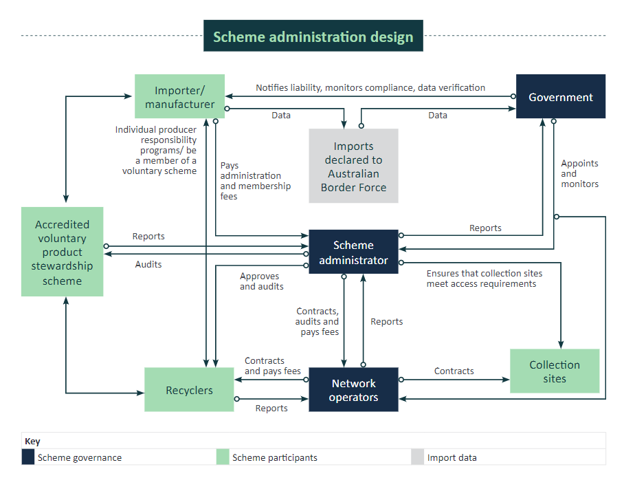

##### Australian Government

Using existing import data, and monitoring production activities, the government would determine who is a liable party and provide notification of liability. The government would also monitor compliance of liable parties. The government would appoint and provide oversight of the scheme administrator and network operators. The government would also undertake regular compliance activities to ensure scheme obligations are being upheld.

Additionally, the government would periodically review the scheme legislation to enhance the scheme and ensure it remains fit for purpose.

##### Liable parties

Corporations that import or manufacture PV Systems and/or SEEE above a set threshold would be considered liable parties. A liable party must register with the scheme administrator, pay scheme administration fees to contribute to the cost of collection and recycling under the scheme.

Liable parties could manage their own individual producer responsibility programs (which collect and recycle their products) to reduce their liability under the scheme. Details of these programs would need to be registered with the scheme administrator and meet auditing and reporting obligations.

##### Accredited voluntary product stewardship schemes

The department expects that in addition to running their own individual producer responsibility programs, some organisations may choose to have some, or all, of their obligations to recycle e-waste met by an Australian Government Accredited Scheme, see section 5.3. For this recycling to be counted as meeting their liabilities under the scheme, it must be done to the standards set out in regulation.

Liable parties may choose to use an accredited voluntary scheme for a variety of reasons, such as alignment with the company’s broader corporate social responsibility goals. An example of this could include a mobile phone importer reducing their liability under the proposed scheme by having MobileMuster undertake recycling on their behalf. Accredited voluntary schemes would have auditing and reporting obligations to the scheme administrator if they wished to participate.

##### Scheme Administrator

Appointed and monitored by the government, the scheme administrator would be responsible for meeting the outcomes of the scheme. The administrator would have specific responsibilities set out in regulation. These would include managing risk, auditing recyclers and network operators, and ensuring the public has appropriate and equitable access to the scheme. The administrator would receive reports from other scheme participants. It must also report to government on the scheme’s performance.

The scheme administrator would not be responsible for physical collection and recycling activities. Rather it would contract with network operators to ensure these activities occurred and met scheme outcomes.

##### Network operators

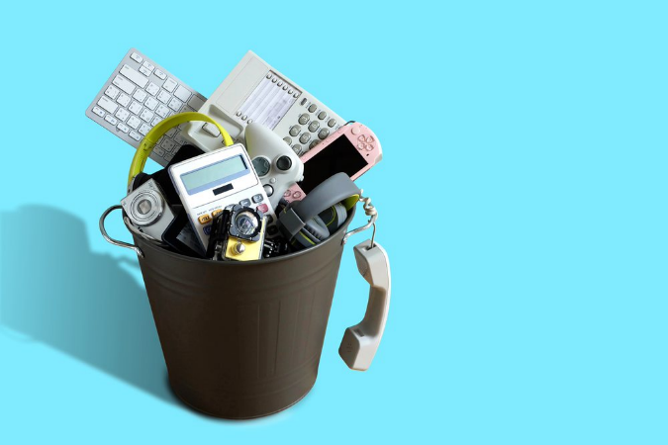Appointed and monitored by the government, network operators would establish and manage collection, transportation and recycling services across a designated geographic area. A network operator may be an established logistics or recycling organisation, or it may be an organisation established solely for the purpose of being a network operator. The scheme administrator would determine whether a particular geographic region (for example, Wollongong) is best served by multiple or single network operators. Only network operators approved by the government could provide services to the scheme administrator.

Network operators would manage contracts with approved recyclers including ensuring recycling occurs, paying recycling fees and reporting recycling outcomes to the scheme administrator. If a recycler elects to become a network operator, they would be required to meet all requirements set out for both network operators and recyclers.

##### Recyclers

Recyclers would be able to opt in to being an approved recycler under the scheme. The administrator would approve and maintain a register of approved recyclers who have been certified and operate to the standards required by the scheme (for example, AS5377/2022)*.* Network operators could only contract with approved recyclers.

#### Additional environmental or social benefits

The proposed scheme would also allow recyclers and network operators to apply to the scheme administrator to be verified as providers of additional environmental or social benefits. For example, they could be accredited as majority First Nations owned or accredited as supporting social enterprises which positively impact the lives of people with disabilities. Further, recyclers and network operators could be verified as providing higher data security protection or higher standards of recycling.

Liable parties would be able to choose to have their liability met by recyclers and/or network operators who have been verified as providers of additional environmental or social benefits. Liable parties would be responsible for paying an extra fee for these providers. Fees would be set by verified providers of additional environmental or social benefits. Liable parties would have no obligation to procure services from these providers or pay additional fees.

## Small electrical and electronic equipment

### Product scope

The proposed scope for SEEE covers most of the small electronic and electrical equipment found in homes and small businesses, see Figure 1. It also includes all products currently covered by the NTCRS. As a general rule, the items proposed to be covered can be easily lifted and carried by a single person (with some exceptions like large televisions). The scheme would also include any embedded batteries in these products. Embedded batteries are batteries that are fixed internally and are not designed to be routinely replaced by the consumer (for example, batteries in laptops, smartphones and tablets). Loose batteries (such as AAA, AA or 9V batteries) are not proposed to be included as in-scope products. These batteries can already be recycled through the accredited B‑cycle scheme.

Figure 1: Proposed product scope

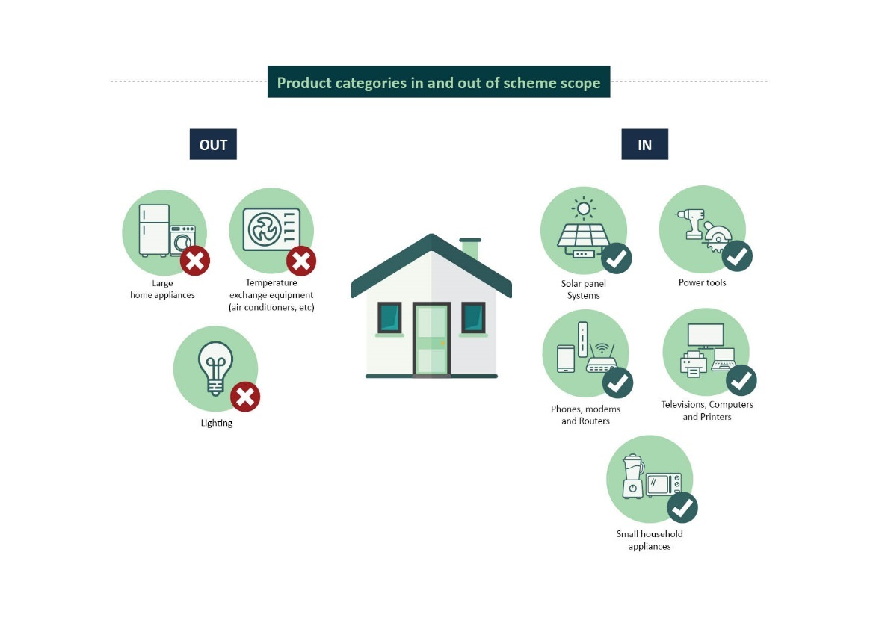

The proposed scope of SEEE has been designed to:

* cover products with low recovery rates
* cover products with limited disposal pathways (for example, products subject to landfill restrictions)
* be easy for consumers and businesses to understand
* provide support for Australia’s transition to a circular economy
* allow for existing import data to be used to identify liable parties (this avoids importers having to report their imports twice).

Examples of proposed in-scope products are listed in Table 1 below.

**Table 1: Examples of the types of in scope products**

|  |  |
| --- | --- |
| Product type | Example products |
| Cooking and cleaning appliances | Vacuum cleaners, carpet sweepers, steam mops, microwaves, irons, toasters, electric knives, electric kettles, etc |
| Appliances for hair and body care | Electric shavers, hair straighteners, hair dryers, etc |
| Audio visual equipment | Radios, video cameras, video recorders, hi-fi equipment, projectors, etc |
| Screens and monitors | Televisions, LCD photo frames, monitors, etc |
| Other small equipment | Scales, e-readers, 3D printers, calculators, clocks, sewing machines, etc |
| Handheld power and gardening tools | Handheld drills, portable electric saws, leaf blowers, etc |
| IT and Telecommunications | Laptops, tablets, notebooks, personal computers, mobile phones, routers, etc |
| Music and sports equipment | Electric and electronic instruments, fitness trackers, heart rate monitors, etc |

HS codes would be used to identify which products trigger regulatory obligations for liable parties. HS codes are a global classification system based on goods descriptions that are used to classify shipments, and assess any applicable duties, taxes, and restrictions. Appendix B lists proposed in-scope SEEE products in greater detail, including HS codes.

### Targets and Obligations

The proposed scheme is anticipated to have 5 categories of targets and obligations for SEEE. These include a target or obligation for:

* how much e-waste must be recycled each year
* the proportion of materials from recycled products that must be recovered for remanufacture (to maximise the material from recycled products is captured and used in manufacturing of new goods)
* accessible drop-off services available to the public
* maximising re-use of in-scope products where practical
* educating and raising awareness about re-use and repair, how to keep in-scope products out of the waste stream as long as practicable and how to choose more sustainable products.

Box 2: Recycling versus recovery

**Recycling**

Processes for converting materials that would have otherwise been disposed into new materials. These processes include sorting, disassembling or shredding, and reprocessing materials for further use in a production system.

**Recovery**

Making use of material that would have otherwise been disposed of including re-use, recycling, energy recovery and other types of recovery. For the purposes of this discussion paper, the term ‘recovery’ refers only to the recovery of material that can be transformed back into usable material to produce goods. It does not include energy recovery.

#### Scheme target

The scheme target would be the minimum amount of in-scope products, in kilograms, that the scheme administrator must ensure enters the recycling system each year. To calculate the scheme target the department would multiply the estimated amount of e-waste that has been generated (in kilograms) by a target percentage. The percentage target would increase annually as the scheme matures and industry has time to develop capacity. Over time the percentage target would be raised to meet the National Waste Policy Action Plan’s target of 80% average recovery rate from all waste streams. The scheme target is also intended to support investment certainty for new e-waste recycling capacity within Australia.

***Estimated waste generated x Percentage Target = Scheme Target***

The department intends to set a single scheme target for SEEE. The department does not propose setting separate targets for different material streams within SEEE. A previous review of the NTCRS found setting targets for each product type adds considerable administrative burden for little additional benefit (Commonwealth of Australia 2014).

#### Recovery target and obligations

The recovery target would be the proportion of recycled material that must be recovered during the recycling process.

The department would impose reporting and traceability obligations on the administrator and network operators to trace and provide data on the types and weights of material that are recovered as usable material, as well as details of any material types sent to other fates (for example, energy recovery or landfill). The data would include material quantity, type, origin and destination. The obligation would also include a requirement to keep information on appropriate end-of-life management for contaminants and residual waste.

The department will seek to ensure reporting and traceability obligations are consistent with relevant frameworks and standards, such as the proposed national framework for recycled content traceability that is currently under development.

While the scheme aims to keep valuable materials in circulation for as long as possible, some materials, such as e-plastics containing POPs, should not be recycled. These limitations mean that material loss is likely and energy recovery in an appropriately designated facility (that is able to destroy POPs) may be preferred over disposal in landfill. The department is seeking views on whether energy recovery should be encouraged by the scheme for materials that would otherwise be disposed or destroyed,   
and if so any restrictions or limitations that should be applied.

#### Access obligations

To ensure that the scheme provides convenient access to e-stewardship services across Australia, the department proposes to impose access obligations on the scheme administrator. These obligations would be fulfilled by network operators.

The proposed obligations would ensure that equitable access to scheme collection services are provided across metro, regional, and remote areas. Different types of collection services would be available to meet the needs of different locations and consumers. These are expected to include retail sites, permanent standalone sites, council hosted sites, pop-up events, convenience collections (such as home or small business pick-ups) and post-back for appropriate products. The department proposes the following specific access obligations.

1. **Provide a prescribed level of access in all regions**. This obligation would set the minimum number, type and availability of collection services that must be provided in areas with different population densities and degrees of remoteness.
2. **Set appropriate standards for collection sites**. Collection sites must meet any state or territory planning, safety and environmental requirements. The administrator must have a process in place for assessing and auditing sites to ensure they operate in accordance with local requirements. Pending further consultation and a decision of government, specific requirements around managing batteries (such as large format household energy storage batteries) may be covered in the scheme rules.
3. **Self-nominated collection sites**. The scheme would recognise self-nominated collection sites, provided they meet collection site requirements. For example, if a local council waste facility nominated as a collection site, the scheme administrator would have to arrange for free-of-charge collection and recycling of in-scope material from that site. The scheme administrator would not fund the operation of self-nominated collection sites.
4. **Educating and advertising obligations**. The scheme administrator, either directly or through network operators, would be required to improve public awareness of collection and drop off opportunities. This would be done through education campaigns focused on where and how in-scope products could be dropped-off.

#### Re-use obligations

The [2020 review of the NTCRS](https://www.dcceew.gov.au/environment/protection/waste/product-stewardship/consultation-review-ps-act-incl-ntcrs) noted that the scheme’s lack of recognition of re-use led to reusable products being recycled instead of being re-used. Some European e-stewardship schemes have set specific re-use targets for large products, like white-goods. Reviews of EU schemes have found that where collecting organisations (such as the proposed network operators) have an obligation to work with repair and re-use organisations (as opposed to a reuse target), there have been positive re-use outcomes for a wide range of small e-products (Baldé et al. 2020 and WEEE Forum 2020).

In line with these findings, the department proposes an obligation to promote re-use rather than a re-use target. This obligation would require the scheme administrator to facilitate specific collection mechanisms for re-use and repair at scheme collection sites, when requested by a repair and re-use organisation. These arrangements would need to take into consideration:

* health and safety
* the nature and location of the collection site
* the suitability of the products being collected for repair or re-use.

Any organisation that wished to participate would need to demonstrate they are suitably qualified and insured to undertake the repair and testing of products. Organisations would also be required to demonstrate that the outcome of the separate collection mechanism is repair and re-use of products and not a mechanism to ‘cherry-pick’ high-value e-waste for recycling.

The scheme administrator would report the types and numbers of products diverted for repair or re‑use to the department annually. SEEE products repaired and resold by liable parties could not be used to meet the scheme administrators re-use obligation.

#### Education and awareness

It is proposed the scheme administrator would be required to annually provide, to the department, a public awareness and education plan on e-waste reduction and sustainable e-product use. The department would assess whether the plan contains sufficient action on raising awareness of e-waste reduction and sustainable e-product use. The plan should also identify alignment with other consumer education activities such as those undertaken by local governments.

The annual awareness and education plan would have the following goals.

* Improve public awareness on how to maximise the useful life of in-scope products. This could include creating awareness of repair and re-use organisations and information on how to safely sell or donate e-products on the second-hand market.
* Improve public awareness of the sustainability of e-products sold by liable parties under the scheme. This could include publishing information on liable parties who import and produce products that are made with recycled materials, are designed to be easily recycled, or are sustainable in other ways.
* Improve public awareness on how to minimise risks associated with improperly disposing, storing or using e-products. For example, this may include awareness raising activities on the risks of improperly disposing products that have embedded lithium-ion batteries.

Once accepted by the department the scheme administrator would be required to complete the actions set out in the plan and provide reports on its effectiveness.

#### Recognition of other recycling

It is important to recognise where liable parties are already taking responsibility for their products. This has primarily occurred where importers and producers arrange for their products to be recycled directly or via voluntary schemes accredited under the RAWR Act.

We propose that the scheme requires the administrator to make provisions for any recycling weight resulting from these arrangements so that it counts toward meeting a liable party’s obligations. This would allow the liable party to acquit part, or all, of their weight liability through direct arrangements and allow the administrator to count this volume towards the scheme target. Any recycling under these arrangements would need to meet all standards and requirements under the scheme.

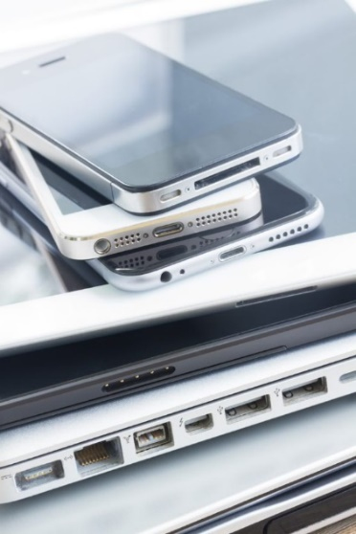For example, an importer already has in place a recycling arrangement with an appropriately licensed and certified recycler that covers 20% of their liable weight. They provide proof to the scheme administrator of the arrangement and a forecast of the recycling that will be done in accordance with the standards and requirements of the scheme. The administrator would then reduce the liable weight by 20% for the purposes of any fees charged for the collection and recycling of liable weight. At the end of the financial year the liable party would provide evidence of the recycling that has occurred and reconciles any fee shortfall between the planned volume of recycling reported to the scheme administrator and recycling undertaken.

If a liable party was in an arrangement that reduced their liable weight to zero, the administrator may still charge reasonable fees for non-recycling obligations of the scheme, such as reporting, compliance, and education and awareness. However, these fees would be required to reflect the proportion of costs attributable to non-recycling scheme activities.

For example, collection and recycling accounted for 85% of overall scheme costs and a liable party has made arrangements for their products to be recycled directly. This reduced their liable weight to zero. This liable party’s scheme fees would be 15% of what they would have been if they had not recycled their own products.

The administrator would be required to report to the department annually on the participants in, and the quantity of, such recycling.

## Small-scale PV systems

* 1. **Product scope**

For the purposes of the scheme, small-scale PV systems would be systems of up to 100 kW capacity (for typical sizes of systems see Table 2 below). The department proposes all solar panels, inverters, attached cabling, racking, and potentially household energy storage batteries, would be covered by a legislated scheme.

**Table 2: Typical installations sizes**

|  |  |
| --- | --- |
| SyStem Capacity | Typical installation |
| 6.6 kiloWatts | 17-20 panels on 40 square metres of roof space |
| 15 kiloWatts | 37-45 panels on 90 square metres of roof space |
| 99 kiloWatts | Up to 400 panels occupying about 640 square metres |

The department also proposes ‘plug and play’ PV systems to be included in the scheme. Plug and play PV systems include camping, automotive, marine and other systems where installation and decommissioning can be performed by a consumer without the need for a qualified electrician.

SEEE and PV would be different product classes. This means that any liability created under the scheme due to PV system importation or production must be acquitted through the recycling of PV systems and not SEEE (and vice versa).

### Legacy waste

The department proposes the scheme would cover all PV systems imported or produced after the scheme starts. It would also cover small-scale PV system legacy waste—that is, waste from small-scale PV systems installed before the proposed scheme commences. The scheme administrator would be responsible for financing (from the scheme fees) the collection, recycling, and disposal of waste from legacy small-scale systems. Section 8.3 discusses pathways for legacy waste from large PV systems.

Legacy waste would comprise most of the waste arising during the first decade of the proposed scheme. There are already over 3 million small-scale PV systems (up to 100 kW) in Australia, more than 90% of which are installed on domestic rooftops. These systems account for 65% of Australia’s installed capacity (APVI 2022).

The department expects that including small-scale legacy systems would help ensure this waste is managed to a high standard, avoid illegal dumping, and reduce regulatory burden. It would also help to drive economies of scale for transport, logistics and specialised PV recycling in the first decade of the scheme, where the majority of PV waste would be from legacy small-scale systems.

### Targets and obligations

#### Small-scale PV targets and obligations

The proposed scheme is anticipated to have 3 types of targets and obligations in relation to small-scale PV systems. These include a target and/or obligation for:

* the proportion of material entering the recycling process that must be recovered as a new product or commodity
* a drop-off network appropriate for the locations of Australia’s installed capacity
* educating and raising awareness among consumers about sustainability of PV products, such as use of recycled content and harmful chemicals in products, and recyclability of products.

#### What small-scale PV targets and obligations would not cover

There are several barriers to PV system re-use (Circular PV Alliance 2023). As such the department is not proposing any obligations on the re-use of solar PV panels or inverters. This position will be re-considered when practicality and safety issues are appropriately addressed. Challenges to re-use include:

* regulations and standards that prevent the connection of used panels to the electricity grid
* faults or damage to used panels that are not easily identifiable during inspection (for example, solar panel micro-fractures)
* the fact that, due to the long operational life of solar PV systems, a material portion of Australia’s installed solar PV capacity do not meet current installation standards. While these panels were compliant when they were installed, evolving standards mean that they would not be compliant with current standards for installation at re-use.

The department expects a kilogram-based scheme target is not required. Access obligations are expected to be sufficient to ensure that disposing of PV system waste at scheme drop-off sites is the most convenient and cost-effective disposal mechanism. The department has also considered EU countries’ experience with weight targets for PV recycling. For example, in 2018 EU Member States had a collection target of 240,000 tonnes, however, only achieved 14,000 tonnes (WEEE Forum 2021a).

The different approach to PV waste from SEEE waste is also based on the different consumer engagement in the 2 waste streams, the process required to decommission PV systems, the size of PV systems and practical disposal options, both legal and illegal (for example, PV panels cannot be disposed of in kerbside bins).

### Recovery target and obligations

The recovery target would be the proportion of recycled material that must be recovered during the recycling process. This does not include contaminants or residual waste sent for disposal.

PV systems contain small amounts of valuable materials like silver, silicon and copper as a proportion of total weight. As advanced processes for high-value recovery are still developing the recovery target will need to consider the technical feasibility and cost of extracting different materials (Komoto et al. 2022).

While the scheme aims to keep valuable materials in circulation for as long as possible, the presence of harmful chemicals influences recovery options. Studies have noted some solar panel backsheets contain polyvinyl flourides and therefore are considered non-recyclable (Deng, Zhuo & Shen 2022). As with SEEE, these limitations mean that material loss is likely and energy recovery in an appropriately designated facility that is able to destroy harmful chemicals may be preferred over disposal in landfill.

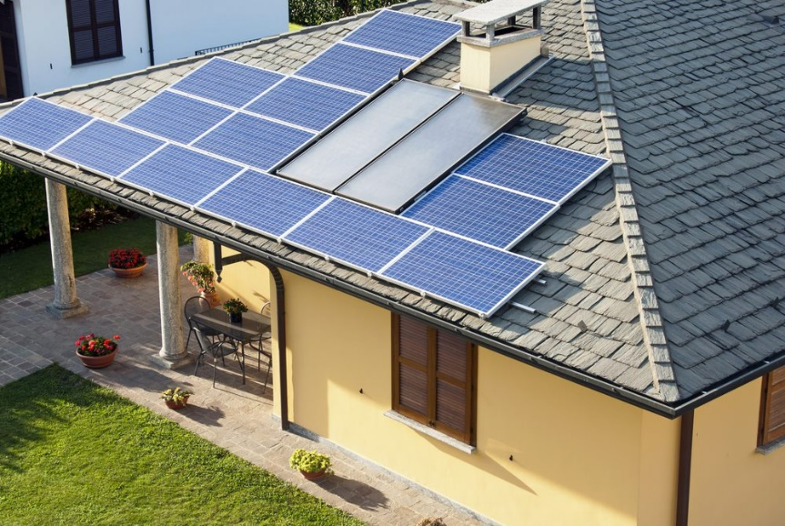The department would also impose reporting and traceability obligations on the administrator and network operators to trace and provide data on the material types recovered and material types sent to different management pathways. The data would include material quantity, type, origin and destination. The obligation would also include a requirement to keep information on appropriate end-of-life management for contaminants and residual waste.

The department will seek to ensure reporting and traceability obligations are consistent with relevant frameworks and standards, such as the proposed national framework for recycled content traceability that is currently under development.

### Access obligations

The department proposes that PV installers and distributors, local governments, state and territory governments, recycling organisations, scrap metal recyclers and similar organisations could nominate a site or sites they control to be an authorised collection point. Becoming an authorised collection point would be subject to eligibility requirements. For example, if a council-managed waste transfer station wanted to become an authorised collection point, it may be required to accept free drop-off of PV waste, subject to health and safety and practical limitations (such as limiting a single drop-off to no more than 45 panels).

Authorised collection sites would be entitled to a ‘collect on request’ service from the scheme administrator. This obligation would require the scheme administrator to provide free and timely collection services to authorised collection sites once they have collected above a minimum weight/unit number threshold. This obligation would be fulfilled by network operators.

The department is seeking feedback on what eligibility requirements would be appropriate and effective for authorised collection points. The department is open to different eligibility requirements for authorised collection points that are hosted by different organisations. For example, for those hosted by local government and those hosted by PV distributers. Regardless of organisation type, to be an authorised collection point the host would not be able to charge for drop-off of PV system waste. The scheme administrator would not fund the operation of authorised collection sites.

Should there be an insufficient number of authorised collection sites within a geographic area the scheme administrator would be required to contract with one or more network operators to establish administrator-run collection sites. Like authorised collection sites, these sites would not be able to charge for PV waste drop-off. The scheme administrator may also contract network operators to establish collection hubs to consolidate waste from collection points, to minimise logistic costs for transporting waste to recyclers.

The scheme administrator, either directly or through network operators, would be required to ensure there is appropriate awareness of location and accessibility of all collection sites among PV industry participants.

All PV system waste collected from authorised and scheme-administered collection sites must be sent for recycling and subject to the recovery target.

### Education and awareness

It is proposed the scheme administrator be required to annually provide a public awareness and education plan on PV system sustainability to the department. The department would assess if this plan contained sufficient action on raising awareness on PV sustainability issues. The annual awareness and education plan would aim to:

* create public awareness on how to maximise the useful life of PV systems and awareness of alternatives to decommissioning functional PV systems
* create public awareness of the sustainability of PV systems sold by liable parties under the scheme. This could include publishing information on liable parties who import and produce products that are made with recycled materials, are designed to be easily recycled, or are sustainable in other ways.

Once accepted by the department the scheme administrator would be required to complete the actions set out in the plan and provide reports on its effectiveness.

## Large-scale PV systems

The proposed scheme would require and/or allow different treatment of waste from small-scale and large-scale PV systems. This section focuses on the proposed scheme’s treatment of waste from large-scale solar systems (solar farms). It covers waste arising from systems commissioned after any potential scheme commences and management of legacy waste.

### Defining large-scale systems

Large-scale solar PV systems over 100 kW are eligible to participate in the Australian Government’s Large-scale Renewable Energy Target scheme (for typical sizes of systems see Table 3 below). The department proposes to mirror this threshold for large-scale systems.

Data from the [Australian PV Institute](https://pv-map.apvi.org.au/power-stations) show that there about 1,650 large-scale PV systems with a capacity over 100 kW. This includes 150 systems that can generate over 5 megawatts (APVI 2023). There are also another 3.2 gigawatts of committed projects in the pipeline for future connection to the grid (CER 2023).

Table 3: Large-scale solar PV systems by capacity 2010 to March 2023

|  |  |  |  |
| --- | --- | --- | --- |
| **Scale** | Application | No. of projects 2010-23 | Total installed capacity, 2023 |
| **100kW-5MW** | Very large rooftop and smaller solar farms | 1,325 (100kW-1MW)  172 (1MW-5MW) | 0.7 GW |
| **5-30MW** | Utility scale solar | 77 | 0.8 GW |
| **>30MW** | Utility scale solar | 73 | 9.1 GW |

(APVI 2023)

### Large-scale obligations

The default for the proposed scheme is that any liable party for solar PV systems can acquit their liability by joining the scheme administrator and paying the appropriate fee. However, the economics and practical considerations of managing waste from large-scale systems are materially different than small-scale systems.

As such it is proposed that there would be additional options to manage liability associated with decommissioning large-scale solar PV systems. These options would be available in situations where the owner of a large-scale system is the liable party for the products used in that system. This could be because the owner is the first importer or producer of the panels used for the large-scale system. Alternatively, liability associated with large-scale systems could be transferred from importers or producers of in-scope products to large-scale system owners, where the following requirements are met.

1. The products were used solely in a large-scale PV system.
2. The owner submits a decommissioning plan that details how:
   1. the system will be decommissioned
   2. in-scope products will be recycled
   3. any residual and hazardous waste will be managed
   4. how other requirements of the scheme that would otherwise apply would be met.
3. The owner demonstrates how the obligations on the plan will be transferred should the system be sold before decommissioning.
4. The owner provides an appropriate bond, surety or guarantee for the commitments made in the plan.

Owners of large-scale projects would retain responsibility for other aspects of decommissioning contained in legislation, or in agreements made with state, territory and local governments and landowners.

### Large-scale legacy waste

Owners of existing large-scale systems are responsible for managing waste from their projects as part of the cost of doing business. The department proposes that waste from large-scale systems which were commissioned before the scheme commences would be managed through transitional arrangements. Management of such waste would not be funded by the proposed scheme.

Under the RAWR Act, mandatory rules can be made to specify requirements in relation to re-using, recycling, recovering, treating or disposing of products. It is proposed that transitional arrangements for large-scale legacy waste would be addressed through a mandatory rule under the RAWR Act. This would require the owners of large-scale PV systems which were in place prior to the scheme’s commencement to provide the scheme administrator with specified information when these systems are decommissioned. This would include information on the re-use, recycling, recovery, treatment or disposal of PV system components (such as PV panels). This may include:

* serial numbers of panels from decommissioned large-scale systems
* information on the organisation/s that are responsible for the decommissioning of these systems
* information on the organisations that are recycling the waste from these systems (if applicable)
* information on re-use or export of these decommissioned products (if applicable)
* information on the disposal of these systems (if applicable).

The proposed mandatory rules would have regard to the guidance provided by the proposed national framework for recycled content traceability that is currently under development.

As legacy waste from large-scale PV described above will not be covered, the scheme administrator would need to take all reasonable steps to ensure that scheme funds are not used to support, subsidise or pay for the recycling or management of PV system legacy waste from large-scale systems. This is to ensure the scheme’s financial reserves prioritise managing legacy waste from small-scale household systems.

It would be open to large-scale PV system owners to hire the services of the scheme administrator and/or network operators to manage PV waste on their behalf. However, system owners would be responsible for covering associated costs.

## Glossary

| Term | Definition |
| --- | --- |
| AS5377:2022 | AS5377:2022 is the Standard for *Management of electrical and electronic equipment for re-use or recycling* prepared by the Australian members of the Joint Standards Australia/Standards New Zealand Committee EV-019, E-waste. |
| Clean Energy Regulator (CER) | The CER is an independent statutory authority which administers schemes legislated by the Australian Government. |
| Circular economy | A circular economy is a way of achieving sustainable consumption and production, nature positive outcomes. In a circular economy, products are either recycled, remanufactured or re-used after they have served their initial purpose. This minimises pressure on the environment and helps tackle global challenges like climate change, biodiversity loss, waste and pollution. |
| Collection (for recycling) | Activities through which recyclable products are gathered, sorted, stored and transported for recycling. |
| Collection rate | Percentage of waste collected for recycling as a proportion of waste arising in a given period. |
| Collection target | The required e-waste to be collected from recycling as a proportion of waste arising in a given year or by a particular time. |
| Compliance | Compliance involves monitoring, investigating and enforcing whether organisations adhere to rules, regulations, laws and standards governing waste management. |
| Contaminant | Harmful chemical within hazardous waste. |
| Critical Minerals | The [Critical Minerals Strategy 2022](https://www.industry.gov.au/publications/critical-minerals-strategy-2022) lists Australia’s critical minerals and includes critical minerals required for electrification, advanced manufacturing and defence. |
| Disposal | Operations which do not lead to the possibility of resource recovery, recycling, direct re-use or alternative uses. |
| E-waste | Discarded electrical and electronic products that rely on an electrical plug or battery in order to function. |
| Energy recovery | Production of useful energy through direct and controlled combustion or other processing of waste. |
| Gigawatt (GW) | Gigawatt is a measure of electricity and also a unit of power for solar energy output. 1000 megawatts equals 1GW. |
| Harmful chemicals | Chemicals that can cause serious harm and can build up in animals. While this sometimes causes immediate harm, it can also lead to subtle degradation of environmental and human health over time. Australia manages chemicals through [chemical frameworks](https://www.dcceew.gov.au/environment/protection/chemicals-management). |
| Hazardous waste | A substance or object that exhibits hazardous characteristics, is no longer fit for its intended use and requires disposal. According to the Hazardous Waste Act, hazardous waste means: (a) waste prescribed by the Hazardous Waste Regulations, where the waste has any of the characteristics mentioned in Annex III to the Basel Convention; or (b) wastes covered by paragraph 1(a) of Article 1 of the Basel Convention; or (c) household waste; or (d) residues arising from the incineration of household waste; but does not include wastes covered by paragraph 4 of Article 1 of the Basel Convention. |
| In-scope products | Products covered by the scheme regulations. |
| Kilowatts (kW) | Kilowatts is a measure of electricity and also a unit of power for solar energy output. A kilowatt equals 1000 watts. |
| Large-scale PV systems | PV systems over 100 megawatts. Also used to refer to solar systems which may be eligible for incentives under the Large-Scale Renewable Energy Target (LRET), which is a scheme administered by the CER. The LRET provides incentives to encourage investment in large projects seeking to export or sell power. |
| Liable party | A company who is liable for any fees or penalties imposed under the proposed scheme. |
| Management | Activities through which waste is dealt with via processes and infrastructure approved to receive it. Types of management are collection, transport, recycling, energy recovery, long-term storage, disposal, treatment and short-term storage. |
| Megawatt (MW) | Megawatt is a measure of electricity and also a unit of power for solar energy output. 1000 kW equals 1 MW. |
| Network operator | Network operators are part of the co-regulatory arrangement, appointed by the government and responsible for managing collection, transportation accredited and recycling services within a set geographic area. |
| Obligation | The minimum requirements that specific bodies or parties must comply with as part of the scheme (for example, access obligations, education and awareness obligations, and re-use obligations). |
| Primary, Raw or Virgin Materials | Natural resources or unprocessed materials that are extracted for use in industrial and manufacturing processes to create products. |
| Persistent Organic Pollutant or POP | Persistent Organic Pollutants (POPs) are organic chemical substances. They possess a particular combination of physical and chemical properties such that, once released into the environment, they: remain intact for exceptionally long periods of time (many years); become widely distributed throughout the environment as a result of natural processes involving soil, water and, most notably, air; accumulate in living organisms including humans, and are found at higher concentrations at higher levels in the food chain; and are toxic to both humans and wildlife. The Stockholm Convention targets chemicals on this [list](http://chm.pops.int/TheConvention/ThePOPs/AllPOPs/tabid/2509/Default.aspx). |
| Product code | The identification code used to identify e-waste products covered by the Scheme, sourced from the *Combined Australian Customs Tariff Nomenclature and Statistical Classification.* Product codes are related to Harmonized System (HS) Codes which are standardized codes used for international trade to classify goods and products. They are recognised globally. |
| Product stewardship | The directed and organised act of minimising the environmental, health and safety impacts of a product and its packaging throughout all stages of the product’s lifecycle. |
| Radio Equipment Directive | European Union Directive 2022/2380 modifying Directive 2014/53/EU of the European Parliament and of the Council of 16 April 2014 on the harmonisation of the laws of the Member States relating to the making available on the market of radio equipment and repealing Directive 1999/5/EC Text with EEA relevance. |
| Recovery | Making use of material that would have otherwise been disposed of including re-use, recycling, energy recovery and other types of recovery. |
| Recovery rate | The proportion of usable material or components that are obtained from the recycling process in a given period for use in new products or further processing (weight of material recovered through a recycling process/weight of material entering the recycling process). |
| Recovery target | The required percentage of materials recovered for sale or proper disposal from the recyclable material entering the recycling process. |
| Recycled content | Recovered materials that have been processed to the point of being suitable for remanufacturing instead of or alongside virgin or raw materials or other mechanism to return it to productive use. |
| Recycling | Processes for converting materials that would have otherwise been disposed into new materials. |
| Recycling rate | Percentage of e-waste entering the recycling process as a proportion of the total amount of waste arising in a given period. |
| Regulation | A rule or order, as for conduct, prescribed by authority; a governing direction or law. |
| Repair | Fix or mend an item so that it is in good working order again, thereby extending its life and diverting it from landfill. |
| Residual waste | Waste deemed unsuitable for recovery, including residual waste which contains harmful chemicals. |
| Resources | Materials or substances that have economic value and can be used for production or consumption purposes. |
| Re-use | Reallocation of products or materials to a new owner or purpose without reprocessing or remanufacture. |
| Scheme Administrator | The party or body approved through a co-regulatory arrangement that is responsible for ensuring the outcomes of the Scheme are achieved |
| Scheme target | The minimum amount of in-scope products, in kilograms, that the scheme administrator must ensure enters the recycling system each year. |
| Small-scale PV system | PV systems up to 100 kW. Also used to refer to solar systems which may be eligible for the Small-scale Renewable Energy Scheme (SRES) incentives administered by the CER. |
| Standard | Standards are documents that set out specifications, procedures and guides that aim to ensure products, services, and systems are safe, consistent and reliable. |
| Target | A measurable goal which may be an amount or proportion of something. |
| Treatment | Recycling, resource recovery and disposal processes for electrical and electronic equipment, separated assemblies, components and parts, harmful chemicals and hazardous waste. |
| Waste | Materials or products that are unwanted or have been discarded, rejected or abandoned. Waste includes materials or products that are recycled, converted to energy, or disposed of. Materials and products that are re-used (for their original or another purpose without reprocessing) are not waste because they remain in use. |
| Waste arising | Estimate for waste generated based on imports and estimated product life. |
| Waste generated | Actual waste diverted plus waste disposed of. |
| Waste hierarchy | The waste hierarchy ranks waste management options. Avoiding waste is the most preferred option and disposing in landfill is the least. Other options are preparing waste for re-use, recycling, recovering energy and treating waste to manage hazards. |
| Waste to energy | A process that burns non-recyclable materials to generate energy in the form of electricity or heat. |
| WEEE Directive | European Union Directive 2012/19/EU of the European Parliament and of the Council of 4 July 2012 on waste electrical and electronic equipment (WEEE). |

## References

Ahlers, J, Hemkhaus, M, Hibler, S & Hannak J 2021, [Analysis of Extended Producer Responsibility Schemes | adelphi](https://adelphi.de/en/publications/analysis-of-extended-producer-responsibility-schemes),Adelphi, accessed 3 April 2023.

APVI 2022, [*PV in Australia Report 2021, APVI, July 2022*](https://apvi.org.au/wp-content/uploads/2022/09/PViA-Report-2022-AUS_v4.pdf), Australian PV Institute, accessed 3 May 2023.

APVI 2023, [*Large-Scale PV Systems*](https://pv-map.apvi.org.au/power-stations)*,* Australian PV Institute, accessed 7 June 2023.

Arduin, RH, Mathieux, F, Huisman, J, Blengini, GA, Charbuillet C, Wagner, M, Baldé, CP & Perry, N 2020, ‘Novel indicators to better monitor the collection and recovery of (critical) raw materials in WEEE: Focus on screens’, *Resources, Conservation and Recycling,* 157(104772):1-12, doi: 10.1016/j.resconrec.2020.104772.

Baldé, CP, Wagner, M, Iattoni, G & Kuehr, R 2020, [*In-depth Review of the WEEE Collection Rates and Targets in the EU-28, Norway, Switzerland, and Iceland* [PDF 5.6MB]](https://www.scycle.info/wp-content/uploads/2020/11/In-depth-review_WEEE-Collection-Targets-and-Rates_UNITAR_2020_Final.pdf), United Nations University (UNU) / United Nations Institute for Training and Research (UNITAR) – co-hosting the SCYCLE Programme, accessed 3 April 2023.

Bontinck, PA & Bricout, J 2022, *Updates to Australia’s e-stewardship model*, report to the Commonwealth Department of Agriculture, Water and the Environment, Iceni Group and Lifecycles, Sydney, Australia.

Brabant, C 2015, [Re-use in France [PDF 1,245KB],](https://www.rreuse.org/wp-content/uploads/Eco-systemes.pdf) Eco-systèmes, accessed 3 April 2023.

CA.GOV n.d., [CalRecycle: Covered Electronic Waste (CEW) Recycling Program](https://calrecycle.ca.gov/Electronics/CEW/), accessed 3 April 2023.

CEWASTE 2021[, *A contribution to future Critical Raw Materials Recycling: CEWASTE project final report* [PDF 2.9MB].](C://Users/AP0105/Downloads/CEWASTE-Final-Public-Raport%20-%20crm.pdf), accessed 3 April 2023.

Chaine, C, Hursthouse, A, McLean, B, McLellan, I, McMahon, B, McNulty, J, Miller, J & Viza, E 2022, ‘Recycling Plastics from WEEE: A Review of the Environmental and Human Health Challenges Associated with Brominated Fire Retardants’ *International Journal of Environment Research and Public Health,* 19(2):766.

Circular PV Alliance 2023, [*Reclaimed PV Panels Market Assessment Industry Report*](https://www.circularpv.com.au/research)*,* <https://www.circularpv.com.au/>accessed 3 May 2023.

CER 2023, [*Power stations and projects by status Power stations and projects by status*](https://www.cleanenergyregulator.gov.au/DocumentAssets/Pages/Power-stations-and-projects-by-status.aspx), Clean Energy Regulator, accessed 1 May 2023.

Commonwealth of Australia 2014, [*National Television and Computer Recycling Scheme – Operational Review* [PDF 2.5MB]](https://www.dcceew.gov.au/sites/default/files/env/pages/1de81785-ce48-4671-8182-9f1d9490b5ce/files/operational-review-national-television-and-computer-recycling-scheme.pdf), Department of the Environment, accessed 3 April 2023.

Comunidad de Madrid n.d., [*Waste Electrical and Electronic Equipment*](https://www.comunidad.madrid/en/servicios/urbanismo-medio-ambiente/residuos-aparatos-electricos-electronicos-raee), Comunidad de Madrid, accessed 3 April 2023.

Cox I 2022, [*Decommissioning Utility-Scale Solar Facilities: Financial Best Practices for Virginia Localities*](https://energytransition.coopercenter.org/reports/decommissioning-utility-scale-solar-facilities)*,* report to the Energy Transition Initiative, University of Virginia, accessed 3 April 2023.

Deng, R, Zhuo, Y, Shen, Y 2022, ‘Recent progress in silicon photovoltaic module recycling processes’ *Resources, Conservation and Recycling*, vol. 187, <https://doi.org/10.1016/j.resconrec.2022.106612>, accessed 3 May 2023.

Deutsche Umwelthilfe 2021, [*Strengthening circularity in photovoltaics: Challenges and opportunities across the lifecycle* [PDF1,263KB](https://www.duh.de/fileadmin/user_upload/download/Pressemitteilungen/Kreislaufwirtschaft/210310_White_Paper_Strengthening_Circularity_in_Photovoltaics_ENG_FINAL.pdf)], accessed 3 April 2023.DISER 2022, [*2022 Critical Minerals Strategy*](https://www.industry.gov.au/sites/default/files/2022-09/2022-critical-minerals-strategy_0.pdf), Department of Industry, Science, Energy and Resources. Australia, accessed 7 June 2023.

El-Kretsen n.d., [*Products from El-Kretsen’s collection*](https://www.el-kretsen.se/products-from-el-kretsens-collection?lang=en), accessed 3 April 2023.

European Commission n,d, [*Waste from Electrical and Electronic Equipment (WEEE)*](https://environment.ec.europa.eu/topics/waste-and-recycling/waste-electrical-and-electronic-equipment-weee_en), European Commission, accessed 3 April 2023.

European Court of Auditors 2021, [*EU actions and existing challenges on electronic waste*](https://www.eca.europa.eu/en/publications?did=58526). Review No 04/2021, European Court of Auditors, Luxembourg.

Forrest, A & Hilton, M 2019, [*DTS 01/209: assessment of WEEE collection systems and their effectiveness in other European countries* [PDF 2.2MB],](https://dts.valpak.co.uk/Content/Documents/Eunomia%20Valpak%20DTS%20Report%202019.pdf) report to Valpak Retail WEEE Services Limited, Eunomia Research & Consulting LTD.

Forti, V, Baldé, CP, Kuehr, R & Bel, G 2020, *The Global E-waste Monitor 2020: Quantities, flows and the circular economy potential*, United Nations University and United Nations Institute for Training and Research co-hosted SCYCLE Programme, International Telecommunication Union & International Solid Waste Association, Bonn/Geneva/Rotterdam.

Gill, V 2022, [*Mine e-waste, not the Earth, say scientists – BBC News*](https://www.bbc.com/news/science-environment-61350996), *BBC News*, 8 May, Accessed 3 April 2023

Hogg, D, Jones, P, Papineschi, J, Hilton, M, Massie, A & Jones, P 2020, [*Study to support preparation of the Commission’s guidance for extended producer responsibility scheme: recommendations for guidance*](https://op.europa.eu/en/publication-detail/-/publication/08a892b7-9330-11ea-aac4-01aa75ed71a1/language-en),Directorate-General For Environment, European Commission,doi:10.2779/301067.

HSE n.d., [*Waste Electrical and Electronic Equipment recycling (WEEE)*,](https://www.hse.gov.uk/waste/waste-electrical.htm) Health and Safety Executive, United Kingdom, accessed 3 April 2023.

Komoto, K, Held, M, Agraffeil, C, Alonso-Garcia, C, Danelli, A, Lee, J, Fang, L, Bilbao, J, Deng, R, Heath, G, Ravikumar, D & Sinha, P 2022, [*Status of PV Module Recycling in Selected IEA PVPS Task 12 Countries* [PDF 1,954KB](https://iea-pvps.org/wp-content/uploads/2022/09/Report-IEA-PVPS-T12-24_2022_Status-of-PV-Module-Recycling.pdf)], International Energy Agency Photovoltaic Power Systems Programme, accessed 3 April 2023.

Magalini, F, Heinz, C, Holt, A, Manclark, T, Daniel, R, Haarman, A, Leroy, P & Hajósi, E 2023, [*The eco-modulation of producers’ financial obligations for WEEE in the UK*](https://www.consultdss.com/content-hub/defra-report-implementing-eco-modulation-uks-weee-system/), dss+ Consulting Solutions, accessed 3 April 2023.

Masson, G (ed.) 2023, [*Snapshot of Global PV Markets 2023*](https://iea-pvps.org/wp-content/uploads/2023/04/IEA_PVPS_Snapshot_2023.pdf), Report IEA-PVPS T1-44:2023, International Energy Agency Photovoltaic Power Systems Program, accessed 6 June 2023.

Take-e-away n.d., [*ElectroG3 2022: News and changes at a glance*](https://www.take-e-way.com/services/elektrog3-2022-news-and-changes/), accessed 3 April 2023.

Tesar, M, Karigl, B, Lampert, C, Neubauer, C, Olivia, J & Wolf, J 2021, [*Study on quality standards for the treatment of waste electrical and electronic equipment (WEEE): final report*](https://data.europa.eu/doi/10.2779/69374), Directorate-General for Environment, European Commission, doi:10.2779/69374.

UK House of Commons Environmental Audit Committee 2020, [*Electronic Waste and the Circular Economy: First report of session 2019 – 21* [PDF 1,012KB].](https://committees.parliament.uk/publications/3675/documents/35777/default/), House of Commons.

WEEE Forum 2020, [*An enhanced definition of EPR and role of All Actors: A WEEE Forum vision for the concept of WEEE Available for Collection and an All Actors Approach to improve official WEEE collection and treatment* [PDF 2.7MB]](https://weee-forum.org/wp-content/uploads/2020/11/EPR-and-the-role-of-all-actors_final.pdf).

WEEE Forum 2021a, [*Issues associated to photovoltaic panels and compliance with EPR Legislation*](https://weee-forum.org/ws_news/weee-forum-releases-pv-paper/)*,* accessed 3 April 2023.

WEEE Forum 2021b[, *Eco-modulation of fees for ‘greener’ products: Concerns and challenges* [PDF 418KB].](https://weee-forum.org/wp-content/uploads/2021/12/Eco-modulation_Interim-findings_2021-07-20_v7_Final2.pdf)

## Appendix A: Contributing stakeholders

The department consulted with the following stakeholders to inform development of this discussion paper:

1. ACT Government
2. ACT NoWaste Transport Canberra and City Services Directorate
3. ActivGroup
4. Australian & New Zealand Recycling Platform
5. Australian Battery Industry Association
6. Association for the Battery Recycling Industry
7. Australian Council of Recycling
8. Australian Industry Group
9. Australian Information Industry Association
10. Australian Local Government Association
11. Western Australian Local Government Association
12. Australian Mobile Telecommunications Association
13. Australian Photovoltaic Institute
14. Australian Repair Network
15. Australian Retailers Association
16. Battery Stewardship Council
17. Choice Australia
18. Clean Energy Council
19. Consumer Electronics Suppliers Association
20. Ecocycle
21. E-Cycle Solutions
22. Electrical Equipment Safety Systems
23. Electrical Regulatory Authorities Council
24. Green Industries South Australia
25. Local Government Association Northern Territory
26. Local Government Association Queensland
27. Local Government Association South Australia
28. Local Government Association Tasmania
29. Local Government New South Wales
30. Municipal Association of Victoria
31. National Electrical and Communications Association
32. New South Wales Department of Planning and Environment
33. New South Wales Environment Protection Agency
34. Northern Territory Department of Environment, Parks and Water
35. Planet Ark
36. Product Stewardship Centre of Excellence
37. Queensland Department of Environment and Science
38. Riverina Eastern Regional Organisation of Councils
39. Smart Energy Council
40. South Australian Environment Protection Authority
41. Southern Sydney Regional Organisation of Councils
42. Sustainable Product Stewards
43. Sustainability Victoria
44. Tasmanian Department of Primary Industries, Parks, Water and Environment
45. Tasmanian Environment Protection Authority
46. Victorian Department of Energy, Environment and Climate Action
47. Victorian Environmental Protection Authority
48. Victorian Local Government Association
49. Waste Management and Resource Recovery Association
50. Waste Recycling Industry Queensland
51. Western Australia Department of Water and Environmental Regulation
52. Western Australian Local Government Association

## Appendix B: Product codes

To define the proposed product scope this paper uses both United Nations University codes (UNU Keys) and the Harmonised System codes (HS codes) used by the Australian Border Force. The table below contains the small electrical and electronic products that the scheme proposes to cover. These products may change in the final policy based on feedback generated by this discussion paper.

|  |  |
| --- | --- |
| UNU keys | ABF HS Codes |
| 0114 – Microwaves | 851650 – Microwave Ovens |
| 0201 – Other Equipment | 630110 – Blankets, electric  841451 – Table, floor, wall, window, ceiling, or roof fans  842310 – Personal weighing machines  845210 – Sewing machine: household  850980 – Domestic appliances with an electric motor  851640 – Electric smoothing irons  910111 – Wrist watches with precious metals: battery  910119 – Wrist watches: other  910191 – Pocket watches  910211 – Wrist watches, stop watches with materials other than precious metals  910212 – Wrist watches, stop watches: Other  910219 – Wrist watches, battery operated, with cases of materials, with display others  910221 – Wrist watches: automatic  910291 – Clocks, watches, and parts thereof  910299 – Wrist watches, pocket watches, stop watches: Other than those of 9101  910310 – Clocks with movements  910390 – Clocks with watch movements  910511 – Alarm clocks  910519 – Alarm clocks: not electrically operated  910521 – Wall clocks  910529 – Wall clocks: Not electrically operated  910591 – Clocks, other  910599 – Other clocks, not electrically operated  910700 – Time switches with clock or watch movement  910811 – Watch movements: with mechanical display  910812 – Watch movements: with opto-electronic display only  910819 – Watch movements: other  910820 – Watch movements: With automatic winding  910890 – Watch movements: other  910910 – Clock movements  910990 – Clock movements, not electrically operated |
| 0202 – Food Preparation | 850940 – Domestic food grinders, mixers, juice extractors  851672 – Electro-thermic appliances; toasters  851679 – Electro-thermic appliances, domestic other |
| 0203 – Hot Water Preparation | 851610 – Electric Instantaneous or Storage Water Heaters  851671 – Electric coffee or tea makers |
| 0204 – Vacuum Cleaners | 850811 – Vacuum cleaners with self-contained electric motor  850819 – Vacuum cleaners with self-contained electric motor, other  850860 – Vacuum cleaners without self-contained electric motor |
| 0205 – Personal Care | 851010 – Electric shavers  851020 – Hair clippers  851030 – Hair removing appliances  851631 – Hair dryers  851632 – Other hairdressing apparatus  851633 – Hand-drying apparatus |
| 0301 – Small IT | 846900 Typewriters other than printers of heading 84.43; word-processing machines.  846911 Word-processing machines  846912 Automatic typewriters  846920 Typewriters, electric  847010 Electronic calculators operable with internal power  847021 Electronic calculators, printing, external power  847029 Electronic calculators, non-printing, external power  847110 Analogue or hybrid computers  847170 Storage units  847180 Units of auto data processing machines  847190 Automatic data processing machines - Other  854370 Electrical machines and apparatus |
| 0305 – Telecom | 851711 – Line Telephone Sets  851718 – Other Telephone Sets  851769 – Other Telecom  851770 – Telecom and computer parts  903040 – Specialist Telecom Measuring Instruments and Apparatus |
| 0306 – Mobile Phones | 851712 – Telephones for cellular networks/for other wireless networks, other than Line telephone sets with cordless handsets  851761 – Base stations for transmission/reception of voice, images/other data, incl. apparatus for communication in a wired/wireless network (such as a local/wide area network)  851950 – Telephone answering machines  852520 – Transmit-receive apparatus for radio, TV, etc. |
| 0401 – Consumer Electronics | 851810 – Microphones and stands  851830 – Headphones and earphones |
| 0402 – Portable Audio and Video | 852712 – Pocket radio cassette player  852713 – Other audio combined recording/producing  852719 – Other broadcast receivers  852791 – Motor vehicle audio receiver, combined with sound recording  852792 – Motor vehicle audio receiver, not combined with sound recording  852799 – Motor vehicle audio receiver, other |
| 0403 – Instruments / Radios | 847210 – Office duplicating machines  847230 – Machines for sorting/folding mail  847290 – Stapling machines  851762 – Machines for the reception, conversion and transmission or regeneration of voice  851840 – Audio-frequency electric amplifiers  851850 – Electric sound amplifier sets  851920 – Money-operated audio players  851930 - Turntables  851981 – Sound recording or reproducing apparatus; using magnetic, optical, or semi-conductor material  851989 –Sound recording or reproducing apparatus; other  852721 – Radio broadcast receivers combined with sound recording  852729 – Radio broadcast receivers, other  920710 – Electrical musical instruments, keyboards  920790 – Electrical musical instruments, other |
| 0404 – Video Players | 852110 – Video recording or reproducing, magnetic tape  852190 – Video recording or reproducing, other  852550 – Radio broadcasting, transmission apparatus  852560 – Radio broadcasting, both transmission and reception  852869 – Projectors  852871 – Reception apparatus for television, without screen  900661 – Photographic discharge lamp  900669 – Photographic flashlight apparatus  900710 – Cinematographic cameras  900720 – Cinematographic projectors  900850 – Image projectors other than cinematographic  900890 – Projectors, parts, and accessories  901010 – Apparatus for automatically developing photographs  901050 – Other apparatus for photographic laboratories  901060 – Projection screens  903149 – Other optical instruments and appliances |
| 0405 – Speakers | 851821 – Single loudspeakers, mounted  851822 – Multiple loudspeakers, mounted |
| 0406 – Cameras | 852580 – Television cameras, digital cameras, and video camera recorders |
| 0601 – Household Tools | 846721 – Drills of all kinds  846722 – Saws  846729 – Blowers, sweepers, vacuums, grinders, planers, routers, sanders, polishers  851511 – Soldering irons and guns  851519 – Brazing/soldering machines  851521 – Machines for resistance welding, automatic  851529 – Machines for resistance welding, other  851531 – Machines for arc welding |
| 0701 – Toys | 950300 – Children’s scooters, bicycles, tricycles, books, puzzles, toy musical instruments, electric trains, models  950490 – Ten pin bowling machinery and equipment, casino roulette machines, casino sorting machines, giant chess set (32 pieces excluding board) |
| 0702 – Game Consoles | 950450 – Video game consoles |
| 0801 – Household Medical | 902140 – Hearing aids |
| 0901 – Household Monitoring and Control | 853110 – Burglar and fire alarms (including car, house, and LED/LCD indicator panels)  853180 – Burglar and fire alarms, other  854370 – Other, including electric fence energisers, signal processors, mixing consoles  901730 – Micrometres, callipers, and gauges  902410 – Machines and appliances for testing metals  902480 – Machines and appliances for testing wood, textiles, paper, plastics  902519 – Thermometers and pyrometers, not liquid-filled  902580 – Barometers, hygrometers, psychrometers  902610 – Instruments for measuring or checking flow level  902620 - Instruments for measuring or checking pressure  902680 – Instruments for measuring or checking in motor vehicles  902710 – Gas or smoke analysis apparatus  902780 – Microtomes, parts, and accessories for spectrometers and pH/rH meters  903020 – Oscilloscopes and oscillographs  903033 – Instruments for checking voltage, current, resistance, or power (without recording device)  903039 – Instruments for checking voltage, current, resistance, or power (with recording device) |