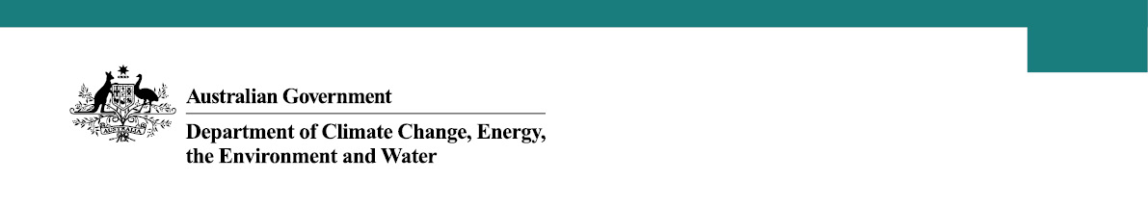

Offshore Wind Industry – Southern Ocean region consultation
The Southern Ocean region is well suited for offshore wind due to a range of factors like excellent offshore wind capacity, nearby energy workforce, and proximity to existing grid infrastructure.
An area was proposed for declaration in the Southern Ocean region off Victoria and South Australia by the Minister for Climate Change and Energy on 28 June 2023. This began the 65-day public consultation period, in which the Minister invited submissions on the proposed area. A total of 3,285 submissions were received during the consultation period.
The Australian Government worked closely with the Victorian and South Australian Governments to understand the views of the community on a future offshore wind industry. The department undertook consultation across the coastal regions of southwest Victoria and southeast South Australia using the following methods:
- advertising through newspapers, radio, and social media
- letterbox drop of flyers encouraging the community to make a submission
- detailed information about the proposal and how to make a submission on the department’s website
- targeted stakeholder meetings with federal, state, and local government agencies, industry, business, and community groups
- five community information sessions from 1 August to 3 August 2023 in Warrnambool, Port Fairy, Portland, Mount Gambier and Port MacDonnell to answer questions and to encourage the community to make a submission.
The majority of submissions expressed concerns about the environment, commercial and recreational fishing, and visual impacts. Details of these concerns, and other concerns raised within submissions were:
- Environmental impacts - the potential impact of turbines on the Bonney coastal upwelling, endangered migratory bird species, whales, dolphins, rock lobsters and other sea life.
- Commercial and recreational fishing impacts – commercial and recreational fishers were concerned that an offshore wind industry could mean they will be excluded from the area and could impact on the viability of the industry.
- Visual impacts - view of turbines and onshore transmission reducing the visual amenity of places along the coastline.
- Local infrastructure and community concerns – the potential impact on existing community services, housing, and the concentration of regional infrastructure investment within the Victorian region.
- Shipping impacts - the risk to safe management of vessel traffic in and around the area.
A number of submissions expressed support for the development of an offshore wind industry. Potential benefits and opportunities highlighted in submissions included:
- Local economy - local jobs and industry growth, including employment opportunities related to construction, manufacturing and maintenance of offshore renewables, opportunity for local skills and training development, and local content.
- Clean renewable energy - the transition to sustainable low-emissions energy sources was widely supported.
- Environment - the potential of offshore wind projects to create new habitats for marine species.
The Minister for Climate Change and Energy has listened, taking on board reservations expressed as part of the consultation process, and declared an updated, smaller area for offshore wind development:
- The declared area offshore in the Southern Ocean off Victoria, covers 1,030 square kilometres, and sits to the south of Port Fairy and Warrnambool.
- The declared area contains conditions for prospective feasibility licence holders, including the need to consult with the Department of Defence, the Australian Maritime Safety Authority, as well as concession or licence holders under the Commonwealth Fisheries Management Act 1991 or the Victorian Fisheries Act 1995.
The area declared in the Southern Ocean will assist in supporting the growth of an offshore wind industry in Victoria and increase regional investment, create job opportunities, and improve energy security, while helping Victoria and the nation reach our climate goals.
Further consultations will take place on any proposed developments and environmental studies once feasibility licences are issued.
Figure 1: Map of Southern Ocean declared area
