

Offshore Renewable Energy Declaration

Southern Ocean Region, Victoria and South Australia   
Public Consultation Submissions Summary Report

Table of Contents

Introduction 3

Development of the Notice of Proposal 3

Consultation process 3

Public consultation 3

First Nations consultation 4

Community information sessions 4

Online sessions 4

Overview of submissions 5

Types of respondents 5

Individuals 5

Organisations 6

Feedback within submissions 7

General sentiment 7

Benefits of offshore renewables and opportunities for the region 7

Community, local economy and onshore transmission 7

Addressing climate change, renewable energy, and the environment 8

Commercial and recreational fishing 8

Existing marine users and local concerns 9

Environment 9

Visual amenity 10

Commercial fishing 10

Recreational fishing 11

Community 11

Other concerns or issues 14

Appendix A: Submissions from Organisations representing others 15

# Introduction

On 28 June 2023, the Minister for Climate Change and Energy announced that an area offshore extending from Warrnambool, Victoria to Port MacDonnell, South Australia; for this purpose, referred to as the Southern Ocean region; was being considered for its suitability to be declared as an offshore renewable energy area under the *Offshore Electricity Infrastructure Act 2021*. This is the third area to be considered under the legislative framework and is another step forward in enabling the development of offshore renewable energy in Australia.

The purpose of this report is to provide an overview of consultation on the Notice of Proposal for the area proposed in the Southern Ocean region, including a summary of the responses, including from submissions received during targeted and public consultation. The responses received as part of the public consultation process reflect considerable time and effort on the part of the respondents. Submissions are used to understand how the proposal could affect communities, determine areas to avoid and if applying conditions will ensure areas of importance or concern are protected. The submissions provided valuable information for the Minister when deciding to declare an area in the Southern Ocean Region as suitable for offshore renewable energy infrastructure. This includes how the proposal might affect communities, issues of concern such as environmental or cultural impacts and what areas are unsuitable or which require conditions to ensure we are protecting areas of importance or concern. The consultation process provides communities and associations with information about the declared area and how offshore wind will operate in Australia including through the Department of Climate Change, Energy, the Environment and Water’s [website](https://www.dcceew.gov.au/energy/renewable/offshore-wind).

The opinions expressed in this report were presented by stakeholders during the public consultation period and do not reflect the views of the Australian, Victorian or South Australian governments.

# Development of the Notice of Proposal

The Notice of Proposal to declare an area off the Southern Ocean, extending from Warrnambool, Victoria to Port MacDonnell, South Australia as suitable for offshore renewable energy infrastructure was developed through consultation with Commonwealth, Victorian and South Australian Government agencies.

# Consultation process



## Public consultation

The Minister published the Notice of Proposal for the area off the Southern Ocean region on 28 June 2023. This commenced the statutory public consultation period as required under the *Offshore Electricity Infrastructure Act 2021*. Members of the public were able to make submissions via the Department of Climate Change, Energy, the Environment and Water’s ‘Have Your Say’ web platform. On 31 August 2023, the public consultation period closed.

The Notice of Proposal was accompanied by a dataset titled ‘*Offshore Electricity Infrastructure Act 2021* – *Proposed Area – Southern Ocean’* that identified the proposed area. An indicative map of the proposed area was also included in the notice. The Consultation Hub page included several resources to provide respondents with additional information in relation to the proposal. This included:

* document providing an overview of the proposed area and FAQs titled ‘Overview of the Proposed Area – Southern Ocean Region’;
* document providing an overview of existing marine users and interests in the vicinity of the proposed area titled ‘Marine Users, Interests and the Environment – Southern Ocean Region’;
* shapefile of the proposed area for download; and
* link to an interactive map of the proposed area hosted by Geoscience Australia.

Information on the public consultation was shared across a number of platforms, including [on](https://www.dcceew.gov.au/) the department’s [website](https://www.dcceew.gov.au/energy/renewable/offshore-wind) and social media channels: Twitter, Facebook, Instagram and LinkedIn. The department also carried out several forms of advertising for the proposed area, notices in local and regional newspapers, articles in local newspapers, radio advertisements and flyer drop to residents in coastal areas adjacent to the proposed area.

The announcement itself also received media coverage, and information on the proposed area was shared more broadly across larger regional newspapers and websites.

The purpose of the public consultation was to inform the community of the proposal and seek feedback on current uses and users of the area to inform the Minister’s decision on whether the proposed area is suitable for offshore renewable energy development.

## First Nations consultation

The First Nations groups that were consulted during the declaration process were:

* Gunditj Mirring Traditional Owner Aboriginal Corporation, Victoria
* Eastern Maar Aboriginal Corporation, Victoria
* Burrandies Aboriginal Corporation and Southeast Aboriginal Focus Group, South Australia

Consultation with the First Nations groups was held in collaboration with the Victorian and South Australian governments. Where possible, contact was established with each group during the preliminary area assessment stage and continued through the public consultation period. Consultation was held via a combination of face-to-face and online meetings. Departmental representatives also attended meetings convened by First Nations groups where appropriate.

In response to feedback from all First Nations groups, the department extended the period for feedback on the proposed area from these groups by four weeks to 29 September 2023. This was in acknowledgement that the timeframes for engaging with First Nations people on a proposed area were challenging, with First Nations groups advising that there was insufficient time for the community to be informed about the process, to propose a position on offshore renewable energy and the proposed area, and to obtain community endorsement on the feedback.

## Community information sessions

The community was invited to participate in community drop-in sessions held during the consultation period across the south-west region of Victoria and south-east region of South Australia. In total, five community information sessions were held in Warrnambool, Port Fairy, Portland, Mount Gambier and Port MacDonnell from 1 August to 3 August 2023, attracting more than 700 attendees.

For each session, departmental staff were on-site and available to talk to members of the community, with Victorian sessions supported by representatives from the Victorian Department of Energy, Environment and Climate Action and VicGrid.

At the sessions, attendees were briefed by department representatives on elements of the proposal, provided with the opportunity to ask questions, discuss key issues, and understand the importance of providing feedback via a submission.

## Online sessions

Between 9 August and 17 August 2023, relevant local industry stakeholders were invited to participate in online, industry-specific sessions targeting commercial fishing, tourism and local business, and community and environmental groups. An additional general public online information session was also held during this period in response to community interest.

Approximately 70 individuals attended these online sessions. These sessions allowed targeted discussions on the interaction of potential offshore renewable energy projects with specific local industries, and gave an opportunity for local industry representatives to have their questions answered. These sessions allowed targeted discussions on the interaction of potential offshore renewable energy projects with specific local industries and gave an opportunity for local industry representatives to have their questions answered.

Analysis of submissions

The department undertook an analysis of the submissions received, as set out below. The analysis provides an overview of public sentiment concerning the proposal as represented in the submissions and outlines the range of concerns and benefits identified by respondents. This feedback informs the Minister’s decision on whether to declare the area as suitable for offshore renewable energy infrastructure.

# Overview of submissions

## Types of respondents

Respondents were able to lodge submissions as an individual or on behalf of an organisation. A total of 3,285 submissions were received. 120 submissions (3.6%) were made on behalf of an organisation and the remaining 3,165 submissions (96.4%) were made by an individual or individuals.

### Individuals

Individuals were asked to identify what best describes themselves, and Figure 1 shows the breakdown of responses. Most individuals identified as a local resident (46.4%), with regular visitors or holidaymakers to the area the next largest proportion of respondents (27.5%).

Figure 1 – Responses of individuals

Respondents were also asked to identify their postcode. A breakdown of the locations of the individuals who made submissions can be seen in Figure 2.

Of the submissions from individuals, over 94% of submissions were from residents in Victoria (45%) and South Australia (49%). Over 62% of the individual submissions received were from residents in the six local council areas closest to the proposed area (Corangamite Shire, Glenelg Shire, Moyne Shire, Warrnambool City, District Council of Grant and Mount Gambier City).

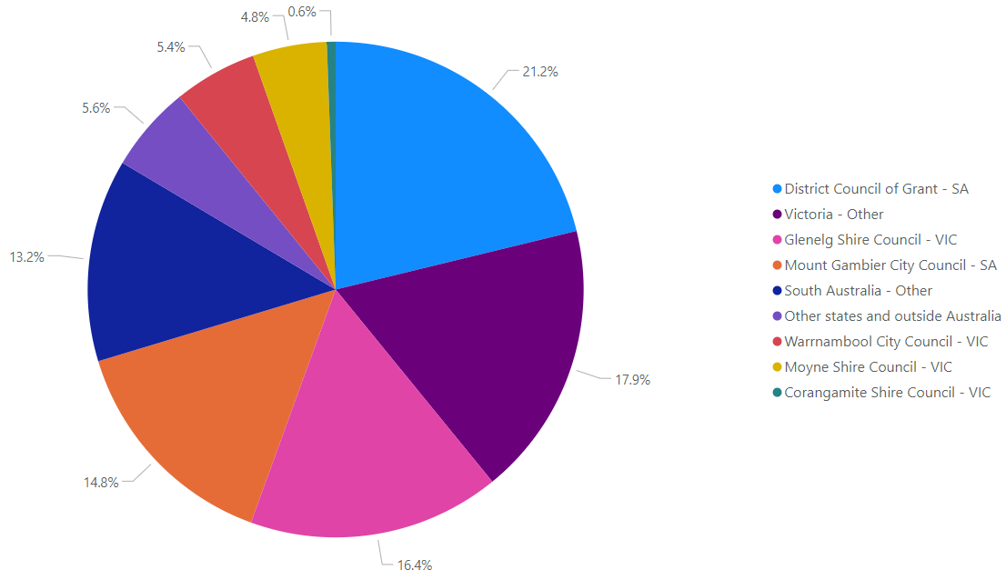

Figure 2 – Locations of individuals submissions

### Organisations

Organisations which made a submission were asked to categorise the sector that best describes their organisation. Figure 3 shows the breakdown of sectors for the 120 responses from organisations. Overall, the largest portion of responses from organisations came from the fishing industry (28%). The next most represented sectors were non-government and community organisations (21.7%) and energy, electricity and renewables industry (15%).

Figure 3 – Submissions from organisations by sector

#### Organisations representing members

Approximately 30 submissions from organisations were from those representing their members, including fishers, workers, First Nations, and environmental groups. Each of these groups have been estimated to represent anywhere from approximately 20 to 500,000 members.

Further details of these organisations which made public submissions, and the number of members they represent can be found in Appendix A.

# Feedback within submissions

## General sentiment

All respondents were provided the opportunity to share their views on the opportunities and benefits of the proposal across the main themes of community and onshore transmission, environment, fishing and other. A variation of sentiment was observed within submissions. Commonly submissions that cited oposition to the proposal also included details of benefits and opportunities, while other supportive submissions contained concerns in respect to individual themes. The variation and range of concerns, benefits and opportunities expressed in submissions have been examined further in the following sections.

## Benefits of offshore renewables and opportunities for the region

A number of submissions noted benefits of offshore renewables and opportunities for the region, across various themes. Figure 4 shows the percentage of submissions that identified benefits and/or opportunities across the main themes. These are expanded on in the sections below.

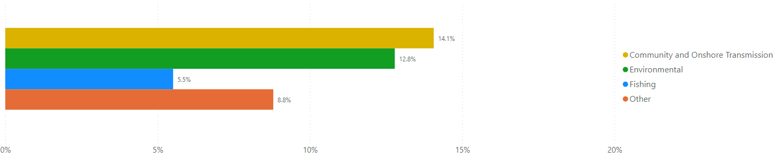

Figure 4 – Submissions identifying benefits or opportunities

### Community, local economy and onshore transmission

Approximately 14.1% of submissions (462) noted benefits of offshore renewable energy projects to the community, local economy and onshore transmission. These included broad sentiments focused on economic benefits such as an increase in employment opportunities related to construction, manufacturing and maintenance of transmission and offshore infrastructure. 338 submissions noted benefits to the local economy and employment, while 61 identified benefits associated with onshore transmission of electricity. The Victorian region, particularly Portland, was frequently mentioned as the potential beneficiary of increased economic development. Some respondents - notably ALCOA Australia - referred to the importance of supplying reliable renewable energy to the existing Portland Aluminium Smelter in providing certainty and creating long term regional job opportunities.

Submissions also highlighted the community benefits to upgrading existing port facilities for offshore wind projects. Organisations representing members in key regional industries such as the Construction, Forestry, Maritime, Mining and Energy Union (CFMEU), Electrical Trades Union (ETU), Maritime Union of Australia (MUA), South West Trades & Labour Council, Australian Institute of Marine and Power Engineers (AIMPE), Australian Maritime Officers Union (AMOU), and Australian Workers’ Union identified opportunities arising from the proposal to develop a highly skilled workforce and retain highly paid long-term employment for the region. Respondents commented on the potential opportunities for local maritime businesses and existing users to benefit from upgraded facilities and economic simulation to local maritime industry.

Submissions also emphasised potential community benefits, such as a local source of reliable renewable energy and a possible increase in local tourism and other investment opportunities in sectors like education, healthcare and community infrastructure. 81 respondents noted the investment in local infrastructure to support offshore energy projects as a community benefit and 32 submissions saw offshore windfarms as a potential tourist attraction in the region. A portion of respondents referred to a sense of pride for their region to take a leading role in Australia’s renewable energy transition.

### Addressing climate change, renewable energy, and the environment

A total of 420 submissions (12.8%) stated that they could see benefits or opportunities related to the environment for offshore renewable energy projects in this proposed area. Submissions from organisations noting the benefits of this proposal in generating more renewable energy and addressing climate change included the Clean Energy Council, and the Corangamite and Glenelg Shire Councils.

Support for clean energy was raised in 375 submissions which focused on the positive environmental implications of transitioning away from a fossil-fuel reliant energy system. Submissions in support of clean energy also mentioned the benefits of improving air quality, having a cleaner environment, and reducing the coal industry’s carbon footprint. Many submissions mentioned the time sensitive nature of developing renewable energy capacity, and the declaration of a suitable area for offshore renewable energy in the Southern Ocean region was seen as an opportunity to reduce the risk of Australia’s decarbonisation.

Renewable energy was mentioned as one of the central means of addressing climate change, and some submissions commented that the long-term benefits would outweigh short-term impacts associated with the construction of the offshore renewable energy infrastructure. Additional benefits also noted in submissions included cheaper energy, improvements to energy security through grid diversification and stability, and being a positive alterative to further harm of the onshore environment.

While many were supportive of offshore renewable energy, the need to ensure that the marine environment was protected, with any impacts being avoided, reduced, or compensated for was strongly expressed. It was suggested that any ecological studies done by licence holders not be carried out individually by developers, but in a coordinated manner to reduce any environmental impact. Many requested that adequate research be conducted into bird flight paths to assist in the positioning and operation of wind turbines minimises impacts to bird life. Mitigation strategies such as suspending construction during the whale migration period and setting up exclusion zones for fish were also suggested.

Some submissions noted the potential environmental benefits of offshore renewables, separate to the broader climate benefits associated with renewable energy. These submissions identified the potential for offshore renewable energy infrastructure to create new habitats for marine life in the offshore area by functioning as artificial reefs, as well as the opportunity to boost Australia’s understanding of our marine ecosystems through potential environmental studies.

### Commercial and recreational fishing

A total of 114 submissions identified the benefits of attracting marine life and reducing stock impacts, 22 submissions identified commercial fishing benefits, 27 submissions identified recreational fishing benefits and 40 submissions identified other benefits.

An [article and research highlighted in The Conversation](https://theconversation.com/wind-turbines-can-breathe-new-life-into-our-warming-seas-177873) was submitted, as well as comments of support suggesting that offshore renewable energy could provide:

* subsea infrastructure which could act as an artificial reef and provide a new marine habitat, improve marine biodiversity and provide both a refuge for species and benefit recreational fishing;
* reduced impact from overfishing; and
* fishing tours around the wind farm.

## Existing marine users and local concerns

Many submissions noted concerns and discussed those who are currently using this marine area. Figure 5 shows the percentage of submissions that identified concerns and existing marine users across the main themes. These are expanded on in the sections below.

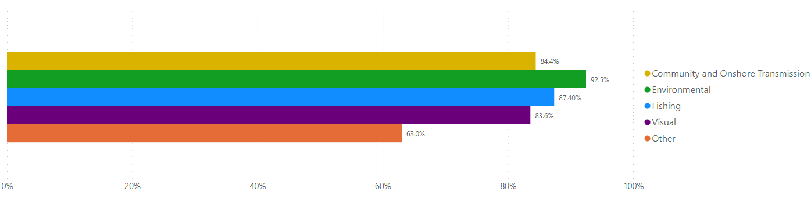

Figure 5 – Submissions identifying existing marine users or concerns

### Environment

Approximately 3,038 (92.5%) submissions identified concerns with the environment.

A total of 1,302 submissions raised concerns that the construction, operation, and decommissioning of offshore wind farms would negatively impact the environment, including concerns that methods of constructing and operating wind farms would interfere with the marine ecosystem. The submissions which raised decommissioning were mainly concerned with how the wind turbines would be handled at their end of life, and the level to which turbines could in fact be recycled. Submissions also considered the risk of damage to the environment and pollution from offshore renewable energy infrastructure was high in comparison to the overall benefits.

Of all the submissions received, 58% were concerned with impacts to fish/lobsters/other marine life, 34% were concerned about impacts to whales and cetaceans, 27% were concerned about impacts to birds, 22% were concerned about the impacts on seabeds and reefs, 16% were concerned about pollution and oil leaks (Figure 6).

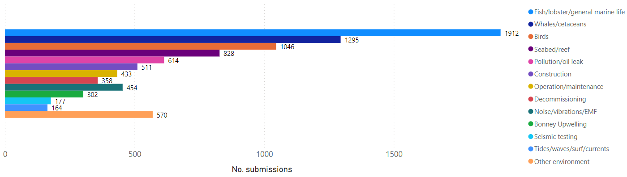

Figure 6 - Submissions with environmental concerns raised

Submissions raised concerns about the impacts to fish, lobsters or other marine wildlife, their habitats and the local ecosystem as a whole. Submissions also outlined perceived impacts to whales and cetaceans, the migratory patterns of threatened whale species, and the impacts of undersea noise and vibrations on whale navigation. Local birdlife includes shearwaters, petrels, muttons, albatross and gannets, and submissions raised concerns that turning turbines could strike and injure or kill this birdlife.

Submissions raised concerns that the installation of wind turbines and sub-sea cables would disturb the seabed and cause damage to marine life habitats, including the large populations of rock lobsters in the area. Concerns for the potential impacts to the Bonney Coast Upwelling were also raised, which is a source of nutrients and food, and attracts species of migratory whales.

Submissions raised concerns with recycling arrangements during decommissioning of end-of-life turbines, the use of seismic testing, the potential for wind farms to impact wave and surf patterns, cause sand displacement or coastal erosion.

Other environmental concerns included issues such as fire from the wind turbines, sea water causing corrosion on the turbines, and the lack of scientific research into the impacts of offshore wind farms in an Australian context. These submissions highlighted concerns regarding a lack of existing baseline environmental studies of the impacts of offshore wind farms on the marine environment in general. Submissions raising other environmental concerns included extreme weather conditions being too much for wind farm infrastructure to handle, which could lead to infrastructure being heavily damaged, consequently damaging the marine environment in the process. Concerns were also raised that developing offshore renewable energy infrastructure would come at the expense of pristine natural environment in the Southern Ocean Region, as well as the environment in general.

### Visual amenity

The impact of offshore wind farms projects on the visual amenity of the region was a prominent concern raised throughout consultation. Of the 3,285 submissions received, 2746 (83%) mentioned the impact on visual amenity as a concern. Concern around the impact on coastal property prices and tourism were also raised and covered in the community concerns section below.

Further concerns were raised on the visual impact of offshore infrastructure during daylight hours, as well as light pollution caused by hazard and navigational warning lights, required for offshore infrastructure for safety reasons, during the night. Submissions raising light pollution at night discussed dark sky views from coastal lookouts and headlands was also a common theme in many submissions.

Some submissions noted there were already many onshore wind farms in the area that had not adversely impacted visual amenity, further considering visual impacts to be minor and less important consideration as any development that reduces reliance on fossil fuels is seen as a positive. Some expressed that the visual amenity of the impacts of climate change far outweighed any visual impacts of turbines in the ocean with many commenting that given the urgency to address global warming and securing a stable source of green electricity, the likely small diminishment of visual amenity would be more than tolerable.

### Commercial fishing

Commercial fishing concerns were raised in 36% of all submissions received during the public consultation. A number of notable fishing industry organisations, including The Game Fishing Association of Australia, Victorian Game Fishing Club, VRFish, Seafood Industry Australia, RecFish SA, and Seafood Industry Victoria, raised detailed concerns as well as recommendations for helping address issues with the development of an offshore renewable energy industry. A number of these organisations expressed support for emissions reductions and net zero targets but were largely opposed to the declared area.

A total of 997 individual submissions expressed concern around access to fishing locations around offshore wind farms, 852 submissions expressed concerns on stock impacts and 703 submissions on the viability of fishing in the area.

Numerous submissions raised the potential impact to the rock lobster fishing industry. Other concerns raised in association with commercial fishing were:

* Exclusion/restricted access from the proposed area from fishing activities
* Destruction of seafloor and habitat
* Noise impacts on target species
* Short-term, long-term, and cumulative economic and social impacts
* Impacts on fish species, distribution, and abundance
* The impact of oil spills and other pollutants
* Navigation hazard and safety concerns
* Interaction of fishing equipment with cables
* Potential impacts of electro-magnetic fields on rock lobster and fish species

Some recommendations provided in submissions to address challenges and concerns. These included:

* Cable locations to be mapped and updates provided to GPS services
* Environmental studies
* Further research on mitigation measures
* Ensuring that all windfarm proposals area subject to thorough and independent environmental impact assessment processes in accordance with the EPBC Act

### Recreational fishing

Recreational fishing concerns were raised in 26% of the submissions made. Similar to commercial fishing, the most common concerns for recreational fishers involved access to preferred areas and navigation risks. Sport fishing was cited as a compromised activity, should widespread recreational access become prohibited. Some submissions linked recreational fishing to tourism, the decline of which could create broader socio-economic impacts in small coastal towns. Preserving the fishing rights and access of traditional owners was also noted as important among many submissions.

### Community

Concerns relating to the community were raised in 84.4% of the total submissions made, making it the third most-raised concern following the environment and visual amenity. Figure 7 below shows the different concerns relating to the community which were raised by respondents, with negative impacts to the local economy, jobs and tourism being the most commonly raised.

It should be noted that 492 submissions saw no benefits to the local community from offshore renewable energy projects, while 232 responses specifically citied no benefits to South Australia because of the belief that the employment opportunities and renewable electricity generation would stay in Victoria.

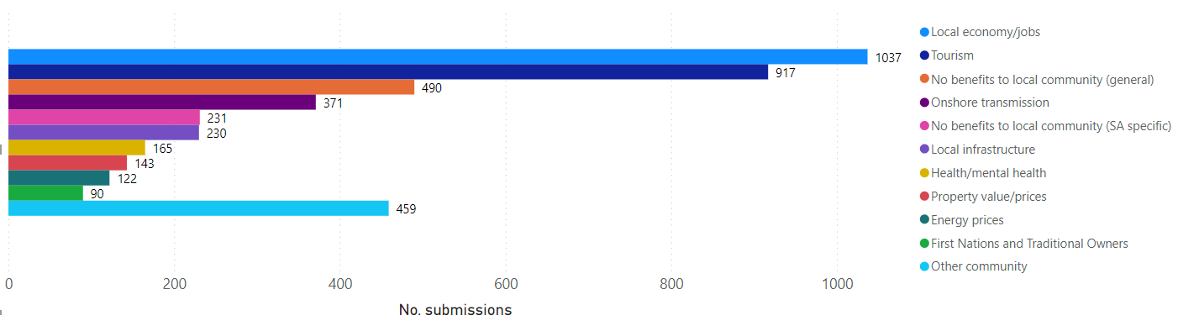

Figure 7 - Submissions with community concerns raised

The following sections outline the specific concerns raised by the public relating to the community.

#### Tourism

There were approximately 917 submissions that had concerns on the impact of offshore windfarms on the tourism industry. Many of the respondents were concerned about the impact to migratory whales, birds and fish and the corresponding impact to the tourism sector. Between June and September visitors are drawn to the region around Warrnambool to view the migration of Humpbacks, Orcas and Southern Right Whales. Submissions associated offshore wind farms with decrease whale viewing opportunities with negative flow on impacts to tourism operators in the region.

Similarly, migratory bird watching was noted by many submissions as a popular tourism activity along both the Victorian and South Australian coastline that could be impacted by offshore wind farms. Many also stated that tourism in the area relied on the environment, the pristine beaches and coastal views (Great Southwest Walk, Port Fairy, Cape Bridgewater, Cape Nelson Lighthouse, Discovery Bay Coastal Park, Brown and Shelly Beaches) were concerned about the negative visual impact of wind turbines.

A significant part of the tourism industry in South-Eastern South Australia and South-Western Victoria is based around recreational boating and fishing activities. Many of these submissions felt these activities would cease due to restricted marine access, detrimental impact on fisheries and the marine ecosystem (particularly the Bonney Coast Upwelling region) caused by the construction of wind turbines. The coastal towns of Port MacDonnell, Port Fairy, Portland and Warrnambool were identified by respondents as communities with small businesses that have been built over generations around tourism income from recreational fishers and boaters. This includes accommodation, charter fishing operations, hospitality and marine retail businesses.

#### Local economy/business/jobs

Approximately 1037 submissions raised concerns regarding the local economy. Most of these submissions expressed concerns regarding the possible negative impact the introduction of offshore renewables to the area would have on the local economy. These comments particularly emphasised changes to significant existing industries such as commercial fishing and tourism, as being detrimental to the local economy.

Respondents described offshore energy projects as causing short periods of regional economic growth followed by a sharp decline. A reoccurring comment in submissions was the assumption that any job creation from offshore energy projects will be insecure, short term and result in a transient workforce. Respondents were concerned that developers would import construction materials and an experienced workforce rather than investing in the local region. Another portion of the respondents noted that local businesses would be unable to compete for staff against offshore energy projects recruiting in the region causing impacts to community services and housing availability. While 145 respondents raised concerns regarding the potential for property values to decrease in the regions where offshore energy and transmission infrastructure would be most visible.

Community concerns around impacts and restrictions to the commercial Southern Rock Lobster industry and supporting businesses in Port MacDonnell was common in submissions. The Southern Zone Rock Lobster Fishery (SZRL) operates from the Murray Mouth in South Australia to the Victorian state border. The South Australian Government’s submission states that ‘The SZRLF contributed over 30% of South Australia’s seafood Gross State Product (GSP) in 2021/22 ($131 million). In 2021/22, the fishery contributed 1068 full time equivalent jobs.’

#### First Nations

Five First Nations groups provided feedback on offshore renewable energy in the proposed area in submissions or at meetings (three local representative groups, and two regional/national First Nations organisations). A range of cultural values and interests were raised, focused on potential environmental, cultural and social impacts from offshore renewable energy projects and associated transmission activities on local Land and Sea Country.

First Nations groups expressed concerns about development of offshore renewable energy projects in the proposed area based on the potential impacts on undersea cultural heritage sites, aesthetic values and highly significant cultural and environmental values. While First Nations groups expressed support for the move to renewable energy, these groups noted the potential impacts on undersea cultural heritage sites, aesthetic values and highly significant cultural and environmental values from offshore wind development. Concerns were raised about the potential impacts on culturally important species of marine mammals, seabirds, eels, bats, turtles and other marine life, as well as the cumulative impacts from multiple wind farms projects in the region. Development of offshore wind projects within the vicinity and viewpoints of the island of Deen Maar in Portland Bay was strongly opposed.

First Nations groups also expressed dissatisfaction with the engagement process. Some groups noted that timeframes for the declaration process were not sufficient for First Nations peoples to become informed about offshore renewable energy in the region, to consult with their communities, and to formalise an agreed position statement on the proposed area. Groups also raised the potential for community benefits from future developments, including employment, training and other opportunities for local First Nations communities.

#### Health /mental health

There were 165 submissions that raised concerns with the potential health and mental health impacts of offshore wind farms. Many of these submissions raised concerns about increased stress and anxiety in the local community around the uncertain details, impacts and number of future offshore renewable energy projects. Others stated that the visibility of offshore turbines would negatively impact the mental health of residents and visitors.

Some submissions mentioned consequences of disruptions to leisure activities such as boating and fishing may contribute to negative mental health outcomes in the community. Additionally, concerns were raised that the loss of family run businesses and local jobs would impact the identity of local communities and the mental health of residents. A portion of submissions also raised concerns about public health and safety caused by noise and vibration from the construction and operation of the turbines and transmission infrastructure.

#### Onshore impacts and transmission

Infrastructure for onshore electricity transmission was identified as a concern in approximately 371 submissions. The area contains existing high voltage transmission lines and significant transmission infrastructure development which contributes to a heightened level of awareness and in some cases, concern regarding onshore transmission. There was a broad understanding that any offshore wind development would require new onshore transmission to achieve connectivity and upgrading to transfer additional power.

Onshore transmission was raised in the context of visual impacts and some respondents highlighted that underground transmission was preferred as a mitigation option for visual impacts. Others raised concerns that the transmission infrastructure would impact the immediate coastal environment resulting from both construction and the placement of long-term infrastructure. Transmission impacts were also described in the context of impacts to the local community including health impacts, property value and loss of productive farmland while the additional power would be distributed for consumption elsewhere.

#### Local infrastructure and other community concerns

Concerns were raised in 231 submissions relating to existing local infrastructure, with some submissions highlighting that areas adjacent to the area may not be suitably equipped to handle an influx of workers and new infrastructure needed to support an offshore renewables industry. These submissions mostly referred to healthcare services, educational institutions, housing availability and public roads as the most vulnerable and as unable to service a sudden increase in population. A subset of submissions was concerned than any investment in regional infrastructure would be concentrated in the Victorian region due to the existing industrial port of Portland.

Various other community concerns were raised in approximately 450 submissions. The most notable included concerns about increased risk of fires from renewable energy infrastructure and negative impacts to the local lifestyle. A small portion of respondents highlighted that offshore wind turbines could cause changes in ocean swells and result in the loss of annual local surfing events.

#### Shipping /navigation

Over 145 submissions raised concerns regarding shipping. These were primarily related to concerns regarding the ability for ships and other vessels to safely navigate through and around wind turbines. Submissions commented that they believed offshore infrastructure would be a major hazard for maritime vessels. A subset of the submissions raised concerns regarding the introduction of offshore wind turbines and underwater transmission infrastructure to the area and how this would inevitably increase the collision and entanglement risk to professional and recreational fishing vessels. A portion cited concerns that offshore wind turbines and exclusion zones would force fishing vessels to travel further from shore into dangerous ocean conditions resulting in marine accidents.

One of the most common issues raised in submissions related to shipping was the increased risk of disaster during extreme weather events. These voiced concerns that adding offshore wind turbines to this area would increase the risk of collisions with ships during periods of low visibility and extreme weather events.

### Other concerns or issues

In addition, 289 submissions raised other concerns or issues which included:

* reliability, viability, and generational capacity of renewable energy, particularly wind power technology;
* decommissioning of offshore renewable energy infrastructure and end of life processes, including ongoing maintenance and recycling of damaged or obsolete materials; and
* increased job opportunities would require specific skills and therefore would not necessarily be accessible to or offered to locals.

## Appendix A: Submissions from Organisations representing others

#### Organisations representing members

The following organisations made public submissions on behalf of their members. The approximate number of members they represent is also indicated:

* Australian Workers’ Union – approx. 75,000 members
* Construction, Forestry, Maritime, Mining, and Energy Union (CFMMEU), Electrical Trades Union (ETU) & Maritime Union Australia (MUA) – approx. 260,000 members combined
* Victorian Trades Hall Council – approx. 500,000 members
* Australian Manufacturing Workers’ Union – approx. 55,000 members
* Australian Parents for Climate Action – approx. 17,000 members
* Seafood Industry Australia – approx. 17,000 members
* Australian Institute of Marine and Power Engineers (AIMPE) & Australian Maritime Officers Union (AMOU) – approx. 2,400 members combined
* Abalone Council Victoria – approx. 1,000 members
* Southern Coast Ocean Care – approx. 27 members
* Bass Strait Game Fishing Club – approx. 5,000 members
* Game Fishing Association of Victoria – approx. 700 members
* RecFish SA – approx. 360,000 members
  + RecFish SA gathered feedback from their members on the proposal. They received 1,700 submissions from their members on the proposal.
* The Save Cape Bridgewater Association – 13 members

The following organisations also made public submissions on behalf of their members, with an unknown number of members:

* Protect the West
* South West Trades & Labour Council
* Australian Federation of Travel Agents (AFTA)
* Koroit & District Angling Club Inc.
* Seafood Industry Victoria
* The Game Fishing Association of Australia
* Victorian Game Fishing Club
* Victorian National Parks Association
* Federation of Victorian Traditional Owner Corporations
* National Native Title Council
* OCEAN Otway Climate Emergency Action Network
* South East Trawl Fishing Industry Association (SETFIA) & Southern Shark Industry Alliance (SSIA)
* Victorian Recreational Fishing Peak Body (VR Fish)
* Western Abalone Divers Association