Marine Users, Interests, and the Environment
Southern Ocean Region
The Minister for Climate Change and Energy has proposed an area in the Commonwealth waters extending from Warrnambool, Victoria to Port MacDonnell, South Australia to be considered for future offshore wind and other renewable energy generation projects.
This area is referred to as the Southern Ocean Region, due to the existing connection points to the electricity grid and major port located in Portland, Victoria. This initial area is a proposal. It is not the final declaration. It acts as a starting point to identifying a zone that could support offshore renewable energy generation and to inform further consultation on future project proposals.
The Australian Government wants to manage the offshore marine environment in a way that recognises all users and balances competing interests. Future offshore renewable energy projects must work with existing users and interests to ensure the area is shared while maintaining a safe marine space during construction, operation and maintenance phases.
Understanding existing users and interests in, and near, the proposed area is important and will help inform the Minister for Climate Change and Energy’s decision on whether the area is suitable for offshore renewable energy developments, like offshore wind projects.
This is your first opportunity to provide feedback. If a declaration is made in the future, developers will be required to seek feasibility licences to advance their project proposals. Feasibility licence holders will be required to seek feedback on any proposed projects and demonstrate how they will share the area with existing users.

Users and interests
We have undertaken preliminary consultation with Commonwealth, Victorian and South Australian government agencies to identify interests in the vicinity of the area. Below is a list of identified interests that may facilitate conversations about the potential suitability of the area for offshore renewable energy.
We have also developed a map that allows users to interact with the Southern Ocean Region proposed area and geographic information relevant to other users and interests in the area. The map, other tools, visualisations, and data relevant to Offshore Renewable Energy in Australian waters are also available on the Australian Marine Spatial Information System portal.
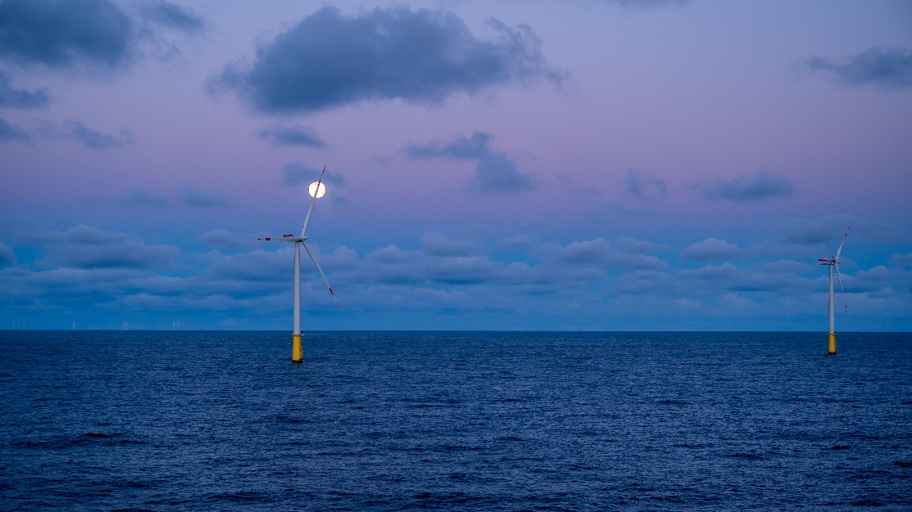

First Nations, Native Title and Sea Country
This area is the First Nations Land and Sea Country of the Gunditjmara, Eastern Maar, and the First Nations of the South East in South Australia.
The region onshore from the proposed area contains the declared Budj Bim Cultural Landscape and World Heritage area and three native title determinations. The world heritage area and native title determination areas do not overlap with the proposed offshore area. First Nations Australians have significant interests in the marine region, as part of their cultural heritage. This includes Deen Maar, an island located in Portland Bay which is considered a significant site by First Nations Australians.
Developers will need to understand their obligations if land-based transmission infrastructure is proposed, as requirements under the Native Title Act 1993 may apply.

Natural Environment
The Southern Ocean Region includes large coastal areas and includes the Budj Bim, Cobboboonee and Mount Richmond National Parks. The region is also home to a range of marine ecosystems and includes the Discovery Bay Marine National Park, which lies east of Portland and adjacent to Cape Bridgewater and Glenelg Estuary Ramsar Wetlands. The Director of National Parks will determine if development activities may have an impact on the values of the National Parks and whether any mitigation measures may be required.
The area also contains a designated Key Ecological Feature, the Bonney Coast Upwelling. Key ecological features define areas of ecological importance in the Commonwealth marine environment. They are elements of the region that, based on current scientific understanding, are considered to be of regional importance for either biodiversity or ecosystem function and integrity. Of consideration to the declaration, key ecological features are not specifically protected under the Environment Protection and Biodiversity Conservation Act 1999 (EPBC Act). However, the marine environment as a whole will be considered before a decision to declare any area is made.
There are a number of Matters of National Environmental Significance, under the EPBC Act, in and near the proposed area. These include:
- birds (Gannets, petrels, albatross, curlews, frigatebirds, shearwaters and penguins)
- cetaceans (whales, dolphins, sharks)
- rays
- Ramsar sites (Glenelg Estuary Wetlands).
Project proposals in Commonwealth waters must not be:
- inconsistent with recovery plans for relevant Matters of National Environmental Significance,
- be likely to change the ecological character of a Ramsar wetland,
- be likely to interfere with the long-term conservation of threatened or migratory seabird species, and
- be inconsistent with the requirements of migratory species treaties.
The Offshore Electricity Infrastructure Act 2021 (OEI Act) has been designed to operate in conjunction with other applicable regulatory regimes. Specifically, offshore renewable energy infrastructure activities are subject to requirements for environmental approval under environment legislation, including the EPBC Act administered by the Department of Climate Change, Energy, the Environment and Water. Approval under the EPBC Act will be required for all prospective projects. This includes an assessment of the relevant impacts and proposed avoidance, management, mitigation and, where appropriate, offset measures, to demonstrate appropriate environmental outcomes can be achieved.
Obtaining early environmental approvals under the EPBC Act (and other relevant Victorian, South Australian and Commonwealth legislation) provides no guarantee that a proposed project location will be included in a declared area or that a proponent will be successful in obtaining a relevant OEI Act licence in the area. Developers must ensure they receive all other relevant approvals and undertake any required consultation processes before they can apply for a commercial licence that allows them to construct infrastructure.

Airports and Defence
The relevant agencies have provided feedback on the proposed area and have not identified any air or defence related factors that need to be accounted for within the declaration proposal. In accordance with Department of Defence advice, developers of wind farms and other infrastructure in the proposed area will likely have to consult with the Department of Defence through the licensing stages to determine potential impacts of their proposed project.

Vessel Traffic and Ports
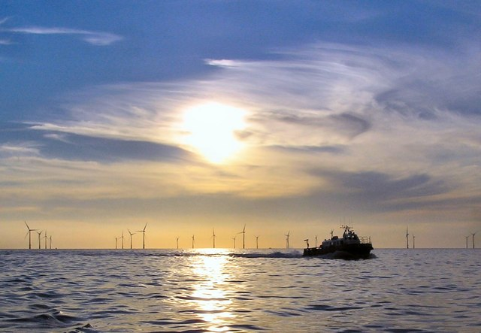
Shipping traffic tends to occur within the bounds of the coastline and 1000m sea depth, overlapping with the proposed area, with most activity coming out of Portland and Port Fairy, Victoria.
The Port of Portland is a significant regional port and is one of Australia’s busiest regional ports. The port provides connectivity to national road and rail networks and strategically located on the southwest coast between Melbourne and Adelaide. Port Fairy is a smaller port in the region that is used by commercial and recreation fishing.
Port MacDonnell is a historical port that is no longer a proclaimed port under the Maritime Services (Access) Act 2000. However, it is frequently used for smaller scale commercial, recreation fishing and marine based tourism. The development of offshore renewable energy infrastructure needs to ensure that it does not disrupt vessel traffic and port operations.
The shipping sector plays a significant role in the global economy and is critical to Australia as an island economy. Over 90% of Australia’s exports depend on sea transport and the combined value of Australia’s seagoing international imports and exports was over $400 billion in 2015/16 — equal to 25% of Australia’s gross domestic product.
The Southern Ocean Region sees a moderate volume of domestic and international shipping traffic heading to a variety of locations. To ensure there is adequate space for vessel traffic in the vicinity of the area, traffic separation schemes, and drifting areas, will need to be considered by the Australian Maritime Safety Authority and the Port Authority of Victoria.

Weather Radars
The Bureau of Meteorology operates the Mt Gambier weather radar at Mt Gambier in South Australia. The radar is the primary weather radar for the populated areas and provides weather information from West of Warrnambool, Victoria, to east of Cape Jaffa, SA. Developers will need to work with the Bureau as part of testing the feasibility of their proposed projects to ensure they do not interfere with weather radars.

Commercial and Recreational Fishing
Commercial fishing is an important industry in the Southern Ocean Region and many of the towns were originally developed to support the fishing industry in the area. Commonwealth and state fisheries overlap the proposed area, including the Southern and Eastern Scalefish and Shark Fishery (SESSF), Southern Zone Rock Lobster and Southern Bluefin Tuna Fishery. The proposed area avoids a high fishing effort area associated with South East Trawl operators in the SESSF from 200m water depth and outwards.
The interaction of offshore renewable energy development on recreational fishing has been examined overseas. Evidence from overseas, where offshore renewable energy projects have existed for many years, suggests that offshore wind and fishing can, in many cases, share the same space. The installation of wind turbines may have long term local benefits as turbines may function as nurseries, potentially increasing fish stocks in surrounding areas.
Depending on the location of offshore renewable energy projects, commercial fishing operators that hold existing fishing rights in the area may be impacted during the construction, operation, maintenance and decommissioning stages. OEI licence holders will need to undertake consultation with the commercial fishing sector to discuss how the area can be shared and potential impacts can be mitigated. Licence holders will need to have a plan for gathering and responding to ongoing feedback from stakeholders, including the commercial fishing industry, throughout the life of a project.
In most cases, commercial and recreational fishing activities will be able to share the space with future offshore renewable energy projects. However, the construction and operation of renewable energy projects in the ocean is a relatively new concept in Australia and there is further work required to understand what arrangements may be needed for fishing activities and these projects to share the same areas.
There may be small, restricted areas around offshore renewable infrastructure such as turbines and substations, as with other marine infrastructure like navigation buoys and oil and gas platforms. These restricted areas are to ensure the safety of offshore workers and other users of the marine environment, and to protect vessels and the infrastructure from damage. There may be larger restricted areas while any approved offshore wind projects are under construction to ensure safety for marine users and construction workers. The exact details of these restricted areas will be determined on a project-by-project basis.

Existing Titles and Infrastructure
Feedback from both the National Offshore Petroleum Titles Administrator (NOPTA) and Geoscience Australia identified that the proposed declaration area intersects with titles provided under the Offshore Petroleum and Greenhouse Gas Storage Act 2006. There are two exploration titles for offshore petroleum activities in the proposed area, and a production title in the east. There is one petroleum production title with infrastructure in place that is outside the proposed declaration area.
The 2021 Petroleum Acreage Release area V21-1 also slightly extends into the proposed area. Though the 2021 Acreage results have not been announced, if they were to become titles, they would be considered as per the other titles mentioned above. Petroleum and gas permit holders are users of the area and will need to be considered by future developers when proposing an area for a proposed offshore renewable energy project. There are several subsea cables which pass around the proposed area, although none directly within it. Ports Victoria currently manages dredging operations required in and around the Portland Harbour area.
Holders of existing titles for petroleum and gas, and owners of existing infrastructure, including subsea cables, will continue to have established legal rights within the area of their titles and in relation to their infrastructure. This may include rights to explore or produce, and rights of access to inspect, maintain and repair their infrastructure. There may be regular vessel and helicopter movements in the area.
Offshore renewables licence holders will need to undertake consultation and demonstrate how they will share the area with other users and will also need to have a plan for gathering and responding to ongoing feedback from stakeholders throughout the life of a project.

Tourism
The onshore Southern Ocean Region falls within the Glenelg Shire, which is part of the Great Ocean Road region. This shire is a major tourist destination in Victoria attracting more than 400,000 people annually. The coastline and beaches are also a major tourist attraction. In 2021-2022, tourism generated approximately $90 million in the Glenelg Shire. The proposed area does not extend as far east as the Twelve Apostles Marine National Park, however we recognise that tourism benefits are important across the whole Great Ocean Road region.
The construction and operation of renewable energy projects in the ocean is a relatively new concept in Australia. However, insights from research undertaken into the first offshore wind project in the United States indicated that, overall, tourism and recreational professionals had largely positive encounters with the project. The research suggested that people were curious about the project especially since it was the first one in the USA and that it helped attract sightseers and recreational fishers to the area. Overall, the researchers found little evidence that the project had adversely affected participation in tourism and recreation in the area.

Potential Projects and Coexistence with Existing Users
As part of testing the feasibility of a proposed project, and prior to approvals for the construction of any infrastructure, offshore renewables licence holders must consult with the local community and show how they will share the area with other users. Licence holders will also need to have a plan for gathering and responding to ongoing feedback from stakeholders throughout the life of an approved project. This is in addition to the obligations for licence holders to consult with the appropriate government agencies to ensure constraints are thoroughly considered and addressed throughout their projects.
Access to any future declared area or licence area by other marine users will not be restricted any more than is necessary to ensure safe navigation and operations, and the protection of infrastructure. This is consistent with the principle of shared use of the marine environment. As with any infrastructure in the marine environment (such as navigation buoys, and oil and gas wells), there may be restricted areas placed around offshore renewable infrastructure, such as individual wind turbines and offshore substations. The size and limitations of restricted areas may
change to reflect the changing activities between construction and general operation of offshore infrastructure to ensure the safety of marine users and workers.

‘South-east marine region profile: A description of the ecosystems, conservation values and uses of the South East Marine Region
Sustainability and tourism: the effect of the United States’ first offshore wind farm on the vacation rental market - ScienceDirect

