Overview of the Proposed Area – Southern Ocean Region

The Southern Ocean Region

An area in the Southern Ocean, extending from Warrnambool, Victoria to   
Port MacDonnell, South Australia, referred to as the Southern Ocean Region, is being considered for   
offshore wind and other renewable energy projects.

This initial area is a **proposal** for feedback. It is **not** the final declaration.

**Starting the conversation**

**This is your first opportunity to provide feedback.**

If a declaration is made in the future, developers will also be required to seek feedback on any   
proposed projects and demonstrate how they will share the area with existing users.

The Southern Ocean Region refers to an offshore area that extends from off Warrnambool in Victoria to Port MacDonnell in South Australia.

This area is the Traditional Land and Sea Country of the Gunditjmara, Eastern Maar, and the First Nations of the South East in South Australia. This is an important consideration, as an offshore renewable energy industry in this region will involve the installation of infrastructure across land and sea country in order to integrate with the Victorian electricity grid.

Portland is the only deep-water seaport between Adelaide and Melbourne, making it a major hub for transport of goods and produce, like wool, grain and woodchips, from surrounding areas. It has a strong economy, driven primarily by the Portland Aluminium smelter, Victoria’s largest single exporter. Its economy also includes the fertiliser industry, wool stores, and a fishing industry focusing on crayfish, lobsters, shark, abalone and deep-sea trawling, all contributing to producing over $2.6 billion in economic output, annually. The region is also an international gateway to the Green Triangle Regions – Australia’s largest plantation forestry area. Portland’s industrial estates have the flexibility to accommodate all types of industrial users, including renewable energy.

The area also contains a designated Key Ecological Feature, being the Bonney Coast Upwelling. It is a seasonal upwelling bringing cold nutrient rich water to the sea surface and supporting regionally high productivity and high species diversity such as migratory whales, penguins and fur seals.

### The benefits of offshore renewable energy in the Southern Ocean Region

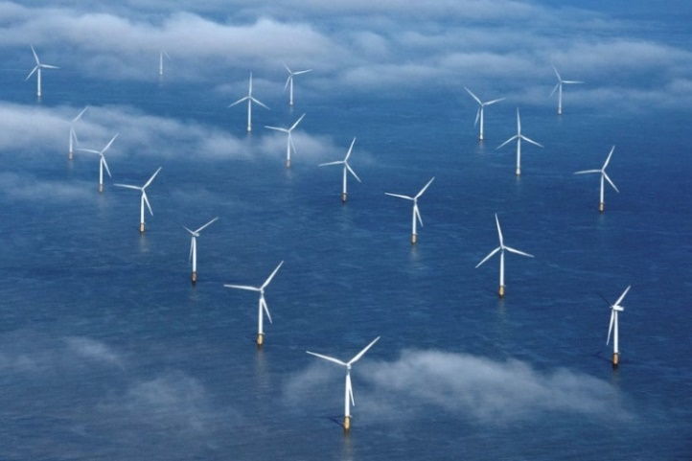The Australian Government has set a target of net zero emissions by 2050, reduce emissions by 43% by 2030, and reach 82% of electricity generation from renewable sources. Offshore renewable energy projects can assist in achieving these goals. Offshore renewable energy has strong generation potential around Australia, including the Southern Ocean Region, and can be a source of significant new power generation for manufacturing hydrogen, green steel, and green aluminium.

Offshore renewable energy is thriving in many regions around the world, particularly offshore wind projects in the United Kingdom and Europe. Currently, offshore renewable development interest in Australia is mostly focused on potential offshore wind projects. This could evolve in the future as more technologies come to market. Future licences could be granted for offshore solar, wave or tidal energy, or other forms of energy generation from renewable sources.

The Southern Ocean Region is well suited for potential projects, particularly offshore wind, because:

* It has strong, consistent winds.
* It is close to areas of high electricity demand including the Portland Aluminium Smelter and existing connections to the grid.
* Industry is very interested in developing projects in the area,
* Ageing coal-fired power stations are planning to shut down in future years,
* The area is within the Victorian (VIC) Government’s planned South West Renewable Energy Zone (REZ).

The Victorian Government’s recently announced updated renewable energy targets are 65% by 2030 and 95% by 2035. It is also targeting at least 2GW of offshore wind energy generation by 2032, 4GW by 2035 and 9GW by 2040, with first power by 2028.

Because of its long coastline and extensive continental shelf, Victoria and South Australia have immense potential for offshore wind power generation. The construction, maintenance and ongoing operations of offshore renewable energy projects must be well-integrated and support the local economy.

The Offshore Wind Policy Directions Paper produced by the Victorian Government estimates that up to 3,000 jobs for 15 years during development and construction would be sustained, with a further 3,000 during ongoing operations[1]. Additionally, the [Blue Economy CRC report](https://blueeconomycrc.com.au/project/offshore-wind-potential-for-australia/) into Offshore Wind in Australia, suggests that the development of offshore wind could potentially offer alternative employment for workers in the coal industry.

Electricity generated by offshore wind projects in the area will supply renewable energy into the grid and to industries with high energy demand, which includes the Portland aluminium smelter.

### A picture containing text, map, screenshot Description automatically generatedThe proposed area

The Minister for Climate Change and Energy has proposed an area in the Commonwealth waters in the Southern Ocean Region to be zoned for future offshore renewable energy generation projects, such as offshore wind. The area extends from off Warrnambool, Victoria in the southeast to off Port MacDonnell, South Australia in the northwest.

The Australian Government is looking to harness renewable energy resources to help decarbonise the economy with year-round clean energy generation. This will reduce emissions and boost the share of renewables in the electricity grid.

This initial area is a **proposal** and consultation is now open. We are seeking your feedback on the proposal and how offshore renewable energy projects could share the area with other users and interests. The Minister will consider the submissions and may remove parts of the proposed area or place conditions on all or part of the area, before making a final declaration.

In defining the boundaries of the proposed area, a number of factors have been considered, including initial feedback received from Commonwealth, Victorian and South Australian Government agencies, Traditional Owner groups and technical limitations identified in the [Blue Economy CRC report](https://blueeconomycrc.com.au/project/offshore-wind-potential-for-australia/) into Offshore Wind in Australia.

We have also developed a map that allows users to interact with the Southern Ocean Region proposed area and geographic information relevant to other users and interests in the area. The map, other tools, visualisations and data relevant to Offshore Renewable Energy in Australian waters are also available on the [Australian Marine Spatial Information System](https://amsis-geoscience-au.hub.arcgis.com/pages/renewables) portal.

### Visual amenity

The proposed area begins at least 5.4 nautical miles (approximately 10 kilometres) from shore. Offshore wind turbines are the tallest renewable energy option being proposed in the area, with current heights of up to approximately 250m above sea level. The relative height and visual effect decreases with distance, especially due to the curvature of the earth.

We understand that the visibility of wind turbines may be of particular interest to local communities. While exact locations of specific projects are not yet known, we encourage you to make a submission if you have suggestions as to how visual impacts could be managed. There will be opportunities provide feedback on specific project proposals once feasibility licences are granted.

Developers who are successful in obtaining feasibility licences will need to consult on the location and placement of any future turbines as part of testing the feasibility of their project proposals, and to support assessment of environmental impacts under the [*Environment Protection and Biodiversity Conservation Act 1999,*](https://www.dcceew.gov.au/environment/epbc/referral-and-assessment-process) before projects are approved for construction.

##### Overseas experience

Denmark is one of the major leaders in the offshore wind industry, with years of experience developing these projects. The Denmark’s Ministry of Foreign Affairs, and The Danish Energy Agency have created a [video demonstration](https://www.offshorewindtour.org/international/?lang=en#/scene/1385/1675/1844/1851:1916) helping to show what offshore wind farms look like from certain distances from the shore. This may help to visualise what potential wind farms will look like.

Future offshore renewable energy projects must demonstrate how they will share the area with existing users and interests.

### Marine users and interests

The Australian Government wants to manage the offshore marine environment in a way that recognises all users and balances competing interests, including those of Traditional Owners in the region. Understanding existing users and interests in and near the proposed area is important and will help the Minister for Climate Change and Energy’s decide whether the area is suitable for offshore renewable energy developments. **Future offshore renewable energy projects must share the area with other users and interests**.

For detailed information on existing users and interests in the vicinity of the area, please read *Marine Users, Interests, and the Environment – Southern Ocean Region*.

### The offshore renewable energy process

**This is your first opportunity to provide feedback on the proposed area**. In the future, and if an area is declared, developers will be required to seek feedback on their proposed projects and must demonstrate, to the satisfaction of the Offshore Infrastructure Regulator, how they will share the area with existing users. For further detailed information on the offshore renewable energy process, please read the *Offshore Renewable Energy Process*.

### Provide your feedback

**This is your first opportunity to provide feedback.** We want your feedback on the proposal to declare an area and how offshore renewable energy projects could share the area with other users and interests.

You can make a submission through our [Have your say portal](https://consult.dcceew.gov.au/oei-southern-ocean). Your feedback will help inform the Minister’s decision on whether the proposed area is suitable for offshore renewable energy. **Your feedback must be provided through the Have our say portal by Thursday 31 August 2023 11:59pm.**

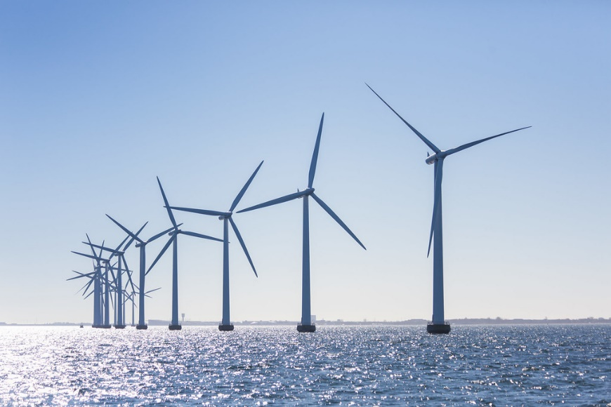**There will be more opportunities to provide your feedback on specific projects and project locations.** Once the area is declared, developers who are successful in obtaining a feasibility licence will need to consult with the local community and demonstrate how they will share the area with other users. Licence holders will also need to have a plan for gathering and responding to ongoing feedback from stakeholders throughout the life of the project.

### Further information

For more information on how marine users, interests, and the environment in the Southern Ocean Region, please see *Marine Users, Interests, and the Environment – Southern Ocean Region*.

For responses to frequently asked questions, please see the *Frequently Asked Questions – Southern Ocean Region.*

For information on the *Offshore Electricity Infrastructure Act 2021* please visit the [Establishing offshore renewable energy infrastructure web page](https://www.dcceew.gov.au/energy/renewable/establishing-offshore-infrastructure). If you have any questions, you can [email our team](mailto:offshorerenewables@dcceew.gov.au).

**Back to top of document ↑**

1. [Offshore Wind Policy Directions Paper | Victoria State Government (energy.vic.gov.au)](https://www.energy.vic.gov.au/__data/assets/pdf_file/0029/580619/Offshore-Wind-Policy-Directions-Paper.pdf)