**Emissions Reduction Fund Safeguard Mechanism**

**Framework for developing default production variables and   
emissions-intensity values**

|  |  |  |
| --- | --- | --- |
| **Date** | **Version** | **Description** |
| 21 February 2018 | 1.0 | Rereleased for consultation as part of consultation on the March 2019 amendments to the Safeguard Rule. |
| 13 August 2019 | 1.1 | Amended to allow partial emissions intensity data points to be used in the calculation of the default emissions intensity in certain circumstances, and to target 50 per cent of production volume when calculating default values. |

As set out in the 2017 review of climate change polices and the Safeguard Mechanism consultation paper, the government will develop default production variables and emission intensity values to simplify and streamline baseline applications and lower administrative costs for businesses.

This document sets out a framework to guide the selection of default production variables and emissions-intensity values for the Emissions Reduction Fund Safeguard Mechanism, and identify which production variables will be eligible for annually adjusted production-adjusted baselines. The framework includes:

* Background on production variables
* Principles for selecting default production variables
* The default calculation method for determining default emissions intensities.

# Process and timing

The Government will develop default values and identify which production variables can be used for annually-adjusted baselines, in consultation with businesses and supported by independent technical advice. Final default values will be included in the Safeguard Rule in two schedules:

* production variables that apply to production-adjusted baselines that are updated ***once*** for production, and then remain fixed (the current approach), and
* production variables that apply to production-adjusted baselines that update ***annually*** with production.

The Government will aim to publish as many as possible in the first half of 2019, for use in 2018-19—noting that calculated baseline applications for this year are due by 31 October 2019.

# BACKGROUND ON PRODUCTION VARIABLES

# What are production variables?

Production variables and emissions-intensity values are used to set facility baselines using a ‘calculated baseline’ approach (*subsection 30(3)* of the Safeguard Rule). They have been part of the Safeguard Mechanism since its inception in 2016. A calculated baseline is the sum of ‘production’ multiplied by the ‘emissions-intensity of production’ for each relevant production variable nominated by the facility, where the:

* **Production variable** identifies the product or service being delivered, for example, tonnes of alumina or passenger kilometres.
* **Emissions-intensity value** specifies the emissions-intensity of production, for example, emissions per tonne of alumina or emissions per passenger kilometre.

A facility can nominate its own production variables (consistent with *section 5* of the Safeguard Rule) and estimate a site-specific emissions-intensity value using audited forecasts of its production and emissions over three years (or five years for new large facilities). Baselines are ‘trued-up’ for actual production after the forecast period, and then remain fixed.

# How will default production variables be defined?

Default production variables would ideally be an output of a facility (e.g. tonnes of aluminium). However, in some cases, it may be impractical to define the production variable as an output, and an alternative—such as an input or intermediate product—may be sought. For instance, a production variable for an intermediate product may be required if the intermediate product can be sold or traded between facilities. An intermediate product or input may also be practical if a facility produces a large number of outputs and it is difficult to apportion emissions among them.

There may be instances where it is not practical to develop a production variable. In these cases, a more generic fall-back—such as energy consumed—may be the only option, though this would be a last resort and used as an interim measure.

# Why can’t all production variables be adjusted annually for production?

Aligning a production variable closely with an output will best allow a baseline to reflect the emissions of production. The further removed the production variable is from the output, the more difficult it is for the baseline to reflect emissions.

In general, output-based production variables will be suitable for annual production adjustments, whereas input-based production variables will not. Intermediate production variables may be suitable under certain circumstances, for example, if they only cover the emissions associated with making the intermediate product. They may not be suitable if they are a proxy for an output (and cover emissions that occur downstream of the intermediate product).

# What are emissions-intensity values?

Emissions-intensity values are expressed as emissions per unit of production variable and are used under the Safeguard Mechanism to develop baselines, consistent with the legislative framework used since the scheme’s inception.

The Government set out in its 2017 review of climate change policies that it would develop ready-made default emissions intensity values that businesses could use if they so choose as an alternative to developing their own site-specific emissions intensity values. This option would simplify baseline applications for businesses and lower administrative costs. A facility can continue to estimate its own site-specific emissions-intensity value rather than use the default.

It is proposed default emissions intensity values for the Safeguard Mechanism will be set at a level that is representative of a sectoral average.

**PRINCIPLES FOR SELECTING DEFAULT PRODUCTION VARIABLES**

The following principles will guide the selection of *prescribed production variables* and calculation of *default emissions intensity* values, and a decision on which production variables will be used for annually adjusted production-adjusted baselines. In practice, the process will involve a balance of these principles.

**Principle 1: Effective**

Provide a suitable basis for setting baselines that reflect emissions per unit of production.

**Principle 2: Consistent**

Treat facilities and industries consistently. Provide a suitable reference point that is representative of a sectoral average.

**Principle 3: Practical**

Be as simple and low cost as possible, avoiding excessive measurement and reporting requirements and building on existing schemes, where possible.

**Principle 4: Robust**

Be based on high quality data and robust methodology that protects the confidentiality of sensitive industry data.

### Guidance on implementing these principles is provided below.

### Principle 1: Effective

### *Provide a suitable basis for setting baselines that reflect emissions per unit of production.*

Production variables should:

* represent products or activities that are similar or interchangeable
  + they should not be adjusted, corrected or discounted for different technologies, geographies, inputs, or practices, among other things as this would undermine the administrative benefits of the government developing broadly applicable production variables. Highly tailored production variables adjusted for such factors are available through site specific production variables nominated by businesses.
* include all activities that contribute to direct (scope 1) emissions, with no overlap between production variables, and
* ideally be based on outputs, noting that there may be instances where intermediate products or inputs are appropriate and practical alternatives, depending on:
  + data availability and quality, including the ability to apportion emissions between activities, processes and products.

They should not:

* affect investment decisions that are not related to greenhouse gas emissions or encourage businesses to restructure themselves to avoid compliance obligations
* encourage a facility to shift emissions causing processes outside the facility, for example by purchasing an intermediate product instead of producing it on-site.

Where practical, production variables should allow for the calculation of an emissions-intensity value—for example, a site-specific or industry average emissions-intensity—that can be used to update baselines annually to reflect actual production. To be suitable for annual production adjustments, a production variable should:

* represent the final output, to best reflect emissions of the entire production process
* reflect discrete steps/processes in the supply chain, where multiple production variables are required, and
* include the majority of emissions-causing processes (in conjunction with other sector production variables).

To be suitable for annual production adjustments, a production variable should not:

* be an input, as this does not best reflect emissions per unit of production
* be (or include) a waste product or by-product, to avoid encouraging the use of inefficient processes and poor quality inputs, or
* encourage facilities to buy intermediate products instead of making them on-site to externalise emissions.

### Principle 2: Consistent

### *Treat facilities and industries consistently. Provide a suitable reference point that is representative of a sectoral average.*

Production variables should be defined in a way that is equitable and consistent across facilities and sectors. This means:

* facilities undertaking the same processes and activities should be able to use the same production variables
  + a production variable may be applicable to multiple sectors where an activity is common (for example, on-site electricity generation)
* multiple production variables may be required where there are multiple discrete steps along a supply chain
  + this will enable production variables to apply consistently across industries where individual facilities could undertake one, more or all of the activities (for example, mining and mineral processing).

Production variable selection should consider the distribution of emissions-intensity within an industry.

### Principle 3: Practical

### *Be as simple and low cost as possible, avoiding excessive measurement and reporting requirements and building on existing frameworks, where possible.*

The selection of production variables should support the calculation of baselines and emissions-intensity values that are as practical and simple as possible.

To achieve this, production variable selection should:

* align with standard industry definitions and existing reporting frameworks
* build on other Government programmes, in particular, adopting existing production variables, where practical, for emissions-intensive, trade-exposed activities from Schedule 6 of the *Renewable Energy (Electricity) Regulations 2001*
* avoid unreasonable measurement and reporting requirements
* include a fall-back option, such as the use of input, fuel, heat or value-added metric, where other options are not practical due to lack of data or excessive cost (particularly for smaller emissions sources).

### Principle 4: Robust

### *Be based on high quality data and robust methodology that protects the confidentiality of sensitive industry data.*

Emissions-intensity values should be calculated using high quality data, with a preference for:

* recent data, where it is available and of a sufficient quality
* data that has been subjected to audits, and
* data points derived using higher order methods, where there is evidence that lower order methods are less accurate at the facility level.

The emissions-intensity value should:

* represent a **sectoral average**, based on data from facilities operating in Australia
  + calculations should be production-weighted to account for different industry profiles, which may include different mixes of large and small facilities
* take account of **natural business cycles**
  + use multiple years of data to avoid setting a value on an unrepresentative year (for example, a year which includes a maintenance shutdown)
* **avoid outliers**
  + use the average of the median (or middle) data points, rather than the average of all data points, to automatically remove outliers (for example where a facility is under construction or in a ramp-up phase)
    1. this may not be necessary in sectors with a small number of facilities and/or no outliers;
* protect data **confidentiality**
  + average multiple data points, rather than using a single data point.

**DEFAULT EMISSIONS INTENSITY CALCULATION METHOD**

Where possible, the following methods will be used to calculate *default emissions-intensity* values for each *prescribed production variable*.

This approach aims to develop emissions intensity values that are representative of a sectoral average and protect facility specific information.

In cases where this is not practical, alternative methods will be considered in consultation with relevant businesses.

**Production-weighted median using five individual years of data**

* For each production variable:
  + Calculate the emissions intensity of production for each relevant facility for the five years from 2012-13 to 2016-17 (that is, five data points per facility), in so far as this is feasible and data is of a sufficient quality.
    - Fewer years may be used if data is not of a sufficient quality. Some facilities or years may be omitted if the data is of a relatively poor quality.
    - Some facilities may be omitted from the calculation if emissions cannot be apportioned among multiple production variables.
    - Where practical, emissions could be apportioned in the same ratio used for calculating the Jobs and Competitiveness Program emissions-intensity values.
  + Rank the data by emissions-intensity (including up to five data points for each facility).
  + Determine the production-weighted, average emissions-intensity of around half the emissions intensity values, centred on the median production unit, and targeting around half the production volume.
    - Where practical, a minimum of 5 values, from at least 2 facilities should be used. If data is only available for a single facility, it should not be used without that facility’s agreement.
    - The data that is used for averaging should represent the median of the sector, but should not reveal protected information about any particular facilities.
    - Where the inclusion or exclusion of the marginal facility record in the data set results in much more (or less) than half of cumulative production being represented in the calculation, the Department will consider splitting that record to include only a portion of its production in the default emissions intensity calculation.

In some cases the above approach may not be practical, for example where apportioning data between activities at a facility is not possible or where there are confidentiality issues. In these cases, it may be necessary to draw more heavily from previously apportioned data, such as that used for calculating Renewable Energy Target exemptions.

* **Relevant facilities** include Safeguard Mechanism facilities, and may include other relevant National Greenhouse and Energy Reporting Scheme (NGERS) facilities where data is of a sufficient quality.
* **Emissions data** will be drawn from NGERS reports.
* **Production data** may be drawn from NGERS reports, Renewable Energy Target data or other sources, including public reports and industry databases (for example, AME).
* An illustrative example is provided below.

Emissions-intensity calculation method: illustrative example

|  |  |  |  |  |  |  |
| --- | --- | --- | --- | --- | --- | --- |
| **Record # (n)** | **Facility** | **Year** | **EI (t CO2e/ t prod.)** | **Production (tonnes)** | **Total production (%)** | **Cumulative Production (%)** |
| 1 | A | 2014-15 | 0.53 | 228,365 | 1.49% | 1.49% |
| 2 | A | 2013-14 | 0.54 | 301,988 | 1.97% | 3.46% |
| 3 | A | 2016-17 | 0.56 | 227,888 | 1.49% | 4.95% |
| 4 | A | 2015-16 | 0.58 | 221,896 | 1.45% | 6.39% |
| 5 | B | 2013-14 | 0.59 | 561,204 | 3.66% | 10.05% |
| 6 | B | 2014-15 | 0.59 | 976,703 | 6.37% | 16.43% |
| 7 | B | 2016-17 | 0.6 | 698,315 | 4.56% | 20.98% |
| 8 | B | 2015-16 | 0.62 | 668,874 | 4.36% | 25.34% |
| 9 | C | 2015-16 | 0.62 | 815,223 | 5.32% | 30.66% |
| 10 | A | 2012-13 | 0.63 | 214,315 | 1.40% | 32.06% |
| 11 | C | 2014-15 | 0.64 | 794,611 | 5.18% | 37.24% |
| 12 | B | 2012-13 | 0.68 | 658,444 | 4.30% | 41.54% |
| 13 | C | 2016-17 | 0.68 | 766,114 | 5.00% | 46.54% |
| 14 | D | 2016-17 | 0.73 | 555,669 | 3.62% | 50.16% |
| 15 | D | 2015-16 | 0.75 | 546,778 | 3.57% | 53.73% |
| 16 | C | 2012-13 | 0.76 | 764,154 | 4.98% | 58.71% |
| 17 | D | 2014-15 | 0.78 | 504,914 | 3.29% | 62.01% |
| 18 | E | 2013-14 | 0.79 | 582,407 | 3.80% | 65.81% |
| 19 | C | 2013-14 | 0.8 | 919,315 | 6.00% | 71.80% |
| 20 | D | 2012-13 | 0.81 | 550,551 | 3.59% | 75.39% |
| 21 | D | 2013-14 | 0.83 | 964,866 | 6.29% | 81.69% |
| 22 | E | 2016-17 | 0.93 | 564,223 | 3.68% | 85.37% |
| 23 | E | 2012-13 | 0.94 | 632,351 | 4.13% | 89.49% |
| 24 | E | 2014-15 | 0.94 | 844,964 | 5.51% | 95.01% |
| 25 | E | 2015-16 | 0.95 | 765,445 | 4.99% | 100.00% |

In this example, the records highlighted in yellow are the 11 records centred on the median production unit, five records above, and five records below. These records will be used to calculate the default value.

The default value is:

**Default EI** = $\frac{\sum_{n=9}^{19}{(EI x Production)}}{\sum_{n=9}^{19}{Production}}$

= **0.717 t CO2-e / t production**

Continued

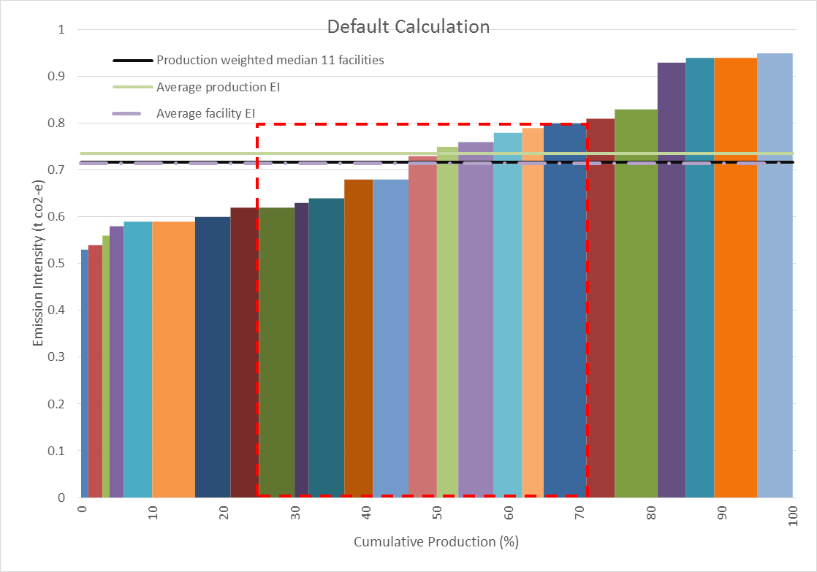

The graph shows emissions-intensity plotted by cumulative production for the example dataset. The proportion of production for the sector that contributes to the default value is indicated by the red dashed line. The emissions intensity default value is represented by the **black line** (0.717 tonnes CO2-e/ t production).