**Overview of the Proposed Area – Illawarra Region**

An area in the Pacific Ocean, off the Illawarra region of New South Wales (NSW) from Wombarra to   
Kiama is being considered for offshore wind and other renewable energy projects.

This area is a **proposal** for feedback. It is **not** the final declaration.

**Starting the conversation**

**This is your first opportunity to provide feedback.**

If a declaration is made in the future, developers will also be required to seek feedback on any   
proposed projects and demonstrate how they will share the area with existing users.

The Illawarra Region

The area proposed for offshore wind development in the Illawarra region of NSW extends from Wombarra in the north to Kiama in the south.

The Illawarra and South Coast of NSW is the traditional land and sea country of the Dharawal and Yuin people. This is an important consideration, as an offshore wind industry in this region will involve the installation of infrastructure across land and sea country to integrate with the NSW energy grid.

The Illawarra region is the third-largest economy within NSW and Port Kembla is the largest deep-water port in the region. Port Kembla handles 100% of car imports for NSW and is a major hub for the transport of goods and produce like grain, coal and shipping containers. Port Kembla contributes over 2.9 billion to the NSW Gross Product every year and supports over 10,000 regional jobs. Port Kembla has also been identified as one of the ports in consideration for the location of the future AUKUS submarine base on the eastern coast of Australia.

Traditionally the Illawarra economy has been heavily based on industrial manufacturing, coal mining and steel production. The Port Kembla Steelworks operated by BlueScope generates over 3 million tonnes of steel per year that is worth over 2 billion dollars and directly employs around 3,000 people. Coal mined in the Illawarra is used to supply coking coal to BlueScope for steel production.

Today, the Illawarra region still relies on these industries but also hosts a large tourism industry. The Illawarra has national parks, beautiful beaches and lakes, and scenic views along the Grand Pacific Drive and the Illawarra escarpment.

### The benefits of offshore renewable energy in the Illawarra Region

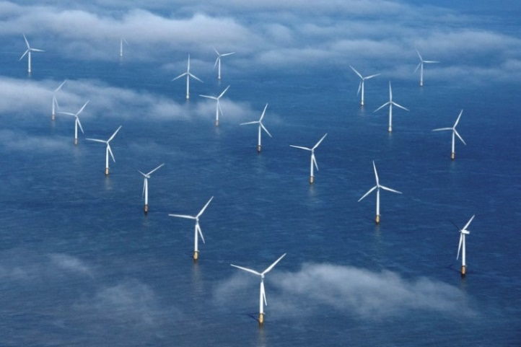The Australian Government has set a target of net zero emissions by 2050. Offshore wind projects can assist in achieving the target. Offshore wind has strong generation potential around Australia, including the Illawarra region, and can be a source of significant new large-scale power generation for manufacturing hydrogen, green steel, and green aluminium.

Offshore wind is thriving in many regions around the world, particularly offshore wind projects in the United Kingdom and Europe. Offshore wind is the current focus of development interest in Australia but this could evolve in the future as more renewable energy technologies come to market. Future licences could be considered for offshore solar, wave or tidal energy, or other forms of energy generation from renewable sources.

The Illawarra region is well suited for supporting an offshore wind industry because:

* It has strong, consistent winds;
* It is close to areas of high electricity demand and has a significant transmission, transport and port infrastructure already in place;
* Industry is very interested in developing projects in the area;
* Ageing coal-fired power stations are planning to shut down in future years throughout NSW, reducing energy production; and
* It is within the New South Wales Government’s proposed Illawarra Renewable Energy Zone (REZ).

NSW has immense potential for offshore wind energy production due to its long coastline and extensive continental shelf. The Illawarra region possesses wind and marine conditions capable of supporting large-scale offshore wind generation that could provide significant opportunities for regional job creation and investment, while also contributing to a reliable, secure, and affordable energy system. The [Blue Economy CRC report](https://blueeconomycrc.com.au/project/offshore-wind-potential-for-australia/) into Offshore Wind in Australia, suggests that the development of offshore wind could potentially offer alternative employment for workers in the coal industry.

Electricity generated by offshore wind projects in the area will supply renewable energy into the grid and to industries with high energy demand.

### The proposed area

The Minister for Climate Change and Energy has proposed an area in Commonwealth waters in the Illawarra region to be zoned for future offshore wind development. The area extends from off Wombarra in the north to Kiama in the south.

Map showing the proposed area in Commonwealth waters in the Illawarra region to be zoned for future offshore wind development. The area extends from off Wombarra in the north to Kiama in the south.

The Australian Government is looking to enable the development of renewable energy resources to help decarbonise the economy with year-round clean energy generation. This will reduce emissions and boost the share of renewables in the electricity grid.

This initial area for the Illawarra is a **proposal** and consultation is now open. We are seeking your feedback on the proposed area and the factors important to you about offshore wind and the potential for an offshore wind industry to coexist with other users and interests. The Minister will consider the submissions before deciding whether to declare all, part or none of the proposed area.

In defining the boundaries of the proposed area, feedback has already been considered at a regional scale, including initial feedback received from Commonwealth and NSW Government agencies, as well as technical limitations identified in the [Blue Economy CRC report](https://blueeconomycrc.com.au/project/offshore-wind-potential-for-australia/) into Offshore Wind in Australia.

Further work is being done with the Australian Maritime Safety Authority (AMSA) and the Port Authority of New South Wales to understand the vessel traffic in the area, and any requirements for the safe management of shipping to and from Port Kembla.

We have also developed a map that allows users to interact with the proposed Illawarra area and geographic information on other uses and interests in the area. The map, other tools, visualisations and data relevant to Offshore Renewable Energy in Australian waters are also available on the [Australian Marine Spatial Information System](https://amsis-geoscience-au.hub.arcgis.com/pages/renewables) portal.

### Visual amenity

We understand that the visibility of wind turbines may be of particular interest to local communities. The area that is currently being proposed is at least 10 kilometres from shore at the closest points. Offshore wind turbines are the tallest renewable energy infrastructure option that could be developed, with some offshore wind turbines currently being manufactured around the world being up to 280m in height. The visual effect of wind turbines will depend on where within a declared area the proposed project is located, the distance of turbines from the shore, the height of the turbines, the elevation from where they are being viewed and the amount of haze in the atmosphere. The relative height and visual effect decreases with distance and due to the curvature of the earth.

Offshore wind projects will only be developed within an area that is declared by the Minister. The exact location of offshore wind projects and number of turbines that may be proposed for an individual project is yet to be determined. We encourage you to make a submission if you have suggestions as to how visual impacts could be managed.

Developers who are successful in obtaining feasibility licences will need to consult on the location and placement of any future turbines as part of testing the feasibility of their project proposals, and to support assessment of environmental impacts under the [*Environment Protection and Biodiversity Conservation Act 1999,*](https://www.dcceew.gov.au/environment/epbc/referral-and-assessment-process) before projects are approved for construction.

##### Overseas experience

Denmark is one of the major leaders in the offshore wind industry, with years of experience developing these projects. The Denmark’s Ministry of Foreign Affairs, and The Danish Energy Agency have created a [video demonstration](https://www.offshorewindtour.org/international/?lang=en#/scene/1385/1675/1844/1851:1916) helping to show what offshore wind farms look like from certain distances from the shore. This may help to visualise what potential wind farms will look like.

Future offshore renewable energy projects must demonstrate how they will share the area with existing users and interests.

### Marine users and interests

The Australian Government wants to manage the offshore marine environment in a way that recognises all users and balances competing interests, including those of Traditional Owners in the region. Understanding existing users and interests in and near the proposed area is important, and will help the Minister for Climate Change and Energy’s decide whether the area is suitable for offshore wind development. Future offshore wind projects must share the area with other users and interests.

For detailed information on existing users and interests in the vicinity of the area, please read [Marine Users, Interests, and the Environment – Illawarra Region](https://storage.googleapis.com/files-au-climate/climate-au/p/prj2869c55100729a52dc66b/public_assets/Marine%20Users%20and%20Interests%20-%20Illawarra%20region.pdf)*.*

### The offshore renewable energy process

**This is your first opportunity to provide feedback on the proposed area**. In the future, and if an area is declared, developers will be required to apply for feasibility licences. Licence holders will be required to seek feedback on their proposed projects and must demonstrate, to the satisfaction of the Offshore Infrastructure Regulator, how they will share the area with existing users. For further detailed information on the Australian Government offshore renewable energy process, please read the [Offshore Renewable Energy Process](https://storage.googleapis.com/files-au-climate/climate-au/p/prj2869c55100729a52dc66b/public_assets/Overview%20of%20the%20Offshore%20Renewable%20Energy%20Process.pdf).

### Provide your feedback

**This is your first opportunity to provide feedback.** We want your feedback on the proposal to declare an area and what your think an offshore wind industry may mean for the region, including the interactions with other marine users and interests.

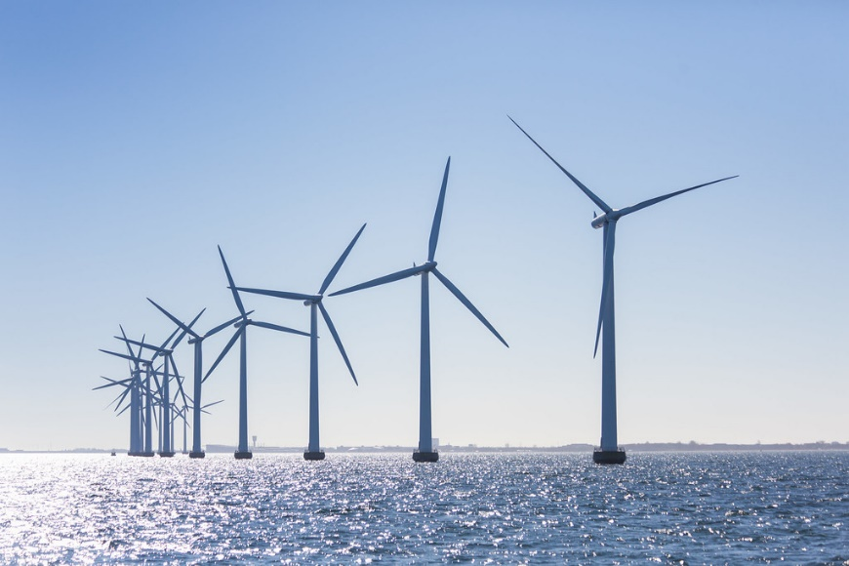You can make a submission through our [Have your say portal](https://consult.dcceew.gov.au/oei-illawarra). Your feedback will help inform the Minister’s decision on whether the proposed area is suitable for offshore wind development. **Your feedback must be provided through the** [Have your say portal](https://consult.dcceew.gov.au/oei-illawarra) **by 11:59pm (AEDT) Wednesday 15 November 2023.**

### Further information

For more information on marine users, interests, and the environment in the Illawarra region, please see [Marine Users, Interests, and the Environment – Illawarra Region](https://storage.googleapis.com/files-au-climate/climate-au/p/prj2869c55100729a52dc66b/public_assets/Marine%20Users%20and%20Interests%20-%20Illawarra%20region.pdf).

For responses to frequently asked questions, please see the [Frequently Asked Questions – Illawarra region](https://storage.googleapis.com/files-au-climate/climate-au/p/prj2869c55100729a52dc66b/public_assets/Frequently%20Asked%20Questions%20-%20Illawarra.pdf).

For information on the *Offshore Electricity Infrastructure Act 2021* please visit the [Establishing offshore renewable energy infrastructure web page](https://www.dcceew.gov.au/energy/renewable/establishing-offshore-infrastructure). If you have any questions, you can [email our team](mailto:offshorerenewables@dcceew.gov.au).

**Back to top**[An area in the Pacific Ocean, off the Illawarra region of New South Wales (NSW) from Wombarra to   
Kiama is being considered for offshore wind and other renewable energy projects.](#_top)

This area is a **proposal** for feedback. It is **not** the final declaration.

**Starting the conversation**

**This is your first opportunity to provide feedback.**

[If a declaration is made in the future, developers will also be required to seek feedback on any   
proposed projects and demonstrate how they will share the area with existing users.](#_top)

**of document ↑**