**Frequently Asked Questions – Proposed offshore renewable energy area in Bass Strait off northern Tasmania**

## What is being proposed?

The area in the Bass Strait, north of Tasmania has been identified as a potential site for zoning for future offshore wind development in Australian Commonwealth waters.

## Where is the Northern Tasmania region?

The proposed area is located at least 20kms from the shoreline of all land areas and extends from Burnie in the west to Bridport in the east.

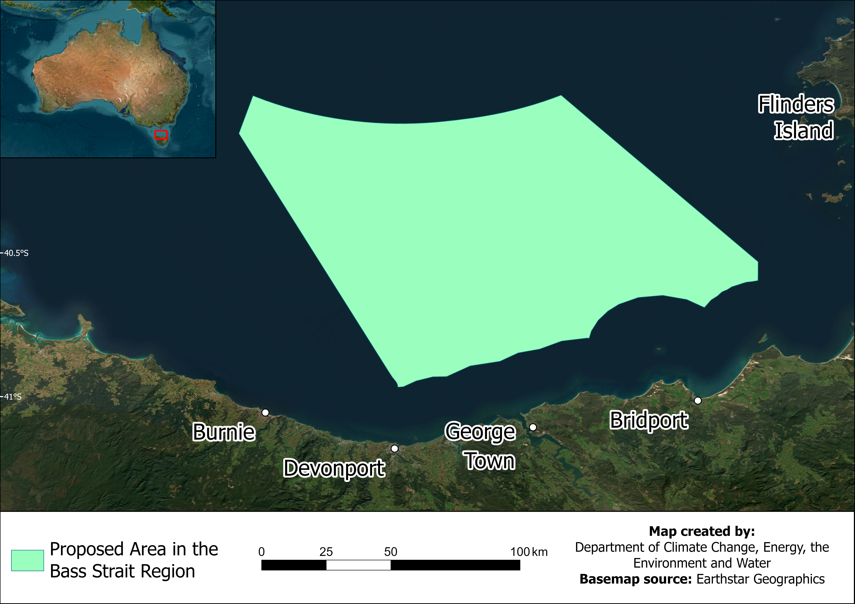

## How can I have my say?

**This is your first opportunity to provide feedback.**

We want your feedback on the proposal and how offshore wind projects could share the area with other marine users and interests. We encourage your feedback through a submission through our [Have Your Say](https://consult.dcceew.gov.au/oei-bass-strait) web portal.

## Is this the only chance to have my say?

**No.** **This is just the first opportunity to provide feedback**.

Proposing an area is a first step to hear about who is using the wider marine area, before developers can seek licences over smaller areas within any area declared by the Minister. As part of testing the feasibility of project proposals, licence holders will need to consult with the local community and marine users. The Australian Government is currently developing regulations that will set out the details and requirements of management plans to be developed in the feasibility stage, including the requirement for licence holders to undertake further consultation.

## Why is offshore wind being considered?

The Australian Government has set a target of net zero emissions by 2050. Offshore wind projects within the Bass Strait region can help the Australian Government meet these targets.

## How will this benefit the local community?

Offshore wind projects in the Bass Strait can help decarbonise the economy with year-round clean energy generation and drive regional jobs growth, with a need for skills in engineering and construction, as well strong transferable skills from other sectors including high-voltage electrical, logistics and offshore work.

## How are Tasmanian Aboriginal people being engaged?

The Tasmanian Aboriginal Community have significant interests in the marine region, Bass Strait and the Bass Strait Islands in particular, as part of their cultural heritage. Engagement with the Aboriginal community is an important part of the declaration process, to ensure decisions are made that support the communities' interests. We welcome feedback from Tasmanian Aboriginal community organisations and individuals through the dedicated engagement process that is underway. Written submissions are required to be made through our [Have Your Say](https://consult.dcceew.gov.au/oei-bass-strait) portal.

## How will the environment be protected?

We have consulted with government agencies responsible for the protection of the environment. Developers must receive approval under the *Environment Protection and Biodiversity Conservation Act 1999* for any project proposed in an area that is declared. This will include an assessment of the relevant impacts and proposed avoidance, management, and mitigation to demonstrate that acceptable environmental outcomes can be achieved and ensure minimal impact on the marine environment. For more information on how the environment will be protected, please see *Marine Users, Interests, and the Environment – Bass Strait region.*

We have recently published guidance material on how we expect offshore wind developers to consider potential environmental impacts before seeking approvals. This is available on our [website](https://www.dcceew.gov.au/environment/epbc/publications/key-factors-guidance).

## What sort of projects might be built in the area?

Currently, development interest is mostly focused on potential offshore wind projects. This could change in the future as more renewable energy generation technologies come to market. Future licences could be granted for offshore solar, wave or tidal energy, or other forms of energy generation from renewable sources.

## Will I still be able to access the area?

Yes, in line with rules that manage safe navigation in the maritime space. The Australian Government will manage the offshore marine environment in a way that recognises all users and balances competing interests. **Future offshore wind projects** **must work with existing users and interests to ensure the area is shared, while maintaining a safe marine space during construction, operation and maintenance phases.**

## Will I be able to fish in the area?

Yes – to the extent possible to ensure a safe marine space. It is Australian Government policy that offshore renewable energy projects will need to share the marine space with existing users. Restrictions may be placed around specific infrastructure to manage safety. However, marine users will be able to still access the areas between turbines and other infrastructure.

It is expected that project developers will consult with fishers and other impacted users to minimise any disruptions. For detailed information on fishing in the vicinity of the area, please read *Marine Users, Interests, and the Environment – Bass Strait region.*

## How many wind turbines could there be, and will I be able to see them?

The proposed area is at least 20 kilometres from the shore. Many population areas along the northern coastline are more than 30 kilometres from the edge of the proposed area, while the distance from Flinders Island is more than 50 kilometres.

The visibility of offshore wind turbines varies according to a range of factors. Their visual effect will depend on their distance to the shore, the height of the turbines, the extent of haze in the atmosphere and the elevation of where from shore they are being viewed. The exact location of projects and number of turbines that may be proposed within a future declared area is yet to be determined.

The table below provides distances from main population centres and significant locations to the nearest point of the proposed area.

|  |  |
| --- | --- |
| Location | Distance to proposed area |
| Stanley | 70 km |
| Wynyard | 50 km |
| Burnie | 40 km |
| Devonport | 20 km |
| George Town | 20 km |
| Bridport | 32 km |
| Cape Portland | 30 km |
| Tareerpattel-tarerenner / Ninth Island | 20 km |
| Truwana / Cape Barren Island | 30 km |
| Flinders Island (Nearest point) | 48 km |
| Flinders Island (Whitemark)  Wilson’s Promontory (Victoria)  King Island | 55 km  100kms  140kms |

## What happens to the wind turbines once they reach their end of life?

Offshore wind turbines have a specific lifespan. Once they reach the end of this, they are decommissioned. Currently, up to 95% of wind turbines are recyclable, with manufacturers aiming to reach 100% recyclable in the next few years. Each developer must provide a clear plan and financial security for decommissioning, before they are granted a commercial licence – they cannot be granted a commercial licence without these. These arrangements must be set out in their management plan, which is approved by the Offshore Infrastructure Regulator (OIR).

## What marine users and interests are in the area?

We have undertaken initial consultation with Commonwealth and Tasmanian government departments and agencies to identify interests in the vicinity of the area. Examples of marine users and interests in the area include: Defence, Indigenous Protected Areas (IPAs), various species of marine animal life, vessel traffic, weather radars, commercial and recreational fishing, owners of existing infrastructure, and tourism industry. For more detailed information, please read *Marine Users, Interests, and the Environment – Bass Strait region.*

## How will this affect shipping and vessel traffic?

We are working with the Australian Maritime Safety Authority (AMSA) and the Tasmanian Port Authority (TasPorts), to determine whether specific areas will need to be identified for vessel traffic to ensure the safe management of shipping in and out of Northern Tasmanian ports. This consultation will be ongoing throughout the public consultation period.

## How will electricity generated in the area be transmitted and used?

Electricity generated by potential offshore wind projects in the area may be transmitted onshore to be fed into the National Electricity Market (NEM) or be used to supply a specific end user, such as heavy industry.

Existing connection infrastructure may have capacity limitations that could put an upper limit on the number of prospective projects. It is the responsibility of prospective developers to understand existing and future capacity requirements and consider the prospective end use of future electricity generated in the area.

## Do existing legal requirements continue to apply?

Yes. Prospective developers are responsible for obtaining all relevant approvals under Commonwealth and State government legislation. Developers are required to be aware of all other rights and obligations that may apply to their respective projects. This may include, but is not limited to, [Underwater Cultural Heritage](https://www.legislation.gov.au/Series/C2018A00085), [Biosecurity](https://www.legislation.gov.au/Series/C2015A00061), [Navigation](https://www.legislation.gov.au/Series/C2012A00128), [Immigration](https://www.legislation.gov.au/Series/C1958A00062), [Customs](https://www.legislation.gov.au/Series/C1901A00006), [Environment Protection and Biodiversity Conservation](https://www.legislation.gov.au/Series/C2004A00485) and [Air Services](https://www.legislation.gov.au/Series/C2004A04931).

## How long will the area be declared for?

When declaring an area suitable for offshore wind development, the Minister is not required to specify for how long the declaration will last. If the declaration instrument does not state an end date, it will remain in force until it is revoked. To revoke the declared area, the Minister must undertake a consultation process and consider the submissions received. If a declaration is revoked, or otherwise ends, any licences that have already been issued will remain; however, they cannot be changed or renewed.