**Overview of the Proposed Area – Bass Strait**

An area in Bass Strait, off Northern Tasmania from offshore Wynyard to   
Bridport, is being considered for offshore wind and other renewable energy projects.

This area is a **proposal** for feedback. It is **not** the final declaration.

**Starting the conversation**

**This is your first opportunity to provide feedback.**

If a declaration is made in the future, developers will also be required to seek feedback on any   
proposed projects and demonstrate how they will share the area with existing users.

### The Bass Strait region

The area proposed for offshore wind development in Bass Strait, off Northern Tasmania extends from Burnie in the west to Bridport in the east. The area is at least 20kms offshore.

The Tasmanian Aboriginal Community have significant interests in the Bass Strait marine region as part of their cultural heritage. Many sacred sites exist on Sea Country, and there is ancestral connection to seabeds that were once dry land. This is an important consideration, as an offshore wind industry in this region will involve the installation of infrastructure across land and sea country.

Bass Strait contains significant port facilities including Bell Bay, Devonport, Burnie and Port Latta. Smaller regional ports include those at Bridport, Smithton, and Ulverstone. These ports provide connectivity to mainland Australia and the Bass Strait Islands and serve tourism and recreational fishing industries as well as bulk commodity exports such as minerals, forestry, and agricultural products.

The Bass Strait region is home to national parks, beaches, islands, and scenic views along a wide range of coastal locations. In the year ending March 2023, there were 1.3 million visitors to Tasmania, generating approximately 3 billion dollars in expenditure[1]. According to Tourism Tasmania, more than half of the visitors to Tasmania visit the northern region.

### The benefits of offshore renewable energy in Bass Strait

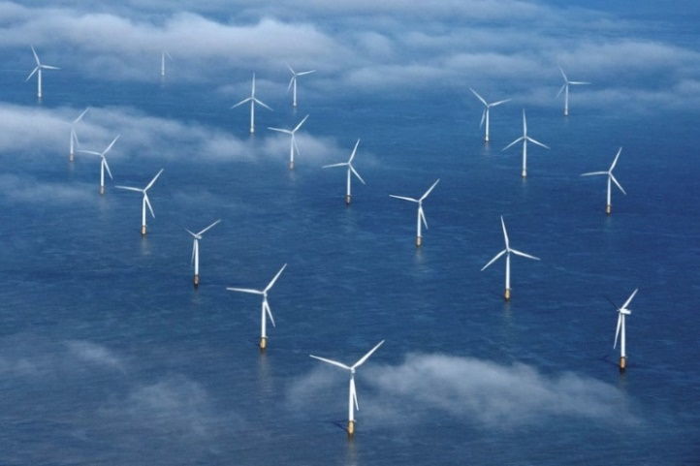The Australian Government has set a target of net zero emissions by 2050. Offshore wind projects can assist in achieving the target. Offshore wind has strong generation potential around Australia, especially in Bass Strait, and can be a source of significant new large-scale power generation for manufacturing hydrogen, green steel, and green aluminium.

Offshore wind is thriving in many regions around the world, particularly offshore wind projects in the United Kingdom and Europe. Offshore wind is the current focus of development interest in Australia but this could evolve in the future as more renewable energy technologies come to market. Future licences could be considered for offshore solar, wave or tidal energy, or other forms of energy generation from renewable sources.

Bass Strait is well suited for supporting an offshore wind industry because:

* It has strong, consistent winds.
* It is close to areas of high electricity demand and has significant transmission, transport and port infrastructure already in place.
* Industry is very interested in developing projects in the area.

Tasmania has immense potential for offshore wind energy production due to its long coastline, it possesses wind and marine conditions capable of supporting large-scale offshore wind generation that could provide significant opportunities for regional job creation and investment, while also contributing to a reliable, secure, and affordable energy system.

Electricity generated by offshore wind projects in the area will supply renewable energy into the grid and to industries with high energy demand.

### The proposed area

The Minister for Climate Change and Energy has proposed an area in Commonwealth waters in Bass Strait to be zoned for future offshore wind development. The area extends from off Wynyard in the west to Bridport in the east.

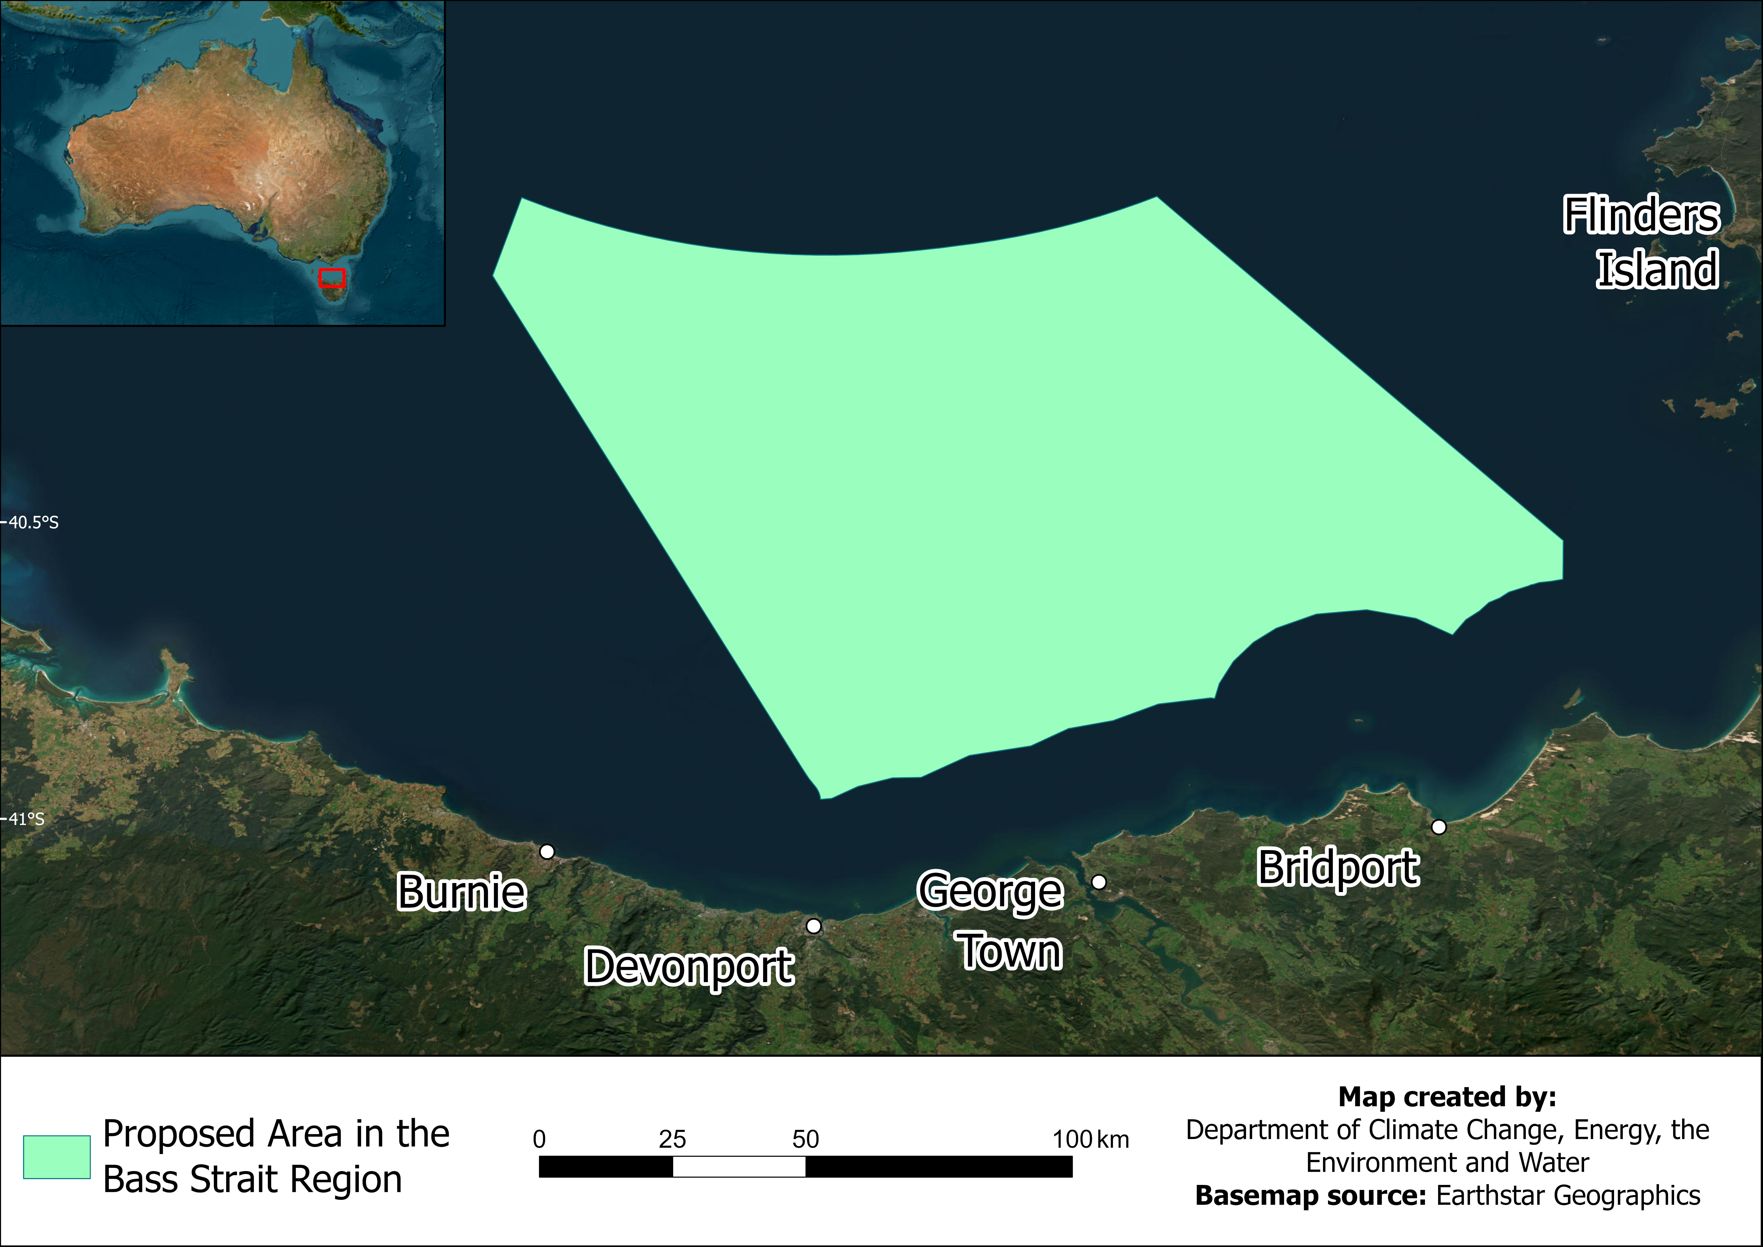

The Australian Government is looking to enable the development of renewable energy resources to help decarbonise the economy with year-round clean energy generation. This will reduce emissions and boost the share of renewables in the electricity grid.

This initial area for Bass Strait is a **proposal** and consultation is now open. We are seeking your feedback on the proposed area and the factors important to you about offshore wind and the potential for an offshore wind industry to coexist with other users and interests. The Minister will consider the submissions before deciding whether to declare all, part or none of the proposed area.

In defining the boundaries of the proposed area, feedback has already been considered at a regional scale, including initial feedback received from Commonwealth and Tasmanian Government agencies, as well as technical limitations identified in the [Blue Economy CRC report](https://blueeconomycrc.com.au/project/offshore-wind-potential-for-australia/) into Offshore Wind in Australia.

Further work is being done with the Australian Maritime Safety Authority (AMSA) and TasPorts to understand the vessel traffic in the area, and any requirements for the safe management of shipping to and from the north coast of Tasmania.

We have also developed a map that allows users to interact with the proposed area and geographic information on other uses and interests in the area. The map, other tools, visualisations and data relevant to Offshore Renewable Energy in Australian waters are also available on the [Australian Marine Spatial Information System](https://amsis-geoscience-au.hub.arcgis.com/pages/renewables) portal.

### Visual amenity

The area that is currently being proposed is at least 20 kilometres from shore at the closest points, and in many parts much further offshore. Offshore wind turbines are the tallest renewable energy infrastructure option that could be developed, with some offshore wind turbines currently being manufactured around the world being up to 280m in height. The visual effect of wind turbines will depend on where within a declared area the proposed project is located, the distance of turbines from the shore, the height of the turbines, the elevation from where they are being viewed and the amount of haze in the atmosphere. The relative height and visual effect decreases with distance due to the curvature of the earth.

Offshore wind projects will only be developed within an area that is declared by the Minister. The exact location of offshore wind projects and number of turbines that may be proposed for an individual project is yet to be determined. We encourage you to make a submission if you have suggestions as to how visual impacts could be managed.

Developers who are successful in obtaining feasibility licences will need to consult on the location and placement of any future turbines as part of testing the feasibility of their project proposals, and to support assessment of environmental impacts under the [*Environment Protection and Biodiversity Conservation Act 1999,*](https://www.dcceew.gov.au/environment/epbc/referral-and-assessment-process) before projects are approved for construction.

### Overseas experience

Denmark is one of the major leaders in the offshore wind industry, with years of experience developing these projects. Denmark’s Ministry of Foreign Affairs, and the Danish Energy Agency have created a [video demonstration](https://www.offshorewindtour.org/international/?lang=en#/scene/1385/1675/1844/1851:1916) helping to show what offshore wind farms look like from certain distances from the shore. This may help to visualise what potential wind farms will look like.

Future offshore renewable energy projects must demonstrate how they will   
share the area with existing users and interests.

### Marine users and interests

The Australian Government wants to manage the offshore marine environment in a way that recognises all users and balances competing interests, including those of Traditional Owners in the region. Understanding existing users and interests in and near the proposed area is important and will help the Minister for Climate Change and Energy decide whether the area is suitable for offshore wind development. Future offshore wind projects must share the area with other users and interests.

### The offshore renewable energy process

**This is your first opportunity to provide feedback on the proposed area**. In the future, and if an area is declared, developers will be required to apply for feasibility licences. Licence holders will be required to seek feedback on their proposed projects and must demonstrate, to the satisfaction of the Offshore Infrastructure Regulator, how they will share the area with existing users. For further detailed information on the Australian Government offshore renewable energy process, please read the *Offshore Renewable Energy Process*.

### Provide your feedback

**This is your first opportunity to provide feedback.** We want your feedback on the proposal to declare an area and what you think an offshore wind industry may mean for the region, including the interactions with other marine users and interests.

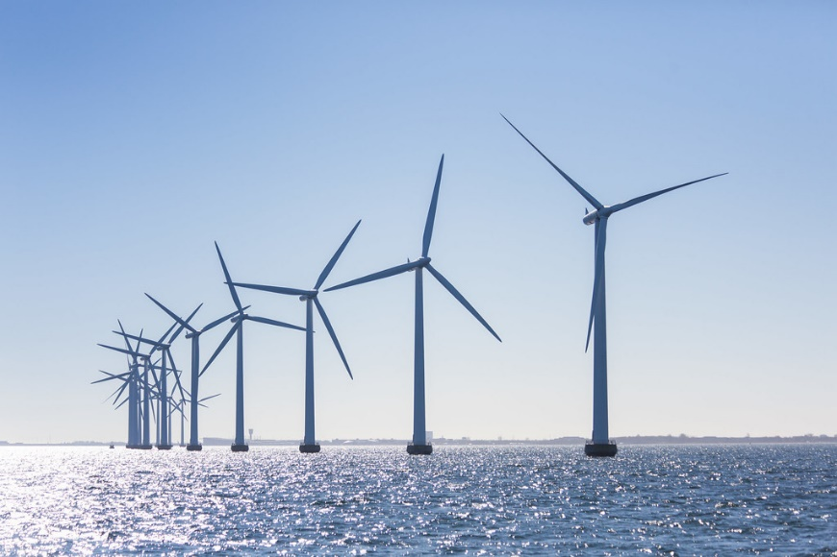You can make a submission through our [Have your say](https://consult.dcceew.gov.au/oei-bass-strait) portal. Your feedback will help inform the Minister’s decision on whether the proposed area is suitable for offshore wind development. **Your feedback must be provided through the** [**Have your say**](https://consult.dcceew.gov.au/oei-bass-strait) **portal** **by 11:59pm (AEDT) Wednesday 31 January 2024.**

### Further information

For more information on marine users, interests, and the environment in Bass Strait, please see *Marine Users, Interests, and the Environment – Bass Strait*.

For responses to frequently asked questions, please see the *Frequently Asked Questions –Bass Strait.*

For information on the *Offshore Electricity Infrastructure Act 2021* please visit the [Establishing offshore renewable energy infrastructure web page](https://www.dcceew.gov.au/energy/renewable/establishing-offshore-infrastructure). If you have any questions, you can [email our team](mailto:offshorerenewables@dcceew.gov.au).

1. [Visitor Statistics - Tourism Tasmania Corporate](https://www.tourismtasmania.com.au/research/visitors/)