# SUMMARY DOCUMENT COCKATOO ISLAND / WAREAMAH DRAFT MASTER PLAN NOVEMBER 2023

View of Sydney Harbour looking from Cockatoo Island to Harbour Bridge.

Cockatoo Island Logo Harbour Trust logo

# CONTENTS

ACKNOWLEDGEMENT OF COUNTRY

1. INTRODUCTION

1.1 The vision that underpins the draft master plan

1.2 About the draft master plan

1.3 Statutory framework and the role of the master plan

2. WHERE WE ARE NOW AND NEXT STEPS

3. FOUR DISTINCT LAYERS OF HISTORY AND HERITAGE

3.1 Natural history

3.2 First Nations Connecting with Country

3.3 Convicts, prisoners and school children

3.4 Dockworking, shipbuilding and defending Australia

4. KEY ELEMENTS OF THE DRAFT MASTER PLAN

4.1 Arrival, circulation and accessibility

4.2 Enhanced food and beverage

4.3. Maritime use

4.4. Public programs and visitor experience

4.5. Accommodation for all

5. HAVE YOUR SAY

# ACKNOWLEDGEMENT OF COUNTRY

The Harbour Trust acknowledges the Traditional Custodians and Owners of the lands, waters, and sky of Sydney Harbour, including the places under our stewardship. We respectfully acknowledge the Traditional Owners of Sydney Harbour, including those belonging to the Borogegal, Birrabirrigal, Cammeraygal, Gadigal, Gayamagal, Wallumedegal and Wangal clans.

The Project Team recognises we are working within a cultural landscape and understand designing with Country is a privilege that comes with responsibility. We are guided by the inspiration of Country and the knowledge it contains.

<pp>2

# 1. INTRODUCTION

**Photo caption: Looking out to Cockatoo Island from ferry. Credit: Sydney Harbour Federation Trust2 people standing on a ferry looking over the water to Cockatoo Island.**

The Harbour Trust has created the Cockatoo Island / Wareamah draft master plan for public exhibition. This is a summary document of the plan. The full draft master plan can be read **here.** [www.harbourtrust.gov.au/cockatoo-island-consultation](http://www.harbourtrust.gov.au/cockatoo-island-consultation)

The draft master plan is a detailed examination of the island’s cultural and natural heritage values, its constraints and opportunities, and presents the Harbour Trust’s long-term vision of place. Master planning for this significant site will involve further engagement with community, state and local government stakeholders, including First Nations community members and knowledge holders, building on the conversation that started in 2019 and the previous consultation on the concept vision in 2021.

The draft master plan provides guiding principles for future revitalisation of both the lands and the built assets within the context of the Harbour Trust’s **Cockatoo Island Management Plan.**

|  |
| --- |
| To have your say about the Cockatoo Island / Wareamah Draft Master Plan, visit [**www.harbourtrust.gov.au/cockatoo-island-consultation**](http://www.harbourtrust.gov.au/cockatoo-island-consultation)and:   * Review this summary of the draft master plan * Review the Cockatoo Island / Wareamah Draft Master Plan * Provide Feedback, see page 16 for details   Submit feedback by 5pm Wednesday 13 December 2023 (AEDT) |

<pp>3

## 1.1 The vision that underpins the draft master plan

The Cockatoo Island / Wareamah draft master plan presents a new vision for reactivation and transformation – for the island to become the vibrant and connected heart of the Western Sydney Harbour.

It offers a sympathetic spatial response to Cockatoo Island / Wareamah’s layers of complexity and opportunity, with re-imagined and authentic places and spaces to enable new and expanded visitor experiences, staged adaptive reuse and place transformation over time.

Importantly, the draft master plan will help ensure Cockatoo Island / Wareamah is no longer a standalone, somewhat isolated place, and is reconnected to the cultural fabric of the city and of the nation. The island is re-positioned as a premium Australian heritage destination, which is central to the Sydney Harbour tourism experiences, known for its maritime ecology and ecosystem restoration, pre-eminent festivals and major events, and connected with whole-of-harbour First Nations experiences.

The Cockatoo Island / Wareamah draft master plan envisions a future for the island that:

* Acknowledges the traditional ownership of First Nations peoples to the lands and waters of Wareamah, establishing, protecting and interpreting First Nations values of place.
* Conserves, interprets and protects the outstanding universal values of place as stated under the sites’ UNESCO World Heritage listing.
* Rehabilitates the lands and conserves the built form to retain and enhance the unique character of Cockatoo Island / Wareamah.
* Revives the ‘working harbour’ industrial site, transforming the island to support a range of new and appropriate uses that connect the island into the fabric of day-to-day Sydney life.
* Supports and enhances Sydney’s cultural and creative life, providing capability that drives significant and sustainable visitation and tourism.
* Evolves to provide an economically resilient and self-sustaining long term future for the island as a highly valued nationally significant cultural heritage asset.

**Photo caption: Cockatoo Island / Wareamah Convict Precinct. Source: Sydney Harbour Federation Trust**

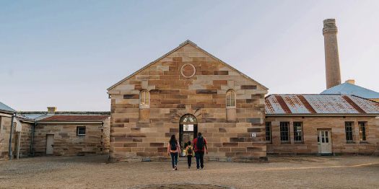

<pp>4

## 1.2 About the draft master plan

Generally, the Harbour Trust defines a master plan as two things. It involves:

* Robust analysis of an area to establish key constraints and opportunities.
* The preparation of a design response that carefully references and responds to the above analysis.

The draft master plan collates insights into a spatial design response which is not a finished ‘solution’ to the island but – consistent with the island’s history of transformation – enables a new chapter of change, attracting visitors, families, tourists, artists, businesses and workers to re-discover and enjoy Cockatoo Island / Wareamah as a must-visit destination on Sydney Harbour. In short, a master plan puts forward a future vision of place.

The Cockatoo Island / Wareamah draft master plan has been prepared to provide a vision for future renewal of both the lands and the built assets within the context of the Harbour Trust’s Cockatoo Island Management Plan and the considerable cultural, natural, geographical and First Nations significance. It outlines the full potential, rather than what current funding permits, so future decisions on projects and staging can be made strategically.

**Photo caption: Aerial view of Cockatoo Island today. Source:** **SydneyImages.com.au**

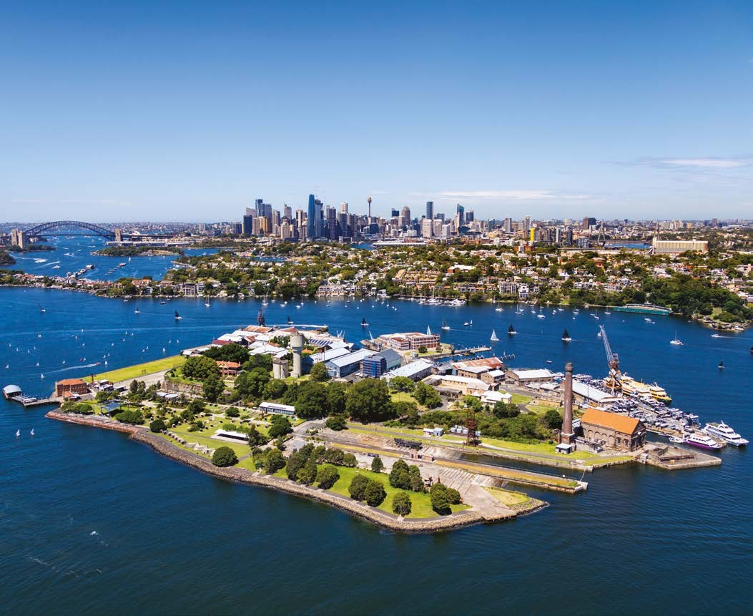

<pp>5

## 1.3 Statutory framework and the role of the master plan

The planning context for the draft master plan is shown below.

The 2003 Comprehensive Plan and the 2017 Cockatoo Island Management Plan are statutory plans which have informed the preparation of the draft master plan. The master plan provides design guidance for future proposals in the precinct. Proposals for implementation must be consistent with the statutory plans, and are subject to the detailed planning approval stage. Significant proposals will be made available for further public consultation.

### Harbour Trust planning framework

Harbour Trust planning framework

<Transcriber's Note>

The Flowchart above shows Statutory Processes – All sites and Design Management Processes.

**Statutory Processes – All Sites**

Environment Protection and Biodiversity Conservation Act 1999 [arrow down to]

* **2017 Cockatoo Island Management Plan** (In accordance with the Comprehensive Plan and the EPBC Act) [Arrow down to]
* Planning Permits and Approvals (In accordance with the SHFT Act and Regulations, and EPBC Act)

Sydney Harbour Federation Trust Act 2001 [arrow down to]

* **Comprehensive Plan** (In accordance with Part 5 of the SHFT Act) [arrow down to]
* **2017 Cockatoo Island Management Plan** (In accordance with the Comprehensive Plan and the EPBC Act) [Arrow down to]
* Planning Permits and Approvals (In accordance with the SHFT Act and Regulations, and EPBC Act)

**Design Management Processes**

**Comprehensive Plan** and **2017 Cockatoo Island Management Plan** have arrows across to

* **Cockatoo Island / Wareamah Draft Master Plan** (Includes stakeholders engagement and community consultation leading to final master plan) [Arrow down to]
* **Design** Includes architecture, engineering research, interpretation, program development and co-design with First Nations peoples for all individual elements proposed withing the Master Plan [Arrow down to]
* **Community consultation** Exhibition of design for feedback [Arrow down to]
* **Final design**

Design has a double headed arrow to 2017 Cockatoo Island Management Plan.

Final design has arrow to Planning permits and approvals.

</Transcriber's Note>

<pp>6

# 2. WHERE WE ARE NOW AND NEXT STEPS

* 2017: COCKATOO ISLAND MANAGEMENT PLAN
* 2019: INDEPENDENT REVIEW OF THE HARBOUR TRUST
* 2019: COCKATOO ISLAND COMMUNITY DIALOGUE
* 2021: COCKATOO ISLAND / WAREAMAH DRAFT CONCEPT VISION PUBLIC CONSULTATION
* Late 2021: COCKATOO ISLAND / WAREAMAH DRAFT CONCEPT VISION CONSULTATION OUTCOMES REPORT
* Late 2021 FIRST NATIONS GUIDING PRINCIPLES DEVELOPED
* 2022 to 2023 HERITAGE CONSERVATION WORKS
* **2023 We are here COCKATOO ISLAND / WAREAMAH DRAFT MASTER PLAN PUBLIC CONSULTATION**
* Early 2024 CONSULTATION OUTCOMES REPORT
* 2024 FINALISE MASTER PLAN AND APPROVAL BY MEMBERS OF THE TRUST
* TBC* DETAILED DESIGN WORK
* TBC* FURTHER CONSULTATION

* The draft master plan outlines the long-term vision for Cockatoo Island / Wareamah across the next 15 years, therefore work is not expected to begin in the immediate future and is subject to funding availability.

<pp>7

# 3. FOUR DISTINCT LAYERS OF HISTORY AND HERITAGE

Four historic journeys or themes, guide the draft master plan design response and help identify opportunities for visitor experience and interpretation. The intention is that the island will attract visitors because of its world class heritage experience, its natural beauty and its diversity of activities for a wide range of people and interests.

The island can be overwhelming, particularly for first-time visitors, so an overall interpretive strategy will be adopted as part of the master plan that introduces the layers of natural and cultural heritage, supports orientation soon after arrival, and encourages active engagement with Cockatoo Island / Wareamah as a place, so that visitors can choose how they would prefer to move around and explore. Around the island, physical wayfinding and interpretation signage will be integrated with the digital guide, and support the four key journeys.

## 3.1 Natural history

Cockatoo Island / Wareamah will present visitors with an unmatched opportunity to understand the natural heritage of the most beautiful harbour in the world. Sydney’s renowned natural beauty is on display both from the island as a viewing point and within the island. This is an opportunity for visitors to connect with Australia’s deep history as a continent, the resilience of our landscapes and contemporary discussions of environmental conservation.

Experiencing this journey could include;

* Walking the shape of the island before 1788
* Regenerating plant and animal communities including Angophora costata canopy, a known Cockatoo habitat
* Relaxing in the new Harbour Park that reflects how the island once was
* Seeing plant and animal life growing on the artificial reef.

**Photo Caption: Illustration of the natural history of the island journey. Source: Tyrrell Studio**

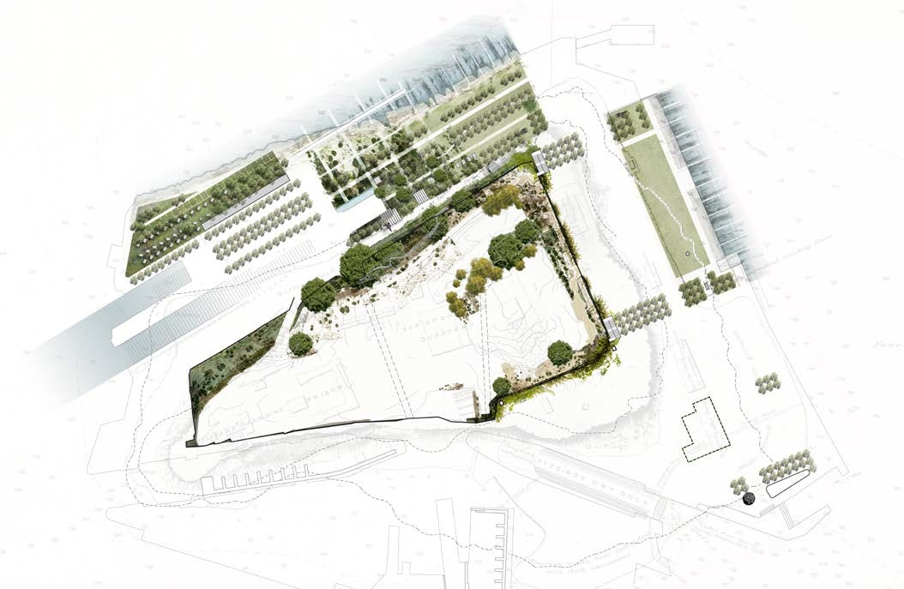

<pp>8

## 3.2 First Nations Connecting with Country

Connecting with Country requires more than acknowledgment, it requires deep understanding, a process that includes connecting with all of the local First Nations peoples, stories and knowledges, walking on Country, listening and challenging the norms of practice.

The places, spaces and experiences proposed for the next chapter of Wareamah / Cockatoo Island will be informed by the cultural values explored in the draft master plan to bring visitors closer to contemporary understandings of Country.

Experiencing this journey could include;

* Welcome to Country at key arrival points
* Yiningma, high Country ceremonial and gathering places overlooking the new Harbour Park
* Exploring Caring for Country through the replanting of native species and reconnecting the cliffs to the water and constructed reef ecologies
* Supporting First Nations practice and business in canoe-making, water tours, traditional boating and canoe hire, First Nations ranger tours and educational experiences.

**Photo caption: Illustration of the First Nations Connecting with Country journey. Source: Tyrrell Studio**

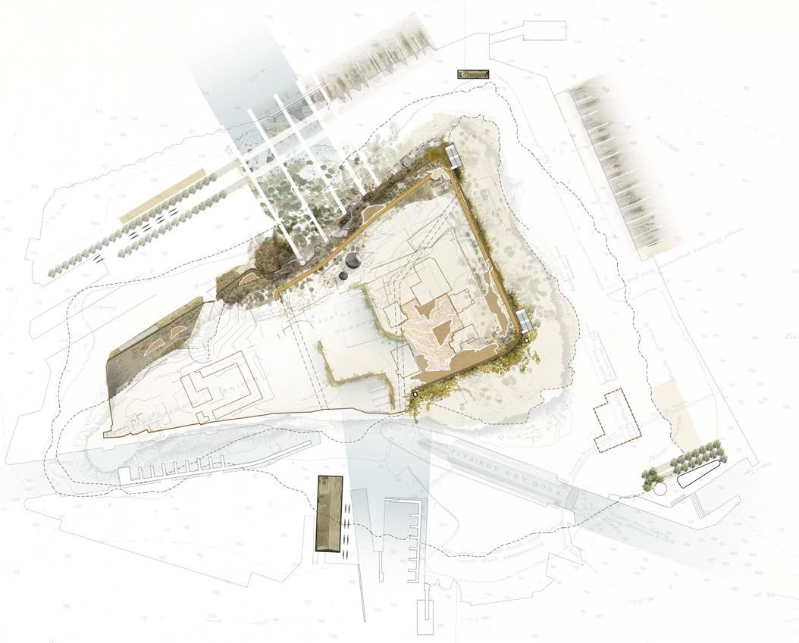

<pp>9

## 3.3 Convicts, prisoners and school children

Cockatoo Island / Wareamah is best known as a place of incarceration. In 2010, the Cockatoo Island Convict Site was inscribed on the UNESCO World Heritage List with 10 other heritage sites nationwide, collectively known as the Australian Convict Sites. Less well-known is that during a short period of the island’s history in the nineteenth century, it was used in two distinct modes during the convict era, later as a prison, and then as a location for an industrial school and reformatory for girls, and a nautical school ship for boys.

As an important place within the colonial system, Cockatoo Island / Wareamah was part of a complex network that saw convicts moved around the colonies, First Nations peoples removed from their traditional lands and incarcerated, and children confined and trained for colonial life. Some of the tangible fabric of this theme is still highly visible across the island, which presents opportunities for visitors to be immersed in the changing conditions of its inhabitants through these periods.

Experiencing this journey could include;

* Exploring the Barracks Precinct, and the hospital, kitchen, mess and sleeping quarters for convicts, soldiers and officers , with selected fitouts to evoke how it was used
* Displays and stories on the convict system and the education institution for boys and girls
* Visiting Fitzroy Dock, which may after investigation, be emptied of water and displayed so visitors can appreciate the achievement of excavating its vast volume by hand
* Exploring the grain silos and imagining the hard labour involved digging them by hand.

**Photo Caption: Illustration of the convicts, prisoners and school children journey. Source: Tyrrell Studio**

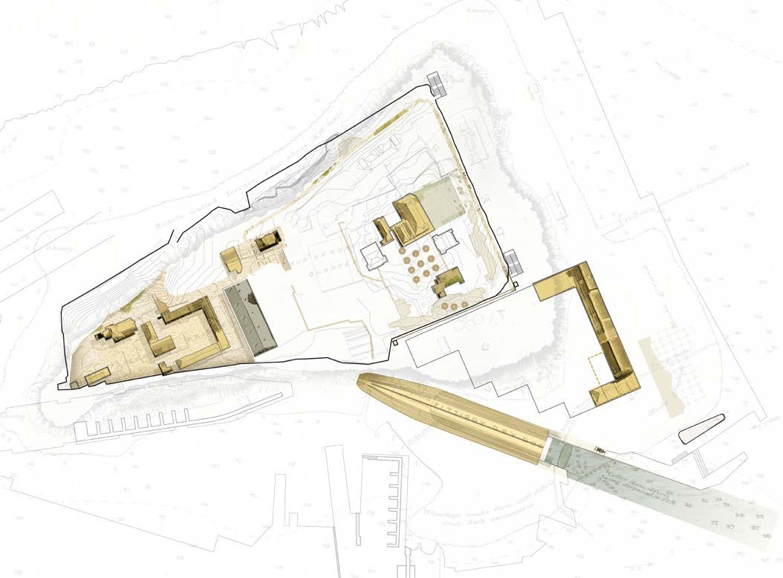

<pp>10

## 3.4 Dockworking, shipbuilding and defending Australia

In the twentieth Century, Cockatoo Island / Wareamah became a military dockyard that in the 1950s was one of Australia’s largest employers. The Royal Navy sought to establish a strong presence and capability to construct and maintain its fleet locally. The island and nearby Woolwich Dock became a giant factory for making and repairing ships, and thousands of workers, apprentices, designers and managers worked in their offices and workshops, often adapted from earlier convict uses. In the 1930s the Navy leased Cockatoo Island / Wareamah as a dockyard, and over the next 60 years worked with the companies that ran the island, building and repairing ships, designing aeroplanes and maintaining Australia’s Oberon-class submarine fleet during the Cold War, in conjunction with what is now the Harbour Trust’s Sub Base Platypus in North Sydney.

Experiencing this journey could include;

* A boat tour to travel around the island and nearby Woolwich Dock
* Introducing the maritime history, the system of shipbuilding and scale of the process to move materials around the island through a dedicated orientation space and interpretation of the large machinery held in situ in the industrial precinct
* Maintaining Sutherland Dock as a working marina and consider future opportunities for ships to visit the island
* The story of Cockatoo Island’s role in defending Australia through two world wars

**Photo caption: Illustration of the dockworking, shipbuilding and defending Australia journey. Source: Tyrrell Studio**

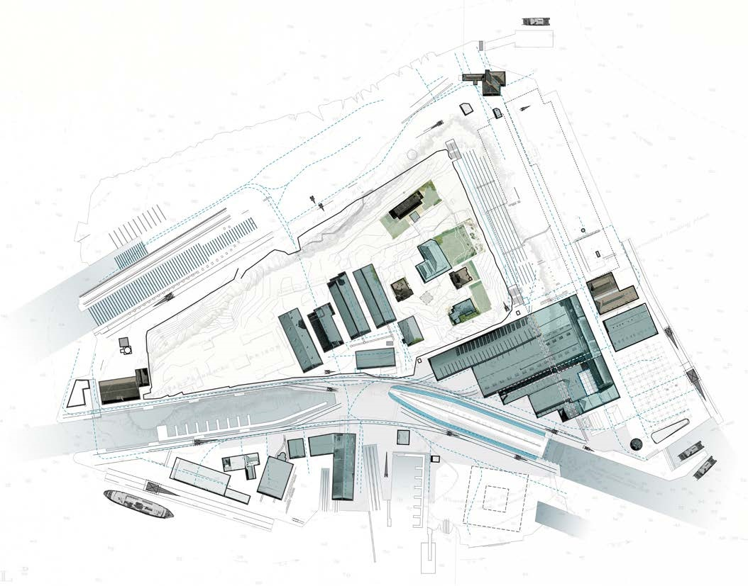

<pp>11-12

# 4. KEY ELEMENTS OF THE DRAFT MASTER PLAN

**Photo Caption: Site plan illustrating key elements of the draft master plan. Source: Tyrrell Studio**

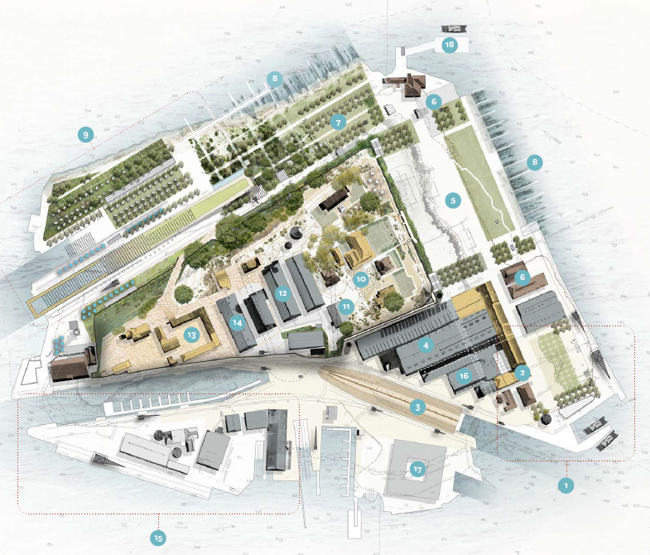

<Transcriber's Note>

Illustration of Cockatoo Island showing The Arrivals Square and Convict Workshop in the bottom right hand corner. To the left of this is the Restoration Workshop and the Industrial and Turbine Halls. Above the Arrivals Square is a potential café / restaurant and above this is the Eastern Apron. To the right is the Marine ecology reefs and in the top right corner is Parramatta Wharf.

There are more ecology reefs at the top of the island above the Northern Parkland and recreation and camping. In the middle part of the island is the Convict Precinct to the left and to the right is the Mound Loft, Plateau Industrial Precinct, Silos and Tent Embassy and Superintendents Precinct.

At the bottom left of the island is the Southern Apron and Accommodation.

</Transcriber's Note>

1. **Arrival Square** – a new, additional ferry wharf at the ‘Ruby Steps’ welcomes visitors into the island’s new arrival and orientation square. Heritage features are highlighted, and the square is activated with events, educational, creative, Country and cultural activities, signature food and beverage.
2. **The Convict Workshop** – a significant convict-era building is restored to be the main visitor hub of the island, with visitor services, tours, island information and general assistance. Its beautiful sandstone façade forms a dramatic backdrop to the new arrivals square.
3. **Fitzroy Dock** – completed in 1857, Fitzroy Dock was the largest engineering project in Australia, carved from sandstone by convict labour. Currently submerged, the draft master plan considers draining this extraordinary structure, adding unique interpretive and light shows to become a premium island experience.
4. **The Industrial and Turbine Halls** – these cathedral-scale spaces are restored to support culture, creative arts, exhibition, First Nations and events programming. New lifts to the upper plateau, new food and beverage, and new supporting infrastructure will enable more frequent, diverse use. Rooftop solar power will support clean energy for the island.
5. **Eastern Apron** – the island’s major event space is retained and further enhanced with permanent enabling infrastructure, new access stairs to the upper plateau, shade trees and ground plane interpretation of the original waterline.
6. **Potential cafe / restaurant** – signature venues within restored heritage buildings. These form part of a wider food and beverage strategy implemented over time and in partnership to support growing visitor numbers and experiences across the island.
7. **Northern Parkland** – the campground is relocated enabling creation of a significant new island park, reconnecting ancient remnant cliffs to the harbour, restoring native landscapes, trees and wildlife, and teaching collective care for Country (both land and water) within a place of recreation, play and rest.
8. **Marine ecology reefs** – constructed on the eastern and northern island waters to support Sydney Harbour biodiversity and enhance rehabilitation of the waters around the island. Offers new marine, interpretive and educational opportunities.
9. **Recreation and camping** – refreshed island-stay experience with new camping, cabins and camp facilities, plus new recreational opportunities including new harbour public pool and non-powered recreational boating and kayaking in the slipways.
10. **Superintendents Precinct** – reconnected to the lower plateau with lifts and stairs, this precinct is enhanced with new interpretive and heritage activations, upgraded gardens, small events, conferencing and refreshed accommodation.
11. **Silos and Tent Embassy** – a First Nations contemporary meeting place for past, ongoing and new traditions and ceremonies. Interpreting the layers of natural and cultural heritage including remnant sandstone, Country, the convict silos and the Aboriginal Tent Embassy.
12. **Plateau Industrial Precinct** – adaptive reuse enabling enhanced interpretive, conferencing and educational opportunities, such as a maritime design learning centre.
13. **The Convict Precinct** – best practice visitor and interpretive experiences will bring alive the complex histories and stories of the island’s convict past, supported with adaptive reuse and decluttered public domain.
14. **The Mould Loft** – ongoing use for public programs, enhanced with displays on the convict system, industrial and reform schools, including people’s stories of resilience, escape and rebellion.
15. **The Southern Apron** – maritime facilities are enhanced for boat repairs and storage, heritage boat building, possible future ship’s chandler, and First Nations small businesses. Supported with infrastructure upgrades.
16. **Restoration Workshop** – enhanced workshop facility supporting ongoing restoration and maintenance of the island’s heritage assets, with community and volunteer activities.
17. **Accommodation** – long term proposal, consistent with statutory Management Plan and international precedent for a World Heritage place.
18. **Parramatta Wharf** – retained - it will support more frequent services to the island.

<pp>13

**Photo Caption: Artist impression – aerial view looking west. Source: Tyrrell Studio/Doug & Wolf**

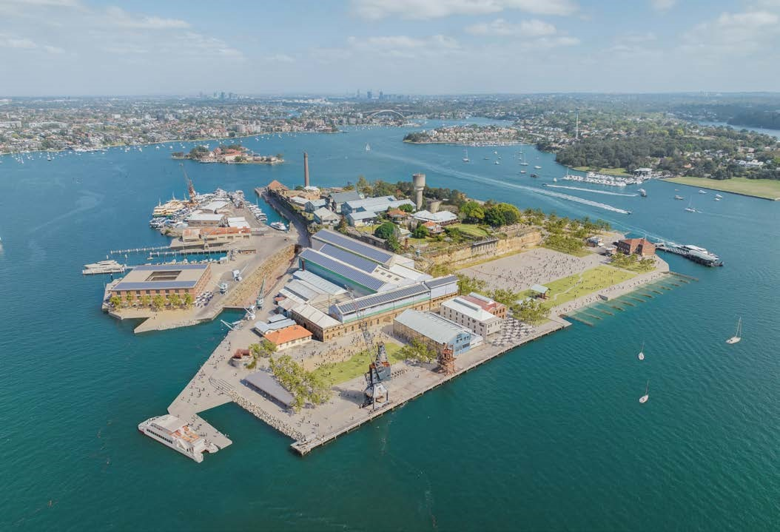

## 4.1 Arrival, circulation and accessibility

Current visitation to Cockatoo Island / Wareamah is relatively low compared to other tourism and heritage sites across Australia. Whilst the ferry ride to Cockatoo Island / Wareamah is short, connections to the broader Sydney public transport system or car parking means overall journey time typically exceeds one hour.

Over time, the most meaningful way to address this is to provide more frequent ferry services, and this would require collaboration with partners that service Sydney Harbour.

With increased visitation it is proposed to introduce a new ferry wharf strategically positioned with direct access to key high value heritage structures such as the Convict Workshop and Fitzroy Dock.

This location would also assist in moving people around the island intuitively, walking in a loop and then to the highest point. To help navigate this complex terrain the lower loop would offer clear and easy access around the island following the original edge. To better connect to the upper loop two new lifts and two new staircases are proposed.

The upper loop will circulate visitors around the island taking in the most significant convict heritage and harbour view lookouts.

In the design phase, all circulation paths will be reviewed with the intention that they are inclusive and barrier free for people with disability. The draft master plan also proposes an overall interpretive and wayfinding strategy that introduces the layers of natural and cultural heritage, and supports orientation soon after arrival. This encourages active engagement with Cockatoo Island / Wareamah as a place, so that visitors can choose how they prefer to move around and explore.

<pp>14

## 4.2 Enhanced food and beverage

To support the new and upgraded experiences, higher visitation and accommodation on the island it is proposed to enhance the food and beverage (F&B) offerings across the island for day visitors, evening visitors and overnight visitors. They will offer high quality breakfast, brunch, lunch, afternoon tea, dinner and evening drinks options.

A range of new F&B outlets can be included from the earliest stages of reactivation, with the master plan providing spaces to accommodate leasing to, and final fit outs by, highly experienced operators.

## 4.3. Maritime use

As a harbour island with a rich boat making industrial history, the draft master plan considers maritime use as a key continued objective. Maritime uses are considered to span recreational harbour use to retaining potential industrial making capacity comprising:

Maintaining Sutherland Dock and Southern Apron for maritime focused activity

* Maintaining access for small boat access and day berthing
* Enhanced capacity for small non-powered recreational vessels to safely land including a new and safe way for visiting kayakers to access the island via the Northern Apron slipway
* Enhanced capacity for the island to host regattas or boat festival events

## 4.4. Public programs and visitor experience

Experiences, activations and events will cater for different visitors’ needs including for locals, tourists and younger visitors, as well as those with a connection to the island through a relative or ancestor, or with an interest in maritime, military, convict or First Nations cultural heritage. The layered approach will provide a richness and variety that will encourage visitors to extend their stay, and return. Experiences being considered include:

* A new enhanced orientation space where different themes and journeys will be introduced and visitors can determine how they explore the island.
* Boat trips – there will be options for additional boat trips such as a circumnavigation or deep dive into the maritime history including a visit to the Woolwich dry dock nearby
* Site-specific art commissions
* An immersive evening program where light, sound and technology will be used to tell the story of its transformation and uses over time as visitors take a looped walk around the island
* Enhanced event spaces which focus on flagship Sydney events that connects people, place and story and provide a contemporary lens on the islands’ key themes.
* Dedicated education space for students and schools
* New parkland, public domain and access to the water for harbour swimming
* Artificial reefs that support the harbour biodiversity and rehabilitate the waters around Cockatoo Island /Wareamah
* Enhanced interpretation of the Convict Barracks Precinct
* Drained Fitzroy Dock surrounded by working steam cranes showing its past use through the use of technology.

<pp>15

**Photo Caption: Artist impression – aerial view looking east. Source: Tyrrell Studio/Doug & Wolf**

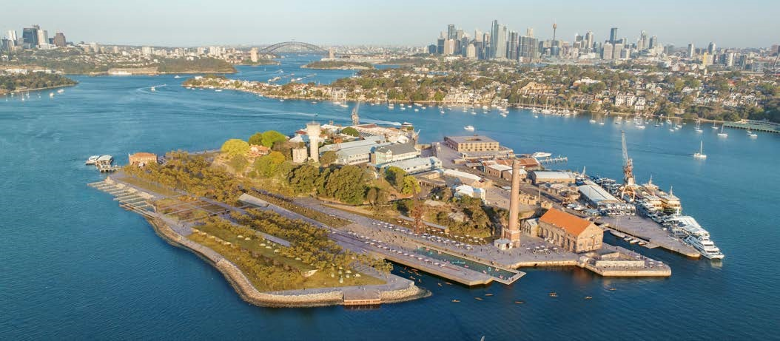

## 4.5. Accommodation for all

Feedback received from the previous consultation asked the Harbour Trust to consider a range of accommodation options that could service different budgets and price points. Key objectives include;

* Providing safe, accessible and unique island accommodation in a World Heritage place in the heart of Sydney harbour
* An expanded offering for a broader budget range developed in stages over a long term (10 years +) as visitation to the island grows
* An enhanced offering to a wider market including families with children
* Enhanced overnight visitation to the island for events, support for food and beverage outlets and contributing to Sydney’s night time economy
* School student accommodation in support of education objectives.

The accommodation types proposed for the island are:

### 1. Camping in the heart of the city

The Harbour Trust currently operates a campground. This offering will continue but be enhanced and in a more private location to the west of the current site which will release the Northern Apron to public domain parkland.

In addition to tent accommodation, the draft master plan recommends consideration of cabin-style accommodation to be co-located with the tent campground. This initiative intends to broaden the market.

### 2. Boutique restored heritage houses

The Harbour Trust currently operates boutique accommodation within restored houses on Cockatoo Island / Wareamah. This offering will continue but be enhanced through additional houses being restored.

### 3. Hotel accommodation

Consistent with the Harbour Trust Management Plan, hotel accommodation remains a long-term aspiration. The long-term intent is consistent with international precedent and would provide unique accommodation in a World Heritage place in the heart of Sydney Harbour. In design phase, master planning recommends examination of this land parcel and zone for accommodation use and will require further industry consultation and partnership.

<pp>16

# 5. HAVE YOUR SAY

To have your say about the Cockatoo Island / Wareamah Draft Master Plan, visit [**www.harbourtrust.gov.au/cockatoo-island-consultation**](http://www.harbourtrust.gov.au/cockatoo-island-consultation) [consultation](http://www.harbourtrust.gov.au/middle-head-consultation) to provide your feedback online.

Submit your feedback by 5pm  
Wednesday 13 December 2023 (AEDT)

<pp> 17

**Harbour Trust**

Building 28, Best Avenue  
Mosman NSW 2088

[**harbourtrust.gov.au**](http://harbourtrust.gov.au/)