
Draft FullCAM Guidelines

Requirements for using the Full Carbon Accounting Model (FullCAM) in the Australian Carbon Credit Unit (ACCU) Scheme methodology determination: Carbon Credits (Carbon Farming Initiative) (Human Induced Regeneration of a Permanent Even Aged Native Forest—1.1) Methodology Determination 2013
These proposed guidelines are for consultation purposes only. They are not to be followed for reporting under the ACCU Scheme.
Version 3.0
(Published and in force from 1 September 2020, updated September 2023)

© Commonwealth of Australia 2023
Ownership of intellectual property rights
Unless otherwise noted, copyright (and any other intellectual property rights) in this publication is owned by the Commonwealth of Australia (referred to as the Commonwealth).
Creative Commons licence
All material in this publication is licensed under a Creative Commons Attribution 4.0 International Licence except content supplied by third parties, logos and the Commonwealth Coat of Arms.
Inquiries about the licence and any use of this document should be emailed to copyright@dcceew.gov.au.

Cataloguing data
This publication (and any material sourced from it) should be attributed as: The Department of Climate Change, Energy, the Environment and Water, FullCAM Guidelines: Requirements for using the Full Carbon Accounting Model (FullCAM) in the Australian Carbon Credit Unit (ACCU) Scheme methodology determination Carbon Credits (Carbon Farming Imitative) (Human Induced Regeneration of a Permanent Even Aged Native Forest—1.1) Methodology Determination 2013, Department of Climate Change, Energy, the Environment and Water, Canberra. CC BY 4.0.
This publication is available at [address to be confirmed].
Department of Climate Change, Energy, the Environment and Water
GPO Box 3090 Canberra ACT 2601
Telephone 1800 900 090
Web dcceew.gov.au
Disclaimer
The Australian Government acting through the Department of Climate Change, Energy, the Environment and Water has exercised due care and skill in preparing and compiling the information and data in this publication. Notwithstanding, the Department of Climate Change, Energy, the Environment and Water, its employees and advisers disclaim all liability, including liability for negligence and for any loss, damage, injury, expense or cost incurred by any person as a result of accessing, using or relying on any of the information or data in this publication to the maximum extent permitted by law.
Acknowledgement of Country
Our department recognises the First Peoples of this nation and their ongoing connection to culture and country. We acknowledge Aboriginal and Torres Strait Islander Peoples as the Traditional Owners, Custodians and Lore Keepers of the world's oldest living culture and pay respects to their Elders past, and present.

Contents
1. Introduction 5
1.1 Use of FullCAM with the Human Induced Regeneration of a Permanent Even Aged Native Forest – 1.1 Determination 2013 5
1.2 Determining which FullCAM option to use 5
1.3 Format of this document 7
1.4 FullCAM background 7
1.5 FullCAM plots and running simulations 8
1.6 Overview of the FullCAM interface 8
2. 2020 FullCAM option 11
2.1 Setting up simulations for each Carbon Estimation Area 11
2.2 Creating a new plot from an ERF template 11
2.3 The About Tab 15
2.4 Saving a Plot 15
2.5 The Configuration Tab 15
2.6 The Timing Tab 16
2.7 The Location info Tab 16
2.8 The Site Tab 18
2.9 The Trees Tab 18
2.10 The Soil Tab 18
2.11 The Initial Conditions Tab 18
2.12 The Events Tab 18
2.13 The Output Windows Tab 29
2.14 Running simulations 30
2.15 Viewing outputs 31
2.16 Accessing outputs as a spreadsheet 31
2.17 Output values required in the Determination 31
3. FullCAM simulations and offsets reporting 32

Tables
Table 1 FullCAM tabs 9
Table 2 FullCAM event types 21
Table 3 FullCAM outputs and corresponding parameters as defined in the determination 32

Figures
Figure 1 FullCAM download options 7
Figure 2 Selecting a new simulation in FullCAM 11
Figure 3 Selecting a template in FullCAM 12
Figure 4 The Australian Government’s National Map 13
Figure 5 The Australian Government’s National Map 13
Figure 6 Adding the long term average rainfall data to the National Map 14
Figure 7 Entering the latitude and longitude of a location into the National Map 14
Figure 8 Identifying the average annual rainfall for a location in the National Map 15
Figure 9 Entering a start date in FullCAM 16
Figure 4 Entering longitude and latitude in FullCAM 17
Figure 11 Querying FullCAM spatial data in FullCAM 17
Figure 12 Adding a new event FullCAM 21
Figure 13 Selecting the event type in FullCAM 22
Figure 14 Selecting a species in tree planting event in FullCAM 23
Figure 15 Inserting standard values for a tree planting event in FullCAM 23
Figure 16 Selecting a standard tree planting event in FullCAM 24
Figure 17 Inserting standard values for a thinning event in FullCAM 24
Figure 18 Selecting a standard thinning event in FullCAM 25
Figure 19 Enabling biomass-based age adjustment for a thinning event in FullCAM 25
Figure 20 Inserting standard values for a forest fire event in FullCAM 26
Figure 21 Selecting wildfire event in FullCAM 27
Figure 22 Disabling age advance for a forest treatment event in FullCAM 29
Figure 23 Selecting the output categories in FullCAM 30
Figure 24 Running a simulation in FullCAM 30
Figure 25 Viewing outputs in FullCAM 31

Introduction

Use of FullCAM with the Human Induced Regeneration of a Permanent Even Aged Native Forest – 1.1 Determination 2013
The calculation of carbon abatement under the Carbon Credits (Carbon Farming Initiative) (Human Induced Regeneration of a Permanent Even Aged Native Forest—1.1) Methodology Determination 2013, (the Determination) is dependent upon the use of the Full Carbon Accounting Model (FullCAM) consistently with the requirements of this document. In particular, section 16 of the Determination makes this document relevant to carbon estimation areas and section 30 requires events queues to meet the requirements of this document. Section 31 requires that FullCAM must be used in accordance with this document to determine several factors used in calculating the net abatement amount. Section 39 references this document in relation to offsets reports. Where content of this document relates to provisions of the Determination, references are given to the location of those provisions.
This document relates to all versions of the Determination starting from the version that commenced on 22 March 2016. Earlier version of the Determination did not use FullCAM and so these guidelines are not relevant to any projects that apply those versions of the Determination.
Project proponents must only change FullCAM default settings as indicated in this document, and all other settings must not be changed. This is to ensure that defaults will apply where relevant.

Determining which FullCAM option to use
The Department of Climate Change, Energy, the Environment and Water updates the Full Carbon Accounting Model (FullCAM) from time to time to reflect the latest science and improve usability. At the time this document was last updated, the latest version was released for public use in 2024 on the Department’s website ([to be confirmed]). The latest publicly released version of FullCAM is constituted by two options.
- Default: 2020 FullCAM option
This is currently the 2020 FullCAM option. The year reflects when the latest version was released at the time this document was last updated. However, a reference to the default or 2020 FullCAM option in this document includes any subsequent release or update of FullCAM on the Department’s website. Accordingly, projects using the default 2020 FullCAM option will be required to use subsequent releases as they are made available.

- Alternative: 2016 FullCAM option
This is identified as the 2016 FullCAM option and is only available for use by some projects, as described below.
Project proponents must access the latest publicly released version of FullCAM from the Department’s website and then ensure they are using the appropriate FullCAM option for their project (see screenshot below).

An exception to the requirement to use the latest publicly released version is for projects with reporting periods that end before 1 September 2020, under a method that specifies to use the version of FullCAM and the associated Guidelines for those periods. If you determine that you must use a version of FullCAM that is unavailable on the website, please contact the Department at FullCAM@dcceew.gov.au or ACCUMethods@dcceew.gov.au to obtain a link.
The requirements below explain when the default 2020 FullCAM option must be used and when the alternative 2016 FullCAM option can be used.
- Whichever FullCAM option is used by the proponent, all CEAs of a given project must be reported on using a single FullCAM option.
- Projects with section 22 declaration applications under the Carbon Credits (Carbon Farming Initiative) Act 2011 (CFI Act), submitted to the Clean Energy Regulator (the Regulator) on or after 1 September 2020, must use the default 2020 FullCAM option.
- Projects with section 22 declaration applications submitted to the Regulator before 1 September 2020 are able to use either the default 2020 FullCAM option or the alternative 2016 FullCAM option. These projects are able to move from the 2016 FullCAM option to the 2020 FullCAM option if they choose to do so. If a choice to use the 2020 FullCAM option is made, the entire project must be moved to 2020 FullCAM and once using 2020 FullCAM in an offsets report, these projects cannot return to using the 2016 FullCAM option.
- If project proponents with section 22 declaration applications submitted to the Regulator before 1 September 2020 add a new project area or areas to the project under section 29 of the CFI Act with effect on or after 1 September 2020, the entire project must use the default 2020 FullCAM option. The only exception to this is where all of the areas added to the project were already using the alternative 2016 FullCAM option under these guidelines as part of another eligible offsets project (these can continue to use the 2016 FullCAM option consistent with the dot point above – therefore the original project must also have been eligible to use the 2016 FullCAM option).
- Projects that transfer from an earlier to a later version of this Determination or transfer to this Determination from another method, with the application under section 128 of the CFI Act submitted on or after 1 September 2020, must use the default 2020 FullCAM option.
Note that FullCAM is not compatible with iOS systems, and must be run in a Windows operating environment.

Figure 1 FullCAM download options
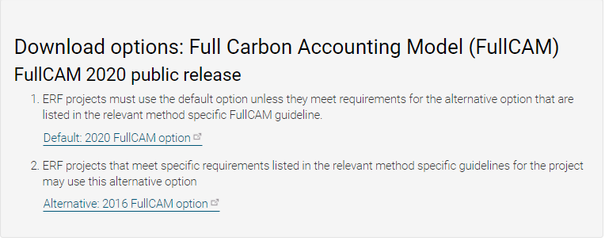
Two options
Screenshot from download page

Format of this document
This document provides:
- an overview of FullCAM relevant to the Determination, its features relevant to users and important requirements for using this document (section 1);
- a step-by-step walkthrough of using 2020 FullCAM to run simulations correctly (section 2); and
- an overview of the FullCAM outputs as they relate to equations within the Determination (section 3).
Note that this document provides a step-by-step walkthrough for 2020 FullCAM alone. This is because this document is for consultation on a modernised interface for that version of FullCAM. The published update to these guidelines will also contain a step-by-step walkthrough for the 2016 FullCAM.
The 2020 FullCAM option requires fewer data entries than the 2016 FullCAM option because many items have been automated in the 2020 FullCAM option through the use of a template.

FullCAM background
FullCAM is used in Australia’s National Greenhouse Gas Accounts for the land sector. FullCAM provides fully integrated estimates of carbon pools in forest and agricultural systems for Australia’s land sector reporting. In addition, it accounts for human-induced changes in emission and sequestration of major greenhouse gases. FullCAM was developed under the National Carbon Accounting System (NCAS) at the then Australian Greenhouse Office to provide a dynamic account of the changing stocks of carbon in Australia’s land systems since 1970 by integrating data on land cover change, land use and management, climate, plant productivity, and soil carbon over time. FullCAM estimates carbon stock change and greenhouse gas emissions at fine spatial and temporal scales, and uses a wide range of spatially referenced data.
Users of FullCAM can determine estimates of carbon stock change and greenhouse gas emissions for ERF projects on a similar basis to that used for land use and land use change in Australia’s National Greenhouse Gas Inventory.

FullCAM plots and running simulations
FullCAM can run simulations on a ‘plot’. A plot, for modelling purposes, is defined as a piece of land for which the event history, when modelled in FullCAM, is the same across that area of land. Separate plot files are created for each CEA.
In the 2016 FullCAM option, there are several types of plots that can be selected. Only ‘forest system’ is relevant to this Determination. This selection does not need to be made in the 2020 FullCAM option because it has been automated through the creation of default templates. At the point in 2016 FullCAM option where users choose to create a new plot file, they instead select an appropriate template from a drop-down list and 2020 FullCAM option then populates FullCAM with the template plot.
FullCAM uses a single ‘model point’ location. Proponents do not need to define plot boundaries within FullCAM. Rather, proponents must input the coordinates for a single location as close as reasonably practicable to the centre of the carbon estimation area (CEA) (the model point – see section 29 of the Determination). The latest spatial data for a plot must be downloaded using the ‘Data Builder’ tab each time the software is run.
In order to ensure all settings are correct, including defaults, we recommend creating new plot files each time a new version of FullCAM or these Guidelines, or a different FullCAM option, is used. Plot files created under previous versions or options may contain different settings that will affect outputs, and users are responsible for ensuring they have used the correct FullCAM version and option, and accurately followed the associated FullCAM Guidelines.

Overview of the FullCAM interface
The FullCAM software user interface displays menus and a series of tabs. Each tab has a suite of fields in which information may either be required to complete as instructed through these guidelines or left unchanged. The program is designed so that certain tabs in a plot file are made available only if required fields have valid information entered in earlier tabs. If the text of a tab or field is red, then FullCAM requires information in that tab or field before a simulation can be run. It will also hide other tabs, depending on the location of the incorrect or missing entry. When all the required fields within a tab have valid information entered, the tab text will become blue.
The below table provides a general overview of each tab selectable within FullCAM once a plot has been created. Help is provided within FullCAM by clicking on the ‘HELP (?)’ button at the top right of the screen, next to the username. This general overview of the public version of FullCAM is not intended to instruct proponents of ERF projects on how to use FullCAM for this Determination. Data entry requirements for this Determination, under each FullCAM option, are described in detail in Section 2 and Section 3 of these Guidelines.

Table 1 FullCAM tabs
Tab | Explanation
About | Includes a free text field where users can enter information about the plot file that they have created. This is a good space to keep track of changes that have been made or editing of event parameters.
Configuration | Users select the system (e.g. forest, agricultural) they want to simulate in the plot.
Timing | Enter the timing for starting and ending the simulation and the time steps required for output data.
Data Builder (“Location Info” in the 2020 tool) | In this tab users enter the latitude and longitude of the ‘Model Point Location’ where they wish to simulate a plot file. Internet access is required to complete this tab. By choosing to ‘Download Spatial Data’ (called “Query FullCAM spatial data” in the 2020 tool) the associated soil and climate data for that latitude and longitude are automatically loaded into relevant parts of the remaining tabs. In the tab users can then download tree and/or crop species information and management regimes as appropriate. This information is also automatically loaded into relevant parts of the remaining tabs.
Site | Specific parameters (e.g. water [rainfall], temperature, productivity) are described.
Trees | Description of the properties of the tree species.
Crops  (not present in the 2020 tool) | Description of the properties of crop or pasture species (only displays if agricultural system selected).
Soil | Description of soil properties.
Initial Conditions | In this tab the values for carbon at the start of the simulation are described. Values will automatically be populated by Data Builder using data downloaded from the FullCAM server.
Events | All of the events for the entire simulation period are listed in this tab. Users can add or remove events. Care must be taken not to violate requirements for modelling ‘management events’ within the Determination.  For the 2016 tool, the names on the event list are colour-coded to indicate whether they are ready, whether they are simulating or not, and what system they affect. The colour codes are:  Red: Event not ready (renders event queue not ready);  Grey: Event non-simulating (outside simulation period, will not affect simulation);  Green: Forest;  Yellow: Agricultural; and  Brown: Mixed.  Finally, the events users select with the cursor are coloured in the usual highlight colour.
Output Window | Defines what outputs are presented in output windows.
Explorer | Display of the parameter settings for each tab.
Plot Digest  (not present in the 2020 tool) | This tab only appears when a plot is saved as a ‘plot digest’ by changing the save as type. It allows users to clone and alter the inputs of a given modelling scenario, and combine the results or output them separately.
Log  (not present in the 2020 tool) | This tab records changes made to the file to assist with analysis and error tracking.

2020 FullCAM option
Section 1.2 describes the requirements for which FullCAM option can be used. The general effect of requirements described in Section 1.2 is that the 2020 FullCAM option is the default. Only projects that satisfy the criteria described in section 1.2 are able to use the 2016 FullCAM option.

Setting up simulations for each Carbon Estimation Area
Simulations for each CEA are undertaken using plot files. Project proponents must use the following steps for creating FullCAM plots and inputting values for each CEA being reported under the Determination. All steps must be followed when creating new plot files and inputting values.
Once a plot file has been setup for a CEA, it can re-opened for modelling at a later date. When reopening plot files, users must first navigate to the “Location Info” tab and click the green “Query FullCAM spatial data” button, before running the simulation, to ensure the latest spatial data is used for the simulation.

Creating a new plot from an ERF template

Steps to create a new plot
- With FullCAM open, click on the menu grid, on the top left of the screen, then select ‘New Simulation’.
Figure 2 Selecting a new simulation in FullCAM
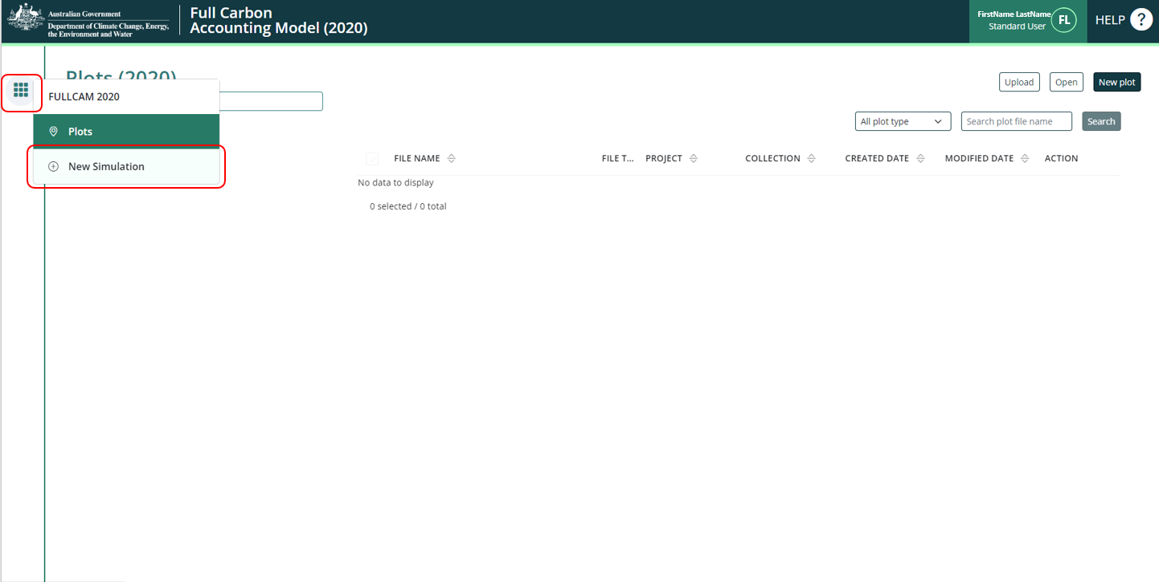

- Select, under the ‘Create from templates’ section, the ‘HIR NFMR and Avoided Clearing Methods’ option corresponding to the long-term average annual rainfall for the applicable model point location (either greater or less than 500mm). This is determined by using the Australian Government’s National Map, with instructions about using this in the following paragraph. The two rainfall options for the natural regeneration calibration differ in the root-to-shoot ratio used to determine biomass allocation to roots. Biomass in roots constitutes a higher proportion of total biomass in the low rainfall option.
The long-term average annual rainfall is determined using the Long Term Average [annual] Rainfall Map Layer, also known as the CFI rainfall map.

Figure 3 Selecting a template in FullCAM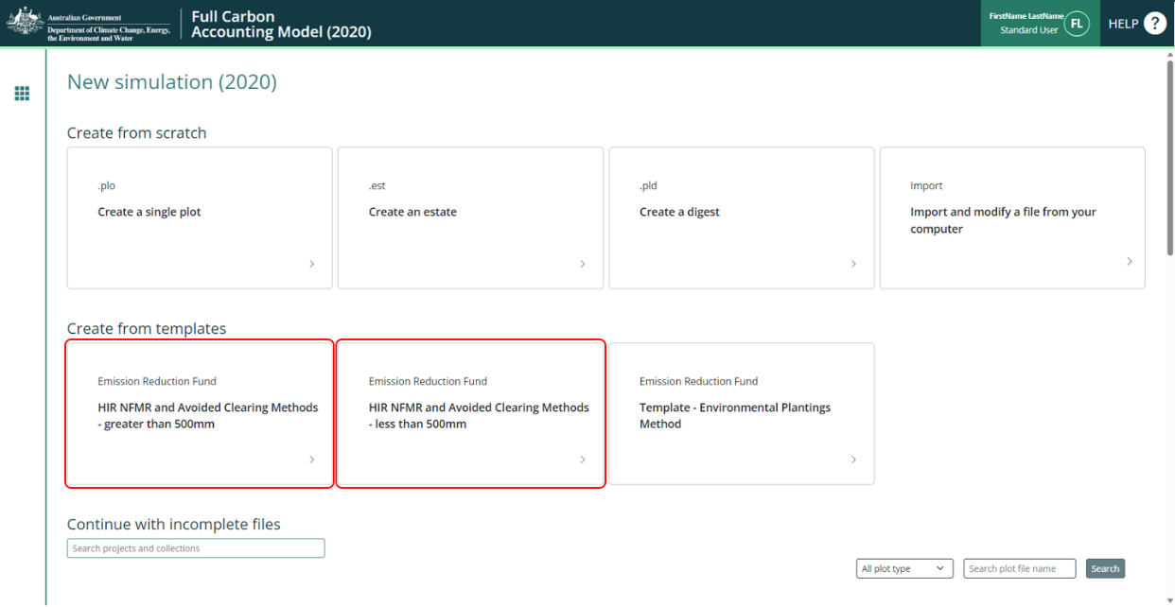
The model point location for a CEA or CEA part that includes land which receives both greater and less than 500mm, according to the CFI rainfall map, must be within the area that constitutes the larger proportion of the CEA. This is to comply with the requirement for the model point location to be representative of the CEA (subsection 29(2)). Including areas of land on both sides of the 500mm rainfall boundary in one CEA or CEA part does not in itself prevent the CEA or CEA part from being modelled with a single events queue.

The long term average annual rainfall map layer shows the long-term average annual rainfall (mm) across continental Australia, calculated for the period 1920-2010. The long-term average annual rainfall map layer (also labelled CFI Mapping tool - Rainfall map) can be accessed for viewing or downloading from data.gov.au under Emissions Reduction Fund Environmental Data (https://data.gov.au/dataset/ds-dga-b46c29a4-cc80-4bde-b538-51013dea4dcb/details?q=emission reduction fund).

Steps to view the long-term average annual rainfall data on data.gov using the Australian Government’s National Map:
- Go to (https://nationalmap.gov.au/) and select the “Upload” button on the top left of the screen.

Figure 4 The Australian Government’s National Map
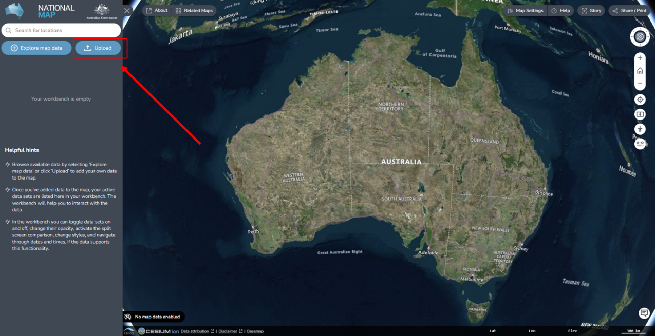
- Select “Add Web Data”
- Choose the file or web service type. It is preferable to use “Web Map Service (WMS) Server” and the link in the next step.
- Paste the following URL: https://data.gov.au/geoserver/emissions-reduction-fund-environmental-data/wms (which is located in data.gov.au under the ERF Environmental data – Preview dataset WMS) and click “Add”.
- On the next pop-up, click “GeoServer Web Map Service” to expand it, and click “Long term average annual rainfall”.
Figure 5 The Australian Government’s National Map
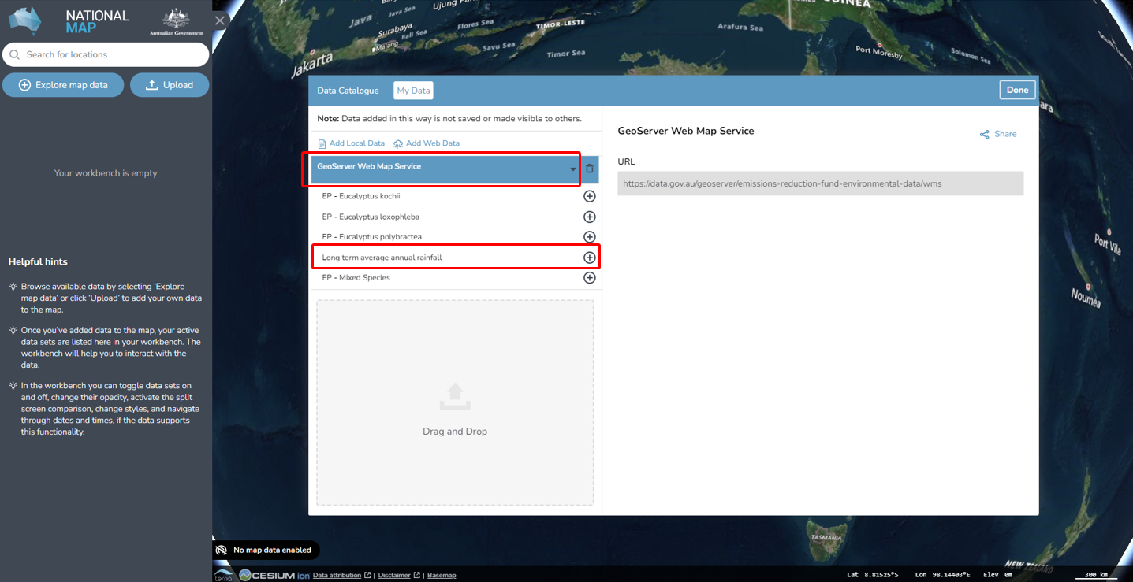
- Then, click the “Add to the map” button at the top right.

Figure 6 Adding the long term average rainfall data to the National Map
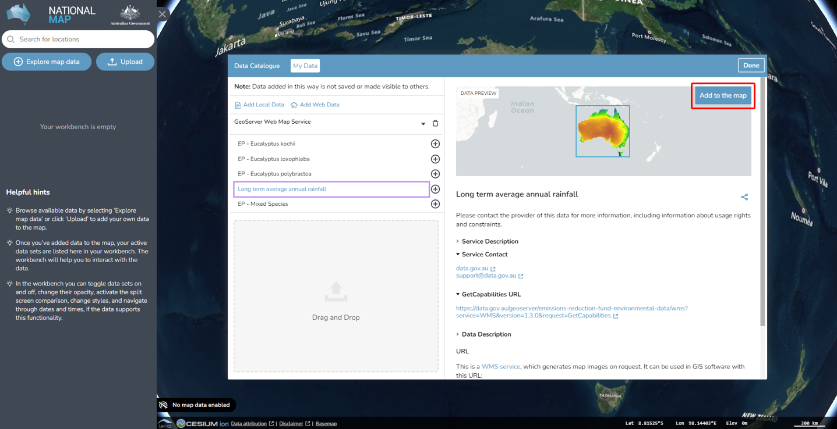
- To check the rainfall amount of the model point location, enter the latitude and longitude in the search bar (located in the top left corner. The search result will be displayed in the search bar. Select the desired location.
Figure 7 Entering the latitude and longitude of a location into the National Map
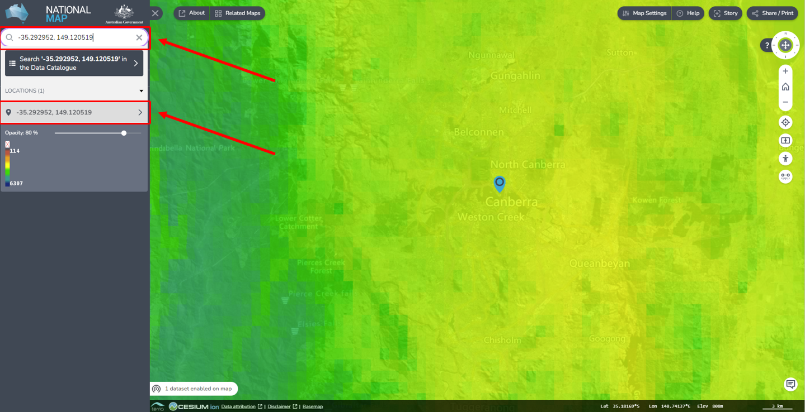
- Click the map marker icon on the map, this will show the “Feature Information” tab on the right hand corner, yielding location and rainfall information. If minimised, click on the “Long term average annual rainfall – Site Data” heading to expand it, revealing the rainfall amount. The “GRAY_INDEX” is the long term average annual rainfall. Note if it is more or less than 500mm, as this impacts the template choice in the FullCAM process.

Figure 8 Identifying the average annual rainfall for a location in the National Map
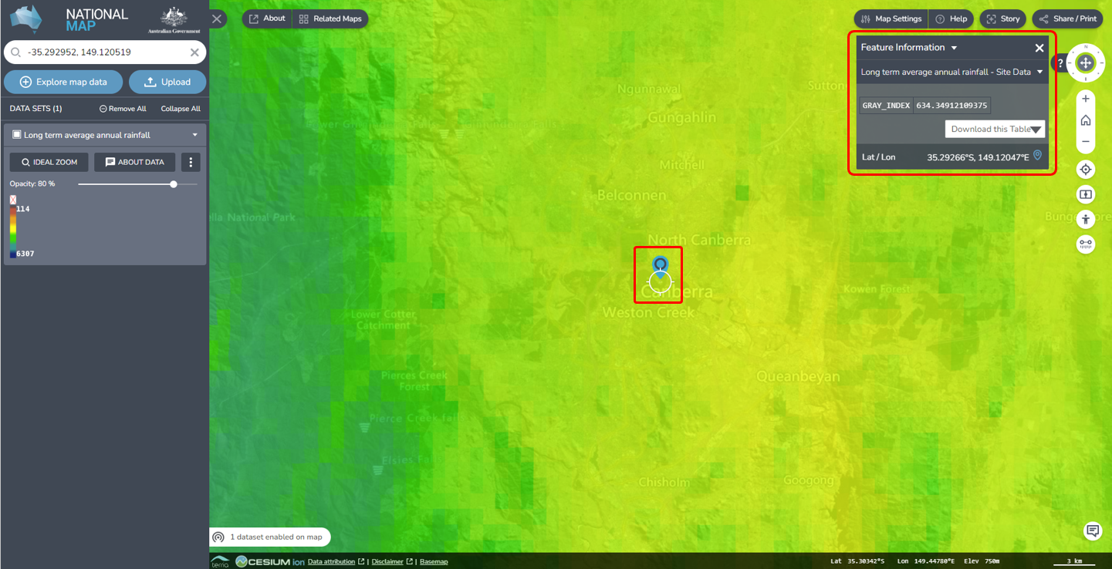

The About Tab
Back on the FullCAM system, edit the “About” information.
- Name the Plot accordingly, choosing one which is easily identifiable and relevant. Note, special characters (including ‘-’) are not allowed.
- Select a Project, or if none exist, create a new one by clicking the underlined button “Create new project”. Doing so requires assigning a name and description to the Project.
- Select a Collection, or if none exist, create a new one by clicking the underlined button “Create new collection”. Doing so requires assigning a name and description to the Collection.
- Add a note, if desired.
Click “Next” (or the “Configuration” tab button).

Saving a Plot
    - You will need to click “Save Plot File” before logging out or leaving the system for an extended period of time, as it will not save the information you enter without doing so.
    - You can then “Update Plot File” to save the changes as you continue.
    - If you log out, you will find your Plot on the list when logging back in. Click on the ‘Edit’ button (with the pencil icon) to continue entering and editing the information of this Plot.

The Configuration Tab
- Edit the “Configuration” information
- This Determination concerns a forest regeneration activity, so you must select Forest system from the “Type” drop-down menu.
- Click “Next” (or the “Timing” tab button).

The Timing Tab
- Enter the modelling start and end dates for the simulation that you will run, in the start date and end date text fields by either typing the date, or selecting through the calendar function
Figure 9 Entering a start date in FullCAM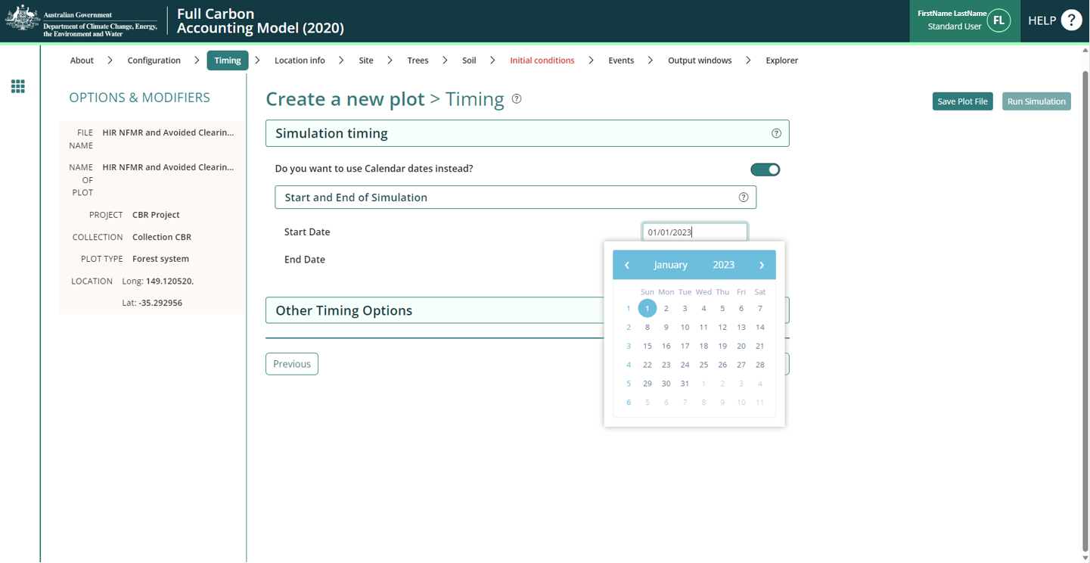
    - The accepted format is DD / MM / YYYY.
    - The “End Date” must be 100 years after the “Start Date”.
Click “Next” (or the “Location info” tab button).

The Location info Tab
Enter the longitude and latitude (in decimal degrees i.e. -xx.xxxxx, xx.xxxxx) of the model point location in the appropriate text fields on the left side. This should be the approximate centre of the CEA (as defined in section 29 of the Determination). Users must enter the full five decimal places as these will be recorded within the plot file itself.

Figure 10 Entering longitude and latitude in FullCAM
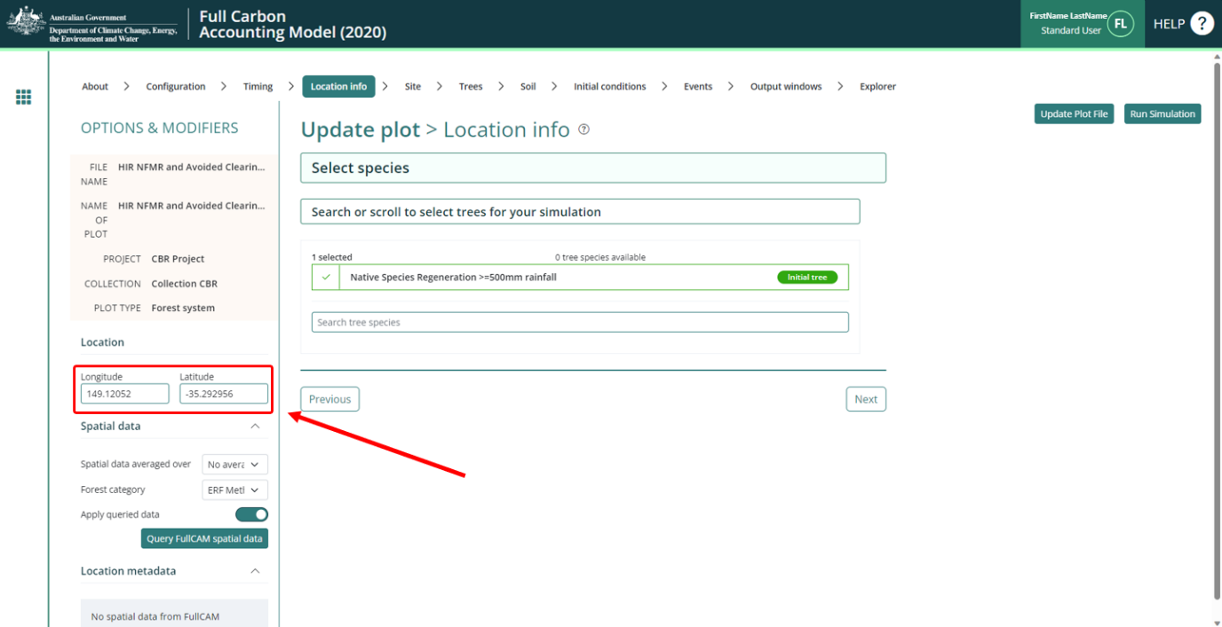
- Click the green “Query FullCAM spatial data” button and check the selected “Initial tree” species. This Determination concerns a forest regeneration activity, so the “Initial tree” species should be either “Native Species Regeneration <500mm rainfall” or “Native Species Regeneration >=500mm rainfall”. The rainfall zone of the “Initial tree” species should correspond to the rainfall zone of the template. Do not add any other species.
Note: FullCAM spatial data must be queried each time FullCAM is opened to run the plot file. This will ensure the data is downloaded and applied each time the plot file is run.
Figure 11 Querying FullCAM spatial data in FullCAM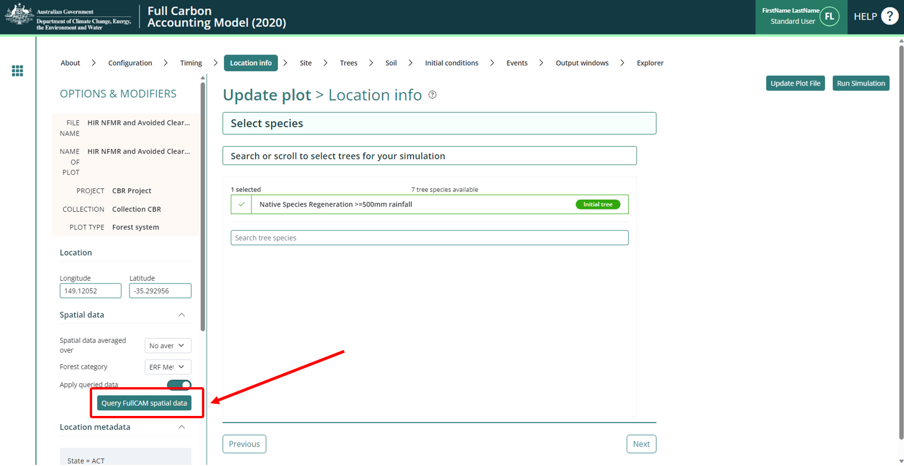
- Click on the “Initial Conditions” tab button.

The Site Tab
Do NOT edit any variables on this page, skip to the “Events” tab.

The Trees Tab
Do NOT edit any variables on this page, skip to the “Events” tab.

The Soil Tab
Do NOT edit any variables on this page, skip to the “Events” tab.

The Initial Conditions Tab
Do NOT edit any variables on this page, skip to the “Events” tab.

The Events Tab
Project proponents must model all events that have occurred in the CEA during the period being modelled. Each event must be added to the event queue, in accordance with the settings and steps described in these Guidelines. Section 30 of the Determination requires that the FullCAM events queue(s) that are used to model carbon stock and emissions from biomass burning in a particular CEA must:
- comply with any relevant requirements of this document; and
- accurately reflect the set of management activities and disturbance events that occurred in the area of land that comprises that CEA during the period being modelled.
Note: a disturbance event may trigger requirements to re-stratify a CEA, as outlined in Section 18 of the Determination. An example occurs when a defined part of a CEA is burnt by a wildfire.
Note: When returning to FullCAM to enter new event(s) on an existing plot some time after the initial set up (e.g. some days, weeks, or months later), it is required to download the latest dataset to ensure accuracy and up to date statistics. To do so, go to the “Location info” tab and click the green “Query FullCAM spatial data” button, and then continue with adding your new Event.

Permitted Events

Regeneration
For each CEA, regeneration events must be added to the FullCAM event queue:
- Initially, when there is sufficient regeneration occurring to demonstrate forest potential.
- Following either a wildfire or mortality disturbance event where 70 – 100% trees are killed on 100% of the CEA, and there is sufficient regeneration occurring to demonstrate forest potential.
The simulation date for the first regeneration event is the modelling commencement date (as defined by section 28 of the Determination).
For subsequent regeneration events following a disturbance (e.g., wildfire), the simulation date is the date for which there is sufficient regeneration of native forest to demonstrate forest potential.

Mortality Disturbance Event
A mortality disturbance event is a disturbance event (other than fire) that resulted in the death of some or all of the trees in the CEA, resulting in the carbon stock in the CEA being materially less than would otherwise have been expected in the absence of the disturbance. It occurs when a disturbance event (other than fire) causes mortality of all or some of the trees, such as pest attack, disease, storm event, clearing that is required by law, or another event.
If an area of native vegetation is destroyed and is unlikely to regenerate to forest cover (i.e., no longer has demonstrated forest potential) or will be kept clear of vegetation, then the project proponent must consider whether re-stratification is required. A mortality disturbance event is not used in these situations.
If trees in the CEA were killed and others damaged (not killed) then both a mortality disturbance event and a growth pause event (see growth pause above) should be modelled. Examples of such events include pest attack or diseases. An exception occurs in the case of drought – while a reduction in growth rate caused by drought does not need to be modelled as a growth pause, the death of trees due to drought must be modelled as a mortality disturbance event.
If trees in the CEA were killed, and there is no significant tree damage to the remaining trees, then only a Mortality Disturbance Event must be modelled. Examples of these events include storm events and mechanical clearing required by law.
The date to enter for modelling this event is the start of the event that resulted in tree mortality. For example, for a mortality disturbance event that occurred over a period of time (e.g., insect attack) it is the start of the period.

Prescribed Burn
A prescribed burn has the objective to reduce fire risk by reducing fuel loads in the debris layer without killing the trees.
If the prescribed burn does kill trees, then a ‘wildfire event’ must be used rather than a prescribed burn event.
The simulation date is the date of the prescribed fire.

Wildfire
Wildfires are defined as all fires that are unplanned and may or may not result in tree mortality. A wildfire across a portion of a CEA will generally trigger requirements to re-stratify a CEA, as outlined in Section 18 of the Determination, unless the boundaries of the fire cannot be clearly determined, in which case it should be modelled as described below.
Prescribed burns that result in tree mortality must also be modelled using a wildfire event.
For all fire events modelled using this event:
- An estimation of the proportion of the CEA affected by fire (irrespective of whether trees are killed or not) is required. As an example, the proportion of the CEA affected by fire could be estimated via aerial or satellite imagery; and
- An estimation of the proportion of trees killed by the fire event within the burnt area (to the nearest 10%) should be made between 1 to 4 months after the fire event. If the proportion of trees killed in the burnt area is not estimated between 1 to 4 months after the fire event, then it is assumed that 70%- 100% trees were killed, and the input category for this must be used.

Growth pause
A growth pause event is used to model the stopping or slowing of vegetation growth due to a suppression disturbance event (or the combined impacts of more than one suppression disturbance event), such as grazing by livestock/feral animals, disease or pests, or another event. Normal climatic variability of wetter and drier periods (i.e., including droughts to an extent) causing fluctuations in the growth rate are already incorporated within the vegetation growth calibration used by the model, and are not required to be added as growth pause events in FullCAM.
The use and timing of any modelled growth pause must be consistent with the records that evidence the type and timing of disturbance events, and their associated dates of occurrence (see section 41 of the Determination). Where there is uncertainty over timing, a longer period may be used to conservatively estimate the duration of the growth pause. Such uncertainty does not preclude including additional growth pauses where appropriate, but the timing of such pauses should best give effect to the available evidence. Growth pauses are applicable throughout the crediting period.
Growth pauses should be included where necessary to ensure consistency with both:
- paragraph 30(b) of the Determination, that the modelling accurately reflects the set of management activities and disturbance events that have occurred. Growth pauses assist in ensuring that the abatement estimates of the method do not overestimate carbon abatement achieved by a project.
- the requirements of the Regulator’s five yearly regeneration checks[1] —required under 70(3A) of the Carbon Credits (Carbon Farming Initiative) Rule 2015. In the absence of the use of growth pauses to account for a lack of regeneration progress, CEAs may be need to be re-stratified to exclude the areas where regeneration cannot be evidenced (refer to the Regulator’s Guidelines).
If the human-assisted regeneration activity undertaken as part of the project includes the exclusion of livestock from the CEA, then grazing by livestock cannot normally be modelled prior to the CEA achieving forest cover through regeneration (as this is not allowed under the Determination). However, if there is unintentional, short-term grazing by livestock (e.g. due to stock entering a CEA through a damaged fence), then the grazing must be modelled as a growth pause for the length of time that the unintentional grazing occurred.
The start date for a growth pause is the date on which growth stopped or slowed. Where there are multiple factors contributing to a suppression disturbance event, or the source of suppression or actual date of suppression disturbance event cannot be identified, the date can be estimated.
If the Growth Pause event is linked to a Mortality Disturbance event, then the date of the event is the same date as that entered for the Mortality Disturbance event.

Setting up an event
Events for the project scenario must be added in accordance with this section one-by-one, following the below steps, with reference to above notes. Add as many events as required. Once created, you can edit an existing Event by clicking on the ‘Edit’ button (a pencil icon).
- Click on the “New event” button. A pop-up will appear.
Figure 12 Adding a new event FullCAM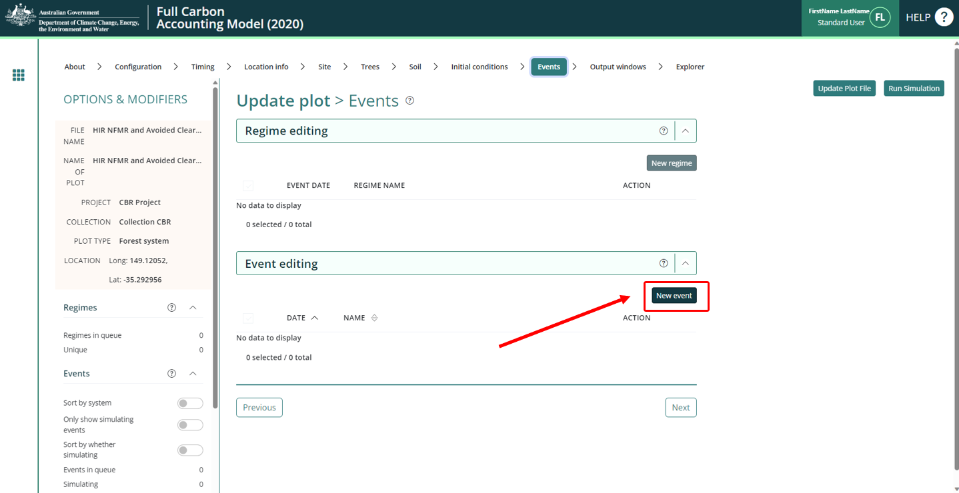
- In the “Type” drop-down list, select the FullCAM event type that corresponds to the Activity/Event that is being modelled, as given below. The notes in section 2.1.11.1 provide information on when to model different events and activities.
Table 2 FullCAM event types
Activity/Event | FullCAM Event Type
Regeneration | Tree planting
Mortality Disturbance Event | Forest thinning
Prescribed Burn | Forest fire
Wildfire | Forest fire
Growth pause | Forest treatment

Figure 13 Selecting the event type in FullCAM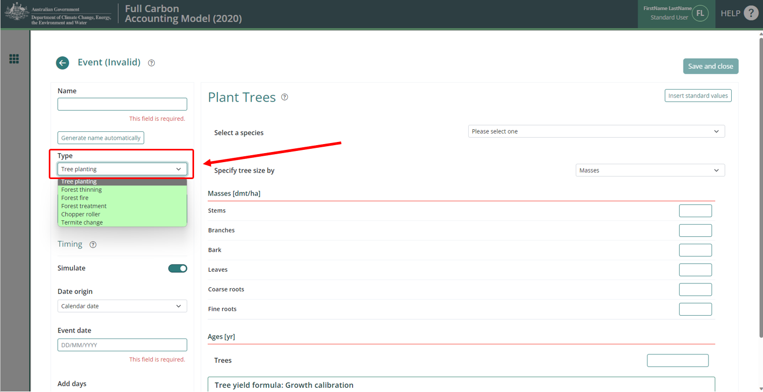

Modelling regeneration events
For each CEA, regeneration events must be added to the FullCAM event queue:
- Initially when there is sufficient regeneration occurring to demonstrate forest potential.
- Following either a wildfire or mortality disturbance event where 70 – 100% trees are killed on 100% of the CEA, and there is sufficient regeneration occurring to demonstrate forest potential.
- Select the “Tree planting” Event Type.
- Select the appropriate species or type of activity.

Figure 14 Selecting a species in tree planting event in FullCAM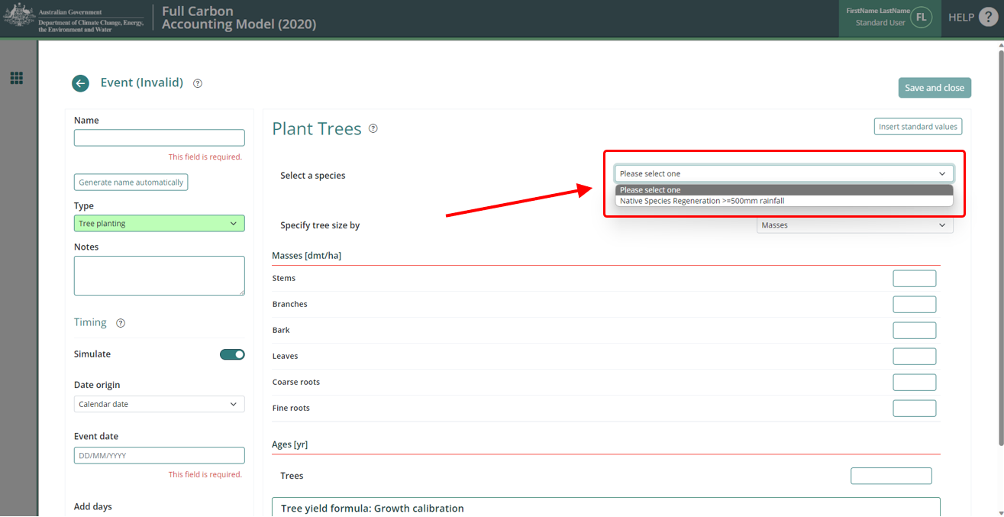
- Click the “Generate name automatically” button in the top left of the screen.
- Click the “Insert standard values” button. This will open a pop-up window.
Figure 15 Inserting standard values for a tree planting event in FullCAM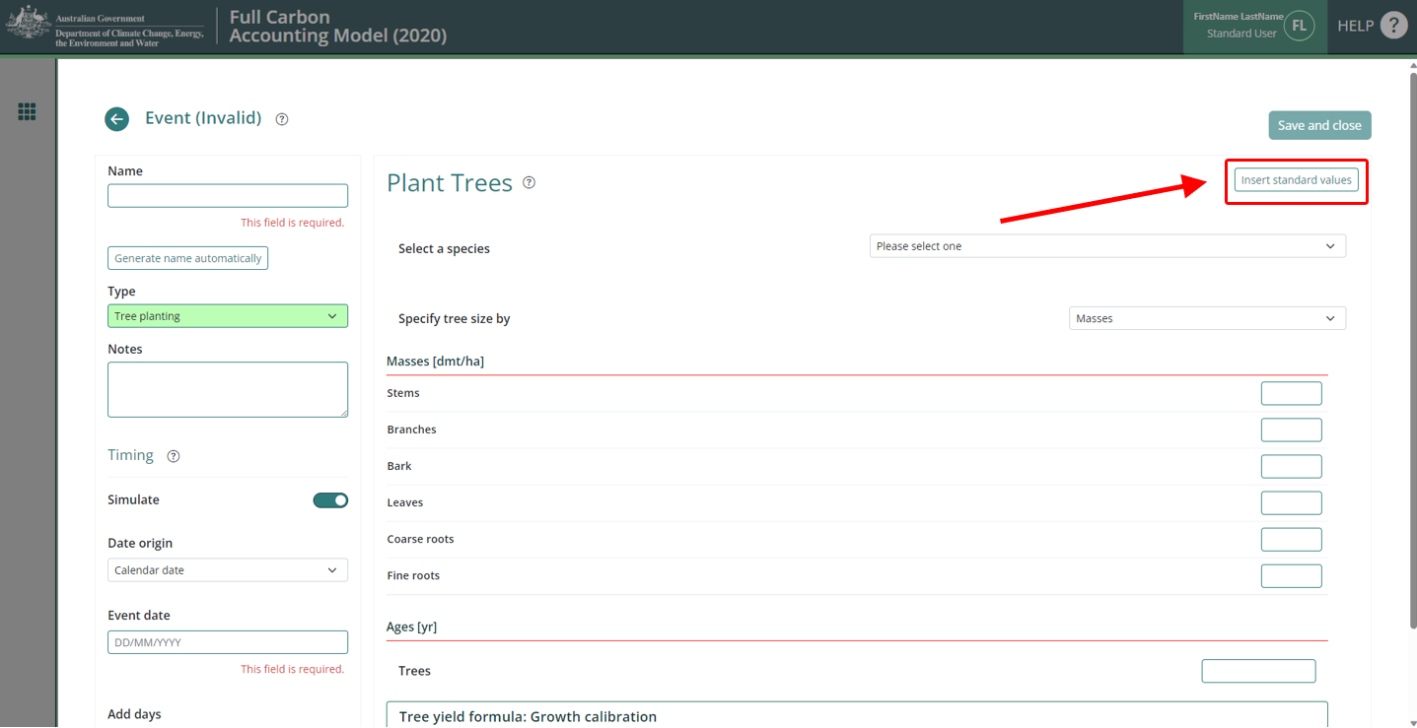
- In the checkbox on the left, select the item with the Event Name (in the middle column) called “Plant trees: natural regeneration in regeneration systems”, and click “Ok” at the bottom right. This will close the pop-up window.

Figure 16 Selecting a standard tree planting event in FullCAM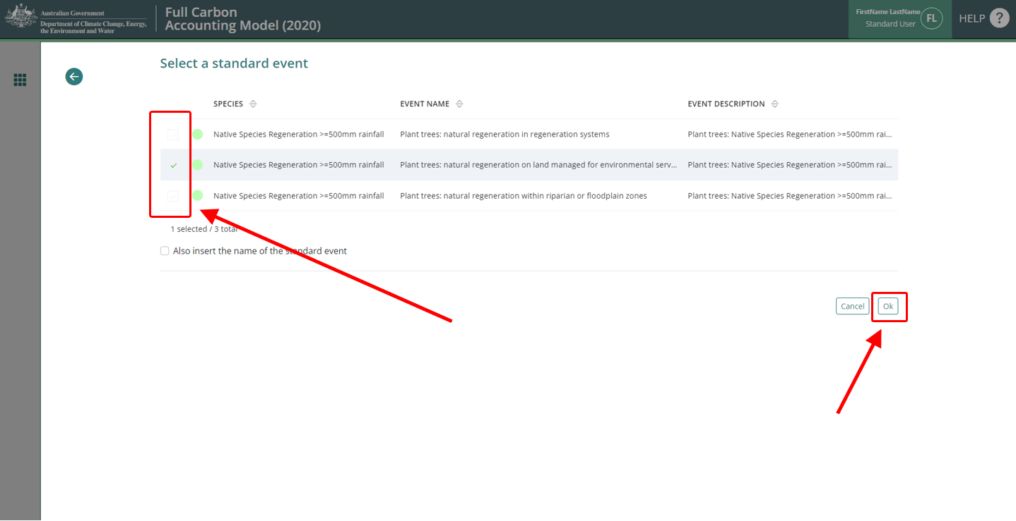
- Enter the Event date. Ensure the Date Origin setting is “Calendar date”. The accepted format for the Event date is DD/MM/YYYY.
- Click the “Save and close” button at the top right of the screen.

Modelling mortality disturbance events
- Select the “Forest thinning” Event Type.
- Click the “Insert standard values” button.
Figure 17 Inserting standard values for a thinning event in FullCAM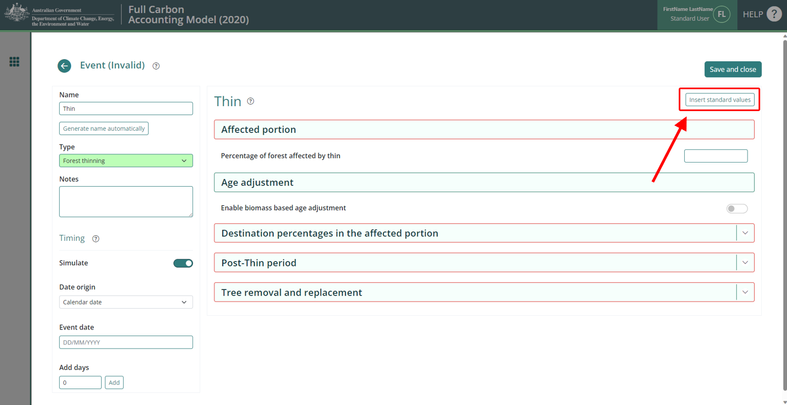
- In the checkbox on the left, select the “Initial clearing: no product recovery” Event, and click “Ok”.

Figure 18 Selecting a standard thinning event in FullCAM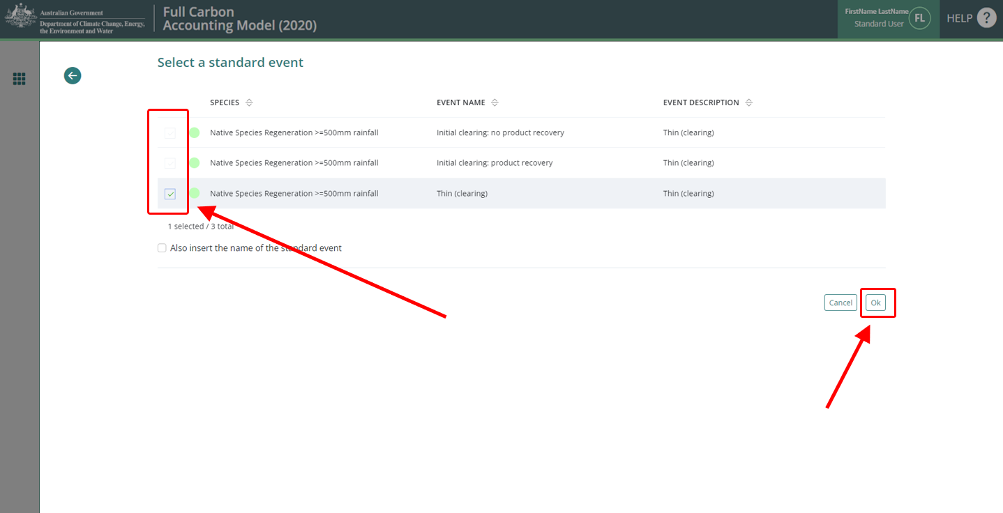
- Enter a name that describes the event (such as ‘Insect Attack’).
- Ensure that in the “Age adjustment” section, the “Enable biomass based age adjustment” is turned ON (it will be green if on, or light grey and white if off).
Figure 19 Enabling biomass-based age adjustment for a thinning event in FullCAM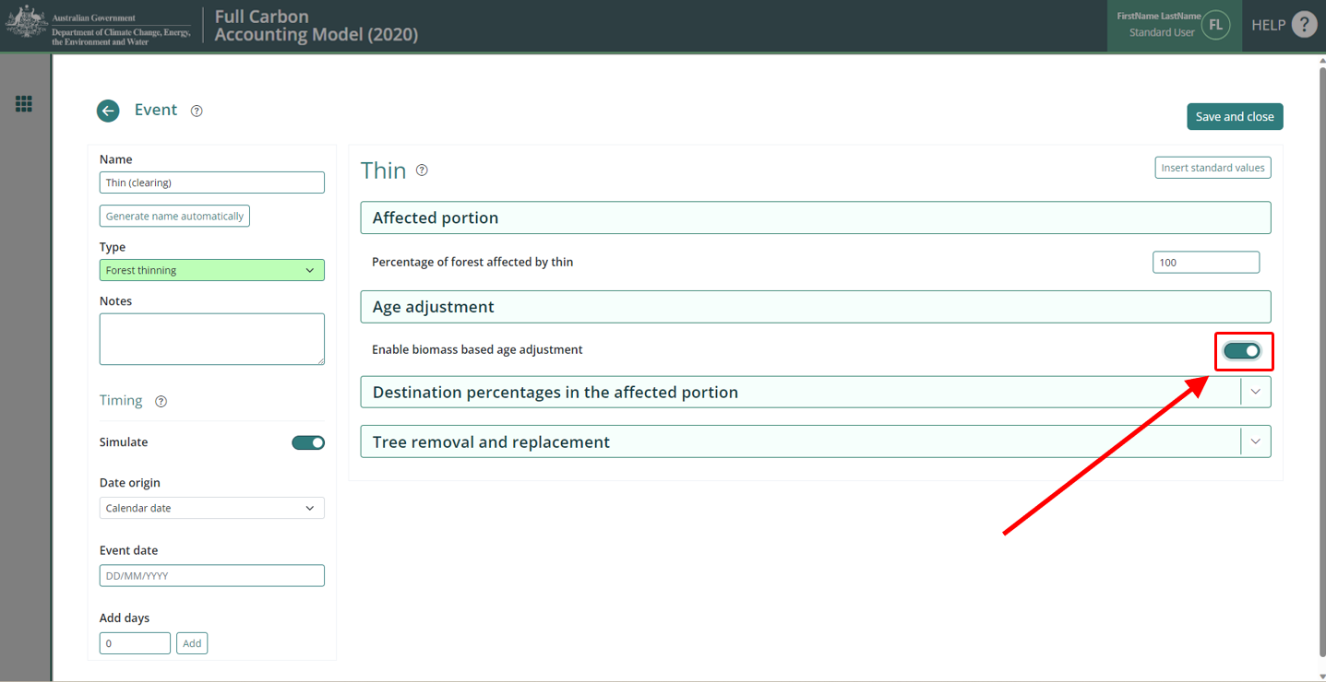
- Enter the Event date. Ensure the Date Origin setting is “Calendar date”. The accepted format for the Event date is DD/MM/YYYY.
- Click the green “Save and close” button in the top right.

Modelling prescribed burning events
A prescribed burn is a management fire with the objective to reduce fire risk by reducing fuel loads in the debris layer without killing the trees.
If the prescribed fire does kill trees, then a ‘wildfire event’ must be used rather than a prescribed burn event.
- Select “Forest fire” Event Type.
- Click the “Insert standard values” button.

Figure 20 Inserting standard values for a forest fire event in FullCAM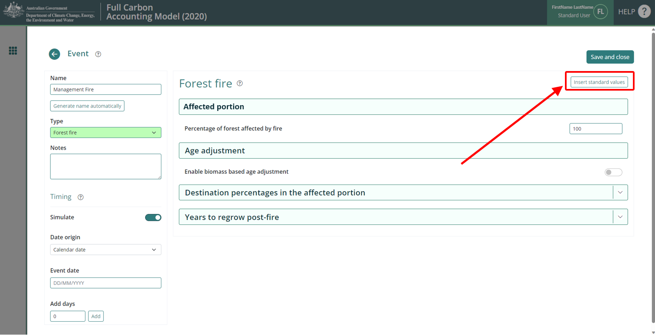
- In the checkbox on the left, select the event with the name “Prescribed burn”, and click the “Ok” button in the bottom right.
- Enter the Event date. Ensure the Date Origin setting is “Calendar date”. The accepted format for the Event date is DD/MM/YYYY.
- Click the green “Save and close” button in the top right.

Modelling wildfire events
Wildfires are defined as all fires that are unplanned and may or may not result in tree mortality.
In addition, prescribed fires that result in tree mortality must be modelled using a wildfire event.
For all fire events modelled using this event:
- An estimation of the proportion of the CEA affected by fire (irrespective of whether trees are killed or not) is required. As an example, the proportion of the CEA affected by fire could be estimated via aerial or satellite imagery; and
- An estimation of the proportion of trees killed by the fire event within the burnt area (to the nearest 10%) should be made between 1 to 4 months after the fire event. If the proportion of trees killed in the burnt area is not estimated between 1 to 4 months after the fire event, then it is assumed that 70%- 100% trees were killed, and input values for these must be used.
- Select the “Forest fire” Event Type option.
- Click the “Insert standard variables” button. This will open a pop-up window.
- In the checkbox on the left, select the event with the name (in the middle column) “Wildfire – xx% trees killed” closest to the estimate of trees killed by the fire event within the burnt area. You may have to go to the second page of items in order to view this.

Figure 21 Selecting a wildfire event in FullCAM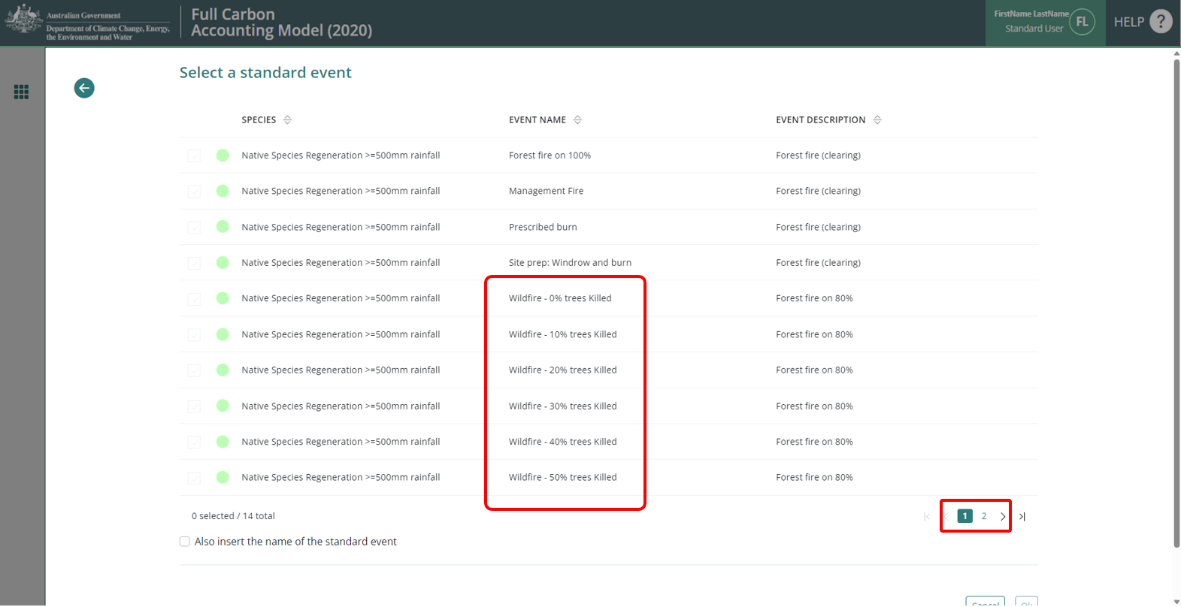
- Click the “Ok” button in the bottom right.
- In the “Affected portion” section, update the “Percentage of forest affected by fire” to reflect the amount of forest impacted by the wildfire. For example, if the entire CEA was burnt (irrespective of whether trees were or were not killed), this would be 100; if only 30 per cent was burned (irrespective of how many in that were killed), enter 30.
- Enter the Event date. Ensure the Date Origin setting is “Calendar date”. The accepted format for the Event date is DD/MM/YYYY.
- Click the green “Save and close” button in the top right of the screen.

Modelling growth pause events
A growth pause event is used to model the stopping or slowing of vegetation growth due to a suppression disturbance event (or the combined impacts of more than one suppression disturbance event), such as grazing by livestock/feral animals, disease or pests, or another event. Normal climatic variability of wetter and drier periods (i.e., including droughts to an extent) causing fluctuations in the growth rate are already incorporated within the vegetation growth calibration used by the model, and are not required to be added as growth pause events in FullCAM.
The use and timing of any modelled growth pause must be consistent with the records that evidence the type and timing of disturbance events, and their associated dates of occurrence (see section 41 of the Determination). Where there is uncertainty over timing, a longer period may be used to conservatively estimate the duration of the growth pause. Such uncertainty does not preclude including additional growth pauses where appropriate, but the timing of such pauses should best give effect to the available evidence. Growth pauses are applicable throughout the crediting period.
Growth pauses should be included where necessary to ensure consistency with both:
- paragraph 30(b) of the Determination, that the modelling accurately reflects the set of management activities and disturbance events that have occurred. Growth pauses assist in ensuring that the abatement estimates of the method do not overestimate carbon abatement achieved by a project.
- the requirements of the Regulator’s five yearly regeneration checks[1] —required under 70(3A) of the Carbon Credits (Carbon Farming Initiative) Rule 2015. In the absence of the use of growth pauses to account for a lack of regeneration progress, CEAs may be need to be re-stratified to exclude the areas where regeneration cannot be evidenced (refer to the Regulator’s Guidelines).
If the human-assisted regeneration activity undertaken as part of the project includes the exclusion of livestock from the CEA, then grazing by livestock cannot normally be modelled prior to the CEA achieving forest cover through regeneration (as this is not allowed under the Determination). However, if there is unintentional, short-term grazing by livestock (e.g. due to stock entering a CEA through a damaged fence), then the grazing must be modelled as a growth pause for the length of time that the unintentional grazing occurred.
The start date for a growth pause is the date on which growth stopped or slowed. Where there are multiple factors contributing to a suppression disturbance event, or the source of suppression or actual date of suppression disturbance event cannot be identified, the date can be estimated.
If the Growth Pause event is linked to a Mortality Disturbance event, then the date of the event is the same date as that entered for the Mortality Disturbance event.
- Select the “Forest treatment” Event Type.
- Do NOT click the “Insert standard values” button.
- Enter a name which describes the suppression disturbance event (e.g., ‘Grazing’ or similar).
- Enter the Event date. Ensure the “Date Origin” setting is “Calendar date”. The accepted format for the Event date is DD/MM/YYYY.
- Toggle ON the “Type 1: Age advance” (from grey and white, to green).

Figure 22 Disabling age advance for a forest treatment event in FullCAM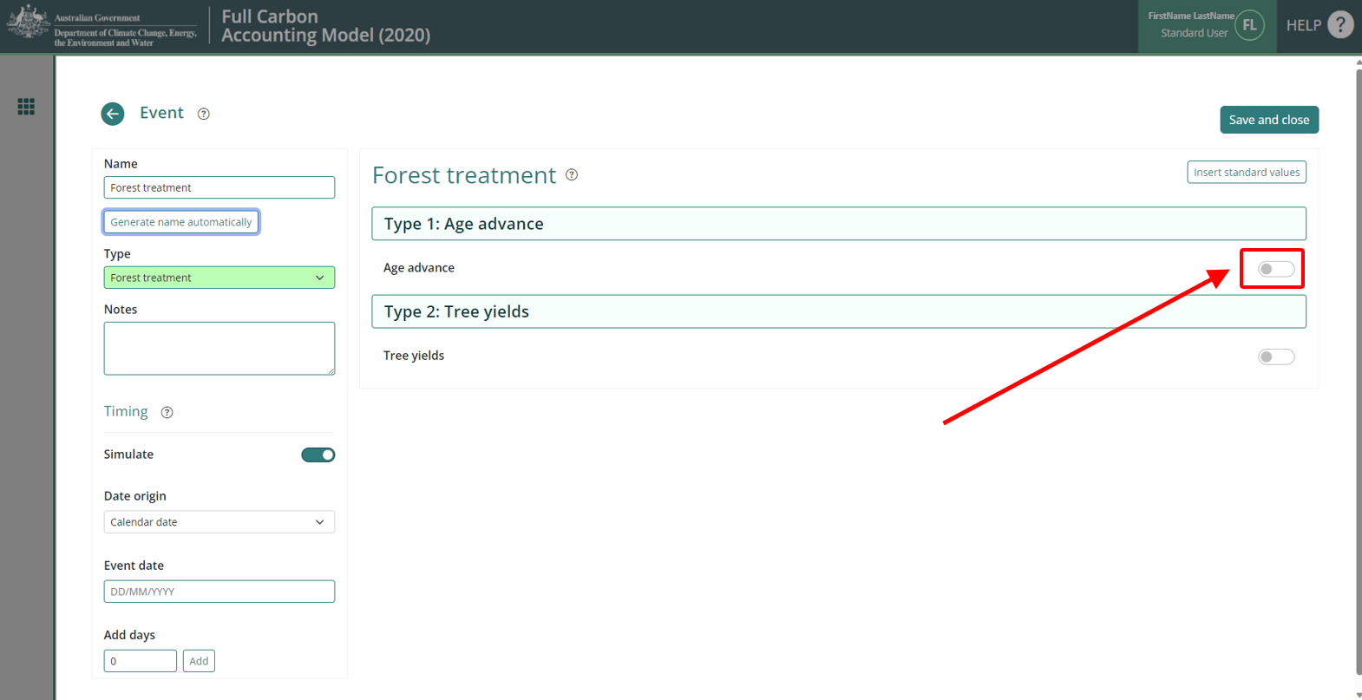
- In the “Age advance due to treatment field, enter an estimate for how long the grazing disturbance event or growth pause event occurred as a decimal proportion in years, and as a negative number. For example, if the grazing disturbance event occurred for 3 years and 9 months, then ‘-3.75’ would be entered in this box. As another example, If the grazing disturbance event occurred for 5 years, then ‘-5’ would be entered in this box.
- In the “Advancement period” box enter the absolute value of the number added in the “Age advance due to treatment” box. For example, using the examples above, the value to add to this box would be: (1) ‘3.75’, or (2) ‘5’.
- DO NOT change the “Tree yields” settings.
- Press “Save and close”.

The Output Windows Tab
From the templates used to create plot files, the following outputs will be selected, consistent with the Determination requirements:
  - the following tree carbon pool: Carbon / Forest / Plants / C mass of trees.
  - the following debris carbon pool: Other / Carbon Projects / C mass of forest debris.
  - the following non CO₂ emission: Carbon / Whole / Emissions / CH4 emitted due to fire
  - the following non CO₂ emission: Nitrogen / Whole / Emissions / N2O emitted due to fire.
Note: only the four pools listed above must be selected. If the plot file has been modified to be inconsistent with this, ensure this is corrected by navigating through the drop-down menus and unselecting any other outputs that have a tick against them.

Figure 23 Selecting the output categories in FullCAM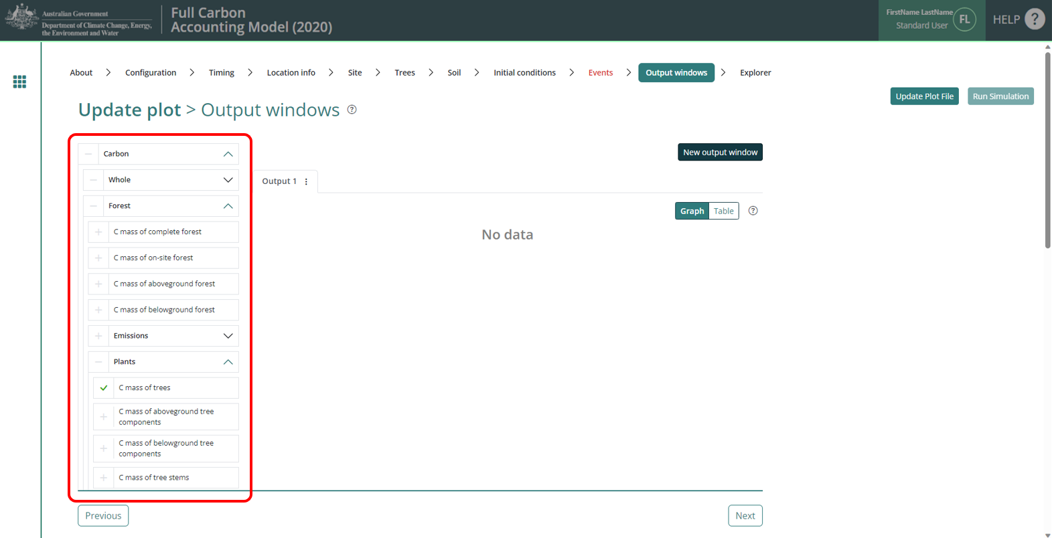

Running simulations
To run the simulation, click the “Run Simulation" button, in the top right of the screen. This will generate the selected outputs in a graph. It will also initialise a download of the result in CSV format. This button will appear faded out and will not be available if the Events queue contains invalid Events, which will appear in red, and the tab will have a red title.
Figure 24 Running a simulation in FullCAM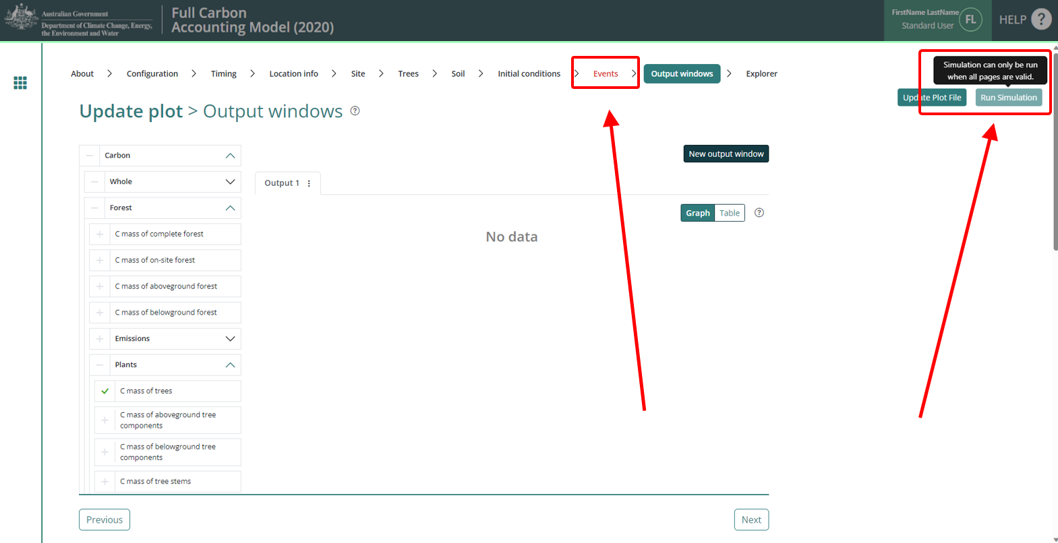
Note that if reopening a plot file, users must first navigate to the “Location info” tab and click “Query FullCAM spatial data” before running the simulation to ensure the latest spatial data is used for the simulation.

Viewing outputs
Outputs can be viewed as a graph or a table by clicking on the corresponding icons at the top right of the Output Window.
Figure 25 Viewing outputs in FullCAM
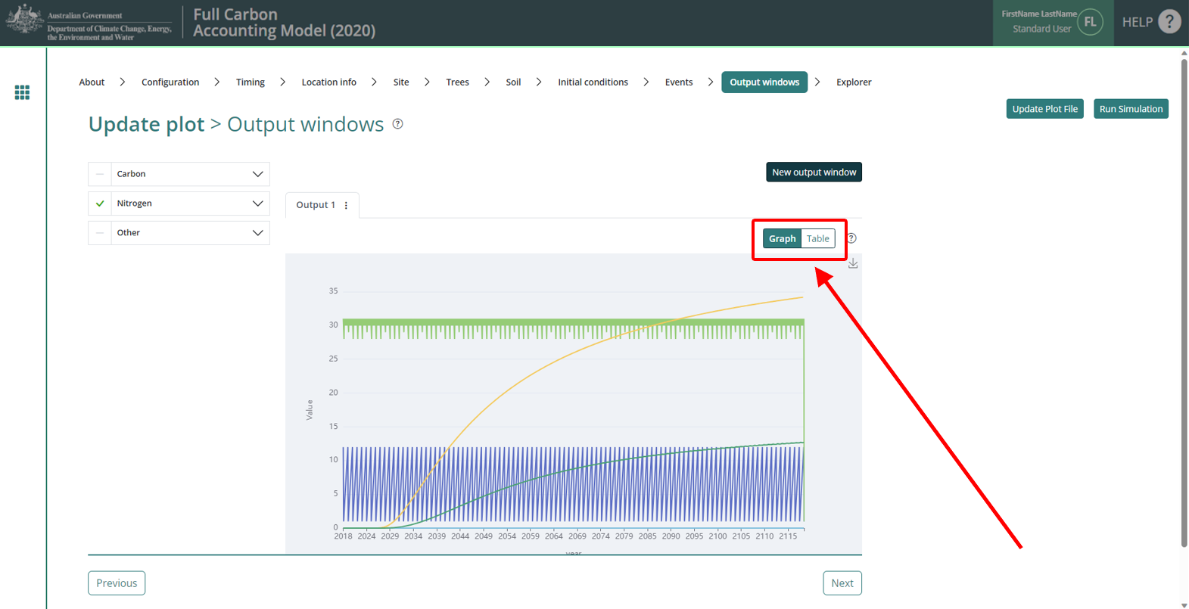

Accessing outputs as a spreadsheet
Running a simulation will automatically download the CSV file with the graph’s data. A pop-up near your ‘Downloads’ button on your browser may request permission to download.

Output values required in the Determination
Once you have the data in a spreadsheet, the steps required are as follows:
Determine initial carbon (if required) for a carbon estimation area:
- The initial carbon stock for a CEA, the C mass of forest debris (CD_{i} ) value to use in Equation 5 is the value in the column labelled “C mass of forest debris (tC/ha)” for the last month before the start of the reporting period.
- Similarly, the C mass of trees (CT_{i} ) value is the value in the column labelled “C mass of trees (tC/ha)” for the last month before the start of the reporting period.
Determine closing carbon stock for a carbon estimation area:
- For the closing carbon stock for a CEA in a reporting period, the C mass of forest debris (CD_{i} ) value to use in Equation 5 is the value in the column labelled “C mass of forest debris (tC/ha)” for the last month in the reporting period.
- The C mass of trees (CT_{i} ) value is the value in the column labelled “C mass of trees (tC/ha)” for the last month in the reporting period.
Calculate the total methane (CH₄) and nitrous oxide (N₂O) emissions for the project activity:
- First enter the SUM function in Excel in an empty cell and highlight the cell range for the “CH₄ emitted due to fire (tCH4/ha)” for each month in the reporting period. Press enter.
- Next enter the SUM function in Excel in a different empty cell and highlight the cell range for the “N₂O emitted due to fire (tN2O/ha)” in each month of the reporting period. Press enter.

FullCAM simulations and offsets reporting
Project proponents must calculate the project net abatement by completing the equations in Part 4 of the Determination. Parameters generated in FullCAM are used in Equations in the Determination consistent with section 31 of the Determination.
Note that for some of the equations the average or sum of the FullCAM output over the reporting period will be required, whereas for others the value of the FullCAM output at the end of the reporting period will be used. Refer to the equations within the Determination to determine which value to use. Averages and sums can be calculated using the average and sum functions within your spreadsheet software.
Table 3 FullCAM outputs and corresponding parameters as defined in the determination
Description | FullCAM Output(s) | Units | Parameter as defined in the Determination | Equation in the determination
Carbon mass of trees | C mass of trees | t C ha⁻¹ | CT_{i} | Equation 5
Carbon mass of forest debris | C mass of forest debris | t C ha⁻¹ | CD_{i} | Equation 5
Methane emitted due to fire | CH₄ emitted due to fire | t CH₄ ha⁻¹ | $$E_{{CH}_{4},i}$$ | Equation 7
Nitrous oxide emitted due to fire | N₂O emitted due to fire | kg N₂O ha⁻¹ | $$E_{N_{2}O,i}$$ | Equation 8

[1] Regulator’s Guidelines on stratification evidence and records for HIR and NFMR: http://www.cleanenergyregulator.gov.au/ERF/Forms-and-resources/Regulatory-Guidance/sequestration-guidance/crediting-abatement-%E2%80%93-human-induced-regeneration-and-native-forest-from-managed-regrowth-methods
[1] Regulator’s Guidelines on stratification evidence and records for HIR and NFMR: http://www.cleanenergyregulator.gov.au/ERF/Forms-and-resources/Regulatory-Guidance/sequestration-guidance/crediting-abatement-%E2%80%93-human-induced-regeneration-and-native-forest-from-managed-regrowth-methods

