
Draft FullCAM Guidelines

Requirements for using the Full Carbon Accounting Model (FullCAM) in the Australian Carbon Credit Unit (ACCU) Scheme methodology determination: Carbon Credits (Carbon Farming Initiative) (Native Forest from Managed Regrowth) Methodology Determination 2013
These proposed guidelines are for consultation purposes only. They are not to be followed for reporting under the ACCU Scheme.
Version 4.1
(Published and in force from 1 September 2020, updated September 2023)

© Commonwealth of Australia 2023
Ownership of intellectual property rights
Unless otherwise noted, copyright (and any other intellectual property rights) in this publication is owned by the Commonwealth of Australia (referred to as the Commonwealth).
Creative Commons licence
All material in this publication is licensed under a Creative Commons Attribution 4.0 International Licence except content supplied by third parties, logos and the Commonwealth Coat of Arms.
Inquiries about the licence and any use of this document should be emailed to copyright@dcceew.gov.au.

Cataloguing data
This publication (and any material sourced from it) should be attributed as: The Department of Climate Change, Energy, the Environment, and Water, FullCAM Guidelines: Requirements for using the Full Carbon Accounting Model (FullCAM) in the Australian Carbon Credit Unit (ACCU) methodology determination Carbon Credits (Carbon Farming Initiative) (Native Forest from Managed Regrowth) Methodology Determination 2013, Department of Climate Change, Energy, the Environment and Water, Canberra. CC BY 4.0.
This publication is available at [address to be confirmed].
Department of Climate Change, Energy, the Environment and Water
GPO Box 3090 Canberra ACT 2601
Telephone 1800 900 090
Web dcceew.gov.au
Disclaimer
The Australian Government acting through the Department of Climate Change, Energy, the Environment and Water has exercised due care and skill in preparing and compiling the information and data in this publication. Notwithstanding, the Department of Climate Change, Energy, the Environment and Water, its employees and advisers disclaim all liability, including liability for negligence and for any loss, damage, injury, expense or cost incurred by any person as a result of accessing, using or relying on any of the information or data in this publication to the maximum extent permitted by law.
Acknowledgement of Country
Our department recognises the First Peoples of this nation and their ongoing connection to culture and country. We acknowledge Aboriginal and Torres Strait Islander Peoples as the Traditional Owners, Custodians and Lore Keepers of the world's oldest living culture and pay respects to their Elders past, and present.

Contents
1. Introduction 5
1.1 Use of FullCAM with the Native Forest from Managed Regrowth Methodology Determination 2013 5
1.2 Determining which FullCAM option to use 5
1.3 Format of this document 7
1.4 FullCAM background 7
1.5 FullCAM plots and running simulations 8
1.6 Overview of the FullCAM interface 9
1.7 Development and updates to this document 11
2. Simulations overview 12
2.1 Baseline scenarios 12
2.2 Baseline materiality test 13
2.3 Non-zero baselines 14
2.4 Overview of simulation for calculating project carbon stocks 18
3. 2020 FullCAM option – Setting up simulations for carbon estimation areas 20
3.1 Creating a new plot from template 20
3.2 The Timing Tab 23
3.3 The Location info Tab 24
3.4 The Site, Trees, Soil, and Initial Conditions Tabs 24
3.5 The Events Tab 24
3.6 The Output Tab 41
3.7 Running Simulations 42
3.8 Viewing outputs 43
3.9 Accessing outputs as a spreadsheet 43
4. FullCAM simulations and offsets reporting 45

Tables
Table 1 FullCAM tabs 9
Table 2 Factors for calculating materiality 13
Table 3 Baselines 13
Table 4 Overview of simulation for calculating C100_5% 13
Table 5 Overview of simulation for calculating C10 14
Table 6 Overview of simulation for calculating a Default Baseline 15
Table 7 Overview of simulation for calculating a Historic or Hybrid Baseline 17
Table 8 Overview of simulation for calculating project carbon stocks 19
Table 9 Simulation types and permitted events 25
Table 10 FullCAM outputs and corresponding parameters as defined in the determination 45

Figures
Figure 1 FullCAM download options 7
Figure 2 Decision tree for determining the type of baseline to be used for each CEA. See section 4.12 of the Determination for the relevant provisions. 12
Figure 3 Selecting a new simulation in FullCAM 20
Figure 4 The Australian Government’s National Map 21
Figure 5 The Australian Government’s National Map 22
Figure 6 Adding the long term average rainfall data to the National Map 22
Figure 7 Entering the latitude and longitude of a location into the National Map 23
Figure 8 Identifying the average annual rainfall for a location in the National Map 23
Figure 9 Entering longitude and latitude in FullCAM 24
Figure 10 Adding a new event FullCAM 26
Figure 11 Enabling age advance for a forest treatment event in FullCAM 35
Figure 12 Selecting regimes in FullCAM 36
Figure 13 Merging regimes in FullCAM 36
Figure 14 Cloning regimes in FullCAM 37
Figure 15 Selecting regimes in FullCAM 38
Figure 16 Merging regimes in FullCAM 38
Figure 17 Cloning regimes in FullCAM 39
Figure 18 Selecting regimes in FullCAM 40
Figure 19 Merging regimes in FullCAM 40
Figure 20 Cloning regimes in FullCAM 41
Figure 21 Selecting the output categories in FullCAM 42
Figure 22 Running a simulation in FullCAM 43
Figure 23 Viewing outputs in FullCAM 43

Introduction

Use of FullCAM with the Native Forest from Managed Regrowth Methodology Determination 2013
The calculation of carbon abatement under the Carbon Credits (Carbon Farming Initiative) (Native Forest from Managed Regrowth) Methodology Determination 2013 (the Determination) is dependent upon the use of the Full Carbon Accounting Model (FullCAM) consistently with the requirements of this document. In particular, sections 4.8, 4.9, 4.12, 4.14, 4.16, 4.18 and 4.19 of the Determination require that the materiality test, baseline scenario and project scenario for each carbon estimation area (CEA) must be modelled in FullCAM in accordance with the requirements in both the Determination and this document.
Section 4.18 of the Determination requires that any project specific inputs specified in this document must be used to determine the project carbon stocks for a CEA. Note that each of the simulations and modelling events detailed in this document have specific inputs that must be used. Section 4.19 also specifies that the relevant events that reflect actual management events and the relevant species setting specified in the document must be used to model the project period.
Sections 4.30 and 4.31 of the Determination also require key input and output data to be produced using FullCAM in accordance with the requirements in the Determination and this document. Where content of this document relates to provisions of the Determination, references are given to the location of those provisions.
Project proponents must only change FullCAM default settings as indicated in this document, and all other settings must not be changed. This is to ensure that defaults will apply where relevant (see subsections 4.14(3) and 4.18(3) of the Determination).

Determining which FullCAM option to use
The Department of Climate Change, Energy, the Environment and Water updates the Full Carbon Accounting Model (FullCAM) from time to time to reflect the latest science and improve usability. At the time this document was last updated, the latest version was released for public use in 2024 on the Department’s website ([to be confirmed]). The latest publicly released version of FullCAM is constituted by two options.
- Default: 2020 FullCAM option
This is currently the 2020 FullCAM option. The year reflects when the latest version was released at the time this document was last updated. However, a reference to the default or 2020 FullCAM option in this document includes any subsequent release or update of FullCAM on the Department’s website. Accordingly, projects using the default 2020 FullCAM option will be required to use subsequent releases as they are made available.

- Alternative: 2016 FullCAM option
This is identified as the 2016 FullCAM option and is only available for use by some projects, as described below.
Project proponents must access the latest publicly released version of FullCAM from the Department’s website and then ensure they are using the appropriate FullCAM option for their project (see screenshot below).
An exception to the requirement to use the latest publicly released version is for projects with reporting periods that end before 1 September 2020, under a method that specifies to use the version of FullCAM and the associated Guidelines for those periods. If you determine that you must use a version of FullCAM that is unavailable on the website, please contact the Department at FullCAM@dcceew.gov.au or ACCUMethods@dcceew.gov.au to obtain a link.
The requirements below explain when the default 2020 FullCAM option must be used and when the alternative 2016 FullCAM option can be used.
- Whichever FullCAM option is used by the proponent, all CEAs of a given project must be reported on using a single FullCAM option.
- Projects with section 22 declaration applications under the Carbon Credits (Carbon Farming Initiative) Act 2011 (CFI Act), submitted to the Clean Energy Regulator (the Regulator) on or after 1 September 2020, must use the default 2020 FullCAM option.
- Projects with section 22 declaration applications submitted to the Regulator before 1 September 2020 are able to use either the default 2020 FullCAM option or the alternative 2016 FullCAM option. These projects are able to move from the 2016 FullCAM option to the 2020 FullCAM option if they choose to do so. If a choice to use the 2020 FullCAM option is made, the entire project must be moved to 2020 FullCAM and once using 2020 FullCAM option in an offsets report, these projects cannot return to using the 2016 FullCAM option. Eligible offsets projects prior to 31 March 2019 have grandfathered growth pause provisions that they will no longer have access to if they move to the 2020 FullCAM option.
- If project proponents with section 22 declaration applications submitted to the Regulator before 1 September 2020 add a new project area or areas to the project under the section 29 of the CFI Act with effect on or after 1 September 2020, the entire project must use the default 2020 FullCAM option. The only exception to this is where all of the areas added to the project were already using the alternative 2016 FullCAM option under these guidelines as part of another eligible offsets project (these can continue to use the 2016 FullCAM option consistent with the dot point above – therefore the original project must also have been eligible to use the 2016 FullCAM option).
- Projects that transfer from an earlier to a later version of this method or transfer to this method from another method, with the application under section 128 of the CFI Act submitted on or after 1 September 2020, must use the default 2020 FullCAM option.
Note that FullCAM is not compatible with iOS systems, and must be run in a Windows operating environment.

Figure 1 FullCAM download options
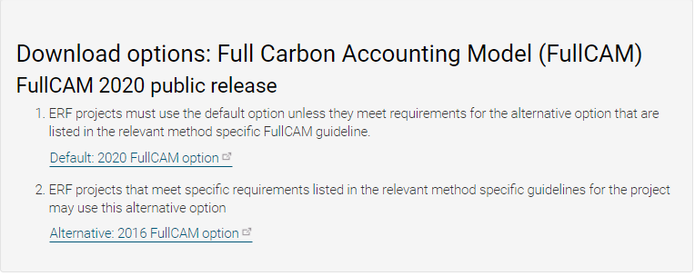
Two options
Screenshot from download page

Format of this document
This document provides:
- an overview of FullCAM relevant to the Determination, its features relevant to users and important requirements for using this document (section 1)
- an overview of the simulations you must run in FullCAM as per the Determination, including the process used to determine which type of baseline proponents must use (section 2). Tables summarise the objective, time period and outputs for each simulation, as well as the project activities that may need to be simulated
- a step-by-step walkthrough of using 2020 FullCAM to run the simulations correctly (section 3). Users should familiarise themselves with the simulations in section 2 before following the steps in section 3 to run the simulations
- an overview of the FullCAM outputs as they relate to equations within the Determination (section 4).
Note that this document provides a step-by-step walkthrough for 2020 FullCAM alone. This is because this document is for consultation on a modernised interface for that version of FullCAM. The published update to these guidelines will also contain a step-by-step walkthrough for the 2016 FullCAM.
The 2020 FullCAM option requires fewer data entries than the 2016 FullCAM option because many items have been automated in the 2020 FullCAM options through the use of templates.

FullCAM background
FullCAM is used in Australia’s National Greenhouse Gas Accounts for the land sector. FullCAM provides fully integrated estimates of carbon pools in forest and agricultural systems for Australia’s land sector reporting. In addition, it accounts for human-induced changes in emission and sequestration of major greenhouse gases. FullCAM was developed under the National Carbon Accounting System (NCAS) at the then Australian Greenhouse Office to provide a dynamic account of the changing stocks of carbon in Australia’s land systems since 1970 by integrating data on land cover change, land use and management, climate, plant productivity, and soil carbon over time. FullCAM estimates carbon stock change and greenhouse gas emissions at fine spatial and temporal scales, and uses a wide range of spatially referenced data.
Users of FullCAM can determine estimates of carbon stock change and greenhouse gas emissions for ERF projects on a similar basis to that used for land use and land use change in Australia’s National Greenhouse Gas Inventory.

FullCAM plots and running simulations
FullCAM can run simulations on a ‘plot’. A plot, for modelling purposes, is defined as a piece of land for which the event history, when modelled in FullCAM, is the same across that area of land. Separate plot files are created for each CEA (see section 3.3 of the Determination). This document outlines the steps required to run simulations in each FullCAM option as outlined in section 3 and section 4 respectively.
In the 2016 FullCAM option, there are several types of plots that can be selected. Only ‘forest system’ is relevant to this Determination. This selection does not need to be made in the 2020 FullCAM option because it has been automated through the creation of a default template.
At the point in 2016 FullCAM option where users choose to create a new plot file, they instead select an appropriate template from a drop-down list and 2020 FullCAM option then populates FullCAM with the template plot.
FullCAM uses a single ‘model point’ location. Proponents do not need to define plot boundaries within FullCAM, rather proponents must input the coordinates for a single location that is at the approximate centre of the CEA (the model point – see paragraph 3.3(1)(c) of the Determination). The latest spatial data for a plot must be downloaded using the ‘Data Builder’ tab each time the software is run.
In order to ensure all settings are correct, including defaults, we recommend creating new plot files each time a new version of FullCAM or these Guidelines, or a different FullCAM option, is used. Plot files created under previous versions or options may contain different settings that will affect outputs and users are responsible for ensuring they have used the correct FullCAM version and option, and accurately followed the associated FullCAM Guidelines.
For each CEA, separate plot files must be created for:
- determining whether a zero baseline or non-zero baseline must be used (initial reporting period only);
- estimating carbon stocks under a non-zero baseline (if a zero baseline is not appropriate); which may be either a ‘default’ baseline, an ‘historic’ baseline or an ‘hybrid’ baseline;
- estimating carbon stocks for the current reporting period; and
- determining if a disturbance event must be reported prior to the next reporting period.

Overview of the FullCAM interface
The FullCAM software user interface displays menus and a series of tabs. Each tab has a suite of fields in which information may either be required to complete as instructed through these Guidelines or left unchanged. The program is designed so that certain tabs in a plot file are made available only if required fields have valid information entered in earlier tabs. If the text of a tab or field is red, then FullCAM requires information in that tab or field before a simulation can be run. When all the required fields within a tab have valid information entered, the tab text will become blue.
The below table provides a general overview of each tab selectable within FullCAM once a plot has been created. Help is provided within FullCAM by clicking on the symbol available in most windows, or the  button in the top right of the 2020 tool. This general overview of the public version of FullCAM is not intended to instruct proponents of ERF projects on how to use FullCAM for this Determination.
Data entry requirements for this Determination, under each FullCAM option, are described in detail in section 3 and section 4 of these Guidelines.
Table 1 FullCAM tabs
Tab | Explanation
About | Includes a free text field where users can enter information about the plot file that they have created. This is a good space to keep track of changes that have been made or editing of event parameters.
Configuration | Users select the system (e.g. forest, agricultural) they want to simulate in the plot.
Timing | Enter the timing for starting and ending the simulation and the time steps required for output data.
Data Builder  (“Location info” in the 2020 tool) | In this tab users enter the latitude and longitude of the ‘Model Point Location’ where they wish to simulate a plot file. Internet access is required to complete this tab. By choosing to ‘Download Spatial Data’ (called “Query FullCAM spatial data” in the 2020 tool) the associated soil and climate data for that latitude and longitude are automatically loaded into relevant parts of the remaining tabs. In the tab users can then download tree and/or crop species information and management regimes as appropriate. This information is also automatically loaded into relevant parts of the remaining tabs.
Site | Specific parameters (e.g. water [rainfall], temperature, productivity) are described.
Trees | Description of the properties of the tree species.
Crops  (not present in the 2020 tool) | Description of the properties of crop or pasture species (only displays if agricultural system selected).
Soil | Description of soil properties.
Initial Conditions | In this tab the values for carbon at the start of the simulation are described. Values will automatically be populated by Data Builder using data downloaded from the FullCAM server.
Events | All of the events for the entire simulation period are listed in this tab. Users can add or remove events. Care must be taken not to violate requirements for modelling ‘management events’ within the Determination.  For the 2016 tool, the names on the event list are colour-coded to indicate whether they are ready, whether they are simulating or not, and what system they affect. The colour codes are:  Red: Event not ready (renders event queue not ready);  Grey: Event non-simulating (outside simulation period, will not affect simulation);  Green: Forest;  Yellow: Agricultural; and  Brown: Mixed.  Finally, the events users select with the cursor are coloured in the usual highlight colour.
Output Window | Defines what outputs are presented in output windows.
Explorer | Display of the parameter settings for each tab.
Plot Digest  (not present in the 2020 tool) | This tab only appears when a plot is saved as a ‘plot digest’ by changing the save as type. It allows users to clone and alter the inputs of a given modelling scenario, and combine the results or output them separately.
Log  (not present in the 2020 tool) | This tab records changes made to the file to assist with analysis and error tracking.

Development and updates to this document
This document has been developed by the Department to give effect to the Determination and assist the Determination to continue to be effective and meet the offsets integrity standards in section 133 of the Carbon Credits (Carbon Farming Initiative) Act 2011. One of the most relevant offsets integrity standards for the Determination and this document to meet is that ‘to the extent to which a method specified in, or ascertained in accordance with, a methodology determination in accordance with paragraph 106(1)(c) involves an estimate, projection or assumption—the estimate, projection or assumption should be conservative’. The use of estimates, projections or assumptions is inherent to the calculation method of the Determination which uses a computer model (FullCAM) to estimate levels of carbon in both baseline and project scenarios.
The input of events and parameters into the FullCAM software is structured to help ensure that the Determination ultimately results in a conservative estimate of the net abatement amount.
The need for conservativeness can have a different impact on how assumptions are used for baseline scenarios and project scenarios.
For example, for a baseline scenario to be ‘conservative’, assumptions are needed which avoid underestimating the amount of carbon in an area of land. Conversely, in a project scenario, assumptions are needed which avoid overestimating the amount of carbon in an area of land.
Another important offsets integrity standard is that the Determination results in ‘eligible carbon abatement from the project’ such that it contributes to meeting Australia’s international emissions reduction obligations and complies with internationally accepted accounting rules. The development of both the FullCAM software and this document is mindful of the role of the Determination in meeting this offsets integrity standard and remaining consistent with international accounting rules. In particular, it is important that carbon abatement from each method is reflected in Australia’s National Inventory Report.
The Emissions Reduction Assurance Committee plays an important role in assessing, reviewing and monitoring methodology determinations for compliance with the offsets integrity standards. In particular, if the Committee considers that there is reasonable evidence that a determination (with its incorporated models and documents) does not comply with one or more offsets integrity standards, the Committee can make a legislative instrument suspending the processing of applications to apply the method. The Department takes into account the views of the Committee on the need to update this document over time and how best to achieve the offsets integrity standards. Where possible, the Department also considers the views of project proponents to ensure that the requirements in this document are practical to use and fair.

Simulations overview
Sections 4.8, 4.9, 4.12, 4.14, 4.18 and 4.19 of the Determination require that the materiality test, baseline scenario and project scenario for each CEA must be modelled in FullCAM in accordance with the requirements in both the Determination and this document.

Baseline scenarios
The baseline for each CEA will be either of two categories depending on the materiality test below (Section 2.2) – a zero baseline or a non-zero baseline.
Within the non-zero baseline category there are three possible baselines depending on the extent of historical information available regarding the clearing history – default, hybrid or historic. The decision flowchart below gives an overview of the process for determining which baseline to use.
Figure 2 Decision tree for determining the type of baseline to be used for each CEA. See section 4.12 of the Determination for the relevant provisions.
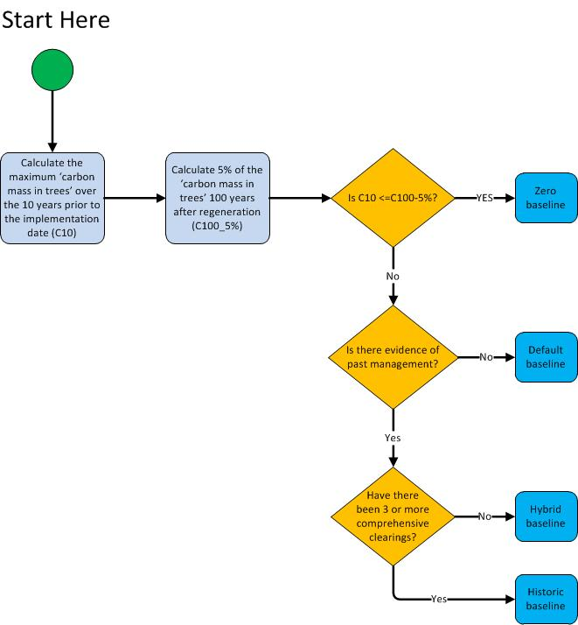

Baseline materiality test
To determine whether a zero baseline may apply in a CEA, project proponents must complete the materiality test explained by this section and to be undertaken by following either section 3 or section 4 of this document. Proponents must also comply with the provisions given for the materiality test in sections 4.7-4.9 of the Determination.
Completing the materiality test involves calculating two factors:
Table 2 Factors for calculating materiality
Factor | Explanation | Process for Calculating
C100_5% | 5 per cent of the ‘carbon mass of trees’ at 100 years after the implementation date | see section 2.2.1 below for how to calculate
C10 | the maximum ‘carbon mass of trees’ over the ten years prior to the implementation date | see section 2.2.2 below for how to calculate
Note: ‘Implementation date’ is defined in section 1.3 of the Determination. It is the date when the project mechanism (a change in land management enabling native vegetation to achieve forest cover) was implemented in a CEA. Each CEA may have a different implementation date.
The values calculated for these factors will allow you to determine which baseline to use:
Table 3 Baselines
Result | Baseline to use
C10 is less than or equal to C100_5% | Zero baseline
C10 is greater than C100_5% | Non-zero baseline (default, hybrid or historic)

Overview of simulation for calculating C100_5%
Table 4 Overview of simulation for calculating C100_5%
Objective | Calculate 5 per cent of the ‘C mass of trees’ at 100 years after the implementation date.
Simulation period | From the implementation date to 100 years after the implementation date.
Events permitted | Regeneration
Outputs | Monthly totals for ‘C mass of trees’ (FullCAM Output = Carbon / Forest / Plants / C mass of trees)

Overview of simulation for calculating C10
Note: When calculating C10, project proponents must have documentary evidence for each event that is entered into the FullCAM event queue.
Table 5 Overview of simulation for calculating C10
Objective | Calculate the maximum carbon mass of trees reached during the 10 years before the implementation date.
Simulation period | From the day after the last comprehensive clearing before the 10 year period that ends on the implementation date to the implementation date.
Events permitted | Regeneration  Growth pause  Clearing  Thinning  Management fire  Windrow and burn
Outputs | Monthly totals for ‘C mass of trees’ (FullCAM Output = Carbon / Forest / Plants / C mass of trees)
Note: ‘comprehensive clearing’ is defined in section 1.3 of the Determination. It means the destruction of trees or saplings, or both, by mechanical or chemical means that may be accompanied by use of fire, leaving the land in a non-forested state for pastoral land use.

Non-zero baselines
Non-zero baselines must be calculated if, according to the materiality test under the previous section, the maximum carbon stock during the ten years prior to the implementation date has reached a material level (i.e. C10 > C100_5%).

Overview of simulation for calculating a Default Baseline
A default non-zero baseline is suitable for project proponents whose records are not sufficient to model either an historic or a hybrid baseline. For further information about default non-zero baselines, see sections 4.12 and 4.15 of the Determination, and pages 19 to 21 and Appendix A of the Explanatory Statement for the original Determination. A default non-zero baseline is modelled in FullCAM by repeating the default baseline management event scenario over the baseline forecast period. This scenario consists of a sequence of comprehensive clearings that occur at 15 year intervals (refer to Table 6).
For the paragraphs below, the ‘applicable date’ for a CEA is the project registration date, except for land later added to the project area through a project variation, in which case it is the project variation date.
Modelling of fires within a Default Baseline where the applicable date is on or prior to 31/03/2019
If project proponents can demonstrate that fire was used to suppress regrowth on land that is part of the same pastoral property as the CEA then:
- a management fire event may be added occurring 7 years after each regeneration event; and
- a windrow and burn fire event may be added occurring 6 months after each clearing event.
Modelling of fires within a Default Baseline where the applicable date is after 31/03/2019
Management Fire
If project proponents can demonstrate that management fire was used to suppress regrowth on land that is part of the same pastoral property as the applicable CEA, but not within the applicable CEA, then:
- a management fire event may be added occurring 7 years after each regeneration event in every odd-numbered baseline interval.

If project proponents can demonstrate that management fire was used to suppress regrowth within the applicable CEA, then:
- a management fire event may be added occurring 7 years after each regeneration event.
Windrow and Burn
If project proponents can demonstrate that a windrow and burn fire event was used following clearing on land within the applicable CEA, then:
- a windrow and burn fire event may be added occurring 6 months after each clearing event.

Table 6 Overview of simulation for calculating a Default Baseline
Objective | Calculate the default baseline which estimates average carbon stocks in a CEA in the absence of an eligible offsets project. The average carbon stocks over the 100 years from the implementation date are used in the calculations within the method (the baseline forecast period), but the simulation period commences at an earlier date (see below).
Simulation period | From one day after the last comprehensive clearing event that occurred before the implementation date. Simulations end 100 years after the implementation date.
Events permitted | Regeneration  Management fire 7 years after regeneration event – where the use of management fires to suppress regrowth can be demonstrated in accordance with the notes above  Clearing  Windrow and burn fire 6 months after clearing event – where windrow and burning events can be demonstrated in accordance with the notes above
Outputs | Monthly totals for ‘C mass of trees’ (FullCAM Output = Carbon / Forest / Plants / C mass of trees)  Monthly totals for ‘C mass of debris’ (FullCAM Output = Carbon / Forest / Debris / C mass of forest debris)

Overview of simulation for calculating a Hybrid Baseline
A hybrid baseline is suitable for project proponents who have evidence of two comprehensive clearings that occurred less than 15 years apart and before the implementation date. For further information about hybrid baselines, see sections 4.12 and 4.15 of the Determination, and pages 19 to 21 and Appendix A of the Explanatory Statement for the original Determination.
A hybrid baseline is modelled in FullCAM by repeating the hybrid baseline management event scenario over the baseline forecast period. This scenario consists of a sequence of comprehensive clearings that occur at two alternating intervals, one default interval of 15 years, followed by one historic interval matching the interval between the last two clearings before the implementation date.
For the paragraphs below, the ‘applicable date’ for a CEA is the project registration date, except for land later added to the project area through a project variation, in which case it is the project variation date.
Modelling of fires within a Default Baseline where the applicable date is on or prior to 31/03/2019
If project proponents can demonstrate that fire was used to suppress regrowth on land that is part of the same pastoral property as the CEA then:
- a management fire event may be added occurring 7 years after each regeneration event in the default interval; and
- a windrow and burn fire event may be added occurring 6 months after each clearing event in the default interval.
Modelling of fires within a Default Baseline where the applicable date is after 31/03/2019
Management Fire
If project proponents can demonstrate that management fire was used to suppress regrowth on land that is part of the same pastoral property as the applicable CEA, but not within the applicable CEA, then:
- a management fire event may be added occurring 7 years after each regeneration event in every odd-numbered default interval.

If project proponents can demonstrate that management fire was used to suppress regrowth within the applicable CEA, then:
- a management fire event may be added occurring 7 years after each regeneration event in each default interval.
Windrow and Burn
If project proponents can demonstrate that a windrow and burn fire event was used following clearing on land within the applicable CEA, then:
- a windrow and burn fire event may be added occurring 6 months after each clearing event in each default interval.

Modelling of fires within the historic interval
If project proponents can demonstrate that fire was used in the historic interval in the applicable CEA, then corresponding fire events set out in these Guidelines may be included in modelling that interval.
If documentary evidence shows, to the satisfaction of the Regulator, that a management event other than a comprehensive clearing occurred in the CEA during the historic interval, that management event may be included in the historic interval if it is a permitted event in Table 7 below.

Overview of simulation for calculating a Historic Baseline
Project proponents wishing to model a historic baseline must have evidence for at least three comprehensive clearings that occurred in the CEA before the implementation date. For further information about historic baselines, see sections 4.12 and 4.15 of the Determination, and pages 19 to 21 and Appendix A of the original Explanatory Statement.
A historic baseline is modelled in FullCAM by repeating the historic baseline management event scenario over the baseline forecast period.
There are stringent evidentiary requirements for modelling a historic baseline. Project proponents must have documentary evidence for each event modelled in the scenario (refer Table 7).
If documentary evidence shows, to the satisfaction of the Regulator, that a management event other than a comprehensive clearing occurred in the CEA before the implementation date, that event may be included in the historic baseline scenario if it is a permitted event in Table 7 below.
Table 7 Overview of simulation for calculating a Historic or Hybrid Baseline
Objective | Calculate historic and hybrid non-zero baselines which estimate average carbon stocks in a CEA in the absence of an eligible offsets project.
Simulation period | One day after the most recent comprehensive clearing event. Simulations end 100 years after the implementation date (the baseline forecast period).
Events permitted | Regeneration  Growth pause  Clearing  Thinning  Management fire  Windrow and burn
Outputs | Monthly totals for ‘C mass of trees’ (FullCAM Output = Carbon / Forest / Plants / C mass of trees)  Monthly totals for ‘C mass of debris’ (FullCAM Output = Carbon / Forest / Debris / C mass of forest debris)

Overview of simulation for calculating project carbon stocks
To determine the project carbon stocks, project proponents must model all events listed in the table below that reflect the actual management events that occurred in the CEA during the entirety of the simulation period (from one day after the last comprehensive clearing before the implementation date until the end of the current reporting period).
Table 8 Overview of simulation for calculating project carbon stocks
Objective | Calculate total carbon stocks in each CEA at the end of each reporting period. These carbon stocks will reflect the age of the regrowth within the CEA, observed climate, and activities and disturbance subsequent to the establishment of the offsets project.
Simulation period | From one day after the last comprehensive clearing before the implementation date. Simulations end at the end of the current reporting period.
Events permitted | Regeneration  Growth pause  Clearing  Thinning  Prescribed fire – to reduce fire risk  Wildfire – trees not killed  Wildfire – trees killed  Management fire  Windrow and burn
Outputs | Monthly totals for ‘C mass of trees’ (FullCAM Output = Carbon / Forest / Plants / C mass of trees)  Monthly totals for ‘C mass of debris’ (FullCAM Output = Other / Carbon Projects / C mass of forest debris)  Monthly totals for emissions of CH₄ from fire (FullCAM Output = Whole / Emissions / CH₄ emitted due to fire)  Monthly totals for emissions of N₂O from fire (FullCAM Output = Nitrogen / Whole / Emissions / N₂O emitted due to fire)

2020 FullCAM option – Setting up simulations for carbon estimation areas
Section 1.2 describes the requirements for which FullCAM option can be used. The general effect of requirements described in Section 1.2 is that the 2020 FullCAM option is the default. Only projects that satisfy the criteria described in section 1.2 are able to use the 2016 FullCAM option.
Simulations for each CEA are undertaken using plots. Project proponents must use the following steps for creating FullCAM plots and inputting values for each CEA registered under the Determination.
All steps must be followed when creating new plot files and inputting values.
Once a plot file has been setup for a CEA and scenario, it can re-opened for modelling at a later date. When reopening plot files, users must first navigate to the “Location info” tab and click the green “Query FullCAM spatial data” button before running the simulation, to ensure the latest spatial data is used for the simulation.

3.1 Creating a new plot from template

3.1.1 Steps to create a new plot
- With FullCAM open, click on the menu grid, on the top left of the screen, then select ‘New Simulation’.
Figure 3 Selecting a new simulation in FullCAM
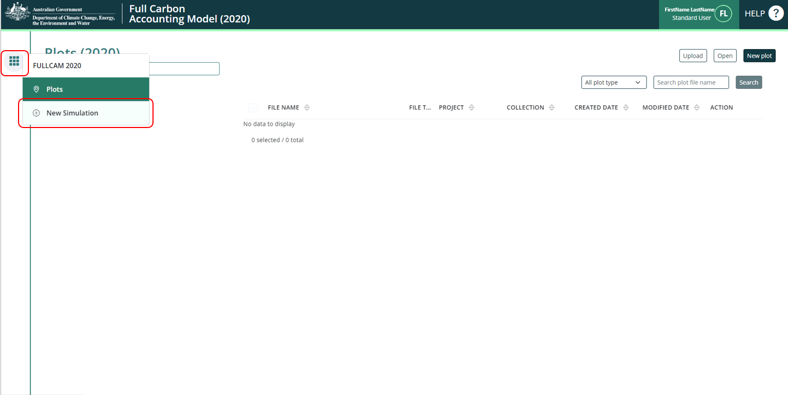
- Select, under the ‘Create from templates’ section, the ‘HIR NFMR and Avoided Clearing Methods’ option corresponding to the long-term average annual rainfall for the applicable model point location (either greater or less than 500mm). The two rainfall options for the natural regeneration calibration differ in the root- to- shoot ratio used to determine biomass allocation to roots. Biomass in roots constitutes a higher proportion of total biomass in the low rainfall option.
The long-term average annual rainfall is determined using the Long Term Average [annual] Rainfall Map Layer, also known as the CFI rainfall map, previously available from the CFI Mapping tool.
A CEA (or CEA part) including areas of land on both sides of the 500mm rainfall boundary, according to the CFI rainfall map, does not in itself prevent the CEA being modelled with a single events queue.
The long term average annual rainfall map layer shows the long-term average annual rainfall (mm) across continental Australia, calculated for the period 1920-2010. The long-term average annual rainfall map layer (also labelled CFI Mapping tool - Rainfall map) can be accessed for viewing or downloading from data.gov.au under Emissions Reduction Fund Environmental Data (https://data.gov.au/dataset/ds-dga-b46c29a4-cc80-4bde-b538-51013dea4dcb/details?q=emission reduction fund).

3.1.2 Steps to view the long-term average annual rainfall data on data.gov using the Australian Government’s National Map:
- Go to (https://nationalmap.gov.au/) and select the “Upload” button on the top left of the screen.
Figure 4 The Australian Government’s National Map
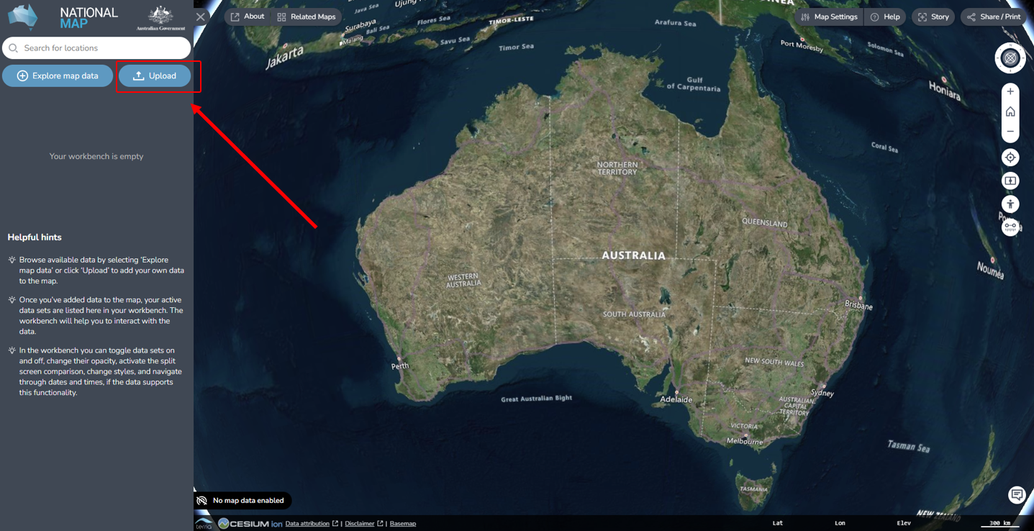
- Select “Add Web Data”
- Choose the file or web service type. It is preferable to use “Web Map Service (WMS) Server” and the link in the next step.
- Paste the following URL: https://data.gov.au/geoserver/emissions-reduction-fund-environmental-data/wms (which is located in data.gov.au under the ERF Environmental data – Preview dataset WMS) and click “Add”.
- On the next pop-up, click “GeoServer Web Map Service” to expand it, and click “Long term average annual rainfall”.

Figure 5 The Australian Government’s National Map
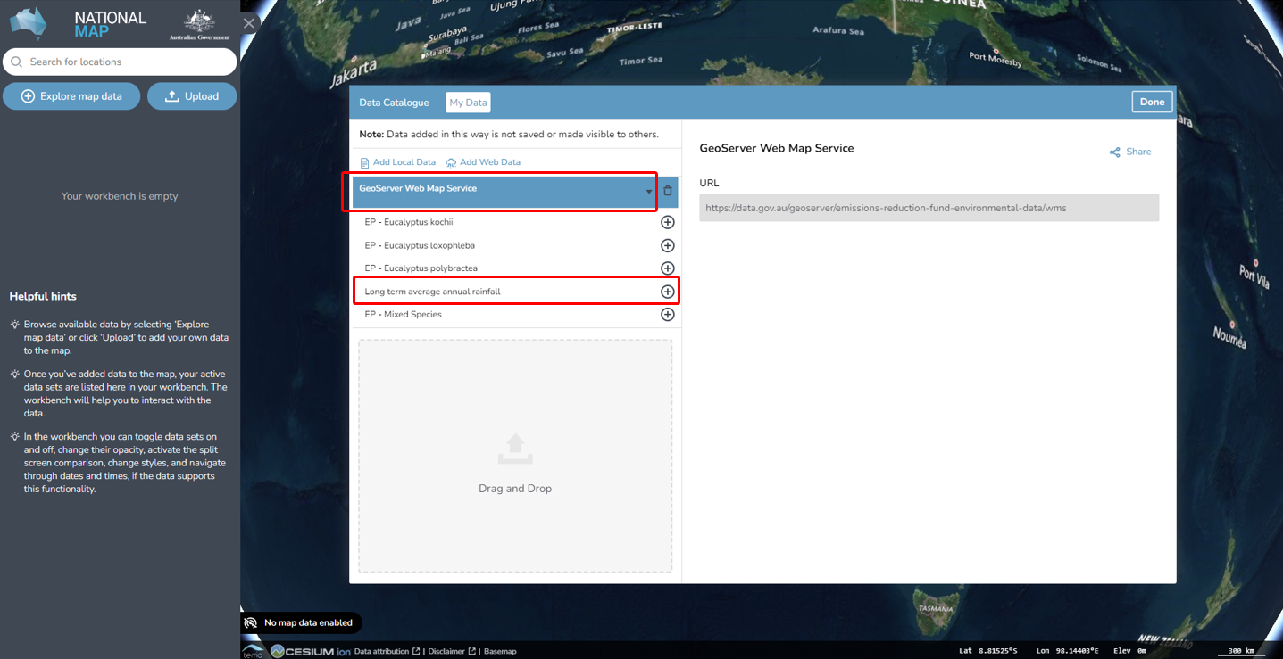
- Then, click the “Add to the map” button at the top right.
Figure 6 Adding the long term average rainfall data to the National Map
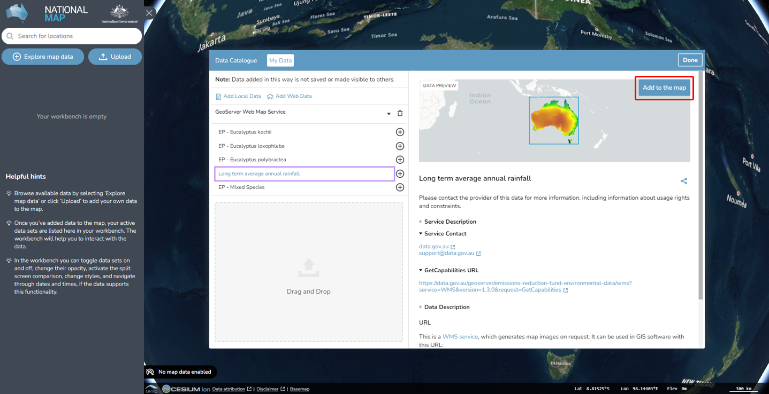
- To check the rainfall amount of the model point location, enter the latitude and longitude in the search bar (located in the top left hand corner). The search result will be displayed in the search bar. Select the desired location.

Figure 7 Entering the latitude and longitude of a location into the National Map
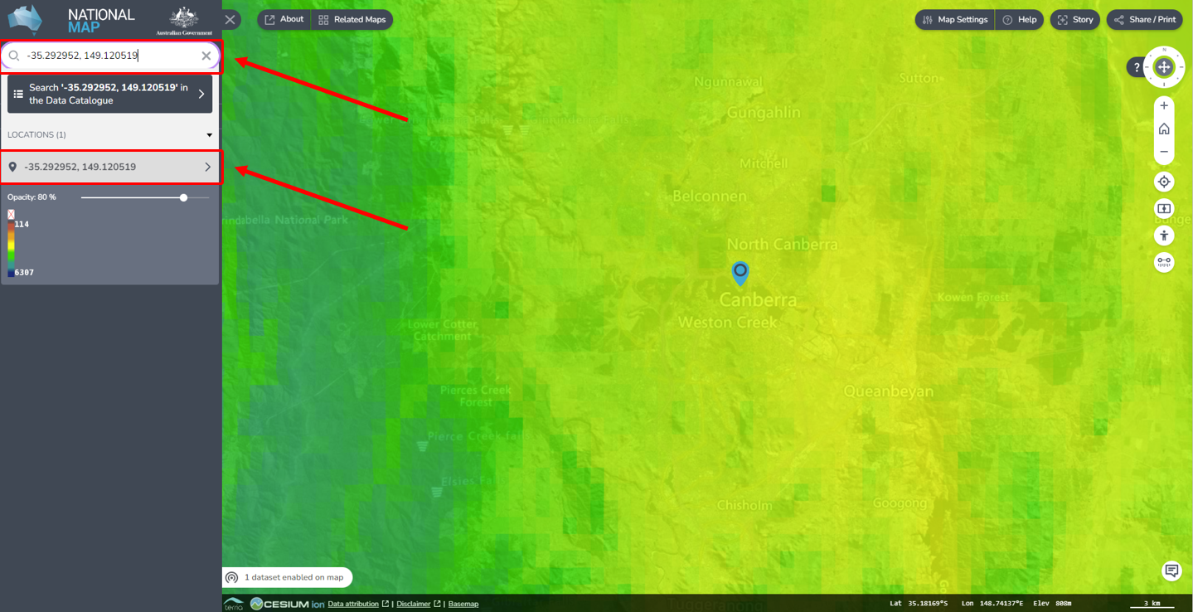
- Click the map marker icon on the map, this will show the “Feature Information” tab on the right hand corner, yielding location and rainfall information. If minimised, click on the “Long term average annual rainfall – Site Data” heading to expand it, revealing the rainfall amount. The “GRAY_INDEX” is the long term average annual rainfall. Note if it is more or less than 500mm, as this impacts the template choice in the FullCAM process.
Figure 8 Identifying the average annual rainfall for a location in the National Map
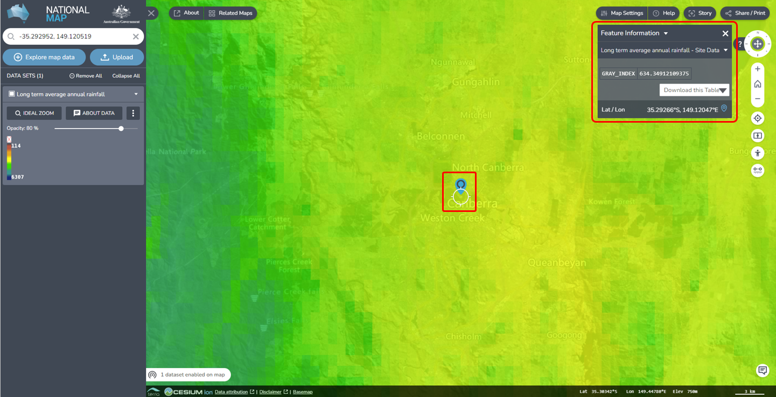

3.2 The Timing Tab
Enter the modelling start and end dates for the simulation that you will run, in the start date and end date text fields. The accepted format is DD / MM /YYYY. Refer to the table below to assign the correct timing to the plot.

3.3 The Location info Tab
- Enter the longitude and latitude (in decimal degrees i.e. xx.xxx xx, xx.xxx xx) of the model point location in the longitude and latitude text fields. This should be the approximate centre of the CEA (as per section 21(4) of the Determination). Note that FullCAM may appear to round off the decimal degrees entered after clicking out of the text fields, but users must enter the full five decimal places as these will be recorded within the plot file itself.
Figure 9 Entering longitude and latitude in FullCAM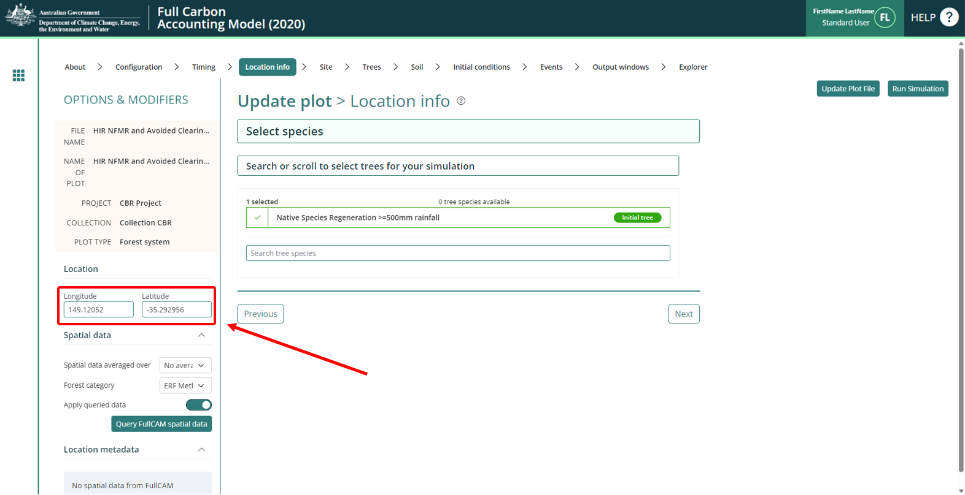
- Click the green “Query FullCAM spatial data” button.
- Click on the “Events” tab.

The Site, Trees, Soil, and Initial Conditions Tabs
Do NOT change any settings in these tabs. Instead, skip to the “Events” tab.

The Events Tab
The Events Tab is where events for a simulation can be added and displayed in sequence. Events can be added individually by following the below steps for each event type. Alternatively, for the default baseline scenario, the corresponding sequence of repeated events can be added by following the sections below.
Note: When returning to FullCAM to enter new event(s) on an existing plot sometime after the initial set up (e.g. some days, weeks, or months later), it is required to download the latest dataset to ensure accuracy and up to date statistics. To do so, go to the “Location info” tab and click the green “Query FullCAM spatial data” button, and then continue with adding your new Event.
Table 9 Simulation types and permitted events
Simulation Type | Permitted Events
C100_5% | Regeneration
C10 | Regeneration  Growth Pause  Clearing  Thinning  Management fire  Windrow and burn fire
Default baseline | Regeneration  Clearing  Management fire – where sufficient evidence (see s 4.12 of the Determination)  Windrow and burn fire – where sufficient evidence (s 4.12 of the Determination)
Historic baseline  Hybrid baseline | Regeneration  Clearing  Thinning  Management fire – where sufficient evidence (see s 4.12 of the Determination)  Windrow and burn fire – where sufficient evidence (s 4.12 of the Determination)
Project carbon | Regeneration  Growth Pause  Clearing  Thinning  Management fire  Windrow and burn fire  Prescribed fire – to reduce fire risk  Wildfire – trees not killed  Wildfire – trees killed

Figure 10 Adding a new event FullCAM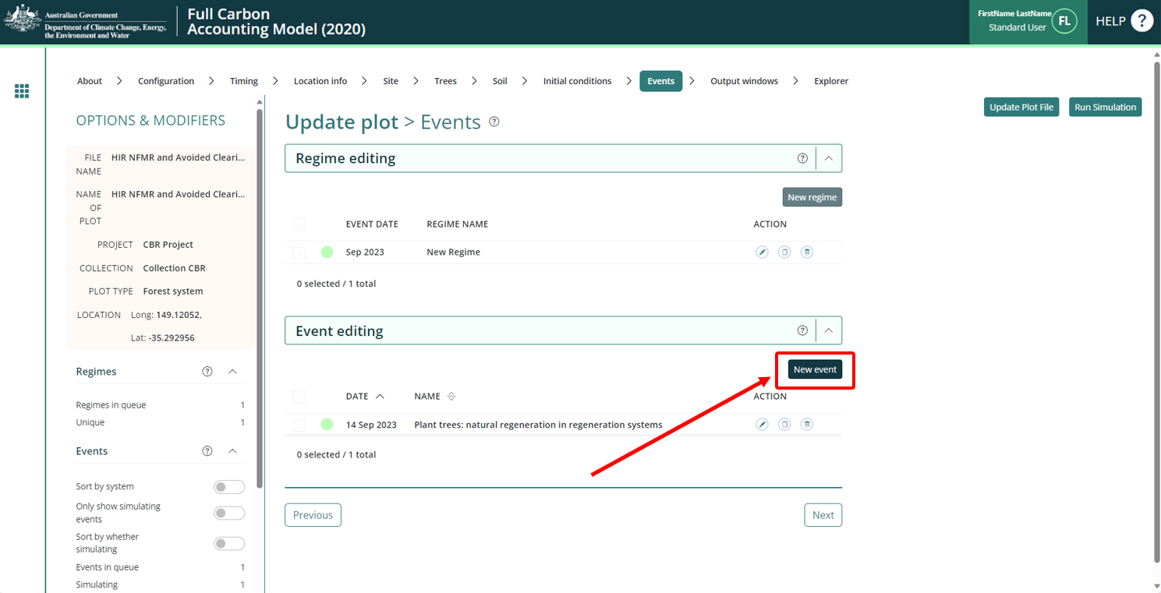
Follow the steps for the appropriate Event and Simulation Type, in sections 3.5.1 to 3.5.6.

Adding a regeneration event
The notes below must be followed to add a regeneration event. There are different requirements for modelling a regeneration event according to the scenario type and when the CEA was first registered within a project area.
For the project carbon scenario, the timing of a regeneration event must be supported by evidence (subsection 4.19(2) and paragraph 5.5(b) of the Method), as well as conform with the input requirements specified here (paragraph 4.18(2)(a) of the Method). The start date of a regeneration event must correspond with the presence of forest potential within the CEA and the requirements set out below for differing project registration/variation dates.
Regeneration is an ongoing event where carbon continues to accumulate in vegetation, rather than a point in time occurrence such as fire or clearing. As per section 3.8, subsection 4.19(2) and paragraph 5.5(b) of the Method, the modelling of regeneration must be supported by evidence that regeneration has occurred throughout the modelling period. In the absence of evidence of ongoing regeneration, either, a growth pause should be modelled (see section 3.5.5) or the CEA should be re-stratified to exclude areas where regeneration has ceased (as per section 3.6 of the Determination).
For the paragraphs below, the ‘applicable date’ for a CEA is the project registration date, except for land later added to the project area through a project variation, in which case it is the project variation date.
If the applicable date is after 31 March 2019, no more than 10 years of cumulative regeneration may be modelled prior to the applicable date. The regeneration event may commence more than 10 years before the applicable date where growth pause events are modelled. For example, for a project registered on 1 January 2020, proponents may model regeneration commencing 12 years earlier in 2008, where a two-year growth pause has been identified and modelled as occurring from 2013-15.
If the applicable date is between 13 December 2017 and 31 March 2019, the timing of a regeneration event in the project carbon scenario cannot be more than 14 years prior to the applicable date.
If the applicable date is before 13 December 2017, the timing of a regeneration event in the project carbon scenario is not limited to a specific period prior to the applicable date. For these CEAs, proponents may optionally elect to model growth pause events in the event of suppression or slowing of regeneration (in accordance with section 3.5.5).
For the default baseline scenario, a regeneration event occurs 12 months after each comprehensive clearing. See subsection 4.12(6) and paragraph 4.15(2)(b) of the Determination.
For the C10, hybrid and historic baseline scenarios, the timing of a regeneration event is 12 months after each comprehensive clearing, unless evidence supports setting the date to another time. See section 4.6, and subsections 4.8(5), 4.12(9) and 4.12(15) of the Determination.

3.5.1.1 Steps for the Project Carbon Scenario Modelling
Simulation Type: Project Carbon
- In the “Type” drop down menu, select “Tree planting”
- Click the “Insert standard values” button. This will open a new pop-up window.
- In the checkbox on the left, select the row with the ‘Event Name’ of ‘Plant trees: natural regeneration in regeneration systems’ and then click ‘OK’.
- Click the “Generate name automatically” button (which will appropriately modify the name of the event).
- Enter the date of the event, determined with respect to the above instructions.
- Do NOT change any other settings.
- Click the green “Save and close” button in the top right to add the event.

3.5.1.2 Steps for the Baseline and Materiality Test Modelling
Simulation Type: C100_5%
- In the “Type” drop down menu, select “Tree planting”.
- Click the “Insert standard values” button. This will open a new pop-up window.
- In the checkbox on the left, select the row with the ‘Event Name’ of ‘Plant trees: natural regeneration in regeneration systems’ and then click ‘OK’.
- Click the “Generate name automatically” button (which will appropriately modify the name of the event).
- Insert the simulation start date in the “Event date”. Accepted format is DD/MM/YYYY.
- Do NOT change any other settings.
- Click the green “Save and close” button in the top right corner.
Simulation Type: C10
- In the “Type” drop down menu, select “Tree planting”.
- Click the “Insert standard values” button. This will open a new pop-up window.
- In the checkbox on the left, select the row with the “Event Name” of “Plant trees: natural regeneration in regeneration systems” and then click ‘OK’.
- Click the “Generate name automatically” button (which will appropriately modify the name of the event).
- In the “Event date” field, enter the appropriate date as specified in the above instructions in Section 3.5.1. Accepted format is DD/MM/YYYY.
- Do NOT change any other settings.
- Click the green “Save and close” button in the top right corner.
Simulation Type: Default Baseline
- In the “Type” drop down menu, select “Tree planting”.
- Click the “Insert standard values” button. This will open a new pop-up window.
- In the checkbox on the left, select the row with the “Event Name” of “Plant trees: natural regeneration in regeneration systems” and then click ‘OK’.
- Click the “Generate name automatically” button (which will appropriately modify the name of the event).
- In the “Event date” enter the date that is 12 months after the most recent comprehensive clearing. The accepted format is DD/MM/YYYY.
- Do NOT change any other settings.
- Click the green “Save and close” button in the top right corner.
Simulation Type: Historic Baseline
- In the “Type” drop down menu, select “Tree planting”.
- Click the “Insert standard values” button. This will open a new pop-up window.
- In the checkbox on the left, select the row with the “Event Name” of “Plant trees: natural regeneration in regeneration systems” and then click ‘OK’.
- Click the “Generate name automatically” button (which will appropriately modify the name of the event).
- In the “Event date” field, enter the appropriate date as specified in the above instructions in Section 3.5.1. Accepted format is DD/MM/YYYY.
- Do NOT change any other settings.
- Click the green “Save and close” button in the top right corner.
Simulation Type: Hybrid Baseline
- In the “Type” drop down menu, select “Tree planting”.
- Click the “Insert standard values” button. This will open a new pop-up window.
- In the checkbox on the left, select the row with the “Event Name” of “Plant trees: natural regeneration in regeneration systems” and then click ‘OK’.
- Click the “Generate name automatically” button (which will appropriately modify the name of the event).
- In the “Event date” field, enter the appropriate date as specified in the above instructions in Section 3.5.1. Accepted format is DD/MM/YYYY.
- Do NOT change any other settings.
- Click the green “Save and close” button in the top right corner.

Adding a clearing event
These steps must be followed to add a clearing event, which corresponds to a comprehensive clearing referred to in the Determination.
NOTE: the “C100_5%” or “Project Carbon” simulation types are NOT permitted for a clearing event.
Simulation Type: C10
- In the “Type” drop down menu, select “Forest thinning” as the event type.
- Click the “Insert standard values” button. This will open a new pop-up window.
- In the checkbox on the left, select the row with the “Event Name” of “Initial clearing: no product recovery” and then click ‘OK’.
- Click the “Generate name automatically” button (which will appropriately modify the name of the event).
- Ensure that in the “Affected portion” section, the “Percentage of forest affected by thin” field has “100” entered.
- In the “Event date” field, enter the appropriate date of the clearing event. Accepted format is DD/MM/YYYY. For subsequent clearing events, insert the date of clearing in this field to represent the observed date or default interval between comprehensive clearings as per section 4.6 of the Determination.
- Do NOT change any other settings.
- Click the green “Save and close” button in the top right corner.
Simulation Type: Default Baseline
- In the “Type” drop down menu, select “Forest thinning” as the event type.
- Click the “Insert standard values” button. This will open a new pop-up window.
- In the checkbox on the left, select the row with the “Event Name” of “Initial clearing: no product recovery” and then click ‘OK’.
- Click the “Generate name automatically” button (which will appropriately modify the name of the event).
- Ensure that in the “Affected portion” section, the “Percentage of forest affected by thin” field has “100” entered.
- In the “Event date” field, insert the date of the clearing event. Each clearing event will be 14 years after the previous regeneration event. Accepted format is DD/MM/YYYY.
- Do NOT change any other settings.
- Click the green “Save and close” button in the top right corner.
Simulation Type: Historic Baseline
- In the “Type” drop down menu, select “Forest thinning” as the event type.
- Click the “Insert standard values” button. This will open a new pop-up window.
- In the checkbox on the left, select the row with the “Event Name” of “Initial clearing: no product recovery” and then click ‘OK’.
- Click the “Generate name automatically” button (which will appropriately modify the name of the event).
- Ensure that in the “Affected portion” section, the “Percentage of forest affected by thin” field has “100” entered.
- In the “Event date” field, enter the appropriate date of the clearing event. Accepted format is DD/MM/YYYY. For subsequent clearing events, insert the date of clearing in this field to represent the observed date or default interval between comprehensive clearings as per section 4.6 of the Determination.
- Do NOT change any other settings.
- Click the green “Save and close” button in the top right corner.
Simulation Type: Hybrid Baseline
- In the “Type” drop down menu, select “Forest thinning” as the event type.
- Click the “Insert standard values” button. This will open a new pop-up window.
- In the checkbox on the left, select the row with the “Event Name” of “Initial clearing: no product recovery” and then click ‘OK’.
- Click the “Generate name automatically” button (which will appropriately modify the name of the event).
- Ensure that in the “Affected portion” section, the “Percentage of forest affected by thin” field has “100” entered.
- In the “Event date” field, enter the appropriate date of the clearing event. Accepted format is DD/MM/YYYY. For subsequent clearing events, insert the date of clearing in this field to represent the observed date or default interval between comprehensive clearings as per section 4.6 of the Determination.
- Do NOT change any other settings.
- Click the green “Save and close” button in the top right corner.

Adding a thinning event
These steps must be followed to add a thinning event.
NOTE: the “C100_5%” or “Default Baseline” simulation types are NOT permitted for a thinning event.
Simulation Types: C10 / Historic Baseline / Hybrid Baseline / Project Carbon
- In the “Type” drop down menu, select “Forest thinning” as the event type.
- Click the “Insert standard values” button. This will open a new pop-up window.
- In the checkbox on the left, select the row with the “Event Name” of “Initial clearing: no product recovery” and then click ‘OK’.
- Click the “Generate name automatically” button (which will appropriately modify the name of the event).
- In the “Affected portion” section, change the “Percentage of forest affected by thin” field to an estimate of the proportion of the stems that were killed in the thinning. You must report on how the estimate was derived in your project report.
- In the “Event date” field, enter the appropriate date of the thinning event. Accepted format is DD/MM/YYYY. The intervals between events must reflect those that occurred historically.
- Do NOT change any other settings.
- Click the green “Save and close” button in the top right corner.

Adding fire events

3.5.4.1 Adding a management fire event
These steps must be followed to add a management fire event. A management fire event encourages grass for pasture. It is a fire that occurs within a clearing interval and is used to set back the regrowth, killing a substantial proportion of the above ground plant parts.
NOTE: the “C100_5%” or “C10” simulation types are NOT permitted for a management fire event.
Simulation Types: Default Baseline/ Historic Baseline / Hybrid Baseline / Project Carbon
- In the “Type” drop down menu, select “Forest fire” as the event type.
- Click the “Insert standard values” button. This will open a new pop-up window.
- In the checkbox on the left, select the row with the “Event Name” of “Management fire” and then click ‘OK’.
- Click the “Generate name automatically” button (which will appropriately modify the name of the event).
- In the “Affected portion” section, change the “Percentage of forest affected by thin” field to an estimate of the proportion of the stems that were killed in the thinning. You must report on how the estimate was derived in your project report.
- In the “Event date” field, enter the appropriate date of the fire event. Accepted format is DD/MM/YYYY. The intervals between events must reflect those that occurred historically. For example, for default values used in baselines, this is 7 years after the regeneration event.
- Do NOT change any other settings.
- Click the green “Save and close” button in the top right corner.

3.5.4.2 Adding a windrow and burn fire event
A windrow and burn fire event reduces the amount of debris that remains after the clearing event. Evidence is required to support modelling a windrow and burn event. See subsection 4.12(5) regarding evidence to support modelling this event under a default baseline scenario, and subsections 4.8(5), 4.12(10) and 4.12(14) for C10, hybrid baseline, and historic baseline scenarios respectively.
For the default baseline scenario, where a windrow and burn event is to be included, it must be modelled as occurring six months after each clearing event.
NOTE: the “C100_5%” or “Project Carbon” simulation types are NOT permitted for a windrow and burn Fire Event.
Simulation Types: C10 / Default Baseline/ Historic Baseline / Hybrid Baseline
- In the “Type” drop down menu, select “Forest fire” as the event type.
- Click the “Insert standard values” button. This will open a new pop-up window.
- In the checkbox on the left, select the row with the “Event Name” of “Site prep: Windrow and burn” and then click ‘OK’.
- Click the “Generate name automatically” button (which will appropriately modify the name of the event).
- In the “Event date” field, enter the date of the fire event. Accepted format is DD/MM/YYYY.
- Do NOT change any other settings.
- Click the green “Save and close” button in the top right corner.

3.5.4.3 Adding a prescribed fire event – to reduce fire risk
These steps must be followed to add a prescribed fire event – to reduce fire risk. These events are aimed at reducing fuel loads and hence fire risk. They control the accumulation of the debris pool. The date modelled must reflect the actual date of that event.
NOTE: the “C100_5%”, “C10”, “Default Baseline”, “Historic Baseline”, and “Hybrid Baseline” Simulation Types are NOT accepted for a prescribed fire event.
Simulation Type: Project Carbon
- In the “Type” drop down menu, select “Forest fire” as the event type.
- Click the “Insert standard values” button. This will open a new pop-up window.
- In the checkbox on the left, select the row with the “Event Name” of “Prescribed burn” and then click “OK”.
- Click the “Generate name automatically” button (which will appropriately modify the name of the event).
- In the “Event date” field, enter the date of the fire event. Accepted format is DD/MM/YYYY.
- Do NOT change any other settings.
- Click the green “Save and close” button in the top right corner.

3.5.4.4 Adding a wildfire – trees not killed event
These steps must be followed to add a wildfire – trees not killed event.
NOTE: the “C100_5%”, “C10”, “Default Baseline”, “Historic Baseline”, and “Hybrid Baseline” Simulation Types are NOT accepted for a wildfire - trees not killed event.
Simulation Type: Project Carbon
- In the “Type” drop down menu, select “Forest fire” as the event type.
- Click the “Insert standard values” button. This will open a new pop-up window.
- In the checkbox on the left, select the row with the “Event Name” of “Wildfire – trees not killed” and then click “OK”. This event option may be on the second page of the list. Use the number or arrow at the bottom right of the page (above the “Cancel” and “Ok” buttons).
- Click the “Generate name automatically” button (which will appropriately modify the name of the event).
- In the “Event date” field, enter the date of the fire event. Accepted format is DD/MM/YYYY.
- Do NOT change any other settings.
- Click the green “Save and close” button in the top right corner.

3.5.4.5 Adding a wildfire – trees killed event
These steps must be followed to add a wildfire – trees killed event.
NOTE: the “C100_5%”, “C10”, “Default Baseline”, “Historic Baseline”, and “Hybrid Baseline” Simulation Types are NOT accepted for a wildfire - trees killed event.
Simulation Type: Project Carbon
- In the “Type” drop down menu, select “Forest fire” as the event type.
- Click the “Insert standard values” button. This will open a new pop-up window.
- In the checkbox on the left, select the row with the “Event Name” of “Wildfire – trees killed” and then click “OK”. This event option may be on the second page of the list. Use the number or arrow at the bottom right of the page (above the “Cancel” and “Ok” buttons).
- Click the “Generate name automatically” button (which will appropriately modify the name of the event).
- In the “Event date” field, enter the date of the fire event. Accepted format is DD/MM/YYYY.
- Do NOT change any other settings.
- Click the green “Save and close” button in the top right corner.

Adding a growth pause event
All projects using the 2020 FullCAM option must follow the growth pause requirements described in this section. This includes projects that previously reported under the 2016 FullCAM option and have moved to the 2020 FullCAM option, even if they were an eligible offsets project prior to 31 March 2019.
A growth pause event is used to model the stopping or slowing of vegetation growth due to a suppression disturbance event (or the combined impacts of more than one suppression disturbance event), such as grazing by livestock/feral animals, disease or pests, or another event.
Normal climatic variability of wetter and drier periods (i.e. including droughts to an extent) causing fluctuations in the growth rate are already incorporated within the vegetation growth calibration used by the model, and are not required to be added as growth pause events in FullCAM.
The use and timing of any modelled growth pause must be consistent with the records that evidence the type, timing and extent of disturbance events (see section 5.5 of the Determination). Where there is uncertainty over timing, a longer period may be used to conservatively estimate the duration of the growth pause. Such uncertainty does not preclude including additional growth pauses where appropriate, but the timing of such pauses should best give effect to the available evidence. Growth pauses are applicable throughout the crediting period.
Growth pauses should be included where necessary to ensure consistency with both:
- paragraph 4.19(2)(a) of the Determination, that the modelling accurately reflects the set of ‘actual management events’ that have occurred in a CEA. Growth pauses for management and disturbance events assist in ensuring that the abatement estimates of the method do not overestimate carbon abatement achieved by a project.
- the requirements of the Regulator’s five yearly regeneration checks[1] —required under 70(3A) of the Carbon Credits (Carbon Farming Initiative) Rule 2015. In the absence of the use of growth pauses to account for a lack of regeneration progress, CEAs may be need to be re-stratified to exclude the areas where regeneration cannot be evidenced (refer to the Regulator’s Guidelines).
The start date for a growth pause is the date on which growth stopped or slowed. Where there are multiple factors contributing to a suppression disturbance event, or the source of suppression or actual date of suppression disturbance event cannot be identified, the date can be estimated.
NOTE: The “C100_5%” and “Default Baseline” are NOT accepted Simulation Types for a Growth Pause event
Simulation Types: C10 / Hybrid Baseline / Historic Baseline / Project Carbon
- In the “Type” drop down menu, select “Forest treatment” as the event type.
- DO NOT click the “Insert standard values” button.
- In the “Type 1: Age Advance” section, turn the switch to ON (‘on’ will be green, and ‘off’ is light grey and white). This will expand the section to reveal two additional fields.

Figure 11 Enabling age advance for a forest treatment event in FullCAM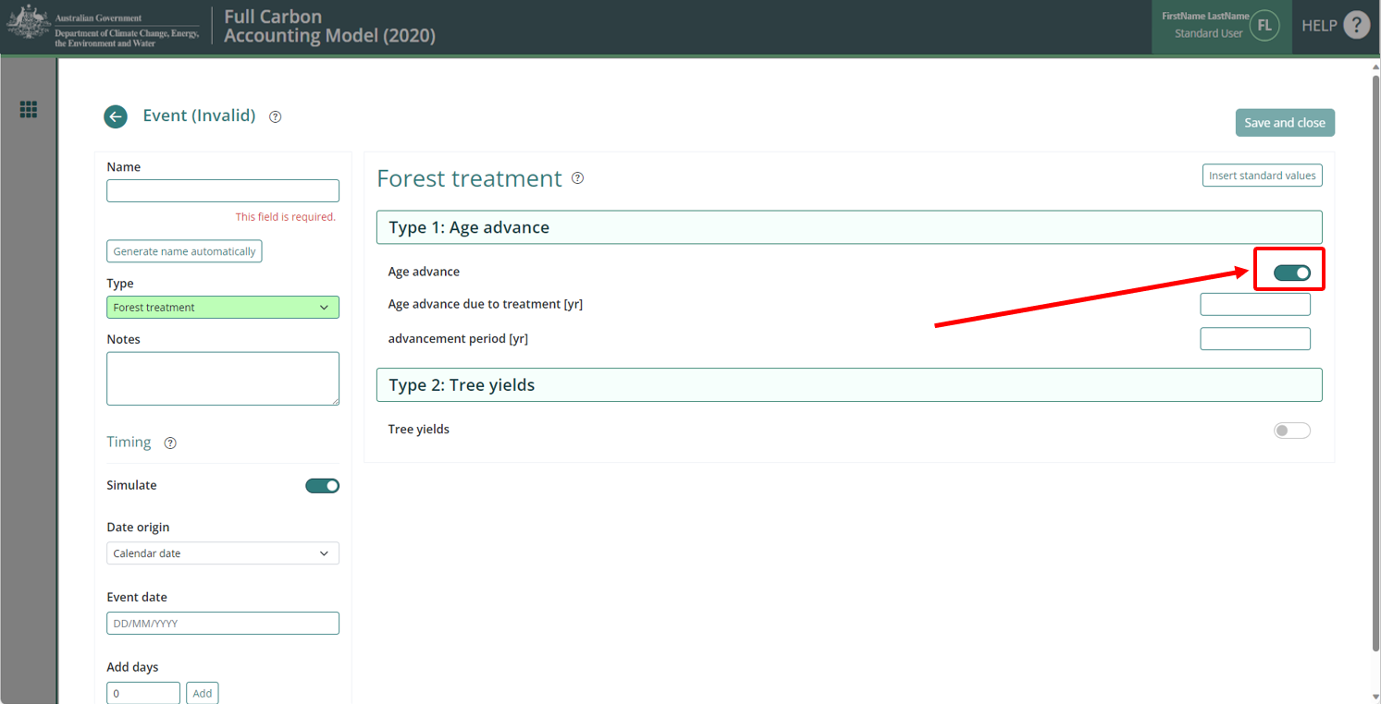
- Following steps 5 and 6 has the effect of ‘pausing’ growth in carbon stocks for the duration of the growth pause event.
- In the “Age advance due to treatment [yr]” field, enter an estimate for how long the growth pause event occurred as a decimal proportion in years, and as a negative number. For example, if the event occurred for 3 years and 9 months, then ‘-3.75’ would be entered in this box. As another example, if the event occurred for 5 years, then ‘-5’ would be entered in this box.
- In the “advancement period [yr]” field, enter the absolute value of the number added in the ‘Age advance due to treatment’ box. For example, using the examples above, the value to add to this box would be: (1) ‘3.75’, or (2) ‘5’.
- Enter a suitable name for the event (e.g., “Grazing” or “Growth Pause”).
- In the “Event date” field, enter the date of the disturbance event. This can be estimated if the actual date is not known. The accepted format is DD/MM/YYYY.
- Do NOT change any other settings.
- Click the green “Save and close” button in the top right corner.

Creating and cloning events to add baseline scenarios to the events queue
For default, historic, and hybrid baselines, the entire events queue that includes all simulated events for the entire baseline management event scenario (see section 4.12 of the Determination) must be cloned to cover the 100-year baseline forecast period (e.g. if entering 30 years, the “number of times” will need to be 4).
Once the events queue has been cloned, the date of each event generated must be checked and adjusted if necessary, by editing the event. This is because leap years and variability in month length can cause the date on which repeating events fall, to shift from the intended date.
NOTE: the “C100_5%”, “C10”, and “Project Carbon” Simulation Types are NOT applicable for this process.
Simulation Type: Default Baseline
- Follow the appropriate steps in Section 3.1 – 3.4 to create a plot, and Sections 3.5.1 to 3.5.5 to create the Events forming a single clearing interval of 15 years (regeneration, windrow and burn where applicable, management fire where applicable, and clearing). By default, FullCAM will create a new Regime for each Event added.
- Click on the checkbox at the heading row of the Regime table to select all existing regimes (or individually select each regime by clicking in its checkbox).
Figure 12 Selecting regimes in FullCAM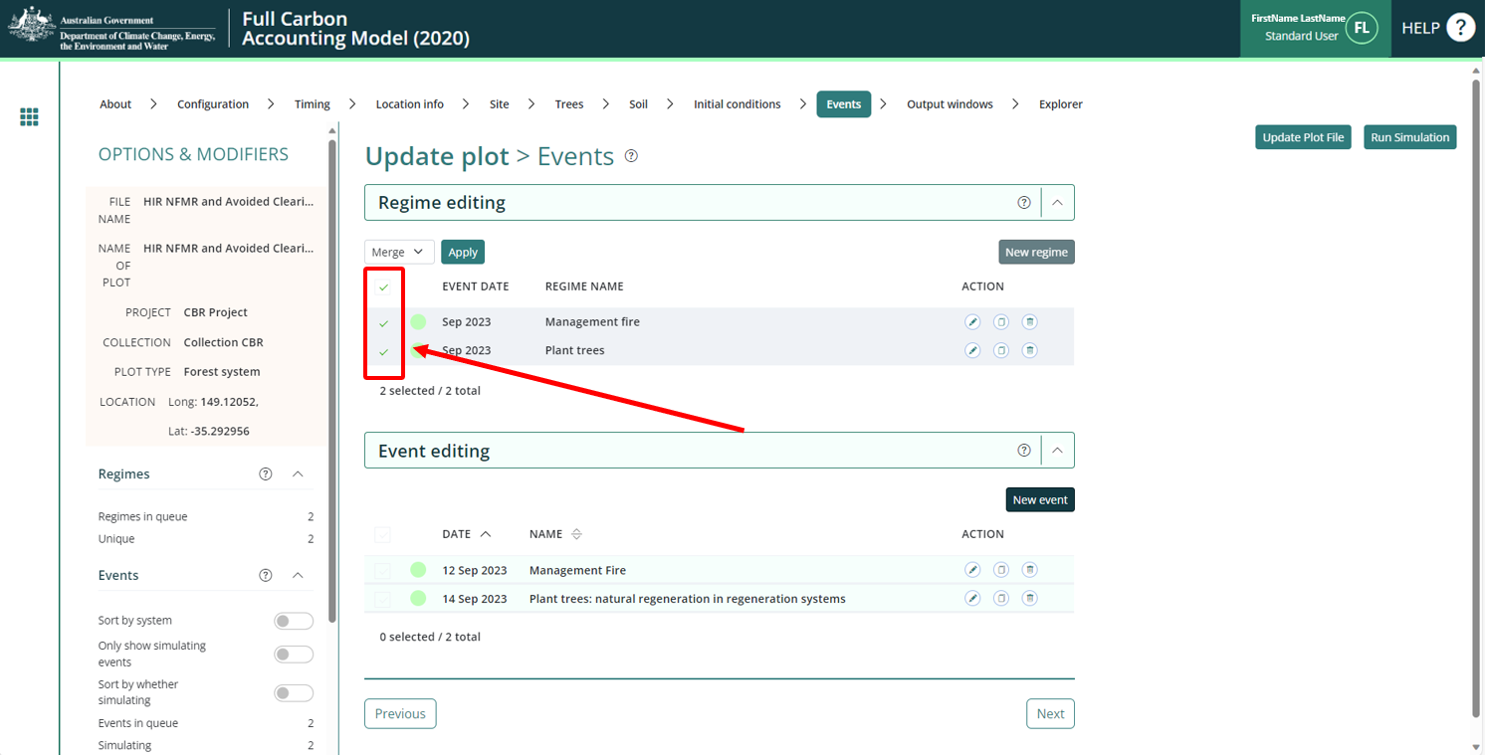
- Click the dropdown that appears and ensure “Merge” is selected. DO NOT CLICK “DELETE”.
Figure 13 Merging regimes in FullCAM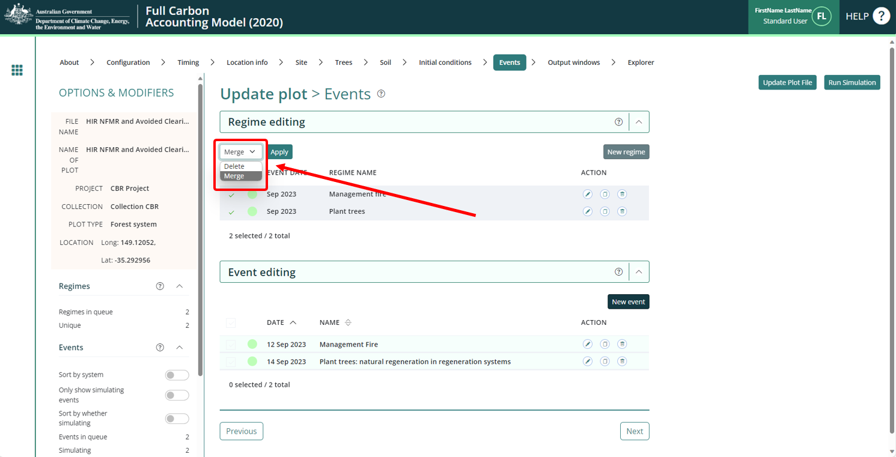
- Click the green “Apply” button to the right of the drop-down field. A new pop-up window will appear.
- Rename the Regime to “Baseline” and click “Save”. This will merge all selected Regimes and save all Events under one regime. This will also close the pop-up window.
- Click on the ‘Clone’ button on the Baseline Regime.
- In the pop-up window, enter ‘15’ or ‘30’ for “Calendar years” (depending on the length of the regime that is being repeated) and for “Number of times”, a value high enough to clone events over the entirety of the 100-plus year baseline period (i.e., if 15 “Calendar years”, 7 for “Number of times”, and if 30 “Calendar years”, enter 4 for “Number of times”)and click “Ok”. (I.e., the period should exceed 100 years to ensure the period is covered, as events that fall beyond the 100 years will not be simulated and can be left in the Event list.) Make sure that the Regime is the same length as the ‘Calendar years’ choice.
Figure 14 Cloning regimes in FullCAM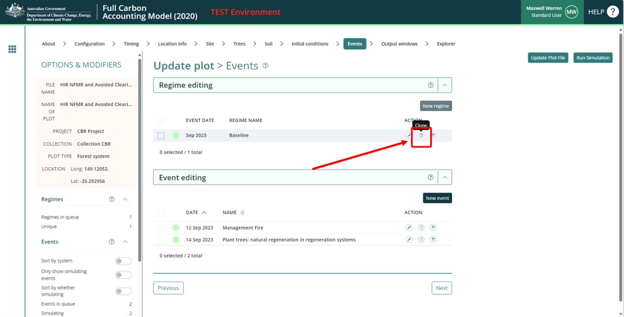
Simulation Type: Historic Baseline
- Follow the appropriate steps in Section 3.1 – 3.4 to create a plot, and Sections 3.5.1 to 3.5.6 to create the Events forming the two clearing intervals of the durations supported by historical evidence.
- Click on the checkbox at the heading row of the Regime table to select all existing regimes (or individually select each regime by clicking in its checkbox).

Figure 15 Selecting regimes in FullCAM
- Click the dropdown that appears and ensure “Merge” is selected. Make sure “Delete” is NOT selected.
Figure 16 Merging regimes in FullCAM
- Click the green “Apply” button to the right of the drop-down field. A new pop-up window will appear.
- Rename the Regime to “Baseline” and click “Save”. This will merge all selected Regimes and save all Events under one regime. This will also close the pop-up window.
- Press the “Clone” button on the Baseline Regime. This will open a pop-up window.

Figure 17 Cloning regimes in FullCAM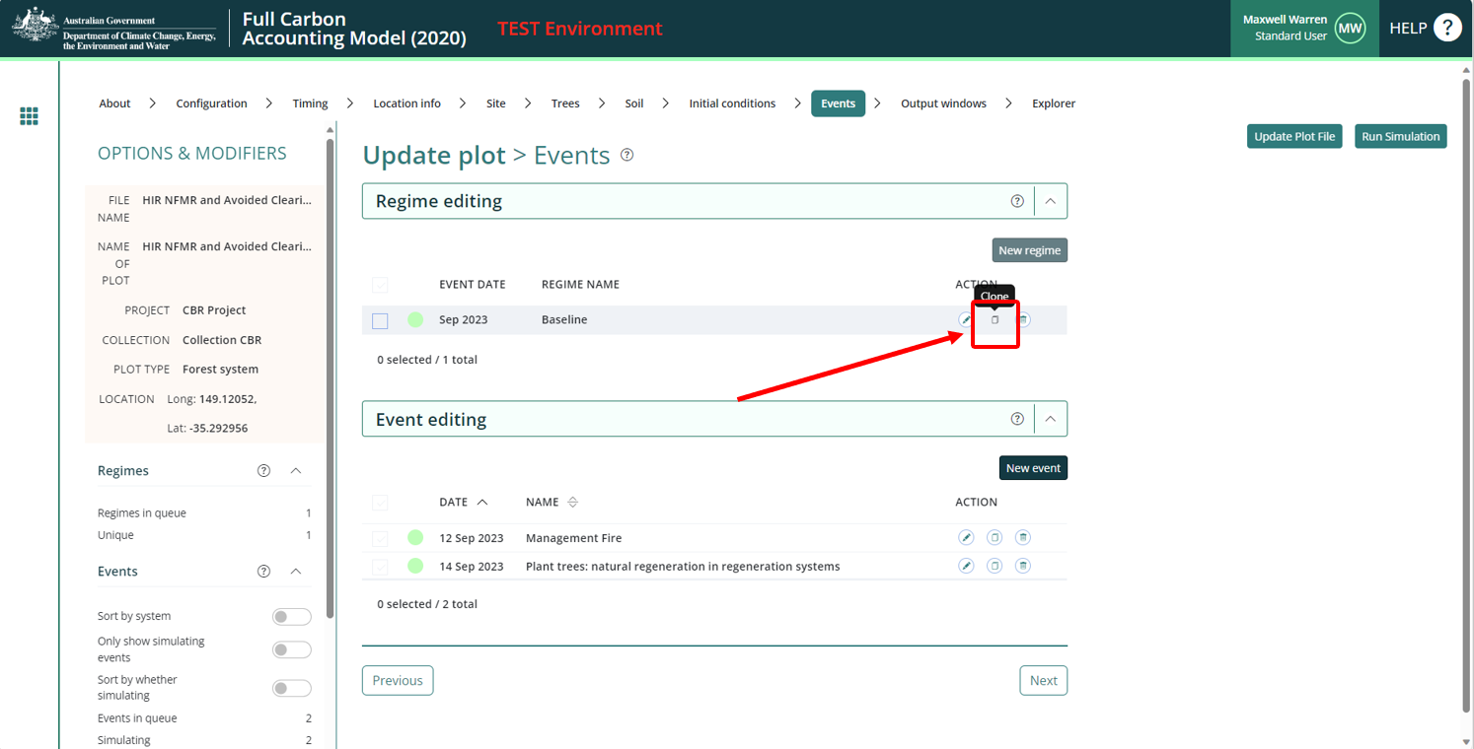
- Calculate the number of years between the first event of the first interval and the last event of the second interval. Add 1 to this number, i.e., years between initial regeneration event modelled and the last clearing event modelled plus 1.
- Enter the number calculated above for “Calendar years”.
- In the “Number of times” field, enter a value high enough to clone events over the entirety of the 100-plus year baseline period and click “Ok”. (I.e., the period should meet or exceed 100 years to ensure the period is covered, as events that fall beyond the 100 years will not be simulated and can be left in the Event list.
- Click “Save”.
Simulation Type: Hybrid Baseline
- Follow the appropriate steps in Section 3.1 – 3.3 to create a plot, and Sections 3.5.1 to 3.5.6 to create the Events forming the first clearing interval of 15 years, and the second clearing interval and the duration supported by historical evidence. By default, FullCAM will create a new regime for each event added.
- Click on the checkbox at the heading row of the Regime table to select all existing regimes (or individually select each regime by clicking in its checkbox).

Figure 18 Selecting regimes in FullCAM
- Click the dropdown that appears and ensure “Merge” is selected. Make sure “Delete” is NOT selected.
Figure 19 Merging regimes in FullCAM
- Click the green “Apply” button to the right of the drop-down field. A new pop-up window will appear.
- Rename the Regime to “Baseline” and click “Save”. This will merge all selected Regimes and save all Events under one regime. This will also close the pop-up window.
- Press the “Clone” button on the Baseline Regime. This will open a pop-up window.

Figure 20 Cloning regimes in FullCAM
- Calculate the number of years between the first event of the first interval and the last event. Add 1 to this number, i.e., years between initial regeneration event modelled and the last clearing event modelled plus 1.
- Enter the number calculated above for “Calendar years”.
- In the “Number of times” field, enter a value high enough to clone events over the entirety of the 100-plus year baseline period and click “Ok”. (I.e., the period should meet or exceed 100 years to ensure the period is covered, as events that fall beyond the 100 years will not be simulated and can be left in the Event list.
- Click “Save”.

Completing Events
- Check the dates of all cloned Events and Regimes and edit as necessary. Any errors will mark the Event or Regime name in red.
- Once all Events and Regimes necessary have been added, click “Update Plot File” and then click “Next” (or the “Output windows” tab button).

The Output Tab
The ‘New from template’ option used to create plot files will by default select the correct output types for the applicable scenario. The below steps can be followed to ensure the output types are correct, and to rectify any issues with those selected.
Selected outputs have a tick next to their name. Categories and subcategories with all outputs selected will have a tick symbol. Categories with some outputs selected will have a ‘-‘ symbol. Categories with no outputs selected will have a ‘+’ symbol.

Figure 21 Selecting the output categories in FullCAM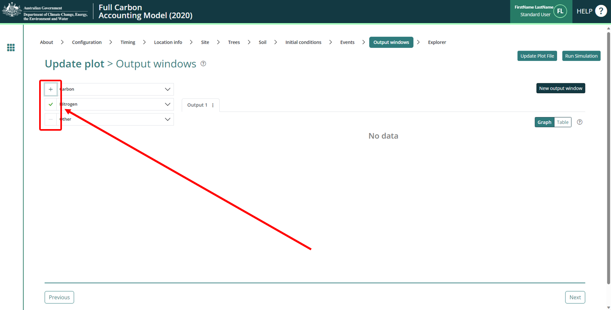
Simulation Types: C100_5% / C10
- Unselect all categories by clicking on the left side of their name until they show a ‘+’ icon.
- Select the following output:
  - Carbon / Forest / Plants / C mass of trees.
Simulation Types: Default Baseline / Hybrid Baseline / Historic Baseline
- Unselect all categories by clicking on the left side of their name until they show a ‘+’ icon.
- Select the following outputs:
  - Carbon / Forest / Plants / C mass of trees
  - Other / Carbon Projects / C mass of forest debris
Simulation Type: Project Carbon
- Unselect all categories by clicking on the left side of their name until they show a ‘+’ icon.
- Select the following outputs:
  - Carbon / Forest / Plants / C mass of trees
  - Carbon / Whole / Emissions / CH4 emitted due to fire
  - Nitrogen / Whole / Emissions / N2O emitted due to fire
  - Other / Carbon Projects / C mass of forest debris

Running Simulations
To run the simulation, click the “Run Simulation" button, in the top right of the screen. This will generate the selected outputs in a graph. It will also initialise a download of the result in CSV format. This button will appear faded out and will not be available if the Events queue contains invalid Events, which will appear in red, and the tab will have a red title.

Figure 22 Running a simulation in FullCAM
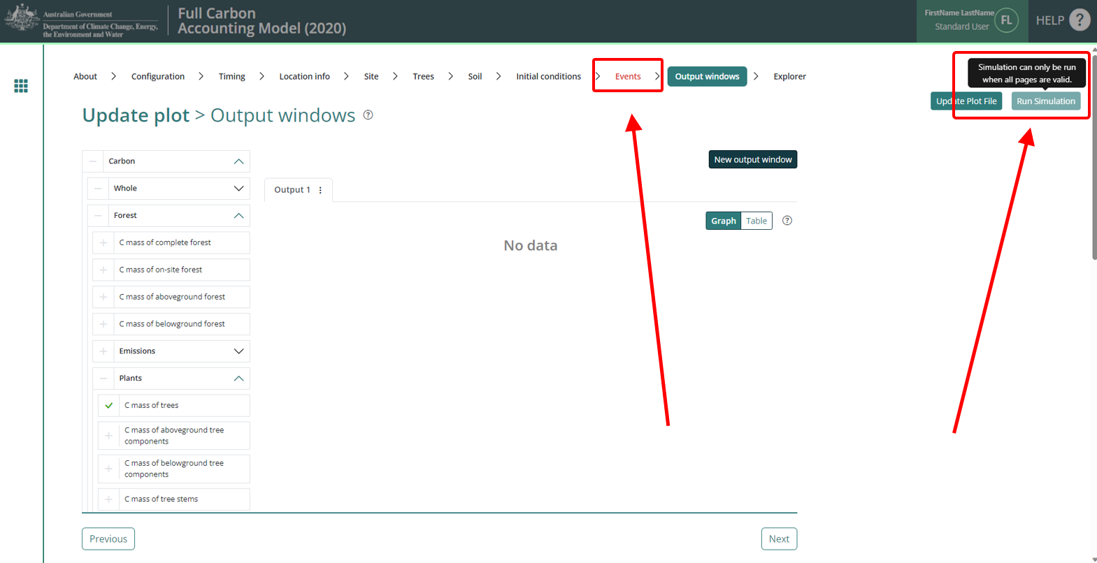
Note that if reopening a plot file, users must first navigate to the “Location info” tab and click “Query FullCAM spatial data” before running the simulation to ensure the latest spatial data is used for the simulation.

Viewing outputs
Outputs can be viewed as a graph or a table by clicking on the corresponding icons at the top right of the Output Window.

Figure 23 Viewing outputs in FullCAM
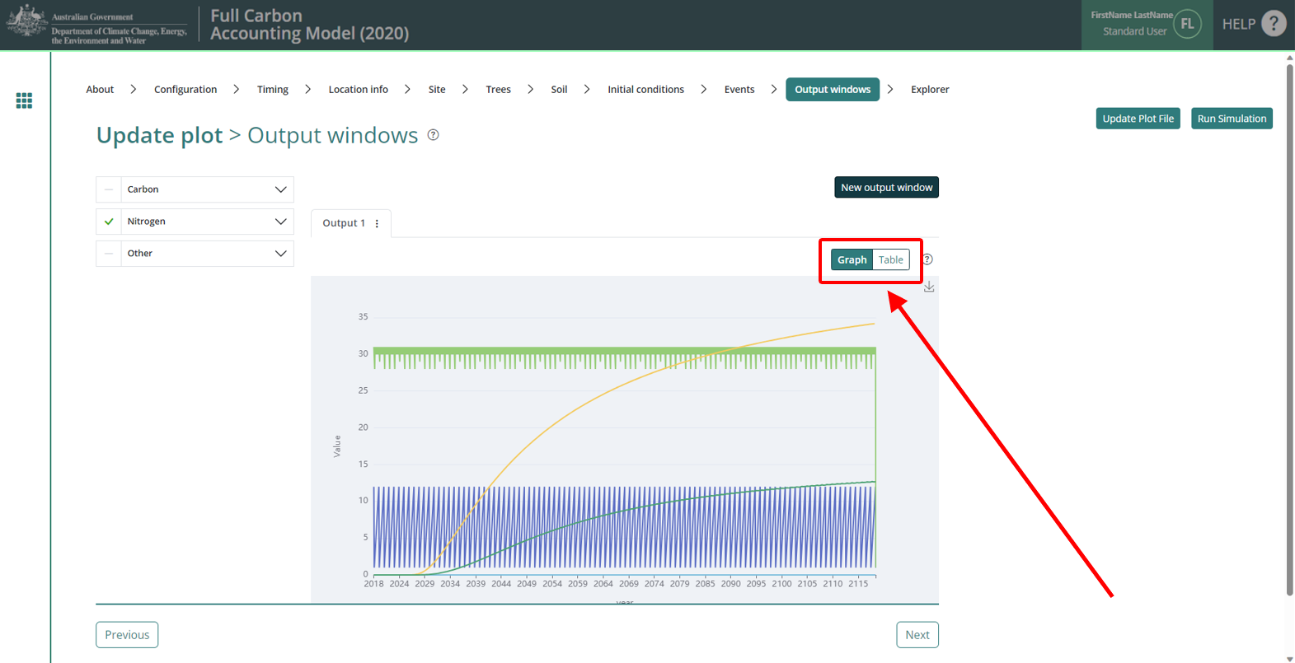

Accessing outputs as a spreadsheet
Running a simulation will automatically download the CSV file with the graph’s data. A pop-up near your ‘Downloads’ button on your browser may request permission to download.
Open the file in Microsoft Excel (or equivalent spreadsheet software) and follow the appropriate steps below, suited to the Simulation Type.
Simulation Type: C100_5%
- Scroll down to the bottom rows of the data in the spreadsheet.
- Record the value in the “C mass of trees” column with the last (which should be the latest) row of data with a date. This is the C100 (the value of Carbon in 100 years).
- To determine the C100_5% (5% of the C100), multiply this final number by 0.05.
This value is used for the materiality test at section 4.7 of the Determination, calculated in accordance with section 4.8 of the Determination.
Simulation Type: C10
- Scroll down to the bottom rows of the spreadsheet, where the “Min” and “Max” values for each column will be displayed.
- Record the “Max” value for the “C Mass of trees” column. This value is used for the materiality test at section 4.7 of the Determination, calculated in accordance with section 4.9 of the Determination.
Simulation Types: Default Baseline / Historic Baseline / Hybrid Baseline
- Refer to Division 4.4 of the Determination for calculating baselines, specifically Equation 4 at section 4.24.
- Section 5 of these Guidelines details how each FullCAM output in the spreadsheet data corresponds to the equation parameters.
Simulation Type: Project Carbon
- Refer to Division 4.4 of the Determination for calculating end of reporting period Project carbon stocks, specifically Equation 2 at section 4.22.
- Section 5 of these Guidelines details how each FullCAM output in the spreadsheet data corresponds to the equation parameters.

FullCAM simulations and offsets reporting
Project proponents must calculate the project net abatement by completing the equations in sections 4.21 to 4.29 of the Determination. Parameters generated in FullCAM are used in Equations in the Determination.
Note that for some of the equations the average of the FullCAM output over the simulation period will be required, whereas for others the value of the FullCAM output at the end of the simulation period will be used. Refer to the equations within the Determination to determine which value to use. Averages can be calculated using the average function within your spreadsheet software.
Table 10 FullCAM outputs and corresponding parameters as defined in the determination
FullCAM Output | Parameter as defined in the Determination | Scenario | Equation in the determination
C mass of debris | CD_{CEA,i} | Project | 3
 | BCD_{CEA,i,k} | Baseline | 4
C mass of trees | CT_{CEA,i} | Project | 3
 | BCT_{CEA,i,k} | Baseline | 4
CH₄ emitted from debris due to fire | E_{CH4,i} | Project | 7
N₂O emitted due to fire | E_{N2O,i} | Project | 8

The 10-year limit reflects work undertaken by CSIRO for the Australian Government in 2018 that found that once carbon per hectare in the combined trees and debris pools within FullCAM reaches five tonnes of carbon per hectare, forest cover should be attained based on the relationship between biomass and canopy cover. FullCAM predicts that most land where the NFMR method is typically implemented attains this amount of carbon after 10 years of unhindered regeneration. The 10-year limit ensures that projects only model amounts of pre-project regeneration consistent with not having forest cover at the project commencement date (an eligibility requirement under section 2.4 of the Method).
The 14-year limit was similarly designed to restrict projects from modelling amounts of pre-project regeneration inconsistent with not having forest cover at the project commencement date. The limit was derived from consideration of the Method’s default baseline assumptions. The default baseline contains the assumption that after 14 years of regeneration the vegetation on the land would have been cleared again for pastoral purposes. Permitting the modelling of longer periods of pre-project regeneration under the project scenario than required under the default baseline (14 years) allows the baseline to be underestimated.
[1] Regulator’s Guidelines on stratification evidence and records for HIR and NFMR: http://www.cleanenergyregulator.gov.au/ERF/Forms-and-resources/Regulatory-Guidance/sequestration-guidance/crediting-abatement-%E2%80%93-human-induced-regeneration-and-native-forest-from-managed-regrowth-methods

