
Draft FullCAM Guidelines

Requirements for use of the Full Carbon Accounting Model (FullCAM) with the Australian Carbon Credit Unit (ACCU) Scheme methodology determination: Carbon Credits (Carbon Farming Initiative—Avoided Clearing or Native Regrowth) Methodology Determination 2015
These proposed guidelines are for consultation purposes only. They are not to be followed for reporting under the ACCU Scheme.
Version 4.0
(Published and in force from 1 September 2020, updated September 2023)

© Commonwealth of Australia 2023
Ownership of intellectual property rights
Unless otherwise noted, copyright (and any other intellectual property rights) in this publication is owned by the Commonwealth of Australia (referred to as the Commonwealth).
Creative Commons licence
All material in this publication is licensed under a Creative Commons Attribution 4.0 International Licence except content supplied by third parties, logos and the Commonwealth Coat of Arms.
Inquiries about the licence and any use of this document should be emailed to copyright@dcceew.gov.au.

Cataloguing data
This publication (and any material sourced from it) should be attributed as: The Department of Climate Change, Energy, the Environment and Water, FullCAM Guidelines: Requirements for using the Full Carbon Accounting Model (FullCAM) in the Emissions Reduction Fund (ERF) methodology determination Carbon Credits (Carbon Farming Initiative—Avoided Clearing of Native Regrowth) Methodology Determination 2015, Department of Climate Change, Energy, the Environment and Water, Canberra. CC BY 4.0.
This publication is available at [address to be confirmed].
Department of Climate Change, Energy, the Environment and Water
GPO Box 3090 Canberra ACT 2601
Telephone 1800 900 090
Web dcceew.gov.au
Disclaimer
The Australian Government acting through the Department of Climate Change, Energy, the Environment and Water has exercised due care and skill in preparing and compiling the information and data in this publication. Notwithstanding, the Department of Climate Change, Energy, the Environment and Water, its employees and advisers disclaim all liability, including liability for negligence and for any loss, damage, injury, expense or cost incurred by any person as a result of accessing, using or relying on any of the information or data in this publication to the maximum extent permitted by law.
Acknowledgement of Country
Our department recognises the First Peoples of this nation and their ongoing connection to culture and country. We acknowledge Aboriginal and Torres Strait Islander Peoples as the Traditional Owners, Custodians and Lore Keepers of the world's oldest living culture and pay respects to their Elders past, and present.

Contents
1. Introduction 5
1.1 Use with the Avoided Clearing of Native Regrowth Methodology Determination 2015 5
1.2 Determining which FullCAM option to use 5
1.3 Format of this document 7
1.4 FullCAM background 7
1.5 FullCAM plots and running simulations 7
1.6 Overview of the FullCAM interface 8
2. Simulations Overview 11
2.1 Baseline scenario simulation 11
2.2 Project scenario simulation 11
3. 2020 FullCAM option - setting up simulations for the baseline and project scenarios 12
3.1 Creating a new plot from template 12
3.2 The Timing Tab 15
3.3 The Location info Tab 16
3.4 The Site, Trees, Soil, and Initial Conditions Tabs 16
3.5 The Events Tab 17
3.6 The Output Windows Tab 28
4. FullCAM Simulations and Offsets Reporting 31

Tables
Table 1 FullCAM tabs 9
Table 2 FullCAM outputs and corresponding parameters as defined in the determination 31

Figures
Figure 1 FullCAM download options 6
Figure 2 Selecting a new simulation in FullCAM 12
Figure 3 The Australian Government’s National Map 13
Figure 4 The Australian Government’s National Map 14
Figure 5 Adding the long term average rainfall data to the National Map 14
Figure 6 Entering the latitude and longitude of a location into the National Map 15
Figure 7 Identifying the average annual rainfall for a location in the National Map 15
Figure 9 Entering a start date in FullCAM 16
Figure 9 Entering longitude and latitude in FullCAM 16
Figure 10 Adding a new event FullCAM 19
Figure 11 Selecting the event type in FullCAM 19
Figure 16 Selecting a standard tree planting event in FullCAM 20
Figure 13 Selecting a species in tree planting event in FullCAM 20
Figure 14 Selecting a thinning event in FullCAM 21
Figure 15 Selecting a fire event in FullCAM 22
Figure 16 Selecting a thinning event in FullCAM 23
Figure 17 Selecting a thinning event in FullCAM 24
Figure 18 Selecting a wildfire event in FullCAM 25
Figure 19 Selecting a wildfire event in FullCAM 26
Figure 20 Adding a new regime in FullCAM 27
Figure 21 Adding an available regime in FullCAM 27
Figure 22 Selecting the output categories in FullCAM 28
Figure 23 Running a simulation in FullCAM 29
Figure 24 Viewing outputs in FullCAM 29

Introduction

Use with the Avoided Clearing of Native Regrowth Methodology Determination 2015
The calculation of carbon abatement under the Carbon Credits (Carbon Farming Initiative—Avoided Clearing of Native Regrowth) Methodology Determination 2015 (the Determination) is dependent upon the use of the Full Carbon Accounting Model (FullCAM) consistently with the requirements of this document. In particular, section 34 of the Determination requires that the baseline and project scenario for each carbon estimation area (CEA) must be modelled in FullCAM in accordance with the requirements in both the Determination and this document. Subsection 47(1) of the Determination also requires key output data to be produced using FullCAM in accordance with the requirements in the Determination and this document. Where content of this document relates to provisions of the Determination, references are given to the location of those provisions.
Project proponents must only change FullCAM default settings as indicated in this document, and all other settings must not be changed. This is to ensure that defaults will apply where relevant.

Determining which FullCAM option to use
The Department of Climate Change, Energy, the Environment and Water updates the Full Carbon Accounting Model (FullCAM) from time to time to reflect the latest science and improve usability. At the time this document was last updated, the latest version was released for public use in 2024 on the Department’s website ([to be confirmed]). The latest publicly released version of FullCAM is constituted by two options.
- Default: 2020 FullCAM option
This is currently the 2020 FullCAM option. The year reflects when the latest version was released at the time this document was last updated. However, a reference to the default or 2020 FullCAM option in this document includes any subsequent release or update of FullCAM on the Department’s website. Accordingly, projects using the default 2020 FullCAM option will be required to use subsequent releases as they are made available.

- Alternative: 2016 FullCAM option
This is identified as the 2016 FullCAM option and is only available for use by some projects, as described below.
Project proponents must access the latest publicly released version of FullCAM from the Department’s website and then ensure they are using the appropriate FullCAM option for their project (see screenshot below).
An exception to the requirement to use the latest publicly released version is for projects with reporting periods that end before 1 September 2020, under a method that specifies to use the version of FullCAM and the associated Guidelines for those periods. If you determine that you must use a version of FullCAM that is unavailable on the website, please contact the Department at FullCAM@dcceew.gov.au or ACCUMethods@dcceew.gov.au to obtain a link.
The requirements below explain when the default 2020 FullCAM option must be used and when the alternative 2016 FullCAM option can be used.
- Whichever FullCAM option is used by the proponent, all CEAs of a given project must be reported on using a single FullCAM option.
- Projects with section 22 declaration applications under the Carbon Credits (Carbon Farming Initiative) Act 2011 (CFI Act), submitted to the Clean Energy Regulator (the Regulator) on or after 1 September 2020, must use the default 2020 FullCAM option.
- Projects with section 22 declaration applications submitted to the Regulator before 1 September 2020 are able to use either the default 2020 FullCAM option or the alternative 2016 FullCAM option. These projects are able to move from the 2016 FullCAM option to the 2020 FullCAM option if they choose to do so. If a choice to use the 2020 FullCAM option is made, the entire project must be moved to 2020 FullCAM and once using 2020 FullCAM in an offsets report, these projects cannot return to using the 2016 FullCAM option.
- If project proponents with section 22 declaration applications submitted to the Regulator before 1 September 2020 add a new project area or areas to the project under section 29 of the CFI Act with effect on or after 1 September 2020, the entire project must use the default 2020 FullCAM option. The only exception to this is where all of the areas added to the project were already using the alternative 2016 FullCAM option under these guidelines as part of another eligible offsets project (these can continue to use the 2016 FullCAM option consistent with the dot point above – therefore the original project must also have been eligible to use the 2016 FullCAM option).
- Projects that transfer from an earlier to a later version of this Determination or transfer to this Determination from another method, with the application under section 128 of the CFI Act submitted on or after 1 September 2020, must use the default 2020 FullCAM option.
Note that FullCAM is not compatible with iOS systems, and must be run in a Windows operating environment.
Figure 1 FullCAM download options
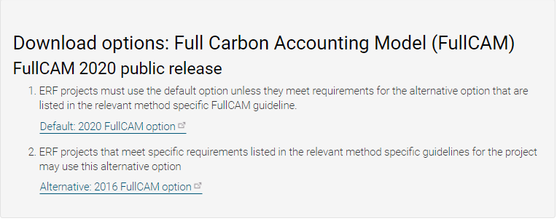
Screenshot from download page
Two options

Format of this document
This document provides:
- an overview of the FullCAM relevant to the Determination, its features relevant to users and important requirements for using this document (section 1)
- an overview of the baseline scenario you must run in FullCAM as per the Determination (section 2)
- a step-by-step walkthrough of how you must use 2020 FullCAM to run simulations for baselines and project reporting (section 3).
- an overview of the FullCAM outputs as they relate to equations within the Determination (section 4).
Note that this document provides a step-by-step walkthrough for 2020 FullCAM alone. This is because this document is for consultation on a modernised interface for that version of FullCAM. The published update to these guidelines will also contain a step-by-step walkthrough for the 2016 FullCAM.
The 2020 FullCAM option requires fewer data entries than the 2016 FullCAM option because many items have been automated in the 2020 FullCAM options through the use of templates.

FullCAM background
FullCAM is used in Australia’s National Greenhouse Gas Accounts for the land sector. FullCAM provides fully integrated estimates of carbon pools in forest and agricultural systems for Australia’s land sector reporting. In addition, it accounts for human-induced changes in emission and sequestration of major greenhouse gases. FullCAM was developed under the National Carbon Accounting System (NCAS) at the then Australian Greenhouse Office to provide a dynamic account of the changing stocks of carbon in Australia’s land systems since 1970 by integrating data on land cover change, land use and management, climate, plant productivity, and soil carbon over time. FullCAM estimates carbon stock change and greenhouse gas emissions at fine spatial and temporal scales, and uses a wide range of spatially referenced data.
Users of FullCAM can determine estimates of carbon stock change and greenhouse gas emissions for ERF projects on a similar basis to that used for land use and land use change in Australia’s National Greenhouse Gas Inventory.

FullCAM plots and running simulations
FullCAM can run simulations on a ‘plot’. A plot, for modelling purposes, is defined as a piece of land for which the event history, when modelled in FullCAM, is the same across that area of land. Separate plot files must be created for each CEA (see section 20 of the Determination).
In the 2016 FullCAM option, there are several types of plots that can be selected. Only ‘forest system’ is relevant to this Determination. This selection does not need to be made in the 2020 FullCAM option because it has been automated through the creation of default templates. At the point in the 2016 FullCAM option where users choose to create a new plot file, they instead select an appropriate template from a drop-down list and 2020 FullCAM option then populates FullCAM with the template plot.
FullCAM models using a single ‘model point’ location. Proponents do not need to define plot boundaries within FullCAM, rather proponents must input the coordinates for a single location (the model point – see subsection 20(4) and section 20(5) of the Determination).
The FullCAM model uses the model point to derive average values of the climate and biophysical variables for the immediate surrounding area.
In order to ensure all settings are correct, including defaults, we recommend creating new plot files each time a new version of FullCAM or these Guidelines, or a different FullCAM option, is used. Plot files created under previous versions or options may contain different settings that will affect outputs and users are responsible for ensuring they have used the correct FullCAM version and option, and accurately followed the associated FullCAM Guidelines.
For each CEA, separate plot files must be created for:
- estimating carbon stocks under the baseline scenario; and
- estimating carbon stocks for the current reporting period.

The latest spatial data for a plot must be downloaded using the ‘Location info’ tab each time the software is run.

Overview of the FullCAM interface
The FullCAM software user interface displays menus and a series of tabs. Each tab has a suite of fields in which information may either be required to complete as instructed through these Guidelines or left unchanged. The program is designed so that certain tabs in a plot file are made available only if required fields have valid information entered in earlier tabs. If the text of a tab or field is red, then FullCAM requires information in that tab or field before a simulation can be run. When all the required fields within a tab have valid information entered, the tab text will become blue.
The below table provides a general overview of each tab selectable within FullCAM once a plot has been created. Help is also provided within FullCAM by clicking on the symbol available in most windows , or the  button in the top right of the 2020 tool. This general overview of the public version of FullCAM is not intended to instruct proponents of ERF projects on how to use FullCAM for this Determination.
Data entry requirements for this Determination, under each FullCAM option are described in detail in section 3 and section 4 of these Guidelines.

Table 1 FullCAM tabs
Tab | Explanation
About | Includes a free text field where users can enter information about the plot file that they have created. This is a good space to keep track of changes that have been made or editing of event parameters.
Configuration | Users select the system (e.g. forest, agricultural) they want to simulate in the plot.
Timing | Enter the timing for starting and ending the simulation and the time steps required for output data.
Data Builder (“Location info” in the 2020 tool) | In this tab users enter the latitude and longitude of the ‘Model Point Location’ where they wish to simulate a plot file. Internet access is required to complete this tab. By choosing to ‘Download Spatial Data’ (called “Query FullCAM spatial data” in the 2020 tool) the associated soil and climate data for that latitude and longitude are automatically loaded into relevant parts of the remaining tabs. In the tab users can then download tree and/or crop species information and management regimes as appropriate. This information is also automatically loaded into relevant parts of the remaining tabs.
Site | Specific parameters (e.g. water [rainfall], temperature, productivity) are described.
Trees | Description of the properties of the tree species.
Crops | Description of the properties of crop or pasture species (only displays if agricultural system selected).
Soil | Description of soil properties.
Initial Conditions | In this tab the values for carbon at the start of the simulation are described. Values will automatically be populated by Data Builder using data downloaded from the FullCAM server.
Events | All of the events for the entire simulation period are listed in this tab. Users can add or remove events. Care must be taken not to violate requirements for modelling ‘management events’ within the Determination.  For the 2016 tool, the names on the event list are colour-coded to indicate whether they are ready, whether they are simulating or not, and what system they affect. The colour codes are:  Red: Event not ready (renders event queue not ready);  Grey: Event non-simulating (outside simulation period, will not affect simulation);  Green: Forest;  Yellow: Agricultural; and  Brown: Mixed.  Finally, the events users select with the cursor are coloured in the usual highlight colour.
Output Window | Defines what outputs are presented in output windows.
Explorer | Display of the parameter settings for each tab.
Plot Digest  (not present in the 2020 tool) | This tab only appears when a plot is saved as a ‘plot digest’ by changing the save as type. It allows users to clone and alter the inputs of a given modelling scenario, and combine the results or output them separately.
Log  (not present in the 2020 tool) | This tab records changes made to the file to assist with analysis and error tracking.

Simulations Overview
This section provides a brief overview of the two simulations that project proponents must simulate in FullCAM consistent with the Determination – the baseline scenario and the project scenario. The credible carbon abatement for the project is calculated under Division 4 of the Determination by subtracting the baseline scenario carbon abatement from the project scenario carbon abatement. Section 34 of the Determination requires that the baseline and project scenario for each CEA must be modelled in FullCAM in accordance with the requirements in both the Determination and this document.
This section directs users to the relevant part of the Determination that users should first familiarise themselves with before progressing to simulating these scenarios as per the steps in section 3 or section 4.

Baseline scenario simulation
For each CEA, the baseline scenario consists of a series of projected regrowth, clearing, and windrow and burn events reoccurring over the 100 year modelling period. Requirements for modelling the Baseline scenario are set out in Division 2 of the Determination, particularly at sections 35-37. Projected events must be modelled consistent with the timing requirements of section 35 of the Determination, and the start and end dates of the modelling period must be as set out at section 37. The first event in the baseline scenario will be the most recent actual regeneration event within the CEA (see section 26 of the Determination).
These events can be added to the baseline scenario together by following section 3 or section 4 below.

Project scenario simulation
The project scenario simulates the actual management and disturbance events that have occurred within each CEA. The simulation period begins the day before the regeneration event referred to in section 26 of the Determination and runs over the 100 year modelling period (see section 37 of the Determination). Specific requirements for modelling thinning, fire and other natural disturbance events are set out at sections 39, 40 and 41 of the Determination respectively.

2020 FullCAM option - setting up simulations for the baseline and project scenarios
Section 1.2 describes the requirements for which FullCAM option can be used. The general effect of requirements described in Section 1.2 is that the 2020 FullCAM option is the default. Only projects that satisfy the criteria described in section 1.2 are able to use the 2016 FullCAM option.
Simulations for each CEA are undertaken using plots. Project proponents must use the following steps for creating FullCAM plots and inputting values for each CEA registered under the Determination.
All steps must be followed when creating new plot files and inputting values.
Once a plot file has been setup for a CEA and scenario, it can re-opened for modelling at a later date. When reopening plot files, users must first navigate to the ‘Data Builder’ tab and click ‘Download Spatial Data’, before running the simulation, to ensure the latest spatial data is used for the simulation.

3.1 Creating a new plot from template
- With FullCAM open, click on the menu grid, on the top left of the screen, then select ‘New Simulation’.
Figure 2 Selecting a new simulation in FullCAM
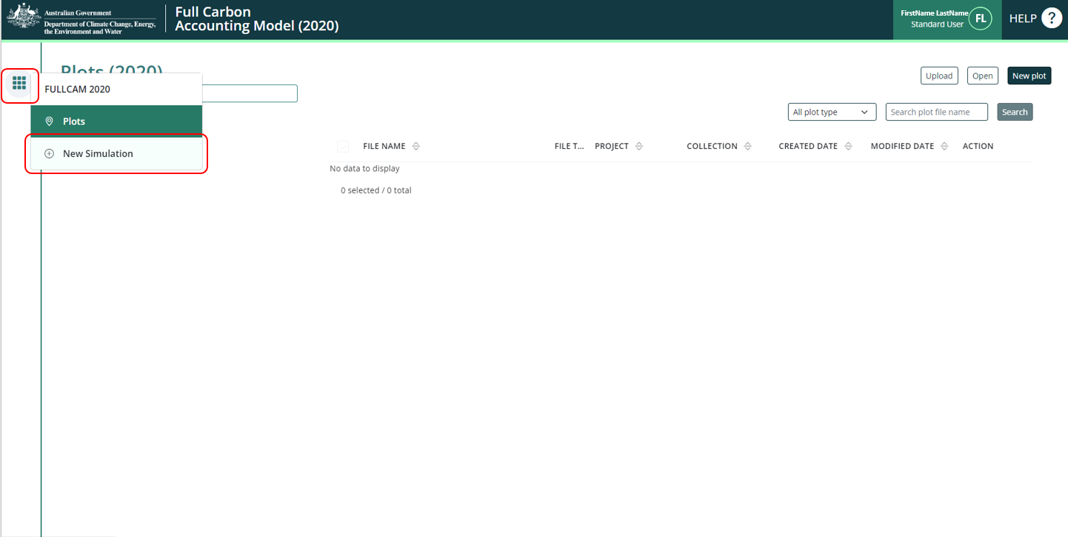
- Select, under the ‘Create from templates’ section, the ‘HIR NFMR and Avoided Clearing Methods’ option corresponding to the long-term average annual rainfall for the applicable model point location (either greater or less than 500mm). The two rainfall options for the natural regeneration calibration differ in the root-to-shoot ratio used to determine biomass allocation to roots. Biomass in roots constitutes a higher proportion of total biomass in the low rainfall option.

The long-term average annual rainfall is determined using the Long Term Average [annual] Rainfall Map Layer, also known as the CFI rainfall map, previously available from the CFI Mapping tool. A CEA (or CEA part) including areas of land on both sides of the 500mm rainfall boundary, according to the CFI rainfall map, does not in itself prevent the CEA being modelled with a single events queue.

The long term average annual rainfall map layer shows the long-term average annual rainfall (mm) across continental Australia, calculated for the period 1920-2010. The long-term average annual rainfall map layer (also labelled CFI Mapping tool - Rainfall map) can be accessed for viewing or downloading from data.gov.au under Emissions Reduction Fund Environmental Data (https://data.gov.au/dataset/ds-dga-b46c29a4-cc80-4bde-b538-51013dea4dcb/details?q=emission reduction fund).

3.1.1 Steps to view the long-term average annual rainfall data on data.gov using the Australian Government’s National Map:
- Go to (https://nationalmap.gov.au/) and select the “Upload” button on the top left of the screen.
Figure 3 The Australian Government’s National Map
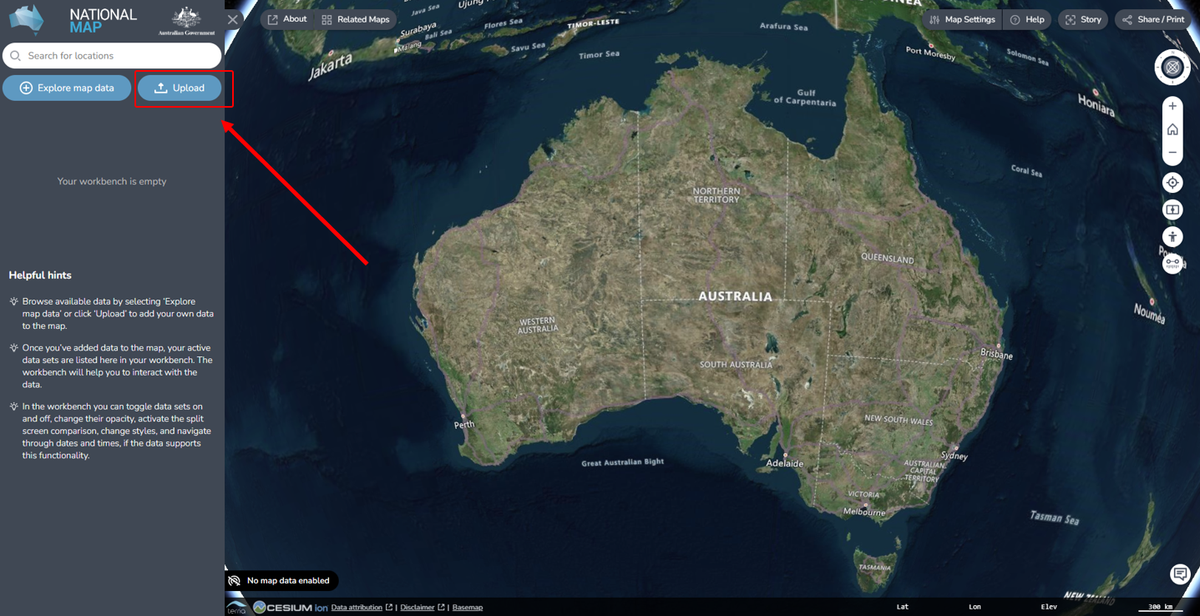
- Select “Add Web Data”
- Choose the file or web service type. It is preferable to use “Web Map Service (WMS) Server” and the link in the next step.
- Paste the following URL: https://data.gov.au/geoserver/emissions-reduction-fund-environmental-data/wms (which is located in data.gov.au under the ERF Environmental data – Preview dataset WMS) and click “Add”.
- On the next pop-up, click “GeoServer Web Map Service” to expand it, and click “Long term average annual rainfall”.

Figure 4 The Australian Government’s National Map
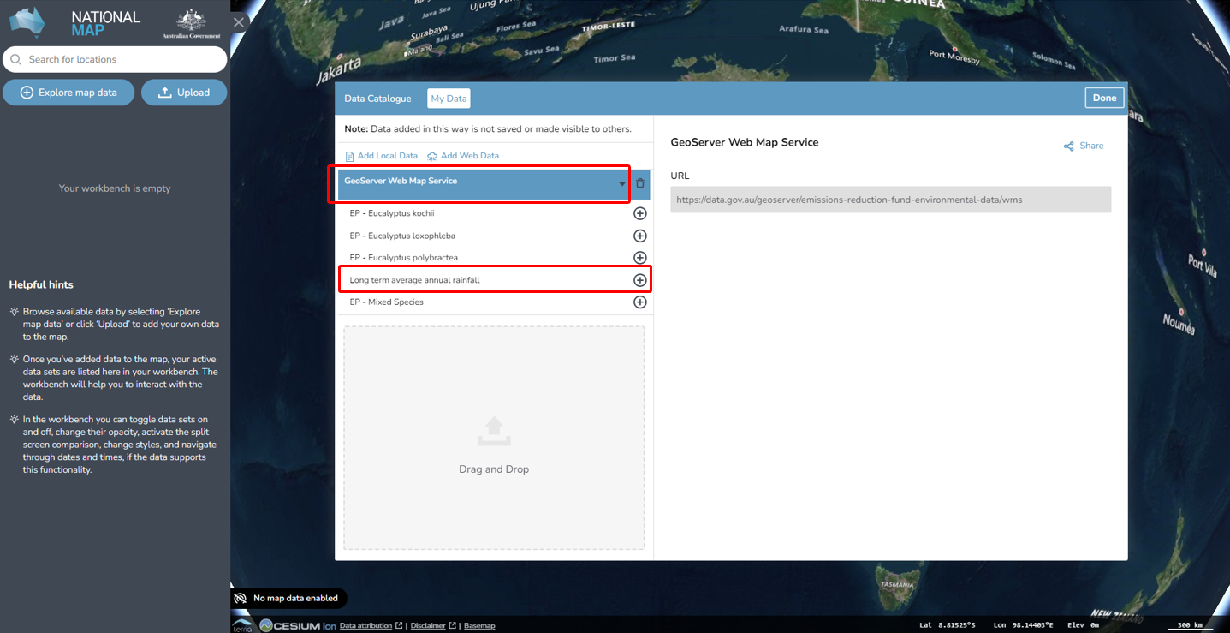
- Then, click the “Add to the map” button at the top right.
Figure 5 Adding the long term average rainfall data to the National Map
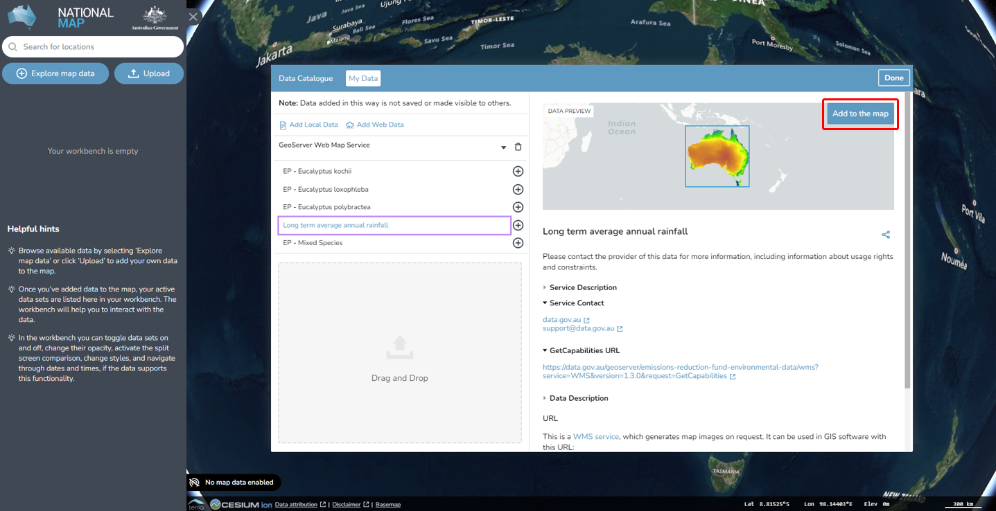
- To check the rainfall amount of the model point location, enter the latitude and longitude in the search bar (located in the top left hand corner). The search result will be displayed in the search bar. Select the desired location.

Figure 6 Entering the latitude and longitude of a location into the National Map
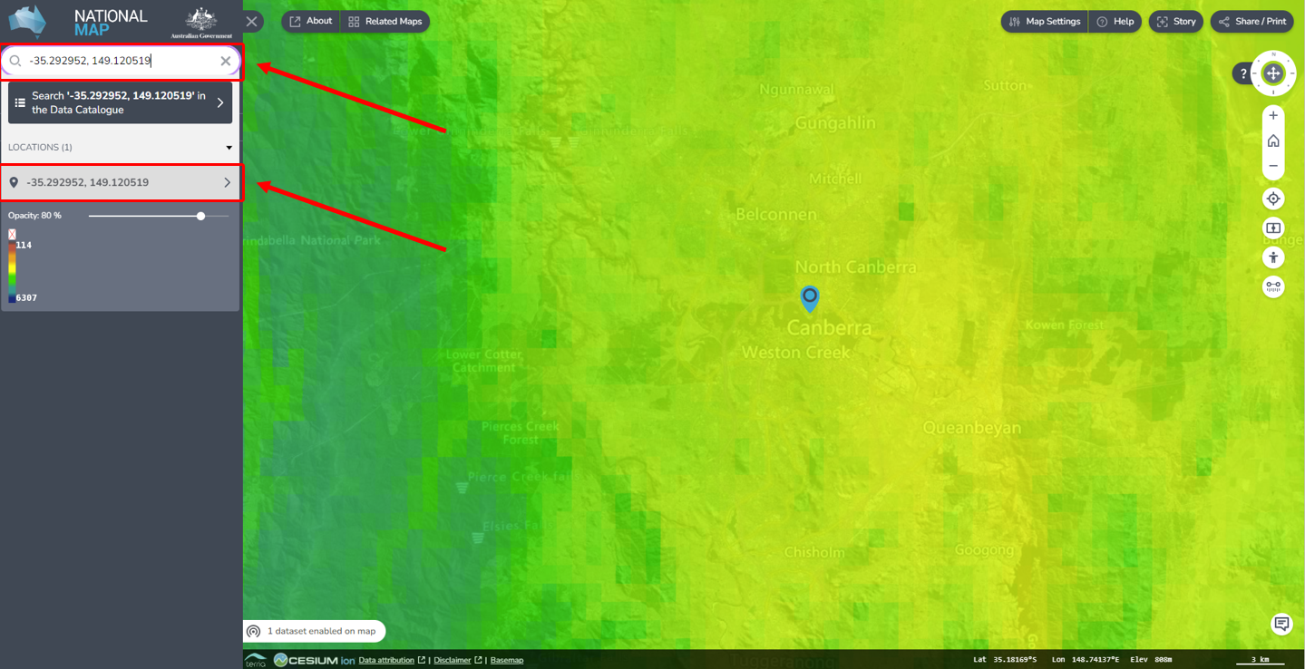
- Click the map marker icon on the map, this will show the “Feature Information” tab on the right hand corner, yielding location and rainfall information. If minimised, click on the “Long term average annual rainfall – Site Data” heading to expand it, revealing the rainfall amount. The “GRAY_INDEX” is the long term average annual rainfall. Note if it is more or less than 500mm, as this impacts the template choice in the FullCAM process.
Figure 7 Identifying the average annual rainfall for a location in the National Map
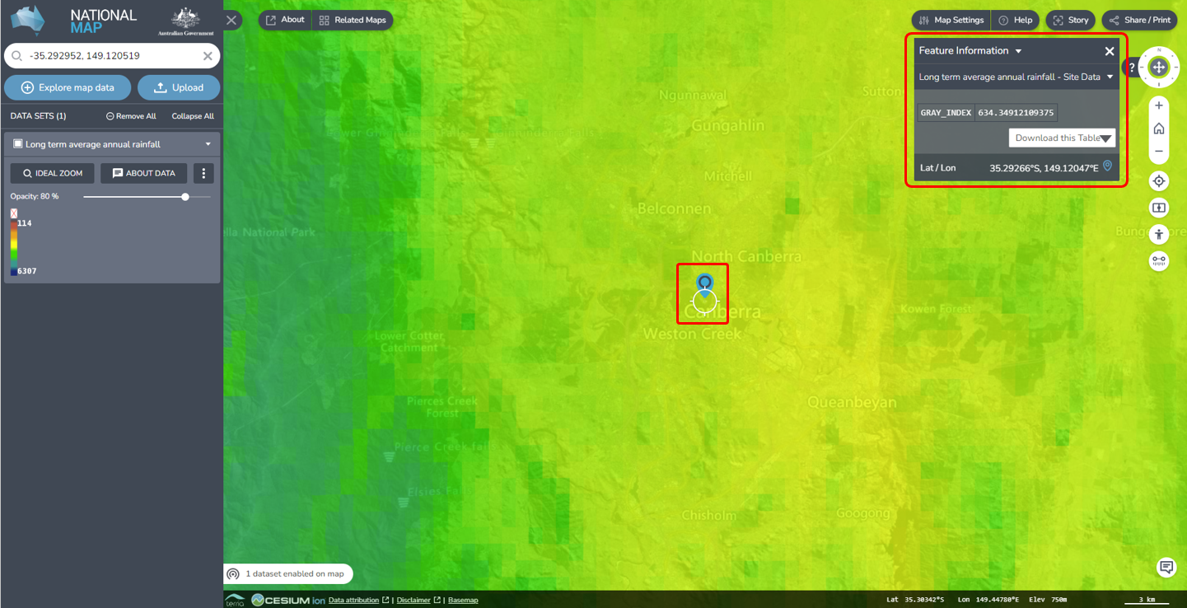

3.2 The Timing Tab
Enter the modelling start and end dates for the simulation that you will run, in the start date and end date text fields. The accepted format is DD/MM/YYYY. These should correspond to those required for either the project or baseline scenario (see section 2 above and section 37 of the Determination.

Figure 8 Entering a start date in FullCAM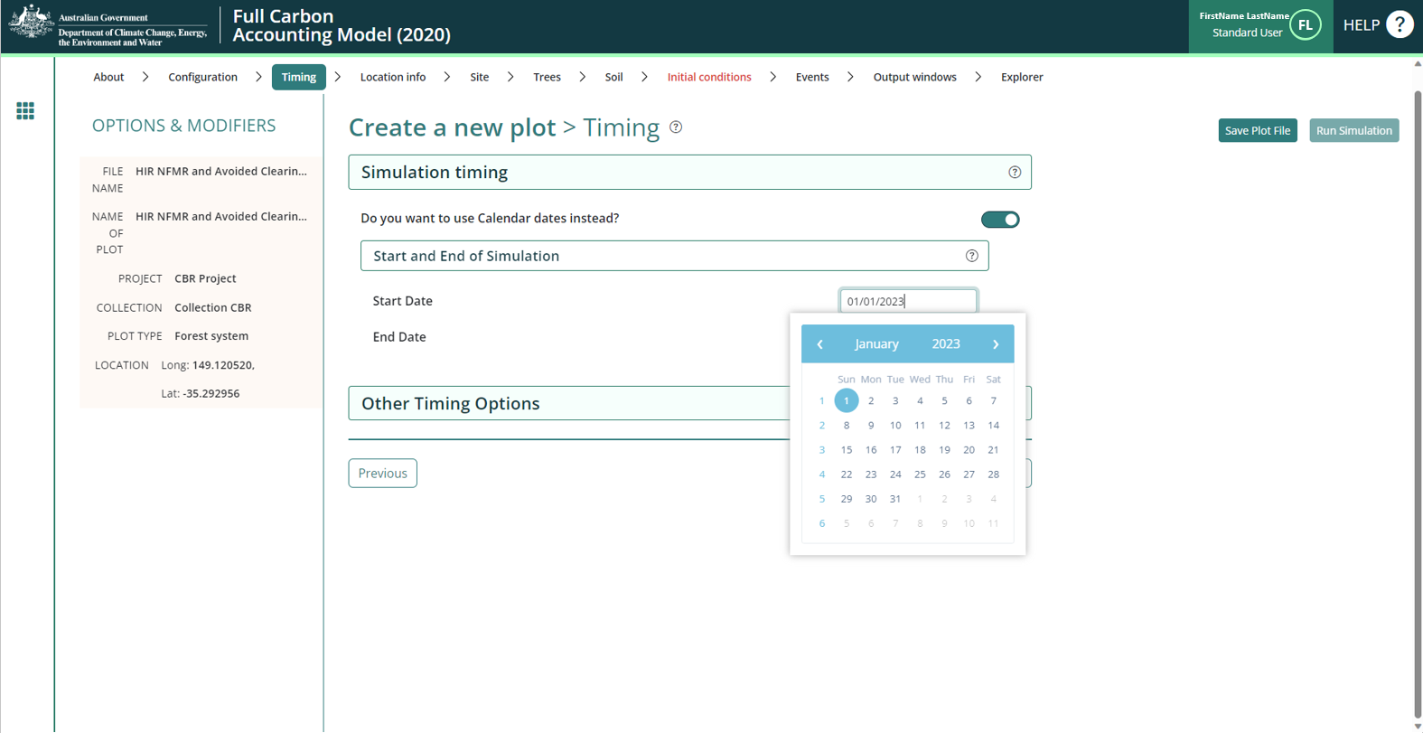

3.3 The Location info Tab
Enter the longitude and latitude (in decimal degrees i.e. xx.xxx xx, xx.xxx xx) of the model point location in the longitude and latitude text fields. This should be the approximate centre of the CEA (as per section 21(4) of the Determination). Note that FullCAM may appear to round off the decimal degrees entered after clicking out of the text fields, but users must enter the full five decimal places as these will be recorded within the plot file itself.
Figure 9 Entering longitude and latitude in FullCAM
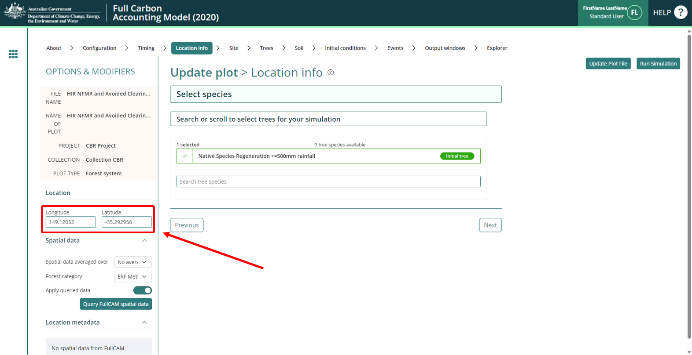

3.4 The Site, Trees, Soil, and Initial Conditions Tabs
Do NOT change any settings in these tabs. Instead, skip to the “Events” tab.

3.5 The Events Tab
The events tab is where users must create the events that must be modelled under either the baseline or project scenarios.

3.5.1 Events types and modelling notes
The baseline scenario has three events that must be modelled:
- Regeneration
- Clearing
- Windrow and burn fire
See section 3.5.2 below, for details of how events are added in the baseline scenario.
The project scenario has five types of events that must be modelled when they occur:
- Regeneration
- Wildfire – trees not killed
- Wildfire – trees killed
- Thinning
- Non-fire disturbances

3.5.1.1 Regeneration
Project scenario
The first regeneration event is modelled in accordance with section 38 of the Determination. In accordance with section 42 of the Determination, project proponents can add a regeneration event following a natural disturbance that kills all the trees in a CEA. The modelling date of this event is determined in accordance with section 42 of the Determination.
Baseline scenario
The first regeneration event is modelled in accordance with section 35 of the Determination. Other projected regeneration events occur at intervals determined in accordance with section 36 of the Determination.
The date of the first baseline clearing event is determined in accordance with section 27 of the Determination. Other projected clearing events occur at intervals determined in accordance with section 36 of the Determination. A clearing event must be modelled to occur in each year a projected clearing event occurs, on 1 January of that year.

Clearing
Baseline scenario
The date of the first baseline clearing event is determined in accordance with section 27 of the Determination. Other projected clearing events occur at intervals determined in accordance with section 36 of the Determination. A clearing event must be modelled to occur in each year a projected clearing event occurs, on 1 January of that year.

3.5.1.3 Windrow and burn
Baseline scenario
Windrow and burn events must be added to the baseline scenario in accordance with section 36 of the Determination. Windrow and burns are modelled to occur one year after each projected clearing event on 1 January.

3.5.1.4 Thinning
Project scenario
Thinning events are used to model thinning for ecological purposes. Ecological thinning events must be added for each separate event that occurs in a CEA during the modelling period in accordance with section 39 of the Determination.

3.5.1.5 Wildfire – trees not killed
Project scenario
Events must be added in accordance with section 40 of the Determination for each fire in which trees are not killed that occurs in a CEA during the modelling period. For each modelled Wildfire – trees not killed event, the modelled date is that determined in accordance with section 40 of the Determination.

3.5.1.6 Wildfire – trees killed
Project scenario
Events must be added in accordance with section 40 of the Determination for each fire in which trees are killed that occurs in a CEA during the modelling period. For each modelled Wildfire – trees killed event, the modelled date is that determined in accordance with section 40 of the Determination.

3.5.1.7 Non-fire disturbances
Project scenario
Non-fire disturbance events must be added to the project scenario in accordance with section 41 of the Determination.

Adding project scenario events individually
Events for the project scenario must be added in accordance with this section one-by-one, following the below steps, with reference to above notes.
- To add a new event, click on the “New Event" button. A new pop-up window will appear.
Figure 10 Adding a new event FullCAM
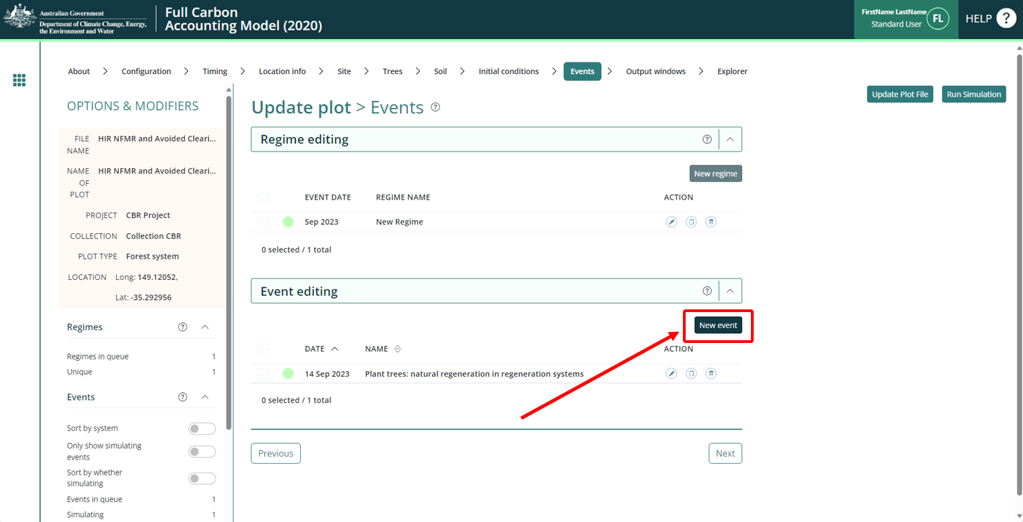

- Select the Event Type from the drop-down list that corresponds to the activity/event as given below. The notes in section 3.5.1 above provide more information of when to model different events and activities under the applicable scenarios (project or baseline) and section 3.5.2.1 to 3.5.2.7 on the specific settings to use for those.
Figure 11 Selecting the event type in FullCAM
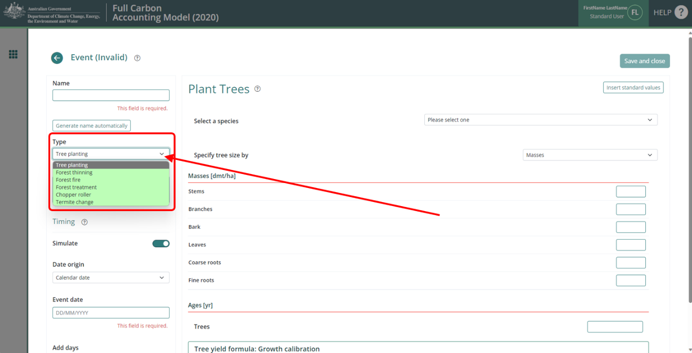

3.5.2.1 Adding a Regeneration Event
- Select the “Tree Planting” Event Type.
- Click the “Insert standard values” button. This will open a pop-up window.
- In the checkbox on the left, select the event with the name (in the middle column) “Plant trees: natural regeneration in regeneration systems”. The parameters for the event will now be filled with standard values.
Figure 12 Selecting a standard tree planting event in FullCAM
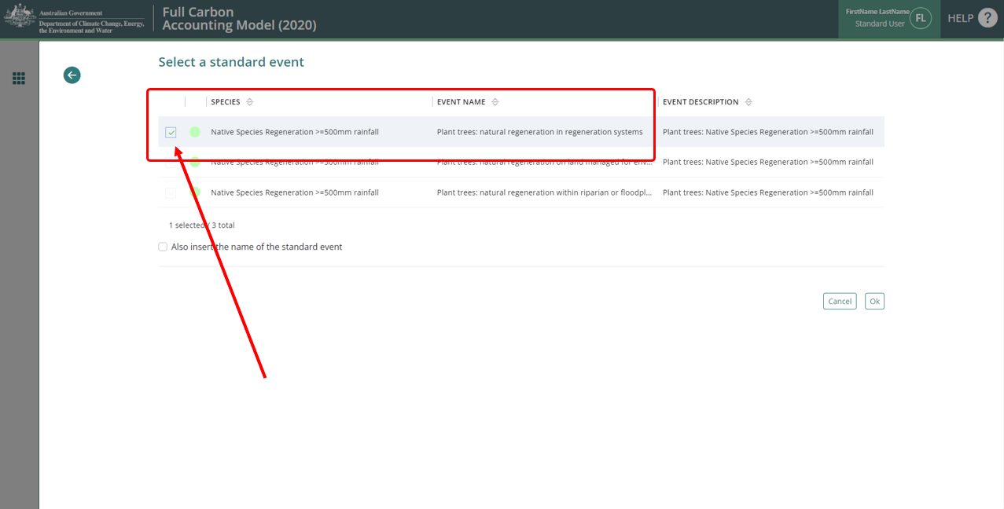
- Click the “Ok” button at the bottom right of the window. This will close the pop-up.
- Select the “Native Species Regeneration” option appropriate to the event in the “Select a species” drop-down menu.
Figure 13 Selecting a species in tree planting event in FullCAM
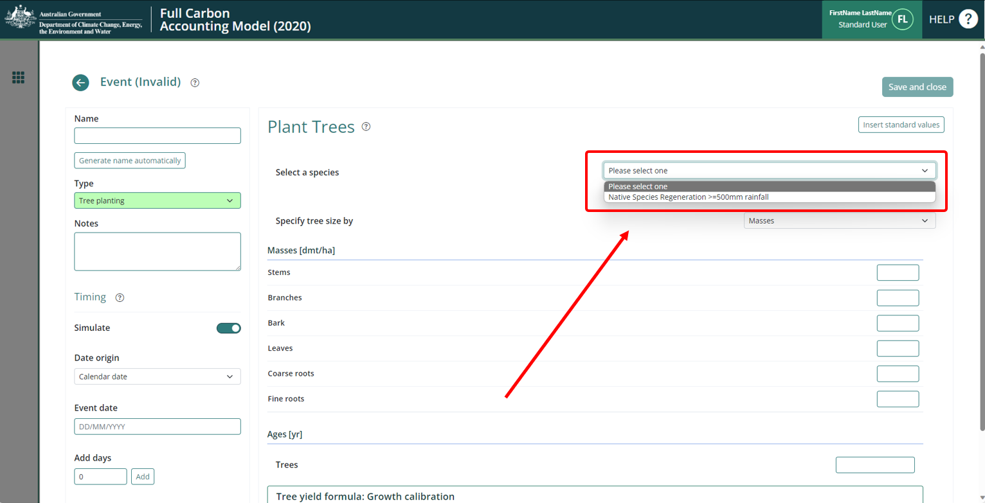
- Click the “Generate name automatically” button in the top left of the window.
- Insert the calendar date for the Event in the “Event Date” field. The accepted format is DD/MM/YYYY. There are specific timing requirements that must be followed with reference to the notes given in section 3.5.1.
- Do NOT edit any other settings.
- Click the green “Save and close” button at the top right of the window.

3.5.2.2 Adding a Clearing Event
- Select the “Forest thinning” Event Type.
- Click the “Insert standard values” button. This will open a pop-up window.
- In the checkbox on the left, select the event with the name (in the middle column) “Initial clearing: no product recovery”. The parameters for the event will now be filled with standard values.
Figure 14 Selecting a thinning event in FullCAM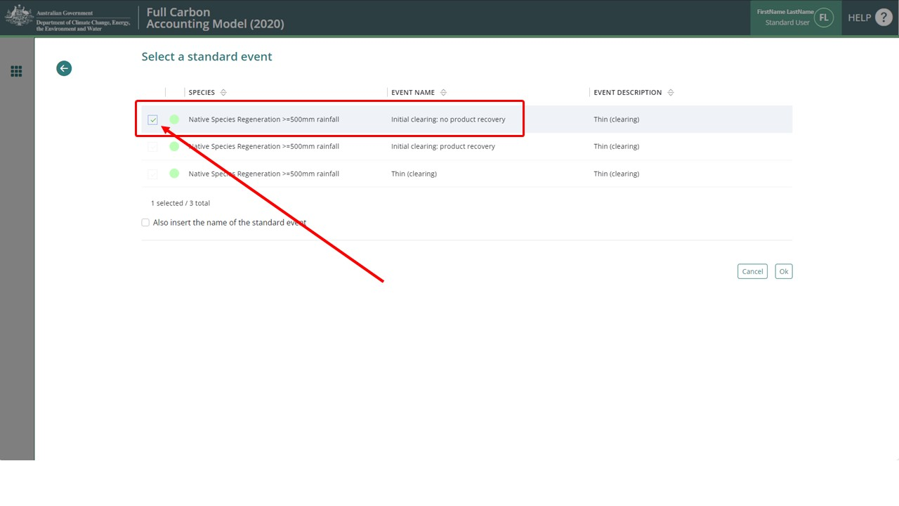
- Click the “Ok” button at the bottom right of the window. This will close the pop-up.
- Click the “Generate name automatically” button in the top left of the window.
- Insert the calendar date for the Event in the “Event date” field. The accepted format is DD/MM/YYYY. There are specific timing requirements that must be followed with reference to the notes given in section 3.5.1.
- Do NOT edit any other settings.
- Click the green “Save and close” button at the top right of the window.

3.5.2.3 Adding a Windrow and Burn Event
- Select the “Forest fire” Event Type.
- Click the “Insert standard values” button. This will open a pop-up window.
- In the checkbox on the left, select the event with the name (in the middle column) “Site prep: Windrow and burn”. The parameters for the event will now be filled with standard values.
Figure 15 Selecting a fire event in FullCAM
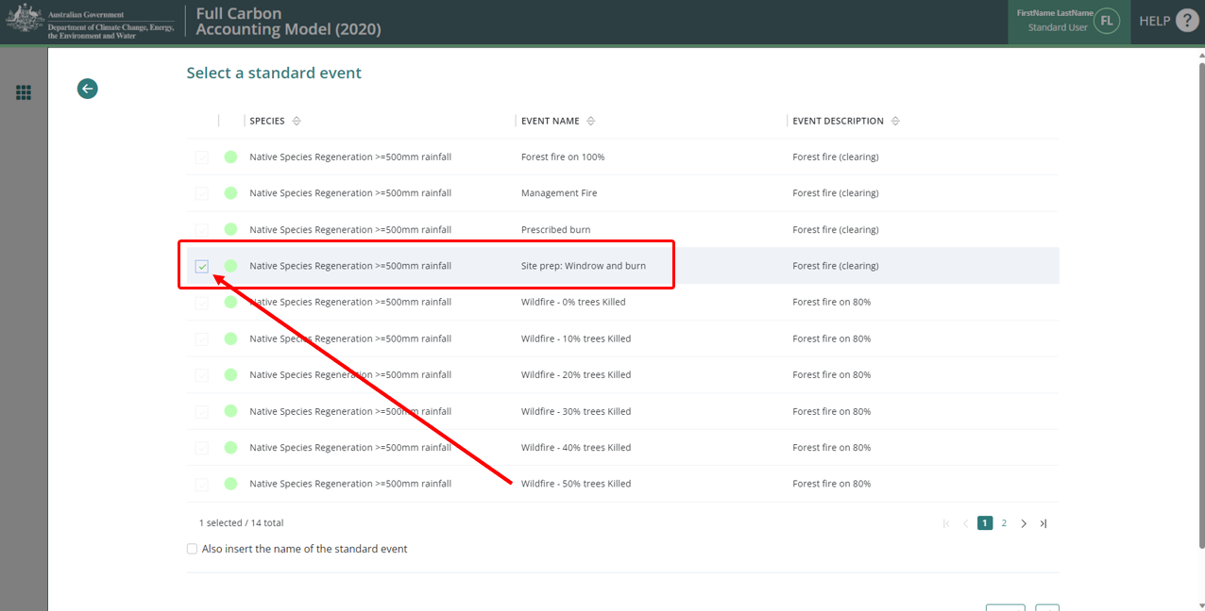
- Click the “Ok” button at the bottom right of the window. This will close the pop-up.
- Click the “Generate name automatically” button in the top left of the window.
- Insert the calendar date for the Event in the “Event date” field. The accepted format is DD/MM/YYYY. There are specific timing requirements that must be followed with reference to the notes given in section 3.5.1.
- Do NOT edit any other settings.
- Click the green “Save and close” button at the top right of the window.

3.5.2.4 Adding a Thinning Event
- Select the “Forest Thinning” Event Type.
- Click the “Insert standard values” button. This will open a pop-up window.
- In the checkbox on the left, select the event with the name (in the middle column) “Initial clearing: no product recovery”. The parameters for the event will now be filled with standard values.
Figure 16 Selecting a thinning event in FullCAM
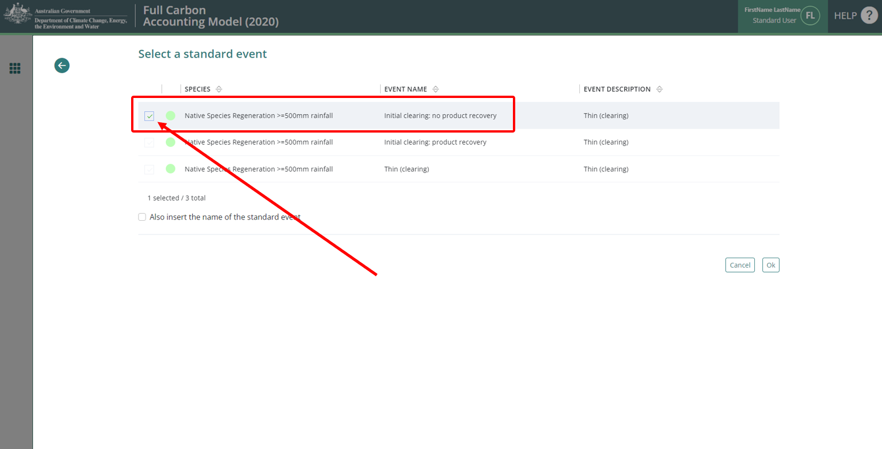
- Click the “Ok” button at the bottom right of the window. This will close the pop-up.
- In the “Affected Portion” section, enter the percentage of the trees that were killed in the thinning in the “Percentage of forest affected by thin”.
- Click the “Generate name automatically” button in the top left of the window.
- Insert the calendar date for the Event in the “Event date” field. The accepted format is DD/MM/YYYY. There are specific timing requirements that must be followed with reference to the notes given in section 3.5.1.
- Click the green “Save and close” button at the top right of the window.

3.5.2.5 Adding a Non-fire Disturbance Event
- Select the “Forest thinning” Event Type.
- Click the “Insert standard values” button. This will open a pop-up window.
- In the checkbox on the left, select the event with the name (in the middle column) “Initial clearing: no product recovery”. The parameters for the event will now be filled with standard values.
Figure 17 Selecting a thinning event in FullCAM
- Click the “Ok” button at the bottom right of the window. This will close the pop-up.
- In the “Affected Portion” section, enter the percentage of the trees that were killed in the thinning in the “Percentage of forest affected by thin”.
- Click the “Generate name automatically” button in the top left of the window.
- Insert the calendar date for the Event in the “Event date” field. The accepted format is DD/MM/YYYY. There are specific timing requirements that must be followed with reference to the notes given in section 3.5.1.
- Click the green “Save and close” button at the top right of the window.

3.5.2.6 Adding a Wildfire – Trees Not Killed Event
- Select the “Forest Fire” Event Type.
- Click the “Insert standard values” button. This will open a pop-up window.
- In the checkbox on the left, select the event with the name (in the middle column) “Wildfire - trees not killed”. The parameters for the event will now be filled with standard values.
Figure 18 Selecting a wildfire event in FullCAM
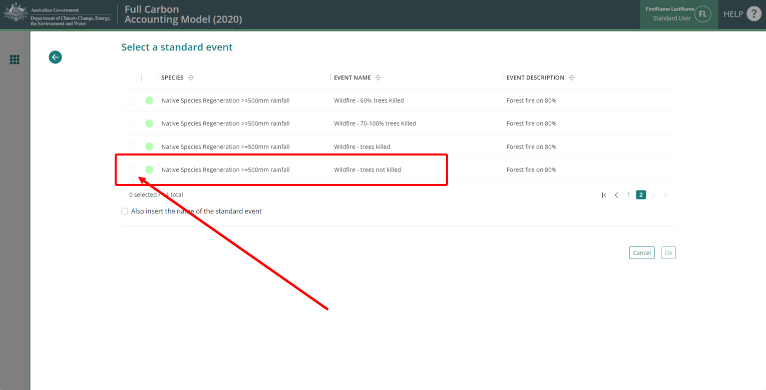
- Click the “Ok” button at the bottom right of the window. This will close the pop-up.
- In the “Affected Portion” section, enter the percentage of the CEA that was affected by the fire in the “Percentage of forest affected by fire” field.
- Click the “Generate name automatically” button in the top left of the window.
- Insert the calendar date for the Event in the “Event date” field. The accepted format is DD/MM/YYYY. There are specific timing requirements that must be followed with reference to the notes given in section 3.5.1.
- Click the green “Save and close” button at the top right of the window.

3.5.2.7 Adding a Wildfire – Trees Killed Event
- Select the “Forest Fire” Event Type.
- Click the “Insert standard values” button. This will open a pop-up window.
- In the checkbox on the left, select the event with the name (in the middle column) “Wildfire – trees killed”. The parameters for the event will now be filled with standard values.
Figure 19 Selecting a wildfire event in FullCAM
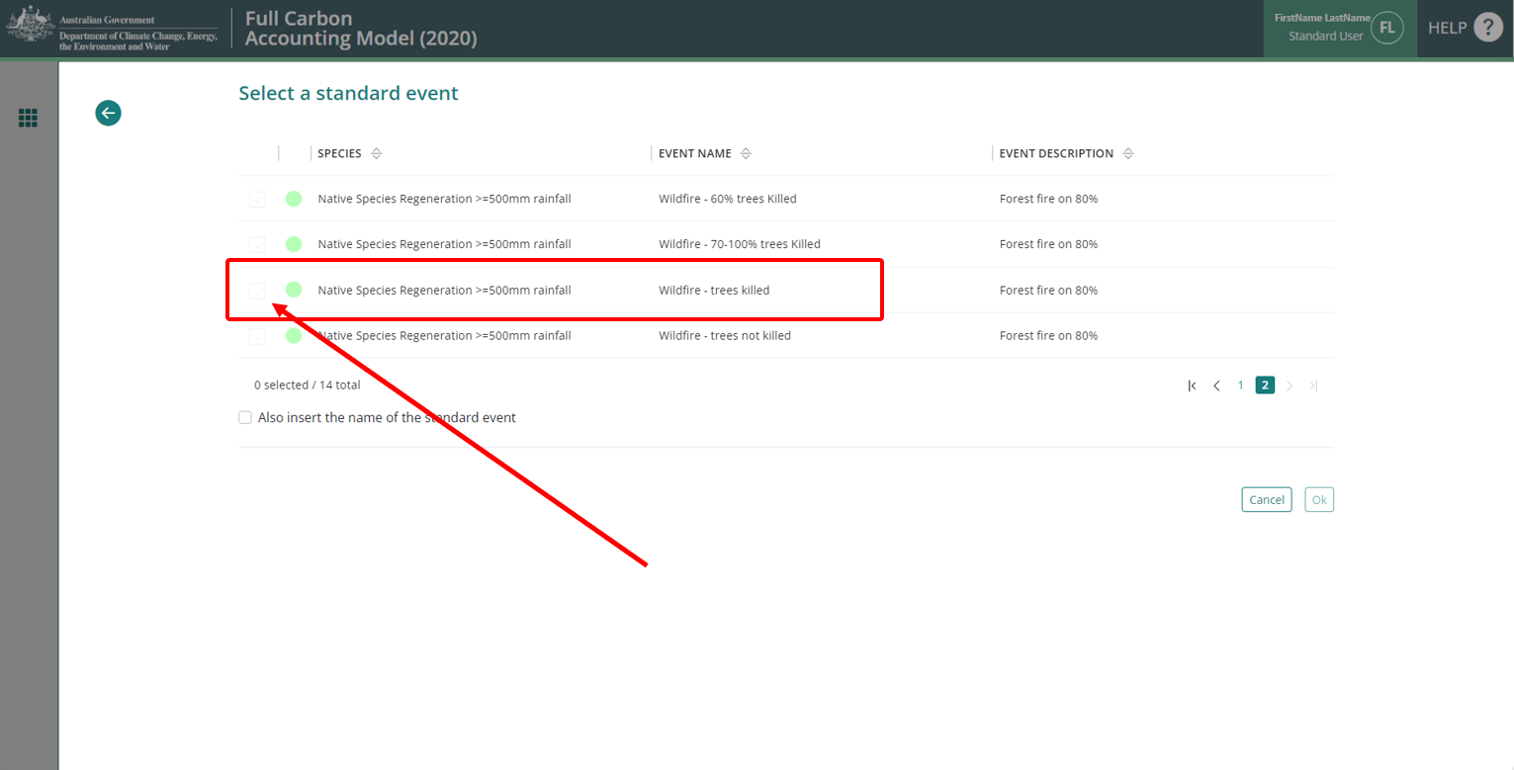
- Click the “Ok” button at the bottom right of the window. This will close the pop-up.
- In the “Affected Portion” section, enter the percentage of trees that were affected by the fire in the “Percentage of forest affected by fire” field.
- Click the “Generate name automatically” button in the top left of the window.
- Insert the calendar date for the Event in the “Event date” field. The accepted format is DD/MM/YYYY. There are specific timing requirements that must be followed with reference to the notes given in section 3.5.1.
- Click the green “Save and close” button at the top right of the window.

Adding the baseline scenario events as a group using the Regime function
The following steps use the new regime function on the events tab to add all the events that must be modelled under the baseline scenario in accordance with sections 35-37 of the Determination.
- Click on the green “New regime” button in the Regime section.

Figure 20 Adding a new regime in FullCAM
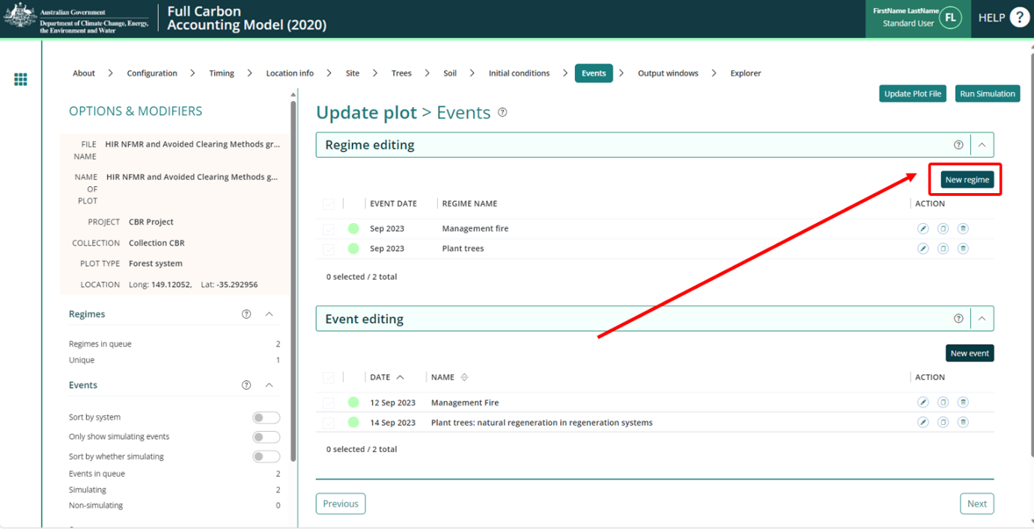
- From the drop-down list in the “Available regimes”, select the “Avoided Clearing Baseline w. Windrow Burn” option. This may be listed with Native Species Regeneration and the chosen annual rainfall category in brackets.
Figure 21 Adding an available regime in FullCAM
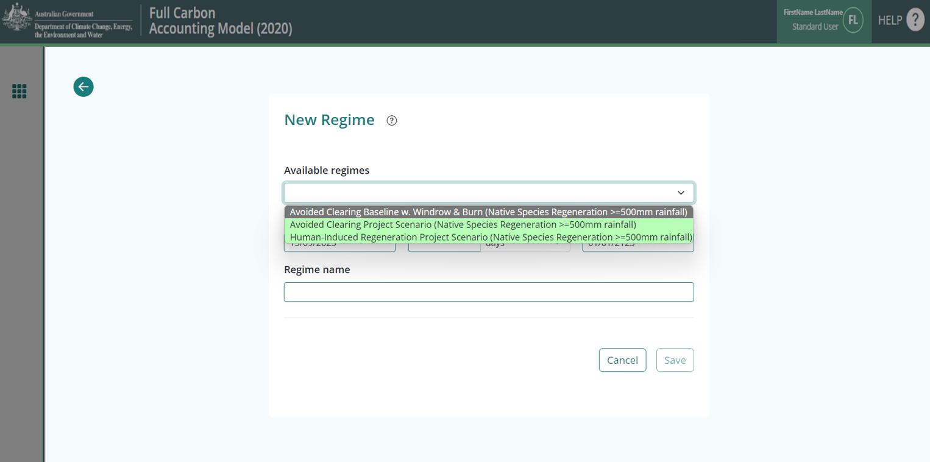
- By default, the start and end dates should cover the start and end date of the simulation period. If not, amend these dates so they correspond to the start and end dates of the simulation period, as determined in accordance with section 37 of the Determination, entering the dates in DD/MM/YYYY format.
- In the ‘Repeat every’ field, enter the interval in years worked out in accordance with subsection 36 (2) of the Determination.

- Click “Save”. The events queue on the events tab will now be filled with the sequence of baseline events recurring at the interval in years specified across the entire simulation period. Once this step is completed, users can proceed to section 3.6 to run the simulation.

The Output Windows Tab

Ensuring correct outputs are selected
The ‘New from template’ option used to create plot files will by default select the correct output types for the applicable scenario. The below steps can be followed to ensure the output types are correct, and to rectify any issues with those selected.
Selected outputs have a tick next to their name.
Categories and subcategories with all outputs selected will have a tick symbol.
Expanded categories, or those with some outputs selected will have a ‘-’ symbol.
Categories with no outputs selected will have a ‘+’ symbol.
Figure 22 Selecting the output categories in FullCAM
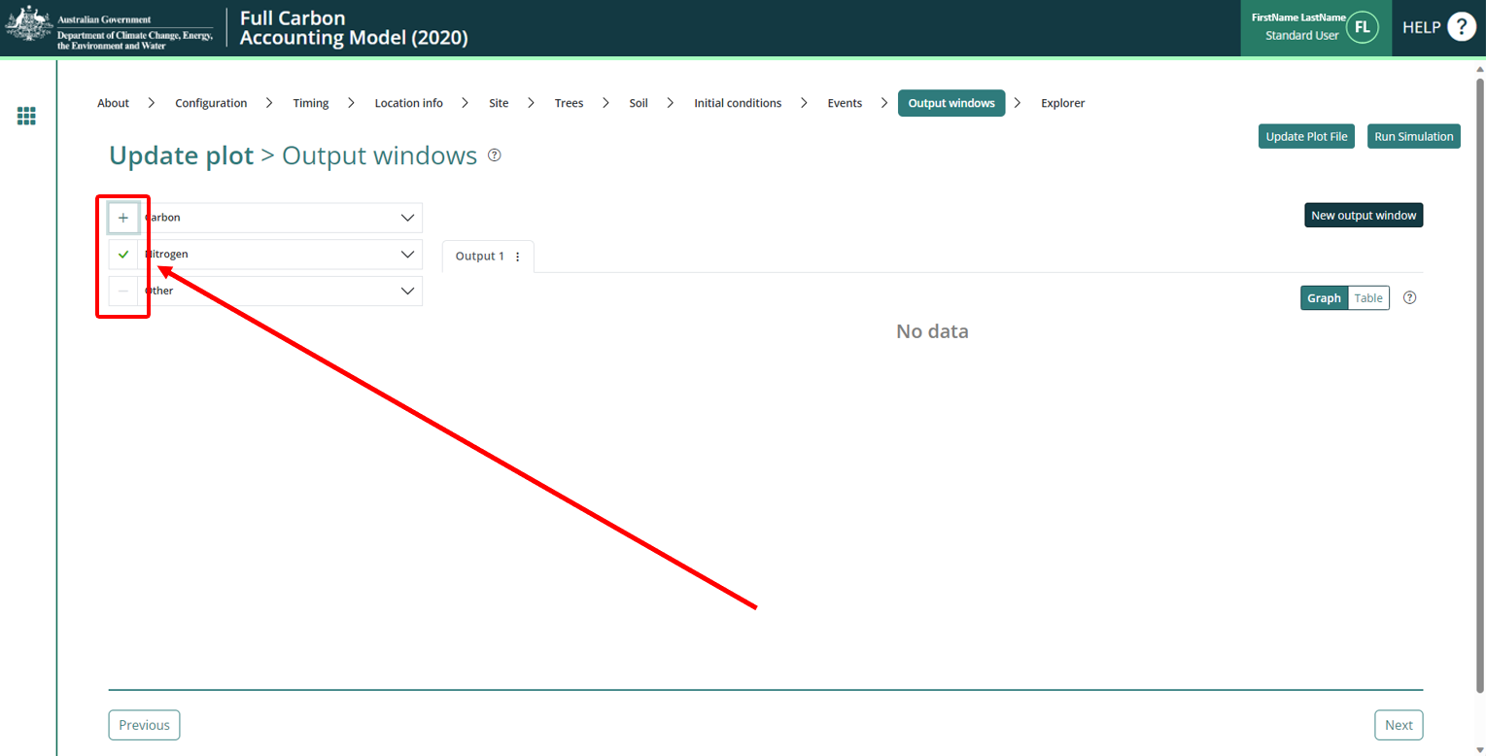
From the templates used to create plot files, the following outputs will be selected, consistent with the Determination requirements:
  - the tree carbon pool: Carbon / Forest / Plants / C mass of trees.
  - the emission: Carbon / Whole / Emissions / CH4 emitted due to fire.
  - the non-CO₂ emission: Nitrogen / Whole / Emissions / N2O emitted due to fire.
  - the debris pool: Other / Carbon Projects / C mass of forest debris.

Note: only the four pools listed above must be selected.

Running simulations
To run the simulation, click the “Run Simulation" button, in the top right of the screen. This will generate the selected outputs in a graph. It will also initialise a download of the result in CSV format. This button will appear faded out and will not be available if the Events queue contains invalid Events, which will appear in red, and the tab will have a red title.
Figure 23 Running a simulation in FullCAM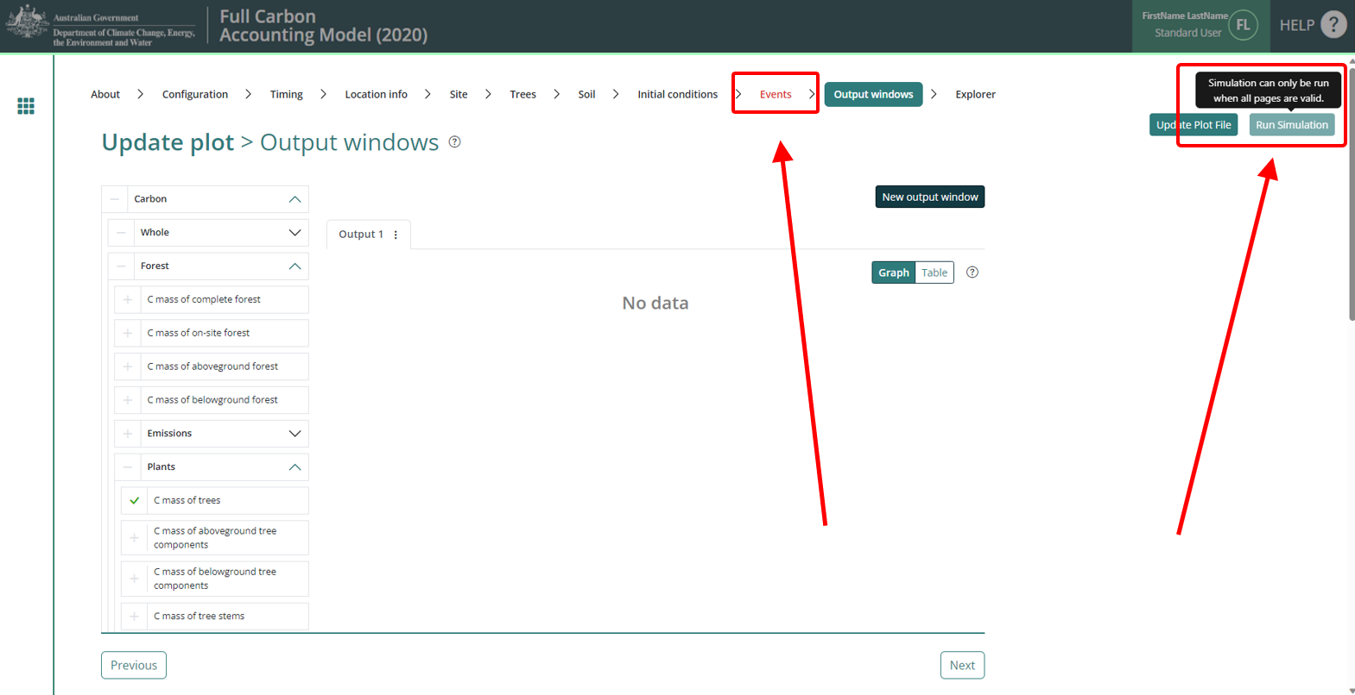
Note that if reopening a plot file, users must first navigate to the “Location info” tab and click “Query FullCAM spatial data” before running the simulation to ensure the latest spatial data is used for the simulation.

Viewing outputs
Outputs can be viewed as a graph or a table by clicking on the corresponding icons at the top right of the Output Window.
Figure 24 Viewing outputs in FullCAM
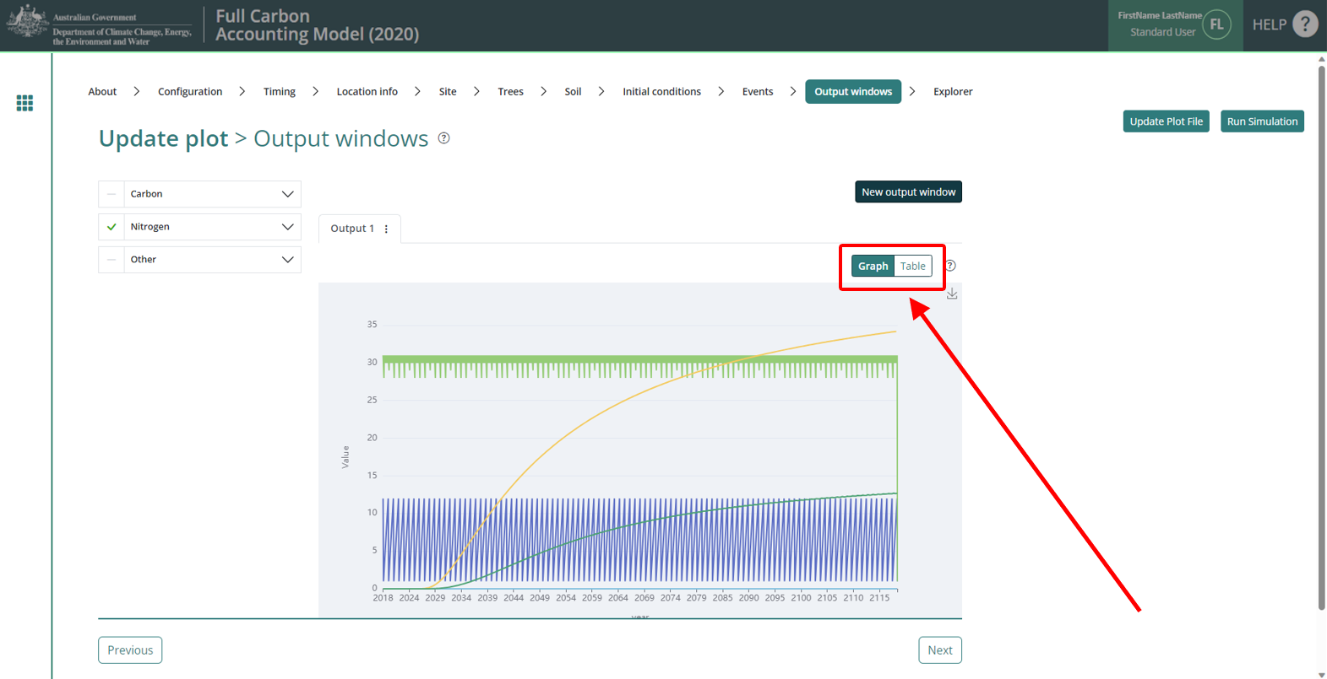

Accessing outputs as a spreadsheet
Running a simulation will automatically download the CSV file with the graph’s data. A pop-up near your ‘Downloads’ button on your browser may request permission to download.

FullCAM Simulations and Offsets Reporting
Project proponents must calculate the project net abatement by completing the equations in Part 4 of the Determination. The net abatement amount is calculated by comparing the baseline and project scenarios. The calculations are made in relation to the carbon stock in each CEA in the last month of the reporting period. Parameters generated in FullCAM and used in Equations in the Determination are given below in Table 3.
Note that for some of the equations the average or sum of the FullCAM output over the simulation period will be required, whereas for others the value of the FullCAM output at the end of the simulation period will be used. Refer to the equations within the Determination to determine which value to use. Averages or sums can be calculated using the average and sum functions within your spreadsheet software.
Table 2 FullCAM outputs and corresponding parameters as defined in the determination
FullCAM Output | Scenario | Parameter | Equation
C mass of trees | Baseline | $$C_{BT,i,k}$$ | 1
C mass of debris | Baseline | $$C_{BD,i,k}$$ | 1
C mass of trees | Project | $$C_{T,i}$$ | 2
C mass of debris | Project | $$C_{D,i}$$ | 2
CH₄ emitted due to fire | Project | $$E_{{CH}_{4},i}$$ | 6
N₂O emitted due to fire | Project | $$E_{N_{2}O,i }$$ | 7

