# Draft FullCAM Guidelines

Requirements for using the Full Carbon Accounting Model (FullCAM) in the Australian Carbon Credit Unit (ACCU) Scheme methodology determination: *Carbon Credits (Carbon Farming initiative) (Reforestation by Environmental or Mallee Plantings—FullCAM) Methodology Determination 2014*

These proposed guidelines are for consultation purposes only. They are not to be followed for reporting under the ACCU Scheme.

Version 4.0  
(published and in force from 1 September 2020, updated September 2023).

© Commonwealth of Australia 2023

**Ownership of intellectual property rights**

Unless otherwise noted, copyright (and any other intellectual property rights) in this publication is owned by the Commonwealth of Australia (referred to as the Commonwealth).

**Creative Commons licence**

All material in this publication is licensed under a [Creative Commons Attribution 4.0 International Licence](https://creativecommons.org/licenses/by/4.0/legalcode) except content supplied by third parties, logos and the Commonwealth Coat of Arms.

Inquiries about the licence and any use of this document should be emailed to [copyright@dcceew.gov.au](mailto:copyright@dcceew.gov.au).



**Cataloguing data**

This publication (and any material sourced from it) should be attributed as: The Department of Climate Change, Energy, the Environment and Water FullCAM Guidelines: Requirements for using the Full Carbon Accounting Model (FullCAM) in the Australian Carbon Credit Unit (ACCU) Scheme methodology determination *Carbon Credits (Carbon Farming Imitative) (Reforestation by Environmental or Mallee Plantings – FullCAM) Methodology Determination 2014*, Department of Climate Change, Energy, the Environment and Water, Canberra. CC BY 4.0.

This publication is available at [[address](https://www.dcceew.gov.au/publications) to be confirmed].

Department of Climate Change, Energy, the Environment and Water

GPO Box 3090 Canberra ACT 2601

Telephone 1800 900 090

Web [dcceew.gov.au](https://www.dcceew.gov.au)

**Disclaimer**

The Australian Government acting through the Department of Climate Change, Energy, the Environment and Water has exercised due care and skill in preparing and compiling the information and data in this publication. Notwithstanding, the Department of Climate Change, Energy, the Environment and Water, its employees and advisers disclaim all liability, including liability for negligence and for any loss, damage, injury, expense or cost incurred by any person as a result of accessing, using or relying on any of the information or data in this publication to the maximum extent permitted by law.

**Acknowledgement of Country**

Our department recognises the First Peoples of this nation and their ongoing connection to culture and country. We acknowledge Aboriginal and Torres Strait Islander Peoples as the Traditional Owners, Custodians and Lore Keepers of the world's oldest living culture and pay respects to their Elders past, and present.

Contents

1. Introduction 5

1.1 Use of FullCAM with the Reforestation by Environmental or Mallee Plantings Methodology Determination 5

1.2 Determining which FullCAM option to use 5

1.3 Format of this document 7

1.4 FullCAM background 7

1.5 FullCAM plots and running simulations 8

1.6 Overview of the FullCAM interface 8

2. 2020 FullCAM option - setting up simulations for each Carbon Estimation Area 11

2.1 Creating a new plot file 11

2.2 The Timing Tab 12

2.3 The Location Info Tab 12

2.4 The Site, Trees, Soil, and Initial Conditions Tab 16

2.5 The Events Tab 16

2.6 Outputs and running a simulation 25

3. FullCAM simulation outputs and offsets reporting 28

**Tables**

Table 1 FullCAM tabs 9

Table 2 FullCAM calibrations in the 2020 and 2016 versions 17

Table 3 Event types corresponding to each management activity 18

Table 4 Outputs generated by FullCAM and the corresponding Determination equations 28

**Figures**

**Figure 1 FullCAM download options** 7

**Figure 2 Selecting a new simulation in FullCAM** 11

**Figure 3 Selecting a template in FullCAM** 12

**Figure 4 Entering longitude and latitude in FullCAM** 13

**Figure 5 Geographic areas that restrict where each ‘specific calibration’ is available as an option** 14

**Figure 6 Selecting a forest category in FullCAM** 15

**Figure 7 Selecting a new event in FullCAM** 18

**Figure 8 Selecting an event type in FullCAM** 19

**Figure 9 Selecting a species in FullCAM** 20

**Figure 10 Selecting the ‘Initial clearing: no product recovery’ standard event in FullCAM** 21

**Figure 11 Selecting the ‘Wildfire – trees not killed’ standard event in FullCAM** 22

**Figure 12 Selecting the ‘Wildfire – trees killed’ standard event in FullCAM** 23

**Figure 13 Selecting the ‘Prescribed burn’ standard event in FullCAM** 24

**Figure 14 Selecting the output categories in FullCAM** 25

**Figure 15 Running a simulation in FullCAM** 26

**Figure 16 Viewing outputs in FullCAM** 27

## 1. Introduction

### Use of FullCAM with the Reforestation by Environmental or Mallee Plantings Methodology Determination

The calculation of carbon abatement under the [*Carbon Credits (Carbon Farming Initiative) (Reforestation by Environmental or Mallee Plantings—FullCAM) Methodology Determination 2014*](https://www.legislation.gov.au/Series/F2014L01212) (the Determination) is dependent upon the use of the Full Carbon Accounting Model (FullCAM) consistently with the requirements of this document. In particular, section 4.5 of the Determination requires that FullCAM must be used to model carbon stocks, emissions from disturbance, and the effects of a management event in accordance with this document. Section 4.7 of the Determination also requires key output data to be produced using FullCAM in accordance with the requirements in the Determination and this document. Section 4.8 requires calibrations to be in accordance with this document and section 4.17 requires inputs to be collected in accordance with this document. Where content of this document relates to provisions of the Determination, references are given to the location of those provisions.

Project proponents must only change FullCAM default settings as indicated in this document, and all other settings must not be changed. This is to ensure that defaults will apply where relevant.

### Determining which FullCAM option to use

The Department of Climate Change, Energy, the Environment and Water updates the Full Carbon Accounting Model (FullCAM) from time to time to reflect the latest science and improve usability. At the time this document was last updated, the latest version was released for public use in 2024 on the Department’s website ([to be confirmed]). The latest publicly released version of FullCAM is constituted by two options.

1. Default: 2020 FullCAM option

This is currently the 2020 FullCAM option. The year reflects when the latest version was released at the time this document was last updated. However, a reference to the default or 2020 FullCAM option in this document includes any subsequent release or update of FullCAM on the Department’s website. Accordingly, projects using the default 2020 FullCAM option will be required to use subsequent releases as they are made available.

1. Alternative: 2016 FullCAM option

This is identified as the 2016 FullCAM option and is only available for use by some projects, as described below.

Project proponents must access the latest publicly released version of FullCAM from the Department’s website and then ensure they are using the appropriate FullCAM option for their project (see screenshot below).

An exception to the requirement to use the latest publicly released version is for projects with reporting periods that end before 1 September 2020, under a method that specifies to use the version of FullCAM and the associated Guidelines for those periods. If you determine that you must use a version of FullCAM that is unavailable on the website, please contact the Department at [FullCAM@dcceew.gov.au](mailto:FullCAM@dcceew.gov.au) or [ACCUMethods@dcceew.gov.au](mailto:ACCUMethods@dcceew.gov.au) to obtain a copy.

The requirements below explain when the default 2020 FullCAM option must be used and when the alternative 2016 FullCAM option can be used.

* Whichever FullCAM option is used by the proponent, all Carbon Estimation Areas (CEAs) of a given project must be reported on using a single FullCAM option.
* Projects with section 22 declaration applications under the *Carbon Credits (Carbon Farming Initiative) Act 2011* (CFI Act), submitted to the Clean Energy Regulator (the Regulator) on or after 1 September 2020, must use the default 2020 FullCAM option.
* Projects with section 22 declaration applications submitted to the Regulator before 1 September 2020 are able to use either the default 2020 FullCAM option or the alternative 2016 FullCAM option. These projects are able to move from the 2016 FullCAM option to the 2020 FullCAM option if they choose to do so. If a choice to use the FullCAM 2020 option is made, the entire project must be moved to FullCAM 2020 and once using 2020 FullCAM option in an offsets report, these projects cannot return to using the 2016 FullCAM option.
* If project proponents with section 22 declaration applications submitted to the Regulator before 1 September 2020 add a new project area or areas to the project under the section 29 of the *CFI Act* with effect on or after 1 September 2020, the entire project must use the default 2020 FullCAM option. The only exception to this is where all of the areas added to the project were already using the alternative 2016 FullCAM option under these guidelines as part of another eligible offsets project (these can continue to use the 2016 FullCAM option consistent with the dot point above – therefore the original project must also have been eligible to use the 2016 FullCAM option).
* Projects that transfer from an earlier to a later version of this Determination or transfer to this Determination from another determination, with the application under section 128 of the CFI Act submitted on or after 1 September 2020, must use the default 2020 FullCAM option.

Note that FullCAM is not compatible with iOS systems, and must be run in a Windows operating environment.

**Figure 1 FullCAM download options**

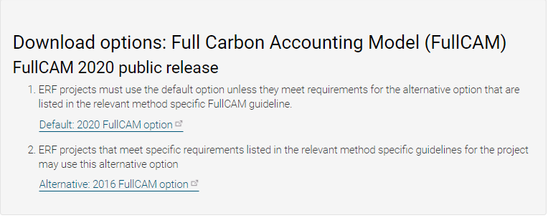

Two options

**Screenshot from download page**

### Format of this document

This document provides:

* an overview of FullCAM relevant to the Determination, its features relevant to users and important requirements for using this document (section 1)
* a step-by-step walkthrough of using 2020 FullCAM to run the simulations correctly (section 2); and
* an overview of the FullCAM outputs as they relate to equations within the Determination (section 3).

Note that this document provides a step-by-step walkthrough for 2020 FullCAM alone. This is because this document is for consultation on a modernised interface for that version of FullCAM. The published update to these guidelines will also contain a step-by-step walkthrough for the 2016 FullCAM*.*

The 2020 FullCAM option requires fewer data entries than the 2016 FullCAM option because many items have been automated in the 2020 FullCAM option through the use of a template.

### FullCAM background

FullCAM is used in Australia’s National Greenhouse Gas Accounts for the land sector. FullCAM provides fully integrated estimates of carbon pools in forest and agricultural systems for Australia’s land sector reporting. In addition, it accounts for human-induced changes in emission and sequestration of major greenhouse gases. FullCAM was developed under the National Carbon Accounting System (NCAS) at the then Australian Greenhouse Office to provide a dynamic account of the changing stocks of carbon in Australia’s land systems since 1970 by integrating data on land cover change, land use and management, climate, plant productivity, and soil carbon over time. FullCAM estimates carbon stock change and greenhouse gas emissions at fine spatial and temporal scales, and uses a wide range of spatially referenced data.

Users of FullCAM can determine estimates of carbon stock change and greenhouse gas emissions for ERF projects on a similar basis to that used for land use and land use change in Australia’s National Greenhouse Gas Inventory.

### FullCAM plots and running simulations

FullCAM can run simulations on a ‘plot’. A plot, for modelling purposes, is defined as a piece of land for which a common event history is modelled in FullCAM. Separate plot files are created for each CEA (see section 5.8 of the Determination). This document outlines the steps required to run simulations in each FullCAM option as outlined in Section 2 and Section 3 respectively.

In the 2016 FullCAM option, there are several types of plots that can be selected. Only ‘forest system’ is relevant to this Determination. This selection does not need to be made in the 2020 FullCAM option because it has been automated through the creation of a default template. At the point in 2016 FullCAM option where users choose to create a new plot file, they instead select the appropriate template from a drop-down list and the 2020 FullCAM option then populates FullCAM with the template plot.

FullCAM modelling uses a single ‘model point’ location. Proponents do not need to define plot boundaries within FullCAM, rather proponents must input the coordinates for a single location (the model point or plot location – see sections 3.29 and 3.30 of the Determination). The latest spatial data for a plot must be downloaded using the ‘Data Builder’ tab each time the software is run.

In order to ensure all settings are correct, including defaults, we recommend creating new plot files each time a new version of FullCAM or these Guidelines, or a different FullCAM option, is used. Plot files created under previous versions or options may contain different settings that will affect outputs, and users are responsible fact for ensuring they have used the correct FullCAM version and option, and accurately followed the associated FullCAM Guidelines.

### Overview of the FullCAM interface

The FullCAM software user interface displays menus and a series of tabs. Each tab has a suite of fields in which information may either be required to complete as instructed through these Guidelines or left unchanged. The program is designed so that certain tabs in a plot file are made available only if required fields have valid information entered in earlier tabs. If the text of a tab or field is red, then FullCAM requires information in that tab or field before a simulation can be run. When all the required fields within a tab have valid information entered, the tab text will become blue.

The below table provides a general overview of each tab selectable within FullCAM once a plot has been created. Help is provided within FullCAM by clicking on the The 'Help' button in FullCAM2016. symbol available in most windows, or the The 'Help' button in FullCAM 2020. button in the top right of the 2020 tool. This general overview of the public version of FullCAM is not intended to instruct proponents of ERF projects on how to use FullCAM for this Determination.

Data entry requirements for this Determination, under each FullCAM option, are described in detail in section 2 and section 3 of these Guidelines.

Table 1 FullCAM tabs

|  |  |
| --- | --- |
| **Tab** | **Explanation** |
| About | Includes a free text field where users can enter information about the plot file that they have created. This is a good space to keep track of changes that have been made or editing of event parameters. |
| Configuration | Users select the system (e.g. forest, agricultural) they want to simulate in the plot. |
| Timing | Enter the timing for starting and ending the simulation and the time steps required for output data. |
| Data Builder (“Location info” in the 2020 tool) | In this tab users enter the latitude and longitude of the ‘Model Point Location’ where they wish to simulate a plot file. Internet access is required to complete this tab. By choosing to ‘Download Spatial Data’ (called “Query FullCAM spatial data” in the 2020 tool) the associated soil and climate data for that latitude and longitude are automatically loaded into relevant parts of the remaining tabs. In the tab users can then download tree and/or crop species information and management regimes as appropriate. This information is also automatically loaded into relevant parts of the remaining tabs. |
| Site | Specific parameters (e.g. water [rainfall], temperature, productivity) are described. |
| Trees | Description of the properties of the tree species. |
| Crops (not present in the 2020 tool) | Description of the properties of crop or pasture species (only displays if agricultural system selected). |
| Soil | Description of soil properties. |
| Initial Conditions | In this tab the values for carbon at the start of the simulation are described. Values will automatically be populated by Data Builder using data downloaded from the FullCAM server. |
| Events | All of the events for the entire simulation period are listed in this tab. Users can add or remove events. Care must be taken not to violate requirements for modelling ‘management events’ within the Determination.  For the 2016 tool, the names on the event list are colour-coded to indicate whether they are ready, whether they are simulating or not, and what system they affect. The colour codes are:  Red: Event not ready (renders event queue not ready);  Grey: Event non-simulating (outside simulation period, will not affect simulation);  Green: Forest;  Yellow: Agricultural; and  Brown: Mixed.  Finally, the events users select with the cursor are coloured in the usual highlight colour. |
| Output Window | Defines what outputs are presented in output windows. |
| Explorer | Display of the parameter settings for each tab. |
| Plot Digest (not present in the 2020 tool) | This tab only appears when a plot is saved as a ‘plot digest’ by changing the save as type. It allows users to clone and alter the inputs of a given modelling scenario, and combine the results or output them separately. |
| Log (not present in the 2020 tool) | This tab records changes made to the file to assist with analysis and error tracking. |

## 2. 2020 FullCAM option - setting up simulations for each Carbon Estimation Area

Section 1.2 describes the requirements for which FullCAM option can be used. The general effect of requirements described in Section 1.2 is that the 2020 FullCAM option is the default. Only projects that satisfy the criteria described in section 1.2 are able to use the 2016 FullCAM option.

Simulations for each CEA are undertaken using ’plot files’. Project proponents must use the following steps for entering data into a plot file for each CEA registered under the Determination.

All steps must be followed when creating new plot files. When reopening plot files, users must first navigate to the ‘Data Builder’ tab and click ‘Download Spatial Data’, before running the simulation, to ensure the latest spatial data is used for the simulation.

### Creating a new plot file

1. With FullCAM open, click on the menu grid on the top left of the screen, and select “*New Simulation*”.

Figure 2 Selecting a new simulation in FullCAM  
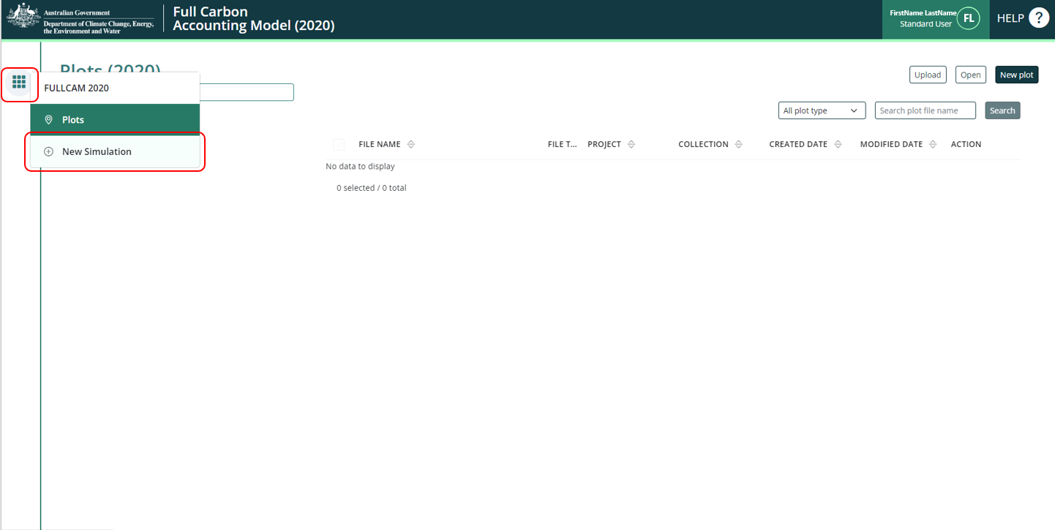

1. In the “Create from Templates” section, click on “*Template - Environmental Plantings Method*”.

**Figure 3 Selecting a template in FullCAM**  
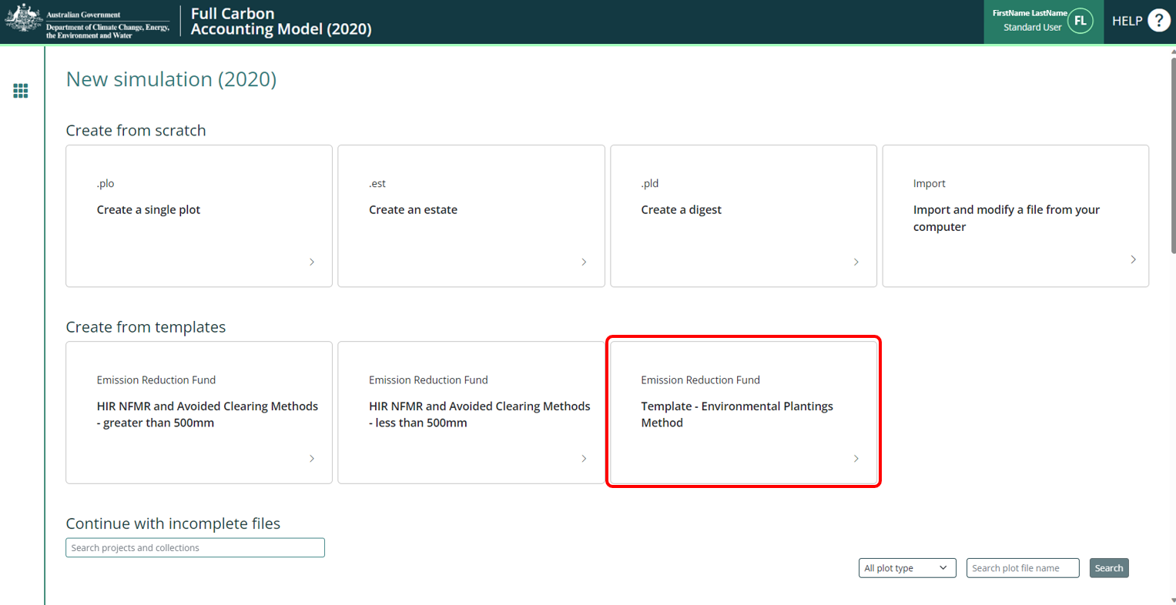

1. Once you have created a plot file, it is best to save immediately to your nominated storage location and save regularly. The new plot file can then be saved form the ‘File’ menu on the FullCAM toolbar. You can choose what to enter for the ‘File name’. This is not linked to the ‘Name of plot’ free text box on the ‘About’ tab. It is recommended that you use a name for the plot that reflects the identifier for the CEA and model scenario, e.g. ‘CEA1_project_east_2020 offsets report’.

#### Saving a plot

* + 1. You will need to click “Save Plot File” before logging out or leaving the system for an extended period of time, as it will not save the information you enter without doing so.
    2. You can then “Update Plot File” to save the changes as you continue.
    3. If you log out, you will find your Plot on the list when logging back in. Click on the ‘Edit’ button (with the pencil icon) to continue entering and editing the information of this Plot.

### The Timing Tab

Enter the modelling start and end dates for the simulation that you will run, in the start date and end date text fields. The accepted format is DD/MM/YYYY.

The start date will be the project implementation date (which must be the Planting Date for the CEA).

The end date will be a date after the end of the period for which the simulation is being run.

### The Location Info Tab

#### Entering Longitude and Latitude

Enter the longitude and latitude (in decimal degrees i.e. xx.xxx xx, xx.xxx xx) of the model point location in the longitude and latitude text fields. This should be the approximate centre of the CEA and representative of the CEA (see sections 3.29 and 3.20 of the Determination for requirements). Note that FullCAM may appear to round off the decimal degrees entered after clicking out of the text fields, but users must enter the full five decimal places as these will be recorded within the plot file itself.

**Figure 4 Entering longitude and latitude in FullCAM**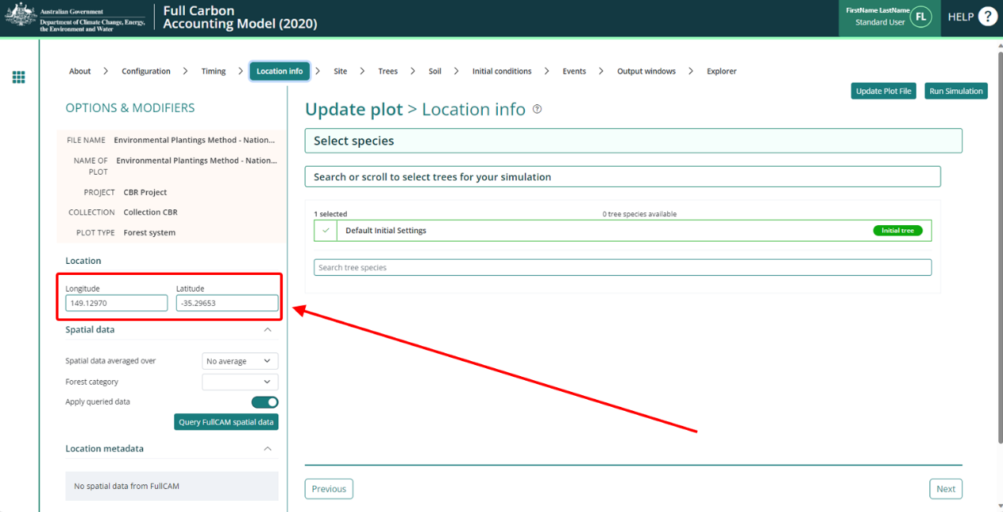

#### Notes on ‘specific calibration’ tree species selection

The tree species calibrations available within FullCAM and applicable to this Determination were substantially revised with the 2020 update to the model (2020 FullCAM option). These changes reflect significant expansion of the underlying datasets.

Under the Determination, and within FullCAM, there are two classes of species calibrations available for this Determination: ‘specific’ and ‘generic’.

* Within the FullCAM 2016 option, the two classes of calibrations produce different abatement estimates, and have different spatial and temporal applicability, and events permitted for modelling.
* The FullCAM 2020 option has removed many of the distinctions between generic and specific species calibrations. The vegetation growth calibrations of the specific calibrations in the 2020 FullCAM option are now the same as the vegetation growth calibrations of the generic calibrations. For the purposes of the Determination, the calibrations of the FullCAM 2020 option are generic calibrations if users follow the steps for applying a generic calibration as shown in section 2.2 of these guidelines; and the calibrations of the FullCAM 2020 option are specific calibrations if users follow the steps for applying a specific calibration as shown in section 2.2 of these guidelines. If a specific calibration is applied, all Determination requirements for specific calibrations must be met.

The ability to select a specific calibration within FullCAM has been retained to ensure operational consistency with the Determination. The ‘specific’ species calibrations and associated ‘regimes’ (which are sequences of events associated with a species) remain selectable within the FullCAM 2020 option (*ERF Method-EMP specific calibrations* dropdown under *forest category* within Data builder tab) where available spatially (see Figures 1-5 and Schedule 1 of the Determination). Users can still choose to download these species and regimes for applicable locations but must still meet the Determination requirements for using the specific calibrations (see Subdivision 3.5.2 and section 4.8 of the Determination).

Where correctly configured, the 2020 FullCAM option specific calibrations will produce the same abatement estimates as the generic species calibrations – ‘Mixed species environmental planting’ or ‘Mallee eucalypt species’. It is the sub-settings within the plant event that now capture variations in growth rates due to stocking densities or planting configurations. Section 2.3 gives the instructions for correctly configuring the plant event, in accordance with stocking density and planting configuration requirements.

**Figure 5 Geographic areas that restrict where each ‘specific calibration’ is available as an option**

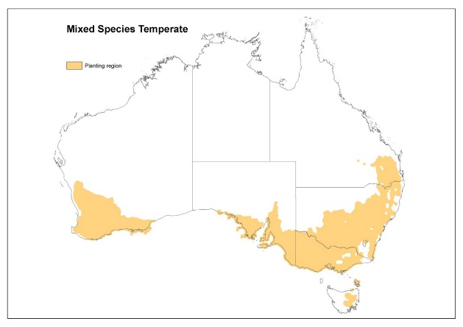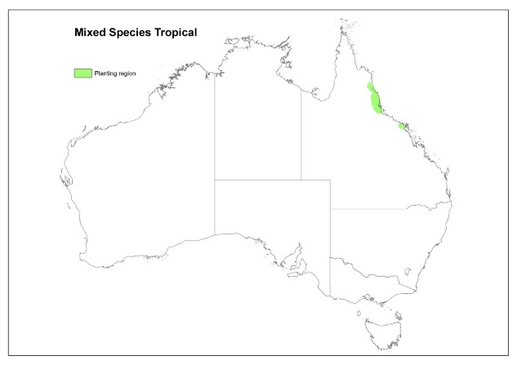

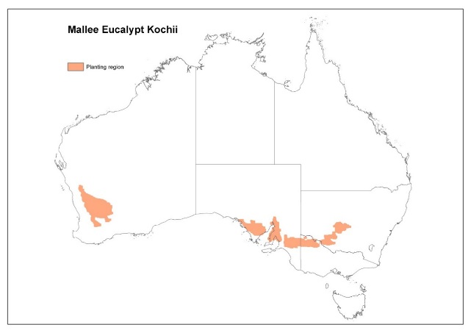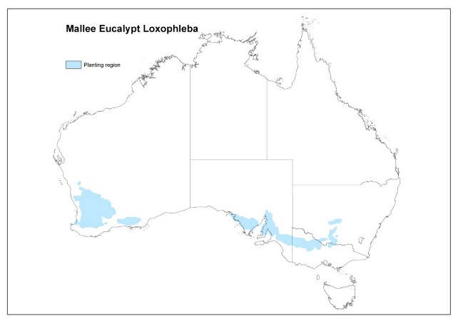

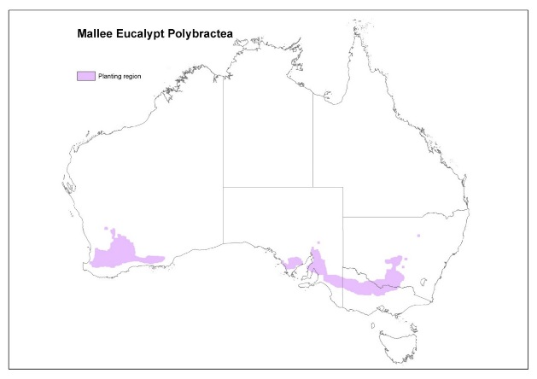

#### Downloading tree species

The final steps in creating the plot file are selecting and downloading the applicable tree species from the Data Builder tab.

Note that changes to the FullCAM model have removed some previous distinctions between calibrations, and introduced new sub-options[1]. The notes below in section 2.3.2, and the instructions for adding plant events provide more details on these changes. Note that *all* Determination requirements for use of specific calibrations still apply, including Subdivision 3.5.2 and section 4.8 of the Determination. It is the proponent’s responsibility to ensure they meet the Determination requirements for the calibration they are using.

The following steps are accessed from the “Spatial data” section and “Forest category” drop down on the left of the screen:

**Figure 6 Selecting a forest category in FullCAM**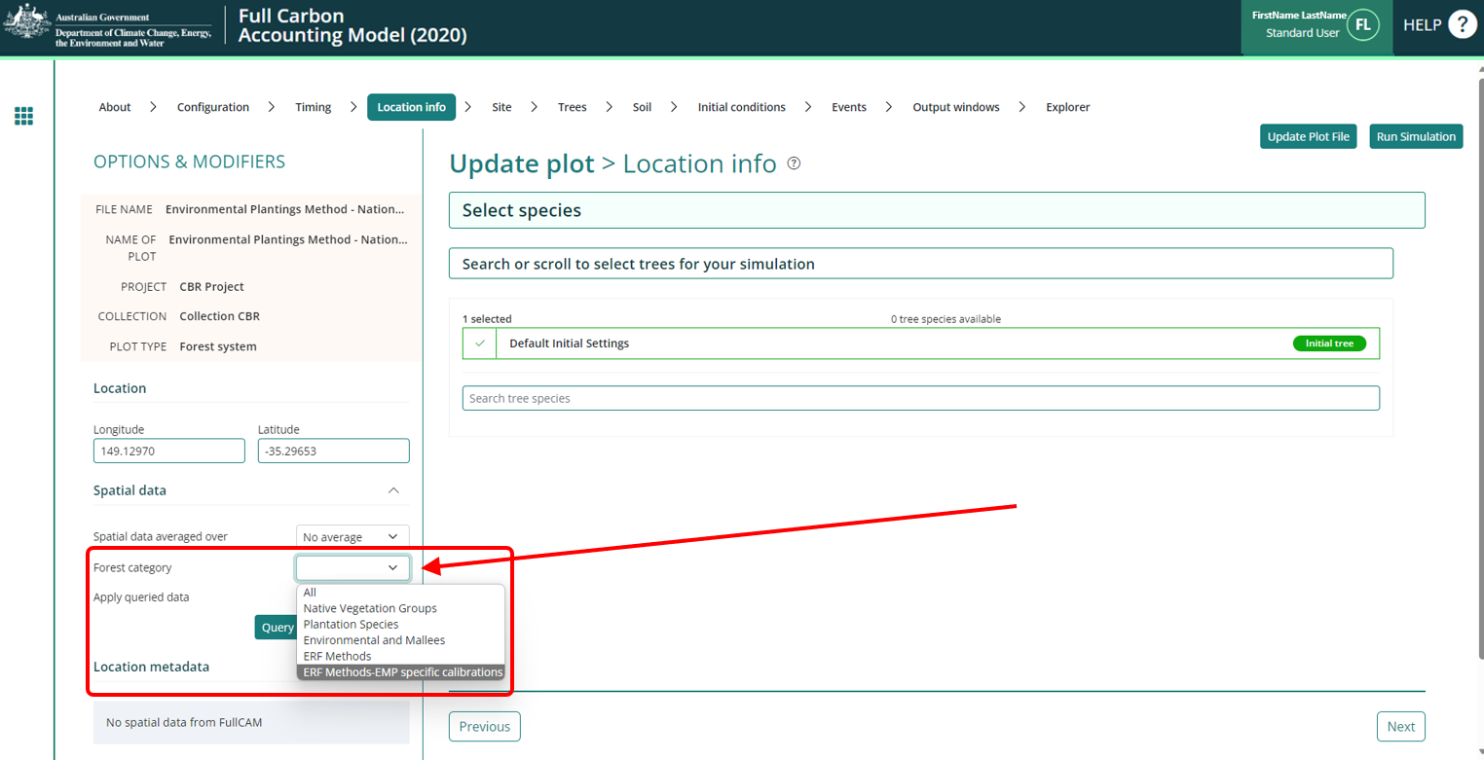

* 1. For *generic* calibrations:
     1. Select “*ERF Methods*”.
     2. Click “Query FullCAM spatial data” button. This will filter the available tree species in the centre of the screen.
     3. Select “*Mixed species environmental planting*”, unless the planting is comprised only of mallee-eucalypt species, in which case select ‘Mallee eucalypt species’ (see subsection 3.9(1) of the determination). Keep the initial selection as well.
  2. For *specific* calibrations:
     1. Select “*ERF Method-EMP specific calibrations*”.
     2. Click “Query FullCAM spatial data”. This will filter the available tree species in the centre of the screen.
     3. Select the desired species, ensuring all the Determination requirements for selecting the calibration are met. Keep the initial selection as well.

### The Site, Trees, Soil, and Initial Conditions Tab

Ignore these tabs, do NOT change any settings here. Instead, progress to the “*Events*” tab.

### The Events Tab

#### Modelling Events

* + - 1. Permitted Events

The below section introduces the events that may be modelled in accordance with the Determination. All permitted management practices that are undertaken in a project, along with wildfires, must be included as events in the simulations for each relevant CEA. If a CEA is re-stratified for any of the reasons specified in the Determination (e.g. section 3.8), then the simulations for each resulting new CEA must have all the permissible management practices and wildfires included as events.

Wildfires must be included as they occur, and the effect on the carbon stock will be reflected by the severity of the fire event. For a wildfire event where the burnt area is patchy and difficult to demarcate, you must enter the affected portion of a CEA as a percentage—other values remain unchanged. However if a clearly defined area or areas of a CEA have been impacted uniformly (e.g. all trees killed), then re-stratification of the CEA may be appropriate.

All project modelling must commence with a *Plant Trees* event (see section 1.3 of the Determination).

* + - 1. Requirements for modelling the plant event, and the associated planting configuration and stocking density requirements

As introduced in section 2.3.2 above, updates to FullCAM in 2020 have resulted in fewer distinctions between the previous ‘specific’ and ‘generic’ species calibrations, particularly for the tree planting event.

There are three growth calibrations that may apply to any species selected under the Determination, provided the planting geometry and sampling requirements are met.

For generic calibrations, the growth calibrations are listed in the Table below, together with the related requirements and a comparison to calibrations in the FullCAM 2016 option. FullCAM will download the applicable growth calibration options for the species downloaded. When adding plant events to the FullCAM 2020 option, users must select from the growth calibration based on the requirements in the following table.

For Specific calibrations, users will be able to select the full range of FullCAM regimes for specific calibrations that are listed in Schedule 1 of the Determination. These will appear as standard events in the FullCAM standard events drop down list (see section 2.5.2). Within FullCAM, these standard events will be associated with one of the three growth calibrations. Consistent with the requirements of section 3.20 and section 3.21 of the Determination, users must sample the stocking density in order to use specific calibrations (or must apply defaults). Users are required to meet the applicable planting geometry requirements set out in the Determination.

Growth calibrations to be selected according to the planting geometry and sampling requirement for stocking density (requirements for planting geometries and sampling stocking densities are provided under subdivision 3.5.2 of the Determination):

Table 2 FullCAM calibrations in the 2020 and 2016 versions

|  |  |  |
| --- | --- | --- |
| 2020 FullCAM option: calibrations | 2020 FullCAM option: Plant Events | Comparative view - 2016 FullCAM option: Plant Events |
| Belt High  (Belt plantings of high density – more than 1500 sph) | Mixed species environmental planting: Belt plantings >1500 sph | Mixed species temperate, Geometry narrow, Stocking >1,500, Prop tree <0.75 or Prop tree >=0.75 |
| Mixed species temperate, Geometry wide, Stocking >1,500, Prop tree >=0.75 or Prop tree <0.75 |
| Mallee eucalypt species: Belt plantings >1500 sph | Mallee eucalypt kochii, Geometry narrow, Stocking >2,300 |
| Mallee eucalypt loxophleba lissophloia, Geometry narrow, Stocking >2,300 |
| Belt Low  (Belt plantings of low density – between 200 and 1500 sph) | Mixed species environmental planting: Belt plantings <1500 sph | Mixed species temperate, Geometry narrow, Stocking <1,500, Prop tree >=0.75 or Prop tree <0.75 |
| Mixed species temperate, Geometry wide, Stocking <1,500, Prop tree >=0.75 or Prop tree <0.75 |
| Block ES  ( Block of planting on land used to deliver environmental services – more than 200 sph) | Mixed species environmental plantings: on land managed for environmental services | Mixed species temperate, Geometry block, Stocking 500 - 1,500, Prop tree >=0.75 or Prop tree <0.75 |
| Mixed species temperate, Geometry block, Stocking <500, Prop tree >=0.75 or , Prop tree <0.75 |
| Mixed species temperate, Geometry block, Stocking >1,500 |
| Mixed species tropical, Geometry block |
| Mixed species environmental planting (1970-present All Plantation low: Non-commercial planting; No prunes) |
| Mixed species environmental planting (1970-present All Plantation high: Non-commercial planting; No prunes) |
| Mixed species environmental planting (1970-present All Plantation medium: Non-commercial planting; No prunes) |
| Mallee eucalypt species: on land managed for environmental services. Block_ES | Mallee eucalypt polybractea, Geometry block |
| Mallee eucalypt loxophleba lissophloia, Geometry block |
| Mallee eucalypt kochii, Geometry block |
| Belt high or Belt Low (based on the stand density – above 200 sph) | Mallee eucalypt species: Belt plantings >1500 sph or Mallee eucalypt species: Belt plantings <1500 sph | Mallee eucalypt kochii, Geometry wide |
| Mallee eucalypt polybractea, Geometry wide |
| Mallee eucalypt loxophleba lissophloia, Geometry wide |
| Mallee eucalypt kochii, Geometry narrow, Stocking <2,300 ( as 1500 split) |
| Mallee eucalypt loxophleba lissophloia, Geometry narrow, Stocking <2,300 ( as 1500 split) |

#### Adding a New Event

1. To add a new event, click on the “*New* *Event*” button. A new pop up window will appear.

**Figure 7 Selecting a new event in FullCAM**  
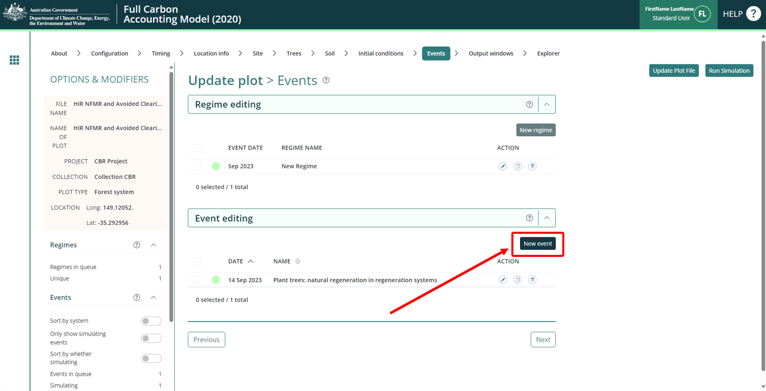

1. Select the Event Type from the “*Type*” drop down list that corresponds to the activity/event as given in the below sections 2.4.2.1 to 2.4.2.7. There are six event types, of which four are permitted under this determination. For each event to be added, select the appropriate Event Type identified for the management activity you are modelling, as indicated in the following table.

Table 3 Event types corresponding to each management activity

| **Management Activity** | **FullCAM Event Type** |
| --- | --- |
| Planting trees | Tree planting |
| Wildfire – trees not killed | Forest fire |
| Wildfire – trees killed | Forest fire |
| Prescribed fire | Forest fire |
| Fertilisation | Forest treatment |
| Weed control | Forest treatment |
| Thinning of forest | Forest thinning |

**Figure 8 Selecting an event type in FullCAM**

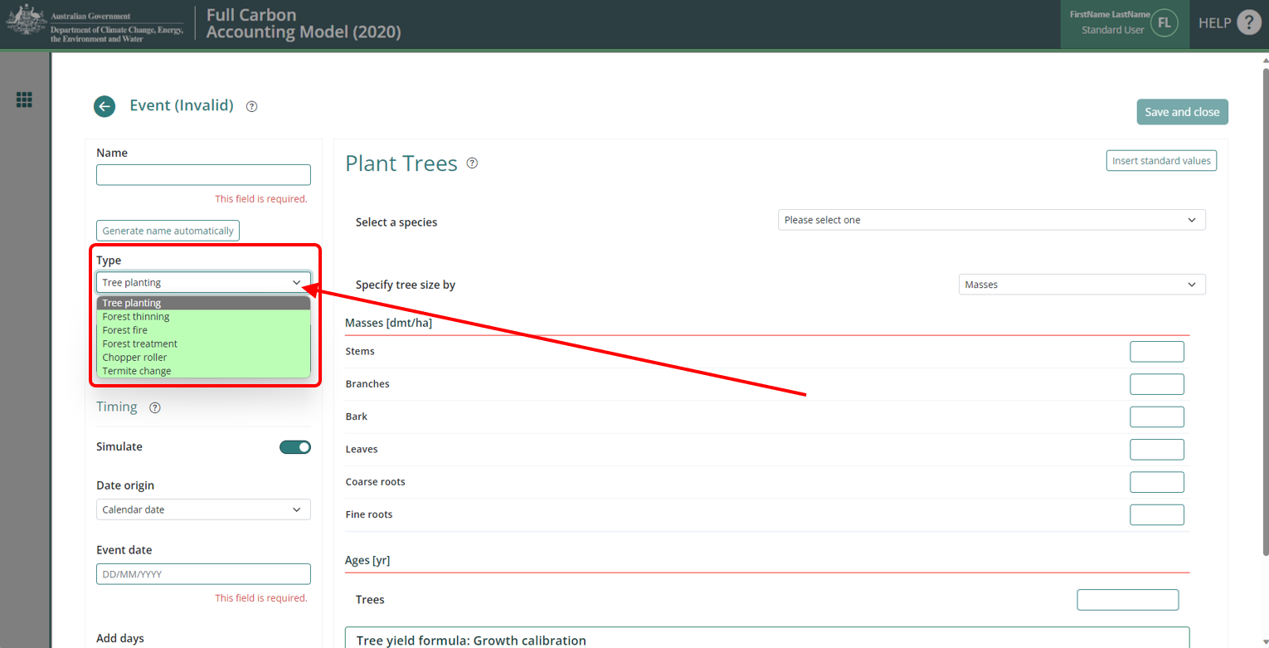

* + - 1. Adding a Tree Planting Event

1. Select the “*Tree Planting*” Event Type.
2. In the “*Select a species*” field, select the appropriate species name which you selected in section 2.3.3.

**Figure 9 Selecting a species in FullCAM**  
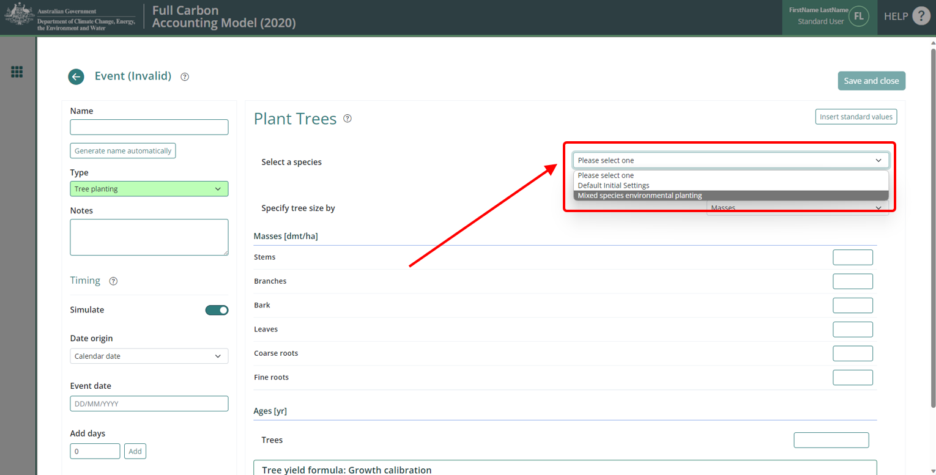

1. Click the “*Insert standard values*” button. This will open a pop-up window.
2. In the checkbox on the left, select the event with the appropriate name of these choices (* Only the standard event options available for the applicable species will appear. See section 3.1.1 outlining the sampling and other requirements for selecting one of these options.):
   1. Plant trees: [species name] on land managed for environmental services; *or*
   2. Plant trees: [species name] Belt plantings <1500 sph; *or*
   3. Plant trees: [species name] Belt plantings >1500 sph; *or*
   4. For specific calibrations, the available FullCAM standard events match the *Available FullCAM Regimes (Initial Rotation)* listed in Table 1, section 3.5
3. Click the “*Generate name automatically*” button in the top left of the window.
4. Insert the calendar date for the Event in the “*Event date*” field. The accepted format is DD/MM/YYYY.
5. Click the green “Save and close” button in the top right of the window. This will close it, add the Event to the list, and create a Regime for it.
   * + 1. Adding a Thinning of Forest Event
6. Select the “*Forest thinning*” Event Type.
7. Click the “*Insert standard values*” button. This will open a pop-up window.
8. In the checkbox on the left, select the event named “*Initial clearing: no product recovery*”.

**Figure 10 Selecting the ‘Initial clearing: no product recovery’ standard event in FullCAM**  
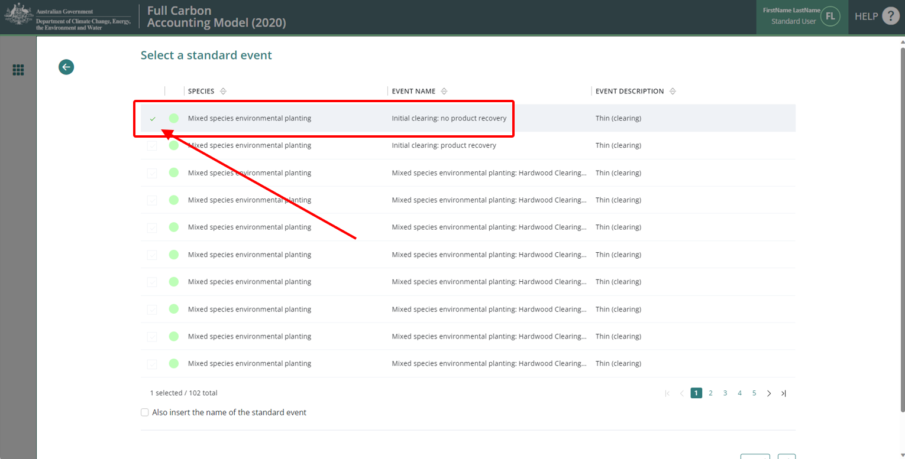

1. Click “*Ok*” at the bottom right. This will close the pop-up window.
2. In the “*Affected portion*” section, in the “Percentage of forest affected by thin” field, enter the percentage of the forest that was thinned. You must report on how the estimate was derived in your project report.
3. Click the “*Generate name automatically*” button in the top left of the window.
4. Insert the calendar date for the Event in the “*Event date*” field. The accepted format is DD/MM/YYYY.
5. Click the green “Save and close” button in the top right of the window. This will close it, add the Event to the list, and create a Regime for it.
   * + 1. Adding a Wildfire – Trees not Killed Event
6. Select the “*Forest fire*” Event Type.
7. Click the “*Insert standard values*” button. This will open a pop-up window.
8. In the checkbox on the left, select the event named “*Wildfire – trees not killed*”.

**Figure 11 Selecting the ‘Wildfire – trees not killed’ standard event in FullCAM**  
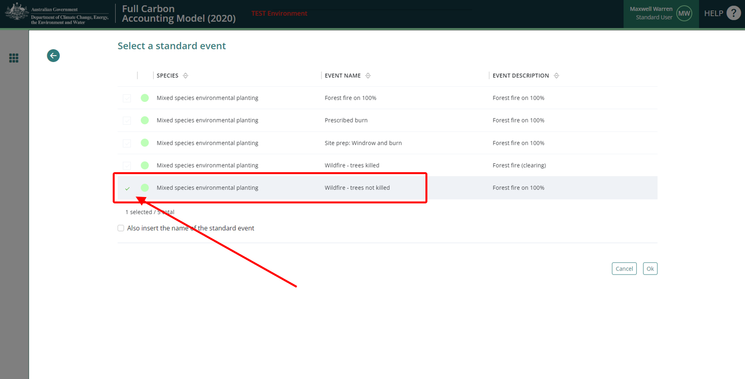

1. Click “*Ok*” at the bottom right. This will close the pop-up window.
2. In the “*Affected portion*” section, in the “Percentage of forest affected by fire” field, enter the percentage of the CEA that was *affected* by fire. You must report on how the estimate was derived in your project report.
3. Click the “*Generate name automatically*” button in the top left of the window.
4. Insert the calendar date for the Event in the “*Event date*” field. The accepted format is DD/MM/YYYY.
5. Click the green “Save and close” button in the top right of the window. This will close it, add the Event to the list, and create a Regime for it.
   * + 1. Adding a Wildfire – Trees Killed Event
6. Select the “*Forest fire*” Event Type.
7. Click the “*Insert standard values*” button. This will open a pop-up window.
8. In the checkbox on the left, select the event named “*Wildfire – trees killed*”.

**Figure 12 Selecting the ‘Wildfire – trees killed’ standard event in FullCAM**  
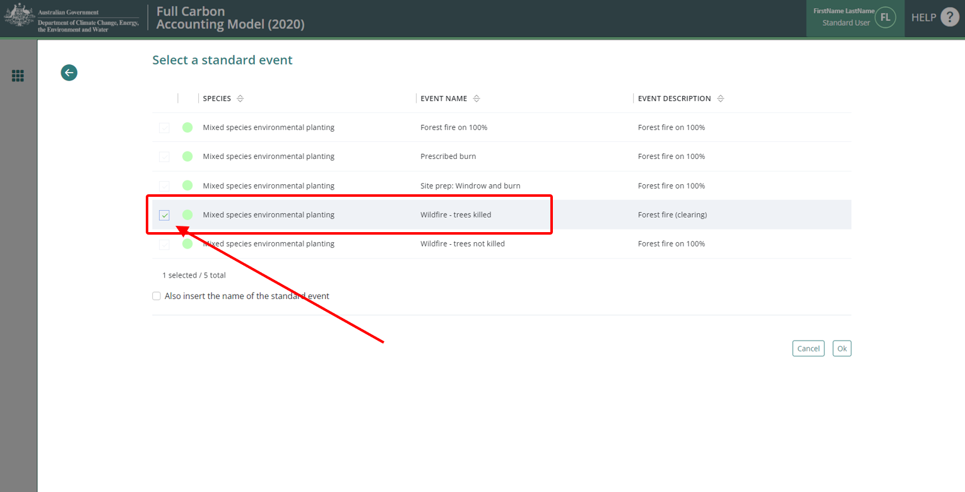

1. Click “*Ok*” at the bottom right. This will close the pop-up window.
2. In the “*Affected portion*” section, in the “Percentage of forest affected by fire” field, enter the percentage of the CEA that was *affected* by fire. You must report on how the estimate was derived in your project report.
3. Click the “*Generate name automatically*” button in the top left of the window.
4. Insert the calendar date for the Event in the “*Event date*” field. The accepted format is DD/MM/YYYY.
5. Click the green “Save and close” button in the top right of the window. This will close it, add the Event to the list, and create a Regime for it.
   * + 1. Adding a Prescribed Fire Event
6. Select the “*Forest fire*” Event Type.
7. Click the “*Insert standard values*” button. This will open a pop-up window.
8. In the checkbox on the left, select the event named “*Prescribed burn*”.

**Figure 13 Selecting the ‘Prescribed burn’ standard event in FullCAM** 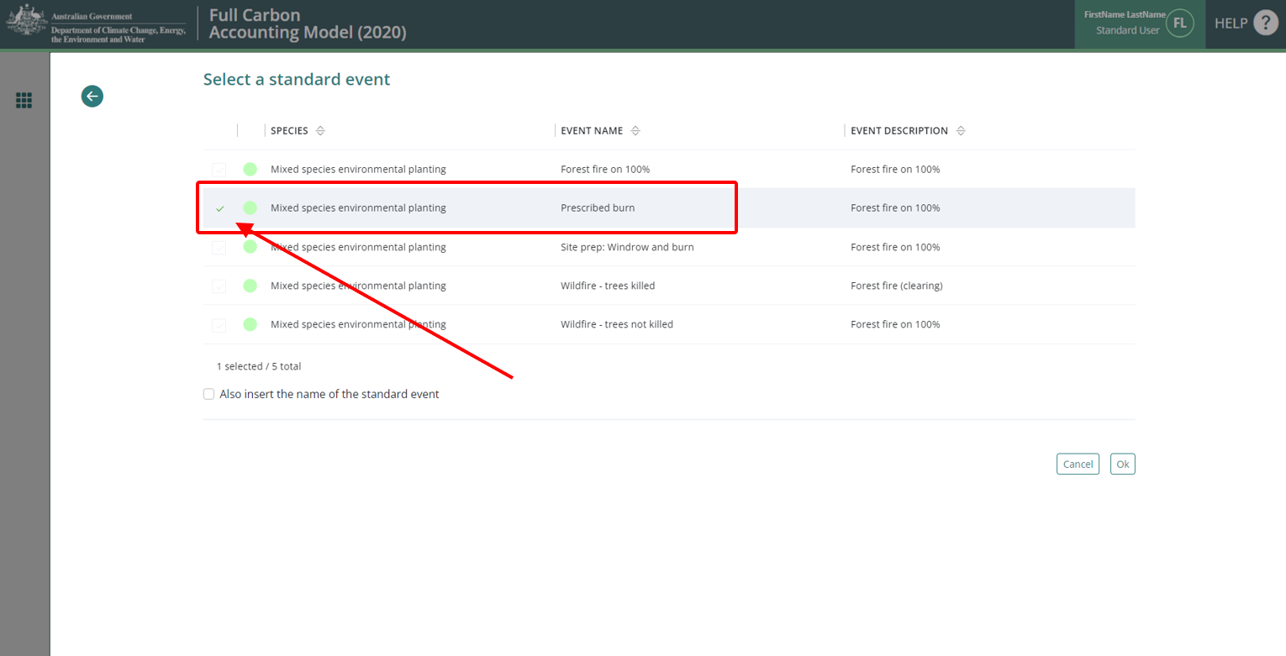

1. Click “*Ok*” at the bottom right. This will close the pop-up window.
2. In the “*Affected portion*” section, in the “Percentage of forest affected by fire” field, enter the percentage of the CEA that was *affected* by fire. You must report on how the estimate was derived in your project report.
3. Click the “*Generate name automatically*” button in the top left of the window.
4. Insert the calendar date for the Event in the “*Event date*” field. The accepted format is DD/MM/YYYY.
5. Click the green “Save and close” button in the top right of the window. This will close it, add the Event to the list, and create a Regime for it.
   * + 1. Adding a Fertilisation Event
6. Select the “*Forest treatment*” Event Type.
7. Click the “*Insert standard values*” button. This will open a pop-up window.
8. In the checkbox on the left, select the appropriate Event, either:
   1. Fertilisation: Mid-rotation (Medium)
   2. Starter fertiliser – normal
9. Click “*Ok*” at the bottom right. This will close the pop-up window.
10. Click the “*Generate name automatically*” button in the top left of the window.
11. Insert the calendar date for the Event in the “*Event date*” field. The accepted format is DD/MM/YYYY.
12. Click the green “Save and close” button in the top right of the window. This will close it, add the Event to the list, and create a Regime for it.
    * + 1. Adding a Weed Control Event
13. Select the “*Forest treatment*” Event Type.
14. Click the “*Insert standard values*” button. This will open a pop-up window.
15. In the checkbox on the left, select the event named “*Weed control – Standard (All, 1980-present)*”.
16. Insert the calendar date for the Event in the “*Event date*” field. The accepted format is DD/MM/YYYY.
17. Click “*Ok*” at the bottom right. This will close the pop-up window.
18. Click the “*Generate name automatically*” button in the top left of the window.
19. Insert the calendar date for the Event in the “*Event date*” field. The accepted format is DD/MM/YYYY.
20. Click the green “Save and close” button in the top right of the window. This will close it, add the Event to the list, and create a Regime for it.

#### After adding all Events

Once all Events are added, navigate to the “*Output Windows*” tab.

### Outputs and running a simulation

#### Ensuring correct outputs selected

The ‘New from template’ option used to create plot files will by default select the correct output types for the applicable scenario. The below steps can be followed to ensure the output types are correct, and to rectify any issues with those selected.

Selected outputs have a tick next to their name.  
Categories and subcategories with *all* outputs selected will have a tick symbol.  
Expanded categories, or those with *some* outputs selected will have a ‘-’ symbol.  
Categories with *no* outputs selected will have a ‘+’ symbol.

**Figure 14 Selecting the output categories in FullCAM**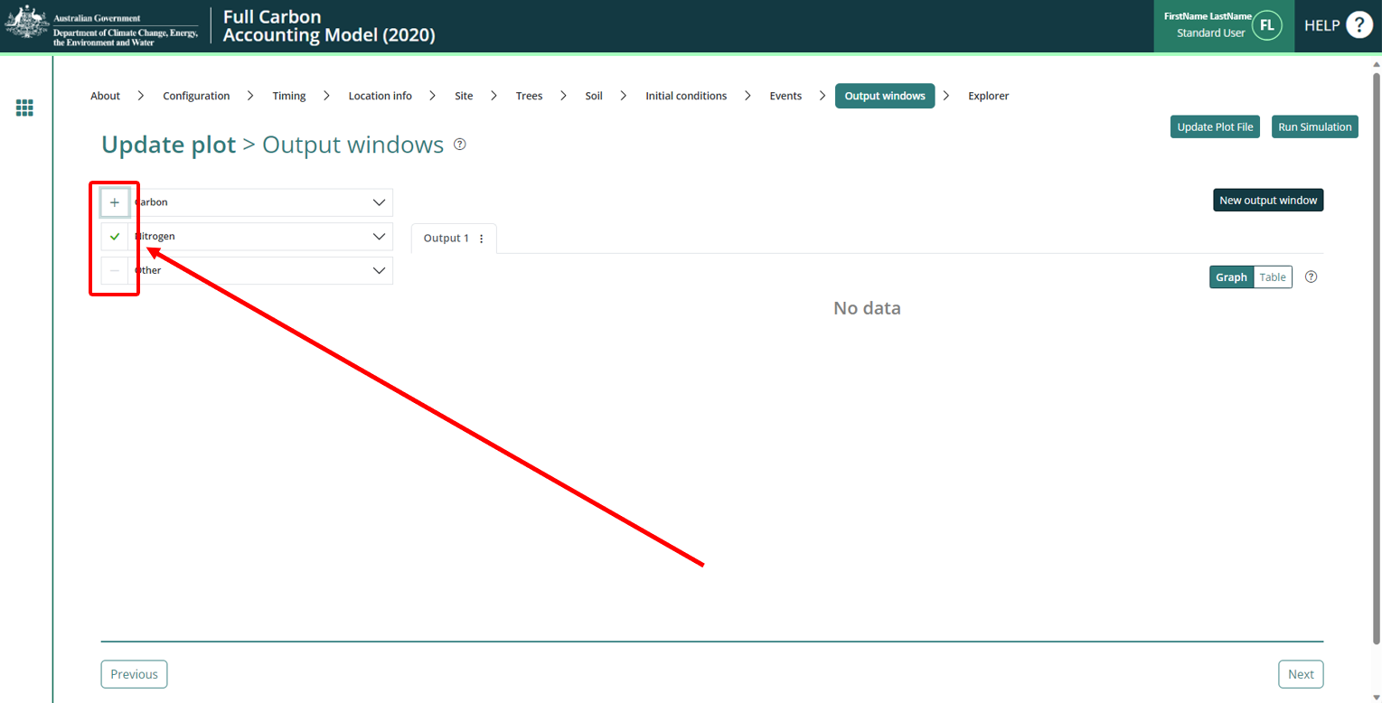

From the templates used to create plot files, the following outputs will be selected, consistent with the Determination requirements:

* + 1. the tree carbon pool: Carbon / Forest / Plants / *C mass of trees*
    2. the emission: Carbon / Whole / Emissions / *CH4 emitted due to fire*
    3. the emission: Nitrogen / Whole / Emissions / *N2O emitted due to fire*
    4. the debris pool: Other / Carbon Projects / *C mass of forest debris*

Note: only the four pools listed above must be selected.

#### Running simulations

To run the simulation, click the “*Run Simulation"* button, in the top right of the screen. This will generate the selected outputs in a graph. It will also initialise a download of the result in CSV format. This button will appear faded out and will not be available if the Events queue contains invalid Events, which will appear in red, and the tab will have a red title.

**Figure 15 Running a simulation in FullCAM**

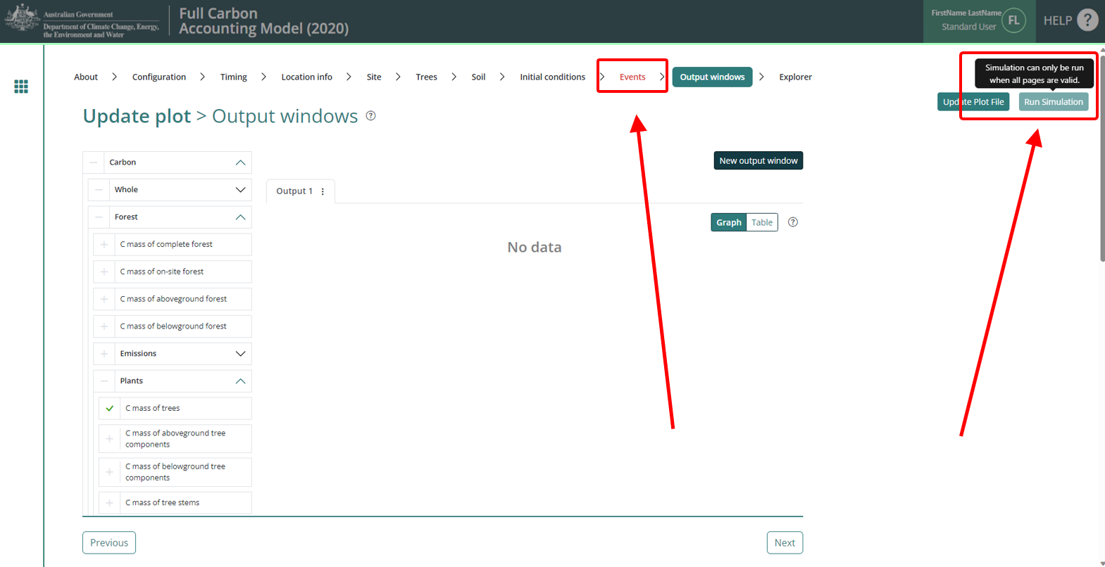

Note that if reopening a plot file, users must first navigate to the “*Location info”* tab and click “Query FullCAM spatial data” before running the simulation to ensure the latest spatial data is used for the simulation.

#### Viewing outputs

Outputs can be viewed as a graph or a table by clicking on the corresponding icons at the top right of the Output window.

**Figure 16 Viewing outputs in FullCAM**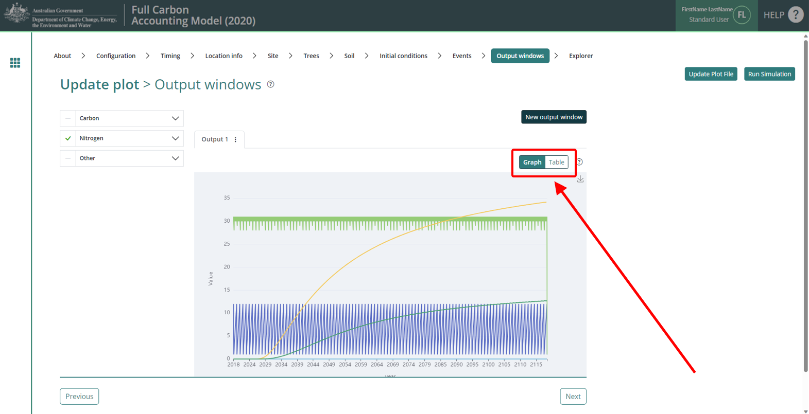

#### Accessing outputs as a spreadsheet

Running a simulation will automatically download the CSV file with the graph’s data. A pop-up near your ‘Downloads’ button on your browser may request permission to download.

## 3. FullCAM simulation outputs and offsets reporting

Project proponents calculate the project net abatement by completing the equations in Divisions 4.3 to 4.5 of the Determination. Table 2 in Division 4.2 in the Determination lists the FullCAM outputs required to inform these equations to calculate project net abatement. This table is re-produced below. Sections 4.5 and 4.7 of the Determination make clear that these outputs must be generated in accordance with the requirements in both the determination and this document.

Note that for some of the equations the average or sum of the FullCAM output over the simulation period will be required, whereas for others the value of the FullCAM output at the end of the simulation period will be used. Refer to the equations within the Determination to determine which value to use. Averages and sums can be calculated using the average and functions within your spreadsheet software.

Table 4 Outputs generated by FullCAM and the corresponding Determination equations

|  |  |  |  |  |
| --- | --- | --- | --- | --- |
| **FullCAM Output** | **Units** | **Description** | **Form** | **Parameter and Equation** |
| Initial C mass of trees | tonnes C per hectare | Initial carbon stock in above-ground and below ground tree biomass | Time series - monthly (cumulative ) | $$C_{Dti}$$ Equation 12a |
| Initial C mass of forest debris | tonnes C per hectare | Initial carbon stock in debris | Time series - monthly (cumulative) | $$C_{Ddi}$$ Equation 12a |
| C mass of trees | tonnes C per hectare | Carbon stock in above-ground and below ground tree biomass | Time series - monthly (cumulative ) | $$C_{ti}$$ Equation 12b |
| C mass of forest debris | tonnes C per hectare | Carbon stock in debris | Time series - monthly (cumulative) | $$C_{di}$$ Equation 12b |
| CH4 emitted due to fire | tonnes CH4 per hectare | Mass of CH4 emitted to the atmosphere due to fire | Time series monthly (non-cumulative) | Equation 13 |
| N2O emitted due to fire | kg N2O per hectare | Mass of N2O emitted to the atmosphere due to fire | Time series –monthly (non-cumulative) | $$E_{N_{2}Oi}$$ Equation 14 |

1. This is based on work by CSIRO. A detailed explanation of factors considered and tested by CSIRO to determine model efficiency of biomass prediction is provided in CSIRO’s technical report: https://publications.csiro.au/rpr/pub?list=SEA&pid=csiro:EP193939&sb=RECENT&expert=false&n=2&rpp=25&page=1&tr=29&q=predicting%20yields&dr=all.