

Offshore Renewable Energy Declaration

Indian Ocean off the Bunbury Region, Western Australia   
Public Consultation Summary Report

September 2024

# Table of Contents

Table of Contents 2

Table of Figures 3

Introduction 4

Development of the Notice of Proposal 4

Consultation process 4

Public consultation 4

First Nations consultation 5

Public community drop-in sessions 5

Targeted information sessions with fishing stakeholders 6

Meetings with peak bodies and local councils 6

Public online panel session 6

Overview of submissions 7

Types of respondents 8

Individuals 8

Organisations 10

Feedback outside submissions 10

Feedback within submissions 11

General sentiment 11

First Nations 11

Benefits of offshore wind and opportunities for the region 12

Addressing climate change, renewable energy and environmental benefits 12

Commercial and recreational fishing benefits 13

Community, local economy and onshore transmission benefits 14

Visual amenity benefits 17

Other benefits or opportunities 18

Concerns regarding offshore wind in the region 19

Environmental concerns 19

Commercial and recreational fishing concerns 21

Community, local economy and onshore transmission concerns 23

Visual amenity concerns 24

Other concerns or issues 25

Appendix A: Submissions from Organisations representing others 27

# Table of Figures

Figure 1 - Responses of individuals 8

Figure 2: Location of submissions from individuals 8

Figure 3 - Age ranges for submissions and the general population of the region (residents aged 18-85) 9

Figure 4 - Organisation responses by sector 10

Figure 5: Percentage of submissions identifying benefits by category 12

Figure 6: Percentage of submissions identifying concerns by category 19

Introduction

On 20 February 2024, the Minister for Climate Change and Energy announced that an area offshore of the Bunbury region was being considered for its suitability to be declared as an offshore renewable energy area under the *Offshore Electricity Infrastructure Act 2021* (OEI Act). The area extends from Dawesville to Cape Naturaliste, Western Australia (WA). This is the sixth area to be considered under the legislative framework and is another step forward in enabling the development of offshore renewable energy in Australia.

The purpose of this report is to provide an overview of consultation on the Notice of Proposal for the proposed area, including a summary of the responses received through the consultation process. The responses submitted through this process reflect considerable time and effort on the part of the respondents. The submissions provided valuable information for the Minister when deciding to declare an area in the Bunbury region as suitable for offshore renewable energy infrastructure.

The opinions expressed in this report were presented by stakeholders during the public consultation period and do not necessarily reflect the views of the Australian or WA Governments.

# Development of the Notice of Proposal

The Notice of Proposal to declare an area in the Bunbury region as suitable for offshore renewable energy infrastructure was developed through consultation with Australian and WA Government agencies.

# Consultation process

## Public consultation

The Minister published the Notice of Proposal for the area off the Bunbury region on 20 February 2024. This commenced the statutory public consultation period as required under the OEI Act. Members of the public were able to make submissions via the Department of Climate Change, Energy, the Environment and Water’s ‘Have Your Say’ web platform. The public consultation period ran for a period of 73 days, which closed on  
3 May 2024.

This timeline was similar to consultation periods for other previously proposed areas, and is longer than the 60 day minimum mandatory consultation period required under the OEI Act.

The Notice of Proposal was accompanied by an indicative map of the proposed area. The Have Your Say page included several resources to provide respondents with additional information in relation to the proposal. This included:

* A document providing an overview of the offshore renewable energy process titled ‘Overview of the Offshore Renewable Energy Process’
* FAQ titled ‘Frequently Asked Questions – Bunbury WA’
* A document providing an overview of existing marine users and interests in the vicinity of the proposed area titled ‘Marine Users, Interests and the Environment – Bunbury WA’
* A link to an interactive map and data download of the proposed area hosted by Geoscience Australia.

Information on the public consultation was shared across multiple platforms, including on the department’s website and social media channels: X (formerly known as Twitter), Facebook, Instagram and LinkedIn. The department carried out several forms of advertising for the proposal, including posts on social media, notices in local and regional newspapers, articles in local newspapers, radio advertisements and flyer drops to residents in coastal areas adjacent to the proposal. The announcement itself also received media coverage, and information on the proposed area was shared more broadly across national, state and regional newspapers and websites.

Prior to an area being proposed, the department engaged with the WA Government, local councils, First Nations groups, fishing peak bodies, and business groups to build awareness that an area was being considered for proposal and to seek opportunities for promotion through established channels to support the department’s own advertising and awareness raising activities. This continued in the period following the announcement of the proposal, with organisations promoting the proposal and consultation process via their social media and other channels.

## First Nations consultation

The Bunbury region of Western Australia is the traditional land and sea country of the Noongar people. Noongar boodja covers the entire South West of WA and is under the South West Native Title Settlement. The settlement is made up of six Indigenous Land Use Agreements (ILUAs) of which three have interests in the Bunbury offshore area: Gnaala Karla Booja, Karri Karrak and Whadjuk.

Meetings between the department, the Western Australian Government and First Nations groups in the region commenced in November 2023 ahead of an announcement of a proposed area. The intention of these meetings was to identify the groups that may have an interest and introduce the declaration process. Meetings were set up with the help of the Western Australian Government.

Engagement has continued throughout the process and comprised of a mix of in-person and online meetings and email correspondence.

The contacts include the Gnaala Karla Booja Aboriginal Corporation, Karri Karrak Aboriginal Corporation and Whadjuk Aboriginal Corporation.

## Public community drop-in sessions

The community was invited to participate in public drop-in sessions held during the consultation period across the Bunbury region. In total, five community information sessions were held in Bunbury, Busselton, Harvey and Mandurah from 19 to 21 March 2024, attracting approximately 1000 attendees in total.

For each session, departmental staff were on-site and available to talk to members of the community, with representatives from: the Offshore Renewables Branch and Nature Positive Regulation Division of the department; the Offshore Infrastructure Regulator; and Geoscience Australia.

At the sessions, attendees were provided information on the Government’s process for proposing and declaring areas that may be suitable for offshore wind. Attendees were able to ask questions, discuss issues, and understand the importance of providing feedback via submissions.

These sessions were undertaken in a ‘drop-in’ format, where attendees were able to attend any time throughout the session for as long or short a time as they chose, and have individual and small group discussions with government representatives. Printed copies of the information supporting the proposal from the departmental website were available, and a rolling presentation of information played on a screen throughout each session. This format was chosen as:

* it enables a deeper level of engagement than a ‘town hall’ style format
* it allows community members to attend at any time during a session that best suits their needs
* it is consistent with the format of sessions that the department held in previous proposed areas.

This format was decided well in advance of sessions being undertaken.

## Targeted information sessions with fishing stakeholders

In recognition of the importance of fishing interests in the region, the department organised additional targeted information sessions with recreational and commercial fishing stakeholders.

Departmental representatives and the Offshore Infrastructure Regulator explained the proposal, with a focus on fishing relevant considerations. Attendees were then invited to share feedback and ask questions about the interaction of the commercial and recreational fishing sectors with a future offshore wind industry.

In total there was one online and one in-person commercial fishing session (with approximately 40 attendees in total), and one online and one in-person recreational fishing session (with approximately 75 attendees in total).

The department worked with the commercial and recreational fishing peak bodies in the region, the Western Australian Fishing Industry Council (WAFIC), Western Rock Lobster Council (WRLC) and Recfishwest, to organise and advertise these sessions. Representatives from these peak bodies were in attendance at each of the targeted information sessions.

## Meetings with peak bodies and local councils

The department engaged with WAFIC, WRLC and Recfishwest before and after the Notice of Proposal was announced, and each peak body was invited to submit data to inform the Minister’s decision-making.

The department also engaged with business groups, including South West Development Commission, Bunbury Geographe Chamber of Commerce and Industry (BGCCI), and the Bunbury Geographe Economic Alliance (BGEA).

Departmental representatives spoke about the proposal at a BGEA luncheon in April 2024, attended by local business leaders including peak bodies, ports, manufacturing, government and Regional Development Australia representatives (RDA).

The department met with local councils throughout the region, to provide more detail about the proposed area for offshore renewable energy, to answer questions, and to understand local perspectives.

## Public online panel session

The department organised an online information session featuring a panel of non-government experts with local knowledge about offshore wind and related topics.

The event was held on Monday 29 April 2024 and ran for 90 minutes. Each speaker presented on their area of expertise, including the marine environment and regional development. This was then followed with a facilitated panel discussion that covered matters raised in the consultation period and answered questions submitted by attendees. Attendees were invited to submit questions through the ticket booking platform prior to the event, and by emailing an event-specific mailbox during the event.

A total of 160 people attended the online event.

# Overview of submissions

The department has undertaken an analysis of the submissions received. The analysis was to understand the matters that the community raised in relation to the proposal represented in the submissions, and to identify the range of concerns and benefits of the proposal to assist the Minister’s decision whether to declare the area as suitable for offshore renewable energy.

In addition, a statistical breakdown of the types of respondents has been provided to understand the demographic profile of respondents, including:

* Responses of individuals
* Location of submission from individuals
* Age ranges for submissions
* Organisation responses by sector.

While statistics have been provided in this report to support the demographic analysis of submissions, the department is aware there are multiple factors that have limited the validity of these statistics. These factors include:

* Submissions made using non-valid email addresses
* Multiple submissions made from the same person(s)
* Multiple submissions made from the same person(s), across multiple email addresses

The analysis of public sentiment has focussed on the content and information provided in each submission.

## Types of respondents

Respondents were able to respond as an individual or on behalf of an organisation. A total of 2670 submissions were received, of which 66 (2%[1]) were made on behalf of an organisation, and the remaining 2604 submissions (98%) were made by an individual or individuals.

### Individuals

Individuals were asked to identify what best describes themselves and Figure 1 shows the breakdown. Most individuals identified as a local resident (74%), with members of the public the next largest (13%) group.

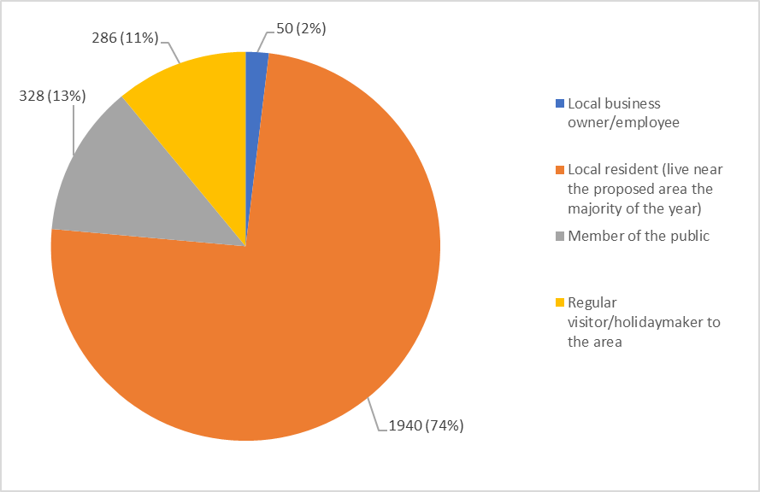

Figure 1 - Responses of individuals

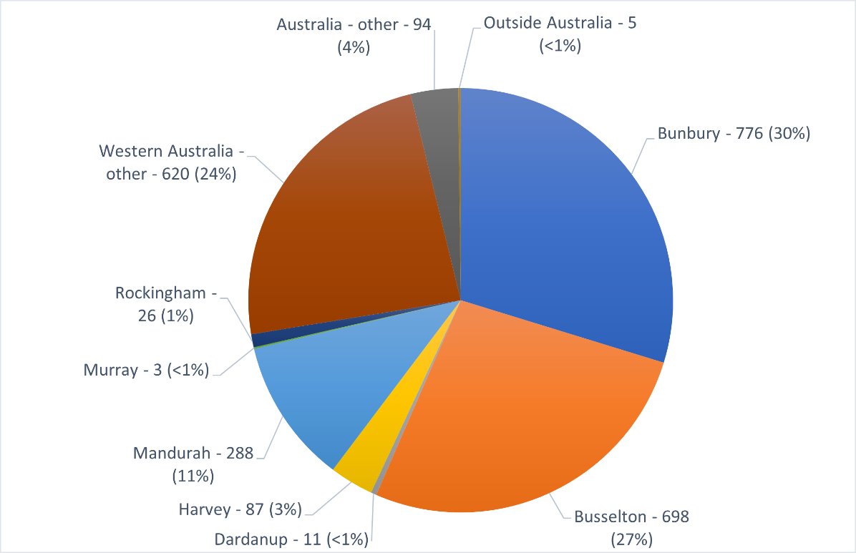Respondents were also asked to identify their postcode. A breakdown of the locations of the individuals who made submissions and identified a postcode can be seen in Figure 2.

Figure 2: Location of submissions from individuals

Of the submissions from individuals, 70% of the individual submissions received were from residents in the coastal areas surrounding Bunbury, Busselton and Geographe Bay, extending north to Mandurah. 23% of submissions were from greater Western Australia area, including Perth, and 6% of submissions were from areas outside of Western Australia (including international).

Individual respondents were also asked to identify their age range. The largest group was represented by those in the 46 to 55 years age group (24%), followed by the 36 to 45 years age group (22%) and then the 56 to 65 years age group (18%). Figure 3 shows the full breakdown of age ranges for individual submissions, and the breakdown of age ranges for the region (Bunbury, Busselton, Capel, Dardanup, Harvey, Mandurah, Murray and Waroona LGAs).

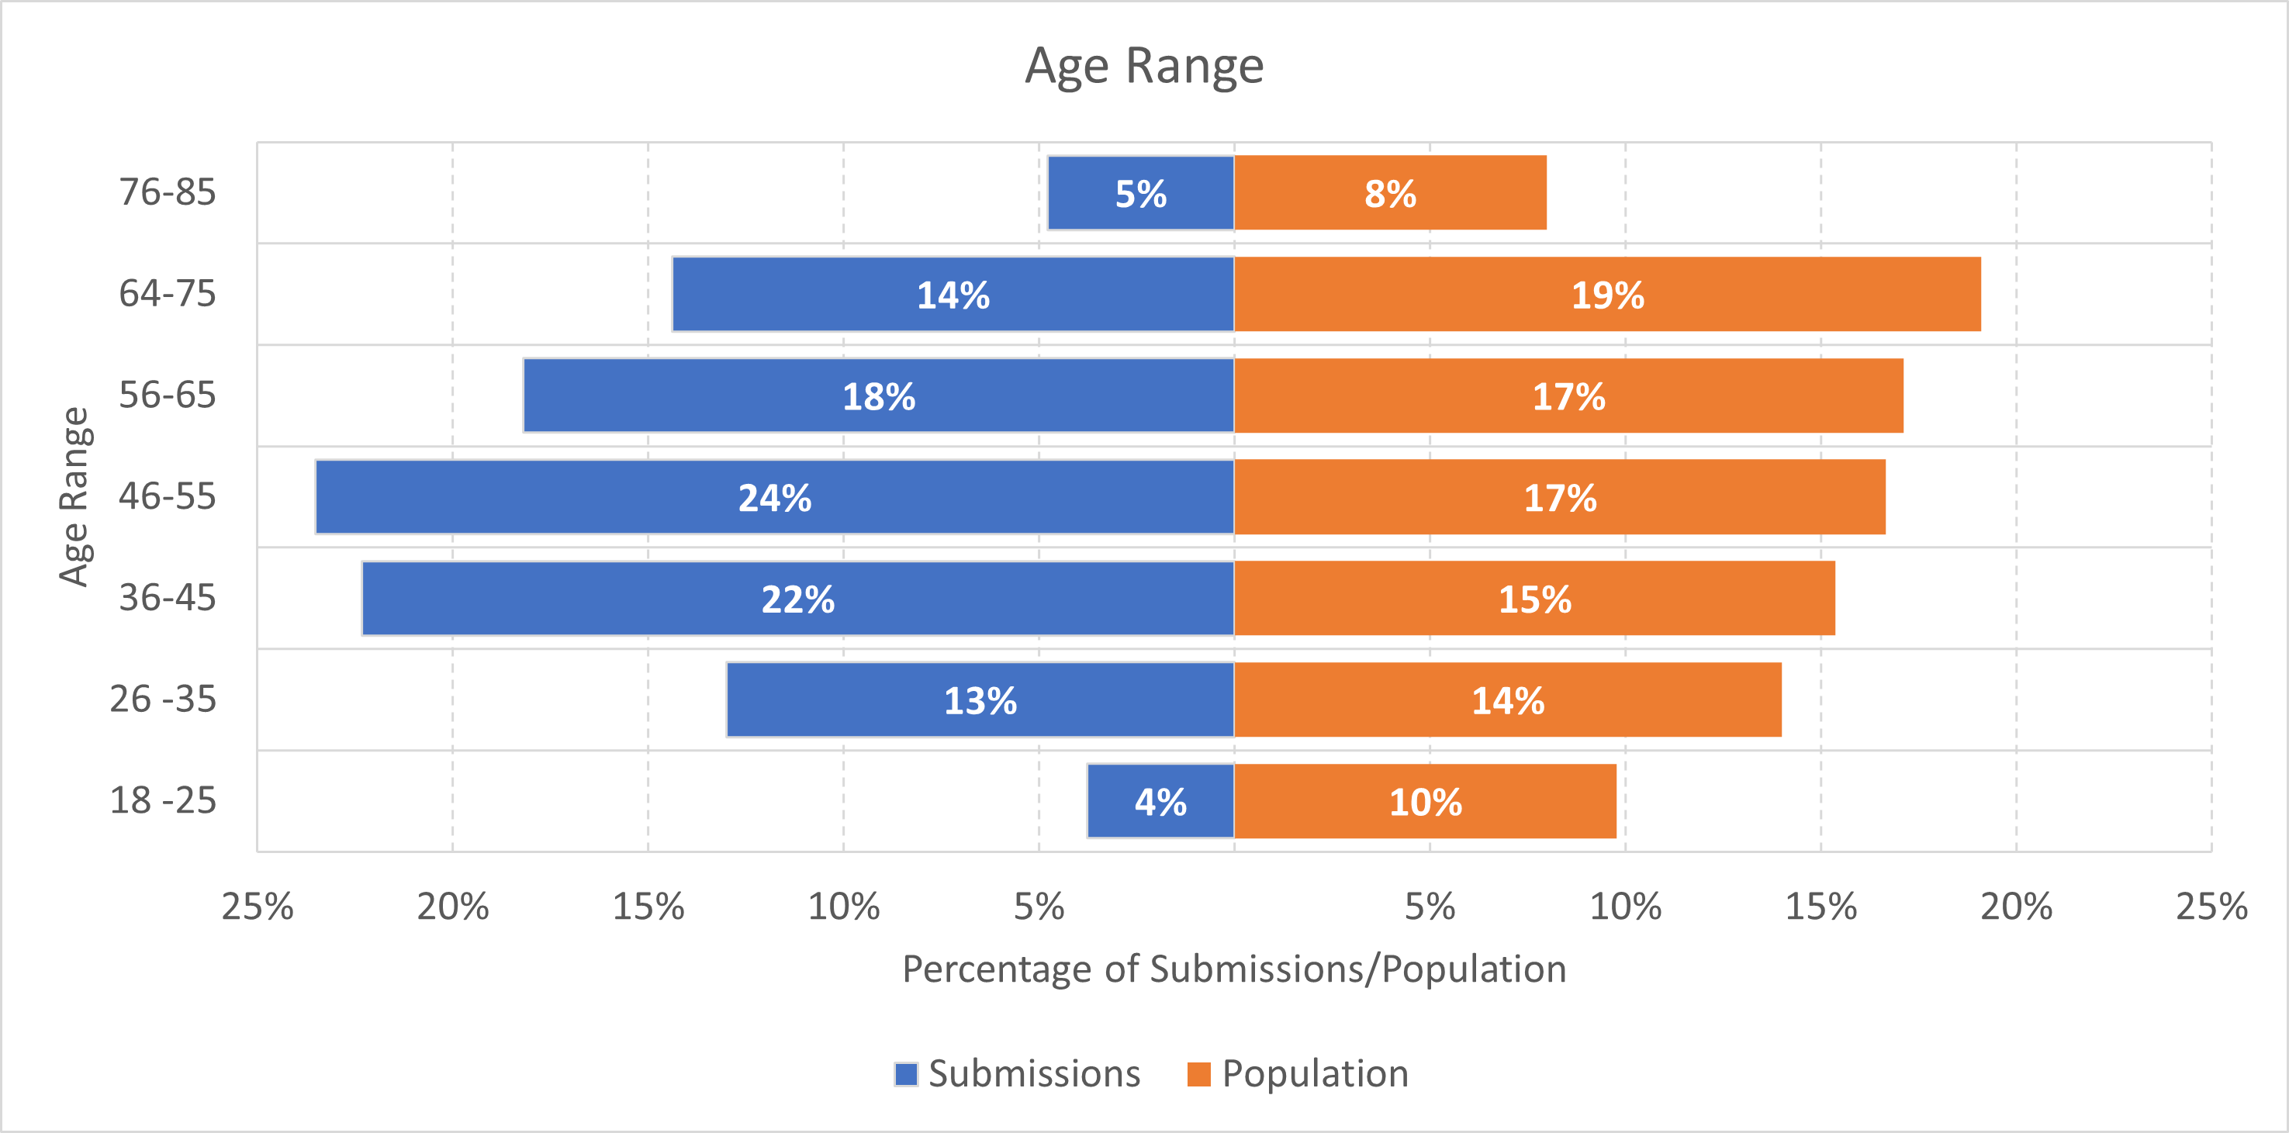

Figure 3 - Age ranges for submissions and the general population of the region (residents aged 18-85)

### Organisations

Organisations that made submissions were asked to categorise the sector that best describes their organisation. Figure 4 shows the breakdown of sectors for responses from organisations. Overall, the largest portion of responses from organisations came from non-government or community organisations (32%). The next most represented sectors were peak business bodies or unions (21%), followed by energy/electricity/renewables industry (17%).

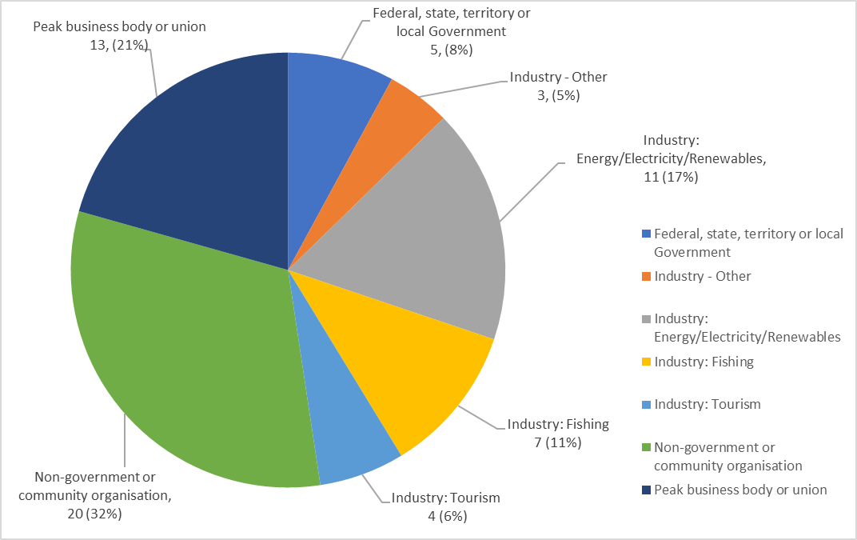

Figure 4 - Organisation responses by sector

#### Organisations representing members

Public submissions from organisations representing members were received from 24 organisations, including fishers, workers, First Nations and environmental groups. Each of these groups have been estimated to represent up to approximately 540,000 members.

Further details of these organisations and number of members represented can be found for those with public submissions in Appendix A.

Submissions were also received from organisations in their own right, for example private companies, or were made privately. While included in the statistical breakdown provided in Figure 4, these are not listed separately in Appendix A.

# Feedback outside submissions

Subsection 19(2) of the *Offshore Electricity Infrastructure Act 2021* sets out that when deciding whether an area is suitable for offshore renewable energy infrastructure,

The Minister may also have regard to any other matters that the Minister considers relevant (Section 19(2), Offshore Electricity Infrastructure Act 2021)

The Minister offered several organisations an extension to provide feedback under this provision. These responses were not considered in the wider analysis reported below, however the benefits and concerns identified were consistent with the analysis of formal submissions received via the consultation portal.

# Feedback within submissions

## General sentiment

Respondents were asked to identify benefits and / or concerns relating to the proposal, across the main themes of environment, visual amenity, community and onshore transmission, fishing, and other. A variation of sentiment was observed within submissions. Many submissions included a range of perspectives, detailing both benefits and concerns in respect to individual themes. The variation and range of concerns, benefits and opportunities expressed in submissions have been examined further in the following sections.

### First Nations

First Nations groups in the Bunbury region have provided feedback into the public consultation process for the proposed Bunbury offshore wind area and their feedback was considered by the Minister in determining whether the area was suitable for offshore wind. First Nations groups have requested that the content of their submissions remain private.

Submissions from or referencing First Nations’ interests flagged concerns and opportunities related to the new industry. The cultural significance and connection to Sea Country was mentioned in many of these submissions.

Submissions raised concerns about environmental, social and cultural impacts of the new industry and the lack of information to enable informed decision making until detailed cultural, environmental, social and economic impact studies had been completed. Submissions also raised concerns about the possible disturbance of submerged cultural heritage along the ancient coastline between 90 and 120m depth, and the importance of its protection.

*“I am concerned for the disturbance of any underwater cultural heritage. Identifying cultural heritage values that may be impacted should consider First Nations Peoples beliefs, practices and connection to Sea Country, places of cultural significance and cultural heritage sites in the proposed area.” (Submission #1492)*

Submissions mentioned the importance of undertaking meaningful, accessible, and culturally appropriate consultation with First Nations groups regarding the proposed areas, identifying the importance for First Nations voices to be heard through this process, and for governments to invest in genuine engagement with First Nations people. Submissions also noted that the ongoing process of developing the offshore wind area should be done collaboratively with Traditional Owners who have a deep understanding of and connection to the land and sea country, and cultural obligation to protect their culture, heritage, the environment and social wellbeing from harm. There was a concern that future developers consulting with First Nations groups may be a burden to these groups who may be under funded and under resourced.

*“Given the connections to Sea Country present in the Indian Ocean proposed area, we see the ongoing consideration and engagement with West Australian Aboriginal communities as imperative to establishing an equitable and socially sustainable industry for the long term.” (Submission #2508, Clean Energy Council)*

Concerns were raised about environmental, social and cultural impacts of the new industry and that there was insufficient information available on these impacts to help inform the submission.

*“I would like to see good oversight to ensure that the project and the environment is managed sensitively and that First Nations people, fishing interests and aesthetic impact are all considered carefully by whoever develops and installs the turbines.” (Submission #1204, MN, Australind)*

Many of the submissions mentioned that First Nations people should benefit from the development of the proposed area including but not limited to economic benefits from long-term training and educational initiatives, and employment and businesses opportunities as well as collaboration between developers and the First Nation communities on cultural and environmental assessments. Some submissions suggested that free and informed consent should be obtained from Traditional Owners for the proposed area to proceed.

*“Make renewable energy infrastructure development good for people, by ensuring the consent of Traditional Owners is obtained, benefits are shared, and jobs are created. It is vital that Traditional Owners are engaged in this process, share in the benefits from developments on their sea country, and that free, prior and informed consent is obtained.” (Submission #2423, Australian Conservation Fund)*

## Benefits of offshore wind and opportunities for the region

Many submissions noted benefits of offshore renewables and opportunities for the region, across various themes. Figure 5 shows the percentage of submissions that identified benefits and / or opportunities across the main themes of environment, fishing, community, visual amenity and other.

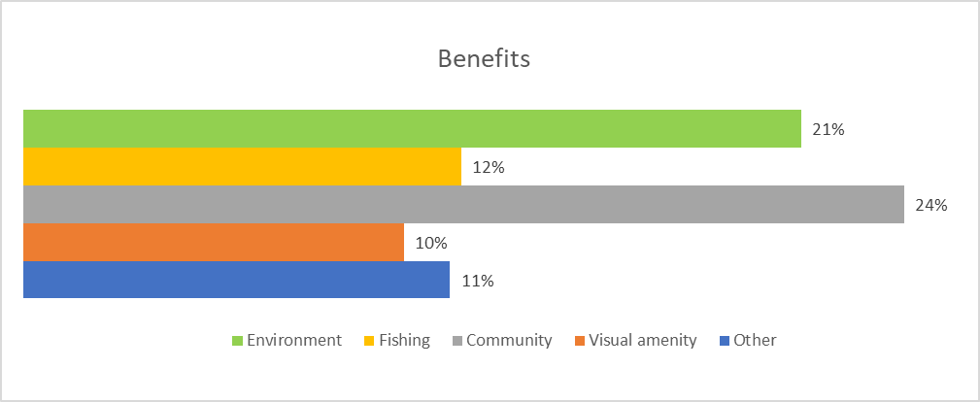

Figure 5: Percentage of submissions identifying benefits by category

### Addressing climate change, renewable energy and environmental benefits

A total of 556 (approximately 21%) submissions considered that they could see benefits or opportunities related to the environment for offshore renewable energy in this proposed area.

Reducing Western Australia’s reliance on using fossil fuels, such as coal and gas, to produce electricity was one of the main benefits mentioned in support of developing the proposed area for offshore wind in Bunbury. Many submissions supported the proposed offshore wind area as it was seen as a low greenhouse gas emission technology that would provide an opportunity to reduce greenhouse gas emissions, address global warming and reduce community vulnerability to climate change. Respondents considered that it would contribute towards the decarbonisation of Australia’s energy network and economy and assist in meeting net zero emissions of greenhouse gases.

*“ACF strongly supports a renewable powered Australia, including energy generation from offshore wind, because well-sited renewable energy is essential to protect nature and people from dangerous climate change. Nature needs well-located renewable energy. The risks that runaway climate change would pose to our native plants, animals, and ecosystems if we do not take urgent action to transition to a renewable powered Australia are catastrophic”. (Submission #2423, Australian Conservation Foundation)*

Some submissions noted the effects of climate change were already impacting the South West of Western Australia, including reduced rainfall, rising temperatures and ecological impacts. The proposed offshore wind area was seen as an opportunity to slow global warming and sea level rises and impacts on the coastal environment of the Bunbury and Peel regions.

*“The greatest threat to marine ecosystems is climate change and large wind projects like this one will be a major contributor to limiting and hopefully reversing the damage by replacing fossil fuel generation.” (Submission #985)*

Many submissions viewed the proposal as an opportunity to accelerate the transition to a clean, reliable energy source, utilising WA’s strong coastal winds and reducing the overall carbon footprint from using fossil fuel alternatives. The reduction in the use of coal to produce electricity was seen to have other positive environmental outcomes, with submissions identifying potential improvements to air and water quality, protecting the health and well-being of local communities.

*“Improvement in air quality. Coal fired power stations produce other emissions apart from CO2. Less waste production. Fly ash from coal power is the second largest waste stream in Australia” (Submission #1747, Busselton Dunsborough Environment Centre)*

The proposed development of the offshore wind area was seen by some submissions as beneficial to the marine environment through the possible creation of artificial reefs/habitats, both through turbine infrastructure itself and other measures that could be implemented through consultation with communities and marine scientists. Some submissions used Busselton Jetty as an example of offshore infrastructure supporting fish and other marine life. Other submissions noted the opportunity to undertake research, collect data and monitor marine species within and adjacent to the proposed area to increase overall knowledge and understanding of the marine environment and fill in data gaps.

*“I also see broader opportunities for valuable oceanographic and ecological research, and for revenue generated from this project to be used to fund marine conservation and restoration efforts, along with community services.” (Submission #134)*

*“The City would like to suggest that should the proposal for an offshore wind area be agreed to by the Minister, the federal government should strongly consider establishing a fund collecting annual contributions from approved proponents of wind farms. These funds should then be used to finance research focusing on identifying methods to quantify and reduce environmental impacts of offshore wind farms, specific to the Indian Ocean off the Bunbury region site.” (Submission #2516, City of Mandurah)*

Environmental advocacy organisations noted the need for Australia, and other nations, to urgently transition to renewable energy generation. Organisations noted the potential for offshore wind to play a role in this transition and expressed support for this potential, noting the importance of ensuring developments undertake rigorous environmental studies and avoid or mitigate impacts.

*“On balance, SSAU is prepared to support the use of technologies and methods of offshore wind (OSW) and other offshore renewable energy (ORE) construction and operation that avoids or minimises adverse impacts on marine life as well as birds and bats transiting the ORE areas, but this must be carefully considered on a site by site basis”. (Submission #2080, Sea Shepherd Australia)*

*“There are numerous strategies to be implemented to ensure projects not only avoid harm (like further improving turbine designs to protect species from risk) but provide actual benefits for nature. Implementing these strategies would help ensure that offshore wind projects are not just protecting nature, but helping nature thrive.” (Submission #2423, Australian Conservation Foundation)*

### Commercial and recreational fishing benefits

A total of 313 (approximately 12%) submissions identified potential benefits and/or opportunities for fishing.

Mitigation of the impacts of climate change and the threat of warming and acidification of oceans on marine life and ecosystems was identified as one of the main benefits identified in submissions, with responses noting the need to transition to renewable energy to avoid negative impacts on the marine environment.

Submissions also identified the potential for offshore wind infrastructure to act as Fish Aggregating Devices (FADs) or artificial reefs, with increased habitat supporting greater populations of fish with flow on benefits for commercial and recreational fishers.

*“Wind turbines could provide habitat for marine life and enhance recreational fishing. Climate change poses a greater threat to fish stocks than wind turbines. Recreational fishers should be allowed to operate within wind farm boundaries, similar to practices in the USA and UK.” (Submission #1595)*

Some submissions also noted that any potential exclusion zones around offshore wind infrastructure and potential limitations to large scale commercial fishing operations was seen as an opportunity to provide marine sanctuary and/or nursery zones that would provide similar opportunities for fish populations to expand and grow to larger sizes.

*“If there are exclusion zones associated with the wind power area then this might not be a bad thing. For the long-term viability of the fishing industry / rec. fishing exclusion zones are an important part of the mix of actions that need to be taken to ensure fish population sustainability.” (Submission #741)*

Other submissions considered that offshore wind and fishing could co-exist with no negative impacts. Submissions identifying this possibility noted that this would be contingent on no, or limited, exclusion zones being in place to enable continued fishing access.

*“GFAA believes game fishing and an offshore wind energy industry can coexist with no loss of access for game fishers once projects are in operation.” (Submission #1745, Game Fishing Association of Australia)*

Many submissions emphasised that the development of projects must include engagement and collaboration with the fishing industry to ensure benefits, and consideration of fisher concerns in future project design.

### Community, local economy and onshore transmission benefits

A total of 630 submissions (approximately 24%) noted benefits of offshore renewable energy projects to the community, local economy and onshore transmission. These included broad sentiments focusing on economic benefits, increased employment opportunities for local communities, the positive impact of increased tourism to the region, the positive impact on community health in the region, benefits of a cleaner environment and reduced energy costs. Many respondents felt that a highly skilled and locally available workforce coupled with industry capability, existing transmission infrastructure and port facilities made the South West and Peel regions an ideal location for the development of offshore renewables.

Many submissions emphasised that offshore wind would provide clean energy for future generations to come and that the benefits outweighed any drawbacks related to visual amenity. Investing in clean energy as a necessary step in dealing with climate change and in ensuring energy security as well as energy equity was frequently mentioned in submissions. Some submissions referred to the positive impact wind turbines could have on the mental health for the community, and the feeling that they were contributing to a greener future.

*“As an organisation of parents, grandparents and carers advocating for a safe climate, we are often opposed to policy and proposals that would create material harm to our environment. Therefore, it is encouraging to see the Government's proposal to develop an offshore wind area that would facilitate the generation of offshore wind energy to significantly increase Australia’s energy grid and facilitate positive social, environmental and economic outcomes at a time where we are seeing global ramifications from the climate wrecking use of coal and gas.” (Submission #2287, Parents for Climate).*

A community benefits scheme where the local community directly benefitted from hosting an offshore wind farm in their region was recommended by many submissions from the community, local members of parliament, local councils and local business. These submissions recommended that sharing the financial and other benefits associated with offshore wind projects would enhance social, environmental and economic outcomes for local communities and assist in creating a cohesive social environment between renewable energy projects and communities directly impacted by their development.

*“The Government should require all renewable energy projects to implement a Benefit Sharing Scheme for communities and Traditional Owners.” (Submission #2287, Parents for Climate)*

Submissions also emphasised other potential community benefits from an offshore wind industry in the Bunbury region including having a local source of reliable renewable energy and increased investment in sectors like education, research and community infrastructure.

*“The project will contribute to a more reliable and decentralized energy system, ensuring a stable electricity supply for Bunbury and surrounding communities.” (Submission #623)*

Many submissions considered that the significant generation capacity offered by the proposed offshore wind area could replace energy from retiring coal fired power stations and diversify the state’s energy mix. Some submissions noted that the region has a strong wind resource, particularly in winter when the prevailing westerlies could provide power when solar input is lower. Some submissions pointed to the need for the state government to include offshore wind as an option to allow for flexibility in achieving the targets associated with the South West Interconnected System (SWIS) Demand Assessment.

*“CME supports the development of an offshore wind zone in the South West region of Western Australia, connecting a consistent and reliable source of low emission electricity to the SWIS to meet increased electricity demand. The ability of the SWIS to supply low emission, reliable and affordable electricity underpins the decarbonisation of South West Industry and contributes to the achievement of national emission reduction targets” (Submission #2492, Chamber of Minerals and Energy WA)*

Access to low emissions electricity was identified in many submissions as an essential pathway for decarbonisation of the mining and resources sector, especially for the facilities located in the South West region that are already connected to the South West Interconnected System (SWIS). Submissions also noted the projected shortfalls facing the West Australian Electricity Market (WEM) in the near to short term future, with offshore wind potentially providing a clear view of new electricity generation.

*“All of our major industries, who are our largest employers (either directly or indirectly) are driven to decarbonise. It is their customers, shareholders and community stakeholders who are demanding this change. This means our Region needs large amounts of renewable energy to not only sustain our current industries but also to attract future investment in new industries.” (Submission #1868, Bunbury Geographe Economic Alliance (BGEA))*

Submissions noted potential for the Bunbury region to become a renewable energy hub, ideally located with high energy demands for heavy industry (e.g. Kemerton Industrial Park, Southern Seawater Desalination Plan), port facilities and existing transmission infrastructure. Submissions supported the location of offshore wind to stimulate other new industries in WA, such as green hydrogen and renewable fuels, which is an area of strategic importance to the WA Government.

*“Offshore wind also creates a significant opportunity for investment and economic development: benefits will flow directly from the construction and operation of projects that feed electricity into Australian grids, while also supporting the growth of a hydrogen export industry, which has the potential to contribute to significant amounts of export revenue as our exports of coal and gas decline.” (Submission #2508, Clean Energy Council)*

Submissions noted that the introduction of a new offshore wind industry into the Bunbury region could create direct and indirect business and economic opportunities across both the South West and Peel regions. Some submissions pointed to the resulting diversification of the local economy with the entry of a new industry and the supply chain opportunities for existing businesses and industries.

*“An offshore wind industry can provide the demand case for boosting local manufacturing capability, and employ thousands of manufacturing workers in the South West”. (Submission #2476, Australian Manufacturing Worker’s Union)*

Businesses and industries that were mentioned as potentially standing to benefit from offshore wind include:

* maritime industry, including vessel building and servicing
* marine research
* manufacturing of wind turbine components and cables
* cultural assessments
* project management
* design and engineering
* construction and maintenance of offshore wind farms
* diving
* ports
* trades including electrical
* tourism related to offshore wind farms.

*“The region's local industry has proved it has the capacity and capability to participate on major infrastructure projects and it is therefore ready to contribute to a project of this scale and ensure the local industry and wider local community realise the economic benefits an offshore windfarm development would bring.” (Submission #2500, Local Content Advisor Network WA)*

Related to the business opportunities are the associated employment, apprenticeship and training opportunities. Many submissions noted the potential for a transfer for skills and employment from the offshore oil and gas industry as well as from the onshore coal mining and power generation industries in the transition to offshore wind and renewable energy more broadly. The planned closure of Collie coal mines and coal fired power stations in 2029 will directly affect hundreds of workers and many thousands more indirectly throughout the South West. Submissions noted the potential for the offshore wind industry to bring billions of dollars of investment to the Region and a range of job and business opportunities to local towns for the long term.

*“The development of Offshore renewable energy projects represents an opportunity for Australian seafarers to make a transition from the hydrocarbon industries to the low or zero carbon emitting industries of the future. This is consistent with the United Nations Global Compact report to COP271.” (Submission #1444, AIMPE & AMOU)*

Submissions pointed to the need for requirements on developers to invest in local skill development and businesses. The benefit of having a local workforce would allow people to live where they work and not rely on fly in fly out jobs. Many saw the creation of job opportunities for young people as a huge benefit in the context of increased job opportunities and retaining young talent in the area. Submissions noted the potential for collaboration between local universities, training providers and industry associations to develop workforce and training programs tailored to the needs of the offshore wind industry and the community.

*“Mandurah has suffered from high unemployment, in particular youth unemployment. New industry such as this will alleviate this problem, especially if local content rules are applied. Existing manufacturing businesses may also be able to benefit from offshore wind projects.” (Submission #2164, Citizens’ Climate Lobby Australia.)*

Some submissions suggested that tourists could be drawn to the Bunbury region specifically for offshore wind farm viewing and tours with some submissions seeing opportunities for increased ecotourism associated with artificial reefs and marine habitats around the wind towers. Many submissions cited Albany Wind Farm as an existing and successful example of renewable energy tourism. Some submissions identified possible new tourism ventures, including photo opportunities, turbine tours and diving around the turbines.

*“Albany has created tourism around the visual of the turbines for locals, visitors and schools.” (Submission #409)*

*“It would be great to see it become a tourist attraction, offering opportunities for boat tours and educational visits, thus promoting environmental awareness and appreciation.” (Submission #1720)*

*“BJI recognises in the international offshore wind context that there are potential tourism benefits related to the development of an offshore wind industry, and this is evidenced in academic literature. Whilst BJI is concerned for potential impacts to its tourism operations, there is little evidence to suggest tourism is negatively affected.” (Submission #2665, Busselton Jetty Inc.)*

Investing in onshore transmission and port facilities was viewed by submissions as beneficial in enabling green electricity for homes and industries including maritime industries. Submissions noted that offshore wind complemented other clean energy technologies including solar and onshore wind. Shared use of the transmission infrastructure was also recommended by some submissions. Submissions noted the benefits of taking advantage of existing transmission infrastructure in the region, reducing the need for additional transmission lines to be built bringing power from locations outside of the region and identified benefits for potential to directly supply existing heavy power users within the region, avoiding the need for additional transmission lines connecting to the existing grid.

*“South West windfarms present an opportunity to plug straight into the Southern Seawater Desalination Plant. The Binningup plant has extremely high energy demands and can utilise power within about 1km of the shore. Another 14km inland, the Kemerton Terminal Station offers an opportunity to minimise visual impact since it is in a non-residential industrial area and provides connectivity to the grid. 330kV and 132kV lines are available in the Strategic Industrial Area. Accessing this opportunity will keep transmission line impacts down to a bare minimum.” (Submission #1591, RDA, South West).*

### Visual amenity benefits

A total of 272 (approximately 10%) submissions identified potential benefits to the visual amenity of the region from offshore renewables development. In addition, 578 submissions (22%) identified that they did not have any concerns for visual amenity.

Some submissions expressed favour for the look of wind turbines offshore, and that some people would enjoy viewing them. The potential to consult with developers regarding less visually intrusive designs was raised to improve visual amenity for those with concerns. There were also submissions noting that given the proposed distance from shore, visibility was already limited and not a concern.

*“Wind turbines located at least 20 km offshore would be an improvement over the visual amenity of ugly coal mines and gas-fired power stations.” (Submission #2396)*

It was commonly suggested that offshore wind turbines would be a visual reminder of WA ‘going green’ as part of a global climate transition, and that they would keep these global climate concerns front of mind. Some wrote that any visual impact paled in comparison to the impacts of climate change.

*“The look or amenity of the installation is of little importance when considering the dire effects climate change is already having on the south west region. This installation is a big step towards mitigating the effects of climate change and we must take it.” (Submission #2249)*

Another common theme was for the positive impact of turbine visibility for navigation, with infrastructure acting as orienting elements to assist with safe marine navigation within the area.

### Other benefits or opportunities

A total of 305 submissions (approximately 11%) identified other benefits or opportunities for offshore wind in the Bunbury area.

A common theme raised through submissions is that offshore wind is a clean and reliable replacement for existing local gas and coal power sources. The South West Interconnected System (SWIS) as the major electricity distribution system in South West WA has increasing supply needs, and submissions identified offshore wind as a potentially significant component of the region’s future energy mix, having both a high capacity factor, along with being more consistent and forecastable.

*“Additional supply of cost-efficient clean energy will help ensure the region has sufficient power generation capacity once the coal stations have closed.” (Submission #1588)*

Some submissions emphasised the affordability and complementary nature of offshore wind in the future energy mix, noting the benefits of having renewable energy projects that generate at different times, which will substantially reduce the need for expensive energy storage, gas generation or nuclear.

*“Offshore wind is cheaper to build than gas peaking plants now and out to 2030, and is less than half the price of small nuclear reactors.” (Submission #2497, CFMEU (Maritime and Construction Divisions), Electrical Trades Union)*

Many submissions raised the potential for offshore wind to contribute to a ‘just transition’ in mitigating climate change, noting that offshore wind has an opportunity to transition jobs and communities from old industries to new industries, in a sustainable and equitable manner.

Other submissions commented on the potential for transitioning and developing the manufacturing industry and local resources, noting offshore wind could provide the renewable energy needed to keep regional manufacturing and energy-intensive industries operating long into the future. This includes the Kwinana Industrial Area, the Kemerton Strategic Industrial Area, new smelting and advanced manufacturing industries planned for Collie as part of that town’s just transition, and established minerals and metals industries, particularly alumina and lithium hydroxide.

The opportunities to build marine research capabilities, enhance local education opportunities and community investment were raised, as was the benefit of making the region’s industry more attractive for overseas businesses and investors that emphasise sustainability and innovation.

## Concerns regarding offshore wind in the region

At least three quarters (greater than 75%) of respondents identified concerns in the categories of environment, fishing, community and onshore transmission, and visual amenity, with 64% having other additional concerns.

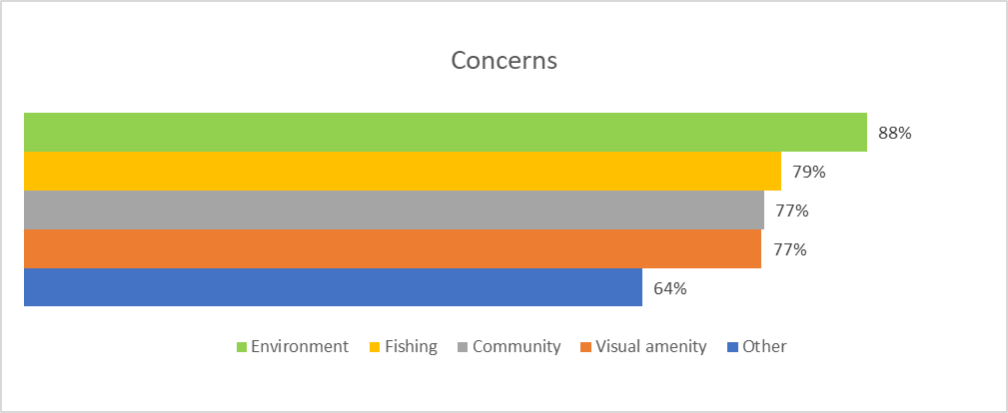

Figure 6: Percentage of submissions identifying concerns by category

### Environmental concerns

The potential impact of offshore wind farms on the environment was a prominent concern raised in submissions, with 2334 (approximately 88%) of submissions raising various environmental concerns.

A concern raised in many submissions was that there was not enough environmental data available, and an environmental assessment had not been undertaken before determining an area that may be suitable for offshore wind. Submissions identified concerns that the environmental impacts of the proposed area were unknown. A similar yet unfounded concern was that the department had already undertaken such studies and was withholding information from the public. Submissions noted that whilst existing environmental laws protected marine life, they were still concerned about the possible harms caused by offshore wind development in this area.

*Despite this preliminary information, it is likely that significant gaps exist in our understanding of the environmental values of the proposed zone. Therefore, regulatory authorities should support targeted research efforts to address these knowledge gaps on offshore wind impacts and the efficacy of mitigation measures before issuing any feasibility licences to potential project proponents. Sustaining ongoing data collection on environmental values throughout the lifespan of the zone is vital. Only through comprehensive marine spatial planning and ocean-use planning efforts can potential impacts on at-risk species and habitats be effectively mitigated. Transparent data collection processes will further enhance public confidence in the protection of environmental values throughout all future projects within the zone. (Submission #2503, Greenpeace Asia-Pacific)*

A concern raised in many submissions was the potential impact of offshore wind farms on whales that migrate along the WA coastline. It was noted that the proposed area overlaps or is adjacent to areas used by blue whales, southern right whales, humpback whales and minke whales. Of particular concern, was the close proximity to the southern right whale calving biologically important area. Submissions raised concerns of the potential impact of the proposed area on whale migration, feeding and breeding. Other concerns raised in submissions were obstacles to the movement of whales, increased risk of collision and/or boat strikes and underwater noise and vibrations. The view that the construction of wind farms should occur outside periods of whale migration was regularly stated.

*“The migration zones for Humpback, Southern Right and Pygmy Blue whales must be excluded from the farm area with specific extra exclusion zones for the service of the turbines during the migration period. Little seems to be known about the Pygmy Blue whales so this has to researched and assessed. Vessels are known to alter the behaviour of whales.” (Submission #1747, Busselton Dunsborough Environment Centre)*

Submissions raised concerns about the proposed offshore wind area being in the flight path of birds, particularly those that migrate along the coastline such as shearwaters, bridled terns and other endangered birds. The presence of wind turbines was seen as disrupting the free movement of birds as it may cause the diversion of birds away from their normal flight paths and migratory routes, create a barrier to migration, cause the birds to use more energy, and lead to collisions with wind turbines and bird deaths. Submissions also mentioned the cumulative impacts of offshore wind farms around Australia on bird mortality particularly for migratory species. Many submissions requested more research into how migratory birds use the area, and how offshore wind turbines may impact them.

*“My primary concern is whether or not the wind farm will disrupt sensitive currents and nutrient flows for existing marine life. The same applies for mitigating impacts to migratory species of whales and birds. I would appreciate ongoing monitoring and research collaboration to ensure the project remains sustainable.” (Submission #134)*

Geographe Bay and the wider region are known for dolphin and whale populations, with institutions such as the Dolphin Discovery Centre established in Bunbury, and with whale watching an important part of the local tourism industry. Similar to concerns relating to whales, many submissions raised concerns about the impacts to cetaceans and other marine life including dolphins, sharks, fish, and lobsters, including electromagnetic fields, and potential impacts on their habitats and complex ecosystems. Submissions raised concerns with the existing threats to marine life in the region including impacts from climate change, plastic pollution, boats, overfishing and existing fishing bans without adding increased traffic and offshore infrastructure development.

*“Geographe Bay is an important location of nursery habitat for crustaceans, fish and marine mammals. Potential impacts to these species during sensitive life history stages of reproduction and feeding can potentially have significant impacts to individual species populations. Many of these local populations are already facing pressures from increasing ocean temperatures, and high recreational use.” (#2665, Busselton Jetty Inc.)*

In understanding the environmental impacts on the marine life in the region, submissions called for regional planning and/or marine spatial planning to ensure the protection of biodiversity and the sustainable use of oceans by marine-based industries. Considering the cumulative impacts of offshore wind farms was considered to be important to ensure offshore wind development is nature positive.

*“There is no precedent for OSW development of this magnitude in the world and it is critical that the cumulative effect of such intensive development be subject to rigorous independent studies to ensure minimisation of the adverse impacts on the marine environment. Further, these studies need to consider the size of infrastructure currently being considered as most in-depth international studies are for far smaller turbines with smaller foundations. Environmentally, the Bunbury region is a sensitive marine area and one that should be approached with extreme caution if OSW development is allowed to proceed.” (Submission #2080, Sea Shepherd Australia)*

Another concern raised in many submissions was the impact of future developments on the physical marine environment, including reef structures, the seabed, sediment dispersal, and impacts to ocean currents and temperatures. Naturaliste Reef, South West Bank, and Bouvard Reef were mentioned as particular areas of concern, with concerns that these reef systems would be disrupted by any development activity. Submissions also raised concerns about possible impacts on the marine flora in the region, specifically seagrass meadows, which not only cycle considerable amounts of carbon, but are critical habitats for many species. Submissions expressed the need to adequately map and understand sea floor habitats and existing geophysical structures to properly manage and mitigate any impacts.

*“From Binningup to Dawesville we have the iconic Bovard Reef system something that should not be interfered with traversed by any industrialisation ever, as it is as good as some parts of the Ningaloo reef system for our climate.” (Submission #2301)*

Submissions identified the proximity of the proposed area to known ecologically sensitive areas, including the Peel-Yalgorup System Ramsar Wetland along the coast between Binningup and Mandurah, the Tuart Forest National Park and the Yalgorup National Park as a concern in relation to transmission and infrastructure development, including impacts on migratory bird species that frequent the area.

*“A large coastal area from Dawesville south to Busselton is devoted to either Yalgorup National Park, areas preserved because of special native species (Tuart), rural properties with production capabilities or for scenic benefit. The area’s natural environment needs careful protection from overhead transmission lines and overdevelopment.” (Submission #1437)*

Many submissions raised concerns about the threat of pollution from offshore wind development, including oil spills, accidental fires, corroding structures, chemical pollution and noise impacts. Oil spills were a common concern, with submissions questioning the processes of handling and remediating polluting events, with assumptions that regular oil leaks were to be expected from these structures. Heat generation, fires and weather exacerbating damage to turbines was also cited as a common concern surrounding the impact of the infrastructure on the environment.

*“I'm deeply concerned about the migration patterns of marine animals and birds, and the potential destruction of reefs. The South West of WA is one of the most pristine areas I have seen… I can't understand why we would want to risk environmental and ecological damage without truly knowing the impact these man made structures would have to this specific area.” (Submission #1672)*

The community also identified concerns relating to the supply chain required to manufacture and establish offshore renewable infrastructure, and the impact this has on the environment. End of life decommissioning of turbines was a common concern, especially surrounding pollution and the disposal and / or recycling of components.

Environmental advocacy organisations noted the need for the precautionary principle to apply to offshore wind development, and ensure any development is preceded by extensive environmental studies to be undertaken to ensure appropriate consideration of the local environment, and how impacts will be avoided or mitigated.

*“While we support the harmonised and integrated development of offshore wind energy production within Australia’s Exclusive Economic Zone (EEZ), the importance of maintaining resilient and biodiverse marine ecosystems, and the need for effective assessment and protection of these values must be front and centre when considering the Proposal. Special attention must be given to migration routes, breeding grounds, foraging areas, seasonal timing of construction, as well as the operational and maintenance activities associated with future projects associated with the Proposal.” (Submission #2308, BirdLife Australia)*

### Commercial and recreational fishing concerns

Concerns relating to fishing were raised in 2105 submissions (approximately 79% of submissions). Submissions were received from representative bodies for game, commercial and recreational fishing including Game Fishing Association of Australia, the West Coast Demersal Scalefish Fishery, Western Australian Fishing Industry Council (WAFIC) and the Western Rock Lobster Industry Council (WRL). Concerns were also identified in submissions by local commercial fishing operators and recreational fishers. The primary concern raised in relation to fishing was possible exclusion zones around offshore wind infrastructure, and the resulting loss of access for fishing. Others considered that offshore wind infrastructure may serve as fishery aggregation devices (FADs) but they were concerned that that possible exclusion zones would negate any benefit to local fishers.

*“There are already too many restrictions in place for our local south west fishers. The exclusion zones around the structures would be even worse.” (Submission #222)*

Concerns were also raised for the cumulative impacts of offshore wind together with other factors such as the expansion of marine parks and fisheries closures, and ongoing climate driven changes to stock distribution. Submissions raised concerns that offshore wind could add further pressure to the viability of commercial fisheries by removing area remaining after previous closures.

*“The reduction in fishing grounds at a cumulative scale in combination with Australia's oceans undergoing rapid change, such as warming and species distribution shifts (Lough & Hobday, 2011; Fulton, 2017), the use of spatial zones, exclusion zones, proposed renewable energy zones and marine park boundaries needs to be reassessed to adapt to climate change impacts.” (Submission #2524, Western Australian Fishing Industry Council)*

Submissions also identified concerns that offshore wind would impact on the local recreational and commercial fishing industry, impacting local communities and economies dependent on recreational and commercial fishing and associated local businesses servicing these industries. Some submissions noted that affected businesses should be compensated for any impacts to their business. Submissions from representative bodies also noted the need to recognise existing user rights and called for more information and clear policy on what co-existence between fishing and offshore wind would look like.

*"There is an urgent need to clarify what co-existence with game fishing looks like." (Submission #1745, Game Fishing Association of Australia)*

Representative bodies raised concerns about the environmental, social and commercial impacts on established commercial fisheries from offshore wind infrastructure and requested that established high value fisheries be excluded from any declared area (WAFIC) or stating opposition to offshore wind within their represented fishery (WRL).

*“Recommendation 3: In collaboration with WAFIC and the fishing industry, exclude high value fishing areas from the proposed area. This will assist both industries in establishing and delivering on co-existence principles.” (Submission #2524, Western Australian Fishing Industry Council)*

*"The Western Rock Lobster Council Inc (WRL) advocates for sustainable development and opposes the establishment of offshore wind farms (OWF) within the West Coast Rock Lobster Managed Fishery due to concerns about economic viability and more importantly the environmental, social and commercial impacts and conflicts with existing marine users." (Submission #2573, Western Rock Lobster Industry Council)*

Many submissions also identified environmental concerns which may reduce overall fishery stocks, including disruption to marine life from vibrations, destruction of natural habitats and reefs from construction, electromagnetic fields (EMF), noise from seismic testing and general concern for unknown detrimental effects on fish. Submissions identified that these matters could have negative impacts on fish and other marine life, which in turn impact on fishing activities.

*“I'm concerned the fish would be impacted by the wind turbines due to changes in their environment from EMF, low-frequency sound and infrasound, BPAs and chemicals, heating of the water temperature near cables, etc.” (Submission #1746)*

### Community, local economy and onshore transmission concerns

A total of 2058 (approximately 77%) submissions raised concerns relating to the community. Submission concerns identified included impacts on community amenity, property prices, the tourism industry and local economy (fishing industry is addressed under commercial and recreational fishing concerns), and onshore transmission.

Respondents were concerned that the benefits associated with establishing offshore wind in the proposed area would not be passed onto the local community and businesses, and that the impacts would far outweigh the benefits. According to some submissions, there was insufficient information in terms of local benefits for the community in terms of energy cost reduction, power supply and community benefit schemes to compensate any impacts.

*“Every concern I have is about the impact on the local community. Just about every community situated south of Mandurah extensively utilises this part of the marine environment. This isn't limited to the coastal communities. People from inland, from communities such as Collie, Harvey etc also use the area extensively as well.” (Submission #2002)*

Some respondents felt that the Bunbury region would not be able to accommodate the projected population influx associated with offshore wind construction and operations, identifying particular concerns for the capacity of healthcare and educational services, housing availability and affordability, and the quality of public roads if there were sudden significant population increases.

*“An influx of thousands of people to take up new jobs will cause further problems with already strained local housing.” (Submission #633)*

Submissions indicated other community concerns from offshore wind infrastructure including mental health and social cohesion. Respondents identified the important role of the beach and ocean as a part of the region’s identity and culture, and the importance of the ocean in improving their own mental health. Concerns of the potential for offshore wind to dimmish this were raised.

*“They will cause visual pollution on what is a beautiful bay residents love to go the beach and look out sea and enjoy the sun set. Goes against every part of Aussie culture, not to mention tourism will drop due to these massive structures being seen from land.” (Submission #257)*

*“Impact on our multi-generational beach and ocean culture of Western Australia, fishing, boating/sailing, diving, whale watching, surfing and enjoying the healing calming properties.” (Submission #1503)*

Other submissions raised concerns about potential physical health impacts from offshore wind and the associated onshore infrastructure, focusing on the potential disruption caused by noise and vibration, and from electromagnetic fields associated with high voltage electricity transmission infrastructure.

*“Important auditory health concerns caused by wind farms have been minimised by proponents. These health concerns apply not only for humans but other species using this environment. Impact on water dwelling species.” (Submission #678)*

Many submissions identified the importance of tourism to the South West and Peel regions of Western Australia, with a particular emphasis on the region’s beaches, and on water tourism industries such as whale watching and other marine life tours, surfing, fishing, and diving. Other tourism industries such as cruise ships, bird watching and hiking were also noted. Respondents raised concerns that the tourist industry would be threatened by the development of offshore wind and listed concerns about the potential impacts to the visual appeal of views over the coast and out to sea. Many submissions pointed to the tourist area of Busselton, including the Busselton Jetty, and were concerned about the visual aspects of an offshore wind farm and how that would affect tourists travelling to the region.

*“It will be visible to the naked eye as it is completely flat and 20km we will definitely see it from Geographe Bay, and even more so when tourists are 1.8km out to see at the end of the Busselton Jetty.” (Submission #914)*

In addition, some submissions raised concerns about how existing marine users would coexist with offshore wind, noting insufficient information was available about how the area would be shared. Respondents were concerned of the potential broader economic impacts for both the tourism sector directly, and for supporting businesses in the region.

*“This will affect, all tourist businesses, café, restaurants, wineries.” (Submission #1528)*

Some submissions were concerned that developers would import construction materials and an experienced workforce rather than investing in the local region. Other respondents were concerned about power generated by offshore wind in the region not benefiting local communities and businesses.

Submissions highlighted concerns of the potential onshore impacts to the community from the transmission infrastructure associated with offshore wind farms. Questions were raised about locations of where cables will come onshore from the offshore wind farms and the impacts on private property, house prices, local land use, beach access, erosion and the environment. Some submissions raised the lack of information available on transmission requirements for this new industry.

*“The onshore transmission infrastructure required for offshore wind farms can be a significant issue. It often involves building new infrastructure, which can disrupt local communities and ecosystems. It's crucial that any development plans take into account the local environment and community well-being.” (Submission #2010)*

### Visual amenity concerns

Concerns relating to visual amenity were identified in 2051 submissions (approximately 77%). In addition, 2357 (88%) of submissions stated that they did not see any benefits to visual amenity from offshore renewable energy.

The impact of offshore wind infrastructure on the visual amenity of the region was a prominent concern raised throughout the consultation. Many submissions talked of the pristine and beautiful coastline of the South West and Peel regions and the significance of the ocean to the community.

Many submissions asserted that offshore infrastructure would destroy the view and untouched visual appeal of the Bunbury-Geographe coastal region. Offshore infrastructure was described by respondents as unnatural, unsightly, and as altering the character of the coastline. It was suggested by some submissions that the proposed area should be moved offshore to a variety of distances from 30km to 70km to over 100km offshore. Some submissions raised concerns about the visibility of turbines whilst undertaking recreational boating or fishing offshore, indicating that any kind of coastal set back would not resolve the visual amenity issue.

*“The Dunsborough / Busselton ocean area is renowned for its stunning natural beauty, boasting some of the most picturesque coastline in Australia. It's a cherished destination for locals and visitors alike, drawn to its pristine beaches, crystal-clear waters, and breathtaking sunsets. However, introducing offshore renewable energy developments in such an iconic and beloved location raises legitimate concerns about preserving its visual amenity.” (Submission #1870)*

Some submissions identified concerns regarding the visualisations published on the department’s Have Your Say webpage, asserting the visualisations did not model light reflectance from the turbines, did not include substations, and suggested turbines would be more visually prominent than displayed in the images given current offshore vessel visibility.

Concern was also expressed on the impact visual amenity could have on the economic sustainability of the region, including coastal property prices and existing tourism operations which rely on fauna within offshore areas (e.g. whale watching), as discussed in the community concerns section. Submissions suggested that house prices would be driven down by visibility of turbines, and that more research was needed on the impact to coastal property values.

*“As a tourist destination, the South West needs to protect its assets. Looking out to the vast expanse of open ocean beyond the bay is an important aspect of the visual attraction for tourists to visit this comparably 'untouched' coastline. This is natural state is what makes the area so unique compared to other coastal attractions around the world.” (Submission #1911)*

### Other concerns or issues

A total of 1719 submissions (approximately 64%) identified a range of other concerns relating to obstacles to development, navigation and shipping, project ownership and cost, the suitability of the location, appropriate consultation, alternate energy and other.

Submissions raised concerns around the safety of shipping and navigation, and the impact of offshore wind on existing shipping routes. There were concerns about the capacity of Bunbury’s port and existing traffic, navigation in and out of Bunbury port and anchorage positions. Navigation hazards were a common theme of concern, with concerns for nighttime visibility and risks to maritime industries and safety, as well as aviation traffic and radar.

*“The proposed area is in the shipping channels around the south west of Australia. This will necessitate the ships travelling further or paths being made through the wind mills. This could well increase costs to shipping and there by increase costs to the Australian consumer. Alternatively it could lead to visual pollution for tourist's cruise ships having to transverse the wind farm channels.” (Submission #1709)*

A common theme of concern identified in submissions was that offshore wind infrastructure may be owned by private and/or foreign companies, and the foreign manufacture and supply of offshore wind turbines and infrastructure. Some respondents asserted a preference for developments to be 100% government owned. Specific concerns raised by some submissions noted a concern of national sovereignty of Australia, and foreign influence over the Australian government. Submissions also raised concerns about the appropriate labour force requirements, and possible foreign multinationals being brought in rather than creating local jobs.

Some submissions raised concerns about the economics and financing of offshore wind, noting offshore wind was expensive and believed to be taxpayer funded. Related questions were raised about the potential expense of the industry to taxpayers, subsequent impacts on cost of living and whether the government will be subsidising the industry.

*“Providing taxpayer-funded subsidies and tax credits to foreign-owned companies for offshore wind farm projects raises many questions about the allocation of public resources and benefits, especially as the average Australian is currently struggling with the ever-rising cost of living.” (Submission #2490)*

In addition, some respondents noted concern with insufficient information demonstrating economic viability of offshore wind, including an adequate estimation or breakdown of costs involved. Access to and impact on global supply chains was also raised in regard to access to minerals, technology, components and other materials for port and infrastructure development.

Submissions addressed concerns surrounding the international context of Australia establishing an offshore wind industry. There were questions of why Australia needs to do this whilst other countries were not playing their part in addressing climate change, and that Australia’s ongoing export of coal to China defeats the purpose of establishing offshore renewable energy.

Other submissions questioned the need for offshore wind at all, suggesting alternative technologies and locations. Alternative energies were noted as preferable in some submissions including coal, nuclear, onshore wind, and solar. Uninhabited onshore locations were a common theme for alternative wind energy siting suggestions, as well as areas north of Perth, off Geraldton and off the Pilbara.

*“Our focus should be towards retrofitting our coal fire power plants to use small modular nuclear reactors. The cost is far less all round and produces reliable baseload power. Not to mention you only require 1kg of enriched uranium per year to run them as opposed to the tons of coal or materials for the turbines needed. And a nuclear power plant would last 100 years where as each windmill is averaged to last only 20.” (Submission #2338)*

Some submissions raised concerns with the existing energy distribution system and its demands, suggesting there may already be an oversupply of solar electricity during the day. Submissions suggested that energy demands should be better managed, rather than establishing a new industry.

The public consultation process was identified as a concern, with submissions highlighting the need for further and broader consultation in the region, and appropriate consultation with traditional owners. There was an element of distrust for the process, with submissions noting concerns around a lack of information provided, insufficient venues and layout for drop-in sessions, and insufficient time to for consultation.

*“Communications have been very poor in respect of this proposal and it is almost too late to recover any level of trust. Without good and reliable information, communities have become defensive and hostile.” (Submission #1591, RDA South West)*

However, other submissions expressed concern about the spread of misinformation and fearmongering of local residents from disingenuous actors deliberately organising disinformation and misinformation campaigns with the aim of stopping offshore wind. Several submissions highlighted the high degree of local political involvement in spreading petitions and misinformation to campaign against the offshore wind proposed area.

*“The proliferation of misinformation concerning the potential impacts of offshore wind on marine species, particularly whales, is alarming. Greenpeace Australia Pacific has been actively combatting this trend by disseminating factual information, as evidenced by our blog post The Low-down on Whales and Wind Farms (2023).” (Submission #2503, Greenpeace Australia Pacific)*

Submissions also revealed a widespread misunderstanding that the consultation process was about a specific offshore wind farm project. Submissions complaining about the lack of detailed, concrete information about “the wind farm” illustrated this misconception. An identified concern was that governments were not spending enough time educating the community on the plans, and the truthfulness of information to counter disinformation.

*“My primary concern is general ignorance pushed by minority to influence greater numbers of negative views. I believe the project should be founded in science and engineering and not allowed to be derailed by ‘feelings and perceptions” (Submission #1737).*

## Appendix A: Submissions from Organisations representing others

#### Organisations representing members

The following organisations made public submissions on behalf of their members. The approximate number of members is also indicated:

* Busselton Jetty Incorporated: 1000 members
* Smart Energy Council: 1300 members
* Western Rock Lobster Industry Council: 1300 members
* Western Australian Fishing Industry Council: 9000 members
* Clean Energy Council: 60 members
* Sea Country Alliance: 45 Traditional Owner member corporations, 10 Traditional Owner associate member corporations
* Construction, Forestry, Maritime and Employees Union (CFMEU) and Electrical Trades Union (ETU): 14,000 members (CFMEU Maritime Division (MUA), 60,000 members (ETU)
* Chamber of Minerals and Energy WA: 79 ordinary members, 92 associates
* Australian Manufacturing Workers Union (AMWU): 8,000 members Western Australia, 55,000 nationally
* National Native Title Council: 73 members
* BirdLife Australia: 360,000 supporters
* Parents for Climate: 22,000 members, 1,000 Western Australia
* Citizens’ Climate Lobby Australia: 4,000 supporters
* Bunbury Geographe Economic Alliance: 18 members
* Game Fishing Association of Australia: 10,000 members
* Kwinana Industry Council: 17 full members, 35 associate members
* Australian Institute of Marine and Power Engineers (AIMPE) and Australian Maritime Officers Union (AMOU): 1,591 members (AIMPE) 1,859 members (AMOU)
* Energeo Alliance: 39 members

The following organisations also made public submissions on behalf of their members, with an unknown number of members:

* National Environmental Law Association
* Australian Conservation Foundation
* Humane Society International Australia
* Busselton Dunsborough Environment Centre
* Australian Fishing Trade Association
* Sustainable Energy Now

1. All percentages in this report have been rounded to the nearest whole number