Frequently Asked Questions

Proposed Area – Indian Ocean off the Bunbury region, Western Australia

What is being proposed?
An area in the Indian Ocean off the Bunbury region, Western Australia (WA), has been identified as a potential shared use area for offshore renewable energy, including offshore wind.
The Department of Climate Change, Energy, the Environment and Water (the department) is now seeking public feedback on the proposed area.

Where is the area?
The proposed area in the Bunbury region is located in Australian Commonwealth waters and extends offshore from Dawesville to Cape Naturaliste. The closest point to the coastline is 20 km.
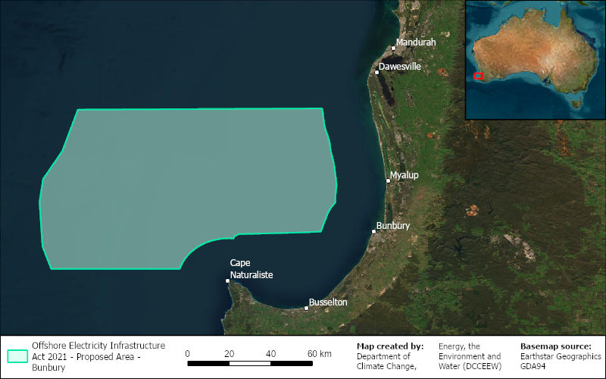

How can I have my say?
This is your first opportunity to provide feedback. Proposing an area is the first step to considering the suitability of this region for offshore wind energy development. We want your feedback on the proposal, to understand how you use the area and to identify benefits and concerns that you want further researched. We encourage your feedback in a submission through our Have Your Say web portal. The Minister for Climate Change and Energy will consider the submissions before deciding whether to declare all, part or none of the proposed area.

Is this the only chance to have my say?
This is your opportunity to provide feedback on a proposed area and the suitability of offshore wind in the region.
The Minister for Climate Change and Energy will consider the matters raised through public submissions, via the Have Your Say web portal, before deciding whether to declare an area for offshore wind development.
There will be further opportunities for feedback in following stages, if an area is declared by the Minister. In a declared area, developers can apply for 7-year feasibility licences to undertake research and further investigate the suitability of the area for offshore wind. During the feasibility licensing stage, licence holders will be required to seek feedback on their proposed projects and must demonstrate, to the satisfaction of the Offshore Infrastructure Regulator, how they will share the area with existing marine users. There will be more opportunities during this stage for communities to provide feedback on the planning and assessments for project proposals.

What are the benefits of offshore wind in this region?
A strong offshore wind industry in the Bunbury region could:
- provide clean, large-scale, affordable and reliable power to local communities and industries
- create new opportunities for regional investment and support thousands of jobs
- help us reach net zero by 2050.
Offshore wind is stronger and more consistent than onshore wind and could play an important role in meeting the energy needs of the region as coal fired power stations are retired.
WA’s annual emissions are increasing compared to 2005 levels (State and territory greenhouse gas inventories: annual emissions - DCCEEW). WA Government’s South West Interconnected System (SWIS) Demand Assessment, an initial assessment of potential future electricity demand required up to 2042, found that around 50GW of new renewable electricity and storage infrastructure is needed to support increased demand over the next 20 years.
Establishment of an offshore wind industry could support the decarbonisation and future of onshore heavy industries and businesses in the Bunbury region. The South West is anticipated to see the largest load growth driven by expansion and electrification of established minerals and metals industries. Electricity generated by offshore wind projects in the area could supply renewable energy into the SWIS, for households, businesses and industries with high energy demand.
The government will require project proposals to demonstrate commitment to using Australian manufactured inputs in their projects. A single 2 GW project requires about 1200 workers during construction and 600 workers for ongoing operations and maintenance.
Offshore wind is a complex industry with many components, jobs and skills required. For example, an offshore wind farm will need: project managers, engineers, cable installation managers and construction managers, electrical, construction and mechanical tradespeople, marine specialists and business professionals.

Why was this area proposed?
This region is one of six across Australia that has been identified to consider for its offshore wind potential, and investigate further.
The Bunbury region is well-suited for supporting an offshore wind industry because:
- It has strong, consistent winds;
- It is close to areas of high electricity demand and has significant transmission, transport and port infrastructure already in place;
- Industry has identified interest in investing in developing projects in the area; and
- Ageing coal-fired power stations are planning to shut down in future years throughout WA, reducing energy production.

How has this proposed offshore area been shaped?
Information on existing marine uses and users across the region has been collected, based on input from Australian and WA Government agencies, to inform the proposed area as well as technical limitations identified in the Blue Economy CRC report into offshore wind in Australia. Well known existing uses include defence activities, marine parks and other environmental values, undersea communication cables, shipping and port activities, and fishing activities among others. The Blue Economy CRC report identified technically accessible resources around the country, which included areas less than 100 km from the coast, in water depths less than 1000m and excluding environmentally restricted areas.
Further work is being done with government agencies. For example, analysis is being undertaken by the Australian Maritime Safety Authority (AMSA) and relevant ports to understand the vessel traffic in the area, and any specific requirements for the safe management of shipping.

What happens if an area is declared?
A declared area is a shared zone and does not exclude other users of the marine space. A declared area designates where offshore wind proponents can locate individual project proposals and apply for feasibility licences.
If an area is declared, it may be the same size as the proposal, it may be smaller, but it cannot be larger.
If the Minister declares an area in the Bunbury region as suitable for offshore wind, developers will be required to apply for smaller feasibility licence areas in order to advance any offshore wind projects. Licence holders will be required to seek feedback on their proposed projects and must demonstrate, to the satisfaction of the Offshore Infrastructure Regulator, how they will share the project area with existing users. For further detailed information on the Australian Government’s offshore renewable energy process, please read the Overview of the Offshore Renewable Energy Process document on the Have Your Say web portal.

How is the environment being protected?
The marine and onshore environment is protected under Australian law. If an offshore wind industry develops in this region, all projects will need to receive environmental approvals under Australian law – the Environment Protection and Biodiversity Conservation Act 1999 (EPBC Act).
Approvals under the EPBC Act are informed by detailed environmental studies and protect matters of national environmental significance, including migratory whale and bird species. Offshore wind projects that do not get EPBC Act approvals cannot proceed.
There are ways to mitigate the impacts of offshore infrastructure on marine life. We have recently published guidance material on how we would expect offshore wind developers to consider potential environmental impacts before seeking approvals. This is available on our website.

How are First Nations groups being engaged with?
As the traditional owners of the region, the Noongar people have significant interests in the marine area. Engagement with local First Nations stakeholders is an important part of the declaration process. The department is engaging with First Nation groups throughout the consultation process. The department wants to understand the cultural and environmental significance of the Sea Country where this area is proposed. The department also encourages First Nations people and groups to make submissions on the proposed area.

How many wind turbines could there be, and will I be able to see them?
The area that is currently being proposed is at least 20 kilometres from shore.
Offshore wind projects will only be developed within an area that is declared by the Minister. The exact location of offshore wind projects and number of turbines that may be proposed for an individual project is yet to be determined. Further consultation on these details will happen if a developer reaches the feasibility stage.
Offshore wind turbines will likely be visible from the shore, to differing extents. Their visual effect will depend on the distance to the shore of projects, the height of the turbines, the extent of haze in the atmosphere and the elevation where they are being viewed from.
Offshore wind turbines are the tallest renewable energy infrastructure option that could be developed, with some offshore wind turbines currently being manufactured around the world being up to 280m in height.

Will I still be able to access the area?
The Australian Government aims to manage the offshore marine environment in a way that recognises all users and balances competing interests, including those of First Nation people in the region.
If an area is declared, future offshore wind project developers must work with existing users and interests to ensure the design of projects incorporates ways for the area to be shared, while maintaining a safe marine space during construction, operation and maintenance phases. Access to the area will continue in line with rules that manage safe navigation in the maritime space.
In future if an offshore wind project reaches approval, the Offshore Infrastructure Regulator may require safety zones around certain offshore infrastructure where certain vessels may not be able to enter, and / or protection zones where certain activities may be restricted or prohibited (s136 and s142 of the OEI Act).

Will I be able to fish in the area?
The proposal or declaration of an area does not in itself exclude any users, including fishing activities.
The proposed area overlaps with waters currently used for commercial and recreational fishing. The Minister will consider the interests of fishers when deciding whether to declare an area.
If an area is declared and feasibility licences granted, offshore wind developers will need to consult with coastal communities to understand and address their concerns about potential impacts in the development of offshore wind proposals. It is Australian Government policy that offshore wind energy projects will need to share the marine space with existing users. Fishing interests will be an important input to the shaping of projects through the feasibility stage. Fishing activities will continue to be undertaken in the area to the extent possible to ensure a safe marine space.

What happens to the wind turbines once they reach their end of life?
Once offshore wind turbines reach the end their lifespan, they are decommissioned. Currently, up to 95% of wind turbines are recyclable, with manufacturers aiming to reach 100% recyclable in the next few years. Each developer must provide a clear plan and financial security for decommissioning at the start of their project, before they are granted a commercial licence to allow construction of any wind turbines. These arrangements must be set out in their management plan, which is approved by the Offshore Infrastructure Regulator.

What marine users and interests are in the area?
We have undertaken initial consultation with Commonwealth and Western Australian government agencies to identify interests in the vicinity of the area. Examples of marine users and interests in the area include: First Nations, marine animal life, commercial and recreational fishing, defence, vessel traffic, weather radars, owners of existing infrastructure, and tourism operators. For more detailed information, please read the Marine Users, Interests, and the Environment – Bunbury region, WA document on the Have Your Say web portal.

How will this affect shipping and vessel traffic?
We are working with the Australian Maritime Safety Authority (AMSA) and port authorities to determine whether specific areas will need to be identified for vessel traffic to ensure the safe management of ships in and out of ports and around the proposed offshore wind area. This consultation will continue throughout the public consultation period.

How will electricity generated in the area be transmitted onshore and used?
Electricity generated by potential offshore wind projects in the area is likely to be transmitted onshore and into the South West Interconnected System, to provide electricity for households and businesses. The electricity may also be used to supply heavy industry. Wind farm developers will work with the Australian and WA Governments to identify suitable grid connections and a pathway for transmission cables during the feasibility stage of a project. The location of the transmission cables and where they will go to shore has not yet been determined.

Do existing legal requirements continue to apply?
Yes. Developers are responsible for obtaining all relevant approvals under Australian and WA government law. Developers are required to be aware of all other rights and obligations that may apply to their respective projects. This may include, but is not limited to, Underwater Cultural Heritage, Biosecurity, Navigation, Immigration, Customs, Native Title, Environment Protection and Biodiversity Conservation and Air Services.

How long will the area be declared for?
When declaring an area suitable for offshore wind development, the Minister is not required to specify for how long the declaration will last. If the declaration instrument does not state an end date, it will remain in force until it is revoked. To revoke the declared area, the Minister must undertake a consultation process and consider the submissions received. If a declaration is revoked, or otherwise ends, any licences that have already been issued will remain; however, they cannot be changed or renewed.

Where can I find more information?
To learn more and make an online submission, visit the Have Your Say web portal: https://consult.dcceew.gov.au/oei-bunbury
The department has recently updated its website with more information about the regulatory process and benefits of developing an offshore wind industry in Australia. This includes a myth busting page that addresses many common misconceptions: https://www.dcceew.gov.au/energy/renewable/offshore-wind
If you have any further questions, please contact the department’s Offshore Renewables team at offshorerenewables@dcceew.gov.au

