Marine Users, Interests, and the Environment
Indian Ocean off the Bunbury region, Western Australia
An area in the Indian Ocean off the Bunbury region, Western Australia (WA) has been identified as a potential area for offshore renewable energy development.
Quick facts:
- This is a proposed area and is not final. It acts as a starting point to identify an area that could support offshore wind. The Minister for Climate Change and Energy will consider public submissions to help inform his decision whether to declare all, part, or none of the proposed area as suitable for offshore wind development.
- The potential declaration of an area does not in itself exclude other marine users from the area.
- The proposed area has been identified based on existing users and interests such as marine parks, Key Ecological Features, marine species, fishing patterns, shipping and defence activities. The government is now seeking further information on activities in the area to build knowledge of the region.
- If an area is declared, any project proposals awarded feasibility licenses in the area must undertake consultation and show how they will share the area with other marine users prior to construction of energy infrastructure.
- No construction of wind turbines can occur until developers have met all requirements under a feasibility licence and are granted a commercial licence. This is likely to take up to seven years.

The Australian Government aims to manage the offshore marine environment in a way that recognises all users and balances competing interests. If this proposed area is declared by the Minister, any future offshore wind licence holders within the area must work with existing marine users and interests to ensure the area is shared, while maintaining a safe marine space during construction, operation, maintenance and decommissioning phases of projects.

Users and interests
The Department of Climate Change, Energy, the Environment and Water has undertaken initial consultation with Australian and Western Australian (WA) government departments and agencies to identify many existing users and interests in the vicinity of the area. We have developed a map that allows users to interact with the proposed Bunbury area and see geographic information on other marine users and interests in the area. The map is available on the Have Your Say web portal.
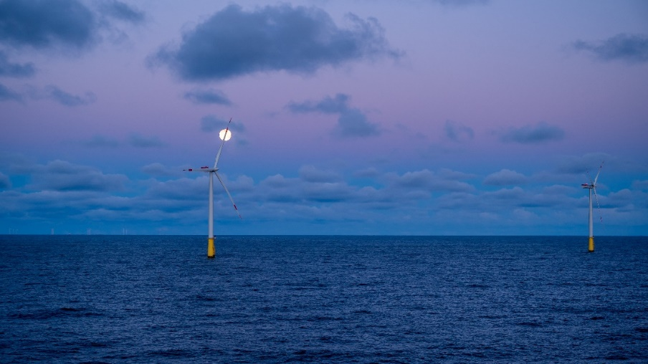

Western Australian Aboriginal Community and Sea Country
The Noongar people are the traditional owners of the region and have significant interests in the marine area as part of their cultural heritage. Sea Country is a complex concept derived from custom, practice, occupation and traditional law. Aboriginal hold traditional rights, responsibilities, and interests across the sea floor and the whole of Sea Country. Many plants and animals found within Sea Country hold significant cultural, environmental and traditional importance.
Acknowledging the significance of this region to its Traditional Owners, the Australian Government will continue to consult with the Western Australian First Nations communities through the declaration process and prior to awarding any licences in a declared area. If an area is declared, developers will be required to continue this engagement.

Marine environment
The Bunbury region is home to a range of important marine ecosystems. The proposed area avoids all marine parks including the Perth Canyon Marine Park. The proposed area also avoids areas of extensive and diverse seagrass meadows along the coast and in Geographe Bay. By moving 20km off the coast, the proposed area avoids many areas along the coast that are important for marine flora and fauna, including estuarine environments and Ramsar wetlands.
The proposed area overlaps with some important environmental features that will require further research and study if an offshore wind project proposal is to be considered. These include Key Ecological Feature (KEF) areas, which are matters of national environment significance under the Environment Protection and Biodiversity Conservation Act 1999 (EPBC Act), such as the Western Rock Lobster KEF, and the Ancient Coastline (between 90m and 120m depth) KEF with high aggregations of marine life and biodiversity. The area also overlaps and is adjacent to Biologically Important Areas for fauna including the Southern Right Whale, Humpback Whale, Pygmy Blue Whale and migratory seabirds. Offshore wind infrastructure activities are subject to requirements for environmental approval under environmental law, including the EPBC Act. This includes an assessment of the relevant impacts and proposed avoidance, management, mitigation, and offset measures. Offshore wind projects that do not get EPBC Act approvals cannot proceed.
There are ways to mitigate the impacts of different types of infrastructure on marine life. We have recently published guidance material on how we would expect offshore wind developers to consider potential environmental impacts before seeking approvals. This is available on our website.
The National Environmental Science Program’s Marine and Coastal Hub has initiated many projects to create tools and databases to support decision making and ensure developments are socially and ecologically sustainable.

Commercial and Recreational Fishing
A variety of different commercial and recreational fishing industries travel to and operate out of the Bunbury region. Acknowledging the significance of this region to fishers, and the benefits that fishing brings to the region, the Australian Government will continue to consult with the Western Australian fishing stakeholders through the declaration process and prior to awarding any licences in a declared area. If an area is declared, developers will be required to continue this engagement.
An important commercial fishery in the south west of WA region is the Western Rock Lobster fishery, which is Australia’s most valuable single-species wild capture fishery, with an estimated $400 million value. There are also other significant commercial fisheries including demersal, shark, deep-sea crustacean, scallops, abalone, and octopus. Beach based methods such as beach seining, near-shore gillnetting, and hand-hauled nets are used to capture whitebait, mullet and whiting. Further off the coast, trawl, potting, long line, gillnet and line fishing methods are prevalent.
The range of recreational fishing opportunities for local residents as well as visitors (including charter-based fishing) includes estuarine fishing, beach fishing and boat fishing, often out to the edge of the continental shelf.
In most cases, commercial and recreational fishing activities may be able to share the space with future offshore wind projects. Depending on the location of offshore wind project proposals, commercial fishing operators that hold existing fishing rights in the area may be impacted to differing extents during the construction, operation, maintenance and decommissioning stages.
All marine users can continue to access the space at this stage of the proposal. In the future, if an offshore wind project is approved somewhere within a declared area, certain activities may be subject to exclusion around pieces of infrastructure, including towers, cables and substations, in a similar way that exclusions that apply to other types of marine infrastructure like navigation buoys and oil and gas platforms. These restricted areas are to ensure the safety of offshore workers and other users of the marine environment, and to protect vessels and the infrastructure from damage. The exact details of these restricted areas will be determined by the Offshore Infrastructure Regulator on a project-by-project basis as the details of specific proposed projects become known, and are likely to be more heavily used in the construction and decommissioning phases.
Any future offshore wind licence holder will need to consult with the fishing sector to discuss their offshore wind project proposal, how the proposed project area can be shared, the potential impacts and how impacts can be mitigated. During the operational phase of a wind farm, some fisheries that use methods such as trawling and longlines may be unable to share the space to the same extent as other types of fishing. There will be many rounds of consultation over multiple years between proponents, governments and fisheries to come to fair arrangements in these cases. Licence holders will need to have plans for gathering and responding to ongoing feedback from marine users, including the commercial and recreational fishing industries, throughout the life of projects.
During this consultation process, the Australian Government is seeking feedback on the suitability of the proposed area for development of an offshore wind industry alongside existing fishing activities.

Airports and Defence
The proposed area will not affect the safety or use of airspace near Jandakot and Perth airports. Developers will have to consult further with aviation authorities, councils and local aerodromes to identify and mitigate potential impacts of their proposed project on civil aviation.
The proposed area avoids parts of the Department of Defence’s Western Australia Exercise Area that cannot coexist with offshore wind. Developers of wind turbines and other infrastructure in the proposed area will have to consult further with the Department of Defence to identify and mitigate potential impacts of their proposed project on any Defence activities.

Vessel Traffic and Ports
One reason why this region was identified as a priority area for offshore renewables is its proximity to important port facilities. The Port of Fremantle is WA’s largest and operates through two harbours. The Port of Bunbury has the largest land holding of any port in Australia and capacity for significant growth.
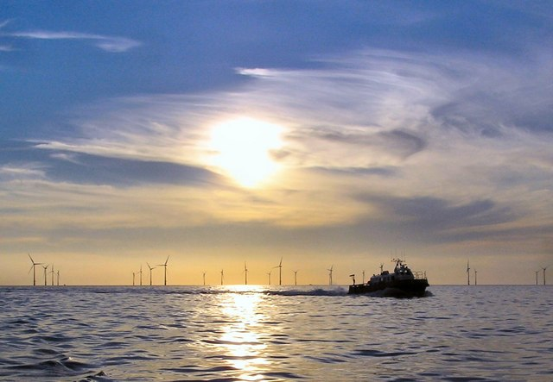
The development of offshore wind needs to ensure that it does not disrupt the safety of vessel traffic and port operations.
The department is working with the Australian Maritime Safety Authority (AMSA), and consulting with port agencies, to seek further details on vessel traffic in the proposed area and ensure the safe management of shipping to and from the region’s ports.
The needs of existing commercial and recreational boating will also be considered in the consultation process, and if an area is declared, boating will need to be considered by individual developers during the licensing phase.

Beaches and Surfing
Many of the beaches alongside the proposed area are popular for surfing, swimming and recreation. Offshore wind turbines would have no impact on the region's surf or beaches, as swell waves wrap around turbines and quickly reform through the process of wave diffraction. All beach-related recreation activities, including surfing, would continue uninterrupted.

Tourism
The Bunbury region is home to national parks, beaches, and scenic views along a wide range of coastal locations. Tourism contributes significantly to the WA economy, providing a positive impact on transport, accommodation, retail, food and beverage, tours and experiences.
Alongside existing research, more investigation is needed on the effects of offshore wind farms on tourism and recreation. There are diverse viewpoints on the impact of wind farms on tourism with local communities concerned about visual impacts. In other countries, boat operators take tourist groups on tours through offshore wind farms. For local residents, their experiences during the planning process influenced their perspectives.
Similar to other marine users, future offshore wind licence holders will need to consult with the tourism sector to discuss how the project areas can be shared, the potential impacts and how impacts can be mitigated.

Potential Projects and Coexistence with Existing Users
As part of testing the feasibility of a proposed offshore wind project, and prior to approvals for the construction of any infrastructure, licence holders must undertake consultation and show how they will share the area with other marine users. Licence holders will also need to have a plan for gathering and responding to ongoing feedback from marine users throughout the life of an approved project. This is in addition to the obligations for licence holders to consult with government agencies to ensure constraints are thoroughly considered and addressed throughout their projects.
Further detail on the requirements for project proponents under the Offshore Electricity Infrastructure Act 2021, including management plan requirements, will be released for public consultation later in 2024.

About The Fishery - Western Rock Lobster
West Coast Bioregion - WAFIC
Recfishwest
The Port - Fremantle Ports, Western Australia
Tourism | City of Perth
Smythe, et al (2020). Beyond the beach: Tradeoffs in tourism and recreation at the first offshore wind farm in the United States. Science Direct. Volume 70. December 2020.

