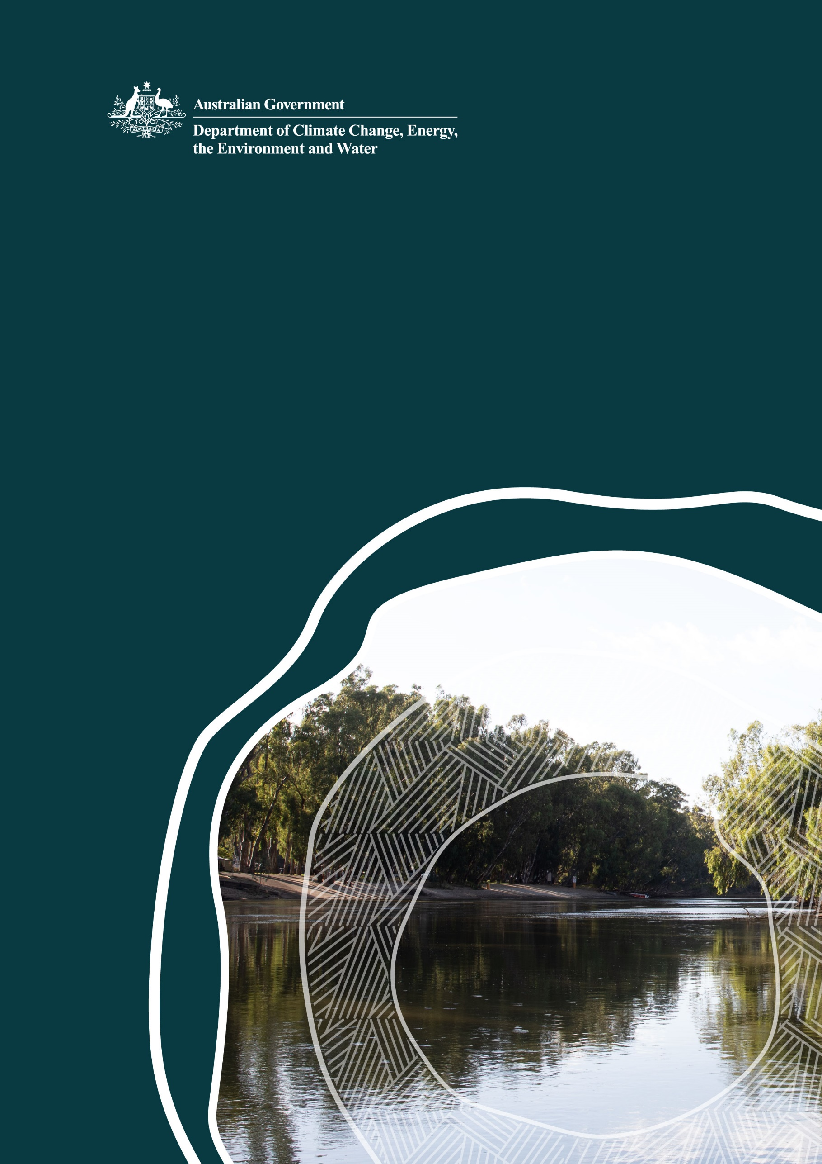
Exploring land and water partnerships

Supporting delivery of 450 gigalitres of environmental water in the Murray-Darling Basin

© Commonwealth of Australia 2024
Ownership of intellectual property rights
Unless otherwise noted, copyright (and any other intellectual property rights) in this publication is owned by the Commonwealth of Australia (referred to as the Commonwealth).
Creative Commons licence
All material in this publication is licensed under a Creative Commons Attribution 4.0 International Licence except content supplied by third parties, logos and the Commonwealth Coat of Arms.
Inquiries about the licence and any use of this document should be emailed to copyright@dcceew.gov.au.

Cataloguing data
This publication (and any material sourced from it) should be attributed as: DCCEEW 2024 Exploring land and water partnerships, Department of Climate Change, Energy, the Environment and Water, Canberra, November 2023. CC BY 4.0.
This publication is available at dcceew.gov.au/publications.
Department of Climate Change, Energy, the Environment and Water
GPO Box 3090 Canberra ACT 2601
Telephone 1800 900 090
Web dcceew.gov.au
Disclaimer
The Australian Government acting through the Department of Climate Change, Energy, the Environment and Water has exercised due care and skill in preparing and compiling the information and data in this publication. Notwithstanding, the Department of Climate Change, Energy, the Environment and Water, its employees and advisers disclaim all liability, including liability for negligence and for any loss, damage, injury, expense or cost incurred by any person as a result of accessing, using or relying on any of the information or data in this publication to the maximum extent permitted by law.
Acknowledgements
The Australian Government thanks relevant basin governments and communities for their input.
Acknowledgement of Country
Our department recognises the First Peoples of this nation and their ongoing connection to culture and country. We acknowledge Aboriginal and Torres Strait Islander Peoples as the Traditional Owners, Custodians and Lore Keepers of the world's oldest living culture and pay respects to their Elders past, and present.

Contents
1 Introduction 4
2 What we heard: land and water partnerships 5
3 Benefits of a land and water approach 6
3.1 Complementary benefits 6
4 Potential criteria for investing in land and water packages 8
4.1 Case Study: Gayini (Nimmi-Caira) 9
5 How you can help 10
6 Next steps 11

Introduction
On 30 November 2023, Australian Government legislation passed allowing for delivery of the Murray—Darling Basin Plan in full. This included the commitment to recover 450 GL of additional environmental water through a range of programs and measures, with all options considered.
The Department of Climate Change, Energy, the Environment and Water (DCCEEW) consulted with stakeholders and communities from May to July 2023 on ideas for delivering the Basin Plan in full. A common theme we heard through our consultations was the potential to use land and water partnerships to meet our Basin Plan targets and outcomes.
Land and water partnerships --or acquiring water entitlement and land parcels under a single acquisition-- have the potential to contribute to environmental water recovery targets under the Basin Plan whilst also providing complementary outcomes.
The complementary outcomes that may be realised through land and water opportunities may include:
- relaxing physical constraints to increase the deliverability of water across the Basin
- enhancing environmental and nature positive outcomes
- providing First Nations outcomes, including increasing involvement in water management, and enhancing First Nations self-determination, living culture, cultural economies, and ability to care for Country
- contributing to biodiversity conservation targets through increasing the protected and conserved areas and growing areas under restoration.

The Australian Government does not directly hold or manage land to support Basin Plan implementation. This means that partnerships from institutions and organisations who can own and manage land are critical to the achievement of outcomes.
We’re seeking further information from individuals, organisations and communities to determine the interest in, and viability of, of a potential land and water partnerships program via a five-week consultation process.
This document sets out a framework for establishing a potential land and water partnerships program. It includes how a land and water partnerships program could work; potential benefits for constraints relaxation, enhanced environmental and nature positive outcomes, and benefits for First Nations people; our proposed criteria for land and water investment decisions; and how you can help us better understand the interest in, and viability of, establishing a such a partnerships program.

What we heard: land and water partnerships
DCCEEW ran a five-week public consultation process from 29 May to 3 July 2023 on ideas for delivering the Basin Plan, with all options to be considered.
A theme that emerged from these consultations was the additional value and improved outcomes that can be achieved by coupling land and water programs through a partnership approach.
Ideas we received featured programs or partnerships with landholders that could achieve environmental benefits while contributing to Basin Plan water recovery targets. These included:
- Expanding the Bitterns in Rice program
- Partnering with local irrigators to water private wetlands
- Accelerating constraints program implementation
- Partnering with landholders for revegetation
We also heard support for creating opportunities for First Nations Peoples to have greater involvement in water policy and management.
We are very interested in additional ideas that could help achieve water recovery and complementary benefits, when land is packaged together with water.
For more information on the ideas we received through our consultation visit What we heard: Delivering the Murray-Darling Basin Plan - DCCEEW.

Benefits of a land and water approach
Land and water partnerships also have the potential to deliver against Basin Plan environmental water recovery targets in a way that recognises and contributes to other Basin Plan outcomes. The recovered water can be used to help rivers flow, keep native plants healthy and support feeding and breeding of native animals, birds, fish, and frogs.

Complementary benefits
There are a number of complementary benefits that can be realised through purchasing land and water as a package or seeking partnerships that allow land and water to be used and managed for improved outcomes.

Constraints relaxation
Under the Basin Plan, a constraint is something that limits the volume of environmental water that can be delivered to the environmental assets of the Basin or the timing of this delivery. Constraints can include physical structures as well as river management practices and operational limits for river heights.
At times, these constraints on environmental water delivery are associated with riparian and floodplain land use and ownership.
The purchasing of land that has these constraints, or formation of a partnership that allows for more flexible water delivery, may enable the removal or relaxing of constraints which can allow better outcomes to be achieved with environmental water.

Enhanced environmental and nature positive outcomes
By purchasing land with water there is the potential to add value to environmental water use by enhancing environmental and nature positive outcomes.
Nature positive is a term used to describe circumstances where nature – species and ecosystems – is being repaired and is regenerating rather than being in decline (Nature Positive Plan 2022).
This can include natural values, such as species, ecosystems, and significant biodiversity, such as wetlands, refuges, or migratory sites, or contributing to environmental values such as ecosystem services or carbon sequestration.

First Nations outcomes
Land and water partnerships could contribute to environmental stewardship, and the economic self-determination of First Nations Peoples. Partnerships may also contribute to cultural flows and protect cultural sites.
Land acquired through land and water partnerships could be divested as freehold land to First Nations groups. Partnerships could also create opportunities for First Nations Peoples to own, access and benefit from cultural flows.
'Cultural flows' are water entitlements owned by First Nations Peoples which improve spiritual, cultural, environmental, social, and economic health and wellbeing, as defined in the Echuca Declaration. First Nations Peoples share an ancestral connection to Australia’s river systems. This is part of their cultural identity. As custodians of Country, they continue to care for Australia’s water resources. Water plays an important role in storytelling and learning. This helps to continue the spiritual relationship with Country.
Land and water packages would also contribute to Closing the Gap, which acknowledges the ongoing strength and resilience of Aboriginal and Torres Strait Islander Peoples in sustaining the world’s oldest living cultures.

Increasing protected areas
Protected and conserved areas play an important role in preserving and improving our biodiversity. They safeguard native species and ecological communities and deliver important ecosystem services and benefits to people. The Australian Government has set a target to protect and conserve 30% of Australia’s landmass by 2030.
The target will be achieved through growing Australia’s National Reserve System (NRS), Australia’s network of protected areas, and through establishing new conserved areas. Both protected and conserved areas can occur on public, private and Indigenous land and can be governed by government, First Nations, privately or jointly.
There may be scope for land and water partnerships to purchase and formally protect or conserve land in the Murray Darling Basin to contribute to the 30 by 30 target. Priority could be given to properties in bioregions that have less than 10% of their area in protected areas such as national parks. These bioregions are: Mitchell Grass Downs, Southern Volcanic Plain, Darling Riverine Plains, Cobar Peneplain, NSW South Western Slopes, Nandewar, Mulga Lands, Brigalow Belt South, Broken Hill Complex, Riverina and Flinders Lofty Block. Priority would also be given to properties with high biodiversity values for example habitats that are rich in species diversity or home to threatened species or threatened ecological communities.

We are very interested in other outcomes than could be achieved.
The outcomes listed above are a small subset of the potential outcomes that could be achieved through land and water purchase or partnerships.
As we consider how governments can understand the range of opportunities and how we can position to get the best possible outcomes, we are very interested in feedback on additional outcomes that can be achieved, as well as descriptions of proposals that can help inform future policy and program development.

Potential criteria for investing in land and water packages
Basin Plan legislation allows for land and water purchases. In consulting on the interest, viability and development of potential land and water partnerships program, we are also seeking feedback on potential criteria we could use to guide investment decisions.
Potential criteria could include:
- Land and water purchase offers must include water that:
- demonstrates value for money
- contributes to Basin Plan water recovery targets that provide environmental outcomes.
- Land and water packages must also contribute to and support delivery of non-water purchase government policies and programs. These include, but are not limited to:
- relaxing physical constraints to increase the deliverability of water across the Basin
- contributing to enhanced environmental and nature positive outcomes by stopping environmental decline and repairing nature in significant Basin ecosystems
- providing First Nations outcomes, including increasing involvement in water management, and enhancing First Nations self-determination, living culture, cultural economies, and ability to care for Country
- increasing protected areas under the National Reserve System, and
- contributing to biodiversity conservation and protection targets
- contributing to biodiversity restoration targets.
- A land manager must be identified that is willing and able to take ownership of the land and be responsible for future management.
- Any land and water package must represent overall value-for-money and be aligned with the cost of similar rights as set by the market.

Case Study: Gayini (Nimmi-Caira)
The Australian Government has been involved in a small number of unique land and water purchases to support Basin Plan implementation. One of these was Gayini (Nimmie Caira).
Gayini highlights the potential of land and water opportunities, also the importance of proponents having a delivery partner and land manager identified to take ownership of the land.
In July 2012 the New South Wales Government brought forward the Nimmie-Caira System Enhanced Environmental Water Delivery State Priority Project of approximately 86,000 hectares of land and associated water entitlements for purchase. The property is located in the lower reaches of the internationally significant Murrumbidgee floodplain near the township of Balranald, NSW and includes 32,000 hectares of water-dependent vegetation.
Gayini (Nimmie-Caira) was purchased in 2013 under an agreement between the Australian and NSW governments. The supplementary water entitlements were transferred to the CEWH to contribute to Basin Plan bridging the gap water recovery targets.
The NSW Government oversaw the project to purchase and hold the land and to reconfigure the extensive irrigation infrastructure to enable efficient watering of the environmental assets.
In 2018, a consortium led by The Nature Conservancy which included the Traditional Custodians, the Nari Nari Tribal Council, was successful in tendering for the future management of Gayini. In 2019, The Nature Conservancy facilitated the legal transfer of ownership of Gayini to the Traditional Custodians, the Nari Nari Tribal Council. The transfer was funded by the Indigenous Land and Sea Corporation and the Wyss Campaign for Nature.
Gayini is an example of an investment that recovered water against Basin Plan targets and resulted in a property being divested to the Traditional Custodians to be sustainably managed for the benefit of people and nature. In 2023, the Nari Nari Tribal Council signed a Conservation Agreement with the NSW Biodiversity Conservation Trust to fund cultural land management and conservation across 55,220 hectares of designed conservation area on the Gayini property.
The future management of the property will focus on three main areas of equal importance: environmental protection; Indigenous engagement and participation; and sustainable development.
Many First Nations Peoples from across the Basin have begun identifying similar opportunities for their Country and are ready to start discussing their ideas and plans. The process and outcomes from establishing Gayini provide an example of what can be achieved through partnerships in land and water acquisitions.
Learn more about the Gayini Nimmie-Caira Project.

How you can help
To assist us in understanding the interest in, and viability of, combining land with water purchases, we’re interested in hearing from interested parties in a land and water partnerships program on:
- land and water they might be willing to sell to the government
- details of the complementary outcomes and benefits that would be realised if land and water are purchased and managed collectively. Noting that we are keen to hear from you on all of your ideas, complementary outcomes could include such things as:
  - relaxing physical constraints to increase the deliverability of water across the Basin
  - enhancing environmental and nature positive outcomes, including stopping environmental decline and repairing nature in significant Basin eco-systems
  - providing First Nations outcomes, including increasing involvement in water management, and enhancing First Nations self-determination, living culture, cultural economies, and ability to care for Country
  - increasing protected areas under the National Reserve System, or recognition as a Conserved Area, contributing to our biodiversity conservation. Demonstrated through identification of the biodiversity values of the land including listing the bioregion the land is in and the known native species and ecological communities present.

To have your say on a potential land and water program visit https://consult.dcceew.gov.au/draft-restoring-our-rivers-framework. Submissions close 1 March 2024.
We also welcome submissions from Basin governments, First Nations groups, private, philanthropic, and non-government organisations who might be interested in the purchase, ownership or ongoing management of land.
Disclaimer:
- This land and water submission process is investigative only, and the government is not offering to purchase your land or water.
- Participation is voluntary and you are encouraged to seek advice relating to your own circumstances and situation (including legal and financial).
- The information requested is indicative only and does not constitute a formal offer to the government.
- The information provided will remain confidential.
- The information provided will be used to inform government policy and assess the interest in, and viability of, a possible land and water purchase program.
- There is no commitment to pursue or fund any submission provided as a part if this process, or to stand up a program in the future.
- DCCEEW may not respond to individual submissions.
- DCCEEW will release a summary of feedback and insights.
- No legal obligations arise or are implied for either party as a result of a submission to this process.

Next steps
We will review all feedback received through this consultation process to determine interest in, and viability of, establishing a land and water partnerships program.
We will share further information, use our analysis to inform government policy and program development and publish a summary in early 2024 of what we heard through this consultation process.
We wish to thank everyone who participated in our consultation to determine if a land and water program could work to support environmental water recovery in the Basin.

