# Draft update to the Climate Change Considerations chapter in Australian Rainfall and Runoff: A Guide to Flood Estimation

Book 1. Chapter 6. Climate Change Considerations

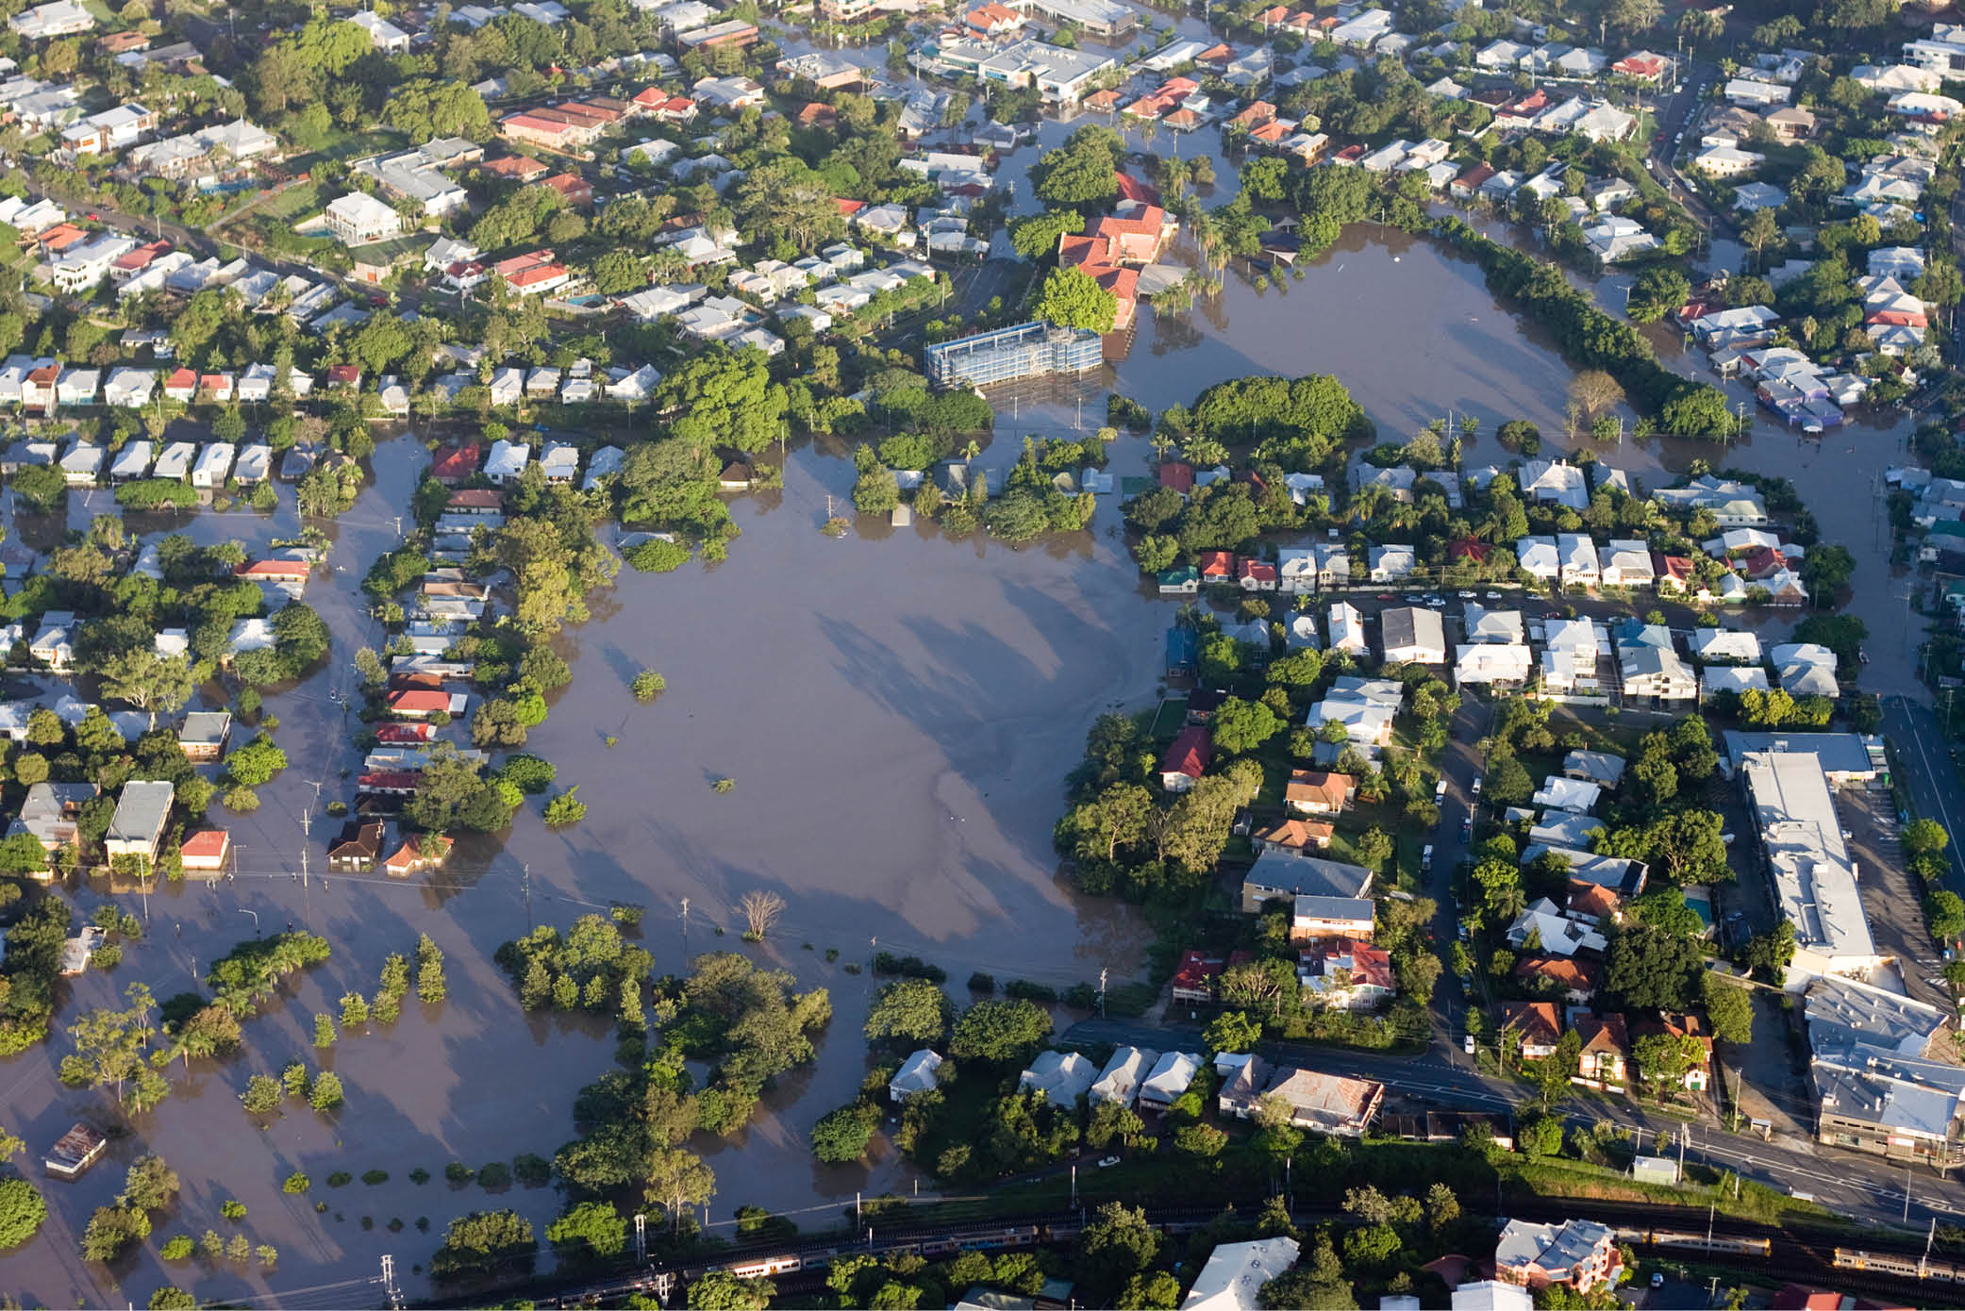

**Technical Working Group**

This document has been developed through engagement with a Technical Working Group, comprising the following members:

* Dr Conrad Wasko, The University of Melbourne
* Professor Seth Westra, University of Adelaide
* Professor Rory Nathan, The University of Melbourne
* Dr Dörte Jakob, Bureau of Meteorology
* Chris Nielsen, Department of Regional Development Manufacturing and Water, Qld
* Professor Jason Evans, The University of New South Wales
* Simon Rodgers, Department of Water and Environmental Regulation, WA
* Mark Babister, WMA Water
* Dr Andrew Dowdy, Bureau of Meteorology
* Dr Wendy Sharples, Bureau of Meteorology

© Commonwealth of Australia 2023

**Ownership of intellectual property rights**

Unless otherwise noted, copyright (and any other intellectual property rights) in this publication is owned by the Commonwealth of Australia (referred to as the Commonwealth).

**Creative Commons licence**

All material in this publication is licensed under a [Creative Commons Attribution 4.0 International Licence](https://creativecommons.org/licenses/by/4.0/legalcode) except content supplied by third parties, logos and the Commonwealth Coat of Arms.

Inquiries about the licence and any use of this document should be emailed to [copyright@dcceew.gov.au](mailto:copyright@dcceew.gov.au).



**Cataloguing data**

This publication (and any material sourced from it) should be attributed as: DCCEEW 2023, *Discussion Paper:* *Update to Climate Change Considerations chapter in Australian Rainfall and Runoff: A Guide to Flood Estimation Discussion Paper*, Department of Climate Change, Energy, the Environment and Water, Canberra, CC BY 4.0.

This publication is available at [dcceew.gov.au/publications](https://www.dcceew.gov.au/publications).

Department of Climate Change, Energy, the Environment and Water

GPO Box 3090 Canberra ACT 2601

Telephone 1800 900 090

Web [dcceew.gov.au](https://www.dcceew.gov.au)

**Disclaimer**

The Australian Government acting through the Department of Climate Change, Energy, the Environment and Water has exercised due care and skill in preparing and compiling the information and data in this publication. Notwithstanding, the Department of Climate Change, Energy, the Environment and Water, its employees and advisers disclaim all liability, including liability for negligence and for any loss, damage, injury, expense or cost incurred by any person as a result of accessing, using or relying on any of the information or data in this publication to the maximum extent permitted by law.

**Acknowledgement of Country**

We acknowledge the Traditional Owners of Country throughout Australia and recognise their continuing connection to land, waters and culture. We pay our respects to their Elders past and present.

Contents

Make a submission 1

Have your say 1

Next steps 1

Contacts 1

1 Introduction 2

1.1 Scientific basis and current guidance 2

1.2 Key updates to existing guidance 2

2 Decision contexts for flood guidance 4

3 Selection of a design flood estimation method 6

4 Incorporating climate change into event-based design flood estimates 8

4.1 Intensity-Frequency-Duration curves 8

4.2 Temporal patterns 12

4.3 Spatial patterns 13

4.4 Loss parameters 13

4.5 Sea levels and sea level interaction 14

4.6 Increased uncertainty due to climate change 14

5 Updates to the climate change considerations 16

6 Worked examples 17

7 Appendix 21

8 References 22

## Make a submission

We are seeking feedback on the draft updated Climate Chance Considerations chapter (the guidance) of *Australian Rainfall and Runoff*: *A Guide to Flood Estimation* (ARR).

Both the scientific and engineering communities recognise that the guidance is based on science that is now over a decade old. The Department of Climate Change, Energy, the Environment and Water (DCCEEW), in partnership with Engineers Australia, are running a project to update the Climate Change Considerations chapter of ARR. The project is funded under the National Emergency Management Agency, Disaster Risk Reduction Package

In May and June 2023, we ran a consultation to ensure that the scope of the update reflects user needs. The consultation returned more than 50 submissions. The survey revealed overwhelming support for both the update and the proposed approach outlined in the consultation paper.

This draft guidance reflects the approach outlined in the consultation paper and incorporates the feedback received from the survey along with the most recent climate science research, projections and observed data.

Your input on this draft guidance will ensure the update reflects user needs before the document is finalised mid 2024.

### Have your say

* Use this [LINK](https://consult.dcceew.gov.au/draft-updates-to-the-climate-change-considerations-chapter-in-arrg) to answer questions.
* You will need to register or sign in to participate. Read our privacy notice before you register.
* Before you share your feedback, read this discussion paper.
* We have included questions for you to consider. You may address all or some of these, or provide more general comments.
* Ensure you provide your feedback by 5 pm (AEDT) on 12 February 2024.

### Next steps

Your ideas will help us to incorporate user needs into the update of the *Climate Change Considerations* chapter of ARR. We may contact you to seek more information about your submission. We will use the feedback provided to finalise the draft chapter. We expect to publish this in the first half of 2024.

### Contacts

For information about the update of the Climate Change Considerations chapter of *Australian Rainfall and Runoff: A Guide to Flood Estimation,* please email [climate.science@dcceew.gov.au](mailto:climate.science@dcceew.gov.au).

## Introduction

**Key messages**

Because our climate is changing, unadjusted historical observations are no longer a suitable basis for design flood estimation: they must be adjusted to reflect the impacts of rising global temperatures. This chapter provides guidance on how to do this. It is based on systematic review and meta-analysis of recent science that was developed to support the update.

### Scientific basis and current guidance

There is unequivocal evidence that greenhouse gas emissions have caused global warming. The Intergovernmental Panel on Climate Change’s sixth assessment report concluded that global surface temperatures have reached 1.1°C above pre-industrial levels, with significant further warming expected (IPCC 2023). This warming is causing an increase in many drivers of flood risk, including an intensification of extreme rainfall events and the elevation of average and extreme sea levels (IPCC 2023).

Traditionally design flood estimation has assumed that historical observations are representative of current and future conditions. This is no longer the case. Records on historical flooding or flood drivers (such as extreme rainfall or sea level) can no longer be assumed to provide a direct analogue of current or future flood risk. There is now a requirement to account for non-stationarity in flood loading conditions to assess current risks, as well as risks over the expected service life of the project.

This chapter provides practitioners, designers, and decision makers with guidance on how to assess the changing risks due to climate change on design flood characteristics. As with the rest of ARR, the content is advisory and not prescriptive or a substitute for regulation.

### Key updates to existing guidance

This chapter replaces the 2019 edition of the Climate Change Considerations chapter (Bates et al. 2019) in Book 1, Chapter 6 of *Australian Rainfall and Runoff* (ARR) (Ball et al. 2019). This chapter provides guidance that reflects the contemporary science, is applicable across the range of design flood approaches, and facilitates consistent application of climate change in design flood estimation. This guidance is based on an extensive and rigorous systematic review and meta-analysis of over 300 distinct peer-reviewed scientific studies published largely from 2011 onwards. For further information on the scientific basis for this guidance, readers are referred to Wasko et al. (2023). Key differences from the 2019 edition of Climate Change Consideration include:

* recognition that global temperatures have increased over the historical period used to derive design rainfall information
* a recommendation to adjust 2016 IFDs to present current climate conditions
* provision of information to support a range of approaches to decision-making
* provision of guidance across the range of Annual Exceedance Probability (AEP) considered in ARR up to and including the Probable Maximum Precipitation (PMP)
* provision of uncertainty estimates
* consideration of additional factors that influence design flood estimates; that is, changes in rainfall losses, temporal patterns, and sea level rise.

This chapter is structured as follows:

* Section 2 discusses the 2 primary types of uncertainty exacerbated by climate change that are relevant to flood design.
* Section 3 covers how climate change affects design flood estimation methods more broadly.
* Section 4 describes how to account for climate change in the key aspects of event-based design flood estimation, with the recommendations linked to the worked examples in Section 6.
* Section 5 presents updates to the climate change considerations chapter.
* Section 6 provides worked examples of the guidance presented in Section 4.

## Decision contexts for flood guidance

**Key messages**

Climate variability heavily influences the risks of flooding from one time period to the next (‘aleatory uncertainty’) and these risks will shift under climate change. There is considerable uncertainty associated with future global emissions and the physical effects of these emissions on flood drivers increases the uncertainty of design flood estimates (‘epistemic uncertainty’). A user needs to choose their approach to design flood estimation in the context of these 2 sources of uncertainty.

ARR provides guidance to support the estimation of design floods that inform either standards-based design criteria (such as designing to the 1% AEP standard) or risk-based approaches that seek to understand flood behaviour across a range of flood magnitudes up to and including the Probable Maximum Flood (PMF) (see Book 1 Chapter 5 for more detail). Guidance in ARR is largely focused on dealing with the inherent randomness of factors (the aleatory uncertainties) that influence the exceedance probability of a given event (Book 4 Chapter 3). In rainfall-based estimates this most often involves consideration of Intensity-Frequency-Duration (IFD) rainfall bursts (Book 2 Chapter 3), variability in rainfall temporal patterns (Book 2 Chapter 5), and the influence of antecedent and event losses (Book 5 Chapter 3). In techniques based directly on the analysis of flood data (Book 3), the aleatory uncertainty of these factors is implicitly accounted for in the sampling variability represented in the available flood observations. Climate change is now impacting the frequency and behaviour of many of the factors that influence flood behaviour resulting in non-stationarity in design flood estimates, shifting estimates of the aleatory uncertainty (Figure 1).

While much of the emphasis of climate science is to understand the likely historical and future changes to key flood risk drivers, another important consequence of climate change is an increase in the epistemic uncertainty of design flood estimates (Figure 1). This additional uncertainty arises from limitations in data and knowledge, where in the context of climate change this includes the uncertainty associated with future global emissions and mitigation strategies, resultant uncertainty in future global and regional temperature changes, and uncertainties on the implication of changing temperatures and associated processes on flood risk drivers. Within risk-based decision-making frameworks (where risk is commonly defined as ‘the effect of uncertainty on objectives’, ISO 31000), considerations of the projected changes in flood risk drivers as well as the increasing level of uncertainty associated with those drivers are both relevant in assessment of overall risk.

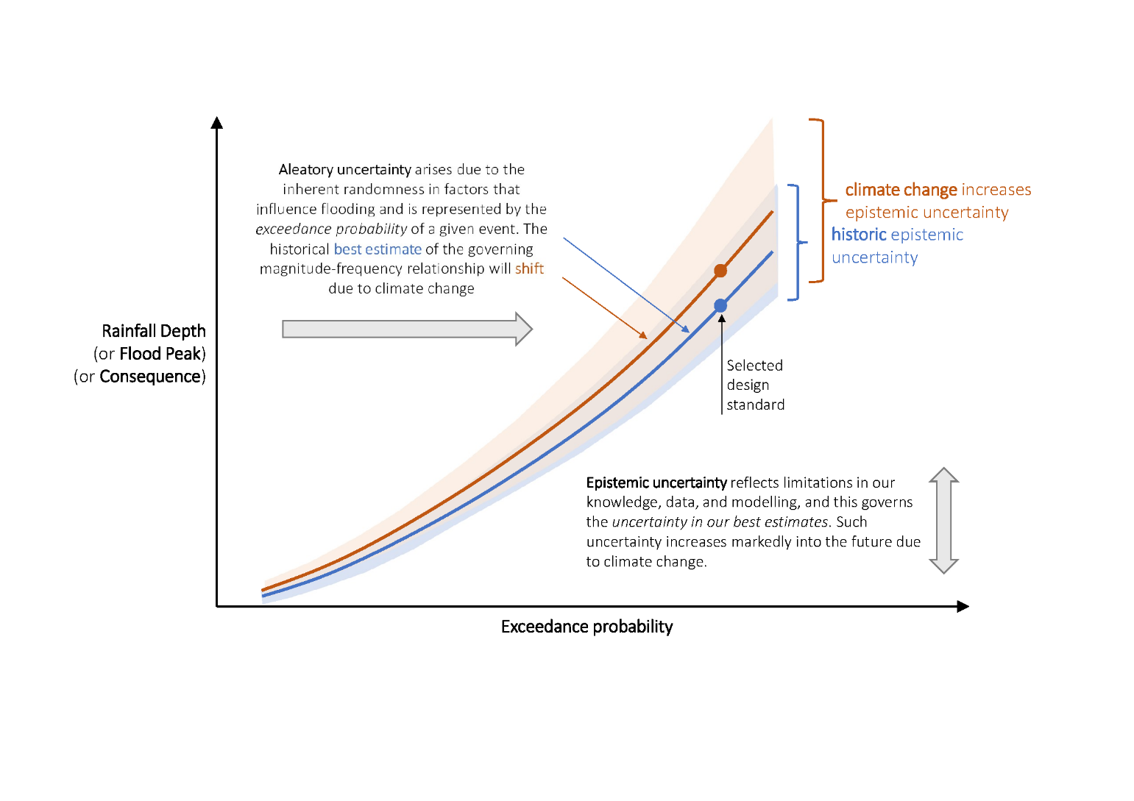**Figure 1.** Climate change is shifting our best estimate of the relationship between event magnitude and frequency and increasing the inherent uncertainty in such estimates.

In addition to standards-based and risk-based decision-making approaches, there has recently been interest in decision-making frameworks that are less reliant on annualised probability-based estimates of flood magnitude. Examples include robust design approaches that can adapt to changes in design flood estimates over time (adaptive management), sensitivity and stress-testing approaches that explore the effect of alternative assumptions on decision-making (‘bottom-up’ and ‘decision-scaling’ approaches), and ‘storyline’ methods that often draw on historical flood events, but which are modified to account for potential impacts of climate change.

This chapter provides guidance for future change to design floods recognising the requirements of current design procedures (and the need to capture the shifts in the magnitude-frequency relationships relevant to both standards-based and risk-based decision-making approaches), while also providing information to assist in estimating the uncertainty associated with those best estimates. This allows for consistency in the guidance here and the above decision-making frameworks. For example, a standards-based approach may adopt the median values presented in Section 4 and incorporate the uncertainty in a Monte Carlo framework. A bottom-up approach may use the uncertainty as a guide for sensitivity testing to develop system response surfaces for the hazard of interest. A risk-based approach may consider the probabilities and consequences of flooding across a range of exceedance probabilities, accounting for both aleatory and epistemic uncertainties.

The reader is referred to Book 1, Chapter 5 for further information on risk-based decision making, with Book 1, Section 5.10.5.2 detailing a possible process of undertaking a non-stationary risk assessment. Further information on approaches for representing epistemic uncertainty as part of the design flood estimation process are presented in Book 7, Chapter 9, with the different approaches to address aleatory uncertainty described in Book 1, Chapter 3.

## Selection of a design flood estimation method

**Key messages**

There are 2 broad classes of flood design estimation methods: direct flood-based procedures and rainfall-based procedures. The latter class can be further divided into continuous and event-based approaches. In the absence of a scientific consensus for incorporating climate change into direct flood-based procedures and continuous approaches, event-based procedures are recommended as the primary class of procedures for incorporating climate change into design flood estimates.

Design flood estimation methods can be divided into 2 broad classes of procedures, flood data-based procedures that involve the direct analysis of observed flood and related data and rainfall-based procedures that use rainfall-runoff models to transform rainfall information into estimates of the design flood (see Book 1, Chapter 3).

Following the review of Wasko et al. (2023), no scientific consensus was identified for incorporating climate change into direct flood-based procedures such as flood frequency analysis. This assessment is based on the following considerations:

1. Any non-stationarity in observed streamflow series may be caused by multiple drivers, not all of which are the result of climate change.
2. For changes attributed to climate change, future trends may not continue at the same rate or in the same manner as historical trends.
3. The high year-to-year variability in observed streamflow series means that inferring trends based on relatively short individual time series is unlikely to be statistically robust.

Although the final point may be addressed by using regionalisation approaches, it is unlikely that the other issues can be addressed in the absence of a process-based approach that appropriately connect the climate drivers to the design flood.

In contrast to flood-based procedures, rainfall-based procedures provide a mechanism to relate information on climate projections to design flood estimates using either event-based or continuous simulation approaches. For continuous simulation to be suitable for flood estimation under a non-stationary climate, the timeseries need to reflect the complexities of future changes. As highlighted in Wasko et al. (2023), extreme rainfall is likely to change at a different rate to average rainfall. Similarly short-duration extremes (sub-daily rainfall) and longer-duration extremes (multi-day accumulations) are likely to be experiencing differing rates of change in both the frequency and intensity, leading to complex changes in the temporal patterns of rainfall. There may also be changes to the seasonality of heavy rainfall events, as well as shifts to the spatial pattern of events.

Although continuous simulation approaches can be adapted to use climate-adjusted input timeseries (rainfall and potential evapotranspiration), further research is required to develop robust and practical methods to generate these climate-adjusted inputs into continuous simulation models, and thus the application of these methods is likely to be limited to highly specialised settings. As a pragmatic minimum it is recommended that extreme rainfalls in the timeseries used for continuous simulation be scaled to reflect the recommendations for incorporating climate change into Intensity-Frequency-Duration curves (Section 4.1), with the remaining rainfalls adjusted to reflect projections of the mean seasonal or annual rainfall for the location of interest.

Due to the above considerations, event-based procedures are recommended as the primary class of procedures for incorporating climate change into design flood estimates. The practical advantage of this recommendation is that event-based procedures are the most commonly used method to derive design flood estimates, and hence the adjustment of these methods to account for climate change represents an easy adoption pathway. In the context of climate change assessments, the advantages of this class of procedures are the ability to clearly map climate projections (including those related to extreme rainfall and/or sea levels) to the inputs of event-based rainfall-runoff and hydraulic models, together with their general applicability across both gauged and ungauged catchments and for a wide range of annual exceedance probabilities from the 1EY event through to the Probable Maximum Precipitation (PMP) (Figure 1.3.2 of Book 1, Chapter 3).

## Incorporating climate change into event-based design flood estimates

**Key messages**

Changes in extreme rainfall are likely to represent the primary mechanism for increases in flood risk across most Australian catchments. This section provides information on how to adjust design rainfall estimates as well as temporal patterns, loss parameters, and sea level rise. Uncertainties are presented for each of the aspects of the design flood estimate for which climate change guidance is provided. The reader is referred to supporting guidance for sea level rise. Examples are presented in Section 6.

Event-based procedures are summarised in Book 4, Chapter 3, and as highlighted in that chapter, they generally take into consideration the following climate-related factors:

1. A design storm of a given AEP and duration, usually derived from published IFD data (Book 2, Chapter 2).
2. Temporal patterns to distribute the design rainfall over the duration of the event (Book 2, Chapter 5).
3. Spatial patterns to represent rainfall variation over a catchment (Book 2, Chapter 4).
4. Loss parameters that represent soil moisture conditions in the catchment antecedent to the event and the capacity of the soil to absorb rainfall during the event (Book 5, Chapter 5).

The above list of climate-related factors is not necessarily exhaustive. For example, in low-lying (such as estuarine) catchments, the above is combined with information on sea levels that are influenced by both astronomical tides and storm surges (Book 6, Chapter 5). In the following sections, guidance is provided on accounting for climate change associated with each of the 4 aspects of event-based design flood modelling described above. The section closes with a discussion of the approach to estimating the epistemic uncertainty.

### Intensity-Frequency-Duration curves

For most Australian catchments, changes in extreme rainfall are likely to represent the primary mechanism for increases in flood risk with Wasko et al. (2023) identifying over 40 studies that quantify changes of extreme rainfall over Australia. For consistency with the Intergovernmental Panel on Climate Change (IPCC) projections, and to be representative of the climatic drivers of changes in moisture sources, a scaling approach is recommended whereby design rainfalls are factored at a rate proportional to global surface temperature increase.

The current IFD curves that are included in the 2016 IFD portal[1] were derived using historical data (Book 2, Chapter 3). The data from individual gauges varies, but a good estimate for the midpoint of the data period used in estimating the 2016 IFDs is 1961-1990. Figure 2 presents the latest Intergovernmental Panel on Climate Change (IPCC) temperature projections based on Shared Socioeconomic Pathways (SSPs) that cover a broad range of potential future development options often referred to as very low (SSP1-1.9), low (SSP1-2.6), medium (SSP2-4.5), high (SSP3-7.0) and very high (SSP5-8.5) emissions pathways. The best estimate for the mid-point of the data used for the generation of the 2016 IFDs is shaded in grey. As global temperatures have risen since this period, design rainfall estimates require factoring to account for this temperature increase.

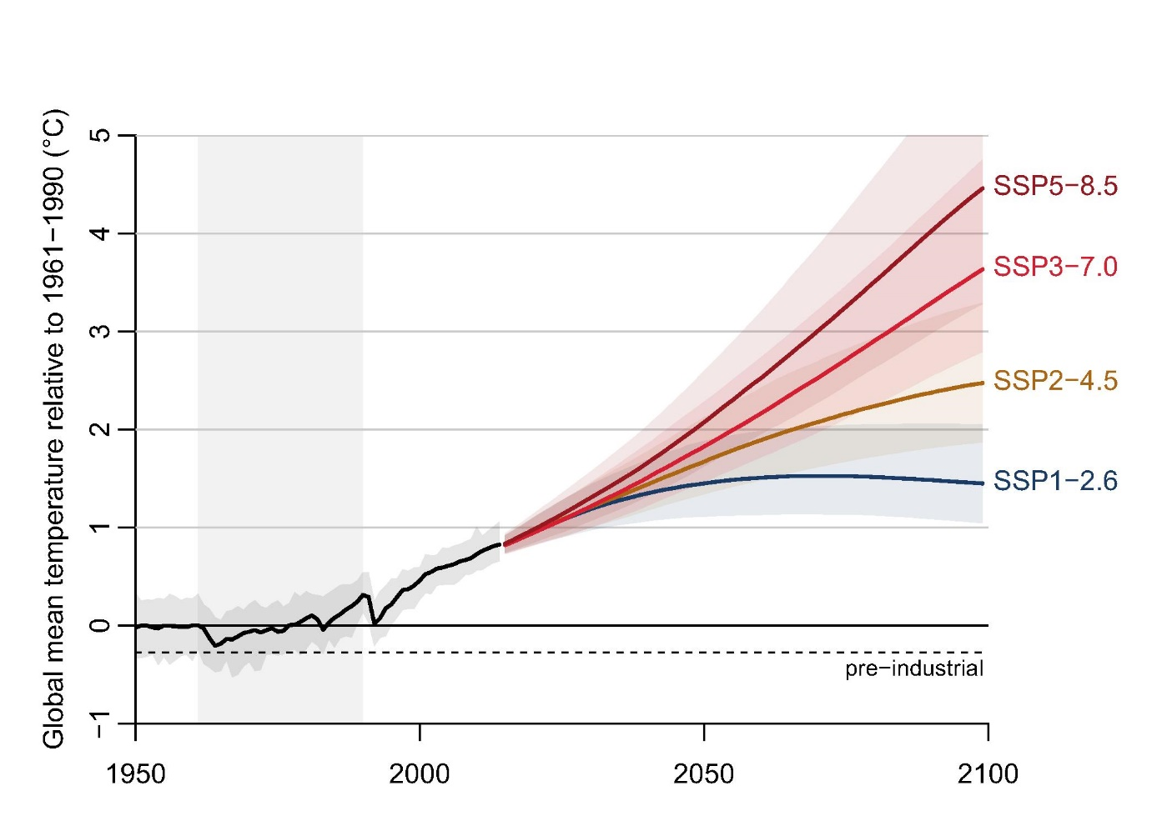

**Figure 2.** Projected temperature increases associated with AR6 socioeconomic pathways relative to 1961-1990 (shaded vertically in grey) and their associated uncertainty[2].

To account for changes since the period represented by the IFD curves in the 2016 IFD portal, it is recommended that IFD information as well as estimates of the PMP should be adjusted using Equation 1 and the relevant rate of change in Table 1:

$I_{p}=I×{(1+\frac{α}{100})}^{∆T}$ (1)

where

* $I_{p}$ is the projected rainfall depth or intensity
* $α$ is the rate of change from Table 1
* $I$ is the design rainfall depth or intensity
* $∆T$ is the most up-to-date estimate of global (land and ocean) temperature projection for the design period of interest and selected climate scenario relative to a baseline time period. When used in conjunction with the 2016 IFD curves the baseline is recommended to be the 1961-1990 period (see Table 2 and text below).

The rates of change in Table 1 apply to exceedance probabilities from the 1EY event through to the PMP and have been developed for application across mainland Australia and Tasmania. There is some evidence for heterogeneity in the rate of change across space as well as by event severity. However, there is insufficient information to quantitatively describe these differences, and/or the magnitude of difference was deemed to be small relative to the associated uncertainty. The information provided in Table 1 relates to storm durations for which most published evidence is available. Guidance on factors for use with burst durations between 1 and 24 hours is given in Appendix A.

The differing rates of change with storm duration reflect the fact that the mechanisms that cause extreme rainfall at these 2 durations are often distinct. Note that short duration extremes are often embedded in longer duration extremes. It is possible that application of the scaling factors provided in Table 1 and Table A1 may yield inconsistencies in the resulting design rainfall frequency curves. Such inconsistencies are not unexpected given the uncertainties involved in their derivation. Accordingly, the IFD curves should be adjusted as minimally as possible to ensure the curve of one duration does not cross the curve of another.

Table 1. Recommended rates of change ($α$) and associated uncertainty derived in Wasko et al. (2023), presented per degree global temperature change (%/°C). The factors in this table are applicable for exceedance probabilities from 1EY up to and including the PMP and are designed for application across mainland Australia and Tasmania.

|  |  |  |  |
| --- | --- | --- | --- |
|  | ≤ 1 hr | > 1 hr and < 24 hr | ≥ 24 hr |
| Central (median) estimate (%/°C) | 15 | Interpolation zone (see **Table A1**) | 8 |
| ‘Likely’ range (corresponding to ~66%† range) (%/°C) | 7-28 | 2-15 |

† Consistent with terminology used by the IPCC the 66% range corresponds to an uncertainty range of +/- 33%.

To ensure consistency with IPCC projections and be representative of the climatic drivers of change in extreme rainfall, the rates of change in Table 1 are presented relative to global temperatures changes. Hence, to adjust IFDs for climate change, global temperature projections $∆T$ are required. The current global temperature projections are provided in Table 2 and derived from the IPCC Sixth Assessment Report (AR6) using the IPCC atlas[3]. An example application of Equation 1 is provided in Example 1a in Section 6.

A range of factors are likely to influence selection of SSP(s) for analysis, including the service life of the asset, perceptions of likelihood, adaptive management options, and the risk appetite associated with the decision. For more information on how to include SSP uncertainty as part of a holistic assessment of flood risk uncertainty, refer to Section 4.6. An example to assist in the choice of appropriate climate scenarios is provided in Example 2 of Section 6. Guidance for using and developing climate scenarios can be found in the Australian Climate Scenarios Framework (in prep).

Table 2. IPCC Sixth Assessment Report (AR6) global mean surface temperature projections ( $∆T)$ for four socio-economic pathways relative to 1961-1990. The 90% uncertainty interval is provided in parentheses†.

|  |  |  |  |  |
| --- | --- | --- | --- | --- |
| Climate Scenario | SSP1-2.6 | SSP2-4.5 | SSP3-7.0 | SSP5-8.5 |
| Current and near-term (2021-2040) (°C) | 1.3 (0.9-1.8) | 1.3 (0.9-1.9) | 1.3 (1.0-1.9) | 1.4 (1.0-2.0) |
| Medium-term (2041-2060) (°C) | 1.6 (1.1-2.3) | 1.8 (1.3-2.6) | 2.0 (1.5-2.9) | 2.3 (1.6-3.2) |
| Long-term (2081-2100) (°C) | 1.7 (1.1-2.6) | 2.7 (1.9-3.8) | 3.6 (2.7-5.0) | 4.5 (3.2-6.3) |

† Projections obtained from the IPCC atlas <https://interactive-atlas.ipcc.ch/> (Iturbide et al. 2021; Gutiérrez et al. 2021)

The IPCC AR6 projections use climate model simulations from the Coupled Model Intercomparison Project Phase 6 (CMIP6) based on a range of assumptions including physical climate science, socio-economic factors and mitigation efforts. These projections are neither predictions nor forecasts but instead describe plausible scenarios that represent future climate uncertainty. It is noted that future Assessment Reports by the IPCC may potentially move away from the current SSPs. If a user wishes to design based on Global Warming Levels – the global temperature change relative to the pre-industrial period of 1850-1900 – then an adjustment for the additional warming of 0.3°C between 1850-1900 and 1961-1990 is required (see Example 2). Further, it may be that IFD curves will be updated in the future. If a user has reason to believe a different baseline (refer Figure 2) is applicable to the adjustment of design rainfalls, then the warming since the baseline needs to be calculated by the user (see Example 3). Readers should always refer to the latest global climate projections and Global Warming Levels[4].

The projections in Table 2 are provided up to 2081-2100. In many cases, the effective service life of infrastructure may extend beyond this period, with an indication of effective service life estimates provided in Table 1.5.2, Book 1 Chapter 5. The IPCC Chapter 4 of Working Group 1 provides some limited information on projections up to 2300 and these are reproduced here in Table 3 relative to 1850-1900. It is noted that for SSP2-4.5, SSP3-7.0 and SSP5-8.5, temperatures are projected to continue increasing beyond 2100 (Figure 2). For further information on potential changes to temperature beyond 2100, the reader is referred to Chapter 4 of the IPCC AR6 Report[5]. For applying these projections relative to 1850-1900 the user is referred to Example 2.

Table 3. IPCC Sixth Assessment Report (AR6) global mean surface temperature projections (∆T) for 2300 for 4 socio-economic pathways relative to 1850-1900. The 90% uncertainty interval is provided in parentheses††

|  |  |
| --- | --- |
| Climate Scenario | Median (°C) |
| SSP5-8.5 | 9.6 (6.6-14.1) |
| SSP3-7.0 | 8.2 (5.7-11.8) |
| SSP2-4.5 | 3.3 (2.3-4.6) |
| SSP1-2.6 | 1.5 (1.0-2.2) |

†† Projections obtained from Table 4.9 of the IPCC AR6 Chapter 4 of Working Group 1 https://www.ipcc.ch/report/ar6/wg1/ (Lee et al. 2021)

### Temporal patterns

Evidence presented in Wasko et al. (2023) found that due to climate change, temporal patterns may become slightly more front-loaded with a greater proportion of the storm volume falling towards the start of the storm. While the shift towards more front-loaded storms based on the analysis of historical data is statistically significant, the magnitude of these changes is small and the impact of temporal pattern changes on design flood estimates may be of little practical significance, particularly for those systems where flood levels are largely dependent on flood volume.

Currently there is no published methodology for quantifying the effect of changing temporal patterns on design flood estimates, nor published literature on the implications on their impacts on design flood estimates. If a user believes their design flood estimate may be sensitive to small changes in the temporal pattern, a sensitivity analysis can be undertaken (Book 7 Chapter 9). This can be performed using a non-uniform sampling (or weighting) approach in either an Ensemble Event averaging (Book 4, Section 3.2.3) or Monte Carlo scheme (Book 4, Section 3.2.4) whereby temporal patterns are preferentially selected based on projected future changes. If Ensemble Event averaging is used, then it may also be possible to directly alter the shape of the temporal patterns.

The projected change can be assessed by applying a reduction in the percentage of the event duration at which 50% of the cumulative event precipitation total is reached. This reduction is to be applied relative to the global temperature change $∆T$ (Table 2) as per Equation 1. For storm durations less than or equal to 6 hours, this change is no greater than a 2.5% per degree global temperature change. For events between 6 and 24 hours in duration the reduction is no greater than 1% per degree global temperature change. For longer durations, the shift may be assumed to be zero. More detailed information on the variation and uncertainty in these factors can be found in Figure 9 in Visser et al. (2023).

### Spatial patterns

Although there is some evidence that climate change will influence spatial patterns of extreme rainfall, there are considerable uncertainties around such changes for localised regions. As such, there is insufficient justification for amending spatial patterns or areal reduction factors.

### Loss parameters

There is evidence that historical changes in antecedent moisture conditions – the expected conditions prior to an extreme rainfall event – have impacted on frequent flood peaks, with smaller proportional impacts for rarer events. The review of Wasko et al. (2023) found multiple studies that presented evidence of drying antecedent moisture conditions across Australia, particularly in regions that are experiencing decreases in annual and/or seasonal rainfall. Ho et al. (2023) linked projected changes in soil moisture to loss model parameters, allowing for the projection of loss parameters in design flood estimation under climate change. Respecting that regional differences will exist due to the differential wetting/drying of the continent with climate change, particularly with greater drying projected in southern Australia, Table 4 presents rates of change per degree Celsius for the National Resource Management Regions clusters (CSIRO and Bureau of Meteorology, 2015). These clusters are those used for temporal patterns (Book 5, Section 5.3.3) and can be obtained from the ARR datahub. The rates of change for initial loss and continuing loss are generally positive (losses will generally increase with higher temperatures), which reduces the impact of increased rainfall intensities, particularly for frequent floods or for systems whose performance is dependent on the volume of a flood as well as its peak.

To adjust the loss parameters for climate change, the rates of change can be applied as per Equation 1 relative to the 1961-1990 baseline, as this represents a similar data baseline for the derivation of loss parameters in Book 5 Chapter 3 (see Example 4). The uncertainty range represents pooling across individual sites, climate change projections, different climate models and bias corrections methods. Given this pooling, and the non-linear response of soil moisture to changes in rainfall and temperature, the uncertainty presented here is likely to underestimate the true uncertainty. A sensitivity analysis to these uncertainties can be undertaken following the methodology in Book 7 Chapter 9.

Table 4. Rates of change for initial loss (IL) and continuous loss (CL) parameters per degree global temperature change (%/°C) for Natural Resource Management Regions clusters (CSIRO and Bureau of Meteorology, 2015), adapted from Ho et al. (2023). The ‘likely’ range (corresponding to ~66% range) is presented in parenthesis. These rates of change should be applied relative to a 1961-1990 baseline global temperature date unless a reasonable alternative is justified.

|  |  |  |
| --- | --- | --- |
| Natural Resource Management Cluster | IL (%/°C) | CL (%/°C) |
| Southern and South - Western Flatlands | 4.5 (2.0-7.1) | 5.6 (2.5-8.7) |
| Murray Basin | 3.1 (1.0-5.7) | 6.7 (1.5-12.1) |
| Southern Slopes | 3.9 (1.5-7.2) | 8.5 (2.9-15.7) |
| East Coast | 2.0 (0.6-4.3) | 3.8 (1.1-8.0) |
| Central Slopes | 1.1 (0.4-2.2) | 2.0 (-0.5-7.5) |
| Wet Tropics | 0.8 (-0.4-2.0) | 1.4 (-0.1-4.8) |
| Monsoonal North | 2.4 (1.0-5.4) | 4.4 (3.1-9.5) |

### Sea levels and sea level interaction

There is significant evidence that sea levels are increasing and will continue to increase due to climate change. Acknowledging that sea level rise and changes in storm surges vary regionally, the reader is referred to the 4th Edition of the Guidelines for Responding to the Effects of Climate Change in Coastal and Ocean Engineering (and future updates). The guidelines assist assessment of the significance of climate change for a particular situation or project. The reader is referred to the IPCC for the most up-to-date projections of mean sea level rise[6].

Changes to the interaction (or ‘joint probability’) between high sea levels (due to the combination of high astronomic tides and storm surges) and heavy rainfall events, remain poorly understood. The approach to calculating the joint probability of extreme rainfall and elevated sea levels described in Book 6 Chapter 5 does not account for possible changes in the interaction between those drivers. One approach to evaluate the importance of changes to the interaction between extreme rainfall and storm surge would be to conduct a sensitivity analysis on the dependence parameter recommended in Book 6 Chapter 5.

### Increased uncertainty due to climate change

As discussed in Section 1.1, design flood estimates need to account for climate change and the associated increase in uncertainty. Epistemic uncertainties (due to lack of knowledge) affect:

* temperature projections, due to future emission pathways and feedbacks within the earth system, as described in Table 2 and Table 3
* future precipitation extremes for a given temperature change, as described in Table 1
* loss parameters, as described in Table 4.

Although not provided here, epistemic uncertainties also impact:

* sea level rise
* other inputs to the rainfall-runoff model, including temporal and spatial patterns
* rainfall-runoff transformation, recognising that potential changes to catchment properties (such as vegetation changes and/or bushfire) may mean that calibration of rainfall-runoff models to historic information may not reflect future conditions.

Each of these epistemic uncertainties affect the overall confidence in the design flood estimate. Epistemic uncertainties are not unique to the consideration of climate change. For example, IFD curves have inherent uncertainties associated with finite sample sizes. There are also other knowledge-based uncertainties associated with translating rainfall to estimates of runoff, flood level and velocity. When applied in the context of risk assessments, there are also uncertainties in estimating consequences (such as damages and/or loss of life) that reflect current and future exposure and vulnerability of assets and populations. It is recommended that approaches to characterising uncertainty associated with design floods should recognise that both climate change factors and non-climate change factors influence the design flood uncertainty. Various approaches for representing uncertainty within design flood estimation methods are provided in Book 7, Chapter 9.

## Updates to the climate change considerations

**Key messages**

While information in this update is the best available at the time of publication, more and better information will become available over the coming years.

Future updates should consider the same approach of drawing on peer-reviewed science, considering multiple lines of evidence, synthesising these lines of evidence and publishing the results in a reputable peer-reviewed journal.

Climate change projections provided in this guidance are based on the review of the science by Wasko et al. (2023) and represent best-available information at the time of publication. The science review adopted a rigorous systematic review process, together with a meta-analysis to quantify the scaling relationships presented in Section 1.4.1. Information from multiple lines of evidence was sought, including the instrumental records (such as daily and sub-daily rainfall datasets and radar rainfall records) and modelling studies (including general circulation models and several classes of regional climate models together with statistical downscaling approaches).

It is recommended that future best practice updates of this chapter should consider:

* drawing on peer-reviewed studies in reputable scientific journals
* adopting a multiple-lines-of-evidence approach that recognises potential limitations with any single line of evidence
* synthesising available evidence using protocols that ensure rigour and avoid potential for biases
* ensuring that any synthesis is peer-reviewed and published in a reputable scientific journal.

## Worked examples

**Key messages**

This section comprises 4 worked examples. The first 3 examples present a simple end-of-life design. They aim to familiarise the practitioner with the use of temperature projections in the context of design rainfall adjustment. The choice of climate scenario in these first examples is solely adopted for the purposes of demonstration design rainfall adjustment.

The last example focuses on design flood estimation using adaptive management, presenting a use case that demonstrates how a practitioner could adopt climate scenarios in their design.

The examples are:

1a Design rainfall adjustment for a given emissions scenario.

1b Design rainfall adjustment for a given global warming level.

1c Design rainfall adjustment using a non-standard baseline.

2 Adaptive management under uncertainty in the future climate.

**Example 1. Design rainfall adjustment for a given emissions scenario.**

This example presents the most typical use case, where a practitioner knows their design AEP, target horizon for decision making, and wishes to estimate the impact of climate change on the existing 2016 IFDs.

A practitioner wishes to estimate the design rainfall for use in the design of a bridge to withstand a 1% AEP flood event for the end of its service life which corresponds to the end of the century (2081 to 2100 time horizon, Table 2). As part of testing critical durations for the catchment, the practitioner wishes to test the 24 hour rainfall.

Using the 2016 IFD portal (Book 2, Chapter 3) the rainfall depth for the 24 hour, 1% AEP is 300 mm.

Table 1 provides an 8%/°C rate of change for a duration of 24 hours. The practitioner is testing the impact of the SSP2-4.5, which corresponds to a 2.7°C increase by the end of the century (Table 2) relative to the baseline adopted for the 2016 IFDs.

Using Equation 1 the factored design rainfall is:

$$300×{(1+\frac{8}{100})}^{2.7}=369mm$$

**Example 1b. Design rainfall adjustment for a given global warming level.**

The Shared Socioeconomic Pathways (SSPs) used in the sixth Assessment Report by the IPCC are likely to be superseded. Global Warming Levels (GWLs), which are derived from climate models run using SSPs, may be used more widely in the future to describe temperature projections. GWLs are reported relative to the pre-industrial period which has a different baseline to that used in the derivation of the 2016 IFDs. This example presents an approach to estimating the impact of climate change on design rainfall using global warming levels.

For comparison the example above is followed. A practitioner wishes to estimate the design rainfall for use in the design of a bridge to withstand a 1% AEP flood event for the end of its service life which is taken to correspond to the end of the century (2081 to 2100 time horizon, Table 2). As part of testing critical durations for the catchment the practitioner wishes to test the 24 hour rainfall. The practitioner is testing a scenario under which the world will warm by 3.0°C[7] by the end of the century relative to preindustrial levels.

Using the 2016 IFD portal (Book 2, Chapter 3) the rainfall depth for the 24 hour, 1% AEP is 300 mm.

Table 1 provides an 8%/°C rate of change for a duration of 24 hours. The data used to derive the IFD curves can be approximated to correspond to the baseline of 1961-1990, but Global Warming Levels are calculated from pre-industrial periods. Hence the additional warming is 3.0°C-0.3°C = 2.7°C where 0.3°C is the difference between the pre-industrial period and the period used for derivation of the 2016 IFD curves.

Using Equation 1 the factored design rainfall is:

$$300×{(1+\frac{8}{100})}^{2.7}=369mm$$

**Example 1c. Design rainfall adjustment using a non-standard baseline.**

It is likely that IFD curves may be updated and hence a different baseline will be relevant. Furthermore, a practitioner may have reason to believe that a different baseline applies to the data for a particular region or location. This example presents how temperature projections can be adjusted to a non-standard baseline[8].

Following the example above, a practitioner wishes to estimate the design rainfall for use in the design of a bridge to withstand a 1% AEP flood event for the end of its service life which is taken to correspond to the end of the century (2081 to 2100 time horizon). As part of testing critical durations for the catchment the practitioner wishes to test the 24 hour rainfall. Here however, the practitioner has estimated the 24 hour 1% AEP design rainfall using a record length from 1951 to 2020.

Table 1 provides an 8%/°C rate of change for a duration of 24 hours. The practitioner needs to choose an emissions scenario. SSP2-4.5 which corresponds to a 2.7°C increase by the end of the century (Table 2) relative to the baseline adopted for the 2016 IFDs. But the temperature projections in Table 2 are estimated relative to 1961-1990. Hence the practitioner needs to check if there was additional warming between these 2 baselines.

There are several reputable sources of global temperature anomalies[9]. Examples include:

* Met Office, in collaboration with the Climatic Research Unit (CRU) at the University of East Anglia (UK).[10]
* Goddard Institute for Space Studies (GISS), which is part of the National Aeronautics and Space Administration (NASA) (USA).[11]
* National Climatic Data Center (NCDC), which is part of the National Oceanic and Atmospheric Administration (NOAA) (USA).[12]

Using the data from NOAA, the difference between the mean global temperature for the 1951-2020 is approximately 0.2°C warmer than the 1961-1990 baseline. The practitioner can proceed using the temperatures provided in Table 2 by adjusting for this increase. The long-term climate projected temperature increase is 2.7°C, or 2.7°C-0.2°C = 2.5°C above the new 1951-2020 baseline.

Using Equation 1, the factored design rainfall is:

$$300×{(1+\frac{8}{100})}^{2.5}=364mm$$

**Example 2. Adaptive management under uncertainty around future climate**.

A local council is considering construction of a levee to protect an adjacent community from flooding. A range of options were considered to find a solution that best balances the trade-offs between construction costs and ongoing savings in avoided damages and flood hazards. It was decided that the levee should provide protection from 1% AEP flooding impacts.

In this example, SSP2-4.5 and SSP3-7.0 are adopted as the moderate and high-warming scenarios, respectively, and the SSP5-8.5 scenario is adopted to aid the stress testing of decisions under a lower risk tolerance. Although SSP5-8.5 is not consistent with expected emission trends (Schwalm et al., 2020), using this scenario in a suite is one method of considering the uncertainty in each of the relationships between emissions, temperatures and resulting climate impacts. That is, use of the SSP5-8.5 scenario is used here to notionally represent a plausible upper bound on the projected climate impacts.

In practice, given the deep uncertainties involved, it was decided to take an adaptive approach whereby the levee was initially designed to provide protection from 1% AEP flooding out to the mid-term (2041-2060) under the mid-range emission scenario (SSP2-4.5). The design incorporated additional capacity in the levee foundations, and an extended riverbank corridor width to allow for a wider and taller embankment. This feature could be added at a time in the future associated with a high-range emission scenario (SSP3-7.0) with consideration given to the very-high (SSP5-8.5) emission scenario.

Accordingly, designs were prepared to provide for 2 combinations of emissions scenarios and time horizons (SSP2-4.5 in the mid-term, 2041-2060, and SSP3-7.0 in the long-term, 2081-2100), with consideration given to SSP5-8.5).

A summary of the design inputs used to develop the adaptive approach is provided in Table 4 for an event with a critical duration of 24 hours and historical design rainfall from the 2016 IFD portal of 125 mm, with initial loss of 15 mm and continuing loss of 2.5 mm/hr.

Table 5. Design inputs factor for climate change for Example 4. Design inputs assume an event critical duration of 24 hours duration and historical design rainfall of 125 mm, with initial loss of 15 mm and continuing loss of 2.5 mm/hr.

|  |  |  |  |
| --- | --- | --- | --- |
| **Design consideration** | **SSP2-4.5 (2041-2060)** | **SSP3-7.0 (2081-2100)** | **SSP5-8.5 (2081-2100)** |
| Temperature increase (°C) | 1.8 | 3.6 | 4.5 |
| 24 hr rainfall (mm) | $$125×{(1+\frac{8}{100})}^{1.8}=144$$ | $$125×{(1+\frac{8}{100})}^{3.6}=165$$ | $$125×{(1+\frac{8}{100})}^{4.5}=177$$ |
| Initial loss (mm) | $$15×{(1+\frac{3.9}{100})}^{1.8}=16$$ | $$15×{(1+\frac{3.9}{100})}^{3.6}=17$$ | $$15×{(1+\frac{3.9}{100})}^{4.5}=18$$ |
| Continuing loss (mm/hr) | $$2.5×{(1+\frac{8.5}{100})}^{1.8}=2.9$$ | $$2.5×{(1+\frac{8.5}{100})}^{3.6}=3.4$$ | $$2.5×{(1+\frac{8.5}{100})}^{4.5}=3.6$$ |

## Appendix

Table A1. Interpolated rate of change for rainfall depth with associated uncertainty range. Values have been interpolated from the values provided in Table 1 which was derived in Wasko et al (2023). Rates of change are presented per degree global temperature change (%/°C). The factors in this table are applicable for exceedance probabilities from 1EY up to and including the PMP and are designed for application across mainland Australia and Tasmania. If applied to the 2016 IFD curves these rates of change should be applied relative to a 1961-1990 baseline global temperature date unless a reasonable alternative is justified. Less information is available for rates of change for storm bursts between 1 and 24 hours, and hence estimates for these durations are obtained by a simple non-linear interpolation that represents the pragmatic interpretation of results obtained from Visser et al. (2021).

|  |  |
| --- | --- |
| **Duration** | **Rate of change (%/°C) and estimates of ‘likely’ range (corresponding to ~66% range) in parentheses.** |
| 1.5 hour | 13.7 (12.6-25.6) |
| 2 hour | 12.8 (11.0-24.0) |
| 3 hour | 11.8 (9.0-22.0) |
| 4.5 hour | 10.8 (7.3-20.3) |
| 6 hour | 10.2 (6.2-19.2) |
| 9 hour | 9.5 (4.8-17.8) |
| 12 hour | 9.0 (3.9-16.9) |
| 18 hour | 8.4 (2.7-15.7) |

## References

CSIRO, Bureau of Meteorology (2015). Climate Change in Australia Projections for Australia’s Natural Resource Management Regions: Technical Report.

Fox-Kemper, B. et al. (2021). Ocean, Cryosphere and Sea Level Change. In Climate Change 2021: The Physical Science Basis. Contribution of Working Group I to the Sixth Assessment Report of the Intergovernmental Panel on Climate Change [eds. Masson-Delmotte, V. et al.]. Cambridge University Press, Cambridge, United Kingdom and New York, NY, USA, pp. 1211–1362, doi: 10.1017/9781009157896.011.

Fyfe, J., Fox-Kemper, B., Kopp, R., Garner, G. (2021). Summary for Policymakers of the Working Group I Contribution to the IPCC Sixth Assessment Report - data for Figure SPM.8 (v20210809). NERC EDS Centre for Environmental Data Analysis, doi:10.5285/98af2184e13e4b91893ab72f301790db. https://dx.doi.org/10.5285/98af2184e13e4b91893ab72f301790db

Gutiérrez, J. M. et al. (2021) Atlas. in Climate Change 2021: The Physical Science Basis. Contribution of Working Group I to the Sixth Assessment Report of the Intergovernmental Panel on Climate Change (eds. Masson-Delmotte, V. et al.) (Cambridge University Press, 2021). [https://interactive-atlas.ipcc.ch/]

Harper, B. (2017) [Guidelines for responding to the effects of climate change in coastal and ocean engineering. Engineers Australia, National Committee on Coastal and Ocean Engineering](https://www.engineersaustralia.org.au/publications/guidelines-responding-effects-climate-change-coastal-and-ocean-engineering).

Ho, M., Wasko, C., O’Shea, D., Nathan, R., Vogel, E., Sharma, A. (2023). [Changes in flood-associated rainfall losses under climate change](https://doi.org/10.1016/j.jhydrol.2023.129950). J. Hydrol. 625, 129950.

IPCC (2021). Summary for Policymakers. In: Climate Change 2021: The Physical Science Basis. Contribution of Working Group I to the Sixth Assessment Report of the Intergovernmental Panel on Climate Change [Masson-Delmotte, V., P. Zhai, A. Pirani, S.L. Connors, C. Péan, S. Berger, N. Caud, Y. Chen, L. Goldfarb, M.I. Gomis, M. Huang, K. Leitzell, E. Lonnoy, J.B.R. Matthews, T.K. Maycock, T. Waterfield, O. Yelekçi, R. Yu, and B. Zhou (eds.)]. Cambridge University Press, Cambridge, United Kingdom and New York, NY, USA, pp. 3−32, doi:10.1017/9781009157896.001.

IPCC (2023). [Climate Change 2023: Synthesis Report. Contribution of Working Groups I, II and III to the Sixth Assessment Report of the Intergovernmental Panel on Climate Change](https://doi.org/10.59327/IPCC/AR6-9789291691647) [Core Writing Team, H. Lee and J. Romero (eds.)]. IPCC, Geneva, Switzerland.

Iturbide, M., Fernández, J., Gutiérrez, J.M., Bedia, J., Cimadevilla, E., Díez-Sierra, J., Manzanas, R., Casanueva, A., Baño-Medina, J., Milovac, J., Herrera, S., Cofiño, A.S., San Martín, D., García-Díez, M., Hauser, M., Huard, D., Yelekci, Ö. (2021). [Repository supporting the implementation of FAIR principles in the IPCC-WG1 Atlas](https://github.com/IPCC-WG1/Atlas). Zenodo, DOI: 10.5281/zenodo.3691645.

Lee, J.-Y., J. Marotzke, G. Bala, L. Cao, S. Corti, J.P. Dunne, F. Engelbrecht, E. Fischer, J.C. Fyfe, C. Jones, A. Maycock, J. Mutemi, O. Ndiaye, S. Panickal, and T. Zhou, 2021: Future Global Climate: Scenario-Based Projections and Near-Term Information. In Climate Change 2021: The Physical Science Basis. Contribution of Working Group I to the Sixth Assessment Report of the Intergovernmental Panel on Climate Change [Masson-Delmotte, V., P. Zhai, A. Pirani, S.L. Connors, C. Péan, S. Berger, N. Caud, Y. Chen, L. Goldfarb, M.I. Gomis, M. Huang, K. Leitzell, E. Lonnoy, J.B.R. Matthews, T.K. Maycock, T. Waterfield, O. Yelekçi, R. Yu, and B. Zhou (eds.)]. Cambridge University Press, Cambridge, United Kingdom and New York, NY, USA, pp. 553–672, doi:10.1017/9781009157896.006.

Visser, J.B., Wasko, C., Sharma, A., Nathan, R. (2021). Eliminating the “hook” in Precipitation-Temperature Scaling. J. Clim. 34, 9535–9549. https://doi.org/10.1175/JCLI-D-21-0292.1

Visser, J.B., Wasko, C., Sharma, A., Nathan, R. (2023). [Changing Storm Temporal Patterns with Increasing Temperatures across Australia](https://doi.org/10.1175/JCLI-D-22-0694.1). J. Clim. 36, 6247–6259.

Wasko, C., Westra, S., Nathan, R., Pepler, A., Raupach, T., Dowdy, A., Johnson, F., Ho, M., McInnes, K., Jakob, D., Evans, J., Villarini, G., and Fowler, H. (2023) [A systematic review of climate change science relevant to Australian design flood estimation](https://doi.org/10.5194/hess-2023-232), Hydrol. Earth Syst. Sci. Discuss. [preprint], in review.

1. http://www.bom.gov.au/water/designRainfalls/ifd/
2. Figure based on Figure SPM.8 from the Summary for Policymakers (SPM) of the Working Group I (WGI) Contribution to the Intergovernmental Panel on Climate Change (IPCC) Sixth Assessment Report (AR6) (IPCC, 2021; Fyfe et al. 2021).
3. <https://interactive-atlas.ipcc.ch/> (Iturbide et al. 2021; Gutiérrez et al. 2021)
4. <https://interactive-atlas.ipcc.ch/> (Iturbide et al. 2021; Gutiérrez et al. 2021)
5. <https://www.ipcc.ch/report/ar6/wg1/> (Lee et al. 2021)
6. <https://interactive-atlas.ipcc.ch/> (Iturbide et al. 2021; Gutiérrez et al. 2021), see also Fox-Kemper et al. (2021).
7. This value corresponds closely to the projected warming for SSP4.5 by the end of the century.
8. The IPCC interactive atlas <https://interactive-atlas.ipcc.ch/> uses a set of standard baselines that may not be applicable to the data used in the derivation of future IFDs.
9. A summary is provided at <https://www.metoffice.gov.uk/weather/climate/science/global-temperature-records>; with links provided at <https://climate.metoffice.cloud/temperature.html>.
10. See also https://crudata.uea.ac.uk/cru/data/temperature/
11. See also https://data.giss.nasa.gov/gistemp/
12. See also https://www.ncei.noaa.gov/access/monitoring/global-temperature-anomalies