Guidance for public consultation on draft national OECM framework
Thank you for taking the time to provide your views on the draft National Other Effective area-based Conservation Measures (OECMs) Framework.
OECMs, also referred to as Conserved Areas throughout the Framework, recognise biodiversity conservation outside of formal Protected Areas. They will contribute to Australia’s national target to protect and conserve 30% of Australia's landmass (the ‘30 by 30 target') and to international protection and conservation goals.
The draft National OECMs Framework identifies principles to guide OECM recognition, provides information on implementation of these principles and includes a site assessment tool. Implementation and delivery arrangements will be developed following agreement to the Framework.
The Framework will guide the recognition of high-quality Conserved Areas in Australia. It has been developed by Australian, state and territory governments and is informed by:
- the Convention of Biological Diversity definition of Other Effective area-based Conservation Measures (OECMs)
- International Union for Conservation of Nature (IUCN) guidance to assist countries to recognise OECMs according to their national circumstances (IUCN-WCPA Task Force on OECMs 2019)
- the experiences of other countries in recognising OECMs
- Australia’s Strategy for the National Reserve System 2009 – 2030 which includes Protected Area requirements in Australia. Where appropriate, requirements for OECMs align with requirements for Protected Areas, and
- submissions received in April 2023 in response to the Department of Climate Change, Energy, the Environment and Water consultation paper on draft principles to underpin a national OECM framework in Australia.
The Framework is one of a suite of policies relating to 30 by 30
Australia has committed to protecting and conserving 30% of its land and 30% of its marine areas by 2030 (the 30 by 30 target). This national target aligns with the Target 3 of the Global Biodiversity Framework under the Convention on Biological Diversity to protect and conserve 30% of the world’s land and 30% of the world’s oceans by 2030.
This draft National Other Effective area-based Conservation Measures (OECMs) Framework, and Australia’s Strategy for the National Reserve System, will underpin Australia’s national Roadmap for protecting and conserving 30% of Australia’s land by 2030 (Figure A). The national Roadmap is under development.
Figure A: Relationship between the roadmap and other national Protected and Conserved Area policies
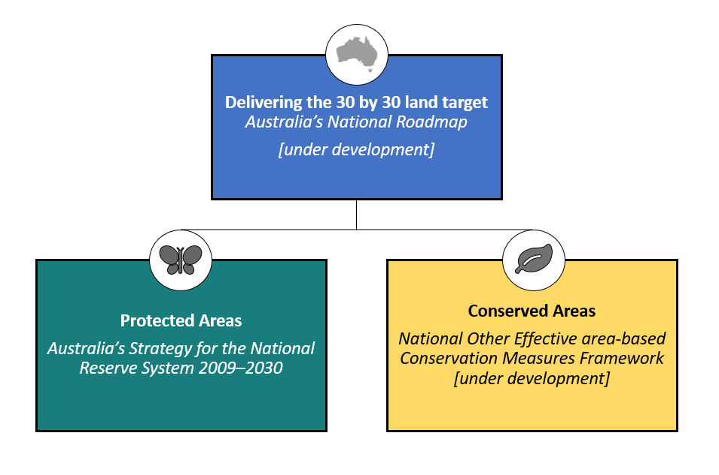
Protecting and conserving 30% of Australia’s land will not single-handedly prevent further biodiversity loss. Protected Areas and Conserved Areas are part of a suite of broader actions that together aim to alleviate the drivers of environmental decline and create conditions in which nature thrives.
All levels of government, including local, state, territory and national, implement a broad range of policies and programs to tackle major threats to biodiversity. At the national level, the Australian Government uses leadership, regulation, direct investment, and data and information to support the achievement of its objectives. For example, national environmental legislation, targeted investments through the Natural Heritage Trust, and the Threatened Species Action Plan. These are complemented by the Nature Repair Market which is in development, the Restoring Our Rivers Act to support full delivery of the Murray–Darling Basin Plan, and regional planning efforts.
All state and territory governments are implementing policies and programs that support positive outcomes for nature. On ground management of biodiversity is undertaken by landholders across Australia, First Nations people and organisations, non-government organisations, industry and volunteers. These actions together aim to put nature on a path to recovery for the benefit of people and the planet.
Responsibility for halting and reversing biodiversity loss sits across multiple sectors and groups, including government, non-government organisations (NGOs), the private sector, landholders, academia, First Nations people and each of us as consumers and members of the public.

Implementation and delivery arrangements will be developed following agreement of the Framework
This draft National OECMs Framework provides guidance on how Conserved Areas can be recognised and implemented in Australia. How implementation and delivery arrangements will operate in practice will be developed following agreement to the Framework. Wherever possible, implementation will seek to leverage existing jurisdictional mechanisms.
Interaction with the global restoration target
Target 2 of the Global Biodiversity Framework (GBF) under the Convention on Biological Diversity aims to ensure 30% of degraded areas are under effective restoration.
Targets 2 and 3 are interrelated. Their interaction in Australia is being explored through the update of Australia’s Strategy for Nature to align with the GBF and development of a national restoration target. Once the national biodiversity restoration target is agreed, consideration of whether Conserved Areas can contribute to both Targets 2 and 3 will occur.
Intersection with the Nature Repair Market
The Nature Repair Market is still in development. The intersection between Conserved Areas and the Nature Repair Market will continue to be considered.
Framework will be reviewed
As recognition of Conserved Areas in Australia is new, once agreed, the Framework will be trialled, reviewed and adjusted as necessary.
Guidance for those reviewing the draft Framework, e.g. questions and any specific issues we’d like feedback on
When reviewing this draft Framework, please consider the following questions:
- Is the Framework, including figures and diagrams, clear?
- Are there any gaps in the Framework?
- Do you think the Framework will contribute to high quality Conserved Area additions to the Conserved Area Network in Australia?
- Is the proposed site assessment tool for Conserved Areas recognition fit for purpose to identify sites eligible for Conserved Area recognition?
- If you are a landholder with a potential Conserved Area site, please consider testing the site assessment tool. Your feedback on the practical application of the tool will assist us in refining the tool if required.
- If you have tested the tool on a specific site, was it easy to use, and do you think it is fit for purpose?

National Other Effective area-based
Conservation Measures Framework

Supporting Australia to achieve 30 by 30 on land

© Commonwealth of Australia 2024
Ownership of intellectual property rights
Unless otherwise noted, copyright (and any other intellectual property rights) in this publication is owned by the Commonwealth of Australia (referred to as the Commonwealth).
The National Other Effective area-based Conservation Measures Framework is licensed by the Commonwealth of Australia for use under a Creative Commons Attribution 4.0 International licence with the exception of the Coat of Arms of the Commonwealth of Australia, the logo of the agency responsible for publishing the report, content supplied by third parties, and any images depicting people. For licence conditions see: http://creativecommons.org/licenses/by/4.0/au/.
This report framework should be attributed as the ‘National Other Effective area-based Conservation Measures Framework Commonwealth of Australia 2024’. This publication was prepared by an interjurisdictional Working Group, consisting of representatives of the Australian, state and territory governments. The Commonwealth of Australia has made all reasonable efforts to identify content supplied by third parties using the following format ‘© Copyright, [name of third party]’.
This publication is available at dcceew.gov.au/publications.
Department of Climate Change, Energy, the Environment and Water
GPO Box 3090 Canberra ACT 2601
Telephone 1800 900 090
Web dcceew.gov.au
Disclaimer
The Australian Government acting through the Department of Climate Change, Energy, the Environment and Water has exercised due care and skill in preparing and compiling the information and data in this publication. Notwithstanding, the Department of Climate Change, Energy, the Environment and Water, its employees and advisers disclaim all liability, including liability for negligence and for any loss, damage, injury, expense or cost incurred by any person as a result of accessing, using or relying on any of the information or data in this publication to the maximum extent permitted by law.
Acknowledgements
The authors thank all who inputted in the development of the National Other Effective area-based Conservation Measures Framework, including Australian Government agencies, state and territory agencies, and the public. This has been vital in developing a robust framework for recognition of Conserved Areas in Australia.
Acknowledgement of Country
We acknowledge the Traditional Owners of Country throughout Australia and their continuing connection to land, sea and community. We pay our respects to them and their cultures and to their elders both past and present. We are committed to working respectfully with Aboriginal and Torres Strait Islander peoples and give particular acknowledgement to their use, knowledge and custodianship of Australia’s native plants and animals over countless generations. We support Aboriginal and Torres Strait Islander peoples and their aspirations to maintain, protect and manage their culture, language, land and sea Country and heritage.

Contents
1 Introduction 4
2 Context 6
2.1 The Kunming-Montreal Global Biodiversity Framework 6
3 What is a Conserved Area? 7
3.1 What is not a Conserved Area? 10
3.2 Why seek Conserved Area recognition? 11
4 Principles to guide recognition of Conserved Areas in Australia 13
5 How it works in practice 15
5.1 Assessing a site 15
5.2 Reporting of sites nationally, and internationally 16
5.3 Managing a site 18
5.4 Sites that are being restored 21
5.5 Requiring a long-term commitment 21
5.6 Assurance 23
5.7 Review and continuous improvement 23
6 Further information 24
Glossary 25
References 29
Appendix 1 – Detailed principles 30
Appendix 2 – Minimum requirements 37
Appendix 3 – Requirements for site management arrangements 39
Appendix 4 – Conserved Areas site assessment tool 40

Figures
Figure 1: Protected and Conserved Area contributions 5
Figure 2: Important biodiversity values for Conserved Areas 8
Figure 3: Protected and Conserved Area characteristics 9
Figure 4: Site assessment process 15
Figure 5: Site reporting process 16
Figure 6: Site management 18

Boxes
Box 1: Case study – what does a Conserved Area look like? 9
Box 2: Case study – what is a Protected Area, and not a Conserved Area? 11
Box 3: Case study – what wouldn’t meet the requirements of a Conserved Area? 11
Box 4: Case study – why seek Conserved Area recognition? 12
Box 5: Case study – monitoring requirements for a Conserved Area with biodiversity conservation as a secondary management objective 20
Box 6: Case study – what is long-term conservation? 22

Introduction
The National Other Effective area-based Conservation Measures (OECMs) Framework provides guidance on recognition of land based OECMs in Australia. The framework identifies principles to guide OECM recognition, provides information on implementation of these principles, and includes a site assessment tool.
OECMs deliver effective in-situ conservation of biodiversity, regardless of primary management objectives. Australia does not currently recognise or record OECMs, which are an important component of Target 3 of the Global Biodiversity Framework under the Convention on Biological Diversity (see section 2). Both Protected Areas and OECMs can contribute to Australia’s 30 by 30 target, and the global 30 by 30 target.
Throughout this framework, OECMs are referred to as Conserved Areas, references to ‘jurisdictions’ include Australian, state and territory governments, and references to ‘land based’ includes inland waters.
This framework is being developed by the Australian, state and territory governments. It will support collective efforts and strategic investment in the protection and conservation of areas of land with important biodiversity values.
The goal of the framework is to provide guiding principles (see section 4) and minimum requirements (see section 5) to underpin a nationally consistent approach across jurisdictions to the recognition of land based Conserved Areas in Australia.
Recognition of Conserved Areas in Australia is an opportunity to:
- Give greater recognition to areas important for biodiversity, including First Nations peoples’ land management (caring for Country), where formal Protected Area designation is not possible, appropriate, or desirable.
- Recognise biodiversity conservation action that is occurring outside formally designated Protected Areas.
- Build ecologically representative and well-connected Protected and Conserved Area networks.
- Recognise voluntary conservation efforts in areas where land is managed for other purposes, such as productive landscapes.
- Enhance the ability of private landholders to protect biodiversity on their land, including through mechanisms such as the Nature Repair Market or as a restoration action under the proposed new national environmental law.
Recognition of Conserved Areas is part of a comprehensive approach to halting and reversing biodiversity loss. All Australian, state and territory governments have legislation, policies and programs that focus on the conservation of Australia’s unique biodiversity. Recognition of Conserved Areas complements these other initiatives.
Nationally agreed initiatives with a focus on biodiversity conservation include Australia’s Strategy for Nature and Australia’s Strategy for the National Reserve System. Relevant Australian Government initiatives include the Nature Repair Market and the Nature Positive Plan: better for the environment, better for business which is the most comprehensive reform of Australia’s national environmental law since it commenced in 2000.
Conserved Areas could be projects under the Nature Repair Market
The Nature Repair Market will mobilise private finance to repair and protect our unique natural environment.
It will create opportunities for landholders to repair, protect and restore nature on their land. It will make it easier for businesses, philanthropists, and other Australians to invest in these outcomes.
The Australian Government is establishing the Nature Repair Market under the Nature Repair Act 2023 (the Act). Many aspects of the scheme are being developed, including the legislative rules, methods and guidance material.
An expert committee – the Nature Repair Committee – will advise on methods that set the rules for types of Nature Repair Market projects, including their integrity requirements.
Subject to the views of the Nature Repair Committee, a method could be developed to deliver a Conserved Area. A Conserved Area method would reflect the national OECM framework requirements, and as such, could be considered and developed once the framework is agreed. Methods would set out requirements to demonstrate the project was unlikely to have occurred otherwise (often referred to as ‘additionality’), and how biodiversity gain would be measured and monitored.
Nature repair projects will be administered by the Clean Energy Regulator (CER), within its existing mandate and resourcing.

Figure 1: Protected and Conserved Area contributions
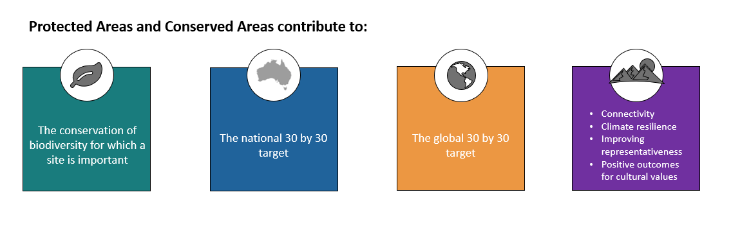

Context

The Kunming-Montreal Global Biodiversity Framework
In December 2022, Parties to the Convention on Biological Diversity (CBD) negotiated a strategic plan for the period to 2030, referred to as the Kunming-Montreal Global Biodiversity Framework (GBF). The GBF will guide international and national biodiversity action and investment until at least 2030.

The global ‘30 by 30’ target
Target 3 of the GBF, often referred to as the ‘30 by 30’ target, aims to ensure 30% of the world’s land and 30% of the world’s ocean is conserved by 2030 through Protected and Conserved Areas.
Target 3: Ensure and enable that by 2030 at least 30% of terrestrial and inland water areas, and of marine and coastal areas, especially areas of particular importance for biodiversity and ecosystem functions and services, are effectively conserved and managed through ecologically representative, well-connected and equitably governed systems of protected areas and other effective area-based conservation measures, recognizing indigenous and traditional territories, where applicable, and integrated into wider landscapes, seascapes and the ocean, while ensuring that any sustainable use, where appropriate in such areas, is fully consistent with conservation outcomes, recognizing and respecting the rights of indigenous peoples and local communities, including over their traditional territories.

Australia’s ‘30 by 30’ target
Reflecting the global 30 by 30 target, the Australian Government has set a national target to protect and conserve 30% of land and 30% of marine areas by 2030. All state and territory Environment Ministers agreed to work collectively to meet the national target.
Around 22% of Australia’s landmass is in formal Protected Areas (as of June 2022). Reaching 30% by 2030 requires additions to Australia’s network of Protected Areas (the National Reserve System), and recognition of Conserved Areas (which will contribute to the Conserved Areas Network). An additional 60 million hectares needs to be protected or conserved to meet the 30% target.
To support efforts towards the 30 by 30 target, Environment Ministers agreed to develop a national 30 by 30 roadmap and to develop this national framework for the recognition of land based Conserved Areas to complement growth in Protected Areas. The roadmap is underpinned by Australia’s Strategy for the National Reserve System 2009–2030, and this framework.

What is a Conserved Area?
OECMs (Conserved Areas) are defined by the Conference of the Parties to the CBD as:
A geographically defined area other than a Protected Area, which is governed and managed in ways that achieve positive and sustained long-term outcomes for the in-situ conservation of biodiversity, with associated ecosystem functions and services and where applicable, cultural, spiritual, socio-economic, and other locally relevant values.
Conserved Areas deliver effective in-situ conservation of biodiversity, even if management for conservation is not the primary management objective. This is distinct from Protected Areas, which must have a primary conservation objective. A primary management objective is one that applies to at least 75% of the site. This is consistent with the ‘75 per cent rule’ described in IUCN guidance on Protected Area management categories (Dudley, N., 2008).
Conserved Areas may be managed with biodiversity conservation as:
- a primary management objective (referred to in this framework as a ‘primary Conserved Area’), e.g. if the landholder does not wish to enter a formal conservation covenant, or there are impediments to applying formal Protected Area designation, (such as pastoral leasehold lands where lease requirements do not allow for a protective mechanism such as a covenant, but do allow for conservation activities); or
- a secondary management objective (referred to in this framework as a ‘secondary Conserved Area’), e.g. a Defence area that has a primary management objective related to Defence activities, but where biodiversity conservation is a secondary management objective; or
- an ‘ancillary’ result of long-term management activities, i.e. there is no explicit intent to conserve biodiversity, however, it is being conserved as a result of the primary management activity (referred to in this framework as an ‘ancillary Conserved Area’).
The management of biodiversity values in a way that achieves their long-term maintenance (or improvement) is the fundamental basis for Conserved Areas. Conserved Areas are expected to achieve the conservation of biodiversity values, rather than conservation of individual species. Conserved Areas must have biodiversity values for which a site is important. Without identification of at least one of the values identified in Figure 3, a site cannot be recognised as a Conserved Area.
Figure 2: Important biodiversity values for Conserved Areas
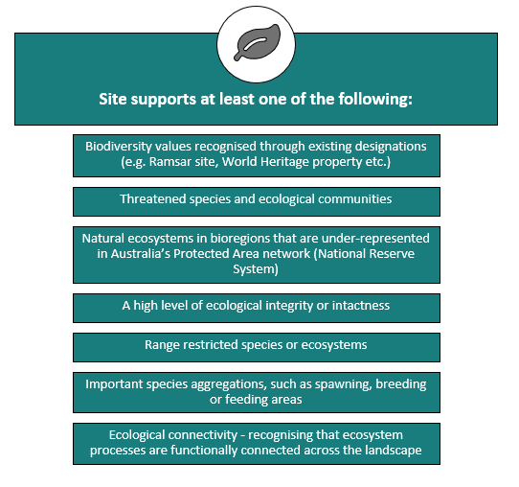
Note: the biodiversity values were adapted from the IUCN guidance to suit Australian circumstances, and are reflected in the Conserved Areas site assessment tool (Appendix 4). (IUCN-WCPA Task Force on OECMs 2019).
Protected and Conserved Areas are complementary mechanisms to increase biodiversity conservation in Australia (refer Figure 4). While there is no requirement for legal protection, Conserved Areas provide opportunities to protect natural areas with important biodiversity values, and mitigate risks to the biodiversity values from human activities. Conserved Area recognition should be considered for areas that do not meet the Protected Area definition, for example where formal Protected Area designation is not possible or supported.
A site can be either a formally designated Protected Area or recognised as a Conserved Area – it cannot be both. This means areas that are National Parks, Indigenous Protected Areas, or any other type of Protected Area, cannot be considered for Conserved Area recognition.
In some cases, Conserved Areas may help conserve or maintain biodiversity values equivalent to, or of more importance, than some Protected Areas.
- Conserved Areas contribute to the Conserved Areas Network.
- Protected Areas contribute to the National Reserve System (NRS).
The Conserved Areas Network complements the NRS. Conserved Areas should be viewed as being of equal value to Protected Areas in terms of the biodiversity outcomes they achieve. The Conserved Area Network complements, but does not duplicate or replace, the National Reserve System.
Figure 3: Protected and Conserved Area characteristics
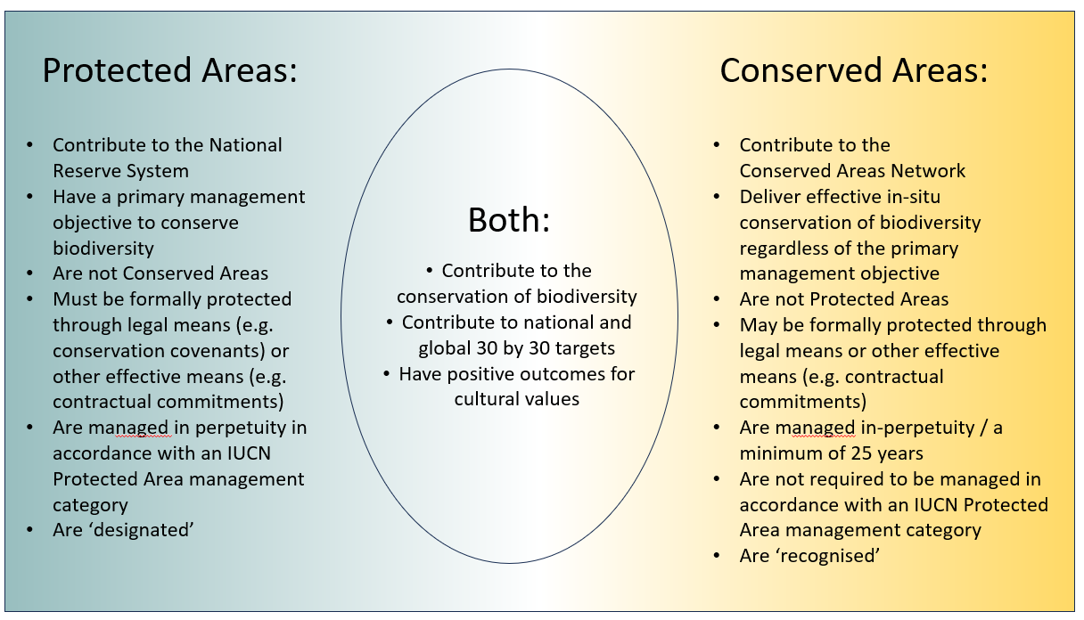
Examples of sites that, dependent on site-specific values, may be recognised as Conserved Areas are some areas of Defence land, travelling stock routes, urban parks managed for recreation that are large enough and sufficiently natural to also achieve in-situ conservation of biodiversity, and natural areas managed by universities for biological research.
An example of an ancillary Conserved Area is a site where there is coincidental protection of habitats, such as when water supply catchment areas are legally protected for water quality purposes, even though biodiversity conservation is not a management objective. Water supply catchment areas do not meet the Protected Area definition as they do not have a primary biodiversity conservation objective, however, they are either managed with biodiversity conservation as a secondary objective, or biodiversity conservation outcomes are the ancillary result of the legal protection and management of the area for water supply.
Box 1: Case study – what does a Conserved Area look like?
A water reservoir is managed by the local council and has the primary management objective of protecting the water supply. The council also appreciates the biodiversity values at the site, and actively conserves those values.
The site is in good condition with few invasive species, and provides important breeding and foraging habitat for threatened species, supports migratory species, and has critically endangered ecological communities. In addition, it is in a bioregion that has less than 10% of its area in Protected Areas.
The reservoir is open to the public for hiking, picnics and non-motorised boating activities. Potentially damaging activities are prohibited, for example, no swimming or camping is allowed and dog walking can only occur on a lead in certain areas.
The council intends to maintain the reservoir in the long term, and to continue to conserve the biodiversity values. The site has a plan of management that describes the site’s important biodiversity values and management actions to address threats to those values. The plan specifies monitoring to track the condition of the site’s biodiversity values.

What is not a Conserved Area?
Conserved areas are distinct from Protected Areas. A site can be a Protected Area or a Conserved Area, it cannot be both.
Conserved Areas will contribute to the Conserved Areas Network, but will not contribute to the National Reserve System of Protected Areas. There is no requirement for Conserved Areas to be managed in accordance with an IUCN Protected Area management category.
Recognition of a Conserved Area does not alter the land tenure of the site or the existing landholder’s ownership arrangements. For example, recognition as a Conserved Area does not change the tenure to Commonwealth land.
Suitability of a site for recognition as a Conserved Area requires assessment of its biodiversity values and management arrangements. Conserved Areas are not able to be identified based on a broad land use category (e.g. agricultural lands, urban parks).
Conserved Areas need to meet all requirements for recognition, for example, a site may have biodiversity values that make it important, but if there are no management arrangements in place, it would not meet the requirements for recognition as a potential primary or secondary Conserved Area.
The CBD term ‘other effective area-based conservation measures’ includes ‘measures’, however, it is not the intent that measures are actions, for example regulations that prohibit entry into environmentally sensitive sites. As noted in the definition, Conserved Areas are geographically defined areas.
Examples of areas unlikely to meet the requirements for Conserved Area recognition are forests managed exclusively for timber supply, agricultural grasslands that are grazed too intensively or where herbicide use does not support native grassland ecosystems, or sites that are degraded to a point where they are not delivering demonstrable biodiversity outcomes.
Box 2: Case study – what is a Protected Area, and not a Conserved Area?
Pauline and Alf have a property that they manage for biodiversity conservation. There are important biodiversity values on the site, including a threatened ecological community.
The property is managed in accordance with an IUCN Protected Area management category.
The property meets the requirements and has been formally designated as a Protected Area through a conservation covenant being registered on the property’s title. As a Protected Area it is part of Australia’s network of Protected Areas, the National Reserve System.
Pauline and Alf’s property is a Protected Area. It is therefore not eligible to be a Conserved Area.
Box 3: Case study – what wouldn’t meet the requirements of a Conserved Area?
Lucie is an environmental officer at a local council. She knows of a park that has trees used by black cockatoos as a ‘mega roosting’ site. Lucie knows mega roosting sites are important habitat and wonders if the site could be recognised as a Conserved Area, as one of the principles for recognition of Conserved Areas is that they must have biodiversity values for which a site is important.
The trees surround a public oval that is used for organised sport, individual exercise and off-leash dog play. The site also has buildings and other infrastructure to support community events.
The site is managed with the primary objective of enhancing the local community’s wellbeing: aiming to be regularly used, aesthetically pleasing, and safe. The turf grass is fertilised and mown. The trees are protected by keeping buildings and carparks a minimum distance away and not removing any taller trees to install infrastructure. The oval is lit each night to extend use opportunities.
While the site has biodiversity values that make it important, the management of the site to support organised sport, individual exercise and off-leash dog play is incompatible with management for biodiversity conservation. As such, it is unlikely to be suitable for recognition as a Conserved Area.

Why seek Conserved Area recognition?
There are a range of reasons why a landholder may seek Conserved Area recognition. Recognition as a Conserved Area:
- Formally acknowledges a landholder’s management of their property’s important biodiversity values.
- Provides international recognition of the area, and its contribution towards global biodiversity targets.
- Allows landholders to continue to manage their land consistent with their primary management objective, which often relates to income generation, or protection for other means (e.g. water catchment areas).
- Allows a landholder to promote that the land is being managed for the long-term conservation of biodiversity values that make a site important, regardless of other land management that is occurring.
- Ensures important biodiversity values are conserved, which will have flow on benefits for the primary purpose of the land being managed. For example, maintaining natural vegetation in a water catchment area will maintain or improve water quality in the water reservoir (See case study at Box 1).
- Can be an entry point into natural resource management. Some landholders may be reluctant to enter into a conservation covenant arrangement in perpetuity. Conserved Area recognition may be a starting point on their conservation journey.
- Increases the likelihood that efforts to conserve biodiversity will continue as landholders are making a conscious decision and overt commitment to conserve biodiversity values.
- Primary producers would still be eligible for relevant tax concessions, compared with Protected Areas where they may not be eligible.
- Allows landholders to credibly market their environmental credentials.
- Could be an aspect of a project under the Nature Repair Market once the scheme is operational.
- Could be considered as a restoration action supported under the reformed national environmental law, including regional plans.
In circumstances where the primary management objective of a site is biodiversity conservation, but there is an impediment to formal protection, (for example, a conservation covenant cannot be registered on the property title), Conserved Area recognition may be appropriate until the impediment can be addressed.
Box 4: Case study – why seek Conserved Area recognition?
Jane manages her property for the primary purpose of producing food, in particular, berries. Jane cares about the significant biodiversity values on her property – in particular, birds that nest in the trees on the property that surround her berry crops. She has actively managed the bird habitat to ensure the birds are not impacted by her food production activities. She documents her efforts, including monitoring the birds’ nesting activities.
Jane is reluctant to register a conservation covenant on her property’s title due to the restrictions it would place on management which may affect her ability to run her business.
Conserved Area recognition enables Jane to be recognised for her efforts to conserve biodiversity on her property, balanced with her primary management objective for the site.

Principles to guide recognition of Conserved Areas in Australia
The following principles guide the type of areas that could be recognised as Conserved Areas in Australia, and underpin the guidance provided throughout the Framework. Detailed explanatory guidance relating to each principle can be found at Appendix 1. The principles are reflected in the site assessment tool at Appendix 4.
PRINCIPLE 1 – CONSENT
- Consent of the site’s governance authority/ies must be informed, voluntary, and obtained before an assessment of a site’s eligibility is undertaken, and before recognition of the site as a Conserved Area.
PRINCIPLE 2 – FREE, PRIOR AND INFORMED CONSENT
- Assessment and recognition of potential Conserved Areas governed by First Nations people requires the free, prior and informed consent of the relevant governance authority or authorities.
PRINCIPLE 3 - BIODIVERSITY VALUES
- Conserved Areas must have biodiversity values for which a site is important, documented in detail at the time of the site assessment. Maintaining values is a long-term objective.
PRINCIPLE 4 – PRIORITISATION OF AREAS OF PARTICULAR IMPORTANCE FOR BIODIVERSITY
- Areas of particular importance for biodiversity should be prioritised for assessment.
PRINCIPLE 5 – OTHER RELEVANT VALUES AND PRACTICES
- Where applicable, cultural, spiritual, socio-economic and other locally relevant values and practices linked to positive biodiversity outcomes may be considered as part of the assessment of a site for Conserved Area recognition.
PRINCIPLE 6 – RESTORATION SITES
- A site that is severely degraded, damaged or destroyed, and not yet under ecologically effective restoration, is not appropriate for Conserved Area recognition.
- A site under ecological restoration may be recognised as a Conserved Area, once delivering demonstrable biodiversity outcomes. Restoration actions must include actions that address the cause of the original degradation / biodiversity loss.
PRINCIPLE 7 – PROTECTED AREA CONSIDERATION
- A site’s suitability for Protected Area designation should be considered first. Conserved Area recognition should be considered in circumstances where formal Protected Area designation is not appropriate, supported, achievable or desirable. However, Conserved Area status may be appropriate while Protected Area designation is being sought.
PRINCIPLE 8 – GEOGRAPHICALLY DEFINED AREA
- Conserved Areas must have clear and agreed boundaries that can be accurately identified on maps and on the ground.
PRINCIPLE 9 – LAND TENURE
- Conserved Areas can be recognised on all forms of land tenure in Australia, with the exception of sites already designated as a Protected Area.
- For Conserved Areas to be recognised on leasehold land, conservation must be compatible with lease conditions and legislation.
PRINCIPLE 10 – GOVERNANCE
- The following governance types will be recognised: governments; organisations or private individuals; First Nations people; and shared or jointly managed areas.
PRINCIPLE 11 – SITE MANAGEMENT
- Management objectives and activities must not be incompatible with biodiversity conservation of the site.
- Sites with a primary or secondary conservation objective should have documented site management arrangements that include (at a minimum), the biodiversity values for which the site is important, the conservation objectives for the site, threats, adaptive management actions, monitoring, and relevant jurisdictional land management requirements.
- Sites must meet land management requirements set in legislation, such as those relating to invasive / feral species management, fire risk management, natural heritage, and First Nations and other cultural heritage protection and management.
- First Nations Peoples’ knowledge in caring for Country should be considered and incorporated where appropriate in Conserved Area management arrangements.
PRINCIPLE 12 – SUSTAINED LONG-TERM
For a site to be recognised as a Conserved Area with a primary or secondary management objective of biodiversity conservation, at a minimum there must be:
- a clear long-term intention (minimum 25 years) for the continuation of management arrangements that deliver in-situ biodiversity conservation outcomes
- a commitment to a minimum timeframe for management arrangements that deliver in-situ biodiversity conservation outcomes, determined at the time of site assessment
- no intention to sell or develop the site in a manner incompatible with biodiversity conservation
- no land use zoning on the site that is incompatible with biodiversity conservation.
For ancillary Conserved Areas, at a minimum there must be:
- a clear long-term intention (minimum 25 years) for the continuation of management activities that are delivering in-situ biodiversity conservation outcomes
- no intention to sell or develop the site in a manner incompatible with biodiversity conservation
- no land use zoning on the site that is incompatible with biodiversity conservation.

How it works in practice
This section provides information on implementation of the principles listed in the previous section. Implementation in accordance with the principles (Appendix 1) and minimum requirements (refer Appendix 2) of this framework will ensure a consistent approach to recognition of Conserved Areas.

Assessing a site
Figure 4: Site assessment process
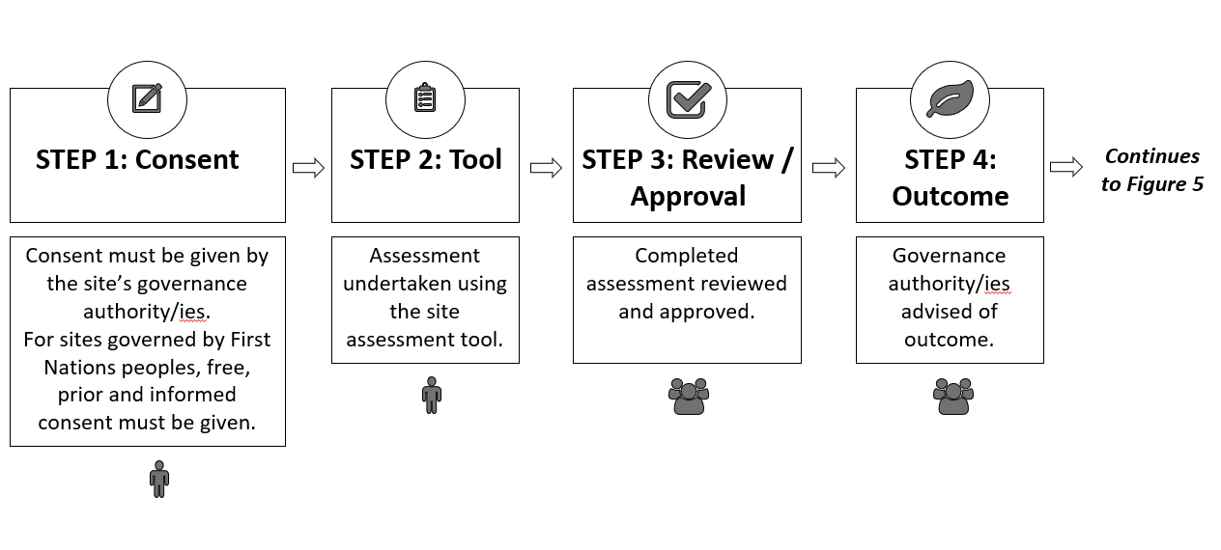
Detailed assessment of potential Conserved Areas should be conducted on a site-by-site basis. Assessment of a site will determine if it can be recognised as a Conserved Area.
The Australian site assessment tool should be used as the basis for assessing potential Conserved Areas. The tool can be found at Appendix 4. The tool requires information on the site’s governance authority/ies, biodiversity values, and management arrangements. Sites must meet all essential requirements in the tool to be eligible to be recognised as a Conserved Area. The tool captures the necessary supporting evidence to allow the site to be assessed, and the site to be approved, reported and recorded as a Conserved Area.
Evidence of consent to undertake an assessment, and consent for a site to be recognised as a Conserved Area, are required. For sites governed by First Nations people, free, prior and informed consent needs to be demonstrated ahead of assessment and recognition. Consent can be withdrawn at any time, including after a site has been recognised. If consent is withdrawn, a site would no longer be recognised as a Conserved Area.
Existing information, such as reports that provide information on biodiversity values, management and monitoring arrangements, can be used to inform the assessment. While an assessment can be based on a desktop analysis alone, where there is uncertainty about the quality or currency of existing information, additional information may need to be collected. This may involve a site visit by the assessor, depending on the type of information required.

Approval of an assessment
Completed assessments require review and approval by a third party, i.e. a person who did not complete the original assessment. The third party could be from a government agency, or another person / organisation.
Following review and approval, the landholder is advised of the outcome. If the site meets all the requirements for recognition, consent of the landholder to formally recognise the site is required, following which the site can be recorded as part of the Conserved Areas Network.

When sites don’t meet the requirements for recognition
Landholders who don’t meet all the requirements for their property to be recognised will be notified of the outcome of the assessment, and provided with information on improvements that may be needed to meet the threshold for recognition.

Reporting of sites nationally, and internationally
Figure 5: Site reporting process
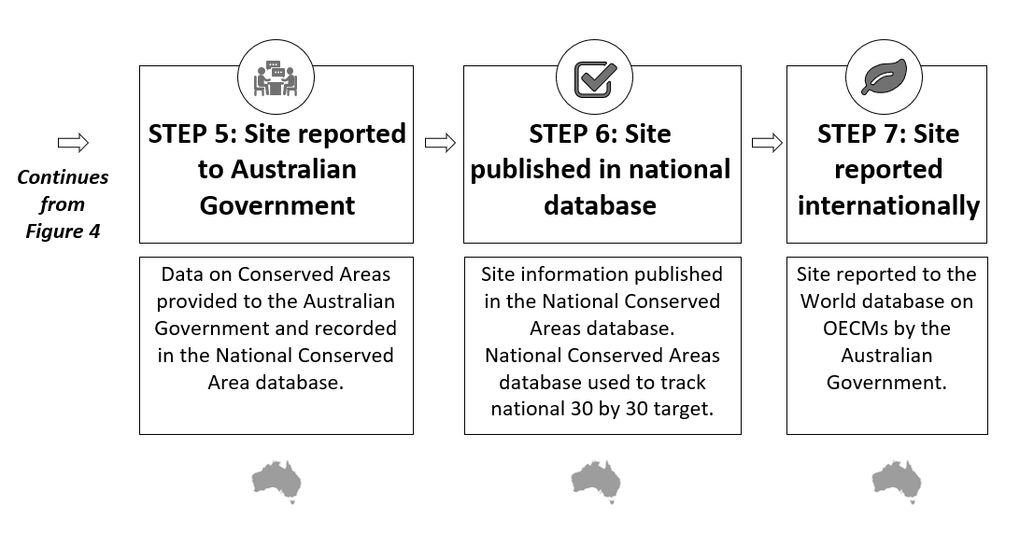
Once recognised as a Conserved Area, the site will contribute to the national and global 30 by 30 targets.
Based on the site assessment, information will be recorded in a database by the relevant government. Information to be captured in the database will include:
- site name
- location, longitude and latitude coordinates, area (hectares), bioregion / subregion
- recognition date, and expiry date for fixed term agreements
- name of the management authority
- spatial boundary information, and source of the spatial boundary
- governance type (governments; organisations or private individuals; First Nations people; and shared or jointly managed areas)
- whether biodiversity conservation is a primary, or secondary management objective, or the ancillary result of other activities
- date of the most recent amendment to the site (for example, date of a management authority or spatial boundary change)
- that site management arrangements are in place.
Data on Conserved Areas will be provided to the Australian Government on a regular basis and recorded in a national database managed by the Australian Government. Collating information and updating the database will occur as soon as practicable.
Internationally, the site will be recorded in the World Database on OECMs.

Environmental offset sites and restoration actions undertaken for regulatory purposes
A site where an environmental offset has been delivered to compensate for the impacts of a development activity under the current Commonwealth environment law (the Environment Protection and Biodiversity Conservation Act 1999) can be considered for recognition as a Conserved Area. The site must meet all relevant requirements, including that it delivers demonstrable biodiversity outcomes. Recognition of the site would be considered on a case-by-case basis. Similarly, under the Australian Government’s proposed new environmental laws, the site where a restoration action is undertaken may be considered for recognition as a Conserved Area.
States and territories have established processes for determining whether environmental offset sites can contribute to the National Reserve System, or whether Protected Areas are suitable locations for environmental offset activities. The role of environmental offsets with Conserved Areas will be at the discretion of the relevant Australian, state or territory government agency. This discretion will also apply in the assessment and inclusion of potential sites under other regulatory settings.

Sensitive data
There may be circumstances where a landholder does not wish to have information about their Conserved Area published. Landholders can request information about their property location or other sensitive information not being disclosed in the databases. In these circumstances, the sensitive data would not be included in public datasets, but would be included in summary statistics without disclosing the location. This is consistent with the approach taken for sensitive Protected Area data recorded in CAPAD.
Note: Some information may be culturally protected and the storage and management of First Nations knowledge must have consideration to protecting Indigenous Cultural Intellectual Property.

Managing a site
Figure 6: Site management
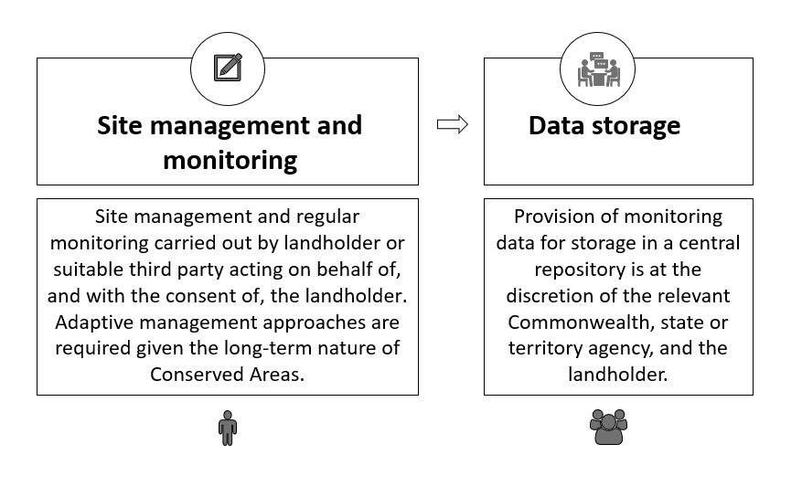
To be recognised as a Conserved Area with biodiversity conservation as either a primary or secondary management objective, management arrangements should be in place. Management arrangements include one or a combination of the following:
- a plan of management
- a management statement or equivalent (including those that have a broader focus but that include a section on biodiversity conservation)
- supplementary documents that define conservation objectives and complement existing plans (e.g. restoration plans, monitoring plans, etc.)
- information in a strategy or plan that covers multiple sites
- information provided in the site assessment tool as part of the assessment process.
As Conserved Areas may have a primary management objective that is not biodiversity conservation, management arrangements may also focus on other operational aspects of the site.
At a minimum, management arrangements should document:
- conservation objectives for the site
- the biodiversity values for which the site is important
- threats to those values
- management actions and
- monitoring.
Management arrangements must also indicate that the site meets land management requirements set in legislation, such as those relating to invasive / feral species management, fire risk management, natural heritage, and First Nations or other cultural heritage protection and management. Where appropriate, First Nations peoples’ knowledge in caring for Country should be considered. Further detail on requirements for management arrangements is at Appendix 3.
Given the long-term nature of Conserved Areas, adaptive management approaches are required, including in response to the changing climate. The widespread impacts of climate change on Australia’s biodiversity, make it difficult for some biodiversity values to be maintained in the long-term, even with adaptive management.
Management arrangements should be reviewed periodically (e.g. every 5 years). They are intended to be living documents that assist land managers to make decisions about the site, ensure appropriate management actions are occurring, and inform adaptive management of the site.

When documenting management arrangements is optional
Conserved Areas that are recognised as having coincidental benefits for biodiversity conservation (i.e. ancillary Conserved Areas) do not require documented biodiversity conservation management arrangements. Ancillary Conserved Areas benefit from protection of a site for another reason (for example, water catchment areas). If biodiversity conservation is explicitly recognised as a management objective, the site would be eligible to be assessed as a primary or secondary Conserved Area, rather than an ancillary Conserved Area.

Publishing management arrangements
Publication of management arrangements allows for shared learnings. It is at the discretion of the landholder.

Monitoring
Well-managed Conserved Areas provide long-term conservation of biodiversity values. Monitoring will assist in tracking whether Conserved Areas are achieving the long-term conservation of biodiversity values for which the site is recognised. Monitoring supports adaptive management, demonstrates the effectiveness of management actions, and allows achievements to be celebrated.
Conserved Areas should be monitored at a frequency required to detect meaningful change in the site’s biodiversity values. This will be dependent on the biodiversity values at the site. This monitoring may be undertaken by the landholder, or someone on the landholder’s behalf. Monitoring is not required more than yearly and should occur no less than every 5 years. Provision of monitoring data for storage in a central repository, such as the biodiversity data repository, is at the discretion of the relevant government agency, and the landholder.
Minimum requirements for monitoring include:
- baseline documentation
- ongoing monitoring of the biodiversity values for which the site is recognised, and the threats to those values
- monitoring of governance, management systems and, where appropriate stakeholder involvement, that contribute to the biodiversity outcomes
- where appropriate, ongoing community-based monitoring, participatory mapping and incorporation of First Nation peoples’ knowledge, including any activities that could contribute towards meeting Closing the Gap targets.
Where there are existing monitoring systems, these can be used. These could include site specific monitoring, jurisdiction monitoring systems, or a system based on national monitoring protocols (such as the Ecological Monitoring System Australia (EMSA), developed by Australia’s Terrestrial Ecosystem Research Network (TERN), and Accounting for Nature). Where possible, monitoring should be based on a scientifically designed and implemented monitoring and reporting program and use monitoring specifications for listed species and ecological communities. Monitoring will assist landholders in the adaptive management of sites.
Box 5: Case study – monitoring requirements for a Conserved Area with biodiversity conservation as a secondary management objective
Jess runs a wellbeing retreat. Her property has native bushland including areas of a Threatened Ecological Community (TEC). The TEC is not impacted by her business activities.
Jess is motivated to maintain the biodiversity values on her property as they add to her business reputation. Jess uses simple and effective management activities to maintain biodiversity values such as: removing weeds; limiting access to areas of high biodiversity value; monitoring biodiversity values and new threats (such as new invasive species); and adapting her management if actions are not effective or new threats are identified.
Jess is keen to recognise her property as a Conserved Area to further build her business’ reputation.
Operating her business is Jess’ primary management objective; biodiversity conservation is a secondary management objective. The site could be recognised as a secondary Conserved Area. Sites that are either primary or secondary Conserved Areas need to have management arrangements and monitoring.
Jess already undertakes effective management (including monitoring) on her property, which is required for it to become a Conserved Area, so she does not need to undertake any additional, regular monitoring for biodiversity values.
If Jess voluntarily decided to change her monitoring or start monitoring additional aspects, the monitoring should be frequent enough to identify substantial change. For example, monitoring established vegetation would be less frequent and more flexible than monitoring a migratory species.

Monitoring cultural, spiritual, socio-economic and other locally relevant values and practices
Monitoring of cultural, spiritual, socio-economic and other locally relevant values and practices is voluntary. Monitoring of these values is at the discretion of landholders and should include consultation with the relevant people, such as First Nations peoples.

Sites that are being restored
Sites being restored, that are delivering the effective in-situ conservation of biodiversity may be recognised as Conserved Areas. However, sites requiring restoration that are not being actively restored, are severely degraded, damaged, or destroyed are not appropriate for Conserved Area recognition.
Conserved areas with 75% or more of their area under restoration should identify additional management and monitoring requirements. This approach is informed by the ‘75% rule’ described in IUCN guidance on Protected Area management categories which states that the primary management objective should apply to at least 75% of the site (Dudley, N. (Ed), 2008). Sites with 25% or less of their area under restoration are not subject to additional requirements.
If a site is under restoration, in addition to meeting the management arrangement requirements outlined at Appendix 3, further detail will be required on management actions and monitoring that will be undertaken to reach and monitor identified restoration outcomes.
The National standards for the practice of ecological restoration in Australia cover planning, implementing, monitoring and evaluating activities including having a clear understanding of the current ecosystem condition, the reference ecosystem to aim for, targets and goals, a description of actions and activities to reach the goals, measurable outcomes and timelines and monitoring requirements. Management arrangements for sites under restoration should, where possible, align with the national standards for restoration, or other relevant state and territory requirements or standards that may be in place.

Requiring a long-term commitment
Landholders should have a clear long-term intention for the continuation of management arrangements that deliver in-situ biodiversity conservation outcomes. In addition there should be:
- A commitment to a minimum timeframe specified at the time of site assessment.
- No intention to sell or develop a site in a manner incompatible with biodiversity conservation.
The site should not have land use zoning that is incompatible with biodiversity conservation.
Where a landholder is not able to commit to in-perpetuity conservation, a minimum period for Conserved Areas is 25 years. This is consistent with the minimum requirement for privately Protected Areas to be considered protected in the long-term, set out in the IUCN Guidelines for Privately Protected Areas (Mitchell, B.A. et. al., 2018).
Box 6: Case study – what is long-term conservation?
Jim’s company has a property that meets the requirements for Conserved Area recognition, but he is unclear how long he would need to commit to meet the long-term requirement. He intends for the property to be a biodiversity conservation site for the foreseeable future, however, fellow board members have raised concerns about lack of flexibility in commitments greater than 30 years.
Biodiversity conservation is most successful when it is long-term and sustained. The board members could agree to conservation for a period of 30 years. As this is greater than the minimum 25 year term, the property could be assessed for Conserved Area recognition.
Conserved Area recognition is voluntary. If the company withdraws consent for recognition at any time, the site would no longer be recognised. If consent is withdrawn, an authorised company representative should speak with the relevant government agency that approves Conserved Areas in the company’s jurisdiction.
There is no requirement for a Conserved Area to be secured by legal means. There may, however, be circumstances in which a legal mechanism (or other effective long-term measure, e.g. a contract or project under the Nature Repair Market once operational) is appropriate. For example, there may be circumstances where a covenant (that is not a private protected area), that allows for biodiversity conservation as a primary management objective and is 25 years or more, could be registered on the land title. Over time, the Commonwealth, states and territories may amend existing or develop new mechanisms to secure long-term Conserved Area recognition.
Some areas of land may already be secured under other legislation that is not Protected Area focused. Including for example, forestry, water, cultural heritage, defence, or local government legislation. This security may provide long-term conservation of the biodiversity values of a site that may be suitable for recognition as a secondary or ancillary Conserved Area.

Changing ownership
The existing owner should inform the relevant government agency that a property is changing hands. This provides an opportunity for the relevant agency to engage with a new landholder and seek their consent for a property to continue to be recognised as a Conserved Area. This requires the new landholder’s agreement to undertake management, monitoring and reporting for the site. If the landholder does not consent, the site would be removed from the Conserved Area Network.
The absence of regular monitoring and reporting, if it was occurring, could indicate a change in landholder circumstances or property ownership.

Assurance
Systems and processes that provide assurance that Conserved Areas are accurately reported and that biodiversity values are conserved will build trust in the effectiveness and integrity of the Conserved Area framework.
Over time Conserved Areas may change, for example, due to changes in management objectives or changes in the condition of the surrounding landscape. Further, the primary management objectives for a site may change, and consequently it may no longer deliver biodiversity outcomes.
Conserved Area recognition may be reviewed when there is:
- a change of site boundary
- a change of management objective
- a large-scale natural disaster (for example, flooding, fire).
The scope of a review would be on a case-by-case basis, dependent on the reason triggering the review. For example, if a boundary change leads to a large reduction in area, a full re-assessment of the Conserved Area site could be required.

Removal of Conserved Area recognition
Sites should have their Conserved Area recognition withdrawn, or removed in the following circumstances:
- Where a site is designated as a Protected Area.
- Where a landholder requests that recognition be removed.
- Where a new landholder does not consent to the continuation of Conserved Area recognition.
- If any of the essential requirements outlined in the site assessment tool are no longer met. For example, the biodiversity values at the site are irreparably damaged.
Conserved Areas are recognised for their biodiversity values. Reasonable steps should be taken to rectify issues to reverse or prevent the long-term decline in a site’s values.
If a site loses its Conserved Area recognition, the site would be removed in the next update of the Conserved Area database. Details of why a site lost its recognition could be retained for consideration, future learning and potential Conserved Area improvements.

Review and continuous improvement
This framework, and its practical implementation, will be reviewed 2 years from the date of agreement to ensure that the policy settings are fit for purpose.

Further information
For further information on the recognition of Conserved Areas, please contact NRS.environment@dcceew.gov.au.

Glossary
Term |  | Definition
Ancillary Conserved Areas | Areas where there is no explicit intent to conserve biodiversity, however the site is being conserved as a result of the primary management activity.
Areas of particular importance for biodiversity | Kunming-Montreal Global Biodiversity Framework Target 3 guidance:  Areas particularly important for biodiversity include areas high in species richness or threatened species, threatened biomes and habitats, areas with particularly important habitats and areas that are important for the continued provision of ecosystem functions and services. The protection of such areas should be prioritised in reaching target 3.
Australia's Strategy for the National Reserve System 2009-2030 | Agreed by all Australian governments in 2009, sets priority actions and targets for a nationally coordinated approach to establishing and managing the National Reserve System.
CAPAD | The Collaborative Australian Protected Area Database (CAPAD) is the national database with information on Australia’s Protected Areas. CAPAD is published every 2 years. CAPAD is compiled using data from state and territory governments and non-government organisations.
Conserved Areas | Australian terminology for Other Effective area-based Conservation Measures  ‘A geographically defined area other than a Protected Area, which is governed and managed in ways that achieve positive and sustained long-term outcomes for the in situ conservation of biodiversity, with associated ecosystem functions and services and where applicable, cultural, spiritual, socio-economic, and other locally relevant values.’ CBD Decision 14/8
Ecological Restoration | Kunming-Montreal Global Biodiversity Framework Target 2 guidance note:  Restoration refers to the process of actively managing the recovery of an ecosystem that has been degraded, damaged or destroyed. Restoration activities can be undertaken for a variety of reasons and across a continuum of actions. For example, ecological restoration includes efforts to increase the area of a natural ecosystem and its integrity through recovering an ecosystem that has been degraded or destroyed, this includes conversion of non-natural transformed ecosystems back to a natural ecosystems state. On the other hand ecosystem rehabilitation includes efforts to increase ecosystem functions and services of transformed ecosystems. Given, the continuum of restoration activities, efforts to reach this target should be specific and identify the type of restoration being undertaken, the overall objectives being sought and the type of area or ecosystem being restored.
Free, prior and informed consent / FPIC | The concept of free, prior and informed consent (FPIC) is a non-binding concept established through the United Nations Declaration on the Rights of Indigenous Peoples (UNDRIP 2007). It implies that there is no coercion, intimidation or manipulation; that consent is obtained in advance; that all information relating to the activity has been provided in a manner and form understandable; and that consultation is undertaken in good faith and in a culturally safe manner.  The United Nations Permanent Forum on Indigenous Issues and the Expert Mechanism on the Rights of Indigenous Peoples (UN Human Rights Council 2011) define the elements of FPIC as follows:  - Free – implies no coercion, intimidation or manipulation.  - Prior – implies that consent is obtained in advance of the activity associated with the decision being made, and includes the time necessary to allow Indigenous peoples to undertake their own decision-making processes.  - Informed – implies that Indigenous peoples have been provided all information relating to the activity and that information is objective, accurate and presented in a manner and form understandable to Indigenous peoples.  - Consent – involves consultation being undertaken in good faith and in a culturally-safe manner, so as to facilitate full and equitable participation in a dialogue that enables the parties to find appropriate solutions in an atmosphere of mutual respect.
GIS | Geographic Information System (GIS) is a digital mapped representation of the real world location of an area where polygons, points and lines are used to depict real world features.
Governance authority | The institution, individual, First Nations peoples or communal group or other body acknowledged as having authority and responsibility for decision-making and management of an area (IUCN-WCPA Task Force on OECMs 2019)  This is often the landholder / land-manager but not always. Examples of governance decisions in a Conserved Area context could include:  - recognising the site as a Conserved Area  - the long-term goal (vision) of the site  - main management objective of the site  - endorsement of a management approach  - deciding who will implement management arrangements  - securing resourcing to support management activities.
Governed | Governed implies that the area is under the authority of a specified entity, or an agreed upon combination of entities.
Governed by First Nations people | The area is under the authority of a First Nations entity, or an agreed upon combination of entities that include First Nations people.
IBRA regions | Australia’s bioregions - Interim Biogeographic Regionalisation for Australia (IBRA) classifies Australia’s landscapes into large geographically distinct bioregions based on common climate, geology, landform, native vegetation and species information.
In-situ conservation of biodiversity | The conservation of ecosystems and natural habitats and the maintenance and recovery of viable populations of species in their natural surroundings, and in the case of domesticated or cultivated species, in the surroundings where they have developed their distinctive properties (CBD Article 2).
IUCN | International Union for Conservation of Nature
Land based | References to ‘land based’ includes inland waters.
Landholder | Someone who owns or leases the land.
Management authority | - The person or entity (or an agreed upon combination of entities) responsible for the ongoing management of the site.
Management arrangement | Management arrangements can include:  - a plan of management  - a management statement or equivalent (including those that have a broader focus but that include a section on biodiversity conservation)  - supplementary documents that define conservation objectives and complement existing plans (e.g. restoration plans, monitoring plans, etc.)  - information in a strategy or plan that covers multiple sites  - information provided in the Tool as part of the assessment process.
National Reserve System | A system of formally recognised parks, reserves and Protected Areas on public, private and Indigenous land dedicated to the long-term protection of Australia’s biodiversity. It is comprised of national parks and nature reserves, Indigenous Protected Areas, private Protected Areas and shared management areas.
Protected Areas | Australian Protected Areas eligible to be included in the National Reserve System. Australia's Strategy for the National Reserve System 2009-2030 defines Protected Areas as, ‘A clearly defined geographical space, recognised, dedicated and managed, through legal or other effective means, to achieve the long-term conservation of nature with associated ecosystem services and cultural values’.  Note – these are not Protected Areas under the EPBC Act, nor are they priority places as identified in the Threatened Species Action Plan.
Quality elements | Quality elements of Target 3 are areas of particular importance for biodiversity and ecosystem functions and services, ecologically representative, and well-connected.
Reporting | The process of compiling data and presenting a summarised version to a database. For example, CAPAD is compiled and published every 2 years to summarise the current state of Australia’s Protected Areas. Australia reports internationally to the Protected Planet database.
Restoration target | Target 2 of the Global Biodiversity Framework  ‘Ensure that by 2030 at least 30 per cent of areas of degraded terrestrial, inland water, and marine and coastal ecosystems are under effective restoration, in order to enhance biodiversity and ecosystem functions and services, ecological integrity and connectivity.’
Spatial boundary | The 'spatial boundary' refers to the delineated conserved area of land represented as accurately georeferenced, digital data using GIS software. The area will be identified by its boundary at a scale that is sufficient to ensure that the features that define the area are represented in an unambiguous manner. A GIS polygon feature is used to capture geographic area information.
Sustainable use | Sustainable use is defined under the CBD as the use of components of biological diversity in a way and at a rate that does not lead to the long-term decline of biological diversity, thereby maintaining its potential to meet the needs and aspirations of present and future generations (CBD Article 2).
World Database of Protected Areas (WDPA) and the World Database on OECMs | These international databases are managed by the United Nations Environment Programme World Conservation Monitoring Centre and accessible through the Protected Planet database.

References
Dudley, N. (Editor) 2008. ‘Guidelines for Applying Protected Area Management Categories’. Gland, Switzerland: IUCN. x + 86pp. WITH Stolton, S., Shadie, P., and Dudley, N. 2013. ‘IUCN WCPA Best Practice Guidance on Recognising Protected Areas and Assigning Management Categories and Governance Types’, Best Practice Protected Area Guidelines Series No. 21, Gland, Switzerland: IUCN. Available from URL: https://portals.iucn.org/

Ecological Monitoring System Australia Monitoring protocols EMSA Protocols Manual EMSA Protocols Manual TERN Australia
IUCN-WCPA Task Force on OECMs 2019. Recognising and reporting other effective area-based conservation measures. The ‘IUCN Guidance’. Gland, Switzerland: IUCN.
Jonas, H. D., MacKinnon, K., Marnewick, D. and Wood, P. 2023. Site-level tool for identifying other effective area-based conservation measures (OECMs). First edition. IUCN WCPA Technical Report Series No. 6. Gland, Switzerland: IUCN
Mitchell, B.A., Stolton, S., Bezaury-Creel, J., Bingham, H.C., Cumming, T.L., Dudley, N., Fitzsimons, J.A., Malleret-King, D., Redford, K.H. and Solano, P. 2018. Guidelines for privately protected areas. Best Practice Protected Area Guidelines Series No. 29. Gland, Switzerland: IUCN. xii + 100pp.
Standards Reference Group SERA 2017. National Standards for the Practice of Ecological Restoration in Australia. Second Edition. Society for Ecological Restoration Australasia. Available from URL: www.seraustralasia.com
Thomas and Middleton 2003. Guidelines for Management Planning of Protected Areas. IUCN Gland, Switzerland and Cambridge, UK. ix + 79pp.
UN Expert Mechanism on the Rights of Indigenous Peoples, Free, prior and informed consent: a human rights-based approach, 39th Session, Agenda Item 3 and 5, A/HRC/39/62 (10 August 2018) [20-23].

Appendix 1 – Detailed principles
PRINCIPLE 1 – CONSENT
- Consent of the site’s governance authority/ies must be informed, voluntary, and obtained before an assessment of a site’s eligibility is undertaken, and before recognition of the site as a Conserved Area.
Assessment of a site’s eligibility, and any subsequent recognition, will be voluntary and requires the consent of the governance authority/ies. Further information on governance authorities is outlined at Principle 10. Consent can be withdrawn at any time.
PRINCIPLE 2 – FREE, PRIOR AND INFORMED CONSENT
- Assessment and recognition of potential Conserved Areas governed by First Nations people requires the free, prior and informed consent of the relevant governance authority or authorities.
The concept of free, prior and informed consent (FPIC) is a non-binding framework for First Nations people to participate in decision-making established through the United Nations Declaration on the Rights of Indigenous Peoples (UNDRIP 2007).
The elements of FPIC have been defined by the United Nations Permanent Forum on Indigenous Issues and the Expert Mechanism on the Rights of Indigenous Peoples (UN Human Rights Council 2011).
Consent can be withdrawn at any time.
Note: Governed by First Nations people means i.e. the area is under the authority of a First Nations entity, or an agreed upon combination of entities that include First Nations people.
PRINCIPLE 3 - BIODIVERSITY VALUES
- Conserved Areas must have biodiversity values for which a site is important, documented in detail at the time of the site assessment. Maintaining values is a long-term objective.
The in-situ conservation of biodiversity is at the heart of Conserved Areas recognition. Knowledge of a site’s biodiversity values at the time a site is assessed is critical to understanding the overall value of the site. Biodiversity values should be documented in detail at the time of assessment. Sites are only eligible if they have biodiversity values for which the site is important (see Figure 2), that will be managed in the long-term to maintain or improve those values.
Climate change is having widespread impacts on Australia’s biodiversity. Ecological change is already occurring, with biodiversity being affected in many ways. The changing climate may make it difficult for some biodiversity values to be maintained in the long-term. As outlined at Principle 11, adaptive management should be used to address effects on biodiversity values.
PRINCIPLE 4 – PRIORITISATION OF AREAS OF PARTICULAR IMPORTANCE FOR BIODIVERSITY
- Areas of particular importance for biodiversity should be prioritised for assessment.
The 30 by 30 target is about protecting and conserving quality areas, not just about reaching the 30% target. One aspect of the global 30 by 30 target is ensuring areas of particular importance for biodiversity are conserved.
The identification of areas of particular importance for biodiversity in Australia may assist in guiding prioritisation of areas for assessment and designation as formal Protected Areas, or recognition as Conserved Areas. Work is underway to assess methodologies for identifying areas of particular importance for biodiversity, for protection and conservation.
PRINCIPLE 5 – OTHER RELEVANT VALUES AND PRACTICES
- Where applicable, cultural, spiritual, socio-economic and other locally relevant values and practices linked to positive biodiversity outcomes may be considered as part of the assessment of a site for Conserved Area recognition.
Heritage, cultural, spiritual, socio-economic and other locally relevant values and practices can achieve positive biodiversity outcomes. Meeting this principle is not essential for Conserved Area recognition, and this is reflected in the site assessment tool. Where applicable, providing this information during site assessment will add to the overall understanding of a site’s values.
Cultural, spiritual, socio-economic or other locally relevant values and practices should complement, and not negatively impact, biodiversity values for which the site is to be recognised. For example, the practice of direct seeding of native grasses in a place of cultural importance to Traditional Owners may result in a positive biodiversity outcome and could be considered during assessment of a proposed Conserved Area.
PRINCIPLE 6 – RESTORATION SITES
- A site that is severely degraded, damaged or destroyed and not yet under ecologically effective restoration is not appropriate for Conserved Area recognition.
- A site under ecological restoration may be recognised as a Conserved Area, once delivering demonstrable biodiversity outcomes. Restoration actions must include actions that address the cause of the original degradation / biodiversity loss.
Only sites that are delivering the effective in-situ conservation of biodiversity can be recognised as Conserved Areas. Sites that are not yet being actively restored, are severely degraded, damaged, or destroyed are not appropriate for Conserved Area recognition.
Recognising the importance of and the need to encourage restoration efforts, sites that are under active, demonstrably effective restoration activities, and already delivering biodiversity outcomes may be recognised.
Restoration needs to include actions that address the cause of the original degradation / biodiversity loss. Restoration actions may also address the impact of future degradation / biodiversity loss due to climate change.
Regular and additional monitoring to measure or identify habitat condition is required to track the level of restoration that is occurring, with minimum thresholds for improvement. This may involve additional monitoring (see section 5.4).
Sites undertaking restoration that are not able to contribute to the 30 by 30 target could form part of Australia’s contribution towards target 2, the restoration target under the CBD Kunming-Montreal Global Biodiversity Framework. Target 2 is focused on degraded areas of terrestrial, inland water, and marine and coastal ecosystems under effective restoration.
PRINCIPLE 7 – PROTECTED AREA CONSIDERATION
- A site’s suitability for Protected Area designation should be considered first. Conserved Area recognition should be considered in circumstances where formal Protected Area designation is not appropriate, supported, achievable or desirable. However, Conserved Area status may be appropriate while Protected Area designation is being sought.
Protected Area designation should be considered in the first instance, particularly for areas of very high biodiversity value. Protected Areas provide the strongest, long-term legal protection of biodiversity via either legislative means or conservation covenants recorded on land title. They are managed in accordance with established IUCN Protected Area management categories, and contribute to the National Reserve System.
Protected Areas and Conserved Areas are complementary mechanisms to increase biodiversity conservation in Australia. While there is no requirement for legal protection, Conserved Areas provide opportunities to protect natural areas and mitigate risks from human activities. Conserved Area recognition should be considered for areas that do not meet the Protected Area definition, or where formal Protected Area designation is not possible or supported. For example:
- Where biodiversity conservation is a primary objective, but there are impediments to applying formal Protected Area designation, e.g. pastoral leasehold lands where lease requirements do not allow for a protective mechanism such as a covenant, but do allow for conservation.
- Where the primary purpose is not biodiversity conservation, but the land is managed for biodiversity conservation as a secondary objective or the ancillary result of management activities, e.g. urban parklands.
- Where connectivity can be achieved between existing Protected or Conserved Areas, but the connecting land is managed for biodiversity conservation as a secondary or ancillary purpose.
- Where management or economic activities contribute to the creation or maintenance of the biodiversity values for which the site is important. For example, sewage ponds that provide habitat for water birds.
There may be instances where neither Protected Areas designation nor Conserved Area recognition are feasible, and other conservation options may be available such as short-term conservation agreements or grant payments to support biodiversity stewardship activities.
There may be a range of entry points for a site to be considered for protection (as a Protected Area) or conservation (as a Conserved Area). For example, a site may be located within a region identified as an area of particular importance for biodiversity; or it may be identified through a jurisdictional mechanism, or put forward by a landholder for consideration. A decision can then be made as to whether a site should be considered for designation as a Protected Area, or considered for recognition as a Conserved Area (consistent with Principle 4).
PRINCIPLE 8 - GEOGRAPHICALLY DEFINED AREA
- Conserved Areas must have clear and agreed boundaries that can be accurately identified on maps and on the ground.
Conserved Area boundaries must be clear and agreed, and of a sufficient size to achieve the long-term in-situ conservation of biodiversity, including all ecosystems, habitats and species communities for which the site is important. Given the site specific nature of scale, no minimum or maximum site size is proposed.
- Where a proposed Conserved Area is part of a larger property, the footprint of the Conserved Area must be clearly described, and able to be accurately identified on maps and on the ground, to differentiate it from other parts of the property.
- In instances where boundaries are in dispute, e.g. where there is an unresolved Native Title claim, Conserved Area recognition would not be appropriate until the claim is settled, or where an established process in place in a jurisdiction has been followed. For example, the NSW Biodiversity Conservation on Crown Lands Policy addresses Native Title claims.
PRINCIPLE 9 - LAND TENURE
- Conserved Areas can be recognised on all forms of land tenure in Australia, with the exception of sites already designated as a Protected Area.
- For Conserved Areas to be recognised on leasehold land, conservation must be compatible with lease conditions and legislation.
Distinct from land use, land tenure in Australia is the legal mechanism under which land is held, e.g. Crown land, leasehold, freehold etc. It is proposed that Conserved Areas be recognised on all forms of land tenure.
Land does not become Commonwealth land or change land tenure if a Conserved Area is recognised.
There are circumstances where Conserved Area recognition may not be possible or appropriate:
- Similar to Protected Areas, there may be impediments to the recognition of Conserved Areas on leasehold land, including the compatibility of conservation with lease terms, and duration of leases. Noting that pastoral lease requirements vary between jurisdictions, it is suggested that leased land only be eligible if conservation is compatible with lease conditions / governing legislation, and the lease is of a long-term nature.
- Where there is an unresolved Native Title claim, Conserved Area recognition would not be appropriate until the claim is settled (or an established process in place in jurisdictions had been followed – see Principle 8), given that agreed demarcated boundaries are required for Conserved Area recognition.
PRINCIPLE 10 - GOVERNANCE
- The following governance types will be recognised: governments; organisations or private individuals; First Nations people; and shared or jointly managed areas.
Recognised governance types for Conserved Areas are proposed to be the same as those identified for Protected Areas in Australia's Strategy for the National Reserve System 2009-2030 - governments, organisations or private individuals, First Nations people, and shared management areas.
PRINCIPLE 11 – SITE MANAGEMENT
- Management objectives and activities must not be incompatible with biodiversity conservation of the site.
- Sites with a primary or secondary conservation objective should have documented site management arrangements that include (at a minimum), the biodiversity values for which the site is important, the conservation objectives for the site, threats, adaptive management actions, monitoring, and relevant jurisdictional land management requirements.
- Sites must meet land management requirements set in legislation, such as those relating to invasive / feral species management, fire risk management, natural heritage, and First Nations and other cultural heritage protection and management.
- First Nations Peoples’ knowledge in caring for Country should be considered and incorporated where appropriate in Conserved Area management arrangements.
Management activities must not be incompatible with biodiversity conservation, at the time of assessment, and for the duration of the recognition of the site as a Conserved Area. For example, environmentally damaging activities that impact biodiversity outcomes should not occur on the site. If there is a distinct footprint where incompatible activities may occur, that area may be excluded from the Conserved Area.
Sustainable use that is consistent with conservation outcomes is allowable. Sustainable use is defined under the CBD as the use of components of biological diversity in a way and at a rate that does not lead to the long-term decline of biological diversity, thereby maintaining its potential to meet the needs and aspirations of present and future generations (CBD Article 2).
Recognising that biodiversity conservation does not have to be a primary management objective for Conserved Areas, management arrangements for a site may not relate only to biodiversity conservation. Where the primary objective of a site’s management is not biodiversity conservation, but it is a secondary objective, site management arrangements should include, at a minimum, a section on biodiversity conservation that outlines the conservation objectives for the site, biodiversity values, threats, actions to adaptively manage it, monitoring actions, and relevant jurisdictional land management requirements.
Sites must be actively managed to comply with the relevant jurisdiction’s existing land management legislation relating to invasive / feral species management, fire risk management, natural heritage, and First Nations or other cultural heritage protection and management.
Given the long-term nature of Conserved Areas, and consistent with the requirement for formally designated Protected Areas, Conserved Areas should be managed adaptively, including in response to the changing climate.
For Conserved Areas where biodiversity conservation is the ancillary result of other management activities, references to biodiversity conservation in management arrangements is not required.
Where appropriate, First Nations peoples’ knowledge in caring for Country and actions undertaken as cultural requirements should be considered in Conserved Area management arrangements. First Nations peoples have managed the Australian landscape for over 65,000 years, through changing seasons, shifting climates, and across all environments.
PRINCIPLE 12 – SUSTAINED LONG-TERM
For a site to be recognised as a Conserved Area with a primary or secondary management objective of biodiversity conservation, at a minimum there must be:
- a clear long-term intention (minimum 25 years) for the continuation of management arrangements that deliver in-situ biodiversity conservation outcomes
- a commitment to a minimum timeframe for management arrangements that deliver in-situ biodiversity conservation outcomes, determined at the time of site assessment
- no intention to sell or develop the site in a manner incompatible with biodiversity conservation
- no land use zoning on the site that is incompatible with biodiversity conservation.
For ancillary Conserved Areas, at a minimum there must be:
- a clear long-term intention (minimum 25 years) for the continuation of management activities that are delivering in-situ biodiversity conservation outcomes
- no intention to sell or develop the site in a manner incompatible with biodiversity conservation
- no land use zoning on the site that is incompatible with biodiversity conservation.
Conserved Area recognition in Australia requires a clear, long-term intention for management and governance arrangements for a site to continue, and a commitment, at the time of assessment, to a minimum timeframe of 25 years for biodiversity conservation arrangements.
At the time of assessment, there should be no intention to sell or develop a site in a manner that is incompatible with biodiversity conservation. This indicates a long-term management intent, rather than an absolute prohibition on sale or development of a site.

Appendix 2 – Minimum requirements
Below is a summary of minimum requirements for recognition of Conserved Areas, noted throughout the framework.
Assessing a site
- Site assessment carried out on a site-by-site basis. (See Section 5.1)
- Evidence of consent to undertake an assessment, and for recognition of a site. (See Section 5.1)
- For sites governed by First Nations people, demonstrated free, prior and informed consent. (See Section 5.1)
- Information on biodiversity values, management and monitoring arrangements that informs the assessment should be recent. (See Section 5.1)
- Completed assessments require review and approval by a third party. (See Section 5.1.1)
Reporting
- Consent required for reporting of a site. (See Tool)
- Information required for a site to be recorded in the national database: (See Section 5.2)
  - Site name
  - Location, longitude and latitude coordinates, area (hectares), bioregion / subregion
  - Recognition date, and expiry date for fixed term agreements
  - Name of the management authority
  - Spatial boundary information and the source of the spatial boundary
  - Governance type/s
  - Whether biodiversity conservation is a primary, or secondary management objective, or the ancillary result of other activities
  - Date of the most recent amendment to the site
  - Confirmation that site management arrangements are in place.
Managing a site
- Management arrangements are in place (not required for ancillary sites) and document: (See Section 5.3)
  - conservation objectives for the site
  - the biodiversity values for which the site is important
  - threats to those values
  - adaptive management actions
  - monitoring
  - an indication that relevant jurisdictional land management requirements are met.
If relevant: additional details on management actions used to reach identified restoration outcomes for sites with at least 75% under restoration. (See Section 5.4)
- Management arrangements are reviewed periodically. (See Section 5.3)
- Monitoring to occurs at least every 5 years and include: (See Section 5.3.3)
  - baseline documentation
  - ongoing monitoring of the biodiversity values for which the site is recognised, and the threats to those values
  - use of Australian, state or territory government monitoring specifications for listed species and ecological communities
  - monitoring of governance, management systems and, where appropriate stakeholder involvement, that contribute to the biodiversity outcomes
  - where appropriate, ongoing community-based monitoring, participatory mapping and incorporation of First Nation peoples’ knowledge, including any activities that could contribute towards meeting Closing the Gap targets
If relevant: additional monitoring for sites with at least 75% under restoration. (See Section 5.4)
Long term commitment
- Landholders have: (See Section 5.5)
  - a clear long-term intention (minimum 25 years) for the continuation of management arrangements that deliver in-situ biodiversity conservation outcomes
  - a commitment to a minimum timeframe (25 years or more) specified at the time of site assessment
  - no intention to sell or develop a site in a manner incompatible with biodiversity conservation.
- Site does not have land use zoning that is incompatible with biodiversity conservation. (See Section 5.5)
- Existing owner of a Conserved Area site informs relevant state or territory agency if property is changing hands. (See Section 5.5.1)
Assurance
- Reasonable steps should be taken to rectify issues to reverse or prevent the long-term decline in a site’s values. (See Section 5.6.1)
- Sites that no longer meet the essential requirements outlined in the site assessment tool would lose their recognition as Conserved Areas. (See Section 5.6.1)

Appendix 3 – Requirements for site management arrangements
These requirements for site management arrangements relate to Principle 11, section 5.3 (Managing a site), and complement the site assessment tool at Appendix 4.
Requirements | Description
Site objectives | - Conservation objectives  - Management objectives
Site description and values | - Location (i.e. address)  - IBRA region  - Biodiversity values for which the site is important e.g.  - species, ecosystems, significant biodiversity – endemism, refuges, wetlands, migration, assemblages, aggregations, breeding or feeding areas, range restricted species or ecosystems  - biodiversity values recognised through designation as a Ramsar site, World Heritage property, National Heritage or Commonwealth Heritage place, Key Biodiversity Area, etc.  - threatened species and ecological communities  - under-represented ecosystems  - ecological integrity or intactness  - ecological connectivity.  If relevant:  - Ecosystem services e.g.  - water purification, pollination, buffer zones, recreational and/or tourism services, nutrient cycling, carbon sequestration.  - Heritage, cultural, spiritual, socio-economic or other relevant values
Threats | - Threats and threatening processes
Management | - Management actions  - Jurisdictional land management requirements  If relevant:  - Additional details on management actions used to reach identified restoration outcomes for sites with at least 75% under restoration
Monitoring | - Condition of values  - Description of monitoring of biodiversity values for which the site is important  - Frequency of monitoring arrangements  If relevant:  - Additional monitoring for sites under restoration
References (as required) | - Appendices, species lists, ecosystems lists etc.  - Supplementary materials e.g. plans and other work programs

Appendix 4 – Conserved Areas site assessment tool
This site assessment tool supports you to assess whether a site meets the requirements for recognition as a Conserved Area.
Select the most appropriate response for your site and provide supporting evidence. Providing supporting evidence will increase the likelihood that your application is successful.
Assessor
The person who completes the assessment can be the landholder, a person from the site’s governing authority, or another person / organisation undertaking the assessment with the landholder or governing authority’s consent.
Name
Position in organisation | If applicable.
Organisation | If applicable.
Phone number
Email address
Date assessment completed

Site Information
Site Name | If applicable.
Address | Full address including state / territory, and postcode.
Lot on Plan
Size  No minimum or maximum site size required, but site must be a sufficient size to achieve positive, long-term outcomes for the biodiversity values present. | In hectares.
Land tenure  Conserved Areas can be recognised on all forms of land tenure in Australia (Principle 9).  The land tenure categories are based on ABS land account definitions. | Select from the following: Freehold, Freeholding lease, Pastoral perpetual lease, Other perpetual lease, Pastoral term lease, Other term lease, Other lease, Nature conservation reserve, Multiple-use public forest, Other Crown Purposes, Other Crown land.
Lease duration and governing legislation (if relevant)  Leased land is only eligible if conservation is compatible with lease conditions / governing legislation, and the lease is of a long-term nature (if not in-perpetuity for a minimum of 25 years). | If applicable, lease duration and expiry date. List any relevant governing legislation e.g. Pastoral Land Act or Crown Lands Act.
Existing conservation measures  Information on existing conservation measures and term e.g. termed covenants (i.e. not in-perpetuity). | List any existing conservation measures and term of protection.
Is biodiversity conservation a primary or secondary management objective or an ancillary result of another management activity?  Ancillary Conserved Areas are those that deliver conservation as a by-product of management activities, even though biodiversity conservation is not a management objective. | Select one of the following: primary, secondary, ancillary.  If ancillary, please explain how biodiversity conservation is the ancillary result of long-term management activities.

Governance and Management Arrangements
Governance type  (Principle 10) | Select one of the following: government, organisation or private individual, First Nations people/group, shared or jointly managed areas.  If shared or jointly managed, please provide details.
Governance authority/ies name  Governance authority is the person or entity (or an agreed upon combination of entities) acknowledged as having authority and responsibility for decision-making. This is often the landholder / land-manager but not always. | Name/s and contact details
Governance authority/ies description | e.g. landholder, lessor of the land, or an organisation managing on behalf of the landholder/lessor.  If governance authority is an organisation, please provide:  - an ABN, an ACN, or charity / not-for-profit status  - information on the organisation’s legal basis for having decision-making authority  - any other relevant details.
Management authority/ies (i.e. land manager/s) (if different from governance authority)  Management authority is the person or entity (or an agreed upon combination of entities) responsible for the ongoing management of the site. | Name/s and arrangements. Provide details of the organisation or entity and the relationship between the two organisations e.g. contract in place to undertake management activities, duration and responsibilities etc.
Primary site management objective  Based on the primary management objective(s) of at least 75% of the area proposed to be recognised as a Conserved Area. | e.g. water catchment protection, travelling stock route, hobby farming, biodiversity or nature conservation, etc.
Name and contact details of any other rights-holders or stakeholders who are involved in completing the site assessment. | e.g. First Nations groups, government agencies, private sector, eNGOs etc.

Declaration of consent for the site to be assessed as a Conserved Area
Consent to assessment of a site’s eligibility for recognition as a Conserved Area must be given by the site’s governance authority/ies and the legal owner of the site (if different) including free, prior and informed consent for any sites governed by First Nations peoples (i.e. the area is under the authority of a First Nations entity, or an agreed upon combination of entities that include First Nations people). The governance authority/ies may be different to the person or organisation that conducts the assessment. Consent should be given by a person with authority to sign on behalf of the organisation.
If consent is required for multiple parties, please duplicate this page

I, [Name of owner or authorised officer/landholder], [position if applicable], on behalf of [insert organisation name, delete if not applicable] consent to the assessment of this site for recognition as a Conserved Area. I have the authority to sign on behalf of the organisation [delete if not relevant].

Signature

Date

Phone number of landholder/ authorised officer
Email address of landholder/ authorised officer

CHECKPOINT
Consent to assessment from all governance authorities has been obtained including free, prior and informed consent for any sites governed by First Nations people. | ☐ YES. Proceed to next section.  ☐ NO. Site is not eligible for Conserved Area recognition. Do not proceed.

Preliminary Screening questions
These screening questions are an initial test of whether the site may qualify as a Conserved Area. Detailed information is not required.
QUESTIONS | RESPONSE
Have you confirmed the site is not a designated Protected Area?  Protected Areas and Conserved Areas are mutually exclusive. Sites, or parts of sites, cannot be recognised as both. | Yes / no
Have you considered the site’s suitability for Protected Area designation and found it not to be appropriate, achievable or desirable (Principle 7)?  Protected Areas must meet the requirements outlined in Australia’s Strategy for the National Reserve System 2009 –2030, and are recorded in CAPAD. | Yes / no
Does available information suggest that the site supports at least one of the following: (Principle 3)  - biodiversity values recognised through designation as a Ramsar site, World Heritage property, National Heritage or Commonwealth Heritage place, Key Biodiversity Area, etc.  - threatened species and ecological communities (see EPBC Act Protected Matters Search Tool, Species Profiles (SPRAT), EPBC Act List of Threatened Ecological Communities, as well as relevant state/territory lists e.g. Victoria’s Naturekit, NSW’s Threatened biodiversity profiles, WA’s Threatened flora and fauna lists, Queensland’s Matters of state environmental significance, ACT’s Threatened Species, SA’s Threatened species, NT’s Threatened Animal List, Tasmania’s list of threatened species).  - natural ecosystems in bioregions that are under-represented in Australia’s Protected Area network (see Australia’s underrepresented Bioregions for information).  - a high level of ecological integrity or intactness.  - range restricted species or ecosystems.  - important species aggregations, such as spawning, breeding or feeding areas.  - ecological connectivity, as part of a network of sites in a landscape or seascape. | At this screening stage, please respond ‘yes’ if there is a reasonable likelihood that there are biodiversity values for which the site is important.

CHECKPOINT
All screening tool responses are YES | ☐ YES. Proceed to next section.  ☐ NO. Site is not eligible for Conserved Area recognition.

Detailed Site Assessment
Where appropriate, responses to these questions requires evidence to be provided.
QUESTIONS | RESPONSE | SUPPORTING INFORMATION / EVIDENCE
Does the site support at least one of the following: (Principle 3)  - biodiversity values recognised through designation as a Ramsar site, World Heritage property, National Heritage or Commonwealth Heritage place, Key Biodiversity Area, etc.  - threatened species and ecological communities (see EPBC Act Protected Matters Search Tool, Species Profiles (SPRAT), EPBC Act List of Threatened Ecological Communities, as well as relevant state/territory lists e.g. Victoria’s Naturekit, NSW’s Threatened biodiversity profiles, WA’s Threatened flora and fauna lists, Queensland’s Matters of state environmental significance, ACT’s Threatened Species, SA’s Threatened species, NT’s Threatened Animal List, Tasmania’s list of threatened species).  - natural ecosystems in bioregions that are under-represented in Australia’s Protected Area network (see Australia’s underrepresented Bioregions for information).  - a high level of ecological integrity or intactness.  - range restricted species or ecosystems.  - important species aggregations, such as spawning, breeding or feeding areas.  - ecological connectivity, as part of a network of sites in a landscape or seascape. |  | Compile and attach information that demonstrates the site’s important biodiversity values and the method used to identify them, such as:  - site sampling using published survey standards  - application of habitat models  - information / site observations from reliable sources (e.g. photos, surveys, reports), including relevant First Nations Peoples’ knowledge (where appropriate)  - expert opinion from suitably qualified professionals  - information on biodiversity values provided in conservation advices, recovery plans, relevant surveys etc.  - information on biodiversity values provided for other listing processes, e.g. world heritage listings for natural sites, National Heritage or Commonwealth Heritage place listings, Ramsar listings, other Plans of Management  - Australian Migratory Bird Agreements.
Is the site within an area important for biodiversity?  Target 3 requires areas important for biodiversity to be prioritised for conservation. Examples of such areas are those high in species richness or threatened species, threatened biomes and habitats, areas with particularly important habitats and areas that are important for the continued provision of ecosystem functions and services. The site may have biodiversity values that are important at a national, state or regional / local scale. | [Not essential for Conserved Area recognition] | If yes or unsure, please provide some background information. For example, the site may be identified by a state or territory as a priority area or region or identified as a priority place under the Threatened Species Action Plan 2022-2032.
Does the site support ecosystem services?  Ecosystem services are the benefits that nature provides to people (Neugarten et al. 2018). | [not essential for Conserved Area recognition] | Provide a description of the associated ecosystem services.  For example, water purification, pollination, buffer zones (against for example, floods, tidal surges), recreational, cultural and/or tourism services, nutrient cycling, carbon sequestration etc.
Does the site improve connectivity between Protected Area and / or Conserved Area sites? | [not essential for Conserved Area recognition] | Describe if the site is important for its connectivity, and / or if the site is part of a network of sites which, together, support biodiversity values.
Does the site support heritage, cultural, spiritual and socio-economic values?  (Principle 5)  Heritage, cultural, spiritual, socio-economic and other locally relevant values and practices can achieve positive biodiversity outcomes. Information on these values will add to the overall understanding of a site’s values. These values should complement, and not negatively impact, biodiversity values for which the site is to be recognised. | [not essential for Conserved Area recognition] | Provide a description of any heritage, cultural, spiritual, socio-economic or other relevant values.
Does the site have a clearly agreed boundary that can be accurately identified on maps and on the ground? (Principle 8)  Where a proposed Conserved Area is part of a larger property, the footprint of the Conserved Area must be clearly described, and able to be identified on maps and on the ground, to differentiate it from other parts of the property. In instances where boundaries are in dispute, for example, where there is an unresolved Native Title claim, Conserved Area recognition would not be appropriate until the claim is settled, or where there is a clear, established process in place in the Australian, state or territory government. |  | Provide an accurate map that clearly shows boundaries agreed by the landholder/s. Digital spatial data preferred.
Are threats to biodiversity values for which the site is important, prevented or mitigated?  (Principle 11)  Threats include those that are within and external to the site boundaries.  Pressures that are entirely beyond the control of the governing and managing authority (such as impacts from a changing climate) do not exclude a site from being identified as a Conserved Area. |  | List any current threats to the biodiversity values of the site. Describe how the management of the site can mitigate or prevent these threats from damaging the biodiversity values. Where threats are beyond the control of the landholder, describe management efforts to minimise their impact.
Does the site have documented site management arrangements (i.e. Plan of Management or other planning document) in place to support the long-term maintenance of biodiversity values?  Does it meet minimum requirements?  (Principle 11)  The site management arrangements can be a short stand-alone Plan of Management document or a chapter / section on biodiversity conservation in a broader site planning document. The level of detail on management arrangements will be driven by site-specific circumstances. | [not essential for Ancillary Conserved Areas] | Provide a copy of the site management arrangements and any other relevant conservation planning documents.  For site management arrangement requirements (see Appendix 3).
Is the site under restoration? If so, do the site management arrangements include a habitat restoration section?  (Principle 6) | [only essential if site is under restoration] | Provide a reference to the restoration section included in documents provided in response to previous question.
Has First Nations Peoples’ knowledge in caring for Country been considered in management arrangements?  (Principle 11) | [not essential for Conserved Area recognition] | Describe how First Nations Peoples’ knowledge in caring for Country has been considered in management arrangements.  Care should be given to the protection and management of any Indigenous Cultural Intellectual Property in your response.
Is there a clear long-term intention (minimum 25 years) for the continuation of management arrangements (or management activities in the case of ancillary sites) that deliver in-situ biodiversity conservation outcomes?  (Principle 12) |  | Describe the legal or other recognised basis for long-term governance.  Describe any official designation related to the site e.g. military zone, protected water catchment, archaeological heritage site.

CHECKPOINT
All criteria essential for Conserved Area recognition in detailed site assessment are met. | ☐ YES. Site assessment can be reviewed by relevant government agency.  ☐ NO. Site is not eligible for Conserved Area recognition.  ☐ Site is an ancillary Conserved Area and exempt from some requirements.

Declaration of consent for the site to be recognised as a Conserved Area
Final consent for the recognition of a site must be given by the site’s governance authority/ies and the legal owner of the site (if different). Free, prior and informed consent must be given for any sites governed by First Nations people.
If consent is required for multiple parties, please duplicate this page.

I, [Name of owner or authorised officer/landholder], [position if applicable], on behalf of [insert organisation name, delete if not applicable] consent to the recognition of this site as a Conserved Area. I have the authority to sign on behalf of the organisation [delete if not relevant].
The information provided in this assessment is complete and correct. No information is false or misleading and there is (tick all that apply):
- a long-term intention, of at least 25 years, for the continuation of management arrangements / activities that deliver in-situ biodiversity conservation outcomes, and
- no intention to sell or develop a site in a manner that is incompatible with biodiversity conservation.
(tick all that apply):
- I consent to the [Department of Climate Change, Energy, the Environment and Water and/or the xx Department of xx] using the information (including spatial information) contained in this application, for reporting purposes at the state / territory level, nationally and internationally.
- I understand that the publication of management arrangements and storage of monitoring data is at the discretion of the jurisdiction.
IMPORTANT If you do not agree to your spatial data being publicly reported, or the publication of management arrangements and storage of monitoring data as above, please contact the Department of Climate Change, Energy, the Environment and Water or relevant state territory agency.

Signature

Date
Phone number of landholder/ authorised officer
Email address of landholder/ authorised officer

FINAL CHECKPOINT
Final consent from all governance authorities has been obtained including free, prior and informed consent for any sites governed by First Nations people. | ☐ YES  ☐ NO

Next step: Please provide your completed assessment to [xx] for review and approval. You will be advised of the outcome once complete.
If the site meets all the requirements for recognition, and consent of the landholder to formally recognise the site is provided, the site can be recorded as part of the Conserved Areas Network.
If the site does not meet all the requirements to be recognised, you will be notified of the outcome of the assessment, and provided with information on improvements that may be needed to meet the threshold for recognition.

