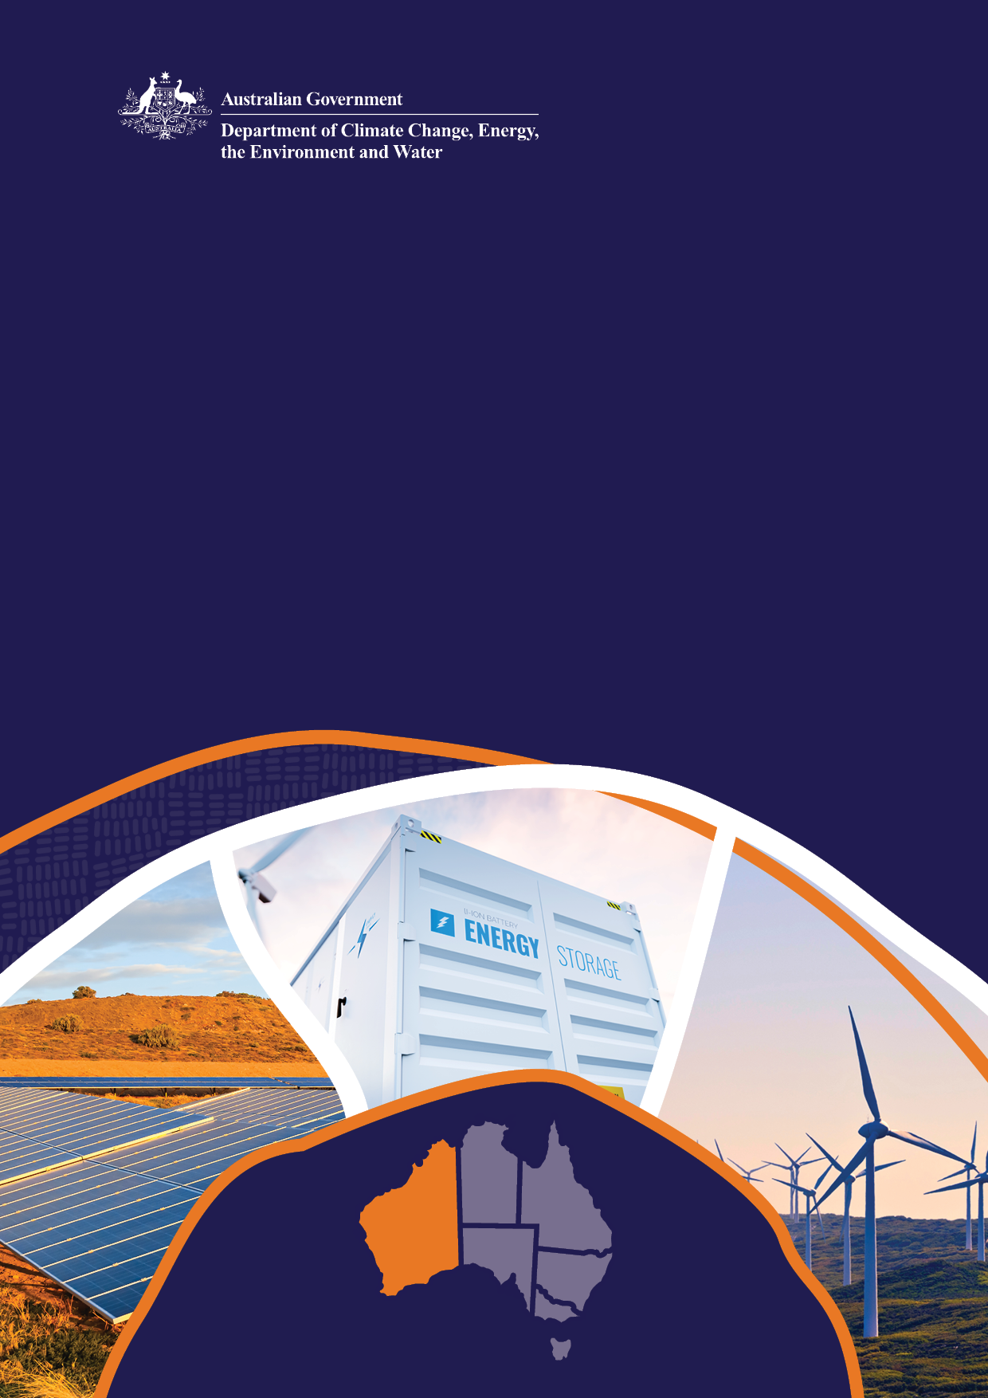

**Western Australia**

**Design Paper**

Capacity Investment Scheme

April 2024

© Commonwealth of Australia 2024

**Ownership of intellectual property rights**

Unless otherwise noted, copyright (and any other intellectual property rights) in this publication is owned by the Commonwealth of Australia (referred to as the Commonwealth).

**Creative Commons licence**

All material in this publication is licensed under a [Creative Commons Attribution 4.0 International Licence](https://creativecommons.org/licenses/by/4.0/legalcode) except content supplied by third parties, logos and the Commonwealth Coat of Arms.

Inquiries about the licence and any use of this document should be emailed to [copyright@dcceew.gov.au](mailto:copyright@dcceew.gov.au).



**Cataloguing data**

This publication (and any material sourced from it) should be attributed as: DCCEEW 2024, *Western Australia Design Paper: Capacity Investment Scheme*, Department of Climate Change, Energy, the Environment and Water, Canberra, April. CC BY 4.0.

This publication is available at [dcceew.gov.au/publications](https://www.dcceew.gov.au/publications).

Department of Climate Change, Energy, the Environment and Water

GPO Box 3090 Canberra ACT 2601

Telephone 1800 920 528

Web [dcceew.gov.au](https://www.dcceew.gov.au)

**Disclaimer**

The Commonwealth of Australia, as represented by the Department of Climate Change, Energy, the Environment and Water, has produced this publication to provide high-level and initial guidance on the proposed rollout of the Capacity Investment Scheme (CIS) in Western Australia. The rollout of the CIS in Western Australia is presently under development and the information contained in this publication is subject to change. This publication does not indicate commitment by the Australian Government to a particular course of action in relation to the CIS in Western Australia or otherwise.

Any transaction implemented under the rollout of the CIS in Western Australia will have its own terms set out in relevant disclosure and process documents. The reader should make their own inquiries of all relevant information and take necessary legal and other professional advice, before taking any action.

The Commonwealth has exercised due care and skill in preparing and compiling the information and data in this publication, however, the Commonwealth, its employees and advisers disclaim all liability, including liability for negligence and for any loss, damage, injury, expense or cost incurred by any person as a result of accessing, using or relying on any of the information or data in this publication to the maximum extent permitted by law. No representation expressed or implied is made as to the currency, accuracy, reliability or completeness of the information contained in this publication.

**Acknowledgement of Country**

We acknowledge the Traditional Owners of Country throughout Australia and recognise their continuing connection to land, waters and culture. We pay our respects to their Elders past and present.

Contents

1 Introduction 4

1.1 Background 4

1.2 Purpose of this paper and consultation process 5

2 Context 6

2.1 Overview of the CIS 6

2.2 Overview of the WEM 7

3 Core design elements and delivery stages 9

3.1 Design principles 9

3.2 Ensuring complementarity between the CIS and WEM 11

3.3 CIS tender process and design 12

3.4 CIS process timing 13

3.5 Eligibility Assessment 15

3.6 CIS tender merit assessment 18

3.7 Setting the CIS contribution to capacity and reliability in the WEM 21

3.8 Underwriting instrument design 22

4 Next steps 24

4.1 Consultation and release of first WEM CIS tender 24

**Tables**

Table 1 CIS Design Framework Principles 9

Table 2 Distinctions between the CIS and RCM 11

Table 3 Eligibility requirements for technology contributing to zero emissions 15

Table 4 Summary of CISA commercial structure 22

**Figures**

Figure 1 Revenue Underwriting Design Instrument 6

Figure 2 Indicative timing of CIS tenders in the WEM 13

Figure 3 Indicative timing of CIS and RCM Certification of Reserve Capacity processes 14

Figure 4 CIS tender assessment stages 18

1. Introduction

## Background

On 23 November 2023, the Australian Government announced an expansion of the Capacity Investment Scheme (CIS)[1] to support the development of 9 GW of dispatchable capacity and 23 GW of renewable capacity across Australia.

The Capacity Investment Scheme (CIS) is a revenue underwriting mechanism that seeks to provide certainty for renewable investors and cheaper, cleaner energy for households and businesses. It was launched in 2023, with the pilot stage having resulted in Capacity Investment Scheme Agreements (CISAs) for over 1 GW of new zero-emissions capacity in New South Wales (NSW), comprised of battery storage and virtual power plant projects[2]. The next tender, spanning South Australia (SA) and Victoria, commenced in December 2023.

|  |
| --- |
| The objective of the CIS is to encourage new investment in renewable capacity and clean dispatchable capacity to support reliability and reduce market volatility in Australia’s rapidly changing energy markets. |

To support the design of the CIS, the Department of Climate Change, Energy, the Environment and Water (DCCEEW) released the CIS Public Consultation Paper (NEM Paper) in August 2023 to gather feedback that would inform the design and delivery of the CIS, with particular focus on application to the National Electricity Market (NEM)[3]. The NEM Paper noted that the different market design of the Wholesale Electricity Market (WEM) in Western Australia (WA)[4] would require specific design consideration when implementing the CIS in the WEM, and committed to further industry consultation.

The Western Australian electricity sector is undergoing rapid transformation and will require significant investment in new generation and storage capacity to secure a smooth transition. The 2023 WEM Electricity Statement of Opportunities (ESOO)[5] has projected the need for significant investment in new capacity over the coming decade to meet growing electricity demand, replace retiring coal-fired generators[6] and to meet commitments from industry and government to reduce carbon emissions.

|  |
| --- |
| Subject to a final Renewable Energy Transformation Agreement being agreed by the Commonwealth and WA Governments and the availability of suitably meritorious projects, the CIS will target an indicative 6.5 TWh of VRE and 1.1 GW of four-hour equivalent dispatchable capacity in the WEM over the period to 2030.  DCCEEW is preparing to commence the first CIS tender for the WEM in June 2024, with an indicative target of 500 MW of clean dispatchable capacity |

Eligible clean dispatchable projects for this tender:

* are yet to reach financial close (or reached financial close after the announcement of the Capacity Investment Scheme on 8 December 2022);
* will be expected to participate in the 2025 Reserve Capacity Cycle (RCC) or be participating in the 2024 RCC; and
* will be expected to be in operation no later than 1 October 2027 (facilities receiving Capacity Credits (as described in section 2.2below) for the first time in the 2024 RCC will need to be operational no later than 1 October 2026 and will be assessed on the basis as described in section 3.6.2 below).

It is intended that future CIS tenders for the WEM, covering both renewable capacity and clean dispatchable capacity would then be conducted on an annual basis, in advance of each year’s Reserve Capacity Mechanism (RCM) process.

The CIS will target a minimum of 6.5 TWh of VRE and 1.1 GW of four-hour equivalent dispatchable capacity in the WEM, subject to a final Renewable Energy Transformation Agreement being agreed by the Commonwealth and WA Governments and the availability of suitably meritorious projects.

## Purpose of this paper and consultation process

This paper describes relevant aspects of the CIS and the WEM and sets out the proposed design for implementation of the CIS in the WEM for both clean dispatchable capacity and renewable capacity. This CIS design seeks to complement WA WEM arrangements to support new investment.

DCCEEW seeks targeted feedback from stakeholders on the proposed CIS design for the WEM, with particular focus on:

* interactions between the RCM processes and CIS tenders;
* the design of the CIS products in the WEM; and
* the proposed eligibility and merit criteria

You can submit feedback through the department’s Consultation Hub ([Have Your Say](https://consult.dcceew.gov.au/capacity-investment-scheme-western-australia-design-paper)).

Submit your feedback by 11:59am (AEST), Monday, 6 May 2024.

The department will also conduct an on-line stakeholder forum in April. Details of the webinar and consultation materials, including this paper, future papers, and any public responses to stakeholder questions, will be posted on the department’s Consultation hub ([Have Your Say](https://consult.dcceew.gov.au)) and Capacity Investment Scheme webpage ([Capacity Investment Scheme | dcceew.gov.au](https://www.dcceew.gov.au/energy/renewable/capacity-investment-scheme)).

1. Context

The CIS seeks to ensure that new capacity enters Australian energy markets to support reliability and affordability, in a way that complements existing markets and processes. To achieve this, the design of the CIS must have regard to particular market characteristics and design elements to avoid unintended impacts on existing electricity market functions and associated rules.

This section sets out design features of the CIS and WEM that are relevant to the proposed implementation model for the CIS in WA.

## Overview of the CIS

The CIS is a Commonwealth scheme available in all jurisdictions nationally. It involves the Australian Government seeking competitive tender bids for renewable capacity and clean dispatchable capacity projects to fill expected capacity gaps and support the achievement of the Australian Government’s 82% renewable electricity by 2030 target.

Selected projects are expected to be offered long-term Australian Government underwriting agreements for an agreed revenue ‘floor’ and ‘ceiling’. This is intended to provide a long-term revenue safety-net that decreases financial risks for investors and encourages more investment when and where it is needed. Similar revenue underwriting schemes are being used in Australia and internationally to support investment in the energy transition.

This contract structure is depicted schematically in Figure 1. Projects under Capacity Investment Scheme Agreements (CISAs) will have a revenue floor and ceiling agreed between the proponents and the Australian Government. If revenue earned by a project exceeds the net revenue ceiling, the owner pays the Australian Government an agreed percentage of revenue above the revenue ceiling. The Australian Government would pay the project an agreed percentage when revenue is below the revenue floor.

**Figure 1 Revenue Underwriting Design Instrument**

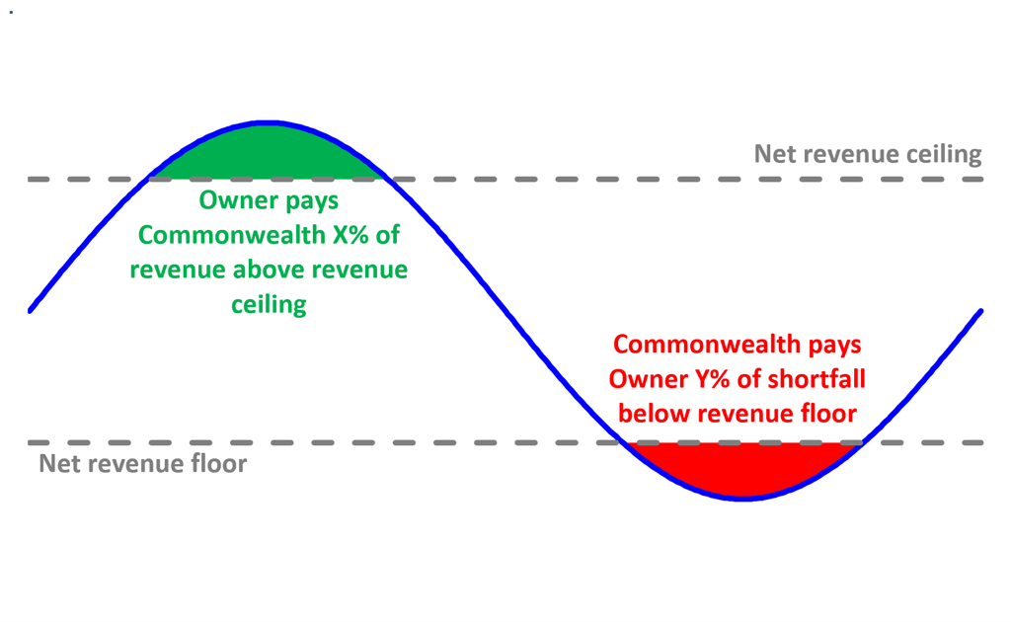

This contract structure is intended to preserve a level of price exposure for project proponents, ensuring that they remain incentivised to participate in wholesale spot markets, and to pursue contracts and alternative revenue streams to ensure more competitive financial bids. Except for limited performance requirements, it is not intended that the CIS will impose additional operational requirements on projects, and CIS projects will remain subject to AEMO directions. Changes to market rules that may occur over time will apply to CIS projects.

The CIS includes two types of revenue underwriting contracts, each of which can have a contract term of up to 15 years:

* **Clean Dispatchable CISA:** to support projects that are registered or intend to be registered with AEMO in the WEM and capable of dispatching as a clean dispatchable generator at a registered capacity of two hours or more; and
* **Generation CISA:** to support clean renewable projects that are registered or intend to be registered with AEMO in the WEM for the central dispatch process.

## Overview of the WEM

This section provides a general overview of the operation of the Wholesale Electricity Market.

The WEM operates in the South West Interconnected System (SWIS), which covers the south-west of WA. Its design[7] is substantially comprised of:

* the Reserve Capacity Mechanism (RCM), which seeks to procure capacity on behalf of the market to meet reliability goals;
* the Short Term Energy Market (STEM), which provides for day-ahead wholesale trading of electricity;
* the Real-Time Market (RTM), which provides for wholesale trading of electricity and procurement of Frequency Co-optimised Essential System Services (FCESS), and guides the dispatch of the power system;
* contract arrangements for other Essential System Services and backstop services that are procured outside of the mechanisms above; and
* bilateral trading of energy and capacity also occurs directly between market participants.

The most significant differences from the design of the NEM are the RCM and the substantial role of bilateral contracting between market participants. These require specific consideration to ensure that the CIS complements the operation of the WEM to support the entry of new investments in renewable and clean dispatchable capacity.

**Reserve Capacity Mechanism**

Through the RCM, qualifying generation, storage and demand response facilities are assigned Capacity Credits, which requires them to make capacity available to the market during the relevant Capacity Year[8], and entitles the facility owners to the capacity revenue stream (Capacity Credits). Eligibility is assessed annually by AEMO, two years ahead of the relevant Capacity Year, and facility owners or developers must provide AEMO with a high level of certainty of project capability and readiness. The assessment includes validation of:

* the technical capability and reliability of the facility;
* environmental approvals;
* network connection contracts or (for new facilities) the status of a network connection application;
* transmission capacity and constraints;
* fuel availability; and
* for new facilities, project timing and the firmness of financial commitment.

Holders of Capacity Credits receive payments for their capacity[9], either through trading bilaterally with market customers who are required to obtain Capacity Credits or through payment from AEMO at the Reserve Capacity Price, which is determined by a Benchmark Reserve Capacity Price, and the supply-demand balance in the RCM[10]. The Reserve Capacity Price is redetermined annually and can shift materially from year-to-year, for example due to swings in the supply-demand balance. While a participant may seek a five-year fixed capacity price for a new project, this can result in the participant moving lower in the Capacity Credit assignment priority order and increase the risk of a lower (or zero) Capacity Credit allocation.

In return, Capacity Credit holders must meet obligations to make their capacity available in the energy markets (STEM and RTM) and refund capacity payments if they fail to do so.

**Bilateral contracting and net settlement**

The majority of the energy and Capacity Credits in the WEM are traded bilaterally, either between market participants or between the generation and retail arms of a gentailer. This practice was in place before the commencement of the WEM and has continued, largely due to the WEM’s unique market structure and the lack of liquid contract and hedging product markets, as exist for the NEM. Bilateral contracting tends to be more concentrated towards larger market participants, with smaller retailers predominantly purchasing their requirements directly through the market due to the lower transaction costs.

The WEM offers market participants the ability to declare bilateral trades to AEMO so that these can be netted out of the central market settlement process. This is common practice for participants, who can mitigate their prudential exposure through this mechanism. For each relevant time interval, participants declare the identity of the counterparties and the quantity of the relevant commodity being traded (i.e., the number of MWh or Capacity Credits), from which AEMO deducts the traded quantity from both participants’ settlement statements. No contract prices are declared to AEMO, and the bilateral trade quantity information remains confidential to the relevant participants and AEMO.

1. Core design elements and delivery stages

The proposed design for implementation of the CIS in the WEM closely mirrors the CIS tenders in the NEM, with differences predominantly focused on ensuring alignment between the CIS and WEM processes. Every effort has been made to ensure that the CIS Tender Process and the RCM Process are not duplicative, and that the CIS Process serves to provide the RCM Process with a pipeline of quality, bankable projects through its technical criteria and provision of financial assurance.

This section describes specific considerations to ensure complementarity between the CIS and the WEM, and lays out details of the proposed CIS design for the WEM.

## Design principles

The CIS provides a national framework to support the rollout of renewable capacity and clean dispatchable capacity across jurisdictions. To support the achievement of the CIS policy objectives, Table 1 displays the framework design principles.

**Table 1 CIS Design Framework Principles**

| Maintaining momentum | Support the continued progress and bring forward investment in projects in **various stages of development to enable the capacity and generation targets to be achieved by 2030[11].**  Further details on the development status eligibility requirements are provided in section 3.5. |
| --- | --- |
| Stimulating investment | Provide long-term **certainty for financiers through a combination of the long-term financial underwriting offered to Projects, and a clear and transparent tender process used to set key commercial terms in the CISA.** |
| Complementing existing market operations | Minimise impact on wholesale electricity market functions and associated rules. Apart from a limited set of performance requirements specific to each CISA, it is not intended that the CIS will impose operational requirements on projects.  Project Operators will be able to sign a CISA and other wholesale contracts, such as swap contracts and tolling agreements. . |
| CIS process and tender product adaptability | Mitigate risks of a disorderly transition by selecting projects that support energy system reliability and lower electricity prices.  The process and form of CISA products will be adaptable with the ability to respond to changing market conditions as the scheme progresses and where consistent with the objectives of the scheme. |
| Supporting our local communities and first nations people | Facilitate shared benefits to regional communities, support the industries that will drive our future economy and help First Nations people preserve their unique culture and heritage and remain on Country. |

### Complementing the operation of Australia’s electricity systems or markets

The expanded CIS seeks to ensure that new renewable capacity and clean dispatchable capacity enters Australian energy markets with limited impact on electricity market functions and associated rules while supporting reliability and affordability. The CIS is intended to support and facilitate Australia’s existing suite of Australian Government and jurisdictional energy policies and markets.

Changes to the Wholesale Electricity Market Rules (WEM Rules) that happen over time will apply to CIS projects. For example, changes to the Reserve Capacity Mechanism being contemplated by the Wholesale Electricity Market Investment Certainty Review working group of the Market Advisory Committee would apply to projects supported by the CIS. Like all generators, CIS projects will remain subject to AEMO or Economic Regulation Authority directions under the WEM Rules.

The CIS will complement other Australian Government, state and territory government policies and actions by businesses and communities to underpin Australia’s transformation to net zero emissions by 2050 and 82 per cent renewable energy in the on-grid electricity sector by 2030.

This includes integration with the delivery of new transmission infrastructure, including through the Australian Government’s $20 billion Rewiring the Nation program. This new transmission infrastructure will connect Australia’s electricity grids to regions with rich renewable resource potential and reinforce and interconnect the existing network to deliver reliable renewable energy to consumers in cities, towns and regional communities.

The allocation of capacity to be tendered in each jurisdiction through the CIS will be determined through Renewable Energy Transformation Agreements (RETAs) between Commonwealth and respective state and territory governments, which also detail how the governments will work together to provide a favourable enabling environment for the investment in new renewables projects supported by the CIS and achieve shared objectives in the renewable energy transformation.

In November 2023 the Energy and Climate Change Ministerial Council (ECMC) agreed that CIS investment will continue to be delivered working with state systems, including the NSW Electricity Infrastructure Roadmap (Long Term Energy Service Agreements), the Victorian Renewable Energy Target and the Western Australian Reserve Capacity Mechanism.

### CIS product and tender process adaptability

Certain states and territories have existing schemes in place, and CIS underwriting contracts (CISA products) along with the tender process will be designed to ensure that, where possible and consistent with the objectives of the CIS, the CIS complements those schemes and supports state and territory governments to achieve their renewable energy targets.

Australia’s energy markets are in a period of substantial change. The CIS is designed to accommodate new and changing business models and to provide investors with the confidence to continue to develop projects in this environment of change. The CIS aims to complement the current reliability framework and support the entry of new investments during a period of rapid transformation.

## Ensuring complementarity between the CIS and WEM

At first glance, the CIS and RCM may appear to have similar objectives and processes, including a years-ahead tender process and eligibility assessment. However, Table 2 outlines critical distinctions in the nature of the revenue support provided under the two schemes, the time horizon and the degree of project certainty required for eligibility, which are important considerations in ensuring that the two mechanisms are complementary in incentivising investment in new capacity in the WEM.

To ensure that the CIS would not be a competing policy, all CIS underwriting contracts in the WEM will require projects to participate in the RCM process and be eligible to receive Capacity Credits in order to receive CIS payments, as noted in section 3.4.

There are sufficient differences between the RCM and CIS to indicate that they can be complementary in incentivising investment in new capacity in the WEM. Table 2 shows distinctions between the CIS and RCM.

**Table 2 Distinctions between the CIS and RCM**

|  | RCM | CIS |
| --- | --- | --- |
| Nature of revenue support | The RCM provides a **short-term price signal** through the Reserve Capacity Price, calculated annually. Facilities receive Capacity Credits if they are deemed eligible and fulfil their capacity commitments made through the RCM. | The CIS provides a **long-term price guarantee** to new capacity through an underwriting agreement of up to 15 years. The underwrite allows new capacity to be built and the CISA is designed to incorporate and adapt to a variety of short-term price signals. The long-term signal provided via the CIS has been structured to support both debt and equity investors. |
| Time Horizon | AEMO assesses facility eligibility and assigns Capacity Credits two years ahead of the relevant delivery year. | CIS tenders will nominate a targeted commissioning date for eligibility. The tender process will operate approximately one year ahead of the RCM process (though may vary between tenders, subject to the timing of reliability requirements and other specific considerations). |
| Degree of project certainty | The RCM requires a high level of project certainty plus financial commitment for a facility to be eligible to receive Capacity Credits. | CISAs may be awarded to projects in advance of a final investment decision (FID), subject to meeting the CIS eligibility requirements and merit assessment. |

The CIS process seeks to leverage existing RCM processes around security deposits and capacity refund payments to minimise duplicative arrangements.

* A Project Owner may be required to provide a bank guarantee as part of the CIS process, but this would expectedly be released after the Project Owner has provided Reserve Capacity Security to AEMO as required under the WEM Rules.[12]
* A Project Owner will need to provide Reserve Capacity refund payments to AEMO, as required under the WEM Rules and it is not intended that they would be subject to additional liquidated damages under a CISA. However, it is expected that Reserve Capacity refunds will not be netted off project revenues for the purposes of the underwriting calculations under a CISA.

Different bid parameters for the revenue floor and ceiling are expected to be employed for Clean Dispatchable CISAs and Generation CISAs, reflecting the different revenue streams in the WEM and different facility operating characteristics:

* For Clean Dispatchable CISAs, proponents will bid the floor and ceiling revenues with reference to total facility revenue per unit of rated capacity ($/MW), which is considered appropriate given the wide range of revenue streams that facilities are likely to earn, and the real-time trade-offs between revenue streams (e.g., between energy and FCESS); and
* For Generation CISAs, proponents will bid a combination of fixed ($/MW) and variable ($/MWh) metrics for determining the floor and ceiling revenues, which aligns more closely with the energy and capacity income streams under the WEM Rules.

In addition, recognising the prevalence of bilateral contracting in the WEM, a CISA will oblige a project owner to share information about revenue earned under bilateral contracts in order that this may be included in underwriting calculations.

## CIS tender process and design

The CIS will utilise robust, transparent processes and institutions to ensure market trust in the tender process. The CIS in the WEM is expected to be delivered in the following way:

* the Australian Government will set objectives, commercial in-confidence financial budgets and, through agreement with the Western Australian Government, MW capacity targets[13] and a target commercial operation date for a CIS Tender Process;
* the CIS tenders will be run by an appropriately qualified body (Tender Delivery Partner), in accordance with CIS tender guidelines to be developed (CIS Tender Guidelines);
* the Tender Delivery Partner will recommend projects for underwriting by the Australian Government based on each applicant’s performance against the eligibility and merit criteria; and
* the Australian Government will make final contracting decisions based on the recommendations of the Tender Delivery Partner.

Successful proponents will receive underwriting contracts in the form of CISAs provided by the Australian Government to support the introduction of new, long term zero-emission capacity that will align with both the CIS and RCM eligibility requirements. Further details of the form of these contracts are provided in section 3.7.

## CIS process timing

The timing of the CIS tender process must strike a balance between ensuring that the CIS promotes bringing forward investment in capacity in a manner that provides genuine additionality and avoids perverse incentives to delay the commencement of new capacity. To achieve this, the CIS Tender Process will be run in advance of the WEM RCM process for a specified Target Commercial Operation Date (Target COD)[14], while enabling participation of projects that participate in earlier RCM processes.

The first WEM CIS tender process is currently proposed to run from approximately June 2024 to February 2025, and will be open to eligible clean dispatchable projects that:

* are yet to reach financial close (or reached financial close after the announcement of the Capacity Investment Scheme on 8 December 2022);
* are expected to participate in the 2025 RCC or to participate in the 2024 RCC; and
* are expected to be in operation no later than 1 October 2027 (facilities receiving Capacity Credits for the first time in the 2024 RCC will need to be operational no later than 1 October 2026 as per their RCM obligations).

This is in advance of the capacity assessment processes of the 2025 RCM cycle, for which applications are scheduled to close on 24 June 2025[15]. This proposed timeline is shown in Figure 2 below. Precise timing for the CIS Tender Process will be made clear in the CIS Tender Guidelines.

It is intended that CIS tenders in future years will be in advance of that year’s RCM process in a similar manner.

**Figure 2 Indicative timing of CIS tenders in the WEM**

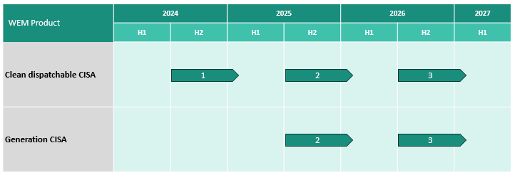

**Figure 3 Indicative timing of CIS and RCM Certification of Reserve Capacity processes**

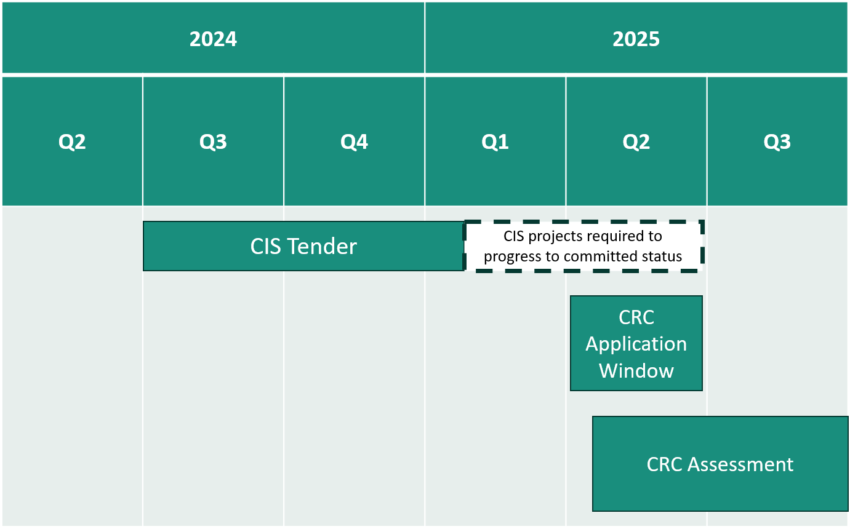

The primary purpose for conducting the CIS Tender Process ahead of the RCM process is to allow projects to achieve the level of financial commitment required for a facility to be eligible for Capacity Credits. It is intended that this may enabling projects that must demonstrate a guaranteed minimum revenue to obtain finance have the ability to use a CISA to achieve bankability. This enables the greatest level of complementarity with the RCM while providing the best method to bring genuine additional clean capacity into WA’s existing capacity market.

The CIS would otherwise operate separately from the RCM process, which is already well understood by WEM participants, and is not intended to affect its timelines or rules. It is anticipated that there may be some aspects of the assessments of projects across the CIS and RCM processes which may require applicants to provide similar information in support of their proposed projects, particularly given the different timing of the processes. However, given the intention for CISAs to support projects through the RCM process, CISAs for the WEM will expectedly contain provisions that would allow for relevant CIS assessment and contract information to be shared with AEMO to facilitate and support AEMO’s RCM assessments for relevant projects.

Relative to the RCM, the CIS is expected to support projects with a wider range of commencement dates as it does not adhere to the RCM’s annual, two-year-ahead cycle. The CIS Tender Process will be open to all projects that achieve, or are expected to achieve, financial close from the relevant announcement onwards (8 December 2022 for Clean Dispatchable CISA tenders, or 23 November 2023 for Generation CISA tenders). This eligibility is intended to avoid creating a perverse incentive for a project owners to opt out of 2024 RCM cycle.

Given that the CIS tender process will occur approximately three years ahead of the Target COD, a lower level of project certainty may be required compared to the RCM, acknowledging the potentially longer project lead time.

## Eligibility Assessment

This section provides an overview of the expected key proponent and project eligibility criteria that potential CIS tender proponents or projects will need to satisfy. The final eligibility criteria may vary and will be outlined in the CIS Tender Guidelines.

The purpose of specifying eligibility criteria is to establish minimum standards for participating in a CIS tender. Eligibility criteria are intended to achieve consistency and transparency of decision-making and may save proponents money by clearly indicating when projects are sufficiently progressed to participate in a CIS tender. In general, most of the eligibility requirements set out below are expected to be common with CIS tender processes in the NEM.

### Registration with AEMO, ownership and minimum size

The project proponent must be a special purpose vehicle (SPV) that owns the project, including all assets and legal rights and permissions reasonably required to undertake the project. This requirement enables the revenues and costs of the project to be separately assessed and monitored during the term of a CISA. Both publicly and privately owned projects will be eligible for CIS tenders.

The project proponent must be registered with AEMO, or have undertaken preliminary facility registration processes[16], and be intending to participate in the WEM’s central dispatch mechanism and RCM. The requirement to participate in the RCM ensures that projects supported by the CIS meet the performance requirements of the RCM and support the reliability of the WEM. The CIS Tender Guidelines will outline further requirements on the form of AEMO registration required.

It is expected that all projects must have a capacity equal to or greater than 30 MW. This is intended to balance the costs of participating in the tender, and the costs and complexity of evaluating projects, while ensuring that projects supported through the CIS make a material contribution to the RCM.

### Technology contributing to zero emissions and reliability

Detailed eligibility requirements (and merit criteria) related to emissions and reliability contributions will be provided for each tender round in the CIS Tender Guidelines.

To meet the zero-emissions objective of the CIS, it is expected that projects will have the following features:

**Table 3 Eligibility requirements for technology contributing to zero emissions**

| **Clean Dispatchable CISA** | **Generation CISA** |
| --- | --- |
| The project’s fuel source must either:   * be an eligible renewable energy source, as described in Section 17 of the *Renewable Energy (Electricity) Act 2000* (Commonwealth) and eligible to create large-scale generation certificates under that Act; * or charge from the WEM; or   a combination of the above.  Projects that:   * are virtual power plants, demand response or other virtual aggregation and flexible loads will not be eligible for the 2024 tender but may be eligible in future CIS tenders. * use native forest wood waste are not eligible. | The project must:  be an eligible renewable energy source, as described in Section 17 of the ***Renewable Energy (Electricity) Act 2000*** (Commonwealth) and eligible to create large-scale generation certificates under that Act; and   * be eligible to be registered with AEMO in the WEM for the central dispatch process.   Projects that:   * use native forest wood waste are not eligible. |

To meet the reliability objectives, projects will be expected to meet the same minimum standards for Capacity Credit eligibility that are stipulated in the WEM Rules. For example:

* storage projects will be assessed according to their ability to supply to the grid over the Electric Storage Resource (ESR) Duration Requirement[17]; and

Thermal generation such as coal and gas is not eligible for the CIS. Projects using fuel where coal or gas form a part of the blended fuel will also not be eligible.

A hybrid project is one that comprises two or more co-located Facility Technology Types, as defined in the WEM Rules. Hybrid projects will be able to participate in the CIS as follows:

* A CISA can apply to all of the components (Facility Technology Types) of a hybrid project.
* Each Facility Technology Type must be a Separately Certified Component under the RCM and the WEM Rules, and receive Capacity Credits.
* Hybrid projects that include one or more Intermittent Generation Systems will only be eligible for the Generation CISA[18].
* Hybrid projects that include only clean dispatchable technologies (e.g., solar thermal and battery storage) will be eligible for the Clean Dispatchable CISA.

For clarity, projects that combine multiple generation assets (e.g., wind and solar), or multiple energy storage assets (e.g., BESS and pumped hydro), that share a common connection point are not expected to be considered a hybrid project for the purposes of the CIS. Instead, these projects will be treated as either a single generation or clean dispatchable project for assessment and contracting.

The Generation CISA will accommodate multiple hybrid contract configurations and may require amendments and additional obligations to enable novel hybrid project configurations.

Proponents may also submit tenders in respect of expansion projects to existing storage or generation assets, or the addition of new storage or generation assets to existing facilities.

### Expected development status of connection approvals

It is expected that projects will have made progress towards obtaining connection approval [upon application to participate in the CIS]. To be regarded as having made such progress, the proponent for the relevant projects must: have received a response to a connection enquiry, or have entered into an access contract, or be seeking to modify an existing access contract. If the proponent does not meet the above criteria, they must establish to the Tender Delivery Partner’s satisfaction that they are highly likely to satisfy one of these criteria within a reasonable period of time.

### Participation in other schemes

Projects that are already, or will be, in receipt of revenue support from either the Australian or WA Governments will not be eligible for the CIS tenders. This is distinct from public ownership, which is not a disqualifying criterion under the CIS. Revenue support refers to periodic and/or ongoing payments that are of a similar nature to funding available under a CIS product.

Projects that have entered into a contract with AEMO under the Non-Co-optimised Essential System Services (NCESS) framework prior to their commercial operation are not expected to be eligible for CIS tenders.

The purpose of this eligibility requirement is to ensure that projects do not access duplicate sources of government support. The following forms of support are not expected to be considered revenue support, and projects in receipt of these forms of support will remain eligible for CIS tenders:

* certificates created under an Australian Government certificate scheme, including large-scale generation certificates (LGCs) received through participation in the Renewable Energy Certificate Market and the Renewable Energy Guarantee of Origin (REGO) scheme.;
* Capacity Credits assigned through the RCM;
* investment received from a Commonwealth or State government body (e.g., the CEFC);
* grants from an Australian Government (e.g., ARENA) or State government body, whether repayable or not[19]; or
* other forms of financial support from the WA Government or Australian Government where the relevant government intends the financial support to be complementary to the CIS.

### Technology, timing and delivery risk

The CIS is a program to improve reliability in Australia’s electricity grids. CIS tender eligibility and merit criteria will focus on projects that adopt established, proven technologies where the delivery risks associated with the project, and the project’s commissioning date, are reasonably assessable.

Due to the need to participate in an upcoming or previously run RCM process, tenders will be expected tocontain targeted commissioning dates, and this could constrain eligibility in some circumstances. For example, projects participating in the 2024 CIS tender process would need to participate in the 2025 RCM process[20] and provide capacity in the 2027-28 Capacity Year, which commences on 1 October 2027. Projects unable to meet these requirements are expected to be ineligible. Similarly, projects participating in the 2024 CIS tender and the 2024 RCM process are expected to be required to provide capacity in the 2026-27 Capacity Year, which commences on 1 October 2026.

### Compliance with the law

To be eligible to participate in a CIS tender, a proponent and project will need to be compliant with applicable State and Commonwealth law and may be asked to produce evidence of compliance.

This will include:

* The Proponent must not have had a judicial decision relating to employee entitlements made against it (not including decisions under appeal), where the Proponent has failed to pay any amounts required to be paid following that judicial decision.
* The Proponent must not have been named as an organisation that has not complied with the *Workplace Gender Equality Act 2012* (Cth).
* The Proponent must not, within the previous 10 years, have been subject to an inquiry by the National Anti-Corruption Commission, or an equivalent State body in a jurisdiction in Australia, where a finding has been made against the Proponent (including that the Proponent has engaged in corrupt conduct).
* The Proponent must not be named as an organisation on the Trade Consolidated List maintained by the Australian Sanctions Office within the Department of Foreign Affairs and Trade
* If the Proponent is a ‘Reporting Entity’ under the Modern Slavery Act 2018 (Cth) the Proponent must have complied with its obligations under that Act.

## CIS tender merit assessment

The objective of CIS tenders will be to select the projects that demonstrate the highest levels of merit, as assessed against objective merit criteria. This section provides an overview of how projects could be merit assessed during CIS tenders in the WEM. Successful projects will be expected to perform strongly against all criteria.

### Overview of merit assessment process

Merit assessment of project bids will be conducted in two stages, as shown in Figure 3:

**Figure 4 CIS tender assessment stages**

Weighting may be assigned to the merit criteria at either Stage A or Stage B. Projects that can demonstrate high benefits for a low cost will be more likely to be successful. The consideration of the benefits and costs will be the primary consideration in the Financial bid stage. Minimum requirements for each merit criteria may also be used to ensure all projects supported by the CIS achieve a minimum standard across all the merit criteria.

### Project bid (Stage A) – technical, commercial and social licence assessment

The initial stage of the CIS tender will assess a project’s technical, commercial and social licence merit.

**Project technical and commercial viability**

A project’s credibility to reaching the Target COD is assessed by examining a project’s progress against key development milestones. This includes:

* progress to securing all relevant land, planning and connections approvals;
* progress to securing all relevant construction procurement and financing documents; and
* demonstrated understanding of key project risks to timely project completion, and appropriate mitigation measures.

Successful projects will have the target FID or financial close (FC) and COD key dates as contracted milestones.

Projects participating in the 2024 CIS tender will be merit assessed against their pathway to reaching COD no later than:

* 1 October 2027 for facilities receiving Capacity Credits for the first time in the 2025 RCC
* 1 October 2026 for facilities receiving Capacity Credits for the first time in the 2024 RCC

This requirement seeks to ensure that successful projects can contribute to capacity requirements in the Capacity Year for which they have received Capacity Credits.

**Proponent capability**

A project proponent’s capability, capacity and track record to deliver projects of a similar size and type will also be assessed. Other key relevant entities involved in the project delivery will also be considered. This is to ensure that reliable organisations are provided government support to deliver their projects.

A proponent’s capability to deliver its proposed project is assessed by considering the prior and current experience of the proponent. The proponent’s project delivery contracting structure, procurement strategy and quality of its delivery plan will also be considered.

**Social licence, employment and local benefits**

Proponents and projects will be assessed on their approach and quality of engagement with Australian supply chains, local communities and First Nations people. This may include:

* Demonstrated efforts to understand Australian supply chain capabilities and to support the development and use of local supply chains in both CAPEX and OPEX project plans.
* Demonstrated understanding of and commitment to worker outcomes, including pay and conditions and training including apprenticeships.
* Demonstrated understanding of local community and stakeholders, including stakeholder mapping.
* Summary of community and First Nations consultations that have occurred to date.

Evidence of having considered or incorporated community and First Nations groups’ feedback during project design, development and future implementation.

* Summary of planned engagement activities in the future.
* Approach to local community engagement activities and benefit sharing that reflect the potential future impacts on the community.
* Adherence to any future community engagement guidelines or standards for renewable energy proponents as defined by the Australian Government and/or state and territory governments.
* Summary of planned approach to decommissioning and remediation.

It is important to note that State and Territory governments have the flexibility to create local requirements for community and First Nations engagement through regulation or legislation. These requirements could vary across jurisdictions and could include geographic restrictions based on renewable energy zones, or targets for categories of workers. The CISA is expected to support this by requiring compliance with relevant WA government imposed requirements.

The national consultation on the [First Nations Clean Energy Strategy](https://www.energy.gov.au/energy-and-climate-change-ministerial-council/working-groups/first-nations-engagement-working-group/first-nations-clean-energy-strategy) has identified clear themes regarding First Nations participation and benefit sharing, including examples from international jurisdictions, such as Canada, and domestically in the resources sector. Understanding options to support greater participation is encouraged.

The recently concluded [Community Engagement Review](https://www.dcceew.gov.au/sites/default/files/documents/community-engagement-review-report-minister-climate-change-energy.pdf) conducted by the Australian Energy Infrastructure Commissioner recommends that a voluntary renewable energy developer community engagement ratings scheme be established and that a positive rating be a requirement for a project to receive government support, including through the CIS. This is currently under consideration by the Energy and Climate Ministerial Council.

**Contribution to system reliability**

The CIS assessment will include a limited review of contribution to reliability, with the aim of reflecting the same principles that are used in the RCM certification and Capacity Credit assignment processes. These RCM processes assess the reliability contribution in more detail, including thorough consideration of plant technical capability at different temperatures, the alignment of renewable capacity facility output with system need through the Relevant Level Method (RLM)[21], and analysis of network capacity and constraints through the Network Access Quantity (NAQ)[22] processes. It is not intended that the CIS tender process would duplicate those aspects of the RCM process.

### Financial bid (Stage B) – financial assessment

The second stage of the merit assessment will require proponents to submit pricing bid variables. Projects will be assessed against the CIS’s policy objectives to support system reliability at a minimal cost to taxpayers.

**Financial Value**

Generation Projects

Projects will be assessed on their value to taxpayers and electricity consumers against forecast cost to the Australian Government across a range of future market scenarios, taking into account the dispatch-weighted prices (i.e. the value of energy) likely to be received by projects. The assessment may consider modelling of several future wholesale electricity market scenarios based on technical information provided by projects and will include consideration of reliability benefits.

Clean Dispatchable Projects

A similar approach as outlined above will be applied for Clean Dispatchable Projects. However, the Project’s impact on reliability and on broader system benefits will be weighted more heavily. Furthermore, the Project’s ability to reduce market price volatility will be considered.

**Commercial departures**

Stage B will also assess the competitiveness of a project’s key bid variables, proposed commercial risk allocation and additional administrative burden from the proforma Project Documents.

**Social licence commitments**

Proponents and projects will be assessed on their social licence commitments and shared benefits established, or to be established within the project’s community. These assessments may consider if the project has:

• Incorporated local community interests in the design process.

• Committed to include local employment and training of apprentices.

• Demonstrated benefits to the Australian supply chain market.

This merit criterion may also consider the degree to which a project demonstrates substantial development of strategies and activities to ensure the successful implementation of their social licence commitments.

## Setting the CIS contribution to capacity and reliability in the WEM

As outlined in section 1.1, the CIS will seek to support the development of 9 GW of dispatchable capacity and 23 GW of renewable capacity across Australia. The allocation of these capacity targets between individual jurisdictions will be specified through agreements between the Australian Government and individual states and territories – Renewable Energy Transformation Agreements (RETAs).

The CIS aims to make a meaningful contribution to achieving near-term and medium-term capacity requirements which are currently forecast in the WEM. Substantial volumes of dispatchable and non-dispatchable capacity are also expected to be built outside of the CIS, including by investors responding to market price signals and potentially through Western Australian Government support.

Subject to a final Renewable Energy Transformation Agreement being agreed by the Commonwealth and WA Governments and the availability of suitably meritorious projects, the CIS is expected target an indicative 6.5 TWh of VRE and 1.1 GW of four-hour equivalent dispatchable capacity in the WEM over the period to 2030. DCCEEW is preparing to commence the first CIS tender for the WEM in June 2024, with an indicative target of 500 MW of clean dispatchable capacity.

## Underwriting instrument design

An objective of the CIS is to accelerate the deployment of renewable capacity in the WEM by reducing risk to investors. This section outlines the commercial key features intended to be reflected in the underwriting agreement.

### Principles of the CISA commercial structure

The CIS commercial structure is intended to deliver the broader objectives of the CIS, and to ensure that the following subsidiary objectives are achieved:

* Investor certainty is increased through a combination of the long-term underwriting and the tender process. The tender process is used to set key commercial terms in the CIS underwriting agreement;
* Limited to no impact on WEM and RCM functions. Except for performance and RCM engagement requirements, the CIS is not seeking to impose operational requirements on projects. The operation of projects contracted under the CIS are expected to be directed by the WEM and RCM and their associated rules; and
* Flexibility in contracting and participating in the wholesale contracts market. Projects will be able to sign a CIS underwriting agreement (CISA) and other wholesale contracts.

A limited set of operational requirements are expected to be included in the CIS underwriting agreement. These performance and participation requirements supplement the existing price signals and rules to ensure that projects receiving financial support from the Australian Government participate in the WEM and RCM. They are summarised in section 3.8.2.

### Summary of the CISA commercial structure

The high-level overview of the expected CISA commercial structure for Generation CISAs and Clean Dispatchable CISAs are provided in Table 4 and Table 4 below, respectively.

**Table 4 Summary of Generation CISA commercial structure**

| **Term** | **Generation CISA** |
| --- | --- |
| **Project characteristics** | The CISA will include a description of the project characteristics (e.g., nameplate capacity, technology). The Project Operator will be required to preserve the agreed project characteristics over the life of the agreement. |
| For a Project assessed as a hybrid project, this will include both generation and storage elements of the Project. |
| **Support Term**  **(Bid Variable)** | Up to a maximum of 15 years.  The CISA will commence on 1 October of the first year after CISA award for which the Project holds Capacity Credits. |
| **Payment mechanism**  **(Multiple Bid Variables)** | Quarterly payments will be made in the first three quarters. At the end of the financial year, an annual reconciliation payment (Annual Adjustment Payment) will be made, subject to an annual payment cap. |
| The floor and ceiling for the Generation CISA will each have two components:   * an energy component, bid as $/MWh of generation in the relevant support year * a capacity component, bid as $/MW of Capacity Credits held by the project in the relevant support year |
| The underwriting mechanism will be based on a project’s net revenue, which is the sum of all revenue for the project minus costs from:   * for storage projects, costs in relation to the import of electricity from the network * costs for Essential System Services, Market Participant fees and market suspension compensation under the WEM Rules * any payments under an Eligible Wholesale Contract (excluding liquidated damages, warranty payments, or non-performance payments).   All other operating costs, taxes, fines and penalties, payments made through the AEMO settlement process arising as a result of prices below $0/MWh, and debt financing interest and other costs are excluded from the calculation of net revenue. |
| **Annual Payment Cap** | Payments from the Commonwealth to the Project Operator or payments from the Project Operator to the Commonwealth will not exceed the Annual Payment Cap in a single support year. The Annual Payment Cap is a single symmetrical value to be bid by proponents during the tender process. |
| **Contracted Percentage**  **(Bid Variable)** | The CISA may relate to some or all of the Project’s capacity. Where a Project bids and receives a CISA for less than 100% of its capacity, the Contracted Percentage is less than 100%.  Where a Project bids and receives a CISA for less than 100% of its capacity, the Quarterly Payment and the Annual Adjustment Payment will be reduced to the percentage of the Project’s capacity covered by the CISA. |
| **Escalation** | The Floor Price and Sharing/Ceiling Price will be bid as a combination of $/MWh and $/MW for each supported year. Proponents can incorporate escalation into their bid. |
| **Performance requirements** | The CISA will involve a limited set of performance requirements, including requiring the Project Operator to:   * operate the project in accordance with best industry practice, including maximising availability of the Project and revenues for the Project[23]; * participate in the RCM and make the Project available in line with its performance obligations under the RCM; * respond to price signals in relevant markets; and * comply generally with its obligations under the WEM Rules.   Where these performance requirements are not regularly met the Commonwealth will have a termination right. |
| **Ownership Structure** | The Project Operator must be a special purpose vehicle (SPV) and that SPV must own the project, including all assets and legal rights and permissions reasonably required to undertake the project. The SPV must be the registered electricity market participant and receive all economic value associated with the Project. The SPV must be the counterparty to all revenue contracts associated with the Project. The SPV must not carry on any other business other than the Project. |

**Table 4 Summary of Clean Dispatchable CISA commercial structure**

| **Term** | **Clean Dispatchable CISA** |
| --- | --- |
| **Project characteristics** | The CISA will include a description of the project characteristics (e.g., nameplate capacity, technology). The Project Operator will be required to preserve the agreed project characteristics over the life of the agreement. |
| **Support Term**  **(Bid Variable)** | Up to a maximum of 15 years.  The CISA will commence on 1 October of the first year after CISA award for which the Project holds Capacity Credits. |
| **Payment mechanism**  **(Multiple Bid Variables)** | Quarterly payments will be made in the first three quarters. At the end of the financial year, an annual reconciliation payment (Annual Adjustment Payment) will be made, subject to an annual payment cap. |
| The floor and ceiling of the Clean Dispatchable CISA will be bid as $/MW of Capacity Credits held by the project in the relevant support year |
| The underwriting mechanism will be based on a project’s net revenue, which is the sum of all revenue for the project minus costs from:   * for storage projects, costs in relation to the import of electricity from the network * costs for Essential System Services, Market Participant fees and market suspension compensation under the WEM Rules * any payments under an Eligible Wholesale Contract (excluding liquidated damages, warranty payments, or non-performance payments).   All other operating costs, taxes, fines and penalties, payments made through the AEMO settlement process arising as a result of prices below $0/MWh, and debt financing interest and other costs are excluded from the calculation of net revenue. |
| **Annual Payment Cap** | Payments from the Commonwealth to the Project Operator or payments from the Project Operator to the Commonwealth will not exceed the Annual Payment Cap in a single support year. The Annual Payment Cap is a single symmetrical value to be bid by proponents during the tender process. |
| **Contracted Percentage**  **(Bid Variable)** | The CISA may relate to some or all of the Project’s capacity. Where a Project bids and receives a CISA for less than 100% of its capacity, the Contracted Percentage is less than 100%.  Where a Project bids and receives a CISA for less than 100% of its capacity, the Quarterly Payment and the Annual Adjustment Payment will be reduced to the percentage of the Project’s capacity covered by the CISA. |
| **Escalation** | The Floor Price and Sharing/Ceiling Price will be bid ($/MW) for each supported year. Proponents can incorporate escalation into their bid. |
| **Performance requirements** | The CISA will involve a limited set of performance requirements, including requiring the Project Operator to:   * operate the project in accordance with best industry practice, including maximising availability of the Project and revenues for the Project[24]; * participate in the RCM and make the Project available in line with its performance obligations under the RCM; * respond to price signals in relevant markets; and * comply generally with its obligations under the WEM Rules.   Where these performance requirements are not regularly met the Commonwealth will have a termination right. |
| **Ownership Structure** | The Project Operator must be a special purpose vehicle (SPV) and that SPV must own the project, including all assets and legal rights and permissions reasonably required to undertake the project. The SPV must be the registered electricity market participant and receive all economic value associated with the Project. The SPV must be the counterparty to all revenue contracts associated with the Project. The SPV must not carry on any other business other than the Project. |

1. Next steps

## Consultation and release of first WEM CIS tender

As noted in section 1.2, the department seeks targeted feedback from stakeholders on the proposed CIS design for the WEM, with particular focus on:

* interactions between the RCM processes and CIS tenders;
* the design of the CIS products in the WEM; and
* the proposed eligibility and merit criteria

You can submit feedback through the Department’s Consultation hub ([Have Your Say](https://consult.dcceew.gov.au)) by 10:00am AWST 6 May 2024. The department may consider submissions in the development of the CIS Tender Guidelines that will provide information to project owners and developers, and their associates, for participation in the first WEM CIS tender process.

1. [Delivering more reliable energy for all Australians | Ministers (dcceew.gov.au)](https://minister.dcceew.gov.au/bowen/media-releases/delivering-more-reliable-energy-all-australians)
2. [Joint media release: Capacity Investment Scheme supports NSW to deliver 1GW of cleaner, cheaper, more reliable energy for NSW | Ministers (dcceew.gov.au)](https://minister.dcceew.gov.au/bowen/media-releases/joint-media-release-capacity-investment-scheme-supports-nsw-deliver-1gw-cleaner-cheaper-more-reliable-energy-nsw)
3. The NEM operates across NSW, Queensland, SA, Tasmania and Victoria.
4. The WEM operates in the South West Interconnected System (SWIS), which covers the south-west of WA.
5. [2023-wholesale-electricity-market-electricity-statement-of-opportunities-wem-esoo.pdf (aemo.com.au)](https://aemo.com.au/-/media/files/electricity/wem/planning_and_forecasting/esoo/2023/2023-wholesale-electricity-market-electricity-statement-of-opportunities-wem-esoo.pdf)
6. Muja C Unit 6 - October 2024 – (196MW of Capacity Credits) Collie Power Station - October 2027 (317.2MW of Capacity Credits), Muja D Unit 7 & 8 - October 2029 (422MW of Capacity Credits)
7. Details of the WEM, including a detailed Wholesale Electricity Market Design Summary report, are available at <https://aemo.com.au/energy-systems/electricity/wholesale-electricity-market-wem/about-the-wholesale-electricity-market-wa-wem>.
8. A Capacity Year runs from 1 October to 30 September.
9. The price cap for energy is significantly lower than that of the NEM – $738/MWh compared with $16,600/MWh, as at 31 January 2024.
10. The supply-demand balance is calculated from the Reserve Capacity Requirement and the final quantity of Capacity Credits assigned for the relevant Capacity Year.
11. This includes uncommitted and committed projects that reached committed status after the 23 November 2023 expanded CIS announcement.
12. It is expected that a CIS security deposit will be significantly smaller than the Reserve Capacity Security requirement under section 4.13 of the WEM Rules. AEMO will hold the Reserve Capacity Security until the facility enters commercial operation and demonstrates its capacity.
13. See section 3.6
14. The Target COD is the latest expected COD that will be eligible for participation in the CIS tender. This does not preclude projects that commence commercial operation before the Target COD.
15. As specified in clause 4.1.11 of the WEM Rules.
16. Facility registration processes differ between the WEM and NEM. In the WEM, formal facility registration occurs just prior to a facility commencing commercial operation, once all facility standing data and details of control and communication systems are known. Ahead of this, a project owner may create an intending facility name and may lodge applications for certification of capacity and Capacity Credits against this placeholder.
17. This requirement has previously been set at four hours (eight Trading Intervals). Starting from the 2025 RCM cycle, the ESR Duration Requirement will be determined annually by AEMO.
18. Such a project may include a dispatchable technology such as an Electric Storage Resource. The storage component of the project may still be underwritten by a Generation CISA but will not be eligible for the Clean Dispatchable CISA.
19. The CIS complements other Commonwealth government programs, such as those run by ARENA, which aim to support the demonstration of emerging technologies.
20. Eligible projects may also participate in earlier RCM cycles.
21. The RLM is used for determining the reliability contribution of VRE facilities, based on the effective load-carrying capacity of each facility.
22. The NAQ process models the available network capacity to enable a facility to provide its capacity during times of greatest system need, placing a cap on the quantity of Capacity Credits that may be allocated to a facility.
23. This will include re-applying annually for capacity certification and assignment of Capacity Credits through the RCM.
24. This will include re-applying annually for capacity certification and assignment of Capacity Credits through the RCM.