
National Greenhouse and Energy Reporting (NGER) scheme

2024 Proposed Amendments

© Commonwealth of Australia 2024
Ownership of intellectual property rights
Unless otherwise noted, copyright (and any other intellectual property rights) in this publication is owned by the Commonwealth of Australia (referred to as the Commonwealth).
Creative Commons licence
All material in this publication is licensed under a Creative Commons Attribution 4.0 International Licence except content supplied by third parties, logos and the Commonwealth Coat of Arms.
Inquiries about the licence and any use of this document should be emailed to copyright@dcceew.gov.au.

Cataloguing data
This publication (and any material sourced from it) should be attributed as: DCCEEW 2024, National Greenhouse and Energy Reporting (NGER) Scheme – 2024 Proposed Amendments, Department of Climate Change, Energy, the Environment and Water, Canberra, April 2024. CC BY 4.0.
This publication is available at dcceew.gov.au/publications.
Department of Climate Change, Energy, the Environment and Water
GPO Box 3090 Canberra ACT 2601
Telephone 1800 920 528
Web dcceew.gov.au
Disclaimer
The Australian Government acting through the Department of Climate Change, Energy, the Environment and Water has exercised due care and skill in preparing and compiling the information and data in this publication. Notwithstanding, the Department of Climate Change, Energy, the Environment and Water, its employees and advisers disclaim all liability, including liability for negligence and for any loss, damage, injury, expense or cost incurred by any person as a result of accessing, using or relying on any of the information or data in this publication to the maximum extent permitted by law.
Acknowledgement of Country
We acknowledge the Traditional Owners of Country throughout Australia and recognise their continuing connection to land, waters and culture. We pay our respects to their Elders past and present.

Contents
Overview 4
A. The National Greenhouse and Energy Reporting (NGER) scheme 4
B. 2024 Proposed Amendments 5
Summary of proposed amendments 7
C. Coal mine fugitive emissions 7
D. Natural gas fugitive emissions 10
E. Fugitive methane emissions: new transparency arrangements 18
F. Scope 2 emissions from consumption of electricity 18
G. Market-based approach for reporting scope 1 emissions from renewable aviation kerosene and renewable diesel 21
H. Emissions from waste 23
I. Other amendments 25
J. Notes on Exposure Draft clauses 26

Overview

The National Greenhouse and Energy Reporting (NGER) scheme
The National Greenhouse and Energy Reporting (NGER) scheme is Australia’s national system for reporting greenhouse gas emissions, energy consumption and energy production by Australian corporations.
The NGER scheme is a key data source which supports Australia’s international and domestic reporting obligations and informs domestic climate and energy policies. Emissions reported under the NGER scheme underpin the operation of the Safeguard Mechanism.
NGER scheme legislation includes:
- the National Greenhouse and Energy Reporting Act 2007 (the Act)
- the National Greenhouse and Energy Reporting Regulations 2008 (the Regulations)
- the National Greenhouse and Energy Reporting (Measurement) Determination 2008 (the Measurement Determination).
The NGER scheme requires the reporting of greenhouse gas emissions from:
- the combustion of fuel for energy
- the extraction, production, flaring, processing and distribution of fossil fuels, and from carbon capture and storage (‘fugitive emissions’)
- industrial processes where a mineral, chemical or metal product is formed using a chemical reaction that generates greenhouse gases as a by-product, as well as emissions of hydrofluorocarbons and sulphur hexafluoride resulting from their use by certain industries
- waste disposal – either in landfill, from management of wastewater or from waste incineration.
The NGER scheme defines two reportable scopes of emissions (defined in Regulations 2.23 and 2.24). Chapters 1 to 5 of the Measurement Determination provide methods for estimating ‘scope 1’ emissions, which are emissions resulting directly from the activities at a facility controlled by the reporting entity. Chapter 7 of the Measurement Determination provides methods to estimate ‘scope 2’ emissions, which are indirect emissions of an entity attributable to the consumption of electricity at facilities within the entity’s operational control.
Companies are required to register under the NGER scheme if the emissions, energy production or energy consumption from facilities within their operational control exceed specified thresholds.
The NGER scheme allows reporters to choose from a number of available emissions estimation methods to accommodate their individual circumstances. Available methods are ranked by number, with higher numbered methods in-principle providing greater accuracy but requiring more active measurement effort. For a given emissions source, available methods comprise some or all of:
- Method 1, which typically involves the use of default emission factors
- Methods 2 and Method 3, which involve greater use of facility-specific information
- Method 4, which requires direct measurement of emissions.
The requirements of Methods 1 to 3 differ for each source for which they are available. The requirements of Method 4, wherever available, are set out in Part 1.3 of the Measurement Determination, which specifies standards to be met regarding positioning of equipment, frequency of monitoring, and how to determine gas concentrations and flow rates.
The NGER scheme is administered by the Clean Energy Regulator (CER). Further information on NGER reporting is available at the CER’s website.
Each year the Department reviews and updates the NGER scheme as part of its continuous improvement program and in response to feedback from users and other stakeholders. Every five years the annual update is also informed by the Climate Change Authority’s review of the NGER scheme. The Authority’s last review of the NGER scheme was delivered in December 2023. The government will respond to the review in mid 2024.

2024 Proposed Amendments
This consultation paper outlines the following proposed amendments to the NGER Measurement Determination:
- Updates to provisions relating to fugitive methane emissions from coal mining:
  - Phase-out of Method 1 for fugitive emissions from the extraction of coal from open-cut coal mines, beginning with Safeguard Mechanism facilities that produced more than 10 million tonnes of coal in FY2023 from 1 July 2025, and other Safeguard Mechanism facilities from 1 July 2026
  - Introduction of a requirement for underground mine facilities to report whether they use periodic or continuous emissions monitoring approaches in applying Method 4
- Enabling market-based estimates of scope 1 emissions from combustion of drop-in renewable liquid fuels
- Updates to provisions for estimating natural gas fugitive emissions:
  - Correcting the categorisation of specified instances of Method 1 for estimating emissions of methane from natural gas venting activities that are consistent with Method 2 requirements
  - Reinstating a method for estimating emissions of methane from natural gas mud de-gassing activities
  - Clarifying Method 2 reporting requirements for estimating emissions from produced formation water when water is reinjected into the reservoir
  - Potential additional Method 2 for the estimation of methane emissions from natural gas flaring activities, and consequential additional Method 2 for the estimation of carbon dioxide emissions from natural gas flaring activities
- Introducing the requirement that the Clean Energy Regulator publish the methods used by Safeguard Mechanism facilities to estimate fugitive methane emissions from coal mining, oil and natural gas sources
- Updates to provisions for estimating scope 2 emissions from consumption of electricity:
  - Introducing state and territory specific residual mix factors in the market-based method for estimating scope 2 emissions
  - Introducing an additional ‘matter to be identified’ requiring reporters to identify the names of relevant generating and consuming facilities where an entity reports scope 1 emissions from the generation of electricity which is then consumed by facilities within the entity’s operational control
- Updates to provisions for estimating emissions from waste:
  - Introducing a reporting requirement for landfills reporting over 100 kilotonnes of carbon dioxide equivalent (kt CO₂-e) to provide an estimate of gross emissions from non-legacy waste
  - Replacing references to “0.75” with “the collection efficiency limit for the landfill calculated in accordance with section 5.15C” for Method 1 for estimating emissions of methane released from landfills
  - Replacing references to “collection efficiency amount” and “CEA” with “collection efficiency limit” and “CEL”, respectively
- Other minor amendments to improve clarity and address reporting issues identified in the 2023-24 NGER reporting cycle:
  - Updating method 2 for estimating emissions from injection of carbon dioxide as part of carbon capture and storage (CCS) activities
  - Clarifying sampling rules under method 2 for estimating emissions of carbon dioxide from combustion of gaseous fuels.
The Department is seeking views on the practical operation and application of the proposed amendments.
This consultation will inform the finalisation of the draft amendment instruments, which will be legislative instruments for the purposes of the Legislation Act 2003.
Except where otherwise noted, the amendments are proposed to commence on 1 July 2024 and would apply to NGER reports submitted by 31 October 2025 for the 2024–25 NGER reporting year.

Information for respondents
Monday 29 April 2024 | Exposure draft amendments available on the Department’s Consultation Hub.
Friday 24 May 2024 | Submissions close.
Commencement | Except where otherwise noted, the amendments are proposed to commence on 1 July 2024 and would apply to NGER reports submitted by 31 October 2025 for the 2024–25 NGER reporting year.

Submissions
Submissions are invited from all interested stakeholders. Submissions should be lodged electronically via the consultation website.
Submissions will be made publicly available. If you wish for your submission to be kept confidential, this should be clearly indicated in your submission.

Summary of proposed amendments

Coal mine fugitive emissions

Open-cut coal mines: phasing out Method 1
Division 3.2.3 of the Measurement Determination provides for the estimation of ‘fugitive’ greenhouse gas emissions, including methane, from the extraction of coal from open-cut mining. Currently NGER reporters have the option of estimating fugitive methane emissions from open-cut mines in accordance with Method 1, 2 or 3.
In financial year 2022-2023 (FY2023), 36 facilities (including 22 facilities covered by the Safeguard Mechanism) used Method 1 and 39 (including 29 Safeguard Mechanism facilities) used Method 2 to estimate fugitive methane emissions from open-cut mines. No facilities currently use Method 3. Safeguard Mechanism facilities accounted for around 94% of fugitive methane emissions reported using Method 1 in FY2023.
The Government proposes to amend Division 3.2.3 of the Measurement Determination to phase out Method 1 as proposed below. Feedback is invited on the proposed amendment, including the timeframes for its commencement and coverage.
- from 1 July 2025, all facilities covered by the Safeguard Mechanism that reported more than 10 million tonnes of run-of-mine coal was extracted during FY2023 must estimate fugitive methane emissions from open-cut mines using Method 2 or 3
- from 1 July 2026 all remaining facilities covered by the Safeguard Mechanism must estimate fugitive methane emissions from open-cut mines using Method 2 or 3
The proposed timing and staging are designed to achieve the Government’s objective of significantly reducing the percentage of fugitive methane emissions estimated using Method 1, while allowing industry time to accommodate the materially different requirements of the higher order Method 2 and 3, which in large part must be completed prior to the commencement of the reporting year to which the higher order method is applied (further information on method requirements is provided below).
The first tranche would apply to a small number of facilities covered by the Safeguard Mechanism, which each produced more than 10 million tonnes of run-of-mine coal in FY2023 (latest reported year) and reported around 41% of fugitive methane emissions estimated using Method 1 in that year. All remaining facilities covered by the Safeguard Mechanism are included in the subsequent tranche because: their emission reduction obligations under the Safeguard Mechanism make more accurate emission estimates a priority; they constitute the largest number of facilities currently using Method 1 (around 56% in FY2023); and their contribution to fugitive methane emissions estimated using that method is significant (53% of total Method 1 fugitive methane emissions in FY2023).
Facilities not covered by the Safeguard Mechanism reported 6% of fugitive methane emissions estimated using Method 1 in FY2023, representing around 4% of total fugitive methane emissions reported from open-cut coal mine facilities in FY2023. The proposed amendment does not change the methods available to non-Safeguard Mechanism facilities. The Department invites feedback on the costs and benefits of extending the phase-out of Method 1 to these non-Safeguard Mechanism facilities, including considerations of timing and coverage.
Australia’s coal industry has over 10 years’ experience implementing Method 2, with over half (39 in FY2023) of its open-cut mine facilities currently using Method 2 and a further 13 facilities that used Method 1 in FY2023 being owned by companies that use Method 2 for other open-cut mine facilities. However, consultation to date suggests that some facilities may encounter difficulties meeting the above proposed timeframes for implementing Method 2 or 3. Such difficulties may include issues accessing drilling equipment, laboratories and qualified personnel, sampling complex or extensive ore bodies and completing related state regulatory processes within the proposed timeframes.
To support an orderly transition to Method 2 the Government proposes to provide the Clean Energy Regulator (the Regulator) with discretionary powers in relation to this method. As the legislative amendment text to provide these discretionary powers is under development, the Department provides the following narrative description for feedback. The proposed discretionary powers will enable the Regulator to extend the transition period in relation to a particular facility. Any decision regarding use of the discretionary power would be guided by risk. As a minimum, the Regulator will need to be satisfied that reasonable steps have been taken to transition to Method 2 and that the need for any extension is genuine. Additional considerations could include the maximum duration of the extension, the operational circumstances of the mine and evidence of efforts made to date to meet the deadline.
The proposed amendment to phase out Method 1 will enhance the accuracy of fugitive methane emissions estimates from open-cut mines by requiring all Safeguard Mechanism facilities to use facility-specific data. Currently, Method 1 provides a simple, low-cost option for estimating fugitive methane emissions from open-cut mines. Method 1 estimates an open-cut mine’s fugitive methane emissions by applying state-specific emissions factors prescribed in the Measurement Determination to facility-level activity data (quantity of run-of-mine coal extracted during the reporting year). The emission factors are based on best available data sources, including state government petroleum datasets and methane flux studies, to derive the average methane content of coal across a given state. Such emission factors do not reflect the mine-specific methane content, which can vary both between coal basins and within the same basin.
In contrast, Method 2 and 3 estimate fugitive emissions based on the mine-specific methane content of the extracted coal. The methods require the development of a mine-specific model for the in-situ methane in place prior to extraction. This model is used to estimate the fugitive emissions of methane each year when extracting coal from the open-cut mine. Modelling, sampling and analysis must be conducted in accordance with the Australian Coal Industry’s Research Program (ACARP) guidelines and relevant Australian Standards. Key components of these methods are set out below, and in further detail in the Clean Energy Regulator’s Estimating emissions and energy coal mining guideline (cer.gov.au).
- A framework for data collection, including borehole sampling and gas testing of coal and gas bearing strata, which ensures representative and unbiased sampling. Third parties are often used for gas sampling and testing. The “Estimator” (see below) must also be satisfied that the competence and approach taken by those performing the required sampling and testing meets appropriate standards, and that finding documented.
- Guidelines and standards for data analysis and interpretation
- An approach for estimating gas in near-surface zones characterised by very low gas contents
- Guidelines on utilising the collected data to produce a model of gas distribution describing the gas content and composition with a defined three-dimensional volume. The process and supporting data for the modelling must also undergo a documented independent peer review by an appropriate professional and demonstrate due diligence.
- Guidelines on estimating the emissions released from the in situ gas stock as blocks of strata within the mine are extracted for coal production
- Minimum qualifications of persons (“Estimator”) who are permitted to estimate emissions from an open-cut mine using the higher order method. It should be evidenced, through the creation and storage of appropriate documentation, that the Estimator (either an individual or a team) used meets the professional and qualification requirements set out in the ACARP guidelines.
- NGER scheme reports are subject to rigorous monitoring and compliance measures administered by the Clean Energy Regulator, including desktop reviews, Greenhouse and energy audits, site visits and data analysis to identify anomalies and reporting errors. Further information on the Regulator’s approach to monitoring and compliance is available at Our compliance approach | Clean Energy Regulator (cer.gov.au).
Unlike Method 1, Method 2 and 3 enable facilities to reflect onsite emission abatement activity. The mine-specific model for the in-situ methane can be adjusted to account for methane captured for combustion, flared, vented or transferred off site.
The proposed amendment is also consistent with Recommendation 15 in the independent Climate Change Authority (CCA) review of the NGER scheme (CCA review), published in December 2023, that recommended “Phase out Method 1 estimation methodologies for fugitive methane emissions, including as a matter of urgency for the extraction of coal in open cut coal mining.”.
The CCA review also recommended a review of Method 2 with respect to sampling requirements and standards (Recommendation 17). The proposed amendment relates to the use of the existing Method 2 as prescribed in the Measurement Determination. The Government will consider Recommendation 17 as part of its response to the CCA’s review. Should a review of Method 2 be conducted and identify the need to make material changes to sampling requirements and standards, consideration will be given to when the updated requirements and standards would apply, such as applying any updates to those areas of a mine that are not yet covered by an existing model or where work to develop a model based on the existing requirements and standards has not commenced.

Underground coal mines: introduction of a new “matters to be identified”
Schedule 4, Part 1 Source 2A of the Measurement Determination sets out the information that a facility must include in reports on fugitive emissions from the extraction of coal from underground mines. This information is called "Matters to be identified" (MTBI). The information provided in the MTBI support the Government's understanding and use of reported emissions, verification of the application of the method used to estimate emissions, and the annual review and update of methods.
Since the 2008 introduction of Method 4 for the estimation of fugitive emissions from underground mines, the NGER scheme has provided for direct measurement of emissions by monitoring the gas stream from the mine via continuous emissions monitoring (CEM) or periodic emissions monitoring (PEM). The Government proposes to amend the Measurement Determination to require reporters to indicate which approach (PEM or CEM) they use in the application of Method 4. This will inform whether the option of using PEM is still required in Method 4.

Natural gas fugitive emissions

Venting: Correcting the categorisation of specified instances of Method 1 for the estimation of methane emissions from natural gas venting activities that are consistent with Method 2 requirements
Division 3.3.9A of the Measurement Determination provides for the estimation of fugitive greenhouse emissions, including methane emissions, from venting from natural gas production activities. Currently NGER reporters have the option of estimating fugitive methane emissions in accordance with Method 1 or 4.
Noting Recommendation 15 of the CCA review, the Department commenced a review of Method 1 options for this emissions source given it is a material fugitive methane emissions source for the oil and gas sector. The Department identified that specified instances of this method do not conform to the typical Method 1 approach of multiplying activity data by default emission factors. Instead, they require a more sophisticated approach, specifically engineering approaches from the American Petroleum Institute (API) Compendium based on facility-specific information, that result in a level of accuracy more consistent with Method 2 approaches in the Measurement Determination.
On this basis, the Government proposes to correct the categorisation of those instances as Method 2. Table 1 sets out the Method 1 instances that are proposed for correction as Method 2, mapped to the relevant section of the API Compendium.
Table 1: Venting methods that use engineering approaches
NGER MD | API 2009 | Engineering calculation approaches as set out in the API
3.85B —emissions from system upsets, accidents and deliberate releases from process vents | API Section 5.3 | Equation 5-14  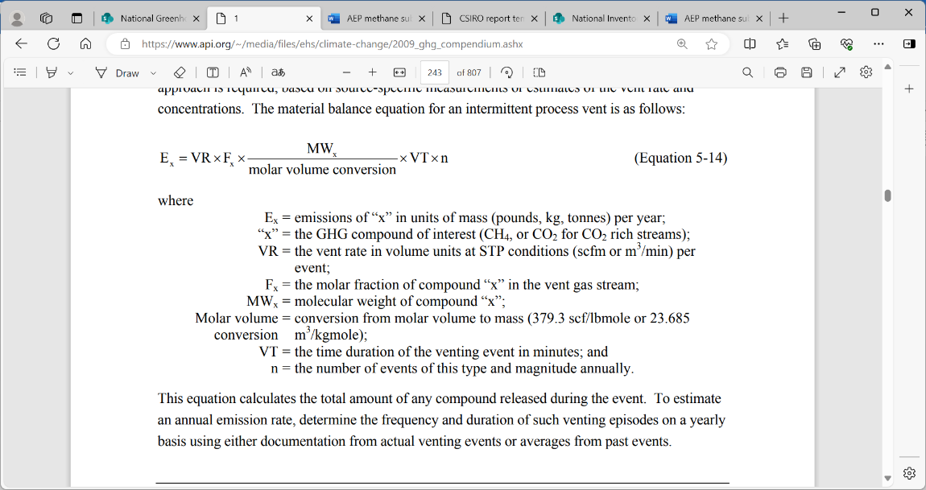  Equation 5-15  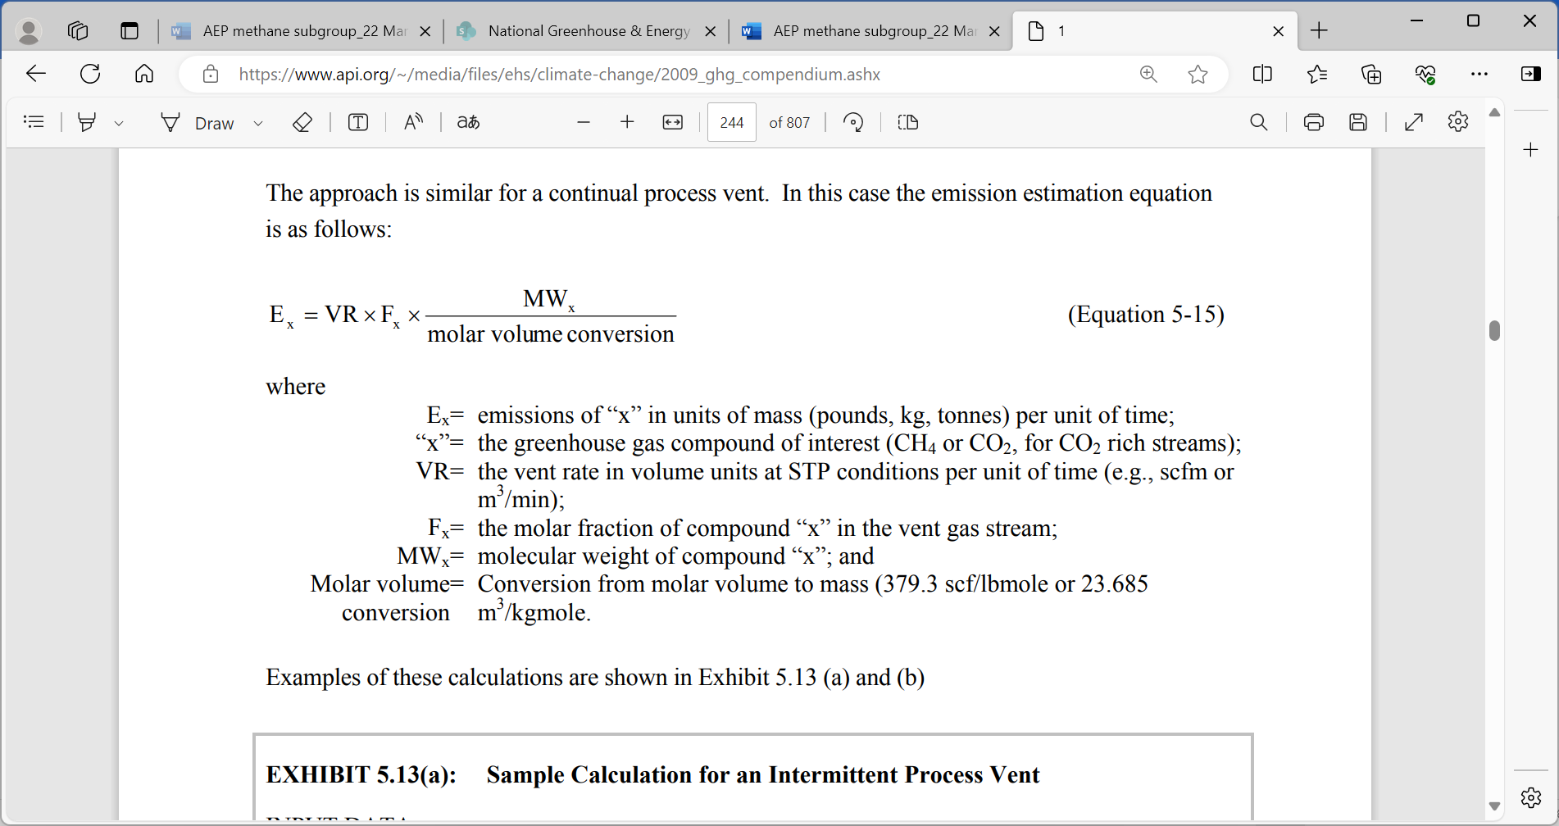
3.85L —emissions from system upsets, accidents and deliberate releases from process vents—production related nonroutine emissions—well blowouts | API Section 5.7.1 | Equation 5-24  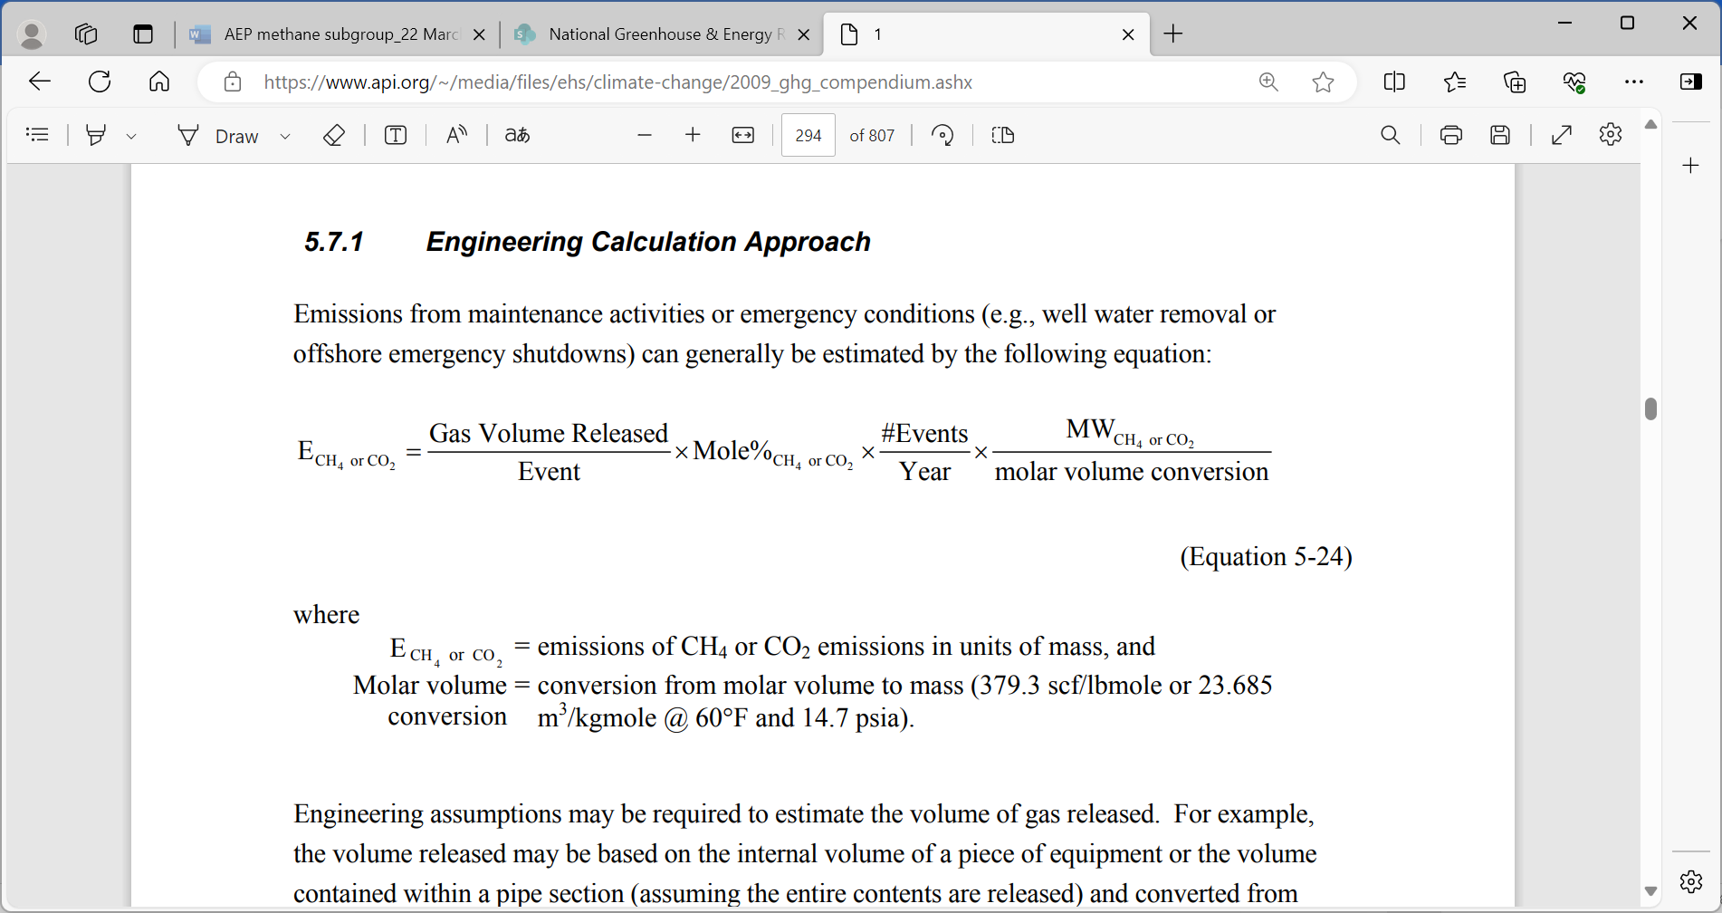  Equation 5-25  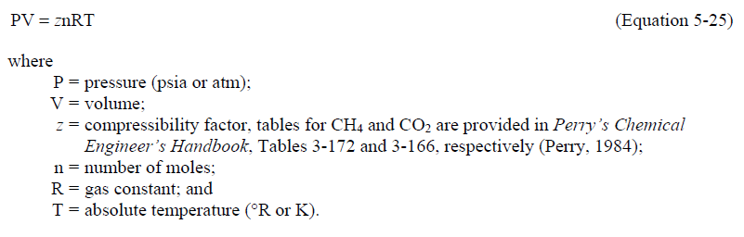  Equation 5-26  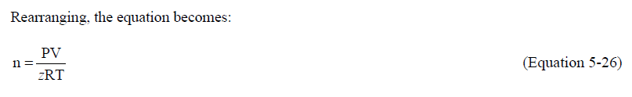  Equation 5-27  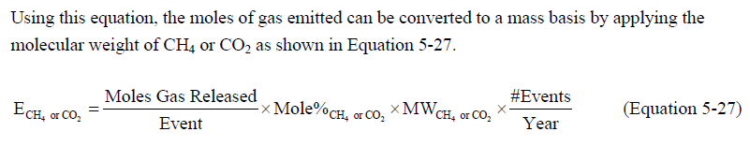
3.85N —emissions from system upsets, accidents and deliberate releases from process vents—production related nonroutine emissions—CO₂ stimulation | API Section 5.7.1 | As above
This proposal would be implemented through amendment of the above provisions in Part 3.3 of the (emission estimation methods) and consequential amendments to Schedule 4, Part 2 (Matters to be Identified), of the Measurement Determination.
Consequential to the proposed amendment, reporters would be required to calculate the uncertainty of reported emissions rather than using the default uncertainty factors under the Method 1 approach. The NGER scheme administrator, the Clean Energy Regulator, will develop a calculator and guidance to support this calculation.
The proposed amendment would have the following benefits:
- Giving the public greater visibility of the higher quality data provided through use of those methods
- Enhancing the consistency of method categorisation across the Measurement Determination
- Improving the accuracy of the uncertainty calculation for the reported emissions estimates.
In the context of future annual NGER scheme updates and continuous improvement, the Department will continue to work with stakeholders to identify improvements to these methods.
The Department will also consider Method 1 venting sources for which the API Compendium provides engineering calculations or measured data approaches as an option, to determine the merit of splitting out that option into a separate Method 2, and incorporating improvements where identified. This case-by-case approach to reviewing Method 1 for estimating fugitive methane emissions reflects the breadth and diversity of sources for which Method 1 is available. As part of that review, consideration also needs to be given to opportunities to improve the existing higher order methods and develop new higher order methods to ensure viable alternatives exist in the event Method 1 is phased out for a particular emissions source. Such an approach could support implementation of Recommendation 15 of the CCA review as it relates to the oil and natural gas sector, and be consistent with Recommendation 16 “Resource the department to establish higher order estimation methods for all fugitive methane emission sources included in the Measurement Determination.”.

Mud de-gassing: Reinstating a method for the estimation of methane emissions from natural gas mud de-gassing activities
Vented emissions during well drilling activities occur due to gas released from ‘drilling mud’. Drilling mud is used for many important purposes, including lubricating and cooling the drill bit, carrying cuttings away from the drill bit, and maintaining desired pressure within the well. In these operations, gas from the well bore may become entrained in the mud. During the drilling process, the drilling mud is recirculated and degassed once outside the well-bore to remove the entrained gas. During mud degassing, gases entrained in the mud are separated from the mud and vented directly to the atmosphere. This venting results primarily in emissions of methane contained in the gas. A method for the estimation of emissions from mud degassing was unintentionally removed from the Measurement Determination in substantive amendments made in 2021.
The Government proposes amendments to the Measurement Determination to reinstate the method. The previous method was set out at item 6 of the table in section 3.84 in the 2020 Measurement Determination. Only the reference relating to mud degassing from that item needs to be reinstated because the other elements (coal seam exploratory drilling and well testing) are covered by subdivisions 3.3.2.2 and 3.3.2.3 of the Measurement Determination. The Department considers this activity to be part of oil or gas exploration, and proposes the amendment be incorporated under Division 3.3.2—Oil or gas exploration and development.
The proposed amendment will update the previously cited references to Section 5.6.3 of the 2009 API Compendium to section 6.2.1 in the 2021 version of that document. This update will enable application of a more up to date emissions factor.
Methane emissions from this activity for a particular facility may fall below the threshold for incidental emissions as set out in sub-regulation 4.27(5) of the NGER Regulations. Consequently, the placement of the method in the Determination will provide reporters with the option of reporting via another method that is consistent with the principles in section 1.13 of the Measurement Determination.
The proposed amendment would have the following benefits:
- Addressing an unintentional omission introduced through the 2021 Measurement Determination amendments
- Providing a method for a reportable source of methane emissions under the Paris Agreement
- Demonstrating that Australia is prioritising completeness of methane emissions reporting.

Produced formation water (PFW): Clarification of reporting requirement for Method 2
Leaked emissions from produced water tanks occur when water extracted from an oil or gas well is stored, and over time, releases dissolved methane to the atmosphere. The leakage rate of methane from the water in a year is driven by the amount of methane that was dissolved in the water, which can be calculated based on the water pressure at time of extraction, and the salinity of the water.
The current Method 2 in the Measurement Determination for this emissions source uses the total volume of water produced in a year. Stakeholder consultations indicate that some facilities reinject water extracted in their processes back into the reservoir without allowing it to be exposed to the atmosphere, rather than storing it in a way that leakage will occur. In such instances the current method overestimates methane emissions.
To address this issue, the Government proposes amending the definition of produced water in Method 2 to mean the net volume of water produced, allowing for reinjected water to be excluded in those instances where it has not been exposed to atmosphere. The proposed amendment to the Method 2 in section 3.73NB of the Measurement Determination would read as follows (proposed new text underlined):
For Section 3.73NB Method 2—produced water (other than emissions that are vented or flared)
W_{i} is the net quantity of produced water during the year associated with the relevant activity measured in megalitres of produced water, where the net quantity is the total quantity of produced water during the year minus the total quantity of produced water not exposed to the atmosphere that is reinjected over the same period.

Oil and natural gas sector provisions: miscellaneous clarifications
The Government proposes the amendments set out in Table 2 to improve understanding of, and therefore support compliance with, oil and gas sector-related provisions. These amendments respond to feedback provided by NGER reporters to the Clean Energy Regulator.
Table 2 – Amendments to improve the clarity of the Measurement Determination
Section impacted | Section Title | Amendment
Part 2.2.3 | General Requirements for sampling under method 2 | An update to the requirements for sampling gaseous fuel to clarify that multiple samples may be used to calculate a representative sample, rather than requiring all samples to be combined into a single composite for measurement (see also section xiii of this paper)
Section 3.73Q(3) | Natural gas processing (other than emissions that are vented or flared) | Resolving a typographical error where “natural gas gathering and boosting stations” are referenced, instead of “natural gas processing stations”
Section 3.87A | Natural gas production (flared methane or nitrous oxide emissions) | Resolving an incorrect reference to a table in Section 3.85(2), to the correct table in Section 3.86(2)

Flaring: Potential additional Method 2 for the estimation of methane emissions from natural gas flaring activities, and consequential additional Method 2 for the estimation of carbon dioxide emissions from natural gas flaring activities
The following proposed amendments are subject to further legislative drafting action and are not included in the Exposure Draft.
Flares are used in the oil and gas industry to manage the disposal of natural gas and hydrocarbon liquids via combustion. The decision on whether to vent or flare depends on a range of considerations, including waste stream composition, local regulatory requirements, and environmental, and safety considerations. Sometimes fuel gas may be used to enrich a waste gas stream so it will support stable combustion during flaring. Waste gas is usually only vented if it is non-odorous and non-toxic, and even then it may be preferentially flared.
The majority of flaring emissions are in the form of carbon dioxide, which has a lower global warming potential than methane. Relatively small amounts of methane emissions occur from incomplete combustion of the flared hydrocarbons.
Divisions 3.3.9A to 3.3.9G of the Measurement Determination provide for the estimation of fugitive greenhouse emissions, including methane emissions, from flaring from natural gas activities. Currently NGER reporters have the option of estimating fugitive methane emissions in accordance with Method 1 or 2A.
Method 2A requires a reporter to estimate their methane or nitrous oxide emissions using the quantity of gas throughput and an emissions factor for the gas based on a measured sample of the gas composition at the flare point, in accordance with general requirements for sampling at Subdivision 2.3.3.2 of the Measurement Determination. Stakeholder consultations have indicated that the sampling requirements under the method present a barrier to uptake of the higher order method. The barrier primarily relates to the requirement that sampling occurs at the flare point and associated costs. This requirement to sample at the flare point can raise safety concerns where variability in gas composition and flow would require a high frequency of sampling. It can also become cost prohibitive when a facility has large numbers of flares on which sampling equipment must be installed and maintained.
The Department is developing a possible new Method 2B, that would be an alternative to the existing Method 2A, and designed to address the above-mentioned barrier to higher order method uptake. As the legislative amendment text is under development, the Department provides the following narrative description of the proposed amendment for feedback.
The new Method 2B would be based on the mass balance approach set out in Equation 5-5 of the 2021 API Compendium set out below. A mass balance applies the concept of conservation of mass to the analysis of a physical system – in this case, because the quantity of carbon atoms in the gas cannot be destroyed in any part of the process, the total mass of carbon that is tracked entering the facility must therefore be equal to the total mass of carbon that leaves the system through any means, including the product stream, or venting, leaking and flaring routes. Effectively this process acts like a chain of custody model, where the carbon is tracked at every section of the facility. The approach would be supported by gas composition sampling of the input gases and the flare feed, rather than the flare point; leveraging sampling arrangements currently undertaken as part of usual business practices, where those arrangements meet representativeness requirements, as per Subdivision 2.3.3.2 of the Measurement Determination. This approach to the new Method 2B would minimise the existing barriers to uptake of a higher order method for this emissions source. The retention of sampling requirements in the new Method 2B will ensure inputs to the mass balance are representative of the facility’s gas composition, thus maintaining the accuracy of emissions estimates at a level equivalent to Method 2A.
$$E_{CH_{4}}=Q_{h}×(1-OF_{k})×GWP_{methane}$$
Where:
$E_{CH_{4}}$ is the total methane emissions, in tonnes of CO₂-e
Q_{h} is the total quantity of hydrocarbons (h) within the flared gas (k), in tonnes, calculated through a mass balance
OF_{k} is 0.98, which is the destruction efficiency of gas k
$GWP_{methane}$ is the global warming potential of methane as prescribed in the NGER Regulations.
If an NGER reporter were to use the new Method 2B mass balance approach to estimate methane emissions, they would be required to use the same mass balance approach to estimate carbon dioxide emissions from the same flare to ensure consistency and completeness in coverage of the carbon balance. The mass balance approach to estimating carbon dioxide emissions would be based on Equation 5-3 of the 2021 API Compendium set out below:
$$E_{CO_{2}}=\left(Q_{h}×CF_{k}×OF_{k}×\frac{44}{12}\right)+Q_{CO_{2}}$$
Where:
$E_{CO_{2}}$ is the total carbon dioxide emissions, in tonnes of CO₂-e
Q_{h} is the total quantity of hydrocarbons (h) within the flared gas (k), in tonnes, calculated through a mass balance
CF_{k} is the carbon weight fraction of flared gas k
OF_{k} is 0.98, which is the destruction efficiency of gas k
$Q_{CO_{2}}$ is the quantity of carbon dioxide within the flared gas, in tonnes, calculated through the same mass balance approach as the estimate for methane content
$\frac{44}{12}$ is the Carbon to CO₂ mass conversion factor

Subject to finalisation of legislative drafting, the new Method 2B would minimise barriers to the use of higher order methods for this source that have been identified by NGER reporters. By moving to the new method, a reporter would be able to more accurately capture a given facility’s natural gas flaring activities. This proposed amendment would also be consistent with Recommendation 16 of the CCA review “Resource the department to establish higher order estimation methods for all fugitive methane emission sources included in the Measurement Determination.”.

Fugitive methane emissions: new transparency arrangements
The CCA review included recommendations to improve the NGER scheme’s transparency. These recommendations build on the enhanced data transparency measures introduced by the Government through the 2023 Safeguard Mechanism reforms. Those reforms include requiring the Clean Energy Regulator to publish by 15 April each year information reported by Safeguard Mechanism facilities on the amount of covered emissions that were carbon dioxide, methane and nitrous oxide emissions data in the previous financial year, commencing in 2025.
The Government is still considering the CCA’s recommendations for further enhancing NGER scheme transparency, with a particular focus on fugitive methane emissions. However, an element of the CCA’s transparency recommendations could be implemented from 1 July 2024 through amendment of the National Greenhouse and Energy Reporting (Safeguard Mechanism) Rule 2015.
In that context, the Government invites feedback on a proposal to amend the Rule to require the Regulator to publish by 15 April each year the method used by each Safeguard Mechanism facility to estimate fugitive methane emissions for the previous financial year from coal mining, oil and natural gas sources. This proposed provision will be included in upcoming public consultations on draft amendments to the Rule, which is primarily focused on inserting additional best practice emissions intensity numbers into the Rule.

Scope 2 emissions from consumption of electricity

State and territory specific Residual Mix Factors
In 2023, an optional, supplementary ‘market-based method’ for calculating the emissions associated with consumption of electricity (‘scope 2’ emissions) was introduced to allow NGER reporters to make unique claims on the zero emissions intensity attributable to some renewable electricity. The market-based method uses a residual mix factor (RMF), which is an emission factor derived from the emissions and generation on-grid, adjusted for the renewable generation associated with Large-scale Generation Certificates (LGCs).
The Government proposes to disaggregate the existing national-based RMF by state and territory. This would provide for a more representative estimate of emissions using the scope 2 market-based method, reflecting the significant differences between states and territories in the emissions intensity of generation and the creation of LGCs. Such differences are particularly material to large users of electricity, providing more accurate emissions estimates at the facility level than using a national RMF.
This proposed refinement has been made in response to ongoing consultation with reporters throughout FY2023/24 and a review of submissions made during the public consultation process on the 2023 NGER amendment cycle.
The Department notes that market-based accounting for scope 2 emissions is proposed to be made mandatory from 2027 under the Treasury-led climate related financial disclosure legislation. However, if the market based method is made mandatory under the NGER scheme earlier than 2027, reporters should disclose market-based scope 2 emissions under the proposed Treasury framework. The Department welcomes submissions from stakeholders on further refinements to the existing method that would be needed to support the mandatory introduction of the market-based scope 2 method.

Method for calculating the Residual Mix Factor for each state and territory
To calculate the RMF for each state and territory, the Department used the following method:

RMF = M / (N – (LGC × 1000))

Where:

RMF is the residual mix factor for the financial year, measured in kilograms of CO₂-e per megawatt hour (MWh) for each state and territory.

M is emissions from on-grid generation for each state and territory based on NGER reports for the preceding reporting year, measured in tonnes CO₂-e. Emissions associated with cogeneration facilities and those whose primary purpose for electricity is for self-use and not for the grid are pro-rated based on the proportion of the amount of total generation and that which is sent to the grid, as reported under NGER.
M includes methane emissions from hydro generation dams in each state and territory (defined as a human-made structure built to contain and control a body of water and used to generate hydroelectricity) based on the method applied in the National Greenhouse Gas Inventory.

N is the electricity generation sent out to the grid in each state and territory, measured in kilowatt hours (kWh), including net interstate trade and excluding distributed small scale solar self-consumption. Generation data is from NGER reports for the preceding reporting year and Australian Energy Market Operator data for that same time period sourced through the NEMReview software package.

LGC is LGC creations for renewable generation in each state and territory which occurred in the same financial year as N and M, measured in MWh, and is based on data provided by the CER from the Renewable Energy Certificate (REC) Registry.

Proposed Scope 2 emissions factors for the 2024-25 NGER reporting year
Proposed scope 2 location and market-based emissions factors for the 2024-25 reporting year are shown below. These values are updated annually based on on-grid generation and emissions in the preceding reporting year as outlined in section vi above.

Table 1 – Proposed location and market-based emission factors
Location | 2024-25 proposed location-based emission factor  (kg CO₂-e/kWh) | 2024-25 proposed market-based residual mix factor  (kg CO₂-e/kWh)
New South Wales and Australian Capital Territory | 0.66 | 0.80
Victoria | 0.77 | 1.08
Queensland | 0.71 | 0.83
South Australia | 0.23 | 0.51
South West Interconnected System in Western Australia | 0.51 | 0.55
Tasmania | 0.15 | 0.19
Northern Territory | 0.56 | 0.57

Schedule 4, Part 7 - new reportable item to flag overlap of scope 1 and scope 2 emissions estimates of a corporation
This proposed amendment is subject to legislative drafting and is not included in the Exposure Draft.
The department has received feedback from reporters that there is scope for a perceived ‘double count’ of emissions in circumstances where an entity reports scope 1 emissions from the generation of electricity which is subsequently also consumed by facilities within the entity’s operational control (this could occur under the non-main grid location-based method in section 7.3, or under the market-based method in 7.4). In these circumstances, those same emissions are both the entity’s scope 1 and scope 2 emissions, and so will be ‘double counted’ if those two scopes are simply added together to give a ‘total’ emissions number for the entity.
Where this is the case, the Government proposes to introduce a requirement for reporters to identify this circumstance to the CER by providing the names of relevant generating and consuming facilities. This will enable the Regulator to flag in their data publication products corporations for which this overlap of scope 1 and 2 emissions exists.
Part 7 of Schedule 4 of the Measurement Determination (Matters to be identified in relation to sources – Scope 2 emissions) currently requires reporters using the optional, market-based method for estimating scope 2 emissions in section 7.4 to report data inputs used for calculation of emissions under that section (Q, Q_{exempt}, REC_{surr} and REC_{onsite}).
The Government proposes to expand Subdivision 4.4.3A of the NGER Regulations to make provision for the reporting of matters in relation to location-based estimates of scope 2 emissions under methods 7.2 and 7.3 of the Determination, and to add a new requirement to Part 7 of Schedule 4 of the Determination that, where: a registered corporation reports scope 1 emissions under Chapter 2 of the Determination from the combustion of fuel for the purpose of generating electricity; and the corporation also reports scope 2 emissions under Chapter 7 of the Determination from the consumption of that electricity, the corporation must identify the names of relevant generating and consuming facilities.

Market-based approach for reporting scope 1 emissions from renewable aviation kerosene and renewable diesel
The Government proposes to introduce a market-based approach for determining scope 1 emissions that occur when renewable aviation kerosene (RAK) and renewable diesel (RD) (collectively, drop-in renewable fuels), are consumed after they have been co-mingled with their fossil fuel equivalents and supplied through shared infrastructure systems.
RAK and RD are biomass-derived hydrocarbon fuels with nearly identical chemical and physical properties to their conventional fossil fuel equivalents (kerosene for use as fuel in an aircraft and diesel oil, respectively). Under the NGER scheme, RAK and RD have the same technical parameters as their respective fossil fuel equivalents, except both are assigned a scope 1 carbon dioxide emission factor of zero. This approach is consistent with other biogenic fuel types, and reflects the fact that their combustion releases carbon which was absorbed by their biogenic source materials from the atmosphere during their life.
Under the NGER scheme’s existing accounting approach, reporters report the scope 1 emissions from combustion of the fuel they physically consume. However, this approach means that when drop-in renewable fuels are co-mingled with their fossil fuel equivalents and distributed through shared infrastructure (for example, through shared pipelines, storage, or refuelling systems, such as a Joint User Hydrant Installation (JUHI)), the claim to their consumption and the associated emissions benefit is spread across all users of the infrastructure. Drop-in renewable fuel purchasers are only able to report consumption of the part share of renewable fuel they physically consume, determined in accordance with the fuel manufacturer’s specification or by fuel sampling.
Stakeholders have indicated that the scheme’s existing accounting approach is impeding domestic uptake of lower emissions fuels, especially for some Safeguard Mechanism facilities for whom renewable fuels may be one of the only viable decarbonisation options. This issue could be addressed through a more flexible ‘market-based’ accounting approach to enable NGER scheme reporters to make a full and exclusive claim to the scope 1 emissions benefit from their drop-in renewable fuel purchases, even if the fuel they purchased is distributed through shared infrastructure and physically consumed by multiple entities.
The Government proposes to implement ‘market-based’ accounting for drop-in renewable fuels through an amendment to the blended fuel provisions in Part 2.6 of the Measurement Determination. The proposed amendments rely on the proposed new term shared infrastructure system meaning a fuel supply system from which fuel may be drawn by multiple facilities (see Schedule 1 Item 1). If a drop-in renewable fuel is supplied as a component of a blended fuel through a shared infrastructure system, the existing sampling-based approach for determining the composition of the blended fuel will no longer apply. Instead, reporters must determine the composition of the blended fuel they draw from a shared infrastructure system based on their fuel purchase, delivery and blending records. Subject to meeting the proposed evidence requirements, reporters will be able to report the blended fuel they draw from a shared infrastructure system as being composed of the fuel or fuels they contracted to have added to the shared infrastructure system on their behalf.
The evidence requirements include reporters being able to demonstrate that they have purchased drop-in renewable fuel, that it has been delivered to the shared infrastructure system and that it is derived or recovered from biomass (see Schedule 1 Item 4). Any fuel drawn from a shared infrastructure system that is not supported by the evidence required to report that fuel as drop-in renewable fuel is deemed to be the relevant fossil fuel equivalent and must be reported as such, even if it physically contains some drop-in renewable fuel added to the shared infrastructure system on behalf of another entity.
To support the proposed amendments, the Government also proposes: (a) to amend the NGER Regulations to enable new reportable items to be specified in Schedule 4 of the Measurement Determination (Matters to be identified in relation to sources) in relation to fuel combustion sources, and (b) for the new reportable items below to be added to the Measurement Determination. Proposed new items are subject to further legislative drafting and so are not included in the Exposure Draft. The proposed items would give greater visibility over the use of blended fuel provisions by requiring reporters who make use of those provisions provided in Part 2.6 of the Measurement Determination (including the proposed new section 2.67B) as part of estimating their scope 1 emissions from fuel combustion to report:
- That they have used the blended fuel provisions
- The total quantity of blended fuel for which the blended fuel provisions have been used
- The quantity of each type of fuel that is contained in the blended fuel, determined in accordance with the blended fuel provisions.

The proposed amendments will be enhanced over time
The proposed amendments are intended to send a clear and early signal to the domestic renewable fuel market and ensure the NGER scheme remains fit-for-purpose in its role of facilitating reporting under the Safeguard Mechanism, including emissions reduction opportunities.
Introducing market-based accounting for scope 1 emissions from fuel combustion would be an important evolution of the NGER scheme. The Department will apply learnings from the implementation of the proposed amendments and work with stakeholders to enhance the market-based accounting for scope 1 emissions overtime, including potential future expansion to other fuel types.
The proposed market-based accounting approach based primarily on fuel purchase and delivery evidence could be amended in future to link the NGER scheme with renewable fuel certifications if they were developed under an expanded Guarantee of Origin (GO) scheme. For example, by amending the NGER scheme to recognise the surrender of GO certificates as a claim to consumption of renewable fuel. Linking the NGER scheme and GO in future could provide additional assurance of the emissions reduction claims made using market-based accounting as the domestic renewable fuel market grows and more complex shared supply chain scenarios emerge.
Without prejudice to the Government’s forthcoming response to Recommendation 7 of the CCA review, the proposed amendment, and the potential to expand initial arrangements to other renewable fuel types and to link the NGER scheme and GO, is consistent with elements of their recommendation to “Introduce optional market-based reporting of renewable liquid and gaseous fuels once a framework for approving certifications for renewable fuels is operational.”. The proposal to implement market-based reporting for scope 1 emissions from RAK and RD now, ahead of a domestic certification scheme for these fuel types being available, is an appropriate and necessary signal to the domestic renewable fuel market. The proposal to implement these arrangements in a compulsory manner rather than as an optional accounting approach in addition to the existing approach is necessary to help remove the risk of double-claiming where reporters use a mix of market-based and the existing sampling-based blended fuel provisions. It will also help to ensure the comparability and consistency of emissions information reported under the scheme and streamline reporting requirements for scheme participants. Implementing the proposed arrangements in a compulsory manner will not create additional reporting burden for scheme participants who do not purchase drop-in renewable fuels.

Interaction with the Fuel Quality Standards Act 2000
Neat renewable diesel does not meet Australia's diesel fuel quality standard parameters (due to its lower density) and cannot be supplied without a variation under the Fuel Quality Standards Act 2000. The Department is developing a fuel quality standard for renewable diesel to remove this barrier and enable the supply of neat renewable diesel in Australia. Until this standard is implemented, anyone intending to supply neat renewable diesel must apply for a variation to the automotive diesel fuel quality standard. The Department can assist potential suppliers with the application process. Further information about the regulation of fuel in Australia and the variation process can be found on the department's website.

Emissions from waste

Reporting gross emissions from non-legacy waste under matters to be identified.
Schedule 4 of the Determination lists ‘matters to be identified’ (MTBI). These matters provide additional information which is used for assurance of estimates made under the NGER scheme.

The Government proposes to introduce an MTBI in Part 6 (Waste) of Schedule 4, requiring landfills reporting scope 1 emissions of more than 100 kt CO₂-e per year to provide an estimate of gross emissions from non-legacy waste, calculated as:

N$LCH₄=\frac{non-legacy emissions}{1-OF}+CH₄ recovery$

Where:

NLCH₄ is the tonnes of methane (CO₂-e), other than legacy emissions, that would be emitted by the facility if emissions were not captured, and oxidation did not occur.

Non-legacy emissions is the emissions (CO₂-e), other than legacy emissions, from the decomposition of waste.

OF is the oxidation factor (0.1) for near surface methane in the landfill.

CH₄ recovery is the sum of the tonnes of methane (CO₂-e), other than legacy emissions, that are captured for combustion, captured and transferred offsite, and flared.

The introduction of this matter as a MTBI will provide information which is used for the calculation of annual baselines under the Safeguard Mechanism.

Emissions of methane released from landfills – update to reporting requirements.
Section 5.4 of the Determination provides a default method (Method 1) to estimate emissions of methane released from landfills (other than from flaring of methane).
Sections 5.4B, 5.4C and 5.4D of the current method reference a previous collection efficiency threshold (0.75). This threshold was updated in the preceding section of the Determination, 5.4, in 2023 and now refers to an amount calculated in accordance with section 5.15C.
The Government proposes to update the text in sections 5.4B, 5.4C and 5.4D of the Determination to replace references to “0.75” with “the collection efficiency limit for the landfill calculated in accordance with section 5.15C”. This change is important to ensure the emissions estimates calculated using Method 1 are in accordance with the updated section 5.4.

Emissions of methane released from landfills – update to terminology.
Sections 5.4 and 5.15 of the Determination provide methods (Method 1 and Method 2, respectively) to estimate emissions of methane released from landfills (other than from flaring of methane).
Sections 5.4, 5.15, 5.15A and 5.15B of the current Method reference a “collection efficiency amount”. This amount is referred to in Section 5.15C as a “collection efficiency limit”.
The Government proposes to update the text in sections 5.4, 5.15, 5.15A and 5.15B to replace references to “collection efficiency amount” and “CEA” with “collection efficiency limit” and “CEL”, respectively. This change is important to align the terminology used in Method 1 with section 5.15C.

Other amendments

Carbon capture and storage and enhanced oil recovery – update to injection method
Methods provided for the estimation of fugitive emissions from the injection of CO₂ for Carbon capture and storage and enhanced oil recovery mirror those provided for natural gas production, as the equipment and processes are comparable.
The current method for CO₂ injection references a previous method for natural gas production that has since been updated to incorporate Australian specific emissions factors.
Amendments are proposed to align the method for estimating emissions from the injection of CO₂ with the current method for natural gas production - 3.73B Method 2—onshore natural gas production, other than emissions that are vented or flared—wellheads.

Sampling of gaseous fuels
Section 2.23 of the Determination sets out requirements relating to sampling and analysis under method 2 for estimating emissions of carbon dioxide from the combustion of gaseous fuels.
Similarly to provisions of solid and liquid fuels, subsection 2.23(1) currently provides that gaseous fuels must be ‘derived from a composite of amounts of the gaseous fuel combusted’.
Feedback from some reporters has indicated that the combining of amounts of gaseous fuels into a composite as required by this subsection introduces technical difficulty and risk of measurement error due to air contamination.
Updates are proposed to remove this risk by deleting the subsection and making minor consequential changes to subsection (2).

Notes on Exposure Draft clauses
National Greenhouse and Energy Reporting (Measurement) Amendment (2024 Update) Determination 2024
Section number | Section name | Description
 | Name | States the name of the 2024 Measurement Determination update instrument.
 | Commencement | Provides that amendments would commence on 1 July 2024, with the exception of amendments to repeal Method 1 for estimating fugitive methane emissions from open-cut mine coal extraction.  Provides that amendments to repeal Method 1 for estimating fugitive methane emissions from open-cut mine coal extraction would commence on 1 July 2025 for facilities covered by the Safeguard Mechanism that reported more than 10 million tonnes of run-of-mine coal was extracted during financial year 2022-23, and commence on 1 July 2026 for all other Safeguard facilities.
 | Authority | States that the instrument is made under section 10(3) of the NGER Act.
 | Schedules | A formal clause which allows the Schedule to amend the Measurement Determination.

Schedule 1 - Amendments
Item number | Item name | Description
 | Section 1.8 (Definitions) | Inserts a definition of 2021 API Compendium to support the use of updated emission factors in the estimation of methane emission from mud degassing activities. (items 11-13 refers)  Inserts a definition of shared infrastructure system to support the market-based estimation of emissions from drop-in renewable fuels and their fossil fuel equivalents.
 | Subsections 2.23(1) and 2.23(2) | Deletes the current section 2.23(1) of the Determination to avoid risk of measurement error through air contamination of samples.
 | Section 2.67 (notation) | Inserts a note to section 2.67 clarifying that the application of section 2.67 is subject to section 2.67B.
 | Chapter 2, Part 2.7 | Inserts a new section 2.67B providing a market-based approach for determining the amount of drop-in renewable fuel in a blended fuel supplied through a shared infrastructure system.
 | Section 3.19 | After the current subsection 3.19(2) adds subsection 3.19(2A) of the Determination to provide that Method 1 in the list of methods available for estimating fugitive emissions from open-cut mine coal extraction cannot be used by the Safeguard Mechanism facilities that reported more than 10 million tonnes run-of-mine coal was extracted during the financial year 2022-23. As stated in the explanatory text for item 2 of section 2 (commencement) above, this amendment would commence on 1 July 2025.
 | Subsection 3.19(2A) | Replaces the text of subsection 3.19(2A) introduced under item 5 with text to provide that Method 1 in the list of methods available for estimating fugitive emissions from open-cut mine coal extraction cannot be used by any Safeguard Mechanism facility. As stated in the explanatory text for item 3 of section 2 (commencement) above, this amendment would commence on 1 July 2026.
 | Section 3.42 | Amends section 3.42 to expand the application of division 3.3.2. to mud degassing.
 | Subsection 3.46A(2) | Makes an editorial change to clarify the phrase “system upsets, accidents and deliberate releases from process vents”
 | Paragraph 3.46A(2)(a) | Amends section 3.46A to specify in the list of available methods for estimating fugitive emission from system upsets, accidents and deliberate releases, the section reference to the reinstated method for estimating fugitive emissions from mud degassing.
 | Division 3.3.2, Subdivision 3.3.2.3.1 | Reinstates a method 1 for estimating emissions from mud degassing during oil or gas exploration or development.
 | Subsection 3.73NB(1) (definition of W_{i} ) | Replaces the definition of W_{i} in the Method 2 formula prescribed for the estimation of fugitive methane emissions from produced water tanks when water is extracted from an oil or gas well.
 | Subsection 3.73Q(3) (definition EF_{ijs} and Q_{i}) | Replaces an incorrect reference to “gathering and boosting station” with “processing station” in section 3.73Q (Method 1—natural gas processing (other than emissions that are vented  or flared).
 | Sections 3.85A, 3.85B, 3.85K, 3.85L, 3.85M, 3.85N, 3.85R and 3.85S | Replaces references to “Method 1” with “Method 2” in methods for estimating fugitive methane emissions from cold process vents, well blowouts, CO₂ stimulation and vessel blowdowns, compressor starts and compressor blowdowns during from natural gas production.
 | Sections 3.85A, 3.85K, 3.85M, 3.85R (notations) | Consequential amendments to implement item 15. Replaces references to “Method 1” with “Method 2” in the notes to the methods identified in item 15.
 | Section 3.85B, 3.85L, 3.85N, 3.85S | Replaces references to “as described” with “the engineering calculations provided” to remove doubt as to whether the engineering calculation formulae set out in the prescribed section of the API Compendium must be used.
 | Section 3.87A (definition EF_{hij}) | Replaces “Section 3.85(2)” with “Section 3.86(2)” to resolve an incorrect reference to a table used in the application of Method 2A for estimating fugitive methane or nitrous oxide emissions from natural gas production.
 | Section 3.96 | Replaces method to bring the estimation of fugitive emissions from injection of a greenhouse gas into a geological formation into alignment with the current 3.73B Method 2—onshore natural gas production, other than emissions that are vented or flared—wellheads
 | Subsections 5.4(2), 5.4(3), 5.15(3), 5.15(4), 5.15(5), 5.15A(1), 5.15B(1) | Replaces references to “collection efficiency amount” with “collection efficiency limit” to align with terminology used in section 5.15C.
 | Subsections 5.4(3) and 5.15(4) (definition of CEA) | Replaces references to “CEA” with “CEL” to align with terminology used in section 5.15C.
 | Subsections 5.4(3) and 5.15(4) | Replaces the acronym “CEA” used in equations with “CEL” to align with terminology “collection efficiency limit” used in section 5.15C.
 | Subsection 5.15A(3) (Note 2) | Replaces a reference to “collection efficiency amount” with “collection efficiency limit” to align with terminology used in section 5.15C.
 | Subsection 5.4B(1) | Replaces reference to “0.75” with “the collection efficiency limit for the landfill calculated in accordance with section 5.15C” to align with section 5.4.
 | Subsection 5.4B(3) (Note 2) | Replaces references to “0.75” with “the collection efficiency limit for the landfill calculated in accordance with section 5.15C” to align with section 5.4.
 | Subsection 5.4C(1) | Replaces reference to “0.75” with “the collection efficiency limit for the landfill calculated in accordance with section 5.15C” to align with section 5.4.
 | Section 5.4D (Note 4) | Replaces references to “0.75” with “the collection efficiency limit for the landfill calculated in accordance with section 5.15C” to align with section 5.4.
 | Subsection 5.15A(3) (Note 2) | Replaces a reference to “collection efficiency amount” with “collection efficiency limit” to align with terminology used in section 5.15C.
 | Subsection 7.4(1) (definition of RMF) | Adapts the definition of Residual Mix Factor to apply it to the state or territory in which the consumption of electricity occurs.
 | Schedule 1, Part 6 | Provides RMF values and updates location factors for states and territories.
 | Schedule 4, Part 1 (Table under Source 2A – Underground mine) | Inserts an item into Schedule 4 of the Determination requiring underground coal mining facilities to indicate whether they use Periodic Emissions Monitoring (PEM) or Continuous Emissions Monitoring (CEM) in the application of Method 4 for estimating fugitive emission from underground mine coal extraction.
 | Schedule 4, Part 2 (Table under Source 2R—Onshore natural gas production—venting) | Consequential amendments to implement item 15. Replaces “Method 1” with “Method 2” in Matters to be Identified in relation to the estimation of fugitive methane emissions from venting activities during onshore natural gas production.
 | Schedule 4, Part 2 (Table under Source 2S—Offshore natural gas production—venting) | Consequential amendments to implement item 15. Replaces “Method 1” with “Method 2” in Matters to be Identified in relation to the estimation of fugitive methane emissions from venting activities during offshore natural gas production.
 | Schedule 4, Part 6 (Table under Source 4A—Solid waste disposal on land) | Inserts an item requiring landfills reporting scope 1 emissions of more than 100 kt CO₂-e per year to provide an estimate of gross emissions from non-legacy waste.

Given their similarity to their fossil-fuel equivalents, stakeholder consultations have indicated that maintenance of existing infrastructure will be the preferred and most cost-effective method of deploying drop-in renewable fuels, rather than through construction of new, segregated infrastructure.
Under the NGER scheme, facilities report scope 1 emissions from fuel combustion. Emissions associated with the production of fuels, including drop-in renewable fuels, are accounted for in the scope 1 emissions reporting of the fuel producer. The NGER scheme is not a lifecycle emissions reporting scheme.
See Part 2.6 of the Measurement Determination for existing provisions on reporting consumption of a blend of fossil and biogenic carbon fuels.
Blended fuel here refers to the blend of a drop-in renewable fuel and its fossil fuel equivalent that arises when they are co-mingled in a shared infrastructure system. Co-mingling of a drop-in renewable fuel and its fossil fuel equivalent will manifest a blended fuel irrespective of whether the drop-in renewable fuel added to the shared infrastructure system was itself a neat fuel or part of a blended fuel immediately before being added.

