

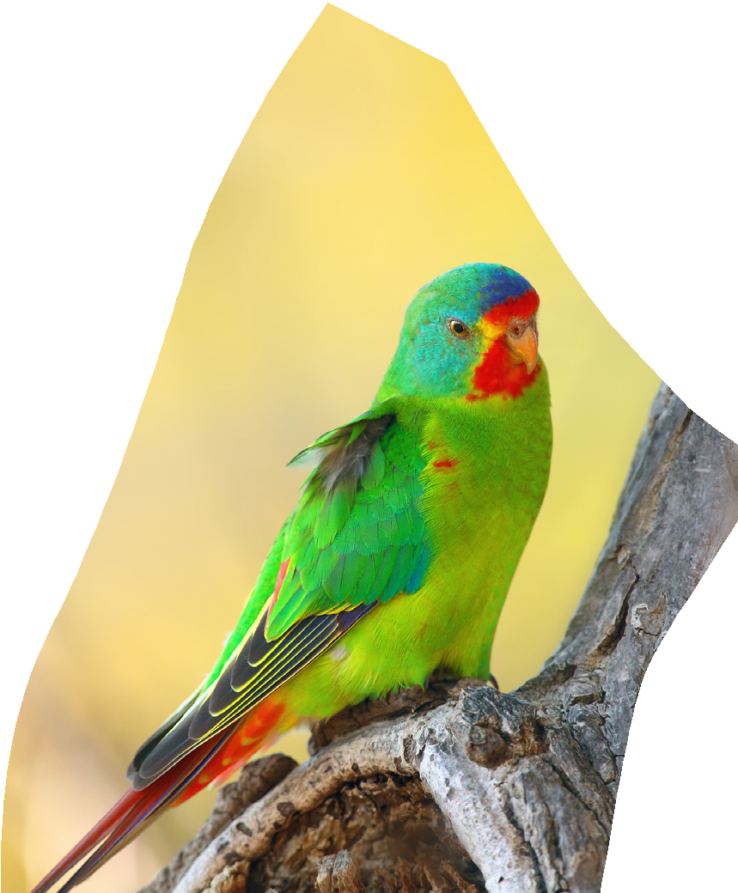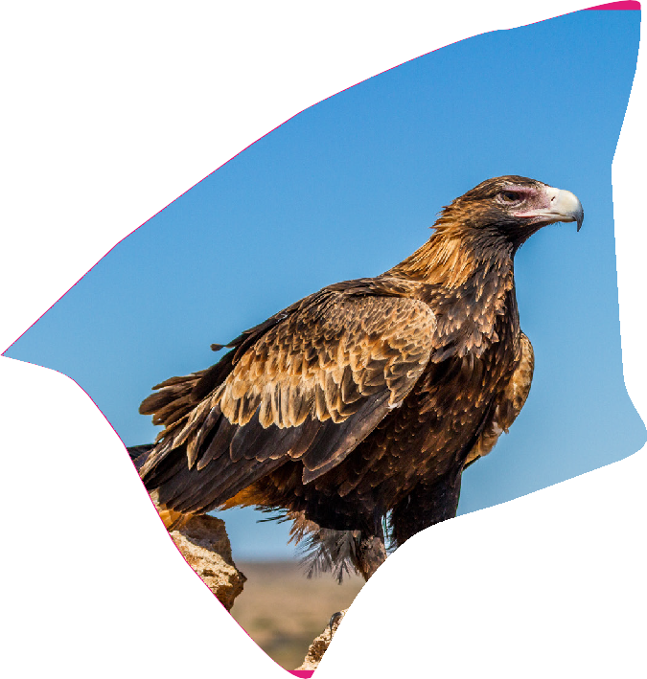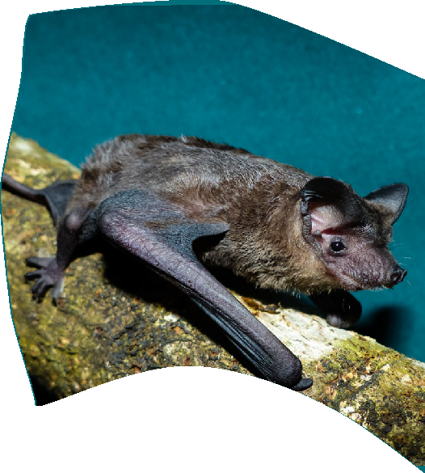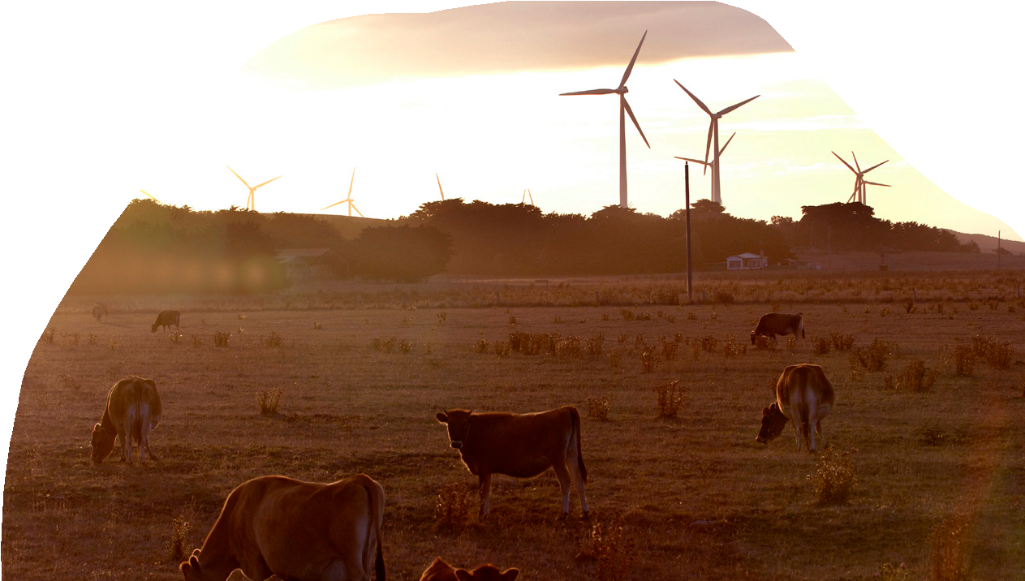

# Onshore Wind Farm Guidance

Best practice approaches when seeking approval under Australia’s national environment law

**May 2024**





© Commonwealth of Australia 2024

**Ownership of intellectual property rights**

Unless otherwise noted, copyright (and any other intellectual property rights) in this publication is owned by the Commonwealth of Australia (referred to as the Commonwealth).

**Creative Commons licence**

All material in this publication is licensed under a [Creative Commons Attribution 4.0 International Licence](https://creativecommons.org/licenses/by/4.0/legalcode) except content supplied by third parties, logos and the Commonwealth Coat of Arms.

Inquiries about the licence and any use of this document should be emailed to [copyright@dcceew.gov.au](mailto:copyright@dcceew.gov.au).



**Cataloguing data**

This publication (and any material sourced from it) should be attributed as: DCCEEW 2024, *Onshore wind farm guidance - best practice approaches when seeking approval under Australia’s national environment law*, Department of Climate Change, Energy, the Environment and Water, Canberra, Month. CC BY 4.0.

This publication is available at [dcceew.gov.au/publications](https://www.dcceew.gov.au/publications).

Department of Climate Change, Energy, the Environment and Water

GPO Box 3090 Canberra ACT 2601

Telephone 1800 920 528

Web [dcceew.gov.au](https://www.dcceew.gov.au)

**Disclaimer**

The Australian Government acting through the Department of Climate Change, Energy, the Environment and Water has exercised due care and skill in preparing and compiling the information and data in this publication. Notwithstanding, the Department of Climate Change, Energy, the Environment and Water, its employees and advisers disclaim all liability, including liability for negligence and for any loss, damage, injury, expense or cost incurred by any person as a result of accessing, using or relying on any of the information or data in this publication to the maximum extent permitted by law.

**Acknowledgement of Country**

We acknowledge the Traditional Owners of Country throughout Australia and recognise their continuing connection to land, waters and culture. We pay our respects to their Elders past and present.

## 

Contents

Introduction 4

Purpose of this document 5

Understanding the EPBC Act assessment process 6

1.1 Legislative framework 6

1.2 EPBC Act policy statements and guidelines 7

1.3 Conservation advices, recovery plans and threat abatement plans 7

1.4 State/Territory government assessment 8

1.5 Information milestones 8

Environmental impacts of onshore wind farms 10

1.6 Consider the context of your action 10

1.7 Avoiding and reducing impacts 11

1.8 Avoidance 12

1.9 Mitigation 13

Referral 14

1.10 Engage with us early 14

1.11 Pre-referral meeting 15

1.12 Recommended referral documentation 15

1.13 Choosing not to refer 16

Assessment survey requirements 16

1.14 Providing ecological data 17

1.15 Heritage Assessment 17

1.16 Establish a baseline through ecological assessment 17

1.17 Habitat and site utilisation assessments 18

Bird and Bat Management Plan 19

1.18 Overview of BBMP 19

1.19 Preparation of your BBMP 20

1.20 Environmental outcomes 20

1.21 Desktop assessment: preliminary site characterisation 21

1.22 Site-specific assessment: site utilisation surveys 21

1.23 Impact risk assessment 22

1.24 BBMP impact thresholds and adaptive management actions 24

1.25 Long-term mortality monitoring 24

1.26 BBMP Reporting requirements 25

1.27 Reporting schedule 26

1.28 Reporting metrics 26

Offsets 27

Post-Approval requirements 27

1.29 Conditions of approval 27

1.30 Long-term site utilisation surveys 28

Decommissioning 28

Glossary 29

References 31

Appendix A 32

## 

## Introduction

Australia has committed to a net zero emissions future. To achieve this, we must continue to grow the number of renewable energy projects to help accelerate the transition of our national energy system to renewables. Climate change and its effects, both direct and indirect, represent some of the key risks to threatened species and ecological habitats. At the same time, Australia’s environment and ecosystem services need to be protected to halt biodiversity decline. The social licence underpinning broad community support for the renewable energy industry is contingent on both regulators and industry delivering positive outcomes for both our climate and for Australia’s unique natural environment.

This guidance has been developed to support a smooth and efficient regulatory pathway that is essential to a renewable energy transition, while maintaining protection for matters of national environmental significance (MNES), including animals, plants, ecological communities, as well as natural, indigenous, and historic heritage places and values, and internationally important wetlands listed under the *Environment Protection and Biodiversity Conservation Act (1999)* (EPBC Act).

The identification and management of impacts during the design of onshore wind projects needs to reflect the Australian Government’s Nature Positive Plan by avoiding and minimising impacts on MNES and supporting restoration of the environment.

This guidance will support you in the development of documentation necessary for the Minister for the Environment or her delegate to assess the environmental impact of proposed wind farm projects, with a specific focus on the impact of wind farms on protected matters (particularly birds and bats). The documentation prepared by you will demonstrate that the project can:

* avoid, minimise and/or mitigate impacts on MNES, particularly through initial site selection, informed by available best practice statistical methodology and survey data and/or modelling that is site-specific
* propose feasible mitigation measures that reduce impacts
* apply survey data and mitigation strategies to deliver adaptive site-specific management plans for impacted MNES with corrective actions to be undertaken if mitigation measures are not effective and commitments of regular review cycles that will be used to adapt the management plans to industry best practices
* as a last resort, propose offsets that deliver gains for the MNES and Australia’s environment.

This guidance also outlines your ongoing responsibilities if a proposed wind farm project is approved.

## 

## Purpose of this document

The purpose of this document is to describe best practice approaches to assist the Australian onshore wind farm industry when bringing projects forward for approval under Australia’s national environmental law, the EPBC Act.

We (the Department of Climate Change, Energy, the Environment and Water) are responsible for implementing the environmental assessment process under the EPBC Act.

This document provides high level guidance on the referral, assessment, and approval process for proposed onshore wind farm projects under the EPBC Act, with a particular focus on bird and bat management. This document should not be applied retrospectively to projects already approved and does not provide detailed guidance on each requirement for assessment.

These guidelines relate only to onshore wind farms and replace [EPBC Act Policy Statement 2.3 : Wind farm industry - DCCEEW](https://www.dcceew.gov.au/environment/epbc/publications/epbc-act-policy-statement-23-wind-farm-industry). For the purposes of this guidance document, an onshore wind farm is a terrestrial site on which wind turbines are erected and operated to generate electricity.

The document is framed around the stages of EPBC Act assessment, so that it is clear about what information and documents we require at each assessment stage, and if a project is approved, what considerations for post-approval monitoring and reporting may be required to undertake as part of the conditions of approval.

You must refer the entire action that you are taking. While the majority of the action is likely to occur on your wind farm site, elements of an onshore wind farm project that may be considered in an assessment under the EPBC Act include:

* changes to land, vegetation, and wildlife management (for example, changed fire regime, impacts on wildlife site use arising from activities such as fencing, clearing, aerial wiring)
* site investigation, clearing, excavation, benching, construction and maintenance works for all project elements
* associated infrastructure on the wind farm site, such as access roads, sub-station(s), transmission lines, battery energy storage systems, automated avifauna detection and/or turbine curtailment systems, the monitoring network and permanent or temporary structures
* associated infrastructure off-site, such as any new reloading and pre-assembly sites, access roads (including roads and alterations to existing roads) and port or wharf facilities required to get machinery and turbine components to the site, quarries, transmission lines, worker accommodation and permanent or temporary structures
* structures built prior to, during and after construction for the operation and maintenance of the wind farm, such as generators and wind monitoring towers
* activities associated with the operation, maintenance and decommissioning of the wind farm, including any likely future upgrades
* the water resources required to construct and operate a wind farm (for example, desalination, groundwater bores, mains water).

If you are new to the EPBC Act process, or require further information, our [Step-by-step guide to the referral and assessment process](https://www.dcceew.gov.au/environment/epbc/approvals)  provides detail about the EPBC Act and how it may apply to your project.

For information on how to work with us to achieve a smoother, faster referral process and to arrange a pre-referral meeting, please refer to our [Pre-referral meeting for EPBC Act assessment process](https://www.dcceew.gov.au/environment/epbc/advice/pre-referral-meeting) advice page.

Otherwise, you can refer your project directly to us via the [EPBC Act Business Portal](https://epbcbusinessportal.awe.gov.au/).

## Understanding the EPBC Act assessment process

### Legislative framework

The EPBC Act is Australia’s national environmental law. It establishes a regulatory framework to protect MNES, also referred to as protected matters, which includes:

* listed threatened species and ecological communities
* listed migratory species protected under international agreements
* Ramsar wetlands of international importance
* the Commonwealth marine environment
* World Heritage properties
* National Heritage places
* Nuclear actions
* Great Barrier Reef Marine Park and water resources.

The Act also protects the environment (including heritage places) when actions are taken on Commonwealth land or impact upon Commonwealth land.

The EPBC Act provides a process to ensure that MNES are identified, and impacts are determined to be significant before developments (such as wind farms) are approved. In addition to the actions specific to your proposed project, economic and social matters are mandatory considerations the Minister must take into account while factoring principles of ecologically sustainable development. The EPBC Act authorises us to undertake this assessment process, considering the documentation you provide us, and briefing the Minister on your proposal.

In the absence of sufficient information provided about MNES at risk of your wind farm project, a conservative assumption of those impacts to MNES would be applied.

When planning a wind farm project, you need to consider whether the proposed action will impact protected matters or upon Commonwealth land. You must refer your proposed wind farm for assessment if it may significantly impact on one or more MNES.

We strongly recommend you engage with us and your state or territory and/or local approval authority early in your project’s development, including organising a [Pre-referral meeting for EPBC Act assessment process](https://www.dcceew.gov.au/environment/epbc/advice/pre-referral-meeting). Read more at Contact the us early.

### EPBC Act policy statements and guidelines

This guidance should be read in conjunction with other relevant EPBC Act policy statements, in particular, the [EPBC Act Significant Impact Guidelines 1.1 –Matters of National Environmental Significance](https://www.dcceew.gov.au/environment/epbc/publications/significant-impact-guidelines-11-matters-national-environmental-significance). This guidance helps with determining whether an action is likely to have a significant impact on a protected matter.

For actions on Commonwealth land or which may impact upon Commonwealth land, or actions by Commonwealth agencies anywhere in the world, you should refer to the [EPBC Act Significant Impact Guidelines 1.2 – Actions on, or impacting upon, Commonwealth land and actions by Commonwealth agencies](https://www.dcceew.gov.au/environment/epbc/publications/significant-impact-guidelines-12-actions-or-impacting-upon-commonwealth-land-and-actions#:~:text=This%20Significant%20impact%20guideline%20applies,environment%20anywhere%20in%20the%20world.).

In addition, you must consider the relevant species-specific policy documents, and/or seek advice from a suitably qualified ecologist in considering how these documents apply to your proposal and the potential significance of your impacts on protected matters.

To align with the Nature Positive Plan, you will also need to consult with relevant [First Nations groups](https://www.dcceew.gov.au/environment/epbc/advice/engagement-first-nations-people-referrals-under-epbc-act). Visit [Engagement with First Nations People for referrals under the EPBC Act](https://www.dcceew.gov.au/environment/epbc/advice/engagement-first-nations-people-referrals-under-epbc-act) for information about First Nations People engagement.

### Conservation advices, recovery plans and threat abatement plans

[Conservation advices](https://www.dcceew.gov.au/environment/biodiversity/threatened/conservation-advices) are plans for the recovery of threatened species and ecological communities, and identify actions required for their conservation and recovery. For some species and ecological communities with more complex planning needs, [recovery plans](https://www.dcceew.gov.au/environment/biodiversity/threatened/recovery-plans) may also be developed to guide recovery. [Threat abatement plans](https://www.dcceew.gov.au/environment/biodiversity/threatened/threat-abatement-plans) provide for the research, management, and any other actions necessary to reduce the impact of a listed key threatening process on protected species and ecological communities.

The Minister is legally bound to make environment approval decisions that are not inconsistent with a species recovery plan or threat abatement plan, and you must refer to these documents (if available) for any species protected under the EPBC Act that may be impacted by your proposed wind farm. The Minister, in deciding whether to approve an action, must also ‘have regard to’ the relevant approved conservation advices of species and ecological communities significantly impacted by the proposal.

The conservation advice and recovery plan (if available) for each listed threatened species or ecological community can be found in the [Species Profiles and Threats (SPRAT) database](http://www.environment.gov.au/cgi-bin/sprat/public/sprat.pl). The [Protected Matters Search Tool](https://pmst.awe.gov.au/#/map?lng=131.50634765625003&lat=-28.671310915880834&zoom=5&baseLayers=Imagery,ImageryLabels) can help you identify whether there are any MNES that may occur in or near your proposed wind farm site.

Additional information should also be sought from other sources, such as the most recent scientific literature and through consultation with agencies and species experts, to ensure a proposed project is designed using the most up to date ecological information.

The EPBC Act also sets out legislative requirements that establish a decision under the EPBC Act must not be inconsistent with the following controlling provisions:

* Australia’s obligations under the World Heritage Convention; or the Australian World Heritage management principles, or a management Plan for a declared World Heritage property
* the National Heritage management principles, or an agreement to which the Commonwealth is party in relation to a National Heritage place, or a plan of management for a National Heritage place
* Australia’s obligations under the Ramsar Convention on Wetlands of International Importance (Ramsar Convention)
* Relevant biodiversity conventions for example, Convention on Biological Diversity (Biodiversity Convention), Convention on Conservation of Nature in the South Pacific (Apia Convention), Convention on International Trade in Endangered Species of Wild Fauna and Flora (CITES) or requirements of a recovery plan or a threat abatement plan for a listed threatened species
* Australia’s obligations under migratory species conventions and treaties for example, Japan-Australia Migratory Bird Agreement (JAMBA), China-Australia Migratory Bird Agreement (CAMBA), Republic of Korea-Australia Migratory Bird Agreement (ROKAMBA), and the Convention on the Conservation of Migratory Species of Wild Animals (Bonn Convention).
* A management plan in force (as applicable)
* Obligations for actions on Commonwealth land and a requirement for a ‘whole of environment’ assessment.

### State/Territory government assessment

The EPBC Act is Commonwealth legislation. It is separate and distinct from state and territory environmental assessment and approval systems and local government planning approvals and does not affect the validity or conduct of those systems. Noting that as state and territory approvals will run concurrently, the Commonwealth will take a coordinated approach to assessment where possible, including sharing information and, in some cases, through bilateral assessment.

If your proposed wind farm requires approval under state or territory legislation, you will need to apply for that separately, in addition to any approval required under the EPBC Act .To reduce delays and provide the opportunity to coordinate assessments, you should consider making an EPBC Act referral no later than when you begin your state or territory government authorisation request.

### Information milestones

We require certain kinds of information, at specific points in the EPBC Act assessment process, in order to help the Minister make statutory decisions. You need to provide information to us:

as part of your referral documentation (if your proposed wind farm has, will have or is likely to have significant impacts on one or more protected matters)

to assist with determination of approval if your project is referred for assessment

post approval, with ongoing information provided to us, if your project is approved. Conditions of approval will outline these requirements, which can include information from your approved monitoring and adaptive management program for the life of the wind farm project.

These information ‘milestones’ are depicted in **Figure 1**, to illustrate the points in the EPBC Act assessment process where we require that input, and over the lifespan of a wind farm if the project is approved. The subsequent sections of this guidance document are structured to reflect these milestones, providing details of the information requirements relevant to each stage.

Providing us with **as much information as possible when the wind farm project is referred** can help the decision-making process to proceed as quickly as possible**.**

**Figure 1**: Information milestones

|  |  |  |  |
| --- | --- | --- | --- |
| **Pre-referral** | **Referral** | **Assessment** | **Post approval requirements** |
| * Determine site selection. * Start ecological surveys, to inform turbine location selection. * Prepare for pre-referral discussion with us. | * Submit all required documentation & information which can include hydrological modelling, noise modelling, light impact modelling for construction, operation and decommissioning, view-shed analysis for amenity impacts, social values considerations, and First Nations engagement. * Submit available ecological survey data. * Incorporate relevant issues discussed at pre-referral meeting. | * Submit ecological survey and spatial datasets. * Submit all other required assessment documentation, which can include hydrological modelling, noise modelling, light impact modelling for construction, operation and decommissioning, view-shed analysis for amenity impacts, social values considerations, and First Nations engagement. * Submit Bird and Bat Management Plans (and other management plans), finalised as far as practicable. * Submit finalised offset information. | * Submit finalised Bird and Bat Management Plan (and other management plans) for the Minister’s approval if not provided during assessment. * Adhere to any approval conditions. * Annual compliance reporting, audit and other reporting (for example incidents, non-compliance and adaptive management approaches). |

## Environmental impacts of onshore wind farms

When considering whether your proposed wind farm is likely to have a significant impact on one or more MNES, you must take into account:

* the scale of the entire action and its impacts, including indirect and facilitated impacts
* the intensity of the action and its impacts, for example, a wind farm may have greater or lesser impacts depending on the extent of excavation, vegetation clearance and other disturbance involved in site preparation, the intensity and geographic extent of construction-related impacts, and the number, size and configuration of turbines
* the duration and frequency of the action and its impacts
* the environmental context; for example, the sensitivity, value, quality and size of the site footprint, the site’s connectivity and proximity to other habitats in the broader landscape and its importance in the conservation of MNES
* the nature of the potential impacts that are likely to result from your actions
* the extent to which you can avoid and mitigate to reduce these impacts.

The significance of impact on any MNES will differ depending on its EPBC Act listing status. The [Significant Impact Guidelines 1.1](https://www.dcceew.gov.au/environment/epbc/publications/significant-impact-guidelines-11-matters-national-environmental-significance)  explains how to take into account these considerations. You will also need to consider whole of environment considerations for activities that impact on Commonwealth Lands.

When assessing possible impacts, you should use the best available information on wind farms and their environmental impacts. At a minimum, this must include Commonwealth statutory documentation from the SPRAT database. Information from scientific literature should also be used.

Where there remains scientific uncertainty, the Minister applies the precautionary principle. That is, where there is a risk of serious or irreversible damage, a lack of scientific certainty about the potential impacts of an action will not in itself justify a decision that the action is unlikely to have a significant impact on the environment.

If you would like more explanation of these concepts and how they may apply to your proposed wind farm, you should discuss your project with us at a pre-referral meeting or with a suitably qualified ecologist.

### Consider the context of your action

The context for an action is the environment in which the action will occur, including all areas or elements of the environment which may be impacted. A good knowledge of the environment that is likely to be impacted by the action, with particular attention to the presence, character, and vulnerability of protected matters, is vital in determining whether or not an action is likely to have a significant impact.

Direct, indirect and facilitated impacts

When considering whether a proposed wind farm requires approval under the EPBC Act the Minister must consider all adverse impacts resulting, either directly or indirectly, from the action, regardless of whether the impacts are within the control of the person proposing to take the action. With regard to wind farms:

* a direct impact could be a protected bird or bat species colliding with a wind turbine, resulting in injury or death, or habitat loss and/or disturbance
* an indirect impact could be noise or light causing changed flight behaviour of species that usually overfly the site. This could result in them undertaking longer flights to access food (which could in turn impact the species’ survival)
* a facilitated impact results from actions which are made possible or facilitated by the proposed wind farm, such as the installation of power lines, or recreation that is made possible by the wind farm’s new access roads.

### Avoiding and reducing impacts

If your proposed wind farm is likely to significantly impact one or more MNES, you need to follow the [mitigation hierarchy](https://www.dcceew.gov.au/environment/epbc/approvals/offsets/guidance/mitigation-hierarchy). The hierarchy is a tool that is used to limit the amount of damage an action, such as a wind farm, will have on protected matters. There are three steps, and each step must be followed in order and to the greatest extent possible before moving on to the next.

These steps are:

1. Avoid
2. Mitigate
3. Offset

Avoiding impacts is always the primary priority. After all reasonable avoidance measures have been put in place, mitigation of any remaining significant impact must be undertaken.

The types of practices that may help avoid or mitigate impacts on protected matters at wind farms can be implemented at appropriate times from planning to decommissioning. Location of the wind farm itself, placement of turbines, access roads and infrastructure, and turbine design and operation, are key areas where significant environmental impacts can be avoided and mitigated.

If after avoidance and mitigation a residual significant impact is likely, then compensatory considerations through offsets are necessary. Offsets will not be considered until all reasonable avoidance and mitigation measures are considered, or acceptable reasons are provided as to why avoidance or mitigation of impacts is not reasonably achievable. Additional information is available at Offsets.

In proposing avoidance, mitigation and offset measures, you must provide clear information about the scale and intensity of impacts of your project and the on-ground benefits to be gained through each of these measures.

The examples listed below are suggestions only.

### Avoidance

The earliest and often the best opportunity to avoid adverse environmental impacts is at the site selection and project design phases before construction begins. It may also be possible to avoid significant environmental impacts through a well-informed layout of the turbines and infrastructure, well-designed turbines, and well-timed actions as the opportunity for micro-siting during the construction phase of a project will be limited.

For example:

* Where possible, turbines should be sited away from known or likely areas of bird or bat habitat, movement, and activity (including roosting and nest sites), particularly of listed threatened species or listed migratory species.
* Where possible, turbine-free buffers should be used around features that attract and support aerial species, such as forest edges, riparian corridors, wetlands, ridgetops and gullies.
* Where possible, turbine-free corridors should be used in areas of regular movement for species of concern to avoid a barrier effects.
* The decision to install transmission and communication lines either above or underground should be determined following an assessment of the values likely to be affected and on the method that will have the least impact. This may result in a decision to construct using a combination of above and underground infrastructure. Underground lines should be installed with as little disturbance to the vegetation, substrate or hydrology of the area as possible. Alternatively, avian safe design options for overhead lines could be considered.
* All infrastructure, including turbines, access roads, transmission lines and fences should avoid both direct and indirect damage to significant areas of natural habitat, such as: wetlands; waterways; dune systems; important breeding, roosting or foraging habitat for listed threatened species and/or listed migratory species; listed threatened ecological communities; and a population of a listed threatened species of plant.
* Some significant impacts can be eliminated by timing construction or other activities to avoid sensitive times of the year or periods when weather conditions are unfavourable for listed threatened plants, animals and communities or listed migratory species. For example:
* timing construction and operation during the period when migratory birds are absent
* curtailment at dawn or dusk if MNES species are likely to be active during those hours.
* You should also consider avoiding actions that are likely to have a significant impact on the First Nations or historic values of your proposed site. Consideration must be given to the listed values and how they may be impacted. These may include tangible or intangible values. Knowledge about such potential impacts should be informed by consultation with relevant First Nations groups and other relevant stakeholders. Visit [Engagement with First Nations People for referrals under the EPBC Act - DCCEEW](https://www.dcceew.gov.au/environment/epbc/advice/engagement-first-nations-people-referrals-under-epbc-act) for information on consulting First Nations communities.
* You should separately consider the likelihood of archaeological deposits, including cultural and heritage objects, culturally significant aspects of the landscape and how unforeseen disturbances will be managed.

### Mitigation

Once you have avoided impacts as far as possible through changes to the design and location of your project, you will need to consider what other things you can do to reduce the impacts that cannot be avoided.

Mitigation is what you can do to reduce how likely, or serious, the unavoidable impact will be.

This section contains suggestions for mitigating potential impacts but should not be interpreted as being the ONLY solutions or approaches. We welcome suggested mitigation strategies as long as they demonstrate the desired environmental outcome. All mitigation strategies will need to be included in your proposed wind farm management plans, including a bird and bat management plan. Please note that the introduction of mitigation options should not inadvertently lead to further impacts.

Mitigating actions, for example:

* Site location of turbines can minimise impact by avoiding high traffic areas and migratory routes and patterns
* Placement of turbines where they cause minimal disturbance to important areas of vegetation or important habitats for fauna (i.e., away from riparian zones, updraft areas and remnant vegetation and scattered trees in otherwise cleared farmland), or out of the line of known movement routes, will help to mitigate impacts
* Site selection can also minimise hydrological impacts.
* Curtailment protocols, particularly turning off wind turbines when wind levels are low and are at speeds that are less profitable or at particular period of high risk (e.g., dawn and dusk or during particular seasons). This can reduce the impact of collision for some species that are known to be more active at low wind speeds, or at different times of the day. This can involve radar and camera systems to detect and track certain flying species.
* Transport of large components to site by air (dirigible) can avoid the need to widen and straighten roads, a major impact of wind farms which are often sited in rugged, relatively undisturbed topography and remote locations.
* Tower design should be such that it minimises their attraction as perches.
* Transmission lines, transmission fences, fence lines and similar structures, offer perches for raptors and other birds and, wherever possible, should be placed where they are least likely to attract birds into the collision zone of turbines. Collision and electrocution risks from overhead transmission lines should be reduced through the implementation of design measures such as line configuration and spacing flight diverters and insulation on conductors and lines as well as considering spacing between lines and overall line height.
* Avoidance of the use of lights that attract insects and insect-eaters such as bats and some smaller birds.
* Land management practices; for example:
* active control of rabbits and livestock, particularly during periods of calving or lambing reduces the attractiveness of the site to large raptors that have been known to collide with turbines
* weeds and pathogens may be brought in on vehicles and, if they spread, could have a significant impact on a listed threatened plant community, the habitat of a listed threatened animal or the ecological character of a listed Ramsar wetland. A weed management strategy can minimise the risk of any impact being significant
* trenching, erosion and stormwater control can be carried out in the least environmentally disruptive manner, to preserve natural processes as much as possible
* covering construction holes so that listed threatened terrestrial species such as lizards and small mammals do not become entrapped, and fencing off areas of important native vegetation
* active control of predators such as cats and foxes may reduce the likelihood of increased predation on listed threatened fauna
* implementing fire mitigation and control measures, and minimising noise, dust and other disturbance.
* Timing of construction work can mitigate actions that would otherwise have a significant impact, for example:
* damage to a listed threatened plant species, such as an orchid, might be reduced by carrying out work at times of year when the orchids are most visible above ground and more easily avoided.
* construction work on turbines and transmission lines near an important wetland may have little impact if carried out at a time of year when the wetland is less used (provided they are not placed where they are likely to cause longer-term problems, such as collision or alienation)
* Noise, dust and other disturbance, such as human presence, can be reduced by timing construction and maintenance to take place during periods of the year when they are likely to cause the least intrusion and disruption to listed threatened plants, animals, communities and their habitats.
* Where roads must traverse the habitat of certain listed threatened species, the likelihood of their impact being significant can be lessened by having speed limits to protect animals from passing vehicles and by making the road and its verges as narrow as possible to allow wildlife to quickly cross the road to avoid increased risk of predation. Speed limits are commonly applied in projects to prevent accident or injury of employees, contractors and threatened species.

## Referral

If your proposed wind farm is likely to significantly impact a protected matter, you need to **refer your project to us for assessment**. To help decide whether to refer your project, you'll need to gather relevant information, do a self-assessment and decide whether to meet with departmental representatives.

When planning your proposed wind farm, take a conservative approach and think about the maximum possible impact your project might have on protected matters.

### Engage with us early

Documenting potential impacts on MNES when screening prospective sites can help you optimise project location and design by avoiding areas that pose the highest risk of adverse environmental impacts. Inadequate consideration of avoidance measures during project planning may have significant biodiversity implications and compromise your project’s viability and EPBC Act approval.

We strongly encourage you to engage with us early in your wind farm’s development, preferably in the site selection phase, so we can assist you to identify potential impacts from the wind farm project on MNES. This may also assist you to undertake your self-assessment to decide whether to refer the action.

Because assessment under the EPBC Act operates in parallel with state/territory government regulation, we also encourage you to engage with other approval authorities prior to making a referral to ensure the assessment process and what is required at Commonwealth and state/territory government levels is well understood. We recommend that you engage with us at the same time as state/territory officials, as information gathering for both processes can be undertaken in parallel, even if it is unclear whether Commonwealth assessment is required.

Before submitting your referral, you'll need to prepare supporting documents. Both your preparation and our process can take some time; for example, you may need to start surveys that can only happen at certain times of the year.

### Pre-referral meeting

If your project has the potential to significantly impact protected matters, or you are not sure, we strongly recommend you contact us to arrange a [pre-referral meeting](https://www.dcceew.gov.au/environment/epbc/advice/pre-referral-meeting). These meetings can guide your referral and assessment activities, and potentially save you time and effort in collecting information that may not meet assessment requirements (i.e., survey standards). Before arranging a pre-referral meeting you will need to have (at minimum):

* used the [Protected Matters Search Tool](https://www.dcceew.gov.au/environment/epbc/protected-matters-search-tool) (this a free, interactive online website application that can help you identify the potential for MNES to occur on or near your project’s site)
* completed a [self-assessment](https://www.dcceew.gov.au/environment/epbc/advice/self-assessments" \o "Self-assessment before making a referral under the EPBC Act)
* a general idea about the types of impacts the project may have on [protected matters](https://www.dcceew.gov.au/environment/epbc/our-role/what-is-protected)
* considered measures to avoid and mitigate adverse impacts on protected matters

While a pre-referral meeting is optional, it presents a valuable opportunity to discuss with us the potential impacts to MNES of your proposed wind farm, and to seek assistance on how to lodge a comprehensive and targeted referral.

### Recommended referral documentation

It will assist the assessment of your proposed wind farm if you can provide us with as much information as possible when you refer your project. This should include desktop research and on-ground surveys (for more information on survey requirements).

We also recommend you consider and provide information on:

* the number and maximum size of wind turbines and their components
* minimum swept height (metres above ground)
* maximum swept height (metres above ground)
* blade length
* expected timeframes of project phases (including construction, commissioning, and operation)
* infrastructure required to support the project including but not limited to transport wind turbine components to site (including roads, wharfs, borrow pits etc)
* as much species survey data that you have available, preferably covering at least a 12-month period
* proximity to listed World and National Heritage places, Ramsar wetlands and major vegetation classes on the entire project site (not just the footprint).

You must refer the entire action that you are taking. While most of the action is likely to occur on your wind farm site, any land clearing or other activities required to, for example, establish or widen existing roads or quarry road-bases; house workers; or connect to existing power grids, are part of your action and need to be included in your referral.

High level information on decommissioning the project will also be required in the description of the action and should include any foreseen impacts (such as whether access tracks will need to be rewidened to remove large turbine components). See decommissioning for more information.

It is possible that there is insufficient available information via desktop analysis (i.e., lack of flight path data) to inform the risk to MNES. Where there is uncertainty in the preliminary assessment, referral of the proposed wind farm is recommended.

### Choosing not to refer

If you decide that the proposed action is unlikely to significantly impact protected matters, you should keep records of your self-assessment that supports your conclusions.

If you commence an action that may have a significant impact on protected matters without the Minister’s approval, you could be subject to serious penalties. You can find more information about [compliance with the EPBC Act](https://www.dcceew.gov.au/environment/epbc/compliance) on our [website](https://www.dcceew.gov.au/environment/epbc/advice/actions-without-approvals).

## Assessment survey requirements

We require survey data from you in order to assess and make a decision on whether or not to approve your wind farm. While it is not mandatory to provide this information at referral stage, it will improve the efficiency of your assessment process and help to identify any key environmental constraints you will need to consider early in the process. For example, conducting a desk-top study and commencing any ecological survey work as part of your wind farm’s planning process means that by the time you refer your project, you may already have many months’ worth of data.

The information provided in this section relates to any MNES likely to be impacted by your wind farm. The Bird and Bat Management Plan section  of this document outlines the requirements that are specific to impacted listed bird and bat species that should be included in a Bird and Bat Management Plan.

### Providing ecological data

We recommend that you engage suitably qualified experts early in the project development to investigate the ecology of the project site and its surrounds to identify whether any MNES may be at risk of impacts from the wind farm, whether directly or indirectly.

A referral will be assessed by us based on the most up-to-date scientific information available at the time of referral. Good quality evidence-based data is important to the environmental impact assessment process as it provides a basis for determining the likely and actual impacts of the proposal.

The format for data and metadata should be agreed with us prior to collection, and the collection of information must be provided in accordance with the following departmental guidelines:

* [Guide to providing maps and boundary data for EPBC Act projects](https://www.dcceew.gov.au/environment/environmental-information-data/information-policy/maps-and-boundary-data-for-epbc-act-projects)
* [Guidelines for biological survey and mapped data - DCCEEW](https://www.dcceew.gov.au/environment/environmental-information-data/information-policy/guidelines-for-biological-survey-mapped-data), using the [Species Observation Data Template](https://www.dcceew.gov.au/sites/default/files/documents/species-observation-data-template.xlsx)
* Species-specific survey guidelines:
* [Survey guidelines for Australia's threatened birds](https://www.dcceew.gov.au/environment/epbc/publications/survey-guidelines-australias-threatened-birds)
* [Survey guidelines for Australia's threatened bats](https://www.dcceew.gov.au/environment/epbc/publications/survey-guidelines-australias-threatened-bats)

Any sensitive ecological data needs to be identified and treated in accordance with the department’s [Sensitive Ecological Data Access and Management Policy](https://www.dcceew.gov.au/environment/environmental-information-data/information-policy/sensitive-ecological-data-access-and-management-policy).

Please note that in the future this information will be consolidated into the Biodiversity Data Repository to allow continual improvement of our understanding of environmental risks and be subject to external publication.

We will take a precautionary approach with regard to data, and in particular a lack of data will not be used as a reason for postponing action to prevent degradation of the environment where there are threats of serious or irreversible environmental damage.

### Heritage Assessment

A heritage assessment may be required. We recommend you include a Heritage Impact Assessment if your proposed project has the potential to impact a World, National or Commonwealth Heritage listed place (either within or adjacent to a listed site:

### Establish a baseline through ecological assessment

The results from your initial research will help to assess the potential impacts of the proposed wind farm, prioritise strategies to avoid and/or mitigate the impact and to establish a baseline against which your wind farm’s post-approval impact monitoring can be compared.

You should collect ecological data relevant to the project’s impact site/s including the wind farm site and sites of any associated infrastructure that is part of the same action. Ecological data may also need to be collected from the region as this will inform the impact assessment.

The impacts of wind farm (and other) developments on any species population can be assessed at a number of scales, ranging from the very local (e.g. on the wind farm site, designated site, etc.); at a regional scale, such as a bioregion; and at a state or national scale. To assess impacts from these scales, data collected as part of an impact assessment must therefore account for the various spatial scales over which the species is impacted.

Ecological data collected should include:

* **Site characteristics**
  + focal habitat types and features
  + topography, (noting the presence and location of updrafts within the site)
  + prevailing wind and weather patterns
  + wetlands (including in the vicinity of the site)
  + distance to known and potential nesting, roosting and foraging areas
  + if the site lies between key foraging and nesting/roosting habitat
  + location in relation to surface and aerial wildlife movement patterns.
* **Species characteristics**
  + behaviour
  + flight or demographic factors (e.g., species presence [ongoing, transitory/migratory])
  + site use (e.g., transit, roosting, breeding and/or foraging)
  + habitat type use
  + movement and flight paths (including nightly foraging and migratory flight paths/patterns)
  + flight heights
  + soaring
  + flocking
  + population numbers.
* **Habitat type**
  + vegetation composition and structure
  + suitable land zones to support foraging and dispersal habitat (corridors)
  + permanent or temporary bodies of water.

### Habitat and site utilisation assessments

To validate the outcomes of habitat assessments, they must be informed by desktop and field surveys (in accordance with departmental or state government survey guidelines, and with reference to the Species Profile and Threats (SPRAT) database, Protected Matters Search Tool and relevant, verifiable departmental documents including (but not limited to):

* conservation advices
* recovery plans
* threat abatement plans
* published research
* other relevant EPBC Act policy statement and guidelines.

To validate the outcomes of the desktop assessment, you must include a detailed discussion of how at-risk listed threatened and migratory species are using the project site (both project site and proposed disturbance footprint). This must be informed by site-specific and species-specific site utilisation surveys (undertaken by a suitably qualified ecologist and supported by other relevant scientific evidence.

High-risk species and populations should be identified based on the desktop assessment, site surveys and species risk ratings provided in Impacts to birds and bats from onshore wind farms. Habitat mapping and flight path analysis for high-risk species should also be undertaken to identify potential areas of high collision risk. Maps with this information should be submitted to us.

You must also clearly demonstrate how the SPRAT database, and relevant departmental policies and guidelines (including statutory documents such as recovery plans) have been used to assess:

* the potential impacts of direct mortality from turbine collision and sudden shifts in air pressure from turbine movement
* potential changes to site utilisation by relevant listed threatened and migratory bird and bat species during construction and operation of the proposed action.

Further, this must include detailed information on how site utilisation surveys for each relevant species have been designed to improve understanding of site utilisation on the project site and its surrounds, and support an ongoing Before-After, Control Impact (BACI) framework for management plan(s).

The proposed site utilisation survey methodology for each relevant species must be included as an appendix.

## Bird and Bat Management Plan

A Bird and Bat Management Plan (BBMP) demonstrates how you will monitor for and manage impacts of turbine strike to birds and bats. This is a risk from wind farms which may well be manageable with proper evidence and consideration.

### Overview of BBMP

This section provides background information and advice about preparing a BBMP for the assessment process.

Wind farms present three potential risks to birds and bats:

* direct habitat loss through construction of wind farm infrastructure
* displacement (also known as indirect habitat loss) when the birds and bats avoid the area due to the wind farm construction and operation, which can also result in breeding disturbances
* strike impact or barotrauma causing death or injury.

The occurrence and mitigation of these risks need to be outlined in a BBMP, which provides a framework by which you can demonstrate that:

* you are taking all practicable steps to avoid and mitigate your proposed wind farm’s impact on listed threatened and migratory bird and bat species
* you ensure that the steps that are proposed will meet our expectations
* the proposed impact risk reduction measures will occur over the life of a wind farm project (planning, construction, operation and decommissioning), as each phase has specific requirements that are needed to ensure effective management.

The *Data Template for Mortality Surveys* is included at **Appendix A**. It illustrates the level of detail required to enable comprehensive, rigorous analysis of annual mortality rates at a wind farm. It is strongly recommended that all data fields relevant to the stage of your project are routinely collected.

### Preparation of your BBMP

The BBMP must be prepared by a suitably qualified ecologist and in accordance with [our guidelines.](https://www.dcceew.gov.au/environment/epbc/advice/action-management-plans).

A suitably qualified ecologist means a person who has relevant professional qualifications, as well as:

* at least three years of work experience designing and implementing surveys for the species in question and in considering the threats posed to these species by wind farms
* who can give an authoritative assessment and advice on:
* the potential presence of those species in the vicinity of the wind farm site during its life
* the potential impacts of the wind farm on those species, using relevant protocols, standards, methods and/or literature.

**Timeframe for BBMP completion**

Timeframe for completion of the BBMP will depend on the complexity of the project. Projects with higher residual uncertainties and higher risks to species associated with those uncertainties, will require a more complete BBMP submitted prior to making a decision on approval. In contrast, we may be more comfortable with a ‘less-complete’ BBMP for projects with lower residual uncertainties and lower risks to species associated with those uncertainties, that could be approved post-approval and prior to construction.

Submitting as many elements as possible of your BBMP **PRIOR TO the Minister's final decision on whether or not to approve the proposed action** will contribute to a faster assessment process.

*At minimum, all baseline survey data and identified actions for avoiding and mitigating identified impacts must be submitted as part of assessment documentation.*

If the BBMP is not approved as part of project approval, you will be required to finalise and submit a completed draft BBMP **for approval prior to commencement of the approved action**.

We will provide more guidance on the timing and requirements of the BBMP on a case-by-case basis.

### Environmental outcomes

The BBMP must define the specific environmental outcomes it intends to achieve, which will enable a long-term approach to mitigating and managing potential impacts on relevant species and potential changes to species’ utilisation of the project site and its surrounds. These outcomes must be reflected in the BBMP adaptive management framework.

Outcomes may include but are not limited to:

* an improved understanding of the risk of turbine collision and sudden shifts in air pressure impacts on listed bird and bat species
* an improved understanding of whether and how project site usage changes as a result of wind farm construction and operation
* collection and analysis of data
* an improved approach to the timely and regular validation and update to the mathematical collision risk modelling (CRM) (discussed further below) using monitoring data, and a robust adaptive management approach
* the development and implementation of tangible, on-ground management measures (for example, using artificial intelligence devices) and corrective actions to promote a long-term reduction in the risk of turbine collision and barotrauma impacts on listed bird and bat species.

### Desktop assessment: preliminary site characterisation

To predict the potential for listed threatened and migratory bird and bat species to use the project site and its surrounds, the BBMP must include the process and outcomes of a preliminary site characterisation (via a desktop analysis and/or initial site visit) for each species that potentially occurs on site, to identify all drivers of presence on the project site and utilisation of the project site.

This characterisation must include, but not be limited by, the consideration of:

* site characteristics: focal habitat features, topography, prevailing wind and weather patterns, protected wetlands (including in the vicinity of 10 kms radius of the wind farm site), distance to known and potential nesting, roosting and foraging areas, and proximity to water bodies
* species characteristics: behaviour, species presence [ongoing, transitory/migratory/diurnal], species absence (peer reviewed), site use (e.g., transit, roosting, breeding and/or foraging), flight paths in relation to the site (including migratory flight paths), flight or demographic factors (flight heights, soaring, flocking, and population numbers, including nationally and internationally important populations of migratory shorebirds).

### Site-specific assessment: site utilisation surveys

To validate the outcomes of the desktop assessment and address any information gaps from the preliminary site characterisation, the BBMP must include a detailed discussion of how at-risk listed threatened and migratory bird and bat species are using the wind farm site and proposed disturbance footprint.

This discussion must be informed by site-specific and species-specific site utilisation surveys undertaken by a suitably qualified expert (as defined in preparation of your BBMP) and supported by other scientific evidence (for example, from data collected by impact sensors and ultrasonic recorders). Specifically, this discussion must include:

* how the design of the site utilisation surveys for each relevant species has been informed by its drivers of presence on the project site and utilisation of the project site (as determined through the preliminary site characterisation)
* how site utilisation surveys for each relevant species have been designed to improve understanding of site utilisation on the project site and its surrounds; and support the proposed ongoing Before-After Control-Impact (BACI) framework in this BBMP.

We recommend that, where appropriate, drones be utilised to provide adequate coverage of a project’s footprint and habitat impacts.

Each site utilisation survey must be of a duration and spatial coverage that ensures a statistically sufficient sample size (including taking into consideration intended turbine layout) to adequately evaluate site utilisation across all seasons. The site utilisation survey methodology and effort details for each relevant species must be included as an attachment to the BBMP.

***Bird and bat utilisation best practice survey requirements***

To provide sufficient baseline data about a relevant species’ potential to utilise the project site and its surrounds, we consider it is best practice to provide **at least 24 months of site utilisation surveys** before assessment of your proposed wind farm can be completed and an approval decision made.

This means that site utilisation surveys should be undertaken for each relevant season over at least two years (up to 8 survey events). The 24 months should ideally be consecutive.

A 24-month survey period is based on expert advice and is also consistent with the recommended time period for wind resource assessments (required by many financial institutions). This allowsus to take account of climatic variations and to capture migratory and cryptic bird and bat species. This supports both rigorous, legally robust environmental assessments, as well as maintaining social licence of the industry as a whole.

The decision on the appropriate time period for site survey will be determined by you taking into account the circumstances of your site. It may be that a shorter or longer period is required. We must apply the precautionary principle when assessing evidence, so a lack of full scientific certainty may not assist when seeking approval of a development.

**You do not have to wait for the referral decision to start this 24-month survey period.**

We recommend that surveys be undertaken concurrently with the assessment and measurement of wind resources for potential turbine sites, which is often undertaken over a similar period. If this occurs there may be no particular delay from the survey period.

Undertaking site-specific surveys as early as possible in the project planning stage will also minimise the likelihood of structural adjustments (for example movement of turbines) prior to the Minister's final decision on whether or not to approve the proposed action.

### Impact risk assessment

To enable a robust assessment of the potential impacts of your wind farm, such as mortality from turbine collision and barotrauma, or potential changes to species’ utilisation of the project site and its surrounds on relevant species, the BBMP must include:

* Relevant features and components of the proposed wind farm:
  + the size of the proposed wind farm and the total disturbance size in hectares, including the disturbance footprint and size for any alternative options
  + rotor swept area and tip heights/rotation speed for each proposed turbine
  + distance and spacing between the pads and tips of turbines
  + details on operating and proposed wind farms within 50km of the proposed wind farm site.
* An assessment of the potential impact pathways on each relevant species (based on the desktop assessment and site utilisation surveys) including, but not limited to:
  + direct mortality from turbine collision and barotrauma
  + potential tower collision
  + changes to site utilisation during construction and operation of the proposed action.
* Identification of potential impacts to each relevant species from direct mortality, including but not limited to:
  + analysis and mapping of suitable habitat, nest sites, territories and activity/utilisation patterns/rates (‘heat maps’) in the project site and its surrounds, including nearby wetlands
  + population numbers and flight path analysis of birds and bats including heights and speeds.
* Where risks to listed threatened species are identified, mathematical ~~(~~CRM~~)~~ must be undertaken, incorporating:
  + wind farm site-wide assessment to identify high risk turbines
  + baseline data collected during site utilisation surveys (see section 5.2)
  + recommendations of an independent peer review of the collision risk model (the peer review must be included as part of every BBMP)
  + literature review
  + justification of the choice of the model used
  + statement of all assumptions and uncertainties.

If a CRM is not required to be undertaken for a particular species, then scientific evidence supporting its omission needs to be presented.

Renewable energy technology changes quickly, and your assessment can be modified to reflect future technological changes. A range of specifications can be provided for consideration, including an assessment on alternatives, which considered the environmental impacts of each alternative. Without a preferred alternative we will consider the range of specifications and adapt them to the most likely negative operating environment.

### BBMP impact thresholds and adaptive management actions

To ensure the environmental outcomes will be achieved for relevant species, the BBMP must include an adaptive management framework. The adaptive management framework must, at a minimum, be designed to clearly demonstrate the linkages between:

* environmental outcomes and impacts for the relevant MNES, and the impact threshold where adaptive management will be initiated
* monitoring, reporting and investigations to track impact thresholds, which incorporates site-specific data collected through ongoing monitoring activities and changes to turbine risk ratings based on the CRM outputs
* implementation of proposed mitigation, adaptive management measures and corrective actions to ensure environmental outcomes are achieved.

Adaptive management generally requires an impact threshold (also referred to as a ‘trigger’) to be met for adaptive management actions to be initiated. For example, if an impact threshold is reached (e.g. through number of individuals impacted by turbine strike/ sudden shifts in air pressure) then the adaptive management actions could include adjusting the activity causing the impact, implementing a mitigation measure and/or offsetting the impact. Monitoring enables you to determine when an impact threshold has been met or exceeded.

Develop impact thresholds for the BBMP that are:

* species specific
* quantitative with transparent, measurable outcomes
* capable of accurate measurement ecologically justified
* based on SMART principles (i.e., specific, measurable, achievable, realistic and timebound).
* include species-specific impact thresholds and targeted adaptive management actions for at-risk target species considered to be at high or very high risk of strike.

All information supporting the design of impact thresholds and adaptive management action must be documented in the BBMP.

Any identified avoidance and mitigation measures must also be documented in the BBMP, including a description of the relevant measures and associated timing**. Additional monitoring or surveying is not considered a mitigation measure. It must be used in conjunction with other mitigation actions to determine actual impacts and the efficacy of adaptive management.**

Where adaptive management actions have been implemented but do not achieve the anticipated outcomes, or cannot be fully implemented, you should consider securing offsets or otherwise compensate for the loss in biodiversity.

### Long-term mortality monitoring

To manage potential long-term mortality impacts on relevant species as a result of turbine collision and barotrauma, the BBMP must include a long-term monitoring and CRM update approach. The approach must, at a minimum:

* include details of the nature, timing and frequency of monitoring to inform progress against achieving the environmental outcomes, and be sufficient to determine whether the BBMP is likely to achieve those environmental outcomes in adequate time to implement all necessary corrective actions
* demonstrate how site-specific and species-specific risks and uncertainties have informed the design of the monitoring program (for example, scavenger activity, searcher efficiency), including engagement with relevant research bodies (for example, Universities)
* include a proposed timeframe for the regular validation and update of the CRM using site-specific data collected through ongoing monitoring activities
* include a commitment to DNA test carcasses that cannot be otherwise identified by a suitably qualified bird or bat expert
* include a commitment for carcass persistence trials to maximise turbine collision detection in a timely manner
* include a commitment for searcher efficiency trials to maximise carcass detection in a timely manner to maximise carcass detection in a timely manner, and a commitment that these trials are blind trials'.

Results of long-term mortality monitoring should be transparently recorded. Please use the *Data Template for Mortality Surveys*, included at **Appendix A**, to document this information.

### BBMP Reporting requirements

You must review the implementation of the approved BBMP at least once **every 12 months** to inform preparation of an annual compliance report submitted to us. This report should:

* update target species risk assessment based on actual turbine strike impacts to date, including monitoring data and incidental species sightings
* re-analyse flight path and habitat predictions and turbine strike impact predictions as required, compared against actual turbine strike impacts to date (including monitoring data and incidental species sightings)
* re-analyse individual turbine strike risk based on monitoring data and incidental species sightings, including justification for any proposed changes to risk ratings based on ongoing monitoring and survey efforts
* reference improvements and updates to the monitoring program, including the methodology applied
* incorporate adjustments to impact thresholds and provide details of associated adaptive management actions taken, including a review of the effectiveness of any implemented BBMP mitigation measures. (Note: these should not generally be reduced without significant evidence over multiple years demonstrating a sustained reduction in risk)
* reference ongoing process improvement and incorporation of new information and technology; for example, improved turbine strike mitigation measures and strike detection technology
* outline unforeseen limitations or issues identified during wind farm operation, and any other matters requested by the decision-maker.

Consideration of the above matters should be informed by current information and data including actual turbine strike impacts to date, target species data, published turbine strike data and peer-reviewed literature.

Additionally, details of your compliance with conditions of approval and summaries of monitoring results need to be published on your public website.

### Reporting schedule

You must comply with the reporting frequency set out in Table B1 unless your wind farm’s approval conditions specify otherwise.

You must also monitor any adaptive management responses every 3 months and report to us any changes that are made to the adaptive management approach (unless a higher frequency reporting schedule is required). This report should follow the format of the annual compliance report, but with a focus on the implemented adaptive management response(s).

Table B1 BBMP reporting frequency

| Report | Frequency |
| --- | --- |
| Annual compliance report | 12 months |
| Summary of adaptive management response (if changes made to approach) | 3 months |
| Investigation of impact relating to a specific trigger level being reached/exceeded | Within 20 business days |
| Trigger level reached or exceeded | Within 2 business days |
| Contravention to conditions for approval | Within 2 business days |

### Reporting metrics

The approved BBMP will require you to provide ongoing reporting of site-specific and species-specific information to us. Examples of required metrics include:

* Annual turbine strike reports comprising:
  + raw strike data and strike notifications
  + survey methodologies
* Results of searcher efficiency and carcass persistence trials, including:
  + environmental/meteorological conditions
  + associated statistical analysis
* estimations of annual mortality rate for each relevant species, comprising supporting evidence from case studies of listed species carcass size classes
* estimations of annual mortality rate per turbine
* results of BACI-impact analysis to detect if species are being displaced
* collision monitoring protocol and survey effort.

## Offsets

The primary approach for managing impacts should focus on avoidance of species habitat, and then mitigations to further reduce the risk of harm. These are the approaches that are considered at the initial referral stage of the project under the EPBC Act. We provide a range of free online resources to support your project planning. Eliminating impacts entirely is often not possible, and if there is a residual (remaining) environmental impact once all avoidance and mitigation strategies have been exhausted, you may need to secure an offset that makes up for unavoidable impacts. Offsets cannot be considered at the initial referral stage and securing these prior to the initial submission is not required and not recommended.

Environmental offsetting compensates for residual significant impacts on protected species in accordance with the [EPBC Act Environmental Offsets Policy](https://www.dcceew.gov.au/environment/epbc/publications/epbc-act-environmental-offsets-policy). The Offsets Policy includes information about suitable and unsuitable offsets. Offsets are to be considered as a last resort after all measures to avoid and mitigate impacts on protected matters have been taken and you should only consider offsetting once those measures have been taken. **However, if the impacts that remain are still unacceptable, offsets cannot make those residual impacts acceptable.**

Considering the information provided in your BBMP and any other relevant management plans, you should provide examples of offsets that could be implemented if adaptive management responses and mitigation measures fail to adequately reduce impacts on relevant protected species. The Offset Policy requires the offset to last as long as the impact. In the case of direct, land-based offsets this may mean securing and managing the site for at least the duration of the impact and can mean in perpetuity.

[Learn more](https://www.dcceew.gov.au/environment/epbc/approvals/offsets) about environmental offsets.

## Post-Approval requirements

### Conditions of approval

If your proposed wind farm is approved, the Minister can impose conditions of approval, and you are required to comply with these conditions. This could include submitting any conditioned action management plan, such as a BBMP, for approval by the Minister and complying with any commitments in the approved plan, as well as complying with administrative conditions of approval such as satisfying annual compliance and other reporting obligations.

You can utilise the draft BBMP developed during the assessment and approval phase; however, this BBMP will need to meet conditions of your approval. It is likely the BBMP will require surveys to monitor the action, including long-term monitoring, and considerations for developing these surveys are outlined below.

If you breach any conditions of approval, you may face civil or criminal penalties; visit [Compliance and enforcement](https://www.dcceew.gov.au/environment/epbc/compliance-and-enforcement) to find out more about your responsibilities as an approval holder.

### Long-term site utilisation surveys

To detect potential long-term changes to species’ utilisation of the project site and its surrounds as a result of a wind farm’s operation, you must develop a long-term site utilisation survey program, prepared by a suitably qualified expert. The program must, at a minimum:

* be designed to ensure that species’ behavioural responses can be detected, including avoidance of turbines, response to any habitat fragmentation, and changes to the wind farm site utilisation
* be designed to support a BACI monitoring framework
* include site utilisation survey methodologies, and proposed timings, which are consistent with and informed by the results of the pre-commissioning site utilisation survey methodologies previously used
* specify measurable performance targets and trigger levels against which adaptive mitigation and management measures, and corrective actions are informed, to ensure environmental outcomes will be achieved and impacts are minimised to the greatest extent reasonably possible.

## Decommissioning

When making decisions under the EPBC Act, we require certainty regarding impacts of wind farm projects on protected matters over the lifetime of the project. However, given the average life of a wind farm is 20 to 40 years, we acknowledge there will be a high level of uncertainty when assessing the feasibility to decommission or redevelop (repower) the project site.

When referring your wind farm proposal (and during its assessment, if relevant) you will need to address decommissioning and what you propose will happen at the end of your wind farm’s life.

We recommend that you consider (but not be limited to):

* potential impacts on protected matters, for example from noise and clearing remediated land
* state/territory government requirements and approvals (such as a decommissioning plan or similar)
* using best practise methods at the time of decommissioning
* planning any community consultation
* the need for further survey work to inform a decommissioning plan.

If the wind farm is proposed to be repowered, then an assessment of the feasibility of the renewed facility should be informed by the experience of the original facility. If there are unknowns regarding repowering of wind farm projects and their impacts to protected matters, further survey work may be required to inform a new referral to be submitted for the repowering component of the project.

Specific decommissioning requirements will vary, depending on the EPBC Act approval conditions for your wind farm, and the planned future of the wind farm site.

## Glossary

| Term | Definition (including wind industry terms that may appear in management plans) |
| --- | --- |
| Adaptive management | An iterative decision-making process, in which monitoring and data collection are incorporated into the management plan with the express purpose of improving the understanding of the system so that the decision can be revisited and improved in a structured, systematic way. A goal of adaptive management is to reduce the uncertainty in the decision-making process over time. |
| Area searched | The total space at a wind facility that is actively examined for bird and bat carcasses. This may be expressed in units of measurement (e.g. km2) or as a proportion of the landscape at a wind facility on which a bird or bat carcass might land after collision with an operating turbine. |
| Barotrauma | Injury due to a change in barometric pressure. There is a rapid air-pressure reduction near moving turbine blades with has been shown to cause barotrauma in bats. |
| Blanket curtailment | When all wind turbines at a wind facility are shut down when the wind speeds are below a pre-defined speed in order to reduce bird or bat fatalities. |
| Carcass persistence | The estimate of the length of time a bird or bat carcass will remain on the landscape before being scavenged by predators or destroyed by the elements. Carcass persistence determines the availability of carcasses to searchers for observation and should be determined through the use of carcass persistence trials and survival analysis. |
| Carcass persistence trials | When bird or bat carcasses are deliberately placed on the landscape to determine how quickly the carcasses will be scavenged by predators or destroyed by the elements. The length of the trial is pre-determined, and the presence or absence of carcasses is checked by researchers on a pre-determined schedule within that time period. |
| Commissioning | The stage sometimes also called Hot Commissioning when generators at the base of the wind turbine generator are used to test the connections and equipment in a simulated live environment. In this stage blades can be seen spinning for a short period (generator disconnected) to test the pitch and yaw controls. |
| Curtailment | A management action in which wind turbines are shut down in order to avoid bird or bat collisions. The decision to shut down a wind turbine may be made on a case specific basis or be more broadly defined to occur below pre-defined speeds. |
| Decommissioning | Removal of wind turbines, site office and any other ancillary infrastructure from a wind farm’ site. Roads and foundation pads are covered and revegetated, allowing land to be returned to its former use. |
| Deterrent | A system that uses sound, signals, lights, colours or other sensory inputs to dissuade birds or bats from approaching an operating turbine, with the intent of reducing the risk of collision with the turbine. |
| Direct effect | An interaction that has an immediate impact on an individual species or population. For example, a mortality due to a bird’s collision with an operating wind turbine. |
| Displacement | When an individual species or population is unable to use or access otherwise suitable habitat and is forced to avoid an area they would otherwise utilise or move to a new location. |
| Diurnal | When a species is active during the daytime and uses the night as a period of rest. |
| Environmental offsetting | A proposed action that is considered to compensate for residual significant impacts on bird and bat species in accordance with the EPBC Act Environmental Offsets Policy. |
| Estimate | A numerical value of interest (e.g., mortality rate, population size) obtained via formal statistical analysis. |
| Facilitated Impact | A facilitated impact results from actions which are made possible or facilitated by the proposed wind farm, such as the installation of power lines, or recreation that is made possible by the wind farm’s new access roads. |
| Feathering | Preventing wind turbine blades from turning when not operational, often by changing the angle of the blades to be parallel to the wind. |
| Habitat fragmentation | When a large expanse of habitat is broken up into smaller pieces, separated from each other by an array of different habitat types. |
| Incidental species sightings | A bird or bat carcass found at a wind facility outside of a regularly scheduled search as part of the post-construction monitoring protocol. |
| Indirect effect | An interaction that results in a long-term impact on an individual species or population by affecting the environment, as opposed to the species or population directly. For example, habitat modification that leads to fewer nesting sites and thus a reduction in reproduction. |
| Likely | A real chance or possibility. |
| Local | A species population is defined to be ‘local’ when at any given time its home range has some degree of spatial overlap with the wind farm site. |
| Local approval authority | Local government councils |
| Migratory species | Species that move from one habitat to another following a seasonal cycle, driven by external factors such as food availability and temperature or internal factors such the need to access breeding grounds. |
| Monitoring | To observe and record data on a bird or bat species over time. This can include, but is not limited to, information on species’ utilisation of an area, their presence or absence at a site, a record of found carcasses. |
| Mortality monitoring (long term) | The act of systematically looking for, identifying and recording bird and bat carcasses on the landscape that have resulted from collision with operating wind turbines. |
| Nocturnal | Species characterised by being active during the night and sleeping during the day. |
| Pre-commissioning | The stage of construction when all connections are tested for correct installation, including the cable connections to the ring main unit and the local network. Nothing is energized and no spinning (blades completing one or more full rotation) can/will occur |
| Rotor swept area / rotor swept height | The two-dimensional space enclosed within a circle subtended by the wind turbine’s rotor blades. It is calculated as Pi times the squared length of the rotor blade, where the length of the rotor blade is taken to be the radius of the circle. |
| Searcher efficiency | The percentage of bird or bat carcasses on the landscape that are found by observers looking for evidence of species’ collision with wind turbines. This defines the ability of the searchers to observe a carcass that is on the landscape. |
| Searcher efficiency trials (or detectability trials) | When bird or bat carcasses are deliberately placed on the landscape without observers’ knowledge prior to a regularly scheduled carcass search. The number of the known carcasses that the observers find is then used to calculate observers’ ability to successfully find a bird or bat carcass within the area they search. |
| Smart curtailment | The use of real-time species utilization and/or environmental data to shut down turbines on a case-by-case basis to reduce bird or bat fatalities while maximizing energy production. |
| Suitably qualified expert | Is a person who has professional qualifications and at least three years of work experience designing and implementing surveys for a specific MNES and can give an authoritative assessment and advice on the presence of the specific MNES and the impacts of wind farms on these using relevant protocols, standards, methods and/or literature. |
| Trigger levels | A predefined threshold, typically a given mortality level, that when reached or exceeded triggers a management response. |

## References

May R, Nygård T, Falkdalen U, Åström J, Hamre Ø, Stokke BG 2020, Paint it black: Efficacy of increased wind-turbine rotor blade visibility to reduce avian fatalities. Ecol Evol. 00:1–9 <https://doi.org/10.1002/ece3.6592>

## Appendix A

**Mortality Survey Data Template**

Note to Reviewers – This is provided as a separate Excel spreadsheet.