# Safeguard Mechanism

# Guidelines for setting international best practice benchmarks

Contents

1 International best practice benchmarks 2

1.1 When will international best practice apply? 3

1.2 Safeguard Mechanism baselines and production variables 3

1.3 Principles for developing international best practice benchmarks 4

2 Setting international best practice benchmarks 5

2.1 High level calculation method 5

2.2 Theoretic example of the calculation method 6

3 Details for setting international best practice benchmarks 8

3.1 Identifying the best practice facilities and data suitability 9

3.2 Data should be appropriate for the Safeguard context 10

3.3 Time period for selecting data 10

3.4 Number of facilities to use in the benchmark calculation. 11

3.5 Adjusting for Australian conditions 11

3.6 Best practice benchmarks cannot be higher than domestic best practice 12

3.7 Supplementary approach and ‘first-of-kind’ products 12

4 Process for setting benchmarks 13

4.1 Timing 14

## International best practice benchmarks

New facilities have the opportunity to use the latest technology and build world’s best practice emissions performance into their design. As part of the reforms to the Safeguard Mechanism, the Government decided new facility baselines (emissions limits) will be set at international best practice**,** adapted for an Australian context. This sends a strong signal to investors that Australia is serious about net zero, and new investments must support this goal.

The reforms to the Safeguard Mechanism will reduce emissions at Australia’s largest industrial facilities. The reforms apply a 4.9 per cent decline rate to facilities’ baselines, so they are reduced predictably and gradually over time on a trajectory consistent with achieving Australia’s emission reduction targets of 43% below 2005 levels by 2030 and net zero by 2050.

The reformed Safeguard Mechanism commenced on 1 July 2023 and legislative rules were registered on 5 May 2023. This includes the *National Greenhouse and Energy Reporting (Safeguard Mechanism) Amendment (Reforms) Rules 2023*, which update the *National Greenhouse and Energy Reporting (Safeguard Mechanism) Rule 2015* (the Safeguard Rules).

Some details for new facilities were settled during the Safeguard reforms:

* For new gas fields supplying liquefied natural gas activities, the best practice benchmark is zero for reservoir carbon dioxide (CO2) emissions[1]. This reflects there are gas fields with negligible levels of reservoir CO2, and opportunities for carbon capture and storage.
* New shale gas projects will have a zero baseline[2].
* When setting the international best practice benchmark for the fossil fuel sectors, the Government will consider emerging international standards on methane emissions, such as the [Metcoal Methane Partnership](https://unece.org/sites/default/files/2023-03/9.%20Kupers%20-%20Metcoal%20Methane%20Partnership%20-%20Slide%20Deck.pdf) and [Oil and Gas Methane Partnership 2.0](https://ogmpartnership.com/), as well as data from Australian facilities that may exceed those standards.

International best practice benchmarks are not a performance standard or regulated performance outcome. They do not mandate a particular facility design or technology. Nor do they reflect the embedded emissions of a product. Instead, they represent a mechanism for setting emissions limits (baselines) which can be met in a variety of ways. Facilities that perform better than the benchmark can generate credits that can be sold to other Safeguard Mechanism facilities. Facilities with emissions above the benchmark can make up the difference by, for example, purchasing credits from another Safeguard facility that has outperformed its baseline. By finding the lowest cost emissions reduction opportunities among Safeguard facilities, this helps Australia to meet its emissions reduction targets at least cost to the economy.

## When will international best practice apply?

*International best practice will apply to new facilities and new products at existing facilities from 1 July 2023.*

International best practice will apply to **new facilities** that are first covered by the Safeguard Mechanism after 1 July 2023. However, it will not apply to facilities that exceed the 100,000 tonne coverage threshold after 1 July 2023 but have been undertaking commercial operations and reporting under NGERS for some time.

International best practice will also apply to **new products at** **existing facilities**. This will reduce competitive distortions between new and existing facilities. International best practice will only apply to the new production variable at the existing facility. The emissions-intensity value associated with other production variables will remain unchanged.

A product is new if the facility has not produced it in commercial quantities before 1 July 2023. International best practice will **not apply if the product is materially similar to a product already being produced**. For example, if a facility starts producing ‘beverage grade ethanol’ using a production line that already produces ‘95% ethanol’, it could apply to the Clean Energy Regulator to set its baseline using the emissions intensity corresponding to ‘95% ethanol’ for its ‘beverage grade ethanol’.

### Safeguard Mechanism baselines and production variables

*New facility baselines decline at the same rate as existing facilities. All facilities—including new facilities—can apply for a reduced decline rate if they face significant costs.*

International best practice benchmarks will be used to set baselines for new facilities and new products at existing facilities. Other Safeguard Mechanism policy settings will be applied consistently to new and existing facilities. This means, for example:

* All baselines—new and existing—are production-adjusted, so they rise and fall with production, helping to decouple emissions and economic growth.
* A decline rate of 4.9 per cent each year will apply to all baselines to 2030, including for new facilities, ensuring Safeguard facilities deliver a proportional share of the 2030 national target.
* Trade-exposed facilities, including new facilities, can apply to be trade-exposed baseline-adjusted (TEBA) facilities, and receive a reduced decline rate if their scheme costs are sufficiently high.

Formulas for setting baselines are in section 11 (for existing facilities) and section 25 (for new facilities) of the Safeguard Rules. In a simplified form, the baseline setting formula is the sum of production multiplied by emissions intensity for all relevant outputs at the facility multiplied by a decline factor:

**Facility baseline = ∑ Production × emissions intensity × decline factor (1)**

Where the sum takes place over each production variable applicable to the facility, and:

* **production** is the quantity of a production variable applicable to the facility. Production variables are the product or service being delivered, for example tonnes of iron ore or tonne-kilometres of bulk freight transport.
* **emissions intensity** is the emissions per unit of production variable, for example, emissions per tonne of iron ore or tonne-kilometre of bulk freight transport.
  + For new facilities and products, this emissions intensity will be set at an international best practice benchmark.
* **decline factor** is the cumulative decline rate, as described in table 1.
  + The decline factor specified for a financial year applies to all baselines applying in that year (unless a reduced rate applies for trade exposure). This means that a new facility first needing a baseline in 2027-28 will have a decline factor of 0.755.

Table 1: Decline factor

|  | 2023-24 | 2024-25 | 2025-26 | 2026-27 | 2027-28 | 2028-29 | 2029-30 |
| --- | --- | --- | --- | --- | --- | --- | --- |
| Decline factor | 0.951 | 0.902 | 0.853 | 0.804 | 0.755 | 0.706 | 0.657 |

Production variables and industry average emissions intensities are legislated in Schedule 1 of the Safeguard Rules. This is where international best practice benchmarks will also be listed. The [Safeguard Mechanism Document](https://www.dcceew.gov.au/climate-change/publications/safeguard-mechanism-document#:~:text=The%20Safeguard%20Mechanism%20and%20National,calculations%20under%20the%20Safeguard%20Mechanism) describes the emissions sources for each production variable that are relevant for calculating the corresponding emissions intensities.

### Principles for developing international best practice benchmarks

Production variables and industry average emissions intensities for these production variables have been developed in consultation with industry under a framework[3] based on four principles:

* *Principle 1: Effective*

Provide a suitable basis for setting baselines that reflect emissions per unit of production.

* *Principle 2: Consistent*

Treat facilities and industries consistently. Provide a suitable reference point that is representative of a sectoral average.

* *Principle 3: Practical*

Be as simple and low cost as possible, avoiding excessive measurement and reporting requirements and building on existing schemes, where possible.

* *Principle 4: Robust*

Be based on high quality data and robust methodology that protects the confidentiality of sensitive industry data.

In many cases these principles are more directly relevant to production variable definitions. However, international best practice benchmark emissions intensities should be set in a way that is consistent with these principles. In particular, they should be based on high quality data and robust methodology.

Further information on the Safeguard Mechanism is on the Department’s website: [Safeguard Mechanism - DCCEEW](https://www.dcceew.gov.au/climate-change/emissions-reporting/national-greenhouse-energy-reporting-scheme/safeguard-mechanism)

## Setting international best practice benchmarks

This section provides an overview of the key steps for calculating international best practice benchmarks and includes a theoretical example. Individual elements of the method are explained in more detail in section 3.

### High level calculation method

Use facility-level emissions and production data from the best performing five facilities globally (including in Australia), ignoring any offsets.

Consistent with the calculation of industry average emissions intensities, best practice benchmarks will use facility-level emissions and production data.

Where practical, the middle three of five years of data, excluding the highest and lowest emissions-intensity years, will be sourced from five facilities. The benchmark will then be set at the production-weighted average emissions intensity of this data.

In summary, the high-level steps are:

1. Identify potential best practice facilities globally, including Australian and international facilities.
2. For each potential best practice facility, collect data for five recent years, where practical, and divide emissions by production to work out its emissions-intensity in each year, ignoring any offsetting. Exclude the highest and lowest emissions-intensity years.
3. If emissions from the facility are associated with more than one production variable, only emissions relevant to the production variable would be used. Any apportioning would be consistent with how industry average emissions intensity values were calculated.
4. If necessary, adjust the emissions intensity for Australian conditions.
5. Revisit step 1. That is, re-order best practice facilities using adjusted emissions intensity values if needed.
6. Calculate a production-weighted average emissions intensity.
7. Use five facilities, ensuring their combined annual production is between 10 and 25% of the combined annual production of all relevant Safeguard facilities.
8. Compare the emissions intensity calculated in step 3 to the top 10 per cent Australian performance and select whichever value is lower.
9. For fossil fuel production variables, compare the value to relevant methane standards. If the standards are more stringent than the benchmark, adjust to account for the standard.

The calculation method is illustrated in a theoretical example below.

### Theoretic example of the calculation method

**Step 1: Identify best practice facilities**

The first step is to identify the best practice facilities, including Australian and international facilities.

In the following example, there are 19 facilities producing a given output globally (including Australia). The following chart ranks each facility by emissions-intensity. Facilities A, B, C, D and E are the potential five best practice facilities. Facilities B, C and D are Safeguard facilities located in Australia.

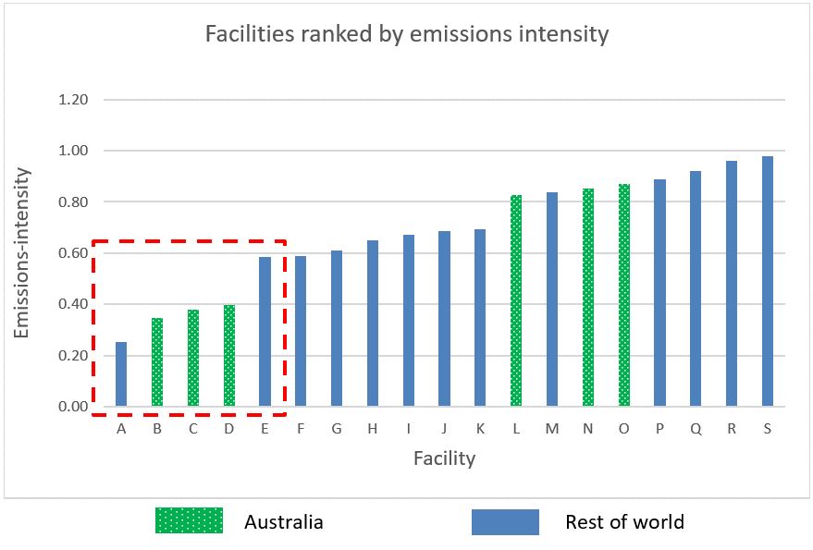

**Step 2: Calculate the emissions-intensity for the 5 best performing facilities using the middle 3 of 5 years, where practical**

The following data is available for facilities A, B, C, D and E.

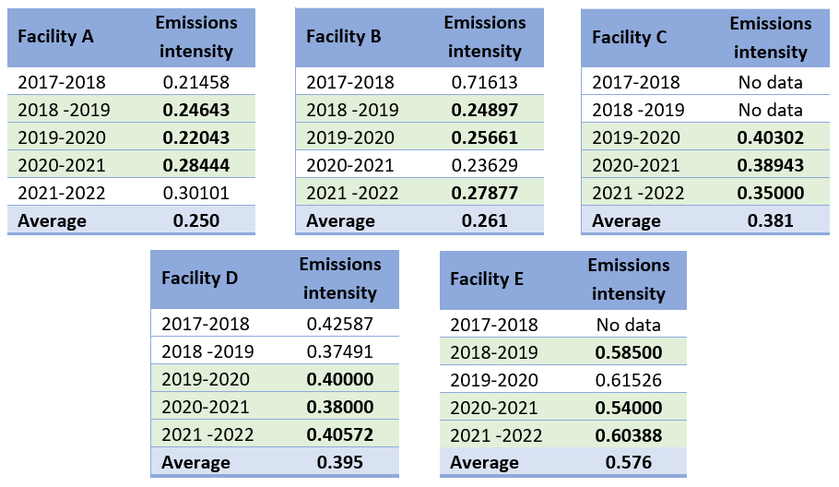

Where 5 years of data are available, the highest and lowest emissions-intensity years are removed. For facility C, only 3 years of data are available. For facility E, 4 years of data are available, so the highest emissions-intensity year is removed. This leaves 3 years of data for the 5 facilities. They remain the five best practice facilities so these 15 data points will be used in the final calculation.

Step 3: Calculate the production-weighted emissions-intensity

The production-weighted emissions-intensity is 0.363 tonnes of CO2-e per tonne of output. This is calculated as the weighted average of the 15 emissions-intensity data points, that is, three data points for each of the five facilities.

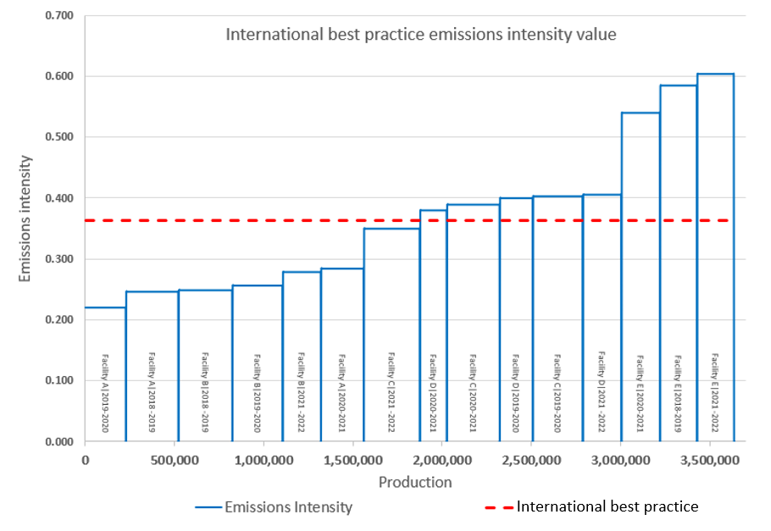

## Details for setting international best practice benchmarks

This section outlines the proposed approach to set international best practice benchmark emissions intensities. If there are circumstances for which it is not practical to implement this approach in full for a production variable, the Department must have regard to the four framework principles outlined above: the benchmark should be determined in a way that is effective, consistent, practical and robust.

### Identifying the best practice facilities and data suitability

*Emissions data should be consistent with NGERS and ignore any offsetting. Production data must be consistent with Safeguard production variables.*

The best practice benchmark will be based on facilities that have the lowest emissions intensity of production, located anywhere in the world (including Australia), for which data can be sourced that is appropriate for setting the benchmark. Requirements for selecting the best practice facilities are:

1. Emissions data should be consistent with relevant international reporting standards, and ignore any offsetting.
2. Production data should be consistent, in material respects, with Safeguard production variables.
3. The facility should have commercial-level production using technologies applicable to Safeguard facilities, which rules out setting the benchmark on:
   * pilot or demonstration plants unlikely to be of a similar scale to a Safeguard facility;
   * highly subsidised production that would not otherwise be commercially viable; or
   * plants under construction or being commissioned, requiring its emissions intensity to be estimated or modelled.
4. The selected facility’s data should be suitable, which means that emissions associated with the product should match the emissions included and excluded from the Safeguard production variables as described in the [Safeguard Mechanism Document](https://www.dcceew.gov.au/climate-change/publications/safeguard-mechanism-document#:~:text=The%20Safeguard%20Mechanism%20and%20National,calculations%20under%20the%20Safeguard%20Mechanism). For example, the emissions should exclude electricity and Scope 2 and 3 emissions; and multi-product facilities should apportion emissions between the products in a way consistent with the Safeguard Mechanism.

If sufficient detail is available, then emissions accounting adjustments can be made to ensure data is suitable for calculating the best practice benchmarks. For example, to adjust for a different Global Warming Potential (GWP), different production units or include an estimate of emissions from a greenhouse gas not covered by overseas reporting arrangements.

Ideally, the best performing facilities used to calculate the benchmark will have the lowest emissions intensity of all facilities. However, in most cases it will not be practical to obtain the emissions intensity of every facility in the world, estimated consistently with the principles above, and rank them all. As such, reasonable estimates and assumptions may be used for the purpose of identifying representative facilities. Data from facilities may also be used if their emissions intensity is expected to be close to the best performing facilities.

### Data should be appropriate for the Safeguard context

*In the Safeguard context, the electricity production variable means on-site electricity to support an industrial facility, not a grid-connected or utility scale generator. Consideration will be given to facility level impacts.*

The best practice benchmarks will use the production variables already defined for the industry average emissions intensities, which are used for setting the baseline for existing facilities.

The international best practice benchmark should be based on data appropriate for the context for how a production variable applies to Safeguard facilities. For example, electricity is a production variable, which applies to on-site electricity generation at a Safeguard facility. Safeguard facilities have on-site electricity generation to reliably meet the demand of their facilities, typically at a location remote from an electricity grid. This means the international best practice benchmark should be based on on-site electricity generation at industrial facilities, not grid-connected or utility-scale generators.

Consideration will be given to facility level impacts. This means, in circumstances where a combination of production variables is likely to be used at one or more new facilities, consideration could be given to what is ‘best practice’ in terms of global facilities that undertake the same activities, when selecting best practice facilities for calculating the benchmark. This may be particularly relevant for on-site electricity generation which is used by a wide range of facilities in different sectors and locations.

### Time period for selecting data

*Use the middle three of five recent years data for each best practice facility, excluding the highest and lowest emissions-intensity years.*

Where practical, benchmarks will be set based on recent data for existing facilities, rather than, for example, forecasts of the emissions intensity for anticipated technologies. One exception is ‘first-of-kind’ facilities, for which historic data is not available (discussed in section 2.7). Technological developments will, in many cases, reduce the emissions intensity of the best performing technologies over time, but this is reflected in the baseline decline that applies to all Safeguard facilities.

Where practical, five years of suitable data will be sourced for each of the potential best practice facilities globally (including in Australia) to help account for year-on-year emissions intensity variations and ensure the data is representative. Recent years will be used. For example, for benchmark values calculated in 2023/24, data will be sought for the years 2017/18 to 2021/22 (2022/23 data could be used if available). It doesn’t matter if the data is for calendar or financial years, or some other time basis.

The three middle values will be used to calculate the emissions-intensity benchmark value, excluding the highest and lowest emissions-intensity years. The following method will be used:

* determine the emissions intensities for each of the 5 years;
* exclude the highest and lowest emissions intensity years to address any significant anomalies, including potential impacts from the pandemic;
* if a facility has four years of data, the highest value will be excluded;
* if a facility has three or less years of data, those years will be used;
* if only one or two years of data are available, consideration should be given to whether the facility is in ramp-up to steady state operations and should be excluded.

### Number of facilities to use in the benchmark calculation.

*Five facilities should be used, so long as* their combined annual production is between 10 and 25% of the combined annual production of all relevant Safeguard facilities.

The best practice benchmark is calculated from five facilities, where suitable data is available.

If the combined annual production of the selected facilities is less than 10% of the combined annual production of Safeguard facilities, then additional facilities should be selected until this threshold is reached.

If the combined annual production of the selected facilities is more than 25% of the combined annual production of Safeguard facilities, then fewer facilities should be selected until combined production falls below this threshold (with the highest emissions intensity facilities removed first).

If the production volume of a single facility is more than 25% of the combined production volume of Safeguard facilities, consideration should be given to including a second facility to ensure the value is representative.

This approach helps to ensure that the calculation is based on a sufficient scale of production that is representative of sectoral best practice.

### Adjusting for Australian conditions

*Adjust for geology and climate, but not the availability of skills or technology. Review if the facility is still best practice after adjustment.*

Adjustments for Australian conditions will be made if the relevant international facility has characteristics **impossible to replicate** in Australia, and this has a material impact on achieving best practice emissions intensity. Two aspects are relevant:

* **Geology**: If the international best practice facility processes or uses a geological resource that is not available anywhere in Australia, such as some types of conventional geothermal resources. This will not extend to different ore grades, as these are a common feature of the Australian mining environment.
* **Climate**: If the ambient conditions of the international best practice facility cannot be replicated in a practical way, anywhere in Australia, and these conditions are materially relevant to the facility’s emissions. For example, less energy is required to liquefy natural gas in colder climates.

The emissions intensity would not be adjusted for skills or technology, availability or cost of fuel or other inputs. There shouldn’t be an adjustment for a lack of technology or skills in Australia because, given demand, technology and skills could be procured or developed. Developing these skills is fundamental to transition to a low emissions economy.

Any adjustment for Australian conditions should be made in a transparent (where appropriate for commercial sensitivities) and robust way (e.g. citing emissions reporting standards or scientific studies). If this isn’t possible, then it may be necessary to exclude the facility from the best practice benchmark calculation, requiring it to be replaced with another.

### Best practice benchmarks cannot be higher than domestic best practice

Best practice benchmarks cannot be less stringent than domestic best practice. This further ensures that benchmarks reflect Australian conditions, and helps to manage issues with data availability.

In some situations, it may be difficult to source suitable data for the best practice facilities, resulting in a benchmark unrepresentative of international best practice. Setting a maximum emissions intensity based on the average of the top 10 per cent of domestic performance helps to address the situation of limited data, for production variables where sufficient data is available. The same data used for calculating the average sectoral emissions intensities can be used for the domestic best practice emissions intensity calculation.

### Supplementary approach and ‘first-of-kind’ products

There may be circumstances where historical data is either not available, or not suitable for use in calculating benchmarks. This could arise if a new or existing facility begins producing a new product that has not been produced before.

In these circumstances, a supplementary approach will be considered. Under the supplementary approach, the following data could be used:

* **Forecast data**: data from planning or project approval documents that include forecasts of emissions and production over the life of the project, or other company reports.
* **Estimated data**: estimates based on a theoretical ‘engineered’ facility using data from other facilities that use similar technologies, or data collected at a higher level or with a different scope, with appropriate adjustments.
* **Benchmarking data:** data from industry bodies, international organisations or technical literature that benchmarks emissions-intensity performance.
  + For example, benchmarks developed in other jurisdictions with benchmarking schemes—such as, Alberta, British Columbia, California and the EU—could be considered on a case-by-case basis if they are sufficiently robust and consistent with the approach described in these guidelines.

## Process for setting benchmarks

Adhering to these guidelines, the Department will, engaging a consultant where relevant:

* Identify best practice facilities and source suitable production and emissions data for each Safeguard Mechanism production variable.
* Scrutinise the circumstances of the best practice facilities to recommend if an adjustment for Australian conditions is required, and if required, justify the adjustment approach and perform the adjustment.

In parallel, the Department will calculate the domestic top 10 per cent best practice emissions intensity and undertake a peer review of these calculations. These emissions intensity values will be a ceiling for the best practice benchmark.

The Department will compare the domestic top 10 per cent best practice emissions intensity to the best practice benchmarks and select the lowest value.

The Department will draft an amendment to insert the benchmarks into Schedule 1 of the Safeguard Rule and release an exposure draft and explanatory document for public consultation. Legislation for the first set of amendments will be consulted on in late 2023.

The explanatory document will include details of the process followed compared to these guidelines, any adjustments for Australian conditions (while protecting the confidentiality of facility-level data), and if the values were based on domestic top 10 per cent best practice performance. The names and data of relevant facilities will be kept confidential.

The Minister for Climate Change and Energy will consider and if satisfied make the amendment to the Safeguard Rule to legislate the benchmark values.

### Timing

The Government will aim to legislate best practice benchmarks for existing production variables in the following two tranches during 2023/24:

* **Early 2024**: the first tranche will include priority production variables (some are expected to be needed for calculating facility baselines in 2023-24), including on-site electricity, run-of-mine coal, run-of-mine metal ore, iron ore, oil and gas, primary iron, lithium hydroxide, bulk road freight transport and hydrogen.
* **May 2024**: the second tranche will include the remaining benchmarks for expected new product or facilities, including in fertilizer, renewable fuels, mining, metal and natural gas transmission sectors. These international best practice benchmarks will be published in May 2024.

Additional production variables will be needed over time when new outputs are produced for the first time in Australia. These will be calculated and published as they arise, based on these guidelines.

1. Section 35A of Schedule 1 to the Safeguard Rules (as amended) contains the provisions on reservoir carbon dioxide from new gas fields.
2. Sections 10 and 54 of the Safeguard Rules (as amended) contain the provisions on shale gas projects.
3. The framework is at [www.dcceew.gov.au/climate-change/emissions-reporting/national-greenhouse-energy-reporting-scheme/safeguard-mechanism](http://www.dcceew.gov.au/climate-change/emissions-reporting/national-greenhouse-energy-reporting-scheme/safeguard-mechanism)