# Draft FullCAM Guidelines

Requirements for using the Full Carbon Accounting Model (FullCAM) in the Australian Carbon Credit Unit (ACCU) Scheme methodology determination: *Carbon Credits (Carbon Farming Initiative—Plantation Forestry) Methodology Determination 2022*

These proposed guidelines are for consultation purposes only. They are not to be followed for reporting under the ACCU Scheme.

Version 2.0  
(Published and in force from January 2022, updated June 2024)

© Commonwealth of Australia 2024

**Ownership of intellectual property rights**

Unless otherwise noted, copyright (and any other intellectual property rights) in this publication is owned by the Commonwealth of Australia (referred to as the Commonwealth).

**Creative Commons licence**

All material in this publication is licensed under a [Creative Commons Attribution 4.0 International Licence](https://creativecommons.org/licenses/by/4.0/legalcode) except content supplied by third parties, logos and the Commonwealth Coat of Arms.

Inquiries about the licence and any use of this document should be emailed to [copyright@dcceew.gov.au](mailto:copyright@dcceew.gov.au).



**Cataloguing data**

This publication (and any material sourced from it) should be attributed as: The Department of Climate Change, Energy, the Environment and Water, FullCAM Guidelines: Requirements for using the Full Carbon Accounting Model (FullCAM) in the Australian Carbon Credit Unit (ACCU) Scheme methodology determination *Carbon Credits (Carbon Farming Initiative—Plantation Forestry) Methodology Determination 2022*, Department of Climate Change, Energy, the Environment and Water, Canberra. CC BY 4.0.

This publication is available at [[ad](https://www.dcceew.gov.au/publications)dress to be confirmed].

Department of Climate Change, Energy, the Environment and Water

GPO Box 3090 Canberra ACT 2601

Telephone 1800 900 090

Web [dcceew.gov.au](https://www.dcceew.gov.au)

**Disclaimer**

The Australian Government acting through the Department of Climate Change, Energy, the Environment and Water has exercised due care and skill in preparing and compiling the information and data in this publication. Notwithstanding, the Department of Climate Change, Energy, the Environment and Water, its employees and advisers disclaim all liability, including liability for negligence and for any loss, damage, injury, expense or cost incurred by any person as a result of accessing, using or relying on any of the information or data in this publication to the maximum extent permitted by law.

**Acknowledgement of Country**

Our department recognises the First Peoples of this nation and their ongoing connection to culture and country. We acknowledge Aboriginal and Torres Strait Islander Peoples as the Traditional Owners, Custodians and Lore Keepers of the world's oldest living culture and pay respects to their Elders past, and present.

Contents

Disclaimer 7

1. Introduction 8

1.1 Use of FullCAM in the Carbon Credits (Carbon Farming Initiative—Plantation Forestry) Determination 2022 8

1.2 Determining which FullCAM version to use 8

1.3 Format of this document 8

1.4 FullCAM background 9

1.5 FullCAM plots and running simulations 9

1.6 Overview of the FullCAM interface 10

2. Simulations Overview 12

2.1 Project scenario simulation 12

2.2 Long-term project scenario simulation 12

2.3 Baseline scenario simulation 13

2.4 Relevant time periods 13

3. Using 2024 FullCAM 14

3.1 Setting up simulations for the project, long-term project and baseline scenarios 14

3.2 Order of setting up plots 14

3.3 Create a new plot file 14

3.4 The Configuration tab 16

3.5 The Timing Tab 16

3.6 The Location info tab 17

3.7 The Site tab 18

3.8 The Trees tab 18

3.9 The Soil tab 18

3.10 The Initial Conditions tab 18

3.11 The Events tab 20

3.12 Adding a New Event 31

3.13 Cloning events to cover the Modelling Period of the long-term project scenario 33

3.14 Cloning events to cover the Modelling Period of the Baseline Scenario 35

3.15 The Output Windows tab 36

3.16 Running simulations 37

3.17 Viewing outputs 37

3.18 Transferring outputs into a spreadsheet 38

3.19 Setting maximum forest growth for the permanent plantings activity 38

3.20 Calculating project abatement at the end of a reporting period 42

3.21 Variables generated in FullCAM and used in equations in the Determination 42

Appendix 1 44

Example event settings for standard events specified in Section 3.11 44

Appendix 2 49

Standard parameters for forest products 49

Appendix 3 1

Maximum Clearfell Ages for Long Rotation Forests 1

Appendix 4 3

Species lists for generic calibrations 3

**Tables**

Table 1 FullCAM tabs 10

Table 2 FullCAM permitted events 22

Table 3 Planting 22

Table 4 Coppicing 23

Table 5 Seeding 23

Table 6 Pruning 24

Table 7 Thinning without harvest 25

Table 8 Clearfelling without harvest 25

Table 9 Natural disturbance other than fire 26

Table 10 Thinning with harvest 27

Table 11 Clearfelling with harvest 27

Table 12 Salvage harvesting 28

Table 13 Controlled burn 28

Table 14 Fire (<5% trees killed in affected area) 29

Table 15 Fire (>5% trees killed in affected area) 30

Table 16 Fire (Windrow and burn) 30

Table 17 Chopper rolling 31

Table 18 Ages of maximum confidence for 2024 FullCAM calibrations 38

Table 19 Relationship between FullCAM outputs and variables defined in the Determination 42

Table 20 Relationship between a pruning event and FullCAM 44

Table 21 Relationship between a commercial event and FullCAM 45

Table 22 Relationship between a wildfire event where trees are not killed and FullCAM 45

Table 23 Relationship between a wildfire event where trees are killed and FullCAM 47

Table 24 Relationship between a growth interruption and FullCAM 48

Table 25 Standard parameters for forest products for implementation into FullCAM 1

Table 28 Maximum clearfell ages for long rotation forests 1

Table 29 Species eligible to be modelled as ‘Other Acacia’ 3

Table 30 Species eligible to be modelled as ‘Other eucalypts’ 3

Table 31 Species eligible to be modelled as ‘Other non-eucalypts hardwoods’ 5

Table 32 Species eligible to be modelled as ‘Other softwood’ 6

**Figures**

Figure 1 Selecting a new simulation in FullCAM 14

Figure 2 Creating a single plot from scratch in FullCAM 15

Figure 3 Navigating to the ‘Plots’ screen in FullCAM 16

Figure 4 Cloning a plot file 16

Figure 5 Entering longitude and latitude in FullCAM 17

Figure 6 The initial conditions tab in FullCAM 18

Figure 7 The forest has no trees growing in it at the start of the simulation 19

Figure 8 Debris values have been set to zero 19

Figure 9 Product values have been given their standard values 20

Figure 10 The “Age advance” switch in the OFF position 24

Figure 11 Adding a new event 31

Figure 12 Selecting the event Type 32

Figure 13 Adding the Event date 32

Figure 14 An example of the ‘Select a standard event’ window 33

Figure 15 Merging regimes 34

Figure 16 Entering a regime name 34

Figure 17 Entering a timing offset for cloned events 35

Figure 18 The tick, minus and plus icons in the output selection menu 36

Figure 19 A simulation cannot be run if a page is not valid 37

Figure 20 Viewing outputs in FullCAM 37

Figure 21 The window for setting the manual abatement cap 41

Figure 22 Example pruning event 44

Figure 23 Example commercial thinning event 45

Figure 24 Example wildfire event where trees are not killed 47

Figure 25 Example wildfire event where trees are not killed 47

Figure 26 Example growth interruption event 48

Figure 24 Fields for entering forest product harvest parameters 49

## Disclaimer

This document has been developed to assist project proponents to calculate abatement in FullCAM as required by the *Carbon Credits Carbon Credits (Carbon Farming Initiative—Plantation Forestry) Determination 2022*. This document is the ‘FullCAM guidelines’ incorporated by reference in various sections of that determination. Project proponents should not use this document as a substitute for complying with the requirements in the Methodology Determination.

Before relying on any material contained in this document, project proponents should familiarise themselves with the following legal documents: *Carbon Credits (Carbon Farming Initiative—Plantation Forestry) Determination 2022*, [*Carbon Credits (Carbon Farming Initiative) Act 2011*](https://www.legislation.gov.au/Details/C2016C00029)*,* [*Carbon Credits (Carbon Farming Initiative) Rule 2015*](https://www.legislation.gov.au/Series/F2015L00156) and the [*Carbon Credits (Carbon Farming Initiative) Regulations 2011*](https://www.legislation.gov.au/Details/F2015C00658). Further explanation of the method can be found in the explanatory statement to the *Carbon Credits (Carbon Farming Initiative—Plantation Forestry) Determination 2022* and the simple method guide for that determination. Project proponents are also advised to obtain professional advice suitable to their particular circumstances.

This document does not displace relevant legislative provisions or other laws. All users are encouraged to read this document in conjunction with the relevant legislation, including the methodology determinations, referenced throughout this document. Where any inconsistencies are apparent, please be aware that the legislative provisions will take precedence.

This document will be updated periodically and users should note that some inputs and values may change over time. It is the user’s responsibility to ensure that they are using the most recent version of this document and any tool/s required in association as in force at the end of the relevant reporting period (consistent with section 7 of the Methodology Determination).

The Commonwealth of Australia will not be liable for any direct, indirect or consequential loss arising out of, or in connection with, or reliance on, information on, or produced by, using this document.

**© Commonwealth of Australia 2024**

## Introduction

### Use of FullCAM in the Carbon Credits (Carbon Farming Initiative—Plantation Forestry) Determination 2022

The calculation of carbon abatement under the Determination is dependent upon the use of FullCAM consistently with the requirements of this document. In particular, section 38 of the Determination requires that the project scenario, long term project scenario and the baseline scenario (where applicable) for each carbon estimation area (CEA) must be created and run as a FullCAM simulation in accordance with the requirements in both the Determination and this document. Sections of the Determination also require key output data to be produced using FullCAM in accordance with the requirements in the Determination and this document. Where content of this document relates to provisions of the Determination, references are given to the location of those provisions.

Project proponents must only change FullCAM default settings as indicated in this document, and all other settings must not be changed. This is to ensure that defaults will apply where relevant.

### Determining which FullCAM version to use

The Department of Climate Change, Energy, the Environment and Water (the department) updates FullCAM from time to time to reflect the latest science and improve usability. At the time this document was last updated, the latest version was released for public use in 2024 on the department’s website (https://www.dcceew.gov.au/climate-change/publications/full-carbon-accounting-model-fullcam). The latest publicly released version of FullCAM is constituted by one option.

1. Default: 2024 FullCAM option

**This is the option that must be used by projects under this Determination.**

The year reflects when the latest version was released at the time this document was last updated. However, a reference to the default or 2024 FullCAM option in this document includes any subsequent release or update of FullCAM on the Department’s website.

### Format of this document

The sections of this document provide:

1. an overview of FullCAM relevant to the Determination
2. an overview of the simulations you are required to run in FullCAM by the Determination
3. a step-by-step walkthrough of using 2024 FullCAM to run those simulations correctly
4. an overview of the FullCAM outputs as they relate to equations within the Determination
5. Appendices:
   * Appendix 1 – Example event settings for standard management events
   * Appendix 2 – Standard parameters for forest products
   * Appendix 3 – Maximum clearfell ages for long rotation forests
   * Appendix 4 – Species lists for generic calibrations

Note that this document provides a step-by-step walkthrough for 2024 FullCAM alone. This is because this document is for consultation on that version of FullCAM.

### FullCAM background

FullCAM is used in Australia’s National Greenhouse Gas Accounts for the land sector. FullCAM provides fully integrated estimates of carbon pools in forest and agricultural systems for Australia’s land sector reporting. In addition, it accounts for human-induced changes in emissions and sequestration of major greenhouse gases. FullCAM was developed under the National Carbon Accounting System (NCAS) at the then Australian Greenhouse Office to provide a dynamic account of the changing stocks of carbon in Australia’s land systems. FullCAM integrates data on land cover change, land use and management, climate, plant productivity, and soil carbon over time. FullCAM estimates carbon stock change and greenhouse gas emissions at fine spatial and temporal scales, and uses a wide range of spatially referenced data.

Users of FullCAM can determine estimates of carbon stock change and greenhouse gas emissions for ACCU Scheme projects on a similar basis to that used for land use and land use change in Australia’s National Greenhouse Gas Inventory.

### FullCAM plots and running simulations

FullCAM can run simulations on a ‘plot’. A plot is defined as a piece of land for which the event history, when modelled in FullCAM in accordance with requirements, is the same across that area of land. Separate plot files are created for each CEA. Where the event history for an area of land differs, a new CEA must be created, with an accompanying plot file (in accordance with section 19 of the determination).

In FullCAM, there are several types of plots that can be selected. Only ‘Forest system’ is relevant to this Determination. This document provides overviews of the simulations that users may be required to create in Section 2, and the steps to run these simulations in Section 3.

FullCAM models abatement using a single ‘model point’ location. Proponents do not need to define CEA boundaries within FullCAM, rather proponents must input the coordinates for a single location within the CEA boundaries that is at the approximate centre of the CEA (the model point – see subsections 14(13)-(15) of the Determination for full model point requirements). The latest spatial data for a plot must be downloaded using the ‘Location info’ tab each time the software is run. This process is described in section 3.6 of this document.

Separate plot files must be created for each CEA (see Part 3, Division 4 of the Determination). In order to ensure all settings are correct, including defaults, we recommend creating new plot files each time a new version of FullCAM or these Guidelines is used. Plot files created under previous versions may contain different settings that will affect outputs and users are responsible for any inconsistencies.

For each CEA, separate plot files may need to be created for:

* the long-term project scenario simulation, which models carbon abatement for the project over the modelling period to set the upper limit to which projects can be credited;
* the project scenario simulation to determine the project’s carbon abatement for each reporting period (subject to the baseline reduction); and
* for all CEAs except new plantation CEAs, the baseline scenario simulation to determine the baseline carbon that must be subtracted from the project scenario carbon.

For definitions of the CEA types under the method, see Section 14 of the Determination.

### Overview of the FullCAM interface

The FullCAM software user interface displays menus and a series of tabs. Each tab has a suite of fields in which users may either be required to input information as instructed in these guidelines or left unchanged. The program is designed so that certain tabs in a plot file are made available only if required fields have valid information entered in earlier tabs. If the text of a tab or field is red, then FullCAM requires information in that tab or field before a simulation can be run.

The below table provides a general overview of each tab selectable within FullCAM once a plot has been created. Help is provided within FullCAM by clicking on the The FullCAM 2024 help button. button in the top right of the 2024 tool. A general overview of each tab follows.

Table 1 FullCAM tabs

|  |  |
| --- | --- |
| Tab | Explanation |
| About | Includes a free text field where users can enter information about the plot file that they have created. This is a good space to keep track of information about the plot file such as the CEA and scenario that it represents and any changes that have been made or editing of event parameters. |
| Configuration | Users select the system type (e.g. Forest system, Agricultural system) they want to simulate in the plot. |
| Timing | Enter the timing for starting and ending the simulation and the time steps required for output data. |
| Location Info | In this tab users enter the latitude and longitude of the ‘Model Point Location’ where they wish to simulate a plot file. Internet access is required to complete this tab. By choosing to ‘Query FullCAM spatial data’ the associated soil and climate data for that latitude and longitude are automatically loaded into relevant parts of the remaining tabs. In the tab users can then load tree and/or crop species information. This information is also automatically loaded into relevant parts of the remaining tabs. |
| Site | Specific parameters for the ‘Model Point Location’ (e.g. water [rainfall], temperature, productivity) are described. |
| Trees | Description of the properties of the tree species. |
| Soil | Description of soil properties. |
| Initial Conditions | In this tab the values for carbon at the start of the simulation are described. Values will automatically be populated by Location info using data downloaded from the FullCAM server. |
| Events | All of the events for the entire simulation period are listed in this tab. Users can add or remove events. Care must be taken not to violate requirements for modelling ‘management events’ within the Determination. |
| Output Window | Defines Output Windows that can be used to present different outputs in each window. |
| Explorer | Display of the parameter settings for each tab. |

## Simulations Overview

Three types of scenario simulations are required to be modelled using FullCAM, as specified in Part 4, Division 2 of the Determination: project scenario; long-term project scenario; and baseline scenario. Note that the baseline scenario is not required to be modelled for new plantation CEAs.

The project scenario simulation calculates the carbon abatement for the latest reporting period, subject to the upper abatement crediting limit established by the long-term project scenario and the deduction calculated under the baseline scenario.

The carbon stock calculated under the long-term project scenario applies the upper limit on which a project CEA can earn carbon credits. Projects are only credited up to the long-term average net carbon stock or long-term project scenario net carbon stock as set out in Part 4 of the Determination.

The baseline scenario simulation calculates the baseline carbon that must be deducted from the project scenario carbon. This deduction is applied differently for ex-plantation CEAs than it is for conversion and continuing plantation CEAs.

The FullCAM steps to produce each of these scenario simulations are similar. The timing of each simulation will differ, along with the events required to be modelled. The long-term project scenario simulation will mirror the project scenario simulation, but also simulate events beyond the reporting period for the remainder of the modelling period.

### Project scenario simulation

The project scenario estimates abatement up to the end of the reporting period.

The carbon stock in the project area at the end of the reporting period is calculated based on outputs from FullCAM for *C mass of forest debris*, *C mass of trees* and *C mass of forest products* in the last month of the reporting period. Emissions from fires during the reporting period are calculated based on FullCAM outputs for *CH4 emitted due to fire* and *N2O emitted due to fire*. Predicted fuel emissions are calculated based on the FullCAM output *C mass of forest products* from harvest events that occur during the reporting period.

### Long-term project scenario simulation

The long-term project scenario aims to establish a ‘cap’ on abatement that proponents can be credited to. This is to ensure that emissions from harvesting are accounted for. The long-term project scenario is different for ex-plantation (Schedule 4) CEAs than for CEAs under the other three schedules.

#### New plantation, Conversion and Continuing Plantation CEAs

For new plantation (Schedule 1), conversion (Schedule 2) and continuing plantation (Schedule 3) projects, the long-term project scenario estimates abatement over a 100‑year modelling period beginning on the ‘forest start date’ (see section 5 of the Determination). Proponents are not permitted to be credited for carbon stocks that exceed those of the long-term project scenario, which represents the average carbon stocks over the 100 years.

The predicted long-term average project carbon stock for the modelling period is calculated based on monthly outputs from FullCAM for *C mass of forest debris, C mass of trees* and *C mass of forest products* over a 100-year modelling period. Emissions from fires during the modelling period are calculated based on FullCAM outputs for *CH4 emitted due to fire* and *N2O emitted due to fire*. Predicted fuel emissions are calculated based on the FullCAM output *C mass of forest products* from harvest events that occur during the modelling period.

#### Ex-Plantation CEAs

For permanent planting (Schedule 4) projects, the long-term project scenario estimates abatement over a period from the forest start date until the expiry of the crediting period. Proponents are not permitted to be credited for carbon stocks that exceed those of the long-term project scenario, which for Schedule 4 projects represents the projected carbon stocks at the expiry of the crediting period.

The predicted long-term project scenario carbon stock for the modelling period is calculated based on monthly outputs from FullCAM for *C mass of forest debris, C mass of trees* and *C mass of forest products* at the end of the crediting period. Emissions from fires during the modelling period are calculated based on FullCAM outputs for *CH4 emitted due to fire* and *N2O emitted due to fire*. Predicted fuel emissions are calculated based on the FullCAM output *C mass of forest products* from harvest events that occur during the modelling period.

### Baseline scenario simulation

You do not need to run a baseline scenario simulation for the new plantation activity as the baseline carbon is assumed to be zero, and thus there is no need to model it.

The baseline for each CEA is calculated based on monthly outputs from FullCAM for *C mass of forest debris*, *C mass of trees* and *C mass of forest products* over the modelling period. Emissions from fires during the modelling period are calculated based on FullCAM outputs for *CH4 emitted due to fire* and *N2O emitted due to fire*. Predicted fuel emissions are calculated based on the FullCAM output *C mass of forest products* from harvest events that occur during the modelling period.

For conversion projects (Schedule 2), the baseline scenario will be ongoing short-rotation forestry. For permanent planting (Schedule 4) or continuing plantation (Schedule 3) projects, the baseline scenario is a single clearfell with harvest, followed by fallow land.

### Relevant time periods

At various times, the Determination refers to the “modelling period”, the “crediting period” and the “forest start date” (see Section 5 of the Determination). The dates that these terms reference vary depending on the type of CEA being modelled and the specifics of the project. You should ensure you are aware of these dates for each CEA within your project, as the calculations in the method often reference points in time relative to these dates.

## Using 2024 FullCAM

### Setting up simulations for the project, long-term project and baseline scenarios

Simulations for each CEA are undertaken using plot files. Project proponents must use the following steps for entering data into each tab in a FullCAM plot file for each CEA registered under the Determination.

When reopening existing plot files, spatial data must be redownloaded in the ‘Location Info’tab as described in section 3.4, and other tabs updated as relevant, including updating the ‘Initial Conditions’ tab as described in section 3.10.

When reopening plot files, users must first navigate to the ‘Location info’ tab and click ‘Query FullCAM spatial data’, before running the simulation, to ensure the latest spatial data is used for the simulation.

### Order of setting up plots

As a long-term project simulation will mirror the project simulation for all events up to the reporting date, you can first setup a project simulation plot file and then use this as the basis for setting up the long-term project simulation plot. When setting up the latter, clone the project simulation as in section 3.3.2, then follow steps, 3.4, 3.5 and 3.10 onwards to redownload the spatial data and reconfigure the timing and events appropriately.

### Create a new plot file

1. With FullCAM open, click on the menu grid on the top left of the screen, and select ‘New Simulation’.

Figure 1 Selecting a new simulation in FullCAM

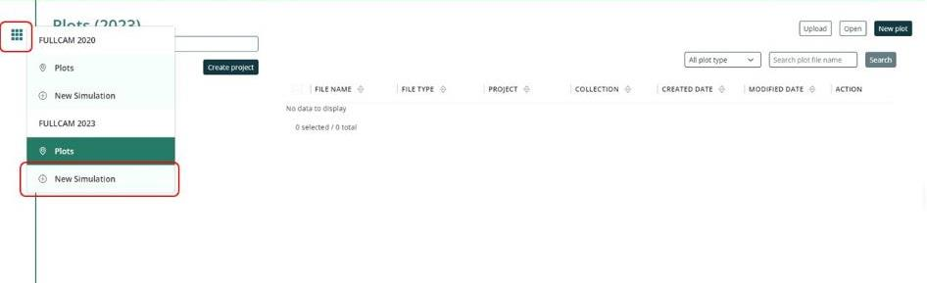

1. In the ‘Create from scratch’ section, click on ‘Create a single plot’

Figure 2 Creating a single plot from scratch in FullCAM

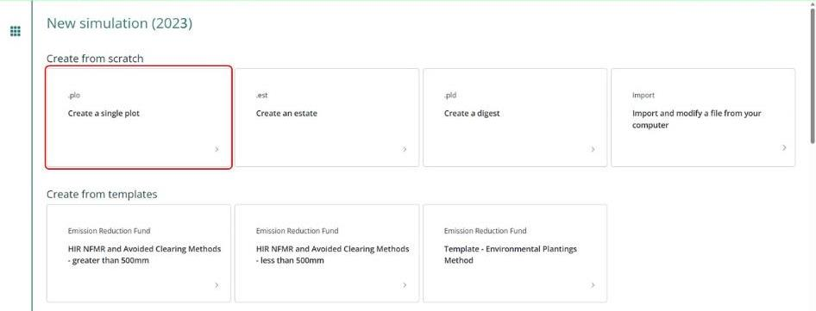

1. Enter a plot name. It is recommended that you use a name for the plot that reflects the identifier for the CEA and model scenario, e.g. ‘CEA1_project_east_2024 offsets report’. Select a project. If you have not created a project, click ‘Select a project’ and ‘Create new project’ in the menu that appears. Select a collection. If you have not created a collection, click ‘Select a collection’ and ‘Create new collection’ in the menu that appears. You can add information to the ‘Note’ section, but this not a required field.
2. Once you have created a plot file, it is best to save immediately. The new plot file can be saved by clicking the ‘Save Plot File’ button in the top right. It is recommended that you use a name for the plot that reflects the identifier for the CEA and model scenario, e.g. ‘CEA1_project_east_2024 offsets report’.

#### Saving a plot

* + 1. You will need to click ‘Save Plot File’ before logging out or leaving the system for an extended period of time, as it will not save the information you enter without doing so.
    2. You can then ‘Update Plot File’ to save the changes as you continue.
    3. If you log out, you will find your Plot on the list when logging back in. Click on the ‘Edit’ button (with the pencil icon) to continue entering and editing the information of this Plot.

#### Cloning a plot

Plot files can be cloned. This is particularly useful when using a project simulation plot file as the basis for setting up the long-term project simulation plot file.

1. To clone a plot file, go to the ‘Plots’ screen by clicking on the grid icon and selecting ‘Plots’.

Figure 3 Navigating to the ‘Plots’ screen in FullCAM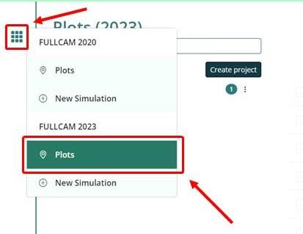

1. In the row of the file you want to clone, click the ‘clone’ button.

**Figure 4 Cloning a plot file**

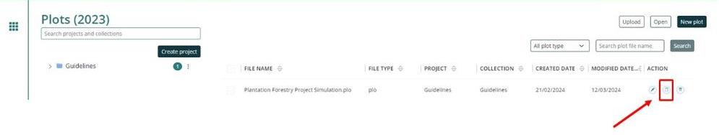

1. Cloning a plot file will open the clone. You must save it manually by clicking the ‘Save Plot File’ button.

### The Configuration tab

The ‘Configuration’tab is where you select the type of system to be modelled.

Select ‘Forest system’ from the ‘Type’ drop down menu*.*

Do not change any other settings on the ‘Configuration’ tab.

### The Timing Tab

* + - 1. Turn the ‘Do you want to use Calendar dates instead?’ slider to the OFF position.

1. Under ‘Start and End of Simulation’populate the ‘Start date (end of)’ and ‘End date (end of)’ fields in the formats YYYY and M (e.g., ‘2021, 6’ for June 2021).
   * Enter the year and month that the relevant dates fall in. For example, if you determine that your scenario simulation must start on October 5th 2009 and end on October 5th 2109, enter ‘2009, 10’ in ‘Start date (end of)’ and ‘2109, 10’ in ‘End date (end of)’.
   * The start date for the project scenario and the long-term project scenario must be the day before the ‘forest start date’ for the CEA as defined in the Determination under Section 5. The start date for the baseline scenario for a Schedule 2 project must be the day before the ‘forest start date’, while for a Schedule 3 or 4 project it must be the day before the ‘baseline rotation start date’, as defined in the Determination under Section 5.
   * The end date must be the last day of the relevant period for the scenario that is being modelled. For the project scenario this is the last day of the reporting period. For the long-term project and baseline scenarios for Schedule 1, 2 and 3 projects, this is 100 years after the ‘forest start date’. For Schedule 4 projects this is the date that the crediting period ends.

### The Location info tab

The ‘Location info’ tab (see figure 5 below) allows you to query the data required by FullCAM from extensive databases maintained by DCCEEW. (Note that the default location is Uluru.)

Users setting up long-term project simulations using existing project simulation plot files must also follow the below steps to reapply the spatial data for the location. This is because on restarting FullCAM, or reopening existing plot files, previously queried spatial information may not be automatically loaded.

#### Entering Longitude and Latitude

Enter the longitude and latitude (in decimal degrees i.e. xx.xxx xx, xx.xxx xx) of the model point location in the longitude and latitude text fields. This should be the approximate centre of the CEA and representative of the CEA (see sections 3.29 and 3.20 of the Determination for requirements). Note that FullCAM may appear to round off the decimal degrees entered after clicking out of the text fields, but users must enter the full five decimal places as these will be recorded within the plot file itself.

Figure 5 Entering longitude and latitude in FullCAM

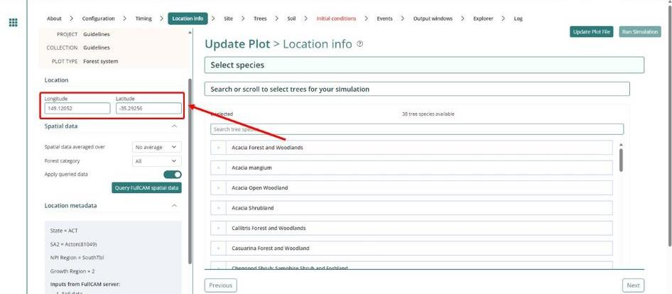

#### Downloading tree species

1. Select ‘All’ in the ‘Forest category’ drop down menu.
2. Click the ‘Query FullCAM spatial data’ button. This will filter the available tree species in the centre of the screen.
3. Select the appropriate species.

**Note:** Under this Determination only a subset of the *Tree Species* options available for selection in the drop down menu are applicable. Those relevant to conversion from short-rotation to long-rotation plantation forest are listed in Schedule 6 of the Determination.

**Note:** While CEAs are permitted to contain species that are not included in a species-specific or generic calibration, these CEAs must use the ‘Environmental Planting’ option to ensure conservative carbon abatement modelling. The species contained by a generic calibration are listed in appendix 4.

**Note:** If the CEA being modelled is an ex-plantation CEA, and the species being grown is Acacia Mangium, participants may instead choose to select the ‘Environmental Planting’ option, as the Age of maximum confidence for Acacia Mangium is low. This is relevant for Section 3.19.

1. A pop-up box will appear asking if you want to make the selected ‘Tree Species’ the ‘initial tree species’. Click ‘Yes’.
2. DO NOT change any other settings on this tab.

**Do not change any settings on the ‘Site’, ‘Trees’ or ‘Soil’ tabs.**

### The Site tab

DO NOT change any settings on this tab.

### The Trees tab

DO NOT change any settings on this tab.

### The Soil tab

DO NOT change any settings on this tab.

### The Initial Conditions tab

The ‘Initial Conditions’tab will look like this:

Figure 6 The initial conditions tab in FullCAM

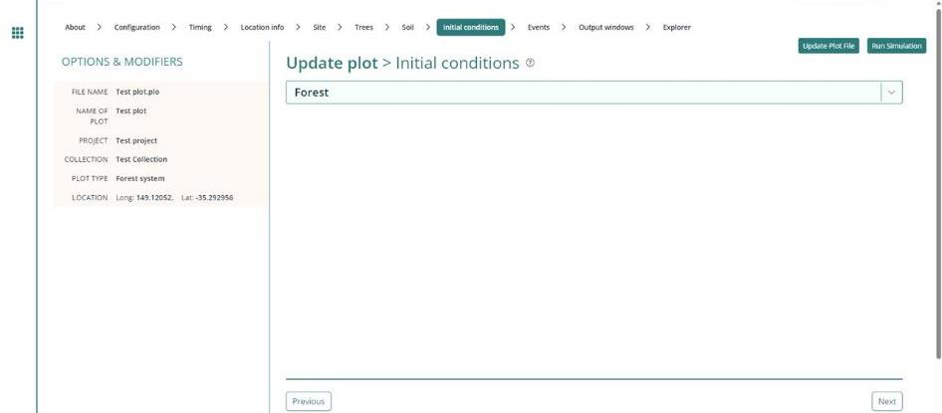

Users setting up long-term project simulations using existing project simulation plot files must also follow the below steps to set up the initial conditions for the plot file. This is because on restarting FullCAM, or reopening existing plot files, previously entered initial conditions may not be automatically loaded.

Steps required:

1. Under the ‘Forest’group, click the button labelled ‘Trees’.
2. On the pop-up window, the species you selected at the ‘Location info’ tab will be showing in the drop-down box under ‘Species’.
3. Under ‘Existence’*,* ensure that the switch (‘The forest has trees growing in it at the start of the simulation’) is in the off position (see figure 7).

Figure 7 The forest has no trees growing in it at the start of the simulation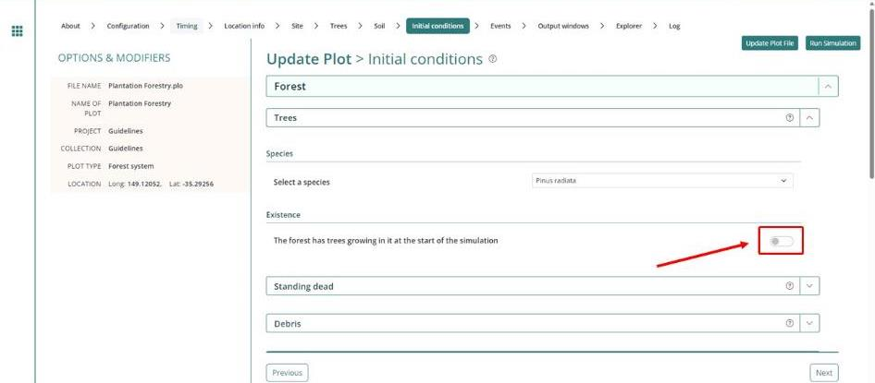

1. Click the downward arrow to the right of ‘Debris’ to open that menu.
2. Ensure all the default settings for each debris pool are set to zero (see figure 8).

Figure 8 Debris values have been set to zero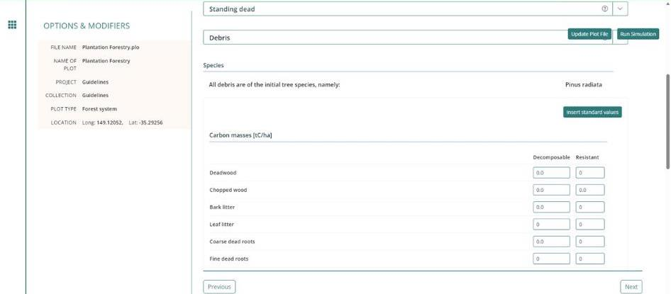

1. Click the downward arrow to the right of ‘Products’ to open that menu.
2. Click the ‘Insert standard values’ button.

**Figure 9**  **Product values have been given their standard values**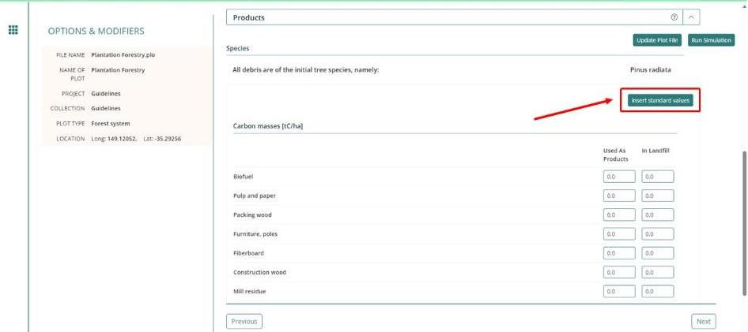

1. DO NOT change any other settings in the ‘Initial conditions’ tab.

Now navigate to the next tab: ‘Events’*.*

### The Events tab

The ‘Events’ tab is where the type and timing of each event is specified. The set of management actions and disturbance events applicable to a rotation is referred to as a regime (see section 26 of the Determination). Each of these must be simulated for each CEA consistent with section 38 of the Determination in particular, and this section of this document.

This section begins by providing simulation-specific instructions for modelling events, followed by a list of the permitted events and the settings that must be used to model them. Next, instructions for adding new events and instructions for how to clone recurring events for long-term and baseline scenario simulations are provided. Appendix 1 provides some examples of the settings windows that will appear when adding new events.

#### Scenario-specific requirements for modelling events

*Project scenario simulation*

For the project scenario simulation, you must simulate all of the management actions and disturbance events from the day before the forest start date up to the last day of the reporting period, as recorded in the ‘management record’ (see sections 23 and 39 of the Determination).

*Long-term project scenario simulation*

The long-term project scenario simulation covers the entire modelling period. This period differs depending on the type of CEA being modelled.

For this simulation type, you must simulate all of the management actions and disturbance events in the *management record*, which covers the modelling period.

For new plantation CEAs, conversion CEAs and continuing plantation CEAs, for the period commencing after the reporting period and running until the end of the modelling period, you must simulate any remaining actions in the current management regime, and then the default management actions recurring with a 12-month interval between rotations (see section 40 of the Determination).

For ex-plantation CEAs, for the period commencing after the reporting period and running until the end of the modelling period, you must simulate the projected management actions for the remainder of the modelling period.

*Baseline scenario simulation*

The baseline scenario simulation does not need to be modelled for new plantation CEAs.

For the baseline scenario simulation for conversion CEAs, users must simulate the management actions of the baseline management regime, recurring with a period of 12 months between rotations, and follow the provisions of the Determination at subsection 41(3) for simulating actual natural disturbance events that have occurred (see section 41 of the Determination).

For the baseline scenario simulation for ex-plantation CEAs and continuing plantation CEAs, users must simulate the conversion of the forest to a non-forested land use by clearfell harvest, and follow the provisions of the Determination at subsection 41(3) for simulating actual natural disturbance events that have occurred (see section 41 of the Determination).

#### Permitted Events

This section includes a list of all permitted events which can be modelled under this methodology. All permitted management actions and disturbance events that are specified in the ‘forest management plan’ for the project, must be included in model simulations for each relevant CEA. If a CEA is re‑stratified for any of the reasons specified in Part 3 Division 4 of the Determination, then each resulting new CEA must have all permitted management actions and disturbance events included in model simulations.

Fires and natural disturbances must be included in the event queue at the time the events occur, in accordance with section 22 of the Determination. The effect on the carbon stock will be reflected by the severity of the fire event. For a wildfire event where the burnt area is patchy and difficult to demarcate, you must enter the affected portion of a CEA as a percentage—other values remain unchanged. However, if a clearly defined area or areas of a CEA have been impacted uniformly (e.g. all trees killed), then re-stratification of the CEA may be appropriate (see section 18 of the Determination for requirements for re-stratification following disturbance events).

Section 3.11.2 describes the user inputs for generating the relevant events. Section 3.12 describes how to enter the events to FullCAM to create the event queue.

The table below contains a summary of permitted events and the sections in this document that contain more information on each.

Note that fertilisation and weed control events are not permitted FullCAM events. Fertilisation and weed control are still permitted in carbon estimation areas, but these events cannot be modelled in FullCAM. This is because the datasets used to calibrate FullCAM’s growth curve are comprised of managed plantations, which have all had these management activities applied. As such, the growth boost experienced from fertilisation is already represented in the growth curve. Proponents should not need to model it separately.

Table 2 FullCAM permitted events

|  |  |
| --- | --- |
| Action or event | Document Section |
| Planting | 3.11.2.1 |
| Coppicing | 3.11.2.2 |
| Seeding | 3.11.2.3 |
| Growth pause | 3.11.2.4 |
| Pruning | 3.11.2.5 |
| Thinning without harvest | 3.11.2.6 |
| Clearfelling without harvest | 3.11.2.7 |
| Natural disturbance other than fire | 3.11.2.8 |
| Thinning with harvest | 3.11.2.9 |
| Clearfelling with harvest | 3.11.2.10 |
| Salvage harvesting | 3.11.2.11 |
| Controlled burn | 3.11.2.12 |
| Fire (<5% trees killed in affected area) | 3.11.2.13 |
| Fire (>5% trees killed in affected area) | 3.11.2.14 |
| Windrow and burn | 3.11.2.15 |
| Chopper rolling | 3.11.2.16 |

##### 3.11.2.1 Planting

A planting event is to be modelled when a plantation starts from planting, as opposed to coppicing or seeding.

The modelling date for the event is defined by section 21(7) of the Determination. For planting completed within a six month-window, and for which at least 80% of the trees planted survive, it is the date within that window when planting is completed. Where planting occurs over a longer window, or less than 80% of trees survive, it is the date when the planting is completed, including for any replacement trees for those that did not survive.

Table 3 Planting

| **Action or event** | **FullCAM Event Type** | **FullCAM Standard Event** | **FullCAM Parameter values** |
| --- | --- | --- | --- |
| Planting | Plant trees | Plant trees: seedlings, normal stocking | Use Defaults |

##### 3.11.2.2 Coppicing

A coppicing event is to be modelled when a plantation starts from coppicing, as opposed to planting or seeding.

As per section 21(8) of the Determination, for modelling, the action of coppicing to start a rotation in a CEA or other area is taken to occur 6 months after the previous clearfelling.

Table 4 Coppicing

| **Action or event** | **FullCAM Event Type** | **FullCAM Standard Event** | **FullCAM Parameter values** |
| --- | --- | --- | --- |
| Coppicing | Plant trees | Plant trees: seedlings, normal stocking | Use Defaults |

##### 3.11.2.3 Seeding

A seeding event is to be modelled when a plantation starts from seeding, as opposed to coppicing or planting.

The modelling date for the event is defined by section 21(7) of the Determination. For seeding completed within a six month-window, and for which at least 80% of the trees seeded survive, it is the date within that window when planting is completed. Where planting occurs over a longer window, or less than 80% of trees survive, it is the date when the seeding is completed, including for any replacement trees for those that did not survive.

Table 5 Seeding

| **Action or event** | **FullCAM Event Type** | **FullCAM Standard Event** | **FullCAM Parameter values** |
| --- | --- | --- | --- |
| Seeding | Plant trees | Plant trees: natural regeneration | Use Defaults |

##### 3.11.2.4 Growth pause

Growth pause events must be modelled when, at the end of the reporting period, the CEA does not satisfy the forest development condition (see section 22(2) of the Determination).

1. Select the “*Forest treatment*” Event Type.
2. Do NOT click the “*Insert standard values*” button.
3. For event name, enter ‘Growth interruption’, followed by the period of growth interruption (for example, Growth interruption =-1 years).
4. Enter the Event date. Ensure the “*Date Origin”* setting is “Calendar date”. The accepted format for the Event date is DD/MM/YYYY.
5. Toggle ON the “*Type 1: Age advance”* (from grey and white, to green).

Figure 10 The “Age advance” switch in the OFF position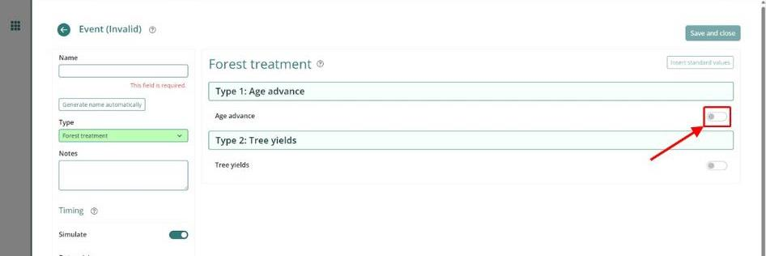

* In the “*Age advance due to treatment* field, enter a negative number that:
  + represents the time period over which the growth interruption occurred (in years); and
  + is equal to the length of the reporting period multiplied by -1; and
  + may be expressed as a proportion of a year, represented by a decimal number.

1. In the “*Advancement period”* box enter a positive number that is equal to the length of the reporting period.
2. DO NOT change the “*Tree yields*” settings.
3. Press “*Save and close*”.

##### 3.11.2.5 Pruning

Pruning events must be modelled each time they occur. Users must define the proportion of the biomass that was pruned when modelling this event.

Table 6 Pruning

| **Action or event** | **FullCAM Event Type** | **FullCAM Standard Event** | **FullCAM Parameter values** |
| --- | --- | --- | --- |
| Pruning | Thin | Prune (Selective 33%) | Define the portion of the forest biomass that was pruned (thinned) if different to 33%. Your project report must describe how the portion was estimated.  Remainder of parameters – use defaults. |

##### Thinning without harvest

Thinning without harvest events are to be modelled where a thinning event occurs and the removed biomass is not utilised for forest products, such as where a rotation in the baseline scenario simulation is ended early as a consequence of a natural disturbance.

Table 7 Thinning without harvest

| **Action or event** | **FullCAM Event Type** | **FullCAM Standard Event** | **FullCAM Parameter values** |
| --- | --- | --- | --- |
| Thinning without harvest | Thin | Initial Clearing: no product recovery | Define the portion of the forest biomass that was thinned. The project report must describe how the portion was estimated.  Remainder of parameters – use defaults. |

##### Clearfelling without harvest

Clearfelling without harvest events are to be modelled where a clearfelling event occurs and the removed biomass is not utilised for forest products. This may occur where clearfelling occurs so early in the rotation as to make harvesting for forest products uneconomic. Note that this event is not permitted to be modelled in the baseline scenario for ex-plantation or continuing plantation CEAs, to ensure conservatism of modelled abatement.

Table 8 Clearfelling without harvest

| **Action or event** | **FullCAM Event Type** | **FullCAM Standard Event** | **FullCAM Parameter values** |
| --- | --- | --- | --- |
| Clearfelling without harvest | Thin | Initial clearing: no product recovery | Define the portion of the forest biomass that was clearfelled (thinned). Your project report must describe how the portion was estimated.  Remainder of parameters – use defaults. |

##### Natural disturbance other than fire

Where a natural disturbance other than fire (such as flood, pest attack, drought or disease) occurs that is not followed by salvage harvesting, the natural disturbance event must be modelled. The timing of the event must be on or as close as discernible to the date of the natural disturbance.

Where a natural disturbance other than fire occurs that is followed by salvage harvesting, only the salvage harvesting event needs to modelled.

Table 9 Natural disturbance other than fire

| **Action or event** | **FullCAM Event Type** | **FullCAM Standard Event** | **FullCAM Parameter values** |
| --- | --- | --- | --- |
| A natural disturbance other than a fire:  (a) that affected the whole of the CEA; and  (b) that killed trees; and  (c) that was followed by salvage harvesting. | No FullCAM event for the natural disturbance.  You must model the salvage harvesting by following the instructions for salvage harvesting in Section 3.11.2.13 of this document. | N/A | N/A |
| A natural disturbance other than a fire:  (a) that affected more than 5% of the CEA; and  (b) that killed trees; and  (c) that was **not** followed by salvage harvesting. | Thin  This event must **not** be followed by salvage harvesting. | Initial clearing: no product recovery | For the thinning event:  (i) The natural disturbance event occurs on the date according to paragraph 22(3)(a) of the Determination; and  (ii) for the portion of the CEA affected by the natural disturbance—the amount determined by the project proponent;  For other settings—the default settings.  NB: Not repeated each rotation. |

##### 3.11.2.9 Thinning with harvest

Thinning with harvest events are to be modelled where a thinning event occurs and the removed biomass is utilised for forest products. To model the event, users will need to specify whether the thin is the first, second or third of the rotation, and the biomass that goes to products in accordance with Appendix 2.

Table 10 Thinning with harvest

| **Action or event** | **FullCAM Event Type** | **FullCAM Standard Event** | **FullCAM Parameter values** |
| --- | --- | --- | --- |
| Thinning with harvest | Thin | Initial Clearing: product recovery | Define the portion of the forest biomass that was thinned. Your project report must describe how the portion was estimated.  The portion of biomass to products must be varied in accordance with Appendix 2 of these guidelines.  Remainder of parameters – use defaults. |

##### 3.11.2.10 Clearfelling with harvest

Clearfelling with harvest events are to be modelled where a clearfelling event occurs and the removed biomass is utilised for forest products. To model the event, proponents must input the biomass that goes to products in accordance with Appendix 2.

Table 11 Clearfelling with harvest

| **Action or event** | **FullCAM Event Type** | **FullCAM Standard Event** | **FullCAM Parameter values** |
| --- | --- | --- | --- |
| Clearfelling with harvest | Thin | Initial clearing: product recovery | Define the portion of the forest biomass that was harvested (thinned) as 100%.  The portion of biomass to products must be varied in accordance with Appendix 2 of these guidelines.  Remainder of parameters – use defaults. |

##### 3.11.2.11 Salvage harvesting

Salvage harvesting may only be modelled when the preceding fire or natural disturbance affected the whole of the CEA. For a fire or disturbance that affected only part of a CEA, it is necessary first to re‑stratify the CEA in accordance with section 18 before salvage harvesting may be modelled. Salvage harvesting is not available in relation to a modelled disturbance event in a baseline scenario simulation to ensure conservative carbon abatement—see subsection 41(5) of the Determination.

Table 12 Salvage harvesting

| **Action or event** | **FullCAM Event Type** | **FullCAM Standard Event** | **FullCAM Parameter values** |
| --- | --- | --- | --- |
| Salvage harvesting following a disturbance event | Thin | Initial clearing: product recovery | For the thinning event:  (i) for the start time in the case of a fire—30 days after the date of the fire; and  (ii) for the start time in the case of another disturbance event—the date of the disturbance event; and  (iii) for the portion of the CEA affected by the disturbance event—100% of the CEA.  Any settings that are defined for that national plantation inventory region, species and regime in Appendix 2.  Remainder of parameters – use defaults. |

##### 3.11.2.12 Controlled burn

 A controlled burn is a human-induced fire which kills no trees. Controlled burns must be modelled as per the appropriate fire event below – either fire (< 5% trees killed) or fire (> 5% trees killed).

Table 13 Controlled burn

| **Action or event** | **FullCAM Event Type** | **FullCAM Standard Event** | **FullCAM Parameter values** |
| --- | --- | --- | --- |
| Controlled burn (no trees killed) | Forest fire | Prescribed burn | Turn the ‘Enable biomass based age adjustments’ switch to the ON position*.*  Remainder of parameters – use defaults. |

##### Fire (<5% trees killed in affected area)

Fires other than controlled burns that do not kill trees, and all fires that kill 1-5% of trees, must be modelled as directed for fire (< 5% trees killed in affected area).

Table 14 Fire (<5% trees killed in affected area)

| **Action or event** | **FullCAM Event Type** | **FullCAM Standard Event** | **FullCAM Parameter values** |
| --- | --- | --- | --- |
| Fire (< 5% trees killed in affected area) | Forest Fire | Wildfire – trees not killed | For the forest fire event:  (i) the natural disturbance event occurs on the date according to paragraph 22(3)(a) of the Determination; and  (ii) the portion of the CEA affected by the natural disturbance is the amount determined by the project proponent;  Turn the ‘Enable biomass based age adjustments’ switch to the ON position*.*  Remainder of parameters – use defaults.  NB: Not repeated each rotation. |

##### Fire (>5% trees killed in affected area)

Fires that kill greater than 5% of trees must be modelled as directed for Fire (> 5% trees killed in affected area).

Table 15 Fire (>5% trees killed in affected area)

| **Action or event** | **FullCAM Event Type** | **FullCAM Standard Event** | **FullCAM Parameter values** |
| --- | --- | --- | --- |
| Fire (> 5% trees killed in affected area) | Forest Fire | Wildfire – trees killed | For the forest fire event:  (i) the natural disturbance event occurs on the date according to paragraph 25(3)(a) of the Determination; and  (ii) the portion of the CEA affected by the natural disturbance is the amount determined by the project proponent;  Turn the ‘Enable biomass based age adjustments’ switch to the ON position*.*  Remainder of parameters – use defaults.  NB: Not repeated each rotation. |

##### Windrow and burn

Windrow and burning involves piling debris into rows and burning it. Windrow and burn events that occur between rotations must be modelled as directed for windrow and burn.

Table 16 Fire (Windrow and burn)

| **Action or event** | **FullCAM Event Type** | **FullCAM Standard Event** | **FullCAM Parameter values** |
| --- | --- | --- | --- |
| Windrow and burn between rotations | Forest fire | Site prep: windrow and burn | Use defaults |

##### Chopper rolling

Chopper rolling involves mechanical site preparation undertaken using a chopper roller. Chopper rolling events that occur between rotations must be modelled as directed for chopper rolling.

Table 17 Chopper rolling

| **Action or event** | **FullCAM Event Type** | **FullCAM Standard Event** | **FullCAM Parameter values** |
| --- | --- | --- | --- |
| Chopper rolling | Chopper Roller | Chopper roller -> 80% (avg) | Use defaults |

### Adding a New Event

Events must be added using the steps below, with reference to the parameters in section 3.11.2, to be consistent with the requirements of Part 4, Division 2, Subdivision 1 of the Determination for modelling management actions and disturbance events. Note that the subsequent sections provide information on cloning recurring events for long-term project and baseline scenarios, to avoid having to add such events more than once.

Steps required:

1. To add a new event, click on the “*New* *Event*” button. A new pop up window will appear.

**Figure 11 Adding a new event**  
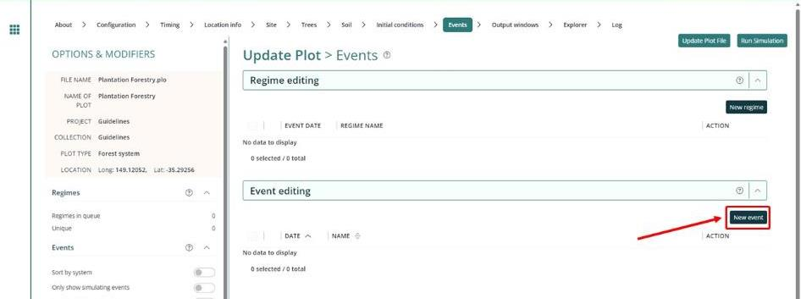

1. There are six event ‘Types’, of which five are permitted under this Determination (i.e. all except ‘Termite change’). For each event to be added, select the appropriate ‘Event Type’ as indicated in Section 3.11.

**Figure 12 Selecting the event Type**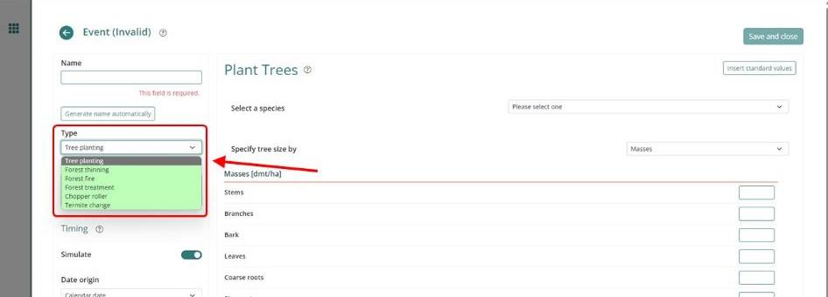

1. For each event to be added, select the appropriate ‘Event Type’ as indicated in Section 3.11.
2. For each event, insert the calendar date for the event in the ‘Event date’ field in the Timing section on the bottom left-hand side of the window. This must be in the format of DD/MM/YYYY.

**Figure 13 Adding the Event date**

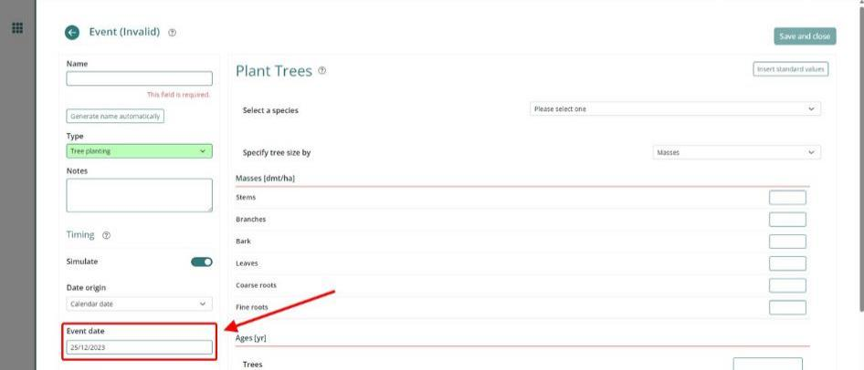

1. For each event added select ‘Insert standard values’*,* unless instructed not to by Section 3.11.
2. A pop-up window will open that allows you to *‘*Select a standard event’. Section 3.11 defines which event ‘Type’ and which standard event must be selected for each management activity. You must use default settings for the standard events unless defined otherwise in Section 3.11. The exceptions are for pruning, thinning and wildfire, whether for trees killed or trees not killed, and for natural disturbances other than a fire, whether for trees killed or trees not killed, for which you must enter the affected portion of the CEA as a percentage. An example of the ‘Select A Standard Event’ window is shown here:

**Figure 14 An example of the ‘Select a standard event’ window**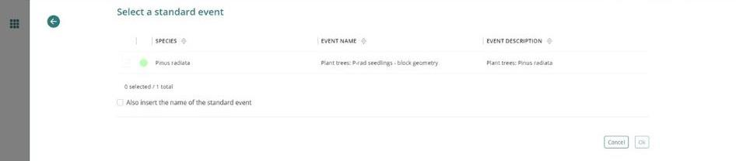

1. If you choose the event type ‘Forest thinning’ and standard event ‘Initial clearing: product recovery’ (for either a ‘thinning with harvest’ event or a ‘clearfelling with harvest’ event), you will need to change the affected portion and the destination parameters in the affected portion listed under ‘stems to’ in accordance with Appendix 2.
2. Click ‘OK’ to close the ‘Event’ window.

Example settings for each type of standard event in Section 3.11 are shown in Appendix 1.

Once all Events are added, navigate to the ‘Output Windows’ tab.

### Cloning events to cover the Modelling Period of the long-term project scenario

For the long-term project scenario, users must simulate all the events in the ‘management record’ up to the end of the reporting period. For beyond the reporting period, users must simulate any remaining events in the current regime, and for new plantation CEAs, conversion CEAs and continuing plantation CEAs, this must be followed by modelling the default management actions recurring for the remainder of the 100‑year modelling period.

The default management actions can be setup and cloned to cover the whole modelling period as follows. Cloning the default management actions involves copying the actions from one time period to be modelled in another. This is done as follows, depending on what stage in a rotation you are up to, and whether the most recent rotation features the default management actions:

Steps:

1. Use the plot file already setup with events for the project scenario. Ensure that is has been saved separately, the spatial data has been redownloaded, the timing reconfigured and the initial conditions reset as per steps 3.3, 3.4, 3.5 and 3.10 above.
2. Determine which of the below situations applies for the relevant CEA:
   * CEA is an ex-plantation CEA – do nothing, no cloning necessary
   * just completed a rotation with the default management actions – go to step 6
   * partially completed a rotation with the default management actions – go to step 3
   * just completed a rotation that differs from the default management actions – go to step 4
   * partially completed a rotation that differs from the default management actions – go to step 5.
3. Beyond the reporting period, add the default management actions as events to complete the current rotation then go to step 6.
4. Add the default management actions as events for the next rotation then go to step 6.
5. Beyond the reporting period, add the remainder of events for the current rotation, then add the default management actions as events for the next rotation. Then go to step 6.
6. Select each of default management actions in the latest queued rotation. To do this, in the Regime editing section, click on each of the check boxes of each of the corresponding events in the queue.
7. With the regimes selected, select ‘Merge’ in the dropdown menu that appears and click the ‘Apply’ button.

**Figure 15 Merging regimes**

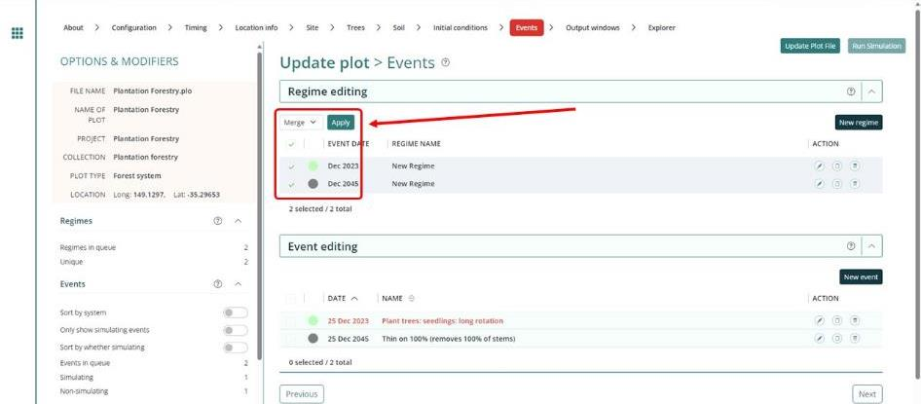

1. Enter a name for the new regime.

**Figure 16 Entering a regime name**

1. In the Regime editing section, ensure your new regime is selected. Click ‘Clone’ under the ‘Action’ column.
2. For ‘Calendar years’, enter the length of the rotation comprising the default management actions in years plus one (i.e. 30 years + 1 = 31). Note that one year is added as the Determination subsection 40(2) and subparagraph 41(1)(c)(i) specify that there must be a period of one year between modelled rotations.
3. For ‘Number of times’, which changes the number of times the events are cloned*,* enter a value high enough to cover the remainder of the modelling period. For example, if there are 70 years remaining in the modelling period beyond the end of the events already modelled, and one rotation of default management actions covers 31 years (varies by species; include the 1 year gap between rotations), you will need to model at least 3 occurrences (3 x 31 = 93).
4. Click ‘OK’. Any cloned events occurring beyond the 100‑year modelling period will be highlighted grey. It is not necessary to delete these as they will not affect the simulation.

**Figure 17 Entering a timing offset for cloned events**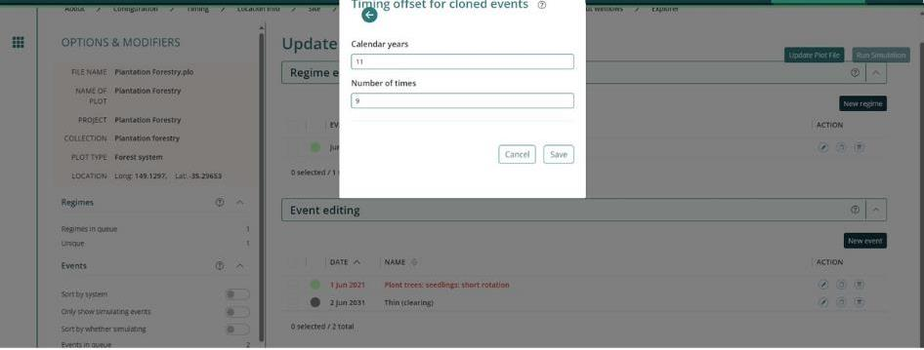

### Cloning events to cover the Modelling Period of the Baseline Scenario

For the baseline scenario, users must simulate all the baseline management actions that applied or would normally have applied (if a rotation still in progress or was subject to a disturbance event) for the baseline rotation period. For the conversion activity, this is ongoing short rotations, recurring over the modelling period with one year between each rotation. For the permanent planting and continuing plantations project activities, this is a single harvest event, followed by permanent fallow. As such, cloning events in the baseline scenario is only required for the conversion activity.

Steps:

1. First ensure all the management actions and disturbance events for the first rotation of the Baseline scenario have been added by following the steps set out in section 3.12 – Adding a New Event.
2. If no disturbance events occurred during the first rotation of the Baseline scenario, go to step 4.
3. If disturbance events did occur during the first rotation of the Baseline scenario, you must model a subsequent rotation that only comprises the management actions as they were intended to apply during the baseline rotation had the disturbance event(s) not occurred.
4. Select each of default management actions in the latest queued rotation. To do this, in the Regime editing section, click on each of the check boxes of each of the corresponding events in the queue.
5. With the regimes selected, select ‘Merge’ in the dropdown menu that appears and click the ‘Apply’ button.
6. Enter a name for the new regime.
7. In the Regime editing section, ensure your new regime is selected. Click ‘Clone’ under the ‘Action’ column.
8. For *Calendar years*, enter the length of the rotation comprising the default management actions in years plus one (i.e. 30 years + 1 = 31). Note that one year is added as the Determination subsection 38(2) and subparagraph 41(1)(c)(i) specify that there must be a period of one year between modelled rotations.
9. For ‘Number of times’, which changes the number of times the events are cloned*,* enter a value high enough to cover the remainder of the modelling period. For example, if there are 70 years remaining in the modelling period beyond the end of the events already modelled, and one rotation of default management actions covers 31 years (varies by species; include the 1 year gap between rotations), you will need to model at least 3 occurrences (3 x 31 = 93).
10. Click ‘OK’. Any cloned events occurring beyond the 100‑year modelling period will be highlighted grey. It is not necessary to delete these as they will not affect the simulation.

### The Output Windows tab

On left side of the ‘Output windows’ tab, the outputs are organised into folders and subfolders, just like files are organised into folders in Windows Explorer. Click the drop-down arrow next to a folder to expand and collapse the folders. A single click on the icon of a folder selects or deselects everything within the folder.

Selected outputs have a tick as their icon.

A minus icon on a folder indicates that at least one output within that folder and its subfolders is selected.

A plus icon on a folder indicates that no outputs within that folder or its subfolders are selected.

**Figure 18 The tick, minus and plus icons in the output selection menu**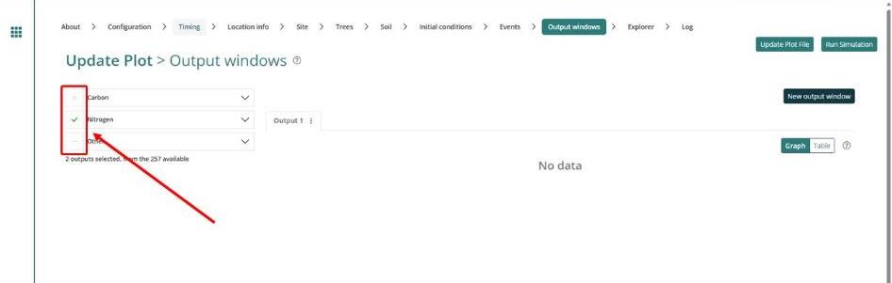

1. Deselect all the pools (by simply clicking on the top-level folders that show a tick or minus, to remove the tick or minus).
2. Use the drop down arrows and navigate through the folders to select:
   * the following tree carbon pool: Carbon / Forest / Plants / C mass of trees
   * the following debris carbon pool: Other / Carbon Projects / C mass of forest debris
   * the following harvested wood products carbon pool: Carbon / Forest / Products / C mass of forest products
   * the following non CO2 emission: Carbon / Whole / Emissions / CH4 emitted due to fire
   * the following non CO2 emission: Nitrogen / Whole / Emissions / N2O emitted due to fire.
   * the following timing output: Other / Timing / Average age of Trees (**Note: this output is only required to be selected for ex-plantation CEAs. For all other CEA types, there is no need to select this output.)**
3. Note: only the five (or six for an ex-plantation CEA) outputs listed above must be selected. The bottom section of the screen shows how many outputs are selected.

### Running simulations

To run the simulation, click the “*Run Simulation"* button, in the top right of the screen. This will generate the selected outputs in a graph. It will also initialise a download of the result in CSV format. This button will appear faded out and will not be available if the Events queue contains invalid Events, which will appear in red, and the tab will have a red title.

**Figure 19 A simulation cannot be run if a page is not valid**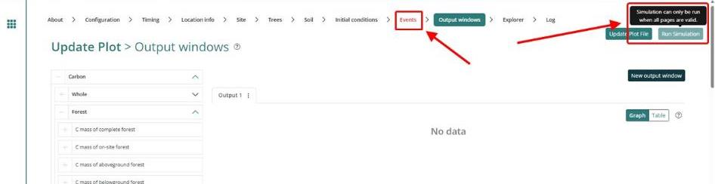

Note that if reopening a plot file, users must first navigate to the “*Location info”* tab and click “Query FullCAM spatial data” before running the simulation to ensure the latest spatial data is used for the simulation.

### Viewing outputs

Outputs can be viewed as a graph or a table by clicking on the corresponding icons at the top right of the Output window.

**Figure 20 Viewing outputs in FullCAM**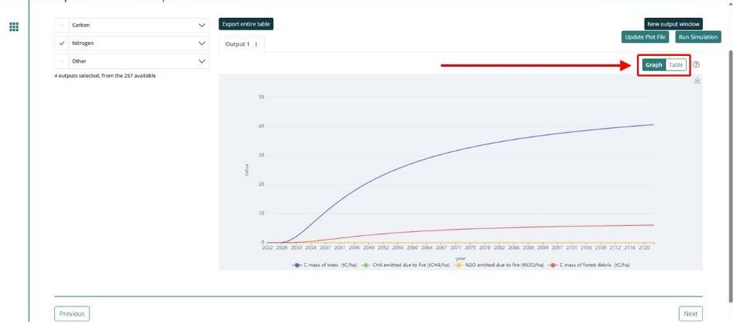

### Transferring outputs into a spreadsheet

Running a simulation will automatically download the CSV file with the graph’s data. A pop-up near your ‘Downloads’ button on your browser may request permission to download.

All subsequent calculations are conducted outside FullCAM. Note that if Section 3.19 applies, participants may be required to revise their FullCAM file, using the original FullCAM output as a reference.

### Setting maximum forest growth for the permanent plantings activity

**This section is only relevant for ex-plantation (Schedule 4) CEAs.** All other CEA types – go to section 3.20.

If, in step 3.6, you selected the ‘environmental planting’ species for the CEA, no manual abatement capping is required, and this section may be disregarded.

The growth calibrations for plantation forests in FullCAM are underpinned by data from commercial growers. As such, very few calibration points exist for forests that are older than typical maximum harvest ages. Thus, to ensure conservative crediting outcomes, the forest growth for species using these calibrations must be capped at the upper limit of confidence in the calibrated growth curves. This upper limit of confidence is the oldest age at which FullCAM can accurately predict the growth of a plantation forest, and is presented in Table 18 below:

Table 18 Maximum ages of confidence for 2024 FullCAM calibrations

|  |  |
| --- | --- |
| Species | Age |
| *Acacia mangium\** | 15 |
| *Araucaria cunninghamii* | 60.5 |
| *Corymbua citriodora* | 45.5 |
| *Corymbia maculata* | 45.5 |
| *Eucalyptus argophloia* | 40.5 |
| *Eucalyptus cladocalyx* | 45.5 |
| *Eucalyptus cloeziana* | 45.5 |
| *Eucalyptus dunnii* | 34.5 |
| *Eucalyptus globulus* | 21.5 |
| *Eucalyptus grandis* | 48 |
| *Eucalyptus nitens* | 21.5 |
| *Eucalyptus pilularis* | 45.5 |
| *Eucalyptus regnans* | 60.5 |
| *Eucalyptus saligna* | 45.5 |
| *Khaya senegalensis* | 25.5 |
| *Pinus caribaea* | 40.5 |
| *Pinus elliottii* | 40.5 |
| *Pinus radiata* | 40.5 |
| *Pinus pinaster* | 40.5 |
| Other acacia | 6 |
| Other eucalypts | 30 |
| Other non-eucalypt hardwoods | 36 |
| Other softwoods | 10 |
| Mallee (Block) | 20 |
| Mallee (Belt geometry with <1500 sph) | 15 |
| Mallee (Belt geometry with >1500 sph (narrow)) | 15 |
| Mallee (Belt geometry with >1500 sph (wide)) | 13 |

For all other species, to manually cap the abatement using growth pause events in FullCAM, follow the below steps. Note that the below instructions differ for situations where a CEA has experienced a disturbance event. This is to ensure that the recovery of the forest after the disturbance event is modelled to occur, prior to manually capping the abatement again. As such, these instructions are split into two sections:

* Section 3.19.1 gives instructions for ex-plantation CEAs that experience no disturbance events.
* Section 3.19.2 gives instructions for ex-plantation CEAs that experience one or more disturbance events.

In order to use the below instructions, participants will need to determine the **date of exceedance** and **maximum biomass value** for the CEA. These can be determined by following the below steps:

1. Locate the species and age in table 18 above.
2. In the ‘Plots’ menu, select the FullCAM plot file that has been generated by following the guidelines up to this point (the ‘**original plot file**’) and press the ‘Clone’ button under the ‘Action’ column. You will be taken a page where you will be able to edit the plot name, notes and the project and collection in which the plot will be located. The new plot file will automatically be named as a clone but you can change this. Click the ‘Save Plot File’ button.
3. On the ‘Events’ page, remove all disturbance events from the events queue in the new plot file, and output the results by following the instructions in section 3.18. This new output is the ‘**non-disturbance output**’.
4. Open the non-disturbance output and navigate to the first row of the ‘Average age of trees (yr)’ in the output that is greater than the age displayed in Table 18. Determine the date in the output file at which this occurs. This is the ‘**date of exceedance’**. For example, if the ‘Average age of trees’ exceeds the age shown in Table 18 in June 2042, the date of exceedance is 1 June, 2042.
5. Record the *C mass of trees* in the non-disturbance output at the date of exceedance. This is the ‘**maximum biomass value**’.

#### Ex-plantation CEAs that experience no disturbance events

In order to set the abatement cap in an ex-plantation CEA that has not experienced a disturbance event, follow the below instructions:

1. Return to the original plot file in FullCAM and follow the instructions below to insert a new growth pause event at the date of exceedance:
   * On the ‘Events’ page, click the ‘New event’ button*.*
   * From the ‘Type’ dropdown menu, select ‘Forest treatment’*.* **Do not select ‘Insert Standard Values’**. In the ‘Forest Treatment’ section:
     + Turn the *‘*Age advance’switch to the ON position.
     + For the ‘Age advance due to treatment [yr]’ enter a negative number that is equal to the remaining number of years in the Crediting period, plus 5. For example, if the date of exceedance falls 6 years before the end of the crediting period for the project, enter -11 for the ‘Age advance due to treatment [yr]’*.*
     + For the ‘Advancement period [yr]’ enter a number that is equal to the number entered for the ‘Age advance due to treatment [yr]’multiplied by -1. For example, if the ‘Age advancement due to treatment [yr]’ is -11, the ‘Advancement period [yr]’ is 11.
     + For the event name, enter ‘Manual Abatement Cap’.
     + Click ‘Save and close’.
2. Follow the steps in Section 3.18 to transfer the outputs from the updated plot file (the ‘Updated output’) to an excel file.

An example of the ‘Event’ window is shown below.

**Figure 21 The window for setting the manual abatement cap**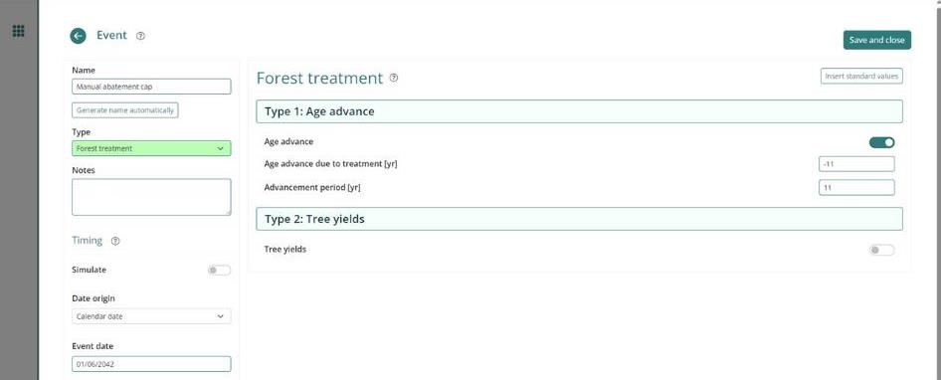

#### 3.19.2 Ex-plantation CEAs that experience one or more disturbance events

Follow the below instructions if the CEA experiences one or more disturbance events (e.g. a fire, growth pause or other natural disturbance) during the modelling period.

1. Return to the original plot file, which should have the disturbance event(s) modelled.
2. In the output from the original plot file, determine the first date in the output from the original plot file at which the *C mass of trees* is equal to or exceeds the maximum biomass value. This date is the **revised date of exceedance*.***
3. Follow the instructions below to insert a new growth pause event at the revised date of exceedance:
   1. On the *Events* page, select ‘New’ under ‘Event Editing’*.*
   2. From the ‘Type’ drop down menu, select ‘Forest treatment’*.* **Do not select ‘Insert Standard Values’**. In the ‘Forest Treatment’ section:
      1. Under ‘Type 1:Age Advance’, turn the ‘Age advance’ switch to the ON position.
      2. For the ‘Age advance due to treatment [yr]’ enter a negative number that is equal to either:
         1. If the CEA experiences a disturbance event between the revised date of exceedance and the end of the crediting period, the number of years between the revised date of exceedance and the next disturbance event. For example, if the CEA experiences a disturbance event 2 years after the revised date of exceedance, enter -2 for the ‘Age advance due to treatment [yr]’; or
         2. If the CEA does not experience another disturbance event prior to the end of the crediting period, the remaining number of years in the Crediting period, plus 5. For example, if the date of exceedance falls 6 years before the end of the crediting period for the project, enter -11 for the ‘Age advance due to treatment [yr]’*.*
      3. For the ‘Advancement period [yr]’ enter a number that is equal to the number entered for the ‘Age advance due to treatment [yr]’multiplied by -1. For example, if the ‘Age advancement due to treatment [yr]’ is -11, the ‘Advancement period [yr]’ is 11.
      4. For the event name, enter ‘Manual Abatement Cap’ followed by a number to represent how many manual abatement capping events have been modelled (e.g. “Manual Abatement Cap 1”).
      5. Click ‘Save and close’.
4. Follow the steps in Section 3.18 to transfer the outputs from the updated plot file (the ‘updated output’) to an excel file.
5. If the event queue in the original plot file contains another disturbance event prior to the end of the crediting period, repeat these instructions from Step 1, using the updated output in place of the output from the original plot file, until the manual abatement cap has been implemented after each disturbance event.

### Calculating project abatement at the end of a reporting period

Project proponents calculate the project net abatement by completing the equations in Division 4.3 of the Determination. The FullCAM outputs required to inform these equations to calculate project net abatement are shown in Table 19 below. They are generated by following the steps in Section 3 of this document.

The project scenario simulation and long-term project scenario simulation, as well as the baseline scenario simulation for *conversion* projects, must be run for each CEA at the end of each reporting period in order to complete the equations set out in the Determination.

### Variables generated in FullCAM and used in equations in the Determination

The outputs generated by modelling the project, long-term project and baseline scenarios in FullCAM are used to calculate the net abatement number using the calculations in Part 4, Division 3 of the Determination. Table 19 shows where the outputs generated by FullCAM feed into the abatement calculations.

Note that for some of the equations the average of the FullCAM output over the simulation period will be required, whereas for others the value of the FullCAM output at the end of the simulation or at a certain date will be used. Refer to the equations within the Determination to determine which value to use. Averages can be calculated using the average function within your spreadsheet software.

Table 19 Relationship between FullCAM outputs and variables defined in the Determination

| **FullCAM Output** | **Scenario** | **Determination Parameter** | **Project Activity Schedule** | **Determination Equation** |
| --- | --- | --- | --- | --- |
| C mass of trees | Baseline | $$C_{BT,i,k}$$ | 2, 3 | 1 |
| Long-term project | $$C_{T,i,k}$$ | 1, 2, 3 | 8 |
| 4 | 9 |
| Project | $$C_{T,i}$$ | 1 | 14 |
| C mass of forest debris | Baseline | $$C_{BD,i,k}$$ | 2, 3 | 1 |
| 4 | 4 |
| Long-term project | $$C_{D,i,k}$$ | 1, 2, 3 | 8 |
| 4 | 9 |
| Project | $$C_{D,i}$$ | 1 | 14 |
| C mass of forest products | Baseline | $$C_{FP,B,i,k}$$ | 2, 3 | 1 |
| 4 | 4 |
| Long-term project | $$C_{FP,i,k}$$ | 1, 2, 3 | 4, 12 |
| 4 | 9, 12 |
| Project | $$C_{FP,i,h}$$ | 1, 2, 3, 4 | 19 |
| CH4 emitted due to fire | Baseline |  | 2, 3 | 2 |
| 4 | 5 |
| Long-term project |  | 1, 2, 3, 4 | 10 |
| Project |  | 1, 2, 3, 4 | 17 |
| N2O emitted due to fire | Baseline | $$E_{g,i,k}$$ | 2, 3 | 2 |
| 4 | 5 |
| Long-term project | $$E_{g,i,k}$$ | 1, 2, 3, 4 | 10 |
| Project | $$E_{g,i,k}$$ | 1, 2, 3, 4 | 17 |

## Appendix 1

### Example event settings for standard events specified in Section 3.11

Table 20 Relationship between a pruning event and FullCAM

| **Management Activity** | **FullCAM Event Type** | **FullCAM Standard Event** | **FullCAM Parameter values** |
| --- | --- | --- | --- |
| Pruning | Thin | Prune  (Selective 33%) | Define the portion of the forest biomass that was pruned (thinned) if different to 33%. Your project report must describe how the portion was estimated.  Remainder of parameters – use defaults. |

**Figure 22 Example pruning event**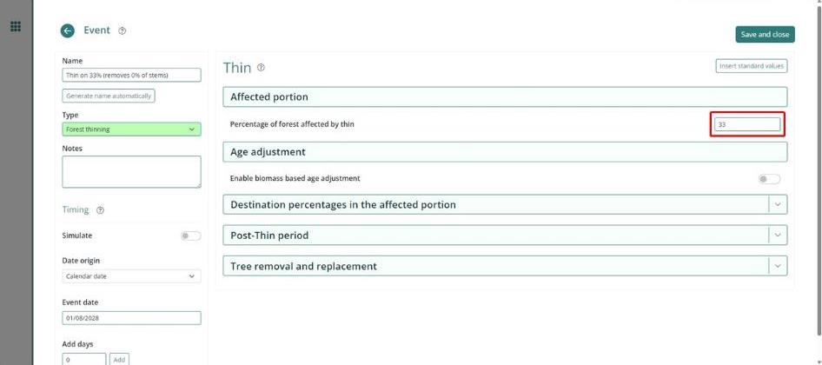

Table 21 Relationship between a commercial event and FullCAM

|  |  |  |  |
| --- | --- | --- | --- |
| **Management Activity** | **FullCAM Event Type** | **FullCAM Standard Event** | **FullCAM Parameter values** |
| Commercial Thinning (Thinning with harvest) | Thin | Initial Clearing: product recovery | Define the portion of the forest biomass that was thinned. Your project report must describe how the portion was estimated.  Remainder of parameters – use defaults. |

**Figure 23 Example commercial thinning event**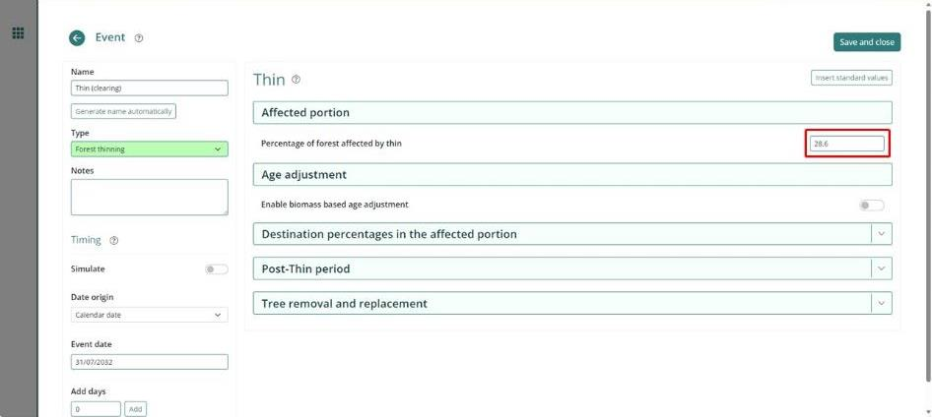

Table 22 Relationship between a wildfire event where trees are not killed and FullCAM

|  |  |  |  |
| --- | --- | --- | --- |
| **Management Activity** | **FullCAM Event Type** | **FullCAM Standard Event** | **FullCAM Parameter values** |
| Wildfire | Forest fire | Wildfire – trees not killed | Amend the portion affected.  Turn the ‘Enable biomass based age adjustments’ switch to the ON position.  Amend portion of stems, branches, and bark to atmosphere and debris.  NB: Not repeated each rotation. |

Steps required:

1. Add a new ‘Forest fire’ event.
2. Select Insert Standard Values, and ‘Wildfire - trees not killed’.
3. Insert the *Name of the Standard Event*.
4. Enter the date of the fire event in accordance with the Determination.
5. Turn the ‘Enable biomass based age adjustment’ switch to the ON position.
6. Change the ‘Percentage of forest affected by fire’to be equivalent to the portion of the area of the CEA affected by the fire (if the entire CEA was burnt, this will be 100).
7. If trees were killed, open the ‘Destination percentages in the affected portion’ panel and:
   * change stems to Atmos and bark to Atmos to 0.1 multiplied by the proportion of biomass killed as estimated in accordance with the Determination.
   * change stems to Debris and bark to Debris 0.9 multiplied by the proportion of biomass killed as estimated in accordance with the Determination.
   * change branches to Atmos to 0.2 multiplied by the proportion of biomass killed as estimated in accordance with the Determination.
   * change branches to Debris to 0.8 multiplied by the proportion of biomass killed as estimated in accordance with the Determination.
8. Leave other values unchanged.

**Figure 24 Example wildfire event where trees are not killed**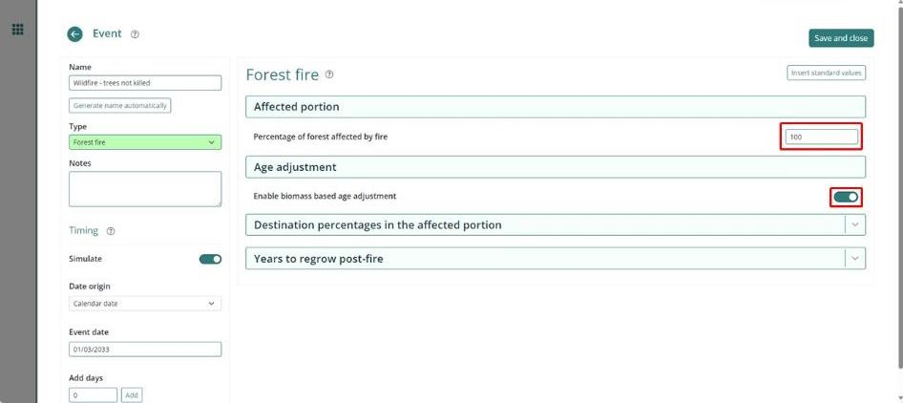

**Table 23 Relationship between a wildfire event where trees are killed and FullCAM**

|  |  |  |  |
| --- | --- | --- | --- |
| **Management Activity** | **FullCAM Event Type** | **FullCAM Standard Event** | **FullCAM Parameter values** |
| Wildfire – trees killed | Forest fire | Wildfire – trees killed | Tick the Enable biomass based age adjustments box.  Remainder of parameters – use defaults.  NB: Not repeated each rotation. |

**Figure 25 Example wildfire event where trees are not killed**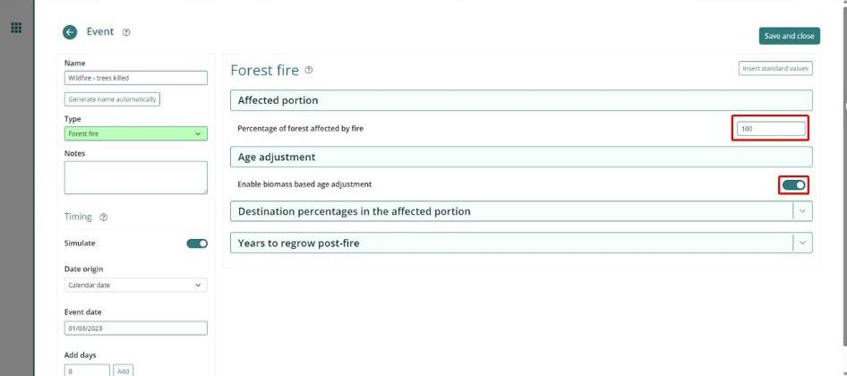

**Table 24 Relationship between a growth interruption and FullCAM**

|  |  |  |  |
| --- | --- | --- | --- |
| **Management Activity** | **FullCAM Event Type** | **FullCAM Standard Event** | **FullCAM Parameter values** |
| Growth interruption | Forest treatment | NA | Tick the *Type 1: Age Advance On* box.  Enter *Age advance due to treatment* (negative number) and *Advancement period* (positive number). |

Steps required:

1. Add a new ‘Forest treatment’ event.
2. Enter the date when the growth interruption commenced as the first day of the reporting period that a growth interruption was detected.
3. Tick the *Type 1: Age Advance On* box.
4. Enter *Age advance due to treatment* (negative number). The value represents the time period over which the growth interruption occurred, and is equal to the length of the reporting period, multiplied by -1. This can be a proportion of a year, expressed as a decimal.
5. Enter *Advancement period* (positive number). The value must be equal to the length of the reporting period.
6. Enter the event Name as “Growth interruption” followed by the period of growth interruption (e.g. Growth interruption – 1 year).

**Figure 26 Example growth interruption event** 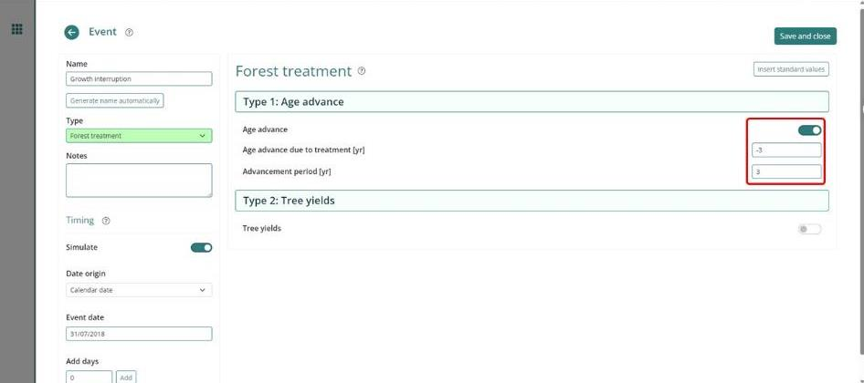

## Appendix 2

### Standard parameters for forest products

When adding thinning or clearfelling events within FullCAM where commercial products are taken, users must use Table 25 below to determine which parameters to enter for the forest products relating to stems (the red circled boxes below). Other parameters will be left unedited. Note that a different set of parameters apply to salvage harvesting, which are given below.

**Figure 24 Fields for entering forest product harvest parameters**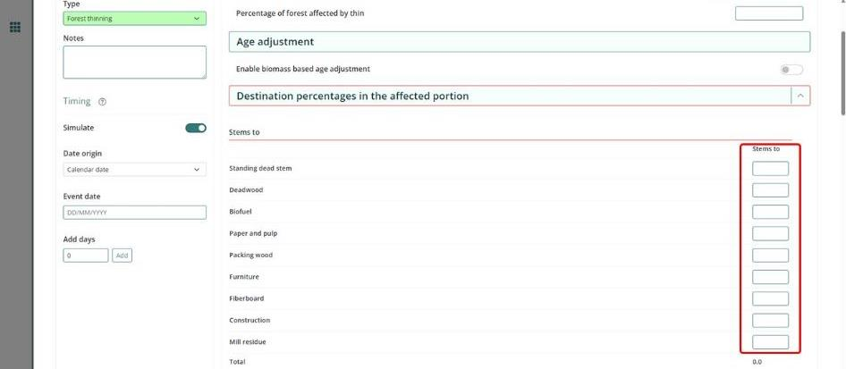

Table 25 lists the parameters to input by NPI Region, then species, regime (i.e. pulplog for short-rotations or sawlog for long-rotations), and thin number or clearing (i.e. first thinning of rotation). Use each of these columns to locate the standard parameters that you are required to input with regard to the following notes where you cannot match the species or thin number.

Note that the below is an entirely separate species selection process to that outlined for the Location Info Tab earlier in this document. It applies to separate sub-components of FullCAM. Please follow each species selection process independent of the other.

Where it is not possible to make an exact match for species, observe the following:

1. For hardwood species, including any of the *Corymbia* genus, use the parameters for the ‘Eucalypt’ species.
2. For softwood species, use the parameters for the ‘Southern Pine’ or ‘Radiata Pine’ species.
3. For all other species, all commercial thins must be modelled as having a ‘deadwood’ parameter of 10, a ‘biofuel’ parameter of 90, and a parameter of 0 for all remaining product categories.

Where a regime has more commercial thinning events than those listed in the table, the thin number prior to the clearfell may be repeated. Where all thin numbers listed in the table have been modelled for this rotation, and the remaining thin affects 100% of the CEA, use the parameters listed under ‘clearfell’ – denoted in Table 25 by ‘C’ in the thin number column.

Where a regime has fewer commercial thinning events than those listed in the table, the thin numbers that do not occur can be skipped. Note that in order to model a sawlog regime, at least one thinning event (with or without harvest) must occur.

Salvage Harvesting

If a salvage harvest following a natural disturbance is being modelled, a different rule regarding parameters applies. In this instance, the following must be observed:

1. The event is to be modelled as a clearfell event but the forest product parameters are to be based on the thin number used to model the thinning event prior to the natural disturbance.
2. Enter the parameters for ‘deadwood’, ‘packaging’, ‘furniture’, ‘construction’ and ‘mill residue’ as listed for that thin number in Table 25.
3. For the ‘biofuel’ parameter, enter the sum of the parameters listed in Table 3 for ‘paper’ and ‘fibreboard’ under that thin number.
4. For the ‘paper’ and ‘fibreboard’ parameters, enter ‘0’.

**Table 25 Standard parameters for forest products for implementation into FullCAM**

| **Region** | **Species** | **Regime** | **Thin number or clearing (c)** | **Deadwood** | **Biofuel** | **Paper and pulp** | **Packing wood** | **Furniture** | **Fibre-board** | **Construction** | **Mill Residue** |
| --- | --- | --- | --- | --- | --- | --- | --- | --- | --- | --- | --- |
| Central Gippsland | E. globulus | Pulplog | C | 10.00% | 0.00% | 88.10% | 0.00% | 0.00% | 0.00% | 0.00% | 1.90% |
| E. globulus | Sawlog | 1 | 20.00% | 0.00% | 78.30% | 0.00% | 0.00% | 0.00% | 0.00% | 1.70% |
| C | 10.00% | 0.00% | 69.30% | 0.00% | 0.00% | 1.40% | 9.70% | 9.60% |
| E. nitens | Pulplog | C | 10.00% | 0.00% | 88.10% | 0.00% | 0.00% | 0.00% | 0.00% | 1.90% |
| E. nitens | Sawlog | 1 | 20.00% | 0.00% | 78.30% | 0.00% | 0.00% | 0.00% | 0.00% | 1.70% |
| C | 10.00% | 0.00% | 69.30% | 0.00% | 0.00% | 1.40% | 9.70% | 9.60% |
| E. regnans | Pulplog | C | 10.00% | 0.00% | 88.10% | 0.00% | 0.00% | 0.00% | 0.00% | 1.90% |
| E. regnans | Sawlog | 1 | 20.00% | 0.00% | 78.30% | 0.00% | 0.00% | 0.00% | 0.00% | 1.70% |
| C | 10.00% | 0.00% | 69.30% | 0.00% | 0.00% | 1.40% | 9.70% | 9.60% |
| Other eucalypts | Sawlog | 1 | 20.00% | 0.00% | 78.30% | 0.00% | 0.00% | 0.00% | 0.00% | 1.70% |
| 2 | 20.00% | 0.00% | 39.50% | 0.00% | 0.00% | 2.90% | 20.00% | 17.60% |
| C | 10.00% | 0.00% | 34.20% | 0.00% | 0.00% | 4.00% | 27.80% | 24.00% |
| P. radiata | Sawlog | 1 | 15.00% | 0.00% | 76.50% | 0.00% | 0.00% | 0.00% | 0.00% | 8.50% |
| 2 | 15.00% | 0.00% | 76.50% | 0.00% | 0.00% | 0.00% | 0.00% | 8.50% |
| C | 10.00% | 0.00% | 54.30% | 0.00% | 0.00% | 2.30% | 20.50% | 12.90% |
| P. radiata | Pulplog | C | 10.00% | 0.00% | 81.00% | 0.00% | 0.00% | 0.00% | 0.00% | 9.00% |
| Spotted gum species | Sawlog | 1 | 20.00% | 0.00% | 67.90% | 0.00% | 0.00% | 0.80% | 5.30% | 6.00% |
| 2 | 20.00% | 0.00% | 51.10% | 0.00% | 0.00% | 2.00% | 14.00% | 12.90% |
| C | 10.00% | 0.00% | 28.70% | 0.00% | 0.00% | 4.40% | 30.60% | 26.30% |
| Central Tablelands | E. globulus | Pulplog | C | 10.00% | 0.00% | 90.00% | 0.00% | 0.00% | 0.00% | 0.00% | 0.00% |
| E. globulus | Sawlog | 1 | 20.00% | 0.00% | 80.00% | 0.00% | 0.00% | 0.00% | 0.00% | 0.00% |
| 2 | 20.00% | 0.00% | 40.00% | 0.00% | 0.00% | 2.90% | 20.00% | 17.10% |
| C | 10.00% | 0.00% | 34.40% | 0.00% | 0.00% | 4.00% | 27.80% | 23.80% |
| E. nitens | Pulplog | C | 10.00% | 0.00% | 90.00% | 0.00% | 0.00% | 0.00% | 0.00% | 0.00% |
| E. nitens | Sawlog | 1 | 20.00% | 0.00% | 80.00% | 0.00% | 0.00% | 0.00% | 0.00% | 0.00% |
| 2 | 20.00% | 0.00% | 40.00% | 0.00% | 0.00% | 2.90% | 20.00% | 17.10% |
| C | 10.00% | 0.00% | 34.40% | 0.00% | 0.00% | 4.00% | 27.80% | 23.80% |
| Other eucalypts | Sawlog | 1 | 20.00% | 0.00% | 80.00% | 0.00% | 0.00% | 0.00% | 0.00% | 0.00% |
| 2 | 20.00% | 0.00% | 40.00% | 0.00% | 0.00% | 2.90% | 20.00% | 17.10% |
| C | 10.00% | 0.00% | 34.40% | 0.00% | 0.00% | 4.00% | 27.80% | 23.80% |
| P. pinaster | Sawlog | 1 | 15.00% | 0.00% | 44.10% | 0.00% | 0.00% | 36.40% | 0.00% | 4.50% |
| 2 | 15.00% | 0.00% | 31.70% | 0.00% | 0.00% | 15.00% | 25.50% | 12.80% |
| 3 | 15.00% | 0.00% | 28.90% | 0.00% | 0.00% | 10.10% | 31.30% | 14.70% |
| C | 10.00% | 0.00% | 34.00% | 0.00% | 0.00% | 16.50% | 26.20% | 13.30% |
| P. pinaster | Pulplog | C | 10.00% | 0.00% | 46.70% | 0.00% | 0.00% | 38.50% | 0.00% | 4.80% |
| P. radiata | Sawlog | 1 | 15.00% | 0.00% | 37.30% | 0.00% | 0.00% | 24.70% | 13.90% | 9.10% |
| C | 10.00% | 0.00% | 30.70% | 0.00% | 0.00% | 10.90% | 32.80% | 15.60% |
| P. radiata | Pulplog | C | 10.00% | 0.00% | 46.70% | 0.00% | 0.00% | 38.50% | 0.00% | 4.80% |
| Central Victoria | E. globulus | Pulplog | C | 10.00% | 0.00% | 90.00% | 0.00% | 0.00% | 0.00% | 0.00% | 0.00% |
| E. globulus | Sawlog | 1 | 20.00% | 0.00% | 80.00% | 0.00% | 0.00% | 0.00% | 0.00% | 0.00% |
| 2 | 20.00% | 0.00% | 80.00% | 0.00% | 0.00% | 0.00% | 0.00% | 0.00% |
| C | 10.00% | 0.00% | 60.60% | 0.00% | 0.00% | 2.10% | 14.70% | 12.60% |
| E. nitens | Pulplog | C | 10.00% | 0.00% | 90.00% | 0.00% | 0.00% | 0.00% | 0.00% | 0.00% |
| E. nitens | Sawlog | 1 | 20.00% | 0.00% | 80.00% | 0.00% | 0.00% | 0.00% | 0.00% | 0.00% |
| 2 | 20.00% | 0.00% | 80.00% | 0.00% | 0.00% | 0.00% | 0.00% | 0.00% |
| C | 10.00% | 0.00% | 60.60% | 0.00% | 0.00% | 2.10% | 14.70% | 12.60% |
| Other eucalypts | Sawlog | 1 | 20.00% | 0.00% | 80.00% | 0.00% | 0.00% | 0.00% | 0.00% | 0.00% |
| 2 | 20.00% | 0.00% | 40.00% | 0.00% | 0.00% | 2.90% | 20.00% | 17.10% |
| C | 10.00% | 0.00% | 34.40% | 0.00% | 0.00% | 4.00% | 27.80% | 23.80% |
| P. radiata | Sawlog | 1 | 15.00% | 0.00% | 85.00% | 0.00% | 0.00% | 0.00% | 0.00% | 0.00% |
| 2 | 15.00% | 0.00% | 64.00% | 0.00% | 0.00% | 1.50% | 13.50% | 6.00% |
| C | 10.00% | 0.00% | 45.50% | 0.00% | 0.00% | 3.20% | 28.60% | 12.70% |
| P. radiata | Pulplog | C | 10.00% | 0.00% | 90.00% | 0.00% | 0.00% | 0.00% | 0.00% | 0.00% |
| Spotted gum species | Sawlog | 1 | 20.00% | 0.00% | 69.30% | 0.00% | 0.00% | 0.80% | 5.30% | 4.60% |
| 2 | 20.00% | 0.00% | 52.00% | 0.00% | 0.00% | 2.00% | 14.00% | 12.00% |
| C | 10.00% | 0.00% | 28.80% | 0.00% | 0.00% | 4.40% | 30.60% | 26.20% |
| Acacia spp. | Sawlog | 1 | 20.00% | 0.00% | 80.00% | 0.00% | 0.00% | 0.00% | 0.00% | 0.00% |
| 2 | 20.00% | 0.00% | 68.80% | 0.00% | 0.00% | 0.80% | 5.60% | 4.80% |
| C | 10.00% | 0.00% | 52.20% | 0.00% | 0.00% | 2.70% | 18.90% | 16.20% |
| East Gippsland - Bombala | E. globulus | Pulplog | C | 10.00% | 0.00% | 90.00% | 0.00% | 0.00% | 0.00% | 0.00% | 0.00% |
| E. globulus | Sawlog | 1 | 20.00% | 0.00% | 80.00% | 0.00% | 0.00% | 0.00% | 0.00% | 0.00% |
| 2 | 20.00% | 0.00% | 80.00% | 0.00% | 0.00% | 0.00% | 0.00% | 0.00% |
| C | 10.00% | 0.00% | 60.60% | 0.00% | 0.00% | 2.10% | 14.70% | 12.60% |
| E. nitens | Pulplog | C | 10.00% | 0.00% | 90.00% | 0.00% | 0.00% | 0.00% | 0.00% | 0.00% |
| E. nitens | Sawlog | 1 | 20.00% | 0.00% | 80.00% | 0.00% | 0.00% | 0.00% | 0.00% | 0.00% |
| 2 | 20.00% | 0.00% | 80.00% | 0.00% | 0.00% | 0.00% | 0.00% | 0.00% |
| C | 10.00% | 0.00% | 60.60% | 0.00% | 0.00% | 2.10% | 14.70% | 12.60% |
| Other eucalypts | Sawlog | 1 | 20.00% | 0.00% | 80.00% | 0.00% | 0.00% | 0.00% | 0.00% | 0.00% |
| 2 | 20.00% | 0.00% | 40.00% | 0.00% | 0.00% | 2.90% | 20.00% | 17.10% |
| C | 10.00% | 0.00% | 34.40% | 0.00% | 0.00% | 4.00% | 27.80% | 23.80% |
| P. pinaster | Sawlog | 1 | 15.00% | 0.00% | 80.00% | 0.00% | 0.00% | 0.00% | 0.00% | 5.00% |
| 2 | 15.00% | 0.00% | 56.30% | 0.00% | 0.00% | 1.90% | 17.40% | 9.40% |
| 3 | 15.00% | 0.00% | 50.90% | 0.00% | 0.00% | 2.40% | 21.30% | 10.40% |
| C | 10.00% | 0.00% | 84.70% | 0.00% | 0.00% | 0.00% | 0.00% | 5.30% |
| P. pinaster | Pulplog | C | 10.00% | 0.00% | 60.30% | 0.00% | 0.00% | 2.00% | 17.90% | 9.80% |
| P. radiata | Sawlog | 1 | 15.00% | 0.00% | 80.00% | 0.00% | 0.00% | 0.00% | 0.00% | 5.00% |
| 2 | 15.00% | 0.00% | 57.40% | 0.00% | 0.00% | 1.80% | 16.60% | 9.20% |
| C | 10.00% | 0.00% | 51.60% | 0.00% | 0.00% | 2.70% | 24.30% | 11.40% |
| P. radiata | Pulplog | C | 10.00% | 0.00% | 84.70% | 0.00% | 0.00% | 0.00% | 0.00% | 5.30% |
| Spotted gum species | Sawlog | 1 | 20.00% | 0.00% | 80.00% | 0.00% | 0.00% | 0.00% | 0.00% | 0.00% |
| 2 | 20.00% | 0.00% | 80.00% | 0.00% | 0.00% | 0.00% | 0.00% | 0.00% |
| C | 10.00% | 0.00% | 60.60% | 0.00% | 0.00% | 2.10% | 14.70% | 12.60% |
| Green Triangle | E. globulus | Pulplog | C | 10.00% | 0.00% | 90.00% | 0.00% | 0.00% | 0.00% | 0.00% | 0.00% |
| E. globulus | Sawlog | 1 | 20.00% | 0.00% | 80.00% | 0.00% | 0.00% | 0.00% | 0.00% | 0.00% |
| 2 | 20.00% | 0.00% | 40.00% | 0.00% | 0.00% | 2.90% | 20.00% | 17.10% |
| C | 10.00% | 0.00% | 34.40% | 0.00% | 0.00% | 4.00% | 27.80% | 23.80% |
| Other eucalypts | Sawlog | 1 | 20.00% | 0.00% | 80.00% | 0.00% | 0.00% | 0.00% | 0.00% | 0.00% |
| 2 | 20.00% | 0.00% | 40.00% | 0.00% | 0.00% | 2.90% | 20.00% | 17.10% |
| C | 10.00% | 0.00% | 34.40% | 0.00% | 0.00% | 4.00% | 27.80% | 23.80% |
| P. radiata | Sawlog | 1 | 15.00% | 0.00% | 73.00% | 0.00% | 0.00% | 11.40% | 0.00% | 0.60% |
| 2 | 15.00% | 0.00% | 64.80% | 0.00% | 0.00% | 9.60% | 7.10% | 3.50% |
| 3 | 15.00% | 0.00% | 48.50% | 0.00% | 0.00% | 5.90% | 21.00% | 9.60% |
| C | 10.00% | 0.00% | 41.60% | 0.00% | 0.00% | 4.10% | 30.60% | 13.70% |
| P. radiata | Pulplog | C | 10.00% | 0.00% | 77.30% | 0.00% | 0.00% | 12.10% | 0.00% | 0.60% |
| Spotted gum species | Sawlog | 1 | 20.00% | 0.00% | 69.30% | 0.00% | 0.00% | 0.80% | 5.30% | 4.60% |
| 2 | 20.00% | 0.00% | 52.00% | 0.00% | 0.00% | 2.00% | 14.00% | 12.00% |
| C | 10.00% | 0.00% | 28.80% | 0.00% | 0.00% | 4.40% | 30.60% | 26.20% |
| Mt Lofty / Kangaroo Island | E. globulus | Pulplog | C | 10.00% | 0.00% | 90.00% | 0.00% | 0.00% | 0.00% | 0.00% | 0.00% |
| E. globulus | Sawlog | 1 | 20.00% | 0.00% | 80.00% | 0.00% | 0.00% | 0.00% | 0.00% | 0.00% |
| 2 | 20.00% | 0.00% | 80.00% | 0.00% | 0.00% | 0.00% | 0.00% | 0.00% |
| C | 10.00% | 0.00% | 60.50% | 0.00% | 0.00% | 2.10% | 14.80% | 12.60% |
| Other eucalypts | Sawlog | 1 | 20.00% | 0.00% | 80.00% | 0.00% | 0.00% | 0.00% | 0.00% | 0.00% |
| 2 | 20.00% | 0.00% | 40.00% | 0.00% | 0.00% | 2.90% | 20.00% | 17.10% |
| C | 10.00% | 0.00% | 34.40% | 0.00% | 0.00% | 4.00% | 27.80% | 23.80% |
| P. radiata | Sawlog | 1 | 15.00% | 0.00% | 85.00% | 0.00% | 0.00% | 0.00% | 0.00% | 0.00% |
| 2 | 15.00% | 0.00% | 79.00% | 0.00% | 0.00% | 0.40% | 3.80% | 1.80% |
| 3 | 15.00% | 0.00% | 67.20% | 0.00% | 0.00% | 1.30% | 11.40% | 5.10% |
| C | 10.00% | 0.00% | 64.10% | 0.00% | 0.00% | 1.90% | 16.70% | 7.30% |
| P. radiata | Pulplog | C | 10.00% | 0.00% | 90.00% | 0.00% | 0.00% | 0.00% | 0.00% | 0.00% |
| Spotted gum species | Sawlog | 1 | 20.00% | 0.00% | 69.30% | 0.00% | 0.00% | 0.80% | 5.30% | 4.60% |
| 2 | 20.00% | 0.00% | 52.00% | 0.00% | 0.00% | 2.00% | 14.00% | 12.00% |
| C | 10.00% | 0.00% | 28.80% | 0.00% | 0.00% | 4.40% | 30.60% | 26.20% |
| Murray Valley | Acacia spp. | Sawlog | 1 | 20.00% | 0.00% | 80.00% | 0.00% | 0.00% | 0.00% | 0.00% | 0.00% |
| 2 | 20.00% | 0.00% | 68.80% | 0.00% | 0.00% | 0.80% | 5.60% | 4.80% |
| C | 10.00% | 0.00% | 52.20% | 0.00% | 0.00% | 2.70% | 18.90% | 16.20% |
| E. globulus | Pulplog | C | 10.00% | 0.00% | 90.00% | 0.00% | 0.00% | 0.00% | 0.00% | 0.00% |
| E. globulus | Sawlog | 1 | 20.00% | 0.00% | 80.00% | 0.00% | 0.00% | 0.00% | 0.00% | 0.00% |
| 2 | 20.00% | 0.00% | 80.00% | 0.00% | 0.00% | 0.00% | 0.00% | 0.00% |
| C | 10.00% | 0.00% | 60.60% | 0.00% | 0.00% | 2.10% | 14.70% | 12.60% |
| E. nitens | Pulplog | C | 10.00% | 0.00% | 90.00% | 0.00% | 0.00% | 0.00% | 0.00% | 0.00% |
| E. nitens | Sawlog | 1 | 20.00% | 0.00% | 80.00% | 0.00% | 0.00% | 0.00% | 0.00% | 0.00% |
| 2 | 20.00% | 0.00% | 80.00% | 0.00% | 0.00% | 0.00% | 0.00% | 0.00% |
| C | 10.00% | 0.00% | 60.60% | 0.00% | 0.00% | 2.10% | 14.70% | 12.60% |
| Other eucalypts | Sawlog | 1 | 20.00% | 0.00% | 80.00% | 0.00% | 0.00% | 0.00% | 0.00% | 0.00% |
| 2 | 20.00% | 0.00% | 40.00% | 0.00% | 0.00% | 2.90% | 20.00% | 17.10% |
| C | 10.00% | 0.00% | 34.40% | 0.00% | 0.00% | 4.00% | 27.80% | 23.80% |
| P. pinaster | Sawlog | 1 | 15.00% | 0.00% | 56.90% | 0.00% | 0.00% | 20.70% | 0.00% | 7.40% |
| 2 | 15.00% | 0.00% | 36.00% | 0.00% | 0.00% | 9.70% | 25.50% | 13.80% |
| 3 | 15.00% | 0.00% | 31.20% | 0.00% | 0.00% | 7.20% | 31.30% | 15.30% |
| C | 10.00% | 0.00% | 38.70% | 0.00% | 0.00% | 10.60% | 26.20% | 14.50% |
| P. pinaster | Pulplog | C | 10.00% | 0.00% | 60.20% | 0.00% | 0.00% | 21.90% | 0.00% | 7.90% |
| P. radiata | Sawlog | 1 | 15.00% | 0.00% | 56.90% | 0.00% | 0.00% | 20.70% | 0.00% | 7.40% |
| 2 | 15.00% | 0.00% | 41.20% | 0.00% | 0.00% | 12.50% | 19.10% | 12.20% |
| C | 10.00% | 0.00% | 29.40% | 0.00% | 0.00% | 5.80% | 37.50% | 17.30% |
| P. radiata | Pulplog | C | 10.00% | 0.00% | 60.20% | 0.00% | 0.00% | 21.90% | 0.00% | 7.90% |
| Spotted gum species | Sawlog | 1 | 20.00% | 0.00% | 69.30% | 0.00% | 0.00% | 0.80% | 5.30% | 4.60% |
| 2 | 20.00% | 0.00% | 52.00% | 0.00% | 0.00% | 2.00% | 14.00% | 12.00% |
| C | 10.00% | 0.00% | 28.80% | 0.00% | 0.00% | 4.40% | 30.60% | 26.20% |
| North Coast | Blackbutt species | Sawlog | 1 | 20.00% | 0.00% | 47.20% | 0.00% | 0.00% | 0.80% | 5.80% | 26.20% |
| 2 | 20.00% | 0.00% | 29.60% | 0.00% | 0.00% | 3.20% | 22.70% | 24.50% |
| C | 10.00% | 0.00% | 30.50% | 0.00% | 0.00% | 4.00% | 28.20% | 27.30% |
| E. grandis (plus hybrids) | Pulplog | C | 10.00% | 0.00% | 60.00% | 0.00% | 0.00% | 0.00% | 0.00% | 30.00% |
| E. grandis (plus hybrids) | Sawlog | 1 | 20.00% | 0.00% | 47.20% | 0.00% | 0.00% | 0.80% | 5.80% | 26.20% |
| 2 | 20.00% | 0.00% | 29.60% | 0.00% | 0.00% | 3.20% | 22.70% | 24.50% |
| C | 10.00% | 0.00% | 30.50% | 0.00% | 0.00% | 4.00% | 28.20% | 27.30% |
| Other eucalypts | Sawlog | 1 | 20.00% | 0.00% | 53.30% | 0.00% | 0.00% | 0.00% | 0.00% | 26.70% |
| 2 | 20.00% | 0.00% | 32.40% | 0.00% | 0.00% | 2.90% | 20.00% | 24.70% |
| C | 10.00% | 0.00% | 30.90% | 0.00% | 0.00% | 4.00% | 27.80% | 27.30% |
| Other Hardwoods (non-eucalypts) | Sawlog | 1 | 20.00% | 0.00% | 53.30% | 0.00% | 0.00% | 0.00% | 0.00% | 26.70% |
| 2 | 20.00% | 0.00% | 47.50% | 0.00% | 0.00% | 0.80% | 5.60% | 26.10% |
| C | 10.00% | 0.00% | 40.20% | 0.00% | 0.00% | 2.70% | 18.90% | 28.20% |
| Other Softwoods | Sawlog | 1 | 15.00% | 0.00% | 85.00% | 0.00% | 0.00% | 0.00% | 0.00% | 0.00% |
| C | 10.00% | 0.00% | 90.00% | 0.00% | 0.00% | 0.00% | 0.00% | 0.00% |
| Pine Hybrids (Southern Pine) | Sawlog | 1 | 15.00% | 0.00% | 85.00% | 0.00% | 0.00% | 0.00% | 0.00% | 0.00% |
| 2 | 15.00% | 0.00% | 85.00% | 0.00% | 0.00% | 0.00% | 0.00% | 0.00% |
| C | 10.00% | 0.00% | 90.00% | 0.00% | 0.00% | 0.00% | 0.00% | 0.00% |
| Spotted gum species | Sawlog | 1 | 20.00% | 0.00% | 47.20% | 0.00% | 0.00% | 0.80% | 5.80% | 26.20% |
| 2 | 20.00% | 0.00% | 29.60% | 0.00% | 0.00% | 3.20% | 22.70% | 24.50% |
| C | 10.00% | 0.00% | 30.50% | 0.00% | 0.00% | 4.00% | 28.20% | 27.30% |
| Non-NPI Region | Biofuel crops and oil extractives | Biofuel | C | 10.00% | 0.00% | 0.00% | 0.00% | 0.00% | 0.00% | 0.00% | 90.00% |
| Generic pulpwood regime | Pulplog | C | 10.00% | 0.00% | 0.00% | 0.00% | 0.00% | 0.00% | 0.00% | 90.00% |
| Generic sawlog regime | Sawlog | 1 | 20.00% | 0.00% | 0.00% | 0.00% | 0.00% | 0.00% | 0.00% | 80.00% |
| 2 | 20.00% | 0.00% | 4.80% | 0.00% | 0.00% | 0.80% | 5.60% | 68.80% |
| C | 10.00% | 0.00% | 16.20% | 0.00% | 0.00% | 2.70% | 18.90% | 52.20% |
| North Queensland | Blackbutt species | Sawlog | 1 | 20.00% | 0.00% | 68.30% | 0.00% | 0.00% | 0.80% | 5.80% | 5.10% |
| 2 | 20.00% | 0.00% | 34.70% | 0.00% | 0.00% | 3.20% | 22.70% | 19.40% |
| C | 10.00% | 0.00% | 33.60% | 0.00% | 0.00% | 4.00% | 28.20% | 24.20% |
| E. grandis (plus hybrids) | Pulplog | C | 10.00% | 0.00% | 27.00% | 0.00% | 0.00% | 4.50% | 31.50% | 27.00% |
| E. grandis (plus hybrids) | Sawlog | 1 | 20.00% | 0.00% | 68.30% | 0.00% | 0.00% | 0.80% | 5.80% | 5.10% |
| 2 | 20.00% | 0.00% | 34.70% | 0.00% | 0.00% | 3.20% | 22.70% | 19.40% |
| C | 10.00% | 0.00% | 33.60% | 0.00% | 0.00% | 4.00% | 28.20% | 24.20% |
| Other eucalypts | Sawlog | 1 | 20.00% | 0.00% | 80.00% | 0.00% | 0.00% | 0.00% | 0.00% | 0.00% |
| 2 | 20.00% | 0.00% | 40.00% | 0.00% | 0.00% | 2.90% | 20.00% | 17.10% |
| C | 10.00% | 0.00% | 34.40% | 0.00% | 0.00% | 4.00% | 27.80% | 23.80% |
| Other Hardwoods (non-eucalypts) | Sawlog | 1 | 20.00% | 0.00% | 68.30% | 0.00% | 0.00% | 0.80% | 5.80% | 5.10% |
| 2 | 20.00% | 0.00% | 34.70% | 0.00% | 0.00% | 3.20% | 22.70% | 19.40% |
| C | 10.00% | 0.00% | 33.60% | 0.00% | 0.00% | 4.00% | 28.20% | 24.20% |
| Other Softwoods | Sawlog | 1 | 15.00% | 0.00% | 79.60% | 0.00% | 0.00% | 0.40% | 3.50% | 1.50% |
| C | 10.00% | 0.00% | 84.30% | 0.00% | 0.00% | 0.40% | 3.70% | 1.60% |
| Pine Hybrids (Southern Pine) | Sawlog | 1 | 15.00% | 0.00% | 82.30% | 0.00% | 0.00% | 0.20% | 1.70% | 0.80% |
| C | 10.00% | 0.00% | 84.80% | 0.00% | 0.00% | 0.40% | 3.30% | 1.50% |
| Spotted gum species | Sawlog | 1 | 20.00% | 0.00% | 68.30% | 0.00% | 0.00% | 0.80% | 5.80% | 5.10% |
| 2 | 20.00% | 0.00% | 34.70% | 0.00% | 0.00% | 3.20% | 22.70% | 19.40% |
| C | 10.00% | 0.00% | 33.60% | 0.00% | 0.00% | 4.00% | 28.20% | 24.20% |
| Northern Territory | Acacia spp. | Pulplog | C | 10.00% | 0.00% | 90.00% | 0.00% | 0.00% | 0.00% | 0.00% | 0.00% |
| Other eucalypts | Sawlog | 1 | 20.00% | 0.00% | 80.00% | 0.00% | 0.00% | 0.00% | 0.00% | 0.00% |
| 2 | 20.00% | 0.00% | 80.00% | 0.00% | 0.00% | 0.00% | 0.00% | 0.00% |
| C | 10.00% | 0.00% | 90.00% | 0.00% | 0.00% | 0.00% | 0.00% | 0.00% |
| Pine Hybrids (Southern Pine) | Sawlog | 1 | 15.00% | 0.00% | 80.80% | 0.00% | 0.00% | 0.00% | 0.00% | 4.20% |
| C | 10.00% | 0.00% | 89.10% | 0.00% | 0.00% | 0.00% | 0.00% | 0.90% |
| Northern Tablelands | E. nitens | Sawlog | 1 | 20.00% | 0.00% | 80.00% | 0.00% | 0.00% | 0.00% | 0.00% | 0.00% |
| 2 | 20.00% | 0.00% | 40.00% | 0.00% | 0.00% | 2.90% | 20.00% | 17.10% |
| C | 10.00% | 0.00% | 34.40% | 0.00% | 0.00% | 4.00% | 27.80% | 23.80% |
| E. nitens | Pulplog | C | 10.00% | 0.00% | 90.00% | 0.00% | 0.00% | 0.00% | 0.00% | 0.00% |
| Other eucalypts | Sawlog | 1 | 20.00% | 0.00% | 80.00% | 0.00% | 0.00% | 0.00% | 0.00% | 0.00% |
| 2 | 20.00% | 0.00% | 40.00% | 0.00% | 0.00% | 2.90% | 20.00% | 17.10% |
| C | 10.00% | 0.00% | 34.40% | 0.00% | 0.00% | 4.00% | 27.80% | 23.80% |
| Other Hardwoods (non-eucalypts) | Sawlog | 1 | 20.00% | 0.00% | 80.00% | 0.00% | 0.00% | 0.00% | 0.00% | 0.00% |
| 2 | 20.00% | 0.00% | 68.80% | 0.00% | 0.00% | 0.80% | 5.60% | 4.80% |
| C | 10.00% | 0.00% | 52.20% | 0.00% | 0.00% | 2.70% | 18.90% | 16.20% |
| P. radiata | Sawlog | 1 | 15.00% | 0.00% | 73.20% | 0.00% | 0.00% | 0.80% | 7.60% | 3.40% |
| C | 10.00% | 0.00% | 62.10% | 0.00% | 0.00% | 2.00% | 17.90% | 8.00% |
| P. radiata | Pulplog | C | 10.00% | 0.00% | 90.00% | 0.00% | 0.00% | 0.00% | 0.00% | 0.00% |
| South East Queensland | Blackbutt species | Sawlog | 1 | 20.00% | 0.00% | 68.30% | 0.00% | 0.00% | 0.80% | 5.80% | 5.10% |
| 2 | 20.00% | 0.00% | 34.70% | 0.00% | 0.00% | 3.20% | 22.70% | 19.40% |
| C | 10.00% | 0.00% | 33.60% | 0.00% | 0.00% | 4.00% | 28.20% | 24.20% |
| E. grandis (plus hybrids) | Sawlog | 1 | 20.00% | 0.00% | 68.30% | 0.00% | 0.00% | 0.80% | 5.80% | 5.10% |
| 2 | 20.00% | 0.00% | 34.70% | 0.00% | 0.00% | 3.20% | 22.70% | 19.40% |
| C | 10.00% | 0.00% | 33.60% | 0.00% | 0.00% | 4.00% | 28.20% | 24.20% |
| E. grandis (plus hybrids) | Pulplog | C | 10.00% | 0.00% | 90.00% | 0.00% | 0.00% | 0.00% | 0.00% | 0.00% |
| Other eucalypts | Sawlog | 1 | 20.00% | 0.00% | 80.00% | 0.00% | 0.00% | 0.00% | 0.00% | 0.00% |
| 2 | 20.00% | 0.00% | 40.00% | 0.00% | 0.00% | 2.90% | 20.00% | 17.10% |
| C | 10.00% | 0.00% | 34.40% | 0.00% | 0.00% | 4.00% | 27.80% | 23.80% |
| Other Hardwoods (non-eucalypts) | Sawlog | 1 | 20.00% | 0.00% | 80.00% | 0.00% | 0.00% | 0.00% | 0.00% | 0.00% |
| 2 | 20.00% | 0.00% | 68.80% | 0.00% | 0.00% | 0.80% | 5.60% | 4.80% |
| C | 10.00% | 0.00% | 52.20% | 0.00% | 0.00% | 2.70% | 18.90% | 16.20% |
| Other Softwoods | Sawlog | 1 | 15.00% | 0.00% | 28.60% | 0.00% | 0.00% | 4.00% | 36.30% | 16.10% |
| C | 10.00% | 0.00% | 30.20% | 0.00% | 0.00% | 4.30% | 38.40% | 17.10% |
| Pine Hybrids (Southern Pine) | Sawlog | 1 | 15.00% | 0.00% | 25.40% | 0.00% | 0.00% | 51.10% | 4.00% | 4.50% |
| 2 | 15.00% | 0.00% | 28.00% | 0.00% | 0.00% | 12.90% | 30.20% | 13.90% |
| C | 10.00% | 0.00% | 30.00% | 0.00% | 0.00% | 8.10% | 35.80% | 16.10% |
| Spotted gum species | Sawlog | 1 | 20.00% | 0.00% | 69.30% | 0.00% | 0.00% | 0.80% | 5.30% | 4.60% |
| 2 | 20.00% | 0.00% | 52.00% | 0.00% | 0.00% | 2.00% | 14.00% | 12.00% |
| C | 10.00% | 0.00% | 28.80% | 0.00% | 0.00% | 4.40% | 30.60% | 26.20% |
| Southern Tablelands | E. globulus | Sawlog | 1 | 20.00% | 0.00% | 80.00% | 0.00% | 0.00% | 0.00% | 0.00% | 0.00% |
| 2 | 20.00% | 0.00% | 40.00% | 0.00% | 0.00% | 2.90% | 20.00% | 17.10% |
| C | 10.00% | 0.00% | 34.40% | 0.00% | 0.00% | 4.00% | 27.80% | 23.80% |
| E. nitens | Sawlog | 1 | 20.00% | 0.00% | 80.00% | 0.00% | 0.00% | 0.00% | 0.00% | 0.00% |
| 2 | 20.00% | 0.00% | 40.00% | 0.00% | 0.00% | 2.90% | 20.00% | 17.10% |
| C | 10.00% | 0.00% | 34.40% | 0.00% | 0.00% | 4.00% | 27.80% | 23.80% |
| E. nitens | Pulplog | C | 10.00% | 0.00% | 90.00% | 0.00% | 0.00% | 0.00% | 0.00% | 0.00% |
| Other eucalypts | Sawlog | 1 | 20.00% | 0.00% | 80.00% | 0.00% | 0.00% | 0.00% | 0.00% | 0.00% |
| 2 | 20.00% | 0.00% | 40.00% | 0.00% | 0.00% | 2.90% | 20.00% | 17.10% |
| C | 10.00% | 0.00% | 34.40% | 0.00% | 0.00% | 4.00% | 27.80% | 23.80% |
| P. radiata | Sawlog | 1 | 15.00% | 0.00% | 76.50% | 0.00% | 0.00% | 0.00% | 0.00% | 8.50% |
| 2 | 15.00% | 0.00% | 44.00% | 0.00% | 0.00% | 2.70% | 24.30% | 14.00% |
| C | 10.00% | 0.00% | 33.50% | 0.00% | 0.00% | 4.00% | 35.60% | 16.90% |
| P. radiata | Pulplog | C | 10.00% | 0.00% | 81.00% | 0.00% | 0.00% | 0.00% | 0.00% | 9.00% |
| Spotted gum species | Sawlog | 1 | 20.00% | 0.00% | 80.00% | 0.00% | 0.00% | 0.00% | 0.00% | 0.00% |
| 2 | 20.00% | 0.00% | 40.00% | 0.00% | 0.00% | 2.90% | 20.00% | 17.10% |
| C | 10.00% | 0.00% | 34.40% | 0.00% | 0.00% | 4.00% | 27.80% | 23.80% |
| Tasmania | Acacia spp. | Sawlog | 1 | 20.00% | 0.00% | 80.00% | 0.00% | 0.00% | 0.00% | 0.00% | 0.00% |
| 2 | 20.00% | 0.00% | 80.00% | 0.00% | 0.00% | 0.00% | 0.00% | 0.00% |
| C | 10.00% | 0.00% | 90.00% | 0.00% | 0.00% | 0.00% | 0.00% | 0.00% |
| E. globulus | Pulplog | C | 10.00% | 0.00% | 90.00% | 0.00% | 0.00% | 0.00% | 0.00% | 0.00% |
| E. globulus | Sawlog | 1 | 20.00% | 0.00% | 80.00% | 0.00% | 0.00% | 0.00% | 0.00% | 0.00% |
| 2 | 20.00% | 0.00% | 80.00% | 0.00% | 0.00% | 0.00% | 0.00% | 0.00% |
| C | 10.00% | 0.00% | 90.00% | 0.00% | 0.00% | 0.00% | 0.00% | 0.00% |
| E. nitens | Pulplog | C | 10.00% | 0.00% | 90.00% | 0.00% | 0.00% | 0.00% | 0.00% | 0.00% |
| E. nitens | Sawlog | 1 | 20.00% | 0.00% | 80.00% | 0.00% | 0.00% | 0.00% | 0.00% | 0.00% |
| 2 | 20.00% | 0.00% | 80.00% | 0.00% | 0.00% | 0.00% | 0.00% | 0.00% |
| C | 10.00% | 0.00% | 90.00% | 0.00% | 0.00% | 0.00% | 0.00% | 0.00% |
| E. regnans | Sawlog | 1 | 20.00% | 0.00% | 80.00% | 0.00% | 0.00% | 0.00% | 0.00% | 0.00% |
| 2 | 20.00% | 0.00% | 80.00% | 0.00% | 0.00% | 0.00% | 0.00% | 0.00% |
| C | 10.00% | 0.00% | 90.00% | 0.00% | 0.00% | 0.00% | 0.00% | 0.00% |
| E. regnans | Pulplog | C | 10.00% | 0.00% | 90.00% | 0.00% | 0.00% | 0.00% | 0.00% | 0.00% |
| Other eucalypts | Sawlog | 1 | 20.00% | 0.00% | 80.00% | 0.00% | 0.00% | 0.00% | 0.00% | 0.00% |
| 2 | 20.00% | 0.00% | 80.00% | 0.00% | 0.00% | 0.00% | 0.00% | 0.00% |
| C | 10.00% | 0.00% | 90.00% | 0.00% | 0.00% | 0.00% | 0.00% | 0.00% |
| P. radiata | Sawlog | 1 | 15.00% | 0.00% | 77.80% | 0.00% | 0.00% | 0.00% | 0.00% | 7.20% |
| 2 | 15.00% | 0.00% | 63.70% | 0.00% | 0.00% | 1.20% | 10.60% | 9.50% |
| C | 10.00% | 0.00% | 42.40% | 0.00% | 0.00% | 3.30% | 30.10% | 14.20% |
| P. radiata | Pulplog | C | 10.00% | 0.00% | 82.40% | 0.00% | 0.00% | 0.00% | 0.00% | 7.60% |
| Western Australia | E. globulus | Sawlog | 1 | 20.00% | 0.00% | 80.00% | 0.00% | 0.00% | 0.00% | 0.00% | 0.00% |
| 2 | 20.00% | 0.00% | 80.00% | 0.00% | 0.00% | 0.00% | 0.00% | 0.00% |
| C | 10.00% | 0.00% | 60.50% | 0.00% | 0.00% | 2.10% | 14.80% | 12.60% |
| E. globulus | Pulplog | C | 10.00% | 0.00% | 90.00% | 0.00% | 0.00% | 0.00% | 0.00% | 0.00% |
| Other eucalypts | Sawlog | 1 | 20.00% | 0.00% | 80.00% | 0.00% | 0.00% | 0.00% | 0.00% | 0.00% |
| 2 | 20.00% | 0.00% | 40.00% | 0.00% | 0.00% | 2.90% | 20.00% | 17.10% |
| C | 10.00% | 0.00% | 34.40% | 0.00% | 0.00% | 4.00% | 27.80% | 23.80% |
| P. pinaster | Sawlog | 1 | 15.00% | 0.00% | 0.00% | 0.00% | 0.00% | 80.80% | 0.00% | 4.20% |
| 2 | 15.00% | 0.00% | 17.00% | 0.00% | 0.00% | 29.80% | 25.50% | 12.70% |
| 3 | 15.00% | 0.00% | 20.90% | 0.00% | 0.00% | 18.20% | 31.30% | 14.60% |
| C | 10.00% | 0.00% | 17.50% | 0.00% | 0.00% | 33.10% | 26.20% | 13.20% |
| P. radiata | Pulplog | C | 10.00% | 0.00% | 0.00% | 0.00% | 0.00% | 85.50% | 0.00% | 4.50% |
| P. radiata | Sawlog | 1 | 15.00% | 0.00% | 0.00% | 0.00% | 0.00% | 80.80% | 0.00% | 4.20% |
| 2 | 15.00% | 0.00% | 15.30% | 0.00% | 0.00% | 34.90% | 23.00% | 11.80% |
| 3 | 15.00% | 0.00% | 15.30% | 0.00% | 0.00% | 34.90% | 23.00% | 11.80% |
| C | 10.00% | 0.00% | 22.80% | 0.00% | 0.00% | 17.20% | 34.20% | 15.80% |
| Spotted gum species | Sawlog | 1 | 20.00% | 0.00% | 80.00% | 0.00% | 0.00% | 0.00% | 0.00% | 0.00% |
| 2 | 20.00% | 0.00% | 80.00% | 0.00% | 0.00% | 0.00% | 0.00% | 0.00% |
| C | 10.00% | 0.00% | 60.50% | 0.00% | 0.00% | 2.10% | 14.80% | 12.60% |

­­­

## Appendix 3

### Maximum Clearfell Ages for Long Rotation Forests

Table 28 below provides the maximum clearfell ages for long rotation forests, as provided for by Section 23(4)(a) of the Determination. If the species your project uses is not listed in the table below, the maximum clearfell age is 60, as provided for by Section 23(4)(b) of the Determination.

Table 28 Maximum clearfell ages for long rotation forests

| **National plantation inventory region** | **Species** | **Maximum Clearfell Age (years)** |
| --- | --- | --- |
| East Gippsland – Bombala | Pinus radiata | 40 |
| East Gippsland - Bombala | Pinus pinaster | 40 |
| Central Gippsland | Pinus radiata | 40 |
| Central Gippsland | Pinus pinaster | 40 |
| Central Tablelands | Pinus radiata | 40 |
| Central Tablelands | Pinus pinaster | 40 |
| Central Victoria | Pinus radiata | 40 |
| Central Victoria | Pinus pinaster | 40 |
| Central Victoria | Eucalyptus cladocalyx | 37 |
| Green Triangle | Pinus radiata | 40 |
| Green Triangle | Pinus pinaster | 40 |
| Mount Lofty Ranges and Kangaroo Island | Pinus radiata | 40 |
| Mount Lofty Ranges and Kangaroo Island | Pinus pinaster | 40 |
| Murray Valley | Pinus radiata | 40 |
| Murray Valley | Pinus pinaster | 40 |
| North Coast | Eucalyptus pilularis | 55 |
| North Coast | Corymbia maculata | 55 |
| North Coast | Eucalyptus grandis | 55 |
| North Coast | Eucalyptus aggregata | 55 |
| North Coast | Eucalyptus cloeziana | 55 |
| North Coast | Eucalyptus lavaeopinea | 55 |
| North Coast | Eucalyptus saligna | 55 |
| North Coast | Araucaria cunninghamii | 60 |
| North Coast | Pinus radiata | 40 |
| North Coast | Pinus pinaster | 40 |
| North Coast | Pinus taeda | 40 |
| North Coast | Pinus elliottii | 40 |
| North Coast | Pinus caribaea x Pinus elliottii | 40 |
| North Queensland | Araucaria cunninghamii | 60 |
| North Queensland | Pinus elliottii | 40 |
| North Queensland | Pinus caribaea | 40 |
| North Queensland | Pinus Caribaea x Pinus elliottii | 40 |
| Northern Tablelands | Pinus elliottii | 40 |
| Northern Tablelands | Pinus radiata | 40 |
| Northern Tablelands | Pinus pinaster | 40 |
| Northern Territory | Khaya senegalensis | 35 |
| South East Queensland | Araucaria cunninghamii | 60 |
| South East Queensland | Eucalyptus argophloia | 55 |
| South East Queensland | Eucalyptus cloeziana | 55 |
| South East Queensland | Pinus caribaea | 40 |
| South East Queensland | Pinus elliottii | 40 |
| South East Queensland | Pinus Caribaea x Pinus elliottii | 40 |
| South East Queensland | Corymbia citriodora | 40 |
| Southern Tablelands | Pinus radiata | 40 |
| Northern Tablelands | Pinus pinaster | 40 |
| Western Australia | Pinus pinaster | 40 |
| Western Australia | Pinus radiata | 40 |

## Appendix 4

### Species lists for generic calibrations

This appendix lists the species that can be modelled with the ‘Other Acacia’, ‘Other eucalypts’, ‘Other non-eucalypts hardwoods’ and ‘Other softwoods’ generic calibrations. The species included in these lists is determined by the species that were present in the data sets on which the calibrations are based. If your species cannot be modelled by either a generic calibration listed here or a specific calibration, you must model its growth using the ‘Environmental plantings’ calibration.

**Table 29 Species eligible to be modelled as ‘Other Acacia’**

|  |
| --- |
| **Species name** |
| A. auriculiformis |
| A. dealbata |
| A. deanii |
| A. decurrens |
| A. elata |
| A. filicifolia |
| A. fulva |
| A. glaucocarpa |
| A. irrorata |
| A. mearnsii |
| A. melanoxylon |
| A. parramattensiis |
| A. silverstris |
| A. trachyphyloia |

**Table 30 Species eligible to be modelled as ‘Other eucalypts’**

|  |
| --- |
| **Species name** |
| C. citriodora |
| C. maculata |
| C. torelliana |
| Corymbia citriodora |
| Corymbia intermedia |
| Corymbia variegata |
| E. acaciiformis |
| E. agglomerata |
| E. amplifolia |
| E. argophloia |
| E. astringens |
| E. bosistoana |
| E. botryoides |
| E. brockwayi |
| E. caliginosa |
| E. camaldulensis |
| E. cameronii |
| E. campanulata |
| E. capitellata |
| E. cladocalyx |
| E. cloeziana |
| E. crebra |
| E. cypellocarpa |
| E. dalrympleana |
| E. delegatensis |
| E. drepanophylla |
| E. dundasii |
| E. dunnii |
| E. elata |
| E. eremophila etc |
| E. eugenioides (was nigra) |
| E. falcata (was argyphea) |
| E. fastigata |
| E. fibrosa |
| E. gardneri |
| E. glaucina |
| E. globoidea |
| E. horistes |
| E. laevopinea |
| E. leucoxylon |
| E. microcarpa |
| E. microcorys |
| E. moluccana |
| E. muellerana |
| E. obliqua |
| E. occidentalis |
| E. oreades |
| E. paniculata |
| E. pauciflora |
| E. pellita |
| E. pilularis |
| E. piperita |
| E. piularis/pyrocarpa |
| E. planchoniana |
| E. polyanthemos |
| E. polybractea |
| E. propinqua |
| E. punctata |
| E. pyrocarpa |
| E. quadrangulata |
| E. radiata |
| E. regnans |
| E. resinifera |
| E. robusta |
| E. rudis |
| E. rudis-camal |
| E. rummeryi |
| E. saligna |
| E. salmonophloia |
| E. salubris |
| E. sideroxylon |
| E. smithii |
| E. socialis |
| E. spathulata |
| E. spathulata, torquata, eremophila, brockwayi |
| E. spathulata, woodwardii, porosa, torquata |
| E. steedmanii etc. |
| E. tereticornis |
| E. tindaliae |
| E. tricarpa |
| E. umbra |
| E. urophylla |
| E. viminalis |
| E. wandoo |
| E.botry/saligna + globulus |

**Table 31 Species eligible to be modelled as ‘Other non-eucalypts hardwoods’**

|  |
| --- |
| **Species name** |
| Allocasuarina verticillata |
| Argyrodendron trifoliolatum (white booyong) |
| Callitris intratropica (Northern Cypress Pine) |
| Canarium australianum (White Beech) |
| Castanospermum australe (Moreton Bay Chestnut) |
| Casuarina cristata |
| Casuarina cunninghamiana |
| Casuarina equisetifolia |
| Casuarina glauca |
| Chakrasia velutina |
| Chukrasia tabularis (Indian mahogany) |
| Cryptocarya erythroxylon |
| Dysoxylum fraserianum (Australian rose mahogany) |
| Dysoxylum mollissimum (red bean) |
| Elaeocarpus grandis ((Blue Quandong) |
| Enterolobium cyclocarpum |
| Flindersia brayleyana (Queensland maple) |
| Flindersia schottiana (bumpy ash) |
| Gmelina leichhardtii (white beech) |
| Grevillea robusta (southern silky oak) |
| Khaya nyasica (East African mahogany) |
| Khaya senegalensis (Africian mahogany) |
| Pterocarpus indicus |
| Pterocarpus macrocarpus |
| Rhodosphaera rhodanthema |
| Swietenia humilis (Pacific Coast mahogany) |
| Swietenia macrophylla (mahogany) |
| Tectona grandis (Teak) |
| Terminalia belerica |
| Terminalia bellirica |
| Terminalia microcarpa |
| Casuarina obesa |
| Callistemon salignus |
| Callistemon viminalis |
| Melaleuca armillaris |

**Table 32 Species eligible to be modelled as ‘Other softwood’**

|  |
| --- |
| **Species name** |
| Agathis robusta (kauri pine) |
| Araucaria cunninghamii (hoop pine) |
| Cedrela odorata (Spanish cedar): Exotic |
| Toona ciliata (red cedar) |