# *River Murray—Darling to Sea* ecological community – consultation guide

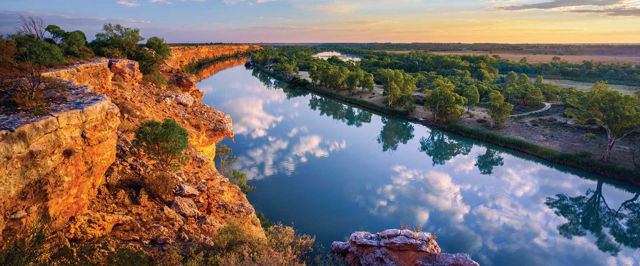**Big Bend, River Murray South Australia © Ben Good**

## Nominated as a national threatened ecological community (EC)

The *River Murray downstream of the Darling River, and associated aquatic and floodplain systems* (*River Murray—Darling to Sea*) ecological community was nominated as a possible threatened ecological community in 2023. A science-based biodiversity threat assessment is now underway by the independent national Threatened Species Scientific Committee to determine if the ecological community is threatened with extinction and eligible for protection under national environment law, the *Environment Protection and Biodiversity Conservation Act 1999* (EPBC Act).

Under the EPBC Act, the Threatened Species Scientific Committee must seek public feedback on ecological communities that are under assessment for possible listing as threatened, particularly which threat category they may be eligible for listing in.

Initial assessment of the *River Murray—Darling to Sea* ecological community indicates that it may be eligible for listing as ‘Critically Endangered’ (which is the category it was nominated for).

Listing assessments are included in a *Conservation Advice*, and the draft for this ecological community provides a full description, a summary of key threats, as well as priority research, management and recovery actions. This guide accompanies the draft Conservation Advice and maps, which are available online at <https://www.dcceew.gov.au/environment/biodiversity/threatened/nominations/comment>

**Comments close on 15 October 2024.**

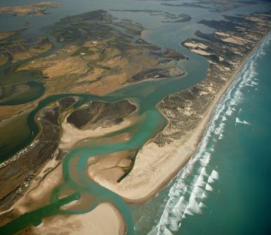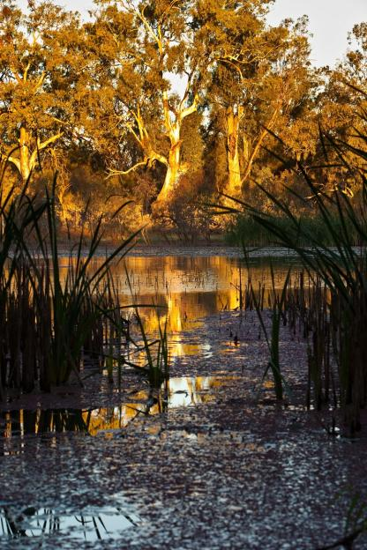

**River Murray Mouth 2004 © Michael Bell, Murray Darling Basin Authority (MDBA) Chowilla floodplain © MDBA**

**Contents**

*River Murray—Darling to Sea* ecological community – consultation guide 1

Nominated as a national threatened ecological community (EC) 1

What is a threatened ecological community? 2

What is the River Murray—Darling to Sea ecological community? 3

Where is the River Murray—Darling to Sea ecological community found? 5

Why is the River Murray—Darling to Sea EC considered threatened? 6

Importance of the *River Murray—Darling to Sea* ecological community 7

What would listing this ecological community mean in general? 7

What would listing this ecological community mean to landholders? 8

What would listing this ecological community` mean to recreational and commercial fishing? 8

What is the difference between the listing of an ecological community and other environmental plans such as the Murray-Darling Basin Plan? 9

Have your say 10

More information 10

## What is a threatened ecological community?

An ecological community is an assemblage of native species that live together in a particular area in nature.

An ecological community may be listed as a matter of national environmental significance under national environment law, if it is threatened with extinction.

* An ecological community can become extinct if it is destroyed or lost entirely.
* More often, an ecological community can become ‘functionally extinct’ if it becomes highly degraded over time, by, for example:
* being invaded by weeds and feral animals transforming it into different vegetation or habitat types, with different structures and/or species
* by changing water flows and/or changes in salinity and acidification.

Listing of a threatened ecological community helps to guide actions for its protection and recovery.

The decision to list a threatened ecological community is made by the Australian Government Minister for the Environment after receiving advice from the Threatened Species Scientific Committee.

Advice of the Threatened Species Scientific Committee on the conservation status of a threatened ecological community is contained in the Conservation Advice document.

A Conservation Advice also describes:

* characteristics of an ecological community (e.g. key plants, animals, and their habitats and ecological functions),
* threats to an ecological community and why it is eligible for listing as threatened, and
* priority threat management and restoration actions to help stop the decline of a threatened ecological community and the associated habitat, and support recovery.

Although not compulsory, land (and water) managers are encouraged to implement priority actions from Conservation Advices, and these may be supported by natural resource management and nature repair initiatives that target listed ecological communities.

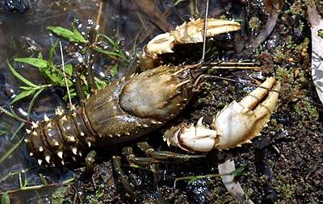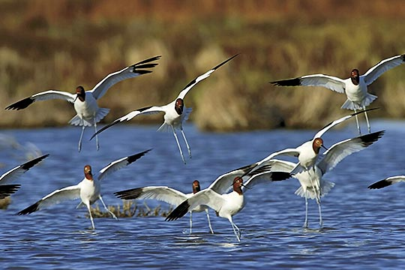

**Murray Crayfish © Dean Gilligan Red Necked Avocet, Coorong © Helga Kieskamp**

## What is the River Murray—Darling to Sea ecological community?

The *River Murray—Darling to Sea* ecological community includes the native plants, animals and other organisms that are associated with and dependent on the Murray River lowland floodplain river system below the river’s confluence with the Darling River.

It includes the river channel itself as well as the associated estuaries, lakes, streams, floodplain wetlands and woodlands/forests/shrublands), and groundwater. Hundreds of species of plants live on the floodplain that makes up part of the ecological community, and around 50 species of freshwater and estuarine fish species live in the water bodies. Species that are particularly important to ecosystem function include River Red Gum and Black Box trees, Lignum shrubs, Murray Cod, Congolli, Freshwater Catfish,migratory birds, Southern purple-spotted Gudgeon, Southern Pygmy Perch, and fully aquatic plants such as Ruppia.

Areas that are ***not*** part of the ecological community include agricultural and urban infrastructure areas on the floodplain, and other landscapes that have historically been heavily modified by clearing or are so badly degraded that the natural characteristics of the area have been lost.

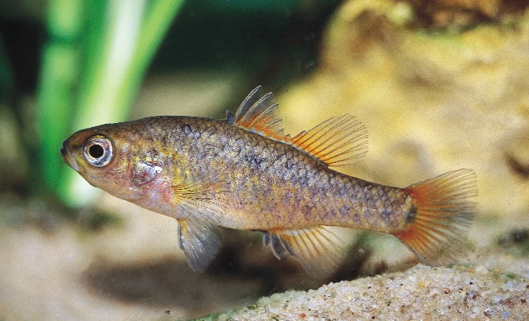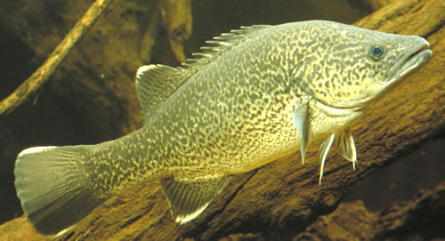

**Southern Pygmy Perch © Michael Hammer Murray Cod © Gunther Schmida**

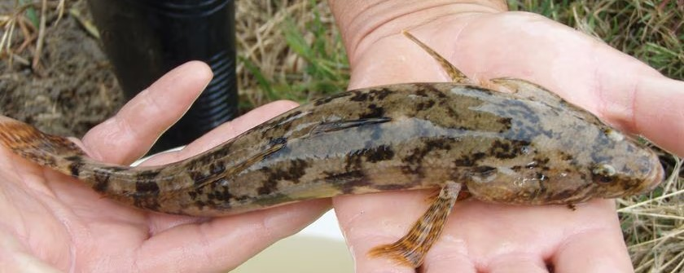

**Congolli © Brenton Zampatti, South Australian Research and Development Institute**

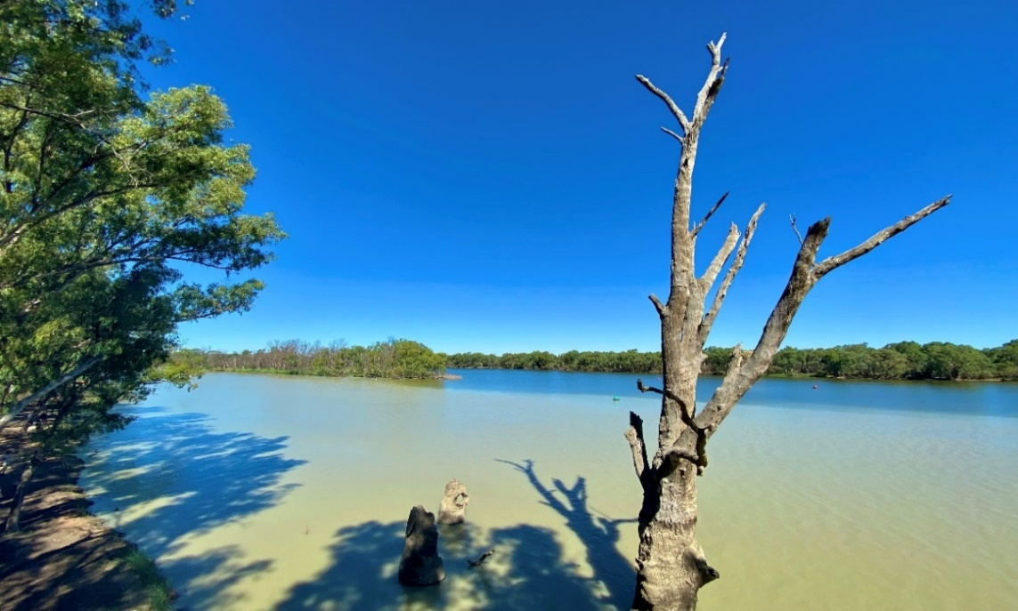

**Junction of the River Murray (right) junction with the Darling River (left) showing different waters. Note, dead eucalyptus trees (stags) can be part of the ecological community as they provide important function and habitat (e.g. hollows or perches) © Matt White, DCCEEW**

### Where is the River Murray—Darling to Sea ecological community found?

The *River Murray-Darling to Sea* ecological community occurs along and within the River Murray downstream of its confluence with the Darling River—from near Wentworth, New South Wales (Lock 10) to the River Murray Mouth near Goolwa, South Australia (refer also to the maps provided on the Have Your Say website).

The ecological community occurs within the Coorong and Lower Lakes, Salt Creek that drains into the Coorong’s South Lagoon, and the series of small coastal lakes south of the South Lagoon. It also includes islands and coastal dune systems within the River Murray Mouth complex, and islands within the river channel, floodplains and wetlands.

It also occurs within other associated streams, tributaries, and wetlands including:

* Lake Victoria, Frenchman’s Creek, and Rufus River
* Lower Darling Anabranch, from Murray River junction upstream to Glen Esk
* any that connect the main channel with wetlands upstream of Mannum (between Lock 1 and 10)
* any entering the River Murray from the Eastern Mount Lofty Ranges (or Marne-Saunders Prescribed Water Resources Areas).

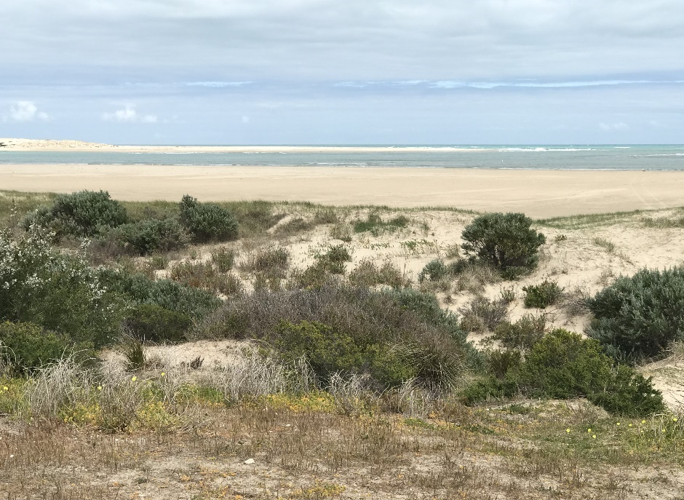

**Dune vegetation at the River Murray Mouth © Gina Newton, DCCEEW**

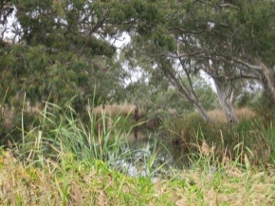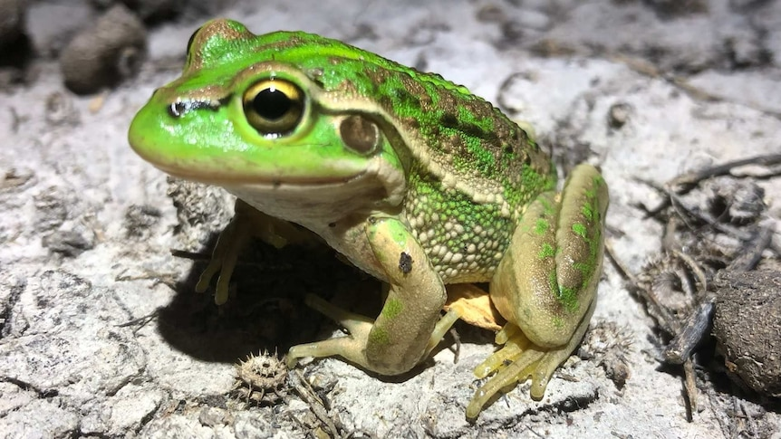

**Finniss River****© Matt White, DCCEEW Southern Bell Frog © Damian Michael, Charles Sturt University**

## Why is the River Murray—Darling to Sea EC considered threatened?

The *River Murray—Darling to Sea* ecological community may be eligible for including in the threatened ecological communities List as **Critically Endangered** under national environment law.

The ecological community has been heavily impacted by multiple threats (historic and current) such as land clearing, water extraction/diversion, invasive species, and climate change. These impacts have led to wide-ranging losses of biodiversity and ecological function:

* This includes the loss or decline of multiple native species, with a key functional role in the health of the ecological community.
* Important ecological processes in the community have been disrupted, together with a decline in community integrity, including conditions that favour invasive species, loss of connectivity as well as increasing salinity and tree dieback across large areas of the floodplain.
* A long-term trend of decline for this ecological community means that it is becoming increasingly difficult for it to recover and survive.

**Salinisation and dead red gum trees on Clark’s Floodplain, SA © Ian Overton**

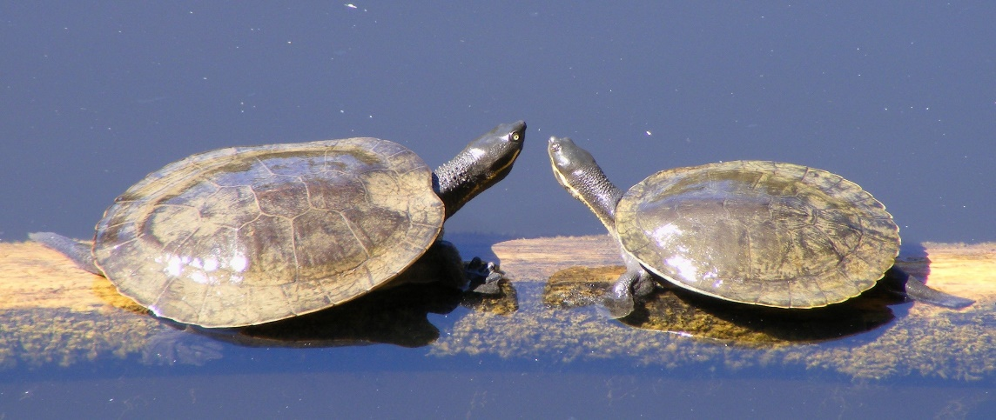

**Murray River turtles (*Emydura macquarii*) declined significantly during the Millenium drought © Peripitus, Creative Commons**

## Importance of the *River Murray—Darling to Sea* ecological community

Ecological communities are part of Australia’s rich and diverse natural heritage. They enrich the environment in which we live by providing many important biodiversity, social, cultural, and economic functions. They are also significant to First Nations and other local communities, landholders, and the broader Australian community.

The *River Murray—Darling to Sea* ecological community is associated with the largest river in Australia. It extends across one of the most nationally distinct and biodiverse sections of the Murray-Darling River system and includes important conservation sites such as three wetlands of international importance (Ramsar wetlands), the Coorong and Murray Mouth (terminus of the Murray-Darling Basin), and six highly valued and nationally recognised Living Murray Icon Sites.

The ecological community has special significance to First Nations Peoples, including the Ngarrindjeri, Ngadjuri, Peramangk, First Nations of the South East (southern Coorong), First Peoples of the River Murray and Mallee, Barkindji, Latje Latje, and Kureinji.

## What would listing this ecological community mean in general?

Under Australia’s national environment law, a listed threatened ecological community becomes a ‘matter of national environmental significance’. This is an important step forward to protect it, and its associated ecosystem functions and services, from further decline, and assist in recovery. Listing, and the associated Conservation Advice published at the time of listing, help to:

* raise awareness of the threatened ecological community and the threats to it,
* prioritise and support government natural resource management initiatives and on-ground management and recovery activities, including environmental watering and
* guide government decisions on new developments that may impact the environment.

If the *River Murray—Darling to Sea* ecological community is listed under national environment law, it would help to promote and guide support for management of threats to the ecological community (and other regional values), such as weeds, pest animals, erosion, and salinity. It would support healthy soil and water, natural carbon storage, as well as future environmental water allocations.

Listing under national environment law also means that a proposed new action that could have a significant impact on the threatened ecological community must be referred for assessment and approval by the Australian Government.

Whether or not an action is likely to have a [significant impact](https://www.dcceew.gov.au/environment/epbc/publications/significant-impact-guidelines-11-matters-national-environmental-significance) (<https://www.dcceew.gov.au/environment/epbc/publications/significant-impact-guidelines-11-matters-national-environmental-significance>) depends on the sensitivity, value and quality of the environment which it impacts, and on the intensity, duration, magnitude and geographic extent of the impacts.

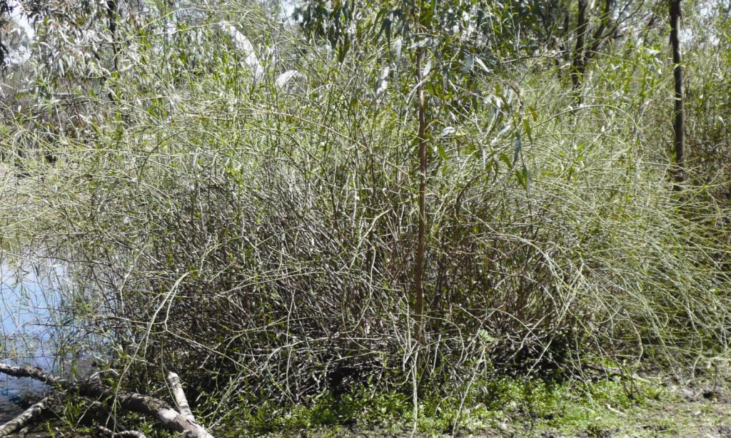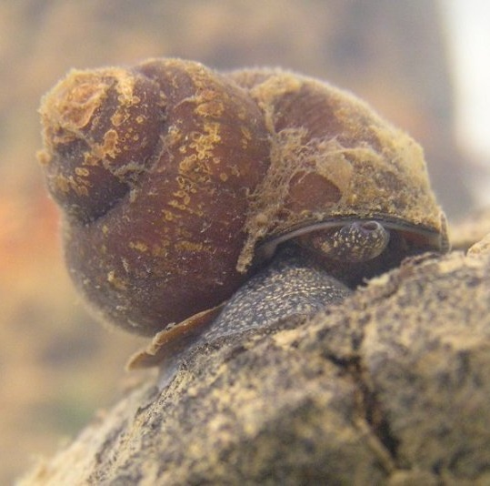

**Tangled lignum © ALA River snail *Notopala hanleyi,* © Dean Gilligan**

## What would listing this ecological community mean to landholders?

Many farmers and other landholders are already helping to ensure that the *River Murray—Darling to Sea* ecological community is protected, including critical remnant areas of native floodplain vegetation.

Listing of the *River Murray—Darling to Sea* ecological community would help land managers gain support for continuing work to protect and restore this ecological community, including revegetation and other work to manage threats that impact both the ecological community and agricultural productivity (such as erosion, salinisation, weeds, and feral animals). It may help land managers to access opportunities through current or future natural resource management programs and nature repair market initiatives.

Listing of a threatened ecological community under national environment law does not change land tenure. Nor does it prevent continuing use of land (and water), as long as there is no major *change or intensification of land-use activities.*

If the *River Murray—Darling to Sea* ecological community is listed as threatened, ongoing activities would generally not need to change or seek approval under national environment law, including:

* + continuation of existing grazing, cropping, or horticultural activities
  + maintenance of existing roads, fences, access tracks or firebreaks
  + maintenance of existing farm gardens or orchards
  + maintenance of existing farm dams, weirs or water storages
  + maintenance of existing pumps, irrigation systems and drainage lines
  + maintenance of sheds, buildings, yards and fences
  + control of weeds and management of pest animals on individual properties
  + fire management consistent with conserving the ecological community, and related regulations.

These types of activities areexempt from needing approval under the national environment law, if the activities are routine and/or unlikely to have a significant impact. This applies to most farming and land management activities and ongoing infrastructure and property maintenance activities. More information on exempt activities is available at [www.dcceew.gov.au/environment/epbc/publications/agricultural-actions-exempt-from-approval-under-national-environmental-law](http://www.dcceew.gov.au/environment/epbc/publications/agricultural-actions-exempt-from-approval-under-national-environmental-law)

However, any activity that has, or may have, a significant impact on a listed threatened ecological community must be avoided or referred for assessment and approval by the Australian Government. This is likely to include significant clearing of native vegetation (that meets minimum condition requirements) within areas where the ecological community occurs and significant changes to hydrology.

Listing of an ecological community under national environment law does not change any existing requirements, regulation or licences required under state law, including state controls on land clearing and water use. National and state water legislation and regulations remain responsible for water allocation, rights, use and trade.

## What would listing this ecological community mean to recreational and commercial fishing?

Listing of the *River Murray—Darling to Sea* ecological community under national environment law would not prevent fishing of introduced species such as carp or redfin. It would also not change any requirements or regulations in place under state laws for commercial or recreational fishing, such as fishing gear restrictions, size and bag limits, and closed fishing seasons.

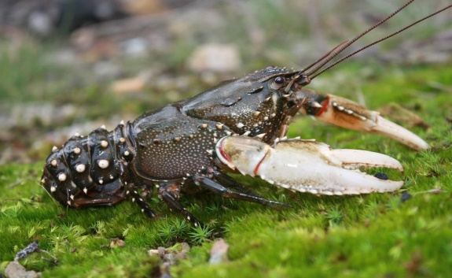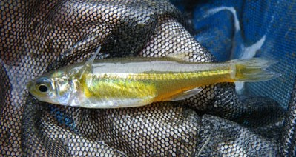

**Murray Crayfish © Nick Whiterod Murray Hardyhead © Michael Hammer**

## What is the difference between the listing of an ecological community and other environmental plans such as the Murray-Darling Basin Plan?

Listing of a threatened ecological community and approving a Conservation Advice for it under national environment law is different to other environmental plans, but they are complementary and work together to protect biodiversity and natural resources.

For example, the *Environment Protection and Biodiversity Conservation Act* (under which threatened ecological communities are listed) and the Murray-Darling Basin Plan give effect to international environmental agreements and are aimed at ensuring that ecosystems, including threatened ecological communities, continue to support native species and natural processes.

The national Water Act and Basin Plan, along with State plans and regulations are the appropriate instruments that determine water allocations, water rights, or water trading.

## Listing of a threatened ecological community is a separate process that does not alter any requirements or directions under any other environmental plans, including the Murray-Darling Basin Plan.

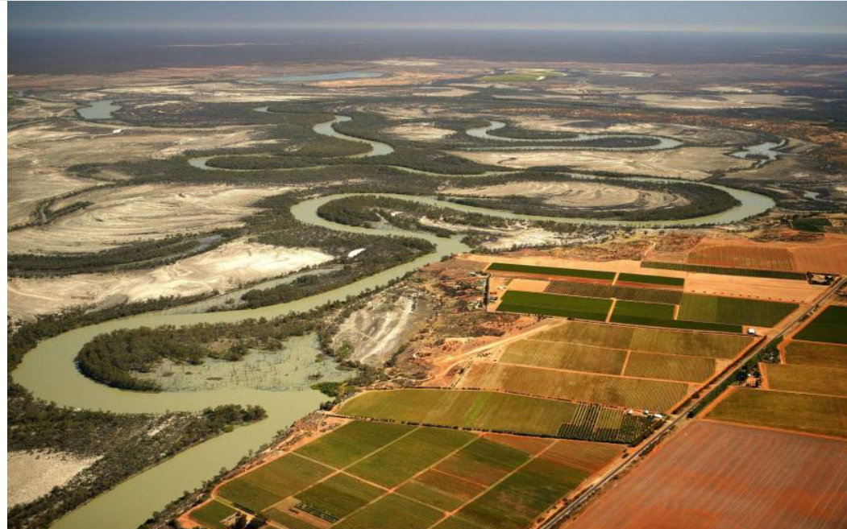

## Lower River Murray catchment © MDBA

## Have your say

Please have your say on the draft *Consultation Advice* for the *River Murray—Darling to Sea* ecological community. In particular, we want to hear from you on the key questions and requests for information highlighted in the *Conservation Advice*.

**The feedback period closes 15 October 2024**

## More information

Comment on listing assessments - DCCEEW at: https://www.dcceew.gov.au/environment/biodiversity/threatened/nominations/comment

Find out more about agriculture and the EPBC Act at: https://www.dcceew.gov.au/sites/default/files/documents/agricultural-actions-exempt-approval-under-national-environmental-law-factsheet.pdf

For further information contact us at: <https://www.dcceew.gov.au/about/contact>, or call 1800 920 528 (freecall).

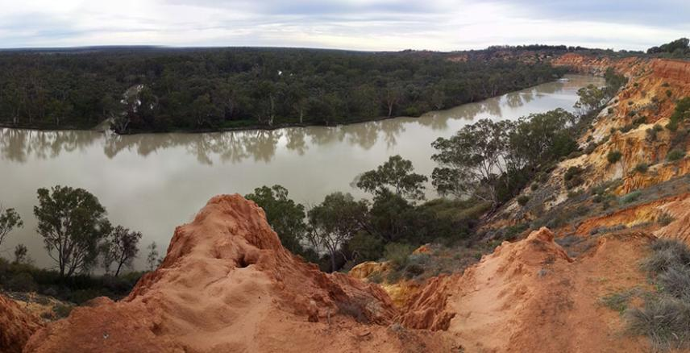

## River Murray, Headings Cliff, Murtho, SA, © MDBA

**Acknowledgement of Country**

We acknowledge the Traditional Custodians of Australia and their continuing connection to land and sea, waters, environment and community. We pay our respects to the Traditional Custodians of the lands we live and work on, their culture, and their Elders past and present.

© Commonwealth of Australia 2024

Unless otherwise noted, copyright (and any other intellectual property rights) in this publication is owned by the Commonwealth of Australia (referred to as the Commonwealth).

All material in this publication is licensed under a [Creative Commons Attribution 4.0 International Licence](https://creativecommons.org/licenses/by/4.0/legalcode) except content supplied by third parties, logos and the Commonwealth Coat of Arms.

The Australian Government acting through the Department of Climate Change, Energy, the Environment and Water has exercised due care and skill in preparing and compiling the information and data in this publication. Notwithstanding, the Department of Climate Change, Energy, the Environment and Water, its employees and advisers disclaim all liability, including liability for negligence and for any loss, damage, injury, expense or cost incurred by any person as a result of accessing, using or relying on any of the information or data in this publication to the maximum extent permitted by law.