# Wetlands and inner floodplains of the Macquarie Marshes ecological community – consultation guide

The Wetlands and Inner Floodplains of the Macquarie Marshes was nominated as a possible threatened ecological community in 2023. An assessment is now underway by the independent national Threatened Species Scientific Committee to determine if the ecological community is threatened with extinction and eligible for protection under national environment law, the *Environment Protection and Biodiversity Conservation Act 1999* (EPBC Act). This is a science-based biodiversity threat assessment.

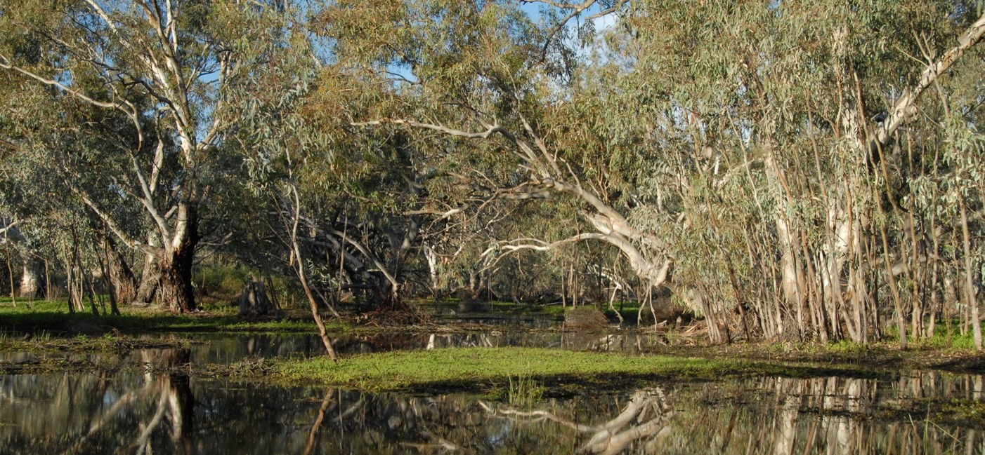**North Macquarie Marsh Nature Reserve © Nerida Sloane DCCEEW**

Under the EPBC Act, the Threatened Species Scientific Committee must seek public feedback on ecological communities that are under assessment for possible listing as threatened, particularly which threat category may be eligible for listing in.

Initial assessment of the Wetlands and Inner Floodplains of the Macquarie Marshes ecological community indicates that it may be eligible for listing as ‘Endangered’ or ‘Critically Endangered’.

Listing assessments are included in a *Conservation Advice*, and the draft for this ecological community provides a full description, a summary of key threats, as well as priority research, management and recovery actions. This guide accompanies the draft Conservation Advice (and map) which is available online at: <https://www.dcceew.gov.au/environment/biodiversity/threatened/nominations/comment>

Your feedback is invited. We seek your comments on the information presented in the draft Conservation Advice, including the plants and animals that make up the ecological community, threats, and priority management and recovery actions.

We also want to know of any new data, papers and reports that will help confirm if this ecological community is threatened with extinction.

**The feedback period closes on 15 October 2024**

**Contents**

What is a threatened ecological community? 3

What is the Wetlands and inner floodplains of the Macquarie Marshes ecological community? 3

Where are the wetlands and inner floodplains of the Macquarie Marshes found? 4

Why is this ecological community considered threatened? 5

Importance of the wetlands and inner floodplains of the Macquarie Marshes 6

What would listing this ecological community mean? 7

What would listing this ecological community mean to landholders? 8

What would listing this ecological community mean to recreational fishers? 9

What is the difference between the listing of an ecological community and other environmental plans such as the Murray-Darling Basin Plan? 9

Have your say 10

More information 10

## What is a threatened ecological community?

An ecological community is a group of native species that live together in a particular area in nature.

An ecological community may be listed as a matter of national environmental significance under national environment law if it is threatened with extinction.

* An ecological community can become extinct if it is destroyed or lost entirely.
* More often, an ecological community can become ‘functionally extinct’ if it becomes degraded over time, by for example:
* being invaded by weeds and feral animals transforming it into different vegetation types with different structures and/or species
* water flows changing and/or changes in temperature, salinity and/or when flows occur

Listing of a threatened ecological community helps to guide actions to protect it and help it recover.

The decision to list a threatened ecological community is made by the Australian Government Minister for the Environment after receiving advice from the Threatened Species Scientific Committee.

Advice of the Threatened Species Scientific Committee on the conservation status of a threatened ecological community is contained in the Conservation Advice.

Conservation Advice also describes:

* characteristics of an ecological community (e.g. key animals, plants and their habitats),
* threats to an ecological community and why it is eligible for listing as threatened, and
* priority management and recovery actions to stop the decline of, and support the recovery of threatened ecological communities and their associated ecosystems.

Although not compulsory, landholders are encouraged to implement priority management and restoration actions from Conservation Advices, and these may be supported by natural resource management and nature repair initiatives that target listed ecological communities.

## What is the Wetlands and inner floodplains of the Macquarie Marshes ecological community?

The Wetlands and Inner Floodplains of the Macquarie Marshes ecological community is the collection of plants and animals that occur on the wettest, most inundated parts of the Macquarie Marshes. The ecological community is a mix of wetland vegetation types that include:

* open water bodies with aquatic vegetation,
* seasonal to intermittent wetlands with reedbeds, cumbungi, water couch or mixed marshes,
* shrubland wetlands with lignum or river cooba, and
* river red gum woodlands on the inner floodplain (often with a wetland understorey).

Areas that are ***not*** part of the Wetlands and Inner Floodplains of the Macquarie Marshesecological community include:

* native vegetation of the outer floodplain such as Coolabah black box woodlands,
* dryland native vegetation such as Weeping myall woodland or chenopod shrublands,
* landscapes that are heavily modified by clearing or are so badly degraded that the natural characteristics of the area have been lost.

## Where are the wetlands and inner floodplains of the Macquarie Marshes found?

The Wetlands and Inner Floodplains of the Macquarie Marshes ecological community occurs within the Macquarie-Castlereagh region in central-west New South Wales. The boundary of the ecological community lies just south of the Barwon and Castlereagh rivers; west of Carinda and Quambone; south of Warren near the Marebone Weir; and east of Marra Creek and Wamboin.

The ecological community is formed where water regularly breaks out of the main Wambuul/Macquarie River channel and develops as a network of smaller channels, including Bulgeraga Creek, Gum Cowal Creek, Monkeygar Creek and Terrigal Creek.

The Wambuul/Macquarie River extends through the ecological community and, depending on waterflows, eventually links downstream with the Barwon River.

The ecological community also includes areas further upstream and downstream from the floodplain that have similar characteristics, such as Ginghet Creek and Marthaguy Creek.

Threatened ecological communities may also occur in areas where listed threatened and migratory species and other protected ecosystems occur.

* The Wetlands and Inner Floodplains of the Macquarie Marshes ecological community occurs in the same area as the Macquarie Marshes Ramsar site which is a wetland of internal significance protected under national environment law.

Reed beds and open water areas in the South Marsh of the Macquarie Marshes New South Wales



**Reed beds South Marsh, Macquarie Marshes © Louise Armstrong and DCCEEW**

## Why is this ecological community considered threatened?

The Wetlands and inner floodplains of the Macquarie Marshes ecological community may be eligible for including in the Threatened Ecological Communities List as **Endangered** or **Critically Endangered** under national environment law.

The ecological community has been heavily impacted by multiple threats (historic and current) such as land clearing, water extraction/diversion, invasive species and climate change. These impacts have led to wide-ranging loss of biodiversity and ecological function:

* This includes the loss or decline of multiple native species with a key functional role in the health of the ecological community such as river red gum woodlands, lignum shrublands, water couch wetlands and reed beds.
* Important ecological processes in the community have been disrupted, together with a decline in community integrity, including conditions that favour invasive species and loss of connectivity. This has resulted in the loss of habitat and feeding areas for wetland and terrestrial animals including waterbirds.
* A long-term decline of this ecological community is occurring, so that it is becoming increasingly difficult for it to survive and recover.

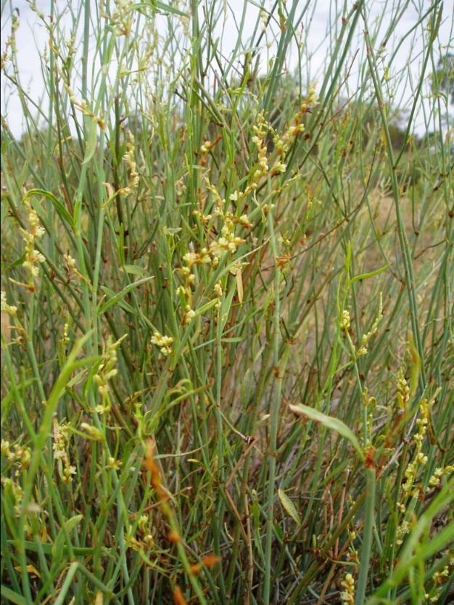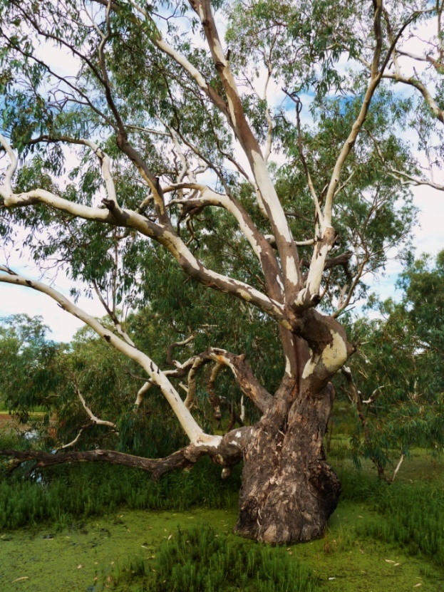

**Left: Tangled lignum flowers in the Wilgara Wetland, Macquarie Marshes © DCCEEW**

**Right: River red gum, Macquarie Marshes © Matt White DCCEEW**

## Importance of the wetlands and inner floodplains of the Macquarie Marshes

Ecological communities are part of Australia’s rich and diverse natural heritage. They enrich the environment in which we live by providing many important biodiversity, social, cultural and economic functions. They are also significant to local communities, landholders and the broader Australian community. The Macquarie Marshes retain rich natural, cultural and spiritual value for First Nations communities who maintain a custodial relationship with the Marshes.

The Macquarie Marshes are vital for the survival of many plants and animals. They provide drought refuges for animals and essential breeding and nursery areas for native fish, crustaceans and waterbirds.

Wetland and woodland birds and bats living in the Macquarie Marshes help to control pest animals and insects that attack nearby crops and plantations. Native insects living in the wetlands also play an important role in the pollination of native and crop plants, and control of pests.

The ecological community includes and connects important conservation sites such as the Macquarie Marshes wetlands of international importance (Ramsar wetlands), the Macquarie Marshes Nature Reserve, and Ginghet Nature Reserve State Conservation Areas.

The Macquarie Marshes are part of Australia’s regional, national and international commitments to improve global environmental outcomes, supporting tourism, recreation activities, such birdwatching. This ecosystem also provides essential eco-system services such as improved soil and water quality, water and carbon retention, and windbreaks for pastures that contribute to the long-term productivity of the landscape, including food and water security.

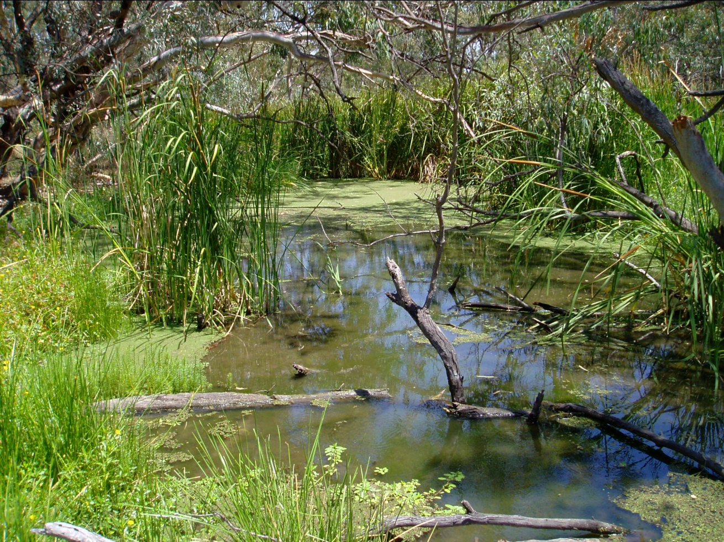

**Macquarie Marshes, New South Wales © DCCEEW**

## What would listing this ecological community mean?

Under Australia’s national environment law, a listed threatened ecological community becomes a ‘matter of national environmental significance’ which helps to protect it, and its associated ecosystem functions and services, from further decline and assist in its recovery. Listing under national environment law also helps to:

* raise awareness of the threatened ecological community and the threats to it,
* help to prioritise and support government funding initiatives and on-ground management and recovery activities, including e-watering, and
* guide government decisions on new developments that may impact the listed ecological community.

If the Wetlands and inner floodplains of the Macquarie Marshes ecological community is listed under national environment law, it would help to promote and guide support for management of threats to the ecosystem such as weeds, pest animals, erosion, and salinity. It would also promote soil health and carbon storage, as well as any e-water allocations.

Listing would make the broader wetland, within and outside the conservation reserves, a potential funding target. Hence, land managers who want to retain good quality vegetation/wetland or intend to restore the ecological community on their properties may be able to access opportunities to manage threats that impact both the ecological community and agricultural productivity and revegetate through current or future Australian Government natural resource management programs. Listing would also further encourage carbon and biodiversity market repair incentives for the broader Macquarie Marshes.

Listing under national environment law also means that a proposed new action that could have a significant impact on the threatened ecological community must be referred for assessment and approval by the Australian Government.

Whether or not an action is likely to have a [significant impact](https://www.dcceew.gov.au/environment/epbc/publications/significant-impact-guidelines-11-matters-national-environmental-significance) (<https://www.dcceew.gov.au/environment/epbc/publications/significant-impact-guidelines-11-matters-national-environmental-significance>) depends on the sensitivity, value and quality of the environment which it impacts, and on the intensity, duration, magnitude and geographic extent of the impacts.

A aerial view of multiple swamps and dry areas in the Macquarie Marshes.


**Aerial view over the Macquarie Marshes Nature Reserve, New South Wales © Allan Fox and DCCEEW**

## What would listing this ecological community mean to landholders?

Many farmers and other landholders are already helping to ensure that the wetlands and inner floodplains of the Macquarie Marshes ecological community is protected.

Listing of the Wetlands and inner floodplains of the Macquarie Marshes ecological community would help land managers gain support for continuing work to protect and restore this ecological community, including revegetation and restoration, and other work to manage threats that impact both the ecological community and agricultural productivity (such as erosion, weeds and feral animals). Land managers may be able to access opportunities through current or future natural resource management programs and nature market repair initiatives.

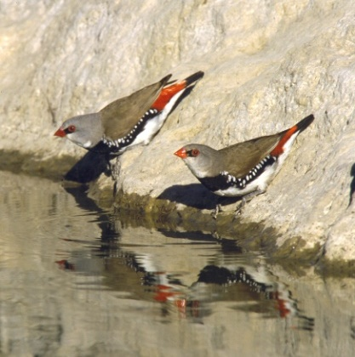Swamp lily (scientific name Ottelia ovalifolia) - a white flower with yellow centre.


**Left: Diamond firetail (*Stagonopleura guttata*) © Brian Furby and DCCEEW**

**Right: Swamp lily (*Ottelia ovalifolia*) © Matt White and DCCEEW**

Listing of a threatened ecological community under national environment law does not change land tenure. It also does not prevent continuing use of land and water as long as there is no major change or intensification of land use activities. Nor does it affect Native Title rights, nor traditional access and use of Country; for example, collecting bushfood and medicine. Current lawful use (including under Native Title) is supported through protection and recovery of the Macquarie Marshes.

If the Wetlands and inner floodplains of the Macquarie Marshes ecological community is listed under national environment law, ongoing activities would generally not need to change or seek approval under national environment law, including:

* + continuation of existing grazing, cropping or horticultural activities
  + maintenance of existing roads, fences, access tracks or firebreaks
  + maintenance of existing farm gardens or orchards
  + maintenance of existing farm dams, weirs or water storages
  + maintenance of existing pumps, irrigation systems and drainage lines
  + maintenance of sheds, buildings, yards and fences
  + control of weeds and management of pest animals on individual properties
  + fire management consistent with recommendations for maintaining the ecological community and related regulations

These types of activities areexempt from needing approval under the national environment law if the activities are routine and/or unlikely to have a significant impact. This applies to most farming and land management activities and ongoing infrastructure and property maintenance activities. More information on exempt activities is available at: [www.dcceew.gov.au/environment/epbc/publications/agricultural-actions-exempt-from-approval-under-national-environmental-law](http://www.dcceew.gov.au/environment/epbc/publications/agricultural-actions-exempt-from-approval-under-national-environmental-law)

Any activity that has, or may have, a significant impact on a listed threatened ecological community must be avoided or referred for assessment and approval by the Australian Government. This is likely to include significant clearing of native vegetation in or adjacent to the ecological community.

Listing of an ecological community under national environment law does not change any existing requirements, regulation or licences required under state law, including New South Wales controls on landclearing and water use. National and state water legislation and regulations remain responsible for water allocation, rights, use or trade.

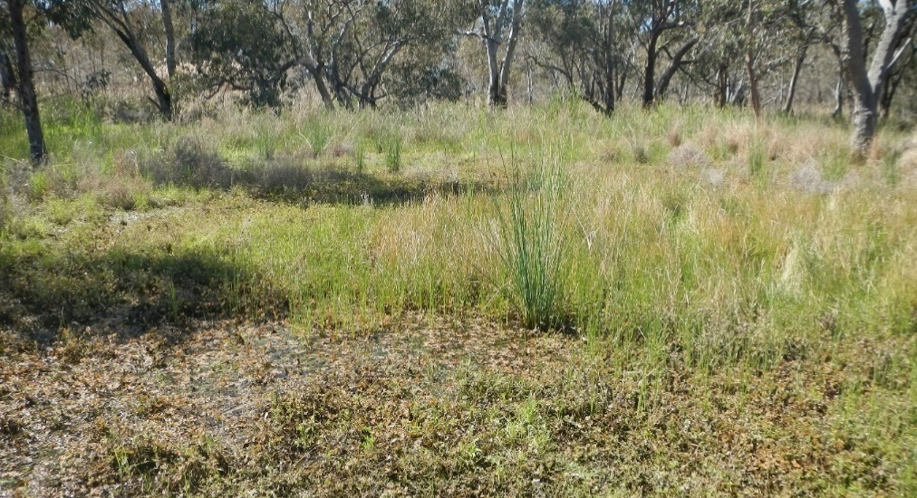

**Rushes and nardoo, Macquarie Marshes © Louise Armstrong and DCCEEW**

## What would listing this ecological community mean to recreational fishers?

Listing of the Wetlands and inner floodplains of the Macquarie Marshes ecological community under national environment law would not prevent recreational fishing of introduced species such as carp or redfin. It would also not change any requirements or regulations in place under New South Wales law such as fishing gear restrictions, size and bag limits, and closed fishing seasons.

## What is the difference between the listing of an ecological community and other environmental plans such as the Murray-Darling Basin Plan?

Listing of a threatened ecological community and approving a Conservation Advice under national environment law is different to other environmental plans, but they work together to protect biodiversity and natural resources.

For example, the *Environment Protection and Biodiversity Conservation Act* (under which threatened ecological communities are listed) and the Murray Darling Basin Plan give effect to international environmental agreements and are aimed at ensuring that ecosystems, including threatened ecological communities, continue to support native species and natural processes.

The national Water Act and Basin Plan, along with State plans and regulations, are the instruments under which water allocations, water rights, and water trading are determined.

Listing of a threatened ecological community does not alter any requirements or directions under any other environmental plans, including the Murray Darling Basin Plan.

## Have your say

Please have your say on the draft *Consultation Advice* for the Wetlands and inner floodplains of the Macquarie Marshes ecological community. In particular, we want to hear from you on the key questions and requests for information highlighted in the Conservation Advice.

**The feedback period closes on 15 October 2024**

## More information

Comment on listing assessments - DCCEEW at: https://www.dcceew.gov.au/environment/biodiversity/threatened/nominations/comment

Find out more about agriculture and the EPBC Act at: https://www.dcceew.gov.au/sites/default/files/documents/agricultural-actions-exempt-approval-under-national-environmental-law-factsheet.pdf

For further information contact us at: <https://www.dcceew.gov.au/about/contact>, or call 1800 920 528 (freecall).

**Acknowledgement of Country**

We acknowledge the Traditional Custodians of Australia and their continuing connection to land and sea, waters, environment and community. We pay our respects to the Traditional Custodians of the lands we live and work on, their culture, and their Elders past and present.

© Commonwealth of Australia 2024

Unless otherwise noted, copyright (and any other intellectual property rights) in this publication is owned by the Commonwealth of Australia (referred to as the Commonwealth).

All material in this publication is licensed under a [Creative Commons Attribution 4.0 International Licence](https://creativecommons.org/licenses/by/4.0/legalcode) except content supplied by third parties, logos and the Commonwealth Coat of Arms.

The Australian Government acting through the Department of Climate Change, Energy, the Environment and Water has exercised due care and skill in preparing and compiling the information and data in this publication. Notwithstanding, the Department of Climate Change, Energy, the Environment and Water, its employees and advisers disclaim all liability, including liability for negligence and for any loss, damage, injury, expense or cost incurred by any person as a result of accessing, using or relying on any of the information or data in this publication to the maximum extent permitted by law.