|  |
| --- |
| **Expert advice for the assessment of Australian teatfish (*Holothuria whitmaei* and *H. fuscogilva*) Fisheries: Queensland Sea Cucumber Fishery (East Coast)**  A report for Australia’s Scientific Authority for the Convention of International Trade in Endangered Species of Wild Fauna and Flora (CITES)  Timothy Skewes June 2024  The Department of Climate Change, Energy, the Environment and Water |

Citation

Skewes TD (2024) Expert advice for the assessment of Australian teatfish (*Holothuria whitmaei* and *H. fuscogilva*) Fisheries: Queensland Sea Cucumber Fishery (East Coast). A Report for The Department of Climate Change, Energy, the Environment and Water. Tim Skewes Consulting, Australia.

Tim Skewes Consulting acknowledges the Traditional Owners of the lands that we live and work on across Australia and pays its respect to Elders past and present.

Copyright and disclaimer

This work is licensed under the Creative Commons Attribution 4.0 International License. To view a copy of this license, visit http://creativecommons.org/licenses/by/4.0/ or send a letter to Creative Commons, PO Box 1866, Mountain View, CA 94042, USA.



Important disclaimer

Tim Skewes Consulting advises that the information contained within are general statements based on scientific research. The information may be unsuitable to be used in any specific purpose. No actions should be made based on that information without considering expert professional, scientific and technical advice. To the extent permitted by law, Tim Skewes Consulting excludes all liability to any person for any consequences, including but not limited to all losses, damages, costs, expenses and any other compensation, arising directly or indirectly from using any information contained in this publication.

Contents

Acronyms vii

1 Background 1

1.1 The fishery 1

1.2 Marine parks 5

2 The species 7

2.1 Distribution within the QSCF 7

2.2 Population structure 10

2.3 Climate change 14

2.4 Inherent vulnerability 17

2.5 Ecological role 18

3 Harvest levels and trends 20

3.1 Historical fishery 20

3.2 The modern QSCF 23

3.3 IUU 32

3.4 Indigenous and Recreational fishing 33

4 Stock trends and stock assessments 34

4.1 Fishery independent surveys 34

4.2 Catch per unit effort (CPUE) 40

4.3 Stock assessments 43

4.4 Ecological Risk Assessment (ERA) 47

5 Management 49

5.1 Current management 49

5.2 History of management 54

5.3 GBRMP 56

5.4 Management of illegal, unreported and unregulated fishing (IUU) 56

5.5 Management effectiveness (monitoring and compliance) 57

6 Conclusions and recommendations 58

6.1 Recommendations 60

References 63

Appendix A: Marine Park maps 73

Appendix B: Current modelling outputs 76

Appendix C: Catch of the QSCF 78

Appendix D: Logbook data treatment 79

Appendix E: History of catch limits 83

Figures

Figure 1. Map showing the boundary of the Queensland Sea Cucumber Fishery (East Coast) (QSCF) and reef features. 2

Figure 2. Map showing the boundaries of the three sea cucumber fisheries in north-east Australia. 3

Figure 3. Frequency of fishing operation days by the number of species caught during that day for the QSCF for the period 1995-2023 (QSCF vessel logbook data). 4

Figure 4. Frequency of fishing operation days by the number of species caught during that day for the QSCF for the period 1995-2023 where Black teatfish was one of the species caught (QSCF vessel logbook data). 4

Figure 5. Frequency of fishing operation days by the number of species caught during that day for the QSCF for the period 1995-2023 where White teatfish was one of the species caught (QSCF vessel logbook data). 4

Figure 6. QSCF area and areas closed to fishing (Coral Sea Marine Park National Park Zones, Great Barrier Reef Marine Park no fishing zones (IUCN IA and II), and the Great Sandy Marine Park). 6

Figure 7. Average catch per day (kg/d) for Black teatfish by rotational zone for the period 1995-96 to 2022-23 (QSCF vessel logbook data). 7

Figure 8. Catch (tonnes landed wt) of Black teatfish by depth (m) rounded to the nearest 5 m for all catch data with depth recorded in the logbooks 2019-20 to 2023-24 (QSCF vessel logbook data). 8

Figure 9. Average catch per day (kg) for White teatfish catches by rotational zone for the period 1995-96 to 2022-23 (QSCF vessel logbook data). 9

Figure 10. Catch (tonnes landed wt) of White teatfish by depth (m) rounded to the nearest 5 m for all catch data with depth recorded in the logbooks 1995-96 to 2022-23 (QSCF vessel logbook data). 9

Figure 11. Hourly water current magnitude and direction (9 m depth) during June full moon (4/06/2023; 13:00-14:00 - Top) and December new moon (12/12/2023; 00:00-01:00 - Bottom), monthly current average magnitude (middle) and monthly average direction (right) for June (winter) and December (summer) 2023. (AIMS eReefs Visualisation Portal: https://ereefs.aims.gov.au/ereefs-aims/gbr1/) 12

Figure 12. Fish Larval Connectivity on Coral Reefs: Spatial Distribution of Sinks, Sources & Corridors (Fontoura et al., 2022) (https://www.arcgis.com/apps/dashboards/7d7167d11e4e4c4496ced8cafacb0fed) 13

Figure 13. Projected vulnerabilities of components of the Reef ecosystem to climate change (GBRMPA, 2019) 15

Figure 14. Annual sea surface temperatures on the Great Barrier Reef between 1900 and 2018. Colour represents the range of average annual temperatures from a low of 26.9° (shades of blue) to a high of 29.1° (shades of red) (GBRMPA, 2019; using data from BoM) 15

Figure 15. Catch of the historic (pre-1950) Queensland sea cucumber fishery (including the GBR, Torres Strait and the Coral Sea) in tonnes gutted weight. Data are from Saville-Kent (1893), Sumner (1981) and Anon (1946). (after Uthicke, 2004). 22

Figure 16. Annual catch (tonnes landed wt) of Black teatfish in the QCSF for the period 1995-96 to 2022-23 (QSCF vessel logbook and Buyer return data). “C” = fishery closed for Black teatfish. 24

Figure 17. Catch (tonnes landed wt) of Black teatfish in QSCF for the period 1995-96 to 2022-23 in reporting grids that comprise 70% (green) and 90% (green and blue) of the catch is taken and the remainder in all other reporting grids (red). Grids are ordered from the north and west (QSCF vessel logbook and buyer return data). 25

Figure 18. Catch (tonnes landed wt) of Black teatfish for the period 1995-96 to 2022-23 in the QSCF by reporting grids that comprise 70% (green) and 90% (green and blue) of the catch and the remainder in all other reporting grids (red) A) before the implementation of the RHA in 2004, and B) after. Grids are ordered from the north and west. (QSCF vessel logbook and buyer return data). 26

Figure 19. Catch (tonnes landed wt) of Black teatfish in QSCF for the period 1995-96 to 2022-23 in fishery reporting grids that comprise 70% (green) and 90% (green and blue) of the catch. (QSCF vessel logbook and buyer return data) 27

Figure 20. Catch (tonnes landed wt) of Black teatfish in the QSCF by rotational zone for the period 1995-96 to 2022-23 (after Koopman and Knuckey, 2023). (QSCF vessel logbook and buyer return data). 27

Figure 21. Annual catch (tonnes landed wt) of White teatfish in the QCSF for the period 1995-96 to 2022-23 (QSCF vessel logbook and buyer return data). 28

Figure 22. Catch (tonnes landed wt) of White teatfish for the period 1995-96 to 2022-23 in reporting grids that comprise 70% (green) and 90% (green and blue) of the catch is taken and the remainder in all other reporting grids (red). Grids are ordered from the north and west. (QSCF vessel logbook and buyer return data). 29

Figure 23. Catch (tonnes landed wt) of White teatfish for the period 1995-96 to 2022-23 in the QSCF by reporting grids that comprise 70% (green) and 90% (green and blue) of the catch and the remainder in all other reporting grids (red) A) before the implementation of the RHA in 2004, and B) after. Grids are ordered from the north and west. (QSCF vessel logbook and buyer return data). 29

Figure 24. Catch (tonnes landed wt) of White teatfish in QSCF for the period 1995-96 to 2022-23 in reporting grids that comprise 70% (green) and 90% (green and blue) of the catch. (QSCF vessel logbook and buyer return data) 31

Figure 25. Catch (tonnes landed wt) of White teatfish by rotational zone for the period 1995-96 to 2022-23. (QSCF vessel logbook and buyer return data). 31

Figure 26. Location of sightings and apprehensions of Vietnamese based illegal fishing vessels (blue boats) for the period March 2016 and February 2017 (data supplied by AFMA). 32

Figure 27. Average densities of Holothuria nobilis in four arbitrary sectors, and in green (Closed Reef) and blue (Open Reef) reefs of the Great Barrier Reef. Error bars indicate 1 SE. (from Benzie and Uthicke, 2003) 35

Figure 28. Black teatfish density during a survey on northern (top) and southern (bottom) reefs of the Great Barrier Reef. (from Benzie and Uthicke, 2003). 36

Figure 29. Average densities of Holothuria nobilis on five green (Closed) and 15 blue (Open) reefs prior to the total closure of the fishery (Survey 1) and about 1 (Survey 2) and 2 (Survey 3) years after the closure. (from Benzie and Uthicke, 2003; Uthicke et al., 2004) 37

Figure 30. Comparison of density estimates for Black teatfish (*H. whitmaei*) in preferred habitat from various studies/regions (see text for source references). Torres Strait mid and outer shelf reef “reef-top buffer” (a 200 m wide buffer around the inside of the reef margin) (Murphy et al., 2021a). FAO “Natural density”: Densities above 12.5 per Ha represent a “natural density” in “suitable habitat” (Kinch et al., 2008). Guidance from the Secretariat Pacific Community provides “rule of thumb” regional reference densities of 50 individuals per Ha for Black teatfish —estimated from the upper 25% of densities across 91 sites assessed in 17 countries over the period 2002–2012 (Pakoa et al., 2014). “Natural” density for Black teatfish in Western Australia include: 11.4 to 17.1 individuals/Ha (Ave 14) in “habitats occupied by Black teatfish” and likely represents minimum natural population densities for Ningaloo Reef (Shiell and Knott, 2010). (After Murphy et al., 2021) 39

Figure 31. Annualised average catch per day (kg/d) of Black teatfish for the period 1995-96 to 2022-23 for vessels fishing in the QSCF on days when Black teatfish occurred in the catch (C=species closed to fishing) (QSCF vessel logbook and buyer returns data). 41

Figure 32. Annualised average catch per hour (kg/hr) of Black teatfish for the period 1995-96 to 2022-23 for vessels fishing in the QSCF on days when Black teatfish occurred in the catch (C=species closed to fishing) (QSCF vessel logbook and buyer returns data) Note: 1995-96 is on a different scale. 41

Figure 33. Annualised average catch per data (kg/d) of White teatfish for the period 1995-96 to 2022-23 for vessels fishing in the QSCF on days (and years) when teatfish occurred in the catch (QSCF vessel logbook and buyer returns data). 42

Figure 34. Annualised average catch per hour (kg/hr) of White teatfish for the period 1995-96 to 2022-23 for vessels fishing in the QSCF on days when White teatfish occurred in the catch (QSCF vessel logbook and buyer returns data). 42

Figure 35. Summary of performance statistics for sensitivity analysis for depletion risk (defined as probability of biomass being reduced below 40% of the comparable no-fishing biomass level, B0) (from Skewes et al., 2014). 45

Figure 36. Summary of performance statistics for management strategies for a) Depletion risk (defined as probability of biomass being reduced below 40% of the comparable no-fishing biomass level, B0). The “all zones” results assume fishing effort is spread evenly across all available zones (from Skewes et al., 2014). 46

Figure 37. Map of the QSCF showing 158 Rotational Harvest Arrangement (RHA) zones (which now also include the Coral Sea reefs as sperate zones), existing Burrowing Blackfish zones (BBFZ) and 3 QSCF offshore fishing zones (Ashmore and Boot, Suamarez and Marion Reefs). The remainder of the GBRMP area is divided into open and closed zones. 50

Figure 38. Monthly average currents during winter (June) and summer (December) for 2018 to 2023. (AIMS eReefs Visualisation Portal: https://ereefs.aims.gov.au/ereefs-aims/gbr1/) 77

Figure 39. Total catch weight for years 2000-01 to 2021-22 for vessel logbook (Logbook) and Buyer returns (Buyer) data after application of Final_wt calculation (as above) to vessel logbook data. 80

Tables

Table 1. Area of the QSCF, shelf, reef and dry reef habitats within the area of the QSCF, and areas closed to fishing (after Skewes et al., 2014, and with the addition of the CSMP closed areas and Ashmore and Boot Reefs). 5

Table 2. Reported catch (t landed weight) of beche-de-mer in the QSCF between 1986/87 and 1994/95 (Damschke, 1997; Stutterd and Williams, 2003) 24

Table 3. Catch of Black teatfish in three areas of the fishery, 1995-96 to 2022-23. 25

Table 4. Catch of White teatfish in four areas of the fishery. 28

Table 5. Catch estimate of a FFV apprehended at Saumarez Reef in February 2017, in gutted and salted and live whole weight (Skewes, 2017). 33

Table 6. Average weights by species and product form from buyer returns, 2000-01 to 2021-22. 80

Table 7. Species names contained in the QSCF Logbook database, the number of records for each combination, and assigned species name for analysis. 81

Acronyms

|  |  |
| --- | --- |
| AFMA | Australian Fisheries Management Authority |
| ABARES | Australian Bureau of Agricultural and Resource Economics and Sciences |
| B0 | Virgin biomass |
| B*lim* | The biomass level beyond which the risk to the stock is regarded as unacceptably high (often related to the PRI - Point of Recruitment Impairment). |
| B*targ* | The desired status of stocks |
| CITES | Convention on International Trade in Endangered Species of Wild Fauna and Flora |
| CSF | Coral Sea Fishery |
| CSMP | Coral Sea Marine Park |
| CSIRO | Commonwealth Scientific and Industrial Research Organisation |
| DAF | Queensland Department of Agriculture and Fisheries |
| DCCEEW | Commonwealth Department of Climate Change, Energy, the Environment and Water |
| EPBC Act | *Environment Protection and Biodiversity Conservation Act 1999*, including any Act amending, repealing or replacing the Act. |
| GBR | Great Barrier Reef |
| GBRMP | Great Barrier Reef Marine Park |
| GBRMPA | Great Barrier Reef Marine Park Authority |
| HS | Harvest strategy |
| IUCN | International Union for the Conservation of Nature. |
| IUU | Illegal, unreported and unregulated fishing |
| Landed wt | Fishery catch and catch limits are reported as landed weight. In the QSCF, landed weight is in gutted and salted, or par-boiled and frozen product form. |
| MSC | Marine Stewardship Council |
| MSL | Minimum Size Limit |
| NDF | CITES Non-detriment finding |
| QSCF | Queensland Sea Cucumber Fishery (East Coast) |
| RHA | Rotational harvest arrangement |
| SICA | Scale Intensity Consequence Analysis |
| t | tonnes |
| TAC | Total allowable catch |
| TACC | Total allowable commercial catch |
| TSBDMF | Torres Strait Beche-de-mer Fishery |
| WTO | Wildlife Trade Operation |

# Background

Sea cucumbers have been harvested for centuries to supply the Chinese market (Yang and Bai, 2015). After a virtual hiatus of over three decades following the second world war, global sea cucumber fisheries rapidly re-emerged from about 1980 in response to increasing demand from a resurgent China (Anderson et al., 2011; Eriksson et al., 2015; Fabinyi et al., 2017). This early expansion phase was often poorly regulated and many sea cucumber fisheries were overexploited (Purcell et al., 2013), especially in developing countries (Barclay et al., 2019) and for high value species (Purcell et al., 2014).

High demand, rapid and largely unregulated expansion and easy access has resulted in 16 species being listed as globally threatened (Vulnerable or Endangered; IUCN, 2023), many of them being the larger, valuable and highly targeted species (Purcell et al., 2014), including the (Pacific) Black teatfish (*Holothuria whitmaei*) which is listed by the IUCN as Endangered (Conand et al., 2013a); and White teatfish (*Holothuria fuscogilva*) which is listed as Vulnerable (Conand et al., 2013b). Subsequently, three species belonging to the subgenus *Holothuria (Microthele)*: White teatfish (*Holothuria (Microthele) fuscogilva*), (Indian Ocean) Black teatfish (*Holothuria (Microthele) nobilis*); and (Pacific) Black teatfish (*Holothuria (Microthele) whitmaei*) were listed on Appendix II of CITES in June 2019 (CITES, 2019).

With the listing of species in Appendix II of CITES, member countries, of which Australia is one, must carry out a non-detriment finding (NDF) for any listed species before it can be exported. This is based on the principle that: “An export permit shall only be granted when… a Scientific Authority of the State of export has advised ***that such export will not be detrimental to the survival of that species”*** (CITES, 1973: Article IV, paragraph 2a). Furthermore, the Scientific Authority must monitor and “limit” the export… “***in order to maintain that species throughout its range at a level consistent with its role in the ecosystems in which it occurs and well above the level at which that species might become eligible for inclusion in Appendix I***” (CITES, 1973: Article IV, paragraph 3).

Australia has several sea cucumber fisheries in State and Commonwealth waters across northern Australia, including the Queensland Sea Cucumber Fishery (East Coast) (QSCF) that includes the Great Barrier Reef (GBR) and some offshore reefs (Ashmore, Boot, Saumarez and Marion Reefs). This fishery mirrors sea cucumber fisheries globally in that it is primarily focussed on exporting dried sea cucumber product (beche-de-mer) to meet demand from China. It is relatively small scale (though Australia’s largest sea cucumber fishery) and multispecies in nature.

This report sets out to provide information that may be suitable for addressing the information requirements of an NDF for Black teatfish and White teatfish in the QSCF. Most of the information was sourced from published scientific papers and reports, from fishery assessment and synthesis reports by the state and federal fishery management agencies, and from fishery commercial vessel logbook and buyer logbook data for the period 20/08/1995 to 6/12/2023 supplied by Queensland Department of Agriculture and Fisheries (DAF). Ashmore and Boot Reefs were not included in the QSCF area until 2019, but were fished under a Queensland Developmental licence (on a 3 year rotation) beginning in 2008-09 – the catches taken under the developmental licence were also supplied by DAF and are included in this analysis. For a more detailed description of vessel logbook and buyer returns data, see Appendix D.

## The fishery

Sea cucumbers have been fished on the Queensland east coast since the early 1800’s when the first Sydney-based beche-de-mer fishers began catching and processing sea cucumbers on mostly island-based processing stations, and exporting the product to Indonesian ports (Ganter, 1994; Sumner, 1981). This early phase of the fishery lasted until about 1850 (Mullins, 1992). The fishery became active again in the early 1860s, including an expansion into Torres Strait, as part of a broader western Pacific maritime trade, exporting products directly to China and nearby ports (Mullins, 1992; 1995; Ganter, 1994), with this phase of the fishery lasting up until about the second world war (Uthicke, 2004).

The (modern) QSCF began in the mid-1980s and operates in a 546,000 km2 area of Queensland and Commonwealth waters adjacent to the Queensland east coast from Cape York to Tin Can Bay which includes most of the GBR, and the Coral Sea reefs of Ashmore, Boot, Marion and Saumarez Reefs (). The Torres Strait Beche-de-mer Fishery (TSBDMF) is adjacent to its northern border, and the Coral Sea Fishery (CSF) is adjacent to its east border ().

The fishery is managed by the Queensland Government, through Fisheries Queensland which sits within the Department of Agriculture and Fisheries (DAF). It is a relatively small State fishery with a limited participation base – with 18 transferable licences currently owned by only two operators. The commercial QSCF had an estimated Gross Value of Production of $4.7M in 2009 (DAF, 2021a).

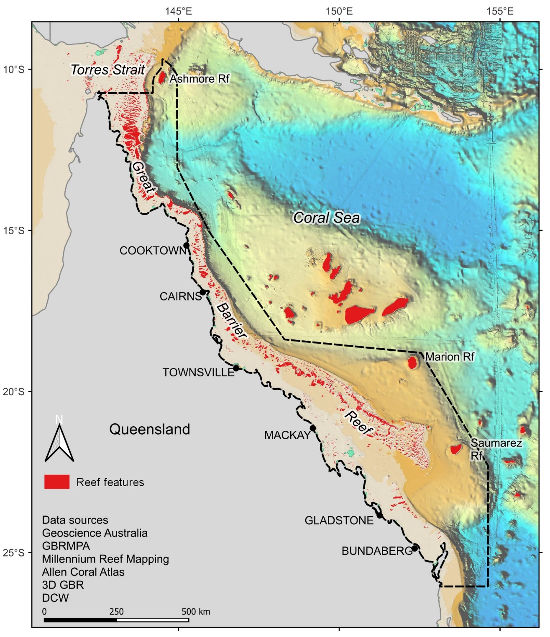

Figure . Map showing the boundary of the Queensland Sea Cucumber Fishery (East Coast) (QSCF) and reef features.

Figure . Map showing the boundaries of the three sea cucumber fisheries in north-east Australia.

Currently, the fishery is fished by a limited number of motherships (up to 4 typically), with up to 4 (but usually 2 or 3) tender vessels carrying up to 6 (usually 2-4) divers (only 4 of which can be in the water at one time), either free diving or using surface supply hookah equipment, on trips that usually last between 10 and 20 days (Breen, 2001; DAF, 2021a; vessel logbook data). Sea cucumbers are usually partially processed on board the motherships by salting or partial boiling and freezing. Product is landed and transhipped to mainland processing facilities, where they are processed into various products predominantly for export to Asian markets, with minimal supply to the domestic market (DAF, 2021a).

During a single day, fishing operations will catch between 1 and 12 species, however about half the time a fishing operation will only catch a single species during that day (primarily when fishing for Burrowing blackfish) (Figure 3).

During fishing operations where Black teatfish was one of the species caught, it was often (41% of the time) the only species in the catch () – this is especially so during the early phase of the modern fishery (before the year 2000). This reflects the highly targeted status of Black teatfish in the early fishery (DAF, 2021a; Skewes et al., 2014).

While White teatfish were the only species targeted about 24% of the time it was caught, often it was caught as part of a multispecies catch (often with other deep-water species such as Prickly redfish) (Figure 5).

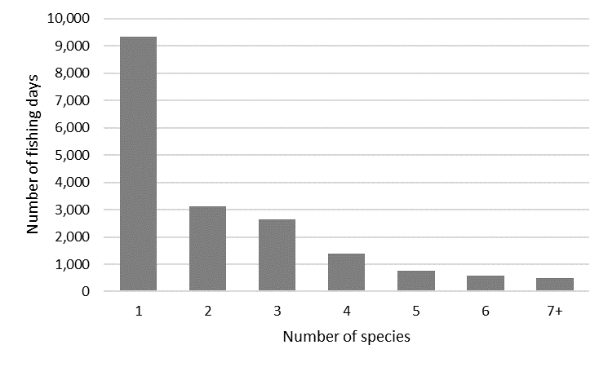

Figure . Frequency of fishing operation days by the number of species caught during that day for the QSCF for the period 1995-2023 (QSCF vessel logbook data).

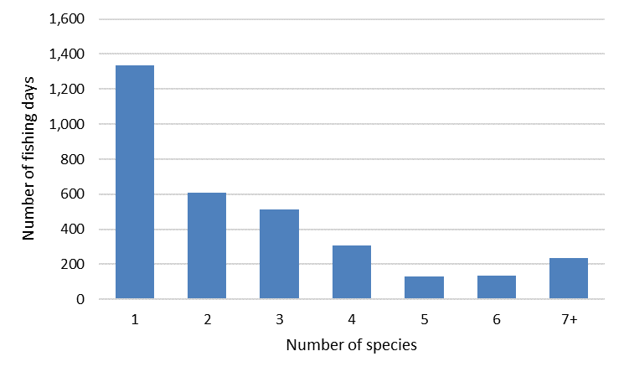

Figure . Frequency of fishing operation days by the number of species caught during that day for the QSCF for the period 1995-2023 where Black teatfish was one of the species caught (QSCF vessel logbook data).

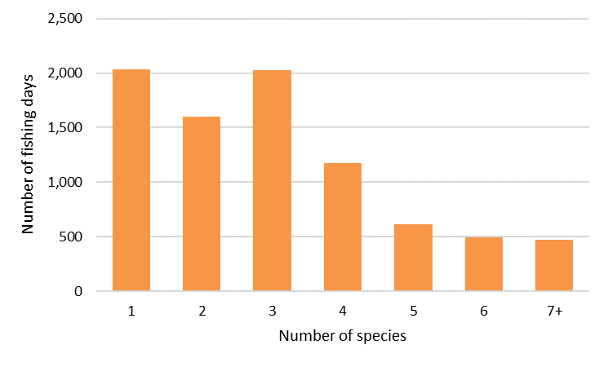

Figure . Frequency of fishing operation days by the number of species caught during that day for the QSCF for the period 1995-2023 where White teatfish was one of the species caught (QSCF vessel logbook data).

### Fishery habitat

Fishery habitat for most commercial sea cucumber species in the QSCF is primarily restricted to reef structures – with the exception of Burrowing blackfish (*Actinopyga spinea*) which is caught in deep sandy inter-reefal benthic habitats (Skewes et al., 2014; DAF, 2021a).

As for teatfish species, these are almost exclusively caught on reef structures (including deep reefs for White teatfish), and rarely occur in open inter-reefal seabed habitats – during a broad and extensive survey of the inter-reefal seabed of the GBRMP area in the early 2000’s, at almost 1,500 sites, no teatfish were observed in trawls, dredges or video (Pitcher et al., 2007). (The most common commercial species in the inter-reefal was Burrowing blackfish (*A. spinea*), Dragonfish (*Stichopus horrens*), and Ocellated curryfish (*S. ocellatus*) (Pitcher et al., 2007)).

The total area of reef features in the QSCF is approximately 26,000 km2 (GBRMPA; Beaman et al., 2010; Skewes et al., 2014) (). This compares to 2,010 km2 of reef habitat in the TSBDMF (Murphy et al., 2021a), and 1,663 km2 of shallow (< 20 m deep) reef habitat in the CSF (Skewes and Persson, 2017; Skewes 2024b).

Table . Area of the QSCF, shelf, reef and dry reef habitats within the area of the QSCF, and areas closed to fishing (after Skewes et al., 2014, and with the addition of the CSMP closed areas and Ashmore and Boot Reefs).

|  |  |  |  |
| --- | --- | --- | --- |
| Fishery area | Total area  (km2) | Closed to fishing  (km2) | Closed to fishing  (%) |
| Fishery area | 546,155.8 | 132,252.0 | 24.2 |
| Shelf1 | 232,323 | 67,285 | 29.0 |
| Reef2 | 26,791.8 | 8,654.9 | 32.3 |
| Dry reef3 | 6262 | 2387 | 38.1 |

1 Shelf is a zone adjacent to a continent (or around an island) extending from the low water line to a depth at which there is usually a marked shelf edge (GBRMPA). An estimate of the area of “submerged banks” on the GBR is 41,000 km2 (Harris et al., 2013).

2 Reefs are rock/coral lying at or near the sea surface. Generally the boundaries of reef areas were mapped to show the outer-most extent of each coral reef that could be observed in Landsat imagery (3dGBR – Beaman, 2010; GBRMPA).

3 Dry-reef are reefs exposed during tidal fluctuations from HAT to LAT (3dGBR – Beaman, 2010; GBRMPA).

## Marine parks

The QSCF includes all the waters of the Great Barrier Reef Marine Park (GBRMP) and Ashmore, Boot, Marion and Saumarez Reefs of the Coral Sea Marine Park (CSMP), and the Great Sandy Strait Marine Park (GSMP) (fishing is allowed in the GSMP under permit – however none are currently granted) (Appendix A; Figure 6). The closed areas of the GBRMP were progressively implemented between 1983 (5.3% no take) and 2004 (36.4%) (GBRMPA, 2003; McCook et al., 2010). The CSMP closed area on Marion reef was implemented in 2018 (Director of National Parks, 2018).

The protected areas of the three marine parks cover about 26% of the total QSCF fishery area, and about 35% of the reefs within the QSCF (Table 1, Figure 6). Analysis of nearest neighbour distances for GBR reefs indicate that the reserve network has maintained dispersal distances between reefs, with 90% of fished reefs within 20 km of a no-take reef (McCook et al., 2010).

Figure . QSCF area and areas closed to fishing (Coral Sea Marine Park National Park Zones, Great Barrier Reef Marine Park no fishing zones (IUCN IA and II), and the Great Sandy Marine Park).

# The species

## Distribution within the QSCF

### Black teatfish

Black teatfish are found throughout the QSCF area. They have been caught by the fishery in almost every rotational fishing zone throughout the fishery (see Section 5.1.1. for background on rotational fishing zones), though they appear to be more common (using fishery catch per day as a rough proxy of density) in the northern and southern GBR reefs (though patchy in the south) () – however the catch per day for reefs between Townsville and Cooktown may be lower due to depletion before 1995. They have not been fished on the three offshore reefs, Ashmore, Saumarez and Marion Reef ().

This pattern matches that seen during broadscale surveys (Benzie and Uthicke, 2003; Uthicke et al., 2004; Knuckey and Koopman, 2016; Koopman and Knuckey, 2021; Skewes and Persson, 2017).

Figure . Average catch per day (kg/d) for Black teatfish by rotational zone for the period 1995-96 to 2022-23 (QSCF vessel logbook data).

Black teatfish are exclusively found associated with reef structures and are rare or absent in the deeper inter-reefal shelf areas of the GBR (Pitcher et al., 2007). Their documented habitat preference is for on reef flats, reef slopes and sandy seagrass beds between 0 and 20 m (Purcell et al., 2023a), and in the QSCF, they are mostly caught in waters shallower than 20 m (Figure 8). However, their habitat preference appears to differ across their range within the QSCF – with the shallow reef top preferred in the north, and both the shallow reef top and deeper reef edge habitats in the south (Koopman and Knuckey, 2021) (indeed the catch at depth data illustrated in Figure 8 primarily reflects the southern GBR depth distribution, as most of the catch-depth records were from that region).

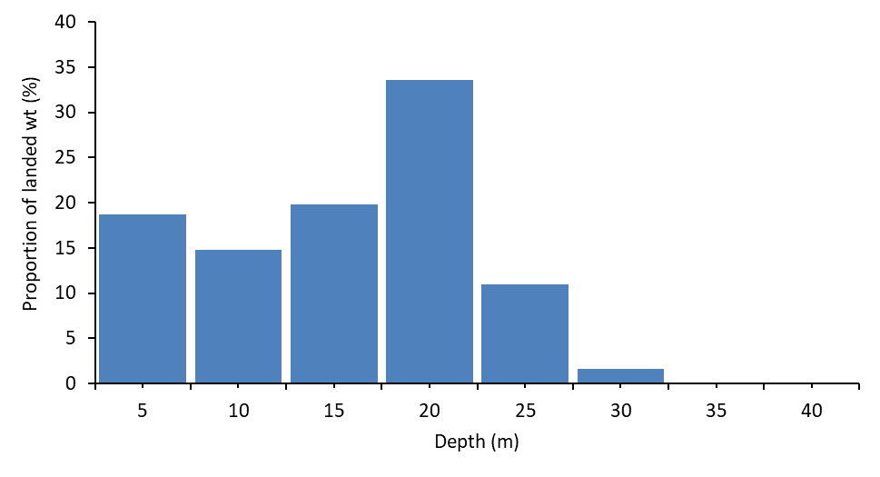

Figure . Catch (tonnes landed wt) of Black teatfish by depth (m) rounded to the nearest 5 m for all catch data with depth recorded in the logbooks 2019-20 to 2023-24 (QSCF vessel logbook data).

### White teatfish

White teatfish are found throughout the QSCF but appear to have a higher density in the northern regions of the GBR (using catch per day as a proxy for density), north of about Townsville at 19° 30’S and on the three offshore reefs (; Koopman and Knuckey, 2021b).

Their documented habitat preference is for outer barrier reef slopes, reef passes and sandy areas in semi-sheltered reef habitats in 10 to 50 m water depth (Purcell et al., 2023a). In the QSCF, fishers report, and the fine scale logbook data confirms, that most of the fishery catch between Townsville and about Cape Flattery (15°S) is taken from deep reef edges or features associated with reefs; whereas north of that they are mostly taken in deeper waters on the landward side of outer barrier reefs, associated with bottom features colloquially called “sinkies” and “tabletops” (Koopman and Knuckey, 2021b).

Throughout the QSCF, they are mostly caught between 20 and 30 m depth (), with over 80% of the catch coming from 15–30 m depth (Koopman and Knuckey, 2021b) – though this depth range may be truncated due to diving depth restrictions. Surveys in east Torres Strait using underwater video transects have found that 72% of the White teatfish population was in deep (>20 m deep) reef associated habitats, though none were seen deeper than 37 m (Murphy et al., 2021a*;* Murphy et al., 2021b).

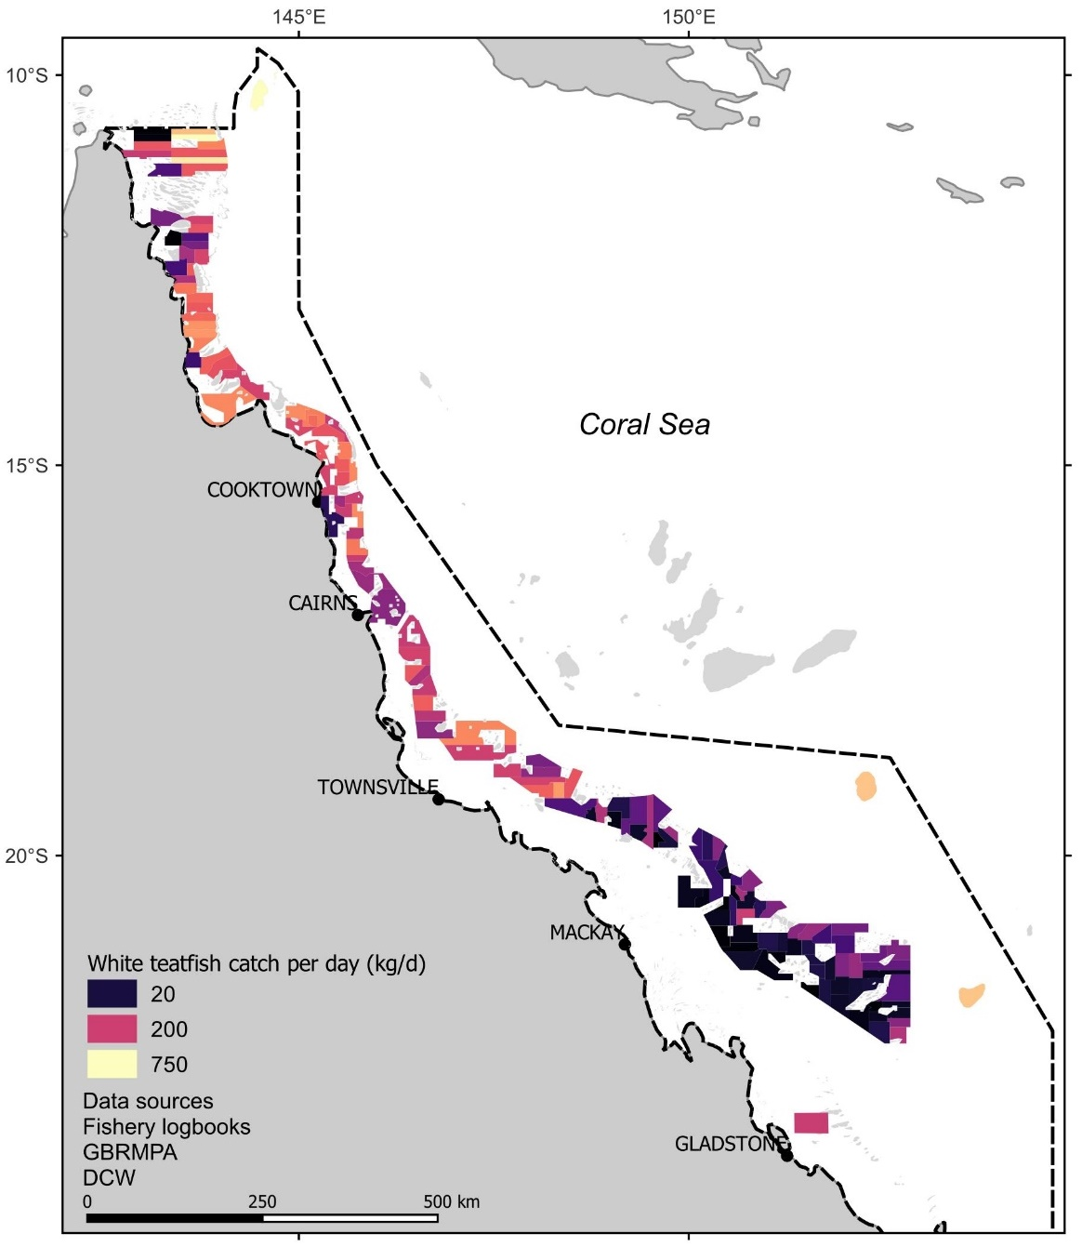

Figure . Average catch per day (kg) for White teatfish catches by rotational zone for the period 1995-96 to 2022-23 (QSCF vessel logbook data).

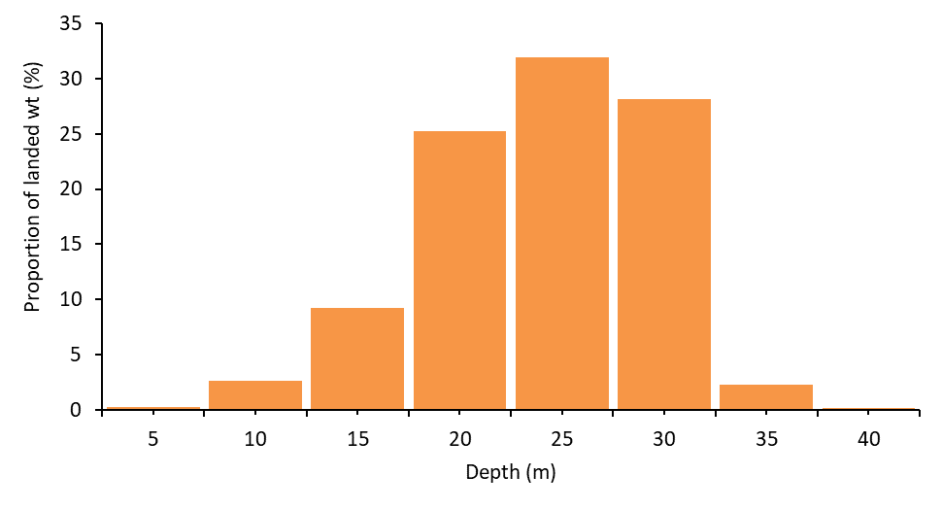

Figure . Catch (tonnes landed wt) of White teatfish by depth (m) rounded to the nearest 5 m for all catch data with depth recorded in the logbooks 1995-96 to 2022-23 (QSCF vessel logbook data).

## Population structure

### Black teatfish

The stock structure of Black teatfish in the QSCF has been the focus of some study. Genetic studies using allozymes (Uthicke and Benzie, 2000) and mitochondrial DNA (Uthicke and Benzie, 2003) showed no significant genetic structure of Black teatfish populations within the GBR indicating high contemporary levels of gene flow. There was also a suggestion of high gene flow between the GBR, the Coral Sea and western Australia. However, it was postulated that the population genetic structures observed between eastern and western Australia at least were likely formed prior to the last ice age (Uthicke and Benzie, 2003). There were other factors that may have contributed to mask evidence of fragmentation in Australian Black teatfish populations, including slow mutation rates of genetic markers and high contemporary gene flow (Uthicke and Benzie, 2003).

However, high genetic connectivity does not infer high demographic connectivity, where populations are highly connected by significant levels of recruitment (Johnson et al., 2018). Counter to the evidence of high gene flow, slow recovery of depleted populations, even in habitats adjacent to high density populations, has indicated restricted demographic connectivity among Black teatfish populations (Uthicke and Benzie, 2003; Johnson et al., 2018)

### White teatfish

The population structure of White teatfish is unknown, however, we can make inferences based on proxies, such as genetic studies on other species; and the biological and oceanographic drivers of population connectivity (e.g. adult population movements, distance between suitable benthic habitats, larval duration, survival, and propagule current delivery vectors) (Treml et al., 2015; Choukroun et al., 2021).

Studies of deep water archipelagic species (e.g. Lollyfish, *H. atra* (Skillings et al., 2011)) and offshore shelf species (e.g. *Cucumaria frondosa* (So et al., 2011), and *H. leucospilota* (Chieu et al., 2023)) have shown high population connectivity across large distances (1,000s of km). Given the habitat preferences for White teatfish, they would likely be aligned with the offshore species in showing high population genetic connectivity across broad regions.

### Biological and oceanographic information

In the absence of appropriate genetic studies, population structure and connectivity can also be inferred using biological and oceanographic information, and by the development of coupled biological-oceanographic models (e.g. CONNIE (<http://www.csiro.au/connie>)) (Choukroun et al., 2021; Fontoura et al., 2022).

*Adult biology*

Sea cucumbers are benthic with a generally low mobility, with annual displacements of 100 m or less (Purcell et al., 2016b; Hammond et al., 2020; Purcell et al., 2023b). However, the ability of adult sea cucumbers to move larger distances may also be underestimated (De la Rosa Castillo, 2023). In any case, the teatfish populations in the QSCF are very likely restricted to the reef or reef system on which they settle.

*Spawning timing*

Black teatfish has been reliably recorded as spawning during winter (April to June) on the GBR (Shiell and Uthicke, 2006) and in New Caledonia (Conand 1993) – although it has also been recorded as spawning during the northern hemisphere summer (April to August) in Guam (Richmond, 1996), and a single record of a Black teatfish male has been recorded as spawning soon after the full moon in December on the GBR (Babcock et al., 1992). Black teatfish are one of the few holothurians that spawn in winter, with this being a key driver for assessments of high vulnerability to climate change for this species (Welch and Johnson, 2013). It may be that some spawning occurs outside the winter established period, with some mature gonads present throughout the year and limited field observations of summer spawning, though only by males (Babcock et al., 1992; Shiell and Uthicke, 2006). This inverse timing has been suggested as an adaptation to the competition with other species (Conad, 1993) or as a strategy to avoid cross fertilisation with closely related White teatfish (Sheill and Uthicke, 2006).

Not only are Black teatfish one of the few winter spawning aspidochirote holothurians, they may also have an unusual model of gonad development, the so called Tubule Recruitment Model (TRM) where tubules mature progressively from anterior to the posterior region of the gonad with at least four stages of gametogenesis present at any one time (Smiley, 1988; Shiell and Uthicke, 2006). This is in contrast to most other sea cucumbers (including White teatfish) where all gonad tubules are generally at a similar stage in development, even though the reinitiation of gametogenesis in spawned and unspawned tubules can occur, resulting in overlapping generations of immature and relict oocytes (Ramofafia et al., 2000; Ramofafia and Byrne, 2001). Other features of Black teatfish reproduction on the GBR include a high fecundity and a male skewed sex ratio (Uthicke and Benzie, 2000; Shiell and Uthicke, 2006).

White teatfish is documented as spawning during summer (November to January) in New Caledonia (Conand, 1993), and late winter to spring (August to October) in the Solomon Islands (Ramofafia et al., 2000). This may indicate some plasticity of breeding seasonality for White teatfish – therefore local studies are likely required. Additionally, the QSCF area covers a large latitudinal range, and it could be that there is variation in the timing of spawning within the fishery area.

*Larval biology*

Empirical estimates of larval dispersal are key to assessing metapopulation connectivity, especially within a demographic context (Carson et al., 2011). Teatfish species larval biology is reasonably well studied - their larvae are planktonic and planktotrophic (feeding on small, suspended material in the water column) (Tanita et al., 2023). Larval duration has been recorded as between 2 and 4 weeks for White teatfish (Friedman and Tekanene, 2005; Burgy and Purcell, 2024) and between 3 and 7 weeks for Black teatfish (though longer periods are from a study in Japan that may have lower temperatures) (Nguyen et al., 2021; Martinez & Richmond, 1998; Minami, 2011).

*Currents within the GBR*

The currents of the GBR are driven by the wind, tides, and temperature and salinity gradients (Saint-Amand et al., 2023; CSIRO-eReefs, <https://research.csiro.au/ereefs/models/models-about/models-hydrodynamics/>). Hydrodynamic model visualisation within the AIMS eReefs Visualisation Portal (<https://ereefs.aims.gov.au/ereefs-aims>) shows short term (hourly) current vectors are dominated by tidal ebb and flow, especially in the southern (Broad Sound and Swains reefs) and northern (Shelburne Bay and southern entrance to Torres Strait) sections of the GBR, where tidal current speeds of over 2 kts are typical (). These tidal currents flip back and forth on daily cycles, mixing of the water column and causing sediment in inshore areas to be resuspended. They are generally more widespread during summer than winter (see monthly average magnitude, Figure 11).

As for longer-term water movements, average water direction inside the GBR lagoon rarely exceeds 0.3 m.s-1 (0.6 kts) in summer or winter, and more commonly was less than 0.1 m.s-1 (0.2 kts) and are predominantly southerly in the southern GBR and northerly in the north (, Appendix B), especially during winter, driven by seasonal SE trade winds.

Currents immediately outside the GBR lagoon are dominated by the southward EAC and northward Hiri Current. In summer, these boundary currents (the EAC especially) are stronger with averaged monthly speeds exceeding 0.8 m.s-1 (1.5 kts) (, Appendix B). The bifurcation point is at about Cape Melville (14°S) in winter but moves south to about Cape Tribulation (16°S) during summer.

This indicates that the transport of planktonic larvae with one month larval duration would be on the scale of ~200 km or less (given that reefs are known to cause a “sticky water” effect; Wolanski et al., 2013) withing the GBR lagoon, but that longer distances would be possible if larvae were transported outside the GBR lagoon boundary.

|  |  |  |  |
| --- | --- | --- | --- |
|  | Hourly | Monthly – av. magnitude | Monthly – av. direction |
| June 2023 |  |  |  |
| December 2023 |  |  |  |

Figure . Hourly water current magnitude and direction (9 m depth) during June full moon (4/06/2023; 13:00-14:00 - Top) and December new moon (12/12/2023; 00:00-01:00 - Bottom), monthly current average magnitude (middle) and monthly average direction (right) for June (winter) and December (summer) 2023. (AIMS eReefs Visualisation Portal: <https://ereefs.aims.gov.au/ereefs-aims/gbr1/>)

*Links with neighbouring regions*

Broader scale biophysical models also predicted strong connections from the Coral Sea reefs and GBR, which is consistent with the dominant westerly current flow in the Coral Sea (Choukroun et al., 2021). Connectivity for larvae with a 30-day pelagic larval duration showed strong connectivity between the Coral Sea and GBR, and between the northern GBR and Torres Strait, but the offshore reefs of the Coral Sea (e.g. Mellish Reef) were less connected. Connectivity from northern Coral Sea reefs (Osprey and Bougainville Reefs) to the northern GBR was among the strongest connections observed in the model (the study did not test for connections from the GBR to the Coral Sea) (Choukroun et al., 2021).

A recent study on broadscale connectivity of larval fishes in northeastern Australia (Fontoura et al., 2022) indicated that many reefs in the Coral Sea act as source reefs for recruitment of fish populations to the GBR; and that the Torres Strait reefs were largely considered sink populations that rely on the reefs of the northern GBR for recruitment. Internally the GBR was a complex mix of source and sink reefs (Figure 12). Connectivity for larvae with a 30-day pelagic larval duration showed strong connectivity between the northern GBR and Torres Strait.

Connectivity on broader scales, such as between the GBR and Indian Oceans through the Torres Strait, is not well understood (Ceccarelli, 2013). However, the low net flows through Torres Strait would indicate it is a barrier to demographic scale recruitment between eastern and northern Australian benthic populations (Saint-Cast, 2008; Wolanski et al., 2013).

Figure . Fish Larval Connectivity on Coral Reefs: Spatial Distribution of Sinks, Sources & Corridors (Fontoura et al., 2022) (<https://www.arcgis.com/apps/dashboards/7d7167d11e4e4c4496ced8cafacb0fed>)

### Population structure - conclusions

Information available would support a relatively well-mixed population of both species in the QSCF over the medium to long term. However, there is likely to be more localised demographic connectivity due to relatively restricted larval transport and significant levels of self-seeding for reefs in the QSCF.

On the GBR, studies of coral dispersal and connectivity have shown, for coral species with comparable larval durations as teatfish, that the formulation of “equivalent reef community configurations” that might serve as distinct operational management units are of the order of 10’s to 100’s of km, with smaller units closer to the coast and along the inshore-offshore gradient (Thomas et al., 2014).

There is also likely to be some significant connectivity between the adjacent Coral Sea reefs and the GBR, and between the northern GBR and Torres Strait reefs, but available evidence suggests that the northern GBR reefs are more likely to be source populations (Appendix B; Fontoura et al., 2022). There may also be some variability to this connectivity on annual and seasonal scales (Appendix B), due to the effect and timing and strength of the monsoon (Saint-Cast, 2008; Murphy et al., 2012) and other stochastic factors (Uthicke et al., 2009).

Therefore, the population structure of both teatfishspecies in the QSCF is likely to be considered as “local populations with maximum connectivity within the meta-population” (or Type D stock structure according to the Marine Stewardship Council population structure classification system; MSC, 2022). In this case, management of the QSCF as a single stock is appropriate, but with consideration of population dynamics on the scale of 50-100 km to maintain local density and for ecological considerations.

## Climate change

### Climate change in GBR

Climate change stressors in marine environments include increased sea temperature (and so-called marine heat waves), sea level rise, ocean acidification, changes to ocean current patterns, and increased storm intensity (IPCC, 2019). Natural climate variability in Australia’s Tropical Pacific Ocean region is also associated with El Niño and La Niña events, which now occurs on top of the warming trend with the potential to modify climate-ocean interactions with flow-on effects for Australia’s climate (NESP, 2018).

The GBR region is particularly vulnerable to changing climate, with the primary concern being the impacts on habitat-forming species, such as corals, seagrasses and mangroves (Figure 13; GBRMPA, 2019). Severe impacts that reduce the abundance or condition of habitats will have flow-on effects to dependent species and communities.

There is an observed warming trend in both air and sea-surface temperatures in north-eastern Australia, and regional projections include warmer sea-surface temperatures. This warming has occurred at 0.08–0.12 °C per decade since 1950 (NESP, 2018), with the GBR region warming by 0.8 degrees in the same period (Figure 14; Lough et al., 2018) and is predicted to be 2.3 ± 0.5 °C by 2070 under the business as usual (RCP 8.5) scenario (IPCC, 2019).

Sea levels have risen on average 2.1 mm/yr over 1966–2009 and 3.1 mm/yr over 1993–2009 around Australia, after accounting for the influence of the El Niño and the effects of vertical land movements due to glacial rebound, the effects of natural climate variability and changes in atmospheric pressure (McInnes et al., 2015). Mean sea level will continue to rise as a result of climate change, and height of extreme sea-level events will also increase (NESP, 2018).

Uptake of anthropogenic CO2 into the oceans has led to a 0.1 unit change in the ocean’s surface water pH (to pH 8.1), which represents a 26 % increase in the concentration of hydrogen ions in seawater (IPCC, 2019). By 2030, pH change is projected to be another 0.08 units lower (to pH 8). By 2090, it is projected to be up to 0.15 units lower (to pH 7.95) for RCP4.5 and up to 0.32 units lower (to pH 7.8) for RCP8.5, representing an additional increase in hydrogen ion concentration of 40 and 100 % respectively (McInnes et al., 2015; IPCC, 2019). In north-eastern Australia, the pH has dropped by 0.085–0.095 between 1880–89 and 2000–09 (NESP, 2018), and is predicted to decrease by 0.31 by 2090 (IPCC, 2019).

Rainfall is highly variable, with a strong influence from the El Niño–Southern Oscillation. A trend due to global warming cannot be identified in the observations. Rainfall will become more variable with more intense extreme events (NESP, 2018).

Projected changes in tropical cyclones predict that they will become less frequent but increase in intensity (McInnes et al., 2015). As a result, a marked increase in the frequency of the most intense cyclones (categories 4 and 5) is projected (GBRMPA, 2019).

Impacts of climate change on the current patterns of north-eastern Australia are little understood (Johnson et al., 2018). However, modelling has indicated very little change in the strength or direction of the SEC current jets that flow through the Coral Sea. However, there may be a strengthening of the Gulf of Papua Gyre, and the EAC may slightly weaken in the top 50 m (Johnson et al., 2018). This may have some influence on currents in the GBR, but are difficult to forecast.

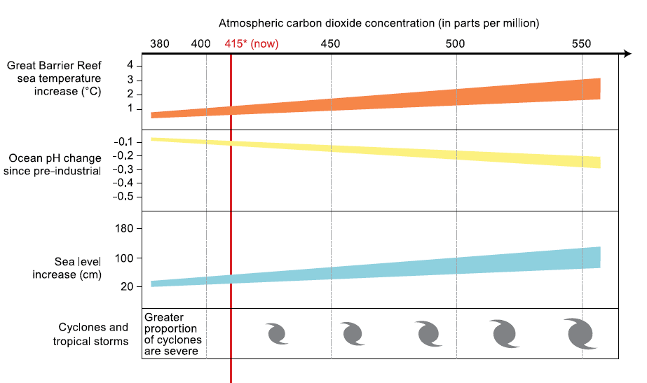

Figure . Projected vulnerabilities of components of the Reef ecosystem to climate change (GBRMPA, 2019)

Figure . Annual sea surface temperatures on the Great Barrier Reef between 1900 and 2018. Colour represents the range of average annual temperatures from a low of 26.9° (shades of blue) to a high of 29.1° (shades of red) (GBRMPA, 2019; using data from BoM)

### Direct impacts of climate change

#### Temperature

Longer-term (> a few weeks) experiments of the effect of raised temperature on sea cucumbers are sparse. Buccheri et al. (2019) found variability in the stress tolerance of three common tropical reef holothurians, *Holothuria atra, Stichopus chloronotus,* and *H. edulis*, to elevated temperatures, suggesting that species might respond differently to ocean warming. A study of a sea cucumber (*Parastichopus regalis*) in the central Mediterranean Sea indicated a range reduction and density decrease, possibly related to climate change temperature and pH changes. Although this finding was not conclusive due to other potentially detrimental factors (e.g. bottom trawling) (Scannella et al., 2022).

Longer term experiments on starfish showed that adult mortality was not altered by increased temperature (Khalil et al., 2023). While they found that temperature regulated starfish physiology, the combination of high temperature and lower pH showed nonlinear and potentially synergistic effects on organismal physiology (e.g., metabolic rate). Indeed, elevated temperature allowed starfish to better cope with the adverse effect of lower pH on calcification and reduced skeletal dissolution (antagonistic interactive effects) interpreted as a result of energetic trade-offs.

#### Ocean acidification

Studies on several species have shown that adult sea cucumbers are largely resilient to projected future changes in pH (pH 7.8 by 2100; IPCC, 2019), but that larger changes can have negative impacts on the acid-base balance, energy consumption, grazing and growth rates of sea cucumbers (e.g. *H. scabra*, *H. parva*, *H. forskali*, *Apostichopus japonicus*) (Collard et al., 2014; Yuan et al. 2015; Yuan et al., 2018). Less-calcified sea cucumbers may be more tolerant to seawater acidification than other heavily calcified echinoderms (Yuan et al., 2018).

There has been some experimentation on the effect of changes in pH on holothurian larvae. For *H. spinifera*, larvae developed faster, grew better and had better survival rates at pH 7.8 (Asha and Muthiah, 2005). For *A. japonicus* a 0.62 unit decrease in pH had relatively small effects on early life-history compared to other echinoderms, leading to a maximum of 6% decrease in post-fertilization success (Yuan et al. 2015). This indicates that predicted changes in pH in the Coral Sea may not greatly impact larval survival, though more extreme changes may have a larger impact on larval survival (González-Durán et al., 2021).

#### Sea level rise

Sea level rise has been assessed as being mostly positive for shallow water species (e.g. Black teatfish) (Plaganyi et al. 2013) and is likely to be neutral for deeper water species such as White teatfish.

*Changes in cyclone frequency and intensity*

Shallow species such as Black teatfish may be negatively impacted by scouring and dislocation by severe storms. Impacts to deeper water species such as White teatfish are likely to be negligible.

### Indirect impacts of climate change

Repeated exposure to damaging marine heatwaves has already resulted in coral bleaching events in 1998, 2002,2016, 2017, 2020 and 2022 (AIMS, 2023), likely resulting in at least short reductions in the cover of live coral, and changes in coral community structure. In the longer term, this is likely to lead to irreversible changes in coral reef assemblages depending on the intensity and timing between successive thermal stress events (Hughes et al., 2018; Johnson et al., 2018).

The impact of these changes to reefs and their benthic and fish communities on sea cucumbers is uncertain. Trophic effects are poorly understood but are likely to be impactful in the longer term (Fulton et al., 2018).

### Vulnerability of teatfish species in the QSCF to climate change

Black teatfish in Torres Strait was assessed as having a high vulnerability to climate change, mainly due to a low adaptive capacity related to winter spawning, low productivity and limited mobility (Johnson and Welch, 2016). However, White teatfish are summer spawners and inhabit deeper water habitats, which may reduce climate change risks (Dutra et al., 2020). The vulnerability of White teatfish to climate change stressors in the QSCF in the short to medium term would appear to be moderate, but with considerable uncertainty, especially for long term temperature changes and indirect impacts.

There could also be synergistic effects to consider. Experiments on starfish showed that the combination of high temperature and high pCO2 showed nonlinear and potentially synergistic effects on organismal physiology (e.g., metabolic rate) (Khalil et al., 2023). In addition, shifts in ecosystem state can potentially go unnoticed and eventually undermine the sustainability of seemingly sustainable fisheries (Fulton et al., 2021).

It is increasingly important to develop models to link climatic effects over a range of life history components and critical habitats for fisheries (e.g. seagrasses, coral reefs) and quantify the resultant impact on fisheries productivity using alternative emission scenarios (Dutra et al., 2020). An integrated risk assessment of sea cucumbers in Torres Strait, based on a Management Strategy Evaluation (MSE) (Plagányi et al., 2013), found that status quo management would result in half the species falling below target levels, moderate risks of overall and local depletion, and significant changes in species composition. Three simple strategies (spatial rotation, closed areas, multi-species composition) were all successful in reducing these risks (Plagányi et al., 2013).

## Inherent vulnerability

In the CITES context (CITES, 2011), “inherent vulnerability” can be defined as the susceptibility to intrinsic or external effects that increase the risk of extinction, even when mitigating factors are taken into account. There are a number of taxon or case-specific biological and other factors that may affect the extinction risk associated with a given percentage decline, small population size or restricted area of distribution (CITES, 2011). Many of these factors are poorly understood for Black and White teatfish, in particular.

#### Factors increasing inherent vulnerability

* Both species are large, easily seen sea cucumbers and are thus easily harvested.
* Both species are high value species that are consistently targeted by QSCF fishers (this report).
* Generation length for both species is unknown, but may be greater than several decades (Conand et al., 2013a; 2013b; Uthicke et al., 2004).
* Both species have been considered as being of low productivity (FAO, 2019).
* There are likely to be depensation (Allee) effects on population productivity at low population density, primarily driven by low fertilisation success for widely distributed spawning pairs (a dilution effect) (Uthicke, 2004). However, the characteristics of the “Allee effect threshold” (e.g. proportion of virgin biomass where low density begins to negatively affect population productivity) and “Allee threshold” (where populations continue to decrease even when fishing ceases) are unknown for any sea cucumber population (Hutchings, 2015; González-Durán et al., 2018). Also, the persistence and recovery (albeit often slow) of heavily depleted sea cucumber populations would suggest the Allee threshold is likely <10% B0 (Murphy et al., 2011a; Ramírez-González et al., 2020; Friedman *et al*., 2010; Prescott et al., 2017; FAO, 2022).
* Larvae of both species are likely planktotrophic, which has been described as a “high risk, high reward” strategy which may lead to high variability in recruitment (Uthicke et al., 2009).
* Black teatfish is listed as Endangered under IUCN criteria because it is commercially exploited throughout its range, the population trend is declining, and IUCN estimates that populations have declined by 80-90% in at least 50% of the species’ range, and populations are overexploited in at least 30% of its range (Conand et al., 2013a).
* White teatfish are listed under IUCN criteria as Vulnerable (Conand et al., 2013b).
* Both species are reef-associated (Purcell et al., 2023a) and will be impacted by declining reef health associated with a range of pressures, including climate change (Hughes et al. 2018; see above).

#### Factors reducing inherent vulnerability

* Both species have a broad geographical range regionally (Conand et al., 2013a; 2013b), and within the QSCF and adjacent fisheries.
* Both species appear to be resilient to local extirpation, even in heavily exploited fisheries (Prescott et al., 2017; FAO, 2019).
* There are some examples of recovery of overfished teatfish stocks (Skewes et al., 2009; Knuckey and Koopman, 2016; Helidoniotis, 2021a)
* Juveniles are very cryptic and rarely observed – offering protection from fishing for juvenile year classes (Prescott et al., 2013; CITES, 2019).
* White teatfish inhabits deeper reef habitats so is less susceptible to fishing, though this effect will be reduced with the use of underwater breathing apparatus and modern depth sounders in the QSCF (Purcell et al., 2014; Koopman and Knuckey, 2021b).
* There is unlikely to be significant ongoing illegal, unreported and unregulated (IUU) fishing for teatfish species in the QSCF (see IUU section in this report).
* Both species are likely to have a significant proportion of their population (>~30%) protected within a comprehensive system of closed MPAs throughout the QSCF area.

From the above, it can be implied that both species have features that would support a range of possible inherent vulnerability findings, with White teatfish having the most uncertainties. Black teatfish certainly are very susceptible to overexploitation, inhabit the shallow reef that is most susceptible to impacts (including climate change) and can take some time to recover, therefore a precautionary assessment of the inherent vulnerability of ‘high’ is likely warranted. White teatfish, on the other hand, probably has a lower inherent vulnerability than Black teatfish – it is less susceptible to fishing pressure, more persistent in catches, and can maintain a relatively high catch rate over extended periods (Skewes et al., 2014; FAO, 2019). In this case, given the resilience of White teatfish in the QSCF to sustained fishing pressure for over 2 decades, the potential for relatively high density of White teatfish in deep reef habitats (Murphy et al., 2021a; Koopman and Knuckey, 2021b), and extensive closed areas throughout the fishery area, a precautionary assessment of the Inherent Vulnerability of ‘medium-high’ for White teatfish in the QSCF is recommended.

## Ecological role

#### Effect on benthic habitats

Holothuroids (i.e., class Holothuroidea) feed on the sea bottom, reducing the organic load and redistributing surface sediments (Uthicke, 1999; Hammond et al., 2020; Williamson et al., 2021), making them bioremediators by enhancing the productivity of sea bottom life (for a comprehensive review of sea cucumber ecological role, see Purcell et al., 2016a). This form of nutrient recycling is crucial in ecosystems with low nutrient levels, as in the Coral Sea (Ceccarelli et al., 2013). The depletion of holothuroids has also resulted in the hardening of the sea floor, thereby eliminating potential habitat for other benthic organisms (Bruckner et al., 2003).

Sea cucumbers are known to be consumed by diverse predators from at least seven phyla, including 19 species of seastars, 17 crustaceans, several gastropods and around 30 species of fish (Purcell et al., 2016a). Although there is little information regarding predators of teatfish. For predators that rely heavily on sea cucumbers as a food source, depletion of sea cucumber populations is likely to have a negative impact (Purcell et al., 2016a). Thus, overexploitation of sea cucumbers may result in a loss of biodiversity or abundance of these predator species or cause them to switch to other prey species, with potential cascading effects in the ecosystem (Purcell et al., 2016a).

#### Effect on local water chemistry

Feeding and excretion by sea cucumbers also increase seawater quality and alkalinity, which contributes to local buffering of ocean acidification. Studies on several sea cucumber species (Curryfish - *Stichopus herrmanni,* Lollyfish - *Holothuria atra,* Snakefish - *H. leucospilota*) has shown they can affect local seawater alkalinity through their digestive processes and release of ammonia (Uthicke, 2001; Schneider et al., 2011; 2013; Wolfe et al., 2017; Vidal-Ramirez and Dove, 2016), potentially moderating ocean acidification and benefiting calcifying organisms such as corals, though the size and even direction of the net impact is dependent on water flushing rates and time of day.

Wolfe et al. (2017) found that Curryfish (*S. herrmanni*) had significant impacts on seawater chemistry through respiration, dissolution of CaCo3 in the gut and by down grazing effects on algae and infauna. These actions contributed to increased reef dissolution during the day, but decreased dissolution at night when reef systems are most vulnerable to dissolution. However, the effect was only measurable in closed mesocosm systems – Curryfish had little effect on seawater chemistry under flowing conditions. Another study on the effect of Lollyfish (*H. atra*) on seawater carbonate chemistry found that the feeding and excretion of that species may even exacerbate the impacts of acidification due to the dissolution of CaCO3 resulting from their production of respiratory CO2 (Vidal-Ramirez and Dove, 2016).

It is likely then, given the dynamic nature of water currents in the QSCF (this report), and primarily slope and deeper reef habitats favoured by White teatfish (Purcell et al., 2023a; Murphy et al., 2021a), that local ameliorating effects on water chemistry by teatfish would be modest at best.

*Ecological role in the QSCF*

The QSCF habitats that contain both teatfish species are predominantly found in the mid and outer shelf regions of the GBR and are likely relatively oligotrophic. Nutrient recycling by larger sea cucumbers such as the teatfishes will therefore play an important role in reef functioning in this area.

# Harvest levels and trends

*A note on fishery catch weight*. Sea cucumbers will change their weight depending on the time out of the water and processed state (Murphy et al., 2021b). Typically, sea cucumber fisheries collect catch weight information at the first opportunity for operators to reliably weigh the catch. In the case of the modern QSCF, this is when the product is partially processed (and stabilised) onboard the mother vessels, or landed at port, and includes gutted and salted, or par-boiled and frozen forms (with product form reported in the fishery logbook and catch disposal records).

The QSCF catch and Total Allowable Catch (TAC) therefore are reported as “landed weight” which includes both the gutted and salted, or par-boiled and frozen forms. Note that, prior to 2007, TACs were allocated as wet gutted weight. In 2007, the overall TAC reduced from 380 t to 361 t “landed” weight (gutted and salted or par-boiled and frozen) (DPIF, 2008) (see management section below).

In this case, all survey data will need to be expressed as fishery landed weight (gutted and salted or par-boiled and frozen) for application to fishery assessments and to TACs (or vice versa). Gutted and salted weight conversion factors are available for most fishery species (including Black teatfish and White teatfish) (Murphy et al., 2021b), but par-boiled and frozen weight conversion factors are not.

A related issue is that, between 2001 and 2011, catch in the QSCF logbooks was reported primarily as numbers, though it was also reported as numbers and weight in the catch Buyers Reporting Logbook (CDR). The logbook data therefore required the use of an estimated weight conversion factor to convert numbers to landed weight. The conversion factors contained within the logbook data as obtained in March 2023 did not have realistic conversion factors (they were listed as 1 kg each for all species). In this case, the CDR provides a more accurate account of historical catch trends and monitor quota usage (DAF, 2021a). For this report, average catch weight for each species was calculated from buyer returns, for each processed state separately, and were then used as conversion factors in the logbook data (for a full description of catch data treatment including conversion factors, see Appendix D).

## Historical fishery

(For a more comprehensive account of historical fishing in Australia, see the National report)

Sea cucumbers have been fished on the Australian east coast since the early 1800’s (Sumner, 1981; Ganter, 1990; Mullins, 1995). The earliest record of fishing was in 1804 when James Aicken collected several barrels of beche-de-mer from Wreck Reef in the Coral Sea (Mullins, 1995), and in 1908, James Austen briefly operated a beche-de-mer station on Lady Elliott Island (Sumner, 1981). A few vessels are known to have been employed in the industry on Queensland's east coast in the 1820s, with 10 tons of bêche-de-mer shipped from the Cooktown area to Kupang in 1827 (Ganter, 1990), and by the 1840s a regular Sydney-based fishery had developed (Mullins 1992; 1995). In 1845 there was a beche-de-mer station in the Holme islands group off Cape Grenville processing catch from the surrounding area (Mullins, 1992; 1995). However, by 1850, this industry appears to have all but died out, due mostly to the closure of northern Australian outposts such as Port Essington, and the emergence of the profitable sandalwood industry in the South Pacific (Mullins, 1992).

The east coast fishery became active again in the early 1860s, this time as part of a broader western Pacific maritime trade, exporting a range of products directly to China and nearby ports (Mullins, 1992; 1995; Ganter, 1990). Sydney based maritime traders sailed regularly along the east coast picking up beche-de-mer and dropping off supplies (Mullins, 1995) including expanding the fishery into Torres Strait.

After languishing almost entirely around 1870, the fishery again revived with a rise in prices, resulting in a flourishing export trade with Hong Kong and China, including a fleet of over 40 boats operating from ports north of Townsville (Bolton, 1970, Sumner, 1981). By 1880, beche-de-mer worth over £13,000 was shipped each year to this market with Cooktown and Thursday Island as the headquarters of the industry (Bolton, 1970). Though records are patchy, exports during this period reached a peak between 1880 and 1890, operating mostly on the northern GBR and Torres Strait (Saville-Kent, 1893; Ryle, 2000; Sumner, 1981). Over 100 boats were engaged in the fishery in 1889 (Saville-Kent, 1893).

In 1890, values ranged from £150 per ton for Black teatfish to £20 per ton for the less well-regarded Sandfish (Saville-Kent, 1893). Due to a poisoning incident, Prickly redfish, dropped in price from £150 per ton in 1880 to only £20 by 1890 (Saville-Kent, 1893; Ryle, 2000).

Assessments of the health of the fishery at the time were optimistic, with government officials stating that there did not appear to be any signs of depletion of the fishery even up to 1890, and that the main fishery had reached no further south than Mackay (Saville-Kent, 1893). It was thought that depleted reefs were being restocked by populations in deeper water, usually after a one-year duration (Saville-Kent, 1893).

However, this optimistic viewpoint was soon proved incorrect, with fishers asserting the need to venture further afield toward PNG by as early as 1882 (Lloyd, 2016), and by the early 1890s the inner reefs were fished out and fishers were forced farther out into the Coral Sea, New Guinea, the Solomon Islands and the New Hebrides (present day Vanuatu) (Saville-Kent, 1893, Lloyd, 2016). These regions were worked by larger ships staying out to sea for up to 6 months (Bolton, 1970; Sumner, 1981). Catches fluctuated greatly after 1890 (Ryle, 2000) with the fishery, while known for some wealth, being largely associated with terror and drudgery (Llyod, 2016).

By 1901 the fishery was in somewhat of a revival, with 11 licensed vessels working out of Cooktown, and based on the reemergence of sea cucumbers on the GBR and also near Erub (Darnley I.) and Mer (Murray I.) in the Torres Strait (Llyod, 2016). By then, the beche-de-mer trade was almost entirely under the control of Japanese or Thursday Islanders (Sumner, 1981), and by 1908, it was rumoured that over fifty Japanese vessels operated in the area south of Cooktown (Ryle, 2000).

A Royal Commission into the fishery in 1908 (Ryle, 2000) concluded that the industry had reached its 'zenith' in 1907 and grounds had been fished bare from New Guinea to Lady Elliot Island. They recommended a two-year closure. However, strong fishing interests and a government focused on economic development saw this recommendation remain unimplemented (Lloyd, 2016).

While there are reports that the Queensland fishery ceased during the First World War (Sumner, 1981), this is not supported by available catch data - exports were still 300-700 t per year (dry weight) throughout the war (Anon, 1946), though much of this may have originated in Torres Strait, where fishing continued under a government subsidised company boat system (Mullins, 2012).

The beche-de-mer industry in Queensland limped on until the 1930s, but had ceased by the start of the Second World War (Sumner, 1981). There was a brief attempt at revival in 1946-7, but by the 1950s fishing activity had ceased altogether (Sumner, 1981).

### Catch

Records of the early “Queensland” fishery catch are only available from 1878 and for about the next decade (Saville-Kent, 1893). They start again when the Commonwealth Year Books began recording exports after federation in 1901 (Anon, 1946). Uthicke (2004) reconstructed historical catches for the early “Queensland” fishery (Figure 15) with data given in Saville-Kent (1893), Sumner (1981) and Anon (1946). As the early export data were recorded as dry weight or value, several assumptions and conversions had to be made, and the author cautions that the data presented can only be taken as a rough estimate (Uthicke, 2004). Weight data was converted from dry-weight (beche-de-mer product) to landed (wet gutted) weight, using a conversion factor of 7.6 (supposedly using conversion data for *Holothuria nobilis*). This is probably a realistic conversion factor for a mixed species catch in any case, according to a review of recent conversion factors (Murphy et al., 2021).

Also, for the years from 1901 to 1940, only the value of the catch is reported. These values were converted to weight by assuming an average value of £4.4 (Australian Pounds) per cwt (hundredweight = 50.8 kg); this figure being the average value of exported sea cucumber for the period 1925 to 1940 derived from Australian Commonwealth export data (Anon., 1946). However, this value may be too low as the average price paid for sea cucumbers in Queensland in the years 1923 and 1928 was £9.36 per cwt (Sumner, 1981). Applying this alternative valuation factor would reduce the 1900-1940 estimated catch in Uthicke (2004) by over 50% - illustrating the uncertainty in the final output. It is also important to acknowledge that the reported catches are also likely to be an underestimate of actual fishery extractions, due to discarding and non-reporting.

In any case, the sea cucumber catch during the historical east coast fishery was very likely several times greater than its modern-day successors – the historical fishery was described as being fished in “vast quantities” over an extended period – with over 100 boats active in the fishery in the early 1880s, the majority based in Thursday Island and Cooktown (Saville-Kent, 1893).

In the 1860’s a whaler could catch up to 1300 teatfish on one trip (MacGillivray, 1862; cited in Mullins, 1992), and a good average catch rate for a fishing station on the northern GBR fishing grounds during the 1880s was 1 ton of dried beche-de-mer (approximately 7.6 t gutted) per month, working with four boats, carrying twenty to twenty-four men (Saville-Kent, 1893). The curing process was labour intensive – between 8,000 and 8,700 teatfish and 18,500 'red fish' were needed to make 1 ton, and a whaler could catch up to 1300 teatfish on one trip (MacGillivray, 1862; cited in Mullins, 1992).

Most of the catch was picked up by walking the reef at the spring low tide, but the higher value species, including Black teatfish and Prickly redfish, was also obtained by free diving to a depth of 2 or 3 fathoms (3.7-5.5 m) (Saville-Kent, 1893). Generally, 9 fathoms (16.5 m) was the maximum depth worked (Sumner, 1881).

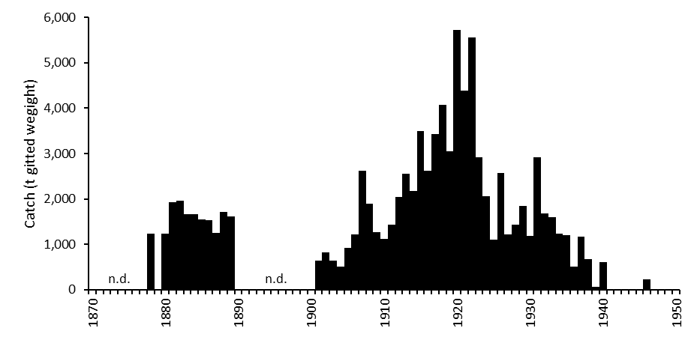

Figure . Catch of the historic (pre-1950) Queensland sea cucumber fishery (including the GBR, Torres Strait and the Coral Sea) in tonnes gutted weight. Data are from Saville-Kent (1893), Sumner (1981) and Anon (1946). (after Uthicke, 2004).

Species composition of the catch of the initial phase of the Queensland fishery (1820-1850) is not known. Catch during the next fishing pulse during the 1880’s included Black teatfish, various species of *Actinopyga* (“black and “red” varieties), White teatfish, Prickly redfish and Sandfish (in rough order of relative value) (Saville-Kent, 1893). In 1890 values ranged from £150 per ton for Black teatfish, and £80 to £110 per ton for the black and red *Actinopygas*; to £20 per ton for the less well-regarded Sandfish (Saville-Kent, 1893). Several “supplementary species” bulked up the catch, including other *Actinopyga* (e.g. Stonefish) and some *Bohadschia* (e.g. Leopardfish). However, most *Bohadschia* (due to the expelling of cuverian tubules) and *Stichopus* (due to easy disintegration) were generally not considered commercial. The total species count during the 1880’s was about 20 (Saville-Kent, 1893)

Black teatfish was the highest value species at the time, and White teatfish was of only small commercial importance (presumably due to moderate value and “low abundance”) (Saville-Kent, 1893). Prickly redfish was, at one time (around 1880), the highest value species, but a poisoning accident in 1881 (caused by processing the sea cucumber in a copper pot) reduced its value, and it never really regained its preeminent position (Saville-Kent, 1893; Ryle, 2000). Sandfish was then considered a low value species, primarily due to the abundance of calcareous spicules on its integument (Saville-Kent, 1893). Species composition during the third phase of the early fishery from 1900 to WWII is unknown.

As for the catch proportions, there is no data. However, all indications are that it was a broad multispecies catch (Saville Kent, 1893, Sumner, 1981). For example, while the value of Black teatfish was £150 per ton in 1890, the average value of the catch for the period 1881-1889 was £90 per ton (Saville Kent, 1893), and the average value of the top 8 listed species was £79 per ton, indicating a well-mixed catch (Saville Kent, 1893). In any case, there is sufficient evidence to overturn the lingering paradigm of historical fisheries being focused on a single or even a small number of target species – more likely that fishers targeted a wide range of species, probably fishing down the value and accessibility chain over time to some extent – but certainly not leaving accessible commercial species unexploited over the period of the fishery.

There is no evidence that any early beche-de-mer fishing operations used underwater diving equipment, and harvesting was generally restricted to 9 fathoms (16.5 m) (Saville-Kent, 1893; Sumner, 1981), though there is mention of weighted spears that could potentially increase the fishing depth. It is likely then that deeper water populations, particularly White teatfish and Prickly redfish would have been protected somewhat from heavy depletion during the historical fishery. Areas with extensive deep habitat, such as the Swains Reefs in the southern GBR may also have been relatively lightly fished – this area would have been very difficult for small sail powered vessels and even larger processing vessels to navigate and work, being exposed to the prevailing winds, waves and currents.

It is very likely that the Black teatfish population in the QSCF area was heavily depleted during this early fishery. The status of White teatfish during this time is uncertain, but likely to be less depleted due to its occurrence in deep habitats and apparently lower levels of targeting.

## The modern QSCF

Note: All data reported in this section are as landed (gutted and salted or par-boiled and frozen) weight unless otherwise specified.

Small-scale “pilot” fishing operations began in the modern QSCF area in the late 1970s, and up to 1986, a few (<5) fishing permits were issued annually to allow assessment of the feasibility of renewing a beche-de-mer industry on the Great Barrier Reef (Harriott, 1985; Damschke, 1997; Breen, 2001). Significant catches did not occur until a boom in effort in the late 1980s (Damscke, 1997) mirroring the global resurgence of sea cucumber fisheries driven by resurgent China (Anderson et al., 2011; Eriksson et al., 2015).

Most of the data used in this report comes from the daily logbook (and later catch disposal records – CDR) that was introduced in October 1995 that recorded daily catch, effort and location information (Damschke, 1997). There is some catch data available before this, as detailed below ()– with the associated description (at least for the catch up to 1996/97) that 65% of the catch was Black teatfish, 20% was Sandfish and 15% other species, including White teatfish (Damschke, 1997). This early (pre 1995/96) catch has been sometimes reported as being all Black teatfish (e.g. Uthicke 2004; Skewes et al., 2014) – probably in error. It is also very likely that the pre-1995/96 catch data is an underestimate of the actual catch, as there was fishing before 1987 and even years with very low reported catches had a high number of “Authorities” (permits or licences) ().

The species composition of the QSCF catch has varied over the years for a number of reasons, including species depletions, management intervention, changes in market value, emerging markets, and fishery and processing technology (Skewes et al., 2014; Eriksson and Byrne, 2015; Wolfe and Byrne, 2022; for all catch data, see Appendix C).

Table . Reported catch (t landed weight) of beche-de-mer in the QSCF between 1986/87 and 1994/95 (Damschke, 1997; Stutterd and Williams, 2003)

|  |  |  |
| --- | --- | --- |
| **Year** | **Catch (t)** | **Authorities** |
| 1986/87 | 0 | 6 |
| 1987/88 | 220 | 13 |
| 1988/89 | 3 | 8 |
| 1989/90 | 5 | 11 |
| 1990/91 | 135 | 17 |
| 1991/92 | 43 | 29 |
| 1992/93 | 340 | 24 |
| 1993/94 | 359 | 24 |
| 1994/95 | 358 | 19 |

### Black teatfish

Black teatfish was an early focus of the fishery up until it was closed in October 1999 (Figure 16) (Uthicke, 2004; Skewes et al., 2014; Eriksson and Byrne, 2015). Available logbook data (from October 1995) shows catches of Black teatfish peaked in 1995-96 at about 142 t, although catches were almost certainly greater in the years preceding this, potentially in the order of 300 t or more (Damschke, 1997, ). Annual catch dropped to just over 82 t in the last full year of fishing in 1998-99 before the fishery was closed in October 1999 (Figure 16). The catch since the fishery reopened in 2019-20 has been close to the current TAC of 30 t (Figure 16).

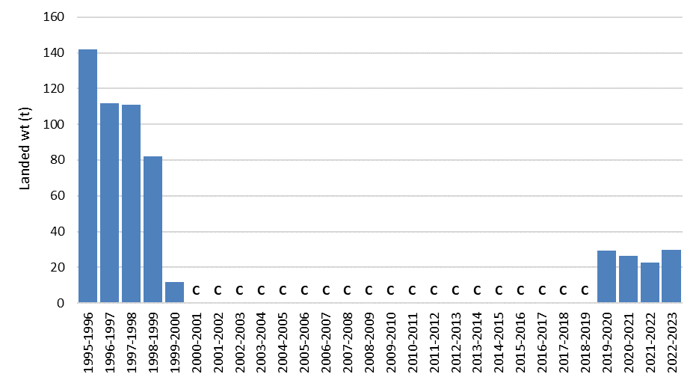

Figure . Annual catch (tonnes landed wt) of Black teatfish in the QCSF for the period 1995-96 to 2022-23 (QSCF vessel logbook and Buyer return data). “C” = fishery closed for Black teatfish.

To identify the spatial characteristic of the Black teatfish catch, catches in the vessel logbooks were aggregated by fishery reporting grid – these are 30nm x 30nm grids across Queensland waters and are used by all fisheries to report the location of catches. About 70% of the catch came from 15 grids (Figure 17), and those plus an additional 18 grids accounted for more than 90% of the catch (Figure 17) – which was about 39% of all grids that had some Black teatfish catch in the QSCF.

The highest catches occurred in the central and northern GBR, north of Townsville (), with a single high catch grid in the southern GBR (). Catch by rotational zone (Section 5.1.1.) also shows the majority of the catch coming from the central and northern regions of the GBR ().

Table . Catch of Black teatfish in three areas of the fishery, 1995-96 to 2022-23.

|  |  |  |
| --- | --- | --- |
| Region | Zones | Catch (t) |
| Cooktown Nth | 42 | 293.2 |
| Townsville to Cooktown | 28 | 194.6 |
| Townsville Sth | 61 | 87.7 |

At least 81% of the Black teatfish catch recorded in fishery logbooks was caught before the implementation of the rotational harvest arrangement in 2004 (5+ years of fishing) (RHA – Section 5.1.1.) compared to 19% after (four years of fishing). Even though the catch and number of fishing years was lower after 2004 (with the fishery only opened in 2019), the catch was taken over more grids after 2004 than before – with 90% of the catch taken in 24 grids before 2004 compared to 27 grids after 2004 (Figure 18). Additionally, less fishing was carried out in northern zones and more in southern ones after 2004 (Figure 18).

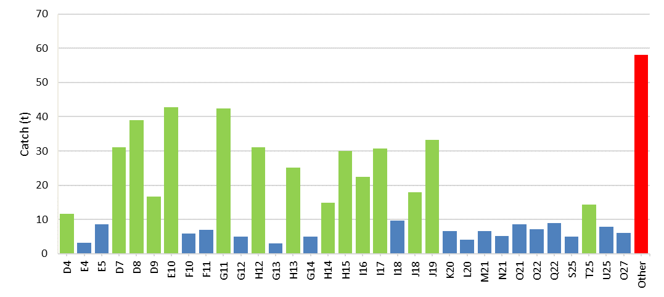

Figure . Catch (tonnes landed wt) of Black teatfish in QSCF for the period 1995-96 to 2022-23 in reporting grids that comprise 70% (green) and 90% (green and blue) of the catch is taken and the remainder in all other reporting grids (red). Grids are ordered from the north and west (QSCF vessel logbook and buyer return data).

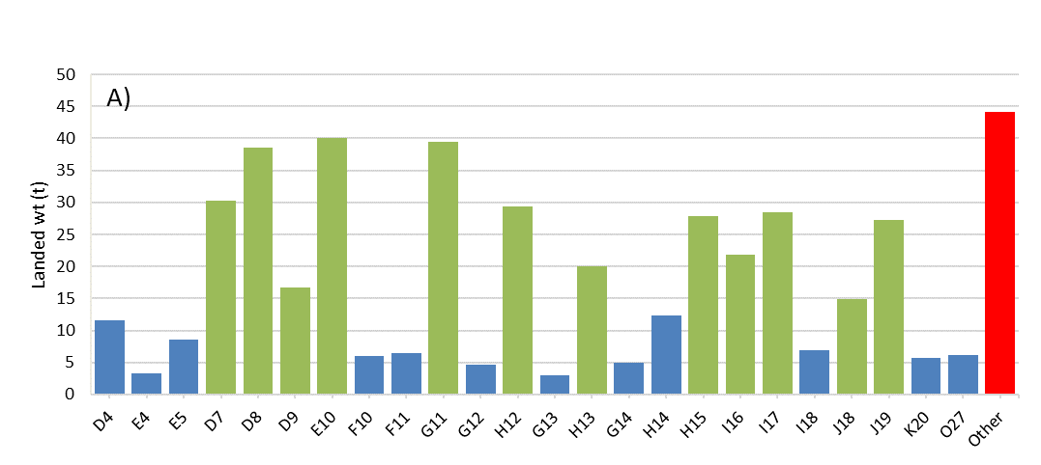

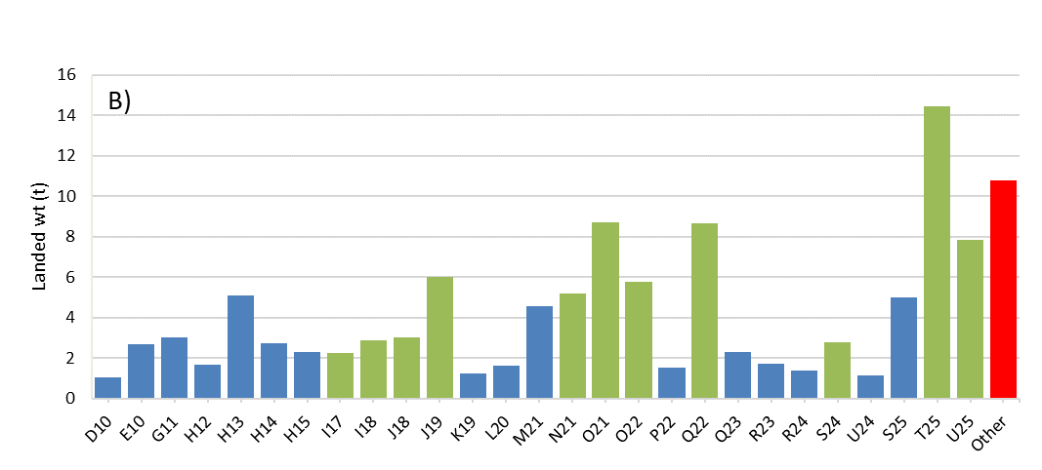

Figure . Catch (tonnes landed wt) of Black teatfish for the period 1995-96 to 2022-23 in the QSCF by reporting grids that comprise 70% (green) and 90% (green and blue) of the catch and the remainder in all other reporting grids (red) A) before the implementation of the RHA in 2004, and B) after. Grids are ordered from the north and west. (QSCF vessel logbook and buyer return data).

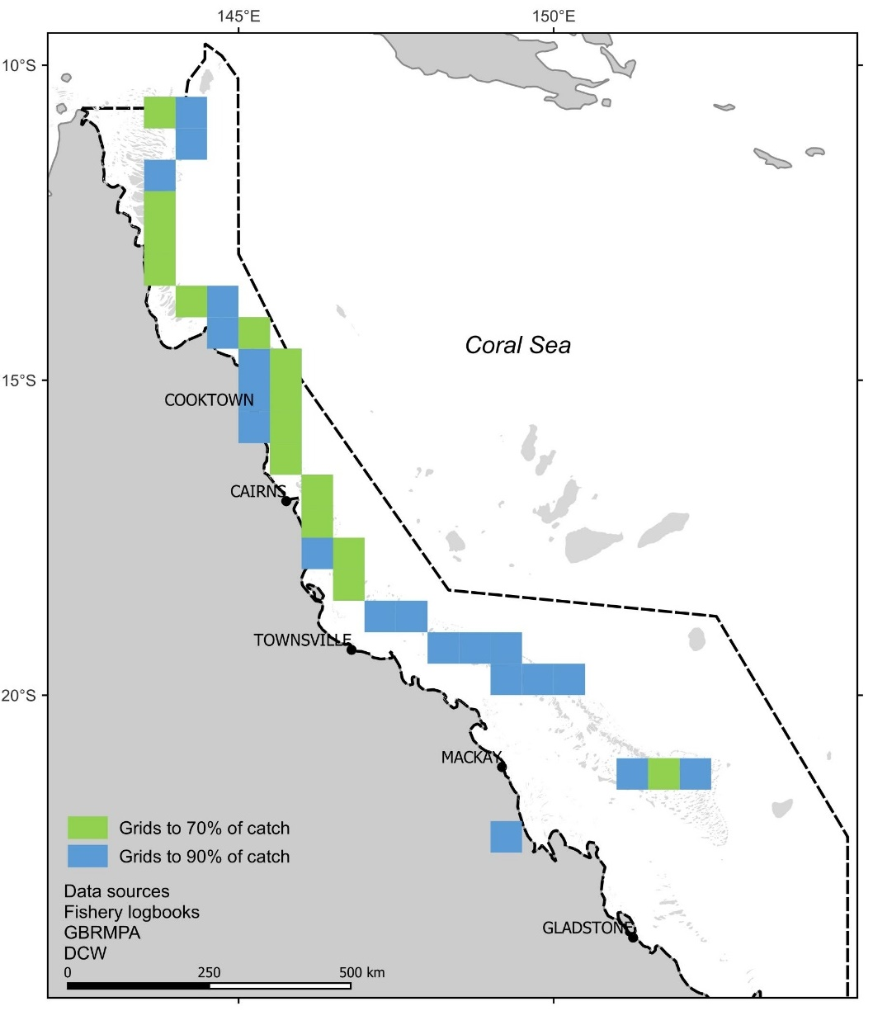

Figure . Catch (tonnes landed wt) of Black teatfish in QSCF for the period 1995-96 to 2022-23 in fishery reporting grids that comprise 70% (green) and 90% (green and blue) of the catch. (QSCF vessel logbook and buyer return data)

Figure . Catch (tonnes landed wt) of Black teatfish in the QSCF by rotational zone for the period 1995-96 to 2022-23 (after Koopman and Knuckey, 2023). (QSCF vessel logbook and buyer return data).

### White teatfish

White teatfish were only a minor component of the catch before 1995-96 (Damschke, 1997), however catches increased rapidly with the decline and closure of the Black teatfish fishery in 1999 (Uthicke, 2004). The highest annual catch was 150. 6 t in 2000-01 (). Species level TACs for White teatfish were implemented in 1999-2000 (127 t), and catches after the peak in 2000-01 reduced generally in synchrony with reductions in White teatfish TACs (see Management history section and Appendix E) to the current 53 t TAC which was implemented in 2011-12.

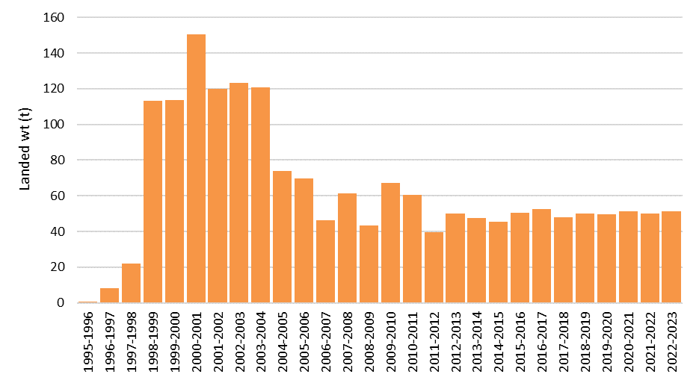

Figure . Annual catch (tonnes landed wt) of White teatfish in the QCSF for the period 1995-96 to 2022-23 (QSCF vessel logbook and buyer return data).

About 70% of the catch of White teatfish came from 13 grids (Figure 22), and those plus an additional 14 grids accounted for more than 90% of the catch – which was about 25% of all grids that had some White teatfish catch. The highest catch was from grid H12 just north of Cooktown at 176.9 t (Figure 22).

The highest catches occurred in the central GBR, between Townsville and Cape Melville (14˚S), with isolated high catch grids in the northern GBR (Figure 24; Table 4). Catch by RHA zone also shows the majority of the catch coming from the central region of the GBR, with significant catches in the northern GBR and offshore reefs (Figure 25). Very little catch comes from the southern GBR (south of Townsville at about 19˚ 30’S (Figure 25; Koopman and Knuckey, 2021). The offshore reefs (Ashmore and Boot, Marion and Saumarez Reefs), while only making up 3 zones, still provide a significant level of catch (Table 4).

About 43% of the White teatfish catch was caught before the implementation of the rotational zone scheme in 2004 (over nine years of fishing; Figure 21) (RHA – Section 5.1.1.) compared to 57% after (over 19 years of fishing; Figure 21). The catch was taken over more grids after 2004 than before – with 90% of the catch taken in 18 grids before 2004 versus 30 grids after 2004 (Figure 23). Before 2004, there was no significant harvest of White teatfish south of Townsville, and even after, the catch in the southern zone was 10% or less.

Table . Catch of White teatfish in four areas of the fishery.

|  |  |  |
| --- | --- | --- |
| Region | Zones | Catch (t) |
| Cooktown Nth | 55 | 694.6 |
| Townsville to Cooktown | 35 | 712.6 |
| Townsville Sth | 78 | 164.5 |
| Offshore reefs | 3 | 81.8 |

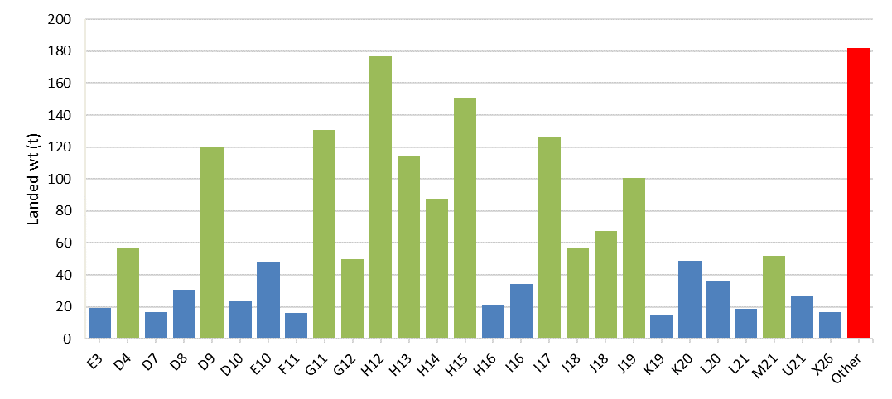

Figure . Catch (tonnes landed wt) of White teatfish for the period 1995-96 to 2022-23 in reporting grids that comprise 70% (green) and 90% (green and blue) of the catch is taken and the remainder in all other reporting grids (red). Grids are ordered from the north and west. (QSCF vessel logbook and buyer return data).

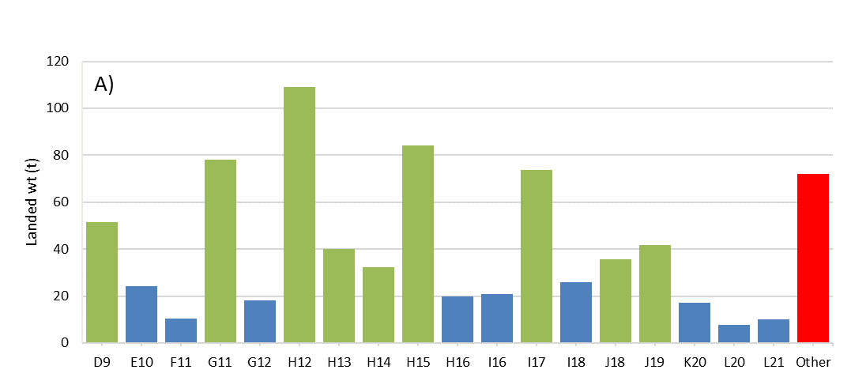

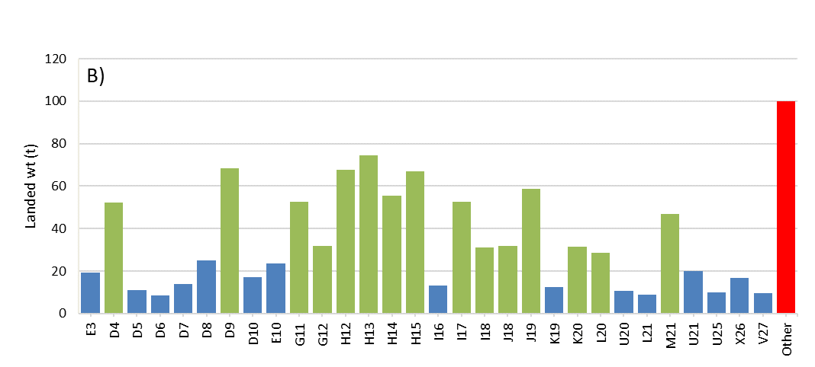

Figure . Catch (tonnes landed wt) of White teatfish for the period 1995-96 to 2022-23 in the QSCF by reporting grids that comprise 70% (green) and 90% (green and blue) of the catch and the remainder in all other reporting grids (red) A) before the implementation of the RHA in 2004, and B) after. Grids are ordered from the north and west. (QSCF vessel logbook and buyer return data).

There are differences in the location of catches in relation to mapped reef features across the fishery. South of about Cape Flattery (15˚S) most of the catch came from habitats associated with reef features, while north of that, most of the catch was taken from deeper GBR lagoon areas just inside the outer barrier reefs in what is known to fishers as “paddock country” (Koopman and Knuckey, 2021), usually associated with bottom features called “sinkies” and “tabletops” (Koopman and Knuckey, 2021). The exact extent of this habitat is not well defined, though some mapping products are available that could be used to do this (e.g. High-resolution depth model for the Great Barrier Reef - 30 m (2020)). The distribution of White teatfish in the southern GBR (south of Townsville) are described as being randomly distributed and in lower densities (Koopman and Knuckey, 2021).

### Discards

There are no discards in the QSCF due to the highly selective nature of hand collection fisheries (DAF, 2021a).

Figure . Catch (tonnes landed wt) of White teatfish in QSCF for the period 1995-96 to 2022-23 in reporting grids that comprise 70% (green) and 90% (green and blue) of the catch. (QSCF vessel logbook and buyer return data)

Figure . Catch (tonnes landed wt) of White teatfish by rotational zone for the period 1995-96 to 2022-23. (QSCF vessel logbook and buyer return data).

## IUU

Reefs within the QSCF have been subject to illegal fishing by foreign fishing vessels (FFV), predominantly Vietnamese based fishing vessels (blue boats) focused on sea cucumber. This activity resulted in 15 FFV sightings within the QSCF area between March 2016 and February 2017, of which 7 were apprehended (Figure 26) (AFMA, unpublished data; Skewes, 2017). Two of the sightings/apprehensions were in deep water off the northern GBR, four in the Swain Reefs area in the southern GBR, and the remainder on Saumarez Reef.

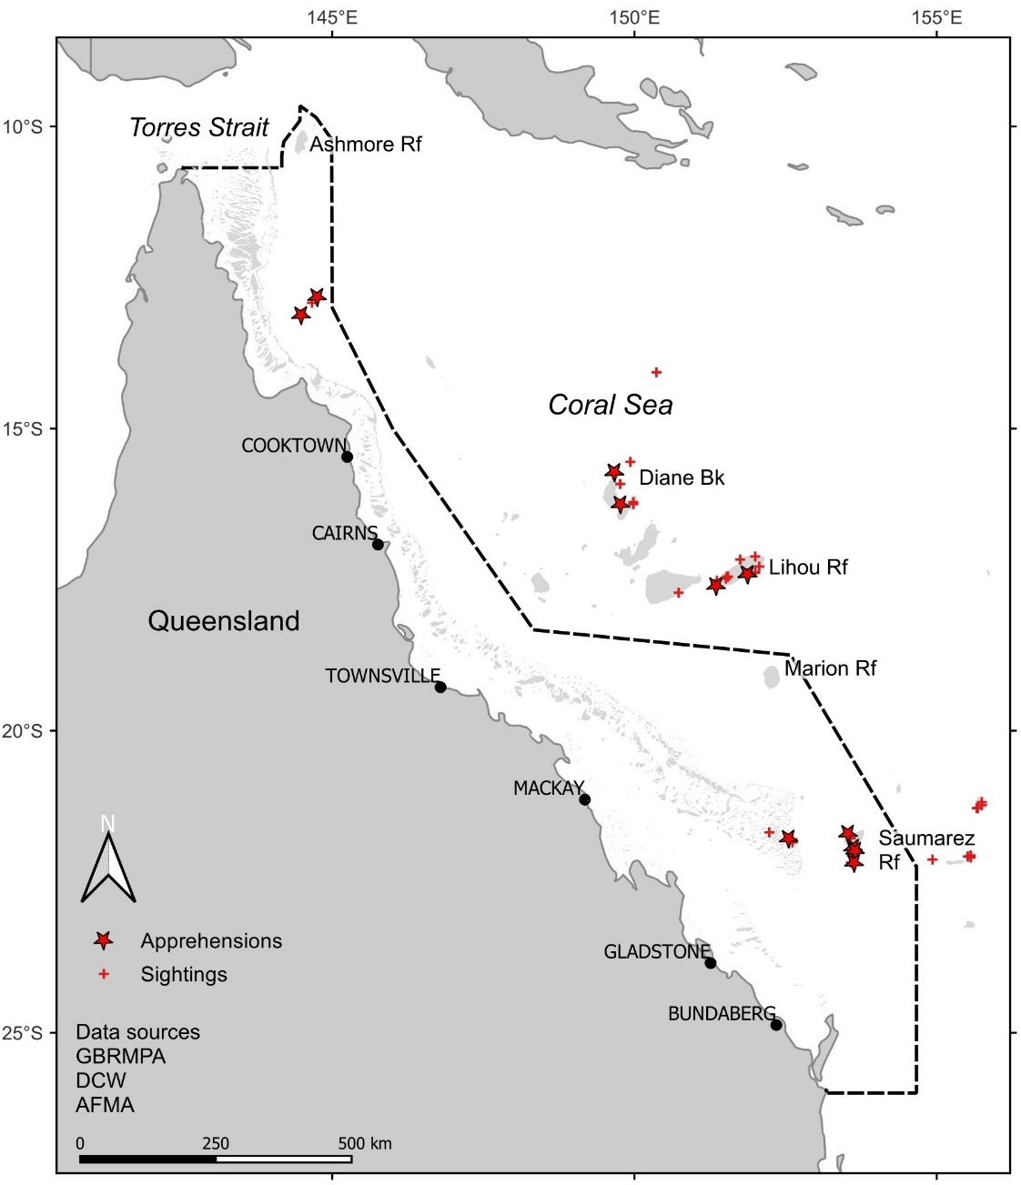

Figure . Location of sightings and apprehensions of Vietnamese based illegal fishing vessels (blue boats) for the period March 2016 and February 2017 (data supplied by AFMA).

Of the 7 vessels apprehended in the QSCF area, the estimated catch on board was 36.8 t (gutted and salted weight), at an average of 5.3 t per vessel (AFMA, unpublished data) – with most of this (25.4 t) coming from Saumarez Reef.

The species composition of the catch of two vessels apprehended at Saumarez Reef (within the QSCF) indicated that they were mainly targeting White teatfish (86%), with smaller quantities of Black teatfish (10%) and only limited Prickly redfish (2%) (Skewes, 2017).

As of about 2021, there had been no confirmed sightings of FFVs in the QSCF since 2017 (AFMA, pers. comm., reported in Noriega et al., 2022).

Table . Catch estimate of a FFV apprehended at Saumarez Reef in February 2017, in gutted and salted and live whole weight (Skewes, 2017).

|  |  |  |  |  |  |  |  |
| --- | --- | --- | --- | --- | --- | --- | --- |
| **Catch (t)** | **White teatfish** | **Black teatfish** | **Prickly redfish** | **Leopard fish** | **Redfish** | **Stone fish** | **Total** |
| Gutted and salted | 5.32 | 0.61 | 0.12 | 0.05 | 0.05 | 0.05 | 6.19 |
| Live weight | 12.26 | 1.15 | 0.24 | 0.11 | 0.11 | 0.11 | 13.98 |

## Indigenous and Recreational fishing

Indigenous and recreational extractions from the QSCF area are unknown, but are likely to be negligible (DAF, 2021a). The recreational take of sea cucumber has an overall possession limit of 5, and is prohibited south of Bowen, with Black teatfish and White teatfish being no-take species throughout Queensland waters (DAF, 2021b).

# Stock trends and stock assessments

## Fishery independent surveys

Fishery independent surveys (stock surveys) are expensive and technically and logistically demanding. They require careful consideration of objectives and planning, an adequate understanding of fishery habitats, expert knowledge of holothurian taxonomy and sufficient training in UVC techniques (Purcell et al., 2010). Comprehensive surveys of sea cucumber populations on shallow reef systems, essentially complex 3-dimensional objects, in a balanced and statistically legitimate fashion are rarely achieved. In addition, surveying deep habitat (>20m) usually requires the use of underwater video equipment, adding to the expense and training required.

Sea cucumbers, and particularly teatfishes, have variable densities across depth gradients and reef morphometric habitats, and in relation to distance from terrigenous influence (across shelf) and even latitudinally (Benzie and Uthicke, 2003; Murph et al., 2021; Purcell et al, 2023). Due to this, and the difficulty and expense in carrying out comprehensive surveys, there is a wide variation in sample design and survey approaches that makes comparisons of sea cucumber densities over time and between locations difficult.

### Black teatfish

*1978-79*

A holothurian resource survey was conducted at nine reefs of the central Great Barrier Reef (approx. between Townsville and Cairns) in 1978-79 (Harriott 1984; 1985). The survey initially compared two census methods, 500 m manta tows and 100 m SCUBA swims, to determine the distribution and abundance of reef dwelling holothurians. Manta tows were chosen as the most effective method although it was estimated that this method underestimated the “real population density” by a factor of 2 – 4 times. The survey was restricted to 10 m water depth.

The density of commercial sea cucumbers were estimated for four reef habitats: forereef slope, reef top, lagoon and consolidated backreef habitats. Only forereef slope and consolidated backreef habitats had significant (>20 per ha) abundances of commercial holothurians. The density of Black teatfish was generally low, with the highest density being 5.19 per ha on Pearl Reef forereef slope, and average density on the 8 highest density reef-habitat combinations only being 1.8 per ha (Harriott, 1985).

Harriott (1985) concluded that given the relatively low densities of holothurians on the Great Barrier Reef and possible prohibitive wage costs (compared to the undeveloped countries) it was not likely that a beche-de-mer fishery would be viable on the reefs surveyed.

#### 1998-99

A broadscale survey of the GBR focused on Black teatfish was carried out in 1998-99 (Uthicke and Benzie, 2000; Benzie and Uthicke, 2003). Based on preliminary surveys showing low density of Black teatfish on nearshore reefs, only the mid shelf and outer barrier reefs were included in the survey. The habitat for the survey was described as the “reef flat area”, though “areas with > 60% sand cover were avoided” (Benzie and Uthicke, 2003) and “areas from the reef flat that are unlikely habitat” were excluded (Uthicke and Benzie, 2000). Other than that, it is not clear how sample locations were chosen (Knuckey and Koopman, 2016).

The survey approach was based on 500m2 manta tows, where Black teatfish and other species were counted, and individuals collected for size measurement. Over a thousand manta tows at 157 locations on 72 reefs were surveyed between Cape Grenville (15˚S) and Keppell Island (23˚S) (Benzie and Uthicke, 2003).

Black teatfish were observed on 56 of 72 mid and outer shelf reefs sampled (Figure 28). They were found in higher density on outer shelf and barrier reefs and generally had a higher density on reefs north of Townsville, with the distribution south of this being patchy (Figure 27).

Density estimates from the active fishery area (Princess Charlotte Bay to Lucinda, 12-19°S) were used to assess stock status by comparing closed and open reefs (Benzie and Uthicke, 2003; Uthicke and Benzie, 2000). Black teatfish density in the “main habitat” on closed reefs was 20.88 per ha (n=6, 95% confidence interval [CI] = 16.3–25.73), compared to the same habitat on ‘open reefs’ of 5.52 per ha (n = 29, 95% CI = 2.84–8.20) indicating that fishing has reduced density and biomass by at least 75% on fished reefs (Uthicke and Benzie, 2000; Uthicke et al., 2004).

The biomass estimate for the active fishery area using the above density estimates and estimates of “dry-reef area” (GBRMPA) was 2,518 t (gutted weight), with the virgin (pre-modern fishery) biomass estimate for the same area as 5,585 t. They compared this biomass reduction (~3000 t) to the estimated total amount fished up until the fishery closure in 1999 (approximately 2000-2500 t) and concluded that overall stock productivity was low and that annual harvest rates of <10% (and perhaps <5%) of virgin biomass was enough to cause “severe” overfishing (Benzie and Uthicke, 2003; Uthicke et al., 2004).

The estimated biomass of the entire GBR fishery area (excluding the offshore reefs) from the survey was 5,801 t (gutted weight); with the virgin biomass estimated at 8,681 t (using the same approach as Uthicke et al., 2004 and using data from Benzie and Uthicke, 2003) – an overall depletion of the GBR Black teatfish population by the fishery by 1999 of about one third (Skewes et al., 2014).

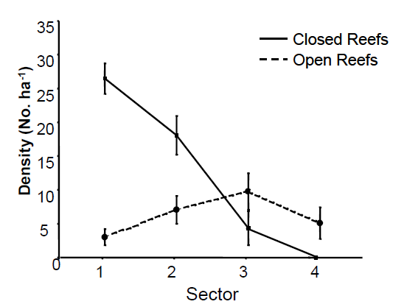

Figure . Average densities of Holothuria nobilis in four arbitrary sectors, and in green (Closed Reef) and blue (Open Reef) reefs of the Great Barrier Reef. Error bars indicate 1 SE. (from Benzie and Uthicke, 2003)

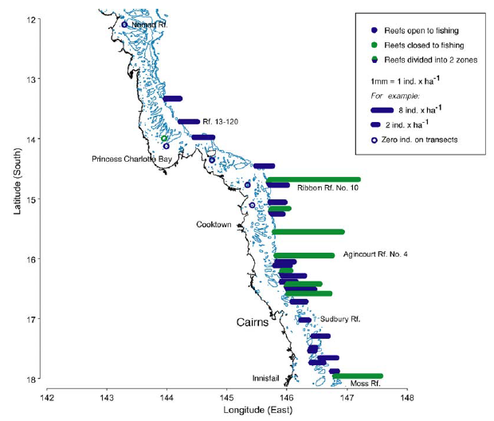

Figure . Black teatfish density during a survey on northern (top) and southern (bottom) reefs of the Great Barrier Reef. (from Benzie and Uthicke, 2003).

The same researchers resurveyed 23 reefs in the previously active fishery area one (2000) and two (2001) years after the fishery closure in 1999 and though there was a slight increase in density on previously fished reefs, it was not statistically significant (Figure 29) (Benzie and Uthicke, 2003; Uthicke et al., 2004).

Figure . Average densities of Holothuria nobilis on five green (Closed) and 15 blue (Open) reefs prior to the total closure of the fishery (Survey 1) and about 1 (Survey 2) and 2 (Survey 3) years after the closure. (from Benzie and Uthicke, 2003; Uthicke et al., 2004)

#### 2015-2021

A population biomass survey of Black teatfish was carried out in the northern (Zone 1 – north of 19°S) fishery area in 2015, 16 years after the fishery closure (Knuckey and Koopman, 2016).

The 2015 survey habitat was defined as the 200 m wide buffer 50 m inside the weather (SE facing) edge of reefs >1km2 in size (Knuckey and Koopman, 2016). This was chosen as the focus habitat as it had been reported that Black teatfish had its highest density in this habitat in Torres Strait (Skewes et al., 2002; 2009; Murphy et al., 2021a) and that the fishery had focused on this habitat in the early fishery (R. Lowden, pers com *in* Knuckey and Koopman, 2016).

The 2015 survey was primarily focused on the same “active fishery” area as the 1998-99 survey just before the Black teatfish fishery closed in 1999. This included reefs in two reef bioregions – the Outer Barrier (RA2) south of 14°S and the Exposed Mid Shelf (RG2) bioregions (Kerrigan et al., 2010), The survey design was based on a random stratified survey design. This survey found:

* The density of Black teatfish in the sampled habitat was 13.5 per ha on closed and 12.5 per ha on open mid-shelf reefs; and 27.0 per ha on the closed and 23.6 per ha on open outer barrier reefs.
* Overall, the total biomass estimate in the sampled habitat was 379 t (gutted weight) (232–525 t 95% CI), which was 28 t (or about 7%) less than the “pre-fishing” biomass estimate of 407 t (202–612 t).

The survey indicated that the Black teatfish population on previously fished reefs in the northern GBR had recovered to between 92.2% and 87.2% of those reefs that had been closed to fishing, therefore the fishery was opened in July 2019 with a 30 t TAC in accordance with the QDAF’s Sea cucumber fishery Performance Management System (PMS) which was current at the time. It stipulated that closed fisheries could only be opened if the stock had been demonstrated to have reached 70% of its unfished biomass (which may be based on comparison of fished versus historically unfished reefs), and that harvest limit be set at <10% of estimated biomass.

Note that the biomass estimate for the 2015 survey was only for the reef buffer strata of reefs >1km2 for two reef bioregions in the GBR, an area totalling 18,365 ha, which was only 8.2% of the estimated habitat area for the 1998-99 survey in the “active fishery area” of 224,241 ha (Benzie and Uthicke, 2003; GBRMPA). Note also that the estimate for the same habitat area (reef buffer) applied in the east Torres Strait fishery was 50,390 ha (Skewes et al., 2004). In this regard, the 2015 survey biomass estimate was considered as a gross underestimate – it included a much smaller habitat area than the 1999-98 survey and, although the reef top buffer habitat had the highest density of Black teatfish in Torres Strait, it only contained 52% of the Black teatfish population (Skewes et al., 2002; 2009; Murphy et al., 2021a).

The restricted habitat scope was justified by its primary objective of assessing the difference between closed and previously open reefs – rather than producing a comprehensive population biomass estimate. In any case, upon opening of the fishery, little commercial fishing occurred in the northern ‘Zone 1’, and a survey of Zone 2 (the fishery area south of 19°S, excluding Saumarez and Marion Reefs) was stipulated (DAWE, 2020). This was carried out in 2021 (Koopman and Knuckey, 2021).

The 2021 survey focused on two broad habitats, the reef top (intertidal and inner lagoon) and deep reef (generally reef slope to 20 m deep) habitats, based on observations by industry that suggested a significant proportion of the Black teatfish population in the southern GBR resided in deeper water (15-20 m) due, it was postulated, to the greater tidal range in that area.

The survey was based on a random stratified survey design and sampled 26 reefs. The survey area roughly corresponded to six reef bioregions (Kerrigan et al., 2010), with an approximate survey area of 497,000 ha (Cf. 18,365 ha for the northern Zone 1 survey), of which about 28% was closed to fishing.

The 2021 survey of Zone 2 found:

* The density of Black teatfish in the various stratum (reef bioregions) and habitats (reef top and deep reef) ranged from zero to 19.04 per ha and were not consistently higher or lower in either the reef top or deep reef across strata. While both closed and open reefs were surveyed, (roughly in proportion to their area), the study authors did not report closed reefs separately.
* Overall, the median total biomass estimate was 6,573 t whole weight (95% CI 4,384–9,570 t) for the fully stratified estimate, with over half of this from a single stratum, the Hard Line Reefs (RHL) reef bioregion. This equates to approximately 4,160 t (95% CI 2,775–6,058 t) gutted weight using a conversion ratio of 0.677 (Murphy et al., 2021b).

The combined fishery biomass for both survey’s, though using quite different approaches and with the Zone 1 biomass in particular for only a restricted area of potential habitat, was 4,384 t gutted weight (no confidence intervals available) (DAF, 2023), or 3,677 t landed weight (using a conversion ratio of 0.529 (Murphy et al., 2021b).

#### Marion and Saumarez Reefs, 2017

A sea cucumber survey on eight different reefs in the Coral Sea was carried out in 2017, which included Marion and Saumarez Reefs (Skewes and Persson, 2017). It found overall reef densities of 2.68 and 1.22 per ha for Black teatfish for Marion and Saumarez Reefs respectively – with a standing stock estimate for both reefs at 59,196 individuals and 56.8 t landed weight (but with wide confidence intervals of ±81.9%, 90%CI).

While the density of Black teatfish on these offshore reefs was lower than reefs in the Torres Strait and the GBR, they also noted that the biomass estimate was high in comparison to estimates of Black teatfish catch on those reefs by the QSCF (24 kg), and the estimated catch for one apprehended FFV (600 kg) (Skewes, 2017).

### Density comparisons to other Black teatfish surveys

Sea cucumbers, particularly teatfish species, have variable densities across different depth and reef morphometric habitats, and in relation to distance from terrigenous influence (across shelf), and latitudinally—and likely several other lesser-known gradients (Benzie and Uthicke, 2003; Koopman and Knuckey, 2021; Murphy et al., 2021; Purcell et al., 2023). Monitoring surveys will be most useful when using the same sample design and survey approach, therefore comparisons of density over time likely indicate actual population status (within the bounds of statistical confidence). Other than that, surveys that include a comprehensive sampling of the entire reef suite of habitats will be most informative (e.g. Skewes et al., 1999; Murphy et al, 2021a; Koopman and Knuckey, 2021).

Therefore, comparing survey densities, as well as against theoretical “thresholds” is often compromised by differences in habitat delineation and sampling approaches. Nevertheless, a comparison of the 2015 and 2021 survey densities with other “comparison” densities is still informative to an extent, and in this regard they are encouraging with respect to the relative health of the Black teatfish population on the GBR (Figure 30).

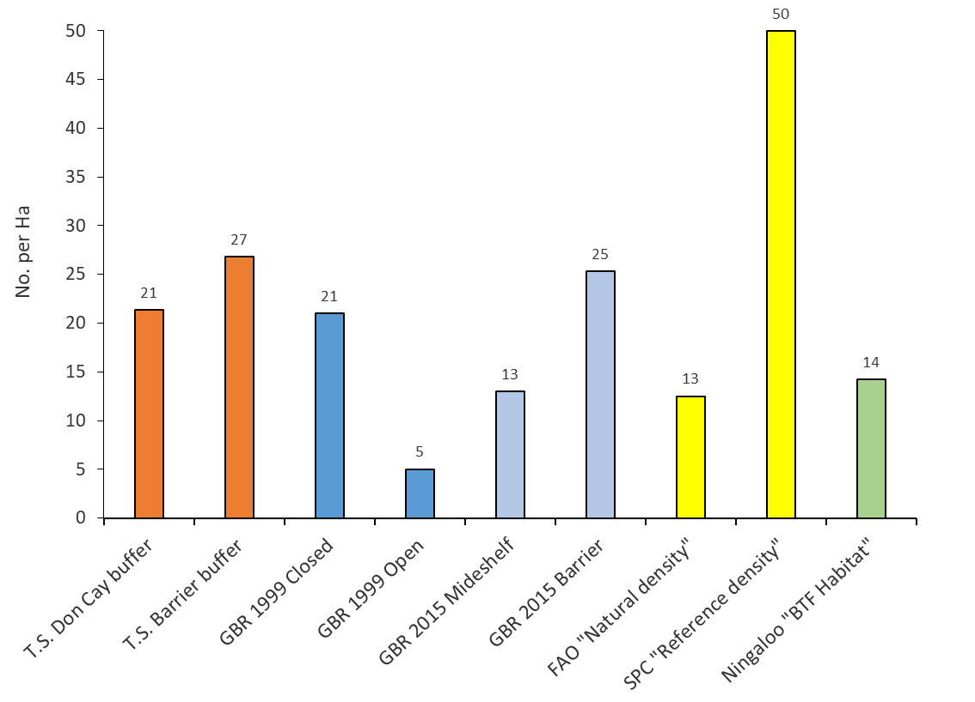

Figure . Comparison of density estimates for Black teatfish (*H. whitmaei*) in preferred habitat from various studies/regions (see text for source references). Torres Strait mid and outer shelf reef “reef-top buffer” (a 200 m wide buffer around the inside of the reef margin) (Murphy et al., 2021a). FAO “Natural density”: Densities above 12.5 per Ha represent a “natural density” in “suitable habitat” (Kinch et al., 2008). Guidance from the Secretariat Pacific Community provides “rule of thumb” regional reference densities of 50 individuals per Ha for Black teatfish —estimated from the upper 25% of densities across 91 sites assessed in 17 countries over the period 2002–2012 (Pakoa et al., 2014). “Natural” density for Black teatfish in Western Australia include: 11.4 to 17.1 individuals/Ha (Ave 14) in “habitats occupied by Black teatfish” and likely represents minimum natural population densities for Ningaloo Reef (Shiell and Knott, 2010). (After Murphy et al., 2021)

### White teatfish

Broadscale surveys for White teatfish in the QSCF have not been carried out, but one has been scoped (Koopman and Knuckey, 2021b) and scheduled for 2023-24 according to the HS (DAF, 2021a), and may occur in late 2024 (Queensland Fisheries, pers comm.).

An options paper was prepared to underpin future White teatfish surveys on the QSCF (Koopman and Knuckey, 2021*b*). They also used available spatial fishery data and expert opinion from fishers at the time to delineate likely White teatfish habitat in the area of the fishery. They provided a protocol for delineating deepwater White teatfish habitat, options for surveying with underwater video (ROV, drop cameras and AUVs), and optimal sample design. Surveying a deep and dispersed species such as this is challenging, however, developing deep water remote surveying techniques show some promise for carrying out efficient and effective population surveys of White teatfish.

The preferred options include those focused on primary White teatfish habitat in the northern GBR, including deeper water habitats called “sinkies”.

*Marion and Saumarez Reefs, 2017*

A sea cucumber survey on eight different reefs in the Coral Sea was carried out in 2017, which included Marion and Saumarez Reefs (Skewes and Persson, 2017). It found the overall reef density of White teatfish on Marion Reef was only 0.04 per ha, and White teatfish were not observed at all on Saumarez Reef. However, they did note that the survey was restricted to 20 m water depth, therefore the potential for White teatfish populations in deeper water could not be excluded. Indeed, the predominance of White teatfish in the catch of a FFV on Saumarez Reef (Skewes, 2017), together with the extensive areas of deep lagoon habitat in the 20 to 40 m depth range (Skewes and Persson, 2017) that may provide suitable habitat for a deep-water species such as White teatfish. Even so, they considered that the shallower habitats at least have been depleted, either by QSCF (55.8 t caught between 2000 and August 2021), FFV (probably 20 t or more in 2016-17), or a combination of the two.

## Catch per unit effort (CPUE)

There are several limitations with respect to using catch per unit effort (CPUE) as a proxy for density/abundance for sea cucumber fisheries, including (but not limited to) hyperstability, differential targeting, spatial and habitat variations, and changes in fisher effort efficiency. This is especially true for White teatfish where the prospecting for new fishing grounds in the northern GBR deep “paddock” habitat by fishers has the potential to maintain catch rates. However, it is still likely that reduced fishery density/abundance will result in a reduction in CPUE, especially over the long term (Uthicke, 2004).

### Black teatfish

Catch per vessel per day of Black teatfish over the period 1995-96 shows two distinct periods – one from 1995/96 to when the fishery was closed in October 1999 from about 300 kg/vessel/day to about 50 kg/vessel/day () being one of the main reasons that the fishery was closed (Uthicke, 2004). Catch rates after the fishery was reopened in 2019 has increased from about 150 kg/vessel/day to over 200 kg/vessel/day . Some logbook records also record hours fished, presumably as the addition of all diver hours in all tender vessels for that day. This data showed a very similar pattern to the catch per vessel per day output ().

A limitation with comparing the recent catch rates with earlier ones is that most of the recent fishing has occurred in the southern GBR, an area with likely lower natural density than the northern reefs that provided most of the early catch. In any case, not withstanding the considerable limitations of this CPUE analysis to reflect actual stock status, there is no discernible downward trend in catch per vessel per day or catch per hr for Black teatfish in the QSCF.

Figure . Annualised average catch per day (kg/d) of Black teatfish for the period 1995-96 to 2022-23 for vessels fishing in the QSCF on days when Black teatfish occurred in the catch (C=species closed to fishing) (QSCF vessel logbook and buyer returns data).

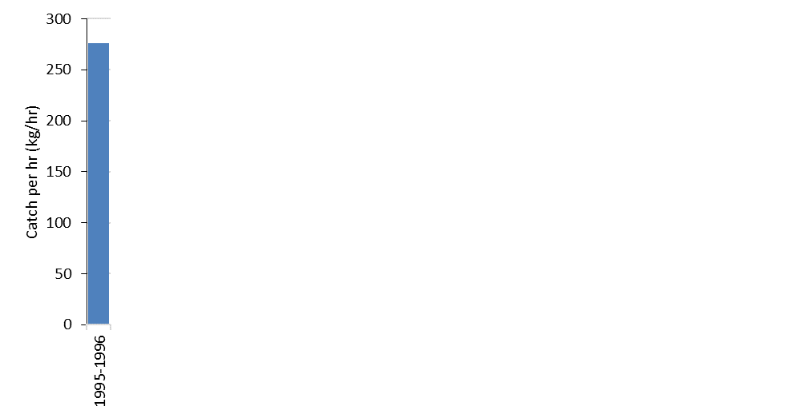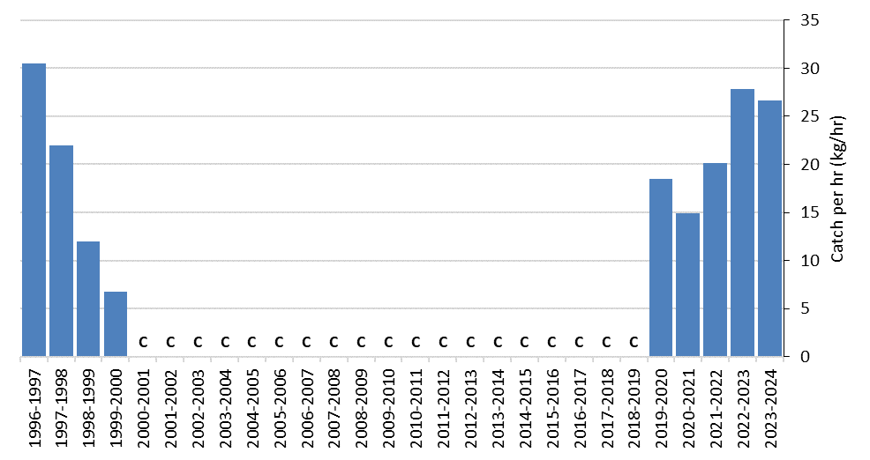

Figure . Annualised average catch per hour (kg/hr) of Black teatfish for the period 1995-96 to 2022-23 for vessels fishing in the QSCF on days when Black teatfish occurred in the catch (C=species closed to fishing) (QSCF vessel logbook and buyer returns data) Note: 1995-96 is on a different scale.

### White teatfish

Catch per vessel per day of White teatfish over the period 1995-96 to 2023-24 shows a steady increase to nearly 350 kg/vessel/day in 2009-10 and then a plateau and gradual decline to about 200 kg/vessel/day (). Some logbook records also record hours fished, presumably as the additional of all diver hours in all tender vessels for that day. This data showed a similar pattern to the catch per vessel per day output (Figure 34) but with an earlier peak in 2006-07, and a more gradual decline to current levels.

This slight decline in catch rates may be a cause for some caution, especially given the reports of fishers prospecting for new unfished habitats in northern GBR (Koopman and Knuckey, 2021) that may contribute to catch rate hyperstability. On the other hand, the catch per hour data is somewhat encouraging.

Figure . Annualised average catch per data (kg/d) of White teatfish for the period 1995-96 to 2022-23 for vessels fishing in the QSCF on days (and years) when teatfish occurred in the catch (QSCF vessel logbook and buyer returns data).

Figure . Annualised average catch per hour (kg/hr) of White teatfish for the period 1995-96 to 2022-23 for vessels fishing in the QSCF on days when White teatfish occurred in the catch (QSCF vessel logbook and buyer returns data).

## Stock assessments

### Black teatfish

A numeric stock assessment of Black teatfish in the QSCF was carried out in 2021 (Helidoniotis, 2021a). It was based on an age structured surplus production model with annual time steps. It also incorporated (perhaps uniquely) catch estimates for the early fishery (see above and Uthicke 2004a), and incorporated population estimates from the southern GBR survey in 2020 (Koopman and Knuckey, 2021a).

The starting biomass in 1877, according to the stock assessment model, was 15,709 t (live weight), and it estimated the 2021 biomass was between 40% and 42% of unfished biomass (B0). The exploitable biomass ratio in 2021 was 40% B0 relative to 1877.

An externally initiated review of the assessment outlined several issues with respect to model parameters and the treatment of uncertainty, bringing into question the reliability of the outputs (DAWE, 2021, unpublished peer review report). In addition, there are incongruities between the population depletion estimates from 1999 (indicating stocks at 45% B0) compared to the stock assessment model (indicating stocks at 40-42% B0 unfished biomass, and very little depletion from the fishing pulse in the late 1990s) which raised further questions about the model outputs, especially the recovery following the Black teatfish closure (DAWE, 2021).

The use of the early fishery data is somewhat problematic in the sense that it is actually very uncertain how much Black teatfish was caught in the early fishery – due to a lack of species level differentiation in catch statistics, the units recorded (data for 1901 to 1940 is primarily reported as value of exports, requiring a “value” type conversion) and the high likelihood of product form outside the area of the QSCF contributing to the catch. It is not known what the impact of the assumptions used has on the final outputs of the stock assessment. While early catch is uncertain, it is very likely that Black teatfish was heavily depleted in the QSCF area (as a high value species accessible by free divers), perhaps multiple times in the past. There are likely other approaches available to represent this early depletion in a stock assessment model that would be more robust than what is applied in the 2021 assessment - these should be investigated.

Nonetheless, the current estimate of biomass from the 2021 assessment is substantially below the target population level of the HS, therefore the current catch TAC should be framed in terms of fishing a recovering population. In fact, the stock model does indicate that the current levels of catch can rebuild the stock to 60% B0 Target biomass.

### White teatfish

A numeric stock assessment of White teatfish in the QSCF was also carried out in 2021 (Helidoniotis, 2021b). It was based on an age structured surplus production model with annual time steps. It indicated that the exploitable biomass declined to roughly 56% B0 in 2003 and has fluctuated around 80% B0 since 2014 (finishing at 78% B0 in 2021). As for spawning biomass, the model estimated that is had declined to 67% B0 in 2002 and has fluctuated around 80% B0 since 2003.

The robustness of the model was determined by evaluating the fit to the standardised catch rate and was considered to be satisfactory. An alternative delay difference model was also run in parallel, and yielded similar results with respect to biomass ratio.

The assessment was fitted to catch rate data from the fishery only, (the open area) and not from the whole stock. No survey data was available to use in the model. This has raised concerns about the accuracy of the assessment as it is based on catch data rather than survey data (DAWE, 2021). As acknowledged in the stock assessment report, there are known limitations with using Catch Per Unit Effort (CPUE) measures as an index of relative abundance for sea cucumbers due to issues of hyperstability in effort – where CPUE declines more slowly than true abundance as a stock declines. There are two scenarios for hyperstability that may apply in this case – fishers fishing new grounds therefore fishing new unexploited segments of the population; and fishers being able to maintain catch rates despite falling density through increased fishing power (through increased fishing knowledge or technology for example). The longer the time series, the lower the risk of hyperstability – but it may still be impacting on the White teatfish dataset as there are reports of fishers prospecting new fishing grounds in the deep water “paddock” fishing grounds that may include unfished populations therefore maintain catch rates (Koopman and Knuckey, 2021b).

Harvest data from 1996 were assumed, for modelling purposes, to represent the commencement of significant fishing mortality, i.e. near virgin state of white teatfish in 1995 in Queensland waters. No allowance was made for historical fishing of White teatfish, and given the limitations for freedivers to harvesting White teatfish (as observed in the Torres Strait fishery where underwater breathing apparatus are banned) and the apparent modest commercial value of White teatfish historically (Saville-Kent, 1893), this is probably legitimate. Even so, some early catch scenarios might be informative.

As with the Black teatfish stock assessment, an externally initiated review of the assessment outlined several issues with respect to model parameters and the treatment of uncertainty, bringing into question the reliability of the outputs (DAWE, 2021, unpublished peer review report).

As it stands, the assessment indicates a healthy stock status of White teatfish (~80% B0 in 2021), especially in relation to the limit reference level in the Harvest strategy and potential recruitment inhibition. However, there is considerable uncertainty related to its outputs, in particular regarding the impact of CPUE hyperstability, that could be addressed by an updated assessment and the provision of stock survey biomass data.

*SAFS*

White teatfish in the QSCF is also assessed in the Status of Australia Fish Stocks (SAFS) classification framework which reports stock status in line with a national framework. The most recently published SAFS report for White teatfish occurred in 2023 (SAFS, 2023) and White teatfish in the QSCF was assigned a status of ‘Sustainable’, mostly based on catch rates and outputs of the 2014 MSE (Skewes et al., 2014).

### MSE

There have been two management strategy evaluations (MSE) carried out on the QSCF, and both included Black and White teatfish. Note that MSE is not designed to assess current stock status, but rather to test the effectiveness of various management strategies on fishery “performance” against fishery objectives. It is particularly effective for data poor situations as it can deal with uncertainties by running many simulations under a range of possible scenarios.

*2014*

The first MSE preformed was focussed on assessing the efficacy of the RHA and was carried out in 2014 (Skewes et al., 2014; Plaganyi et al., 2015). It included an “operational model” (OM) that included spatial and age-structured population models. The analysis was considered as a “low data” analysis and was based on several estimation approaches and assumptions. To account for this, the modelling approach that was applied included testing across a broad range of uncertainty by using alternative models, stochastic replicates, and alternative life history parameters. This resulted in 160 population projections run under each of a range of future harvest scenarios with different periodicity and magnitude. The study tested several alternative management approaches, including how fishing mortality was allocated to rotational zones and increased TACs. It also included several sensitivity tests, including low mortality and growth, larger size at maturity and high recruitment variability.

The following four factors were assumed to account for most of the uncertainty regarding the key considerations of resource status and productivity: (i) the natural mortality rate, (ii) the steepness parameter of the stock-recruitment functions, (iii) the underlying recruitment pattern (stochastic and variable vs. deterministic), and (iv) the starting (1995) biomass.

The starting biomass for Black teatfish in the model was based on the density estimates from the 1998-2000 survey (Uthicke and Benzie, 2000; Benzie and Uthicke, 2003; Uthicke et al., 2004), which resulted in a starting standing stock (SS) of 8.68M (or 8,056 t landed weight using average weight from logbook data), of which 3.58M (3,325 t) was in MPAs (Skewes et al., 2014).

The estimate for White teatfish used density estimates from Torres Strait surveys sampled in comparable habitats (Skewes et al., 2010) which resulted in a starting biomass of 5.40M (or 6,845 t landed weight), of which 2.63M (3,331 t) was in MPAs (Skewes et al., 2014).

The MSE performance outputs were based on a risk management approach, as this was deemed to be a pragmatic means of evaluating the relative benefits of management approaches for difficult to predict data-poor stocks. The risk metric chosen was the risk of the stock falling below 40% B0. For the base case (current RHA, historical catch average for White teatfish and an assumed TAC of 58t for Black Teatfish) the risk of depletion below 40% B0 for Black teatfish was about 10% B0, and for White teatfish about 17% B0 (though the fact that White teatfish catches in some zones exceeded the biomass estimate indicated that the starting biomass was underestimated) (), and for all sensitivity cases tested, risk increased, especially for the combination of increased age at maturity (negating the effect of the MSL) and increased TACs. As for alternate management scenarios, the risk is greater for the no RHA scenario (Figure 36), and a decreased risk (essentially to zero) if catch was spread equally between all RHA zones.

Besides indicating the benefits of the RHA to reducing risk to QSCF target species, including teatfish, the model results were sensitive to larger age at maturity, emphasizing the enhanced benefits of the minimum size limit (MSL) implementation to supplement an RHA, with the best outcomes obtained when an RHA is used combined with a size limit that protects at least the first age at maturity (Plaganyi et al., 2015).

The study concluded that Black teatfish and White teatfish appeared to be somewhat vulnerable, especially under higher catch scenarios, and should be managed with caution and more data gathered.



Figure . Summary of performance statistics for sensitivity analysis for depletion risk (defined as probability of biomass being reduced below 40% of the comparable no-fishing biomass level, B0) (from Skewes et al., 2014).



Figure . Summary of performance statistics for management strategies for a) Depletion risk (defined as probability of biomass being reduced below 40% of the comparable no-fishing biomass level, B0). The “all zones” results assume fishing effort is spread evenly across all available zones (from Skewes et al., 2014).

*2024*

A second MSE was carried out in 2024 (Wickens et al., 2024) and was focussed on assessing the effectiveness of current management arrangements for meeting fishery objectives contained in the current harvest strategy (See Section 5). The operating model (OM) for the MSE was based on an age-structured spatial population model. It contained performance metrics (PMs) to assess the results against the fishery’s harvest strategy (HS). The assessment was fitted to time series of catch effort data. While a recent stock assessment for Prickly redfish, Curryfish and Burrowing blackfish (Smart et al., 2024a; 2024b) informed the MSE, the previous teatfish stock assessments (Helidoniotis, 2021a; 2021b) were not included.

Its primary conclusion was that the settings contained in the current HS, together with other management arrangements (closed areas, MSL etc), were likely sufficient to meet the fishery’s objective of attaining a target biomass level of 60% B0 (with B0 being the biomass at the start of the modern fishery in in 1985) and that the risk of depletion for most species was low. However, there were some risks to species with a history of high catch, including Black teatfish and White teatfish, if “similar catches” were reinstated.

The simulated biomass of Black teatfish and White teatfish in 2023 was about 60% B0, attributed to these species having long catch histories. However, for both teatfish species, there was less than 1% probability that the biomass would fall below 20% of unfished biomass across all projection years under current catch levels.

The Black teatfish historical population biomass trajectory produced by the MSE OM shows an extreme depletion (in both the fishery area and closed areas) in the 1990s, followed by a partial recovery. This trajectory is certainly more extreme than available fishery data would support (Benzie and Uthicke, 2003; Uthicke and Benzie, 2000; Uthicke, 2004) which indicated that the early (1990s) modern fishery had depleted the open reefs to 25% of closed reefs, and only in the most active area of the fishery between Townsville to Cooktown (although concluding that there was likely some depletion of closed reefs and in other areas of the fishery over that period as well). It is also more extreme than the previous stock assessment model for Black teatfish (Helidoniotis, 2021) which indicated only a minor depletion by the modern fishery, with most of the depletion occurring in the historical (1840-1940) fishery. In any case, the projected biomass in the MSE shows a continued recovery under most (including current) management settings, with only two high catch scenarios resulting in the population reducing to below 60% B0 into the future (with the high TAC scenario resulting in stock collapse).

For White teatfish, there was more (and large) variation in historical and projected biomass in the MSE OM, with significant depletion during the high catch period in the late 1990s and early 2000s, but stabilising when catches were reduced to near current levels. Most management scenarios resulted in a relative biomass above 60% B0, including the current management settings. Higher catch scenarios resulted in stock depletion and collapse. Higher MSL had a significant effect on depletion risk, with the no MSL scenario resulting in depletion of the stock below 60% B0.

Interestingly for the teatfishes (and for most species assessed in the MSE for that matter), when *F*MSY (the fishing rate consistent with MSY) is applied to the fishery, population levels in the fished area of the fishery are reduced to about 40% B0, indicating that current management strategies (mostly related to current catch rates) are well below *F*MSY and the target biomass level, 60% B0, is significantly higher than BMSY – which is appropriate for the aim of achieving maximum economic benefit and for ecological considerations. However, it is not known if sufficient depensation has been applied to the stock recruitment relationship, which would likely influence this output.

The MSE OM also found that populations in closed areas, while showing some divergence for species that were mostly fished after the implementation of the GBRMP RAP in 2004, would eventually be depleted by fishing under high fishing pressure scenarios, albeit at a much slower rate, while also providing resilience to heavily fished zones through interzone recruitment.

When testing a minimum size limit (MSL) 25% above the length-at-maturity, the model found that it provided substantial resilience to fishing, but performed the best when paired with a total allowable catch and rotational HS. Larger MSL results in a higher relative biomass and lower risk of depletion, though there was often a loss of yield with higher MSL, especially for White teatfish. Also, the MSE does not appear to have addressed harvest efficiency in consideration of the efficacy of MSL for economic objectives.

It also found that the rotational harvest arrangement (RHA) in most cases exceeded the performance of the corresponding non-rotational management procedures with current catch and size limits, resulting in a greater average biomass even for the high TAC scenario, reinforcing the benefits of the RHA.

In any case, the MSE provided a reasonably consistent set of outcomes for the various species in the fishery, regardless of the level of historical targeting and current stock status. One of these was that MP that was based on current catch levels (at least for the last 10 years), the RHA and a MSL 125% of size at maturity was the “best” overall for managing the conflicting objectives of maximising yield while protecting the population from falling below 60% B0 – though it must be noted that economic efficiency does not appear to be considered in the MSE.

Though not designed to estimate current stock status, the MSE OM results in both teatfish populations currently being at or above target refence levels – for Black teatfish it is with moderate confidence (some surveys available, but effect of earlier heavy fishing pressure unknown); and for White teatfish it is with low confidence (no survey or other data available).

Even though the 2014 and 2024 MSEs were based on OMs that had two distinct stock recruitment assumptions, the conclusions of the latest MSE was reasonably consistent with the 2014 assessment (Skewes et al., 2014; Plaganyi et al., 2015), including the efficacy of the RHA to reduce the risk of localised and overall depletion, and improve long term fishery yield. They both also highlighted the importance of size limits for reducing the risk of depletion. The two teatfish species also had the relatively highest risks, though in this MSE, it was deemed appropriately low.

It is unknown if any of the issues raised in the previous reviews of the teatfish stock assessments will also be applicable to this study. They (Wickens et al., 2024) acknowledge that the MSE “*incorporated a larger level of uncertainty than is often typical*”, and attributed most of this uncertainty to a lack of reliable biological information for species assessed in the MSE. The study requires an expert review and response, which could be addressed using a consultative review process, as was recently completed for several other species in the fishery (Smart et al., 2024a; 2024b; 2024c; Buckworth and Skewes, 2024).

## Ecological Risk Assessment (ERA)

Two Ecological Risk Assessments (ERA) have been caried out on the QSCF, the first in 2004 (Roelofs, 2004) and the most recent in 2021 (Pidd and Jacobsen, 2021). The most recent assessment followed Ecological Risk Assessment Guideline (the Guideline) (DAF, 2018), which in turn is broadly aligned with the national risk assessment framework; otherwise known as the Ecological Risk Assessment for the Effects of Fishing (ERAEF) (AFMA, 2017). This framework is based on a hierarchical approach and describes how a fishery will move from a qualitative assessment (level 1) through to a fully quantitative assessment (level 3).

The 2021 QSCF ERA applied a Level 1 (qualitative) assessment to 18 ecological components including two quota species (Black teatfish and White teatfish); Burrowing blackfish; the ‘other species’ basket; bycatch; Species of Conservation Concern (SOCC); marine habitats, and ecosystem processes. These were assessed against seven fishing activities (harvesting, discarding, contact without capture, loss of fishing gear, travel to/from fishing grounds, disturbance due to presence in the area, and boat maintenance and emissions).

Each ecological component was assigned a preliminary risk rating based on the highest risk score within their profile. Preliminary risk ratings are meant to be precautionary. A secondary evaluation was conducted on ecological components with higher ratings, which examined the likelihood of the risk coming to fruition over the short to medium term.

The Level 1 ERA indicated that 16 (89%) of the ecological components were at negligible, low or low/intermediate risk of experiencing an undesirable event due to fishing activities in the QSCF, primarily reflecting the fact that the QSCF is a hand collection fishery and has minimal/negligible impacts on non-target species. Two components, Burrowing blackfish and the ‘Other Species’ basket were assigned risk ratings of intermediate and intermediate/high respectively.

In the case of the ‘Other Species’ category, the Intermediate/High, risk ranking was mainly due to the fact that effort could theoretically be redirected towards a small number of species within the ‘Other species’ quota of 308 tonnes if, for example, market demand for a single species increased. This risk was compounded by the limited information on the sustainability of species included in the ‘Other Species’ category. The risk was somewhat mitigated by the (at the time impending) implementation of the new Harvest Strategy for the QSCF; low risks of non-compliance through the use of the VMS, prior reporting, and cross-referencing; and low levels of additional fishing mortality from other sectors.

Despite identifying the key role the sea cucumbers play in benthic habitats, the difficulty in ascertaining how their exploitation may impact regional ecosystems, and the high risks associated with basket species due to the less specified controls on catch and effort, ecosystem processes were assessed as a low/intermediate risk. The study contends that the ecosystem risks are mitigated by catch limits for key species, rotational harvesting and a comprehensive system of spatial closures. They concede that the risk to ecosystem processes may increase if catch and/or effort were to increase.

The assessment concluded that, based on the outputs of the Level 1 ERA and the pending introduction of a fishery-specific harvest strategy, progression of the QSCF to a Level 2 assessment is not considered a priority.

It did recommend consideration of the need for sustainability assessments for other target species not currently managed under species-specific quotas, and examining the suitability or applicability of managing their take under species-specific TACC limits.

Other relevant recommendations included:

* Improve the level of information on the biology, stock structure, and status of key species (though prioritising white teatfish, black teatfish and burrowing blackfish);
* Obtain more information on the cumulative fishing pressures (commercial, recreational and indigenous fishing) exerted on these species and gaining a better understanding of total fishing mortality.

# Management

## Current management

The QSCF is managed under relevant Queensland fisheries legislation, including the *Fisheries Act 1994*. Fishers must also comply with state marine park and Great Barrier Reef Marine Park zoning rules. The Commonwealth *Environment Protection and Biodiversity Conservation Act 1999* (Cwlth) applies to export product from the fishery. Since September 2021, the sea cucumber fishery has been managed under the Queensland sea cucumber fishery harvest strategy (HS) (DAF, 2021b), which implements objectives consistent with the Queensland Sustainable Fisheries Strategy 2017–2027 (DAF, 2017a).

The primary management strategies contained in the above include:

* Limited entry. Commercial fishery access can only occur under a primary commercial fishing licence with a B1 fishery symbol. From January 1995 entry into the fishery was limited to 18 licences. (Currently, all licences are controlled by 2 operators in the fishery)
* The fishery has been quota-managed since 1991 with a total allowable commercial catch (TACC). The TACC is allocated amongst individual transferable quota (ITQ) units for Black teatfish (currently 30 t), White teatfish (currently 53 t) and other sea cucumbers. The TACC is adjusted according to the decision rules in the HS each year. The current TACC can be found in the Fisheries Quota Declaration 2019.
* Gear restrictions – collection by hand only, commercial collectors allowed to use underwater breathing apparatus.
* Species specific minimum size limits (MSL) are implemented as a condition of authority.
* Vessel restrictions – One main vessel that is allocated on each authority, with up to 4 dories less than 7m in length for each authority holder.
* Up to 6 fishers per authority working at any one time.
* The fishery is managed under a rotational harvest arrangement. Reefs within the Great Barrier Reef Marine Park and the Coral Sea in the fishery area are divided into 158 zones.
* An approved vessel tracking unit must be installed as per the department’s Vessel tracking installation and maintenance standard.
* Compliance with Queensland State fisheries reporting requirements.

### Rotational harvest arrangement (RHA)

In 2004 a Rotational Zoning Scheme (hereafter referred to as the Rotational Harvest Arrangement (RHA)) was introduced into the QSCF in response to concerns about localised and serial depletion of sea cucumber stocks in the ECBDMF, and the implementation of closed areas as part of the GBRMP zoning scheme (Smith and Roelofs, 2011). The RHA was designed by the members of the QLD Sea Cucumber Association. It has 158 zones, at an average size of approximately 553.2 km2, (range 161.7 km2 to 2092.0 km2) and containing, on average, 95.0 km2 of shallow reef (range 0.6 km2 to 312.0 km2), and 23.3 km2 of emergent reef (range 0.1 km2 to 117.7 km2). The zones were mapped throughout the main reef areas of the GBRMP (Figure 37). Each zone is available for harvesting in the fishery once every 3 years for 18 days of fishing.

Three additional “zones” were included in the scheme, based on the offshore reefs that are contained within the QSCF area – Ashmore and Boot Reefs, Saumarez Reef and Marion Reef, and these are allocated as per the rotational pattern (Figure 37).

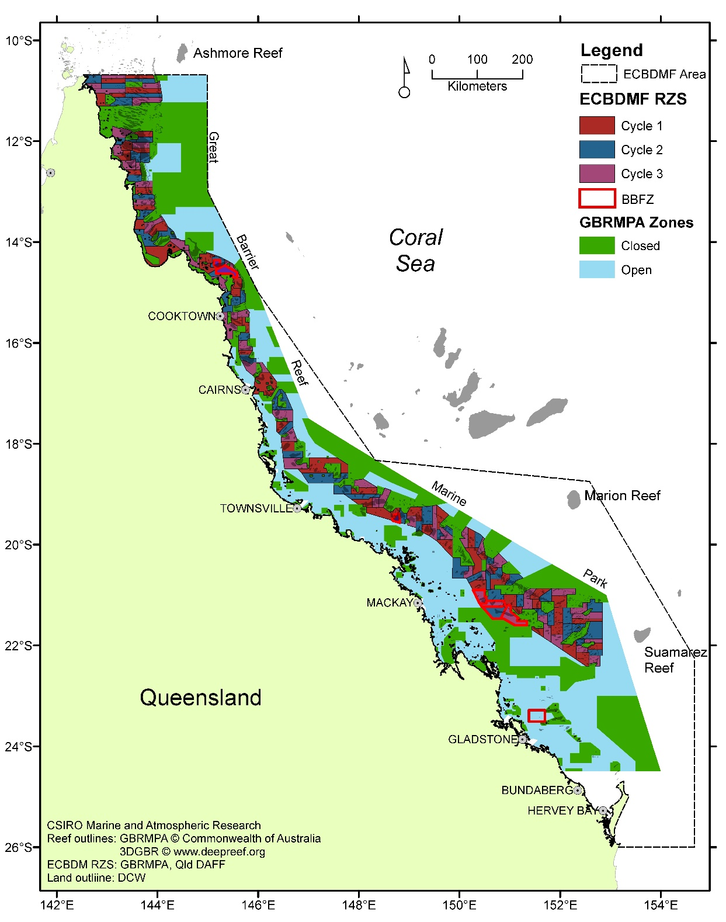

Figure . Map of the QSCF showing 158 Rotational Harvest Arrangement (RHA) zones (which now also include the Coral Sea reefs as sperate zones), existing Burrowing Blackfish zones (BBFZ) and 3 QSCF offshore fishing zones (Ashmore and Boot, Suamarez and Marion Reefs). The remainder of the GBRMP area is divided into open and closed zones.

An assessment of the efficacy of the RHA in 2014 indicated that there was a substantial reduction in the risk of localized depletion, higher long-term yields, and improved economic performance (Skewes et al, 2014; Plaganyi et al., 2015). However, this benefit is highly reliant on compliance with the zone catch and effort limits, and the adherence to the MSL applied to the fishery species.

The recent MSE (Wickens et al., 2024) while not specifically testing the RHA also found that the rotational harvest strategy in most cases exceeded the performance of the corresponding non-rotational management procedures with current catch and size limits, resulting in a greater average biomass even for the high TAC scenario, reinforcing the benefits of the RHS.

### Harvest strategy

The QSCF Harvest Strategy (HS) was implemented in September 2021 (DAF, 2021b), and has a primary objective of attaining maximum economic yield (defined in the HS as target biomass level of 60% of unfished biomass for stocks harvested in the fishery). The target biomass level (B*targ*) is set at 60% of unfished biomass, at which point the HS will be considered as meeting its fishery objectives, and the limit biomass level (B*lim*) is set at 20% of unfished biomass.

The HS has a tiered structure, with three species as Tier 1 target species: Black teatfish, White teatfish, and Burrowing blackfish. Their management includes performance indicators relative to biomass reference points produced by stock assessments, and reactive trigger points that reduce fishing pressure as necessary. The decision rules for setting a sustainable harvest for Tier 1 species are based on a ‘hockey stick’ approach where the total allowable catch (TAC) is set based on a linear relationship between B*lim*, where the level of fishing mortality is equal to zero, and B*targ*, where the exploitation rate and TAC are set to achieve the maximum economic yield. As such, estimating the exploitable biomass level for Tier 1 species to a high degree of confidence is greatly important for the operation of the HS (DAF, 2021b; DAWE, 2021). The current HS stipulates an “Industry survey (white teatfish)” to be carried out in 2023-24.

The remaining sea cucumber species are classed as Tier 2 species and are managed by reactive catch triggers. If the annual catch of a Tier 2 species exceeds its catch trigger level, “*then a TAC will be set to maintain the annual catches of that species at, or below, the trigger level until a further assessment can be undertaken*” (DAF, 2021b).

The HS does outline that other performance indicators for the stock (e.g. stock status, length frequency distributions, standardised commercial catch rates, total harvest etc.) will also be reviewed by the sea cucumber fishery working group to ensure that stocks are performing in a way that will achieve the target biomass – but no detail around these assessments is provided.

The 60% B0 target and 20% B0 limit level in the harvest strategy are proxy values (DAF, 2017a; 2021c) that have not been tested for sea cucumber fisheries. The limit reference level in particular may be too low to protect sea cucumber populations from “*unacceptably high risk to recruitment*” (possibly equivalent to the level of recruitment impairment; MSC, 2022) given the likelihood of “Allee” type depensation effects (caused by low fertilisation success for sea cucumbers at low densities), and the important ecological role sea cucumber play in reef ecosystems. For the Torres Strait Beche-de-mer Fishery, the Harvest Strategy uses a biomass limit of 40% unfished biomass.

Also, it is not clear if it includes the population in closed areas in the fishery, though the HS does stipulate that “*The primary performance measure will be exploitable biomass*”. However, the recent MSE (Wicken et al., 2024) states that “*the OMs represent the biomass that is vulnerable to fishing by the commercial sector as well as the biomass protected by the RAP*” (i.e. closed areas in the GBRMPA representative areas program).

### Fishery approval under the EPBC Act

The *Environment Protection and Biodiversity Conservation Act 1999* (EPBC Act) requires the Australian Government to assess the environmental performance of fisheries and promote ecologically sustainable fisheries management (DAWE, 2021; DCCEEW, 2023a). DCCEEW’s (the Department) primary role is to evaluate the environmental performance of fisheries, including:

* the strategic assessment of fisheries under Part 10 of the EPBC Act
* assessments relating to impacts on protected marine species under Part 13 and
* assessments for the purpose of export approval under Part 13A.

These assessments ensure that, over time, fisheries are managed in an ecologically sustainable way. The assessments are conducted against the 2nd edition of the Guidelines for the Ecologically Sustainable Management of Fisheries (the Guidelines), and in doing so, also consider all public comments received on the application. The Guidelines outline specific principles and objectives designed to ensure a strategic and transparent way of evaluating the ecological sustainability of fishery management arrangements.

The Departments’ assessment forms the basis for approvals granted under Parts 13 and 13A of the EPBC Act, and also forms the basis for the Australian CITES Scientific Authority’s Non-Detriment Finding for CITES species harvested in this fishery. A positive finding under this process results in the granting of a Wildlife trade operations (WTO) certificate for each species exported. In order to export Australian native animal or plant specimens and/or CITES listed specimens for commercial purposes, the specimens must come from an approved program such as a WTO.

The Department assessed an application for the QSCF in 2021 (DAF, 2021a; DAWE, 2021; DCCEEW, 2023b). Both the public submissions and DAF’s response were considered in the Department’s assessment. The assessment raised a range of issues, including changes to management strategies with the implementation of the new Harvest Strategy (HS), the appropriateness of the default limit reference point, and the efficacy of the current management regime to protect all species in the fishery from overexploitation. There was also concern about the lack of stock assessments and comprehensive and representative fishery independent surveys for other species targeted by the fishery and has recommended conditions to help further this work.

They noted that a stock assessment has been completed for White teatfish, but that uncertainty remains due to the lack of biomass surveys for this species and critical assumptions made in the stock assessment. They noted that the Harvest Strategy indicates a survey in 2023–24 that reduce this uncertainty.

They also noted that there were substantial catches of White teatfish from the offshore Coral Sea reefs of the QSCF (Ashmore and Boot Reefs, Marion Reef and Saumarez Reef) and that the CSF White teatfish does not have export approval. They noted that managers of the Coral Sea Marine Park have expressed concerns about the capacity of individual reefs in the park to sustain the levels of fishing pressure outlined in the Rotational Harvest Arrangements.

The assessment concluded that there was currently insufficient evidence at the time of a clear recovery of Black teatfish to demonstrate that ongoing harvest would not be detrimental to the stock status of the species. In this regard, there was not enough evidence to support a positive Non-Detriment Finding for Black Teatfish. Since that time, the southern GBR survey has been completed and the 2024 MSE.

Following this assessment, DCCEEW recommended that the fishery be declared an approved WTO for a period of three years until November 2024 subject to a number of conditions (a revised set of conditions were stipulated in early 2023 (DCCEEW, 2023b)). The conditions included (those relevant to teatfishspecies sustainability):

* (Condition 5) The Queensland Department of Agriculture and Fisheries must commission a Management Strategy Evaluation (MSE) to evaluate the ability of the settings contained in the 'Queensland Sea cucumber fishery HS 2021-2026' and any other legislated and enforceable management arrangements to meet the fishery's objectives of attaining maximum economic yield (defined in the HS as target biomass level of 60% of unfished biomass for stocks harvested in the fishery). The MSE must consider the risk posed to each individual species harvested in the fishery, identify information needs and make recommendations for any improvements to the management arrangements considered necessary for the management of the fishery to meet its objective.

1. The scope and Terms of Reference for this review should be developed in consultation with the Department of Climate Change, Energy, the Environment and Water.
2. The updated MSE must include all new data, including data from fishery independent surveys. The updated MSE must be published on the Queensland Department of Agriculture and Fisheries website by 30 May 2024.
3. The outcomes of the MSE must be considered as part of an implementation plan to be provided to the Department of Climate Change, Energy, the Environment and Water by 30 May 2024. The implementation plan must outline how and when any required changes to the management of the fishery will be delivered.

* (Condition 6) The Queensland Department of Agriculture and Fisheries must:

1. Undertake desktop research on the main sea cucumber species harvested in the fishery to determine biologically meaningful minimum size limits. Investigations should consider key biological parameters, for example, size at maturity. Findings of this research should be published on the Queensland Department of Agriculture and Fisheries website before the commencement of the 2022–23 fishing season.
2. Work with industry to undertake fieldwork within the fishery to determine appropriate ways to implement the minimum size limits determined through 6a. This may include the development of appropriate conversion factors to account for changes in size resulting from processing. Findings of this research should be published on the Queensland Department of Agriculture and Fisheries website before the commencement of the 2023–24 fishing season.
3. Implement minimum size limits based on work completed in 6a and 6b prior to the 2024–25 fishing season. Implementation of minimum size limits should be described in the Queensland Department of Agriculture and Fisheries application for the next Wildlife Trade Operation for this fishery.

* (Condition 9) The Queensland Department of Agriculture and Fisheries must:

1. Ensure that harvest of White Teatfish (Holothuria fuscogilva) does not exceed 53 t per season.

* (Condition 10) The Queensland Department of Agriculture and Fisheries must:

1. Report information on the species harvested from Ashmore and Boot Reefs, Marion Reef and Saumarez Reef including species harvested, amount of harvest per species and location of harvest from the Coral Sea Marine Park. This reporting must be done as part of the annual report required under Condition 4.
2. Ensure that White Teatfish (*Holothuria fuscogilva*) is not harvested from the Coral Sea Marine Park including Ashmore and Boot Reefs, Marion Reef and Saumarez Reef.

Even though the Departments assessment was that there was not sufficient information required to satisfy Objective 3 (*The fishery is conducted, in a manner that minimises the impact of fishing operations on the ecosystem generally*), they determined that significant ecological impacts were unlikely under current management arrangements, and rather than raise a specific condition, instead relied on conditions related to stock surveys and the MSE assessment to fulfill this objective.

The current export approval for the QSCF is valid until 30 November 2024, and the fishery is now due for assessment for ongoing export accreditation.

An application from Qld DAF for consideration by the department for the next export approval process was received on 12 June 2024 and is currently released for public comments (DAF, 2024). The report provides an update on the fishery and lists the implementation of any conditions or recommendations made in the previous assessment.

In the assessment, in relation to the above conditions, Qld DAF noted the following:

* Condition 5: The MSE has been completed and published (reviewed above). Qld DAF indicated that the MSE did not identify any species where management changes were required to meet the 60% biomass targets set out in the harvest strategy. But they did make a series of recommendations to address uncertainty, mostly related to key species biology.
* Condition 6: A desktop review of minimum size limits was completed and published in 2022 with the primary finding that “*Generally this desktop research found that the species-specific size limits applied in the QSCF were considerably larger than the species’ size at maturity (where data available) and the size limits applied in other fisheries. This makes the QSCF size limits, which are implemented in licence conditions, relatively precautionary from a biological perspective*”. It identified Blackfish (*A. palauensis*) and Burrowing blackfish (*A. spinea*) as priorities for size at maturity research given limited available information. The DAF assessment report states that “*No changes were recommended to the minimum size limits from this 2022 report*” and that it considers that the condition has largely been met (DAF, 2024). However, the implementation plan from mid-2023 does subsequently outline some current research on size at maturity for Burrowing blackfish, and that they would “*Review of the minimum size limits for vastus curryfish, herrmanni curryfish, black teatfish and white teatfish and develop a plan within 18 months to fill priority information gaps within the next WTO term. In particular, noting the need for growth and maturity information for vastus curryfish (maturity information is needed to inform appropriate size limits) and growth information for black teatfish, white teatfish, burrowing blackfish and herrmanni curryfish*”.
* Condition 9: The 53 t TAC for White teatfish is set legislation and has not been exceeded.
* Condition 10: No sea cucumber fishing has been recorded on any of the offshore reefs in the Coral Sea since the WTO was issued on 2 December 2021.

The recent application (DAF, 2024) will be used to assess the operation of the fishery for the purposes of Part 13 and Part 13A of the Environment Protection and Biodiversity Conservation Act 1999 (EPBC Act), this includes Australia’s obligations as a Party to the Convention on International Trade in Endangered Species of Wild Fauna and Flora (CITES). Relevant CITES non detriment findings will be considered in this process.

## History of management

The following timeline pertains to the modern fishery (Damschke, 1997; Breen, 2001; Roelofs, 2004; Helidoniotis, 2021a; 2021b).

1978: The first beche-de-mer fishing (“pilot”) permit for the Qld East Coast is issued by Queensland Department of Primary Industries (QDPI). Up to 1986, only a few (<5) fishing permits were issued annually to allow assessment of the feasibility of renewing a beche-de-mer industry on the Great Barrier Reef.

1978-79: The first surveys are carried out to establish the potential for a beche-de-mer fishery on the GBR (Harriott, 1984; 1985). It considered that, given the density, price and fishing costs, the fishery was unlikely to be viable at the time.

1983-1989: Implementation of initial GBRMP zoning schemes (Sections) resulting in approximately 5.3% no take (GBRMPA, 2003).

1987: A boom period began that saw the number of participants increased in Queensland's beche-de-mer fishery, with up to 29 permit holders (in 1991/92) on the east coast.

1991: An overall (i.e. total for all retained species) Total Allowable Commercial Catch (TAC) was set at 500 tonnes (wet gutted weight), with individual quotas assigned to licence holders in 15 (12), 25 (4) or 50 (2) tonne lots (only max 380 was ever allocated).

1991: Compulsory commercial catch logbook reporting commenced. At that time, catch and effort information is recorded on a quarterly basis.

1995: The Fisheries Regulations 1995 outlined new management arrangements for wildstock fisheries in Queensland and management was transferred to the Queensland Fisheries Management Authority (QFMA).

1995: From 1 January 1995, the east coast beche-de-mer fishery became a limited entry fishery, with 18 permits authorised, and no new permits have been granted since that time. The TAC is divided among the 18 authorities using a system of individual quotas (IQs).

1995: In October 1995, a daily logbook was introduced allowing detailed information to be recorded on daily catch, effort and location information.

1996: In July 1996, QFMA granted beche-de-mer east coast permit holders with a new authorisation: "Authority to Take Fish For Trade Or Commerce" endorsed with the fishery symbol B1.

1998: Authorities became transferable (by 2001, there were only 4 entities that owned licences, and by 2015 there were only two).

1998: The TAC was reduced to 380 t (wet gutted weight).

1998: A minimum legal size of 15cm applies to all species in the beche-de-mer fishery implemented by authority condition.

1999: A reduction in catch rates and concerns over the status of the population led to the closure of Black Teatfish in October 1999.

1999: A TAC of 127 t was introduced for White Teatfish. The subsequent TAC changes for White teatfish are shown below (and see Appendix E):

* 1999: 127 tonnes
* 2000: 158 tonnes (to compensate fishers in part for costs associated with VMS)
* 2001: 127 tonnes
* 2004: 127 tonnes (split into northern Zone 1 and southern Zone 2 at 19°S)
* 2005: 89 tonnes
* 2010: 64 tonnes
* 2011: 53 tonnes
* 2014: 53 (removal of zone catch split).

1999: VMS made mandatory in the sea cucumber fishery.

2000-2001: Twenty eight new coastal areas included in the GBRMP which increased the amount of protected reefs to 22% (GBRMPA, 2003; Breen, 2001).

2000: Fishing for sea cucumber (Sandfish in particular) in Hervey Bay and Tin Can Bay was closed due to declining catch rates.

2004: The implementation of the GBRMP Zoning in July increases areas closed to fishing to 24.2% of the fishery area and 32.3% reefs in the fishery area (including Ashmore and Boot Reefs) (GBRMPA, 2003).

2004: A rotational zoning scheme (RHA) is implemented in the fishery, due to concerns over localised depletion and the overall sustainability of the fishery.

2004: Implementation of zonal quotas for White teatfish into southern (Zone 2) and northern (Zone 1) quota zones (split at 19°S).

2004: Implementation of species-specific minimum size limits —Sandfish: 20 cm; White teatfish: 40 cm; Black teatfish: 30 cm; Prickly redfish: 50 cm; Blackfish: 20 cm; Deepwater redfish: 20 cm; Surf redfish: 25 cm; Lolly fish: 20 cm; Green fish: 20 cm; Curryfish: 35 cm; Elephant trunkfish: 40 cm; Brown sandfish: 25 cm; Leopard fish: 35 cm; Amberfish: 50 cm; all other species: 15 cm. Size limits are prescribed by condition of authority.

2007: Overall TAC reduced to 361 t landed weight (salted or par boiled and frozen). Up to this point, fishery catch and quota had been reported as wet gutted form. After an assessment of the relevance of a quota stated in wet gutted weight given the operational requirement and processing techniques for mother vessels operating in the fishery, management and industry agreed to change quota weights as landed (salted/frozen boiled) form rather than wet gutted form. As a result the TAC changed from 380 t to 361 t based on agreed weight conversion ratios (DPIF, 2008).

2008: Minimum size limits are in place for all the major species and species groups harvested in the fishery. Size limits are prescribed by condition of authority:

* Sandfish 20 cm
* White teatfish 40 cm
* Black teatfish 30 cm
* Prickly redfish 50 cm
* Blackfish 20 cm
* Deep water redfish 20 cm
* Surf redfish 25 cm
* Lollyfish 20 cm
* Greenfish 20 cm
* Curryfish 35 cm
* Elephant trunkfish 40 cm
* Brown sandfish 25 cm
* Leopard fish 35 cm
* Amberfish 50 cm
* All other species 15 cm.

2008: A performance management system (PMS) is implemented for the fishery. It includes a range of provisions to ensure the sustainability of the fishery, including implementation of Review reference points (essentially catch triggers) for all species without individual TACs that will trigger “*a clear timetable for implementation of appropriate management responses*”.

2008: Spatial TACs for Burrowing Blackfish implemented for designated zones.

2014: Removal of north/south zones, as its continued existence was increasing some costs for fishers in terms of the requirements to return to port and unload catch before crossing into the other zone (DAF, 2017b).

2019: Black teatfish reopened to fishing with a 30 t TAC.

2019: Ashmore and Boot Reefs included in the QSCF B1 Endorsement area. Before this, these reefs were fished under a Queensland Developmental licence (on a 3 year rotation) beginning in 2008-09.

2021: The Queensland sea cucumber fishery harvest strategy: 2021–2026 implemented. Species-specific individual transferable quotas (ITQ) for Black teatfish and White teatfish, and a combined ITQ for other species.

## GBRMP

Licence holders require a permit issued by the Great Barrier Reef Marine Park Authority (GBRMPA) to operate in the GBRMP. Under the current zoning plan, commercial fishing for Sea Cucumbers is prohibited in the Conservation Park, Buffer, Scientific Research, Marine National Park and Preservation Zones, covering approximately 37% of the GBRMP. Outside of these protected areas, commercial fishers may apply for permits to harvest sea cucumber in the General Use and Habitat Protection Zones.

Permits outline the areas where commercial fishing can occur, the fishing methods that can be used, and the conditions that need to be followed while operating or transiting through the park. Hard or electronic copy of approvals must be carried on board fishing vessels. Approval also requires a navigational chart showing the boundaries of the approved zones in which the approved actions are being conducted to be kept aboard or otherwise accessible.

## Management of illegal, unreported and unregulated fishing (IUU)

As with most quota-based fisheries, there is a degree of risk associated with illegal fishing, non-reporting of product (black marketing), inaccurate reports of catch weights, and/or non-compliance (Pidd and Jacobsen, 2021). In Queensland managed waters, these risks are managed through the QBFP, who continue to enforce the current regulations including adherence to spatial/temporal closures and Vessel Tracking.

On-water compliance is supported by a range of monitoring and reporting initiatives that include the use of vessel tracking, commercial catch and effort logbooks, an Automated Integrated Voice Response (AIVR) system (pre-trip, prior notices, weight notices), catch disposal records and wholesale sale dockets. This combination of measures provides a system of crosschecks that can be used to validate catch against key reference points and reduce the risk of non-compliance with the quota system.

Recreational fishing compliance is implemented and enforced by Queensland Boating and Fisheries Patrol (QBFP), an organisational unit of Fisheries Queensland. The key strategies adopted by QBFP for detecting and monitoring non-compliance are:

* intelligence and information gathering including Fishwatch (a community reporting service) and information sharing agreements with compliance partners
* patrols and inspections – random and targeted, land-based and at-sea patrols and inspections
* investigation and surveillance operations – specialist investigators manage and investigate complex and/or protracted breaches
* cooperation with other agencies – including cross decking with compliance partners, first nations sea rangers and interstate agencies to enforce Queensland fisheries legislation effectively increases field presence and the capacity for apprehending offenders in Queensland and its border regions.

IUU fishing by foreign fishing vessels (FFZ) is also a threat to the QSCF, though surveillance is likely to be relatively high (cf. CSF). Foreign IUU fishing is addressed through a National Plan of Action to Prevent, Deter and Eliminate Illegal, Unreported and Unregulated Fishing (NPOA-IUU). It involves several government agencies that cooperate to carry out aerial surveillance, sea patrols and real-time monitoring of fishing vessels.

Australia is also active at an international level promoting stronger measures to combat IUU fishing through The International Plan of Action to Prevent, Deter and Eliminate Illegal, Unreported and Unregulated Fishing (IPOA-IUU) which calls on all states to take effective measures globally, regionally and nationally to combat IUU fishing.

Despite a pulse of foreign IUU fishing in 2016 and 2017, the sustained and coordinated efforts of Australian Government agencies appears to have been successful in reducing foreign IUU activities within the QSCF area, including apprehensions and convictions of several vessel and diplomatic efforts with source countries to curtail IUU vessels in their home ports (Noriega, 2022).

## Management effectiveness (monitoring and compliance)

The collection of catch data in the QSCF is subject to a series of cross-checks and data validation using various reporting methods (i.e. Vessel tracking, pre-trip notices, commercial catch and effort logbooks, prior notices, weight notices, catch disposal records and wholesale sale dockets). While catch data is collected through the logbooks, weight notices are used to monitor quota utilisation and the catch disposal records provides an accurate representation of the species-specific weights and avenue of sale.

In summary, fishers must:

* lodge a pre-trip notice (AIVR)
* complete catch and effort logbooks
* complete the threatened, endangered and protected animal logbook
* lodge a prior report before landing for all catch to which a TACC applies (AIVR)
* complete weight notices for all catch to which a TACC applies (AIVR)
* complete catch disposal records for the disposal of all catch to which a TACC applies
* keep sale dockets for all wholesale sales for 5 years, including to businesses involved in the processing and storage of fisheries resources.

QBFP and the reporting unit detect instances of non-compliance. A number of issues were identified which affect the enforceability and effectiveness of the current management arrangements. Not all trips can be inspected, and as a result, there is a level of self-compliance about the correct weighing and reporting of catch. While this is not considered to be an issue of significance in the QSCF, the inability to monitor catch in real or near-real time remains an area of risk for most commercial fisheries operating in Queensland (Pidd and Jacobsen, 2021).

Reporting requirements for the QSCF were also reviewed as part of the harvest strategy development process. Updated reporting arrangements, which will apply from 1 September 2021 are described at 1A.-Reporting-flowcharts_v1.0_details-removed-Sea-cucumber.pdf (daf.qld.gov.au) (DAF, 2021a).

# Conclusions and recommendations

The QSCF is Australia’s largest sea cucumber fishery, with a long history. After decades of low levels of fishery related research, which has resulted in some stock depletions and criticism of the sustainability and management of the fishery (Eriksson and Byrne, 2015; Wolfe and Byrne, 2022), there have recently been stock surveys, stock assessments, and management strategy evaluations that have been useful for assessing the status of the teatfish stocks.

This report has attempted to use that information to address the key information fields relevant to formulating an NDF for Black teatfish and White teatfish in the QSCF. While the CITES does provides detailed and objective guidance for the initial listing of species in Appendices (e.g. population levels, range reduction levels, risk levels), there is less objective guidance for making an NDF. The basic criteria/principles for the formulation of an NDF are: “An export permit shall only be granted when… a Scientific Authority of the State of export has advised ***that such export will not be detrimental to the survival of that species”*** (CITES, 1973: Article IV, paragraph 2a). Furthermore, the Scientific Authority must monitor and “limit” the export… “***in order to maintain that species throughout its range at a level consistent with its role in the ecosystems in which it occurs and well above the level at which that species might become eligible for inclusion in Appendix I***” (CITES, 1973: Article IV, paragraph 3).

While appearing quite broad, the CITES NDF criteria recommended for sea cucumber fisheries are really no different from the standard criteria for assessing fisheries, but with less focus on bycatch and/or environmental impacts as would be normal under an EBFM approach, and perhaps with a lower risk tolerance than would be normally applied to assessments of stock status conventionally (e.g. see approach to risk in DAWR, 2018). This includes information showing that: the status of the stock is established and at sustainable levels; that the environmental impacts are assessed; that there is an effective management regime in place, including a working harvest strategy; and that there are effective monitoring and control mechanisms (MSC, 2022; Di Simone et al., 2021).

The information available for both species is summarized below:

***Black teatfish***

* Inherent vulnerability for Black teatfish in the QSCF is assessed as high.
* Black teatfish are a high value species and is a primary target species in the QSCF.
* They were heavily targeted in the historical fishery, and likely depleted to low levels.
* They were heavily targeted in the beginning of the modern fishery. By 1999, they were depleted to low density (>75%) in northern GBR fished reefs, and they were closed to fishing.
* Surveys in 2015 and 2021 have indicated that:
* The population on previously depleted reefs in northern GBR had recovered to near “natural/virgin” levels.
* Density is at levels where recruitment processes are unlikely to be greatly impaired. They were equivalent to or greater than reference levels for a “healthy population” as stipulated by the SPC and similar to population densities observed in the TSBDMF.
* The biomass on the GBR as of 2021 is probably at least about 4,400 t gutted weight.
* The fishery reopened in 2019 with a 30 t TAC (landed weight, equivalent to 36.4 t gutted weight), which is small (<1%) compared to the likely biomass.
* A stock assessment in 2021 found that the exploitable population was at about 40% B0 relative to 1877 but with low confidence due to parameter settings and treatment of the historical fishery depletion. It showed a very large biomass pre-fishery in 1880 and a very low productivity stock, however the impact of the fishing pulse in the late 1990s was assessed as being negligible. An external review raised several issues with the assessment.
* The 2024 MSE indicated that the Black teatfish population will recover to 60% B0 by about 2030 under current management arrangements. However, the MSE OM does not include the historical fishery, and has the stock reduced to very low levels by the modern fishery with a rapid rebound. This assessment has not been externally reviewed.
* A significant proportion of the Black teatfish population (likely ~37%) is protected in a comprehensive and representative system of closed MPAs.
* Black teatfish are managed within the HS as a Tier 1 species with a TAC of 30 t.
* The minimum legal size (30 cm) is above the size at first maturity (26 cm).
* Overall fishery operation monitoring is adequate, and compliance is likely to be high.

***White teatfish***

* Inherent vulnerability for White teatfish in the QSCF is assessed as medium-high.
* White teatfish are an important fishery species in the QSCF and have been consistently targeted for over two decades.
* Historical fishing depletion levels are unknown but are not likely to be significant.
* Current density and population size/biomass is unknown.
* A stock assessment in 2021 found that the exploitable biomass declined to roughly 56% B0 in 2003 and has fluctuated around 80% B0 since 2014. It was assessed as 76% B0 in 2021. An external review raised several issues which has not been responded to by DAF.
* The 2024 MSE indicated that White teatfish populations will be maintained at or higher than the target refence level of 60% B0 under current management arrangements, but with low confidence as there is no survey or other data available to validate this finding. This assessment has not been externally reviewed.
* A significant proportion of the population (likely >30%) is protected in a comprehensive and representative system of closed MPAs.
* White teatfish are managed within the HS as a Tier 1 species, with a TAC of 53 t. The current HS stipulates an “Industry survey (white teatfish)” to be carried out in 2023-24.
* The catch has reduced over the years from a high of about 150 t. However, the catch has fluctuated around the TAC level for over 20 years with only a slight reduction in catch rates.
* The slight decrease in CPUE for White teatfish could be cause for caution, as there are some factors that may be maintaining CPUE in the face of declining density (hyperstability).
* The RHA appears to have spread the effort and reduced the risk of depletion. However, prospecting of new White teatfish fishing grounds in deep water could undermine the RHA as it was based on shallow reef features.
* Overall fishery operation monitoring is adequate, and compliance is likely to be high.

Although it is likely that both teatfishspecies in the QSCF are currently above the level of problematic recruitment impairment (nominally the current B*lim* of 20% virgin biomass, though this requires justification – see below) the current population status for both species is uncertain – in the case of Black teatfish it is due to the impact of historical population depletion; in the case of White teatfish it is due to the lack of fishery independent biomass estimates. Given both species are primary target species in the fishery, more precise estimates of stock status (ideally in relation to the unfished biomass B0) are required. Additionally, this should be updated on a regular basis consistent with the level of risk appropriate for a CITES listed species, including the acquisition of fine scale spatial fishery dependant and/or fishery independent data suitable for assessing stock status. This should extend to management of the risk of localised depletion.

Some additional key uncertainties include species biology, especially with respect to early growth of juveniles to breeding age, local size at maturity and breeding seasonality, mortality rates of juveniles and adults; recruitment processes in fished populations; and vulnerability to climate change impacts.

## Recommendations

1. Maintain a 30 t TAC for Black teatfish pending the results of an updated stock assessment.

It is highly likely that the Black teatfish population is currently above the level of problematic recruitment impairment. Recent assessments show that the current levels of catch can rebuild the stock even if it is depleted below the target biomass level of 60% B0. In this regard, and given current estimates of the size of the Black teatfish population in the QSCF, the 30 t TAC appears to be a low risk to the overall status of the Black teatfish population in the QSCF – though an updated stock assessment would still be required to establish the status of the population with some certainty in the medium term.

It is very likely that Black teatfish was heavily depleted in the QSCF area by the historical fishery, perhaps multiple times. There are likely other approaches available to represent this early depletion in a stock assessment model that could prove more robust than what is applied in the 2021 assessment For example, in the recent QSCF Prickly redfish stock assessment (Smart et al., 2024a), a 60% historical depletion scenario showed a recovery time of about 3 decades, resulting in a full population recovery before the start of the modern fishery.

The updated stock assessment should be peer reviewed to establish its credibility. The recent review process for several other priority species in the QSCF may provide a template for a suitable review process (Smart et al. 2024c; Buckworth and Skewes, 2024).

1. Reduce the White teatfish TAC to 40 t until a stock survey and updated stock assessment and MSE justifies a higher TAC with some certainty.

The White teatfish population has been relatively heavily targeted for over 20 years, with most of the effort in the northern section of the GBR and the offshore reefs. This includes fishing in deep off-reef “paddock” features that are being mapped and fished by fishers – this has the potential to maintain catch rates by fishing unexploited populations – which in turn can result in catch rate hyperstability.

While it is still likely that the population is above the level of problematic recruitment impairment on a fishery wide basis, the lack of fishery independent stock density and biomass estimates, and unaddressed issues related to the most recent stock assessment and uncertainty in MSE outputs make the current TAC difficult to justify in regards to population status risk appropriate for a CITES listed species.

While the 2021 stock assessment and the 2024 MSE both found that the current TAC was maintaining the White teatfish population at or above the target refence level of 60% B0, and even considering other management strategies in place such as a large MSL and the likelihood of significant parts of the population being in closed areas, the uncertainty in the assessment outputs mean it is probably necessary and justified for a “discount factor” to be applied to account for this uncertainty, as per the QSCF harvest strategy – until an updated assessment and MSE with higher confidence is produced i.e. including the results of a fishery independent survey. That discount factor should probably be in the order of 25% of the current TAC.

A stock survey of White teatfish was stipulated in the HS to occur in 2023-24, and an options paper outlining several approaches has already been produced (Koopman and Knuckey, 2021b). The outputs will provide important biomass information for White teatfish for input onto updated assessment models and for setting demonstrably sustainable TACs.

As with the Black teatfish updated assessment, the updated White teatfish assessment and updated MSE should also be peer reviewed to establish its credibility.

1. Maintain the White teatfish closure on the offshore reefs.

The offshore reefs (Ashmore, Boot, Marion and Saumarez Reef) have been heavily targeted for White teatfish by QSCF and IUU fishers in the recent past that has the potential to cause localised depletion. The closure of these reefs for White teatfish should remain in place until an assessment of potential recovery is carried out, potentially using the outputs from the updated White teatfish stock assessment. Any re-opening should also consider reef level catch limits that are demonstrably sustainable for those reefs.

1. Increase the Black teatfish MSL to 33 cm.

The 2024 MSE recommended a MSL 125% the size at maturity (Wicken et al., 2024), which is a basic principle for increasing resilience and reducing risk (Purcell, 2010; Prince and Hordyk, 2019). The best estimate of size at maturity for Black teatfish is 26 cm (though collection of local information is still desirable). The current MSL for Black teatfish is 30 cm.

1. Consider a higher default B*lim* for the QSCF.

The default HS biomass limit reference point, B*lim*, is at 20% B0. This is likely to low for sea cucumber species due to potential “Allee” depensatory affects caused by low fertilisation success for sea cucumbers at low densities, but also due to their high susceptibility to overexploitation, slow recovery from overexploitation, and important ecological role sea cucumber play in reef ecosystems. For example, in the TSBDMF, the HS biomass limit reference limit is 40% B0.

1. Assess the efficacy of the current RHA for reducing the risk of localised depletion of teatfish species.

The RHA does spread the catch and reduce risk; however, it may still not be spreading effort to the extent where it achieves its full benefit. Even after the implementation of the RHS, most of the teatfish catch is caught in about 35% of potential fishery grids. The concentration of harvest needs to be assessed as to the potential for localised depletion, especially for highly targeted grids/RHA zones. In addition, the inclusion of deeper “paddock” fishery habitats for White teatfish has the potential to undermine the original zone scheme that was based on identifiable reef structures – this should also be assessed.

1. Establish accurate conversion ratios for live to processed form used in the fishery.

The QSCF reports catch and implements fishery TACs as “landed weight” and includes gutted and salted, or par-boiled and frozen forms (with product form reported in the fishery logbook and catch disposal record). In this case, all survey data will need to be expressed as fishery landed weight (gutted and salted or par-boiled and frozen) for application to fishery assessments and to formulate TACs (or vice versa). Live to gutted and salted weight conversion factors are available for both teatfish species but live to par-boiled and frozen are not.

1. Assess and manage for climate change risks.

The vulnerability of Black teatfish in particular to climate change stressors may be significant, but with considerable uncertainty, including for indirect impacts. Development of models to link climatic effects over a range of life history components and critical habitats for sea cucumber fisheries to quantify potential impacts using alternative emission scenarios will help reduce exposure to climate change risks.

1. Support research on important life history parameters.

The fisheries biology of both teatfish species, especially with respect to local size at maturity and breeding seasonality, early growth of juveniles to breeding age, and mortality rates of juveniles and adults are uncertain or unknown. Many of these life history parameters (growth, natural mortality, reproductive biology) are critical inputs into stock assessments. They also underpin assessments of species productivity and inherent vulnerability. This knowledge gap applies to many commercial sea cucumber populations and requires more research.

1. Fishery and environmental monitoring.

To account for potential impacts and uncertainty in the vulnerability of Black and White teatfish in the QSCF, regular species level and environmental monitoring is required to reduce sources of uncertainty (such as how climate affects recruitment), and to detect changes that affect the status and/or vulnerability of both species. A monitoring program of each population and related environmental parameters should be formulated and incorporated into the HS.

In addition, there is significant ecological monitoring that occurs already in the GBRMP, however this could be better synthesised to assess ecosystem impacts form sea cucumber fishing – and targeted ecosystem monitoring relevant to sea cucumber habitats should also be encouraged.

1. Standardise survey approaches.

There have been multiple surveys for Black teatfish including in 1999, 2015 and 2020 which have all used different methodologies and surveyed different areas making comparisons difficult. The only comprehensive stratified survey that appears to legitimately estimate the Black teatfish population in a region is the 2020 survey - the two other surveys (1999 and 2015) were primarily designed to illustrate differences in density between fished and unfished reefs – making them difficult to use in stock assessment models.

1. Co-ordinate management of straddling stocks in the TSBDMF and CSF.

Though QSCF reefs are likely to be relatively well connected and the fishery self-seeding to a large extent, connectivity between the QSCF and those of the TSBDMF and CSF (especially between the northern GBR and Torres Strait) is also likely to be significant, and coordinated management (e.g. HS frameworks and fishery reference points, temporal and spatial closures, size limits, rotational zone size, timing and move-on provisions) and research (life history parameters, MSE, conversion rations) among all three fisheries will help reduce risk to species in the region.

References

AFMA, 2017. Guide to AFMA’s Ecological Risk Management.

AIMS, 2023. Coral bleaching events. <https://www.aims.gov.au/research-topics/environmental-issues/coral-bleaching/coral-bleaching-events#:~:text=Mass%20bleaching%20events%20on%20the,bleaching%20events%20around%20those%20times>. Accessed 1/8/2023

Anderson, S.C., Flemming, J.M., Watson, R., Lotze, H.K., 2011. Serial exploitation of global sea cucumber fisheries: Serial exploitation of sea cucumbers. Fish and Fisheries 12, 317–339. https://doi.org/10.1111/j.1467-2979.2010.00397.x

Anon. 1946. Pearl shell, beche-de-mer and trochus industry of Northern Australia. Commonwealth of Australia, Department of Commerce and Agriculture, Commonwealth Fisheries Office, Economic Report No.1, Sydney. 105pp.

Asha, P.S., Muthiah, P., 2005. Effects of temperature, salinity and pH on larval growth, survival and development of the sea cucumber Holothuria spinifera Theel. Aquaculture 250, 823–829. https://doi.org/10.1016/j.aquaculture.2005.04.075

Babcock, R., Mundy, C., Keesing, J., Oliver, J., 1992. Predictable and unpredictable spawning events: In situ behavioural data from free-spawning coral reef invertebrates. Invertebrate Reproduction & Development 22, 213–227. https://doi.org/10.1080/07924259.1992.9672274

Barclay, K., Fabinyi, M., Kinch, J., Foale, S., 2019. Governability of High-Value Fisheries in Low-Income Contexts: a Case Study of the Sea Cucumber Fishery in Papua New Guinea. Hum Ecol 47, 381–396. https://doi.org/10.1007/s10745-019-00078-8

Beaman, R., 2010. Project 3DGBR: gbr100 High-resolution Bathymetry for the Great Barrier Reef and Coral Sea (JCU). eAtlas.dataset. https://eatlas.org.au/data/uuid/200aba6b-6fb6-443e-b84b-86b0bbdb53ac

Benzie, J.A.H., Uthicke, S., 2003. Stock size of bêche-de-mer, recruitment patterns and gene flow in black teatfish, and recovery of overfished black teatfish stocks in the Great Barrier Reef. Australian Institute of Marine Sciences, Townsville, Qld.

Breen, S., 2001. Queensland East Coast Beche-de-mer Fishery Statement of Management Arrangements.

Bruckner, A.W., Johnson, K.A., Field, J.D., 2003. Conservation strategies for sea cucumbers: Can a CITES Appendix II listing promote sustainable international trade. SPC Bêche-de-mer information Bulletin 18, 24–33.

Buccheri, E., Foellmer, M.W., Christensen, B.A., Langis, P., Ritter, S., Wolf, E., Freeman, A.S., 2019. Variation in Righting Times of Holothuria atra, Stichopus chloronotus, and Holothuria edulis in Response to Increased Seawater Temperatures on Heron Reef in the Southern GBR. Journal of Marine Sciences 2019, e6179705. https://doi.org/10.1155/2019/6179705

Buckworth, R.C., Skewes, T.D., 2024. Independent Review of Sea Cucumber Stock Assessments (Report to Fisheries Queensland, Department of Agriculture and Fisheries No. FQ24013). Sea Sense Australia Pty Ltd.

Business Queensland, 2023. Reporting requirements for commercial fishers <https://www.business.qld.gov.au/industries/farms-fishing-forestry/fisheries/reporting-requirements> (accessed 1/8/2023)

Carson, H.S., Cook, G.S., López-Duarte, P.C., Levin, L.A., 2011. Evaluating the importance of demographic connectivity in a marine metapopulation. Ecology 92, 1972–1984.

Ceccarelli, D.M., McKinnon, A.D., Andréfouët, S., Allain, V., Young, J., Gledhill, D.C., Flynn, A., Bax, N.J., Beaman, R., Borsa, P., et al., 2013. The coral sea: physical environment, ecosystem status and biodiversity assets. Adv. Mar. Biol. 66, 213–290.

Cheng, C., Wu, F., Ren, C., Jiang, X., Zhang, X., Li, X., Luo, P., Hu, C., Chen, T., 2021. Aquaculture of the tropical sea cucumber, Stichopus monotuberculatus: Induced spawning, detailed records of gonadal and embryonic development, and improvements in larval breeding by digestive enzyme supply in diet. Aquaculture 540, 736690. https://doi.org/10.1016/j.aquaculture.2021.736690

Chieu, H.D., Premachandra, H.K.A., Powell, D., Knibb, W., 2023. Genome-wide SNP analyses reveal a substantial gene flow and isolated-genetic structure of sea cucumber Holothuria leucospilota populations in Western Central Pacific. Fisheries Research 264, 106718. https://doi.org/10.1016/j.fishres.2023.106718

Choukroun, M., Harrison, H., Hoey, A., Prachett, M., 2021. Coral Sea - Coral Reef Health Project: In situ measurements of water temperature and current flow (Report to the Director of National Parks). JCU, Townsville.

CITES, 1973. Convention on International Trade in Endangered Species of Wild Fauna and Flora.

CITES, 2011. Non-detriment findings. Conf. 16.7 (Rev. CoP 17).

CITES, 2019. Consideration of proposals for amendment of appendices i and ii. Cop18 prop. 45. (Rev. 1)

Collard, M., Eeckhaut, I., Dehairs, F., Dubois, P., 2014. Acid–base physiology response to ocean acidification of two ecologically and economically important holothuroids from contrasting habitats, Holothuria scabra and Holothuria parva. Environmental Science and Pollution Research 21, 13602–13614. https://doi.org/10.1007/s11356-014-3259-z

Conand, C., 1993. Reproductive biology of the holothurians from the major communities of the New Caledonian Lagoon. Marine Biology 116, 439–450. https://doi.org/10.1007/BF00350061

Conand, C., Gamboa, R., Purcell, S. & Toral-Granda, V., 2013a. *Holothuria whitmaei*. The IUCN Red List of Threatened Species 2013: e.T180440A1630988. <http://dx.doi.org/10.2305/IUCN.UK.2013-1.RLTS.T180440A1630988.en>

Conand, C., Purcell, S. & Gamboa, R., 2013b. *Holothuria fuscogilva*. The IUCN Red List of Threatened Species 2013: e.T200715A2681354. http://dx.doi.org/10.2305/IUCN.UK.2013-1.RLTS.T200715A2681354.en

Connie 3.0. CSIRO Connectivity Interface, https://connie.csiro.au/

CSIRO-BOM, 2015. Climate Change in Australia - Projections for Australia’s NRM Regions: WetTropics Sub-Cluster. CSIRO.

DAF, 2017a. Queensland Sustainable Fisheries Strategy 2017-2027.

DAF, 2017b. spatial catch trends for White Teatfish post removal of the north-south quota boundary in 2014-15 (Report to the Department of the Environment and Energy). Queensland Department of Agriculture and Fisheries.

DAF, 2018. Ecological Risk Assessment Guidelines. Available at https://www.daf.qld.gov.au/business-priorities/fisheries/sustainable/sustainable-fisheries-strategy-overview

DAF, 2020. Sea Cucumber Fishery (East Coast). Status report for reassessment and approval under protected species and export provisions of the Environment Protection and Biodiversity Conservation Act 1999. Fisheries Queensland, Department of Agriculture and Fisheries.

DAF, 2021a. Queensland Sea Cucumber Fishery (East Coast). Status report for reassessment and approval under protected species and export provisions of the Environment Protection and Biodiversity Conservation Act 1999.

DAF, 2021b. Sea Cucumber Harvest Strategy: 2021-2026. Available at <https://www.publications.qld.gov.au/dataset/queensland-fisheries-harvest-strategies/resource/f9ec2eab-9f61-4d49-930f-6f9446102b85> (Accessed 1 June, 2023)

DAF, 2021c. Queensland Harvest Strategy Policy V 2.01 (No. FIS/2020/5464).

DAF, 2023. Evidence to inform a non-detriment finding for Black teatfish (*Holothuria whitmaei*) in the Queensland sea cucumber fishery. Fisheries Queensland, Department of Agriculture and Fisheries.

DAF, 2024. Application for assessment of the Queensland Sea Cucumber Fishery for approval under the Environment Protection and Biodiversity Conservation Act 1999. Fisheries Queensland, Department of Agriculture and Fisheries.

Damschke, S.B. (Ed.), 1997. Sea Cucumber (Beche-de-mer) Fishery Management Workshop. Brisbane 8-9 December 1997. Queensland Fisheries Management Authority, Brisbane.

DAWE, 2021. Assessment of the Queensland Sea Cucumber Fishery (East Coast). Department of Agriculture, Water and the Environment.

DAWR, 2018. Commonwealth Fisheries Harvest Strategy Policy. Department of Agriculture and Water Resources, Canberra.

DCCEEW, 2023a. Fisheries Assessments. Accessed 1/6/2023. <https://www.dcceew.gov.au/environment/marine/publications/factsheet-fisheries-assessments>

DCCEEW, 2023b. Letter outlining revised conditions for the fishery is at Attachment A.

DEH, 2004. Assessment of the Queensland East Coast Beche-de-mer Fishery.

De la Rosa Castillo, J.E., Gamboa-Álvarez, M., Ponce-Márquez, M., López-Rocha, J., 2023. Active rolling movement record of the sea cucumber Astichopus multifidus 30, 135–143.

Director of National Parks, 2018. Coral Sea Marine Park Management Plan 2018. National Parks, Canberra.

Di Simone, M., Horellou, A., Conand, C., 2021. The listing of three sea cucumber species in CITES Appendix II enters into force 2.

DPIF, 2008. Annual status report 2008 - East Coast Beche-de-mer Fishery.

Dutra, L.X.C., Sporcic, M., Murphy, N., 2021. Ecological Risk Assessment for the Effects of Fishing. Report for Torres Strait Fishery: Bêche-de-mer Fishery 2016- 2020 (Report for the Australian Fisheries Management Authority). CSIRO Oceans and Atmosphere.

Eeckhaut, I., Parmentier, E., Becker, P., Da Silva, S.G. and Jangoux, M., 2004. Parasites and biotic diseases in field and cultivated sea cucumbers. In: A. Lovatelli, C. Conand, S. Purcell, S. Uthicke, J.F. Hamel and A. Mercier (eds), Advances in sea cucumber aquaculture and management. Fisheries Technical Paper No. 463, Food and Agriculture Organization of the United Nations, Rome.

Eriksson, H., Österblom, H., Crona, B., Troell, M., Andrew, N., Wilen, J., Folke, C., 2015. Contagious exploitation of marine resources. Frontiers in Ecology and the Environment 13, 435–440. https://doi.org/10.1890/140312

Eriksson, H., Byrne, M., 2015. The sea cucumber fishery in Australia’s Great Barrier Reef Marine Park follows global patterns of serial exploitation. Fish and Fisheries 16, 329–341. https://doi.org/10.1111/faf.12059

Fabinyi, M., Barclay, K., Eriksson, H., 2017. Chinese Trader Perceptions on Sourcing and Consumption of Endangered Seafood. Frontiers in Marine Science 4. https://doi.org/10.3389/fmars.2017.00181

FAO, 2019. Report of the sixth FAO Expert Advisory Panel for the Assessment of Proposals to Amend Appendices I and II of CITES Concerning Commercially-exploited Aquatic Species, FAO Fisheries and Aquaculture Report No. 1255. FAO, Rome.

Fontoura, L., D’Agata, S., Gamoyo, M., Barneche, D.R., Luiz, O.J., Madin, E.M.P., Eggertsen, L., Maina, J.M., 2022. Protecting connectivity promotes successful biodiversity and fisheries conservation. Science 375, 336–340. <https://doi.org/10.1126/science.abg4351>

Friedman, K., Eriksson, H., Tardy, E., Pakoa, K., 2010. Management of sea cucumber stocks: patterns of vulnerability and recovery of sea cucumber stocks impacted by fishing: Management of sea cucumber stocks. Fish and Fisheries 12, 75–93. https://doi.org/10.1111/j.1467-2979.2010.00384.x

Fulton, E.A., Hobday, A.J., Pethybridge, H., Blanchard, J., Bulman, C., Cheung, W., Dutra, L., Gorton, R., Hutton, T., Lozano-Montes, H., Pecl, G., Plagányi, E.E., Villanueva, C., Zhang, X., 2018. Decadal scale projection of changes in Australian fisheries stocks under climate change (FRDC Final Report No. FRDC Project No: 2016/139). Canberra.

Fulton, E.A., van Putten, E.I., Dutra, L., Melbourne-Thomas, J., Ogier, E., Thomas, L., Rayns, N., Murphy, R., Butler, I., Ghebrezgabhier, D., Hobday, A.J., 2021. Guidance on Adaptation of Commonwealth Fisheries management to climate change (CSIRO Report for FRDC). FRDC, Hobart.

Ganter, R., 1994. The Pearl-shellers of Torres Strait: Resource Use, Development and Decline, 1860s-1960s. Melbourne University Press.

Gardner, M.G., Fitch, A.J., Li, X., 2012. Population genetic structure of Sea Cucumbers (bêche-de-mer) in northern Australia 47.

GBRF. 2022. Drones, AI and e-DNA keeping tabs on Great Barrier Reef and animal health https://www.barrierreef.org/news/news/drones-ai-and-edna-keeping-tabs-on-great-barrier-reef-and-animal-health

GBRMPA, 1998. Great Barrier Reef Features (Version 1.4) [Dataset] Great Barrier Reef Marine Park Authority. 2164DB88-FD79-449E-920F-61C37ADE634B. Retrieved from http://www.gbrmpa.gov.au/geoportal.

GBRMPA, 2003. Great Barrier Reef Marine Park Zoning Plan 2003. Great Barrier Reef Marine Park Authority.

GBRMPA, 2019. Great Barrier Reef Outlook Report 2019, Great Barrier Reef Marine Park Authority, Townsville

González-Durán, E., Hernández-Flores, A., Seijo, J.C., Cuevas-Jiménez, A., Moreno-Enriquez, A., 2018. Bioeconomics of the Allee effect in fisheries targeting sedentary resources. ICES Journal of Marine Science 75, 1362–1373. https://doi.org/10.1093/icesjms/fsy018

González-Durán, E., Hernández-Flores, Á., Headley, M.D., Canul, J.D., 2021. On the effects of temperature and pH on tropical and temperate holothurians. Conserv Physiol 9, coab092. https://doi.org/10.1093/conphys/coab092

Hammond, A.R., Meyers, L., Purcell, S.W., 2020. Not so sluggish: movement and sediment turnover of the world’s heaviest holothuroid, Thelenota anax. Mar Biol 167, 60. https://doi.org/10.1007/s00227-020-3671-5

Harriott, V.J., 1984. Census techniques, distribution, abundance and processing of large sea-cucumber species (echinodermata: holothuroidea) on the Great Barrier Reef (Report to the Great Barrier Reef Marine Park Authority). James Cook University, Townsville, Australia.

Harriott, V.J., 1985. The potential for a beche-de-mer fishery. Aust.Fish. 18–21.

Harris, P.T., Bridge, T.C.L., Beaman, R.J., Webster, J.M., Nichol, S.L., Brooke, B.P., 2013. Submerged banks in the Great Barrier Reef, Australia, greatly increase available coral reef habitat. ICES Journal of Marine Science 70, 284–293. https://doi.org/10.1093/icesjms/fss165

Helidoniotis, F., 2021a. Stock assessment of black teatfish (Holothuria whitmaei) in Queensland, Australia.

Helidoniotis, F., 2021b. Stock assessment of white teatfish (Holothuria fuscogilva) in Queensland, Australia.

Hu, C., Xu, Y., Wen, J., Zhang, L., Fan, S., Su, T., 2010. Larval development and juvenile growth of the sea cucumber Stichopus sp. (Curry fish). Aquaculture 300, 73–79. https://doi.org/10.1016/j.aquaculture.2009.09.033

Hu, C., Li, H., Xia, J., Zhang, L., Luo, P., Fan, S., Peng, P., Yang, H., Wen, J., 2013. Spawning, larval development and juvenile growth of the sea cucumber Stichopus horrens. Aquaculture 404–405, 47–54. https://doi.org/10.1016/j.aquaculture.2013.04.007

Hughes T.P., Anderson K.D., Connolly S.R., et al., 2018. Spatial and temporal patterns of mass bleaching of corals in the Anthropocene. Science 359: 80-83.

Hutchings, J.A., 2015. Thresholds for impaired species recovery. Proceedings of the Royal Society B: Biological Sciences 282, 20150654. https://doi.org/10.1098/rspb.2015.0654

IPCC, 2019. Technical Summary. The Ocean and Cryosphere in a Changing Climate: Special Report of the Intergovernmental Panel on Climate Change, 1st ed. Cambridge University Press. https://doi.org/10.1017/9781009157964

IUCN, 2023. The IUCN Red List of Threatened Species. Version 2022-2. <https://www.iucnredlist.org>

Johnson, J.E., Welch, D.J., Marshall, P.A., Day, J., Marshall, N., Steinberg, C.R., Benthuysen, J.A., Sun, C., Brodie, J., Marsh, H., Hamann, M., Simpfendorfer, C., 2018. Characterising the values and connectivity of the northeast Australia seascape: Great Barrier Reef, Torres Strait, Coral Sea and Great Sandy Strait. Report to the National Environmental Science Program. Reef and Rainforest Research Centre Limited, Cairns (81 pp).

Khalil, M., Doo, S.S., Stuhr, M., Westphal, H., 2023. Long-term physiological responses to combined ocean acidification and warming show energetic trade-offs in an asterinid starfish. Coral Reefs. https://doi.org/10.1007/s00338-023-02388-2

Knuckey, I.A., Koopman, M., 2016. Survey to estimate the biomass and recovery of Black teatfish (Holothuria whitmaei) in Zone 1 of the Queensland Sea Cucumber Fishery (East Coast). Fishwell Consulting.

Koopman, M., Knuckey, I.A., 2021a. Biomass survey of Black Teatfish in Zone 2 of the Queensland Sea Cucumber Fishery (East Coast). Fishwell Consulting.

Koopman, M., Knuckey, I., 2021b. Options to survey White Teatfish (*Holothuria fuscogilva*) in the Queensland Sea Cucumber Fishery (East Coast) (Report to the Department of Agriculture, Water and the Environment).

Koopman, M., Knuckey, I., 2023. Proposed design of a biomass survey of Prickly Redfish (*Thelenota ananas*) and Curryfish (*Stichopus herrmanni, S. vastus, and S. ocellatus*) in the Queensland Sea Cucumber Fishery (East Coast). Fishwell.

Leeworthy, G., 2007a. Survey of the burrowing blackfish (*Actinopyga spinea*) stocks on the Great Barrier Reef, Queensland, using the hip-chain transect method for underwater visual census. Gould Reef, 2004. (Research report for the Queensland Sea Cucumber Association.).

Leeworthy, G., 2007b. Survey of the burrowing blackfish (Actinopyga spinea) stocks on the Great Barrier Reef, Queensland, using the hip-chain transect method for underwater visual census. Lizard Island/Waining Reef, January 2005. (Research report for the Queensland Sea Cucumber Association.).

Lough, J.M., Anderson, K.D. and Hughes, T.P. 2018, Increasing thermal stress for tropical coral reefs: 1871– 2017, Scientific Reports 8(1): 6079.

McCook, L.J., Ayling, T., Cappo, M., Choat, J.H., Evans, R.D., De Freitas, D.M., Heupel, M., Hughes, T.P., Jones, G.P., Mapstone, B., Marsh, H., Mills, M., Molloy, F.J., Pitcher, C.R., Pressey, R.L., Russ, G.R., Sutton, S., Sweatman, H., Tobin, R., Wachenfeld, D.R., Williamson, D.H., 2010. Adaptive management of the Great Barrier Reef: A globally significant demonstration of the benefits of networks of marine reserves. Proceedings of the National Academy of Sciences 107, 18278–18285. https://doi.org/10.1073/pnas.0909335107

McInnes, K. et al., 2015, Wet Tropics Cluster Report, Climate Change in Australia Projections for Australia’s Natural Resource Management Regions: Cluster Reports, eds. Ekström, M. et al., CSIRO and Bureau of Meteorology, Australia.

Minami, Y., 2011. Breeding Trials during the Planktonic and Benthic Stages of Sea Cucumbers (Holothuria nobilis and H. scabra). Aquaculture Science 59, 393–401. <https://doi.org/10.11233/aquaculturesci.59.393>

MSC, 2022. MSC Fisheries Certification Process and Guidance v3.0. Marine Stewardship Council.

Mullins, S., 1992. The Torres Strait Beche-De-Mer Fishery: A Question of Timing. The Great Circle 14, 21–30.

Mullins, S., 1995. Torres Strait: a history of colonial occupation and culture contact, 1864-1897. Central Queensland University Press, Rockhampton, Qld.

Murphy, N., Skewes, T., Filewood, F., David, C., Seden, P., Jones, A., 2011. The recovery of the Holothuria scabra (sandfish) population on Warrior Reef, Torres Strait (CSIRO Wealth from Oceans Flagship Final Report, CSIRO, Cleveland).

Murphy, N., Skewes, T., McLeod, I., Dovers, E., Carr, S., 2012. Reef Gardens in Torres Strait-Community based management in action 2012.

Murphy, N., Plaganyi, E., Edgar, S., Salee, K., Skewes, T., 2021a. Stock survey of sea cucumbers in East Torres Strait (Final report.). CSIRO, Australia.

Murphy, N.E., Skewes, T.D., Plagányi, É.E., 2021b. Updated conversion ratios for beche-de-mer species in Torres Strait, Australia. SPC Beche-de-mer Information Bulletin #41 – March 2021 3.

NESP, 2018. Climate change in the Torres Strait: implications for fisheries and marine ecosystems (Earth Systems and Climate Change Hub Report No. 4). NESP Earth Systems and Climate Change Hub, Australia.

Noriega, R., Keller, K., Butler, I., Curtotti, R., 2022. Coral Sea Fishery: Fishery status reports 2022, in: Fishery Status Reports 2022. Australian Bureau of Agricultural and Resource Economics and Sciences, Canberra.

Pidd, A., Jacobsen, I., 2021. Level 1 Ecological Risk Assessment Queensland Sea Cucumber Fishery (East Coast). Fisheries Queensland, Brisbane.

Pitcher, C.R., Doherty, P., Arnold, P., Hooper, J., Gribble, N., et al., 2007. Seabed biodiversity on the continental shelf of the Great Barrier Reef World Heritage Area (AIMS/CSIRO/QM/QDPI CRC Reef Research Task Final Report). CSIRO Marine and Atmospheric Research, Cleveland, Qld.

Plagányi, É.E., Skewes, T.D., Dowling, N.A., Haddon, M., 2013. Risk management tools for sustainable fisheries management under changing climate: a sea cucumber example. Climatic Change 119, 181–197. https://doi.org/10.1007/s10584-012-0596-0

Plagányi, É.E., Skewes, T., Murphy, N., Pascual, R., Fischer, M., 2015. Crop rotations in the sea: Increasing returns and reducing risk of collapse in sea cucumber fisheries. Proceedings of the National Academy of Sciences 112, 6760–6765. https://doi.org/10.1073/pnas.1406689112

Prescott, J., Vogel, C., Pollock, K., Hyson, S., Oktaviani, D., Panggabean, A.S., 2013. Estimating sea cucumber abundance and exploitation rates using removal methods. Mar. Freshwater Res. 64, 599–608. https://doi.org/10.1071/MF12081

Prescott, J., Riwu, J., Prasetyo, A.P., Stacey, N., 2017. The money side of livelihoods: Economics of an unregulated small-scale Indonesian sea cucumber fishery in the Timor Sea. Marine Policy 82, 197–205. https://doi.org/10.1016/j.marpol.2017.03.033

Prince, J., and Hordyk, A., 2019. What to do when you have almost nothing: A simple quantitative prescription for managing extremely data-poor fisheries. Fish and Fisheries 20, 224–238. <https://doi.org/10.1111/faf.12335>

Purcell, S.W., Lovatelli, A., Vasconcellos, M., Ye, Y., 2010. Managing sea cucumber fisheries with an ecosystem approach, FAO fisheries and aquaculture technical paper. Food and Agriculture Organization of the United Nations, Rome.

Purcell, S.W., Mercier, A., Conand, C., Hamel, J.-F., Toral-Granda, M.V., Lovatelli, A., Uthicke, S., 2013. Sea cucumber fisheries: global analysis of stocks, management measures and drivers of overfishing: Management of sea cucumber fisheries. Fish and Fisheries 14, 34–59. https://doi.org/10.1111/j.1467-2979.2011.00443.x

Purcell, S.W., Polidoro, B.A., Hamel, J.-F., Gamboa, R.U., Mercier, A., 2014. The cost of being valuable: predictors of extinction risk in marine invertebrates exploited as luxury seafood. Proceedings of the Royal Society B: Biological Sciences 281, 20133296–20133296. https://doi.org/10.1098/rspb.2013.3296

Purcell, S.W., Conand, C., Uthicke, S., Byrne, M., 2016a. Ecological roles of exploited sea cucumbers: a review. Oceanography and Marine Biology: An Annual Review

Purcell, S.W., Lovatelli, A., González-Wangüemert, M., Solís-Marín, F.A., Samyn, Y., Conand, C., 2023a. Commercially important sea cucumbers of the world – Second edition., FAO Species Catalogue for Fishery Purposes No. 6, Rev. 1. FAO, Rome. https://doi.org/10.4060/cc5230en

Purcell, S.W., Rallings, S.L., Hammond, A.R., 2023b. Long-term home ranging in the large sea cucumber, *Holothuria fuscopunctata*. Coral Reefs. https://doi.org/10.1007/s00338-023-02413-4

Ramírez-González, J., Moity, N., Andrade-Vera, S., Reyes, H., 2020. Overexploitation and More Than a Decade of Failed Management Leads to No Recovery of the Galápagos Sea Cucumber Fishery. Frontiers in Marine Science 7.

Ramofafia, C., Battaglene, S.C., Bell, J.D., Byrne, M., 2000. Reproductive biology of the commercial sea cucumber *Holothuria fuscogilva* in the Solomon Islands. Marine Biology 136, 1045–1056. https://doi.org/10.1007/s002270000310

Ramofafia, C., Byrne, M., Battaglene, S.C., 2003. Development of three commercial sea cucumbers, *Holothuria scabra*, *H. fuscogilva* and *Actinopyga mauritiana*: larval structure and growth. Mar. Freshwater Res. 54, 657–667. https://doi.org/10.1071/mf02145

Ramofafia, C., Byrne, M., 2001. Assessment of the “tubule recruitment model” in three tropical Aspidochirote holothurians. SPC Beche-de mer Information Bulletin #15 15.

Richmond, R. 1996. The Biology and Ecology of Sea Cucumbers. In: Suggestions for the Management of Sea cucumber Resources in Micronesia: Results of the Workshop ‘A regional management plan for a sustainable Sea Cucumber Fishery for Micronesia’. R. Richmond, (Ed). University of Guam Marine Laboratory Technical Report, No. 101. pp. 7–25. Mangilao, University of Guam.

Roelofs, A., 2004. Ecological assessment of Queensland’s East Coast Beche-de-mer Fishery 48pp.

Rousselet, L., Doglioli, A.M., Maes, C., Blanke, B., Petrenko, A.A., 2016. Impacts of mesoscale activity on the water masses and circulation in the Coral Sea. Journal of Geophysical Research: Oceans 121, 7277–7289. https://doi.org/10.1002/2016JC011861

SAFS, 2023. Status of Australian fish stocks report. White Teatfish (Sea Cucumber) (2023) <https://www.fish.gov.au/report/287-White-Teatfish-(Sea-Cucumber)-2023>.

Saint-Amand, A., Lambrechts, J., Hanert, E., 2023. Biophysical models resolution affects coral connectivity estimates. Sci Rep 13, 9414. https://doi.org/10.1038/s41598-023-36158-5

Saint-Cast, F., 2008. Multiple time-scale modelling of the circulation in Torres Strait—Australia. Continental Shelf Research 28, 2214–2240. https://doi.org/10.1016/j.csr.2008.03.035

Scannella, D., Bono, G., Di Lorenzo, M., Di Maio, F., Falsone, F., Gancitano, V., Garofalo, G., Geraci, M.L., Lauria, V., Mancuso, M., Quattrocchi, F., Sardo, G., Titone, A., Vitale, S., Fiorentino, F., Massi, D., 2022. How does climate change affect a fishable resource? The case of the royal sea cucumber (Parastichopus regalis) in the central Mediterranean Sea. Frontiers in Marine Science 9.

Schneider, K., Silverman, J., Woolsey, E., Eriksson, H., Byrne, M., Caldeira, K., 2011. Potential influence of sea cucumbers on coral reef CaCO3 budget: A case study at One Tree Reef. J. Geophys. Res. 116, G04032. https://doi.org/10.1029/2011JG001755

Schneider, K., Silverman, J., Kravitz, B., Rivlin, T., Schneider-Mor, A., Barbosa, S., Byrne, M., Caldeira, K., 2013. Inorganic carbon turnover caused by digestion of carbonate sands and metabolic activity of holothurians. Estuarine, Coastal and Shelf Science 133, 217–223. https://doi.org/10.1016/j.ecss.2013.08.029

Shiell, G.R., Uthicke, S., 2006. Reproduction of the commercial sea cucumber *Holothuria whitmaei* [Holothuroidea: Aspidochirotida] in the Indian and Pacific Ocean regions of Australia. Marine Biology 148, 973–986. https://doi.org/10.1007/s00227-005-0113-3

Skewes, T., Dennis, D., Jacobs, D.R., Gordon, S.R., Taranto, T.J., Haywood, M., Pitcher, C.R., Smith, G.P., Milton, D., Poiner, I., 1999. Survey and stock size estimates of the shallow reef (0-15 m deep) and shoal area (15-50 m deep) marine resources and habitat mapping within the Timor Sea MOU74 box. Volume 1: Stock estimates and stock status.

Skewes, T., Murphy, N., McLeod, I., Dovers, E., Burridge, C., Rochester, W., 2010. Torres Strait hand collectables, 2009 survey: Sea cucumber.

Skewes, T., Plagányi, É., Murphy, N., Pascual, R., Fischer, M., 2014. Evaluating rotational harvest strategies for sea cucumber fisheries. FRDC Final Report. Canberra. 192 pp.

Skewes, T.D., 2017. Coral Sea sea cucumber catch sampling. Catch of two foreign fishing vessels, Coral Sea, February 2017. Tim Skewes Consulting, Brisbane.

Skewes, T.D., Persson, S., 2017. Coral Sea sea cucumber survey (A report for Parks Australia.). Tim Skewes Consulting.

Skewes, T., 2023a. Expert Advice for the Assessment of Australian Sea Cucumber (Thelenota) Fisheries - Queensland Sea Cucumber Fishery (East Coast) (A report for Australia’s Scientific Authority for the Convention of International Trade in Endangered Species of Wild Fauna and Flora (CITES)). Tim Skewes Consulting.

Skewes, T., 2023b. Expert Advice for the Assessment of Australian Sea Cucumber (Thelenota) Fisheries - Coral Sea Fishery (A report for Australia’s Scientific Authority for the Convention of International Trade in Endangered Species of Wild Fauna and Flora (CITES)). Tim Skewes Consulting.

Skewes, T., 2023c. Expert Advice for the Assessment of Australian Sea Cucumber (Thelenota) Fisheries - Torres Strait Beche-de-mer Fishery (A report for Australia’s Scientific Authority for the Convention of International Trade in Endangered Species of Wild Fauna and Flora (CITES)). Tim Skewes Consulting.

Skewes, T., 2023d. Expert Advice for the Assessment of Australian Sea Cucumber (Thelenota) Fisheries - National report (A report for Australia’s Scientific Authority for the Convention of International Trade in Endangered Species of Wild Fauna and Flora (CITES)). Tim Skewes Consulting.

Skillings, D.J., Bird, C.E., Toonen, R.J., 2011. Gateways to Hawai‘i: Genetic Population Structure of the Tropical Sea Cucumber *Holothuria atra*. Journal of Marine Biology 2011, 1–16. <https://doi.org/10.1155/2011/783030>

Smart, J.J., Wortmann, J., Wickens, M.E., 2024a. Stock assessment of Queensland east coast prickly redfish (*Thelenota ananas*), herrmanni curryfish (*Stichopus herrmanni*) and vastus curryfish (*Stichopus vastus*) with data to December 2023 (Technical Report). State of Queensland.

Smart, J.J., Wortmann, J., Wickens, M.E., 2024b. Stock assessment of Queensland east coast burrowing blackfish (*Actinopyga spinea*), with data to June 2023 (Technical Report). State of Queensland.

Smart, J.J., Wortmann, J., Wickens, M.E., 2024c. Response to ‘Independent Review of Sea Cucumber Stock Assessments’ (Technical Report). State of Queensland.

Smith, T., Roelofs, A., 2011. Evaluating the effectiveness of the Rotational Zoning Scheme for the Queensland East Coast Bêche-de-mer Fishery. Fisheries Queensland, the Department of Employment, Economic Development and Innovation (DEEDI).

Smiley, S. 1988. The dynamics of oogenesis and the annual ovarian cycle of *Stichopus californicus* (Echinodermata: Holothuroidea). Biol. Bull. 175:79–93.

So, J.J., Uthicke, S., Hamel, J.-F., Mercier, A., 2011. Genetic population structure in a commercial marine invertebrate with long-lived lecithotrophic larvae: *Cucumaria frondosa* (Echinodermata: Holothuroidea). Marine Biology 158, 859–870. https://doi.org/10.1007/s00227-010-1613-3

Sumner, R., 1981. A noisome business‐the trepang trade and Queensland. Journal of Australian Studies 5, 61–70. https://doi.org/10.1080/14443058109386837

Tanita, I., Sanda, T., Iwasaki, T., Ohno, K., Yoshikuni, M., 2023. Artificial rearing of Actinopyga lecanora (Holothuroidea: Holothuriida) with spawning induction using relaxin: Lecithotrophic short larval period. Aquaculture 567, 739226. https://doi.org/10.1016/j.aquaculture.2022.739226

Thomas, C.J., Lambrechts, J., Wolanski, E., Traag, V.A., Blondel, V.D., Deleersnijder, E., Hanert, E., 2014. Numerical modelling and graph theory tools to study ecological connectivity in the Great Barrier Reef. Ecological Modelling 272, 160–174. https://doi.org/10.1016/j.ecolmodel.2013.10.002

Treml, E., Ford, J., Black, K., Swearer, S., 2015. Identifying the key biophysical drivers, connectivity outcomes, and metapopulation consequences of larval dispersal in the sea. Movement Ecology 3. https://doi.org/10.1186/s40462-015-0045-6

Uthicke, S., 1999. Sediment bioturbation and impact of feeding activity of Holothuria (Halodeima) atra and Stichopus chloronotus, two sediment feeding holothurians, at Lizard Island, Great Barrier Reef. Bull. Mar. Sci. 64, 129–141.

Uthicke, S., Benzie, J.A.H., 2000. Allozyme electrophoresis indicates high gene flow between populations of *Holothuria* (Microthele) *nobilis* (Holothuroidea: Aspidochirotida) on the Great Barrier Reef. Marine Biology 137, 819–825. https://doi.org/10.1007/s002270000393

Uthicke, S., 2001. Nutrient regeneration by abundant coral reef holothurians. Journal of Experimental Marine Biology and Ecology 265, 153–170. https://doi.org/10.1016/S0022-0981(01)00329-X

Uthicke, S., Benzie, J., 2001. Restricted gene flow between *Holothuria scabra* (Echinodermata: Holothuroidea) populations along the north-east coast of Australia and the Solomon Islands. Mar. Ecol. Prog. Ser. 216, 109–117. https://doi.org/10.3354/meps216109

Uthicke, S., Benzie, J.A.H., 2003. Gene flow and population history in high dispersal marine invertebrates: mitochondrial DNA analysis of *Holothuria nobilis* (Echinodermata: Holothuroidea) populations from the Indo-Pacific. Molecular Ecology 12, 2635–2648. https://doi.org/10.1046/j.1365-294X.2003.01954.x

Uthicke, S., Welch, D., Benzie, J.A.H., 2004. Slow Growth and Lack of Recovery in Overfished Holothurians on the Great Barrier Reef: Evidence from DNA Fingerprints and Repeated Large-Scale Surveys. Conservation Biology 18, 1395–1404. https://doi.org/10.1111/j.1523-1739.2004.00309.x

Uthicke, S., Purcell, S., 2004. Preservation of genetic diversity in restocking of the sea cucumber Holothuria scabra investigated by allozyme electrophoresis. Canadian Journal of Fisheries and Aquatic Sciences 61, 519–528. https://doi.org/10.1139/f04-013

Uthicke, S., 2004. Overfishing of holothurians: lessons from the Great Barrier Reef (In Lovatelli A, Conand C, Purcell S, Uthicke S, Hamel J-F and Mercier A (eds). Advances in Sea Cucumber Aquaculture and Management No. Fisheries Technical Paper, 463). FAO, Rome.

Uthicke, S., Schaffelke, B., Byrne, M., 2009. A boom–bust phylum? Ecological and evolutionary consequences of density variations in echinoderms. Ecological Monographs 79, 3–24.

Vidal-Ramirez, F., Dove, S., 2016. Diurnal effects of Holothuria atra on seawater carbonate chemistry in a sedimentary environment. Journal of Experimental Marine Biology and Ecology 474, 156–163. https://doi.org/10.1016/j.jembe.2015.10.007

Welch, D.J. and Johnson, J.E. 2013. Assessing the vulnerability of Torres Strait fisheries and supporting habitats to climate change. Report to the Australian Fisheries Management Authority. C2O Fisheries, Australia (114pp.).

Wickens, M.E., Smart, J.J., Wortmann, J., 2024. Management strategy evaluation of the Queensland east coast sea cucumber fishery, with data to June 2023. State of Queensland, Brisbane.

Williamson, J.E., Duce, S., Joyce, K.E., Raoult, V., 2021. Putting sea cucumbers on the map: projected holothurian bioturbation rates on a coral reef scale. Coral Reefs. https://doi.org/10.1007/s00338-021-02057-2

Wolfe, K., Vidal‐Ramirez, F., Dove, S., Deaker, D., Byrne, M., 2017. Altered sediment biota and lagoon habitat carbonate dynamics due to sea cucumber bioturbation in a high-pCO2 environment. Global Change Biology 24, 465–480. https://doi.org/10.1111/gcb.13826

Wolanski, E., Lambrechts, J., Thomas, C., Deleersnijder, E., 2013. The net water circulation through Torres strait. Continental Shelf Research 64, 66–74. <https://doi.org/10.1016/j.csr.2013.05.013>

Yang, H., Bai, Y., 2015. Chapter 1 - Apostichopus japonicus in the Life of Chinese People, in: Yang, H., Hamel, J.-F., Mercier, A. (Eds.), Developments in Aquaculture and Fisheries Science. Elsevier, pp. 1–23. https://doi.org/10.1016/B978-0-12-799953-1.00001-5

Yuan, X., Shao, S., Dupont, S., Meng, L., Liu, Y., Wang, L., 2015. Impact of CO2-driven acidification on the development of the sea cucumber *Apostichopus japonicus* (Selenka) (Echinodermata: Holothuroidea). Mar Pollut Bull 95, 195–199. https://doi.org/10.1016/j.marpolbul.2015.04.021

Yuan, X., McCoy, S.J., Du, Y., Widdicombe, S., Hall-Spencer, J.M., 2018. Physiological and Behavioral Plasticity of the Sea Cucumber *Holothuria forskali* (Echinodermata, Holothuroidea) to Acidified Seawater. Frontiers in Physiology 9.

Appendix A: Marine Park maps

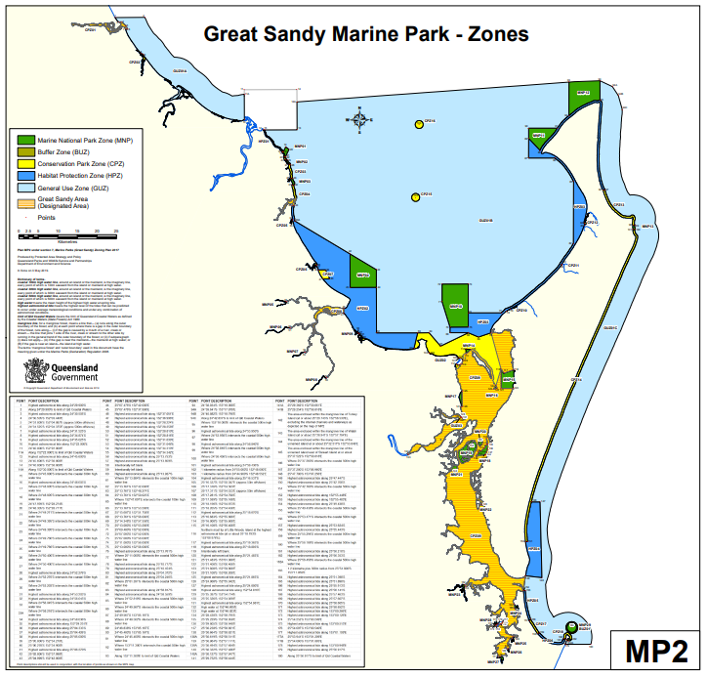

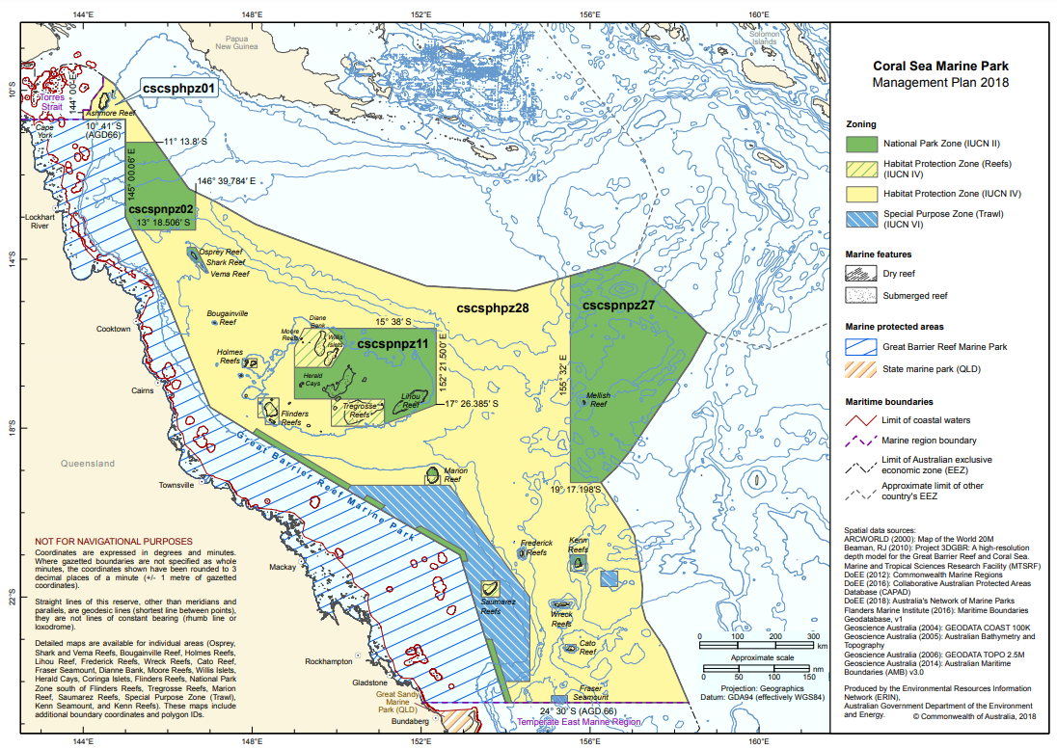

Appendix B: Current modelling outputs

Monthly average currents during winter (June) and summer (December) for 2018 to 2023.

|  |  |  |  |
| --- | --- | --- | --- |
|  | 2018 | 2019 | 2020 |
| June |  |  |  |
| December |  |  |  |

|  |  |  |  |
| --- | --- | --- | --- |
|  | 2021 | 2022 | 2023 |
| June |  |  |  |
| December |  |  |  |

Figure . Monthly average currents during winter (June) and summer (December) for 2018 to 2023. (AIMS eReefs Visualisation Portal: https://ereefs.aims.gov.au/ereefs-aims/gbr1/)

Appendix C: Catch of the QSCF

Catch for the period 20/8/1995 to 6/12/2023. Includes catches from Ashmore and Boot Reefs from 2008-09 that were added to the QSCF area in 2019.

|  |  |  |  |  |  |  |  |  |  |  |  |  |  |  |  |  |  |  |  |  |  |  |  |  |  |  |  |  |  |
| --- | --- | --- | --- | --- | --- | --- | --- | --- | --- | --- | --- | --- | --- | --- | --- | --- | --- | --- | --- | --- | --- | --- | --- | --- | --- | --- | --- | --- | --- |
| **(t)** | **1995-1996** | **1996-1997** | **1997-1998** | **1998-1999** | **1999-2000** | **2000-2001** | **2001-2002** | **2002-2003** | **2003-2004** | **2004-2005** | **2005-2006** | **2006-2007** | **2007-2008** | **2008-2009** | **2009-2010** | **2010-2011** | **2011-2012** | **2012-2013** | **2013-2014** | **2014-2015** | **2015-2016** | **2016-2017** | **2017-2018** | **2018-2019** | **2019-2020** | **2020-2021** | **2021-2022** | **2022-2023** | **Grand Total** |
| Amberfish | 0.0 | 0.0 | 0.0 | 0.0 | 0.9 | 4.2 | 3.9 | 11.2 | 0.1 | 0.0 | 0.0 | 0.0 | 0.0 | 0.0 | 0.0 | 0.0 | 0.0 | 0.6 | 0.0 | 0.0 | 0.0 | 0.0 | 0.2 | 0.0 | 0.0 | 0.0 | 0.0 | 0.0 | 21.0 |
| Black teatfish | 141.9 | 111.6 | 111.0 | 82.2 | 11.9 | 0.0 | 0.0 | 0.0 | 0.0 | 0.0 | 0.0 | 0.0 | 0.0 | 0.0 | 0.0 | 0.0 | 0.0 | 0.0 | 0.0 | 0.0 | 0.0 | 0.0 | 0.0 | 0.0 | 29.1 | 26.3 | 22.5 | 29.6 | 566.3 |
| Blackfish | 1.1 | 1.4 | 3.2 | 1.7 | 1.7 | 2.2 | 13.4 | 43.6 | 185.7 | 306.6 | 301.6 | 32.9 | 28.2 | 4.1 | 20.7 | 7.4 | 5.9 | 12.6 | 14.1 | 3.8 | 11.4 | 16.7 | 1.9 | 10.5 | 19.9 | 9.0 | 19.6 | 15.0 | 1,096.1 |
| Brown sandfish | 0.0 | 0.0 | 0.0 | 0.0 | 0.3 | 0.1 | 2.4 | 9.0 | 0.3 | 14.1 | 0.0 | 0.0 | 8.7 | 0.0 | 0.0 | 0.0 | 0.9 | 1.5 | 8.6 | 9.8 | 3.0 | 5.0 | 10.3 | 5.3 | 6.3 | 7.3 | 10.2 | 6.7 | 109.6 |
| Burrowing blackfish | 0.0 | 0.0 | 0.0 | 0.0 | 0.0 | 0.0 | 0.0 | 0.0 | 0.0 | 0.0 | 0.0 | 220.9 | 224.7 | 234.1 | 214.6 | 261.7 | 230.2 | 255.9 | 213.2 | 183.5 | 179.7 | 165.5 | 140.6 | 126.5 | 168.0 | 157.4 | 111.0 | 59.4 | 3,146.8 |
| Curryfish | 0.0 | 0.0 | 0.0 | 0.0 | 0.0 | 0.0 | 0.0 | 0.0 | 0.0 | 0.0 | 0.0 | 0.0 | 4.7 | 34.6 | 40.3 | 46.4 | 8.0 | 9.7 | 10.8 | 2.4 | 1.3 | 0.9 | 1.6 | 0.9 | 0.0 | 2.8 | 10.9 | 3.7 | 178.9 |
| Curryfish hermanni | 0.0 | 0.0 | 0.0 | 0.0 | 0.0 | 0.0 | 0.0 | 0.0 | 0.0 | 0.0 | 0.0 | 0.0 | 0.0 | 0.0 | 0.0 | 12.8 | 49.0 | 25.6 | 23.0 | 25.5 | 33.3 | 32.5 | 35.6 | 37.0 | 33.5 | 34.1 | 29.3 | 30.4 | 401.6 |
| Curryfish vastus | 0.0 | 0.0 | 0.0 | 0.0 | 0.0 | 0.0 | 0.0 | 0.0 | 0.0 | 0.0 | 0.0 | 0.0 | 0.0 | 0.0 | 0.0 | 7.9 | 12.4 | 12.0 | 12.2 | 16.1 | 16.9 | 17.5 | 18.7 | 17.9 | 19.0 | 16.0 | 13.7 | 17.1 | 197.4 |
| Deepwater blackfish | 0.0 | 0.0 | 0.0 | 1.0 | 2.1 | 0.0 | 3.3 | 18.9 | 1.7 | 0.0 | 0.0 | 0.0 | 0.0 | 0.0 | 0.0 | 0.0 | 0.0 | 0.0 | 0.0 | 0.0 | 0.0 | 0.0 | 0.0 | 0.0 | 0.0 | 0.0 | 0.0 | 0.0 | 27.0 |
| Deepwater redfish | 0.1 | 0.9 | 1.1 | 0.8 | 1.4 | 0.0 | 0.4 | 0.1 | 0.0 | 0.0 | 0.0 | 0.0 | 0.0 | 0.0 | 0.0 | 0.0 | 0.0 | 0.0 | 0.0 | 0.0 | 0.0 | 0.0 | 0.0 | 0.0 | 0.0 | 0.0 | 0.0 | 0.0 | 4.8 |
| Elephant trunkfish | 0.0 | 0.9 | 0.1 | 0.0 | 3.8 | 25.7 | 20.8 | 29.0 | 6.5 | 1.4 | 0.0 | 0.0 | 0.2 | 0.1 | 0.0 | 0.0 | 0.2 | 2.0 | 0.0 | 0.0 | 0.0 | 0.0 | 0.0 | 0.0 | 0.0 | 0.0 | 0.0 | 0.0 | 90.7 |
| Golden sandfish | 0.0 | 0.0 | 0.0 | 0.0 | 0.0 | 0.0 | 12.0 | 6.5 | 0.0 | 5.0 | 8.5 | 0.0 | 9.0 | 8.8 | 3.4 | 0.5 | 6.6 | 5.6 | 3.7 | 4.9 | 3.7 | 2.7 | 3.7 | 7.6 | 4.2 | 7.5 | 9.2 | 1.8 | 114.9 |
| Greenfish | 4.3 | 1.8 | 0.4 | 0.0 | 0.0 | 0.1 | 0.0 | 0.0 | 0.0 | 0.0 | 0.0 | 0.0 | 0.0 | 0.0 | 0.0 | 0.0 | 0.0 | 0.0 | 0.0 | 0.2 | 0.1 | 0.0 | 0.0 | 0.0 | 0.0 | 0.0 | 0.0 | 0.0 | 7.0 |
| Leopardfish | 0.5 | 0.1 | 0.0 | 0.0 | 0.1 | 1.0 | 0.0 | 0.0 | 0.0 | 0.0 | 0.0 | 0.0 | 0.0 | 0.0 | 0.1 | 0.2 | 4.4 | 2.7 | 1.3 | 3.6 | 4.5 | 1.8 | 3.1 | 2.1 | 3.5 | 5.4 | 6.9 | 6.4 | 47.4 |
| Lollyfish | 0.2 | 0.1 | 0.1 | 1.2 | 0.2 | 4.7 | 0.2 | 1.1 | 0.0 | 0.0 | 0.0 | 0.0 | 0.0 | 0.0 | 0.0 | 0.1 | 0.0 | 0.0 | 0.0 | 0.0 | 0.0 | 0.0 | 0.0 | 0.0 | 0.3 | 0.0 | 0.0 | 0.0 | 8.2 |
| Prickly redfish | 7.0 | 16.2 | 2.4 | 2.1 | 44.3 | 73.2 | 58.4 | 46.8 | 38.5 | 25.4 | 21.9 | 11.3 | 13.1 | 45.4 | 22.8 | 17.4 | 46.6 | 34.3 | 28.2 | 33.8 | 36.5 | 36.7 | 33.8 | 29.0 | 35.4 | 35.7 | 37.4 | 33.8 | 867.3 |
| Sandfish | 36.6 | 62.8 | 25.9 | 5.8 | 13.6 | 0.9 | 15.2 | 3.6 | 2.7 | 7.3 | 20.9 | 14.3 | 1.6 | 0.0 | 0.2 | 0.0 | 1.3 | 0.0 | 0.5 | 1.7 | 0.4 | 0.0 | 0.0 | 0.4 | 2.8 | 3.7 | 0.0 | 3.6 | 225.8 |
| Stonefish | 0.0 | 0.0 | 0.0 | 0.0 | 0.0 | 0.0 | 0.4 | 0.0 | 0.0 | 0.0 | 0.0 | 0.0 | 0.0 | 0.0 | 0.0 | 0.0 | 0.0 | 0.0 | 0.0 | 0.0 | 0.0 | 0.0 | 0.0 | 0.0 | 0.0 | 0.0 | 0.0 | 0.0 | 0.4 |
| Surf redfish | 0.9 | 0.8 | 1.6 | 0.8 | 0.3 | 3.5 | 14.2 | 2.5 | 0.6 | 4.6 | 0.0 | 0.0 | 0.0 | 5.5 | 0.0 | 0.1 | 0.1 | 0.0 | 0.0 | 0.0 | 0.0 | 0.0 | 0.0 | 0.0 | 0.4 | 0.1 | 0.2 | 0.4 | 36.7 |
| White teatfish | 0.7 | 8.4 | 22.0 | 113.3 | 113.7 | 150.6 | 120.1 | 123.3 | 120.9 | 73.7 | 69.7 | 46.3 | 61.3 | 61.5 | 67.4 | 60.5 | 44.6 | 50.1 | 47.6 | 45.4 | 50.5 | 52.5 | 52.4 | 49.9 | 49.4 | 51.3 | 50.2 | 51.2 | 1,808.5 |
| Unknown | 0.0 | 0.3 | 0.0 | 0.0 | 0.0 | 0.0 | 1.2 | 0.2 | 0.0 | 0.0 | 0.0 | 0.0 | 0.0 | 0.0 | 0.0 | 0.0 | 0.2 | 0.0 | 3.3 | 0.0 | 0.0 | 1.7 | 0.0 | 0.0 | 0.1 | 0.7 | 0.0 | 0.0 | 7.7 |
| **Grand Total** | **193.4** | **205.3** | **167.9** | **208.9** | **194.1** | **266.1** | **265.9** | **295.8** | **357.0** | **438.2** | **422.6** | **325.7** | **351.6** | **394.2** | **369.5** | **414.9** | **410.4** | **412.7** | **366.5** | **330.8** | **341.4** | **333.5** | **301.8** | **287.0** | **372.0** | **357.1** | **321.1** | **259.0** | **8,964.1** |

Appendix D: Logbook data treatment

**Vessel Logbooks**

The QSCF vessel logbooks begin in November 1995 and until 1999-2000, operators were required to record both weights and numbers. However, there is low confidence in the accuracy of some of the early count data as some records have the same value for weight and number – which is unlikely. The “Product description” (processed state) is also listed during that time as “Whole dead”.

From 2000-01 until about 2010-11, only numbers and processed form were required in the logbooks and the product weight is derived in the logbook database based on a conversion ratio of 1kg/piece and should not be used. From early 2011 to the end of 2013, both number and weight are often recorded - this data was requested to be collected by Qld Fisheries and GBRMPA to try and validate the Buyer returns. From 2013 weight only was usually recorded.

**Buyer Returns**

The Buyer Return logbooks started in 2000-01 and recorded the exact weights that were sold to various buyers. Exact weights are also collected by the Queensland Fisheries Quota team, however they only started up in 2006 and therefore do not have information prior to that. The Buyer Return logbook weights are regarded as generally accurate. Buyer return logbooks were superseded by a more substantial reporting framework in recent years consisting of pre-trip notifications, vessel tracking, logbooks, prior reports, weight notices, catch disposal records and wholesale sale dockets.

**Derivation of catch weights for logbook data**

Average catch weight for each species was calculated from buyer returns, for each processed state separately (excluding zeros, outliers i.e. average weight >5 kg, and product form = “cutlet” from analysis) (Table 6).

To produce catch weight for each logbook record (Final_wt):

Final_wt = RetainedWt (if entered), or where that is NULL or zero, = RetainedNumber multiplied by the average wt for that species and form (from Buyer records in Table 6); however if that is an Error (e.g where no average wt is available for that species-form combination), then use RetainedWholeWtDerived.

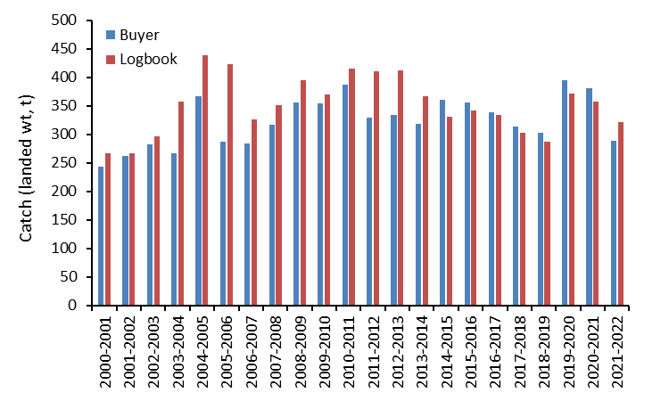

Figure . Total catch weight for years 2000-01 to 2021-22 for vessel logbook (Logbook) and Buyer returns (Buyer) data after application of Final_wt calculation (as above) to vessel logbook data.

Table . Average weights by species and product form from buyer returns, 2000-01 to 2021-22.

|  |  |  |  |
| --- | --- | --- | --- |
| **Common Name** | **Product Form** | **Average wt (kg)** | **n** |
| Amberfish | Frozen & Boiled | 1.24 | 11 |
| Amberfish | Salted | 1.50 | 10 |
| Black fish | Frozen & Boiled | 0.31 | 110 |
| Black fish | Salted | 0.69 | 397 |
| Black fish | Salted & Chilled | 0.57 | 30 |
| Black fish | Salted & Frozen | 0.69 | 12 |
| Black lolly fish | Frozen & Boiled | 1.03 | 5 |
| Black lolly fish | Salted | 0.41 | 18 |
| Black lolly fish | Salted & Chilled | 0.28 | 4 |
| Blackfish - burrowing | Frozen & Boiled | 0.19 | 251 |
| Blackfish - burrowing | Salted | 0.51 | 3 |
| Brown sandfish | Salted | 0.61 | 42 |
| Curryfish | Frozen & Boiled | 1.01 | 6 |
| Curryfish | Salted | 0.56 | 32 |
| Curryfish vastus | Salted | 0.49 | 28 |
| Elephants trunk fish | Frozen & Boiled | 1.11 | 18 |
| Elephants trunk fish | Salted | 1.19 | 107 |
| Elephants trunk fish | Salted & Chilled | 1.25 | 13 |
| Elephants trunk fish | Salted & Frozen | 1.06 | 6 |
| Golden sandfish | Frozen & Boiled | 0.36 | 19 |
| Golden sandfish | Salted | 0.65 | 55 |
| Leopardfish | Frozen & Boiled | 0.91 | 3 |
| Leopardfish | Salted | 0.61 | 28 |
| Prickly red fish | Frozen & Boiled | 1.25 | 38 |
| Prickly red fish | Salted | 1.73 | 426 |
| Prickly red fish | Salted & Chilled | 1.95 | 27 |
| Prickly red fish | Salted & Frozen | 1.85 | 7 |
| Red fish | Salted | 0.59 | 16 |
| Sand fish | Frozen & Boiled | 0.88 | 22 |
| Sand fish | Salted | 0.62 | 112 |
| Sand fish | Salted & Chilled | 0.58 | 19 |
| Stonefish | Salted | 0.43 | 33 |
| Surf red fish | Salted | 0.48 | 106 |
| White teat fish | Frozen & Boiled | 1.61 | 76 |
| White teat fish | Salted | 1.21 | 523 |
| White teat fish | Salted & Chilled | 1.27 | 36 |
| Black teatfish | Gutted weight | 0.928 | 1625 |

Note: Black teatfish average weight was obtained from vessel logbook data previous to 2000.

Note: Prickly redfish “Whole Dead” is a common product form – however the conversion ratio from Buyer data is uncertain, therefore used the average of salted and frozen and boiled weight instead (1.49 kg).

Note that the Buyer return weight data is still underestimated in some years (e.g. 2004-05 and 2005-06) due to inadequate conversion ratios for counts only data in buyer returns database (Figure 39).

**Species names**

The Logbook has two columns for species name [CAABSpeciesCommonName] and [LogCommonName] – and these have somewhat inconsistent naming conventions, including the spelling of CAAB names and the relationship between [LogCommonName] (presumably assigned by fishers) and [CAABSpeciesCommonName] (presumably applied by Qld Fisheries). Although there is no discrepancies relating to Black teatfish and White teatfish, the following naming convention was applied to the data for analysing catch using the logbook data (

Table . Species names contained in the QSCF Logbook database, the number of records for each combination, and assigned species name for analysis.

|  |  |  |  |
| --- | --- | --- | --- |
| **CAABSpeciesCommonName** | **LogCommonName** | **Total** | **Final_name** |
| [a holothurian] | Vastus Curryfish | 1903 | Curryfish vastus |
| Amberfish | Amberfish | 147 | Amberfish |
| Beche de mer - unspecified | Bdm Not Specified | 40 | Unknown |
| Black fish | Black fish | 3495 | Blackfish |
| Black fish | Blackfish | 2003 | Blackfish |
| Black fish | Palauensis Blackfish | 15 | Deepwater blackfish |
| Black lolly fish | Black lolly fish | 194 | Lollyfish |
| Black lolly fish | Deepwater black fish | 296 | Deepwater blackfish |
| Black lolly fish | Lollyfish - Black | 2 | Lollyfish |
| Black teat fish | Black teat fish | 3265 | Black teatfish |
| Blackfish - burrowing | Burrowing Black Fish | 2646 | Burrowing blackfish |
| Blackfish - burrowing | Burrowing Blackfish | 2088 | Burrowing blackfish |
| Brown sandfish | Brown sandfish | 960 | Brown sandfish |
| Curryfish | Hermanni Curryfish | 1962 | Curryfish hermanni |
| Elephants trunk fish | Elephant trunk fish | 1027 | Elephant trunkfish |
| Elephants trunk fish | Elephants Trunk Fish | 40 | Elephant trunkfish |
| Golden sandfish | Golden sandfish | 866 | Golden sandfish |
| Green fish | Green fish | 45 | Greenfish |
| Leopardfish | Leopard fish | 1703 | Leopardfish |
| Prickly red fish | Prickly red fish | 5892 | Prickly redfish |
| Red fish | Deepwater red fish | 412 | Deepwater redfish |
| Sand fish | Golden sandfish | 326 | Golden sandfish |
| Sand fish | Sand fish | 957 | Sandfish |
| sea cucumbers | Curry Fish | 37 | Curryfish |
| sea cucumbers | Curryfish | 617 | Curryfish |
| sea cucumbers | Sea cucumbers | 42 | Unknown |
| Stonefish | Stonefish | 44 | Stonefish |
| Surf red fish | Red surf fish | 594 | Surf redfish |
| Surf red fish | Surf red fish | 204 | Surf redfish |
| White teat fish | White teat fish | 7582 | White teatfish |
| White teat fish | Zone 1 white teat fish | 697 | White teatfish |
| White teat fish | Zone 2 white teat fish | 194 | White teatfish |

**Other data corrections**

2022.02.10, Seafresh – changed longitude from 143.5145 to 145.5145 and grid to G13.

Remove “Retained weight” = 5 for “Whole Dead” for Seafresh records on 2009-2010 – these were obviously in error.

**Spatial information**

Location data in Logbooks

There are several location descriptors in the Logbook data:

LocationDescription: Has various location names; reefs, RHA Zones etc – and a lot of NULLs

BDMZone: Mix of numbers (maybe white teatfish zones and burrowing blackfish zones?), RHA Zones, a few reef names etc.

Lat/Long – Derived: These are populated based on the fields that were populated directly from the logbook; e.g. if Grid was reported, LatDeriv & LongDeriv are the centroid of that Grid

GridDerived: Grid number – looks compete. Are actually derived from the lats and longs (so same as spatial join in GIS).

SiteDerived: All numbers, and quite a few NULLs

Appendix E: History of catch limits

|  |  |  |  |
| --- | --- | --- | --- |
| **YEAR** | **White Teatfish TAC (t)** | **Black Teatfish TAC (t)** | **TACC (t)** |
| 1990/91 | - | - | Open |
| 1991/92 | - | - | 500 |
| 1992/93 | - | - | 500 |
| 1993/94 | - | - | 500 |
| 1994/95 | - | - | 500 |
| 1995/96 | - | - | 500*a.* |
| 1996/97 | - | - | 500 *a.* |
| 1997/98 | - | - | 500 *a.* |
| 1998/99 | - | 188 | 380 |
| 1999/00 | 127 | 0 (Oct 1999) | 380 |
| 2000/01 | 158*b.* | 0 | 380 |
| 2001/02 | 127 | 0 | 380 |
| 2002/03 | 127 | 0 | 380 |
| 2003/04 | 127 | 0 | 380 |
| 2004/05 | 127*c* (57 t Zone1, 70 t Zone 2) | 0 | 380 |
| 2005/06 | 89 t (57 t Zone 1, 32 t Zone 2) | 0 | 380 |
| 2006/07 | 89 t (57 t Zone 1, 32 t Zone 2) | 0 | 380 |
| 2007/08 | 89 t (57 t Zone 1, 32 t Zone 2) | 0 | 361 |
| 2008/09 | 89 t (57 t Zone 1, 32 t Zone 2) | 0 | 361 |
| 2009/10 | 89 t (57 t Zone 1, 32 t Zone 2) | 0 | 361 |
| 2010/11 | 64 t (51 t Zone 1, 13 t Zone 2) | 0 | 361 |
| 2011/12 | 53 t (40 t Zone 1, 13 t Zone 2) | 0 | 361 |
| 2012/13 | 53 t (40 t Zone 1, 13 t Zone 2) | 0 | 361 |
| 2013/14 | 53 t (40 t Zone 1, 13 t Zone 2) | 0 | 361 |
| 2014/15 | 53 t*d* | 0 | 361 |
| 2015/16 | 53 t | 0 | 361 |
| 2016/17 | 53 t | 0 | 361 |
| 2017/18 | 53 t | 0 | 361 |
| 2018/19 | 53 t | 0 | 361 |
| 2019/20 | 53 t | 30 | 391*e* |
| 2020/21 | 53 t | 30 | 391 |
| 2021/22 | 53 t | 30 | 391 |
| 2022/23* | 53 t | 30 | 391 |
| 2023/24* | 53 t | 30 | 391 |

*a.* Though the TAC was 500t, only 380 t was allocated to licence holders   
*b.* For 2000/01 the former Queensland Fisheries Management Authority (QFMA) determined that a further 25% TAC of white teatfish be available (total of 158,750 tonnes) as a ‘one-off’ only to ease the transitional management arrangements following the closure of black teatfish stocks (Breen, 2001)   
*c*. Zone TACs implemented. Zone 1 is north of 19°S and Zone 2 is south.  
*d*. Zone TACs removed.   
*e.* The overall TACC was increased by 30 t due to the reopening of the closed BTF fishery.   
* Assumed.

Sources: Breen, 2001; Roelofs, 2004; DPIF, 2005; DPIF, 2008; DAF, 2017b; DAF, 2020.

|  |
| --- |
| CONTACT  Tim Skewes Consulting  m +61 0419 382 697  e timskewes@outlook.com |

