|  |
| --- |
| **Expert advice for the assessment of Australian teatfish (*Holothuria whitmaei* and *H. fuscogilva*) Fisheries: Torres Strait Beche-de-mer Fishery**  A report for Australia’s Scientific Authority for the Convention of International Trade in Endangered Species of Wild Fauna and Flora (CITES)  Timothy Skewes July 2024  The Department of Climate Change, Energy, the Environment and Water |

Citation

Skewes TD (2024) Skewes TD (2024) Expert advice for the assessment of Australian teatfish (*Holothuria whitmaei* and *H. fuscogilva*) Fisheries: Torres Strait Beche-de-mer Fishery. A Report for The Department of Climate Change, Energy, the Environment and Water. Tim Skewes Consulting, Australia.

Tim Skewes Consulting acknowledges the Traditional Owners of the lands that we live and work on across Australia and pays its respect to Elders past and present.

Copyright and disclaimer

This work is licensed under the Creative Commons Attribution 4.0 International License. To view a copy of this license, visit http://creativecommons.org/licenses/by/4.0/ or send a letter to Creative Commons, PO Box 1866, Mountain View, CA 94042, USA.



Important disclaimer

Tim Skewes Consulting advises that the information contained within are general statements based on scientific research. The information may be unsuitable to be used in any specific purpose. No actions should be made based on that information without considering expert professional, scientific and technical advice. To the extent permitted by law, Tim Skewes Consulting excludes all liability to any person for any consequences, including but not limited to all losses, damages, costs, expenses and any other compensation, arising directly or indirectly from using any information contained in this publication.

Contents

Acronyms vi

1 Background 1

1.1 The fishery 1

2 The species 7

2.1 Distribution within the TSBDMF 7

2.2 Population structure 10

2.3 Climate change 15

2.4 Inherent vulnerability 17

2.5 Ecological role 18

3 Harvest levels and trends 20

3.1 Fishery extractions 20

3.2 Black teatfish 22

3.3 White teatfish 23

3.4 IUU and any other extractions 24

4 Stock trends and stock assessments 25

4.1 Fishery independent data (surveys) 25

4.2 Stock assessments 30

4.3 Ecological Risk Assessment (ERA) 32

5 Management 33

5.1 Current management 33

5.2 History of management 35

5.3 Management of illegal, unreported and unregulated fishing (IUU) 37

5.4 Management effectiveness (monitoring and compliance) 38

6 Conclusions and recommendations 39

6.1 Recommendations 40

References 42

Appendix A: Catch data for TSBDMF 51

Appendix B: Catch data for Western Province, PNG 52

Figures

Figure 1. Area of the Torres Strait beche-de-mer Fishery (TSBDMF). Also shown is the extent of the Warrior Reef (Australian Sandfish fishery) and multispecies East Torres Strait sub-fisheries (East Torres Strait fishery) and the PNG Western Province beche-de-mer fishery (PNG fishery (WPBDMF)). 3

Figure 2. The three sea cucumber fisheries in north-east Australia. 3

Figure 3. Fishery zones utilised in the TSBDMF for catch reporting of TIB fishers and survey stratification (AFMA). Hatched zones indicate where most of the ETS catch occurs (Murphy et al., 2021a). 4

Figure 4. East Torres Strait average live coral (hard) cover from five surveys (does not include deep-reef strata) (error bars = 1 s.e.) (Murphy et al., 2021a). 5

Figure 5. East Torres Strait average soft coral cover from five surveys (does not include deep-reef strata) (error bars = 1 s.e.). (Murphy et al., 2021a). 6

Figure 6. East Torres Strait average density for Crown of thorns (*A. cf. solaris*) on shallow reefs from five surveys (error bars = 1 s.e.) (Murphy et al., 2021a). 6

Figure 7. Site density for Black teatfish for all 5 surveys carried out by CSIRO, 1995-2020 and fishery zones (Murphy et al., 2021a). 7

Figure 8. Zone and stratum average density (No. per ha) for Black teatfish in 2019/20 (Murphy et al., 2021a). 8

Figure 9. Site density for White teatfish from all 5 surveys carried out by CSIRO, 1995-2020 and fishery zones (Murphy et al., 2021a). 9

Figure 10. Zone and stratum average density (No. per ha) for White teatfish in 2019/20 (Murphy et al., 2021a). 9

Figure 11. Location after 28 days of simulated larvae released from locations where black teatfish (*Holothuria whitmaei*) were observed during reef surveys (Murphy et al., 2012). (Symbols represent different tidal release times – for an explanation, see Murphy et al., 2012). 13

Figure 12. Fish Larval Connectivity on Coral Reefs: Spatial Distribution of Sinks, Sources & Corridors (Fontoura et al., 2022) (https://www.arcgis.com/apps/dashboards/7d7167d11e4e4c4496ced8cafacb0fed) 14

Figure 13. Catch (tonnes landed wt) of the TSBDMF for 1993 to 2023 (Skewes et al., 2010; AFMA, 2023a). Note 1993-1995 and 1996-2023 are on a different scale. 21

Figure 14. Breakdown of TSBDMF catch for 1993-2009 (Top) and 2010-2023 (Bottom) (Top 10 species in catch weight only shown as individual species) (Skewes et al., 2010; AFMA, 2023a). 21

Figure 15. Catch (tonnes landed wt) of Black teatfish in the TSBDMF, 1993 to 2023 (Skewes et al. 2010 (1996 to 2002); AFMA logbooks (2004 to 2023)). 22

Figure 16. Catch (tonnes landed wt) of Black teatfish by Torres Strait fishery zone for the period 2018-2023 (Fishery TDB02 CDR data – note that location is not a compulsory field). 23

Figure 17. Catch (tonnes landed wt) of White teatfish in the TSBDMF, 1993 to 2023 (Skewes et al. 2010 (1996 to 2002); AFMA logbooks (2004 to 2023)). 23

Figure 18. Catch (tonnes landed wt) of White teatfish by Torres Strait fishery zone for the period 2018-2023 (Fishery TDB02 CDR data – note that location is not a compulsory field). 24

Figure 19. East Torres Strait (4 zone = Cumberland, Darnley, Seven Reefs and Don Cay) average (stratified) density (No. per ha) for reef stratum for Black teatfish from five surveys (error bars = 1 s.e.) (does not include deep-reef strata) (Murphy et al., 2021a). 25

Figure 20. Stock estimate in 2019/20 and catch for period 2018-2022 for each fishery zone for Black teatfish (Murphy et al., 2021a; Fishery TDB02 CDR data – note that location is not a compulsory field). 26

Figure 21. Comparison of density estimates for Black teatfish (*H. whitmaei*) in preferred habitat from various studies/regions (see text for detail). Torres Strait mid and outer shelf reef “reef-top buffer” (a 200 m wide buffer around the inside of the reef margin) (Murphy et al., 2021a). GBR (northern section) open and closed density of “suitable reeftop habitat” (Benzie and Uthicke, 2003). GBR (northern section) “reef top buffer” for midshelf and outer barrier reefs (Knuckey and Koopman, 2016). FAO “natural density” in “suitable habitat” (Kinch et al., 2008). Guidance “rule of thumb” regional reference densities for Black teatfish (Pakoa et al., 2014). “Natural” density for Black teatfish in Western Australia in “habitats occupied by Black teatfish” for Ningaloo Reef (Shiell and Knott, 2010). (After Murphy et al., 2021a) 28

Figure 22. East Torres Strait (4 zone = Cumberland, Darnley, Seven Reefs and Don Cay) average (stratified) density (No. per ha) for reef stratum for White teatfish from five surveys (error bars = 1 s.e.) (does not include deep-reef strata) (Murphy et al., 2021a). 29

Figure 23. Stock estimate in 2019/20 and catch for period 2018-2022 for each fishery zone for White teatfish (Murphy et al., 2021a; Fishery TDB02 CDR data – note that location is not a compulsory field). 30

Tables

Table 1. Stock estimate for Black teatfish in 2019/20. For each Zone and for East Torres Strait (ETS), the number of sites, stratified mean density (No. per ha), stratified variance, population stock estimate in numbers (n), live weight and landed (wet gutted) weight; and for all ETS, the bootstrapped lower 90th percentile of the landed (wet gutted) weight (B), and the lower 90th percentile of B greater than minimum size limit (MSL) (GNE = Great North East, ETS = East Torres Strait) (Murphy et al., 2021a). 26

Table 2. Stock estimate for White teatfish in 2019/20. For each Zone and for East Torres Strait (ETS), the number of sites, stratified mean density (No. per ha), stratified variance, population stock estimate in numbers (n), live weight and landed (wet gutted) weight; and for all ETS, the bootstrapped lower 90th percentile of the landed (wet gutted) weight (B), and the lower 90th percentile of B greater than minimum size limit (MSL) (GNE = Great North East, ETS = East Torres Strait) (Murphy et al., 2021a). 29

Table 3 Biological stock status of sea cucumber stocks in the CSF, as Fishing mortality status (is it being overfished or not); and Biomass status (is it overfished or not). For the target species: Black teatfish and White teatfish for the period 2017 to 2022. Source: ABARES Fishery status reports 2018-2022. Source: ABARES Fishery status reports 2018-2022 (see Butler et al., 2023 and previous). 31

Table 4. Catch of sea cucumbers in the TSBDMF in tons landed (gutted) weight per year. 51

Table 5. Catch of sea cucumbers in the PNG Western Province Fishery in tons landed (gutted) weight per year. 52

Acronyms

|  |  |
| --- | --- |
| AFMA | Australian Fisheries Management Authority |
| ABARES | Australian Bureau of Agricultural and Resource Economics and Sciences |
| B0 | Virgin biomass |
| BLIM | The biomass level beyond which the risk to the stock is regarded as unacceptably high (often related to PRI). |
| BTARG | The desired status of stocks |
| CITES | Convention on International Trade in Endangered Species of Wild Fauna and Flora |
| CDR | Catch Disposal Record. A mandatory catch record for receivers of TIB fisher product. |
| CSF | Coral Sea Fishery |
| CSIRO | Commonwealth Scientific and Industrial Research Organisation |
| EPBC Act | Environment Protection and Biodiversity Conservation Act 1999, including any Act amending, repealing or replacing the Act. |
| ETS | east Torres Strait |
| GBR | Great Barrier Reef |
| HS | Harvest strategy |
| IPA | Indigenous Protected areas |
| IUCN | International Union for the Conservation of Nature. |
| IUU | Illegal, unreported and unregulated fishing |
| Landed wt | Fishery catch and catch limits are reported as landed weight. In the TSBDMF, landed weight is in wet gutted product form. |
| LRP | Limit Reference Point – a reference point that equates to the population at BLIM |
| MSC | Marine Stewardship Council |
| MSL | Minimum Size Limit |
| MSY | Maximum Sustainable Yield |
| NDF | CITES Non-detriment finding |
| PRI | Point at recruitment impairment |
| PNG | Papua New Guinea |
| PZJA | Protected Zone Joint Authority |
| QSCF | Queensland Sea Cucumber Fishery (East Coast) |
| SICA | Scale Intensity Consequence Analysis |
| TIB | Traditional Inhabitant Boat (a type of fishing licence in Torres Strait) |
| TSBDMF | Torres Strait Beche-de-mer Fishery |
| WPBDMF | Western Province Beche-de-mer Fishery, Papua New Guinea |
| WTO | Wildlife Trade Operation |

# Background

Sea cucumbers have been harvested for centuries to supply the Chinese market (Yang and Bai, 2015). After a virtual hiatus of over three decades following the second world war, global sea cucumber fisheries rapidly re-emerged from about 1980 in response to increasing demand from a resurgent China (Anderson et al., 2011; Eriksson et al., 2015; Fabinyi et al., 2017). This early expansion phase was often poorly regulated and many sea cucumber fisheries were overexploited (Purcell et al., 2013), especially in developing countries (Barclay et al., 2019) and for high value species (Purcell et al., 2014).

High demand, rapid and largely unregulated expansion and easy access has resulted in 16 species being listed as globally threatened (Vulnerable or Endangered; IUCN, 2023), many of them being the larger, valuable and highly targeted species (Purcell et al., 2014), including the (Pacific) Black teatfish (*Holothuria whitmaei*) which is listed by the IUCN as Endangered (Conand et al., 2013a); and White teatfish (*Holothuria fuscogilva*) which is listed as Vulnerable (Conand et al., 2013b). Subsequently, three species belonging to the subgenus *Holothuria (Microthele)*: White teatfish (*Holothuria (Microthele) fuscogilva*), (Indian Ocean) Black teatfish (*Holothuria (Microthele) nobilis*); and (Pacific) Black teatfish (*Holothuria (Microthele) whitmaei*) were listed on Appendix II of CITES in June 2019 (CITES, 2019).

With the listing of species in Appendix II of CITES, member countries, of which Australia is one, must carry out a non-detriment finding (NDF) for any listed species before it can be exported. This is based on the principle that: “An export permit shall only be granted when… a Scientific Authority of the State of export has advised ***that such export will not be detrimental to the survival of that species”*** (CITES, 1973: Article IV, paragraph 2a). Furthermore, the Scientific Authority must monitor and “limit” the export… “***in order to maintain that species throughout its range at a level consistent with its role in the ecosystems in which it occurs and well above the level at which that species might become eligible for inclusion in Appendix I***” (CITES, 1973: Article IV, paragraph 3).

Australia has several sea cucumber fisheries in State and Commonwealth waters across northern Australia, including in the Torres Strait between Cape York and the southern Papua New Guinea coastline, the Torres Strait beche-de-mer fishery (TSBDMF). This fishery mirrors sea cucumber fisheries globally in that it is primarily focussed on exporting dried sea cucumber product (beche-de-mer) to meet demand from China. It is fished by local traditional inhabitants and is relatively small scale and multispecies in nature.

This report sets out to provide information that may be suitable for addressing the information requirements of an NDF for Black teatfish and White teatfish in the TSBDMF. Most of the information was sourced from published scientific papers and reports, and on fishery assessment and synthesis reports by the State and Commonwealth fishery management agencies. Fishery commercial docketbook data (primarily from island based Traditional fishers and from non-traditional inhabitant operators prior to 2014), catch disposal records (CDR – compulsory from 2017) and fishery logbook data up to August 2023 was supplied by the Australian Fisheries Management Authority (AFMA). The data were used to characterise spatial fishing effort for teatfish species, and to calculate total annual harvests. For a more detailed description of all data holdings, see Appendix A.

## The fishery

Sea cucumbers have been fished in Torres Strait since about 1863, when the first Sydney-based beche-de-mer fishing ventures descended *en masse* on Torres Strait, as part of a broader western Pacific maritime trade, exporting a range of products directly to China and nearby ports (Mullins, 1992; 1995); bringing with them rapid and permanent change to Torres Strait economy and society (Ganter, 1990). This early phase of the fishery lasted until about the second world war (Uthicke, 2004).

The (modern) TSBDMF began in about 1990 and occurs in a 45,700 km2 area of the Australian EEZ within the Australian jurisdiction area of the Torres Strait (Zenadth Kes), the sea strait between Australia and Papua New Guinea (PNG) (). The fishery boundary extends from 100 km west of Thursday Island to the outer Great Barrier Reef 250 km to the east, and from Cape York in the south to the northern extent of the Australian EEZ.

The adjacent northern area of Torres Strait is Papua New Guinea’s (PNG) Western Province Beche-de-mer Fishery (WPBDMF) (). The Queensland Sea Cucumber Fishery (East Coast) (QSCF) is adjacent to its southern border, and the Coral Sea fishery (CSF) is 70 km to the east of its eastern extent (). Ashmore and Boot reefs, which sit just outside its eastern boundary are fished by Qld based fishers under a Queensland Fishing Permit.

The management of the TSBDMF is the responsibility of the Protected Zone Joint Authority (PZJA) - a body set up to manage Australian fisheries under the Torres Strait Treaty - an agreement between Australia and Papua New Guinea. The treaty defines the border between Australia and Papua New Guinea and provides a framework for the management of the common border area - the Torres Strait Protected Zone (TSPZ). The treaty was primarily designed to protect the traditional ways of life of Traditional Inhabitants in the area. It also includes arrangements for the sharing of commercial catch for straddling stocks – known as “Article 22” fisheries. Although being a straddling stock (for some species at least, e.g. Sandfish), sea cucumber was not included as an Article 22 fishery (probably as it was not active at the time), therefore catch sharing agreements are not required. The TSBDMF includes waters within the TSPZ, and an area ‘outside but near’ the TSPZ, as declared under the *Torres Strait Fisheries Act 1984* ().

The PZJA comprises the relevant Commonwealth and Queensland government ministers and the Chair of the Torres Strait Regional Authority (TSRA), which is the Commonwealth agency established under the *Aboriginal and Torres Strait Islander Act 2005* that represents the interests of Torres Strait Islanders. The PZJA is supported by several government agencies. However the Australian Fisheries Management Authority (AFMA) provides the bulk of management and advisory services and implements appropriate fisheries management arrangements for the fishery (see Management section below).

Currently, access to the fishery is limited to Torres Strait Traditional Inhabitants. In 2022 there were 160 Traditional Inhabitant Boats licences with an endorsement to fish for sea cucumbers (42 of which recorded catch) (Butler et al., 2023). Fishers are almost exclusively island based, and sea cucumbers are collected by hand while freediving from small dinghies, or reef-top walking, which limits most fishing effort to a depth of approximately 15 m (AFMA, 2023a; Butler et al., 2023). Underwater breathing apparatus are currently banned.

The socio-economic characteristics of the fishery are not well understood, and probably vary markedly over time with trends in species availability, price and market forces (e.g. Banister, 2020). The current fishery activity is primarily based on about 5-6 dedicated fishing operations employing 2-8 islanders each that fish a variety of species throughout the year, mostly on the Mer, Erub and Masig communities. A further 30-60 fishers participate at various times throughout the year and during the brief (~4 day) Black teatfish opening (Hand Collectables Working Group (HCWG) fisher reports contained in minutes; fisher interviews, pers comm.; AFMA, unpublished data; Butler et al., 2023).

Sea cucumbers are usually partially processed to salting stage and then shipped to southern processors for final processing to beche-de-mer. However, there are some limited operations processing to dried beche-de-mer product also occurring in Torres Strait, especially for Curryfish, which do not transport as partially processed product easily. Fishers sell to buyers in southern centres including Cairns, Brisbane, Hervey Bay and Melbourne, who then predominantly export to the Asian markets, with minimal supply to the domestic market (AFMA, 2023a; Butler et al., 2023). Buyers are selected on price and personal relationships (fisher interviews, pers comm.). Future developments may include central processing, branding, and marketing in Torres Strait facilitated by regional fishery industry bodies such as Zenadth Kes Fisheries, with potentially direct export to overseas markets.

Though estimates of net economic returns for the TSBDMF are scant, for Torres Strait Islanders, the TSBDMF is considered an important local commercial fishery where employment opportunities may be limited (Plaganyi et al., 2020). Gross value of production (GVP) of the TSBDMF was an estimated $0.62 million in 2022, so future data are required to understand economic trends for the fishery (Butler et al., 2023).

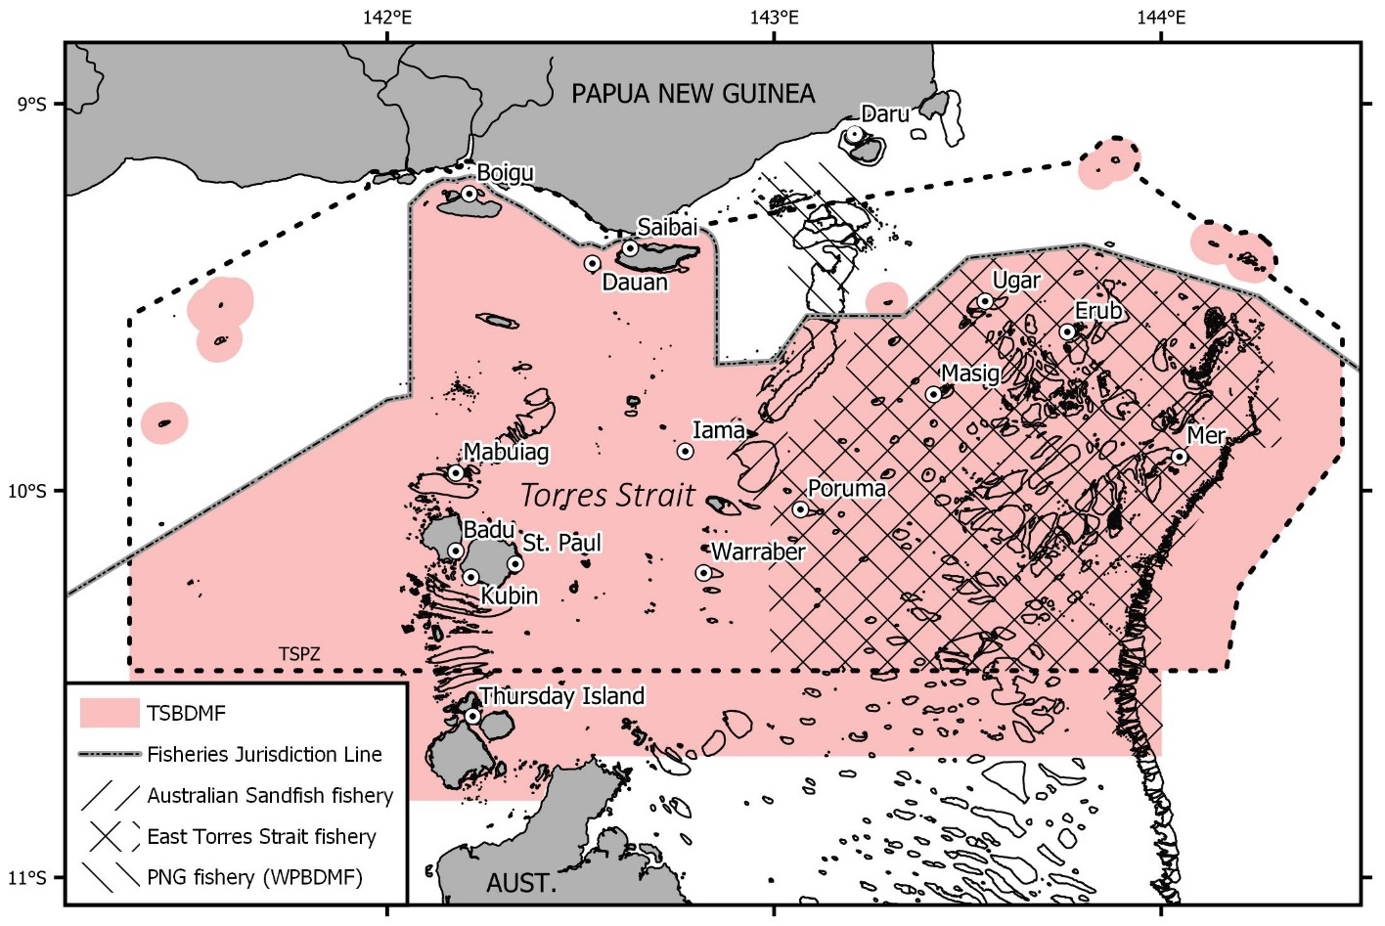

Figure . Area of the Torres Strait beche-de-mer Fishery (TSBDMF). Also shown is the extent of the Warrior Reef (Australian Sandfish fishery) and multispecies East Torres Strait sub-fisheries (East Torres Strait fishery) and the PNG Western Province beche-de-mer fishery (PNG fishery (WPBDMF)).

Figure . The three sea cucumber fisheries in north-east Australia.

For the purposes of fishery management, monitoring and research, Torres Strait is divided into 20 fishery zones based on available physiographic characteristics of the fishery habitats (Figure 3) (Skewes et al., 2004; AFMA, 2023a). Traditional Inhabitant Boat (TIB) catch is recorded using this spatial designation (though reporting levels are patchy), and surveys are stratified and reported using the same arrangement.

While the fishery boundaries are as described above, the TSBDMF is at times divided into two main fishing regions – the Sandfish fishery on Warrior Reef, and the multispecies east Torres Strait (ETS) fishery that extends from east of Warrior Reef to the eastern extent of the GBR (). Commercial sea cucumbers are rare west of Warrior Reef for reasons that are not well understood (Long et al., 1996; Haywood et al., 2007).

Fishery habitat for commercial species in Torres Strait is primarily restricted to reefs – very few commercial species are found in the inter-reefal areas throughout Torres Strait, apart from Dragonfish (*S. horrens*), a commercial but not currently targeted species (Pitcher et al., 2007; Murphy et al., 2021a).

The total area of shallow reefs in the TSBDMF is 240,300 ha, of which 138,800 ha is in the ETS sub-fishery area (Murphy et al., 2021a). There is also 110,400 ha of deep (>20 m) reef habitat in the TSBDMF (this includes the deep outer reef edge (>20 m) to the bottom of the reef slope where it raises off the sea floor, and the deep-reef lagoon (Lawrey and Stewart, 2016; Murphy et al., 2021a)) of which 62,200 ha is in the ETS sub-fishery area (Murphy et al., 2021a).

This compares to 166,319 ha of shallow (< 20 m deep) reef habitat in the CSF and 2.6M ha of shallow reef habitat in the QSCF (GBRMPA; Beaman et al., 2010; Skewes et al., 2014) (Figure 2). The deep reef habitat area compares to 1.11M ha of deep reef (20-70 m) habitat in the CSF area, and 23.2M ha of “shelf” habitat for the QSCF (GBRMPA; Skewes et al., 2014).

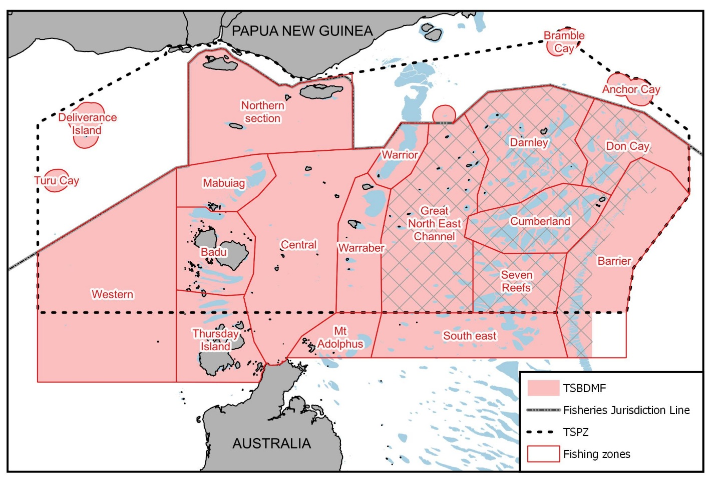

Figure . Fishery zones utilised in the TSBDMF for catch reporting of TIB fishers and survey stratification (AFMA). Hatched zones indicate where most of the ETS catch occurs (Murphy et al., 2021a).

### Biophysical research

There is no regular reporting on the health of Torres Strait reefs (despite their importance to fisheries and local communities) (Johnson et al., 2015). Some limited surveys have been carried out by AIMS (Osborne et al., 2013), and some reef health parameters (e.g. coral cover) are collected during CSIRO sea cucumber surveys (Murphy et al., 2021a).

Although it can be considered an extension of the northern GBR, Torres Strait is also unique due to the influence of the flow-through between the Arafura Sea and Coral Sea, and because of the influence of large riverine outflows from southern PNG rivers (e.g. Fly River). These result in strong physical gradients across Torres Strait related to the proximity to the PNG river systems, average sea floor depth, current bottom stress, wave exposure and the influence of waters of the Coral Sea and Gulf of Carpentaria (Pitcher et al., 2007; Haywood et al., 2007; Johnson et al., 2015).

The AIMS surveys (Osborne et al., 2013) found that there were two major types of reef community: the Central and Eastern groups. They found that the benthic and demersal fish communities of the central group reefs were similar to shallow inshore reefs of the GBR. They concluded that, while coral reefs in the Torres Strait are less frequently affected by cyclone damage than those of the GBR, other threats such as crown-of-thorns starfish outbreaks, coral bleaching and disease are present (Osborne et al., 2013).

The CSIRO surveys (Murphy et al., 2021a) found that hard () and soft () coral on the shallow reefs had declined since 2002, with hard coral declining by 63% from 2009 to 2019/20, possibly the result of widespread coral bleaching in the region in 2010 (Bainbridge and Berkelmans, 2014) and 2016 (Wolanski et el., 2017).

There was also a documented crown of thorns (*Acanthaster cf. solaris*) outbreak in 2009 (Murphy et al., 2011b), that had then decreased to previous low levels by 2019 (Figure 6) (Murphy et al., 2021a).

Figure . East Torres Strait average live coral (hard) cover from five surveys (does not include deep-reef strata) (error bars = 1 s.e.) (Murphy et al., 2021a).

Figure . East Torres Strait average soft coral cover from five surveys (does not include deep-reef strata) (error bars = 1 s.e.). (Murphy et al., 2021a).

Figure . East Torres Strait average density for Crown of thorns (*A. cf. solaris*) on shallow reefs from five surveys (error bars = 1 s.e.) (Murphy et al., 2021a).

# The species

## Distribution within the TSBDMF

### Black teatfish

Black teatfish is widely distributed in east Torres Strait (ETS), but has its highest densities in the eastern and north-eastern fishery zones () (Murphy et al., 2021a) – being found especially in the Barrier and Don Cay zones (; ). They were rarely seen in PNG reef surveys carried out in 1995/96 (; Long et al., 1996).

Black teatfish are found in all shallow (<20 m) reef habitats, but has its highest density in the reef top buffer habitat, an area of reef top 200 m inside the reef crest () (Murphy et al., 2021a). It is not found in the deep (>20 m) reef (Murphy et al., 2021a) or inter-reefal habitats of Torres Strait (Pitcher et al., 2007). This distribution pattern is consistent with previous surveys in Torres Strait (Skewes et al., 2010) and also on the adjacent northern GBR (Benzie and Uthicke, 2003; Knuckey and Koopman, 2016).

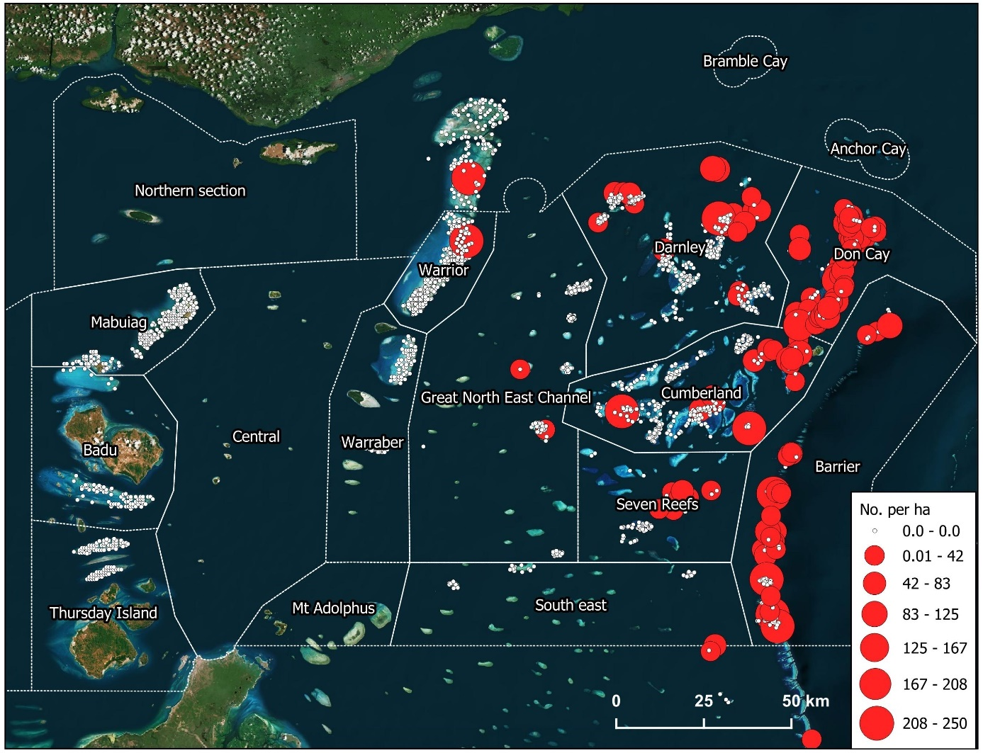

Figure . Site density for Black teatfish for all 5 surveys carried out by CSIRO, 1995-2020 and fishery zones (Murphy et al., 2021a).

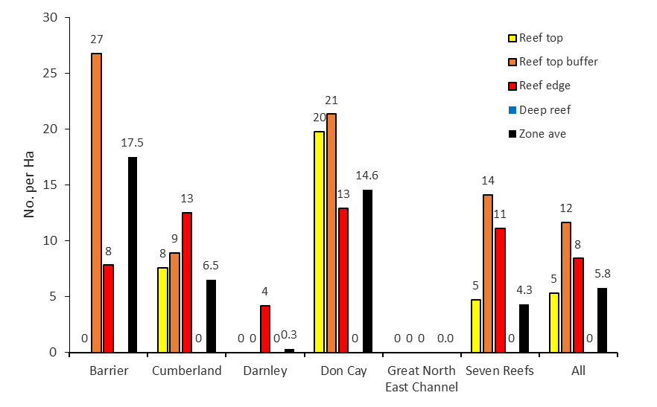

Figure . Zone and stratum average density (No. per ha) for Black teatfish in 2019/20 (Murphy et al., 2021a).

### White teatfish

White teatfish has a slightly more restricted distribution in ETS, with its highest densities in zones immediately behind the outer barrier reefs – the Don Cay zone in particular but also Darnley, Seven Reefs and Cumberland (, ) (Murphy et al., 2021a). It does not appear to be common on the outer barrier reefs (Barrier zone), mirroring the distribution of White teatfish on the northern GBR (Koopman and Knuckey, 2021). They were not seen in PNG reef surveys carried out in 1995/96 (; Long et al., 1996).

White teatfish are mostly found on the reef edge and deep (>20 m) reef habitats (; Murphy et al., 2021a) with the 2019-20 survey finding that 72% of the White teatfish population was in deep (>20 m deep) reef associated habitats, though none were seen deeper than 37 m (Murphy et al., 2021b). It is not found in the deep inter-reefal habitats of Torres Strait (Pitcher et al., 2007).

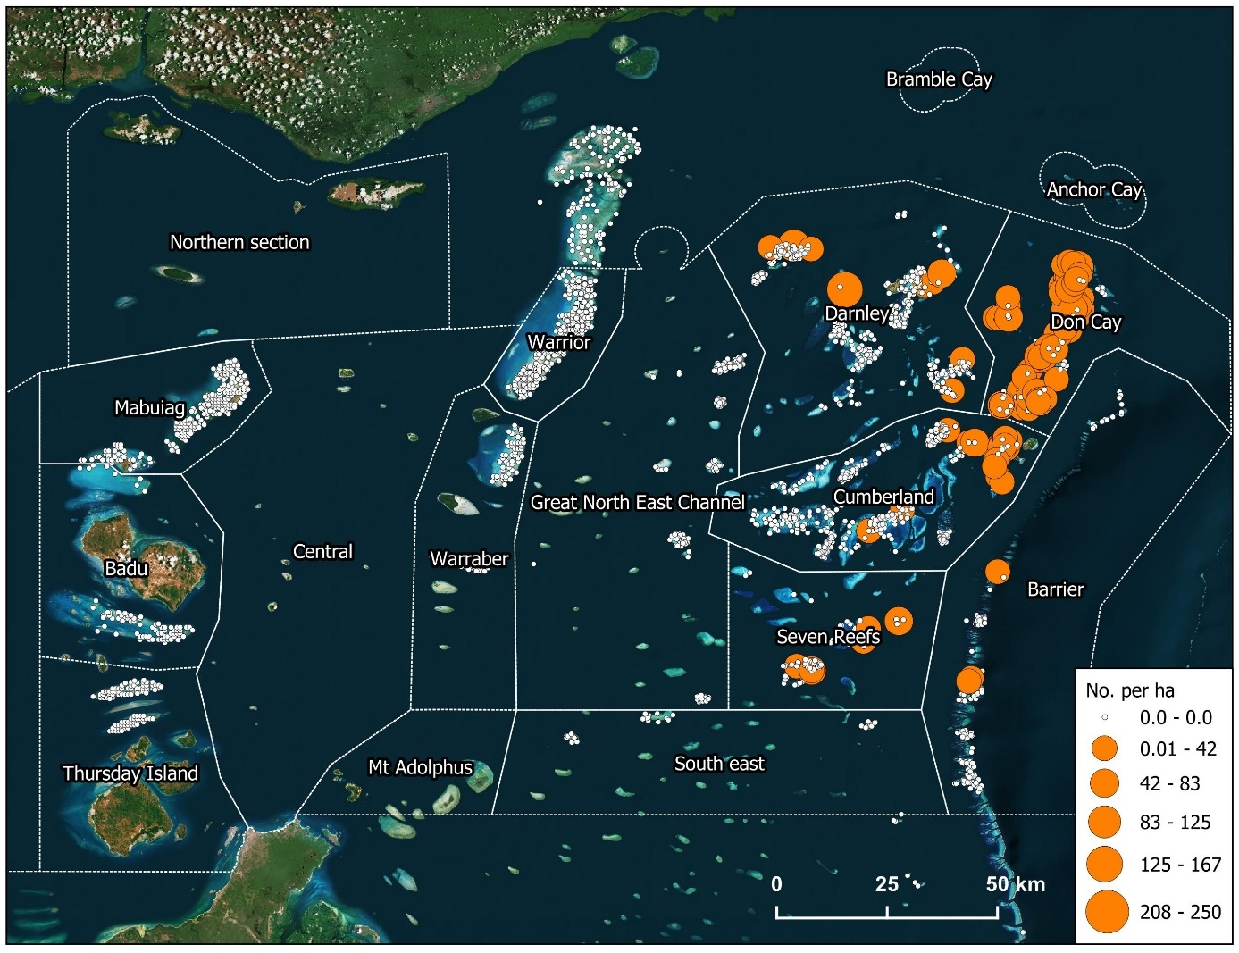

Figure . Site density for White teatfish from all 5 surveys carried out by CSIRO, 1995-2020 and fishery zones (Murphy et al., 2021a).

Figure . Zone and stratum average density (No. per ha) for White teatfish in 2019/20 (Murphy et al., 2021a).

## Population structure

The stock structure of Black teatfish and White teatfish in the TSBDMF is unknown. We can, however, make inferences about population structure based on studies in other jurisdictions, studies on other species; and the biological and oceanographic drivers of population connectivity (e.g. adult population movements, distance between suitable benthic habitats, larval duration, survival, and propagule current delivery vectors) (Treml et al., 2015; Choukroun et al., 2021).

### Other regions

The stock structure of Black teatfish in the neighbouring GBR has been the focus of some study. Genetic studies using allozymes (Uthicke and Benzie, 2000) and mitochondrial DNA (Uthicke and Benzie, 2003) showed no significant genetic structure of Black teatfish populations within the GBR indicating high contemporary levels of gene flow. There was also a suggestion of high gene flow between the GBR, the Coral Sea and Western Australia. However, it was postulated that the population genetic structures observed between eastern and western Australia at least were likely formed prior to the last ice age (Uthicke and Benzie, 2003). There were other factors that may have contributed to mask evidence of fragmentation in Australian Black teatfish populations, including slow mutation rates of genetic markers and high contemporary gene flow (Uthicke and Benzie, 2003).

### Other species

Studies on offshore shelf species such as *Cucumaria frondosa* (So et al., 2011), and *H. leucospilota* (Chieu et al., 2023)) and deep-water archipelagic species (e.g. *H. atra* (Skillings et al., 2011)) has shown high population connectivity across large distances (1,000s of km).

This is in contrast to small scale (<100 km) population structuring observed in inshore species, especially those inhabiting isolated habitats (e.g. Sandfish, *H. scabra* (Uthicke and Benzie, 2001; Uthicke and Purcell, 2004; Gardner et al., 2012)).

Given the offshore reef setting for Black teatfish and White teatfish in the CSF, they would likely be aligned with the offshore species in showing high population genetic connectivity across broad regions. However, high genetic connectivity does not infer high demographic connectivity, where populations are highly connected by significant levels of recruitment (Johnson et al., 2018).

### Biological and oceanographic information

In the absence of appropriate genetic studies, population structure and connectivity can be inferred using biological and oceanographic information, and by the development of coupled biological-oceanographic models (Choukroun et al., 2021; Fontoura et al., 2022).

*Adult biology*

Sea cucumbers are benthic with a generally low mobility, with annual displacements of 100 m or less (Purcell et al., 2016b; Hammond et al., 2020). However, the ability of adult sea cucumbers to move larger distances is likely underestimated (De la Rosa Castillo, 2023). Therefore, the Coral Sea – sea cucumber populations are very likely restricted to the reef on which they settle, with both teatfish species likely to be found throughout individual reef systems, including deeper lagoon areas of most reefs for White teatfish at least.

*Spawning timing*

Black teatfish has been reliably recorded as spawning during winter (April to June) on the GBR (Shiell and Uthicke, 2006) and in New Caledonia (Conand 1993) – although it has also been recorded as spawning during the northern hemisphere summer (April to August) in Guam (Richmond, 1996), and a single record of a Black teatfish male has been recorded as spawning soon after the full moon in December on the GBR (Babcock et al., 1992). Black teatfish are one of the few holothurians that spawn in winter, with this being a key driver for assessments of high vulnerability to climate change for this species (Welch and Johnson, 2013). It may be that some spawning outside the winter established period, with some mature gonads present throughout the year and limited field observations of summer spawning, though only by males (Babcock et al., 1992; Shiell and Uthicke, 2006). This inverse timing has been suggested as an adaptation to the competition with other species (Conad, 1993) or as a strategy to avoid cross fertilisation with closely related White teatfish (Sheill and Uthicke, 2006).

Not only are Black teatfish one of the few winter spawning aspidochirote holothurians, they may also have an unusual model of gonad development, the so called Tubule Recruitment Model (TRM) where tubules mature progressively from the anterior to the posterior region of the gonad with at least four stages of gametogenesis present at any one time (Smiley, 1988; Shiell and Uthicke, 2006). This is in contrast to most other sea cucumbers (including White teatfish) where all gonad tubules are generally at a similar stage in development, even though the reinitiation of gametogenesis in spawned and unspawned tubules can occur, resulting in overlapping generations of immature and relict oocytes (Ramofafia et al., 2000; Ramofafia and Byrne, 2001). Other features of Black teatfish reproduction on the GBR include a high fecundity and a male skewed sex ratio (Uthicke and Benzie, 2000; Shiell and Uthicke, 2006).

White teatfish is documented as spawning during summer (November to January) in New Caledonia (Conand, 1993), and late winter to spring (August to October) in the Solomon Islands (Ramofafia et al., 2000). This may indicate some plasticity of breeding seasonality for White teatfish – therefore local studies are likely required. Additionally, the QSCF area covers a large latitudinal range, and it could be that there is variation in the timing of spawning within the fishery area.

*Larval biology*

Empirical estimates of larval dispersal are key to assessing metapopulation connectivity, especially within a demographic context (Carson et al., 2011). Teatfish species larval biology is reasonably well studied - their larvae are planktonic and planktotrophic (feeding on small, suspended material in the water column) (Tanita et al., 2023). Larval duration has been recorded as between 2 and 4 weeks for White teatfish (Friedman and Tekanene, 2005; Burgy and Purcell, 2024) and between 3 and 7 weeks for Black teatfish (though longer periods are from a study in Japan that may have lower temperatures) (Nguyen et al., 2021; Martinez & Richmond, 1998; Minami, 2011).

*Currents within Torres Strait*

The circulation within the Torres Strait is relatively well established (Saint-Cast, 2008; Wolanski et al., 2013). The Torres Strait connects the Arafura Sea to the west and the Coral Sea to the east, and water circulation in the region is driven primarily by differences in sea height between these two water bodies at the entrances to the strait. Tidal phases in the Arafura and Coral Seas are not coherent, and sea level differences across the strait drive strong tidal currents (> 1 m/s) through the strait that switch diurnally and vary on spring neap cycles.

However, the net long-term flow through Torres Strait is driven primarily by winds, but is small to negligible (< 0.1 m/s) due to strong damping by bottom friction in the shallow strait and the highly energetic tidal flows around islands, reefs and shoals resulting in a “sticky water” effect (Saint-Cast, 2008; Wolanski et al., 2013). Some net directional flow does occur and is strongly influenced by seasonal wind patterns. During the summer monsoon season (November-March), the prevailing winds are generally from the northwest, and drive the net current direction easterly; while during the remainder of the year (April-October), the trade winds from the southeast are dominant, pooling GBR lagoon waters in the eastern entrance to Torres Strait and driving net flow to the west (Saint-Cast, 2008; Wolanski et al., 2013).

In general terms, net flow appears to be more variable over the monsoon period, reflecting year-to-year variability in wind forcing including the timing and strength of the monsoon. Small changes in the timing of the monsoon have the potential to produce large anomalies around the change in season (Saint-Cast, 2008; Murphy et al., 2016).

At the finer scale, currents are significantly reduced near large reefs and in lagoons (Wolanski et al., 2013). Also, there is generally little vertical stratification in the region because of strong vertical mixing by tidal currents.

*Current vector connections with neighbouring regions*

Tidal and seasonal flows are strongly connected to the northern GBR and northeastern Gulf of Carpentaria, but showed little connectivity with the coastal circulation in the Gulf of Papua (Saint-Cast, 2008; Wolanski et al., 2013).

*Linked physical-biological models*

A linked hydrodynamic-biological model of the Torres Strait was used to simulate the trajectories of Black teatfish larvae from realistic starting locations (locations of larval release) and for periods corresponding to observed planktonic larval durations (Murphy et al., 2012). The Black teatfish simulations used the distribution data from the 1995/96 sea cucumber survey (Long et al., 1996). The “larvae” were modelled using summer (November) and winter (June) larval releases, at three depths, and with a 14-day and 28-day larval duration ().

Generally, they found that larvae release at all times of the year and all depths were heavily influenced by short time scale tidal driven currents, with strongly rectilinear movements along an east-west axis (Murphy et al., 2012). A decrease in transport distance with increasing starting depth was observable but was not strong.

Simulated larvae released from reefs east of Warrior Reefs during December were generally maintained near natal reefs, particularly when released at deeper depths. Retention near natal reefs generally increases as the depth of larval release increases, suggesting a vertical migratory behaviour would increase retention relative to continuous passive transport near the surface. They also concluded that the hydrodynamic model spatial scale is not small enough to capture some finer scale flow characteristics, such as eddies behind reefs, which may increase larval retention near their natal reefs (Murphy et al., 2012). This is reinforced by later hydrodynamic modelling showing low net movements of water near reefs due to the “stick water” effect (Wolanski et al., 2013).

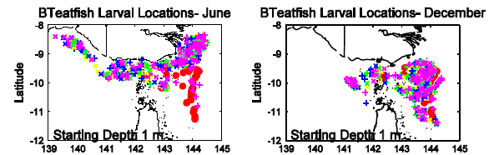

Figure . Location after 28 days of simulated larvae released from locations where black teatfish (*Holothuria whitmaei*) were observed during reef surveys (Murphy et al., 2012). (Symbols represent different tidal release times – for an explanation, see Murphy et al., 2012).

*Links with neighbouring regions*

A recent study on broadscale connectivity of larval fishes in northeastern Australia (Fontoura et al., 2022) indicated that many reefs in the Coral Sea act as source reefs for recruitment of fish populations to the GBR; and that the Torres Strait reefs were largely considered as sink populations that rely on reefs of the northern GBR for recruitment. Internally the GBR was a complex mix of source and sink reefs (Figure 12). Connectivity for larvae with a 30-day pelagic larval duration showed strong connectivity between the northern GBR and Torres Strait.

Connectivity on broader scales, such as between the Coral Sea and Indian Oceans through the Torres Strait, is not well understood (Ceccarelli, 2013). However, the low net flows through Torres Strait would indicate it is a barrier to demographic scale recruitment between eastern and northern Australian benthic populations (Saint-Cast, 2008; Wolanski et al., 2013).

Figure . Fish Larval Connectivity on Coral Reefs: Spatial Distribution of Sinks, Sources & Corridors (Fontoura et al., 2022) (<https://www.arcgis.com/apps/dashboards/7d7167d11e4e4c4496ced8cafacb0fed>)

### Population structure – conclusions

While there is likely to be significant levels of self-seeding for reefs in the TSBDMF, the highly dynamic current patterns found in Torres Strait would also support a well-mixed population of both species in ETS. There is also likely to be some significant connectivity between Torres Strait reefs and the northern GBR, but available evidence suggests that Torres Strait are more likely to be sink populations than a source of recruits (Fontoura et al., 2022). There may also be some variability to this connectivity on annual and seasonal scales, due to the effect and timing and strength of the monsoon (Saint-Cast, 2008; Murphy et al., 2016) and other stochastic factors (Uthicke et al., 2009).

There is no evidence of significant stocks of Black teatfish or White teatfish on the PNG side of Torres Strait. They are rarely reported in the PNG (WPBDMF) catch, and only low numbers of Black teatfish have been observed during surveys in northern Torres Strait.

Therefore, the population structure of both species in the TSBDMF is likely to be considered as “local populations with maximum connectivity within the meta-population” (or Type D stock structure according to the Marine Stewardship Council population structure classification system; MSC, 2022). In this case, management of the TSBDMF as a single stock is appropriate, but with consideration of localised depletion to maintain reef level populations for reducing risk and ecological considerations.

Recruitment from the northern GBR may be important, therefore complimentary management will help ensure population sustainability moving forward.

## Climate change

### Predicted climate change trends in Torres Strait

Climate change stressors in marine environments include increased sea temperature (and so-called marine heat waves), sea level rise, ocean acidification, changes to ocean current patterns, and increased storm intensity. Natural climate variability in Australia’s Tropical Pacific Ocean region is associated with El Niño and La Niña events, which now occurs on top of the warming trend with the potential to modify climate-ocean interactions with flow-on effects for Australia’s climate (NESP, 2018; IPCC, 2019; Dutra et al., 2020).

There is an observed warming trend in both air and sea-surface temperatures in Torres Strait, and regional projections include warmer sea-surface temperatures. In the Torres Strait, this warming has occurred at 0.08–0.12 °C per decade since 1950 (NESP, 2018), and is predicted to be 2.3 ± 0.5 °C by 2070 under the business as usual (RCP 8.5) scenario (Dutra et al., 2020).

Sea levels have risen on average 2.1 mm/yr over 1966–2009 and 3.1 mm/yr over 1993–2009 around Australia, after accounting for the influence of the El Niño and the effects of vertical land movements due to glacial rebound, and the effects of natural climate variability and changes in atmospheric pressure (McInnes et al., 2015). However, in the period 1993–2015, sea level has increased in the Torres Strait by 6–7 mm per year. Mean sea level will continue to rise as a result of climate change, and height of extreme sea-level events will also increase (NESP, 2018).

Uptake of anthropogenic CO2 into the oceans has led to a 0.1 unit change in the ocean’s surface water pH (to pH 8.1), which represents a 26 % increase in the concentration of hydrogen ions in seawater (IPCC, 2019). By 2030, pH change is projected to be another 0.08 units lower (to pH 8). By 2090, it is projected to be up to 0.15 units lower (to pH 7.95) for RCP4.5 and up to 0.32 units lower (to pH 7.8) for RCP8.5, representing an additional increase in hydrogen ion concentration of 40 and 100 % respectively (McInnes et al., 2015; IPCC, 2019). In the Torres Strait, the pH has dropped by 0.085–0.095 between 1880–89 and 2000–09 (NESP, 2018), and is predicted to decrease by 0.31 by 2090 (Dutra et al., 2020).

Rainfall is highly variable, with a strong influence from the El Niño–Southern Oscillation. A trend due to global warming cannot be identified in the observations. Rainfall will become more variable with more intense extreme events (NESP, 2018).

Tropical cyclones generally track south of Torres Strait, and this is not likely to change. Projected changes in tropical cyclones predict that they will become less frequent but increase in intensity (McInnes et al., 2015). In the rare event that one does traverse Torres Strait (there have been six since 1906) it is likely to be more intense as a result of climate change (NESP, 2018).

Impacts of climate change on the currents of Torres Strait are little understood (Johnson et al., 2018; Dutra et al., 2020). However, modelling has indicated very little change in the strength or direction of the SEC current jets that flow through the Coral Sea. However, there may be a strengthening of the Gulf of Papua Gyre, and the EAC may slightly weaken in the top 50 m (Johnson et al., 2018). This may have some influence on currents in Torres Strait, but are difficult to forecast.

### Direct impacts of climate change

*Temperature*

Longer-term (> a few weeks) experiments of the effect of raised temperature on sea cucumbers are sparse. Buccheri et al. (2019) found variability in the stress tolerance of three common tropical reef holothurians, *Holothuria atra, Stichopus chloronotus,* and *Holothuria edulis*, to elevated temperate, suggesting that these species might respond differently to ocean warming. A study of a sea cucumber (*Parastichopus regalis*) in the central Mediterranean Sea indicated a range reduction and density decrease, possibly related to climate change temperature and pH changes. Although this finding was not conclusive due to other potentially detrimental factors (e.g. bottom trawling) (Scannella et al., 2022).

Longer term experiments on starfish showed that adult mortality was not altered by increased temperature (Khalil et al., 2023). While they found that temperature regulated starfish physiology, the combination of high temperature and lower pH showed nonlinear and potentially synergistic effects on organismal physiology (e.g. metabolic rate). Indeed, elevated temperature allowed starfish to better cope with the adverse effect of lower pH on calcification and reduced skeletal dissolution (antagonistic interactive effects) interpreted as a result of energetic trade-offs.

*Ocean acidification*

Studies on several species have shown that adult sea cucumbers are largely resilient to projected future changes in pH (pH 7.8 by 2100; IPCC, 2019), but that larger changes can have negative impacts on the acid-base balance, energy consumption, grazing and growth rates of sea cucumbers (e.g. *H. scabra*, *H. parva*, *H. forskali*, *Apostichopus japonicus*) (Collard et al., 2014; Yuan et al. 2015; Yuan et al., 2018). Less-calcified sea cucumbers may be more tolerant to seawater acidification than other heavily calcified echinoderms (Yuan et al., 2018).

There has been some experimentation on the effect of changes in pH on holothurian larvae. For *H. spinifera*, larvae developed faster, grew better and had better survival rates at pH 7.8 (Asha and Muthiah, 2005). For *A. japonicus* a 0.62 unit decrease in pH had relatively small effects on early life-history compared to other echinoderms, leading to a maximum of 6% decrease in post-fertilization success (Yuan et al. 2015). This indicates that predicted changes in pH in the Coral Sea may not greatly impact larval survival, though more extreme changes may have a larger impact on larval survival (González-Durán et al., 2021).

*Sea level rise*

Sea level rise has been assessed as being mostly positive for shallow water species (e.g. Black teatfish; Plaganyi et al., 2013) and is likely to be neutral for deeper water species such as White teatfish.

*Changes in cyclone frequency and intensity*

Shallow species such as Black teatfish may be negatively impacted by scouring and dislocation by severe storms. Impacts to deeper water species such as White teatfish are likely to be negligible.

### Indirect impacts of climate change

Torres Strait habitats will be impacted by climate change (NESP, 2018; Dutra et al., 2020). Repeated exposure to damaging marine heatwaves has already resulted in coral bleaching events in 2010 (Bainbridge and Berkelmans, 2014), and 2016 (Wolanski et al., 2017; Johnson et al., 2018), likely resulting in reductions in the cover of live coral (Murphy et al., 2021a) and other impacts. In the longer term, this is likely to lead to irreversible changes in coral reef assemblages depending on the intensity and timing between successive thermal stress events (Hughes et al., 2018; Johnson et al., 2018; Dutra et al., 2020).

The impact of these changes to reefs and their benthic and fish communities on sea cucumbers is uncertain. Trophic effects are poorly understood but are likely to be impactful in the longer term (Welch and Johnson, 2013; Fulton et al., 2018; Dutra et al., 2020).

### Vulnerability of teatfish species in Torres Strait to climate change

A vulnerability assessment of Black teatfish in Torres Strait was assessed as having a high vulnerability to climate change, mainly due to a low adaptive capacity related to winter spawning, low productivity and limited mobility (Johnson and Welch, 2016). The impact of increased temperature on spawning will be important for quantifying this risk.

The vulnerability of White teatfish to climate change stressors in the short to medium term would appear to be low, but with considerable uncertainty, especially for long term temperature changes and indirect impacts. White teatfish is a summer spawner and inhabit deeper water habitats, which may reduce climate change risks (Dutra et al., 2020).

There could also be synergistic effects to consider. Experiments on starfish showed that the combination of high temperature and high pCO2 showed nonlinear and potentially synergistic effects on organismal physiology (e.g., metabolic rate) (Khalil et al., 2023). In addition, shifts in ecosystem state can potentially go unnoticed and eventually undermine the sustainability of seemingly sustainable fisheries (Fulton et al., 2021).

It is increasingly important to develop models to link climatic effects over a range of life history components and critical habitats for fisheries (e.g. seagrasses, coral reefs) and quantify the resultant impact on fisheries productivity using alternative emission scenarios (Dutra et al., 2020). An integrated risk assessment of sea cucumbers in Torres Strait, based on a Management Strategy Evaluation (MSE) (Plagányi et al., 2013), found that status quo management would result in half the species falling below target levels, moderate risks of overall and local depletion, and significant changes in species composition. Three simple strategies (spatial rotation, closed areas, multi-species composition) were all successful in reducing these risks (Plagányi et al., 2013) – though there has been significant changes in the TSBDMF management since that study, including the implementation of the HS in 2019 (including precautionary TACs and annual reviews of all data) and a biomass survey in 2019/20. Data used to support MSE testing was also limited at that time.

## Inherent vulnerability

In the CITES context (CITES, 2011), “Inherent Vulnerability” can be defined as the susceptibility to intrinsic or external effects that increase the risk of extinction, even when mitigating factors are taken into account. There are a number of taxon or case-specific biological and other factors that may affect the extinction risk associated with a given percentage decline, small population size or restricted area of distribution (CITES, 2011). Many of these factors are poorly understood for Black and White teatfish.

*Factors increasing inherent vulnerability*

* Both species are large, easily seen sea cucumbers and are thus easily harvested.
* Both species are high value species that have been consistently targeted by TSBDMF fishers.
* Generation length for both species is unknown, but may be greater than several decades (Conand et al., 2013a; 2013b; Uthicke et al., 2004).
* Both species have been considered as being of low productivity (FAO, 2019).
* There are likely to be depensation (Allee) effects on population productivity at low population density, primarily driven by low fertilisation success for widely distributed spawning pairs (a dilution effect) (Uthicke, 2004). However, the characteristics of the “Allee effect threshold” (e.g. proportion of virgin biomass where low density begins to negatively affect population productivity) and “Allee threshold” (where populations continue to decrease even when fishing ceases) are unknown for any sea cucumber population (Hutchings, 2015; González-Durán et al., 2018). Also, the persistence and recovery (albeit often slow) of heavily depleted sea cucumber populations would suggest the Allee threshold is likely <0.1 of virgin biomass (B0) (Murphy et al., 2011a; Ramírez-González et al., 2020; Friedman *et al*., 2010; Prescott et al., 2017; FAO, 2022).
* Larvae of both species are planktotrophic (Tanita et al., 2023), which has been described as a “high risk, high reward” strategy which may lead to high variability in recruitment (Uthicke et al., 2009).
* Subpopulations on isolated reefs are likely to be primarily self-seeding, and particularly vulnerable to overexploitation.
* Black teatfish is listed as Endangered under IUCN criteria because it is commercially exploited throughout its range, the population trend is declining, and IUCN estimates that populations have declined by 80-90% in at least 50% of the species’ range, and populations are overexploited in at least 30% of its range (Conand et al., 2013a).
* White teatfish are listed under IUCN criteria as Vulnerable (Conand et al., 2013b).
* Both species are reef-associated (Purcell et al., 2023a) and will be impacted by declining reef health associated with a range of pressures, including climate change (Hughes et al. 2018; see above).

*Factors reducing inherent vulnerability*

* Both species have a broad geographical range globally (Conand et al., 2013a; 2013b), and within Torres Strait (Murphy et al., 2021a).
* Both species appear to be resilient to local extirpation, even in heavily exploited fisheries (Prescott et al., 2017; FAO, 2019).
* There are some examples of recovery of overfished teatfish stocks (Knuckey and Koopman, 2016; Helidoniotis, 2021a; Murphy et al., 2024a; Wicken et al., 2024)
* Juveniles are very cryptic and rarely observed – offering protection from fishing for juvenile year classes (Prescott et al., 2013; CITES, 2019).
* White teatfish inhabits deeper reef habitats so is less susceptible to fishing (Purcell et al., 2014; Murphy et al, 2021b).
* There is unlikely to be significant illegal, unreported and unregulated (IUU) fishing for teatfish species in the TSBDMF (this report).

From the above, it can be implied that both species have features that would support a range of possible “inherent vulnerability” findings, with White teatfish having the most uncertainties. Black teatfish certainly are very susceptible to overexploitation, inhabit the shallow reef that is most susceptible to impacts (including climate change) and can take some time to recover, therefore a precautionary assessment of the Inherent Vulnerability of ‘high’ is likely warranted. White teatfish, on the other hand, probably has a lower inherent vulnerability than Black teatfish – being less susceptible to fishing pressure due to the potential for relatively high density of White teatfish in deep reef habitats (Murphy et al., 2021a; Koopman and Knuckey, 2021), a precautionary assessment of the Inherent Vulnerability of ‘medium-high’ for White teatfish in the TSBDMF is recommended.

## Ecological role

*Effect on benthic habitats*

Holothuroids (i.e., class Holothuroidea) feed on the sea bottom, reducing the organic load and redistributing surface sediments (Uthicke, 1999; Hammond et al., 2020; Williamson et al., 2021), making them bioremediators by enhancing the productivity of sea bottom life (for a comprehensive review of sea cucumber ecological role, see Purcell et al., 2016a). This form of nutrient recycling is crucial in ecosystems with low nutrient levels, as in the Coral Sea (Ceccarelli et al., 2013). The depletion of holothuroids has also resulted in the hardening of the sea floor, thereby eliminating potential habitat for other benthic organisms (Bruckner et al., 2003).

Sea cucumbers are known to be consumed by diverse predators from at least seven phyla, including 19 species of seastars, 17 crustaceans, several gastropods and around 30 species of fish (Purcell et al., 2016a). Although there is little information regarding predators of teatfish. For predators that rely heavily on sea cucumbers as a food source, depletion of sea cucumber populations is likely to have a negative impact (Purcell et al., 2016a). Thus, overexploitation of sea cucumbers may result in a loss of biodiversity or abundance of these predator species or cause them to switch to other prey species, with potential cascading effects in the ecosystem (Purcell et al., 2016a).

*Effect on local water chemistry*

Feeding and excretion by sea cucumbers also increase seawater quality and alkalinity, which contributes to local buffering of ocean acidification. Studies on several sea cucumber species (Curryfish - *Stichopus herrmanni,* Lollyfish - *Holothuria atra,* Snakefish - *H. leucospilota*) has shown they can affect local seawater alkalinity through their digestive processes and release of ammonia (Uthicke, 2001; Schneider et al., 2011; 2013; Wolfe et al., 2017; Vidal-Ramirez and Dove, 2016), potentially moderating ocean acidification and benefiting calcifying organisms such as corals, though the size and even direction of the net impact is dependent on water flushing rates and time of day.

Wolfe et al. (2017) found that Curryfish (*S. herrmanni*) had significant impacts on seawater chemistry through respiration, dissolution of CaCo3 in the gut and by down grazing effects on algae and infauna. These actions contributed to increased reef dissolution during the day, but decreased dissolution at night when reef systems are most vulnerable to dissolution. However, the effect was only measurable in closed mesocosm systems – Curryfish had little effect on seawater chemistry under flowing conditions. Another study on the effect of Lollyfish (*H. atra*) on seawater carbonate chemistry found that the feeding and excretion of that species may even exacerbate the impacts of acidification due to the dissolution of CaCO3 resulting from their production of respiratory CO2 (Vidal-Ramirez and Dove, 2016).

It is likely then, given the dynamic nature of water currents on reef systems in the Coral Sea (Choukroun et al., 2021), and primarily slope and deeper water habitats favoured by White teatfish (Purcell et al., 2023a; Murphy et al., 2021a; Skewes and Persson, 2017), that local ameliorating effects on water chemistry would be modest at best.

*Ecological role in Torres Strait*

The TSBDMF fishery habitats that contain both teatfish species are in east Torres Strait and are classified as relatively oligotrophic (Haywood et al., 2007). Nutrient recycling by larger sea cucumbers will therefore play an important role in reef functioning in this area.

# Harvest levels and trends

This section only reports on fishery extractions since the beginning of the modern fishery in Torres Strait, in about 1990. There was also significant fishing for sea cucumbers from about 1864 up until about the Second World War.

*A note on fishery catch weight*. Sea cucumbers will change their weight depending on the time out of the water and processed state (Murphy et al., 2021a). Typically, sea cucumber fisheries collect catch weight information at the first opportunity for operators to reliably weigh the catch. In the case of the TSBDMF, this is usually when the product is sold to a local buyer as gutted and salted, but also wet gutted and gutted and boiled (curryfish only) and sometimes live whole. Small quantities of dried product are also sold (mostly curryfish) (Murphy et al., 2021a). Product form of catch is reported in the logbook and CDR.

All fishery catches for the TSBDMF are reported as wet gutted weight and catches in other forms are converted using available conversion ratios (AFMA, 2023a; Plaganyi et al., 2019). All survey data is also expressed as fishery landed weight (wet gutted) for application to fishery assessments and to formulate TACs. Conversion factors are available for most fishery species (including teatfish) (Murphy et al., 2021b). All data reported here are as landed (wet gutted) weight.

## Fishery extractions

The modern sea cucumber fishery in Torres Strait began in about 1990 in the PNG Western Province Beche-de-mer Fishery (WPBDMF), on the northern Warrior Reefs (). The WPBDMF was initially almost entirely based on Sandfish and the catch during this time ranged between 109 t and 192 t of processed beche-de-mer (equivalent to approximately 1164 t to 2049 t gutted weight respectively (Appendix B)). The WPBDMF fishery since that time has been opened and closed periodically. Black teatfish has appeared in the catch occasionally, with a total catch of 1 t (gutted wt) (Appendix B) for the period 1990-2019. White teatfish are not listed in the catch at any time – though it could be part of the “Unspecified catch”, but even then, it would be in very small quantities (Appendix B).

The TSBDMF on the Australian side of Torres Strait began around 1992, also focused on Sandfish on the southern Warrior Reef (), with catches peaking at over 1200 t (gutted weight) in 1995 (Figure 13, Appendix A). A survey in 1998 (Skewes et al., 2000) found that the Sandfish population was severely depleted, and the fishery was subsequently closed. After the closure of sandfish in 1998, the fishery mostly targeted Black teatfish, Surf redfish (*A. varians*) (although a large proportion of the reported surf redfish catch is understood to be Deepwater redfish (*A. echinites*) (Skewes et al., 2010)), and Hairy blackfish (*A. miliaris*) (but probably a mix of several black *Actinopyga* species (Skewes et al., 2010)) ().

A survey in March 2002 found that Black teatfish and Surf redfish were probably overexploited (Skewes et al., 2004), and a prohibition on the harvest of these species was introduced in January 2003. The closure of these highly targeted species saw a decline in fishing activity between 2003 and 2010 (). A subsequent survey in 2009 found that the density of black teatfish had recovered to near natural densities and it was recommended that this species be reopened to fishing (Skewes et al., 2010). Trial openings of Black teatfish were conducted in 2014, 2015, but the 15 t TAC was overcaught and there were concerns about catch under-reporting. After implementation of a mandatory Fish Receiver System (FRS) in 2017, the Black teatfish fishery was again opened in 2021, 2022 and 2023 (AFMA, 2023a), this time with a 20 t TAC and, since 2022, observer-based size frequency monitoring (Murphy et al., 2024b).

In addition, a developmental fishing permit for hookah (underwater breathing apparatus) was granted to two operators for the 2011/12 to 2013/14 financial years (it is otherwise banned in the fishery) – primarily to target the White teatfish population in deeper water. These developments saw renewed interest in the fishery, and the targeting of Prickly redfish and Curryfish species (*Stichopus herrmanni, S. vastus*) in the fishery after 2010 (, ). Curryfish, a relatively high value species (Purcell et al. 2018), have only been recently fished due to advances in handling this difficult-to-process species.

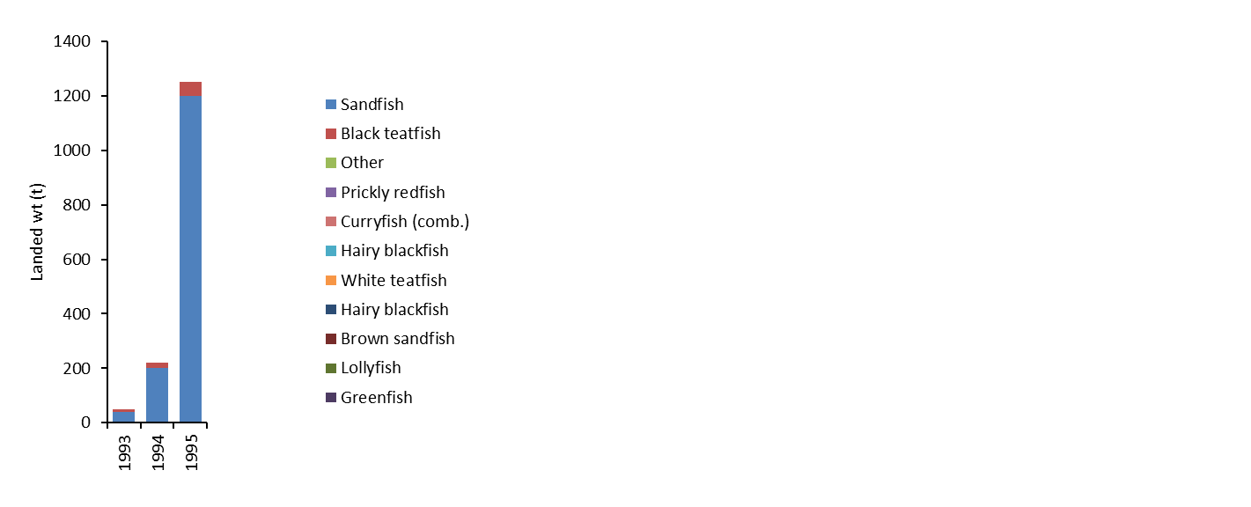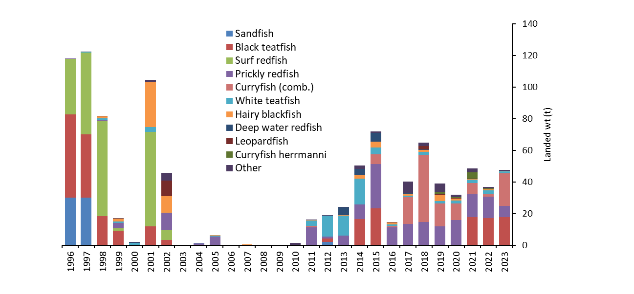

Figure . Catch (tonnes landed wt) of the TSBDMF for 1993 to 2023 (Skewes et al., 2010; AFMA, 2023a). Note 1993-1995 and 1996-2023 are on a different scale.

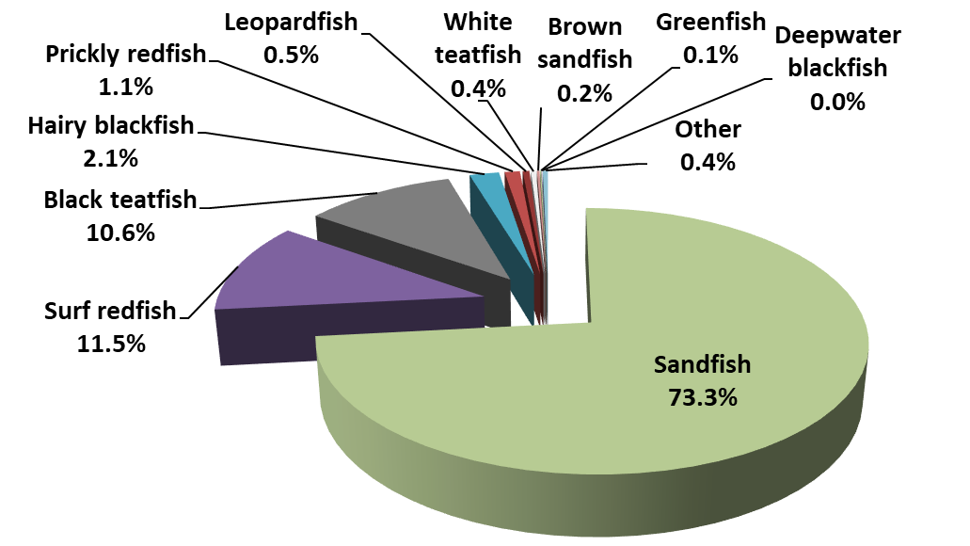

**1993-2009**

**(2,039 t landed wt)**

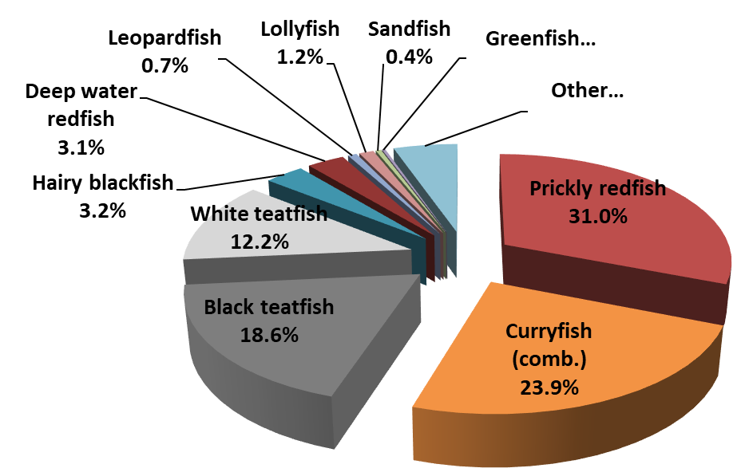

**2010-2023**

**(509 t landed wt)**

Figure . Breakdown of TSBDMF catch for 1993-2009 (Top) and 2010-2023 (Bottom) (Top 10 species in catch weight only shown as individual species) (Skewes et al., 2010; AFMA, 2023a).

## Black teatfish

Black teatfish was an early target species, and was heavily fished in the mid 1990s, with a peak catch of 52.8 t in 1996 (Figure 15) though this is probaly an underestimate due to unreliable catch recording – there was no local catch reciever data collection in place at this time and the catch numeration relied on Queensland logbooks. Catch rates dropped precipitously after this, especially in areas close to communities, and the fishery was closed in 2003.

After surveys indicated a recovery in the Black teatfish population (Skewes et al., 2010), trial fishery openings occurred in 2014 and 2015 with a 15 t TAC (overcaught both times), and the fishery reopened on a regular basis in 2021 with a 20 t TAC, after the implementation of compulsory catch recording for island based buyers and a positive survey and stock assessment in 2019/20 (Murphy et al., 2021a) (Figure 15).

Catch data collected since 2017 shows that Cumberland zone provided the bulk of the catch (Figure 16), followed by Darnley and Don Cay zones which is likely due to their proximity to fishing communities and relatively sheltered habitat. A significant proportion (33%) of the catch location is unknown – this is currently not a compulsory field in the mandatory CDR implemented for the fishery –however, recording of location is the focus of discussions with local fishers and is likely to improve over time (AFMA Hand Collectable Working Group papers).

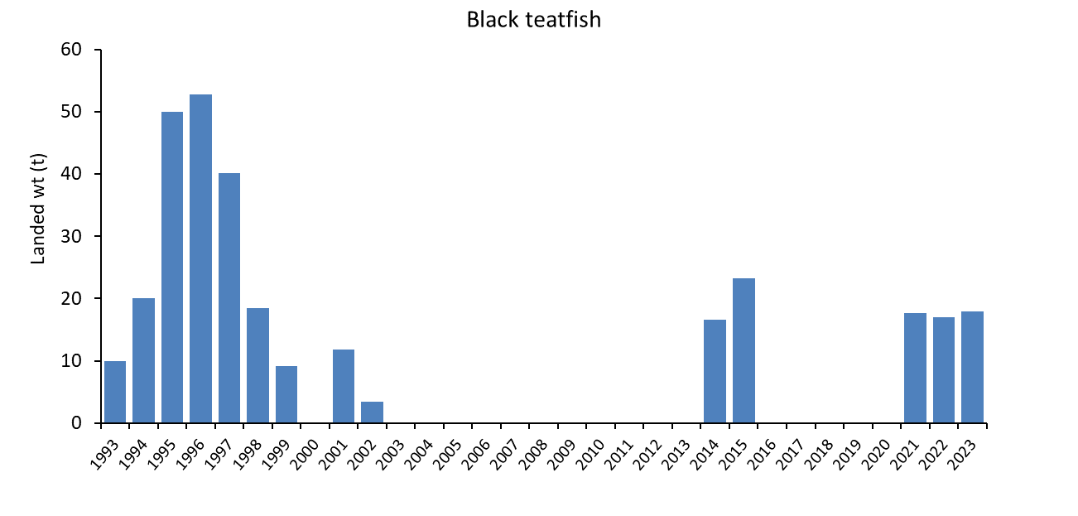

Figure . Catch (tonnes landed wt) of Black teatfish in the TSBDMF, 1993 to 2023 (Skewes et al. 2010 (1996 to 2002); AFMA logbooks (2004 to 2023)).

Figure . Catch (tonnes landed wt) of Black teatfish by Torres Strait fishery zone for the period 2018-2023 (Fishery TDB02 CDR data – note that location is not a compulsory field).

## White teatfish

White teatfish has featured in the catch for many years but catch has been restricted due to the prohibition of underwater breathing apparatus in the TSBDMF. The exceptions were for the years 2012-2014 where a developmental fishing licence was granted to use hookah in the TSBDMF on two vessels with a 15 t TAC (Figure 17). Apart from those developmental licence years, the annual catch has averaged about 1.7 t.

Catch data collected since 2017 shows that Cumberland and Don Cay zones provided the bulk of the catch (Figure 18). A significant proportion (41%) of the catch location is unknown – this is currently not a compulsory field in the mandatory CDR implemented for the fishery –however, recording of location is the focus of discussions with local fishers and is likely to improve over time (AFMA Hand Collectable Working Group papers).

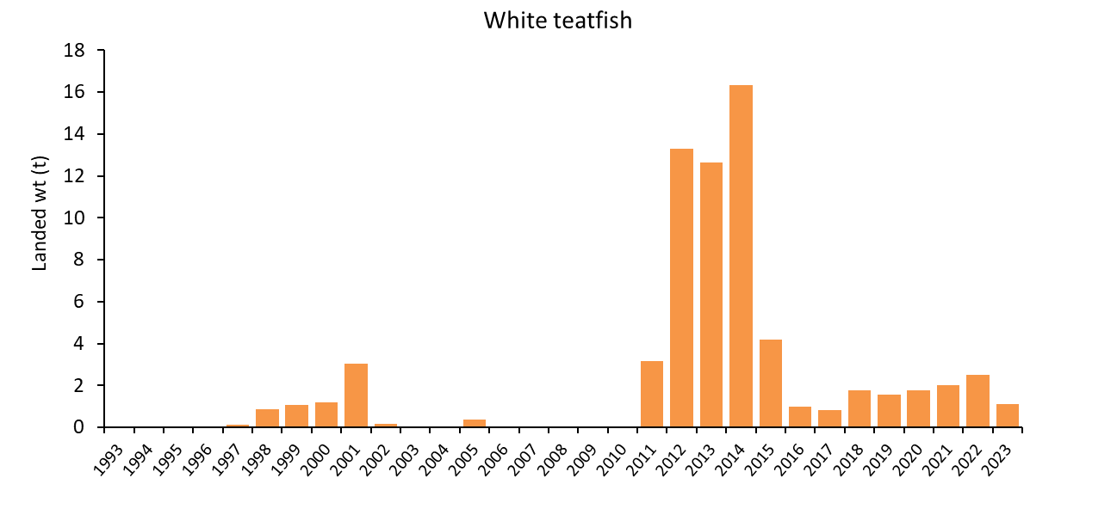

Figure . Catch (tonnes landed wt) of White teatfish in the TSBDMF, 1993 to 2023 (Skewes et al. 2010 (1996 to 2002); AFMA logbooks (2004 to 2023)).

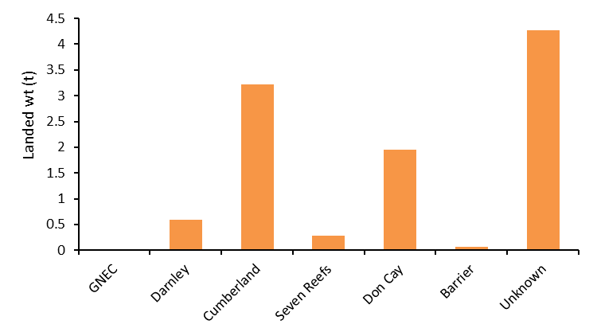

Figure . Catch (tonnes landed wt) of White teatfish by Torres Strait fishery zone for the period 2018-2023 (Fishery TDB02 CDR data – note that location is not a compulsory field).

### Discards

While there has been some reports of discards in the TSBDMF, mostly regarding the spoiling of Curryfish species during the capture and initial processing stages (HCWG papers – reports from fishers, pers comm), there is likely to be minimal discarding of teatfish species in the TSBDMF due to the highly selective nature of hand collection fisheries, and the high recognition of teatfish as a valuable fishery species and established processing procedures (Dutra et al., 2021).

## IUU and any other extractions

There has been substantial IUU reported in Torres Strait dating back to at least the mid-1990s, primarily by PNG nationals targeting Sandfish and Tropical rock lobster on Warrior Reef (AFMA, unpublished reports). For example, in late 2009, 11 digital photographs of the catch of apprehended PNG fishers from Warrior Reef showed that the illegal take was almost entirely Sandfish with smaller proportions (<5%) of Blackfish (*A. miliaris/A. spinea*), Deepwater redfish (*A. echinites*), Stonefish (*A. lecanora*), and a single Prickly redfish (Skewes et al., 2010). Substantial IUU fishing also occurred in Torres Strait in, 2013, 2014, 2016 (Thomassin, 2019; AFMA, unpublished data) and recently in 2021 and 2022 (ABC, 2023; Bunch, 2023), but again, centred on Warrior Reef and primarily targeting Sandfish.

Apart from foreign vessel IUU, there has been one documented incidence of domestic IUU in the TSBDMF. This related to an unlicensed fish receiver who was apprehended in 2020 with five tubs of White teatfish and one tub of Prickly redfish (AFMA, 2020).

The quantum of the IUU sea cucumber catch has been reliably quantified.

# Stock trends and stock assessments

## Fishery independent data (surveys)

The ETS sea cucumber populations of the TSBDMF have been surveyed 5 times, in 1995/96 (Long et al., 1996), 2002 (Skewes et al., 2004), 2005 (Skewes et al., 2006), 2009 (Skewes et al., 2010), and most recently in 2019/20 (Murphy et al., 2021*a*). Surveys were stratified by reef habitat strata (reef top, reef top buffer (the 200 m buffer inside the reef crest), and reef edge (to 20 m deep) habitats; and by fishery zones (). Population trends were calculated as average density across the 4 zones consistently surveyed over the years: Cumberland, Darnley, Don Cay and Seven Reefs. An estimate of fishery biomass (gutted weight) was also calculated, where feasible.

In 2019/20 the deep reef (>20 m deep) habitat was also surveyed using an ROV for counting sea cucumbers at depths of 20–50 m (Murphy et al., 2021*b*). The deep reef stratum was not factored into the 4-zone density trends, but was used in the calculation of overall available biomass.

### Black teatfish

The 4-zone stratified density for Black teatfish in 2019/20 was slightly lower than 2009, which in turn, were the highest ever observed in Torres Strait since surveys began (though with low statistical confidence) (), (Murphy et al., 2021a). Given the low levels of fishery extractions between 2003 and 2019 (~40 t) relative to current estimates of fishery biomass (see below), it was concluded that the population was highly likely to be above the limit refence point (BLIM) of 40% B0.

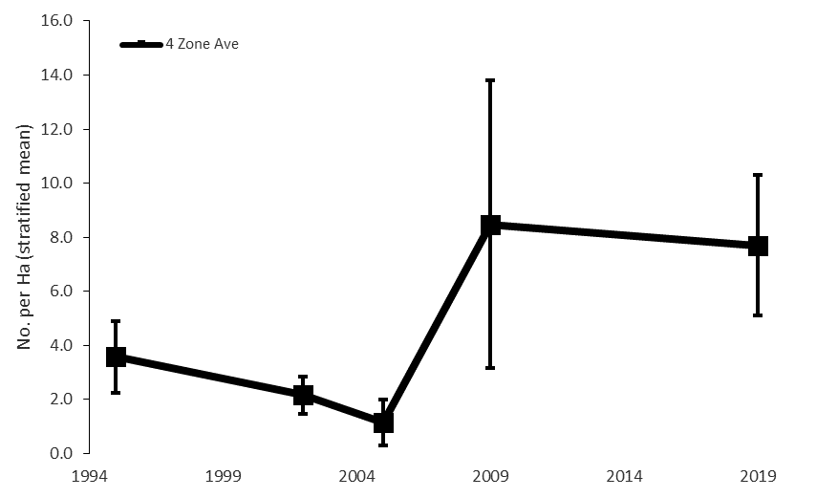

Figure . East Torres Strait (4 zone = Cumberland, Darnley, Seven Reefs and Don Cay) average (stratified) density (No. per ha) for reef stratum for Black teatfish from five surveys (error bars = 1 s.e.) (does not include deep-reef strata) (Murphy et al., 2021a).

The estimated biomass of Black teatfish in ETS in 2019/20 was 1,233 t landed (wet gutted) weight and the bootstrapped lower 90th percentile of the stock estimate (B) was 787 t (). Of that estimate, the available stock above fishery size limit (> MSL = 25 cm) for Black teatfish was 172.3 t ().

Table . Stock estimate for Black teatfish in 2019/20. For each Zone and for East Torres Strait (ETS), the number of sites, stratified mean density (No. per ha), stratified variance, population stock estimate in numbers (n), live weight and landed (wet gutted) weight; and for all ETS, the bootstrapped lower 90th percentile of the landed (wet gutted) weight (B), and the lower 90th percentile of B greater than minimum size limit (MSL) (GNE = Great North East, ETS = East Torres Strait) (Murphy et al., 2021a).

|  |  |  |  |  |  |  |  |  |
| --- | --- | --- | --- | --- | --- | --- | --- | --- |
| Zone | Sites | Mean  Density  (No. per ha) | Var  (st) | Stock  (n) | Live wt  (t) | Landed wt  (t) | B  (t) | B >MSL  (t) |
| Barrier | 16 | 17.5 | 117.5 | 283,515 | 462.7 | 313.3 | - | - |
| Cumberland | 50 | 6.5 | 17.7 | 412,235 | 672.8 | 455.5 | - | - |
| Darnley | 89 | 0.3 | 0.1 | 16,534 | 27.0 | 18.3 | - | - |
| Don Cay | 104 | 14.6 | 16.2 | 282,963 | 461.8 | 312.7 | - | - |
| GNE Channel | 6 | 0 | 0 | 0 | 0 | 0 | - | - |
| Seven Reefs | 33 | 4.3 | 3.4 | 120,489 | 196.7 | 133.1 | - | - |
| ETS | 298 | 5.8 | 3.0 | 1,115,735 | 1,821.0 | 1,232.8 | 787.0 | 172.3 |

Comparing the stock estimates to recent recorded catch shows that some fishery zones are fished more heavily relative to standing stock (Figure 20). Darnley fishery zone was fished the heaviest relative to standing stock, with an annual take (for 2018-2022) of about 10% of standing stock – if the unknown catch is allocated pro rata, then this could be as high as 13%. The remaining zones were all less than 1 % annual fishing rate (Figure 20).

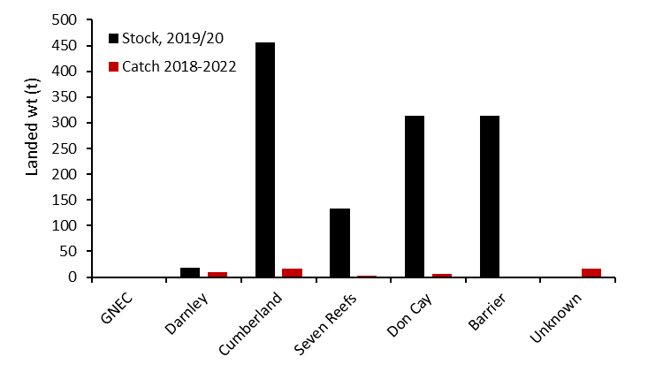

Figure . Stock estimate in 2019/20 and catch for period 2018-2022 for each fishery zone for Black teatfish (Murphy et al., 2021a; Fishery TDB02 CDR data – note that location is not a compulsory field).

*Comparisons to other Black teatfish populations*

Sea cucumbers, particularly teatfish species, have variable densities across different depth and reef morphometric habitats, and in relation to distance from terrigenous influence (across shelf), and latitudinally—and likely several other lesser-known gradients (Benzie and Uthicke, 2003; Koopman and Knuckey, 2021; Murphy et al., 2021; Purcell et al., 2023). Therefore, comparing survey densities, as well as against theoretical “thresholds” is often compromised by differences in habitat delineation and sampling approaches. Nevertheless, a comparison of the 2019/20 survey densities with other “comparison” densities is still informative to an extent.

Surveys of Black teatfish were carried out on the GBR in 1999 (Uthicke and Benzie, 2000; Benzie and Uthicke, 2003). Density estimates of the mid and outer shelf reefs in the “area of the fishery” (12-19° S—Princess Charlotte Bay to Lucinda) were used to infer stock status. The habitat surveyed was described as the “shallow reef flat” though “areas with > 60% sand cover were avoided”. Black teatfish density on ‘closed reefs’ were 20.97 per ha (n=6, 95% confidence interval [CI] = 16.3–25.73) and density on the same habitat on ‘open reefs’ was 5.01 per ha (indicating a severe depletion caused by the fishery, and the fishery wasclosed in 1999) (Uthicke and Benzie, 2000).

A survey in the northern zone of the GBR (Knuckey and Koopman, 2016) was carried out in 2015. Again, it was focused on the same fishery area as the 1999 survey but delineated the survey habitat area as the 200 m reef edge buffer on the weather (SE facing) side of reefs >1km2. This survey found the density of Black teatfish on mid shelf reefs was 13.5 per ha on closed reefs and 12.5 per ha on open reefs (av. 13 per ha); and on barrier reefs was 27.0 per ha on closed and 23.6 per ha on open reefs (av. 25 per ha)

#### Natural Densities

A review of survey data from throughout the West Pacific concluded “the range of densities found at “closed” sites it seems a conservative assumption that densities above 12.5 per ha represent a “natural” density for this species on suitable habitat” (Kinch et al., 2008).

Guidance from the Secretariat Pacific Community provides “rule of thumb” regional reference densities of 50 per ha for Black teatfish —estimated from the upper 25% of densities across 91 sites assessed in 17 countries over the period 2002–2012 (Pakoa et al., 2014).

Other estimates of “natural” density for Black teatfish in Western Australia include: 11.4 to 17.1 per in “habitats occupied by Black teatfish” and likely represents minimum natural population densities for Ningaloo Reef (Shiell and Knott, 2010).

#### Conclusion

Though there are limitations with comparing density across different studies, the density of Black teatfish observed in Torres Strait in 2019-20 compares well with other studies. The highest site density observed during the 2019/20 survey of Torres Strait was 167 per ha, and the mean of the upper 25% of densities in the reef top buffer strata for all reefs was 62.6 per ha, and 82.3 per ha for the Don Cay and Barrier zones combined.

This indicates that the Black teatfish populations in Torres Strait observed during the survey undertaken in 2019/20, are at near natural (unfished) densities and this finding further corroborates Traditional Owners observations (of high densities) reported to consultative fora.

Figure . Comparison of density estimates for Black teatfish (*H. whitmaei*) in preferred habitat from various studies/regions (see text for detail). Torres Strait mid and outer shelf reef “reef-top buffer” (a 200 m wide buffer around the inside of the reef margin) (Murphy et al., 2021a). GBR (northern section) open and closed density of “suitable reeftop habitat” (Benzie and Uthicke, 2003). GBR (northern section) “reef top buffer” for midshelf and outer barrier reefs (Knuckey and Koopman, 2016). FAO “natural density” in “suitable habitat” (Kinch et al., 2008). Guidance “rule of thumb” regional reference densities for Black teatfish (Pakoa et al., 2014). “Natural” density for Black teatfish in Western Australia in “habitats occupied by Black teatfish” for Ningaloo Reef (Shiell and Knott, 2010). (After Murphy et al., 2021a)

### White teatfish

The overall 4-zone density average in 2019/20 was the second highest compared to previous survey years (Figure 22) (Murphy et al., 2021a). Note that this data does not include the “deep reef” stratum, where the majority of White teatfish are likely to be found (Murphy et al., 2021b)

The estimated landed (wet gutted) weight of White teatfish in East Torres Strait in 2019/20 was 1,493 t and the bootstrapped lower 90th percentile (landed (wet gutted) weight) of the stock estimate (B) was 880 t (Table 2). Of that estimate, the available stock above fishery size limit (> MSL = 320 mm) for White teatfish was 142.9 t (Table 2). The 2019-20 survey found that 72% of the White teatfish population was in deep (>20 m deep) reef associated habitats, though none were seen deeper than 37 m (Murphy et al., 2021b).

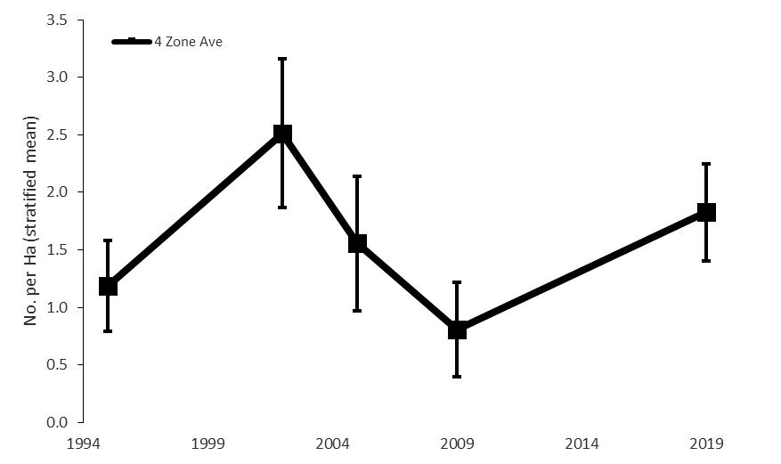

Figure . East Torres Strait (4 zone = Cumberland, Darnley, Seven Reefs and Don Cay) average (stratified) density (No. per ha) for reef stratum for White teatfish from five surveys (error bars = 1 s.e.) (does not include deep-reef strata) (Murphy et al., 2021a).

Table . Stock estimate for White teatfish in 2019/20. For each Zone and for East Torres Strait (ETS), the number of sites, stratified mean density (No. per ha), stratified variance, population stock estimate in numbers (n), live weight and landed (wet gutted) weight; and for all ETS, the bootstrapped lower 90th percentile of the landed (wet gutted) weight (B), and the lower 90th percentile of B greater than minimum size limit (MSL) (GNE = Great North East, ETS = East Torres Strait) (Murphy et al., 2021a).

|  |  |  |  |  |  |  |  |  |
| --- | --- | --- | --- | --- | --- | --- | --- | --- |
| Zone | Sites | Mean  density  (No. per ha) | Var  (st) | Stock  (n) | Live wt  (t) | Landed wt  (t) | B  (t) | B (>MSL)  (t) |
| Barrier | 16 | 1.5 | 1.2 | 24,426 | 59.8 | 37.5 | - | - |
| Cumberland | 50 | 4.1 | 1.6 | 258,989 | 633.7 | 397.3 | - | - |
| Darnley | 89 | 6.3 | 31.4 | 326,497 | 798.9 | 500.9 | - | - |
| Don Cay | 104 | 10.9 | 8.6 | 210,747 | 515.7 | 323.3 | - | - |
| GNE Channel | 6 | 0 | 0 | 0 | 0 | 0 | - | - |
| Seven Reefs | 33 | 5.4 | 16.1 | 152,258 | 372.5 | 233.6 | - | - |
| ETS | 298 | 5.0 | 2.9 | 972,917 | 2,380.5 | 1,492.6 | 879.5 | 142.9 |

Comparing the stock estimates to recent recorded catch shows that for all zones with White teatfish stocks, the annual catch was less than 1% of estimated standing stock (Figure 20), even if the catch that had no location recorded was allocated pro rata.

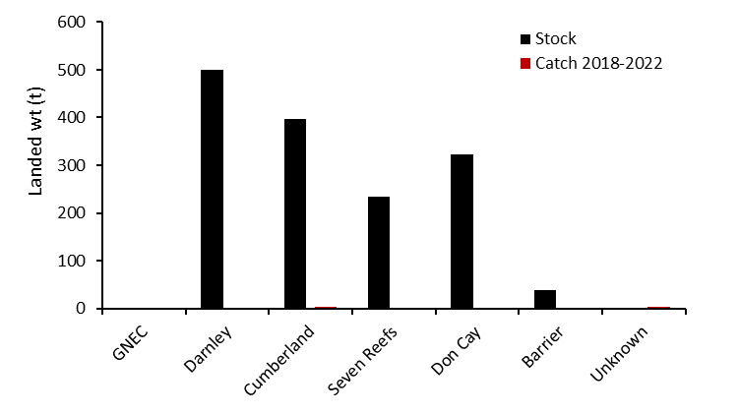

Figure . Stock estimate in 2019/20 and catch for period 2018-2022 for each fishery zone for White teatfish (Murphy et al., 2021a; Fishery TDB02 CDR data – note that location is not a compulsory field).

## Stock assessments

### Black teatfish

Black teatfish population estimates from surveys and size frequency sampling data gathered during the 2020-2023 fishery openings have been used in two stock assessment models: a biomass dynamics model (Schaefer model) and an age-structured model (Murphy et al., 2021a; Plaganyi et al, 2023a). A range of scenarios were tested, especially in the age structured model. (Note: while the assessment has not been externally reviewed, the models and outputs have been presented to the Torres Strait Hand collectables Resource Assessment Group (AFMA, 2023a)).

Both these models indicate that for Black teatfish in the TSBDMF, a 20 t TAC is sustainable across most model versions, but higher catches may not be. As more data become available, including further catch sampling and potentially spatial catch and effort data from compulsory FRS, it will be possible to refine and substantially improve modelling results and reduce uncertainty.

### White teatfish

An integrated age-structured production model for white teatfish has been developed using available survey and catch data (Plaganyi et al., 2023b). Despite considerable uncertainty (mostly due to low contrast in the data related to the very small historical catches relative to biomass), the age-structured model results suggests that the current White teatfish TAC of 15 t would have a very small effect on the Torres Strait White teatfish population. This indicated that the current TAC is likely highly conservative. (Note: while the assessment has not been externally reviewed, the model and outputs have been presented to the Torres Strait Hand Collectables Resource Assessment Group (AFMA, 2023a)).

Additional monitoring outputs will improve the reliability of the model, including spatial catch information and repeated survey, especially in the event of catch increases in the future (e.g. through the introduction of underwater breathing apparatus into the fishery).

### ABARES Fishery Status Reports

Annually, ABARES reviews the available information and assesses the status of Commonwealth fisheries. They make a determination as to whether the fishing mortality status (is it being overfished or not); and population biomass status (is it overfished to be the limit reference point (LRP) or not). As for the definition of LRP, ABARES equates this to a biomass limit (BLIM) “where the risk to the stock is regarded as unacceptable” as defined in the Commonwealth Fisheries Harvest Strategy Policy (HSP; DAWE, 2018). The Harvest Strategy Policy (HSP) specifies default LRP as half the biomass required for MSY (0.5BMSY) or 20 per cent of the unfished biomass (0.2B0). The HSP requires that fish stocks remain above a biomass level reference point, where the risk to the stock is regarded as unacceptable (BLIM), at least 90 per cent of the time (DAWE, 2018).

In assessing biomass status, ABARES considers whether the biomass of a stock is above or below the limit reference point (LRP or BLIM). If biomass is below this level, a stock is considered to be overfished. ABARES uses a weight-of-evidence approach to determine status (ABARES, 2022; Stobutzki et al., 2015).

Note that the level of risk (10% chance of depleting a fishery below LRP) is likely too high for a CITES listed species, given that the consequence of such an occurrence may lead to at least localised extinction. Also, there have been no specific LRP determined for sea cucumber species, and the default HSP LRP of 0.2B0 is likely to be too low for sea cucumbers (being based on generic indices for finfish) due to the likelihood of significant depensatory (Allee) effects on population productivity at low population densities (Hutchings, 2015; González-Durán et al., 2018), and sea cucumbers important ecological role in maintaining the health of coral reef systems (Purcell et al., 2016a). It is also important to note that the LRP under the TSBDM Fishery Harvest Strategy is 0.4B0 - a more conservative value than the default LRP under the HSP (see below).

In the most recent assessment (for the 2022 fishing year; Butler et al., 2023), Black teatfish and White teatfish were assessed as not subject to overfishing and not overfished – which continued positive assessments that occurred since at least 2017 (Table 3).

The outcomes were largely based on the results of stock surveys and stock assessments (Butler et al., 2023). For Black teatfish, is concluded that the densities reported in the most recent survey were found to be similar to unfished densities, and greater than BMSY, and that the stock was unlikely to be below the LRP and is therefore classified as not overfished. Given that the catch in 2022 was below the maximum annual TAC estimated by stock assessment modelling to be sustainable in the long term, the stock was classified as not subject to overfishing.

For White teatfish, they concluded that the stock was unlikely to have been depleted and that it was likely to be above the LRP, therefore the stock was classified as not overfished. Recent catches have been less than 1% of the lower 90th percentile estimate of total biomass and, therefore, it was classified as not subject to overfishing.

Table Biological stock status of sea cucumber stocks in the CSF, as Fishing mortality status (is it being overfished or not); and Biomass status (is it overfished or not). For the target species: Black teatfish and White teatfish for the period 2017 to 2022. Source: ABARES Fishery status reports 2018-2022. Source: ABARES Fishery status reports 2018-2022 (see Butler et al., 2023 and previous).

|  |  |  |  |  |  |  |  |  |  |  |  |  |
| --- | --- | --- | --- | --- | --- | --- | --- | --- | --- | --- | --- | --- |
|  | 2017 | | 2018 | | 2019 | | 2020 | | 2021 | | 2022 | |
| Stock | Fishing mortality | Biomass | Fishing mortality | Biomass | Fishing mortality | Biomass | Fishing mortality | Biomass | Fishing mortality | Biomass | Fishing mortality | Biomass |
| Black teatfish (*Holothuria whitmaei*) |  |  |  |  |  |  |  |  |  |  |  |  |
| White teatfish (*Holothuria fuscogilva*) |  |  |  |  |  |  |  |  |  |  |  |  |
|  | Not subject to overfishing/Not overfished | | | | | | | | | | | |
|  | Uncertain | | | | | | | | | | | |

## Ecological Risk Assessment (ERA)

An Ecological Risk Assessment (ERA) of the TSBDMF was carried out in 2021 (Dutra et al., 2021). It applied a scale, intensity, consequence analysis (SICA) and found that no species or ecosystem component was at moderate or higher risk from the direct impact of fishing, meaning no further risk assessment was required. The analysis identified Prickly redfish as the most vulnerable commercial species in the fishery as it was the most consistently targeted species in the fishery in recent times. But the risk was still assessed as minor given the results of population surveys and increasing catch per unit of effort (CPUE) (Murphy et al., 2021a). Black teatfish and White teatfish were considered as less vulnerable than Prickly redfish, and therefore the risk to these species was also minor at most (Dutra et al., 2021).

Given that the ERA did not identify any moderate or higher risks, the management response is that no specific ecological risk management strategy is required at this time (AFMA, 2023a).

# Management

## Current management

The governance arrangements in the Torres Strait are complex. The management of the TSBDMF is the responsibility of the Protected Zone Joint Authority (PZJA), a body set up to manage Australian fisheries under the Torres Strait Treaty between Australia and PNG. The PZJA comprises the relevant Commonwealth and Queensland government ministers, and the Chair of the Torres Strait Regional Authority, which is the Commonwealth agency established under the *Aboriginal and Torres Strait Islander Act 2005* that represents the interests of Torres Strait Islanders.

The PZJA is supported by several government agencies, including the Australian Fisheries Management Authority (AFMA), the Commonwealth Department of Agriculture, Fisheries and Forestry (DAFF), the Queensland Department of Agriculture and Fisheries (QDAF) and the TSRA. However, AFMA provides the bulk of management and advisory services and implements appropriate fisheries management arrangements for the fishery.

To assist in the management of the TSBDMF the PZJA has established advisory committees: the Hand Collectables Working Group (HCWG) for management advice, and the Hand Collectable Resource Assessment Group (HCRAG) for stock assessment advice. These committees are comprised of Traditional Inhabitant, scientific and management agency members. In addition, representatives of relevant registered native title body corporates (RNTBC, e.g. Malu Lamar) are also included through formal consultation and as invited participants on the PZJA advisory committees.

The fishery is managed in accordance with the *Torres Strait Fisheries Act 1984* and the *Torres Strait Fisheries Regulations 1985*. Key management tools include license arrangements and licence conditions, the Torres Strait Fisheries (Bêche-de-mer) Management Instrument 2022, and the Torres Strait Bêche-de-mer Fishery Harvest Strategy. Like other fisheries in Torres Strait, the TSBDMF is managed under objectives that differ from solely Australian Government–managed fisheries. For Torres Strait fisheries, the PZJA aims to optimise resource use, protect the traditional way of life and livelihood of traditional inhabitants and encourage traditional inhabitant participation in the fishery (AFMA 2019). As acknowledged in the TSBDMF Harvest Strategy (AFMA, 2019), the objectives for the TSBDMF are:

* sustainable use of sea cucumbers in Torres Strait, with a long-term view of sustainability for future generations
* development of sea cucumber populations for the benefit of Traditional Inhabitants, taking into account commercial considerations
* consideration of an ecosystem approach to management
* development of long-term recovery strategies for species, where appropriate.

The TSBDMF is managed using various input and output controls (AFMA, 2019; 2023). These include:

* Limiting participation in the fishery to TIB licence holders. (There is currently no upper limit on the number of TIB licences that can be issued)
* Limiting fishers to using vessels no longer than 7 m
* Hand collection only
* Prohibiting the use of hookah and scuba gear. (The feasibility of using hookah for certain species is being investigated by PZJA processes (AFMA, 2021))
* Species specific minimum size limits (MSL)
* Total allowable catches (TAC)
* Black teatfish, 20 t (But subject to specific annual fishery opening arrangements and catch reporting requirements)
* White teatfish, 15 t
* Prickly redfish, 15 t
* Deepwater redfish, 5 t
* Hairy blackfish, 5 t
* Greenfish, 40 t
* Curryfish common (*Stichopus herrmanni*) and Curryfish vastus (*S. vastus*), combined 60 t
* A single TAC of 50 t applies to other species (including Amberfish). Some of these other species have a specific catch trigger limit (but Amberfish currently do not).
* Sandfish and Surf redfish are currently closed species.

There are no formal closed fishery areas in the TSBDMF. However, there are a number of Indigenous Protected Areas (IPAs) in Torres Strait (NIAA, 2023). The most relevant to the teatfish populations is the Warraberalgal and Porumalgal Indigenous Protected Area (IPA), which was dedicated in July 2014. It comprises nine culturally significant islands, sandbanks and rocks with a total are of 63 hectares. The people of Warraber (Sue Island) and Poruma (Coconut) Island are the owners of the IPA (NIAA, 2023). IPAs deliver biodiversity conservation outcomes for the benefit of all Australians through voluntary agreements with the Australian Government. Most IPAs are dedicated under International Union for Conservation of Nature (IUCN) Categories 5 and 6 (NIAA, 2023).

There are also traditional access arrangements that are implemented through customary and Traditional Laws, “Ailan Kastom”, that can control effort, and though not formally documented, does contribute to the sustainability of marine resources in Torres Strait in general (AFMA, 2019; Plaganyi et al., 2020). For example, agreements between Island nations regarding spatial access has been instrumental in limiting effort during annual Black teatfish opening since 2020 (Anon, 2021); and fishers have implemented rotation harvesting to reduce localised depletion of Prickly redfish population since at least 2020 (AFMA, 2022a).

### Harvest strategy

A Harvest Strategy (HS) for the TSBDMF was implemented in 2019 (AFMA, 2019; Plaganyi et al., 2020). It includes a tiered (or step-wise) approach for how fishery data can be used to manage the fishery and control effort to levels assessed as a low risk of overexploitation, and potentially to support higher TACs with appropriate levels of supporting information. Specific decision rules apply at each tier level and to the different species categories in the Harvest Strategy to control effort, TACs and MSL. Rules for reopening stocks with zero TACs, MSL, conversion ratios, options for spatial/ temporal closures and an ability to accommodate traditional community management initiatives are also described in the harvest strategy. The HS also specifies the requirements for monitoring, with agreement that a fishery will be closed if no data are provided by fishers and fish receivers. The Strategy uses a range of indicators to assess fishery status including surveys, total catch and catch per unit effort (CPUE) depending on the tier level being applied (AFMA, 2023a).

TACs for the various species listed in the 2019 harvest strategy were determined based on biomass estimates from previous surveys, and relative population density trends (AFMA, 2019). Data from the most recent 2019/20 sea cucumber survey are directly input into the HS, supporting a number of decision-making processes for future management of the fishery (Murphy, 2021; AFMA, 2023a).

Though not implemented for any species, the harvest strategy suggests a default limit reference point (LRP) of 40% of unfished spawning biomass (0.4B0). This is due to the likelihood of significant depensatory (Allee) effects on population productivity at low population densities (Hutchings, 2015; González-Durán et al., 2018), and sea cucumbers important ecological role in maintaining the health of coral reef systems (Purcell et al., 2016a). This is higher than the default LRP of 0.2B0 stipulated in the Commonwealth HSP (DAWE, 2018). In addition, the HSP requires that fish stocks remain above the LRP (BLIM) at least 90 per cent of the time (DAWR, 2018), which is likely too high a risk for a CITES listed species, given that the consequence of such an occurrence may lead to at least localised extinction. This should be considered in future assessments of CITES listed sea cucumbers.

### Fishery approval under the EPBC Act

The *Environment Protection and Biodiversity Conservation Act 1999* (EPBC Act) requires the Australian Government to assess the environmental performance of fisheries and promote ecologically sustainable fisheries management (DAWE, 2020, DCCEEW, 2023). The departments’ primary role is to evaluate the environmental performance of fisheries, including:

* the strategic assessment of fisheries under Part 10 of the EPBC Act
* assessments relating to impacts on protected marine species under Part 13 and
* assessments for the purpose of export approval under Part 13A.

An independent assessment of all export and all Australian Government managed fisheries is required. These assessments ensure that, over time, fisheries are managed in an ecologically sustainable way. The assessments are conducted against the 2nd edition of the Guidelines for the Ecologically Sustainable Management of Fisheries (the Guidelines), and in doing so, also consider all public comments received on the application. The Guidelines outline specific principles and objectives designed to ensure a strategic and transparent way of evaluating the ecological sustainability of fishery management arrangements.

The Departments’ assessment forms the basis for approvals granted under Parts 13 and 13A of the EPBC Act, and also forms the basis for the Australian CITES Scientific Authority’s Non-Detriment Finding for CITES species harvested in this fishery.

A positive finding under this process results in the granting of a Wildlife trade operation (WTO) certificate for each species exported. In order to export Australian native animal or plant specimens and/or CITES listed specimens for commercial purposes, the specimens must come from an approved program such as a WTO.

The Department most recently assessed an application for the TSBDMF in 2023 (DCCEEW, 2023). Both the public submissions and AFMA’s response were considered in the Department’s assessment. The Department recommended that the fishery be declared an approved WTO for a period of three years until November 2026 subject to conditions. These conditions relate to additional reporting requirements for CITES listed species, and providing the scope and timeline for the next fishery independent survey of sea cucumbers in the Torres Strait.

## History of management

The following timeline pertains to the modern TSBDMF. For information about the historical sea cucumber fishery, see the National report.

1985: The Torres Strait Treaty enters into force after being signed 1978. This treaty defines the border between Australia and Papua New Guinea and provides a framework for the management of the common border area. As well as defining the maritime boundaries between Papua New Guinea and Australia, the Treaty implements the Torres Strait Protected Zone (TSPZ), which was primarily designed to protect the traditional ways of life of Traditional Inhabitants in the area. It also includes arrangements for the sharing of commercial catch for straddling stocks – known as “Article 22” fisheries. Although being a straddling stock (for some species at least e.g. Sandfish), sea cucumber was not included as an Article 22 fishery (probably as it was not active at the time). Therefore catch sharing agreements are not required. Two primary management instruments under the Treaty are the Traditional Inhabitants' Meeting (TIM) and Joint Advisory Council (JAC).

At the same time, management of Australian fisheries under the Treaty (Article 22 fisheries) fall under the newly formed Torres Strait Protected Zone Joint Authority (PZJA) – which currently includes representative of the Commonwealth, Queensland State and TSRA. The PZJA managed the following fisheries in accordance with Commonwealth law in the Australian component of the TSPZ: Traditional Fishing; jointly managed (between Australia and PNG) fisheries in the TSPZ listed in Article 22 of the treaty (prawn, Spanish mackerel, pearl shell, Tropical rock lobster, dugong and turtle fisheries). The Torres Strait fisheries are managed in accordance with the *Torres Strait Fisheries Act 1984* and the *Torres Strait Fisheries Regulations 1985*. (Note: the TSBDMF continued to fall under Queensland jurisdiction).

New licencing arrangements are implemented for all commercial fisheries. Transferable vessel holder (TVH) licences were granted to fishers that could demonstrate the required prior history and commitment to fishing in Torres Strait (primarily non-Traditional Inhabitants). Traditional Inhabitants could access the commercial fishery using a non-transferable TIB licence granted on an annual basis based on demonstrated recognition as a “Traditional Inhabitant”.

1988: Sea cucumber fishing begins on the Papua New Guinea side of the border in Torres Strait, primarily for Sandfish on northern Warrior Reef.

1992: Sea cucumber fishing begins on the Australian side of the border in Torres Strait, primarily for Sandfish on southern Warrior Reef.

1992: Mabo Native Title determination.

1998: Sandfish becomes a closed species in the TSBDMF due to overfishing.

1999: Fisheries not originally included in the Treaty arrangement (Article 22 fisheries) also come under the jurisdiction of the PZJA, including: finfish, crabs, trochus, and beche-de-mer. (Note: Recreational fishing, including charter fishing, are still managed by the Queensland Department of Agriculture and Fisheries. (PZJA website; accessed 29/6/2023).

1999: Implementation of minimum size limits and prohibition of underwater breathing apparatus in the TSBDMF (Fisheries Management Notice 53; CoA, 2003). (May have been in force before this time but uncertain)

1999: TSBDMF becomes limited entry for non-Traditional Inhabitant fishers. One non-Indigenous licence issued (non-transferable) (TSRA, 2014).

2001: Torres Strait Sea Claim Part A (Torres Strait Islander) and Part B (Kaurareg) lodged (TSRA, 2014).

2003: Surf Redfish and Black Teatfish become prohibited species in the TSBDMF due to overfishing.

2004: The Torres Strait Seafood Buyers and Processors Docket-book program (non-compulsory) (TDB01) is introduced to collect catch data from the TIB Sector.

2011: Two developmental permits (one TIB operator one non-Traditional Inhabitant (TVH) operator) allowing for hookah diving apparatus were issued by the PZJA for 2011/12 and 2012/13. Permit conditions required fine-scale catch and effort information to be provided to fisheries managers.

2012: The Full Federal Court hands down its decision regarding Torres Strait Sea Claim Part A, an appeal of the Federal Court’s Decision from July 2010. The Full Federal Court found that the native title rights over the sea claim area do not “extend to taking of fish and other aquatic life for sale or trade” (TSRA, 2014).

2013: The High Court hands down decision regarding Torres Strait Sea Claim Part A The decision overturned the Full Federal Court decision from March 2012 and found that the native title rights in the sea claim area include the right to take fish for commercial or trading purposes (TSRA, 2014).

2014: Malu Lamar is appointed as the Registered Native Title Body Corporate for the Sea Claim Area Part A (TSRA, 2014).

2014: Trial reopening of the Black teatfish fishery for two years with a 20 t TAC (TAC exceeded both years).

2015: The single non-Indigenous TSBDMF licence is acquired by the TSRA. The fishery becomes 100% Torres Strait owned (AFMA, 2023a).

2017: A mandatory Fish Receiver System (FRS) (TDB02) is introduced to replace the voluntary docket book (TDB01) program. All licenced commercial fishers are now required to land their product to a licenced fished receiver. The fish receiver is then required to accurately weigh and record data about the landed product in a catch disposal record (CDR) book. The CDR also has a voluntary section which seeks information on fishing effort including the area the product was caught, the number of days fished, the number of fishers and the fishing method. This information remains voluntary due to the legislative limitations within the TSF Act (AFMA, 2023a).

2017: Prickly redfish TAC reduced from 20 t to 15 t due to reports of declining catch rates by TS fishers.

2019: The Torres Strait Bêche-de-mer (Sea cucumber) species ID guide is updated with the latest fishery information (Murphy et al., 2019).

2020: A new harvest strategy for the Torres Strait Bêche-de-mer (sea cucumber) Fishery (TSBDMF) is implemented in consultation with the Hand Collectables Working Group (HCWG), AFMA, TSRA, Malu Lamar and other stakeholders.

2020: Black teatfish and White teatfish listed as CITES species.

2021: Black teatfish fishery reopened with a 15 t TAC (after introduction of mandatory catch reporting and other measures).

2022: Prickly redfish and Amberfish listed as CITES species with May 2024 set for the implementation of all supporting administrative and regulatory arrangements

2022: Sea claim determination made for Parts B and C of the Torres Strait Sea Claim

## Management of illegal, unreported and unregulated fishing (IUU)

There is a long history of IUU fishing in Torres Strait, primarily by PNG nationals targeting Sandfish and Tropical rock lobster on Warrior Reef, exacerbated by population growth, poverty and lack of governance in Western Province, PNG (Busilacchi et al., 2021).

IUU fishing within the Australian EEZ, including the Torres Strait, is addressed through a National Plan of Action to Prevent, Deter and Eliminate Illegal, Unreported and Unregulated Fishing (NPOA-IUU). It involves several government agencies that cooperate to carry out aerial surveillance, sea patrols and real-time monitoring of fishing vessels. Australia is also active at an international level promoting stronger measures to combat IUU fishing through The International Plan of Action to Prevent, Deter and Eliminate Illegal, Unreported and Unregulated Fishing (IPOA-IUU) which calls on all states to take effective measures globally, regionally and nationally to combat IUU fishing.

AFMA’s approach to combating IUU fishing is outlined in its International Compliance and Engagement Program 2022-24 and includes five components:

* Communication: Improving public understanding and awareness of AFMA’s activities to combat IUU fishing, including working with Australia’s neighbouring countries in sharing information and planning regional fisheries operations.
* Enforcement operations: Leading and supporting enforcement operations to support monitoring, control and surveillance (MCS) activities in Australian waters and in areas of Australia’s interest.
* Strategic engagement: Working closely with other Australian Government departments and agencies in engaging with other countries, particularly Australia’s neighbours, to develop and promote regional strategies to address IUU fishing.
* Capability development and supplementation: Developing national and regional capacity to undertake risk-responsive MCS operations to combat IUU fishing, delivered through the provision of theoretical training, on-the-job mentoring and participation in regional fisheries surveillance operations.
* Targeted threat program: Implementation of a risk-based compliance approach to facilitate the effective and efficient deployment of AFMA’s resources to high-risk areas.

The program seeks to prioritise limited resources against key risk areas.

In Torres Strait, AFMA works to counter IUU fishing, through an active program of detection, interdiction and sanctioning of illegal foreign fishers along with the forfeiture of their vessels and catch. This program includes working with Maritime Border Command in the risk responsive tasking and deployment of surface and air assets. AFMA also participate in annual meetings at the bilateral (Australia-PNG) and regional level, working with partner agencies in PNG, Timor Leste and Indonesia to foster and encourage a united approach to combatting IUU fishing in the region. Australian and PNG government agencies also conduct visits to the 13 PNG Torres Strait Treaty villages, situated along the Southern Coastline of Western Province, PNG, as a part of the Department of Foreign Affairs (DFAT) led Treaty Awareness Program.

## Management effectiveness (monitoring and compliance)

As of 1 July 2018, AFMA officially took on the role of delivering the domestic compliance program from Queensland Boating and Fisheries Patrol within the TSPZ and adjacent outside but near area. AFMA takes a risk-based approach to monitoring and compliance in accordance with its National Compliance and Enforcement Policy 2022 (the Policy), which aims to target compliance and enforcement in the areas where it is most needed, “thereby using AFMA’s resources most effectively” (AFMA, 2022). In addition to the risk treatment model, AFMA maintains a general deterrence program by maintaining a presence at fishing ports (and at sea).

AFMA assesses risks through the conduct of biennial risk assessments in accordance with the international standard for risk management (ISO 31000:2018). The methodology utilised for these assessments is detailed in AFMA’s National Compliance Risk Assessment Methodology 2021-23. The assessments are conducted across the major Commonwealth domestic fisheries, including Torres Strait fisheries and inform the development of annual compliance and enforcement programs. The 2022–23 National Compliance and Enforcement Program (AFMA, 2023b) details four major components of the program, including a Compliance Risk Management Team (CRMT) that will target risks in Torres Strait fisheries.

In the trial openings in 2014 and 2015, catch limits were exceeded both years due to poor (voluntary) catch reporting and pulses in fishing effort and the Black teatfish sub-fishery of the TSBDMF was subsequently closed. Since then, including compulsory catch reporting and an Indigenous Torres Strait Islander led industry workshop that agreed to implementing “Ailan Kastom” (Island custom) traditional management, alongside western management (AFMA, 2021; Murphy et al., 2024a).

Black teatfish openings have now occurred in 2021,2022, 2023 and 2024 with a 20 t TAC and with real time catch reporting (catch receivers were required to send an image of completed catch records electronically to management, on the same day that catch was received). In each instance, the fishery was closed under-quota (AFMA, 2023a; AFMA unpublished data).

# Conclusions and recommendations

The TSBDMF is an important local fishery with a long history. It provides an important source of local income for Torres Strait Island communities. Due to its semi-artisanal nature and legislative barriers (e.g. TSF Act does not permit the implementation of logbooks for Traditional Inhabitant fishers), it has been challenging to manage and collect useful fishery dependant data. However, for various reasons, it has been well studied by fisheries researchers, providing a sound basis for its sustainable management.

Some key uncertainties remain, including: the biology of both species, especially with respect to local size at maturity, early growth of juveniles to breeding age, fecundity and breeding seasonality, and mortality rates of juveniles and adults; and climate change stressors impacts and their effect on future extinction risk.

This report has attempted to address the key information fields for an NDF for Black teatfish and White teatfish in the TSBDMF. Some of the key findings related to each species are:

***Black teatfish***

* Inherent vulnerability for Black teatfish in the TSBDMF is assessed as high.
* Black teatfish are widely distributed on eastern shallow reefs within the TSBDMF.
* Black teatfish are a key fishery species in the TSBDMF, and were heavily targeted in the mid 1990s and at least locally depleted to low levels. The fishery was closed in 2003.
* Surveys in 2009 and 2019/20 indicated that the population has recovered to near virgin levels. The fishery has gradually reopened starting in 2014 to the current annual 20 t TAC.
* The density and biomass in the TSBDMF is currently considered to be at relatively healthy levels, with a 2019/20 survey resulting in a biomass estimate for the TSBDMF of 1,233 t (landed weight), with a lower 90th percentile estimate of 787 t, and of that, 172 t being larger than the MSL.
* Black teatfish catches are modest compared to estimated biomass in Torres Strait.
* A recent stock assessment concluded that the 20 t TAC was sustainable, but more information will increase the reliability of the assessment.
* Catch on the reefs closest to communities is relatively high and may lead to localised depletion. In contrast, the Barrier zone, which has a relatively high density and biomass, has been relatively unfished.

***White teatfish***

* Overall inherent vulnerability for White teatfish in the TSBDMF is assessed as moderate-high.
* White teatfish are widely distributed within the shallow reefs and deep reef habitats within the TSBDMF.
* White teatfish are a key fishery species in the TSBDMF, however catches have been restricted due to the current ban on underwater breathing apparatus.
* White teatfish are likely at near virgin biomass levels, with a 2019/20 survey resulting in a biomass estimate for the TSBDMF of 1,493 t (landed weight), with a lower 90th percentile estimate of 880 t, and of that, 143 t being greater than the MSL.
* White teatfish catches have been very small compared to the estimated biomass in Torres Strait.
* A significant proportion of the population (likely >70%) is in deep reef (>20 m) habitat, which is currently protected by a ban on underwater breathing apparatus.
* A recent stock assessment concluded that the population had been little impacted by fishing, and that the current 15 t TAC was sustainable and conservative, but that more information was required to increase the reliability of the assessment.

## Recommendations

1. Maintain the current 20 t TAC for Black teatfish and closely monitor the population for signs of depletion.

The current 20 t TAC for Black teatfish is based on an analysis of long-term survey density trends and a numeric stock assessment and is likely sustainable. However, the stock assessment model should be updated on a regular basis consistent with the level of risk appropriate for a CITES listed species, including the integration of fishery dependant and/or fishery independent data suitable for assessing stock status. In addition, the population status at the zone level is uncertain, and there may be localised depletion due to fishing taking place close to communities. Consideration of management strategies that address the risk of localised depletion should be considered.

1. Maintain the current 15 t TAC for White teatfish and closely monitor the population for signs of depletion.

The current 15 t TAC for White teatfish is based on an analysis of long-term survey density trends and a stock assessment and is likely sustainable. Current population status is likely near to B0 (virgin biomass) level, due mostly to a lack of fishing effort related to current gear restrictions. Further development of the stock assessment modelling should be carried out to address uncertainties, and particularly if underwater breathing apparatus should be approved for the fishery, which would increase the take of White teatfish in the TSBDMF substantially.

1. Review and implement appropriate minimum size limits (MSL) for both teatfish species (and other priority species such as Prickly redfish).

Recent guidance is for a MSL at 125% the size at maturity (Wickens et al., 2024), which is a basic principle for increasing resilience and reducing risk (Purcell, 2010; Prince and Hordyk, 2019). Some MSL may not meet this guidance (e.g. Black teatfish MSL is 25 cm, and best age at maturity estimate is 26 cm).

In addition, catch monitoring has shown variability in length and weight for Black teatfish during the recent fishery opening (Murphy et al., 2023) that may or may not be related to handling and time out of water. Also, guidance on animal measurement (e.g. in or out of water) should be specified to gain full advantage of MSL for sustainability while considering fishery feasibility and economic yield.

1. Assess the efficacy of the HS to maintain teatfish (and other CITES listed species) near target reference levels.

While the HS is consistent with both the Commonwealth Fisheries Harvest Strategy Policy and Guidelines and objectives of the Torres Strait Fisheries Act 1984 (Butler et al, 2022)—the higher precaution and lower risk profile appropriate for CITES listed species requires all CITES species in the TSBDMF (teatfish and *Thelenota* species) to be managed with low risk of overexploitation. The HS should be further developed to include appropriate population reference points (especially BLIM) for all CITES listed species, and improved harvest control rules that ensure that the exploitation rate is reduced below BTARG to recover depleted populations, and that fishing will cease if BLIM is reached. A management strategy evaluation would be most suitable for this objective – and would also have the additional advantage of better dealing with assessment uncertainties (Plaganyi et al., 2023a).

1. Support research on important life history parameters.

Life history parameters (growth, natural mortality, reproductive biology) are all critical inputs into stock assessments and the application of effective management strategies. The fisheries biology of both teatfish species, especially with respect to local size at maturity and breeding seasonality, early growth of juveniles to breeding age, and mortality rates of juveniles and adults are uncertain or unknown. This knowledge gap applies to many commercial sea cucumber populations and requires more research, some of which can be supported on a regional basis and over the medium term.

1. Carry out periodic fishery species and environmental monitoring.

To account for potential impacts and uncertainty in the vulnerability of teatfish in the TSBDMF, species level and environmental monitoring is required periodically (suggest every 3-5 years) to reduce sources of uncertainty (such as how climate affects recruitment), and to detect changes that affect the status and/or vulnerability of teatfish species. A periodic monitoring program of the population and related environmental parameters should be formulated and incorporated into the HS.

1. Assess and manage for climate change risks.

The vulnerability of Black teatfish in particular to climate change stressors may be significant, but with considerable uncertainty, including for indirect impacts. Development of models to link climatic effects over a range of life history components and critical habitats for sea cucumber fisheries to quantify potential impacts using alternative emission scenarios will help reduce exposure to climate change risks. In the interim, the implementation of spatial rotation and/or closed areas should be considered to ameliorate climate change risks.

1. Co-ordinate management of straddling stocks in the QSCF and CSF.

Though Torres Strait reefs are likely to be well connected and self-seeding to some extent, connectivity between the TSBDMF populations and QSCF (especially northern GBR) is also likely to be strong, and northern CSF reefs may also be a source of recruitment to Torres Strait. Coordinated management (e.g. HS frameworks and fishery reference points, temporal and spatial closures, size limits, rotational zone size, timing and move-on provisions) and research (life history parameters, MSE, conversion ratios) among all three fisheries will help reduce risk to species in the region.

References

ABARES, 2015. Reducing uncertainty in fisheries stock status, ABARES research report, Canberra, August. CC BY 3.0

ABARES, 2022. Fisheries Status Reports 2022. Australian Bureau of Agricultural and Resource Economics and Sciences, Canberra.

ABC, 2023. Foreign illegal fishing boats on the increase, Torres Strait Islanders say, amid calls for an investigation. ABC News. [https://www.abc.net.au/news/2023-01-31/illegal-foreign-fishing-boats-increase-torres-strait-islanders/101910034]

AFMA, 2013. National compliance and enforcement policy 2013. Available at: http://www.afma.gov.au/managing-our-fisheries/compliance-activities/

AFMA, 2019. Torres Strait Beche-de-mer Fishery Harvest Strategy.

AFMA, 2020. Unlicensed fish receiver fined in the Torres Strait [https://www.afma.gov.au/news/unlicensed-fish-receiver-fined-torres-strait]

AFMA, 2021. Black teatfish industry workshop. In Report of an industry workshop held on Mer, Torres Strait, 8–10 February 2021. Australian Fisheries Management Authority.

AFMA, 2022. Torres Strait Bêche-de-mer (BDM) Fishery Species Assessment Sheets - 2022. Hand Collectables Resource Assessment Group (HCRAG) Meeting No.2. 27-28 September 2022

AFMA, 2022. National Compliance and Enforcement Policy.

AFMA, 2023a. AFMA submission for reassessment of the Torres Strait Bêche-de-mer Fishery under the EPBC Act June 2023. Australian Fisheries Management Authority Canberra, Australia.

AFMA, 2023b. National Compliance and Enforcement Program 2023-25.

Anderson, S.C., Flemming, J.M., Watson, R., Lotze, H.K., 2011. Serial exploitation of global sea cucumber fisheries: Serial exploitation of sea cucumbers. Fish and Fisheries 12, 317–339. https://doi.org/10.1111/j.1467-2979.2010.00397.x

Anon, 2021. Black teatfish Industry Workshop 8-10 February 2021, Mer. Final outcomes (Report prepared by AFMA).

Asha, P.S., Muthiah, P., 2005. Effects of temperature, salinity and pH on larval growth, survival and development of the sea cucumber Holothuria spinifera Theel. Aquaculture 250, 823–829. https://doi.org/10.1016/j.aquaculture.2005.04.075

Bainbridge, S. and Berkelmans, R. (2014) The use of climatologies and Bayesian models to link observations to outcomes; an example from the Torres Strait. Environmental Science: Processes & Impacts, 16(5): 1041-1049

Banister, J., 2020. ‘Coronavirus hits Torres Strait’s traditional fishers as rock lobster market hits rock bottom’, The Guardian, 23 February, theguardian.com/australia-news/2020/feb/23/coronavirus-hitstorres-straits-traditional-fishers-as-rock-lobster-market-hits-rock-bottom, accessed June 2023.

Beaman, R., 2010. Project 3DGBR: gbr100 High-resolution Bathymetry for the Great Barrier Reef and Coral Sea (JCU). eAtlas.dataset. https://eatlas.org.au/data/uuid/200aba6b-6fb6-443e-b84b-86b0bbdb53ac

Bruckner, A.W., Johnson, K.A., Field, J.D., 2003. Conservation strategies for sea cucumbers: Can a CITES Appendix II listing promote sustainable international trade. SPC Bêche-de-mer information Bulletin 18, 24–33.

Bunch, A., 2023. “Raping our reef”: Torres Strait alarm over foreign fishing “invasion.” InQueensland. [https://inqld.com.au/insights/2023/02/28/raping-our-reef-torres-strait-alarm-over-foreign-fishing-invasion/]

Busilacchi, S., Butler, J.R.A., Putten, I. van, Cosijn, M., Posu, J., Fitriana, R., Slamet, A., 2021. Why does illegal wildlife trade persist in spite of legal alternatives in transboundary regions? Human Dimensions of Wildlife 0, 1–18. https://doi.org/10.1080/10871209.2021.1876963

Buccheri, E., Foellmer, M.W., Christensen, B.A., Langis, P., Ritter, S., Wolf, E., Freeman, A.S., 2019. Variation in Righting Times of Holothuria atra, Stichopus chloronotus, and Holothuria edulis in Response to Increased Seawater Temperatures on Heron Reef in the Southern GBR. Journal of Marine Sciences 2019, e6179705. https://doi.org/10.1155/2019/6179705

Butler, J., Bohensky, E., Skewes, T., Maru, Y., Busilacchi, S., Rochester, W., Katzfey, J., Wise, R., 2014. Drivers of change in the Torres Strait region: status and trends (Report to the National Environmental Research Program). Reef and Rainforest Research Centre Limited, Cairns.

Butler, I., D’Alberto, B., Cao, A., 2023. Torres Strait Bêche-de-mer and Trochus fisheries, in: Butler, A., Patterson, H., Bromhead, D., Galeano, D., Timmmiss, T., Woodhams, J., Curtotti, R. (Eds.), Fishery Status Reports 2023. Australian Bureau of Agricultural and Resource Economics and Sciences, Canberra.

Carson, H.S., Cook, G.S., López-Duarte, P.C., Levin, L.A., 2011. Evaluating the importance of demographic connectivity in a marine metapopulation. Ecology 92, 1972–1984.

Ceccarelli, D.M., McKinnon, A.D., Andréfouët, S., Allain, V., Young, J., Gledhill, D.C., Flynn, A., Bax, N.J., Beaman, R., Borsa, P., et al., 2013. The coral sea: physical environment, ecosystem status and biodiversity assets. Adv. Mar. Biol. 66, 213–290.

Cheng, C., Wu, F., Ren, C., Jiang, X., Zhang, X., Li, X., Luo, P., Hu, C., Chen, T., 2021. Aquaculture of the tropical sea cucumber, Stichopus monotuberculatus: Induced spawning, detailed records of gonadal and embryonic development, and improvements in larval breeding by digestive enzyme supply in diet. Aquaculture 540, 736690. https://doi.org/10.1016/j.aquaculture.2021.736690

Chieu, H.D., Premachandra, H.K.A., Powell, D., Knibb, W., 2023. Genome-wide SNP analyses reveal a substantial gene flow and isolated-genetic structure of sea cucumber Holothuria leucospilota populations in Western Central Pacific. Fisheries Research 264, 106718. https://doi.org/10.1016/j.fishres.2023.106718

Choukroun, M., Harrison, H., Hoey, A., Prachett, M., 2021. Coral Sea - Coral Reef Health Project: In situ measurements of water temperature and current flow (Report to the Director of National Parks). JCU, Townsville.

CITES, 1973. Convention on International Trade in Endangered Species of Wild Fauna and Flora.

CITES, 2011. Non-detriment findings. Conf. 16.7 (Rev. CoP 17).

CITES, 2019. Consideration of proposals for amendment of appendices i and ii. Cop18 prop. 45. (Rev. 1)

Collard, M., Eeckhaut, I., Dehairs, F., Dubois, P., 2014. Acid–base physiology response to ocean acidification of two ecologically and economically important holothuroids from contrasting habitats, Holothuria scabra and Holothuria parva. Environmental Science and Pollution Research 21, 13602–13614. https://doi.org/10.1007/s11356-014-3259-z

Conand, C., Gamboa, R., Purcell, S. & Toral-Granda, V., 2013a. *Holothuria whitmaei*. The IUCN Red List of Threatened Species 2013: e.T180440A1630988. http://dx.doi.org/10.2305/IUCN.UK.2013-1.RLTS.T180440A1630988.en

Conand, C., Purcell, S. & Gamboa, R., 2013b. *Holothuria fuscogilva*. The IUCN Red List of Threatened Species 2013: e.T200715A2681354. <http://dx.doi.org/10.2305/IUCN.UK.2013-1.RLTS.T200715A2681354.en>

CSIRO-BOM, 2015. Climate Change in Australia - Projections for Australia’s NRM Regions: WetTropics Sub-Cluster. CSIRO.

DAFF, 2007. Commonwealth fisheries harvest strategy: policy and guidelines. Department of Agriculture Fisheries, and Forestry, Canberra, A.C.T.

DAWE, 2018. Commonwealth Fisheries Harvest Strategy Policy. Department of Agriculture and Water Resources, Canberra.

DAWE, 2020. Assessment of the Torres Strait Bêche-de-mer Fishery. Department of Agriculture, Water and the Environment

DCCEEW, 2023. Fisheries Assessments. Accessed 1/6/2023. <https://www.dcceew.gov.au/environment/marine/publications/factsheet-fisheries-assessments>

DCCEEW, 2023. Assessment of the Torres Strait Bêche-de-mer Fishery. Department of Climate Change, Energy, the Environment and Water. <https://www.dcceew.gov.au/sites/default/files/documents/torres-strait-beche-de-mer-assessment-2023.pdf>

De la Rosa Castillo, J.E., Gamboa-Álvarez, M., Ponce-Márquez, M., López-Rocha, J., 2023. Active rolling movement record of the sea cucumber Astichopus multifidus 30, 135–143.

Dichmont, C.M., Fulton, E., Punt, A.E., Little, L.R., Dowling, N., Gorton, R., Sporcic, M., Smith, D.C., Haddon, M., Klaer, N., 2017. Operationalising the risk- cost-catch trade-off (Fisheries Research and Development Corporation Project 2012-202). CSIRO Oceans and Atmosphere.

Dowling, N.A., Dichmont, C.M., Haddon, M., Smith, D.C., Smith, A.D.M., Sainsbury, K., 2015. Guidelines for developing formal harvest strategies for data-poor species and fisheries. Fisheries Research 171, 130–140. https://doi.org/10.1016/j.fishres.2014.09.013

Dutra, L.X.C., Sporcic, M., Murphy, N., 2021. Ecological Risk Assessment for the Effects of Fishing. Report for Torres Strait Fishery: Bêche-de-mer Fishery 2016- 2020 (Report for the Australian Fisheries Management Authority). CSIRO Oceans and Atmosphere.

Eeckhaut, I., Parmentier, E., Becker, P., Da Silva, S.G. and Jangoux, M., 2004. Parasites and biotic diseases in field and cultivated sea cucumbers. In: A. Lovatelli, C. Conand, S. Purcell, S. Uthicke, J.F. Hamel and A. Mercier (eds), Advances in sea cucumber aquaculture and management. Fisheries Technical Paper No. 463, Food and Agriculture Organization of the United Nations, Rome.

Eriksson, H., Österblom, H., Crona, B., Troell, M., Andrew, N., Wilen, J., Folke, C., 2015. Contagious exploitation of marine resources. Frontiers in Ecology and the Environment 13, 435–440. https://doi.org/10.1890/140312

Fabinyi, M., Barclay, K., Eriksson, H., 2017. Chinese Trader Perceptions on Sourcing and Consumption of Endangered Seafood. Frontiers in Marine Science 4. https://doi.org/10.3389/fmars.2017.00181

FAO, 2019. Report of the sixth FAO Expert Advisory Panel for the Assessment of Proposals to Amend Appendices I and II of CITES Concerning Commercially-exploited Aquatic Species, FAO Fisheries and Aquaculture Report No. 1255. FAO, Rome.

FAO, 2022. Report of the Seventh FAO Expert Advisory Panel for the Assessment of the Proposals to Amend Appendices I and II of CITES Concerning Commercially-Exploited Aquatic Species, FAO Fisheries and Aquaculture Report No. 1389. FAO, Rome. https://doi.org/10.4060/cc1931en

Fontoura, L., D’Agata, S., Gamoyo, M., Barneche, D.R., Luiz, O.J., Madin, E.M.P., Eggertsen, L., Maina, J.M., 2022. Protecting connectivity promotes successful biodiversity and fisheries conservation. Science 375, 336–340. https://doi.org/10.1126/science.abg4351

Friedman, K., Eriksson, H., Tardy, E., Pakoa, K., 2010. Management of sea cucumber stocks: patterns of vulnerability and recovery of sea cucumber stocks impacted by fishing: Management of sea cucumber stocks. Fish and Fisheries 12, 75–93. https://doi.org/10.1111/j.1467-2979.2010.00384.x

Fulton, E.A., van Putten, E.I., Dutra, L., Melbourne-Thomas, J., Ogier, E., Thomas, L., Rayns, N., Murphy, R., Butler, I., Ghebrezgabhier, D., Hobday, A.J., 2021. Guidance on Adaptation of Commonwealth Fisheries management to climate change (CSIRO Report for FRDC). FRDC, Hobart.

Ganter, R., 1990. The Pearl-Shellers Of Torres Strait.

Gardner, M.G., Fitch, A.J., Li, X., 2012. Population genetic structure of Sea Cucumbers (bêche-de-mer) in northern Australia 47.

González-Durán, E., Hernández-Flores, A., Seijo, J.C., Cuevas-Jiménez, A., Moreno-Enriquez, A., 2018. Bioeconomics of the Allee effect in fisheries targeting sedentary resources. ICES Journal of Marine Science 75, 1362–1373. https://doi.org/10.1093/icesjms/fsy018

González-Durán, E., Hernández-Flores, Á., Headley, M.D., Canul, J.D., 2021. On the effects of temperature and pH on tropical and temperate holothurians. Conserv Physiol 9, coab092. https://doi.org/10.1093/conphys/coab092

Hammond, A.R., Meyers, L., Purcell, S.W., 2020. Not so sluggish: movement and sediment turnover of the world’s heaviest holothuroid, *Thelenota anax*. Mar Biol 167, 60. https://doi.org/10.1007/s00227-020-3671-5

Haywood, M.D.E., Browne, M., Skewes, T., Rochester, W., McLeod, I., Pitcher, C., Dennis, D., Dunn, J., Cheers, S., Wassenberg, T., 2007. Improved knowledge of Torres Strait seabed biota and reef habitats Report for the Marine and Tropical Sciences Research Facility. CSIRO Marine and Atmospheric Research, Cairns.

Helidoniotis, F., 2021a. Stock assessment of black teatfish (*Holothuria whitmaei*) in Queensland, Australia.

Helidoniotis, F., 2021b. Stock assessment of white teatfish (*Holothuria fuscogilva*) in Queensland, Australia.

Hu, C., Xu, Y., Wen, J., Zhang, L., Fan, S., Su, T., 2010. Larval development and juvenile growth of the sea cucumber Stichopus sp. (Curry fish). Aquaculture 300, 73–79. https://doi.org/10.1016/j.aquaculture.2009.09.033

Hu, C., Li, H., Xia, J., Zhang, L., Luo, P., Fan, S., Peng, P., Yang, H., Wen, J., 2013. Spawning, larval development and juvenile growth of the sea cucumber Stichopus horrens. Aquaculture 404–405, 47–54. https://doi.org/10.1016/j.aquaculture.2013.04.007

Hughes T.P., Anderson K.D., Connolly S.R., et al., 2018. Spatial and temporal patterns of mass bleaching of corals in the Anthropocene. Science 359: 80-83.

Hutchings, J.A., 2015. Thresholds for impaired species recovery. Proceedings of the Royal Society B: Biological Sciences 282, 20150654. https://doi.org/10.1098/rspb.2015.0654

IPCC, 2019. Technical Summary. The Ocean and Cryosphere in a Changing Climate: Special Report of the Intergovernmental Panel on Climate Change, 1st ed. Cambridge University Press. https://doi.org/10.1017/9781009157964

IUCN, 2023. The IUCN Red List of Threatened Species. Version 2022-2. <https://www.iucnredlist.org>

Johnson, J., Marsh, H., Hamann, M., Duke, N., Burrows, D., Bainbridge, S., Brodie, J., Bohensky, E., Butler, J., Laurance, S., Sweatman, H., 2015. Tropical Research in Australia’s Torres Strait Region: Synthesis of NERP Tropical Ecosystem Hub Research. <https://doi.org/10.13140/2.1.2391.1209>

Johnson, J.E., Welch, D.J., 2016. Climate change implications for Torres Strait fisheries: assessing vulnerability to inform adaptation. Climatic Change 135:611-624.

Johnson, J.E., Welch, D.J., Marshall, P.A., Day, J., Marshall, N., Steinberg, C.R., Benthuysen, J.A., Sun, C., Brodie, J., Marsh, H., Hamann, M., Simpfendorfer, C., 2018. Characterising the values and connectivity of the northeast Australia seascape: Great Barrier Reef, Torres Strait, Coral Sea and Great Sandy Strait. Report to the National Environmental Science Program. Reef and Rainforest Research Centre Limited, Cairns (81 pp).

Khalil, M., Doo, S.S., Stuhr, M., Westphal, H., 2023. Long-term physiological responses to combined ocean acidification and warming show energetic trade-offs in an asterinid starfish. Coral Reefs. https://doi.org/10.1007/s00338-023-02388-2

Kinch, J., 2004. A Review of the Beche-de-mer Fishery and it’s Management in Papua New Guinea (A report for the National Fisheries Authority). Motupore Island Research Centre – University of Papua New Guinea, Port Moresby.

Kinch, J., 2007. Socio-economic Assessment of the Beche-de-mer Fisheries in the Western, Central and Manus Provinces, Papua New Guinea. National Fisheries Authority.

Knuckey, I.A., Koopman, M., 2016. Survey to estimate the biomass and recovery of Black teatfish (Holothuria whitmaei) in Zone 1 of the Queensland Sea Cucumber Fishery (East Coast). Fishwell Consulting.

Koopman, M., Knuckey, I., 2021. Options to survey White Teatfish (*Holothuria fuscogilva*) in the Queensland Sea Cucumber Fishery (East Coast) (Report to the Department of Agriculture, Water and the Environment).

Lawrey E.P. and Stewart M., 2016. Mapping the Torres Strait Reef and Island Features: Extending the GBR Features (GBRMPA) dataset. Report to the National Environmental Science Programme. Reef and Rainforest Research Centre Limited, Cairns. 103 pp.

Lokani, P., 1994. Beche-de-mer fishery frofile for Western Province. Department of Fisheries and Marine Resources, Port Moresby.

Long, B., Skewes, T., Dennis, D., Poiner, I., Pitcher, C., Taranto, T., Manson, F., Polon, F., Karre, B., Evans, C., others, 1996. Distribution and abundance of beche-de-mer on Torres Strait reefs (Final Report to the Queensland Fisheries Management Authority).

Liu, H., Shen, M., 2021. Characterization and phylogenetic analysis of the complete mitochondrial genome of prickly redfish *Thelenota ananas* (Jaeger, 1833). Mitochondrial DNA B Resour 6, 2275–2277. https://doi.org/10.1080/23802359.2021.1920509

Long, B., Skewes, T., Dennis, D., Poiner, I., Pitcher, C., Taranto, T., Manson, F., Polon, F., Karre, B., Evans, C., others, 1996. Distribution and abundance of beche-de-mer on Torres Strait reefs (Final Report to the Queensland Fisheries Management Authority).

Lopez-Duarte, P.C., Carson, H.S., Cook, G.S., Fodrie, F.J., Becker, B.J., DiBacco, C., Levin, L.A., 2012. What Controls Connectivity? An Empirical, Multi-Species Approach. Integrative and Comparative Biology 52, 511–524. https://doi.org/10.1093/icb/ics104

McInnes, K. et al., 2015, Wet Tropics Cluster Report, Climate Change in Australia Projections for Australia’s Natural Resource Management Regions: Cluster Reports, eds. Ekström, M. et al., CSIRO and Bureau of Meteorology, Australia.

MSC, 2022. MSC Fisheries Certification Process and Guidance v3.0. Marine Stewardship Council.

Mullins, S., 1992. The Torres Strait Beche-De-Mer Fishery: A Question of Timing. The Great Circle 14, 21–30.

Mullins, S., 1995. Torres Strait: a history of colonial occupation and culture contact, 1864-1897. Central Queensland University Press, Rockhampton, Qld.

Murphy, N., Skewes, T., Filewood, F., David, C., Seden, P., Jones, A., 2011a. The recovery of the Holothuria scabra (sandfish) population on Warrior Reef, Torres Strait (CSIRO Wealth from Oceans Flagship Final Report, CSIRO, Cleveland).

Murphy, N.E., Skewes, T., Dovers, E., Rochester, W., Long, B., 2011b. Incipient outbreak of Crown-of-thorns starfish (Acanthaster planci) in Torres Strait, Australia (Final Report). CSIRO Wealth from Oceans, Dutton Park.

Murphy, N., Skewes, T., McLeod, I., Dovers, E., Carr, S., 2012. Reef Gardens in Torres Strait-Community based management in action 2012.

Murphy, N., Fischer, M., Skewes, T., 2019. Torres Strait Beche-de-mer (Sea cucumber) species ID guide. CSIRO and AFMA. 60pp.

Murphy, N., Plaganyi, E., Edgar, S., Salee, K., Skewes, T., 2021a. Stock survey of sea cucumbers in East Torres Strait (Final report.). CSIRO, Australia.

Murphy, N.E., Skewes, T.D., Edgar, S., Salee, K., Plaganyi, E.E., 2021b. Successful use of a remotely operated vehicle to survey deep-reef habitats for white teatfish (*Holothuria fuscogilva*) in Torres Strait, Australia. SPC Beche-de-Mer Information Bulletin 41, 4.

Murphy, N., Plaganyi, E., Skewes, T., 2023. Black teatfish trial fishery openings: 2021-2023. Report to Hand Collectable Resource Assessment Group Meeting No.3, 17-18 October 2023. https://www.pzja.gov.au/sites/default/files/2024-02/240216-HCRAG03-Meeting-Record.pdf

Murphy, N., Skewes, T., Plagányi, É., 2024a. Boom and no bust for a teatfish in Torres Strait, Australia from combined forms of western and Indigenous management. Conservat Sci and Prac e13073. https://doi.org/10.1111/csp2.13073

Murphy, N.E., Plaganyi, E.E., Dutra, L. and Skewes, T.D., 2024b. Size frequency program for Black teatfish. CSIRO, Australia. 69 pp.

NESP, 2018. Climate change in the Torres Strait: implications for fisheries and marine ecosystems (Earth Systems and Climate Change Hub Report No. 4). NESP Earth Systems and Climate Change Hub, Australia.

NIAA (National Indigenous Australians Agency). 2023. Warraberalgal and Porumalgal IPA., <https://www.niaa.gov.au/indigenous-affairs/environment/warraberalgal-and-porumalgal-ipa>. accessed 23 June 2023

Osborne, K., Miller, I., Johns, K., Jonker, M., Sweatman, H., 2013. Preliminary report on surveys of biodiversity of fishes and corals in Torres Strait.

Pirog, A., Latreille, A.C., Madelaine, C., Gélin, P., Frouin, P., Magalon, H., 2019. High clonal propagation and low population connectivity in the holothurian Stichopus chloronotus from the Indo-Pacific. Mar Biol 166, 63. https://doi.org/10.1007/s00227-019-3512-6

Pitcher, R., Haywood, M., Hooper, J., Coles, R., et al., 2007. Mapping and characterisation of key biotic and physical attributes of the Torres Strait ecosystem (Final report No. CRC-TS task number: T2.1). CSIRO Marine and Atmospheric Research, Cleveland, QLD, Australia.

Plaganyi, E. E., T. D. Skewes, N. A. Dowling, and M. Haddon. 2013a. Risk management tools for sustainable fisheries management under changing climate: a sea cucumber example. Climatic Change 119:181-197.

Plagányi, É.E., Murphy, N., Skewes, T., Dutra, L.X.C., Dowling, N., Fischer, M., 2020. Development of a data-poor harvest strategy for a sea cucumber fishery. Fisheries Research 230, 105635. https://doi.org/10.1016/j.fishres.2020.105635

Plaganyi, E., Murphy, N., Skewes. 2022. Stock assessment for Torres Strait Black teatfish. Presentation to the Hand Collectable Resource Assessment Group on 27-28 September 2022. Considered under Agenda Item 3. CSIRO, Australia. Accessible at: https://www.pzja.gov.au/sites/default/files/2023-03/230223-HCRAG02-Meeting-Record.pdf

Plaganyi, E., Murphy N., and Skewes, T., 2023a. Torres Strait Black teatfish stock assessment modelling. Presentation to the Hand Collectable Resource Assessment Group Meeting No.3, 17-18 October 2023. CSIRO https://www.pzja.gov.au/sites/default/files/2024-02/240216-HCRAG03-Meeting-Record.pdf

Plaganyi, E., Murphy N., and Skewes, T., 2023b. Torres Strait White teatfish stock assessment modelling. AFMA project 2021-0815. Presentation to the Hand Collectable Resource Assessment Group Meeting No.3, 17-18 October 2023. CSIRO https://www.pzja.gov.au/sites/default/files/2024-02/240216-HCRAG03-Meeting-Record.pdf

Prescott, J., Vogel, C., Pollock, K., Hyson, S., Oktaviani, D., Panggabean, A.S., 2013. Estimating sea cucumber abundance and exploitation rates using removal methods. Mar. Freshwater Res. 64, 599–608. https://doi.org/10.1071/MF12081

Prescott, J., Riwu, J., Prasetyo, A.P., Stacey, N., 2017. The money side of livelihoods: Economics of an unregulated small-scale Indonesian sea cucumber fishery in the Timor Sea. Marine Policy 82, 197–205. https://doi.org/10.1016/j.marpol.2017.03.033

Purcell, S.W., Mercier, A., Conand, C., Hamel, J.-F., Toral-Granda, M.V., Lovatelli, A., Uthicke, S., 2013. Sea cucumber fisheries: global analysis of stocks, management measures and drivers of overfishing: Management of sea cucumber fisheries. Fish and Fisheries 14, 34–59. https://doi.org/10.1111/j.1467-2979.2011.00443.x

Purcell, S.W., Polidoro, B.A., Hamel, J.-F., Gamboa, R.U., Mercier, A., 2014. The cost of being valuable: predictors of extinction risk in marine invertebrates exploited as luxury seafood. Proceedings of the Royal Society B: Biological Sciences 281, 20133296–20133296. https://doi.org/10.1098/rspb.2013.3296

Purcell, S.W., Conand, C., Uthicke, S., Byrne, M., 2016a. Ecological roles of exploited sea cucumbers: a review. Oceanography and Marine Biology: An Annual Review

Purcell, S., Piddocke, T., Dalton, S., Wang, Y., 2016b. Movement and growth of the coral reef holothuroids *Bohadschia argus* and *Thelenota ananas*. Mar. Ecol. Prog. Ser. 551, 201–214. https://doi.org/10.3354/meps11720

Purcell, S.W., Williamson, D.H., Ngaluafe, P., 2018. Chinese market prices of beche-de-mer: Implications for fisheries and aquaculture. Marine Policy 91, 58–65. https://doi.org/10.1016/j.marpol.2018.02.005

Purcell, S.W., Lovatelli, A., González-Wangüemert, M., Solís-Marín, F.A., Samyn, Y., Conand, C., 2023a. Commercially important sea cucumbers of the world – Second edition., FAO Species Catalogue for Fishery Purposes No. 6, Rev. 1. FAO, Rome. https://doi.org/10.4060/cc5230en

Purcell, S.W., Rallings, S.L., Hammond, A.R., 2023b. Long-term home ranging in the large sea cucumber, *Holothuria fuscopunctata*. Coral Reefs. https://doi.org/10.1007/s00338-023-02413-4

Ramírez-González, J., Moity, N., Andrade-Vera, S., Reyes, H., 2020. Overexploitation and More Than a Decade of Failed Management Leads to No Recovery of the Galápagos Sea Cucumber Fishery. Frontiers in Marine Science 7.

Rousselet, L., Doglioli, A.M., Maes, C., Blanke, B., Petrenko, A.A., 2016. Impacts of mesoscale activity on the water masses and circulation in the Coral Sea. Journal of Geophysical Research: Oceans 121, 7277–7289. https://doi.org/10.1002/2016JC011861

Saint-Cast, F., 2008. Multiple time-scale modelling of the circulation in Torres Strait—Australia. Continental Shelf Research 28, 2214–2240. https://doi.org/10.1016/j.csr.2008.03.035

Scannella, D., Bono, G., Di Lorenzo, M., Di Maio, F., Falsone, F., Gancitano, V., Garofalo, G., Geraci, M.L., Lauria, V., Mancuso, M., Quattrocchi, F., Sardo, G., Titone, A., Vitale, S., Fiorentino, F., Massi, D., 2022. How does climate change affect a fishable resource? The case of the royal sea cucumber (Parastichopus regalis) in the central Mediterranean Sea. Frontiers in Marine Science 9.

Schneider, K., Silverman, J., Woolsey, E., Eriksson, H., Byrne, M., Caldeira, K., 2011. Potential influence of sea cucumbers on coral reef CaCO3 budget: A case study at One Tree Reef. J. Geophys. Res. 116, G04032. https://doi.org/10.1029/2011JG001755

Schneiders, A., Van Daele, T., Van Landuyt, W., Van Reeth, W., 2012. Biodiversity and ecosystem services: Complementary approaches for ecosystem management? Ecological Indicators 21, 123–133. <https://doi.org/10.1016/j.ecolind.2011.06.021>

Skewes, T., Dennis, D., Burridge, C., 2000. Survey of Holothuria scabra (sandfish) on Warrior Reef, Torres Strait. (Report to Queensland Fisheries Management Authority). CSIRO Division of Marine Research Final Report. Brisbane: CSIRO.

Skewes, T., Dennis, D., Koutsoukos, A., Haywood, M., Wassenberg, T., Austin, M., 2004. Stock survey and sustainable harvest strategies for Torres Strait bêche-de-mer. CSIRO, Cleveland.

Skewes, T., Taylor, S., Dennis, D., Haywood, M., Donovan, A., 2006. Sustainability assessment of the Torres Strait sea cucumber fishery, CRC Final Report. CSIRO Division of Fisheries, Cleveland.

Skewes, T.D., Murphy, N.E., McLeod, I., Dovers, E., Burridge, C., Rochester, W., 2010. Torres Strait Hand Collectables, 2009 survey: Beche-de-mer. CSIRO, Cleveland. 68pp. ISBN 9781921605321

Skewes, T., Plagányi, É., Murphy, N., Pascual, R., Fischer, M., 2014. Evaluating rotational harvest strategies for sea cucumber fisheries. FRDC Final Report. Canberra. 192 pp.

Skewes, T.D., Persson, S., 2017. Coral Sea sea cucumber survey (A report for Parks Australia.). Tim Skewes Consulting.

Skillings, D.J., Bird, C.E., Toonen, R.J., 2011. Gateways to Hawai‘i: Genetic Population Structure of the Tropical Sea Cucumber Holothuria atra. Journal of Marine Biology 2011, 1–16. https://doi.org/10.1155/2011/783030

So, J.J., Uthicke, S., Hamel, J.-F., Mercier, A., 2011. Genetic population structure in a commercial marine invertebrate with long-lived lecithotrophic larvae: Cucumaria frondosa (Echinodermata: Holothuroidea). Marine Biology 158, 859–870. https://doi.org/10.1007/s00227-010-1613-3

Stobutzki, I., Larcombe, J., Woodhams, J., Patterson, H., 2015. 11 Stock status determination: weight- of-evidence decision-making framework. p. 22.

Stutterd, E., Williams, G., 2003. The future of bêche-de-mer and trochus fisheries and aquaculture in Australia., Final report to the Fisheries Resources Research Fund. Bureau of Rural Sciences (BRS).

Tanita, I., Sanda, T., Iwasaki, T., Ohno, K., Yoshikuni, M., 2023. Artificial rearing of Actinopyga lecanora (Holothuroidea: Holothuriida) with spawning induction using relaxin: Lecithotrophic short larval period. Aquaculture 567, 739226. https://doi.org/10.1016/j.aquaculture.2022.739226

Thomassin, A., 2019. ‘Ina ngalmun lagau malu’ (This Part of the Sea Belongs to Us): Politics, Sea rights and Fisheries Co-management in Zenadh Kes (Torres Strait).

Treml, E., Ford, J., Black, K., Swearer, S., 2015. Identifying the key biophysical drivers, connectivity outcomes, and metapopulation consequences of larval dispersal in the sea. Movement Ecology 3. https://doi.org/10.1186/s40462-015-0045-6

TSRA, 2014. Torres Strait Commercial Fisheries. Torres Strait Regional Authority.

Uthicke, S., Benzie, J.A.H., 2000. Allozyme electrophoresis indicates high gene flow between populations of Holothuria (Microthele) nobilis (Holothuroidea: Aspidochirotida) on the Great Barrier Reef. Marine Biology 137, 819–825. https://doi.org/10.1007/s002270000393

Uthicke, S., 2001. Nutrient regeneration by abundant coral reef holothurians. Journal of Experimental Marine Biology and Ecology 265, 153–170. https://doi.org/10.1016/S0022-0981(01)00329-X

Uthicke, S., Benzie, J., 2001. Restricted gene flow between Holothuria scabra (Echinodermata: Holothuroidea) populations along the north-east coast of Australia and the Solomon Islands. Mar. Ecol. Prog. Ser. 216, 109–117. https://doi.org/10.3354/meps216109

Uthicke, S., Benzie, J.A.H., 2003. Gene flow and population history in high dispersal marine invertebrates: mitochondrial DNA analysis of Holothuria nobilis (Echinodermata: Holothuroidea) populations from the Indo-Pacific. Molecular Ecology 12, 2635–2648. https://doi.org/10.1046/j.1365-294X.2003.01954.x

Uthicke, S., Welch, D., Benzie, J.A.H., 2004. Slow Growth and Lack of Recovery in Overfished Holothurians on the Great Barrier Reef: Evidence from DNA Fingerprints and Repeated Large-Scale Surveys. Conservation Biology 18, 1395–1404. https://doi.org/10.1111/j.1523-1739.2004.00309.x

Uthicke, S., Purcell, S., 2004. Preservation of genetic diversity in restocking of the sea cucumber Holothuria scabra investigated by allozyme electrophoresis. Canadian Journal of Fisheries and Aquatic Sciences 61, 519–528. https://doi.org/10.1139/f04-013

Uthicke, S., 2004. Overfishing of holothurians: lessons from the Great Barrier Reef (In Lovatelli A, Conand C, Purcell S, Uthicke S, Hamel J-F and Mercier A (eds). Advances in Sea Cucumber Aquaculture and Management No. Fisheries Technical Paper, 463). FAO, Rome.

Uthicke, S., Schaffelke, B., Byrne, M., 2009. A boom–bust phylum? Ecological and evolutionary consequences of density variations in echinoderms. Ecological Monographs 79, 3–24.

Welch D.J., Johnson J.E., 2013. Assessing the vulnerability of Torres Strait fisheries and supporting habitats to climate change. Report to the Australian Fisheries Management Authority, C2O Fisheries, Australia.

Wolanski, E., Lambrechts, J., Thomas, C., Deleersnijder, E., 2013. The net water circulation through Torres strait. Continental Shelf Research 64, 66–74. <https://doi.org/10.1016/j.csr.2013.05.013>

Wolanski, E., Andutta, F., Deleersnijder, E., Li, Y., Thomas, C.J., 2017. The Gulf of Carpentaria heated Torres Strait and the Northern Great Barrier Reef during the 2016 mass coral bleaching event. Estuarine, Coastal and Shelf Science 194, 172–181. https://doi.org/10.1016/j.ecss.2017.06.018

Vidal-Ramirez, F., Dove, S., 2016. Diurnal effects of Holothuria atra on seawater carbonate chemistry in a sedimentary environment. Journal of Experimental Marine Biology and Ecology 474, 156–163. https://doi.org/10.1016/j.jembe.2015.10.007

Wickens, M.E., Smart, J.J., Wortmann, J., 2024. Management strategy evaluation of the Queensland east coast sea cucumber fishery, with data to June 2023. State of Queensland, Brisbane.

Wolfe, K., Vidal‐Ramirez, F., Dove, S., Deaker, D., Byrne, M., 2017. Altered sediment biota and lagoon habitat carbonate dynamics due to sea cucumber bioturbation in a high-pCO2 environment. Global Change Biology 24, 465–480. https://doi.org/10.1111/gcb.13826

Yang, H., Bai, Y., 2015. Chapter 1 - Apostichopus japonicus in the Life of Chinese People, in: Yang, H., Hamel, J.-F., Mercier, A. (Eds.), Developments in Aquaculture and Fisheries Science. Elsevier, pp. 1–23. https://doi.org/10.1016/B978-0-12-799953-1.00001-5

Yuan, X., Shao, S., Dupont, S., Meng, L., Liu, Y., Wang, L., 2015. Impact of CO2-driven acidification on the development of the sea cucumber Apostichopus japonicus (Selenka) (Echinodermata: Holothuroidea). Mar Pollut Bull 95, 195–199. https://doi.org/10.1016/j.marpolbul.2015.04.021

Yuan, X., McCoy, S.J., Du, Y., Widdicombe, S., Hall-Spencer, J.M., 2018. Physiological and Behavioral Plasticity of the Sea Cucumber Holothuria forskali (Echinodermata, Holothuroidea) to Acidified Seawater. Frontiers in Physiology 9.

Appendix A: Catch data for TSBDMF

Table . Catch of sea cucumbers in the TSBDMF in tons landed (gutted) weight per year.

|  |  |  |  |  |  |  |  |  |  |  |  |  |  |  |  |  |  |  |  |  |  |  |  |  |  |  |  |  |  |  |
| --- | --- | --- | --- | --- | --- | --- | --- | --- | --- | --- | --- | --- | --- | --- | --- | --- | --- | --- | --- | --- | --- | --- | --- | --- | --- | --- | --- | --- | --- | --- |
| Species | 1993 | 1994 | 1995 | 1996 | 1997 | 1998 | 1999 | 2000 | 2001 | 2002 | 2003 | 2004 | 2005 | 2006 | 2007 | 2008 | 2009 | 2010 | 2011 | 2012 | 2013 | 2014 | 2015 | 2016 | 2017 | 2018 | 2019 | 2020 | 2021 | 2022 |
| Sandfish | 40.0 | 200.0 | 1200.0 | 30.0 | 30.0 | 0.0 | 0.0 |  |  |  |  |  |  |  |  |  |  | 0.0 | 0.0 | 2.2 | 0.0 | 0.0 |  |  |  | 0.0 |  |  |  |  |
| Black teatfish | 10.0 | 20.0 | 50.0 | 52.8 | 40.2 | 18.5 | 9.2 |  | 11.8 | 3.4 |  |  |  |  |  |  |  |  | 0.1 | 2.0 | 0.1 | 16.6 | 23.3 |  |  | 0.0 |  |  | 17.6 | 17.1 |
| Deep water redfish |  |  |  |  |  |  |  |  |  |  |  |  |  |  |  |  |  | 0.0 |  |  | 5.0 | 4.2 | 5.5 |  | 0.6 | 0.2 | 0.1 |  | 0.0 | 0.0 |
| Prickly redfish |  |  |  | 0.0 | 0.0 | 0.6 | 3.3 | 0.3 | 0.2 | 10.5 |  | 1.2 | 5.6 |  | 0.1 |  |  | 0.1 | 11.1 | 1.3 | 5.9 | 9.2 | 28.1 | 11.2 | 13.2 | 14.7 | 11.9 | 15.7 | 15.0 | 13.5 |
| Curryfish (comb.) |  |  |  |  |  |  |  |  |  |  |  |  |  |  |  |  |  |  | 1.1 |  |  |  | 6.1 | 1.1 | 17.0 | 42.4 | 14.5 | 10.5 | 6.7 | 1.6 |
| Curryfish herrmanni |  |  |  |  |  |  |  |  |  |  |  |  |  |  |  |  |  |  |  |  |  |  |  |  |  |  | 1.3 | 0.6 | 4.1 | 0.4 |
| Curryfish vastus |  |  |  |  |  |  |  |  |  |  |  |  |  |  |  |  |  |  |  |  |  |  |  |  |  |  | 0.5 | 0.2 | 1.9 | 0.4 |
| Hairy blackfish |  |  |  |  | 0.1 | 1.2 | 1.7 |  | 28.5 | 10.7 |  |  | 0.2 |  | 0.1 |  |  |  | 0.5 | 0.1 | 0.2 | 2.0 | 3.6 | 1.1 | 1.2 | 1.4 | 3.5 | 1.4 | 0.5 | 0.7 |
| White teatfish |  |  |  |  | 0.1 | 0.9 | 1.1 | 1.2 | 3.0 | 0.1 |  | 0.0 | 0.7 |  |  |  |  |  | 3.2 | 13.3 | 12.6 | 16.3 | 4.2 | 1.0 | 0.8 | 1.8 | 1.6 | 1.8 | 2.0 | 2.5 |
| Leopardfish |  |  |  |  |  |  |  |  | 0.0 | 9.6 |  |  |  |  |  |  |  |  |  |  |  |  |  |  | 0.1 | 2.3 | 1.0 | 0.2 | 0.2 |  |
| Brown sandfish |  |  |  |  |  |  | 0.0 |  | 0.4 | 3.4 |  |  |  |  |  |  |  |  |  |  |  |  |  |  | 0.0 | 0.0 | 0.2 |  |  |  |
| Lollyfish |  |  |  |  |  |  |  |  |  |  |  |  |  |  |  |  |  |  |  |  |  |  |  |  |  | 0.5 | 4.0 | 1.3 | 0.4 |  |
| Greenfish |  |  |  |  |  | 0.4 |  |  | 0.1 | 1.2 |  |  |  |  |  |  |  |  |  |  | 0.0 | 0.0 | 0.0 |  |  | 1.0 | 0.3 | 0.0 |  |  |
| Elephants trunkfish |  |  |  |  |  |  |  |  | 0.4 | 0.4 |  |  |  |  |  |  |  |  | 0.0 | 0.0 | 0.0 |  | 0.1 |  |  | 0.4 | 0.0 |  |  |  |
| Surf redfish | 20.0 |  |  | 35.0 | 51.7 | 60.3 | 1.5 |  | 59.7 | 6.5 |  |  |  |  |  |  |  |  |  |  | 0.1 | 0.0 |  |  | 0.1 |  |  | 0.2 |  |  |
| Deepwater blackfish |  |  |  |  |  |  | 0.2 | 0.2 | 0.5 |  |  |  |  |  |  |  |  |  |  |  |  |  |  |  |  |  | 0.2 | 0.2 | 0.2 | 0.6 |
| Golden sandfish |  |  |  |  |  |  |  |  |  |  |  |  |  |  |  |  |  |  |  |  | 0.1 | 0.4 | 0.1 |  | 0.1 | 0.0 | 0.0 |  |  |  |
| Stonefish |  |  |  |  |  |  |  |  |  |  |  |  |  |  |  |  |  | 0.5 |  |  |  |  |  |  |  |  |  |  |  |  |
| Amberfish |  |  |  |  |  |  |  |  | 0.2 |  |  |  |  |  |  |  |  |  |  |  |  |  |  |  |  |  |  |  |  |  |
| Burrowing blackfish |  |  |  |  |  |  |  |  |  |  |  |  |  |  |  |  |  |  |  |  |  |  |  |  |  |  | 0.0 |  |  |  |
| Unidentified |  |  |  |  |  |  |  |  |  |  |  |  |  |  |  |  |  | 0.7 | 0.1 |  | 0.2 | 1.6 | 0.9 | 0.0 | 6.9 | 0.1 |  |  |  |  |
| Total (Year) | 70.0 | 220.0 | 1250.0 | 117.8 | 122.0 | 81.9 | 17.1 | 1.7 | 104.7 | 45.7 |  | 1.2 | 6.5 |  | 0.3 |  |  | 1.3 | 16.1 | 18.8 | 24.2 | 50.3 | 72.0 | 14.4 | 40.1 | 64.7 | 39.0 | 32.0 | 48.6 | 36.8 |
| Source | 1 | 1, 2 | 1, 3 | 1, 4 | 4 | 4 | 4 | 4 | 4 | 4 | 5 | 5 | 5 | 5 | 5 | 5 | 5 | 5 | 5 | 5 | 5 | 5 | 5 | 5 | 5 | 5 | 5 | 5 | 5 | 5 |
| Notes | 1 |  |  | 2,3 | 3 | 3 | 3 | 3 | 3 | 3 | 4 |  |  | 4 |  | 4 | 4 |  |  | 5 |  | 6 | 6 | 6 | 7 | 7 | 8 | 9 | 9 |  |

*It is highly likely that most of the early catch of Surf redfish is actually Deepwater redfish (Skewes et al., 2010).

Sources:

1 Nyal Ledger (pers comm.)

2 Grant Leeworthy (pers comm.)

3 Williams et al., 2000

4 QDPI logbook data

5 AFMA Fishery Data Extract (12/9/2023)

Notes:

1 F.V. Warunda stationed at Murray Island, Feb 1993 buying Black teatfish (T. Skewes pers Obs.)

2 QDPI reported sandfish 10,717 kg, but increased to 30 t local catch est. (N. Ledger, pers comm.)

3 As reported in Skewes et al., 2010

4 No fishing. As reported in AFMA, 2011.

5 Sandfish from experimental fishing (Murphy et al., 2012)

6 As reported to HCWG No. 11, June 2017

7 As reported to HCWG No. 16, March 2020

8 As reported to HCWG No. 17, August 2020

9 As reported in Butler et al., 2022

Appendix B: Catch data for Western Province, PNG

Table . Catch of sea cucumbers in the PNG Western Province Fishery in tons landed (gutted) weight per year.

|  |  |  |  |  |  |  |  |  |  |  |  |  |  |  |  |  |  |  |  |  |
| --- | --- | --- | --- | --- | --- | --- | --- | --- | --- | --- | --- | --- | --- | --- | --- | --- | --- | --- | --- | --- |
| Species | 1990 | 1991 | 1992 | 1993 | 1996 | 1997 | 1998 | 1999 | 2002 | 2003 | 2003 | 2004 | 2005 | 2006 | 2007 | 2008 | 2009 | 2017 | 2018 | 2019 |
| Blackfish |  |  |  |  | 42.5 |  |  |  |  | 14.6 | 2.7 |  |  |  |  |  |  |  |  |  |
| Black teatfish |  |  |  |  | 0.2 |  |  |  | 0.0 | 0.4 | 0.4 |  |  |  |  |  |  |  |  |  |
| Brown sandfish |  |  |  |  |  |  |  |  |  | 1.8 | 1.8 | 0.9 |  |  |  |  |  |  |  |  |
| Curryfish |  |  |  |  |  |  |  |  |  | 6.6 | 6.6 | 2.0 |  |  |  |  |  |  |  |  |
| Deep-water redfish |  |  |  |  | 2.4 |  |  |  |  |  |  |  |  |  |  |  |  |  |  |  |
| Greenfish |  |  |  |  |  |  |  |  |  | 5.0 | 5.0 |  |  |  |  |  |  |  |  |  |
| Lollyfish |  |  |  |  |  |  |  |  | 4.0 |  |  | 0.4 |  |  |  |  |  |  |  |  |
| Prickly redfish |  |  |  |  |  |  |  |  |  |  |  | 0.3 |  |  |  |  |  |  |  |  |
| Sandfish | 1,163.6 | 2,049.4 | 1,699.6 | 418.1 | 193.0 |  |  |  | 229.4 | 69.2 | 85.2 | 250.3 | 112.6 | 425.5 |  |  |  | 85.1 |  | 180.9 |
| Snakefish |  |  |  |  |  |  |  |  |  |  |  | 0.4 |  |  |  |  |  |  |  |  |
| Surf redfish |  |  |  |  | 4.9 |  |  |  | 5.7 | 40.6 | 23.8 | 8.1 |  |  |  |  |  |  |  |  |
| Stonefish |  |  |  |  | 5.5 |  |  |  | 24.9 | 12.8 | 16.0 | 10.2 | 11.3 |  |  |  |  |  |  |  |
| Tigerfish |  |  |  |  |  |  |  |  |  | 2.0 | 2.0 | 2.2 |  |  |  |  |  |  |  |  |
| Unspecified |  |  | 16.2 | 407.8 |  |  |  |  |  |  |  |  |  | 20.6 |  |  |  |  |  |  |
| Total | 1,163.6 | 2,049.4 | 1,715.8 | 825.9 | 248.5 | n/d | n/d | n/d | 264.1 | 153.1 | 143.5 | 274.9 | 123.9 | 446.1 | n/d | n/d | n/d | 85.1 | 0 | 180.9 |
| Source | 1, 2 | 1, 2 | 1, 2 | 1, 2 | 3 |  |  |  | 4 | 4 | 4 | 4 | 5 | 6 |  |  |  |  |  | 7 |
| Fishery status | Open since 1988 | Open | Open | Closed September 1993 | Open to March 1st | ? | ? | Open to 1st April | Open | Open | Open | Open | Open | Open | Open | Open | Closed Oct 2009 | Open | ? | Open |
| Notes |  |  | 1 | 1 | 2 |  |  |  |  |  |  |  |  | 3 |  |  |  |  |  |  |

n/d – No data

The fishery was closed (no reported catch) in 1994, 1995, 2000, 2001, 2010-2016, 2020-2022.

Sources:

1. Western Prov. BdM Fishery Man Plan. PNG NFA. June 1995

2. Lokani, P. 1994.

3. Kinch, 2004.

4. Catch data supplied by P. Polon, PNG NFA, 2005

5. Kinch 2007.

6. Catch data supplied by Mr. Odorri Kolonie, Enforcement Coordinator - Fisheries

7. J. Posu, PNG NFA, HCWG RAG, October 2022

Notes:

1. Unspecified described as Actinopyga sp. (Lokani, 1994)

2. Quota Sandfish 30 t, Other 10 t

3. Total catch from processors, sandfish estimated

|  |
| --- |
| CONTACT  Tim Skewes Consulting  m +61 0419 382 697  e timskewes@outlook.com |

