# Draft National Energy Equity Framework

© Commonwealth of Australia 2024

**Ownership of intellectual property rights**

Unless otherwise noted, copyright (and any other intellectual property rights) in this publication is owned by the Commonwealth of Australia (referred to as the Commonwealth).

**Creative Commons licence**

All material in this publication is licensed under a [Creative Commons Attribution 4.0 International Licence](https://creativecommons.org/licenses/by/4.0/legalcode) except content supplied by third parties, logos and the Commonwealth Coat of Arms.

Inquiries about the licence and any use of this document should be emailed to [copyright@dcceew.gov.au](mailto:copyright@dcceew.gov.au).



**Cataloguing data**

This publication (and any material sourced from it) should be attributed as: DCCEEW 2024, *Draft National Energy Equity Framework*, Department of Climate Change, Energy, the Environment and Water, Canberra, September. CC BY 4.0.

Department of Climate Change, Energy, the Environment and Water

GPO Box 3090 Canberra ACT 2601

Telephone 1800 920 528

Web [dcceew.gov.au](https://www.dcceew.gov.au)

**Disclaimer**

The Australian Government acting through the Department of Climate Change, Energy, the Environment and Water has exercised due care and skill in preparing and compiling the information and data in this publication. Notwithstanding, the Department of Climate Change, Energy, the Environment and Water, its employees and advisers disclaim all liability, including liability for negligence and for any loss, damage, injury, expense or cost incurred by any person as a result of accessing, using or relying on any of the information or data in this publication to the maximum extent permitted by law.

**Acknowledgement of Country**

We acknowledge the Traditional Owners of Country throughout Australia and recognise their continuing connection to land, waters and culture. We pay our respects to their Elders past and present.

## 

## About this document

This document details the National Energy Equity Framework (the framework) that has been developed under the interjurisdictional Energy Equity Work Program.

The framework is supported by research undertaken by the Group of Energy Efficiency Researchers (GEER) Consortium for the Energy Equity Working Group, a sub-group of the Energy and Climate Change Ministerial Council’s Energy Transformation Enablers Working Group.

Contents

About this document iii

The National Energy Equity Framework v

Reaffirming a national commitment to consumers v

Framework documents v

Better practice principles for more equitable policy 1

1 The driver or state of energy hardship to be addressed should be clearly defined 1

2 Policies and programs should be designed for scalability 1

3 Costs and benefits should be considered more broadly than the energy sector 2

4 Friction and burden should be reduced as much as possible for target households 2

5 Inclusive framing should be used in all policy and program communications 2

6 The strategic context should be considered 2

7 Evaluation approach should be incorporated into the design of the policy or program from the outset 3

Establishing common language and understanding 3

What is energy equity? 3

Hardship and vulnerability states – the ABATE model 4

Measuring the extent and distribution of hardship and vulnerability 5

The D-I-O model 5

Categorising intervention measures, policies, and programs 6

The P-S-R model 6

A community of better practice 8

**Figures**

1. The ABATE model
2. An application of the P-S-R framework that aims to guide policy strategy to alleviate energy hardship
3. Hypothetical example of using the P-S-R model

## The National Energy Equity Framework

### Reaffirming a national commitment to consumers

The National Energy Equity Framework (the framework) reaffirms the commitment of Energy Ministers to achieving an equitable energy transition for all Australians.

The transition to Net Zero holds many opportunities and also presents challenges. Energy Ministers are conscious that over recent years affordability and wellbeing challenges for many Australian households have become increasingly prominent due to high energy prices and rising costs of living.

A growing number of Australians are finding themselves less able to engage with and benefit from our energy system, and without action are at risk of being left behind in the transition to Net Zero.

In response, over recent years Energy Ministers have committed to improving equity in energy, including through the National Energy Performance Strategy, which includes the objectives of *supporting low-income households and those experiencing energy hardship;* and *enabling households to access the benefits of energy performance improvements.* The strategy’s intended outcomes include equitable access to energy performance benefits.

Alongside a commitment to improving equity, the framework establishes the foundation for this improved understanding and a new approach for addressing the challenges facing customers at risk of vulnerability in the energy market. It comprises five (5) aspects:

1. Better practice **principles** for more equitable policy.
2. **Common language** around definitions of energy equity and customers at risk of vulnerability.
3. A means of **measuring the extent and distribution** of these levels of hardship over time (including metrics, data availability and reporting models).
4. A way to **categorise intervention measures, policies, and programs**.
5. A **community of better practice** in designing for equity in energy policy and programs.

### Framework documents

This document is published alongside the following reports, produced by the Group of Energy Equity Researchers (GEER) Consortium for the interjurisdictional Energy Equity Work Program, which together comprise the common evidence base supporting the framework:

* Phase 1 Research Report
* Phase 2 Barriers to Scalability and Co-design Findings
* Phase 2 Household Interviews and Journey Maps
* Phase 2 Data Regime
* Phase 2 Summary Report
* Phase 3 Better Practice Guide.

## Better practice principles for more equitable policy

There are seven principles that should be used to guide better practice to design more equitable policies and therefore achieve more equitable outcomes for Australian consumers:

1. The driver or state of energy hardship to be addressed should be clearly defined.
2. Policies and programs should be designed for scalability.
3. Costs and benefits should be considered more broadly than the energy sector.
4. Friction and burden should be reduced as much as possible for target households.
5. Inclusive framing should be used in all policy and program communications.
6. The strategic context should be considered.
7. Evaluation approach should be incorporated into the design of the policy or program from the outset.

### The driver or state of energy hardship to be addressed should be clearly defined

Energy equity is a multifaceted issue, and no individual policy or program can solve the entirety of the problem. For a policy or program to be successful, it must be tailored to specific drivers for customers at risk of vulnerability. If this is not properly defined, it risks:

* developing duplicative policies and programs;
* not effectively addressing the identified problem;
* not achieving the intended outcome(s);
* not aligning with broader strategic goals.

### Policies and programs should be designed for scalability

There are many people who are facing hardship, vulnerability, or otherwise inequitable outcomes from the operation of the energy sector, and programs should be scaled according to this identified need. This includes:

* sufficient funding to deliver benefits to the entire target population, or a clear pathway for ongoing funding;
* a scalable delivery model which can effectively identify and reach the target population;
* addressing the root cause of the problem rather than symptoms, to minimise the need for future action.

### Costs and benefits should be considered more broadly than the energy sector

The framework is designed to help improve energy equity outcomes and is not intended to be a guide for policies or programs beyond energy. However, equitable energy policies and programs are likely to have significant benefits beyond the scope of these energy outcomes. For example, a policy that improves access to energy efficiency for households experiencing energy hardship could help reduce exposure to extreme heat and cold, providing health benefits. In considering costs and benefits, policymakers should consult with relevant agencies to quantify these benefits and minimise the effects of siloing.

### Friction and burden should be reduced as much as possible for target households

There are five key design criteria which influence the accessibility of a policy or program by target households in particular vulnerability or hardship states. If these accessibility criteria are not addressed during the design phase, the policy or program risks unknowingly excluding households in need or including households who are not in need. These criteria include:

* **Eligibility criteria** – criteria should be developed using the D-I-O, ABATE and P-S-R models (discussed in sections 2, 3 and 4 below), and include households based on an identified need to ensure that eligible participants are those who would benefit most from the policy or program.
* **Ease of use –** the application process must be easy to navigate and sensitive to the personal circumstances of households. Where possible, programs should consider removing the need for target households to apply by implementing auto-enrolment for eligible households where possible.
* **Affordability** – remove / minimise cost barriers, e.g., high upfront costs, loan schemes or co-payments for those households who are unable to afford upfront costs or ongoing loans.
* **Structural** – design policies and programs around barriers which households have no control over, e.g., a tenant being unable to upgrade the energy efficiency of their home without gaining consent from their landlord.
* **Awareness –** policies and programs must be promoted sufficiently to the target population.

### Inclusive framing should be used in all policy and program communications

Ill-chosen language risks stigmatising the target population or raising feelings of shame, guilt and/or embarrassment. This may deter people from participating, especially those who are vulnerable to but not facing energy hardship, or who may already be reluctant to access support. Consideration should be made for whether language is positively or negatively framed.

### The strategic context should be considered

Individual programs and policies should be aligned with broader strategic goals around energy equity and reducing energy hardship, as well as the broader goal of an equitable transition to Net Zero. Programs should be designed to complement existing policies and programs wherever possible, which may exist at different levels of government. Not aligning a policy/program with broader strategic goals and existing policies and programs risks efforts becoming fragmented or duplicated. Energy hardship is a complex problem that likely needs to be addressed by a suite of complementary policies and programs.

### Evaluation approach should be incorporated into the design of the policy or program from the outset

Early identification and development of an evaluation plan ensures that the key indicators of success can be built into the policy or program from the policy or program’s inception, ensuring that the success of the measure can be properly evaluated. This can allow for real-time monitoring of results, which can enable an iterative approach to policy implementation which is otherwise impossible.

## Establishing common language and understanding

The concept of energy equity has historically been inadequately defined. The framework, developed with input from researchers, consumers, and consumer advocates, has developed a clear definition for use by governments.

The framework provides a tool, the ABATE model, for categorising energy hardship and vulnerability states to assist in designing policies and programs. It is not intended to replace or otherwise effect the definition of hardship which is included in the National Energy Retail Law. The ABATE model is designed to usefully delineate between different hardship and vulnerability states.

### What is energy equity?

**Energy equity exists where all consumers can fairly access and benefit from the energy system.**

In the context of the energy market and energy transition, moving toward energy equity means:

* Decision-making, policies, and programs address differences in access and benefits between consumers leading to inequality.
* Social and distributional impacts and procedural justice are considered in decision making.

This could include:

* Addressing structural barriers to enable all consumers to access benefits relating to energy.
* Ensuring decisions, policies and programs do not create or exacerbate vulnerability.

### Hardship and vulnerability states – the ABATE model

Households can fall in and out of hardship and may experience hardship to various degrees. The ABATE model (of hardship states) demonstrates four states of hardship depicting varied household experiences based on duration and severity of suffering. It includes three states of vulnerability, as well as the most common pathways through which consumers move between states.

The ABATE vulnerability and hardship states aim to provide nuance to actual household experiences by describing the different states of energy hardship.

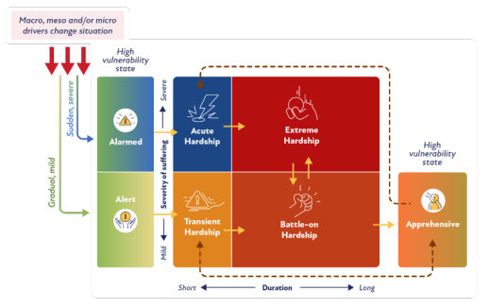

*Figure 1 The ABATE model*

#### Hardship states

**Acute hardship** – this is a severe and short-term state of energy hardship, whereby a household may experience a sudden change in their situation that causes severe suffering because of their energy bills. Without adequate support, these households will likely remain in energy hardship for longer, moving into the extreme hardship state.

**Battle-on hardship** – this is a mild but enduring state of energy hardship, where a household will struggle with every energy bill and manage to get by, but usually accrue debt. If the household’s challenges are addressed, they can move out of hardship from this state.

**Transient hardship** – this is a mild and short-term (0–6 months) state of energy hardship; however, without adequate support, households in transient hardship may move into a long-term state and experience frequent hardship.

**Extreme hardship –** this is the most critical form of energy hardship, as households in this state experience severe, enduring hardship. It is likely that these households will require maximum assistance.

##### Vulnerability states

**Alert vulnerability –** this high-vulnerability state takes place just before the household enters transient hardship. It is a mild and short-term state, where the household is alert to the potential impact of pending changes in their life.

**Alarmed vulnerability –** this high-vulnerability state takes place just before the household enters acute hardship. It is a short-term state that can be severe, where the household is alarmed about how they will cope with a drastic change in their circumstances.

**Apprehensive vulnerability** – this is the state experienced just after battle-on state (a common exit point). Households are apprehensive about their situation worsening again; they may have a high risk of falling back into hardship and so remain “apprehensive”. These households would benefit from preventative policies that reduce their vulnerability to energy hardship.

## Measuring the extent and distribution of hardship and vulnerability

### The D-I-O model

Measuring the extent of different hardship states is useful for designing policies and programs which are appropriately targeted to those people, and essential in monitoring the success of these policies and programs over time. Metrics can be categorised between *Drivers* (causes or triggers of hardship), *Indicators* (symptoms of the ‘state’ of hardship) and *Outcomes* (consequences of being in hardship) – the D-I-O model.

**Drivers (Indirect measure of hardship)**

The drivers of energy hardship can be considered an indirect measure of hardship. The drivers of energy hardship can be divided into macro, meso and micro drivers:

* **Macro drivers** include factors that can drive energy hardship more broadly, such as energy prices, and housing energy performance.
* **Meso drivers** include factors that affect some, but not all, households. Examples are deficient retailer behaviours (e.g., misleading plans, inconsistent responses) and poor landlord behaviours (e.g., refusing to conduct energy-efficiency upgrades or perform maintenance and repairs).
* **Micro drivers** include factors impacting only specific households. Examples are:
* unique high energy needs (e.g., for health requirements)
* low income (e.g., households whose income is always low, or who face a sudden drop in income)
* non-energy bills (e.g., high cost of living)
* high energy bills
* energy-hungry appliances (e.g., heating and cooling)
* energy-inefficient housing
* financial abuse.

**Indicators (Direct measures of hardship)**

Indicators are considered direct measures of harm, because they are linked to a specific harm that a given household is suffering. They are either action-based, situation-based or proxy-based:

* **Action-based** indicators reflect a household behaviour that reveals a state of hardship (e.g., coping strategies such as under-consumption of energy).
* **Situation-based** indicators reflect a household experience that reveals a state of hardship (e.g., thermal discomfort or difficulty paying bills).
* **Proxy-based indicators** reflect a metric that reveals a level of suffering linked to being in a state of energy hardship (e.g., low/high indoor temperature or mould).

**Outcomes (Indirect measures)**

The outcomes of energy hardship refer to the result of hardship, which may have other causes and as such are not conclusive of energy hardship. The outcomes of energy hardship have six key themes:

* stress (e.g., anxiety, shame, or depression)
* worsened health (e.g., health compromised to pay an energy bill)
* poorer living conditions (e.g., compromised quality of living)
* energy debt
* non-energy debt
* disconnection.

## Categorising intervention measures, policies, and programs

### The P-S-R model

The needs of households in energy hardship will be different to those of households facing vulnerability to, or exiting from, energy hardship. As such, successful intervention measures, policy and/or programs, will be designed to target specific households that may be in different states of vulnerability and/or hardship.

Intervention measures, policies and programs can be organised into four (4) broad categories:

* Prevention (structural barriers)
* Prevention (personal factors)
* Support
* Relief

Prevention, support, and relief – the P-S-R model.

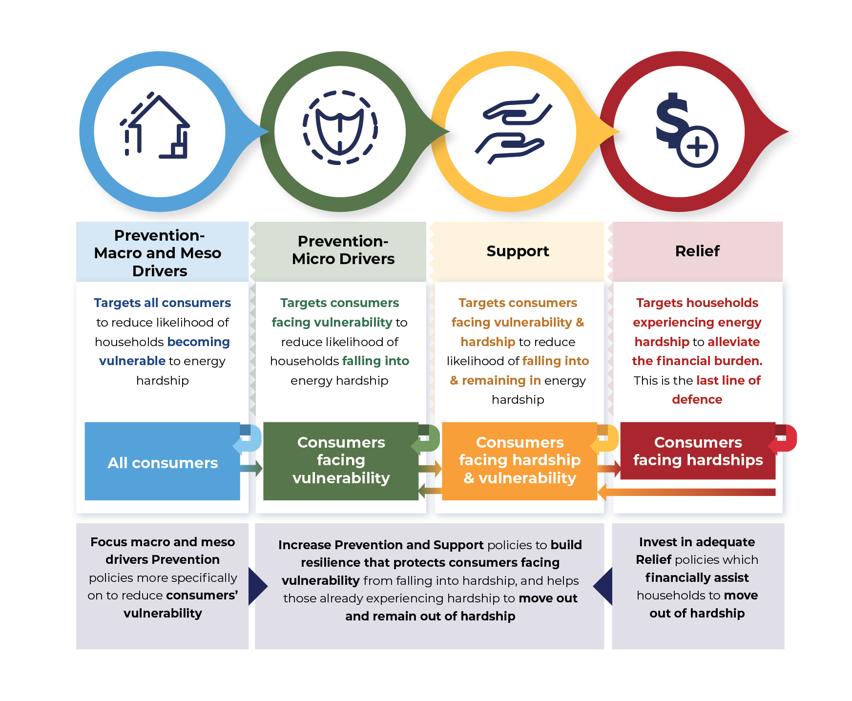

*Figure 2 An application of the P-S-R framework that aims to guide policy strategy to alleviate energy hardship*

Applying the P-S-R model to the relevant, existing suite of intervention measures, policies and programs can be a useful exercise to quickly identify any gaps that may exist, enabling policy makers to better target future policy and/or program design efforts. A hypothetical example is presented below:

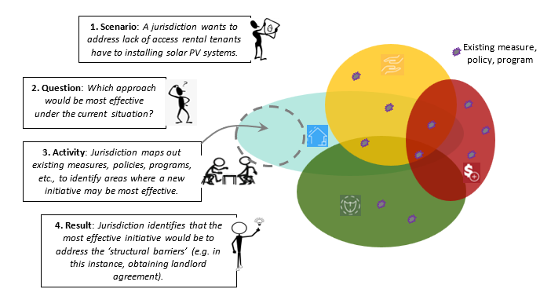

*Figure 3 Hypothetical example of using the P-S-R model*

## A community of better practice

The tools and research published alongside the framework can be used by government officials in the development and evaluation of energy policies and programs. They can form the basis of a community of better practice which will, in turn, provide an opportunity improve equity in policy and program design and better outcomes for those vulnerable to or facing hardship.