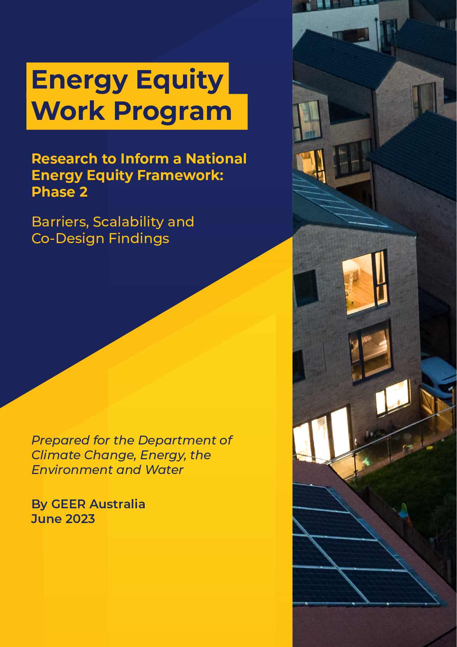

**Energy Equity Work Program – Phase 2**

**Barriers, Scalability and Co-Design Findings**

Final Report



**March 2023**

Prepared for the Department of Climate Change, Energy, the Environment and Water

By GEER Australia

**Prepared by GEER Australia**

**Swinburne University of Technology**

**4th March 2022**

**Contact: Dr Rowan Bedggood  
M:** 0439 167 868  
**E:** [rbedggood@swin.edu.au](mailto:rbedggood@swin.edu.au)

**W:** www.swinburne.edu.au/

**To cite this report**

Russell-Bennett, R., Bedggood, R., Miller, W., Letheren, K., McAndrew, R., Gardner, J., Adams, H., (2023) “Barriers, Scalability and Co-Design Findings,” Final Report (1 of 4) for the Commonwealth Energy Equity Work Program – Phase 2, GEER Australia, Swinburne University of Technology, Melbourne.

**Participant acknowledgement**

The GEER Consortium extends our heartfelt gratitude to those who participated in interviews for this project: to households who shared their stories and to sector workers for sharing their insights, wisdom and passion for seeing improved outcomes for those households most in need.

**Funding acknowledgment**

This project was funded by the Commonwealth Department of Climate Change, Energy, the Environment and Water (DCCEEW) as part of the Energy Equity Work Program. The views expressed in this report do not necessarily reflect the views of the Commonwealth Government of Australia.

**About GEER Australia**

The Group of Energy Efficiency Researchers (GEER) Australia is the peak research body on residential energy efficiency and wellbeing. It comprises researchers and industry partners from across Australia who are committed to driving change in the energy sector towards improved outcomes for Australian households. Its purpose is to improve energy-related wellbeing in households and communities in Australia, through collaborative research that achieves practical outcomes and informs future practice and policies. GEER’s research and activities thus focus on energy efficiency as it relates to quality of life, health, affordability and environmental sustainability.

**Project Team**

|  |
| --- |
| Dr Rowan E. Bedggood  *Swinburne University of Technology*  Project Lead & Project Manager |
| Dr John Gardner  *Commonwealth Scientific and Industrial Research Organisation*  Professor Rebekah Russell-Bennett, Dr Kate Letheren and Dr Ryan McAndrew  *Queensland University of Technology*  Henry Adams  *Common Capital*  Wendy Miller  *Queensland Council of Social Service*  Project Advisors:  Professor Ross Gordon  *Queensland University of Technology*  Luke Reade  *Energetic Communities* |



# Executive Summary

**Executive Summary**

‘

This report is the first of four reporting findings from Phase 2 of a research project carried out by GEER Australia under the Energy Equity Work Program for the Energy Ministers Meeting (formerly the Council of Australian Governments Energy Council). It offers the results of two literature reviews as well as co‑design research with key industry stakeholders to elucidate household energy hardship experiences:

* The first review has a national focus and provides findings on the barriers and enablers to households benefiting from Distributed Energy Resources (DER) and Energy Efficiency (EE) in Australia.
* The second review has an international focus and examines access and scalability issues associated with energy programs.
* The co-design offers insights into the drivers of household energy hardship, household coping strategies when experiencing energy hardship, eligibility challenges for households attempting to access support, sector challenges for addressing energy hardship, and what an equitable energy transition may look like from a household perspective.

Together, the insights from the reviews and the co-design (including the findings in Report 2) provide input into both the *Data Regime* (Report 3) and the *Better Practice Guide Towards Energy Equity* (Report 4).

The first review revealed 71 barriers to household uptake of DER and EE consistent with the following ***five categories of barriers***, which combine to create consumer perceptions of volatility, uncertainty, complexity and ambiguity:

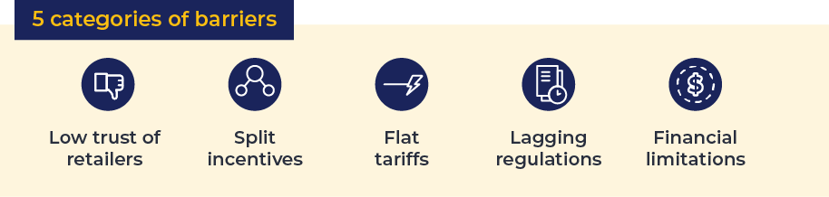

This first review also revealed 41 enablers of household uptake of DER and EE consistent with the following ***six categories of enablers***,which offer a way to co‑create functional, social, emotional and altruistic value with households to enhance uptake:

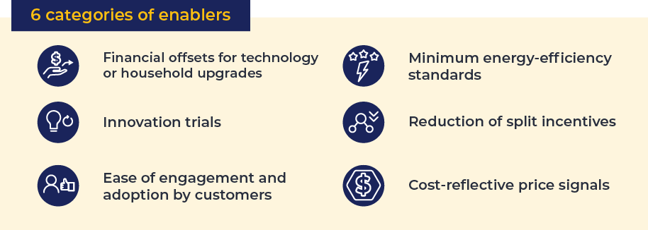

These findings provide the basis for DER and EE solutions that meet household needs.

The second review uncovered:

* ***five factors that influence access*** (eligibility, funding allocation, partnerships, application processes and access criteria for EE/DER)
* ***six factors that influence scalability*** (budget, scale, impact, market scalability, measurability and market awareness)
* the following ***access solutions*** synergised from the review:
* focusing on achieving an accurate definition of the energy issues the policy/program intends to address in advance of the policy/program being developed
* developing a relevant “suite” of policies/programs to support access for households
* ensuring access for both homeowners and renters
* providing effective incentives and messaging
* as well as the following ***scalability solutions***:
* ensuring sufficient return on investment for households contributing financially to energy efficiency (e.g., by purchasing solar panels, efficient appliances)
* offering programs in stages to support personalisation at scale
* encouraging government to partner with trusted community organisations to deliver programs
* considering national programs augmented with state-level concessions where necessary
* including non-traditional housing in policies and programs.

Overall, the literature indicates scalability is best achieved by national policies, which:

* support an equitable energy transition
* consider household needs
* target incentives to outcomes aimed at alleviating split incentives
* regulate strong energy-efficiency requirements.

The co-design confirmed the drivers from the original Drivers Indicators Outcomes framework [1]. It generated insights around the presence of macro and meso drivers, that is, drivers at the structural or system level that were beyond the control of the household but nevertheless drove household-level inequity. These included:

* energy sector complexity (macro)
* high prices (macro)
* poor retailer behaviour (meso).

Other factors that exacerbate energy hardship also emerged, including:

* government protections
* lack of trust
* lack of control
* cost of living flow-on effects
* lack of home maintenance.

Next, the co-design examined ***coping strategies***, and the analysis confirmed the coping strategies identified by households (see Report 2): under-consumption coping strategies and other coping strategies. The co-design offers nuanced insights around the social/relational consequences of coping strategies and the potential for hardship spirals.

Analysis further revealed ***five broad categories of eligibility challenges***:

* household knowledge/awareness (demand side)
* household emotions (demand side)
* processes for accessing support (supply side)
* retailer or government behaviours (supply side)
* eligibility criteria (supply side).

A clear issue emerged where criteria were seen as being misaligned (or even mal-aligned) to household needs, misapplied and difficult for households to access.

***Four central themes emerged within sector challenges*** for addressing energy hardship:

* compounding factors
* insufficiency
* landlord behaviours
* overarching sector challenges.

Finally, analysis of the co-design data revealed ***six aligned challenge and opportunity themes*** (in square brackets). These themes extend the sector challenges themes, providing an overarching view of the current challenges and opportunities for the future:

* compounding impacts on the equity gap [Leverage energy transition as equity transition.]
* insufficiency of support [Sufficient support offers holistic benefits.]
* inability to manage what we do not measure [Measure energy transition equity.]
* policy and regulation improvements [Policy has the power to end hardship.]
* mal-alignment of objectives [Alignment means a fairer sector for all.]
* high prices hurting energy households [Equitable foundations create lower prices.].

These insights led to ***four key inputs for the Data Regime***:

* We cannot address what we cannot measure, and we cannot measure what we have not defined.
* We need to decide on priorities and how they can be measured before implementation.
* Effective measurement supports access and scalability.
* An effective data regime needs to be supported by effective policy.

A further ***three key inputs were provided for the Better Practice Guide***:

* We must not place the burden of engagement on the shoulders of households.
* We need a holistic approach.
* We need to define what “enough” looks like.

# Table of Contents

**Contents**

Executive Summary i

1. Overview 1

2. Literature Reviews 2

2.1 Barriers and Enablers to Benefitting from DER and EE – National Review 2

2.1.1 Introduction 2

2.1.2 Barriers to the Uptake of DER and EE 2

2.1.3 Enablers to the Uptake of DER and EE 3

2.1.4 Key Takeaways 5

2.2 Access and Scalability – International Review 6

2.2.1 Introduction 6

2.2.2 Access 7

2.2.3 Scalability 8

2.2.4 Key Takeaways 9

3. Co-Design with Stakeholders 10

3.1 Introduction 10

3.2 Key Findings from Co-design with Stakeholders 10

3.2.1 Drivers of Household Energy Hardship 10

3.2.2 Household Coping Strategies for Energy Hardship 11

3.2.3 Eligibility Challenges for Households Accessing Support 12

3.2.4 Sector Challenges for Addressing Energy Hardship 12

3.2.5 Envisioning an Equitable Energy Transition 13

4. Key Inputs for Data Regime and Better Practice Guide 15

4.1 Key Inputs for the Data Regime Report 15

4.2 Key Inputs for the Better Practice Guide 15

References 16

Appendices 19

Appendix 1: Rationale and Key Search Terms for Rapid Literature Reviews 19

Appendix 2: List of Barriers and Enablers to Accessing DER and EE 20

Barriers – Themes and List with References 20

Enablers – Themes and List with References 20

Appendix 3: Barriers and Corresponding Enablers to Accessing DER and EE 22

# Overview

**1. Overview**

Phase 2 of the research carried out under the Energy Equity Work Program for the Energy Ministers Meeting resulted in four reports. Reports 1, 2 and 3 all inform Report 4: *Better Practice Guide Towards Energy Equity*.

**Report 1**: ***Barriers, Scalability and Co-Design Findings*** (this report) – comprises two literature reviews: a national review of barriers and enablers to Distributed Energy Resources (DER) and Energy Efficiency (EE); and an international review of access and scalability of DER and EE programs. It also includes key findings from a co‑design workshop held with a range of experts from the energy and advocacy sectors. The findings summarise suggestions regarding:

* drivers of energy hardship
* household coping mechanisms
* sector support structures
* related sector challenges.

Key findings inform reports 3 and 4.

**Report 2: *Household Insights and Journey Maps*** – comprises key findings from household interviews, including information to further inform the three energy equity frameworks developed in Phase 1 of this research:

* the Drivers Indicators Outcomes (DIO) framework
* the ABATE framework (of hardship states)
* the prevention, support or relief (P-S-R) framework.

Interviews provided a deep dive into household coping strategies and the support households sought and received. Journey maps reflect household lived experiences and synthesise five archetypical journeys through vulnerability and hardship states. This research identified three high vulnerability states in addition to the four hardship states identified in Phase 1 of the research. Key findings inform Reports 3 and 4, as well as Phase 3 of this research.

**Report 3: *Data Regime*** –informed by the findings of Reports 1 and 2, this report describes the findings from a co‑design approach with key energy sector experts examining the use of existing data sources to capture and track energy hardship. The findings provide direction for future data needs in terms of metrics to be measured and the approach to capturing the necessary data. Key findings inform Report 4 and Phase 3 of this research.

**Report 4: *Better Practice Guide Towards Energy Equity*** –this guide is intended to help energy policy and program designers develop effective programs that reduce energy inequity. It reflects the overall findings from Phase 1 and Phase 2 of the research carried out under the Energy Equity Work Program (EEWP) for the Energy Ministers Meeting.

# Literature Reviews

**2. Literature Reviews**

## Barriers and Enablers to Benefiting from DER and EE: National Review

### Introduction

#### Background

EE is the efficient management of electricity such that less energy is used to do the same work, or the same amount of energy is used to do more work [2]. DER are devices that generate and/or store electricity to help households manage their energy demand [3]. Examples of DER devices include:

* rooftop solar photovoltaic (PV) units
* wind-generating units (at residential or commercial premises)
* battery storage systems
* hot water systems
* pool pumps and air conditioners
* smart appliances
* electric vehicles [3].

DER offers several important consumer benefits, such as reduced energy costs and increased energy equity, even for those households unable to personally invest in DER technology (Blackhall, Kuiper, Nicholls, and Scott, 2020). In part due to these benefits, DER adoption is rapidly increasing, leading to the decentralisation of global energy systems. Nowhere is this change occurring faster than in Australia [4].

However, the benefits of DER are not guaranteed. Rather, the equitable realisation of these benefits for households and the sector depends on the ability of the energy sector to establish DER markets and procurement and to effectively engage households, as well as the household response to engagement attempts. Trust is of particular concern here, as DER incentives and technical capabilities cannot be realised without consumer trust in the energy sector, its regulation and the processes for energy transformation and transition. Households are, and must remain, at the centre of the energy transition, given they are the individual owners of DER technologies and also stand to benefit significantly through improvements to their financial wellbeing (through reduced bills) and quality of life [4].

### Barriers to the Uptake of DER and EE

#### Types of Barriers

A total of 71 barriers to the uptake of DER and EE resulted from the rapid review (see Appendix A for a list of the key search terms and rationale for conducting a rapid review). Five core themes emerged which encapsulate the scale and nature of the barriers present in the literature review. These themes represent five categories of barrier to household uptake of DER and EE:

* low trust of retailers
* split incentives
* flat tariffs
* lagging regulation
* financial limitations.

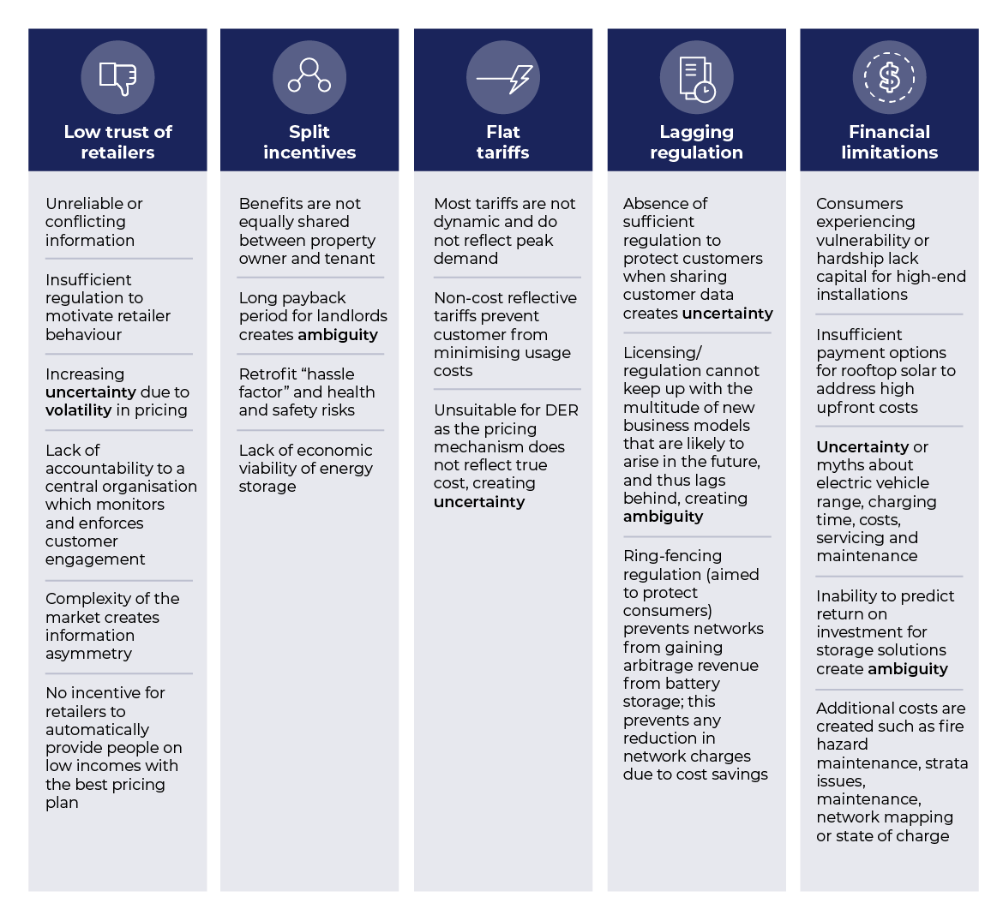Together these barriers create household perceptions of volatility, uncertainty, complexity and ambiguity that reduce uptake. Figure 1 provides a summary, and a full list with associated sources is provided in Appendix B.

Figure 1: Barriers to Household Uptake of DER and EE

### Enablers to the Uptake of DER and EE

#### Types of Enablers

A total of 41 enablers to the uptake of DER and EE resulted from the rapid review. Figure 2 summarises these themes, and a full list is provided in Appendix B, with a comparison between barriers and enablers provided in Appendix C. There are six categories of enablers to household uptake of DER and EE:

* financial offsets for technology or household upgrades
* innovation trials
* ease of engagement and adoption by households
* minimum energy-efficiency standards
* reduction of split incentives
* cost-reflective price signals.

These enablers create functional, social, emotional and/or altruistic values for the household which increases its uptake.

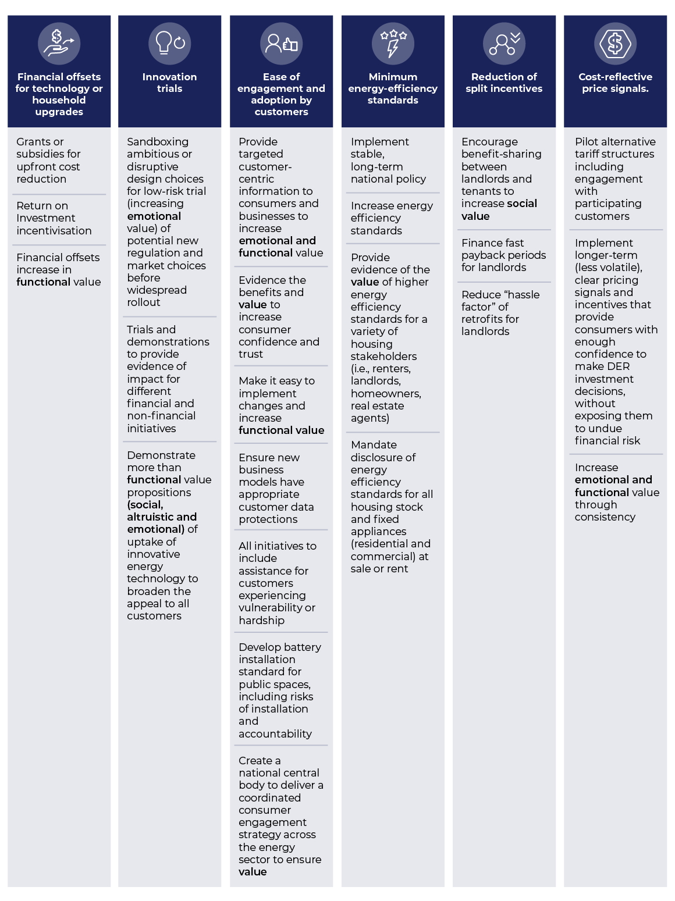

Figure 2: Enablers to Household Uptake of DER and EE

### Key Takeaways

* Many more barriers/challenges exist in the literature than enablers/solutions. Policy-makers should be aware that there may not currently be a solution to an existing challenge (see Appendix C), so potential future solutions may be needed to solve these challenges.
* Overall, the enablers/solutions allow researchers and policy-makers to better respond to DER/EE needs.
* Some enablers such as cost-reflective tariffs may be unwanted by households who prefer flat tariffs. Policy‑makers should use caution when making major changes to the households’ environment.
* Split incentives by the property owners and tenants are a key barrier and enabler to future DER and EE adoption. Policy-makers should incentivise this through shared-value programs.

## Access and Scalability: International Review

### Introduction

#### Background

This review examines issues related to access and scalability of DER and EE programs. The motivation is to explore these issues and potential solutions to ensure DER and EE programs are as accessible and scalable as possible. Without access, the benefits cannot reach intended users; and without scalability, benefits cannot be fully realised, as only a small number of beneficiaries can be reached.

Factors related to ***access*** include:



* **Eligibility** – some previous programs and policies have used ineffective eligibility criteria that “locked out” those who truly needed assistance, instead delivering benefits to the wealthy [5], [6].



* **Funding allocation** – to ensure access, the program must first have adequate funding allocation to allow for this goal to be met [7].



* **Partnerships** – for instance, working with third parties such as charities to deliver rebates and increase accessibility [8].



* **Application process** – the impact of the application process itself on access is determined by several factors, for instance, offering:
  + high vs low complexity
  + paper only vs digital
  + English only vs other languages
  + assisted (e.g., customer service desk) vs unassisted (e.g., self-completion) processes [9].
* **Access criteria** – programs that have ensured effective access have spent time at the beginning of the program to determine priority groups, who is included vs excluded, how targeting is “designed” into the initiative/suite of initiatives and the resultant distributional equity [10].

Factors related to ***scalability*** include:



* **Budget** – how the program/policy is funded (e.g., self-funding mechanisms, white certificate schemes, government funding) [11].



* **Scale** – the actual size of a given government initiative and how it is defined (metrics), e.g., the number of households, measures of impact, how many “types” of people are included [12].



* **Impact** – deep but narrow program vs broad and shallow. Neither is necessarily better than the other; rather, it is about which is fit for purpose in a given situation [13].



* **Market scalability** – mechanisms that create points of leverage to enable market-based outcomes such as:
  + growth of markets and sectors
  + product or business model innovation
  + new market entrants
  + enhanced competition, for instance, by ensuring positive Return on Investment (ROI), creating policies that define market settings and rules vs 1:1 cost–benefit outcomes, and encouraging economies of scale [14].



* **Measurability** – programs which offer measurability via a robust evaluation framework are easier to scale, as their benefits and impact are clear, and enhance the chances of additional funding [15].



* **Market awareness levels** (high or low) of the current support available.

### Access

#### Access Issues

Ensuring appropriate and adequate access to policies and programs designed to support energy equity is imperative. While this may seem a simple matter, complexities can emerge around problem definition, consistency in policies and programs, and appropriate targeting of support to ensure access to benefits.

One initial problem with ensuring access is defining and understanding the impact of energy hardship (sometimes referred to as energy poverty in the literature) on households. For instance, in the European Union (EU) there are significant variations in the definition of households and consumers experiencing vulnerability, and very little consideration of energy poverty as a distinct experience of vulnerability beyond general consumer protection measures. Indeed, less than one-third of EU member states recognise energy poverty explicitly [16]. This leads to a lack of specific policies and programs aimed at increasing energy equity [17], as an issue that is not well defined cannot be adequately addressed.

Once defined, access may be further affected by inconsistency in policies and programs. At best, this may represent a positive influence if policies consider local needs, while at worst, inconsistency can lead to increased confusion and a lack of equitable access. Studies of energy-efficiency policy instruments indicate that implementation of a single separate policy instrument will most likely fail [8], highlighting that at least some consideration of multiple influences and localisation may be beneficial. For instance, in Australia, rather than a national approach, different solar feed-in tariffs were implemented across the states and territories, reflecting the different constitutional heads of power for the Commonwealth and the states and territories. Adding to this complexity, feed-in tariffs sometimes vary by distribution area or even by household within one state, reflecting a decision for providers competing for households in the market [6].

Finally, there is the issue of ensuring program benefits go to those who need them. In the United States (US), for example, eligibility for weatherisation services is determined by income level or the receipt of existing welfare and aid programs [9]. Similarly, in the Australian state of Victoria, energy concessions and income support are often provided to existing welfare recipients, although access is impeded by requiring the household to seek assistance and through use of a one-size-fits-all approach to support [7].

Access can also be supported for households from the beginning. This happens via building standards and regulations that ensure households can access energy efficiency almost by default on moving into their new homes, as demonstrated in the Cooperative Research Centre (CRC) Low Carbon Living Pilot [18]. This is often more effective than educational campaigns suggesting residents make changes to their existing dwellings, even when these changes are suggested as part of a freely provided energy audit, as such options rely on the resources and initiative of individual consumers and households to access benefits [7].

Indeed, targeting programs to the needs of recipients is key, as sometimes otherwise well-designed programs may fail to provide access to benefits. For instance, the Australian Small‑Scale Renewable Energy Scheme benefits homeowners over renters. Renters were ineligible to take advantage of subsidies despite being the ones inhabiting the house [5], and hence needed to rely on landlords deciding to apply for the program to have a chance of benefiting from the scheme. While government subsidies have been shown to prompt retrofit activity by landlords, they are not always effective at engaging landlords and often need to be combined with tenant requests or situations of appliances breaking down. Research indicates that financial implications and tenant needs are key to influencing landlord behaviour, but also notes that landlords using property managers may have little understanding of tenant needs [17], [19].

#### Access Solutions

The literature focused mainly on issues and gave few examples of tested solutions. Hence, unless otherwise referenced, the solutions provided in this section are inferred from the nature of the problem in the “access issues” section.

**Summary of Access Solutions:**

* The issues (i.e*.,* households in energy hardship, the nature of energy equity) must be accurately defined to ensure that energy-efficiency resources are distributed in a fair and equitable manner [20].
* Consideration should be given to the optimum “suite” of policy instruments and programs required to ensure access. Often, implementation of multiple policies and/or programs is necessary to address energy equity holistically. Correct sequencing of policies and programs being introduced is also a requirement for success [8], [12].
* Programs should consider household ownership types and develop ways for both homeowners and renters to take advantage of programs, without renters remaining dependent on the actions of landlords. One example could be a local energy-sharing scheme where not all households require access to solar PV, but rather use a network of internet-enabled batteries to share resources [21]. Another option is a program of incentives for all participants, including use of a utility-managed on-bill financing mechanism to tackle split incentives [22].
* Incentives and additional messaging have been shown to be effective when program access is easy but participation remains low [23].

### Scalability

#### Scalability Issues

Once a policy/program is both effective and easily accessible by the target beneficiaries, it is then valuable to ensure the benefits are realised as widely as possible. Scalability is most effective when it is “built in” during the design of the policy or program. Key considerations include over-reliance on household financial resources, using energy efficiency standards as a “set and forget” option, and coordination and cooperation among all actors.

Scalability can be hampered when initiatives rely too heavily on household capital, essentially transferring the financial and cognitive burden of the energy transition to households. For instance, in Australia the installation of batteries relies primarily on household motivation and financial resources. Consequently, many households do not install batteries due to financial constraints or a failure to see the value relative to cost [6]. In some instances, policy can be used to influence value perceptions, as smaller solar feed-in tariffs have been shown to positively influence battery uptake [6].

Technical barriers to scalability also exist in areas such as amount of building materials able to be distributed, heating systems installed or electrical appliances obtained [13].

Next, sole focus on efficiency standards can further impede scalability. Efficiency standards are a less strong policy instrument than other options, such as taxes or educational campaigns focusing on influencing behaviour. Indeed, while the “set and forget” nature of these standards has some benefits in reducing household burdens, in some cases energy-efficiency standards can actively work against scalability by reducing available choices and creating perverse incentives. For instance, the complexity and inconsistencies surrounding renewable energy generation targets and levels of support – particularly across jurisdictions and renewable types – can act as a deterrent to scalability [5].

A range of programs is available to enhance energy equity. Some require transformation at the household level, that is, across millions of households within Australia; and others are relevant to more targeted populations, that is, solar and battery use in small businesses.

To best support scalability, coordination of all actors and policies is key. In Spain, for example, three separate ministries are involved in built environment energy efficiency but coordination and cooperation is lacking among them. This lack of coordination is further impacted by the complex, slow and opaque administrative procedures of the government [13], making it difficult to scale effective energy policy, which would require strong alignment and cooperation among different actors. By contrast, in Australia, regulators and market actors prefer to support consumer agency and market participation capabilities, once again transferring the burden of engagement onto households [24]. For energy equity to be supported and scaled, however, all actors must work together to share responsibility for addressing issues and ensuring energy equity and an effective energy transition.

#### Scalability Solutions

As was the case with ***Access***, above, the literature on scalability also tended to focus primarily on barriers to scalability rather than solutions. Hence, unless otherwise referenced, the solutions we put forward in this section are inferred from the nature of the problem in the “scalability issues” section.

**Scalability solutions include the following.**

* If relying on households to contribute financially to energy efficiency, recognise that households see this as an investment that must generate adequate ROI. For instance, a study found that households purchasing small-scale renewable energy were seeking long-term support from their purchase, such as through income from the export of energy to the grid or lowering reliance on the grid by reducing consumption and enhancing efficiencies. Further, Renewable Energy Certificate (REC) prices, which provide a rebate and reduce the overall cost of a PV system, also incentivise installation by reducing the initial cost of the technology investment [5].
* To offer personalisation at scale, consider a staged program. For instance, in the US, the Weatherization Assistance Program (WAP) provides grants to states, which then provide grants to local weatherisation agencies. Although the program only upgrades approximately 35,000 homes every year, it has assisted over seven million families [25]. The program entails offering households an energy audit first, followed by installing energy-saving measures tailored to their home (e.g., air sealing, insulation, furnace repair/replacement, duct sealing, relevant health and safety measures [9]).
* Government can support scalability by partnering with community organisations trusted by households, as per the approach of the Australian Low Income Energy Efficiency Program [26], [27]. While these programs were on a small scale, some, such as the Reduce Your Juice digital platform [28], started as pilot programs and were able to scale to a broader audience later on.
* While a whole-of-country focus has economies of scale [13], applying Australia-wide policy with state-level concessions is another option for achieving scale while considering local needs. For instance, minimum energy performance standards for rental housing are applied in Victoria and Queensland [7] while maintaining new build minimum energy standards in Australia.
* Further, it is worth considering how measures may scale beyond the four walls of traditional housing, as alternative living spaces alter our understanding of how energy consumption and social practice interact [29].

### Key Takeaways

Several key takeaways emerge from dealing with access and scalability issues and solutions. Specifically:

* A national set of policies is needed to transcend the patchwork of state and territory programs.
* Mandatory energy-efficiency requirements for rental housing can create a strong retrofit prompt for landlords.
* Energy poverty or hardship needs to be framed in terms of a just and fair energy transition and leaving no-one behind.
* Policies should take a segmented approach whereby household variations are considered.
* Subsidies may be most effective if they incentivise retrofits with the potential to improve thermal comfort for tenants.

# Co-Design With Stakeholders

**3. Co-Design with Stakeholders**

## Introduction

In all research, but particularly in studies dealing with the complex ecosystem of energy services, it is imperative to triangulate insights across multiple stakeholders to ensure rich, multifaceted insights that represent multiple viewpoints. In this project, asynchronous co-design contributed to Deliverable 2 by providing industry stakeholder insights into key areas of concern we addressed in the household interviews. Specifically, industry stakeholders came together to co-design insights around the drivers of energy hardship, household coping strategies and potential solutions for household energy hardship.

We conducted asynchronous online co-design with key industry stakeholders from the energy sector as well as across policy, industry, advocacy and community services, over a period of approximately two weeks in August 2022, attracting 18 unique contributors, 87 comments and 144 post-interactions during this time. We selected this method as it allowed co-design participants to contribute freely (all participation was anonymous), to access the interactive worksheet multiple times while it was open (allowing additions to their own thoughts and ideas or reflections on those of others) and to engage in their own time with ample opportunity for reflection. Importantly, co-design is invaluable for ensuring relevant stakeholders take ownership of insights [30], [31] and can see the relevance to themselves and their particular sphere. This method of co-design not only allowed co‑design participants to engage with their own ideas and those of others but also brought forward the contributions of this important group of stakeholders from the traditional post‑report phase to being part of the findings and the report itself. We present direct quotes from co-design participants (originally provided as written comments on the interactive worksheets online) in grey boxes throughout this section as indicative examples.

## 3.2 Key Findings From Co-Design With Stakeholders

### 3.2.1 Drivers of Household Energy Hardship

We asked co-design participants to comment on the question “What do you believe are the main drivers of energy hardship for households?”, which resulted in several important insights that enhanced our understanding of these drivers.

Phase 1 of this research proposed the DIO framework [1]. We used this framework during the analysis of the co-design contributions and it was strongly validated when all the original drivers from the DIO framework were identified again, confirming their validity and continued relevance over time. Of the existing drivers, participants most frequently mentioned the following:

* dwelling energy efficiency
* energy costs
* household income
* low financial/energy literacy
* lack of access to services
* poor retailer behaviours.

New insights emerged around the presence of macro and meso drivers, that is, drivers at the structural or system level that are beyond the control of the household but nevertheless drive household-level inequity. These included:

* energy sector complexity (macro)
* high prices (macro)
* poor retailer behaviour (meso).

For example, one comment referring to the overall structure and objectives of the energy sector clearly highlights the energy sector complexity macro driver (see panel, right).

*“A retail energy market that is not fit for the purpose of providing an essential service. It’s inefficient and not structured to meet the needs of people and requires constant individual engagement and advocacy to get an assumed benefit.”*

New factors that may exacerbate energy hardship also emerged from the co-design workshop findings, including government protections, lack of trust, lack of control, cost of living flow‑on effects and lack of home maintenance. For example, one comment indicated the important interrelationship between housing costs, cost of living and energy hardship: energy hardship is exacerbated not only by energy costs but also by other key living costs such as housing. Energy is one area where a household may look to compromise/cut costs. Where housing is energy-inefficient, this adds to the risk of energy hardship. This interrelationship is important. We also identified language  
/culture as an exacerbating factor in the comments.

Broadly, the comments revealed an overall sense of concern among co‑design participants about a pervasive inability for households to gain support, as well as concerns about the inadequate structure/support of the market itself.

### 3.2.2 Household Coping Strategies for Energy Hardship

The question “What do you believe are the main coping strategies households adopt to manage, or cope, with energy hardship?” resulted in a range of confirmed and new insights around how households respond to energy hardship, as well as the consequences of these coping mechanisms.

#### 3.2.2.1 General Coping Strategies

As for the results seen for “drivers”, many of the coping strategies we identified in Phase 1 of the EEWP were again identified here, as were all of the revised categories emerging from this research (Managing Bills, Managing Energy Efficiency, Building Knowledge and Under-Consuming/Sacrificing – see Report 2). Several comments added nuances to existing findings on “Managing Bills” with “ignoring the issue” and continuing to amass large energy bills/go into debt mentioned as a potential coping strategy. However, while on the surface this may appear a maladaptive strategy, households are simply prioritising their health or comfort (e.g., having electricity is important right now).

*One comment noted that households sometimes expect that “… by the time of the next bill things will have improved.”*

#### 3.2.2.2 Under-Consumption Coping Strategies

Another point to note was some comments identified that coping mechanisms can have social/relational consequences – particularly in the “Under-Consuming/Sacrificing” category. While social network support is a powerful resource for households (e.g*.,* relying on support from community, family and friends, which also acts as a “Building Knowledge” coping strategy), this can lead to relational strain or, conversely, using coping mechanisms that involve forgoing the essential comfort of social presence (e.g*.,* not having people over due to concerns over energy needed to heat/cool house or prepare meals). Hence, a paradox is created: coping with energy hardship encourages householders to leverage social network support while simultaneously depriving households of the important bonding behaviours that reinforce this social support.

*“Under-utilisation may be particularly problematic due to the poverty premium where low-income households cannot afford the upfront cost of energy-efficient appliances or rooftop solar/battery storage, so are reliant on energy-inefficient appliances that lead to higher energy bills.”*

Finally, we repeatedly noted that some of these behaviours are mutually reinforcing and part of a hardship spiral. It is suggested further that some households have odds stacked against them due to the “poverty premium”.

### 3.2.3 Eligibility Challenges for Households Accessing Support

We also asked co-design participants, “What do you believe are the main challenges for households around eligibility criteria when trying to access support?”. Analysis revealed five broad categories of challenges across both the demand side and the supply side of the energy sector. The first two categories were related to demand‑side issues with eligibility criteria for support:

*“Retail and government supports are restricted on the assumption that there is a difference between people who can’t pay and people who won't – this makes assistance hard to access, gate-kept, and a source of stress and shame for people trying to access it.”*

* household knowledge/awareness
* household emotions.

The next three categories were related to supply-side issues, namely:

* processes (for accessing support)
* retailer or government behaviours
* the eligibility criteria themselves.

The largest number of comments emerged in this last category, followed by household awareness and knowledge issues.

Importantly, the supply-side factors can be linkedto demand-side outcomes, for instance, household stress and shame resulting from support being difficult to access (see panel, right). Alternatively, households may feel confused about how to access supports and anxious about how they will be treated (see panel, left).

*“Complexity of the energy market and help schemes. Confidence to raise issues with retailers and have it handled sensitively and efficiently.”*

Finally, the comments indicated a clear issue with the criteria being misaligned (or even mal-aligned) to needs, misapplied or inconsistently applied by retailers, and difficult for households to access, as noted in the final comment box for this section (see panel, below).

*“… eligibility is based on criteria that don't necessarily align with need.”*

*“Eligibility criteria are defined, subjectively (and narrowly) by retailers – and their business incentives are directly counter to the interests of people in payment difficulty and their access to the support they need.”*

### 

### 3.2.4 Sector Challenges for Addressing Energy Hardship

We also addressed sector challenges via the following question: “What do you believe are the main sector challenges that need to be overcome to reduce energy hardship?”. While existing macro and meso drivers discussed as structural barriers in the Phase 1 Report [1] were confirmed (specifically: poor retailer behaviour, needless sector complexity, poor housing quality, insufficient social housing, low social welfare and high energy prices), four additional central themes emerged (see Figure 3):

* compounding factors
* insufficiency
* landlord behaviours
* overarching sector challenges.

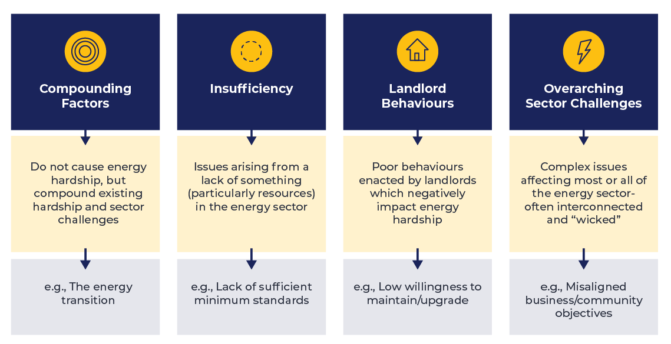

Figure 3: The Four Key Energy Sector Challenges

First, compounding factors do not themselves cause energy hardship but rather act to compound existing hardship and sector challenges associated with addressing hardship. Second, insufficiency describes any issue resulting from a lack of something within the sector. Next, landlord behaviours are similar to the “poor retailer behaviours” discussed as a structural barrier in the Phase 1 Report, except these poor behaviours relate exclusively to landlords. Finally, overarching sector challenges are large problems that affect all or most of the sector, and are close to being “wicked problems” in some instances.

Comments often maintained a steady focus on the present and future state of the energy sector (i.e., what is, or will soon be, needed to alleviate sector challenges). They also indicated a need for urgent and equitable restructure in the energy sector to reduce compounding pressures and support the energy transition. For instance, this comment: “Reducing the burden of engagement on people is necessary, ensuring fair outcomes regardless of household actions, actively reducing costs and obligations for more vulnerable groups, and having an explicit objective to deliver the energy needs of people as equitably and efficiently as possible must be the challenge of the sector in fundamental reforms to the way it delivers the energy needs of the community”.

### 3.2.5 Envisioning an Equitable Energy Transition

As we have noted in several previous sections, there is a call from co-design participants for urgent and equitable restructure in the energy sector to reduce compounding pressures and support the energy transition. Indeed, energy market bodies have an important role in helping the energy sector through the transition by making changes to how policy-makers and industry stakeholders act in relation to energy hardship. As a result of analysing the final question asked of co-design participants, “What is your one thing that you want us to know or bring to the fore in this project?”, a range of useful insights for implementing an equitable energy transition emerged. When themed, the majority of suggestions revolved around **policy and programs**, including:

* enacting overarching sector reforms
* establishing an energy transition framework
* creating new National Energy Objectives
* regulating cost distribution
* funding retrofit programs
* ensuring clean energy for First Nations peoples
* establishing and enforcing minimum building and EE standards (including for landlords)
* regulating building quality and EE standards.

The next theme that emerged from the comments was around **equitable design**, and included the following types of comments:

* applying, assessing and monitoring programs/policy reforms
* ensuring continuity of support
* offering support through mainstream programs (not “hardship” programs)
* ensuring support is aligned to need
* pursuing innovation
* using inclusive design principles
* enabling access to technology
* reducing the household costs associated with experiencing vulnerability.

Next, a theme emerged around how **funding and resourcing** may look, and included suggestions around:

* energy concessions
* program funding
* advocacy funding
* income/financial supports for households
* introduction of social tariffs
* holistic welfare support.

This last point refers to the observation that households experiencing energy hardship were often experiencing multiple types of hardship which all require support to address the actual hardship experience (i.e., a household experiencing energy hardship, food insecurity and lack of safe accommodation may be warmer on receiving energy concessions, but no less hungry or at risk overall). In terms of how support might look for households, the final theme referenced:

* a reduced burden of engagement with the energy system
* support for renters and others currently ineligible for assistance
* easier access to supports
* more consumer protections.

Overall, six challenge themes emerge from the co-design data (represented by the yellow circles in Figure 4), but these challenge themes are joined by aligned opportunity themes (represented by the navy circles).

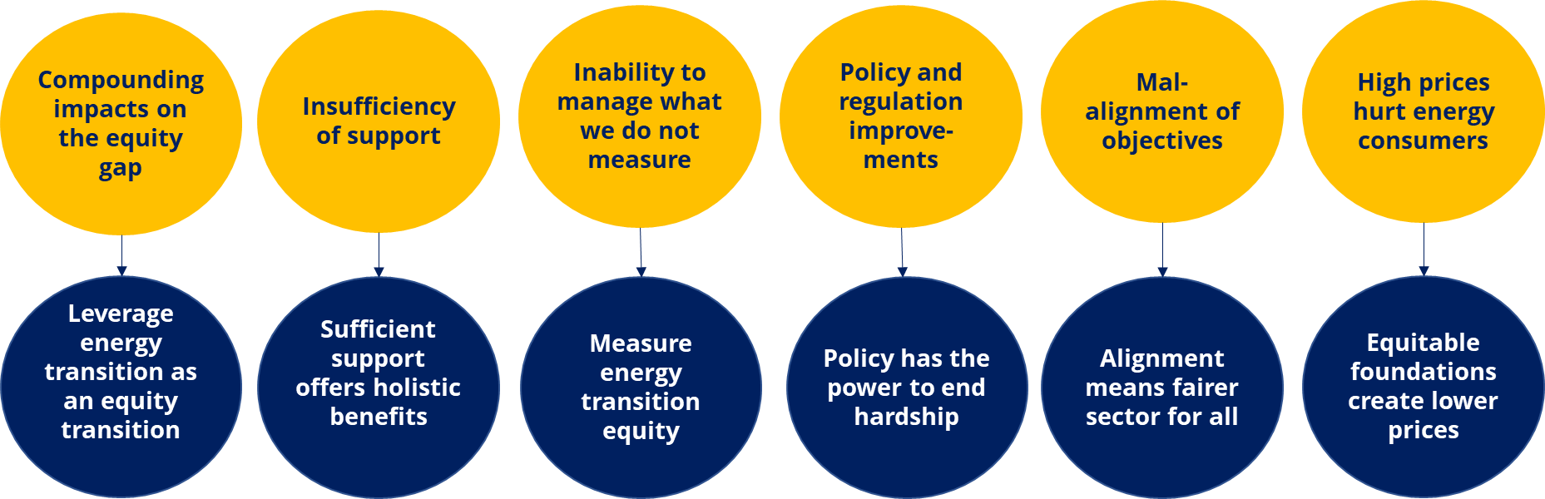

Figure 4: Six Aligned Challenge and Opportunity Themes for Energy Equity

Opportunities were sometimes implied in comments that spoke about a lack of something, and sometimes directly suggested. The overarching message implied in these paired themes is one of hope and urgency – the data reveal we have a real chance to leverage our opportunities to overcome our energy hardship challenges now and throughout the energy transition. The final themes speak to the need for equitable foundations (i.e*.,* aligned objectives, better policy, sufficient support, an equitable transition) to support equitable, lower prices.

# Key Inputs for the *Data Regime* and *Better Practice Guide*

**4. Key Inputs for the Data Regime and Better Practice Guide**

## 4.1 Key Inputs for the *Data Regime* Report

The reviews and the co-design findings have resulted in four key inputs for the *Data Regime*:

* **We cannot address what we cannot measure, and we cannot measure what we have not defined:** Lessons from national and international examples provided in the review demonstrate the importance of ensuring a consistent and agreed-upon definition for any concept requiring empirical quantitative or qualitative measurement. The data regime therefore needs to be based on strong definitions, ideally with consideration for how the elements of these definitions can be quantified.
* **Decide on priorities and how they can be measured before implementation:**   
  Supporting energy equity (along with the access and scalability that are key to successful policies and programs) involves navigating a complex system with multiple interconnected stakeholders. Identifying the actors, their interdependencies and their priorities is important. Once we identify priorities, decisions on the best options for quantifying the achievement of these priorities should be made in advance of embarking on the policy/program.
* **Effective measurement supports access and scalability:**  
  Effective measurement options provide two key benefits for supporting access and scalability. First, we can measure outcomes of programs and policies throughout implementation to ensure that access objectives are being achieved. Second, measurement allows us to quantifiably demonstrate the success of specific policies and programs, which can help ensure the continued commitment necessary for scalability.
* **An effective data regime needs to be supported by effective policy:**As continually demonstrated across both the review and the co-design, policy has an integral role to play in ensuring positive outcomes. Policy can be leveraged to strengthen the data regime through providing regulatory support for the definition, implementation and evaluation of key energy equity outcomes.

## 4.2 Key Inputs for the *Better Practice Guide*

The reviews and co-design findings have resulted in three key inputs for the practitioner’s guide:

* **We must not place the burden of engagement on the shoulders of households:**A lesson emerging from both the reviews and co-design is that, all too often, the burden of engaging with DER, EE and even engaging with the energy transition tends to be transferred to individual consumers and households with little consideration of their resources. Relying on any one stakeholder group in a complex system can have deleterious effects on the shared goal of achieving energy equity and should be avoided.
* **We need a holistic approach:**Rather than relying on consumer agency and empowerment, all actors within the energy sector must work together. This means that industry stakeholders, policy-makers, households, advocates and other relevant stakeholders come together in a shared engagement approach that resolves competing priorities and creates a more equitable – and, indeed, sustainable – energy system for all.
* **We need to define what “enough” looks like:**The theme of insufficiency of support was particularly pronounced in the co-design findings but was also echoed throughout the reviews. Insufficient support limits access, ensures a lack of scalability and makes it more likely that resources committed to such policies and programs are lost. Insufficiency is not always about funding but about considering what is required to create “enough” support and engagement across the different realities of stakeholders and households within the complex energy ecosystem. A “one‑size‑fits‑all” approach rarely provides sufficient support, tending to provide too little to some groups and too much for others. Collectively, we need to consider what “enough” means for different stakeholder groups, as well as appreciating the differences within those groups (e.g., different households).

# References

**References**

[1] R. Bedggood, J. Gardner, R. Gordon, H. Adams, L. Reade, W. Miller, L. Poruschi, R. Russell-Bennett, R. McAndrew, K. Letheren, M. Clarke, and C. O’Mahony, “Assessing Energy Inequity and the Distributional Effects of Energy Policies,” Final Report, GEER Australia, Swinburne University of Technology, Melbourne, 2022.

[2] IEA, “The value of urgent action on energy efficiency,” 2022. https://www.iea.org/reports/the-value-of-urgent-action-on-energy-efficiency

[3] AEMO, “About the DER Program,” 2022. https://aemo.com.au/en/initiatives/major-programs/nem-distributed-energy-resources-der-program/about-the-der-program

[4] L. Blackhall, G. Kuiper, L. Nicholls, and P. Scott, “Optimising the value of distributed energy resources,” *The Electricity Journal*, vol. 33, no. 9, p. 106838, 2020.

[5] A. J. Chapman, B. McLellan, and T. Tezuka, “Residential solar PV policy: An analysis of impacts, successes and failures in the Australian case,” *Renewable Energy*, vol. 86, pp. 1265–1279, 2016.

[6] R. Best, H. Li, S. Trück, and C. Truong, “Actual uptake of home batteries: The key roles of capital and policy,” *Energy Policy*, vol. 151, p. 112186, 2021.

[7] N. Willand, B. Middha, and G. Walker, “Using the capability approach to evaluate energy vulnerability policies and initiatives in Victoria, Australia,” *Local Environment*, vol. 26, no. 9, pp. 1109–1127, 2021.

[8] R. Aboltins and D. Blumberga, “Key factors for successful implementation of energy efficiency policy instruments: A theoretical study and the case of Latvia,” *Rigas Tehniskas Universitates Zinatniskie Raksti*, vol. 23, no. 2, pp. 187–206, 2019.

[9] B. Tonn, B. Hawkins, E. Rose, and M. Marincic, “Income, housing and health: Poverty in the United States through the prism of residential energy efficiency programs,” *Energy Research and Social Science*, vol. 73, p. 101945, 2021.

[10] J. Perelman, “Increasing energy efficiency in existing residential buildings: A case study of the Community Home Energy Retrofit Project (CHERP),” 2016.

[11] B. K. Sovacool, “Fuel poverty, affordability, and energy justice in England: Policy insights from the Warm Front Program,” *Energy*, vol. 93, pp. 361–371, 2015.

[12] C. Cattaneo, “Internal and external barriers to energy efficiency: Which role for policy interventions?,” *Energy Efficiency*, vol. 12, no. 5, pp. 1293–1311, 2019.

[13] J. Y. Travezan, R. Harmsen, and G. van Toledo, “Policy analysis for energy efficiency in the built environment in Spain,” *Energy Policy*, vol. 61, pp. 317–326, 2013.

[14] M. Lang, R. Lane, K. Zhao, and R. Raven, “Energy efficiency in the private rental sector in Victoria, Australia: When and why do small-scale private landlords retrofit?”, *Energy Research and Social Science*, vol. 88, p. 102533, 2022.

[15] B. Girod, T. Stucki, and M. Woerter, “How do policies for efficient energy use in the household sector induce energy-efficiency innovation? An evaluation of European countries,” *Energy Policy*, vol. 103, pp. 223–237, 2017.

[16] S. Pye *et al.*, “Energy poverty and vulnerable consumers in the energy sector across the EU: Analysis of policies and measures,” *Insight Energy*, vol. 2, pp. 64-89, 2015.

[17] J. Lowitzsch and F. Hanke, “Consumer (co-)ownership in renewables, energy efficiency and the fight against energy poverty: A dilemma of energy transitions,” *Renewable Energy Law and Policy Review*, vol. 9, no. 3, pp. 5–21, 2019.

[18] “Low Carbon Living CRC,” *Low Carbon Living CRC: Resources*, 2023. https://www.lowcarbonlivingcrc.com.au/resources

[19] M. Lang, R. Lane, K. Zhao, S. Tham, K. Woolfe, and R. Raven, “Systematic review: Landlords’ willingness to retrofit energy efficiency improvements,” *Journal of Cleaner Production*, vol. 303, p. 127041, Jun. 2021, doi: 10.1016/J.JCLEPRO.2021.127041.

[20] R. Walker, C. Liddell, P. McKenzie, C. Morris, and S. Lagdon, “Fuel poverty in Northern Ireland: Humanizing the plight of vulnerable households,” *Energy Research and Social Science*, vol. 4, pp. 89–99, 2014.

[21] R. Gupta, A. Bruce-Konuah, and A. Howard, “Achieving energy resilience through smart storage of solar electricity at dwelling and community level,” *Energy and Buildings*, vol. 195, pp. 1–15, 2019, doi: 10.1016/j.enbuild.2019.04.012.

[22] S. Bird and D. Hernández, “Policy options for the split incentive: Increasing energy efficiency for low-income renters,” *Energy Policy*, vol. 48, pp. 506–514, 2012.

[23] R. J. Bator, K. Phelps, J. Tabanico, P. W. Schultz, and M. L. Walton, “When it is not about the money: Social comparison and energy conservation among residents who do not pay for electricity,” *Energy Research and Social Science*, vol. 56, 2019, doi: 10.1016/j.erss.2019.05.008.

[24] S. Chandrashekeran, J. Cludius, D. McConnell, V. Noka, and D. Ritter, “Energy affordability: Sharing lessons from the EU and Australia’s low carbon transitions”. Melbourne: University of Melbourne, 2021.

[25] Department of Energy, “Weatherization Assistance Program,” 2023. https://www.energy.gov/scep/wap/weatherization-assistance-program

[26] Department of Industry Innovation and Science, “Low Income Energy Efficiency Program (LIEEP),” 2016. https://www.energy.gov.au/publications/low-income-energy-efficiency-program-lieep

[27] Acil Allen Consulting, “CEEP and LIEEP,” Australia, 2016.

[28] “Reduce Your Juice: Assisting low-income households to better manage their energy use – Service thinking for social problems.” <https://research>.qut.edu.au/servicesocialmarketing/research-projects/reduce-your-juice/

[29] B. Middha, S. Robertson, N. Willand, and R. Horne, “Man caves, granny flats and alternative living spaces: Low carbon home retrofit and implications for policymaking,” *Energy Research and Social Science*, vol. 87, p. 102470, 2022.

[30] E. Blomkamp, “The promise of co‐design for public policy,” *Australian Journal of Public Administration*, vol. 77, no. 4, pp. 729–743, 2018.

[31] M. Steen, M. Manschot, and N. De Koning, “Benefits of co-design in service design projects,” *International Journal of Design*, vol. 5, no. 2, pp. 53–60, 2011.

[32] T.W. Heffernan *et al*., “Towards an environmentally sustainable rental housing sector,” *Housing Studies*, vol. 36, no. 3, 2021.

[33] Queensland Council of Social Service (QCOSS), “Choice and control? The experiences of renters in the energy market,” Brisbane, 2017.

[34] Energy Supply Association of Australia, “ESAA: Improving energy concessions and hardship payments policies,” Sydney: Deloitte Corporate Finance Pty Limited, 2013.

[35] Energy Transformation Taskforce, “Distributed energy resources roadmap,” Perth, 2019.

[36] P. T. Buergelt *et al.*, “Working together with remote Indigenous communities to facilitate adapting to using energy wisely: Barriers and enablers,” *Energy Procedia*, vol. 121, pp. 262–269, 2017.

[37] H. Ransan-Cooper, “Stakeholder views on the potential role of community scale storage in Australia,” Canberra, 2021.

[38] T. Dodd and T. Nelson, “Australian household adoption of solar photovoltaics: A comparative study of hardship and non-hardship customers,” *Energy Policy*, vol. 160, p. 112674, 2022.

[39] J. Halldorsson *et al.*, “Energy efficiency in social housing: Literature and program review,” Parramatta: Department of Planning, Industry and Environment, 2020.

[40] T. Campey *et al.*, “Low emissions technology roadmap,” Commonwealth Scientific and Industrial Research Organisation (CSIRO): Australia, EP167885, 2017.

[41] W. Hadingham, K. Rayney, A. Blaver, B. Smart, and J. Thomas, “Distributed energy resources roadmap: How the state of Western Australia is leading in integration,” *IEEE Power and Energy Magazine*, vol. 19, no. 5, pp. 76–88, 2021.

[42] A. Ambrose, "Improving energy efficiency in private rented housing: Why don't landlords act?." *Indoor and Built Environment*, vol. 24, no. 7, pp. 913-924, 2015.

# Appendices

**Appendices**

## 

## Appendix A: Rationale and Key Search Terms for Rapid Literature Reviews

#### Rationale for the Rapid Review

Using a rapid review process, we addressed the following research aims:

* summarised barriers and enablers for EE DER
* focused on national and international papers and reports that specify best practice principles regarding access and scalability for households facing vulnerability and hardship.

A rapid review offers a synthesis of evidence which selectively omits some stages of a standard systematic review to provide timely support for decision-making. Searching completeness was determined by time constraints, and the synthesis was documented typically in narrative and tabular form.

The search included an examination of grey literature (i.e., content that has not been peer-reviewed) as well as peer-reviewed scholarly articles. Using both Google and Google Scholar (a freely accessible web search engine that indexes the full text or metadata of scholarly literature across an array of publishing formats and disciplines) this research searched for relevant papers. Some papers were behind paywalls, but university access allowed for retrieval.

The rapid review consisted of the following criteria:

* past ten years (from 2012 to 2022)
* Australian-focused, where possible (Deliverable 2e only)
* inclusion of both grey and peer-reviewed literature (peer review is likely to be more international in scope but still relevant, with research results transferable across contexts).

We used two streams of searching, one focusing on DER and one examining EE. Many tools, technologies, policies and initiatives are likely to be found under such searches, with no one type being the focus of this rapid review.

Thematic analysis then reduced these barriers into collections of themes via two rounds of synthesis and theme extraction.

As for barriers, we conducted two rounds of synthesis and theme extraction to draw out five core themes which summarise the enablers of DER and EE uptake.

#### Key Search Terms Used for the Review

* “energy efficiency” enablers barriers “Australia”
* “Distributed energy Resources” enablers barriers “Australia” hardship or vulnerability low-income disadvantage
* “policy evaluation” “energy efficiency”
* “policy evaluation” “distributed energy resources” “vulnerable”
* “policy evaluation” “energy efficiency” “vulnerable”
* “policy evaluation” “energy efficiency” “vulnerable people”
* “accessibility” Or “eligibility criteria” Or “priority groups” OR “qualify” OR “practical access” OR “upfront capital” OR “Channel” “Channel partners” affordability promoted/secreted, trusted channel, skills levels required
* “Scalability” Or “market based policy” Or “proportionality” OR “pilot projects” OR “tokenism” OR “too small”
* “policy” “energy efficiency” “scalability”
* “policy” “energy efficiency” “accessibility”
* “energy efficiency program” “policy analysis” “vulnerable”
* “energy efficiency program” “scalability” “vulnerable”
  + “household sector” energy efficiency policy evaluation
  + “critical evaluation” energy efficiency policies.

## Appendix B: List of Barriers and Enablers to Accessing DER and EE

Barriers: Themes and List With References

1. **Lack of consumer trust in retailers**

* lack of awareness, lack of reliable information, real estate agents lack knowledge of EE benefits [32]
* lack of regulation, little to no minimum standards [32], [33]
* lack of political drive [32]
* information asymmetries in consumer education [34]
* energy providers exempt from requiring a retail or distribution license are not subject to energy-specific consumer protections such as disconnections and hardship [35]
* absence of secure and consistent arrangements for access and sharing of customer data [35]
* consumers lack trust in the electricity sector, with contributing factors including the doubling of retail electricity prices in less than 10 years, market complexity and conflicting messages [4]
* no organisation currently performs, or has been identified as being currently well positioned and widely viewed as suitable to perform, the role of centrally leading consumer engagement [4], [36]
* people on concessions or with a credit history potentially excluded from neighbourhood battery schemes (being left on tariffs that are more expensive) [37].

1. **Split incentives problems reducing the uptake of DER/EE**

* split incentives where the property owner and tenant do not share equal benefits [32], [38], [39]
* long payback periods for landlords [32]
* health and safety risks in adopting retrofits, “hassle factor”, strata issues, uncertainty of tenancy length [32]
* current network charges challenge economic viability of storage, such as the double charging of Distribution Use of System (DUOS) each time the neighbourhood-scale battery is used [37].

1. **Flat tariff structures unsuitable for DER technologies**

* static, inefficient and non-cost reflective consumer pricing [34]
* existing flat electricity tariff structures are increasingly unsuitable as more DER is installed [35].

1. **Licensing and regulation lagging new business models**

* The absence of secure and consistent arrangements for the access and sharing of customer data may compromise customer protections as new technology and business models proliferate [35].
* Licensing/regulation regime may not be supportive of new business models [35].
* Ring-fencing challenges (real and perceived) may inhibit networks from participating in storage business models, where networks cannot gain any arbitrage revenue from the battery [37].
* There is potential for some groups to resist regulatory or policy changes that enable benefits to be unlocked to new entrants [37].

1. **Financial barriers (such as high costs, loss of rent and long payback periods)**

* installation costs [32], [39]
* capital constraints faced by financially vulnerable consumers [34]
* bounded rationality (limited understanding/interest dictating product purchase) [34]
* barriers to uptake of low emissions technologies:
  + rooftop solar (upfront expense for low-income households, lack of market signals for value provided, split incentives)
  + electric vehicles (EVs) (cost of vehicles and infrastructure; charging impact on network; lack of familiarity; perceived drawbacks (e.g., range, charging time); lack of skills in the automobile industry (e.g., mechanics) [40].
* future market design uncertainty creates a context where incumbents may be unlikely to invest in storage without knowing possible rates of return [37], [41]
* practical challenges identified:
  + fire hazard management
  + maintenance
  + network mapping
  + state of charge
  + educating decision-makers and the general community
  + cost of providing reliability services
  + smarter meters and “identifying electrons”
  + battery life cycle [37].

Enablers: Themes and List With References

1. **Financial offsets such as grants and subsidies for new technology and household upgrades**

* upfront cost reduction incentivisation: grants/subsidies [32]
* ROI incentivisation:
  + feed-in-tariff to landlords
  + facilitate utilities to be included in rental
  + reduced running costs
  + tax-based incentives linked to sustainability upgrades
  + rates discounts [32], [34]
* sandboxing ambitious or disruptive design choices, a low-risk way of learning about new regulation and market choices before committing these changes to the rules. The ability to fail in a low-risk manner and fail fast is critical to facilitate the required innovation [4]
* trials and demonstrations enabled by regulatory sandboxes to understand different financial and non-financial values of storage models and options for community participation [4].

1. **High consumer awareness where the benefits are known**

* [For solar PV] Offer leasing models aimed at low-income households. Provide targeted information to consumers and businesses demonstrating potential savings in electricity costs (with and without energy storage) [40].
* Education (communication):
  + Evidence the benefits.
  + Raise awareness of the benefits of retrofitting/ renewables.
  + Provide utilities information for tenants [32], [36].
* Ease of implementation (facilitation):
  + do-it-yourself (DIY) retrofits
  + “turnkey” solutions
  + low maintenance [32].
* Appropriate customer protections are retained and applied to new business models [41].
* Develop the Consumer Data Right (CDR) with consideration of emerging business models and subsequent data-related consumer protection needs [35].
* Develop complementary targeted vulnerable customer and hardship assistance (as part of pilots) [33], [35].
* Develop a standard for installation of batteries in public spaces, including cover for the risks of installation. Put regulations in place to ensure a clear chain of accountability for liability and how customers can seek effective resolution in the event of faults in storage operation [37].
* Consumer engagement is led by a national central body or organisation delivering a coordinated engagement strategy to consistently communicate energy system and technology issues and encourage households to contribute to beneficial grid outcomes [4].

1. **Minimum energy efficiency standards promote adoption**

* Implement stable, long-term policy to drive uptake of low-emissions electricity generation technology consistent with required electricity sector decarbonisation [40].
* Higher energy-efficiency standards (e.g*.,* insulation, double glazing, efficient appliances, solar panels) have been shown to positively impact the price achieved at rent or sale [32].
* An increase to legislation (regulation) will support:
  + minimum energy-efficiency standards
  + mandatory disclosure
  + mandatory replacement of inefficient technology
  + policy stability [32].

1. **Reduce split incentives by benefit-sharing between property owner and tenant [32], [38], [39]**
2. **Cost-reflective price signals to align DER operation**

* pilots of alternative tariff structures including engagement with participating customers [35]
* longer-term, clear pricing signals and incentives that provide consumers with enough confidence to make DER investment decisions, without exposing them to undue financial risk. (Cost-reflective price signals to align DER operation with optimal system-wide utilisation of assets both short and long-term.) [4].

## Appendix C: Barriers and Corresponding Enablers to Accessing DER and EE

**Table C1: Summary of Barriers and Corresponding Enablers**

| **Category** | **Barriers/Challenges** | **Enablers/Solutions** | **Focus of the Literature** |
| --- | --- | --- | --- |
| **Incentives (split incentives)** | Split incentives between property owner and tenant to install DER or EE. The costs and benefits of an investment are not perceived to be equally shared between the landlord and the tenants. Renters excluded from household solar PV, as landlords have a low incentive/ unwillingness/low support to bear the economic cost of the system given that renters gain the financial benefit of lower electricity bills. Theoretically, split incentives emerge from the rational choice economics concept of the principle-agent problem. |  | DER & EE |
| **Incentives/Costs (installation costs, opportunity costs/foregone revenue)** | Initial financial barriers faced by landlords: loss of rent during works, cost of retrofits, focus only on financial benefits, undervaluing of retrofit benefits. | Upfront cost-reduction incentivisation: grants/subsidies. | EE |
| **Incentives/Value (ROI; payback period)** | Barriers faced by landlords: long payback periods, no tax rebates for sustainable retrofits, hard to value comfort, split incentives. | Higher energy-efficiency standards (e.g., insulation, double-glazing, efficient appliances, solar panels) have been shown to positively impact the price achieved at rent or sale. ROI incentivisation: feed-in-tariff to landlord, facilitate utilities to be included in rental, reduced running costs, tax-based incentives linked to sustainability upgrades, rates discounts. | EE |
| **Consumer engagement (awareness, literacy)** | Lack of awareness (communication) by landlords and agents: lack of communication on performance of retrofits, perceived lack of benefits for landlord, lack of reliable information, agents lack knowledge of benefits. | Education (communication): Evidence the benefits, raise awareness of benefits of retrofitting/renewables, utilities information for tenants. | EE |
| **Policy (gaps, unavailability)** | Lack of regulations: no minimum standards for energy efficiency, lack of political drive. | Increased legislation (regulation): minimum energy-efficiency standards, mandatory disclosure, mandatory replacement of inefficient technology, policy stability. | EE |
| **Practical (installation and operation)** | Difficulty of implementation by landlords/ property managers: health and safety risks (e.g*.,* asbestos), “hassle factor”, strata issues, physical/technical barriers. | Ease of implementation (facilitation): DIY retrofits, “turnkey” solutions, low maintenance. | EE |
| **Incentives (insufficient/gaps)/ Misalignment of market structures and conditions** | Rental market conditions: over-inflation of rental market, lack of demand from tenants, uncertainty of tenancy length. | Rental market conditions: facilitating long-term tenancies, changing standard tenancy agreements, landlords needing to compete for tenants, changes to strata rules. | EE |
| **Incentives (split incentives)/Product (product-market fit)** | — | Benefit-sharing between property-owners and tenants. | — |
| **Regulatory (new market models)** | Licencing/regulation regime may not be supportive of new business models | Licencing or other regulatory arrangements are applied to new business models so that market fees, hardship schemes and exemptions are appropriately applied. | DER |
| **Regulatory (new market models)** | Energy providers exempt from requiring a retail or distribution license are not subject to energy-specific consumer protections such as disconnections and hardship. | Appropriate customer protections are retained and applied to new business models. | DER |
| **Data access** | Absence of secure and consistent arrangements for access and sharing of customer data. | Development of the CDR with consideration of emerging business models and subsequent data-related consumer protection needs. | DER |
| **Consumer engagement** | Lack of effective engagement where customer engagement (behaviours, choices) is a requisite of accessing DER benefits. | — | DER |
| **Tariff structures** | Existing flat electricity tariff structures increasingly unsuitable as more DER is installed. | Pilots of alternative tariff structures including engagement with participating customers. | DER |
| **Complementary measures** | — | Development of complementary targeted vulnerable customer and hardship assistance (as part of pilots). | DER |
| **Tariff structures** | Flat tariff structures (combined with high technology costs) have prevented storage systems from providing an attractive economic proposition for households. | — | DER (Storage) |
| **Problem and outcome definition/Tariff structures, price signals and incentives** | Cost-reflectivity is becoming more complex to understand, including knowing who incentives and markets should be structured for – whether for humans or for automated aggregation capabilities that control DER assets (machines). | — | DER |
| **Tariff structures, price signals and incentives** | — | Longer-term, clear pricing signals and incentives that provide consumers with enough confidence to make DER investment decisions, without exposing them to undue financial risk. (Cost-reflective price signals to align DER operation with optimal system-wide utilisation of assets both short- and long-term.) | DER |
| **Market development structures** | — | It may be beneficial to encourage an iterative approach to the design, implementation and evaluation of new markets or incentives as the operating environment continues to evolve. | Problem-solving |
| **Market development structures** | — | Sandboxing ambitious or disruptive design choices, a low-risk way of learning about new regulation and market choices before committing these changes into the rules. The ability to fail in a low-risk manner and fail fast is critical to facilitate the required innovation. | Problem-solving |
| **Expectations** | Differences in expectation between the general public and energy sector. Governance models are inherently political in nature. For the general public, expectations are underpinned by values and expectations for future energy systems and who benefits (how the community benefits). Potential for some groups to resist regulatory or policy changes that enable benefits to be unlocked to new entrants. Based on the current view of values and expectations, the general public envision a minimal role for large retailers and networks. | Role of aligned expectations on governance models in acceptance of regulatory or policy changes needs to be addressed. Governance models and which model is selected being inherently political in nature, any proposed regulatory changes must take this into account and provide a pathway to explore different models so as to reveal which models are most likely to benefit all energy consumers. Preference for models that are simple to interact with, owned by local government and run as a not-for-profit entity. | Problem-solving/DER (front-of-meter batteries) |
| **Suitable market development structures** | — | Trials and demonstrations enabled by regulatory sandboxes to understand different financial and non-financial values of storage models and options for community participation. | Problem-solving/DER (front-of-meter batteries) |
| **Regulatory** | Future market design uncertainty creates a context where incumbents may be unlikely to invest in storage without knowing possible rates of return. | — | DER (front-of-meter batteries) |
| **Practical (installation and operation)** | Practical challenges identified: fire hazard management, maintenance, network mapping, state of charge, educating decision-makers and the general community, cost of providing reliability services, smarter meters and “identifying electrons”, battery life cycle. | — | DER (front-of-meter batteries) |
| **Regulatory (economics)** | Current network charges challenge economic viability of storage such as the double charging of DUOS each time the battery is used. | — | DER (front-of-meter batteries) |
| **Product (eligibility)** | People on concessions or with a credit history being potentially excluded from community battery schemes (being left on tariffs that are more expensive). | Careful consideration of the effects of regulatory changes | DER (front-of-meter batteries) |
| **Product (risk and responsibilities)** | Risks to public safety and grid operation including installation, operation and safety risks. | Develop a standard for installation of batteries in public spaces, including cover for the risks of installation. Put regulations in place to ensure a clear chain of accountability for liability and how customers can seek effective resolution in the event of faults in storage operation. | DER (front-of-meter batteries) |
| **Regulatory (ring‑fencing)** | Ring-fencing challenges (real and perceived) may inhibit networks from participating in storage business models, where networks cannot gain any arbitrage revenue from the battery. | — | DER (front-of-meter batteries) |
| **Costs (transaction costs)** | Transaction costs associated with lots of smaller customers or multiple aggregators are a significant barrier to defer network investments. | — | DER |
| **Organisational (culture)** | The conservative culture within some networks (as well as retailers and regulators) is a barrier to participation. | — | DER (front-of-meter batteries) |
| **Incentives (misaligned)** | Misalignment of desires and incentives between consumers, system and network operators. | Align the desires and incentives for consumers, system and network operators such that consumer-owned DER assets meaningfully and dependably contribute to the operation of the electricity system. | DER (integration) |
| **Unified direction, roles and responsibilities** | Not all system participants agree that it is worth pursuing DER services at scale, due to the complexity of integrating potentially millions of small-scale DER assets. | — | DER (integration) |
| **Trust** | Consumers lack trust in the electricity sector with contributing factors including the doubling of retail electricity prices in less than 10 years, market complexity and conflicting messages. | Rebuild consumer trust to optimise the contribution of consumer investments in DER technologies for electricity system benefits. | DER (integration) |
| **Trust** | — | The industry might need to allow for a certain level of inefficiency and avoid overly controlling and prescriptive solutions to build trust with consumers. | DER (integration) |
| **Product (product–market fit)** | Tension between how a consumer prioritises energy use and desirable outcomes for the system as a whole. | A balance between system and consumer needs and priorities will need to be found. | DER (integration) |
| **Consumer engagement (coordinated)** | No organisation currently performs, or has been identified as being currently well positioned and widely viewed as suitable to perform, the role of centrally leading consumer engagement. | Consumer engagement is led by a national central body or organisation delivering a coordinated engagement strategy to consistently communicate energy system and technology issues and encourage households to contribute to beneficial grid outcomes. | DER (integration) |
| **Consumer engagement (messaging)** | The need to better engage consumers. | Identify and use language that aligns with consumer understanding and interests. | DER |
| **Consumer engagement (literacy)** | Current level of community understanding of some energy concepts, such as minimum demand issues and the need to make changes to integrate DERs into the power system, is low. | — | DER (integration and orchestration) |
| **Incentives (insufficient/gaps)** | Focusing solely on technical optimisation and economic least-cost outcomes will widen the gap between those who can afford to invest in DER and low-income households, renters and those in unfavourable locations for DER. | — | DER |
| **Unified direction, roles and responsibilities** | Continuing debate within the energy sector as to what extent equity in access to affordable electricity via the use of new energy technologies should be addressed inside or outside the electricity market. | — | DER and EE |
| **Organisational (incumbent retailers)** | Overall, incumbent retailers who represent consumers in markets are not yet moving to keep pace with, or capture some of the market in, DER investment. | — | DER |
| **Regulation (compliance)** | Compliance with standards is an existing problem for DER. | Effective compliance via suitable testing and visibility over DER hardware and software and the ability and resources to enforce compliance. | — |
| **Competition (reduced competition)/ Regulation (standards)** | Reduced benefits of competition (i.e., competition that is likely to yield desirable outcomes for consumers in the medium- to long-term) because of consumers locking themselves into one aggregator or retailer. Lock-in risk due to use of closed proprietary standards by that provider. | Standards ensure adequate interoperability between different manufacturers, aggregators and retailers. | DER |
| **Costs (technology costs)** | High technology costs (and a flat tariff structure) have prevented storage systems from providing an attractive economic proposition for households. | Front-of-the-meter battery storage can allow customers a cost-effective alternative to expensive behind-the-meter storage while allowing customers access to value streams that might otherwise be closed to them. | DER (storage) |
| **Consumer (uncertainty)** | Uncertainty of renters about the costs and benefits of rooftop solar PV. | — | DER (rooftop solar) |
| **Pricing structures (upfront costs)** | Solar PV pricing structures require upfront capital outlay, which excludes some people. | — | DER (rooftop solar) |
| **Consumer (access to capital)** | Limited access to capital (including discretionary personal capital and access to finance) or the desire not to go into debt, resulting in difficulty paying energy bills and investing in infrastructure to lower energy costs.  Contributing factors to the capital constraints of hardship customers that may lead to low household solar PV adoption include: larger family and household size, low incomes, reliance on government financial benefits due to unemployment.  Low income is the leading contributor. | — | DER and EE |
| **Policy (fit-for-purpose design)** | Requirement to partially fund the installation of rooftop solar PV has been a feature of incentives. The primary focus on reducing costs of installation has benefited middle-class individuals more likely to own their home and have access to capital. The income effect suggests that wealthier households might benefit disproportionately more from [Feed in Tariffs (FiTs) and upfront discounts] government support policies for PV compared with lower-income households, corroborating findings of potential inequities in benefits derived from FiTs and upfront discounts. | — | DER (rooftop solar) |
| **Incentives (split, misaligned)** | Renters are excluded from household solar PV as landlords have a low incentive to bear the economic cost of installation given that renters derive the financial benefits (i.e., lower electricity bills).  Landlord unwillingness and low landlord support to make such investments in rental properties where the renter will gain financial benefit through lower electricity bills. | — | DER and EE |
| **Policy (gaps, unavailability)** | Renters remain overlooked in relation to solar PV adoption policies, which favour owner–occupiers over rental households. | — | DER (rooftop solar) |
| **Short rental tenures** | Australia is characterised by relatively short rental tenures (approx. two years), which means that tenants are unlikely to recover capital outlay. The prevalence of short-term leases in Australia means it is rarely economically feasible for a renter to invest their own resources in changes to their rented home. The lack of secure and long-term tenure in Australia acts as a barrier for private renters to benefit from new energy products and services. | — | DER and EE |
| **Renter consumer (lack of information/awareness)** | For instance, a study on landlord perceptions in the UK found low awareness of the benefits of energy‑efficiency measures (including solar PV) for tenants [42]. Thus, even socially or environmentally minded landlords, who may be willing to install solar PV on rental properties for non-economic reasons, may lack sufficient information to inform action. Renters receive limited information about the energy features of rental properties to help them make informed choices. | Mandatory disclosure of energy-efficiency ratings in places such as the Australian Capital Territory has been found to increase sale and lease prices. It has also been found that mandatory disclosure of energy-efficiency ratings increased landlord investment in PV. Implement a mandatory disclosure scheme which enables renters to compare the energy performance rating of different rental properties.  Require the key energy features in rental properties to be disclosed to renters at the point of advertisement, on entry condition reports and as part of the lease agreement. | DER and EE |
| **Power asymmetry (lack of choice, rights and control)** | Power asymmetry may contribute to lower PV adoption on tenanted properties. Most laws prevent tenants from making changes to housing fixtures (including appliances) or modifying any part of the property. Installation of solar panels, battery storage, solar hot water, insulation and connection to controlled load tariffs each require electrical work to be undertaken, or for changes to be made to the building structure or fixed appliances. These are actions which require action or agreement from the lessor. | — | DER and EE |
| **Consumer engagement (literacy)** | Lack of knowledge of rights: confusion and inconsistency around energy fees and charges, practical barriers to accessing concessions and hardship assistance, lack of access to appropriate dispute resolution, conflict where the rights of a renter as an “energy consumer” overlaps or conflicts with their rights as a “tenant”. | Publishing clear and independent information so all parties (renters, lessors, property agents and exempt sellers) clearly understand their rights and obligations. | DER |
| **Conflicting rights** | — | Address barriers to equitable access to consumer safeguards for renters by reviewing legislation related to energy, residential tenancy, body corporate, retirement villages and manufactured homes to ensure consistency and equity in outcomes for renters as energy consumers. | — |
| **Renter risks (price rise)** | Energy-efficiency improvements leading to increases in rent, offsetting any benefit to tenants. | — | DER and EE |
| **Tenancy fears of landlord repercussions from making requests** | Tenant anxiety about asking landlords to add energy-efficiency benefits such as solar PV. Tenants do not ask their lessor to make improvements to reduce their energy bills as they do not want to seem difficult or put their tenancy at risk. Fear of loss of tenure can even make renters reluctant to notify lessors about faulty or inefficient fixed appliances that may be resulting in higher energy costs. | — | — |
| **Government policy (targeted)** | Poorly targeted government policy: poorly targeted solar PV subsidies resulting in poor distributional outcomes for adoption. Almost all policies adopted are not means-tested and support existing homeowners (as they are the only people who have the agency to install solar PV, given they own the roof space being used). | Government solar PV subsidies modified to provide targeted solar PV adoption incentives. | — |
| **Decision-making based on incorrect assumptions** | Prior assumptions regarding hardship customers using less energy than standard households do not necessarily apply in Australia | — | — |
| **Product (availability)** | Shared solar PV on community housing properties not available at scale across Australia. | — | — |
| **Product (availability)** | Solar gardens not available at scale across Australia. | — | — |
| **Product (potential solution)** | — | Shared value models could stimulate greater investment in solar PV for properties without government intervention. | DER (rooftop solar) |
| **Product**  **(product–market fit)** | — | Shared solar PV on community housing properties assist low-income renters to access the environmental and financial benefits of solar PV. | DER (shared solar) |
| **Product**  **(product–market fit)** | — | Solar gardens assist low-income renters to access the environmental and financial benefits of solar PV. | DER (front-of-meter solar) |
| **Geography (living in socioeconomically disadvantaged areas)** | In socioeconomically disadvantaged areas, there is a disproportionately lower level of information disclosure that would assist tenants in understanding the energy-related costs associated with housing stock, such as energy efficiency and potential access to solar PV. | — | — |
| **Lack of research** | Dearth of research studies that examine the environmental and social consequences of hardship customer exclusion from access to low transmission cost solar PV. Policy-makers lack information on how to use limited resources available to increase the adoption of PV. | — | DER (rooftop solar) |
| **Signals and incentives** | Lack of market signals for value provided. | — | DER (rooftop solar) |
| **Consumer disengagement/ inability to engage** | While there is some evidence that some disadvantaged households do engage actively in the energy market to find the best deals, other cohorts of disadvantaged households are more disengaged and the inability to engage puts people at further disadvantage ... a significant proportion of consumers may not want to be, or are in a position to be, informed and engaged consumers. | — | Energy |
| **Consumer engagement (accessible formats)** | — | Information provided in accessible formats (including languages and modes of dispersion) and in accessible locations (including for regional, rural and remote communities). | Energy |
| **Consumer engagement (consumer literacy)** | — | Literacy, including adequate financial and energy literacy to be able to comprehend and take action from information. | Energy |
| **Consumer engagement (time and energy)** | Many disadvantaged households are facing multiple time and energy stressors, which limit their ability to take on additional tasks, such as hunting for a better energy deal. | — | Energy |
| **Consumer participation (language)** | Disadvantaged households face barriers to participation from language barriers. | — | Energy |
| **Competition (reduced competition)/ geography** | Disadvantaged households face barriers to participation from reduced competition in regional areas, and lack of retail competition in specific geographic areas including regional Queensland and Western Australia. | — | Energy |
| **Consumer participation (internet access)** | Disadvantaged households face barriers to participation from lack of internet access. | — | Energy |
| **Data access** | Disadvantaged households face barriers to participation from lack of straightforward access to data to enable independent third parties to assess and provide services such as recommending different tariffs. This includes states with smart meters such as Victoria. | — | Energy |
| **Consumer participation (trust)** | Disadvantaged households face barriers to participation from lack of trust in providers. | — | Energy |
| **Trust** | Disadvantaged households face barriers to participation from lack of trust in the outcomes of switching. | — | Energy |
| **Trust** | Disadvantaged households face barriers to participation from lack of trust in engagement in DER. | — | DER |
| **Equitable costs of transition** | — | Costs associated with the transition to clean energy and growth of distributed energy must be equitable. | — |
| **Bounded rationality** | Limited understanding/interest dictating product purchase. | — | EV |
| **Information asymmetries in consumer education** | — | — | — |
| **Price (high cost)** | Cost of EVs and EV infrastructure. | — | EV |
| **Consumer engagement (awareness, literacy)** | Lack of familiarity with EVs. | — | EV |
| **Consumer engagement (awareness, literacy)** | Perceived drawbacks of EVs, e.g., range, charging time. | — | EV |
| **Policy (fit-for-purpose design)** | — | Implement stable, long-term policy to drive uptake (consistent with electricity sector decarbonisation). | — |
| **Product**  **(product–market fit)** | — | [For solar PV] Offer leasing models aimed at low-income households. | — |
| **Consumer engagement (awareness, literacy)** | — | Provide targeted information to consumers and businesses demonstrating potential savings in electricity costs (with and without energy storage) | — |
| **Market failure** | Market failure to operate properly due to: imperfect information, incomplete markets (lack of knowledge, awareness, information); imperfect competition and uncertainty; limited access to capital and hidden cost of negotiating and enforcing contracts (lack of appropriate long-lasting financial and legal support); lack of appropriate market structure; difficulties in the proper pricing of the services; financial cost (e.g., investment, service and maintenance costs). | — | EE |
| **Organisational/unified direction, roles and responsibilities** | Lack of agreement how, for e.g., demand response should be measured and remunerated. | — | — |