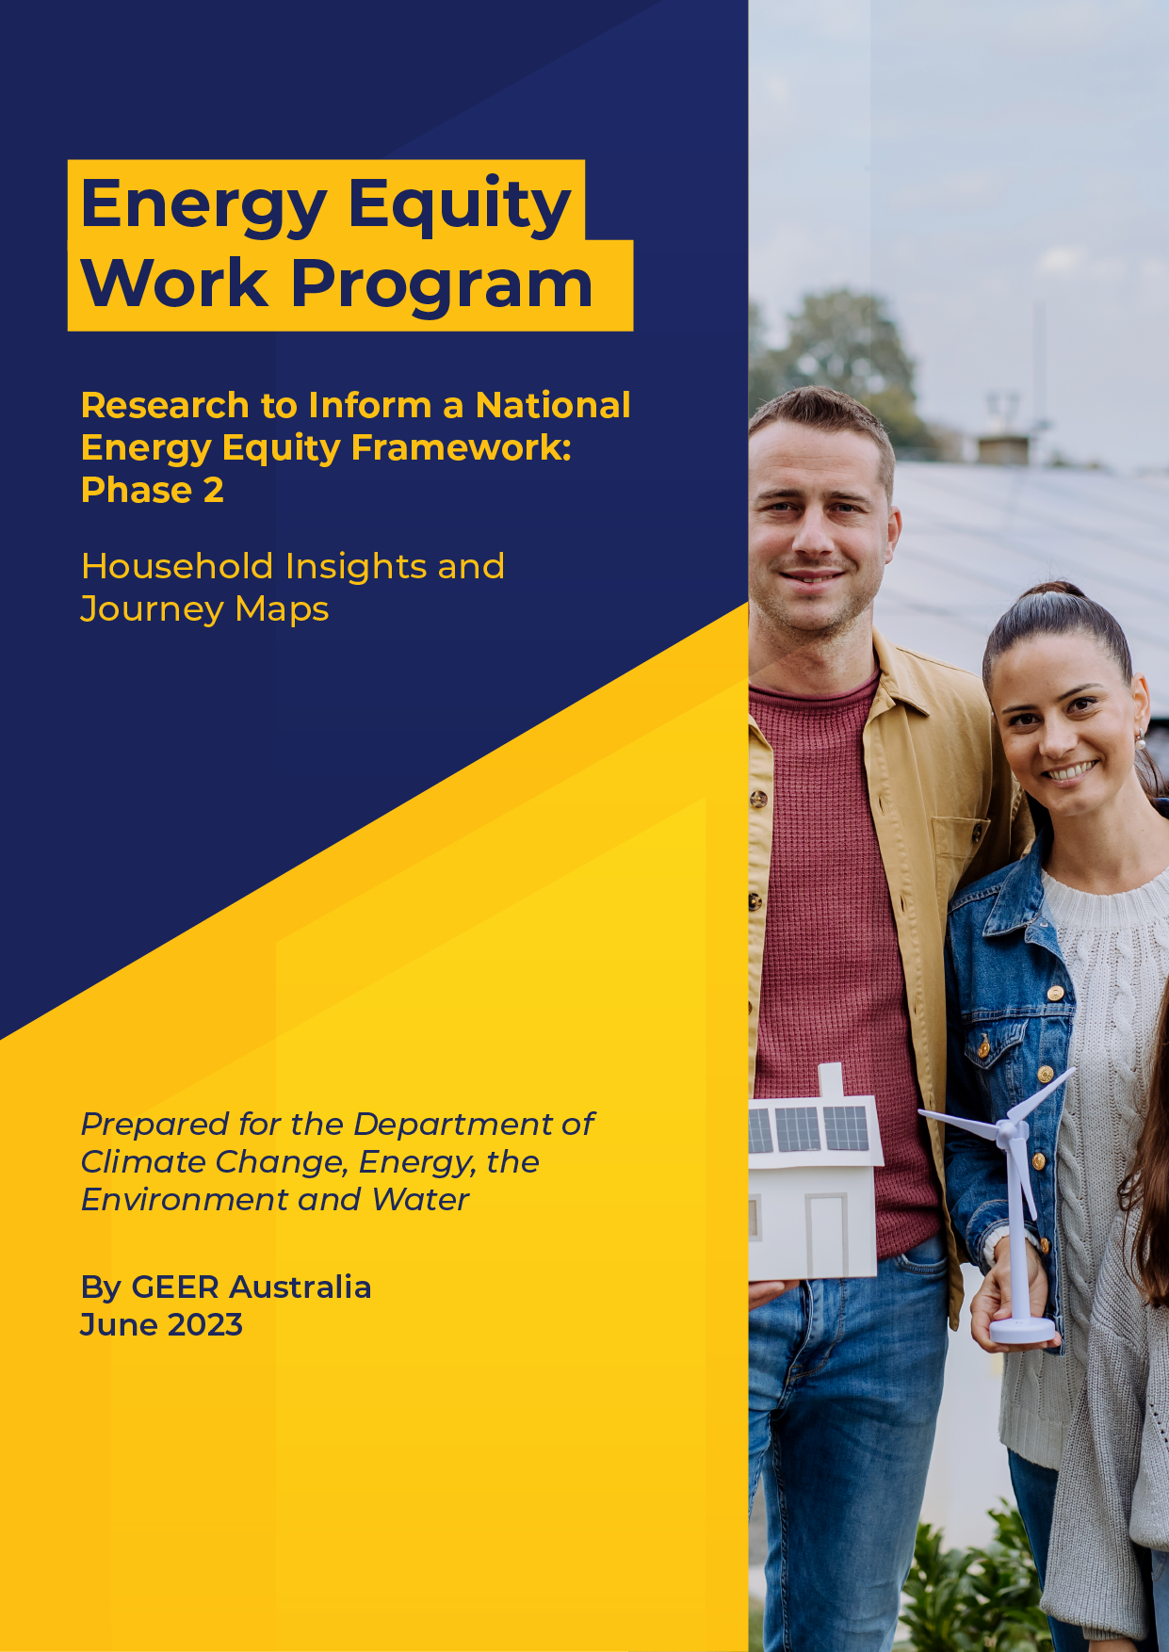

**Prepared by GEER Australia**

**Swinburne University of Technology**

**4th March 2022**

**Contact: Dr Rowan Bedggood  
M:** 0439 167 868  
**E:** [rbedggood@swin.edu.au](mailto:rbedggood@swin.edu.au)

**W:** www.swinburne.edu.au/



**Energy Equity Work Program – Phase 2**

**Household Insights and Journey Maps**

Final Report

**March 2023**

Prepared for the Department of Climate Change, Energy, the Environment and Water

By GEER Australia

**To cite this report**

Bedggood, R., Russell-Bennett, R., Letheren, K., Gardner, J., Adams, H., McAndrew, R. and Miller, W. (2023) “Household Insights and Journey Maps,” Final Report (2 of 4) for the Commonwealth Energy Equity Work Program – Phase 2, GEER Australia, Swinburne University of Technology, Melbourne.

**Participant acknowledgement**

The GEER Consortium extends our heartfelt gratitude to those who participated in interviews for this project: to households who shared their stories and to sector workers for sharing their insights, wisdom and passion for seeing improved outcomes for those households most in need.

**Funding acknowledgment**

This project was funded by the Commonwealth Department of Climate Change, Energy, the Environment and Water (DCCEEW) as part of the Energy Equity Work Program. The views expressed in this report do not necessarily reflect the views of the Commonwealth Government of Australia.

**Project Team**

|  |
| --- |
| **Dr Rowan E. Bedggood**  *Swinburne University of Technology*  Project Lead & Project Manager |
| **Dr John Gardner**  *Commonwealth Scientific and Industrial Research Organisation*  **Professor Rebekah Russell-Bennett, Dr Kate Letheren and Dr Ryan McAndrew**  *Queensland University of Technology*  **Henry Adams**  *Common Capital*  **Wendy Miller**  *Queensland Council of Social Service*  **Project Advisors:**  Professor Ross Gordon  *Queensland University of Technology*  Luke Reade  *Energetic Communities* |

**About GEER Australia**

The Group of Energy Efficiency Researchers (GEER) Australia is the peak research body on residential energy efficiency and wellbeing. It comprises researchers and industry partners from across Australia who are committed to driving change in the energy sector towards improved outcomes for Australian households. Its purpose is to improve energy-related wellbeing in households and communities in Australia, through collaborative research that achieves practical outcomes and informs future practice and policies. GEER’s research and activities thus focus on energy efficiency as it relates to quality of life, health, affordability and environmental sustainability.

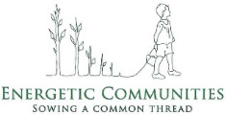**Project partner Common Capital logoProject lead Swinburne University of Technology logo**

# Symbol to represent main section "Executive Summary"Executive Summary

**Executive Summary**

**Purpose**

This report is the first of four providing findings from Phase 2 of a research project carried out by GEER Australia under the Energy Equity Work Program for the Energy Ministers Meeting (formerly the Council of Australian Governments Energy Council). It seeks to identify the prominent metrics we need to consider when determining measures of energy hardship. Towards this aim, the research project gained direct insights from households while also informing the refinement of three frameworks developed in Phase 1: the Drivers, Indicators, Outcomes (DIO) framework, ABATE hardship states framework and initiatives that provide prevention, support or relief (the P-S-R framework). Uniquely, the report develops journey maps and personas to represent movement across ABATE states.

**Approach**

We interviewed 40 households from four regions in Australia, sourced via community-based organisations (CBOs). The purpose of the interviews was to understand the journey of households as they experience vulnerability and hardship and to track how consumers coped and were able to move out of energy hardship. This report presents the findings that emerged from thematic analysis of the data we collected during the interviews. In addition, to enhance our understanding of household experiences, we produced journey maps for each household. These facilitate understanding of each household’s journey into and out of energy hardship. We synthesised them to create five archetypical journeys showing common pathways for households who enter energy hardship.

Analysis of participant stories revealed the key findings outlined below.

****DIO Findings**

***The main drivers of energy hardship revealed by households were:***

* macro drivers: high energy prices; poor, inefficient housing; and low social benefits
* meso drivers: poor retailer and landlord behaviours
* ******micro drivers: unique household needs; low income; energy-hungry appliances.

***The main indicators of energy hardship revealed by households were:***

* under-consumption coping strategies: under-using energy, other essentials, basics and luxuries, and reducing socialising (note: reducing socialising means not engaging in normal socialising at home and/or avoiding normal socialising outside of home)
* thermal discomfort (being too hot or too cold in the home) or uncomfortable indoor temperature (the home being usually too hot or too cold)
* ******difficulty paying energy/non-energy bills.

***The main outcomes of energy hardship revealed by households were:***

* stress, anxiety and depression
* worsened health
* poor quality of life
* rising energy (and other) debt.

Analysis uncovered **“invisible”** households. People in such households find a way to pay their bills on time but under-consume energy, other essentials, basics and non-essentials, and reduce socialising to do so. Current metrics will not capture this type of suffering and so this cohort is “invisible” to programs and policies that address energy hardship based on debt/bill metrics. This finding is critical for informing future data metrics and methods of capturing national energy hardship figures. Importantly, it suggests that “affordability” is not the key term to use when describing the issue such households face or to describe their suffering. A more fitting term is the high “cost of living”. This term does not challenge the self-sufficiency identity of some households, nor does it generate other forms of shame.

**Barriers to Accessing Support**

Faced with so many challenges, the need for support is paramount. However, households reported numerous barriers to accessing or receiving support (especially from retailers or landlords).

***The main barriers to accessing support were identified as:***

* shame: includes embarrassment, guilt or protecting a “self-sufficiency” identity
* eligibility criteria
* lack of awareness coupled with complex processes
* unhelpful staff.
* New barrier: low assistance literacy – low literacy about how to find and access assistance.

**Household Suggestions for Future Support**

Participants were very clear in describing what *would* have helped them, based on “what was missing” from the array of assistance they had already received. Their ideas form solid solutions to address energy hardship in the future. Without knowing, they described many of the drivers well documented in previous studies and in this series of research.[1] Participants provided several **suggestions that would improve their circumstances**:

* **tangible items** to improve the home’s energy efficiency: mainly upgraded heating/cooling systems
* **lower bills**: preferably ones that are fixed and affordable
* **financial assistance**: should be sufficient to alleviate suffering
* **people**: when providing support, staff need to be helpful, listen to the consumer, be trustworthy and provide fair outcomes
* **design**: when designing support, it should be clear what is available, in one place, and via processes that are simple or automated, where possible. Solutions should be able to be tailored to people’s unique circumstances.

**Updated ABATE Framework, Journey Maps and Personas**

We created journey maps for each household; they confirmed the four previously identified ABATE hardship states: Transient, Battle-on, Acute and Extreme. They also captured information about the pre and post states of hardship, producing three (new) **high vulnerability states**: ***Alert*** and ***Alarmed*** are pre-hardship and ***Apprehensive*** a post-hardship state. Analysis across all journey maps revealed five archetypical pathways:

1. **Transient (and possibly out of hardship)**
2. **Transient to Battle-on (and possibly out of hardship)**
3. **Transient to Battle-on to Extreme**
4. **Acute to Extreme**
5. **Acute to Extreme to Battle-on (and possibly out of hardship).**

**Households exit hardship** only from Transient or Battle-on states, although most do not manage to exit hardship. For those who exited hardship, key triggers included:

* major appliance upgrade: energy-efficient heating/cooling installed
* solar photovoltaic installed (usually by the landlord)
* increased income: by returning to work or increasing hours worked
* changed living arrangements: such as moving to a more energy-efficient home/downsizing/house-sharing.

The personas we developed for each ABATE hardship state reveal unique drivers and coping strategies. These are useful to inform improved assistance and policy that would better address the various needs.

**Conclusion**

This investigation provides potential metrics to inform the *Data Regime* (Report 3), which aims to develop new and **robust metrics to better capture energy hardship**. Potential metrics needed are:

* **from retailers**: includes sudden or drastic under-consumption of energy
* **from households**: includes income (and changes to income), thermal comfort, dwelling energy efficiency, household size and sacrificing behaviours (under-consumption of essentials/basics).

In conclusion, the findings from capturing household insights and journeys reveal that household experiences vary (supporting the ABATE framework), as do households’ needs for assistance. The findings identified that most households in energy hardship suffer across numerous areas. Efforts to alleviate their situation are often thwarted as they face ongoing macro and meso drivers. Alleviating energy hardship is not just about providing assistance (which is currently burdensome for consumers to find and access). It will also require addressing the main drivers of hardship to prevent people from falling into hardship in the first place.

# Symbol for next section "Contents" (table)Table of contentsTable of Contents

**Contents**

Executive Summary i

Table of Contents iv

1. Overview 1

2. Household Interviews 2

2.1 Approach and Participant Recruitment 2

2.2 Journey Maps 2

3. Key Household Insights 3

3.1 Drivers of Energy Hardship 3

3.1.1 Macro Drivers 3

3.1.2 Meso Drivers 4

3.1.3 Micro Drivers 5

3.1.4 Interactive Effect of Drivers 7

3.2 Indicators of Energy Hardship 8

3.2.1 Under-Consumption Coping Strategies of Households: Action-Based Behaviours 9

3.2.2 Thermal Comfort: Experience-Based 9

3.2.3 Difficulty Paying Bills: Experience-Based 9

3.2.4 Indoor Temperature: Proxy-Based 10

3.2.5 Drafts/Mould: Proxy-Based 10

3.3 Outcomes of Energy Hardship 11

3.3.1 Stress 11

3.3.2 Worsened Health 11

3.3.3 Worse Living Conditions 11

3.3.4 Energy Debt 11

3.3.5 Non-Energy Debt 12

3.3.6 Disconnection 12

3.4 Household Ways of Coping With Energy Hardship 13

3.5 Barriers to Households Seeking/Receiving Assistance 15

3.4.1 Shame 15

3.4.2 Eligibility Criteria 15

3.4.3 Lack of Awareness 16

3.4.4 Complex Processes 16

3.4.5 Unhelpful Staff 16

3.4.6 Comprehension 16

3.5 Preferred Assistance 16

3.5.1 Tangible Items 17

3.5.2 Lower Bills 17

3.5.3 Financial Assistance 17

3.5.4 People Providing Assistance 17

3.5.5 Design of Assistance 17

3.5.6 Non-Energy Assistance 18

4. Journey Maps and Personas 19

4.1 Archetypical Journeys Through Vulnerability and Hardship States 19

4.1.1 Vulnerability and Hardship Journeys 19

4.1.2 Movement Between Vulnerability and Hardship States 19

4.2 Personas of ABATE Hardship States 21

4.2.1 About the Method 21

4.2.2 Insights From Personas 21

5. Conclusion 21

Appendices 23

Appendix A: Legend for Diagrams of Findings (Themes) 23

Appendix B: Coping Strategies – Sub-Themes in Detail 24

Appendix C: Archetypical Journey Maps of Energy Hardship 27

Appendix D: Persona Descriptions 30

# 

# Symbol for next main section "1. Overview"Overview

**1. Overview**

Phase 2 of the research carried out under the Energy Equity Work Program for the Energy Ministers Meeting resulted in four reports. Reports 1, 2 and 3 all inform Report 4: *Better Practice Guide Towards Energy Equity*.

**Report 1**: ***Barriers, Scalability and Co-Design Findings*** – comprises two literature reviews: a national review of barriers and enablers to Distributed Energy Resources (DER) and Energy Efficiency (EE); and an international review of access and scalability of DER and EE programs. It also includes key findings from a co‑design workshop held with a range of experts from the energy and advocacy sectors. The findings summarise suggestions regarding:

* drivers of energy hardship
* household coping mechanisms
* sector support structures
* related sector challenges.

Key findings inform reports 3 and 4.

**Report 2: *Household Insights and Journey Maps*** (this report) – comprises key findings from household interviews, including information to further inform the three energy equity frameworks developed in Phase 1 of this research:

* the Drivers Indicators Outcomes (DIO) framework
* the ABATE framework (of hardship states)
* the prevention, support or relief (P-S-R) framework.

Interviews provided a deep dive into household coping strategies and the support households sought and received. Journey maps reflect household lived experiences and synthesise five archetypical journeys through vulnerability and hardship states. This research identified three high vulnerability states in addition to the four hardship states identified in Phase 1 of the research. Key findings inform Reports 3 and 4, as well as Phase 3 of this research.

**Report 3: *Data Regime*** – informed by the findings of Reports 1 and 2, this report describes the findings from a co‑design approach with key energy sector experts examining the use of existing data sources to capture and track energy hardship. The findings provide direction for future data needs in terms of metrics to be measured and the approach to capturing the necessary data. Key findings inform Report 4 and Phase 3 of this research.

**Report 4: *Better Practice Guide Towards Energy Equity*** –this guide is intended to help energy policy and program designers develop effective programs that reduce energy inequity. It reflects the overall findings from Phase 1 and Phase 2 of the research carried out under the Energy Equity Work Program (EEWP) for the Energy Ministers Meeting.

# Symbol for next main heading "2. Household Interviews"Household Interviews

**2. Household Interviews**

### Approach and Participant Recruitment

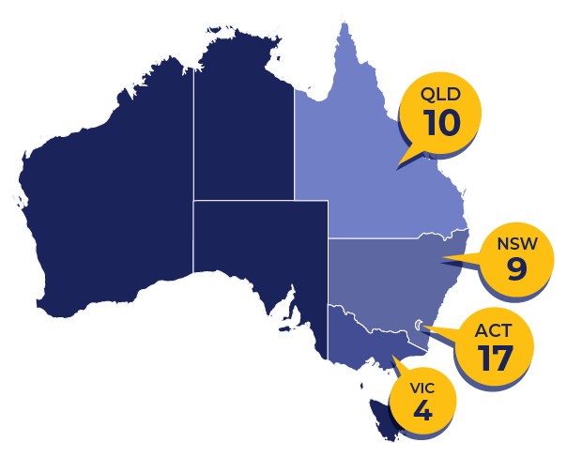To understand the experiences of households facing hardship, we interviewed 40 households from Queensland, New South Wales, the Australian Capital Territory and Victoria (see Figure 1). This reflected various temperature and region variations expected to broadly represent household experiences in Australia. Most participants were recruited with the support of four community-based organisations (CBOs). A three-step process meant that households were first contacted by a trusted source (step 1) and, without pressure, had time to consider the project and whether they wanted to participate before being contacted by a researcher (steps 2 and 3). Five household participants were referred by other households. We conducted the interviews by phone, and digitally recorded and later transcribed them. Analysis was conducted using transcriptions. We use pseudonyms for quotations throughout this report.

##### Participant Profile

Participants were mostly female (33 females, seven males). Seventeen were families, with 10 of those being single-parent families. A further 17 participants were single, while three were couples and three were in a house-sharing arrangement. In terms of tenancy, 32 were renting, three were homeowners and five unspecified. We recorded the interviews and later transcribed them and coded them into a spreadsheet. We then conducted thematic analysis on the data, informed by the following aims:

* to understand the key drivers, indicators and outcomes of energy hardship, with a view to informing the development of metrics (DIO framework)
* to identify key coping strategies which serve as indicators of the extent of hardship to inform future metrics

Figure 1: Participant Numbers From Four Jurisdictions

* to reveal the support initiatives that improved, or would have improved, the situation of participants (informing prevention, support or relief (the P-S-R framework)), including personal resources
* to identify how households move into various hardship states and whether, and how, they move out of them (the ABATE framework).

### Journey Maps

In additional to conducting thematic analysis of interview data, we produced journey maps for each household based on their story, or journey, through energy challenges. We asked participants to describe their recent experiences, but to also go back in time to when they first experienced energy hardship (described to them as difficulty paying for energy bills or not being able to use enough energy in the home to stay warm/cool). Some households described their journey as reflecting movement into and out of hardship, while most described long and enduring experiences of hardship for over 10 years. We then synthesised individual household journey maps to produce archetypical journeys. Interviews and journey maps were then used to produce personas for each ABATE hardship state.

# Symbol for next main heading "3. Key Household Insights"Key Household Insights

**3. Key Household Insights**

We present the findings from both thematic analysis and journey map development under the following broad categories:

* drivers of energy hardship, including bill shock journey
* indicators of energy hardship, including coping strategies and services received and their impact
* outcomes of energy hardship
* support that would have helped
* barriers to accessing support
* journey maps and personas for ABATE hardship states.

Direct quotations from households are given in grey boxes for each area throughout this section. We selected them for being typical of the sorts of comments made by all households on that theme. A diagram is provided for each area investigated – the top row of boxes represents themes, the boxes below each represent sub-themes (dashed boxes). Where no sub-themes emerged, a brief description is provided (blue dotted boxes). The colour of all boxes indicates the prevalence of participant comments. Darker colours represent greater prevalence of comments and lighter colours represent fewer comments (see Appendix A for a legend).

### 3.1 Drivers of Energy Hardship

Grouped generally as “drivers” in the Phase 1 report (Bedggood *et al.,* 2022) this study now divides them into macro, meso and micro drivers.

#### 3.1.1 Macro Drivers

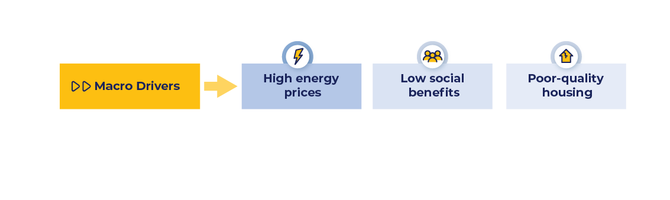Termed structural barriers in the Phase 1 report (Bedggood *et al*., 2022), macro drivers include factors that drive energy hardship across the board. Interview data revealed three macro drivers negatively impact households: high energy prices, low social benefits and poor-quality housing (see Figure 2). The first two were the most frequently cited (as above, darker colours indicate higher prevalence, *i.e.,* darker themes and sub-themes indicate more comments were made on that subject).

##### High Energy Prices

Figure 2: Macro Drivers of Energy Hardship

**“It wasn’t much of a worry – then suddenly ‘bang’ – energy went up for everybody and it just kept going up, up, up, up, and it’s just been a constant battle all the time.”** *Darren, NSW*

The main macro issue that drove consumers into energy hardship, or worsened their hardship state, was high energy prices. Consumers revealed they felt prices were unreasonably high and unaffordable. Several households expressed concern over coming price rises.[2]

##### Low Social Benefits

**“We are lucky if we get $300 per fortnight to eat … anyone who is living on a pension … [needs] to be a magician."**

*Lily, ACT*

The next macro driver was low social benefits, with participants consistently saying the amount was insufficient to live on and they had to make sacrifices to survive.

##### Poor-Quality Housing

Many households commented on the poor quality of their homes which made them energy-inefficient. Lack of maintenance and repairs was an issue for many tenants, preventing them from improving their situation. Most participants who commented on living in poor-quality homes lived in social housing. They reported difficulties in having their government landlords complete major and minor repairs.

**“Most rental properties are, like, most people are freezing and living in poor optimal temperature conditions."***Tully, ACT*

***Implications:*** Considering the three macro factors together, people are faced with increasing and high energy prices coupled with insufficient social benefits and very cold and drafty (or very hot) homes. This means they need more energy to attain basic thermal comfort and maintain health, yet can afford significantly less energy.

“These houses are forgotten, like no efficient insulation, no efficient electricity or gas equipment." *Ahmed, VIC*

Several households elaborated, saying they felt energy prices were “unfair”. Some blamed the government for the situation. A few households said they “felt helpless” and their mental health was negatively impacted due to constant struggle. Given the interaction effect between these macro drivers, **to properly alleviate energy hardship, poor housing quality, low social benefits and high energy prices need addressing**.

#### 3.1.2 Meso Drivers

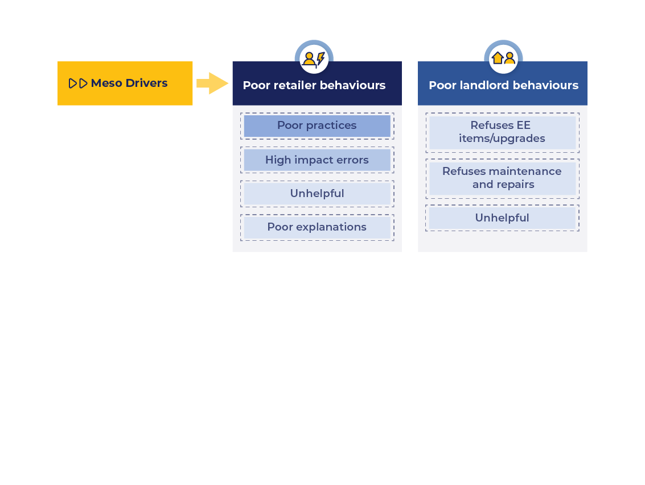Meso drivers include factors that are common to some but not to all. We identified two meso drivers: **poor retailer behaviours** and **poor landlord behaviours** (see Figure 3). Poor retailer behaviours were previously considered a structural barrier, although the further division of drivers allows an important distinction between “occurring to all” (macro) and “occurring to many” (meso).

##### Poor Retailer Behaviours

Figure 3: Meso Drivers of Energy Hardship

Of all drivers, poor retailer behaviour was by far the most frequently mentioned. With 100 stories of negative encounters (from 40 households), participants revealed that this driver is dominant in triggering or exacerbating energy hardship. Four sub-themes emerged from the analysis of household comments. In order of prevalence:

***Enquiring about an unusually high bill with a retailer:***

**“They said ‘It’s accurate and that’s just how it is. And it’s the dryer’… but my use of the dryer has not changed."**  *Ally, NSW*

1. **poor practices,** such as:no offer of support, reneging on an agreed obligation, not being flexible, taking a long time to resolve an error, refusing to release a household, forced and unaffordable payment plans, inconsistent responses, threatening disconnection.
2. **high-impact errors,** such as: incorrect meter readings and billing to the wrong address or changing payment arrangements without notifying the household. Coupled with this is reluctance by retailers to correct their mistakes. Those households able to find assistance reported needing advocacy or mediation/arbitration to resolve matters, which took a long time while the household energy debt rose.

**“[The retailer’s staff] were very rude and it was just like it’s not their problem."***Clarissa, NSW*

**“[The retailer] changed the plan … nobody told me."** *Ahmed, VIC*

**“Constant [meter] misreadings"** *Mandy, VIC*

1. **being unhelpful,** such as: households often feeling harassed and/or not understood, and finding retailers to be judgemental, uncaring, inconsistent and varying in their flexibility as to what they were willing to do or what they advised. Households felt they had to “find the right person” or else their matter would not be resolved.
2. **poor explanations,** such as: poor, inadequate or not-insightful information provided in response to questions about anomalies in the bill, meter reading or other areas.

**“I am paying [for] gas six months after I moved out. [When I rang the retailer they said] ‘At the end of the day, you’re an adult, that’s your own fault, you should have changed it.’ So, I had to pay it anyway.”** *Bella, ACT*

Overall, many households revealed their experiences with retailers left them “exhausted”, stressed, disillusioned and distrustful. With comments like “there’s nothing more I can do” being common, some households reported feeling “helpless” while others reported having to seek legal or advocacy assistance.

##### Poor Landlord Behaviours

**“Four months, I had sewerage coming out of the drains in the backyard. Four months, I was begging them to do something about it … the smell was making me sick.”** *Lily, ACT*

Household stories revealed that many encounters with landlords about energy-related matters were negative. This problem was common with those who were tenants in social housing. Three sub-themes emerged that grouped these encounters:

1. **refuses maintenance/repairs**: landlords would either refuse to conduct maintenance or repairs needed in the home or, if they did complete the work, it was done poorly.

**"I’ve got letters and doctor’s certificates saying the coldness affected me, and they just did nothing. [Housing] never responded to one letter."**

*Robert, ACT*

1. **refuses energy-efficient upgrades**: upgrades needed in the property are either not conducted or completed poorly.
2. **unhelpful:** once contacted, households often found landlords to be unhelpful, not knowledgeable, rude or dismissive. For some, these responses led to feelings of hopelessness and despair.

**"That house manager is rude, that doesn’t even want to acknowledge what I’m going through."** *Marbrooka, ACT*

**“I have been trying … to get someone to hear me for the last four years … and it’s just gone on for too long – it’s ridiculous.“** *Cermaka, ACT*

Issues around these three factors were most prominent for those in social housing.

In summary, the negative experiences of households due to poor retailer and/or landlord behaviours means households must seek further assistance or find additional ways of coping. Many seek advocacy support through CBO negotiation or legal mediation/arbitration. This generates a high level of busy-ness for households around receiving support and increases the complexity they must navigate and the burden they must carry.

#### 3.1.3 Micro Drivers

From the analysis, seven micro drivers and 14 sub-themes emerged. All sub-themes belong within the first five of the micro drivers. The most reported drivers in order of prevalence are: the household facing unique energy needs at certain times or due to a change in those living in the home; low income; high non-energy expenses, high energy bills and energy-hungry appliances. Many households also commented on the energy-inefficiency of the dwelling or the type of dwelling (that it was prone to being too hot/cold), while a handful of households 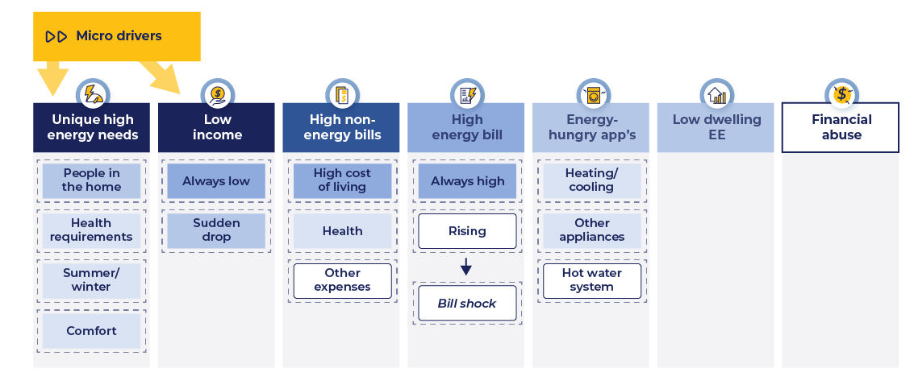reported facing financial abuse (see Figure 4). These micro drivers are discussed below in order of prevalence.

Figure 4: Micro Drivers of Energy Hardship

**“I have 5 kids and we are 7 people in the household, [so] whatever I do to bring [the bill] down, it’s still very high"** *Narina, NSW*

##### Unique High Energy Needs

The micro driver of energy hardship most frequently cited by households is their unique energy needs based on a range of circumstances. These include the ***people in the home***, whether it be many children/other occupants, caring for others (elders), or being home more often (such as working from home more). Other circumstances include ***health requirements***, such as needing the home to be warm/cool based on respiratory or frailty needs. People also described how they needed to use substantially more ***energy in summer/winter*** due to the home they live in (highly related to dwelling energy efficiency). Others revealed they needed to maintain a certain level of ***comfort*** in the home as a priority.

**“I’ve got my mum here, 94, and she depends upon the electricity, so we’re on a do not turn off system"** *Darren, NSW*

##### Low Income

Low income was the next most prominent micro driver. Common triggers include:

“With my disability pension, you don’t get [much] money, so you have to be frugal" *Daniel, QLD*

* ***low income:*** includes working part-time/casual hours, receiving social benefits or earning a very low full-time salary. In all cases, households commented that their income was insufficient to cover their bills, including energy bills. Some households reported they were unable to obtain or sustain sufficient work hours for reasons including health or carer commitments.

**“I’ve been a single mum for 6.5 years … money is super tight – like – it’s always tight.”** *Natalie, ACT*

* ***sudden loss of income:*** includes suddenly losing a job or having to stop work due to health reasons, or separation from a partner. In all cases, the household suddenly plummeted into energy hardship and had difficulty coping with bills (this is the main driver for Acute hardship).

“I was in a car crash and had like a brain injury, so can’t work or study …it’s just put all of the finances kind of are much more difficult!” *Tully, ACT*

##### Non-Energy Expenses

Other bills also dominated the concerns of most households. Having many other expenses reduced household capacity to pay for energy bills. Such non-energy expenses included those associated with the cost of living: medical, car, rent, school, phone, business, legal and commuting bills, or being a carer.

**“It’s not just electricity – it’s everything – it makes it hard as well.”** *Jessabelle, QLD*

##### High Energy Bill

Many households reported receiving high energy bills. Some participants felt that their ***bills had always been high*** while others noticed that ***bills had increased*** a lot recently. Being unable to pay the bill often meant the household went into debt and/or had to adopt other coping strategies.

**“I couldn’t believe it … I thought they must just make up numbers."**  *Carly, ACT*

For some, receiving high bills resulted in **“bill shock”**. Households appeared to experience two types of bill shock: feeling ***surprised*** at a higher than usual bill or feeling ***baffled*** as to why the bill was so high. The experience of households after receiving a high bill surfaced the following responses:

**“… We’ve always got to pay – give an arm and a leg to pay it – just so [we] can survive."** *Naomi, NSW*

* **shock, alarm, stress**: receiving a high bill caused a strong reaction as households struggled to pay the bill or to understand why it was so high.
* **cognitive reasoning**: households would question “Is it me or is it them?”. They often embarked on some form of investigation of the reason, whether with their retailer, online, seeking advice from family/friends or experimenting with an appliance. Some households reported approaching an ombudsman to help resolve their issue, believing the bill to represent retailer error.
* **resigned**: some households revealed they were resigned to their situation. They were invariably still searching for the reason for their high bills but felt powerless to resolve it. Some shared they lost trust in their retailer as they assumed an error had been made and the retailer was not prepared to review it.

##### Energy-Hungry Appliances

**“The house came with pretty shitty wall-heaters that didn’t really do much … [the space heater] doesn’t actually heat anywhere else other than that room.”** *Jenifer, ACT*

The most frequently reported inefficient appliance was ***heating/cooling***, followed by ***other appliances*** (such as the refrigerator, dryer, washing machine, dishwasher or oven) and the ***hot water system***. Importantly, households were mostly renters, and were not able to change appliances. As for the consequences of poor landlord behaviour, households have little option but to incur high bills or drastically reduce energy use to a point of discomfort.

##### Dwelling Energy Efficiency (Includes Type of Dwelling)

Whether it was due to poor insulation, drafts or positioning of the building/rooms, low energy efficiency of the dwelling generally produced either extremely cold or hot homes. This meant that some households had little choice but to live in unhealthy conditions or use lots of energy knowing this would result in high bills. This situation seemed to be common for those living in social housing.

“These houses are forgotten, like no efficient insulation, no efficient electricity or gas equipment."  
 *Ahmed, VIC*

Comments about the type of dwelling were about its age, size and/or location relative to other buildings or the sun. Households living in older, larger and/or poorly situated homes attributed those factors as causes of their high bills.

**“It’s the coldest space I have ever lived in."** *Marlene, VIC*

##### Financial Abuse

A few participants revealed they had experienced financial abuse. This seems to be a factor driving energy hardship *if* it limits a person’s financial access and knowledge (financial literacy) or limits their access to energy bills or knowledge (energy literacy). It usually went with sudden income loss or very high bills/debt.

**“There was quite a bit of financial abuse and controlling.”** *Julie, ACT*

#### 3.1.4 Interactive Effect of Drivers

Macro, meso and micro drivers interact, which increases the likelihood and extent of energy hardship. Figure 5 shows how they are linked and sequenced. Macro, meso and micro drivers lead to either high energy bills or lower disposable income. Together with a low income base, these have a compounding effect – and evidence in this research shows multiple drivers are experienced by all households.

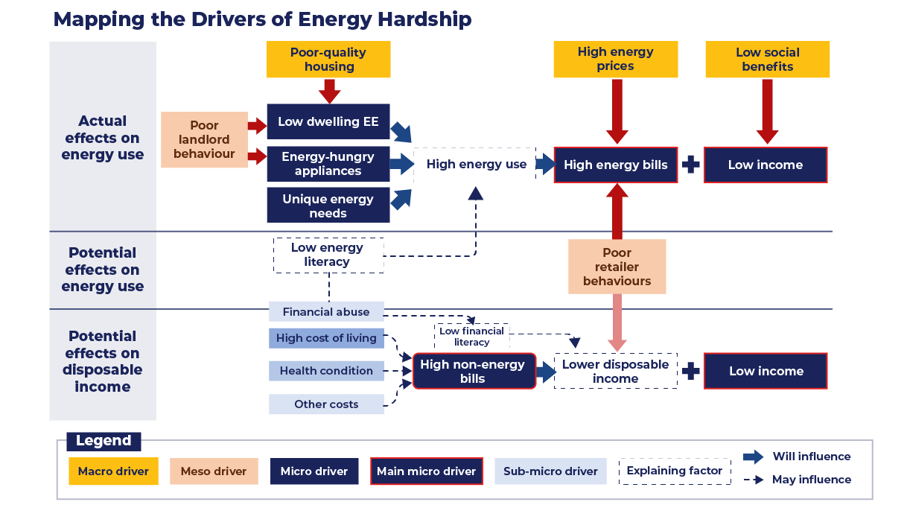

Figure 5: Inter-Connections Between Drivers of Energy Hardship

### 3.2 Indicators of Energy Hardship

We consider the following three factors to be indicators of energy hardship:

1. **action-based**: reflects a behaviour of the household which indicates they are in hardship (coping strategies)
2. **experience-based**: reflects the experience of the household living in the home (thermal comfort, difficulty paying bills)
3. **proxy-based**: reflects a metric that would indicate suffering is likely (indoor temperature, draft/mould) (see Figure 6).

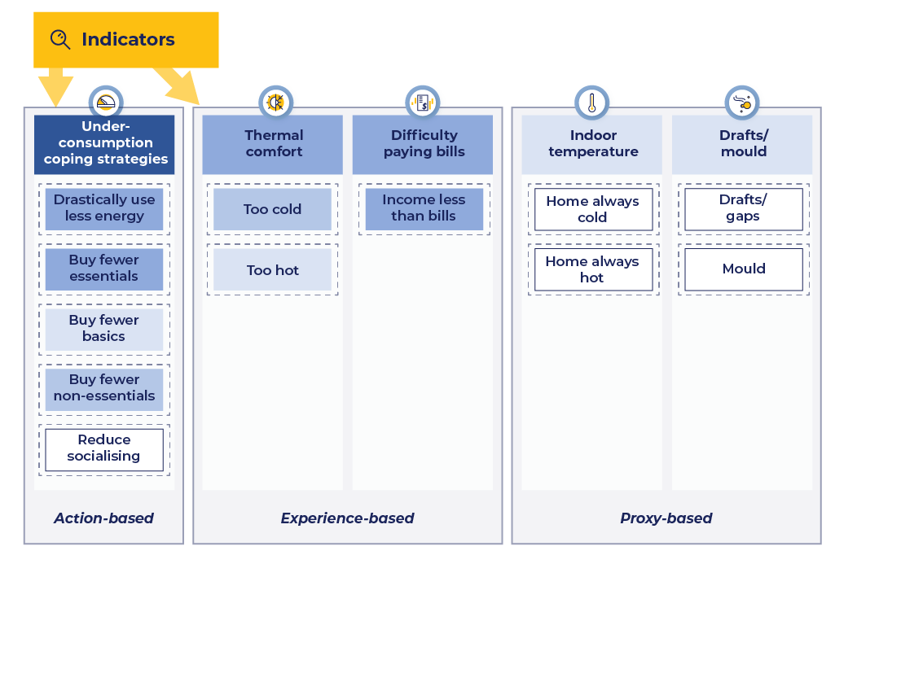

Figure 6: Inter-Connections Between Drivers of Energy Hardship

#### 3.2.1 Under-Consumption Coping Strategies of Households: Action-Based Behaviours

Under-consumption is a sacrificing behaviour of households that trades off paying bills for wellbeing. Known as the “heat or eat” dilemma, these findings extend it to identify five areas of under-consumption beyond energy and food (see Appendix B1 for more details on under-consumption):

1. ***Drastically reduce energy use***: Avoid or limit energy use to a point which substantially sacrifices comfort.
2. ***Buy fewer essentials***: Limit or go without, *e.g.,* food/groceries/petrol.
3. ***Buy fewer basics***: Avoid buying, *e.g.,* coffee/lunch; delay purchasing household items; limit appliance use.
4. ***Buy few non-essentials***: Avoid, for *e.g.,* eating out/travelling; buy lower-quality items.
5. ***Reduce socialising***: Avoid having visitors (to save energy) or reduce/avoid going out (to save money).

#### 3.2.2 Thermal Comfort: Experience-Based

**“We would sit there of a night-time, and we would freeze because we were too frightened to use energy."** *Clarissa, NSW*

Households described how living in their homes meant they were often **too cold or too hot**. With many living in poor-quality homes (macro driver) with energy-hungry appliances (micro driver), it is no surprise that households reveal feeling thermal discomfort.

#### 3.2.3 Difficulty Paying Bills: Experience-Based

***Paying the bill***

**“It was really hard and really created so many problems.”** *Nishu, NSW*

Households revealed having difficulty paying for energy (and other) bills. This is expected, given the blend of drivers such as high prices/bills, energy-inefficient homes and appliances and low income. Households show little resilience against changes in circumstances if they require energy or funds (to address issues such as health or caring for a senior family member).

We note that not all households reported “difficulty paying bills”. This provides evidence that **many households who are suffering are paying bills on time and going without many other essentials and comforts in life so they can afford energy**. However, these “invisible” households still reveal they struggle to pay their bills and make sacrifices to do so.

**“I spent 30 years in hell-on-earth trying to survive paying these electricity bills."**  *Lily, ACT*

#### 3.2.4 Indoor Temperature: Proxy-Based

Closely related to thermal comfort is the indoor temperature of the home. Here, households described the inside temperature of their home as a proxy for thermal comfort and health. If the home is too cold or too warm generally, it indicates thermal comfort will be low and the household is under‑consuming energy.

**“[The house] makes you feel like you’re in an oven.”** *Katherine, QLD*

#### 3.2.5 Drafts/Mould: Proxy-Based

The presence of drafts and/or mould[3] indicate air flow problems in the home, making it a proxy-based factor. Several households mentioned their homes were drafty and had gaps around the doors or windows. This required them to use more heating/cooling to keep the home comfortable. Also, a few households mentioned they had mould issues which were exacerbating or causing health issues and damaging their furnishings.

**"We … HAVE to use the heaters around the house, because the house is so cold – it’s like you’re sitting inside a fridge."** *Marbrooka, ACT*

**"I had to spend like five hours [cleaning], like I realised behind all the shelving and stuff, there was hectic mould."**

*Tully, ACT*

### 3.3 Outcomes of Energy Hardship

Households described the consequences of struggling to pay energy bills and/or having to under‑consume to survive (termed outcomes). Six key themes emerged from the data: (in order of prevalence) stress, worsened health, poor living conditions, energy debt, non-energy debt and disconnection (see Figure 7).

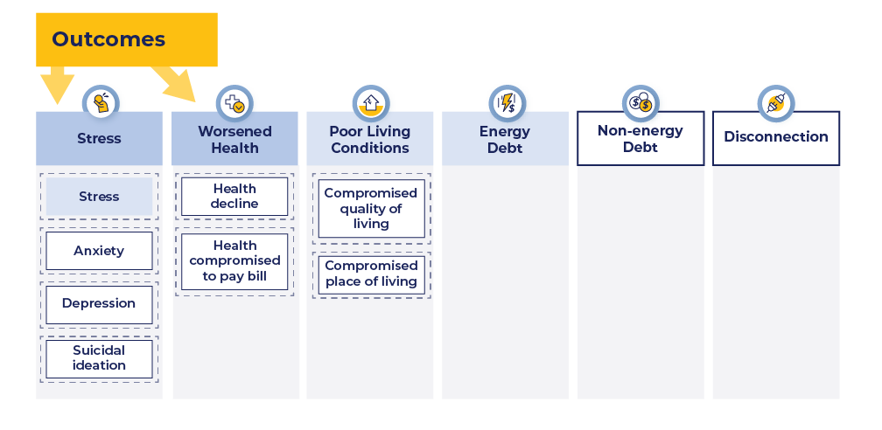

Figure 7: Outcomes (Consequences) of Households in Energy Hardship

#### 3.3.1 Stress

Stress was the most reported outcome of energy hardship. Comments we allocated to stress as a barrier to accessing support are different from those we allocated to stress as an outcome. If participants said they felt stress because of their struggles (rather than saying it blocked them from accessing support) it was allocated here. Generalised **stress, anxiety, depression and suicidal ideation** were the four sub-themes that emerged. Feeling under constant pressure to pay for energy bills, trying to find ways to manage, or radically reducing energy use place a high and stressful burden on households.

**“I nearly had a heart attack – I was so stressed and really worried about this bill."***Carly, ACT*

**“I sit here, and I worry, and I stress, and I have panic attacks."** *Lily, ACT*

#### 3.3.2 Worsened Health

Participants’ health had worsened due to being in a state of energy hardship. **Their health had declined**, and they presented with, for example, respiratory problems, lowered resilience due to being too cold or a worsened existing health condition. Other households reported that their **health was compromised by having to work to pay for energy bills despite being unwell** or they were malnourished due to going without food.

“I’d been doing radiation, chemo, and I actually HAD to work because they kept threatening to disconnect everything." *Jolene, VIC*

#### 3.3.3 Worse Living Conditions

“Cutting back energy use has definitely impacted negatively on our family, having to change our whole lifestyle so drastically“ [due to heavy under-consumption].”

*Mandy, VIC*

Several households’ **living conditions had worsened** due to being in energy hardship. Comments allocated to this theme were sometimes a collective of several indicators and other outcomes, for example, thermal discomfort, under-consumption and stress. Living conditions worsened if the household was **evicted** or became **homeless** due to being unable to pay for energy or rent.

#### 3.3.4 Energy Debt

Many households in hardship described their concern over rising energy debt. They invariably prioritised health, thermal comfort or the wellbeing of others in the home, and so used energy despite the bills. One household reported a $12,000 debt, the participant believing it would take her lifetime to pay it off.

#### 3.3.5 Non-Energy Debt

It was rare for a household to be facing energy debt only. Many described struggling in other areas too, such as paying for rent, medical bills, school expenses and petrol. This reflects the macro drivers of high energy costs and low social benefits and the micro drivers of high energy bills, low income and energy-hungry appliances.

#### 3.3.6 Disconnection

Some households revealed they had been disconnected by their retailer and “did not bother to reconnect” as a strategy to save money by using drastically less energy. Some who had been disconnected could not afford to pay the reconnection fee. Self-disconnection also occurred by deliberately cutting off energy in most rooms of the home.

### Household Ways of Coping With Energy Hardship

Households engage in coping strategies for common drivers such as high bills, low income and energy-inefficient dwellings and appliances. This area represented a considerable proportion of the story households shared, reflecting that many face a constant and challenging battle to survive, with “struggle to pay” and “trying to survive” common expressions. Of all the areas investigated, data allocated to **coping strategies dominated all others,** with over 280 comments from the 40 households. (The highest number of comments for other themes was 120.) This indicates **a household in energy hardship typically adopts multiple coping strategies**. It is thus evident that households are kept profoundly busy coping with high bills and keeping energy use at a minimum. This places an **undue burden on households**.

Under-consumption is one form of coping strategy households adopt (as discussed under Indicators). Other coping strategies are also used. Some align with types of formal assistance sought/received, others with various forms of informal assistance from friends/family, others with householders drawing on personal resources.

Two important observations can be made:

1. All coping strategies would be useful indicators of energy hardship, although learning of these coping strategies would require direct contact with the household.
2. Assistance received is usually *sought out* by the household (not passively received). All services received were therefore grouped with coping strategies, as they shared similar themes (managing bills, managing energy efficiency and building knowledge).

We have extended the previously identified coping strategies due to this deep-dive investigation. **Under‑consumption** was the original type of coping strategy; in this research, we have identified an **additional three** (see Figure 8).

* **Manage bills:**
  + - ***Gain funds***: *e.g.,* vouchers, matched payments, debt waivers, or borrowed funds from friends/family.
    - ***Manage funds***: *e.g.,* decide to accrue debt to prioritise health (keep using energy anyway) or to protect mental health (disengage due to low cognitive bandwidth).
    - ***Home checks***: *e.g.,* checks for appliances, dwelling energy efficiency, draft/mould, meter readings.
    - ***Change retailer***: find a lower price or better service.
* **Under-consume:**
  + ***Drastically reduce energy use:*** *e.g.,* avoid heating/cooling completely, use minimum energy or self-disconnect.
  + ***Buy fewer essentials, basics and/or non-essentials:*** *e.g.,* go without food, buy lower quality groceries, avoid buying takeaway coffee/food.
  + **Reduce socialising to an austere degree:** *e.g.,* avoid having people over altogether, or rarely
* **Manage energy efficiency:**
  + Install or use ***energy-efficient products***: *e.g.,* door stoppers, electric blankets or appliance upgrades.
  + Adopt ***energy-efficient behaviours***: *e.g.,* use energy mindfully, reduce use of energy-hungry appliances, implement energy savings tips.
* **Build knowledge:** *e.g.,* from formal or informal sources such as websites or friends/family.

See Appendix B2 for further details about each type of coping strategy.

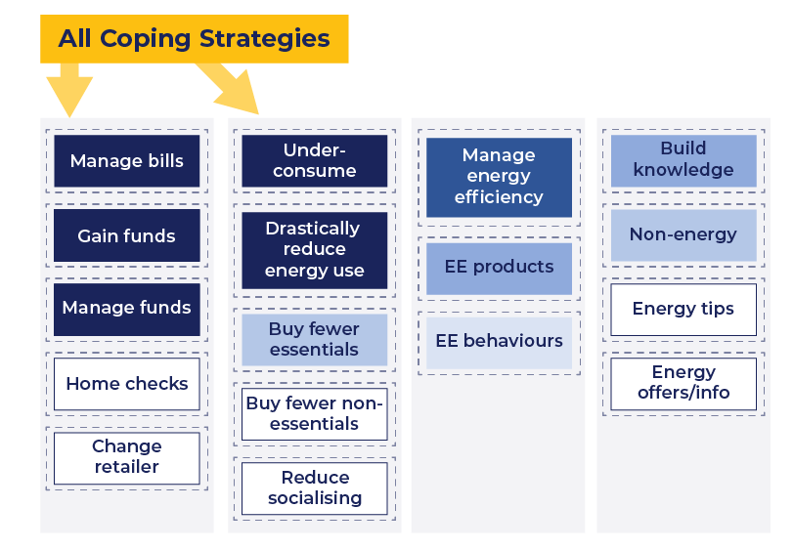

Figure 8: Coping Strategies of Households in Energy Hardship

##### Some Households Need Advocacy Assistance

**“[The CBO] organised … a new … air conditioner with Housing … Before summer came, I got a brand-new air conditioner … I was just so happy.”** *Carly, ACT*

One further type of assistance that households pursued was **advocacy** **–** **a facilitating step** to several coping strategies, such as gain funds, manage funds, home checks and energy-efficient products. Advocacy was often necessary for households to achieve a fair outcome with their retailer or landlord, or to obtain support that was too challenging for the household to access alone.

In seeking resolution or assistance, households reported they sought advocacy help: negotiation, mediation or arbitration. Households often sought negotiation assistance from a CBO to speak with their retailer (most common) or landlord (less common) to help the household understand the problem and negotiate a better outcome on their behalf. If this did not work, some households would go further and seek mediation or arbitrations support, for example, from an ombudsman.

**“I had to go through [an] ombudsman – it was an absolute joke to resolve the high bills.”** *John, ACT*

To access assistance, households need to exert considerable effort. This requires finding what is available, where it is available and how to access it. For many, this involves meeting difficult and complex eligibility criteria (e.g*.,* completing stringent questionnaires or limiting the number of vouchers one can access in a year) and overcoming shame. When households achieve all this and still find themselves in an untenable situation, they must exert more effort and seek out legal or arbitration assistance (see Figure 9).

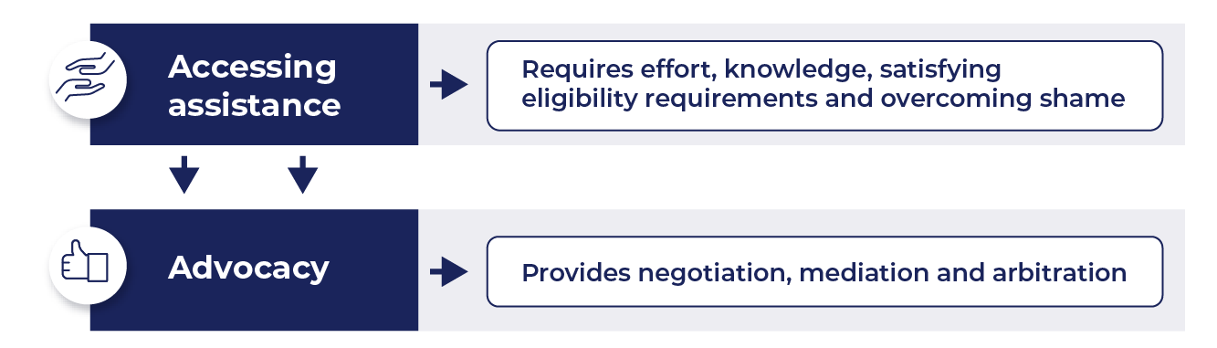

Figure 9: The Burden of Accessing Assistance and the Need for Advocacy

Addressing the barriers to accessing assistance would not only reduce the burden on consumers but also on advocacy organisations and staff, as well as retailers.

##### 

**Takeaways From Understanding Coping Strategies**

* **Households draw on many resources to cope, sometimes undertaking drastic measures** to “survive” using and paying for energy in the home; yet, despite these efforts, most remain in hardship. This means additional assistance is needed beyond what is currently accessible.
* The **three most common coping strategies are to gain funds, drastically reduce energy use and manage funds.** These actions could serve as indicators of the energy hardship state

### 3.5 Barriers to Households Seeking/Receiving Assistance

We asked participants to describe the barriers they faced in accessing energy-related assistance. From the analysis, six key barriers emerged (see Figure 10). These can be grouped as:

* internal barriers: shame, lack of awareness or comprehension
* 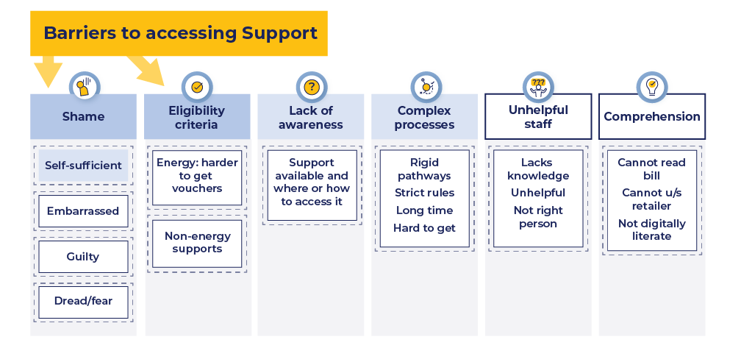external barriers: eligibility criteria, complex processes, unhelpful staff

Figure 10: Barriers to Seeking and Accessing Energy Hardship Assistance

#### Shame

**“I’m not a charity case."** *Nafisa, NSW*

Half of those we interviewed revealed they struggled to access support due to “shame”. Shame is the most common barrier, and it extends beyond feeling embarrassed. The most **dominant sub-theme under shame relates to the self-identity of the household** (or bill-payer). These participants revealed they were “not that desperate” or “not the type of person” who needs/accesses assistance. They tend to see themselves as **self-sufficient** – a self-identity that does not match their image of someone who would need help.

Others revealed feeling ***embarrassed*** about asking for help or in having to share details of their private situation. Some households revealed they struggled to access assistance due to feelings of ***guilt*** and felt it was not morally rightfor them to access assistance when others were also in need. A few households shared they felt ***fearful*** of contacting their energy retailer and dreaded having to interact with them.

**“I don’t want to take food out of other people’s mouths."** *Kylie QLD*

**“I felt really ashamed about taking [job assistance from the government]."** *Daphne, ACT*

If feelings of shame prevent households from seeking assistance (the “invisible” consumers), then programs and policies should ensure future assistance is automated where possible.

#### Eligibility Criteria

Only a few households commented on insurmountable eligibility criteria as a barrier to accessing assistance, for example,energy assistancevouchers being harder to obtain. However, eligibility for accessing non-energy related support was an issue for several households. For example, participants revealed they had difficulty accessing Centrelink payments including the disability pension and support payments, family tax benefits, maternity leave or housing benefits. This finding highlights that many households in energy hardship face numerous challenges in their life and are not receiving assistance that is designed for them from multiple sectors, including energy.

***Vouchers:***

**“They’re much more stringent to get now.”** *Darren, NSW*

#### Lack of Awareness

Several households revealed it was a challenge to know what to do or where to go. In some cases, the household was **not aware there was a problem** until they received a very high bill. Once this had happened, participants said they were **unclear about what assistance was available**, **where it could be accessed** and **how to obtain it**. This was not necessarily due to lack of information provided on websites, as reading about support does not address all three questions.

**“You don’t know who to ask or where to go or how to go about it."***Jenifer, ACT*

#### Complex Processes

**“It’s a full-time job – just trying to get them whatever paperwork they need.”** *Jolene, VIC*

Accessing energy assistance was found to be complex, confusing, time-consuming and, on occasion, humiliating for households (especially in having to share their personal story over and over). Comments referred to rigid rules and a lack of flexibility to deviate from them.

#### Unhelpful Staff

Most of the comments about unhelpful staff were allocated to poor retailer behaviour or poor landlord behaviour. Participants revealed that the unhelpful behaviour/attitude of staff formed a barrier to the household accessing energy assistance. Instead of receiving the assistance they sought, they felt rejected and dejected from the experience.

**“All I needed was advice where to go, but she hadn’t given it to me, so that’s when I came home and I started stressing out."** *Daphne, ACT*

**.’”**

#### Comprehension

This investigation **did not detect substantive challenges around energy literacy, financial literacy or comprehension in general**. This final sub-theme of “comprehension” was experienced by just a few participants, who revealed they sometimes had trouble understanding their retailer (who spoke with an accent, in their view) or had trouble reading the bill due to very small font, or they were not digitally adept and had trouble with online navigation. These matters are not indicative of low energy literacy.

***Insufficient Level of Assistance***

An observation during the analysis of “barriers to seeking/receiving assistance” is even when households overcame barriers, in most cases, the assistance was insufficient to address their needs. Participants commented that most assistance they accessed was helpful but provided little alleviation for their situation. The exception was when the household received a major appliance upgrade. Most of the assistance provided by retailers, government, landlords or CBOs was insufficient to alleviate hardship. At best, it made their situation “less worse”.

**“I am very happy with the voucher they are giving … but [it’s] not enough to cover [the] outstanding balance … which is still $1,500."** *Narina, NSW*

### 3.5 Preferred Assistance

At each key point in the household’s journey, we asked participants for their views on what assistance *would have* alleviated their situation at the time. Five key themes emerged from the analysis: tangible items, lower bills, financial assistance, people providing assistance and designing assistance (see Figure 11).

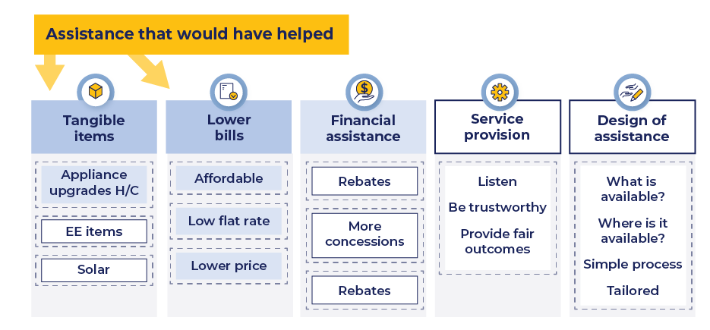

Figure 11: Households’ Preferred Assistance to Alleviate Energy Hardship

#### 3.5.1 Tangible Items

Most participants shared that having tangible items to improve their energy use/bills would have been the most helpful form of assistance. Suggestions mostly referred to upgraded heating/cooling systems, but also referred to other items to better manage indoor temperatures, such as insulation, draft and window seals, double-glazed windows, blinds, curtains and room thermostats.

**“I think for these apartments, they should have put in some reverse cycle or something like that – or some fans at least."***Bella, ACT*

#### 3.5.2 Lower Bills

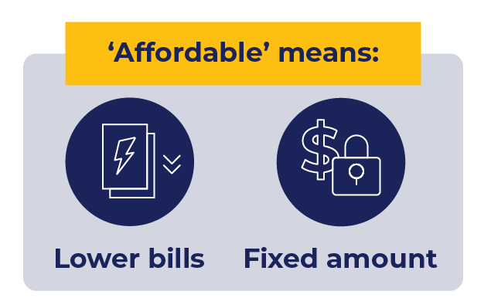Another suggestion was for bills to be lower. Three areas were emphasised by households: bills need to be **affordable**, much **lower** than currently and of a **fixed** amount, as this feels safer to households who can better predict expenditures on their very tight budgets. Those households who are “invisible” (because they regularly pay their bills, despite suffering to do so) also commented on wanting lower, affordable prices that are preferably predictable.

**“It would have been really helpful if energy bills were not that expensive… because it’s really high for some reason… it just becomes too much."** *Nishu, NSW*

**“I cannot pay more than $100 a month or my kids will starve.”** *Ahmed, VIC*

When it comes to affordability, several households revealed what they can pay. Many who were on a retailer payment plan said it was either not affordable or they were stressed because their regular bill was accruing. Ranges of **affordability** were from $25 per fortnight (p/f) to $100 p/f, with the most common being **$50 p/fn**.

#### 3.5.3 Financial Assistance

Households provided several ideas for how financial assistance could be boosted to a point that helped them out of their situation. Some suggested they would have liked to receive a **bonus** for regular payments; others suggested a **rebate** to assist with their bill or **appliance upgrades or solar installations**. Some felt that **more people should qualify** for receiving an **energy concession (discount)**, to include survivors of family violence, those with major illnesses or single parents. Most people advised it would be a relief to them if they received such concession allowances **automatically** so they did not need to “jump through hoops”.

#### 3.5.4 People Providing Assistance

The way people are treated when seeking assistance is important. Some participants shared that the people they dealt with were often unhelpful, dismissive or rude, which corresponded with the household feeling harassed, shamed or judged. Participants shared that staff dealing with households need to **listen** to the household’s situation and explanation, provide clear advice in a way that is **trustworthy,** and be knowledgeable and believable. Households also seek a **fair** outcome to their dilemma.

**“There are so many scams and fraudulent people out there that when you’re already anxious, you want to be able to trust it [offers/people], but you don’t know you can."** *Mandy, VIC*

#### 3.5.5 Design of Assistance

The design of future assistance theme drew on multiple areas of participants’ stories when they commented on how things could have been done differently. Participants revealed it was difficult for them to find assistance, with some advising that when they did, there were many options, which was overwhelming. It was difficult for participants to navigate their way through the complex support system. Some said that even after accessing assistance, they often remained in the same state of hardship, which motivated them to seek additional assistance. They commented that even once they knew what was available, it was not always clear where to go to access it, or what process to follow (and these processes were often long and complex and required telling their story over and over, which was distressing).

***Tailored support:***

**“It would have been nice for them [retailer] to look at my situation … such as … my low income in general … and … being a single mum."** *Rebecca, NSW*

Households shared that it would be easier if everything they needed were available in one place. They also wanted some acknowledgement of their unique situation, with allowances or adjustments possible to **tailor** the assistance to better suit their needs (see Figure 12).

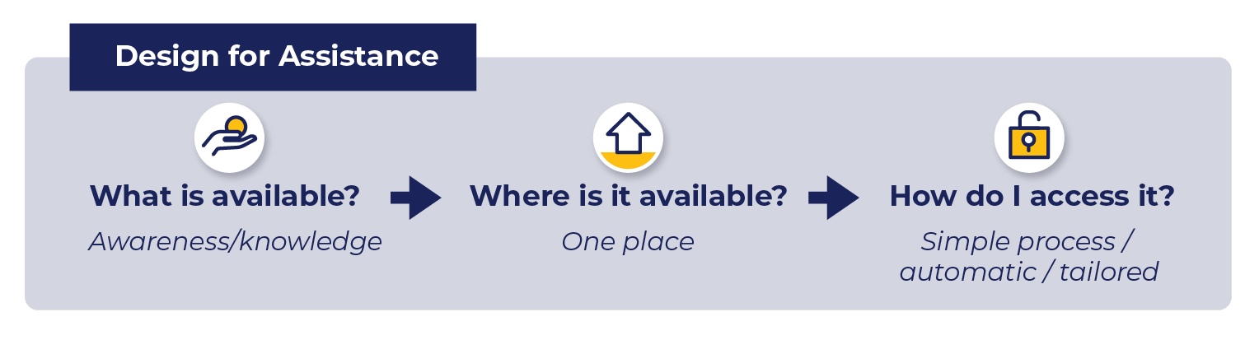

Figure 12: Household Views on How to Better Design Assistance

#### 3.5.6 Non-Energy Assistance

Many participants revealed that other assistance needs to increase as well, namely, the National Disability Insurance Scheme (NDIS), social benefits, mental health and concessions, and that more should be available for people with an illness or who are single parents.

# Symbol for next main section: 4. Journey Maps and PersonasJourney Maps and Personas

**4. Journey Maps and Personas**

### Archetypical Journeys Through Vulnerability and Hardship States

#### Vulnerability and Hardship Journeys

Analysis of the 40 household journey maps, together with other interview data, revealed five archetypical journeys households go through when entering and exiting energy hardship. We provide examples of archetypical, full journey maps in Appendix C.

During the analysis of the journey maps, we identified new “high vulnerability” states. The “**A**” of ABATE, which meant “Amplify” in the Phase 1 report, now stands for three situations reflecting high vulnerability, **Alert**, **Alarmed** or **Apprehensive**:

* **pre (hardship) vulnerability states**: households have not yet entered hardship and, due to changing circumstances, become either ***Alert*** before entering Transient hardship or ***Alarmed*** before entering Acute hardship.
* **post (hardship) vulnerability state**: households have recently exited a hardship state and become ***Apprehensive*** about the risk of returning to a state of hardship. Due to prior hardship experiences, they are likely to proactively engage in coping strategies.

The ABATE Hardship framework is therefore renamed the **ABATE Vulnerability and Hardship** framework (see Figure 13). Further research is needed to develop personas for the high vulnerability pre and post states.

#### Movement Between Vulnerability and Hardship States

##### Key Observations From the 40 Interviews

* Exiting hardship from Transient hardship is possible, but not common. If support or policies were devised to target those who enter Transient hardship, the household would exit quickly, thus reducing the support needed in the long term.
* Exiting hardship from Battle-on is possible, and the most likely exiting point for most households in hardship. Since more households are in Battle-on than any other state, support efforts need scaling up and reforming, so they effectively help households exit this state.
* Exiting hardship is not common from Acute hardship and is not possible from Extreme hardship. This means households will need significant and broad support to reduce the severity of their hardship, and then different support to exit hardship (from the reduced Battle-on state). Households entering Acute hardship are ill-equipped to draw on available assistance and generally enter Extreme hardship. Material, financial relief is needed for households in the short (Acute) and long (Extreme) hardship states.
* Households remain Apprehensive when exiting hardship. This reflects a higher level of stress and fear about their risk of returning to hardship.
* Most households appear to become Alert or Alarmed before entering hardship. Most have some awareness their situation is concerning before they are not able to afford energy and/or they engage in sacrificing (trade-off) behaviours (reflecting an energy hardship state).

Analysis of the journeys reveals common paths, forging five archetypical journeys. Table 1 presents a description of each journey with matching description and path.

Table 1: Archetypical Journeys of Energy Hardship

|  |  |  |
| --- | --- | --- |
| **Journey** | **Description** | **Path Depiction** |
| **1. Transient Journey** | Entering hardship that is mild/short.  Only two households revealed they were in Transient hardship, with one having exited hardship from this state. Note that most households do not find a way to exit Transient hardship and instead move on to Battle-on hardship.  ***Can*** exit from Transient state. | Diagram of journey: Alert (vulnerability state), transient hardship, to out of hardship but still Apprehensive (vulnerability state) |
| **2. Transient to Battle-on Journey** | Dominating all journeys are those who enter Transient hardship and move into Battle-on hardship as, over time, their circumstances do not improve.  ***Can*** exit from Battle-on state. | Diagram for journey: Alert vulnerability, transient hardship, battle-on hardship, and possibly out of hardship to Apprehension |
| **3. Transient to Battle-on to Extreme Journey** | After enduring Battle-on hardship, some households find their situation worsens, moving into Extreme hardship.  ***Difficult to*** exit from Extreme state. | Diagram for journey: Alert vulnerability, transient hardship, battle-on hardship, extreme hardship. |
| **4. Acute to Extreme Journey** | While it is possible to exit hardship from the Acute state, no households interviewed reported this experience. Instead, all households in Acute hardship moved over time into Extreme hardship.  ***Difficult to*** exit from Extreme state. | Diagram for journey: Alert vulnerability state, acute hardship, extreme hardship |
| **5. Acute to Extreme to Battle-on Journey** | Some households who shared the Acute–Extreme journey were able to improve their situation, reducing the severity of hardship to the Battle-on state. From there, some were able to move out of hardship.  ***Can*** exit from Battle-on state. | Diagram for journey: Alarmed vulnerability state, acute hardship, extreme hardship, battle-on hardship, and possibly out of hardship to apprehension |

Colour legend for states of hardship pictures: 
yellow = transient hardship
orange = battle-on hardship
blue = acute hardship
red = extreme hardship
green = vulnerable to hardship states (3)


Figure 13 presents an overview of the vulnerability and hardship states, together with common movements between states.

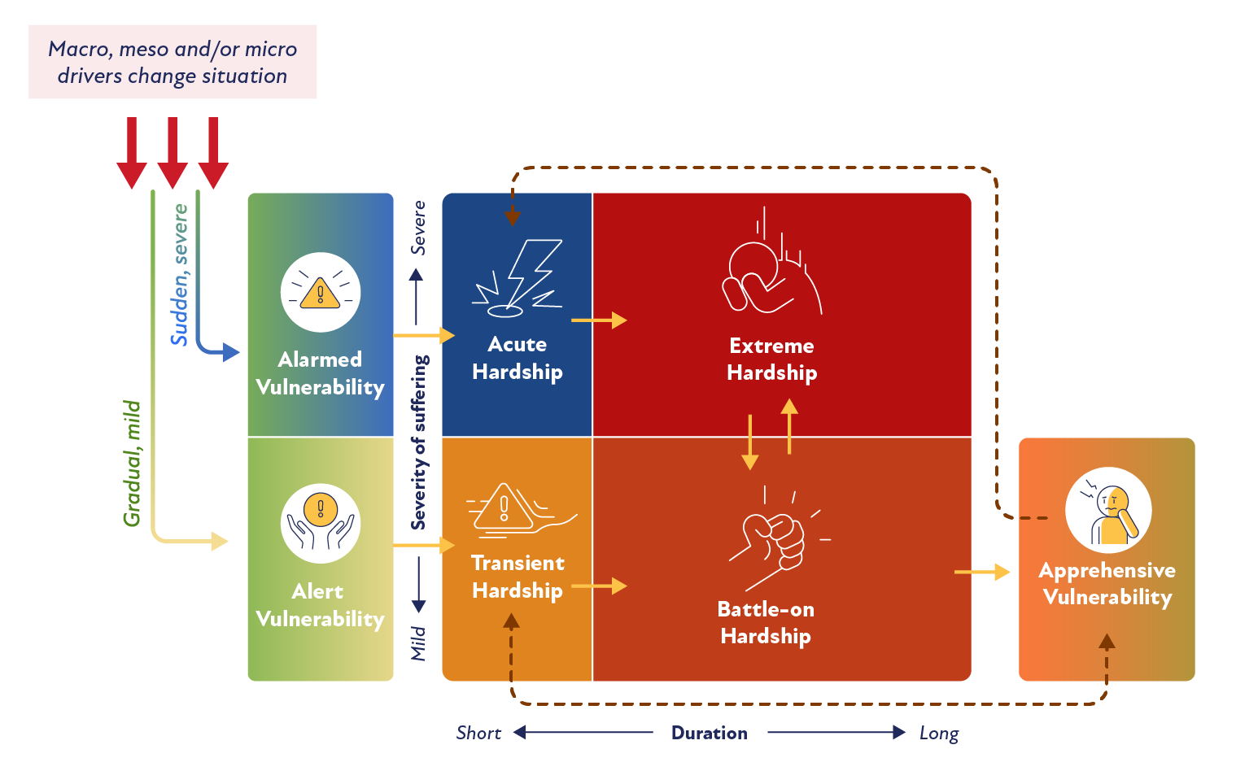

***Figure 13: ABATE Vulnerability and Hardship Framework Showing Common Journeys Between States***

### 4.2 Personas of ABATE Hardship States

#### 4.2.1 About the Method

We designed the household interview questions to elicit details of the experience of hardship and the circumstances influencing movement through the hardship states. The questions applied a strengths-based lens to provide insight into the behaviours and mindset of households. We developed personas by analysing each journey map, which captured movement between states, as well as the coping strategies and support types commonly used in each state. The original ABATE hardship states hold in this analysis, so we developed personas to represent households in the Transient, Acute, Battle-on and Extreme hardship states (see Appendix D for an overview of each persona).

#### 4.2.2 Insights From Personas

The personas share several similarities as well as important differences that make each distinct. Unique personas can be used to guide the types of assistance that may best suit each situation. For example, all personas in hardship seek social support as part of their coping strategy, generally from CBOs or family/friends. All personas try to solve their own problem, except for the Extreme Hardship persona, who has exhausted their capacity for problem-focused coping and is either relying on external assistance or engaging in avoidance behaviours. The Extreme Hardship persona requires the broadest range of social assistance: instrumental, emotional and network. The Acute persona also seeks emotional support, indicating that severe hardship creates a significant emotional and mental impact that requires its own support (in addition to addressing the drivers of hardship).

All hardship personas share the coping strategies of managing funds, gaining funds and accruing debt. Only those in mild hardship focus on energy efficiency (Transient and Battle-on personas). Those in more severe states reveal they have already applied all the energy savings tips they can and believe further efforts are futile, and some have little control over improving the dwelling’s EE as they are tenants. While the level of deprivation or trade-offs required increases with both severity and time. For example, the Transient Hardship persona might socialise less often and become more energy efficient, while the Extreme Hardship persona may stop socialising entirely, face food poverty, stop using electricity and even sacrifice their health to get by.

The likelihood of exiting hardship varies by persona. The personas who experience mild hardship are more likely to exit (although still unlikely overall to do so), and those experiencing severe hardship are very unlikely to exit without significant external assistance. Importantly, the assistance required is less for those in milder and/or shorter duration hardship. Greater assistance is required once personas have entered the hardship spiral, where ongoing and increasing hardship compounds their experiences.

# Symbol for next main section: 5. ConclusionConclusion

**5. Conclusion**

This investigation interviewed 40 households to uncover deeper insights into the prevalence of the drivers that trigger energy hardship, the most common indicators of hardship and the barriers to accessing support. It revealed that the support available requires significant effort from households to access, and this proves too burdensome for some. Importantly, this observation meant that “coping strategies” included the search for support. This was the most prevalent factor keeping households busy and stressed.

We identified the presence of the “invisible consumer” in energy hardship. These consumers explained that they always pay their bill on time, as this is a prime requirement for their self-identity – to be self-sufficient or to avoid shame. To do so, they forgo many other things, including other essentials such as food, basics, socialising or other daily items. This suggests that certain metrics of energy hardship, such as energy debt or late payments, will not capture this cohort. These households will go unnoticed by current energy hardship metrics.

Overwhelmingly, participants revealed that support is difficult to access. Households need to know what is available, where to find it and how to access it – and all three matters were problematic for most households. Even after going through the labour-intensive task of finding and accessing support, households revealed it was mostly insufficient to alleviate their hardship. At best, it prevented their situation from worsening. This suggests that much more support is needed to address hardship. Alternatively, less support would be warranted if the drivers of hardship were adequately addressed.

The combination of macro, meso and micro drivers has a large and negative impact on households. To alleviate energy hardship, all drivers (causes) of hardship need to be addressed. These include high energy prices, low social benefits, energy-inefficient housing, poor retailer and landlord behaviours, low incomes and energy‑hungry appliances. **Without addressing these main drivers, the sacrificing behaviours of households are likely to continue or increase.** This would worsen the suffering of those households. Many households show little resilience for coping with their current situation, and no resilience for coping with any further setbacks such as increasing energy prices and other cost of living increases.

Developing journey maps confirmed the four previously identified ABATE hardship states, as well as three (new) high vulnerability states: *Alert* and *Alarmed* are pre-hardship and high vulnerability states, and *Apprehensive* is a post-hardship and high vulnerability state. Analysis of the journey maps revealed five archetypical journeys: Transient, Transient to Battle-on, Transient to Battle-on to Extreme, Acute to Extreme, and Acute to Extreme to Battle-on. Households exit hardship only from Transient or Battle-on states, though most do not manage to exit hardship at all. For those who do exit hardship, the key triggers include:

* having energy-efficient heating/cooling installed
* having solar installed (usually by the landlord)
* increasing their income (returning to work or increasing their hours worked)
* moving to a more energy-efficient home/downsizing/house-sharing.

The personas we developed for each hardship state reveal unique drivers and household coping strategies. They are useful to inform improved assistance and policy that would better address household needs.

# Symbol for next main section: "Appendices"Appendices

**Appendices**

### Appendix A: Legend for Diagrams of Findings (Themes)

##### Themes vs Sub-Themes

In all diagrams, the top row of boxes are the main themes emerging on the factor. Sub-themes are also presented in boxes and fall below each theme.

##### Dominant to Least Dominant Themes

The colour of the box represents the prevalence of household comments on that theme, with deeper colours representing greater prevalence of comments:

Appendix A Diagram showing how themes are captured: darker colours for dominant themes to lighter colours for minor themes

##### Sub-Themes

Sub-themes are shown by boxes with a blue dashed line.

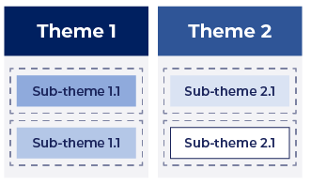

##### List Instead of Sub-theme

Where too few comments were made to form a sub-theme (i.e*.,* less than three), a list of the individual topics are provided in a blue-dotted box below the theme. The text is also smaller and non-bold.

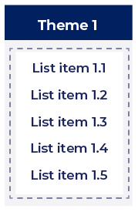

### Appendix B: Coping Strategies – Sub-Themes in Detail

**B1: Under-Consumption Coping Strategies**

##### Under-Consuming/Sacrificing Behaviours

One coping strategy revealed by participants is when the household chooses to under-consume as a way of coping with energy bills and/or usage. Under-consumption behaviours refer to actions that require the household to sacrifice something. These areas were grouped as follows:

###### *Drastically Reduce Energy Use*

A commonly reported way of coping with large bills was to drastically reduce home energy use to a point of suffering (beyond being energy‑efficient). This was achieved by:

**“If I could do it last year, I could probably [go] through this winter not using any of my gas at all but it’s not as easy.”** *Cermaka, ACT*

1) ***using substantially* *less* *energy*:** households described the varied ways they attempt to reduce energy use in the home. Examples include not allowing energy use in most rooms, not using heating/cooling at all, hypervigilance about all appliance use, avoiding using appliances completely and/or having cold showers. Households revealed a high level of suffering with this drastic action.

2) ***disconnection*:** some households shared that they allowed themselves to be disconnected by their energy retailer or would self-disconnect to ensure they did not consume any more energy. **Since energy is deemed an essential service, choosing to disconnect is an alarm of “ecosystem failure” for the sector**.

###### *Use/Buy Fewer Essentials*

Most participants revealed they sacrifice using or buying other essentials to use and/or pay for energy. The two common actions are:

**“[The retailer] used to charge me $200 a fortnight, and I did that for a few years until I got really, really sick.  I was so malnourished because I didn't have enough money to feed myself.”**

*Lily, ACT*

1) **going without food:** manyparticipants revealed they either skipped meals, ate less or ate food of a lower quality (such as having plain rice for lunch and dinner) so they could afford to pay energy bills. In some cases, children were also reported to go without food or eat less. All households who reported going without food had already drastically reduced their energy use.

**2) going without other essentials:** some respondents also shared they cut back on other ***grocery items***, such as toilet paper or ***petrol***.

###### *Use/Buy Fewer Basics*

Some participants deliberately ***limited their energy use of non-essential items***, such as not watching TV, or not using the dishwasher or dryer. These behaviours were milder than “drastic”, but were allocated here if the participant revealed they were making a “sacrifice” in their quality of life to adopt the action. Other sacrifices included not buying coffee/lunch or delaying purchases for the home.

**“[I] can’t afford to go to Perth anymore to see [my] daughter.”** *Marlene, VIC*

###### *Use/Buy Fewer Non-Essentials*

**“[I’m] not going to have anyone over because you’re adding more power when you have people over to entertain.”***Mandy, VIC*

Although infrequently reported, some participants revealed they avoided buying non-essential items, or bought fewer of them. For example, some households would buy lower-quality products, avoid eating out, and avoid air travel and other higher-priced items. Data allocated to this theme revealed change to what the household had once done before entering energy hardship.

###### *Socialise Less*

A few households revealed they would limit their social interactions by either not having people over or not attending social events, as both incur costs.

**“… I’ve had a proper draft report done … We’ve turned around and said the house is badly insulated and blah blah blah. There’s drafts coming in here, here’s the photos.”** *Robert, ACT*

**B2: Three Additional Coping Strategies**

##### Manage Bills

Participant stories revealed that activities involving managing energy bills are the most dominant coping strategy adopted by households. Households typically adopt one or several of the following strategies:

"I had to bite the bullet, because my brother’s quite well off, and had him basically pay my bills, just so I could afford to stay afloat for a while."  *Jolene, VIC*

* Gain Funds

To cope with a high bill, all participants described undertaking significant effort to gain funds. This includes funds gained or bills reduced/waived. Funds were sought to cover energy bills from two broad sources:

1) ***personal networks***, such as friends or family. This often involved borrowing money, or, for example, a family member (living elsewhere) working extra shifts to help pay their relative’s energy bill.

2) ***support initiatives*** (e.g*.,* vouchers, matched payments, debt waivers) obtained from either a CBO or energy retailer. Whether accessing one’s personal network or support initiatives from CBOs/government and retailers, the ***support had to be*** ***sought***, placing an additional burden on the household at a time when they were already struggling. Once support was received, participants commented that it helped, but was rarely enough to fully alleviate their situation.

**“[I am] writing everything down fortnightly, my income, all the expenses, and adding it all up and seeing – factoring in [my retailer] and noting what costs.”**  *Chloe, ACT*

###### Manage Funds

Approaches to managing funds from the household’s resources included hyper-budgeting, hyper-checking bills/meters, and moving house or having people move in to share the load. In seeking assistance from energy retailers, households would be offered a payment plan, bill smoothing or deferred payments. Strategies to manage funds with retailers did not necessarily ease the burden and often debt continued to accrue.

###### *Accrue Debt*

**“I am going to pay whatever I have to … to get warm.”** *Marlene, VIC*

Some participants revealed they choose to ***prioritise*** their health and/or thermal comfort, and thus use heating/cooling as needed, despite knowing they will be unable to pay the energy bill. They are not “ignoring” the bill but rather choosing the most important place their limited funds will be spent. A few participants revealed they ***disengage*** from thinking about or paying their energy bill. In these instances, the person had “low cognitive bandwidth” for energy matters, as they had too many other serious concerns in their life. These participants revealed they had made the decision to disengage to protect their mental health.

**“And I weighed up the pros and cons, and I went well, the electricity or his health? Well, I chose his health ... I have to keep [my husband] alive.”** *Clarissa, NSW*

**“I was sick … I had surgery … I’m not ignoring [the bill].”** *Ava, ACT*

###### *Home Checks*

Believing there was an error in the bill or something wrong in the home, some participants called on their retailer, landlord or friend/family to check the potential fault. Participants noted that landlords rarely provided the home check.

###### *Change Retailer*

**“So, when I moved house, I moved the [retail] company as well, because they treat me badly.”** *Ahmed, VIC*

A handful of participants revealed they changed their energy retailer to manage their bills. While some participants mentioned their retailer had not released them until they paid their debt, they shared that they moved retailers as soon as they could.

##### Manage Energy Efficiency

Households invariably sought to improve the energy efficiency of their homes or their behaviours as a way of reducing future energy use and bills. Two key sub-themes emerged:

**“I went out, like I got all of the kids extra warm doonas so that we’re not heating their bedrooms individually. So, I went out and outlaid the money for that.”** *Jenifer, ACT*

###### Purchase Energy-Efficient Products

Products bought (or received) included minor energy-efficient items like draft seals, but also included ways of keeping warm, such as extra blankets, thicker curtains and hot water bottles. This was to keep energy use at a minimum. On rare occasions, households bought a more energy‑efficient appliance (such as a refrigerator or washing machine) but were unable to afford to upgrade the big-ticket items such as heating/cooling. Some participants sought assistance from friends/family to help hang thicker curtains, install a new appliance or fix something else in the home.

###### Engage in Energy-Efficient Behaviours

**“[I am ] conscious of use of things like the dryer … [and the] unit heater… So been really conscious of any little additional electricity usage."**

*Ally, NSW*

Most participants revealed they adopted several energy‑efficient behaviours, such as turning appliances/lighting off when not in use, heating/cooling single rooms in the home and wearing warmer clothing.

##### Build Knowledge

Participants were motivated to explore better options to increase their ability to pay energy bills in future. This included building knowledge related to other areas. Three sub-themes emerged: ***non-energy knowledge*** (the dominant sub-theme), ***energy-saving tips*** and ***energy offers/info*** (including solar). Households revealed that they built their knowledge in one of two ways:

**“Part of the strategy of keeping above these bills is knowing what's available and talking to people that know about these things. It is a big part of my strategy because I get very worried about not being able to pay a bill."**

*Kylie, QLD*

###### Self-Investigate

Some participants would search websites for energy offers or for information about energy technologies (e.g*.,* solar) and energy savings tips.

###### Seek Advice

Participants would seek the advice of friends and family, particularly for finding the assistance that is available from CBOs. Participants revealed they often did not know what assistance was available, where to obtain it or how to obtain it. They also sought advice from their personal network or from retailers/CBOs regarding information about the bill, retailers and solar.

**“[The CBO] organised … a new … air conditioner with Housing … Before summer came, I got a brand-new air conditioner … I was just so happy.”** *Carly, ACT*

One further support that households often pursued was advocacy. We add **advocacy as a facilitating step** to several coping strategies, such as gain funds, manage funds, home checks and energy-efficient products. Advocacy was often necessary for households to achieve a fair outcome with their retailer or landlord, or to obtain support that was too challenging for the household to access alone.

### Appendix C: Archetypical Journey Maps of Energy Hardship

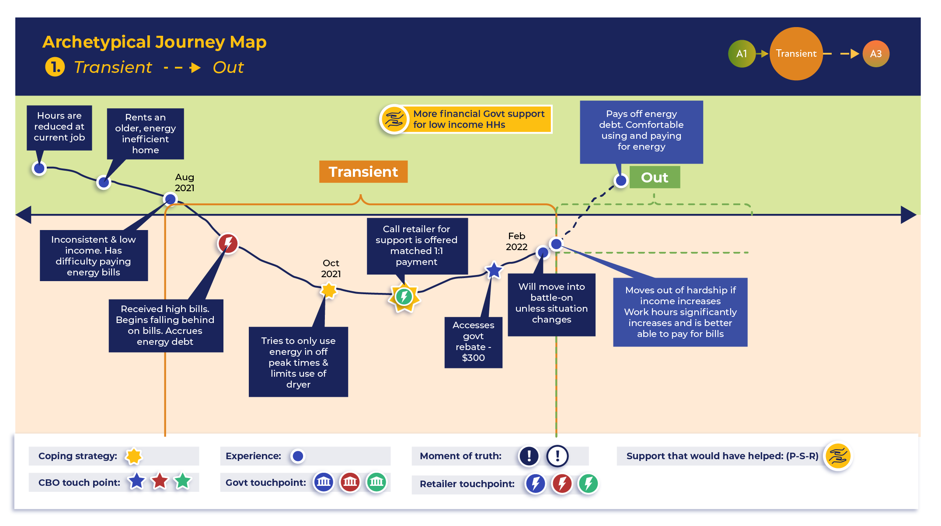

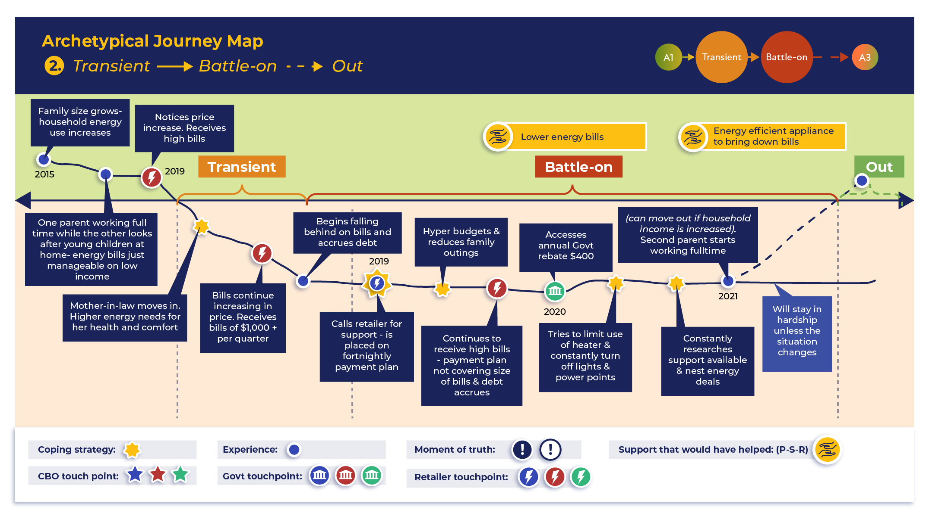

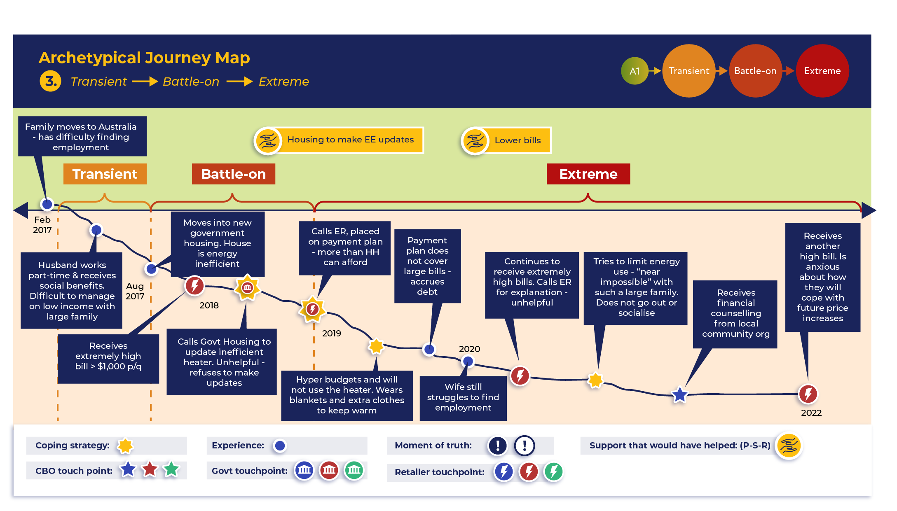

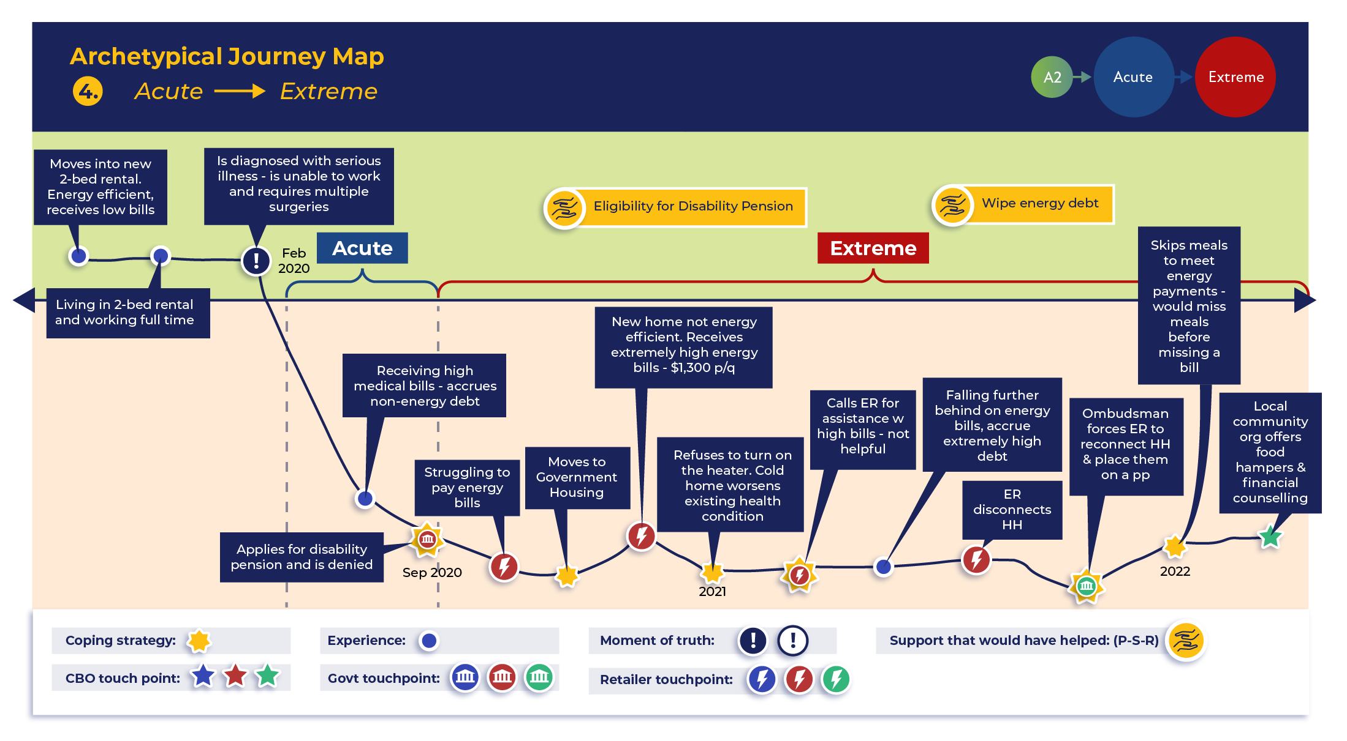

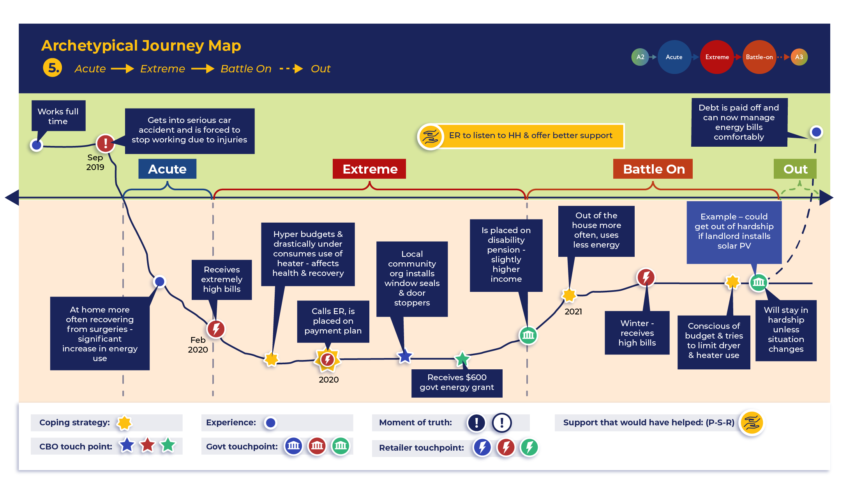

### Appendix D: Persona Descriptions

|  |  |
| --- | --- |
| **Hardship State** | **Persona Description** |
| **Transient Hardship** | Transient Persona households are experiencing mild hardship for a short duration. Their mindset is that their current experience is “just a temporary set-back”. They are experiencing some mild–moderate circumstances but are still focused on, and hopeful for, a swift exit from hardship. At this stage, the trade-offs made are more minor in nature and their coping strategies are problem-focused and leverage social support. The latter includes instrumental and network support. This persona may engage in managing funds, gaining funds, accruing debt, energy-efficiency behaviours and a reduction in socialising to save money/electricity use. This persona might leave hardship without moving to another hardship state, but only with timely assistance. |
| **Acute Hardship** | Acute Persona households experience a significant, sudden negative circumstance that is outside their control (*e.g.,* illness, accident or sudden job loss) and are attempting to deal with multiple crises at the same time. Their hardship is sudden and severe. Energy hardship is not their only concern, and they are engaging in multiple trade-offs as they attempt to reverse the negative impact of the precipitating event(s). They also engage in problem-focused and social-support coping, with a focus on instrumental and emotional support. Like the Transient Persona, they manage funds, gain funds and accrue debt, but engage in more significant under-consumption behaviours, alongside significant changes (*e.g.,* lifestyle, retailer). Unfortunately, Acute Persona households are much more likely to enter Extreme Hardship than to exit hardship. |
| **Battle-on Hardship** | Battle-on Persona households experience mild hardship but for a long time. As a result, they see their energy hardship as “just the way things are now” and are focused on “trying to get by”. To do so, they make ongoing minor trade-offs. Their coping strategies are also problem- and social support-focused and include instrumental and network support. Like Transient households, they engage in managing funds, gaining funds, accruing debt and energy-efficiency behaviours, but are also likely to under-consume energy. In addition, this persona will under-consume some basics (*e.g.,* socialising or local travel). While it is possible for this persona to exit hardship, they generally need to enact a range of strategies to do so, and are at risk of entering Extreme Hardship. |
| **Extreme Hardship** | The Extreme Hardship Persona households experience severe and ongoing hardship. They are “trying to survive” by any means necessary and tend to make major and sacrificing trade-offs, including complete cessation of energy use and other essentials, such as food. This persona has tried many coping strategies for an extended period. They may also seek social support and engage in avoidance behaviours (e.g., “I don’t even look at the bill anymore because I know I cannot afford to pay it”) because they have exhausted their capacity for self-advocacy. They require instrumental, emotional and network support, and engage in the same types of coping strategies as other personas but at a more extreme level (*e.g.,* extreme under-consumption). It is unlikely that this persona will exit hardship without significant external assistance or a drastic change in circumstances. |

The following graphics capture the profile for each persona.

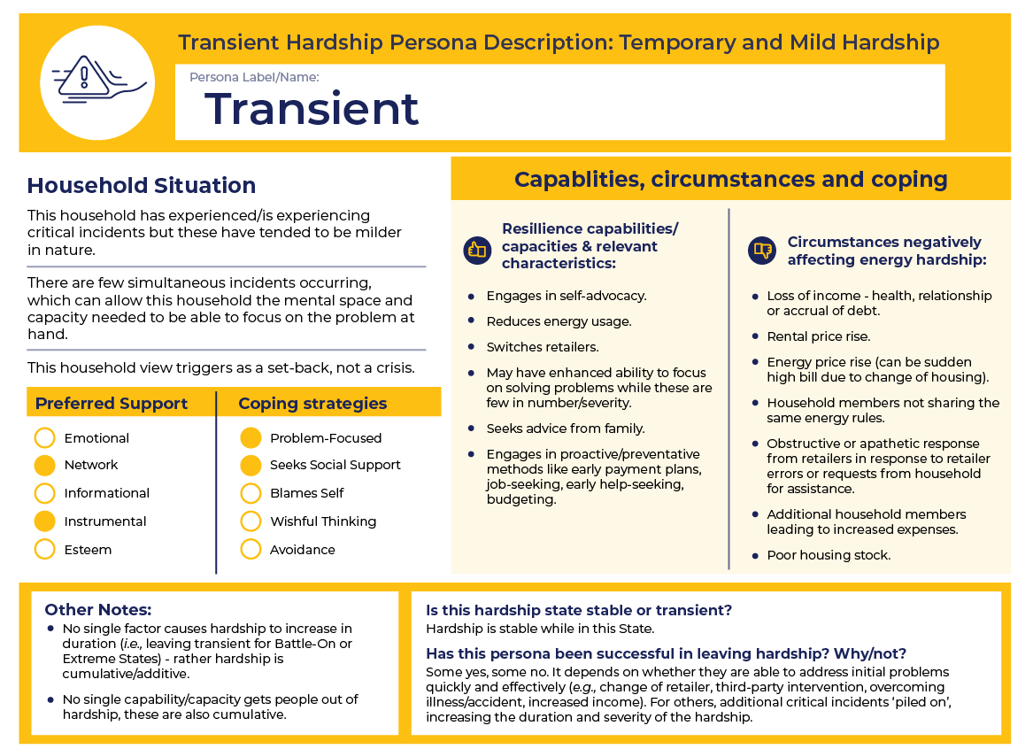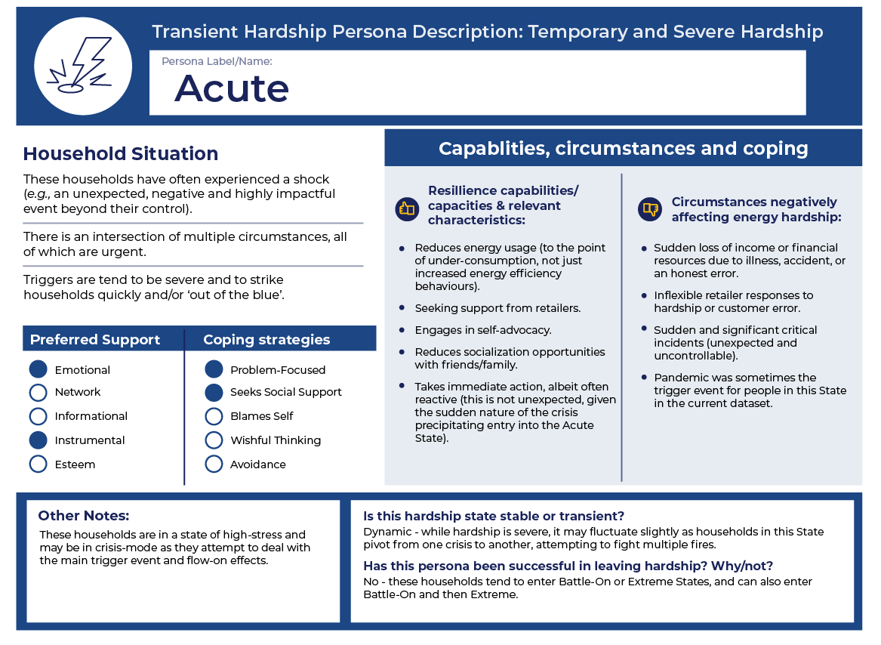

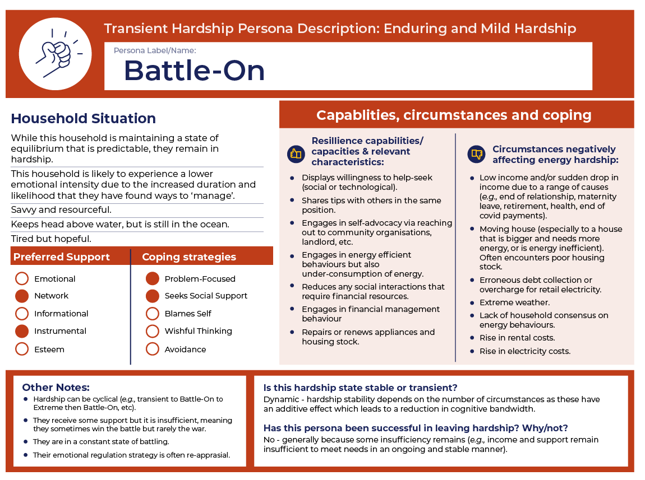

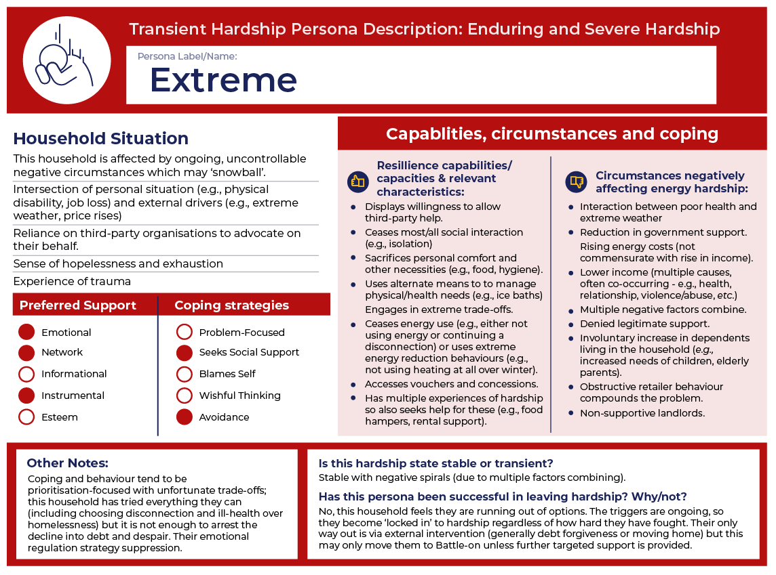

1. For Phase 1 findings, see Bedggood, R., Gardner, J., Gordon, R., Adams, H., Reade, L., Miller, W., Poruschi, L., Russell-Bennett, R., McAndrews, R., Letheren, K., Clarke, M. and O’Mahony, C. (2022) “Assessing Energy Inequity and the Distributional Effects of Energy Policies,” Final Report, GEER Australia, Swinburne University of Technology, Melbourne.
2. Just before the interviews, a national announcement had been made regarding pending energy price rises, which was of great concern to several of those interviewed.
3. C. N. B. Grey, S. Jiang, C. Nascimento, S. E. Rodgers, R. Johnson, R. A. Lyons, and W. Poortinga, “The short-term health and psychosocial impacts of domestic energy efficiency investments in low-income areas: a controlled before and after study,” *BMC Public Health*, vol. 17, p. 140, 2017, doi: <https://doi.org/10.1186/s12889-017-4075-4>.