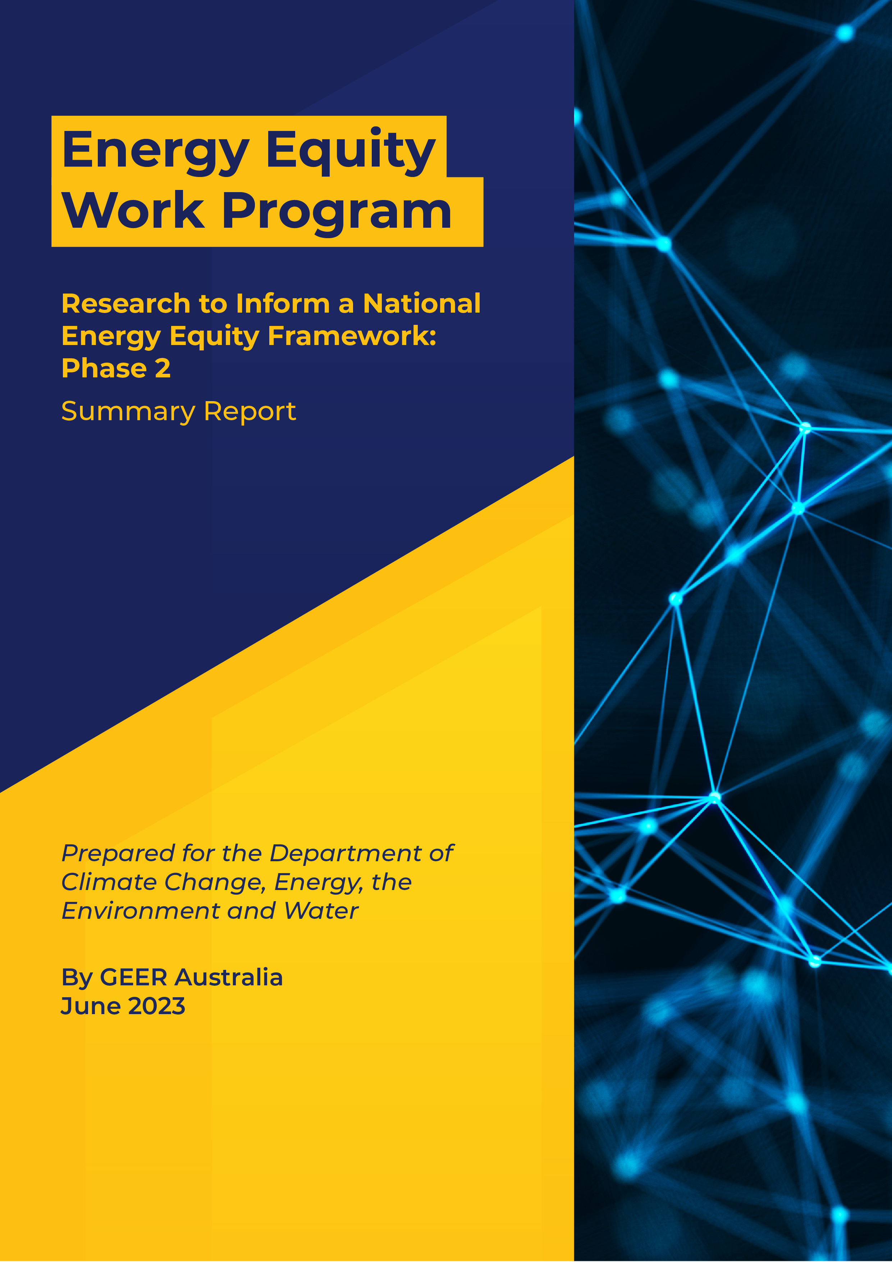

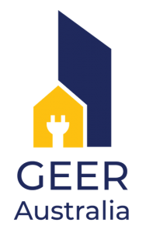

To cite this report

Bedggood, R., Gardner, J., Adams, H., Russell-Bennett, R., Letheren, K., McAndrews, R. and Miller, W. (2023) “Research to Inform a National Energy Equity Framework: Summary Report,” for the Commonwealth Energy Equity Work Program – Phase 2, GEER Australia, Swinburne University of Technology, Melbourne.

Participant acknowledgement

The GEER Consortium extends our heartfelt gratitude to those who participated in interviews for this project: to households who shared their stories and to sector workers for sharing their insights, wisdom and passion for seeing improved outcomes for those households most in need.

Funding acknowledgement

This project was funded by the Commonwealth Department of Climate Change, Energy, the Environment and Water (DCCEEW) as part of the Energy Equity Work Program. The views expressed in this report do not necessarily reflect the views of the Commonwealth Government of Australia.

|  |  |
| --- | --- |
|  |  |

**Project Team**

|  |
| --- |
| Dr Rowan E. Bedggood  *Swinburne University of Technology*  Project Lead & Project Manager |
| Dr John Gardner  *Commonwealth Scientific and Industrial Research Organisation*  Professor Rebekah Russell-Bennett, Dr Kate Letheren and Dr Ryan McAndrew  *Queensland University of Technology*  Henry Adams  *Common Capital*  Wendy Miller  *Queensland Council of Social Service*  Project Advisors:  Professor Ross Gordon  *Queensland University of Technology*  Luke Reade  *Energetic Communities* |

**About GEER Australia**

The Group of Energy Efficiency Researchers (GEER) Australia is the peak research body on residential energy efficiency and wellbeing. It comprises researchers and industry partners from across Australia who are committed to driving change in the energy sector towards improved outcomes for Australian households. Its purpose is to improve energy-related wellbeing in households and communities in Australia, through collaborative research that achieves practical outcomes and informs future practice and policies. GEER’s research and activities thus focus on energy efficiency as it relates to quality of life, health, affordability and environmental sustainability.

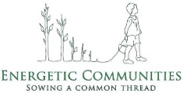Project partner Common Capital logoProject lead Swinburne University of Technology logo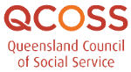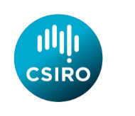

OFFICIAL

This Report

**Summary Report**

This report summarises the work completed by the Group of Energy Efficiency Researchers (GEER) Australia under the Energy Equity Work Program – Phase 2, for the Energy Ministers’ Meeting (formerly the Council of Australian Governments Energy Council). It starts by contextualising the work based on Phase 1 findings. It then presents a summary of the four reports comprising Phase 2, and concludes by outlining the scope of work required for Phase 3.

## Background

### The Finkel Review: Identifying Inequity in the Electricity Market

In June 2017, the Finkel Review delivered a plan to maintain security and reliability in the National Energy Market (NEM) as the sector transitioned to a new future. The report found that structural issues in the energy market meant that consumers facing vulnerability and hardship experience limited benefits from new Distributed Energy Resources (DER) technologies such as rooftop solar. Since the release of the Finkel Review, affordability and wellbeing challenges for many Australian households have intensified due to high energy prices and rising costs of living. These developments have led to a growing number of Australians unable to use energy in their homes without suffering or compromising other needs.

It is important that all consumers are able to share in the benefits of the energy transition, in particular, consumers on low incomes and those experiencing vulnerability and hardship or otherwise facing barriers to accessing the benefits of DER and energy efficiency improvements (e.g., renters). Designing policies and programs to deliver the benefits of the energy transition to all households requires a comprehensive understanding of these households, particularly their circumstances, their interactions with the energy sector and the barriers and challenges they face. This understanding will require new frameworks to understand and articulate energy hardship, as well as new metrics to evaluate the performance of energy sector initiatives and progress towards alleviating energy hardship. This spawned a three-phase body of work: the Energy Equity Work Program.



Phase 1 work sought to understand the causes and impacts of households experiencing energy hardship, explore data and metrics as markers of energy hardship and identify best practice approaches to alleviate it. Broadly, the aim of this project was to determine: 1) whether current metrics accurately capture the extent of energy hardship in Australian households; and 2) whether energy programs and policies are effectively addressing the issue. This information is necessary to design programs and policies that will protect households from unfair or unpredicted consequences through the energy transition. The GEER consortium first explored existing knowledge (in a literature review) and data sources to understand the nature and extent of energy hardship in Australia. We then conducted a tri-level investigation to better understand the impacts of policies and programs from the perspective of: 1) those who work to support households; 2) those who are program leads or policy experts; and 3) policy gaps in policy documents (gap analysis). Phase 1 work is depicted in Figure 1.

Diagram for Figure 1: Phase 1 Work (overview):
1. Current knowledge
2. Existing data
3. Impacts of programs and policies on households (micro level)
4. Impacts of programs and policies on households (meso level)
5. Impacts of programs and policies on households (macro level)

*P&P = Energy-related programs and policies

***Figure 1: Phase 1 Work***

When households endure negative consequences as a result of using (or not using) energy in the home, such as a decline in mental and/or physical health, thermal discomfort or economic distress, then everything possible should be done to alleviate the situation. The recommended term to capture this situation is “energy hardship”, which is defined in the Phase 1 report[1] as being “when a household is unable to use energy services in the home to live a comfortable, dignified and healthy life without restricting other essential needs” (p. 22). The short definition is “when a household is unable to use energy without suffering” (p. 22).



**As a result of the Phase 1 investigation, we developed three frameworks:**

**The ABATE framework (of hardship states):** this produced four states of hardship depicting varied household experiences based on duration and severity of suffering (additional vulnerability states were identified in Phase 2, as well as pathways of moving through the states).

**The Drivers, Indicators and Outcomes (DIO) framework:** this produced a range of drivers, indicators and outcomes of energy hardship to inform future metrics (dominant drivers were identified in Phase 2).

**The Prevention, Support and Relief (P-S-R) framework:** this produced a framework to inform policies and programs based on whether they prevent hardship, support households in hardship or provide relief to those experiencing hardship. (Application of this framework across hardship states was extended in Phase 2.)

Furthermore, we identified that current metrics and measures used to capture energy hardship in Australia are not sufficient to reflect the proportion of households in hardship, and existing data sources are unable to be glued together to paint a full picture. In addition, analyses revealed numerous gaps in policies across jurisdictions that prevent substantial alleviation of energy hardship. We developed better practice principles to inform improved policies and programs in the future. For details about the findings and frameworks in Phase 1, and the recommendations they make, refer to the full report.1

## Graphic for sub-heading "Phase 2"

The aim of the Phase 2 body of work was to build on the outputs of Phase 1 and fill the identified key knowledge gaps by understanding the dominant DIOs for households. This was to inform the development of a data regime to guide future efforts to accurately measure, and thus address, energy hardship. Phase 2 concluded by drafting a *Better Practice Guide* to inform future policy and program development to achieve energy equity. Deep insights were captured in four reports, as outlined below.

**Report 1: Barriers, Scalability and Co-Design Findings**

This report is the first of four presenting the findings from Phase 2 of two literature reviews as well as co‑design research with key industry stakeholders to elucidate household energy hardship experiences:

* The first review has a national focus and provides findings on the barriers and enablers to households benefiting from DER and Energy Efficiency (EE) in Australia.
* The second review has an international focus and examines access and scalability issues associated with energy programs.
* The co-design offers insights into:
  + the drivers of household energy hardship
  + household coping strategies when experiencing energy hardship
  + eligibility challenges for households attempting to access support
  + sector challenges for addressing energy hardship
  + what an equitable energy transition may look like from a household perspective.

Together, the insights from the reviews and the co-design (including the findings in Report 2) provide input into both the *Data Regime* (Report 3) and the *Better Practice Guide Towards Energy Equity* (Report 4).

The first review revealed 71 barriers to household uptake of DER and EE consistent with the following **five categories of barriers**, which combine to create consumer perceptions of volatility, uncertainty, complexity and ambiguity.

Box containing 5 categories of barriers:
- Low trust of retailers
- Split incentives
- Flat tariffs
- Lagging regulations
- Financial limitations

This first review also revealed 41 enablers of household uptake of DER and EE consistent with the following **six categories of enablers**,which offer a way to co‑create functional, social, emotional and altruistic value with households to enhance uptake.

Box containing 6 categories of enablers:
- financial support for upgrades
- innovation trials
- easy for customers
- establish minimum energy efficiency standards
- reduce split incentives
- cost-reflective pricing

These findings provide the basis for DER and EE solutions that meet household needs.

The second review uncovered:



* **factors that influence access** (eligibility, funding allocation, partnerships, application processes and access criteria for EE/DER)
* **factors that influence scalability** (budget, scale, impact, market scalability, measurability and market awareness)



* **access solutions:**
* focusing on achieving an accurate definition of the energy issues the policy/program intends to address in advance of the policy/program being developed
* developing a relevant “suite” of policies/programs to support access for households
* ensuring access for both homeowners and renters
* ****providing effective incentives and messaging
* **scalability solutions:**
* ensuring sufficient return on investment for households contributing financially to energy efficiency (e.g., by purchasing solar panels, efficient appliances)
* offering programs in stages to support personalisation at scale
* encouraging governments to partner with trusted community organisations to deliver programs
* considering national programs augmented with state-level concessions where necessary
* including non-traditional housing in policies and programs.

Overall, the literature indicated scalability is best achieved by national policies, which:

* support an equitable energy transition
* consider household needs
* target incentives to outcomes aimed at alleviating split incentives
* regulate strong energy-efficiency requirements.

The co-design confirmed the drivers from the original DIO framework. It generated insights around the presence of macro and meso drivers, that is, drivers at the structural or system level that were beyond the control of the household but nevertheless drove household-level inequity. These included:



Poor retailer behaviour (meso)

energy sector complexity (macro)

high prices (macro)

Other factors that exacerbate energy hardship also emerged, including:

* government protections
* lack of trust
* lack of control
* cost of living flow-on effects
* lack of home maintenance.

Next, the co-design examined **coping strategies**, and the analysis confirmed the coping strategies identified by households (see Report 2): under-consumption coping strategies and other coping strategies. The co-design offers nuanced insights around the social/relational consequences of coping strategies and the potential for hardship spirals.

Analysis further revealed **five broad categories of eligibility challenges**:

Categories of eligibility challenges:
Demand side (household knowledge/awareness and emotions)
Supply side (processing for accessing support, retailer/gov behaviours, criteria)

**Supply Side**

**Demand Side**

* processes for accessing support
* retailer or government behaviours
* eligibility criteria
* household knowledge/awareness
* household emotions

A clear issue emerged whereby criteria were seen as being misaligned (or even mal-aligned) to household needs, misapplied and difficult for households to access.

**Four central themes emerged within sector challenges** for addressing energy hardship:

Box containing themes of sector challenges:
- compounding factors
- insufficiency
- landlord behaviours
- overarching sector challenges

landlord behaviours

overarching sector challenges

compounding factors

insufficiency



Finally, analysis of the co-design data revealed **six aligned challenge and opportunity themes** (in square brackets). These themes extend the sector challenges themes, providing an overarching view of the current challenges and opportunities for the future:

* compounding impacts on the equity gap [Leverage energy transition as equity transition.]
* insufficiency of support [Sufficient support offers holistic benefits.]
* inability to manage what we do not measure [Measure energy transition equity.]
* policy and regulation improvements [Policy has the power to end hardship.]
* mal-alignment of objectives [Alignment means a fairer sector for all.]
* high prices hurting energy households [Equitable foundations create lower prices.].



These insights led to **four key inputs for the *Data Regime***:

* We cannot address what we cannot measure, and we cannot measure what we have not defined.
* We need to decide on priorities and how they can be measured before implementation.
* Effective measurement supports access and scalability.
* An effective data regime needs to be supported by effective policy.

A further three key inputs were provided for the Better Practice Guide:

* We must not place the burden of engagement on the shoulders of households.
* We need a holistic approach.
* We need to define what “enough” looks like.

**Report 2: Household Insights and Journey Maps**

This report is the second of four providing findings from Phase 2 which aimed to identify the prominent metrics we need to consider when determining measures of energy hardship. The research project gained direct insights from households while also informing the refinement of the three frameworks developed in Phase 1: the DIO framework, the ABATE hardship states framework and the P-S-R framework. Uniquely, the analysis developed journey maps and personas to represent movement across ABATE states.

We interviewed 40 households from four regions in Australia, sourced via community-based organisations. The purpose of the interviews was to understand the journey of households as they experience vulnerability and hardship, and to track how consumers coped and were able to move out of energy hardship. This report presents the findings that emerged from thematic analysis of the data we collected during the interviews. In addition, to enhance our understanding of household experiences, we produced journey maps for each household. These facilitate understanding of each household’s journey into and out of energy hardship. We synthesised them to create five archetypical journeys showing common pathways for households who enter energy hardship.

Analysis of participant stories revealed the key findings outlined below.

****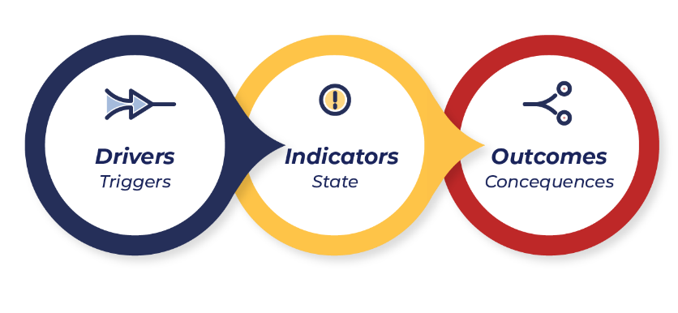

**The** **drivers of energy hardship can be divided into macro, meso and micro drivers**

* **Macro drivers** include factors that drive energy hardship more broadly, such as high energy prices, low social benefits and poor-quality housing.
* **Meso drivers** include factors that affect some, but not all, households. Examples are poor retailer behaviours (e.g.,misleading plans, inconsistent responses) and poor landlord behaviours (e.g.,refusing to conduct energy-efficiency upgrades or perform maintenance and repairs).
* **Micro drivers** include factors impacting only specific households. Examples are:
  + unique high energy needs (e.g.,for health requirements)
  + low income (e.g., households whoseincome is always low, or who face a sudden drop in income)
  + non-energy bills (e.g.,high cost of living)
  + high energy bills (e.g.,bill shock)
  + energy-hungry appliances (e.g.,heating and cooling)
  + energy‑inefficient housing
  + financial abuse.

****To alleviate energy hardship, the drivers of such hardship should be addressed.

The indicators of energy hardship are either action-based, situation-based or proxy-based

* **Action-based** indicators reflect a household behaviour that reveals a state of hardship (*e.g.,* coping strategies such as under-consumption of energy).
* **Situation-based** indicators reflect a household experience that reveals a state of hardship (*e.g.,* thermal discomfort or difficulty paying bills).
* **Proxy-based** indicators reflect a metric that reveals a level of suffering linked to being in a state of energy hardship (*e.g.,* low/high indoor temperature or mould).

 The outcomes of energy hardship have six key themes

* stress (*e.g.,* anxiety, shame or depression)
* worsened health (*e.g.,* health compromised to pay an energy bill)
* poorer living conditions (*e.g.,* compromised quality of living)
* energy debt
* non-energy debt
* disconnection.

**The ABATE vulnerability and hardship states recognise that energy hardship is dynamic and varies by severity and duration**

Households can fall in and out of hardship and experience hardship to various degrees. The ABATE vulnerability and hardship states aim to provide nuance to actual household experiences by describing the different states of energy hardship. They also capture the high vulnerability states households experience before entering hardship and the high vulnerability state that persists after exiting hardship. As shown in Figure 2, energy hardship can be either short-term (temporary) or long-term (enduring), and either mild or severe.

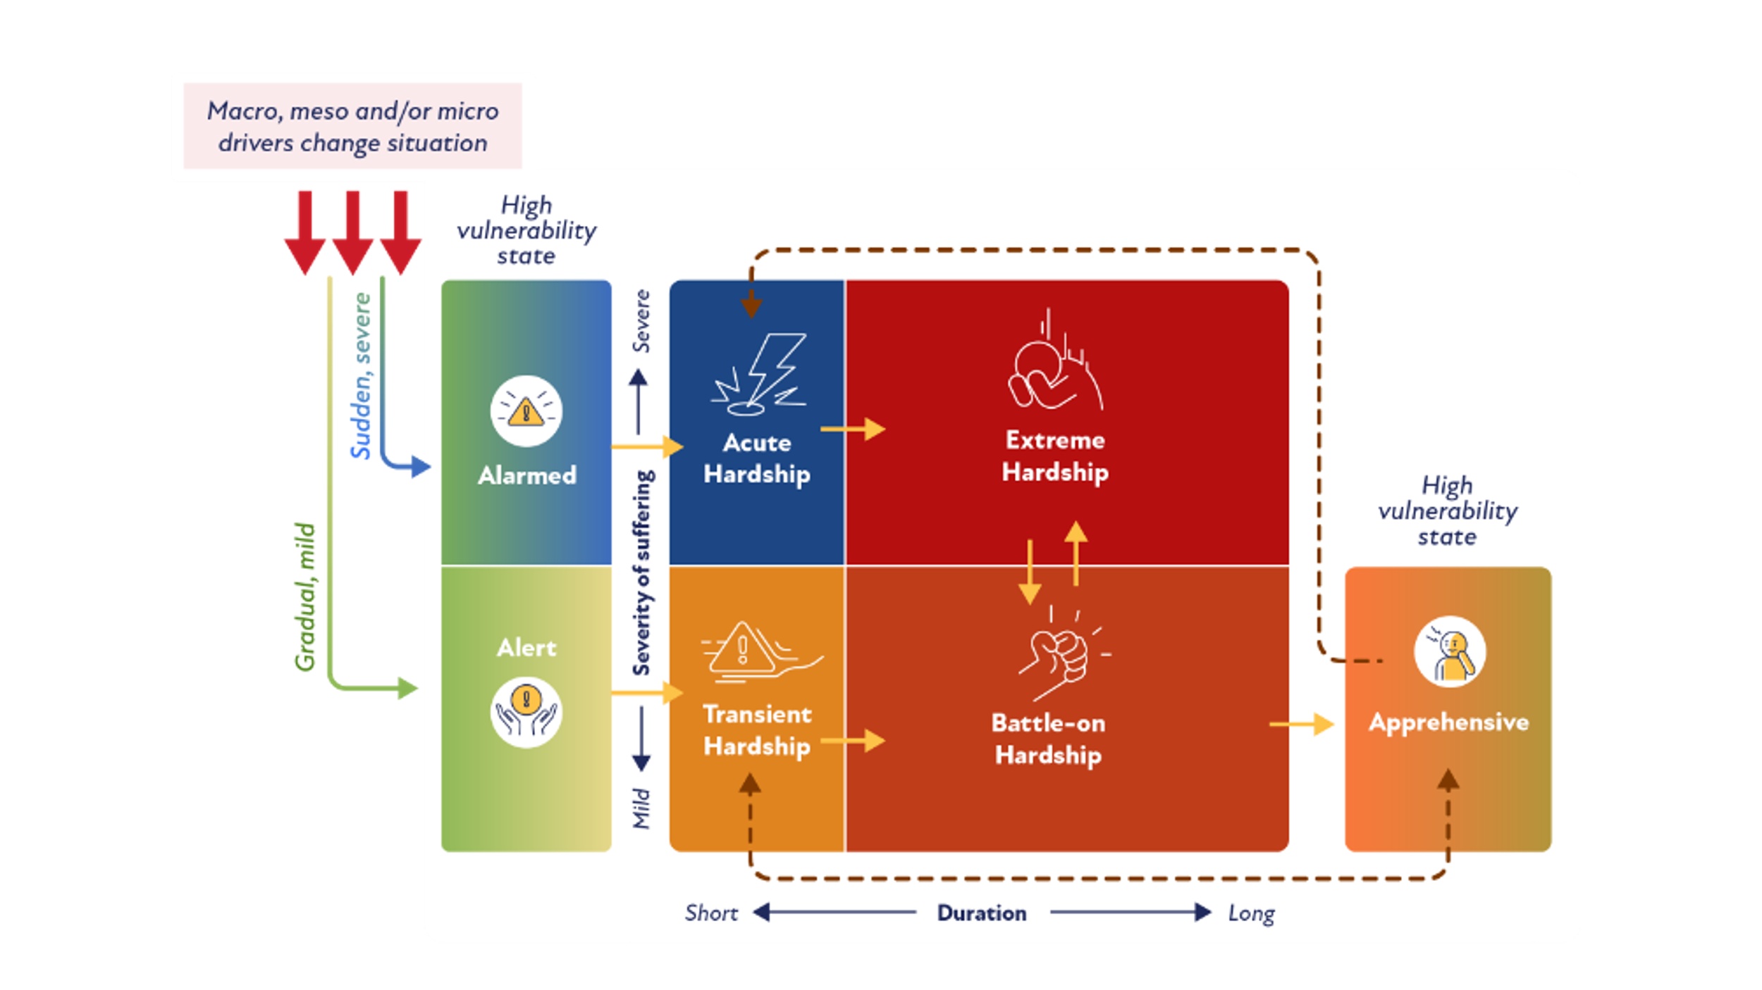

***Figure 2: ABATE Energy Vulnerability and Hardship States with Common Journeys***

ABATE reflects seven states: three high-vulnerability states (Alert and Alarmed are pre-hardship; Apprehensive is post-hardship) and four hardship states (Battle-on, Acute, Transient and Extreme). The seven states are described in order of duration and severity below.

* **Alert vulnerability** – this high-vulnerability state takes place just before the household enters transient hardship. It is a mild and short-term state, where the household is alert to the potential impact of pending changes in their life.
* **Transient hardship** – this is a mild and short-term (0–6 months) state of energy hardship; however, without adequate support, households in transient hardship may move into a long-term state and experience frequent hardship.
* **Alarmed vulnerability** – this high-vulnerability state takes place just before the household enters acute hardship. It is a short-term state that can be severe, where the household is alarmed about how they will cope with a drastic change in their circumstances.
* **Acute hardship** – this is a severe and short-term state of energy hardship, whereby a household may experience a sudden change in their situation that causes severe suffering as a result of energy bills. Without adequate support, these households will likely remain in energy hardship for longer, moving into the extreme hardship state.
* **Battle-on hardship** – this is a mild but enduring state of energy hardship, where a household will struggle with every energy bill and manage to get by, but usually accrue debt. If the household’s challenges are addressed, they can move out of hardship from this state.
* **Extreme hardship** – this is the most critical form of energy hardship, as households in this state experience severe, enduring hardship. It is likely that these households will require maximum assistance that spans beyond energy.
* **Apprehensive vulnerability** – this is the state experienced just after battle-on state (a common exit point). Households are apprehensive about their situation worsening again; they have a high risk of falling back in to hardship and so remain “apprehensive”. These households would benefit from preventative policies that reduce their vulnerability to energy hardship.

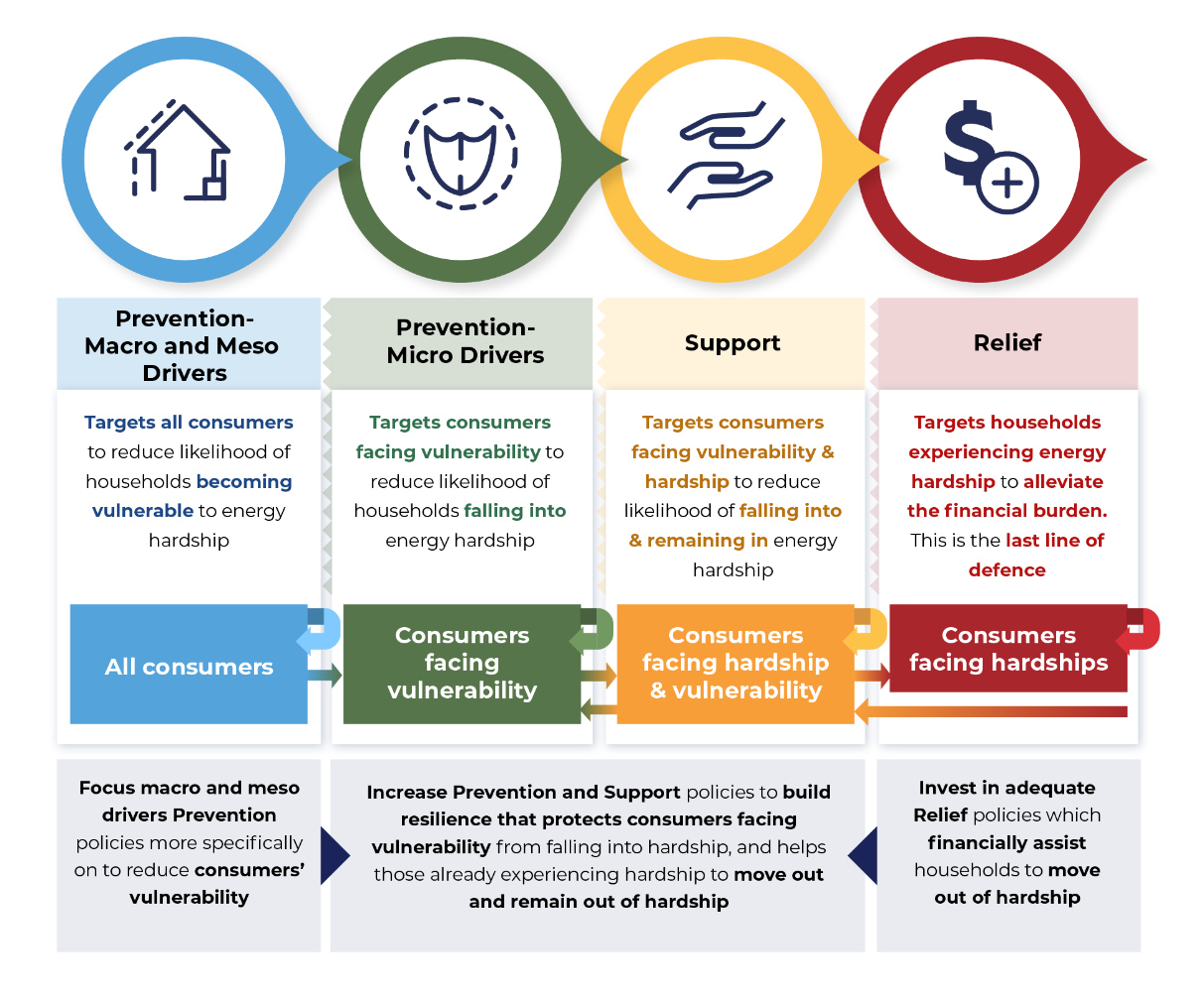

***Figure 3: An Application of the P-S-R Framework that Aims to Guide Policy Strategy to Alleviate Energy Hardship***

Analysis uncovered **“invisible”** households. People in such households find a way to pay their bills on time but under-consume energy, other essentials, basics and/or non-essentials, and reduce socialising to do so. Current metrics will not capture this type of suffering and so this cohort is “invisible” to programs and policies that address energy hardship based on debt/bill metrics. This finding is critical for informing future data metrics and methods of capturing national energy hardship figures. Importantly, it suggests that “affordability” is not the key term to use when describing the issue such households face or to describe their suffering. A more fitting term is the “high cost of living”. This term does not challenge the self-sufficiency identity of some households, nor does it generate other forms of shame.

**Barriers to Accessing Support**

With households facing so many challenges, the need for support is paramount. However, households reported numerous barriers to accessing or receiving support (especially from retailers or landlords).

**The *main* barriers to accessing support were identified as*:***

* shame: includes embarrassment, guilt or protecting a “self-sufficiency” identity
* eligibility criteria that limit access to those who need support
* lack of awareness of the support available, coupled with complex processes
* unhelpful staff who work in a support role in retailers and government agencies
* **New barrier**: low assistance literacy – low literacy about how to find and access assistance.

**Household Suggestions for Future Support**

Participants were very clear in describing what *would* have helped them, based on “what was missing” from the array of assistance they had already received. Their ideas form solid solutions to address energy hardship in the future. Without knowing it, they described many of the drivers well documented in previous studies and in this series of research.[2] Participants provided several **suggestions that would improve their circumstances**:

* **tangible items** to improve the home’s energy efficiency: mainly upgraded heating/cooling systems
* **lower bills**: preferably ones that are fixed and affordable
* **financial assistance**: which should be sufficient to alleviate suffering
* **people**: when providing support, staff need to be helpful, listen to the consumer, be trustworthy and provide fair outcomes
* **design**: when designing support, it should be clear what is available, in one place, and via processes that are simple or automated, where possible. Solutions should be able to be tailored to people’s unique circumstances.

**Updated ABATE Framework, Journey Maps and Personas**

We created journey maps for each household; they confirmed the four previously identified ABATE hardship states: Transient, Battle-on, Acute and Extreme. They also captured information about the pre and post states of hardship, producing three (new) **high vulnerability states**: ***Alert*** and ***Alarmed*** are pre-hardship states and ***Apprehensive*** a post-hardship state. Analysis across all journey maps revealed five archetypical pathways:

1. **Transient (and possibly out of hardship)**
2. **Transient to Battle-on (and possibly out of hardship)**
3. **Transient to Battle-on to Extreme**
4. **Acute to Extreme**
5. **Acute to Extreme to Battle-on (and possibly out of hardship).**

**Households exit hardship** only from Transient or Battle-on states, although most do not manage to exit hardship and, instead, progress through two to three hardship states over a long period of time. For those few who manage to exit hardship, key triggers included:

* major appliance upgrade: energy-efficient heating/cooling installed
* solar photovoltaic installed (usually by the landlord)
* increased income: by returning to work or increasing hours worked
* changed living arrangements: such as moving to a more energy-efficient home/downsizing/house-sharing.

The personas we developed for each ABATE hardship state provide a human-centred approach which puts a face to a group of people. They reveal unique drivers and coping strategies. These are useful to inform improved assistance and policy that would better address the various needs of households.

Journey maps provide a powerful visual tool that reveal household experiences over time. These were used to depict five archetypical journeys through energy hardship. They reveal common drivers and household coping strategies, together with the support usually sought. We note that **none of the journeys indicated a need for information. Households seemed to be quite literate about knowing what to do to reduce bills or get by**. The maps reveal such knowledge was usually insufficient to address energy hardship as most households progressed into a long-term state of hardship despite application of energy savings tips and techniques.



**Conclusion**

This investigation provides potential metrics to inform the Data Regime (Report 3), which aims to develop new and robust metrics to better capture energy hardship. Potential metrics needed include:

The findings from capturing household insights and journeys reveal that household experiences vary (supporting the ABATE states), as do households’ needs for assistance. The findings identified that most households in energy hardship suffer across numerous areas. Efforts to alleviate their situation are often thwarted as they face ongoing macro and meso drivers of hardship. Alleviating energy hardship is not just about providing assistance (which is currently burdensome for consumers to find and access). It will also require addressing the main drivers of hardship to prevent people from falling into hardship in the first place.

* from retailers: sudden or drastic under-consumption of energy, unusually high or low bills, and growing debt
* from households: income (and changes to income), thermal comfort, dwelling energy efficiency, household size and sacrificing behaviours (under-consumption of essentials/basics).

**Report 3: Data Regime**

This report is the third of the four, and aimed to explore the possibility of using existing data sources to properly capture and track energy hardship, or to raise alternatives. Towards this aim, we consulted a panel of data experts in Australia for their insights and suggestions.

Box containing summary of interviews with data experts and document reviews:
- measures needed
- existing data
- new sources of data to supplement

**This report summarises the outcomes of the interviews with data experts and document reviews, regarding:**

* measures needed to assess energy hardship in the Australian population
* existing data relevant to that measurement, as well as the feasibility and cost-effectiveness of accessing it
* potential new sources of data to supplement existing data and fill identified gaps.

This project assumes that a nationally representative sample of the population is required to capture the extent of energy hardship at any point in time. It also assumes that any mechanism of assessing household energy hardship needs to sample hardship at the household level. This will enable identification of specific households that are experiencing hardship or face heightened vulnerability to future hardship.

Energy hardship can be measured in multiple ways. A minimum viable set of these measures includes *energy burden*, *energy poverty*, *energy under-consumption* and *invisible energy hardship*. Gathering data to assess this range of measures requires collecting data from households themselves. No alternative means exists for some components of these measures. It therefore remains important to minimise the burden of data collection on households and find alternative sources where possible.

We identified several limitations among the non-household sources of data that we reviewed. Most are constrained as they lack a representative national sample. Also, privacy controls limit access to these data or prevent their use to identify specific households. The data have only limited capacity for connection to individual household data to allow for cohesive assessment.

Combining multiple data sources increases complexity, cost and time, so the solution with the fewest separate data sources is preferred. The single data source holding the most easily accessible data that we cannot gather directly from household is the energy retailer. In addition, energy retailers hold ready access to mechanisms for contacting and recruiting households into planned research. We conclude that a combination of household‑sourced and retailer-sourced data is the most effective way of generating household-level metrics of energy hardship in Australia.

**Report 4: Better Practice Guide Towards Energy Equity**

The *Better Practice Guide* collates the latest research from GEER Australia on energy hardship as part of the Energy Equity Work Program. It has been written for government executives, program and evaluation leads, and policy analysts who are working in areas where energy, social and health policies intersect. We have developed the guide to help address gaps and strengthen existing programs to prevent households in, or vulnerable to, energy hardship from being left behind by Australia’s energy transition.

An overarching challenge is that the concept of “energy hardship” has historically been poorly defined and remains poorly understood. Discussion of energy hardship policy in Australia can sometimes conflate mandatory retailer “energy hardship” programs under National Energy Retail Rules (NERR) with the broader issue of energy hardship. As part of our work, GEER developed the ABATE framework (the term now encompasses all three frameworks – see below) for understanding energy hardship, and for addressing energy hardship and improving energy equity. The ABATE framework has three components:

Box containing the ABATE (Equity) framework:\
- Drivers, Indicators, Outcomes
- ABATE energy vulnerability and hardship states
- P-S-R to guide policy for each state

* the Drivers Indicators and Outcomes (DIO) framework to measure energy hardship, which reveals insights into what drives hardship and the consequences of household experiences of hardship
* the ABATE energy vulnerability and hardship states to capture the various experiences of households
* the Prevention, Support and Relief (P-S-R) framework to guide programs and policies tailored to each vulnerability and hardship state.

The ABATE framework can be used to understand energy hardship and to help design policies that overcome it.

Another underlying challenge is that energy hardship is a complex problem, and policy should therefore accurately identify and measure both the scale and distribution of energy hardship – that is, the severity of hardship and the number of households in, or facing vulnerability to, energy hardship. Currently, the available data on energy hardship are limited and fragmented. Existing data sets are cross-sectional, which means the duration and extent of hardship (including how households move between the ABATE states) cannot be accurately monitored and assessed.

Key metrics and indicators to identify and further understand the distribution and scale of energy hardship may include:

* households with both a low income and high energy burden
* households who deliberately under-consume energy to reduce costs, often sacrificing thermal comfort and/or wellbeing
* households who reduce consumption of other goods and services or go into non-energy debt to pay their energy bills.

Phase 1 of the Energy Equity Work Program found that while there are many policies and programs aimed at alleviating energy hardship, they face key challenges which present opportunities for improvement. In Phase 1, we also identified many transferable lessons from policy or program innovations that aligned well with energy equity policy imperatives. These can be synthesised into seven better practice principles:



1. Clearly define the driver or state of energy hardship you are trying to address, and develop a policy/program that will have a material impact.
2. Ensure your policy/program is designed for scalability.
3. Assess costs and benefits at a whole-of-government level.
4. Improve accessibility by reducing friction and burden for the households you are trying to help.
5. Use inclusive framing in all of your policy/program communications.
6. Be aware of your strategic context.
7. Incorporate your evaluation approach into the design of your policy/program.

This guide will help policy and program leads by providing an understanding of the key considerations and next steps needed to apply these principles. This in turn will help with designing and improving policies and programs to deliver material improvements in energy equity outcomes.

### Insights from the Final Co-Design Workshop

To provide an interactive experience that deepens understanding, while garnering the contributions of the Working Group and Strategic Reference Group in this final session, we used a metaphor of ships and sailing. Metaphors can be used to drive innovation and creativity, and allow us to engage in divergent thinking more freely by lifting us out of our existing constraints (or cognitive biases).

We used four situations where the type of boat reflects the dwelling and household resources, and the type of storm reflects the severity of the situation faced. This metaphor is fitting, as boats at sea are at the mercy of the elements, and many households are at the mercy of a range of macro, meso and micro drivers:

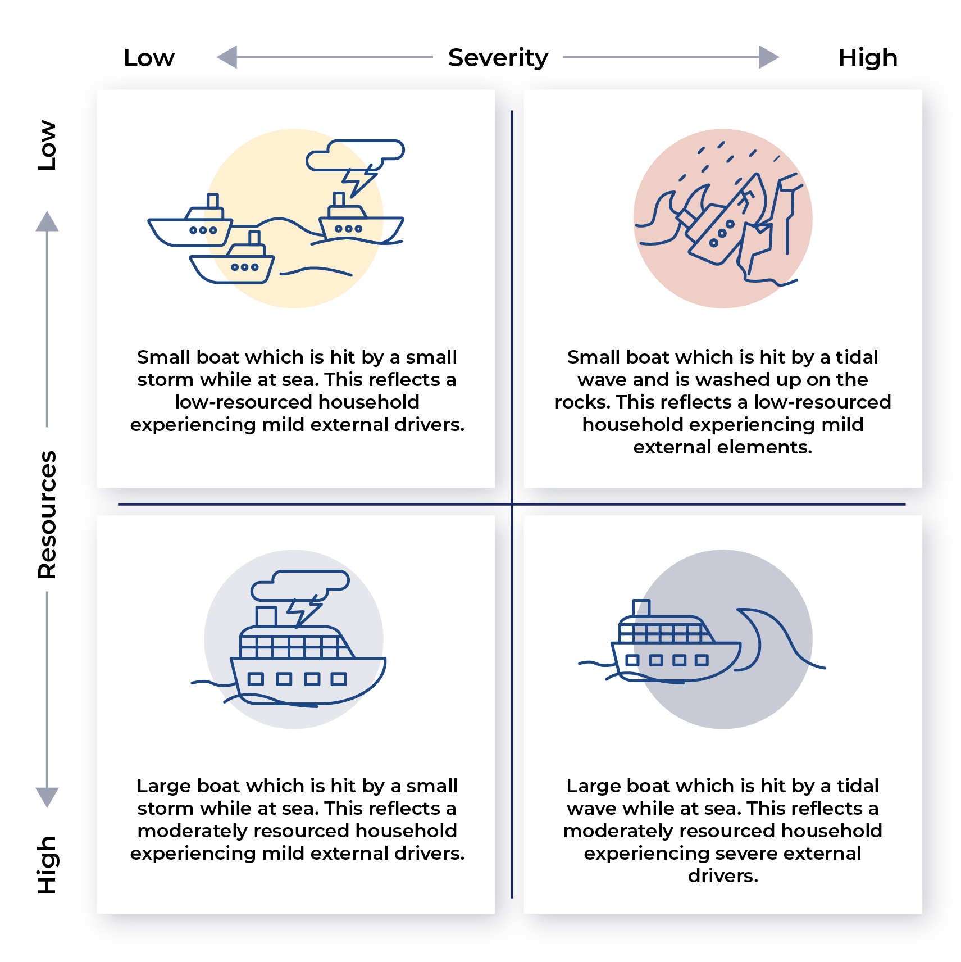

Key observations from the metaphor exercise of boats sailing in stormy weather include:

* Low-resourced households have little resilience to small, adverse drivers. Small changes can have a substantial negative impact.
* A flare used by sailors to signal distress and the need for rescuing has no equivalent in the energy sector. New metrics may be able to be used by retailers to provide “warm” leads (a “flare”) to signal to support agencies that a household needs emergency services.
* Warning a coast guard of a pending trip also has no clear equivalent. Such a strategy could help prevent many households from falling into hardship (P-S-R).
* Support needs to be nuanced to the household situation, depending on:
  + household resources
  + how fast they are “sinking”
  + type of home
* Many solutions place a burden on the household requiring them to initiate seeking support or to reach out. This is problematic for many, as they may:
  + not know what to do or where to find help
  + be stressed and have low cognitive bandwidth to work out how to access support
  + feel too ashamed to send up a flare (reach out).

### Final Comments

We note that solutions proferred tended to expect, if not encourage, households to adopt maladaptive behaviours (such as under-consuming energy or other essentials, and sacrificing health and comfort). This creates a normative standard that is harmful to energy consumers.

We also note that most solutions to energy hardship tended to avoid addressing systemic drivers (macro drivers such as high prices, low social benefits, poor-quality housing and an overly complex energy system; and meso drivers such as poor retailer and landlord behaviour).

While many households in energy hardship experience struggles in multiple (non-energy) areas, it was acknowledged that assisting households is beyond the scope of the energy sector. However, energy retailers often receive the first indication that something is wrong, which could be harnessed to send a flare to other sectors. A coordinated approach to addressing energy hardship across government agencies and support services is needed.

Also, information played a low or insignificant role for households in this project. One type of very specific information that might help is mandatory and meaningful disclosure of energy efficiency of the property at the point of lease. This information approach is different to the usual approach of providing energy and/or financial literacy, as it places the burden on landlords and rental agencies rather than on consumers.

Currently, we rely on households to self-identify that they need assistance, and to be in such a mindset and emotionally healthy state that they know what to do and can access help. With the problem reaching beyond energy, an over-reliance on the household to resolve their struggles and work within what is provided is problematic for policy-makers. This indicates that the default thinking from most policy-makers when coming up with solutions is “what can the consumer do”, and not “what can be changed in the system”. What is needed is a mindset shift in policy-makers, retailers and program managers. According to systems thinking, mindset shifting is the most powerful place to intervene and create real change.[3]

The body of work on the Energy Equity Work Program to date highlights the necessity of government agencies to work together across policy areas to alleviate energy and other types of hardship experiences of many households. We need policy to consider how households may proactively communicate the potential for their situation to worsen (i.e.,before they reach crisis), and how it might reduce or remove the burden currently placed on households to address a situation that is largely not of their own making.

**Next Step: Phase 3**

The next step is to refine energy hardship metrics that can be measured from households and from retailers. Phase 3 of the EEWP will test the data collection and sharing regime developed in Phase 2 to measure and track energy equity over time. These nationally consistent metrics will enable policymakers and other stakeholders to understand the levels and distributions of energy hardship across and within all Australian governments’ jurisdictions and use this knowledge to address energy hardship.

1. Bedggood, R., Gardner, J., Gordon, R., Adams, H., Reade, L., Miller, W., Poruschi, L., Russell-Bennett, R., McAndrews, R., Letheren, K., Clarke, M. and O’Mahony, C. (2022) “Assessing Energy Inequity and the Distributional Effects of Energy Policies,” Final Report, GEER Australia, Swinburne University of Technology, Melbourne.
2. For Phase 1 findings, see Bedggood, R., Gardner, J., Gordon, R., Adams, H., Reade, L., Miller, W., Poruschi, L., Russell-Bennett, R., McAndrews, R., Letheren, K., Clarke, M. and O’Mahony, C. (2022) “Assessing Energy Inequity and the Distributional Effects of Energy Policies,” Final Report, GEER Australia, Swinburne University of Technology, Melbourne.
3. Meadows, D. H. (2008) “Thinking in Systems: A Primer,” Chelsea Green Publishing.