
Energy Equity Work Program
Research to Inform a National Energy Equity Framework: Phase 3

Better Practice Guide Towards Energy Equity
Prepared for the Department of Climate Change, Energy, the Environment and Water
By GEER Australia
July 2024



To cite this Better Practice Guide
Project Team
Dr Rowan E. Bedggood Swinburne University of Technology
Project Lead & Project Manager
Dr John Gardner Commonwealth Scientific and Industrial Research Organisation
Professor Rebekah
Russell-Bennett, Dr Kate Letheren and Dr Ryan McAndrew Queensland University of Technology

Henry Adams, Klara Klippel and Emma Rubenach
Common Capital
Wendy Miller
Queensland Council of Social Service

Project Advisors:
Professor Ross Gordon Queensland University of Technology
Luke Reade
Energetic Communities
Adams, H., Bedggood, R., Rubenach, E., Klippel, K., Gardner, J., Miller, W., Russell-Bennett, R., Letheren, K. and McAndrews, R. (2024) “Better Practice Guide Towards Energy Equity,” GEER Australia, Swinburne University of Technology, Melbourne.

Participant acknowledgement
The GEER Consortium extends our heartfelt gratitude to those who participated in interviews for this project: to households who shared their stories and to sector workers for sharing their insights, wisdom and passion for seeing improved outcomes for those households most in need.

Funding acknowledgment
This project was funded by the Commonwealth Department of Climate Change, Energy, the Environment and Water (DCCEEW) as part of the Energy Equity Work Program. The views expressed in this guide do not necessarily reflect the views of the Commonwealth Government of Australia.

About GEER Australia
The Group of Energy Efficiency Researchers (GEER) Australia is the peak research body on residential energy efficiency and wellbeing. It comprises researchers and industry partners from across Australia who are committed to driving change in the energy sector towards improved outcomes for Australian households. Its purpose is to improve energy-related wellbeing in households and communities in Australia, through collaborative research that achieves practical outcomes and informs future practice and policies.
GEER’s research and activities thus focus on energy efficiency as it relates to quality of life, health, affordability and environmental sustainability.

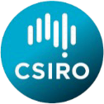


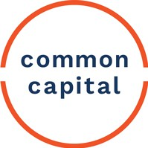
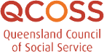
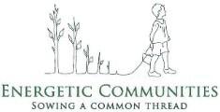

This better practice guide collates the latest research from the Group of Energy Eﬃciency Researchers (GEER) Australia on energy hardship. It has been written for government executives, program and evaluation leads, and policy analysts who are working in areas where energy, social and health policies intersect. We have developed the guide to help address gaps and strengthen existing programs to prevent households in, or vulnerable to, energy hardship from being left behind by Australia’s energy transition.

Executive Summary
An overarching challenge is that the concept of “energy hardship” has historically been poorly deﬁned and remains poorly understood. Discussion of energy hardship policy in Australia can sometimes conﬂate mandatory retailer “energy hardship” debt management programs under National Energy Retail Rules (NERR) with the broader issue of energy hardship. Other programs often conﬂate administratively expedient concession cards with those in need of policy support. Both approaches inadvertently exclude many households in and vulnerable to hardship. Concession cards also inadvertently spread limited funding over many households who are unlikely to be in or vulnerable to hardship.
As part of the Energy Equity Work Program Phase 1 and Phase 2 projects, GEER developed an Equity framework for understanding and addressing energy hardship and improving energy equity. The central ﬁnding is that energy hardship is not a ﬁxed set of attributes people have, rather it is a short- or long-term state households are experiencing, which may vary from being mild to severe over time and across households. This state of energy hardship is best understood as:
When a household is unable to use suﬃcient energy services in the home to live a comfortable, digniﬁed and healthy life without restricting other essential needs.

The Equity framework has three components designed to help policy makers understand the root causes and
nature of hardship diﬀerent households may be in or at risk of to better target solutions:





- the Drivers, Indicators and Outcomes (DIO) framework to measure energy hardship

- the ABATE vulnerability and hardship states to capture the various experiences of households

- the Prevention, Support or Relief (P-S-R) framework to guide programs and policies tailored to
each vulnerability and hardship state [1].
Another underlying challenge is that the available data on energy hardship are limited and fragmented. Energy hardship is a complex problem, and policy should therefore accurately identify and measure both the scale and distribution of energy hardship – that is, the severity of hardship and the number of households in, or facing vulnerability to, energy hardship. Existing data sets are cross-sectional, which means the duration and extent of hardship (including how households move between the ABATE states) cannot be accurately monitored and assessed.

Key metrics and indicators to identify and further understand the distribution and scale of energy hardship may include:
- households with both a low income and high energy burden
- households who deliberately under-consume energy to reduce costs, often sacriﬁcing thermal
comfort and/or wellbeing
- households who reduce consumption of other goods and services or go into non-energy debt to pay their energy bills.

Phase 1 of the Energy Equity Work Program found that while there are many policies and programs aimed at alleviating energy hardship, they face key challenges which present opportunities for improvement. In Phase 1, we also identiﬁed many transferable lessons from policy or program innovations that aligned well with energy equity policy imperatives. These can be synthesised into seven better practice principles:
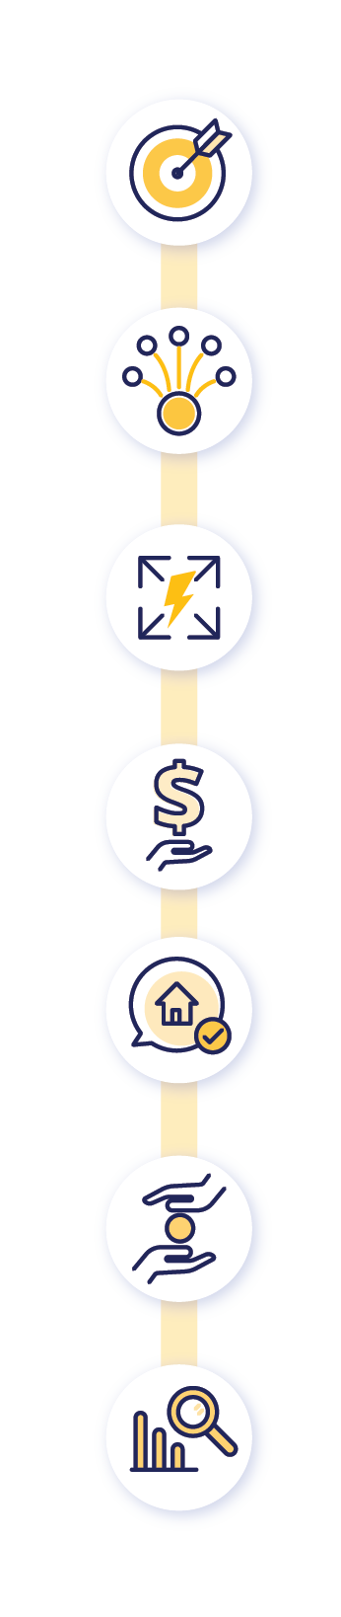

- TARGET your program to maximise impacts by understanding the state and drivers of energy hardship for the households you wish to help

- LEVERAGE complementary programs in your jurisdiction to ensure a broad a range of households are reached

- SCALE the outcomes of your program through adequate funding, timelines, delivery models and impacts

- SECURE suﬃcient funding by measuring costs and beneﬁts at a whole-of-government
level

- INCLUDE the households you seek to help with appropriate language, framing and channels in program communications

- REDUCE friction for targeted households by removing accessibility barriers in program design and delivery

- MEASURE, collect and analyse data to support program implementation, continuous improvement and evaluation

This Guide has been informed by a series of research. Key findings from literature reviews, co-design workshops and interviews throughout the course of Phases 1, 2 and 3 are reflected in the overall findings of this Guide.


This Guide will help policy and program leads by providing an understanding of the key considerations and next steps needed to apply these principles. This, in turn, will help with designing and improving policies and programs to deliver material improvements in energy equity outcomes.

Executive Summary 3
Contents

Section 1: Use the ABATE framework to understand energy hardship 10

Section 2: Issues with the way energy hardship is identiﬁed and 18

measured in households

Section 3: Better practice principles for eﬀective energy hardship 21

policy

Introduction to this Guide

This Better Practice Guide (Guide) collates the latest research from the Group of Energy Eﬃciency Researchers (GEER) Australia on energy hardship. It has been written for government executives, program and evaluation leads, and policy analysts who are working in areas where energy, social and health policies intersect. This Guide uses terms that are also used in the National Energy Retail Law, but these should not be taken to be equivalent to the legal definition unless specified. The concepts and issues discussed are relevant across all jurisdictions.


The purpose of this guide is to support the design of new, and reform of existing, equitable energy policies and programs
We have developed this Guide to help energy policy and program leads to better deliver energy equity outcomes. It provides an introduction to the key concepts of energy hardship and current best practice regarding energy equity policies and programs. It outlines key considerations and next steps to guide the design and implementation of energy hardship policies and programs that will maximise beneﬁts and overcome key barriers to ultimately achieve energy equity.
This Guide can be used to support the design of new policies and programs or to improve existing ones. Phase one of this work program identiﬁed many pre-existing state, territory and national initiatives with the potential to prevent, support or relieve energy hardship. These may have opportunities for enhancements to improve their eﬀectiveness, having been developed before the synthesis of these best practices. For example, some policy instruments, eligibility criteria, communications and delivery approaches may inadvertently exclude the households most in need of support. Some existing initiatives may beneﬁt from small tweaks to align with best practice. Others may be very eﬀective at supporting certain household types, but may require new complementary initiatives to better prevent, support and relieve energy hardship.
The insights within this Guide are relevant to both programs that directly aim to reduce energy hardship, as well as helping to ensure that broader energy initiatives do not unintentionally reduce energy equity outcomes.
Supplementary links to other resources are also provided for further reading on key concepts.
Households in a state of energy hardship are likely to face broader hardship, whereby other essential services are also unaﬀordable. This means that energy equity policy is a subset of broader hardship policy. Hence, energy equity policies should be developed in close collaboration with other portfolios. However, this Guide is focused speciﬁcally on developing and reforming energy policies that improve energy equity.
Case studies throughout this guide illustrate the many facets of energy hardship. Energy hardship is not homogenous; rather, people experience energy hardship for many diﬀerent reasons, and it can present in many diﬀerent ways. Consequently, a “one size ﬁts all” approach is likely to be ineﬀective. Energy equity programs should be tailored to the targeted population, and use limited funding more eﬀectively. The case studies aim to apply energy hardship frameworks to illustrate diﬀerent experiences, states and drivers of energy hardship tangibly.

Section 1:
Using the ABATE framework to understand energy hardship
Section 2:
Issues with how energy hardship is identiﬁed and measured in households
Section 3:
Better Practice Principles for eﬀective energy hardship policy
This Guide has three sections:



Australia’s energy transition risks leaving behind households facing energy vulnerability and hardship

Australia’s energy system is in transition to new, cleaner technologies and market structures that will provide clean, aﬀordable and reliable energy. This includes innovations that oﬀer opportunities for households to reduce energy costs through energy eﬃciency and consumer energy resources (CER), for example, solar systems, battery storage, demand shifting and the electriﬁcation of ineﬃcient and unhealthy gas appliances. However, this transition is amplifying existing inequities.
Many Australians are under pressure from rising energy costs and face signiﬁcant barriers to accessing the beneﬁts of energy eﬃciency and CER innovations. Households who are unable to aﬀord energy services without sacriﬁcing other needs are in a state of energy hardship (sometimes referred to as energy poverty, fuel poverty or energy disadvantage) [1]. Energy hardship is a state of being, rather than a permanent characteristic. As such, energy hardship is not static, and households can move in and out of hardship which can vary by severity and duration.
State, territory and national agencies have, and are continuing to develop, a portfolio of initiatives to address aspects of this issue for households facing vulnerability to energy hardship [1]. The ultimate and overarching policy goal is to help households move out of energy hardship and protect households from entering energy hardship in the future “Energy equity” is a term used to describe the broader portfolio of policies and programs required to address hardship and deliver the outcome of energy equity. Energy hardship is defined for the purpose of the Energy Equity Work Program as: “When a household is unable to use suﬃcient energy services in the home to live a comfortable, digniﬁed and healthy life without restricting other essential needs.”


The issue of “Energy hardship” is broader and more nuanced than commonly applied

Energy hardship is a state of being, rather than a permanent characteristic. As such, energy hardship is not static, and households can move in and out of hardship which can vary by severity and duration.

Discussion of energy hardship policy in Australia sometimes equates National Energy Retail Rules (NERR) hardship customers with the broader issue of energy hardship. The Energy Equity Work Program found that there are additional indicators of energy hardship and many people in or vulnerable to different states of hardship, which other programs may seek to support. Conversely, it also found that the common use of energy concessions to target assistance for energy equity programs may inadvertently include many who are not in hardship, while also excluding many who are.




This Guide sets out a framework for better understanding and developing new approaches to adequately address the problem
In Phase 1 of the EEWP, GEER conducted a meta review of the national portfolio of policies and programs which seek to directly or indirectly progress the goal of energy equity [1]. This review included benchmarking 51 distinct national, state and territory programs, and conducting a gap analysis of existing strategic policy and the national Trajectory for Low Energy Buildings against the energy hardship framework.

The study found that while there are many policies and programs aimed at alleviating energy hardship, they face key challenges that present opportunities for improvement [1].
For example:

Clear, long-term, measurable objectives around reducing or eliminating energy hardship appear to be lacking.
Funding is generally not well targeted or proportional to the problem.
Often there is no plan to scale policies and programs to reach the remainder of those in hardship.

Program delivery across jurisdictions and portfolios, and between programs within the same department, is siloed.
Policies and programs tend to focus on monitoring and evaluating outputs (e.g., number of rebates delivered, or number of solar systems installed) rather than outcomes (e.g., reducing energy bills and hardship).

There is a material risk that eﬀective energy equity programs are not developed as there are existing programs (even though ineﬀective) and households in need go unsupported.

Is this guide for you?
How you use the information in this guide will depend on whether you are designing a new program or evaluating or reﬁning an existing one. The quiz below provides a diagnostic to help you understand whether your program reﬂects current best practice. If it does not, the quiz will refer you to the relevant section to help you understand why not. The section will also provide key considerations and next steps to help you improve your program.
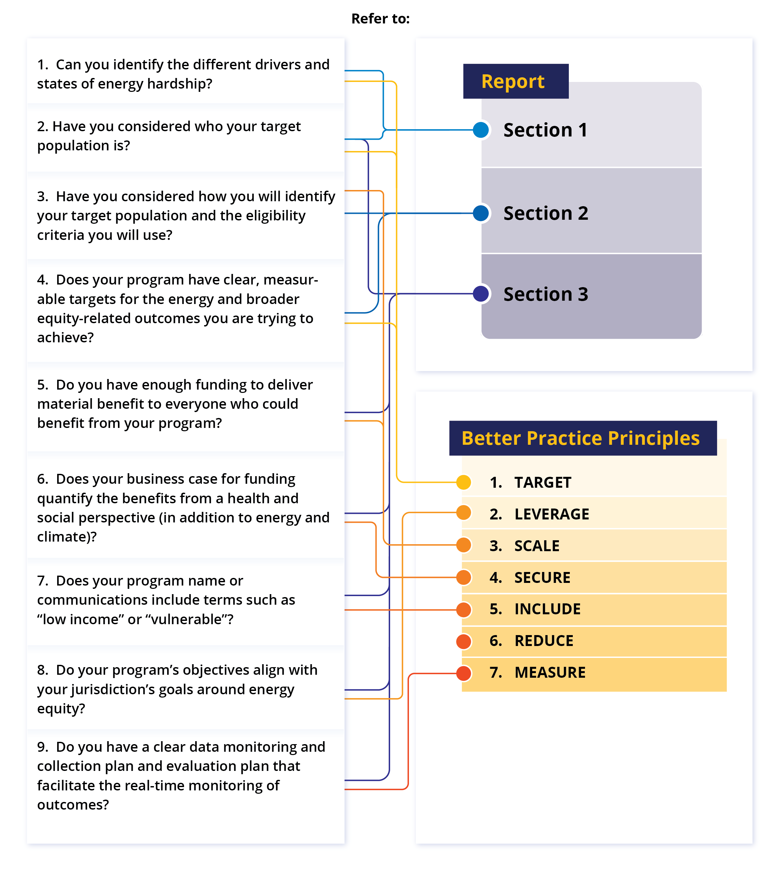

Use an Equity framework to understand energy hardship
Section 1

As part of the EEWP Phase 1 and Phase 2 projects, GEER developed an Equity framework for understanding and
addressing energy hardship and improving energy equity. The framework has three components:
- DIOs (drivers, indicators and outcomes) to measure energy hardship
- ABATE energy vulnerability and hardship states to capture the various experiences of households
- P-S-R (prevention, support and relief) to guide programs and policies tailored to each vulnerability and
hardship state [1].
You can use the Equity framework to understand energy hardship and to create policies designed to overcome it. This will help achieve the ultimate policy outcome of energy equity for all Australian households.

Use DIOs to measure energy hardship: capture the drivers, indicators, and outcomes of energy hardship to help determine what to measure and what to address
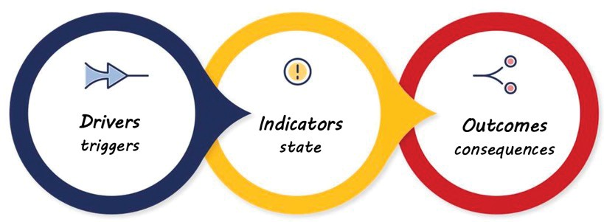
Figure 1: Drivers, Indicators and Outcomes (DIOs) of Energy Hardship



The drivers of energy hardship can be divided into macro, meso and micro drivers

You can use the ABATE framework to understand energy hardship and to create policies designed to overcome it. This will help achieve the ultimate policy outcome of energy equity for all Australian households.
- Macro drivers include factors that drive energy hardship more broadly, such as high energy prices, low social
beneﬁts and poor-quality housing.
- Meso drivers include factors that aﬀect some, but not all, households. Examples are poor retailer behaviours (e.g., misleading plans, inconsistent responses) and poor landlord behaviours (e.g., refusing to conduct energy-eﬃciency upgrades or perform maintenance and repairs).
- Micro drivers include factors impacting only speciﬁc households. Examples are unique high energy needs (e.g., for health requirements), low-income (e.g., households whose income is always low, or who face a sudden drop in income), non-energy bills (e.g., high cost of living), high energy bills (e.g., bill shock), energy-hungry appliances (e.g., heating and cooling), energy ineﬃcient housing and ﬁnancial abuse.
A key ﬁnding of the EEWP research was that energy literacy is not a material driver of energy hardship. Information-based initiatives aimed at improving general household energy literacy cannot prevent or relieve energy hardship unless the underlying drivers that households face are ﬁrst addressed.
The ﬁgure below demonstrates how macro and meso drivers can amplify micro drivers and other barriers. As shown below, it is the compounding eﬀect of each additional driver that can inﬂuence a household’s vulnerability to entering a state of energy hardship. To alleviate energy hardship, macro, meso and micro drivers of energy hardship should be addressed.

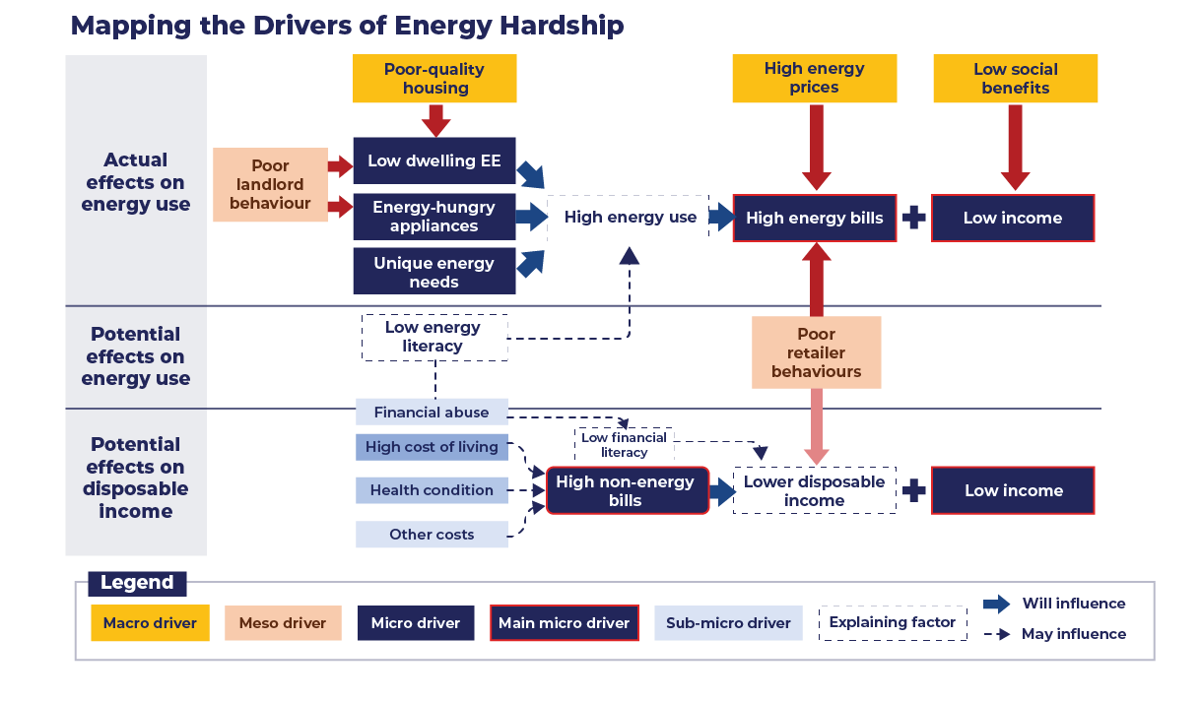
Figure 2: Mapping the Drivers of Energy Hardship


The indicators of energy hardship are either action-based, situation-based or proxy-based
- Action-based indicators reﬂect a household behaviour that reveals a state of hardship (e.g., coping strategies such as under-consumption of energy).
- Situation-based indicators reﬂect a household experience that reveals a state of hardship (e.g., thermal discomfort or diﬃculty paying bills).
- Proxy-based indicators reﬂect a metric that reveals a level of suﬀering linked to being in a state of energy hardship (e.g., indoor temperature or mould).

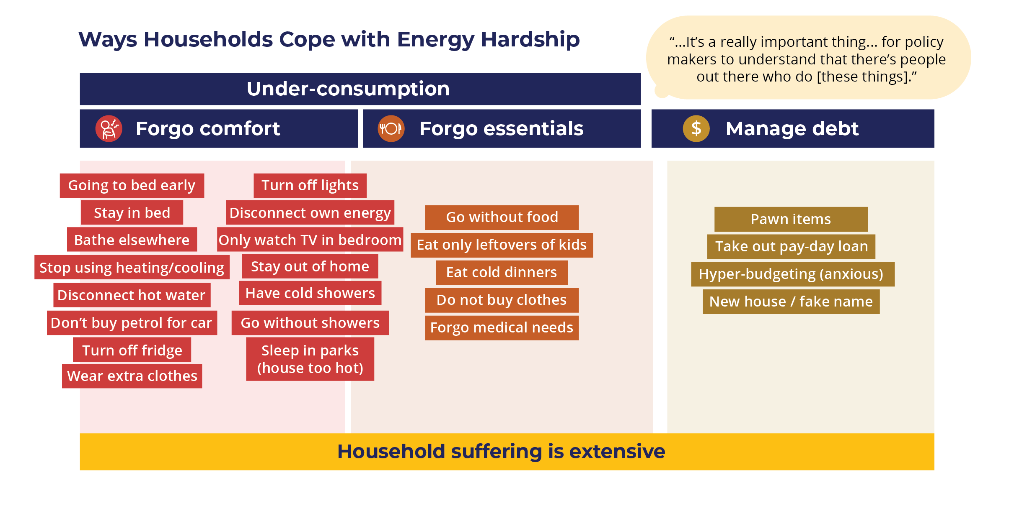

Under-consumption

Figure 3: Understanding the ways Households Cope with Energy Hardship


The outcomes of energy hardship have six key themes
- Stress (e.g., anxiety, shame or depression)
- Energy debt
•

•
Worsened health (e.g., health compromised to pay an energy bill)
Poorer living conditions (e.g., compromised quality of living)
- Non-energy debt
•
Disconnection

The ABATE vulnerability and hardship states recognise that energy hardship is dynamic and varies by severity and duration
Households can enter and exit a state of energy hardship and experience hardship to various degrees. The ABATE vulnerability and hardship states aim to provide nuance to actual household experiences by describing the diﬀerent states of energy hardship. They also capture the high vulnerability states households experience before entering hardship and the high vulnerability state that persists after exiting hardship. As shown in Figure 4, energy hardship can be either short-term (temporary) or long-term (enduring), and either mild or severe.

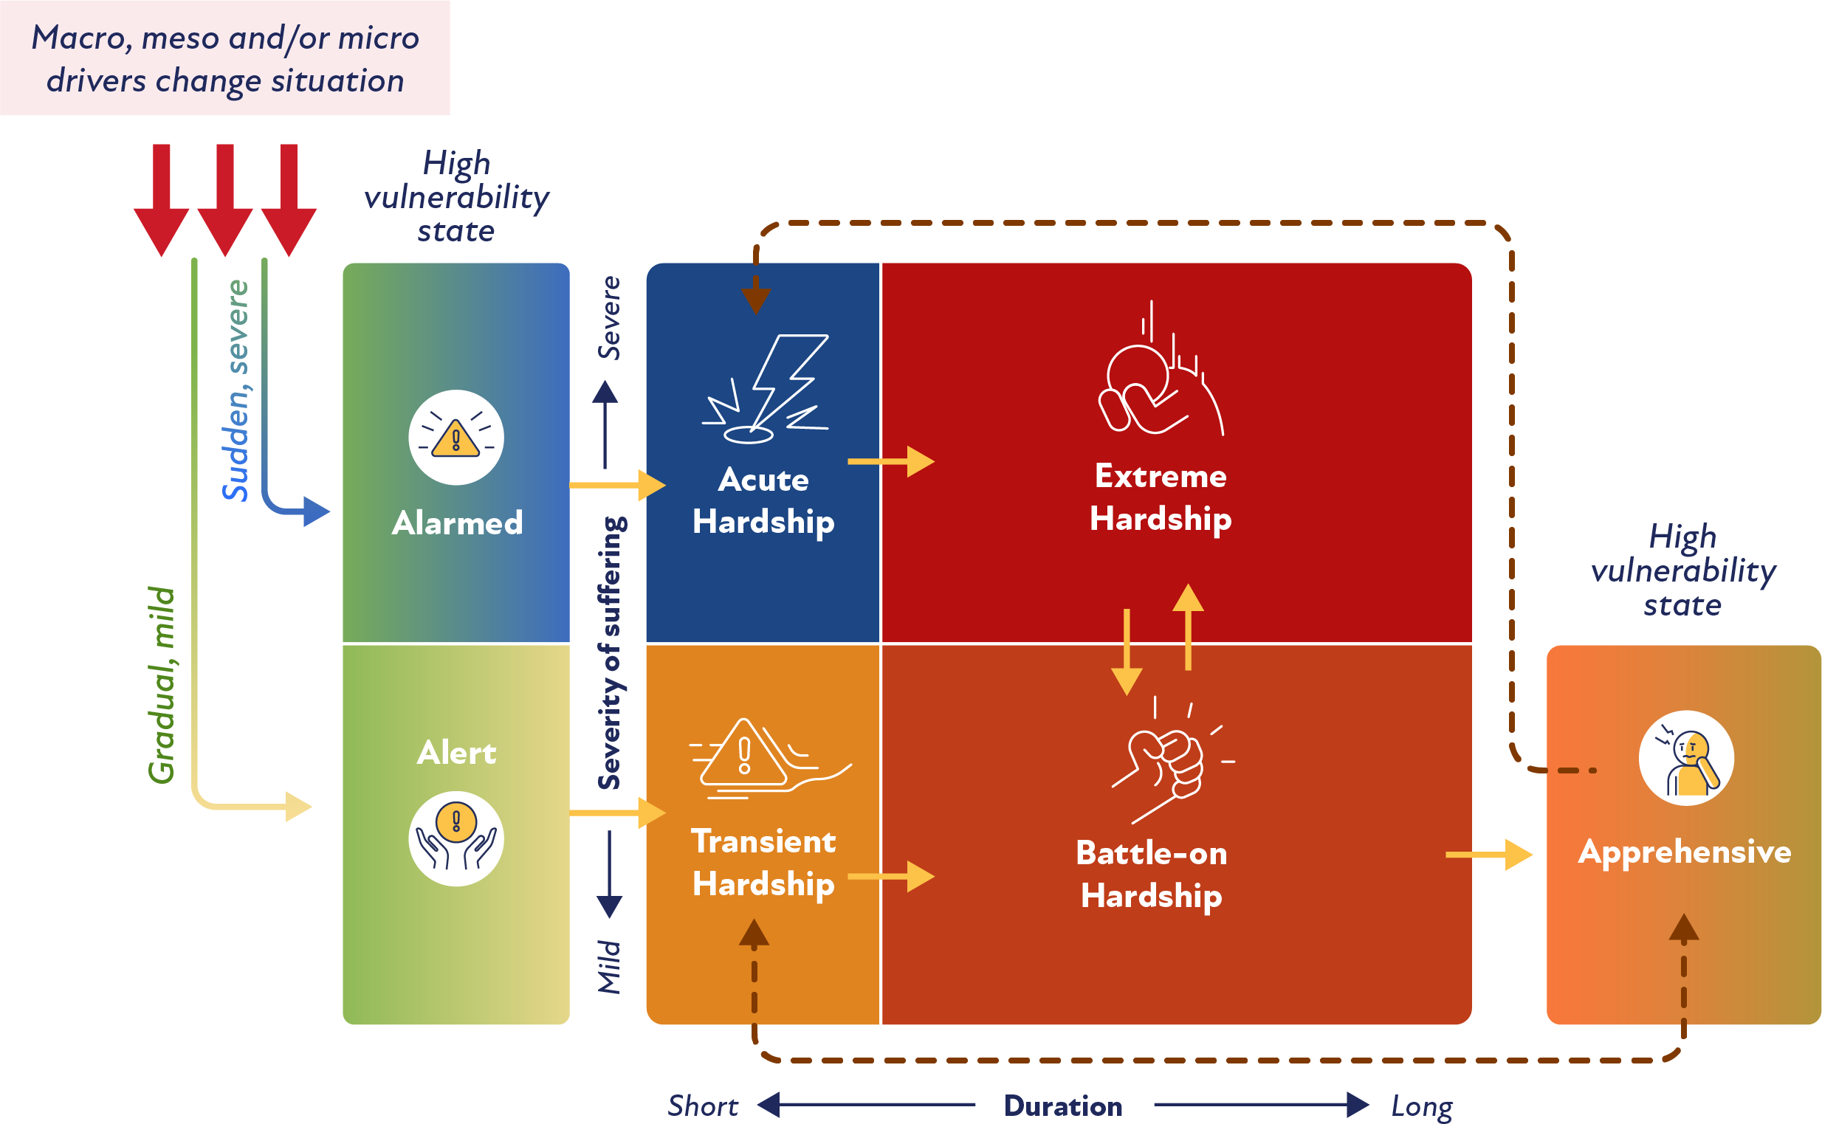

Figure 4: ABATE Energy Vulnerability and Hardship States with Common Journeys

ABATE reﬂects seven states: three high-vulnerability states (Alert and Alarmed are pre-hardship, Apprehensive is post-hardship) and four hardship states (Battle-on, Acute, Transient and Extreme). The seven states are described in order of duration and severity below:










Alert vulnerability – this high-vulnerability state takes place just before the household enters transient hardship. It is a mild and short-term state, where the household is alert to the potential impact of pending changes in their life.

Transient hardship – this is a mild and short-term (0–6 months) state of energy hardship; however, without adequate support, households in transient hardship may move into a long-term state and experience frequent hardship.

Alarmed vulnerability – this high-vulnerability state takes place just before the household enters acute hardship. It is a short-term state that can be severe, where the household is alarmed about how they will cope with a drastic change in their circumstances.

Acute hardship – this is a severe and short-term state of energy hardship, whereby a household may experience a sudden change in their situation that causes severe suﬀering. Without adequate support, these households will likely remain in energy hardship for longer, moving into the extreme hardship state.

Battle-on hardship – this is a mild but enduring state of energy hardship, where a household will struggle with every energy bill and manage to get by, but usually accrue debt. If the household’s challenges are addressed, they can move out of hardship from this state.

Extreme hardship – this is the most critical form of energy hardship, as households in this state experience severe, enduring hardship. It is likely that these households will require maximum assistance that spans beyond energy.

Apprehensive vulnerability – this is the state experienced just after battle-on state (a common exit point). Households are apprehensive about their situation worsening again; they have a high risk of falling back into hardship and so remain “apprehensive”. These households would beneﬁt from preventative policies that reduce their vulnerability to energy hardship.

It is important to note that households can move between the states of energy hardship. This can happen for several reasons. For example, if a household becomes aﬀected by any of the drivers discussed under the DIO framework, their situation is likely to worsen and/or persist for longer. Eﬀective energy hardship policy can reduce the severity and duration of the energy hardship experienced by households and help to transfer them into less severe states. Conversely, the absence of adequate and eﬀective energy hardship policy can increase the severity and duration of the energy hardship experienced by households.
If households can be quickly identiﬁed as they approach (alert or alarmed vulnerability states) or enter energy hardship (acute or transient hardship states) their situation may be alleviated quickly and thus prevent them from entering a long-term state of energy hardship. This is vital as our research revealed that most households were not able to exit a short-term state of hardship, and once they entered the extreme hardship state, they were unable to improve their circumstances suﬃciently to exit energy hardship.

The P-S-R framework helps inform the suite of policies needed to tailor assistance to households in various vulnerability and hardship states
The needs of households in energy hardship will be diﬀerent from those of households facing vulnerability to, or exiting, energy hardship. As such, policy should be designed to target households in diﬀerent states of vulnerability and hardship. For example, households highly vulnerable to energy hardship will require preventative policies and programs that remove barriers and improve their resilience to the drivers of energy hardship (captured in the DIOs). However, it is likely that support or relief policies will be more eﬀective for households already in a state of energy hardship (as described in the ABATE vulnerability and hardship states above). Energy hardship is both complex and dynamic; consequently, programs may need to evolve so they can continue to provide appropriate assistance for targeted households.
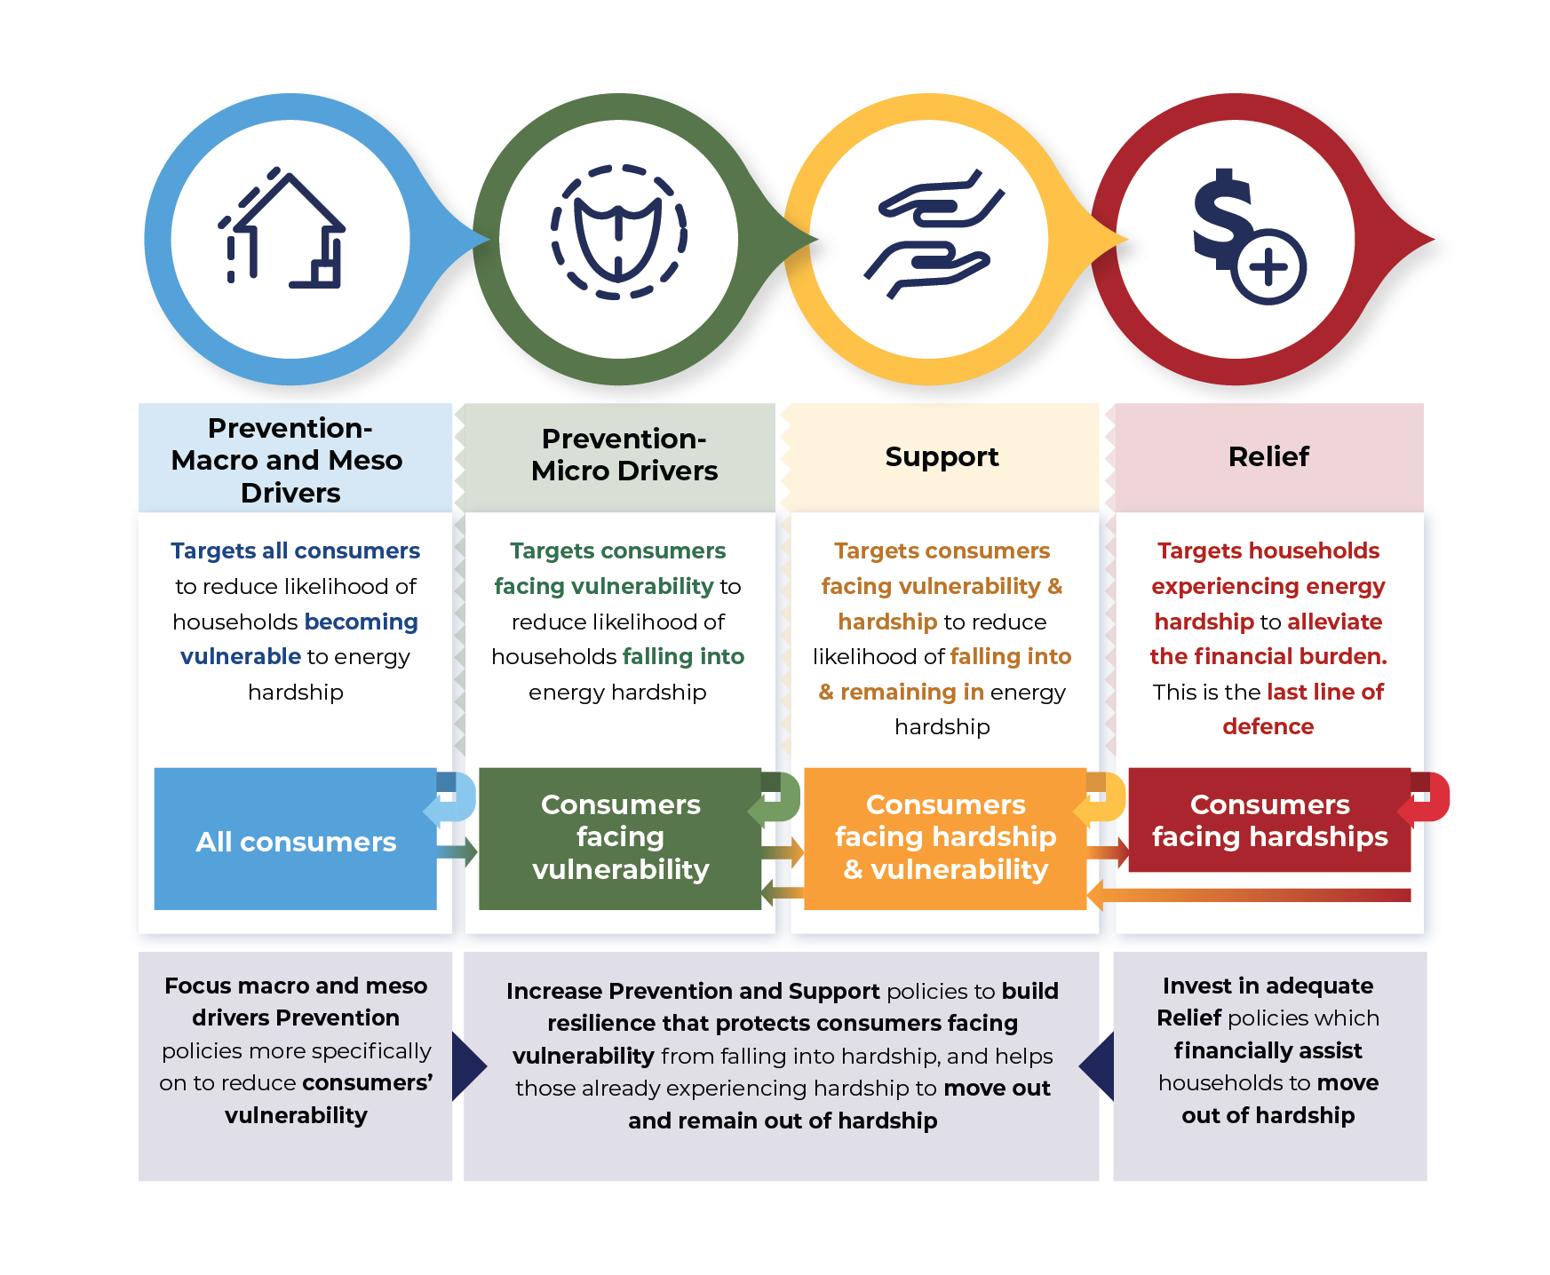

Figure 5: An application of the P-S-R framework that aims to guide policy strategy to alleviate energy hardship

As shown in Figure 5, a cohesive suite of policies is required to address households in various states of energy hardship. These include:

- Prevention policies that aim to address macro and meso drivers, and build resilience against micro drivers, to reduce household vulnerability to energy hardship. Policies could include retailer regulation.
- Support policies that aim to provide initiatives that help households better manage their energy consumption and energy bills, which may help them move out of hardship and remain out of hardship. Policies could include support for energy-eﬃciency upgrades.
- Relief policies that aim to provide ﬁnancial assistance that relieves suﬀering. Policies could
include concessions, subsidies, vouchers and matched payments by retailers.
The ﬁgure below demonstrates the journey of a household that entered a transient state of energy hardship – which is considered to be a relatively mild and short-term state. However, due to compounding macro, meso and micro drivers, the household enters more severe and enduring states of hardship. This example demonstrates that latter states of hardship can be avoided with eﬀective preventative policies. In addition, this journey map identiﬁes existing policy gaps in providing support and relief to households that prevents them entering a more severe and enduring state of energy hardship.

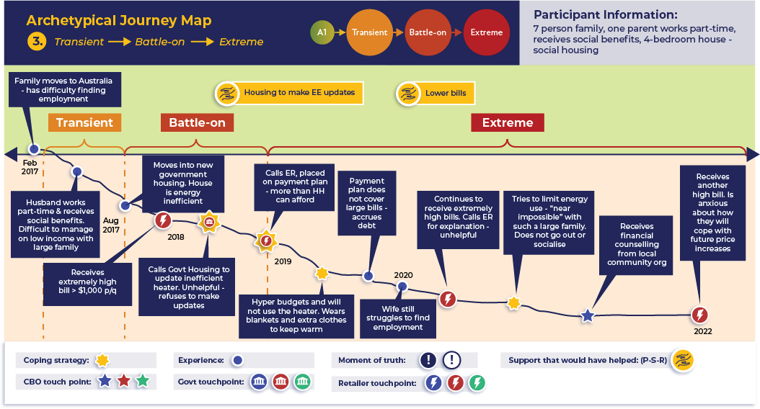

Figure 6: An archetypical journey map of a household that enters a state of Transient energy hardship and moves to Battle-on and Extreme States

Monitoring allows you to continually measure and track energy vulnerability and hardship and to check your program is working – or to make any necessary amendments
There is no “one size ﬁts all” way of knowing how households move in and out of energy hardship. As such, policies and programs should continue to gather data on households who are vulnerable to, or already in, energy hardship to better understand the problem and subsequently design appropriate government assistance. After monitoring, return to the DIO, ABATE states and P-S-R tools. These will help you continually measure, assess and assist households in hardship, and determine which approaches have the most impact and may be reducing energy hardship.

Applying the ABATE framework to real-life household experiences
The household case studies in this guide are drawn from household interviews we conducted as part of the Phase
2 EEWP. The two that follow describe the journey of households experiencing diﬀerent states of energy hardship.


Case study 1

Household: Jenny’s income was reduced when she was diagnosed with cancer, and she then couldn’t afford to heat/cool her home.

Jenny was a single mother working full-time, managing her energy bills and feeling comfortable with her energy use – until she was diagnosed with cancer and started chemotherapy. Her income was signiﬁcantly reduced because she couldn’t work for longer than four hours due to exhaustion. As her work hours went down, she struggled to pay many bills, including her energy bills. Jenny rang her energy retailer to explain she was having diﬃculty paying her winter energy bill. Although she told them she was being treated for cancer, the only oﬀer the retailer made was to place her on a payment plan for the ﬁrst bill while the next bill was accruing. Jenny knew she couldn’t pay both bills, and so she took radical steps to reduce her consumption. She would never turn the air-conditioner or heater on, leaving her and her daughter either very cold or very hot in the home for much of the year. Together with her daughter, Jenny rented a smaller, one-bedroom home to reduce her living costs. Jenny slept on the ﬂoor while her daughter slept in the only bed. Jenny was able to return to work a year after her diagnosis.
Under the ABATE states, Jenny was initially in acute hardship for the period she couldn’t work full-time. However, compounding levels of energy debt put her into a state of extreme energy hardship for several years. Cancer was a micro driver (health condition), although her situation was ampliﬁed due to the macro drivers of high energy prices, low social beneﬁts and poor-quality housing. A key
action-based indicator of hardship was Jenny’s drastic under-consumption of energy. However, Jenny was invisible to, and excluded from, many programs that aim to provide support or relief for energy hardship because she did not hold a concession card and was still making payments via a payment plan.
The payment plan helped manage debt collection for the energy retailer but exacerbated rather than alleviated Jenny’s hardship by increasing her debt levels at a time of ﬁnancial stress. As a renter, she had no control over major factors driving her energy use, including the building fabric, water heating and the eﬃciency of ﬁxed heating and cooling. As she was not a concession card holder, she did not qualify for energy concessions or subsidised energy eﬃciency schemes in her jurisdiction, and nor did her landlord.
If there had been a policy in place that provided rapid, signiﬁcant and temporary assistance with her initial bill shock, Jenny could have avoided moving from acute to extreme hardship. Examples of such a policy include nuanced eligibility criteria for existing energy concession and energy-eﬃciency programs that include renters and people without concession cards.


Case study 2

Household: Katie skips meals to pay her energy bills but does not appear to be in energy hardship.
Katie worked full-time as a chef, earning a relatively high income enabling her to buy her own home. She generally lived comfortably and had no diﬃculties paying for energy or using energy in her home. On retiring, however, Katie found the pension to be a drastic drop from the income she was used to. After ﬁnding her bills, particularly her energy bills, diﬃcult to pay for two years, Katie learned from some of her retired friends that she could access an energy concession which would lower her bills.
She succeeded in obtaining the concession, but found herself already in hardship by the time she
found out about it. Her bills were reduced only slightly, and she still could not aﬀord to pay them.
Katie began drastically under-consuming her use of energy in the home, and even resorted to missing meals or eating only rice two weeks before an energy bill was due so she could aﬀord to pay it. Katie is eligible for a subsidy on insulation and ducted heating and cooling, but she cannot aﬀord the high upfront costs for these measures. Katie did receive the government-subsidised lighting upgrades; however, this did not materially reduce her energy bills.
Under the ABATE framework, Katie was in battle-on energy hardship, which she entered due to a micro
driver (retirement), and her situation worsened due to the macro driver of low social beneﬁts.

Katie’s state of hardship could have been minimised had there been an active policy to automatically enroll her for a concession when she retired. In addition, Katie’s situation highlights the shallow depth of support for energy eﬃciency, that is, only small amounts of ﬁnancial support are provided to a large population, and upfront costs are prohibitively high for those in need of energy-eﬃciency measures.

Energy hardship is a complex problem. Policy should therefore accurately identify and measure the scale and distribution of energy hardship. That is, it should identify and measure both the severity of hardship experienced by households and the number of households in, or facing vulnerability to, energy hardship.

Issues with the way energy hardship is identified and measured in households
Section 2

New approaches are needed to better identify and target households in, or facing vulnerability to, energy hardship

We currently do not have readily available administrative tools to accurately identify and target support to those in or vulnerable to energy hardship. NERR hardship programs and energy concessions have been developed to solve related, but different problems, and can result in under or over allocation of support if applied in other program contexts that they were designed for. This is because:

- There are various states of energy hardship (as per the ABATE framework described above)
- The methods exclude households vulnerable to energy hardship who need help to avoid falling into actual energy hardship.
- The methods exclude households in invisible hardship. That is, those implementing various coping strategies to pay their energy bills that have an adverse eﬀect on other areas of their lives (e.g., under-consumption of energy resulting in adverse health impacts due to low thermal performance of housing or under-consumption of food to save money to pay energy bills).

Case study 3

Household: Tully is ineligible for social benefits despite not being able to work.

Tully earns a minimum wage working at a café where her hours ﬂuctuate week to week. She was on top of her energy bills until she moved into a new rental home which had considerably less eﬃcient heating and poor building fabric. Her energy use rapidly increased and, consequently, so did her energy bills.
Given Tully has regular work, she doesn’t qualify for any concessions. To avoid losing her energy connection, Tully pays her energy bills on time. However, she skips meals and drastically under-consumes energy by not using the heater. She even places bubble-wrap on the windows to try to retain heat.
Under the ABATE framework, Tully is in extreme energy hardship. Her state of energy hardship is identiﬁable due to action-based indicators (under-consumption of energy and food) and is exacerbated by the macro driver of poor-quality housing.
However, because Tully is paying her bills and doesn’t qualify for energy concessions, she doesn’t show up in current energy hardship data, making her invisible.
Examples of policies that can help people in invisible energy hardship include improving the quality of rental housing and the energy eﬃciency of appliances. This can help reduce household energy bills without reducing consumption. However, the ﬁrst challenge to overcome in supporting people in invisible energy hardship is to develop an appropriate framework to identify them. This can be explored by using inclusive framing on energy hardship support programs and extending eligibility criteria to provide more support to households in need (i.e., to include people without concession cards and renters).

Current data on the scale and distribution of energy hardship is poor
The available data on energy hardship is limited and fragmented. Existing data sets are cross-sectional, which means the duration and extent of hardship (including how households move between the ABATE states) cannot be accurately monitored and assessed. Limitations to the available data include the following.

- Data on households in retailer hardship programs are limited (including when they exit the program). This means the eﬀectiveness of these programs cannot be established or measured.

- Variables are not consistently captured in one data set. This means it is often not possible to assess the relationships between variables across data sets.
- There are no agreed standards for measuring energy hardship. This means household income
cut-oﬀs and energy hardship cut-oﬀs are arbitrary.
- Data on energy hardship-related areas are limited and cross-sectional. This means it is not
possible to monitor households (or variables) over time.

- Existing data cannot be used or reconﬁgured to accurately measure the level and extent of energy hardship in Australia. This means existing data (which do not in any case capture all the required information listed above) cannot be combined.
Addressing these limitations is vital when designing energy hardship policies and programs that aim to achieve energy equity.

Improve both the data points that measure energy hardship and the source of data

Key metrics and indicators can be used to identify and further understand the distribution and scale of energy hardship. Relevant indicators may include households who:
- Have both a low income and high energy burden
- Deliberately under-consume energy to reduce costs, often sacriﬁcing thermal comfort and/or
wellbeing
- Reduce their consumption of other goods and services or go into non-energy debt to pay their
energy bills.

The core data that can be used to calculate these indicators include:
•
•
•
Household income
Energy consumption and billing data
Percentage of household income used to pay for energy
Dwelling energy eﬃciency
•
•
•
•
•
Typical energy prices and bills Thermal (dis)comfort Worsened health
Mortality rates from exposure to low/high temperatures.
Each additional data metric collected will add nuances which can result in a more accurate measure of the state of energy hardship.

Improving data availability is an important part of ensuring energy hardship policies and programs are reaching and providing eﬀective support to those households who could beneﬁt from them. Focus should be placed on collating a broader data set that encompasses other areas such as health and housing. This would involve collecting and combining data from multiple sources, including both large-scale sources (e.g., the Australian Energy Regulator, Department of Human Services, Australian Energy Market Operator, Australian Taxation Oﬃce and Australian Bureau of Statistics) and smaller-scale sources (e.g., gas and electricity retailers and households). Note that data sources should be accessible, current, comprehensive and connectable (to other data sets).






Whether you are developing a new policy or amending an existing one, it is important to understand that no individual program can solve the whole problem of energy hardship. To ensure the success of your program, understand which driver(s) or state(s) of energy hardship it addresses, which gaps it ﬁlls in existing policy and which policies and programs it complements. Ensure your program has a material impact by directing your funding to remove barriers, and to provide support and relief to the subset of households you are targeting.
Better practice principles for effective energy hardship policy
1. TARGET your program to maximise impacts by understanding the state and drivers of energy hardship for the households you wish to help
Section 3


Why this is important
Without clearly deﬁning your targeted state(s) of energy hardship, and the driver(s) inﬂuencing this state, you risk spreading funding too thinly or too narrowly. That is, you risk funding activities that do not reduce or prevent hardship and/or that spend limited resources on households who are not in, or vulnerable to, energy hardship. Moreover, you risk:

- developing policies and programs that are duplicative
- not eﬀectively addressing your identiﬁed problem within your target population
- not achieving the intended outcome(s)
- not aligning with broader strategic jurisdictional goals.



Suggested actions
- Deﬁne ultimate program outcomes.
- Document the program logic and theory of change.
- Develop SMARTA (speciﬁc, measurable, attainable, relevant, timely and agreed) objectives.
Considerations
- Who is the target population?
  - Which ABATE state are you targeting? (See Section 1)
- Which drivers of energy hardship are present for the target population? (See Section 1)
- How would this speciﬁc program address those needs?
  - Is your program designed for prevention, support or relief? (See Section 1)
- What are the ultimate goals you are trying to achieve (e.g., decreased energy distribution costs resulting in decreased energy bills; improved energy equity)?
  - How do these goals align with broader policy goals for your jurisdiction?




1 New South Wales Government Premier and Cabinet. Evaluation toolkit: Develop program logic and review needs. Funded by the Sustainability Fund of the Victorian Government and Sustainability Victoria.
Culturally and linguistically diverse.



2. LEVERAGE complementary programs in your jurisdiction to ensure a broad a range of households are reached
Your program should align with your jurisdiction’s broader strategic goals around energy hardship, and complement existing policies and programs. Complementary policies and programs may exist at various levels of government (e.g., state/territory, national). Being aware of the broader context will help you to design your program to complement existing programs, which is likely to provide additional beneﬁts to participants.

Why this is important
Not aligning your program with your jurisdiction’s existing policies and programs, and broader strategic goals, risks eﬀorts becoming fragmented or duplicated. Energy hardship is a complex problem that likely needs to be addressed by a suite of complementary policies and programs. You need to understand which part of the problem your program is best placed to solve. This will allow you to design and implement your program in a way that complements existing policies and programs, and broader strategic policy goals.
Suggested actions

- Map existing policies and programs.
- Adapt your theory of change (see Principle 1) to incorporate any interactions with existing complementary
policies and programs.
- Build active linkages and collaborations with complementary programs to improve mutually beneﬁcial
outcomes.
Considerations
- What are the existing policies and programs at a state/territory or national level that may complement your program?
- What are your jurisdiction’s relevant broader equity, health and energy policy goals that your program can contribute to?
- Does your program duplicate existing programs? If so:
  - Does it target the same population?
  - Does it provide the same level of impact?
- What complementary policies does the program need?


3. SCALE the outcomes of your program through adequate funding, timelines, delivery models and impacts

To maximise the impact of your program, ensure it is designed to be delivered at scale, with outcomes sustained over the long-term. To achieve this, you should incorporate the following three important components of scalability into your program design.

- Design a scalable funding model with a quantum of funding that is suﬃcient to deliver beneﬁts to the entire target population in need; or develop a clear pathway that identiﬁes where additional funding can be sourced if your program is a success.
- Design a scalable delivery model which eﬀectively identiﬁes and reaches your target population.

- Design your program to address the root cause of the problem to ensure there is potential for market transformation, minimising the need for future government intervention.

Why this is important
If you do not design your program to be scalable, you risk running out of funding before solving the problem you set out to address. Scalability is pivotal to making a broad and meaningful impact and avoiding a proliferation of pilot programs. Often, initiatives either provide tokenistic assistance to many, or provide a lot of assistance to only a select few. While insuﬃcient assistance may move a household from one ABATE state to another (e.g., extreme hardship to battle-on hardship), the household remains in energy hardship and the overall impact is transitory rather than transformative.
Transformative policy is required to deliver lasting change, for example, by eliminating the aspect of hardship your program is targeting. Thus, it seeks to eliminate the root cause of a speciﬁc aspect/segment of hardship rather than temporarily making things “a little less bad”. While temporary support/relief policies are an important part of energy hardship policy, you should design your program for long-term success.
Suggested actions
- Explore potential funding models.
- Identify and document key barriers to uptake.
- Assess various funding and delivery models to maximise impact.
- Consider modelling uptake rates under various scenarios to optimise market transformation potential.
Considerations
- Does your idea provide material beneﬁt to households in hardship?
- How can your program be delivered to your entire target population?
- Will your program move households out of energy hardship (or from one ABATE state to another)?
- Is the proposed funding model scalable?
  - If not, are there other models, e.g., cost recovery, which may be viable?
- What changes would you make to the program to:
  - Have a higher impact?
  - Better reach the target population?

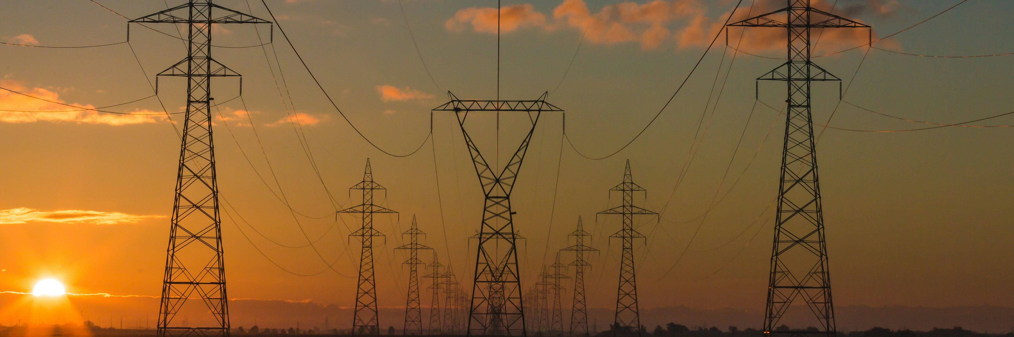
Case study 4

Program: Market transformation in the Australian Capital Territory.
Under the Australian Capital Territory’s Energy Eﬃciency Incentive Scheme (EEIS), energy retailers have an obligation to deliver a set amount of annual energy savings. They do this through subsidising eligible energy eﬃciency upgrades for households and businesses [3]. They also have a priority household sub target. This means that 40% of total energy savings must come from priority households (i.e., those in, or facing vulnerability to, energy hardship) [4]. Recognising that one program alone cannot solve a complex problem like energy hardship, the EEIS bolsters its impacts through a range of complementary programs, including the Sustainable Household Scheme (SHS). This scheme provides zero-interest loans to eligible households to perform activities that help save energy (e.g., installing solar systems, upgrading hot water heat pumps and switching to electric vehicles) [5]. Under the EEIS and SHS, day to day program delivery is managed by industry – through regulators (for EEIS) and a contract with government (for SHS). Funding is integrated at the point of sale so that customers have no out-of-pocket expenses and do not need to ﬁnd installers and additional funding separate from the program processes. These programs are having a market transformation eﬀect, as they place the incentive to ﬁnd customers on the installer (rather than on the Government).





SECURE sufficient funding by measuring costs and benefits at a whole-of-government level

Your energy hardship program will likely provide signiﬁcant beneﬁts beyond the scope of the energy portfolio. For example, policy that improves access to energy eﬃciency for households experiencing, or facing vulnerability to, energy hardship can help reduce exposure to extreme heat and cold, providing considerable health beneﬁts. This will reduce future health system costs and should be included in an assessment of energy program costs and beneﬁts. Assessing costs and beneﬁts at a whole-of-government level may also provide an opportunity for cross-portfolio funding, which may help to expand the scale and impact of your program.

Why this is important
Assessing your program’s costs and beneﬁts in isolation risks a less desirable cost:beneﬁt ratio. This may negatively impact your business case, limiting your ability to access suﬃcient funding. It may also exclude opportunities for cross-portfolio funding that may help deliver more material and scalable assistance to targeted households.

Considerations
  - Does my program deliver beneﬁts to other portfolios?
    - Which portfolios are they?
    - What is the long-term impact?
    - Work with relevant agencies to quantify and include their information in your business case
to help secure suﬃcient funding.
    - Work with relevant agencies to quantify the energy-related beneﬁts that may exist for their
portfolio’s program and could strengthen their business case
  - What is the opportunity cost for other portfolios if your program is not implemented?

Suggested actions
  - Quantify the beneﬁts for other portfolios.
  - Explore cross-portfolio funding options.
  - Include other portfolios’ costs and beneﬁts when completing your program’s cost–beneﬁt analysis.

Case study 5

Program: A Victorian upgrade program assessed social, health and energy costs and benefits.

The Victorian Healthy Homes Program provided an average of $2,809 for energy eﬃciency upgrades to support approximately 1,000 low-income households with a health or social care need to improve the thermal comfort of their dwelling [6]. The program was run as a multi-year trial, commencing in 2018 and running for three years. It was evaluated based on its impact on resident wellbeing and health, dwelling thermal comfort and energy use, and costs to society. The trial found that healthcare savings were ten times higher than energy cost savings. If the program had not assessed non-energy beneﬁts, the payback period would have appeared signiﬁcantly longer, which may have aﬀected the perceived viability of the program.





To ensure your target population responds positively to your program, use inclusive framing wherever possible. Most importantly, your program should be appropriately named to encourage participation.
5. INCLUDE the households you seek to help with appropriate language, framing and channels in program communications

Why this is important
Ill-chosen language risks stigmatising your targeted population or raising feelings of shame, guilt and/or embarrassment. This may deter people from participating. For example, this project has evolved to reframe energy hardship policy as energy equity policy because many people in targeted populations may not associate themselves with, or identify as being in, energy hardship. This can be particularly true of those who are facing vulnerability to, but are not in, energy hardship. It is also true for those who are reluctant to access support (invisible hardship).

Considerations
  - Is the name of your program positively or negatively framed?
  - Is the messaging for your program positively or negatively framed?
  - Is there any possibility your targeted population would not identify with the language you use in your program’s communications?
  - In what ways is inclusive framing being used in all program communications?

Suggested actions
  - Co-design potential program names and messaging with stakeholders who have a deep understanding of the experience and perspectives of your program’s targeted participants.

Case study 6

Program: Several examples of inclusive program framing in Australia.

  - The New South Wales Home Power Saver Program (HPSP) was originally named the Low-Income Household Program in the policy development stage. Before it launched, however, its developers recognised that this name could be stigmatising and changed it [10].
  - The Australian Capital Territory changed the name of its Solar for Low-Income Households program to the Home Energy Support Program (HESP) after ﬁnding that the language of the original name risked excluding people who would beneﬁt from the program [11].
  - The New South Wales Aboriginal Housing Oﬃce has a program called the Climate Resilience Living Program, which is designed to address energy poverty [12]. However, it uses neutral language and communicates the intended outcome rather than the targeted participants’ state of hardship.
  - In New South Wales, the Energy and Water Ombudsman has decided to use “energy aﬀordability” rather than “energy hardship” (although we note that “aﬀordability” is not something that those in invisible hardship would readily relate to) [13].




To ensure your target population can participate in your program, ﬁve key accessibility barriers should be addressed:
6. REDUCE friction for targeted households by removing accessibility barriers in program design and delivery

Why this is important
- Eligibility criteria – give nuance to your eligibility criteria so that they prioritise and include all households in need. Phase 1 ﬁndings suggest that the eﬀorts of some programs to exclude a small number of people who might be in less need can unintentionally exclude signiﬁcant numbers of eligible potential beneﬁciaries.
- Evidentiary requirements – reduce friction for targeted households by minimising the evidence households are required to submit to prove they meet the eligibility criteria. Not only can the submission of evidence be an accessibility barrier, it can be demeaning and become a breach of privacy.
- Ease of use – ensure your application process is easy to navigate, sensitive to the personal circumstances of house- holds in, or facing vulnerability to, energy hardship and accommodates CALD3 households. Gold standard programs remove the application process by implementing auto-enrolment for eligible households. For example, an energy rebate program could include a retailer assessment of customer eligibility (in line with government requirements) at the point of sign-up, with the rebate applied directly to the customer bill. This is better than every individual customer having to discover the rebate, apply for it and be paid separately by the government out of sync with their energy bill.
- Aﬀordability – remove cost barriers, e.g., high upfront costs, co-payments, split incentives.
- Structural – remove barriers in a household’s external environment that they have no control over, e.g., a tenant being unable to upgrade the energy eﬃciency of their home without gaining consent from their landlord (meso driver).
- Awareness – promote your program suﬃciently to your target population and engage with them about it to ensure households who could beneﬁt from it are aware of it.


Considerations
- What are the key barriers to uptake for your target population?
  - How would your program address these barriers?
  - Is there potential for long-term removal of these barriers?
- Will the focus of your program be on promotion and engagement or auto-identiﬁcation and auto-enrolment?
- Does your program add a burden to the household (i.e., does it require household eﬀort to access it/ participate in it/ receive support/relief)? If yes:
  - Can your program be provided automatically (i.e., without household eﬀort)?
  - Can you develop metrics that can be used to provide automated support?
- Do the proposed eligibility criteria exclude households in the targeted population?
- Do the proposed eligibility criteria include households outside the targeted population?
- If your program has an application process, is it easy to navigate?
  - Is assistance readily available?
- Are households required to pay participation costs? If yes:
  - Have alternative options been considered, e.g., zero interest loans?

Suggested actions
    - Explore methods for automatically identifying eligible households.
    - Conduct user-testing on the application process.

3 Culturally and linguistically diverse.
OFFICIAL 28

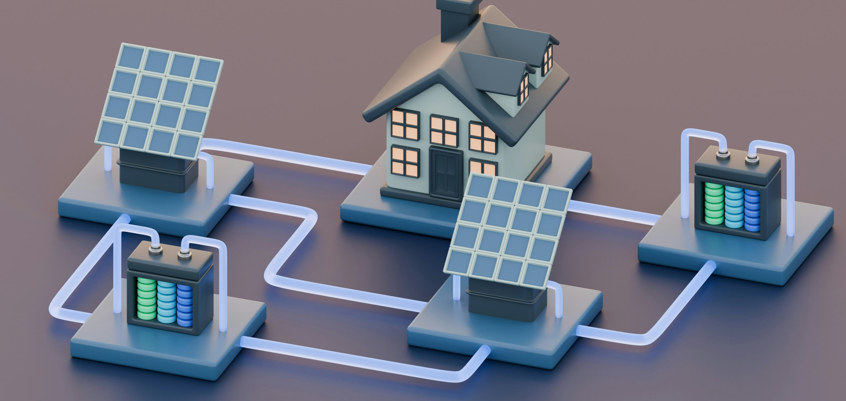
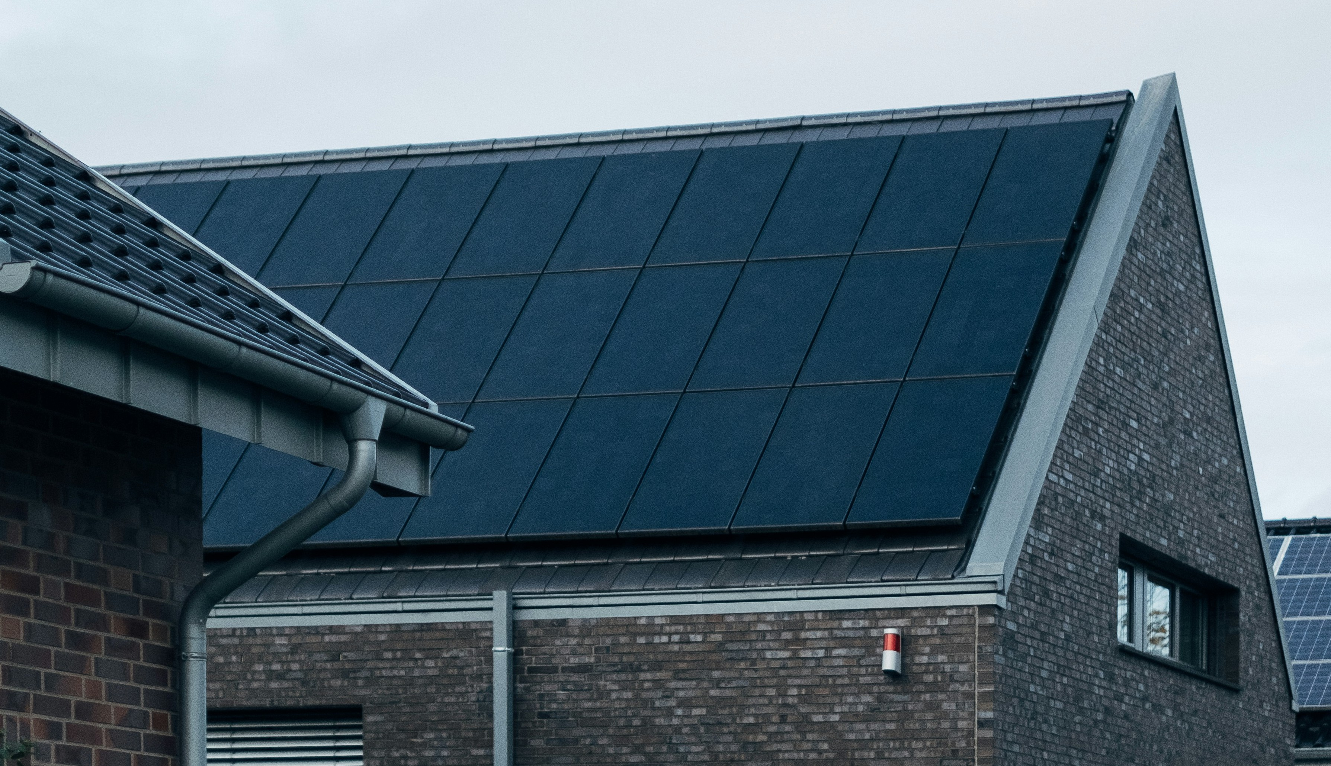
Case study 7

Program: Various state programs have implemented processes to remove accessibility barriers.

- The Queensland Solar for Rentals program used property managers as a key channel for program delivery and communication to improve accessibility for renters. The program provided funding for energy-eﬃciency upgrades to leased rural households. It overcame the split incentive barrier for landlords by providing an incentive to property managers to actively facilitate and encourage landlords to adopt (rather than obstruct) the program [7].
- The Home Energy Support Program (HESP) in the Australian Capital Territory provides rebates to low-income households to access energy-saving upgrades. To identify and reach targeted households, HESP uses concession cards as well as partnering with community organisations, who refer households to the program and qualify them for it using a holistic assessment of needs [8].
- The former South Australian Retailer Energy Eﬃciency Scheme (REES) used concession cards only to identify low-income households. The new Retailer Energy Productivity Scheme (REPS) has expanded the criteria to include a residential premises in which a person resides who:
- Has a residential tenancy agreement with the landlord of the premises and the rent for the
premises is $400 or less per week; or
- Is actively participating in an energy retailer hardship program; or
- Is actively participating in an energy retailer’s payment plan (oﬀered and applied as per s. 50 of the National Energy Retail Law); or
- Has received a referral from a registered member of the South Australian Financial Counsellors Association.

Energy Equity Work Program – Phase 3

GEER Consortium | Better Practice Guide Towards Energy Equity GEER
Australia


7. MEASURE, collect and analyse data to support program implementation, continuous improvement and evaluation
Now that you know the ultimate policy outcomes your program aims to achieve (having documented your program logic and theory of change under Principle 1), identify the key indicators of success and the datasets you would need to assess these indicators. You should identify these as early as possible in the design of your program. This will enable you to design and implement a data monitoring and collection plan and evaluation plan that speciﬁes how each indicator will be assessed and what data will be required. Energy related initiatives have advantages over many areas of public policy in their ability to require and access precisely metered data (smart or interval) that give granular insights into energy, cost and climate program impacts. Health and comfort can also be relatively accurately measured through temperature, humidity and air quality monitoring.

Why this is important
If you do not design your evaluation approach early, you risk not being able to credibly evaluate the success of your program, which may lead to its dissolution. A data monitoring and collection plan and an evaluation plan need to be developed early in the program design phase to identify and resolve data constraints. Contractual arrangements may be required for the ongoing collection of data and these processes can be time-consuming. Real-time data collection also allows for real-time monitoring of outcomes, enabling an iterative approach to policy implementation. In addition, monitoring activities should commence from the day of inception to ensure data is being captured accurately and that the program is not resulting in any unanticipated adverse impacts.

Considerations
  - What are the leading indicators of success for your program (e.g., immediate outcomes)?
  - What are the lagging indicators of success for your program (e.g., intermediate/ultimate outcomes)?
  - What data are required to assess these indicators?
- Are these data readily available?
- Who is responsible for collecting these data?
  - Does your evaluation plan allow for an iterative approach to policy implementation?
  - Is your evaluation approach feasible with regards to budget, timeline and staﬃng?

Suggested actions
  - Develop an evaluation plan, including drafting key evaluation questions.
- Include a process, interim and outcome evaluation.
  - Develop a data monitoring and collection plan.
  - Ensure program budget and scope include provisions for metering, data access and data analysis.
  - Ensure program participation documentation includes consent agreements to collect before and after energy data – from meters, utilities and the Australian Energy market Operator
  - Review and verify metering and data are being collected in relevant and useable formats very early into program roll-out so issues can be rectified.

[1]

References

[2]

[3]

[4]

[5]

[6]

[7]

[8]

[9]

[10]

[11]

[12]

[13]

[14]
Bedggood, R, et al, “Assessing Energy Inequity and the Distributional Eﬀects of Energy Policies,” GEER Australia
and Swinburne University of Technology, Melbourne, 2021.
Climate Choices, ACT Government, “Energy Eﬃciency Improvement Scheme,” [Online]. Available: https://www.climatechoices.act.gov.au/policy-programs/energy-eﬃciency-improvement-scheme. [Accessed 18
February 2023].
ACT Government, “Energy Eﬃciency (Cost of Living) Improvement (Priority Household Target) Determination 2021,” [Online]. Available: https://www.legislation.act.gov.au/View/di/2021-165/current/html/2021-165.html. [Accessed 18 February 2023].
Climate Choices, ACT Government, “Sustainable Household Scheme,” [Online]. Available: https://www.climatechoices.act.gov.au/policy-programs/sustainable-household-scheme. [Accessed 18 February 2023].
Sustainability Victoria, “The Victorian Healthy Homes Program: Research ﬁndings,” Victoria State Government,
August 2022. [Online]. Available:
https://assets.sustainability.vic.gov.au/susvic/Report-Energy-Victorian-Healthy-Homes-program-research.pdf.
Kearny, D and Taylor, T, Interviewees, Interview with Queensland Department of Resources representatives for the project: Assessing energy inequity and the distributional eﬀects of energy policies. [Interview].
19 August 2020.
Climate Choices, ACT Government,
“https://www.climatechoices.act.gov.au/policy-programs/home-energy-support-rebates-for-homeowners,” [Online]. Available:
https://www.climatechoices.act.gov.au/policy-programs/home-energy-support-rebates-for-homeowners.
[Accessed 8 February 2023].
Summer Hayes, D and Mahanama, R, Interviewees, Interview with NSW Department of Planning Industry and Environment representatives for the project: Assessing energy inequity and the distributional eﬀects of energy policies. [Interview]. 13 August 2020.
Humphries, E, Interviewee, Interview with an ACT Government representative for the project: Assessing energy inequity and the distributional eﬀects of energy policies. [Interview]. 24 August 2020.
Newport, S, Interviewee, Interview with a NSW Aboriginal Housing Oﬃce representative for the project: Assessing energy inequity and the distributional eﬀects of energy policies. [Interview]. 18 August 2020.
Young, J, Interviewee, Interview with NSW Energy and Water Ombudsman for the project: Assessing energy inequity and the distributional eﬀects of energy policies. [Interview]. 2 September 2020.
Utilities Commission, “Northern Territory Electricity Retail Review 2018-19,” 2020. [Online]. Available:
https://utilicom.nt.gov.au/news/2020/2018-19-northern-territory-electricity-retail-review.
Tidermann, C, Koegel, M and Hutley, N, “TENTS TO CASTLES: BUILDING ENERGY EFFICIENT, COST-SAVING AUSSIE
HOMES,” Climate Council, 2022. [Online]. Available:
https://www.climatecouncil.org.au/wp-content/uploads/2022/04/Tents-to-castles-2022-ﬁnal.pdf.
Walker, C, Maiese, T and Bria, P, Interviewees, Interview with South Australian Government representatives for the project: Assessing energy inequity and the distributional eﬀects of energy policies. [Interview]. 20 August 2020.

Adoption of the term “energy adversity” to describe this broader state could potentially avoid confusion with the NERR definition of hardship.

