# Logo for Australian Government Department of Climate Change, Energy, the Environment and WaterLogo for CSIROAn Ecological Knowledge System to support nature repair in Australia

The Ecological Knowledge System (EKS) will deliver information about biodiversity and restoration options to support the Nature Repair Market scheme. It will help market participants to design projects and assess potential biodiversity benefits, as well as help investors compare the benefits of different projects.

The *Nature Repair Act 2023* came into effect on 15 December 2023 establishing a framework for a world-first legislated, national, voluntary biodiversity market. The Nature Repair Market scheme is a government initiative that incentivises actions to restore and protect the environment. Improving access to high integrity environmental information will be key to the success of the scheme.

## What is the EKS?

The EKS will be a credible, robust, and transparent source of information and biodiversity assessment capability for the Nature Repair Market. It is a collaborative partnership between CSIRO and the Australian Government Department of Climate Change, Energy, the Environment and Water (DCCEEW). The EKS will integrate national data with regional information and expertise to support biodiversity assessment and management at local scales.

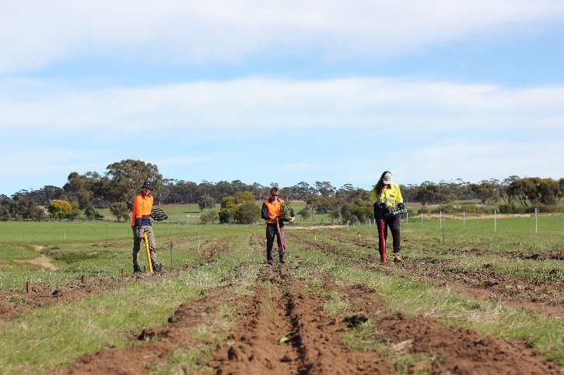

The EKS will help to ensure that market participants can access locally relevant ecological information to support the design of their biodiversity projects. Source: G. Wiehl, CSIRO.

Key components of the EKS include:

* **Ecosystem models:** State and transition models (STMs) are used to synthesise knowledge about the dynamics and restoration options for different ecosystem types. They can be used in project planning to identify current ecosystem states and condition. These may range from highly modified states with low condition, to ‘reference’ states with very high condition. STMs also describe the actions that are required to improve ecosystem condition by restoring structure, function, and composition. A range of experts were consulted to provide advice, knowledge, and data to create STMs that reflect regional ecosystem dynamics.
* **National Biodiversity Assessment System (NBAS):** The NBAS integrates information from the ecosystem models, local project data, and national scale mapping to forecast expected biodiversity benefits for a project at the local and the whole-of-system level. Whole-of-system level benefits include contribution to landscape connectivity, restoration of highly cleared vegetation types, and overall persistence of biodiversity.
* **First Nations knowledge, values and data**: CSIRO and the DCCEEW recognise the important roles of First Nations peoples1 as Traditional Owners and knowledge holders. Ongoing work is exploring how First Nations knowledge, values and data could interact appropriately with the EKS. A process is currently underway for the co-design of a framework to guide this interaction. This process recognises the importance of Indigenous data sovereignty, supporting Indigenous leadership and enabling appropriate governance systems to lead the co-design.

**___________________________________________**

This term is inclusive of Aboriginal and Torres Strait Islander peoples, Indigenous Australians, Traditional Owners and Traditional Custodians

## How will the EKS support the market?

The EKS will provide participants in the market with information about:

* the biodiversity status of a proposed project area (e.g. ecosystem type and condition)
* the management actions needed to enhance biodiversity
* the expected biodiversity benefits from implementing those management actions
* the likelihood of these biodiversity benefits being achieved over specific timeframes

DCCEEW’s Platform for Land and Nature Repair (PLANR), will act as the web interface for the NBAS. It will provide access to the ecosystem models and other data and information developed through the EKS. For market opening in 2025, EKS information and products will be available for priority ecosystem types in regions we expect to be eligible under the first nature repair method.

## Next steps for the EKS

Updates to the EKS will be released as part of a program of continuous improvement and to increase coverage across Australia. This will ensure the EKS can incorporate new data and knowledge as it becomes available. Key improvements being considered include how to better account for the effects of climate change on ecosystem restoration outcomes, how to predict the benefits of nature repair for specific species, and how best to apply the EKS in coastal ecosystems.

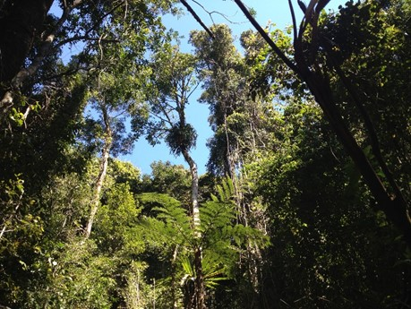

The EKS will be continuously improved and expanded to increase coverage across Australia. Source: Kate Giljohann, CSIRO.

## Further information

To learn more about the EKS and the Nature Repair Market, see the following sources:

* Project website – [An Ecological Knowledge System for the Nature Repair Market - CSIRO](https://www.csiro.au/en/research/natural-environment/natural-resources/Natural-capital-accounting/ecological-knowledge-system)
* [EKS high-level technical summary](https://doi.org/10.25919/9zx8-g268)
* [Nature Repair Market - DCCEEW](https://www.dcceew.gov.au/environment/environmental-markets/nature-repair-market)

**Acknowledgement of Country**

The CSIRO and Department of Climate Change, Energy, the Environment and Water acknowledge the Traditional Owners of Country throughout Australia and recognise their continuing connection to land, waters, and culture. We pay our respects to their Elders past and present.

For further information

Dr Helen Murphy

CSIRO Environment

[Helen.Murphy@csiro.au](mailto:Helen.Murphy@csiro.au)

[csiro.au/environment](https://csiroau-my.sharepoint.com/personal/tet004_csiro_au/Documents/csiro.au/environment)

As Australia’s national science agency,  
CSIRO is solving the greatest challenges through   
innovative science and technology.

CSIRO. Creating a better future for everyone.

**Contact us** | 1300 363 400 | [csiro.au/contact](http://www.csiro.au/contact) | [csiro.au](http://www.csiro.au)

**Department of Climate Change,   
Energy, the Environment and Water**   
[naturerepairmarket@dcceew.gov.au](mailto:naturerepairmarket@dcceew.gov.au)   
[dcceew.gov.au](https://www.dcceew.gov.au/)

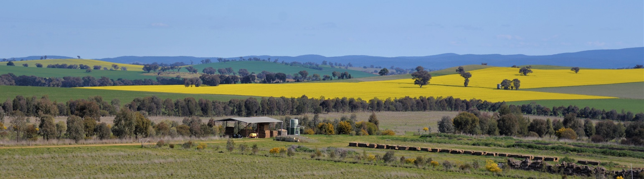

Corridor revegetation plantings near Molong, NSW. Source: Suzanne Prober, CSIRO.