
  - High-level technical summary report of the proposed approach
Helen Murphy, Simon Ferrier, Peter Fitch, Andrew Hoskins, Peci Lyons, Cath Moran, Samantha Munroe, Anna Richards, Ana Bugnot, Don Butler, Phil Duncan, Meg Good, David Lemon, John McEvoy, Geoff Hosack, Suzanne Prober, Megan Saunders, Drew Terasaki Hart and Kristen Williams
October 2024
Commonwealth Scientific and Industrial Research Organisation (CSIRO) in partnership with the Australian Government Department of Climate Change, Energy, the Environment and Water (DCCEEW)
The Ecological Knowledge System (EKS) for the Nature Repair Market

The Ecological Knowledge System for the Nature Repair Market is funded by the Department of Climate Change, Energy, the Environment and Water (DCCEEW). The work is being undertaken through a partnership between the CSIRO and DCCEEW.
Citation
Murphy HT, Ferrier S, Fitch P, Hoskins A, Lyons P, Moran C, Munroe SEM, Richards AE, Bugnot A, Butler D, Duncan P, Good MK, Hosack G, Lemon D, McEvoy J, Prober SM, Saunders MI, Terasaki Hart D and Williams KJ (2024) The Ecological Knowledge System for the Nature Repair Market. High-level technical summary of the proposed approach. CSIRO, in partnership with the Australian Government Department of Climate Change, Energy, the Environment and Water, Australia. https://doi.org/10.25919/9zx8-g268
Affiliation is CSIRO except for:
- Butler D (Australian National University)
- Duncan P (University of Canberra)
- Good M (Good Ecology)
- Moran C (Cath Moran Ecological)
Copyright
© Commonwealth of Australia 2024.
Ownership of intellectual property rights
Unless otherwise noted, copyright (and any other intellectual property rights) in this publication is owned by the Commonwealth of Australia (referred to as the Commonwealth).
Creative Commons licence
All material in this publication is licensed under a Creative Commons Attribution 4.0 International Licence except content supplied by third parties, logos and the Commonwealth Coat of Arms. The authors request attribution as follows: include the citation as shown above, plus the following copyright notice © Commonwealth of Australia 2024.
Inquiries about the licence and any use of this document should be emailed to copyright@dcceew.gov.au.


Disclaimer
The Australian Government acting through the Department of Climate Change, Energy, the Environment and Water and CSIRO have exercised due care and skill in preparing and compiling the information and data in this publication. While reasonable efforts have been made to ensure that the contents of this publication are factually correct, the Commonwealth and CSIRO do not accept responsibility for the accuracy or completeness of its contents. It does not constitute legal or other professional advice. Notwithstanding, the Department of Climate Change, Energy, the Environment and Water, its employees and advisers including CSIRO disclaim all liability, including liability for negligence and for any loss, damage, injury, expense or cost incurred by any person as a result of accessing, using or relying on any of the information or data in this publication to the maximum extent permitted by law. You should seek legal or other professional advice in relation to your specific circumstances.
Acknowledgement of Country
We acknowledge the Traditional Owners of Country throughout Australia and recognise their continuing connection to land, waters and culture. We pay our respects to their Elders past and present.
Credits
Cover photo: 32 year old woodland revegetation near Toogong NSW. Source: Suzanne Prober, CSIRO

Contents
Figures iv
Tables iv
Acknowledgements v
Glossary vi
Acronyms vii
1 Context 1
1.1 EKS purpose 1
1.2 Scope of the EKS 2
1.3 EKS governance framework 5
1.4 First Nations knowledge, values and data 6
2 Ecosystem models 7
2.1 Purpose 7
2.2 Classifying ecosystem states 7
2.3 Aligning ecosystem states with condition 9
2.4 Describing and quantifying transitions between states 12
2.5 Expert elicitation of STMs 12
2.6 Coverage of state and transition models 14
2.7 Next steps 15
3 National Biodiversity Assessment System (NBAS) 16
3.1 Purpose 16
3.2 Conceptual framework 16
3.3 Operational implementation 17
3.4 Implementing the NBAS for market opening 20
3.5 NBAS next steps 23
4 Key data inputs 24
4.1 Data Assessment Framework 24
4.2 National Vegetation Information System (NVIS) 25
4.3 Habitat Condition Assessment System (HCAS) 26
4.4 National ecosystem accounts 26
References 29

Figures
Figure 1 How information is expected to flow from the EKS through the online planning tool PLANR to project proponents, and then through the CER to the register, certificate and buyers. 3
Figure 2 An example of a proposed project area (white dotted line) and activity areas (coloured shapes 1 and 2) that could be identified in PLANR as part of planning a biodiversity project. 4
Figure 3 Definitions of the core principles of the Ecological Knowledge System (EKS) and examples of how they are incorporated into the procedures specific to the National Biodiversity Assessment System (NBAS) and state and transition models (STMs). 6
Figure 4 AusEcoModels archetype models are grouped in 14 umbrella classes 8
Figure 5 Template of reference and modified states in forest and woodland ecosystems based on the VAST classes. ‘Replaced – ad’ refers to the ‘Replaced- adventive’ class in VAST, ‘Replaced – man’ refers to the ‘Replaced – managed’ class in VAST. ‘under’ refers to ‘understorey’. 10
Figure 6 Draft graphic representation of the state and transition model (STM) developed for rainforest and vine thicket ecosystems in the Burnett Mary region, Queensland. Currently in peer review. 11
Figure 7 Process diagram of the expert elicitation method - modified from Good et al. (2024). 13
Figure 8 Proposed STM model coverage in ecosystems (Major Vegetation Groups) across the proposed eligible method area. 15
Figure 9 Conceptual approach to using the NBAS modelling of biodiversity persistence at system level as a foundation for (a) assessing the expected biodiversity benefit of an action within a given project area, (b) spatial prioritisation and (c) evaluating the net cumulative outcome achieved by actions implemented within multiple project areas. 18
Figure 10 A proposed high level workflow for the initial version of the NBAS at market opening. Further information about the workflow associated with the circled numbers is given on the following page. 21
Figure 11 Summary of HCAS model workflow structure 28

Tables
Table 1 VAST classes, VAST narrative for each class based on regenerative capacity (Thackway and Lesslie 2006) and condition range for each class based on HCAS condition scores with 1.0 for an ecosystem that has integrity and a score of 0 for an ecosystem that is completely extinguished. 9
Table 2 Data Assessment Framework key concepts 25

Acknowledgements
The Ecological Knowledge System (EKS) has been funded by the Australian Government Department of Climate Change, Energy, the Environment and Water (DCCEEW) to support the Nature Repair Market scheme. CSIRO is leading development of the EKS in partnership with DCCEEW. We thank our DCCEEW colleagues Ian Warren, Elizabeth Edye, Dayani Gunawardana, Kate Sargeant and Laura Perrott for their guidance and feedback on this work.
We are grateful to the regional experts who generously contributed their time and knowledge to develop the ecosystem models. The elicitation of expert knowledge of ecosystem states and transitions was approved by CSIRO’s Social Science Human Research Ethics Committee in accordance with the National Statement on Ethical Conduct in Human Research (2007): ethics approval 049/24.
We also thank members of three advisory groups, convened by DCCEEW, for their feedback on earlier documentation of the approach: the Biodiversity Assessment Expert Reference Group, the State and Territory Working Group (measuring and tracking biodiversity) and the EKS Project Board and Working Group.
We gratefully acknowledge Karel Mokany and Dan Rosauer for their review of an earlier version of this document which improved this final version.

Glossary
Term | Definition
Archetype model | Archetype models in the AusEcoModels framework (Richards et al. 2020) describe the endogenous disturbance (reference) dynamics and ecosystem expressions that characterise systems with ecosystem integrity. These dynamics include those driven by Indigenous land management. The models provide a conceptual guide for description of reference and modified states in state and transition models.
Biodiversity persistence | Biodiversity persistence refers to the continued survival and health of species, ecosystems, or other biodiversity elements over time. In ecological terms, it is a measure of the likelihood that the elements making up biodiversity (e.g. species) will continue to exist without significant loss or decline, both now and into the foreseeable future.
Causal chain | All management interventions, abiotic conditions and biotic processes required for the transition from one ecosystem state to another. Unique causal chains are developed for each plausible transition between two ecosystem states.
Drivers | Any abiotic, biotic or land and water management variables that may cause (or influence the rate of) a transition.
Ecological Knowledge System  (EKS) | The EKS is a partnership between CSIRO and the Australian Government to establish a transparent and authoritative source of information and biodiversity assessment capability for the Nature Repair Market.
Ecosystem condition | Represents the capacity of an area to provide the structures and functions necessary for the persistence of all native species naturally expected to occur in that area if it were in an intact (or reference) state and is calculated using departure from a reference state.  Ecosystem condition is a measure of ecosystem integrity which reflects the level of intactness, completeness and integration in the structure, composition and function of an ecosystem with respect to the persistence of biodiversity. Ecosystem condition scores range from 0.0 (ecosystem integrity extinguished) to a maximum of 1.0 (ecosystem integrity in reference condition). The Habitat Condition Assessment System (HCAS) is used in the state and transition models to link ecosystem states to ecosystem condition scores (see Section 4.3).
Ecosystem state | The observed ecosystem (including its structure, function and composition) at a particular point in space and time. An ‘ecosystem state’ represents a conceptual partitioning of the most common forms that an ecosystem takes across a landscape. Ecosystem states may be reference states or modified states.
Ecosystem type | An ecosystem type reflects a distinct set of abiotic and biotic components and their interactions. In the AusEcoModels Framework an ecosystem type is a unit of an ecosystem classification defined by the ecosystem characteristics (for example, facets of structure, function, composition) that characterise the reference state (archetype model) for a given scale of organisation, and defined by its discrete disturbance and recovery dynamic (Richards et al. 2020; Kay 1991).
Endogenous disturbances | A disturbance internal to an ecosystem that maintains ecological integrity and to which Australian ecosystems are adapted. They include fire, drought, floods, cyclones, storms, erosive and depositional processes, heatwaves, cold snaps, chemical intrusion and biotic outbreaks. They may be driven by anthropogenic (e.g. cultural fire management) or non-anthropogenic (climate) processes.
Exogenous disturbances | A disturbance external to an ecosystem that can trigger transitions from the reference to modified states by transforming transient disturbances into persistent disturbances (e.g. switching from macropod grazing regimes to continuous cattle grazing), introducing new disturbances that result in chronic stress on an ecosystem (e.g. habitat fragmentation from land clearing) or suppressing important disturbance events (e.g. fire suppression near urban areas) (Suding and Hobbs 2009). These disturbances can be threatening processes, resulting in loss of biological diversity and homogenisation of ecosystems or management interventions which attempt to restore elements of ecosystem integrity.
Management actions | Deliberate action undertaken by people to alter aspects of an ecosystem, often resulting in the transition from one ecosystem state to another. One or more management actions may be part of an exogenous disturbance.
Modified state | An ecosystem state that is not in reference condition due to exogenous disturbances. A modified ecosystem state can be assigned an ecosystem condition score representing its integrity relative to the reference state (i.e. ecosystem condition < 1.0).
National Biodiversity Assessment System  (NBAS) | The National Biodiversity Assessment System provides a nationally consistent approach to forecasting expected biodiversity benefits of a given project, and the cumulative benefit of a diverse array of actions that could be implemented locally within Nature Repair projects.
Reference state | The dynamic state of an ecosystem that has the highest ecosystem integrity and is in pre-1750 reference condition (ecosystem condition score of 1.0). Archetype models are used as templates for the description of a reference state for a particular ecosystem type.
State and transition models  (STMs) | Conceptual tool that describes the state of a particular ecosystem (which may vary, for example, from reference to degraded, in terms of ecosystem integrity), and the drivers or agents that cause transitions between states. Transitions between states occur as a result of the introduction of new exogenous disturbance regimes, the transformation of transient disturbances into persistent disturbances, and/or changes to reference disturbance regimes (resulting in a shift to an exogenous disturbance), altering environmental conditions and resources available to constituent species. These changes may be directly caused by recent anthropogenic modification of local habitats (e.g. vegetation thinning or clearing, stock grazing, introduction of native or alien invasive species), or may result from recent and rapid climate change (i.e. an indirect anthropogenic driver). STMs can be produced at varying levels of resolution e.g. NRM region or bioregion, down to property-scale.
Threats | Process(s) or activity(s) that impacts the survival, abundance or evolutionary development of a native species or condition of an ecosystem.
Transitions | Describe the pathway through which an ecosystem may pass from one state to another. Transitions are difficult to reverse without application of intensive management, an extreme event or long timeframe, and are distinguished from pathways between different ecosystem expressions within a state, which often result from slow-acting but incremental successional processes (Rumpff et al. 2011).  A transition timeframe is the time over which a transition between ecosystem states could occur and, given this timeframe, may include an estimate of the likelihood of that transition.
Umbrella class | Group of archetype models in the AusEcoModels Framework (Richards et al. 2020) that is compatible with Major Vegetation Groups in the National Vegetation Information System (NVIS) (NVIS Technical Working Group 2017).

Acronyms
Acronym | Definition
BAI | Biodiversity Assessment Instrument
CER | Clean Energy Regulator
EKS | Ecological Knowledge System
HCAS | Habitat Condition Assessment System
NBAS | National Biodiversity Assessment System
NVIS | National Vegetation Information System
PLANR | Platform for Land and Nature Repair
STM | State and Transition Model
VAST | Vegetation Assets, States and Transitions framework

Executive Summary
The Ecological Knowledge System (EKS) is a partnership between CSIRO and the Department of Climate Change, Energy, the Environment and Water (DCCEEW) to establish a transparent and authoritative source of information and biodiversity assessment capability for the Nature Repair Market. Trust in environmental information will be essential for the integrity and success of the market.
The information delivered by the EKS will support market integrity and reduce barriers to participation by making it easier for market participants to access robust and regionally relevant information. This information will support project planning and help participants compare the potential biodiversity benefits of different projects. It will also assist the Clean Energy Regulator (CER) in their functions as the market regulator.
The EKS has two main technical components that are described in this report:
- ecosystem models (i.e. state and transition models), and
- the National Biodiversity Assessment System (NBAS).
State and transition models (STMs) are used in the EKS to synthesise knowledge about the dynamics, management, and restoration of ecosystems from a diverse range of sources including from regional experts (e.g. on-ground land managers, ecologists). STMs describe ecosystem states which may vary from reference to degraded in terms of ecosystem condition. They also describe the management actions that are required to improve ecosystem integrity given a starting ecosystem state and condition.
The NBAS provides a nationally consistent approach to forecasting the expected biodiversity benefits of a given project. It integrates information from the STMs, national spatial datasets and on-ground project data. The NBAS assesses and reports the potential change in biodiversity persistence that a proposed project may achieve. This change in biodiversity persistence is assessed as a function of the change in ecosystem condition expected at project level, the contribution of the project to enhancing connectivity across the broader landscape, and the conservation significance of the ecosystem type.
For market opening in 2025, the EKS will be focused on providing ecosystem information and functions that support the market's first method. The EKS will be gradually expanded to increase coverage across Australia and updated as needed to support additional methods. Updated versions of the EKS will be periodically released as part of a structured program of continuous improvement. Key areas of future development include considering how to incorporate information about likely futures under climate change, and how the approaches used in the EKS can be adapted and applied in coastal and marine systems. CSIRO and DCCEEW are also continuing work with First Nations people to co-design a framework that appropriately considers the interaction of Indigenous knowledge and values with the EKS.
An EKS governance framework establishes clear principles and policies to guide the implementation of the EKS and the process of continuous improvement.

Context
The Nature Repair Act 2023 (the Act) came into effect on 15 December 2023 establishing a framework for a world-first legislated, national, voluntary biodiversity market. The Act provides legislated rules to support transparency and integrity and to foster collaborative efforts to address environmental decline. Work is underway for the market to open in 2025. This includes work to develop biodiversity assessment instruments and methods. Methods set out how Nature Repair Market projects are to be carried out. Biodiversity assessment instruments (BAIs) support consistency in how projects describe biodiversity improvements.
To support the market, CSIRO was engaged by DCCEEW to lead development of the Ecological Knowledge System (EKS).
The EKS aims to:
- establish a trusted, transparent and authoritative source of information and biodiversity assessment capability for the Nature Repair Market, and
- support market integrity and reduce barriers to participation by making it easier for market participants to access the ecological information needed to inform nature repair projects that deliver genuine biodiversity benefits.
The EKS has been designed to support a range of potential methods and to enable continuous improvement as the market scheme evolves, knowledge improves and technology changes over time. The initial design and pilot phase is nearing completion and has involved testing in two regions: the Burnett-Mary NRM region in Queensland and the North Central Catchment Management Authority region in Victoria. National implementation will occur over several years building on the learnings from the pilot phase and responding to the requirements of the market. For market opening, the EKS will be adapted, if needed, to support the first Nature Repair Market method, when it is finalised.
The intent of this report is to provide sufficient technical information to allow interested parties to understand and provide feedback on the proposed approach to the EKS and how it supports implementation of methods and of the biodiversity assessment instrument. A report with the full technical details, data inputs, workflows and outputs will be released in the future.

EKS purpose
The information delivered by the EKS is designed to:
- help proponents design projects that meet scheme requirements (e.g. requirements of the relevant method) and assess the potential benefits of their project for biodiversity,
- help buyers compare and have confidence in the benefits of the projects,
- assist the Clean Energy Regulator (CER) in their functions as the regulator (e.g. assessment of project applications), and
- inform development of methods and BAIs.
The EKS will provide scheme users and the CER with information about:
- the status of biodiversity in a proposed project area (e.g. desktop mapping of ecosystem type and ecosystem condition that can be subsequently verified with data from a site visit),
- what management actions are needed to enhance biodiversity (given the ecosystem type and starting condition in a project area),
- the biodiversity benefit that may be expected from implementing management actions, and
- the likelihood of these biodiversity benefits being achieved over specific timeframes.
In some cases, use of the EKS may be required by a method. For example, the detailed outline of the proposed Replanting Native Forest and Woodland Ecosystems method specifies that the National Biodiversity Assessment System (NBAS), a key component of the EKS, must be used to forecast the expected benefits of a project for biodiversity. In other cases, proponents may choose to use the EKS as one source of evidence and guidance to plan projects.

Scope of the EKS
The EKS has two main technical components that are summarised in this report:
- ecosystem models (i.e. state and transition models, STMs), and
- the National Biodiversity Assessment System (NBAS).
Other work is considering how the EKS can be improved and expanded following market opening and includes:
- a co-designed framework for interaction of the EKS with First Nations knowledge, values and data (see Section 1.4),
- how to incorporate information about likely futures for biodiversity and ecosystems under climate change, and
- if the approaches used in the EKS, currently designed for terrestrial ecosystems, can be adapted and applied in coastal and marine systems.
At market opening, we expect EKS information to be available for priority ecosystem types in regions proposed to be eligible under the first method. That is, eligible regions currently proposed in the detailed outline of the proposed Replanting Native Forest and Woodland Ecosystems method. Proponents and the CER will be able to access the EKS through the Platform for Land and Nature Repair (PLANR) tool (see Figure 1 and Box 1).

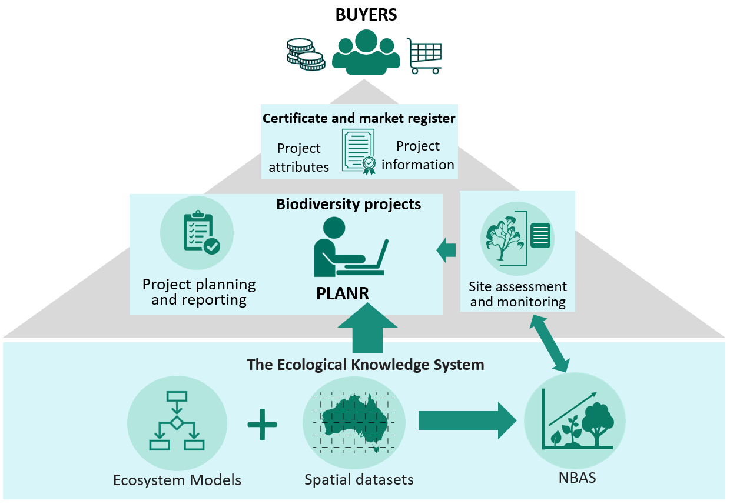
Figure 1 How information is expected to flow from the EKS through the online planning tool PLANR to project proponents, and then through the CER to the register, certificate and buyers.
NBAS = National Biodiversity Assessment System
After market opening, it is intended that:
- The EKS will be gradually expanded to increase coverage across Australia.
- Updated versions of the EKS will be periodically released as part of a program of continuous improvement, supported by a governance framework (Section 1.3). This will be required to ensure the EKS can support additional methods, respond to evaluation and feedback and incorporate new data and knowledge as it becomes available.
- Improvements to the information infrastructure will be considered and designed to be adaptable and capable of handling increasing data volumes and complexity as the market evolves and new methods are developed.

Box 1. Platform for Land and Nature Repair (PLANR – https://planr.gov.au/)
DCCEEW’s Platform for Land and Nature Repair (PLANR) serves as a gateway for landholders to access biodiversity and carbon service markets. It provides tools to plan, apply, and cost projects effectively, along with assessments of current assets and future biodiversity benefits, with a focus on Nature Repair Market projects. PLANR also facilitates connections between buyers and sellers, helping market participants engage more easily in environmental markets and generate income from their conservation efforts.
When the market opens, PLANR will provide the web interface for the National Biodiversity Assessment System (NBAS) and provide access to the ecosystem models and other data developed through the Ecological Knowledge System (EKS).
The integration of EKS products with PLANR will allow users to produce paddock-level insights on current biodiversity assets and forecast biodiversity benefits from proposed biodiversity projects (Figure 2). This function will initially focus on project types eligible under the first Nature Repair Market method.
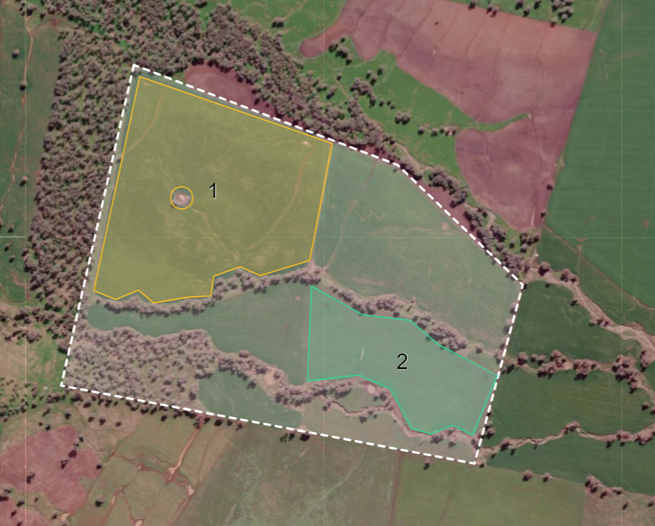
Figure 2 An example of a proposed project area (white dotted line) and activity areas (coloured shapes 1 and 2) that could be identified in PLANR as part of planning a biodiversity project.

EKS governance framework
A trusted, transparent and authoritative EKS requires a robust governance framework. The EKS governance framework establishes clear principles and policies to guide the implementation of the EKS and ongoing improvements. The governance framework is intended to be adaptable to market changes, scientific or technological advancements, changing governance structures, and to changes in the way that the EKS is delivered over time.
The EKS governance framework is founded on the core principles of transparency, integrity, reliability, consistency, and sustainability; these principles are implemented directly in a range of ways (examples in Figure 3).
The details of processes and procedures that have been established at market commencement to ensure compliance with governance principles and policies will be included in the technical documentation for the key EKS components. These governance procedures provide a template for future operations including contributions to the EKS by third parties. The governance framework will also respond to the needs of the First Nations framework once it is developed (see Section 1.4).
The EKS governance framework will:
- continue to develop and refine a range of policies and procedures that will ensure reliable supply chains of data and information, transparent probity management, and mechanisms for ongoing updates and improvements
- define the roles and responsibilities of core governance bodies in overseeing the EKS functions, including those providing advice and recommendations and those ultimately responsible and accountable for its proper operation (e.g. Nature Repair Committee, Clean Energy Regulator, DCCEEW)
- provide general guidance regarding key ethical considerations, including policies for data collection and sharing
- outline best practices for the review and incorporation of third-party contributions (e.g., state and transition models contributed by third-parties) to the EKS
- identify limitations of information generated by the EKS and the resulting risks for market operations, such as output uncertainty, reproducibility, and inter-operability.
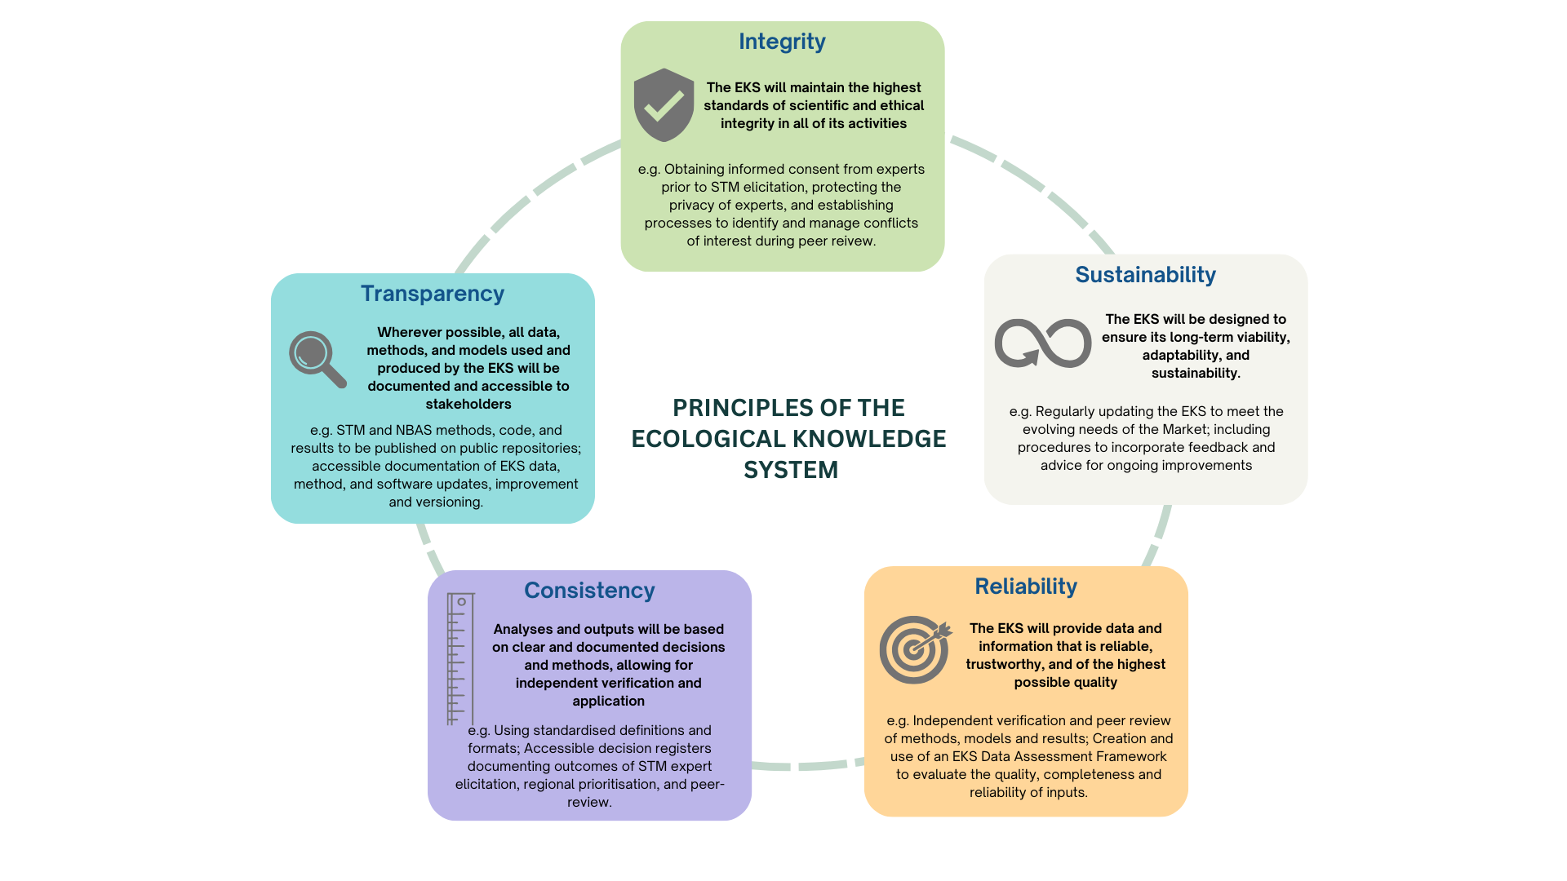
Figure 3 Definitions of the core principles of the Ecological Knowledge System (EKS) and examples of how they are incorporated into the procedures specific to the National Biodiversity Assessment System (NBAS) and state and transition models (STMs).

First Nations knowledge, values and data
One of the biodiversity integrity standards in the Act sets out a requirement for consistency with relevant Indigenous knowledge and values. In line with this, ongoing work is exploring how Indigenous knowledge and values could appropriately interact with the EKS. A process is currently underway for the co-design of a framework to guide this interaction. This process recognises the importance of Indigenous data sovereignty, supporting Indigenous leadership and enabling appropriate governance systems to lead the co-design. Funding and resourcing have been committed to support an Indigenous advisory group to lead the co-design process which is underpinned by a commitment to the principles of free, prior and informed consent at each stage of engagement and communication.
The timeframe for delivery of the framework is mid-2025. It is anticipated that the outputs of the co-design process will guide subsequent activities regarding the interaction of Indigenous ecological knowledge and data with the Nature Repair Market scheme.

Ecosystem models

Purpose
Nature repair, including the restoration or reconstruction of ecosystems and the reversal or slowing of biodiversity loss, requires a framework with measurable and time-bound goals and science-backed approaches to achieve goals. Understanding and describing the current ecosystem state and condition and the steps required to restore structure, function, and composition towards a target state is key to the development of a project plan that can deliver genuine biodiversity benefits (Standards Reference Group SERA 2016).
State and transition models (STMs) are used in the EKS to synthesise knowledge of the dynamics, management, and restoration of ecosystems. STMs are conceptual tools that describe the state of a particular ecosystem (which may vary, for example, from reference to degraded, in terms of ecosystem integrity), and the drivers or agents that cause transitions between states (Westoby et al. 1989; Stringham et al. 2003; Bestelmeyer et al. 2017).
STMs are a useful and intuitive modelling framework because they account for the tendency of ecosystems to respond to drivers differently depending on the starting ecosystem state. These state-dependent trajectories are generally already, either unconsciously or consciously, factored into management decisions and recovery planning and so the process of explicitly collating these predictions can help in the implementation of adaptive management.
STMs are able to capture regionally-relevant expert knowledge in a consistent way as well as being able to synthesise diverse forms of other data and information, including observational information, empirical datasets from monitoring, and remote sensing products. This synthesis of multiple lines of evidence can provide greater confidence in outcomes while also capturing uncertainty where evidence is lacking. This is advantageous in areas where data availability is sparse or where novel and relatively untested restoration approaches might be applied.

Classifying ecosystem states
To develop STMs in a consistent and reproducible way, a hierarchical approach is needed (Good et al. 2024). This allows for the grouping of similar ecosystems which can be described according to their shared dynamics and responses to disturbance. The Australian Ecosystem Models (AusEcoModels) Framework (Richards et al. 2020) is a nationally consistent framework from which management-focused STMs can be developed. The AusEcoModels Framework contains conceptual models (termed ‘archetype’ models) describing the reference ecosystem dynamics of 14 broad terrestrial ecosystem types (umbrella classes) across Australia (Figure 4). The 46 archetype models are based on a synthesis of ecological science and land management expertise (for examples see Prober et al. (2023a); Prober et al. (2023b); Roxburgh et al. (2023)).
Ecosystem dynamics within archetype models are driven by endogenous disturbances that may be a result of anthropogenic (e.g. cultural fire management) or non-anthropogenic processes to which Australian ecosystems have adapted over evolutionary timeframes. Several archetype models within each umbrella class describe the variable characteristics and drivers of change in ecosystems that display ecological integrity. The 14 umbrella classes can be aligned with different vegetation (e.g. the National Vegetation Information System (NVIS, see Section 4.2; NVIS Technical Working Group (2017)) and ecosystem classification schemes (e.g. Keith et al. 2022) allowing for comparisons with state, national and global approaches to ecosystem and vegetation classification.
Figure 4 AusEcoModels archetype models are grouped in 14 umbrella classes
The naming of these classes has been derived from the National Vegetation Information System (NVIS). Within each umbrella class, ecosystems are grouped by similarities in their disturbance and biomass recovery dynamics, regardless of their climatic and edaphic distributions.
The development of management-focused STMs involves first describing a set of common ‘modified states’ (in terms of how they differ from the reference state). This involves using information from the national set of archetype models in the AusEcoModels Framework to describe a dynamic reference state for a relevant ecosystem type at a regional scale. Importantly, the archetype models provide information on ecosystem responses to disturbances to which ecosystems have adapted over evolutionary timeframes. Ecosystem responses to contemporary exogenous disturbances (e.g. livestock grazing), often mimic the archetype, and thus these models provide a template from which information about ecosystem responses to new disturbances (including restoration activities) can be surmised.
It is important to note that the reference state in STMs developed for the EKS may not be a target state for restoration and, in fact, may not be achievable in the short-medium term and given rapid climate change (Higgs et al. 2014; Jackson and Hobbs 2009). Considering impacts of climate change and other irreversible changes to a site, an ‘adjusted reference’ may be appropriate in some circumstances. An adjusted reference ecosystem must still represent the condition of an ecosystem that can maintain the highest level of ecological integrity, stability and resilience. For example, it may represent a different native ecosystem or native system analogue with ecological integrity that is more appropriate given any irreversible changes to the site or other risk factors.

Aligning ecosystem states with condition
In order to link ecosystem states described in the STMs to an index of ecosystem condition (required for estimating biodiversity benefits in the NBAS), we aligned ecosystem state descriptions with the Vegetation Assets, States, and Transitions (VAST) narrative framework (Table 1, Thackway and Lesslie (2006, 2008)). In a previous study, expert elicitation was used to assign condition scores based on the Habitat Condition Assessment System (HCAS – see Section 4.3) to each VAST category (Williams et al. 2023; Giljohann et al. 2024).
Table 1 VAST classes, VAST narrative for each class based on regenerative capacity (Thackway and Lesslie 2006) and condition range for each class based on HCAS condition scores with 1.0 for an ecosystem that has integrity and a score of 0 for an ecosystem that is completely extinguished.
Taken from Giljohann et al. (2024)
VAST CATEGORY | VAST DESCRIPTION OF CURRENT REGENERATIVE CAPACITY | Condition score range
Class 0: Residual Bare | Natural regenerative capacity unmodified— ephemerals and lower plants | NA*
Class I: Residual | Natural regenerative capacity unmodified | 0.75–1.0
Class II: Modified | Natural regeneration tolerates or endures under past and or current land management practices | 0.51–0.75
Class III: Transformed | Natural regenerative capacity limited or at risk under past and or current land use or land management practices. Rehabilitation and restoration possible through modified land management practice | 0.30–0.51
Class IV: Replaced - Adventive | Regeneration of native vegetation community has been suppressed by ongoing disturbances of the natural regenerative capacity; limited potential for regeneration without active intervention | 0.16–0.30
Class V: Replaced - Managed | Regeneration of native vegetation community lost or suppressed by intensive land management; limited potential for regeneration without active intervention | 0.07–0.16
Class VI: Removed | Native vegetation community removed | 0.0–0.07
*Class not used in STM template; NA = not applicable
The modified states template (Figure 5) includes all combinations of overstorey and understorey modification, nested within 5 of the 6 VAST classes. Experts use the template as a starting point for describing which modified states occur most commonly in the region of interest. An ecosystem-specific description of each modified state is then elicited. Once each modified ecosystem state in the focus region has been assigned to a corresponding VAST class, it adopts the central condition score (or range) of that class (Table 1). An example of the elicited modified states and transitions for Rainforest and Vine Thicket ecosystems in the Burnett-Mary region in Queensland is shown in Figure 6.
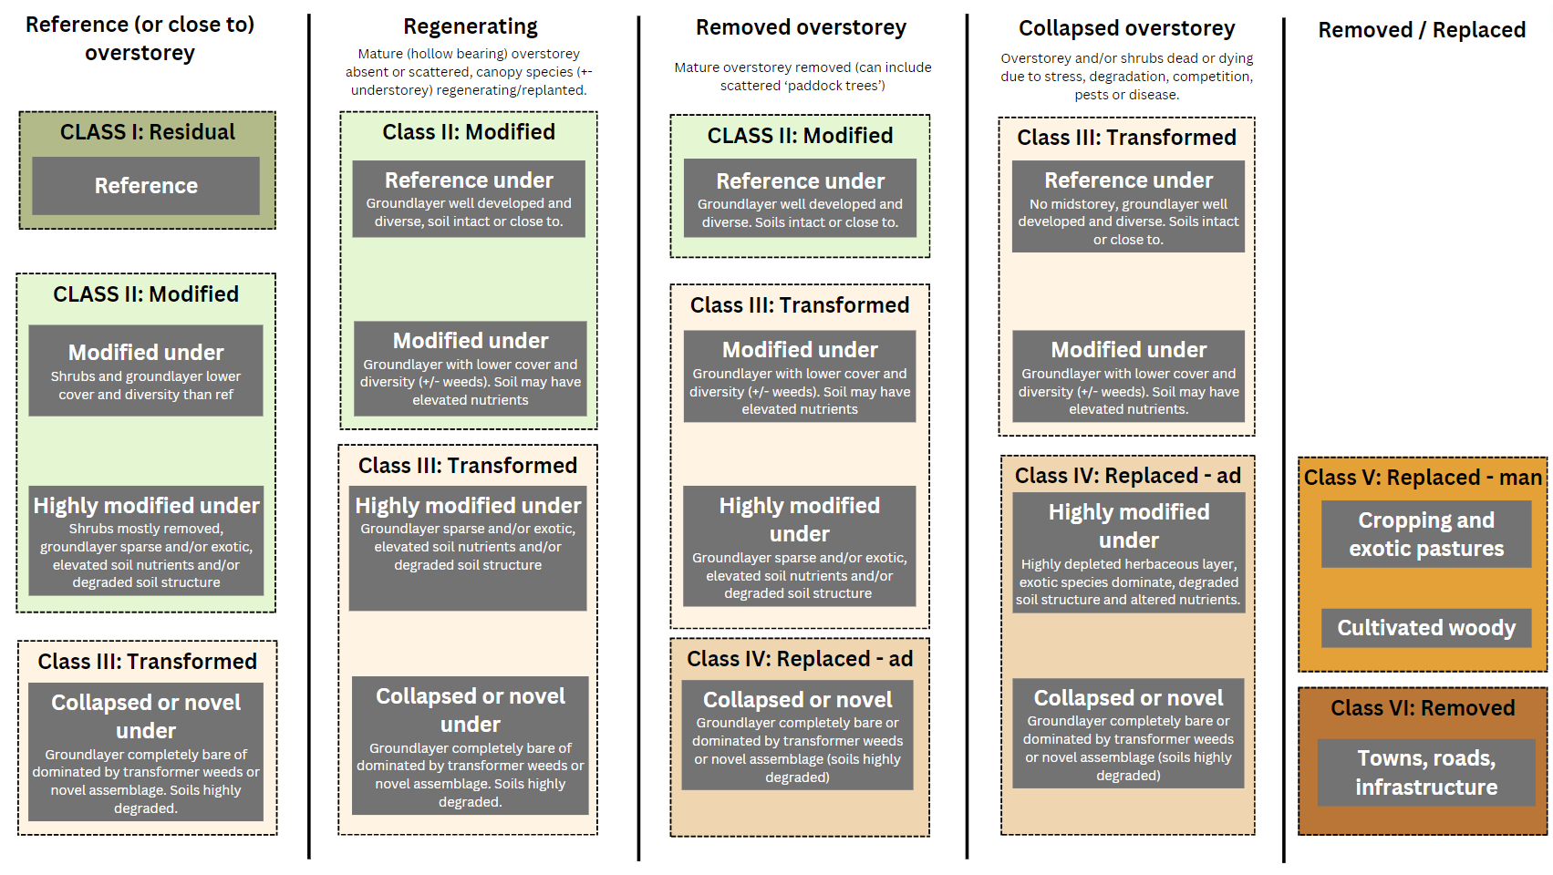
Figure 5 Template of reference and modified states in forest and woodland ecosystems based on the VAST classes. ‘Replaced – ad’ refers to the ‘Replaced- adventive’ class in VAST, ‘Replaced – man’ refers to the ‘Replaced – managed’ class in VAST. ‘under’ refers to ‘understorey’.
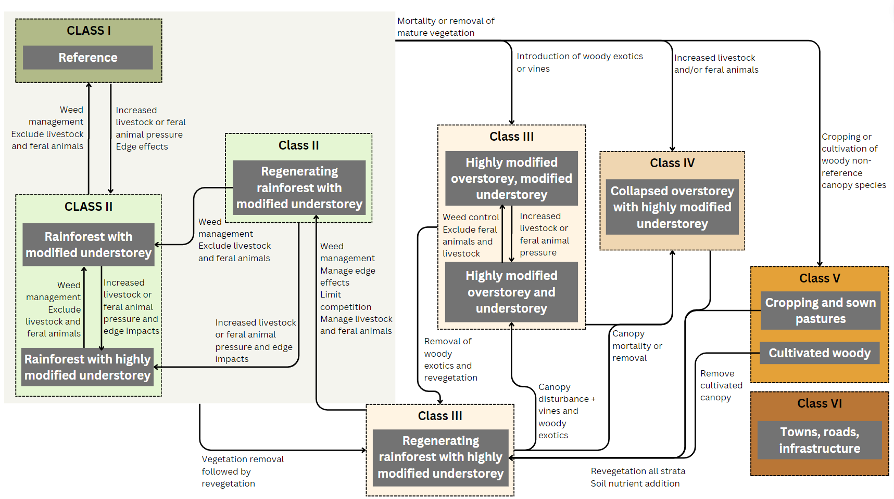
Figure 6 Draft graphic representation of the state and transition model (STM) developed for rainforest and vine thicket ecosystems in the Burnett Mary region, Queensland. Currently in peer review.

Describing and quantifying transitions between states
Once modified and reference ecosystem states have been described and agreed upon, transitions between pairs of states are comprehensively assessed and described by first determining which direct transitions are plausible and then creating unique causal chains that describe:
- the drivers of transition, including management interventions, biotic processes and abiotic conditions required for the transition to occur,
- measurable indicators of a transition are also noted and include the expected direction of change (for example ‘increased density of eucalypt saplings’),
- specific hazards that might slow or prevent the transition or specific conditions required (e.g. above average rainfall), including the consideration of recent climate trends, and
- the probability of transition (given drivers and hazards) at different points in time.

Expert elicitation of STMs
The compilation of STMs requires a transparent and reproducible method for eliciting knowledge from a diversity of experts. Expert elicitation is used to build sets of consistent and structured estimates or hypotheses about how ecosystems will respond to drivers or management interventions from different starting ecosystem states.
The expert elicitation method for STMs in the EKS includes several standardised typologies and templates which support the collection and synthesis of consistent and repeatable knowledge, including:
- classification, naming and description of ecosystem types, reference states and modified states, using archetype model templates from the AusEcoModels Framework (Richards et al. 2020),
- naming, classification and quantification of drivers of transitions including threats and management actions,
- standardised descriptions of ecosystem attributes related to structure, function, composition, abiotic and landscape factors,
- guidelines for selecting experts and templates for workshop agendas, the documentation and synthesis of elicited information, participant information sheets, and workshop evaluation, and
- guidelines for validation of information, peer review and governance processes.
The full STM expert elicitation method will be published prior to market opening.
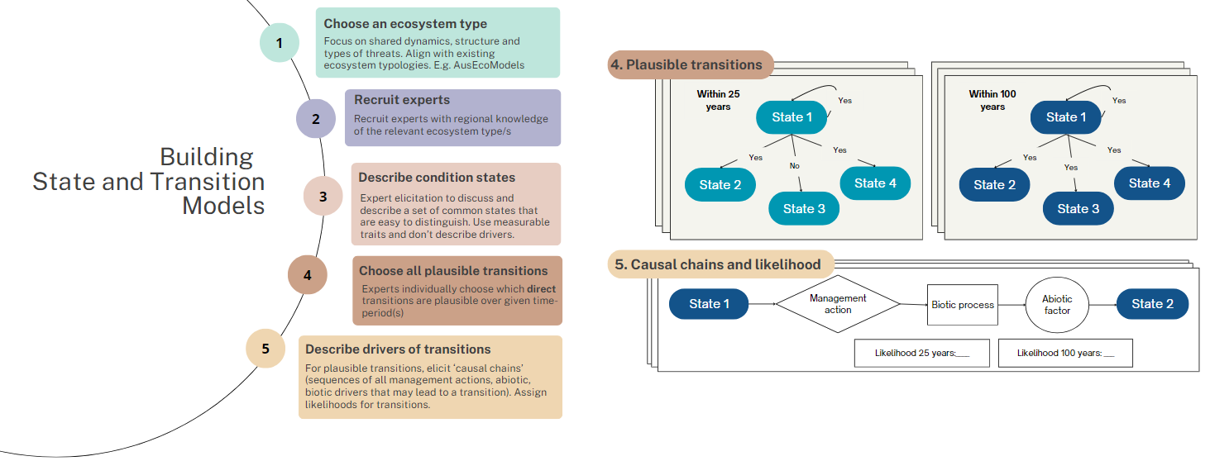
Figure 7 Process diagram of the expert elicitation method - modified from Good et al. (2024).

Coverage of state and transition models
At market commencement, STMs will be available for priority ecosystem types in regions likely to be eligible under the first method. However, the resolution of the models will differ across the eligible area. We have classified STM coverage into three categories (the proposed distribution of these is shown in Figure 8):
- Regional model – a regionally specific STM has been developed through the EKS regional expert elicitation process and can be applied in this area.
- Nationally-resolved model – the STM in this area is not specific to this region, that is, regional experts in this area have not had input into this model. It has been derived from STMs developed by experts in other regions and adapted (if needed) to be applied across the eligible area.
- Generic model – an STM for this ecosystem is not available. A ‘generic’ STM model has been developed, based on likely eligible starting and target ecosystem states for the proposed Replanting native forests and woodland ecosystems method. This model has been derived from a review of the nationally-resolved models for similar ecosystem types (e.g. woodland or forest) and common descriptions of starting and target states, condition scores and transition times. The coverage of the generic models is a relatively small proportion of the proposed eligible method area.
Where regional STMs are not available, greater emphasis or effort may need to be placed on on-ground assessment and verification of the ecosystem state, ecosystem condition and the parameters in the transition causal chains.
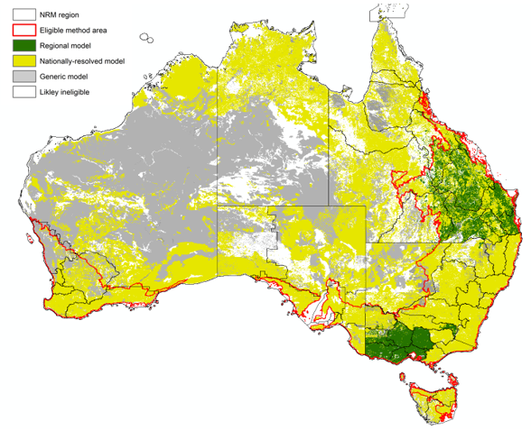
Figure 8 Proposed STM model coverage in ecosystems (Major Vegetation Groups) across the proposed eligible method area.

Next steps
Regional STMs will be progressively elicited in the EKS to increase coverage across Australia. These will replace the nationally resolved and generic STMs and be incorporated in future updates. Future updates may also include refinements to regional STMs in response to new knowledge, evidence, or other feedback.
In addition, over the next year, elicitation and scenario-based approaches to incorporating recent and future climate change impacts in STMs will be developed and trialled. Climate change is likely to be incorporated into the STMs through (a) climate-adjusted ecosystem state descriptions, (b) incorporation of climate change considerations into transition probabilities, and (c) a climate adjusted-reference (where justified) for locations where the reference ecosystem will change dramatically (e.g. floodplain forest to dry woodland) under climate change.

National Biodiversity Assessment System (NBAS)

Purpose
The NBAS provides a nationally consistent approach to forecasting expected biodiversity benefits of a given project. It is being designed to align with and support implementation of biodiversity assessment instruments and methods.
Feedback on the conceptual framework for the NBAS was sought from a large group of experts during early 2024 and a prototype is now being developed that can be iteratively tested and improved from September 2024 onwards.
The following sections provide an overview of the conceptual framework for the NBAS and the proposed operational workflow. The workflow will be adapted to align with the first method when it is finalised.

Conceptual framework
The framework for the NBAS builds on major advances in the science and application of ‘whole-system approaches’ to biodiversity conservation assessment made over recent decades (e.g. Moilanen 2008; Ferrier and Drielsma 2010; Ferrier and Wintle 2009; Walker et al. 2012; Pollock et al. 2020). The core focus of these approaches is on assessing the collective state of biodiversity across a whole system of interest (e.g. a given region, or the entire continent). Benefits for biodiversity expected at a whole-system level can provide a consistent way to compare Nature Repair Market projects that involve different activities in different ecosystem types and in different places across Australia.
The NBAS adopts persistence of species-level biodiversity as the ‘common currency’ for assessments to be undertaken using the NBAS framework (see Box 2), which aligns with the first Object of the Nature Repair Act 2023 ‘to promote the enhancement and protection of biodiversity in native species in Australia’. This approach models the persistence of biodiversity expected across a specified spatial domain (e.g. region, state, entire country) as a function of the current state (or ‘condition’) of habitat across that domain, and changes in this condition expected to result from management actions. Biodiversity persistence is defined by the IUCN as ‘persistence of a biodiversity element means that its loss (e.g. species extinction, ecosystem collapse) or decline (e.g. of numbers of mature individuals of a species, ecosystem extent and condition) is avoided, both now and into the foreseeable future’ (IUCN 2016).
Metrics based on this concept are increasingly being employed as a common currency for assessing and expressing the present and/or expected future state of biodiversity within any given spatial domain of interest, either for particular species of interest (e.g. Di Fonzo et al. 2016; Clements et al. 2019; Marshall et al. 2021; Marshall et al. 2022) or for biodiversity more generally at both species and ecosystem levels (e.g. Walker et al. 2012; IUCN 2016; Jones et al. 2016; Brancalion et al. 2013; Prober and Smith 2009; Gardner et al. 2009; Janishevski et al. 2015; Pulla et al. 2015; Richards et al. 2023a; Richards et al. 2023b; Schmidt et al. 2023).
The NBAS offers a holistic assessment of the change in biodiversity persistence expected to result from a proposed project, while also disaggregating this overall estimate into several component parts. These include:
- local change (gain) in ecosystem condition within the project area expected to result from the actions proposed for that area,
- contribution that this local change in condition is expected to make to enhancing the connectivity of habitat across the broader landscape surrounding the project area,
- conservation significance of the ecosystem types being repaired, accounting for the rarity, and past level of depletion and degradation, of these types across their range, and
- overall contribution that actions proposed for the project area are expected to make to enhancing biodiversity persistence at a system level, combining the effects of the above three components.
The NBAS framework combines analysis and modelling undertaken at two spatial levels as per the general approach described by Ferrier and Drielsma (2010) (Figure 9):
- At the local level of individual spatial units (e.g. grid cells, or polygons defining project areas) the expected future condition of each unit is modelled as a function of the present condition of that unit, and the impact that any prevailing pressures and any proposed or implemented management actions are expected to have on this present state.
- Results of this modelling of future condition for each spatial unit within the region of interest then serve as an input to modelling of expected biodiversity persistence undertaken at a system level. This system-level modelling considers spatial relationships between the future-condition layer generated by local-level modelling and the distribution of biodiversity elements (e.g. ecosystem types, species) to account for the rarity and loss / degradation of those elements, along with expected impacts of spatial ecological processes on biodiversity persistence at a system level (e.g. impacts of functional habitat connectivity).

Operational implementation
Depending on the relative emphasis a given Nature Repair Market method places on achieving benefits for individual species of conservation concern, versus benefits for biodiversity as a whole (i.e. all species), the NBAS framework can be used either to model persistence of species individually, or to model persistence of overall species diversity (using community/ecosystem-level modelling techniques).
The flexibility of this approach, and its ability to contextualise biodiversity change across local, regional and national scales, means that the NBAS can serve multiple biodiversity assessment roles within the market. For individual projects, the NBAS will assess the expected biodiversity benefit of an action. This role focuses on assessing and quantifying the biodiversity benefit expected from implementing a specific management action within a defined project area. It considers both local and system level benefits (Figure 9a).

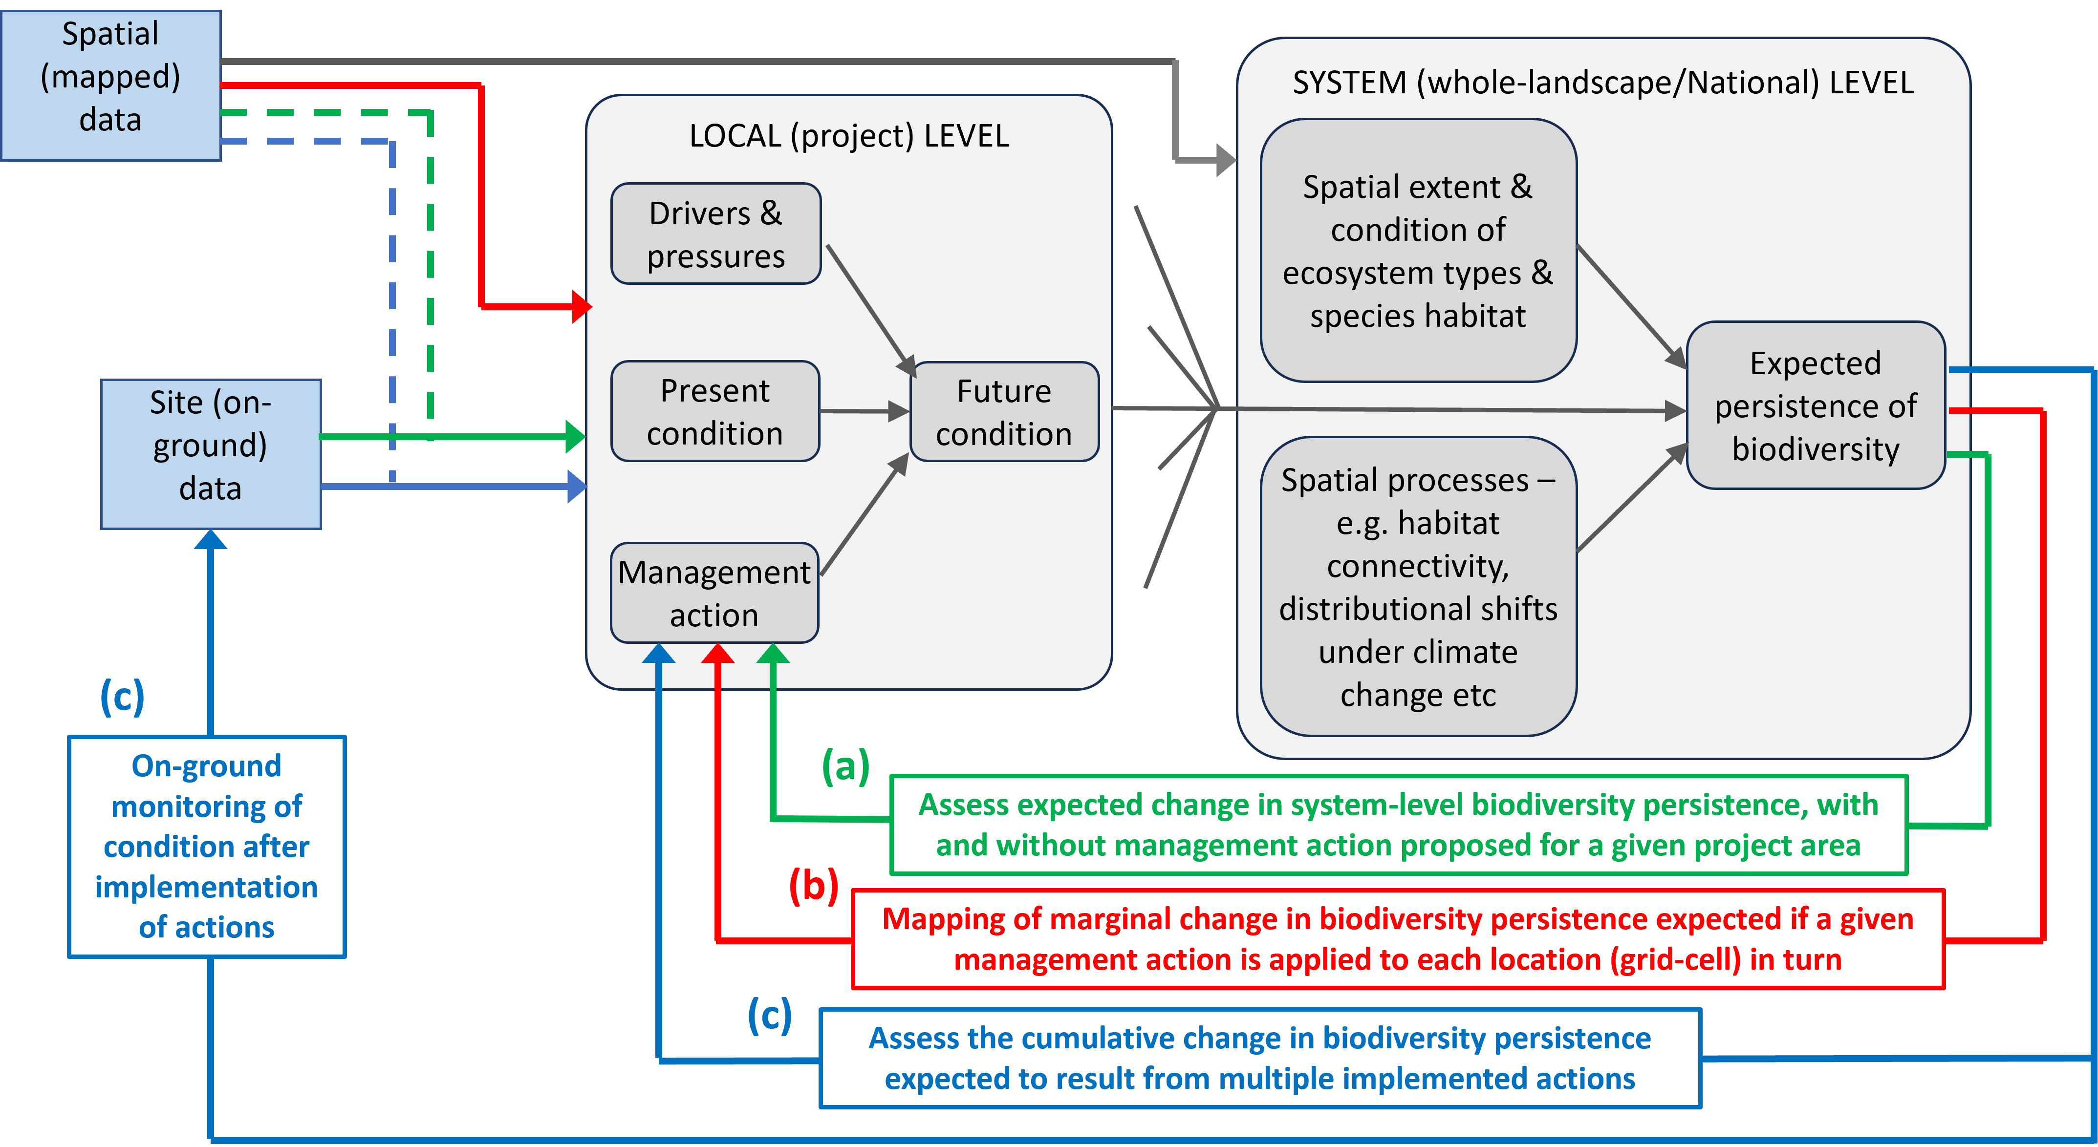
Figure 9 Conceptual approach to using the NBAS modelling of biodiversity persistence at system level as a foundation for (a) assessing the expected biodiversity benefit of an action within a given project area, (b) spatial prioritisation and (c) evaluating the net cumulative outcome achieved by actions implemented within multiple project areas.
At the system level the NBAS enables integration across multiple actions and consideration of landscape context to allow spatial prioritisation of management actions towards areas where biodiversity benefits will be maximised, alongside the evaluation of the net cumulative benefits of multiple actions.
When spatially prioritising where to best implement actions the NBAS maps the relative biodiversity benefit (marginal gain) expected from implementing a specified type of management action to each grid-cell in turn within the spatial domain of interest (e.g. an ecosystem type, a region, or the entire continent). Each of the priority maps generated by this process is therefore action-specific, with the aim being to provide information to help market participants understand where different types of action are expected to provide higher biodiversity benefits. This assessment will rely on remotely mapped spatial datasets that have complete national coverage (Figure 9b).
Assessing the net cumulative outcome achieved by multiple projects implemented under the Nature Repair Market involves aggregating and scaling up local-level benefits from individual projects to assess cumulative benefits at whole-landscape and national scales. Conceptually this is similar to the other two NBAS roles, but rather than assessing potential gain from proposed future actions, it assesses actual benefits from a set of implemented projects, in terms of the broader (collective) benefit expected from these projects at a system level, integrating field-based monitoring of project areas where available (Figure 9c).
In summary, once fully deployed the NBAS will enable assessment of biodiversity benefits from management actions at local, regional and national scales. By taking a system-level approach to biodiversity assessment it can model collective benefits for biodiversity, even if projects implemented under the market involve a mix of different types of actions across multiple ecosystem types (e.g. habitat protection versus restoration or enhancement of condition).
Box 2. What is biodiversity persistence and how does it relate to NBAS?
Biodiversity persistence refers to the continued survival and health of species, ecosystems, or other biodiversity elements over time. In ecological terms, it is a measure of the likelihood that the elements making up biodiversity (e.g. species) will continue to exist without significant loss or decline, both now and into the foreseeable future. The concept of biodiversity persistence is central to conservation because it emphasises maintaining whole-of-system diversity and ecological function, making it a complement to approaches which emphasise conserving individual species or elements within a system.
In practical terms, biodiversity persistence can be affected by a range of factors, including pressures from human activity, and management interventions like restoration or protection efforts. When biodiversity persists, it means that those ecosystems are functioning well, and species are continuing to thrive without reaching critical thresholds that could lead to their decline or extinction.
Species-level biodiversity persistence is essentially the inverse of extinction risk. A higher value of biodiversity persistence means that the species making up this diversity have, on average, a lower risk of extinction. Conservation efforts often aim to enhance biodiversity persistence by mitigating risks that lead to the decline of species, such as habitat destruction, climate change, or invasive species. This can be done by improving habitat quality, reducing threats, or enhancing the resilience of ecosystems.
In the context of the EKS, the NBAS assesses how well biodiversity persistence is improved at local and system levels by predicting how different management actions improve the long-term survival of biodiversity. The NBAS assesses and reports the potential change in biodiversity persistence that a proposed project may achieve, by combining fit-for-purpose datasets representing the current state (condition) of ecosystems, the expected change in local condition given a set of actions (via state and transition models), and the contribution this local change will make to the connectivity of habitat in the surrounding landscape. The initial version of NBAS will then, in turn, assess the contribution that such changes in condition and connectivity are expected to make to biodiversity persistence at a whole-system level through a relatively simple form of species-area analysis. This value is expressed as the fractional gain in species persistence at a whole-system level - in other words, the improvement in the proportion of all species in an ecosystem type expected to persist (i.e. not go extinct) as a result of the proposed set of actions.
It is envisaged that further development of the NBAS following commencement of the market will add functionality to allow biodiversity persistence to also be assessed for individual species (e.g. of conservation or cultural significance) by modelling the contribution that local actions are expected to make to increasing the amount of suitable habitat available across the range of any given species.

Implementing the NBAS for market opening
At market opening the NBAS will assess the contribution of a proposed project to change in local (project) level ecosystem condition and change in system level biodiversity persistence (including its component parts of connectivity and conservation significance).
The NBAS integrates multiple components of the EKS to offer a cohesive approach for biodiversity assessment. It utilises the best available STMs for the region concerned (see Section 2.5) and combines spatial and ecological data to predict how proposed management actions will impact biodiversity (see Box 2) across local, regional, and national scales (Figure 10 and Box 3). This is achieved through development of a software package utilising fit-for-purpose spatial datasets and modelling tools, providing a robust framework for assessing the expected biodiversity benefit of management actions proposed under the market.
The NBAS is effectively a versioned software and data package designed to ensure repeatability and transparency while also allowing growth and refinement as the market develops. It will be accessible through the PLANR interface, giving users flexibility in how they interact with, and apply, its outputs.
A proposed high-level workflow for the initial version of the NBAS is shown in Figure 10. This workflow will be adapted to deliver the biodiversity assessment functions required for the first method at market commencement.
Other capabilities and extensions added over time will be described in future technical documents (see Section 3.5).
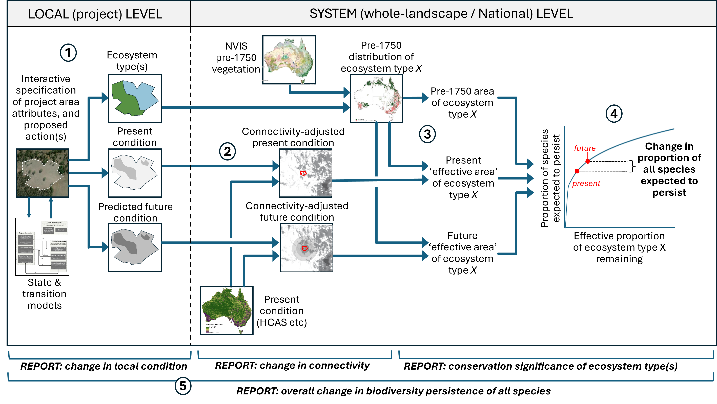
Figure 10 A proposed high level workflow for the initial version of the NBAS at market opening. Further information about the workflow associated with the circled numbers is given on the following page.

Figure 10 includes five numbered circles which correspond to five key steps in the analytical process:
- User: i) delineates boundary of the project area; ii) delineates distribution of pre-1750 ecosystem types and ecosystem states within the project area (through available spatial data and local knowledge/site assessment); and iii) specifies proposed management actions (informed by STMs). Three spatial grids for the project area are then generated for use in the system level analysis: i) pre-1750 ecosystem type; ii) present ecosystem condition as a function of ecosystem state, and any ancillary condition information (e.g. higher resolution ecosystem condition data or on-ground data); and iii) future ecosystem condition predicted as a function of proposed management, based on state and transition modelling.
- The present condition spatial grid for the project area is amalgamated with best-available condition mapping across the entire landscape (e.g. from HCAS – see Section 4.3). Condition values in this amalgamated grid are then adjusted to account for the effect of connectivity between each and every cell in the grid and habitat in the surrounding neighbourhood (Drielsma et al. 2007). This adjustment for connectivity is also repeated for the future condition grid (incorporating the changes in ecosystem condition predicted to result from management proposed for the project area).
- The connectivity-adjusted condition grids from the previous step are intersected with the pre-1750 distribution of the ecosystem type of interest to calculate: i) the total pre-1750 area of this ecosystem; ii) the present ‘effective area’ of the ecosystem calculated by summing the present connectivity-adjusted condition values of all cells falling within the ecosystem type’s pre-1750 distribution; and iii) the future ‘effective area’ of the ecosystem type calculated by summing the future connectivity-adjusted condition values (reflecting changes predicted to result from the proposed management). If management is being applied to more than one ecosystem type/state within a project area, then this and the following step need to be repeated for each of these ecosystem types/states.
- The species-area relationship (SAR) is used to predict the proportion of species associated with this ecosystem type which are expected to persist (i.e. avoid extinction) over the long term, as a function of the effective proportion of that ecosystem remaining – i.e. effective area divided by pre-1750 area (Ferrier and Drielsma 2010; Drielsma et al. 2014). This is repeated for both present and future effective areas, with the change (gain) in proportion of species predicted to persist then serving as an overall measure of the expected benefit of the proposed management action, within a whole-system context.
- This overall measure will reflect the effects of three main factors, all of which can also be quantified and reported separately for proposals under the Nature Repair Market using the following metrics:
- Local change (gain) in ecosystem condition within the project area expected to result from the actions proposed for that area.
- Contribution to enhancing the connectivity-adjusted condition of habitat across the broader landscape surrounding the project area.
- Conservation significance of the ecosystem type being repaired, accounting for both the rarity of the type, and its past level of depletion and degradation. This can be quantified by using the species-area relationship (from Step 4 above) to calculate the change in proportion of species expected to persist in the ecosystem type if a fixed amount of habitat (e.g. 1ha) is added to the total effective area of habitat remaining for that type. The magnitude of this hypothetical change reflects both the past level of depletion/degradation of the ecosystem type (more depleted types will be positioned towards the lower, and therefore steeper, end of the species-area curve) and the natural rarity of the type (adding a fixed amount of habitat will move a rarer type further up the curve than will be the case for a more common type).

NBAS next steps
The NBAS released for market opening will provide biodiversity assessment tools to support the first method while also leaving room for significant enhancements to accommodate future market methods. The following will not be included in the first release of the NBAS:
- Consideration of compositional variation within and between ecosystem types: i.e. variation in species composition associated with fine-scale environmental variation within each type, and varying levels of overlap in species composition between different types.
- Estimation of benefits for individual species: future versions will consider the expected impact of proposed actions on individual species. This could include species with conservation significance (e.g. EPBC Act listed species) or cultural significance (as appropriate).
- Incorporation of climate change effects: including expected shifts in the distribution of species and ecosystem types and the potential effects of climate change on the projected benefits of a project.
- Spatial prioritisation: i.e. the ability to map the relative benefit for biodiversity expected to be achieved by applying a specified type of management action across different parts of any given spatial domain of interest (e.g. a region, or the entire continent), to help inform proactive targeting of actions towards places where those actions are expected to deliver the highest benefits for biodiversity (this is the second role for the NBAS identified in Section 3.2).
- Evaluation of net cumulative benefits achieved by implemented actions: i.e. the ability to evaluate cumulative (overall) benefits for biodiversity achieved by multiple projects implemented through the Nature Repair Market (this is the third role for the NBAS identified in Section 3.2).

Key data inputs
The EKS is underpinned by several key datasets, in addition to the expert-elicited information contained in STMs. These datasets are being evaluated using a Data Assessment Framework (Section 4.1) and, where possible, will be national in scale or coherent with national and international frameworks and methods so that information delivered through the EKS is comparable across regions.

Data Assessment Framework
To undertake assessments of the EKS datasets, a framework has been developed that covers numerous dimensions of a dataset that a potential user should be concerned about when determining fitness-for-purpose. This framework is described in detail in Lemon et al. (2024). This framework consists of two high-level concepts: a general framework and activity profiles (Table 2).
The general framework adopts the Australian Bureau of Statistics Data Quality Framework dimension structure as well as the Australian Institute for Health and Welfare (AIHW) approach of posing a set of questions within each dimension to which the answer can only be ‘Yes’ or ‘No’.
The development of the questions has been guided by analysis of existing data quality frameworks—the FAIR and CARE principles, the Shared Analytic Framework for the Environment (Western Australian Biodiversity Science Institute and Western Australian Marine Science Institution 2023)—and a number of metadata and data quality standards (DCMI, ISO TC211).
The second component of the Data Assessment Framework allows the user to tailor the framework for the specific needs of their activity (or use-case) through the development of the activity profile. The activity profile captures the expectations or requirements that an activity has with respect to each of the questions, and the actions to be taken if, during an assessment, a dataset does not meet these requirements.
The framework also considers the input data supply chains for any risks to the data in question such as ongoing updates and dependencies.
The Data Assessment Framework is intended for use in evaluating primary data inputs used in STMs (Section 2) and the NBAS (Section 3).

Table 2 Data Assessment Framework key concepts
Component | Description
General framework
Dimensions | Dimensions are areas of concern related to the assessment of the dataset. For the framework, the dimensions are:  - Accessibility - Ease of access to data by users including appropriate licencing  - Institutional Environment - Institutional and organisational factors that may have influence on the credibility of the data.  - Relevance - How well the dataset meets user needs.  - Timeliness - The latency between dataset data collection, collation, supply and use as well as update frequency.  - Accuracy - The degree of correctness of the data for the estimate provided.  - Coherence - The comparability of the dataset to other data of similar type, as well as to prior version of the same dataset.  - Interpretability - The availability of information to aid interpretation of that data to generate insights.
Questions | A set of questions, relevant to the dimension which are designed to evaluate the suitability for use of a particular dataset. The answer to a question can only be “Yes”, “No” or “Not applicable”.
Activity profiles
Activity | An activity, project, initiative, programme of work which will seek to use one or more datasets as inputs and will likely have similar requirements of these datasets with respect to the general assessment framework
Relevance assessment | An initial assessment of the general framework questions to determine which are relevant to the activity profile.
Activity requirements | The set of requirements that define ‘fit for use’ for each question within the activity profile. In other words, the “bar” that needs to be met to achieve ‘Yes’ for the question.
Activity guidance | For each question in an activity profile, advice needs to be provided on how to proceed if the answer to a question is ‘No’. Specific guidance is needed for each question.

National Vegetation Information System (NVIS)
The National Vegetation Information System (NVIS) is an ongoing collaborative initiative between the Australian and state and territory governments to manage national vegetation data to help improve vegetation planning and management within Australia. The Australian Vegetation Attribute Manual (NVIS Technical Working Group 2017) underpins NVIS by providing guidelines for standardising the national collection, compilation and monitoring of Australia's vegetation. Maintenance and further development of the technical infrastructure is coordinated by the NVIS Technical Working Group. Each state and territory have developed an NVIS-compatible database which is populated with its native vegetation data. This data – often derived from decades of activity in vegetation survey and mapping using a variety of methods and classifications – is collated into the NVIS database by the Australian Government, who also leads on building and improving the system architecture.
The NVIS database provides a range of products for use at different scales, including increasingly detailed data from levels 1 (class) to 6 (sub-association) of the vegetation hierarchy, and web services to support delivery. The more detailed levels of the vegetation hierarchy have been used to crosswalk different vegetation classifications, such as that developed by the International Union for the Conservation of Nature (IUCN) Global Ecosystem Typology (Keith et al. 2020; Keith et al. 2022), which is an international standard for ecosystem accounting, and to map outputs of the AusEcoModels Framework (Richards et al. 2020) that classifies ecosystems into reference and modified states connected by processes that drive change (see Section 2.2).
The most up-to-date pre-1750 NVIS product is used to determine the ecosystem type relevant to a project area and will be used in the National Biodiversity Assessment System (NBAS) to calculate: i) the total pre-1750 area of each ecosystem; and ii) the present ‘effective area’ of the ecosystem using the methods as outlined in Section 3. These NVIS products and their derivatives will be evaluated using the data assessment framework (Section 4.1) to demonstrate under which circumstances they will be fit for purpose.

Habitat Condition Assessment System (HCAS)
The HCAS is a satellite-based monitoring method for national reporting on the estimated degree to which a location departs from its contemporary ecosystem reference state (i.e. highest integrity within a natural range of variability as might have existed prior to European colonisation) (Box 3; Figure 11). Condition is scored on a 0–1 scale, where 1.0 is the highest attainable ecosystem integrity and, at 0.0, all trace of the original ecosystem has been removed. The method has been developed and incrementally improved through a partnership between CSIRO and DCCEEW (Harwood et al. 2016; Williams et al. 2020; Williams et al. 2021; Williams et al. 2023). HCAS is used in the STMs to link ecosystem states to condition scores via the VAST narrative framework (see Section 2.3) and in workflows that link information in STMs to the NBAS (Figure 10).
HCAS reference sites are identified using multiple lines of evidence, including land use mapping and expert knowledge elicited using the Habitat Condition Assessment Tool (HCAT). HCAT is a web-based platform hosted by the Atlas of Living Australia that enables experts with deep ecological knowledge and experience to contribute site-level habitat condition scores. Data collected through HCAT also supports the development of STMs directly through the identification of local reference areas. Box 3 provides more technical detail about the HCAS workflow.

National ecosystem accounts
To ensure alignment with national and international frameworks the EKS, where possible, will use the same input datasets for ecosystem extent and condition as those used in Australia’s national ecosystem accounts. The National Ecosystem Accounting Project (NEAP) is delivering national terrestrial, freshwater and ocean ecosystem accounts, which will help users to understand the importance of the environment and its contribution to our economic and social wellbeing. These accounts will provide a source of trend data for state of the environment reporting and environmental indicators as well as national data for the Nature Repair Market. The first release of accounts in early 2025 is a starting point that will be built on and improved over time as new methods and data become available.
Ecosystem extent spatial datasets and ecosystem condition spatial datasets (derived from HCAS and described in Section 4.3) that have been developed as part of NEAP are also key data inputs to the EKS. Ecosystem extent datasets may include the extent of Ecosystem Functional Groups described in the IUCN GET (Keith et al. 2020; Keith et al. 2022), and derived from NVIS information (see Section 4.2). The IUCN GET is the recommended ecosystem classification for global comparison in the System for Environmental Economic Accounting Ecosystem Accounting (SEEA EA) framework. A second dataset, reporting the extent of ecosystem states based on the AusEcoModels Framework (Richards et al. 2020) and the HCAS outputs, will be used as a line of evidence for the identification of starting ecosystem states in the EKS. This dataset can be used to interpret change in ecosystem condition accounts, and has been derived from NVIS information and cross-walked to the IUCN GET ecosystem functional groups.
The use of spatial datasets that may also be used to develop national ecosystem accounts, ensures that there is good compatibility and consistency between information delivered by the EKS and data used in other national reporting forums. The derivation of the ecosystem extent spatial data from NVIS (that compiles information from state-based vegetation data), also ensures alignment between national-scale ecosystem descriptions and regional to local information delivered through the EKS.

Box 3. HCAS workflow
The Digital Earth Australia Collection 3 Landsat archive between 1988 and 2022 underpins HCAS version 3, which is being summarised at 90 m grid resolution to match the resolution of a wide array of environmental covariates provided by TERN (Searle 2023). A pilot version of HCAS using these data has been developed at 250 m (HCAS v3.0) to test and refine workflows (Valavi et al. 2024; Williams et al. 2024).
The outputs of HCAS include a ‘base model’ which applies a long-term epoch over which the remote sensing input data are averaged (1988-2022 in the case of v3) and a time-series of short-term epochs. The HCAS v3 uses 14 Landsat-derived remote sensing variables to represent a wide range of ecosystem characteristics – mainly structural and functional components. The short-term epochs are averaged over 3 years of the remote sensing data, although longer periods may be needed to address limitations in data quality due to cloud and other atmospheric interferences.
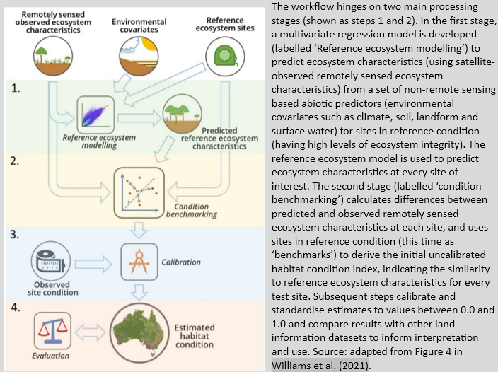
Figure 11 Summary of HCAS model workflow structure

References
Brancalion PHS, Melo FPL, Tabarelli M and Rodrigues RR (2013) ‘Biodiversity persistence in highly human-modified tropical landscapes depends on ecological restoration’, Tropical Conservation Science, 6(6): 705-710. https://doi.org/10.1177/194008291300600601
Clements HS, Kerley GIH, Cumming GS, De Vos A and Cook CN (2019) ‘Privately protected areas provide key opportunities for the regional persistence of large- and medium-sized mammals’, Journal of Applied Ecology, 56(3): 537-546. https://doi.org/10.1111/1365-2664.13300
Di Fonzo MMI, Possingham HP, Probert WJM, Bennett JR, Joseph LN, Tulloch AIT, O'Connor S, Densem J and Maloney RF (2016) ‘Evaluating Trade-Offs between Target Persistence Levels and Numbers of Species Conserved’, Conservation Letters, 9(1): 51-57. https://doi.org/10.1111/conl.12179
Drielsma M, Ferrier S and Manion G (2007) ‘A raster-based technique for analysing habitat configuration: The cost–benefit approach’, Ecological Modelling, 202(3-4): 324-332. https://doi.org/10.1016/j.ecolmodel.2006.10.016
Drielsma M, Ferrier S, Howling G, Manion G, Taylor S and Love J (2014) ‘The biodiversity forecasting toolkit: Answering the ‘how much’,‘what’, and ‘where’of planning for biodiversity persistence’, Ecological Modelling, 274: 80-91. https://doi.org/10.1016/j.ecolmodel.2013.11.028
Ferrier S and Wintle BA (2009) Quantitative approaches to spatial conservation prioritisation: matching the solution to the need. In: Moilanen A, Possingham HP and Wilson KA (eds), Spatial conservation prioritization: quantitative methods and computational tools. Oxford University Press, Oxford, 1-15. https://doi.org/10.1093/oso/9780199547760.001.0001
Ferrier S and Drielsma M (2010) ‘Synthesis of pattern and process in biodiversity conservation assessment: a flexible whole-landscape modelling framework’, Diversity and Distributions, 16(3): 386-402. http://dx.doi.org/10.1111/j.1472-4642.2010.00657.x
Gardner TA, Barlow J, Chazdon R, Ewers RM, Harvey CA, Peres CA and Sodhi NS (2009) ‘Prospects for tropical forest biodiversity in a human-modified world’, Ecology Letters, 12(6): 561-582. https://doi.org/10.1111/j.1461-0248.2009.01294.x
Giljohann KM, Williams KJ, Hossack GR, Lehmann EA and Richards AE (2024) Reanalysis of the expert interpretation of VAST condition scores - technical report. NEAP Ecosystem condition activity (in prep). CSIRO, Canberra, Australia.
Good MK, Rumpff L, Fraser H, Gould E, Jones CS, Prober SM, Bourne M, Butt N, Byrne M, Duncan DH, Gorrod E, Gosper CR, Jordan R, McIntyre S, Moore JL, Nerenberg S, Pulsford S, Richards AE, Rogers DJ, Sinclair S, Standish RJ, Tulloch A, Travers SK, Vranjic J, White M, Wilson J, Begley J, Wright J, Yates C and Vesk PA (2024) ‘A structured approach for building multi-community State and Transition Models to support conservation planning’, Journal of Applied Ecology, 61(9): 2294-2307. https://doi.org/10.1111/1365-2664.14718
Harwood TD, Donohue RJ, Williams KJ, Ferrier S, McVicar TR, Newell G and White M (2016) ‘Habitat Condition Assessment System: A new way to assess the condition of natural habitats for terrestrial biodiversity across whole regions using remote sensing data’, Methods in Ecology and Evolution, 7(9): 1050-1059. https://doi.org/10.1111/2041-210X.12579
Higgs E, Falk DA, Guerrini A, Hall M, Harris J, Hobbs RJ, Jackson ST, Rhemtulla JM and Throop W (2014) ‘The changing role of history in restoration ecology’, Frontiers in Ecology and the Environment, 12(9): 499-506. https://doi.org/10.1890/110267
IUCN (2016) A Global Standard for the Identification of Key Biodiversity Areas, Version 1.0. IUCN, Gland, Switzerland, https://iucn.org/resources/publication/global-standard-identification-key-biodiversity-areas-version-10
Jackson ST and Hobbs RJ (2009) ‘Ecological Restoration in the Light of Ecological History’, Science, 325(5940): 567-569. https://doi.org/10.1126/science.1172977
Janishevski L, Santamaria C, Gidda S, Cooper H and Brancalion PHS (2015) ‘Ecosystem restoration, protected areas and biodiversity conservation’, Unasylva, 245(3): 19-28.
Jones KR, Watson JEM, Possingham HP and Klein CJ (2016) ‘Incorporating climate change into spatial conservation prioritisation: A review’, Biological Conservation, 194: 121-130. https://doi.org/10.1016/j.biocon.2015.12.008
Kay JJ (1991) ‘A nonequilibrium thermodynamic framework for discussing ecosystem integrity’, Environmental Management, 15(4): 483-495. https://doi.org/10.1007/BF02394739
Keith DA, Ferrer-Paris JR, Nicholson E and Kingsford RT (eds) (2020) The IUCN Global Ecosystem Typology 2.0: Descriptive profiles for biomes and ecosystem functional groups. International Union for Conservation of Nature (IUCN), Gland, Switzerland. https://seea.un.org/content/iucn-global-ecosystem-typology-20-descriptive-profiles-biomes-and-ecosystem-functional
Keith DA, Ferrer-Paris JR, Nicholson E, Bishop MJ, Polidoro BA, Ramirez-Llodra E, Tozer MG, Nel JL, Mac Nally R, Gregr EJ, Watermeyer KE, Essl F, Faber-Langendoen D, Franklin J, Lehmann CER, Etter A, Roux DJ, Stark JS, Rowland JA, Brummitt NA, Fernandez-Arcaya UC, Suthers IM, Wiser SK, Donohue I, Jackson LJ, Pennington RT, Iliffe TM, Gerovasileiou V, Giller P, Robson BJ, Pettorelli N, Andrade A, Lindgaard A, Tahvanainen T, Terauds A, Chadwick MA, Murray NJ, Moat J, Pliscoff P, Zager I and Kingsford RT (2022) ‘A function-based typology for Earth’s ecosystems’, Nature, 610(7932): 513-518. https://doi.org/10.1038/s41586-022-05318-4
Lemon D, Fitch P and Schwenke A (2024) A data assessment framework for data users. CSIRO, Australia
Marshall E, Valavi R, Connor LO, Cadenhead N, Southwell D, Wintle BA and Kujala H (2021) ‘Quantifying the impact of vegetation-based metrics on species persistence when choosing offsets for habitat destruction’, Conservation Biology, 35(2): 567-577. https://doi.org/10.1111/cobi.13600
Marshall E, Visintin C, Valavi R, Wilkinson DP, Southwell D, Wintle BA and Kujala H (2022) ‘Integrating species metrics into biodiversity offsetting calculations to improve long-term persistence’, Journal of Applied Ecology, 59(4): 1060-1071. https://doi.org/10.1111/1365-2664.14117
Moilanen A (2008) ‘Generalized Complementarity and Mapping of the Concepts of Systematic Conservation Planning’, Conservation Biology, 22(6): 1655-1658. https://doi.org/10.1111/j.1523-1739.2008.01043.x
NVIS Technical Working Group (2017) Australian Vegetation Attribute Manual, National Vegetation Information System, Version 7.0. Australian Government Department of the Environment and Heritage, Canberra. https://www.dcceew.gov.au/environment/land/publications/australian-vegetation-attribute-manual-version-7
Pollock LJ, O’connor LM, Mokany K, Rosauer DF, Talluto MV and Thuiller W (2020) ‘Protecting biodiversity (in all its complexity): new models and methods’, Trends in ecology & evolution, 35(12): 1119-1128. https://doi.org/10.1016/j.tree.2020.08.015
Prober SM and Smith FP (2009) ‘Enhancing biodiversity persistence in intensively used agricultural landscapes: A synthesis of 30 years of research in the Western Australian wheatbelt’, Agriculture Ecosystems & Environment, 132(3-4): 173-191. https://doi.org/10.1016/j.agee.2009.04.005
Prober SM, Cook GD, Gosper CR, Hodgson JR, Langridge JM, Rumpff L, Williams RJ, Yates CJ and Richards AE (2023a) The Australian Ecosystems Model Framework: Eucalypt woodlands, Version 1.0. . csiro:EP2023-2878. https://doi.org/10.25919/9g9r-nh21
Prober SM, Richards AE, Hodgson JR, Langridge JM, Gosper CR, Sundholm AM, White M and Yates CJ (2023b) The Australian Ecosystems Model Framework: Mallee woodlands and shrublands, Version 1.0. . csiro:EP208384. https://doi.org/10.25919/9kpp-xd43
Pulla S, Ramaswami G, Mondal N, Chitra-Tarak R, Suresh HS, Dattaraja HS, Vivek P, Parthasarathy N, Ramesh BR and Sukumar R (2015) ‘Assessing the resilience of global seasonally dry tropical forests’, International Forestry Review, 17: 91-113. https://www.jstor.org/stable/26431598
Richards AE, Dickson F, Williams KJ, Cook GD, Murphy H, Roxburgh S, Doherty M, Warnick A, Metcalfe D and Prober SM (2020) The Australian Ecosystems Models Framework Project: A conceptual framework. CSIRO Land and Water, Canberra, Australia. https://doi.org/10.25919/f61q-1386
Richards AE, Brandon C, Liu N, Mokany K, Schmidt RK, Smith GS, Williams KJ, Evans D, Ferrier S, Geffersa A, Giljohann KM, Harwood TD, Hayward J, Johnson S, Jordan R, Khan S, Lehmann EA, Liedloff AC, Luxton S, Macfadyen S, Murphy HT, Newnham G, Pascoe S, Prober SM, Roxburgh SH, Scheufele G, Stewart SB, Szetey K, Tetreault-Campbell S, Ware C and Woodward E (2023a) Experimental ecosystem accounts for the Western Australian Wheatbelt. A synthesis report from the Regional Ecosystem Accounting Pilot projects. CSIRO, https://doi.org/10.25919/8zcs-3b36
Richards AE, Brandon C, Liu N, Mokany K, Schmidt RK, Smith GS, Williams KJ, Evans D, Ewamian Ltd and Ewamian People Aboriginal Corporation RNTBC, Ferrier S, Giljohann KM, Grainger D, Harwood TD, Hayward J, Jarvis D, Johnson S, Khan S, Lehmann EA, Liedloff AC, Murphy HT, Newnham G, Pascoe S, Roxburgh SH, Scheufele G, Stewart SB, Tagalaka Aboriginal Corporation RNTBC, Tetreault‑Campbell S and Ware C (2023b) Experimental ecosystem accounts for the Flinders, Norman and Gilbert river catchments. A synthesis report from the Regional Ecosystem Accounting Pilot projects. CSIRO, https://doi.org/10.25919/xeas-3102
Roxburgh SH, Fairman T, Furlands JM, Nitschke C, Langridge JM and Prober SM (2023) The Australian Ecosystems Model Framework: Eucalypt forests, Version 1.0. . csiro:EP2023-2878. https://doi.org/10.25919/dgje-s945
Rumpff L, Duncan DH, Vesk PA, Keith DA and Wintle BA (2011) ‘State-and-transition modelling for Adaptive Management of native woodlands’, Biological Conservation, 144(4): 1224-1236. https://doi.org/10.1016/j.biocon.2010.10.026
Schmidt RK, Brandon C, Mokany K, Richards AE, Smith GS, Stewart SB, Williams KJ, Evans D, Ferrier S, Giljohann KM, Harwood TD, Johnson S, Khan S, Lehmann EA, Liu N, McIlgorm A, Newnham G, Nichols R, Pascoe S, Roxburgh SH, Scheufele G, Tetreault-Campbell S and Ware C (2023) Experimental ecosystem accounts for the Murray-Darling Basin. A synthesis report from the Regional Ecosystem Accounting Pilot projects. CSIRO, https://doi.org/10.25919/dbjj-ya71
Searle R (2023) HCAS Optimised SLGA Products. https://aussoilsdsm.esoil.io/other/hcas-optimised-slga-products
Standards Reference Group SERA (2016) National Standards for the Practice of Ecological Restoration in Australia. Society for Ecological Restoration Australasia.
Suding KN and Hobbs RJ (2009) ‘Threshold models in restoration and conservation: a developing framework’, Trends in ecology & evolution, 24(5): 271-279. https://doi.org/10.1016/j.tree.2008.11.012
Thackway R and Lesslie R (2006) ‘Reporting vegetation condition using the Vegetation Assets, States and Transitions (VAST) framework’, Ecological management & restoration, 7: S53-S62. https://doi.org/10.1111/j.1442-8903.2006.00292.x
Thackway R and Lesslie R (2008) ‘Describing and mapping human-induced vegetation change in the Australian landscape’, Environmental Management, 42: 572-590. https://doi.org/10.1007/s00267-008-9131-5
Valavi R, Williams KJ, Liu N, Levick S, Giljohann KM, Johnson S, Botha EJ, Munroe SEM, Lehmann EA, Collings S, Searle R, Van Niel TG, Newnham G, Paget M, Joehnk K, Hosack GR, Harwood TD, Malley C, Gunawardana D, Sivanandam P, Carlile P, Richards AE, Tetreault Campbell S, Schmidt RK and Ferrier S (2024) HCAS 3.0 (1988-2022) base model estimate of habitat condition (250m grid), National Connectivity Index (NCI) 2.0, 3-year average annually rolling epochs of HCAS and NCI from 1990 to 2022, trends and other derivatives for continental Australia. Data Collection. https://data.csiro.au/collection/csiro:62484
Walker S, Stephens RTT and Overton JM (2012) ‘A unified approach to conservation prioritisation, reporting and information gathering in New Zealand’, New Zealand Journal of Ecology, 36(2): 243-251. https://newzealandecology.org/nzje/3029
Western Australian Biodiversity Science Institute and Western Australian Marine Science Institution (2023) Capabilities for a national supply chain of environmental information: The shared analytic framework for the environment (SAFE 2.0). Western Australian Biodiversity Science Institute (WABSI), Perth, Australia. https://wabsi.org.au/wp-content/uploads/2023/05/SAFE-2.0_May-2023.pdf
Williams KJ, Donohue RJ, Harwood TD, Lehmann EA, Lyon P, Dickson F, Ware C, Richards AE, Gallant J, Storey RJL, Pinner L, Ozolins M, Austin J, White M, McVicar TR and Ferrier S (2020) Habitat Condition Assessment System: developing HCAS version 2.0 (beta). A revised method for mapping habitat condition across Australia. Publication number EP21001. CSIRO Land and Water, Canberra, Australia. https://doi.org/10.25919/85f4-1k65
Williams KJ, Harwood TD, Lehmann EA, Ware C, Lyon P, Bakar S, Pinner L, Schmidt RK, Mokany K, Van Niel TG, Richards AE, Dickson F, McVicar TR and Ferrier S (2021) Habitat Condition Assessment System (HCAS version 2.1): Enhanced method for mapping habitat condition and change across Australia. CSIRO, Canberra, Australia. https://doi.org/10.25919/n3c6-7w60
Williams KJ, Giljohann KM, Richards AE, Harwood TD, Lehmann EA, Liu N, Ferrier S, Murphy HT, Prober SM, Hosack GR, Tetreault-Campbell S and Schmidt RK (2023) Extended methods used in developing the Habitat Condition Assessment System (HCAS) version 2.3, ecosystem condition account-ready data and experimental accounts for two mixed-use landscapes. A technical report from the Regional Ecosystem Accounting Pilot projects. Publication number: EP2023-1426. CSIRO, Canberra, Australia. https://doi.org/10.25919/r12v-ya32
Williams KJ, Liu N, Valavi R, Levick S, Giljohann KM, Johnson S, Botha EJ, Munroe SE, Lehmann EA, Collings S, Searle R, Niel TGV, Newnham G, Paget M, Joehnk K, Hosack GR, Harwood TD, Malley C, Gunawardana D, Sivanandam P, Carlile P, Tetreault-Campbell S, Schmidt RK and Ferrier S (2024) Habitat Condition Assessment System version 3.0: A guide to the data collection (in prep). CSIRO, Canberra, Australia.

As Australia’s national science agency, CSIRO is solving the greatest challenges through innovative science and technology.
CSIRO. Creating a better future for everyone.
Contact us
1300 363 400
+61 3 9545 2176
csiro.au/contact
csiro.au
For further information
Dr Helen Murphy
CSIRO Environment
Helen.Murphy@csiro.au
csiro.au/environment

Department of Climate Change,
Energy, the Environment and Water
naturerepairmarket@dcceew.gov.au
dcceew.gov.au

https://www.abs.gov.au/websitedbs/D3310114.nsf/home/Quality:+The+ABS+data+quality+framework
https://nla.gov.au/nla.obj-788584958/view
https://ardc.edu.au/resource/fair-data/
https://ardc.edu.au/resource/the-care-principles/
https://wabsi.org.au/our-work/projects/safe-shared-analytic-framework-for-the-environment/
https://www.dublincore.org/specifications/dublin-core/dcmi-terms/
https://www.iso.org/committee/54904.html
https://www.dcceew.gov.au/environment/land/native-vegetation/national-vegetation-information-system
https://www.dcceew.gov.au/environment/land/native-vegetation/national-vegetation-information-system/technical-working-group
https://seea.un.org/ecosystem-accounting
https://www.dcceew.gov.au/environment/land/native-vegetation/national-vegetation-information-system/data-products
https://research.csiro.au/biodiversity-knowledge/projects/hcas/
https://dx.doi.org/10.25914/6099413995ed0
https://aussoilsdsm.esoil.io/other/hcas-optimised-slga-products

