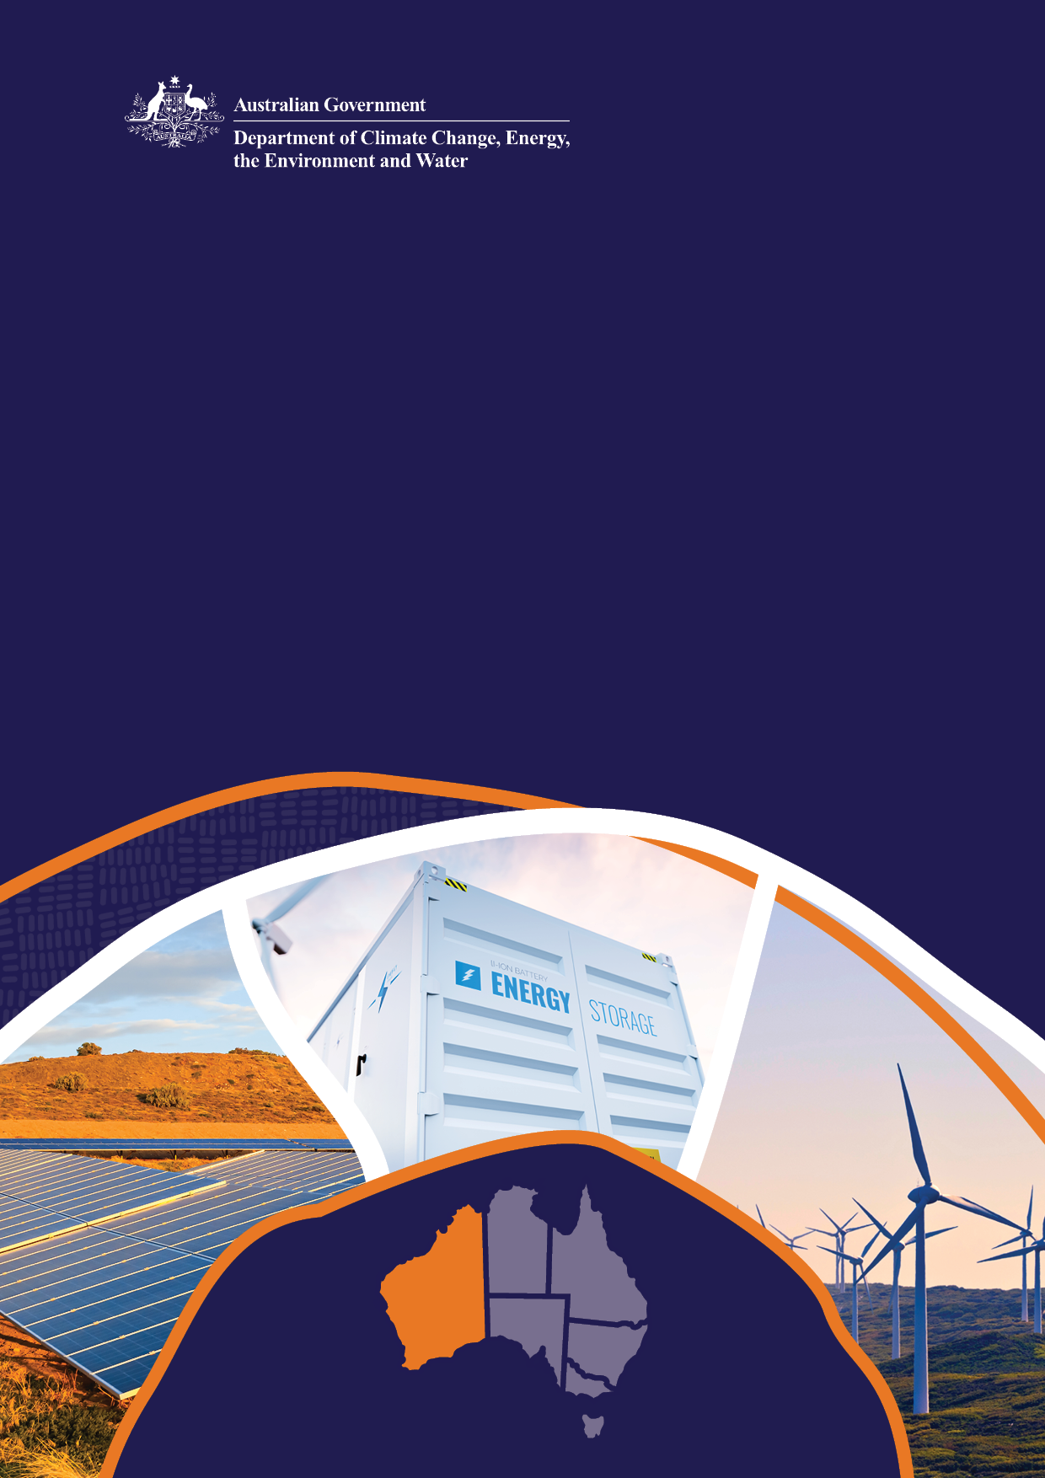

**Proposed National Electricity Law (NEL) Amendment**

Capacity Investment Scheme

October 2024

© Commonwealth of Australia 2024

**Ownership of intellectual property rights**

Unless otherwise noted, copyright (and any other intellectual property rights) in this publication is owned by the Commonwealth of Australia (referred to as the Commonwealth).

**Creative Commons licence**

All material in this publication is licensed under a [Creative Commons Attribution 4.0 International Licence](https://creativecommons.org/licenses/by/4.0/legalcode) except content supplied by third parties, logos and the Commonwealth Coat of Arms.

Inquiries about the licence and any use of this document should be emailed to [copyright@dcceew.gov.au](mailto:copyright@dcceew.gov.au).



**Cataloguing data**

This publication (and any material sourced from it) should be attributed as: DCCEEW 2024, *National Electricity Law Amendment Consultation Paper: Capacity Investment Scheme*, Department of Climate Change, Energy, the Environment and Water, Canberra, July. CC BY 4.0.

This publication is available at [dcceew.gov.au/publications](https://www.dcceew.gov.au/publications).

Department of Climate Change, Energy, the Environment and Water

GPO Box 3090 Canberra ACT 2601

Telephone 1800 920 528

Web [dcceew.gov.au](https://www.dcceew.gov.au)

**Disclaimer**

The Commonwealth of Australia, as represented by the Department of Climate Change, Energy, the Environment and Water, has produced this publication to provide a high-level outline of, and invite submissions regarding the proposed amendment to the National Electricity Law for the Capacity Investment Scheme (CIS). This publication does not indicate commitment by the Australian Government to a particular course of action in relation to the CIS or otherwise.

The Commonwealth has exercised due care and skill in preparing and compiling the information and data in this publication, however, the Commonwealth, its employees and advisers disclaim all liability, including liability for negligence and for any loss, damage, injury, expense or cost incurred by any person as a result of accessing, using or relying on any of the information or data in this publication to the maximum extent permitted by law. No representation expressed or implied is made as to the currency, accuracy, reliability or completeness of the information contained in this publication.

**Acknowledgement of Country**

We acknowledge the Traditional Owners of Country throughout Australia and recognise their continuing connection to land, waters and culture. We pay our respects to their Elders past and present.

# Introduction

## Background

The Capacity Investment Scheme (CIS) is a revenue underwriting mechanism that seeks to provide certainty for renewable investors and cheaper, cleaner energy for households and businesses. It was launched in 2023, with the pilot stage having resulted in support for over 1 GW of new zero-emissions capacity in New South Wales (NSW), comprising battery storage and virtual power plant projects[1]. A second pilot tender for dispatchable capacity in South Australia (SA) and Victoria, commenced in December 2023.

|  |
| --- |
| The objective of the CIS is to encourage new investment in renewable capacity and clean dispatchable capacity to support reliability and reduce market volatility in Australia’s rapidly changing energy markets. |

An expansion of the Capacity Investment Scheme (CIS) was announced in November 2023. The expanded CIS seeks to incentivise the national deployment of 32 GW of renewable capacity and clean dispatchable capacity by 2030 – 9 GW of dispatchable capacity and 23 GW of renewable capacity.

Competitive tenders are anticipated to be conducted biannually for the National Electricity Market (NEM) and annually for the Western Australian Wholesale Electricity Market (WEM) until 2027.

## CIS delivery partner

The Australian Energy Market Operator (AEMO) has been engaged to support the roll-out of the CIS as the tender delivery partner, with the support of its subsidiary AEMO Services Limited (ASL), commencing with the South Australia-Victoria Tender. As the delivery partner, AEMO will conduct the competitive tender processes, and will recommend projects to the Minister for Climate Change and Energy for approval, consistent with the tender guidelines. More information on the design of the CIS can be found [here](https://storage.googleapis.com/files-au-climate/climate-au/p/prj2c881026ae734a70e1030/survey/Capacity%20Investment%20Scheme%20-%20Implementation%20Design%20Paper.pdf).

In providing the tender delivery services for the South Australia-Victoria Tender, AEMO identified two gaps in the National Electricity Law (NEL) that could hinder its delivery of the CIS. The gaps are:

* A new statutory function that allows AEMO to deliver the CIS needs to be made part of AEMO’s existing statutory functions in s49 of the NEL; and
* There are currently no protections under the NEL that would include AEMO’s subsidiaries (including ASL) and the CIS Investment Committee members.[2]

To address these gaps and allow for the running of the CIS (both the South Australia – Victoria and subsequent tender in the NEM and WEM), amendments to the NEL are required.

At present, whilst the Commonwealth has partially indemnified AEMO in its performance of the CIS services under the head contract, this indemnification has limits and does not offer the same level of protection as statutory immunities. As an interim measure, Minister Bowen has written to AEMO under s51(1) of the NEL to request that AEMO perform the CIS services. The letter from Minister Bowen allows the CIS services to be characterised as a ‘function or power of AEMO’, thereby allowing AEMO, its officers and employees to benefit from immunity under s119(1) of the NEL when performing the CIS services. This does not, however extend to AEMO’s subsidiary nor the CIS Investment Committee members.

On 26 June 2024 Energy Ministers from NEL jurisdictions approved the drafting instructions to begin drafting the NEL amendments.

## Purpose of this paper and consultation process

This paper describes the relevant NEL provisions that are proposed to be altered to give AEMO the appropriate functions to be able to provide their services as the delivery partner of the CIS. We are seeking your feedback on whether these amendments to the NEL are suitable.

**You can submit feedback through the department’s Consultation Hub by 5pm (AEST) 1 November 2024.**

# NEL Amendment

The Commonwealth has engaged AEMO, in partnership with its subsidiary ASL, to run tenders and manage contracts under the CIS. There is currently no statutory provision that allows AEMO to perform its functions as the delivery partner. In addition, the Commonwealth’s contract with AEMO is cost recovered under an arrangement where costs payable by the Commonwealth in relation to the delivery of the tenders cannot be recovered from energy consumers under s 52 of the NEL. However, the Commonwealth is unable to fully indemnify AEMO for its work on the CIS, thereby potentially exposing AEMO to liability for work performed on the CIS.

Below is the proposed approach to amending the NEL.

## Proposed approach

Summary of proposed changes to the NEL

|  |  |  |
| --- | --- | --- |
| **TO E** |  | **AEMO’S PROPOSAL FOR NEL AMENDMENT** |
| **NEL CHANGE** | **NEL SECTION** | **REASON** |
| New statutory function | s49(1) | Introduce a new function for AEMO to undertake activities related to the Commonwealth CIS. This enables AEMO to rely on the protection under s119 of the NEL in undertaking these activities. |
| Protection extension | s119 and s49 | Currently, s119 only protects AEMO and its officers and employees in the performance of functions or exercise of powers under the NEL. Extend the s119 protection to ASL and its officers and employees to the extent they are assisting AEMO in the performance of the CIS under an agreement with AEMO.  This would be achieved either by amending s 119 by inserting a subsection 119(6a) which provides that where a subsidiary assists AEMO with AEMO Capacity Investment Scheme functions, a reference to AEMO includes a reference to its subsidiary. |
| Protection for CIS Investment Committee members | s119 | The CIS Investment Committee will have the primary governance role for the CIS. Section 49B(1) of the NEL allows for delegation of functions or powers to a committee established by AEMO. Existing s119 immunities do not apply to all CIS Investment Committee members, only those who are officers or employees of AEMO.  To extend s119 protections to all members of the CIS Investment Committee, a new s 119(6b) could be inserted to make a reference to an officer or employee of AEMO include a reference to a person exercising an AEMO Capacity Investment Scheme function under a s 49B(1)(b) delegation. |

### Analysis – new statutory function

Section 49 of the NEL lists statutory functions conferred on AEMO for which protections to civil monetary liability apply under s119 of the NEL. Services provided by AEMO for the Commonwealth’s CIS are not covered by the existing statutory functions enumerated in s49. This means that in the absence of the proposed amendment, AEMO could have civil monetary liability exposure in the delivery of the CIS.

Amending s49(1) of the NEL to codify AEMO’s delivery of the CIS will ensure that AEMO is protected from civil monetary liability under s119 of the NEL when providing CIS services. Conferring an additional statutory function on AEMO under s49(1) of the NEL will also allow AEMO to charge fees for the costs of its delivery of the CIS which will have the effect of cost recovery under s52(6) of the NEL. The Commonwealth does not anticipate that this cost recovery provision would be enlivened as the Commonwealth has committed to covering AEMO's delivery costs through contractual arrangements. For the avoidance of doubt, cost recovery under the CIS applies only to AEMO’s costs of the delivery of CIS tenders, and not the underwriting payments made to CIS proponents.

### Analysis – protections for ASL

The protections provided in s119 of the NEL only apply to AEMO and do not extend to ASL as a subsidiary of AEMO. As a result, ASL is exposed to potential liability with no means of recovering any associated costs from the Commonwealth or via the NEL, unless AEMO fully indemnifies ASL, thereby shifting the liability risk onto AEMO. Even if s49 of the NEL is amended to include the CIS as an AEMO statutory function, AEMO is unable to fully realise the benefit of the s119 protections without these protections also applying to ASL for the purposes of carrying out the CIS.

An additional clause in s49 and s119 of the NEL operating to extend s119(1) and s119(5) to ASL for the purposes of carrying out the CIS would allow the s119 protections to extend to ASL’s work on the CIS.

The above proposed amendments to s49 of the NEL would benefit AEMO members by ensuring both AEMO and ASL are largely statutorily protected for their work on the CIS, reducing any need for cost recovery to fund potential litigation.

### Analysis – protections for the CIS Investment Committee

The CIS Investment Committee oversees the provision of CIS services to the Commonwealth and recommends projects that have tendered for CIS underwriting for subsequent approval by the Minister for Climate Change and Energy. The CIS Investment Committee includes independent individual members, members of the AEMO Board and the ASL Board, with those from the ASL Board acting in an individual capacity.

Section 49B(1) of the NEL allows for AEMO to delegate any of its functions or powers to a member of a committee established by AEMO, thereby conferring s119 protections to said member(s). However, these current protections only apply to committee members who are officers or employees of AEMO and do not extend to committee members who are acting in an individual capacity.

Adding a subclause to s119(6b) of the NEL to specify that a reference to an AEMO employee includes a delegate or subdelegate of AEMO performing the CIS function under s49B(1)(b) will ensure that the s119 protections apply to CIS Investment Committee members acting in an individual capacity.

The proposed changes above are the minimum changes required to allow AEMO and ASL to perform their functions as the delivery partner to deliver the CIS.

For ease of review, the proposed amendments are detailed in Attachment 1. We are seeking your feedback on whether the NEL amendments detailed above are sufficient in achieving their purpose.

# Next steps

An indicative timeline of next steps is provided below. Once feedback is received, the Department may choose to contact those who provide a submission for further information. All submissions will be made public on our website. The timing of steps may be dependent on the number and complexity of submissions received.

|  |  |
| --- | --- |
| **Milestone** | **Date** |
| Open for consultation | October 2024 |
| Public consultation closes | November 2024 |
| Review submissions | November 2024 |
| Ministers to review NEL amendments | December 2024 |
| If agreed, amendment provided to South Australian Parliament for scheduling | January 2025 |

**You can submit feedback through the Department’s Consultation hub by 5pm (AEST) 1 November 2024.**

Attachment 1 – NEL amendments

South Australia

**National Electricity (South Australia) (Capacity Investment Scheme Function) Amendment Bill 2024**

A Bill For

An Act to amend the [*National Electricity (South Australia) Act 1996*](http://www.legislation.sa.gov.au/index.aspx?action=legref&type=act&legtitle=National%20Electricity%20(South%20Australia)%20Act%201996).

Contents

Part 1—Preliminary

1 Short title

2 Amendment provision

Part 2—Amendment of *National Electricity (South Australia) Act 1996*

3 Amendment of section 2—Definitions

4 Amendment of section 49—AEMO's statutory functions

5 Amendment of section 49B—Delegation

6 Amendment of section 119—Immunity of AEMO and network service providers

**The Parliament of South Australia enacts as follows:**

Part 1—Preliminary

1—Short title

This Act may be cited as the *National Electricity (South Australia) (Capacity Investment Scheme Function) Amendment Act 2024*.

2—Amendment provision

In this Act, a provision in Part 2 amends the *National Electricity Law* set out in the Schedule to the [*National Electricity (South Australia) Act 1996*](http://www.legislation.sa.gov.au/index.aspx?action=legref&type=act&legtitle=National%20Electricity%20(South%20Australia)%20Act%201996).

Part 2—Amendment of *National Electricity (South Australia) Act 1996*

3—Amendment of section 2—Definitions

Section 2(1)—after the definition of ***Australian Energy Market Operator*** or ***AEMO*** insert:

***AEMO Capacity Investment Scheme function***—see section 49(1)(fb);

***Capacity Investment Scheme*** means the Capacity Investment Scheme Program prescribed under section 33(1) of the *Industry Research and Development Act 1986* of the Commonwealth;

4—Amendment of section 49—AEMO's statutory functions

(1) Section 49(1)—after paragraph (fa) insert:

(fb) to operate and administer the Capacity Investment Scheme for the Commonwealth;

(2) Section 49(1), Notes—after the entry numbered "4" insert:

5 Under the Capacity Investment Scheme program, the Commonwealth enters into arrangements to provide underwriting in respect of clean dispatchable capacity projects or renewable generation capacity projects. Amounts payable by the Commonwealth under those underwriting arrangements are not recoverable under section 52.

5—Amendment of section 49B—Delegation

Section 49B(3)—after "AEMO" insert:

or, if a subsidiary of AEMO assists AEMO in the performance or exercise, or purported performance or exercise, of the AEMO Capacity Investment Scheme function, a director, officer or employee of the subsidiary

6—Amendment of section 119—Immunity of AEMO and network service providers

Section 119—after subsection (6) insert:

(6a) If a subsidiary of AEMO assists AEMO in the performance or exercise, or purported performance or exercise, of the AEMO Capacity Investment Scheme function, a reference in this section (and Regulations made for the purposes of subsection (3)) to AEMO includes a reference to the subsidiary.

(6b) A reference in this section (and Regulations made for the purposes of subsection (3)) to an officer or employee of AEMO includes a reference to a person performing or exercising, or purportedly performing or exercising, the AEMO Capacity Investment Scheme function pursuant to a delegation or subdelegation under section 49B(1)(b).

1. [Joint media release: Capacity Investment Scheme supports NSW to deliver 1GW of cleaner, cheaper, more reliable energy for NSW | Ministers (dcceew.gov.au)](https://minister.dcceew.gov.au/bowen/media-releases/joint-media-release-capacity-investment-scheme-supports-nsw-deliver-1gw-cleaner-cheaper-more-reliable-energy-nsw)
2. Currently, s119 of the NEL only protects AEMO and its officers and employees.