





|  |
| --- |
| Western Australia’s Abalone Managed Fishery  Submission to the Department of Climate Change, Energy, the Environment and Water  Against the *Guidelines for Ecologically Sustainable Management of Fisheries*  **September 2024** |

Table of Contents

Acronyms 3

Introduction 4

The Fishery 5

Description of the fishery 5

6

Fishing methods and gear 7

Target and byproduct species 7

Estimates of total removals 7

Value of the fishery 7

Management regime 8

Controlling the level of harvest 9

Recreational Management Regime 10

Harvest Strategy 13

Harvest Strategy for Roe’s Abalone -Area 7-Perth Metropolitan Region 14

Recovery Plan 16

Current Recovery Strategies 17

Performance against objectives, performance indicators and performance measures 18

Annual reporting 18

Stock assessments 18

Summary of 2023 assessment key outcomes 18

Monitoring and data collection 21

Statutory logbook reporting 21

Vessel monitoring system 21

Data collection, validation, and monitoring programs 21

Ecosystem 24

Mitigating impacts on the wider ecosystem 24

Ecological risk assessments 24

Bycatch and protected species interactions 24

Enforcement of the management arrangements 25

Consultation process 25

Research 26

Fishery Independent Stock Surveys 26

References 28

Important Disclaimer 29

# Acronyms

AMF Abalone Managed Fishery

BCA *Biodiversity Conservation Act 2016*

CDR Catch disposal record

DBCA Department of Biodiversity, Conservation and Attractions

DCCEEW Department of Climate Change, Energy the Environment and Water

DPIRD Department of Primary Industries and Regional Development

EBFM Ecosystem-based fisheries management

EPBC Act *Environment Protection and Biodiversity Conservation Act 1999*

ERA Ecological risk assessment

ESD Ecologically sustainable development

ETP species Endangered, threatened and protected species

FRMA *Fish Resources Management Act 1994*

FRMR *Fish Resources Management Regulations 1995*

GVP Gross value product

HS Harvest Strategy

ITQ Individual transferable quota

LENS List of Exempt Native Specimens

MFL Managed Fishery Licence

MSC Marine Stewardship Council

MSY Maximum Sustainable Yield

PI Performance Indicator

RAF Recreational Abalone Fishery

RL Reference Level (s)

RS Recovery Strategy

SCPUE Standardised Catch per unit effort

SHL Sustainable Harvest Level

SRFAR Status Reports of the Fisheries and Aquatic Resources of WA

SST Sea Surface Temperature

TACC Total allowable commercial catch

TARC Total Allowable Recreational Catch

VMS Vessel monitoring system

WA Western Australia

WAFIC Western Australian Fishing Industry Council

WCB West Coast Bioregion

# Introduction

This submission meets the requirements for the assessment of the Western Australian (WA) Abalone Managed Fishery (AMF) under the *Environment Protection and Biodiversity Conservation Act 1999* (EPBC Act).

This submission has been produced by the Department of Primary Industries and Regional Development (DPIRD) to enable the Department of Climate Change, Energy, the Environment and Water (DCCEEW) to assess the AMF management arrangements against the *Guidelines for the Ecologically Sustainable Management of Fisheries – 2nd Edition* and the requirements set out in relevant sections of the EPBC Act.

# The Fishery

## Description of the fishery

The WA abalone resource (resource) consists of three species: Roe's abalone (*Haliotis roei*), Greenlip abalone (*H. laevigata*) and Brownlip abalone (*H. conicopora*).

All three species are currently approved for export under the List of Exempt Native Specimens (LENS) exempt from export regulations.

Whilst the boundaries of the AMF encompasses all WA waters (**Figure 1)**, commercial abalone fishers primarily operate in shallow coastal waters off the south-west and south coasts of WA where they hand-collect abalone while diving or wading. Greenlip and Brownlip abalone are caught primarily on the south coast of WA, whilst Roe’s abalone is most abundant on the south-west coast.

In 2024 there are 50 Managed Fishery Licence’s (MFL’s) in the AMF, with 29 licences endorsed to take Roe’s abalone and 21 endorsed to take Greenlip and Brownlip abalone. There are 30 vessels used in the AMF; 12 of which target all three abalone species, 10 targeting only Roe’s abalone and 8 targeting only Greenlip and Brownlip abalone.

The AMF achieved Marine Stewardship Council (MSC) certification in 2017 (Hart et al., 2017) and is due for recertification in late 2024. The full MSC assessment report can be found on the DPIRD website - [Marine Stewardship Council Full Assessment Report Western Australian Abalone Managed Fishery](https://library.dpird.wa.gov.au/cgi/viewcontent.cgi?article=1016&context=fr_msc)

## Figure 1. Boundaries and management areas of the commercial Abalone Managed Fishery in WA. The fishery for Greenlip and Brownlip abalone operates in Areas 1 to 4 and the Roe’s abalone fishery operates in Areas 1, 2, 5, 6, 7 and 8.

**Figure 1**. Boundaries and management areas of the commercial Abalone Managed Fishery in WA. The fishery for Greenlip and Brownlip abalone operates in Areas 1 to 4 and the Roe’s abalone fishery operates in Areas 1, 2, 5, 6, 7 and 8.

## Fishing methods and gear

Abalone are commercially harvested through targeted hand collection. Roe’s, Greenlip and Brownlip abalone are caught in the AMF by divers operating from small vessels, generally less than nine metres in length, using surface supplied breathing apparatus (hookah). Divers measure abalone before removal and use a hand-held abalone ‘iron’ to prise individual abalone off the substrate.

Since the mid 1980’s, divers have used cages whilst diving to ensure personal safety. Use of these cages is believed to have changed fishing behaviour reducing catch rate as it decreases diver mobility and manoeuvrability. The cages are equipped with a tank to maintain neutral buoyancy and minimise contact with the bottom.

## Target and byproduct species

Target species vary between areas of the AMF, based on species distribution, abundance and market price. In Areas 1, 2, 5, 6, 7 and 8, operators primarily target the more abundant Roe’s abalone, whilst fishers in Areas 1-4, target Greenlip abalone.

Brownlip abalone has historically been considered a byproduct species. However, since 2023 there has been an increase in the targeting of Brownlip, especially in Area 2 and Area 3. This is due to recent sustainability issues in Greenlip abalone fishing in Area 3 which is now closed to both commercial and recreational fishing. This change in fishing behaviour is being monitored and managed according to the resource’s harvest strategy ([Abalone Resource of Western Australia Harvest Strategy Version 2.2. (October 2023) Fisheries Management Paper No. 283](https://www.fish.wa.gov.au/Documents/management_papers/fmp283.pdf)).

## Estimates of total removals

#### Commercial

In 2022, the total commercial Greenlip/Brownlip abalone catch was 40.1 t whole weight (Greenlip 26.6 t, and Brownlip 13.5 t), which was 89% of the combined TACC (45 t whole weight). The total commercial catch of Roe’s abalone in 2022 was 28.9 t whole weight, which was 41% of the 70.7 t whole weight TACC. Due to low market demand the Roe’s abalone TACC was not reached.

Additional information on species retained by the AMF and total estimated live weight of species retained in the AMF per fishing season, is reported in the annual [Status Reports of the Fisheries and Aquatic Resources of Western Australia (SRFAR)](https://www.fish.wa.gov.au/About-Us/Publications/Pages/State-of-the-Fisheries-report.aspx) i.e. ‘State of the Fisheries’.

#### Recreational

The recreational catch of Roe’s abalone in 2022 was 48.8 t whole weight, which represents 62.8% of the total Roe’s abalone catch. The recreational take of Greenlip and Brownlip abalone off the southern coast is much smaller at around 8 tonnes, which historically represents approximately 3 – 4 % of the total catch of these two species (Strain et al. 2021).

## Value of the fishery

#### Roe’s Abalone Resource

Estimated annual value (to commercial fishers) of Roe’s abalone for 2022-2023 was $0.7 million, based on the estimated average beach price of $25.56/kg whole weight. The price has dropped by nearly 50% since 2000, when it was $55/kg whole weight. This was due to changes in the value of the Australian dollar and wild caught Roe’s abalone being in direct market competition with aquaculture produced abalone (State of the Fisheries 2022-2023).

There have also been other economic impacts on overseas markets, which subsequently reduced the Roe’s abalone catches and consequently the Gross Value of Production (GVP) of the fishery in 2022.

#### South Coast Greenlip/Brownlip Abalone Resource

The dispersed nature of the AMF means that small coastal towns receive income from the activities of commercial abalone fishing (Hart et al. 2013a).

Estimated annual value (to commercial fishers) for 2022 was $2.4 million, based on the estimated average price received by commercial fishers of $165.22/kg meat weight ($61.95/kg whole weight) for Greenlip abalone, and $133.58/kg meat weight ($53.43/kg whole weight) for Brownlip abalone (State of the Fisheries 2022-2023).

#### Export potential value

The majority of Roe’s, Greenlip and Brownlip abalone are exported overseas, mainly to Asian markets. The economic value of the AMF is strongly affected by the value of the Australian dollar, with a decreased volume of sales when the dollar value is high.

The international market for abalone has also been periodically affected by financial pressures i.e., the global financial crisis in 2007 depressed the demand for high priced fisheries products, including abalone and overall, during this period prices were significantly reduced, sometimes by as much as 30%. More recently international demand reduced due to the impacts of COVID-19 on overseas markets.

Large increases in illegal catches have also affected the world abalone market. It has been estimated that in 2008 the worldwide illegal catch totalled about 5,300 tonnes. The availability of illegal catch has had and continues to have a destabilizing effect on the world market. The dramatic increase in production of abalone from aquaculture over the past 10 years has had a large effect on the dominant species available on the world market, product availability and prices (Cook 2014).

The AMF is currently on the LENS, allowing export of abalone product overseas until 30 May 2025.

#### Recreational fishing value

Recreational fishing for Greenlip, Brownlip and Roe’s abalone can only be undertaken by a person holding a current recreational abalone fishing licence. There are no restrictions on the number of recreational licences issued and in 2022-2023 there were 16,605 licences at a value of $50 per licence generating a return to Government of over $800,000 per year.

## Management regime

#### Legislative framework

The AMF is managed by DPIRD under the following legislation:

* *Fish Resources Management Act 1994* (FRMA).
* *Fish Resources Management Regulations 1995* (FRMR).
* *[A](https://www.wa.gov.au/system/files/2021-08/Abalone.pdf)*[balone](https://www.wa.gov.au/system/files/2021-08/Abalone.pdf) *[Managed Fishery Management Plan 1992](https://www.wa.gov.au/system/files/2021-08/Abalone.pdf)*

Fishers must also comply with the requirements of (but not limited to):

* The Australian Government *Environment Protection and Biodiversity Conservation Act 1999* (EPBC Act).
* *Marine Safety (Domestic Commercial Vessel) National Law Act 2012*.
* WA *Marine Act 1982*.
* WA *Biodiversity Conservation Act 2016* (BCA).
* WA *Conservation and Land Management Act 1984.*

**Licensing framework**

Commercial fishers in the AMF are required to have an Abalone MFL to fish in the AMF. There are a limited number of licences in the AMF. In 2023/24 the number of licences was 50.

## Controlling the level of harvest

The AMF is a limited entry fishery managed using output controls via an Individual Transferable Quota (ITQ) system.

The Total Allowable Commercial Catches (TACCs) are set each year based on the state of the resource relative to species- and area-specific reference levels (RL).

TACCs are divided into ITQ units for Roe’s, Greenlip and Brownlip abalone within each management area on AMF MFLs.

Abalone quota units are currently distributed across areas 1-2 and 5-8 for Roe’s abalone, and areas 1-4 for Greenlip and Brownlip abalone.

The total number of permanent units for Roe’s abalone is:

* Area 1 – 1980 units,
* Area 2 – 3600 units,
* Area 5 – 4000 units,
* Area 6 – 2400 units,
* Area 7 – 7200 units,
* Area 8 – 6000 units.

The total number of permanent units for Greenlip abalone is:

* Area 1 – 600 units,
* Area 2 – 6000 units,
* Area 3 – 7200 units,
* Area 4 – 0 units.

The total number of permanent units for Brownlip abalone is:

* Area 1 – 60 units,
* Area 2 – 1440 units,
* Area 3 – 800 units,
* Area 4 – 0 units.

## Recreational Management Regime

Sectoral allocation between commercial and recreational fishers for the resource only exists for the Perth metropolitan Roe’s abalone fishery, which comprises of Area 7 (commercial) and the Western Zone (recreational zone 1) **Figure 2**.

The Recreational Abalone Fishery (RAF) is managed via a combination of input and output controls. **Table 1** provides a summary of recreational management arrangements. Management measures include -

* size, bag and possession limits,
* temporal and spatial closures,
* requirement of an abalone licence to target any abalone species in WA,
* three zones: the Northern Zone, the Western Zone and the Southern Zone.

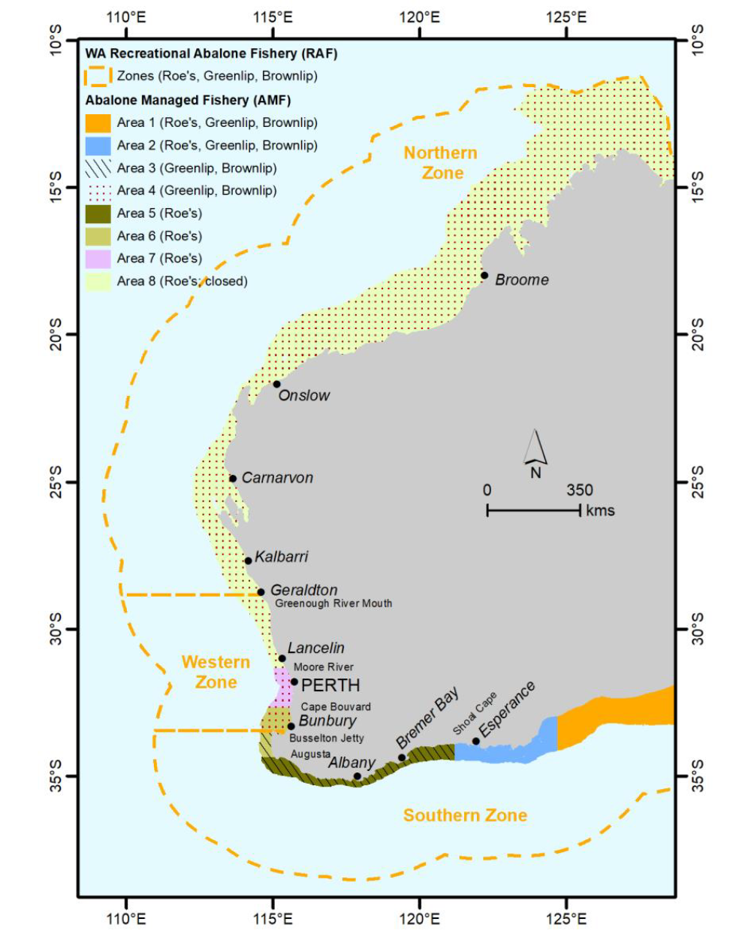

**Figure 2**. Map of AMF and RAF Management Areas.

The Western Zone is the centre of the RAF and includes the Perth metro fishery. The Western Zone is highly regulated and only permitted for four x 1 hour sessions per year, which can be reduced or extended if in-season monitoring shows it is necessary to protect stocks.

The Northern Zone in the RAF (corresponding to Area 8 of the AMF) and the northern end of the Western Zone (Order 2011-Prohibition on taking Abalone north of Moore River) has been closed to both recreational and commercial fishing since 2011 due to a catastrophic mortality (99.9%) associated with a marine heatwave. The Southern zone is dominated by catches of Greenlip and Brownlip abalone.

**Table 1.** Recreational Management Arrangements.

|  |  |  |
| --- | --- | --- |
| Measure | Description | Instrument |
| **Bag limits** | Roe’s abalone   * 15 per fisher per session in the West Coast Zone (Zone 1) * 20 per fisher per day in the Southern Zone (Zone 3)   Greenlip/Brownlip abalone (combined)   * 5 per fisher per day * Where take of Greenlip abalone is prohibited, a bag limit of 5 Brownlip applies. | [*Fish Resources Management Regulations 1995*](https://www.legislation.wa.gov.au/legislation/statutes.nsf/law_s4447.html) *Schedule 3 Division 7* |
| **Size limits** | * Brownlip abalone 140mm * Greenlip abalone 140mm * Abalone Roe’s 60mm | [*Fish Resources Management Regulations 1995*](https://www.legislation.wa.gov.au/legislation/statutes.nsf/law_s4447.html) *Schedule 2 Part 3 Division 6* |
| **Effort restrictions** | Diving for abalone using breathing apparatus prohibited in Abalone Zone 1 (West Coast Zone). | [*Fish Resources Management Regulations 1995*](https://www.legislation.wa.gov.au/legislation/statutes.nsf/law_s4447.html) *Part 4, Division 5B r 38E* |
| **Gear Restrictions** | Possession of fishing gear in Abalone Zone outside fishing season (1) A person must not, in Abalone Zone 1, 2 or 3, be in possession of any fishing gear capable of being used to take abalone at any time other than during the fishing season for that Abalone Zone. | [*Fish Resources Management Regulations 1995*](https://www.legislation.wa.gov.au/legislation/statutes.nsf/law_s4447.html) *Part 4, Division 5B r 38EA* |
| **Seasons** | In this Division —  fishing season means —  (a) for Abalone Zone 1, between 7 am and 8 am on the second Saturday in January, the first and third Saturdays in February and the second Saturday in December in any year; and  (b) for Abalone Zones 2 and 3, the period beginning on 1 October in any year and ending on 15 May in the following year. | [*Fish Resources Management Regulations 1995*](https://www.legislation.wa.gov.au/legislation/statutes.nsf/law_s4447.html) *Part 4, Division 5B r 38DB* |
| **Spatial Closures** | * Prohibition on Recreational Fishing for Greenlip abalone (Busselton Jetty to Shoal Cape) Order 2023 * Prohibition on taking abalone (North of Moore River) Order 2011 | FRMA Section 43 Order |

## Harvest Strategy

The AMF and the RAF are currently managed in accordance with the [Abalone Resource of Western Australia Harvest Strategy Version 2.2. (October 2023) Fisheries Management Paper No. 283.](https://www.fish.wa.gov.au/Documents/management_papers/fmp283.pdf)  The harvest strategy (HS) was developed in 2017 with the WA Fishing Industry Council (WAFIC) and Recfishwest (RFW) as the key sources of coordinated consultation for the commercial and recreational sectors, respectively.

The HS involves two interrelated decision-making processes:

* The first constitutes the formal review of targeted stocks and other ecological assets against defined RL to determine performance against management objectives relating to ecological sustainability.
* The second process involves an annual fishery-level review that determines whether the current catch/effort by each of the relevant fisheries/sectors is consistent with the levels expected when ecological objectives are met.

In addition to ensuring the biological sustainability of all captured aquatic resources, the HS includes broader ecological objectives for each relevant ecosystem component, as well as high-level social and economic objectives for the sectors targeting this resource. It is important to note that the social and economic objectives are applied within the context of Ecological Sustainable Development (ESD) and are considered once the ecological objectives have been met.

Under the HS when the Performance Indicator (PI) in a management area falls below the target and/or threshold RL, the extent to which the annual Sustainable Harvest Level (SHL) for the following year will be reduced is reflective of how far the indicator has fallen from the target/threshold RL (**Figure 3**). This allows for a precautionary approach to management, with reductions in catches addressed in a timely manner to minimise the risk of the indicator reaching the limit RL.

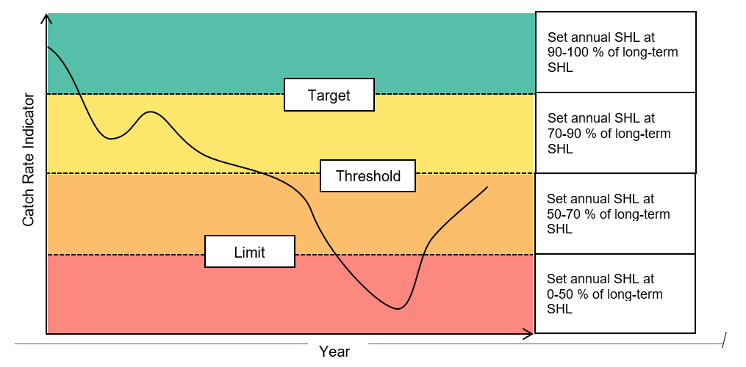

**Figure 3** Schematic of how the harvest control rules are applied to managing the abalone resource of Western Australia.

### Harvest Strategy for Roe’s Abalone -Area 7-Perth Metropolitan Region

For Roe’s abalone in the Perth metropolitan fishery, evidence on future harvest sized stock abundance is used as the primary PI and obtained from a stock prediction model (**Figure 4**). It uses evidence from annual recruitment surveys of Age 1+ animals, combined with the average summer sea surface temperature (SST, i.e. January – March) during the four-year period in which the Age 1+ cohort grows to harvest size, to predict the availability of harvest size stock (density of abalone ≥71 mm in length) in the target year.

Such a model is only possible in the Perth metropolitan Roe’s abalone fishery because there is a 20-year time series trend of fishery-independent survey data at both fished and unfished sites.

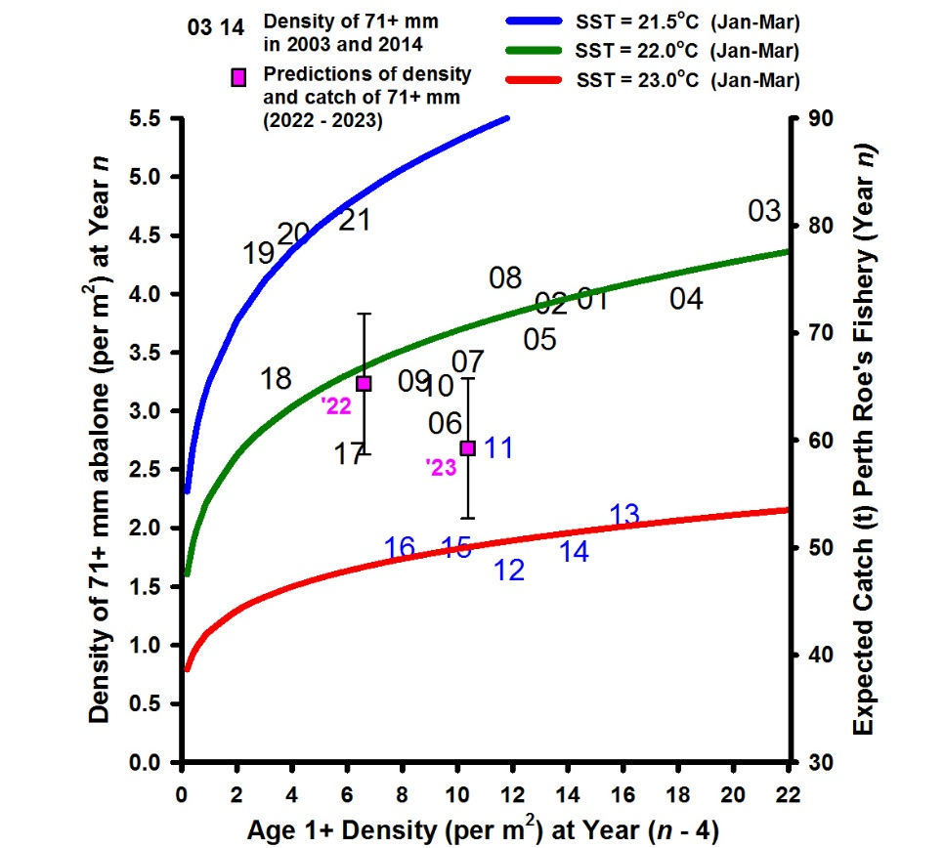

**Figure 4** Density (per m2) and expected catch (t) of harvest-sized (≥71 mm) Roe’s abalone (year n), recruitment density (number per m2 of Age 1+ (17 – 32 mm) at year n – 4, e.g. 15 = density of Age 1+ in 2011) and the relationship with mean summer SST (January to to March) during the 4 year period (years n - 3 to n).

The predicted availability of harvest size stock (density of abalone ≥71 mm in shell length) in the target year is then converted into a Total Allowable Catch (TAC) for the Perth metropolitan Roe’s abalone fishery.

This TAC is divided by the catch-share allocation equations that provide a TACC for the commercial fishery (Area 7) and a Total Allowable Recreational Catch (TARC) for the recreational fishery (Zone 1). The reference levels for the TARC are monitored throughout the Perth metropolitan Roe’s open season.

|  |
| --- |
| Equation 1 – Separate Area 7/Zone 1 SHL by habitat: |
| Subtidal habitat TAC=SHL×60%  Platform habitat TAC=SHL×40% |
| **Equation 2 – Determine TACC and TARC by sector use on each habitat TAC:** |
| Area 7 TACC = ((Subtidal habitat TAC)/((a+b)) ×a)  Zone 1 TARC = ((Subtidal habitat TAC)/((a+b) ) ×b)+(Platform habitat TAC) |

**Table 2**. Equations to allocate Roe’s abalone TAC in the Perth metropolitan Roe’s abalone fishery proportionally between sectors, based on the distribution of Roe’s abalone spawning biomass and sectoral fishing effort by habitat. In Equation 2, a is the percentage of the commercial fishing effort that occurs in the subtidal habitat (100% in 2020/21) and b is the percentage of the recreational fishing effort that occurs in the subtidal habitat (17% in 2020/21).

#### In season Recreational Effort Rule

To manage the Western Zone TARC during the season, an in-season recreational effort control rule (RECR) management decision process has been established to limit catch to a pre-defined TARC based on annual sustainability assessments.

As part of the RECR the recreational reference level (RRL) is set at the TARC minus 6 tonnes (the average hourly catch achieved by recreational abalone fishers in Zone 1).

During the in season catch monitoring if the RRL is exceeded after the first two or three hours of the Zone 1 fishing season (of the four (potentially five) x one hour-long fishing sessions), the season length will be shortened by two or one fishing session(s) respectively.

If the RRL is not reached after the completion of the advised WA RAF Zone 1 season, the season may be extended by one session. This will only occur if there are no stock sustainability issues, and weather conditions are deemed the main contributing factor.

In addition, a review is triggered to determine the reasons for the low recreational catch in Zone 1.

### Recovery Plan

If the PI for an abalone species breaches the limit, the HS requires that appropriate management action be taken to reduce the annual TACC to 0-50% of the long-term SHL, to return the PI to above the threshold within two generations. A Recovery Strategy (RS) is to be initiated in the year immediately following a breach of the limit and defines when the timeframe for recovery begins.

A resource that has fallen below the acceptable level and for which suitable management adjustments have been implemented to reduce catch and/or effort (as outlined in the Harvest Control Rules (HCRs) is considered to be in a recovery phase.

For target stocks that fall below the limit RL, a RS will be developed and implemented to ensure that the resource can rebuild at an acceptable rate (i.e. within two generations). Where the environmental conditions have led, or contributed significantly, to the resource being at an unacceptable level, the strategy needs to consider how this may affect the speed and extent of recovery.

There are three steps as part of the process to recover abalone in accordance with the requirements of the RS. The time frames for these steps are consistent with the maximum time permitted to recover by the MSC. There steps are:

**Step 1:** Initiate Recovery (Milestone: PI above limit within 4 years of the limit breached).

**Step 2:** Recover by rebuilding the PI to the threshold reference level (Milestone: at or above the threshold within XX (two generation times) years of the limit breached).

**Step 3:** Building to the Target (Milestone: PI above the target).

### Current Recovery Strategies

#### Greenlip Abalone Area 3

In response to declining stock biomass of Greenlip abalone in Area 3 to below the limit RL, a RS has been developed and implemented since 2019.

* The RS aimed to return the PI to above the limit reference level within four years of being implemented.
* There has been limited positive response (increase) by the PI to the reduced TACC.
* As such, appropriate management action was implemented with respect to the timeframes outlined in the RS and this resulted in the closure of Area 3 to all (commercial and recreational) Greenlip abalone fishing (in 2023).
* Given the rebuilding trajectory has not met Step 1 of the Area 3 Greenlip abalone RS, revision of the RS is being undertaken and consultation with all stakeholders will occur throughout 2024 and 2025.

#### Greenlip Abalone Area 2

* A RS was initiated in 2020 for greenlip abalone in Area 2
* Since the reduction of the TACC in 2020/21 the PI has shown a positive response.
* Area 2 Greenlip abalone is considered a recovering fishery and has transitioned to Step 2 of the RS where any potential increase in the annual TACC should be between 0-10% of the previous season’s TACC.

#### Brownlip Abalone Area 2

* Following a sharp decline post the 2011 marine heatwave, the PI Standardised Catch Per Unit Effort (SCPUE) for Area 2 Brownlip has been below the limit RL for nine of the last ten seasons and has subsequently been managed under a RS since 2021.
* The stock has shown no positive response to management, despite five years of consecutive catch reductions. The PI reached historic low levels in 2022/23 and 2023/24.
* In 2024, Brownlip abalone in Area 2 was formally closed to commercial abalone fishing (0 kilogram TACC) as the Primary PI CPUE had fallen below the limit for nine of the last ten seasons.
* Fishing remains open to recreational fishers. Given the low level of recreational catch (approximately 1500) the risk to the Brownlip stock posed by recreational fishers is considered low. This position will be reviewed for the 2025/26 season.

## Performance against objectives, performance indicators and performance measures

### Annual reporting

#### SRFAR

DPIRD reports on the status of the AMF in the annual SRFAR. DPIRD has finalised and released the 2022/23 SRFAR, which includes stock status information up to and including the 2021-2022 fishing season. Key conclusions of this report with respect to the status of indicator species taken by the AMF in the 2022/23 SRFAR are as follows:

* Statewide commercial take of Roe’s was assessed as being **Adequate**. Total catch = 70.7t.
* Statewide commercial take of Greenlip/Brownlip were assessed as being **Inadequate**. Total catch = 45t. TACC reduced to 29.9t and Area 3 closed to Greenlip abalone fishing for the 2023 season. Further information can be found in [*Status Reports of the Fisheries and Aquatic Resources of Western Australia 2022/2023*](https://www.fish.wa.gov.au/Documents/sofar/status_reports_of_the_fisheries_and_aquatic_resources_2022-23.pdf)*.*

## Stock assessments

#### Principles

DPIRD carries out annual weight of evidence stock assessments for all three species of abalone in WA. The stock assessment informs the stock status for the Department’s Annual Report and the Status Reports of the Fisheries and Aquatic Resources of WA, the MSC annual audit and the biennial Status of Australian Fish Stocks Report. This assessment is undertaken through a weight of evidence approach and evaluates the PI for each species within the individual management areas of the AMF against the specified RL.

For Greenlip abalone in Area 3, a model-based assessment is also updated periodically to monitor the stock relative to Maximum Sustainable Yield (MSY)-based RL and RS, and to evaluate whether the stock is rebuilding at the required rate. This has been incorporated into the HS and the weight of evidence assessment for this stock.

### Summary of 2023 assessment key outcomes

As part of the annual TACC setting process an AMF stock assessment is carried out.

|  |  |  |
| --- | --- | --- |
| Species | Area | Status |
| **Roe’s abalone – *Haliotis roei*** | **1** | * This area continues to have an exploratory TACC, noting that only 3,299 kg has been harvested over the past 10 seasons and no catch has been taken in the 2022/23 season to date. |
| **2** | * The PI is above the target RL whereby the HCR advises that the TACC be set at 90-100% of the long-term SHL; 18,000 kg. * Note, only 37.3% of TACC has been taken due to the impact of COVID-19 on overseas markets. |
| **5** | * The PI is above the target RL whereby the HCR advises that the TACC be set at 90-100% of the long-term SHL (20,000 kg). * Less than 1% of the TACC had been caught at the time of assessment due to the impact of COVID-19 on overseas markets. |
| **6** | * The PI is above the target RL whereby the HCR advises that the TACC be set at 90-100% of the long-term SHL. Stock levels are considered adequate due to low catch over the past 11 seasons. * Only 16.2% of TACC had been caught at the time of assessment due to the impact of COVID-19 on overseas markets. |
| **7** | * For Roe’s abalone in the Perth metropolitan fishery (Area 7) under the HS, evidence on future harvest sized stock abundance (71+ mm) obtained from a stock prediction model is used as the primary PI to set the TACC. * Recovery of the Perth abalone stocks from historically low levels was complete in 2021. * Stock indicators for adult Roe’s abalone (harvest-size animals and spawning biomass) are above pre-2011 marine heatwave levels with some at or near record-high levels since the Perth abalone stock surveys began (1997). * However, the increasing trend across all stock indicators (post 2015) halted in 2022, with juvenile recruitment exhibiting a sharp decline. * The stock prediction model has estimated a decline in density of harvest size (71+ mm) Roe’s abalone for 2023 (corresponds to end of the 2022/23 season given timing of surveys). * This corresponded to an overall commercial and recreational catch (TAC) reducing for the 2022/23 season. * There was no change in the TACC for the 2023/24 season until the mid-season review that will be carried out in June 2024. * This allows consideration of the results from the 2023 fishery-independent survey. |
| **8** | * Fishery closed due to catastrophic mortality associated with the marine heatwave in 2011. |
| **Greenlip abalone – *Haliotis laevigata*** | **1** | * This is an exploratory fishing area as stocks in this area are “stunted” and very minimal fishing has been undertaken since 2010/11 (910 kg). * No catch has been taken in the 2022/23 season to date. |
| **2** | * As per the HS, Area 2 Greenlip abalone has been under a RS, noting the TACC has been set at between 0-50% of the long-term SHL (30,000 kg) for the last five seasons (TACC reduced to 9,000 kg in 2018/19). * However, additional management action was undertaken in 2020/21 (TACC reduced to 6,000 kg) because of the continued decline in PI. * Since the reduction of the TACC to 6,000 kg in 2020/21 the PI has increased, where in 2022/23 it is above the limit RL (high degree of certainty). * Under Step 2 of the RS, when there is a positive trend in PI any potential increase in the annual TACC will only be 0-10% of the previous seasons TACC. * In 2022/23, in line with the RS 5% increase in TACC was implemented as to be more precautionary approach to a TACC of 6,300kg. * For 2024/2025 season a further 5% increase TACC of 6,600 kg was implemented in line with Step 2 of the recovery strategy. |
| **3** | * Area 3 Greenlip abalone is currently being managed under a RS and is closed to both recreational and commercial fishing. |
| **Brownlip abalone – *Haliotis conicopora*** | **1** | * No Brownlip abalone stocks of note in this area. |
| **2** | * As per the HS Area 2 Brownlip abalone has been under Step 1 of the RS, the TACC was set at between 0-50% of the long-term SHL in 2021/22. * Additional management action was undertaken in 2022/23 because of the continued decline in PI. * The PI for Brownlip abalone within Area 2 in 2022/23 is below the limit RL and at a record low level. * In 2024 Area 2 Brownlip fishing was closed to commercial fishing. * Area 2 Brownlip fishing remains open to recreational fishers. * Given the low level of recreational catch the risk to the Brownlip stock posed by recreational fishers is considered low. * This position will be reviewed for the 2025/26 season. |
| **3** | * The PI has been fluctuating around the target RL for the last five seasons. * In 2022/23 the PI’s lower 95% confidence interval overlaps the target and is marginally above the threshold RL and as such, it cannot be determined with a high degree of certainty that the PI is above the target. * Note, only 2,700 kg of the 4,500 kg TACC had been caught at the time of assessment, while over the last eight seasons the catch has been on average 85% of the annual TACC. * Given the level of certainty around the PI in relation to the RLs and the low catch in the 2022/23 season, the precautionary approach would be to recommend the lower HCR range (70-90% of long-term SHL (5,500 kg)). * The reduced Greenlip abalone TACC in recent seasons, the closure of the Augusta sub-area and now full closure to Greenlip abalone fishing has facilitated a change in fishing practices in Area 3 to the targeting of Brownlip abalone (historically was a by-product species). * The effect of this change in fishing practices is being explored through the consolidated model-based assessment. * Aquatic Science and Assessments advice is for the TACC to remain at 4,500 kg (81.8% of the long-term SHL) for the 2023/24 season. |

**Retained (non-indicator) species**

Divers have the ability to target abalone of their choice (species, sizes and quality of abalone), and do not inadvertently harvest bycatch in their normal fishing activities.

## Monitoring and data collection

### Statutory logbook reporting

Within 90 minutes of bringing abalone ashore, the person who is the nominated operator of the licence must complete a Catch and Disposal Record (CDR) with accurate details of the weight and number of abalone caught (by species), fishing locations, diving time and any Endangered, Threatened or Protected (ETP) interactions.

Reporting is via electronic digital in Fisheye or in the CDR paperwork.

There are currently 18 approved processors that hold a fish processor licence and are authorised to process abalone. All processors are Australian Quarantine and Inspection Service established facilities. Abalone product arrives with the CDR that includes the licence holders name and number and a consignment number.

Information on species retained by the AMF and total estimated live weight of abalone species retained in the AMF, is reported in the annual SRFAR.

## Vessel monitoring system

Vessel monitoring systems (VMS) has not been implemented in the AMF.

## Data collection, validation, and monitoring programs

A summary of dependant and independent assessments for management of the WA abalone resources can be seen in Table 3.

**Table 3**.Summary of information available for assessing WA Abalone.

|  |  |  |  |  |  |
| --- | --- | --- | --- | --- | --- |
| Data Type | Fishery-dependent or Independent | Purpose/Use | Area of collection | Frequency of collection | History of collection |
| Commercial catch | Dependent | Monitoring of commercial catch | State | Annual |  |
| Commercial catch and effort databases | Dependent | Monitoring of commercial catch and effort trends, calculation of catch rates and the area fished | 60x60 NM block | Monthly |  |
| Recreational catch and effort estimates | Dependent | Monitoring of recreational catch and effort trends | Metropolitan phone-recall survey  State | Annual  Annual |  |
| Perth Metro Roes Abalone Recreational catch and effort estimates | Dependant | On-site monitoring | West Coast Zone (Perth Metro) | In season | 1997-2010 |
| Biological information | Dependent and Independent | Patterns of growth and reproduction, stock structure | State | Intermittent |  |

#### Fishery-dependent monitoring

The stock status of Roe’s, Greenlip and Brownlip abalone in WA is assessed using a risk-based weight of evidence approach that considers all the available (fishery-dependent and fishery-independent) information for this resource. This annual assessment of the abalone resource is primarily based on monitoring of standardised fishery-dependent catch rates of each species in their relevant management areas in the AMF.

Commercial catch rates for each species in their relevant management areas are calculated from the daily catch and effort data reported by commercial fishers in the daily logbooks. The catch rates are standardised using a generalised linear modelling approach to account for the variables that influence the catching efficiency and abundance of abalone (Hart et al. 2009). The annual SCPUE is used as the PI and compared against the species- and area-specific reference levels to determine the annual SHLs in accordance with the HCRs.

#### Fishery-independent monitoring

Fishery-independent population surveys are undertaken regularly in the different areas of the resource to collect data on the size and density of abalone. These data provide information on recruitment, estimates of mortality and independent measures of abundance to compare to fishery-dependent catch rates for the different species.

Population surveys of Roe’s abalone are undertaken annually at 19 indicator sites in the Perth metropolitan Roe’s abalone fishery; 17 that are fished and two that are in areas where no fishing is permitted. Surveys are carried out on two habitats, the reef platform and the sub-tidal habitat, which generally correspond to the recreational and commercial fisheries, respectively.

Surveys of Greenlip and Brownlip abalone along the southern coast are undertaken periodically at fixed sites throughout the fishery (121 sites in Area 2 and 131 sites in Area 3). Survey sites were selected based on known stock distributions, and range broadly in the level of productivity. Two main sub-areas (Arid in Area 2 and Augusta in Area 3) are surveyed annually (72 sites), while other areas are visited once every 2-3 years.

A stock prediction model that allows setting of the annual SHL as a function of stock abundance using fishery-independent data has been developed for the Perth metropolitan Roe’s abalone fishery. The development of similar predictive models for other management areas and species of the resource are in the early stages of development.

In the Perth metropolitan Roe’s abalone fishery, a stock-recruitment-environment relationship using fishery-independent data has recently been established and is shown in Figure 4. It uses evidence from annual spawning biomass surveys, combined with the average summer SST (i.e. January – March) in the year of spawning to predict the recruitment densities (Age 1+) two years later. Evidence on future recruitment densities from this relationship will be used as a secondary performance indicator against spawning biomass RLs in the weight-of-evidence approach.

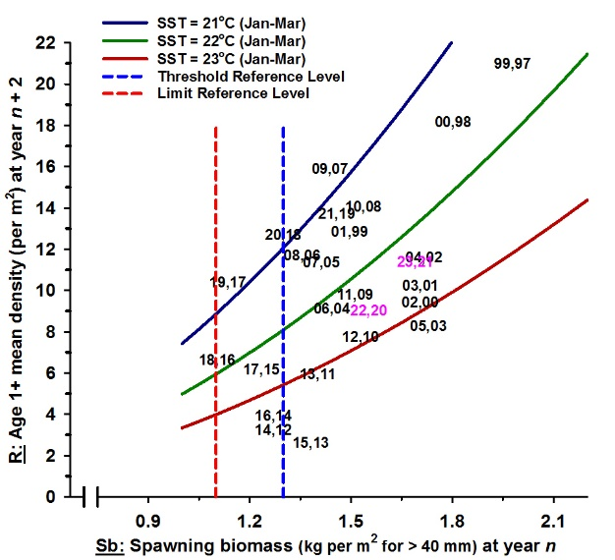

**Figure 5**. Stock-recruitment-environment relationship for Roe’s abalone in the Perth metropolitan fishery. Spawning biomass (kg per m2 index of ≥40 mm abalone at year *n*) and recruitment density (number of Age 1+ (17 – 32 mm) per m2 at year *n* +2) relationship with summer SST (January to March) at the time of spawning (years *n*). Pink symbol (e.g. 22,20) represents the predicted Age 1+ recruitment in 2022 arising from the spawning biomass and the summer SST in 2020. Biological RLs (Limit and Threshold) for spawning biomass are presented as a secondary PI.

Model-based assessments of Greenlip and Brownlip abalone have recently been undertaken to derive management area specific RLs for the primary PI (i.e. commercial SCPUE). These assessments align with the key assessment levels (tiers) used by DPIRD to determine the status of WA fisheries resources and range in complexity, data requirements and inherent assumptions. These model-based assessments will be conducted every 2-3 years and provide periodic estimates of spawning biomass (relative to the unfished stock) to be used as a secondary PI (included in the weight-of-evidence assessment), with threshold reference levels at *B*MSY and limit reference levels at 0.5*B*MSY.

#### Economic and social monitoring

Processor production and value is monitored using statutory logbooks. This information provides estimates of weighted average price which, when multiplied with total landings produces estimates of GVP of the AMF.

## Ecosystem

### Mitigating impacts on the wider ecosystem

DPIRD utilises an integrated EBFM approach for fisheries management in WA. The EBFM approach ensures that fishing impacts on the overall ecosystems are appropriately assessed and managed. In line with the principles of ESD, the EBFM approach also recognises that the economic and social benefits of fishing to all users must be considered.

Implementation of EBFM involves a risk-based approach to monitor and assess the cumulative impacts on WA’s aquatic resources from all fishing activities (commercial, recreational, customary), operating at a bioregional or ecosystem level. The level of risk to each resource is used as a key input to the DPIRD Risk Register, which is an integral component of the annual planning cycle for assigning activity priorities (research, management, compliance, education etc.) across each bioregion.

### Ecological risk assessments

Where possible, DPIRD undertake Ecological Risk Assessments (ERA) periodically to assess the risk of fishing activities on target scalefish species and bycatch species, and the broader ecosystem.

An ERA for the AMF was undertaken in December 2015 (Webster et al. 2017). A further ERA was carried out in 2021, an updated ERA will be carried out in 2026. The ERA findings guide internal management and decision making. The fishery has MSC certification since 2017, the MSC assessment process also considers impacts on the wider ecosystem.

### Bycatch and protected species interactions

The AMF fishing method is species-specific with no bycatch being taken and animals are measured in situ prior to harvest.

Fauna under the BCA; and other species that are listed under the EPBC Act.

## Enforcement of the management arrangements

Operational compliance plans (OCP), guide the enforcement of management arrangements for the AMF. OCPs are informed and underpinned by a compliance risk assessment and are reviewed every 1-2 years. OCPs have the following objectives:

* 1. to provide clear direction and guidance to officers regarding compliance activities that are required to support effective management of the fishery;
  2. to provide a mechanism that aids the identification of future and current priorities;
  3. to encourage voluntary compliance through education, awareness, and consultation activities; and
  4. to review compliance strategies and their effective implementation.

The primary monitoring activity in the AMF relates to the reporting and validation of catches for quota-monitoring purposes. The AMF vessels are not required to operate a vessel monitoring system (VMS) but pre fishing nominations to advise of launching, fishing and landing areas are required. There is a monitoring, control and surveillance (MCS) system in place including:

* Departmental checking of processor reported weights and those in CDRs;
* Attending industry meetings;
* Intel-driven investigations;
* Land patrols, including opportunistic inspections of catch and licenses;
* Sea patrols;
* Use of drones and CCTV footage
* Pre fishing nominations for targeted inspections;
* Processor inspections; and
* Road-side check points (in collaboration with the WA Police) for protected fish species or black market operations.

## Consultation process

Management changes for the AMF are given effect through amendments to legislation, such as the AMF management plan, regulations, and orders. These changes require consultation with all affected parties and the approval of the Minister for Fisheries and/or DPIRD’s Director General (or appropriate delegates). In making decisions relevant to fisheries, the Minister for Fisheries may choose to receive advice from any source but has indicated that:

1. DPIRD is the primary source of management advice; and
2. the peak body WAFIC is the primary source of advice and representation from the commercial sector.
3. DPIRD also consults directly with the Abalone Industry Association of WA (AIAWA) and the West Coast Abalone Divers Association (WCADA) on specific commercial abalone science, management and operational issues.

WAFIC is funded by the WA State Government under a Service Level Agreement to undertake their representation/advisory and consultation roles. Under the agreement with DPIRD, WAFIC is required to undertake statutory consultation functions related to the AMF management and the facilitation of management meetings.

Management meetings between DPIRD, WAFIC and authorisation holders in the AMF are held annually and are important forums to consult on the management of the AMF. During these meetings, DPIRD (science, management, and compliance) staff, licence holders and WAFIC discuss current and future management issues. DPIRD also consults directly with industry, where relevant, on specific management and operational issues. Follow-up meetings may be held as required.

## Research

Decision-making processes can be triggered following the identification of new or potential issues as part of an ERA (generally reviewed every 5 years), results of research, management or compliance projects or investigations, monitoring or assessment outcomes (including those assessed as part of the HS) and/or expert workshops and peer freview of aspects of research and management.

Catch and effort information is collected monthly. Catch data has been captured since the late 1970s. Daily catch and effort is stored within the CDR. Catch is also officially weighed at licenced processor facilities and entered into the abalone catch and effort database (Hart et al 2013).

Annual recreational catch and effort estimates are derived from an annual field survey in the West Coast Zone and by occasional phone surveys covering the entire state.

[Fisheries Research Report No. 333 - *Recreational fishing for Abalone in Western Australia in 2021/22: estimates of participation, effort and catch* C.B. Smallwood, K.L. Ryan, E.K.M. Lai, L.J. Rudd and L.W.S. Strain, i](https://www.fish.wa.gov.au/Sustainability-and-Environment/Fisheries-Science/Documents/frr333.pdf)nformed management decisions that contributed to the closure of Area 3 Greenlip fishing. The statewide phone-recall survey of the RAF complements annual on-site monitoring within the Perth metropolitan Roe’s abalone fishery, as well as provide robust estimates for use in stock assessments.

The Perth metropolitan Roe’s abalone fishery field survey estimates catch, and effort form each distinct Roe’s abalone stock within the metro area. Estimates are based on average catch, catch rates, and fisher counts conducted by fisheries volunteers and research personnel from shoreline vantage points and aerial surveys.

### Fishery Independent Stock Surveys

#### Greenlip/Brownlip Abalone

Research diver transect surveys are carried out for Greenlip and Brownlip for fishery independent surveys. There are 85 stock survey sites in Area 2 of the AMF and 116 in Area 3 targeting a range of sites of different productivity. The arid and Augusta sub areas are surveyed annually and other sub areas are surveyed every 2-3 years.

Habitat is quantified and utilised to obtain a density estimate. Suitable abalone habitat was defined as habitable surfaces (generally granite or limestone) of sufficient quality and area to allow effective attachment for abalone above 40mm shell length (I+ years) (Hart et. al 2017). Younger juveniles are cryptic, while the larvae settle preferentially on non-geniculate coralline algae, and require different habitat and sampling requirements (Daume et al., 1999; McShane, 1995).

#### Roe’s Abalone

Size and density of Roe's abalone in the Perth metropolitan fishery is measured annually at 13 indicator sites between Yanchep and Penguin Island. 11 of these are fished while the other two are the Waterman's Reserve Marine Protected Area (MPA) and the Cottesloe Fish Habitat Protection Area (FHPA). Sites initially began in 1996 at five sites, with the full complement of 13 indicator sites available from 2011 onwards.

Surveys are carried out on two habitats, the reef platform and the sub-tidal habitat, which generally correspond to the recreational and commercial fisheries respectively. The methodology involves surveying fixed quadrats of 0.25 and 0.5 m at each site and counting and measuring all animals within these quadrats (Hart et. al 2013).

Size and density of Greenlip abalone are surveyed by commercial industry divers using a specifically developed video survey methodology for these species (Hart et al., 2008.). The reason for using industry divers is a cost-effective measure as many fishing sites are remote.

Whilst fishing in any given sub-area, the commercial diver films one site per day at the commencement of the second dive, prior to harvesting the animals. This ensures a randomised site selection process. The procedure is to undertake a 10-minute (approx.) survey, filming each abalone in turn so that lengths for each animal can be later determined. The footage is sent back to the ASA Division, where the images are extracted and counts of abalone density and estimates of length are undertaken using digital image analysis software (Hart et al. 2013).

#### Fishing Mortality

Commercial Greenlip and Brownlip fishers provide a random sample of shells harvested from each day’s fishing and these are categorised into relevant sub-areas. Commercial divers also undertake digital video surveys on commercially fished reefs from which a random sample of abalone (~30% of the total) are selected and measured. The legal size animals from the video survey data are used to estimate fishing mortality where applicable.  
This sampling provides length-frequency data to enable estimation of total mortality and fishing mortality. These datasets are used in the development of performance indicators and TACC assessment processes and to assess the changes in targeting practices between years (Hart et. al 2013).

The large variation in growth of abalone, coupled with the inability to estimate age with any degree of accuracy precludes the use of age-based estimation methodologies for ascertaining total and fishing mortality. Consequently, a length-based catch-curve analysis method is used. The main assumptions of this are that growth, recruitment and natural mortality parameters are constant from year to year. None of these assumptions are likely to hold strictly true, however they facilitate an estimate of relative fishing mortality that is comparable between years, and relatively robust to violations of the assumptions. For example, an increase in growth rates or recruitment under a constant catch is likely to shift the frequency of the median length-class upward, which would result in a reduction in fishing mortality estimates (Hart et. al 2013).

#### Stock Enhancement

DPIRD on occasion may carry out experiments on stock enhancement. Such as experiments with Greenlip abalone that have been carried out in collaboration with industry divers since 2004. In 2008 a further experiment was initiated at Flinders Bay, Augusta. This experiment involved the release of abalone at high density at three sites, with 11,000 animals of 20 - 30 mm (1+ age) released at an approximate density of 18 - 20 juveniles m-2. The animals were bred from wild broodstock obtained from Augusta in November 2006. Control sites and effects of the enhancement on the habitat and other species are also being examined at part of this research.

In 2009, the Australian Seafood Cooperative Research Centre awarded an externally funded research project. The project was called "Bioeconomic evaluation of commercial scale stock enhancement in abalone", with the objectives to undertake a comprehensive evaluation of the feasibility for stock enhancement in abalone over 2009 to 2012.

#### Recovering a collapsed abalone stock through translocation

This project was in response to a catastrophic mortality of the AMF due to an anomalous environmental event in the summer of 2010/11. During this event, termed a "marine heatwave", SST rose to lethal levels for Roe's abalone and coupled with deoxygenation of the water during an extended calm period, effectively wiped out an entire stock. The project arose following a closure of this part of the AMF to protect any remaining stock and a desire by the industry to examine the possibility of assisted recovery.

## References

Abalone Resource of Western Australia Harvest Strategy 2021-2026 Version 2.2. (October 2023). Fisheries Management Paper No. 283. Department of Primary Industries and Regional Development, Government of Western Australia.

Anthony M. Hart, Frank Fabris, Jamin Brown and Nick Caputi (2013). Biology, history and assessment of Western Australia abalone fisheries. Fisheries Research Report No.241, 2013. Department of Primary Industries and Regional Development, Government of Western Australia.

C.B. Smallwood, K.L. Ryan, E.K.M. Lai, L.J. Rudd and L.W.S. Strain (2023). Recreational fishing for Abalone in Western Australia in 2021/22: estimates of participation, effort and catch. Fisheries Research Report No. 313. Department of Primary Industries and Regional Development, Government of Western Australia.

Cook et al. (2014). The Worldwide Abalone Industry Modern Economy, 2014, 5, 1181-1186.

Daume, S., Brand-Gardner, S. and Woelkerling, Wm. J. (1999) Settlement of abalone larvae (Haliotis laevigata Donovan) in response to non-geniculate coralline red algae (Corallinales, Rhodophyta). Journal of Experimental Marine Biology and Ecology 234, 125 - 143.

Hart A.M., Fabris F., Murphy D., Brown J., Strain M. and Davidson M. (2013c). Stock enhancement of Greenlip abalone Part II: Population and ecological effects. Reviews in Fisheries Science 21(3-4): 310-320.

Hart, A., Strain, L., Hesp, A., Fisher, E., Webster, F., Brand-Gardner, S. and Walters, S. (2017). Marine Stewardship Council Full Assessment Report Western Australian Abalone Managed Fishery. Department of Fisheries, Western Australia. 288pp

Hart, A.M., Fabris, F.P., Brown, J., Caputi, N. (2013a). Biology, history, and assessment of Western Australian abalone fisheries. Fisheries Research Report No 241, Department of Fisheries, Western Australia, 90 pp.

Hart, A.M., Strain, L., Fabris, F., Brown, J., and Davidson, M. (2013b). Stock enhancement of Greenlip abalone Part I: Long-term growth and mortality. Reviews in Fisheries Science 21(3-4): 299-309..

Status reports of the fisheries and aquatic resources of Western Australia 2022-23 State of the fisheries. DPIRD 2022

Strain, L, Hart, A., Jones, R. (2021) Western Australian Marine Stewardship Council Report Series No. 8: Western Australian Abalone Managed Fishery Addendum 4, 28pp

Strain, L. and Heldt, K., 2021, Roe’s Abalone, in Toby Piddocke, Crispian Ashby, Klaas Hartmann, Alex Hesp, Patrick Hone, Joanne Klemke, Stephen Mayfield, Anthony Roelofs, Thor Saunders, John Stewart, Brent Wise and James Woodhams (eds) 2021, Status of Australian fish stocks reports 2020, Fisheries Research and Development Corporation, Canberra.

Strain, L., Brown, J. and Jones, R. (2021). West Coast Roe’s Abalone Resource Status Report. In: Status Reports of the Fisheries and Aquatic Resources of Western Australia 2020/21: The State of the Fisheries eds. Newman, S.J., Wise, B.S., Santoro, K.G. and Gaughan, D.J. Department of Primary Industries and Regional Development, Western Australia. pp. 34-40.

Webster, F.J., Wise, B.S. and hart, A. (2017) Ecosystem -Based Fisheries Management (EBFM) Risk Assessment of the Western Australian Abalone Managed Industry. Western Australian Marine Stewardship Council Report Series No. 7, 2017

Wells, F.E, Keesing, J.K. (1989).Reproduction and feeding of the abalone Haliotis roei Gray. Australian Journal of Marine and Freshwater Research 40:187-197.

## Important Disclaimer

The Chief Executive Officer of the Department of Primary Industries and Regional Development and the State of Western Australia accept no liability whatsoever by reason of negligence or otherwise arising from the use or release of this information or any part of it.

Copyright © State of Western Australia (Department of Primary Industries and Regional Development), 2024.

