



Application for assessment of Western Australia’s Abrolhos Islands and Mid West Trawl Managed Fishery and South Coast Trawl Fishery under the Environment Protection and Biodiversity Conservation Act 1999
  - Submission to the Department of Climate Change, Energy, the Environment and Water

Against the Guidelines for Ecologically Sustainable Management of Fisheries

  - 26 November 2024

Contents
Acronyms 4
Introduction 5
The Fisheries 5
Description of the Fisheries 5
Abrolhos Islands and Mid West Trawl Managed Fishery 5
South Coast Trawl Fishery 12
Fishing methods and gear 16
Abrolhos Islands and Mid West Trawl Managed Fishery 17
South Coast Trawl Fishery 18
Target species and byproduct 19
Abrolhos Islands and Mid West Trawl Managed Fishery 19
South Coast Trawl Fishery 20
Value of the Fisheries 20
Management Regime 21
Legislative Framework 21
Licensing Framework 21
Controlling the level of harvest 22
Abrolhos Islands and Mid West Trawl Managed Fishery 22
South Coast Trawl Fishery 22
Harvest Strategy 23
Abrolhos Islands and Mid West Trawl Managed Fishery 23
South Coast Trawl Fishery 24
Recovery Strategy 24
Abrolhos Islands and Mid West Trawl Managed Fishery 24
South Coast Trawl Fishery 25
Performance against objectives, performance indicators and performance measures 25
Status Report of the Fisheries and Aquatic Resource (SRFR) 25
Annual fishery performance 25
Stock Assessments 26
Principles 26
Weight of evidence reports and annual season review 26
Monitoring, data collection and validation 27
Fishery-independent monitoring 27
Statutory logbook reporting 28
Vessel monitoring system 28
Ecosystem 28
Marine Stewardship Council (MSC) accreditation 28
Mitigating impacts of the wider ecosystem 29
Ecological Risk Assessments 29
Bycatch and protected species interactions 30
Habitat 31
Enforcement of Management Arrangements 31
Operations and Compliance 31
Strategic Objectives 32
Compliance Operations 32
Vessel Monitoring System 33
Operations and Communications Procedure 34
Consultation Process 34
Commercial sector consultation and decision-making 35
Communication of season arrangements 35
Voluntary closures 36
Consultation with other groups 36
Changes since the previous assessment 37
Abrolhos Islands and Mid West Trawl Managed Fishery 37
South Coast Trawl Fishery 38
References 39
Appendix 1 – Retained catch data (target and byproduct species) 41
Appendix 2 – Bycatch data (2023) in the AIMWTMF 42
Appendix 3 – Fishing catch and effort 46
Appendix 4 – AIMWTMF Weight of Evidence Stock Assessment Report (2024) 52
Appendix 5 – SCTMF Weight of Evidence Stock Assessment Report (2024) 80

Acronyms
WA Western Australia
AIMWTMF Abrolhos Islands and Mid West Trawl Managed Fishery
SCT South Coast Trawl Fishery
EPBC Act Environment Protection and Biodiversity Conservation Act 1999
DPIRD Department of Primary Industries and Regional Development
DCCEEW Department of Climate Change, Energy the Environment and Water
SRFAR Status Reports of the Fisheries and Aquatic Resources of WA
GVP Gross value product
FRMA Fish Resources Management Act 1994
FRMR Fish Resources Management Regulations 1995
BCA Biodiversity Conservation Act 2016
WAFIC Western Australian Fishing Industry Council
CPUE Catch per unit effort
ETP species Endangered, threatened and protected species
VMS Vessel monitoring system
EBFM Ecosystem-based fisheries management
ERA Ecological risk assessment
DBCA Department of Biodiversity, Conservation and Attractions
OpCP Operational compliance plans
OCP Operations and Communications Procedure for the SCTF
ALC Automatic location communicators
MFL Managed Fishery Licence
FBL Fishing Boat Licence
IoE Instrument of Exemption
HCR Harvest Control Rule \
LENS List of Exempt Native Specimens
WoE Weight of Evidence

Introduction
This submission meets the requirements for the assessment of the Western Australian (WA) Abrolhos Islands and Mid West Trawl Managed Fishery (AIMWTMF, Fishery) and the South Coast Trawl Fishery (SCTF, Fishery) under the Environment Protection and Biodiversity Conservation Act 1999 (EPBC Act).
This submission has been produced to enable the Department of Climate Change, Energy, the Environment and Water (DCCEEW, Cth) assess management arrangements for the AIMWTMF and SCTF against the Guidelines for the Ecologically Sustainable Management of Fisheries – 2nd Edition and requirements set out in relevant sections of the EPBC Act.
Export of product from the AIMWTMF and SCTF are currently approved until 30 May 2025, through their inclusion on the List of Exempt Native Specimens (LENS). It is requested that these Fisheries’ accreditation under Part 13 of the EPBC Act for the purposes of protected species provisions and export approval granted under Part 13A through inclusion on the LENS be continued based on the information and evidence prepared in this application.
Enquiries on this submission can be directed to:
Bec Leaversuch, Fisheries Management Officer
Department of Primary Industries and Regional Development
Rebecca.Leaversuch@dpird.wa.gov.au

The Fisheries

Description of the Fisheries

Abrolhos Islands and Mid West Trawl Managed Fishery
The AIMWTMF is a commercial fishery accessing (western) saucer scallops (sp: Ylistrum balloti) in the waters surrounding the Houtman Abrolhos Islands, located 60km off the mid-west coast of Geraldton, in the West Coast Bioregion (WCB) of Western Australia (WA). The boundaries of the Fishery lie within Commonwealth and WA waters of the Indian Ocean between 27°51’ south latitude and 29°03’ south latitude on the landward side of the 200m isobath (Figure 1).
There are ten Managed Fishery Licences (MFLs) in the AIMWTMF held by two independent operators, of which four are actively fished. The capacity of the AIMWTMF is managed by a maximum headrope allocation that is divided equally across all MFLs. Licenced vessels are permitted to access areas to fish in accordance with Schedule 1 of the Abrolhos Islands and Mid West Trawl Limited Entry Fishery Notice 1993 (Management Plan), and the CEO Determination Notice of Areas Closed to Fishing in the AIMWTMF No. 1 of 2023, which is renewed every three years to ensure spatial and temporal management arrangements continue to facilitate sustainable harvest of scallops Additionally, voluntary spatial (and/or temporal) closures may be implemented prior to, or during a season based on the abundance and quality of scallops to maintain adequate stock biomass for future fishing seasons.
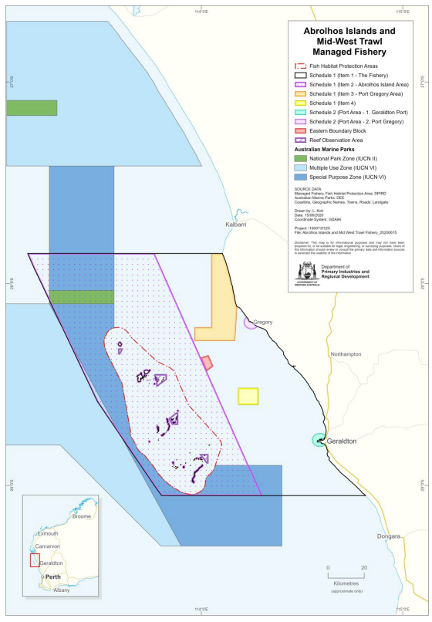
Figure 1: Boundaries and management areas of the AIMWTMF, as prescribed in the Management Plan.
In 2019, a Code of Conduct developed in consultation with industry to provide guidelines for responsible fishing aiming to mitigate potential impacts of trawling on the Rock Lobster industry and the broader environment. Under the Code of Conduct, the AIMWTMF is divided into traditional and non-traditional trawl areas. Traditional trawl grounds represent historically established fishing grounds that are known to regularly produce commercial quantities of scallop (Figure 3, Figure 4). In these areas, fishing with main gear is permitted any time during the season. The ‘non-traditional’ areas are sandy habitats not historically fished and are subject to an exploratory fishing approach.
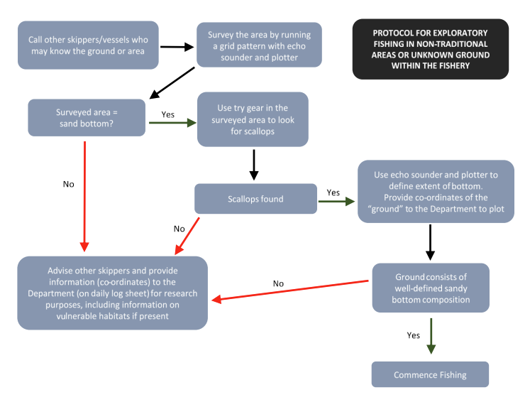
Protocols for ‘exploratory fishing’ are also set out in the Saucer Scallop Resource of the Abrolhos Islands Harvest Strategy 2020 - 2025 (AIMWTMF Harvest Strategy). outlines the process to develop new fishing grounds using exploratory fishing (a combination of echo soundings and surveys using try gear) and following a scientific assessment by DPIRD. Total area closures near major population centres, including Port areas, apply throughout the season.
Figure 2: Protocols for Exploratory Fishing in Non-Traditional Areas or Unknown Grounds within the AIMWTMF.

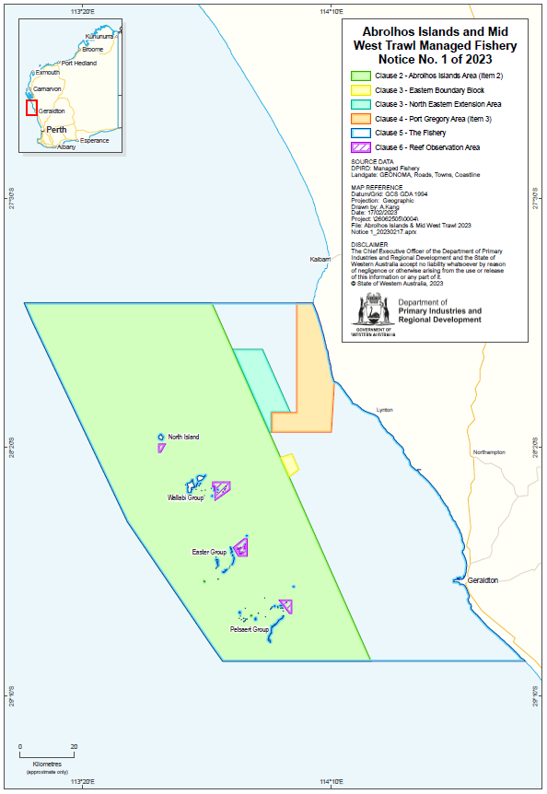
Figure 3: Boundaries and management areas of the AIMWTMF, as per Notice No. 1 of 2023 – Areas Closed to Fishing for Scallops and Prawns.
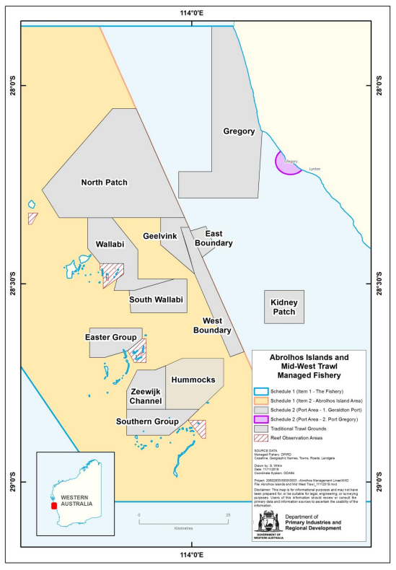
Figure 4: Traditional scallop trawl areas in the AIMWTMF.
AIMWTMF trawl footprint information continues to be updated annually. In 2023, the footprint was estimated at 457km², representing ~7.7% of the AIMWTMF allowable fishery area (~5900 km²) (Figure 8).This is comparable to levels of spatial fishing effort reported for the AIMWTMF for 2005 and 2019 and is 116 km² smaller than the cumulative area fished from 2010-19, being 573 km² . This suggests an increasing level of targeted fishing by the fleet.
Considering the spawning period of saucer scallops (August to February/March of the following year), trawling for scallops in the Fishery is only permitted between 1 March and 31 August. The actual commencement and duration of fishing however, depends on scallop distribution and abundance, which is highly variable. A pre-season survey conducted in November each year, and supported by a second survey the following February, is used to base the duration of the season on, as well as identify areas to avoid, to protect the stock. Historically, fishing has occurred for between one and eight weeks. The time and duration of fishing is also dependent on the productivity of other WA scallop managed fisheries, which AIMWTMF operators also hold authorisations to fish in.
The AIMWTMF also manages prawn fishing in a specified area within the Fishery boundary; the Port Gregory Area (Figure 4). The Port Gregory area is open to fishing from 1 March until 15 November of each year, however fishing in this area to target prawns has not occurred since 2019.
Since 2021, the AIMWTMF has been certified under the Marine Stewardship Council (MSC) accreditation standards (version 2.01).

South Coast Trawl Fishery
The SCTF operates under an Instrument of Exemption to the Fisheries Notice No. 556 Trawl Prohibition (Whole of State) Notice 1992 permitting four Fishing Boat Licences (FBLs) to access (western) saucer scallops (sp: Ylistrum balloti) off the South Coast of WA, and Commonwealth waters in the Great Australian Bight, between Cape Leeuwin (115 degrees E) and 125 degrees E on the landward side of the 200 metre (m) isobath. The Fishery area also includes all WA waters (to three nautical miles seaward from the mean low water mark) between 125 degrees and 129 degrees E (i.e. the WA/South Australian border) (Figure 5).
While the boundary of the Fishery covers a large section of the South Coast of WA, actual fishing effort is targeted to small sandy areas of higher scallop abundance, which is approximately 1-3% of the allowable SCTF fishing area. There are four key fishing areas: Cheynes Beach (near Albany), Doubtful Islands (including Bremmer Bay), the Recherche Archipelago (off Esperance) and Israelite Bay. Fishing at Cheynes Beach and Bremer Bay is managed under an Operations and Communications Protocol (OCP, 2021), developed by DPIRD in consultation with industry to support information sharing between the Fishery’s operators and relevant stakeholders. The objective of the OCP is to provide adequate information to be able to respond to potential community and media enquiries regarding trawling vessel locations and/or operations. Bremer Bay and Cheynes Beach were identified as key areas of interest due to their high visibility and the OCP provides specific measures that operators must adhere to when planning to fish in these areas.
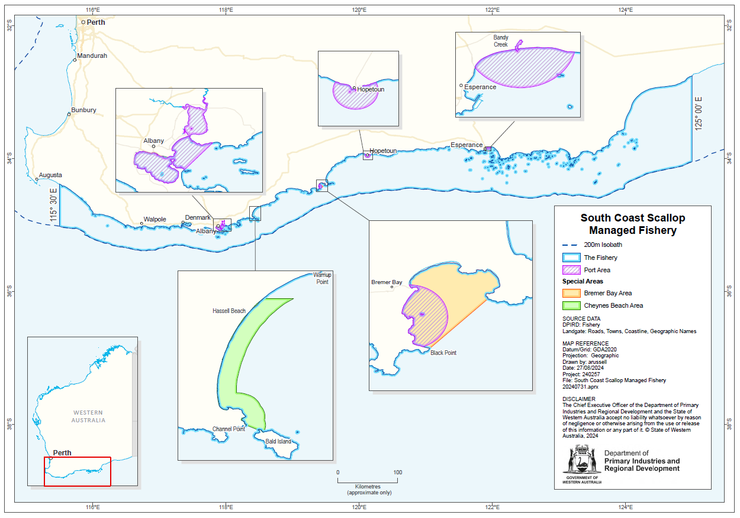
Figure 5: Boundaries and management areas of the SCTF.
Fishing in the SCTF is permitted from 1 April to 31 October each year, with the remainder of the year (1 November to 30 March) closed to trawling to protect spawning scallop stock and recover post-spawned scallops. Noting areas of the Fishery are visible to popular tourist destinations, and that holiday periods occur over the Easter (generally April) break, DPIRD requires that operators seek DPIRD approval to commence fishing prior to 1 May. Fishing season duration is generally 6-8 weeks, depending on scallop abundance.

Fishing methods and gear
Both the AIMWTMF and SCTF harvest saucer scallops using low-opening otter trawls (Figure 6). A maximum of two trawl nets and one try net can be used to fish in these Fisheries, where nets have a 10mm ground chain that weighs down the nets and meshes not exceeding 100mm. Nets are towed along the seabed and are held open by a pair of otter boards on either side attached to the wings of the net.
Figure 6: Standard twin-rig otter trawl (with try gear). (Source: adapted from Sterling 1998; cited in Kangas et al. 2019).
Since 2003 and 2012 respectively, Bycatch Reduction Devices (BRDs) have been required to be fitted to all standard otter trawl nets (excluding try nets) being used to fish in the AIMWTMF and SCTF. Specifically, a rigid barrier grid (Figure 7) (installed at an angle no greater than 60 degrees), which comprises vertical bars spaced a minimum of 200mm apart and attached to the circumference of the net. The BRDs are an effective means of minimising the capture of large animals (including turtles), as they are designed to guide these animals, and/or objects, towards the escape opening forward of the grid, which must be at least 750mm wide transversely across the net and 500 mm along the net from the mid-point of the width measurement.
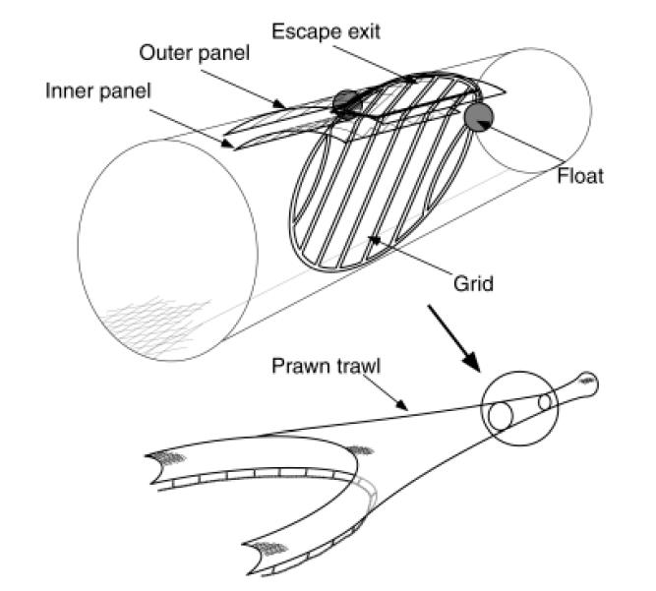
Figure 7: Diagrammatic representation of the grid bycatch reduction device used in Western Australian trawl fisheries, including the scallop trawl fisheries. (Source: DoF 2004).

Abrolhos Islands and Mid West Trawl Managed Fishery
Operators primarily access scallops within the traditional trawl areas around the Abrolhos Islands (Figure 3, Figure 4), however, exploratory fishing occurs in non-traditional fishing grounds, where vessels are required to commence fishing with ‘try-gear’ to determine scallop abundance prior to deploying and fishing with main gear. A try net is a trawl net with a headrope length not exceeding 5 metres and mesh size no less than 50 mm. In accordance with AIMWTMF Harvest Strategy, fishing with main gear can commence if an area of scallops is found, and the ground consists of well-defined sandy substrate. Information regarding these new areas must be provided to other skippers and DPIRD.
Historically, the Fishery operated under a maximum total net headrope capacity restriction of 256.1 metres (excluding try nets). Following a significant amalgamation of licences, the headrope unitization management approach was removed (in 2018). Since then, the Fishery has operated with a standardised net configuration; allowing each vessel to operate using two 12.8 metre (7 fathom) nets in twin gear configuration. Chafers or liners may not cover more than the bottom half of the cod end. Each otter board must not be greater than 1.1 meters in height with no more than 2.64 square meters in surface area.
Although not recently done, fishers in the AIMWTMF are permitted to fish for both scallops and prawns in the Port Gregory area. In this area operators are permitted to use slightly larger otter trawl nets with a maximum headrope length of 29.27 metres (2 x 8 fathom nets) and may use prawn mesh (61 mm).
When fishing in the Port Gregory area, a Fish Escape Device (FED) must also be incorporated into the nets. A FED is a type of BRD, either a square/rectangular opening not less than 400 mm by 300 mm, or a triangular opening with no side measuring less than 300 mm and having a mesh size less than 100mm. FEDs must not contain netting or any other material that may inhibit the egress of fish.
Trawling takes place in the day and/or night, in waters less than 40 metres (AIMWTMF 2nd MSC Surveillance Audit, 2024). Each tow can last from 30 minutes up to three hours, depending on scallop abundance. Tow speed is around 2.5 to 3.5 knots. Fishing generally occurs over sandy areas to target scallops and avoid damaging fishing gear on substrates such as reefs. Management mechanisms implemented in the Fishery to mitigate these risks of interactions with vulnerable benthic habitat, including sponges, seagrasses and soft corals are detailed in Table 1 of the AIMWTMF Harvest Strategy.

South Coast Trawl Fishery
Fishing effort for all WA scallop fisheries is driven by the abundance of scallops in any given year, which can be highly variable due to sporadic recruitment. Recruitment in the SCTF is influenced by environmental factors including sea temperatures, with warmer than average sea temperatures, brought by the warm Leeuwin Current tending to improve scallop recruitment on the South Coast.
Fishing in the SCTF is intermittent due to temporal restrictions imposed through management controls, the naturally challenging weather conditions on the South Coast, environmental conditions influencing recruitment and operators prioritising fishing in other WA scallop managed fisheries for which they also hold authorisations. For these reasons, landings since the last assessment of the Fishery have ranged from 31 tonne (meat weight) in 2018 to 238.6t in 2020. When fishing does occur in the SCTF, vessels are generally active for approximately 6-8 weeks (longer in large abundance years), between July-September.
Four authorised vessels (not exceeding a boat length of 32m) are permitted to access saucer scallops on the South Coast of WA under an exemption. However, depending on annual scallop abundance, typically only 1 to 3 vessels smaller than 25m in length access the Fishery.
Under current exemption arrangements, each of the four authorised FBLs can operate up to two otter trawl nets and one try net with a maximum headrope capacity of 36.58m (excluding the headrope length of try nets; <5m headrope length). This headrope length is the equivalent of two 10 fathom nets.
Management arrangements, soon to transition under a new Management Plan for the Fishery, will formalise the use of ‘standard’ scallop gear, which includes the net configuration of a maximum of two seven fathom (12.8m) otter trawl nets, and one try net. This is driven by recent (2024) consultation with operators in the SCTF which indicated that since 2018 (the time at which gear units were removed from the AIMWTMF) vessels accessing all three WA scallop-based fisheries (i.e. SCTF, AIMWTMF and Shark Bay Scallop Managed Fishery (SBSMF)) have used the same ‘standard’ scallop gear to improve operational ease and efficiency, i.e. two seven fathom otter trawl nets.
Specifications regarding the maximum size of otter boards and otter board shoes are not currently managed for this Fishery. It is proposed that this gear, as well as mesh type and size and BRDs will also be ‘standardised’ and formalised under the proposed new Management Plan.

Target species and byproduct
The AIMWTMF and SCTF target saucer scallops (Ylistrum balloti); a bivalve mollusc of the family Pectinidae. The species is predominantly sub-tropical, occurring on both the east and west coasts of Australia and in New Caledonia. On the west coast of Australia, this species is distributed from Broome in the north to Israelite Bay in the south and does not overlap with the eastern population.
The saucer scallop species is generally known to have an annual spawning cycle, which varies across the State and associated water temperatures. In the Abrolhos Islands, the saucer scallop population has a spawning period extending from September through to March. The species develops rapidly, in which they grow to a size of 90 mm in 6-12 months; reaching a fishable size from one year’s spawning. Although, an animal can grow as large as 140 mm throughout its life. The species also reaches maturity at around one year of age. Ballot’s saucer scallop is a short-lived species whereby an animal may survive to a maximum age of approximately three years (Scallop (fish.wa.gov.au).
Recruitment is highly variable and not thought to be dependent on the density of spawning biomass. Extreme environmental events, as was observed with a marine heat wave in the summer of 2010/11, can have a significant impact on scallop stocks, particularly at the Abrolhos Islands. Assessments of stock biomass indicate that annual variations in recruitment are due to environmental impacts, particularly water temperature, and that catch rates and annual tonnage disparity is not due to fishing pressure. As the species is short-lived, displaying a characteristically high rate of natural mortality, they are susceptible to a ‘boom and bust’ life history.
The larger mesh size of 100 mm or greater used in trawl nets for scallop fishing and the requirement to have BRDs in the form of grids fitted in all trawl nets to minimise larger animals being captured, combined with the low number of authorisations and relatively small area/s trawled, is considered to minimise the take of byproduct species.

Abrolhos Islands and Mid West Trawl Managed Fishery
The Fishery is permitted to retain the following species as a byproduct component of the catch:
- Western king prawns (Penaeus latisulcatus). Low numbers of this species have been recorded in recent years. Western king prawns have a wide distribution in Australia; found west from South Australia and north all around the coast to northern New South Wales.
- Slipper lobster and bugs (Thenus sp.), although reported landings of these species have been very low and have represented less than 0.1% of the catch between 2008 and 2018 (DPIRD-ERA, 2020).
- Demersal Scalefish, if encountered, as specified under clause 24 of the West Coast Demersal Scalefish (Interim) Managed Fishery Management Plan. However, operators are required to have FEDS fitted to their nets when operating in the Port Gregory Area, minimising the capture of demersal scalefish and other fish species in this location.

South Coast Trawl Fishery
Operators have adopted similar harvesting strategies to that used in the AIMWTMF, such as move-on rules when vessels encounter areas of low scallop abundance, small scallops, and vulnerable habitat.
In accordance with the exemption, authorised vessels are permitted to retain species of the Class Osteichthyes (bony fishes) except for Australian Salmon, small pelagic fish as defined in the South Coast Purse Seine Management Plan 1994 and any fish specified as under Commonwealth control or management in the Offshore Constitutional Settlement 1995. FEDs are not required to be used in this Fishery and therefore some fish species are retained as byproduct.
Historically, this Fishery has targeted fish species, however, recent catch records indicate that there has not been active targeting of fish species, with negligible fish and other non-target byproduct being retained (Table 6).
In the past ten years, the most retained species after scallop has been Balmain bugs, with less than one tonne of this species and/or other byproducts of all species’ groups retained. Other byproduct species include cuttlefish, squid, flathead sp., flounder and John Dory. Some commercial scallop (Pecten fumatus Reeve 1852.) are retained, but also represent a small proportion of the total catch.
Refer to Appendix 3 for historic catch and effort data for the AIMWTMF and SCTF.

Value of the Fisheries
Effort in the AIMWTMF and SCTF fisheries vary widely depending on the strength of recruitment with fishing in the SCTF being particularly intermittent.
In 2023/24 the beach price for saucer scallops was $43.37 / kg (whole weight) based on:
- 1317 t whole weight of scallop caught in the AIMWTMF in 2023/24.
- <140 t whole weight of scallop caught in the SCTF in 2023/24.
Scallops are shucked, processed at sea and frozen. The majority of product is exported with small quantities left in the shell or in the half-shell to supply to local gourmet seafood markets (Ref: Abrolhos scallop_MSC-2nd Surveillance Report_FINAL.pdf).

Management Regime

Legislative Framework
The AIMWTMF and SCTF are managed by DPIRD under the following legislation:
- Fish Resources Management Act 1994 (FRMA).
- Fish Resources Management Regulations 1995 (FRMR).
- Abrolhos Islands and Mid West Trawl Limited Entry Fishery Notice 1993 (Management Plan) Fisheries Act 1905 (www.wa.gov.au).
- South Coast Trawl Fishery, FRMA Section 7 – Instrument of Exemption:
(No. 3659) currently lists vessels (Fishing Boat Licences, FBLs) exempt from legislation that would otherwise prevent these operators from fishing for saucer scallops in the specified waters off the south coast of Western Australia.
- Notice of Areas Closed to Fishing for Scallops and Prawns in the Abrolhos Islands and Mid West Trawl Managed Fishery – No. 1 o 2023.
- FRMA s.43 order – Trawling Prohibition (Whole of State) Notice 1992.
Fishers must also comply with the requirements of (but not limited to):
  - Commonwealth Environment Protection and Biodiversity Conservation Act 1999 (EPBC Act).
  - Marine Safety (Domestic Commercial Vessel) National Law Act 2012.
  - WA Marine Act 1982.
  - WA Biodiversity Conservation Act 2016 (BCA).
  - WA Conservation and Land Management Act 1984.

Other policy/management documents applied to these Fisheries include:
- Saucer Scallop Resource of the Abrolhos Islands Harvest Strategy 2020-2025.
- Abrolhos Islands and Mid West Trawl Managed Fishery Code of Conduct (2019).
- South Coast Trawl Fishery Operations and Communications Procedure (2021).

Licensing Framework
Commercial fishers in the AIMWTMF are required to have an AIMWTMF MFL to fish in the Fishery.
Operators in the SCTF must be the holder of an authorised FBL, as specified on the current Instrument of Exemption No. 3659 (exemption). Currently, there are no MFLs that provide secure access to operators in the SCTF, however, MFLs will be granted to eligible applicants per the Management Plan, expected to be implemented in 2025.

Controlling the level of harvest
Effort in WA scallop fisheries is related to the abundance of available scallops each year, which fluctuates due to recruitment variability.
Management for scallop-based fisheries are generally based on:
- Catch limits (and/or catch rate cut-offs)
- Effort limits
- Limited entry
- Gear controls and vessel restrictions
- Seasonal (spatial and temporal) closures.

Abrolhos Islands and Mid West Trawl Managed Fishery
The regulatory harvesting system for AIMWTMF is based on a constant escapement approach, which aims to ensure that fishing does not deplete the residual stock so that an adequate abundance of breeding stock remains in the Fishery to replenish the resource and support fishing in future seasons.
Recognising the highly variable nature of scallop recruitment, a high level of protection is provided to the spawning stock, particularly in years when scallops are naturally low in abundance. For example, the fishing season nominally opens on 1 March, however this may be delayed to increase protection of spawning scallops in years when the previous years’ (November) spawning index is low.
Additionally, noting the life history of this species being approximately 2-3 years, management arrangements attempt to provide adequate opportunity to harvest the stock at optimal quality and prior to the end of their short life span. This approach is informed by fishery-independent and dependent survey information, whereby several surveys are undertaken during the year to assess stock abundance and size composition, and commercial catch rates are monitored to a threshold level of 150 kg daily meat weight. Where the average daily catch rate of fishing vessels over seven consecutive fishing days falls below this level, fishing will cease for the remainder of the fishing season. Further, if areas with a high abundance of juvenile scallops (<60 mm in size) or sensitive habitats are encountered, these areas are avoided by the fishing fleet to minimise potential adverse impacts.
Details of the harvesting approach and management mechanisms used to control the scallop fishing in the Fishery are explicitly described in the AIMWTMF Harvest Strategy.

South Coast Trawl Fishery
Due to authorised operators prioritising fishing in other WA scallop managed fisheries, there is low and infrequent fishing effort applied to the SCTF. As such, a formal approach to harvesting scallops in this Fishery has not yet been developed. However, noting that the same operators’ fish across both the AIMWTMF and the SCTF, as well as the SBSMF, arrangements have been adopted that align with the harvest approach in these other scallop-based fisheries. For example, while there are no formal catch limits, fishers in the SCTF cease fishing at threshold catch rates and/or adopt the ‘move-on’ rule to avoid areas of small and/or low abundances of scallops.
Fishing is also managed under limited entry with gear restrictions, including a maximum headrope capacity, and seasonal closures.
Management arrangements consistent with the current operations of the Fishery, as well as other best-practice scallop fishery management arrangements, will be legislated under the new Management Plan, with the development of a Harvest Strategy to follow. The Harvest Strategy will consider incorporating the current voluntary arrangements, such as the catch rate thresholds and move-on rules, as applied in the AIMWTMF.

Harvest Strategy

Abrolhos Islands and Mid West Trawl Managed Fishery
The AIMWTMF is currently managed in accordance with the Fishery’s 2020 Harvest Strategy, developed by DPIRD in consultation with the commercial fishing sector, WAFIC and other key stakeholders. A copy of the Harvest Strategy is available here.
The Harvest Strategy is structured to describe, hierarchically:
- the high-level, long-term objectives of management.
- the short-term, operational objectives.
- how objectives translate into the management approach used for the fishery.
The long- and short-term objectives for the management of the Fishery focus on sustainable saucer scallops fishing practices, the environment, social and community benefit, and economic viability. There is no formal allocation between the commercial and recreational fishing sectors, nor a customary allocation.
The Harvest Strategy also provides a detailed description of the specific monitoring and assessment processes used to evaluate ecological sustainability and fishery performance and ascertain whether objectives are being met. Suitable indicators are selected to measure the Fishery’s performance, which are assessed against defined reference levels; established to separate acceptable from unacceptable performance.
In association with the Fishery’s performance, Harvest Control Rules (HCRs) are developed and outlined in the Harvest Strategy to define the management action that should occur in relation to the value of each ecological performance indicators compared to the reference level. HCRs are designed to maintain the resource above the threshold levels, and therefore the extent of management action taken is determined by the extent to which a performance indicator has breached a reference point, increasing in line with an increasing risk to the resource.
Management objectives, performance indicators, reference levels and HCRs are detailed in the AIMWTMF Harvest Strategy.
Central to the AIMWTMF Harvest Strategy is a co-management approach, whereby industry will work cooperatively to monitor fishing in areas both within and outside of the traditional trawl grounds. Specifically, when operating in non-traditional fishing grounds, an exploratory fishing approach applies, as described in the Harvest Strategy (refer to Figure 2) and in the Code of Conduct, whereby operators fish with try gear and abide by a move on rule that is triggered when vessels encounter areas of juvenile scallops and sensitive habitats.
Vessels will cease fishing in these areas and return to the cumulative trawl footprint and, under the cooperative framework, may also propose voluntary closures to minimise impacts on small scallops and vulnerable habitats.
Periodic reviews of the Harvest Strategy are scheduled to ensure the current arrangements remain fit for purpose. A review of the Harvest Strategy is also initiated when an indicator suggests that the Fishery’s impact on the resource is no longer acceptable.

South Coast Trawl Fishery
No formal harvest strategy has been developed for the SCTF, although it is anticipated that one will be developed following the transition of this Fishery to a formal Management Plan. However, operators apply a similar harvesting approach to that in the AIMWTMF Harvest Strategy, whereby recommended catch rate cut offs and move-on rules apply to maintain a sustainable abundance of scallops and protect areas of juvenile scallops and any identified sensitive habitat.
Based on the 2023 Weight of Evidence (WOE) stock assessment, the target species and other components of the ecosystem did not indicate that a shift in the existing management arrangements were required for the SCTF 2024 season.

Recovery Strategy

Abrolhos Islands and Mid West Trawl Managed Fishery
Considering the sensitivity of scallops to fluctuating environmental conditions, which effects recruitment and subsequent abundance, a precautionary management approach is applied to WA scallop fisheries to account for the ‘boom and bust’ nature of this species. As such, a Recovery Strategy is provided within the Appendix 2 of the AIMWTMF Harvest Strategy. The objective of the Recovery Strategy is to protect the residual biomass of scallops to allow the stock to recover at an acceptable rate (within five years) when it has fallen below the threshold (or limit) reference level.
The effectiveness of the Harvest Strategy and implementation of the Recovery Strategy was most recently demonstrated in 2022, when independent (and dependent) survey information indicated the AIMWTMF saucer scallop resource was environmentally limited; leading to poor recruitment and low abundance, i.e. 45 sc/nm, well below the limit reference level. As such, in accordance with the Harvest Strategy, the Fishery was closed for the 2022 season. Scallop abundance improved throughout 2022 and survey results in early 2023 indicated that fishing under precautionary arrangements, in accordance with the Recovery Strategy, could commence. Fishing has continued in 2024, indicating a positive response to the management arrangements used to recover the AIMWTMF stock.

South Coast Trawl Fishery
No formal Recovery Strategy is in place for the SCTF, however, as this Fishery is effectively co-managed between DPIRD and industry, fishing will only occur where catch-rates indicate that there is available/sustainable stock. One may be developed with development of the Harvest Strategy following transition to a Management Plan.

Performance against objectives, performance indicators and performance measures

Status Report of the Fisheries and Aquatic Resource (SRFR)
DPIRD conducts a formal, resource-level review to assess the status of target stocks and performance in relation to ecological objectives. The status of the AIMWTMF and SCTF is reported in the annual SRFAR. DPIRD has finalised and published the 2022/23 SRFAR, which includes stock status information up to, and including, that years’ fishing season. Key conclusions of this report regarding the status of saucer scallops taken by WA scallop trawl fisheries, including the AIMWTMF and SCTF, in 2022-23 are as follows:
- AIMWTMF – Commercial scallop catch was 0 t, due to the fishery being closed for the 2022 season. The stock was assessed as inadequate, due to being environmentally limited.
- SCT – The commercial scallop stock was assessed as adequate (sustainable), with a catch of 29 t (caught over 57 days).
- WA saucer scallop catch, which includes all WA scallop fisheries (including SBSMF and the South West Trawl Managed Fishery) was assessed as adequate.
Further information can be found in the Status Reports of the Fisheries and Aquatic Resources of Western Australia 2022/2023 and at resource_assessment_report_003.pdf (fish.wa.gov.au).

Annual fishery performance
A broad catch tolerance range of 95-1,830 t whole weight has been set for the AIMWTMF based on the historical catch range (1990-1998). Defining this annual tolerance range provides a formal but efficient basis to evaluate the effectiveness of current management arrangements in delivering the levels of catch and/or effort specified by the HCRs and any sectoral allocation decisions, where relevant (Fletcher et al. 2016).
The tolerance levels are reviewed annually and published in the State of Fisheries and Aquatic Resources Report. If the annual catch/effort (or any other indicator specified to measure performance against the economic and social objectives) remains within the tolerance range, the fishery is operating ‘acceptably’ with no need to review the management settings. If any fishery performance indicator falls outside of the tolerance range and this cannot be adequately explained (e.g. documented evidence of environmental or market-induced impacts), this will result in a review of the cause and re-assessment of the resource status against the performance indicators and HCRs. This could potentially lead to a change in management settings and therefore a revision of the tolerance levels.
Additionally, in line with the principles of ESD, this fishery level review process also considers performance against any objectives relating to the economic and social amenity benefits of fishing. Where possible, and in due consideration of ecological sustainability, fisheries management arrangements can be adjusted or reformed to help meet these economic and/or social objectives.
The economic and social objective for the scallop fishery does not currently have explicit performance measures. Rather it is through formal consultation processes that regulatory impediment to maintaining or enhancing economic return, and maximising social benefits of fishing, are discussed. This broadly considers the ability of fishers to retain scallops at times when it is most economically favourable based on the size and quality of scallops.

Stock Assessments

Principles
All DPIRD stock assessments take a weight-of-evidence, risk-based approach. This requires consideration of each available line of evidence, both individually and collectively, to generate the most appropriate overall assessment conclusion of the status of the stock, and the risk of future depletion. Lines of evidence include outputs that are generated from each available quantitative method, plus any qualitative lines of evidence such as biological and fishery information that describe the productivity and vulnerability of the species/stock, and information from fishers, stakeholders, and other sources. In the case of the AIMWTMF, the information is also reviewed against the Harvest Strategy to inform the required management response to manage sustainability.
Stock assessments for the AIMWTMF and SCTF consider:
- Commercial catch and catch per unit effort (CPUE) standardisation;
- Analysis of biological information collected from fishing-independent (research) sampling;
- Fishery independent indices of stock levels (AIMWTMF only).

Weight of evidence reports and annual season review
Annual weight of evidence reports are produced for each fishery following conclusion of the season. The respective Fishery’s 2023/24 stock assessment weight of evidence reports have been provided at Appendix 4 and 5. These reports summarise fishery performance and are provided to industry and discussed during annual season review meetings, with results used to set season arrangements for the coming season in accordance with HCRs within respective harvest strategies, as applicable.
Assessments of the AIMWTMF target stock use performance indicators, derived from fishery dependent and independent information including annual surveys, catch/effort data, and other performance indicators applied to measure social and economic objectives, to determine the status of the stock and whether the AIMWTMF is operating ‘acceptably’. Further information regarding the assessment of the AIMWTMF is provided in section 3.4.1 of the Harvest Strategy.
If any indicator specified to measure performance falls outside of the tolerance range and cannot be adequately explained (i.e. environmental or market-induced impacts) this will result in a review and re-assessment of the resource status against the Harvest Strategy, with additional management adjustments being made accordingly.

2023 stock assessment
2023 weight-of-evidence stock assessments of the saucer scallop resource accessed by operators in the AIMWTMF and SCTF indicated the following:
- AIMWTMF - High (Above Limit, below Threshold): It is POSSIBLE (20-50%) that the stock is below the Threshold and above the Limit. The February index breached the threshold and there was a lower level of recruitment. This may be a result of poor scallop quality reducing reproductive output and hence lower than expected recruitment.
- SCT - Moderate (Above Threshold, below Target): It is LIKELY (>50%) that the stock is above the threshold level. Recent catch levels were obtained with reduced effort in 2023, resulting in improved catch rates, from traditional fishing grounds.

Monitoring, data collection and validation

Fishery-independent monitoring
Scallop surveys in the Abrolhos Islands have been undertaken annually in November since 1997. An additional February/March survey was introduced in 2014 and has been undertaken regularly since 2016. Scallop surveys are used to estimate scallop abundance, as well as overall size composition and meat size/quality within standard sites in each major fishing ground (i.e. traditional trawl grounds).
Further information regarding fishery-independent monitoring is available in section 3.6.1.3 of the AIMWTMF Harvest Strategy.
There are no fishery dependent or independent survey regimes currently in place for the SCTF. Therefore, logbook catch and effort data is used to assess the status and management of the South Coast scallop stock.
For these two scallop-based fisheries, environmental information, including depth, water temperature and sea conditions, and climate data, are collected and used to assess potential spawning and/or recruitment impairment, which is driven by temperature fluctuations.
Spatial data validation is undertaken by plotting maps of logbook effort and using VMS to monitor fishing activities. Refer to Vessel Monitoring System section for more information.

Statutory logbook reporting
Commercial catch and effort data in the AIMWTMF and SCTF is monitored using statutory daily logbooks. A voluntary daily logbook program was introduced in the AIMWTMF in 1998, with all vessels completing these since 2000. In 2008, the provision of daily logbook records of catch (in weight and numbers) and effort (trawl start time and duration) became a statutory requirement in the AIMWTMF. In the SCTF, active vessels provide fishery-dependent information to DPIRD, which is validated against processor unload records.
Noting that most catches have typically been shucked at sea, skippers record an estimate of the meat weight (on average approximately 20% of the whole weight) together with the number of baskets of whole scallops caught. DPIRD staff check, enter and validate the logbook data against processor unload records monthly and any potentially erroneous entries or gaps are checked with skippers and possibly adjusted, if required.
As part of catch and effort logbook reporting, fishers are required to report all retained species caught and any Endangered, Threatened and Protected (ETP) species interactions, including release condition. Further information on species retained by the AIMWTMF and SCTF are reported in annual stock assessment reports and in the annual SRFAR.

Vessel monitoring system
A Vessel Monitoring System (VMS) is used in the AIMWTMF and SCTF to monitor effort levels and ensure compliance with management arrangements.
For more information regarding VMS in these Fisheries, see Enforcement of management arrangements section.

Ecosystem

Marine Stewardship Council (MSC) accreditation
The AIMWTMF received third party MSC accreditation in 2021, demonstrating its achievement of high standards in relation to sustainability of fish stocks, the minimisation of environmental impacts resulting from fishing activities, and effective management of the Fishery. The AIMWTMF is scheduled to be reassessed under the MSC accreditation system in 2026.
Based on this assessment of the Fishery, no conditions were set at certification for any of the following ecosystem components: target species, non-target retained species (byproduct), non-retained species (bycatch), endangered species, habitat, and the ecosystem overall.
Further information regarding the current status of the AIMWTMF MSC certification is available in the 2024 Surveillance Audit Report.

Mitigating impacts of the wider ecosystem
DPIRD adopts an integrated Ecosystem Based Fisheries Management (EBFM) approach to manage WA fisheries. EBFM framework involves a risk-based monitoring and assessment approach to determine the cumulative impacts of all fishing activities (commercial, recreational and customary) on the overall ecosystems in which fishing occurs. In line with the principles of Ecologically Sustainable Development (ESD), the EBFM approach also recognises that the economic and social benefits of fishing to all users must be considered.
EBFM is applied across all fisheries, and aquatic resources, operating at a regional or ecosystem level. The level of risk to each resource is used as a key input to the DPIRD Risk Register, which is an integral component of the annual planning cycle for assigning activity priorities (research, management, compliance, education, etc.) across each bioregion. Outcomes of each assessment contribute to developing and implementing appropriate and sustainable management arrangements.

Ecological Risk Assessments
Ecological Risk Assessments (ERAs) are undertaken periodically to assess the impacts of fisheries on all components of the aquatic environments in which they operate. The risk assessment methodology (utilised at the time of the AIMWTMF ERA, 2019) is based on the global standard for risk assessment and risk management (AS/NZS ISO 31000). This methodology applied a consequence-likelihood analysis, which involves the examination of the magnitude of potential consequences from fishing activities and the likelihood that those consequences will occur given (current) management controls.
An ERA was convened by DPIRD for the AIMWTMF in 2019, with a final report published in February 2020 (AIMWTMF ERA 2019). All risks were assessed using a consultative and structured workshop, held in September 2019, and focused on evaluation the ecological impact of the scallop trawl component of this fishery (i.e. excluding the Port Gregory prawn fishery) on all retained species, bycatch, ETP species, habitats and the broader ecosystem. Workshop participants included subject matter experts, DPIRD management, compliance and research staff, and representatives from the commercial fishing industry.
Risks assessed during the 2019 ERA workshop were scored as medium, low or negligible risks using the adopted methodology. Risk rankings of medium or less are considered acceptable for a well-managed fishery, subject to ongoing management practices and performance monitoring.
Ongoing performance of the AIMWTMF indicates that the risk of fishing interactions to ecological assessed components remains acceptably low.
The next periodic ERA for the WA saucer scallop resource, which includes the AIMWTMF and SCTF, is scheduled for 2025.

Bycatch and protected species interactions
Several ETP species are listed under the EPBC Act for the West Coast and South Coast regions where the AIMWTMF and SCTF operate. These ETP species mostly comprise of elasmobranchs, cetaceans, turtles and migratory seabirds.
It is a statutory requirement for commercial fishers to report interactions of ETP species in logbooks. Owning to the larger mesh size of scallop otter trawl nets (being not less than 100mm), the main ETP species at risk or interacting with boats and fishing gear in these fisheries are cetaceans, marine turtles, sygnathids, sea snakes and Australian sea lions. No interactions of ETP species have been recorded by the Fisheries since 2008 and, given trawl speed is slow (2-3 knots while trawling and up to 9 knots while streaming), it is highly unlikely that wildlife would be struck by vessels.
Further, the implementation of BRDs in both the AIMWTMF and SCTF has reduced the capture of larger animals, while other species, such as Sygnathids, which are typically associated with seagrass and macroalgal habitats, are not often encountered due to large components of the nearshore waters, specifically in the Abrolhos Islands, being closed to scallop trawling.
Fishery independent and dependent bycatch sampling programs have been established in the AIMWTMF and SCTF to provide information to DPIRD regarding species interactions resulting from fishing activities. Bycatch sampling was undertaken by DPIRD in the AIMTMF in January 2023, with results confirming that while the bycatch composition was diverse (180 species), each species was <1% in total weight (Appendix 2 – Bycatch data (2023) in the AIMWTMF). On behalf of DPIRD, one designated vessel undertook bycatch sampling surveys in the SCTF in 2023 and 2024. Fishery managers, research and industry worked collaboratively to develop sampling protocols, including specific sampling sites and the number of shots/samples, etc. Bycatch samples have been provided to DPIRD Aquatic Science and Assessment for analysis and results will be reported on and assessed as part of the 2025 ERA.
DPIRD reports on protected and listed species interactions with WA fisheries, which includes publication of annual statistics to fishery and gear level (where not prohibited by confidentiality requirements). Interaction reports are published in the annual reports of the status of the fisheries and aquatic resources of Western Australia, which is available on DPIRD’s website (Status reports of the fisheries). Recent fishery status reports for the AIMWTMF and SCTF have indicated no ETP species interactions. Further, the 2019 ERA reported that the risk of the Fishery to bycatch and byproduct species was negligible (ERA, 2020).

Habitat
Most fishing in the AIMWTMF and SCTF occurs in sandy habitat to target scallops and actively avoid areas that can damage fishing gear (e.g. reefs), whereby the impacts to these areas caused by scallop trawling activities are expected to be minor and short-lived (ERA, 2020).
While research regarding otter trawl systems has demonstrated that these have the least impact of all forms of trawling on marine ecosystems (ERA 2020), there is potential for these fisheries to interact with other benthic habitats which may be vulnerable to trawl fishing, such as sponges, seagrasses and soft corals.
The impact of scallop trawling on habitats is monitored by estimating the annual spatial trawl footprint of the AIMWTMF and ensuring it does not extend across more than 20% of the entire Fishery (AIMWTMF Harvest Strategy). Quantitative studies suggest that sand and silt habitats are relatively resilient to trawl fishing (ERA, 2020). Repeat trawling over the same ground is limited.
Management controls within the Harvest Strategy aim to minimise the potential impacts on sensitive and/or vulnerable habitats in the AIMWTMF. A move on rule is triggered when vulnerable habitat bycatch exceeds a specified amount (refer to Table 1 of the AIMWTMF Harvest Strategy). Additionally, an exploratory fishing approach is in place for fishing in unknown or non-traditional fishing areas, which requires the use of try gear to minimise adverse interactions with habitats.
The interaction of trawl gear with benthic habitats in the AIMWTMF was assessed as posing a low risk in the 2020 ERA and 2024 Stock Assessment.
Noting the sporadic fishing activity that occurs in the SCTF, formal arrangements that apply in the AIMWTMF to manage the harvest of scallop stocks, such as catch rate thresholds and ‘move on’ rules, have not been applied at this time. However, operators have adopted a (voluntary) precautionary harvest approach, whereby if a vessel encounters an area of small scallops and/or low levels of scallop abundance, commercial vessels will avoid the area and advise other fishing vessels to also avoid the area. This also applies to areas of vulnerable and sensitive habitats.

Enforcement of Management Arrangements

Operations and Compliance
DPIRD has important statutory functions as a regulator. The contribution of regulatory compliance teams within DPIRD supports the development and implementation of quality legislation, policy and regulatory compliance services. DPIRD is committed to delivering a comprehensive awareness and education program to improve awareness of the legislation, and to increase people’s ability to willingly comply with the regulatory requirements.

Strategic Objectives
DPIRD’s regulatory approach intends to provide international and national markets, primary industries, consumers and the Western Australian community the confidence that our aquatic resources are managed within sustainable limits.
DPIRD’s strategic objective as it relates to fisheries compliance is:
‘To serve the Western Australian community and promote sustainable and responsible fishing by promoting stewardship and compliance with relevant legislation, preventing offences, and monitoring, investigating and enforcing compliance with relevant legislation’.
DPIRD also seeks to achieve the following outcome as provided in the Australian Fisheries National Compliance Strategy 2022-2026 (the National Strategy):
An Optimal Level of Compliance, which can be described as, ‘that which holds the level of non-compliance at an acceptable level, which can be maintained at a reasonable cost while not compromising the integrity of fisheries management or ecological sustainability and ensuring ongoing social licence and legitimacy’.
The Department’s regulatory approach is shaped by the three key compliance strategies recommended by the National Strategy:
- Effective deterrence.
- Organisational capability and capacity.
- Maximising willing compliance.

Compliance Operations
During 2023, the Department developed and implemented a new annual risk-based management framework for commercial fishing and aquaculture compliance programs in WA.
The new framework ensures that:
- a consistent risk assessment, planning, monitoring and reporting process for commercial fisheries and aquaculture compliance programs statewide is completed on an annual basis.
- fair, reasonable, and cost-effective compliance approaches are implemented with a focus on outcomes.
- both inward and outward facing compliance reporting is greatly improved.
- relationships continue to strengthen between Management, Science, and Compliance, including improving communication with a two-way flow of information.
DPIRD delivers a range of monitoring, surveillance, inspection, and investigation services. This regulatory compliance program plays an important role in general deterrence to non-compliance with the legislation and provides confidence to the community that offences will be detected and appropriate sanctions imposed on those who commit the offences. Compliance activities that are used in commercial fisheries include:
- Land and sea patrols.
- Catch validation against managed fishery licences.
- Inspections of wholesale and retail outlets.
- Inspections at processing facilities.
- Inspections of vessels in port and pre-season briefings.
- At sea inspections of fishing boats.
- Closed area/season monitoring via VMS.
- Aerial surveillance.
Inspections may involve inspection of:
- All compartments on board the vessels.
- All authorisations.
- Logbooks.
- Catch on board the boat.

Vessel Monitoring System
There are no formal (legislated) nomination requirements in either the AIMWTMF or SCTF. However, authorised operators (voluntarily) advise DPIRD staff when intending to access these fisheries; providing details regarding proposed fishing activities, the number of vessels that will be operating, the estimated duration of fishing, and proposed areas that will be fished within the waters of the Fishery.
VMS is a mandatory requirement to enable real-time monitoring of fishery operations and activities to ensure fishers are operating within the legislated permitted fishing areas during designated fishing times.
All vessels operating in the AIMWTMF and SCTF are fitted with an automatic location communicator (ALC), which is used to track the location of boats by transmitting information such as the geographical position, course, and speed. Information from the ALC is submitted to DPIRD via satellite and is processed by specialised software designed to receive, analyse, display and record position reports and messaging via satellite.
Fishers must ensure that all operational ALC requirements are carried out in accordance with the relevant Approved Directions.
- Abrolhos Islands and Mid West Trawl Managed Fishery Approved Directions (abrolhos_island_midwest_trawl_ap_directions.pdf (fish.wa.gov.au).
- South Coast Trawl Fishery Approved Directions (south_coast_trawl_ap_directions.pdf (fish.wa.gov.au).
DPIRD uses VMS to monitor fishery compliance with operational ALC requirements and spatial closures. VMS information is also used to monitor fishing activities and effort, which is then used to assist with reporting on compliance, evaluating management arrangements and verifying research data. VMS information is presented to fishery operators by DPIRD staff during management meetings.

Operations and Communications Procedure
In 2021, the SCTF Operations and Communications Procedure (OCP) was developed collaboratively with DPIRD, authorised operators, and other relevant stakeholders. The OCP requires that authorised vessels within the Fishery notify DPIRD via an ALC nomination prior to entering specific areas to fish. The objective of the OCP is to support information sharing between SCTF operators and relevant stakeholders when occupying specified waters off the South Coast to communicate fishing locations, operations and scheduled duration/s of fishing activities to enable stakeholders to respond appropriately to potential community and media enquiries regarding vessels/fishing activities.
The OCP applies to two popular tourist destinations on the South Coast; Cheynes Beach and Bremer Bay. In accordance with the OCP, one authorised vessel may enter the area/s to undertake surveys and determine whether commercial quantities of scallops are sufficient to continue fishing. No trawling occurs in or near the Bremer Canyon, or in Commonwealth Marine Parks.
Recent compliance risk assessments of WA invertebrate trawl fisheries have identified the need to formalise nomination requirements under management plans to ensure DPIRD can adequately monitor fishing activities. Nomination requirements, as specified under the OCP, are proposed to transition to the new SCTF Management Plan, currently in development. Similar amendments will be applied to the AIMWTMF Management Plan. Maintaining communication and collaboration with fishery operators allows DPIRD to effectively discuss and propose management action or change more efficiently, if required, such as implementing temporal or spatial closures to manage stock sustainability or including additional scientific survey regimes in the SCTF to support data collection and inform harvesting strategies and management frameworks.

Consultation Process
Management changes are given effect through amendments to legislation, including the AIMWTMF Management Plan, FRMR, exemptions and CEO determinations, orders and/or notices. These changes require consultation with all affected parities (or interested persons in the case of management plan amendments) and the approval of the Minister for Fisheries and/or DPIRD’s Director General (or appropriate delegates). In making decisions relevant to fisheries, the Minister for Fishery may choose to receive advice from any source, although has indicated that:
- DPIRD is the primary source of management advice; and
- the peak body, WAFIC, is the primary source of advice and representation from the commercial fishing sector.

Commercial sector consultation and decision-making
WAFIC is funded by the WA State Government under a Service Level Agreement (SLA) to undertake their representation/advisory and consultation roles. Under the SLA WAFIC is required to undertake statutory consultation functions related to the management of the AIMWTMF and SCTF. Further, WAFIC are responsible for facilitating management meetings between DPIRD, authorised operators in the AIMWTMF and SCTF and WAFIC. These meetings are generally held each year and are important forums to consult on the management of the Fishery, as well as other relevant updates to DPIRD activities and priorities. During these meetings, DPIRD (science, management, and compliance) staff, licence holders and WAFIC discuss current and future management issues. DPIRD also consults directly with industry, where relevant, on specific management and operational issues.
Management of the SCTF is currently regulated under an Instrument of Exemption (No. 3659). There is no requirement for statutory (external) consultation when amending or renewing this exemption, although relevant stakeholders, including SCTF operators, are involved in discussions when the exemption is renewed every two to three years. DPIRD’s science, management and compliance staff are also consulted on exemption conditions prior to it being approved.

Communication of season arrangements
Annual management meetings, held with DPIRD, WAFIC and licence holders in the AWIMMF and SCTF provide a forum to discuss and consult on the current and future management of the fisheries. Any issues that have arisen during the previous fishing season and proposed changes to the management arrangements for the upcoming fishing season are discussed.
Follow-up meetings may be held, when necessary, following the November and February/March fishery independent surveys, to discuss appropriate season arrangements informed by the survey results prior to the commencement of the fishing season.
Skipper’s briefings are also conducted with those skippers operating authorised vessels for that season to ensure all management arrangements, particularly any voluntary agreements and reporting requirements, are understood.
VMS messaging may also be used to provide information directly to skippers, as required.

Voluntary closures
Voluntary arrangements (non-statutory) may be used to implement area openings and closures, creating a more responsive management approach through facilitating rapid decision making in response to survey results and other available information. DPIRD consults directly with industry on these specific management and operational issues, as required.
Such issues may include the need for area closures to protect discrete areas of scallops due to low abundance, small size or poor quality. These arrangements are implemented voluntarily under the cooperative, co-management framework, whereby DPIRD management, ASA and Compliance work with industry to determine the timing, extent and criteria of voluntary spatial arrangements considering all available information.

Consultation with other groups
Consultation on scallop management with the recreational sector is undertaken in accordance with the SLA between DPIRD and Recfishwest, as the recognised peak sector body for the recreational fishing sector. Recfishwest is required to engage and consult with recreational fishers as necessary to meet its obligations.
Consultation with other stakeholders, including customary fishers and non-fisher stakeholders, such as Government agencies, conservation sector non-Government organizations and other affected/interested parties, is undertaken consistent with DPIRD’s Stakeholder Engagement Guideline (SEG).
The SEG apply a framework designed to assist with selecting the appropriate level of engagement for difference stakeholder groups and includes collaborating with and involving key stakeholders, seeking input from interested parties through a public consultation process and keeping all parties fully informed through the provision of balanced, objective and accurate information.
Key fishery specific documents, such as harvest strategies, recovery plans and bycatch action plans, are subjected to both formal key stakeholder consultation and public consultation processes.
Noting that parts of the AIMWTMF and SCTF are within (proposed) Marine Park boundaries, key stakeholders that have been identified in accordance with the SEG include the Department of Biodiversity, Conservation and Attractions.
A Code of Conduct has been developed for operators in the AIMWTMF to manage potential impacts between trawling activities and rock lobster fishing operations.
An Operations and Communications Protocol (OCP) has been developed for the SCTF to support information sharing of fishing operations between DPIRD, industry, and key stakeholder groups.

Changes since the previous assessment
In 2015, the AIMWTMF was assessed by DCCEEW against the Guidelines, under Part 13 and Part 13A of the EPBC Act. DCCEEW assessed the SCTF in 2017.
Assessments determined the AIMWTMF and SCTF posed a low environmental risk and as a result, the Australian Government Minister for the Environment declared LENS export approval to both Fisheries.
A copy of DCCEEW’s assessment reports and letters of approval are available on the DCCEEW website (AIMWTMF: Abrolhos Island and Mid West Trawl Managed Fishery - DCCEEW; SCT: Western Australian South Coast Trawl Fishery - DCCEEW) and an analysis of changes to each fishery since the previous assessment is provided in Table 1.
Table 1: Level of change since previous assessments of the AIMWTMF and SCTF.
Issue | Area of Interest | AIMWTMF |  | SCTMF
Issue | Area of Interest | Yes | No | Yes | No
Fishery | Has there been any change to management arrangements, and/or fishing practices?
External influence | Has there been any change to an environmental issue/influence outside of the fishery management agency’s control?
Interactions with protected species | Has there been any change in the nature, scale, or intensity of impact and/or management response?
Ecosystem impacts (e.g. habitat, food chains, etc.) | Has there been any change in nature, scale, or intensity of impact and/or subsequent management response?
Target stock status | Has there been any change in the target stock status? e.g., Increase or decrease in number of overfished or uncertain stocks, limit reference points of performance indicators have been triggered.
By-product/bycatch stock status | Has there been any change in the by-product and/or bycatch stock status? e.g., performance indicators triggered, or risk assessment outcomes show risk levels have changed.

Abrolhos Islands and Mid West Trawl Managed Fishery
Changes to the status of the target stock in the AIMWTF since the last assessment has primarily been driven by external influences, specifically changes to the environment. DPIRD and industry have continued to manage the Fishery under the collaborative, co-management framework, and in accordance with the Harvest Strategy, to mitigate the impacts imposed to the scallop stock.
The effectiveness of this management approach for the AIMWTMF, from the performance monitoring and assessment of the stock to the decision-making processes, was evident in the 2022 fishing season. The November fishery independent survey indicated scallop abundance was well below the threshold reference level (45 sc/nm), as prescribed in Table 1 of the Harvest Strategy. As such, DPIRD and industry adopted the co-management framework and collaboratively closed the Fishery for the season, under a voluntary industry agreement. Subsequently, when the stock rebuilt to above the threshold level (determined by November 2022 surveys), the Fishery reopened in accordance with the Harvest Strategy and appropriate precautional management measures were voluntarily adopted.

South Coast Trawl Fishery
The SCTF has continued to operate under an instrument of exemption since the last assessment, due to DPIRD information indicating that the Fishery poses a low risk to stock sustainability, and the broader environment. This assessment is based on factors including fishery dependent catch (and bycatch) reporting, environmental assessments of the South Coast Bioregion, and Fishery operations, including fishing frequency, extent and type of areas fished and the fishing gear used to target scallops, with nets having a larger net mesh size and dedicated BRDs that offer an escape opening for non-target animals/fish.
DPIRD is in the process of transitioning the Fishery to a formal management framework; declaring the SCTF as a Managed Fishery under the determination of a Management Plan. Management arrangements have been developed in consultation with internal DPIRD staff and current Fishery operators to reflect current fishing practices, while also applying contemporary management measure to provide flexibility to enforce best practice and adaptive management as the Fishery, and other external factors, change in the future. The South Coast Scallop Managed Fishery Management Plan is anticipated to come into effect as of the commencement of the 2025 fishing season.

References
Chandrapavan A., 2023. Ballot’s Saucer Scallop. Ballots Saucer Scallop 2020 (fish.gov.au)
Chandrapavan A., Kangas M., and Caputi N., 2015. Understanding recruitment variation (including the collapse) of Ballot’s saucer scallop stocks in Western Australia and assessing the feasibility of assisted recovery measures for improved management in a changing environment (FRDC Project No. 2015/026). "Understanding recruitment variation (including the collapse) of Ballot" by Arani Chandrapavan, Mervi Kangas et al. (dpird.wa.gov.au)
Department of Primary Industries and Regional Development, 1993. Abrolhos Islands and Mide West Trawl Limited Entry Fishery Notice 1993 .Fisheries Act 1905 (www.wa.gov.au)
Department of Primary Industries and Regional Development, 2020. Ecological Risk Assessment of the Abrolhos Islands and Mid West Trawl Managed Fishery. Ecological Risk Assessment of the Abrolhos Islands and Mid-West Trawl Managed Fishery (dpird.wa.gov.au)
Department of Primary Industries and Regional Development, 2020. Saucer Scallop Resource of the Abrolhos Islands Harvest Strategy 2020-2025. fmp299.pdf (fish.wa.gov.au)
Department of Primary Industries and Regional Development, 2022. State of the Fisheries 2021/22. status_reports_of_the_fisheries_and_aquatic_resources_2021-22.pdf
Department of Primary Industries and Regional Development, 2023. State of the Fisheries 2022/23. status_reports_of_the_fisheries_and_aquatic_resources_2022-23.pdf
Department of Primary Industries and Regional Development - Fisheries, 2013. Scallop. Scallop (fish.wa.gov.au)
Department of Primary Industries and Regional Development, 2023. Notice of Areas Closed to Fishing for Scallops and Prawns in the Abrolhos Islands and Mide West Trawl Managed Fishery.
Department of Sustainability, Environment, Water, Population and Communities, 2013. Assessment of the Western Australian Abrolhos Islands and Mid West Trawl Managed Fishery. https://www.dcceew.gov.au/sites/default/files/env/pages/c74a140e-8640-415e-aba5-d455fa623d13/files/abrolhos-assessment-2013.pdf
Department of Sustainability, Environment, Water, Population and Communities, 2013. Assessment of the Western Australian (WA) South Coast Trawl Fishery. assessment-2013.docx (live.com)
Kangas M.I., Chandrapavan A., Wilkin S., Fisher E.A., Evans S., 2021. Resource Assessment Report, Abrolhos Islands and Mid-West Trawl Managed Fishery Resource.wamsc_report_no_20.pdf (fish.wa.gov.au)
MRAG Americas, 2021. Abrolhos Islands and Mid West Scallop Trawl Fishery – Marine Stewardship Council Assessment Report. MRAG_Abrolhos scallops_PCR (1).pdf.
MRAG Americas, 2023. Abrolhos Islands and Mid West Trawl Managed Fishery, Certificate No: MSC-F-31526, Surveillance Report. Abrolhos scallop_MSC-2nd Surveillance Report_FINAL.pdf

Appendix 1 – Retained catch data (target and byproduct species)
Table 1: Retained catch data (target and byproduct species) from 2018 to 2023 in the AIMWTMF.
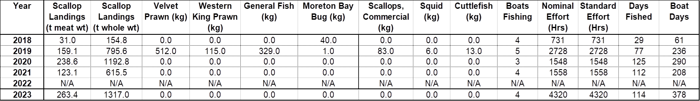
NOTE: In 2019, one vessel fished for prawns in accordance with the provisions of the Management Plan, which relates to fishing in the Port Gregory area to target prawns.

Appendix 2 – Bycatch data (2023) in the AIMWTMF
Table 2: Estimated total catch, including bycatch, weights in the AIMWTMF in 2023 (*total survey catch from all shots, including both port and starboard nets)
Catch category | Survey catch (kg)* | Survey effort (hours) | Survey catch rate (kg/trawl hour) | Estimated annual AIMWTMF catch in 2023 (tonnes) | Status
Ylistrum balloti | 2,709 | 5.33 | 508.0 | 1,317 | Retained
Other Mollusca | 15 | 5.33 | 2.8 | 7 | Discarded
Porifora | 45 | 5.33 | 8.5 | 22 | Discarded
Echinodermata | 69 | 5.33 | 13.0 | 34 | Discarded
Cnidaria | 3 | 5.33 | 0.6 | 1 | Discarded
Chordata | 30 | 5.33 | 5.6 | 15 | Discarded
Arthropoda | 15 | 5.33 | 2.8 | 7 | Discarded

Table 3: Contributions (by weight and number) of individual species to catches taken by the port side net during the 2023 AIMWTMF bycatch survey.
PHYLUM | Category | Common Name | Scientific Name | Weight (kg) | Number of individuals | % of total weight | % of total number
Mollusca | Bivalvia | Ballot's Saucer Scallop | Ylistrum balloti | 1,322.38 | 22,162 | 95% | 98%
 |  | Commercial Scallop | Pecten fumatus | 0.04 | 1 | <1% | <1%
 |  | Scallop | Decatopecten spp. | 0.01 | 1 | <1% | <1%
 |  | Scallop, Doughboy | Mimachlamys asperrima | 0.33 | 6 | <1% | <1%
 |  | Scallop, Fan | Annachlamys flabellata | 1.85 | 49 | <1% | <1%
 |  | Venus Cockle | Costacallista planatella | 0.08 | 1 | <1% | <1%
 | Cephalopoda | Cuttlefish | Sepia novaehollandiae | 0.22 | 1 | <1% | <1%
 |  | Giant Cuttlefish | Sepia apama | 0.08 | 1 | <1% | <1%
 |  | Papuan Cuttlefish | Sepia papuensis | 0.04 | 1 | <1% | <1%
 |  | Pharaoh Cuttlefish | Sepia pharaonis | 0.50 | 2 | <1% | <1%
 | Gastropoda | Dog whelk (egg casing) | Nassariidae | 0.30 | 2 | <1% | <1%
Subtotal |  |  |  | 1,325.82 | 22,227 | 95% | 98%
Echinodermata | Ascidiacea | Ascidian | Ascidiacea sp. 1 | 0.20 | 1 | <1% | <1%
 |  | NA | Ascidiacea sp. 2 | 2.85 | 2 | <1% | <1%
 |  | NA | Ascidiacea sp. 3 | 0.24 | 1 | <1% | <1%
 | Asteroidea | Archaster angulatus Seastar | Archaster angulatus | 0.06 | 2 | <1% | <1%
 |  | Galloping Sea Star | Stellaster equestris | 2.52 | 29 | <1% | <1%
 |  | Giant Starfish | Asteroidea sp. 1 | 11.41 | 6 | 1% | <1%
 |  | Seastar | Luidia maculata | 1.74 | 10 | <1% | <1%
 |  |  | Luidia sp. | 2.50 | 1 | <1% | <1%
 | Echinoidea | Collector Sea Urchin | Tripneustes gratilla | 0.56 | 2 | <1% | <1%
 |  | Heart Urchin | Breynia desorii | 2.34 | 7 | <1% | <1%
 |  | Sea urchin | Prionocidaris bispinosa | 2.15 | 22 | <1% | <1%
 |  |  | Salmaciella dussumieri | 0.15 | 2 | <1% | <1%
 |  | Urchin, Sea | Temnopleurus michaelseni | 0.07 | 1 | <1% | <1%
 | Holothuroidea | Brown sandfish | Holothuria spinifera | 0.66 | 1 | <1% | <1%
 |  | Holothurian | Colochirus crassus | 0.08 | 3 | <1% | <1%
 |  |  | Holothuriidae sp. 2 | 0.27 | 1 | <1% | <1%
 |  |  | Holothuriidae sp. 3 | 1.30 | 1 | <1% | <1%
 | Ophiuroidae | Basket Star | Gorgonocephalidae | 0.31 | 1 | <1% | <1%
Subtotal |  |  |  | 29.40 | 93 | 2% | <1%
Chordata | Elasmobranchs | Maskray Bluespotted | Neotrygon australiae | 0.55 | 2 | <1% | <1%
 |  | Painted Maskray | Neotrygon leylandi | 1.13 | 6 | <1% | <1%
 |  | Yellow shovelnose stingaree | Trygonoptera galba | 0.16 | 2 | <1% | <1%
 | Teleosts | Cardinalfish, Bulls-eye | Apogonichthyoides atripes | 0.04 | 3 | <1% | <1%
 |  | Cobia | Rachycentron canadum | 0.53 | 1 | <1% | <1%
 |  | Coffin Ray | Hypnos monopterygius | 1.74 | 1 | <1% | <1%
 |  | Dragonet, Highfin | Repomucenus meridionalis | 0.01 | 1 | <1% | <1%
 |  | Eye Gurnard | Lepidotrigla argus | 0.06 | 2 | <1% | <1%
 |  | Fanbelly Leatherjacket | Monacanthus chinensis | 0.36 | 4 | <1% | <1%
 |  | Flounder, Olive wide-eye | Engyprosopon maldivensis | 0.10 | 5 | <1% | <1%
 |  | Flounder, Oval | Bothus myriaster | 0.19 | 2 | <1% | <1%
 |  | Flounder, Spiny Headed | Engyprosopon grandisquama | 0.99 | 5 | <1% | <1%
 |  | Goatfish, Asymmetrical | Upeneus asymmetricus | 0.99 | 29 | <1% | <1%
 |  | Goatfish, Stott's | Upeneichthys stotti | 0.01 | 1 | <1% | <1%
 |  | Hair-finned Leatherjacket | Paramonacanthus choirocephalus | 0.16 | 5 | <1% | <1%
 |  | Japanese Threadfin Bream | Pentapodus nagasakiensis | 0.52 | 9 | <1% | <1%
 |  | Largescale Saury | Saurida undosquamis | 0.29 | 2 | <1% | <1%
 |  | Longspine flathead | Platycephalus grandispinis | 0.17 | 1 | <1% | <1%
 |  | Pinkbanded Grubfish | Parapercis nebulosa | 0.21 | 4 | <1% | <1%
 |  | Rosy Goatfish | Parupeneus chrysopleuron | 0.22 | 6 | <1% | <1%
 |  | Scorpionfish, Long-finned Waspfish | Apistus carinatus | 0.03 | 2 | <1% | <1%
 |  | Smalltooth Flounder | Pseudorhombus jenynsii | 0.51 | 2 | <1% | <1%
 |  | Sole, Lemon tongue | Paraplagusia bilineata | 0.02 | 1 | <1% | <1%
 |  | Sole, Wicker-work | Zebrias craticula | 0.04 | 1 | <1% | <1%
 |  | Spiny flounder | Pseudorhombus spinosus | 0.46 | 4 | <1% | <1%
 |  | Spotfin Anglerfish | Antennarius nummifer | 0.01 | 1 | <1% | <1%
 |  | Threadfin Emperor | Lethrinus genivittatus | 0.04 | 1 | <1% | <1%
 |  | Toadfish, Hick's | Torquigener hicksi | 0.52 | 19 | <1% | <1%
 |  | Turretfish, Small spined | Tetrosomus reipublicae | 0.04 | 1 | <1% | <1%
 |  | Western Butterfish | Pentapodus vitta | 0.14 | 2 | <1% | <1%
 |  | Whiting, Bay | Sillago ingenuua | 0.12 | 3 | <1% | <1%
Subtotal |  |  |  | 10.36 | 128 | 1% | 1%
Arthropoda | Decapoda | Crab | Charybdis jaubertensis | 0.04 | 1 | <1% | <1%
 |  | Crab, Cornflake | Portunus rubromarginatus | 0.20 | 11 | <1% | <1%
 |  | Crab, Hairyback crab | Charybdis granulata | 0.15 | 3 | <1% | <1%
 |  | Crab, Sponge | Dromiidae sp. 1 | 0.12 | 1 | <1% | <1%
 |  |  | Dromiidae sp. 2 | 0.91 | 5 | <1% | <1%
 |  | Crab, Swimmer | Xiphonectes rugosus | 0.13 | 15 | <1% | <1%
 |  | General Hermit Crabs (Marine) | Diogenidae - undifferentiated | 0.14 | 2 | <1% | <1%
 |  | Hairy crab | Bathypilumnus pugilator | 0.02 | 1 | <1% | <1%
 |  |  | Pilumnidae | 0.01 | 6 | <1% | <1%
 |  | Moreton Bay Bug | Thenus sp. | 0.05 | 1 | <1% | <1%
 |  | Penaeid prawn | Trachysalambria (Trachypenaeus) curvirostris | 0.07 | 15 | <1% | <1%
 |  | Prawn, Coral | Metapenaeopsis crassissima | 0.79 | 89 | <1% | <1%
 |  | Prawn, Coral (Soft/Broken) | Metapenaeopsis sp. | 0.07 | 15 | <1% | <1%
 |  | Spider crab | Hyastenus campbelli | 0.04 | 1 | <1% | <1%
 |  |  | Paranaxia keesingi | 0.85 | 3 | <1% | <1%
 |  | Western King Prawn | Melicertus latisulcatus | 0.28 | 7 | <1% | <1%
 |  | Western Rock Lobster | Panulirus cygnus | 4.83 | 7 | <1% | <1%
Subtotal |  |  |  | 8.69 | 183 | 1% | 1%
Cnidaria | Octocorallia | Soft Corals | Dendronephthya spp. | 2.34 | 5 | <1% | <1%
Porifera | Unspecified sponge | Sponge - General | Porifera - undifferentiated | 22.11 | 37 | 2% | <1%
TOTAL |  |  |  | 1,398.70 | 22,670 | 100% | 100%

Appendix 3 – Fishing catch and effort
ABROLHOS ISLANDS AND MID WEST TRAWL MANAGED FISHERY

Table 4: Annual scallop catch and effort for the AIMWTMF.

Table 5: Cumulative (2010-19) compared to annual SBPMF(AIMWTMF) effort levels within the allowable fishing area of the AIMWTMF (km²).
Year | Total Spatial Effort of Fishery (km²) | Spatial Effort within FHPA  (km²) | Vessels Operating
2010-19  2001 | 573  189 | 380  96 | Various  16
2004 | 93 | 66 | 16
2005 | 416 | 291 | 17
2006 | 79 | 71 | 14
2007 | 47 | 40 | 14
2008 | 210 | 190 | 15
2010 | 188 | 170 | 15
2011 | 237 | 229 | 8
2017 | 139 | 120 | 4
2018 | 107 | 95 | 4
2019  2020  2021 | 333  165  167 | 156  35  92 | 5  3  3
2022 | 0 | 0 | 0
2023 | 457 | 118 | 4

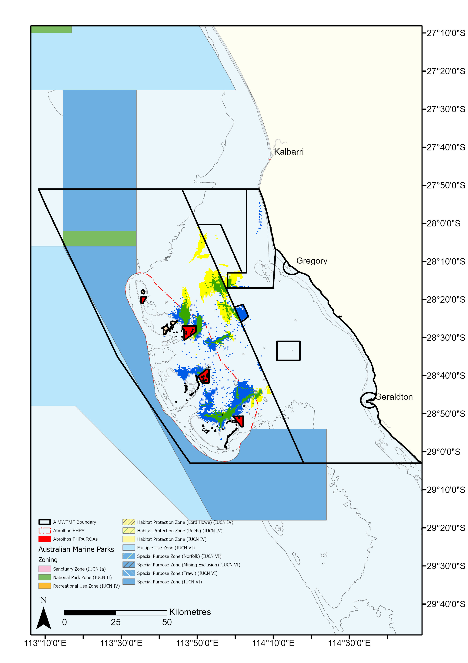
Append. Figure 8: Spatial change in the AIMWTMF fishing effort for 2023 compared to the 2010-19 cumulative trawl footprint. Blue blocks indicate a retraction, yellow blocks indicate an expansion and green blocks indicate areas which remain fished between the 2010-19 cumulative and 2023 footprints. Individual blocks are representative of a 0.25 km² area and have not been trimmed by management zones.
SOUTH COAST TRAWL FISHERY
Table 6: Historical catch and effort in the South Coast Fishery. (NF – No fishing).

Table 7: Area trawled by scallop vessels in the SCTF. Total Fishery is 57299.8 km2 or 16706.0 nm2 (NF - No fishing).

Appendix 4 – AIMWTMF Weight of Evidence Stock Assessment Report (2024)
ECOSYSTEM BASED FISHERIES ASSESSMENT FOR THE ABROLHOS ISLANDS SAUCER SCALLOP FISHERY - 2023
Arani Chandrapavan, Sharon Wilkin, Scott Evans and Jason How
11 March 2024

Weight of Evidence Stock Assessment
Category | Line of Evidence
L0  Biology & vulnerability | The PSA score is LOW for this species. The score reflects this species being short-lived (maximum age ~2-3 years), highly fecund, broadcast spawning strategy, medium trophic level, but being highly selected by the fishing gear and exhibits low to moderate post-release mortality and negative impacts of increasing water temperatures.
L0 PSA Assessment
- Scallops are a highly productive species
- There is strong selectivity by fishing gear, though post-release mortality is low to moderate
Therefore, this species is at LOW risk based on its biology and vulnerability.
L1 Catch | Annual scallop landings (meat weight) have fluctuated markedly from < 20 t to up to 1300 t, with landings in most years being between 30 and 300 t (Table 8). The fishery has also been closed to fishing due to low abundance of scallops between 2012 and 2016 and scallop quality related to growth stunting during 2009.  Stock level was depleted at the end of 2021 leading to the closure of the fishery during 2022, however subsequent recruitment was not impaired, and the stock recovered to allow for commercial fishing during 2023. The 2023 catch landings of 263.4 t was the highest since 2016 (Figure 9) and well above the predicted catch range of 140-235 t.  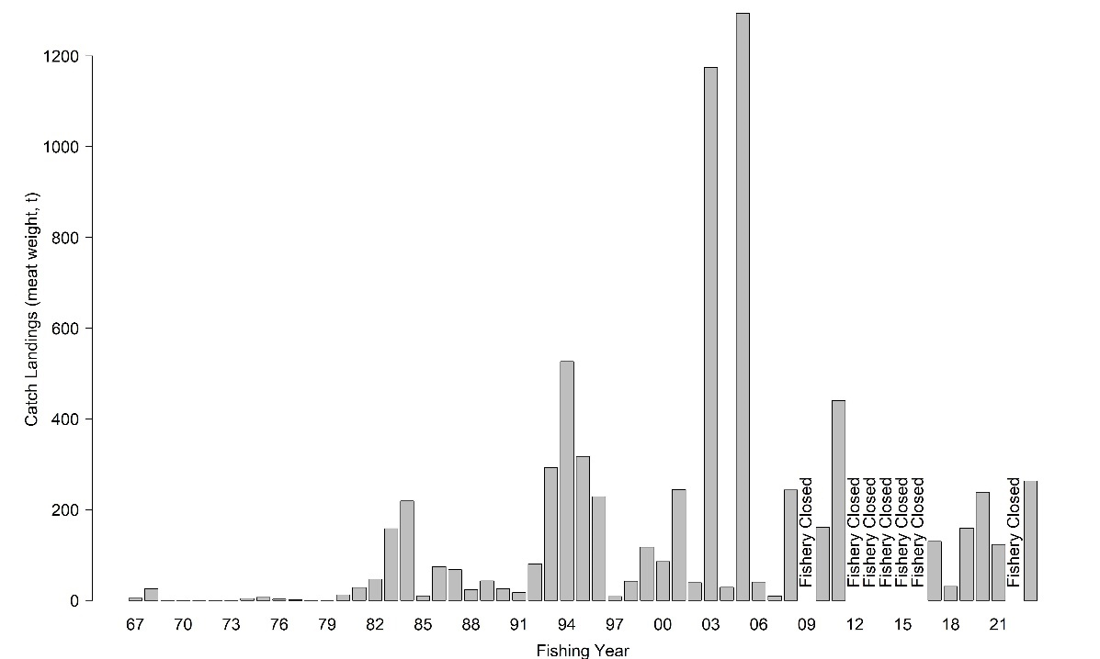  Figure 9 Annual catch (meat weight; t) of scallops from the Abrolhos Islands Mid West Trawl Managed Fishery. Fishery was closed during 2009, 2012-2016 and 2022.
L1 Spatial/ Temporal Catch Distribution | There are a number of different scallop grounds which are accessed by the AIMWTMF (Figure 10). Approximately ~80% of the catch in 2023 was retained from within the northern range of established fishing grounds which is similar to 2021fishing season (Figure 10). However, there was a slight expansion during 2023 with grounds fished to the east of Hummocks, Geelvink and West Boundary. The overall similarity of catch distributions between 2021 and 2023, indicates that serial depletion does not appear to be occurring.  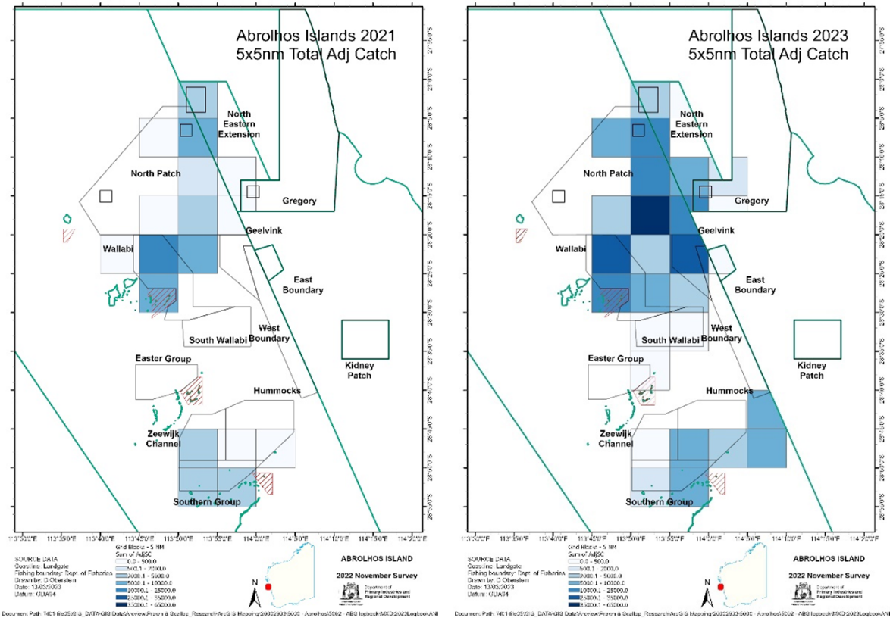  Figure 10 Proportion of annual catch of scallops in 2021 (left) and 2023 (right) from 5 x 5 nautical mile blocks.  Catch in 2023 was also accessed during the typical period for this fishery, from April – July. Occasional fishing has occurred either side of this time period (March and August), though these catches have been comparatively lower than the main months (Figure 11).  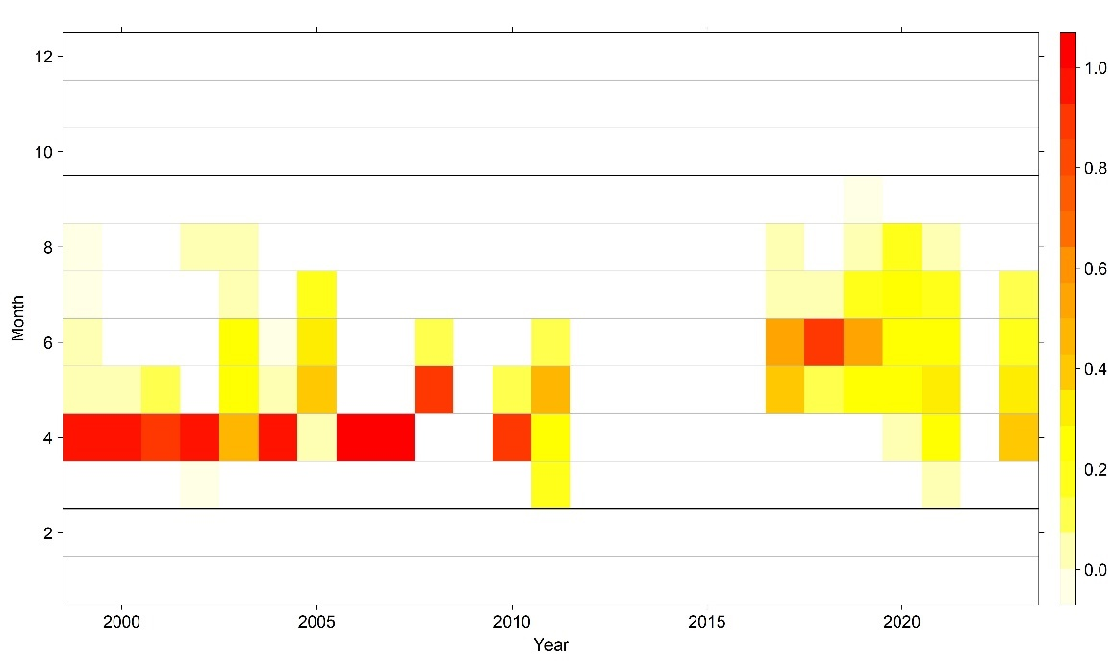  Figure 11 Proportion of catch (see legend) retained in each month by year for scallops accessed by the AIMWTMF. Thick lines denotes the start and end of the fishing season
L1 Catch MSY | A catch MSY assessment has not been undertaken for this component of the resource to date
L1 Assessment
- Catch of 263.4 t was within typical catch ranges (30 – 300 t)
- Catch landings exceeded the catch prediction range of 140 - 235 tonnes
- Similar interannual catch distribution across the fishing grounds
Based on the results from the multiple catch indicators (level of catch and catch distribution) there is no indication of unacceptable stock depletion
L2 Effort | Vessel numbers have remained stable since the closure period from 2012 – 2016 (Figure 12a). Four of the ten licensed boats operated at the Abrolhos Islands in 2023 resulting in 56 fathoms of net headrope (out of a maximum of 140 fathoms) being utilised. A total of 114 days fishing and 4351 trawl hours (standardised effort to 14-fathom headrope) were recorded for the 2023 season ( Figure 12a). This is higher than previous seasons which typically varied between 700 and 2700 trawl hours when the fishery was open ( Figure 12b).  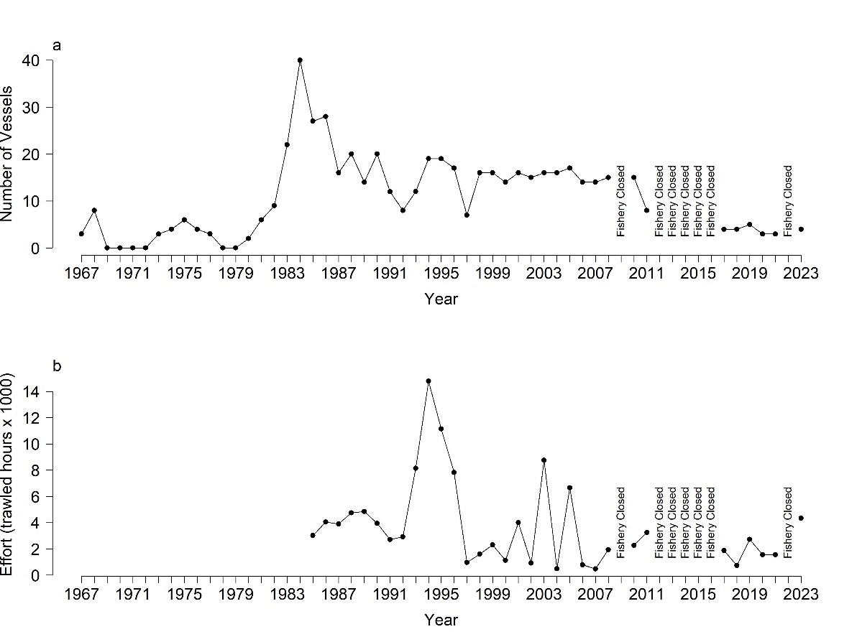  Figure 12 Annual a) number of vessels, and b) trawl hours (x1000) for the AIMWTMF
L2 Catch Rate | Catch rates for scallops in the AIMWTMF are highly variable, with variation increasing with increasing catch rates (Figure 13a). In 2023, the mean catch rate (kg meat / hr) was 85.2 kg / hr which is similar to 2017 and 2019, though markedly lower than the last two seasons fished (2020 & 2021) where it was between 259 and 134 kg / hr respectively (Figure 5a). This is largely influenced by the spread and concentration of scallops between fishing areas and other operational factors.  The intra-annual variation in catch rates is also due in part to the depletion which occurs throughout the season. Daily catch rates ranged from 1 311 to 155 kg / day throughout the season (Figure 13b). However, the decline in daily catch rates did not fall below the threshold level of 150 kg / day (over seven consecutive days) which would necessitate the fishery closing. The increasing daily catch rate at the end of the season was due to less vessels fishing this component of the Resource while other vessels moved to access the south coast component of the Resource.  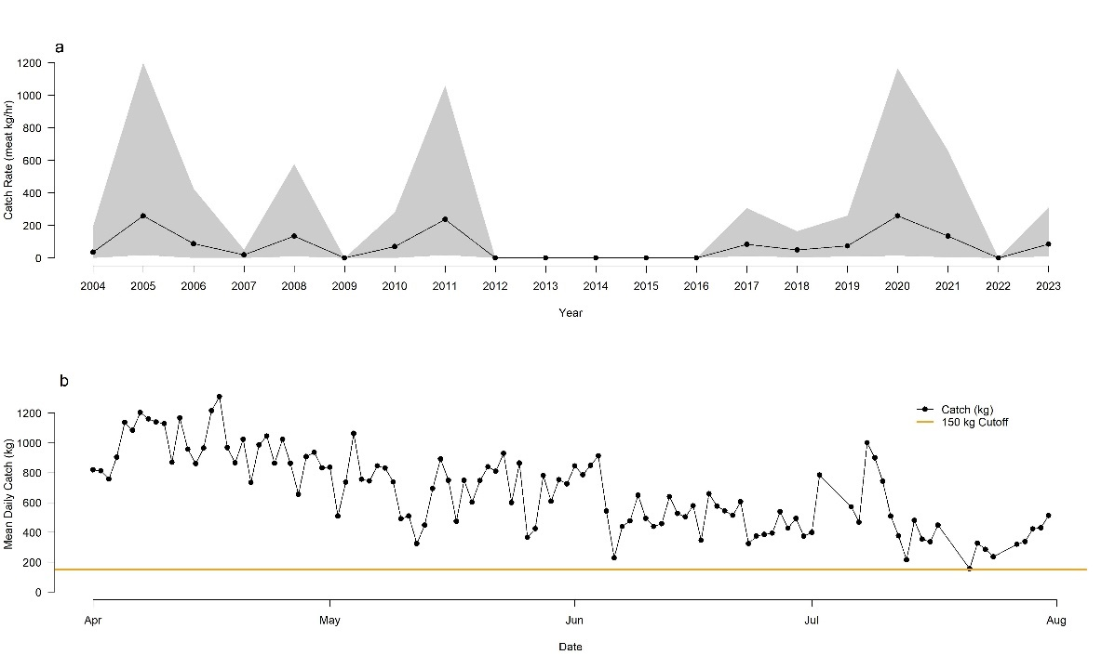  Figure 13 Catch rates of scallops for the AIMWTMF a) annual mean meat weight per hour (± 95 CI; grey shading) and b) daily meat weight relative to the 150 kg threshold (orange line) during the 2023 fishing season.
L2 Assessment
- Effort levels higher than typical range due to higher catches
- Annual catch rates were lower than recent years but within historic range
- Daily catch rates remained above the threshold level
Based on the results from the catch rate indicators there is minimal indication of an unacceptable level of stock depletion
L3 Size Composition | Fishery-independent sampling in February and November annually indicates two cohorts on each sampling occasion representing 0+ (recruits) and 1+ (residuals). Generally, growth progression over two years starts from a mean 45 mm shell height (SH) in February year 0 (3-4 months), to a mean ~90 mm SH in November year 0 and the following February year 1. In February 2021, the 0+ recruitment cohort was the lowest since the recovery of the fishery which translated to a very low 1+ cohort by November 2021. But despite this low abundance of spawning stock, the following recruitment observed in February 2022 improved greatly and a strong 1+ residual cohort was evident in November 2022. This cohort was fished during 2023 that provided for 263.4 tonnes being landed (Figure 14).  The 2023 November survey had an average shell height for the 0+ cohort of ~84 mm (range: 50 to 115 mm SH). Scallops less than ~70 m SH sampled during November are generally considered either as very slow growing or growth stunted individuals which is a common occurrence for this species (Figure 14). The most recent 2024 February survey indicated no significant shift in the size range of 1+ scallops since November 2023 while the newly recruiting 0+ cohort ranged between 20- and 60-mm SH as in previous years. This suggests possible stunting of the residual cohort. Additionally, the strength of the 2024 recruitment cohort is below average and similar to February 2020 survey results.  Stressed, diseased or physiologically compromised scallops impact scallop quality, which can visually manifest as: biofouling of top and bottom valves, splotches of purple and green colouration on or within shell matrix, fragile thin shells that appear to be old and brittle, poor meat quality that is crumbly and unproportionally small for its shell size (Figure 16).  Examination of size composition data at a finer spatial scale, indicated differential impacts of poor growth and quality of scallops for the various fishing grounds. These occurrences first appeared at a few sites in the Hummocks in November 2023, but occurred at most sites in the February 2024 survey.  In the 2024 February survey, a qualitative assessment of the catch composition indicated almost 90-100% of scallops at the Hummocks and 50% of the scallops at the Southern Group were of poor shell and meat quality with a high degree of growth stunting. The majority of residual scallops at Zeewijk Channel appear to have died (Figure 15), while a large amount of dead scallop shells came up in the trawl shot from South Wallabi. Approximately 70% scallops at the Easter Group and one site at East Beacon were also of poor shell and meat quality. The Wallabli and North Patch fishing grounds all indicated < 5% of stunted and poor shell quality scallops (Figure 15).  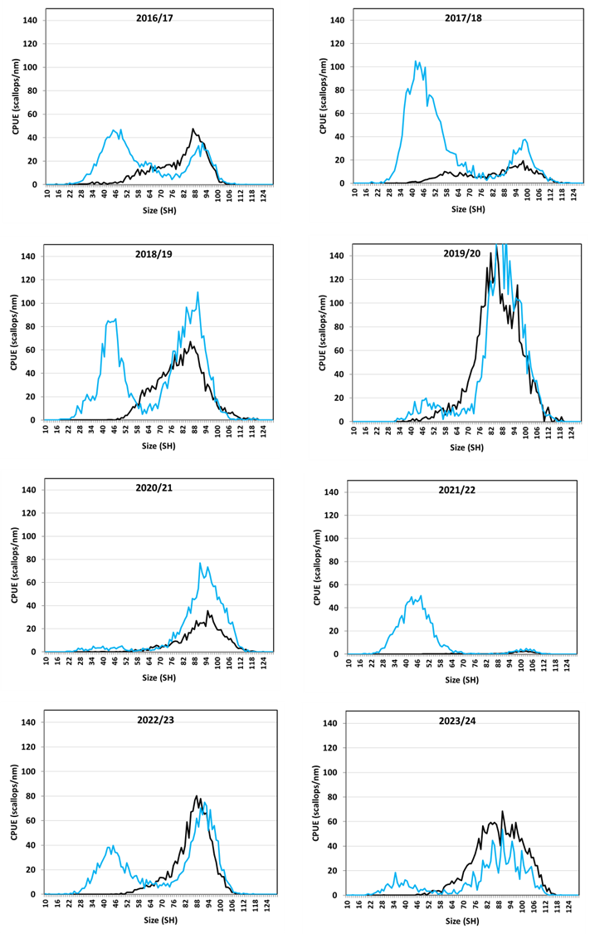  Figure 14 Shifts in shell height frequencies of Ylistrum balloti between November (y)(black line) and February (y+1)(blue line) stock surveys since 2016, across all survey sites  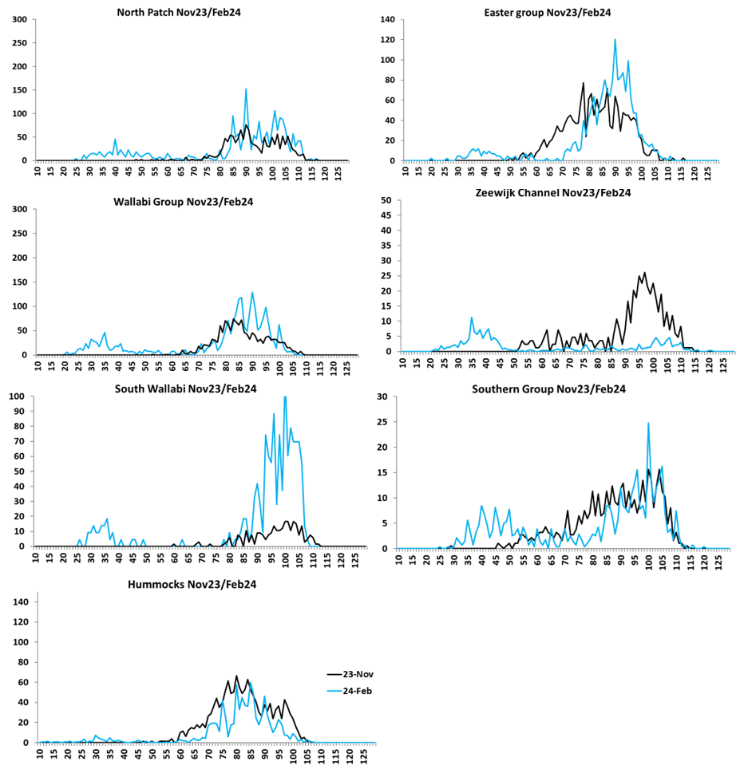  Figure 15 Shifts in shell height frequencies of Ylistrum balloti between November 2023 (y)(black line) and February 2024 (y+1)(blue line) surveys at the seven key fishing grounds.  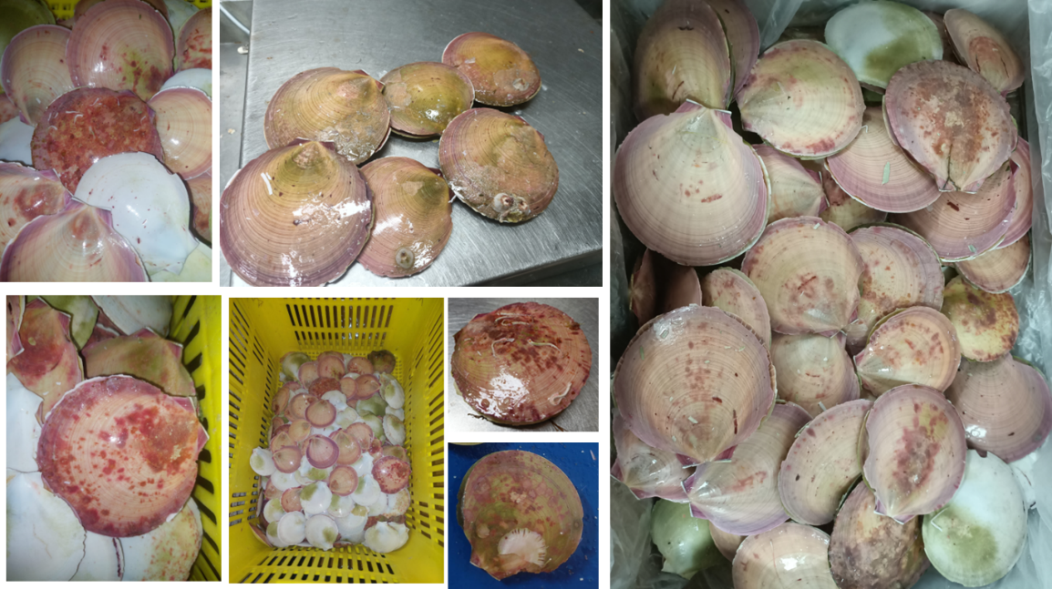  Figure 16 . Images of scallops that are of poor shell condition from the November 2023 and February 2024 surveys.
L3 Assessment
- There was an average residual cohort evident in November 2023 which further reduced by February 2024, accompanied by a poor recruitment cohort.
- There is evidence of stunting (retarded growth) and poor scallop quality in the Hummocks fishing ground during November 2023
- Qualitative assessments indicated that there were quality issues with scallops, which was more prevalent in the southern fishing grounds and greater prevalence moving further north during the February 2024 survey
- With the exception of the Wallabi and North Patch fishing grounds, majority of the residual scallops across the Abrolhos Islands are of poor shell condition and meat quality which may result in a higher level of natural mortality.
Based on the results from the size composition there is minimal indication of an unacceptable level of current stock depletion. However, recently sampled size composition, shell and meat condition data raise concern over the biomass of residual scallops being able to be of harvestable quality and support the catch prediction.
L4 Fishery-independent indices | Two fishery-independent surveys are conducted in the AIMWTMF, one in November (post fishing) to provide an indication of 1+ residual stock levels that will be fished during the following season, and in February to capture juvenile recruits (recruitment index) and survival of adult 1+ stock over summer (February index) prior to fishing commencing in March / April.  The November index (all sized scallops) comprises of all 0+ and 1+ scallops between 70 – 110 mm SH (Figure 14). Majority of the scallops from the November survey spawn over the summer months (September to March) and are fished in the following fishing season, and hence provides a measure of the spawning biomass. The 2023 index has declined slightly from the 2022 level to 974 scallops/nm but remains above the threshold reference level (Figure 17).  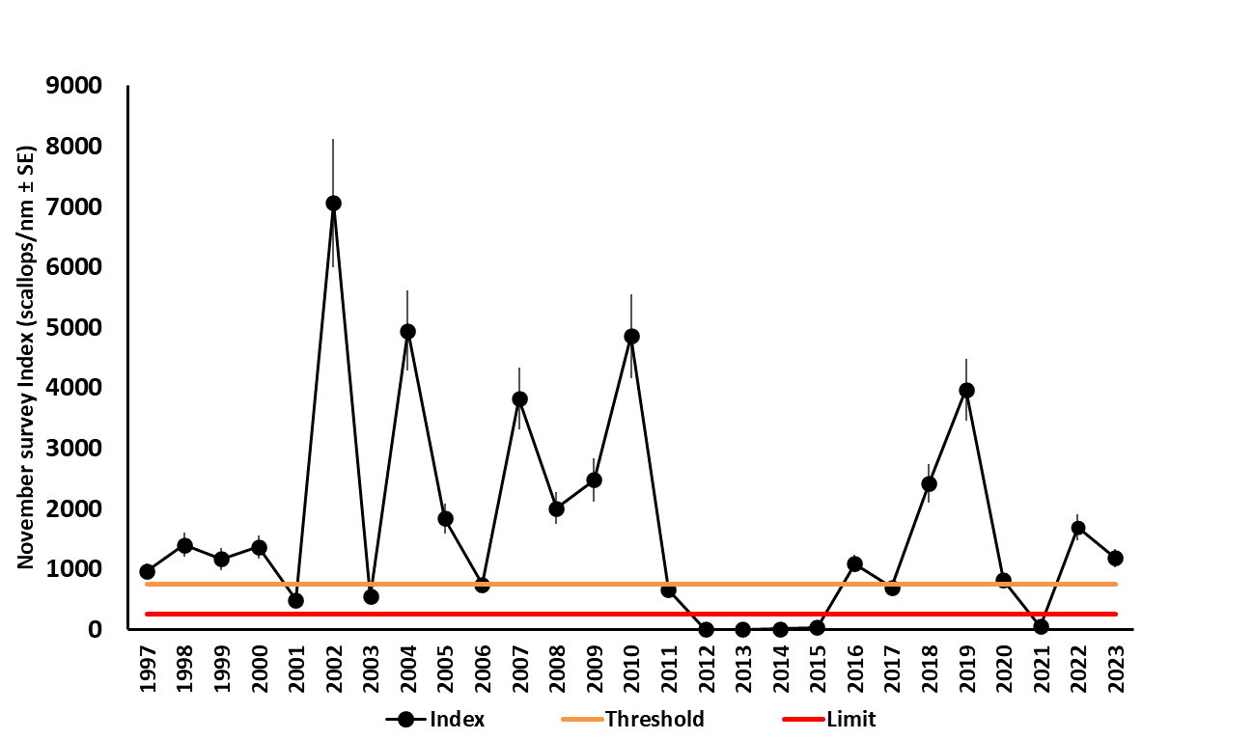  Figure 17 Annual November index (scallops/nm ± s.e.) for the AIMWTMF with associate limit (250 scallops/nm; red line) and threshold (750 scallop/nm; orange line) reference levels. Note that the CPUEs between 2012 and 2015 and during 2021 were all < 50 scallops/nm.  The February survey provides for a secondary measure for the residual 1+ scallop abundance persisting over the summer months. The residual index from The February 2024 survey has declined to 727 scallops/nm and has fallen below the threshold reference level of 750 scallops/nm (Figure 18).  Additionally, the February survey generates a recruitment (0+) index. This provides an indication of the future spawning stock which will be assessed during November 2024. This index from the February 2024 survey has also declined markedly to 402 scallops/nm (Figure 19).  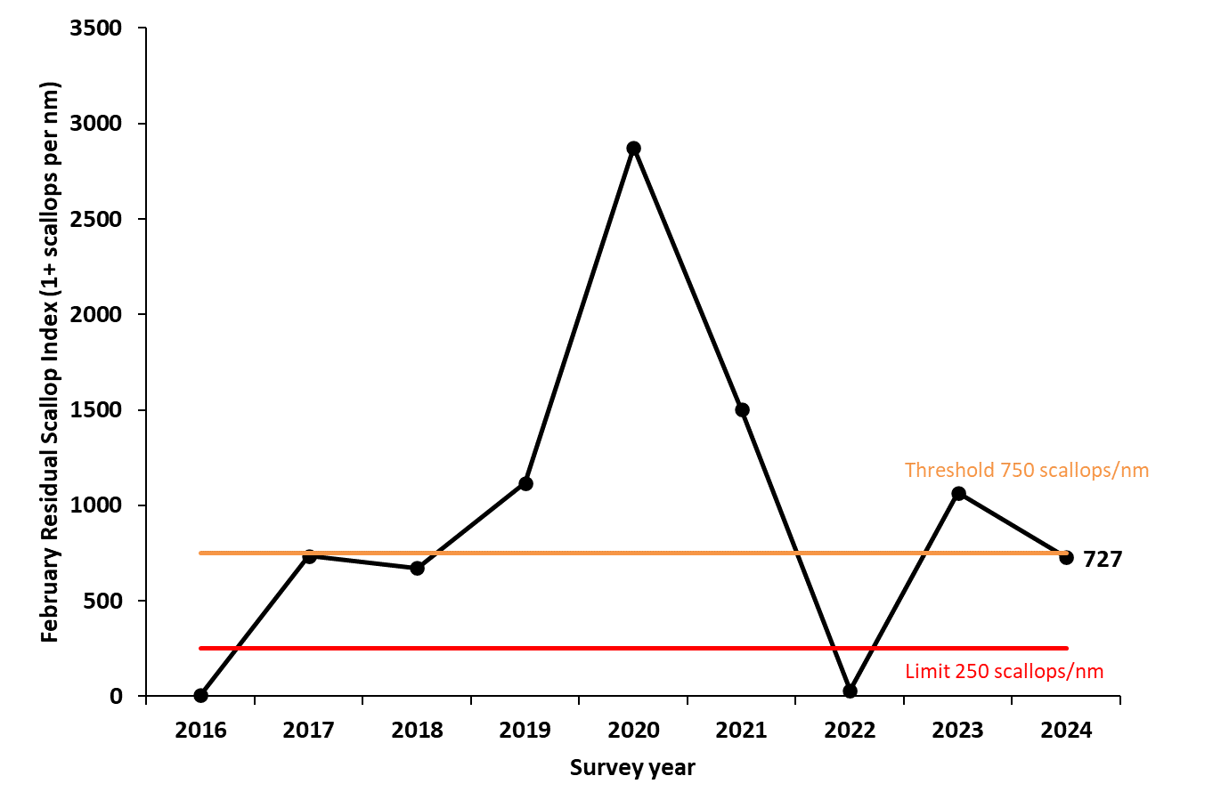  Figure 18 Preliminary annual February residual index since 2016 with associated threshold (750 sc/nm; orange) and limit (250 sc/nm; red) reference levels  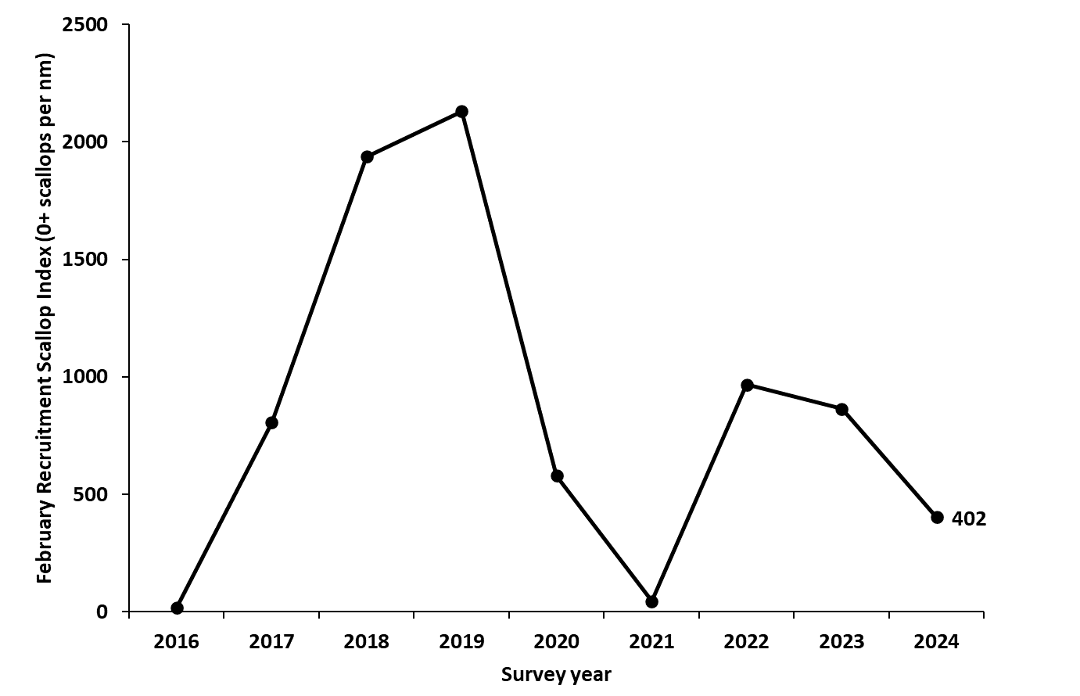  Figure 19 Preliminary annual February recruitment (0+) index since 2016 where reference levels are yet to be developed.  The 2024 February survey indicated that the Zeewijk Channel fishing ground had a majority of sampled scallops below 60 mm SH (Table 8, Figure 15). The specific locations of high recruit abundance, and associated research advice regarding any potential spatial closures to protect these recruits are in harvest Control Rules and Upcoming Season Advice.  Table 8 Relative percentage of small (< 60 mm SH) scallops by fishing grounds, with those areas with a high percentage (>50%) denoted in bold from the 2024 February survey.
  Fishing Grounds | Small (<60mm SH) Scallops Measured | Total Scallops Measured | Percentage
  East Boundary | 0 | 206 | 0
  Easter Group | 67 | 748 | 9
  Geelvink | 3 | 141 | 2
  Hummocks | 91 | 1,458 | 6
  North Patch | 108 | 383 | 28
  South Wallabi | 29 | 277 | 10
  Southern Group | 296 | 1,129 | 26
  Wallabi Group | 303 | 1,424 | 21
  West Boundary | 12 | 150 | 8
  Zeewijk Channel | 348 | 598 | 58
L4 BDM | A biomass dynamics model has not been generated for this component of the Resource
L4 Assessment
- The November 2023 index has declined from 2022 but remains above the threshold level
- The February residual index has however declined below the threshold level and likely due to a combination of poor quality, condition and mortality of scallops. The cause of this widespread event is unclear.
- The poor condition of 1+ spawning stock has likely contributed to the below average recruitment index in February 2024
Based on the results from the November and February residual and recruitment indices, there is concern that majority of the residual stock may succumb to a higher level of natural mortality during 2024.
Environmental Impacts | Above average SSTs can have significant negative impacts on scallop abundance at the Abrolhos Islands. This is particularly the case if it occurs during summer when spawning and recruitment occur. The hottest summer SSTs on record (2010/11 and 2011/12) were considered to have led to a significant negative effect on recruitment over 2011-13, resulting in record low spawning stock (Figure 17). Similarly, marine heatwave conditions over the 2020/2021 summer may have contributed to the very low recruitment event during November 2021, leading to its closure for the 2022 fishing season. Water temperatures returned to near average conditions during 2023 (Figure 20) as the ENSO climate mode shifted into El Niño, and so favourable recruitment prediction for 2024 despite above average SSTs during December 2023.  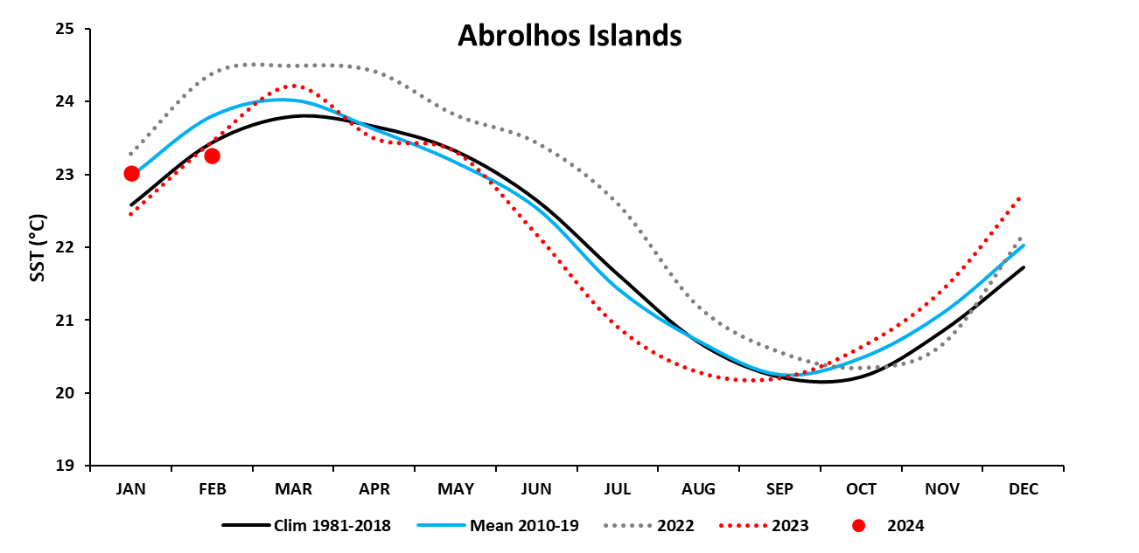  Figure 20 Monthly mean SST for 2022 (red dotted line) and 2023 (red dots) in comparison to the climatology (1981-2018) and the most recent decade (2010-19).  A stock-recruitment-environment relationship (SRR-E) is evident for scallops in Abrolhos Islands, with summer SSTs a significant factor for the spawning stock. The recovery in recruitment levels in early 2022 translated to good spawning stock levels during early 2023 despite warmer than average summer temperatures. Based on the 2023 spawning stock level and together with another above average summer temperatures over the summer of 2022/23 (last summer of the La Niña period), the model predicts below average recruitment for November 2024 (Figure 21). Early detection of this recruiting cohort was present in the 2024 February survey which indicated a below average recruitment index of 402 scallop/nm (indicative of the spawning stock level for 2025).  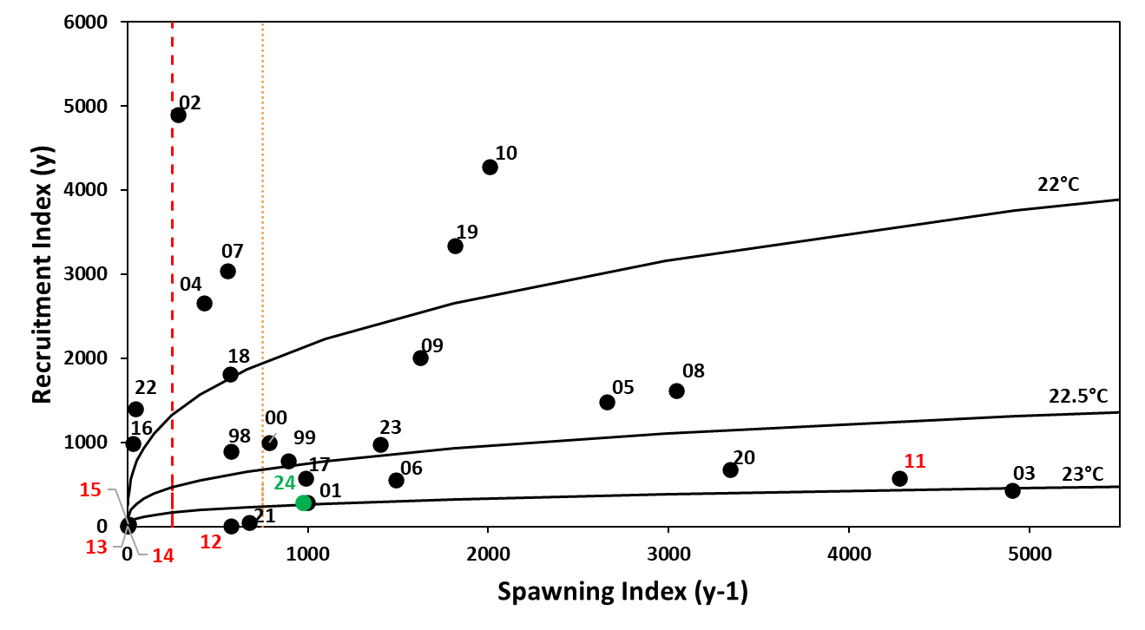  Figure 21 Relationship between the annual mean scallop spawning index (November_{y-1}) and recruitment index (November_{y}) between 1998 and 2023. Data labels denotes the recruitment year (y), and the lines represent the mean summer SST (November _{y-2}- March _{y-1}) that influence the spawning stock. The dashed red line is the current limit spawning stock reference level and the dotted orange line is the threshold reference level. The 2024 model prediction is indicated by the green data point.
Environment Risk Rating based on future expected environmental conditions
- Future climate conditions are predicted to see increased SSTs and increased frequency and intensity of marine heatwaves (MHW) globally (Oliver et.al 2018)
- MHW conditions over summer have had a significant negative impact on scallop stock levels at the Abrolhos Islands (Chandrapavan et. al 2020)
Scallops at the Abrolhos Islands are HIGH
Final Risk:
While scallops at the Abrolhos Islands are a high risk under future environmental conditions, in the short term, stock levels and SST pose minimal to no indications of unacceptable stock decline. Future catch levels are set in accordance with stock levels to ensure mitigation of over-exploitations. The WOE assessment for the 2023 season is:

C1 Minor (Above Target): It is REMOTE (<5%) that the stock is above the target level owing to no formal target levels being established for this component of the Resource.
Remote (1) x Minor (1)-> Negligible
C2 Moderate (Above Threshold, below Target): It is LIKELY (>50%) that the stock is above the threshold level. The November index was above the threshold level, though the subsequent recruitment was below average and the February residual index just breached the threshold level.
Likely (4) x Moderate (2)-> Medium
C3 High (Above Limit, below Threshold): It is POSSIBLE (20-50%) that the stock is below the Threshold and above the Limit. The February index breached the threshold and there was a lower level of recruitment. This may be a result of poor scallop quality reducing reproductive output and hence lower than expected recruitment.
Possible (3) x High (3)-> High

C4 Major (Below Limit): It is UNLIKELY (5-20%) that the stock is below the limit reference level, based on the length frequency of standing stock and predicted recruitment levels.
Unlikely (2) x Major (4)-> Medium

Therefore, the overall weight of evidence assessment for scallops at the Abrolhos Islands accessed by the AIMWTMF during 2023 is a HIGH risk (Table 9). Information pertinent to the application of the stock assessment and future catch levels are presented below.

Table 9 Risk matrix of stock depletion for Abrolhos Island scallops accessed by the AIMWTMF.
 |  | LIKELIHOOD
CONSEQUENCE |  | Remote  (1) | Unlikely  (2) | Possible  (3) | Likely  (4)
CONSEQUENCE | Minor  (1) | Negligible | Negligible | Low | Low
CONSEQUENCE | Moderate (2) | Negligible | Low | Medium | Medium
CONSEQUENCE | High  (3) | Low | Medium | High | High
CONSEQUENCE | Major  (4) | Low | Medium | Severe | Severe

Ecological Assessment
Category | Line of Evidence
Retained Species | There were no other species retained by the AIMWTMF in 2023. Retention of species other than scallops in this fishery is typically < 2 t resulting in the combined weight of retained species being < 1 % of scallop catch in a year. The species typically retained by the AIMWTMF other than scallops are Velvet and Western King Prawns.
Retained Species Assessment
- There was no other retained species in 2023
- Retained species retention is typically low
- Previous Ecological Risk Assessments (ERA; Stoklosa 2019) scored other retained species (bugs) as Negligible Risk
The risk of fishing on other retained species is NEGLIGIBLE
By-catch Species | A bycatch survey undertaken during January 2023 (Appendix 3 – MSC Recommendation 2) confirmed that while the bycatch composition was diverse with 180 species, there were relatively very low quantities of each individual bycatch species (<1% of total weight), which equates to an annual AIMWTMF catch of <5 t per bycatch species (typically <3 t). Bycatch reduction devices, slower trawl speeds and larger mesh size all reduce the quantum of bycatch (DPIRD 2020b). Such quantities are expected to have negligible / low impacts on the breeding stock of each species.
By-catch Species Assessment
- Recent sampling confirmed a diverse, yet minimal by weight bycatch from the fishery
- Previous ERA (Stoklosa 2019) scored bycatch as Negligible Risk
The risk of fishing on bycatch species is NEGLIGIBLE
ETP Species | While turtles do occur in the Abrolhos Islands, these species are towards the southern extent of their range, and do not breed in the Abrolhos Islands area because water temperatures are generally too low. Consequently, interactions with turtles were always minimal, and with grids compulsory in the fishery, their capture should be eliminated. Few other protected species occur in this area. In 2023 only one interaction was reported in the AIMWTMF when an alive sea snake was captured and subsequently released.
Endangered, Threatened and Protected (ETP) Species Assessment
- Only one sea snake was captured
- Previous ERA (Stoklosa 2019) scored ETP interactions as Negligible Risk
The risk of fishing on ETP species is NEGLIGIBLE
Habitat | The areas associated with scallops are primarily sandy habitats and trawling activity does not impact these significantly. The area fished is relatively low, on average ~4.3 % of the total area per year between 2001 and 2020 and cumulatively ~16 % of the total for 2010 to 2020. Where habitat data is available within the Abrolhos Fish Habitat Protection Area (FHPA), it confirms AIMWTMF fishing also occurs primarily on sandy substrate  An assessment of the area trawled during 2023 and its potential impact on the habitat is provided in Appendix 4.
Habitat Assessment
- Previous ERA (Stoklosa 2019) scored habitat interactions as Negligible risk for all habitats except for sand which was scored as a Low risk
- The extent of the area fished in 2023 was 4.4 % of the whole fishery
The risk of fishing on habitats is LOW
Ecosystem | The total biomass taken by this fishery is generally small. Moreover, due to the high natural variability of scallop stock abundance it is unlikely that any predators are highly dependent on this species. The ERA determined food chain effects to be negligible (DPIRD 2020b).
Ecosystem Assessment
- Previous ERA (Stoklosa 2019) scored impacts on the ecosystem structure as Negligible risk
The risk of fishing on habitats is NEGLIGIBLE
Ecosystem Effects of Fishing Risk Assessment : All components of the ecological assessment of scallop fishing by the AIMWTMF are either LOW or NEGLIGIBLE. These are based on current empirical data or expert-elicited risk assessments. The current operation of the fisher did not indicate any shifts which may impact the overall assessment of the ecological impact on the fishery. Therefore, the ecosystem effects of fishing by the AIWMTMF on the Resource is considered to be LOW.

Harvest Control Rules and Upcoming Season Advice
The AIMWTMF is currently operating under a formal harvest strategy (DPIRD 2020a). This contains pre and in-season decision rules based on performance against specific reference levels. These primarily include;
- In-season commercial daily catch rates
- November index
- February index and
- February size composition
The season opening date can be delayed based on the abundance of scallops from the November survey. The index from the November 2023 survey was 974 scallops / nautical mile (sc/nm). This was above the threshold level of 750 sc/nm (Figure 18), placing this PI in the target region. Thus, the corresponding control rule indicates that;
- The scallop fishing season for 2024 will be set to open on 1 March
However, the residual index from February 2024 survey was 727 sc/nm, which is just below the threshold level of 750 sc/nm (Figure 18). The corresponding control rule subsequently indicates that;
- If either Threshold is breached, review all available information and implement precautionary management measures aimed to return the stock to the target level (e.g. delay season opening and/or implement spatial/temporal closures)
A delay to the season opening would permit more growth of recruits to a size closer to harvestable sizes. The recruitment cohort (February 2024) is already below average levels (Figure 19) and represents the spawning stock for 2025 recruitment. A delayed start date may also potentially lead to more of the harvestable stock from being impacted by the poor scallop quality issues. Therefore, it is more appropriate for the stock to be fished earlier in the season thus protecting future spawning stock (recruits). Therefore;
- The scallop fishing season for 2024 could open on 1 March
With this overall lower level of recruitment, consideration should be given to an earlier finish to the fishing season to ensure that the next year’s spawning stock are not accessed by the fishery. The daily catch rate threshold at 150 kg / day (e.g Figure 13.b) may lead to an earlier closure of the fishery if harvestable biomass is lower than expected.
The scallop size data indicated > 50% of scallops were < 60 mm SH at the Zeewijk Channel fishing ground (Table 8). These areas of high recruitment should be protected to maximise spawning success (Table 10).
- Spatial closure in the Zeewijk Channel fishing ground to protect better quality recruit abundance as a precautionary measure. Size of the closure to be determined with Industry consultation.
Table 10 Sites within fishing grounds with high percentage of small (< 60 mm SH) scallops and their respective percentage of small scallops.
Fishing Grounds | Site Number | Small (<60mm SH) Scallops | Total Scallops | Percentage
Zeewijk Channel | AB10 | 21 | 142 | 15
Zeewijk Channel | AB11 | 206 | 226 | 91
Zeewijk Channel | AB30 | 121 | 230 | 53

There is also widespread evidence of poor scallop shell condition and meat quality that is indicative of either diseased or stressed scallops and is impacting a range of sizes and fishing grounds. These scallops are likely to be subject to a higher level of natural mortality. The catch prediction for 2024 based on the November 2023 index was 94 t (Figure 22). However, based on the poor scallop quality and condition impacting 60-70% of the harvestable biomass, this prediction is likely an over-estimate.
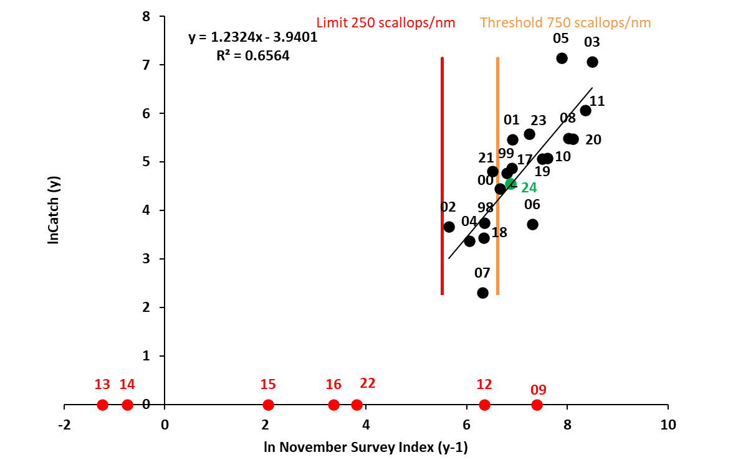
Figure 22 Relationship between the November survey index (ln total scallops/nm trawled (y-1)) with the annual landings (ln catch y, t meat weight) in the following year. Years when no fishing occurred are not included in the relationship and indicated in red. The red vertical line represents the limit reference level (250 scallops/nm) and orange line represents the threshold level (750 scallops/nm). The predicted catch (point estimate) for the 2024 is indicted in green.
Ecological components impacted by the fishery (see table above) are assessed using a periodic risk assessment as the performance indicator. The habitat component has an additional PI related to extent of fishing area trawled annually. The highest identified risk was to sand habitat, which was a LOW risk. This is within the target region of a moderate risk or lower. Additionally, the extent of area trawled in 2023 was 4.4 % which is below the threshold level of 20%. The corresponding control rules indicate that;
- Continue management aimed at achieving ecological, economic and social objectives

References
Chandrapavan A, Kangas M, Caputi N (2020). Understanding recruitment variation (including the collapse) of Ballot’s saucer scallop stocks in Western Australia and assessing the feasibility of assisted recovery measures for improved management in a changing environment. Fisheries Research Report No. 308 Department of Primary Industries and Regional Development, Western Australia. 76pp.
Department of Primary Industries and Regional Development (DPIRD) (2020a) Saucer Scallop Resource of the Abrolhos Islands Harvest Strategy 2020 - 2025 Version 1.1. Fisheries Management Paper No. 299. 35pp
Department of Primary Industries and Regional Development (DPIRD) (2020b). Western Australian Marine Stewardship Council Report Series No. 15: Ecological Risk Assessment of the Abrolhos Islands and Mid-West Trawl Managed Fishery. DPIRD, Western Australia.
Oliver, E. C. J., M. G. Donat, M. T. Burrows, P. J. Moore, D. A. Smale, L. V. Alexander, J. A. Benthuysen, M. Feng, A. Sen Gupta, A. J. Hobday, N. J. Holbrook, S. E. Perkins-Kirkpatrick, H. A. Scannell, S. C. Straub and T. Wernberg (2018). Longer and more frequent marine heatwaves over the past century. Nature Communications, 9 (1324).
Stoklosa, R. 2019. Ecosystem Based Fishery Management—Ecological Risk Assessment of the Abrolhos Islands and Mid-West Trawl Managed Fishery, prepared for the Department of Primary Industries and Regional Development, Fishery, Western Australia. E-Systems, Hobart.

Appendix 1
Boundaries of fisheries accessing the South Scallop Resource
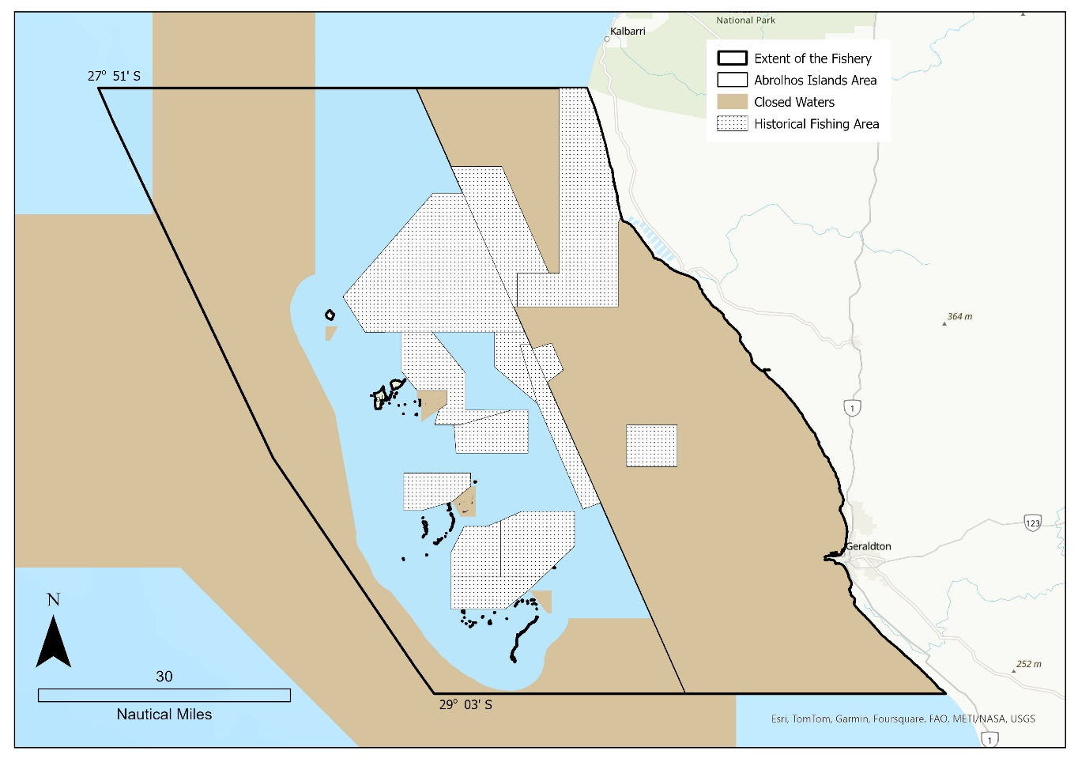
Append. Fig. 1 Boundaries of the Abrolhos Islands Mid-West Trawl Managed Fishery

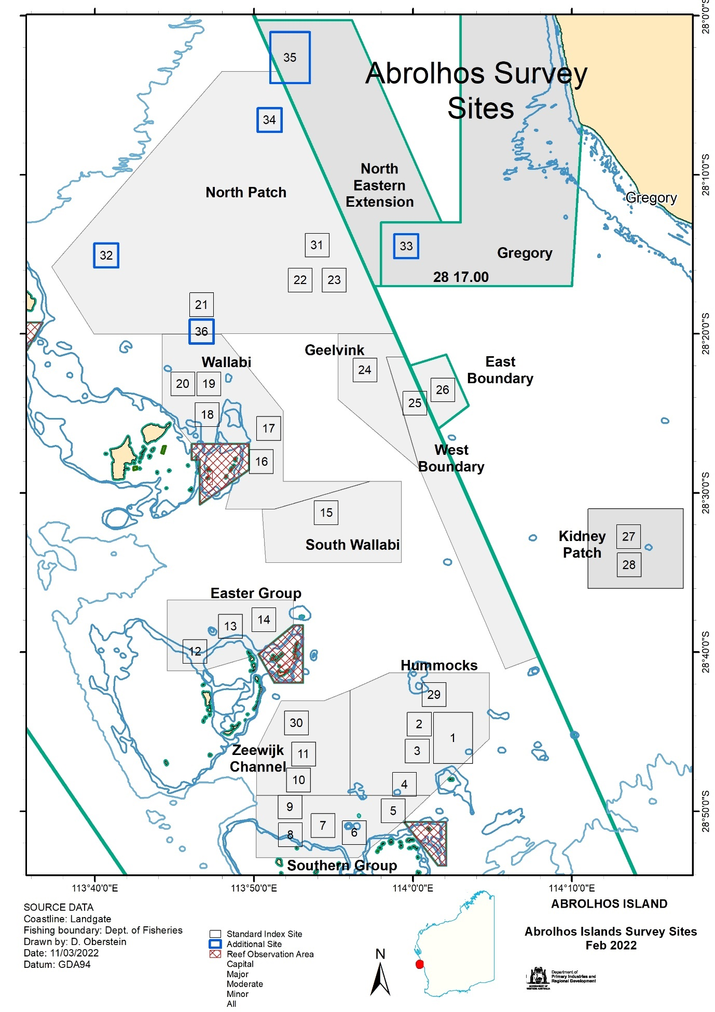
Append. Fig. 2 Location of standard and additional sampling sites (numbered boxes) within the fishing grounds at the Abrolhos Islands for the AIMWTMF
Appendix 2
MSC Recommendation 1
PI 1.2.4 (c): Spawning stock-recruitment-environment analyses suggest that the November spawning index is a good predictor of future recruitment, along with water temperature. This result was achieved despite acknowledged uncertainty in the estimate of November spawning density caused by an inconsistent number of sites conducted in some early years. It is recommended to conduct a review of the November survey and its subsequent biomass measure to reduce uncertainty and to assess the appropriateness of the measure for data specific to the fishery.
Progress Year 2
Current and historic survey data is being coded to ensure consistent and appropriate generation of the November index. This will then be incorporated into an updated SSR-E relationship for this component of the Resource. It is envisaged that this will be progressed for the audit in 2025.
Appendix 3
MSC Recommendation 2
PI 2.1, 2.2 and 2.3 components: As indicated in the report, there is sufficient information available from sources such as logbooks and fishery-independent surveys to meet the requirements of the performance indicators at the SG80 level or above for PIs 2.1, 2.2 and 2.3. As the intention of the survey trawls is to include small “recruit (0+)” individuals, the nets used are smaller mesh (prawn nets) than typical scallop trawl gear. This will inevitably bias the bycatch data to include more and smaller animals that would ordinarily escape through the mesh of commercial scallop trawls. Hence, the data presented will reflect a wider species composition than is taken in the commercial fishing gear. In addition, the samples on which this data is based were taken during the recovery phase of this fishery (following the 2011 marine heatwave). Also, the most recent survey data available for this assessment dates to 2017. There was discussion with DPIRD during the site visit that side-by-side trials of scallop gear and prawn gear are being considered for the fishery. The assessors recommend that this would be a useful approach to provide improved information from the fishery to be considered at surveillance audits (in relation to primary, secondary and ETP species) to better address the relevant performance indicators. Alternatively, observer data from the fishery could serve the same purpose and attempts should be made to collect observer data from the fishery, especially if the abovementioned surveys are not undertaken.
Progress Year 2
2023 AIMWTMF bycatch survey report
A bycatch survey was completed during January 2023 using commercial scallop vessels with scallop gear. A total of 16 shots (20-minute duration) were completed over a ~18 hour period, starting on the 30th and ending on the 31st of January 2023 (Append. Table 1). After each shot, the contents of the starboard and port side nets were brought onboard and processed separately. All scallop species were identified, counted and weighed (to nearest gram, shell on). The remainder of the catch was grouped into broad taxonomic categories (e.g. “Decapoda”) and the number of organisms in each group and their total weight (to nearest gram) was recorded.
For port side catches, all organisms were identified to lowest possible taxon (typically species), counted and weighed. Scallops and larger-bodied organisms were processed onboard. The remainder of the catch was retained, frozen in boxes and later processed in the laboratory. Estimated total catch (or bycatch) weights in the AIMWTMF in 2023 were estimated from the average catch rate (kg/trawl hour) during the survey multiplied by the annual effort (i.e., 4332 trawl hours) reported by the fishery in 2023. In this survey, catch weights for scallops refer to whole scallops, prior to shell removal and processing.
Append. Table 1. Dates, times and locations of all shots during the 2023 bycatch survey.
Date | Shot Number | Site | Start Time | Shot duration (min)
30/01/2023 | 1 | AB24 | 14:37 | 20
30/01/2023 | 2 | AB17 | 16:14 | 20
30/01/2023 | 3 | AB18 | 17:17 | 20
30/01/2023 | 4 | AB19 | 17:52 | 20
30/01/2023 | 5 | AB21 | 18:43 | 20
30/01/2023 | 6 | AB22 | 19:57 | 20
30/01/2023 | 7 | AB21 | 21:16 | 20
30/01/2023 | 8 | AB19 | 22:12 | 20
30/01/2023 | 9 | AB18 | 22:47 | 20
31/01/2023 | 10 | AB29 | 2:00 | 20
31/01/2023 | 11 | AB2 | 2:43 | 20
31/01/2023 | 12 | AB6 | 4:10 | 20
31/01/2023 | 13 | AB7 | 4:52 | 20
31/01/2023 | 14 | AB7 | 5:58 | 20
31/01/2023 | 15 | AB5 | 6:47 | 20
31/01/2023 | 16 | AB2 | 7:50 | 20

Key results
The total catch weight (from all shots, port and starboard nets included) during the survey was 1,399 tonnes. Ballot’s scallops (Ylistrum balloti) comprised 94% (by weight) of the total catch. Individual scallop catches ranged from 10 to 363 kg per shot and represented between 30 and 100% of catch weight per shot (Append. Figure. 3).
Bycatch comprised 6% of the total catch by weight and included 80 different species (or taxa) from 6 phyla (based on analysis of the port side net catches). Bycatch weight ranged from 0 to 28 kg per shot. Based on the average catch rate of bycatch in the survey, the total annual bycatch in the AIMWTMF during the 2023 fishing season was estimated to be 86 t (Append. Fig.5). This quantity excludes any undersized scallops that were discarded. The contributions to the total catch by individual bycatch species were extremely low. Each bycatch species contributed <1% by weight to the total catch, with the exception of the giant starfish (Asteroidea sp.) (1%) and sponges (Porifera – undifferentiated) (2%) (Append.Table 2). No ETP species were captured during the survey.
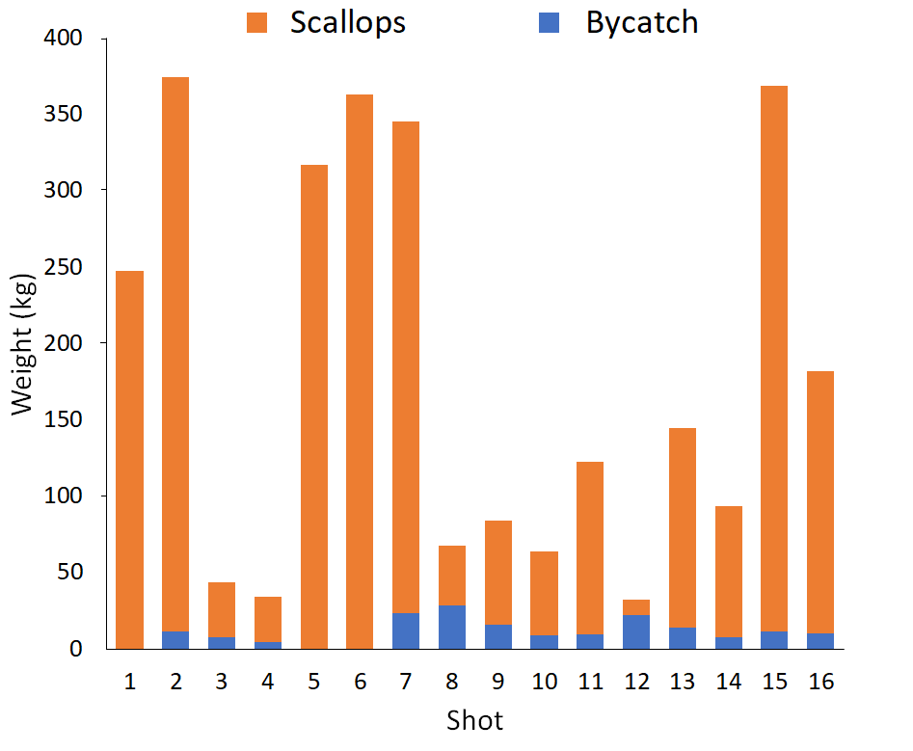
Append. Figure. 3 Weights (kg) of scallops (Ylistrum balloti) and bycatch (all other species) in each shot taken during the 2023 bycatch survey.
Append. Table 2 Estimated total catch (bycatch) weights in the AIMWTMF in 2023 (*total survey catch from all shots, including both port and starboard nets)
Catch category | Survey catch (kg)* | Survey effort (hours) | Survey catch rate (kg/trawl hour) | Estimated annual AIMWTMF catch in 2023 (tonnes) | Status
Ylistrum balloti | 2,709 | 5.33 | 508.0 | 1,317 | Retained
Other Mollusca | 15 | 5.33 | 2.8 | 7 | Discarded
Porifora | 45 | 5.33 | 8.5 | 22 | Discarded
Echinodermata | 69 | 5.33 | 13.0 | 34 | Discarded
Cnidaria | 3 | 5.33 | 0.6 | 1 | Discarded
Chordata | 30 | 5.33 | 5.6 | 15 | Discarded
Arthropoda | 15 | 5.33 | 2.8 | 7 | Discarded
Discussion
- This survey confirmed that while the bycatch composition was diverse with 180 species, there were relatively very low quantities of each individual bycatch species (<1% of total weight), which equates to an annual AIMWTMF catch of <5 t per bycatch species (typically <3 t)(Append. Table 3). However, the survey was conducted in summer, unlike the commercial fishery which operates between March and September. Thus, bycatch composition in the survey may differ to that of the fishery due to seasonal differences in the availability and movement of bycatch species.
- Such bycatch quantities are expected to have negligible/low impacts on the breeding stock of each species, especially since at least some discarded individuals are likely to survive. Post-release survival unknown for bycatch species, but many species are typically released alive & at least some expected to survive. Tag-recapture studies at the Abrolhos Islands have provided some evidence of this (Chandrapavan et al. 2020). Presumably other bivalves and robust species would also survive.
- No ETP species were captured in survey, consistent with very low number of ETP interactions reported by AIMWTMF fishers in statutory returns. Estimated annual sponge catch (37 t) may be related to a habitat issue
Append. Table 3: NOTE – refers to contribution (by weight and number) of individual species to catch taken by the port side net during bycatch survey, as captured in Appendix 2, Table 4 of the application.

APPENDIX 4
AIMWTMF Spatial Effort Footprint Annual Update (2023)
2023 fishing season, in relation to the Abrolhos Islands and Midwest region of Western Australia, and the marine benthic habitats defined within the AIMWTMF. There was no fishing activity for this fishery in 2022. A full summary of the initial reporting, including methodology and habitat description can be found in the MSC Initial Assessment (MRAG, 2021) and this annual update should be read in conjunction with that report. For 2023, there were changes in the reporting of spatial closures, specifically in relation to additional reduction of the total allowable fishing area in relation to the Australian Commonwealth Marine Park boundaries and the opening of new management areas in the north east (Append. Figure 6). In 2023 the fleet consisted of 4 vessels operating in the AIMWTMF.
Spatial extent and intensity of AIMWTMF fishing interaction with Abrolhos Islands and Midwest region and marine habitats defined within the SBPMF for 2021
The AIMWTMF trawl footprint is calculated with the spatial location data obtained from the Department of Primary Industries and Regional Development (DPIRD) fishery independent vessel monitoring system (VMS) which is limited temporally to the start and end times of fishing activity reported in the mandatory SBPMF dependent logbooks. In 2023 the footprint was an estimated 457km², which equates to ~7.7% of the AIMWTMF allowable fished areas (~5900 km²). This is comparable to levels of spatial fishing effort reported for the AIMWTMF for 2005 and 2019 (Table 1) and, overall, 116 km² smaller than the cumulative area fished from 2010-19 of 573 km² (Append. Figure 1; Append. Table 4). There has been an observed shift of effort of the fishery, starting in 2020 and 2021 to other traditional fishing areas (e.g., 2005) in the north and east of the allowable fishing area, which equate to an approximate 42.5% expansion outside of the 2010 to 2019 cumulative footprint, with ~37% of the 2010 to 2019 cumulative footprint still maintaining fishing effort and ~63% with no effort in 2023 (Append. Figure 6).
Of the 457km² footprint for 2023, 118km² was within the Abrolhos Fish Habitat Protection Area (which is ~4.8% of the total allowable fished area of the FHPA) (Figure 1; Table 1). This is reduction of spatial effort of 271.8km² (~71.5%) for the AIMWTMF in the Abrolhos FHPA compared to 2010 to 2019, primarily from reductions in the south and west of the Abrolhos FHPA management area (Append. Figure 6)
Appen. Table 4: NOTE – refers to cumulative (2010-29) compared to annual SBPMF effort levels within the allowable fishing area of the AIMWTMF (km²), as captured in Appendix 3, Table 6 and append. Figure 8 of this application.
Habitat Interactions
Assessing the larger 2010 to 2019 cumulative trawl footprint to habitat data, where available, confirms that the AIMWTMF primarily targets sand habitats (91.9%) (MRAG 2021). Although not covering the entirety of AIMWTMF, the available marine habitat data and biology of the target species, supports that the AIMWTMF annual spatial effort on habitat types, other than sand, is likely to be low.
References
MRAG Americas (2021) Abrolhos Island and Mid-West Scallop Trawl Fishery. MSC Initial Assessment. Prepared on behalf of Far West Scallops and Elmwood/McBoats. MRAG Americas, Inc. St. Petersburg, Florida.

Appendix 5 – SCTMF Weight of Evidence Stock Assessment Report (2024)
ECOSYSTEM BASED FISHERIES ASSESSMENT FOR THE ABROLHOS ISLANDS SAUCER SCALLOP FISHERY - 2023
Arani Chandrapavan, Sharon Wilkin, Scott Evans and Jason How
6 March 2024

Weight of Evidence Stock Assessment
Category | Line of Evidence
L0 Biology & vulnerability | The PSA score is LOW for this species. The score reflects this species being short-lived (maximum age ~2-3 years), highly fecund, broadcast spawning strategy, medium trophic level, but being highly selected by the fishing gear and exhibiting low to moderate post-capture mortality and negative impacts of increasing water temperatures.
L0 Assessment
- Scallops are a highly productive species
- There is strong selectivity by fishing gear, though post-release mortality is low to moderate
Therefore, this species is at LOW risk based on its biology and vulnerability.
L1 Catch | The total scallop catch during 2023 was 28 t meat weight (140.1 t whole weight). This level of catch is very similar to both 2022 catch of 29.3 t and 2021 catch of 29.4 t and within the seasonal catch average of 27.8 t (mean catch between 1990 and 2022, excluding year 2000 of exceptional catch landings).  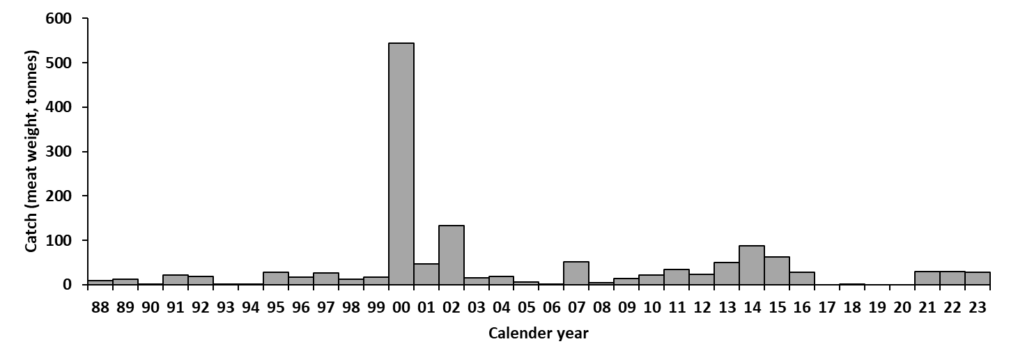  Figure 23 Historical annual catch (tonnes, meat weight) between 1988 and 2023. No fishing occurred during 2017, 2019 and 2020.  Catches are influenced by water temperatures (Figure 27). The 2024 season is expected to be below average as ocean temperatures shifted under an El Niño influence and weaker Leeuwin Current during 2023.  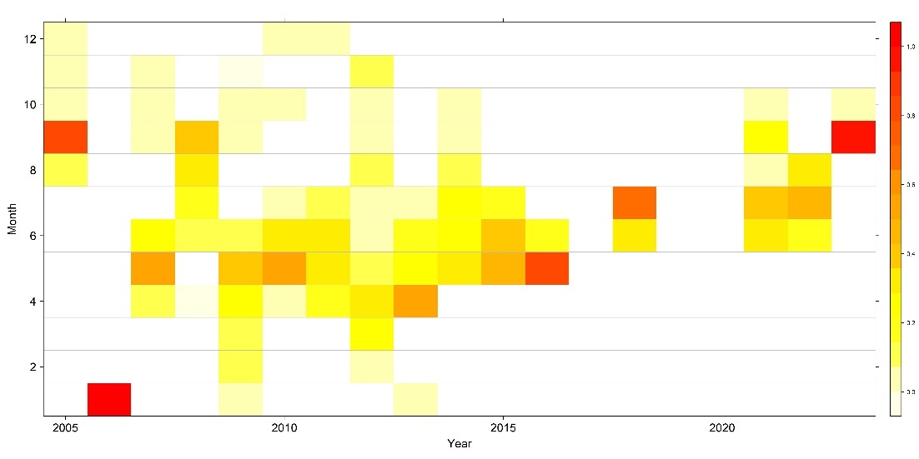  Figure 24 Proportion of catch (see legend) retained in each month by year for scallops accessed by the SWTMF.
L1 Catch MSY | A catch MSY assessment has not been undertaken for this component of the resource to date
L1 Assessment
- Catch of 28 t was consistent with recent catch levels
- Catches were retained from traditional fishing grounds, though there was a shift in the proportion of catch which was retained from each area
- Temporal patterns of fishing continue to vary, with the majority of catch coming from one month
Based on the results from the multiple catch indicators (level of catch, catch distribution) there is no indication of an unacceptable level of stock depletion
L2 Effort | While the catch landing during 2023 was similar to 2021 and 2022, the number of vessels have increased slightly in recent seasons (Figure 25a) though the number of boat days has remained reasonably stable (Figure 25b). This catch level was maintained despite a slight decline in hours fished (Figure 25c).  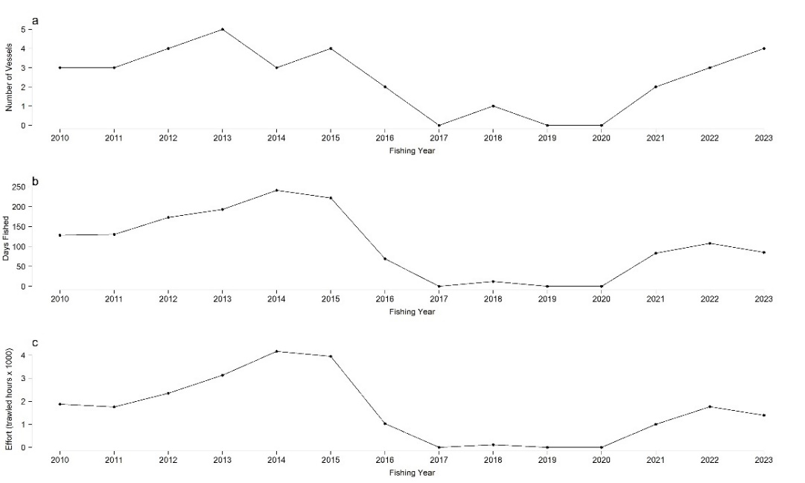  Figure 25 Annual a) number of vessels, and b) trawl hours (x1000) for the SCTF
L2 Catch Rate | Seasonal catch rates for scallops in the SCTF are highly variable and influenced by the very large spatial scale of the fishery, the different fishing vessels operating across different grounds of varying scallop abundance and the associated weather conditions (Figure 26). In 2023 the mean catch rate of 311 (kg meat / boat day) was similar to 2022 but lower than 2021. Overall, catch rates were well within the average catch rate range for this fishery.  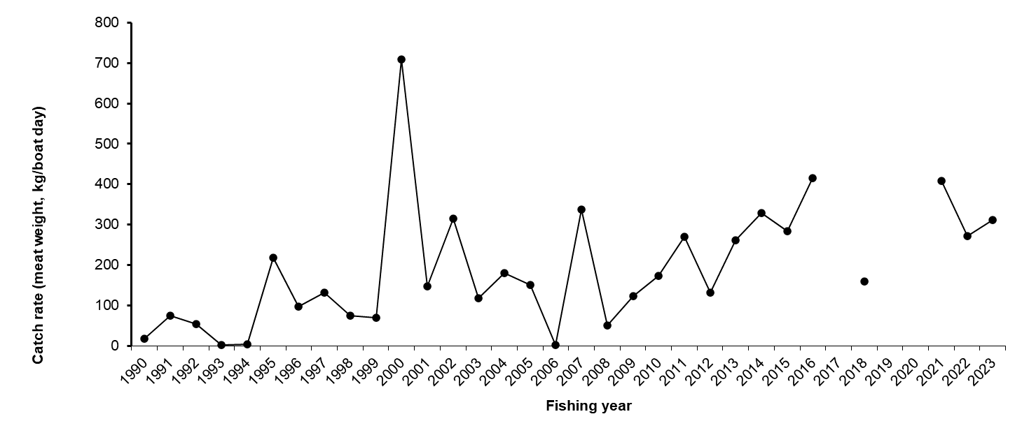  Figure 26 Annual mean catch rate (meat weight per boat day) of scallops from SCTF. No scallops were retained between during 2016, 2019-2020.
L2 Assessment
- Effort levels within typical range for this fishery
- Annual catch rates also within historic range and around the average
Based on the results from the effort and catch rate indicators there is minimal indication of an unacceptable level of stock depletion
Environmental Impacts | Water temperatures that influence the growth and survival of juvenile scallops to adults (March to November) explains approximately 52% of recruitment variability expressed as catch (as a proxy for recruitment strength) the following season (Figure 27). These water temperatures are greatly influenced by the strength and position of the Leeuwin Current around the Capes and along the South Coast. During strong La Niña years, this current is closer inshore and thus brings warmer ocean temperatures where scallops occur and vis versa during El Niño periods. Both 1999/00 and 2010/11 MHW events resulted in the water temperatures along the South Coast to be elevated by ~1°C and likely contributed to the SCTF producing its highest scallop catch on record during 2000 (544 t) and above average catches between 2013-15 (51-87 t). The more recent 2020-23 La Niña period was relatively weaker, and thus catches on has been relatively around average levels. The transition to El Niño during 2023 (Figure 24) has cooled down the South Coast and thus catches predicted to be below average for 2024 at 12.44 tonnes.  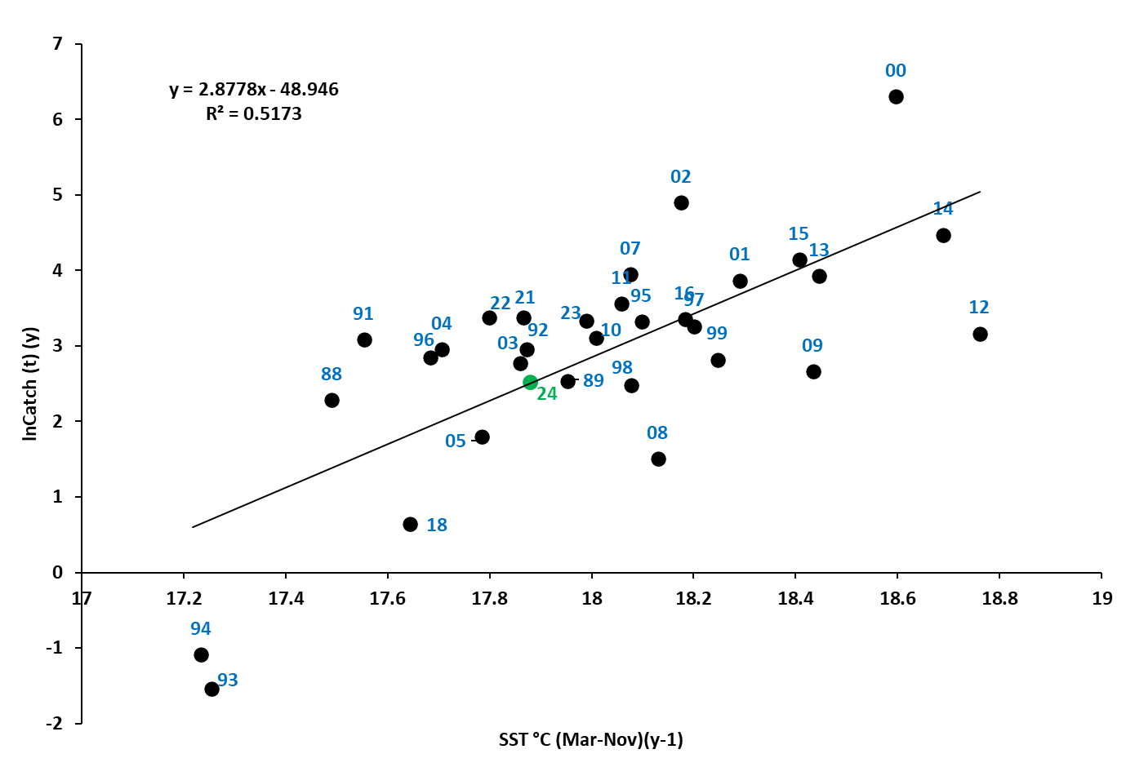  Figure 27 Relationship between log-transformed annual catch (y) during and mean SST (March - November) (y-1) for the period 1988 to 2023. Data point labels indicate catch year with the 2024 catch prediction indicated in green. Data points for 1990 and 2006 has been omitted due to catch data being unreliable.  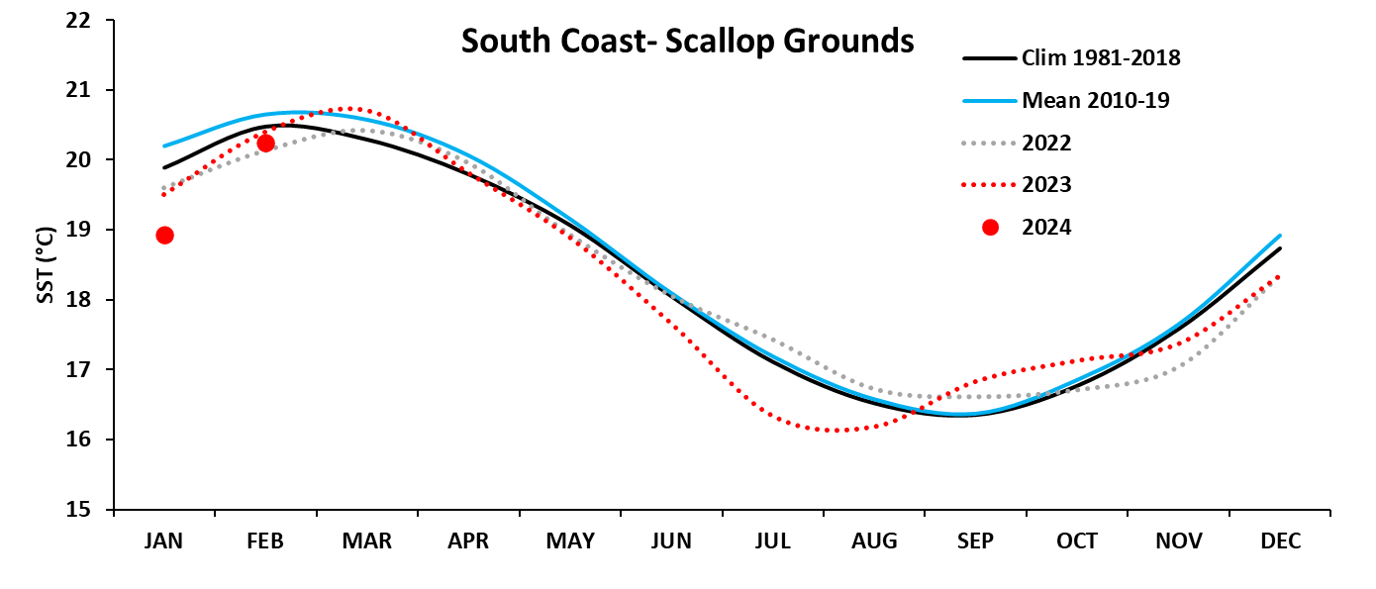  Figure 28 Monthly mean SST within scallop grounds on the South Coast for 2022 (grey dotted line), 2023 (red dotted line and 2024 (red dots) in comparison to the climatology (1981-2018) and the most recent decade (2010-19).
Environment Risk Rating based on future expected environ conditions.
- Recruitment levels are strongly influenced by water temperature and wind conditions
- Catches of south coast scallops increase with warmer water conditions under La Niña periods
- Ocean temperatures and occurrence of MHWs are expected to increase into the future
Scallops on the south coast are likely to be positively impacted through medium to longer term climate change trends of increasing water temperatures in Western Australia.
Final Risk:
Scallops on the south coast are expected to benefit under future environmental conditions, with recruitment and subsequent catches impacted heavily by environmental conditions. Future catch levels are set in accordance with stock levels to ensure mitigation of over-exploitations. The WOE assessment for the 2023 season is:
C1 Minor (Above Target): It is REMOTE (<5%) that the stock is above the target level owing to no formal target levels being established for this component of the Resource.
Remote (1) x Minor (1)-> Negligible
C2 Moderate (Above Threshold, below Target): It is LIKELY (>50%) that the stock is above the threshold level. Recent catches levels were obtained with reduced effort in 2023, resulting in improved catch rates, from traditional fishing grounds.
Likely (4) x Moderate (2)-> Medium
C3 High (Above Limit, below Threshold): It is UNLIKELY (5-20%) that the stock is below the Threshold and above the limit. This is a productive species, with residual stock sufficient to produce sufficient recruitment.
Unlikely (2) x High (3)-> Medium
C4 Major (Below Limit): It is REMOTE (<5%) that the stock is below the limit reference point, based on the level of fishing and likely extent of unfished grounds on the south coast
Remote (1) x Major (4)-> Low
Therefore, the overall weight of evidence assessment for scallops on the south coast accessed by the SCTMF during 2023 is a MEDIUM risk (Table 11).

Table 11 Risk matrix of stock depletion of scallops on the south coast accessed by the SCTMF
 |  | LIKELIHOOD
CONSEQUENCE |  | Remote  (1) | Unlikely  (2) | Possible  (3) | Likely  (4)
CONSEQUENCE | Minor  (1) | Negligible | Negligible | Low | Low
CONSEQUENCE | Moderate (2) | Negligible | Low | Medium | Medium
CONSEQUENCE | High  (3) | Low | Medium | High | High
CONSEQUENCE | Major  (4) | Low | Medium | Severe | Severe

ECOLOGICAL ASSESSMENT
Category | Line of Evidence
Retained Species | There were no other species retained by the SCTMF in the 2023 season. Retention of other species is not prevalent in the SCTMF, with < 0.5 t being retained since 2013 (Figure 29).  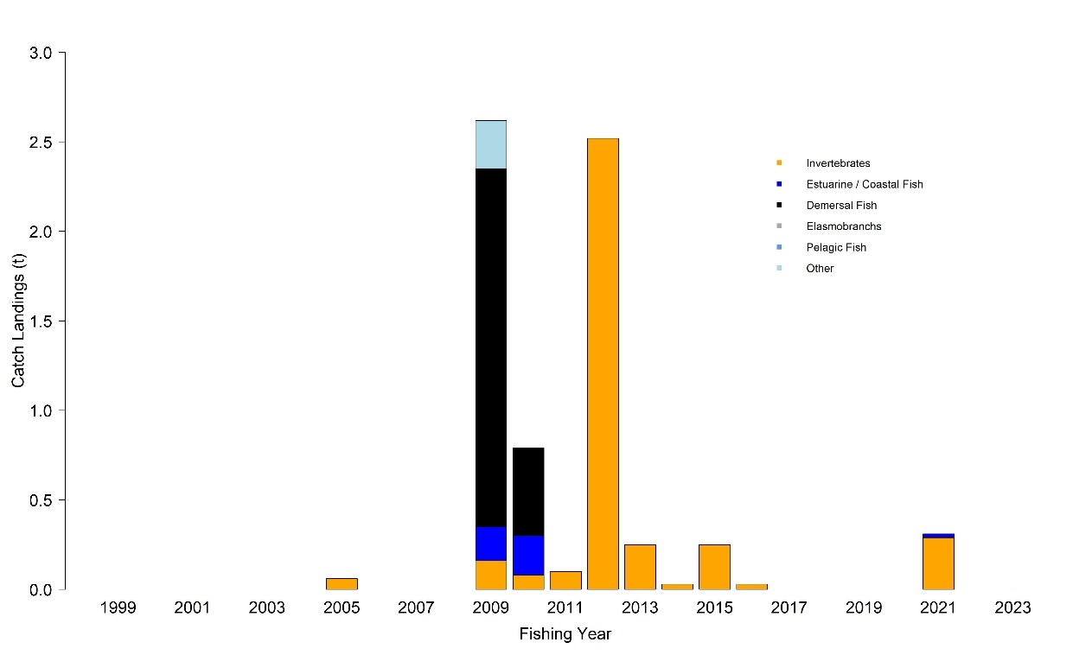  Figure 29 Annual retained catch (t) of species other than scallops while accessing the south coast component of the Resource
Retained Species Assessment
- There were no other retained species in 2023
- Retention of other species is not prevalent
The risk of fishing on other retained species is NEGLIGIBLE
By-catch Species | Information about bycatch in the SCTMF is limited and the fishery is not required to report the discarded component of its catch. A pilot scale fishery-independent bycatch sampling program was introduced in late 2023. Samples of catch were retained from try net gear. A total of 29 bycatch species were identified weighing 14.7 kg were captured in the two shots, which also retained an additional 1.4 kg of scallops. The dominant species retained by weight were rays (3.6 kg), toadfish (2.7 kg), stingaree (2.5 kg), scallops (1.4 kg) and boxfish (1.2 kg). The elasmobranch species are believed to have a good post release survival, with the toad and box fish being ubiquitous species.
By-catch Species Assessment
- Minimal bycatch sampling has occurred on the south coast
- Dominant captured species are common and likely good post release survival
- The quantum of bycatch to target species is ~ 10 times
- There is minimal fishing effort, restricted to specific grounds
The risk of fishing on bycatch species is LOW
ETP Species | There were no protected species interactions reported in 2023. Previous capture of a Loggerhead Turtle has been reported, which was released alive.
Endangered, Threatened and Protected (ETP) Species Assessment
- There were no reported ETP interactions
- There is minimal potential for interactions, with species released alive
The risk of fishing on ETP species is NEGLIGIBLE
Habitat | Four boats reported landings during the 2023 season and the area trawled within this fishery represents a very small (1.4%) percentage of the legislated boundary and is within historic levels (Table 12).  Table 12 Area trawled by scallop vessels in the South Coast fishery. Total fishery is 57299.8 km2 or 16706.0 nm2. (NF – No fishing)
Habitat Assessment
- Fishing occurs over sandy habitats
- The extent of fishing is small in comparison to the extent of the fishery
- The area fished (812.4 km²) was within historic levels
The risk of fishing on habitats is NEGLIGIBLE
Ecosystem | The food chain effects in the SCTMF are considered to be low because of the low overall effort and the very small percentage (< 3%) of the legislated fishing area actually trawled each year. Moreover, the total biomass of retained species is generally very low, and the high natural variability of scallop stock abundance (the key target species) means it is unlikely that any predators are highly dependent on this species
Ecosystem Assessment
- Low overall catch levels of target and other retained species
- Main species kept are highly productive (scallops and prawns) and exhibit marked natural interannual fluctuations in recruitment
- Unlikely that there are highly dependent predators on these species
The risk of fishing on the ecosystem is NEGLIGIBLE
Ecosystem Effects of Fishing Risk Assessment : All components of the ecological assessment of scallop fishing by the SCTMF are NEGLIGIBLE or LOW. Fishing practices in 2023 did not indicate any noticeable or significant shifts which may impact the overall assessment of the ecological impact on the fishery. Therefore, the ecosystem effects of fishing by the SCTMF on the Resource is considered to be LOW.

Appendix 1
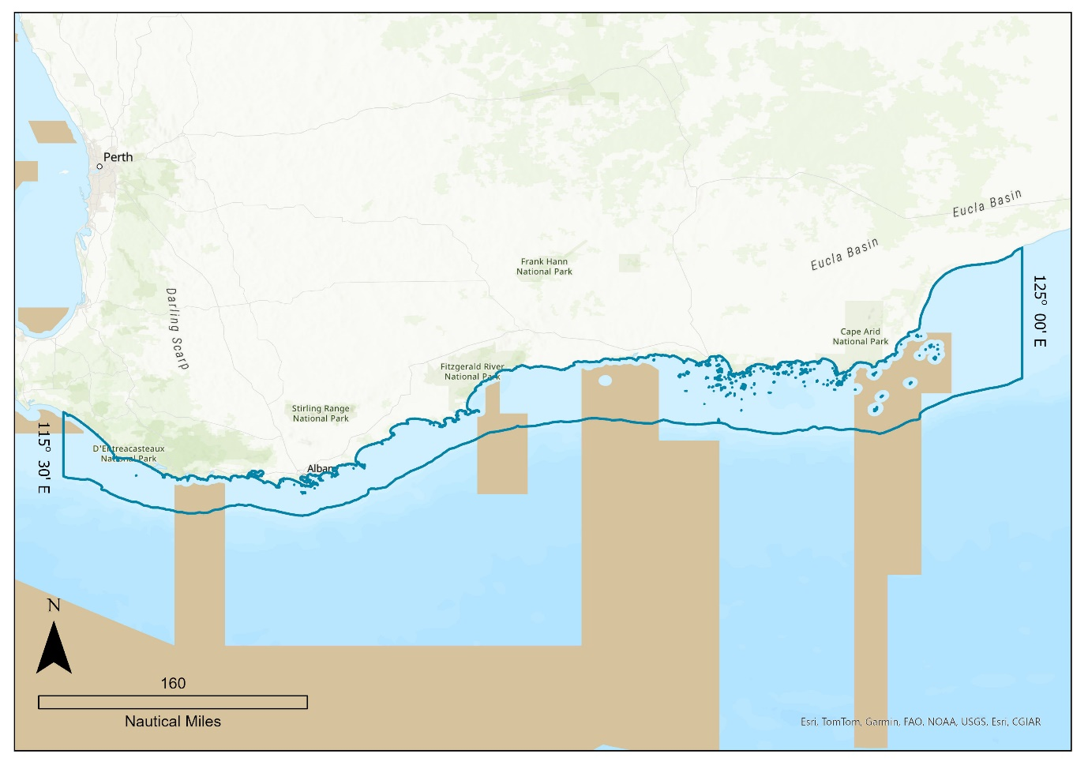
Append. Fig. 4 Boundaries of the South Coast Trawl Managed Fishery

Important Disclaimer
The Chief Executive Officer of the Department of Primary Industries and Regional Development and the State of Western Australia accept no liability whatsoever by reason of negligence or otherwise arising from the use or release of this information or any part of it.

Copyright © State of Western Australia (Department of Primary Industries and Regional Development), 2024.

Traditional scallop trawl grounds also reflect areas as described in Notice 1 of 2023 (refer to Figure 3).
https://www.wa.gov.au/system/files/2024-03/regulatory_compliance_approach.pdf
https://www.afma.gov.au/sites/default/files/2023-02/18050_national_fisheries_compliance_strategy-v2_1.pdf

