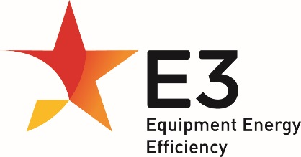

External Power Supplies  
Consultation Regulation Impact Statement

The Commonwealth of Australia (referred to as the Commonwealth) asserts the right to be recognised as author of the original material in this publication and this document should be attributed in the following manner: External Power Supplies – Consultation Regulation Impact Statement, Commonwealth of Australia 2024.

**Ownership of intellectual property rights**

Unless otherwise noted, copyright (and any other intellectual property rights) in this publication is owned by the Commonwealth of Australia (referred to as the Commonwealth). The Commonwealth asserts the right to be recognised as owner of the original material in the following manner: © Commonwealth of Australia 2024.

**Creative Commons licence**

External Power Supplies – Consultation Regulation Impact Statement is licensed by the Commonwealth for use under a Creative Commons Attribution 4.0 International licence with the exception of the Coat of Arms of the Commonwealth, the logo of the agency responsible for publishing the report, content supplied by third parties, and any images depicting people. For licence conditions see the Creative Commons website – Attribution 4.0 International page.

Inquiries about the licence and any use of this document should be emailed to copyright@dcceew.gov.au.



**Disclaimer**

The Commonwealth has exercised due care and skill in preparing and compiling the information and data in this publication. While reasonable efforts have been made to ensure that the contents of this publication are factually correct, the Commonwealth does not accept responsibility for the accuracy or completeness of its contents. This publication is intended to provide reference material for general information purposes only. It does not constitute legal or other professional advice.

The department disclaims liability, to the extent permitted by law, for any liabilities, losses, damages and costs arising from any reliance on the information contained in this publication. You should seek legal or other professional advice in relation to your specific circumstances. The views and opinions expressed in this publication are those of the Department of Climate Change, Energy, the Environment and Water.

**Acknowledgement of Country**

We acknowledge the Traditional Owners of Country throughout Australia and recognise their continuing connection to land, waters and culture. We pay our respects to their Elders past and present.

**Using our logo**

The Department of Climate Change, Energy, the Environment and Water’s logo and the Commonwealth Coat of Arms must not be used without the prior, specific, written permission of the Commonwealth. If you wish to seek permission, please contract [copyright@dcceew.gov.au](mailto:copyright@dcceew.gov.au).

Executive Summary

This consultation Regulation Impact Statement (RIS) considers different policy options for changing the level and scope of minimum energy performance standards (MEPS) applying to external power supplies (EPS) in Australia and New Zealand. This follows a review of the Greenhouse and Energy Minimum Standards (GEMS) determination covering these products in Australia completed in November 2021 by the Commonwealth Department of Climate Change, Energy, the Environment and Water (DCCEEW). This review determined that a full assessment of the costs and benefits of changes to the level and scope of MEPS covering EPS was required.

The Australian GEMS determination and the New Zealand regulation covering EPS lag behind international standards in both scope and stringency by a considerable margin. Due to advances in technology, the majority (approximately 87%) of EPS sold in Australia and New Zealand are not captured by the scope of the regulations. Many EPS sold in Australia and New Zealand meet the more stringent international standards, but this is not true for all EPS. There is also an observed delay between the introduction of more stringent regulations overseas and higher efficiency products filtering through to the Australian and New Zealand markets.

There would be a total net benefit for Australia of $28.8m[1] for the period 2025-2040 if Australia was to align its EPS MEPS with international efficiency standards. This would include expanding the scope (i.e., including simultaneous multiple voltage EPS and adaptive voltage EPS – fast charging USB-PD devices) and increasing the stringency (mark VI level on the international efficiency marking protocol for EPS). There is likely to be minimal unintended disruption to the market in doing this, because the MEPS levels have been in place for almost a decade in the EU and the US, and because these products are almost all manufactured internationally and imported into Australia and New Zealand.

International regulators (the EU Commission and the US Department of Energy) are considering a further increase in standards, which is likely to be implemented around 2027, if it is determined to be effective. There would, therefore, be an additional net benefit for Australia of $41.6m if Australia was to follow international regulators and increase to the mark VII level as soon as practical after international implementation. This would ensure Australian regulations remain aligned with international standards.

Similarly, aligning New Zealand’s MEPS with current international energy efficiency standards would deliver a positive net benefit to New Zealand of $1m for the period 2025-2040, with this net benefit increasing to $3m, if New Zealand aligns with the anticipated mark VII level after it is implemented internationally.

In addition, Australia and New Zealand should consider amending their regulations to accept product testing to international test standards (e.g., EN 50563 and US DOE). These standards are all technically consistent with the Australian and New Zealand standards (AS/NZS 4665.1 and 4665.2) and any products that comply with these international standards will also comply with local standards. Accepting test certificates that refer to any of these standards would reduce costs and improve administrative efficiency for industry.

A summary of the key findings and recommendations of the analysis in this RIS is provided below, with more detail provided throughout the relevant sections of this RIS. A detailed summary of the modelling approach and assumptions is provided in Appendix One.

# Summary of key findings

## The effectiveness of the current regulation has declined

Both the scope and stringency of the current regulation are insufficient to drive efficiency gains in Australia and New Zealand. The scope of the regulation now excludes a large percentage (approximately 87%) of EPS products available in the market. This includes adaptive voltage EPS (e.g., fast charging USB-PD devices for charging phones and laptops) that constitute a growing proportion of the market, as well as simultaneous multiple voltage devices (e.g., multiple port USB wall adapters).

International efficiency standards have also increased considerably, driving efficiency gains globally, while the Australian and New Zealand standards have not changed for 16 years. The EPS market is a global market. The same products are sold into many international markets. As a result, the increase in international regulations have filtered through to the Australian and New Zealand markets. However, this process can take between six to eight years. The US introduced a mark VI standard in 2016, followed by the EU in 2019. In 2022, around 80% of the EPS that are covered by the current regulations in the Australian and New Zealand markets met the mark VI level. Mark VI is well above the current local MEPS, which remain at Mark III.

## There are inefficiencies with the current regulation

When the AS/NZS standard was developed in 2005, the intention was for it to be aligned with an international testing standard for EPS. To a certain extent this did happen, but since then international test standards have moved on to include adaptive voltage EPS and simultaneous multiple voltage devices. All the international testing standards are technically consistent with the AS/NZS standard (although the international test standards have a wider scope) and may be considered harmonised standards. However, despite the harmonisation, suppliers and importers of EPS in Australia and New Zealand must reference the AS/NZS standard in their testing report to register products in compliance with the regulation. This means that manufacturers who have already tested products to a technically consistent international standard need to re-test or re-certify products to sell them into the Australian and New Zealand markets. This creates duplication and increases costs for manufacturers. In interviews, an industry expert explained that the cost of testing per product (to the AS/NZS Standard) is $600 USD.

## Local and international regulations are preventing market failures

There are several market barriers that prevent energy efficiency gains in EPS, in the absence of local or international regulations:

* Consumer choice does not drive energy efficiency of EPS. EPS are often bundled with an end-use product, so consumers are unaware or unable to choose the type of EPS they are buying.
* Consumers are likely to make choices based on the features of the product for which the EPS is used and are unlikely to consider the efficiency of the EPS.
* Higher efficiency EPS cost more to manufacture and feedback from the market suggests that suppliers and consumers are largely driven by cost. Since lower efficiency EPS are usually cheaper to manufacture, manufacturers lack an incentive to produce higher efficiency products in the absence of regulation.
* Product labelling is unlikely to change consumer behaviour, because consumers choose between products based on features, rather than the efficiency of the EPS.

# Summary of results

## Policy options considered

Five scenarios have been considered in the analysis:

* Scenario 1: Business-as-usual (baseline scenario for comparison)
* Scenario 2: Regulations are removed from 2025
* Scenario 3: MEPS is increased to mark VI from 2025, no change in scope
* Scenario 4: MEPS is increased to mark VI from 2025, expanded scope
* Scenario 5: MEPS is increased to mark VI from 2025 and then increased to the anticipated “mark VII” in 2029, expanded scope

## Summary of results

The results of the cost-benefit analysis are summarised in Table 1 and Table 2 below for Australia and New Zealand respectively. New Zealand and Australia have different cost benefit analysis requirements, and so the results cannot be compared directly. New Zealand cost benefit analysis is based at a societal level, while Australia is based on public benefits.

Table 1: Cost-benefit analysis results summary by scenario (compared to business-as-usual) for Australia. Central scenario, medium cost of carbon and discount rate of 7%.

|  | Scenario 2: No regulation from 2025 | Scenario 3: Mark VI from 2025 | Scenario 4: Mark VI from 2025 (expanded scope) | Scenario 5: Mark VI from 2025, Mark VII from 2029 (expanded scope) |
| --- | --- | --- | --- | --- |
| Energy savings (GWh) | -81 | 27 | 219 | 733 |
| Emissions reduction (tCO2-e) | -13,264 | 7,143 | 54,654 | 108,860 |
| Peak demand saving (MW) | -0.7 | 0.3 | 3 | 7 |
| Total costs (NPV $ AUD) | -$9.9M | $2.6M | $12.7M | $47.9M |
| Total benefits (NPV $ AUD) | -$13.4M | $5.3M | $41.5M | $118.3M |
| Net benefit (NPV $ AUD) | -$3.4M | $2.8M | $28.8M | $70.4M |
| Total benefit cost ratio | **0.74** | **2.07** | **3.28** | **2.47** |

Table 2: Cost-benefit analysis results summary by scenario (compared to business-as-usual) for New Zealand. Central scenario, medium cost of carbon and discount rate of 5%.

|  | Scenario 2: No regulation from 2025 | Scenario 3: Mark VI from 2025 | Scenario 4: Mark VI from 2025 (expanded scope) | Scenario 5: Mark VI from 2025, Mark VII from 2029 (expanded scope) |
| --- | --- | --- | --- | --- |
| Energy savings (GWh) | -15 | 5 | 40 | 134 |
| Emissions reduction (tCO2-e) | -798 | 266 | 2,063 | 7,176 |
| Peak demand saving (MW) | 0 | 0.1 | 0.5 | 1.3 |
| Total societal costs (NPV $ NZD) | -$0.5M | $0.3M | $2.3 | $6.6 |
| Total societal benefits (NPV $ NZD) | -$1.1M | $0.4M | $3.3M | $9.7M |
| Net societal benefit (NPV $ NZD) | **-$0.6M** | **$0.1M** | **$0.9M** | **$3.0M** |
| Total societal benefit cost ratio | **0.45** | **1.45** | **1.40** | **1.45** |

Scenario 5 provides the highest net benefit for both Australia and New Zealand. Scenario 5 would see both countries aligning with international regulations in the short-term by increasing the MEPS to mark VI and expanding the scope, followed by a further increase to the anticipated “mark VII” two years after the US or EU implement the increased standard. While scenario 5 has a lower total benefit-to-cost ratio than scenario 4 in Australia, it results in a significantly larger net benefit of $70m AUD. Similarly in New Zealand, scenario 5 delivers a $3m NZD net societal benefit with a positive benefit-to-cost ratio. Both scenarios also involve amending the existing regulations to allow manufacturers and suppliers to register products using a test certificate that references the internationally consistent test standards (EN and DOE).

# Stakeholder feedback

Stakeholder feedback is sought on the policy options and results presented in this consultation RIS. Questions for consideration by stakeholders are included in section 5 of this document.

Submissions should be provided by 28 April 2025.

**To provide feedback on the RIS, please make a submission at:**

For Australian stakeholders—the Department of Climate Change, Energy, the Environment and Water’s [consultation website](https://consult.dcceew.gov.au/)

For New Zealand stakeholders—by email to [star@eeca.govt.nz](mailto:star@eeca.govt.nz)

Enquiries may be emailed with the subject line “External Power Supplies CRIS”:

* for Australian stakeholders—to the Australian Government Department of Climate Change, Energy the Environment and Water (DCCEEW): [GEMSProductReview@dcceew.gov.au](mailto:GEMSProductReview@dcceew.gov.au)
* for New Zealand stakeholders—to the Energy Efficiency and Conservation Authority (EECA) of New Zealand: [star@eeca.govt.nz](mailto:star@eeca.govt.nz)

Table of Contents

Executive Summary 3

Summary of key findings 4

The effectiveness of the current regulation has declined 4

There are inefficiencies with the current regulation 4

Local and international regulations are preventing market failures 5

Summary of results 5

Policy options considered 5

Summary of results 5

Stakeholder feedback 7

Background 12

Introduction to Australia and New Zealand legislation and external power supplies 12

Section 1: Understanding the problem 14

1.1 Inefficient products increase energy demand and emissions 14

1.2 The effectiveness of the current regulation has declined 15

The scope of the MEPS excludes the majority of the current EPS market 15

International standards have increased considerably, driving efficiency above the MEPS 18

The efficiency of the market is now well above the MEPS 20

1.3 The current regulation is inefficient 21

1.4 There are challenges with compliance 22

Section 2 Rationale for government action 24

2.1 Regulation is needed to prevent market failures 24

Consumer behaviour does not drive efficiency 24

Product labelling is unlikely to drive energy efficiency in EPS 24

Manufacturers are not incentivised to increase the energy efficiency of EPS 25

2.2 Current standards must be increased to remain effective 25

Australian and New Zealand efficiency gains lag international standards 26

Section 3: Policy options for consideration 27

3.1 Principles for policy option design 27

3.2 Considerations for increasing MEPS stringency 28

Aligning MEPS stringency with international standards 29

Including a 10% load efficiency 31

3.3 Considerations for expanding scope 32

Aligning scope with international standards 32

Including wireless chargers 33

3.4 Modelling scenarios 34

Scenario 1: Business as usual (BAU) 34

Scenario 2: Remove regulations from 2025 35

Scenario 3: Increase MEPS to align with international standards without changing the scope 35

Scenario 4: Increase scope and MEPS to align with international standards 36

Adopt international testing standards 36

Scenario 5: Direct harmonisation with international standards 37

Section 4: Impact assessment 38

4.1 Framework for analysis 38

Cost-benefit analysis input and assumptions 39

Market size and distribution 40

Market growth 41

Cost to industry 41

Incremental product cost for increased efficiency 42

Electricity prices 43

Government costs 45

Avoided energy network costs 45

Health benefits associated with improved air quality 45

Reduced greenhouse gas emissions 46

Cost of carbon 46

4.2 Benefit cost ratios 46

Incremental product costs assumptions 49

Administrative efficiency improvements 49

Section 5: Proposed changes 51

Family of models 53

Product classes 53

MEPS 54

Testing 54

Name plate requirements 55

Section 6: Questions for consultation 56

Preferred policy option 56

Compliance 56

Implementation 57

EPS market dynamics 57

Estimated costs and benefits 58

Section 7: Conclusion 59

Section 8: Implementation and review 60

Implementation – next steps by Government 60

Australia 60

New Zealand 60

Implementation – next steps for industry 61

Evaluation 62

References 63

Appendix One: Modelling approach and assumptions 67

Product usage data 67

Efficiency levels 74

Market size and distribution 75

Market change 82

Participant costs and benefits 83

Cost to industry 83

Incremental product cost for increased efficiency 84

Electricity prices 91

Government costs 92

Non-participant costs and benefits 92

Avoided energy network costs 92

Health benefits associated with improved air quality 93

Reduced greenhouse gas emissions 93

Social cost of carbon 94

Appendix Two: Detailed modelling results 96

Sensitivity analysis 96

Central scenario results Australia 97

Central scenario results New Zealand 98

High scenario results Australia 99

High scenario results New Zealand 100

Low scenario results Australia 101

Low scenario results New Zealand 102

**Glossary**

|  |  |
| --- | --- |
| ABS | Australian Bureau of Statistics |
| BAU | Business as usual |
| COAG | Council of Australian Governments |
| CRIS | Consultation Regulation Impact Statement |
| DCCEEW | Department of Climate Change, Energy, Environment and Water (Commonwealth) |
| DOE | Department of Energy (USA) |
| E3 | Equipment Energy Efficiency program (of the Commonwealth, State, Territory and New Zealand governments) |
| EECA | Energy Efficiency and Conservation Authority (New Zealand) |
| EERE | Energy Efficiency and Renewable Energy |
| EEWG | Energy Efficiency Working Group |
| EPA | US Environmental Protection Agency |
| EPS | External Power Supplies |
| EU | European Union |
| EUP | Energy Efficiency (Energy Using Products) Regulations 2002 (New Zealand Regulation, 2002) |
| GEMS | Greenhouse and Energy Minimum Standards (Commonwealth Act, 2012) |
| IEC | International Electrotechnical Commission |
| MEPS | Minimum energy performance standards |
| NAEEEP | US National Appliance and Equipment Energy Efficiency Program |
| NCC | National Construction Code |
| NPV | Net present value |

Background

# Introduction to Australia and New Zealand legislation and external power supplies

The Greenhouse and Energy Minimum Standards (GEMS) Act 2012 provides a national framework for appliance and equipment energy efficiency in Australia. GEMS establishes minimum product energy efficiency standards and energy labelling requirements for Australia (Australian, State and Territory and New Zealand Governments , 2020). Before a product is offered to supply in Australia it must meet the energy efficiency standards and labelling requirements. New Zealand has similar legislation and uses the *Energy Efficiency and Conservation Act 2000* and *Energy Efficiency (Energy Using Products) Regulations 2002* (EUP regulations).

The Equipment Energy Efficiency (E3) program is a cross-jurisdictional initiative of the Australian Government, states and territories and the New Zealand Government responsible for energy efficiency standards and energy labelling for equipment and appliances (Australian, State and Territory and New Zealand Governments, n.d.).

The GEMS Regulator manages the E3 Program, in conjunction with the Energy Efficiency Working Group (EEWG) and is the sole party responsible for administration of GEMS legislation in Australia (Australian, State and Territory and New Zealand Governments, n.d.). It is housed by the Commonwealth Department of Climate Change, Energy, the Environment and Water (“the Department”). In New Zealand, the Energy Efficiency and Conservation Authority (EECA) is responsible for implementing the EUP regulations.

The GEMS regulator (on behalf of E3) enforces minimum standards for energy efficiency by implementing GEMS determinations for particular products. GEMS determinations include minimum energy performance standards (MEPS) (known as GEMS level requirements), which establish a minimum threshold of energy performance (Australian, State and Territory and New Zealand Governments , 2020). Manufacturers or importers of appliances or equipment covered by a GEMS determination must ensure their products meet the minimum threshold to be offered for supply in Australia. EECA sets similar requirements in New Zealand under the EUP regulations, with EECA performing the role of the regulator.

A MEPS for External Power Supplies (EPS) supplied in Australia was first introduced by states and territories in 2008. New Zealand introduced similar requirements in 2011. These regulations were designed to ensure products were more efficient and produced fewer greenhouse gas emissions while in use. These regulations were replaced by the GEMS determination in 2014 which maintained the original MEPS at an efficiency level of mark III. This regulation covers single output external power supply units with a maximum output power of 250 watts or 250 volt-amperes (VA), with product classes outlined in the determination (Australian Government, 2014). It also covers power supplies that can change their output voltage by a user selectable switch.

### A sunsetting review determined that EPS regulation required a cost-benefit analysis of policy options for regulation change

The GEMS Determination in Australia for EPS was thought to be due to sunset in 2025. The standard process for regulations approaching sunsetting is for the Department to conduct a preliminary review to determine if further analysis is required. This review was conducted by the Department for EPS in 2021 (E3 Program, 2021). Overall, this review found the following:

* The MEPS for EPS are no longer effective or efficient at driving gains in energy efficiency.
* Australia and New Zealand are a small market compared to US and European markets. Suppliers are mostly making EPS for these markets that already exceed the Australian MEPS.
* EPS that automatically adjust their output voltage in response to the load without user intervention (e.g. USB-C phone chargers and laptop power supplies) are excluded.

Therefore, the regulation is no longer effective at increasing efficiency, saving energy and reducing greenhouse gas emissions.

The review found that the existing determination affects approximately 5 million products sold every year in both Australia and New Zealand. It noted that if the scope of the MEPS were to be increased in line with international standards, the number of regulated EPS products could reach over 45 million (E3 Program, 2021). This could dramatically increase the scale of both costs and benefits for EPS under the GEMS Determination and New Zealand regulation, and therefore requires careful consideration.

Following the ‘Sunsetting’ review, DCCEEW determined that the Commonwealth’s sunsetting requirement did not apply to any regulations implemented under the GEMS Act, including external power supplies. The Energy Efficiency Working Group agreed that a consultation RIS should be prepared to test the option of increasing the stringency of the MEPS level and expanding the scope of coverage, so that the Australian and New Zealand regulations aligned with international best practice.

This CRIS explores several policy options for increasing both the scope and the stringency of the current regulation and compares the costs and benefits of these different options to a business-as-usual scenario.

Section 1: Understanding the problem

The section outlines issues with low efficiency external power supplies and the existing Australian determination and New Zealand regulation. The effectiveness of the current regulation is low due to its narrow scope and low MEPS. It is not driving improvements in the energy efficiency of EPS. Local Australian and New Zealand testing standards are also causing inefficiencies for manufacturers and suppliers who must repeat testing and certification processes.

## 1.1 Inefficient products increase energy demand and emissions

External Power Supplies (EPS) are products that connect an electronic device (such as phones, laptops, and tablets) to the mains power – i.e., the wall outlet. Because there are so many of these electronic devices, small gains in energy efficiency can have a large impact on energy use, peak demand, and associated greenhouse gas emissions. More energy efficient products will reduce electricity bills for consumers. Further, by lowering the cumulative demand for electricity, consumers will receive an additional reduction in electricity bills through reduced network charges and energy prices resulting from a reduction in peak demand. EPS are covered by energy efficiency regulations in both Australia and New Zealand. In Australia this regulation first came into force through minimum energy performance standards (MEPS) in states and territories in 2008 (Australian Government Department of Environment and Energy, 2017), following the AS/NZS 4665.1:2005 standard prepared by the joint Technical Committee TE-001 (Sai Global, n.d.). This MEPS required a minimum efficiency level of performance mark III. In 2012, the *Greenhouse and Energy Minimum Standards (GEMS) Act 2012* replaced the previous law with a single act for all states and territories (Australian Government Department of Environment and Energy, 2017). In 2014, a new determination was published which maintained the minimum efficiency performance level at mark III but allowed labelling of higher efficiency performance levels up to mark VI. New Zealand first introduced MEPS in 2011 using the *Energy Efficiency (Energy Using Products) Regulations 2002*. These requirements were jointly developed between New Zealand and Australia under the Equipment Energy Efficiency (E3) Program (Energy Efficiency Conservation Authority, n.d.).

Importers, sellers and manufacturers of EPS must comply with certain requirements to legally supply[2] EPS in Australia and to sell, lease, hire or hire-purchase EPS in New Zealand, even if the EPS are packaged with another product (Australian Government Department of Environment and Energy, 2017). These regulations are designed with product efficiency in mind. Put simply, the Australian legislation (GEMS) and New Zealand legislation (EUP regulations) ensure that any EPS sold in Australia and New Zealand – within the scope of the regulation – will be at least as efficient as the regulation stipulates.

EPS can function in two distinct states. In this report we will refer to these states as: active mode and no-load mode. Active mode refers to when an external power supply is connected and supplying power to an end-use product. For example, an EPS charger plugged in and supplying power to a laptop. No-load mode (sometimes referred to as ‘standby mode’) is when the same EPS is connected to the mains power but is not connected to an end-use product. In no-load mode, the external power supply is still drawing current from the mains power, albeit a smaller amount.

In active mode, energy consumption is the energy used by the end-use product plus the energy lost as heat in the conversion process between the wall outlet and end-use product (through the EPS) (Collins & Holt, 2007). Consequently, the conversion losses will be treated as an inefficiency in this equation.

In no-load mode, the external power supply may shut down the active mode circuitry and only draw enough power to “listen” for a load. Once a load is detected, this type of external power supply will activate the power conversion circuitry to supply the load.

In any case, all energy drawn from the mains power by the EPS is treated as an inefficiency since more energy is being consumed by the EPS than output. Setting limits on the no-load power consumption reduces power consumption of EPS that are not connected to a load.

Hence, the regulation stipulates a minimum energy efficiency requirement for both conversion losses and energy used in no-load mode (Australian Government Department of Environment and Energy, 2017). While the energy consumed by EPS in both no-load and active modes is relatively small compared with other, larger electronic products that are also regulated under GEMS (e.g. refrigerators, air-conditioners) the large number of EPS sold and used in Australia and New Zealand means that the energy savings that can be achieved through effective minimum energy efficiency regulation are still significant.

## 1.2 The effectiveness of the current regulation has declined

In the current EPS marketplace, the MEPS no longer drives energy efficiency improvements for most of the current market. There are two changes to the EPS market that have led to this:

* The EPS market has evolved since the Australian regulations were introduced by states and territories in 2008, and hence the scope of the requirements now excludes a large percentage (approximately 87%) of EPS products currently sold
* International efficiency standards have increased considerably, driving efficiency gains globally, while the Australian and New Zealand standards have not changed for 16 years.

### The scope of the MEPS excludes the majority of the current EPS market

The EPS market has evolved considerably since the Australian and New Zealand regulations were introduced. Adaptive voltage EPS devices (e.g. USB-C) that allow fast charging are now commonplace, as are EPS devices that output multiple voltages simultaneously. As a result, the scope of the MEPS excludes a large proportion of the current EPS market.

The following information is from the GEMS EPS determination. New Zealand references the AS/NZS Standard directly, and so the specific wording is different, but the intent is the same.

The current regulation covers single output EPS with a maximum output power of 250 watts or 250 volt-amperes (VA) that meet the following criteria (Australian Government, n.d.). They:

* supply power to other appliances
* have an AC input from the mains
* have an extra-low voltage output (either AC or DC) – either fixed or user selectable through a switch on the device
* are sold with, or intended to be used with, a separate end-use product that constitutes the primary load on the power supply.
  + Note that external power supplies sold separately to an end-use item are still covered.
* are contained in a separate physical enclosure from the end-use product
* are connected to the end-use product via a hard-wired or removable male/female electrical connection, cable, cord or other wiring
* do not have batteries, or battery packs that physically attach directly to the EPS (either permanently or for charging). Batteries that are charged through the end-use device are covered e.g. some cordless vacuums.
* do not have either a battery chemistry or type selector switch, or an indicator light or state of charge meter.

These devices are categorised under the four different product classes (summarised in Table 3 below) (Australian Government Department of Environment and Energy, 2017).

Table 3: Scope of the current EPS determination which includes EPS units with a maximum output power of 250W (Australian Government Department of Environment and Energy, 2017)

| Product class | Description |
| --- | --- |
| 1 | Single output EPS with non-user selectable output voltage and with AC input and DC output. (a.c.-d.c.) |
| 2 | Single output EPS with user selectable output voltage and with AC input and DC output. (a.c.-d.c.) |
| 3 | Single output EPS with non-user selectable output voltage and with AC input and AC output. (a.c.-a.c.) |
| 4 | Single output EPS with user selectable output voltage and with AC input and AC output. (a.c.-a.c.) |

EPS with simultaneous multiple output voltages, e.g., multiple USB port wall chargers (that have multiple simulations output voltages) are not covered by the 2014 Determination (Collins & Holt, 2007). Adaptive voltage EPS (capable of multiple output voltages which are not user selectable on the device) are also not covered. These are EPS that adjust their output voltage automatically based on the type of device that is connected, e.g., USB-PD (also commonly referred to as USB-C) chargers that are capable of fast charging. Adaptive voltage EPS account for a growing portion of the EPS market. Based on our modelling it appears that adaptive voltage EPS devices have replaced up to 80-90% of fixed voltage EPS in some product classes. Other exclusions are as follows:

* Direct current to direct current (DC to DC) voltage conversion equipment
* Single output EPS for transformers and electronic step-down converters for extra-low voltage (ELV) lamps
* Therapeutic devices on the Australian Register of Therapeutic Goods in accordance with the *Therapeutic Goods Act 1989* and the *Therapeutic Goods (Medical Devices) Regulations 2002*
* Direct current (DC) or battery-powered equipment.

In New Zealand, the Energy Efficiency and Conservation Authority (EECA) has collected sales data for all registered EPS sales since 2012. From this data it is possible to ascertain the number of EPS sales annually, by product category. In the United States, the Office of Energy Efficiency and Renewable Energy have also published the data they used for their recent impact analysis for a proposed change to the current US Energy Conservation Standards for External Power Supplies (U.S. Department of Energy, 2022). The DOE aggregated their data from individual EPS manufacturer and supplier interviews and cross-checked this with published global market research.

Evident in Table 4 below, there is a considerable difference between the reported sales in New Zealand (which would only include EPS that are in scope of the current regulation) and the total potential New Zealand EPS sales, extrapolated from the US number based on population. The EECA data only covers 13% of the total possible EPS market in New Zealand. This is largely explained by the differences in scope between the GEMS regulation and the US EPS regulation, and also potential non-compliance with registration or sales data requirements. For example, EPS such as multiple and adaptive output voltages are not captured by the MEPS. However, it is possible that some of the discrepancy could also be attributed to a level of non-compliance with the Determination and regulations. For example, products that are unregistered and/or are being bought or sold in New Zealand but are not being recorded.

This analysis has also been conducted for based on data from the review of Commission Regulation (EC) No 278/2009 (European Commission, 2019) on the ecodesign requirements for External Power Supplies (EPS).

Table 4: Comparison of scope between US (U.S. Department of Energy, 2022), EU (EU Commission, 2019) and Australia/New Zealand regulations (extrapolated from EECA data)

| Jurisdiction | EPS sales in market | Extrapolated NZEPS sales (based on population) | NZ EPS sales (EECA reported data) | NZ registered sales (% of total EPS sales) |
| --- | --- | --- | --- | --- |
| US | 729,303,696 | 11,257,073 | 1,508,558 | 13% |
| EU | 504,000,000 | 4,985,176 | 1,508,558 | 30% |

There may also be differences between the US and EU markets and Australian and New Zealand markets that cannot be explained by differences in population alone. For example, some types of product applications that require an EPS may be sold more in one market than others. However, this is probably the case for smaller market share applications (e.g., home security systems, e-bikes, aquarium accessories etc.), rather than the applications that make up a larger share of the EPS market (e.g., smartphones, laptops, monitors etc.).

### International standards have increased considerably, driving efficiency above the MEPS

International EPS markets such as the US, EU and Asia are larger than those in Australia and New Zealand. When these larger markets introduce new regulations for EPS, over time, the bulk of products imported into Australia and New Zealand will comply with international regulations. It can take up to eight years for this market adjustment to occur. It is not just the EPS itself that is sold internationally, but also the end-use product that the EPS is attached to. Typically, the EPS powers a more expensive device, so it is more cost effective for the manufacturer to bundle one standard device (that complies with the most stringent international standards), than to customise it for the Australian and New Zealand markets. Not all products will move to the most stringent international requirements and there is still merit in increasing the local MEPS requirement to avoid Australia and New Zealand becoming a dumping ground for low efficiency EPS.

There is an internationally established efficiency mark and system that is used in Australia and New Zealand, China, the US and the EU called the International Efficiency Marking Protocol (IEMP) (Brown, 2022). A roman numeral describing the efficiency level of the device is printed on the power supply. Levels range from mark III (the current Australian and New Zealand minimum standard) upwards. For context, Figure 1 below shows the increase in average active mode efficiency achieved between mark levels for AC-DC low voltage EPS. In addition, the accepted no-load power output decreases from 0.75W at mark III to 0.1W at mark VI.

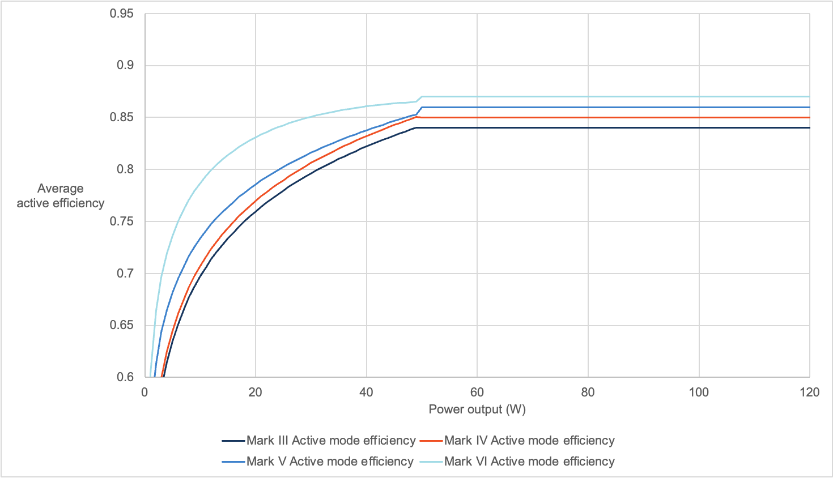

Figure 1: Average active mode efficiency at different mark levels for AC-DC Low Voltage EPS

In 2014, the US announced plans to increase the minimum energy performance standard from mark IV to mark VI. This came into effect in 2016, after a two-year notice and transition period. In 2014, the European Union (EU), which was aligned with the mark V level, introduced a voluntary Code of Conduct Tier-1 to harmonize with the US mark VI (DCCEEW, 2022). Then, in 2019, the EU Ecodesign Directive (Ecodesign) introduced the Commission Regulation (EU) 2019/1782 which enforces the mark VI level. Mark VI, the current and most stringent overseas standard, demands a significantly higher level of energy efficiency than that of the AU/NZ MEPS which remains at the mark III level (DCCEEW, 2022).

The US and EU are currently reviewing their EPS regulations and both regulators were interviewed as part of the development of this document. The US is consulting on the results of their recent impact assessment, regarding increasing the efficiency standard beyond mark VI. The results show that an increase to a proposed mark VII level would be beneficial in the US (U.S. Department of Energy, 2022). If this increase is eventually approved, it would likely come into effect around 2027. The EU Commission has suggested that they will likely harmonise with the US should they decide to adopt mark VII.

In addition to the minimum energy efficiency standard, in 2019 the EU implemented waste minimisation regulations for EPS. A ‘common charging’ initiative has been introduced to promote a clean, circular economy by increasing the interoperability of radio equipment and accessories (e.g., chargers) (European Commission, 2022). By harmonising charging ports around the USB-C standard the EU hopes to reduce 980 tonnes of electronic waste per year (European Commission, n.d.). In addition to this, further regulations have been introduced to ensure that manufacturers, importers or other authorised representatives must make EPS available to all professional repairers, as spare parts for a respective end-use product for 7 years after placing the last unit of the model on the market (European Commission, 2019).

Regulations for EPS also exist in China, albeit with a narrower scope. In 2014, the ‘Energy Saving Certification Rules’ were released. These rules cover single output AC-DC and AC-AC EPS (China Quality Certification Centre). The regulation in China is only applicable to EPS with an output power less than or equal to 250W that convert AC voltage to a fixed, single-channel low-voltage DC (not greater than 36V) or low-voltage AC (not greater than 36V) output voltage. There is a discrepancy in the testing conditions specified by the regulations. One source mentions a 220V/ 50Hz power supply (China Quality Certification Centre) while another indicates 115v/ 60Hz, 230V/ 50Hz or 220V/ 50Hz if single-rated (Tektronix, 2016). The regulation excludes DC-DC power supplies and other EPS used in industrial equipment and medical devices (China Quality Certification Centre).

While the regulations in China do not line up perfectly to other international regulations, the minimum energy efficiency of the products that are covered are very similar to the mark IV level (Tektronix, 2016).

Table 25 in Appendix One provides a summary of the average active efficiency and no-load condition at each of the international mark levels.

### The efficiency of the market is now well above the MEPS

As discussed, because the market for EPS is global and international regulations have increased well beyond those of Australia and New Zealand, the efficiency of most EPS sold in Australia and New Zealand far exceeds the MEPS (but with a time lag behind the international markets). This is evident in Figure 2 and Figure 3 below, where the number of EPS sales represented in the New Zealand database remains relatively stable each year (Figure 2), while the number of sales of EPS at mark III (MEPS) has declined significantly (Figure 3).

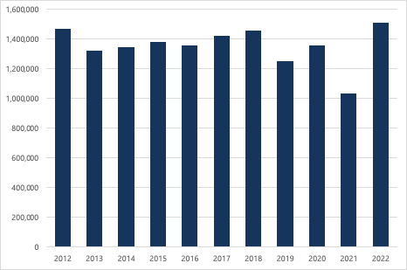

Figure 2: Number of registered external power supplies sold in New Zealand 2012 to 2022 (EECA data)

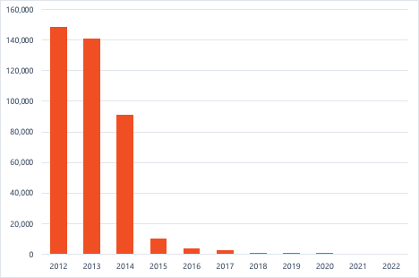

Figure 3: Registered external power supplies sold in New Zealand with an energy efficiency of MEPS (mark III) (EECA Data)

## 1.3 The current regulation is inefficient

The Australian and New Zealand test standards (AS/NZS 4665.1:2005) were developed to assist designers, manufacturers, importers, test laboratories and regulators to assess energy efficiency of EPS in a consistent fashion (Sai Global, n.d.).

There are two parts to this standard:

1. Test method and energy performance mark – AS/NZS.4665.1:2005 + A1
2. MEPS requirements – AS/NZS.4665.2:2005 + A1 (Sai Global, n.d.)

Part 1, which involves the test method for assessing the energy efficiency of EPS, is the focus of this section of this RIS.

The AS/NZ 4665 series was created in 2005 in response to the US National Appliance and Equipment Energy Efficiency Program (NAEEEP). It is based on a test method published by the US Environmental Protection Agency (EPA) which was a part of the Energy Star program (Sai Global, n.d.).

The AS/NZS (360 Compliance, 2016) (Johnson, 2021) standard aligns with the IEC testing methodology that is recognised in the US and can be found on testing certificates for the region (Keyway, 2019) (SL Power Electronics, 2016). On testing certificates for the EU, the EN 50563:2011 is referenced, which is technically similar to the AS/NZS and EPA test (European Standard, 2011). A further EU Commission regulation (2019/1782) is also referenced which stipulates that a 10% loading condition must be tested (Keyway, 2019).

However, despite the intention for international harmonisation, the AS/NZS 4665 series of standards is the only means of compliance cited in the AU/NZ regulation. This means that suppliers and importers of EPS in Australia and New Zealand must test to the AS/NZS standards in their testing reports to register products in compliance with the regulation (Australian Govermnet: Energy Rating, n.d.). The citation of the AS/NZS 4665 series of standards alone means that manufacturers need to test and certify products specifically to sell them into the Australian and New Zealand markets. In interviews, an industry expert explained that the cost of testing per product is $600 USD, for a more-or-less identical test to the one that they would have already performed for EU and US markers. If Australia and New Zealand were to accept test certificates that refer to the international testing standards, manufacturers would not incur a further cost to test their products for local markets.

If Australia and New Zealand accept international testing standards under the regulation:

* Manufacturers/importers that sell to the EU and US will not need to pay for further testing or certification in order to sell into local markets; and
* local manufacturers will be able to sell their products – if they wish – to international markets without incurring any further costs.

Recognising international testing standards is separate to the question of whether certain technologies should be regulated. If Australia and New Zealand were to accept international testing standards the updating testing protocols when new technologies enter the market (such as wireless EPS) would be easier. It would provide a level of future proofing for Australia and New Zealand’s testing methodology and improve the efficiency and cost effectiveness of the regulation. Note that any amendment to a Standard must be incorporated into the AU/NZ legislation before it could be used.

## 1.4 There are challenges with compliance

Compliance is an integral part of any regulatory regime. EPS are typically packaged and supplied with an end-use product, such as consumer electronics e.g. laptops. They are large volume products where millions are sold per year. As a result of this there are compliance challenges introduced that don’t apply to standalone (and lower volume) regulated products, such as household fridges/freezers. Under the current regulations suppliers of regulated products are required to:

* Have their products meet MEPS
* Register them through the joint Australia/New Zealand registration system
* Mark the EPS with their rated efficiency mark
* Provide sales data annually (New Zealand only)

Due to the way EPS are supplied it can be difficult to identify the product, and if it is complying with the above requirements. If the MEPS requirements and or scope is increased for EPS, the compliance challenges will be amplified, as the current scope only covers around 13% of EPS supplied in Australia/New Zealand.

E3 are interested in stakeholder feedback about how the compliance challenges of external power supplies can be addressed.

Section 2 Rationale for government action

### This section outlines the case for government action to address the issues raised in Section 1. Minimum standards are the most effective means of increasing the energy efficiency of EPS. This is because consumers do not have the capacity to choose more efficient devices in most cases, and manufacturers/importers are not incentivised to increase efficiency or import products with the energy efficiency level beyond regulatory compliance.

## 2.1 Regulation is needed to prevent market failures

### Consumer behaviour does not drive efficiency

Most EPS are “bundled” together and sold with an end-use product. The consumer’s objective is the purchase of the end-use product. The fact that the consumer is also purchasing an EPS is, in the consumer’s mind, purely incidental. Further, the EPS is selected by the supplier of the end-use product, removing a level of consumer choice. As a result, consumers often lack the choice or knowledge about which EPS they are purchasing. Some standalone EPS are available for products that do not come packaged with an EPS (e.g., many smartphones that have a standard USB-C charging connection) and replacement EPS required for like-for-like replacement if a product fails. However, even for these EPS, energy efficiency likely does not drive consumers’ purchasing decisions.

Based on insights provided by suppliers during interviews for this RIS it seems that the more predominant drivers for consumers are cost, design and performance of the end-use product. Sometimes these features overlap with energy efficiency, for example consumers do not want EPS or end-use products that become very hot during use. Generally, heat is the product of an energy conversion loss and therefore, EPS that don’t become as hot tend to be more energy efficient. So, while there may be a crossover in the product features that consumers desire and energy efficiency, it is likely not the energy efficiency of the product itself that is driving consumer behaviour.

### Product labelling is unlikely to drive energy efficiency in EPS

Marking on EPS does not impact consumer behaviour, as the consumer does not see the efficiency mark as part of the purchasing process. For certain products, e.g., refrigerators, air conditioner or televisions, best practice procedures to change consumer behaviour are to provide energy-saving information and third-party certification labels (Wang, Sun, & Zhang, 2019). In contrast, because EPS are not usually bought as a separate product, labelling them does not have the same impact. For example, if a consumer wants to buy a certain phone and that phone comes with a charger containing a low efficiency EPS, it is unlikely the consumer will buy a different phone on that basis alone. It is unlikely that the EPS is considered at all, beyond charging speed and computability with other products. In interviews, this assertion was affirmed by an industry expert who explained that “[labels] are not viewed by the customer at all. It has no purpose other than probably for enforcement at the end of the day.”

The EPS regulation in Australia and New Zealand includes a requirement to display the achieved Energy Performance Mark on the product itself, so EPS sold in these markets do have energy efficiency labels. However, the labels are included in the fine print on the product nameplate alongside many other regulatory compliance labels, and consumers are unlikely to be aware of them. They are also unlikely to have the expertise to understand the significance of them with respect to technical energy efficiency specifications. Essentially, consumer behaviour is not driving energy efficiency for EPS and requiring product labelling would not change this.

### Manufacturers are not incentivised to increase the energy efficiency of EPS

For EPS manufacturers, cost is a primary driver of production. There is little incentive for manufacturers to prioritise energy efficiency or life cycle costs (Collins & Holt, 2007). Since consumers do not have access to information regarding capital costs and energy efficiencies for EPS, they are unable to consider life cycle costs when making their purchasing decisions. As long as consumers continue to buy EPS as they are (packaged with an end-use product), there is no incentive for manufacturers, importers, or suppliers to alter their offerings (Collins & Holt, 2007).

With the addition of energy efficiency regulations in larger markets, such as the US and EU, manufacturers are incentivised to meet these standards in order to sell their products to these markets. However, there is little incentive for manufacturers to create EPS with an efficiency level beyond what is required by these regulations or demanded by consumers. However, in Australia and New Zealand, the efficiency of external power supplies being sold is higher than what is required by the legislation. One reason for this is that there is no benefit to suppliers changing the EPS supplied with their products for a less efficient EPS for the Australian and New Zealand market.

The manufacturing cost of EPS increases with the efficiency of the EPS. In the 2022 US technical support document (TSD) for their impact assessment, the engineering analysis for EPS consistently showed an increase in the incremental cost for all EPS (across all wattage, AC, DC and multiple output groups) as the efficiency level increased. The average incremental manufacturing cost increase was $2.93 USD between mark VI efficiency level (referred to as CSL0 in the TSD) and the ‘max tech’ efficiency – max tech represents the top 5% of the market, which typically also represents the highest active mode efficiency and lowest no-load power consumption achievable with current technology (US Department of Energy, 2022).

While manufacturers are largely driven by cost, other product features that are desirable to consumers may be considered. These product features in some cases overlap with improved energy efficiency, such as not becoming too hot when in use, or reduced overall product size.

## 2.2 Current standards must be increased to remain effective

The current EPS regulations and standards do not adequately cover products that are supplied on the market today (DCCEEW, 2022). The regulations lack both the scope and stringency required to deliver effective efficiency gains and associated public and private benefits.

The stringency of the current regulations is well below the level of efficiency that most EPS are already achieving because international regulations have improved the minimum efficiency requirements with each revision and the majority of the EPS market is now covered by international standards (DCCEEW, 2022). The scope of the current regulations does not capture a large proportion (87%) of EPS imported and sold in Australia and New Zealand, mostly due to technology changes since the regulations were initially introduced.

### Australian and New Zealand efficiency gains lag international standards

As discussed in Section 1, the current MEPS in Australia and New Zealand are lagging the major international markets. As EPS manufacturers innovate to meet the energy efficiency standards imposed in larger international markets, many of the EPS being imported into Australia and New Zealand exceed the MEPS. However, it takes some time for devices sold in the Australian and New Zealand markets to catch up to these international standards, with a small number of products remaining well below the US standard almost ten years after introduction.

Figure 4 below shows the efficiency of EPS (covered by the current scope of regulations) sold in New Zealand before and after various international regulatory announcements. The introduction of the mark VI regulation in the US led to an increase in the proportion of mark VI efficiency EPS in New Zealand. While the amount of higher efficiency EPS increases, there is still a significant delay and gap between the US market (which would theoretically be 100% mark VI or higher) and the New Zealand market breakdown.

With government action, Australia and New Zealand can accelerate this catch-up period, which may also yield energy savings. Increasing the scope and stringency of the MEPS would eliminate the sub-set of existing lower efficiency EPS that are currently being sold in Australia and New Zealand. This may facilitate a level of public and private savings that is desirable for both governments.

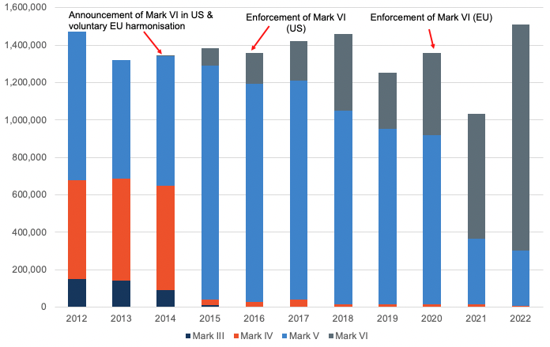

Figure 4: Annual EPS sales by efficiency level (New Zealand, EECA, 2012-2022)

Section 3: Policy options for consideration

### This section summarises the policy options for consideration. It presents options for increasing both the stringency and scope of the MEPS to improve the effectiveness of the regulation and to better align with international standards. The impacts of proposed policy options are assessed in Section 4.

## 3.1 Principles for policy option design

The policy options proposed in this RIS are designed to improve the average energy efficiency of EPS sold in Australia and New Zealand. The proposals are intended to:

* Improve energy efficiency, to deliver further benefits such as reduced electricity bills and avoided electricity network costs
* Ensure international alignment of efficiency regulatory requirements and minimise trade barriers
* Minimise the public and private costs associated with regulating EPS (such as costs associated with manufacturing, registration, compliance and enforcement)
* Ensure a sufficient supply of EPS for Australian and New Zealand consumers
* Reduce greenhouse gas emissions, which will help both Australia and New Zealand’s climate-related commitments:
* For New Zealand, the policy proposal is strategically aligned with its energy transition goals including improving energy efficiency and lowering emissions to achieve net zero by 2050 (New Zealand Legislation, 2019). The proposal also contributes to the New Zealand Energy Efficiency and Conservation Strategy (Ministry of Business, Innovation & Employment, 2017)
* For Australia, the proposal aligns with and contributes to the COAG National Energy Productivity Plan which aims to make a 40% improvement to energy productivity (COAG Energy Council, 2015). Further, one of the supporting actions in the ‘Technology and innovation’ focus area in the National Energy Performance Strategy (NEPS) is to “streamline, expand and modernise the Greenhouse and Energy Minimum Standards (GEMS) framework (Department of Climate Change, Energy, the Environment and Water, 2024). Improving the regulations will also contribute to the Australian Government’s target to reduce greenhouse gas emissions by 43% percent below 2005 levels by 2030 and to the individual states’ commitments to reach net zero by 2050 or earlier (Australian Government: Australian Office of Financial Management, 2022).

The sections below discuss considerations for increasing both the stringency and scope of the current requirements to ensure they remain relevant within the global context and effective at driving energy efficiency improvements and preventing market failures.

## 3.2 Considerations for increasing MEPS stringency

The stringency of the current regulations in Australia and New Zealand (mark III) are detailed in Table 5 below:

Table 5: Mark III efficiency requirements (Australian and New Zealand MEPS. Note SV=single voltage (Australian Government Department of Environment and Energy, 2017))

| Output | Nameplate output power (Pno) | No-load mode power* | Average efficiency in active mode |
| --- | --- | --- | --- |
| SV | 0 to 1W | ≤ 0.5 | ≥ 0.49 x Pno |
| > 1 to 49W | ≤ 0.75 | ≥ 0.09 x ln(Pno) + 0.49 |
| > 49 to 250W | ≥ 0.84 |

In the US and EU, both the scope and stringency of the regulations that EPS must comply with are more comprehensive. The minimum energy efficiency required by mark VI is detailed in Table 6 below.

Table 6: Mark VI efficiency requirements (current US and EU standards. SV=single voltage, MV=multiple voltage (US Department of Energy, 2022)

| Output | Nameplate output power (Pno) | No-load mode power | Average efficiency in active mode |
| --- | --- | --- | --- |
| **SV** | 0 to 1W | AC-DC: ≤ 0.100  AC-AC: ≤ 0.210 | Basic voltage: ≥ 0.5 x Pno + 0.16  Low voltage: ≥ 0.517 x Pno + 0.087 |
| > 1 to 49W | Basic voltage: ≥ 0.071 x ln(Pno) – 0.0014 x Pno + 0.67  Low voltage: ≥ 0.0834 x ln(Pno) – 0.0014 x Pno + 0.609 |
| >49 to 250W | ≤ 0.210 | Basic voltage: ≥ 0.880  Low voltage: ≥ 0.870 |
| **MV** | 0 to 1W | ≤ 0.3 | ≥ 0.497 x Pno + 0.1669 |
| >1 to 49W | ≥ 0.075 x ln(Pno) + 0.561 |
| >49 to 250W | ≥ 0.860 |

### Aligning MEPS stringency with international standards

Increasing the MEPS to mark IV or V will not drive energy efficiency gains. Based on NZ EECA data we know that a large majority of EPS already meet mark VI level; very few are at mark III, IV and V. This makes sense given that large markets such as the US and EU require mark VI products. Many of the same products are being sold in Australia and New Zealand which is why a large portion of these markets are also comprised of mark VI products. This is supported by Figure 2, Figure 3 and Figure 4 above which show a considerable decline in the number of EPS sold at the MEPS (mark III) and an increase in the number of EPS sold at mark VI level, between 2012 and 2022.

Increasing the MEPS to align with international standards will not cause supply or manufacturing constraints. Because of the relative size of the Australian and New Zealand markets compared to the US and EU, the increased demand for higher efficiency EPS will not cause supply shortages. For those manufacturers that may be targeting countries with less stringent regulations, there may be a transition period required in order to adapt to producing higher efficiency products. Any changes to regulations following this RIS should be accompanied by an adequate transition period. However, interviews with industry experts confirmed that manufacturers can adapt to efficiency requirements with relative ease.

Increasing the MEPS to align with international standards will not significantly increase the cost of EPS. This is because most EPS on the market in Australia and New Zealand are already compliant with mark VI. This was confirmed in interviews with industry experts - we heard that bringing the scope and stringency of regulations in line with international standards will not drastically increase costs. There is a small increase in product cost associated with increased efficiency, however this would only apply to the small portion of the market that does not already meet the mark VI level (see section 4 and appendix 1 for anticipated product cost mark-ups). There would, however, be a larger increase in costs if Australia and New Zealand were to implement regulations beyond mark VI before similar regulations were implemented in other international markets.

As both the US and EU are in the process of conducting impact analyses on further increasing the stringency of their regulations, beyond mark VI to a probable mark VII, Australia and New Zealand may wish to also consider this level. The level being considered in the US analysis will likely become mark VII and is anticipated to be implemented around 2027. The EU have suggested that they will follow suit and align with the US. The efficiency requirements that are expected to be defined as mark VII are outlined in Table 7 below.

Table 7: Proposed mark VII efficiency standard. SV=single voltage, MV=multiple voltage (US Department of Energy, 2022)

| Output | Nameplate output power (Pno) | No-load mode power | Average efficiency in active mode |
| --- | --- | --- | --- |
| **SV** | 0 to 1W | AC-DC: ≤ 0.075  AC-AC Basic: ≤ 0.075  AC-AC Low: ≤ 0.072 | Basic voltage: ≥ 0.5 x Pno + 0.1669  Low voltage: ≥ 0.517 x Pno + 0.091 |
| > 1 to 49W | Basic voltage: ≥ 0.071 x ln(Pno) – 0.00115 x Pno + 0.67  Low voltage: ≥ 0.0834 x ln(Pno) – 0.0011 x Pno + 0.609 |
| >49 to 250W | AC-DC: ≤ 0.150  AC-AC Basic: ≤ 0.075  AC-AC Low: ≤ 0.185 | AC-DC Basic voltage: ≥ 0.890  AC-DC Low voltage: ≥ 0.880  AC-AC Basic voltage: ≥ 0.902  AC-AC Low voltage: ≥ 0.880 |
| **MV** | 0 to 1W | ≤ 0.075 | ≥ 0.497 x Pno + 0.067 |
| >1 to 49W | 0.0782 x ln(Pno) – 0.013 x Pno + 0.643 |
| >49 to 250W | ≤ 0.125 | ≥ 0.885 |

Australia and New Zealand will need to consider if they wish to harmonise with these markets and if so, when it is best to do so. In interviews we heard that a two-year lag period behind the US and EU markets is sufficient for Australian and New Zealand markets to be able to follow suit without incurring supply shortages and cost increases.

Going beyond international regulations is not feasible for Australia and New Zealand. If Australia and New Zealand were to move to mark VII or a different, more stringent energy efficiency standard before the other large markets, it is possible that there would be significant market and trade disruptions. Australia and New Zealand’s markets are not big enough to drive manufacturers to create higher efficiency products. This means that these markets would only be able to sell existing products that are already at an efficiency level above VI. There is limited data on the number of EPS that exceed level VI. As the Australian and New Zealand markets tends to lag the US market by 6-8 years, it is likely that the proportion of EPS exceeding level VI locally is much lower.

### Including a 10% load efficiency

The EU includes a 10% loading point efficiency requirement in their EPS regulations (The European Commission, 2019). This differs from the international testing standard and both the US regulations and the MEPS which only sets a requirement for EPS active average efficiency (average of 25%, 50%, 75% and 100% loading points) and a separate no-load requirement (U.S. Department of Energy, 2022). One argument in favour of testing EPS at a 10% load is that it captures their performance at lower loads (0 – 25%) which would otherwise not be captured. In response, it is argued that there is a correlation between how an EPS operates at the average active efficiency – i.e., the average efficiency across 25%, 50%, 75% and 100% loads – and how an EPS operates at lower loads. The data below, obtained from the EU’s consultation materials for its review of the Ecodesign regulation, shows that there appears to be some relationship between the efficiency at 10% of rated load and the average efficiency.

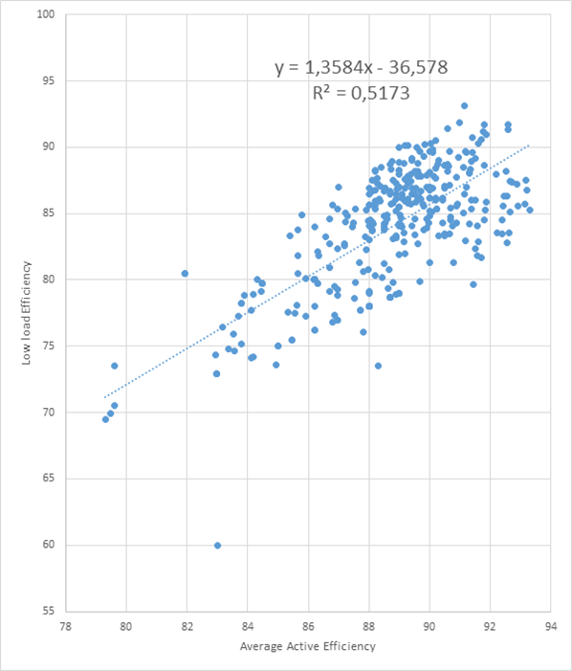

Figure 5: Correlation between average active efficiency and low load efficiency (10%) in EPS devices tested for the EU commission’s review of EPS Ecodesign regulation

Beyond the statistical considerations, there are regulatory barriers to implementing a test standard in the US which includes a 10% loading condition. In interviews we confirmed that the US would require a new law if they wished to add the 10% loading conditions. This is because in the US, the Energy Policy and Conservation Act (“EPCA”) only provides authority to the DOE to include a single test (Department of Energy, 2019). In contrast, the EU was able to add a separate 10% loading condition in their regulation without the same regulatory barriers.

Including an Australian and New Zealand requirement that is not part of the US standard would mean fewer compliance pathways for manufacturers, as tests conducted to the US standard would no longer be acceptable. Under the EU eco-design requirements 2019/1782 there is an additional test point, 10% load. This requirement is not used in the active mode active efficiency calculation (load points 100%, 75%, 50%, 10%), but is collected to determine the “feasibility of setting a requirement regarding minimum energy efficiency at 10% load”. The modelling for this C-RIS does not include the 10% loading point as we do not have enough information to understand the cost implications of the 10% load efficiency values on the Australian and New Zealand EPS markets. We would like to hear stakeholders’ views on the 10% load point testing requirement. The data above suggests that many products are already achieving a reasonable low load efficiency, so the additional testing and compliance costs are not likely to deliver significant additional benefit.

## 3.3 Considerations for expanding scope

### Aligning scope with international standards

The scope of the current regulation in Australia and New Zealand captures less than 20% of EPS sales when compared to the capture of international regulations, e.g., US and EU. The current regulation does not include multiple voltage EPS and adaptive voltage devices that allow for fast charging. These types of EPS are common to many phones, tablets, laptops and other personal electronic devices. The EU Common Charger initiative will require USB-C charging ports for many devices from 2024 (European Union, 2022), which will further increase the adoption of adaptive voltage EPS devices. Given the ubiquity of these electronic devices in today’s marketplace, by excluding them under the current regulations, a significant and growing portion of the market remain unregulated. The US and EU currently regulate these products at an efficiency level of mark VI (U.S. Department of Energy, 2022) (The European Commission, 2019).

Australia and New Zealand could consider expanding the scope of their regulations and aligning with the current US and EU regulations. This would mean including newer technologies that will deliver more power over time. For example, USB Power Delivery (USB-PD). USB-PD is a fast-charging protocol and standard that allows for higher power delivery over USB connections. Devices such as smartphones, tablets, laptops, and other electronics have become more power-hungry, thus the need for faster and more powerful charging capabilities has grown. USB-PD addresses this need. It allows devices to receive the optimal amount of power they require for faster charging – up to 100W (20V at 5A). In interviews with industry experts, we heard that further innovation was taking place to develop USB-PDs to deliver up to 250W.

The US and EU have suggested they are likely to expand the scope of their regulations further to capture new technologies like wireless chargers if, and when, they increase their current regulations to mark VII as anticipated. Developing a consistent test method and standard for these devices is challenging. However, wireless chargers have the potential for large energy conversion losses due to inefficient designs or large power consumption. In interviews, industry experts relayed concerns about the energy losses from more powerful wireless chargers that may be developed. Australia and New Zealand should consider the possibility of continuously updating their regulatory scope in line with international regulations. Under the proposed mark VII US regulation, EPS in devices such as wireless chargers are likely to be covered.

### Including wireless chargers

The US and EU are proposing to include some types of wireless chargers in their regulations and Australia and New Zealand could follow these markets with an adequate lag period.

Wireless chargers are devices that allow the charging of compatible electronic devices – such as smartphones, smartwatches, headphones and tablets – without the need for a physical cable connection. Instead of plugging the device directly into a power source, wireless charging relies on electromagnetic fields to transfer energy from the charging pad to the device's battery. Wireless chargers have become increasingly popular in recent years.

We heard in interviews with experts that there are some issues with regulating wireless chargers. The energy efficiency of wireless chargers depends on a few factors. One factor is the position of a device relative to the charging pad. There is an optimal position on the charging pad, however, consumers may not place their devices in this exact position. This lack of consistency poses a challenge for energy efficiency testing, although not all wireless charging devices face this issue.

Broadly speaking, there are two different ways that wireless chargers “connect” with a device. There are fixed-location wireless chargers which refer to inductive wireless battery chargers that use a physical receiver locating feature (such as a cradle, dock or magnet). This feature allows for consistent alignment and orientation of the receiver to the transmitter, ensuring efficient charging. Devices intended for use in wet environments that fall under this definition (such as toothbrush or shaver chargers) are mandated to undergo testing following the Department of Energy (DOE) test procedure to meet the necessary standards and regulations (U.S. Department of Energy, 2022). The proposed 2027 (mark VII) regulations in the US are considering expanding the requirement for fixed-location wireless chargers. It is likely that the EU would follow the US in this case.

There are also open-placement wireless chargers that do not have a physical locating feature, such as charging mats used for phones (U.S. Department of Energy, 2022). This type of wireless charger is not being considered under the proposed regulations. This is due to the difficulty of testing for, and enforcing of, a standard for open-placement wireless chargers. International regulators have proposed a method that only regulates the no-load mode. That is, testing an open-placement wireless charger when no device is present. Interviews confirmed that this method would ensure consistency. Both US and EU markets are considering adopting this method of testing in their upcoming regulations in 2027. We also heard in interviews that Australia and New Zealand would be able to follow international regulations regarding wireless chargers with sufficient notice. In addition, an adequate transition period after deciding on the regulations will be necessary.

While wireless charging remains a relatively new technology in the market, there are some recognised standards that are developing. The Wireless Power Consortium (WPC) – a collaborative standards development group comprised of more than 350 companies globally – have a developed a “de facto wireless charging standard” for delivering 5-15 watts of power called “Qi” (Wireless Power Consortium: Qi, n.d.). The WPC estimate that there are currently 9,000 Qi certified products on the market today. In the May 2020 Request for Information (RFI), the DOE reported that the WPC commented that there were no commonly recognised test procedures for wireless chargers for industry or regulatory use (U.S. Department of Energy, 2022). This was before the DOE differentiated between fixed position and open position wireless chargers – these terms were introduced in 2021 in a battery test procedure which may have been a response to the WPC’s call for consistency.

This RIS includes fixed-location wireless charging included in the current US test method and regulations. We do not include the potential expanded definition for fixed location wireless chargers or open location wireless charging in our modelling for this RIS as they are not currently included in the international regulations. Should international regulations change to include these devices, further consultation and modelling may be required to determine whether MEPS should also include these devices.

## 3.4 Modelling scenarios

The following policy options are proposed for modelling. They seek to address the problems highlighted in Section 1 and 2.

### Scenario 1: Business as usual (BAU)

Under this scenario, we assess the costs and benefits of renewing the current regulation in Australia and New Zealand so that it continues into the future. This constitutes the baseline scenario which other scenarios will be compared to. In this scenario we will quantify the BAU case, as well as projecting future changes under BAU conditions. Future conditions are subject to changes in international regulations, technology, the price of electricity, the emissions output of electricity per kWh on energy, and the overall demand for EPS.

The current scope of the MEPS is detailed in Section 1.2 of this report. Of note, the MEPS is considerably narrower in scope compared to the total EPS market in Australia and New Zealand. The stringency of the MEPS is detailed below in Table 8.

Table 8: Current MEPS for EPS in Australia and New Zealand – at mark III level

| Mark | Nameplate output power (Pno) | No-load mode power* | Average efficiency in active mode |
| --- | --- | --- | --- |
| **III** | 0 to 1W | ≤ 0.5 | ≥ 0.49 x Pno |
| > 1 to 49W | ≤ 0.75 | ≥ 0.09 x ln(Pno) + 0.49 |
| >49 to 250W | ≥ 0.84 |

### Scenario 2: Remove regulations from 2025

Under Scenario 2, the Australian and New Zealand governments would no longer regulate the minimum energy efficiency requirements of EPS from 2025. Approximately 80% of the currently regulated market in Australia and New Zealand already meet the mark VI efficiency level, despite the much lower Australian and New Zealand minimum standard of mark III. It appears that the Australian and New Zealand markets are benefitting from the international market and international regulations. As such, this scenario will help determine if there is a net benefit produced by removing the regulations all together.

A further consideration for the modelling of this policy option is the potential for dumping of low efficiency products in Australia and New Zealand to increase. Currently, despite the impact of international regulations, there are still a small number of mark III and mark IV products sold in Australia and New Zealand. There is a risk that manufacturers and suppliers of EPS that are currently meeting, but not exceeding, the MEPS will adapt to a regulation-free market and start making or sourcing lower efficiency products if regulations are removed. Findings from our interviews with international regulators suggested that lower efficiency products were cheaper to make and suppliers suggested that they would typically just source the cheapest available product from manufacturers. Therefore, it is likely that there would be an increase in the number of EPS at or below the current MEPS if regulations were removed.

### Scenario 3: Increase MEPS to align with international standards without changing the scope

Scenario 3 is a policy option that involves increasing the stringency of the MEPS to align with current international regulations. The scope of the current regulation would remain unchanged.

Both the EU and US currently have a minimum energy efficiency standard at the mark VI level. The minimum energy efficiency associated with mark VI is summarised in Table 9 below.

Table 9: Mark VI efficiency standard. SV=single voltage, MV=multiple voltage (US Department of Energy, 2022)

| Output | Nameplate output power (Pno) | No-load mode power | Average efficiency in active mode |
| --- | --- | --- | --- |
| **SV** | 0 to 1W | AC-DC: ≤ 0.100  AC-AC: ≤ 0.210 | Basic voltage: ≥ 0.5 x Pno + 0.16  Low voltage: ≥ 0.517 x Pno + 0.087 |
| > 1 to 49W | Basic voltage: ≥ 0.071 x ln(Pno) – 0.0014 x Pno + 0.67  Low voltage: ≥ 0.0834 x ln(Pno) – 0.0014 x Pno + 0.609 |
| >49 to 250W | ≤ 0.210 | Basic voltage: ≥ 0.880  Low voltage: ≥ 0.870 |
| **MV** | 0 to 1W | ≤ 0.3 | ≥ 0.497 x Pno + 0.1669 |
| >1 to 49W | ≥ 0.075 x ln(Pno) + 0.561 |
| >49 to 250W | ≥ 0.860 |

Under scenario 3, there will be an increase in the regulated efficiency for both active and no-load modes across all power ranges, compared with mark III.

The scope of the MEPS (outlined in Section 1.2) will not change in this policy option. Therefore, many EPS such as multiple voltage EPS and adaptive voltage EPS will remain unregulated.

### Scenario 4: Increase scope and MEPS to align with international standards

Under this scenario, we will assess the costs and benefits of increasing the scope and stringency of the MEPS to align with international standards at mark VI (defined in Table 9) in 2025. The expanded scope would include multiple voltage and adaptive voltage EPS that are currently unregulated in Australia and New Zealand.

### Adopt international testing standards

In addition to aligning with the scope and stringency of the current international (EU and US) standards, this scenario considers adopting international testing standards. As discussed in Section 1.3, there are inefficiencies with the current regulation. Suppliers of EPS in Australia and New Zealand must be tested to the AS/NZS testing standard. This means that products sold globally that have already been tested using EU or US test methods must repeat testing. For scenario 4 and 5 we consider adopting international testing standards, i.e. removing the need for and the cost of additional testing to register a product in Australia or New Zealand.

### Scenario 5: Direct harmonisation with international standards

The US and EU are currently in consultation over a proposed update to their EPS minimum efficiency standards and are likely to align at what would become mark VII (defined in Table 10 below). Under this scenario we will assess the costs and benefits of increasing the MEPS (in scope and stringency) to mark VI in 2025 and then further increasing the MEPS from mark VI to mark VII in 2029. This would allow at least a two-year lag time after the EU and the US are likely to increase their standards.

Table 10: Proposed mark VII efficiency standard. SV=single voltage, MV=multiple voltage (US Department of Energy, 2022)

| Output | Nameplate output power (Pno) | No-load mode power | Average efficiency in active mode |
| --- | --- | --- | --- |
| **SV** | 0 to 1W | AC-DC: ≤ 0.075  AC-AC Basic: ≤ 0.075  AC-AC Low: ≤ 0.072 | Basic voltage: ≥ 0.5 x Pno + 0.1669  Low voltage: ≥ 0.517 x Pno + 0.091 |
| > 1 to 49W | Basic voltage: ≥ 0.071 x ln(Pno) – 0.00115 x Pno + 0.67  Low voltage: ≥ 0.0834 x ln(Pno) – 0.0011 x Pno + 0.609 |
| >49 to 250W | AC-DC: ≤ 0.150  AC-AC Basic: ≤ 0.075  AC-AC Low: ≤ 0.185 | AC-DC Basic voltage: ≥ 0.890  AC-DC Low voltage: ≥ 0.880  AC-AC Basic voltage: ≥ 0.902  AC-AC Low voltage: ≥ 0.880 |
| **MV** | 0 to 1W | ≤ 0.075 | ≥ 0.497 x Pno + 0.067 |
| >1 to 49W | 0.0782 x ln(Pno) – 0.013 x Pno + 0.643 |
| >49 to 250W | ≤ 0.125 | ≥ 0.885 |

This scenario would also adopt international EPS testing standards, as described in scenario 4 above.

Section 4: Impact assessment

This section summarises the results of the cost-benefit analysis which compares four different policy options to a baseline scenario of business as usual (BAU). The impacts have been assessed separately in the Australian and New Zealand contexts. A qualitative discussion of the policy options and implementation considerations is also included in this section.

## 4.1 Framework for analysis

A cost-benefit analysis has been performed to systematically evaluate the impacts of changes to the existing regulation on direct participants, the community, and the economy. These impacts were determined in monetary terms to understand the potential comparative gains or losses from each option, and to identify the option that maximises the net benefits to society.

A multi-step, bottom-up modelling process was used to estimate the net economic impact of each option, compared to the baseline scenario (continuing with the existing regulation). The model estimates the impact of regulation changes at a product level and scales this to market level to determine the net economic impacts.

The cost-benefit model includes four main components (illustrated in Figure 6):

* Scenario inputs: The key variables that determine the scale, scope, and compliance methodology of the regulation for each modelled scenario. These settings informed each of the other model components.
* Product costs and energy savings: current and projected costs for each product to comply with the MEPS, the theoretical energy consumption changes stimulated by the MEPS, and the likely use and energy demand profile for the product to determine annual energy savings and the time that these savings occur.
* Market adoption: The historic and current market size for each product, projected product uptake rates, and projected changes in product and electricity costs over the modelling period.
* Total impact: The aggregate costs and benefits of the regulation to participants (both industry and households), government (administration and enforcement costs) and society as a whole (external benefits such as emissions, health, and avoided electricity network costs shared by all customers). The total impacts have been individually determined for Australia and New Zealand.

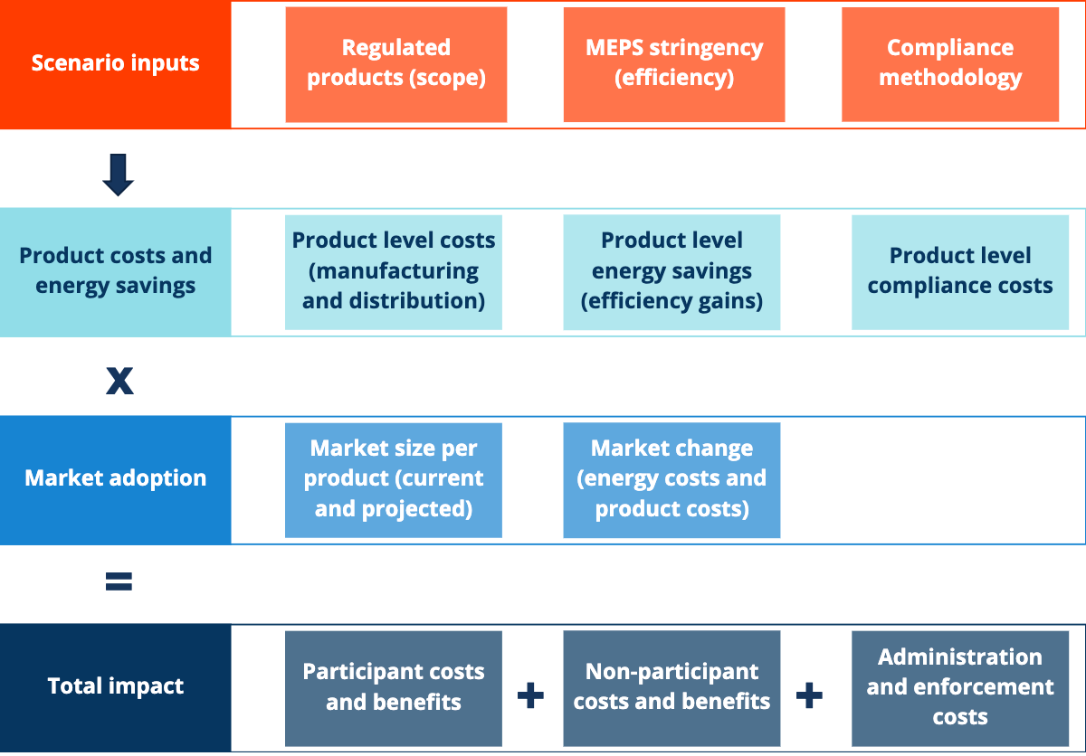

Figure 6: CBA model components

### Cost-benefit analysis input and assumptions

Table 11 below outlines the main costs and benefits considered in the analysis. New Zealand takes a societal level approach to its cost-benefit analyses. A detailed explanation of inputs, assumptions and modelling methodology is provided in Appendix One.

*Table 11: Considered costs and benefits (public, private and societal for Australia and New Zealand)*

| Type | Costs | Benefits |
| --- | --- | --- |
| Public (AUS) | * Administrative and enforcement costs | * Reduced greenhouse gas emissions * Improved air quality * Avoided energy network costs |
| Private (AUS) | * Compliance cost for industry (certification, manufacturing and distribution) * Incremental product mark-up cost (increased efficiency) | * Energy bill savings (residential and commercial) |
| Societal (NZ) | * Wholesale product price factor – 50% of incremental product mark-up cost (increased efficiency) * Compliance cost for industry (certification, manufacturing and distribution) * Administrative and enforcement costs (government) | * Energy bill savings (long run marginal cost) * Reduced greenhouse gas emissions * Avoided energy network costs |

Savings are compared to the ‘business as usual’ baseline scenario (Scenario 1) where no changes are made to the regulation. The impact scenarios modelled are:

* Scenario 2: Remove regulations from 2025 (baseline scenario until 2025).
* Scenario 3: Increase MEPS to mark VI from 2025, no change to scope.
* Scenario 4: Increase scope and MEPS to align with international standards (mark VI) from 2025, adopt international testing standard.
* Scenario 5: Increase scope and MEPS to align with international standards (mark VI) from 2025, with a further increase to mark VII in 2029, adopt international testing standard.

The impact assessment quantifies the differences between these scenarios and the baseline scenario (Scenario 1 – no change to the current Australian and New Zealand regulations). Several key input assumptions are detailed in the sub-sections below (see Appendix One for a more comprehensive discussion).

### Market size and distribution

Market size and distribution assumptions are based on extrapolation from two data sources, including:

* New Zealand EPS reported sales data (2012-2022), provided to the Energy Efficiency and Conservation Authority (EECA).
* US Department of Energy (DOE), Energy Efficiency and Renewable Energy (EERE) – Preliminary analysis for external power supply (EPS) (US Department of Energy, 2022).

It has been assumed that the EECA data represents compliant (i.e., meet MEPS) sales under the current scope of the regulation in New Zealand (extrapolated to the Australian market based on population). The US DOE data has been assumed to represent total US EPS sales under the scope of their current regulations. For the expanded scope scenarios (Scenario 4 and 5) we have extrapolated the US DOE data to the Australian and New Zealand markets based on population. The US data was collated from a series of interviews with manufacturers and suppliers, conducted by consultants preparing the US impact assessment, and was cross-checked with global market research. As such, it is likely that the US data represents the total US market, rather than the total compliant US market. To account for any potential non-compliance, we have applied a compliance factor of 0.8 in our model.

Distribution of EPS by product class and by efficiency level was determined through analysis of the EECA sales data. The analysis has been performed using the same product classes the US DOE used in their recent analysis, which were found to be representative of the total market. The product classes are defined as follows:

* Single voltage EPS AC-DC Basic Voltage 2.5W (0W – 7.25W)
* Single voltage EPS AC-DC Basic Voltage 12W (7.25W – 18W)
* Single voltage EPS AC-DC Basic Voltage 24W (18W-54W)
* Single Voltage EPS AC-DC Basic Voltage 60W (54W-90W)
* Single voltage EPS AC-DC Basic Voltage 120W (>90W)
* Single voltage EPS AC-DC Low Voltage 5W (0W-7.5W)
* Single voltage EPS AC-DC Low Voltage 10W (7.5W-11W)
* Single voltage EPS AC-DC Low Voltage 12W (11W-18W)
* Single voltage EPS AC-DC Low Voltage 24W (>18W)
* Single voltage EPS AC-AC Basic Voltage 3.6W (0W-13.8W)
* Single voltage EPS AC-AC Basic Voltage 24W (13.8W-32W)
* Single voltage EPS AC-AC Basic Voltage 40W (>32W)
* Single voltage EPS AC-AC Low Voltage 12W (0W-14.5W)
* Single voltage EPS AC-AC Low Voltage 17W (14.5W-20.5W)
* Single voltage EPS AC-AC Low Voltage 24W (>20.5W)
* Multiple voltage EPS 18W (0W-24W)
* Multiple voltage EPS 30W (24W-60W)
* Multiple voltage EPS 90W (>60W)

The US also defined the distribution by end-use product application (e.g. smartphone, USB wall-adapter, notebooks etc.) within each product class. We assumed the same distribution in our analysis, combined with their data on loading point and usage (hours per week) by end-use application. This enabled us to calculate a weighted average energy usage per week (including both active and no-load modes) for each product class.

### Market growth

We have assumed growth in EPS sales based on population, using the medium case under the New Zealand National Population Projections: 2022-2073 (Stats NZ, 2022) and the medium series under the ABS Population Projections, Australia (Australian Bureau of Statistics, 2018). We have assumed the same growth rate applies across all product categories. This was the same approach taken by the US DOE impact assessment.

### Cost to industry

The assumed annual costs to business for complying with the current regulation are shown in Table 12 below. These costs were determined through interviews with suppliers.

Table 12: Annual costs (in AUD, 2023 pricing) to business for current regulation (Scenario 1, 2 and 3)

|  |  |  |
| --- | --- | --- |
| Annual administrative cost | Annual registration fees | Annual testing cost |
| $77,630 | $99,753 | $984,729 |

Table 13: Annual costs (in AUD, 2023 pricing) to business for expanded scope regulation (Scenario 4 and 5)

|  |  |  |
| --- | --- | --- |
| Annual administrative cost | Annual registration fees | Annual testing cost |
| $464,257 | $373,103 | $0 |

The administrative cost was based on the formula below:

*Administrative cost = input cost * time * population*

Where:

* Inputs = $70 hourly cost (wages, overhead and non-wage costs)
* Time = 1 hour to complete the registration
* Population (current scope) = 1,109 registrations per year
* Population (expanded scope) = 6,632 registrations per year

The average cost of testing an EPS is assumed to be $888 AUD ($600 USD quoted by a supplier in interviews) and all registered products are assumed to require testing. Registration fees are $440 per registration. Note that registrations last for five years. For Scenario 4 and 5 we have assumed that the regulation has been amended to adopt international testing standards so that additional testing is not required to register a product in Australia or New Zealand.

Note that approximately 2% of products are registered in New Zealand. The above costs have been applied to 2% of registrations to calculate the New Zealand industry costs. But the registration fees have not been included for New Zealand, as there are none for importers/manufacturers.

### Incremental product cost for increased efficiency

We have extrapolated the cost efficiency curves that were developed for the different product categories in the US DOE analysis. Mark VI was the baseline scenario in the US analysis; hence we have had to readjust our cost baseline to mark III for this analysis (see example for SV AC-DC Basic Voltage (24W) devices in Figure 7 below). This process has been followed for each of the product classes.

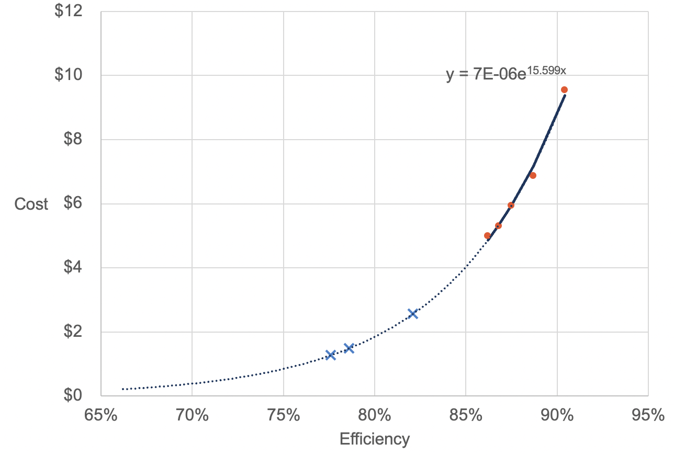

Figure 7: Cost-efficiency curve extrapolated from US DOE analysis for SV AC-DC Basic Voltage 24W EPS (US Department of Energy, 2022). Blue crosses represent mark III, mark IV and mark V efficiency levels, red dots represent the US efficiency scenarios tested (including mark VI and the proposed 2027 updated regulation)

We have also included an industry learning factor to account for reduced product manufacturing costs to achieve mark VI since the original implementation of the mark III MEPS level. This reflects stakeholder feedback that the current additional cost to manufacture a mark VI efficiency level is low for most products.

These costs are included as a private industry cost in the Australian analysis. For New Zealand, 50% of the incremental manufacturing costs for compliant products are included as a societal cost to reflect the avoidable economic burden to the community.

### Electricity prices

We have assumed the same retail electricity price projections for Australian jurisdictions as those used in the DRIS for the NCC 2022 update (see Figure 8 below) (ACIL Allen, 2022). As EPS sales are unlikely to differ by state, apart from by population, we used a population weighted average national electricity price. In New Zealand as the cost benefit is calculated at a societal level, the Long Run Marginal Cost (LRMC) of electricity is used.

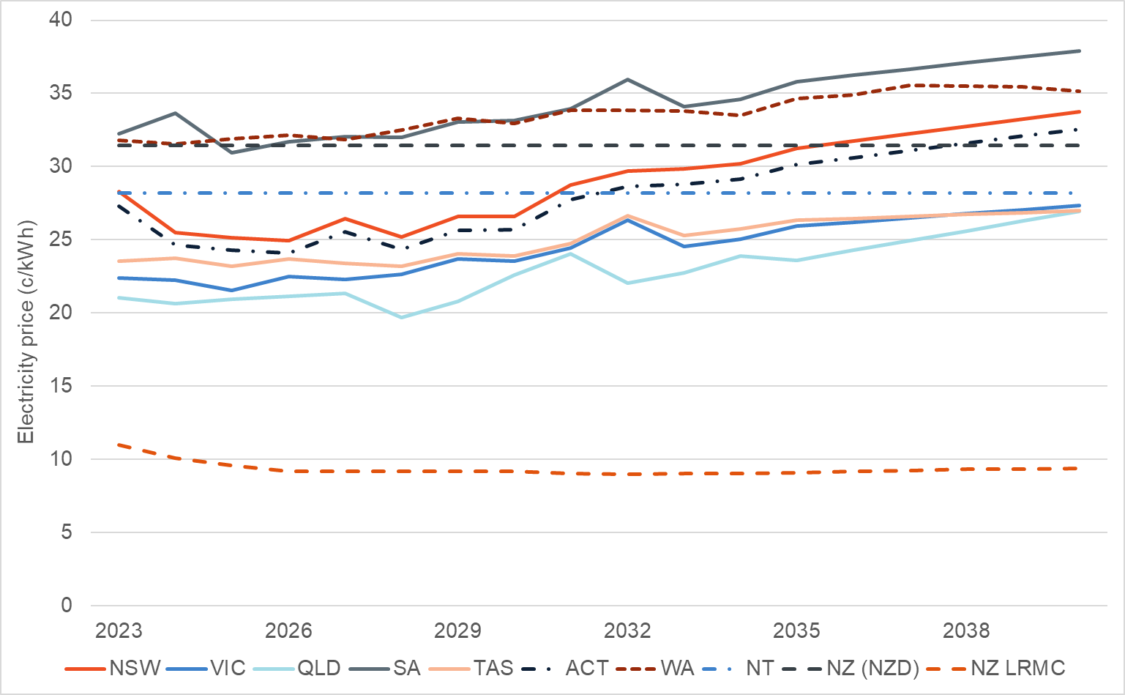

Figure 8: Retail electricity price projections by jurisdiction (NCC DRIS, ACIL Allen (ACIL Allen, 2022) – adjusted to 2022 pricing, added NZ). Note LRMC is the long run marginal cost of electricity

We have used the same commercial/residential electricity pricing ratios developed for the Electronic Displays C-RIS. These were developed based on a review of commercial electricity tariffs offered by larger electricity retailers. The assumptions are summarised in Table 14 below.

Table 14: Commercial/Residential electricity price ratio by jurisdiction. Electronic Screens CRIS assumptions provided by DCCEEW.

| Jurisdiction | Commercial/Residential ratio |
| --- | --- |
| NSW | 1.296 |
| VIC | 1.129 |
| QLD | 1.303 |
| SA | 1.206 |
| WA | 1.107 |
| TAS | 0.908 |
| NT | 1.164 |
| ACT | 1.214 |

### Government costs

We have made the following assumptions for the costs to government of administering and enforcing the EPS regulation in Australia and New Zealand (Table 15). These costs are currently recovered from industry in Australia through product registration fees.

Table 15: Government administration and enforcement costs

| Administration and enforcement cost category | Assumption ($ AUD) |
| --- | --- |
| Input cost (wages, overheads and non-wage costs) | $72 per hour* |
| Time per registration | 30 min |
| Market screening (non-compliance) | 10 days per year |
| Enquiries | 10% of registrations, 30 min per enquiry |
| Regulatory reviews and other administrative costs (Australia only) | $200,000 every 5 years |
| Product check-testing | ($850 per test + $100 product cost) * 1% of registered products |

*Based on APS5 at central rate and 1.75 overhead scaling

### Avoided energy network costs

The reduction in peak demand is based on an assumed conservation load factor (CLF) of 1.0 for EPS (residential and commercial applications). This factor was included in the Energy Efficiency Forecasts: 2019-2041 report prepared for the Australian Energy Market Operator (AEMO) (Strategy. Policy. Research., 2019). Peak demand reduction is calculated using the following formula:

We have assumed a cost-benefit of $500/kW (2019 dollars) peak reduction in Australia (as used in the 2019 Jacobs report for the VEU program energy market modelling (JACOBS, 2019)) and an equivalent value of NZD $230/kW in New Zealand (used in the Electronic Screens CRIS).

### Health benefits associated with improved air quality

There are health benefits associated with improved air quality resulting from electricity savings in Australia. Reduced pollution resulting from reduced coal or gas generated electricity result in health benefits associated with respiratory and cardiac diseases. We will assume the same benefits used in the NCC DRIS, which are as follows:

* Coal-generated electricity - $2.75/MWh (2022 pricing) (Mazaheri, et al., 2021)
* Gas-generated electricity - $0.99/MWh (2022 pricing) (Australian Academy of Technological Sciences and Engineering, 2009)

We have assumed health benefits to be negligible in New Zealand based on the high percentage of renewables in the electricity supply

### Reduced greenhouse gas emissions

The indirect scope 2 and 3 combined emissions factors from the Australia’s emissions projections 2023 report, published by the Department of Climate Change, Energy, the Environment and Water (Australian Government Department of Climate Change, Energy, the Environment and Water, 2023) have been used for the Australian analysis. For New Zealand, emissions projections were sourced from the He Pou a Rangi Climate Change Commission (New Zealand Government, 2022). See Appendix One for full details.

### Cost of carbon

The central cost of carbon used for the Australian analysis is based on the Ministerial Council on Energy’s statement on the interim value of greenhouse gas emissions reduction (VER) (Australian Energy Market Commission, 2024). The VER measures the dollar value per tonne of avoided greenhouse gas emissions resulting from changes in regulations. A lower sensitivity setting was also tested for Australia using a carbon price forecast taken from the 2022 Decision RIS for a proposal to increase residential building energy efficiency improvements in the National Construction Code (ACIL Allen, 2022).

The New Zealand Government provided different social cost of carbon scenarios (low, central, high) to be used in their analysis. See Appendix One for full details.

## 4.2 Benefit cost ratios

In this section we present the results of the central scenario. We have also run a sensitivity analysis to understand the best and worst cases. The settings for the three scenarios are summarised in Table 16 below. The results for the low and high scenarios are included in Appendix Two.

Table 16: Sensitivity analysis settings

|  | Central | High | Low |
| --- | --- | --- | --- |
| Discount rate (AUS) | 7% | 3% | 10% |
| Discount rate (NZ) | 5% | 2% | 8% |
| Cost of carbon (AUS) | VER (AEMC) | Social cost of carbon high scenario (ACIL Allen, 2022) | Social cost of carbon medium scenario(ACIL Allen, 2022) |
| Social cost of carbon (NZ) | Central | High | Low |

The results for the central case in Australia are summarised in Table 17 below (compared to a business-as-usual baseline). For scenarios 4 and 5, which involved increases to the existing regulation (scope and stringency), a positive net benefit was achieved. While the costs increased considerably under scenario 5, there was an additional net benefit of $5m AUD (above scenario 4) for increasing to “mark VII” in 2029. This positive net benefit held true under each of the sensitivity settings. While scenario 5 increased private costs to industry, the combined public and private benefits exceeded any cost increase (total benefit to cost ratio of 1.16).

Table 17: Cost-benefit analysis results summary by scenario (compared to business-as-usual) for Australia, modelled to 2040

|  | Scenario 2: No regulation from 2025 | Scenario 3: Mark VI from 2025 | Scenario 4: Mark VI from 2025 (expanded scope) | Scenario 5: Mark VI from 2025, Mark VII from 2029 (expanded scope) |
| --- | --- | --- | --- | --- |
| Energy savings (GWh) | -81 | 27 | 219 | 733 |
| Emissions reduction (tCO2-e) | -13,264 | 7,143 | 54,654 | 108,860 |
| Peak demand saving (MW) | -0.7 | 0.3 | 3 | 7 |
| Total costs (NPV $ AUD) | -$9.9M | $2.6M | $12.7M | $47.9M |
| Total benefits (NPV $ AUD) | -$13.4M | $5.3M | $41.5M | $118.3M |
| Net benefit (NPV $ AUD) | -$3.4M | $2.8M | $28.8M | $70.4M |
| Total benefit cost ratio | **0.74** | **2.07** | **3.28** | **2.47** |

Energy bill savings for consumers were by far the greatest benefit delivered under each scenario (see Figure 9 below). The expansion in scope would deliver eight times the energy savings benefits in Australia, compared to the scope of the current regulation. These benefits are further tripled with the increase to “mark VII” in scenario 5.

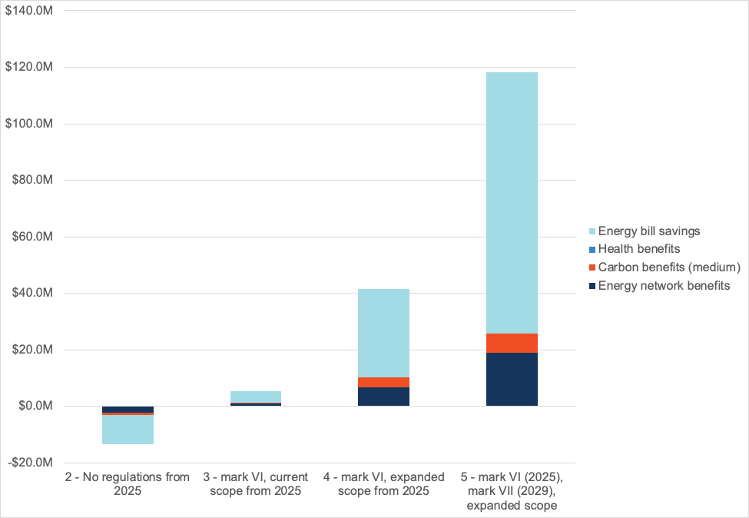

Figure 9: Stacked benefits (public and private) under each scenario, compared to BAU, in Australia

The results for the central case in New Zealand are summarised in Table 18 below (compared to a business-as-usual baseline). The New Zealand summary data includes an assessment of societal costs. For this analysis, 50% of the incremental manufacturing costs for compliant products are included as a societal cost to reflect the avoidable economic burden to the community, and a long run marginal cost for electricity is included to estimate the societal benefit associated with avoided electricity generation. A positive net societal benefit is achieved in scenarios 3, 4 and 5.

Table 18: Cost-benefit analysis results summary by scenario (compared to business-as-usual) for New Zealand, modelled to 2040

|  | Scenario 2: No regulation from 2025 | Scenario 3: Mark VI from 2025 | Scenario 4: Mark VI from 2025 (expanded scope) | Scenario 5: Mark VI from 2025, Mark VII from 2029 (expanded scope) |
| --- | --- | --- | --- | --- |
| Energy savings (GWh) | -15 | 5 | 40 | 134 |
| Emissions reduction (tCO2-e) | -798 | 266 | 2,063 | 7,176 |
| Peak demand saving (MW) | 0 | 0.1 | 0.5 | 1.3 |
| Total costs (NPV $ NZD) | -$0.5M* | $0.3M | $2.3 | $6.6 |
| Total benefits (NPV $ NZD) | -$1.1M* | $0.4M | $3.3M | $9.7M |
| Net benefit (NPV $ NZD) | **-$0.6M\*** | **$0.1M** | **$0.9M** | **$3.0M** |
| Total benefit cost ratio | **0.45** | **1.45** | **1.40** | **1.45** |

*For consistency the same set of costs and benefits have been reported for each scenario, for scenario 2, this results in negative costs (nominally benefits) and negative benefits (nominally costs) hence the formula for BCR for this scenario is actually costs/benefits

### Incremental product costs assumptions

Incremental mark-up costs are an important assumption in the modelling, particularly for New Zealand where the electricity supply is made up of over 80% renewable generation and hence emissions and health benefits are considerably lower or negligible. As discussed in Section 4.1, the mark-up costs used in our analysis were extrapolated from the recent US DOE impact assessment. We understand, from our conversations with the DOE, that their numbers were based on a combination of interviews with manufacturers and their own product tear downs and pricing of individual components. The DOE analysis used mark VI as the baseline and calculated incremental mark-ups for the anticipated mark VII and even higher efficiency scenarios tested. As a small percentage of the Australian and New Zealand markets only meet mark III, IV or V, we have extrapolated the US cost-efficiency curves and re-baselined at mark III. We have also included an industry learning factor to account for reduced product manufacturing costs to achieve mark VI since the original implementation of the mark III MEPS level. This reflects stakeholder feedback that the current additional cost to manufacture a mark VI efficiency level is low for most products. We consider that this still results in a conservative estimate of cost impacts.

### Administrative efficiency improvements

Throughout this RIS process, several opportunities have been identified to improve the administrative efficiency of the regulation, which will further reduce costs to both industry and governments and align with good regulatory practice. Some of these have been integrated into the modelling at the request of government, others were not pertinent to the modelling, but are listed here for government to explore further as required.

Administrative efficiencies that were incorporated into the model were as follows:

* Engaging with international regulators prior to commencing the RIS process to ensure that future anticipated increases to international standards (e.g., “mark VII”) can be considered at the same time. This may avoid the need for a future RIS and ensures Australia and New Zealand can remain aligned with international standards.
* Amending the regulation to allow for manufacturers/suppliers to register products using test certificates that reference international testing standards that are technically consistent with AS/NZS.4665.1 and 4665.2. Consultation with industry suggested that suppliers were having to ask manufacturers to re-test or re-certify products to the AS/NZS standard, despite them having already been tested to comply with consistent international standards. This cost saving for industry was included in scenario 4 and 5.

Additional efficiencies that were not included in the modelling, but could be explored further by government as needed, are:

* Reviewing and increasing the range of products that would fit under a family of models. This is currently possible for a range of non-user selectable models (with different output voltages) or multi -switch single output models that are based on common technically equivalent components. They can be sold under different brand names or model numbers, they just need to be included on a single test report and have the same performance mark to qualify. A draft definition of product families for the expanded scope scenarios (4 and 5) is proposed in Section 5 below. We seek industry feedback on appropriate family definitions for the expanded scope.

Section 5: Proposed changes

This section provides additional technical details of the proposed changes under scenario 4 and 5.

The information below is to help stakeholders understand the proposed changes at a technical level. The final wording in any new regulation may differ.

Scope

|  |  |  |
| --- | --- | --- |
| Current regulations | Proposed | |
| MEPS covers power supplies (including power supplies sold (packaged) with products, such as laptops and mobile phones) which,  Are designed for mains input power (normally 230V AC), and  have a maximum output power of less than or equal to 250W, and  have a single output voltage (either AC or DC), or  multiple outputs that are user selectable (multiple output but only one is active at a time, and is selectable through a selector switch).  **Excluded:**  MEPS does not apply to,  DC input power or battery powered equipment, or  DC to DC converters, or  power supplies within the scope of AS/NZS 4879 or IEC 61347.1.13, or  internal power supplies, or  external power supplies with multiple simultaneous output voltages, or  if it is designed to charge more than one type of battery, or  a transformer or converter for an extra low voltage lamp, or  electronic control-gear for an LED module, or  medical equipment, provided it is listed in the Australian Register of Therapeutic Goods. | The MEPS will continue to cover external power supplies, but the definition of external power supply is changed to align with Regulation (EU) 2019/1782 Article 2. The definition is below.  **External power supply** means a device which meets all of the following criteria:   1. It is designed to convert alternating current (AC) power input from the mains power source input into one or more lower voltage direct current (DC) or AC outputs 2. It is used with one or more separate devices that constitute the primary load; it is contained in a physical enclosure separate from the device or devices that constitute the primary load; it is connected to the device or devices that constitute the primary load with removable or hard-wired male/female electrical connections, cables, cords or other wirings; it has nameplate output power not exceeding 250 watts 3. Excluded: The exclusions are mostly similar to Regulation (EU) 2019/1782 Article 1, with the following changes: i) Exclusion h in Regulation (EU) 2019/1782 Article 1 (“spare parts” exception) is removed. ii) Addition of Australia/New Zealand-specific exclusions regarding Therapeutic goods iii) Addition of Australia/New Zealand-specific exclusion for power supplies that fall in scope of AS/NZS 4879 or IEC 61347.1.13. This is an extension of the general exclusion d for lighting converters.   The exclusions (with proposed Australia/New Zealand-specific extensions in *italics*) are shown below.   1. voltage converters 2. uninterruptible power supplies 3. battery chargers without power supply function 4. lighting converters 5. external power supplies for medical devices 6. active power over Ethernet injectors 7. docking stations for autonomous appliances 8. *medical equipment, provided it is listed in the Australian Register of Therapeutic Goods* 9. *power supplies within the scope of AS/NZS 4879 or IEC 61347.1.13.* |

### Family of models

The family of models is currently defined in AS/NZS 4665.1 Clause 1.3.8 (non-user-selectable output voltage) and Clause 1.3.9 (user-selectable output voltage).

The EU does not have a definition of *family of models* in the sense that it is used in Australia and New Zealand. The definition from 10 CFR 430.2 “External power supply design family”, along with the parts of the definition 10 CFR 430.2 “Basic model” as they apply to external power supplies is proposed instead.

|  |  |
| --- | --- |
| Current regulations | Proposed |
| Non-user selectable  A range of non-user selectable single output models based on common technically equivalent component, but may each have a different output voltage. They must have the same energy performance mark.  User selectable  A user selectable single output model based on common technically equivalent component voltage. They must have the same energy performance mark. | **Family of models** means a set of external power supply **basic models**, which share the same circuit layout, output power, and output cord resistance, but differ in output voltage.  They must have   * Technically equivalent components * The same output power * The same product class * The same performance mark * Listed on a single test report where the least efficient model has been tested (active power, standby power). |

### Product classes

The proposed product classes are mapped directly to the efficiency requirements. It is important to note that attempting to classify products by combinations of output voltage, number of outputs, voltage output range and such can have a “multiplier effect” on the number of product classes. The proposed set below is the minimal set based on efficiency requirements.

|  |  |
| --- | --- |
| Current regulations | Proposed |
| single output EPS with non-user selectable output voltage and with an alternating current input and a direct current output (a.c.–d.c.)  single output EPS with user selectable output voltage and with an alternating current input and a direct current output (a.c.–d.c.)  single output EPS with non-user selectable output voltage and with an alternating current input and an alternating current output (a.c.–a.c.)  single output EPS with user selectable output voltage and with an alternating current input and an alternating current output (a.c.–a.c.) | AC-AC external power supplies, except low voltage and multiple voltage output external power supplies  AC-DC external power supplies, except low voltage and multiple voltage output external power supplies  Low voltage external power supplies  Multiple voltage output external power supplies |

### MEPS

|  |  |
| --- | --- |
| Current regulations | Proposed |
| Efficiency Mark III | **Scenario 3 and 4**: Efficiency Mark VI  **Scenario 5**: Efficiency Mark VI, then 2 years after US/EU introduction Efficiency Mark VII. |

### Testing

The proposed testing requirements include the ability to test to international test standards.

| Current regulations | Proposed |
| --- | --- |
| AS/NZS 4665.1:2005 + A1 | AS/NZS 4665.1:2005 + A1 *Performance of External Power Supplies – Part 1: Test method and energy performance mark*  EN 50563:2011+A1:2013 *External a.c. - d.c. and a.c. - a.c. power supplies – Determination of no-load power and average efficiency of active modes*  United States Code of Federal Regulations, Title 10, Part 430, Subpart B, Appendix Z *Uniform Test Method for Measuring the Energy Consumption of External Power Supplies* |

### Name plate requirements

AS/NZS 4665.2 Section 5 requires all external power supplies to show the energy performance mark. The proposed name plate requirements incorporate extra requirements to mark output power, output voltage and output current. These come from Regulation (EU) 2019/1782 Annex II Clause 2. The requirement to show the energy performance mark is carried over.

|  |  |
| --- | --- |
| Current regulations | Proposed |
| The product must be marked with the energy performance mark that it meets. | The product must be marked with   * Output power * Output voltage * Output current * The energy performance mark that it meets. |

Section 6: Questions for consultation

This section provides questions that should be considered during consultation to ensure the robustness of this analysis and minimise any impacts on consumers and industry.

The purpose of this consultation is to solicit valuable feedback from stakeholders regarding the Regulatory Impact Statement (RIS) and its associated analysis. Your insights and inputs will play a pivotal role in developing a robust and effective regulatory regime.

Your participation in this feedback process is encouraged as it provides an opportunity to review the Consultation RIS and any related matters, including changes in your position and the reasons behind those changes. By doing so, we aim to gain a comprehensive understanding of the potential impact of market and modelling assumptions, as well as the implications on industry, energy consumption, greenhouse gas emissions, regulation and compliance, and domestic trade considerations. We submit the following questions for consultation:

**Please ensure that you explain your response to each question, as the reason for each answer will help us understand.**

# Preferred policy option

* Do you support aligning the Australian and New Zealand EPS scope, MEPS, and nameplate requirements with international standards?
* What are your views on increasing the MEPS requirements on EPS in New Zealand and Australia?
* Scenario 3 and 4, mark VI (current US and EU requirements)
* Scenario 5, mark VII (expected future international requirements)
* Do you support any of the scenarios presented (please explain why, including if you do not support any of the scenarios)?
* Scenario 2: No regulation from 2025
* Scenario 3: Mark VI from 2025
* Scenario 4: Mark VI from 2025 (expanded scope to match EU/US)
* Scenario 5: Mark VI from 2035 (expanded scope to match EU/US) and Mark VII from 2029

## Compliance

* Do you have suggestions on how the compliance of EPS could be improved?
* We have assumed 1% of products will be check-tested. Is this sufficient to ensure compliance?
* We have assumed a uniform level of non-compliance (including registration and MEPS) of 20% across EPS in Australia and New Zealand. Do you have any feedback about non-compliance levels locally or abroad?
* Are there any specific products that will be unable to comply with mark VI or higher? If yes, please provide details whether this a technical issue

## Implementation

* Do you agree with a 2-year transition timeline to further increase the MEPS to mark VII following international adoption (scenario 5)?
* Do you agree with proposed expanded scope (scenario 4 and 5)?
* Do you think that fixed-wireless charging product should be included?
* Do you agree with the proposed family of models definition (scenario 4 and 5)?
* Do you agree with the proposed product classes (scenario 4 and 5)?
* Do you agree with the proposed alternative test Standards/methods (scenario 4 and 5)?
* Are products normally tested at both 110V and 230V for the US market?
* Do you support the proposed nameplate requirements (scenario 4 and 5)?
* What are your views on requiring testing at 10% load (aligned with EU)
* Are there any other administrative efficiencies that could be implemented to improve the registration process?

## EPS market dynamics

* In this RIS, we have comprehensively outlined the market drivers influencing the EPS markets both domestically and internationally. Are international regulations driving the market, and if not, what is?
* We have considered the impacts of the Common Charger initiative in the EU. Are there specific impacts of this initiative on the Australian and New Zealand markets that you believe should be considered?
* Do you have any feedback regarding the modelling approach and assumptions as detailed throughout this consultation paper? Further details can be found in Appendix One.
* We have assumed a similar distribution of EPS in the Australian and New Zealand market as the US market. See Section 1.2 and Appendix for details. Are there any idiosyncrasies in the Australian and/or New Zealand EPS markets that should be considered?
* Australia and New Zealand are small EPS markets. Therefore, we have assumed that the international manufacturing and supply of EPS products is sufficient to meet any increase in the demand for mark VI efficiency EPS. A 2-year transition period will also aid this process.
* Will there be supply disruptions if a subsequent increase to mark VII (after the US and/or EU and with an additional 2 years to transition) was to be regulated in Australia and New Zealand?
* If the market for standalone EPS grows (e.g., phone or laptop chargers purchased separately) would there be any benefit of product labelling?

## Estimated costs and benefits

* Is there currently an additional cost for manufacturers/suppliers to re-test or re-certify products for registration in Australia or New Zealand?
* Our approach to modelling the incremental cost of manufacturing higher efficiency level EPS has been based on the US engineering analysis discussed in the Technical Support Document (TSD) 2022. Also see the attached appendix for details of our approach. Do you have any feedback regarding the modelling approach and assumptions for incremental manufacturing costs?

Section 7: Conclusion

Based on the results of our analysis and feedback provided by regulators and industry to date, our recommended policy option is **scenario 5** **in both Australia and New Zealand**. This option involves increasing the MEPS for EPS to mark VI in 2025 and expanding the scope to include multiple voltage (simultaneous output) devices and adaptive voltage EPS which are currently excluded from the regulation. A further increase in MEPS to mark VII should then be implemented two years after it comes into force in the US and/or EU.

This policy option would also involve a change to the regulations in Australia and New Zealand to allow for products to be registered referencing internationally accepted testing standards (e.g., EN 50563 and US DOE). These standards are all technically consistent with the Australian and New Zealand standards (AS/NZS.4665.1 and 4665.2) and accepting test certificates that refer to any of these standards would reduce costs and increase administrative efficiency for industry. The recommended option provides the greatest net total benefit, an estimated $70m AUD in Australia and $3m NZD in New Zealand.

In addition to the energy savings, avoided network costs and greenhouse gas reductions that can be achieved, implementing the recommended option will also address the problems identified in this consultation RIS. These include existing regulations not keeping pace with international regulations and technology improvements, manufacturers having little incentive to improve the efficiency of EPS in unregulated or under-regulated environments, and consumers valuing other product features over energy efficiency (including the features of the end-use product powered by the EPS).

Consultation with stakeholders through this RIS process may uncover issues that have not yet been considered in this analysis. If this occurs, then changes to the above recommendation may be warranted. These changes will be incorporated into a Decision RIS and further consultation with industry may be required.

Section 8: Implementation and review

## Implementation – next steps by Government

Once submissions have been gathered from this consultation process, they will be analysed with any new data assessed. Fundamental changes as a result of comments or new data can be discussed again with industry.

The Decision RIS will be considered by Energy Ministers in both New Zealand and Australia. It will outline relevant issues raised by industry and how government can address them. Industry will be informed on the recommended option(s), expected implementation dates, and any changes decided by Ministers. New Zealand has a separate process to consider policy proposals and to update the *Energy Efficiency (Energy Using Products) Regulations 2002*, which involves New Zealand Cabinet approval.

## Australia

* Following stakeholder feedback on this Consultation RIS, the comments and feedback received will be considered before proceeding to a Decision RIS.
* If it is resolved to proceed, a Decision RIS (incorporating feedback on the Consultation RIS policy proposals) will be submitted to the Energy and Climate Change Ministerial Council.
* If a policy proposal in the Decision RIS is approved by the Energy and Climate Change Ministerial Council, the legal instruments (referred to as GEMS Determinations) will be created or revised.
* Once Ministerial approval is provided for the revised Determinations, there will be a period before any policy change comes into force.

## New Zealand

* Policy proposals will be considered by New Zealand Cabinet, and if approved the *Energy Efficiency (Energy Using Products) Regulations 2002* will be amended to incorporate the new requirements.
* Once the amended Energy Efficiency (Energy Using Products) Regulations 2002 have been approved by Cabinet, there will be a minimum 6-month period before they come into force. The implementation timing of legislation in Australia and New Zealand will be aligned where possible.

Given the E3 Program’s experience with implementing or revising energy efficiency requirements, the risks associated with implementation are considered to be low. Any transitional arrangements will be developed in close consultation with industry.

## Implementation – next steps for industry

In Australia, once the changes (if any) are in force:

* EPS imported or manufactured prior to the law change that don’t meet the new requirements may still be supplied until stock is depleted. Their registrations will be grandfathered (status changed to “Superseded” in the registration system). Evidence of date of import may be requested for compliance purposes. New import or manufacture of these products from the date of the law change is not permitted.
* Registered EPS imported or manufactured prior to the law change that already meet the new requirements may continue to be supplied. Their registrations will be re-validated and updated to the new GEMS determination.
* Suppliers wishing to import or manufacture models that are in scope and do not have an approved registration, will need to complete a registration application, pay the registration fee and lodge the application with the GEMS Regulator.
* Unregistered products that fall within the scope of the Determination are not permitted to be supplied or used for any commercial purpose at any time.

In New Zealand, once the changes (if any) are in force:

* The regulations the EPS must comply with are dependent on the date of importation or manufacture in New Zealand.
* If the EPS is imported or manufactured in New Zealand before the enforcement date of the amended regulations it must comply with the pre-amended regulations. i.e. for the current scope be registered in Australia or New Zealand, display the efficiency mark on their nameplate, and meet MEPS requirement of III.
* If the EPS is imported or manufactured in New Zealand from the enforcement date of the amended regulations it must comply with the amended regulations. i.e. be registered in Australia or New Zealand, display the efficiency mark on their nameplate, and meet the higher MEPS requirement e.g. VI (dependent on policy option).
* All currently registered EPS will be assessed against the new requirements, and if they comply, they will be upgraded to the new regulations. If the EPS registration does not comply its status will change to superseded, meaning that existing stock imported or manufactured in New Zealand before the enforcement date can made for sale, lease, hire, or hire-purchase, but no new stock may be imported or manufactured in New Zealand.
* EPS captured by the expanded scope and are imported or manufactured in New Zealand from the enforcement date, will need to comply with the amended requirements.
* It should be noted that the Trans-Tasman Mutual Recognition Agreement can be used to supply products in Australia or New Zealand: [Trans-Tasman Mutual Recognition Agreement and Free Trade Agreements | EECA](https://www.eeca.govt.nz/regulations/equipment-energy-efficiency/how-to-comply-with-e3-product-regulations/manufacturers-and-importers/ttmra-and-fta/)

Australian and New Zealand regulators undertake compliance activities, involving education, surveys, store inspections and checking claims in media. They also purchase EPS using a risk-based approach, for the purpose of laboratory check testing, to assess whether efficiency claims made in registrations are accurate.

## Evaluation

The E3 Program uses various sources of information to evaluate both the effectiveness of the program and product category requirements. This includes retrospective reviews to compare the effect of policies versus what was projected in RIS analysis; analysing sales data to understand changes in product market share, consumer awareness and usage of energy efficiency labelling; tracking the hits on the Energy Rating website; and utilising ABS and other surveys of consumer intent and consideration of energy efficiency in purchase decisions.

In New Zealand, by 1 August each year, sales data from EPS suppliers is requested on how many products (in scope) they have sold and various energy efficiencies, so that energy savings can be tracked against predictions.

References

360 Compliance. (2016, February). *External Power Supplies Must Meet Level VI Energy Efficiency Requirements for U.S. DoE*. Retrieved 2023, from https://360compliance.co/energy-efficiency/rpsum-dolor-sit-amet-consectetuer-adipiscing-elit/

ACIL Allen. (2022). *National Construction Code 2022: Decision Regulation Impact Statement for a proposal to increase residential building energy efficiency requirements.* ACIL Allen.

Australian Academy of Technological Sciences and Engineering. (2009). *The Hidden Costs of Electricity: Externalities of Power Generation in Australia.* ATSE.

Australian Bureau of Statistics. (2018, November 22). *Population Projections, Australia.* Retrieved April 21, 2023, from https://www.abs.gov.au/statistics/people/population/population-projections-australia/latest-release

Australian Energy Market Commission. (2024). *How the national energy objectives shape our decisions, Final Guidelies.*

Australian Govermnet: Energy Rating. (n.d.). *External Power Supplies*. Retrieved 2023, from https://www.energyrating.gov.au/industry-information/products/external-power-supplies

Australian Government. (2014, November 21). *Greenhouse and Energy Minimum Standards (External Power Supplies) Determination 2014.* Retrieved August 2, 2023, from https://www.legislation.gov.au/Details/F2014L01580

Australian Government Department of Climate Change, Energy, the Environment and Water. (2023). *Australia’s emissions projections 2023.* Commonwealth of Australia.

Australian Government Department of Environment and Energy. (2017). *Fact Sheet: External Power Supplies Minimum Energy Performance Standards.*

Australian Government. (n.d.). *Energy rating: external power supplies*. Retrieved July 11, 2023, from https://www.energyrating.gov.au/industry-information/products/external-power-supplies

Australian Government: Australian Office of Financial Management. (2022). *Australian Government Climate Change COmmitments, Policies and Programs.*

Australian, State and Territory and New Zealand Governments . (2020). *Legislation*. Retrieved October 4, 2022, from https://www.energyrating.gov.au/suppliers/legislation#:~:text=Legislative%20Framework-,Overview,administering%20the%20legislation%20in%20Australia

Australian, State and Territory and New Zealand Governments. (n.d.). *About the E3 program*. Retrieved October 4, 2022, from https://www.energyrating.gov.au/about

Brown, S. (2022). *International External Power Supply Regulations.* Campbell: Renesas.

China Quality Certification Centre. (n.d.). *Energy-saving certification rules for single-output AC -DC and AC -AC external power supplies.* 2014.

COAG Energy Council. (2015). *National Energy Productivity Plan 2015 - 2030.*

Collins, R., & Holt, S. (2007). *Energy efficiency options for external power supplies in Australia.* ECEEE.

DCCEEW. (2022). *Sunsetting Review of EPS Determination.*

Department of Climate Change, Energy, the Environment and Water. (2024). *The National Energy Performance Strategy.*

Department of Energy. (2019). *Energy Conservation Program: Test Procedure for External Power Supplies: 10 CFR Part 430.*

E3 Program. (2021). *Public Consultation Paper: Review of the GEMS External Power Supplies Determination.* Australian Government Department of Industry, Science, Energy and Resources.

Energy Efficiency Conservation Authority. (n.d.). *Australia's Greenhouse and Energy Minimum Standards (GEMS) due to expire*. Retrieved July 2023, from https://www.eeca.govt.nz/regulations/regulatory-requirements-under-review/australias-greenhouse-and-energy-minimum-standards-gems-due-to-expire/

EU Commission. (2019). *COMMISSION STAFF WORKING DOCUMENT IMPACT ASSESSMENT Accompanying the document Commission Regulation laying down ecodesign requirements for external power supplies pursuant to Directive 2009/125/EC of the European Parliament and of the Council repealing Co.* Retrieved from https://eur-lex.europa.eu/legal-content/EN/TXT/?uri=celex%3A52019SC0345

European Commission. (2019). COMMISSION REGULATION (EU) 2019/2021 - laying down ecodesign requirements for electronic displays pursuant to Directive 2009/125/EC of the European Parliament and of the Council, amending Commission Regulation (EC) No 1275/2008 and repealing Commission Re. *Official Journal of the European Union*.

European Commission. (2022). DIRECTIVE (EU) 2022/2380 OF THE EUROPEAN PARLIAMENT AND OF THE COUNCIL - Amending Directive 2014/53/EU on the harmonisation of the laws of the Member States relating to the making available on the market of radio equipment. *Official Journal of the European Union*.

European Commission. (n.d.). *One common charging solution for all*. Retrieved July 2023, from https://single-market-economy.ec.europa.eu/sectors/electrical-and-electronic-engineering-industries-eei/radio-equipment-directive-red/one-common-charging-solution-all_en

European Standard. (2011). *External a.c. - d.c. and a.c. - a.c. power supplies – Determination of no-load power and average efficiency of active modes.* Retrieved from https://cdn.standards.iteh.ai/samples/23095/9c00e32ce7c24f4e9b4c3cc87499a353/SIST-EN-50563-2012.pdf

European Union. (2022). *Directive (EU) 2022/2380 of the European Parliament and of the Council of 23 November 2022 amending Directive 2014/53/EU on the harmonisation of the laws of the Member States relating to the making available on the market of radio equipment.*

Interagency Working Group on Social Cost of Greenhouse Gases, United States Government. (2021). *Technical Support Document: Social Cost of Carbon, Methane, and Nitrous Oxide Interim Estimates under Executive Order 13990.* Washington DC.

JACOBS. (2019). *2019 Victorian Energy Upgrades Program Energy Market Modelling.* JACOBS.

Johnson, A. (2021). *External Power Supply Efficiency Regulations Outside the U.S. and E.U.* (The American Society of Mechanical Engineers) Retrieved 2023, from https://www.asme.org/topics-resources/content/external-power-supply-efficiency-regulations-outside-the-us-and-eu

Keyway. (2019). *External Power Supplies Energy Effieincy Test Report*. Retrieved 2023, from https://www.amigoelec.com/pdf/AMS200-1201500FV_FB_F.pdf

Keyway. (2019). *https://sonoff.tech/wp-content/uploads/2022/08/813-CEC报告TR19110143-S-000.pdf*. Retrieved 2023, from https://sonoff.tech/wp-content/uploads/2022/08/813-CEC报告TR19110143-S-000.pdf

Mazaheri, M., Scorgie, Y., Broome, R., Morgan, G., Jalaludin, B., & Riley, M. (2021). Monetising Air Pollution Benefits of Clean Energy Requires Locally Specific Information. *Energies, 14*(22), 7622.

Ministry of Business, Innovation & Employment. (2017). *New Zealand Energy Efficiency and Conservation Strategy 2017-2022.*

New Zealand Government. (2022, October). *CBAx Tool User Guidance.* Retrieved August 2, 2023, from https://www.treasury.govt.nz/sites/default/files/2022-10/cbax-guide-oct22.pdf

New Zealand Legislation. (2019). *Climate Change Response (Zero Carbon) Amendment Act.*

Office of Best Practice Regulation. (2020). *Australian Government Guide to Regulatory Impact Analysis .* Commonwealth of Australia, Department of the Prime Minister and Cabinet.

Office of Energy Efficiency, Department of Energy. (2023). *Energy Conservation Program: Energy Conservation Standards for External Power Supplies - Notice of proposed rulemaking and announcement of public meeting.*

Sai Global. (n.d.). *AS/NZS 4665.1: 2005 Performance of External Power Supplies Test Methods njd energy performance mark*. Retrieved July 2023, from https://www.saiglobal.com/PDFTemp/Previews/OSH/as/as4000/4600/4665.1-2005.pdf

SL Power Electronics. (2016). *Energy Efficiency Requirements by Levels: VI*. Retrieved 2023, from https://slpower.com/data/collateral/PW174KB_DS.pdf

Stats NZ. (2022, July 27). *National population projections: 2022(base)-2073.* Retrieved April 21, 2023, from https://www.stats.govt.nz/information-releases/national-population-projections-2022base2073/

Strategy. Policy. Research. (2019). *Energy Efficiency Forecasts: 2019-2041: Final Report.* Strategy. Policy. Research.

Tektronix. (2016). *Efficiency Requirements External Power Supplies (EPS) / AC Adapters.*

The European Commission. (2019). *COMMISSION REGULATION (EU) 2019/1782: laying down ecodesign requirements for external power supplies pursuant to Directive 2009/125/EC of the European Parliament and of the Council and repealing Commission Regulation (EC) No 278/2009.*

U.S. Department of Energy. (2022). *Technical Support Document: Energy Efficiency Program for Consumer Products and Commercial and Industrial Equipment: External Power Supplies.* Washington DC.

US Department of Energy. (2008). *Technical support document: Energy efficiency program for consumer products and commercial and industrial equipment: External power supplies.* Washington DC.

US Department of Energy. (2022). *Technical Support Document: Energy Efficiency Program for Consumer Products and Commercial and Industrial Equipment: External Power Supplies.* Washington DC.

Wang, Z., Sun, Q., & Zhang, B. (2019). Purchasing intentions of Chinese consumers on energy-efficient appliances: Is the energy efficiency label effective? *Journal of Leaner Production, 238*.

*Wireless Power Consortium: Qi*. (n.d.). Retrieved July 2023, from https://www.wirelesspowerconsortium.com/qi/

Appendix One: Modelling approach and assumptions

# Product usage data

The US DOE defined average hourly usage per week at various loading points for different types of EPS applications (U.S. Department of Energy, 2022) (US Department of Energy, 2008). These were based on a combination of product testing, published research and stakeholder comments. We have assumed the same product usage profiles and loading points in our analysis. These values are summarised in Table 1 - Table 6 below.

*Table 19: Average usage, loading point and lifetime by application type, adapted from DOE analysis* (U.S. Department of Energy, 2022)(US Department of Energy, 2008)

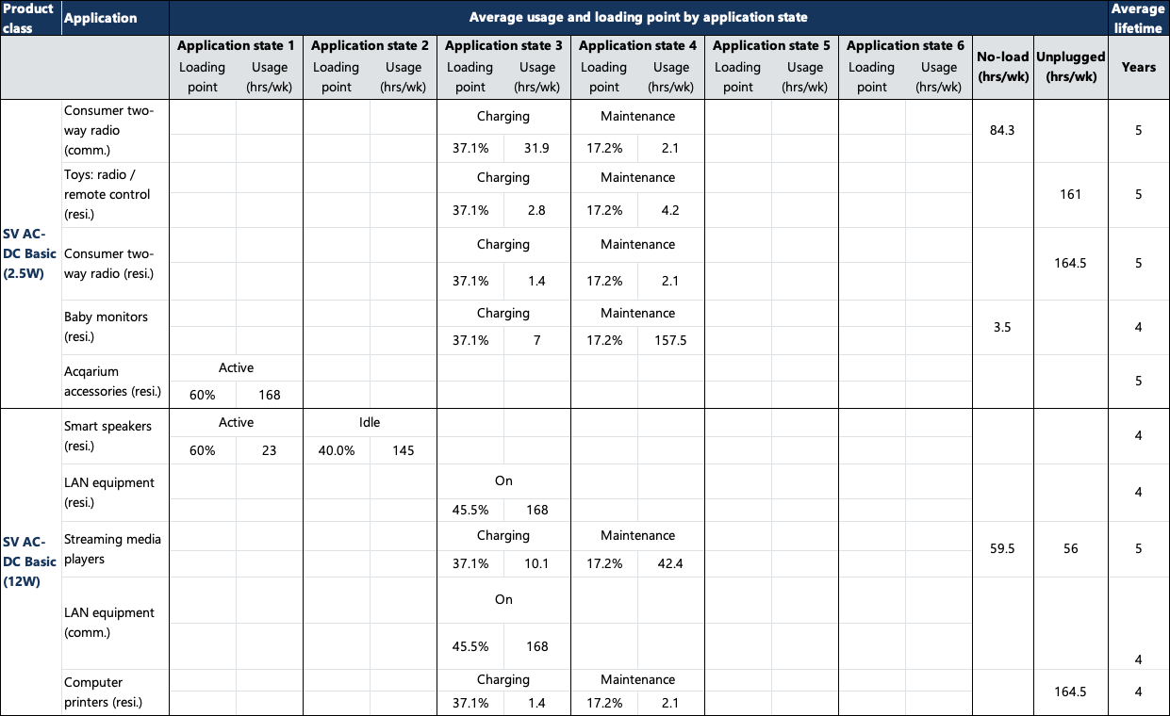

Table 20: Average usage, loading point and lifetime by application state, adapted from DOE analysis (U.S. Department of Energy, 2022) (US Department of Energy, 2008)

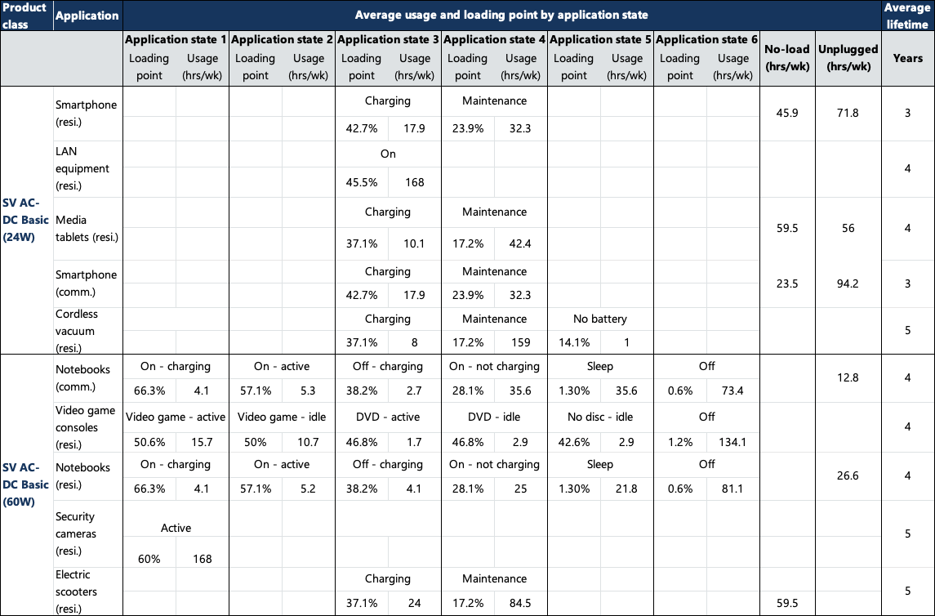

Table 21: Average usage, loading point and lifetime by application state, adapted from DOE analysis (U.S. Department of Energy, 2022) (US Department of Energy, 2008)

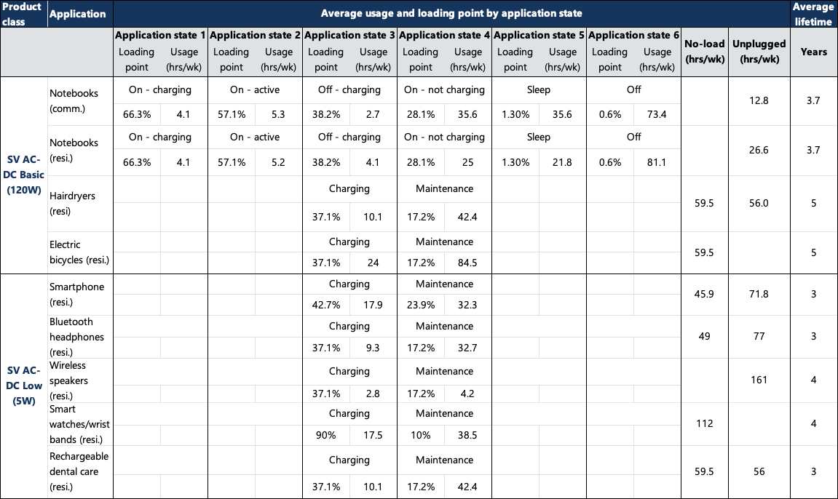

Table 22: Average usage, loading point and lifetime by application state, adapted from DOE analysis (U.S. Department of Energy, 2022) (US Department of Energy, 2008)

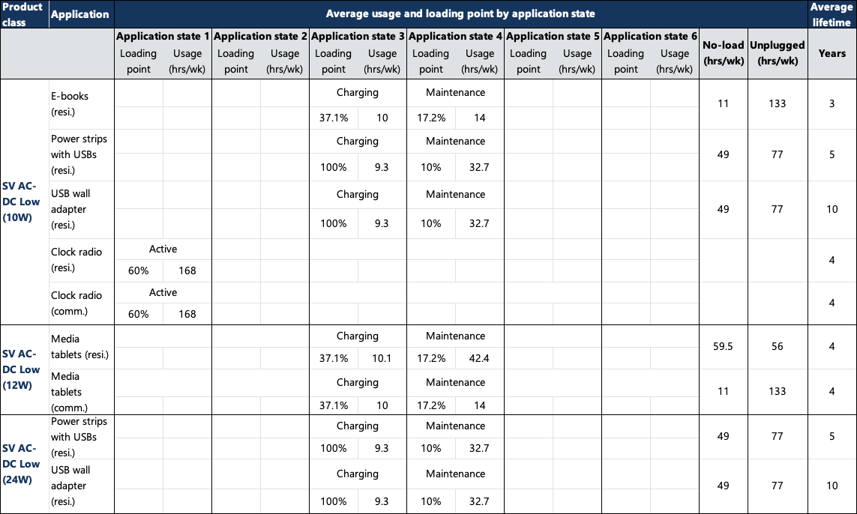

Table 23: Average usage, loading point and lifetime by application state, adapted from DOE analysis (U.S. Department of Energy, 2022) (US Department of Energy, 2008)

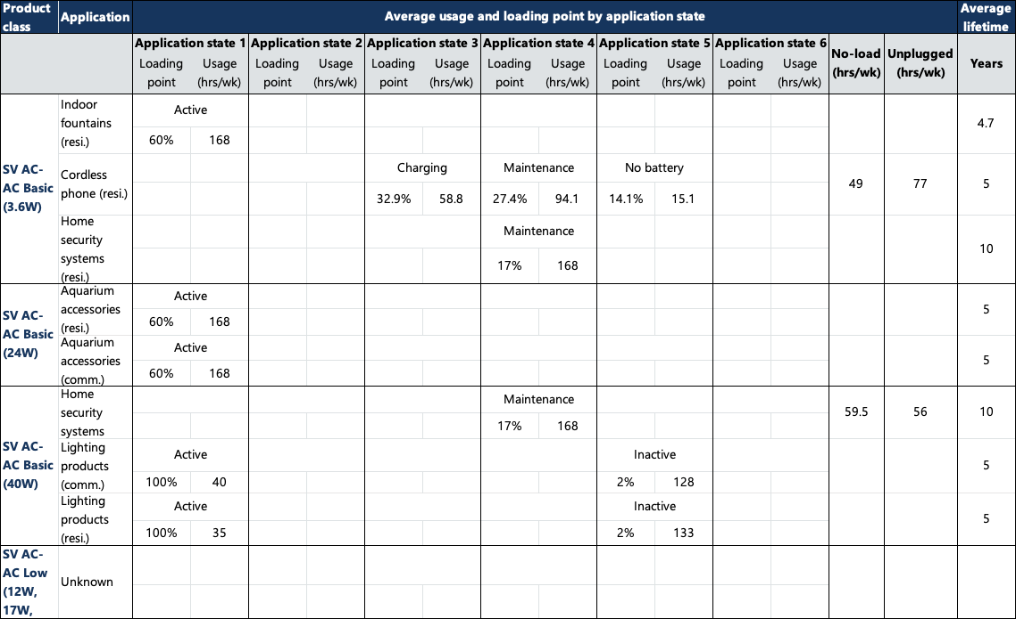

Table 24: Average usage, loading point and lifetime by application state, adapted from DOE analysis (U.S. Department of Energy, 2022) (US Department of Energy, 2008)

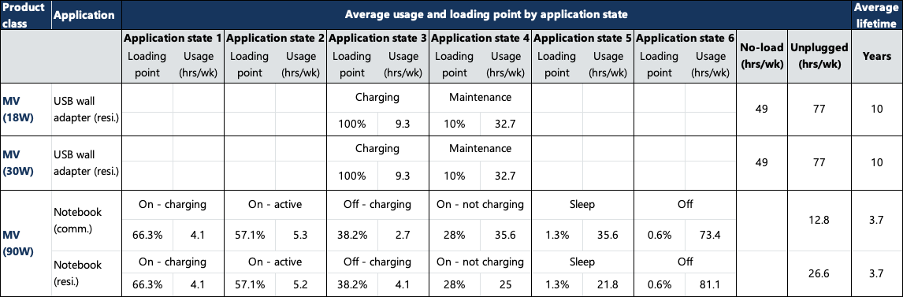

# 

# Efficiency levels

The international efficiency mark levels are summarised in Table 7 below.

Table 25: Efficiency assumptions for the different product classes and Mark levels (Mark III represents the current MEPS, Mark VI is the current US and EU standard, and “mark VII” is the proposed future standard (Office of Energy Efficiency, Department of Energy, 2023). SV=single voltage, MV=multiple voltage

| Mark | Nameplate output power (Pno) | No-load mode power | Average efficiency in active mode |
| --- | --- | --- | --- |
| III | 0 to 1W | ≤ 0.5 | ≥ 0.49 x Pno |
| > 1 to 49W | ≤ 0.75 | ≥ 0.09 x ln(Pno) + 0.49 |
| >49 to 250W | ≥ 0.84 |
| IV | 0 to 1W | ≤ 0.5 | ≥ 0.5 x Pno |
| >1 to ≤ 49W | ≥ 0.09 x ln(Pno) + 0.5 |
| 49 to ≤ 250W | ≥ 0.85 |
| V | 0 to ≤ 1W | AC-DC: ≤ 0.3  AC-AC: ≤ 0.5 | **Basic voltage: ≥ 0.480 x Pno + 0.140  **Low voltage: ≥ 0.497 x Pno +0.067 |
| >1 to ≤ 49W | Basic voltage: ≥ 0.0626 x ln(Pno) + 0.622  Low voltage: ≥ 0.0750 x ln (Pno) + 0.561 |
| >49 to 250W | ≤ 0.5 | Basic voltage: ≥ 0.870  Low voltage: ≥ 0.860 |
| VI (SV) | 0 to ≤ 1W | AC-DC: ≤ 0.100  AC-AC: ≤ 0.210 | Basic voltage: ≥ 0.5 x Pno + 0.16  Low voltage: ≥ 0.517 x Pno + 0.087 |
| > 1 to ≤ 49W | Basic voltage: ≥ 0.071 x ln(Pno) – 0.0014 x Pno + 0.67  Low voltage: ≥ 0.0834 x ln(Pno) – 0.0014 x Pno + 0.609 |
| >49 to ≤ 250W | ≤ 0.210 | Basic voltage: ≥ 0.880  Low voltage: ≥ 0.870 |
| VI (MV) | 0 to 1W | ≤ 0.3 | ≥ 0.497 x Pno + 0.1669 |
| >1 to 49W | ≥ 0.075 x ln(Pno) + 0.561 |
| >49 to 250W | ≥ 0.860 |
| “VII” (SV) | 0 to ≤ 1W | AC-DC: ≤0.075  AC-AC Basic: ≤ 0.075  AC-AC Low: ≤ 0.072 | Basic voltage: ≥ 0.5 x Pno + 0.169  Low voltage: ≥ 0.517 x Pno + 0.091 |
| >1 to ≤ 49W | Basic voltage: ≥ 0.071 x ln(Pno) – 0.00115 x Pno + 0.67  Low voltage: ≥ 0.0834 x ln(Pno) – 0.0011 x Pno + 0.609 |
| 49 to ≤ 250W | AC-DC: ≤0.150  AC-AC Basic: ≤ 0.075  AC-AC Low: ≤ 0.185 | AC-DC Basic voltage: ≥ 0.890  AC-DC Low voltage: ≥ 0.880  AC-AC Basic voltage: ≥ 0.902  AC-AC Low voltage: ≥ 0.880 |
| “VII” (MV) | 0 to 1W | ≤ 0.075 | ≥ 0.497 x Pno + 0.067 |
| >1 to 49W | 0.0782 x ln(Pno) – 0.013 x Pno + 0.643 |
| >49 to 250W | ≤ 0.125 | ≥ 0.885 |

*Low voltage is anything under 6V. All other devices are basic voltage.

# Market size and distribution

Our market size and distribution assumptions are based on extrapolation from two data sources, including:

* New Zealand EPS sales data (2012-2022), provided by Energy Efficiency and Conservation Authority (EECA).
* US Department of Energy, Energy Efficiency and Renewable Energy (EERE) – Preliminary analysis for external power supply (EPS) (US Department of Energy, 2022).

Table 8 below shows the projected 2023 shipments of EPS devices by product class in the US. We have then extrapolated these numbers to the Australian and New Zealand markets based on differences in population. Additional confidential sales data for NZ products was provided by EECA to inform this analysis. There are some differences between the extrapolated US numbers and the EECA data which are likely largely explained by the differences in scope of the GEMS determination and US regulation. However, it is possible that non-compliance in Australia and New Zealand also contributes.

Table 26: Australian and NZ 2023 sales by product class extrapolated based on US 2023 projected shipments included in the DOE EPS analysis (US Department of Energy, 2022) and the 2022 NZ EPS sales recorded in the EECA data.

| Product class | US 2023 shipments | AUS 2023 | NZ 2023 |
| --- | --- | --- | --- |
| SV EPS AC-DC Basic (2.5W) | 6,038,115 | 467,367 | 93,201 |
| SV EPS AC-DC Basic (12W) | 66,854,257 | 5,174,709 | 1,031,920 |
| SV EPS AC-DC Basic (24W) | 136,639,628 | 10,576,294 | 2,109,084 |
| SV EPS AC-DC Basic (60W) | 42,835,544 | 3,315,592 | 661,183 |
| SV EPS AC-DC Basic (120W) | 24,602,274 | 1,904,286 | 379,745 |
| SV EPS AC-DC Low (5W) | 403,049,358 | 31,197,162 | 6,221,217 |
| SV EPS AC-DC Low (10W) | 7,193,982 | 556,835 | 111,042 |
| SV EPS AC-DC Low (12W) | 29,950,654 | 2,318,265 | 462,299 |
| SV EPS AC-DC Low (24W) | 1,925,704 | 149,055 | 29,724 |
| SV EPS AC-AC Basic (3.6W) | 1,717,300 | 132,924 | 26,507 |
| SV EPS AC-AC Basic (24W) | 2,821,659 | 218,404 | 43,553 |
| SV EPS AC-AC Basic (40W) | 3,697,376 | 286,187 | 57,070 |
| SV EPS AC-AC Low (12W) | 221,523 | 17,147 | 3,419 |
| SV EPS AC-AC Low (17W) | 221,523 | 17,147 | 3,419 |
| SV EPS AC-AC Low (24W) | 221,523 | 17,147 | 3,419 |
| MV EPS (18W) | 51,517 | 3,988 | 795 |
| MV EPS (30W) | 257,585 | 19,938 | 3,976 |
| MV EPS (90W) | 1,004,174 | 77,726 | 15,500 |

To account for potential non-compliance within the Australian and New Zealand markets, we have applied a 20% non-compliance factor to the extrapolated Australia and New Zealand figures above and used this as the market size under the expanded scope scenarios. The final market size figures for both current and expanded scope scenarios are shown in Table 9 below.

Table 27: Market size by product class under the current and expanded scope scenarios

| Product class | Australia (current scope) | AUS (expanded scope) | NZ (current scope) | NZ (expanded scope) |
| --- | --- | --- | --- | --- |
| SV EPS AC-DC Basic (2.5W) | 303,190 | 373,894 | 60,461 | 74,561 |
| SV EPS AC-DC Basic (12W) | 476,642 | 4,139,767 | 95,050 | 825,536 |
| SV EPS AC-DC Basic (24W) | 2,823,077 | 8,461,035 | 562,967 | 1,687,267 |
| SV EPS AC-DC Basic (60W) | 978,517 | 2,652,474 | 195,132 | 528,946 |
| SV EPS AC-DC Basic (120W) | 694,131 | 1,523,429 | 138,421 | 303,796 |
| SV EPS AC-DC Low (5W) | 1,497,577 | 24,957,730 | 298,641 | 4,976,974 |
| SV EPS AC-DC Low (10W) | 482,624 | 445,468 | 96,243 | 88,834 |
| SV EPS AC-DC Low (12W) | 132,783 | 1,854,612 | 26,479 | 369,839 |
| SV EPS AC-DC Low (24W) | 118,070 | 119,244 | 23,545 | 23,779 |
| SV EPS AC-AC Basic (3.6W) | 963 | 106,339 | 192 | 21,206 |
| SV EPS AC-AC Basic (24W) | 0 | 174,723 | 0 | 34,842 |
| SV EPS AC-AC Basic (40W) | 0 | 228,950 | 0 | 45,656 |
| SV EPS AC-AC Low (12W) | 57,302 | 13,718 | 11,427 | 2,735 |
| SV EPS AC-AC Low (17W) | 0 | 13,718 | 0 | 2,735 |
| SV EPS AC-AC Low (24W) | 0 | 13,718 | 0 | 2,735 |
| MV EPS (18W) | 0 | 3,190 | 0 | 636 |
| MV EPS (30W) | 0 | 15,950 | 0 | 3,181 |
| MV EPS (90W) | 0 | 62,181 | 0 | 12,400 |

We assumed the following baseline distribution by efficiency level in the current Australian and New Zealand markets. These numbers are based on a combination of EPS registration data and insights from interviews with suppliers. We assumed that products still at mark III and IV were unlikely to increase in efficiency without further regulation, while the mark V products were assumed to continue to increase to mark VI at a rate of 5% per year.

Table 28: Distribution of EPS by product class and efficiency level (combination of public registration data and insights from interviews).

| Product class | Mark III | Mark IV | Mark V | Mark VI |
| --- | --- | --- | --- | --- |
| SV EPS AC-DC Basic (2.5W) | 0% | 6% | 72% | 22% |
| SV EPS AC-DC Basic (12W) | 0.5% | 0.9% | 27% | 71% |
| SV EPS AC-DC Basic (24W) | 0% | 0% | 17% | 83% |
| SV EPS AC-DC Basic (60W) | 0% | 0% | 5% | 95% |
| SV EPS AC-DC Basic (120W) | 0% | 0.1% | 0.1% | 99.8% |
| SV EPS AC-DC Low (5W) | 0.01% | 0.5% | 23% | 77% |
| SV EPS AC-DC Low (10W) | 0% | 0.2% | 30% | 70% |
| SV EPS AC-DC Low (12W) | 0% | 0% | 37% | 63% |
| SV EPS AC-DC Low (24W) | 0% | 0% | 0% | 100% |
| SV EPS AC-AC Basic (3.6W) | 0% | 100% | 0% | 0% |
| SV EPS AC-AC Basic (24W) | 0% | 100% | 0% | 0% |
| SV EPS AC-AC Basic (40W) | 0% | 100% | 0% | 0% |
| SV EPS AC-AC Low (12W) | 0% | 0% | 100% | 0% |
| SV EPS AC-AC Low (17W) | 0% | 0% | 100% | 0% |
| SV EPS AC-AC Low (24W) | 0% | 0% | 100% | 0% |
| MV EPS (18W) | 0% | 5% | 95% | 0% |
| MV EPS (30W) | 0% | 5% | 95% | 0% |
| MV EPS (90W) | 0% | 5% | 95% | 0% |

For Scenario 2 – no regulations, we assumed that the efficiency of mark V and VI products would remain the same over time, as these products are already exceeding the existing standard. We assumed that the efficiency of mark III and IV products would decrease when regulations were removed. We extrapolated the product class power-efficiency curves to define a “mark II” level for each product class and assumed that existing mark III and IV devices would drop to that level when regulations were removed. The “mark II” efficiency levels are defined in Table 11 below.

Table 29: Average active efficiency and no-load for “mark II” – no regulations scenario 2

| Product class | Average active efficiency | No-load power |
| --- | --- | --- |
| SV EPS AC-DC Basic (2.5W) | 0.51 | 0.9 |
| SV EPS AC-DC Basic (12W) | 0.68 | 0.9 |
| SV EPS AC-DC Basic (24W) | 0.74 | 0.9 |
| SV EPS AC-DC Basic (60W) | 0.82 | 1 |
| SV EPS AC-DC Basic (120W) | 0.82 | 1 |
| SV EPS AC-DC Low (5W) | 0.6 | 0.9 |
| SV EPS AC-DC Low (10W) | 0.65 | 0.9 |
| SV EPS AC-DC Low (12W) | 0.68 | 0.9 |
| SV EPS AC-DC Low (24W) | 0.75 | 0.9 |
| SV EPS AC-AC Basic (3.6W) | 0.55 | 0.9 |
| SV EPS AC-AC Basic (24W) | 0.74 | 0.9 |
| SV EPS AC-AC Basic (40W) | 0.8 | 0.9 |
| SV EPS AC-AC Low (12W) | 0.68 | 0.9 |
| SV EPS AC-AC Low (17W) | 0.71 | 0.9 |
| SV EPS AC-AC Low (24W) | 0.75 | 0.9 |
| MV EPS (18W) | 0.65 | 1.08 |
| MV EPS (30W) | 0.7 | 1.8 |
| MV EPS (90W) | 0.75 | 5.4 |

To calculate the energy consumption across the market, we needed to also understand the market distribution by product class and application. Our assumptions are shown in Table 12 below. They are based on the US market distribution by product class and product application provided in the DOE’s EERE cost benefit analysis (US Department of Energy, 2022).

Table 30: EPS market distribution by product application and product category, adapted from US DOE analysis (US Department of Energy, 2022)

| Product category | Range | Product applications | Market share |
| --- | --- | --- | --- |
| SV AC-DC Basic (2.5W) | 0W < Pout < 7.25W | Consumer two-way radio (commercial) | 34% |
| Toys: radio/remote control (residential) | 17% |
| Consumer two-way radio (residential) | 17% |
| Baby monitors (residential) | 16% |
| Aquarium accessories (residential) | 13% |
| Other | 4% |
| SV AC-DC Basic (12W) | 7.25W ≤ Pout < 18W | Smart speakers (residential) | 42% |
| LAN equipment (residential) | 33% |
| Streaming media players | 9% |
| LAN equipment (commercial) | 6% |
| Computer printers (residential) | 3% |
| Other | 7% |
| SV AC-DC Basic (24W) | 18W ≤ Pout < 54W | Smartphone (residential) | 33% |
| LAN equipment (residential) | 14% |
| Media tablets (residential) | 14% |
| Smartphone (commercial) | 9% |
| Cordless vacuum (residential) | 8% |
| Other | 21% |
| SV AC-DC Basic (60W) | 54W ≤ Pout < 90W | Notebooks (commercial) | 34% |
| Video game consoles (residential) | 31% |
| Notebooks (residential) | 23% |
| Security cameras (residential) | 8% |
| Electric scooters (residential) | 2% |
| Other | 1% |
| SV AC-DC Basic (120W) | Pout ≥ 90W | Notebooks (commercial) | 46% |
| Notebooks (residential) | 31% |
| Hairdryers (residential) | 22% |
| Electric bicycles | 1% |
| SV AC-DC Low (5W) | 0W < Pout < 7.5W | Smartphone (residential) | 36% |
| Bluetooth headphones (residential) | 17% |
| Wireless speakers (residential) | 16% |
| Smart watches/Wrist bands (residential) | 8% |
| Rechargeable dental care (residential) | 7% |
| Other | 17% |
| SV AC-DC Low (10W) | 7.5W ≤ Pout < 11W | E-books (residential) | 69% |
| Power strips with USBs (residential) | 22% |
| USB wall adapter (residential) | 5% |
| Clock radio (residential) | 5% |
| Clock radio (commercial) | 0.04% |
| SV AC-DC Low (12W) | 11W ≤ Pout < 18W | Media tablets (residential) | 86% |
| Media tablets (commercial) | 15% |
| SV AC-DC Low (24W) | Pout ≥ 18W | Power strips with USBs (residential) | 81% |
| USB wall adapter (residential) | 19% |
| SV AC-AC Basic (3.6W) | 0W < Pout < 13.8W | Indoor fountains (residential) | 67% |
| Cordless phone (residential) | 19% |
| Home security systems (residential) | 13% |
| SV AC-AC Basic (24W) | 13.8W ≤ Pout < 32W | Aquarium accessories (residential) | 76% |
| Aquarium accessories (commercial) | 24% |
| SV AC-AC Basic (40W) | Pout ≥ 32W | Home security systems (residential) | 28% |
| Lighting products (commercial) | 36% |
| Lighting products (residential) | 36% |
| SV AC-AC Low (12W) | 0W < Pout < 14.5W | Home security systems (residential) | 100% |
| SV AC-AC Low (17W) | 14.5W ≤ Pout < 20.5W | Home security systems (residential) | 100% |
| SV AC-AC Low (24W) | Pout ≥ 20.5W | Home security systems (residential) | 100% |
| MV (18W) | 0W < Pout <24W | USB wall adapter (residential) | 100% |
| MV (30W) | 24W ≤ Pout < 60W | USB wall adapter (residential) | 100% |
| MV (90W) | Pout ≥ 60W | Notebook (commercial) | 59% |
| Notebook (residential) | 41% |

# Market change

The annual New Zealand EPS sales (regulated models only) and the corresponding growth rate are shown in Figure 1 below.

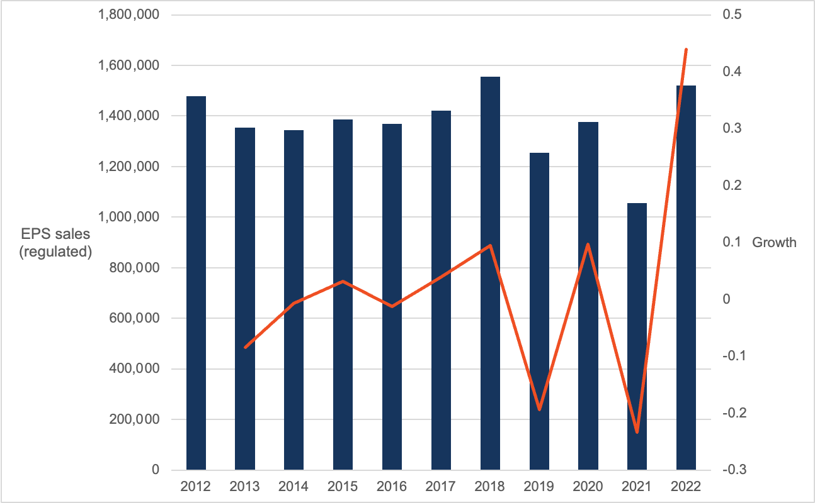

Figure 10: Annual New Zealand EPS sales (regulated models) and the corresponding growth rate

It is difficult to ascertain a trend from this data. This may be the result of inconsistencies in the sales reported to EECA between years or inconsistencies in the number of EPS sales each year. Sales appear relatively stable from 2012 to 2018. There was a sizeable drop in 2019 which is difficult to explain. It appears that the COVID-19 pandemic may have had some impact on the market in 2020 and 2021, which has then corrected in 2022.

As a result of this unclear trend, we will assume growth in EPS sales based on population. We will assume the medium case under the New Zealand National population projections: 2022(base)-2073 (Stats NZ, 2022). For Australia, we will assume the medium series under the ABS Population Projections, Australia (Australian Bureau of Statistics, 2018). We will assume the same growth rate applies across all product categories. This was the same approach taken by the DOE for their recent impact assessment.

# Participant costs and benefits

## Cost to industry

The assumed annual costs to business for complying with the current regulation are shown in Table 13 below. These costs were determined through interviews with suppliers.

Table 31: Annual costs to business for current regulation (Scenario 1, 2 and 3)

|  |  |  |
| --- | --- | --- |
| Annual administrative cost | Annual registration fees | Annual testing cost |
| $77,630 | $487,960 | $984,729 |

Table 14 below shows the assumed costs to industry for the expanded scope scenarios (4 and 5).

Table 32: Annual costs to business for expanded scope regulation (Scenario 4 and 5)

|  |  |  |
| --- | --- | --- |
| Annual administrative cost | Annual registration fees | Annual testing cost |
| $463,456 | $2,913,152 | $0 |

The administrative cost was based on the formula below:

Administrative cost = input cost x time x population

Where:

* Inputs = $70 hourly cost (wages, overhead and non-wage costs)
* Time = 1 hour to complete the registration
* Population (current scope) = 1,109 registrations per year
* Population (expanded scope) = 6,620 registrations per year

The average cost of testing an EPS is assumed to be $888 AUD ($600 USD quoted by supplier in interviews) and all registered products are assumed to require testing. Registration fees are $440 per registration. Note that registrations last for five years. For Scenario 4 and 5 we have assumed that the regulation has been amended to adopt international testing standards so that additional testing is not required to register a product in Australia or New Zealand.

Note that approximately 2% of products are registered in New Zealand. The above costs have been applied to 2% of registrations to calculate the New Zealand industry costs.

## Incremental product cost for increased efficiency

We have extrapolated the cost efficiency curves that were developed for the different product categories in the US DOE analysis. Mark VI was the baseline scenario in the US analysis; hence we have had to readjust our cost baseline to Mark III for this analysis (see example for SV AC-DC Basic Voltage (24W) devices in Figure 2below). This process has been followed for each of the product classes.



Figure 11:Cost-efficiency curve extrapolated from US DOE analysis (US Department of Energy, 2022). Blue crosses represent mark III, mark IV and mark V efficiency levels, red dots represent the US efficiency scenarios tested (including mark VI and the proposed 2027 updated regulation)

We have also included an industry learning factor to account for reduced product manufacturing costs to achieve mark VI since the original implementation of the mark III MEPS level. This reflects stakeholder feedback that the current additional cost to manufacture a mark VI efficiency level is low for most products.

These costs are included as a private industry cost in the Australian analysis. For New Zealand, 50% of the incremental manufacturing costs for compliant products are included as a societal cost to reflect the avoidable economic burden to the community.

Table 33: AC-DC Basic voltage EPS incremental mark-up for active mode efficiency increases. Costs in AUD (2023 pricing).

|  |  |  |  |  |  |  |  |  |  |  |
| --- | --- | --- | --- | --- | --- | --- | --- | --- | --- | --- |
|  | 2.5W | | 12W | | 24W | | 60W | | 120W | |
|  | Active mode efficiency | Incr. mark-up (AUD) | Active mode efficiency | Incr. mark-up (AUD) | Active mode efficiency | Incr. mark-up (AUD) | Active mode efficiency | Incr. mark-up (AUD) | Active mode efficiency | Incr. mark-up (AUD) |
| “Mark II” | 51.00% | -$0.68 | 68.00% | -$0.37 | 74.00% | -$0.60 | 82.00% | -$0.77 | 82.00% | -$0.78 |
| Mark III | 57.25% | $0.00 | 71.36% | $0.00 | 77.60% | $0.00 | 84.00% | $0.00 | 84.00% | $0.00 |
| Mark IV | 58.25% | $0.13 | 72.36% | $0.15 | 78.60% | $0.24 | 85.00% | $0.48 | 85.00% | $0.49 |
| Mark V | 67.93% | $1.98 | 77.76% | $1.44 | 82.09% | $1.43 | 87.00% | $1.66 | 87.00% | $1.75 |
| Mark VI | 73.16% | $3.53 | 82.96% | $4.05 | 86.20% | $3.97 | 88.00% | $2.39 | 88.00% | $2.54 |
| “Mark VII” | 73.22% | $3.55 | 83.26% | $4.27 | 86.80% | $4.50 | 89.00% | $3.23 | 89.00% | $3.46 |

Table 34: AC-DC Low voltage EPS incremental mark-up for active mode efficiency increases. Costs in AUD (2023 pricing)

|  |  |  |  |  |  |  |  |  |
| --- | --- | --- | --- | --- | --- | --- | --- | --- |
|  | 5W | | 10W | | 12W | | 24W | |
|  | Active mode efficiency | Incr. mark-up (AUD) | Active mode efficiency | Incr. mark-up (AUD) | Active mode efficiency | Incr. mark-up (AUD) | Active mode efficiency | Incr. mark-up (AUD) |
| “Mark II” | 60.00% | -$0.60 | 65.00% | -$0.82 | 68.00% | -$0.67 | 75.00% | -$0.72 |
| Mark III | 63.48% | $0.00 | 69.72% | $0.00 | 71.36% | $0.00 | 77.60% | $0.00 |
| Mark IV | 64.48% | $0.20 | 70.72% | $0.24 | 72.36% | $0.25 | 78.60% | $0.35 |
| Mark V | 68.17% | $1.10 | 73.37% | $1.02 | 74.73% | $0.97 | 79.93% | $0.91 |
| Mark VI | 73.62% | $3.00 | 78.70% | $3.53 | 79.94% | $3.35 | 84.04% | $3.42 |
| “Mark VII” | 73.77% | $3.07 | 79.00% | $3.72 | 80.30% | $3.57 | 84.76% | $4.03 |

Table 35: AC-AC Basic voltage EPS incremental mark-up for active mode efficiency increases. Costs in AUD (2023 pricing)

|  |  |  |  |  |  |  |
| --- | --- | --- | --- | --- | --- | --- |
|  | 3.6W | | 24W | | 40W | |
|  | Active mode efficiency | Incr. mark-up (AUD) | Active mode efficiency | Incr. mark-up (AUD) | Active mode efficiency | Incr. mark-up (AUD) |
| “Mark II” | 55.00% | -$0.61 | 74.00% | -$0.71 | 80.00% | -$0.72 |
| Mark III | 60.53% | $0.00 | 77.60% | $0.00 | 82.20% | $0.00 |
| Mark IV | 61.53% | $0.14 | 78.60% | $0.26 | 83.20% | $0.44 |
| Mark V | 70.22% | $1.87 | 82.09% | $1.51 | 85.29% | $1.66 |
| Mark VI | 75.59% | $3.62 | 86.21% | $3.93 | 87.59% | $3.67 |
| “Mark VII” | 75.68% | $3.66 | 86.80% | $4.41 | 88.59% | $4.84 |

Table 36: AC-AC Low voltage EPS incremental mark-up for active mode efficiency increases. Costs in AUD (2023 pricing)

|  |  |  |  |  |  |  |
| --- | --- | --- | --- | --- | --- | --- |
|  | 12W | | 17W | | 24W | |
|  | Active mode efficiency | Incr. mark-up (AUD) | Active mode efficiency | Incr. mark-up (AUD) | Active mode efficiency | Incr. mark-up (AUD) |
| “Mark II” | 68.00% | -$0.68 | 71.00% | -$0.78 | 75.00% | -$0.71 |
| Mark III | 71.36% | $0.00 | 74.50% | $0.00 | 77.60% | $0.00 |
| Mark IV | 72.36% | $0.25 | 75.50% | $0.28 | 78.60% | $0.35 |
| Mark V | 74.74% | $0.97 | 77.35% | $0.89 | 79.94% | $0.90 |
| Mark VI | 79.94% | $3.33 | 82.15% | $3.14 | 84.04% | $3.43 |
| Proposed US 2027 | 80.30% | $3.54 | 82.66% | $3.46 | 84.76% | $4.05 |

Table 37: Multiple voltage EPS incremental mark-up for active mode efficiency increases. Costs in AUD (2023 pricing). Note that the lowest defined international efficiency level for multiple voltage EPS devices is Mark VI.

|  |  |  |  |  |  |  |
| --- | --- | --- | --- | --- | --- | --- |
|  | 18W | | 30W | | 90W | |
|  | Active mode efficiency | Incr. mark-up (AUD) | Active mode efficiency | Incr. mark-up (AUD) | Active mode efficiency | Incr. mark-up (AUD) |
| Mark IV | 70.10% | $0.00 | 75.40% | $0.00 | 82.40% | $0.00 |
| Mark V | 73.90% | $0.86 | 79.80% | $1.38 | 84.20% | $0.69 |
| Mark VI | 77.78% | $2.24 | 81.61% | $2.20 | 86.00% | $1.51 |
| Proposed US 2027 | 84.56% | $6.77 | 87.00% | $6.10 | 88.50% | $2.94 |

## 

## Electricity prices

We have assumed the same retail electricity price projections for Australian jurisdictions as those used in the DRIS for the NCC 2022 update (see Figure 3 below). As EPS sales are unlikely to differ by state, apart from by population, we used a population weighted average national electricity price.



Figure 12: Retail electricity price projections by jurisdiction (NCC DRIS, ACIL Allen (ACIL Allen, 2022)– adjusted to 2022 pricing. NZ figures provided by EECA, LRMC is Long Run Marginal Cost)

We have used the same commercial/residential electricity pricing ratios developed for the Electronic Screens CRIS. These were developed based on a review of commercial electricity tariffs offered by larger electricity retailers. The assumptions are summarised in Table 20.

Table 38: Commercial/Residential electricity price ratio by jurisdiction. Electronic Screens CRIS assumptions provided by DCCEEW.

| Jurisdiction | Commercial/Residential ratio |
| --- | --- |
| NSW | 1.296 |
| VIC | 1.129 |
| QLD | 1.303 |
| SA | 1.206 |
| WA | 1.107 |
| TAS | 0.908 |
| NT | 1.164 |
| ACT | 1.214 |

For New Zealand, we have used the long run marginal cost provided by EECA assumed to be 10.99c/kWh (2023).

## Government costs

We have made the following assumptions for the costs to government of administering and enforcing the EPS regulation in Australia and New Zealand (Table 21). These costs are currently recovered from industry in Australia through product registration fees.

Table 39: Government administration and enforcement costs

| Administration and enforcement cost category | Assumption ($ AUD) |
| --- | --- |
| Input cost (wages, overheads and non-wage costs) | $72 per hour* |
| Time per registration | 30 mins |
| Market screening (non-compliance) | 10 days per year |
| Enquiries | 10% of registrations, 30 mins per enquiry |
| Regulatory reviews and other administrative costs (Australia only) | $200,000 every 5 years |
| Product check-testing | ($850 per test + $100 product cost) x 1% of registered products |

*Based on APS5 at central rate and 1.75 overhead scaling

# Non-participant costs and benefits

## Avoided energy network costs

The reduction in peak demand is based on an assumed conservation load factor (CLF) of 1.0 for external power supplies MEPS (residential and commercial applications). This factor was included in the Energy Efficiency Forecasts: 2019-2041 report prepared for the Australian Energy Market Operator (AEMO) (Strategy. Policy. Research., 2019). Peak demand reduction is calculated using the following formula:

We have assumed a cost benefit of $500/kW (2019 dollars) peak reduction in Australia (as used in the 2019 Jacobs report for the VEU program energy market modelling (JACOBS, 2019)) and an equivalent value of NZD230/kW in New Zealand (used in the Electronic Screens CRIS).

## Health benefits associated with improved air quality

There are health benefits associated with improved air quality resulting from electricity savings in Australia. Reduced pollution resulting from reduced coal or gas generated electricity result in health benefits associated with respiratory and cardiac diseases. We will assume the same benefits used in the NCC DRIS, which are as follows:

* Coal-generated electricity - $2.75/MWh (2022 pricing) from Mazaheri et al. (Mazaheri, et al., 2021)
* Gas-generated electricity - $0.99/MWh (2022 pricing) from 2009 Australian Academy of Technological Sciences and Engineering (ATSE) report (Australian Academy of Technological Sciences and Engineering, 2009)

We have assumed health benefits to be negligible in New Zealand based on the high percentage of renewables in the electricity supply.

## Reduced greenhouse gas emissions

The indirect scope 2 and 3 combined emissions factors from the Australia’s emissions projections 2023 report, published by the Department of Climate Change, Energy, the Environment and Water (Australian Government Department of Climate Change, Energy, the Environment and Water, 2023) have been used for the Australian analysis. For New Zealand, emissions projections were sourced from the He Pou a Rangi Climate Change Commission (New Zealand Government, 2022).

Table 40: New Zealand electricity emissions projections (tonnes/MWh) (source: He Pou a Rangi Climate Change Commission). Australian electricity emissions projections (tonnes/MWh) (source: DCCEEW Australian emissions projections 2023 (Australian Government Department of Climate Change, Energy, the Environment and Water, 2023))

| Year | NZ | AUS (all grid connected) |
| --- | --- | --- |
| 2023 | 0.0921 | 0.73 |
| 2024 | 0.0788 | 0.67 |
| 2025 | 0.0401 | 0.62 |
| 2026 | 0.043 | 0.57 |
| 2027 | 0.0458 | 0.47 |
| 2028 | 0.0485 | 0.39 |
| 2029 | 0.0512 | 0.28 |
| 2030 | 0.0536 | 0.21 |
| 2031 | 0.0562 | 0.20 |
| 2032 | 0.0558 | 0.16 |
| 2033 | 0.0552 | 0.13 |
| 2034 | 0.0551 | 0.10 |
| 2035 | 0.0548 | 0.07 |
| 2036 | 0.0544 | 0.07 |
| 2037 | 0.0541 | 0.07 |
| 2038 | 0.0538 | 0.07 |
| 2039 | 0.0528 | 0.07 |
| 2040 | 0.0517 | 0.07 |

## Social cost of carbon

The central cost of carbon used for the Australian analysis is based on the Ministerial Council on Energy’s statement on the interim value of greenhouse gas emissions reduction (VER) (Australian Energy Market Commission, 2024). The VER measures the dollar value per tonne of avoided greenhouse gas emissions resulting from changes in regulations. A lower sensitivity setting was also tested for Australia using a carbon price forecast taken from the 2022 Decision RIS for a proposal to increase residential building energy efficiency improvements in the National Construction Code (ACIL Allen, 2022).

The New Zealand Government provided different social cost of carbon scenarios (low, central, high) to be used in their analysis.

Table 41: Cost of carbon scenarios for New Zealand. The central scenario was used in the central case in this model.

| Year | Real carbon price (NZD per tonne) - Low scenario | Real carbon price (NZD per tonne) - Central scenario | Real carbon price (NZD per tonne) - High scenario |
| --- | --- | --- | --- |
| 2023 | 59 | 87 | 171 |
| 2024 | 65 | 97 | 182 |
| 2025 | 72 | 107 | 193 |
| 2026 | 78 | 116 | 203 |
| 2027 | 85 | 126 | 214 |
| 2028 | 91 | 136 | 219 |
| 2029 | 98 | 146 | 224 |
| 2030 | 104 | 155 | 230 |
| 2031 | 108 | 161 | 235 |
| 2032 | 112 | 167 | 241 |
| 2033 | 116 | 174 | 247 |
| 2034 | 120 | 180 | 253 |
| 2035 | 124 | 186 | 259 |
| 2036 | 129 | 192 | 265 |
| 2037 | 133 | 198 | 271 |
| 2038 | 137 | 204 | 278 |
| 2039 | 141 | 210 | 284 |
| 2040 | 145 | 216 | 291 |

Table 42: Cost of carbon (AUD 2022 per tonne) – low, central and high scenarios. The central case is from (Australian Energy Market Commission, 2024). The low and high scenarios are from (ACIL Allen, 2022).

| Year | Low (AUD per tonne) | Central (AUD per tonne) | High (AUD per tonne) |
| --- | --- | --- | --- |
| 2023 | 84 | 70 | 125 |
| 2024 | 85 | 70 | 127 |
| 2025 | 87 | 75 | 129 |
| 2026 | 89 | 80 | 131 |
| 2027 | 91 | 84 | 133 |
| 2028 | 92 | 89 | 136 |
| 2029 | 94 | 95 | 138 |
| 2030 | 96 | 105 | 140 |
| 2031 | 97 | 114 | 142 |
| 2032 | 99 | 124 | 144 |
| 2033 | 101 | 135 | 146 |
| 2034 | 103 | 146 | 149 |
| 2035 | 105 | 157 | 151 |
| 2036 | 107 | 169 | 153 |
| 2037 | 108 | 181 | 155 |
| 2038 | 110 | 194 | 157 |
| 2039 | 112 | 207 | 160 |
| 2040 | 114 | 221 | 162 |

Appendix Two: Detailed modelling results

# Sensitivity analysis

Table 43: Sensitivity analysis settings

|  | Central | High | Low |
| --- | --- | --- | --- |
| Discount rate (AUS) | 7% | 3% | 10% |
| Discount rate (NZ) | 5% | 2% | 8% |
| Cost of carbon (AUS) | VER (AEMC) | Social cost of carbon high scenario (ACIL Allen, 2022) | Social cost of carbon medium scenario(ACIL Allen, 2022) |
| Cost of carbon (NZ) | Central | High | Low |

## Central scenario results Australia

Table 44: Modelling results (central scenario) for Australia. Scenarios compared to BAU baseline modelled out to 2040

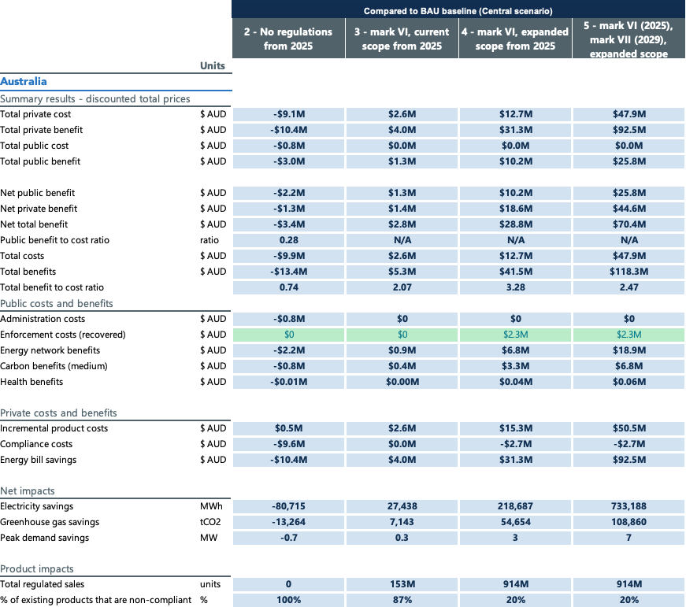

## Central scenario results New Zealand

Table 45: Modelling results (central scenario) for New Zealand. Scenarios compared to BAU baseline modelled out to 2040

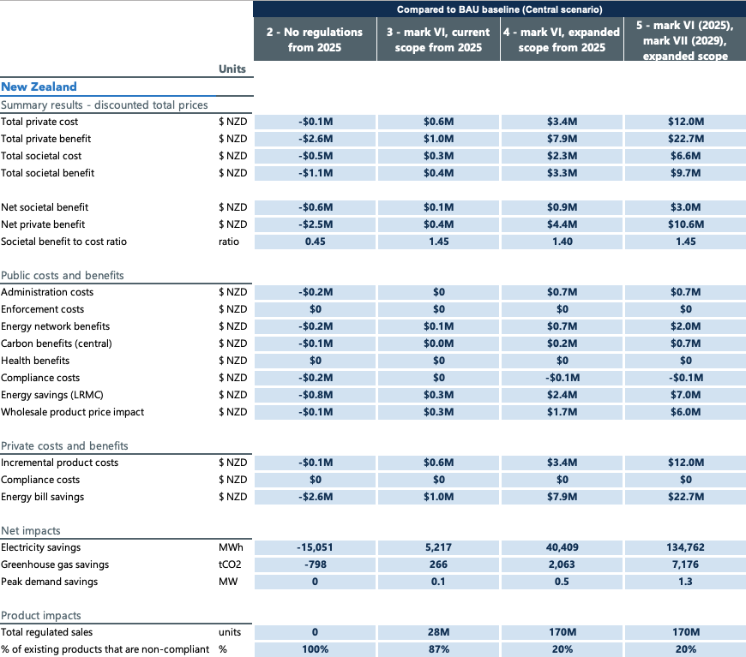

## High scenario results Australia

Table 46: Modelling results (high scenario) for Australia. Scenarios compared to BAU baseline modelled out to 2040

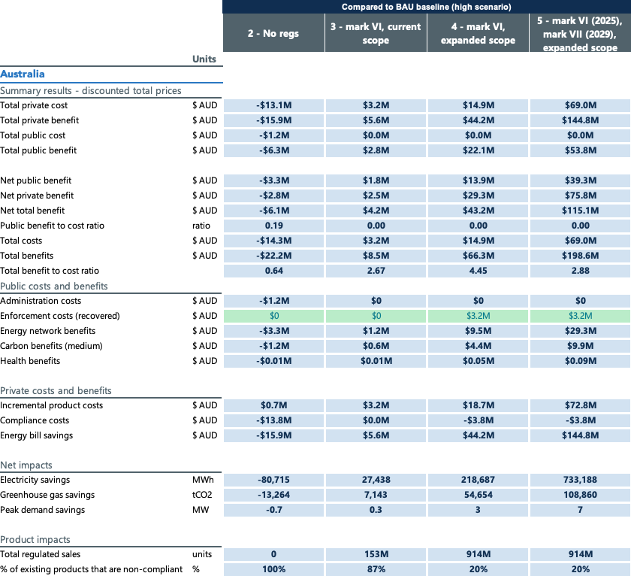

## High scenario results New Zealand

Table 47: Modelling results (high scenario) for New Zealand. Scenarios compared to BAU baseline modelled out to 2040

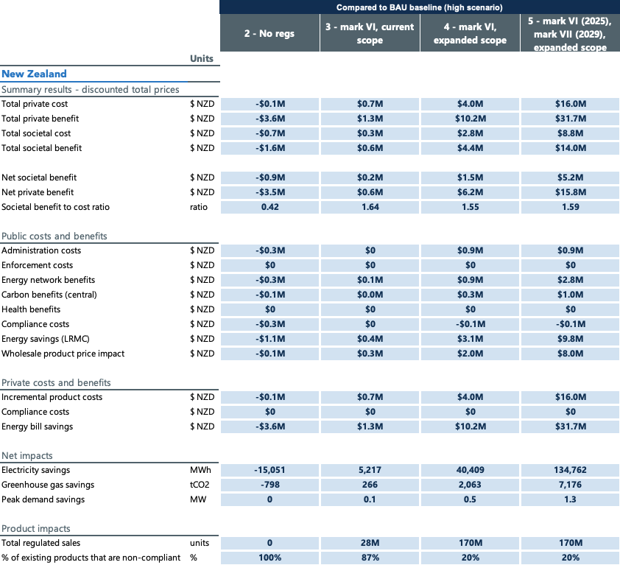

## Low scenario results Australia

Table 48: Modelling results (low scenario) for Australia. Scenarios compared to BAU baseline modelled out to 2040

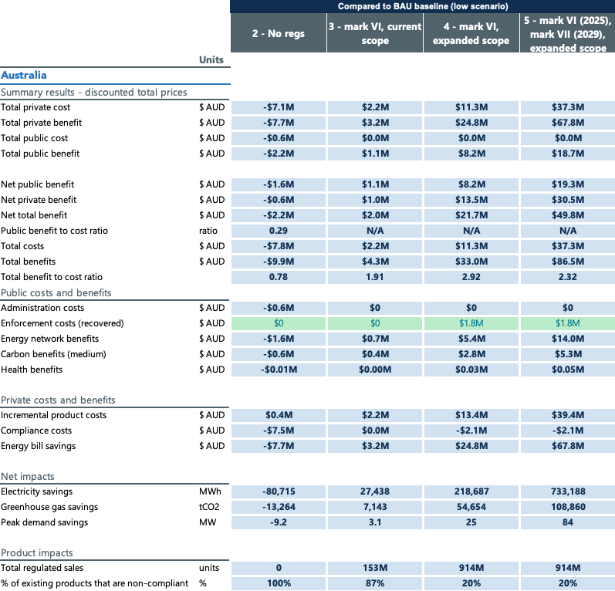

## Low scenario results New Zealand

Table 49: Modelling results (low scenario) for New Zealand. Scenarios compared to BAU baseline modelled out to 2040

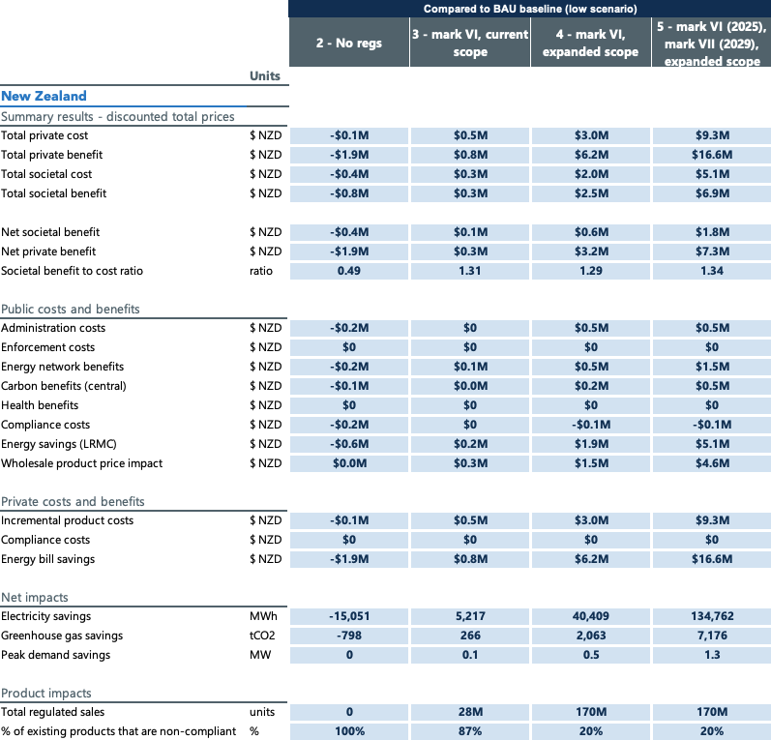

Table 50: CBA results for scenario 2 (no regulations) compared to BAU baseline, from 2025 when regulations are removed to 2040, for Australia

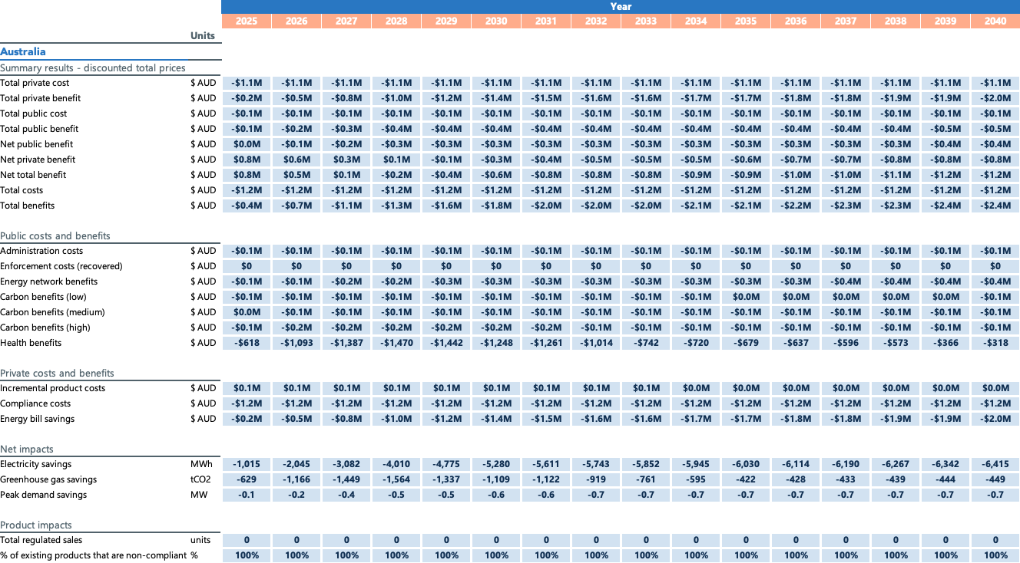

Table 51: CBA results for scenario 2 (no regulations) compared to BAU baseline, from 2025 when regulations are removed to 2040, for New Zealand

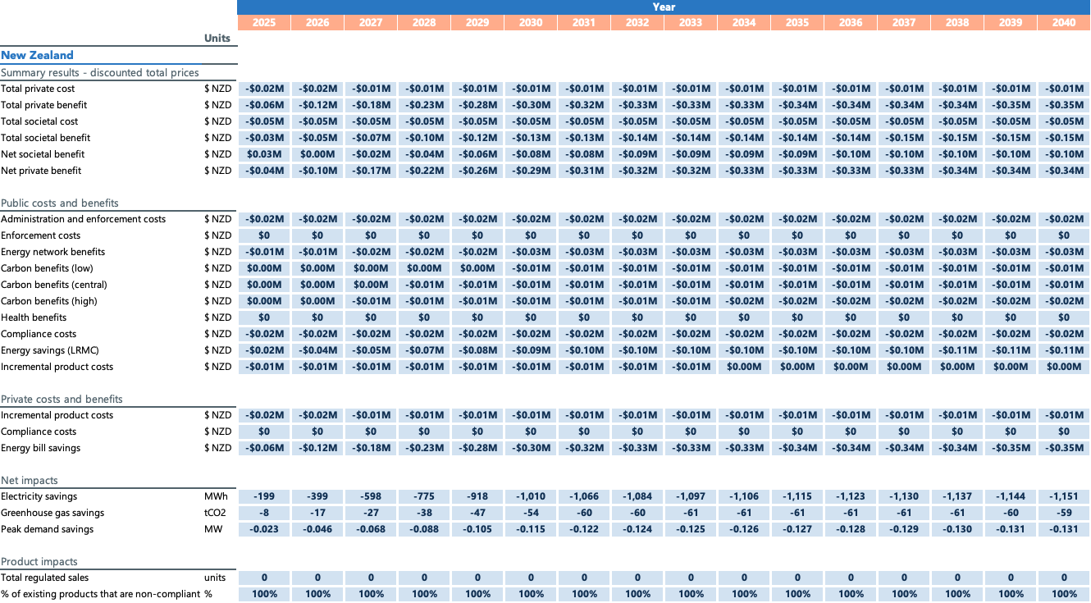

Table 52: CBA results for scenario 3 (Mark VI from 2025, current scope) compared to BAU baseline, for Australia

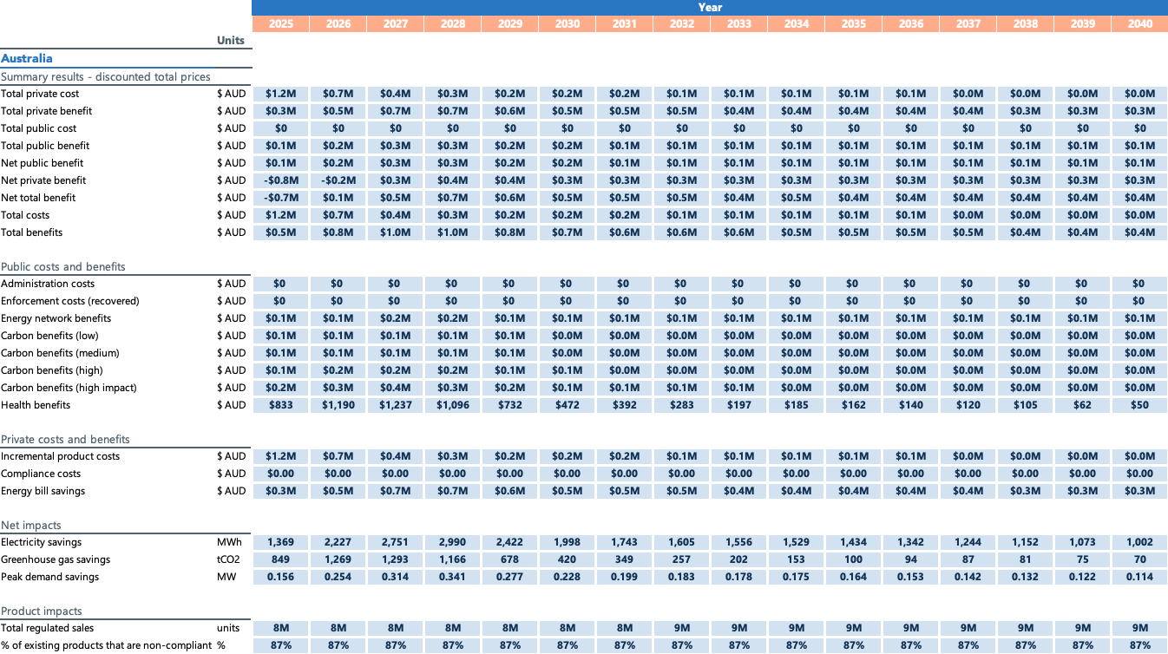

Table 53: CBA results for scenario 3 (Mark VI from 2025, current scope) compared to BAU baseline, for New Zealand

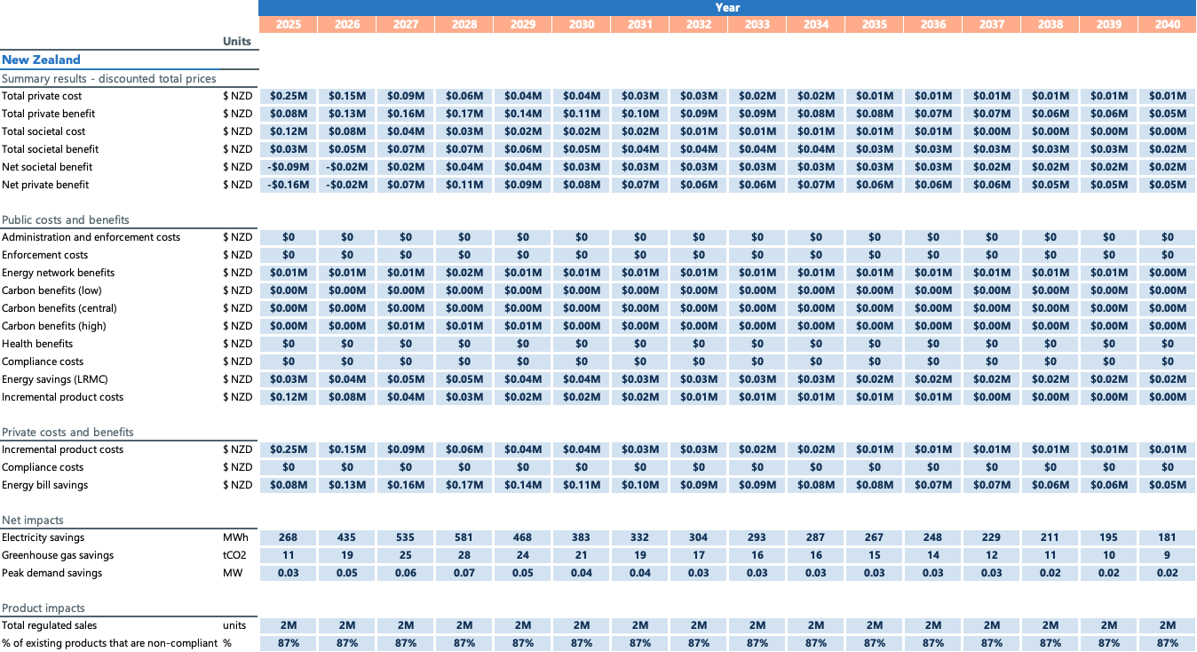

Table 54: CBA results for scenario 4 (Mark VI from 2025, expanded scope) compared to BAU baseline, for Australia

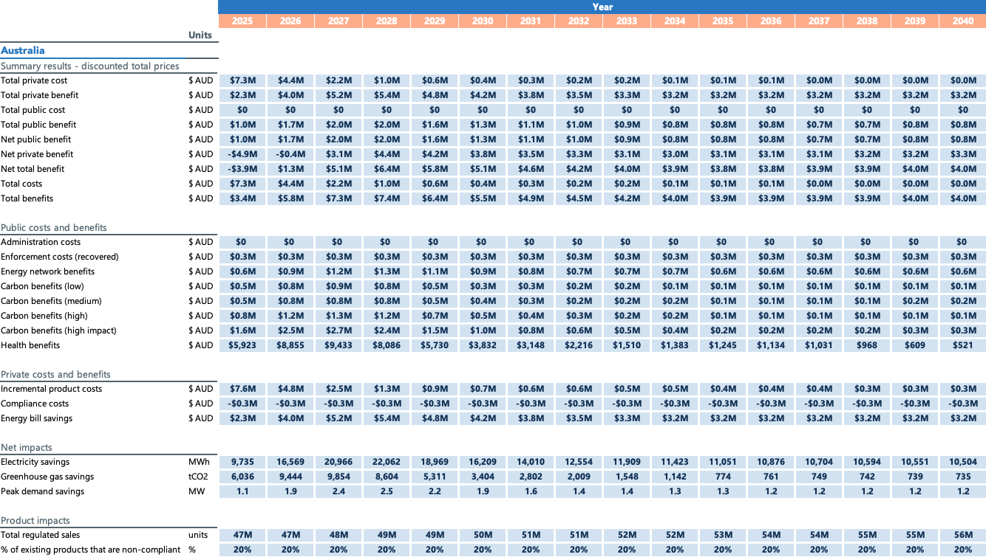

Table 55: CBA results for scenario 4 (Mark VI from 2025, expanded scope) compared to BAU baseline, for New Zealand

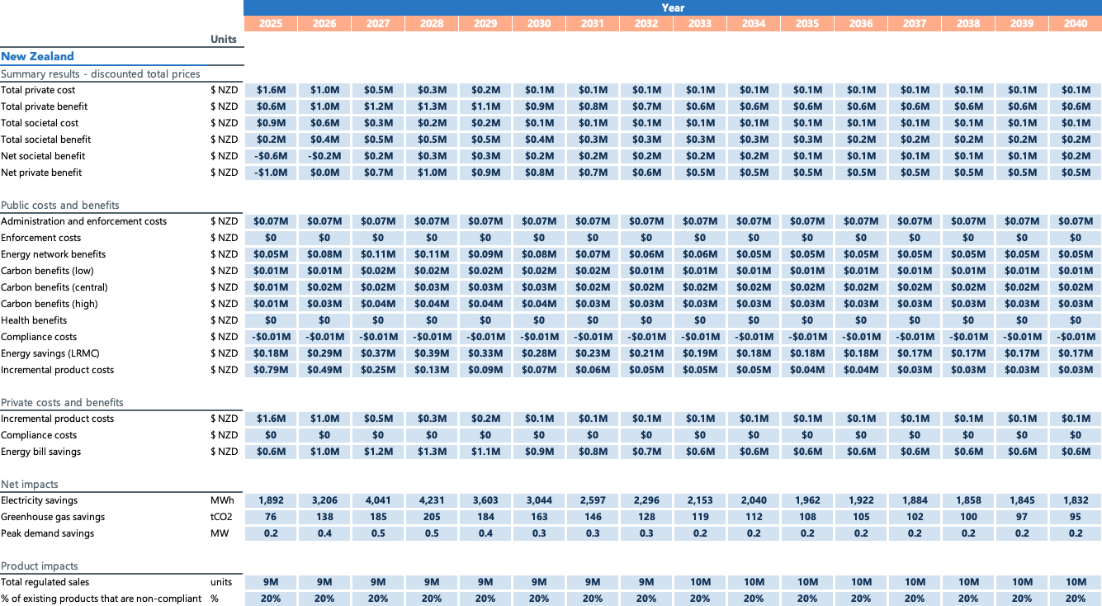

Table 56: CBA results for scenario 5 (Mark VI from 2025, mark VII from 2029, expanded scope) compared to BAU baseline, for Australia

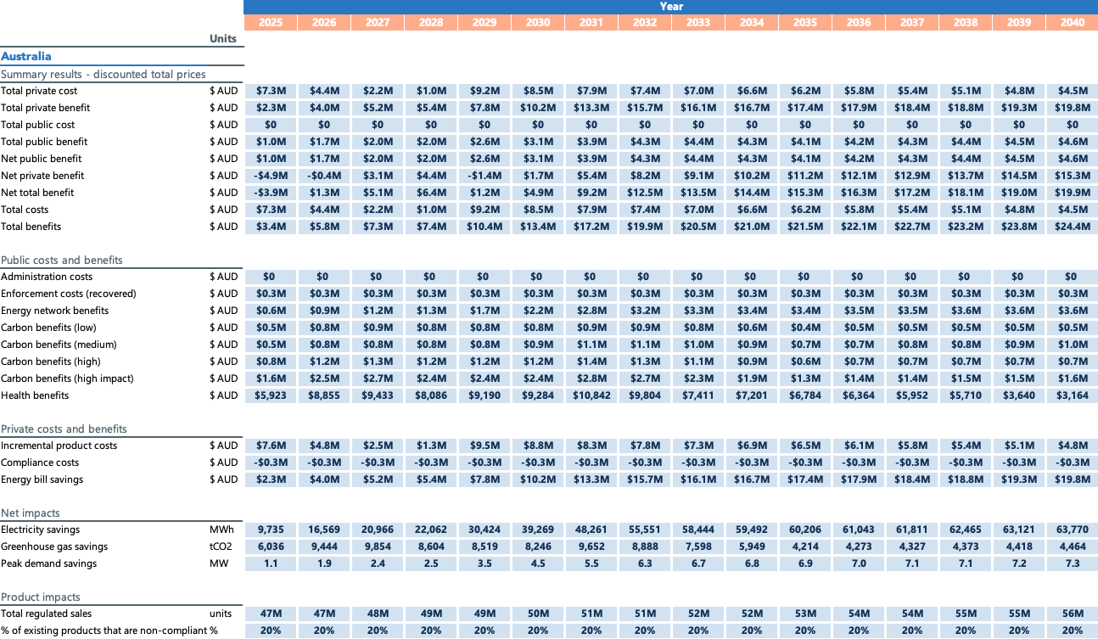

Table 57: CBA results for scenario 5 (Mark VI from 2025, mark VII from 2029, expanded scope) compared to BAU baseline, for New Zealand

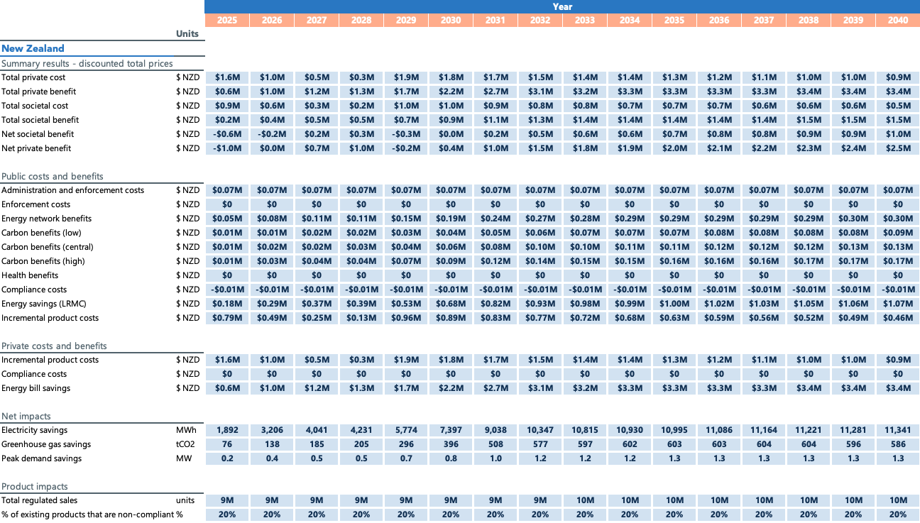

1. All financial estimates are in present value terms to 2040, discounted at 7% in Australia and 5% in New Zealand (unless otherwise specified).
2. In Australia, the GEMS Act (subsection 14(1)) states that supplying a GEMS product includes a supply of the product by way of sale, exchange, gift, lease, loan, hire or hire‑purchase. In New Zealand the regulations cover sale, lease, hire and hire-purchase.