Improving the water efficiency of commercial ice makers

**Impact Analysis**

Prepared by the Department of Climate Change, Energy the Environment and Water

© Commonwealth of Australia 2025

Ownership of intellectual property rights

Unless otherwise noted, copyright (and any other intellectual property rights) in this publication is owned by the Commonwealth of Australia (referred to as the Commonwealth).

Creative Commons licence

All material in this publication is licensed under a [Creative Commons Attribution 4.0 International Licence](https://creativecommons.org/licenses/by/4.0/legalcode) except content supplied by third parties, logos and the Commonwealth Coat of Arms.

Inquiries about the licence and any use of this document should be submitted via our online contact [form](https://www.dcceew.gov.au/about/contact).



Cataloguing data

This publication (and any material sourced from it) should be attributed as: Improving the Water Efficiency of Commercial Ice Makers, Department of Climate Change, Energy, the Environment and Water, Canberra, February. CC BY 4.0.

This publication is available at *TBC – updated on completion of the Impact Analysis*.

Department of Climate Change, Energy, the Environment and Water

GPO Box 3090 Canberra ACT 2601

Telephone 1800 920 528

Web dcceew.gov.au

Disclaimer

The Australian Government acting through the Department of Climate Change, Energy, the Environment and Water has exercised due care and skill in preparing and compiling the information and data in this publication. Notwithstanding, the Department of Climate Change, Energy, the Environment and Water, its employees and advisers disclaim all liability, including liability for negligence and for any loss, damage, injury, expense or cost incurred by any person as a result of accessing, using or relying on any of the information or data in this publication to the maximum extent permitted by law.

Contents

Summary 7

Glossary 10

1. Background and problem 11

Commercial Ice Makers 11

Technology 11

Product categories 12

The industry 15

Users of ice 15

Operating costs 16

Availability of information 18

Current regulations 19

The problem 20

2. Objectives of government intervention 23

3. Policy options 28

The following list of policy options is subject to revision following consultation with stakeholders. 28

3.1 Option 1. Status quo 28

3.2 Option 2. Voluntary declaration with WELS support (Non-regulatory) 29

3.3 Option 3A. Product registration and information declaration (Regulatory) 30

3.4 Option 3B. Product registration and information declaration - accelerated implementation (Regulatory) 31

3.5 Option 4A. Product registration, Minimum Water Efficiency Standards and information declaration (Regulatory) 31

3.6 Option 4B. Product registration, Minimum Water Efficiency Standards and information declaration - accelerated implementation (Regulatory) 32

3.7 Timing and sequencing of options 32

4. Projected costs and benefits 36

4.1 Scenarios modelled 36

4.2 Projected benefits 36

4.3 Projected costs 41

WELS Regulator burden 43

Purchaser burden 44

4.4 Benefit/cost analysis 45

Uncertainty and sensitivity 49

4.5 Stakeholder Impacts 51

Suppliers 51

Purchasers 52

The WELS Regulator 53

Impacts on competition 54

References 55

Appendix A Questions for Stakeholders 57

Appendix B Cost-Benefit Modelling Details 62

Water Prices 62

Operating costs 64

Projected trends 67

Product prices 72

Administrative costs 73

Appendix C US Data on CIM water use 74

Appendix D New Zealand costs and benefits 83

#### Table of Figures

Table 1 Categories of Commercial Ice Maker 14

Table 2 Indicative Timing 33

Table 3 Summary of Proposed options 35

Table 4 Estimates of Regulatory Burden Costs per liable entity 42

Table 5 Estimate of total regulatory burden 43

Table 6 Change in costs ($ million) by sector 43

Table 7 Estimates of costs to WELS Regulator 44

Table 8 Summary of projected costs and benefits, Australia 46

Table 9 Sensitivity to discount rate assumptions, Australia 49

Table 10 sensitivity to cooling water reuse assumptions 50

Table 11 Summary of projected costs and benefits, Australia (Price doubled) 50

Table 12 simple payback period (years) for cim purchasers 53

Table 13 Estimated mains-supplied water charges by jurisdiction, 2025 62

Table 14 Capacity, Market share and BAU water-intensity by CIM class 65

Table 15 Estimated lifetime capital and operating costs for individual icemakers, 2025 (Australian average) 66

Table 16 Potable water use by USEPA Energy Star certified CIMs, 2024 74

Table 17 Condenser water use by USDOE Registered water-cooled CIMs, 2024 75

Table 18 Estimates of cost to New Zealand industry and Regulators 86

Table 19 Summary of projected costs and benefits, New Zealand 87

Table 20 Sensitivity to discount rate assumptions, New Zealand 88

Figure 1 Ice maker refrigeration cycle 12

Figure 2 Self-contained ice maker, modular ice maker with ice storage bin and ice maker with dispenser 13

Figure 3 NPV of Lifetime operating costs by class of CIM (7% discount rate) 17

Figure 4 Indicative water efficiency trends by option 37

Figure 5 Water consumption by jurisdiction, CIMs purchased 2025-40, Australia 38

Figure 6 Water consumption by purpose, CIMs purchased 2025-40, Australia 39

Figure 7 Water consumed by CIMs sold 2025-2040, Australia 40

Figure 8 Water saved by WELS option for CIMs sold 2025-2040, Australia 41

Figure 9 Costs (C), Benefits (B) and B/C ratios by option, Australia 47

Figure 10 NPV of program costs, 2025-2040, Australia 47

Figure 11 Stacked benefits by stringency of WELS options by CIM configuration, Australia 48

Figure 12 Projected water prices by jurisdiction 64

Figure 13 Projected water-intensity trends for IMH-Air-Batch CIMs 69

Figure 14 Projected water-intensity trends for IMH-Air-Cont CIMS 69

Figure 15 Projected cooling water-intensity trends for IMH-Water-Batch CIMS 70

Figure 16 Projected cooling water-intensity trends for IMH-Water-Cont CIMS 70

Figure 17 Projected water-intensity trends for SCU-Air-Batch CIMs 71

Figure 18 Projected water-intensity trends for SCU-Air-Cont CIMs 71

Figure 19 ES certified CIMs, IMH-Batch-Air, Energy & potable water intensity by capacity 76

Figure 20 ES certified CIMs, IMH-Cont-Air, Energy & potable water intensity by capacity 76

Figure 21 ES certified CIMs, SCU-Batch-Air, Energy & potable water intensity by capacity 77

Figure 22 ES certified CIMs, SCU-Cont-Air, Energy & potable water intensity by capacity 77

Figure 23 ES certified CIMs, Split-Batch-Air, Energy & potable water intensity by capacity 78

Figure 24 ES certified CIMs, Split-Cont-Air, Energy & potable water intensity by capacity 78

Figure 25 ES certified CIMs, IMH-Batch-Air, Potable water- vs energy- intensity 79

Figure 26 ES certified CIMs, SCU-Batch-Air, Potable water- vs energy-intensity 79

Figure 27 ES certified CIMs, Split-Batch-Air, Potable water- vs energy-intensity 80

Figure 28 UDDOE registered CIMs, IMH-Batch-Water, Cooling water-vs energy-intensity 80

Figure 29 USDOE registered CIMs, IMH-Cont-Water, Cooling water-vs energy-intensity 81

Figure 30 USDOE registered CIMs, SCU-Batch-Water, Cooling water-vs energy-intensity 81

Figure 31 USDOE registered CIMs, SCU-Cont-Water, Cooling water-vs energy-intensity 82

Figure 32 Water consumed by CIMs sold 2025-2040, New Zealand 85

Figure 33 Water saved by WELS option for CIMs sold 2025-2040, New Zealand 85

Figure 34 NPV of costs and benefits, 2025-2040, New Zealand 87

Figure 35 NPV of program costs, 2025-2040, New Zealand 88

# Summary

This draft Regulatory Impact Analysis considers policy options to improve the water efficiency of commercial ice makers (CIMs) supplied in Australia.

Ice is used for a wide range of applications in the production, transport, preparation, display and service of food, beverages, medicines, and other perishable products. Common uses include cubed ice served in drinks, and flaked ice as a bed for displaying seafood.

Ice makers generally use potable water to produce food-grade ice. The majority of CIMS are air-cooled, however some models also use water (not necessarily potable) as the cooling medium. At present, CIM suppliers make very little information available to purchasers about the water use of the products they offer in Australia, although water represents the largest component of lifetime operating costs after energy (and for some CIM types, even more than energy).

A Determination under the *Greenhouse and Energy Minimum Standards (GEMS) Act 2012* which came into force on 3 March 2025 imposes Minimum Energy Performance Standards on CIMs to be supplied or offered for supply after 3 March 2026. The GEMS Determination defines CIMs as automatic ice makers with provision for both water supply and drainage connections and a production capacity up to 1,000 kg/24hr when tested in accordance with specified standards. It excludes manual-fill ice makers and those built into domestic refrigerators.

The GEMS Determination requires suppliers to declare CIM energy use to the GEMS Regulator. It also allows for the voluntary declaration of CIM water use rates. It is uncertain whether suppliers will voluntarily declare water use information in sufficient numbers and whether the information will be disseminated in ways and at times that can usefully inform CIM purchasing decisions.

The Water Efficiency Labelling and Standards (WELS) scheme has the objective of reducing the water consumption of selected products. The *Water Efficiency Labelling and Standards Act 2005* (WELS Act) provides for the mandatory registration of products, application of water rating labels, and Minimum Water Efficiency Standards. At present it regulates showers, taps, flow controllers, toilets, urinals, clothes washers and dishwashers.

CIMs consume significant quantities of water – over 6.1 Gigalitres (litres x 109) per annum in Australia, equivalent to the water use of about 35,000 households. Water efficiency varies widely across product types (e.g. air versus water cooling) and within types. Purchasers could make substantial lifetime savings if they compared the water use of alternative models and selected the more efficient models on offer.

About 10,500 CIMs are sold in Australia each year, with an estimated installed stock of about 65,000. There is only one Australian manufacturer, and most of the market is supplied by imports from Europe, China and the USA. CIM water use is increasing due to growth in population and in the foodservice and food retailing sectors.

Purchasers are rarely aware of the water consumption or operating costs of the models they are considering because the information is either unavailable or presented in ways that make it difficult or impossible to compare models. This is a significant information failure, preventing purchasers from identifying water efficient products. This results in purchasers spending more on water use than if they were properly informed and could compare the water use of products prior to purchase.

Furthermore, some CIMs are purchased by intermediaries who may be unconcerned with the operating costs, which will be borne by the end user.

WELS has developed a range of options to improve the water efficiency of CIMs, leveraging the GEMS Determination and using the same tests standards and product scope definitions. The objective is to make trusted, reliable, consistent, comprehensive and readily accessible information available to purchasers, regarding the complete operating costs of CIMs.

The costs and benefits of the following 5 options have been modelled and compared with the status quo (Option 1). The status quo represents CIM suppliers being able to voluntarily declare water use data to the GEMS Regulator.

* Option 2: Voluntary declaration with WELS Support (no new regulation). WELS works with suppliers and purchasers to encourage the declaration of water use to the GEMS Regulator, with the aim of at minimum 80% of registrants declaring water use and representing at minimum 80% of models (ensuring less water efficient models are also covered).
* Option 3A: Product registration, information declaration and labelling (regulated under WELS Act).
* Option 3B: Product registration, information declaration and labelling (regulated under WELS Act) - accelerated implementation without assessing the success of Option 2 if implemented.
* Option 4A: Product registration, Minimum Water Efficiency Standards and information declaration (regulated under WELS Act). This option would exclude the least water efficient products from the market.
* Option 4B: Product registration, Minimum Water Efficiency Standards and information declaration (regulated under WELS Act) – accelerated implementation.

The benefit under each option is calculated as the net present value (NPV) of the projected savings in water supply and wastewater charges due to the purchase of CIMs that are, on average, more water efficient than under the status quo (Option 1). The modelling covers all CIMs expected to be sold in Australia between 2025 and 2040.

The costs of each option comprise:

* The costs to industry of internal administration, revising brochures and advertising, interacting with the WELS Regulator and purchasers and (for regulatory options) payment of registration fees to the WELS Regulator. There are no testing costs beyond the status quo, as the test reports required for GEMS registration include water use measured under the same standard test.
* The administration costs to the WELS Regulator, beyond those covered by registration fee income.
* The costs to purchasers of price increases due to improvements in the average water efficiency of CIMs, whether forced by Minimum Water Efficiency Standards or voluntarily incurred through exercising a preference for more water efficient models.

The costs and benefits are summarised in the following table. They are expressed in terms of the present value (PV) in real 2025 dollars (ignoring inflation), with expenditures and savings in future years discounted at 7%. The sensitivity of outcomes to key inputs and to discount rates of 3% and 10% have also been modelled. Outcomes are cost-effective (Benefits/Costs ratio >1) under scenarios modelled.

|  |  |  |  |  |  |  |  |  |  |
| --- | --- | --- | --- | --- | --- | --- | --- | --- | --- |
|  | Costs ($M PV) compared with status quo | | | | Benefits ($M NPV) | | Benefits/ Costs | GL water saved | |
|  | Industry | WELS | Purchasers | Total | Gross | Net | In 2040 | 2025-48 |
| Option 2 | 0.8 | 0.8 | 2.2 | 3.8 | 32.5 | 28.7 | 8.5 | 0.4 | 4.6 |
| Option 3A | 2.4 | 0.7 | 3.6 | 6.7 | 35.3 | 28.6 | 5.3 | 0.6 | 6.2 |
| Option 3B | 2.7 | 0.8 | 4.1 | 7.6 | 37.9 | 30.3 | 5.0 | 0.6 | 7.2 |
| Option 4A | 2.3 | 0.9 | 13.9 | 17.1 | 70.0 | 52.9 | 4.1 | 1.8 | 22.0 |
| Option 4B | 2.5 | 0.7 | 11.9 | 15.1 | 63.3 | 48.2 | 4.2 | 1.5 | 18.4 |

**Have your say**

The release of this draft Regulatory Impact Analysis marks the beginning of a public consultation period. Appendix A, Questions for Stakeholders, lists specific questions which stakeholders are invited to answer. Stakeholders can respond to these questions as an electronic survey or by submission.

The responses will inform the preparation of a final Regulatory Impact Analysis.

Submissions and enquiries can be directed to wels@dcceew.gov.au.

Survey responses and submissions on this document close on 20 June 2025.

Information sessions will be held by videoconference on 27 and 29 May 2025.

## Glossary

|  |  |
| --- | --- |
| AS/NZS | Australian/New Zealand Standard |
| AHRI | Air Conditioning, Heating and Refrigeration Institute (USA) |
| ANSI | American National Standards Institute |
| ASHRAE | American Society of Heating, Refrigerating and Air-Conditioning Engineers |
| Batch | Mode of production for shaped ice |
| BAU | Business as usual |
| CIM | Commercial ice maker |
| Cont(inuous) | Mode of production for flaked ice |
| DCCEEW | Department of Climate Change, Energy the Environment and Water |
| E3 | Equipment Energy Efficiency program |
| EECA | Energy Efficiency and Conservation Authority (New Zealand) |
| ES | Energy Star program of the USEPA |
| GEMS | Greenhouse and Energy Minimum Standards (Commonwealth Act, 2012) |
| GL | Gigalitres (litres x 109) |
| HE | High efficiency |
| IMH | Ice making head (configuration of CIM) |
| ISO | International Standards Organization |
| kg/24hrs | Maximum production capacity of a commercial ice maker (at a defined rating point) |
| kL | Kilolitres (litres x 103) |
| kWh/kg | Electrical energy (kWh) consumed to produce a kg of ice (at a defined rating point) |
| L/kg | Water (litres) consumed to produce a kg of ice (at a defined rating point) |
| MEPS | Minimum Energy Performance Standards |
| NAFES | National Association of Food Equipment Suppliers |
| NPV | Net Present Value: PV of projected costs less PV of projected benefits |
| PV | Present value of a stream of projected values, calculated using a specified discount rate |
| Rating point | A CIM operating condition defined by ambient air and supplied water temperatures |
| SCU | Self-contained unit (configuration of CIM) |
| RCRC | Remote condensing (i.e. split) and remote compressor (configuration of CIM) |
| RCU | Remote condensing unit (i.e. split) but not remote compressor (configuration of CIM) |
| Split | A CIM in which the IMH and condenser are physically separate (RCRC and RCU) |
| TTMRA | Trans-Tasman Mutual Recognition Act |
| USDOE | US Department of Energy |
| USEPA | US Environmental Protection Agency |
| WELS | Water Efficiency Labelling and Standards (Commonwealth Act, 2005) |

# Background and problem

## Commercial Ice Makers

Commercial ice makers (CIMs) are part of the standard equipment needed to operate food, catering and hospitality businesses. They consume potable water to produce food-grade ice. The majority of CIMs are air-cooled, however some models also use water (not necessarily potable) as the cooling medium. At present, CIM suppliers make very little information available to purchasers about the water use of the products they offer, although water represents the largest component of lifetime operating costs after energy (and for some CIM types, even more than energy).

As there is a wide range in the water efficiency of different models, many purchasers select products which consume more water than would be the case if they had access to this information prior to their purchase, or if all CIMs were subject to Minimum Water Efficiency Standards. The difference can amount to hundreds or even thousands of dollars in excess running costs over the CIM’s service life.

Technology

Ice is used for a wide range of applications in the production, transport, preparation, display and service of food, beverages, medicines, and other perishable products. Common uses include cubed ice served in drinks, and flaked ice as a bed for displaying seafoods. Ice makers generally use potable water to produce food-grade ice, although there is also non-potable industrial ice, for specialised uses such as slowing the curing of concrete.

Ice is made by freezing water, essentially using the same refrigeration cycle as other freezers. Water is run or sprayed over a shaped panel that is cooled by evaporation of a refrigerant gas. The gas absorbs heat from the evaporator and is pumped around a closed circuit to a condenser, where it transfers the heat to the ambient air (or in some cases, water) and condenses to a liquid (Figure 1).[1] The process consumes electrical energy in a number of ways: mainly in the motor driving the refrigeration compressor, but also in other fans, pumps and heaters, depending on the design of the ice maker.

Figure 1 Ice maker refrigeration cycle

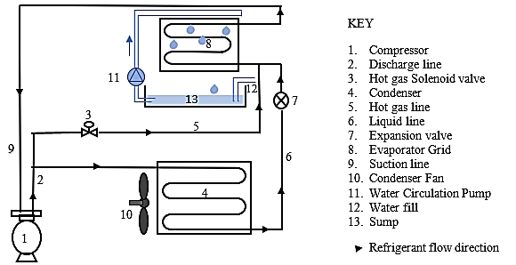

Product categories

There are many different ways to categorise ice makers – by type of ice made, production capacity (usually expressed in kg ice/24 hrs), physical configuration and other factors. For the purposes of this document, the scope and classifications are identical to those adopted for regulating CIMs with regard to their energy efficiency under a Determination made under the Commonwealth [*Greenhouse and Energy Minimum Standards (GEMS) Act 2012*](https://www.legislation.gov.au/F2025L00262/latest/text).

This covers ice makers with plumbed connections and which are capable of producing up to 1,000 kg of ice per 24 hrs, when tested in accordance with standard AS/NZS 4865 or an equivalent.[2] The following types are explicitly excluded from the scope of the GEMS Determination:

* Manual-fill ice makers, which lack a water supply connection point and a drain point.
* Ice makers built into domestic refrigerators.

Of the ice makers within scope, self-contained units have both the ice maker and the storage bin built into the one cabinet (Figure 2, left). The storage bin capacity is typically a third to a half of the 24-hour production capacity. Most self-contained units are designed for under counter installation, but there is also dispenser models designed to sit on countertops for high-turnover beverage service applications. Modular ice makers (Figure 2, centre) are designed to sit on top of separate ice storage bins, so production capacities and bin volumes can be matched according to usage patterns. All ice makers are designed to automatically cease operation once the bin is full, and resume once the ice level in the bin falls, whether from usage or melting. The storage may be designed so that ice is removed manually or dispensed automatically without being handled (Figure 2, right).

Figure 2 Self-contained ice maker, modular ice maker with ice storage bin and ice maker with dispenser

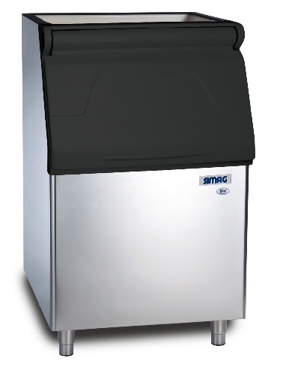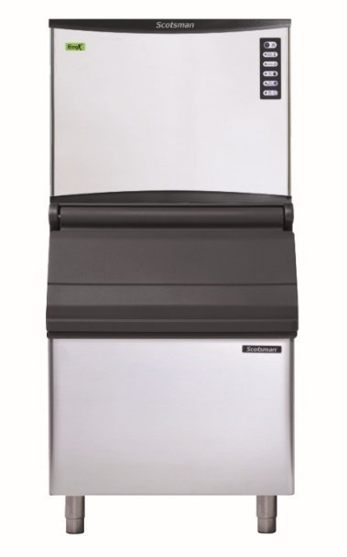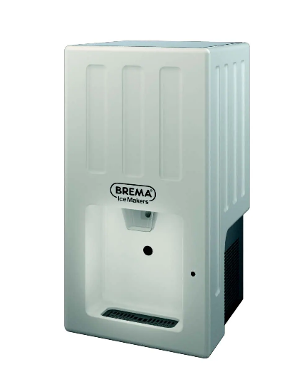

Most of the ice makers sold use air to cool the condenser, but models where cooling water is run over the condenser are also available. These use less energy per kilogram of ice made but consume significant quantities of cooling water if continuously run to waste. Their most efficient use is in installations with chilled water recirculation systems coupled with cooling towers that can serve several ice makers as well as air conditioner heat exchangers. Water cooling also reduces the heat load where ice makers are installed in air-conditioned spaces. Another way to reduce heat load is to locate the condenser remotely from the ice maker and link the two by refrigerant lines. This configuration is called a split system. The compressor can be housed either with the ice making head or with the remote condenser.

Apart from the physical configuration and mode of cooling, ice makers are also classified by the type of ice they make and how they make it (Table 1). Cubed or shaped ice is hard, clear, dry, slow to melt and intended mainly for adding to beverages. It can be produced in a range of sizes and shapes such as dice, crescents, balls and cylinders. It is made in batches: water is sprayed or run on to a shaped evaporator, and once the ice reaches the required shape and size the batch is harvested by either momentarily heating the evaporator with hot refrigerant gas or running warmer inlet water behind the ice, which has the advantage of pre-cooling the water for the next batch.

Some of the potable water used for batch ice is flushed away to remove impurities, but this loses both the water and the energy used to cool it. Batch ice makers can use as much potable water in the flushing and harvesting as is contained in usable ice. Some designs can minimise water loss while maintaining ice quality.

Table 1 Categories of Commercial Ice Maker

| **Configuration** | **Product class (GEMS)** | **Cooling mode** | **Production mode** |
| --- | --- | --- | --- |
|  |
| **Modular (Ice Maker Head)** | 1 | Air | Batch |  |
| 2 | Air | Continuous |  |
| 3 | Water | Batch |  |
| 4 | Water | Continuous |  |
| **Self-contained (SCU)** | 5 | Air | Batch |
| 6 | Air | Continuous |
| 7 | Water | Batch |  |
| 8 | Water | Continuous |
| **Split system (remote, condensing, no remote compressor)** | 9 | Air | Batch |
| 10 | Air | Continuous |  |
| **Split system (remote, condensing, remote compressor)** | 11 | Air | Batch |  |
| 12 | Air | Continuous |  |

Source: Greenhouse and Energy Minimum Standards (Commercial Ice-makers) Determination 2025

Flaked or granular ice is shapeless and contains some entrapped water and air. It is ideal for preserving and displaying perishable foods such as fish or vegetables, since it accommodates irregular shapes and the water content means it does not bruise or dry the produce. However, it melts faster than cube ice. Flaked ice is made by a continuous process in which water is sprayed on to or inside a rotating cylindrical evaporator and removed as it forms by a scraper or augur. The manufacture of flaked ice is less energy-intensive and quieter than for cubed ice and there is very little potable water wastage.

Nugget or tubular ice is generally made by a continuous process, and the ice is then shaped or compressed by a secondary operation. Nugget ice is often used in lower-value soft drinks, in quick service restaurants and in hospitals, where it is easier for patients to chew.

The industry

Most ice makers sold in Australia are imported. The one company still manufacturing CIMs in Australia and New Zealand also imports a number of models to supplement its locally made range.

The ice maker industry is dominated by global brands including Scotsman and Manitowoc (originally based in the USA), Hoshizaki (Japan), Brema, Simag, Icematic and Ice-o-matic (Italy) and ITV (Spain). These companies have expanded their manufacturing to Mexico, Britain and China.

Some global brands supply models for rebadging by local importers (e.g. Skope) while also selling under their own brands. In some cases, variants of the same model may be made in different company owned factories, depending on the market for which they are intended.[3] Chinese companies have also started to supply the Australian market under their own brands (e.g. Blizzard).

At a higher level of aggregation, the Italian Ali Group owns a large number of global commercial cooking equipment and refrigeration brands, including the ice maker brands Scotsman, Icematic, Ice-o-matic, Simag and Kold-Draft, which together account for about a third of the Australian market.

Users of ice

The primary market for ice and CIMs is the hospitality and food services industry: hotels, bars, restaurants and cafes. Quick service restaurants and juice bars consume large volumes of lower-quality ice (e.g. nuggets), whereas bars, hotels and restaurants mainly use cubed or shaped ice. Some venues prefer smaller cubes that can be more easily crushed and blended into drinks. Institutional facilities such as hospitals and aged care also use ice.

In recent years, the mining and construction industries have emerged as major markets for CIMs. Workers typically fill their personal drink and food coolers with ice from dispensing bins at the beginning of their shift, so ice production capacity must be adequate to supply two or three shift starts each day.

As with all perishable products, ice is subject to problems of peak demand, storage and distribution. Ice makers are usually left on continuously. The bin is generally full when a shift or trading session starts and ice making resumes as ice is drawn off steadily over the session. Over a 24-hour period, an ice maker will typically make 70 to75% of its rated 24 hour production capacity.

Some facilities will have ice demand that peaks weekly or irregularly – for example, event venues or convention centres. In such cases, the ice makers may be run for several days to build up ice stocks, which are then stored in freezers, either bagged or in bins.

Flake ice is produced and used at all stages in the food production, processing and delivery chain. Fishing boats have on-board ice makers or go to sea with ice on board. Perishables may be packed in ice for transport, if suitable chilled-space transport is not available. Many supermarkets and food retailers have flaked ice makers for daily fish, meat, and vegetable display. There is also extensive non-food use of ice in healthcare, scientific and pathology applications, to preserve tissue and samples and to control temperatures for chemical reactions.

The daily ice needs of households have traditionally been met by domestic refrigerators – ice trays in the freezer or, more recently, through-the-door ice dispensers. The occasional demand for larger quantities is generally supplied by bagged ice, available from supermarkets, bottle shops and service stations. With rising incomes, and falling product prices, there is now a significant market for home ice makers, which are manually filled and emptied. These non-CIMs have relatively low production capacity and tend to be used irregularly, so limiting their total energy and water consumption. However, the industry reports a growing market for small CIMs for installation in larger, more expensive homes and for home treatment of exercise and sports injuries.

Operating costs

The typical operating life of a CIM is 8 to 9 years. The cost to the purchaser comprises:

1. The initial capital cost (including installation, which is costlier for water-cooled models).
2. The present value (PV) of the projected lifetime energy costs (with future costs appropriately time-discounted. e.g. $100 to be spent next year has a lower PV than $100 spent this year).
3. The PV of the projected lifetime potable water costs.
4. For water-cooled CIMs, the PV of the projected lifetime cooling water costs.
5. The PV of servicing, cleaning and consumables such as water filters over the operating life.

In theory, the NPV of any expected resale price could be deducted from the capital cost, but industry sources advise that the second-hand market for CIMs is negligible. The assumptions used to calculate cost components (a) to (d) are detailed in Appendix B. It is assumed that component (e) is independent of energy and water consumption and so is excluded from further consideration.

Figure 3 illustrates the estimated average lifetime operating cost components for each of the 12 CIM classes described in Table 1. These are based on the average size, retail price and daily ice production of CIMs purchased in each category, and the Australian average prices for:

* Electricity supplied to non-residential consumers (35c/kWh in 2025).
* Potable water supplied to non-residential consumers ($3.03 per kilolitre in 2025).
* Volumetric wastewater discharge prices to non-residential customers ($1.24 per kilolitre in 2025). Not all water authorities charge for wastewater on a volumetric basis, and those that do generally apply a discharge factor to allow for the fact that some of the potable water supplied may not end up in the sewer (e.g. it may be used on a garden). For businesses such as hotels and restaurants, supply authorities assume that up to 95% of the supplied water will be sent to the sewer. An average discharge factor of 90% has been assumed.

For air-cooled CIMs, the major cost component is electricity, accounting for 65-78% of lifetime costs. The balance is divided between the capital cost and the potable water cost. These are averages, and models producing the same quantity and type of ice may vary considerably with regard to both energy and water use.

Figure 3 NPV of Lifetime operating costs by class of CIM (7% discount rate)

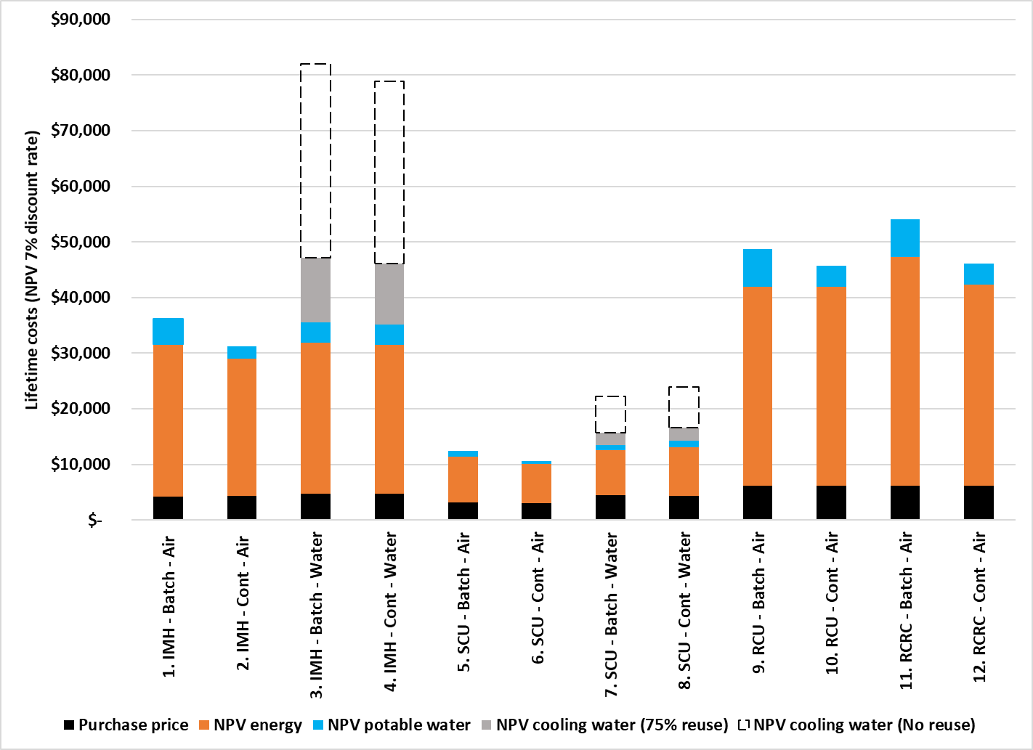

Source: Appendix B Table 15

For water-cooled CIMs, the lifetime cost of the cooling water depends on its source and whether it is used once only (single-pass) and then discharged as waste, or recirculated. The dotted outline at the top of the cost bar for water-cooled products indicates the lifetime cooling water cost if all of the cooling water were potable and discarded after a single-pass. In that case, cooling water would account for 38-55% of the lifetime costs., compared with 33-36% for electricity. However, this is an unlikely scenario. Most large capacity water-cooled CIMs are installed in buildings such as clubs, hotels, convention centres or hospitals where they are connected to a cooling water circuit that discharges heat through the air conditioning cooling towers. The system designers are generally aware that single-pass cooling would be uneconomical. However, smaller self-contained CIMs are also offered as air-cooled and water-cooled variants, on the proposition that water-cooling requires less energy, is quieter and does not discharge heat into the internal space.

For the cost-benefit analysis it is assumed that water-cooled CIMS take on average, 25% of their cooling water requirement from the potable supply. The other 75% is met either by recirculating the water after passing it through a cooling tower or using a free source of non-potable water. On this assumption, water costs (ice-making plus cooling) make up 19-32% of the lifetime costs of water-cooled CIMs.

Availability of information

Information of the kind illustrated in Figure 3 can be estimated for any specific model of CIM if there is reliable data on its energy and water use. The one market in the world where this information is readily available is the USA, which has Department of Energy (USDOE) mandated Minimum Energy Performance Standards (MEPS) for all types of CIMs, and mandated cooling water efficiency standards for water-cooled types (but no standards for potable water efficiency).

There is also a voluntary Energy Star certification program, operated by US Environmental Protection Agency (USEPA) for air-cooled CIMs that exceed the MEPS levels by specified margins and also meet specified levels of potable water efficiency (but no criteria for cooling water efficiency).

All of the data published by USDOE and the Energy Star program are based on the same standard test conditions: an ambient temperature of 90°F (32.2°C) with potable water supplied at 70°F (21.1°C). This contrasts with the information published by Australian suppliers, which offer little information beyond a nominal capacity (kg of ice produced in 24 hours), usually based on lower ambient and water temperatures which exaggerate the production capacity, and without reference to a test standard.

The US data indicate that even for products that meet the stringent USDOE or Energy Star requirements, the quantity of energy and water needed per kilogram of ice made can vary from model to model by a factor of 2:1 or more (see Appendix C). As there will be many models on the Australian market which fall short of the US standards, the range in water efficiency could be even wider. The correlation between energy efficient and water efficient CIMs is very weak, so purchasers would need to consider both aspects separately. They cannot rely on an energy efficient CIM to be water efficient or vice versa.

CIM purchasers usually have firm requirements regarding the type of ice they need, the capacity and the physical configuration (IMH, SCU or split), but if comprehensive and reliable efficiency information were available to Australian CIM purchasers, they would be able to:

* make a more informed choice between air-cooled and water-cooled models
* select the more water efficient of the models on offer in their category
* make a judgement about whether to adopt single-pass cooling, use alternative water supplies or recirculate cooling water, in the case of water-cooled models
* select the more energy efficient of the models on offer in their category.

As the next section shows, reliable information on energy use should become available under current regulatory settings, but the availability of information about water use remains uncertain.

## Current regulations

In Australia, CIMs have in the past only been subject to general electrical safety requirements and the WaterMark Certification Scheme applicable to all water-using products. In 2021 the Equipment Energy Efficiency (E3) program of the Commonwealth, state, territory and New Zealand governments began investigating the costs and benefits of adopting MEPS for CIMs. Following the usual process of [Regulatory Impact Analysis](https://consult.dcceew.gov.au/gems-commercial-ice-makers-consultation-paper) and stakeholder consultation, Energy Ministers decided to adopt the recommended MEPS levels and DCCEEW was tasked with developing a Determination under the GEMS Act 2012 to give them effect (equivalent New Zealand regulations will also be implemented under the Energy Efficiency Regulations). A final [GEMS Determination](https://www.legislation.gov.au/F2025L00262/latest/text) for CIMs was gazetted on 3 March 2025, with compliance being mandatory for all CIMs supplied or offered for supply in both countries from 3 March 2026.

The GEMS Determination defines a CIM as an automatic ice maker with provisions for both water supply and drain connections, and with a production capacity of up to 1,000kg per 24hr when tested under the conditions specified in *AS/NZS 4865.1:2008: Performance of commercial ice makers and ice storage bins, Part 1: Test methods for ice makers—Environmental performance* or the equivalent US and ISO standards. All three approved standards use near identical test conditions and methods in which production capacity, energy and water consumption (potable and for cooling if applicable) are all measured during the one test.

The GEMS Determination will require all models of CIMs offered for supply in Australia:

* To be tested in accordance with one of the approved standards.
* To be registered with the GEMS Regulator.
* To declare, at the time of registration, the production capacity (kg/24hr) and the energy efficiency (kWh/kg ice).
* To meet the MEPS formula required for its class and production capacity (derived from *AS/NZS 4865.3:2008: Performance of commercial ice makers and ice storage bins, Part 3*: *Minimum energy performance standard (MEPS) requirements*).
* To display the current GEMS registration number whenever a product covered by the GEMS Determination is advertised for sale or supply, whether in print, in store or online. This is to direct purchasers to a website where they can compare the performance of models, and to assist regulators with market monitoring and compliance checks.

Given that GEMS mandates MEPS for all CIM models offered to purchasers, even buyers who do not want to or do not place value on energy consumption, will receive a product that meets a minimum level of energy efficiency.

In addition, CIM registrants may choose to voluntarilydeclare the potable water use rate (L/kg ice) and, for water-cooled products, the cooling water use (L/kg ice) as measured on the standard tests. The GEMS Act does not empower the Minister to set requirements for matters not directly related to energy performance, although if water related performance is declared to the GEMS Regulator it must be in accordance with the specified standards. The proportion of suppliers who will choose to voluntarily declare data on water use is currently unknown.

The GEMS Regulator will publish the registered information on the Energy Rating website ([www.energyrating.gov.au](http://www.energyrating.gov.au)). The website lists all models of product types regulated under GEMS. If registrants choose to declare a water use rate, that information will be listed against the entry for that model.

At time of writing, registration was due to be made available during March 2025, to give a year for suppliers to register products before the GEMS Determination takes effect. It was not clear whether registrants would have to enter all the model characteristics at the one time, or whether they could declare the voluntary water use data later. This will depend on the design of the online registration process and ability to make later registration modifications.[4]

## The problem

The Australian Government Guide to Policy Impact Analysis discusses a number of market characteristics and failures which may warrant government intervention. The one most relevant to the CIM market is information asymmetry, leading in turn to irrational behaviour:

*Markets may not allocate resources efficiently if one party in a transaction has significantly more information than another…Intervention may be an option to impose the obligation to declare or certify relevant information* (OIA 2013,18)

At present, CIM suppliers make very little information available to purchasers about the energy performance of the products they offer in Australia and even less about the water performance. The GEMS Determination will ensure that CIMs supplied from March 2026 will meet minimum levels of energy efficiency and that their energy performance will be declared, but does not ensure the same for water use or water efficiency.

As indicated in Figure 3, this means that water-use rates which account for a significant share of lifetime operating costs in all CIMs, and potentially the majority of costs in water-cooled models, could remain invisible to purchasers.

While suppliers will have the option of declaring water use information to the GEMS Regulator they may choose not to do so, even though they would have the data from the energy tests and so incur no further testing costs. The reasons for a lack of declaration may include that suppliers:

* do not see a commercial advantage in declaring the information, especially for models with poor water performance
* do not wish to draw attention to the high water use of water-cooled variants
* do not wish to increase their liability should the water use values be found to be incorrect in subsequent regulatory check testing
* may wish to continue to publish more favourable water values based on non-standard operating conditions
* as an industry, may not wish to provide Australian regulators with information that might enable the setting of Minimum Water Efficiency Standards because it may lead to additional costs associated with redesign or sourcing of products to meet the standards, or reduce the range of products that can be offered to the market.

Even if water use is made public on the GEMS energy rating database, purchasers may be unaware of its availability at the time of their purchasing decision, as there are no requirements to provide the information at point of sale, or in advertising or product display. Furthermore, if purchasers were aware that the water use information was available on the GEMS energy rating database at a time that could inform their purchasing decision, they may have difficulty in interpreting it.[5]

The problem is therefore the possible continuation of market failure with regard to the provision of trusted, reliable, consistent, comprehensive and readily accessible information regarding the complete operating costs of CIMs. Consequently, the total water consumption of CIMs would be significantly higher than if purchasers had the information to make the most cost-effective decisions.

The need for such information is especially acute without the protection of Minimum Water Efficiency Standards, unlike the purchaser protection offered by MEPS, which will exclude the least energy efficient models from the market.

Another common form of market failure is the externalisation of environmental costs. If water consumption is higher than necessary to achieve an objective (in this case the production of ice) then the externalities not included in the price of potable water are also higher. In the absence of an explicit carbon price, the costs of damage due to climate change are external to the pricing of energy. The inclusion of a shadow price for CO2 emissions from electricity supply increased the value of projected energy saving from CIM MEPS by about 6.5% (E3 2023, p10).

Electricity is also used in the pumping and treatment of water and wastewater. While water and wastewater prices include the financial costs of that energy, the value of the associated emissions needs to be internalised. However, the calculated price impact is less than 1.5% (see Section 4.3).

It is uncertain whether the long run marginal cost of supplied water includes the environmental costs of additions to supply infrastructure. In its 2018 evaluation of the WELS scheme, the Institute of Sustainable Futures estimated the present value of deferring a $1.5 billion supply increment (whether dam or desalination plant). In south-east Queensland the present value of a 10 year deferment was equivalent to 5% of the water supply price and for Sydney the value of a 16 year deferment was 25% of the supply price (ISF 2019, p74). However, all mainland state capital cities are served by desalination plants commissioned between 2006 and 2012. As these are all operating below capacity, the need for further supply increments is likely to be pushed out beyond the cost-benefit analysis horizon of CIM water efficiency measures.

The direct costs of CIM water use and wastewater disposal are incurred in the first instance by CIM owners and operators. A café, bar or restaurant must cover all its operating costs, so the costs of food and drink to customers will reflect both the capital and the running costs of equipment. To the extent that the sum of these is lower due to greater water efficiency, the price of the food and drink supplied can be less. Therefore, greater water efficiency is anti-inflationary.

The same applies on a larger scale for institutions such as hospitals or aged care facilities. Savings on equipment operation can be passed on as a reduction in costs of treatment, accommodation and services to patients and residents. Ultimately, all Australians purchase raw food or consume prepared food and drink where ice has been used in the production, transport, retail and service chain. Therefore, the problems of higher than necessary water use, and the benefits of reducing it are distributed throughout the entire population and economy.

# Objectives of government intervention

CIMs consume significant quantities of both water and energy. Both water efficiency and energy efficiency vary widely across product types (e.g. air versus water-cooled) and within types. Purchasers could make substantial lifetime savings if they compared the water use of alternative models and selected the more efficient models. However, they are unable to, because:

* Consistent and reliable Information about water and energy consumption and efficiency is almost impossible to access in Australia.
* Where information is made available it is in a form that makes comparisons across models difficult.
* The information is not provided to the purchaser directly through the product advertising or at point of sale.
* As a group, purchasers are relatively uninterested in operating costs, even though these make up at least two thirds of time-discounted lifetime ownership costs (Figure 3).

There is evidence of the following market failures:

* Information asymmetry.
* Split incentives: some CIMs are purchased by intermediaries who may be unconcerned with operating costs because they will be borne by the end user.
* Irrational market behaviour, or ‘bounded rationality’: according to industry sources[6], CIM purchasers are relatively indifferent to both water and energy running costs.

As a consequence, the users of CIMs are significantly worse off financially than if they had been aware and responded to information about water and energy use and efficiency. At the level of the economy, this also results in an inefficient allocation of resources and higher negative externalities.

After considering the issues and conducting a [Regulatory Impact Analysis,](https://oia.pmc.gov.au/published-impact-analyses-and-reports/commercial-ice-maker-energy-efficiency) the Commonwealth, state, territory and New Zealand governments decided to implement MEPS through the GEMS Act, to take effect on 3 March 2026. The analysis and the regulations were restricted to energy, which makes up the majority of CIM operating costs. Water efficiency is outside the scope of the GEMS Act.

The same market failures are evident regarding CIM water use, which is substantial. CIMs use over 6.1 Gigalitres (litres x 109) per annum in Australia, equivalent to the water consumption of about 35,000 households.[7] The GEMS Determination provides for voluntary declaration of water use rates and sets parameters for the source, quality and format of such declarations. However, declared water use rates alone would not indicate the likely magnitude of product annual water use and operating cost, which may have more impact on purchasers.

If water and energy use were closely linked, the imposition of MEPS by the GEMS Regulator would also lead to significant water savings, and there would be limited scope for government intervention to increase water savings. However, analysis of the available data indicate that the water/energy use relationship is weak (Appendix C). Water efficient products are not necessarily energy efficient and vice versa.

The market does not provide consistent, reliable or accessible information on either water or energy use. Some suppliers provide no information apart from the maximum litres per 24 hrs and maximum kW electricity demand, which are useful for sizing electrical and plumbing connections but convey no information about water or energy efficiency(expressed in litres per kg of ice and kWh per kg of ice).

Where suppliers do publish information about water and energy efficiency, it is generally at an arbitrary rating point (combination of air and water temperatures) that shows their own models in the best light. Often the rating point is not disclosed. This makes it very difficult for even motivated purchasers to accurately compare the performance of different models.

The CIM industry has not attempted to introduce a label or to standardise information on water and energy use. Voluntary water and energy labelling programs have had limited impact without either a strong industry association to establish and enforce them, or the expectation of government intervention (so incentivising early movers and the hope of avoiding such intervention). This is partly due to industry fragmentation. There is no single association representing the CIM industry, although some suppliers are members of the National Association of Food Equipment Suppliers (NAFES).

Where voluntary labelling programs have been introduced, whether by an unusually powerful industry association or by government, suppliers have tended to label only their better performing products, so purchasers are unable to identify and avoid the least efficient ones.

Suppliers consulted during the development of MEPS indicated that they believed only a few purchasers were interested in energy use and even fewer in water use. In effect, information failures and bounded rationality reinforce each other. If purchasers are not made aware of the magnitude of water and energy use and running costs, they cannot take them into account in purchasing decisions.

Consumer surveys conducted after the implementation of mandatory energy labelling in Australia in the 1980s and 1990s showed that purchaser awareness of the high energy use of appliances, and preference for more energy efficient models, increased only after the introduction of government-enforced labelling (GWA 1993).

Evaluation of the WELS scheme, established in 2005, also found that consumer awareness of the WELS label and use of it increased over time, reaching 53% in 2008 and stabilising at 87% in 2014 (Quantum 2014) and 86% in 2023 (Water Night Survey 2023). The fact that the label was administered by Government rather than industry contributed to its credibility:

*The credibility of water rating labels remains very high amongst consumers in Australia, with 83% believing the scheme to be either ‘very’ or ‘quite’ credible. Consumers understand that WELS is a government funded initiative that is properly regulated and meets a set of Australian standards, which gives consumers confidence to trust the information they see on water rating labels (*Quantum 2014).

The objective of the proposed government intervention is to address market failures using proportionate and proven policy instruments. Information declaration and minimum performance standards have demonstrated their effectiveness in overcoming market and information failures in a wide range of appliance and equipment markets, as the WELS and E3/GEMS programs have demonstrated.[8]

The introduction of GEMS requirements for CIMs offers an opportunity to leverage measures to increase CIM water efficiency at relatively low cost. The status quo will mean that CIM suppliers will need to have products tested for energy and water use, and register their energy efficiency with the GEMS Regulator. However, registration of water efficiency with the GEMS Regulator and inclusion of that information in product data or on products themselves remain optional under the status quo.

As information on CIM water use is not currently available, it is difficult to predict how CIM suppliers and purchasers will respond. For example, it raises the following questions:

* How many CIM suppliers will take up the option to declare water use when registering products under the GEMS Determination?
* Will CIM suppliers declare water use information for only their more water efficient products or for their entire range?
* How widely will the information be disseminated: only on the GEMS energy rating database ([www.energyrating.gov.au](http://www.energyrating.gov.au)), on product information and advertising, or on physical products themselves?
* Will CIM purchasers become aware of the water use information and if so, will they change purchasing decisions as a result?
* If information alone cannot address market failures regarding water use rates or water efficiency, is it more effective to proceed to Minimum Water Efficiency Standards (as is the case with the GEMS Determination)?

There are opportunities for a graduated WELS response, starting with non-regulatory measures, proceeding to mandatory information declaration, labels and ratings (which do not oblige suppliers to change their product offerings), through to mandatory Minimum Water Efficiency Standards (which are likely to limit CIM product offerings).

There is no reason to believe that CIM suppliers will do anything beyond the minimum required to meet their GEMS obligations. That is, to ensure that the models they offer for supply after 3 March 2026 comply with MEPS and to register the production capacity and energy efficiency of those models as determined under standard tests.

Historically the industry has not chosen to publicise the standardised water or energy efficiency of products and is not likely to do so without intervention. While the GEMS Determination requires the GEMS registration number to be included in product advertisements and at the point of sale, this will only provide an identifier by which motivated purchasers can check the standardised energy efficiency of the product (and if declared, the water use). Suppliers can continue to withhold the standardised data and, confusingly for purchasers, continue to provide non-standardised data that shows their product in a better light. Purchasers are protected to some extent regarding CIM energy use because of the application of MEPS, but there is no such protection with regard to CIM water use.

Government intervention appears necessary to ensure supplier participation, credibility and purchaser awareness of both water and energy efficiency information. However, if the Government decides to intervene in order to address market failures regarding CIM information asymmetry and bounded rationality, it does not necessarily need regulation beyond the status quo to do so.

One ‘no new regulation’ measure would involve using existing programs and policy levers. The WELS scheme is well established, well regarded and has been found to be effective in reaching purchasers and promoting greater water efficiency in the products it regulates. Existing WELS processes and resources could be used to encourage CIM suppliers to declare product water use rates to the GEMS Regulator and for WELS and GEMS to jointly use this information to promote awareness of water efficiency among CIM purchasers. This would require relatively modest government resources and avoid the need for new regulation. Information declaration responses can be sequenced to make use of data as it accumulates. For example, if a high proportion of suppliers voluntarily declare product water use rates to the GEMS Regulator, then the additional benefits of mandating product registration and labelling through the WELS Act would be reduced.

The success of interventions, whether regulated or not, can be measured through specific, measurable, achievable, relevant, and time-bound (SMART) targets. For example, reasonable success criteria for voluntary declaration might be that at least 80% of suppliers voluntarily register water use by the time the GEMS Determination takes effect (3 March 2026), and that at least 80% of models are covered (otherwise, declaration might be limited to the most water efficient models).

The achievement of these participation targets could be measured though the GEMS energy rating database. The impact of water use information on purchasers would need to be monitored through surveys and by tracking changes in the average declared water use of models over time.

Another objective of Government intervention is flexibility. In a graduated strategy, options that are more onerous for stakeholders, including Government itself, should only be implemented if simpler and cheaper options prove inadequate. If a Government led voluntary information program for CIMs is successful, it should not be necessary to proceed to regulation. If information alone addresses the market identified failures, it should not be necessary to proceed to Minimum Water Efficiency Standards. If it emerges that market factors such as split incentives are severely limiting the impact of information measures, there would be a case for proceeding to Minimum Water Efficiency Standards.

The next section presents a range of options regarding the combination and sequencing of both non-regulatory and regulatory measures.

# Policy options

## The following list of policy options is subject to revision following consultation with stakeholders.

## 3.1 Option 1. Status quo

The status quo is the requirement to register CIMs with the GEMS Regulator and the implementation of MEPS from 3 March 2026. MEPS works by requiring a minimum energy efficiency for all products that can be offered to purchasers. As such, purchasers do not need to be aware of or make an active choice about energy efficiency, as all products should meet the minimum standard. It does not rely on purchaser choice or the need for government to encourage purchasers to prefer the more energy efficient models, although it enables those strategies.

The GEMS registration process, which is now open, offers suppliers the option to voluntarily declare the potable water use (L/kg of ice produced) for all CIMs and condenser water use for water-cooled CIMs.

Total CIM water consumption under the status quo should be somewhat lower than if there were no GEMS Determination, because:

* some suppliers may take the opportunity to change their model range to more water efficient models as well as more energy efficient models, in the expectation that both factors will deliver a commercial advantage; and
* better informed purchasers should show greater preference for models where water efficiency has been declared, all else being equal.

The extent to which purchasers can exercise a preference for CIMs with lower water use rates using the data in the GEMS energy rating database will depend on the proportion of models where water use has been declared and if the information is brought to their attention prior to their purchasing decision. While the GEMS Determination requires the GEMS registration number to be included in product advertisements and at the point of sale, suppliers are not obliged to publicise the registered data or prevented from providing non-standardised data that shows their product in a better light.

During consultations for this Impact Analysis, CIM suppliers will be asked whether they intend to register water use rates with the GEMS Regulator and why. The responses will give early indication of the likely effects of Option 1 and the potential scope for Option 2.

The voluntary declaration of water use rates may be encouraged but not mandated or enforced by the GEMS Regulator. The role for the WELS Regulator under status quo is restricted to observation and collection of declared water related data published on the GEM energy rating database. The risk is that suppliers will choose not to declare standardised water use rates to the GEMS Regulator and/or continue to present alternative water-related information (or none) to purchasers.

## 3.2 Option 2. Voluntary declaration with WELS support (Non-regulatory)

This option involves the WELS scheme offering support to and enhancement of the status quo, to increase the probability that suppliers will choose to register CIM water use with the GEMS Regulator and to encourage purchaser preference for water efficient CIMs. Both the WELS and GEMS Regulators are part of the same department (DCCEEW), which would assist in facilitating co-ordination and information sharing. No new regulation is required.

The measures which WELS might employ include:

* Encouraging suppliers to make voluntary water use declarations when registering their CIMs with the GEMS Regulator.
* Encouraging manufacturers and suppliers to include standardised water related information in CIM product data, manuals, advertising and at point of sale.
* Adding text about CIMs to the WELS website and linking to the GEMS energy rating database.
* Reproducing on the WELS Water Rating website the CIM water use rates from the GEMS energy rating database.
* Making clear to the industry that failure to declare water use rates could result in mandatory WELS measures. There could be explicit threshold targets, e.g. at least 80% participation rate by CIM suppliers by a target date, and 80% of models with water use rates declared (to counter the tendency in voluntary programs to limit declaration to efficient models only).
* Working with industry to develop voluntary labelling or water use information at point of sale.

Logically, these measures should result in higher levels of declaration, stronger purchaser preference for more water efficient products and lower overall CIM water consumption than under the status quo, at relatively small additional cost.

This option may include the development of a CIM water efficiency label which suppliers could choose to apply to models for which water use rates have been registered with GEMS. There is no energy label requirement for CIMs, since MEPS has been selected as the best option to drive energy efficiency. However, there are requirements for models to be identifiable by their GEMS registration number. Apart from the rates of voluntary declaration, the success of Option 2 could be measured by factors like the rate of adoption of voluntary labelling and the number of website visits.

There is precedent for inclusion of a voluntary use label in WELS standard (AS/NZS 6400), which currently only covers mandatory WELS labels. The E3 Committee operated a voluntary energy labelling scheme for swimming pool pumps from 2010 to 2022. It permitted and controlled the voluntary use of an energy label which was part of a published standard.[9] The voluntary scheme was intended as a transition to a mandatory scheme, which took longer than expected to implement. As expected, suppliers only labelled their most efficient pool pumps until labelling and MEPS became mandatory in October 2022.

Voluntary water and energy labelling programs have had limited impact without either a strong industry association to enforce them, or the expectation of government intervention (so incentivising early movers with the hope of avoiding such intervention). There is no single association representing the CIM industry, although some suppliers are members of NAFES, which could be approached to assist with WELS led initiatives. Therefore, the main incentive for voluntary adoption of a water use label under Option 2 would be to forestall regulatory action.

The main risk for the WELS program is that a significant number of suppliers could still choose not to declare the water efficiency of their products or continue to use non-standardised data in their advertising and product information. This could delay effective regulatory action.

## 3.3 Option 3A. Product registration and information declaration (Regulatory)

This option involves product registration with the WELS Regulator and application of mandatory product labelling and/or information provisions. It would require amendment to the existing WELS Determination, revision of the WELS standard (AS/NZS 6400) and the establishment of a registration process for CIMs, with applicable registration fees. If there is no parallel New Zealand regulation, mandatory WELS options may also require a ruling under the Trans-Tasman Mutual Recognition Act (TTMRA) under which a product lawfully manufactured in or imported into either Australia or New Zealand can be exported to the other. Without such an exemption, the risk presented is that New Zealand importers of CIMs would be able to re-export them to Australia even if they did not meet WELS registration or labelling requirements.

The WELS Determination would require suppliers to register their products and include the WELS-registered water efficiency information in their CIM product information and advertising. This would need the inclusion of a CIM water efficiency label in the WELS standard (AS/NZS 6400) to convey information via a comparative star rating, a water intensity value (L/kg ice produced), estimated annual water use (kl/yr) or a combination of these.

Mandatory labelling requirements could be restricted to batch-production (shaped ice) CIM product classes, where there is a wide range in water efficiency. Continuous production (flaked ice) CIMs all use similar amounts of potable water per kg of ice produced, so labelling would be less informative, although it would still alert buyers to take water use into consideration.

This option would be implemented in the event that the status quo or Option 2 (if implemented) proved ineffective. The main risk is that effective action would therefore be delayed, resulting in higher water use and higher operating costs for possibly tens of thousands of CIM sales. The significant lead times to revise the WELS standard (AS/NZS 6400) and to amend delegated legislation add to this risk.

## 3.4 Option 3B. Product registration and information declaration - accelerated implementation (Regulatory)

Option 3B is similar to Option 3A, except with regard to the timing. While Option 3A could be implemented sequentially after Option 2 in the event that voluntary participation is low, Option 3B would be initiated sooner, as an alternative rather than a potential follow-up to Option 2.

The main risk is that greater costs will be imposed on both suppliers and the WELS Regulator than under a voluntary approach (Option 2), without knowing whether that would have been effective.

## 3.5 Option 4A. Product registration, Minimum Water Efficiency Standards and information declaration (Regulatory)

This option involves mandatory product registration with the WELS Regulator, application of Minimum Water Efficiency Standards, and (optionally) application of mandatory product labelling and/or information provision at point of sale.

This is the most stringent option in that it would impose the heaviest burden on suppliers and for some, force changes to their model range. However, it should result in the lowest aggregate water use and may be the most cost-effective option if projected benefits outweigh costs by a sufficient margin.

Minimum Water Efficiency Standards (expressed as maximum L/kg limits, possibly varying with output capacity) may be applied to potable water use, condenser water use or both. If the minimum standards are intended to be the main policy drivers for greater water efficiency, then mandatory labelling as in Options 3A and 3B may not be necessary. The GEMS Regulator has taken this approach by mandating MEPS without labelling, while leaving open the option of mandating energy labelling for CIMs in the future. The GEMS Regulator has also flagged a review of the MEPS levels no sooner than two years after implementation of the initial GEMS Determination (i.e. no sooner than March 2028).

The impact on the model range if CIMS are regulated for both minimum energy efficiency and minimum water efficiency is not known, but logically it should reduce the model range in the short term. The more stringent the minimum standards, the greater the restriction. The extent could be significant and this would need to be determined as part of establishing the minimum standards. The intent of regulation is not to disrupt the market but rather to cost-effectively drive product design and purchaser choice to more water efficient (and energy efficient) models.

Setting L/kg limits will remain subject to a high degree of uncertainty until reliable information on CIM water use rates becomes available, i.e. after the status quo, Option 2 (if successful), and/or Option 3A or 3B have been implemented.

It may be feasible to implement Option 4A without passing through Options 2, 3A or 3B. A proposed set of standards somewhat less stringent than the USDOE and USEPA Energy Star levels could be published for consultation and a decision to proceed (or modify) informed by stakeholder responses. The model range on the Australian market overlaps to some extent with the model range on the US market, for which water use and energy use data are published by the USEPA and the USDOE. The greater the overlap, the greater the confidence with which average water use in Australia can be estimated even before GEMS registered data becomes available.

The main risk with Minimum Water Efficiency Standards is in setting the optimum standard levels. If too low, few models will be excluded and there will be little benefit. If too stringent, the market will face disruption and purchaser choice will be limited in some product segments. Some suppliers may have to leave the market entirely, so reducing competition. These risks can be managed in Option 4A by setting the MEPS levels only after data becomes available for a significant share of the market, i.e. following prior implementation of Option 2, 3A or 3B.

## 3.6 Option 4B. Product registration, Minimum Water Efficiency Standards and information declaration - accelerated implementation (Regulatory)

Option 4B is similar to Option 4A, except with regard to the timing and the approach to setting Minimum Water Efficiency Standards. While Option 4A could be implemented sequentially after the information measures (Options 2, 3A or 3B), Option 4B is the immediate implementation of mandatory product registration, Minimum Water Efficiency Standards and possibly information disclosure, informed solely by overseas standards.

As with Option 4A, the main risk is in setting the optimum standard levels. As these would need to be set before there is comprehensive data on models on the Australian market, it would be prudent to set less stringent levels than in Option 4A.

## 3.7 Timing and sequencing of options

Estimating costs and benefits relies in part on the timing of measures. Table 2 presents an indicative timeline for the phasing and sequencing of options. For each option there is an analysis phase which ends with a government decision that is conveyed to stakeholders, a notice period during which industry can test and register products, and an implementation phase which begins when all CIMs supplied or offered for supply must comply. No final choice of option can be made before the conclusion of the Impact Analysis process, which will occur in the second half of 2025.

For Option 1 (status quo), the research and analysis phase ended and the notice period started when the final GEMS Determination was gazetted on 3 March 2025. GEMS registrations will be open a year before MEPS implementation. All CIM models must be registered by 3 March 2026.

Energy Ministers agreed to consider the possibility that more stringent MEPS levels could take effect at least two years after implementation, i.e. not before March 2028. If so, investigations and discussions with industry would need to start in mid-2026 and higher MEPS levels would need to be set no later than March 2027 to give at least one year’s lead time. The analysis of options for higher MEPS could start once all current models are registered. This timetable is relevant to possible Minimum Water Efficiency Standards because it would be less disruptive for industry to introduce them at the same time as the next round of MEPS, if there is to be one.

Table 2 Indicative Timing

Bar chart showing timelines for implementing WELS options 2, 3A, 3B, 4A and 4B.

Orange = Research & analysis phase, Yellow = Industry notice period, Green = Implementation phase.

If Option 2 (Voluntary declaration with WELS support) is adopted, the WELS Regulator could give early notice to industry and reinforce the efforts of the GEMS Regulator to encourage higher levels of voluntary declaration of water use during the GEMS registration process.

The extent of voluntary declaration should become apparent as the GEMS registration proceeds, although registrants may be able to add water efficiency data later by way of seeking amendment to their GEMS registration data. As all CIMs must be registered with GEMS by 3 March 2026, the WELS Regulator should have enough information by then to decide whether the rate of declaration is high enough to continue with Option 2, or whether it is necessary to move to a mandatory option.

Option 3A in Table 2 is the introduction of mandatory registration with the WELS Regulator and mandatory information declaration, in the event of poor adoption of voluntary declaration of water use rates to the GEMS Regulator. In this option, time will be needed to amend the WELS Determination, add a CIM label and testing standards to the WELS standard (AS/NZS6400) and give notice to industry. The earliest practical compliance date would be early 2027, but it could take up to a year longer.

Option 3B is the immediate introduction of mandatory registration with the WELS Regulator and information declaration without waiting to see the extent of voluntary water use disclosure to the GEMS Regulator. If this option is adopted, time will be needed to amend the WELS Determination, add a CIM label and testing standards to the WELS standard (AS/NZS 6400) and to give notice to industry. The earliest practical compliance date would be early 2026, but it could take up to a year longer.

Co-ordinating Option 3B with the introduction of GEMS requirements in March 2026, if that were practicable, would give certainty to industry, who would have the water use data for products registered with the GEMS Regulator. On the other hand, implementing any mandatory WELS option before March 2028 might conflict with the E3 Consultation Regulation Impact Statement, which may have raised the expectation with suppliers that there would be no changes to the CIM regulatory regime for at least two years.

Option 4A proposes Minimum Water Efficiency Standards in addition to mandatory registration and potentially, information declaration, to be informed by information gathered under Options 2, 3A or 3B. If Option 4A is adopted after Option 2, some time will be needed to add a CIM label and testing standards to the WELS standard (AS/NZS 6400), to set Minimum Water Efficiency Standards, amend the WELS Determination (or amend the WELS standard or WELS Determination again, if Option 4A follows 3A or 3B) and to give notice to stakeholders.

The earliest by which analysis of the water use data registered with GEMS could be completed is mid to late 2026. If the WELS Standard was published by early 2027 to take effect in early 2028, it could by co-ordinated with the Stage 2 GEMS requirements (should those proceed). This would give suppliers a year to review their model range and only import models that meet boththe WELS and the GEMS requirements.

Option 4B proposes Minimum Water Efficiency Standards in addition to mandatory registration and potentially, information declaration, informed by overseas standards and market information but without complete data on the Australian market.

Following agreement by Energy Ministers, the GEMS Regulator introduced MEPS without a mandatory or voluntary information disclosure stage. However, there were factors present for energy that are not present to support moving directly to Minimum Water Efficiency Standards:

* *AS/NZS 4865.3:2008 Performance of commercial ice makers and ice storage bins Part 3: Minimum energy performance standard (MEPS) requirements* includes MEPS and HE (high efficiency) levels previously agreed by a standards committee comprising ice maker industry stakeholders. The 2008 HE levels were adopted for the initial MEPS. There are no equivalent Australian reference standards for CIM water efficiency.
* While the energy performance data currently available from suppliers is poor, the availability of water use and efficiency data is worse.

For these reasons, there would be an elevated risk to proceed immediately to Minimum Water Efficiency Standards without first obtaining reliable Australian data on CIM water use and efficiency. The risks of Option 4B could be partly mitigated by setting less ambitious standards than in Option 4A, since they would be based on less market information. On the other hand, an advantage of Option 4B is that it could take effect at least a year earlier than Option 4A.

Table 3 summarises the options. As nearly all products on the Australian market are imports, it would add to supplier burden if the timing of these policy measures overlapped with regulatory changes in the countries of origin. This is not the case. In 2023 the USDOE published an intention to increase the US MEPS levels for CIMs, but without changing the water efficiency requirements.[10] With the change in US administration in January 2025 these proposals are unlikely to proceed.

Table 3 Summary of Proposed options

|  |  |  |  |  |  |  |
| --- | --- | --- | --- | --- | --- | --- |
|  | Status quo | Option 2 | Option 3A | Option 3B | Option 4A | Option 4B |
| New WELS regulation needed? | No | No | Yes | Yes | Yes | Yes |
| Earliest implementation | Under way | 2026 | 2027 | 2026 | 2028 | 2027 |
| Additional tests needed? | No | No | No | No | No | No |
| Addresses information asymmetry? | Possibly | Probably | Yes | Yes | Yes (if with labelling) | Yes (if with labelling) |
| Addresses bounded rationality? | Possibly | Probably | Yes | Yes | Yes | Yes |
| Addresses split incentives? | No | No | No | No | Yes | Yes |
| Burden on WELS | Very low | Low | Moderate | Moderate | Higher | Higher |
| Burden on suppliers | No extra burden | Low | Moderate | Moderate | Higher | Higher |
| Risks | Low participation | Low participation | Water/cost savings delayed | Option 2 may have worked | Water/cost savings delayed | Standards too high or too low |

# Projected costs and benefits

## 4.1 Scenarios modelled

The costs and benefits of the following scenarios have been modelled and compared with the Option 1 (status quo) scenario.

* Option 2: Voluntary declaration with WELS Support (Non-regulatory).
* Option 3A: Product registration and information declaration (Regulatory).
* Option 3B: Product registration and information declaration - accelerated implementation (Regulatory).
* Option 4A: Product registration, Minimum Water Efficiency Standards and information declaration (Regulatory).
* Option 4B: Product registration, Minimum Water Efficiency Standards and information declaration – accelerated implementation (Regulatory).

The timing of each of these measures is illustrated in Table 2, Section 3.7.

The data and assumptions used in the cost-benefit analysis are based on information about CIM products and the Australian CIM market, gained through analysis of published data sheets and through interviews with the CIM suppliers conducted for the Regulation Impact Statement for MEPS. The 15 suppliers interviewed covered over 90% of the market. Additional data on the US market was obtained from the USDOE and USEPA, as detailed in Appendix C.

## 4.2 Projected benefits

The projected benefits of each option are derived from the money saved on potable water and wastewater charges, through CIM owners purchasing more water efficient models than would otherwise have been the case without the market impacts of that option.

The price per kl of water supplied and wastewater removed in each State and Territory is projected in Appendix B. It is assumed that the prices reflect the long run marginal cost of supplying those services, apart from the externality of greenhouse gas emissions associated with electricity used in pumping and water treatment. A shadow price was calculated for these emissions, based on the $/tonne CO2 values adopted by the Australian Energy Market Commission (AEMC 2024). This had relatively little impact, representing less than 1.5% of the water and wastewater charges.

It is assumed that suppliers will be more inclined to provide information when there is encouragement and incentive to do so. For Option 2 the incentive is partly to gain a commercial advantage for models with low water use and partly to avoid the application of regulatory options.

For Options 4A and 4B all models must meet the Minimum Water Efficiency Standards by the implementation date. The increase in the average water efficiency of products sold after that time will depend on the stringency of the adopted standard. At the time of writing, there was minimal data on the range of water-efficiencies on the Australian market, so for modelling purposes the Minimum Water Efficiency Standard levels were set somewhat less stringently than the USDOE and USEPA Energy Star levels (see Appendix B). A longer lead time to implementation (Option 4A) would enable the setting of more rigorous standards because more market data would be available, delivered either through the Option 1, Option 2, Option 3A or Option 3B.

If information declaration is implemented alongside Minimum Water Efficiency Standards in Option 4A or 4B, as is the usual practice for WELS products, water efficiency would continue to increase above the minimum standard leveldue to better informed purchasing decisions, but this would occur at a lower rate than in Option 3A or 3B because the standards would exclude the least efficient products from the market and the range between most and least water efficient models would be narrowed.

Figure 4 illustrates the effects of the options on CIM water efficiency in relation to a notional starting efficiency level of 1.0 in 2025 (the actual values used in the modelling are in Appendix B). Option 1 assumes a modest degree of voluntary water use declaration to the GEMS Regulator, and hence some increase in average water efficiency compared with a case in which GEMS had not regulated CIMs (Option 0).

Figure 4 Indicative water efficiency trends by option

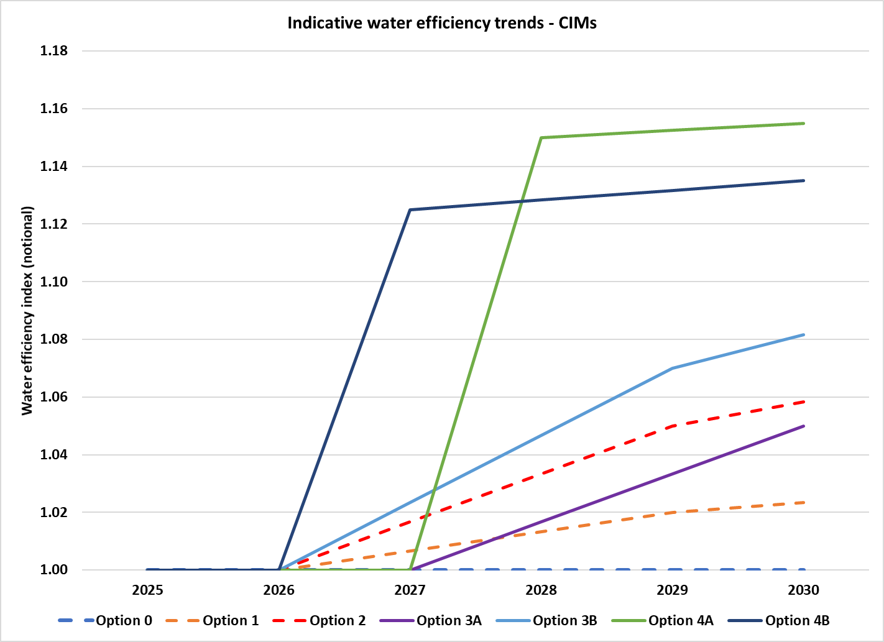

Benefits and costs are calculated from the viewpoint of mid-2025, when it is assumed that a decision about which option to adopt will be made. They are calculated separately for each of the 12 classes of CIM and for each of the 8 Australian states and territories.

The modelling takes into account the projected capital and water usage costs of the CIMs that are expected to be purchased in Australia from 2025 to 2040 (i.e. 16 calendar years). It is assumed that 100% of each year’s cohort survives to the 8th year, 50% to year 9, and none to year 10, implying an average service life of 8.5 years. The model calculates the net present value (NPV) of total national CIM water consumption as far out as 2048 (capturing the lifetime water consumption of units sold up to 2040), using the range of discount rates required by the Office of Impact Analysis (OIA) (3%, 7% and 10%).

Figure 5 illustrates the total water consumed by new CIMs purchased from 2025 to 2040 inclusive in each jurisdiction under Option 1 (status quo). The share of the national CIM market allocated to each jurisdiction is weighted by population, by share of national commercial and service sector GDP and by confidential market information from suppliers. Figure 5 does not cover the total consumption of the entire CIM stock, since the consumption of products in operation prior to 2025 will be unaffected by any of the options. The estimated operating life of CIMs is 8.5 years, so by 2033 almost the entire stock will consist of CIMs purchased in 2025 or later. Each new post-2025 cohort adds about 1 gigalitre per annum of water consumption. The consumption trend flattens after 2033 because post-2025 models start reaching the end of their service lives and start retiring from the post-2025 stock.

Figure 5 Water consumption by jurisdiction, CIMs purchased 2025-40, Australia

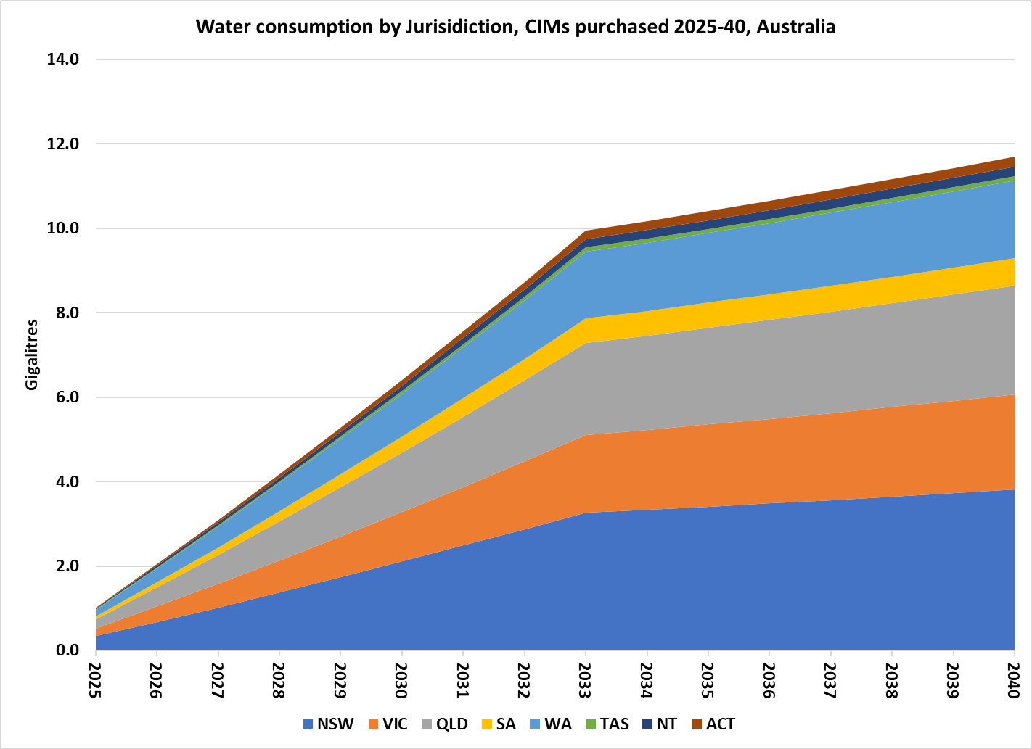

Figure 6 breaks down the same quantity of water as in Figure 5 by purpose: water converted to ice (whether cubed, shaped or flaked, including potable water losses during ice-making) and mains-supplied water used for cooling. Only about 8% of CIMs sold are water-cooled, but those units can used more than 10 times as much cooling water per kilogram of ice made as the potable water in the ice itself. Therefore, water cooling can account for about 22% of all the water that passes through a CIM.

Water-cooled CIMs may be installed so that the cooling water is discharged to waste after a single pass or connected to the water cooling loop that serves the building’s air conditioning system. According to the CIM stakeholders, purchasers of large-capacity CIMs, most of which are installed in buildings with air conditioning cooling towers, are aware of the high water charges for single-pass cooling and use recirculation cooling (unless they have access to a free non-mains supply).

Some purchasers of smaller CIMs however find it convenient to use single-pass water cooling to avoid fan noise and the heat load that air cooling would add to a bar or café. For modelling purposes, it is assumed that on average, 25% of all CIM cooling water is taken from the supply mains. The other 75% is met either by recirculated water or from a free source of non-potable water. The cost-benefit analysis is sensitive to these assumptions. The higher the recirculation rate, the lower the total value of the saving from increased efficiency of cooling water use.

Figure 6 Water consumption by purpose, CIMs purchased 2025-40, Australia

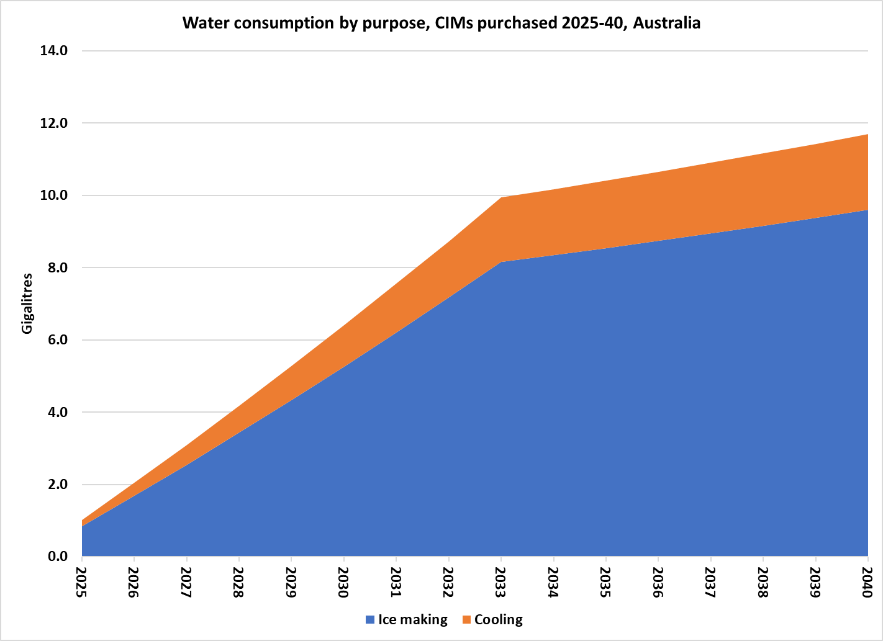

Figure 7 illustrates the projected total water used by CIMs purchased between 2025 and 2040 under all options. The top line corresponds to the total water use in Figure 5 and Figure 6 (Option 1)

Figure 7 Water consumed by CIMs sold 2025-2040, Australia

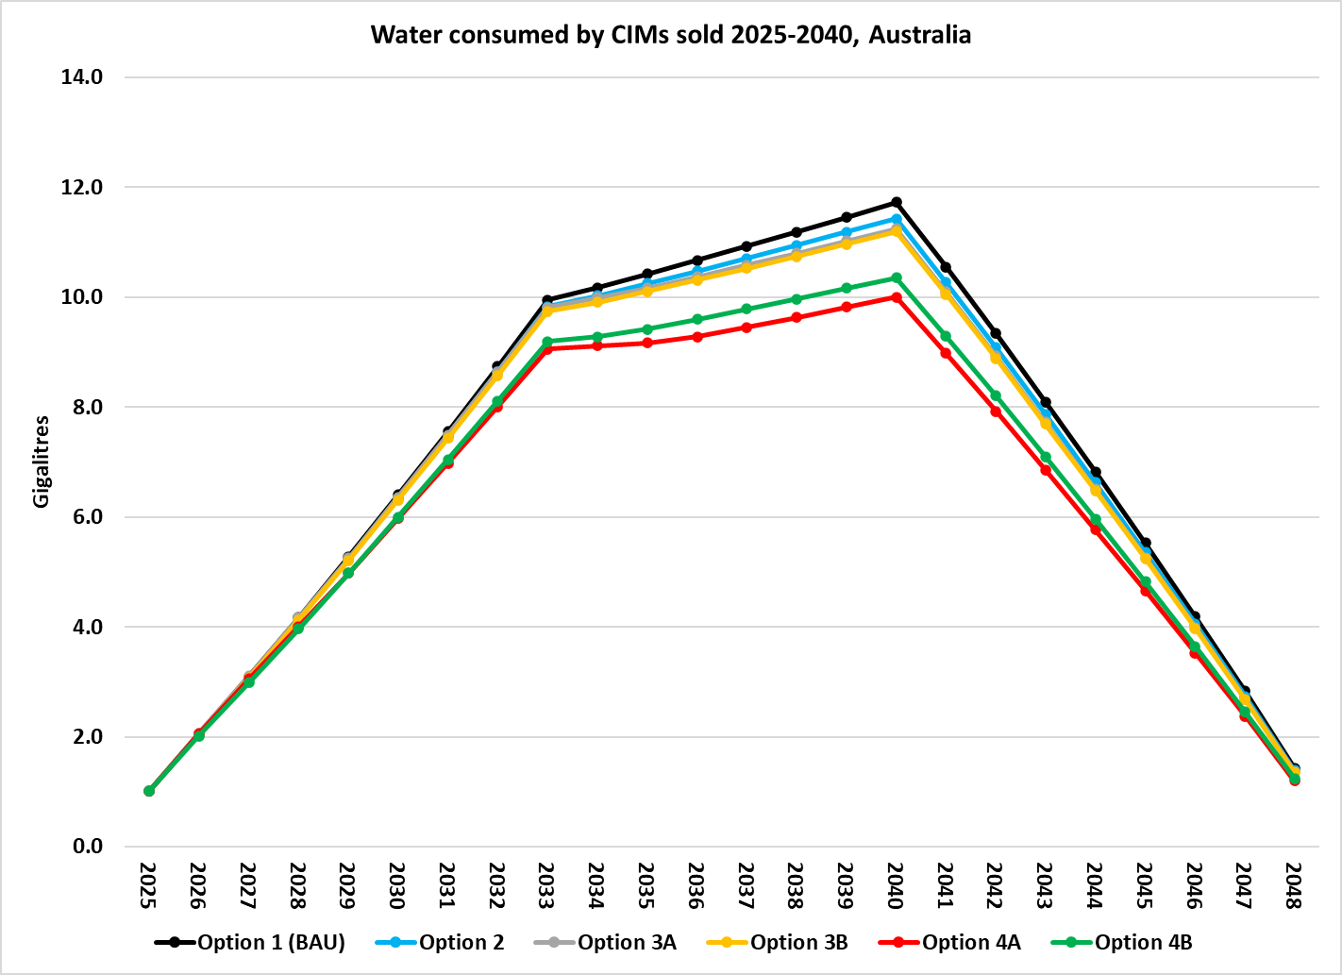

The area between the Option 1 line and each option line in Figure 7 represents the water saved by that option. Figure 8 illustrates the water savings at a larger scale. The water saving from Option 2 are projected to peak around 40,000 kilolitres (0.04 GL) per year in 2040 and then decline as CIMs retire. The maximum savings are from the Mandatory Water Efficiency Standards Option 4A (1.84 GL in 2040). This is higher than Option 4B because more stringent minimum standards can be set under Option 4A, due to the gathering of market data through implementation of Options 2, 3A or 3B.

Figure 8 Water saved by WELS option for CIMs sold 2025-2040, Australia

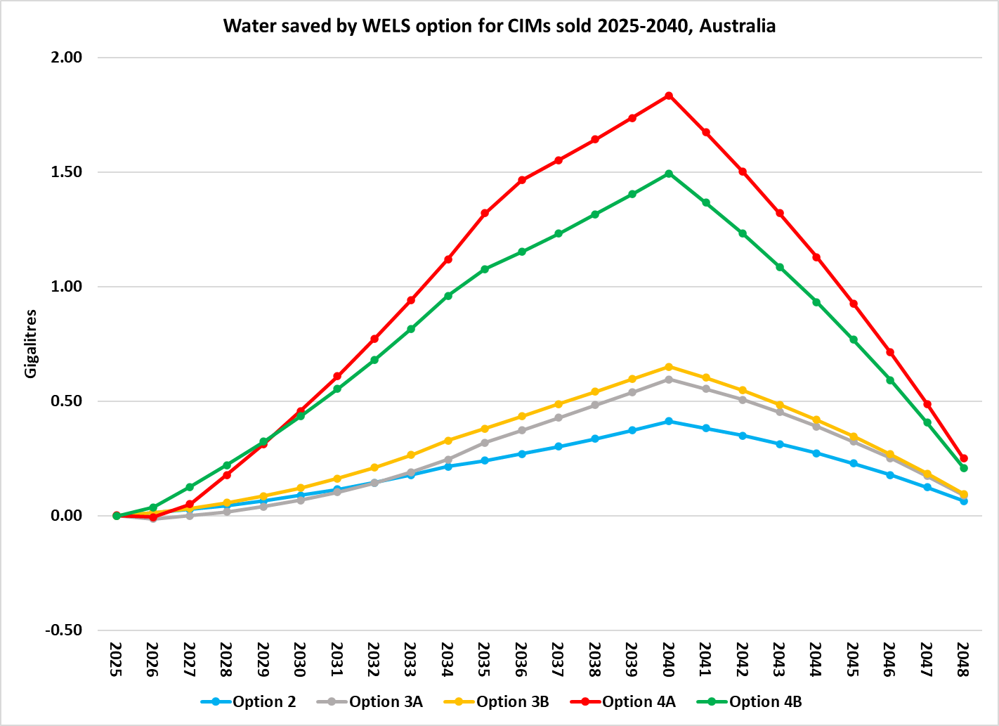

## 4.3 Projected costs

**Regulatory Burden**

The regulatory burden of the options has been calculated in accordance with OIA’s [Regulatory Burden Measurement Framework](https://oia.pmc.gov.au/resources/guidance-assessing-impacts/regulatory-burden-measurement-framework) and includes consideration of the following regulatory costs:

* Administrative costs incurred by regulated entities primarily to demonstrate compliance with the policy (usually record keeping and reporting costs). These are mainly time costs incurred by importers in dealing with the WELS Regulator and with distributors under Options 2, 3A, 3B, 4A and 4B. Testing costs would normally be included, but there are no additional testing costs beyond those needed under the status quo. The same tests measure both water and energy use, and if the test report is in the form as required by the GEMS Determination it will include the required water use data.
* Substantive compliance costs incurred by distributors to deliver the outcomes being sought (mainly training to employees and providing information to purchasers, including by way of physical labelling).
* Delay costs: expenses and loss of income incurred through application or approval delays. These are effectively zero in this case as testing and registration is required for every CIM model as part of compliance with the GEMS Determination and other regulatory requirements, e.g. electrical safety and WaterMark certification. It is assumed that the time period required for WELS registration would run in parallel.

Table 4 presents the estimates of the number of importers and secondary distributors that would incur a regulatory burden on account of the proposals, and the annual cost to each entity. It is estimated that the administrative costs would be borne mainly by the importers, and the substantive compliance costs by the distributors. All costs are additional to the status quo. That is, they are beyond the costs imposed by compliance with the GEMS Determination. It is assumed that these costs are higher in the introduction phase and then fall to a lower constant level.

Table 5 summarises the present value of the projected stream of regulatory burden costs. The direct regulatory burden would fall on the businesses that import and distribute CIMs, not on community organisations or on individuals (

Table 6).

Table 4 Estimates of Regulatory Burden Costs per liable entity

|  |  |  |  |  |  |
| --- | --- | --- | --- | --- | --- |
|  | **Option 2** | **Option 3A** | **Option 4B** | **Option 4A** | **Option 4B** |
| Number of importers | 30 | 30 | 30 | 30 | 30 |
| Secondary distributors (2025, 2040) | 40, 50 | 40, 50 | 40, 50 | 40, 50 | 40, 50 |
| Administrative cost per liable entity importer; Year 1 of implementation) | $5,000 | $10,000 | $10,000 | $10,000 | $10,000 |
| Administrative cost per liable entity; Year 2 etc) | $2,500 | $5,000 | $5,000 | $5,000 | $5,000 |
| Substantive compliance cost per liable entity (Year 1) | 0 | $5,000 | $5,000 | $5,000 | $5,000 |
| Substantive compliance cost per liable Admin entity (Year 2 etc) | 0 | $2,500 | $2,500 | $2,500 | $2,500 |
| Delay cost per liable entity | 0 | 0 | 0 | 0 | 0 |

Table 5 Estimate of total regulatory burden

|  |  |  |  |  |  |
| --- | --- | --- | --- | --- | --- |
|  | Option 2 $M PV | Option 3A $M PV | Option 3B $M PV | Option 4A $M PV | Option 4B $M PV |
| Administrative costs | 0.78 | 1.41 | 1.56 | 1.27 | 1.41 |
| Substantive compliance costs | 0 | 1.08 | 1.19 | 0.98 | 1.08 |
| Delay costs | 0 | 0 | 0 | 0 | 0 |
| Total $M | 0.78 | 2.49 | 2.74 | 2.25 | 2.49 |

PV is present value of regulatory burden over period 2025-2040 at discount rate of 7%

Table 6 Change in costs ($ million) by sector

|  | Business $M PV | Community organisations $M PV | Individuals $M PV | Total change in costs $M PV |
| --- | --- | --- | --- | --- |
| Option 2 | 0.78 | 0 | 0 | 0.78 |
| Option 3A | 2.49 | 0 | 0 | 2.49 |
| Option 3B | 2.74 | 0 | 0 | 2.74 |
| Option 4a | 2.25 | 0 | 0 | 2.25 |
| Option 4B | 2.49 | 0 | 0 | 2.49 |

PV is present value of regulatory burden over period 2025-2040 at discount rate of 7%

### WELS Regulator burden

For Options 3A, 3B, 4A and 4B, industry would have to register their products with the WELS Regulator, which would impose fees on the registrant. It is assumed that the current approach to charging and cost recovery would apply. This involves the application of a tiered fee structure at the time of applying to register products, and for the renewal of registration every 12 months if the supplier wanted to keep supplying the models to the market.[11]

The WELS Regulator would incur costs for:

* preparing the necessary legislative amendments
* revisions to the WELS standard (AS/NZS 6400)
* modifications to the WELS registration database
* identifying and communicating with businesses affected by the regulation
* staff time need for establishing new processes, assessing product registration applications, processing payments and providing education and support to registrants.

The WELS Regulator would also incur costs associated with compliance monitoring at various points of sale, to ensure the integrity of the WELS scheme. While the GEMS Regulator will likely undertake check tests to ensure the integrity of MEPS compliance, the models targeted for water related compliance checks may be different. The possible sharing of check test costs between regulators has not been considered in the costings. The registration and regulator costs are summarised in Table 7.

Table 7 Estimates of costs to WELS Regulator

|  |  |  |  |  |  |
| --- | --- | --- | --- | --- | --- |
|  | **Option 2** | **Option 3A** | **Option 4B** | **Option 4A** | **Option 4B** |
| Registration costs per year per importer | $2,900 | $2,900 | $2,900 | $2,900 | $2,900 |
| WELS admin costs per year | $75,000 | $150,000 | $150,000 | $150,000 | $150,000 |
| Check tests (Yr 1 of implementation) | 4 | 6 | 8 | 8 | 8 |
| Check tests (Yr 2, etc) | 2 | 3 | 4 | 4 | 4 |
| Cost per check test | $6,250 | $6,250 | $6,250 | $6,250 | $6,250 |
| Cost per label | NA | $0.50 | $0.50 | $0.50 | $0.50 |

Note: These costs are held constant in real terms but may rise in nominal terms with inflation.

### Purchaser burden

It is assumed that all compliance costs initially borne by industry and by the WELS Regulator are ultimately passed on to CIM purchasers. Purchasers also incur the costs of price increases due to improvements in the average water efficiency of CIMs, whether forced on them by Minimum Water Efficiency Standards which remove the cheapest and least water efficient models from the market or voluntarily incurred through exercising a preference for more water efficient models.

The relationship between product price and water efficiency is captured in modelling by assuming a Price/Efficiency (P/E) ratio. A P/E ratio of 1.0 implies that a 10% increase in water efficiency brings about a 10% increase in price. A P/E ratio of 0.5 implies a 5% price increase for every 10% increase in efficiency and so on.

The projected price impacts of energy efficiency improvements due to MEPS are already built into the unit price trends in Option 1. In addition, the following technical changes will be happening under Options 2, 3A, 3B, 4A and 4B:

* Improvements in potable water efficiency. A P/E ratio of 0.1-0.15 has been assumed for information declaration options (2, 3A and 3B) and 0.2-0.3 for options that include Minimum Water Efficiency Standards (4A and 4B).
* For water-cooled products, improvements in cooling water efficiency. A P/E ratio of 0.2-0.3 has been assumed for cooling water efficiency improvements under all options.

Note that the price increase effects are additive: for water-cooled categories, separate cost and price effects are estimated for potable water efficiency and condenser water efficiency improvements, since they involve different technological pathways.

Goods and Services Tax (GST) effects are not included in the modelling on either the cost or the benefits side. Volumetric water charges are not subject to GST in any case, and though GST is charged on CIM sales, CIM purchasers are businesses which can claim back any GST payments.

## 4.4 Benefit/cost analysis

The value of projected water savings for states and territories under each option is calculated by multiplying the quantity of water and wastewater saved (i.e. the equivalent of Figure 8 for that jurisdiction) by the projected water supply and wastewater price in that jurisdiction (Figure 12 in Appendix B). The present value in 2025 of the stream of savings is calculated at a 7% discount rate.[12]

The present value of projected costs is estimated over the period 2025 to 2040. The period of savings accumulation is longer because even if a market intervention option terminates in 2040 through abandonment or adoption of a more stringent measure, the CIMs purchased before then will continue to accumulate water savings until they are retired from use.

Table 8 and Figure 9 summarise the projected costs, benefits and water savings of each option. Program cost is the sum of the regulatory burden on business and the WELS Regulator burden, Options 2, 3A, 3B have very similar net benefits. The additional water savings delivered by Options 3A and 3B are largely negated by the costs of regulation.

Table 8 Summary of projected costs and benefits, Australia

|  |  |  |  |  |  |  |  |  |  |  |  |
| --- | --- | --- | --- | --- | --- | --- | --- | --- | --- | --- | --- |
|  | Costs $M PV | | | Benefit $M PV | | | Net  Benefit | B/C  ratio | Increase in CIM prices | GL water saved | |
| In 2040 | 2024-48 |
|  | Price | Prog | Total | Potable | Cooling | Total |  |  |
| Option 2 | $2.2 | $1.6 | $3.8 | $25.6 | $6.9 | $32.5 | $28.7 | 8.5 | 0.4% | 0.4 | 4.6 |
| Option 3A | $3.6 | $3.9 | $7.5 | $28.5 | $6.8 | $35.3 | $27.8 | 4.7 | 0.7% | 0.6 | 6.2 |
| Option 3B | $4.1 | $4.4 | $8.5 | $31.0 | $6.9 | $37.9 | $29.4 | 4.5 | 0.8% | 0.6 | 7.2 |
| Option 4A | $13.9 | $3.9 | $17.8 | $61.8 | $8.2 | $70.0 | $52.2 | 3.9 | 2.7% | 1.8 | 22.0 |
| Option 4B | $11.9 | $4.0 | $15.9 | $58.0 | $5.3 | $63.3 | $47.4 | 4.0 | 2.3% | 1.5 | 18.4 |

B/C ratio is total benefits divided by total costs. PV is present value, at 7% discount rate. Note that price increases are additional to those projected to occur as a result of compliance with MEPS.

Figure 9 Costs (C), Benefits (B) and B/C ratios by option, Australia

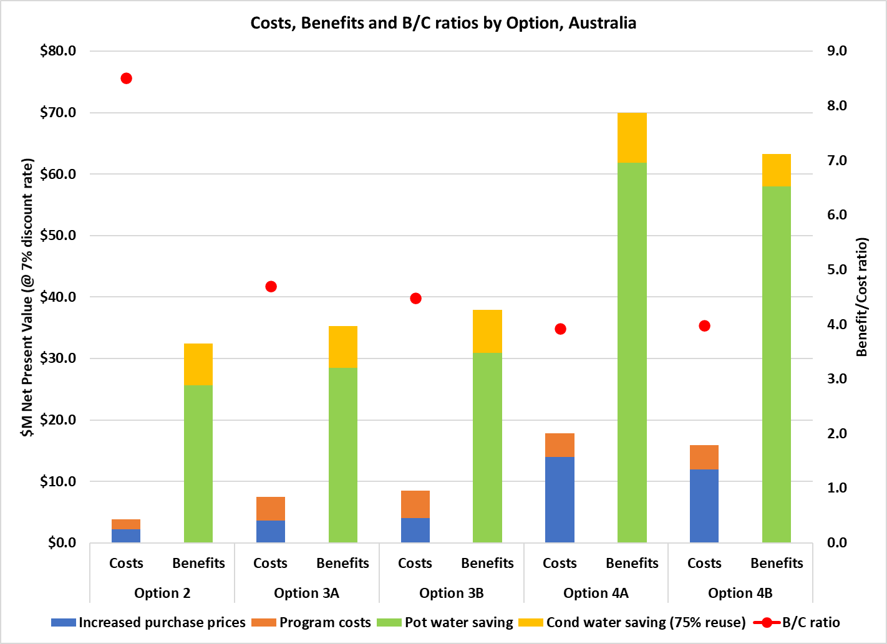

The program costs indicated in Figure 9 are disaggregated in Figure 10. The product registration fees incurred by CIM suppliers are in effect transfer payments to the WELS Regulator, so the actual cost to the Regulator is net of this income. Physical labelling costs are estimated at $0.50 per applied label and make a negligible contribution to program costs.

Figure 10 NPV of program costs, 2025-2040, Australia

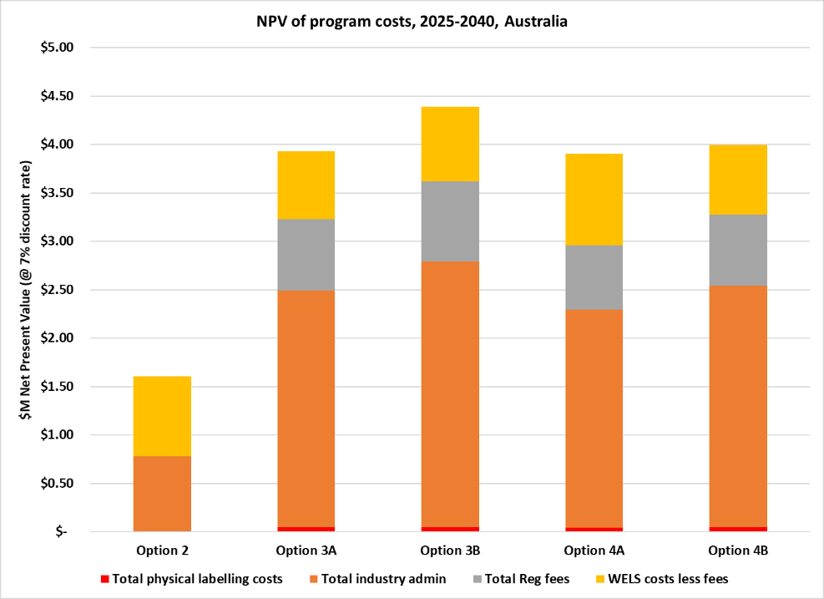

Ultimately, it is assumed that all costs, whether borne initially by industry or by the WELS Regulator are passed on to CIM purchasers as higher product prices (although technically the unrecovered share of WELS Regulator costs are borne by the taxpayer). All benefits accrue to CIM purchasers.

Figure 11 shows the stacked benefits for each option, starting with the lowest projected benefit (Option 2, $M 32.5) up to the highest benefit (Option 4A, $M 70.0). This is a visual indicator of the additional benefit from moving to progressively more stringent measures. It shows that:

* There is little difference in benefit between Option 2 (Voluntary declaration with WELS support) and Options 3A and 3B (Product registration and information declaration), provided that Option 2 has high take-up by suppliers. If Option 2 is not successful then Option 3A would become more attractive.
* The Minimum Water Efficiency Standards options (4A and 4B) lead to a near doubling of benefit, but at much lower B/C ratios.
* Most of the benefits come from IMH models, because of their high average ice production, and from batch-production (cube ice) models, which have far greater scope to increase potable water efficiency than continuous (flaked ice) models.
* Water-cooled models deliver slightly more benefit than air-cooled models, but this depends on the assumed rate of recirculation of cooling water. This is discussed in the next section.

Figure 11 Stacked benefits by stringency of WELS options by CIM configuration, Australia

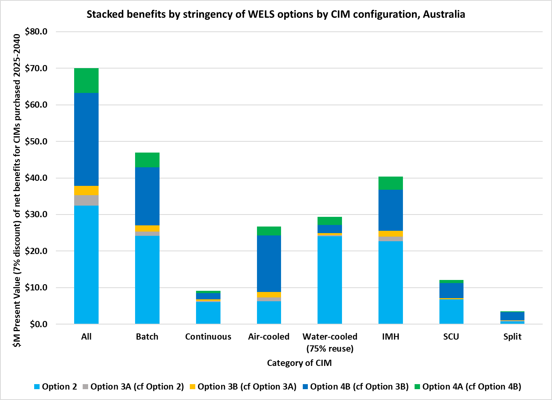

### Uncertainty and sensitivity

As with all projections, there are uncertainties due to both imperfect information about the present and assumptions about the future. It is impossible to calculate statistical uncertainties of the impacts of any given WELS option without having reliable information about the CIM models available on the Australian market, which will only become available once all CIMs on the market are tested to the same standard and their water use rates declared.

Calculating the sensitivity of outcomes to the discount rate assumptions is more straightforward. Table 9 summarises the NPV of net benefits and B/C ratios for Australia, at discount rates of 3% and 10%, as well as the central rate of 7%. The lower the discount rate the higher the net benefit, because the value of future water savings are not discounted as heavily. On the other hand, future capital costs due to water efficiency increases are also discounted less and so have a higher PV.

The projected outcomes are moderately sensitive to discount rates, but B/C ratios are highly favourable even at the highest discount rate (10%). By way of comparison, the projected net benefit of the CIM MEPS option implemented by GEMS was estimated at $M 246.6, with a B/C ratio of 7.7 at the 7% discount rate (E3 2023).

Table 9 Sensitivity to discount rate assumptions, Australia

|  |  |  |  |  |  |  |
| --- | --- | --- | --- | --- | --- | --- |
|  | $M NPV at discount rates | | | B/C ratio at discount rates | | |
|  | 3% | 7% | 10% | 3% | 7% | 10% |
| Option 2 | $47.2 | $28.7 | $20.5 | 9.7 | 8.5 | 7.8 |
| Option 3A | $47.3 | $27.8 | $19.3 | 5.4 | 4.7 | 4.3 |
| Option 3B | $50.0 | $29.4 | $20.4 | 5.2 | 4.5 | 4.1 |
| Option 4A | $89.8 | $52.2 | $35.9 | 4.4 | 3.9 | 3.6 |
| Option 4B | $80.9 | $47.4 | $32.8 | 4.5 | 4.0 | 3.7 |

Another significant uncertainty is the value of cooling water savings. If water-cooled CIMs become more water efficient in their cooling water use, but all of their cooling water is effectively zero cost because it is recycled or obtained free from a non-potable supply, the value of cooling water savings would approach zero. Water-cooled CIMS would also be subject to measures aimed at improving their potable water use, so they would still be expected to return some water savings.

Table 10 indicates the sensitivity of the findings to assumptions about the rate of cooling water reuse. The central assumption, based on industry information, is that:

* 80% of water-cooled ice maker head (IMH) units will be connected to water recirculation circuits, so only 20% will use single-pass cooling water supplied from the mains; and
* 70% of self-contained (SCU) units will be connected to water recirculation circuits, so only 30% will use single-pass cooling water supplied from the mains. As the average SCU produces much less ice than the average IMH, purchasers will be less concerned about high water use.

This combination is called the 75% reuse scenario, being the average of 80% for IMH and 70% for SCU. Additional scenarios have also been modelled - 65% reuse (70/60), 85% reuse (90/80) and 100% reuse (100/100). The results are presented in Table 10.

The higher the cooling water reuse rate, the less the total value of mains water and wastewater saved. However, as program costs remain the same, the B/C ratio falls. At 100% reuse the B/C ratios for all options are still greater than 1, indicating that all options are cost-effective even under the least favourable assumptions.

Table 10 sensitivity to cooling water reuse assumptions

|  |  |  |  |  |  |  |  |  |
| --- | --- | --- | --- | --- | --- | --- | --- | --- |
|  | $M NPV at 7% discount rate, at various levels of cooling water reuse | | | | B/C ratio at various levels of cooling water reuse | | | |
|  | 65% | 75% | 85% | 100% | 65% | 75% | 85% | 100% |
| Option 2 | $40.0 | $28.7 | $17.3 | $4.1 | 11.5 | 8.5 | 5.5 | 2.1 |
| Option 3A | $39.3 | $27.8 | $16.3 | $2.9 | 6.2 | 4.7 | 3.2 | 1.4 |
| Option 3B | $41.0 | $29.4 | $17.9 | $4.3 | 5.8 | 4.5 | 3.1 | 1.5 |
| Option 4A | $64.7 | $52.2 | $39.7 | $25.1 | 4.6 | 3.9 | 3.2 | 2.4 |
| Option 4B | $59.1 | $47.4 | $35.7 | $21.9 | 4.7 | 4.0 | 3.2 | 2.4 |

Finally, Table 11 indicates the sensitivity of outcomes if the increases in CIM prices were twice as great as estimated in Table 8. This may occur if, for example, some suppliers withdrew and so lessened price competition in the market. This is very unlikely for the information only options (2,3A and 3B) but is a risk for the Minimum Water Efficiency Standards options (4A, 4B). Even with price-doubling, all options would remain cost effective.

Table 11 Summary of projected costs and benefits, Australia (Price doubled)

|  |  |  |  |  |  |  |  |  |  |
| --- | --- | --- | --- | --- | --- | --- | --- | --- | --- |
|  | Costs $M PV, 7% discount rate | | | Benefit $M PV, 7% discount rate | | | Net | B/C | % increase in |
|  | Price | Program | Total | Potable | Cooling | Total | Benefit | ratio | CIM prices |
| Option 2 | $4.4 | $1.6 | $6.0 | $25.6 | $6.9 | $32.5 | $26.5 | 5.4 | 0.8% |
| Option 3A | $7.2 | $3.9 | $11.1 | $28.5 | $6.8 | $35.3 | $24.2 | 3.2 | 1.4% |
| Option 3B | $8.2 | $4.4 | $12.6 | $31.0 | $6.9 | $37.9 | $25.0 | 3.0 | 1.6% |
| Option 4A | $27.8 | $3.9 | $31.7 | $61.8 | $8.2 | $70.0 | $38.3 | 2.2 | 5.4% |
| Option 4B | $23.8 | $4.0 | $27.8 | $58.0 | $5.3 | $63.3 | $35.5 | 2.3 | 4.6% |

B/C ratio is total benefits divided by total costs. PV is present value. Note that price increases are additional to those projected to occur as a result of compliance with MEPS.

## 4.5 Stakeholder Impacts

### Suppliers

There are about 30 CIM importers, one Australian manufacturer and about 40 secondary distributors, who would need to respond to any new water efficiency measures.[13] The importers and manufacturer will have to register their CIM models with the GEMS Regulator in accordance with the GEMS Determination that comes into effect in March 2026. This will mainly involve obtaining energy and water consumption test results from overseas suppliers. Local test laboratories have also shown interest in offering AS/NZS 4865 testing but will be reluctant to obtain the necessary accreditation until there is a demand for the service.

Models for which the necessary test data are not available by the time the GEMS Determination takes effect would have to be withdrawn from the market, either permanently or until thy can be tested in the country of manufacture or in Australia. WELS adoption of the same CIM definitions, categories, test standards and water and energy test methods means that there should be no extra costs to obtaining water performance data.

The WELS Regulator can leverage the GEMS Determination and help suppliers assess how their decisions to declare water use rates to the GEMS Regulator might influence future WELS options. If the WELS Regulator implements the non-regulatory Option 2 with the intention of moving to a regulatory option if there is insufficient voluntary take-up, all parties would benefit from knowing what the trigger criteria would be (e.g. if fewer than 80% of suppliers and 80% of models participate voluntarily).

Options 2, 3A and 3B do not impose any restrictions on the CIM model range and leaves it to suppliers to make commercial decisions about which models to promote or remove. These decisions will no doubt be informed by a supplier’s perception about how, or whether, purchasers use the information made available to them.

Options 4A and 4B would set limits on water consumption which could exclude a significant number of models. Given the present limitations on water use information for CIMs on the Australian market, setting any Minimum Water Efficiency Standard carries risk. If set too low, the Minimum Water Efficiency Standards will have no effect, and if set too high they could exclude so many models that the market would be disrupted, and some suppliers may have to exit the market entirely. The number of models excluded at any given Minimum Water Efficiency Standard cannot be known until all models are registered. Logically, the more stringent the standard the more models excluded.

However, most importers have access to a wide range of products, manufactured and sold in different parts of the world. Those intended for the US market are likely to be the most water efficient, because of the impacts of the USDOE mandatory cooling water efficiency standards and the USEPA Energy Star program. The possibility of changing models from the existing global product range should enable most importers to meet a water efficiency standard that is equal to or less stringent than the USA levels, without a significant reduction in the range of products on offer in Australia.

### Purchasers

Purchasers of CIMs from importers or secondary suppliers may face higher average prices but would benefit from a greater saving in lifetime costs. Table 8 indicates the estimated price increase for each option as a result of the relationship between water efficiency and price described earlier. The mean price increase ranges from 0.4% for Option 2 up to 2.7% for Option 4A, averaged over all CIMs projected to be purchased over the period 2025-2040.

The years required for the savings in water use costs to match the increase in capital costs is indicated in Table 12. These estimates are based on the average production capacity by CIM type: about 70 kg/24 hrs for SCUs, 300 kg/24 hrs for IMHs and 400 kg/24 hrs for split units. The larger the capacity, the higher the purchase price and the higher the savings in running costs, all else being equal.

Most of the payback periods are less than two years. Commercial catering businesses surveyed by the NSW Department of Environment in 2020 indicated that they would expect a 2 to 4-year payback for investments in more efficient equipment (E3 2023). All of the proposed measures would meet that criterion for most types of CIM, with a few exceptions.

A payback period longer than 8 years carries the risk that the unit will fail before payback. In general, the payback periods for batch-production models are significantly shorter than for continuous-production models, because the potable water consumption per kilogram of ice is much greater and there is more scope for water saving.

For water-cooled products, there will be a very short payback period if the unit is installed for single-pass cooling (0% reuse) but a very long payback (exceeding the product lifetime) if it is connected to a cooling water recirculation system (100% reuse). The high water costs of single-pass cooling (unless the cooling water is free) should be communicated as part of any CIM information program devised by the WELS Regulator, especially under Option 2.

Apart from the product price increases expected from a rise in average water efficiency of the CIMs purchased, it is assumed that the program costs initially borne by suppliers (administration, registration and labelling) will also be passed on to purchasers. As these costs are not model or type-specific, it is difficult to know how they will be allocated. Suppliers may adjust the prices of some models more than others. The second group of payback periods in Table 12 calculates payback periods in the event that industry costs incurred in 2030 are allocated evenly to every model sold in 2030. For Options 2, 3A and 3B, the recovery of supplier costs from purchasers can significantly lengthen the payback period.

Ice makers are essential equipment for restaurant, hospitality, foodservices, food retail and similar businesses, and it is unlikely that they would hesitate to purchase a new or replacement unit because the price of a typical $5,000 product increases by $20 (0.4%) to $135 (2.7%). At the margins, however, some businesses that currently rely on bagged ice may defer purchasing an ice machine if they face higher purchase prices.

None of the proposed options are expected to impact on the average service life of CIMs. According to suppliers, the most significant factors affecting service life are frequency of cleaning and servicing.

Table 12 simple payback period (years) for cim purchasers

|  |  |  |  |  |  |  |  |  |  |  |  |
| --- | --- | --- | --- | --- | --- | --- | --- | --- | --- | --- | --- |
| Category | Cooling water Reuse | Water efficiency related price increases only | | | | | With industry costs equally distributed | | | | |
| Option  2 | Option  3A | Option  3B | Option  4A | Option  4B | Option  2 | Option  3A | Option 3B | Option 4A | Option 4B |
| IMH-Air-Batch | NA | 0.8 | 1.0 | 0.9 | 1.1 | 1.0 | 1.2 | 2.5 | 2.2 | 1.4 | 1.4 |
| IMH-Air-Cont | NA | 2.7 | 1.4 | 2.1 | 2.2 | 2.2 | 7.3 | 6.1 | 8.2 | 3.2 | 3.2 |
| IMH-Water-Batch | 100% | 1.9 | 2.1 | 2.0 | 1.1 | 1.5 | 2.2 | 3.4 | 3.1 | 1.3 | 1.8 |
|  | 0% | 0.1 | 0.2 | 0.2 | 0.2 | 0.2 | 0.2 | 0.3 | 0.3 | 0.2 | 0.2 |
| IMH-Water-Cont | 100% | 8.6 | 4.6 | 6.6 | 3.9 | 3.0 | 12.5 | 8.5 | 11.7 | 4.7 | 3.8 |
|  | 0% | 0.2 | 0.2 | 0.2 | 0.4 | 0.4 | 0.3 | 0.3 | 0.3 | 0.5 | 0.6 |
| SCU-Air-Batch | NA | 2.5 | 2.9 | 2.9 | 3.9 | 3.7 | 3.6 | 7.4 | 6.8 | 4.9 | 4.9 |
| SCU-Air-Cont | NA | 4.9 | 5.7 | 5.3 | 6.7 | 6.4 | 11.7 | 26.0 | 22.6 | 9.6 | 10.4 |
| SCU-Water-Batch | 100% | 4.5 | 5.2 | 5.6 | 2.4 | 3.3 | 5.3 | 8.5 | 8.5 | 3.2 | 4.2 |
|  | 0% | 0.7 | 0.9 | 0.9 | 0.7 | 0.9 | 0.9 | 1.4 | 1.4 | 0.9 | 1.1 |
| SCU-Water-Cont | 100% | 21.2 | 18.7 | 18.1 | 16.4 | 11.7 | 26.5 | 34.4 | 31.4 | 18.5 | 14.8 |
|  | 0% | 0.6 | 0.7 | 0.7 | 1.2 | 0.8 | 0.7 | 1.3 | 1.2 | 1.3 | 1.0 |
| RCU-Air-Batch | NA | 0.7 | 0.8 | 0.8 | 0.7 | 0.7 | 0.8 | 1.4 | 1.3 | 0.9 | 0.9 |
| RCU-Air-Cont | NA | 2.0 | 1.5 | 1.9 | 1.5 | 1.5 | 3.9 | 4.6 | 5.3 | 2.1 | 2.1 |
| RCRC- Air-Batch | NA | 0.7 | 0.8 | 0.8 | 0.7 | 0.7 | 0.8 | 1.4 | 1.3 | 0.9 | 0.9 |
| RCRC-Air-Cont | NA | 2.0 | 1.5 | 1.9 | 1.4 | 1.4 | 3.9 | 4.6 | 5.4 | 2.1 | 2.1 |

Cases highlighted yellow may exceed the service life of the product, and those highlighted red do exceed it.

### The WELS Regulator

In both Option 1 (status quo) and Option 2 (Voluntary declaration with WELS support) the GEMS Regulator is responsible for registering products and checking compliance. In Option 2, the WELS Regulator encourages suppliers to declare water use rates through a range of information measures directed at purchasers of CIMs.

Options 3A, 3B, 4A and 4B would formally include CIMs within the WELS scheme. This would involve:

* Working with Standards Australia to amend AS/NZS 6400 to include CIM water consumption tests (which would be those already specified in the GEMS Determination) and possibly a WELS label and Minimum Water Efficiency Standards for CIMs.
* Amending Section 6 of the Water Efficiency Labelling and Standards Determination 2013 (No. 2) to add CIMs (with definitions) as a WELS product; and amending Section 7 to reference the amended version of AS/NZS 6400 (the current reference is to the 2016 edition).
* Amending the WELS Registration system to enable CIM product registration and charging.

As with all other products subject to WELS labelling and standards, there will be administrative costs for assessing registration applications, operating a registration system, maintaining a public registration database, enforcing compliance and maintaining the Water Rating website to support stakeholder education. These are projected to cost the WELS Regulator an average of AUD $150,000 per year between 2025 and 2040 (equivalent to the salary and on-costs for one full-time APS 6 officer). It is estimated that about half the costs will be covered from WELS registration fee income and the rest will need to be made up from Government contributions.

The criteria for accepting test results for registration would need to be aligned with the GEMS Determination, to minimise costs to both registrants and the WELS Regulator. Any check testing of water use by the WELS Regulator would rely on accredited independent laboratories, of which there are presently none in Australia. In 2022, the NSW government commissioned trial testing at an Australian laboratory which confirmed the practicality of the AS/NZS 4865.1 test and confirmed that the results were very close to the US tests. As the GEMS Determination will be in place first, the GEMS Regulator should have established a framework for check testing before the WELS Regulator needs to make use of it.

### Impacts on competition

Some impacts are likely to increase market competition while others might reduce it. In the short term, the withdrawal of the least water efficient models (under Options 4A and 4B) could reduce the range of models on the market, at least until importers secure supplies of more efficient ones, which are known to exist on the global market.

On the other hand, reliable information about the water efficiency of every model will be available for the first time, which should enhance competition based on differences in water-intensity. It is also likely to sharpen competition between air-cooled and water-cooled products.

There are no apparent negative or anti-competitive implications for international trade. Any WELS regulations would apply equally to both imports and locally manufactured products. Products may be tested and registered under three different (but near-identical) test standards: the AS/NZS standard, the ASHRAE/AHRI test used in the US and Canada and the ISO test standard. This expands choices for global suppliers. Overall, the impact on supplier and model competition is likely to be minimal.

# References

AEMC (2024) *How the national energy objectives shape our decisions*, Australian Energy Market Commission, 28 March 2024

Allen and Clarke (2021) *Independent Review of the Water Efficiency Labelling and Standards Scheme and Intergovernmental Agreement*, for Department of Agriculture, Water and the Environment, July 2021

ANSI/AHRI 820–2017 *Standard for Performance Rating of Ice Storage Bins*

ANSI/ASHRAE 29–2009 *Method of Testing Automatic Ice Makers*

AS/NZS 4865:2008 *Performance of commercial ice makers and ice storage bins,   
Part 1: Test methods for ice makers—Environmental performance  
Part 3:* Minimum energy performance standard (MEPS) requirements

AS/NZS 6400:2016 *Water efficient products—Rating and labelling*

CFR 431 *USA Code of Federal Regulations PART 431—Energy Efficiency Program for Certain Commercial and Industrial Equipment, Subpart H—Automatic Commercial Ice Makers*

E3 (2011) *Retrospective Review of the E3 Program: Lessons learnt from two reviews*, E3 Committee, September 2011

E3 (2023) *Regulation Impact Statement for Consultation: MEPS and other measures for Commercial Ice Makers*, Equipment Energy Efficiency Program, 2023

ES (2018) *ENERGY STAR Program Requirements for Automatic Commercial Ice Makers – Eligibility Criteria* Version 3.0, January 2018

GEMS (2019) *Independent Review of the Greenhouse and Energy Minimum Standards (GEMS) ACT 2012*, Final Report, June 2019

GEMS (2025) *Greenhouse and Energy Minimum Standards (Commercial Ice-makers) Determination 2025,* 3 March 2025

GWA (1993) *Benefits and costs of implementing minimum energy performance standards for household electrical appliances in Australia*: George Wilkenfeld and Associates with Lawrence Berkeley Laboratory for Demand Management Unit, State Electricity Commission of Victoria, 1993

ISF (2019) *Evaluation of the environmental and economic impacts of the WELS scheme*, Institute for Sustainable Futures for Department of Agriculture and Water Resources, February 2019

OIA (2023) *Australian Government Guide to Policy Impact Analysis*, Office of Impact Assessment, Department of Prime Minister and Cabinet, March 2023

Quantum (2014*) WELS Scheme Effectiveness: Report of Survey Findings* Quantum Market Research for Department of the Environment, July 2014

# Appendix A Questions for Stakeholders

**General survey questions**

1. Are you a member of an industry association that represents your commercial ice maker interests?
2. Yes
3. No
4. Question not relevant to my business/organisation
   1. Please list industry association memberships.
5. Do you see a competitive advantage for manufacturers and suppliers to promote the water use or water efficiency of commercial ice makers in Australia?
6. Yes
7. No
8. Are you a commercial ice maker supplier?
9. Yes
10. No
    1. What percentage of your commercial ice makers are water-cooled?
11. In your view, is the total Australian market share of water-cooled commercial ice makers:
12. Increasing
13. Decreasing
14. Remaining steady
15. Don’t know

**Survey questions relating to Options 1 and 2 of the Regulatory Impact Analysis**

1. The Greenhouse and Energy Minimum Standards (GEMS) Regulator has implemented Minimum Energy Performance Standards (MEPS) for commercial ice makers, to come into effect in March 2026.

As part of this regulation, the GEMS Regulator has introduced the voluntary declaration of a model’s potable water use rate and condenser water use rate (for water-cooled products) in litres/kg ice produced. This is part of the product registration process. Water use rates are measured during the test for production rate and energy use.

When registering your products for MEPS, do you intend to declare potable water use rates and condenser water use rates (for water-cooled products)?

1. Yes, all models
2. Yes, some models
3. No
4. I do not have responsibility for registering commercial ice makers with the GEMS Regulator

5.1 Please indicate why you are choosing to declare your product’s water use rate.

5.2 Please indicate why you are choosing not to declare your product’s water use rate.

1. On a scale of 1 to 5, with 1 being completely unsupportive and 5 being completely supportive, please rate your level of support for the principle that the potable water use (L/kg ice) should be declared for all commercial ice maker models.

|  |  |  |  |  |  |
| --- | --- | --- | --- | --- | --- |
| 1 | 2 | 3 | 4 | 5 | 6 |
| Completely unsupportive | Unsupportive | Neutral | Supportive | Completely supportive | Don’t know |

* 1. Please explain why.

1. On a scale of 1 to 5, with 1 being completely unsupportive and 5 being completely supportive, please rate your level of support for the principle that the condenser water use (L/kg ice) should be declared for all water-cooled commercial ice maker models.

|  |  |  |  |  |  |
| --- | --- | --- | --- | --- | --- |
| 1 | 2 | 3 | 4 | 5 | 6 |
| Completely unsupportive | Unsupportive | Neutral | Supportive | Completely supportive | Don’t know |

* 1. Please explain why.

1. Should information about the water performance of commercial ice makers be published on a government website and made public?
2. It should not be required.
3. It should be a business decision for industry (manufacturers and suppliers).
4. Industry should be actively encouraged by other parties to publish the information (such as industry associations, water authorities and/or the Australian Government).
5. It should be mandatory for industry to publish the information.
   1. Please explain why.
6. If a supplier volunteers to declare the water use rates of their commercial ice maker models as part of their GEMS registration, would it be useful to establish rules for standard information provided to purchasers of CIMS, so they can easily compare products?
7. No - leave it to the market.
8. Yes - the information should be available to purchasers and should be standardised.
   1. Please explain why.

**Survey questions relating to Option 3 of the Regulatory Impact Analysis**

1. On a scale of 1 to 5, with 1 being completely unsupportive and 5 being completely supportive, please indicate how strongly you support the principle that there should be mandatory water efficiency information (of potable and condenser water use) at point of sale for purchasers, and that products must be registered under the Water Efficiency Labelling and Standards Act 2005?

|  |  |  |  |  |  |
| --- | --- | --- | --- | --- | --- |
| 1 | 2 | 3 | 4 | 5 | 6 |
| Completely unsupportive | Unsupportive | Neutral | Supportive | Completely supportive | Don’t know |

* 1. Please explain why.

1. Are there any product types or categories falling within the definition of commercial ice makers (as specified in the consultation draft Regulatory Impact Analysis) that should be excluded from the requirement to declare water use rates or water efficiency?
2. Yes
3. No
4. Don’t know
   1. Please explain why.

**Survey questions relating to Option 4 of the Regulatory Impact Analysis**

1. On a scale of 1 to 5, with 1 being completely unsupportive and 5 being completely supportive, please indicate how strongly you support the principle that there should be Minimum Water Efficiency Standards for commercial ice makers (potable water use and condenser water use [when relevant]), expressed as a maximum L/kg ice in relation to production capacity?

|  |  |  |  |  |  |
| --- | --- | --- | --- | --- | --- |
| 1 | 2 | 3 | 4 | 5 | 6 |
| Completely unsupportive | Unsupportive | Neutral | Supportive | Completely supportive | Don’t know |

* 1. Please explain why.

1. If Minimum Water Efficiency Standards were adopted for potable water consumption, should they be:
2. The same as the commercial ice maker water use standards adopted by the US Energy Star program?
3. Less stringent (i.e. allow for more potable water use per kg ice)?
4. More stringent (i.e. allow for less potable water use per kg ice)?
5. Unsure
6. If Minimum Water Efficiency Standards were adopted for condenser water consumption, should they be:
7. The same as the commercial ice maker water use standards adopted by the US Department of Energy?
8. Less stringent (i.e. allow for more condenser water use per kg ice)?
9. More stringent (i.e. allow for less condenser water use per kg ice)?
10. Not sure
11. Are there any product types or categories falling within the definition of commercial ice makers (as specified in the Regulatory Impact Analysis) that should be excluded from Minimum Water Efficiency Standards?
12. Yes
13. No
14. Don’t know

15.1 Please explain why.

**Closing survey questions**

1. Do you agree with the assumptions in the Regulatory Impact Analysis regarding market size, water use, water efficiency, costs or any other aspects of the analysis?
2. Agree
3. Don’t agree
   1. Please explain why and if possible, provide additional data or information on any of the assumptions.
4. Please rank the policy options to improve the water efficiency of commercial ice makers in order of effectiveness – **with 1 being the most effective**. Please don’t allocate a ranking to options you don’t believe can help improve water efficiency.

Rank up to 4

1. To not regulate commercial ice makers under the WELS Act (Status quo).
2. To encourage businesses who register commercial ice makers with the Greenhouse and Energy Minimum Standards Regulator to declare water use rates, and to publish water use rates to inform consumers.
3. To regulate commercial ice makers under the WELS Act and require mandatory registration and declaration of product information at point of sale.
4. To regulate commercial icemakers under the WELS Act and require mandatory registration; declaration of product information at point of sale; and application of minimum water efficiency standards.
   1. Why do you feel this way?
5. What opportunities or difficulties would the proposed options create for your business or the industry?
6. Do you have additional comments you would like to provide?
7. Yes
8. No
   1. Please provide further information.

# Appendix B Cost-Benefit Modelling Details

Information on the size of the Australian market for CIMs (units with water supply and drainage connections, with production capacity up to 1000 kg/24 hr at 32/21) was obtained from interviews with suppliers and from analysis of customs data (E3 2023). It is estimated that the market is currently about 10,500 units per year. Given that the typical service life of each unit is 7 to 10 years, and taking into account stock growth of about 2.0% per annum, the estimated total stock is currently about 63,000 units.

The modelling takes into account the projected capital costs of the CIMs that are expected to be purchased in Australia from 2025 to 2040 (i.e. 16 calendar years). It is assumed that 100% of each year’s cohort survives to the 8th year, 50% to year 9, and none to year 10. This implies an average service life of 8.5 years. Therefore, the model calculates the net present value (NPV) of total national CIM maker water consumption as far out as 2049, using the range of discount rates required by the OIA (4%, 7% and 10%).

### Water Prices

The model is structured by jurisdiction (states and territories) because water and wastewater prices vary, as indicated in Table 13.

Table 13 Estimated mains-supplied water charges by jurisdiction, 2025

|  |  |  |  |  |  |  |  |
| --- | --- | --- | --- | --- | --- | --- | --- |
|  | Region | | Businesses  ('000) |  | Total $/kL | Supply $/kl | Waste $/kl |
| NSW | | Metro | 148.4 | 51% | 3.99 | 2.69 | 1.30 |
|  | | Other | 143.6 | 49% | 3.20 | 2.47 | 0.73 |
|  | | Total | 292.0 |  | 3.60 | 2.58 | 1.02 |
| Victoria | | Metro | 172.7 | 72% | 4.79 | 3.30 | 1.49 |
|  | | Other | 66.9 | 28% | 4.30 | 2.49 | 1.80 |
|  | | Total | 239.6 |  | 4.66 | 3.08 | 1.58 |
| Queensland | | Metro | 77.3 | 63% | 7.44 | 4.90 | 2.54 |
|  | | Other | 45.5 | 37% | 3.25 | 3.25 | 0.00 |
|  | | Total | 122.8 |  | 5.89 | 4.29 | 1.60 |
| SA | | Total | 60.0 |  | 3.21 | 3.21 | 0.00 |
| WA | | Metro | 67.1 | 85% | 7.10 | 2.85 | 4.25 |
|  | | Other | 12.2 | 15% | 3.71 | 3.71 | 0.00 |
|  | | Total | 79.3 |  | 6.58 | 2.98 | 3.59 |
| TAS | | Total | 22.4 |  | 1.22 | 1.22 | 0.00 |
| NT | | Total | 10.0 |  | 3.86 | 3.86 | 0.00 |
| ACT | | Total | 10.9 |  | 2.20 | 2.20 | 0.00 |
| Australia | |  | 837.0 |  | 4.41 | 3.03 | 1.38 |

The prices in Table 13 are derived from the ABS National Water Accounts.[14] They are based on the non-residential (i.e. business, excluding industrial) volumetric tariffs published by the metropolitan water authorities and the three largest non-metro suppliers in each jurisdiction. A state/territory average price was calculated from the number of non-residential customers reported by each water authority. The components of the water price are:

* Supply charge ($/kl, taking the second-highest tier where there are different steps); plus
* Wastewater charge ($/kl) where wastewater is charged on a volumetric basis, assuming 90% of the portable water supplied is discharged to the sewer (water authorities levy wastewater charges on as much as 95% of supplied water volumes for restaurants and cafes; less for larger institution such as hotels or hospitals).

Some authorities do not levy a volumetric wastewater charge, but a fixed annual fee based on rated property value or some other metric. In those cases, there will be no wastewater cost saving to the CIM user from an increase in its water efficiency.

Figure 12 projects real business water prices to 2040 (excluding the effects of inflation). The early years are informed by price rises already announced by major water authorities and the rest are author estimates. Some water authorities have the power to impose surcharges in years when water storages are low and desalination plant need to be run: these have not been applied.

Figure 12 Projected water prices by jurisdiction

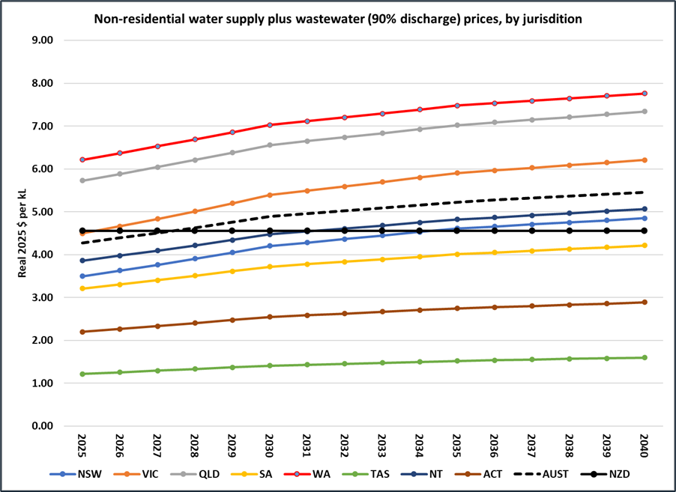

### Operating costs

Table 14 summarises the estimated breakdown of the CIM market in 2025, based on customs import data and information provided by suppliers during consultations. The industry does not maintain any centralised data collection. These market share estimates were published in the CIM MEPS RIS (E3 2023) and there was no disagreement from respondents. Industry estimates are that IMH and split units operate at about 80% of their maximum capacity (i.e. equivalent to 19.2 hrs per day) and SCUs at 70% (16.8 hrs/day). This enables calculation of their average annual ice production, and hence total annual energy and water consumption under each water-intensity scenario. SCUs account for 60% of sales but are a much smaller output capacity than IMHs, so account for only 20% of ice made.

Table 14 Capacity, Market share and BAU water-intensity by CIM class

|  |  |  |  |  |  |  |
| --- | --- | --- | --- | --- | --- | --- |
|  | Average kg/24 hr capacity | Market  Share (sales) | Potable water | | Condenser water | |
|  | litres/kg ice - BAU | | litres/kg ice - BAU | |
|  | 2025 | 2040 | 2025 | 2040 |
| 1. IMH - Batch - Air | 281 | 21% | 2.00 | 1.94 |  |  |
| 2. IMH - Continuous - Air | 281 | 11% | 1.13 | 1.11 |  |  |
| 3. IMH - Batch - Water | 330 | 3% | 2.00 | 1.94 | 17.50 | 17.18 |
| 4. IMH - Continuous - Water | 330 | 1% | 1.13 | 1.11 | 16.40 | 15.79 |
| 5. SCU - Batch - Air | 55 | 51% | 2.50 | 2.46 |  |  |
| 6. SCU - Continuous - Air | 65 | 5% | 1.23 | 1.21 |  |  |
| 7. SCU - Batch - Water | 72 | 3% | 2.50 | 2.46 | 17.00 | 16.83 |
| 8. SCU - Continuous - Water | 85 | 1% | 1.23 | 1.21 | 16.25 | 16.09 |
| 9. RCU - Batch - Air | 420 | 1% | 2.00 | 2.06 |  |  |
| 10. RCU - Continuous - Air | 420 | 1% | 1.13 | 1.11 |  |  |
| 11. RCRC - Batch - Air | 424 | 1% | 2.00 | 2.06 |  |  |
| 12. RCRC - Cont - Air | 424 | 1% | 1.13 | 1.11 |  |  |
|  |  | % sales | % of total ice made | |  |  |
| IMH total |  | 36% | 69% |  |  |  |
| SCU total |  | 60% | 20% |  |  |  |
| Split total |  | 4% | 11% |  |  |  |
| Air-cooled total |  | 92% | 89% |  |  |  |
| Water cooled total |  | 8% | 11% |  |  |  |
| Batch total |  | 80% | 69% |  |  |  |
| Continuous total |  | 20% | 31% |  |  |  |

Table 15 presents the lifetime operating cost of each of the types in Table 14 under a ‘no-measures’ scenario, before the impacts of the MEPS or any WELS measures (this is called Option 0). These are calculated for units with the average characteristics for that class as purchased in 2025, Australian-average projected energy prices (as detailed in E3 2023) and the projected water prices in Figure 12. The streams of future energy and water expenditures are discounted at 7% to bring them to a present value (PV). This type of information is currently unavailable to prospective CIM purchasers.

Table 15 Estimated lifetime capital and operating costs for individual icemakers, 2025 (Australian average)

|  |  |  |  |  |  |  |  |  |  |
| --- | --- | --- | --- | --- | --- | --- | --- | --- | --- |
|  | Purchase price | NPV energy | NPV potable water | NPV cooling water (75% reuse) | NPV cooling water (No reuse) | Total (75% reuse) | Total (0% reuse) | Total (75% reuse) | Total (0% reuse) |
| 1. IMH - Batch - Air | $ 4,287 | $ 27,301 | $ 4,546 | $ - |  | $ 36,134 | $ 36,134 | 12.6% | 12.6% |
| 2. IMH - Cont - Air | $ 4,323 | $ 24,688 | $ 2,174 | $ - |  | $ 31,184 | $ 31,184 | 7.0% | 7.0% |
| 3. IMH - Batch - Water | $ 4,734 | $ 27,107 | $ 3,737 | $ 11,599 | $ 34,796 | $ 47,176 | $ 70,374 | 7.9% | 54.8% |
| 4. IMH - Cont - Water | $ 4,734 | $ 26,718 | $ 3,737 | $ 10,919 | $ 32,758 | $ 46,108 | $ 67,947 | 8.1% | 53.7% |
| 5. SCU - Batch - Air | $ 3,165 | $ 8,283 | $ 973 | $ - |  | $ 12,421 | $ 12,421 | 7.8% | 7.8% |
| 6. SCU - Cont - Air | $ 3,025 | $ 7,099 | $ 559 | $ - |  | $ 10,683 | $ 10,683 | 5.2% | 5.2% |
| 7. SCU - Batch - Water | $ 4,530 | $ 7,991 | $ 1,019 | $ 2,166 | $ 6,497 | $ 15,706 | $ 20,037 | 6.5% | 37.5% |
| 8. SCU - Cont - Water | $ 4,400 | $ 8,671 | $ 1,203 | $ 2,406 | $ 7,219 | $ 16,681 | $ 21,493 | 7.2% | 39.2% |
| 9. RCU - Batch - Air | $ 6,184 | $ 35,702 | $ 6,859 | $ - |  | $ 48,745 | $ 48,745 | 14.1% | 14.1% |
| 10. RCU - Cont - Air | $ 6,184 | $ 35,702 | $ 3,875 | $ - |  | $ 45,761 | $ 45,761 | 8.5% | 8.5% |
| 11. RCRC - Batch - Air | $ 6,120 | $ 41,194 | $ 6,794 | $ - |  | $ 54,109 | $ 54,109 | 12.6% | 12.6% |
| 12. RCRC - Cont - Air | $ 6,120 | $ 36,142 | $ 3,839 | $ - |  | $ 46,101 | $ 46,101 | 8.3% | 8.3% |

### Projected trends

Water-intensity is projected to change at different rates under each WELS Option. The trends for the largest-selling product classes are illustrated in Ultimately, it is assumed that all costs, whether borne initially by industry or by the WELS Regulator are passed on to CIM purchasers as higher product prices (although technically the unrecovered share of WELS Regulator costs are borne by the taxpayer). All benefits accrue to CIM purchasers.

Figure 11 shows the stacked benefits for each option, starting with the lowest projected benefit (Option 2, $M 32.5) up to the highest benefit (Option 4A, $M 70.0). This is a visual indicator of the additional benefit from moving to progressively more stringent measures. It shows that:

* There is little difference in benefit between Option 2 (Voluntary declaration with WELS support) and Options 3A and 3B (Product registration and information declaration), provided that Option 2 has high take-up by suppliers. If Option 2 is not successful then Option 3A would become more attractive.
* The Minimum Water Efficiency Standards options (4A and 4B) lead to a near doubling of benefit, but at much lower B/C ratios.
* Most of the benefits come from IMH models, because of their high average ice production, and from batch-production (cube ice) models, which have far greater scope to increase potable water efficiency than continuous (flaked ice) models.
* Water-cooled models deliver slightly more benefit than air-cooled models, but this depends on the assumed rate of recirculation of cooling water. This is discussed in the next section.

Figure 11 to Figure 17. In these diagrams:

* Option 0 is the ‘no-regulations’ case, without either GEMS or WELS impacts. In this scenario water-intensity is not expected to change.
* Option 1 (status quo) shows the effects of the GEMS regulations. While these are mainly directed at energy-intensity, it is expected that there will be some reduction in water-intensity as well. as suppliers review their product range.
* Option 2 shows a faster reduction in water-intensity due to WELS efforts to encourage declaration of water-intensity values and promote the importance of water use to CIM buyers.
* Options 3A and 3B show a faster reduction in water-intensity than Option 2 due to mandatory WELS labelling, though the later implementation of Option 3A leads to a small delay in the rate of improvement in the first years.
* Options 4A and 4B involve mandatory water efficiency standards (expressed as water-intensity values). These are shown as a set of horizontal lines:
  + ‘USEPA std’: for a CIM to qualify for the USEPA’s Energy Star certification its potable water-intensity use must be at or below this value.
  + ‘USEPA Max (2024)’: the highest declared water-intensity value by any Energy Star certified CIM (of that class) at the end of 2024 (see Appendix C).
  + ‘USEPA Min (2024)’: the lowest declared water-intensity value by any Energy Star certified CIM (of that class) at the end of 2024 (see Appendix C).
  + ‘USEPA Avg (2024)’: the average declared water-intensity value by all Energy Star certified CIMs (of that class) at the end of 2024 (see Appendix C).
  + ‘Option 4B WELS Std’: this proposed mandatory value is less stringent (i.e. more conservative) than the USEPA standard, because it would be based on very little data on the Australian product range.
  + ‘Option 4A WELS Std: this proposed mandatory value is more stringent than Option 4B WELS Std (i.e. less conservative) because it would be based on complete data on the Australian product range.
* Under the mandatory standards options, all products must meet the standard by the prescribed date but are free to better it, and indeed encouraged to do so under the influence of WELS labelling. ‘Option 4A Avg’ and ‘Option 4B Avg’ show these trends.

For continuous production CIMS (e.g. Figure 14) the potable water-intensity range is much narrower than for batch products. The existing water-intensity range in the Australian market is probably already below the USEPA standard and there is less scope for further improvement.

Figure 15 and Figure 16 show the equivalent cooling water efficiency projections for water-cooled IMH models. The L/kg values are much higher, and the reference standards on the diagrams are USDOE rather than USEPA (the USDOE sets cooling water standards, while the USEPA sets potable water standards).

Figure 13 Projected water-intensity trends for IMH-Air-Batch CIMs

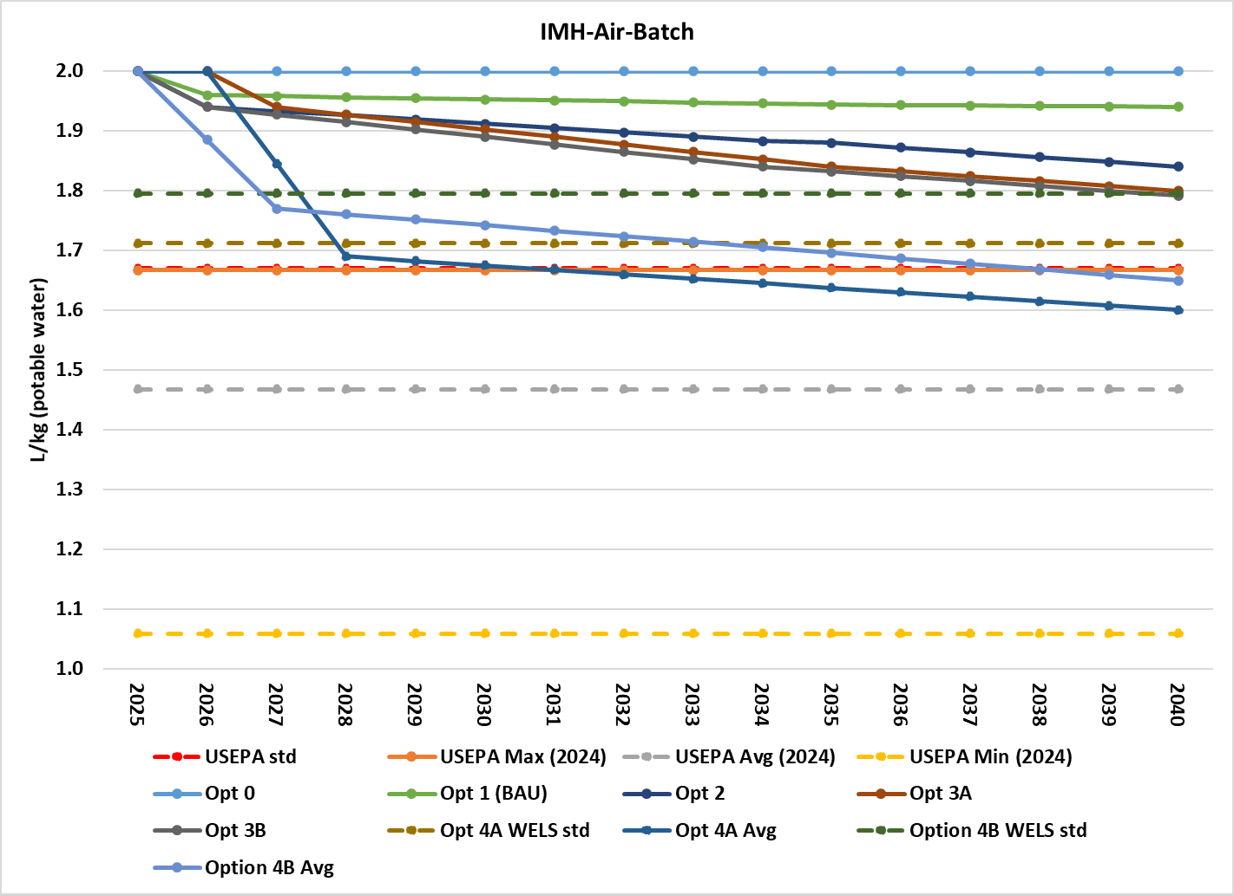

Figure 14 Projected water-intensity trends for IMH-Air-Cont CIMS

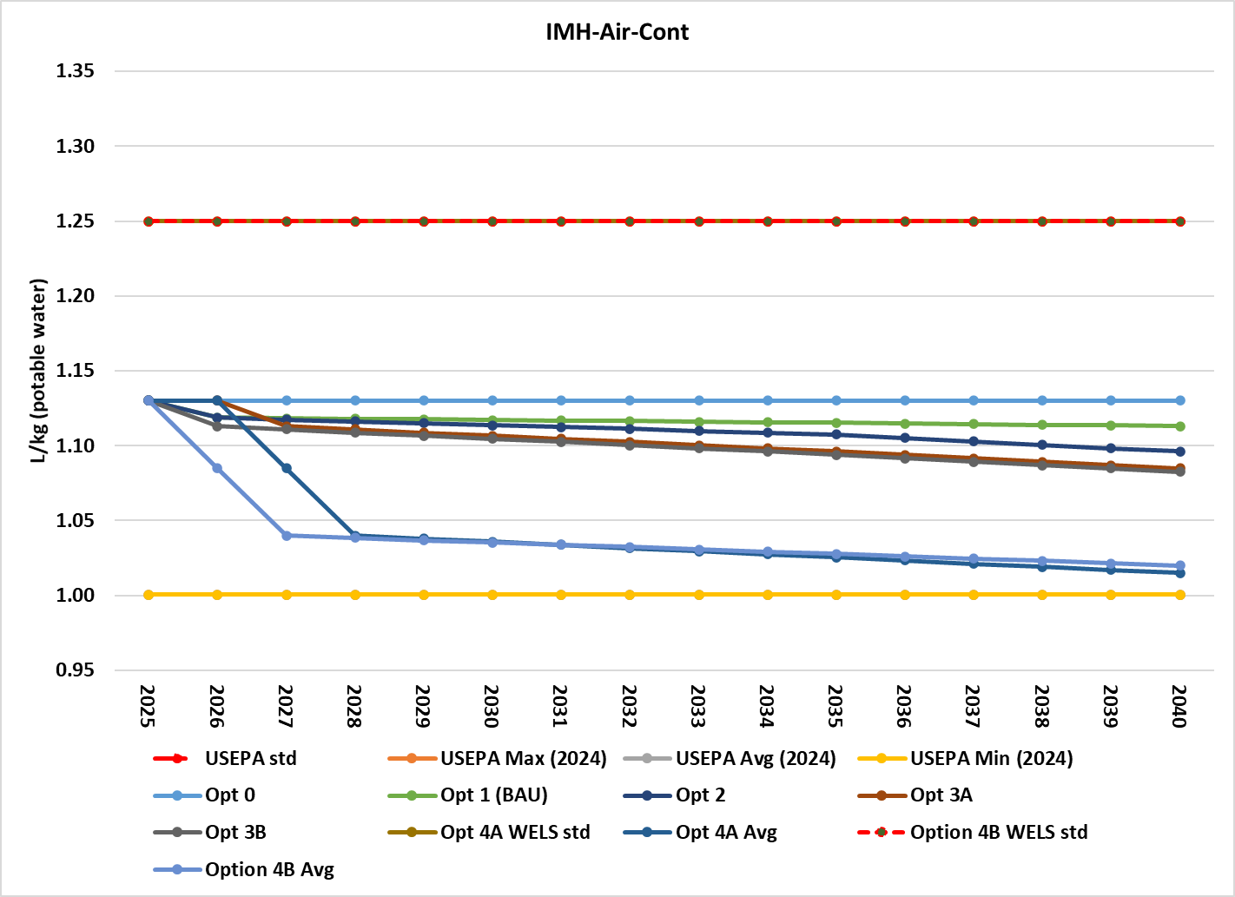

Figure 15 Projected cooling water-intensity trends for IMH-Water-Batch CIMS

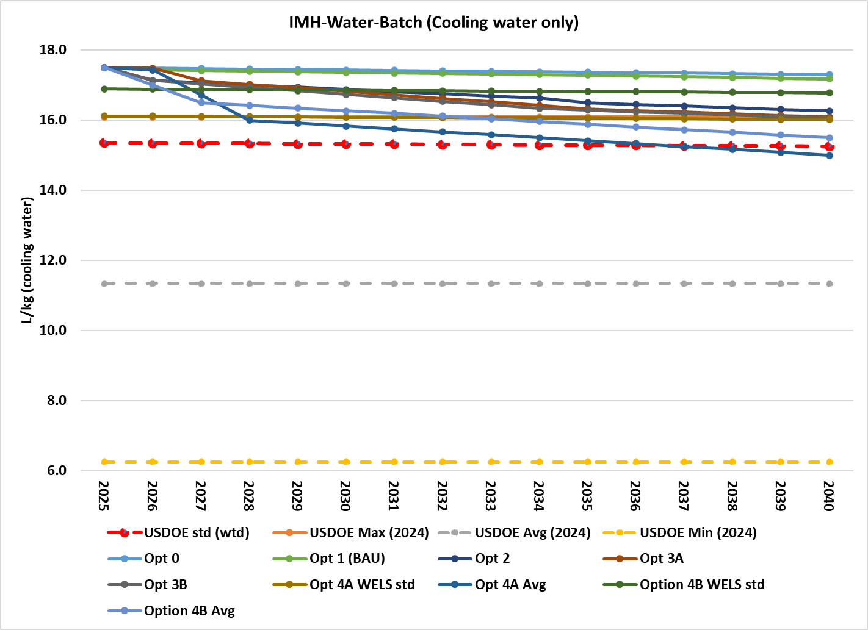

Figure 16 Projected cooling water-intensity trends for IMH-Water-Cont CIMS

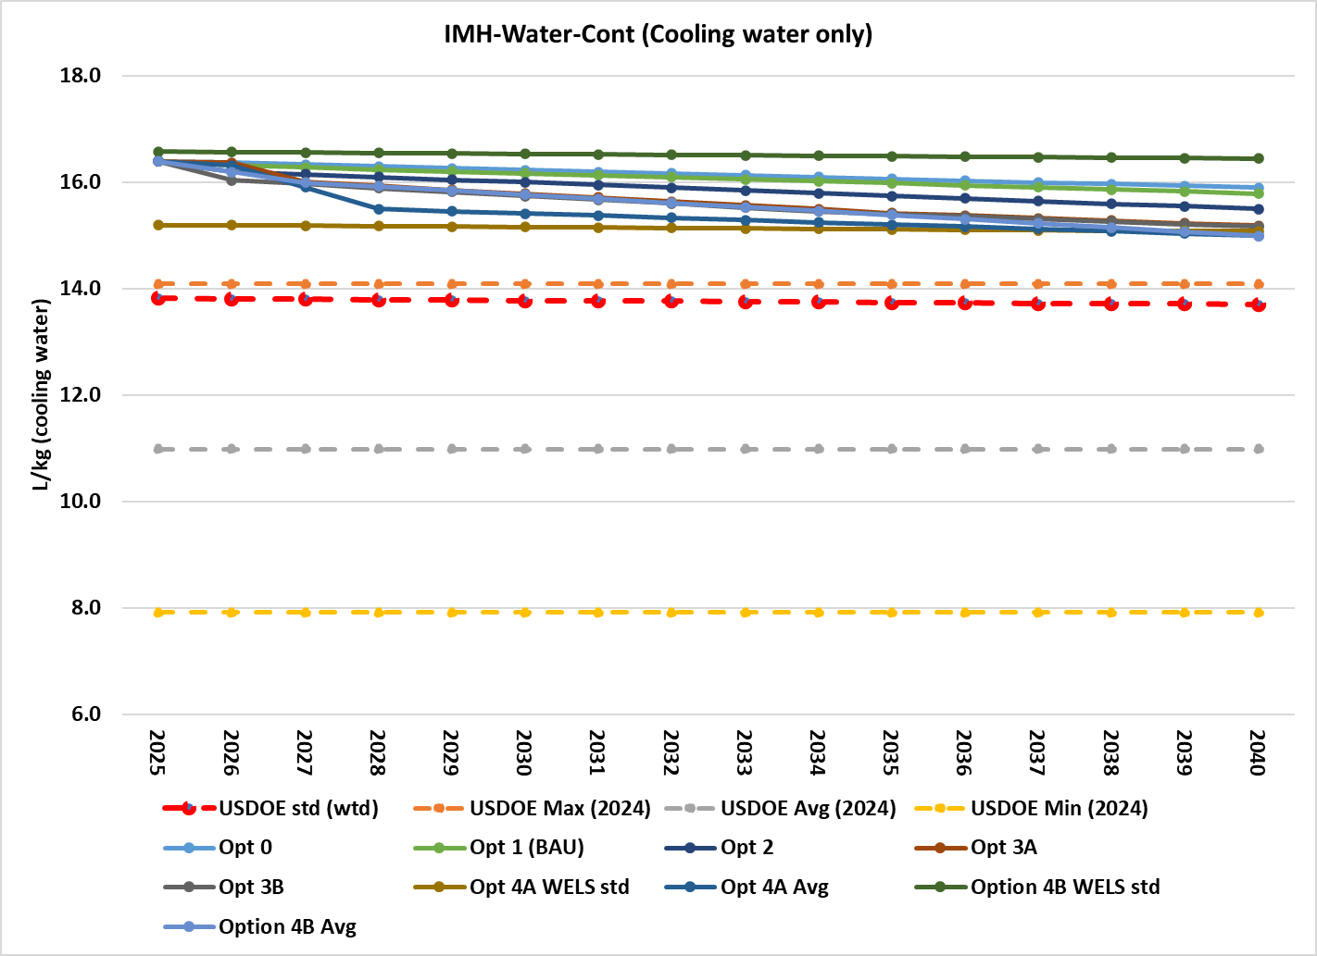

Figure 17 Projected water-intensity trends for SCU-Air-Batch CIMs

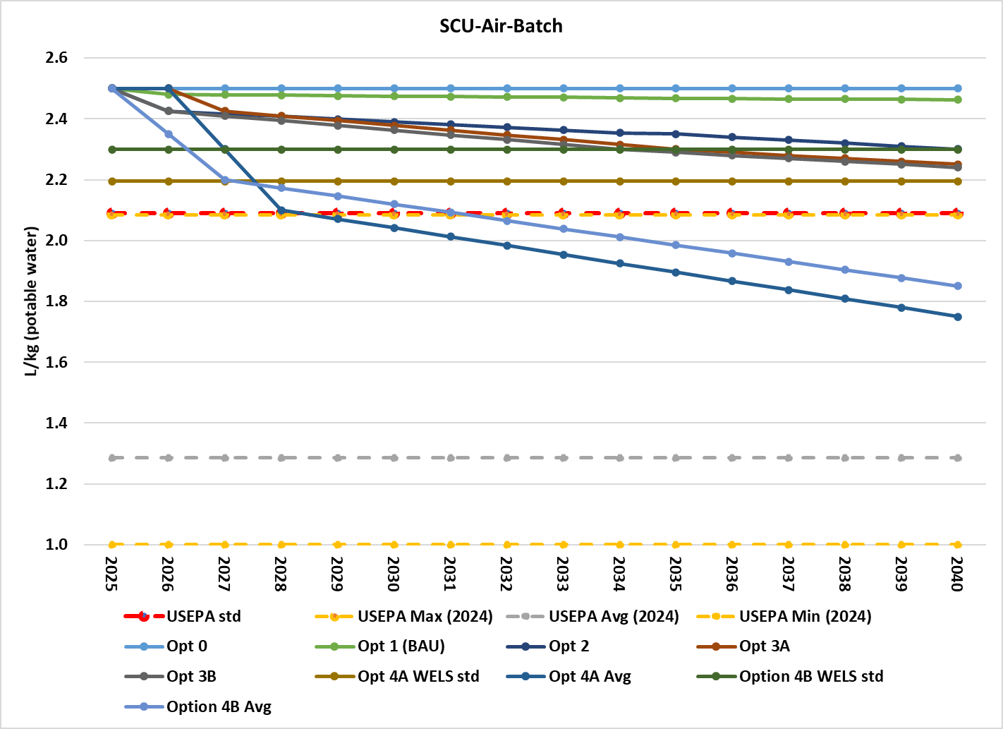

Figure 18 Projected water-intensity trends for SCU-Air-Cont CIMs

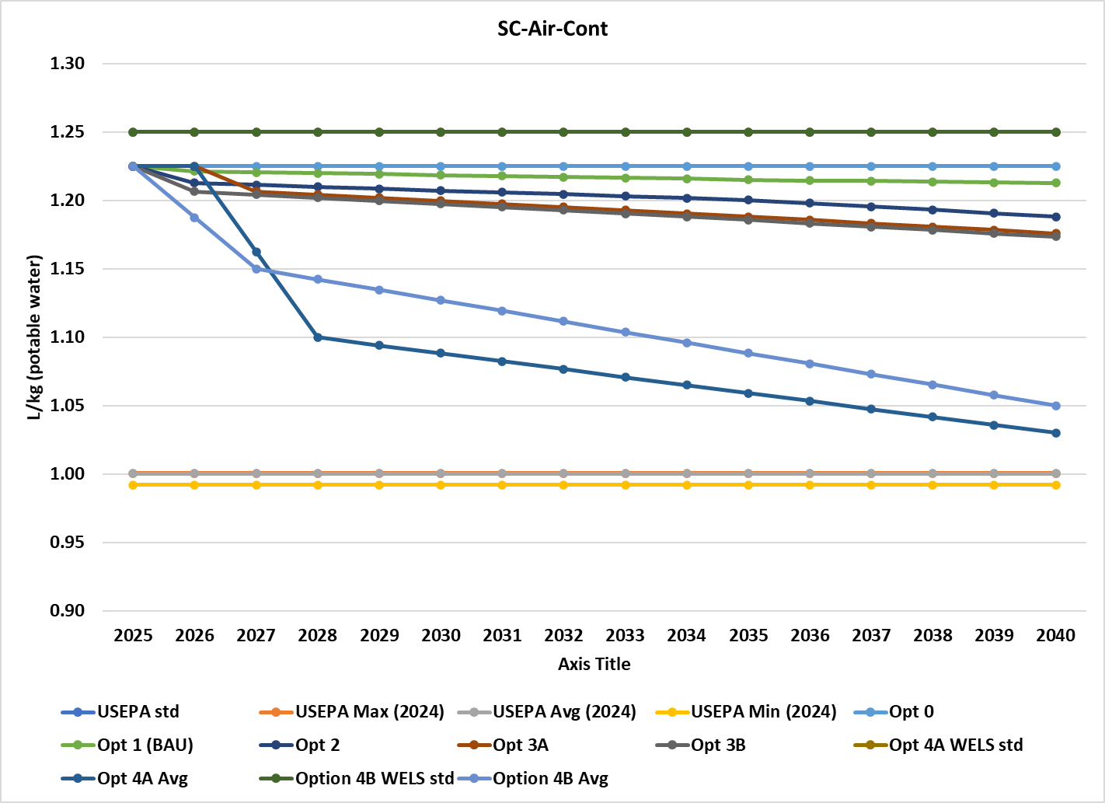

The kilolitres of water saved under each option is represented by the area between the trendline for that option and the Option 1 (status quo) trendline, multiplied by the number of units entering service and the average number of years in service. The savings increase as each new cohort enters service up to the end of the modelling period (2040), after which savings decline as units retire. The aggregate water savings for the whole of Australia are illustrated in Section 4.2.

### Product prices

It is prudent to assume that there is a relationship between the water efficiency of a product and its cost of production. A more water efficient product may contain higher quality components or more complex sensors and controls. The costs of research and development will also need to be recovered. In fact, these relationships have been found to be more complex in practice, and for some products the introduction of MEPS had no apparent impact on prices (E3 2011). The re-engineering of products can lead to material and production savings, and the replacement of electro-mechanical with electronic controls may bring both cost and water savings. Furthermore, changes in production costs may not be passed on at all if the market is highly competitive, or over-recovered by charging a premium for high-efficiency products.

The relationship between price and water efficiency can be captured in modelling by assuming a Price/Efficiency (P/E) ratio. A P/E ratio of 1.0 implies that a 10% increase in water efficiency brings about a 10% increase in price. A P/E ratio of 0.5 implies a 5% price increase for every 10% increase in efficiency and so on.

Three types of technical change will be happening simultaneously:

* Improvements in average energy efficiency due to the GEMS regulations. The [GEMS Regulatory Impact Statement](https://consult.dcceew.gov.au/gems-commercial-ice-makers-consultation-paper) estimated P/E ratios in the range 0.3–0.6 (depending on category of CIM) at the time of MEPS implementation, rising to 0.5-0.8 by year 15 as further technical improvements become more difficult. These price increases are built into the status quo scenario, Option 1 of the Impact Analysis.
* Improvements in potable water efficiency. There is a very wide range in potable water efficiency for batch-production CIMs, but very little in continuous-production types. A P/E ratio of 0.1-0.15 has been assumed for information-only options (2,3A,3B) and 0.2-0.3 for the water standards options (4A, 4B).
* For water-cooled products, improvements in cooling water efficiency. There is a very wide range in condenser water efficiency across water-cooled products. A P/E ratio of 0.2-0.3 has been assumed for cooling water efficiency improvements under all options.

The price increase effects are additive: for water-cooled categories, separate cost and price effects are estimated for potable water efficiency and condenser water efficiency improvements. Both volumetric water charges and price impacts are net of goods and services tax (GST), which is a transfer payment – nearly all CIM users are businesses which can claim back any GST payments.

The impact of any given water-intensity MEPS level on product purchase price in any year is calculated separately for each of the 12 product classes as follows:

Status quo average L/100kg – post-measure average L/100kg x Status quo average $/unit x P/E ratio  
 Status quo average L/100kg

### Administrative costs

Apart from an increase in CIM prices, WELS interventions will carry costs for both industry and the WELS Regulator. Table 4**Error! Reference source not found.** in Section 4.3 presents the cost estimates used in the modelling.

CIM importers will bear the costs of interacting with the Regulator and, for the mandatory options, registering products, fixing labels and ensuring compliance. Secondary distributors (who obtain CIMs from the importers to on-sell) would also incur compliance costs, for ensuring that labels and other information requirements apply at the points of advertising and display. It is assumed that adding CIMS to the WELS workload costs $75,000 per year for Option 2 (non-regulatory) and $150,000 per year for the mandatory options – the equivalent of a full-time APS 6 grade officer, including overheads.

It is assumed that the WELS Regulator will commission some check tests each year even in Option 2 to ensure the integrity of the voluntary declarations; suppliers are more inclined to participate in voluntary programs if they believe that all parties are making accurate declarations.

The present values in 2025 of the stream of future administrative costs for each option are illustrated in Figure 10. Figure 10 NPV of program costs, 2025-2040, AustraliaThey are combined with water efficiency-induced increases in purchase price in Figure 9.

# Appendix C US Data on CIM water use

The USEPA Energy Star (a voluntary accreditation program) only covers air-cooled products, which account for the great majority of the market, both in the USA and in Australia (i.e. GEMS Classes 1,2,5,6,9-12). To qualify for Energy Star, a batch type ice maker must have a potable water consumption of no more than 25 gals/100 lb ice (2.08 litres per kg) if a self-contained unit (Class 5) and no more than 20 gals/100 lb ice (1.67 litres per kg) for other air-cooled configurations. A continuous type CIM must use no more than 15 gals/100 lb ice (1.25 litres per kg), whatever the configuration.

At present the only consistent data set on the potable water use of CIMs is the USEPA’s list of Energy Star certified models. Analysis of the current list reveals that for batch type CIMS, some models just meet the ES limit but most are considerably more water efficient (Table 16). The most water efficient batch models convert all the potable water to ice (i.e. 1.0 litre/kg) and use half the water of the least water efficient certified product. As three quarters of the air-cooled CIM models on the US market are *not* certified for Energy Star, it may be safely assumed that many of those use more potable water than the Energy Star limit.

For continuous production models, there is very little variation in potable water efficiency. All models claim around 1.0 litres/kg, well below the Energy Star limit of 1.25.

Table 16 Potable water use by USEPA Energy Star certified CIMs, 2024

|  |  |  |  |  |  |  |  |
| --- | --- | --- | --- | --- | --- | --- | --- |
|  |  |  | L/100kg | | | | |
| Production | Configuration | Models | ES limit | Max | Min | Avg | Max/Min |
| Batch | Ice Making Head | 141 | 1.67 | 1.67 | 1.06 | 1.47 | 157% |
|  | Remote Condensing | 67 | 1.67 | 1.67 | 1.12 | 1.52 | 149% |
|  | Self Contained | 49 | 2.08 | 2.08 | 1.00 | 1.29 | 208% |
| Continuous | Ice Making Head | 18 | 1.25 | 1.00 | 1.00 | 1.00 | 100% |
|  | Remote Condensing | 9 | 1.25 | 1.03 | 1.00 | 1.00 | 103% |
|  | Self Contained | 61 | 1.25 | 1.00 | 0.99 | 1.00 | 101% |

Energy Star only covers air-cooled models, but data on condensing water consumption of water-cooled models is available from the USDOE (see Table 17). The USDOE has different product classifications than the USEPA and sets limits on cooling water-intensity based on the production capacity of the unit, so there is no single limit value as there is for Energy Star. All water-cooled models on the market must fall below that limit. As Table 17 shows, there is a wide range in condenser water use per kg of ice, and condenser water use is typically 8 to 10 times potable water use.

Table 17 Condenser water use by USDOE Registered water-cooled CIMs, 2024

|  |  |  |  |  |  |  |
| --- | --- | --- | --- | --- | --- | --- |
|  |  |  | L/100kg | | | |
| Production | Configuration | Models | Max | Min | Avg | Max/Min |
| Batch | Ice Making Head | 166 | 16.1 | 6.3 | 11.3 | 257% |
|  | Self Contained | 23 | 15.2 | 7.7 | 12.4 | 198% |
| Continuous | Ice Making Head | 46 | 14.1 | 7.9 | 11.0 | 178% |
|  | Self Contained | 9 | 11.3 | 8.9 | 10.1 | 127% |

Figure 20 ES certified CIMs, IMH-Cont-Air, Energy & potable water intensity by capacity

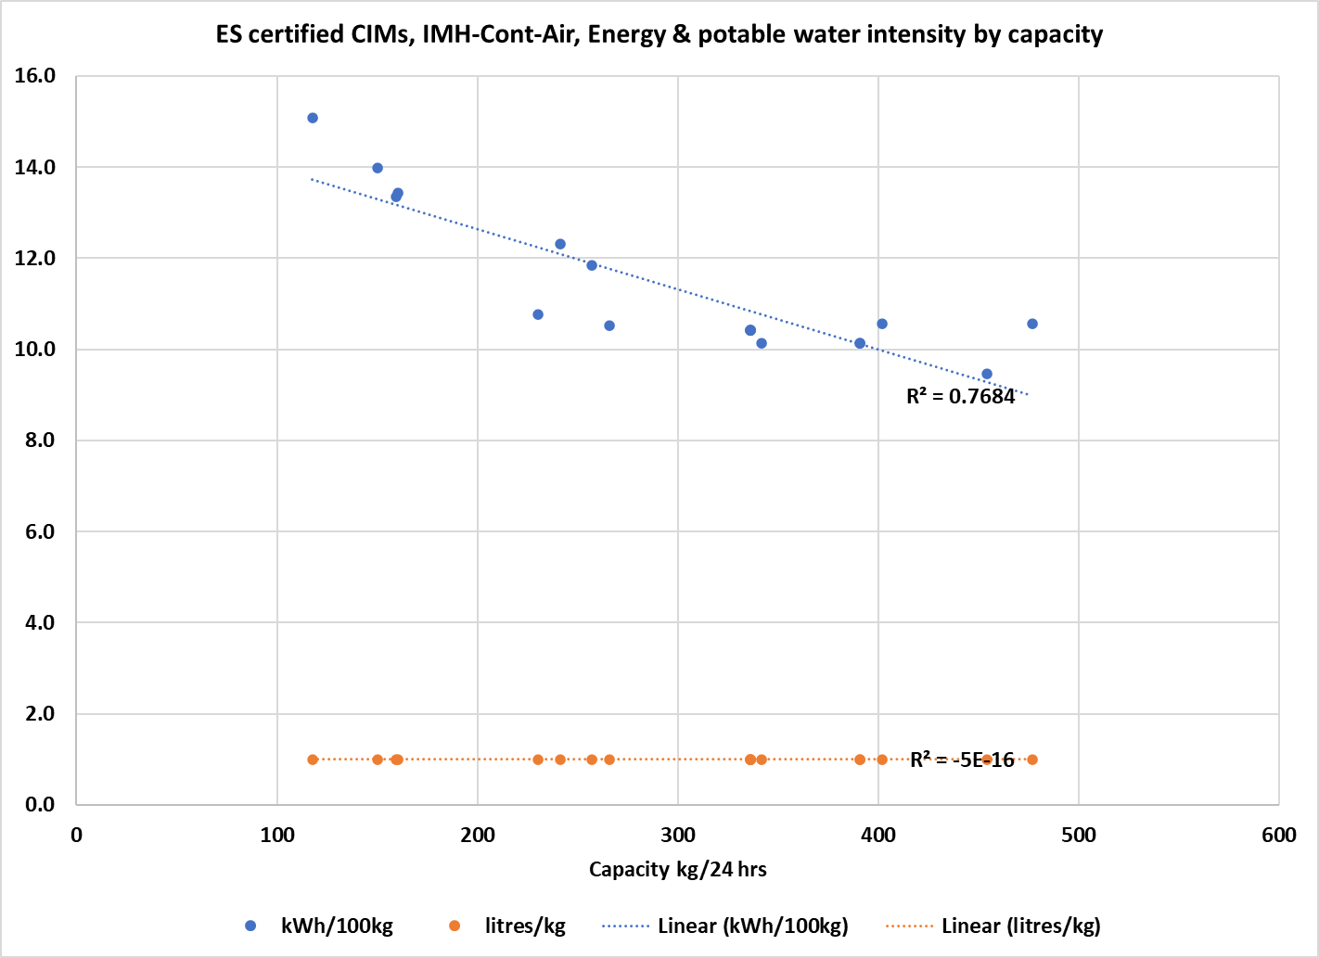

Figure 21Figure 19 to Figure 24 (US Energy Star data) show:

* A much weaker relationship between potable water efficiency and capacity than between energy efficiency and capacity. Purchasers may think that because a larger unit usually has a lower energy-intensity (kWh/kg) it may also have a lower water-intensity (L/kg). This is not the case higher capacity products are not necessarily more water efficient.
* Hardly any relationship for continuous types: very narrow band of potable water efficiency.

Figure 25 to Figure 27 (US Energy Star data) show:

* No apparent relationship between energy-and potable water efficiency. An energy efficient CIM is not necessarily water efficient, so additional information (or standards) for water are valuable.
* At any given energy efficiency level there is a range of water-efficiencies (for batch products).

Figure 28 to Figure 31 (USDOE data) show:

* For water-cooled products, there is no apparent relationship between capacity and cooling water efficiency.
* There are several groups of models (presented as horizontally clustered dots) with different capacity but the same cooling water efficiency, suggesting that the same cooling circuit is being used across a model family (rather than optimised according to the cooling load). This may lead to technical inefficiencies and presents one pathway for improvement.

Figure 19 ES certified CIMs, IMH-Batch-Air, Energy & potable water intensity by capacity

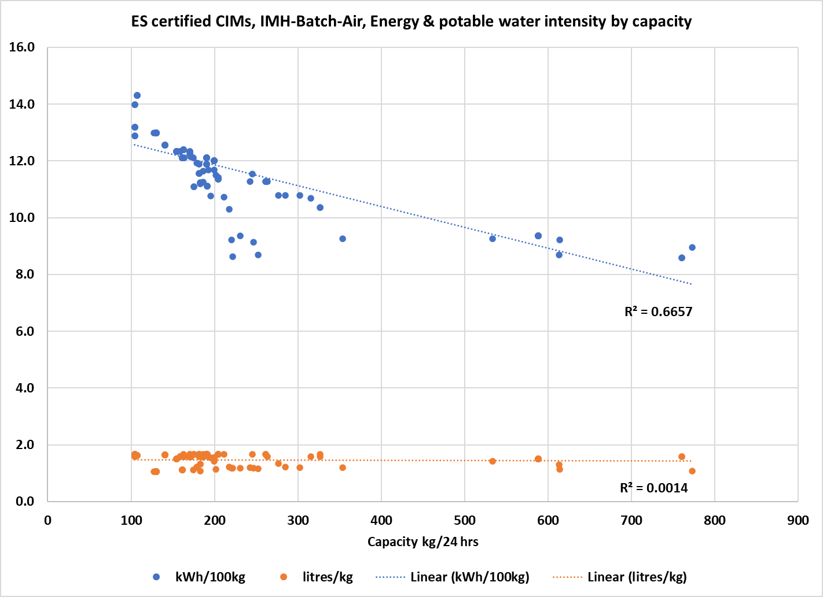

Figure 20 ES certified CIMs, IMH-Cont-Air, Energy & potable water intensity by capacity



Figure 21 ES certified CIMs, SCU-Batch-Air, Energy & potable water intensity by capacity

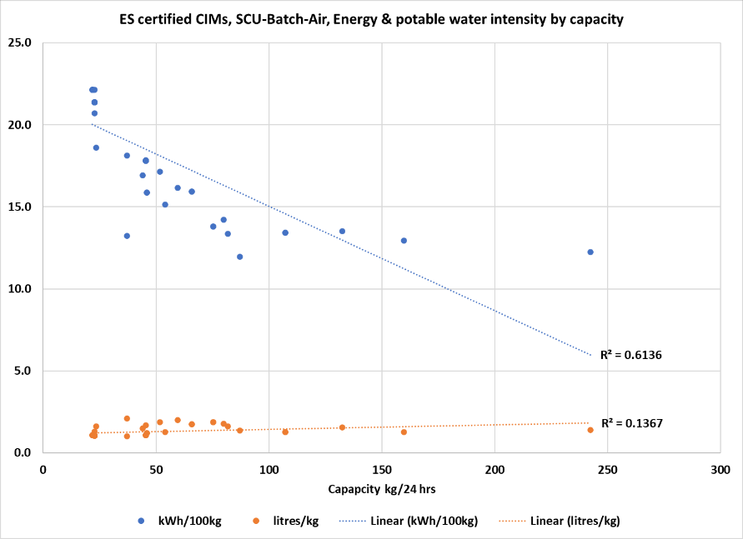

Figure 22 ES certified CIMs, SCU-Cont-Air, Energy & potable water intensity by capacity

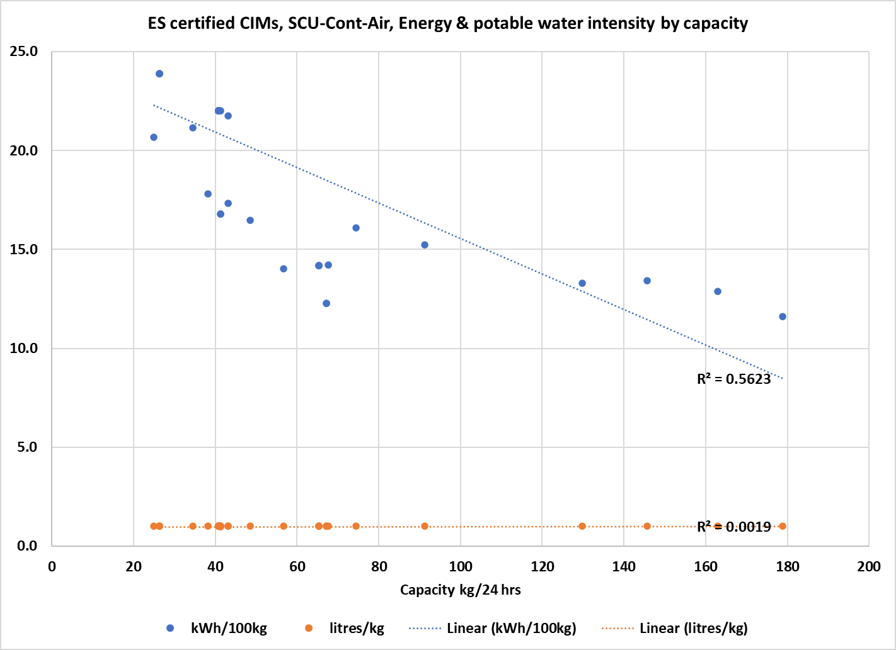

Figure 23 ES certified CIMs, Split-Batch-Air, Energy & potable water intensity by capacity

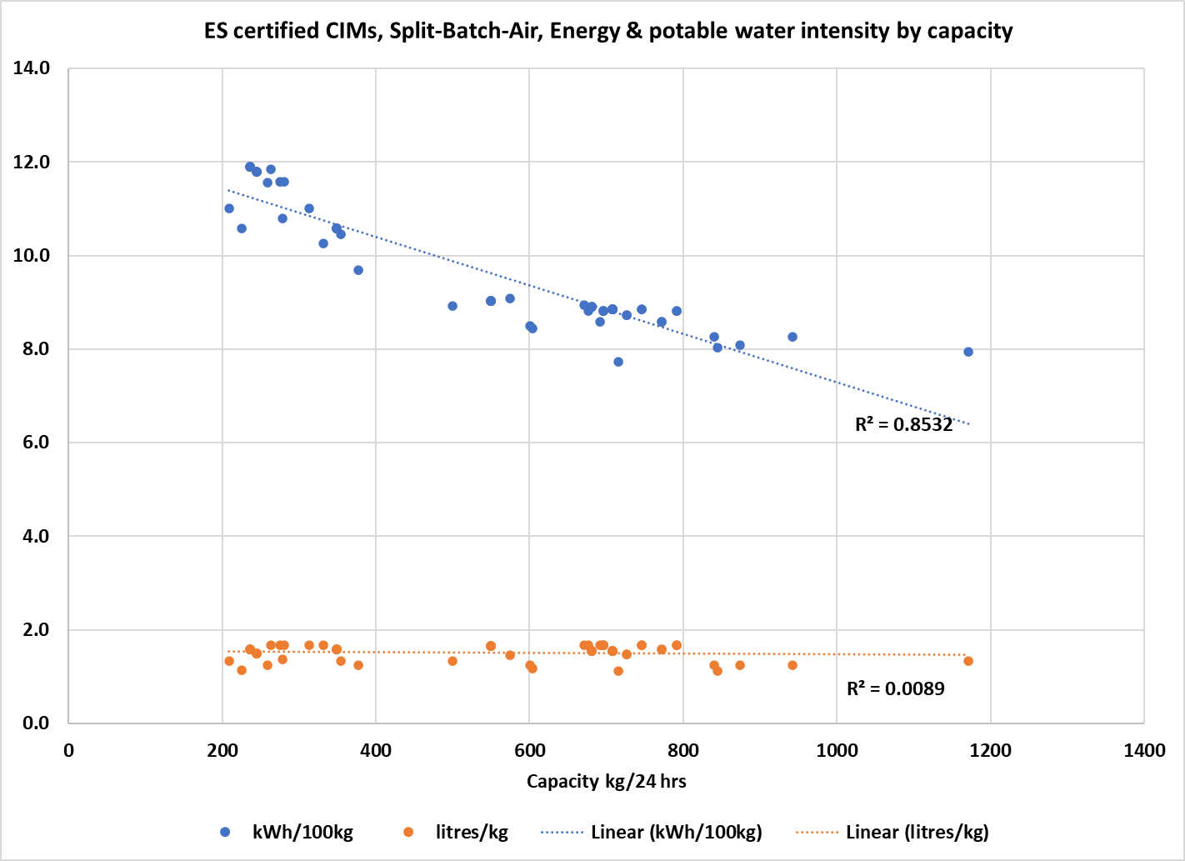

Figure 24 ES certified CIMs, Split-Cont-Air, Energy & potable water intensity by capacity

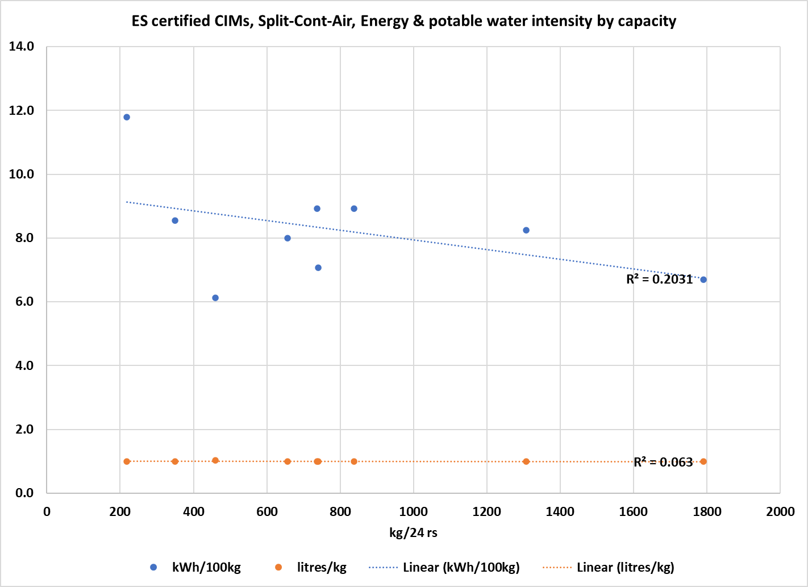

Figure 25 ES certified CIMs, IMH-Batch-Air, Potable water- vs energy- intensity

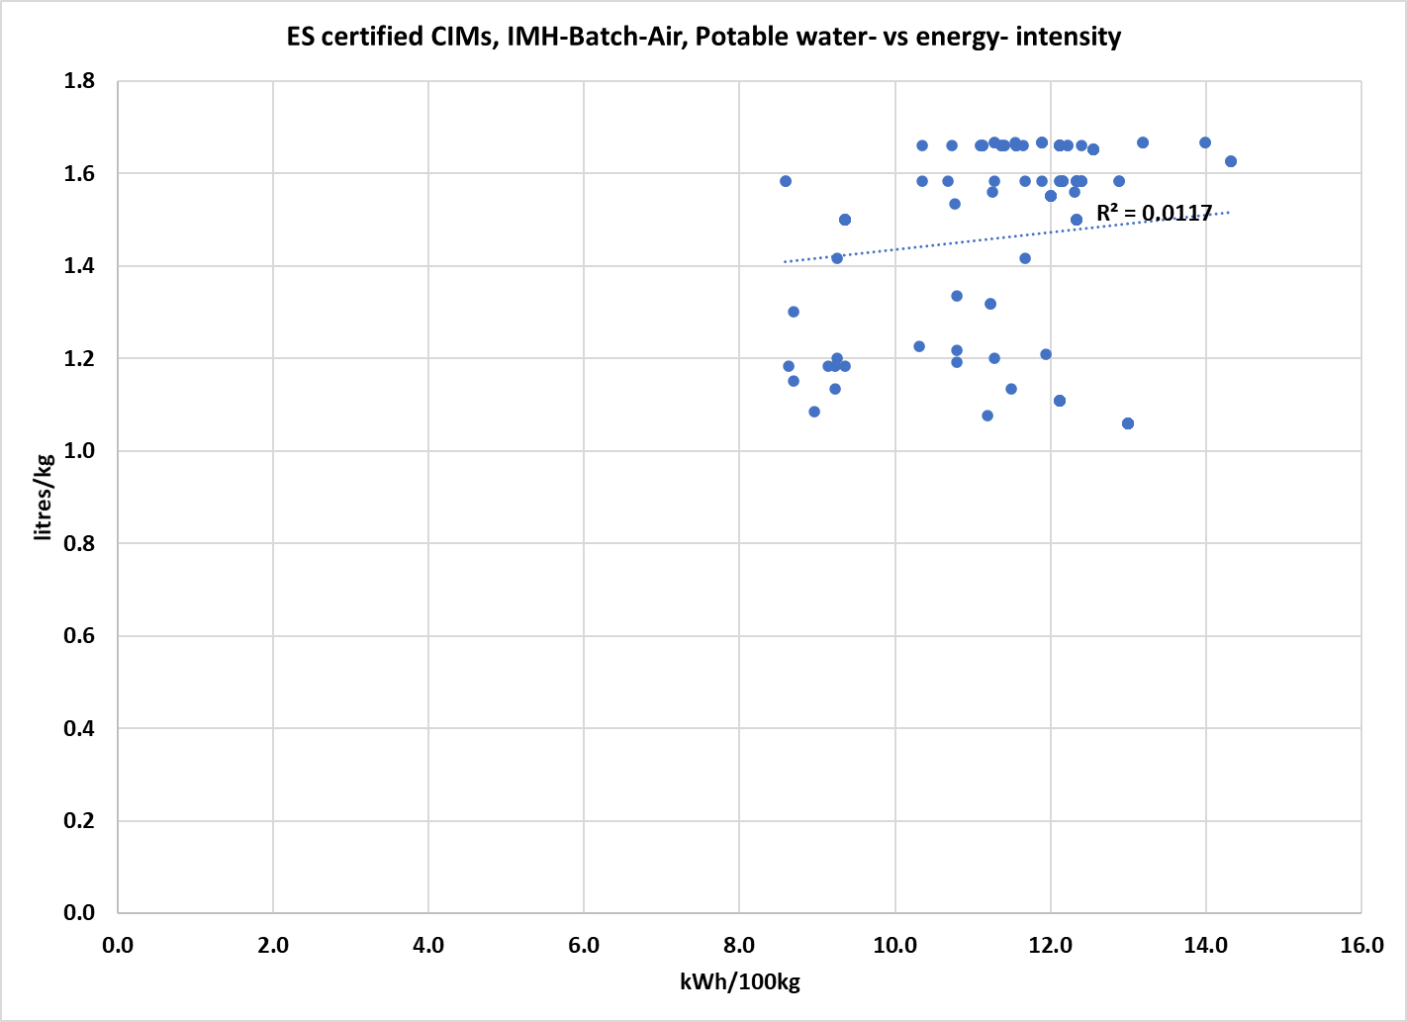

Figure 26 ES certified CIMs, SCU-Batch-Air, Potable water- vs energy-intensity

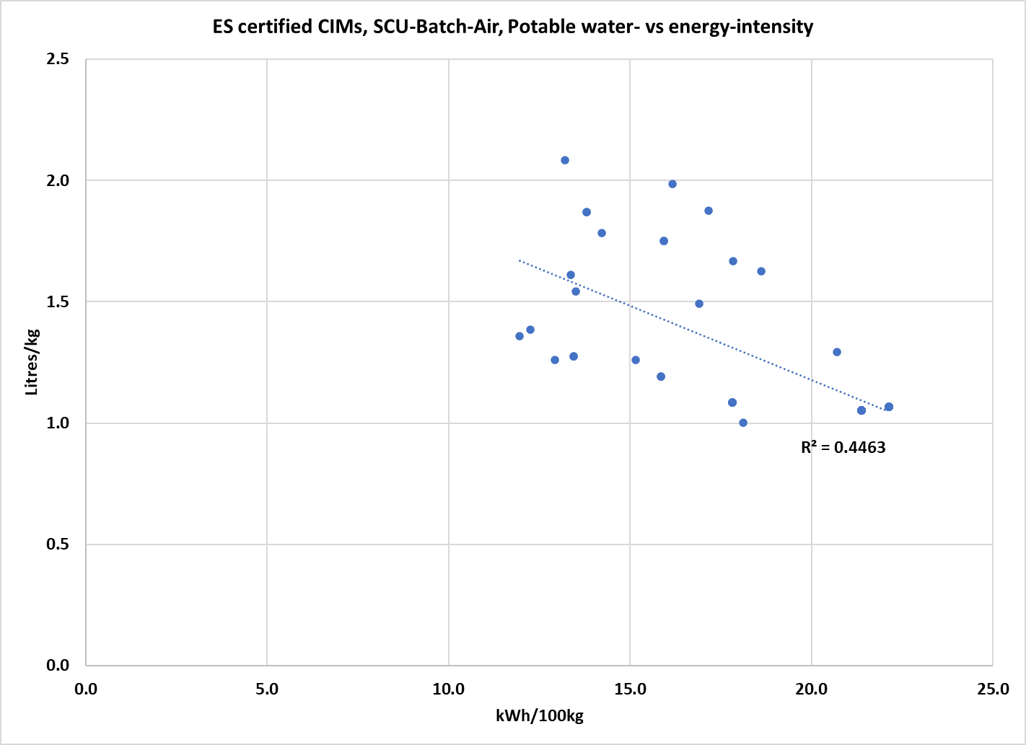

Figure 27 ES certified CIMs, Split-Batch-Air, Potable water- vs energy-intensity

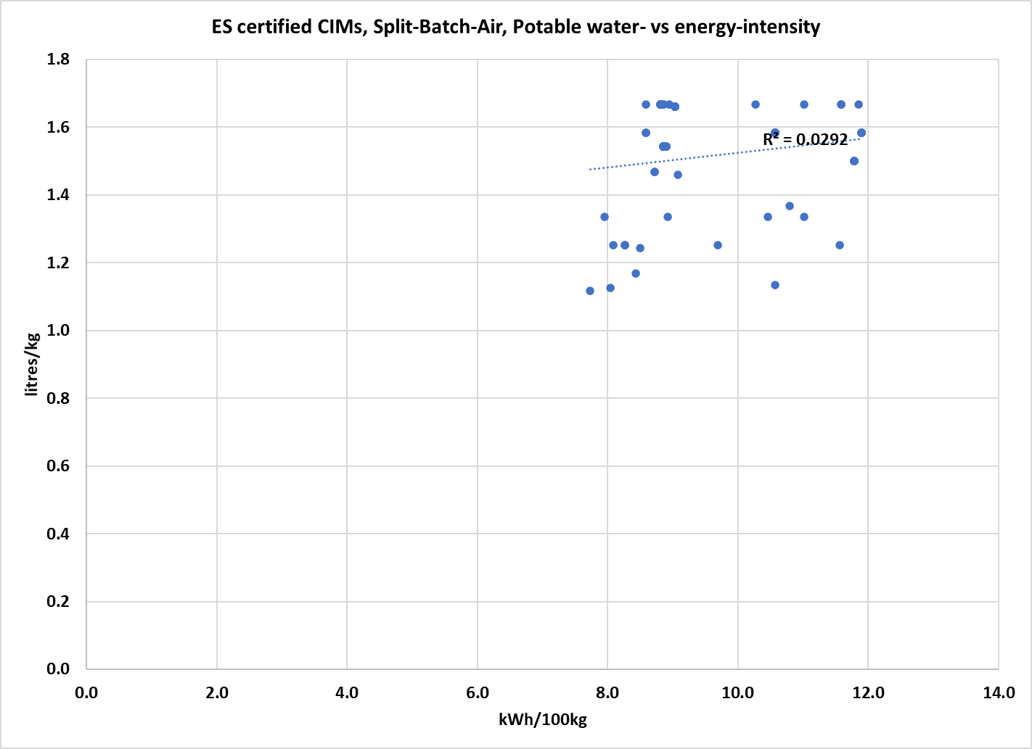

Figure 28 UDDOE registered CIMs, IMH-Batch-Water, Cooling water-vs energy-intensity

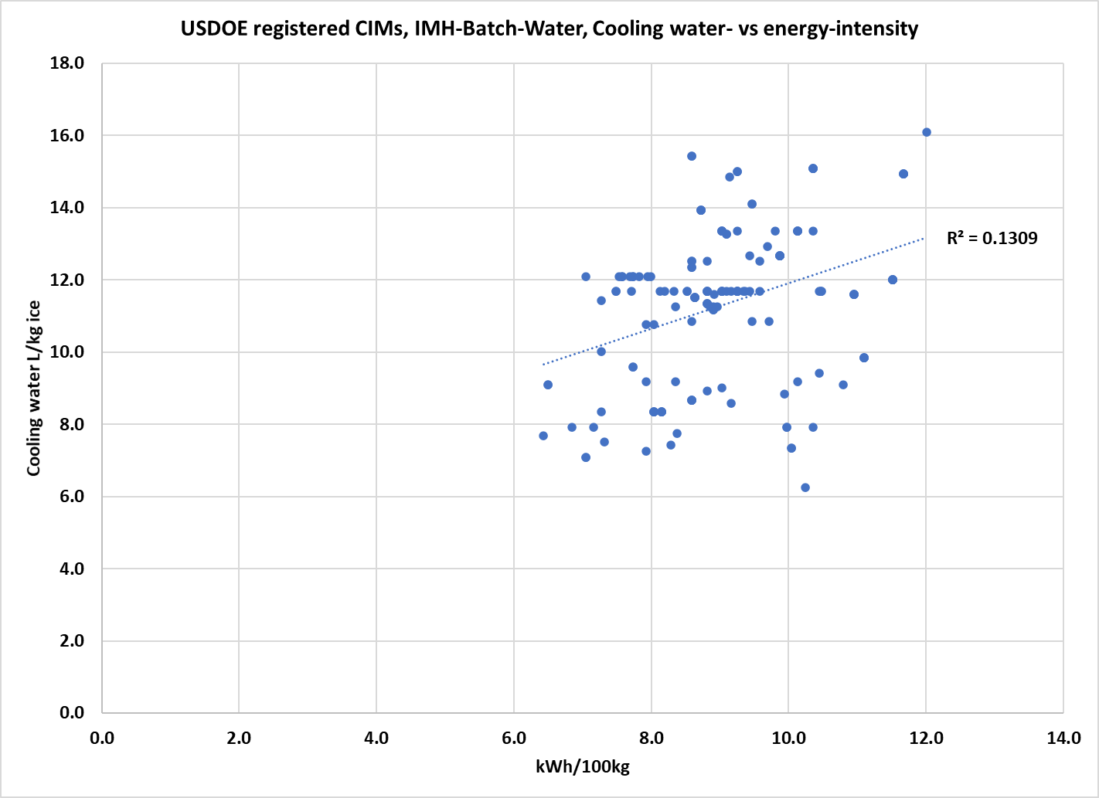

Figure 29 USDOE registered CIMs, IMH-Cont-Water, Cooling water-vs energy-intensity

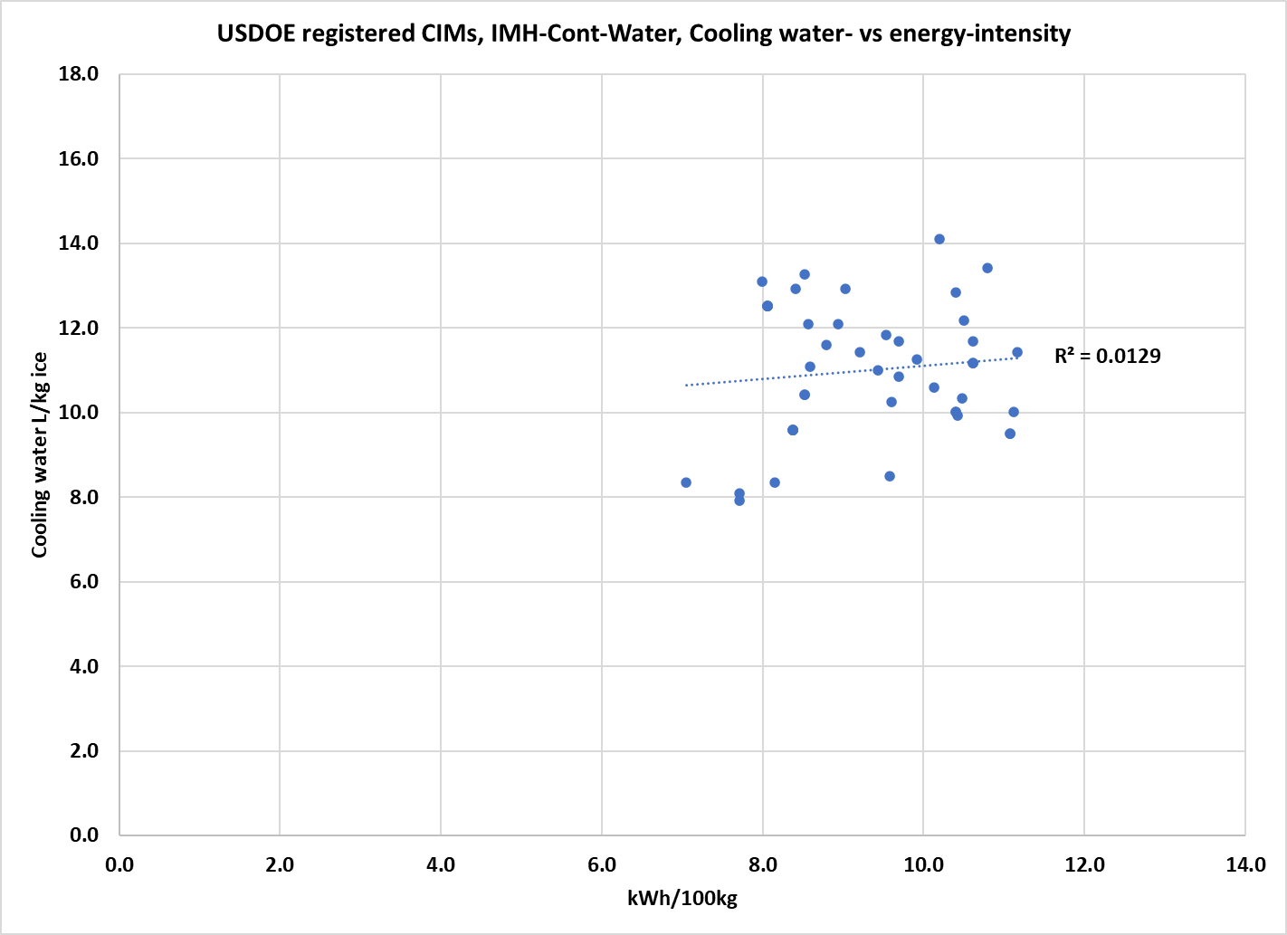

Figure 30 USDOE registered CIMs, SCU-Batch-Water, Cooling water-vs energy-intensity

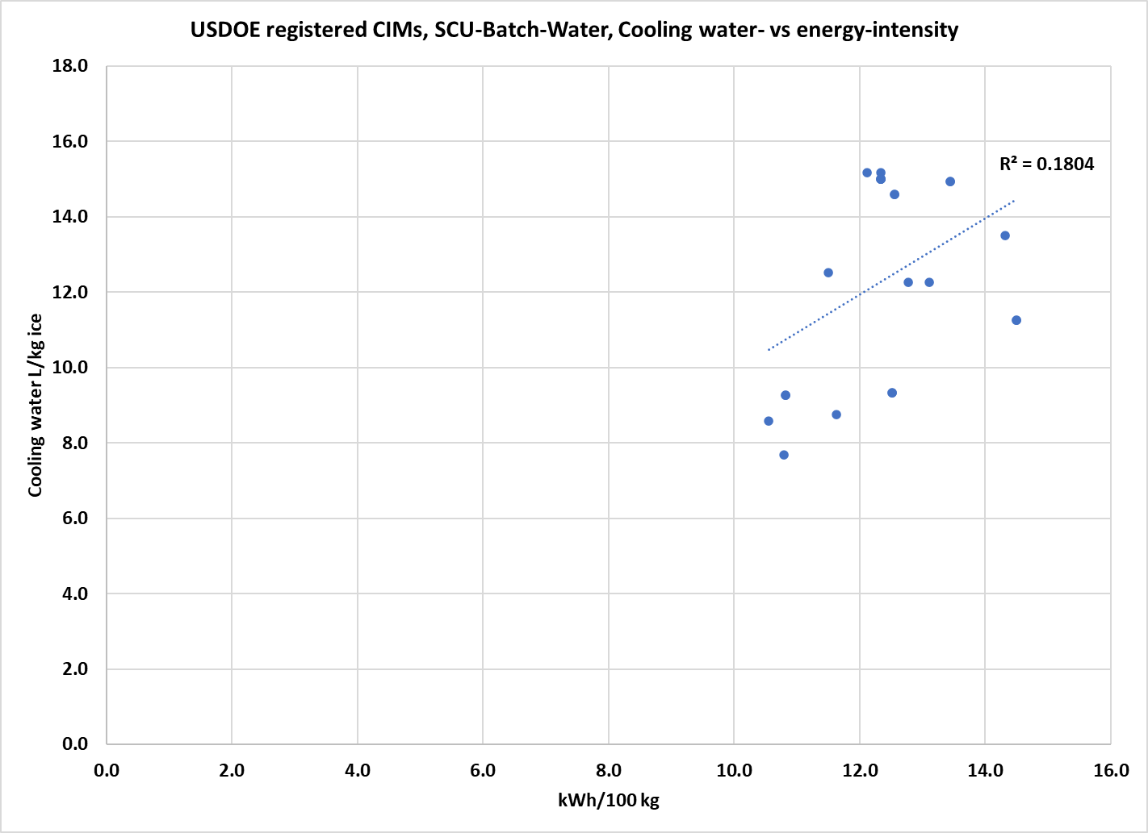

Figure 31 USDOE registered CIMs, SCU-Cont-Water, Cooling water-vs energy-intensity



# Appendix D New Zealand costs and benefits

It is estimated that the New Zealand market is about a sixth the size of Australia’s (for about a fifth the population). This equates to 1600 to 1800 units per year, and national stock of about 10,500 CIMs.

The same international brands dominate the market as in Australia. The products are mostly imported direct to New Zealand from the country of manufacture, although some Australian companies ship to New Zealand as well and New Zealand companies such as Skope ship to Australia. The primary importers supply other local distributors as well. It is assumed that average CIM prices are equivalent to those in Australia, but 10% higher in New Zealand dollar (NZD) terms allowing for the currency exchange rate.[15]

An average water supply price of $4.56 has been estimated for New Zealand, based on 2022 data supplied by Water New Zealand, updated for subsequent price increases reported by the largest suppliers. The supply price comprises $1.84/kL supply charge and $2.72/kL wastewater charge. No further real price increases are projected for the modelling period (see Figure 12 for comparison with water prices in Australian jurisdictions).

MEPS for CIMs are to be introduced in New Zealand via the *Energy Efficiency (Energy Using Products) Regulations 2002*, administered by the Energy Efficiency and Conservation Authority (EECA), at the same time as they take effect in Australia under the Greenhouse and Energy Minimum Standards (GEMS) Act. The target implementation date is March 2026. This is the status quo (Option1).

CIMs offered for supply in either country will have to be registered with one of the Regulators: EECA in New Zealand or the GEMS Regulator in Australia. There will be a common registration system and the information for each registered model will be published on [www.energy-rating.gov.au](http://www.energy-rating.gov.au). There are no registration fees for models registered with the New Zealand Regulator but there is a requirement to report annual sales, which is not the case in Australia. Registration requires mandatory declaration of the production capacity (kg/24hrs) and energy-intensity (kWh/kg of ice produced) for each model, measured under standard test conditions. However, declaration of water-intensity (L/kg ice produced) measured at the same test conditions is optional. It remains to be seen how many suppliers will choose to register water related information.

New Zealand already participates in the WELS labelling system via its *Consumer Information Standards (Water Efficiency) Regulations 2017* administered by the Ministry for the Environment.

The same range of options has been modelled for New Zealand as for Australia. All are compared with the Option 1 (status quo) scenario.

* Option 2: Declaration of water use rates with the support of the New Zealand agencies responsible for encouraging the efficient use of water (Non-regulatory);
* Option 3A: Declaration of information (Regulatory). It is assumed this would be implemented via amendment to the Consumer Information Standards (Water Efficiency) Regulations 2017.
* Option 3B: Declaration of information (Regulatory) – accelerated implementation.
* Option 4A: Minimum Water Efficiency Standards and declaration of information (Regulatory). It is possible that new regulations would be required to enforce Minimum Water Efficiency Standards, as the Consumer Information Standards (Water Efficiency) Regulations 2017 only covers labelling. However, the regulation references AS/NZS 6400 Water efficient products—Rating and labelling, so if CIM minimum water efficiency standards are included in AS/NZS 6400 they could be enforced by that route.
* Option 4B: Minimum Water Efficiency Standards and declaration information (Regulatory) – accelerated implementation.

In the New Zealand WELS system, there is no registration for products or for suppliers. Therefore, assessing the effectiveness of each option in New Zealand would rely largely on monitoring GEMS, EECA and WELS registrations. It is assumed that each option is as effective at reducing CIM water use as it is in Australia. The differences in water saving are due to the smaller market size.

Figure 32 illustrates the projected total water use, under each option, of CIMs purchased in New Zealand between 2025 and 2040. The diagram goes to 2048 because it captures the lifetime water consumption of units sold as late as 2040 (the end of the sales projection period), which will still be operating in 2048 given average service lives.

The area between the lines represents the water saved by that option. Figure 33 illustrates, at larger scale, the intervals between the lines in Figure 32. The water saving from Option 2 are projected to peak around 60,000 kilolitres (0.06 gigalitres) in 2040 and then decline as post-2025 CIMS retire. The maximum savings are from the mandatory water efficiency standards Option 4A (0.30 GL in 2040). These are higher than Option 4B because, even though they come into effect a year later, the standard levels are more stringent.

The present value of these saving can be calculated by multiplying the kl of water saved in each year by the cost of water ($4.56/kl). The stream of savings is brought to a present value by applying a 5% discount rate as specified by the New Zealand Treasury.

The costs of the measure are incurred initially by three groups: CIM suppliers, the program administrator/regulator and CIM purchasers. There are however transfers of costs between groups, as is described in the cost/benefit analysis methodology (Appendix B).

As neither additional testing nor payment of registration fees would be not required in New Zealand, industry costs comprise the administration time costs of dealing with the regulator and purchasers, reprinting brochures and changing website contents, and attaching physical labels if required. It is assumed that these costs are higher at the introduction phase and then reduce to a lower constant level. The dollar value estimates for each activity are summarised in Table 18.

Figure 32 Water consumed by CIMs sold 2025-2040, New Zealand

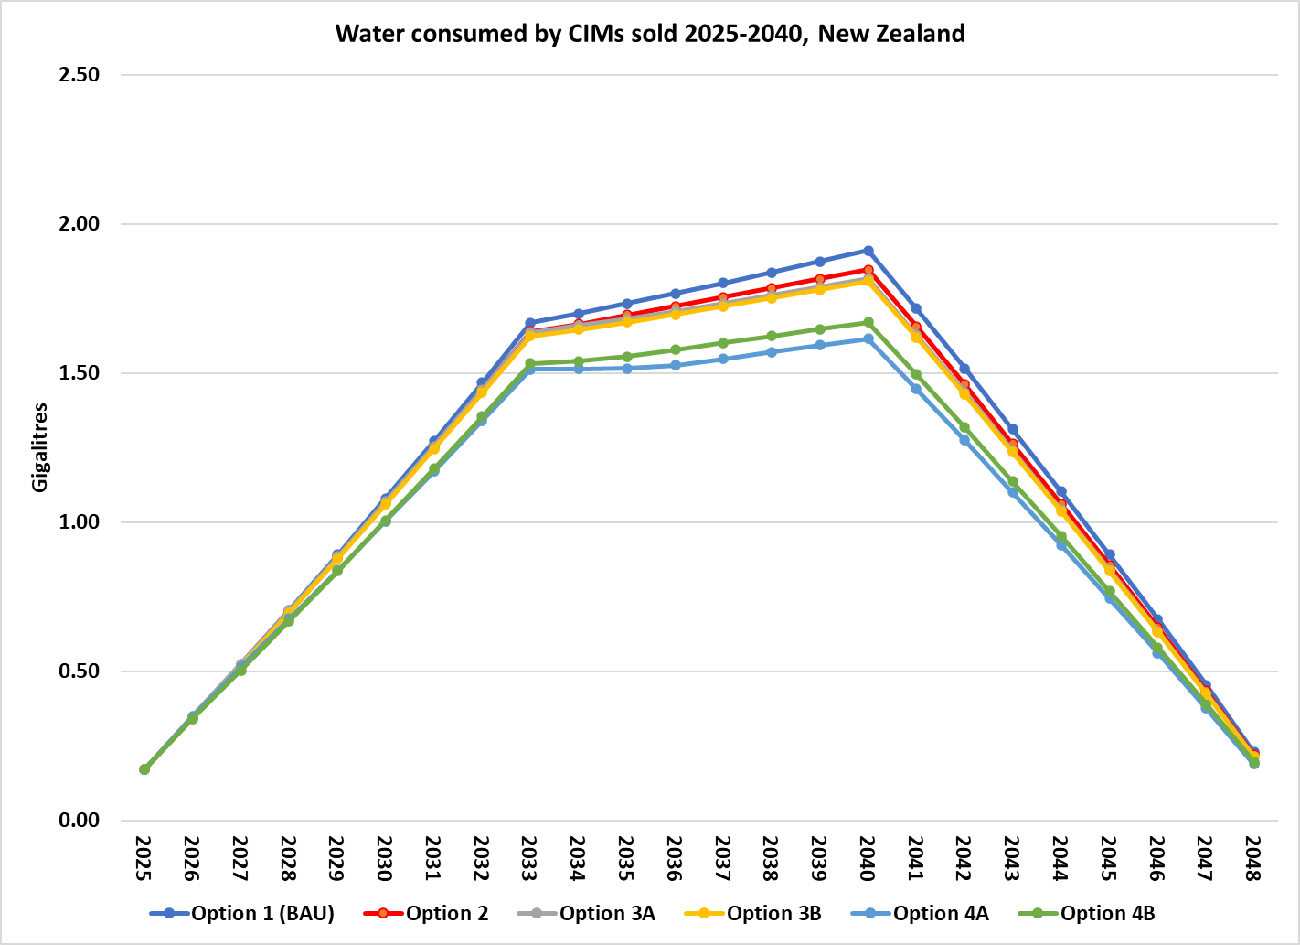

Figure 33 Water saved by WELS option for CIMs sold 2025-2040, New Zealand

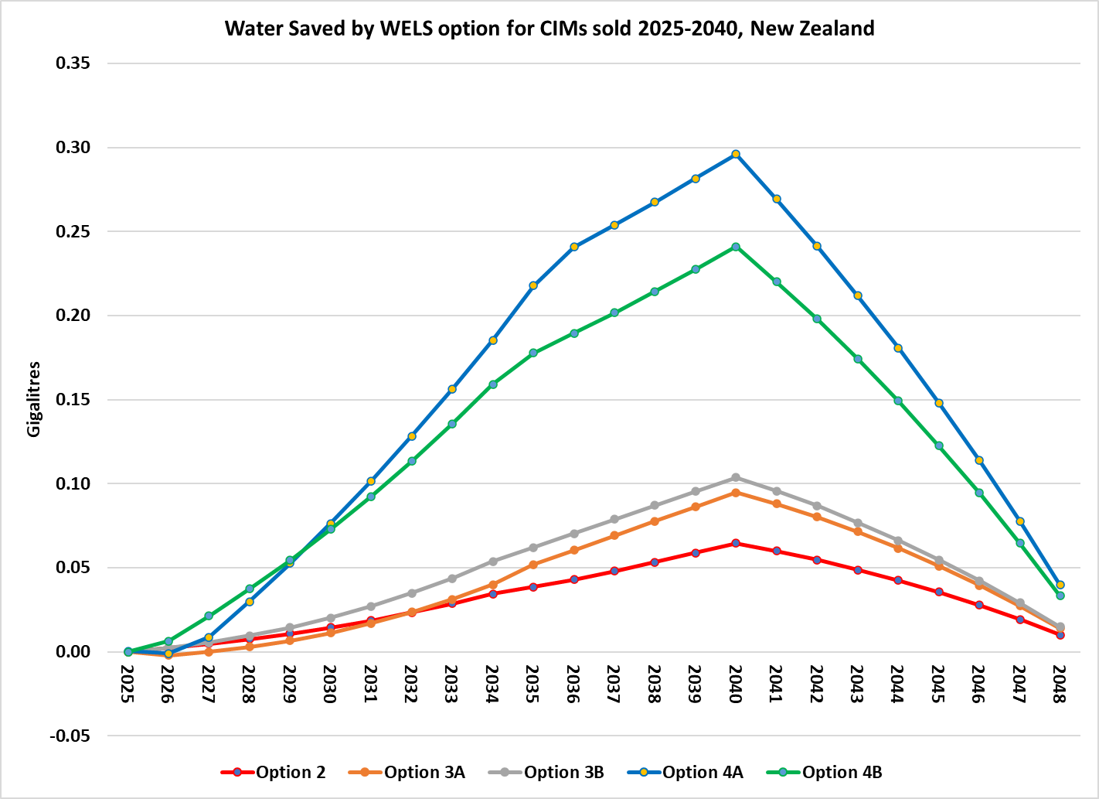

Table 18 Estimates of cost to New Zealand industry and Regulators

|  |  |  |  |  |  |
| --- | --- | --- | --- | --- | --- |
|  | **Option 2** | **Option 3A** | **Option 3B** | **Option 4A** | **Option 4B** |
| Importers | 10 | 10 | 10 | 10 | 10 |
| Secondary distributors | 20 | 20 | 20 | 20 | 20 |
| Models (2025, 2040) | 300-400 | 300-400 | 300-400 | 300-400 | 300-400 |
| Admin cost per importer (Yr 1) | $5,000 | $7,000 | $7,000 | $7,000 | $7,000 |
| Admin costs per importer (Yr 2 etc) | $2,500 | $5,000 | $5,000 | $5,000 | $5,000 |
| Registration costs/yr per importer | 0 | 0 | 0 | 0 | 0 |
| Admin cost per distributor (Yr 1) | 0 | $2,500 | $2,500 | $4,000 | $4,000 |
| Admin costs per distributor (Yr 2 etc) | 0 | $2,500 | $2,500 | $2,500 | $2,500 |
| Regulator Admin costs per year | $30,000 | $50,000 | $50,000 | $50,000 | $50,000 |
| Check tests (Yr 1) | 0 | 1 | 1 | 2 | 2 |
| Check tests (Yr 2, etc) | 0 | 1 | 1 | 1 | 1 |
| Cost per check test | $6,250 | $6,250 | $6,250 | $6,250 | $6,250 |
| Cost per label | NA | $0.50 | $0.50 | $0.50 | $0.50 |

Note: These costs are held constant in real terms but may rise in nominal terms with inflation. All values are in NZ dollars.

There are no additional costs for product testing, because this will be required for every CIM model as part of compliance with the *Energy Efficiency (Energy Using Products) Regulations 2002*. The same tests measure both energy and water use, and if the test report is in the form required by EECA and the GEMS Regulator Australia it will include the water use data as a well.

It is assumed that no mandatory options for CIMS would be introduced in New Zealand unless the same options were introduced in Australia. As most New Zealand CIM suppliers would need to comply with the Australian requirements in any case, the additional costs of meeting New Zealand requirements would be less than in Australia.

Administrative costs to the regulator are estimated to be a third of the Australian level, because the costs of registration, checking test reports etc would be largely borne by the Australian GEMS and WELS Regulators. Nevertheless, there would be staff costs for engagement with industry and purchasers and verifying compliance with regulations. Allowance has been made for a small number of check tests in case the regulator needs to verify performance claims for models not sold in Australia (which will have a larger check test program).

Table 19 and Figure 34 summarise the projected costs and benefits of each option. All three information-only options (2, 3A, 3B) have very similar net benefits. While the water savings increase by mandating information declaration, the costs of regulation partially offset the extra savings.

Table 19 Summary of projected costs and benefits, New Zealand

|  |  |  |  |  |  |  |  |  |  |
| --- | --- | --- | --- | --- | --- | --- | --- | --- | --- |
|  | Costs $M PV, 5% discount rate | | | Benefit $M PV, 5% discount rate | | | Net | B/C | % Price |
|  | Price | Program | Total | Pot | Cond | Total | Benefit | ratio | increase |
| Option 2 | $0.5 | $0.6 | $1.1 | $6.6 | $1.8 | $8.4 | $7.3 | 7.6 | 0.5% |
| Option 3A | $0.8 | $1.6 | $2.4 | $7.1 | $1.7 | $8.8 | $6.4 | 3.7 | 0.8% |
| Option 3B | $0.9 | $1.7 | $2.6 | $7.5 | $1.7 | $9.2 | $6.6 | 3.5 | 0.9% |
| Option 4A | $3.0 | $1.6 | $4.6 | $12.5 | $1.7 | $14.2 | $9.6 | 3.1 | 3.1% |
| Option 4B | $2.6 | $1.7 | $4.3 | $12.1 | $1.1 | $13.3 | $9.0 | 3.1 | 2.6% |

Figure 34 NPV of costs and benefits, 2025-2040, New Zealand

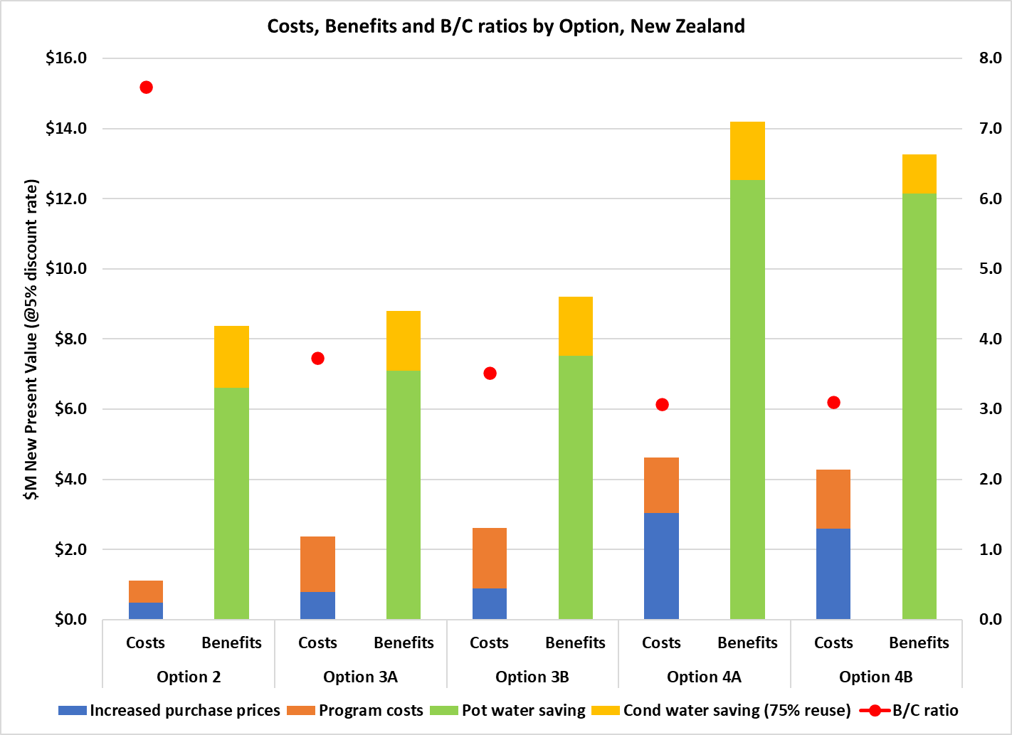

Figure 35 NPV of program costs, 2025-2040, New Zealand

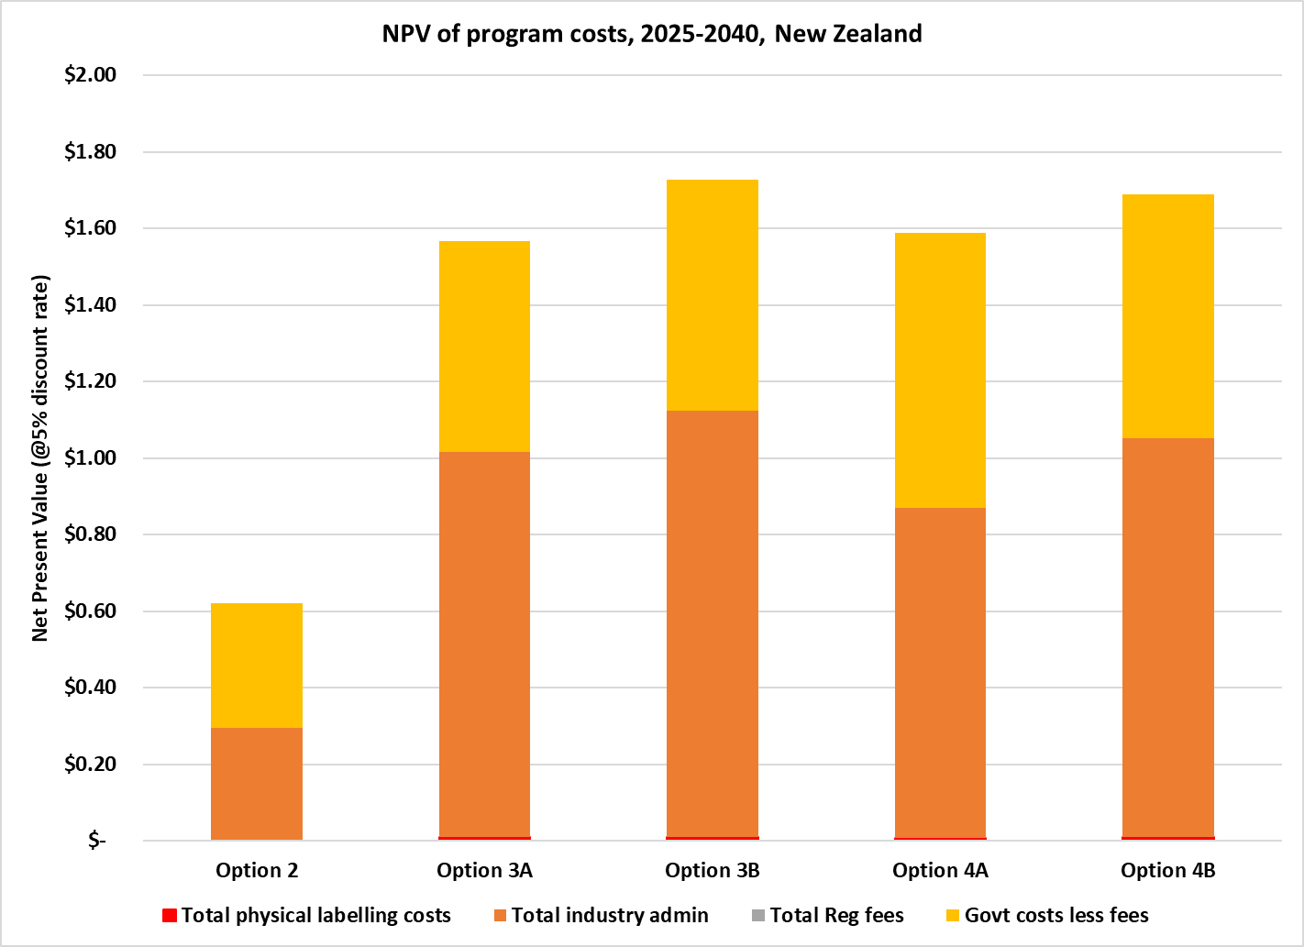

Table 20 indicates the sensitivity of outcomes to discount rates higher than lower than the central 5% discount rate used by New Zealand Treasury. All options are highly cost-effective under all discount rates.

Table 20 Sensitivity to discount rate assumptions, New Zealand

|  |  |  |  |  |  |  |
| --- | --- | --- | --- | --- | --- | --- |
|  | $M NPV at discount rates | | | B/C ratio at discount rates | | |
|  | 2% | 5% | 8% | 2% | 5% | 8% |
| Option 2 | $10.6 | $7.3 | $5.2 | 8.4 | 7.6 | 7.0 |
| Option 3A | $9.6 | $6.4 | $4.5 | 4.1 | 3.7 | 3.4 |
| Option 3B | $9.8 | $6.6 | $4.5 | 3.9 | 3.5 | 3.2 |
| Option 4A | $14.5 | $9.6 | $6.5 | 3.3 | 3.1 | 2.9 |
| Option 4B | $13.5 | $9.0 | $6.2 | 3.4 | 3.1 | 2.9 |

1. Ice may also be used as a thermal storage medium, e.g. to reduce air conditioner peak loads by making ice at off-peak times and melting it to assist cooling at peak times. In those cases, the water/ice is usually contained in a closed circuit. The present report deals with equipment where the ice is consumed and lost.
2. Most CIM advertising claims production capacities at rating points (combinations of air and water temperature) that are more favourable than the rating point in AS/NZS 4865. This means that models commonly advertised with production capacities up to 1,400 kg/24hrs could be within scope.
3. One major design variant relates to the electricity supply in the target market. Europe, China, Australasia and eastern Japan are 230V/50Hz regions. North America is a 115V/60Hz region. Western Japan is a 230V/60Hz region.
4. GEMS allows multiple CIM models to be registered as a single family if they share a test report, are of the same class and have the same tested capacity and energy consumption rate. The GEMS Determination does not specify same water consumption rate, but potable water use rates are unlikely to vary within the one model family. If WELS registration were to be also required, GEMS family members would be treated as distinct models for calculating WELS fee tiers under current rules.
5. The product lists on [www.energyrating.gov.au](http://www.energyrating.gov.au) allow users to manipulate the data by (a) limiting searches by selected brand, product class or capacity and (b) re-sorting entries by values (highest to lowest or vice versa). There is also an energy cost calculator so users can input their $/kWh tariff to get annual energy costs. The GEMS energy rating database could be set up so that the L/kg values could be sorted in order and $/kL values input (or defaults used) to calculate annual water costs. For water-cooled products, users could also be asked to indicate a single pass or recirculation installation.
6. The Australian Government Guide to Regulatory Impact Analysis (OIA 2023) notes that: *Experience with behavioural insights tells us that people do not always make rational, considered decisions even in an otherwise efficiently functioning market.* (p19)
7. Average Australian household water use in 2021/22 was 175,300 litres - see [ABS Water Accounts](https://www.abs.gov.au/statistics/environment/environmental-management/water-account-australia/latest-release).
8. See [Independent Review of the WELS Scheme 2020](https://www.waterrating.gov.au/about/review-evaluation/2020-review#third-report) and [Independent Review of the GEMS Act 2019](https://www.energyrating.gov.au/industry-information/publications/gems-act-2017-review) 
9. *AS5102.2-2009 Performance of Household Electrical Appliances – Swimming Pool Pump-Units Part 2: Energy labelling and minimum energy performance standard requirements.*
10. https://energy.gov/sites/default/files/2023-04/acim-ecs-nopr.pdf
11. At the time of writing, a modified WELS charging structure was being considered. This structure involves the application of a fee-for-service (per model) at time of registration application; and a levy (per model) at time of annual product registration renewal.
12. The rate that converts future values into present values is known as the discount rate. If the discount rate were constant at *r* per cent per year, a benefit of *Bt* dollars received in *t* years is worth *Bt*/(1+*r*)*t* now. [OIA](https://oia.pmc.gov.au/resources/guidance-assessing-impacts/cost-benefit-analysis) requires the calculation of net present values at a ‘central’ discount rate of 7%, with additional calculations at 3% and 10%.
13. In March 2025 the manufacturer, Stuart Ice Makers, was acquired by Heatlie Pty Ltd and moved its operations from Sydney to Adelaide. https://www.icemachines.com.au/
14. <https://www.abs.gov.au/statistics/environment/environmental-management/water-account-australia/latest-release#data-downloads>.
15. All values in this section are in 2025 New Zealand dollars.