# Marine mammal critical habitats, connectivity, and health indices in the Oceania region

**Principal and co-investigators:** ProfChandra Salgado Kent1,2 , DrKerstin Bilgmann1,3, MsJennah Tucker1, MsAlexandra D’Cruz1,2

**Institutions:** Oceans Blueprint (Western Australia) 1; Centre for Marine Ecosystems Reserch, School of Science2; Edith Cowan University (Western Australia), Macquarie University3

**Objectives and Purpose**

The overall aims of the project are to integrated complementary observational sampling techniques (photo‐identification, visual observation, and passive acoustic monitoring) with biological sample collection to:

* + 1. provide insight on marine mammal occupancy (using relative abundance and relative encounter rates) at different locations within the Oceania region;
    2. Identify critical habitats and insight on their connectivity for marine mammals at different locations within the Oceania region;
    3. Infrom on health indicators of several species; and
    4. collect required information for developing species-specific Passive Acoustic Monitoring (PAM) tools (a cost‐effective monitoring tool for monitoring species occurrence, abundance and habitat usage).

The specific objectives are to:

collect sighting information for mapping the occurrence, abundance and distribution of marine mammal at various locations along the Oceania region;

collect cetacean images and biological samples opporunistically from biological tissue associated with nearby animals and deceased animals to use for identifying re-sights, lesions/injuries present, sex, age class, diet, and assess relative health and inform habitat use, occupancy, and home range;

integrate acoustic and visual data to determine species-specific vocalisations to further develop passive acoustic monitoring methods.

**Methods**

***Species:*** The observational-based aspect of the study will include species that are commonly encountered in the broad region of the proposed study, which includes the highly biodiverse Coral Triangle region known to have >26 species of marine mammals. A list of species and numbers likely to be encountered from boats and aircrafts are provided in Table 1. The proposed list includes an anticipated overestimate of numbers of sightings of different species that could be encountered during observational studies, most of which will be observed from several hundred meters to kilometres away. Numbers for certain species are high due to the nature of some sampling techniques optimised to survey marine mammals and the behaviour of the animals. For instance, humpback whales are often surveyed by aircraft over a large area in densely occupied areas such as Exmouth Gulf. Thus, hundreds are easily sighted within periods of less than an hour. Many of the species of delphinids occurring in offshore waters form mega-pods composed of hundreds of individuals. Thus, a vessel survey that encounters one mega-pod on a single day could easily observe >300 individuals within a 10 min period.

Table 1. Focal study species (per year).

|  |  |  |  |
| --- | --- | --- | --- |
| **Common name** | **Scientific name** | **EPBC Conservation Status** | **Number** |
| Humpback whale | *Megaptera novaeangliae* | NA | 5000 |
| Blue whale | *Baleanoptera musculus* | Endangered | 3000 |
| Southern right whale | *Eubaleana australis* | Endangerd | 3000 |
| Bottlenose dolphin | *Tursiops spp.* | NA | 1000 |
| Common dolphin | *Delphinus spp.* | NA | 1000 |
| Snubfin dolphin | *Orcaella heinsohni* | Vulnerable | 1000 |
| Indo-Pacific humpback dolphin | *Sousa chinensis* | NA | 5000 |
| Sperm whale | *Physeter macrocephalus* | NA | 1000 |
| Dwarf sperm whale | *Kogia sima* | NA | 500 |
| Pygmy sperm whale | *Kogia breviceps* | NA | 500 |
| Short-finned pilot whale | *Globicephala macrorhynchus* | NA | 500 |
| Orca (Killer whale) | *Orcinus orca* | NA | 5000 |
| False killer whale | *Pseudorca crassidens* | NA | 1000 |
| Pygmy killer whale | *Feresa attenuata* | NA | 1000 |
| Melon-headed whale | *Peponocephala electra* | NA | 1000 |
| Risso's dolphin | *Grampus griseus* | NA | 1000 |
| Fraser's dolphin | *Lagenodelphis hosei* | NA | 1000 |
| Spinner dolphin | *Stenella longirostris* | NA | 1000 |
| Pan-tropical spotted dolphin | *Stenella attenuata* | NA | 1000 |
| Rough-toothed dolphin | *Steno bredanensis* | NA | 200 |
| Cuvier's beaked whale | *Ziphius cavirostris* | NA | 200 |
| Mesoplodon spp. (unidentified) | *Mesoplodon spp.* | NA | 200 |
| Longman's Beaked Whale | *Indopacetus pacificus* | NA | 200 |
| Blainville's beaked whale | *Mesoplodon densirostris* | NA | 200 |
| Ginkgo-toothed beaked whale | *Mesoplodon ginkgodens* | NA | 200 |
| Bryde's whale | *Balaenoptera brydei* | NA | 400 |
| Omurai’s whale | *Balaenoptera omurai* | NA | 400 |

* These numbers are considered over-estimates of numbers expected to be observed opportunistically and during dedicated aerial, boat and land-based surveys each year. For example, aerial survey-based observations of humpback whales undertaken in past research at 1000 ft high resulted in many more animals than anticipated. While the number seems large, these consist of instantaneous observations from an aircraft flying at 1000 ft over the ocean. In addition, many species, such as spinner and spotted dolphins, commonly form mega-pods of several hundred individuals, which can be observed within a single encounter.

In-water slough skin, tissue, faecal matter from nearby live animals (non-invasive as this is tissue floating in the water and not attached to the animal) and tissue, teeth and biopsies from deceased cetaceans will be obtained as opportunities present themselves.

***Study location:***

The region of Oceania includes [Australasia](https://en.wikipedia.org/wiki/Australasia), [Melanesia](https://en.wikipedia.org/wiki/Melanesia), [Micronesia](https://en.wikipedia.org/wiki/Micronesia) and [Polynesia](https://en.wikipedia.org/wiki/Polynesia), and covers an area of over 8 Mil square kilometres. Many baleen whale species migrate over expansive areas, such as from Antarctica through Australian waters, to waters in the broader Oceania region outside the Australian Exclusive Economic Zone. For instance, endangered pygmy blue whales are thought to migrate through Western Australian waters to their breeding and/or mating grounds in the Indonesian/Timor Leste/Maluku (Ambon) region and then back through Australian waters to the Southern Ocean. The exact breeding and/or mating grounds and migratory routes remain, however, poorly understood, with inter-seasonal and inter-annual variations in habitat use likely. Thus, by including this broader region, this study aims to capture broad spatial-scale movements to better inform trans-boundary conservation goals.

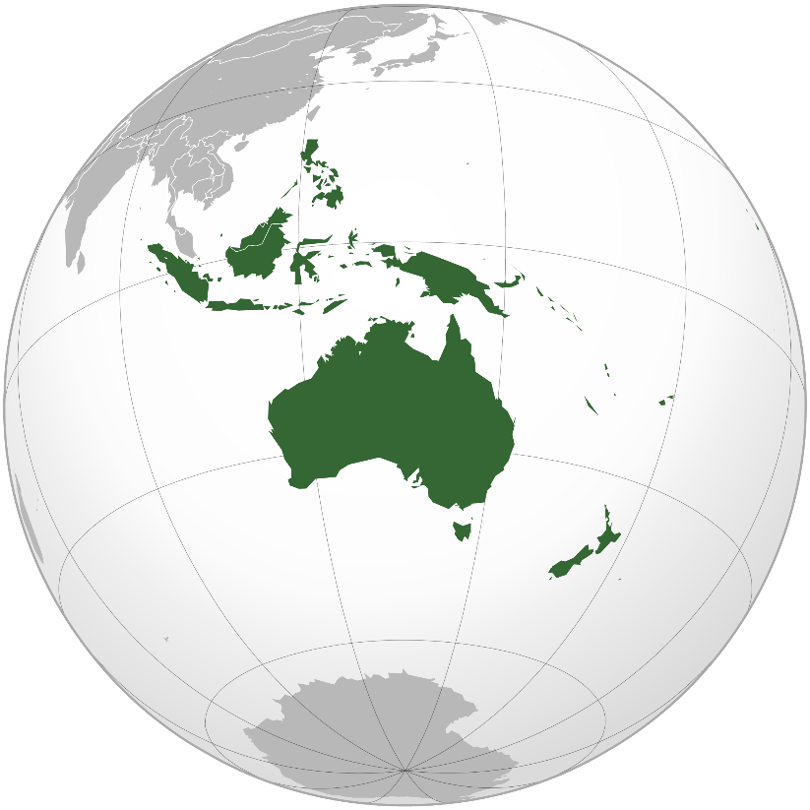

Figure 2. Study area in the Oceania region *(Source: Ch1902, updated by kwami (Transferred by rohith_goura) - Own work based on: Australia (orthographic projection).svg -, CC BY-SA 3.0, https://commons.wikimedia.org/w/index.php?curid=16426329)*

Within Australia, the project will be undertaken in state and Commonwealth waters in several key state and Commonwealth Marine Parks to maximise information on their management. Many of these marine parks are known or suspected critical habitat for a range of species, some of which travel from one to another through migratory corridors. The Marine Parks include Australian Marine Parks in the Southewest Marine Parks Network (e.g., Bremer Marine Park, Geographe Marine Park), and the following state parks:

• Shoalwater Islands Marine Park

• Ngari Capes Marine Park

• Yawuru Nagulagun / Roebuck Bay Marine Park

• Ningaloo Marine Park

• South Coast Marine Park

***Observational survey methods:*** This project uses integrated and complimentary sampling techniques (photo-identification, visual observation, and passive acoustic monitoring) during opportunistic vessel surveys resulting from: 1) opportunities to undertake a designed, dedicated survey (such as in Salgado Kent et al. 2012 attached), 2) transits resulting from unrelated activities outside of the scope of this project, and 3) imagery using a drone (for which permits and permissions from relevant managers/owners will be sought as required). For dedicated surveys, the number of surveys and design will depend upon strategic funds available. However, wherever possible a survey will be designed to ensure equal probability coverage (as in Salgado Kent et al. 2012) and follow distance sampling methodology (Buckland et al. 2004). When insufficient funds are available or the vessel is one of opportunity, a log of the track will be recorded so that effort (in space and time) can be used to quantify observations. Surveys at any one location will be undertaken at frequencies ranging from 2 weeks apart for long-term surveys undertaken throughout the year to every day interspersed with days of poor weather conditions over several months to capture high resolution information during key periods (such as during migration for baleen whales). High temporal resolution surveying will **not** occur over prolonged periods. For migrating whales, the chance of re-disturbing the same animals are reduced significantly since many are moving through the area. The importance of repeat observations is to establish trends in numbers, distribution, and residency periods.

During each vessel or land-based survey, one to two observers (whom will be documented) will scan continuously in all directions while ‘on-effort’. The time start, time end, and observation position/track will be recorded. Upon sighting a marine mammal, in the case of vessel surveys, the vessel will slow gradually and be placed in neutral. For vessel and land-based surveys, data on species, group size, distance and angle to the sighting, GPS position, depth, sea-surface temperature (when possible), and weather conditions will be recorded. If the animals can be easily approached (travelling slowly or remaining in the same location), the animal or group of animals will be approached slowly by the vessel or by a launched drone from the location of the researcher, according to the procedure described under ‘Method of approach’ below, and the following information collected:

* Species confirmation
* Number of animals in the group
* Composition (including adult females and males, sub-adults, and juveniles where these can be distinguished, and calves/pups)
* Behaviour (behavioural states including foraging, resting, travelling/migrating, socialising, and any key indicator instantaneous behaviours)
* Images (photos & video)
* Underwater acoustic recordings
* Counts of vessels/people/other potential threats in the immediate area of marine mammals
* Time start and time end of group observation

Before approach, the species, number of animals, composition, and behaviour will be obtained using the naked eye or 7 x 50 marine reticule binoculars as required. The distance and bearing will be obtained when possible using the binocular’s inbuilt compass and reticules (number of reticules down from the horizon).

If animals are within close enough proximity or upon approach, photos and images will be taken using: an SLR 7D Cannon camera with 300-400 m zoom lens or similar, a high definition standard or 3D video camera (either held by the researcher on the deck of the vessel, or held underwater by the researcher on deck by extending a 1-m pole the camera is mounted off the side of the vessel), and/or a drone (operated under guidelines for safe operation). In good underwater visibility conditions, underwater video will allow for information on sex and health to be collected, including body condition, number of and position of lesions, possible pregnancies in females, prevalence of cookie cutter scars, scars or marks due to fisheries interactions. Underwater images will allow for a greater extent of the body to be assessed, as routinely only a small fraction of a marine mammals’ body is exposed above the surface of the ocean. 3D video are currently being tested for size measurements (as an indicator of health). Drones provide proven high-quality information on individual identification (especially for right whales) and health indices (in addition to information on group spacing, numbers and behaviour).

In instances where the 1-m pole mounted camera cannot be deployed safely or be able to collect the required information, the underwater imagery will be obtained by the researcher slipping into the water near the vessel instead with the underwater camera in hand. The period in the water will be minimised to the least necessary time to collect the data, and image acquisition ceased upon any signs of disturbance to animals.

Acoustic recordings will be taken with a hand-held hydrophone (connected to a Sound Devices 744T or similar recorder) held over the side of the vessel to ~4 m depth. Simultaneous acoustic and video recordings will also be collected when the opportunity allows using a small tow-fish outfitted with a camera and hydrophone (Soundtrap), towed behind the vessel at approximately 10 m (image below).

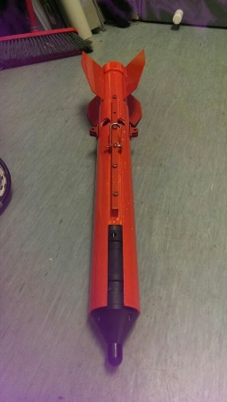

Figure 3. Small towfish outfitted with camera and hydrophone (~60 cm long 10 cm wide)

***Steps taken to mimimise impacts on cetaceans (method of vessel and drone approach):*** For all observations made, animals will be monitored and disturbance as outlined in Australian National Guidelines for Whale and Dolphin Watching (2017) and the Wildlife Conservation (Close Season for Marine Mammals) Notice (1998) will be minimised at all times. The following will be monitored as indicators of disturbance:

• attempts to leave the area or moves away from the vessel quickly or slowly;

• regular changes in direction or speed of swimming;

• hasty dives;

• changes in breathing patterns;

• increased time spent diving compared to time spent at the surface;

• changes in acoustic behaviour; and

• aggressive behaviours such as tail slashes, and trumpet blows

Upon any signs of distress (aggressive behaviours, attempts to leave an area, regular changes in direction or speed of swimming), all observations will cease and the researchers or drone (if the researchers are at a distance) will slowly move away.

The vessel and drone when used will be manoeuvred in such a way as to minimise the disruption of behaviour. From boats, animals will be approached as outlined in the Australian National Guidelines for Whale and Dolphin Watching (2017). Upon approach and departure, no sudden changes in course or speed will be undertaken, and if there is a need to stop the vessel’s speed will be reduced gradually and the vessel placed into neutral. Noise will be minimised, including from communications aboard the vessel. Areas of approach will be from the sides as outlined in the Australian National Guidelines for Whale and Dolphin Watching (2017). There will be ‘no waiting in front of direction of travel’ and ‘no approaching from the rear’ (indicated in the figure below). The vessel will not restrict the movement of animals against the shore, disperse or separate groups, or herd animals. Extra caution will be taken with cow-calf so that separation does not occur.

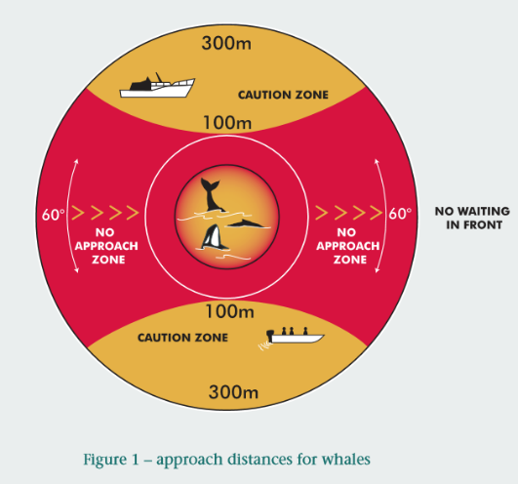 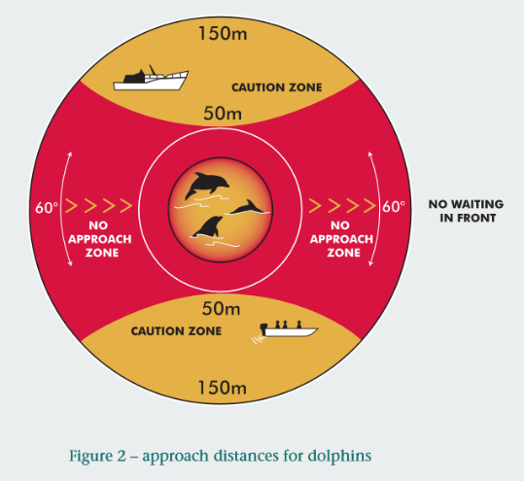

Figure 4. Approach zones (Source: Australian National Guidelines for Whale and Dolphin Watching 2005).

While observations are anticipated to be made at ranges outlined in guidelines developed for the public whenever possible, to ensure that accurate data and images with sufficient quality for photo-identification and health indices are collected, minimum distances anticipated for this research vessel are:

* 20 m for baleen whales,
* 15 m for odontocetes, and

For the drone, minimum distances will be 15 m for all species. This height is required to obtain the necessary resolution for small cameras that do not have a zoom lens. For whales, the vessel is above air and much smaller and quitter than a boat.

For boats, if animals voluntary approaches the vessel at distances closer than the minimum distances described above, the engine will be completely disengaged. When deploying the tow-fish, the vessel will be manoeuvred so that distances of > 30 m are targeted to control any potential risk of entanglement.

The observation period will be the minimum necessary to collect accurate information. This period will usually range from 20 min to 1 hour. For a blue whale that surfaces on average once every 10 min for approximately 2-3 min, this gives two to five brief opportunities to collect photo-ID, health, pod composition, and behavioural state information). For odontocetes (dolphins and toothed whales) which surface more frequently, ~20 min will generally be sufficient, unless the pod is large then the collection of images from all individuals could take up to an hour.

***Biological sample collection of deceased animals:***

For deceased animals in water, a small (<2 cm) biopsy from the surface of the animal will be taken, or from live animals nearby, slough skin from the water, tissue and/or faecal material floating in the water will be taken and stored as per standard practices (e.g., placed in ethanol or DMSO in a vial). For deceased animals on land, permission will be sought from DBCA Operations, Shire/Councils to collect samples. For deceased animals, where possible a biopsy sample will be taken as above, three teeth will be extracted and placed in ethanol (e.g., 90%). Images will be taken of the deceased animal for body condition information.

**References**

Buckland, S.T., Anderson, D.R., Burnham, K.P., Laake, J.L., Borchers, D.L. and Thomas, L., editors. 2004. Advanced Distance Sampling. Oxford University Press, Oxford.

**Salgado Kent, C.P**., Jenner, C., Jenner, M. Bouchet, P., and Rexstad, E. 2012. Southern Hemisphere Breeding Stock 'D' Humpback Whale Population Estimates from North West cape, Western Australia. Journal of Cetacean Research and Management. 12(1): 29-38.