Draft Conservation Advice for the Pinkwood cool temperate rainforests of south east New South Wales and far east Victoria

This draft document is being released for consultation on the description, threats, listing eligibility and conservation actions for the ecological community.
The purpose of this consultation document is to elicit additional information to better understand the definition and status of the ecological community and help inform conservation actions. The draft assessment below should therefore be considered tentative at this stage, as it may change as a result of responses to this consultation process.

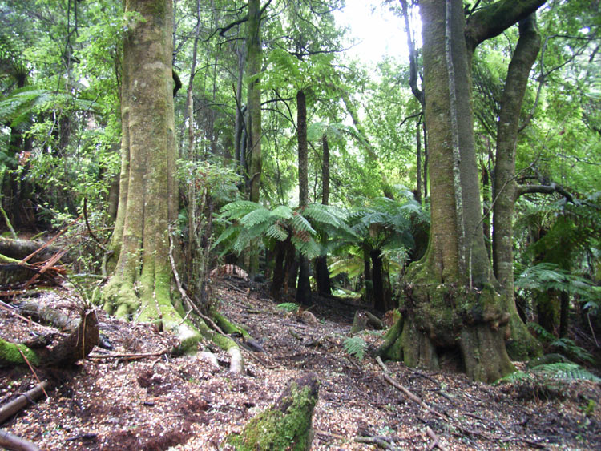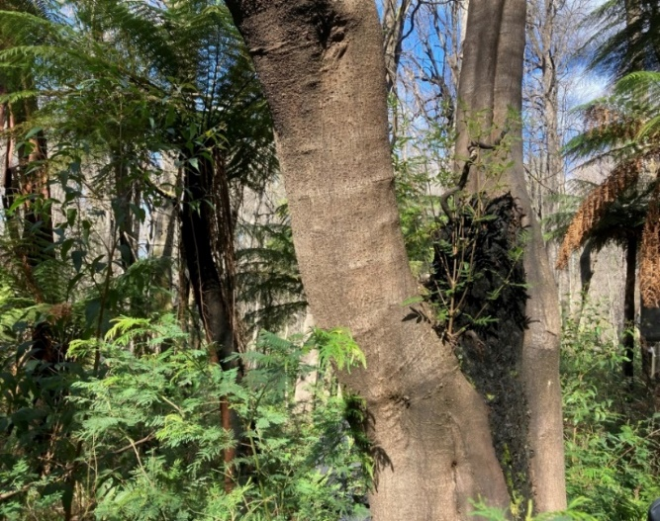
Pinkwood cool temperate rainforests at Monga National Park:
Left – in March 2007, showing dominant trees Eucryphia moorei (pinkwood) and Dicksonia antarctica (smooth tree fern) in deep organic duff. © Murray Fagg
Right – two years after the January 2020 fire. Top-killed Eucryphia moorei (foreground) resprouting small shoots from the base, showing slow recovery, while about 50% of trees at the site did not survive. Full canopy recovery may require many decades or more than a century in the absence of fire. © David Keith

The Pinkwood cool temperate rainforests of south east New South Wales and far east Victoria ecological community occurs within Country (the traditional lands) of the Yuin, Dharawal and Bidwill peoples. We acknowledge the continuing connection to, and stewardship of, the ecological community and the Country it inhabits by First Nations peoples.
Proposed Conservation Status
Pinkwood cool temperate rainforests of south east New South Wales and far east Victoria is proposed to be listed in the Endangered category of the threatened ecological communities list under the Environment Protection and Biodiversity Conservation Act 1999 (Cwlth) (EPBC Act).
Ecological communities can also be listed as threatened under state and territory legislation. At the time of this draft Conservation Advice, the Victorian extent of the ecological community corresponds closely with the ‘Warm Temperate Rainforest (Cool Temperate Overlap, Howe Range) Community’, which is listed as threatened under the Victorian Flora and Fauna Guarantee Act 1988.

Draft Conservation Advice for the Pinkwood cool temperate rainforests of south east New South Wales and far east Victoria
About this document
This document describes the ecological community and where it can be found (section 1). It outlines information to assist in identifying the ecological community and important occurrences of it (section 2) and summarises key aspects of the ecological community’s cultural significance for First Nations peoples (section 3).
Consistent with requirements of section 266B of the EPBC Act, this document sets out the grounds on which the ecological community is eligible to be listed as threatened (section 6), outlines the main factors that cause it to be eligible for listing (section 4), and provides information about what could appropriately be done to stop its decline and/or support its recovery (section 5).

CONTENTS
1 Ecological community name and description 4
1.1 Name 4
1.2 Description of the ecological community and the area it inhabits 4
2 Identifying areas of the ecological community 18
2.1 Key diagnostic characteristics 18
2.2 Additional information to assist in identifying occurrences of the ecological community 20
2.3 Condition classes, categories and thresholds 24
2.4 Habitat critical to the survival of the ecological community 27
2.5 High value occurrences – broader environment and landscape context 28
3 Cultural significance 29
3.1 Significant areas 29
4 Threats 32
4.1 Threat table 32
5 Conservation of the ecological community 38
5.1 Primary conservation objective 38
5.2 Existing protection and management plans 39
5.3 Principles and standards for conservation 40
5.4 Conservation and recovery actions 41
6 Listing assessment 48
6.1 Eligibility for listing 48
Appendix A – Species lists 67
Appendix B – Conceptual model of ecosystem dynamics 74
Appendix C – Relationship to other vegetation classification and mapping systems 75
References 79

Ecological community name and description

Name
The name of this ecological community is the Pinkwood cool temperate rainforests of south east New South Wales and far east Victoria (also referred to as pinkwood cool temperate rainforests or the/this ecological community). The name refers to the dominance in many stands of the regionally endemic tree Eucryphia moorei (pinkwood, plumwood or eastern leatherwood); the simple structure of this rainforest community as a closed-canopy, wet forest with abundant ferns and mosses; and, its occurrence in cool climates on coastal mountains and upper escarpment slopes of south east New South Wales (NSW) and the far reaches of eastern Victoria. This community belongs to a class of rainforests commonly known as ‘cool temperate rainforests’ (Baur 1965, 1989; Floyd 1990; Keith 2004).
This ecological community was placed on the 2023 Finalised Priority Assessment List as the 'Pinkwood cool temperate rainforests of south east New South Wales and far east Victoria’, following its nomination for potential listing by the Threatened Species Scientific Committee. The nomination was based on a study by Keith et al. (2022b) commissioned by the Department of Climate Change, Energy, the Environment and Water to examine ecological communities affected by the 2019–2020 bushfires.
Consultation Question on the Name
- Do you agree that this should be the name of the ecological community? If not, please provide an alternative recommendation and your reasons.

Description of the ecological community and the area it inhabits
The EPBC Act defines an ecological community as an assemblage of native species that inhabit a particular area in nature. This section describes the species assemblage and area in nature that define the Pinkwood cool temperate rainforests of south east New South Wales and far east Victoria.
The ecological community described in this Conservation Advice is the assemblage of plants, animals and other organisms associated with a type of rainforest that occurs in cool temperate, humid climates on coastal mountains and upper escarpment slopes, scattered mostly from the upper Clyde River catchment and Budawang Range, south to the NSW-Victorian (Vic) border region. Within the International Union for Conservation of Nature (IUCN) Global Ecosystem Typology (Keith et al. 2022a), this ecological community belongs to Ecosystem Functional Group T2.3 ‘Oceanic cool temperate rainforests’. In an Australian context, this ecological community belongs to the ‘Microphyll Fern Forest’ and ‘Nanophyll Moss Forest' structural forms of Webb (1968), the ‘Cool temperate rainforest’ structural form of Baur (1954) and Floyd (1990), and the ‘Cool Temperate Rainforests’ vegetation class of Keith (2004). More broadly this ecological community is within the A2 floristic province of Webb and Tracey (1981).
Helman (1983) splits the Pinkwood Communities into a higher elevation pure Cool Temperate type with Eucryphia moorei (pinkwood) and occasional Elaeocarpus holopetalus (black oliveberry) from 550 to 1050m elevation in the Clyde Mountain Range and a lower elevation mixed or intermediate (Cool and Warm Temperate) type with E. moorei codominant with Doryphora sassafras (sassafras) and Syzygium smithii (lilly pilly) from 400 to 900m elevation around Gulaga (Mt Dromedary, NSW).
Pinkwood cool temperate rainforests of south east New South Wales and far east Victoria in its undisturbed state has a simple, closed-forest structure with dense horizontally-held foliage and abundant ferns and mosses in the understorey and on the trunks and branches of trees and shrubs.
This section describes the assemblage of flora and fauna species and the areas of habitat that represent the typical range of natural states of the ecological community. More information to assist in identifying occurrences of the ecological community is provided in section 2. Because of past loss or degradation, not all extant occurrences of the ecological community are in a completely natural state. Section 2.3 provides information to identify which patches retain sufficient conservation values to be considered a matter of national environmental significance.

Area in nature inhabited by the ecological community
Pinkwood cool temperate rainforests of south east New South Wales and far east Victoria occurs as small patches (mostly less than 20 ha (Tozer et al. 2010)) in the South East Corner, South East Highlands and Sydney Basin bioregions (IBRA V7, DoE 2013), scattered mainly between the upper Clyde River catchment in the north and in the vicinity of the NSW-Vic border in the south.
Other outlying and transitional patches of this ecological community with mesothermal (warm temperate) rainforests have a greater diversity of tree, vine and shrub species and less abundant bryophytes and tree ferns. These patches of the ecological community occur at the lower elevational range of the community, to the north on the Illawarra escarpment as far as Mt Keira and in sheltered sandstone gorges around Avon and Cataract dams. In this region, these patches of the ecological community tend to be restricted favourable microclimates, within broader areas of warm temperate rainforest (see section 1.2.1.1). Additional occurrences are found in the Barren Grounds/Budderoo plateau escarpment and to the south on the Howe Range near the NSW-Vic border (see Section 1.2.2 for further details).
As at June 2025, the ecological community occurs in the NSW South East (Local Land Services) and Victorian East Gippsland (Catchment Management Authority) Natural Resource Management (NRM) regions and in the following Local Government Areas (LGAs):
- Bega Valley Shire Council
- Eurobodalla Shire Council
- Kiama Municipal Council
- Queanbeyan-Palerang Regional Council
- Shellharbour City Council
- Shoalhaven City Council
- Snowy Monaro Regional Council
- Wingecarribee Shire Council
- Wollongong City Council
- East Gippsland Shire Council (Victoria).

Environmental characteristics of the Area in nature
The ecological community typically occurs on sheltered upper slopes and gully heads, usually with a southerly or easterly aspect. Sometimes the ecological community may also occur on relatively flat terrain, but proximal to steep escarpments or mountain slopes.
The ecological community occurs on a range of lower fertility felsic to intermediate volcanic and fine-grained siliciclastic sedimentary substrates, rarely on mafic volcanics. These are mapped primarily as Kandosols and Ferrosols, with minor occurrences on other soils such as Tenesols, Kurosols and Dermosols (DPIE 2021).
Based on available survey data, the ecological community is found at elevations within the interquartile range of 600–750 m above sea level (ASL), though it may occur as low as 400 m and as high as 1050 m ASL (Tozer et al. 2010). At these elevated sites, the mean minimum temperatures of the coldest month are approximately 0–2.5°C (full range across the distribution); and mean temperatures of the warmest quarter are approximately 16–20°C (Bureau of Meteorology 2021). Most of the ecological community occurs in areas with mean annual rainfall of 940–1120 mm, with weak summer seasonality. Based on Dyer’s (2009) water balance model applied to available long-term average weather data (1976-2005), this ecological community experiences a small deficit, which occurs during warmer months when available soil moisture fails to meet plant demand (averaging ~10 % of annual precipitation, but varying year to year) (Appendix B – Conceptual model of ecosystem dynamics). Cloud stripping where moisture-laden orographic air streams from the ocean are intercepted by the tree canopies (Keith 2004), also known as occult precipitation or fog interception, may compensate in some times of the year for rainfall deficits at some sites favoured by this ecological community. Temperate cloud dependent rainforests are much less researched than tropical montane cloud forests (Bruijnzeel 2001). More research is needed on the contribution of cloud moisture to the water balance of this ecological community.
The Pinkwood cool temperate rainforests can also occur as a narrow riparian strip along gullies and creeks at lower elevations (Fig. 1). These narrow strips usually feature Eucryphia moorei (pinkwood) trees as a strip along the stream or gully within a larger patch of warm temperate (laurophyll or low nutrient) rainforest that is usually dominated by Ceratopetalum apetalum (coachwood) and Doryphora sassafras (sassafras).
Cool air drainage (katabatic flow) occurs where cool air drains downwards from elevated parts of the landscape, especially in gullies or valleys and at night. The influence of katabatic flow is highly likely to play a role in creating suitable cool moist microclimate for this ecological community at lower elevations, as is increased groundwater and stream water availability in creating a micro-refugial area where E. moorei can survive. Examples of these narrow Pinkwood rainforests can be seen at the Avon River dam and the Cataract dam. Other small patches of the ecological community can be found at the base of south-facing sandstone cliffs where groundwater seepage occurs and the topography shelters the site from direct sunlight and reduces fire risk by creating microrefugia or lithorefugia (Couper & Hoskin 2008).
Consultation Question on the location and physical environment:
- Do you agree with the statements on the location and physical environment? Please provide any alternative recommendations and your reasons.

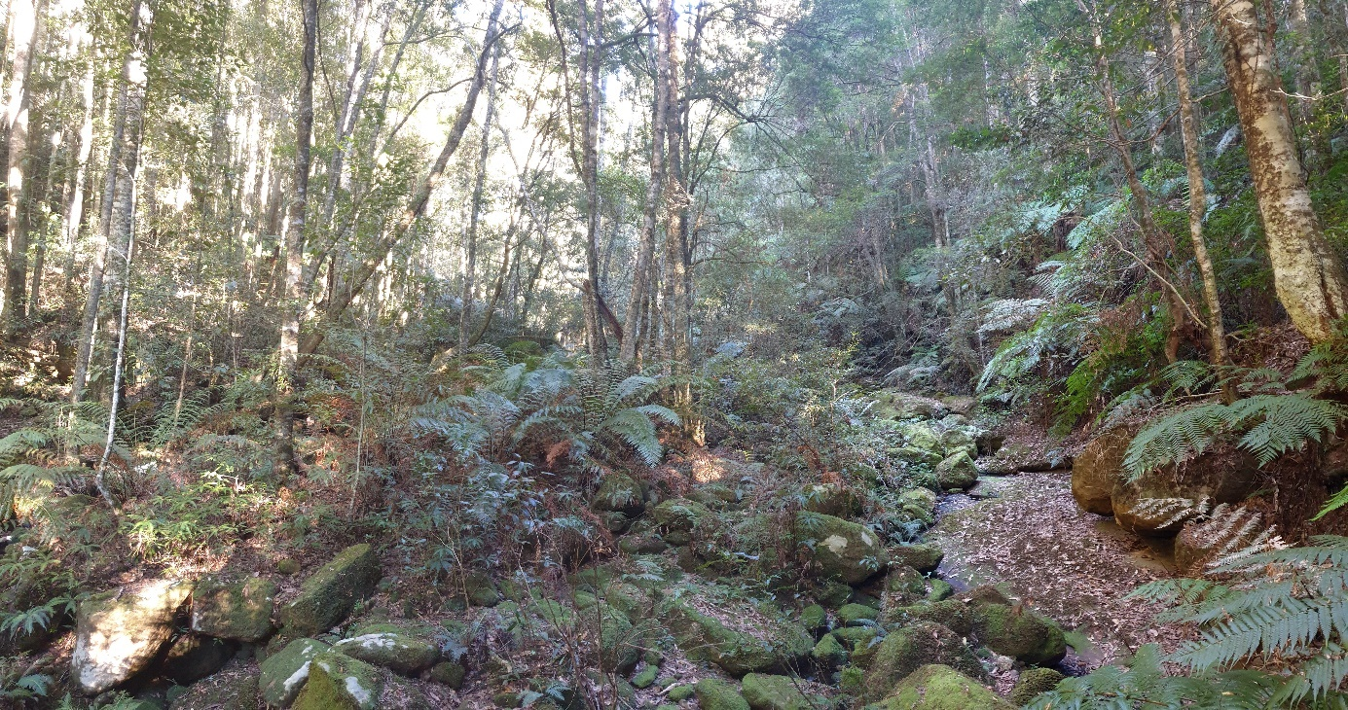
Figure 1. Eucryphia moorei (pinkwood) occurring as a narrow riparian community along a stream within C. apetalum (coachwood) Warm Temperate Rainforest in the Avon River Catchment, elevation 350m. © L. Weber

Description of the assemblage

Vegetation Structure
Pinkwood cool temperate rainforests of south east New South Wales and far east Victoria in its relatively undisturbed state typically has a simple, closed forest structure with dense horizontally-held foliage and abundant ferns and mosses in the understorey and on the trunks and branches of trees and shrubs (Fig. 2). The tree canopy averages 20 m (standard deviation (SD) ± 10 m) in height with an average projective foliage cover of 73% (SD± 19 %) (based on map unit RF p317 ‘South east Cool Temperate Rainforest’ of Tozer et al. 2010). Emergent trees are generally absent except for occasional eucalypts, and the closed canopy is relatively uniform with microphyll foliage (2.5–20 cm²) (Walker & Hopkins 1990). Trees lack buttress roots although some may have multi-stemmed growth forms. Palms are absent and vines are not major components of the ecological community. A layer of tree ferns and mesophyllous shrubs averages 3.7 m (± 1.0 m) in height and 27% (± 21%) cover, while the groundlayer is dominated by ferns and forbs and averages 0.6 m (± 0.4 m) in height and 42% (± 38%) cover (Tozer et al. 2010). At lower elevations and near the northern extent of its distribution, the ecological community typically transitions into more complex structural forms with greater representation of notophyll foliage in the tree canopy and greater abundance of vines and shrubs, but lower abundance of tree ferns and bryophytes.
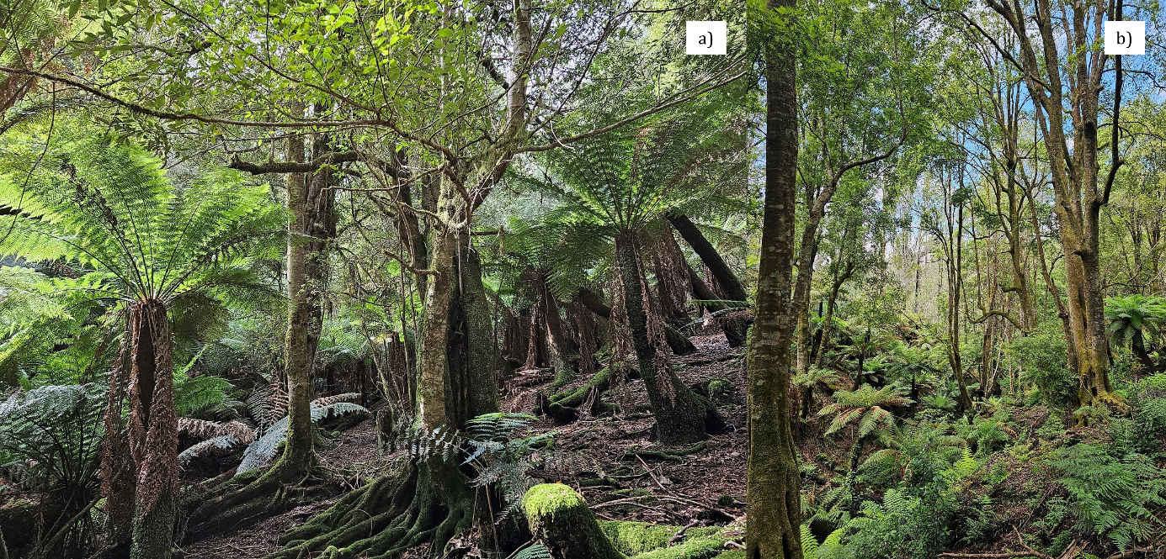
Figure 2. a) Typical structure of Cool Temperate Rainforest dominated by Elaeocarpus holopetalus (black oliveberry) and Atherosperma moschatum (southern sassafras) with tree ferns (Dicksonia antarctica) dominating the mid layer at Brown Mountain, elevation 990m. b) Mature E. moorei stand in a sheltered gully mostly undamaged by fire at Monga NP, elevation 800m. Most stands were severely burned in this area (b). © L. Weber

Flora
Plant species richness is relatively low compared to other rainforest types, with most of the plant diversity occurring in the understorey and typically dominated by one or two canopy species. The floristics of this ecological community include a mix of warm and cool temperate rainforest species. Paleo-floristically the assemblage consists mainly of Gondwanan lineages with a more limited number of Asian lineages (Sniderman & Jordan 2011). The assemblage of plant species that characterises the ecological community was defined in a quantitative analysis of available floristic survey data throughout mainland south-eastern Australia (Keith et al. 2023), and has been augmented with targeted field assessments, expert elicitation and consultation workshops. The descriptions below include species that have been identified as commonly occurring if they were recorded in more than 30% of the samples assigned to this assemblage using the methods outlined in Appendix D – Methods used to estimate distribution and exposure to threats, or that were listed as characteristic by other primary sources (Keith & Bedward 1999; Peel 1999), field assessments or expert advice. More detailed lists of species and their conservation status are provided in Appendix A - Species lists.

Canopy species
Eucryphia moorei (pinkwood, plumwood, eastern leatherwood) is the dominant tree species in most occurrences of the ecological community and is regionally endemic. Other commonly occurring tree species in the ecological community (in descending frequency of occurrence) include Hedycarya angustifolia (native mulberry), Syzygium smithii (lilly pilly), Doryphora sassafras (sassafras) and Synoum glandulosum (scentless rosewood). Other common species at higher elevations include Elaeocarpus holopetalus (black olive berry) and Atherosperma moschatum (black sassafras).
Transitional occurrences of the ecological community at lower elevations and in the north of its distribution typically include a greater diversity of tree species. For example, below the Budderoo escarpment, west of Berry, Eucryphia moorei occurs with abundant Ceratopetalum apetalum (coachwood) and Quintinia sieberi (possumwood); while to the south in the Howe Range, Victoria (within Croajingolong National Park), Eucryphia moorei occurs with Syzygium smithii, along with a higher diversity of vines (SAC 1996).
The presence of trees in the genus Nothofagus is a contra-indicator of this ecological community as these trees dominate other types of cool temperate rainforests outside the range of this ecological community. For example, cool temperate rainforests containing N. moorei that occur north of the Hunter Valley in NSW and in south-east Queensland; and also cool temperate rainforests containing N. cunninghamii that occur in Victoria and Tasmania.
A more comprehensive list of canopy species that occur, or are likely to occur in the ecological community, are in Appendix A – Species lists.

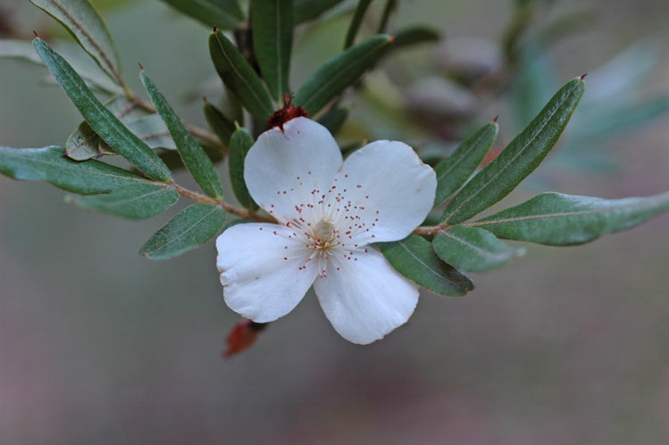
Figure 3. Eucryphia moorei flower. © Murray Fagg (Australian Plant Image Index)

Understorey species
Commonly occurring tree ferns and shrubs in the understorey include Dicksonia antarctica (soft tree fern), Cyathea australis (rough tree fern), Coprosma quadrifida (prickly current bush) and Olearia argophylla (musk daisy-bush). Hedycarya angustifolia (native mulberry) may be present in the understorey as well as, or instead of, the canopy. Pepperbushes Tasmannia lanceolata and T. insipida are also common shrubs. Pittosporum bicolor is an occasional shrub or small tree.
The Howe Range (eastern Victoria, near Mallacoota) stands support Correa lawrenceana (mountain correa), Cyathea cunninghamii (slender tree-fern), Hedycarya angustifolia (Austral mulberry), Persoonia sylvatica (forest geebung) and Polyscias sambucifolia subsp. Long leaflets (broad-leaf panax).
Other shrubs are often present on the rainforest margins or after disturbance, these include Pomaderris aspera (hazel pomaderris), Bedfordia arborescens (blanket leaf) and Prostanthera lasianthos (Victorian Christmas bush).
Vines characteristically occur in the understorey, most commonly Fieldia australis (fieldia), Smilax australis (lawyer vine), Pandorea pandorana (wonga wonga vine), Parsonsia brownii (mountain silkpod), Marsdenia rostrata (milk vine) and Clematis aristata (old man’s beard), although P. brownii occasionally reaches the tree canopy.
Other commonly occurring ground layer plants include forbs, Australina pusilla (small shade nettle), Urtica incisa (stinging nettle), and a diverse array of ferns, some of which cover rocks and tree trunks or branches, such as Pyrrosia rupestris (rock felt fern), Crepidomanes venosum (a filmy fern), Blechnum patersonii (strap water fern), Microsorum scandens (fragrant fern), Polystichum proliferum (mother shield fern), Asplenium flabellifolium (necklace fern), Microsorum pustulatum subsp. pustulatum (kangaroo fern), Lastreopsis acuminata (glossy shield fern), Blechnum wattsii (hard water fern), Pellaea falcata (sickle fern), Histiopteris incisa (bat’s wing fern) and Diplazium australe (austral lady fern).
Helman (1987) lists more than 100 species of bryophytes recorded in rainforests of southern NSW, including a range of terrestrial, lithophytic and epiphytic mosses and liverworts (bryophytes). Many of these are likely to occur in this ecological community. Although conspicuous on the forest floor and tree fern trunks, the biomass of epiphytic mosses is relatively low in this ecological community compared to other cool-climate rainforests. The ecological community also includes many other crytogamic plants and fungi species that play essential ecological roles, such as decomposition and as food.
The fern assemblage occurring in this ecological community is specialised to cool moist conditions including frequent mists and ground level clouds and indicative of cool temperate rainforests. In particular there is a high diversity of epiphytic and lithophytic ferns as well as tree ferns and ground ferns (Fig. 5). The Hymenophyllaceae fern family or filmy ferns are particularly diverse and well represented within the ecological community. There are several regionally endemic or near endemic species. Hymenophyllum pumilum is regionally endemic. H. lyallii is only known from this region of Australia but is common in New Zealand. All nine species of Hymenophyllum present on mainland NSW are present in this region plus two additional filmy ferns Abrodictyum caudatum and Polyphlebium venosum.
A more comprehensive list of understorey species that occur or are likely to occur in the ecological community are in Appendix A – Species lists.

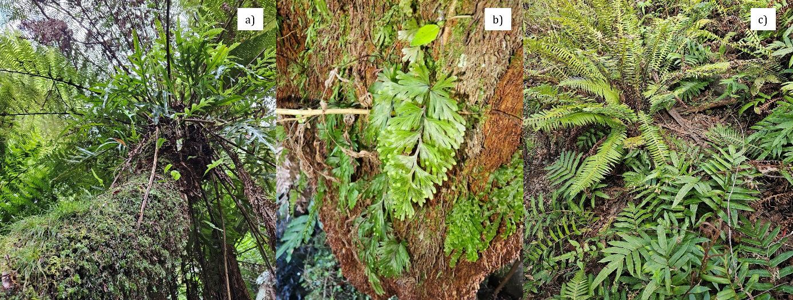
Figure 4. The tree fern Dicksonia antarctica is often a dominant in the understorey of the ecological community. These tree fern trunks in turn support many other epiphytic fern species. a) Microsorum pustulatum and Polyphlebium venosum grow with a small sedge Carex austrotelella on this single trunk at Brown Mountain. b) The filmy ferns Hymenophyllum flabellatum and Polyphlebium venosum on a tree fern trunk at Brown Mountain, NSW (South East Forests National Park). c) Typical ground ferns include Blechnum wattsii and B. nudum. These were regenerating after fire destroyed the canopy at Peak Alone, Wadbilliga National Park, NSW. © L. Weber

Consultation Questions on the flora species assemblage
- As noted in 1.2.2.2, the species listed above occur in at least 30% of survey plots assigned to this ecological community. This aids the consistency of description and helps to distinguish related communities. Are there other important plant species (i.e. those perceived to be characteristic or distinctive) that should be added to the description?
- Please provide information on fungi species that are known to occur in the ecological community.
- Please provide additional information or alternative recommendations and your reasons.

Threatened flora species
Twelve plant species occurring in the Victorian Howe Range stands of Pinkwood cool temperate rainforest are listed as threatened under the Victorian Flora Fauna Guarantee Act 1988. Most significantly the dominant tree Eucryphia moorei is considered Critically Endangered in Victoria.
A more comprehensive list of threatened flora species that occur or are likely to occur in the ecological community are in Appendix A – Species lists.

Fauna
The faunal component of the Pinkwood cool temperate rainforests of south east New South Wales and far east Victoria use the vegetation for shelter, breeding or foraging habitat. Rainforest can also be important as landscape refuges during hot weather.
Typical ground mammal species include Wallabia bicolor (swamp wallaby), Potorous tridactylus (long-nosed potoroo), Cercartetus nanus (eastern pygmy-possum), Dasyurus maculatus (spotted-tail quoll) and Tachyglossus aculeatus (echidna). Arboreal species include Petaurus peregrinus (common ringtail possum), Petaurus breviceps (sugar glider) and Acrobates pygmaeus (feather-tail glider), while a range of insectivorous forest bats may forage within, nearby or above the forest canopy, including Rhinolophus magaphyllus (eastern horseshoe bat), Saccolaimus flaviventris (yellow-bellied sheathtail-bat), Miniopterus orianae oceanensis (large bent-winged bat), Myotis macropus (southern myotis), Scoteanax rueppellii (greater broad-nosed bat), Phoniscus papuensis (golden-tipped bat), Falsistrellus tasmaniensis (eastern false pipistrelle), and Episticus sagittula (large forest episticus). In addition, the Vulnerable Pteropus poliocephalus (Grey-headed flying fox) is likely to be part of the ecological community seasonally, during which it would feed on the fruit of some plants and helps to disperse their seed.
The bird fauna includes Tyto novaehollandiae (masked owl), Tyto tenebricosa (sooty owl), Ninox strenua (powerful owl), Artamus cyanopterus cyanopterus (dusky woodswallow), Daphoenositta chrysoptera (varied sittella), Hirundapus caudacutus (white-throated needletail), Melanodryas cucullata cucullata (hooded robin, south-eastern form), Petroica boodang (scarlet robin), Petroica phoenicea (flame robin), Petroica rodinogaster (pink robin), Menura novaehollandiae (superb lyrebird), Pachycephala olivacea (olive whistler), Pachycephala pectoralis (golden whistler), Colluricincla harmonica (grey shrike-thrush), Monarcha melanopsis (black-faced monarch), Rhipidura rufifrons (rufous fantail), Rhipidura fuliginosa (grey fantail), Psophodes olivaceus (eastern whipbird), Sericornis frontalis (white-browed scrubwren), Acanthiza pusilla (brown thornbill) Meliphaga lewinii (Lewin’s honeyeater), Zosterops lateralis (silvereye) and Ptilonorhynchus violaceus (satin bowerbird).
Microdonacia pilosa is a species of leaf beetle confined to cool temperate rainforest on the eastern slopes of the coastal range between Clyde Mountain and the Monga area (Reid 1992). Eucryphia moorei is the sole known host plant (Reid 1992). Other invertebrate species are diverse but not well known. The Tallaganda Gourock range supports several species of velvet worm. Pallocephalle tallagendensis is an ancient monospecific genus endemic to the area, and while Euperipatoides rowellii is more widespread in temperate montane eastern Australia, it exhibits complex genetic structuring within small moist forested catchments separated by ridges in Tallaganda that indicates survival in small refugia from past climatic changes (Garrick et al. 2012; Bull et al. 2013).
The ecological community also includes many microbial species that play essential ecological roles, including in soil cycling. However, they are relatively poorly documented.
A list of threatened fauna species associated with the ecological community is in Appendix A – Species lists.
Consultation Questions on the fauna species assemblage
- Please provide any relevant sources of information on vertebrate and invertebrate fauna that are characteristically or often part of this ecological community
- In particular, which species of frogs (in addition to those in Appendix A) and reptiles are known from the ecological community?

Functionally important species of the ecological community
Closed canopy trees and tree ferns in the understorey (see section 1.2.4) are of critical importance to the function of the ecological community, due to their role in maintaining a moist microclimate and shade (Pfiefer et al. 2018). This provides habitat conditions suitable for establishment and persistence of drought-sensitive plants in the understorey, as well as refugial properties for birds and mammals that shelter from heat in rainforests (Adam 1994; Bowman 2000). Tree fern trunks, particularly of Dicksonia antarctica, also provide a substrate for establishment of tree seedlings, notably Eucryphia moorei (pinkwood, plumwood) (Helman 1987) and Quintinia sieberi (red possumwood) as well as numerous small epiphytic ferns and mosses (see further details in section 1.2.4).
Lyrebirds are important ecosystem engineers in these and other rainforests in south eastern Australia. Although most research on lyrebirds has been undertaken in wet eucalypt forests in central Victoria, the species is likely to play similar ecological roles in rainforest ecosystems. Lyrebirds may displace 150-200 tonnes of topsoil per hectare per annum, mixing leaf litter into mineral soil, thus reducing soil compaction and thickness of surface leaf litter contributing to nutrient and carbon cycling within the top 10 cm of the soil profile (Ashton & Bassett 1997; Maisey et al. 2021). The very high rates of turnover have implications for surface fuel accumulation and drying (Nugent et al. 2014), as well as soil invertebrate and microbial communities (Maisey et al. 2021). Turned-over patches of soil provide litter-free niches for the establishment of tree fern prothalli and shade-tolerant herbs (Ashton & Bassett 1997) and for seedling emergence in a range of other plants (Maisey et al. 2022). Lyrebirds also play a role in dispersal of soil fungi (Elliott & Verges 2019), which may be important in areas where fossorial mammals are locally extinct. Interactions with forest herbivores potentially sustain ecosystems in a state suitable for lyrebird persistence (Maisey et al. 2022), although canopy fires may reduce their abundance, at least temporarily (Nugent et al. 2014).
Consultation Questions on the functionally important species
- Can you add any evidence on species important to the function of this ecological community? If so, please provide any relevant sources of information.

Key ecological processes
Although not comprehensive, some key ecological processes are outlined in this section.
The dominant trees of Pinkwood cool temperate rainforests of south east New South Wales and far east Victoria have closed canopies of small (microphyll, 2.5–20 cm²), non-sclerophyll leaves that maintain a moist microclimate in the understorey and on the forest floor. The canopies contribute to ‘cloud stripping’ where moisture-laden orographic air streams from the ocean are intercepted by the tree canopies (Keith 2004).
The dense tree canopies, as well as a subcanopy of tree ferns, provide refugial shelter from heat and thermoregulatory opportunities for vertebrate animals; and, together with frequent cloud and fog stripping, they are critical to development and maintenance of a conspicuous cover of epiphytic ferns, mosses, liverworts, lichens and algae (Helman 1987; Keith 2004).
Mesic microclimates sustained beneath the dense tree canopies maintain low flammability under weather conditions that promote fire spread in the surrounding eucalypt-dominated landscapes (Appendix B – Conceptual model) (Bowman 2000). These rainforests are therefore rarely burnt, but fires can burn through them when prolonged droughts combine with extreme fire weather characterised by low humidity, high wind speeds and high temperatures (Keith et al. 2023). While most trees, shrubs and non-woody plants have basal regenerative organs that promote survival and recovery after fire, rainforest trees typically have thin bark and aerial stems may be killed if exposed to fires of low to moderate severity (Lawes et al. 2014). Very few tree, shrub or ground layer plant species in this ecological community and other rainforests have persistent seed banks, limiting the abundance and diversity of seedling recruitment after fire (Keith et al. 2023). There is strong evidence of a negative association between rainforest taxa and fire occurrence over geological time scales (Adam 1994; Bowman 2000; Mooney et al. 2017).
Rapid leaf turnover in the tree canopies, relative to adjacent eucalypt forests, promotes development of a thick litter layer on the forest floor. Ecological engineers, notably foraging fossorial birds and mammals, rapidly incorporate litter into the topsoil (Maisy et al. 2021). The resulting organic topsoil is inhabited by an assemblage of decomposers and detritivores characterised by specialised fungi, bacteria, invertebrate fauna and frogs. Rapid leaf turnover promotes rapid nutrient cycling (Lamb 1991), enabling the ecological community to persist on the moderately low nutrient substrates that it occupies across most of its range (section 1.2.1). However, the buffering capacity of these cool temperate rainforests is less than in more complex rainforests at lower elevations and latitudes where leaf turnover and nutrient cycling is even more rapid (Lamb 1991).
The reproductive phenology of trees in this ecological community is poorly known, although a number of dominant trees in other cool and warm temperate rainforests of south eastern Australia are characterised by masting, a strategy that may regulate pollinator activity and pollination success and the impact of predators on fruits, seeds and emerging seedlings.
A close relative of Eucryphia moorei is E. lucida (leatherwood) from Tasmania. This species has well-studied pollination biology (Mallick 2001). Flowers of E. lucida are long-lived (12-13 days) and protandrous, with around one week of pollen presentation (male phase) followed by slightly less than a week of stigma receptivity (female phase). E. lucida flowers secrete a dilute nectar ~20% sugar wt/wt) from nectaries at the bases of the stamens. On warm days nectar becomes concentrated through evaporation to > 60% sugars wt/wt. This concentrated nectar is highly attractive to insects and flowers receive multiple insect visits per day.
“Flowers of E. lucida received visits from a broad range of native diurnal insects (dipterans; 16 families, coleopterans; 6 families, hymenopterans; 5 families, and lepidopterans; 2 families) and nocturnal insects (tipulid flies, elaterid beetles, blattellid cockroaches, and geometrid and pyralid moths), as well as from the introduced honeybee.
Visitation rates varied enormously between sites, ranging from < 2 to > 25 visits per flower per 10-hour day. Nocturnal visitation rates were < 2 visits per flower per 10-hour night. Large dipterans and large coleopterans appeared to be the most important native pollinators of E. lucida” (Mallick 2001). The pollination of E. moorei is likely to be broadly similar as the flowers have similar structure and size.
Little is known of the germination biology of plants in this ecological community, although relatively few woody species other than post-disturbance ‘pioneers’ in rainforests have persistent seed banks (Hopkins & Graham 1987). Recruitment of tree seedlings may occur after fire in species that lack seed banks if surviving trees produce and release seeds after the fire event. So-called ‘pioneer’ components of the ecological community, however, do accumulate persistent soil seed banks (Hopkins & Graham 1987), including Acacia melanoxylon (black wattle), Polyscias sambucifolia, Solanum spp. and several ground layer forbs (e.g. Hydrocotyle spp.), and typically exhibit pulsed recruitment after disturbance.
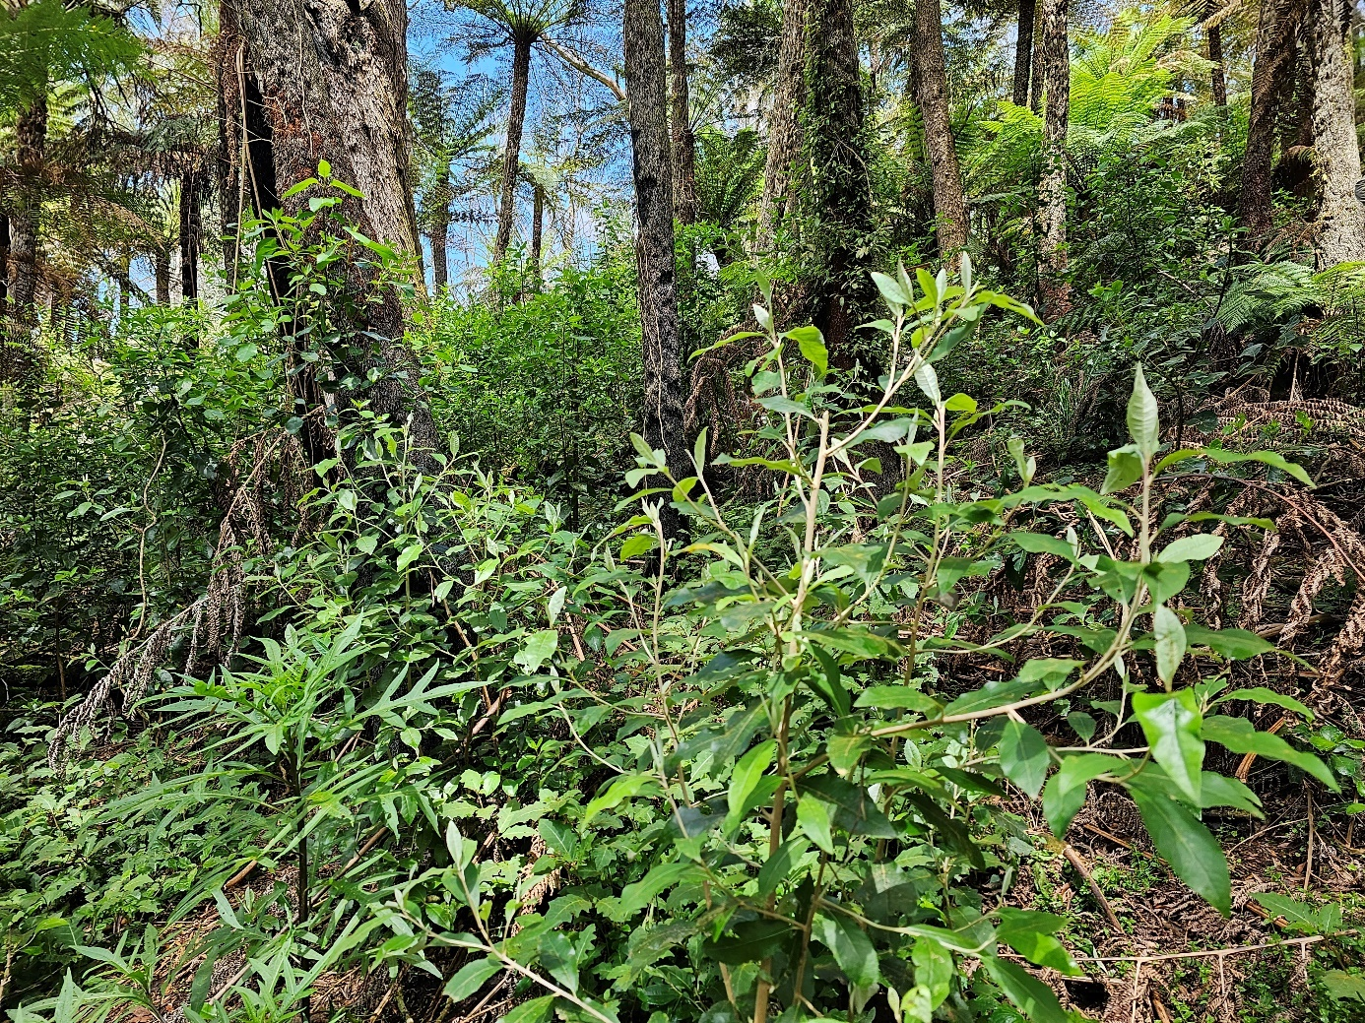
Figure 5. Dense growth of early successional (pioneer) shrubs (Olearia argophylla, Solanum spp., Hedycarya angustifolia, Pomaderris aspera) after 2019 fire in Monga NP 2023 (Photo L. Weber).
Like other rainforest communities, Pinkwood cool temperate rainforests of south east New South Wales and far east Victoria exhibits gap phase dynamics (Appendix B – Conceptual model) , a process in which new trees are recruited into the forest canopy in small gaps created by local disturbances such as tree fall (Bazzaz & Pickett 1980). Most plants species recruit seedlings in deep shade, and these may remain in a largely arrested state of development for several years before they eventually die or release from shade enables them to grow (Keith 2004). Subsequent growth is slow and may be arrested until a treefall opens canopy space enabling growth to maturity.
Unlike woody species in most other rainforest types, seeds of Eucryphia moorei, Quintinia sieberi (red possomwood) and other species such as Hedycarya angustifolia (native mulberry), are capable of germinating epiphytically on the fibrous trunks of Dicksonia antarctica (soft tree fern) and Cyathea australis (Helman 1987) (Fig. 6). This is a strategy that may give developing seedlings and saplings access to more reliable moisture, nutrients and light (once they overtop the tree fern crown), and also limit exposure to herbivores. Over time, the host tree fern dies and the tree develops a basal burl from which it is capable of coppicing (Johnson & Lacey 1983).
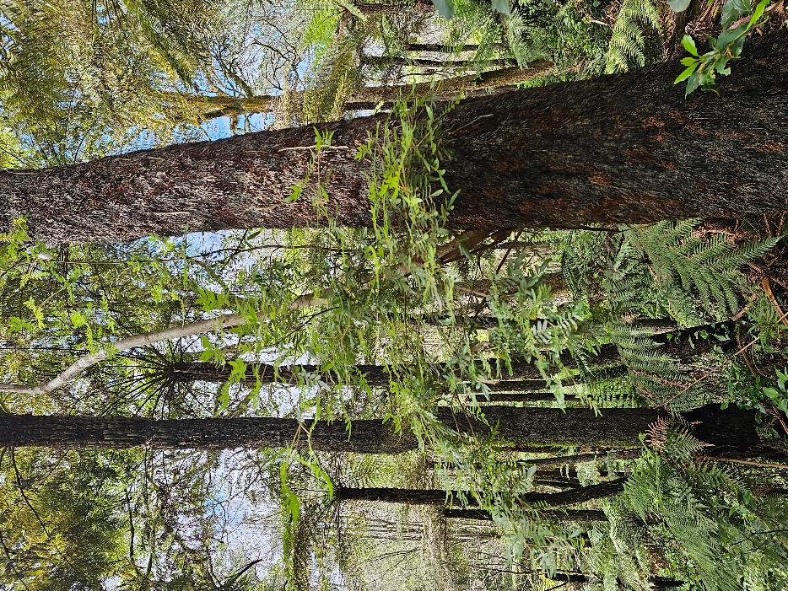
Figure 6. Eucryphia moorei sapling on Dicksonia antartica tree fern trunk Monga NP (Photo L. Weber).
While the dominants of the ecological community (Eucryphia moorei, Dicksonia antarctica) are dispersed by wind (Fig. 7), several associated woody plants of the overstorey and understorey have fleshy fruits dispersed by vertebrates including possums, flying foxes and frugivorous birds. Rainforest elements dispersed in the eucalypt forest matrix, as well as those in refugial sites, are likely to be important for the long-term persistence of the ecosystem. They may retain genetic diversity and capacity for persistence through successive episodes of rainforest contraction and re-expansion in response to climatic variations over millennial time scales (Peel 1999).
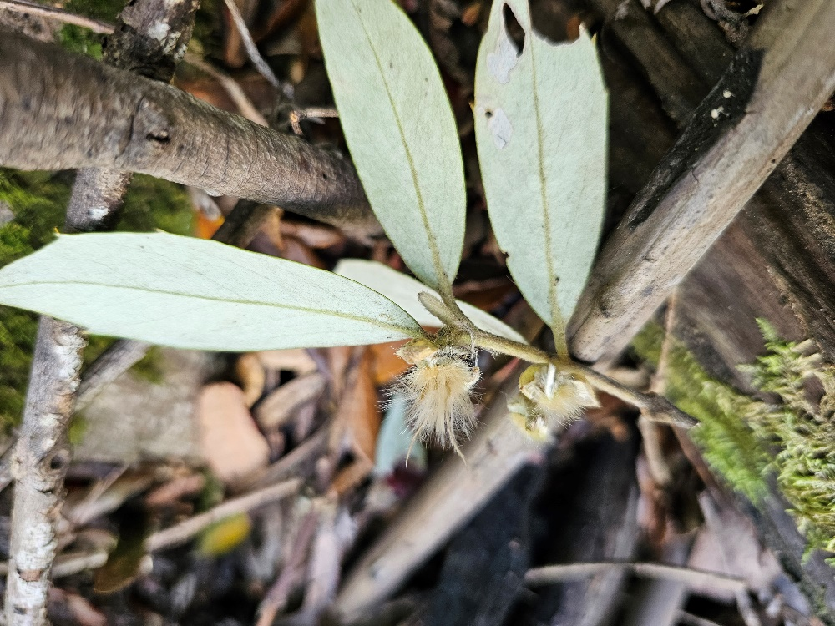
Figure 7. Wind dispersed seeds of Atherosperma moschatum at Brown Mountain, NSW (Photo L. Weber).
Consultation Questions on the relevant biology and ecology
- Please provide any additional relevant information about the ecology of the ecological community or component species that play a key functional role.

Identifying areas of the ecological community
Section 1.2 describes the species assemblage comprising the ecological community and the particular area in nature that it inhabits. This section provides additional information to assist with the identification of the ecological community and important occurrences of it.
The Pinkwood cool temperate rainforests of south east New South Wales and far east Victoria intergrades with, or may be similar to, other ecological communities (see section 0). Key diagnostic characteristics outline the features that identify an assemblage of species as being the Pinkwood cool temperate rainforests of south east New South Wales and far east Victoria and distinguish it from other communities; noting that additional information to assist with identification is provided in the other sections of this document, particularly the description (section 1.2) and Appendix A – Species lists.

Key diagnostic characteristics
The key diagnostic characteristics are designed to inform the identification of the ecological community. Assemblages of native species that do not meet the key diagnostics are not part of the nationally listed ecological community.
The ecological community is defined as the assemblage of native species inhabiting a particular area in nature as described in section 1.2 and referenced information therein, that meets the following key diagnostic characteristics:
- Occurs in New South Wales and far east Victoria in the South East Corner Bioregion, with limited occurrences also in the Burragorang, Ettrema, Moss Vale and Illawarra, Sydney Cataract subregions in the southern reaches of the Sydney Basin Bioregion, and the Bungonia and Kybeyan-Gourock subregions of the South East Highlands Bioregion.
- Occurs mostly at elevations of 620–750 m above sea level, but has been recorded as low as 450 m and more than 900 m above sea level.
- Occurs at sites periodically exposed to mist and fog which can reduce moisture deficits at some times of year.
- Occurs on one or more of the following substrates: felsic – intermediate volcanics (such as rhyolite, latite, trachyte, tuff, diorite and monzonite) and fine-grained siliciclastic sediments that produce soils mapped primarily as Kandosols and Ferrosols; with minor occurrences on other soils such as Tenesols, Kurosols and Dermosols.
- Possesses a closed tree canopy typically dominated or co-dominated by one to three tree species, most commonly Eucryphia moorei (pinkwood, plumwood, eastern leatherwood) (present at most, but not all sites), Elaeocarpus holopetalus (black olive berry), Atherosperma moschatum (black or southern sassafras)
- Other common tree species include Acacia melanoxylon (black wattle, blackwood), Hedycarya angustifolia (native mulberry), and, less frequently, Syzygium smithii (lilly pilly), Doryphora sassafras (sassafras), Callicoma serratifolia (black wattle, and/or Synoum glandulosum (scentless rosewood).
- Diagnostic tree species, characteristic of the ecological community at higher elevations or subregions where E. moorei is absent include Elaeocarpus holopetalus (black olive berry), Atherosperma moschatum (black or southern sassafras) and the small tree or shrub Pittosporum bicolor (whitewood, cheesewood, banyalla).
- Eucalypts, commonly including Eucalyptus fastigiata (brown barrel), may occur as emergent trees, or overhang from the margins of patches of the ecological community, but are not typically dominant in terms of foliage cover or stem density, with the exception in some scenarios following fire5.
- Canopy dominance of rainforest tree species may decline after disturbance such as fire and Eucalypts may appear dominant in the short to medium term while the ecological community is recovering.
- A prominent understorey layer dominated by tree ferns, Dicksonia antarctica (soft tree fern) or Cyathea australis (rough tree fern).
- A shrub layer is usually present and often sparse with common species including Coprosma quadrifida (currant bush), Tasmannia lanceolata (tasmanian pepper), T. insipida (northern pepper), Lomatia fraseri (forest or silky lomatia), Hedycarya angustifolia (native mulberry) and Olearia argophylla (musk daisy bush or silver shrub).
- After disturbance such as storm damage or fire, the shrub layer often becomes dense including species such as Solanum aviculare (kangaroo apple), S. prinophyllum (forest nightshade), S. pungetium (jagged nightshade), Olearia argophylla (silver shrub), Pomaderris aspera (hazel pomaderris) and Bedfordia arborescens (blanket leaf).
- A ground layer dominated by ferns, forbs, mosses, including species such as Blechnum wattsii (hard water fern), B. nudum, Polystichum proliferum (mother shield fern), Lastreopsis acuminata, Stellaria flaccida, Hydrocotyle geraniifolia, Australina pusilla var. muelleri, and Schelhammera undulata (lilac lily), typically interspersed with a thick organic litter layer.
- Abundant epiphytic bryophytes and ferns, on tree ferns and rough-barked trees are typically present.

Additional information to assist in identifying occurrences of the ecological community
The following information should also be taken into consideration when applying the key diagnostic characteristics to assess if the ecological community is present at a site.

Identifying an occurrence
A patch is a discrete and mostly continuous area of the ecological community, as defined by the key diagnostics, but can include small-scale variations, gaps and disturbances within this area. The smallest patch size that can be identified is 0.05 ha. It may be difficult to assess the key diagnostics for smaller areas than this (see also Section 2.3 for minimum patch size). Where a larger area has been mapped or classified as a different vegetation type, localised areas of Pinkwood cool temperate rainforests of south east New South Wales and far east Victoria greater than 0.05 ha may be present within this larger area.

Breaks in a patch
When it comes to defining a patch of the ecological community allowances are made for “breaks” up to 30 metres between areas that meet the key diagnostics. Such breaks may be the result of watercourses or drainage lines, fence lines, tracks, paths, roads, powerline easements or other gaps presenting as areas of water, rocks, exposed soil, leaf litter, and areas of localised variation in vegetation that do not meet the key diagnostics. For example, a single patch could include two areas of Pinkwood cool temperate rainforests of south east New South Wales and far east Victoria that meet the key diagnostics, but which are separated by a narrow strip of eucalypt-dominated vegetation. Such breaks do not significantly alter the overall functionality of the ecological community and form a part of the patch. Watercourses or drainage lines, gaps made by exposed areas of soil or leaf litter, and areas of localised variation in vegetation should be included in the calculation of the size of the patch and be taken into account when determining the overall condition of the patch. Tracks, paths, roads or other artificial surfaces should be excluded from the calculation of patch size and condition. Where there is a break in the ecological community of 30 metres or more (e.g. due to permanent artificial structures, wide roads or other barriers, water bodies or other types of vegetation) then the gap indicates that separate patches are present.

Variation within a patch
Patches of the ecological community may contain areas that vary in structural or biological characteristics. For example, spatial variation in species occurrence and vegetation structure within a patch means that some diagnostic features may not always be present in parts of a patch. Species that are sensitive to disturbance (such as fire sensitive species) may also be absent for a time after disturbance, and one part of a patch may have been recently burnt and at a stage of regeneration. Variation in vegetation across a patch should not be considered to be evidence of multiple patches, so long as the patch as a whole meets the key diagnostics using appropriate survey methodology (see Section 2.2.3).

Revegetation and regrowth
Restored (including reconstructed) sites or areas of regrowth are not excluded from the listed ecological community, as long as the patch meets the key diagnostic characteristics.
Where ecological restoration is planned, the aim should be for recovery of as many key biodiversity and ecosystem attributes as practical for a particular site, so that the ecological community is on a trajectory to recovery and is self-sustaining. This should be based on identifying appropriate reference site(s) for the ecological community following the National Standards for the Practice of Ecological Restoration in Australia (Standards Reference Group SERA 2021) (also see 5.4.2 RESTORE and MANAGE the ecological community).

Survey requirements
Patches of the ecological community can vary markedly in their shape, size, condition and features. Thorough and representative on-ground surveys are essential to accurately assess the extent and condition of a patch. The Australian Soil and Land Survey Field Handbook (National Committee on Soil and Terrain 2009) and New South Wales Native vegetation interim type standard (Sivertsen 2009) may provide guidance.
The size, number and spatial distribution of plots or transects must be adequate to represent variation across the patch. Sampling design should address likely variation in species composition and significant variation in the vegetation (including areas of different condition), landscape qualities and management history (where known) across the patch. Recording the survey date/s and the search effort (identifying the number of person hours spent per plot/transect and across the entire patch; along with the surveyor’s level of expertise and limitations at the time of survey) is useful for future reference.
Whilst identifying the ecological community and its condition is possible at most times of the year, consideration must be given to the role that season, rainfall and disturbance history may play in a survey/assessment. For example, after a fire, logging or tree fall event, one or more vegetation layers, or groups of species, may not be evident for a time (see Appendix A – Species lists). Timing of surveys should allow for a reasonable interval after a disturbance (natural or human-induced) to allow for regeneration of species to become evident and be timed to enable diagnostic features to be identified. Where regeneration occurs over long time frames, it may be possible to project features of the mature state of the ecological community at a site. At a minimum, it is important to note climate conditions and how the history of disturbance may have affected the observable features within a patch at the time of survey.

Mapping and vegetation classifications
Several vegetation classification and mapping studies in NSW describe vegetation types relevant to Pinkwood cool temperate rainforests of south east New South Wales and far east Victoria. Although none of these studies directly map areas of this ecological community according to its key diagnostics, they can provide useful information on its likely occurrence. Appendix C – Relationship to other vegetation classification and mapping systems outlines the map units or classifications from a number of common mapping and classification systems that best relate to the ecological community.

Other relevant ecological communities
Pinkwood cool temperate rainforests of south east New South Wales and far east Victoria belongs to a ‘thermal’ series of structurally simple rainforest assemblages associated with ‘cool temperate’ climates distributed in a latitudinal sequence along the Great Divide from south east Queensland to central Victoria and the Otway Range. This series of assemblages is distinguished from more structurally complex and species-rich rainforests associated with warmer climates (Webb 1968). It extends from montane south east Queensland along the eastern escarpment and coastal mountains of New South Wales into the eastern and southern Victorian ranges and the humid uplands and lowlands of western, northeastern and southern Tasmania and the Ben Lomond plateau (Webb et al. 1984; Metcalfe et al. 2017).
The northern cool temperate rainforest (Barrington tops to McPherson Range) is dominated by its signature tree Nothofagus moorei (Antarctic beech). The central cool temperate rainforest is dominated by Eucryphia moorei, and the focus of this ecological community, while the southern cool temperate rainforest is dominated by Nothofagus cunninghamii (myrtle beech) in Victoria and Tasmania. Two other tree species occur in some parts of all three cool temperate rainforests Atherosperma moschatum and Elaeocarpus holopetalus from the northern NSW Tablelands region (Ebor and Tia Gorge), south to Victoria. Therefore, these trees are of limited diagnostic value in identifying which of the three cool temperate rainforest types are present where they occur in stands alone without the signature species of that region.
There is strong fossil evidence that Nothofagus and Eucryphia trees would have both been present in Gondwanan temperate rainforests as they are today in Chilean South American cool temperate rainforests and in Tasmania. Eucryphia is relictual in the northern cool temperate rainforest with Antarctic Beech with E. jinksii having contracted to only as single mountain plateau with the highest rainfall (Springbrook). Eucryphia moorei in contrast is dominant in most stands of the central cool temperate rainforest which Nothofagus having become regionally extinct but represented by a fossil log in the Snowy Mountains. The reverse is true in Victorian cool temperate rainforest with Nothofagus cunninghamii being dominant but Eucryphia being regionally extinct. Tasmania in comparison has two species each of Eucryphia and Nothofagus.
On the northern edge of its range around Sassafras, Pinkwood cool temperate rainforests of south east New South Wales and far east Victoria intergrades with the ‘Robertson Rainforest in the Sydney Basin Bioregion’, nationally-listed as a critically endangered ecological community. Consequently, patches of rainforest in this area may exhibit diagnostic features of either or both listed ecological communities. Although compositionally similar, Pinkwood cool temperate rainforests of south east New South Wales and far east Victoria typically occurs on lower fertility felsic to intermediate volcanic and fine-grained siliciclastic sedimentary substrates, rarely on mafic volcanics. Whereas the Robertson Rainforest in the Sydney Basin Bioregion ecological community typically occurs on more fertile mafic volcanics such as basalt and basanite.
At the lower reaches of its elevational range, the Pinkwood cool temperate rainforests of south east New South Wales and far east Victoria intergrades with ‘Simple mesothermal rainforests of the New South Wales south coast hinterland’ and with ‘Simple mesothermal rainforests of East Gippsland and far south east New South Wales’, and commonly known as ‘warm temperate rainforests’ (Baur 1965, 1989; Floyd 1990; Keith 2004). In both cases, Syzygium smithii becomes a more prominent component of the tree canopy and characteristic high-elevation species such as Eucryphia moorei, Elaeocarpus holopetalus and Athersoperma moschatum are replaced by species associated with warmer climates including Elaeocarpus reticulatus, Pittosporum undulatum, Cryptocarya glaucescens, Alectryon subcinereus and others.
To the south, Pinkwood cool temperate rainforests of south east New South Wales and far east Victoria intergrades with ‘Simple microtherm rainforests in cool temperate Victoria’. In the Central Ranges and Otway Ranges, these Victorian cool temperate rainforests (Peel 1999) are dominated by the distinctive Nothofagus cunninghamii, which is not known from NSW except as fossils. In far the East Gippsland highlands, the rainforests lack Nothofagus cunninghamii and are dominated by Atherosperma moschatum, Hedycarya angustifolia and Elaeocarpus holopetalus (Peel 1999), suggesting intermediate status between the Myrtle Beech and Pinkwood cool temperate rainforest types.
Eucryphia moorei has a discontinuous distribution between the Howe Range just south of the Victorian border and the Cataract Dam and Bulli Tops area in the northern Illawarra. Gaps in the distribution of Pinkwood are present in several regions especially at higher altitudes around 1000m that also contain cool temperate rainforests dominated by other tree species including Atherosperma moschatum, Elaeocarpus holopetalus. Examples of stands without E. moorei can be seen in the Glenbog SF, SE Forests NP near Cochrane Dam and Brown Mountain areas east of Nimmitabel. Similar stands of cool temperate rainforest without E. moorei are also present in the Tallaganda-Gourock area. Two subspecies of A. moschatum are present, subsp. moschatum, from Tasmania to Brown Mountain, and subsp. integrifolium, restricted to NSW from the Monga area to Tia gorge near Armidale in the NSW northern tablelands.
Recent genetic studies of A. moschatum have revealed remarkably low genetic diversity with unique chloroplast lineages in each region (Worth et al. 2011). One lineage coded H6 was found North from the Blue Mountains to New England to the north of the Pinkwood cool temperate rainforest region, while populations at Brown Mountain west of Bega were closely related to Victorian populations (H3). The Monga area in contrast supported a unique genotype (H5) not found to the North or South which is indicative that this area is likely to have served as a refugium for Cool Temperate Rainforest through the last glacial maximum 18 000 years ago (Worth et al 2011).
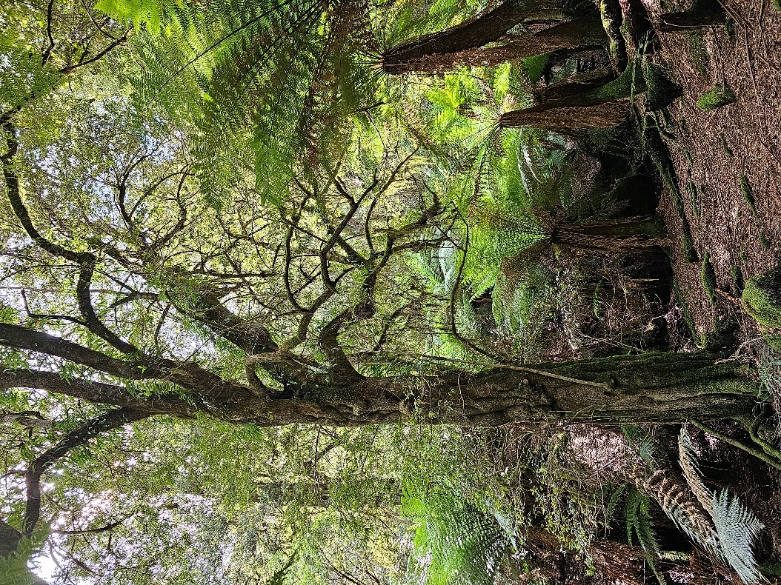
Figure 8. Unburned cool temperate rainforest at Brown Mountain dominated by E. holopetalus and A. moschatum subsp. moschatum with abundant D. antarctica tree ferns (Photo L. Weber).
The Monga area appears to have most of the typical tree species present with Eucryphia moorei, Atherosperma moschatum (a unique genotype Worth et al. 2011), Elaeocarpus holopetalus, Acacia melanoxylon and also Doryphora sassafras and Callicoma serratifolia slightly lower in elevation around Clyde Mountain on the eastern facing ranges just East of Monga such as “Pooh Bear corner”. This area has been severely impacted by fires in 2019 and not all tree species were present in all patches around Monga.
Small stands of cool temperate rainforest are also present to the south-west of the region and known to support Pinkwood in the Pilot wilderness area of Kosciusko National Park. These are dominated by Atherosperma moschatum and Elaeocarpus holopetalus at 1000 - 1400m altitude (Doherty et al 2011). These stands would be better classified with the Myrtle Beech and Erinunderra cool temperate rainforests of Victoria.
This higher elevation cool temperate rainforest while present in Victoria is potentially on the verge of long-term extinction in NSW. Scattered records of Atherosperma moschatum in Kosciusko NP without significant rainforest patches being present in most of the national park are potential evidence of the long-term contraction of cool temperate rainforest in the Northern Australian Alps.
Genetic studies of the cool temperate rainforest shrub Tasmannia lanceolata found South from the Blue Mountains of NSW, throughout Victoria to Tasmania revealed remarkable fine scale structuring (Worth et al. 2010). Genetic lineage 1r is restricted to the Blue Mountains while the closely related lineage 1s is restricted to Gippsland. Two lineages 1o and 1j are found in the region of the ecological community, with 1o being only found close to the NSW Victorian border. Both of these lineages are also found in Eastern and Central Victoria. These genetic patterns are similar to those in A. moschatum but without a unique genotype like the Monga lineage.

Condition classes, categories and thresholds
Land use, disturbance history and other factors that may cause degradation or loss of its features will influence the state and condition of individual occurrences of the ecological community. National listing focuses legal protection on occurrences of the ecological community that are the most functional, and in comparatively good condition. These occurrences are identified through minimum condition thresholds.
Condition classes are also used to distinguish between occurrences of the ecological community of different qualities, to aid environmental management decisions.
In order to be protected as a matter of national environmental significance occurrences of the ecological community must meet both:
- the key diagnostic characteristics (section 2.1) AND
- at least the minimum condition thresholds (Table 1).
Table 1 outlines the different condition classes and categories that apply to the ecological community. The minimum condition thresholds are designed to identify those occurrences that retain sufficient conservation value to be considered a matter of national environmental significance, to which the referral, assessment, approval and compliance provisions of the EPBC Act apply. These include all patches in Classes A, B and C.
Occurrences that do not meet the minimum condition thresholds for at least Class C are not included in the listing of this ecological community under the EPBC Act. In many cases, the loss or degradation is irreversible because natural features have been permanently altered or removed. Nevertheless, many of these occurrences may retain important natural values and may be protected through state and local laws or planning schemes.
In addition, occurrences that can be restored should not be excluded from recovery and other management actions (see section 5) as these actions may improve condition, such that it subsequently can be included as part of the ecological community that is listed under the EPBC Act. Management actions should be designed to restore occurrences to high condition where practical.
When assessing the condition of an occurrence of the ecological community it is important to refer to the key diagnostic characteristics (section 2.1) and the information on defining an occurrence (section 2.2) to determine the area to assess for condition.
The broadest area that meets the key diagnostic characteristics of the ecological community should be used in determining condition. Where condition is variable and the condition of the total area falls below the minimum thresholds, the largest area or areas within the overall area that do meet the minimum condition thresholds should be identified. This may result in multiple protected occurrences of the ecological community being identified within the overall area first considered.
Recent disturbance by fire is likely to result in the ecological community presenting in a temporarily or permanently altered state with severely reduced canopy cover, simplified vegetation structure and altered species composition. Resprouting trees and shrubs may be top-killed when partially or completely scorched and some plant and animal species may be undetectable or absent from the ecological community. This condition may or may not be temporary, although for rainforest full recovery of forest structure and composition could take decades and may be interrupted by subsequent fires that transform the ecological community. Surveys should be conducted in line with guidance in section 2.2.3 Survey requirements.

Table 1. Condition classes, categories and thresholds
Patch size thresholds à  Biotic thresholds â | LARGER PATCH  ≥ 0.05 ha | SMALL PATCH  0.01 ha – 0.05 ha
HIGH CONDITION  In mature or advanced recovery state¹,  EITHER  i) total projective cover² of non-eucalypt canopy trees and vines is ≥60%  AND  ii) at least 15 characteristic native plant species³, including a tree fern species, are present within the patch | CLASS A  Large structurally intact patch with diversity of characteristic species | CLASS B  Small structurally intact patch with diversity of characteristic species
GOOD CONDITION  In mature or advanced recovery state¹,  EITHER  i) total projective cover² of non-eucalypt canopy trees and vines is ≥40% and <60%  OR  ii) at least 15 characteristic plant species³, including a tree fern species, are present within the patch | CLASS B  Large structurally or compositionally suboptimal (good condition) patch | CLASS C  Small structurally or compositionally suboptimal (good condition) patch
MODERATE CONDITION  In mature or advanced recovery state¹,  EITHER  i) total projective cover² of non-eucalypt canopy trees and vines is ≥30% and <40%  OR  ii) at least 12 characteristic plant species³ are present within the patch | CLASS C  Large partially degraded (moderate condition) patch | Not protected  Small partially degraded (moderate condition) patch
¹ Tree canopy cover, native plant species tally should be assessed against this requirement when the patch shows no evidence of recent disturbance by fire, windthrow, treefall or proximal timber harvesting. Where such disturbances are recorded or evident in the past 30 years, recovering areas ≥0.1 ha (particularly areas previously recorded to be the ecological community) should be assumed to be the ecological community while recovery is taking place. Understorey/ground layer is inclusive of all flora below canopy layer, including small trees and both the juvenile forms of canopy species and fire-/drought-affected canopy trees that are resprouting below the canopy branches.
²Cover measurements should be based on representative areas within a patch of the ecological community. Total projective cover of the canopy is the proportion of area occupied by all live and dead leaf and branch material of canopy trees and vines when projected vertically onto a horizontal plane (Hnatiuk et al. 2007).
³Characteristic plants species are those listed in Appendix A1.
⁴A patch is defined in section 2.2.1.

Consultation Questions on condition classes, categories and thresholds
- Do you see any difficulties or problems in applying the above categories and thresholds (e.g. would any indicators, thresholds or categories give inadequate representation of ecological condition)? Please suggest how these might be resolved.
- Please identify any additional indicators that are readily assessed in the field and consistently represent degrees of degradation across the full range of rainforest expression.

Habitat critical to the survival of the ecological community
The habitat or areas most critical to the survival of Pinkwood cool temperate rainforests of south east New South Wales and far east Victoria are those occurrences that meet the Key Diagnostic Characteristics (section 2.1) and are in the best condition (i.e., Classes A and B in Table 1) and those occurrences in the process of recovery after disturbance (fire, tree fall), and likely to conform with Classes A and B when they reach their mature state. These represent those parts of the ecological community that retain the highest diversity and most intact structure and ecological function, particularly intact tree canopies and moist microclimates associated with reduced flammability, and therefore have the highest chance of persisting (viability and resilience) in the long-term. In addition, habitat critical to survival of this ecological community includes additional areas that are likely to become suitable for its development (see physical conditions described in section 1.2.1) as climate change unfolds during the next 100 years.
Occurrences that are recovering or otherwise meet the minimum condition thresholds (i.e., Class C in Table 1) are also important for the functioning and survival of the ecological community. These occurrences are critical to the survival of the ecological community if they occur in locations or landscape positions that are particularly important for biodiversity or function and/or may contain suites of species, habitat features or other values that are important in a regional or local context (see Section 2.5).
No Critical Habitat as defined under section 207A of the EPBC Act has been identified or included in the Register of Critical Habitat at this time. No significant occurrences of this ecological community are known to occur on Commonwealth land at this time.

Consultation Questions on habitat critical to the survival
- Please provide any additional information on what areas are critical to the survival of the ecological community, either in terms of vegetation condition or other attributes.

High value occurrences – broader environment and landscape context
The following additional indicators of high-conservation value should be considered when assessing the impacts of proposed actions under the EPBC Act, or when determining priorities for protection, recovery, management and funding.
- Patches that meet, or are closest to, the high quality (Class A) condition for this ecological community. Condition assessments may be based on on-site observations or inferred from known past management history.
- Patches that represent one of few occurrences in the surrounding area (e.g. within a 5 km radius).
- Patches assigned to condition class B that are particularly large or diverse examples of the ecological community, based on recorded species richness of relevant taxa (e.g. plants, birds, mammals, frogs, invertebrate groups, fungi, etc.) or inferred from habitat diversity.
- Patches that escape disturbance or degradation that affected most other occurrences in the vicinity (e.g. within a 5 km radius).
- Unique or unusual variants of the ecological community, e.g. with a unique flora and/or fauna composition, or a patch that contains flora or fauna that have largely declined across the broader ecological community or region.
- Patches that show evidence of recruitment of key diagnostic native plant species or the presence of a range of age cohorts (including through successful assisted regeneration or management of sites).
- Patches likely to remain resilient and viable under future climates.
- Patches that contribute to movement corridors.
- Patches containing nationally or state-listed threatened species.
- Patches with relatively low exposure to weeds, feral animals, grazing by domestic livestock or drought.
- Patches in landscape positions that are likely afford protection from future fires.

Consultation Questions on areas of high value
- Please provide any additional information on the high value and surrounding environment and landscape context considerations when protecting, managing and restoring the ecological community.

Cultural significance
Traditional Owners and Custodians have ongoing connections, rights and responsibilities over land where the Pinkwood cool temperate rainforests of south east New South Wales and far east Victoria occurs. First Nations cultural values, traditional uses and land management are important to the protection and recovery of the ecological community.
The Pinkwood cool temperate rainforests of south east New South Wales and far east Victoria occurs on Country (the traditional lands) of the Yuin (Djiringanj), Dharawal (Tharawal) and Bidwell/Bidawal peoples.
The significance of the ecological community, particular species, spiritual and other cultural values are diverse and varied for the First Nations people that live in the vicinity and care for Country. This section describes some examples of this significance but is not intended to be comprehensive or applicable to, or speak for, all First Nations people. In some cases, such knowledge may be only held by groups and individuals who are the custodians of this knowledge and have the rights to decide how it is shared and used.

Significant areas
The upper gullies of Gulaga (also known as Mt Dromedary) support important areas of Pinkwood cool temperate rainforests of south east New South Wales and far east Victoria. Gulaga Mountain is a sacred site for Aboriginal people of the Yuin Nation and was restored to Aboriginal ownership in 2006. Jodi Edwards, a Walbunja Yuin woman, says:
“Within its landscape, it shows us the physical aspects of our creation story from the Dreaming. Lead by Elders along a pathway framed with trees and rocks, it helps to teach us our story of creation and the connection to our dreaming stories” (Edwards, 2017).
Gulaga is ringed by stones which act as guardians. The Yuin people understand that the boulders are linked to the well-being of the mountain, particularly the state of the trees and the water. The destruction of any part of the nexus would threaten the whole, a situation which is believed to be dangerous to all people who live in the area (Rose 1990, cited in Egloff et al. 2005, pg. 93). Other features, for example caves, tors, and the summit, have special meanings and play specific roles for local people, including educational, ceremonial and healing purposes. Many of these places, activities and beliefs are restricted knowledge. ‘The Tors’, an area near the summit, is one area which can be openly discussed, as seen in the AHC video ‘Sites We Want To Keep’, in which Anna and Ted Thomas discuss the significance of the area. The Tors is an example of a place which is intrinsic to a recent renewal in woman’s teaching (Egloff et al. 2005, pg. 93).
Aboriginal site types in the locality include a quarry, open campsite, rock shelter, grinding grooves, and shell middens. The Yuin people have a deep and significant understanding of the mountain, and this plays a definitive role in their self identity, associations with past generations, and spirituality. Gulaga is understood to be the source of the Yuin people, and accordingly has associated creation stories (Egloff et al. 2005, pg. 93).
In late 2019 Djiringang Elder Warren Forster Senior from Wallaga Lake called for nationwide corroborees to be held at the same time. Scores of people travelled to the feet of Minga Gulaga (Mother Guluga Mountain) to dance stories to heal country as the 2019-2020 bush fires raged along the NSW coast in late 2019. The Bunnaan was held in the Djirringanj and Dhurga languages of the Yuin Nation on the NSW south coast. Warren Forster said it was the perfect timing because the Yuin peoples place of birth the mother Guluga has been crying, “Minga Gulaga is the one that birthed us all and she has called us back to heal the spirit, heal the country and heal the land.” There are many Minga Guluga stories, some are public. Warren Foster has spent most of his life on Wallaga Lake telling the stories of his people through song, dance, music, film and story’ (NSW LALC 2021). “Dance is our traditional way of telling our stories…when you see us dance…it's our cultural story,” says Warren Foster 2021, and compares the practice of telling stories with books to cave depictions (NSW LALC 2021).
Aunty Vivian a mother, grandmother, great-grandmother, lore, and culture woman; a keeper of fire knowledge and practice says:
“We grew up with fires. We used to burn our camps before we set it up and the kids had to get in and help, too. There’s a certain way we did it.”
Pinkwood cool temperate rainforests of south east New South Wales and far east Victoria also occur in upper gullies of Balawan (also known as Mt Imlay), another coastal mountain further south on Bidwell lands. The Bundian Way, an important songline or travelling route connecting the coast with the Snowy mountains, passes around the base of Balawan (Blay & EALC 2011). Balawan is a place of high cultural significance to Bidwell people as it has been traditionally used for ceremonial practices and as a place of learning. Documented and oral history has identified the mountain as an area containing Aboriginal cultural heritage values, although no archaeological sites have yet been recorded there despite numerous sites located in the surrounding landscape. Detailed archaeological surveys are recommended for Balawan (to inform future management (Donaldson 2010).

3.2 Culturally significant plants and animals
Plants are widely used by First Nations peoples for food, tools and medicine. Plants are used in medicine, weaving, and the manufacture of weapons and tools. First Nations peoples view plants and animals as having spiritual significance and use them as totemic symbols or totems.
Yulbah is a probable local Aboriginal name for the dominant tree Pinkwood (Eucryphia moorei) (Robson 1993).
Wood of Hedycarya angustifolia (native mulberry), a common subdominant tree and shrub in this ecological community, is used to make spear tips and bow drills. Its fruit is used to treat cuts and stings, whereas fruit of Syzygium smithii (wanduin, lilly pilly), a tree occurring within the lower-altitude part of the range of the ecological community, is eaten raw, made into a jelly or jam and also used as a dye.
The seeds, insect galls and larvae that inhabit trunks and branches of some Acacia species are eaten raw or cooked on hot coals, and various wattle branches, leaves are used for medicinal purposes. The leaves from certain wattles can be used as soap and fibre can be made from the bark. The resin of some species is eaten raw or mixed with water to make a sweet drink. It is also used as a glue for tools such as spears and axes. Rubus species (native raspberries and brambles) provide food and shelter for culturally significant animals, their fruits are edible, and the leaves are used medicinally.
The stems of Dicksonia antarctica (soft tree-fern) are split and the pith is scooped out and eaten raw or roasted in ashes. The white starchy core of rhizomes of Blechnum species can also be eaten raw.
Vines and climbers are used for multiple purposes. The roots of Clematis species (Minam‘'Berang) are cooked and eaten, and leaves are used medicinally to treat aching bones. The fruits of Smilax australis (lawyer vine) are eaten, and the leaves are sucked to soothe a dry mouth. The stems of Pandorea pandorana (wonga wonga vine) are used in fashioning woomera-cast spears.
Culturally significant animals that are part of this ecological community include Wallabia bicolor (swamp wallaby) and Petraurus breviceps (sugar glider) (pers. comm. Jacinta Tobin 2021, Robert Bell 2022; Indigenous Working Group Threatened Species Recovery Hub, Threatened Species Recovery Hub, 2019). Traditionally, cloaks were made from skins of Trichosurus vulpecula (brushtail possum) and Pseudocheirus peregrinus (ringtail possum) throughout south eastern Australia, where possums are abundant and the climate is seasonally cool. Few original cloaks remain, as indigenous cultural practices, including hunting were disrupted, the fragility of the material, and because Aboriginal people were often buried with them (Culture Victoria 2016).
Consultation Questions on cultural and community significance
- Please identify any sources of information (publications, documents, oral histories, contacts) in the public domain that identify plants, animals, landforms or localities associated with this ecological community that are of significance to indigenous culture or which may have past or present uses by First Nations people.

Threats
The Pinkwood cool temperate rainforests of south east New South Wales and far east Victoria is primarily threatened by altered fire regimes and climate change, in combination with its very restricted distribution and invasive species.

Threat table
Table 2 outlines the key threats facing the ecological community and their impacts on ecological community processes and dynamics are summarised in the ecosystem model (Figure B1). These represent the main factors that cause it to be eligible for listing as required by section 266B (2) (a) (ii) of the EPBC Act. This information supports the assessment against the criteria at section 6. Although presented as a list, in reality these threats often interact, rather than act independently.
Table 2. Summary of threats facing the ecological community
Threat factor | Threat Status* | Threat impacts
Fire regimes that cause declines in biodiversity | Timing: ongoing  Trend: increasing  Severity: minor to extreme  Scope: whole | Over evolutionary time scales, rainforests are very rarely burnt (Adam 1994; Bowman 2000), and many of their component species have traits that are incompatible for promoting regeneration and reproduction under recurring fires. As the risk of landscape-scale fires increases under a warming climate, this ecological community and other rainforest communities are becoming exposed to a range of fire-related threats (DAWE 2022; Keith et al. 2022b).  Low and high severity fire  Fires of any severity may result in partial or complete death of rainforest tree canopies, either due to canopy scorch during the fire event, or due to the exposure of basal stems to lethal heat. Complete canopy scorch is a relatively rare event observed in this ecological community. However, during fires in 2019-20, which followed severe drought conditions, there were significant occurrences of complete canopy scorch/death in less sheltered areas of the ecological community (e.g. on shallower gullies and slopes). Basal scorch by low severity fires often kills the vascular tissue beneath the bark, “collaring” the aerial stems and causing death of the unscorched canopy over the ensuing weeks (Trouvé et al. 2021; Keith et al. 2023; Kooyman unpubl. data in Ferrer & Keith 2022). Low severity fires producing scorch heights of 1-2 m, or even less, may collar stems resulting in top-kill of trees. Both low and high severity fires therefore result in mortality of some or all burnt individuals of both canopy and understorey species, even though they may be equipped with traits promoting fire resistance and regeneration. Mortality levels vary depending on the species’ resistance and regenerative traits (e.g. bark thickness, regenerative tissues), the growth stages of individuals present, their exposure to lethal temperatures during fire, and environmental conditions before and after fire that influencing resource availability to support survival (Keith 1996, 2012). Epiphytic juveniles and saplings of tree species that establish on tree fern trunks (e.g. Eucryphia moorei) are particularly prone to fire mortality. When the dead tree stems collapse (a process hastened by wind throw), irrespective of basal resprouting, they may uproot the tree, causing its death. Collateral damage and partial or total collapse of neighbouring trees exacerbates opening of the rainforest canopy and makes the habitat less suitable for rainforest biota associated with mesic microclimates, including a range of ferns, non-vascular plants, fungi, litter and soil invertebrates and some vertebrates.  Exposure to lethal temperatures during fire in rainforest, including this ecological community, depends on fuel moisture content and real-time fire weather and microclimate (Nolan et al. 2021). Extended drought (Nolan et al. 2020) and canopy disruption (Lindenmayer et al. 2011) both promote drying of ground fuels, increasing the likelihood of fire propagation through the rainforest. The dry conditions also enable combustion of organic topsoils and deep litter later (DAWE 2022), which may reduce habitat suitability for rainforest seedling establishment, invertebrates and microbes.  High frequency fire  Impacts that are often associated with high fire frequency, such as disruption of life cycle processes and alteration of habitat (Keith 2012), may affect the ecological community, even where fire return intervals exceed mulit-decade or even century time scales. Recurring fires may disrupt the slow re-establishment of the forest canopy after top-kill by preceding fires (Tolsma et al. 2019). Trees with sufficient bark thickness to enable stem and canopy survival after basal scorch, may be progressively weakened by successive fires, eventually resulting in tree death (Peacock & Baker 2022). Appreciable mortality rates of trees and shrubs noted above are likely to be cumulative under recurring fires and are unlikely to be compensated by post-fire seedling recruitment due to the lack of seed banks (Hopkins & Graham 1987). Successful seedling recruitment of primary forest dominants is generally limited to conditions associated with the mature ecological community (Connell et al. 1984; Lusk et al. 2013). Hence there is a risk that subsequent fires will maintain the ecological community in a state that is unsuitable for recruitment of the rainforest trees. By prolonging an open-canopy forest state, high frequency fires also maintain unsuitable conditions for a range of rainforest biota that require conditions such as deep shade, high humidity, epiphytic niches, and deep, moist litter layers. Recurring fires may also promote incursions of fire-prone biota, such as eucalypts and other sclerophyll plants, that maintain the site in a more fire-prone state than undisturbed rainforest (Bowman 2000; Bond 2020; Tolsma et al. 2019).  Interactions between fire and other threats  Fires may render rainforest biota more susceptible to negative interactions with feral predators, herbivores and disease (e.g. enhanced competitive abilities of weeds relative to native plant species, increased impact of diseases or reduced disease resistance; see also respective threats below). They may also increase exposure to these threats by promoting their dispersal into the ecological community (DAWE 2022; Keith et al. 2022b).  If fires coincide with the timing of droughts and or heavy rainfall events they may exacerbate threats posed by water stress and soil erosion (DAWE 2022; Keith et al. 2022b).  Fires also interact with forest management activities, potentially amplifying effects of fragmentation and disturbance associated with timber extraction (see ‘Timber harvesting’ below). Detrimental impacts associated with track construction, on-ground fire suppression operations water bombing and aerial application of fire retardants, such as ammonium phosphates and ammonium sulphates, are poorly documented, but may have become more common in recent years.  The spatially restricted distribution and small patch sizes of the ecological community suggest that large fires could affect a large portion of the range, as they did in the 2019-20 fire season because all patches are surrounded by more flammable forest types throughout the range.  Severe fire can lead to dense regeneration of Eucalyptus and Acacia species in cool temperate rainforest patches (as seen in Monga NP after the 2019-20 bushfires). These rainforest patches are normally too shady to allow these sclerophyll species to regenerate. The growth of these sclerophyll plant species is likely to increase flammability of the rainforest patch and promote future fires to be more intense due to combustion of oil laden Eucalypt leaf litter, leading to the contraction and potential loss of the rainforest patches over time.
Climate change | Timing: ongoing / future  Trend: increasing  Severity: major  Scope: whole | Pinkwood cool temperate rainforests of south east New South Wales and far east Victoria occurs in a region that is climatically marginal for rainforest development. Occurrence of the community is closely associated with orographic oceanic moisture streams and sheltered topographic niches (Keith 2004). Spatial models of climatic water balance indicate a small, annualised deficit in warmer months when moisture availability fails to meet evapotranspiration demand, which is projected to increase under future regional climates (Dyer 2009; Keith et al. 2023). The likely increasing climatic moisture deficit threatens characteristic components of the ecological community that depend on humid microclimates within and beneath the tree canopy, such as bryophytes, ferns, fungi and litter invertebrates (Adam 1994).  Current and future droughts and fire weather are occurring within the context of global climate change. Using a multi-model approach for both historic records (1900-2005) and simulated predictions (2006-2100 using RCP8.5) indicate that more severe drought conditions will increase for south eastern Australia (Kirono et al. 2020). This is despite some variation in the range of results primarily arising from uncertainty in the global climate model rainfall projections, which may either moderate or enhance drought severity due to the increase in potential evapotranspiration (Kirono et al. 2020).  To date, indicators of forest fire danger in south-east Australia have already increased to outside the range of long-term historical records, suggesting that increases in climate-driven fire risk have already been detected within the region where the ecological community occurs (Abram et al. 2021). The risk of fire weather with similar or increased severity than that observed in the 2019/20 fire season has increased by at least 30%, with some but not all drivers of severe fire weather showing evidence of being caused by anthropogenic climate change (Van Oldenborgh et al. 2021).  Climate change is therefore projected to increase the severity and incidence of drought and extreme fire weather over the course of the century for the region occupied by the ecological community, facilitating fire spread into rainforest areas that previously had only rarely burnt. Rainforests are more susceptible to degradation from any level of fire severity, as discussed in the previous table section.
Feral predators | Timing: ongoing  Trend: unknown  Severity: minor  Scope: majority | Feral predator species known to occur within the distribution of the ecological community include Felis catus (feral or wild cat), Vulpes vulpes (European red fox) and Sus scrofa (feral or wild pig), including within the protected area estate where control activities are implemented (e.g. NSW NPWS 2006, 2011a, 2011b, 2014). These predators are likely to deplete the vertebrate and invertebrate fauna of the ecological community.  Fire-predator interactions are likely to influence the level of threat to the ecological community (DAWE 2022). Predation pressures from foxes, cats and pigs are likely to be amplified in the post-fire period due to increased dispersal and foraging efficiency of predators and reduced cover for prey species (e.g. Hradsky 2020).
Feral herbivores | Timing: ongoing  Trend: increasing  Severity: major to minor depending on animal density  Scope: majority | Browsing and habitat degradation by invasive herbivores threaten the ecological community and related communities (Peel 1999; Peel et al. 2005; Davis et al. 2016; Tolsma et al. 2019; Nilar et al. 2019). Although Cervids (deer) are likely to be associated with the greatest impacts, Capra hircus (feral/unmanaged goats), Sus scrofa (feral or wild pig) and Oryctolagus cuniculus (European rabbit) may be associated with local impacts and native wallabies may be detrimental in disturbed areas (Nilar et al. 2019). These species selectively reduce the abundance of palatable plants species, while trampling, rooting and digging reduces sensitive groundcover of bryophytes and degrades soil structure and promotes surface erosion (Keith & Pellow 2005; Peel et al. 2005). Seedlings and juveniles of rainforest trees are especially susceptible to browsing, which may inhibit tree recruitment. Impacted areas are likely to have a more open understorey, potentially reducing the moist microclimate on which much of the biotic assemblage depends.  Deer also affect small trees and shrubs by rutting, causing damage or mortality via bark stripping. Cervus unicolor (Sambar deer) is likely to be the primary species of deer that threatens the ecological community (Peel et al. 2005; Davis et al. 2016). As well as density, actual impacts are sensitive to spatial and temporal variability in deer behaviour, which is difficult to predict.  Fire-herbivore interactions are likely to influence the level of threat to the ecological community (DAWE 2022). Herbivore pressures appear to be initially reduced after large severe fires, but occupancy may rapidly recover in the post-fire period unless control measures are effective (Forsyth et al. 2011). Patchy and low severity fires are unlikely to reduce numbers and instead may amplify impacts on regenerating vegetation in the post-fire period due to increased foraging efficiency of herbivores and increased palatability of regenerating plants (Keith 2012).
Erosion | Timing: ongoing  Trend: increasing  Severity: minor  Scope: majority | Many stands of the ecological community occur in steep gullies where overland flows become channelised, and intense rainfall events may generate considerable erosive force. Approximately one-fifth of the distribution of the ecological community occurs at sites with a modelled erosion risk exceeding 2 tonnes per hectare per year (Yang 2020; Keith et al. 2022).  The region is also prone to intense rainfall events, for example with approximately one-third of the distribution of the ecological community experiencing extreme rainfall (more than two standard deviations greater than the long-term average) in the 8 weeks following fires in 2019-20 (Keith et al. 2022b). Intense rainfall in the early post-fire period is likely to exacerbate erosion outcomes due to reduced vegetation cover (DAWE 2022).
Timber harvesting | Timing: past  Trend: impacts stable  Severity: minor / unknown  Scope: minority | Relatively few areas of Pinkwood cool temperate rainforests of south east New South Wales and far east Victoria are likely to have been directly logged in the past, due to their inaccessibility, and all occurrences are now protected from logging activities. However, some patches of the ecological community may be exposed to legacy effects of past logging activities, either by direct harvest of rainforest trees or indirectly by operations in surrounding eucalypt forests.  Most, if not all, of this activity is likely to have pre-dated modern management prescriptions that protect rainforests (McCormack 1996). Legacy effects of past logging activities including disturbances associated with construction of access and snig tracks, treefall into rainforest patches, depletion of tree or canopy-dependent fauna and their habitat suitability in the surrounding landscape and fragmentation of forest structure. Alterations to forest structure associated with timber harvesting operations may also increase the probability of fire propagation into rainforest under extreme conditions, through increased drying rates of fuels on the forest floor (Lindenmayer et al. 2011; Tolsma et al. 2019).
Disturbance associated with visitor access and other human activity | Timing: ongoing  Trend: increasing  Severity: minor  Scope: majority | Disturbance associated with human access may have localised effects on the ecological integrity of the ecological community. These include changes to vegetation structure and soils associated with construction and maintenance of roads or walking tracks, redirection of drainage and associated earthworks, uncontrolled vehicle and pedestrian access, trampling of sensitive vegetation, dumping or refuse and introduction of weeds or pathogens. Human populations are increasing in all the Local Government Areas where the ecological community occurs.
Disease | Timing: future & past  Trend: increasing  Severity: unknown  Scope: minority | One of the subdominant canopy species in the ecological community, Syzygium smithii (lilly pilly) belongs to the family Myrtaceae, and may therefore be susceptible to infection by the causal agent of myrtle rust Austropuccinia psidii. In susceptible species, the disease causes foliage necrosis, reduced growth and reproductive output and, in some cases, tree mortality (Pegg et al. 2021).  Batrachochytrium dendrobatidis (chytrid fungus) is also a likely threat to the frogs of the ecological community (Murray et al. 2010, 2011). The majority of frogs that characterise the ecological community are likely heavily affected, as the disease causes greatest mortality in cooler habitats with limited sun exposure. Chytrid spread across the region before systematic surveys were undertaken, hence the magnitude and historic amphibian fauna of the ecological community is poorly known.  The increased occurrence of fires, associated with climate change, exacerbate impacts. For example, fire may increase the impact of significant pathogens such as Phytophthora cinnamomi (root rot disease) and increase the exposure and vulnerability of susceptible plants to myrtle rust (DAWE 2022).
*Timing – the threat occurs in the past (and unlikely to return), is ongoing (present/continuing), is likely to occur/return in the future, or timing is unknown
Trend – the severity of the threat and its consequences are likely to be decreasing, increasing, stable/static or unknown.
Severity – the threat causes or has the potential to cause impacts that are extreme (leading to loss or transformation of affected patches/occurrences), major (leading to degradation of affected patches/occurrences), minor (impacting some components of affected patches/occurrences), negligible or unknown
Scope – the threat is affecting the whole (>90%), a majority (>50%), a minority (<50%), a negligible amount, or unknown amount of the ecological community

Key threatening processes
The EPBC Act provides for the identification and listing of key threatening processes. A process is defined as a key threatening process if it threatens or may threaten the survival, abundance or evolutionary development of a native species or ecological community.
The following are EPBC-listed key threatening processes, current at the date of writing, that may be relevant to the ecological community or specific plants and animals that comprise it are:
- Fire regimes that cause declines in biodiversity
- Loss of climatic habitat caused by anthropogenic emissions of greenhouse gases
- Novel biota and their impact on biodiversity
- Predation, Habitat Degradation, Competition and Disease Transmission by Feral Pigs
- Predation by feral cats
- Predation by European red fox
- Competition and land degradation by rabbits
- Competition and land degradation by unmanaged goats
- Chytridiomycosis due to the amphibian chytrid fungus
Any approved threat abatement plans or advice associated with these items provides information to help landowners manage these threats and reduce their impacts to biodiversity. These can be found at http://www.environment.gov.au/cgi-bin/sprat/public/publicgetkeythreats.pl.
Consultation Questions on threats
- Please advise of additional information sources relating to threats to this ecological community.
- To what extent are weeds impacting this ecological community?

Conservation of the ecological community

Primary conservation objective
To minimise risk of extinction of the Pinkwood cool temperate rainforests of south east New South Wales and far east Victoria ecological community in the near and medium-term future and to support recovery of its biodiversity and function (particularly functionally important species and processes).
This will be achieved by stopping and reversing the loss of the ecological community and improving its abundance, diversity, integrity and resilience (viability).
The secondary objectives and criteria to achieve the primary conservation objective include:
- Protect, maintain or increase the range of the ecological community (EOO).
- Protect, maintain or increase the amount of the ecological community (AOO).
- Manage threats to the ecological community to reduce their scale and impacts.
- Restore current or former patches of the ecological community to condition class A — including patches that do not yet meet the minimum condition thresholds (i.e. in Table 1).
- Increase knowledge and community awareness of the ecological community, including its biology, ecology, threat prevention and good management.

Existing protection and management plans

Existing protections
Pinkwood cool temperate rainforests of south east New South Wales and far east Victoria occurs in several NPWS reserves, including Morton, Bundawang, Monga, Deua, Wadbilliga, Gulaga and South East Forest National Parks. Small transitional examples occur at the southern extremity of the ecological community’s range, in Mt Imlay National Park and Maxwells Creek Flora Reserve. In Victoria the only known stands in the Howe Range are entirely within the Croajingolong National Park (SAC 1996).
While large areas of its distribution were historically state forest or other crown tenures, most of the ecological community (c. 54–55%) currently occurs in lands that are now reserved for nature conservation. Most threats to the ecological community operate across land tenures, however, and are challenging to manage in remote areas of the distribution.

Existing management plans
The following list is not comprehensive. It is intended to help identify where some other information relevant to the management of the ecological community and broader landscape may be found.
- NSW NPWS (2001) Morton National Park and Budawang National Park Plan of Management. https://www.environment.nsw.gov.au/-/media/OEH/Corporate-Site/Documents/Parks-reserves-and-protected-areas/Parks-plans-of-management/morton-budawang-national-parks-plan-of-management-010131.pdf
- NSW NPWS (2006) South East Forest National Park and Egan Peaks Nature Reserve Plan of Management. https://www.environment.nsw.gov.au/-/media/OEH/Corporate-Site/Documents/Parks-reserves-and-protected-areas/Parks-plans-of-management/south-east-forests-national-park-egan-peaks-reserve-plan-of-management-060645.pdf
- NSW NPWS (2011) Far South Coast Escarpment Parks Plan of Management. https://www.environment.nsw.gov.au/resources/planmanagement/final/20110159FarSthCoastFinal.pdf
- NSW NPWS (2014) Plan of Management Yuin Bangguri (Mountain) Parks. https://www.environment.nsw.gov.au/-/media/OEH/Corporate-Site/Documents/Parks-reserves-and-protected-areas/Parks-plans-of-management/yuin-bangguri-mountain-parks-plan-of-management-150003.pdf
Consultation Questions on existing protection and management plans
- Are there any other relevant management plans? If so, please provide details.

Principles and standards for conservation
To meet the conservation objective, existing occurrences of the ecological community must be maintained, particularly those occurrences that are relatively intact and of high or good condition. Larger and more intact occurrences are likely to retain a fuller suite of native plant and animal species, and ecological functions. Certain species, particularly fauna, may not be easy to recover in practice, if lost from a site.
The principle of maintaining existing occurrences of ecosystem types is highlighted in the National Standards for the Practice of Ecological Restoration in Australia (Standards Reference Group SERA, 2021):
“Ecological restoration is not a substitute for sustainably managing and protecting ecosystems in the first instance.
The promise of restoration cannot be invoked as a justification for destroying or damaging existing ecosystems because functional natural ecosystems are not transportable or easily rebuilt once damaged and the success of ecological restoration cannot be assured.”
Standards Reference Group SERA (2021).
The principle discourages ‘offsets’ where intact remnants are removed with an undertaking to set aside and/or restore other, lower quality, sites. The destruction of intact sites represents a net loss of the functional ecological community because it is unlikely that all the species and ecological functions of the intact site can be replicated elsewhere. It is therefore more cost-effective and less risky to retain an intact occurrence than to allow degradation or loss and then attempt to restore it or establish an occurrence in another area to replace it.
Where restoration is to be undertaken, it should be planned and implemented with reference to the National Standards for the Practice of Ecological Restoration in Australia. These Standards guide how ecological restoration actions should be undertaken and are available online from the Standards Reference Group SERA (2021). They outline the principles that convey the main ecological, biological, technical, social and ethical underpinnings of ecological restoration practice.
Other principles that should guide protection of this ecological community are adopting best practice for effective threat management through an adaptive management approach based on partnerships around co-design, co-implementation and social learning. Also promoting wide acceptance and capacity building, including explicit use of local knowledge in planning, management actions and monitoring supported by cost-effectiveness and risk-based collective decision making.

Conservation and recovery actions
Actions to abate threats and support recovery of the ecological community are designed to provide guidance for:
- planning, management and restoration of the ecological community by landholders, NRM and community groups, Traditional owners/custodians and other land managers;
- conditions of approval for relevant controlled actions under national environment law (the EPBC Act); and
- prioritising resourcing for on-ground recovery and conservation action.
Detailed advice on specific actions may be available in other plans, such as management plans for weeds, fire or certain parks or regions. The most relevant at the time this Conservation Advice was developed are listed in section 5.2.
This Conservation Advice identifies four key approaches to priority conservation actions including: PROTECT; RESTORE; COMMUNICATE, ENGAGE WITH and SUPPORT; and RESEARCH and MONITORING (Fig. 9).

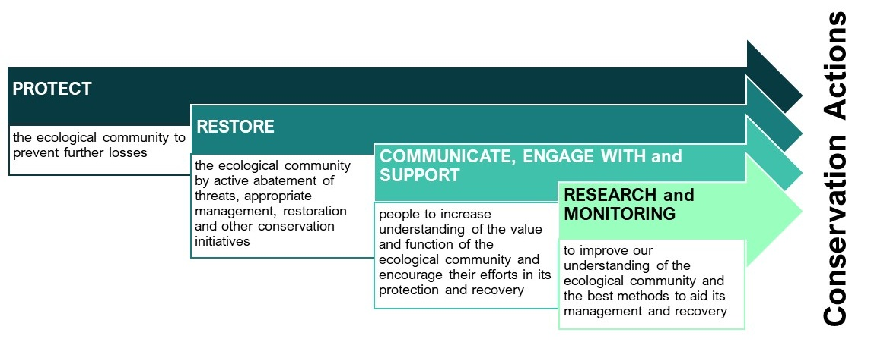
Figure 9. Four key approaches to priority conservation actions

These approaches may overlap and co-occur. They may also be iterative, thereby allowing for learning and improvements along the way (as per Fig. 10). Conservation actions cover a range of types—such as, but not restricted to, planning, action on the ground and/or offsite, research and review/evaluation. Importantly, these actions are underpinned by the need for a collaborative, transparent, and inclusive approaches.
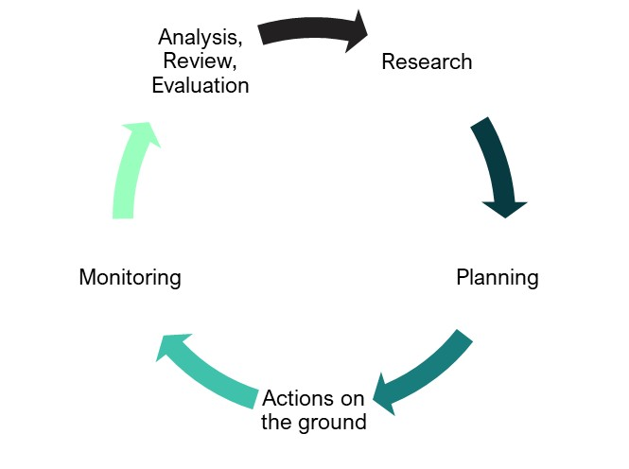
Figure 10. The iterative nature of ‘Protect, Restore, Communicate, Research/Monitor’ approach which, ideally, should culminate in a review or evaluation action to capture learnings and encompass a pathway of continuous improvement/adaptive management.

PROTECT the ecological community
This approach includes priorities intended to protect the ecological community by preventing further losses of occurrences.
- Protect and conserve all remaining areas of the ecological community, particularly areas that are critical to the survival of the ecological community (see Section 2.4).
- Where the ecological community is regenerating (e.g. following fire), protect it to maturity.
- Exclude all prescribed fire from patches of the ecological community and the immediate surrounding vegetation.
- During the early stages of planning for zoning and development projects, ensure of all occurrences of the ecological community are protected from clearing and degradation.

- Minimise impacts of human activity on the ecological community by:
  - retaining and avoiding damage to higher quality patches, which should be managed to retain their high or good condition state.
  - mitigating residual impacts (e.g. those associated with fire management, emergency access works, road development and maintenance, communications infrastructure).
- Offsets for impacts on the ecological community arising from developments should be avoided on the basis that only a very small area of the ecological community remains. Additionally, restoration/replacement may not contain all the attributes compared to a remnant and there can be a long time lag before any gains in condition and habitat values realised.
- Protect mature and over-mature trees and stags, particularly those with hollows or fissures that provide shelter and support a diversity of animals.
- Protect other important habitat features, such as intact tree canopies and humid microclimate.
- Environmental assessments should address impacts that extend beyond the immediate footprint of developments, including the need for asset protection works that involve removal, modification or burning of the ecological community.
- Minimise risk of indirect impacts from activities outside of the ecological community.
- For example, avoid building fire‑sensitive infrastructure (such as powerlines or telecommunications infrastructure) near patches of the ecological community — because of the potential for them to require fire-hazard reduction activities and restrict ecological burning that would otherwise protect the ecological community from fire.
- Control runoff during nearby construction activities (e.g. roadworks) to prevent movement of weeds and pathogens into the ecological community.
- Prevent degrading activities such as flora and fauna collection (e.g. ferns, invertebrates), off-road trail biking, dumping garden waste, soil, or rubbish within areas of the ecological community.
- Avoid construction of new trails through or near the ecological community.
- Increase representation and active management of the ecological community in formal conservation reserves, and identify areas, including predicted climate refuges, that require protection to achieve long-term conservation of the ecological community throughout its range. This includes investigating formal conservation arrangements, management agreements and covenants to protect patches on private land. This is particularly important for larger patches or areas that link to other patches of native vegetation.
- Undertake strategic and management initiatives to reduce the impacts of climate change (such as fire and drought) on this ecological community. This includes implementing the other threat abatement and restoration actions outlined elsewhere in Section 5.4 to enhance resilience of the ecological community to the impacts of climate change.
Apply buffer zones
- Protect and apply appropriate buffers, particularly using other native vegetation (around the edges of patches of the ecological community), to minimise impacts arising outside of the ecological community or off-site from a particular proposed activity. A buffer zone is a contiguous area adjacent to a patch, that is important for protecting the integrity of the ecological community. The risk of indirectly damaging an ecological community usually increases the closer you are to it. Buffer zones can minimise this risk, by absorbing and reducing the extent of impacts. They also guide land managers to be aware that the ecological community is nearby and to take extra care. For instance, buffer zones help protect the root zone of the outermost trees and other components of the ecological community from weed invasion, polluted water runoff and other damage. Native vegetation is often the best buffer. Fire breaks, and other built asset protection zones, are not usually suitable as buffers and should only be considered an addition to (rather than instead of) vegetation buffers.

- A buffer zone of at least 100 m (beyond the canopy of the outermost trees in a patch of the ecological community) will help protect the patch from many potential adverse impacts (Smith & Smith 2010). This distance accounts for likely influences on the root zone. A larger buffer zone should be used to protect patches of high conservation value, or where indirect impacts may be more extensive.

RESTORE (and MANAGE) the ecological community
Act to increase the extent, condition, and landscape scale connectivity of this ecological community (including connectivity with other surrounding native habitats), through actions that restore the ecological community through active threat abatement, management, restoration and conservation. This includes:
- Develop site specific plans that aim for self-sustaining, resilient areas of the ecological community, through restoration of a range of key biodiversity and ecosystem attributes.
- Where follow up or ongoing management is required, consider resourcing to secure long‑term recovery (e.g. how many years should weed management be repeated).
- Develop plans, capacity, early warning systems and readiness to suppress unplanned fires in the vicinity of the ecological community wherever there is a risk of incursion.
- Develop and implement plans to: i) control feral predators and herbivores within, and in the vicinity of the ecological community; ii) protect the ecological community from feral predators and herbivores (e.g. by installation, monitoring and maintenance of appropriate fencing) using learnings and priority actions of the Australian Pest Animal Strategy and associated National Feral Pig Action Plan, National Feral Deer Action Plan and the Threat abatement plan for predation by feral cats.
- Develop and implement response plans to ensure readiness for immediate action to mitigate post-fire impacts of feral predators and herbivores on the ecological community and its biota (e.g through pest control, fencing, etc).
- Limit human access to burnt or otherwise disturbed areas of the ecological community to enable uninterrupted regeneration.
- Design visitor interpretation and access infrastructure sensitively to maximise visitor experience and minimise collateral impacts on the ecological community.
- Where regeneration is occurring after fire, past logging or clearing activities, implement measures that will support the regeneration to maturity, recognising that the ecological community will exist in alternative condition states post-disturbance and gradually transition towards a recovered state.
- Maintain connectivity of the ecological community with native vegetation in the surrounding landscape to conserve the full diversity of habitats, enable uninhibited movement of native biota and its ability to recolonise disturbed habitats, and act as buffer zones between the ecological community and threats.
- Manage risks of disease introduction (particularly chytrid, root rot and myrtle rust) including through good biosecurity hygiene, and where practical mitigate symptoms of disease.
- Restore degraded occurrences of the ecological community to a higher condition (preferably Class A as per Table 1), meeting national standards for ecological restoration. This includes restoring areas that do not currently meet the key diagnostic characteristics and minimum condition thresholds, and thereby increasing both the extent and integrity of the listed ecological community.
- Consider including this ecological community as a target in nature repair and other environment restoration strategies and programs.

COMMUNICATE, engage with and support
This approach includes priorities to promote awareness of the ecological community and to encourage people and groups to contribute to its protection and recovery. This includes communicating, engaging with and supporting the public and key stakeholders to increase their understanding of the value and function of the ecological community and to assist their efforts in its protection and recovery. Key groups include local restoration and NRM groups, government agencies, landholders, land managers, land use planners, researchers, First Nations communities and other community members and groups.
- Liaise with landholders, NRM and community groups, Traditional Owners/Custodians and government agencies to promote understanding of the values of the ecological community and to support, undertake and promote programs that halt threats.
- Undertake public information campaigns and surveillance to prevent unplanned fire ignitions on predicted high and extreme fire weather days.
- Undertake effective community engagement and education to highlight the importance of minimising disturbance during recreational activities such as walking and off-road vehicle use, and of minimising pollution, littering and damage to habitat via informative and explicit signage.
- Develop education programs, information products and signage to help the public recognise the presence and importance of the ecological community, and their responsibilities under state and local regulations and the EPBC Act.
- Support First Nations engagement in management and protection of the ecological community, including identifying and supporting culturally appropriate mechanisms to share Traditional Ecological Knowledge.
- Encourage local participation in restoration efforts through local conservation groups, through ‘friends of’ groups, field days and management projects, etc.
- Liaise with local fire management authorities and agencies and engage their support in fire management of the ecological community. Ensure land managers are given information about how to manage fire risks to conserve this and other threatened ecological communities and species.
- Adopt best management practice based on partnerships around co-design, co-implementation and social learning.
- Promote explicit use of local knowledge in planning, management actions and monitoring supported by cost-effectiveness and risk-based collective decision making.

RESEARCH and monitoring
This approach includes priorities for research into the ecological community, and monitoring, to improve understanding of the ecological community and the best methods to aid its recovery through restoration and protection. Relevant and well-targeted research and other information gathering activities are essential in informing the protection and management of the ecological community.
- Map selected patches of the ecological community and its structural features using high resolution imagery to monitor boundary dynamics structural change and disturbance effects.
- Monitor the dynamics of patches of the ecological community regenerating after the 2019–20 (and future) fires with appropriate reference sites.
- Where practical conduct monitoring consistent with the methods described by the Ecological Monitoring System Australia (EMSA) (O'Neill et al. 2023).
- Investigate methods to increase resistance and resilience of the ecological community and surrounding vegetation types (e.g. eucalypt forests) to bushfires.
- Use adaptive management approaches (with appropriate replication, reference and control sites) to explore how specific manipulations contribute to conservation of the ecological community, such as removal of eucalypt seedlings and saplings, exclusion or control of feral herbivores and predators, etc.
- Undertake surveys to improve understanding of characteristic vertebrate and invertebrate fauna of the ecological community across its range.
- Improve understanding of habitat requirements of fauna associated with the ecological community and dependency of their survival, foraging and reproduction on rainforest attributes at different stages of their life cycles.
- Understand the threats from weeds to this ecological community and monitor to detect and quantify impacts from incursions of diseases, pests and weeds.
- Improve understanding of the reproductive and growth phenology of component plants species.
- Improve understanding of germination biology, seedling recruitment and propagule dispersal and their dependencies.
- Improve understanding of regeneration processes after fire or treefall, and the time taken to reach different stages of recovery.
- Improve understanding of fire survival and reproductive responses, and relevant traits of plant and animal species to predict community responses to alternative fire regimes.
- Quantify the climatic niche of the ecological community and its component species through relevant experiments and modelling, and improve projections of the ecological community’s distribution and transformational processes under different future climate scenarios.
- Research appropriate and integrated methods to manage pests that affect the ecological community.

Consultation Questions on priority actions
- Are other actions needed for effective conservation of this ecological community (please give details)?
- What other information is necessary to support conservation management and restoration of the ecological community?

Listing assessment
This assessment outlines the grounds on which the ecological community is eligible to be listed as required by section 266B (2) (a) (i) of the EPBC Act.
The Threatened Species Scientific Committee has provided this draft for assessment for consultation.

Eligibility for listing
An ecological community is eligible for listing under section 182 of the EPBC Act if it meets the prescribed criteria outlined in section 7.02 of the EPBC Regulations. This assessment uses the criteria set out in section 7.02 the EPBC Regulations and the TSSC Guidelines for nominating and assessing the eligibility for listing of threatened ecological communities (TSSC 2017), as in force at the time of the assessment.
The TSSC Guidelines (TSSC 2017) outline indicative timeframes to be used when interpreting the prescribed criteria, in relation to the generation length of any long-lived or key species believed to play a major role in sustaining the ecological community. For the purposes of this assessment the relevant species used to determine this timeframe is Eucryphia moorei (see section 1.2.3), which is likely to live for several hundred years, and therefore has a likely generation length exceeding 100 years.
Information on listing eligibility under the IUCN Red List for Ecosystems criteria (Bland et al. 2017) is included for information only.

Criterion 1 – decline in geographic distribution
Not eligible under Criterion 1
 | Category
 | Critically Endangered | Endangered | Vulnerable
Its decline in geographic distribution is: | very severe | severe | substantial
decline relative to the longer-term/1750 timeframe | ≥90% | ≥70% | ≥50%
decline relative to the past 50 years | ≥80% | ≥50% | ≥30%
Source: TSSC 2017
Evidence:
Estimates of the historical decline since 1750 in geographic distribution of the ecological community vary from 23–26%, based on three sets of maps that represent the range of uncertainty in the historic and extant distribution of the ecological community across most of its range (Keith et al. 2023)⁶. The primary cause of decline is likely to have been timber harvest followed by conversion to pasture, much of which occurred during the mid 19th and mid 20th centuries (Keith 2004). Appraisal of the maps suggested that, while the extant distribution of the ecological community is well characterised, the pre-clearing distribution may have been overestimated on the Sassafras plateau. Therefore, the decline in geographic distribution is likely to have been less than 25% of the historical extent and does not meet the threshold for threatened status under Criterion 1.
Following preliminary assessment, the Committee therefore considers that the ecological community is not eligible for listing in any threatened category under Criterion 1.
Based on currently available data, Pinkwood cool temperate rainforests of south east New South Wales and far east Victoria meets criteria A1 and A3 for the Least Concern category, and there are insufficient data to assess criteria A2a and A2b, based on the IUCN Red List of Ecosystems protocol (Bland et al. 2017).

Criterion 2 – limited geographic distribution coupled with demonstrable threat
Eligible under Criterion 2 for listing as Endangered.
Its geographic distribution is: |  | very restricted | restricted | limited
Extent of occurrence (EOO) |  | < 100 km2  = <10,000 ha | <1,000 km2  = <100,000 ha | <10,000 km2  = <1,000,000 ha
Area of occupancy (AOO) |  | < 10 km2  = <1,000 ha | <100 km2  = <10,000 ha | <1,000 km2  = <100,000 ha
Average patch size |  | < 0.1 km2  = <10 ha | < 1 km2  = <100 ha | -
AND the nature of its distribution makes it likely that the action of a threatening process could cause it to be lost in:
the immediate future | 10 years or 3 generations  (up to a maximum of 60 years) | Critically  endangered | Endangered | Vulnerable
the near future | 20 years or 5 generations  (up to a maximum of 100 years) | Endangered | Endangered | Vulnerable
the medium term future | 50 years or 10 generations  (up to a maximum of 100 years) | Vulnerable | Vulnerable | Vulnerable
Source: TSSC 2017
Evidence:
The Extent of Occurrence (EOO) is based on a minimum convex polygon that encloses all mapped occurrences and for this ecological community was estimated to be approximately 5600–7000 km² (Keith et al. 2023) and up to 20,807 km² (DEECCW). This represents a limited geographic distribution. The Area of Occupancy (AOO) is approximately 11–16 km² (possibly as low as 10 km²) based on mapped distributions of Keith et al. (2023) (see criterion 1) and up to 76 km² (DCCEEW). This represents a restricted geographic distribution. The estimates of DCCEEW are larger, and likely an over-estimate, because they encompass a range of spatial vegetation units that may only contain small areas of the ecological community within them (see section 1.2.1 and Appendix C).
The restricted distribution of the ecological community, the nature of that distribution limited to small, sheltered gullies, and the action of threatening processes (Table 2) could cause it to be lost in the near future. The ‘near future’ therefore encompasses the next 100 years, as five generation lengths of the dominant tree species greatly exceeds this maximum period (see section 6.2). The following threatening processes are most likely to contribute to the risk of loss in the near future.
Exposure to climate change
Climate change is projected to increase the incidence of extreme weather, particularly heat waves and prolonged severe drought, across the entire geographic distribution of the ecological community (see Table 2), threatening the drought- and heat-sensitive flora and fauna that characterise the ecological community. By 2070, mean precipitation of the driest quarter of the year is projected to decline by at least 10% across more than 75% of the distribution of Pinkwood cool temperate rainforests of south east New South Wales and far east Victoria (Keith et al. 2023). In part, this may be due to declining incidence of fog and mist, and rising cloud bases (e.g. Auld & Leishman 2015). Combined with increases in mean temperature of the warmest quarter, of at least 1°C (projected across all emission scenarios by 2070; Keith et al. 2023), this will very likely increase the climatic moisture deficit at sites currently occupied by the ecological community, threatening its characteristic components and making its current locations less suitable for long-term persistence and function (see Table 2 and section 6.2.4 for further details on current trends).
Temperatures along the escarpment and coastal ranges of southern New South Wales are projected to increase substantially over the next 50 years. Mean maximum temperatures at elevations of up to 500 m to 1200 m above sea level are projected to rise 1.7–2.8°C by 2060–2079 relative to 1990–2009, while mean minimum temperatures are projected to rise by 1.6–3.0°C across the range of possible future changes in climate (see Figs. 4 and 5 of Ji et al. 2022). Temperature rises in summer and spring are projected to be greater than in autumn and winter. Large changes are also projected for extreme temperatures, with the number of warm days and warm nights per year both increasing by 12–24% by 2060–2079 relative to 1990–2009 and the coldest daily minimum temperature increasing by 1.6–3.2°C (see Fig. 8 of Ji et al. 2022).
The ecological effects of these projected temperature rises are uncertain, but are likely to include reduced plant growth rates (Wood et al. 2015), reduced rates of seedling recruitment (Singh et al. 2021), increased tree mortality related to moisture stress and heat waves (Choat et al. 2018; Hoffmann et al. 2019), and impacts on forest fauna through reduced growth rates, increased mortality, and changes in phenology and morphology (Hoffmann et al. 2019).
Climate change is likely to further squeeze the currently marginal bioclimatic conditions for persistence of rainforest within the distribution of the ecological community. Moisture inputs are increasingly limited by projected declines in winter rainfall of at least 5% throughout the distribution of the ecological community under all climate scenarios, and by at least 10% over more than three-quarters of the distribution for moderate to high climate warming scenarios (i.e. greater than RCP4.5; Keith et al. 2023). Simultaneously, moisture loss is projected to increase, with rises of mean temperature of the driest quarter of at least one degree across more than half of the distribution for moderate to high climate warming scenarios. Overall, these projections indicate an increase modest annualised moisture deficit (i.e. evapotranspirative demand exceeds precipitation), and increasingly marginal conditions for rainforest persistence. See Table 2 and section 6.2.4 for further information on climate-related threats.
Changing fire regimes
Recent trends in fire activity are consistent with projections that fires are likely to become more frequent, more severe and larger due to the effects of increasing drought incidence and severity on fuel moisture and the increasing incidence of severe fire weather conditions (Boer et al. 2020; Nolan et al. 2020a; Abram et al. 2021; Canadell et al. 2021; Collins et al. 2021a;). van Oldenborgh et al. (2021) showed that the probability of a Fire Weather Index as high as that in 2019-20 has increased by at least 30% since 1900 across south east Australia as a result of anthropogenic climate change and that this trend is likely to continue into the future. Projected into the future over a time frame required for this assessment, their models indicate that a Fire Weather Index (FWI) as high as in 2019-20 would become at least four times more likely with a 2°C temperature rise (a rise exceeded under moderate climate scenarios RCP 4, 5 and above), compared with the year 1900. As the trend in extreme temperature is a driving factor behind this fire risk increase and they assert that the climate models underestimate the observed trend in extreme temperature, the authors concluded that the attributable increase in fire risk could be much higher. These findings supersede more moderate projections based on averages and older approaches (e.g. DPIE (2019)). Fires of low or high severity, threaten the persistence of Pinkwood cool temperate rainforests of south east New South Wales and far east Victoria, especially when they recur frequently (at intervals <c. 100 years) or occur in association with droughts (Bowman 2000; Tolsma et al. 2019; Peacock & Baker 2022; Keith et al. 2022b; DAWE 2022). Further discussion is in Table 2 and Criterion 4 – reduction in community integrity.
Spread of invasive species
Pinkwood cool temperate rainforests of south east New South Wales and far east Victoria is threatened by invasive predators, invasive herbivores and diseases (Table 2). Some of these invasive species, such as Rusa unicolor (Samba deer), are spreading within the distribution of the community (Davis et al. 2016). Impacts on native components of the ecological community (see section 6.2.4; Table 2) are likely to continue into the future, despite strategic control efforts. Most invasive plants are localised in their occurrence and closely associated with disturbance associated with earthworks, runoff or logging. Other invasive species such as Austropuccinia psidii (myrtle rust) are likely to become more pervasive (Pegg et al. 2021), with increasing impacts on community structure, composition and function. Increasing fire activity is likely to exacerbate the spread of invasive species, and their impacts on the persistence of the ecological community (DAWE 2022).
Myrtle rust disease (Table 2) has not been directly observed in Pinkwood cool temperate rainforests of south east New South Wales and far east Victoria at the time of this assessment, however, the lower-elevation portion of its range could be affected where Syzygium smithii (lilly pilly) co-dominates the canopy of the ecological community and where the climate appears to be suitable for the spread of the disease (Pegg et al. 2021). Syzygium smithii is ranked as ‘relatively tolerant to moderately susceptible’ to the strain of the disease that is currently invading the region (Makinson 2018).
Conclusion
The geographic distribution of the ecological community is estimated to be restricted, based on its mapped area occupied. Cumulative impacts from climate change, altered fire regimes and invasive species have the potential to cause the loss of the ecological community within 100 years (less than 5 generations of Eucryphia moorei (plumwood, pinkwood) and other dominant trees).
The restricted geographic distribution, and the nature of this distribution, makes it likely that the action of a threatening process could cause it to be lost in the near future. After preliminary assessment, the Committee considers that the ecological community may have met the relevant elements of Criterion 2 to make it eligible for listing as Endangered.
Pinkwood cool temperate rainforests of south east New South Wales and far east Victoria meets criterion B1(a)ii,iii,(b),(c) for listing as an Endangered ecosystem type based on the IUCN Red List of Ecosystems (Bland et al 2017) because its Extent of Occurrence is greater than 2,000 km² and less than 20,000 km², combined with evidence of continuing decline, observed threatening processes and small number of threat-defined locations. It meets criterion B2a,b,c. It also meets criterion B3 for listing as a Vulnerable ecosystem because it occurs at a very small number of threat-defined locations and is prone to the effects of stochastic events (fires) within a very short time period in an uncertain future, and thus capable of Collapse or becoming Critically Endangered within a very short time period.

Criterion 3 – decline of functionally important species
Insufficient data to determine eligibility under Criterion 3
 | Category
 | Critically Endangered | Endangered | Vulnerable
For a population of a native species that is likely to play a major role in the community, there is a: | very severe decline | severe decline | substantial decline
Estimated decline over the last 10 years or three generations (up to a maximum of 60 years), whichever is longer | 80% | 50% | 20%
to the extent that restoration of the community is not likely to be possible in: | the immediate future | the near future | the medium-term future
timeframe | 10 years or 3 generations (up to a maximum of 60 years) | 20 years or 5 generations (up to a maximum of 100 years) | 50 years or 10 generations (up to a maximum of 100 years)
Source: TSSC 2017
Evidence:
Trees and tree ferns are functionally important species in Pinkwood cool temperate rainforests of south east New South Wales and far east Victoria (see section 1.2.3). No time series data are available to assess rates of population change over the last three generations of those species. However, survey data gathered from three sites at Monga National Park and Maxwells Creek Flora Reserve in December 2021, two years after the 2019-20 bushfires, sampled a total of 38 Eucryphia moorei trees and 37 Dicksonia antarctica trees (Keith et al. in Ferrer & Keith 2022). All Eucryphia were top-killed by the fire, and 24 individuals were resprouting from the base, including three individuals in which the main stems had fallen, partially uprooting the tree. Most of the 14 trees killed outright were advanced saplings that were rooted in the ground, but still associated with tree fern trunks on which they germinated. Only two seedlings were observed. Given uncertainty in the survival of uprooted individuals and seedlings, mortality of Eucryphia (and hence decline in mature individuals) across the two sites was estimated to be 37-46% after a single fire event. Of 37 Dicksonia antarctica individuals sampled, 27 were resprouting from the apex and no recruits were observed, suggesting a mortality rate and decline in mature individuals of 27% after a single fire event.
Inspection by DEECCW officers in December 2023 in the headwaters of Paddy’s Creek at an elevation 960m at Peak Alone Mountain, Wadbilliga National Park, revealed stands of Eucryphia moorei after suffering high intensity fire in 2019 with dead canopies and <50% of trees with small basal reshoots (the others were dead).
Similar inspections at Brown Mountain SE Forests NP showed similar canopy death and basal reshoots in Elaeocarpus holopetalus and Atherosperma moschatum. Treeferns Dicksonia antarctica and Cyathea australis had a higher survival rate with the majority recovering from fires.
Approximately 87-90% of the distribution of the ecological community occurs within the mapped footprint of the 2019-20 bushfires (DAWE 2020), including 20-50% within mapped areas of canopy scorch (Keith et al. 2022b; Keith et al. 2023.). If the estimates of post-fire decline from these sites are indicative of trends in these burnt areas of the ecological community, declines over a three-generation period (>60 years) could exceed 30% or possibly 50%, given that this period could include multiple fires. However, there is considerable uncertainty about spatial variation in mortality rates and whether previous fires in the last 60 years had similar effects.
Based on estimates from the 2019-20 fires alone, the data suggest a potentially substantial decline in the population of Eucryphia moorei (plumwood, pinkwood), Elaeocarpus holopetalus (black oliveberry), Atherosperma moschatum (southern sassafras) and some decline in Dicksonia antarctica (soft treefern), such that restoration of the community is not likely to be possible in the medium-term future. After preliminary assessment, however, the Committee considers that there are insufficient data to determine whether the ecological community may have met the relevant elements of Criterion 3 to make it eligible for listing as Vulnerable.

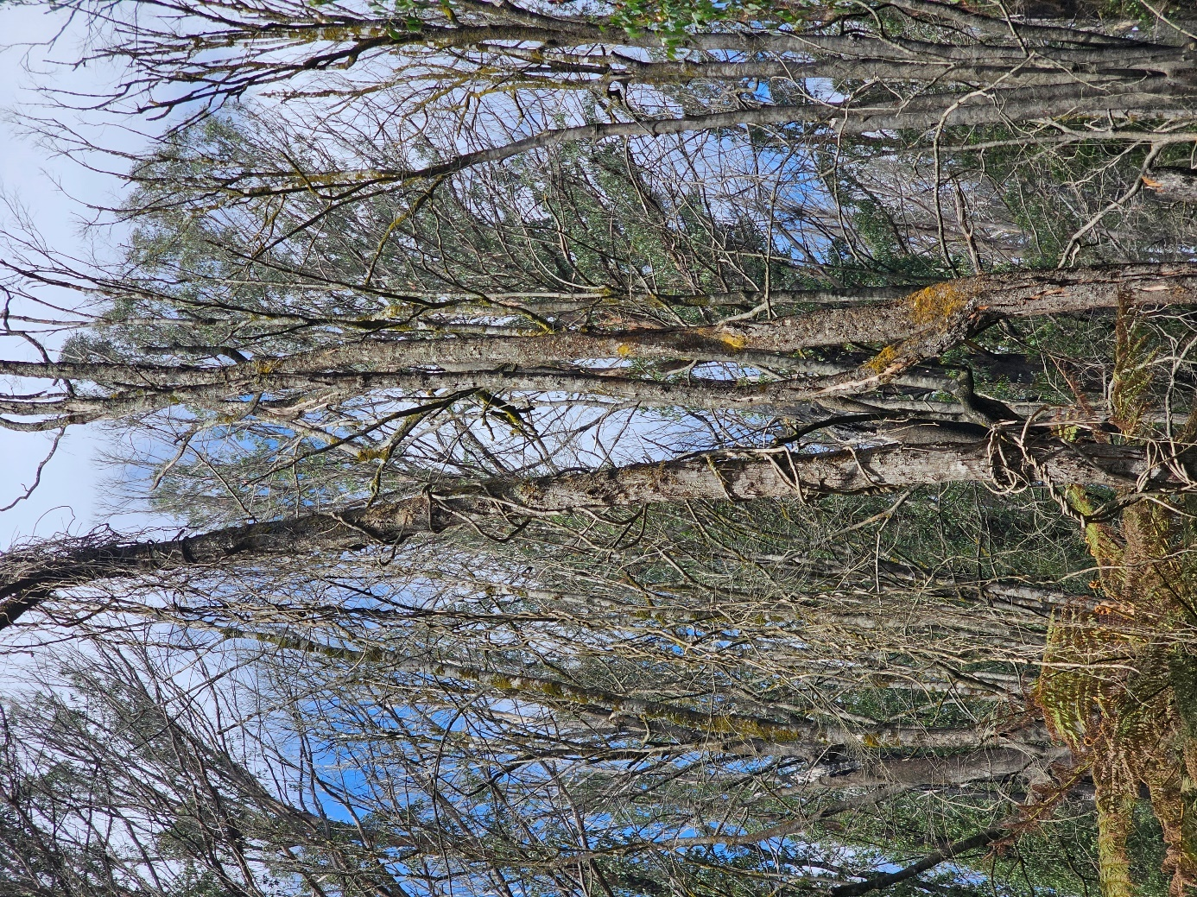
Figure 11. Pinkwood CTRF impacted by high intensity fire in 2019, Monga National Park. Photo December 2023 (Photo L. Weber).
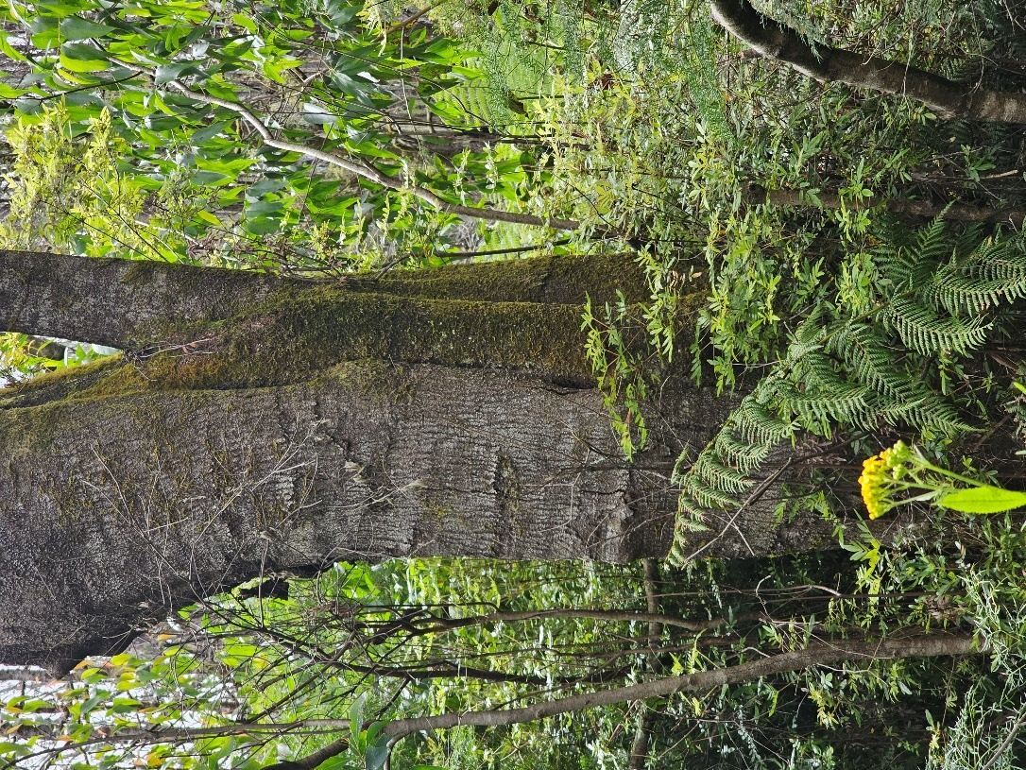
Figure12. E. moorei (pinkwood)basally resprouting after fire at Monga NP. Note the healthy sapling of Eucalyptus fastigiata (brown barrel)on right. Photo December 2023 (Photo L. Weber).
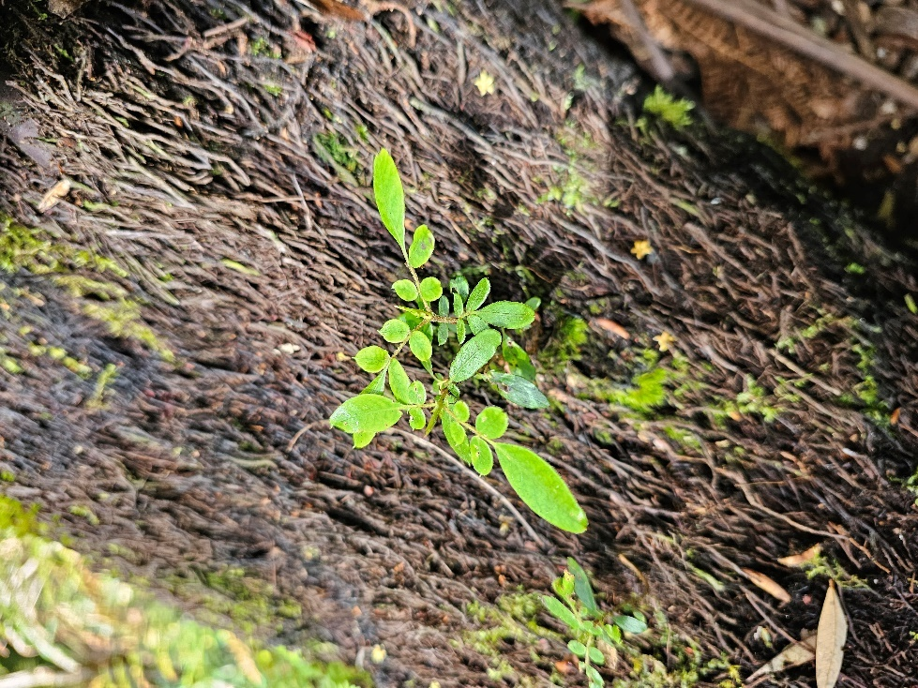
Figure 13. Small E. moorei seedlings on treefern trunk were only present in very low abundance, Monga National Park. Photo December 2023 (Photo L. Weber).
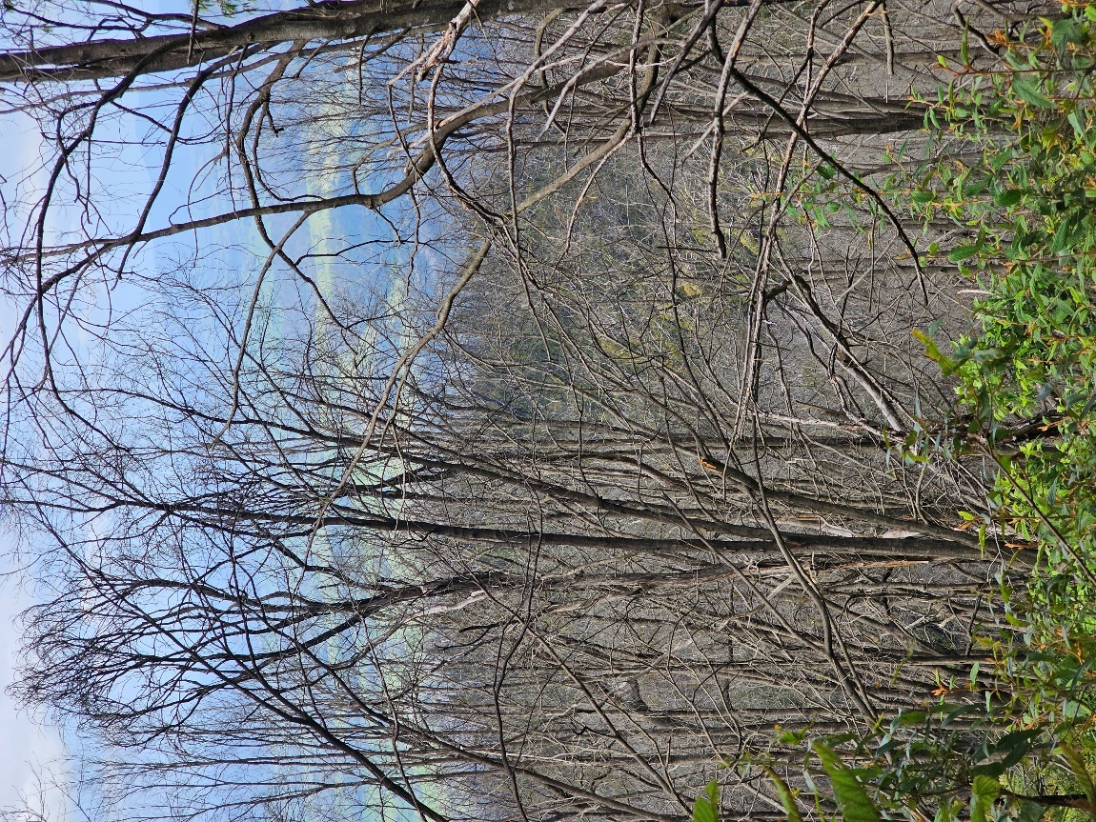
Figure 14. Dead canopy previously dominated by E. moorei impacted by high severity fire in 2019 at Peak Alone, Wadbilliga National Park, in December 2023 (Photo L. Weber).
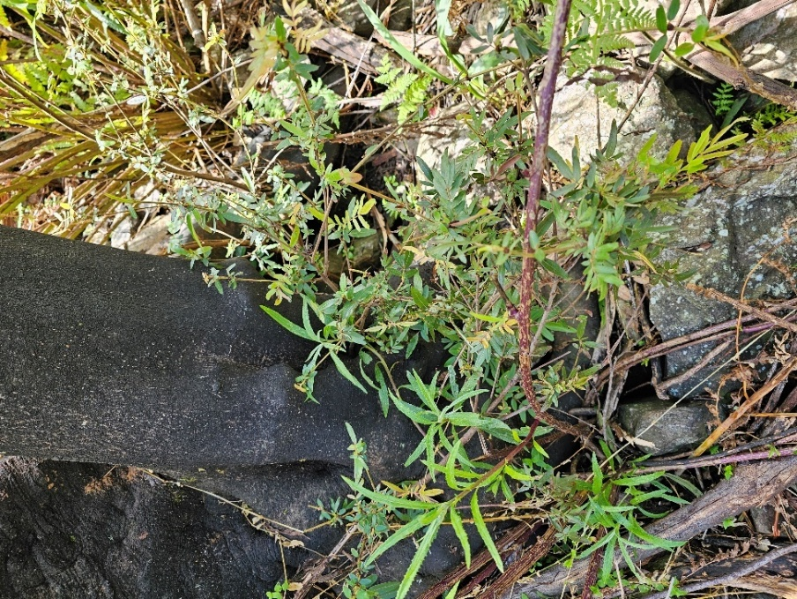
Figure 15. Small shoots at the past of a burned E. moorei at Peak Alone, Wadbilliga National Park. Photo December 2023 (Photo L. Weber).
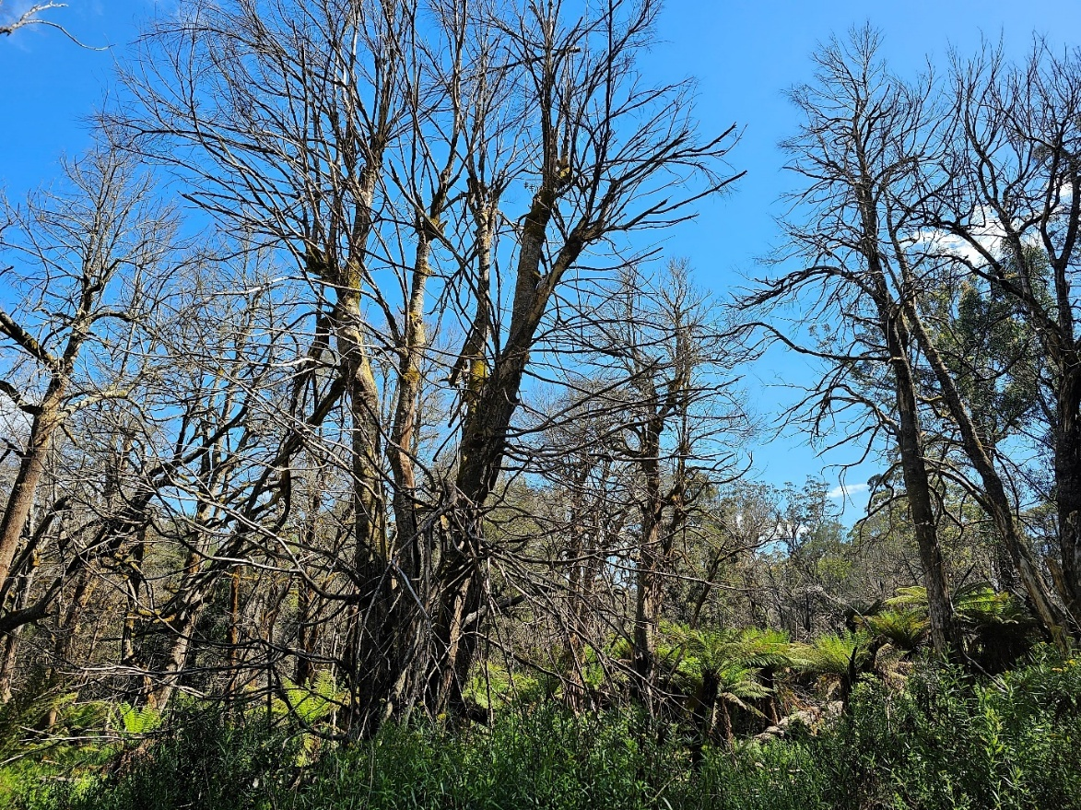
Figure 16. Cool temperate rainforest stand of E. holopetalus and A. moschatum subsp. moschatum with dead canopies impacted by high intensity fire in 2019 at Brown Mountain, December 2023 (Photo L. Weber).

Criterion 4 – reduction in community integrity
Eligible under Criterion 4 for listing as Endangered
 | Category
 | Critically Endangered | Endangered | Vulnerable
The reduction in its integrity across most of its geographic distribution is: | very severe | severe | substantial
as indicated by degradation of the community or its habitat, or disruption of important community processes, that is: | very severe | severe | substantial
such that restoration is unlikely (even with positive human intervention) within | the immediate future (10 years or 3 generations up to a maximum of 60 years) | the near future (20 years or 5 generations up to a maximum of 100 years) | the medium-term future (50 years or 10 generations up to a maximum of 100 years)
Source: TSSC 2017
Evidence:
Multiple interacting threatening processes are causing severe reductions in integrity and degradation of ecological functions in the ecological community, across most of its geographic range. The ecological community has undergone severe changes in structure and function as a result of the threats outlined in Section 6.2. The ecological community has experienced a reduction in integrity across most of its extent primarily because of:
- Climate change
- Fire regimes that cause declines in biodiversity
- Loss of fauna species
- Invasive feral predators, herbivores and diseases
Exposure to climate change
Incidence of extreme weather, including heat waves and prolonged severe drought, is increasing across the geographic distribution of the ecological community, consistent with climate change projections (see Threats, Table 2). South-eastern Australia is spending more time in droughts that are longer in duration and more intense relative to the latter decades of the twentieth century (Kirono et al. 2020). The last 6 months of 2019 was the driest of all years on record across 60–64% of the range of the ecological community; and within the driest 2% of historic records for that 6-month period across 88–90% of the range (Keith et al. 2022; Keith et al. 2023). The ecological community also underwent extensive, severe and prolonged drought during 2009–2010. Although direct evidence was poorly documented, these droughts are likely to have caused prolonged reductions in growth and reproduction of trees and shrubs, reduced abundance of moisture-dependent biota such as ferns and bryophytes, reduced habitat suitability and food availability for a range of dependent fauna and increased flammability (see ‘Changing fire regimes’ below).
Similarly, heat waves are becoming more frequent, longer and hotter (Cowan et al. 2014; Trancoso et al. 2020), diminishing the function of rainforest patches as landscape refuges. Both drought and high temperatures limit the moist microclimate that is critical to much of the rainforest ecosystem, its ecological processes and its biota (Adam 1994; Keith 2004). Declining moisture availability and increasing temperatures reduce the functionality of rainforest patches as thermoregulatory refuges for birds and mammals, and the suitability of habitat for drought- and heat-sensitive flora. This includes tree ferns, filmy ferns and mosses, as well as fungi and litter invertebrates, that depend on humid microclimates within and beneath the tree canopy that characterise the ecological community. Increased aridity and higher temperatures are also likely to be driving the decline of threatened arboreal fauna in the region (Wagner et al. 2020). Severe drought and extreme temperatures are associated with large and severe wildfires (see below and Table 2).
Changing fire regimes
Fires are becoming more frequent, more severe and larger due to the effects of increasing drought incidence and severity on fuel moisture and the increasing incidence of severe fire weather conditions (Abram et al. 2021; Boer et al. 2020; Canadell et al. 2021; Collins et al. 2021; Nolan et al. 2020; van Oldenborgh et al. 2021). In 2019–20, fires affected 87–90% of the distribution of Pinkwood cool temperate rainforests of south east New South Wales and far east Victoria (DAWE 2020; Keith et al. 2023); more than any previously recorded fires. As much as 20–50% of its distribution was estimated to have experienced canopy scorch (Keith et al. 2022b; Keith et al. 2023), resulting in top-kill of most or all trees and outright mortality as high as 37–46% (see section 6.2.3). Collapse of top-killed trees occurred in burnt areas of this ecological community within 2 years of bushfires in 2019–20 at Monga National Park (Keith et al. data in Ferrer & Keith 2022). Top-kill has likely resulted in prolonged disruption of the moist microclimate because the closed tree canopy recovers very slowly over subsequent decades (e.g. Tolsma et al. 2019), reducing habitat suitability for a range of rainforest biota and increasing exposure of understorey plants and litter fauna to more rapid drying after precipitation events (see section 6.2.3).
Table 3. Fire burn area of the ecological community and severity during 2019–20 bushfires (DCCEEW 2020). This estimate encompasses the broadest units that may contain the ecological community, including areas outside of the burn area (e.g. Illawarra region).
Fire Severity Category (GEEBAM) | Area of Ecological Community burnt (ha) | % of Total Ecological Community Area (7,633 ha)
3 - Low and Moderate | 726 | 9.5%
4 - High | 653 | 8.6%
5 - Very High | 973 | 12.7%
Total | 2353 | 30.8%

The 2019–20 fires were the second fire event to affect the ecological community in the past 50 years, across 60-64% of its distribution (Keith et al. 2022b). Such intervals indicate a substantially higher fire frequency than in recent centuries and millennia, when rainforest fires were likely to have been rare (Adam 1987; Peel 1999; Bowman 2000; Keith 2004). There is evidence that frequent fire recurrence at multi-decadal intervals causes cumulative mortality of long-lived trees, tree ferns and shrubs, as well as the reduction or elimination of duff layers on the forest floor, and hence long-term structural transformation (Tolsma et al. 2019; Peacock & Baker 2022). Successive fires also interrupt recovery processes, particularly dispersal and seedling recruitment in dominant trees. These processes depend on conditions and substrates in established rainforest, including roosting sites for avian seed dispersers, moist topsoil and microclimate, availability of tree fern trunks and occasional formation of small gaps (Helman 1983, 1986; Adam 1987; Bowman 2000; Peacock & Baker 2022). Severe fires that cause rainforest tree canopy death also provided an opportunity for invasion by eucalypts from the surrounding forests, as observed in Monga National Park (Keith et al. data in Ferrer & Keith 2022) and similar forests in Victoria (Tolsma et al. 2019). Incursion of eucalypts increases flammability of the ecosystem (Tolsma et al. 2019), as a likely consequence of the more rapid drying of understorey and ground fuels and through increased mass of more flammable carbon-rich eucalypt foliage (Lindenmayer et al. 2011).
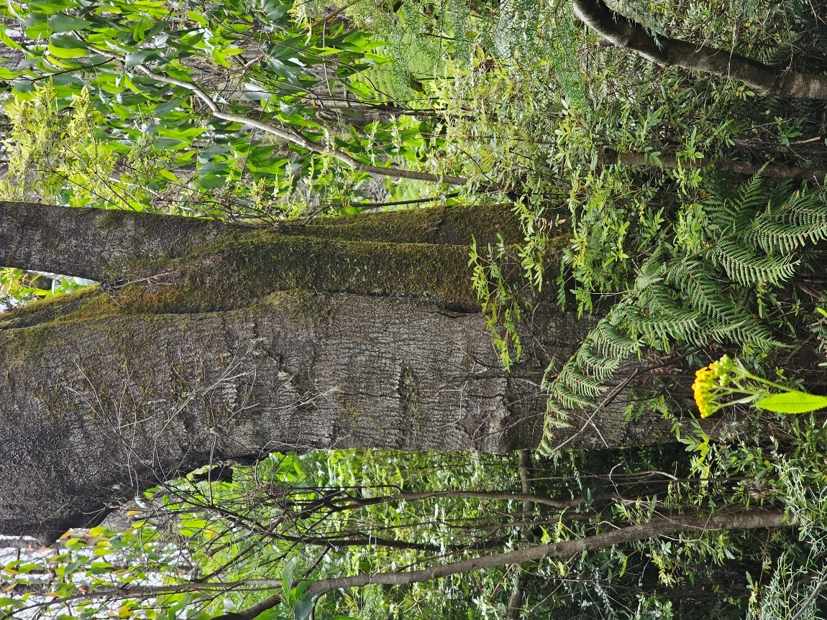
Figure 17. Eucalypt saplings surrounding a mature E. moorei tree with basal resprout at Monga National Park after the 2019 fire. Photo December 2023 (Photo L. Weber).
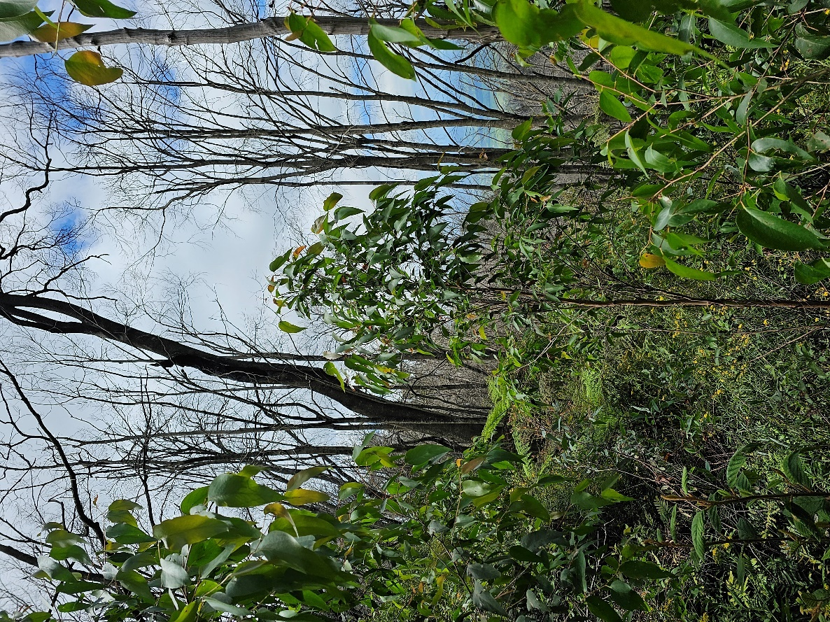
Figure 18. Healthy eucalypt saplings invading a patch of the ecological community with dead rainforest canopy after 2019 fire at Peak Alone, Wadbilliga National Park (Photo L. Weber).
A number of previously healthy patches exhibit little regeneration of canopy tree species over the last 4–5 years between the 2019 fires and December 2023 with almost no seedlings (<10 per patch) and most of the canopy trees exhibiting dead crowns with living basal resprouts of 1–2m tall shoots.
If a fire of even moderate to high intensity was to occur in the next one or two decades in already fire damaged stands of the ecological community then whole patches could lose their dominant rainforest tree species and become tree fern gullies with a Eucalypt-dominated canopy. Young eucalypt saplings present since 2019 (see photos above) could increase the fire intensity with their flammable foliage. Examples of patches that are at high risk of elimination from fires in the near future are at Peak Alone and most in Monga NP.
Large and severe wildfires that burnt rainforest patches and the surrounding eucalypt forest matrix are likely threatening the persistence of some forest fauna taxa, particularly mammals, birds and frogs (Lindenmayer et al. 2013; Berry et al. 2015; McLean et al. 2018).

Degradation by invasive species
The Pinkwood cool temperate rainforests of south east New South Wales and far east Victoria ecological community is threatened by invasive predators, invasive herbivores and invasive diseases, which have degraded and continue to degrade different components of the ecological community (Table 2). While densities of foxes and cats are poorly documented, one or both predators may be responsible for declines and local extinctions of vertebrate forest fauna, such as Orthonyx temminckii (Australian logrunner), Ptilonorhynchus violaceus (satin bowerbird), Potorous tridactylis (long-nosed potoroo), Dasyurus viverrinus (eastern quoll) and Dasyurus maculatus (tiger quoll). These animals play important roles in trophic webs and physical processes within the rainforest and adjoining areas (e.g. litter and soil turnover), and their loss is likely to have had an impact on ecosystem functioning. Predation by both foxes and cats increases in the post-fire environment (Table 2; DAWE 2022). Based on coarse national-scale density and diet models, Keith et al. (2022) estimated that 20% of the distribution of the ecological community was exposed to high post-fire predation pressures from feral cats after fires in 2019–20.
The invasive herbivore, Rusa unicolor (samba deer), occurs in the ecological community, browsing on foliage of rainforest shrubs, saplings and seedlings, damaging bark by antler-rubbing and causing soil disturbance via trampling (Peel et al. 2005). Evidence of deer browsing on basal resprouts, including consumption of leaves and branch tips of Eucryphia moorei (plumwood, pinkwood) and associated soil disturbance were observed at Monga National Park two years after fire (D. Keith, pers. comm. 30/6/2022). Such effects appeared less conspicuous prior to fires, suggesting that impacts of herbivores are amplified in the post-fire environment, consistent with studies on other ecosystems and herbivore species (e.g. Leigh & Holgate 1979; Giljohann et al. 2017; Heaton et al. 2022), where overabundance of herbivores inhibits seedling establishment and changes community structure and composition. Deer scats were also observed by DCCEEW officers at a burnt patch of the ecological community in Glenbog State Forest that was being investigated as part of this assessment. Based on coarse national-scale density models, Keith et al. (2022) estimated that about one-quarter of the distribution of the ecological community was exposed to high densities of deer and was within the 2019–20 footprint.
The frog fauna of the ecological community is poorly documented. However, it is likely that the abundance and diversity of the frogs of the ecological community underwent precipitous declines as chytridiomycosis spread through the Southern Tablelands and escarpment (Scheele et al. 2017). The disease is therefore likely to have reduced the integrity of the ecological community, although effects are difficult to quantify because no inventory data were available prior to introduction of the disease into the region.
Timber harvesting
There is anecdotal evidence of direct exploitation of this ecological community for rainforest timbers by European settlers, “The pale, pinkish-brown, close-grained timber was used by the early settlers for cabinet making and possibly axe and tool handles” (ANH 2012). However direct exploitation is likely to have been localised. Logging of adjacent eucalypt forest occurred during the 20th century, exposing many occurrences of the ecological community are exposed to legacy effects of past logging activities including disturbances associated with construction of access and snig tracks, treefall into rainforest patches, depletion of tree or canopy-dependent fauna and their habitat suitability in the surrounding landscape and fragmentation of forest structure (Table 2). Approximately 11–18% of the distribution of the ecological community is within areas of past timber harvesting activities mapped by state forestry authorities (Keith et al. 2022; Keith et al. 2023), all of which occurred prior to 1996 when modern forest management prescriptions were introduced (McCormack 1996) and the reserve system was expanded. Alterations to forest structure associated with timber harvesting operations may also increase the probability of fire propagation into rainforest under extreme conditions, through increased drying rates of fuels on the forest floor (Lindenmayer et al. 2011; Tolsma et al. 2019).
Conclusion
The combination of these threats, particularly altered fire regimes, has degraded the structure, species assemblage and ecological function across the range of the ecological community.
This represents a severe reduction in integrity across most of its geographic distribution, as indicated by a severe degradation of the ecological community and its habitat and a severe disruption of important community processes, particularly regenerative processes. After preliminary assessment, the Committee considers that the ecological community may have met the relevant elements of Criterion 4 to make it eligible for listing as Endangered.
Further spatial analysis of fire effects and climate change on the ecological community may enable it to be assessed under criterion C of the IUCN Red List of Ecosystems, while effects of invasive species and logging legacies could be assessed under criterion D (Bland et al. 2017).

Criterion 5 – rate of continuing detrimental change
May be eligible under Criterion 5 for listing as Vulnerable.
 | Category
 | Critically Endangered | Endangered | Vulnerable
Its rate of continuing detrimental change is:  as indicated by: | very severe | severe | substantial
(a) rate of continuing decline in its geographic distribution, or a population of a native species that is believed to play a major role in the community, that is:  OR | very severe | severe | serious
(b) intensification, across most of its geographic distribution, in degradation, or disruption of important community processes, that is: | very severe | severe | serious
an observed, estimated, inferred or suspected detrimental change over the immediate past, or projected for the immediate future (10 years or 3 generations, up to a maximum of 60 years), of at least: | 80% | 50% | 30%
Source: TSSC 2017
Evidence:
The Pinkwood cool temperate rainforests of south east New South Wales and far east Victoria ecological community is undergoing continuing detrimental change primarily as a result of a warming and drying regional climate, with associated changes in fire regimes. Throughout eastern Australia, palaeo-evidence indicates the sensitivity of rainforest distribution to changes in climate over millennial time scales (Adam 1987; Bowman 2000). Historically, major contractions in rainforest distribution have occurred as climates became drier, with increased deposition of charcoal indicative of increased fire activity. While the overall trend during the Cenozoic era (66 million years ago to present) was rainforest contraction, this trend was punctuated by periods of reversal, such as during the Pleistocene-Holocene transition (c. 15,000–9,500 years ago), when rainforests underwent expansion, coincident with a warmer and wetter climate and relatively low fire activity (Mooney et al. 2017). Since then, rainforests underwent a further cycle of contraction and expansion, with the present-day distribution of this ecological community restricted to topographically sheltered sites and elevated misty sites. These sites serve as local refuges where moisture availability is greater and fire activity is lower than the landscape at large where regional climatic conditions are largely unsuitable for rainforest persistence (see section 1.2.4 for details).
Recent events, consistent with projections, suggest that anthropogenic climate change is making these local refuges even more marginal environments for rainforest persistence, with associated degradation of rainforests that currently occupy these niches. Evidence for intensifying degradation of the ecological community comes primarily from increased fire incursions into the ecological community, with associated declines in structural integrity and shifts in species composition. This is occurring across most of the distribution of the ecological community, with 87–90% of the range estimated to have been affected by fires of varied severity during 2019–20 (Keith et al. 2022b). Spatial analysis of fire severity suggests that one-quarter to more than half of the ecological community extent may have undergone canopy scorch and top-kill of trees, resulting in a long-lasting degradation of forest structure (Keith et al. 2022b). These fires have been observed to cause substantial mortality of characteristic trees and understorey dominants (see section 6.2.3), structural transformation and changes in species composition, for example through incursion of sclerophyll trees (see section 6.2.4). This appears to represent a detrimental change of over 30% in the immediate past.
Autogenic (successional) recovery from such disturbance is expected to take many decades and is at risk of disruption by future fires. Increasing flammability of rainforest is promoted by continued climatic drying and positive feedbacks in which canopy degradation enhances drying rates of ground fuels, making the forest available to burn under a wider range of weather conditions than its unburnt state. Indeed, two-thirds of area of the ecological community burnt in 2019–20 was within the mapped extent of earlier fires within the preceding 50 years (Keith et al. 2022b), indicating a modern regime of recurrent fire that is intensifying rates of rainforest degradation. As well, evidence of the invasion by eucalypts (Keith et al. data in Ferrer & Keith 2022) suggest long-term transformational change is already underway at some sites.
This may represent a serious rate of continuing detrimental change in the ecological community as indicated by a potentially serious intensification in degradation across most of its geographic distribution over the recent past and likely to continue immediate future. After preliminary assessment, the Committee considers that the ecological community may have met the relevant elements of Criterion 5 to make it eligible for listing as Vulnerable.
Cumulative effects of fire events and other threats identified here can be assessed under IUCN Red List of Ecosystems criteria A, C and D.

Criterion 6 – quantitative analysis showing probability of extinction
Insufficient data to determine eligibility under Criterion 6
 | Category
 | Critically Endangered | Endangered | Vulnerable
A quantitative analysis shows that its probability of extinction, or extreme degradation over all of its geographic distribution, is: | at least 50% in the immediate future | at least 20% in the near future | at least 10% in the medium-term future
timeframes | 10 years or 3 generations (up to a maximum of 60 years) | 20 years or 5 generations (up to a maximum of 100 years) | 50 years or 10 generations (up to a maximum of 100 years)
Source: TSSC 2017
Evidence:
Quantitative analysis of the probability of extinction or extreme degradation over all its geographic distribution has not been undertaken. The Committee considers that there is insufficient information to determine the eligibility of the ecological community for listing in any category under this criterion.
Similarly, the ecological community is likely to be Data Deficient under IUCN Red List of Ecosystems Criterion E (Bland et al. 2017), due to the lack of relevant modelling.
Consultation Questions on listing assessment
- Please identify any further sources of information on past, current and projected changes in the ecological community relevant to the assessment criteria.

Appendix A – Species lists
This Appendix lists the assemblage of native species that characterises the ecological community throughout its range at the time of listing, particularly characteristic and frequently occurring vascular plants at Table 4 and macroscopic animals at Table 5. The ecological community also includes fungi, cryptogamic plants and other species; however, these are relatively poorly documented.
The species listed may be abundant, rare, or not necessarily be present in any given patch of the ecological community, and other native species not listed here may be present. The total list of species that may be found in the ecological community is considerably larger than the species listed here.
Species presence and relative abundance varies naturally across the range of the ecological community based on factors such as historical biogeography, soil properties (e.g., moisture, chemical composition, texture, depth and drainage), topography, hydrology and climate. They also change over time, for example, in response to disturbance (by logging, fire, or grazing), or to the climate and weather (e.g., seasons, floods, drought and extreme heat or cold). The species recorded at a particular site can also be affected by sampling scale, season, effort and expertise. In general, the number of species recorded is likely to increase with the size of the site.
Scientific names used in this Appendix are nationally accepted names as per the Atlas of Living Australia, as at the time of writing.
- Flora
Table 4: Characteristic, frequently occurring or threatened flora
Scientific name | Common name/s | EPBC status | State status
Canopy tree species
Acacia melanoxylon | blackwood
Atherosperma moschatum subsp. moshatum | southern sassafras
Atherosperma moschatum subsp. integrifolium | untoothed southern sassafras
Doryphora sassafras | sassafras
Elaeocarpus holopetalus | black olive berry
Eucryphia moorei | plumwood/pinkwood |  | CE Vic
Hedycarya angustifolia | native mulberry
Pittosporum undulatum | sweet pittosporum
Quintinia sieberi | possumwood
Syzygium smithii | lilly pilly
Callicoma serratifolia | black wattle, callicoma
Understorey tree and shrub species
Bedfordia arborescens | blanket bush
Callicoma serratifolia | black wattle, callicoma
Coprosma quadrifida | prickly currant bush
Coprosma hirtella
Correa lawrenceana | mountain correa
Lomatia ilicifolia | hilly leaf lomatia
Lomatia fraseri | Fraser’s lomatia
Lomatia myricoides | willow lomatia
Myrsine howittiana | brush muttonwood
Notelaea venosa | veined mock-olive
Olearia argophylla | native musk
Persoonia silvatica | forest geebung
Pittosporum multiflorum | orange thorn
Pittosporum bicolor | whitewood, cheesewood, banyalla
Polyscias sambucifolia (ferny leaf form) | elderberry panax
Pomaderris aspera | hazel pomaderris
Rubus rosiifolius | rose-leaf bramble
Solanum aviculare | kangaroo apple
Solanum pungetium | jagged nightshade
Solanum prinophyllum | southern forest nightshade
Synoum glandulosum | scentless rosewood
Tasmannia insipida | brush pepperbush
Tasmannia lanceolata | mountain pepperbush
Tree fern species
Cyathea australis | rough treefern
Dicksonia antarctica | soft treefern
Cyathea leichhardtiana | prickly treefern
Cyathea cunninghamii | slender treefern
Epiphytic or lithophytic species
Abrodictyum caudatum | jungle bristle fern |  | E Vic
Asplenium flaccidum subsp. flaccidum | weeping spleenwort
Dendrobium pugioniforme | dagger orchid
Notogrammitis billardierei | finger fern
Hymenophyllum australe
Hymenophyllum cupressiforme | common filmy fern
Hymenophyllum flabellatum | shiny filmy fern
Hymenophyllum bivalve
Hymenophyllum pumilum
Hymenophyllum lyalii
Hymenophyllum marginatum
Hymenophyllum peltatum
Hymenophyllum rarum
Polyphlebium venosum
Pyrrosia rupestris | rock felt fern
Sarcochilus falcatus | orange blossom orchid
Tmesipteris parva
Notogrammitis heterophylla
Ground fern species
Asplenium gracillimum
(syn. A. bulbiferum subsp. gracillimum)
Asplenium flabellifolium | necklace fern
Blechnum cartilagineum | gristle fern
Blechnum patersonii | strap water fern
Blechnum wattsii | hard water fern
Blechnum nudum | water fern
Dennstaedtia davallioides | lacy ground fern
Diplazium australe | austral lady fern
Histiopteris incisa | bat’s wing fern
Lastreopsis acuminata | shiny shield fern
Lastreopsis decomposita | trim shield fern
Lastreopsis microsora subsp. microsora | creeping shield fern |  | E
Leptopteris fraseri | crepe Fern
Lindsaea trichomanoides
Notogrammitis billardierei
Microsorum pustulatum subsp. pustulatum
Microsorum scandens | fragrant fern
Pellaea falcata | sickle fern
Polystichum proliferum | mother shield fern
Pteris umbrosa | jungle brake
Rumohra adiantiformis | leather fern
Herb and orchid and sedge/graminoid species
Australina pusilla var. muelleri | small shade nettle
Elatostema reticulatum
Hydrocotyle geraniifolia
Sambucus australasic | native elderberry
Sambucus gaudichaudiana
Stellaria flaccid
Urtica incisa | stinging nettle
Drymophila cyanocarpa
Vine/scrambler/climber/epiphyte species
Aphanopetalum resinosum | gum vine
Cissus hypoglauc | giant water vine
Clematis aristata | old man’s Beard
Fieldia australi
Gynochthodes jasminoides | sweet morinda
Marsdenia rostrat | milk vine
Pandorea pandoran | wonga wonga vine
Parsonsia brownii | mountain silkpod
Smilax australis | lawyer vine
Vincetoxicum barbatum | bearded tylophora
Sources: include Keith et al. (2023); herbarium records; expert consultation; and field surveys.
EPBC status refers to species listed under the EPBC Act at the time this document was prepared; State status refers to species listed under state legislation at the time this document was prepared. CR: Critically Endangered; EN: Endangered; VU: Vulnerable. For information on the current listing status of species under relevant state or territory legislation, see the Species Profile and Threats Database

- Fauna
Table 5: Threatened fauna likely to be associated with recorded the ecological community
Scientific name | Common name/s | EPBC status | NSW status
Mammals
Cercartetus nanus | eastern pygmy-possum | Vulnerable | Vulnerable
Dasyurus maculatus | spotted-tailed quoll | Vulnerable | Endangered
Falsistrellus tasmaniensis | eastern false pipistrelle | Vulnerable | Vulnerable
Micronomus norfolkensis | eastern coastal free-tailed bat | Vulnerable | Vulnerable
Miniopterus orianae oceanensis | large bent-winged bat | Vulnerable | Vulnerable
Myotis macropus | southern myotis | Vulnerable | Vulnerable
Petauroides volans | southern greater glider | Endangered | Endangered
Petaurus breviceps | sugar glider | Not listed | Not listed
Petaurus peregrinus | common ringtail possum | Not listed | Not listed
Phoniscus papuensis | golden-tipped bat | Vulnerable | Vulnerable
Potorous longipes | long-footed potoroo | Critically Endangered | Endangered
Potorous tridactylus | long-nosed potoroo | Vulnerable | Vulnerable
Pteropus poliocephalus | grey-headed flying-fox | Vulnerable | Vulnerable
Saccolaimus flaviventris | yellow-bellied sheathtail-bat | Vulnerable | Vulnerable
Scoteanax rueppellii | greater broad-nosed bat | Vulnerable | Vulnerable
Tachyglossus aculeatus | echidna | Not listed | Not listed
Wallabia bicolor | swamp wallaby | Not listed | Not listed
Birds
Artamus cyanopterus cyanopterus | dusky woodswallow | Vulnerable | Vulnerable
Callocephalon fimbriatum | gang-gang cockatoo | Vulnerable | Endangered
Calyptorhynchus lathami | glossy black-cockatoo | Vulnerable | Vulnerable
Daphoenositta chrysoptera | Varied sittella | Vulnerable | Vulnerable
Hirundapus caudacutus | white-throated needletail | Not listed | Vulnerable
Lathamus discolor | swift parrot | Endangered | Critically Endangered
Melanodryas cucullata cucullata | hooded robin (south-eastern form) | Vulnerable | Vulnerable
Ninox strenua | powerful owl | Vulnerable | Vulnerable
Orthonyx temminckii | Australian logrunner | Not listed | Not listed
Pachycephala olivacea | olive whistler | Vulnerable | Vulnerable
Petroica boodang | scarlet robin | Vulnerable | Vulnerable
Petroica phoenicea | flame robin | Vulnerable | Vulnerable
Petroica rodinogaster | pink robin | Vulnerable | Vulnerable
Ptilonorhynchus violaceus | satin bowerbird | Not listed | Not listed
Tyto novaehollandiae | masked owl | Vulnerable | Vulnerable
Tyto tenebricosa | sooty owl | Vulnerable | Vulnerable
Amphibians
Litoria watsoni | southern heath frog |  | Endangered
Mixophyes australis | southern barred frog | Endangered | Vulnerable
Sources: EPBC status refers to species listed under the EPBC Act at the time this document was prepared; NSW status refers to species listed under the NSW Biodiversity Conservation Act 2016 at the time this document was prepared.

Consultation Questions on species lists
- Please identify any additional sources of information about characteristic species of this ecological community
- Specifically, what species of frogs, reptiles and invertebrates are likely to occur in (be part of) this ecological community?

Appendix B – Conceptual model of ecosystem dynamics

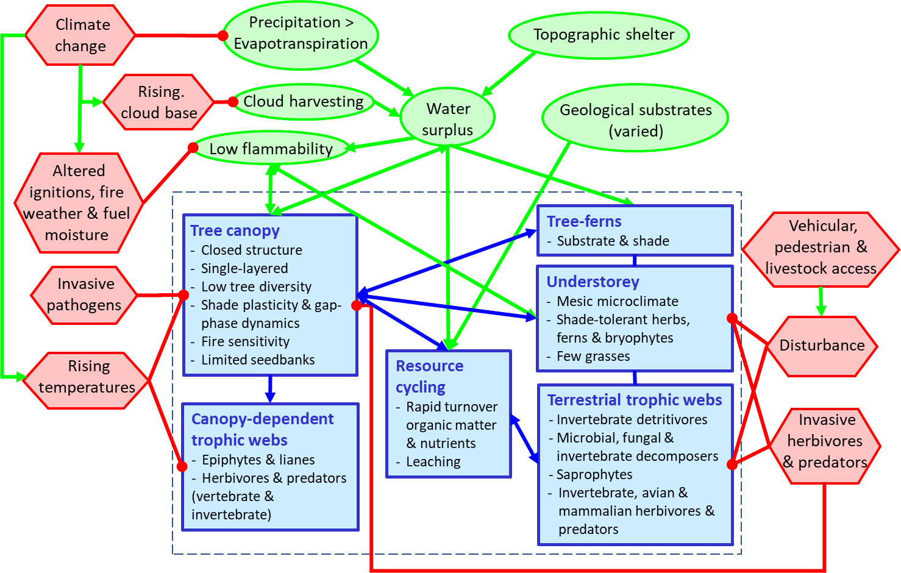
Figure B1. Model of ecosystem function and threats for Pinkwood cool temperate rainforests of south east New South Wales and far east Victoria, developed in collaboration with experts at the Species Expert Assessment Plan (SEAPs) workshop on rainforests and wet forests of south-eastern Australia, held in Bateman’s Bay, May 2022.
Key components (blue rectangles), ecological processes (green ellipses), interactions (lines) and threats (red hexagons) that characterise Pinkwood cool temperate rainforests of south east New South Wales and far east Victoria. Arrows show positive effects (e.g. facilitation), circles show negative effects.

Appendix C – Relationship to other vegetation classification and mapping systems
Ecological communities are complex to classify. States and Territories apply their own systems to classify vegetation communities, which may be fundamentally different to nationally-listed threatened ecological communities. Reference to vegetation and mapping units as equivalent to the ecological community, at the time of listing, should be taken as indicative rather than definitive. A unit that is generally equivalent may include elements that do not meet the key diagnostics and minimum condition thresholds. Conversely, areas mapped or described as other units may sometimes meet the key diagnostics for the ecological community. Judgement of whether the ecological community is present at a particular site should focus on how the site meets the description (section 1.2), the key diagnostic characteristics (section 2.1) and minimum condition thresholds (section 2.3 ).
State vegetation mapping units are not the ecological community being listed. However, for many sites (but not all) certain vegetation map units will correspond sufficiently to provide indicative mapping for the national ecological community, where the description matches.
On-ground assessment is vital to finally determine if any area is an occurrence of the ecological community.
A series of regional-scale vegetation surveys have been carried out that describe plant species assemblages referrable to Pinkwood cool temperate rainforests of south east New South Wales and far east Victoria. The currently adopted Plant Community Type (PCT) classification also includes assemblages that are referrable to this ecological community. Table 6 summarises referrable classification units and their sources.
Table 6: Relationships of regional vegetation classifications and their sources that likely correspond (wholly, or in part) to the ecological community (i.e. where key diagnostic characteristics are met).
Classification unit | Source | Relationships
Community type 1: Cool temperate rainforest | Helman (1983) | Wholly corresponds
Community type 2: Intermediate cool temperate – warm temperate rainforest | Helman (1983) | Wholly corresponds
Map unit 8: Cool temperate rainforest | Keith & Bedward (1999) | Wholly corresponds
Vegetation class 1a | Gellie (2005) | Wholly corresponds
RF p317: South east Cool Temperate Rainforest | Tozer et al. (2010) | Wholly corresponds
RF p116: Intermediate Temperate Rainforest | Tozer et al. (2010) | Partly corresponds.  Occurrences of RF p116 at higher elevations (>600 m ASL) south from Sassafras correspond with the ecological community.
Alliance Cool Temperate Rainforest Eucryphia Alliance  Sub-Alliances  52 Eucryphia moorei  53 Eucryphia moorei - Elaeocarpus holopetalus  54 Eucryphia moorei - Doryphora sassafras/ Atherosperma moschatum  55 Eucryphia moorei – Acmena smithii  56 Elaeocarpus holopetalus – Atherosperma moschatum  57 Elaeocarpus holopetalus  Warm Temperate Rainforest Ceratopetalum Alliance  38 Ceratopetalum Eucryphia Doryphora Acmena  Warm Temperate Rainforest Acmena alliance  44 Acmena Eucryphia Doryphora | Floyd (1990) | Wholly corresponds
NSW PCT 3054  South east Cool Temperate Rainforest | NSW DCCEEW (2024): PCT classification | Wholly corresponds
NSW PCT 4106  Illawarra Escarpment Cool Temperate Rainforest | NSW DCCEEW (2024): PCT classification | Wholly corresponds
NSW PCT 3028  Illawarra Escarpment Warm Temperate Rainforest | NSW DCCEEW (2024): PCT classification | Partly corresponds.  Mostly excluded from the ecological community, but small areas meeting key diagnostic characteristics included. Nowra to Wollongong/Cataract region.
NSW PCT 3036  South Coast Warm Temperate-Subtropical Rainforest | NSW DCCEEW (2024): PCT classification | Partly corresponds.  Mostly excluded from the ecological community, but small areas meeting key diagnostic characteristics included. Nowra to Wollongong/Cataract region.
NSW PCT 3046  Southeast Warm Temperate Rainforest | NSW DCCEEW (2024): PCT classification | Partly corresponds.  Mostly excluded from the ecological community, but small areas meeting key diagnostic characteristics included. SE corner of NSW.
NSW PCT 3077  Illawarra Complex Dry Rainforest | NSW DCCEEW (2024): PCT classification | Partly corresponds.  Mostly excluded from the ecological community, but small areas meeting key diagnostic characteristics included. Kiama escarpment region.
Vic EVC 31: Cool Temperate Rainforest | DEECA (2023):  EVC classification | Partly corresponds.  Mostly excluded from the ecological community, but transitional outliers at low elevation on the Howe Range are included.
Vic EVC 32: Warm Temperate Rainforest | DEECA (2023):  EVC classification | Partly corresponds.  Mostly excluded from the ecological community, but small areas meeting key diagnostic characteristics included. Howe Range.
Warm temperate rainforest | DELWP (2020) | Partly corresponds.  Mostly excluded from the ecological community, but small areas meeting key diagnostic characteristics included. Howe Range.
Warm Temperate Rainforest (Cool Temperate Overlap, Howe Range) | SAC (1996) | Wholly corresponds.

References
- Abram NJ, Henley BJ, Sen Gupta A et al. (2021) Connections of climate change and variability to large and extreme forest fires in south east Australia. Commun Earth Environ 2, 8. https://doi.org/10.1038/s43247-020-00065-8
- Adam P (1994) Australian rainforests. Oxford University Press, Oxford.
- ANH Australian National Herbarium (2012) Information about Australian native plants: Eucryphia moorei. Australian National Botanic Gardens and Centre for Australian National Biodiversity Research, Canberra. Available at: https://www.anbg.gov.au/gnp/gnp14/eucryphia-moorei.html
- Aravena R, Lyons M, Roff A & Keith DA (2021) A colourimetric approach to ecological remote sensing: Case study for the Rainforests of south-eastern Australia. Remote Sensing 13, 2544.
- Ashton DH & Bassett OD (1997) The effects of foraging by the superb lyrebird (Menura novae-hollandiae) in Eucalyptus regnans forests at Beenak, Victoria. Australian Journal of Botany 22, 383–394.
- Auld TD & Leishman MR (2015) Ecosystem risk assessment for Gnarled Mossy Cloud Forest, Lord Howe Island, Australia. Austral Ecology 40, 364-372.
- Baur GN (1965) Forest types in New South Wales. Research Note No. 17. Forestry Commission of New South Wales, Sydney.
- Baur GN (1989) Forest types of New South Wales. Research Note 17. Revised edition. Forestry Commission of NSW, Sydney.
- Bazzaz FA & Pickett STA (1980) Physiological ecology of tropical succession: A comparative review. Annual Review of Ecology & Systematics 11, 287–310.
- Bland L, Keith D, Miller R, Murray N & Rodriguez J (eds) (2017) Guidelines for the application of IUCN Red List of Ecosystem Categories and Criteria, Version 1.1. IUCN, Switzerland. Available from https://www.iucn.org/es/content/guidelines-application-iucn-red-list-ecosystems-categories-and-criteria
- Berry LE, Driscoll DA, Banks S& Lindenmayer DB (2015) The use of topographic fire refuges by the greater glider (Petauroides volans) and the mountain brushtail possum (Trichosurus cunninghami) following a landscape-scale fire. Australian Mammalogy 37, 39–45.
- Boer MM, Resco de Dios V & Bradstock RA (2020) Unprecedented burn area of Australian mega forest fires. Nature Climate Change 10, 171–172.
- Bond WJ (2020) Open Ecosystems: ecology and evolution beyond the forest edge. Oxford University Press, Oxford.
- Bowman DMJS (2000) Australian rainforests: islands of green in a land of fire. Cambridge University Press, Cambridge.
- Bruijnzeel LA (2001) Hydrology of tropical montane cloud forests: a reassessment. Land use and water resources research, 1(1), 1.
- Bull JK, Sands CJ, Garrick RC, Gardner MG, Tait NN, Briscoe DA, et al. (2013) Environmental Complexity and Biodiversity: The Multi-Layered Evolutionary History of a Log-Dwelling Velvet Worm in Montane Temperate Australia. PLoS ONE 8(12): e84559. doi:10.1371/journal.pone.0084559
- Bureau of Meterorology (2021) Recent and historical rainfall maps. Australian Government. Available from: http://www.bom.gov.au/climate/maps/rainfall/?variable=rainfall&map=totals&period=daily&region=nat&year=2022&month=07&day=01
- Canadell JG, Meyer CPM, Cook GD, Dowdy A, Briggs PR, Knauer J, Pepler A & Haverd V (2021) Multi-decadal increase of forest burned area in Australia is linked to climate change. Nature Communications 12, 6921.
- Collins, L, Bradstock, RA, Clarke, H, Clarke, MF, Nolan, RH & Penman TD (2021). The 2019/2020 mega-fires exposed Australian ecosystems to an unprecedented extent of high-severity fire. Environmental Research Letters 16, 044029.
- Connell JH, Tracey JG & Webb LJ (1984) Compensatory recruitment, growth, and mortality as factors maintaining rain forest tree diversity. Ecological Monographs 54(2), 141–164.
- Couper P & Hoskin C (2008) Litho-refugia: the importance of rock landscapes for the long-term persistence of Australian rainforest fauna. Australian Zoologist, 34 (4), 554–560. doi: https://doi.org/10.7882/AZ.2008.032
- Cowan T, Purich A. Perkins S, Pezza A, Boschat G. Sadler K. (2014) More frequent, longer, and hotter heat waves for Australia in the twenty-first century. Journal of Climate 27 (15), 5851–5871.
- Davis NE, Bennett A, Forsyth DM, Bowman DMJS, Lefroy EC, Wood SW, Woolnough AP, West P, Hampton JO & Johnson CN (2016) A systematic review of the impacts and management of introduced deer (family Cervidae) in Australia. Wildlife Research 43, 515–32.
- DAWE (2020) NIAFED: National Indicative Aggregated Fire Extent Database. Department of Agriculture, Water & Environment, Australian Government. http://www.environment.gov.au/fed/catalog/search/resource/details.page?uuid=%7B9ACDCB09-0364-4FE8-9459-2A56C792C743%7D
- DAWE [Department of Agriculture, Water and the Environment] (2022) Fire regimes that cause declines in biodiversity – Advice to the Minister for the Environment from the Threatened Species Scientific Committee on amendments to the List of Key Threatening Processes under the Environment Protection and Biodiversity Conservation Act 1999. Australian Government, Canberra.
- DCCEEW [Department of Climate Change, Energy, the Environment and Water] (2020) Australian Google Earth Engine Burnt Area Map (AUS GEEBAM). Available at: https://fed.dcceew.gov.au/maps/6f3b09d1852043478883af7e774796ff/about
- DELWP [Department of Energy, Environment and Climate Action] (2019) Native Vegetation – Modelled 2005 Ecological Vegetation Classes (with Bioregional Conservation Status) [Dataset]. Victorian Government. Available at https://discover.data.vic.gov.au/dataset/native-vegetation-modelled-2005-ecological-vegetation-classes-with-bioregional-conservation-sta
- Department of Energy, Environment and Climate Action (2023) Native Vegetation – Modelled 2005 Ecological Vegetation Classes (with Bioregional Conservation Status) [Dataset]. Victorian Government. Available at https://discover.data.vic.gov.au/dataset/native-vegetation-modelled-2005-ecological-vegetation-classes-with-bioregional-conservation-sta
- DoE [Department of the Environment] (2013). Interim Biogeographic Regionalisation for Australia (Subregions–- States and Territories) Version 7. Downloaded June 2022. Available at https://www.dcceew.gov.au/environment/land/nrs/science/ibra#ibra
- Doherty MD, Robertson G, Corcoran D and Wright G (2011) Cool Temperate Rainforest in the Pilot Wilderness Area, Kosciuszko National Park, New South Wales: Distribution, composition and impact of the 2003 fires. Cunninghamia 12 (2), 119–127.
- DPIE [Department of Planning, Industry & Environment] (2021) Australian Soil Classification (ASC) Soil Type map of NSW [Online]. Parramatta, NSW: NSW Department of Planning, Industry and Environment. Available: https://datasets.seed.nsw.gov.au/dataset/australian-soil-classification-asc-soil-type-map-of-nsweaa10
- Dyer JM (2009) Assessing topographic patterns in moisture use and stress using a water balance approach. Landscape Ecology 24, 391–403.
- Edwards J (2017) Our Dreaming: The Indigenous link between the physical and spiritual world. Published 23 January 2017. SBS Voices. Available at: https://www.sbs.com.au/voices/article/our-dreaming-the-indigenous-link-between-the-physical-and-spiritual-world/c1ttdtwrc
- Egloff B, Peterson N & Wesson SC & New South Wales. Office of the Registrar, Aboriginal Land Rights Act 1983 (2005) Biamanga and Gulaga: Aboriginal cultural association with the Biamanga and Gulaga National Parks. Office of the Registrar, Aboriginal Land Rights Act 1983 Surry Hills, NSW.
- Elliott TF & Vernes K (2019) Superb Lyrebird Menura novaehollandiae mycophagy, truffles and soil disturbance. Ibis 161, 198–204.
- Ferrer-Paris JR & Keith DA (2022) Fire Ecology Traits for Plants: A database for fire research and management. Version 1.00. Centre for Ecosystem Science, University of New South Wales, Sydney, Australia.
- Floyd AG (1990) Australian rainforests in New South Wales. Volumes 1 & 2. Surrey Beatty and Sons, Chipping Norton.
- Forster PI & Hyland BPM (1997) Two new species of Eucryphia Cav. (Cunoniaceae) from Queensland. Austrobaileya, 4(4), 589–596. http://www.jstor.org/stable/41738890
- Forsyth DM, Gormley AM, Woodford L & Fitzgerald T (2012) Effects of large-scale high-severity fire on occupancy and abundances of an invasive large mammal in south-eastern Australia. Wildlife Research 39, 555–564.
- Garrick RC, Rowell DM & Sunnucks P (2012) Phylogeography of Saproxylic and Forest Floor Invertebrates from Tallaganda, South-eastern Australia. Insects3(1), 270–94. doi: 10.3390/insects3010270.
- Gellie NJH (2005) Native vegetation of the Southern Forests: South-east Highlands, Australian Alps, South-west Slopes and SE Corner bioregions. Cunninghamia 9(2), 219–253.
- Giljohann KM, McCarthy MA, Keith DA, Kelly L, Tozer MG & Regan TJ (2017) Interactions between rainfall, fire and herbivory drive resprouter vital rates in a semi-arid ecosystem. Journal of Ecology 105, 1562–1570. [DOI: 10.1111/1365-2745.12768]
- Hansen K (1987) Reproductive biology of Eucryphia moorei (F. Muell). Honours Thesis. Department of Zoology, Australian National University.
- Heaton DJ, McHenry MT & Kirkpatrick JB (2022) The Fire and fodder reversal phenomenon: vertebrate herbivore activity in burned and unburned Tasmanian ecosystems. Fire 5, 111. [https://doi.org/10.3390/fire5040111]
- Helman C (1983) Inventory analysis of southern New South Wales rainforest vegetation. MSc thesis. University of New England, Armidale.
- Helman C (1987) Rainforest in southern New South Wales. In: The rainforest legacy: Australian national rainforests study. Volume 1 (Eds. G Werren, P Kershaw), pp47–70. Australian Government Publishing Service, Canberra.
- Hnatiuk R, Thackway R & Walker J (2009) Vegetation. In: The Australian soil and land survey field handbook (Ed. National Committee on Soil and Terrain), pp73-146. CSIRO Publishing, Collingwood.
- Hopkins MS & Graham AW (1987) The viability of seeds of rainforest species after experimental soil burials under tropical wet lowland forest in north-eastern Australia. Australian Journal of Ecology 12, 97–108.
- Hoffmann AA, Rymer PD, Byrne M, Ruthrof KX , Whinam J, McGeoch M, Bergstrom DM, Guerin GR, Sparrow B, Joseph L, Hill SJ, Andrew NR, Camac J, Bell N, Riegler M, Gardner JL & Williams SE (2019) Impacts of recent climate change on terrestrial flora and fauna: Some emerging Australian examples. Austral Ecology 44, 3–27.
- Hradsky BA (2020) Conserving Australia’s threatened native mammals in predator-invaded, fire-prone landscapes. Wildlife Research 47, 1–15.
- Johnson RD & Lacey CJ (1983) Multistemmed trees in rainforest. Australian Journal of Botany 31, 189–195.
- Karypis G, Han E-H & Kumar V (1999) CHAMELEON A hierarchical clustering algorithm using dynamic modelling. Computer 32(8), 68–75.
- Keith DA (1996) Fire-driven mechanisms of extinction in vascular plants: a review of empirical and theoretical evidence in Australian vegetation. Proceedings of the Linnean Society of New South Wales 116, 37–78.
- Keith DA (2004) Ocean shores to desert dunes: the native vegetation of New South Wales and the ACT. NSW Department of Environment and Conservation, Sydney.
- Keith DA (2012) Functional traits: their roles in understanding and predicting biotic responses to fire regimes. In: Flammable Australia: fire regimes, biodiversity and ecosystems in a changing world. Second edition (Eds. RA Bradstock, RJ Williams and AM Gill), pp97–125. CSIRO, Melbourne.
- Keith DA & Pellow BJ (2005) Effects of Javan Rusa deer (Cervus timorensis) on native plant species in the Jibbon-Bundeena area, Royal National Park, New South Wales. Proceedings of the Linnean Society of New South Wales 126, 99–110.
- Keith DA & Simpson CC (2016) Vegetation Formations and Classes of NSW (version 3.03–- 200m Raster). NSW Office of Environment & Heritage, Sydney. Available from: https://datasets.seed.nsw.gov.au/dataset/vegetation-classes-of-nsw-version-3-03-200m-raster-david-a-keith-and-christopher-c-simpc0917
- Keith DA, Ferrer-Paris JR, Nicholson E, Bishop MJ, Polidoro BA, Ramirez-Llodra E, Tozer MG, Nel JL, Mac Nally R, Gregr EJ, Watermeyer KE, Essl F, Faber-Langendoen D, Franklin J, Lehmann CER, Etter A, Roux D, Stark JS, Rowland JA, Brummitt NA, Fernandez-Arcaya UC, Suthers IM, Wiser SK, Donohue I, Jackson LJ, Pennington RT, Iliffe TM, Gerovasileiou V, Giller P, Robson BJ, Pettorelli N, Andrade A, Lindgaard A, Tahvanainen T, Terauds A, Chadwick MA, Murray NJ, Moat J, Pliscoff P, Zager I & Kingsford RT (2022a) A function-based typology for Earth’s ecosystems. Nature 610, 513–518. [doi: 10.1038/s41586-022-05318-4]
- Keith DA, Allen SP, Gallagher RV, Mackenzie BDE, Auld TD, Barrett S, Buchan A, English V, Gosper C, Kelly D, McIllwee A, Melrose RT, Miller BJ, Neldner J, Tolsma AD, White MD, Rogers D, van Leeuwen S, Yates CJ & Tozer MG (2022b). Fire-related threats and transformational change in Australian ecosystems. Global Ecology and Biogeography 31, 2070–2084. [doi: 10.1111/geb13500]
- Keith DA, Hay S, Murray A, Lloyd C, Simpson CC, Etchells H & Tozer MG (2023) Species Expert Assessment Plan Project: Ecological Communities. Final Report to the Department of Climate Change, Energy, the Environment and Water. Centre for Ecosystem Science, University of NSW, Sydney.
- Kirono DGC, Round V, Heady C, Chiew FHS & Osbrough S (2020) Drought projections for Australia: Updated results and analysis of model simulations. Weather and Climate Extremes 30, 100280. [https://doi.org/10.1016/j.wace.2020.100280]
- Kodela P (1992) Native vegetation remnants and notes on some rare and locally significant plant species in the Robertson area, New South Wales. Eucryphia 6, 6–9.
- Kodela P (1990b) Robertson plateau rainforest: remnants of the Yarrawa Brush. National Parks Journal 34(4), 28–31.
- Lamb D (1991) Variability and change in nutrient cycling in Australian rainforests. In: The rainforest legacy: Australian national rainforests study. Volume 2 (Eds. G Werren, P Kershaw), pp83–91. Australian Government Publishing Service, Canberra.
- Lawes Richardson SJ, Clarke PJ, Midgley JJ, McGlone MS & Bellingham PJ (2014) Bark thickness does not explain the different susceptibility of Australian and New Zealand temperate rain forests to anthropogenic fire. Journal of Biogeograpahy 41, 1467–1477.
- Leigh JH & Holgate MD (1979) The responses of the understorey of forests and woodlands of the Southern Tablelands to grazing and burning. Australian Journal of Ecology 4, 25–45.
- Lindenmayer DB, Hobbs RJ, Likens GE, Krebs CJ & Banks SC (2011) Newly discovered landscape traps produce regime shifts in wet forests. Proceedings of the National Academy of Sciences of the United States of America 108, 15887–15891.
- Lindenmayer DB, Blanchard W, McBurney L, Blair D, Banks SC, Driscoll D, Smith AL, Gill AM (2013) Fire severity and landscape context effects on arboreal marsupials. Biological Conservation 167, 137–148.
- Lusk CH, Kelly JWG & Gleason SM (2013) Light requirements of Australian tropical vs. cool-temperate rainforest tree species show different relationships with seedling growth and functional traits. Annals of Botany 111, 479–488.
- Maisey, AC Haslem, A, Leonard, SWJ & Bennett AF (2021) Foraging by an avian ecosystem engineer extensively modifies the litter and soil layer in forest ecosystems. Ecological Applications 31(1), e02219.
- Maisey AC, Haslem A, Leonard, SWJ & Bennett AF (2022) Differential effects of ecosystem engineering by the superb lyrebird Menura novaehollandiae and herbivory by large mammals on floristic regeneration and structure in wet eucalypt forests. Ecology & Evolution 12(6), e8956.
- Makinson RO (2018) Myrtle Rust reviewed: the impacts of the invasive pathogen Austropuccinia psidii on the Australian environment. Plant Biosecurity Cooperative Research Centre, Canberra. Available from: https://anpc.asn.au/wp-content/uploads/2019/02/Myrtle_Rust_reviewed_June_22_2018_web_ALL.pdf
- Mallick SA (2001) Pollination ecology of Tasmanian leatherwood (Eucryphia lucida Eucryphiaceae Labill.) and the impacts of hive honeybees. University Of Tasmania. Thesis. https://doi.org/10.25959/23228651.v1
- McCormack RJ (1996) A review of forest practice codes in Australia. In: Forest codes of practice: Contributing to environmentally sound forest operations (Eds. DP Dykstra, R Heinrich), pp105-116. Food and Agriculture Organisation of the United Nations. Available from: https://www.fao.org/3/W3646E/w3646e0f.htm
- McLean CM, Kavanagh RP, Penman T& Bradstock R (2018) The threatened status of the hollow dependent arboreal marsupial, the Greater Glider (Petauroides volans), can be explained by impacts from wildfire and selective logging. Forest Ecology and Management 415–416, 19–25.
- Metcalfe DJ & Green PT (2017) Rainforests and vine thickets. In: Australian vegetation (Ed. DA Keith), pp257–280. Third edition. Cambridge University Press, Cambridge.
- Mills K (1987). The distribution, character and conservation status of the rainforests of the Illawarra district, New South Wales In The Rainforest Legacy: Australian National Rainforests Study Volume 1. Australian Government Publishing Services. Canberra
- Mills K (1988) The clearing of Illawarra rainforest: problems in reconstructing pre European vegetation patterns. Australian Geographer 19(2), 230–240.
- Mills K (1985) Cool Temperate Rainforests: New South Wales In: Rainforests of Australia, Weldons, Sydney pp. 185–198.
- Mooney SD, Sniderman K, Kershaw P, Haberle S & Roe J (2017) Quaternary vegetation in Australia. In: Australian vegetation (Ed. DA Keith), pp63–88. Third edition. Cambridge University Press, Cambridge.
- Moore GW, Bond BJ, Jones JA, Phillips N & Meinzer FC (2004) Structural and compositional controls on transpiration in a 40- and 450-yr-old riparian forest in western Oregon, USA. Tree Physiol. 24, 481–491.
- Murray KA, Retallick R, McDonald KR, Mendez D, Aplin K, Kirkpatrick P, Berger L, Hunter D, Hines HB, Campbell R, Pauza M, Driessen M, Speare R, Richards SJ, Mahony M, Freeman A, Phillott AD, Hero J-M, Driscoll D, Puschendorf R & Skerratt LF (2010) The distribution and host range of the pandemic disease chytridiomycosis in Australia spanning surveys from 1956 to 2007. Ecology 91, 1557.
- Murray KA., Retallick RWR, Puschendorf R, Skerratt LF, Rosauer D, McCallum H, Berger L, Speare R & van der Wal J (2011) Assessing spatial patterns of disease risk to biodiversity: implications for the management of the amphibian pathogen, Batrachochytrium dendrobatidis. Journal of Applied Ecology 48(1), 163–173.
- National Committee on Soil and Terrain (2009) Australian Soil and Land Survey Field Handbook, Australia. CSIRO Publishing, Melbourne.
- Nilar H, Kimberly Maute K, Dawson MJ, Scarborough R, Hudson J, Reay J & Gooden B (2019) Effectiveness of different herbivore exclusion strategies for restoration of an endangered rainforest community. Forest Ecology and Management 435, 18–26.
- Nolan RH, Boer MM, Collins L, Resco de Dios V, Clarke H, Jenkins M, Kenny B & Bradstock RA (2020) Causes and consequences of eastern Australia’s 2019-20 season of mega-fires. Global Change Biology 26, 1039–1041.
- NSW National Parks and Wildlife Service (1995) Budderoo National Park, Macquarie Pass National Park, Barren Grounds Nature Reserve and Robertson Nature Reserve: Draft Plan of Management. NSW National Parks and Wildlife Service. Sydney
- NSW DCCEEW [Department of Climate Change, Energy, the Environment and Water] (2024). NSW State Vegetation Type Map (SVTM) Version C2.0 M2.1 [Dataset]. NSW Government. Available at https://datasets.seed.nsw.gov.au/dataset/nsw-state-vegetation-type-map.
- NSW NPWS (2001) Morton National Park and Budawang National Park Plan of Management. NSW National Parks and Wildlife Service, Nowra. https://www.environment.nsw.gov.au/-/media/OEH/Corporate-Site/Documents/Parks-reserves-and-protected-areas/Parks-plans-of-management/morton-budawang-national-parks-plan-of-management-010131.pdf
- NSW NPWS (2006) South East Forest National Park and Egan Peaks Nature Reserve Plan of Management. https://www.environment.nsw.gov.au/-/media/OEH/Corporate-Site/Documents/Parks-reserves-and-protected-areas/Parks-plans-of-management/south-east-forests-national-park-egan-peaks-reserve-plan-of-management-060645.pdf
- NSW NPWS (2011a) Deua & Monga National Parks (incl. Badja Swamps NR, Berlang, Frogs Hole and Monga SCA’s) Fire Management Strategy.
- NSW NPWS (2011b) Far South Coast Escarpment Parks Plan of Management. https://www.environment.nsw.gov.au/resources/planmanagement/final/20110159FarSthCoastFinal.pdf
- NSW NPWS (2014) Plan of Management Yuin Bangguri (Mountain) Parks. https://www.environment.nsw.gov.au/-/media/OEH/Corporate-Site/Documents/Parks-reserves-and-protected-areas/Parks-plans-of-management/yuin-bangguri-mountain-parks-plan-of-management-150003.pdf
- Nugent DT, Leonard SWJ & Clarke MF (2014) Interactions between the superb lyrebird (Menura novaehollandiae) and fire in south-eastern Australia. Wildlife Research 41, 203–211.
- Peacock RJ & Baker PJ (2022) Informing post-fire recovery planning of northern NSW rainforests. Bushfire and Natural Hazards CRC, Melbourne.
- Peel B (1999) Rainforests and cool temperate mixed forests of Victoria. Victorian Department of Natural Resources and Environment, Melbourne.
- Peel B, Bilney RJ & Bilney RJ (2005) Observations of the ecological impacts of Sambar Cervus unicolor in East Gippsland, Victoria, with reference to destruction of rainforest communities. The Victorian Naturalist 122, 189–200.
- Pegg G, Shuey L, Giblin F, Price R, Entwistle P, Carnegie A, McTaggart A & Firn J (2021) Fire and rust – impact of myrtle rust on post-fire regeneration. Project 8.3.5 update report. NESP Threatened Species Recovery Hub, Brisbane.
- Pfeifer M, Gonsamo A, Woodgate W et al. (2018) Tropical forest canopies and their relationships with climate and disturbance: results from a global dataset of consistent field-based measurements. Forest Ecosystems 5, 7. https://doi.org/10.1186/s40663-017-0118-7
- Pypker TG, Mix AC, Unsworth MH, Rugh W, Ocheltree T, Alstad K & Bond BJ (2007) Using nocturnal cold air drainage flow to monitor ecosystem processes in complex terrain: a pilot study on the carbon isotopic composition, advection of ecosystem, respiration. Ecol. Appl. 17, 702–714.
- Reid CAM (1992) The leaf-beetle genus Microdonacia Blackburn (Coleoptera: chrysomelidae: galerucinae): revision and systematic placement. Systematic Entomology (1992) 17, 359–387.
- Robson PJ (1993) Checklist of Australian Trees: alphabetical listings of common and scientific names.
- Scheele BC, Skerratt LF, Grogan LF, Hunter DA, Clemann N, McFadden M, Newell D, Hoskin CJ, Gillespie GR & Heard GW (2017) After the epidemic: Ongoing declines, stabilizations and recoveries in amphibians afflicted by chytridiomycosis. Biological Conservation 206, 37–46.
- Scientific Advisory Committee (1996) Final Recommendation on a Nomination for Listing – Nomination No. 363 Warm Temperate Rainforest (Cool Temperate Overlap) Community. Victorian Flora and Fauna Guarantee Scientific Advisory Committee. Unpublished Report.
- Silver MJ & Carnegie AJ (2017) An independent review of bell miner associated dieback. Final report to the Project Steering Committee: systematic review of bell miner associated dieback. NSW Office of Environment and Heritage, Sydney.
- Singh A, Baker PJ, Kasel S, Trouvé, R, Stewart SB & Nitschke CR (2021) The role of climatic variability on Eucalyptus regeneration in south eastern Australia. Global Ecology and Conservation 32, e01929.
- Sivertsen D (2009) Native vegetation interim type standard. NSW Department of Environment & Climate Change & Water, Sydney. Available from: https://www.environment.nsw.gov.au/-/media/OEH/Corporate-Site/Documents/Research/Maps-and-data/native-vegetation-interim-type-standard-100060.pdf
- Sniderman K & Jordan G (2011) Extent and timing of floristic exchange between Australian and Asian rain forests. Journal of Biogeography. 38. 1445–1455. 10.1111/j.1365-2699.2011.02519.x.
- Standards Reference Group SERA (2021) National Standards for the Practice of Ecological Restoration in Australia. Edition 2.2. Society for Ecological Restoration Australasia. Available from http://www.seraustralasia.com/pages/standards.html
- Stiles A (1991) Checklist of vascular plants in Robertson rainforest. Eucryphia 2, 4–8.
- Tolsma A, Hale R, Sutter G & Kohout M (2019) Post-fire dynamics of Cool Temperate Rainforest in the O’Shannassy Catchment. Arthur Rylah Institute for Environmental Research Technical Report Series No. 298. Department of Environment, Land, Water and Planning, Heidelberg, Victoria.
- Tozer MG, Turner K, Keith DA, Tindall D, Pennay C, Simpson C, MacKenzie B, Beukers P & Cox S (2010) Native vegetation of south east NSW: a revised classification and map for the coast and eastern tablelands. Cunninghamia, 11, 359–406.
- Trouvé R, Oborne L & Baker PJ (2021) The effect of species, size, and fire intensity on tree mortality within a catastrophic bushfire complex. Ecological Applications 31, e02383.
- TSSC [Threatened Species Scientific Committee] (2017). Guidelines for nominating and assessing the eligibility for listing of ecological communities as threatened according to the Environment Protection and Biodiversity Conservation Act 1999 and the EPBC Regulations 2000. Department of the Environment and Energy. Available from http://www.environment.gov.au/biodiversity/threatened/nominations/forms-and-guidelines
- Van Oldenborgh GJ, Krikken F, Lewis S, Leach NJ, Lehner F, Saunders KR, Van Weele M, et al. (2021) Attribution of the Australian bushfire risk to anthropogenic climate change. Natural Hazards and Earth System Sciences 21(3), 941–960.
- Walker J & Hopkins MS (1990) Vegetation. In: Australian Soil and Land Survey Field Handbook (Eds. RC McDonald, RF Isbell, JG Speight, J Walker & MS Hopkins). Second edition. Inkata Press, Melbourne.
- Webb LJ (1968) Environmental relationships of the structural types of Australian rain forest vegetation. Ecology 49, 296–311.
- Webb LJ & Tracey JG (1981) Australian rainforests: patterns and change. In: Ecological Biogeography of Australia, Monographie Biologicae 41, A. Keast (ed) (The Hague: W. Junk) 1(2): pp. 605–694.
- Webb LJ, Tracey JG & Williams WT (1984) A floristic framework of Australian rainforests. Australian Journal of Ecology 9, 169–198.
- Wood SW, Prior LD, Stephens HC & Bowman DMJS (2015) Macroecology of Australian Tall Eucalypt Forests: Baseline Data from a Continental-Scale Permanent Plot Network. PLoS ONE 10(9): e0137811. https://doi.org/10.1371/journal.pone.0137811
- Worth JRP, Jordan GJ, Marthick JR, McKinnon GE & Vaillancourt RE (2010) Chloroplast evidence for geographic stasis of the Australian bird-dispersed shrub Tasmannia lanceolata (Winteraceae). Molecular Ecology, 19: 2949–2963. https://doi.org/10.1111/j.1365-294X.2010.04725.x
- Worth JR, Marthick JR, Jordan GJ & Vaillancourt RE. (2011) Low but structured chloroplast diversity in Atherosperma moschatum (Atherospermataceae) suggests bottlenecks in response to the Pleistocene glacials. Annals of botany 108(7):1247–56. doi: 10.1093/aob/mcr220.

© Commonwealth of Australia 2024 
Ownership of intellectual property rights
Unless otherwise noted, copyright (and any other intellectual property rights) in this publication is owned by the Commonwealth of Australia (referred to as the Commonwealth).
Creative Commons licence
All material in this publication is licensed under a Creative Commons Attribution 4.0 International Licence except content supplied by third parties, logos and the Commonwealth Coat of Arms. Contact us to request permission to use material for purposes outside the terms stated on the website or on the material.
Cataloguing data
This publication (and any material sourced from it) should be attributed as: Department of Climate Change, Energy, the Environment and Water 2024, Draft Conservation Advice for Pinkwood cool temperate rainforests of south east New South Wales and far east Victoria, Canberra.
Department of Climate Change, Energy, the Environment and Water
GPO Box 858, Canberra ACT 2601
Telephone 1800 900 090
Web dcceew.gov.au
The Australian Government acting through the Department of Climate Change, Energy, the Environment and Water has exercised due care and skill in preparing and compiling the information and data in this publication. Notwithstanding, the Department of Climate Change, Energy, the Environment and Water, its employees and advisers disclaim all liability, including liability for negligence and for any loss, damage, injury, expense or cost incurred by any person as a result of accessing, using or relying on any of the information or data in this publication to the maximum extent permitted by law.
Version history table

Document type | Title | Date [dd mm yyyy]
Consultation Draft | Pinkwood cool temperate rainforests of south east New South Wales and far east Victoria Draft Conservation Advice | 25 06 2025
– | – | –

IUCN Global Ecosystem Typology https://global-ecosystems.org/explore/groups/T2.3
The production of many seeds by a plant every two or more years in regional synchrony with other plants of the same species” https://www.britannica.com/science/mast-seeding
Interim Biogeographical Regionalisation of Australia Version 7 (DoE 2013)
Closed forest canopies typically have crown cover >80% (touching or overlapping tree crowns) with foliage cover >70%, though sometimes 50-70%, when measured in plots (~0.1 ha) (Hnatiuk et al. 2009). See footnote 5 for exceptions.
Understorey features may be difficult to observe and assess after fire until regeneration progresses. Recent disturbance, such as fire, may remove the living canopy and cause a shift to a regenerative state. Under these circumstances, the loss is likely to be a temporary phenomenon, if natural regeneration is not disrupted. This temporary regenerative state is included as part of the ecological community when the other key diagnostic characteristics are met. In these cases, there should be evidence that the canopy species will regenerate from seedlings, saplings, basal resprouts or from epicormic regrowth. See section 2.2 for more information.
Top-kill: Death of the canopy and above-ground stems.
The estimates were based on gridded rainforest mapping produced using a combination of remote sensing and modelling methods employed by state agencies (Keith & Simpson 2016; DEECA 2023; Aravena et al. 2021). Mapped areas of rainforest were attributed to rainforest types using random forest models based on geocoded floristic plots obtained from state agencies as training points with a set of bioclimatic predictor variables (Keith et al. 2023). Plots were attributed to rainforest assemblages using a non-hierarchical multivariate clustering method (Karypis et al. 1999). Bioclimatic predictors were selected to represent the hypothesised constraints on rainforest development (https://www.worldclim.org/data/bioclim.html). The models were developed in the Biodiversity and Climate Change Virtual Laboratory (BCCVL) and EcoCommons platform (https://www.ecocommons.org.au/) for each of 30 rainforest assemblages defined from the analysis of available floristic plots in the south east Australian study area from Townsville to the Otway Ranges, west of Melbourne. Alternative mapped distributions were generated by applying different assembly rules to combine the models into a single layer : i) maximum probability across all 30 assemblage with no constraint; ii) maximum probability with balanced omission and commission errors; or iii) maximum probability constrained P>0.5 (more likely occurrence than absence) (Keith et al. 2023).

