

Technical options to address cooling seasonal performance calculation issues for air conditioners

Contents

Introduction 1

The issue 3

How the calculations in the standard relate to the performance calculations in the determination and regulations 4

T0 for Commercial use profiles 6

The relationship between rated and tested values 6

Technical options to address the issue 9

Applying the revised standard to rated values 9

Amending the allowance on the relationship between rated and tested values – tolerance 9

Amending the allowance on the relationship between rated and tested values – Slope 10

Next steps 11

Questions 11

## Introduction

Seasonal performance ratings for air conditioners were introduced in 2019, becoming mandatory for new air conditioner models in Australia in 2020 and New Zealand in 2021. The Zoned Energy Rating Label (ZERL) provides detailed information on an air conditioner’s seasonal performance, including a star rating and annual running cost for heating and cooling across three climate zones in Australia and New Zealand.

Figure 1 below provides an example of the ZERL.

Figure 1: Example of the ZERL

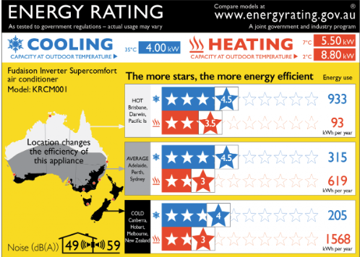

The equations that drive the star ratings and energy consumption figures for cooling are set out in the standard AS/NZS 3823.4.1 2014 +A1 - Air conditioners - Cooling seasonal calculations and in the:

* Greenhouse and Minimum Energy Standards (GEMS) Determination in Australia, and
* Energy Efficiency (Energy Using Products) Regulations 2002 (EUP) in New Zealand.

There is a flaw in the equations that allows the energy efficiency of air conditioners to be overstated for cooling, implying lower energy consumption and earning more stars than what can be reasonably achieved by a product. This issue can result in a 17% increase in Total Cooling Seasonal Performance Factor (TCSPF) for the Residential use case in the Cold zone and a 310% increase in TCSPF for the Commercial use case in the Cold zone. This is misleading to purchasers of air conditioners and disadvantageous for businesses who do not take advantage of this flaw in the equations.

The standard is being amended to fix this issue, but the determination and regulations will also need to be amended to pick up the amended standard and deal with the consequences for current and future registrations of affected air conditioners.

The Department of Climate Change, Energy, the Environment and Water (DCCEEW) in Australia, and the Energy Efficiency and Conservation Authority (EECA) in New Zealand are seeking stakeholders’ views on two technical issues:

* how rated values are treated in the determination and regulations; and
* the minimum temperature at which cooling is assumed to be used in performance calculations for commercial settings.

The issues and implications of the proposals are explored in the body of the paper.

Adoption of the revised standard alone would result in different cooling performance in a significant proportion of registered air conditioners, necessitating re-registration and new ZERLs.

In evaluating the options, DCCEEW and EECA will consider the views of industry and interested parties, as well as other factors, including:

* How much overstated performance can be claimed (after applying the proposed option), and
* How many registrations and ZERLs would be affected by the change.

In New Zealand further consultation will be conducted at the appropriate time if any regulatory change is considered to the Energy Efficiency (Energy Using Products) Regulations 2002 because of this technical consultation.

## The issue

Under the standard, AS/NZS 3823.4.1: 2014[1] (based on ISO 16358-1:2013), tested or default input power values are used to determine the Total Cooling Seasonal Performance Factor (TCSPF). TCSPF is used to determine the star rating on the ZERL and cooling season total energy consumption (TECcs). TECcs is used to determine the annual energy consumption figure on the ZERL. The tested or default values are determined under the following conditions:

* **Standard Cooling (T1)**: Indoor Dry Bulb 27°C / Wet Bulb 19°C and Outdoor Dry Bulb 35°C / Wet Bulb 24°C and
* **Low temperature cooling (Low Temperature cooling test point)**: Indoor Dry Bulb 27°C / Wet Bulb 19°C and Outdoor Dry Bulb 29°C / Wet Bulb 19°C.

Measurements at each test point may include the Full Capacity, Half Capacity and Minimum Capacity operating points of the air conditioner. Some of tests at these points are mandatory and others are optional, depending on the type of air conditioner being tested.

A line is extrapolated and interpolated between the test point data (T1 and Low Temperature cooling test points) to provide power input and capacity data at the range of temperatures that may be experienced in a particular climate. T0 is the term used to specify the outdoor temperature at which cooling is first used. For example, if T0 is specified as 17°C then the performance calculations will assume the air conditioner is not used for cooling when the outdoor temperature is 17°C or below.

If the T1 input power is unusually larger than the Low Temperature cooling input power, or if the outdoor temperature is significantly lower than the low temperature cooling capacity test point (29°C), or both, the calculated input power can become negative, which is a nonsensical result.

The revision to the ISO standard (16358-1:2013) requires that where optional test data for half capacity or minimum capacity have been used and these values lead to results in the power input figure falling below zero within T0 – 5, then default values are applied to the power input figures instead. This is expressed mathematically in the standard as set out below:

The temperature Tz,haf at which Phaf is equal to zero shall be determined by the formula:

A formula for calculating at what external temperature the power input for cooling would be equal to zero for an air conditioner running at half capacity.

If Tz,haf is greater than T0-5, the optional half capacity and power data shall be deemed invalid and default values shall be used. The default values at the low temperature cooling test point are a capacity of 1.077 times the capacity at T1 and a power input of 0.914 times the power input at T1.

For minimum capacity and power data, the temperature Tz,min at which Pmin is equal to zero is determined by the formula:

A formula for calculating at what external temperature the power input would be equal to zero when an air conditioner is running at minimum capacity.

If Tz,min is greater than T0-5, the optional minimum capacity and power data shall be deemed invalid, and shall not be used.

The revised standard also includes the note that the outdoor temperature for T0 “can be no lower than 18°C” for “valid calculations”. The Australia/New Zealand standards committee has resolved to make the same amendment to AS/NZS 3823.4.1. This amendment is expected to be made in 2025.

Adopting the revised standard in legislation would lead to optional half capacity and power data, or minimum capacity and power data, or both, that has been used in test reports to register several hundreds of models of air conditioner to be deemed invalid. This is because the test results would not meet the new validity requirement (T0 – 5), and so default values would have to be used. Approximately 17% of current registrations [740/4360], and 17% of registrations that require a ZERL [338/1984]) would be deemed invalid.

The difference between the rated and default “tested” values would in many cases be outside the rated and tested allowance specified in the current determination and regulations as set out in Table 1 on page 7. Therefore, even if the only change made to the determination and regulations was to cite the revised standards, several hundred registrations would not meet the requirements of the revised legislation without modification of rated values. This would require updates to registrations or the re-registering of affected air conditioners.

As several hundreds of registrations would be affected, we are interested in views on what is a suitable transition period to make the change, including the requirement to display a revised label. It should be noted that the determination and regulations cannot be applied retrospectively. Any air conditioner imported into Australia or New Zealand before the change comes into force can be sold without complying with the new determination or amended regulations, but must still comply with the previous determination or regulations.

## How the calculations in the standard relate to the performance calculations in the determination and regulations

A methodology based on the calculations in the standard is used to calculate the seasonal performance of air conditioners that is reported in the [publicly available database](https://reg.energyrating.gov.au/comparator/product_types/) and displayed on the Zoned Energy Rating Label.

The performance of air conditioners is calculated for three climate zones: Hot, Average, and Cold (called Hot & Humid, Mixed, and Cold in the standard) under Residential and Commercial usage profiles.

For each of the climate zones there is a set number of hours at each temperature point at which cooling is assumed to be used under Residential and Commercial profiles.

Figure 2: Cooling hours by temperature, climate zone and profile

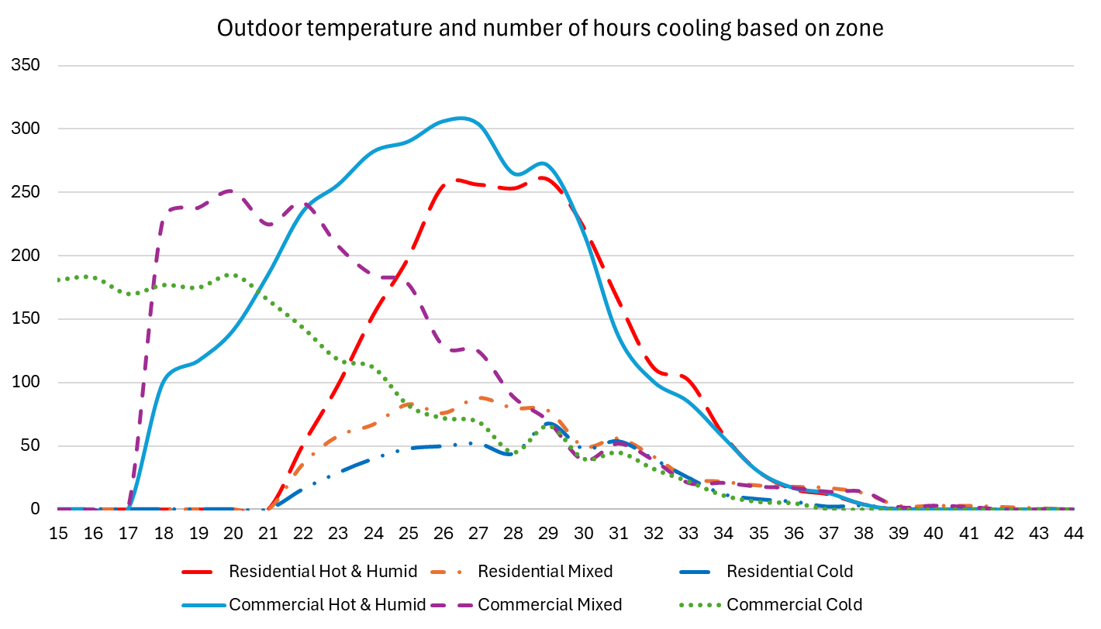

In the figure above, it can be seen that the number of cooling hours drops to zero at 21°C and below on the Residential use profile across all three climate zones. This is because it is assumed for the purposes of the calculations that air conditioners are not used for cooling in residential use cases where the outside temperature is 21°C or below, i.e. T0 is 21°C for Residential profile calculations.

For the Commercial use profile for the Hot [Hot & Humid] and Average [Mixed] zones T0 is 17°C. In the Cold zone, T0 is 14°C. The lower T0 for the Commercial use profile reflects the need to offset the effect of body heat from occupants, machinery and equipment in commercial premises. The Commercial use case also assumes different daily hours of use than the residential profile, such as no cooling use after 7pm. Whether it would be appropriate to adjust T0 for the Commercial profile calculations in light of the amendment to the standard is discussed on page 6 overleaf.

The performance calculations in the standard provide figures for the input power and capacity of every air conditioner at a given outdoor temperature. When registering an air conditioner, suppliers are required to select a rated value for each test point, based on the test result. The extent to which these “rated” values are permitted to deviate from the “tested” values is set out in the determination and regulations and is discussed further below. The annual energy consumption is then calculated by summing the input powers together for each climate zone and the use profile over the course of a year.

The star rating is determined by taking the total cooling load for the year and dividing it by the total input power for the year.

## T0 for Commercial use profiles

The revised standard notes that “valid calculations” should assume that no cooling is used until the outdoor temperature is 18°C or higher.

The calculations used in AS/NZS 3823.4.1: 2014 and in the determination and regulations for cooling in Residential situations assume that cooling will not be used until the outdoor temperature is 21°C or higher, so the Residential energy efficiency performance figures are unaffected by the note regarding T0 and these are the figures that are used on Zoned Energy Rating Labels.

The T0 values for the Commercial setting are set out in Schedule 6, Section 2 of the Greenhouse and Energy Minimum Standards (Air Conditioners up to 65kW) Determination 2019 and in Schedule 2A Section 18 of the Energy Efficiency (Energy Using Products) regulations 2002.

Figure 3: T0 values for commercial zones

| **Climate zone on zoned energy rating label** | **T0(°C) for cooling** |
| --- | --- |
| Hot | 17 |
| Average | 17 |
| Cold | 14 |

The calculations in the determination and regulations for cooling in a Commercial setting assume that cooling will start to be used when the temperature is above 17°C in the Hot and Average climate zones and when it is above 14°C in the Cold climate zone. Calculations and star ratings based on these figures are publicly available from government websites in Australia and New Zealand. They are also able to be used by air conditioner suppliers in advertising material.

If the T0 levels were adjusted that would affect the calculated hours of use, the annual energy consumption figures and the calculated energy efficiency under the commercial use profiles.

* In view of the note in the revised standard that T0 be set no lower than 18°C, should the T0 value for the Commercial use cases be amended? If so, how?

## The relationship between rated and tested values

The figures used in the air conditioner determination and regulation to calculate air conditioner performance, including for Zoned Energy Rating Label, are ‘rated’ values provided by the suppliers of the air conditioners at point of registration. The standard does not refer to, or have a concept of, ‘rated’ values.

Figure A4 of AS/NZS 3823.4.1: 2014 sets out the mandatory and optional tested values for variable capacity air conditioners. This category covers the vast bulk of the market.

Figure 4: Relationship between input power and outdoor temperature

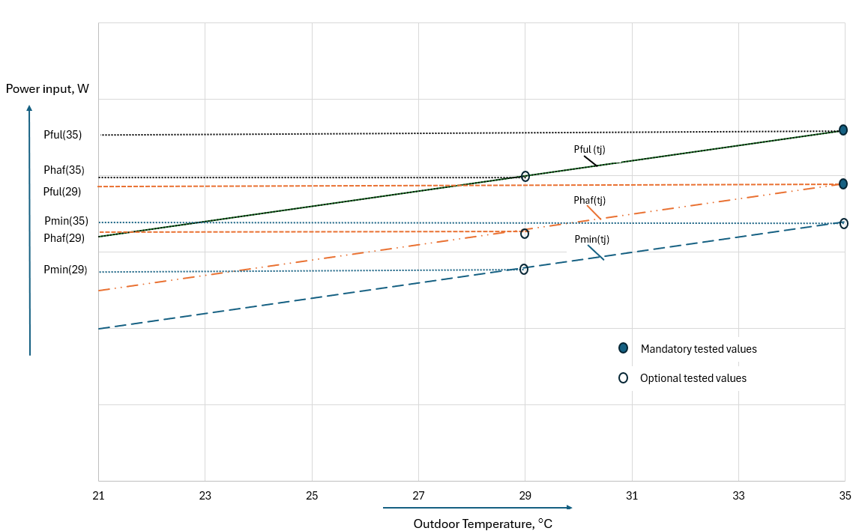

The Greenhouse and Energy Minimum Standards (Air Conditioners up to 65kW) Determination 2019 and section 10/Schedule 2A Section 58 of the Energy Efficiency (Energy Using Products) regulations 2002 allow for the creation of rated values for air conditioners and set the limits of the permissible difference between the rated and tested values. Rated values allow the manufacturer or importer to derate the product to ensure that every unit supplied will meet the claimed performance.

The current relationship between tested and rated values are shown in table 1 below:

Table 1: Rated and tested tolerance in legislation

| Variable | Tolerance |
| --- | --- |
| Rated capacity | $$≤\frac{tested capacity}{0.95}$$ |
| Rated input power | $$≥\frac{tested input power}{1.05}$$ |

Note that in terms of the restrictions on rated versus tested values there is no limit to how much the rated input power can be increased relative to the tested input power.

A simplified version of the permitted relationship between tested and rated input powers is shown in Figure 5 below.

Figure 5: Relationship between tested and rated input powers

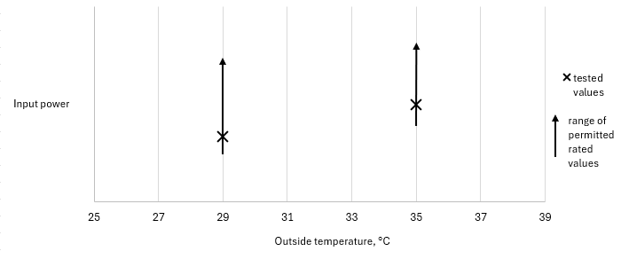

Given the tolerance on the relationship between rated and tested input powers, a registrant can artificially increase the products rated input power at the 35°C ambient temperature test point indefinitely and artificially decrease the products rated input power at the 29°C ambient temperature test point by a limited amount. At lower temperatures, rated input power can even become negative (as shown in Figure 6 below).

If many hours are theoretically spent cooling at lower temperatures this can cause a significant reduction in the annual energy consumption and an inflated star rating. In some cases, most commonly in the Commercial Cold zone, this can result in a calculated result of negative energy consumption for cooling. The issue mostly affects half capacity tests at T1 (35°C) and half capacity tests at low temperature (29°C). It can also affect minimum capacity tests at these temperatures.

Figure 6: Rated input power slope and tested input power slope

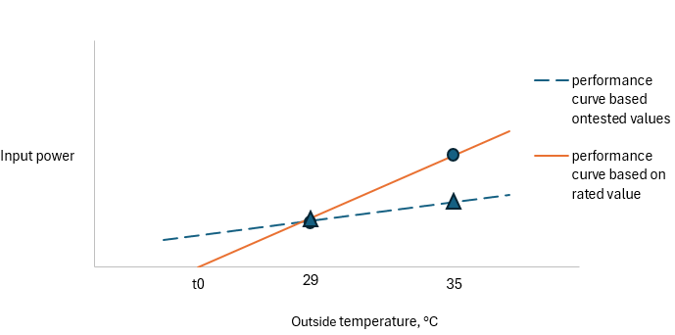

Given the distribution of cooling hours as shown in Figure 2 above, setting rated values in this way leads to inflated air conditioner cooling performance compared to using the tested values.

The tolerance allowed between rated and tested values, including changing the permitted relationship between the data for T1 and low temperature data points, has contributed to unsatisfactory annual performance calculations for air conditioners. There are a range of possible treatments, which could be used singly or in combination. For example:

* + Applying the revised standard to rated values;
  + Amending the allowance on the relationship between rated and tested values; and
  + Creating a relationship between T1 and Low temperature rated and tested values, for example limiting the difference in the slope of the line between the tested and rated values.

It is anticipated that whatever treatment is applied, the necessary calculations would be built into the registration process rather than having to be made by registrants. These possible treatments are discussed in some more detail in the following section.

## Technical options to address the issue

There are three technical options presented to address the issues:

1. Applying the revised standard to rated values,
2. Amending the allowance on the relationship between rated and tested values – tolerance,
3. Amending the allowance on the relationship between rated and tested values – Slope

The options could be implemented individually or in combination e.g. you could implement the revised standard validity test to rated values, and implement a requirement on the relationship between the rated and tested values.

### Applying the revised standard to rated values

Firstly, the revised standard could be applied to both tested values and rated values. This would mean that, if by using the rated values the calculated power input became zero or less at any temperature above T0-5 (in any zone commercial and residential), then those rated values would not be allowed to be used. With T0 in the Residential use case calculations being 21°C, if the calculated power input fell to zero at any temperature above 16°C those rated values would not be allowed to be used. Across the Residential and Commercial use cases on the current T0 settings, approximately 18% of current registrations would not meet the requirement based on their current rated values.

The effect of such a change, and of the other possible changes, on the overstatement of performance varies between climate zones and between Residential and Commercial use cases, because they are influenced by the temperature and hours of use set out in Figure 2 above. Applying such a constraint would reduce the opportunity for overstatement of performance by 36% for the Residential use case in the Cold Zone and by 93% in the Commercial use case in the Cold Zone.

### Amending the allowance on the relationship between rated and tested values – tolerance

Another approach would be to apply a maximum allowed difference for rated values both above and below the tested value they are based on (applying the revised standard to rated values). This approach is depicted in Figure 7 below.

Figure 7: Possible new relationship between rated and tested values, tolerance method

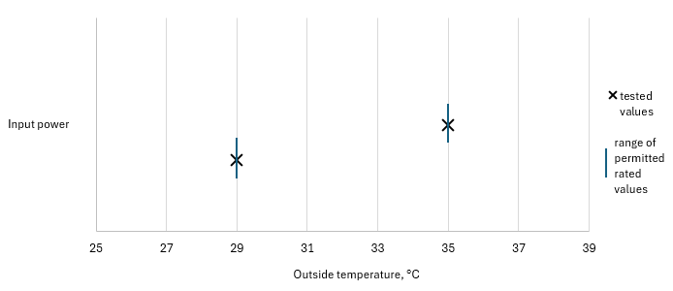

The stringency of the allowance would determine the number of registrations affected and the allowable discrepancy between rated versus tested values for the performance of the model. For example, if rated values were required to be within 5% of the tested Power Input values, some 29% of current registrations would not meet this requirement. Applying such a constraint would reduce the amount the performance of an air conditioner model could be overstated by some 41% for Residential use case in the Cold zone and 93% for the Commercial use case in the Cold zone.

If the allowance is set such that rated Power Inputs could be up to 5% below and up to 10% above the tested values, then the proportion of affected registrations drops to 21% and the maximum discrepancy between performance based on rated versus tested values would be reduced by 37% for Residential use case in the Cold zone and 93% for the Commercial use case in the Cold zone.

The discrepancy between the calculated performance of a model based on its rated compared to its tested values comes from changing the slope of the performance curve.

### Amending the allowance on the relationship between rated and tested values – Slope

Another way this issue could be resolved would be to limit the difference in the slope of the line between the line drawn from tested values and the line drawn based on rated values (applying the revised standard to rated values). This approach is depicted in Figure 8 overleaf.

Figure 8: Possible new relationship between rated and tested values, slope method

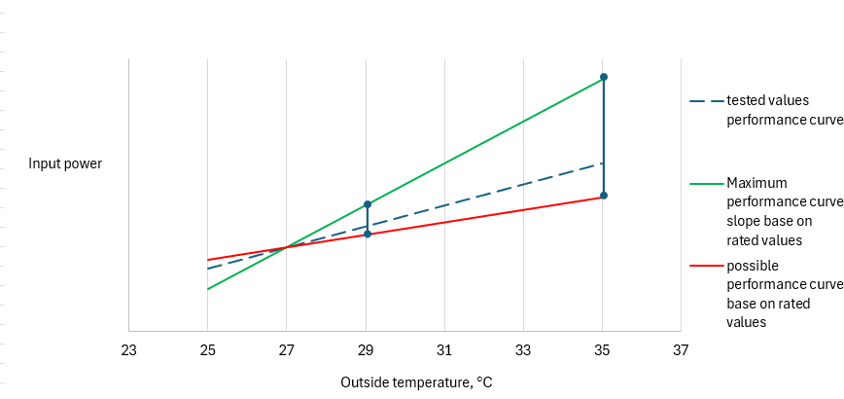

Such an approach is similar to the current arrangements in that it would not specify an upper limit to the rated values. This approach would allow suppliers to include whatever magnitude of buffer between the tested and rated values they considered prudent, but the constraint would be on the relationship between the pairs of tested and rated values. Such a test would need to be applied for every performance line between pairs of results, for example for the Full Capacity line or the Half Capacity line. A requirement that the rated power input at Full Capacity is greater than at Half Capacity, which in turn is greater than at Minimum Capacity, would be included as part of this approach.

The stringency of the allowance would determine the number of registrations affected and the amount the discrepancy between results of calculations for the performance of the model based on rated versus tested values. For example, if the relative slope of the line drawn from rated values and the line drawn from tested value were required to be less than 10% (rated slope-tested slope)/tested slope, then some 21% of current registrations would not meet this requirement. Applying such a constraint would reduce the amount the performance of an air conditioner model could be overstated by some 46% for the Residential use case in the Cold zone and 95% for the Commercial use case in the Cold zone.

If the allowance were set such that the relative slope had to be less than 20%, then the proportion of affected registrations drops to 19% and the maximum discrepancy between performance based on rated versus tested values would be reduced by 45% for the Residential use case in the Cold zone and 94% for the Commercial use case in the Cold zone.

## Next steps

Submissions received during the consultation period will be considered in the development of an approach to address the issue. A summary document will set out the recommended approach, timeline and likely effects. Whichever approach is adopted implementing the change will require a new determination for Australia and revised regulations for New Zealand.

In Australia any regulatory change must be approved by the Energy and Climate Change Ministerial Council (ECMC). In New Zealand any proposed regulatory change will be subject to regulatory consultation, and any proposal will need approval from the New Zealand Government before being implemented.

In New Zealand, the *Energy Efficiency and Conservation Act 2000* and Energy Efficiency (Energy Using Products regulations 2002 are used to implement MEPS and labelling requirements, while in Australia the *Greenhouse and Energy Minimum Standards Act 2012* and determinations are used.

## Questions

We would like feedback to the questions below to assist in developing options to be recommended to ministers. The matters involved are quite technical and the options can be implemented individually or in combination. Accordingly, more detail in your response is preferred where possible, in particular to understand which of the effects of any changes are the most important to you.

1. In view of the note in the revised standard that T0 be set no lower than 18°C, should the T0 value for the Commercial use cases be amended? If so, how?
2. How should the relationship between rated and tested values be amended? If so, how?
3. The options presented here were (which could be implemented individually or in combination):
   1. Applying the revised standard to rated values,
   2. Amending the allowance on the relationship between rated and tested values – tolerance,
   3. Amending the allowance on the relationship between rated and tested values – Slope
4. How much consideration should be given to the following in determining the preferred option:
   1. Re-testing of products,
   2. Re-registration of products,
   3. Re-labelling of products,
   4. Reduction in scope for manipulating inputs maximise the star rating and minimise annual energy consumption.
5. Are there any other factors that should be considered?
6. What is a suitable transition period to implement the option, including the requirement to display a revised label?

It should be noted that a determination and regulations cannot be applied retrospectively. Any air conditioner imported into Australia or New Zealand before the option takes effect can be sold without complying with the new determination or amended regulations, but must comply with the previous determination and regulations.

1. Performance of electrical appliances – Air conditioners and heat pumps Part 4.1: Air-cooled air conditioners and air-to-air heat pumps – testing and calculating methods for seasonal performance factors – Cooling seasonal performance factor (ISO 16358-1:2013 (MOD))