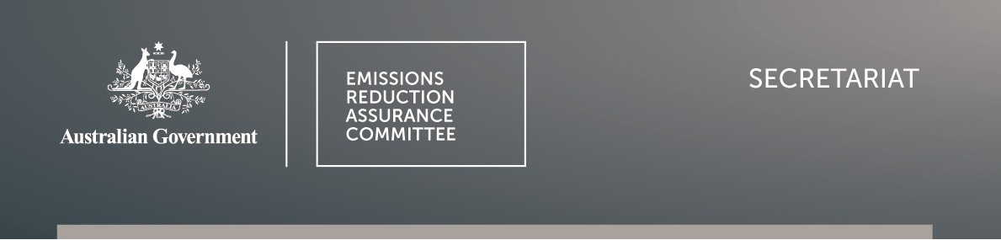
OFFICIAL

Summary of proposed Animal effluent management variation public consultation responses
- The public consultation period on the proposed Animal effluent management (AEM) method variation was from 4 July 2025 to 25 July 2025.
- Six submissions were received, all of which supported the extension of the crediting period for electricity and flaring end uses of biogas, including four confidential submissions.

Stakeholder | Summary of submission
This section has been amended to remove details of a confidential submission with the intention of not disclosing confidential information, as per subsection 123D(5) of the Carbon Credits (Carbon Farming Initiative) Act 2011.
Northmore Gordon (NG) | - supports the variation but proposed to extend the crediting period to 15 years for thermal-use projects with proper metering. This would incentivise the most effective and lowest-cost option, which cuts Scope 1 emissions by replacing fossil fuels with biogas for onsite heat.  - expects further updates on the integration of the Wastewater (WW) method into AEM and the introduction of restart provisions for expired projects through the periodic review process.
Waste Management and Resource Recovery Association of Australia (WMRR) | - supports the proposed extension.  - urges consideration of extended crediting periods for other emissions avoidance methods, not just AEM, where significant capital investment is required to deliver abatement projects.

