# Overview of Analytical Framework & Industry Capability Model

**For a high CER future**

### Analytical Framework

Prior to defining and implementing the required data architecture that will support the effective integration of CER into Australia’s power systems and markets – the data models, systems, tools and framework of policies, standards and rules – it is critical to identify and define the “business needs” for data sharing in a high CER power system. By understanding these business needs – the data sharing functional requirements – subsequent efforts to define the data architecture that will support these requirements will be able to clearly assess and align against these needs.

The following framework was constructed to determine the data sharing requirements for a high CER power system. Subsequent sections outline each component of the framework in more detail.

**Figure 1: Framework for identifying Data Sharing Arrangements for a high CER power system**

|  |  |
| --- | --- |
| **CER Lifecycle**  Map the lifecycle of a consumer energy resource as it is integrated into the energy system and markets | Depicts circular lifecycle of CER, which includes oversee, plan, connect, operate, and trade. |
|  |  |
| **Capability Model *(Top-down view)***  For each stage (or domain) of the CER lifecycle, identify the capabilities required across the sector to effectively integrate CER into the energy system and markets | Depicts how a stage (or domain) consists of different capabilities. |
|  |  |
| **Use Case Groups**  Build out ‘CER journeys’ as it integrates into the power system and markets – Planning and Oversight, Connecting and Integrating, Operating and Trading (in normal and emergency conditions) | Depicts the Planning and Oversight grouping.Depicts the Connect grouping.Depicts the Operate and Trade grouping. |
|  |  |
| **Use Case Group Diagrams *(Bottom-up detail)***  For each ‘journey’ or Use Case Group, and capturing all relevant industry capabilities, identify key activities involving information objects and sharing, and associated roles (“bottom up” detail) | Depicts a schematic that maps out roles to different capabilities. |
|  |  |
| **Activity Diagrams**  For some activities with critical interactions between different roles, clarify responsibilities and interrogate key capabilities by identifying further discrete use cases and important data flows | Depicts a schematic that maps out activities at a more detailed level. |
|  |  |
| **Data Categorisation**  For every use case identified in prior components, identify and then categorise the relevant information object(s). | Depicts a section of an Excel worksheet that is used to help map out information objects. |
|  |  |
| **Gap analysis**  Review the data categorisation and assess whether the infrastructure, capabilities, or regulatory arrangements are in place to support the required data sharing | Depicts a section of an Excel worksheet that is used to help with the gap analysis. |
|  |  |
| **Options and Priority Use Cases**  Consider options available to overcome identified gaps, highlighting Priority use cases | Depicts a section of an Excel worksheet that is used to help with developing Options and Priority Use Cases. |
|  |  |
| **Key Initiatives**  Reviewing options, group them into logical work efforts that seek to enable a “data sharing minimum viable product (MVP)”, a key initial outcome towards the future state Data Sharing infrastructure | Depicts key initiatives through a row of document icons. |

### CER Lifecycle and the Industry Capability Model

To comprehensively identify the data sharing requirements in a high CER power system, the project team initially sought to scope the lifecycle of a consumer energy resource. By understanding the CER lifecycle, the team could then break down the activities, capabilities and associated data sharing requirements for each stage (or domain) of the mapped lifecycle.

This CER lifecycle, shown in the figure below, is comprised of the following domains:

#### Level 1 Definitions

|  |  |  |
| --- | --- | --- |
| Domain Name | Description | Capability Summary |
| Oversee | The regulatory, governance, and oversight capabilities related to CER integration. This includes setting policy goals, developing standards, engaging stakeholders, and monitoring compliance and performance to improve the integration of CERs into the power system, networks, as well as markets and services. | Capabilities that ensure policies, regulations and relevant monitoring is enabled to ensure consumers get the best value for their energy investments |
| Plan: | The strategic planning and forecasting of energy needs and CER capabilities. This includes planning for and forecasting the medium to long term infrastructure needs and changes in the energy landscape to improve decision-making and prepare for more effective CER integration. | Capabilities that forecast and plan ahead to ensure consumers future needs are met and their choices supported |
| Connect: | The building of physical and digital infrastructure, as well as the actual connection of CERs to the grid. This covers the design and deployment of enabling infrastructure, manufacturing and supplying CERs, and the processes for electrically and digitally connecting CERs into the power system and markets ecosystem. | Capabilities that ensure consumers can easily engage with market and system opportunities |
| Operate: | The daily operation and management of consumer assets, the electricity networks, the bulk power system and markets with CER participation, including short-term operational planning and forecasting. | Capabilities that facilitate a stable, reliable and efficient power system which supports consumers participation |
| Trade: | The exchange of CER-based energy, system security and network services for monetary or other value for consumers. This includes the payment for and delivery of both off-market (e.g. hedging arrangements or non-network solution contracts) and on-market (e.g. energy) transactions across various timeframes, markets or service arrangements. | Capabilities that allow consumers to maximise their CER investments |

Figure 2: CER Lifecycle

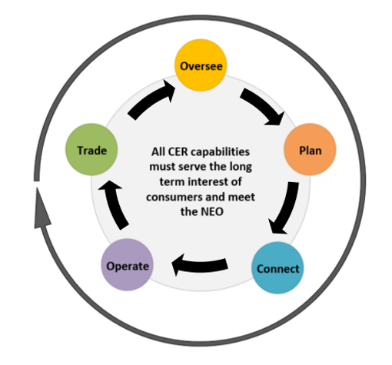

### Industry Capability Model: Level 2 Capabilities

The five core CER integration lifecycle domains established broad categories of capability which the energy industry would require to effectively integrate CER into the power system and markets.

These five lifecycle stages were then broken down into more detailed functions to highlight specific capability groups. This top-down approach sought to represent all the different elements of each capability group and was tested with subject matter experts (SMEs)[1], including through the assignment of each domain (and associated capability groups) to an illustrative time scale showing the speed required to complete them, as shown in the figure below.

Figure 3: CER Lifecycle Domains and Capabilities Mapped to an Illustrative Timescale

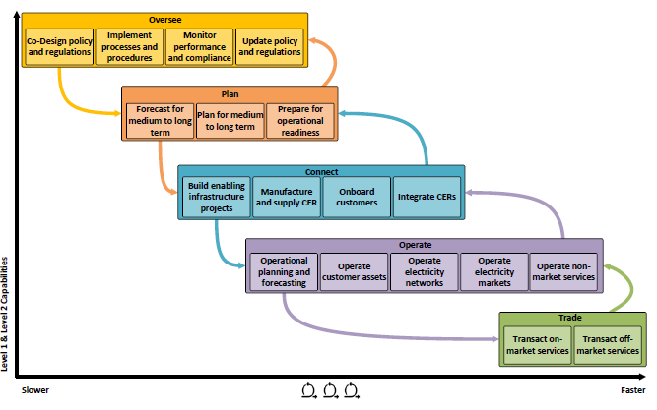

This approach helped SMEs identify relationships and dependencies between different capability groups, enabling initial high-level concepts to be broken down into clear, concrete capabilities (or functions) required to effectively integrate CER into the power system and markets. Moreover, further validation of capabilities occurred as SMEs identified and discussed potential future scenarios, highlighting the need for potential further granularity as well as helping define the right level of detail to adopt.

Detailed definitions for each Level 2 capability within the Capability Model are provided in the Section 1.9 Capability Model: Level 2 Definitions.

### Industry Capability Model: Level 3 Capabilities

Further detail for industry capabilities required to effectively integrate CER was undertaken to ensure gaps identified at Level 2 definitions were closed, help clarify items surrounding investments and priorities, identify key business drivers and design requirements, and to result in an integrated framework that would support future decision-making.

More extensive definitions for each Level 3 capability were drafted to display this further detail, identify any working assumptions, make boundaries explicit, and identify specific examples where appropriate.

Detailed definitions for each Level 3 capability within the Capability Model are provided in the Section 1.10 Capability Model: Level 3 Definitions.

The figure below outlines the Level 3 capabilities associated with each stage of the CER lifecycle.

Figure 4: Industry Capabilities (Level 3) for each stage of the CER Lifecycle

|  |
| --- |
| Depicts the oversee domain – involving capabilities to co-design policy and regulations, implement procedures and guidelines, monitor performance and compliance, and update policy and regulations. |
| Depicts the plan domain – involving capabilities to forecast for medium to long term, plan for medium to long term, and prepare for operational readiness. |

|  |
| --- |
|  |
|  |
|  |
|  |
| Depicts the connect domain – involving capabilities to build and manage CER enabling infrastructure, manufacture and supply CERs, onboard customers to products and services, and integrate CERs. | |
| Depicts the operate domain – involving capabilities to conduct operational planning and forecasting, operate customer assets, and operate electricity networks and power system. | |
| Depicts the remaining section of the operate domain – involving capabilities to operate electricity markets and operate non-market services. |
| Depicts the trade domain – involving capabilities to transact on-market and off-market. |

### Use Case Groups and Diagrams

To best identify and assess the required current and future activities and associated capabilities for effectively integrating CER, the project team combined stages of the CER lifecycle into distinct “journeys” or Use Case Groups that helped provide context for identifying use cases (and subsequent information objects associated with them).

This approach allowed for the mapping of key interconnected phases of the CER journey as it integrates into the power system and markets, while also enabling a clear delineation between different phases of the connected pathways for integrating CER. This also helped highlight important feedback loops and dependencies between each Use Case Group.

It is important to note that the project team, and those SME stakeholders directly engaged to review and help populate Use Case Group content, sought to identify capabilities and activities that are both currently required within Australia’s energy markets and projected to be required in the coming decade or so. Further, interactions with the *M.3/P.5* workstream helped highlight some prospective functions (and role allocations) that might also be required in a high CER power system. Nevertheless, the project team cannot warrant that the process undertaken to identify its use case content has sufficient and comprehensive foresight for every potential use case that might emerge in a high CER future.

The four (4) Use Case Groups adopted for this analysis were:

Figure 5: Use Case Groups

|  |  |
| --- | --- |
| **Planning and Oversight (PO)**  Establishing and implementing policies, monitoring performance and compliance, and updating rules |  |
| **Connecting and integrating CER into the power system and markets (CI)**  From customer awareness, education and decision making to physical and digital connection |  |
| **Operate and Trade in the wholesale market and non-market services (normal conditions) (OTN)**  Includes business-as-usual scenarios such as managing peak and low demands, as well as trading between organisations |  |
| **Operate and Trade in the wholesale market and non-market services (emergency conditions) (OTE)**  Identifying capabilities to ensure ongoing power system security even when threats emerge |  |

Use Case Group diagrams were constructed to map capabilities and more granular activities to specific market or system roles (not actors), enabling a higher level (“birds-eye”) view of use cases prior to potential further interrogation and more detailed activity diagram views. This approach helped comprehensively elucidate the relationships and capabilities needed to effect functions necessary to integrate CER, without requiring the more extensive and detailed effort to map cross-organisational processes. Market and system SMEs[2] were heavily engaged to identify use cases relevant to each use case group diagram.

An example Use Case Group diagram has been provided in the figure below, with all Use Case Group Diagrams available for review by Stakeholders at consult.dcceew.gov.au.

Figure 6: Sample Use Case Group Diagram

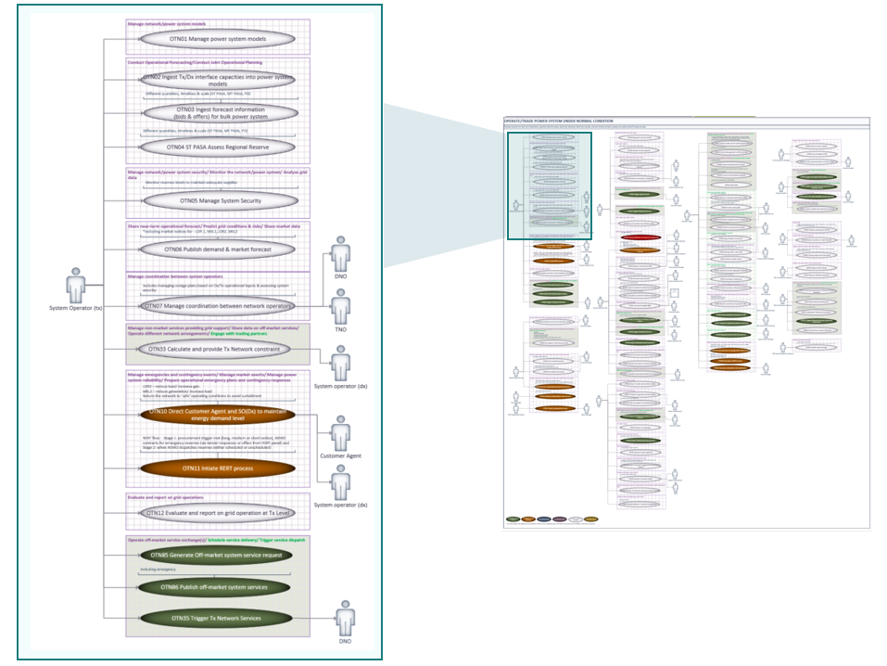

### Activity Diagrams

For some functions and activities identified as use cases in earlier analysis, further interrogation of the nature of these capabilities was required to identify specific data attributes as well as highlight the potential for shared responsibilities across roles for fulfilling the capability. This later requirement was of particular interest for the CER Roadmap working group engaged for the *M.3/P.5* workstream[3].

Where such deeper interrogation of key capabilities was required, Activity Diagrams were produced to expand upon the base use case identification. The use of Activity diagrams:

Included processes, activities and interactions between market or operational roles that were identified using existing industry knowledge and subject matter expertise;

Enabled deeper interrogation of critical capabilities and associated activities with different levels of detail;

Facilitated the identification of specific data attributes and triggers for complementary CER Roadmap Taskforce workstreams;

Was not intended to produce an indisputably accurate process flow depiction, rather, provide a directionally correct level of detailed activity flow that would elucidate upon the required elements for those capabilities under analysis.

An example Activity Diagram is shown is the figure below.

Figure 7: Sample Activity Diagram (Operate & Trade under Emergency Conditions)

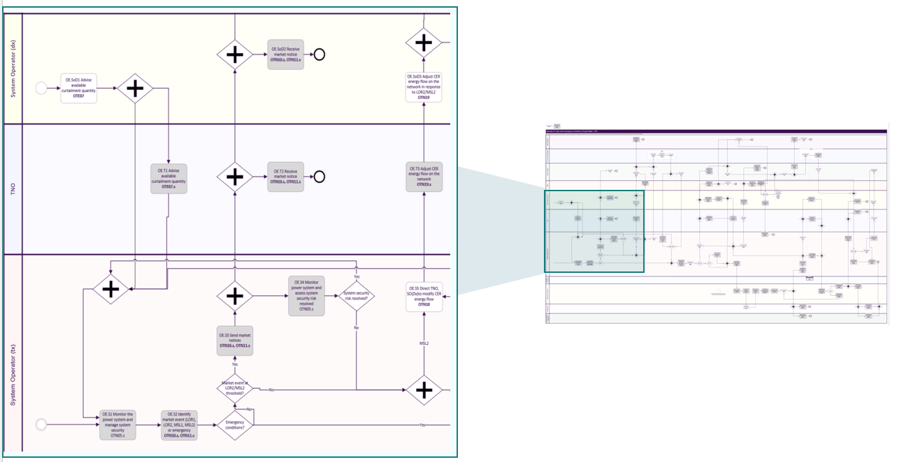

All Activity Diagrams produced as part of the Data Sharing Arrangements analysis are available for review by Stakeholders at consult.dcceew.gov.au.

### Data Categorisation

A key requirement in determining the data sharing arrangements that would most effectively integrate CER into the power system and markets is to identify existing and emerging data sources:

produced by devices such as smart meters and CER devices, secure gateway devices, home energy management systems, etc.

from market and system operation actors, including consumers, CER controllers, and Distribution Network Service Providers (DNSPs).

Once all current and prospective capabilities and related activities - use cases - envisaged as part of a future high CER power system were detailed, the information objects associated with each use case were required to be identified. For example, the activity “Publish demand and market forecasts”, part of the “Forecast and Planning Operations” use case, has an associated information object called “Market forecast”.

With information objects listed against all use cases, a comprehensive data categorisation effort was undertaken by [M.2] Data sharing arrangements to inform planning and enable future markets. Each information object was assigned along the following categories:

**Information Category**: the type of data the object is. See Section 1.11 Information Categories: Definitions for the list of information categories used and their definitions

**Initiator**: which role produces (“owns”) the data and would initiate the data sharing;

**Receiver**: which role(s) consume / would receive the data being shared by the Initiator

**Interfaces**: how data is received, including:

* System to System: system-generated data and delivered to another system
* System to Person: system-delivered data transfer, such as email;
* Person to Person: an interaction between two (2) or more people, such as a phone call, where the information is shared;
* Person to System: where a person inputs data into a system or portal.

**Minimum Frequency**: the frequency of data being received in minutes, hours, days, months, years, or on demand;

**Latency**: how fast data is received, in minutes, hours, days, months, years, or as per the Frequency (where on demand)

**Sensitivity**: whether the data is confidential and the impact of any lapses in availability on safety, power system and market security, or consumer protections, classified by:

* Public: publicly available data, not considered confidential
* Restricted: information is not public at the time of its sharing or considered commercial in nature and sent only to select recipients
* Critical: information that requires high availability to ensure safety, power system and market security, and consumer protections, and which may or may not be sensitive to share.

**Quality**: an assessment about whether the data is currently available, accurate and timely to facilitate the use case. If assessed as being available, accurate and timely to enable the use case, the data was classified as No Issues, otherwise it was determined as having Issues and brief rationale was outlined to highlight the data quality gap.

A snapshot of the data categorisation undertaken is shown in the figure below.

The complete Data Categorisation artefact is available for review by Stakeholders through the Data Categorisation Worksheet at consult.dcceew.gov.au (refer to ‘Data Categorisation’ Tab in the worksheet).

Figure 8: Data categorisation snapshot

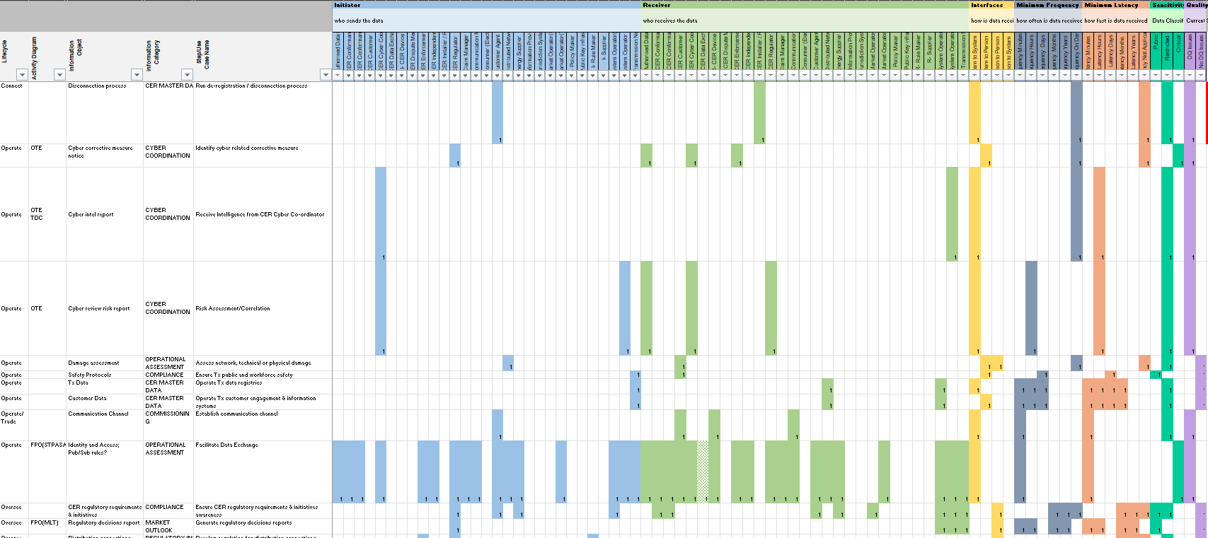

### Gap Analysis and Action Assessment

Having completed a comprehensive literature review, stakeholder interviews, listing of use cases, associated information objects, and extensive data categorisation, an assessment of the current state of the required data and their sharing arrangements was undertaken by [M.2] Data sharing arrangements to inform planning and enable future markets.

The gap analysis conducted sought to identify:

Current gaps in data and associated categories, including whether the required data was available and accessible, whether the identified role and function had been established (to initiate the data sharing), if the required interfaces have been established, and whether data security and quality were as needed to enable effective sharing for market and operational purposes;

Current gaps in data sharing capabilities, whether they existed, or potentially required augmentation, or whether they do not exist and thus would require construction of a new capability.

Gaps were qualified with existing evidence from published documents, interviews with subject matter experts and assessed against the CER Roadmap vision, outcomes and principles.

Proposed Actions were developed for priority data gaps considering:

Alignment to the CER Roadmap vision, outcomes and principles

Whether expertise, regulations, processes or infrastructure already exists

Holistic design considerations

Implementation considerations

The complete gap analysis table available through the ‘Distinct Gap Analysis’ tab in Data Categorisation Worksheet, made available at consult.dcceew.gov.au, outlines each distinct Data and Data Sharing gap identified as part of this project and mapped to the three (3) Major Outcomes highlighted by the CER Roadmap workstream *Redefine roles for market and power systems operations* (M.3/P.5). These Major Outcomes are:

* CER is **visible and predictable** and can be effectively used as part of power system operations
* CER is **orchestrated effectively** to deliver value for consumers and the power system
* CER plays a central role in **system security and emergency management** frameworks and processes.

The Use Cases identified in ‘Distinct Gap Analysis’ tab are available in more detail within the Capability, Use Case and Role-Actor assignment Worksheet, made available at consult.dcceew.gov.au, and produced as part of the project.

### Capability Model: Level 2 Definitions

| **#** | **Domain** | **Name** | **Definition** |
| --- | --- | --- | --- |
| 1.1 | Oversee | Co-design policy and regulations | Create foundational and steady state policies, standards, and regulatory frameworks for CER integration. |
| 1.2 | Oversee | Implement procedures and guidelines | Operationalise oversight processes, procedures, and practices across the CER ecosystem. |
| 1.3 | Oversee | Monitor performance and compliance | Observe and assess CER performance through value-chain, compliance with requirements, and impacts throughout the broader ecosystem. |
| 1.4 | Oversee | Update policy and regulations | Change rules and laws based on the findings, learnings, and opportunities identified in the evolving CER technology and regulatory landscape. |
| 2.1 | Plan | Forecast for medium to long term | Project medium to long term scenarios for CER adoption and future system and market conditions to inform decision-making. |
| 2.2 | Plan | Plan for medium to long term | Develop medium to long term infrastructure and resource strategies to accommodate CER integration. |
| 2.3 | Plan | Prepare for operational readiness | Ensure the industry is prepared and capable of operating the power system, networks, and markets with high CER under various conditions. |
| 3.1 | Connect | Build and manage enabling infrastructure projects | Create the technical specifications and plans, source and acquire the necessary equipment, then build and install the physical and digital enabling infrastructure to support CER integration. |
| 3.2 | Connect | Manufacture and supply CER | Produce CER equipment and related components to meet market and system needs, distributing and delivering these products to suppliers, installers, and end-users. |
| 3.3 | Connect | Onboard customers to products and services | Develop and connect customers to products, services, and offers related to CER. |
| 3.4 | Connect | Integrate CERs | Establish physical and digital connections between customers, CER, and established industry systems. |
| 4.1 | Operate | Conduct operational planning and forecasting | Develop near-term operational strategies and schedules for operating a system with CER and predict near-term CER behaviours and system conditions for operational decisions. |
| 4.2 | Operate | Operate customer assets | Manage and coordinate CERs at customer sites. |
| 4.3 | Operate | Operate electricity networks | Maintain grid stability, power quality, and reliability in high-CER environments at each level of the grid (distribution, transmission, and broader power system). |
| 4.4 | Operate | Operate electricity markets | Facilitate and manage market operations for CER participation, such as the retail or wholesale markets. |
| 4.5 | Operate | Operate non-market services | Facilitate and manage non-market services for CER, such as common data sharing infrastructure or local services exchanges. |
| 5.1 | Trade | Transact on-market services | Trading services with CER that are settled through established central markets. |
| 5.2 | Trade | Transact off-market services | Trading services with CER that are not procured through a central market mechanism, where prices derived through procurement and contract decisions. |

### Capability Model: Level 3 Definitions

| # | Name | Definition |
| --- | --- | --- |
| 1.1.1 | Co-design goals and objectives | Collaboratively develop high-level policy aims and specific targets for CER integration with key stakeholders, balancing and aligning competing interests and policy priorities. This occurs at the Federal and State government level, as well as through NEM body processes, and should align to the National Electricity Objective (NEO) for the long-term interests of consumers. |
| 1.1.2 | Establish regulations | Create customer-centric national electricity rules and national energy laws, as well as Federal and State legislations, that enable CER integration, operation, market participation, and governance. This includes the design of market structures and mechanisms. |
| 1.1.3 | Develop tariffs, prices, incentives | Design and implement enduring distribution network tariff settings and structures, competitive (i.e., financially responsible market participants and other traders) prices and charges, as well as different Federal and State government benefits or rebates to incentivise CER uptake and participation. |
| 1.1.4 | Create customer protections | Develop Federal, State, and market regulations that protect CER customer's rights and interests, ensuring participation is fair, reasonable, and non-discriminatory. |
| 1.1.5 | Set technical standards | Define and maintain technical specifications and requirements for CER and related assets - which could include electrical connection, performance, and safety / protection requirements, as well as communication, interoperability, and cybersecurity functions. |
| 1.1.6 | Form governance | Develop overarching governance structures and processes with stakeholders that oversee the creation, implementation, and change of CER integration regulations across market and non-market activities. This includes setting roles and responsibilities, as well as institutions / systems (for instance, establishing a CER Technical Regulator). |
| 1.2.1 | Operationalise policy and regulations | Implement regulations into supporting governance or processes, like AEMO procedures or AER guidelines, as well as industry or business level plans. This also includes transition planning. |
| 1.2.2 | Develop compliance processes | Create Federal, State, NEM, as well as participant-level compliance processes to verify and ensure adherence to different CER rules and laws, technical standards (including cyber security), as well as procedures, guidelines, supporting processes. |
| 1.2.3 | Engage stakeholders to coordinate implementation | Facilitate communication and collaboration between relevant industry and community stakeholders to ensure smooth implementation and operationalisation of regulations. |
| 1.3.1 | Monitor CER integration progress | Gather all relevant data and develop / share key insights on how well the industry is performing with regard to CER integration. This includes monitoring trends, integration challenges, performance of regulatory frameworks, governance of market and non-market activities, stakeholder feedback, and progress towards stated objectives such as the NEO. |
| 1.3.2 | Evaluate compliance and conformance | Check individual and industry-level adherence against established regulations to identify non-compliance, as well as non-conformance with network / market operational requirements. |
| 1.3.3 | Enforce regulations, including penalties | Implement corrective measures or penalties for failures to meet CER regulations and requirements (e.g., standards or conformance to operational requirement). |
| 1.4.1 | Review policy and regulations | Regularly review Federal, State, and NEM CER regulations to pinpoint aspects that require updates, modifications, or wholesale changes based on market and technology developments, as well as stakeholder feedback. This could also include how different changes are prioritised and interactions are managed. |
| 1.4.2 | Update policy and regulations | Formulate, submit and subsequently address formal change requests to Federal, State, and NEM-level CER regulations to address identified gaps or inefficiencies - assessing the impact of change. Updates should align back to the NEO and support the long-term interests of consumers. |
| 1.4.3 | Update tariffs, prices, incentives | Adjust enduring network tariffs, competitive prices, and government incentives regularly to maintain their effectiveness in light of market / technology changes and policy goals. |
| 1.4.4 | Change customer protections | Change regulations that protect CER customer's rights and interests, ensuring participation is fair, reasonable, and non-discriminatory based on new information or preferences. |
| 1.4.5 | Revise technical standards | Update existing or create new technical standards and specifications to keep pace with changing advancements and requirements. |
| 1.4.6 | Reform governance | Modify existing governance structures, policies, and institutions to adapt to new challenges or improve outcomes, based on changing circumstances, stakeholder engagement, or changes in the external environment. |
| 2.1.1 | Predict customer demand for CER | Predict what products, services, and technologies customers are likely to demand over the medium to long term, in order to develop and inform market strategies. This could include different scenarios and assumptions |
| 2.1.2 | Project CER technology growth | Estimate the medium to long term uptake of different types of CER, technology developments / advancements, and how its likely to differ across the power system - informing medium to long term network infrastructure planning. This could include different scenarios and assumptions. |
| 2.1.3 | Forecast supply and demand | Anticipate shifts in the supply-demand patterns over the medium to long term due to higher levels of CER integration and participation. |
| 2.1.4 | Predict prices and costs | Assess medium to long term financial metrics for CER products, services, and related network / market factors. |
| 2.1.5 | Model future power system | Forecast medium to long term changes in the electricity generation sources and needed capacity across various CER adoption scenarios. |
| 2.1.6 | Share relevant forecast | Exchange different types, levels, and forms of medium to long term forecasts about CER integration and participation between multiple relevant stakeholders involving in network / power system planning, as well as operations. |
| 2.2.1 | Plan network infrastructure | Create strategic plans for grid infrastructure expansion, augmentation, and retirement necessary to meet customer and CER integration needs over the medium to long term - using medium to long term forecasts. |
| 2.2.2 | Conduct Integrated System Planning | Create strategic plans for the power system, informed by medium to long term forecasting, to ensure efficient operation and development of infrastructure to meet medium to long term energy demands. |
| 2.2.3 | Publish plans and engage stakeholders | Release planning data to facilitate coordination and validation of medium to long term plans between stakeholders. |
| 2.2.4 | Create strategies to utilise CER flexibility | Develop strategies and processes to efficiently leverage CER capabilities to deliver customer value and electricity services, including identifying locational value for CER. Separate to embedding these operational procedures. |
| 2.2.6 | Develop financial and investment plans | Establish financial strategies, business cases, and investment decisions to actually deliver physical and digital infrastructure and operational needs efficiently and at least cost - based on relevant medium to long term forecasting and planning. |
| 2.3.1 | Develop operating procedures for a high CER future | Test, commission and embed strategies to utilise CER flexibility in standard operating procedures for asset, network, power system, and market or non-market operations. This includes the coordination of multiple actors. |
| 2.3.2 | Set contingency plans and emergency responses | Embed strategies informed by risk assessments to manage emergencies at different levels, with specific response actions, between multiple different organisations - from operational incidents to major system-wide events. |
| 2.3.3 | Manage coordination mechanisms | Design, construct and manage scalable and interoperable systems for efficient coordination between / across multiple organisations and CER assets, including cybersecure methods for coordination at all levels of the value chain. |
| 2.3.4 | Develop workforce capabilities | Enhance the skills, knowledge, and technologies the electricity workforce have access to, in order to ensure that our people can effectively navigate a high CER future. |
| 2.3.5 | Engage with stakeholders to coordinate operational readiness | Collaborate with all the relevant and necessary stakeholders in order to effectively execute physical and digital CER integration plans and projects - to inform a feedback loop for future medium to long term forecasting and planning. |
| 3.1.1 | Monitor and maintain existing CER enabling infrastructure | Oversee and manage the entire, end-to-end lifecycle of physical and digital enabling infrastructure - maintaining it to quality and necessary standards, informing future network / power system operations. |
| 3.1.2 | Augment (or remove) existing CER enabling infrastructure | Upgrade (or remove) existing physical and digital enabling infrastructure to accommodate an identified need, gap, or objective in support of CER integration. |
| 3.1.3 | Build and commission new CER enabling infrastructure | Construct and deploy new physical and digital projects that were identified in medium to long term plans, to support CER integration and participation. This includes testing and commissioning before bringing the assets into operation. |
| 3.1.4 | Engage with community and affected stakeholders | Collaborate with the necessary and relevant stakeholders in order to tailor physical and digital enabling infrastructure builds with their needs, as well as bring them along the journey to onboard customers in the future. |
| 3.2.1 | Produce CER products to standard | Manufacture CER equipment that meets all relevant, established, regulatory technical standards, specifications, and requirements. This could include quality, safety, communication, interoperability, and cybersecurity standards. |
| 3.2.2 | Supply CER products to market | Distribute CER equipment through various channels and intermediaries to retailers, installers, and other end-users like customers. This includes coordinating the timing and logistics to ensure a smooth customer experience. |
| 3.2.3 | Verify CER product compliance | Certify that CER products meet relevant technical standards, as well as other regulatory / quality requirements, through an evidenced testing processes. This certification should also inform the future physical installation and configuring CER for customers. |
| 3.2.4 | Manage CER asset disposal / recycling | Manage the end of the CER product lifecycle, that includes its disposal, including both product recall and recycling processes. |
| 3.2.5 | Develop customer-centric CER products / services | Develop customer-centric CER products per supplier, market, and end-user (e.g., installer or customer) feedback, technological progress, and changing regulatory requirements. |
| 3.2.6 | Publish CER product information | Make relevant CER product details publicly available in order to aid customer comparisons and decision-making for the product(s) that best suits their needs. |
| 3.3.1 | Provide network connection terms and tariffs | Develop and offer the customer terms for monopoly grid connection, including capacity subscriptions, charges, and tariff settings and structures specifically for CER. These network offers and tariffs may include the choice of static/dynamic connection agreement, or participation in time of use / dynamic network pricing. |
| 3.3.2 | Provide competitive market offers and prices | Develop and offer the customer terms for competition service provision, including active CER management, pricing, and reward settings, as well as value-stacking opportunities and ecosystem products specifically for CER. |
| 3.3.3 | Publish CER service information | Make relevant CER service details publicly available in order to aid customer comparisons and decision-making for the offers(s) that best suits their needs. |
| 3.3.4 | Onboard customers | Manage customer onboarding processes once customers sign up to a service provider, product, or service. |
| 3.3.5 | Record customer consent and preferences | Document what customers have explicitly consented to, including agreements, tariffs and prices, services, and service providers. This could also include customer consent for different service providers to have different responsibilities, or have rights to access / share data. |
| 3.3.6 | Manage customer protections and requirements | Implement and oversee measures to safeguard CER customer's interests throughout the physical and digital connection processes. |
| 3.3.7 | Pre-qualify CER | Share and verify the entitlements the CER asset, owner, and operator have to access various market and non-market services - such as, location or customer consent to enrol in value-stacking opportunities. |
| 3.3.8 | Manage customer switching processes | Facilitate a smooth transition for customers changing between service providers and longer term programs or service agreements. |
| 3.3.9 | Support and service ongoing customers | Maintain the customer relationship to support them throughout the CER integration lifecycle, including providing assistance, updates on system performance, or guidance on optimising their CER |
| 3.4.1 | Connect customers and CER to grid | Physically link customers and their CER installations to the grid according to service and installation rules, relevant network connection requirements, that are informed by medium to long term infrastructure plans and forecasts. Connections also need to be validated through an evidenced testing process. |
| 3.4.2 | Configure installation and CER to requirements | Set up the CER installation to comply with the relevant technical and operational specifications, as well as customer preferences, that is verified through an evidenced testing process. |
| 3.4.3 | Verify CER installation compliance | Conduct on-site inspections and testing of newly installed CER systems (and related assets / infrastructure) to ensure it meets safety, technical, and network requirements. |
| 3.4.4 | Educate and support customers through integration process | Develop and implement programs to educate customers about CER, their potential customer value, the installation process and provide ongoing awareness through various channels to ensure customers are well informed / can effectively manage their CER integration journey. |
| 3.4.5 | Register CER with required systems | Digitally link customers and their CER installations into the existing ecosystem according to operational requirements, that are validated through an evidenced testing process. |
| 3.4.6 | Establish communication links | Set up standardised communication pathways for transmitting market, non-market, price, and control signals to and from CER and Customer Agents, maintaining cyber security and privacy obligations. |
| 3.4.7 | Share CER metadata on installation | Provide relevant CER asset information - at the point / time of physical / digital connection - through to the relevant, necessary actors and systems of record. |
| 3.4.8 | Keep CER metadata current over time | Establish processes and systems to keep CER registration and related metadata, communication links, and operational data exchange current throughout the life of the CER asset. This includes regular updates, change management producers, and verification of information over time. |
| 4.1.1 | Conduct operational forecasting | Predict how much power CER will produce or customer in the near-term, amongst the broader supply-demand mix, and how they intersect. This relies on integrating near-term weather forecasts into supply-demand forecasts. |
| 4.1.2 | Share near-term operational forecasts | Distribute estimates, predictions, and forecasts about near-term CER inputs and outputs, as well as operational states, events, or trends to relevant organisations. |
| 4.1.3 | Predict grid conditions and risks | Anticipate how the network / power system will perform with near-term forecasted CER and supply-demand activity to manage risks in operational states, conditions, and events. |
| 4.1.4 | Conduct joint operational planning | Collaborate with other operators to prepare for joint operations that integrate CERs into network / power system, as well as market / non-market operations, and ultimately co-optimise different operations across different regions. This could include how the setting of constraints, or dealing with conflicts, is managed in market time. |
| 4.1.5 | Coordinate outages | Manage network and asset planned outages between and across multiple system operators - in order to schedule and ultimately minimise impacts to efficient network, power system, market and non-market operations. |
| 4.1.6 | Prepare operational emergency plans and contingency response | Prepare strategies and procedures for dealing with both credible and non-credible contingencies and emergency system risks or conditions when they arise that were identified in the operational readiness / preparation plans. This includes coordinated responses related to CER coordination that maintains system integrity. |
| 4.1.7 | Ensure customer privacy and cybersecurity practices | Enforcing robust security measures and data protection practices to safeguard sensitive customer information, as well as broader system integrity, against unauthorised access, breaches, and cyber threats during all phases of operational activity. |
| 4.2.1 | Identify and manage value-stacking opportunities | Identify and manage market and non-market opportunities available to the customer, that they have recorded consented to, in order to maximise participation in different value-stacking options on the customer's behalf. These offers are informed by the established market design structures and regulations. |
| 4.2.2 | Monitor and analyse relevant customer CER behaviour | Track and measure customer and CER performance, as well as its associated, relevant operational behaviours. This could also include the detection and diagnosis of faults on the customer's premise |
| 4.2.3 | Operate CER per connection agreement | Have relevant actors receive visibility of the relevant point, feeder, substation, and system limits necessary to manage CER within safe operational boundaries, such as network physical limits. |
| 4.2.4 | Operate CER per service requirements / directions | Manage and utilise CER in alignment with specific operational guidelines, performance criteria, as well as price / control signals to deliver services. This always must be done within the physical limit. |
| 4.2.5 | Operate CER per customer preferences | Ensure that CER participation in market and non-market services is operated according to user-defined settings and preferences, like amenity or risk tolerances. |
| 4.2.6 | Operate CER under emergency conditions | Ensure secure operation of CER under emergency conditions, including the disconnection of CER under a backstop direction, as well as the safe restart of the customers site back to system normal conditions. |
| 4.2.7 | Optimise CER capacity / flexibility contributions | Depending on the customer's preferences, maximise CER self-consumption of load and optimise the utilisation of 'spare' CER capability and capacity for grid flexibility. This could also include optimising the value of CER across static / dynamic network and retail tariffs. |
| 4.2.9 | Engage and inform customers about CER operations | Inform customers about their CER system status, performance, actions, and other relevant matters that is in their interest or in line with a stated preference. |
| 4.2.10 | Ensure CER compliance | Maintain the CER installation's safety, security, and ongoing compliance and conformance with requirements when operating in market / non-market services. |
| 4.2.12 | Maintain CER | Perform regular and routine troubleshooting of customer's CER and associated assets to ensure operational efficiency and reliability of hardware maintenance and software updates, excluding major upgrades, retirements, or extensions. |
| 4.3.1 | Manage network / power system security | Directly control and adjust grid infrastructure, including both physical and digital components, to ensure optimal integration of CERs, during both normal and emergency situations. |
| 4.3.2 | Monitor network / power system | Continuously observe network and power system activities and conditions to identify CER impacts on the power system, including monitoring available capacity, losses, leakages and faults. |
| 4.3.3 | Analyse grid data | Continuously analyse network and power system activities and conditions to identify factors that affect CER performance, such as available capacity, losses, leakage. |
| 4.3.4 | Optimise hosting capacity | Maximise the grid's ability to integrate CERs in a way that maximises the value for customers while keeping it safe and secure within physical limits. This should inform the CER connection process and network offers. |
| 4.3.5 | Calculate and publish physical limits | Determine and distribute the minimum and maximum operational boundaries of different grid components (such as connection points, feeders, substations, and broader system limits) to relevant, authorised organisations. Excludes the coordination or control signals, or enforcing conformance with those signals. |
| 4.3.6 | Manage power system reliability | Monitor and manage supply demand balance to ensure power system reliability in real time, linking with operational forecasting functions and issuing market notices as a call for action to address operational reliability gaps. |
| 4.3.7 | Manage non-market services providing grid support | Coordinate the procurement of non-market services, outside of wholesale dispatch, that utilise CER capabilities to support different needs (e.g., network support or retail hedging). This could involve the operation of off-market services exchanges and data sharing infrastructure. |
| 4.3.8 | Manage network / power system models | Maintain and enhance grid simulation and representation models to accurately reflect the current state and status of CER integration, ensuring that planning and operational decisions are based on the latest observability. |
| 4.3.9 | Manage emergencies and contingency events | Coordinate responses across various organisations to mitigate and resolve grid disruptions that are caused by / impact CER integration, participation, and operation to ensure efficient and swift returns to system normal. |
| 4.3.10 | Manage coordination between system operators | Manage communications, decisions, and actions taken by or between system operators organisations to provide a reference for future analysis, compliance, and accountability. |
| 4.3.11 | Assess compliance and conformance | Evaluate whether individual CERs and aggregate CER portfolios are operating within established operational boundaries and compliance standards. |
| 4.3.12 | Evaluate and report on grid operations | Collect, analyse and share data on how a high CER network is performing, including the behaviour of assets and actors within a high CER network, to inform stakeholders and guide decision-making. |
| 4.3.13 | Manage network assets | Control and coordinate grid equipment involved in enabling efficient CER integration to the network and power system. |
| 4.3.14 | Ensure public and workforce safety | Implement, enforce, and maintain safety protocols to protect the public and workforce involved in CER operations from hazards associated with electrical infrastructure. |
| 4.4.1 | Operate wholesale electricity market(s) | Administer an organised market to facilitate the real-time optimisation of buying and selling of CER market services, with significant participation from CERs, ensuring a competitive and transparent market arrangement. These market arrangements are informed by designed, established, and regulated market structures. |
| 4.4.2 | Operate retail electricity market(s) | Administer systems to support the retail electricity market, for instance including metering and customer switching. |
| 4.4.3 | Monitor markets' performance and compliance | Track and analyse the health and conditions of the market, such as prices, forward liquidity, and functioning of market mechanism, to ensure the efficient integration and utilisation of participating CERs. This should inform / be informed by established monitoring processes for regulatory compliance. |
| 4.4.4 | Monitor participants’ performance and conformance | Assess and verify CER operators are following market rules, requirements, and their performance metrics, ensuring fair and efficient market operation. |
| 4.4.5 | Manage market events | Address and resolve significant events within the electricity market that could affect the stability and integrity of market / power system operations. |
| 4.4.6 | Manage financial transactions | Handle the settlement of financial transactions related to CER trading activities and processes in the market, processing the payment accurately and promptly. |
| 4.4.7 | Share market data | Distribute relevant market-related information, such as prices and events, to the appropriate, authorised organisations, to support informed decision-making and transparency in the market. |
| 4.4.8 | Co-optimise market and grid operations | Align energy market activities with the physical operation of the electricity grid to ensure that market transactions support physics requirements and enhance reliability, efficiency, and stability of supply. For instance, ensuring sufficient FCAS is procured to maintain power system security. |
| 4.5.1 | Operate off-market services exchange(s) | Run a structured non-market exchange system (or systems) to facilitate CER transactions between one or many organisations / CER. |
| 4.5.2 | Share data on off-market services | Publish information on non-market opportunities for relevant organisations to explore and potentially offer CER capabilities outside the market. |
| 4.5.3 | Operate customer engagement and information systems | Manage systems that share and publish information to customers, such as comparison websites, as well as to broader stakeholders, fostering engagement within CER operations. |
| 4.5.4 | Operate data sharing infrastructure | Maintain common and private information sharing systems for the secure and efficient exchange of data and information objects related to the entire CER integration, participation, and operation lifecycle. These data sharing infrastructure(s) must provide clear information flows between CER, grid, and market / non-market operations, |
| 4.5.5 | Operate data registries | Maintain authoritative systems of record / sources of truth for data and information objects needed throughout the entire CER integration lifecycle. This could include CER data registers and portfolio management systems. |
| 4.5.6 | Operate different network arrangements | Administer various configurations of the grid (such as embedded networks, stand-alone power systems, and local REZs - informed by medium to long term plans) that incorporate CERs, ensuring each arrangement is optimised for its specific context and requirements. |
| 4.5.7 | Manage off-market financial transactions | Oversee financial activities related to energy trades that occur outside of the formal energy market exchanges, ensuring these transactions are conducted legally, transparently, and in accordance with contractual agreements between organisations |
| 5.1.1 | Develop bid and offer strategies | Create and execute plans that detail pricing and structuring of CER assets and capabilities for competitive market participation - depending on medium to long term / near-term forecasts and planning - to maximise revenue from customer's CER contribution to the market. |
| 5.1.2 | Submit and manage bids and offers | Enter and adjust commitments to sell CER services into market operations, responding to near-term market conditions and aiming to managing risks. This includes the strategic withdrawal or modification of bids and offers as necessary. |
| 5.1.3 | Receive and process market dispatch instructions | Receive official directions to activate and deploy CER capabilities into the market per rules and agreements. This is separate from the actual control / operation of the CER. |
| 5.1.4 | Deliver market-dispatched services | Fulfill the services as outlined in market dispatch orders, ensuring conformance with dispatch targets per market expectations and operational capabilities. This can only occur for market services that the customer has consented to. |
| 5.1.5 | Co-optimise market services with other outcomes | Align various services within the energy market to enhance overall market efficiency, reliability, and cost-effectiveness. This could include things like wholesale and local network service dispatch optimisations. |
| 5.1.6 | Record on-market performance | Measure, submit, and log how well the CER asset or operator fulfilled its market commitments, informing compliance and conformance activities using things like metering data. |
| 5.1.7 | Analyse trading performance | Create individual and industry-level feedback loops to optimise future trading activities and inform regulatory reviews or planning processes. |
| 5.2.1 | Engage with trading partners | Establish and maintain engagement with potential and current trading partners to facilitate the exchange of non-market CER services. |
| 5.2.2 | Negotiate and structure transactions | Work out the details of non-market service agreements (such as prices, service levels, and contractual obligations) for CER capabilities with one or more organisations. This should be informed by established strategies to utilise flexibility. |
| 5.2.3 | Schedule service delivery | Determine the specific times / time period that CER is expected to provide non-market services, to ensure commitments, readiness, and coordination with other trading outcomes. |
| 5.2.4 | Trigger service dispatch | Initiate the operation of CERs either by sending a direct activation signal or by setting up systems that allow CERs to automatically start providing services according to pre-agreed terms. This is separate from the actual control / operation of the CER. |
| 5.2.5 | Deliver off-market services | Operate CERs to provide non-market services per service agreements and requirements. This can only occur for non-market services that the customer has consented to. |
| 5.2.6 | Co-optimise off-market services with other outcomes | Align various services within the energy market to enhance overall market efficiency, reliability, and cost-effectiveness. This could include things like volume bids, physical limits, and wholesale dispatch. |
| 5.2.7 | Record off-market performance | Measure, submit, and log how well the CER asset or operator fulfilled its non-market commitments, measuring service levels, reliability, and adherence to terms of service using this like metering data. This should also inform enrolment in future transactions. |
| 5.2.8 | Analyse off-market trading commitments | Create individual and industry-level feedback loops to optimise future trading activities and inform forecasts, market structures, and operational strategies. |

### 

### Information Categories: Definitions

The table below outlines the categorisation of information objects identified as part of the Data Categorisation effort.

Table 1: Detailed Information Categories

| Information Group | Information Category | Description |
| --- | --- | --- |
| Contracts | **Agreement** | Supports establishing and managing contractual and consent-based arrangements for CER integration. It includes developing default contract offers, negotiating and accepting connection agreements, and facilitating customer consent for opting in or out of CER services. This area also handles inquiries, changes to service agreements, and publishing requirements to ensure transparent and standardised connection processes for CER deployment. |
| **Breach & Compensation** | Addresses the enforcement of customer protection regulations and the management of non-compliance and DOE limit breach events related to CER operations. It involves administering customer protections, implementing corrective actions, and issuing breach notifications. Additionally, this area manages compensation claims, investigates breaches, and applies enforcement measures such as compensatory controls, connection agreement clause triggers (e.g. reversion to zero export limits for persistent breaches of comms/connectivity obligations) or loss of accreditation to maintain compliance and protect customers. |
| **CER Service Offers** | Providing information and access to CER products, services, and incentives. It includes publishing product catalogues, offering details on incentives and subsidies, and enabling customers to find and compare CER offerings. This area ensures transparency by making relevant CER device, product, and service information publicly available to support informed decision-making by customers and stakeholders. |
| **Flex (Retail)** | Covers forecasting and managing future Retail flexibility services using resources outside their CER portfolios. It includes generating forecasts for retail flexibility, publishing service needs, and releasing requests for tenders. This area supports the integration of flexible CER services into retail markets, enhancing grid responsiveness and customer participation. |
| **Flex Services** | Defines and manages network support related flexibility service characteristics and contract terms. It includes publishing service needs and engaging off-market CER flexibility services to meet grid demands. This area ensures that flexibility services are well-defined and accessible, supporting dynamic grid operations. |
| **Locational Services** | Relates to procuring and managing off-market (non-wholesale market) system services to address specific transmission and distribution grid needs. It includes publishing service needs, defining contract terms, and negotiating transactions for transmission and distribution network services. This ensures CER availability for off-market services, supporting localised grid stability and flexibility. |
| **Portfolio** | Covers establishing and managing CER portfolios, including Voluntarily Scheduled Resources (VSRs) under Integrating Price Responsive resources (IPRR)[4] reforms. It includes optimising portfolio capacities, developing bid and offer strategies, and confirming CER availability for off-market services. This maximises the value of CER contributions to grid services and market operations. |
| **Service Orders** | Supports requests and processes for CER device installation and meter alteration works. It includes developing installation services and coordinating service orders to ensure efficient and compliant deployment of CER devices. |
| Forecasting | **Conformance** | Focuses on monitoring and assessing CER adherence to established technical and operational frameworks. It includes developing conformance frameworks, monitoring non-conformance incidents, and implementing corrective actions. This area also assesses the performance of CER devices against standards and ensures compliance with emergency commands and dispatch processes to maintain grid reliability. |
| **DOE** | Focuses on managing and optimising CER operations within network constraints. It includes monitoring Dynamic Operating Envelopes (DOE) allocations, calculating transmission and distribution network capacities, and providing limits advice. This area generates DOE profiles, manages technical envelopes, and ensures CER operations align with network constraints to support grid stability and efficiency. |
| **Forecast** | Relates to generating and publishing demand, market, and operational forecasts for CER integration. It includes ingesting historical data, weather data, and bids/offers to create load and generation forecasts for distribution, transmission, and retail operations. This area supports strategic planning and real-time decision-making for grid management. |
| **Market Outlook Report/Publication** | Informs analysis and reporting on CER uptake, market trends, and grid planning. It includes generating medium- to long-term forecasts, developing market insights, and identifying high-growth areas for CER. This area supports strategic planning through integrated system plans and joint investment planning with network operators. |
| **Operational Assessment** | Information to support evaluating and monitoring grid and network security, focusing on system and network constraints. It includes conducting under-frequency studies, advising on curtailment quantities, and developing monitoring frameworks for distribution networks. This area ensures proactive management of system security risks and grid operations. |
| Master Data | **CER Master Data** | Information sharing required for managing and maintaining the metadata and asset data for CER devices. This includes establishing system goals and maintaining up-to-date registries for CER assets. Functions involve installing, validating, updating, and de-registering CER devices, as well as providing notifications for successful installations and ensuring accurate CER metadata for operational and compliance purposes. |
| **Commissioning** | Covers the processes for installing, testing, and activating CER devices to ensure operational readiness. It includes establishing communication channels, conducting onsite performance testing, and confirming compliance with technical standards. Notifications are sent to installers and customers to verify successful installation and operational status, enabling CER devices to integrate seamlessly into the grid. |
| **Compliance** | Ensures that CER devices and installations adhere to technical and regulatory standards. It involves authorising product certifications, defining technical standards, and conducting mandatory training for installers. Ongoing monitoring, testing, and reporting of CER conformance, along with providing guidance materials and accreditation processes, ensure that CER installations meet safety, performance, and regulatory requirements. |
| **Disconnection & Disposal** | Supports the processes for safely disconnecting and disposing of CER devices. It includes initiating disconnection requests and ensuring proper disposal procedures are followed to comply with regulatory and environmental requirements, minimising risks to the grid and customers during decommissioning. |
| Measurements | **Historic Telemetry** | Historical (non-real-time), traditional operational metering telemetry and weather data to inform forecasting and operational models. It includes ingesting historical load and generation data into power system models and creating transmission operational forecasts to enhance grid planning and reliability. It is distinct from CER or aggregated CER telemetry. |
| **Telemetry (Device)** | Information to enable monitoring of CER device performance data. It includes confirming data visibility and capture, ensuring accurate telemetry for individual devices to support operational monitoring and compliance with limits (DOEs). |
| **Telemetry (Portfolio)** | Provides aggregated performance telemetry for CER portfolios. It supports grid operators by delivering comprehensive data on portfolio performance, enabling effective management and optimisation of CER contributions. |
| Operations | **Customer Comms** | Facilitates communication with customers regarding CER operations and maintenance. It includes sending notifications about energy flow adjustments, tracking usage, and issuing alerts for dynamic pricing or maintenance needs. This area ensures customers are informed about their CER’s performance and any operational changes, enhancing engagement and transparency. |
| **Cyber Coordination** | Addresses cybersecurity for CER integration, focusing on threat detection, incident response, and risk containment. It involves assigning security identities, isolating affected CER devices, and communicating threat intelligence. This area also develops monitoring capabilities, generates cyber risk reports, and activates incident response plans to safeguard CER operations from cyber threats. |
| **Market Notice** | Handles the issuance and management of market-related notifications, such as emergency notices, system black notices, and market suspension notices. It ensures that CER customers and stakeholders are informed of critical market events and prepared to respond, maintaining grid reliability during emergencies. |
| **Operational Intervention** | Information exchanges supporting emergency and restorative actions to maintain grid stability. It includes developing restoration strategies, approving emergency protocols, and directing energy flow adjustments during critical events. This area ensures rapid response to system emergencies, including backstop processes and system restarts. |
| **Tx/Dx Interface** | Information relating to the integration and coordination between transmission and distribution networks. It includes developing infrastructure plans, defining interface standards, and calculating interface capacities. This area ensures seamless interaction between transmission and distribution systems for CER integration. |
| Power system Models | **Outage Plan** | Sharing of outage plans for distribution and transmission networks. It includes developing and sending outage plans, assessing their impact on grid flows, and ensuring coordination between network operators to minimise disruptions and maintain system security. |
| **PS Models** | Sharing of possible/proposed future transmission and distribution network scenarios. It includes formulating transmission constraints, providing medium- and long-term forecasts, and supporting grid planning for a high-CER future. This area ensures robust modelling for future grid reliability and efficiency. |
| Reports | **Regulatory Instrument** | Data sharing of regulatory decisions, documents and capabilities including network tariff schedules, workforce assessments and, consumer protections and investment submissions |
| Transactions | **Activation** | Information exchanges supporting processes and functions for engaging, triggering, and managing CER services to support grid operations. It includes issuing dispatch instructions, triggering network services (both transmission and distribution), and handling emergency and backstop commands to ensure system reliability. Key activities involve engaging off-market system services, retail flexibility services, and measuring Voluntarily Scheduled Resource (VSR) portfolios. |
| **Financial** | Handles the financial aspects of CER integration, including setting and tracking incentives, managing settlements, and processing payments. It involves developing investment plans, running prudential processes, and settling payments for network services and off-market flexibility services. This area ensures financial transparency and supports economic incentives for CER adoption and operation. |
| **Market** | Relates to CER participation in wholesale energy and ancillary markets, including maintaining prudentials within bids and offers. It focuses on optimising CER contributions to market operations, ensuring compliance with market rules, and supporting portfolio management to maximise service delivery value. |

1. Particularly within AEMO but also more broadly across the participation of the Distribution System and Market Operations working group [M.3 / P.5]
2. Within AEMO and with the participation of the working group engaged with the M.3/P.5 workstream, *Redefine roles for market and power systems operations*
3. Made available at consult.dcceew.gov.au
4. Available at <https://www.aemc.gov.au/rule-changes/integrating-price-responsive-resources-nem>