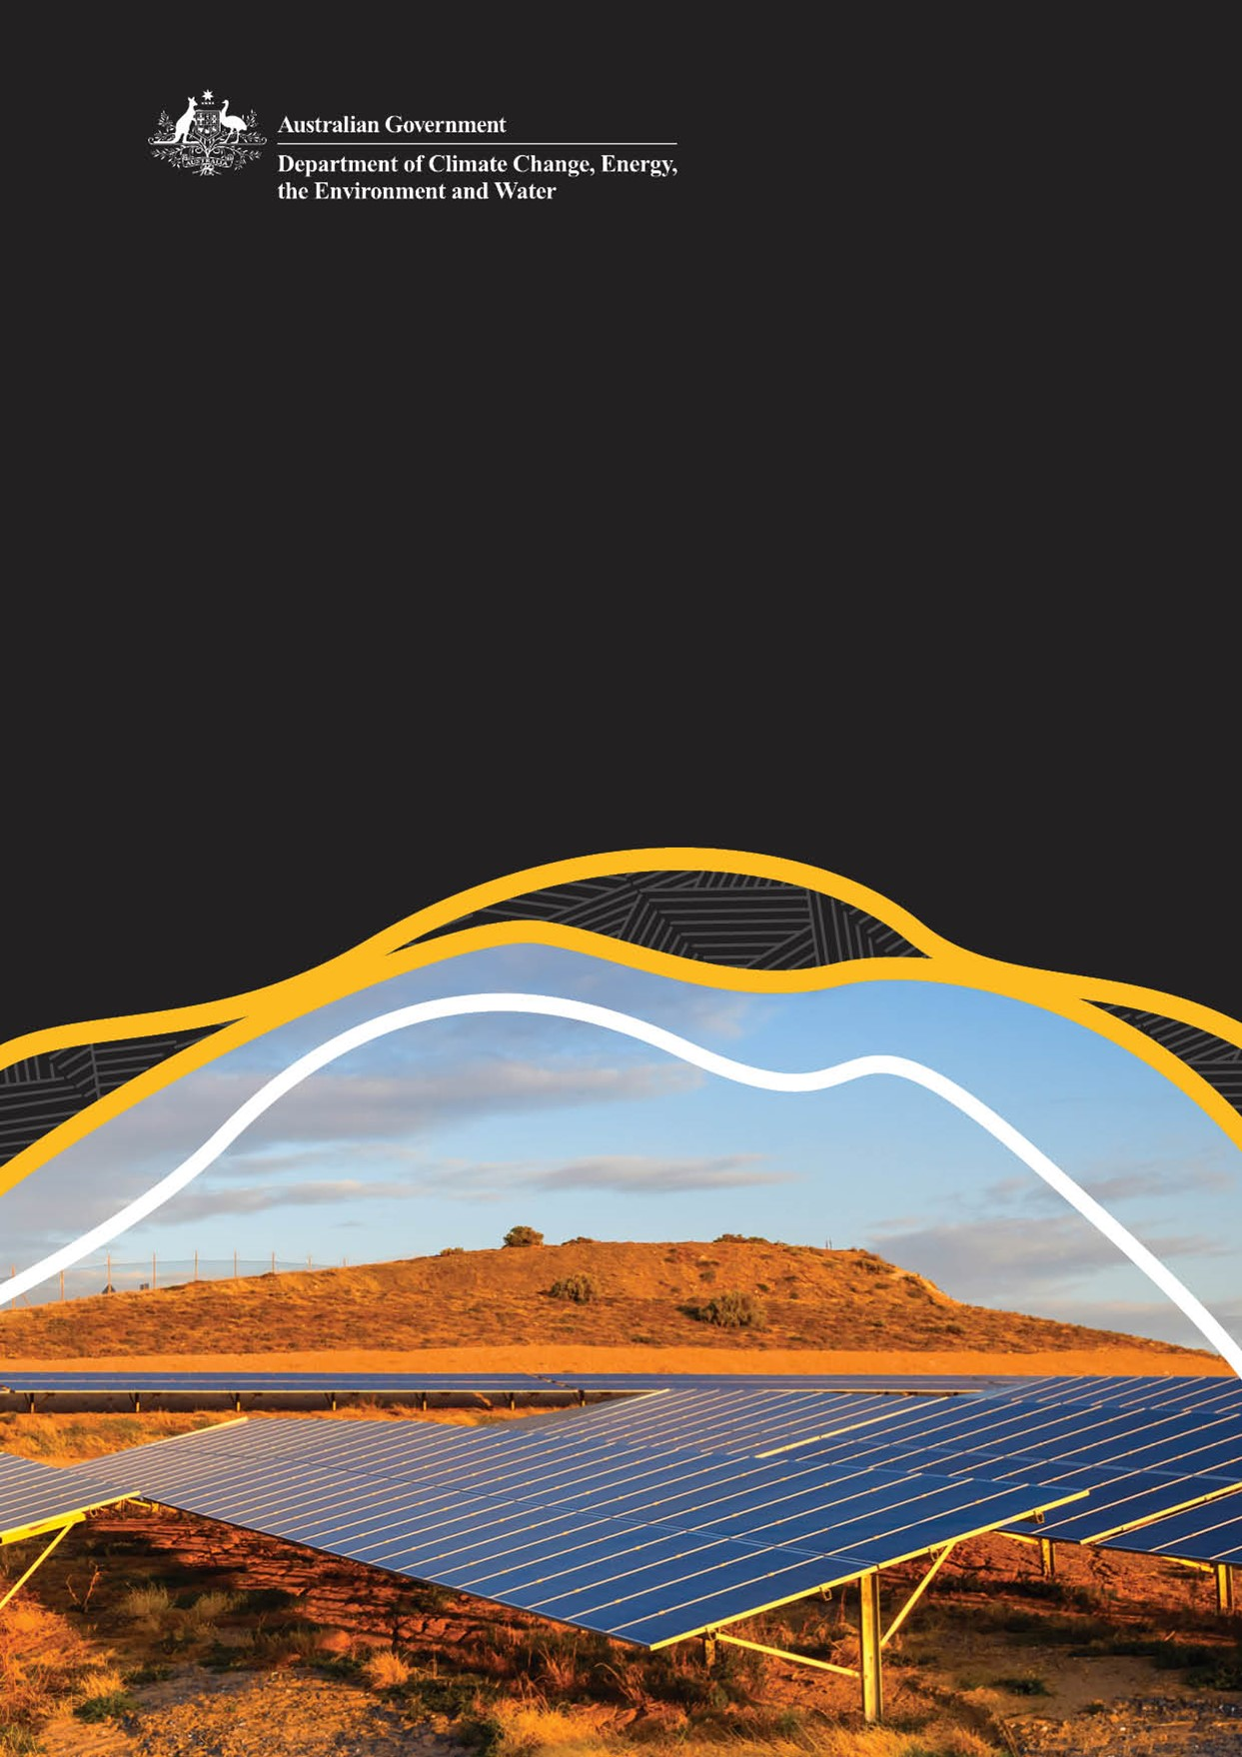
First Nations Clean Energy Program
Design and Delivery consultation

First Nations Clean & Clean Energy Facilitation Branch
Department of Climate Change, Energy, the Environment and Water
© Commonwealth of Australia 2025
Ownership of intellectual property rights
Unless otherwise noted, copyright (and any other intellectual property rights) in this publication is owned by the Commonwealth of Australia (referred to as the Commonwealth).
Creative Commons licence
All material in this publication is licensed under a Creative Commons Attribution 4.0 International Licence except content supplied by third parties, logos and the Commonwealth Coat of Arms.
Inquiries about the licence and any use of this document should be submitted via our online contact form.

Cataloguing data
This publication (and any material sourced from it) should be attributed as: DCCEEW 2025, First Nation Clean Energy Program, Department of Climate Change, Energy, the Environment and Water, Canberra, February. CC BY 4.0..
Department of Climate Change, Energy, the Environment and Water
GPO Box 3090 Canberra ACT 2601
Telephone 1800 920 528
Web dcceew.gov.au
Disclaimer
The Australian Government acting through the Department of Climate Change, Energy, the Environment and Water has exercised due care and skill in preparing and compiling the information and data in this publication. Notwithstanding, the Department of Climate Change, Energy, the Environment and Water, its employees and advisers disclaim all liability, including liability for negligence and for any loss, damage, injury, expense or cost incurred by any person as a result of accessing, using or relying on any of the information or data in this publication to the maximum extent permitted by law.

Acknowledgement Of Country
The Department of Climate Change, Energy, the Environment and Water acknowledges the Traditional Owners of Country throughout Australia and their continuing connection to land, skies, waters, and community. We pay our respects to Elders past and present.
Indigenous knowledge is critical to living sustainably in Australia. The 65,000 years of knowledge that Aboriginal and Torres Strait Islander peoples hold as Custodians of Australia’s land and natural resources can and should underpin a fair and just energy transformation.

Contents
First Nations Clean Energy Program 1
Acknowledgement Of Country 3
1. Purpose and objectives of this process 5
1.1 How to Respond: 5
2. Program Intent and Key Measures 6
3. Design and delivery conditions 6
4. Program Measures 7
4.1 Pilot Project Pipeline – First Nations led projects 7
4.1.1 How to submit an Expression of Interest 8
4.2 Clean Energy Toolkit: we want to hear from service providers 8
4.2.1 How to submit an Expression of Interest 9
5. Program Design and Assessment Criteria Feedback 10
Appendix 1 EOI Template – Pilot Project Pipeline 11
Appendix 2 EOI template – Clean Energy Toolkit 12

Purpose and objectives of this process
Sponsored by the Australian Minister for Climate Change and Energy, and the Minister for Indigenous Australians, the First Nations Clean Energy Strategy 2024–2030 (the Strategy) is a national framework to realise meaningful economic benefits and energy equity for First Nations peoples through the clean energy transformation.
The Strategy has a central vision for a sustainable clean energy future for all Australians, with Country and Culture at the heart. Information about the Strategy and how it was developed can be found at First Nations Clean Energy Strategy | energy.gov.au.
The Commonwealth Government has announced $70 million in funding over 3 years from 2025-26 for the First Nations Clean Energy Program.
To maximise the impact and benefit of this funding, we are now seeking non-binding expressions of interest (EOI) put from service providers and project proponents to inform the design and delivery of two key measures:
- The Pilot Project Pipeline, and
- The Clean Energy Toolkit.
This process aims to support our continuing commitment to First Nations leadership and participation in program design and delivery. We understand that not all traditional modes of Government Program delivery work for First Nations people and their communities, especially regional and remote communities.

How to Respond:
Submit your response by 31 August 2025 using the templates provided in the Appendices.
Please be aware that:
- This is not a grant or procurement process and responses will not be accepted as applications for future advertised grant or procurement opportunities.
- Your responses are non-binding and will be used to inform program design including development of grant and procurement activities.
- Information provided will be handled in accordance with the relevant privacy notice which will be presented as part of the Have Your Say Survey.
- Program information in this paper is indicative only. The final grant and procurement guidelines will specify all program requirements.
Submissions can be made at the First Nations Clean Energy Program consultation page available at: https://consult.dcceew.gov.au/first-nations-clean-energy-program .
For any questions related to this process please contact fnces@dcceew.gov.au and include ‘HYS EOI’ in the subject line of your email.

2. Program Intent and Key Measures
When we were developing the First Nations Clean Energy Strategy, feedback highlighted significant barriers to First Nations peoples’ participation in the clean energy transformation. Barriers included limited access to technical expertise, culturally appropriate information and project development funding.
The Program aims to address these barriers through measures which are expected to include:
- The Pilot Project Pipeline– targeted pilot funding to support a small number of First Nations proponents to progress their clean energy projects along the project development pipeline towards final investment decision; and build evidence of the critical investment barriers to support future program opportunities.
- The Clean Energy Toolkit – a suite of tailored clean energy information products and services to build First Nations peoples’ knowledge of the energy transformation, support informed decision-making, and improved access to resources to support participation.
- Clean Energy Advice Grants – small scale, low barrier grants to support eligible First Nations applicants to access the independent professional expertise they need to participate in clean energy opportunities.
Please note: The Clean Energy Advice Grants are currently in development and are not included in this consultation process.
To register your interest in upcoming grants, complete the Have your Say survey.

3. Design and delivery conditions
All measures will be designed and delivered in line with the Strategy’s guiding principles and vision, and the priority reforms of the National Agreement on Closing the Gap. They will also reflect the recommendations of the 2024 Productivity Commission review of the Closing the Gap partnership agreement. The review emphasised the importance of empowering First Nations peoples and organisations with the resources, authority and decision-making power to lead the design and implementation of programs that support First Nations interests.
Aligned with this approach, DCCEEW anticipates all measures within the Program will:
- Be First Nations-led in design and delivery.
- Adopt a demand-driven and needs-based approach, meeting First Nations peoples where they are and responding to community-identified priorities.
- Be informed by meaningful and ongoing engagement with First Nations organisations, businesses and communities to ensure cultural relevance and long-term impact.
- Promote gender equity and the inclusion of vulnerable groups, ensuring diverse representation and participation across all program activities.
- Incorporate innovative and sector-leading delivery approaches that empower First Nations peoples and organisations to shape and deliver clean energy solutions that reflect their aspirations and values.
- Include robust monitoring and evaluation (M&E) frameworks to track outcomes, support learning, and ensure accountability to report against the broader Strategy objectives.
- Include appropriate governance structures and where necessary, support to build the capacity needed to ensure accountability, probity and risk management, including transparent reporting.
- Be based on a strong collaborative approach to ensure a cohesive Program.
DCCEEW anticipates some of the Program measures will be delivered by First Nations-led service providers and organisations/businesses.
Measures might also be delivered through consortia approaches bringing together expertise from different parties to maximise impact and outcomes. This could include First Nations-led partnerships with non-First Nations organisations.

4. Program Measures
This section outlines current proposed design and delivery details. NB: This information is subject to change.

4.1 Pilot Project Pipeline – First Nations led projects
During Strategy consultations, we heard that First Nations peoples who want to develop clean energy projects face significant barriers. These barriers include: accessing business development support, establishing governance structures for projects, engaging appropriate technical expertise to undertake feasibility and due diligence related work, develop benefit sharing arrangements, including regionally, and securing necessary financing.
In response to this feedback, DCCEEW expects to fund a small set of projects through the Pilot Project Pipeline to:
- address these barriers and progress clean energy projects towards final investment decision;
- support innovative approaches to project development; and
- share knowledge and lessons about First Nations led/driven projects and models of project development.
We anticipate that projects funded under the Pilot Project Pipeline may require support in some or all of the following areas:
- Opportunity assessment: renewable energy resource mapping and assessment, site selection and assessment, land use planning
- Business development: establishing commercial governance structures, legal frameworks, and associated advice
- Design and engineering: technical feasibility, technology assessment
- Approvals: Permitting, regulatory and environmental approvals
- Benefit sharing frameworks: including trust structures and benefit negotiation processes
- Financing: financial feasibility and modelling, identifying investors and negotiating financial agreements
- Procurement: negotiation of contracts.

4.1.1 How to submit an Expression of Interest
Using the template provided in the Appendices, please provide a separate response for each individual project you expect to submit for the Pilot Project Pipeline. Then attach it to your Have your Say response. Check the Frequently Asked Questions on the Have your Say page for more details on how to submit.
Note: you can attach more than one response and submit responses to both projects via the Have your Say site.

4.2 Clean Energy Toolkit: we want to hear from service providers
During Strategy consultations, we heard that First Nations peoples needed better access to high-quality, trusted information and resources. This will strengthen knowledge of the clean energy transformation and its opportunities and risks for First Nations peoples. We heard that this information needs to be tailored, culturally appropriate, and designed to support informed decision-making.
Regional benefit sharing models were also discussed and governance arrangements to enable these kinds of approaches across First Nations communities. Empowering First Nations communities to participate in the energy transformation through self-determined approaches was another consistent theme.
To address this, DCCEEW proposes to fund the development of a Clean Energy Toolkit. This measure will consolidate existing clean energy resources in a more accessible way, while also addressing critical gaps in culturally relevant information and services tailored specifically for First Nations peoples in the clean energy sector.
For this process, a service provider is defined as an individual or organisation that could offer services to Program beneficiaries under a contract or agreement with DCCEEW that specifies the scope, quality and cost of the services to be delivered.
We expect the toolkit to provide several key resources, including but not limited to:

Products: First Nations Clean Energy Website
A trusted, central knowledge hub that brings together existing and new resources on First Nations clean energy rights and interests in a coordinated, easy-to-use way.
The website will link to relevant programs and opportunities across Australia and internationally, be regularly maintained and ensure open and equitable access.

Products: Tailored Clean Energy Resources
Hosted on the First Nations Clean Energy website, these culturally appropriate products may include:
- Clean energy facts
- How-to guides
- Tools for benefit-sharing, negotiation and agreement-making
- Digital maps and On Country mapping guidance
- Case studies and best practices
- Thematic research reports, underpinned by data able to be used nationally and regionally.
- ‘When the lights go off’ - pre-paid metering resources.

Services: Outreach and Extension Activities
Designed to build awareness and capacity, these activities may include:
- Tailored communications and engagement to promote understanding of the clean energy transformation and its opportunities
- Needs-based workshops and education sessions covering a range of topics
- Participatory energy planning and systems design activities
- Community information sharing forums to foster learning between First Nations communities
- Supporting materials for engagement activities, such as case studies.
We expect a mapping assessment of existing clean energy information and resources is needed to ensure this measure complements existing resources. This will help avoid duplication and identify areas of need. Consultation with First Nations stakeholders will be essential to design toolkit resources that are tailored, culturally appropriate and fit-for-purpose.

4.2.1 How to submit an Expression of Interest
Using the template provided in the Appendices to submit your response for the Clean Energy Toolkit. Then attach it to your Have your Say response. Check the Frequently Asked Questions on the Have Your Say page for more details.
Note: you can attach more than one response and submit responses to both measures via the Have your Say site.

5. Program Design and Assessment Criteria Feedback
In addition to questions about the Program measures, we are seeking your feedback on the proposed assessment criteria. These criteria will ensure that service providers design and deliver in the most effective and culturally appropriate way, aligned to the principles and goals outlined in Section 3 of this paper. To provide your feedback on the proposed criteria, complete question 4 of the Have Your Say survey.https://consult.dcceew.gov.au/first-nations-clean-energy-program .

Appendix 1 EOI Template – Pilot Project Pipeline
Please address the following areas in your Expression of Interest and provide a separate response for each individual project you expect to submit under this measure.

1. Project description
- Name and description:
- Start and end date for the project:
- Project stages and milestones:
- Project location(s):

2. Project participants and partners
- Lead funding applicant (including First Nations equity arrangements if applicable):
- Note: must be an Australian organisation, preferably a First Nation-led organisation.
- Project partners and participants:
- Expected support of the relevant State or Territory government:
- Stakeholders your project will affect and proposed engagement plan:

3. Project funding
- Estimated total project cost (excluding GST):
- Proposed funding sought, phased over each financial year:
- Proposed contribution by your organisation including cash and in-kind
- contributions:
- Any other funding sources including cash and in-kind contributions:

4. Project outcomes
- Outline the critical challenges currently preventing the project from achieving a financial investment decision:
- Expected outcomes including benefits to First Nations communities and electricity consumers:
- Proposed performance metrics:

5. Project risks and dependencies
- Describe key risks and mitigation strategies involved in the project

6. General design feedback
- What do you think about the proposed design details for this measure?
- Are there any details which could be improved to better deliver the intent of the measure?

Appendix 2 EOI template – Clean Energy Toolkit
Please address the following areas in your Expression of Interest.

1. Project description
- Name and description:
- Start and end date for the project:
- Project stages and milestones:
- Project location(s):
- Describe the products and/or services to be designed and delivered:
- In addition, please provide the following:
  - Detail the types of products and/or services your organisation typically provides:
  - Detail where you typically provide products/services in Australia and at what scale: e.g. Australia-wide, a specific region, community level, which states/territories, etc.

2. Project participants and partners
- Lead funding applicant:
  - Note: must be an Australian organisation, preferably a First Nation-led organisation.
- Project partners and participants:
- Expected support of the relevant State or Territory government (if relevant):
- Stakeholders your project will affect and proposed engagement plan:

3. Project funding
- Estimated total project cost (excluding GST):
- Proposed funding sought, phased over each financial year:
- Proposed contribution by your organisation including cash and in-kind contributions:
- Any other funding sources including cash and in-kind contributions:

4. Project outcomes
- What critical gaps will the project address:
- Expected outcomes including benefits to First Nations communities and electricity consumers:
- Proposed performance metrics:

5. Project risks and dependencies
- Describe key risks and mitigation strategies involved in the project

6. General design feedback
- What do you think about the proposed design details for this measure?
- Are there any details which could be improved to better deliver the intent of the measure?

