
Tasmanian Marine Resources
Department of Natural Resources and Environment Tasmania

Application for assessment of the Tasmanian Commercial Dive Fishery for approval under the Environment Protection and Biodiversity Conservation Act 1999

Contents
Introduction 3
The fishery 3
Description of the fishery 3
Fishing methods and gear 3
Target and byproduct species 3
Value of the fishery 4
Management regime 4
Description of the management regime 4
Consultation processes 6
Performance against objectives, performance indicators and performance measures 6
Controlling the level of harvest 7
Harvest strategy 8
Recovery strategies for overfished stocks 8
Enforcement of the management arrangements 8
Mitigating impacts on the wider ecosystem 9
National policies, plans and strategies 9
Changes since the previous assessment 9
Monitoring and data collection 10
Data collection, data validation and data monitoring programs 10
Stock Assessments 11
Key target and byproduct species 11
Distribution and spatial structure of key stocks 12
Estimates of total removals 12
Indicator byproduct species 13
Bycatch 14
Bycatch composition 14
Risk assessment on the effects of fishing on bycatch 14
Bycatch mitigation measures 14
Indicator bycatch species 14
Management actions 14
Protected species and threatened ecological communities 14
Fishery impacts on protected species and communities 14
Mitigating risks to protected species and communities 15
CITES-listed species 16
Ecosystem 16
Ecosystem management actions 16
Management responses 16
Marine bioregional plans 17
Research 17
Progress against current Conditions 19
References 19
Appended Data Tables 20
APPENDIX 1 – Retained catch data (target and byproduct species) 20
APPENDIX 2 – Discarded catch data (target and non-target species) 22
APPENDIX 3 – Protected species interaction data 22
APPENDIX 4 – Fishing effort 23
APPENDIX 5 – Approved Logbooks 25

Introduction
This submission meets the requirements for the assessment of the Tasmanian Commercial Dive Fishery under the Environment Protection and Biodiversity Conservation Act 1999 (Cth) (EPBC Act).
This submission has been produced to enable the Department of Climate Change, Energy, the Environment and Water (DCCEEW) to assess the Commercial Dive Fishery management arrangements against the Guidelines for the Ecologically Sustainable Management of Fisheries – 2nd Edition and the requirements set out in relevant sections of the EPBC Act.

The fishery

Description of the fishery
The Tasmanian Commercial Dive Fishery operates within all State Waters of Tasmania, with jurisdiction granted to Commonwealth waters out to 200 nautical miles under Offshore Constitutional Settlements (OCS) arrangements covering crustaceans, molluscs, and echinoderms, with sea urchins included in the latter category. The fishery is divided into five fishery parts to which catch limits are applied, and further divided into blocks and subblocks for spatial management purposes. The fishery parts are set under rule 12 of the Fisheries (Commercial Dive) Rules 2021 (hereafter referred to as ‘the Rules’).
A static map of the fishery parts—Western, South-Eastern, Central-Eastern, North-Eastern, and Northern—is maintained online at Commercial Dive Zones | Fishing Tasmania, and an interactive map of the blocks and subblocks is accessible online at LISTmap.

Fishing methods and gear
The Tasmanian Commercial Dive Fishery is exclusively a dive fishery, with divers permitted to use dive and snorkel gear which includes masks, snorkels, fins, wetsuits, compressed air and associated equipment including hookah and nitrox. With nitrox, divers may reach depths of up to 30 metres.
Commercial divers are permitted to collect species into netted bags by hand, and with the aid of single pronged hooks or tongs, the latter defined in r 28 of the Fisheries (Commercial Dive) Rules 2021 (hereafter referred to as ‘the Rules’) as consisting of two arms each having a single prong or flattened end no more than 100 millimetres wide. No other forms of collection aids are permitted.
Commercial divers dive from small licenced vessels with assistance provided by a deckhand. Divers may work singly or in teams, with catch identified to individuals. Diving is usually conducted as day trips; overnight mother-boating is permitted but is exceedingly rare in this fishery owing to prohibitive costs and that urchins do not maintain quality for long post-harvest.

Target and byproduct species
The fishery is currently limited to Wavy Periwinkles (Lunella undulata), Shortspined Sea Urchins (Heliocidaris erythrogramma), and Longspined Sea Urchins (Centrostephanus rodgersii). The former two species are native to south-east Australian waters including Tasmania, whereas the latter is range-extended from NSW with the first Tasmanian detections made in ~1978.
Being a dive fishery with targeted hand collection, bycatch/byproduct species are nil to negligible.
The target species are each managed with species-specific annual commercial catch limits, divided by the five fishery parts. Smaller catch-caps may be applied annually to defined areas (usually a grouping of subblocks) to constrain localised effort and spread effort to other parts of the fishery. All catch limits and catch-caps are determined by 1 September of each year by published notice under r 14 of the Rules, and are published online at Catch and Closures | Fishing Tasmania.
Table 3 in Appendix 1 provides the weight of all retained catches of each species per year for the past five years. The catch of all species has been trending up over the past decade, but with decreased in the most recent year since 2023-24 (Figures 1, 3 and 5). Broadly, this is reflective of changes to the Longspined Sea Urchin part of the fishery, the accelerated growth of which has been underpinned by an incentivised fishing program introduced in 2018, and a motivated seafood processor. Increases in that part of the fishery from 2018 buoyed fishers to utilise their fishery investment and increase catches of Shortspined Sea Urchin and Periwinkles. However, there were major consecutive disruptions to the processing sector in 2023 and 2024, with the net result being a recent decrease in commercial dive catch.
The Periwinkle harvest has also seen a recent decrease in catch in the Western fishery part, further contributing to the downward trends. The West coast is wild and remote, and access is only possible with large fishing vessels, of which there are few in the commercial dive fishery. Changes to vessel ownership has altered the fleet dynamics such that there are currently few overnighting mother-boats able to access the rugged West coast.
The Shortspined Sea Urchin harvest has been impacted by multiple increased minimum size limits (MSL). The MSL increased from 60mm to 70mm in the 2019-20 season, then to 75mm in the 2020-21 season, and again to 80mm in the 2023-24 fishing season. Furthermore, in 2023 there was a switch in focus within the major part of the processing sector from building total urchin processing capacity, to building capacity for Longspined Sea Urchin preferentially, which also drove the overall harvest across the seasons.

Value of the fishery
The Social-Economic Analysis of the Tasmanian Dive Sector: Snapshot Report 2024 estimated the value of the Tasmanian Commercial Dive Fishery in the 2022-23 financial year as $2.8M measured as total direct output of the sector, and $3M measured as total Gross Value Added (GVA) of the dive sector plus $15.7M GVA attributed to processing. The current figures may sit a little lower to this owning to reduced catches.
The majority of urchin catch is processed by licenced fish processors for export, with smaller quantities entering the domestic market through the Sydney fish market.
The Periwinkle fishery supplies the domestic market through localised direct sales by divers to consumers, retailers, wholesalers, and the major fish markets.

Management regime

Description of the management regime
The Tasmanian Commercial Dive Fishery is managed under the Living Marine Resources Management Act 1995 (LMRMA) and subordinate legislation including the Fisheries (Commercial Dive) Rules 20​21 (‘the Rules’; these Rules also act as the management plan), Fisheries Rules 2019, Fisheries (General and Fees) Regulations 2016, and the Fisheries (Penalty)​ Regulations 2021​.
A plain English summary of the Rules and prevailing management arrangements are made publicly available online within the Operational Guide for the Commercial Dive, Shellfish and Undaria Fisheries. An updated copy of the guide is published online and provided to all commercial divers at the start of the fishing season, by 1 September of each year.
In addition to defined fishery parts, spatial closures, total catch limits, and catch-caps described earlier in this document, the fishery is further managed with minimum size limits (MSL) for commercial fishers as prescribed under rule 13 of the Rules. Currently, the commercial MSL is 45mm for Periwinkles to allow for two years of spawning prior to entering the fishery, and 80mm for Shortspined Sea Urchin which provides for three years of spawning before entry to the fishery. A MSL does not apply to Longspined Sea Urchins which are a range-extended species that are being intentionally overfished in Tasmanian waters with the aid of an incentivised fishing program—worth approximately $350,000 pa—funded by the Abalone Industry Reinvestment Fund (AIRF).
Recreational catch is managed with recommended (i.e., non-mandatory) MSL commensurate to commercial MSL, and a daily bag limit of 100 Periwinkles.
A range of conditions are applied to all commercial dive fishing licences to govern the use of the licence, measuring devices, and loggers. These read as:
1. It is a condition of this licence that the holder, or supervisor of the licence (both hereinafter referred to as the 'diver') must, whilst on a fishing trip not enter the water and dive without being in possession of:
- an instrument supplied by the Institute for Marine and Antarctic Studies (hereinafter referred to as IMAS) for the purposes of automatically recording the depth to which a diver is diving) hereinafter referred to as the 'depth logger'; and
- an instrument supplied by IMAS for the recording of the location of the diver (hereinafter referred to as the location logger) when entering the water.
2. It is a further condition of this licence that the diver must, whilst on a fishing trip not to enter the water without first manipulating and observing an instrument supplied by IMAS, that is in their possession, by:
- activating the power switch of the location logger and observing a display of latitude, longitude and time and at least 30% remaining charge displayed on the power indicator; and
- observing the depth logger for a period of greater than 90 seconds to ensure the power indicator light flashes orange or green but not red.
3. It is a condition of this licence that the only person with the authority to take fish using this licence is the person specified in this fishing licence (commercial dive), and that the diver:
- must whilst diving carry and use an accurate measuring device.
- must ensure the use of accurate weighing instruments for the period of this licence to determine the weight information to be entered into any original docket or record when carrying on any activity under the licence as required by the Living Marine Resources Management Act 1995.
Licences can be further endorsed, upon application, for the use of fish caufs at specified sites.

Consultation processes
The Marine Resources business unit of NRE Tas undertakes public consultation with a wide range of stakeholders when developing or updating fisheries management arrangements. These consultative processes are a requirement under Part 3 of the LMRMA, and includes mandated periods of public comment together with targeted consultation with relevant recognised peak fishing bodies to modify or make a management plan. The prevailing management plan is the Fisheries (Commercial Dive) Rules 2021 which is due to expire February 2032.
Scientific advice is provided contractually to NRE Tas by the Institute for Marine and Antarctic Studies (IMAS) via the Sustainable Marine Research Collaboration Agreement (SMRCA). Under the SMRCA, IMAS provides scientific advice regarding fishery performance and key indicators including CPUE and CPUA derived from catch records and mandatory GPS/depth loggers worn by commercial divers.
Operational advice is provided directly by the Tasmanian Commercial Divers Association (TCDA) and Seafood Industry Tasmania (SIT), both of which are relevant recognised peak fishing bodies under section 25 of the LMRMA. Open lines of communication are maintained with the peak bodies by NRE Tas fishery managers, with formal meeting opportunities facilitated via Fishery Consultative Groups.
The Commercial Dive Fishery Consultative Group (formerly referred to as the Commercial Dive Fishery Core Group) is a formal mechanism by which NRE Tas facilitates open dialogue with scientific experts, peak bodies, and invited representatives of the fishery. The group meets several times per year, normally coinciding with preparation for peak body general meetings and catch limit setting determinations. Formal Minutes are not kept, but action items, talking points, and general notes are maintained and stored by NRE Tas, and circulated post-meeting to attendees.
The Incentivised Centrostephanus Fishing Program is funded by the Abalone Industry Reinvestment Fund (AIRF), which is a joint initiative between the Tasmanian Government and the recognised peak fishing body for the abalone fishery, Tasmanian Abalone Council Limited (TACL). The AIRF contributes approximately $300,000 pa towards the program, which is ultimately managed by NRE Tas. The AIRF Committee—comprising members of NRE Tas, IMAS, and TACL—meets annually with members of the Commercial Dive Fishery Consultative Group and IMAS to make recommendations for the per kilogram incentive rates and spatial scales to be applied in the coming fishing season. The final determination regarding the incentivised Centrostephanus fishing program is made by NRE Tas.

Performance against objectives, performance indicators and performance measures
The harvest strategy for Periwinkles and Shortspined Sea Urchins outlined in NRE Tas Policy Paper 2005 (which should be read in conjunction with Policy Paper Update 2011) uses standardised catch rates—both CPUE and CPUA—obtained from logbooks and loggers, and size structure data obtained from measuring devices in processing facilities, as performance indicators. Trigger points for catch rates are reached if there is a decline of 20% in each of two consecutive years or 35% in a year; these triggers are intended to be reviewed in the near future with the potential to introduce Limit and Target Reference Points (LRP, TRP).
The Longspined Sea Urchin fishery utilises the same performance indicators, but is further supported with fishery-independent surveys. Biomass in the Longspined Sea Urchin fishery is assessed by CPUE trends and extrapolation from counts obtained from fishery-independent transect surveys. A dynamic size-structured stock assessment model to analyse population growth and the effects of fishing on Longspined Sea Urchin stock biomass in east coast Tasmanian waters has been developed.
Fishery performance is monitored throughout the year by IMAS under the SMRCA, with formal annual assessments and stock status published by IMAS. Currently, IMAS has classed each species as Sustainable: Shortspined Sea Urchin, Longspined Sea Urchin, and Periwinkles. Likewise, the latest Status of Australian Fish Stocks Reports (SAFS) classes each species as Sustainable: Longspined Sea Urchin 2023, Shortspined Sea Urchin 2023, Wavy Periwinkle 2023.
The Tasmanian Commercial Dive Fishery fits the model of a S-Fishery (small-scale, spatial structured, sedentary target species), and IMAS-led FRDC project 2022-039 is currently underway to develop more robust spatial based assessment methodologies and tools for such fisheries, with the Tasmanian Commercial Dive Fishery as a case study. Within this project and through a future harvest strategy consultative process, appropriate LRPs, TRPs, and control rules for each species should be identified which will inform a review of the Harvest Strategy setting within the prevailing policies.

Controlling the level of harvest
Harvest for Periwinkles and Shortspined Sea Urchins is controlled using annual Total Allowable Commercial Catch (TACCs) limits set for each of the five fishery parts. Smaller catch-caps are applied annually to specific subblocks to constrain localised effort and spread effort to other parts of the fishery. Once the limits/caps are reached, area/species-specific closures are instated with 24 - 48 hours’ notice provided to fishers.
Catch limits, catch-caps, and species/area closures are determined under notice at Tasmanian Government Public Notices, and are published online at Catch and Closures | Fishing Tasmania.
In determining limits, NRE Tas consults with IMAS, the recognised peak fishing bodies (SIT and TCDA) and the Commercial Dive Fishery Consultative Group and considers estimates of all sources of mortality on each stock. Recreational and customary fishing is estimated as nil to negligible. The commercial fishery is limited entry with only 52 commercial dive licences, and approximately 25 to 35 active divers at any one time.
Catch constraints are not applied to the Longspined Sea Urchin Fishery.
Commercial catch is recorded at species-level in an approved fishery logbook, the Commercial Diver’s Docket book (Figure 9 of Appendix 5). Dockets must be completed by the diver and receiver of the fish prior to leaving the landing area, and they must be posted to NRE Tas within 48 hours of completion. Licensed seafood processors verify catch weights and report these independently using an approved logbook, the General Fish Processors Return (Figure 10 of Appendix 5), which is submitted to NRE Tas monthly.
Divers are also permitted to cauf their fish if their licence is endorsed with cauf locations, and to self-process and sell their own catch; in practice, this is constrained to the Periwinkle fishery. Divers are required to maintain cauf records and direct sales records for 5 years and make these available to the Fisheries Officers and NRE Tas upon request.
All Commercial Diver’s Dockets and General Fish Processor Returns are entered into the Fisheries Integrated Licensing and Monitoring System (FILMS) electronic database by NRE Tas staff and reviewed for errors or instances of non-compliance.

Harvest strategy
The Tasmanian Commercial Dive Fishery is managed under the provisions of its management plan, the Fisheries (Commercial Dive) Rules 2021, with a harvest strategy outlined in the in NRE Tas Policy Paper 2005, which should be read in conjunction with Policy Paper Update 2011. The fishery uses catch rates—both CPUE and CPUA—and size structure as performance indicators. Trigger points for catch rates are reached if there is a decline of 20% in each of two consecutive years or 35% in a year.
The trigger points have been flagged as needing review to guard against year-on-year declines and the risk of serial depletion. A dedicated Harvest Strategy document with robust TRPs and LRPs is desirable. As resources allow for it, NRE Tas is working towards developing Harvest Strategies for all fisheries including Commercial Dive.
The Longspined Sea Urchin fishery utilises the same performance indicators, but is further supported with periodic fishery-independent surveys. Biomass in the Longspined Sea Urchin fishery is assessed by CPUE trends and extrapolation from counts obtained from fishery-independent transect surveys.
Annual decisions regarding catch limits, spatial closures, and size limits, are made following scientific assessment of performance indicators by IMAS, and upon advice obtained through the Commercial Dive Fishery Consultative Group or other reliable sources.
Future development of a more contemporary harvest strategy for each species is largely dependent on the outcomes of IMAS-led FRDC Project 2022-039: Developing spatial based assessment methodologies and tools for small scale dive fisheries: Case study of the Tasmanian Commercial Dive Fishery.

Recovery strategies for overfished stocks
There are no active recovery plans in place at this time because the stock status for all species is classified as sustainable.
Precautionary, adaptive management is practiced in this fishery to protect stock with responses to dynamic/seasonal impacts upon the fishery including from marine heatwaves, harmful algal blooms, or localised overfishing. Concerns raised by industry are taken into consideration when determining catch limits and closures. For example, in response to depletion concerns for Shortspined Sea Urchins and Periwinkles, on the back of successive marine heatwaves the industry, the industry proposed through the peak bodies a 50% reduction to all catch limits be applied in the 2024-25 fishing season. This was a highly conservative and precautionary measure to mitigate against potential overfishing which was supported and implemented by NRE Tas.
If a recovery strategy were required, NRE Tas would engage with IMAS and consult with the industry to develop one.

Enforcement of the management arrangements
NRE Tas contains a dedicated Marine Resources Compliance and Monitoring team who are responsible for ensuring fishery operators adhere to management arrangements. The team monitors harvest data submitted by harvesters and processors, and are aided with a sophisticated electronic database with automated error and non-compliance detection rules.
The Marine Resources Compliance team investigate all matters of referred non-compliance in the first instance, with responses varying from education to infringement/prosecution and the application of demerit points upon convictions. Some matters may be escalated to the Tasmanian Marine Police (TasPol) for further investigation.
Fisheries Officers within the Marine Resources Compliance team conduct scheduled inspections/audits of fish processing premises with a focus on records and equipment. Fisheries Officers from TasPol routinely conduct spot inspections of fish processors, conduct at-sea and in-port inspections of catches and vessels.
Matters of concern may occasionally be raised through other means. For example, some evidence of fishing for undersized Shortspined Sea Urchins was detected in 2023 and 2024 through a voluntary catch measuring program employed in several processing facilities. The matter was referred to the Compliance team for handling. Diver education was prioritised at the diver general meetings, and the requirement to carry and use a measuring device whilst diving was introduced. TasPol increased their on-water presence at critical fishing times, and divers were offered confidential access to their personalised catch size data for the purpose of self-regulation and improvement.

Mitigating impacts on the wider ecosystem
An ecological risk assessment has not been undertaken for this fishery, however, the nature of the fisheries operations—hand collection of small quantities of targeted species by diving—renders the risk very low. The Tasmanian Commercial Dive fishery, particularly the urchin fishery component, is being actively used as a beneficial tool in the protection and restoration of several threatened and protected species and ecological communities. Please refer down to sub-heading Protected species and threatened ecological communities for more information.

National policies, plans and strategies
The fishery’s management arrangements are compliant with national policies and strategies.
- Threat abatement plans:
Compliance is not explicitly required for this fishery, with only one plan relevant: Threat abatement plan for the impacts of marine debris on the vertebrate wildlife of Australia’s coasts and oceans (2018). The fishery is consistent owing to limited gear types (scuba, hookah, hand-held/rope-attached bags, and pronged tongs).
- Recovery plans:
Compliance is not explicitly required for this fishery, with none of the plans being relevant.
- National Policy on Fisheries Bycatch:
The fishery is consistent with the policy. Bycatch and discards are not practiced within the fishery because harvested fish are individually hand selected by divers. Without quota limitations, there is no incentive to high-grade catch. On-water mortalities are negligible as this is a single-dive-day fishery (i.e., overnighting is permitted but not practiced) with most catch processed same-day. Post-harvest mortalities of caufed animals are recorded in cauf records, with those fish having already been included on diver catch records and counted towards the catch limits.

Changes since the previous assessment
A range of changes have been implemented since the previous assessment. These include:
- Mandatory use of GPS and Depth Loggers
The use of diver GPS location and depth loggers has been mandatory since September 2022, with CPUA and depth data being incorporated into catch limit setting considerations. Prior to this, the loggers were being trialled on a voluntary basis for several years.
- Mandatory use of Measuring Devices
The carriage and use of accurate measuring devices whilst diving has been mandatory since September 2024, to aid with adherence to minimum size limits.
- Minimum Size Limits (MSL)
The MSL for commercially harvested Shortspined Sea Urchin increased from 60mm to 70mm in the 2019-20 season, then to 75mm in the 2020-21 season, and again to 80mm in the 2023-24 fishing season. A new licence condition was introduced in 2023-24 to require commercial divers to carry and use a measuring device.
The measures are projected to enable approximately 80% of the population to spawn for three years before they grow to a size where they are available to the fishery, rather than two years of spawning per the previous size limit. This measure has been introduced to provide additional protection to breeding stocks.
A minimum size limit for Periwinkles has been maintained at 45mm. Size limits do not apply at this time to Longspined Sea Urchin which are not native to Tasmanian waters.
- Operational Guidelines
The Operational Guide for the Commercial Dive, Shellfish and Undaria Fisheries was first introduced in 2023, with updated versions to be released every August prior to the start of the new fishing season. This acts as a plain English guide to the fishery for the benefit of operators and the public.
- Fixed Fishing Area Borders and Change of Blocks/Subblocks Map
The borders of the fishery parts were fixed in position in September 2022, where they had previously been shifted on an ad hoc basis to accommodate industry requests. At the same time, the fishery moved away from its grid-block map and adopted the same blocks and subblocks as the commercial abalone fishery. This has streamlined reporting by enabling consistency between seasons, and simplified matters for the industry where half of the operators are also active in the abalone fishery.

Monitoring and data collection

Data collection, data validation and data monitoring programs
Commercial Diver’s Docket books are issued to individual divers by NRE Tas for completion of daily catch records (Figure 9 of Appendix 5). Completion of all relevant sections is mandatory, with divers required to complete details pertaining to their personal identification; prior fishing telephone report number; vessel; GPS and depth loggers; dive location/s by fishery part, name, and subblock; dive time and depth; estimated weight of catch per species; transfer date, time, and type (i.e., to a processor, direct sale at time of landing, or cauf for self-processing); and value (kilograms and dollars) of direct sales between completion of the last Commercial Diver’s Docket and the current one.
Dockets must be completed by the diver and receiver of the fish prior to leaving the landing area, and they must be posted to NRE Tas within 48 hours of completion. Divers are also required to maintain cauf records for five years and make them available to Fisheries Officers if requested.
General Fish Processor Returns must be submitted monthly by licensed fish processers, as is mandatory (Figure 10 of Appendix 5). All data are entered into the Fisheries Integrated Licensing and Monitoring System (FILMS) electronic database by Marine Resources staff. FILMS auto-validates data entered against other sources of data, including telephone reports, and raises flags if details appear invalid.
FILMS tracks the harvest against catch limits and catch-caps and notifies fishery managers when a limit is approaching caught. FILMS also flags any fishing that has occurred within a closed area, or any other breach of a management plan or fishing rule. The program works exceptionally well for fisheries management and monitoring purposes.
Data is not captured for byproduct or bycatch as these are negligible to nil in this fishery. Likewise, protected species interactions are not recorded as the gear type and fishing methods mitigate against entanglements or trapping.
Commercial divers must use GPS and depth loggers when commercially diving. This fine-scale spatial is housed with IMAS for the purposes of measuring the spatial distribution of the fishing effort and producing an annual fishery assessment, and it is made available to NRE Tas or Fisheries Officers for validation of catch data upon request.
IMAS collect size structure data using purposely designed digital measuring boards located within processing premises, with fish measured upon receipt into the processing premises. This is a voluntary program that has captured size structure data from all parts of the fishery throughout the fishing season. The data is housed with IMAS for annual fishery assessment purposes.
IMAS conduct periodic surveys of Longspined Sea Urchin biomass along the Tasmanian east coast, including in 2001-02, 2016-17, 2020-21, and limited surveys in 2024. The general trend is of increasing biomass; a summary may be found in the most recent SAFS Report.

Stock Assessments

Key target and byproduct species
Each of the Tasmanian Commercial Dive Fishery sub-fisheries (i.e., species-specific) are formally assessed every few years at the jurisdictional level, and stock status reported in the SAFS reports. All Tasmanian stocks were assessed as sustainable in the most recent reports for each species in 2023 (Table 1), with the status directly attributed to robust and adaptive management strategies.
SAFS assessment for Shortspined Sea Urchin commenced in 2023. Standardised CPUE is considered as a proxy for available biomass for the stock assessment. Additional to this, IMAS provides yearly updates of the fishery status to the Commercial Dive Fishery Consultative Group (formally referred to as the Commercial Dive Fishery Core Group) to enable informed annual TACC setting.
The primary data inputs for the assessment are fishery-dependent data collected from Commercial Divers Dockets—including daily records of catch reported in whole weight, fishing effort in hours, and fishing locations by subblock level—and fine-scale spatial and depth data from diver-worn and vessel-attached loggers.
IMAS also collects biological data on the size structures, growth rates, and reproductive maturity of Tasmanian Commercial Dive Fishery species to inform the assessment process. Commercial catch sampling is undertaken to gather data on the size structure of the harvested populations.
Table 1. Stock status, both current and from the previous two assessments, for Periwinkles, Shortspined Sea urchin and Longspined Sea Urchins caught in the Tasmanian Commercial Dive Fishery as determined from catch data and CPUE. Colours reflect those used in SAFS reporting: red = depleted, yellow = depleting, green = sustainable. NA = Not assessed in that period.
Reports Year →  Tasmanian Stock ↓ | SAFS 2023 | SAFS 2020 | SAFS 2018
Periwinkles | Sustainable | Sustainable | Sustainable
Shortspined Urchins | Sustainable | NA | NA
Longspined Urchins | Sustainable | Sustainable | NA

Distribution and spatial structure of key stocks
The three species targeted in this fishery occur across the Great Southern Reef in other parts of Australia. They are not managed or assessed as a single stock; stock assessment is at the jurisdictional level.
Longspined Sea Urchins are broadcast spawners and larvae can populate southern regions if the currents and water temperatures are favourable. Tasmania is a sink for northern urchin stocks, and recent modelling information out of IMAS indicates that NSW and Victorian longspined sea urchin are source populations for Tasmania’s east coast.
Shortspined Sea Urchins and Periwinkles have a short larval period of about five days, meaning that reefs are likely to be locally populated from close source populations. For this reason, the Tasmanian jurisdiction is divided into fishery parts, with additional catch cap areas and robust size limits, to minimise the likelihood of localised depletion.
Refer to the linked Status of Australian Fish Stocks (SAFS) Reports for a summary of regional management: Wavy Periwinkle 2023, Shortspined Sea Urchin 2023, Longspined Sea Urchin 2023.

Estimates of total removals
Refer to Table 3 of Appendix 1 for a summary of total commercial catches across the previous five fishing season (2019-20 to 2023-24 complete seasons, and 2024-25 up to July 2025). The data is broken down to species level with maps indicating catch origins along the coastlines for Periwinkles (Figure 1), Shortspined Sea Urchins (Figure 3), and Longspined Sea Urchins (Figure 5), as well as applicable catch limits compared to catches for Periwinkles (Figure 2) and Shortspined Sea Urchins (Figure 4). Note, catch limits are not set for Longspined Sea Urchins.
Comparison between years for each species is limited because the fishery part borders shifted prior to 2022, and the efficiency of closures improved with the introduction of a 24-hour notice period in 2023. Further, there have been multiple increases to minimum size limits for Shortspined Sea Urchins (from 60mm to 70mm in the 2019-20 season, then to 75mm in the 2020-21 season, and to 80mm in 2023-24), and in 2023 there was a switch in focus within the major part of the urchin processing sector from building total urchin processing capacity, to building capacity for Longspined Sea Urchin preferentially, which also drove the overall harvest across the seasons.
There have been very few exceedances of commercial catch limits. The most notable exceedance for Periwinkles was in the North-Eastern part in 2019-20 which overran the limit by ~7t. The most notable exceedance for Shortspined Sea Urchins was in the Central-Eastern part in 2019-20 which overran the limit by ~13t. In each case, there was a lag between receipt of catch data and when a closure could be enacted, however, the areas were also fishing well and all indicators supported the extended fishing periods beyond the pre-determined limit; this is reflected in the increased catch limits in the following season.
Refer to Appendix 4 for a summary of the fishing effort in the fishery from 2005-06 to 2023-24. Figure 6 shows that the effort in the Periwinkles fishery has fluctuated over time, often changing marginally with changes in the urchin fisheries. Periwinkles is a specialised niche within the Commercial Dive Fishery, with a stable group of divers who have secured limited markets. New entrants are constrained by those limited markets and the need for holding facilities to purge periwinkles prior to sale. Effort in hours fished has increased over the past decade in line with the urchin fisheries, but the number of fishers holds relatively stable.
There has been a steady increase in the number of active divers and number of hours fished in the Shortspined Sea Urchin fishery (Figure 7), particularly since 2018-19 which aligns with the start of incentivised growth in the related Longspined Sea Urchin fishery. I.e., the two urchin fisheries have complementary seasons and as the Longspined Sea Urchin fishery has grown with support of the AIRF-funded incentivised Centrostephanus fishing program, the divers active in that fishery have extended their urchin diving season by increasing effort in the Shortspined Sea Urchin fishery.
Figure 8 demonstrates how the Longspined Sea Urchin fishery component has been the significant driver of increased effort in other parts of the Commercial Dive fishery. The total effort—both number of divers and hours spent diving—increased significantly in 2017-18 and through from 2018-19 to the present. This is a direct result of the incentivised fishing program for the species, which aims to limit the southward climate-driven range-extension of the urchin and mitigate the development of new urchin barrens by paying a per kilogram rate (up to $3.50/kg) for C. rodgersii urchins taken in priority regions.
Recreational and Indigenous catch is unlicensed and there are no records kept for their harvests. Non-commercial harvest may contribute to localised depletion in some populated inshore areas, particularly for Periwinkles which can be easily collected by wading in the shallows. However, this take is localised and does not impact the populations in deeper and more inaccessible waters. The non-commercial take of minor species is considered nil to negligible.

Indicator byproduct species
Not applicable.
Being a dive fishery with targeted hand collection, byproduct species are not permitted. There is low occurrence of biofouling of marine algae species on the shells of Periwinkles, however this is not quantified or considered problematic.

Bycatch

Bycatch composition
Not applicable.
Being a dive fishery with targeted hand collection and no quota, bycatch including discards (i.e. high-grading) is negligible to nil. There is low occurrence of biofouling of marine algae species on the shells of Periwinkles, however this is not quantified or considered problematic.

Risk assessment on the effects of fishing on bycatch
Not applicable.
Being a dive fishery with targeted hand collection and no quota, bycatch including discards (i.e. high-grading) is negligible to nil. There is low occurrence of biofouling of marine algae species on the shells of Periwinkles, however this is not quantified or considered problematic.

Bycatch mitigation measures
Not applicable.
Being a dive fishery with targeted hand collection and no quota, bycatch including discards (i.e. high-grading) is negligible to nil. There is low occurrence of biofouling of marine algae species on the shells of Periwinkles, however this is not quantified or considered problematic.

Indicator bycatch species
Not applicable.
Being a dive fishery with targeted hand collection and no quota, bycatch including discards (i.e. high-grading) is negligible to nil. There is low occurrence of biofouling of marine algae species on the shells of Periwinkles, however this is not quantified or considered problematic.

Management actions
Not applicable.
Being a dive fishery with targeted hand collection and no quota, bycatch including discards (i.e. high-grading) is negligible to nil. There is low occurrence of biofouling of marine algae species on the shells of Periwinkles, however this is not quantified or considered problematic.

Protected species and threatened ecological communities

Fishery impacts on protected species and communities
The Tasmanian Commercial Dive fishery is highly targeted, with three readily-identifiable species hand collected by divers. The nature of the fishery naturally mitigates against capture, killing, or injuring of protected species and ecological communities, including by way of bycatch and entanglement. Interaction with threatened, endangered, or protected species (TEPS) data is not collected in this fishery.
The Tasmanian Commercial Dive fishery is being actively used as a beneficial tool in the protection and restoration of several threatened and protected species and ecological communities. Please see next section for description.

Mitigating risks to protected species and communities
General
Within the fishery’s Operational Guide, divers are provided information about what to do if they encounter Threatened, Endangered, or Protected Species (TEPS). Divers are requested to contact NRE Tas’ 24-hour Marine Wildlife (Whale) Hotline to report sightings and strandings of whales and dolphins, or interactions with whales, dolphins, seals, or seabirds. Guidelines are also provided in the Operational Guide for viewing and approaching whales and dolphins, based on those provided by NRE Tas Marine Conservation Section for all water users including commercial operators and recreational boaters.
The only TEPs that are regularly sighted in the fishery are sharks, including white sharks and grey nurse sharks. Overall, the threat to the diver is greater than the threat to the shark.
Red Handfish
Commercial divers occasionally operate in Red Handfish habitat when directed to do so for habitat restoration purposes. Red handfish are classified as Critically Endangered under the EPBC-Act (Cwlth) and by the IUCN, and as Endangered under the Threatened Species Act 1995 (Tas). Collection of Red Handfish is not permitted without prior authorisation under the LMRMA (Tas). Native Shortspined Sea Urchin populations are overabundant within Red Handfish habitat where they are building and maintaining urchin barrens, threatening the marine plant species that Red Handfish require for breeding and shelter.
Under permit and direction from threatened species teams (within NRE Tas, IMAS, and DCCEEW), commercial divers and IMAS scientific divers have engaged in controlled urchin harvests/culls to reduce numbers of all size classes of native Shortspined Sea Urchins within Red Handfish habitat. Translocation of urchins is being trialled as an alternative to harvest/culling, particularly from areas immediately adjacent to and surrounding Red Handfish habitat, with urchins translocated to harvest sites within the same bioregion to mitigate biosecurity concerns and boost future commercial harvests. Direct interaction with Red Handfish is avoided and strict operational methods apply.
Giant Kelp Marine Forests of South East Australia
The Giant Kelp Marine Forests of South East Australia ecological community, listed as Threatened under the EPBC-Act (Cwlth), provides habitat for species targeted by this fishery. Although divers may occasionally fish the fringes of Giant Kelp forests, there is a real risk of entanglement when hookah-diving so extra care is taken by divers. The community itself is not targeted, and divers do not interfere with Giant Kelp plants.
Further mitigating risk, Tasmanian commercial divers are contracted to assist with Giant Kelp restoration efforts led by IMAS, The Nature Conservancy (TNC), and Eaglehawk Dive Centre (EDC). After attending training, divers assist with clearing of other marine plant species and outplanting of lines seeded with baby Giant Kelp plants, and they harvest urchins to reduce grazing pressures. Operators within the Tasmanian Commercial Dive fishery are, therefore, highly cognisant and involved in the protection and restoration of Giant Kelp communities.
Harvesting of Longspined Sea Urchin from within Giant Kelp forest restoration sites is critical to ensuring survivability of giant kelp outplants. Commercial divers have been engaged in this work under permit, and with specialised training from IMAS researchers they are now also involved in ongoing outplanting work.
The sum impact of the Longspined Sea Urchin fishery is positive, with evidence that the harvest is pushing the range-extended species into deeper water, limiting its incursions, and reducing formation of incipient urchin barrens. This is critical to protect habitat for all species including economically important species like Abalone and Southern Rock Lobster, and also to provide broad socio-economic benefits for East coast communities.

CITES-listed species
Not applicable. The fishery does not harvest CITES-listed species.

Ecosystem

Ecosystem management actions
There are no concerns relating to ecosystem impacts from harvesting the native species due to the responsive annual catch limit setting policy which involves consultation between IMAS, divers, and NRE Tas. In addition, diving and hand selection fishing methods are very gentle on marine habitats. Commercial divers must not intentionally damage other organisms, and they must avoid dragging catch bags along the bottom or onto boulders per the Australian Wild Abalone Quality Assurance Code of Practice Master Manual; although a separate fishery, commercial divers adhere to the relevant sections which are applicable across dive fisheries.
Commercial divers are well educated regarding ecosystem management and habitat restoration, having become increasingly contracted into marine restoration work. The controlled harvest of native Shortspined Sea Urchin from critical Red Handfish habitat, with oversight and direction from handfish experts at IMAS, is reducing native urchin barrens in vulnerable habitat. This is paving the way for seagrass restoration work under permit soon.
Harvesting of Longspined Sea Urchin from within Giant Kelp forest restoration sites is critical to ensuring survivability of Giant Kelp outplants. Commercial divers have been engaged in this work under permit, and with specialised training from IMAS researchers they are now also involved in ongoing outplanting work.
The sum impact of the Longspined Sea Urchin fishery is positive, with evidence that the harvest is pushing the range-extended species into deeper water, limiting its incursions, and reducing formation of incipient urchin barrens. This is critical to protect kelp and seaweed habitat for all species including economically important species like Abalone and Southern Rock Lobster, and also to provide broad socio-economic benefits for East coast communities.

Management responses
There are no formal decision rules that trigger management responses when monitoring detects significant impacts on associated ecosystems. However, harvest conditions are reviewed annually and spatial/temporal closures would be implemented in the first instance if detrimental ecosystem impacts were reasonably suspected or detected.

Marine bioregional plans
The fishery operates within Tasmanian waters, however, under an Offshore Constitutional Settlement (OCS) agreement the boundary extends into Commonwealth waters of the South-East Marine Bioregion. This bioregion is not currently subject to a bioregional plan, and any catch from within the South-East Marine Bioregion would be negligible owing to natural diver-depth limits (i.e., divers cannot realistically harvest below 30 metres depth).

Research
A chapter published in the 2024 Food and Agriculture Organization of the United Nations book discusses the Tasmanian Longspined Sea Urchin as a case study for managing marine invasive species. Further, multiple fishery assessments have been conducted by IMAS since the last application. These can be viewed online here: Longspined Sea Urchin Assessments.
FRDC project 2022_039 remains current with funding from FRDC, and partnership between IMAS and NRE Tas. The project will develop methodologies for a robust commercial dive fishery stock assessment, inclusive of native species (Periwinkles and Shortspined Sea Urchin) with broader application across ‘S-fisheries’ (i.e., small-scale, spatial structured, sedentary target species) in other parts of Australia.
FRDC project 2022_107 is researching, trialling and evaluating a market driven approach to commercialising Longspined Sea Urchin in Tasmania. The project is completed and undergoing review before publication.
The Abalone Industry Reinvestment Fund (AIRF) continues as a joint initiative between NRE Tas and the Tasmanian Abalone Council Limited (TACL) to fund abalone and Longspined Sea Urchin projects. Please visit the webpage for a full list of relevant projects, otherwise a condensed list of recent AIRF projects of significance for the fishery is included below:
- In 2023, IMAS delivered a Risk Profile for the paralytic shellfish toxins (PST) from Alexandrium catenella in Tasmanian Sea Urchins. The rick profile states that the probability of Tasmanian urchin roe accumulating concerning levels of PST during Alexandrium catenella blooms is low. Risk during G. catenatum blooms is currently unknown due to limited sampling during these blooms. The current control measures are highly conservative. There is no evidence that controls are needed to mitigate PST risk during low to moderate A. catenella blooms, although monitoring during more extensive blooms may be appropriate.
On the basis of the risk profile, NRE Tas has made several appeals to DCCEEW to review the recommendations and de-link Tasmanian urchins from the Abalone Biotoxin Risk Management Plan, and instead utilise risk monitoring results from other seafood biotoxin monitoring programs operating in Tasmania to determine potential PST risk associated with Gymnodinium catenatum and Alexandrium catenella (the latter during high bloom scenarios), considering both where and when harvest activity is occurring. Requests for review have gone unanswered since November 2023.
- In 2024, an IMAS project to assess the risk profile for Periwinkles got underway; this project will utilise lab trials in place of field data. A scientific paper on this work has recently been published: Toxin uptake and slowed reflexes by the marine snail Lunella undulata following exposure to paralytic shellfish toxin producing Alexandrium catenella.
- In 2024, IMAS conducted a survey for Longspined Sea Urchin in commercial fishing blocks 21 and 29 to determine the extent of their incursion along productive abalone fishing grounds. Outcomes of the survey informed the 2024-25 setting of Longspined Sea Urchin fishing incentives and directed commercial divers to harvest from priority abalone habitat.
- In 2022-25, IMAS led a ​Restoration by Harvest Pilot Program in Fortescue Bay that aimed to restore kelp habitat along a 5km stretch of coastline, providing valuable insights into the efficacy of expanded control programs in priority abalone habitat areas and to guide the Regional Centrostephanus Strategy development. This project is quantifying the considerable level of coordination and funding required to remove all size classes of Longspined Sea Urchin from small patches to a level necessary to restore kelp habitat.
- In 2023-24, NRM South initiated Long-spined sea urchin on Tasmania's East Coast: an education and engagement program. This was a direct follow up to the 2022 Longspined Sea Urchin removal volunteer program feasibility study, which found that such a program was feasible but constrained by insurance and program lead considerations. The new project undertook a community survey to identify knowledge gaps and sentiments regarding Longspined Sea Urchin. Outcomes from the project are informing the way NRE Tas communicates the problem and engages at public events to build community awareness about the urchin problem and solutions.
- In 2024-25, NRE Tas undertook website development and communication product development to build a Longspined Sea Urchin website to engage the community and inform them about the impacts. This is acting as a platform for NRE Tas and our many partners and stakeholders (i.e., NRM South, IMAS, TACL, TCDA, CSIRO, etc) to showcase their work combatting impacts from the urchin’s southward range-extension, and to build the profile of the commercial fishery. The website can be found at: https://fishing.tas.gov.au/centro
- In 2024, ​a spatial planning framework for long-spined sea urchin control in Tasmania was developed by IMAS to inform the incentivised Longspined Sea Urchin fishing program.
- In 2024, a Social-economic analysis for the Tasmanian dive sector (including both the commercial dive and abalone dive fisheries) was finalised, with figures used elsewhere in this report.
- In 2024, Prime Perspectives Pty Ltd was funded to create a documentary ​Hot water - Investigating Australia's Marine Ecosystem which includes a segment on Longspined Sea Urchins to raise awareness and build the issues profile.
- In 2024, a second National Centrostephanus Workshop was funded by FRDC and held in Melbourne, Victoria. As party to the National Centrostephanus Task Force, NRE Tas helped coordinate and develop the agenda, and the AIRF funded Tasmanian representation at the event by TCDA, TACL, IMAS, and NRE Tas. This followed the highly successful inaugural National Centrostephanus Workshop held in Launceston in 2023, jointly coordinated by NRE Tas and FRDC.
- In 2025, an Australian Sea Urchin Uni (Roe) Summit will be held in Hobart, bringing together urchin experts from Japan and Australia to consider how best to increase the domestic market for urchin products.

Progress against current Conditions
Table 2: Progress on conditions and/or recommendations since the last assessment.
CONDITIONS FOR TASMANIAN COMMERCIAL DIVE FISHERY | DUE DATE | PROGRESS AGAINST THE CONDITION AS OF JULY 2025
The harvest from the Tasmanian Commercial Dive Fishery will be carried out in accordance with the Fisheries (Commercial Dive) Rules 2021 (Tas) in force under the Living Marine Resources Management Act 1995 (Tas). | Unclear. Have aligned report with end of fishing season for data consistency. | The operation of the commercial dive fishery has continued to be carried out in full accordance with the Fisheries (Commercial Dive) Rules 2021 (Tas) in force under the Living Marine Resources Management Act 1995 (Tas).
The NRE Tas to advise [DCCEEW] of any intended amendments to the commercial dive fishery management arrangements that could affect the criteria on which EPBC Act decisions are based, within three months of that change being made. | Unclear. Have aligned report with end of fishing season for data consistency. | Any material changes within the Tasmanian commercial dive fishery management arrangements, which may affect the assessment against which Environment Protection and Biodiversity Conservation Act 1999 (Cth) decisions are made, have been outlined within this document and have been made to strengthen fishery arrangements.
Reports to be produced and presented to [DCCEEW] annually, as per Appendix B to the Guidelines for the Ecological Sustainable Management of Fisheries – 2nd Edition. | Unclear. Have aligned report with end of fishing season for data consistency. | Annual submissions have been made and accepted.

References
Please use the links and view footnotes where provided throughout the report.

Appended Data Tables

APPENDIX 1 – Retained catch data (target and byproduct species)
Table 3: Comparison of Tasmanian Commercial Dive Fishery harvests across recent seasons, noting that a season runs from 1 September to 31 August of the following year, and the reported unit is kilograms. Note, the 2024-25 season data is current only to June 2025.
 | Season (1 Sept – 31 Aug)
Species |  | 2019-20 | 2020-21 | 2021-22 | 2022-23 | 2023-24 | 2024-25*
Species | Periwinkles | 42,531 | 41,683 | 43,429 | 32,714 | 24,801 | 9,633
Species | Shortspined Sea Urchin | 100,038 | 90,014 | 107,180 | 129,719 | 94,464 | 33,627
Species | Longspined Sea Urchin | 360,527 | 497,150 | 494,154 | 548,860 | 387,909 | 262,956

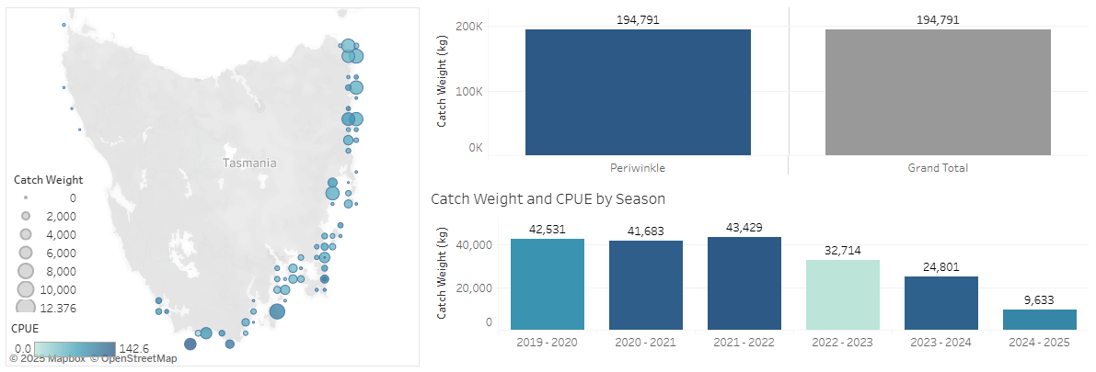
Figure 1: Comparison of Periwinkle harvests across recent seasons, noting that a season runs from 1 September to 31 August of the following year, and the reported unit is kilograms. Note, the 2024-25 season data is current only to June 2025.
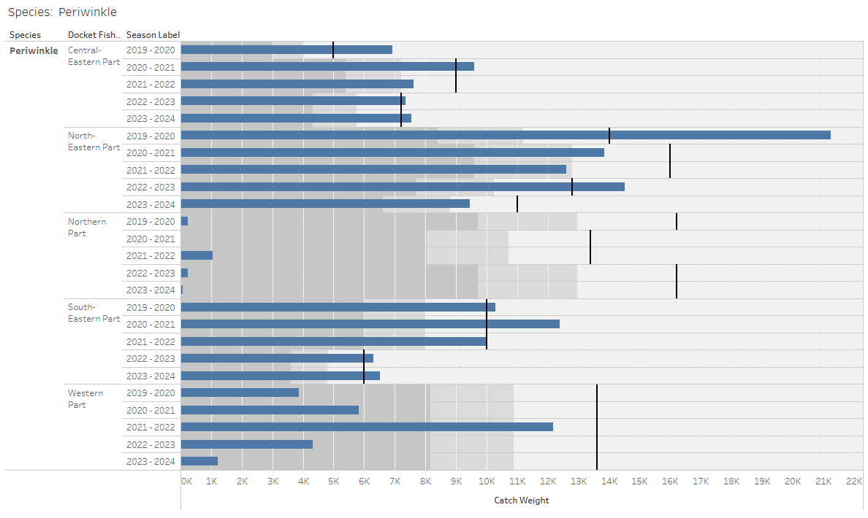Figure 2: Breakdown of the catch limits (black lines) and catch data (blue bars) for Periwinkles in each fishing zone in the 2019-20 to 2023-24 fishing seasons. The grey shading represents 60% and 80% of the limit.

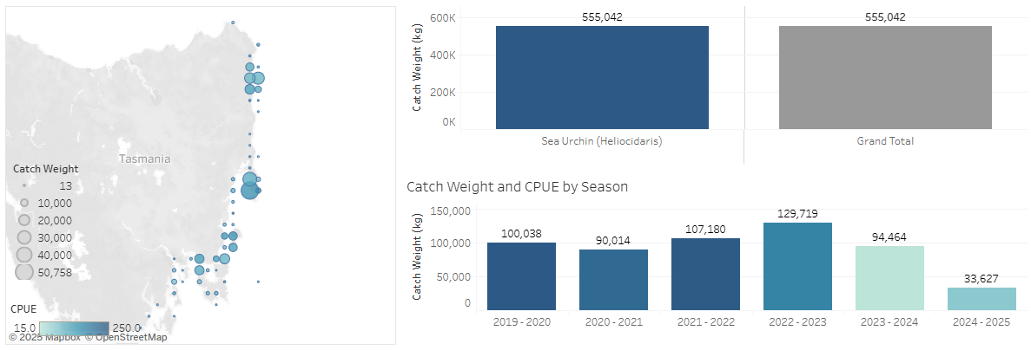
Figure 3: Comparison of Shortspined Sea Urchin harvests across recent seasons, noting that a season runs from 1 September to 31 August of the following year, and the reported unit is kilograms. Note, the 2024-25 season data is current only to June 2025.

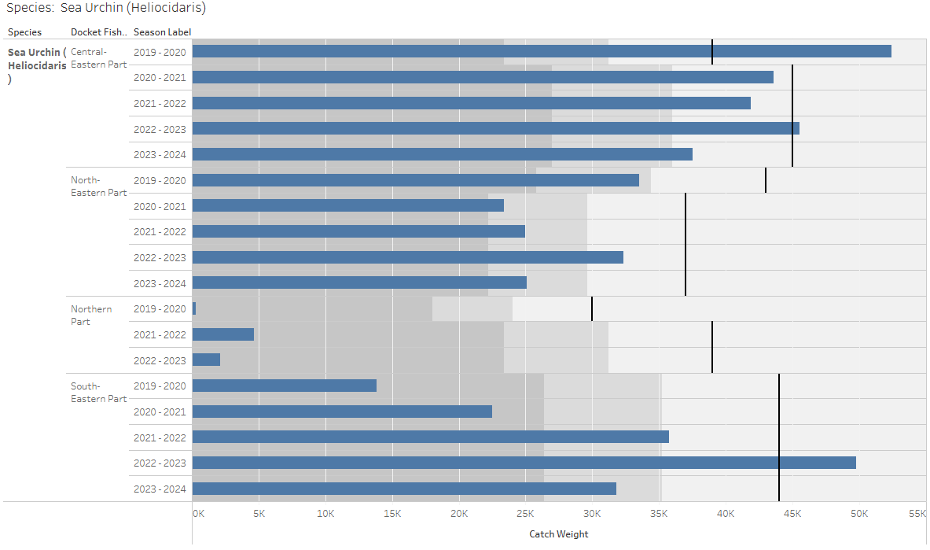
Figure 4: Breakdown of the catch limits (black lines) and catch data (blue bars) for Shortspined Sea Urchin in each fishing zone in the 2019-20 to 2023-24 fishing seasons. Grey shading represents 60% and 80% of the limit.
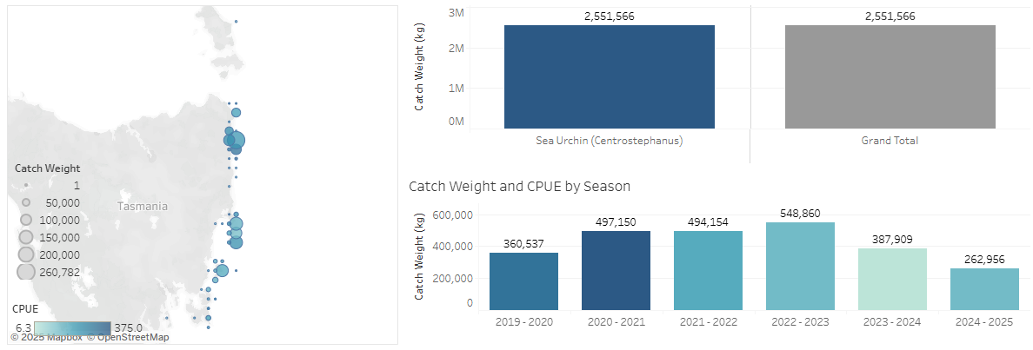
Figure 5: Comparison of Longspined Sea Urchin harvests across recent seasons, noting that a season runs from 1 September to 31 August of the following year, and the reported unit is kilograms. Note, the 2024-25 season data is current only to June 2025.

APPENDIX 2 – Discarded catch data (target and non-target species)
This section is not applicable in this fishery.
Being a dive fishery with targeted hand collection and no quota, bycatch including discards (i.e. high-grading) is negligible to nil.

APPENDIX 3 – Protected species interaction data
Interactions would be limited to vessel-strikes or hookah-line entanglement, the latter of which poses greater risk to divers than other species; there have been no such reports.
The risk of vessels striking TEPS is no greater than any other water users and the risk of hookah air-hose entanglements is negligible.

APPENDIX 4 – Fishing effort
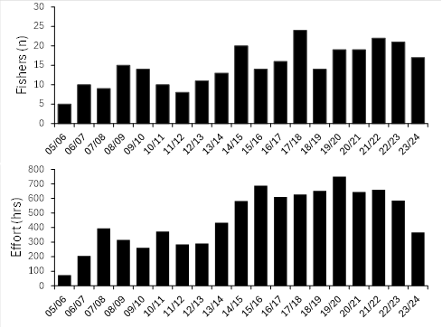
Figure 6. Periwinkle effort per season represented by number of active fishers (top) and total combined dive hours (bottom) for complete seasons from 2005-06 to 2023-24.

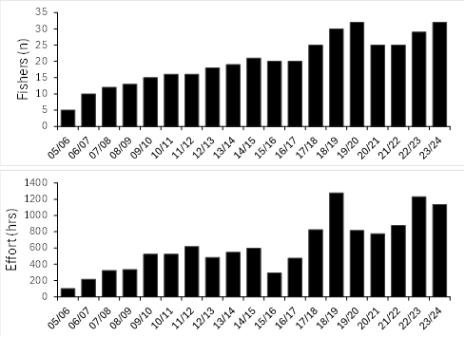
Figure 7. Shortspined Sea urchin effort per season represented by number of active fishers (top) and total combined dive hours (bottom) for complete seasons from 2005-06 to 2023-24.

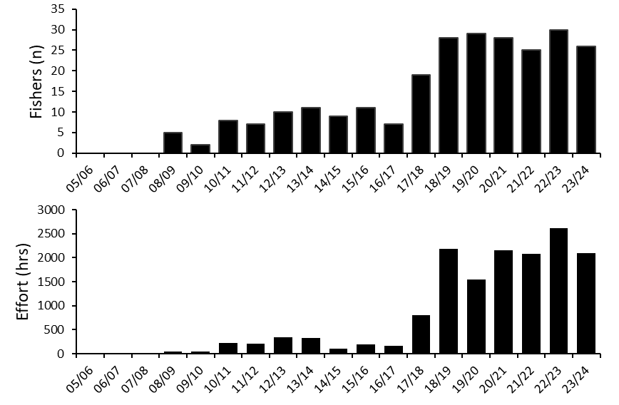
Figure 8. Longspined Sea Urchin effort per season represented by number of active fishers (top) and total combined dive hours (bottom) for complete seasons from 2005-06 to 2023-24.

APPENDIX 5 – Approved Logbooks
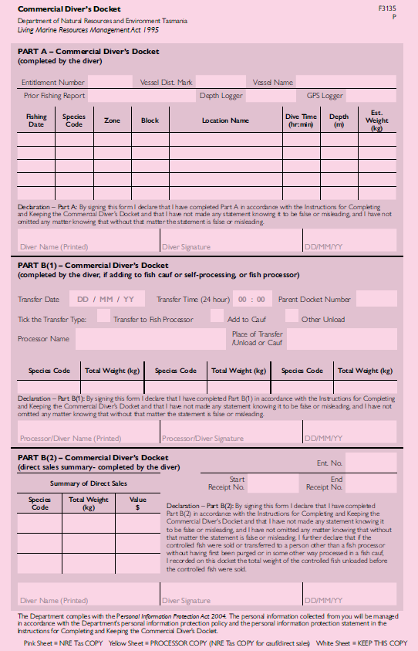
Figure 9. Copy of the approved Commercial Diver’s Docket which captures harvest and disposal information.
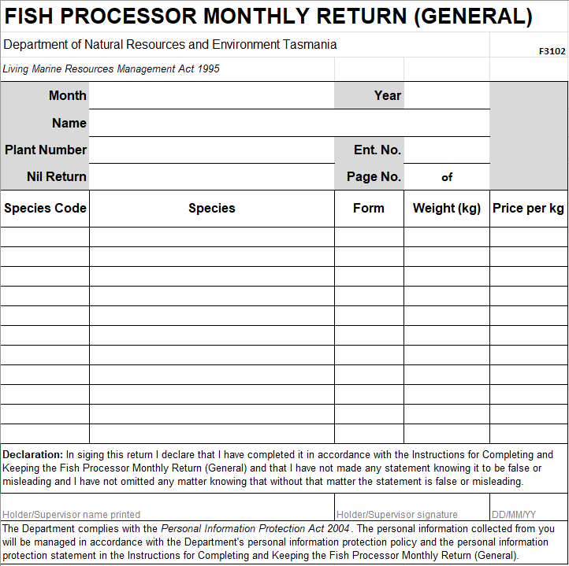
Figure 10. Copy of the approved General Fish Processor Monthly Return which captures fishing data upon receipt at a licenced fish processing premises.

Keane, JP, Lyle, J, Mundy, C and Hartmann, K 2014, Periwinkle Fishery of Tasmania: Supporting Management and a Profitable Industry, Institute for Marine and Antarctic Studies Hobart.
Keane J P., Walley, G. Jesson-Kerr, M, Campus, P., Yang, B, Bowditch Wharton, E.J., White, C., Adams, L.R., Bolch, C., Mundy, C., Ling, S. (in review), Fisheries Biology of Shortspined Sea Urchins in Tasmania: Supporting a Profitable Harvest and Appropriate Management, Institute for Marine and Antarctic Studies, Hobart.
Azzurro, E., Bahri, T., Valbo-Jørgensen, J., Ma, X., Strafella, P. & Vasconcellos, M., eds. 2024. Fisheries responses to invasive species in a changing climate – Lessons learned from case studies. FAO Fisheries Technical Paper, No. 704. Rome, FAO.

