

Australia’s National  
Science Agency

Technical assessment of SavCAM/FullCAM for development of savanna fire management methods under the Australian Carbon Credit Unit (ACCU) Scheme

Comparison of SavCAM with SavBAT versions 2.2 and 3.0

Stephen Roxburgh, David Forrester   
  
August 2025

Prepared for the Department of Climate Change, Energy, the Environment and Water (DCCEEW)

CSIRO, Environment Business Unit

Citation

Roxburgh SH, Forrester DI (2025) Technical assessment of SavCAM/FullCAM for development of savanna fire management methods under the Australian Carbon Credit Unit (ACCU) Scheme. Prepared for the Department of Climate Change, Energy, the Environment and Water (DCCEEW). Report prepared for The Department of Climate Change, Energy, the Environment and Water (DCCEEW). CSIRO. Canberra. pp. 47.

Copyright

© Commonwealth Scientific and Industrial Research Organisation 2025. To the extent permitted by law, all rights are reserved and no part of this publication covered by copyright may be reproduced or copied in any form or by any means except with the written permission of CSIRO.

Important disclaimer

CSIRO advises that the information contained in this publication comprises general statements based on scientific research. The reader is advised and needs to be aware that such information may be incomplete or unable to be used in any specific situation. No reliance or actions must therefore be made on that information without seeking prior expert professional, scientific and technical advice. To the extent permitted by law, CSIRO (including its employees and consultants) excludes all liability to any person for any consequences, including but not limited to all losses, damages, costs, expenses and any other compensation, arising directly or indirectly from using this publication (in part or in whole) and any information or material contained in it.

CSIRO is committed to providing web accessible content wherever possible. If you are having difficulties with accessing this document, please contact [csiro.au](http://www.csiro.au/contact)/contact.

Executive summary

The Department of Climate Change, Energy, the Environment and Water (DCCEEW) is currently developing two new Savanna Fire Management (SFM) methods under the Australian Carbon Credit Unit (ACCU) Scheme: the 2025 SFM Emissions Avoidance method and the 2025 SFM Sequestration and Emissions Avoidance method. These two methods build on, and replace, the existing 2018 SFM Emissions Avoidance method, and 2018 SFM Sequestration and Emissions Avoidance method.

The proposed new SFM methods include a new tool for calculating carbon emissions abatement and sequestration called the Savanna Fire Management Carbon Accounting Model (SavCAM), which integrates required historical spatial fire data with data on the spatial distribution of eligible vegetation, and calculates abatement using the formulae as specified in the method determination. SavCAM sends project-specific settings and data to the carbon accounting model, FullCAM (Full Carbon Accounting Model), which is used to calculate changes over time in living biomass, dead biomass, and fire emissions. SavCAM then summarises the FullCAM results for reporting.

Preliminary analyses undertaken by CSIRO in 2024 were focussed on ensuring that the FullCAM savanna fire management model parameters developed by Paul and Roxburgh (2024) had been implemented correctly in SavCAM, and that SavCAM generates abatement estimates that are consistent with the proposed method determination.

This report summarises results from three additional analyses:

**1. Independent validation of SavCAM algorithms**

This analysis provides an independent check of the SavCAM algorithms, by replicating the SavCAM functionality in a separate programming language. A single project area was selected for analysis, and sequestration and abatement for a single reporting year were compared.

*Key findings*

The replicate of the SavCAM calculations predicted very similar results to SavCAM for the test project area, with overall differences between the two models generally within 2%. This relatively minor discrepancy is explainable by: (a) unavoidable differences in the application of the equations, involving the requirement to randomly exclude model locations to simulate fire patchiness; and (b) other possible minor differences in implementation, for example differences in the algorithms used for the spatial modelling, including potential differences in the pre-processing of spatial data prior to analysis.

*Conclusion*

Overall, the results were within the expected bounds given the above constraints, and the overall close agreement based on the independent coding of the calculations confirms SavCAM is calculating emissions avoidance and sequestration as expected.

**2. Comparison of results between SavCAM and SavBAT versions 2.2 and 3.0**

The aim of this analysis was to provide an assessment of the expected difference in sequestration and emissions avoidance between SavCAM and two previous methodology versions (2015 and 2018), that use the online abatement calculators SavBAT versions 2.2 and 3.0, respectively. Comparison of SavCAM results with SavBAT 1.0 was outside the scope of this study.

The model comparison was conducted across 81 case study areas, based on existing savanna burning projects, but standardised to a central 50 km x 50 km area within each existing project. Input data for each case study area (baseline and reporting year settings, and vegetation fuel maps) were manually uploaded to the appropriate web software for analysis (SavBAT 2.2, SavBAT 3.0 or SavCAM).

To provide a clear basis for comparison, abatement was assessed for only a single reporting year (the first year after the assumed baseline period for each case study region). Importantly, the analysis did not seek to replicate possible abatement outcomes on a project-by-project basis. Such an analysis would need to be based on the actual vegetation fuel type map for each project, would require checking of the baseline periods assumed in this study to ensure they are consistent with actual project activity, and would require analysis over multiple years, to provide a more representative assessment of longer-term sequestration and emissions outcomes.

*Key findings*

Both emissions avoidance and sequestration abatement with SavCAM showed notable increases compared to the earlier SavBAT versions. On average, emissions avoidance increased by a factor of 1.31x when compared to SavBAT 2.2, and by 3.77x relative to SavBAT 3.0. The corresponding average (and range) of emissions avoidance for the three methods, summarised across all case study areas, are in the table below:

|  |  |  |  |
| --- | --- | --- | --- |
| Emissions avoidance1 | SavBAT 2.2 | SavBAT 3.0 | SavCAM |
| Minimum (tCO2 ha-1) | -0.293 | -0.168 | -0.358 |
| Average (tCO2 ha-1) | 0.070 | 0.024 | 0.092 |
| Maximum (tCO2 ha-1) | 0.455 | 0.149 | 0.530 |

1Emissions avoidance values are the difference between emissions for a single reporting year, and the average emissions over the baseline period. Average, minimum and maximum values are calculated over n=81 case study areas for SavBAT 2.2 and 3.0, and n=76 case study areas for SavCAM.

Sequestration predictions also increased under SavCAM, with an average relative increase of 1.69x compared to SavBAT 3.0. Note that, providing effective fire management is maintained over the 25-year crediting period, carbon storage would be expected to stabilise over time as a new model equilibrium is attained.

The actual time it will take for the model to stabilise will depend on the characteristics of the project, particularly changes in fire frequencies in response to management, and changes in the occurrence of Early Dry Season (EDS) and Late Dry Season (LDS) fires. Analysis of the FullCAM model suggests new equilibrium carbon stocks will be attained within approximately 5-25 years, depending on how both fire frequency and the balance of EDS and LDS fires respond to the change in fire management. The corresponding average (and range) of sequestration for the first post-baseline year are in the table below:

|  |  |  |
| --- | --- | --- |
| Sequestration | SavBAT 3.0 | SavCAM |
| Minimum (tCO2 ha-1) | -0.144 | -9.980 |
| Average (tCO2 ha-1) | 0.043 | 0.074 |
| Maximum (tCO2 ha-1) | 0.245 | 4.371 |

1Sequestration values are the difference between average carbon stocks for a single reporting year, and the average carbon stocks over the baseline period. Average, minimum and maximum values are calculated over n=81 case study areas for SavBAT 3.0, and n=76 case study areas for SavCAM.

*Conclusions*

Compared to previous methods, SavCAM has introduced two new pools of carbon to the abatement calculations, increasing the total amount of carbon available for both sequestration and emissions avoidance. These new pools are living biomass and standing dead biomass. Because of the addition of these new pools, abatement from both emissions avoidance and sequestration are expected to increase under SavCAM, relative to SavBAT 2.2 and 3.0.

Results from the analyses indicate that between-project variability in outcomes is likely to increase under SavCAM. This means that both the highest and lowest abatement estimates across projects are expected to be more extreme compared to those projected by the earlier versions of SavBAT. This increase in variability under SavCAM is due to the use of the underlying FullCAM model (which was not used in the earlier SavBAT calculations), where monthly (and annual) variability in carbon storage occurs due to the impact of individual fire events (and to a lesser extent, climate variability – see below), which leads to fluctuations in carbon storage, and thus the amount of carbon available for combustion, at monthly and annual timescales. As the crediting period proceeds, the influence of these fluctuations on the calculation of abatement would be expected to diminish over time.

**3. Influence of climate variability**

Growth and decomposition in FullCAM are influenced by year-to-year fluctuations in climate, as well as by changes in the extent and timing of fires. Since abatement under savanna fire management is based on fire management, to avoid issues of additionality it is important to ensure that any carbon abatement calculated by FullCAM (and, by extension, SavCAM) arises predominantly from changes in fire, rather than from natural climate variability, which lies outside human control.

*Key findings*

To assess the impact of climate variability on FullCAM outputs, the 81 50 km x 50 km case study areas used in the *Comparison of results between SavCAM and SavBAT versions 2.2 and 3.0* were analysed, over the period of the available spatial fire history, 2000 to 2024. The results showed that only 1.3% of annual variability in carbon storage could be attributed directly to climate variability. In comparison, 94.3% was attributable to fire, with the remaining 4.5% capturing the covariance between climate and fire. In terms of fire emissions, 9.1% of annual variability was found to be attributable to climate.

The results indicated a relatively higher contribution of climate to total annual variability in the Low Rainfall Zone (LRZ, 600mm to 1000mm annual rainfall) for both sequestration and emissions. But even within the LRZ, the influence of climate on carbon storage remained below 10%, while its effect on emissions peaked at 15%, with most case study areas showing less than 10% climate-related variability. The elevated contribution of climate in the LRZ is likely due to reduced fire frequency in low rainfall regions, diminishing the relative contribution of fire to total variability.

*Conclusions*

Within the FullCAM model climate variability is a minor contributor to total between-year variability in both carbon storage and fire emissions. The low contribution of climate variability compared to fire is likely due to two factors.

First, the climate influence on tree growth in FullCAM is via modifications to the annual growth increment. However, for the savanna burning calculations mature vegetation is assumed, where tree growth increments are close to zero. Additionally, when biomass is reduced by fire, tree recovery is governed by FullCAM’s empirical ‘recovery function’ that is not impacted by the climate. Therefore, in FullCAM, climate variability plays a very minor role in determining the growth of the living vegetation when it is close to maturity.

Second, the influence of climate variability is predominantly on the rates of decomposition of the dead biomass (debris and standing dead material), however because of the relatively high fire frequencies observed over the savanna region, and the susceptibility of dead biomass to combustion, rates of loss from fire tend to dominate over losses from decomposition.

Table of Contents

Executive summary 3

1 Independent validation of SavCAM algorithms 10

1.1 Methods 10

1.2 Results 11

1.3 Discussion 15

2 Comparison of results between SavCAM and SavBAT versions 2.2 and 3.0 16

2.1 Methods 16

2.2 Results 18

2.3 Discussion 25

3 Influence of climate variability 27

3.1 Methods 27

3.2 Results 29

3.3 Discussion 31

Acknowledgements 33

References 33

Appendix 1. Additional per-ha results 34

Appendix 2. Total case study area summary results 44

Introduction

The Department of Climate Change, Energy, the Environment and Water (DCCEEW) is currently developing two new Savanna Fire Management (SFM) methods under the Australian Carbon Credit Unit (ACCU) Scheme: the 2025 SFM Emissions Avoidance method and the 2025 SFM Sequestration and Emissions Avoidance method. These two methods build on, and replace, the existing 2018 SFM Emissions Avoidance method, and 2018 SFM Sequestration and Emissions Avoidance method. Development of the new versions of the SFM methods is a priority of the government (announced in October 2021 by the [then] Minister for Energy and Emissions Reduction). The key differences between the proposed new and previous SFM methods include:

* Inclusion of a new vegetation fuel type (Pindan).
* For sequestration and emissions avoidance activities, the addition of two new biomass pools (standing dead tree biomass, comprising part of ‘heavy’ fuel, and living above-ground biomass).
* A new modelling approach based on FullCAM (the Full Carbon Accounting Model), using growth, turnover, mortality and fire impact and response parameters published by Paul and Roxburgh (2024).

The proposed new SFM methods include a new tool for calculating carbon emissions abatement and sequestration called the Savanna Fire Management Carbon Accounting Model (SavCAM), which integrates required historical spatial fire data with data on the spatial distribution of eligible vegetation, and calculates abatement using the formulae as specified in the method determination. SavCAM accesses the existing carbon accounting model, FullCAM, which is used to calculate changes over time in living biomass, dead biomass, and fire emissions (Figure 1). SavCAM has been under development since late 2022.

Preliminary analyses undertaken by CSIRO (Roxburgh et al. 2024) were focussed on ensuring that the FullCAM savanna fire management model parameters developed by Paul and Roxburgh (2024)[1] had been implemented correctly in SavCAM, and that SavCAM generates abatement estimates that are consistent with the proposed method determination.

This report summarises results from three additional analyses:

1. Independent validation of SavCAM algorithms

This analysis provides an independent check of the SavCAM algorithms, by replicating the SavCAM functionality in a separate programming language. Results for a single test project area were compared against SavCAM to ensure consistency and correctness in the implementation of the calculations. This analysis supports the preliminary checks undertaken by Roxburgh et al. (2024) and provides an additional validation of the overall approach.

1. Comparison of results between SavCAM and SavBAT versions 2.2 and 3.0

This analysis provides an assessment of the expected difference in abatement (both sequestration and emissions avoidance) between SavCAM and two previous methodology versions (2015 and 2018), that use SavBAT versions 2.2 and 3.0, respectively. Comparison of SavCAM results with SavBAT 1.0 was outside the scope of this report. This analysis is based on running SavCAM, SavBAT 2.2, and SavBAT 3.3 across 81 case study areas that extended across northern Australia, each 50 km x 50 km in area.

1. Influence of climate variability

This analysis investigated in detail the relative contributions of climate variability and fire extent and timing on FullCAM-predicted carbon sequestration and fire emissions. Growth and decomposition in FullCAM are affected by year-to-year changes in both climate and fire, and as abatement under savanna fire management is based on changes in fire management, to avoid issues of additionality it is important to check that any abatement that is calculated by FullCAM (and therefore SavCAM) is due primarily to changes in fire behaviour (i.e. the target of management action) and not climate variability.

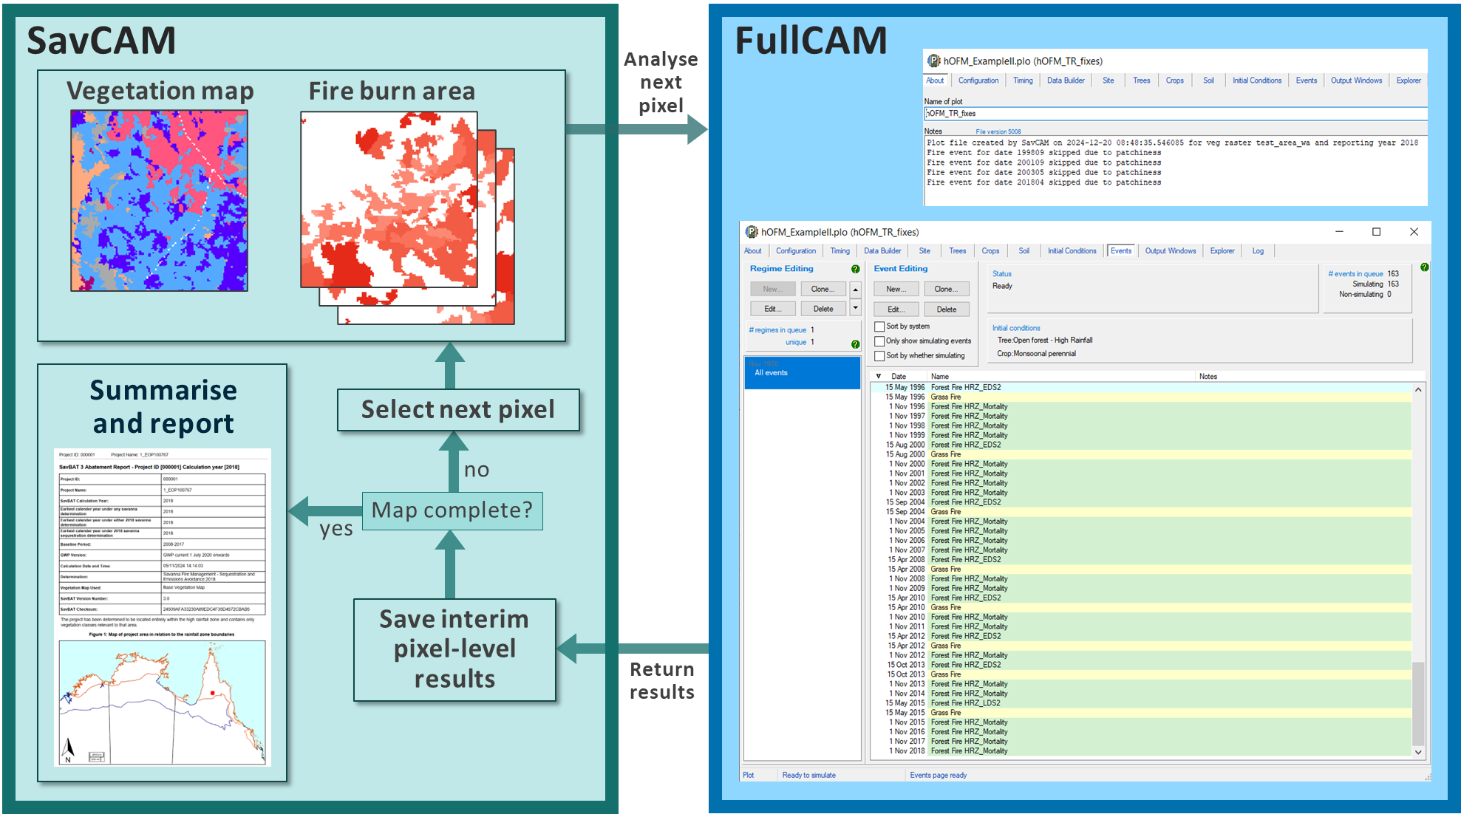

**Figure 1** Summary of the workflow underpinning the proposed new Savanna Fire Management methodologies. SavCAM (left panel) is a web-based software system that coordinates the input of user data, user settings, and the creation of pixel-level FullCAM plotfiles (right panel) that contain location-specific vegetation growth and turnover parameters and historical fire events. Plotfiles are sent to FullCAM, and the raw sequestration and emissions results from FullCAM are returned to SavCAM for summarising and reporting.

# Independent validation of SavCAM algorithms

## Methods

To provide an independent check of the SavCAM algorithms and functionality, abatement for both emissions avoidance and sequestration for a test project area (test area #18, Appendix 1) was selected for detailed analysis. The original planning for this analysis involved the selection of a number of locations at random within the test project area, and then undertaking analyses using FullCAM directly, to provide a library of results for comparison against SavCAM. However, with approximately 10,000 locations and a complex fire history mosaic, it became clear that even a relatively large sample of points would be difficult to interpret, and would likely be unrepresentative. It was therefore deemed to be more comprehensive, and more transparent, to code a separate ‘stand-alone’ version of SavCAM, to allow a full spatial analysis across all project locations.

Replication of the SavCAM functionality followed the procedure in Figure 1, and required the following steps:

* Reading in the savanna vegetation classification map and the Northern Australian Fire Information (NAFI) fire scar history maps for the test project area.
* On a pixel-by-pixel basis, scanning through the full spatial extent and creating a FullCAM plotfile for each pixel, with the growth and turnover parameters for the vegetation class at that location (Paul and Roxburgh 2024), and fire events (Early Dry Season (EDS) and Late Dry Season (LDS)) added based on the NAFI fire history. As per SavCAM, fire patchiness was added at the pixel level, through drawing a random number and including the event only if the random number was ≤ the appropriate patchiness parameter (EDS = 0.709; LDS = 0.889).
* Each simulation was initiated in 1900, and the historical fire record (2000-2024) was hind-cast back to 1900 by repeating the 2000-2024 fire history record backwards through time, to ensure steady state for the included carbon pools.
* Running FullCAM (which includes automatic updates to the FullCAM plotfile with location-specific climate and other data), and then reading in and saving FullCAM results for summarising and reporting.
* Emissions avoidance and sequestration calculations were only calculated for a single reporting year (the year immediately after the end of the baseline period).

An independent replication of the SavCAM functionality has two main advantages:

* By replicating SavCAM in independent code, it provides yet another check of the accuracy of the calculations.
* A separate code base allows results to be interrogated in more detail, e.g. through saving detailed biomass, heavy, coarse and fine fuel emissions avoidance and sequestration components separately (to allow easier comparison with previous SavBAT versions); and to allow switching off and on climate variability, to explore the contribution of climate variability to the modelling results (Section 3).

For clarity, the stand-alone SavCAM replicate is referred to below, and in the figures, as SavCAM*. SavCAM* was coded in the Delphi programming environment.

Note that for a number of reasons, exact numerical agreement between SavCAM and SavCAM* would not be expected, due to potential differences in the preparation of the GIS input data, the random nature of the implementation of fire patchiness (that is not possible to replicate exactly in an independent code base), and potential differences in the way the timing of fire events is specified in the pre-2000 ‘spin-up’ period. The aim of this analysis was therefore to identify any notable discrepancies in the respective implementations, with agreement within 5% deemed acceptable. It is also worth noting that detailed testing to ensure the correctness of FullCAM parameters within SavCAM, and correctness of the SavCAM abatement calculations, was completed prior to this analysis (Roxburgh et al. 2024).

## Results

### Comparison of SavCAM with SAVCAM*

#### 1.2.1.1 Analysis area

The total eligible area across the project, as reported in SavCAM, is 81,587.50 ha. In SavCAM* the total eligible area is 81,613 ha, a difference of approximately 4 pixels, and 99.9% in agreement.

This very minor difference is likely due to the use of different underlying GIS processing algorithms between SavCAM and SavCAM*, and/or differences in the preparation of the spatial data prior to analysis.

#### 1.2.1.2 Fire history

The historical fire record in terms of per cent area burnt determined by both SavCAM and SavCAM* are in agreement (Figure 1), illustrating that SavCAM* is correctly accessing the NAFI fire history data.

**Figure 2** Percent area burnt over the period 2000-2023 as determined by SavCAM* (coloured lines) and SavCAM (grey lines behind coloured lines) for the test project area.

#### 1.2.1.3 Emissions history & emissions abatement

Total fire emissions (CH4 + N2O) are also in close agreement between SavCAM and SavCAM*, and are generally within 2% of one another (Figure 3).

**Figure 3** Total fire emissions (CH4 + N2O) as predicted by SavCAM and SavCAM*.

Total baseline (2002-2021) and project (2022) emissions, and calculated abatement, are also very similar between SavCAM and SavCAM*, with the estimate of abatement being within 5% (Figure 4).

**Figure 4** Baseline (2002-2021), project (2022), and calculated unadjusted emissions abatement for SavCAM and SavCAM*.

#### 1.2.1.4 Sequestration & sequestration abatement

Total baseline (2002-2021) and project (2022) carbon storage, and calculated sequestration, are also similar between SavCAM and SavCAM* (Figure 5). Note there is some variability in the baseline calculations, with the two versions of the calculation differing by approximately 2.5%. Whilst this is reasonably close, because the sequestration component is calculated as the difference between two very large numbers, this small difference can lead to relatively large differences in predicted sequestration (899,085 tCO2-e for SavCAM, and 610,395 tCO2-e for SavCAM*).

**Figure 5** Baseline (2002-2021), project (2022), and calculated unadjusted sequestration for SavCAM and SavCAM*.

### Interpretation

#### 1.2.2.1 Change in burn area over time

Figure 2 shows the change in burn area over time, with an overall decline in total burn area between 2000 and 2023, a marked decline in LDS fire, and some increase in EDS fire. This clear change in fire behaviour (with associated changes in emissions and carbon storage) is what is driving the overall positive emissions avoidance and sequestration abatement shown in Figures 4 and 5.

#### 1.2.2.2 Change in emissions over time

Separation of the total emissions into biomass, heavy, coarse and fine fuel components shows that the majority of emissions are attributable to the fine and heavy fuels (Figure 6).

Direct comparison of SavCAM emissions and sequestration results with previous savanna fire management methods (SavBAT 2.2 and 3.0) is problematic, because SavCAM has expanded the fuel and biomass pools included in the calculations (Table 1); therefore in SavCAM there is more biomass available for consumption by fire and for sequestration. Thus although the pool names are consistent between methods (0-6 mm material (‘fine’); 6 mm-50 mm material (‘coarse’); and >50 mm material (‘heavy’)), the components of ecosystem biomass that contribute to those pools differ. For example, in SavCAM the ‘heavy’ pool includes both coarse woody debris (CWD; >50 mm) as well as standing dead trees, whereas in SavBAT 2.2 and 3.0 the heavy pool includes only the CWD component.

**Figure 6** Fire emissions (CH4 + N2O) for the four fuel classes as predicted by SavCAM*.

#### 1.2.2.3 Sequestration over time

Separation of total carbon storage into biomass (tree), heavy, and coarse components shows the most carbon is stored in the live tree biomass (Figure 7).

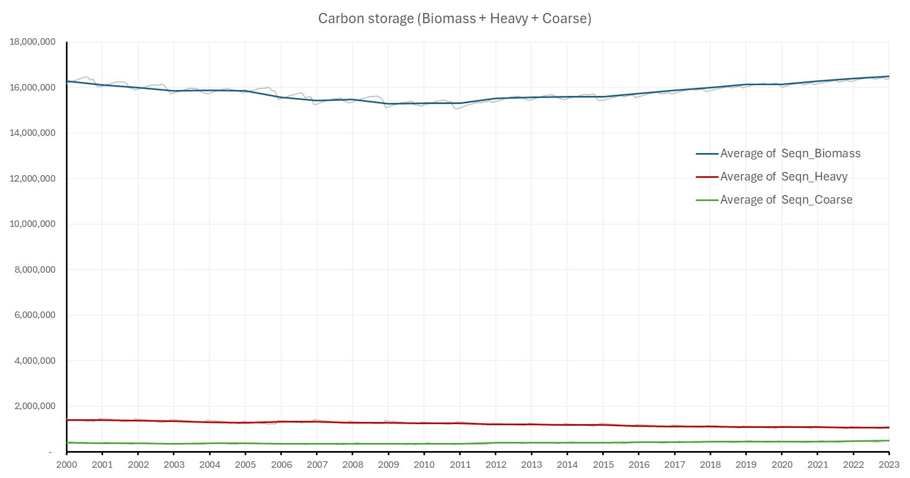

**Figure 7** Carbon storage for the three eligible fuel classes as predicted by SavCAM*. The coloured lines are the annual average values, with the underlying grey line showing the monthly variability.

## Discussion

In this analysis, the calculations underlying the SavCAM model were replicated in an independent code base, SavCAM*, and applied to a single savanna burning project area to cross-check the integrity of SavCAM and its outputs. SavCAM* predicted very similar results to SavCAM, with differences between the two models generally within 2%.

Differences between the two implementations likely arise from a combination of factors, including potential differences in the handling and pre-processing of spatial input data between SavCAM and SavCAM*, the actual pixels burnt between the implementations, due to the application of random fire patchiness, and the protocols for adding fire events to the pre-2000 year ‘spin-up’ period.

Whilst it might be possible to further refine SavCAM* to bring it even closer into line with SavCAM, for example by directly comparing code between SavCAM and SavCAM*, the overall close agreement in results using an independent coding of the calculations is within the expected level of agreement, given the complexity of translating what are a relatively complex set of calculations. Further, it supports the results of previous validation work that indicates SavCAM is calculating emissions avoidance and sequestration as expected.

For the test project area, the increase in carbon storage following declines in fire occurrence and a shift from late to early season fires for the reporting year investigated, is 899,085.25 tCO2-e (equivalent to 11.1 tCO2-e ha-1). For the fire regimes characteristic of this case study, this initial response to fire management would be expected to stabilise within approximately 5-25 years, assuming the current low-intensity and low-occurrence fire regime is maintained (see Discussion in Section 2 for further details on the likely rates of ecosystem recovery). How quickly and to what level the new equilibrium is established will be a function of the difference between the frequency of fires over the baseline period compared with the project period, and the difference in the number of EDS vs. LDS fires.

# Comparison of results between SavCAM and SavBAT versions 2.2 and 3.0

The aim of this analysis was to provide an assessment of the difference in predicted abatement between the new SavCAM model, and SavBAT versions 2.2 and 3.0 used for the abatement calculations for two previous savanna fire management methods, 2015 and 2018, respectively.

The expectation is that both emissions avoidance and sequestration abatement will increase under SavCAM, due to the addition of two new biomass pools (standing dead mass, and live tree mass) compared to the previous SavBAT versions (Table 1).

Table 1 Comparison of included fuel classes in SavCAM, SavBAT 2.2 and SavBAT 3.0. ✓ = included in the calculation of emissions avoidance. ✓ = included in the calculation of sequestration.

|  |  |  |  |  |  |
| --- | --- | --- | --- | --- | --- |
| Method | Fine fuel  <6 mm | Coarse fuel  6 – 50 mm | Heavy fuel  > 50 mm | | Live tree  biomass |
|  |  |  | CWD | Standing  dead |  |
| SavBAT 2.2 | ✓ | ✓ | ✓ |  |  |
| SavBAT 3.0 | ✓ | ✓✓ | ✓✓ |  |  |
| SavCAM | ✓ | ✓✓ | ✓✓ | ✓✓ | ✓✓ |

## Methods

To provide a standardised basis for comparison, 81 savanna burning ACCU scheme project boundaries were downloaded from <https://data.gov.au>, and the centroids for each project area calculated. For each project, a 50 km x 50 km square case study area was centred on each centroid (Figure 8). No attempt was made to reduce overlap between case study areas, therefore a number of test areas will have overlap in spatial extents, particularly in Cape York.

**Figure 8** Locations of 81 case study areas of 50 km x 50 km, centred within existing savanna burning project boundaries. Grey areas are existing savanna fire management project boundaries.

SavBAT 2.2 only includes the option for emissions avoidance, whereas SavBAT 3.0 and SavCAM include both emissions avoidance and sequestration. Although 81 case study areas were selected for analysis, only 76 could be analysed in SavCAM due to either non-return of results (a SavCAM error that has since been corrected), or runs not undertaken because of incompatibility in baseline period selection options, with SavBAT-equivalent baseline years not available in SavCAM. Baseline and reporting year settings for each test area were provided by DCCEEW.

Although results for each case study area are presented individually in Appendix 1, the main focus of the analysis was the overall (i.e. average) comparison results across all 81 areas (or in the case of the SavCAM runs, 76 areas). Results for individual areas are based on only a single reporting year, thus may not be representative of the longer-term outcome over the course of the (future) 25-year crediting period (see e.g. Figure 9). Averaging over all case study areas therefore provides a more robust indication of the differences between the three models tested.

It is important to note that this analysis does not seek to replicate possible abatement outcomes for each underlying project. Such an analysis would need to be based on the actual vegetation fuel type map for each project (rather than 50 km x 50 km areas centred on the project centroid). Such an analysis would also require checking of the baseline periods assumed here to ensure they are consistent with actual project activity, and would require analysis over multiple years, not comparison within a single reporting year.

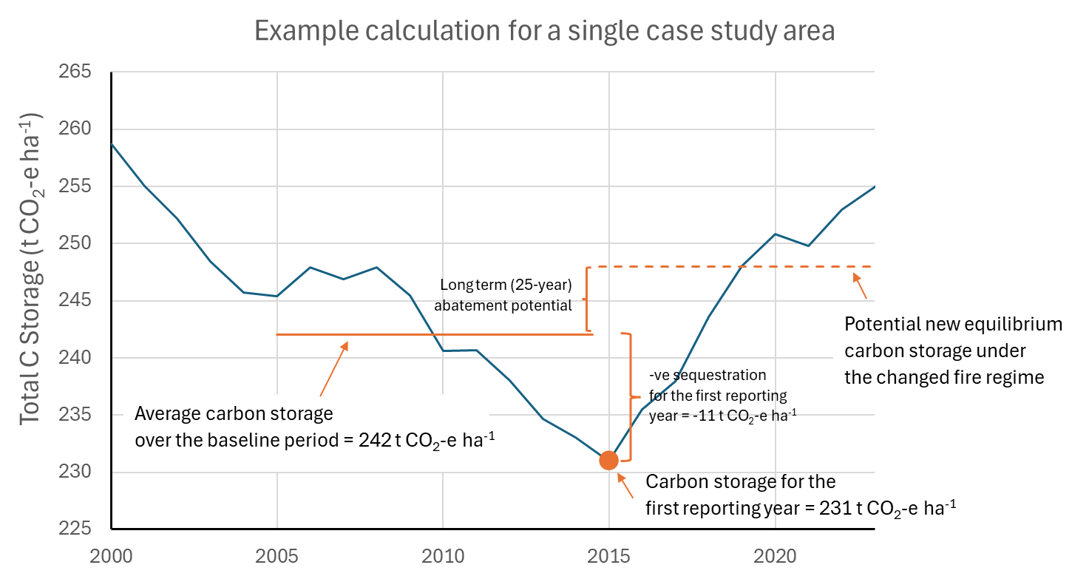

**Figure 9** Illustration of the calculation of sequestration for a single reporting year. In this example the baseline carbon storage is 242 tCO2-e ha-1, and the carbon storage at the first reporting year is 231 tCO2-e ha-1, yielding a negative abatement for that year of -11 tCO2-e ha-1. In contrast, the long term (25 year) expectation is a net carbon benefit. The baseline and reporting years are hypothetical, but the carbon storage timeseries is taken from one of the 81 case study areas.

Spatial input *.kml files for vegetation fuel type (Thackway et al. 2014; downloaded from https://v3.savbat.savtools.dcceew.gov.au/) were created for each of the 81 case study areas, and then manually uploaded to the appropriate web software for analysis (SavBAT 2.2, SavBAT 3.0 or SavCAM). Because neither version of SavBAT includes the recently added Pindan vegetation fuel type, Pindan vegetation is not included in any of these comparisons.

## Results

The results presented below express emissions and sequestration values on a per-ha basis to account for differing areas of eligible vegetation within each 50 km x 50 km test area. Comparable results for total area emissions and sequestration are given in Appendix 2.

### Emissions avoidance

Averaged over all case study areas, total baseline emissions predicted by SavCAM were 2.31x higher than SavBAT 2.2, and 2.95x higher than SavBAT 3.0, with comparable values for reporting year emissions (2.26x and 2.81x for SavBAT 2.2 and SavBAT 3.0, respectively). For emissions avoidance abatement (the difference between baseline and reporting year emissions), SavCAM abatement was on average 1.31x higher than SavBAT 2.2, and 3.77x higher than SavBAT 3.0 (Figures 10, 11; Table 2).

On an individual project basis, there was consistency across calculation methods in the direction of abatement (positive or negative), with 70 of 76[2] or 92% of case study areas having agreement in the direction of abatement across all three possible calculation methods (Figure A1.1). There was less consistency in the relative ranking of emissions avoidance abatement, with SavBAT predicting a higher magnitude of abatement (positive or negative) compared to SavBAT 2.2 in 50 of 76 cases, and a lower magnitude in 26 of 76 cases. Compared to SavBAT 3.0 results, SavCAM had a higher magnitude of abatement in 72 of 76 cases, and a lower magnitude in only 4 of 76 cases. This reflects the overall lower emissions avoidance abatement that is predicted by SavBAT 3.0 compared to SavBAT 2.2.

Average (± s.d.) avoided emissions abatement across all case study areas for SavBAT 2.2 was 0.070 (±0.121) tCO2-e ha-1, 0.024 (±0.045) tCO2-e ha-1 for SavBAT 3.0, and 0.092 (±0.140) tCO2-e ha-1 for SavCAM (Figure 11). In terms of the difference between SavCAM and SavBAT, SavCAM predicts an overall average increase in emissions avoidance of 0.022 tCO2-e ha-1 compared to SavBAT 2.2, and an increase of 0.068 tCO2-e ha-1 compared to SavBAT 3.0 (Table 2). On a per-project basis the results are variable (Figures A1.1), with a predicted range of -0.358 to 0.530 tCO2-e ha-1 for emissions avoidance with SavCAM; a range of -0.293 to 0.455 tCO2-e ha-1 for SavBAT 2.2; and a range of -0.168 to 0.149 tCO2-e ha-1 for SavBAT 3.0.

Figure 12 shows that the emissions avoidance abatement predicted by SavCAM is approximately positively linearly related to that calculated under SavBAT 2.2 (Figure 12b) and SavBAT 3.0 (Figure 12c), indicating where emissions avoidance abatement in either SavBAT version is high (or low), then similar trends should follow in SavCAM.

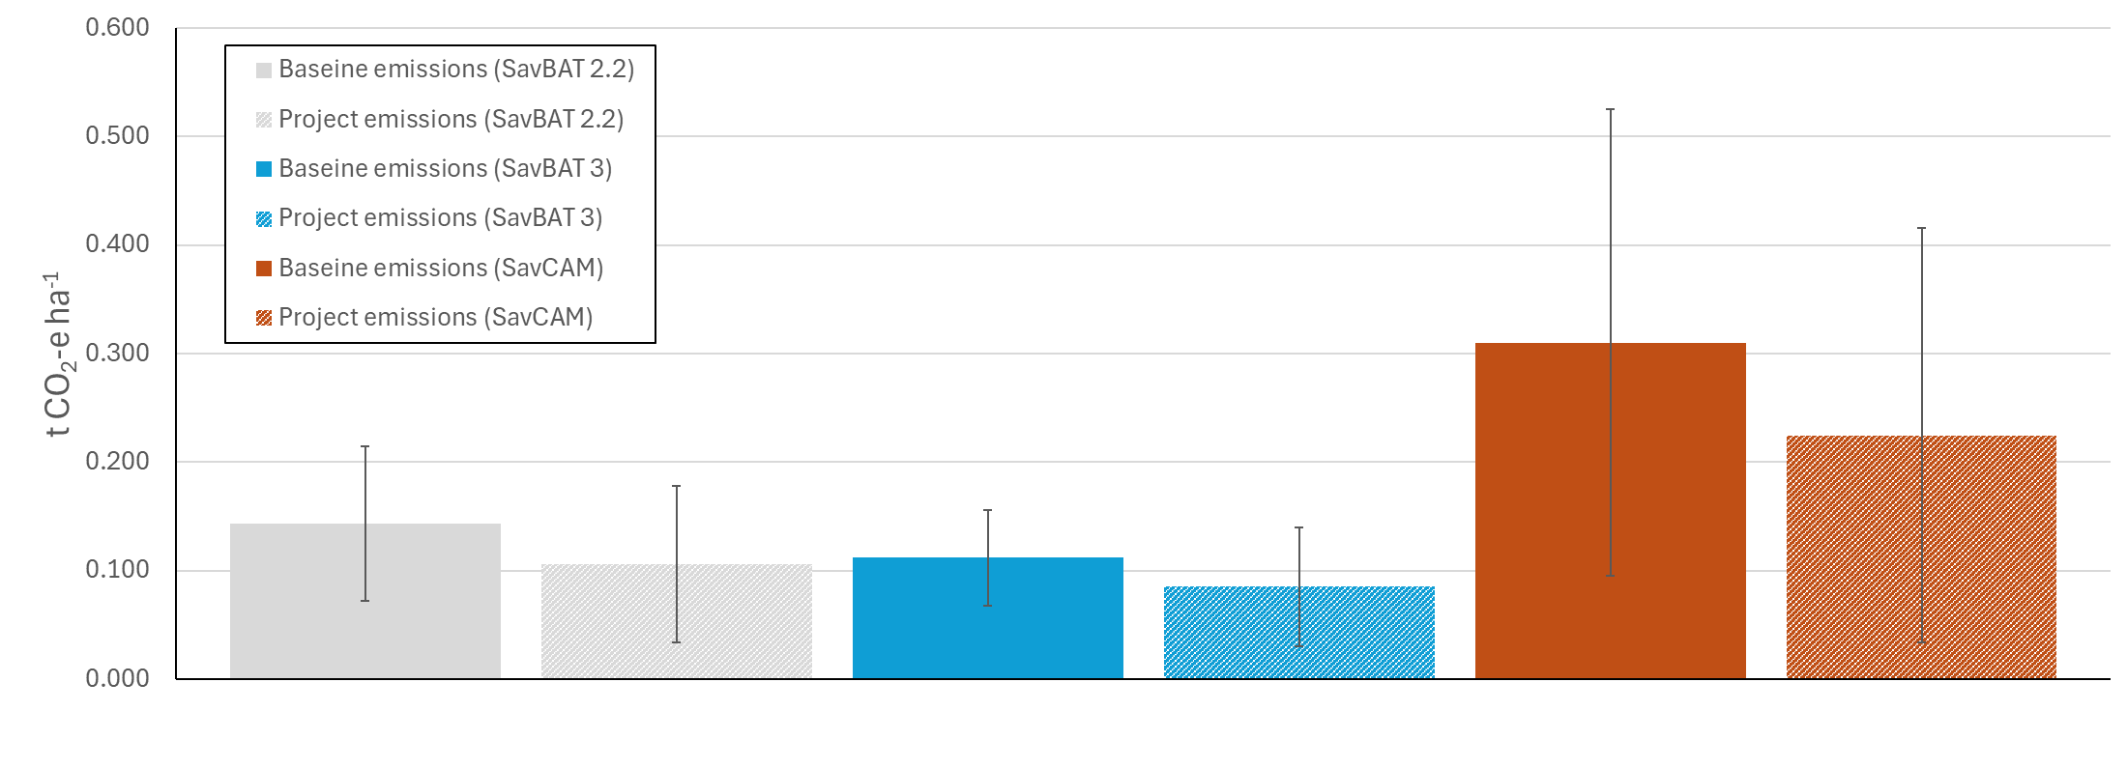

**Figure 10** Total emissions for SavBAT 2.2, SavBAT 3.0, and SavCAM, averaged over *n*=81 case study areas (*n*=76 for SavCAM). Error bars are standard deviations. Project emissions are total emissions for the reporting year. Baseline emissions are average annual emissions over the baseline period.

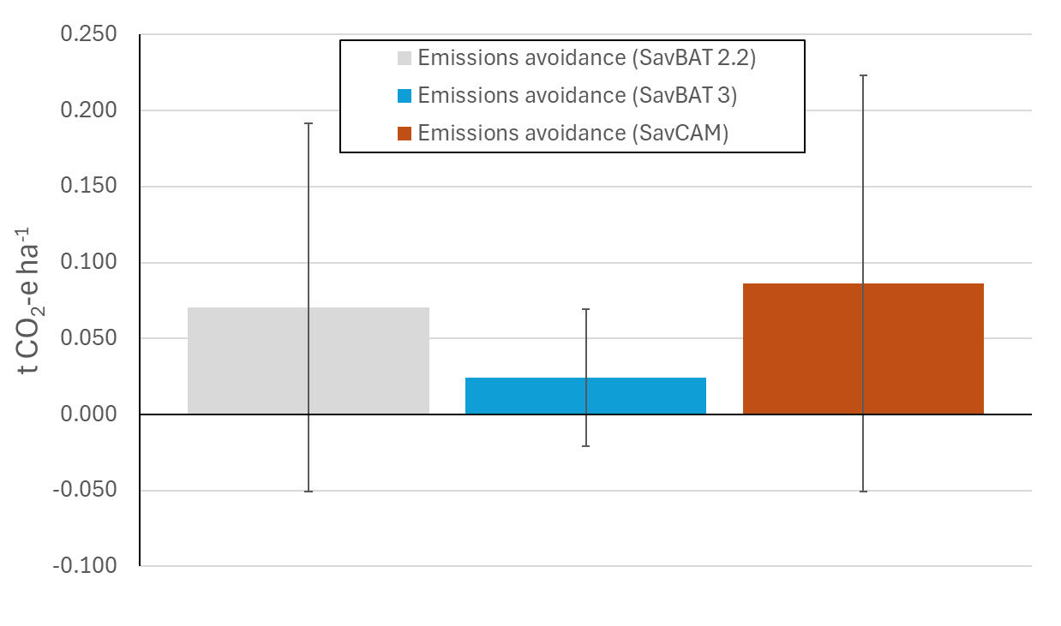

**Figure 11** Emissions avoidance(baseline emissions – project emissions) for SavBAT 2.2, SavBAT 3.0, and SavCAM, averaged over *n*=81 case study areas (*n*=76 for SavCAM). Error bars are standard deviations. Emissions avoidance values are total emissions for the reporting year, subtracted from average annual total emissions over the baseline period.

Table 2 Mean difference (n=76 case study areas) between SavCAM and SavBAT versions 2.2 and 3.0 for total emissions and emissions avoidance (baseline – project) from Figures 10 and 11, expressed as (a) fractional change, and (b) tCO2 ha-1. For fractional change, a value of +2.0 means SavCAM predicted twice the value of the respective SavBAT version. ‘±’ values are the interval that encompasses approximately 90% of all test area results.

|  |  |  |  |
| --- | --- | --- | --- |
| (a) Fractional change: SavCAM results relative to SavBAT | Total emissions | | Emissions avoidance |
|  | Mean baseline | Project |  |
| SavBAT 2.2 | +2.31x | +2.26x | +1.31x |
| SavBat 3.0 | +2.95x | +2.81x | +3.77x |

|  |  |  |  |
| --- | --- | --- | --- |
| (b) Change in tCO2 ha-1:SavCAM results relative to SavBAT | Total emissions | | Emissions avoidance |
|  | Mean baseline | Project |  |
| SavBAT 2.2 | +0.187(±0.363) | +0.133(±0.335) | +0.022(±0.308) |
| SavBat 3.0 | +0.219(±0.351) | +0.154(±0.326) | +0.068(±0.244) |

(b)

(c)

(a)

**Figure 12** Emissions avoidance across case study areas for: (a) SavBAT 2.2 vs. SavBAT 3.0, (*n*=81), (b) SavBAT 2.2 vs. SavCAM (*n* =76*)*, and (c) SavBAT 3.0 vs. SavCAM (*n*=76).

### Sequestration

Averaged over all case study areas, baseline and reporting year carbon storage under SavCAM was 24.78x and 22.60x higher than SavBAT 3.0, respectively (Table 3, Figure 13). For sequestration (the difference between project and baseline carbon stocks), SavCAM abatement was on average 1.69x higher than SavBAT 3.0 (Table 3, Figure 14).

On an individual project basis 54 of 76[3] (or 76%) of the case study areas share the same direction of predicted abatement between SavBAT 3.0 and SavCAM. For all test area comparisons, sequestration under SavCAM exceeded that of SavBAT 3.0 (Figure A1.2).

Average (± s.d.) reporting year carbon storage across all case study areas for SavBAT 3.0 was 5.67 (±1.82) tCO2-e ha-1, and 139.32 (±55.06) tCO2-e ha-1 for SavCAM (Figure 13). This very large difference in carbon store is primarily due to the inclusion of living biomass in SavBAT, with an average live tree biomass of 125.54 tCO2-e ha-1. For sequestration, SavCAM predicts an average increase in sequestration of 0.03 tCO2-e ha-1 compared to SavBAT 3.0 (Table 4). The relatively small difference in sequestration between SavCAM and SavBAT 3.3 relative to storage (0.03 vs approximately 133 tCO2-e ha-1; Table 4) is because sequestration is calculated as the difference between the baseline and project carbon stock values, and when averaged over all test areas, the difference in carbon stock is minimal (Figure 13). As with emissions avoidance, outcomes on a per-project area basis are highly variable, with SavCAM sequestration ranging from -9.98 to 4.37 tCO2-e ha-1, compared to the SavBAT range of -0.14 to 0.25 tCO2-e ha-1 (Figure A1.2).

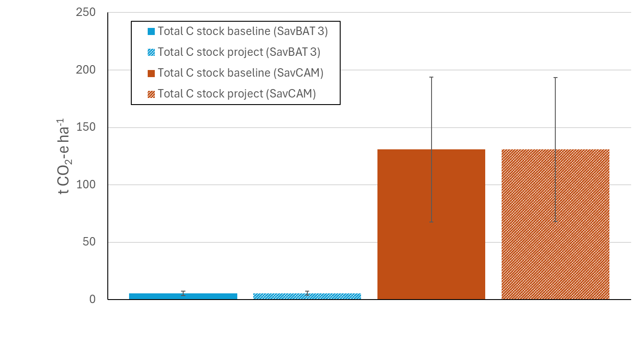

**Figure 13** Total carbon storage for SavBAT 3.0 and SavCAM, averaged over *n*=81 case study areas (*n*=76 for SavCAM). Error bars are standard deviations. Total C stock project values are average C stock over the reporting year. Total C stock baseline values are average C stock over the baseline period.

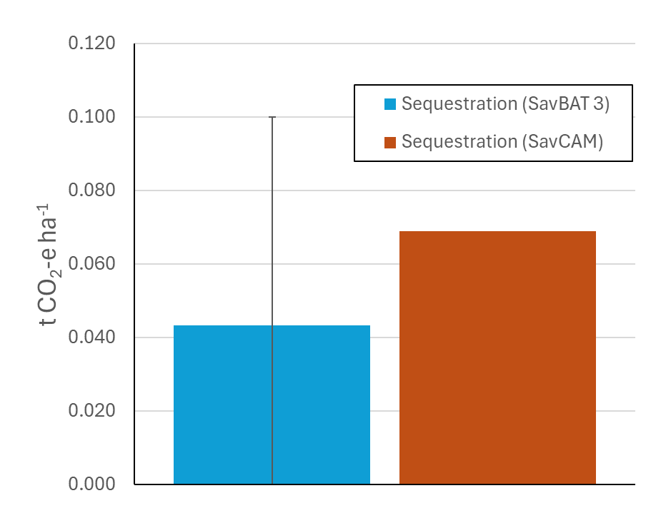

**Figure 14** Sequestration (project carbon storage - baseline carbon storage) for SavBAT 3.0 and SavCAM, averaged over *n*=81 case study areas (*n*=76 for SavCAM). Error bars are standard deviations (error bar for SavCAM omitted for display purposes). Sequestration values are average C stock over the reporting year, subtracted from the average C stock over the baseline period.

Table 3 Mean difference (n=76 case study areas) between SavCAM and SavBAT 3.0 for total carbon storage and sequestration (project - baseline) from Figures 13 and 14, expressed as (a) fractional change, and (b) tCO2 ha-1. For fractional change, a value of +2.0 means SavCAM predicted twice the value of the respective SavBAT version. ‘±’ values are the interval that encompasses approximately 90% of all case study area results.

|  |  |  |  |
| --- | --- | --- | --- |
| (a) Fractional change: SavCAM results relative to SavBAT 3.0 | Total C storage | | Sequestration |
|  | Mean baseline | Project |  |
| SavBat 3.0 | +24.78x | +24.60x | +1.69x |

|  |  |  |  |
| --- | --- | --- | --- |
| (b) Change in tCO2 ha-1:SavCAM results relative to SavBAT 3.0 | Total C storage | | Sequestration |
|  | Mean baseline | Project |  |
| SavBat 3.0 | +133.70(±91.67) | +133.72(±91.01) | +0.030(±3.48) |

### Sequestration – separate fuel components

Carbon storage in SavCAM is dominated by the live tree biomass, contributing approximately 90% to the total store (Figure 15). Because both live tree biomass and standing dead mass are additional to the carbon stores included in SavBAT 3.0, it is instructive to consider these three carbon stores separately.

Although the average total sequestration predicted by SavCAM is a relatively modest 0.074 tCO2-e ha-1, and similar to that predicted by SavBAT 3.0 at 0.043 tCO2-e ha-1 (Figure 16d), separation of the contributing fuel class components shows the net SavCAM sequestration to be the balance of a relatively large gain in live biomass carbon of 0.400 tCO2-e ha-1 (Figure 16c), a relatively large loss in the heavy fuel component (driven by the decline in the standing dead stock; Figure 16b), and a relatively large gain in the coarse fuel component (Figure 16a). These results illustrate some of the dynamics of the underlying FullCAM model, where declines in standing dead mass following the reduction or removal of fire are expected, as standing dead mass is created in response to fire events in FullCAM (Paul and Roxburgh 2024). The increase in live biomass reflects the reduced mortality incurred by living trees as fire is reduced or removed, and the increase in the coarse fuel class reflects lower rates of combustion following fire management.

Similar to the patterns observed across the case study areas for total sequestration (Figure A1.2), sequestration in the coarse, heavy and live biomass fuel classes for the reporting year is highly variable across space (Figures A1.3-A1.5). However, because of the significant differences in the carbon pools included in the sequestration calculations (Table 1), on a per-project basis rates of sequestration are likely to differ substantially between those calculated under SavBAT 3.0 and SavCAM, with only a very loose relationship between SavCAM predictions and predictions from SavBAT 3.0 (Figure 17).

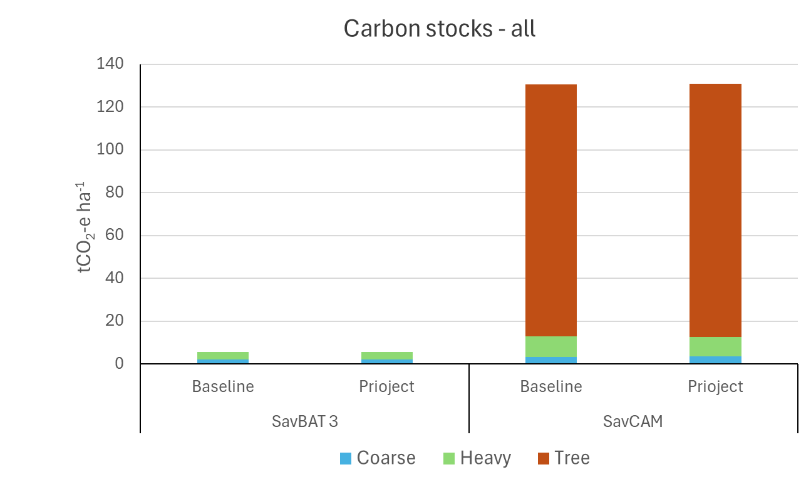

(a)

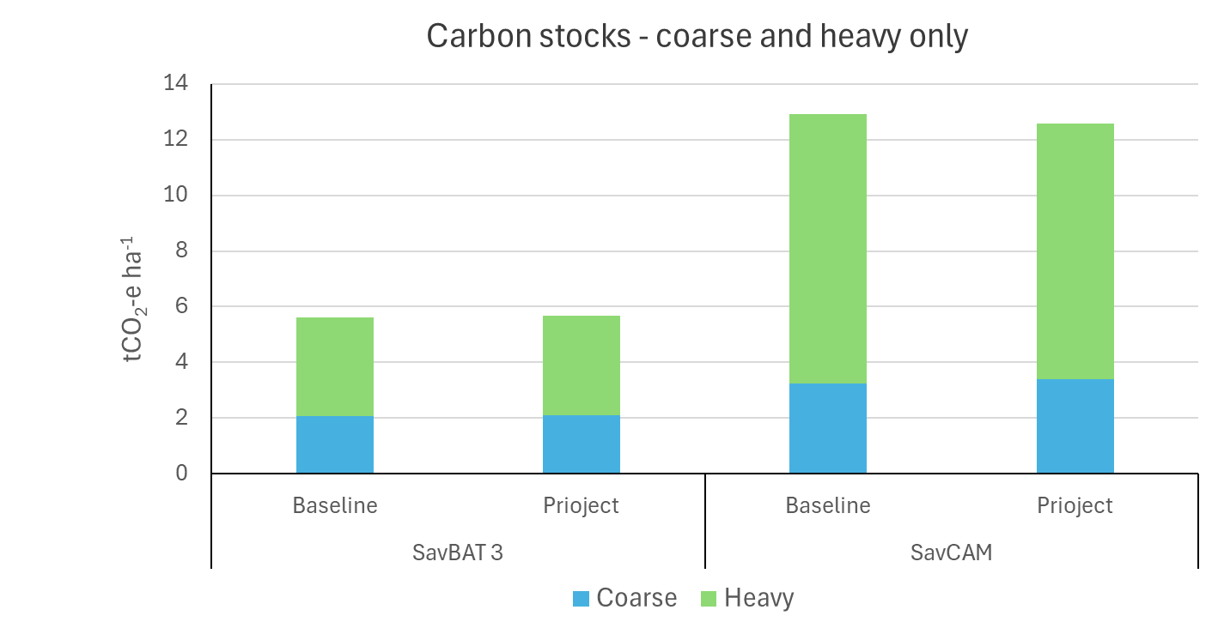

(b)

**Figure 15** Total carbon storage for SavBAT 3.0 (*n*=81) and SavCAM (*n*=76). (a) all fuel classes (coarse, heavy and live tree components), and (b) only the coarse and heavy components. Project values are average C stock over the reporting year. Baseline values are average C stock over the baseline period.

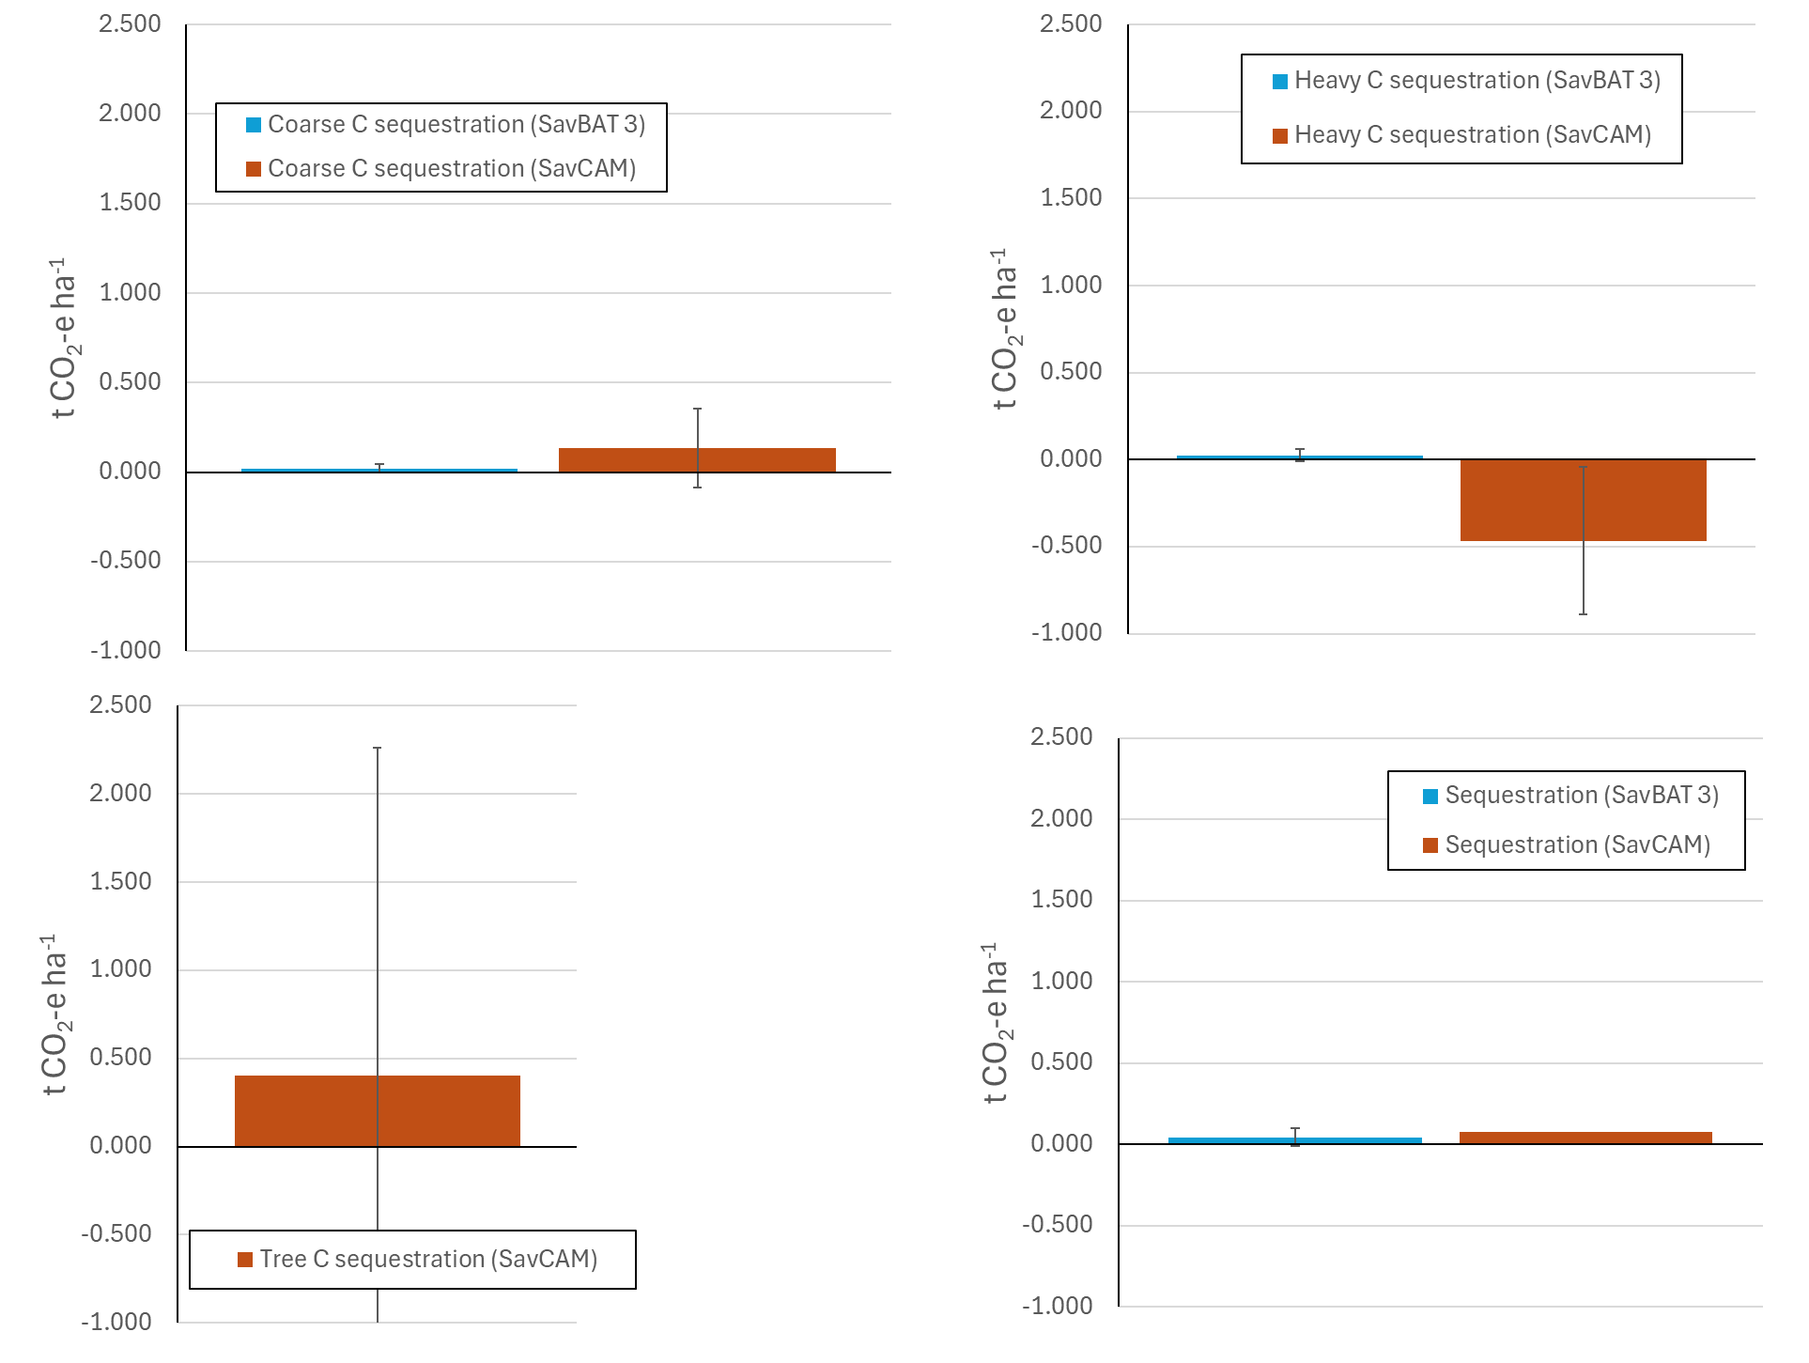

(b)

(a)

(c)

(d)

**Figure 16** Sequestration (project carbon storage - baseline carbon storage) for (a) coarse fuel, (b) heavy fuel, (c) live tree biomass, and (d) total sequestration, averaged over *n*=76 case study areas. Error bars are standard deviations. Sequestration values are average C stock over the reporting year, subtracted from the average C stock over the baseline period.

(b)

(a)

**Figure 17** Sequestration across 81 case study areas for SavBAT 3.0 vs. SavCAM for (a) coarse fuel, and (b) heavy fuel.

## Discussion

A model comparison was conducted across 81 case study areas using SavBAT 2.2, SavBAT 3.0, and SavCAM (76 case study areas). The aim of the analysis was to assess differences in the calculation methods for emissions avoidance and carbon sequestration across the three models. To provide a clear basis for comparison, abatement was assessed only for a single reporting year (the first year after the assumed baseline period for each case study region). Importantly, the analysis did not seek to replicate possible abatement outcomes on a project-by-project basis. Such an analysis would need to be based on the actual vegetation fuel type map for each project (rather than a 50 km x 50 km area centred on the project centroid); would require checking of the baseline periods assumed here to ensure they are consistent with actual project activity; and would require analysis over multiple years, to average over SavCAM’s year-to-year variability in both sequestration and emissions.

With the incorporation of new carbon pools in SavCAM (living biomass, and standing dead biomass), both emissions avoidance and sequestration abatement showed notable increases compared to the earlier SavBAT versions. On average, emissions avoidance increased by a factor of 1.31x when compared to SavBAT 2.2, and by 3.77x relative to SavBAT 3.0. The corresponding average (and range) of emissions avoidance for the three methods, summarised across all case

|  |  |  |  |
| --- | --- | --- | --- |
| Emissions avoidance1 | SavBAT 2.2 | SavBAT 3.0 | SavCAM |
| Minimum (tCO2 ha-1) | -0.293 | -0.168 | -0.358 |
| Average (tCO2 ha-1) | 0.070 | 0.024 | 0.092 |
| Maximum (tCO2 ha-1) | 0.455 | 0.149 | 0.530 |

1Emissions avoidance values are the difference between emissions for a single reporting year, and the average emissions over the baseline period. Average, minimum and maximum values are calculated over n=81 case study areas for SavBAT 2.2 and 3.0, and n=76 case study areas for SavCAM.

Sequestration predictions also increased using SavCAM, with an average relative increase of 1.69x compared to SavBAT 3.0. Note that, assuming effective fire management is maintained over the 25-year crediting period, the carbon storage would be expected to stabilise over time as a new model equilibrium is attained. The actual time taken for the model to stabilise will depend on the characteristics of the project, particularly the difference between pre-project and post-project fire frequencies, and the difference between the pre- and post-project occurrence of EDS and LDS fires.

A simplified simulation using FullCAM, where a regime of regular LDS fires every two years is replaced by a regime of regular EDS fires every two years, predicts that new equilibrium carbon stocks will be attained within approximately 20-25 years, with this rate independent of site productivity. Increasing the gap between fires leads to reductions in the time to attain equilibrium, with fire frequencies every 4-6 years reaching equilibrium after approximately 5-10 years. These results illustrate the time to attain equilibrium is a function of how far the average baseline carbon stock is from the theoretical capacity, with more frequent and/or a greater occurrence of LDS fires leading to greater reductions in carbon storage, and consequently, longer recovery times. Because actual fire regimes have irregular inter-fire intervals and are not solely represented by either EDS ore LDS fires, the actual time to recover lost carbon stocks will likely fall within these theoretical ranges.

The corresponding average (and range) of sequestration rates for the two methods that recognise sequestration are:

|  |  |  |
| --- | --- | --- |
| Sequestration | SavBAT 3.0 | SavCAM |
| Minimum (tCO2 ha-1) | -0.144 | -9.980 |
| Average (tCO2 ha-1) | 0.043 | 0.074 |
| Maximum (tCO2 ha-1) | 0.245 | 4.371 |

1Sequestration values are the difference between average carbon stocks for a single reporting year, and the average carbon stocks over the baseline period. Average, minimum and maximum values are calculated over n=81 case study areas for SavBAT 3.0, and n=76 case study areas for SavCAM

The results from the analyses in this section indicate that between-project variability in outcomes are likely to increase under SavCAM. This means that both the highest and lowest abatement estimates are expected to be more extreme compared to those projected by the earlier versions of SavBAT. For example, although the predicted sequestration for a single reporting year under SavCAM was on average just 0.031 tCO2 ha-1 higher than that of SavBAT 3.0, across the 76 case study areas for which SavCAM results were available, the range was -9.84 tCO2 ha-1 lower, and 4.13 tCO2 ha-1 higher, compared to SavBAT 3.0. The results for emissions avoidance were less pronounced. Compared to SavBAT 2.2 the average SavCAM emissions abatement was just 0.02 tCO2 ha-1 higher, with a range across the 76 test areas of -0.07 tCO2 ha-1 to +0.08 tCO2 ha-1. When compared to SavBAT 3.0 the average SavCAM emissions abatement was 0.07 tCO2 ha-1 higher, with a range across the 81 test areas of -0.19 tCO2 ha-1 to +0.07 tCO2 ha-1.

The increase in variability between case study areas under SavCAM is due to the use of the underlying FullCAM model, where monthly (and annual) variability in carbon storage occurs due to the impact of individual fire events, and to a lesser extent, climate variability (see Section 3), which leads to fluctuations in carbon storage at monthly and annual timescales (Figure 9). As the crediting period proceeds, the influence of these fluctuations on the calculation of abatement would be expected to diminish over time.

To provide further context to the magnitude of the abatement estimates, the rates of sequestration under SavCAM and SavBAT can be compared to a typical Human-Induced Regeneration (HIR) project. Such a project typically achieves a total sequestration of approximately 150 tCO₂ ha⁻¹ over a 25-year crediting period, equating to approximately 6 tCO₂ ha⁻¹ per year. This is appreciably higher than the per-ha rates predicted under both SavBAT versions and under SavCAM. Whilst it is difficult to compare numbers directly, given the analyses here represent only a single reporting year (not the aggregate over a 25-year crediting period), it is likely that total rates of annual sequestration, averaged over 25 years, will typically be less than 1 tCO₂ ha⁻¹.

# Influence of climate variability

## Methods

Growth and decomposition in FullCAM are affected by year-to-year changes in the climate, as well as changes in fire extent and timing. Because abatement under savanna fire management is based on changes in fire management, to avoid issues of additionality it is important to check that any abatement that is calculated by FullCAM (and therefore SavCAM) is due primarily to changes in fire behaviour (i.e. the target of management action) and not climate variability (which is not under human control).

This was achieved by running the FullCAM model within SavCAM* (Section 1) across each of the 81 50 km x 50 km case study areas spread across the northern savanna region (Figure 8). Model runs were conducted only at locations within each case study area with valid vegetation fuel types, as recognised by SavCAM and as determined by the publicly available mapping of savanna vegetation (Thackway et al. 2014). FullCAM plot files for each modelled location were populated with the appropriate FullCAM climate and other spatial data using the FullCAM data builder functionality, and mortality and fire events were added as per the vegetation-specific parameters in Paul and Roxburgh (2024), with fire events obtained from the NAFI web site[4]. To limit computational overhead, only every fourth pixel within each case study area was modelled, providing a maximum of approximately 2500 FullCAM runs per case study area.

Variability over time at a pixel level was investigated for both carbon storage (sequestration) and emissions. Carbon storage and emissions were calculated from the FullCAM outputs as per the draft methodology specifications. As per the methods described in Section 1, simulations were initiated in 1900, and the historical fire record (2000-2024) was hind-cast back to 1900 by repeating the 2000-2024 fire history record.

Four model runs for each case study region were conducted:

F+C+: this was the ‘full’ model run, with both fire and climate variability enabled. This represents the standard settings for running FullCAM.

F-C+: for this run all fire events were disabled, but temporal climate variability was retained. This run provides the information to quantify the contribution of climate variability to total year-to-year variability in sequestration, in the absence of fire.

F+C-: for this run all fire events were enabled, but temporal climate variability was removed by setting all FullCAM climate variables to their long-term average values (i.e. temperature, rainfall, pan evaporation, and forest productivity index). This run provides the information to quantify the contribution of fire to total year-to-year variability in sequestration and emissions, in the absence of climate variability.

F-C-: for this run all fire events were disabled, and temporal climate variability was removed by setting all FullCAM climate variables to their long-term average values. This run was included to confirm that starting the model run in 1900 was sufficient to attain approximate steady state conditions, with the expectation that year-to-year variability in carbon storage would be negligible with these settings.

The contribution of both climate and fire to total between-year variability in sequestration and emissions was calculated over the historical fire history record (2000-2024), to provide an integrated assessment of the partitioning of climate and fire variability within FullCAM (Figure 18a).

Results from the F-C- run indicated, on average, annual variability in carbon storage was just 0.003% that of the full run (F+C+). Predicted carbon storage over the period 2000-2024 had therefore effectively stabilised, confirming the assumption of steady state. Because of the negligible contribution of this variance term, it was omitted from any further calculations.

For sequestration, the total variability in the model was calculated as the between-year statistical variance in carbon storage over the period 2000-2024 in the full F+C+ run, represented as VarStorage,F+C+. This total variation can be partitioned into three components (Figure 18b); variability that is due to climate alone, variability that is due to fire alone, and a covariance component (CovF,C) that captures how climate and fire covary (or are correlated) over time.

The % annual variability in carbon storage that is due to climate variability is given by:

$\%_{Annual variability in carbon storage due to climate}=100×\left(\frac{{Var}_{Storage,F-C+}}{{Var}_{Storage,F+C+}}\right)$ (Eqn. 1)

where *VarEmissions,F+C+* and *VarEmissions,F-C+*are the between-year variances in annual emissions over the period 2000-2024 in the F+C+ and F-C+ runs, respectively.

The % annual variability in carbon storage that is due to fire is given by:

$\%_{Annual variability in carbon storage due to fire}=100×\left(\frac{{Var}_{Storage,F+C-}}{{Var}_{Storage,F+C+}}\right)$ (Eqn. 2)

where *VarEmissions,F+C+* and *VarEmissions,F+C-*are the between-year variances in annual emissions over the period 2000-2024 in the F+C+ and F+C- runs, respectively.

The covariance contribution can be calculated by difference as:

$\%_{Contribution of {Cov}_{F,C}}= \frac{{Var}_{Storage,F+C+}-\left({Var}_{Storage,F+C-}+{Var}_{Storage,F-C+}\right)}{{Var}_{Storage,F+C+}}$ (Eqn. 3)

where *VarEmissions,F+C+*, *VarEmissions,F+C-*and *VarEmissions,F+C-*are the between-year variances in annual emissions over the period 2000-2024 in the F+C+ and F+C- and F-C+ runs, respectively.

For emissions there is no covariance term, because when there is no fire, there are no emissions, thus the % annual variability in emissions that is due to climate variability is given by:

$\%_{Annual variability in emissions due to climate}=100×\left(\frac{{Var}_{Emissions, F+C-}}{{Var}_{Emissions,F+C+}}\right)$ (Eqn. 4)

where VarEmissions,F+C+ and VarEmissions,F+C- are the between-year variances in annual emissions over the period 2000-2024 in the F+C+ and F+C- runs, respectively.

The four variance terms (Equations 1-4)) were calculated at the pixel-level within each case study area, and summarised, for each case study area, as the average across all calculated pixels. No investigation was made of changes and/or implication of variability within the 2000-2024 time series, such as sub-periods that might be more conducive to fire management, or periods that might be impacted by changes in e.g. monsoonal activity.

**Figure 18** (a) Generalised example of changes in carbon storage as predicted by FullCAM over the period 2000-2024. (b) Partitioning of the total between-year variability in carbon storage (VarF+C+) into an independent component due to climate variability (VarF-C+), an independent component due to fire alone (VarF-C+), and a covariance term (CovF,C) that captures the joint (or correlated) variation due to both climate and fire.

## Results

As noted above, the results from the F-C- analysis showed minimal year-to-year variability in carbon storage, averaging (± s.d.) just 0.003% (±0.003%) of the variability of the F+C+ runs across the 81 cast study areas. This confirms carbon stocks in the absence of fire or climate variability were very close to steady state.

The contribution of the fire and climate covariance term (CovF,C ) to total variability was relatively minor, averaging 4.5% (±2.3%) across the 81 case study areas, indicating that within the FullCAM model the influence of fire and climate on carbon storage are acting predominantly independently.

For sequestration the results from the analysis indicated 1.3% (±1.7%) of annual variability was due to climate (Figure 19), with 94.3% (±3.0%) due to variability in fire extent and timing (Figure 20). For fire emissions, 9.1% (±2.4%) of annual variability was found to be due to climate (Figure 21). These results confirm that, overall, the contribution of climate variability to both year-to-year variability in fire emissions and carbon storage in FullCAM is relatively low, and that additionality due to the influence of the climate is unlikely to be an issue.

There was also an indication in the results that the climate contribution to total variability was relatively higher in the Low Rainfall Zone (LRZ; 600 mm-1000 mm annual rainfall) compared to the High Rainfall Zone (HRZ; >1000 mm annual rainfall), with up to approximately 10% contribution (compared to an average of 1.3%) for sequestration (Figure 19), and up to approximately 15% (compared to an average of 9.1%) for fire emissions (Figure 21).

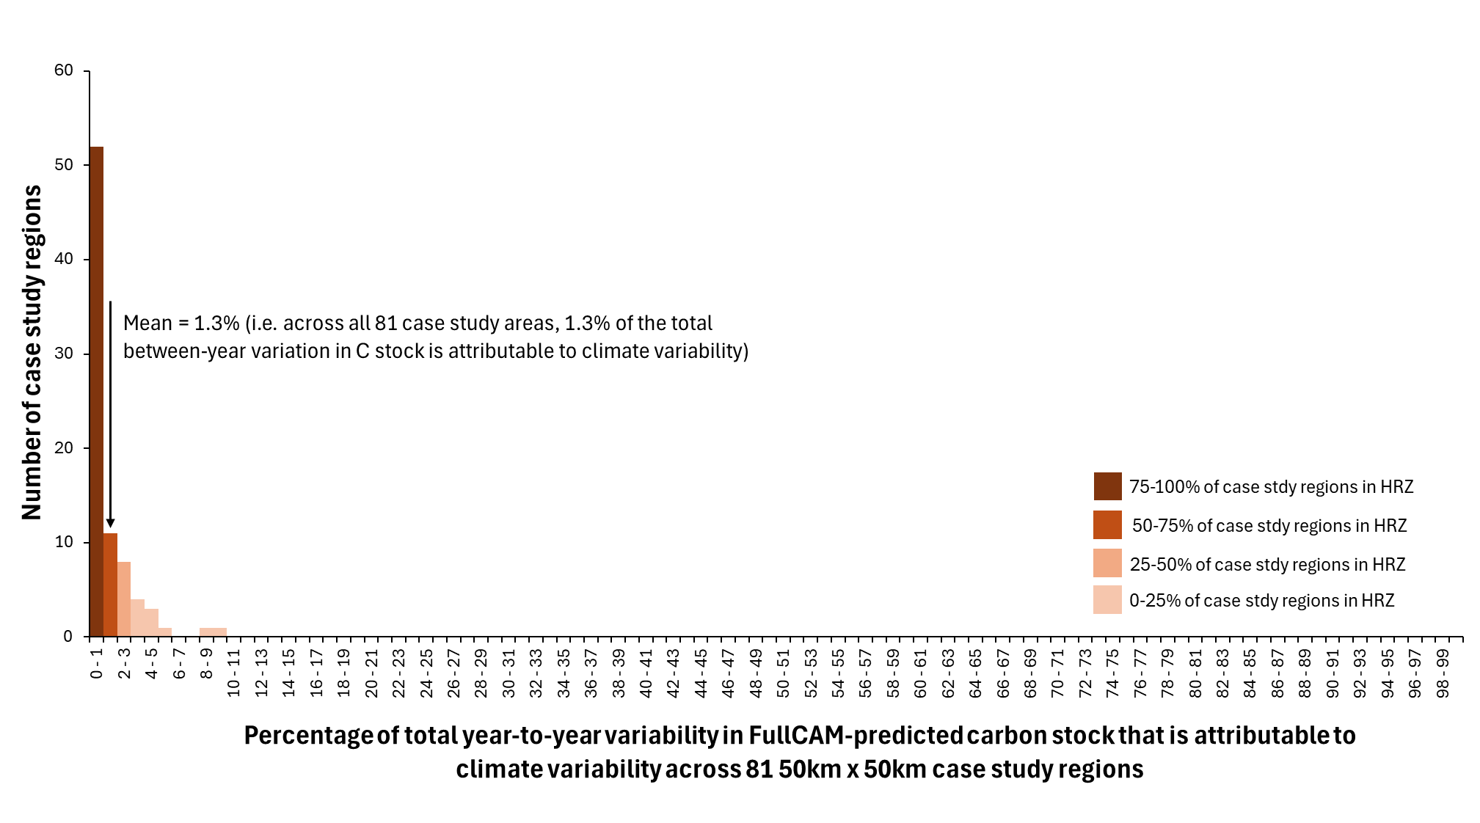

**Figure 19** Frequency histogram of *%Annual variability in carbon storage due to climate* (Eqn. 1) across 81 50 km x 50 km case study regions, and an indication of what percentage of the case study regions within each 1% frequency bin were in the High Rainfall Zone (HRZ).

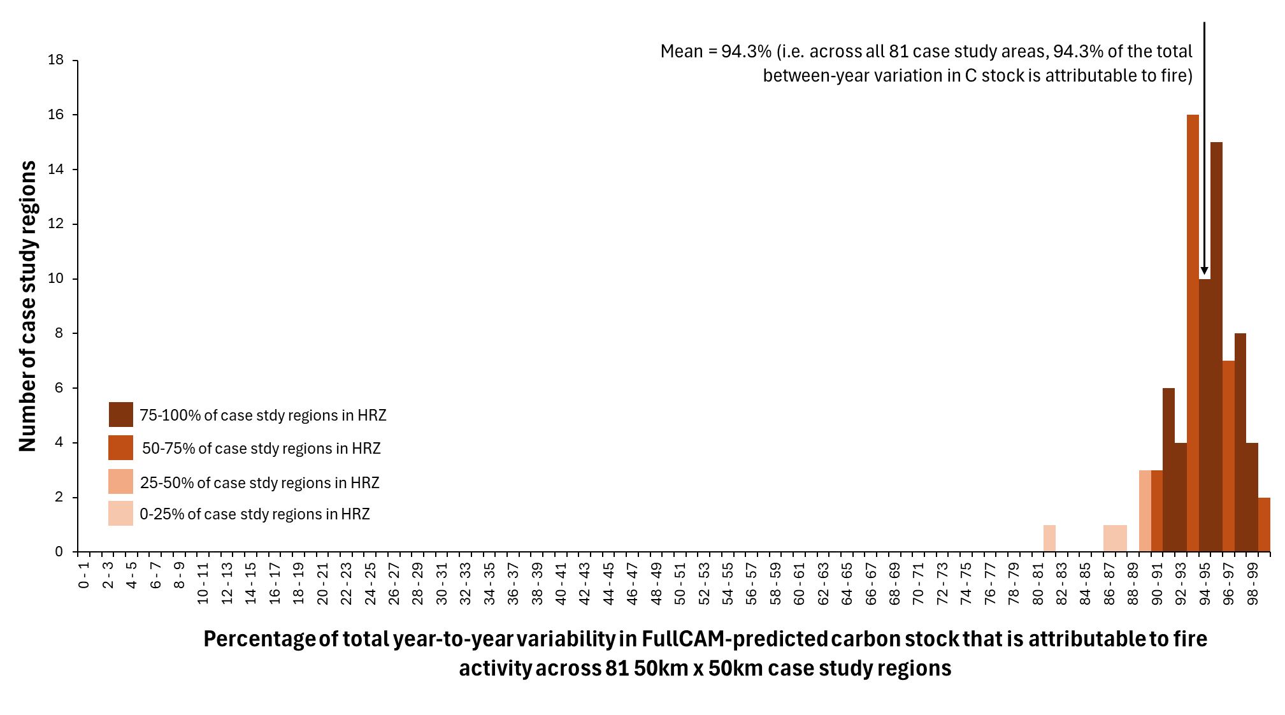

**Figure 20** Frequency histogram of *%Annual variability in carbon storage due to fire* (Eqn. 2) across 81 50 km x 50 km case study regions, and an indication of what percentage of the case study regions within each 1% frequency bin were in the High Rainfall Zone (HRZ).

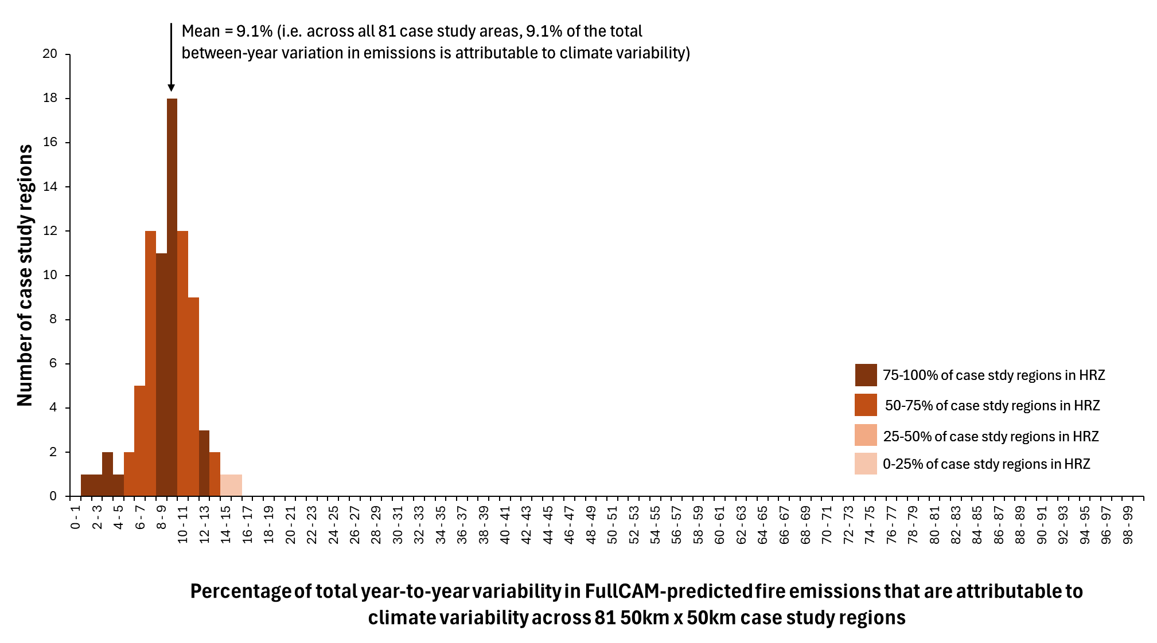

**Figure 21** Frequency histogram of *%Annual variability in fire emissions due to climate* (Eqn. 4) across 81 50 km x 50 km case study regions, and an indication of what percentage of the case study regions within each 1% frequency bin were in the High Rainfall Zone (HRZ).

## Discussion

Growth and decomposition in FullCAM are influenced by year-to-year fluctuations in climate, as well as by changes in the extent and timing of fires. Since abatement under savanna fire management is based on fire management, it is important to ensure that any carbon abatement calculated by FullCAM (and, by extension, SavCAM) arises predominantly from changes in fire, rather than from natural climate variability, which lies outside human control.

To assess the impact of climate variability on FullCAM outputs, 81 50 km x 50 km case study areas were analysed, over the period 2000 to 2024 (the extent of the spatial fire history record). The findings revealed that only 1.3% (±1.7%) of annual variability in carbon storage could be attributed directly to climate variability. In comparison, 94.3% (±3.0%) was attributable to fire, with the remaining 4.5% (±2.3%) capturing the covariance between climate and fire. In terms of fire emissions, 9.1% (±2.4%) of annual variability was found to be attributable to climate.

The results indicated a relatively higher contribution of climate to total annual variability in the LRZ for both sequestration and emissions. Even within the LRZ, the influence of climate on carbon storage remained below 10%, while its effect on emissions peaked at 15%, with most case study areas showing less than 10% climate-related variability. These elevated figures in the LRZ are likely due to reduced fire frequency in low rainfall regions, diminishing the relative contribution of fire to total variability.

The relatively low contribution of climate variability compared to fire is likely due to two factors.

First, the climate influence on tree growth in FullCAM is via modifications to the annual growth increment. However, for the savanna burning calculations mature vegetation is assumed (as confirmed by the F+C- analysis), where tree growth increments are close to zero. Additionally, when biomass is reduced by fire, tree recovery is governed by FullCAM’s empirical ‘recovery function’ that is not impacted by the climate. Therefore, in FullCAM climate variability plays very little role in determining the growth of the living vegetation when it is close to maturity.

Second, the influence of climate variability is predominantly on the rates of decomposition of the dead biomass, however because of the relatively high fire frequencies observed over the savanna region, and the susceptibility of dead biomass to combustion, rates of loss from fire tend to dominate over losses from decomposition.

# Acknowledgements

We thank Kirsten Knox for providing the baseline periods and reporting years on which the analyses in Sections 1 and 2 are based. We also thank staff from DCCEEW and the CER, and Jacqui England, for comments on an earlier draft of this report.

# References

Paul KI and Roxburgh SH (2024) A national accounting framework for fire and carbon dynamics in Australian savannas. International Journal of Wildland Fire 33(4).

Roxburgh S.H, Forrester D., Paul K (2024) Technical assessment of SavCAM/FullCAM for development of savanna fire management methods under the Australian Carbon Credit Unit (ACCU) scheme. Final report on project activities 1-3. 58pp.

Thackway, R., Auricht, C., Edwards, A., Lynch, D. and Cuff, N., (2014). A vegetation fuel type map for Australia’s northern savannas. Unpublished report prepared for the Department of the Environment, Canberra. Auricht Projects, Adelaide, South Australia. pp 42. [DotE_savanna_burn_fuel_types_final_Auricht_Projects_20140814_final.pdf](https://bushfireresearch.org.au/wp-content/uploads/2021/08/DotE_savanna_burn_fuel_types_final_Auricht_Projects_20140814_final.pdf)

# Appendix 1. Additional per-ha results

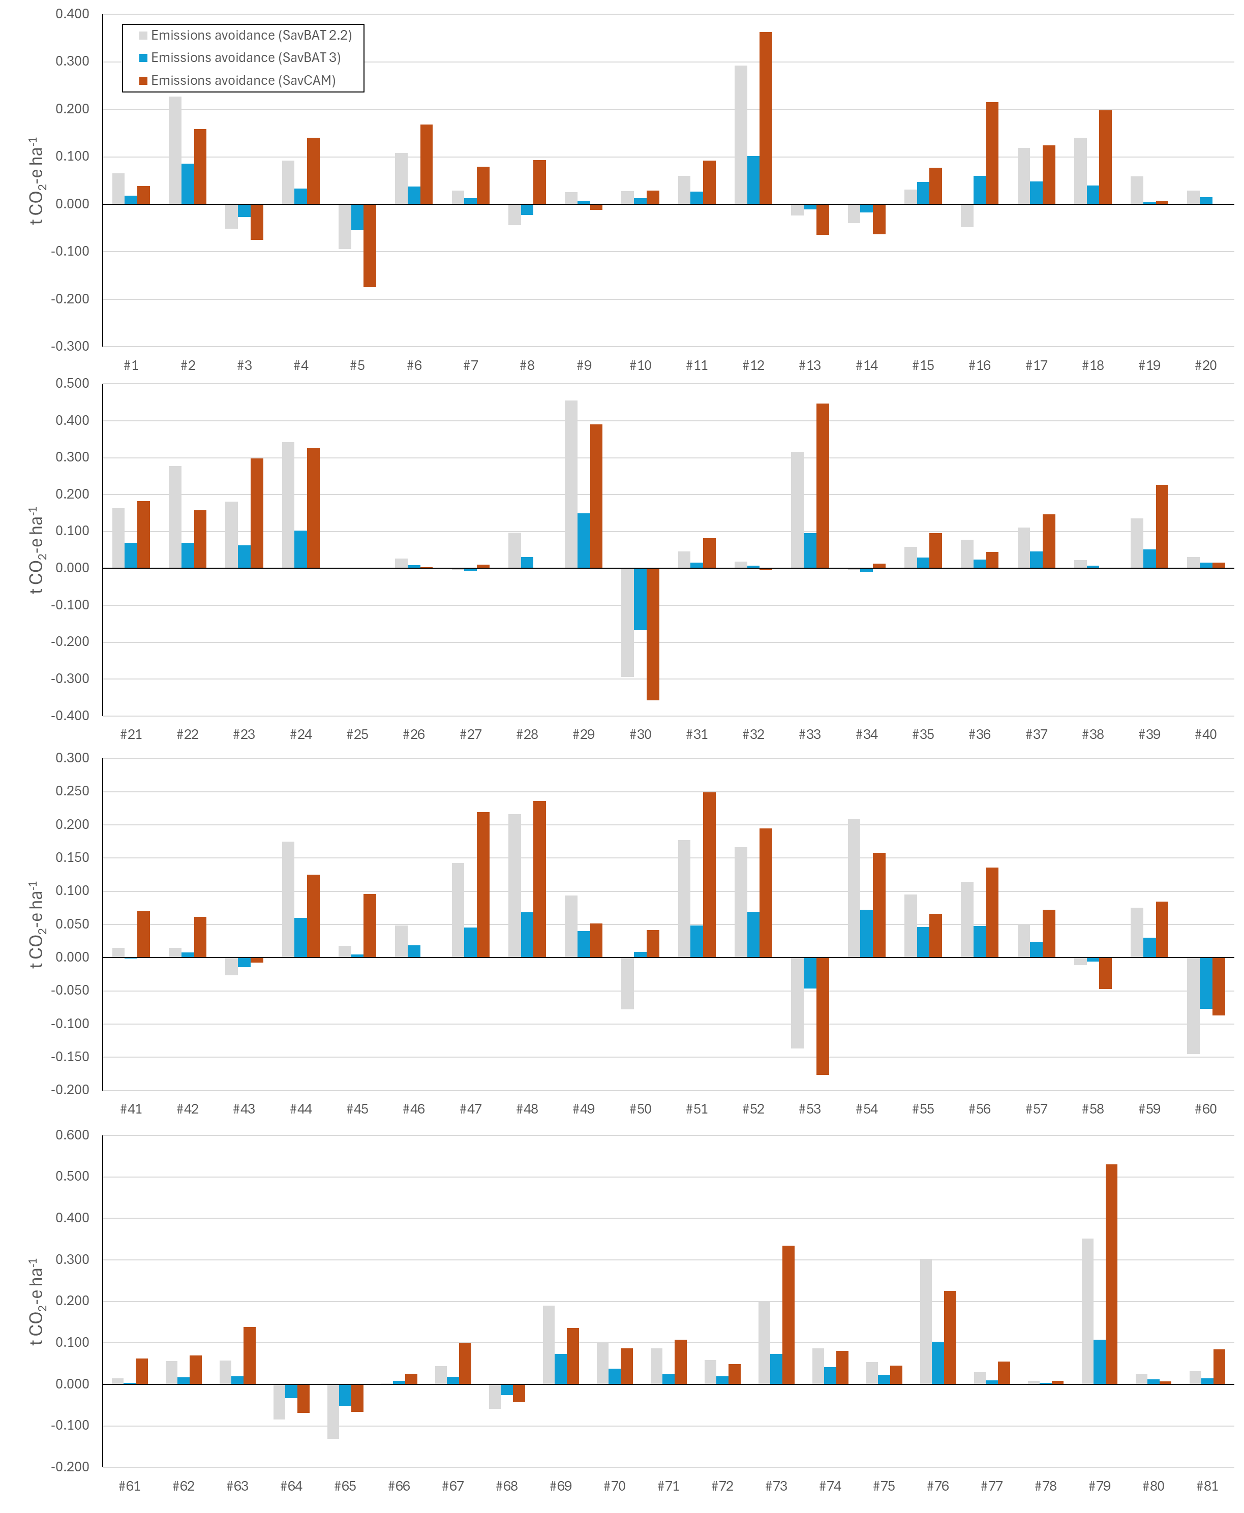

**Figure A1.1** Per test-area emissions avoidance for SavBAT 2.2, SavBAT 3.0 and SavCAM. Emissions avoidance values are total emissions for the reporting year, subtracted from average annual total emissions over the baseline period.

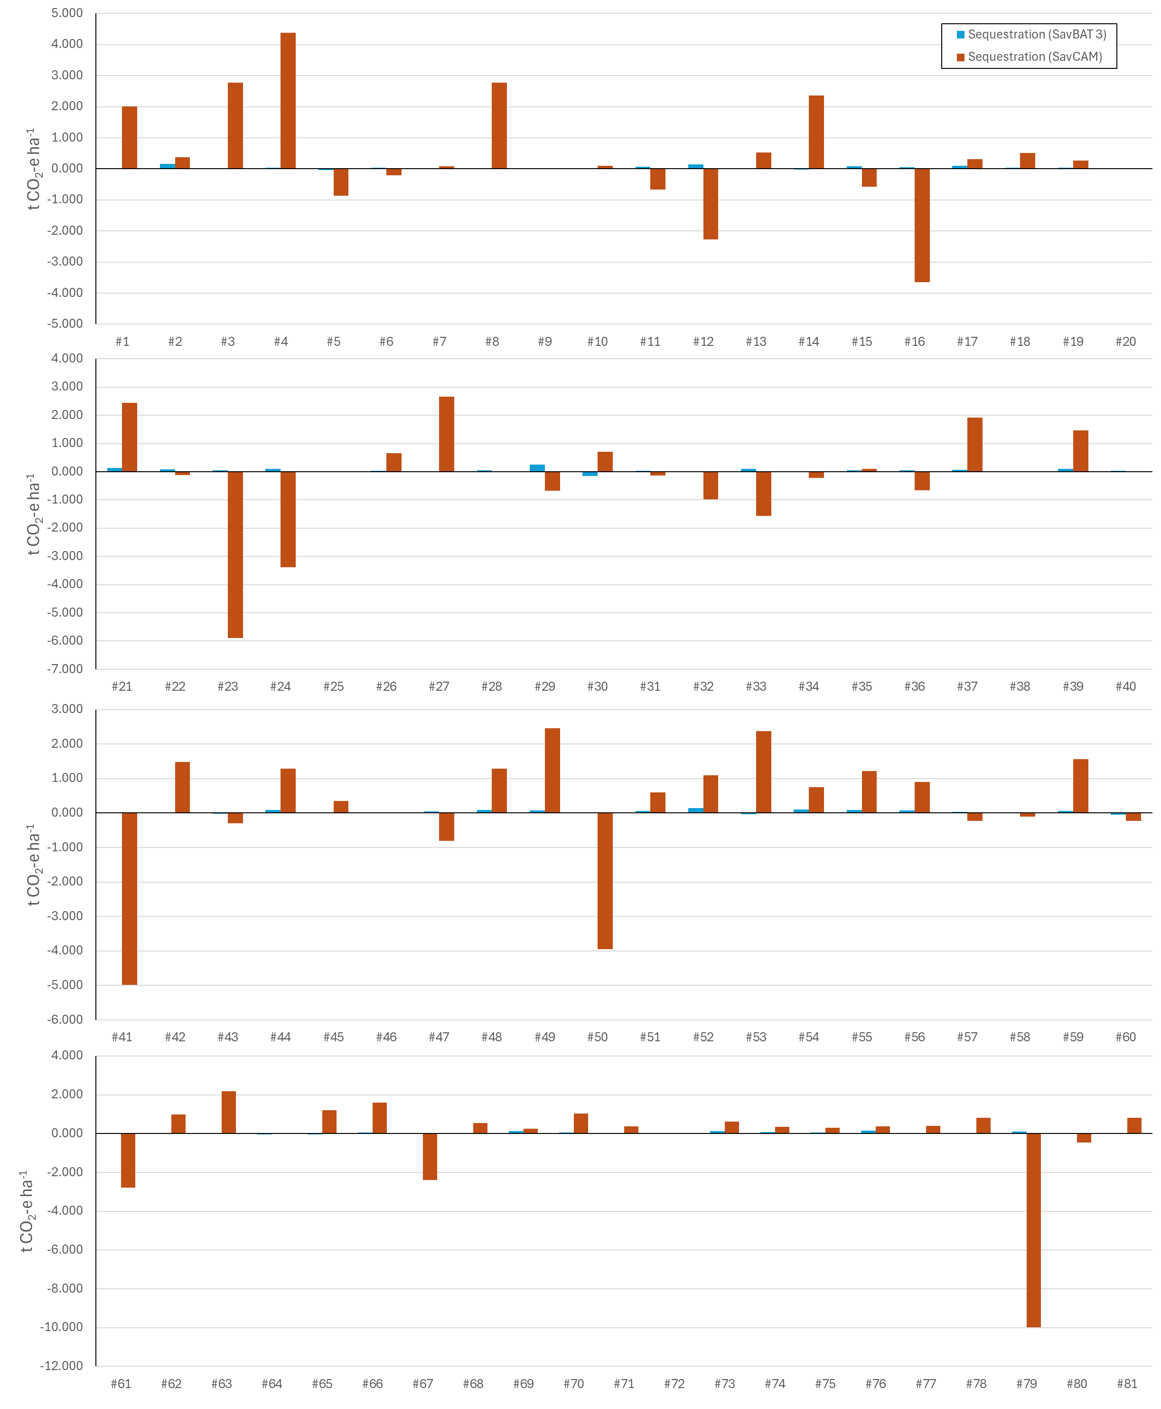

**Figure A1.2** Per test-area total sequestration for SavBAT 3.0 and SavCAM. Sequestration values are average C stock over the reporting year, subtracted from the average C stock over the baseline period.

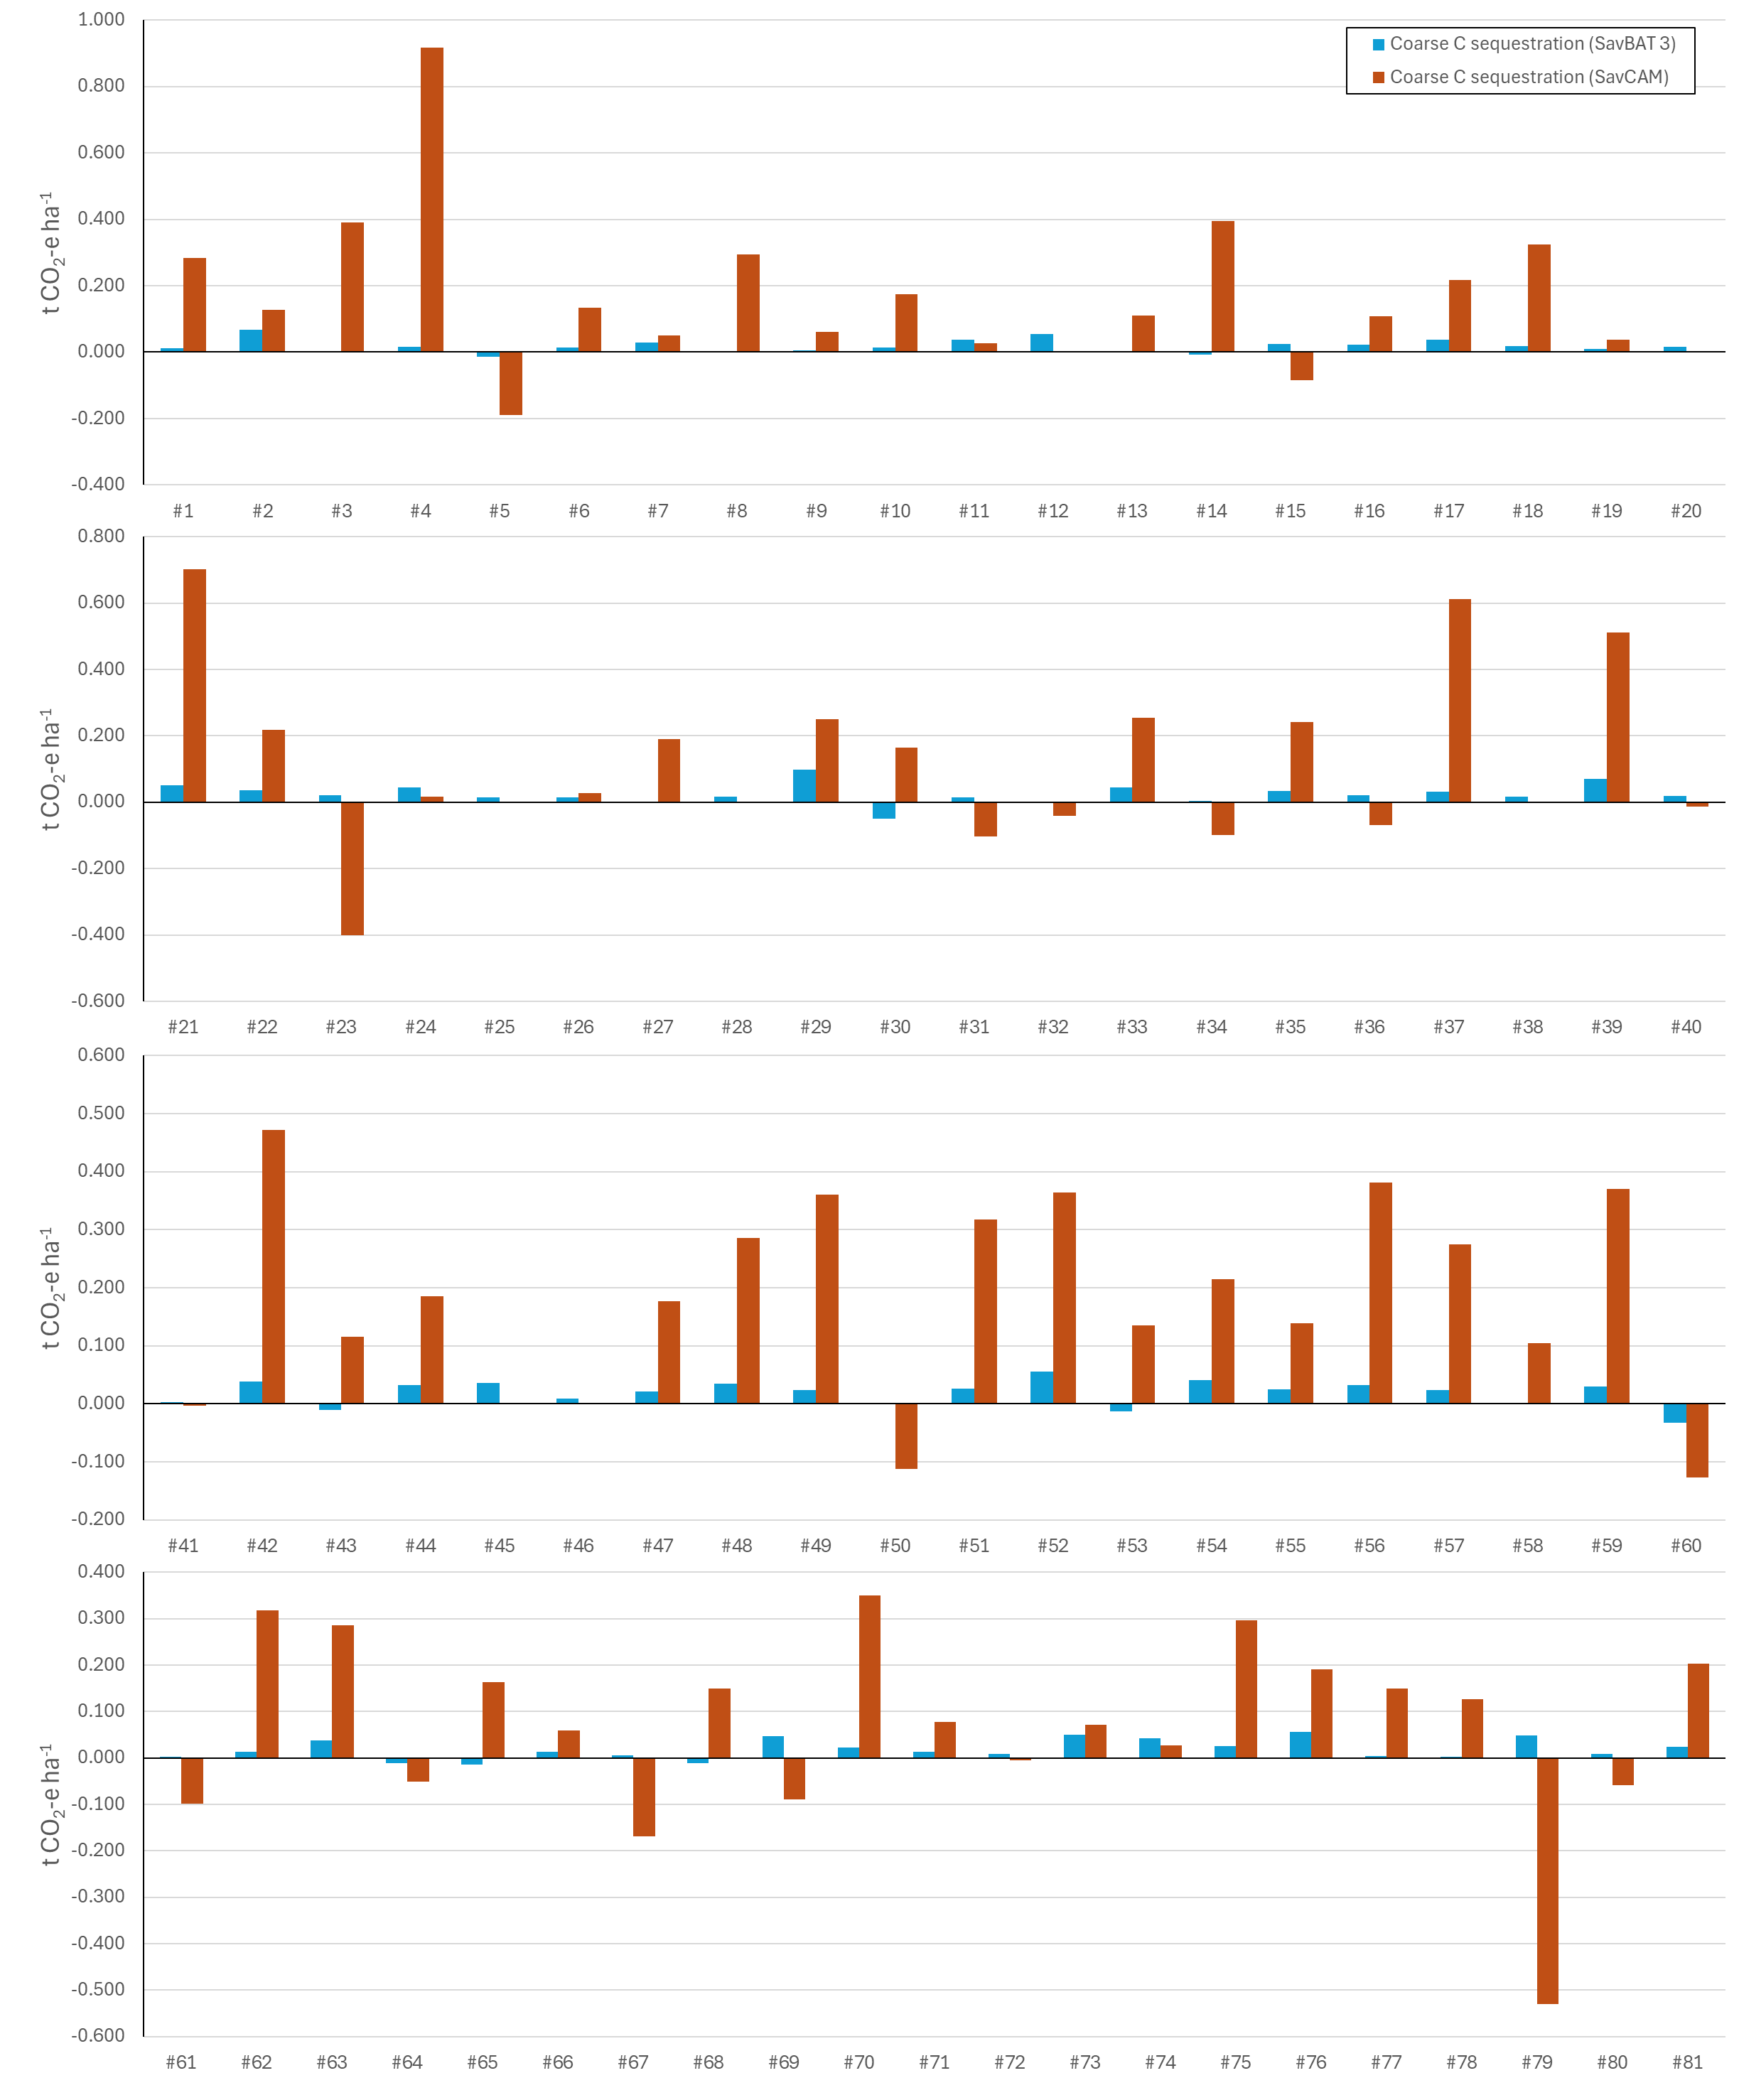

**Figure A1.3** Per test-area coarse fuel sequestration for SavBAT 3.0 and SavCAM. Sequestration values are average C stock over the reporting year, subtracted from the average C stock over the baseline period.

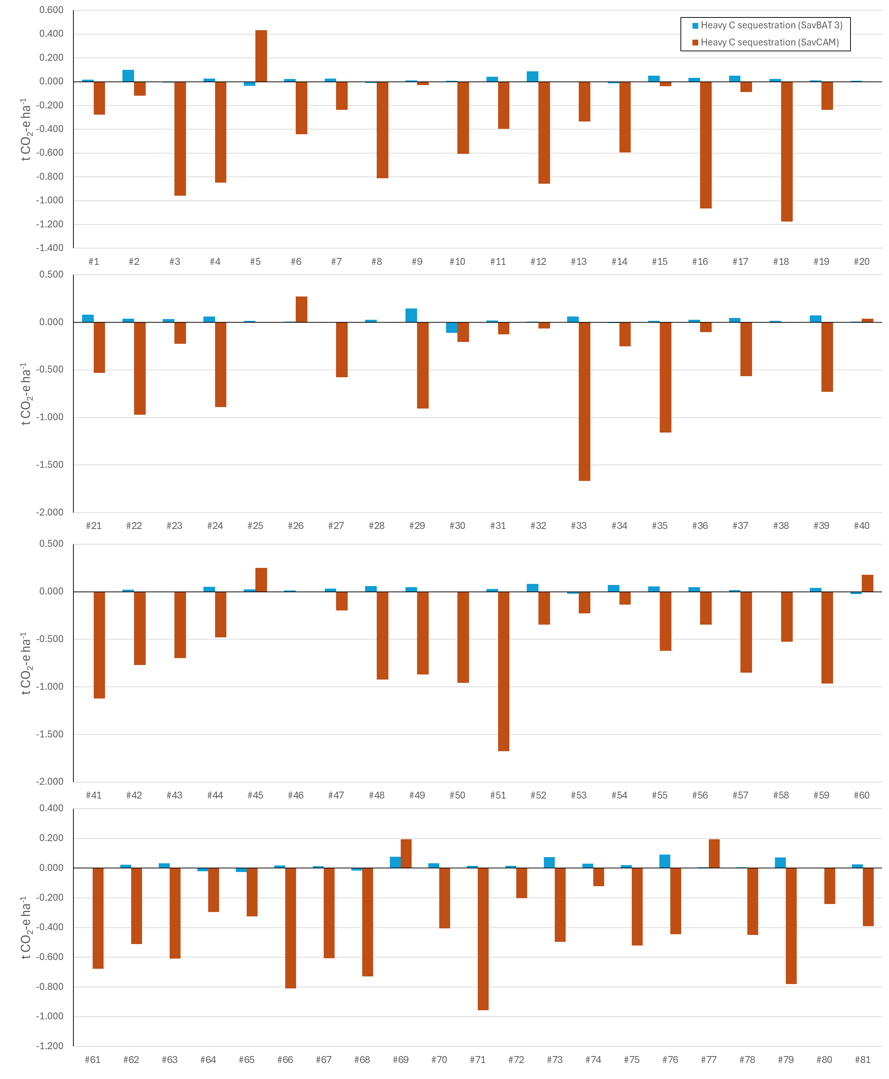

**Figure A1.4** Per test-area heavy fuel sequestration for SavBAT 3.0 and SavCAM. Sequestration values are average C stock over the reporting year, subtracted from the average C stock over the baseline period.

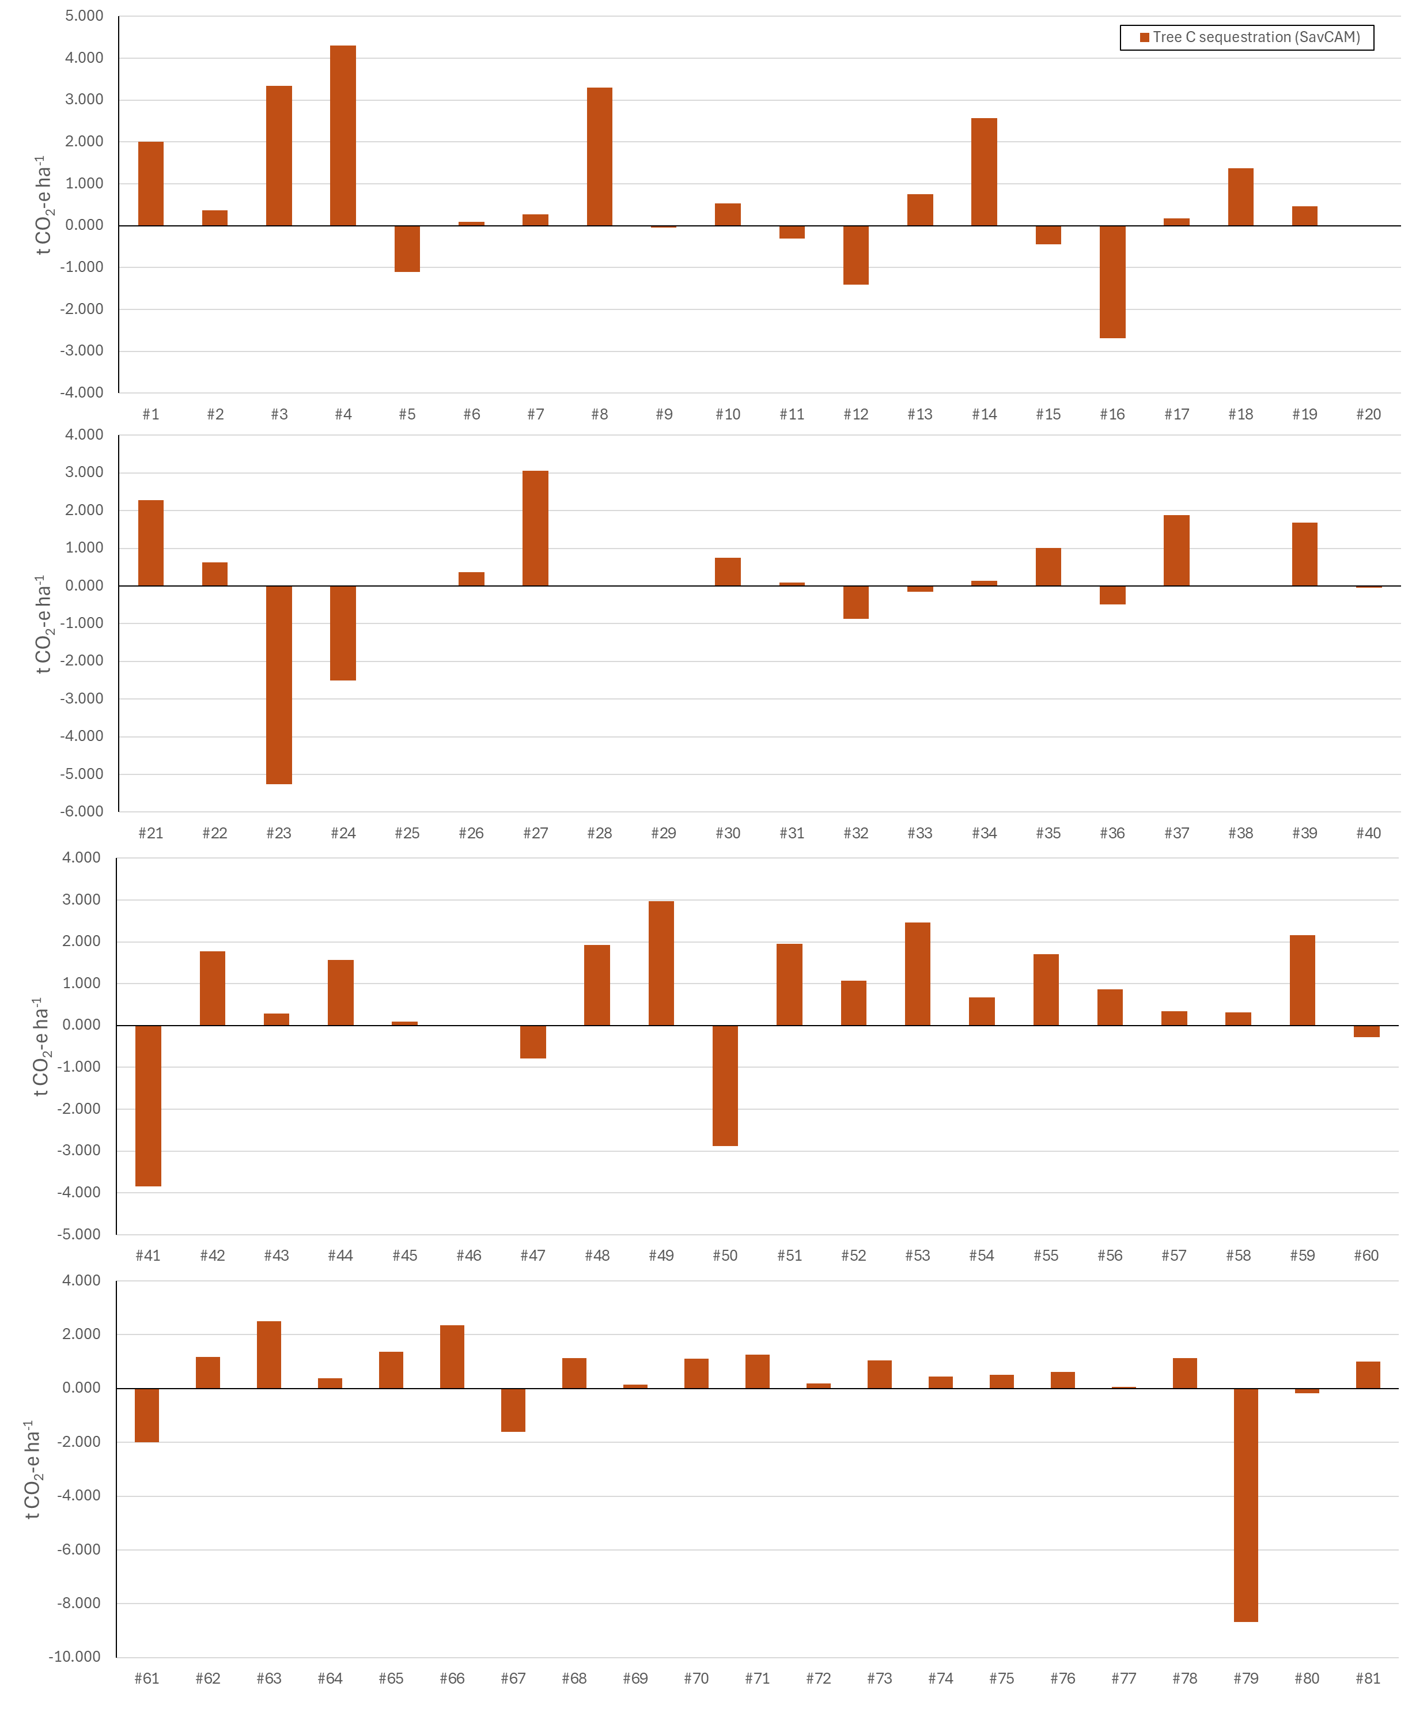

**Figure A1.5** Per test-area live biomass sequestration for SavBAT 3.0. Sequestration values are average C stock over the reporting year, subtracted from the average C stock over the baseline period.

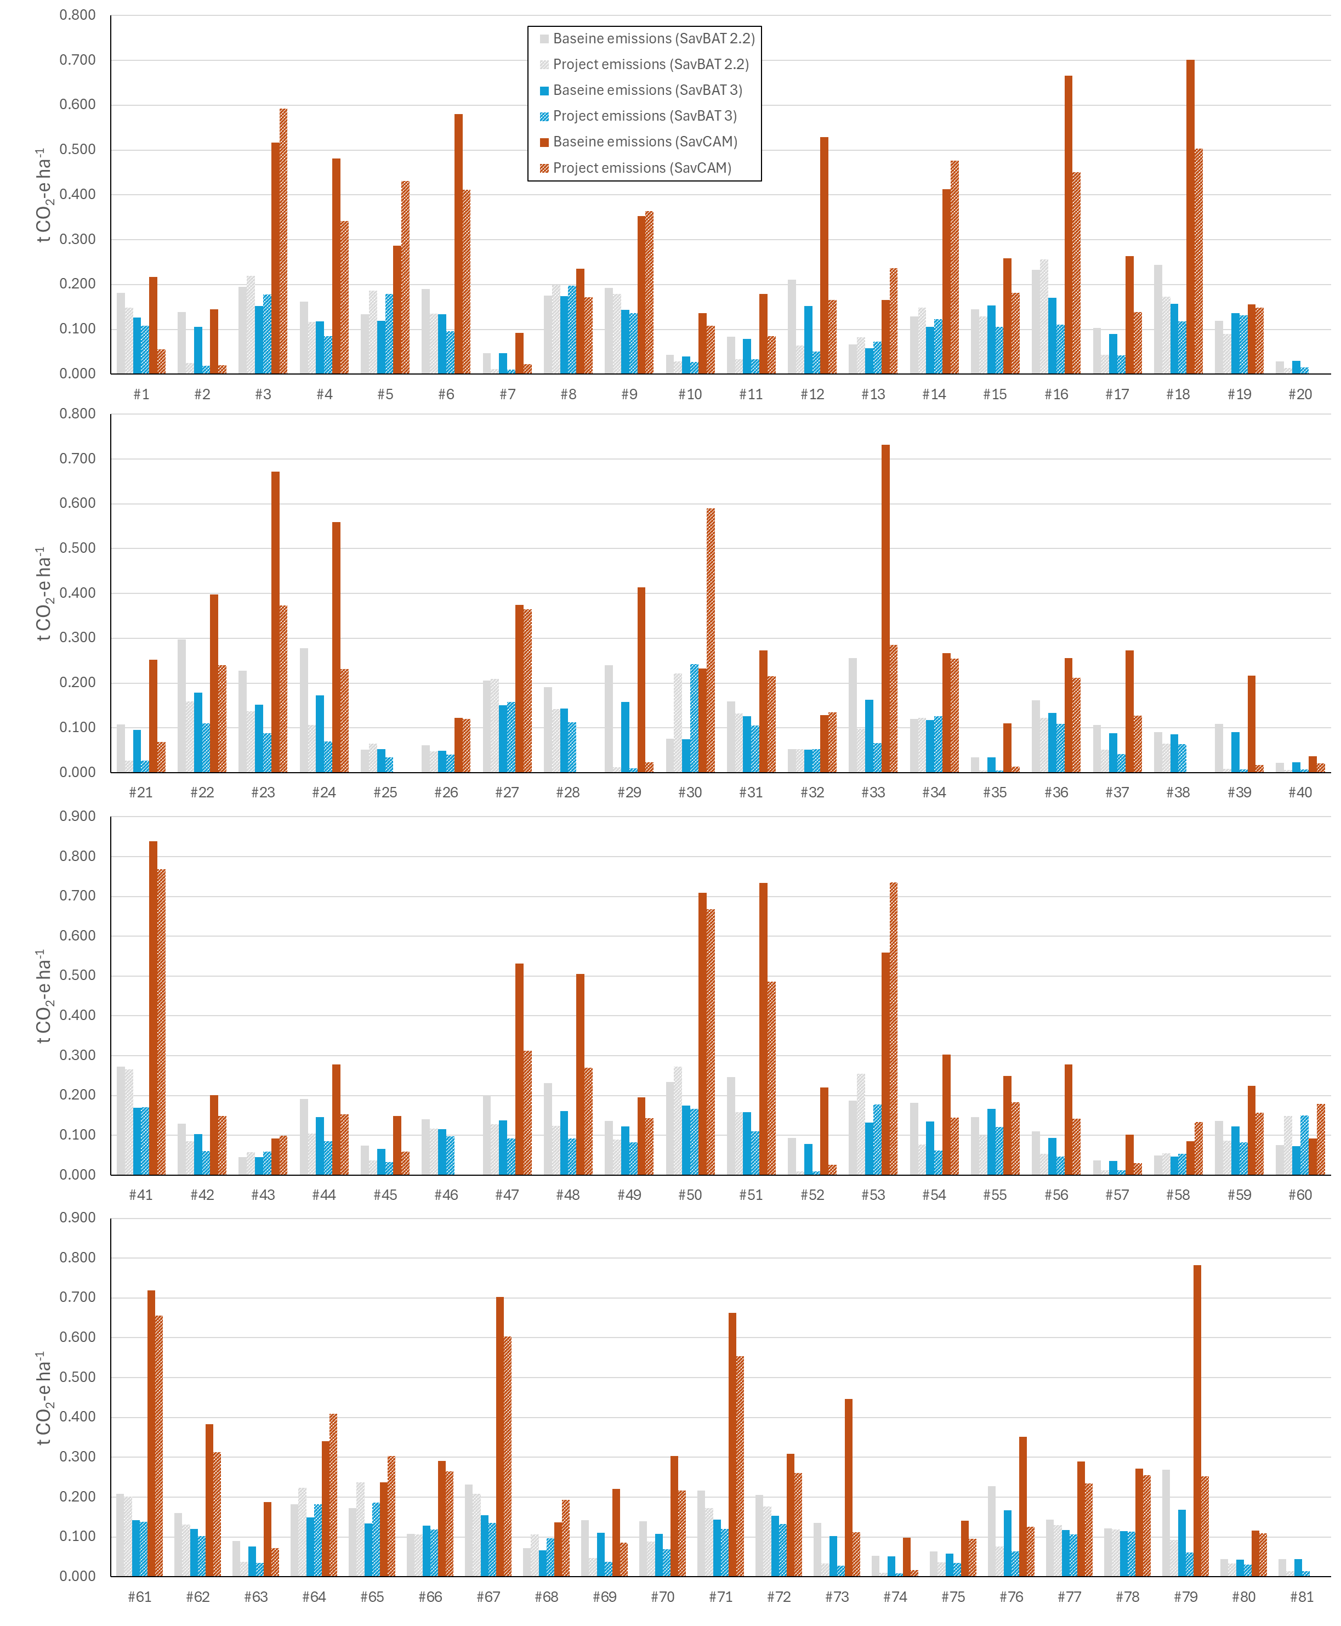

**Figure A1.6** Per test-area baseline and project emissions for SavBAT 2.2, SavBAT 3.0 and SavCAM. Project values are total emissions for the reporting year. Baseline values are average annual emissions over the baseline period.

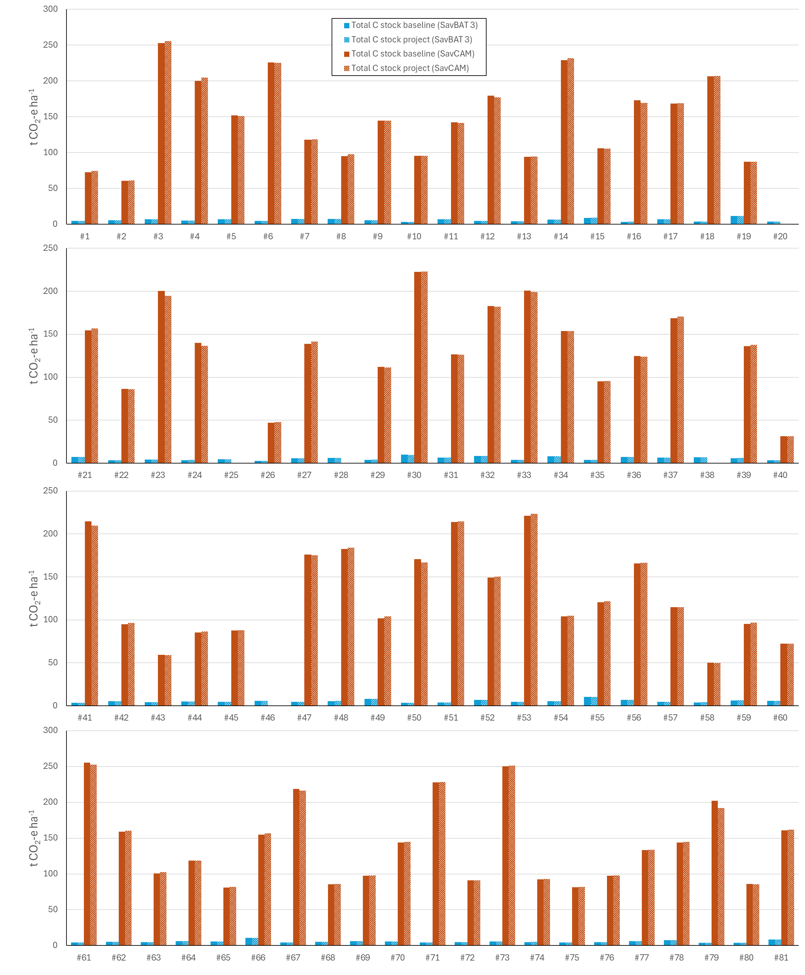

**Figure A1.7** Per test-area baseline and project total C stock for SavBAT 3.0 and SavCAM. Total C stock project values are average C stock over the reporting year. Total C stock baseline values are average C stock over the baseline period.

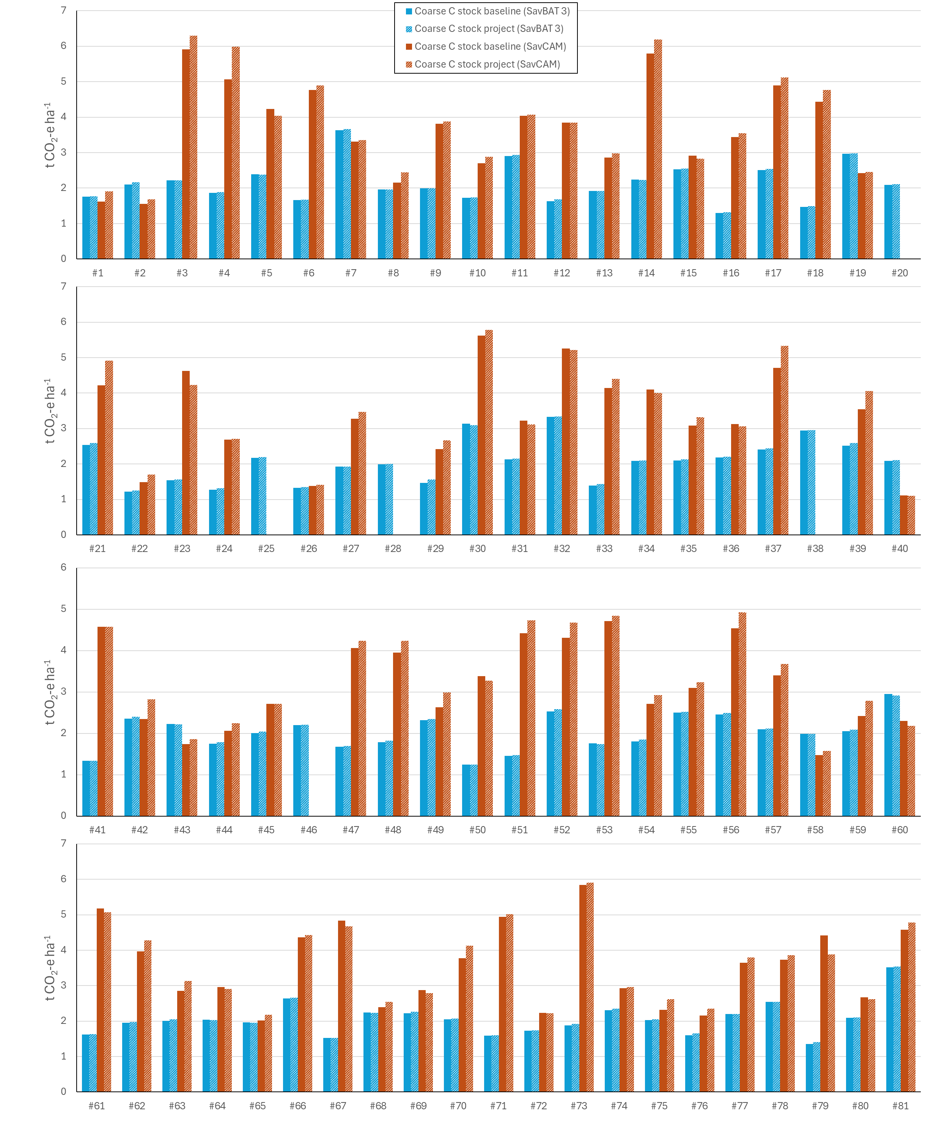

**Figure A1.8** Per test-area baseline and project coarse fuel C stock for SavBAT 3.0 and SavCAM. Coarse C stock project values are average C stock over the reporting year. Coarse C stock baseline values are average C stock over the baseline period.

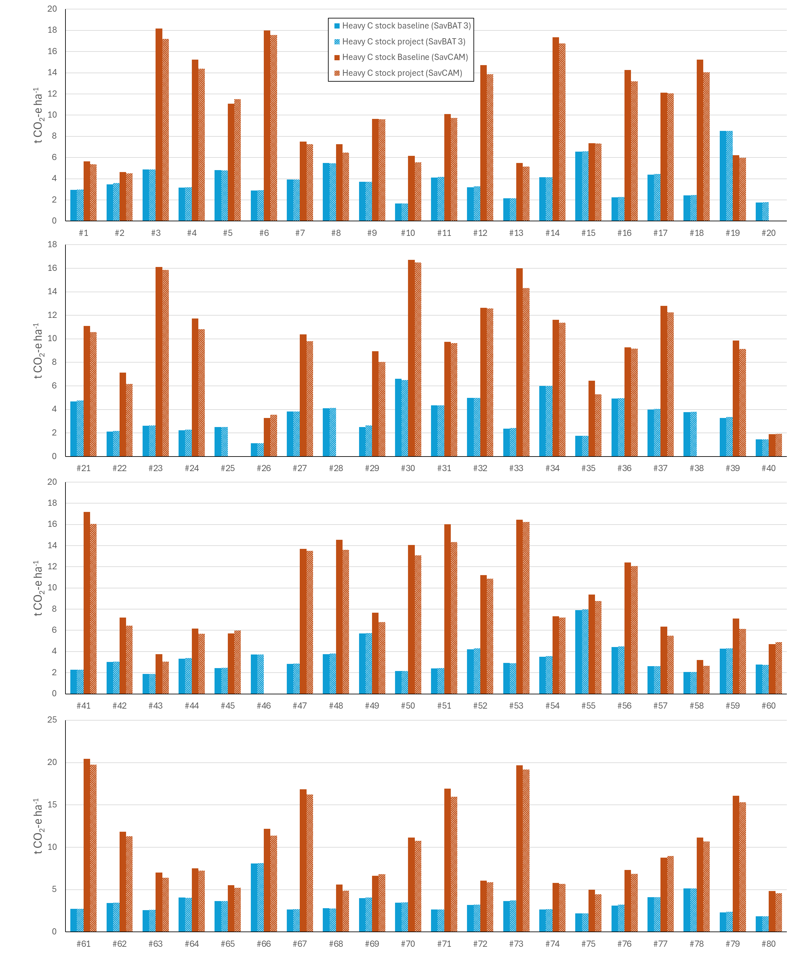

**Figure A1.9** Per test-area baseline and project heavy fuel C stock for SavBAT 3.0 and SavCAM. Heavy C stock project values are average C stock over the reporting year. Heavy C stock baseline values are average C stock over the baseline period.

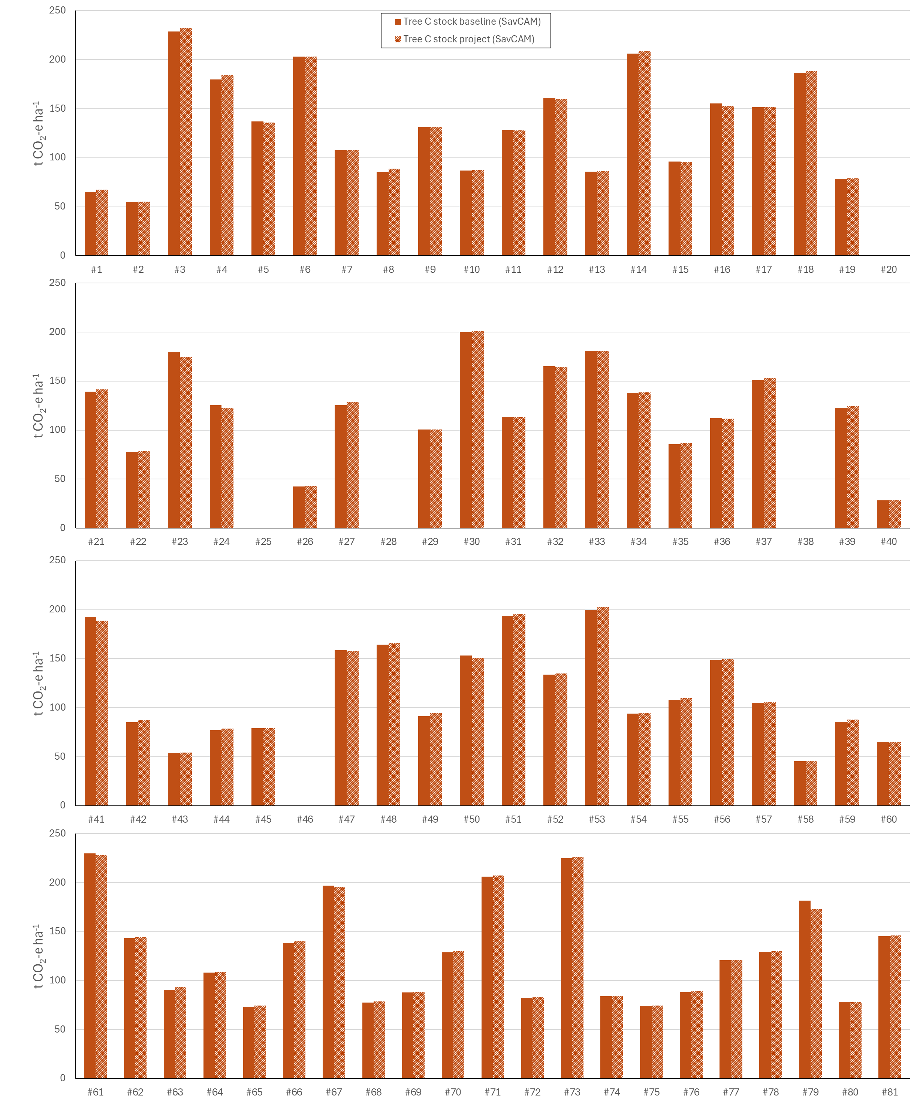

**Figure A1.10** Per test-area baseline and project tree C stock for SavCAM. Tree C stock project values are average C stock over the reporting year. Tree C stock baseline values are average C stock over the baseline period.

# Appendix 2. Total case study area summary results

The results presented below complement the figures in the main text, and express emissions and sequestration values on a total project area basis.

**Emissions avoidance**



**Figure A2.1** Total emissions for SavBAT 2.2, SavBAT 3.0, and SavCAM, averaged over *n*=81 project test areas (*n*=76 for SavCAM). Error bars are standard deviations. Project emissions are total emissions for the reporting year. Baseline emissions are average annual emissions over the baseline period.

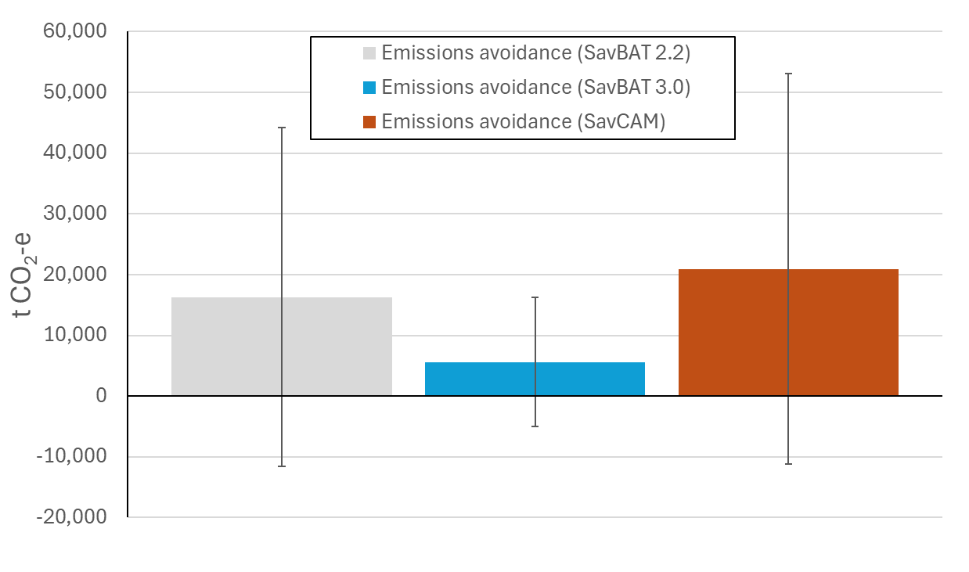

**Figure A2.2** Emissions avoidance(baseline emissions – project emissions) for SavBAT 2.2, SavBAT 3.0, and SavCAM, averaged over *n*=81 project test areas (*n*=76 for SavCAM). Error bars are standard deviations. Emissions avoidance values are total emissions for the reporting year, subtracted from average annual total emissions over the baseline period.

Table A2.1 Mean difference (n=76 test areas) between SavCAM and SavBAT versions 2.2 and 3.0 for total emissions and emissions avoidance (baseline – project), expressed as (a) fractional change, and (b) tCO2. For fractional change, a value of +2.0 means SavCAM predicted twice the value of the respective SavBAT version. ‘±’ values are the interval that encompasses approximately 90% of all test area results.

|  |  |  |  |
| --- | --- | --- | --- |
| (a) Fractional change | Total emissions | | Emissions avoidance |
|  | Mean baseline | Project |  |
| SavBAT 2.2 | +2.26x | +2.22x | +1.28x |
| SavBat 3.0 | +2.86x | +2.72x | +3.72x |

|  |  |  |  |
| --- | --- | --- | --- |
| (b) Change in tCO2 | Total emissions | | Emissions avoidance |
|  | Mean baseline | Project |  |
| SavBAT 2.2 | +42,725(±78,500) | +30,791(±75,252) | +4,628(±70,815) |
| SavBat 3.0 | +49,774(±75,955) | +35,419(±73,466) | +15,284(±56,361) |

**Sequestration – total**

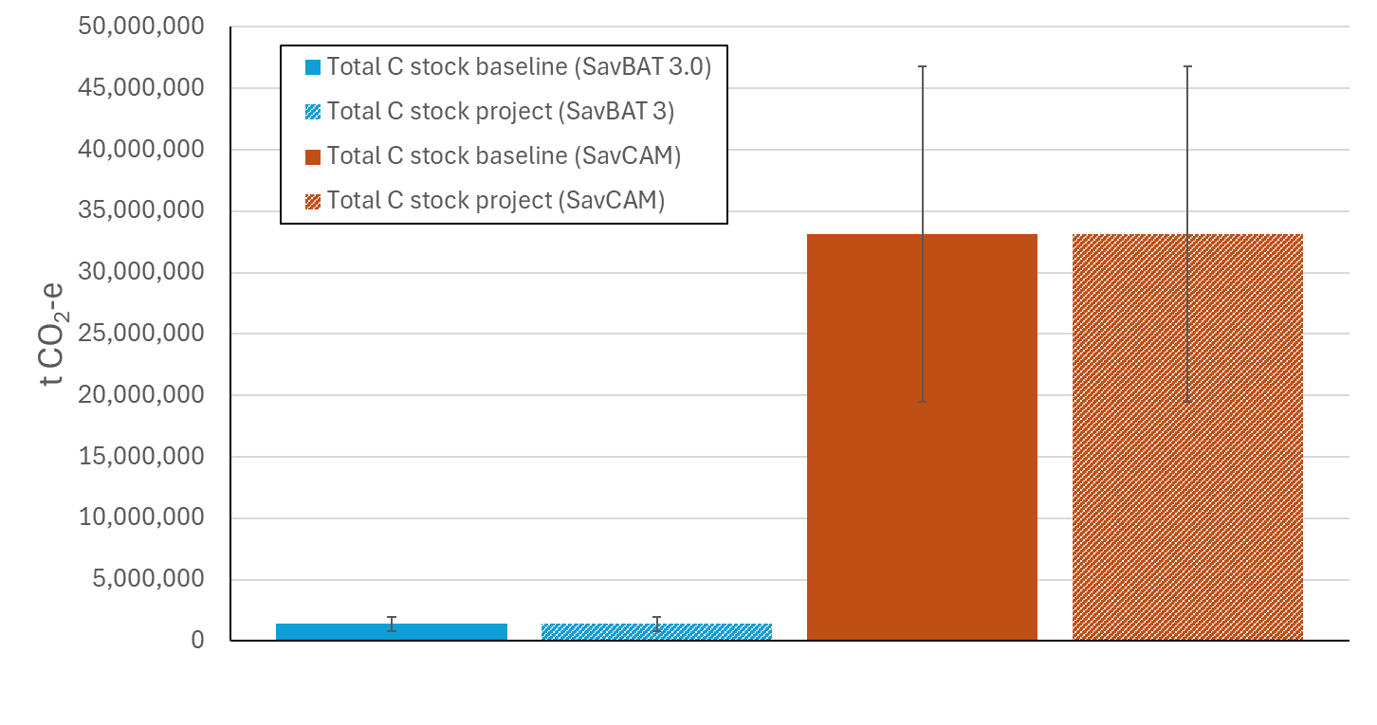

**Figure A2.3** Total carbon storage for SavBAT 3.0 and SavCAM, averaged over *n*=81 project test areas (*n*=76 for SavCAM). Error bars are standard deviations.

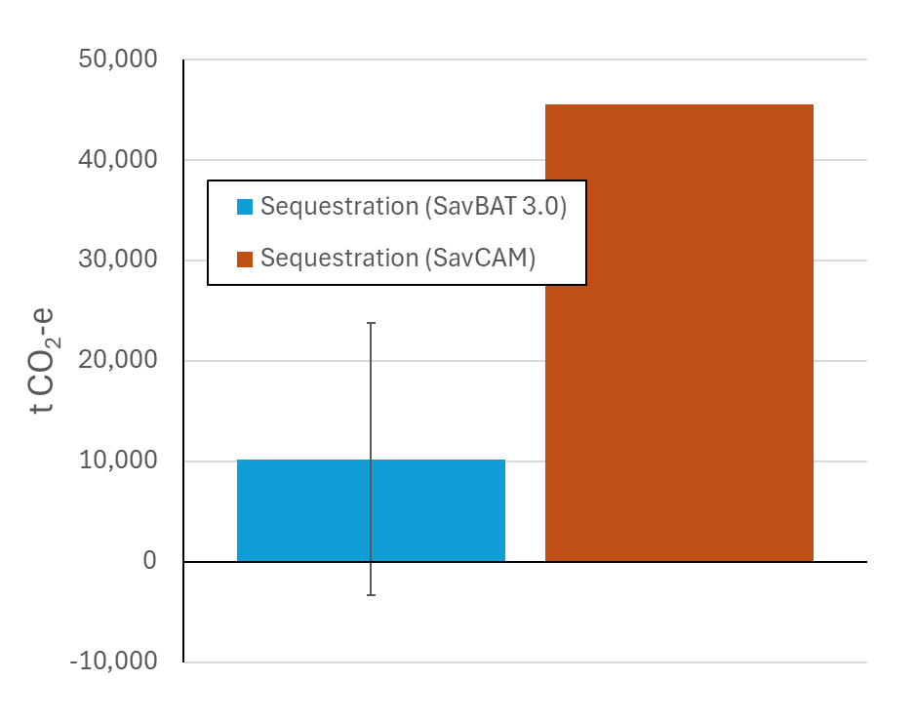

**Figure A2.4** Sequestration (project carbon storage - baseline carbon storage) for SavBAT 3.0 and SavCAM, averaged over *n*=81 project test areas (*n*=76 for SavCAM). Error bars are standard deviations (error bar for SavCAM omitted for display purposes). Total C stock project values are average C stock over the reporting year. Total C stock baseline values are average C stock over the baseline period.

Table A2.2 Mean difference (n=76 test areas) between SavCAM and SavBAT 3.0 for total carbon storage and sequestration (project - baseline), expressed as (a) fractional change, and (b) tCO2 ha-1. For fractional change, a value of +2.0 means SavCAM predicted twice the value of the respective SavBAT version. ‘±’ values are the interval that encompasses approximately 90% of all test area results.

|  |  |  |  |
| --- | --- | --- | --- |
| A. Fractional change | Total C storage | | Sequestration |
|  | Mean baseline | Project |  |
| SavBat 3.0 | +23.99x | +23.84x | +4.46x |

|  |  |  |  |
| --- | --- | --- | --- |
| B. Change in tCO2 | Total C storage | | Sequestration |
|  | Mean baseline | Project |  |
| SavBat 3.0 | +31,727,550(±22,766,325) | +31,762,318(±22,752,366) | +35,318(±754,890) |

**Sequestration – separate fuel components**

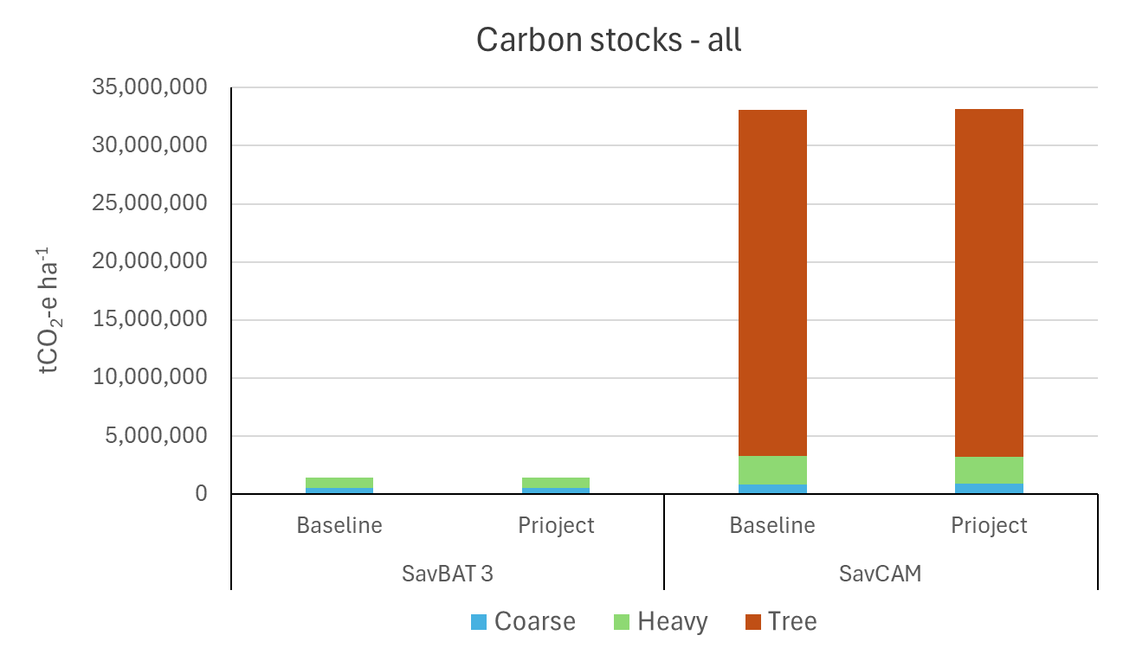

(a)

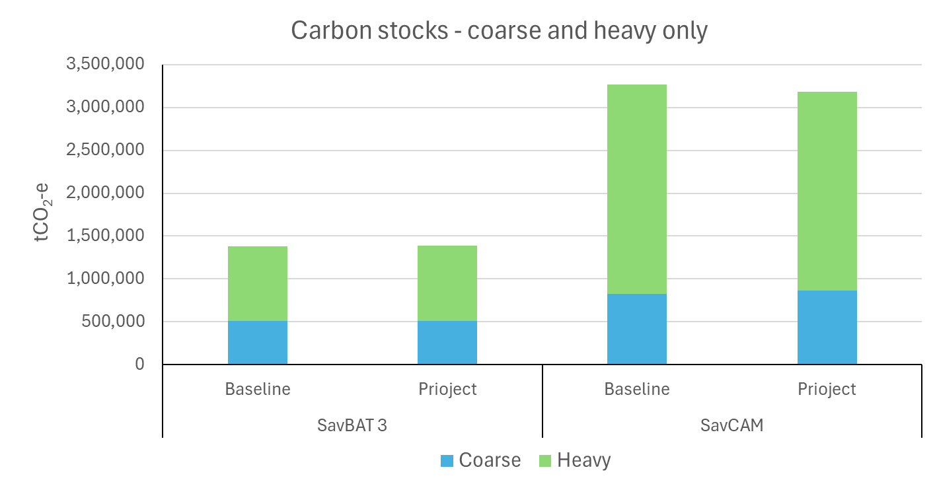

(b)

**Figure A2.5** Total carbon storage for SavBAT 3.0 (*n*=81) and SavCAM (*n*=76). (a) all fuel classes (coarse, heavy and live tree components), and (b) only the coarse and heavy components. Project values are average C stock over the reporting year. Baseline values are average C stock over the baseline period.

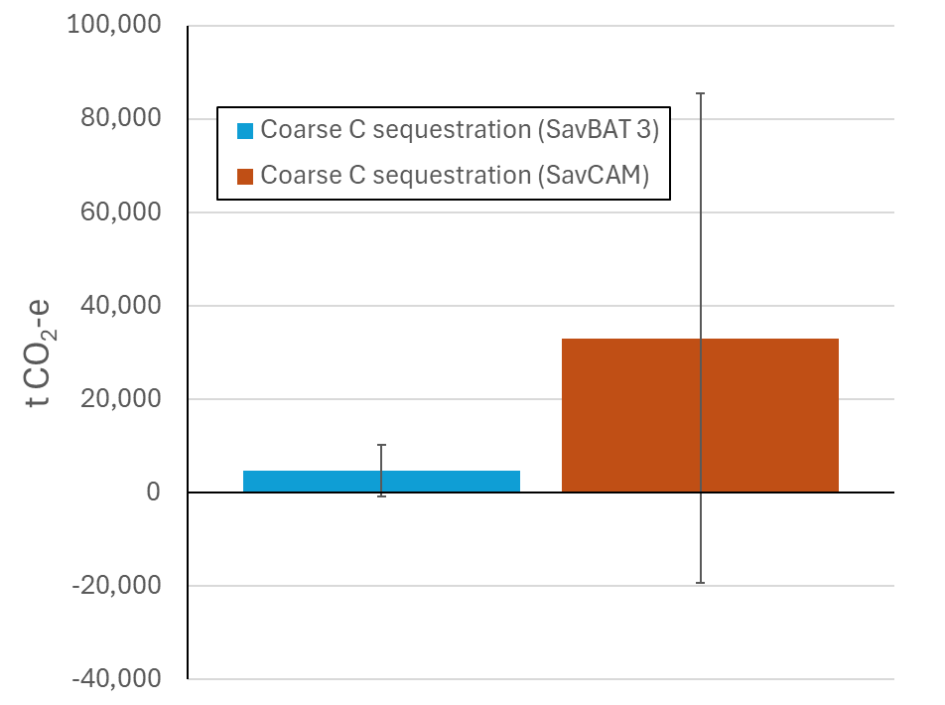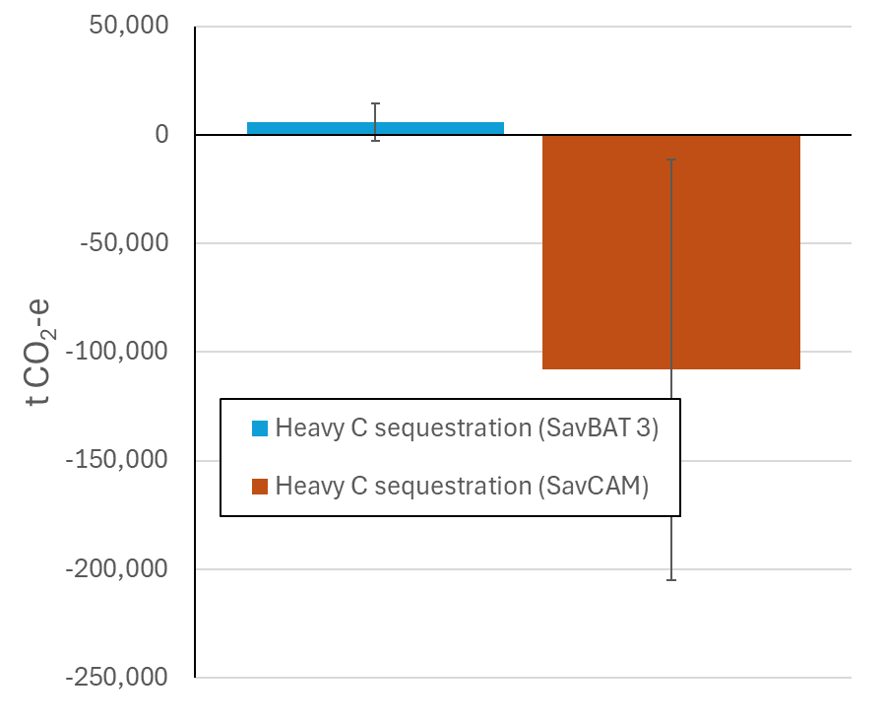

(b)

(a)

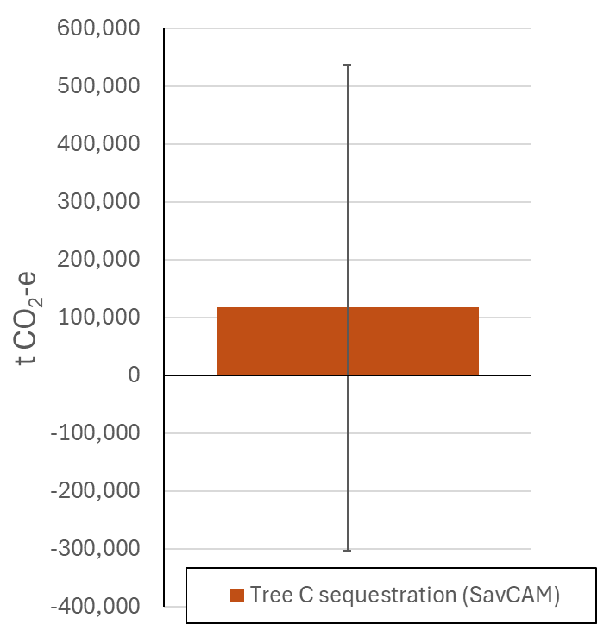

(c)

**Figure A2.6** Sequestration (project carbon storage - baseline carbon storage) for (a) coarse fuel, (b) heavy fuel and (c) tree biomass, averaged over *n*=76 project test areas. Error bars are standard deviations. Sequestration values are average C stock over the reporting year, subtracted from the average C stock over the baseline period.

Table A2.3 Mean difference (n=76 test areas) between SavCAM and SavBAT 3.0 for coarse and heavy fuel total carbon storage and sequestration (project - baseline), expressed as (a) fractional change, and (b) tCO2 ha-1. For fractional change, a value of +2.0 means SavCAM predicted twice the value of SavBAT 3.0 version. ‘±’ values are the interval that encompasses approximately 90% of all test area results.

|  |  |  |  |
| --- | --- | --- | --- |
| A. Fractional change | Total C storage | | Sequestration |
|  | Mean baseline | Project |  |
| Coarse | +1.64x | +1.69x | +6.95x |
| Heavy | +2.79x | +2.64x | -18.05x |

|  |  |  |  |
| --- | --- | --- | --- |
| B. Change in tCO2 | Total C storage | | Sequestration |
|  | Mean baseline | Project |  |
| Coarse | +322,500(±591,730) | +352,986(±608,574) | +28,310(±87,722) |
| Heavy | +1,562,814(±1,965,685) | +1,441,635(±1,935,736) | -114,069(±161,814) |

|  |  |  |
| --- | --- | --- |
| As Australia’s national science agency and innovation catalyst, CSIRO is solving the greatest challenges through innovative science and technology.  CSIRO. Unlocking a better future for everyone.  Contact us  1300 363 400  +61 3 9545 2176  [csiro.au/contact](http://www.csiro.au/contact)  [csiro.au](http://www.csiro.au) |  | For further information  Environment  **Stephen Roxburgh** +61 2 6246 4056  stephen.roxburgh@csiro.au  csiro.au/en/about/people/business-units/Environment |

1. https://www.publish.csiro.au/WF/fulltext/WF23104
2. i.e. excluding 5 project areas for which no SavCAM results were available
3. i.e. excluding 5 project areas for which no SavCAM results were available
4. https://www.firenorth.org.au/nafi3/